EFFECT OF CREDIT FACILITIES ON MAIZE PRODUCTIVITY OF SMALLHOLDER FARMERS IN SUMBAWANGA RURAL AND MBOZI DISTRICTS IN TANZANIA

DIONIS JOSEPH NDOLAGE

A THESIS SUBMITTED IN FULFILMENT OF THE REQUIREMENTS FOR THE DEGREE OF DOCTOR OF PHILOSOPHY (PhD)
DEPARTMENT OF ACCOUNTING AND FINANCE
OF THE OPEN UNIVERSITY OF TANZANIA
2020

CERTIFICATION
The undersigned certify that we have read and hereby recommend for examination the thesis entitled; Effect of Credit Facilities on Maize Productivity of Smallholder Farmers in Sumbawanga Rural and Mbozi Districts in Tanzania: in fulfillment of the requirement for the award of the Degree of Doctor of Philosophy (PhD) of the Open University of Tanzania.

……………………………………….
Dr. Gwahula Raphael

…………………………………….
Date

……………………………………..
Dr. Saganga M. Kapaya

………………………………
Date

COPYRIGHT
No part of this thesis may be reproduced, stored in any retrieval system, or transmitted in any form by any means, electronic, mechanical, photocopying, recording or otherwise without prior written permission of the author or the Open University of Tanzania.

DECLARATION
I, Dionis Joseph Ndolage, do hereby declare that, the work presented in this thesis is original. It has not been presented to any other University or institution. Where other people’s work has been used, references have been provided.

…………………………………….
Signature

………………………………….
Date

DEDICATION
This PhD thesis is dedicated to Almighty God for giving me life, health and emotional resilience during the despair, distraction, frustration and happiness while doing this work.

ACKNOWLEDGEMENT
Praise is to Almighty God for blessing me throughout the journey from the beginning when this work was being conceived until the end of it. He made me know better what it means by devotion and endurance when dealing with academic affairs involving research and training work.

This thesis is a product developed in recognition of the contributions made by other individuals either directly or indirectly at some stage of study conception through its final approval. I convey my sincere gratitude to everyone for their invaluable roles. To start with, I am indebted to acknowledge my two supervisors, namely, Dr Raphael Gwahula and Dr Saganga M. Kapaya. These two were of great help to me through their guidance, advice, corrections and mentorship. They tirelessly encouraged me, allocated much of their time to scrutinize this work. I also extend my appreciation to Dr. Hawa Oiso, Dr Juma Matonya, Dr Salum Soud Mohamed, Dr Abdiel Abayo, Dr Bukaza Loth Chachage, Dr Proches Ngatuni, Dr Salvio Macha, Dr France Shayo, Dr.Joseph Magali and Prof. Jan- Erick Jaenson who commented immensely on this work when approached for to give their observations for improving the document, I, say thanks to them.

I also thank and acknowledge the contributions of my sponsors and promoters, namely the Open University of Tanzania and my family particularly my dear wife, Ms Stella A. Meella for her tireless endurance, comfort and encouragement during the whole process of the study. I extend my gratitude to my lovely son Arthur Dionis and my daughter Nicole Dionis.

ABSTRACT
This study aimed at examining the effect of credit facilities on maize productivity of rural smallholder farmers in Sumbawanga rural and Mbozi districts in Tanzania. Specifically, the study aimed at determining the effects of (i) formal financial institutions credit (ii) semi-formal financial institutions credit and (iii) informal credit on maize productivity of smallholder farmers. This study was guided by the theory of financial intermediation and neoclassical economic growth theory. The research design was descriptive quantitative in nature where balanced panel data for the year 2018 to 2020 was used. A random effect model was used to analyse 321 sample observations. The Pearson correlation coefficient results indicated that formal financial institutions credit, semi-formal financial institutions credit and informal credit has significant and positive effect on maize productivity. Moreover, resuts for mean and standard deviation indicated that semi formal financial institutions credit and informal credit were higly accessed and highly dispersed from the mean than formal financial institutions credit. It was also revealed that a unit increase of formal financial institutions credit ratio, semi formal financial institutions credit ratio and informal credit ratio has increased maize productivity. Additionally, R-square results for the overall variation indicate that 29% of the dependent variables were being explained by the independent variable. The study concludes that independent variables are predictors of dependent variable. Thus, it is recommended that policy makers (government) should set policies that encourage the increase of financial access points, reduced transaction costs and enrolling agricultural trustworth agents in rural areas.
Keywords: Credit Facilities, Small Holders, Rural Areas, Maize Productivity.

TABLE OF CONTENTS
CERTIFICATION ii
COPYRIGHT iii
DECLARATION iv
DEDICATION v
ACKNOWLEDGEMENT vi
ABSTRACT vii
TABLE OF CONTENTS viii
LIST OF TABLES xiii
LIST OF FIGURES xv
LIST OF ABBREVIATIONS AND ACRONYMS xvi
CHAPTER ONE 1
INTRODUCTION 1
1.1 Overview 1
1.2 Background to the Study 1
1.3 Statement of the Research Problem 4
1.4 Research Objectives 6
1.4.1 Main Objective 6
1.4.2 Specific Objectives 6
1.5 Relevance of the Study 7
1.6 Organization of the Thesis 8
CHAPTER TWO 10
LITERATURE REVIEW 10
2.1 Overview 10
2.2 Conceptual Definitions 10
2.2.1 Credit Facilities 10
2.2.2 Maize Productivity 11
2.2.3 Formal Financial Institutions Credit 12
2.2.4 Semiformal Financial Institutions Credit 12
2.2.5 Informal Credit 13
2.2.6 Smallholder Farmers 13
2.3 Theoretical Literature Review 13
2.3.1 Financial Intermediation Theory 14
2.3.2 Neoclassical Economic Growth Theory 25
2.4 Summary of Theoretical Literature Review 29
2.5 Empirical Literature Review 30
2.5.1 The Effect of Formal Financial Institutions Credit on Maize Productivity. 31
2.5.2 The Effect of Semiformal Financial Institutions Credit on Maize Productivity 39
2.5.3 Effect of Informal Credit on Maize Productivity of Rural Smallholder Farmers 50
2.6 Summary of Empirical Literature Review 55
2.7 Research Gap 55
2.8 Policy Review 58
2.9 Conceptual Frame Work of the Study 58
CHAPTER THREE 61
RESEARCH METHODOLOGY 61
3.1 Overview 61
3.2 Research Philosophy 61
3.3 Research Approach 63
3.4 Research Design and Strategy 64
3.5 Research Population and Study Area 65
3.6 Sampling Design and Procedure 66
3.7 Sample Size and Observations Sample Frame 67
3.7.1 Sample Size 67
3.8 Observation Sample Frame 77
3.9 Data Collection 77
3.10 Variables and Measurement 78
3.10.1 Credit Facilities Measurement 78
3.10.2 Maize Productivity Measurement 80
3.10.3 Control Variables 81
3.11 Data Processing and Analysisi 83
3.12 Descriptive and Inferential Statistical Analysis 83
3.13 Inferential Statistical Analysis 84
3.14 Model Analysis and Hypothesis Testing 85
3.14.1 Model of Analysis 85
3.14.2 Hypothesis Testing 86
3.15 Panel Data Analysis 89
3.16 Model Specification 89
3.17 Model Specification Test 90
3.17.1 Examining Group Effect (f tests: Pooled or FEM or REM) 90
3.17.2 F-Test, Chi - Square Test and the Breusch and Pagan Lagrange Multiplier Test 91
3.17.3 Hausman Test: Fixed Effect Model (FEM) or Random Effect Model 92
3.18 Ordinary Least Square (OLS) Regression Assumptions 93
3.19 Ommited Variables and Specification Error Testing 97
3.20 Validity and Reliability of Measurements 97
3.21 Ethical Considerations 100
CHAPTER FOUR 102
DATA ANALYSIS AND INTERPRETATION OF FINDINGS 102
4.1 Overview 102
4.2 Data Preparation 102
4.3 Testing Assumptions for Multiple Linear Regressions 103
4.3.1 Linearity and Functional Form Testing 103
4.3.2 Results from Extreme Values Testing 109
4.3.3 Results from Homoscedasticity Testing 112
4.3.4 Results from Multicollinearity Testing 114
4.3.5 Results from Normality Testing 116
4.3.6 Ommited Variables and Specification Error Tests 120
4.4 Descriptive Statistics 121
4.4.1 Individuals Demographic 122
4.4.2 Multivariate analysis 131
4.5 Pairwise Correlation Analysis 140
4.7.3 Farm/Farmer Related Characteristics. 147
CHAPTER FIVE 153
DISCUSSION OF FINDINGS 153
5.1 Overview 153
5.2 Descriptives Analysis 153
5.3 Regression Analysis 154
5.4 Maize Productivity Determinants 155
5.5 Credit Facilities Determinant 156
5.6 Farm Related Characteristics 159
5.7 Hypothesis Testing 161
5.8 Model Improvement 162
5.9 Summary of Discussion of Findings 165
CHAPTER SIX 166
CONCLUSION AND RECOMMENDATIONS 166
6.1 Overview 166
6.2 Conclusion 166
6.3 Contribution and Implications of the Study 170
6.3.1 Theoretical Contributions and Implications 170
6.3.2 Contextual Contributions and Implications 172
6.4 Practical Implications 174
6.5 Policy Recommendations from the Study 175
6.6 Study Limitations and Areas for Future Research 176
REFFERENCE 178
APPENDICES 195

LIST OF TABLES
Table 2.1: Previous Studies on the Effect of FFIs Credit on Maize Productivity 38
Table 2.2: Previous Studies on the Effect of Semi-FFIs Credit on Maize Productivity 50
Table 2.3: Previous Studies on the Effect of Informal Credit on Maize Productivity 55
Table 3.1: Summary of Sample Size and Observations Sample Frame Procedures 77
Table 3.2: Measurement of Credit Facilities 79
Table 3.3: Measurement of Maize Productivity 80
Table 3.4: Control Variables (Farmer Related Characteristics) 81
Table 3.5: Farm related Control (Dummy) Variables 82
Table 4.1: Linear Regression 107
Table 4.2: Breusch-Pagan/Cook-Weisberg Table for Testing Heteroskedasticity 114
Table 4.3: Multicollinearity Test Results Using VIF Test 116
Table 4.4: Shapiro-Wilk W Test for Normal Data 120
Table 4.5: Regress Model Results for the Residuals 121
Table 4.6 Ramsey Reset Test Using Powers of The Fitted Values of Maize Productivity 122
Table 4.7: Link (Specification) test 122
Table 4.8: Descriptives Statistics for Dependent, Independent and Control Variables 136
Table 4.9: Descriptives Statistics for Overall, Between and Within Variations 141
Table 4.10: Correlations Matrix Results 147
Table 4.18: Farm/Farmer Related Characteristics. 154
Figure 5.1: Modified Conceptual Model From Financial Intermediation Theory 167

LIST OF FIGURES
Figure 2.1: Financial Intermediation Theory Conceptual Model 21
Figure 2.2: Conceptual Framework of the Study 61
Figure 4.1: Linear Regression Scatter Plots Formal Financial Institutions Credit Ratio 107
Figure 4.2: Linear Regression Scatter Plots Semi Formal Financial Institutions Credit Ratio 108
Figure 4.3: Linear Regression Scatter Plots Informal Credit 109
Figure 4.5: Etotal_ Productivity (Grams/Input) Vs E_ Semi Formal Financial Institutions Credit Ratio 112
Figure 4.6: Etotal_ Productivity (Grams/Input) Vs E_Inform Credit Ratio 113
Figure 4.7: Residual vs fitted values 114
Figure 4.8: Kernel Density Estimate Test/Check 118
Figure 4.9: Kernel Density With Histogram Estimate Test/Check 118
Figure 4.10: Residual Vs Inverse Normal Test/Check 119
Figure 4.11: NormalF (e_m)/s vs Empirical P[i] test/check 120
Figure 4.12: Gender of Respondent 124
Figure 4.13: Age Group of Respondent 126
Figure 4.14: Marital Status of Respondents 127
Figure 4.15: Education Level of Respondent 128
Figure 4.16: Household Size of Respondents 129
Figure 4.17: Farming Experience of Respondents 131
Figure 4.18: Farm Size of Respondent 132

LIST OF ABBREVIATIONS AND ACRONYMS
ACGSF Agricultural Credit Guarantee Scheme Fund
AISP Agricultural Input Subsidies Voucher Program
AMCOS Agricultural and Marketing Cooperatives
ASPS Agricultural Sector Development Strategy Policy
BP-LM Breusch and Pagan Lagrange Multiplier
CB Commercial Banks
C F Credit Facilities
DALDO District Agricultural and Livestock Development Officer
ESPCBR Economic Survey of Pakistan and Commercial Banks Records
FD Financial Development
FEM Fixeed Effect Model
FI Financial Intermediaries
FIT Financial Intermediation Theory
FFIs Formal Financial Institutions
GDP Gross Domestic Product
GLS Generalized Least Square
IC Informal Credit
IFC International Finance Corporation
IITA International Institute of Tropical Agriculture
JSACCOS Jipemoyo Saving and Credit Cooperative Societies
LGA Local Government Area
LSDV Least Square Dummy Variable
MFB Microfinance Banks
MFI’s Microfinance Institutions
MP Maize Productivity
MT Maize Traders
NBS National Bureau of Statistics
NGO’s Non-government Organizations
NAPA National Adaptation Program of Action
OAF One Acre Fund
OLS Ordinary Least Square
POLS Pooled Ordinary Least Square
PML Pravate Money Lenders
REM Random Effect Model
RMSE Root Mean Square Error
ROSCAS Rotating Saving and Credit Associations
Semi- FFIS Sem- Financial Institutions
SSA Sub Saharan Africa
SARB South Africa Reserve Bank
SACCOS Saving and Credit Cooperative Societies
Semi-FFIs Semiformal Financial Institutions Credit
TV Torerance Value
Tzsh Tanzanian Shillings
U.R.T United Republic of Tanzania
U.S.A United State of America
VAR Vector Autoregressive
VICOBA Village Community Bank
VIF Variance Inflation Factor
WALDO Ward Agriculture and Livestock Development Officer
WALRB Wards Agricultural Loan Record Book
WARB Wards Agriculture Record Book

CHAPTER ONE

INTRODUCTION

1.1 Overview
This chapter provides background information and narrates the research problem that prompted this study. It further lays down the objectives, relevance for carrying out this study, and finally winds up with an explanation about how this thesis is organized.

1.2 Background to the Study
The importance of credit facilities to smallholder farmers in rural areas is undisputable and widely acknowledged since it develops high potential and most productive farmers who are the foundation for creating the viable infrastructure for agricultural productivity (Ohens et al., 2018). Chandio, (2015 and Owusu, (2017) posited that, credit facilities are considered as a catalyst that activates factors of agricultural productivity and makes under-used functional capacity for increasing maize productivity. It also plays pivotal role in agricultural development as it equips rural smallholder farmers to reap economies of scale and venture in fields of production that are expected to be new empowering them and providing `utilities for widening their market expectation (Kudakwashe and He, 2019).

In the past few decades, credit facilities financing has been the centerpiece of many rural development programs in developing countries. Donors and most Governments in the developing countries have recognized that financial constraints continue to weaken performance in maize productivity and have direct link to poverty seen in rural area, (Ademola et al., 2017). Both internal and external shocks which have been affecting maize productivity like long period of dry season, lack of inputs and floods have continued lowering maize productivity, (Amurtiya et al., 2018; Olaniyi and Adewale, 2012). They also argued that, the effects of low maize productivity have affect most of the developing countries gross domestic product (GDP) growth performance and a large segment of population in the World especially those living in rural areas.

Moreover, in Tanzania, most societies consume maize as their staple food and the need for maize productivity has increased globally on which its importance has increased an interest in the research on the factors that affect it (NBS, 2015). Maize agriculture occupies about 45% of the total land of Tanzania and about 4.5 million of rural smallholder farmers utilize their land for maize agriculture (NBS, 2015). Maize is highly grown in Mbozi district with 67,736 hactares followed by Sumbawanga rural district covering 65,434 hactares in southern highland part of Tanzania (NBS, 2012). Its production contributes about 31 % of the total food crop production and constitutes more than 75 % of the cereal consumption in Tanzania, (Olaniyi et al., 2012). Rural smallholder farmers produce over 85% of total national maize production, the rest being contributed by community farms, large farms both private and public, (Miho, 2017; Maziku, 2017 and Rashid, 2015).

Miho (2018) argued that, credit facilities to maize productivity to rural smallholder farmers is inevitability for the globle economic development. She further posited that, different countries provide enabling environments for investing in maize productivity as a way of expanding and consolidating their economies. Moreover, Linh et al., (2019) posited that, credit facilities are inevitable in purchasing agricultural inputs. The agricultural inputs considered by Linh et al., (2019) includes, fertilizers, pesticides, modern seeds, plough and tractors. However, these studies ended on inconclusive results. Some studies that concluded a positive and significant relationship on credit facilities and maize productivity includes that of (Miho, 2018; Chandio et al., 2015; Mustafa, 2017) from outside Africa. In Africa are (Ogunleye, 2018; Aphu et al., 2017 and Owusu, 2017) and in Tanzania are (Nsubil, 2018; Mwakaje, (2013), However, some of the studies that revealed some contradicting results include that of (Kinuthia, 2018; Mwakaje et al., 2013; Nwanko, 2008).

Moreover, studies by Owusu, (2017); Deshpande, (2017); Chandio, (2015) and Melania et al., (2015) contended that credit facilities and maize productivity relationship has some variables that need to be controlled for positive existence of the relationship. These control variables are either farmer related characteristics or farm related characteristics considered as dummy variables in this study. Suggested control variable by these authors are age, gender, education, household size, experience, seed type, farm size, pesticide, insecticide, fertilizers, and irrigation practices. Others are the use of hand hoe, plough or tractor (i.e., levels of mechanization) in farming.

Furthermore, Tanzania like other countries in the developing and less developed countries have been confronted with unique social, economic, political and environmental challenges that influence credit facilities and maize productivity relationship. Besides, Kessler et al., (2017) argued that with insuficient credit facilities access by smallholder farmer’s lower agricultural productivity have been revealed in rural areas. Therefore, this study focuses on the effect of credit facilities on maize productivity to rural smallhoder farmers in Tanzania context. In addition to that, this current study made its contribution to the theory of financial intermediation and neuclasical economic growth as explained in section 2.3.

1.3 Statement of the Research Problem
The need for credit facilities is more demanded and is even more acute in the rural areas (Ogunleye, 2018). This need is for acquiring improved inputs like modern seed, advanced technology, fertilizers, plant protections (Yusuph et al., 2014). Miho (2018) posits that to meet the required essential investment (i.e., inputs) to bring about the increased maize productivity, borrowing becomes inevitable. However, very tiny credit facilities amounting to less than one per cent of the credit from financial institutions destined to the largest population who engage into agricultural sector in developing countries (Awotide, 2015).

Moreover, efforts to mobilize domestic savings and provision of credit facilities have for too long been concentrated in the urban areas because rural smallholder farmers are thought to be too poor to save or receive credit facilities (Chandio et al., 2016). Neverthless, the effect of less credit facilities in financing agriculture have reduced maize productivity of most farmers in rural areas in most of the developing countries, (Ogunleye, 2018).

Despite several effort that have been made by most governments in Africa and in most developing countries, over fifty percent of the population that is engaged as smallholder maize farmer continues to have lower maize productivity (NBS, 2015). On the same vein, agricultural sector in developing countries such as the united republic of Tanzania (U.R.T) continues to exhibit low maize productivity in comparison with developed countries like United States of America and China, (Undry, 2015). For instance, in the year 2014 maize productivity of the united republic of Tanzania was about 1.3 ton per hectare. The productivity that was low when compared to other countries like South Africa that had 2.7 ton per hectare and the World whose maize productivity was at 4.3 tons per hectare (NBS, 2015). Thus, due to the increasing needs for credit facilities to facilitate maize productivity worldwide, the analysis of the effect of credit facilities on maize productivity is the consequential issue to Tanzanian rural agriculture stakeholders, (Rashid, 2017). In the other word, there was a need to conduct this study in Tanzania context so that to contribute in this context.

To the author’s best knowledge, none of the study in Tanzania has examined maize productivity while considering the effect of credit facility sources specifically to rural smallholder farmers. Additionally, the current study has also used the panel data which distinguish this study to other studies globally. Some distinguished studies includes that of Chandio et al., (2018); Chandio et al., (2016); Sarker, (2016); Nisar et al., (2016); Amurtiya et al., (2018); Mustapha, (2017); Joseph et al., (2013) and Kinuthia, (2018).

Neverthless, most of these studies ended into inconclusive results. Some studies have argued that there is positive relationship between the two constructs, other studies also revealed a negative relationship on the two constructs. For instance, studies by (Aphu et al., 2017 and Owusu, 2017) revealed positive relationship while that of Kinuthia et al., (2018) and Ibrahim et al., (2013) revealed a controversial relationship on the two constructs. This shows no consensus on the revealed results on the relationship of the two variables among scholars. Hence, this study corroborates the structural of financial intermediation theory by confirming that the interplay between individual credit facilities and maize productivity differ significantly from one source to another depending on how easier individual credit can be acquired.

Therefore, this study introduced semiformal financial institutions credit and informal credit variables to the theory of financial intermediation. Moreover, this study introduced formal financial institutions credit, semi formal financial institutions credit and informal credit in explaining capital variable as the factor of production in neoclassical economic growth theory. Therefore, the findings from this study contributed knowledge and more insight on the literatures of credit facilities and maize productivity and the two theories to rural smallholder farmers in Tanzania context.

1.4 Research Objectives

1.4.1 Main Objective
The main objective of this study is to determine the effect of credit facilities on maize productivity of rural smallholder farmers in Mbozi and Sumbawanga rural districts in Tanzania.

1.4.2 Specific Objectives
The specific objectives of this study are to;
- Determine effects of formal financial institution’s (FFIs) credit on maize productivity of rural smallholder farmers.
- Determine effects of semi-formal financial institution’s (Semi-FFIs) credit on maize productivity of rural smallholder farmers.
- Determine effects of informal credit on maize productivity of rural smallholder farmers.

1.5 Relevance of the Study
The knowledge obtained from this study offer the strategies for establishing effective access of formal financial institution’s credit like commercial bank’s credit, agricultural bank’s credit and investment banks to rural smallholder maize farmers for successful maize productivity and continuity. Additionally, it also offer the strategies for establishing effective access of semiformal financial institution’s credit like Non Government Organization’s (NGOs) credit, Village Community Bank’s (VICOBA) credit and Saving and Credit Cooperative Societies (SACCOS) to rural smallholder maize farmers for successful maize productivity and continuity. Moreover, this study offer the strategies for establishing effective access of informal credit such as Rotating Saving and Credit Association (ROSCAS), relatives and friend’s credit, Maize trader’s credit and agricultural input trader’s credit to rural smallholder maize farmers for successful maize productivity and continuity.

In addition to that, the study offer theoretical and empirical evidences that link credit facilities and maize productivity to smallholder farmers in rural areas. Specifically, the findings of this study, guide policy makers (i.e., government) to establish or review available credit lending policy for formal financial institution’s, semi formal financial institutions and informal lending practices so that rural smallholder farmers have favorable conditions in accessing credit.

Furthermore, to education institutions, consulting firms and funding organizations, the knowledge acquired from this study assist in designing education and training programmes for the access and utilization of credit facilities in increasing maize productivity to smallholder farmers in rural areas in Tanzania. Additionally, the findings from this study contributed knowledge and more insight on the literatures of credit facilities and maize productivity and validate financial intermediations theory and neuclasical economic growth theory in Tanzania context.

1.6 Organization of the Thesis
Chapter one introduces the concept of credit facilities, briefly discusses the association between credit facilities and maize productivity of smallholder farmers in rural areas. It also draws out a picture of what research context is and delineates clearly the problem of the study. Moreover, it involves research objectives, relevance and organization of the research study. The remainder of the thesis is organized as follows:

Chapter two presents intensive review literature. Specifically, it consists of conceptual definitions, theoretical review, empirical studies, research gaps and conceptual frame work. In addition to that, chapter three covers research methodology used in the study. Specifically, chapter three covers research philosophy, research strategies, study area, population of the study, sampling techniques, sources of data, data collection tools, data analysis, and ethical issues. Moreover, chapter four presents the findings of the study in the form of descriptive and inferential statistics. Specifically, it consists of analysed data from the model and in the form of frequency distribution, percentages, pie charts and curves of the key variables in checklist and the tested hypothesis.

Furthermore, chapter five discusses the research findings obtained from data analysis in chapter four. This chapter includes the interpretation of the research finding and also the hypothesis testing using F-test, Chi -Square (χ² ) test and the Breusch and Pagan Lagrange multiplier(BP-LM) test, Hausman test and panel regression modeling. In this chapter researcher compares and contrast the findings obtained to theoretical postulations and other relevant empirical studies.

Lastly, chapter six provides a review of the study to address the research objectives and hypothesis. Specifically, this chapter provides conclusions, implications and recommendations of the study and areas for further research.

CHAPTER TWO

LITERATURE REVIEW

2.1 Overview
This chapter provides in-depth information of the literature related to the effect of credit facilities on maize productivity of rural smallholder farmers. The review was done to critically assess what had already been done by other researchers on the effect credit facilities on maize productivity. The essence of critical literature review was observing the strengths and weakness of the past studies and eventually establishing the existing research gap for improving maize productivity given its importance to the world.

The conceptual definitions for the key terms in this study were covered. The critical literature review relevant to theories relating to credit facilities and maize productivity were deeply done to identify the theoretical gaps. Moreover, research gaps rooting from the theoretical and empirical reviews were stated in order to bridge contribution on the current study. Finally the conceptual framework was built to present the conceptual relationship between credit facilities and maize productivity.

2.2 Conceptual Definitions
Into this subsection the concepts of credit facilities, maize productivity, formal financial institution’s credit, semi-formal financial institution’s credit, informal credit and smallholder farmer were well defined.

2.2.1 Credit Facilities
Credit facilities are loan or fund possessed (given) to business without immediate payment which provides capital, (Mishra and Mohapatra, 2017). They described the main two credit facility sources in agriculture as institutional and non institutional credit source. They also mentioned that, the institutional credit sources consist of formal financial institutions and semi formal financial institutions credit source. In addition to that, they mentioned non institutional source as informal credit sources. Moreover, Kinuthia (2018) posited that, formal financial institutions consists of Commercial Banks (CB), Microfinance Banks (MFB), Corperative and Rural Development Banks (CRDB), Investment Banks(IB) and Agricultural Banks(AB).

Semi formal financial institutions consists of Non Government Organizations (NGO), Microfinance Institutions (MFI), Village Community Banks (VICOBA), Saving and Credit Cooperative Societies (SACCOS) and informal credit being the loan from relative and friends and other unregulated credit sources like Rotating Saving and Credit Association (ROSCAS), maize traders and private money lender. Credit lendered from these sources may be short term credit, medium term credit or long term credit. Short term credit are repaid within one year, medium term credit repaid in one to five years and long term credit repaid in five years and above, (Mgbakor et al., 2014). The current study adopted Mishra and Mohapatra (2017) conceptualization one as it is a comprehensive and widely accepted by credi facility source researchers.

2.2.2 Maize Productivity
Maize productivity is defined as the ratio of maize output in tons per hectare and inputs used in the production process in a unit of money per hectare, (Chandio et al., 2015). Besides, maize productivity is also termed as the efficiency of the maize farm. Efficiency of the farm are the ability of one farm to produce the same output as another farm while using less input or produce more output from the same inputs (Egwu, 2015 and Mohamed, 2008). This study adopted the definition by (Chandio et al., 2015) as it is the recent one and also suits our interpretation of maize productivity in the current study.

2.2.3 Formal Financial Institutions Credit
Formal financial institutions credit is defined by Mishra and Mohapatra, (2017) as a credit from financial service providers that are registered to offer financial services and controlled by central monetary authority. Additionally, Dadson et al., (2012) posited that formal financial institutions credits are credit lendered from banks. These banks include Commercial Banks, Microfinance Banks, Cooperative and Rural Development Banks, Investment Banks and Agricultural Banks. However, this study adopted the definition by (Mishra and Mohapatra, 2017) as it suit well with this current study.

2.2.4 Semiformal Financial Institutions Credit
Semi formal financial institutions credit is defined as credit lendered from the financial institutions which are registered to provide financial services and are not controlled by the central monetary authority, although may partially be regulated by government agencies through supervision or licensing, (Kessler et al., 2017). In addition to that, Dadson et al., (2012) argued that, semi formal financial institutions credit is also known as quasi-formal credit. They are provided by government or non government organization, microfinance institutions, saving and credit cooperative societies (SACCOS) and village community bank (VICOBA). This study adopted the definition by Kessler et al., (2017) as it suits with this study.

2.2.5 Informal Credit
Informal credits are loans that rely on personal relationships or social sanctions as means of enforcement, Mishra and Mohapatra, (2017). They also defined informal credit as the credits from friends or neighbors, family and other unregulated credit sources like rotating saving and credit association (ROSCAS), money lenders, traders (trade lenders), communal clubs, relatives and friends, store owners/merchants and farmer lenders. The current study adopted Mishra and Mohapatra, (2017) as it suits with this study.

2.2.6 Smallholder Farmers
Smallholder farmers are defined as those farmers who produce on small scale, (Amurtiya, 2018). He further argued that, smallholder farmers, produce on subsistence level and are mostly not involved in commercial agriculture, In the same vein, Ibitola et al., (2019) argued that, smallholder farmers are often using very little to no expensive technologies and usually cultivate on very little land of around less than ten acres (1 – 10 acres) or less than five hectares annually on the average. This study adopted the definition by Ibitola et al., (2019) as it suits with this study.

2.3 Theoretical Literature Review
This subsection reviews relevant theories of credit facilities and maize productivity. Several models and theories have been developed on the effects of credit facilities on maize productivity. Such models and theories are argued to form the framework for many studies as they support the development of hypothesis hence give rise to new findings that enlarge such particular field of study, (Zacharias, (2015). However, theoretical literature review revealed financial intermediation theory and neoclassical economic growth theory as the two theories that explain the effect of credit facilities on maize productivity to rural smallholder farmers. The reviewed authors are such as; Andries, (2009); Swany and Tulasimara (2013); Dewatripont et al., (2010); Werner, (2016); Rajeev et al., (2017) and Schiliro, (2017).

2.3.1 Financial Intermediation Theory
This review reflects among the relationship between the real world practices and current theory of financial intermediation. Critical analysis of this current theory of financial intermediation expected to leads to several building blocks of a new financial intermediation theory Werner (2016). Therefore, in this study financial intermediation theory literature reviews was used to provide an explanation on why these financial intermediaries exist then the link between credit facilities and maize productivity was established (Swany and Tulasimara, 2013).

The concept of financial intermediation theory was brought up, starting in the mid twenty-th century in the 1960’s about sixty years ago by the work of Guley and Shaw, (1960). The starting work of (Gurley and Shaw, 1960) on financial intermediation theory was based on the agency theory and the theory of informational asymmetry. Andries (2009) argued that existence of financial intermediaries is explained by existence of categories of factor(s) which are high cost(s) of transaction, method(s) of regulations and deficit of complete information in a useful time. He also described that, the main used factor in most studies that regards financial intermediation is the information asymmetry.

The information asymmetry are considered to generate imperfections of the market thus deviations of the perfect market theory sense. In regard to the perfect financial markets models in the neoclassical theory, the following conditions are being fulfilled; (1) no participant can influence the price(s), (2) for all participants, the borrowing conditions are same, (3) to all participants there is no discriminatory fees, (4) lack of competitive advantage(s) at the level of participant(s), (5) homogeneity of all financial securities, (6) transactional and dividable, (7) no transaction cost of acquiring information and (8) considering the elements and factors that influence future and current values of financial instrument. It also explains that all participants can immediately access all complete informations. A lot of these imperfections which are generated by information(s) asymmetry do lead to the emergence of specific form of transaction cost.

The financial intermediaries emerged exactly to eliminate at least these costs. For instance, (Dewatripont et al, 2010) described financial intermediaries as coalitions which deal with distribution of information. Diamond and Dybvig (1983) considered financial intermediaries as bank defined as the coalition of depositors that ensure savers against risks which could affect own state of liquidity. Additionally, (Dewatripont et al, 2010) defined financial intermediaries as the authorized agents of savers and they can achieve economies of scale. Thus, savers trust their deposits to these intermediaries to be invested to whichever project(s) considered viable and they have all the possibility to withdraw their deposits at any time they want through pre-established conditions.

In capitalist economies, the savings/investment process is organized by financial intermediaries through making them as a central institution for economic growth. Additionally, in the economy for both developed and developing countries, the optimal allocation of resources is being contributed by two important institutions; these are financial intermediaries and financial markets. Financial intermediaries are the firms that borrow from savers or consumer and lend to other firms or companies that need resource(s) for investment (Andries, 2009).

The modern financial intermediaries analyze mainly the function(s) of financial intermediation, the effect(s) of government’s policies on the financial intermediaries and the way in which financial intermediation affects the economy as whole. Moreover, the financial intermediation theory explains shortly on the role in achieving durable economic growth and impact of regulations on financial intermediation by accentuating the role and functions of the central bank(s) in the regulation, control and supervisions of financial intermediaries (Swany and Tulasimara, 2013).

In addition to that, the financial development nexus was an established source(s) of debate among economists since Patric (1996)’s seminal work that established his first hypothesis. He hypothesized on a bi direction relationship among financial development and countries economic growth. Several empirical literatures have tested this hypothesis, (Methew and Thompson, 2005). With regard to Gertler and Kiyotaki, (2011), financial intermediation can accelerate economic growth by influence rate of saving and the marginal productivity of investment(s). He further argued that the role of financial intermediaries lies in the views of financial intermediation and consider its major role as to transfer financial resources from savers in an economy to investor(s). Financial intermediaries are also considered to pool the national savings for countries economic growth purposes (Werner, 2016).

The Increase in the gross national savings is considered to impact positively on the gross domestic product (GDP) of the economy, (Swany and Tulasimara, 2013). Methew and Thompson, (2005) argued that, in developing countries where there is a discrepancy between the prediction and the reality of the orthodox financial intermediary’s, its role have changed and therefore asymmetric information and transaction cost might not be the only factors that explains the differences between financial intermediation in transition and less developed or developed countries.

Moreover, there was the failure of the financial intermediation theory to predict the inadequate level of financial intermediary’s development in transition countries that lead large scope for reducing transaction cost and asymmetric informations. Besides, in the case of these countries, other assumption(s) on the present financial intermediation theory could also be a problem since could not have applicability to transition economy need or might need some modification (Werner, 2016).

Swany and Tulasimara, (2013) posited that Presence of financial intermediary’s depend on the existence of imperfect market which is also characterised by asymmetric information. This means that so that financial intermediary’s to exist there should be information difference between borrowers and lender of the fund. Normally, depositors are risk averse and are not certain on their future need(s) of consumption, thus they don’t know whom to lend money to. On the other hand, fund borrowers are aware to their financial need(s), collaterals, industriousness and moral integrity that are necessary to acquire fund. Moreover, financial intermediaries come up as results of the problem of provision of specialized financial commodities. These commodities are sold for prices that are expected to cover operation’s costs and satisfy the need(s) for borrowers and depositors (Methew and Thompson, 2005).

Furthermore, Andries, (2009) distinguished financial intermediary’s by listing the four features; these are; first, most depositors are short term, second, their main categories of liabilities and deposits are fixed sum and are not correlated to their portifolio performance, third, asset(s) and liabilities aren’t transferable to the third party, and fourth, on demand the high proportion of liabilities can be withdrawn. Swany and Tulasimara, (2013) opined that effective financial intermediation leads to financial development and sustainable financial development is achieved better through reduction of transaction cost for not only borrowers but also the lenders. Reduction of transaction cost can be ensured by designing cost efficient financial intermediaries appropriately. This significantly reduces transaction cost(s). He further explained that the process of transaction cost reduction may also involve innovations of financial intermediation which includes innovation of microfinance models that can for sure spur the rate of financial development (FD) which in turn can enhances economic growth.

Andries (2009) asserted that reduction of transaction costs for financial intermediaries involves the transformation of its credit portfolio demanded with borrowers into depositor portfolio desired by lender. These transformations are first; engagement of financial intermediaries in the terms of transformation. For liquidity reasons most households prefer short term deposit while most firms prefer to finance projects with long term creditor(s). However, non financial firms prefer to issue instrument(s) like demand deposit which are the short-term saving contracts. It is also considered to be more costly to small householder creditors to enter into debt contracts with firms because they seem to be complex agreements to firm activities restrictive clauses.

Additionally, small householder creditors would typically need to diversify their own risks. This implies a large number of contracts and thus bigger transaction costs to the firms. Secondary, transaction costs are reduced by financial intermediaries through systems of payment. If these processes are centralized to the level of financial intermediary’s then wasteful duplication of verification cost become fully avoided. Dewatripont et al, (2010) posited that, the banking activities vision are also cost reduction, although relevance is incomplete for the issue of regulations and control which stimulate development of other views that regards functions of banks.

Werner, (2016) posits that at present the dominant financial intermediation theory (FIT) demand that banks are merely financial intermediaries, they do gather deposits and lend these deposits out, thus they are not different from other non bank financial institutions. In the recent author’s words, liquidity is created by banks through short borrowing and long lending. This means bank borrows from depositors with short maturity and lend to borrowers at long maturity (Dewatripont et al, 2010). The earlier proponents of the theory of financial intermediation include that of Stein (2014) who explained that bank activities as negotiators of credit and its characteristics includes, lending to other people’s who are money borrowers. Furthermore, this author explained that, the main purpose for the bank to borrow money is to lend it. Therefore, banks are negotiators between grantees of credit and granters of credit. Also, bankers are those who lend others money while those who lend their own capital are called capitalists and not bankers (Stein, 2014).

Apart from that, financial intermediation theory has been publicised in the economics journals which are highly ranked. Some of these well-known economists includes Methew and Thompson (2005); Kashyap et al., (2002); Diamond and Rajan (2001) and Allen and Santomero (2001). These authors hold that, savings needed to be gathered for investment to take place.

These views have also been reflected in the Keynesian models of growth (Werner, 2016). These views are the one which are based on the financial intermediation theory shown in figure 2.1.

Savings From
- Lenders
- Depositors

Banks- CB as reserve ( FFIs credit)

Investment for agricultural productivity in productive Projects/sectors.

1 2

3

Figure 2.1: Financial Intermediation Theory Conceptual Model
Source: Werner, (2016)
Where arrow 1 indicates lenders and depositors saving to banks, Arrow 2 indicates bank credit lending to most productive investment projects like agricultural and manufacturing projects that enhances economic growth. Arrow 3 indicates purchase of newly issued equity/debt which equals to direct financing/or disintermediation. Following the conceptual model of the financial intermediation theory (figure 2.3), the transformation process of any financial institution/firm is regarded to involve borrowing of the funds from the surplus spending unit and lending these funds to the deficit spending unit.

The process of productivity in either manufacturing or in agricultural sector depends on the productivity process involved in the financial institutions/firms. The financial institutions/firms view points are the multistage productivity processes which involves intermediate output where loanable and borrowing from depositors are serviced by the financial institutions/firms for the the purpose of using these funds as a capital and material inputs to use in the productivity of earning assets, Casu and Girardone, (2006).

Furthermore, Gertler and Kiyotaki, (2011), argued that financial intermediaries like banks their main economic functions involve consolidation risks and transforming them on one hand and ot the other hand serving the dealers or brokers in the credit market. Kashyap et al., (2002) posits that financial intermediation theory demands banks as the financial intermediaries that servs borrowers and lenders. More precisely, they meant that bank borrows from depositor(s) then lend these deposits to investors. Basically, in capitalist economy, most investor’s projects are managed and owned by private firms and private entrepreneurs. In general, these investors do lack enough fund fully to finance their project(s), thus they look for loan to complete financing their projects. On the other hand, banks aggregate deposits for catering these loans.

Kashyap et al., (2002) asserted that, banks are purely financial intermediaries that use deposits fund or bonds or the equity insurance to purchase assets. The total purchased assets are to be financed partly by deposits demandable. In addition to that, (Cecchetti, 2008 and Casu et al., 2006) opined that, banks are financial intermediaries that play a pivotal role in both developed and developing countries economy. They channel fund from surplus unit to deficit unit and reconcile borrower’s needs and lenders through transforming low-risk, high liquidity deposits and small-size ones into larger size loans, liquidity and higher risk.

Krugman (2015) had further asserted that banks make their own profit by taking deposits and lend these acquired funds out at higher interest rate. Moreover, Dewatripont et al., (2010) also argued that financial intermediaries like banks enhance productivity in agricultural sector preliminary based on the individual savings that are eventually lend out. In addition to that, Rajeev et al., (2017) argued that, banks are efficient formal financial intermediaries that gather deposites (resources) from savers and channel these deposits to higher productive projects. He further asserted that these formal systems of the well-developed financial sector like agricultural do enhance performance leading into promoting manufacturing hence increase economic growth of most countries. Reflecting on the above arguments it becomes reasonable to put forth the following hypothesis regarding formal financial institutions credit and maize productivity.
H_{1:} Formal financial institutions credit has a positive and significant effect on maize productivity among rural smallholder farmers.

Furthermore, Krugman, (2015) recommended that it has been centuries since when the banks has used short-term debts and deposit to fund loans. Out of these two activities, the unique activities to banks have been deposit taking. Werner (2016) argued that, apart from banks, any other institutions, semi-formal or informal ones can also make loans and assess the loan applicant’s credit worthness and be able to monitor their performance. He also posited that improving the efficiency of semi-formal and informal sectors like lending from friends, may lead into agricultural and manufacturing sector improvement same as the banks. Based on this view, this study suggested the improvement of the theory of financial intermediation by proposing two hypotheses that includes semi-formal finantial institutions and informal sector as the financial intermediaries that create short-term debts and deposit to fund loans. This study has also considered maize productivity of smallholder farmers in rural area in Tanzania context. These hypotheses are;
H_{2:} Semi-formal financial institutions credit has a positive and significant effect on maize productivity among rural smallholder farmers and,
H_{3:} Informal credit has a positive and significant effect on maize productivity among rural smallholder farmers.

Similarly, among the key important issue to improve the theory of financial intermediation is to whether or not there still exists fundamental reason for functions of a financial intermediaries basing on banks. This is because financial intermediaries such as banks serve to reduce informational asymmetries of financial informational and transaction costs. That means financial intermediation become redundant when the financial markets are perfect. This is because when financial markets are perfect, savers and investors disclose all financial market information, so they find each other without any intermediation and there are no any impediments and costs needed (Scholtens et al., 2003).

Moreover, Zakharchenko and Averchkna (2018) affirmed that, the simplest model for the banks is the direct financial intermediary between borrowers and depositors. However, the modern trend in the financial markets and banking development call into so many questions on the correctness of this tradition model. They further argued that due to changes of technologies, there is grounds to believe that bank contribution to the economic growth are significantly reduced. This is because tradition mediation and payment function(s) deteriorates to the face of new technologies and financial instruments are able to be provided by non bank financial institution(s).

As long as most banks continue to provide intermediary services in a competitive advantage even by having enterprises and households information available, it becomes unlikely for the traditional products that they offer would be unclaimed. This is undoubtedly, since the banking functions are expected to continue changing. Therefore, this study considered that, it is necessary to create another model of the theory of financial intermediation for banking and provide a more comprehensive approach that accommodate semi-formal financial institutions and and informal credit. These two variables contributes to this theory, explains the current banking practices and fundamental principles.

2.3.2 Neoclassical Economic Growth Theory
Neoclassic economic growth theory (NEGT) is among the three theories of economic growth. Apart from NEGT other economic growth theories are classical growth theory (CGT) and endogenous growth theory (EGT). Classical growth theory (CGT) postulates that economic growth of a country decreases with increasing population and limited resources, Krugman, (2015). This CGT postulation was an implication of the beliefs of the CGT economists who think that a temporary increase in a real Gross Domestic Products (RGDP) per person is inevitably leading to a population explosion which can limit resources of the nation, hence lowering real Gross Domestic Products (RGDP) which results to the slow down of the economic growth of the country, Acemoglu, (2007).

On the other hand, Endogenous Growth Theory (EGT) postulates that economic growth of any country is generated internally in economy i.e., through endogenous force(s) and not through exogeneous force(s) (Acemoglu, 2007). However, the current Neoclassical Economic Growth Theory (NEGT) provided an economic model of growth that outlines how steady economic growth rate results when capital, labour and technology come into play (Masoud, 2013).

Moreover, neoclassical economic growth theory (NEGT) was first introduced by Robert Solow and Trevor Swan in the year 1956. Initially neoclassical economic growth theory (NEGT) considered exogenous population increases to set the increase in economic growth rate, later on in the year 1957 Robert Solow incorporated technology change. The theory postulates that short term economic equilibrium results from a varying amount of capita and labour that play a major role in increasing productivity. Masoud, (2013) posited that with neoclassical economic growth theory, capital and labour are received as income input variables that contribute to agricultural and manufacturing productivity. He further argued that, its theoretical construction is based on the national aggregates of capital and labour, on which the contribution of capital and labour in the national aggregate, are simply the amount of contribution of each factor of production received in the aggregate.

Similarly, Acemoglu, (2007) argued that, the entire edifice of NEGT is built on a concept of diminishing returns while considering capital and labour as the factor of both agricultural and manufacturing productivity in the case of modern economy. The theory claim that one with particular fixed area of land as the means of agricultural or manufacturing productivity, the addition of more and more labor result into diminishing returns to each additional unit of labor (Werner, 2016). However, there may be “constant returns to scale”, If both land and labor are increased at the same rate, thus, no diminishing returns. This is one of the weaknesses of NEGT since at this point the theory considers two situations only with capital and labor being the inputs to productivity (Casu and Girardone, 2006).

The reasons are that, first, to each additional unit of labor there are diminishing returns if capital is held constant and labor is increased. This is likely to be so, if we assume that no new factories are built or expanded. Second, there are diminishing returns to each additional unit of capital if labor is held constant. This is in a case of full employment in a particular firm or industry (Dewatripont et al., 2010). Thus, NEGT has left most practitioners very unsatisfied since they saw it impossible to describe the main process of increasing output value (ie. productivity) through the process of decreasing labour and capital values (Casu and Girardone, 2006).

Another weakness that has been encountered in NEGT is that, neoclassical economists concentrate on short-run economic processes. In short-run a process of diminishing returns regards capital as a fixed variable and labor as an increasing variable. This is the case where there is decreasing marginal productivity of labor. However, factories are designed with certain kind of machine that specifically attended with a certain kind of worker, if there is one worker extra, he or she will yield no return (Kashyap et al., 2002). If fewer workers are assigned, the assembly line may completely shut down, or the other workers may scramble to make up the work (Werner, 2016). Thus, the cases of diminishing returns to labor vis-à-vis capital do not bring full explanation of how the economy operates. However, in industrial processes, increasing returns to scale demand that, doubling all inputs, the output should be more than double (Solow, 1988). Additionally, the rate of growth of output per unit of labor input depends entirely on the rate of technological progress and is independent of the saving (investment) rate which follows aggregate production function (Acemoglu, 2007).

Schiliro (2017) affirmed that, technology change influences the overall functioning of country’s economy significantly. Thus, NEGT outlines capital, labour and technology as the necessary factors (i.e., variables) for country’s agricultural and manufacturing growth. He further argued that, the accumulation of capital within the economy and how people utilize the available capital is very important for country’s economic growth. Thus, with proper capital utilization, technology is also thought to augument labour productivity and labour output capability, of which together increases both agricultural and manufacturing productivity leading into economic growth of a country (Kashyap et al., 2002). Acemoglu (2007) posited that capital caters for labour productivity and enhance relevant technology which is required to increase the economy of a country. Based on this, the current study proposed that formal financial institutions credit, semi formal financial institutions credit and informal credit as the capital which is injected for both manufacturing and agricultural productivity.

Likely, the production function of neoclassic economic growth theory (NEGT) is used to measure the growth and equilibrium of an economy. The aggregate production function of NEGT is denoted by Y = AF (K, L). Where Y denotes an economy’s gross domestic product (GDP) i.e., productivity, K represents the amount of capital, usually measured as the monetary value of the plant and equipment of an economy, L represents the amount of unskilled labor in an economy, usually counted as total man-hours used in an economy over the course of current year and A represents a determinant level of technology.

However, because of the increase of the relationship between technology and labour, an economy’s production function is oftern written as Y = F (K, AL). This is the neoclassic economic growth model which states that technology is labor argumenting and that worker’s productivity depends on the level of technology. Hence, the assumptions involved in neoclassic economic growth model are;
First, capital subject to diminishing return. This is an important assumption of the neoclassic economic growth model which is also subjected to diminishing returns provided that the economy is the closed economy. The second is the impact on the total output. This impact the level of productivity, provided that labour is constant or fixed and the impact on the total output of the last unit of capital accumulated will always be less than the one before.

The third assumption is the steady state of the economy. This is in the short term, the rate of growth slows down because of diminishing returns effect, and the economy convert into a steady state of economy (i.e., in a relativelyconstant state). Therefore, this study considered that, it is necessary to create another model of the neoclassical economic growth theory and provide capital injection from relevant variation sources in a more comprehensive approach. Hence, the introduced capital variables have accommodated formal financial institutions credit, semi-formal financial institutions credit and and informal credit as a capital injected in manufacturing and agricultural productivity. These three variables, adds to labour and technology and contributes to this theory, hence filled this theoretical gap.

2.4 Summary of Theoretical Literature Review
The theoretical literature review above sheds on many issues about credit facilities and maize productivity and its consequences. It also shows that capital is the base for both manufacturing and agricultural productivity. It revealed that credit facilities which are the capital has become an important construct that governments need to consider when setting their economic strategies. This is because rural smallholder farmers demand capital to enhance their agriculture which is also the base of country’s economic development.

It also has been revealed that there is no solid theoretical foundation about the link between credit facilities and maize productivity (Schiliro, 2017; Acemoglu, 2007; Masoud, 2013; Scholtens et al., 2003 and Krugman, 2015). The relationship between credit facilities and maize productivity has also generated inconsistence and debatable conclusions (Werner, 2016; Kashyap et al., 2002; Dewatripont et al., 2010; Casu and Girardone, 2006). On the other hand, there is conflicting ideas among scholars on credit facilities and maize productivity relationship (Kinuthia et al., 2018; Gertler and Kiyotaki, 2011 and Anetor et al., 2016). These studies contributed on these conflicting conclusions among researchers.

Moreover, the reviewed literature has also pointed on how to mesure credit facilities and maize productivity. In measuring credit facilities, an individual credit facility dimensions (i.e., FFIs credit, semi-FFIs credit and informal credit variables) are measured from their ratios, Werner, (2016). Similarly, Maize productivity is measured from the ratios of total maize produced (output) in grams per acre over total money used (Schiliro, 2017). Furthermore, the current study theoretically contributed to the credit facilities literature as so far there was no solid theoretical foundation on the relationship between credit facilities and maize productivity. Hence, this study added semi FFI credit and informal credit to FIT and FFI credit, semi-FFI credit and informal credit to neuoclasical economic growth theory as used as capital to enhance both agricultural and manufacturing productivity in increasing country’s economy.

2.5 Empirical Literature Review
Empirical review was done basing on the three research specific objectives as the same approach was also adopted by (Odekina, 2015). After empirical literature review on each specific objective the null (H_{O}) were stated. The null hypothesis (H_{O}) assumes that samples really come from the populations (Adjognon et al., 2017).

2.5.1 The Effect of Formal Financial Institutions Credit on Maize Productivity.
Literatures on the effect of formal financial institutions credit on maize productivity are scanty especially in the developing countries. Majority of the literatures so far are mainly concentrated in developed countries such as the United States of America, European countries and some Asian countries contrasted to sparse research undertaken in developing countries where credit facilities are probably mostly needed to rural smallholder farmers (Adjognon et al., 2017).

Additionally, many studies have identified the relationship between agricultural credit and agricultural productivity. In this sub section, the current study focuses on the effect of formal financial institutions credit to maize productivity to rural smallholder farmers in Tanzanian context. The mentioned formal financial institutions credit includes the credit receive by individual maize farmers from either commercial banks, cooperative and rural development banks, microfinance banks, agricultural banks or investment banks. Specifically, this study determines this credit facilities effect on maize productivity of smallholder farmers in rural area in Tanzania context. Some global authors who identified this relationship include that of (Chandio et al., 2018; Chandio et al., 2015; Sarker, 2016 and Nissar et al., 2015).

Others Africa and East Africa includes that of (Amurtiya et al., 2018; Aphu et al., 2017; Mustapha, 2017; Joseph et al., 2013; Anetor et al., 2016 and Kinuthia, (2018).
Chandio et al., (2018) examined the effects of agricultural credit on wheat productivity of rural smallholder farmers in Pakistan. The study area and population targeted was Sindh which is the third largest and second highest populated province in Pakistan. The researcher used primary data that were gathered using modified version of structured questionnaires and applied a random sampling technique to collect a sample of 180 farmers from highest wheat grower districs in Sindh. This study sample contained only those wheat growers that acquired credit from Khushhali commercial bank (KCB) and Zarrai Taraqiati commercial bank (ZTCB).

The study results revealed that both short-term and long-term agricultural credit had a positive and significant effect on wheat productivity. In addition to that, this study used Cobb-Doglas production function and classified agricultural credit on its types (i.e. long term loans (LTL) and short term loans (STL) but the present study is defferent from previous studies in which researcher treated agricultural credit as to its dimensions (FFIs credit, semi-FFIs credit and informal credit) and see the effect of each dimension to maize productivity to smallholder in rural areas and consider the effect of different source within a dimension. For instance, in this part the different sources of FFIs credit are ceredit from commercial banks, microfinance banks, cooperative and rural development banks, investment banks, agricultural banks and state government-owned credit institutions. Furthermore, the study used crossectional data with 180 nindividuals while this study improved the methodology employing panel data with 321 sample observations.

Another author, Mustafa et al., (2017) from Nigeria, investigated the effect of access to credit and agricultural performance in Sub-Saharan Africa. The study area and population targeted was for 21 selected Sub-Saharan African countries. The analysis of the collected data was analysed using Panel co-integration approach. The study results indicated clear evidence that total credit positively and significantly influenced the level of agricultural productivity in the region. However, this study is not clear on the target group sampled, the sample frame and sampling procedure is not explained while the author only suggested the use of sample of 21 selected African countries over the period of 2000 to 2014. Therefore, the present study is different from this study because the researcher stipulates clearly that the target group, the sample frame and sampling procedure is clearly explained.

Moreover, the study by Sarker (2016) examined the effects of commercial bank credit on agricultural development of rural farmers in Bangladesh. Data used in this study were based on both primary and secondary data. To obtain the primary data, the researcher conducted a semi-structured interview to obtain 50 respondents. Out of these 50 respondents 35 were agricultural loan borrowers and 15 were credit officers of different banks. However, this study did not explain clearly on the number of banks targeted or /sampled and the sampling procedures. This study also, does not stipulate the sample obseravation of respondents over the period of 2010 to 2014. The author only suggested the use of different data of agricultural loan banks in Bangladesh over the period of 2010 to 2014.

Therefore, the current study is different from this study because the researcher studdy stipulates clearly the sample space, sample frame and sampling procedures. The model of analysis and how the the analysis of the collected data was done are not clearly explained. This makes another distinction of this study from the present study. This is because in the present study the researcher stipulates clearly that panel data analysis was done using random effect model (REM).

Another study by Amurtiya et al., (2018) in Nigeria assessed the effect rural farm household’s access to formal agricultural credit and agricultural productivity. The study used a sample size of 140 rural smallholder farmers and analyzed the data using binary logit regression model (BLRM) and descriptive and inferential statistics. The results show that formal agricultural credit increases farmer’s agricultural productivity. However, this study was limited on one state leaving similar smallholder farmers on other state. Hence, providing need for more studies to that may reflect properly the population.

Besides, a study by Aphu et al., (2017) investigated the relationship between opportunity international savings and credit and maize productivity in Techiman municipality Ghana to rural smallholder farmers. The author conveniently sampled 60 smallholder farmers for the study and analyzed the collected data using descriptive and multiple regression. The findings from this study revealed that credit influenced maize productivity positively. The limitation of this study emanates from five communities were purposively sampled. The study relying on the sample brings concerns on whether the results can be generalized to other group of communities. These groups may behave differently.

Similarly, Chandio et al., (2015) conducted a study on raising maize productivity through agricultural credit from commercial banks in Pakistan. The author used secondary data. Cobb-Doglas production function was used to estimate ordinary least square (OLS) and Pearson Correlation and regression (PCR) was used to analyze data of the study. The finding revealed positive association between agricultural credit and maize productivity. However, the findings of this study makes the other sources of credit redundant hence need to replicate to other financial sources to have a full picture of their effects in maize productivity to rural smallholder farmers.

Another study by Joseph et al., (2013) studied on bank credit and agricultural output in South Africa. The study used time series secondary data of 1970 to 2009. Cobbs-Doglas production function was used to estimate ordinary least square (OLS). The study revealed that, keeping other factors of production constant, capital injection (bank credit) has a positive and significance effect on agricultural productivity. However this study was limited to commercial bank credit only, thus more studies were to be done to determine effects of other credit sources to agriculture in rural smallholder farmers in South Africa for generalization of the two relationships.

Additionally, Anetor et al., (2016) in Nigeria also conducted a study on agricultural scheme funds. The study aimed at comparing the effects of credit and agricultural credit guarantee scheme fund (ACGSF) on maize productivity. The author use secondary collected in a series of 34 years form 1981to 2013. The collected data was analyzed using Vector autoregressive (VAR). The finding of this study shows that formal credit supply from commercial banks have a significant effect on agricultural productivity. However, the result also showed insignificant relationship between agricultural credit guarantee scheme fund (ACGSF) and agricultural productivity.

On the other hand, Nisar et al., (2015) examined the impact of agricultural credit on agricultural productivity to rural smallholder farmers of other district Jhang, Pakistan. The author applied simple and stratified random sampling techniques to select 160 smallholder farmers. Cobbs-Doglas production function was used in this study to the estimate ordinary least square (OLS). The results of this study were similar to most results and depicted positive relationship between credit and agricultural productivity.

Furthemore, the study by Kinuthia et al., (2018) examined the constraints of agricultural credit on agricultural productivity of rural smallholder farmers in East Africa. The aim of this study was to examine the impact of agricultural credit on agricultural productivity and efficiency losses which is associated with agricultural credit constraints. The study area and population targeted was smallholder farmers in Tanzania and Uganda which was considered highest agricultural crops producers’ countries in East Africa. The researcher used panel data collected from living standard measurement study intergrated surveys on agriculture (LSMS- ISA) which was established by Bill and Melinda Gates foundation then implimented by living standard measurement study in the development research group at the World Bank.

In Uganda the data were gathered from Uganda national household survey (UNHS). In Uganda the first season was 2005-2006 consisted 3,200 households, these 3,200 households were also observed (revisited) in the second season 2009- 2010 and the third season 2010 – 2011. In Tanzania the first season was 2007-2008 consisted a sample of 3265 households, the second season 2010 -2011 consisted a sample of 3924 households and the third season 2011-2012 consisted a sample of 5,015 households. The number of household sample in Tanzania kept on increasing from the first, second to the third season because all members interviewed in the first season were also interviewed in the second and third season plus all adults who had relocated was tracked then re-interviewed with their new households in their new location.

In addition to that, the study used agricultural productivity as a dependent variable. The amount of credit credit obtained by household’s form banks was considered as independent variables. The author used logistic regression to analyze data. The household fixed effect model (FEM) was used to capture the impact of time variant household’s characteristics that affected agricultural productivity. However, at 1 percent two – stage least square regression (2SLSR) was preferred for both Durbin chi-square test and and Haussmann F-statistics. Thus for this study both two – stage least square regression (2SLSR) and fixed effect model (FEM) gave the unbiased estimates for both countries. The study model both two – stage least square regression (2SLSR) and fixed effect for Tanzania the results indicated that household borrowing has no significant effect on agricultural productivity.

Additionally, the farm size affected agricultural yields negatively but also was significant at 1 percent level of significant. Similarly, extension service(s) and some other income sources affected agricultural productivity negatively but were also significant at 10 percent level. In Uganda the results show that borrowers that use credit had higher agricultural productivity and were significant at 1 percent level. Similarly, extension service(s) and some other income sources affected agricultural productivity positively at 1 percent level of significant. These mixed results brought a need for this current study. Thus, the present study intended to contribute into these conflicticting results by determing the current effect(s) of formal financial institutions credit to maize productivity in Tanzania context. Same as (Kinuthia, 2018), the current study used panel data analyse. However, the models of analysis for this study were random effect model different from the previous study which used fixed effect model in data analysis. Despite these mixed results of the empirical literature review above, this study seconded the hypothesis H₁ as proposed in chapter 2.3.1.

Table 2.1: Previous Studies on the Effect of FFIs Credit on Maize Productivity
Author and Year | Study Objectives | Study Location | Sampling Method | Analytical Method | Sample size | Findings
Chandio et., al(2018) | The effect of agricultural credit on wheat productivity of small farms in Pakistan | Pakistan | Random sampling | Two stage least square | 180 | Positive and Significant
Mustapha (2017) | Analysis of access to credit and agricultural performance in Sub-Saharan Africa. | Nigeria | Panel data(200-2014 SSA countries) | Panel co-integration approach | 21 SSA countries | positive and significant influence
Sarker. (2016) | the role of banks on agricultural development | Bangladesh | Primary data and Secondary data. | Descriptive and inferential statistics | 50 respondents | positive and significant influence
Kinuthia, (2018) | Credit constraints and agricultural productivity in developing countries in East Africa | Tanzania and Uganda | Panel data | logistic regression | 3,265; 3924 and5015 | Insignificant relationship
Amurtiya et.,al (2018) | Analysis of the effect rural farm household’s access to formal agricultural credit and farmers agricultural productivity. | Nigeria | Purposive sampling | Descriptive and inferential statistics | 140 respondents | Positive relationship between access to formal credit and famer’s agricultural productivity
Aphu et al., (2017) | The effects of opportunity international savings and loans credit facility on maize production and health | Ghana | Purposive and  Primary data used. | Descriptive, Multiple Regression | 60 | Positive and Significant  relatioship
Chandio et., al (2015) | Raising Maize Productivity through Agricultural Credit | Pakistan | secondary data | Pearson Correlation and regression (PCR),  OLS | 300 sample observations | positively significant relationship
Joseph et.,al (2013) | Bank credit and agricultural output in South Africa | South Africa | Secondary data | OLS estimates from Cobbs-Doglass production function | 400 sample observation | positive and significant relationship
Anetor et al., (2016) | A VAR approach on formal credit supply and agricultural production | Nigeria | Secondary data | Vector autoregressive VAR | 436 sample observations | Bank credit has Positive and Significant while ACGSF had negative relationship to maize agricultural productivity
Nisar et.,al (2015) | Impact of agricultural credit on wheat productivity | Jhang, Pakistan | Simple and stratified random sampling techniques | Cobbs-Doglass production function | 160 smallholder farmers | positive and significant effects
Source: Compiled by the researcher from empirical literature reviews (2020)

2.5.2 The Effect of Semiformal Financial Institutions Credit on Maize Productivity
The critical review of semi formal financial institutions credit and maize productivity constructs indicates that, there are scanty literatures especially in the developing countries. Majority of the literature so far are mainly concentrated in developed countries, (Adjognon et al., 2017). Therefore, in this sub section, the current study focuses on the effect of semi formal financial institutions credit to maize productivity to rural smallholder maize farmers in Tanzania context.

The mentioned semi formal financial institutions credit includes the credit receive by individual maize farmers from either government or Non Government Organization (NGO’s), Microfinance Institutions (MFI’s), Saving and Credit Cooperative Societies (SACCOS) or Village Community Bank (VICOBA). Some global authors who identified the relationship between semi formal financial institutions credit and maize productivity to rural smallholder maize farmers include (Bora et al., 2019; and Kajenthini and Thayaparan, 2017). Others authors in Africa and East Africa includes that of (Ohen et al., 2018; Nuhu et al, 2014; Geta et al., 2014; Agunleye, 2018 and Ekise et al., 2013).

The study by Kajenthini and Thayaparan (2017) examined the impact microfinance loans on paddy productivity among rural smallholder farmers in Sri Lanka. The researcher used primary data that were gathered using modified version of structured questionnaires and applied a random sampling technique to collect a sample of 93 paddy farmers who were credit beneficiaries and non-credit beneficiaries from the study area.
The study results of the sample t-test revealed that there was an increase on average production among the micro-finance credit beneficiaries as compared to non- the micro-finance credit beneficiaries. In addition to that, this study used simple regression analysis and the results revealed that the farmer who received loan from microfinance institutions were able to purchase inputs which lead them to increase their average paddy productivity than farmers who did not receive the loan. However, the present study is defferent from this study in that, this study did not clearly explain sampling procedures done to collect credit beneficiaries and non credit beneficiaries’ smallholder farmers. In addition to that, the current studt is different from this study because the authors of this study used crossectional data with 93 individuals while the current study improved the methodology by employing panel data with 321 sample observations and the sample frame and sampling procedures are well explained.

The study by Borah et al., (2019) from India, investigated the impact of non government organizations (NGOs) agricultural development in India. The study area and population targeted was for 120 selected smallholder farmers NGOs beneficiaries. The analysis of the collected data was done by simple regression model to identify the impact of NGOs on agricultural productivity. The sample t-test was used to identify whether there was a change in households’ agricultural productivity after intervations of non government organizations (NGOs) and after intervations of non government organizations (NGOs). These differences were used to obtain the standard deviations of the sample and also used to find out the sample t-test.
The study results of the sample t-test revealed that after non government organizations (NGOs) intervations there happened an increase in agricultural productivity and household farmers was able to increase their land for cultivation. The NGOs intervations to the householder farmers included various activities of NGOs such as providing help to farmers on how to get agricultural credit, consultancies and training services. In addition to that, the current studt is different from this study because the authors of this study used crossectional data with 120 individuals while the current study improved the methodology by employing panel data with 321 sample observations.

Another study by Ogunleye (2018) examined the effects of access to microcredit on agricultural productivity of rural smallholder farmers in Nigeria. The study area and population targeted was Osuna state which is divided into three federal senatorial districts namely Osuna east, Osuna west and Osuna central. The researcher used primary data that were gathered using modified version of structured questionnaires and applied a multi-stage sampling procedure technique to collect a sample of 100 farmers from highest cassava grower states in Nigeria. The study results for the socio-economic distributions of cassava farmers revealed that majority of the respondents were male and cassva productivity were very high to cassava farmers with acess to micro credit from micro finance institutions compared to those without access to microcredit.

In addition to that, the results of the stochastic frontier production function showed that the cassava farmers to accessed microcredit from microfinance institutions were more efficient and cassava productivity was increased. These farmers were also able to make more investment into their farm business compared to their counterparts who had no access to microcredit. However, the analysis of this study was based on crossectional data with 120 individuals but this is different from the current study in which the improvement was made on the methodology by employing panel data with 321 sample observations.

Moreover, the study by Anang et al., (2016) examined the effects of agricultural credit on rice productivity for small lhouse hold farmer’s credit beneficiaries as compared to small house hold farmer’s non-credit beneficiaries in Ghana. The aim of this study was to compare the rice productivity for the smallholder farmer’s who credit beneficiaries were and those who were non credit beneficiaries. The researcher used primary data that were gathered using semi- structured questionnaires and applied multistage stratified random sampling techniques to collect a sample of 300 farmers from highest rice grower regions in Northen Ghana. The collected data was analysed using Cobb-Doglas production model to estimate efficiency of rice production. This study also used probit estimates using STATA version 14 tools to analyse data of the credit participation and propensity score.

The study results revealed that out of 300 respondents, 104 (34.7%) respondents used credit in rice production and their rice productivity increased. Addtitionally, credit users were matched to the non-credit users in sample and the results shows that credit users had higher household income than non-users. The results showed that the matched sample have no systematic differences in the observed covariates between credit users and non –credit users on rice productivity. Furthermore, using Cobbs Doglas function model, variables (i.e. credit and rice productivity) included in the inefficiency effects models jointly revealed production inefficiency for the respondents.However, after controlling for the self-selection of respondents using propensity score marching, rice productivity for credit participants (users) were higher than non-credit participanting (users) group.

It was also revealed that there was an insignificancy effect of credit on technical efficiency to rice productivity for credit participants with small loan size. Hence the authors suggested that microfinance institutions lender enough credit to right farmers who need for it so that to minimize the possibility of channellining received credit into other uses. However, the current study is different from this study because the authors of this study used crossectional data with 300 individuals; hence the current study improved the methodology by employing three years panel data with 321 sample observations.

Additionally, the study by Gater et al, (2017) investigated the access of microcredit and its effects on crop productivity and household incomed in Ethiopia. The aim of this study was to identify the factors that affect access to credit from microfinance institutions and evaluating its effect on maize and haricot beans productivity and smallhouse hold farmer’s income. The study area and population targeted was small holder farmers in Hawassa Zuris district of Sidama zone southern Ethiopia.

The researcher used primary data that were gathered using semi-structured questionnaires and applied multistage stratified random sampling techniques to collect a sample of 194 farmers who accessed credit from microfinance institutions and those who did not access credit from microfinance institutions. To select the representative sample, this study employed two stage sampling techniques. At the first stage, the researcher purposively made strata of small holder farmers of Hawassa zuria Woreda into two agro-ecological namely Kola stratum and Woynadega stratum. In the second stage the sample smallhouse holds were selected randomly and proportionally after listing total house hold of these strata.

Furthermore, the study used maize and haricot beans yield per hactre (i.e., productivity) as a dependent variable and the amount of credit received by the smallholder farmers from microfinance institutions was considered as independent variables. The collected data were quantitative in nature. The data analysis was done using descriptive statistics and econometric models. Descriptive statistics consisted of frequencies, percentages and mean which was employed to describe the characteristics of the sample house holds. In addition to that, econometric models involved logistic regression model and multiple linear regression models for examining both independent and dependent variables.

The logistic regression analysis was done so as to identify factors determing microcredit form microfinance institutions of rural small holder farmers while ordinary least square (OLS) estimation techniques of multiple linear regression nmodels were used to assess maize and haricot yield per hectre (i.e. productivity) of the study area. The results from all methods of analysis showed that access to microcredit from microfinance institutions had a positive and significanty effects on maize productivity, haricot beans productivity and smallhouseholds income in rural areas. However, the current study is different from this study because the authors of this study used crossectional data with 94 individuals and the current study improved this study by improving the methodology and employing three years panel data with 107 individual samples that is 321 sample observations.

Moreover, Kwai et al.,(2015) determined the contribution of Saving and Credit Cooperative Societies (SACCOS) in poverty reduction. They used Cluster sampling to obtain 160 smallholder farmers in Mbozi in Tanzania. Descriptive and inferential statistics used for data analysis in this study. The findings indicate that smallholder rural farmer SACCOS members had a positive impact on poverty reduction compared to non SACCOS members. However this study did not specify the kind of agricultural activities that were supported credit from SACCOS. This provides a need to have more studies that reveal a generalized results and able to show the effect of using all credit sources as well as SACCOS in enhancing agricultural productivity of the rural smallhoder farmers in Mbozi and Tanzania as a whole in reducing poverty.

Another study by Ekise et al., (2013) examined impact of government Agricultural Input Subsides Vocher Programme (AISP) on the livelihoods of small scale maize producers in Kirehe district, eastern Rwanda. The author used random sampling to obtain 96 rural smallholder farmers and a structured questionnaire interview also descriptive and linear regression model analysis applied. The results of this study revealed that Agricultural Input Subsidies Voucher Program (AISP) had a positive and significant effect on maize productivity. However, the results of this study cannot be generalized to other areas in Rwanda as it used only one programme while there are other programmes that support agriculture in the country. Hence bring a need for more study that will include all supportive programmes and inclusion of other credit source that enhance agriculture specifically maize to allow generalization of the results.

Besides, Nuhu et al., (2014) investigated the relationship between Microfinance Institution (MFI) credits on crop productivity in Ghana to rural smallholder farmers. The author purposively sampled 100 rural smallholder farmers for the study and analyzed collected data using descriptive and exploratory. The findings from this study revealed a positive and significant relationship on the use of credit from MFIs and crop productivity, while also revealing a negative and insignificant relationship to non users of MFIs credit and crop productivity. This study results bring the need for more study to be conducted that will consider all sources of credit to be accessed by rural smallholder farmers in relation to crops productivity for generalization.

Moreover, Kwai et al., (2015) determined the contribution of saving and credit cooperative societies (SACCOS) in poverty reduction. They used Cluster sampling to obtain 160 smallholder farmers in Mbozi in Tanzania. Descriptive and inferential statistics used for data analysis in this study. The findings indicate that smallholder rural farmer SACCOS members had a positive impact on poverty reduction compared to non SACCOS members. However this study did not specify the kind of agricultural activities that were supported credit from SACCOS. This provides a need to have more studies that reveal a generalized results and able to show the effect of using all credit sources as well as SACCOS in enhancing agricultural productivity of the rural smallhoder farmers in Mbozi and Tanzania as a whole in reducing poverty.
Another study by Ekise et al., (2013) examined impact of government Agricultural Input Subsides Vocher Programme (AISP) on the livelihoods of small scale maize producers in Kirehe district, eastern Rwanda. The author used random sampling to obtain 96 rural smallholder farmers and a structured questionnaire interview also descriptive and linear regression model analysis applied. The results of this study revealed that Agricultural Input Subsidies Voucher Program (AISP) had a positive and significant effect on maize productivity. However, the results of this study cannot be generalized to other areas in Rwanda as it used only one programme while there are other programmes that support agriculture in the country. Hence bring a need for more study that will include all supportive programmes and inclusion of other credit source that enhance agriculture specifically maize to allow generalization of the results.

Similarly, Nuhu et al., (2014) investigated the relationship between Microfinance Institutions (MFI) credits on crop productivity in Ghana to rural smallholder farmers. The author purposively sampled 100 rural smallholder farmers for the study and analyzed collected data using descriptive and exploratory. The findings from this study revealed a positive and significant relationship on the use of credit from MFIs and crop productivity, while also revealing a negative and insignificant relationship to non users of MFIs credit and crop productivity. This study results bring the need for more study to be conducted that will consider all sources of credit to be accessed by rural smallholder farmers in relation to crops productivity for generalization.

On the other side, Ohen et al ., (2018) examined the efficiency of saving and credit cooperative societies (SACCOS) in credit delivery to agricultural enterprises in Yakurr Local Government area ,Cross river state in Nigeria. Descriptive statistics and queuing theory was used for data analysis. A sample size of 30 cooperative societies was utilized by this study. The study found that SACCOS had a negative and insignificant outcome to agricultural productivity. This was due to the constraints faced by these cooperatives in sourcing for fund (insufficient fund for disbursement) and lack of capacity of staff in funding management. However, this finding suggests the need to have another study that will consider the relationship of the effects of all sources of credit to fund disbursement to SACCOS that will allow borrowing to rural smallholder farmers in relation to agricultural productivity.

Nevertheless, Ibrahim et al.,(2013) in Sudan conducted a study on access to microfinance institutions credit and its impact on farm productivity and profitability. The study used Multi-stage random sampling technique to obtain 200 smallholder farmers. Descriptive statistical and Heckman model were utilized for data analysis. The findings indicate that MFIs credit positively influenced farm productivity and profitability. However, the author was relying on a single source of credit, this imply that the results can be generalized to other credit sources that can also be utilized by smallholder farmers in rural area. Hence bringing the need for other study to be conducted

Furthermore, the study by Mwakaje et al, (2013) investigated the impact if microfinance institutions credit to maize and sunflowers productivity of smallholder farmers in Tanzania. The aim of this study was to investigate the impact of microfinance institutions to maize and sunflower productivity on smallholder farmers of Iramba district in Tanzania. The researcher used both qualitatitive and quantitative method and collected both primary and secondary data. Total of 98 smallholder farmers involved in this research. The analysis of the collected data was done by multiple regression, descriptive statistics and t-test with the help of IBM SPSS software version 22.

The study results of the sample t-test revealed that there was an increase in aggregate productivity and individual crop productivity among the micro-finance credit beneficiaries as compared to non- the micro-finance credit beneficiaries. In addition to that, the results obtained from multiple regression analysis revealed that the smallholder farmer who received credit from microfinance institutions were able to purchase inputs like improved seeds,fertilizer and hire labour which lead them to increase their average maize and sunflower productivity than farmers who did not receive the credit. Multiple regression results also revealed that credit used to purchase farming technology inputs such as tractor, ox-plough and increasing of land size by smallhousehold farmers were not significant in determining maize and sunflower productivity.

The current study improved the methodology by employing three years panel data with 321 sample observations. Additionally, the analysis of the collected data was done by multiple regressions, descriptive statistics and t-test with the help of IBM SPSS software version 22. However, the present study improved by anlysing the collected panel data through random effect model with the help of STATA 13 software. Despite these mixed results of the empirical literature review above, this study seconded the hypothesis H₂ as proposed in chapter 2.3.1.

Table 2.2: Previous Studies on the Effect of Semi-FFIs Credit on Maize Productivity
Author and Year | Study Objectives | Study Location | Sampling Method | Analytical Method | Sample size | Findings
Borah et al.,(2019) | the impact of NGOs agricultural development | India | Random sampling | Multiple regression | 120 | Positive relationship to agricucultural productivity
Kajenthini et. al., (2017) | Impact of Microfinance Loans on Small Holder Farmers. | Sri Lanka | Random sampling | Multiple regression | 93 | Positive relationship to agricucultural productivity
Ogunleye, (2018) | Effect of access to microcredit on agricultutral productivity and profitability. | Nigeria | Multistage sampling | descriptive statistics, budgetary and stochastic production frontier | 100 | Positive relationship to agricucultural productivity
Anang et. al., (2016) | The effect of microcredit on smallholder farmers on rice agricultural productivity | Ghana | Purposive, Mutistage random sampling | propensity score matching (PSM) and stochastic frontier production function | 300 | positive and significant relationship
Geta et al ., (2017) | access to microcredit and its Effect on maize and haricot beans crop productivity | Ethiopia | Random sampling | Logistic regression and binary Multiple | 194 | positively relationship to agricultural productivity
Mwakaje et al, (2013) | The impact of microfinance institutions on smallholder farm based on maize and sunflower productivity | Tanzania | Random sampling | Multiple Regression, Descriptive statistics and t-test. | 98 | Insignificant to tractor and plough and significant to all others and +vely related.
Ibrahim et al.,(2013) | Access to Micro credit and its Impact on Farm Profit among Rural Farmers | Sudan | Multi-stage random sampling technique | Descriptive statistical and Heckman model analysis | 200 | MFI’s has significant effect on agricultural productivity
Ohen et al ., (2018) | the efficiency of SACCOS in credit delivery to agricultural enterprises | Nigeria | Random sampling | Descriptive statistics and queuing theory | 30 SACCOS | negative relationship to agricultural enterprices
Kwai et al .,(2015) | The contribution of SACCOS to income poverty reduction | Taznzania | Cluster sampling | Descriptive and Inferential | 160 | Positive relationship to the test variable to agricultural
Ekise et al.,(2013) | Impact of AISVP on the livelihoods of small scale maize producers | Rwanda | Random sampling | Descriptive and Linear regression model analysis | 96 | positive and significant relationship to the test variable
Nuhu et al.,(2014) | Impact of microfinance on crop production | Ghana | Purposive sampling | Descriptive & Exploratory analysis | 100 | Microcredit had a positive effect to crop production
Sulemana et al.,(2015) | The impact of microfinance on agricultural production in developing countries. | Ghana | Cross-sectional survey | IBM SPSS software version 17, regression analysis | 156 | Positive relationship to agricultural productivity
Source: Compiled by the researcher from empirical literature reviews (2020)

2.5.3 Effect of Informal Credit on Maize Productivity of Rural Smallholder Farmers
The critical review of informal credit and maize productivity constructs shows that, literatures on the effect of informal credit on maize productivity are scanty especially in the developing countries. Majority of the literatures so far mainly concentrate on the countries located in Asia, America and others in Europe, (Adjognon et al., 2017). In this sub section, the current study focuses on the effect informal credit to maize productivity to rural smallholder farmers in Tanzanian context.The mentioned informal credit includes the credit receive by individual maize farmers from either rotating saving and credit association (ROSCAS), money lenders, traders (trade lenders), communal clubs, relatives and friends or store owners/merchants farmer lender.Some authors who identified informal credit and maize productivity relationship includes that of Ngegba et al.,,(2016) and Yusuf et al.,(2015).

The study by Ngegba et al., (2016) examined the impact of village saving and loan association on farm productivity in lower Banta chiefdom, in southern Sierra Leone. The aim of this study was to investigate the impact of village saving and loan association on farm productivity in Sierra-Leone. The population of this study comprised of all members of village saving and loan association in lower Banta chiefdom in Movamba district who made saving decisions. The researcher used primary data that were gathered through face to face interview with sample smallholder farmers using pre tested and back translater questionnaires.

The study design was multistage stratified random sampling which was use to collect a sample of 350 farmers. Sample selection categories involved 250 farmers who accessed credit from microfinance institutions (participants) and trhose who did not access credit from microfinance institutions (non participants). The data analysis was done using descriptive statistics such as frequencies, and mean with the help of International Business Machine Social Statistical Package for the Social Sciences (IBM SPSS) software. The results of analysis showed that access from village saving and loan association had a positive relationship on agricultural (farm) productivity, increased farmer’s income level, increased access to food processing facilities and increased farm labour. However, the current study is different from this study because the authors of this study used crossectional data with 350 individuals and the current study improved this study by improving the methodology and employing three years panel data with 321 sample observations.

Another study by Cheruiyot et al.,(2016) in Kenya assessed on the relationship existing between Rotating Savings and Credit Association (ROSCAS) and agricultural productivity and their lives. The study used a total sample size of 57 respondents and analyzed data using descriptive data analysis. The results show that ROSCAS had positive and significant relationship in increasing agricultural productivity and improve the lives of middle income earners. However, this study has limitation of having relatively fewer participants of ROSCAS members especial on the chosen study area respondents to represent all population in the country. In other words, these results reflect need to another study of ROSCAS which will reflect the whole population of the country.

Moreover, Nwankwo, (2008) from Nigeria examined the effect of informal credit on agricultural productivity. In this study, the author used random sampling to get a sample size of 150 and descriptive statistics for the data analysis. The study shows that informal credit had positive relationship with crops productivity. However, the results also revealed the deviation of informal credit by smallholder farmers to other social activities hence minimized crops productivity. These mixed results call for more studies to be done on the association between the effects of informal credit in relation to agricultural crops productivity.

Another study by Yusuf et al., (2016) examined the effect of informal credit on maize productivity of small-scale farmers in Nigeria. The study area and population targeted was small holder farmers in Nigeria. The researcher used primary data that were gathered using structured questionnaires that was administered to small scale farmers. Multistage stratified random sampling techniques was employed to this study and Jema’a local government area was purposively selected at first stage then at the second stage four wards were purposively selected based on the concentration of farming activities in the villages.
The random technique was employed to select a sample of 75 respondents the collected data were quantitative and the analysis was done using descriptive statistics and farm budgeting. Descriptive statistics consisted of frequencies, percentages and mean which was employed to describe the characteristics of the smallscale farmer. In addition to that farm budgeting involved gross margin that used to evaluate cost and retuirnto obtain profit. The gross margin was calculated by taking the difference between the value of the output and the total variable cost.

Table 2.3: Previous Studies on the Effect of Informal Credit on Maize Productivity
Author and Year | Study Objectives | Study Location | Sampling Method | Analytical Method | Sample size | Findings
Ngegba et al., (2016) | the impact of village saving and loan association on farm productivity | Sierra Leone. | ultistage random sampling | Descriptive statistics | 350 | access from village saving and loan association had a positive and significanty effects on agricultural (farm) productivity
Yusuph et al., (2015) | The role of informal credit utilization on small scale maize farmers | Nigeria | Purposive sampling | Descriptive statistics and Gross and Margin | 75 | Informal credit had Significant on maize productivity
Cheruiyot et al., (2016) | The impact of (ROSCAs) on the lives of LMIE | Kenya | Random sampling | Descriptive data analysis | 57 | ROSCAs had positoive relationship to agricultural productivity
Nwankw, (2008) | The impact of informal credit on agricultural production | Nigeria | Random sampling | Descriptives analysis | 150 | informal sources were not significant to agricultural productivity
Source: Compiled by the researcher from empirical literature review (2020)

The results from all methods of analysis showed that informal credit had a positive relationship on maize productivity to small scale fqarmers in rural areas. The current study improved this study on the method of analysis and employ random effect model on three years panel data with 321 sample observations. Despite these mixed results of the empirical literature review above, this study seconded the hypothesis H₃ as proposed in chapter 2.3.1. Table 2.3 summarizes some of the previous studies done on the effect of informal credit on maize productivity.

2.6 Summary of Empirical Literature Review
The table 2.1, 2.2 and 2.3 indicate the summary of the reviewed literatures on the association between formal financial institutions credit, semi formal financial institutions credit and informal credit financing and maize productivity variables. The critical literature review revealed that some researchers used probability sampling techniques while others used non-probability sampling techniques such as purposive sampling. However, the current study utilized multistage and random sampling. Moreover, the literature reviews revealed that, credit beneficiary’s rural smallholder farmers were able to acquire farm land and farm inputs like modern seeds, and agro-chemicals.

Therefore, credit facilities had positive and significant effects to maize productivity in rural areas. Some studies reviewed are; (Bora et al., 2019; Ogunleye, 2018; Geta et al., 2017; Eric et al., 2017; and Chandio et al., 2018). Another observation from these reviewed literatures is that some of the results are controversial. Some of these are such as that of (Mwakaje et al., 2013 and Nwankwo, 2013) Hence, the current study saw a need to added knowledge and provide more insight on the literature of the effect of credit facilities on maize productivity to rural smallholder farmers.

2.7 Research Gap
In research, the real meaning is to find more knowledge from existing research gaps and add to the existing body of knowledge. After intensive theoretical and empirical literature review in section 2.3 and 2.5, the results revealed no common agreement by scholars about the effect of credit facilities on maize productivity to rural smallholder maize farmers. Some of these studies had mixed and conflicting results, for instance, the studies that have positive and significant effects on agricultural productivity are that of (Bora et al., 2019; Ogunleye, 2018; Geta et al., 2017; Eric et al., 2017 and Chandio et al., 2018). Some other studies that had controversial results include that of Mwakaje et al., (2013); Ibrahim et al., (2013) and Nwankwo, (2008) who did not find the direct relationship between credit facilities borrowed by farmes and its effects to agricultural productivity. This made it difficult to make a solid contextual foundation on the link between the two constructs. Therefore, these controversal conclusions among researchers created a contextual contribution by this study.

Moreover, the process of maize productivity in agricultural sector depends on its process involved in the financial institutions/firms. The financial institutions/firms view points are the multistage maize productivity processes which involves intermediate output where loanable and borrowing from depositors are serviced by the financial institutions/firms for the the purpose of using these funds as a capital and material inputs to use in the productivity of earning assets, (Casu and Girardone, 2006). To author’s best knowledge, there was lack of information on which specific credit facility sources are built, deployed and related to maize productivity to rural smallholder farmers. Moreover, the literature indicates that, financial intermediation theory and neoclassical economic growth theory is not exclusively satisfactory in explaining on how to increase maize productivity.
Financial intermediation theory based on bank credit which are formal financial institutions credits and how this variable improves agricultural productivity. However, the theory did not explain the other non-bank financial institutions. Therefore, this made a new theoretical contribution from this study. Thus, this study focuses on maize productivity and introduced credit facilities based on its three sources in addition to bank credit which are formal financial institution’s credit. Hence the current study accounted maize productivity being affected by semi formal financial institution’s credit and informal credit as addition constructs to financial intermediation theory.

Moreover, the literature from authers such as (Schiliro, 2017 and Acemoghu, 2007) indicates that, neoclassical economic growth theory is not exclusively satisfactory in explaining on the sources of capital employed in increasing agricultural productivity. Hence, this study introduced formal financial institutions credit, semi formal financial institutions credit and informal credit as the capital variable that adds to labour and technology explained in neoclassical economic growth theory.

Furthermore, most of the reviewed studies on section 2.3 and section 2.5 revealed to use stochastic frontier production function model, propensity score matching model, budgetary, logistic regression, multiple regressions, gross and margin, descriptive statistics and inferential statistics methods in analyzing the collected data. Some authors also used panel co intergration approach. The Panel cointergration model used by some of the study like that of Mustapha, (2017) considers all the variables to be non-stationary at level but when converted into first differenced then they become stationary. However, this current study have improved this method of data analysis and used three year stationary panel data with random effect model of analysis to determine the effect of credit facilities on maize productivity for 321 sample observations of smallholder farmers in Mbozi and Sumbawanga rural districts. The author’s best knowledge, none of the study in Tanzania has examined maize agricultural productivity while considering this method. Hence, this study fulfilled this methodological gap.

2.8 Policy Review
This study has empirically demonstrated positive relationship on effect of credit facilities to maize productivity to rural smallholder farmers. This called review for protection policy which attracts adoption and usage of credit in supporting maize agriculture to smallholder farmers in rural areas. On this basis, policies that can stimulate and enhance maize productivity such as the National Agricultural Policy of 2013 and Agricultural Sector Development Strategy policy of 2015 to 2025 are provided a framework for implementation of maize agricultural sustainability and improvement. The mentioned policies are aimed at operationalizing transformation of the agricultural sector into modern, commercial, highly productive, resilient, and competitive in the national and international market which leads to achieving poverty reduction. Hence, the findings of this study suits to the mentioned policy for implimantation purposes.

2.9 Conceptual Frame Work of the Study
A conceptual framework usually contains key factors, variables and presumed relationships among them and can either be presented graphically or in a narrative form (Saunders et al., 2012). The base for developing the conceptual framework in figure 2.2 was intensive theoretical and empirical review. The motivation for developing the conceptual framework is helping in focusing to specific research objectives and avoiding overloading of information, (Kothari, 2015). The conceptual model of this study is the product of this research and has been drawn from financial intermediation theory and is presented in Figure 2.2. The model suggests that credit facilities which involve formal financial institution’s credit, semi formal financial institution’s credit and informal credit lending affects maize productivity of rural small household farmers. This relationship have been revealed from the literature reviewed such studies are like that of (Bora et al., 2019; Ogunleye, 2018; Geta et al., 2017; Eric et al., 2017and Chandio et al., 2018)

The model suggests that maize productivity may be improved using credit facilities from any of the sources which are formal financial institutions, semi formal financial institutions or informal sources or any of the combination depending on its availability. The diagram stipulates that credit facilities are the independent variables while maize productivity is the dependent variable. Semi formal financial institutions credit and informal credit are the two contributed variables to the modified model of the theory of financial intermediation.

Additionally, capital (k) being a factor of production, has been explained from credit facility sources, hence contribution made to neoclassic economic growth theory from this modification. Moreover, the study considered age, gender, fertilizers, pesticide, insecticide, households’ size, education, experience, maize type, infrastructure, irrigation, and levels of mechanization as the dummy or control variables. Hence, the dummy variable has not been shown in the conceptual frame work ledther we run them in groups to crosscheck their effect with dependent variables. These control variables are regreesed in groups to avoid multicollinearity Park, (2011).

The following conceptual model (figure 2.2) shows the connection between credit facilities sources which are fomal financial institutions credit that involved Commercial Banks (CB), Microfinance Banks (MFB), Coorperative and Rural Development Bank (CRDB), Investment Bank (IB) and Agricultural Bank (AB), semifomal financial institutions credit that involved Non Government Organization (NGO), Microfinance Institutions (MFI), Village Community Bank (VICOBA), Saving and Credit Cooperative Society (SACCOS) and informal credit that involved Rotating Saving and Credit Association (ROSCAS), Relatives and Friends (R&F), Maize Traders Credit (MTC), Agricultural Input Traders (AIT) and Private Money Lender (PML) and maize productivity that involved total maize output and total credit input.

Independent Variable Dependent Variable
Credit Facilities
Formal financial institutions credit
- CB, MFB, CRDB, IB and AB.

H₁
Semiformal financial institutions credit
- NGOs, MFIs, VICOBA and SACCOS

Maize productivity
- Total maize output
- Total credit input
H₂
H₃
Informal Credit
- ROSCAS, R&F, MTC, AIT and PML

Figure 2.2: Conceptual Framework of the Study
Source: Developed from theoretical literature review (2020)

CHAPTER THREE

RESEARCH METHODOLOGY

3.1 Overview
The chapter contains the research methodology employed to obtain information concerning the effect of credit facilities and maize productivity to smallholder farmers in rural area in Tanzania. Moreover, this chapter explains research philosophy and approach, research design, survey populations, research area and sampling design and procedure. Thereafter, sample size, variables and measurement procedures, methods of data collection, data processing and analysis, techniques for ensuring reliability and validity of the research findings together with ethical issues have been considered.

3.2 Research Philosophy
The research philosophy is defined as the basic set of beliefs that guide action and primarily helps in explaining why a researcher should choose qualitative, quantitative or mixed methods approaches for the study under investigation, (Creswell, 2014). Several other researchers had been defined this research philosophy. For instancy, Saunders et al., (2012) defined research philosophy as a system of beliefs and assumptions on knowledge development. On the other hand, Greener et al., (2008) defined research philosophy as a set of beliefs which guides researchers on what to be researched and how the findings should be interpreted.

In this study a post-positivism philosophical approach was utilized which is a sibling of the positivist paradigm. It is also an advanced thinking of positivism paradigm with the current world views (Kapaya, 2017 and Creswell, 2014). Additionally, this research philosophy is known as realism (Saunders et al., 2012). Postpositivism is therefore a deterministic paradigm in which causes determine effects or outcomes. As the results, postpositivism allows knowing how a change in one variable, namely predictor is able to cause change in another variable, namely dependent variable.

On the other hand, the positivist paradigm is strictly empirical in nature. It tends to ignore all logical reasoning which may not be tapped by strictly empirical analysis, (Creswell, 2014). However, the Post-positivist paradigm takes a position from which one can make reasonable inferences about a phenomenon by combining empirical observations with logical reasoning, (Kothar, 2015). Post-positivists view business phenomenon as being probabilistic, based on many contingencies, and habitually seek to discover these contingencies as a way of comprehending reality better (Bhattacherjee, 2012). Moreover, in this philosophical orientation the data, evidence, and rational considerations shape knowledge. Based on this, the researcher used secondary data from farmers loan register book known as wards Agricultural Loan Record Book (WALRB) and panel data technique was employed to retrieve three year respondent’s missing information on each particular agricultural season.The research sought to develop relevant, true statement, in terms of questions and hypothesis that explained the effect of credit facilities on maize productivity from each respondents.

Lastly, being objective is an essential aspect of competent inquiry of which researcher has to examine methods and conclusion for bias (Creswell, 2014). Control was incorporated to ensure the standards of validity and reliability of the data. This was because the researcher considered that knowledge is conjectural and anti-foundational. The theory identified and tested to address the research objectives under this research were financial intermediation theory and neoclassic economic growth theory. Postpostivism systematically uses existing theory to build up the hypothesis and advance a theory in the sense that the quantitatively tested hypothesis may either be wholly or partly rejected and thus leading into further research, (Saunders et al., 2012). Similarily, the tested hypothesis resulted in validating the findings or modifying the initial theory and hence new knowledge contribution.

3.3 Research Approach
This study applied deductive approach. This approach is often derived from a set of first principles or axioms. Deduction is the process of drawing conclusions about a phenomenon or behaviour based on theoretical or logical reasons based on an initial set of premises (Creswell, 2014). Therefore, deductive approach was chosen because this study expected to collect data that was used to assess propositions or hypothesis linked to the theory. Additionally, the approach was aiming at showing relationship between theories, reality and reasoning (theory to observation). Thus, using this approach, the two theories (i.e., financial intermediation theory and neoclassic economic growth theory) was revised based on the testing of conceptual framework through observations or investigations (Saunders et al., 2012).

Since deductive research involves theory-testing, the next step was to identify one or more theories that were relevant to address the research objectives. The theories identified were namely financial intermediation theory and neoclassic economic growth theory which are the existing theory (Bhattacherjee, 2012). These theories were used to explain the relationships between the variables and concepts of this study.

3.4 Research Design and Strategy
The research study design and strategy employed was mono quantitative methodology. The study used secondary data in which panel data technique was employed. It also used a checklist to ensure important information for maize productivity has not been overlooked. The study employed panel data. Observations were collected from Wards Agricultural Loan Record Book Wards (WALRB). Agricultural Loan Record Book (WALRB) is used by Wards Agriculture Officers (WAO) and Village Agriculture Officers (VAO) to guarantee farmers on borrowing agricultural credit fund. In the study area, some credit facilities lenders involved were One Acre Fund (OAF) and Agricultural and Marketing Cooperatives (AMCOS). The study used this research technique and procedures are similar to those used by other studies in the field such as Mbulawa, (2014) and Aremu et al., (2013).

Moreover, the implication of using quantitative method was that all concepts and variables were operationalized so that they could be measured in order for them to be analyzed statistically. In addition to that, this study to used panel data regression analysis techniques because of its objectivity in methods and outputs. Others advantage are degrees of freedom are increased and co-linearity among the explanatory variables is reduced, thus the efficiency of economic estimates is improved, (Abor, 2008, p. 13). In using panel data methods, micro panel data gathered on individuals, firms and households may be more accurately measured and biases resulting from aggregation over firms or individuals may be reduced or eliminated, (Baltagi, 2005, p. 7). Furthermore, a panel data set also allows us to control for unobserved cross section heterogeneity, control for individual heterogeneity, provides more informative data, more variability and more efficiency data (Woodridge, 2002, p. 169).

3.5 Research Population and Study Area
The population of interest for this study was 987,132 rural smallholder maize farmers in Mbozi districts in Songwe region and Sumbawanga rural district in Rukwa region in the southern highland zone of Tanzania. This population was from 507,124 smallholder maize farmers of Mbozi district and 480,008 smallholder maize farmers in Sumbawanga rural district. Southern highland zone was chosen because is the highest maize grower zone in Tanzania, consisting of Mbeya, Iringa, Songwe, Njombe, Ruvuma and Rukwa regions producing about 42% of the total maize produced in Tanzania, NBS, (2015). In addition to that, according to NBS, (2012), Mbozi district lead in maize productivity with 67,736 hectares followed by Sumbawanga rural district with 65,434 hectares.

Additionally, Mbozi district is bordered to the north by Chunya district, to the east by Mbeya urban and Ileje district, to the south by Zambia and to the west by Rukwa region while Sumbawanga rural district is one of the three districts of Rukwa region, bordered to the northeast by Sumbawanga Urban District, to the south by Zambia and to the northwest by the Nkasi district of Katavi region (Appendix XII).

3.6 Sampling Design and Procedure
The selection of a sample from the population is commonly used because of the resource limitation to cover the whole population (Sunder et al., 2012). In this research study, the probability sampling technique was used, including multistage and random sampling to get representative sample in order to allow generalization of the findings. Multistage cluster sampling was used at three stages to get the study sample. The first stage was guided by District Agricultural and Livestock Development Officer (DALDO) in Mbozi and Sumbawanga rural districts. At this stage secondary data were obtained from District Agricultural Loan Record Book (DALRB) from the two districts. This was done to select wards with largely located maize farmer who are credit beneficiaries.

Mbozi district has four divisions namely Vwawa, Iyula, Igamba and Itaka, the two divisions selected was Iyula and Igamba while in Sumbawanga rural districts that also has four divisions namely Laela, Mpui, Kipeta and Mtowisa the two divisions selected was Laela and Mpui. Subsequently, based on the same assumption mentioned above, from Mbozi district Iyula and Mlangali wards from Iyula divisions and Igamba and Msia wards from Igamba division were selected while from Sumbawanga rural district Laela and Mnokola wards from Laela division and Mpui and Nyangalile wards from Mpui division were selected.

In the second stage, based on the same assumption mentioned above, secondary data for each village were obtained from wards agriculture record book (WARB). In Mbozi district, a total of 11 villages were sampled from the four selected wards of the two selected divisions while in Sumbawanga rural district, 34 villages were sampled from the four selected wards of the two selected divisions. Finally, the secondary data of each individual for the maize productivity and credit facilities from the selected villages were listed in the checklist. Thereafter, grand total sample of 107 individual credit beneficiaries’ farmers were observed in three years.

Hence the sample observation was nT = 107 x 3 = 321 sample observations as shown in Table 3.1. The multi-stage sampling was chosen in this study because the method ensured a high degree of representativeness and provided the sampling units with the same chances of being included as part of the sample, (Saunder et al., 2012).

3.7 Sample Size and Observations Sample Frame

3.7.1 Sample Size
According to Kothari (2007) sample is a collection of some parts of the population to be a true representative of the population (i.e. number of items to be selected from the population). The sample size of this study consisted 107 individuals. These 107 individual samples were observed in three years to make a total of 321 sample observations. In finding sample size, this study considered sampling suggestion argued by Tabachnick and Fidell, (2007) who suggested the use of N > 104 + m for testing individual predictors. Hence used N > 104 + m.
Where N stands for the individual sample size and
m stands for the number of independent variables.

This study had a total of three independent variables which are formal financial institutions credit, semi formal financial institutions credit and informal credit.
Using, ,
Where m = 3;
Thus, and N = 107 was the minimum sample.

Additionally, 107 sampled individuals were provided with a checklist which intended to obtaine individuals missing information. Moreover, from the two districts, three year observation of 54 individual (ie. 54 x 3 = 162 observations) from Mbozi district were chosen from two divisions selected from 4 divisions of the district, two wards Iyula and Igamba selected from 29 wards. Also, from 54 individuals, a total of 38 individual (i.e. 38 x 3 = 114 observations) were selected from 6 villages out of 12 villages of Iyula division while 16 individuals (i.e. 16 x 3 = 48 sample observations) were from five villages sampled from 13 villages of Igamba division making a total of 54 individual (ie. 162 sample observations) from Mbozi district.

In addition to that, 53 individuals were sampled from Sumbawanga rural district. The selected division was Laela and Mpui sampled from 4 divisions available in the district. Laela and Mnokola wards were chosen from 5 available wards of Laela division and 14 villages were sampled from 29 villages available. Out of 9 available wards of Mpui division, 33 individuals were selected from Mpui and Nyangalile wards. Then 20 villages were sampled from 39 villages available where 20 individuals were sected. Thus, a grand total of 321 sample observations were obtained as indicated in Table 3.1.

3.8 Observation Sample Frame
The sample frame for this research is as shown in table 3.1;

Table 3.1: Summary of Sample Size and Observations Sample Frame Procedures
MBOZI DISTRICT | Number of Divisions | Number of Wards | Division sampled | Wards Sampled | Number of Villages | Total smallholder farmers | Number of Villages Sampled | Sample observation per division | TOTAL SAMPLE OBSERVATIONS
MBOZI DISTRICT |  |  | 1. Iyula | 1.Iyula | 6 | 50458 | 2 | 114
MBOZI DISTRICT | 4 | 29 |  | 2.Mlangali | 6 | 50458 | 4 | 114 | 162
MBOZI DISTRICT |  |  | 2. Igamba | 1.Igamba | 7 | 40918 | 3 | 48
MBOZI DISTRICT |  |  |  | 2.Msia | 6 | 40918 | 2 | 48
SUMBAWANGA RURAL DISTRICT | Number of Divisions | Number of Wards | Division sampled | Wards Sampled | Number of Villages | Total smallholder farmers | Number of Villages Sampled | Sample observation per division | TOTAL SAMPLE OBSERVATIONS
SUMBAWANGA RURAL DISTRICT |  |  | 1. Laela | 1.Laela | 18 | 83204 | 10 | 99
SUMBAWANGA RURAL DISTRICT | 4 | 27 |  | 2.Mnokola | 11 | 83204 | 4 | 99 | 159
SUMBAWANGA RURAL DISTRICT |  |  | 2. Mpui | 1.Mpui | 23 | 10021 | 14 | 60
SUMBAWANGA RURAL DISTRICT |  |  |  | 2.Nyangalile | 16 | 10021 | 6 | 60
GRAND TOTAL RESEARCH SAMPLE OBSERVATIONS |  |  |  |  |  |  |  |  | 321
Source: Mbozi and Sumbawanga rural district WARB, WALRB and DALDO report, (2020)

3.9 Data Collection
This study employed secondary data. The secondary data for both maize productivity and credit facilities were collected from wards agriculture record book (WARB) for the year 2018, 2019 and 2020. A check list was also used. This ensured that individual’s important information was not overlooked. Some individual farmer’s missing information in the WARB were such as land preparation cost, planting cost, weeding cost, Harvesting cost, maize cleaning cost, cost of transportation of maize harvest from farm to home or gordown, plough cost and tractor cost. In addition to that, a check list with individual required information for the study and a coppy of WARD was distributed with the help of research assistant.

Sampled Individuals were asked to fulfill all credit facilities and maize production informations as recorded into WARD with help of research assistant for the three consecutive maize seasons (i.e. year 2018, year 2019 and year 2020). The adapted a check list used by (Chandio et al., 2018) with slight modification to fit this current study. The check list was translated in Swahili and individual missing information was fulfilled. Collected data was conducted in Swahili then translated into English. Eight local research assistants were used to deliver and collect check list. They had one day training on how to adminster these check list before going to the research field and was facilitated.

3.10 Variables and Measurement
Exogenous variables examined in this study were credit facilities dimensional sources formal financial institutions credit, semi-formal financial institutions credit and informal credit while maize productivity was the endogenous variable.

3.10.1 Credit Facilities Measurement
Credit facilities dimensions which are formal financial institutions credit, semi-formal financial institutions credit and informal credit variables were measured from their ratios. These ratios were obtained by taking the total individual credit source (i.e., formal financial institutions credit, semi-formal financial institutions credit and informal credit) borrowed by a farmer in a particular season over total money used (i.e., capital injected) by a farmer per acre. Table 3.2 stipulates the year (season) of maize production, the credit facility source lendered to farmer in that year (season), the individual credit facility source that lendered credit, individual credit from the particular individual source and total individual credit received by respondent.

Table 3.2: Measurement of Credit Facilities
Years (Season) | Credit facilities | Lender (s)/Institution (s) | Individual Credit received (Tzs) | Total individual Credit Received (Tzs)
2018  or  2019  or  2020 | Formal financial institution’s credit | Commercial banks
 |  | Microfinance banks
 |  | Corperative and rural development banks
 |  | Investment banks
 |  | Agricultural banks
 | Semi-formal financial institution’s credit | Non government organizations (NGOs)
 |  | Microfinance institutions (MFIs)
 |  | Village community bank (VICOBA)
 |  | Saving and credit cooperative societies (SACCOS)
 | Informal credit | Rotating saving and credit association (ROSCAS)
 |  | Relatives and friends credit
 |  | Maize trader’s credit
 |  | Agricultural input traders
 |  | Private money lenders
Source: Modified from Chandio et al., (2018) and Aphu et al., (2017).

3.10.2 Maize Productivity Measurement
Maize productivity measurements were from the ratios of total maize produced (output) in grams per acre over total money (capital injected) used (input) in Tanzanian shillings (Tzs). The output was the total grammes of maize produced in a particular season per acre while the input was the amount of money used (i.e., capital injected) in that season per acre. Table 3.3 stipulates the year (season), identification for the money used or not used on an individual item, the total money used to all individual items and total maize produced (output) in grams per acre.

Table 3.3: Measurement of Maize Productivity
Year (season) | Item description | Used (Please tick (√)) | Not used (Please tick (√)) | Total Money used (capital injected) -Tzs | Total maize produced (output) -gm/acre
2018 or 2019 or 2020 | Land hire
 | Land Preparation
 | Labour hired
 | Hoes
 | Plough
 | Tractor
 | Seeds
 | Planting
 | Weeding
 | Fertilizer
 | Pesticide/Herbicides
 | Insecticide
 | Harvesting
 | Cleaning
 | Transportation of harvest (home, godown etc.)

Source: Modified from Chandio et al., (2018) and Aphu, et al., (2017)

3.10.3 Control Variables
Control variables are variables that researcher keeps constant to prevent confounding with the independent variable. Studies by Owusu, (2017; Deshpande, (2017); Chandio et al., (2015) and Melania et al., (2015) contended that credit facilities and maize productivity relationship has some variables that need to be controlled for positive existence of the relationship. These are farmer and farm related characteristics considered as dummy variables in this study. Suggested control variable by these authors are education level, household size, farmers experience, seed type, farm size, pesticide, insecticide, fertilizers, and irrigation practices. Others are the use of hoe, plough and tractor in farming.

Table 3.4: Control Variables (Farmer Related Characteristics)
Farmer related | Symbol | Measurement | Variable group
Gender | Gd | Female or male | Categorical
Age | Ag | Number of years of household respondent | Ordinal
Education | Ed | Number of years of formal education of the household respondent | Ordinal
Household size | HhS | Number of persons of respondent’s household | Ordinal
Experience | Exp | Respondent’s number of years in maize cultivation | Ordinal
Source: Modified from Chandio, et al., (2018); Nsubil, (2015) and Aphu et al., (2017)

Table 3.4 stipulates farmer’s related control (dummy) variables on which some are categorical variables while others are ordinal variables. Categorical (or norminal) variables are the one that has two or more categories eg, gender is either female or male. There is no instinct order to the category. Ordinal variables are variables that increase in an order, (Saunders et al, 2012). There is a clear ordering of variable in ordinal variable eg. in Tanzania a pupil in kindergatern take 3 years, in primary school take 7 years, secondary school take 4 years and in advanced level take 2 years. Farmer’s gender was categorical variable while age, education level, household size and experience were ordinal variables (table 3.4).

Moreover, table 3.5 stipulates farm related control (dummy) variables on which some are categorical variables while others are ordinal variables. Farm sizes are ordinal variable measured by the number of acres cultivated by respondent(s). Seed type, pesticide, insecticide, fertilizer, irrigation, hand hoe, plough and tractor were all categorical variables. Modern seed, seed type, pesticide, insecticide, fertilizer, irrigation, hand hoe, plough and tractor use or non use were to be marked in the checklist by individual farmer. On regression categorical variable groups were run using interactions. Ordinal and categorical variable groups in panel regression run separately to avoid multicollinearity.

Table 3.5 Farm related Control (Dummy) Variables
Years (Season) | Input item | Please tick ( √ ) where appropriate | Please tick ( √ ) where appropriate | Variable group
2018 | Farm size | Number of acres |  | Ordinal
or | Seed type | Modern seeds used ( ) | Modern seeds not used ( ) | Categorical
 | Pesticide | Used ( ) | Not used ( ) | Categorical
2019 | Insecticide | Used ( ) | Not used ( ) | Categorical
or | Fertilizer | Used ( ) | Not used ( ) | Categorical
2020 | Irrigation | Applied ( ) | Not applied ( ) | Categorical
 | Hand hoe | Used ( ) | Not used ( ) | Categorical
 | Plough | Used ( ) | Not used ( ) | Categorical
 | Tractor | Used ( ) | Not used ( ) | Categorical
Source: Modified from Chandio et al., (2018)

3.11 Data Processing and Analysisi
In order to clearly capture the required information for this study in the simplest form, the collected data were systematically processed, analysed and interpreted. Processing and analysis of data includes organization of the checklist then storing the data in the computer, selecting the appropriate software package and performing statistical computations, the same procedure as that of Kothari, (2009). In this study, before the actual data analysis, collected data was virtually inspected to check for incompleteness, data entry errors and data which are missing. This was done to ensure that data was of good quality. Therefore, the quantitative data for all three research objectives were tabulated and analysed by the relevant statistical tool. Stata 13 software supported the data analysis from the checklist by using correlation analysis and multiple linear panel regression analysis. Stata 13 was mainly employed to support data analysis because it is easily available and appropriate for panel data analysis. Both descriptive and inferential data analysis were employed in data analysis.

3.12 Descriptive and Inferential Statistical Analysis
Descriptive statistical analysis was carried out for measurement purposes; comparison purposes and strength check for the given data characteristics. Additionally, descriptive analysis for respondent’s sex, age, education level, maize farming experience and all background information were analysed to check their statistics in relation to this study. Data analysis was based on a balanced panel data with 321 observations same as Kapaya (2017) who adopted the same approach. A panel of a total of three (3) years from 2018 to 2020 was constructed. Moreover, the analyses consisted of statistics such as mean, standard deviation, overall variation, between variation, within variation, minimum value, maximum value, F-statistics, t-statistics and chi-square for the dependent, independent and control variables. Descriptive information was presented in the form of pie charts, histograms and curves depending on the nature of the required information.

3.13 Inferential Statistical Analysis
Inferential statistical analysis was done in order to assist in drawing the conclusions about the relationship between independent and dependent variables by using panel data models. This study employed random effect model in data analysis. Kothari, (2015) argued that if the study consists of the data with only one variable is called univariate population, the data with two variables is known as bivariate population and the data with more than two variables is known as multivariate population. This study employed multivariate technique for data analysis because it had three independent variables, namely formal financial institutions credit, semiformal financial institutions credit and informal credit.

Additionally, Hair et al., (2010) defined multivariate analysis as all techniques which simultaneously analyse the multiple measurements on individual objects under the study. Kothari (2007) argued that there are two types of multivariate techniques for data analysis; the first the data which contain both dependent and independent variable and the second are the data which contain several variables but do not depend on each other. The data in this study contained both independent and dependent variables. The correct data analysis technique for this study was panel data analysis. However, before panel data regression, the choice for the best model for the corrected data pooled ordinary least square (POL), fixed effect model (FEM) or random effect model (REM) was done. Moreover, panel regression and correlation analysis was done to assess the correlation between, within and among the overall variables without inferring cause or effect of those variables and testing multicollinearity problem among independent variables.

3.14 Model Analysis and Hypothesis Testing
The analysis of data was quantitatively done using random effect model (REM) with the help of STATA software version13 as a tool for analyzing data. Both descriptive and multivariate analysis techniques were used and reported.

3.14.1 Model of Analysis
The method used to determine the effect of credit facilities on maize productivity was the panel data regression. This method was most appropriate for this study because it uses both cross section and time series data. The key advantage of using panel data in this study was the ability to study dynamic relationships and to model the differences, or heterogeneity, between credit facilities utilization and its effect to maize productivity. Other advantages were that panel data gave more informative data, more variability, less collinearity among the variables, more degree of freedom and more efficiency. In addition to that, panel data identify and measure effects that are simply not detectable in the pure cross-section or pure time-series data. Micro panel data gathered on individuals, firms and households may be more accurately measured at the macro level (Park, 2011).

Lastly, unlike the problem of nonstandard distributions typical of unit roots tests in time-series analysis, micro panel data have a longer time series (Baltagi, 2008). The key disadvantage seen in using panel data are always the difficulty in designing the sampling scheme to decrease the issue of subjects of leaving the study prior to its completion. This was taken care see on the sample frame on table 3.1. Other disadvantages encountered in using panel data are that, observations are not independent across space, distortion of measurement errors, short time-series dimension, cross-sectional dependence, selectivity problems (self-selectivity, non response) and analysis pooling data is much more difficult than running a cross-sectional analysis (Baltagi, 2008). Some studies that have used panel data analysis are that of (Park, 2011 and Mustapha 2017). In this study panel data regression was executed using random effect model (REM) and Stata 13 software as a tool for data analysis.

3.14.2 Hypothesis Testing
Equations to test the effect of credit facilities to maize productivity have been expressed as a multiple regression. The purpose of the multiple regression equations for this research was to predict maize productivity variable as a linear function of credit facilities injected and the control variables. The other reason for use of regression equation were to determine whether credit facilities explains a significant variation in maize productivity, determine how much of the variation in the maize productivity variable can be explained by credit facilities, and to control for the identified control variables.

Furthermore, maize productivity was explained as a function of formal financial institutions credit, semi formal financial institutions credit and informal credit together with the control (dummy) variables. Thus, written as;
However, this study determined maize productivity as the function of individual credit facility sources and the control variables as shown in equation (3), (4) (5), (6), (7) and (8).
Maize productivity was first determined as the function of formal financial institutions credit together with the control (dummy) variables shown in equation (3) and (4).
Where, f stands for function, FFIs = Formal financial institutions credi individual farmer received in a particular maize agriculture season. 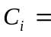 Individual control (dummy) variable which includes education level, household size, experience, seed type, farm size, pesticide, insecticide, fertilizers, irrigation practices hand hoe, plough and tractor, β_{o} = constant term which indicates the amount of maize production if other variables are kept constant, β₁ = the coefficients of the formal financial institutions credit which indicates an increasing amount of maize productivity for a unit increase of formal financial institutions credit, 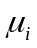 = the coefficients of the control variables which indicates an increasing amount of maize productivity for a unit increase of individual control variable and ε_{ij} stands for the residues ( error terms).

Moreover, maize productivity was then determined as the function of semi formal financial institutions credit and the control (dummy) variables shown in equation (5) and (6).
Where, f stands for function, Semi FFIs = Semi formal financial institutions credi respondents received in a particular maize agriculture season. Individual control (dummy) variable which includes education level, household size, experience, seed type, farm size, pesticide, insecticide, fertilizers, irrigation practices hand hoe, plough and tractor, β_{o} = constant term which indicates the amount of maize production if other variables are kept constant, β₁ = the coefficients of the semi formal financial institutions credit which indicates an increasing amount of maize productivity for a unit increase of semi formal financial institutions credit, = the coefficients of the control variables which indicates an increasing amount maize productivity for a unit increase of individual control variable and ε_{ij} stands for the residues ( error terms).

Furthermore, maize productivity was determined as the function of informal credit and the control (dummy) variables as shown in equation (7) and (8)).
Where, f stands for function, Individual control (dummy) variable which includes education level, household size, experience, seed type, farm size, pesticide, insecticide, fertilizers, irrigation practices hand hoe, plough and tractor, β_{o} = constant term which indicates the amount of maize production if other variables are kept constant, β₁ = the coefficients of the informal credit which indicates an increasing amount of maize productivity for a unit increase of informal credit, = the coefficients of the control variables which indicates an increasing amount of maize productivity for a unit increase of individual control variable and ε_{ij} stands for the residues ( error terms).

3.15 Panel Data Analysis
Panel data regression analysis were the most appropriate method in data analysis on this study because the study used both cross-sectional and time series data for maize production season of the periods 2018, 2019 and 2020 years. The advantages and disadvantages of using panel data analysis have been described in 3.13.1.

3.16 Model Specification
The overall objective of the study sought to determine the effect of credit facilities on maize productivity of rural smallholder farmers in Mbozi and Sumbawanga rural districts in Tanzania. Moreover, the specific objectives broke down credit facilities into formal financial institution’s credit, semi formal financial institution’s credit and informal credit and have to determine their effects on maize productivity.

Random effects models (REM) for panel data were used to estimate the data. Random effects models (REM) assumes that the individual-specific effect is a random variable that is uncorrelated with the explanatory variables. However, during the choice of the best model to use for this study, the fixed effect model (FEM) was estimated by using xtreg and least square dummy variable (LSDV). Morever, the random effect model (FEM) was also estimated by xtreg with re. Thus, to decide between REM and FEM, both models were run and then Hausman test was performed, where random effects models (REM) had most reliable results and is the model that fitted the collected data most correctly.

3.17 Model Specification Test
To identify the best model fixed effect model (FEM) or random effect model REM) the study examined group effect (F- tests: Pooled or FEM or REM), Hausman test and the Breusch and Pagan Lagrange Multiplier (LM) Test were done.

3.17.1 Examining Group Effect (f tests: Pooled or FEM or REM)
Examination of the group effect was done so that to see whether there was fixed group effect or not (Park, 2011). The hypothesis testing was by f-test and the null hypothesis is as shown in equation 9.
In making decision to choose POL or FEM or REM, Park, (2011) suggested the following five criterions;

First criterion, if the choice is FEM and f-test is done and the null hypothesis is not rejected it means FEM is not favoured. Similarly, if the choice is RE and we do the Breusch and Pagan’s (1980) Lagrange Multiplier (LM) test and if the null hypothesis is again not rejected it means the REM is not favoured. Hence, we conclude that the pooled ardinary least square model (POLS) is favoured.
Second criterion, if the choice is FEM and f-test is done and the null hypothesis is rejected it means FEM is favoured. Similarly, if the choice is RE and we estimate with the Breusch and Pagan’s (1980) Lagrange Multiplier (LM) test and if the null hypothesis is not rejected it means the REM is not favoured. Hence, we conclude that FEM is our choice.

Third criterion, if the choice is FEM and f-test is done and the null hypothesis is not rejected it means FEM is not favoured. Similarly, if the choice is RE and we do the Breusch and Pagan’s (1980) Lagrange Multiplier (LM) test and if the null hypothesis is rejected it means the REM is favoured. Hence, we conclude that REM is our choice.

Fourth criterion, if the choice is FE and f-test is done and the null hypothesis is rejected it means FEM is favoured. Similarly, if the choice is RE and we do the Breusch and Pagan’s (1980) Lagrange Multiplier (LM) test and if the null hypothesis is again rejected it means the REM is favoured. Hence, we conclude that Hausman test has to be done to choose FEM or REM. because both FEM and REM are all favoured.

Fifth criterion, when Hausman test is done, we choose a FEM if the null hypothesis of a Hausman test is rejected and we choose a REM if the null hypothesis of the Hausman test is not rejected.

3.17.2 F-Test, Chi - Square Test and the Breusch and Pagan Lagrange Multiplier Test
The Breusch and Pagan Lagrange Multiplier Test is the test that helps to decide between a random effect’s regression and simple or pooled OLS regression. The test to know if fixed effect and /or random effects exist in the collected panel data was done. The model selection results (Table 4.12) among POLS, FEM when estimated with xreg, FEM when estimated with least square dummy variable1 (LSDV1) and RE. The fixed effect was tested by F-test, while a random effect was examined by Breusch and Pagan’s (1980) Lagrange Multiplier (LM) test (table 4.13). Additionally, when OLS regress was run (table 4.12) and FE estimated with xtreg.( (FE_xtreg.) the F-test results was 4.30 and when OLS regress was run and FE estimated with least square dummy variable 1 (FE_LSDV1) the F-tests results was 10.29. These F statistic values were statistically significant and were large (p > 0.0000) enough to reject the null hypothesis in favor of the fixed effect.

Moreover, when OLS regress runs (table 4.13) and Breusch and Pagan’s (1980) Lagrange Multiplier (LM) test was done to estimate RE, the results was statistically significant (ie. Prob = 0.0000) hence the null hypothesis was rejected and RE was favoured. Since all the tests (FEM test and REM test) were statistically significant and both FEM and REM were all rejected with the two tests, therefore the Hausaman test to decide between FEM or REM was done (table 4.14).

3.17.3 Hausman Test: Fixed Effect Model (FEM) or Random Effect Model
The Hausman specification test done was to choose between FEM and REM to ensure that the more applicable model gives consistent results. Hausman test do test the null hypothesis that the estimated coefficients by the efficient random effects estimator do not differ substantially to the one estimated by the consistent fixed effect estimator. It is alright to use random effects if they are insignificant and the P-value is larger than 0.05.
Hausman specification test results indicate insignificant results with the p-value of 0.859 hence the null hypothesis of the Hausman test was not rejected. This confirmed that the random effect model (REM) was more appropriate than fixed effect model (FEM). Therefore, for this study, REM has most reliable results and was the model that fit the collected data most correctly.

3.18 Ordinary Least Square (OLS) Regression Assumptions
In research, statistical tests mostly rely on assumptions about the variables utilized in data analysis and if these assumptions are smartly met the results are truthworthy, Green, (2008). Kapaya, (2017) and Hair et al., (2010) argued that in order to achieve the analysis objectives, the basic regression equation takes into account the ordinary least square (OLS) regression assumptions. The necessary assumptions that needed to be met and/or controlled for our data to qualify for the analysis were reviewed and tested. OLS five major assumptions are linearity, normality, outliers, homoskedasticity and multicollinearity.

3.18.1 Linearity Testing
In testing for linearity of the collected data, the analysis of residuals was very useful. To achieve best linear unbiased estimators, diagnostic tests were run to assess if the data meet the OLS regression assumptions. The test for linearity was done using OLS_LSDV1 models with the help of STATA 13 and the command used was augmented component-plus-residual plot (acprplot) which provided a graphical way to examine the relationship between variables.

Tabachnick and Fidell, (2007) and Torres-Reyna, (2007) recommended that researcher must run regression before commanding STATA command acprplot. They further argued that the STATA command option locally weighted scatter plot smoothing (lowess) draws the observed residual pattern in the data to help identify nonlinearities. Accordingly, as suggested by Tabachnick and Fidell (2007), this study tested linearity assumption of data collected through the inspection of bivariate scatter plots. Figure 4.1, Figure 4.2 and Figure 4.3 shows no serious violation of linearity and the scatter plots for the argumented component plus residuals was lianear in nature. The three scatter plots indicate that all point variables linearly followed the regress line. Hence the linearity was mate.

3.18.2 Extreme Values Testing
The second assumption for the ordinary least square regression assumptions are the absence of substantial extreme value(s) in the data which means no outliers. According to Hair et al., (2010), outliers are data points which are extreme and have a unique combination of characteristics exclusively distinctly from other observations. Therefore, ignoring them can result in a loss of precision and render the results biased. Rhoads, (2012) argued that a value is missing completely at random if the probability that a data point is missing depends on neither observed nor unobserved variables.

In this study, outliers’ variables were tested/checked using regression models with the help of Stata 13 tool through which the ovtest command was used. To check for outlier, we used the avplots command (added-variable plots). It was revealed that the possible impact of outliers on the results was negligible. Residuals were also assessed on whether they are normally distributed by basically producing a normal probability plot known as p-p plot and all plots (figure 4.4, 4.5 and 4.6) indicated that majority of the data point were in range. These were sufficiently used to assess the possibility of extreme outliers of which none was discovered.

3.18.3 Homoscedasticity Testing
To test for homoscedasticity assumption, an important assumption is that the variance in the residuals has to be homoskedastic or constant. Additionally, residuals cannot be varied for lower of higher values of independent variable. In testing for homoscedasticity, the regression was run first (Appendix IV) and using rvfplot, yline (0) command in Stata 13 automatically scatterplott between residuals and predicted values (fitted values) ploted. The residuals (figure 4.7) were highly clustered at higher levels of the Rline (0). This indicates the abscense of heteroskedasticity and presence of homoskedacity hence the assumption is fulfilled.

Additionally, Breusch-Pagan / Cook-Weisberg test (table 4.2) for heteroskedasticity a non graphical method for testing presense heteroskedasticity to the data set was tested. The results indicated p-value of 0.1104 (i.e p > 0.0000). This indicated that using Breusch-Pagan / Cook-Weisberg test for heteroskedasticity; there were no heteroskedasticity hence presence of homoskedacity on which the assumption is fulfilled again.

3.18.4 Multicollinearity Testing
Hair et al., (2016), defined multicollinearity as the extents on which a predictor variable can be explained by another predictor variable. The test is undertaken to measure the correlation of the regressors in the model. However, the high correlation of the explanatory variables can lead to imprecise estimation of the regression and slight fluctuations in correlation. This may lead to large differences in regression coefficients. In testing multicollinearity, bivariate correlation of exogenous variables and variance inflation factor (VIF) and torerance value (TV) were used. The multiple linear regression models were run and Stata command used to check for multicollinearity was vif. The cutoff point as suggested Hair et al., (2016) were considered as postulated by authors that VIF values greater than 5 and TV of less than 0.2 indicate the presence of multicollinearity. Hence, this study ensured no multicollinearity issue as the VIF and TV values suggests (Table 4.3).

3.18.5 Normality Testing
Normal testing is another assumption of the regression model (OLS) that impact the validity of all tests (ie. p-test, t-test and F-test). In testing for linearity and normality of the collected data, the analysis of residuals was very useful. It shows whether the residuals behave normal. These residuals are indicated by a symbol α. Generally normal testing generates the variables called residuals α. The data normality was checked/tested using (i) graphical check which was Kernel density estimate and histogram and scatter plot for residue while (ii) the non graphical check/ test were done with Shapiro-Wilk W test (table 4.4). The residual was first assessed using Kernel density estimate and histogram and scatter estimates in figure 4.8 and figure 4.9. The result indicated that the data are normally distributed.

The residual was also assessed using scatter plots seen in figure 4.10 and figure 4.11. The values of the stadardised residuals were plotted against the expected values from the standard inverse normal distribution (figure 4.10). The resulted graph indicated that all residuals were normally distributed since they all lie on residual vs inverse normal line. Moreover, the residual was assessed using scatter plots for the NormalF (e_m)/s vs Empirical P[i] (figure 4.11). The values of the stadardised residuals were plotted against the expected values from the standard normal distribution. The resulted graph indicated that all residuals were normally distributed since they all lie on diagonal line, signifying that all data were normally distributed.

3.19 Ommited Variables and Specification Error Testing
Omitted variables test and specification error test was done by Ramsey RESET test using powers of the fitted values of the dependent variable and hat square value (_hatsq) check. This was done after running the regression models first using Stata 13 tool and the ovtest command. The result (Table 4.5) indicated that all variables were significant (p-value = 0.000). Additionally, Ramsey RESET tests using powers of the fitted values of dependent variable and link (specification) test was done. The result (Table 4.6) indicated the p-value of 0.0837. This result is higher than the threshold of 0.05. Moreover, link test results (table 4.7) provided the hat square value of 0.692 which is higher than the p-value threshold which is 0.05. Therefore, hat square value of 0.692 concludes that there were no specification errors on the measurement variables. Therefore, the three tests concluded that the model had no omitted variables and no specification error.

3.20 Validity and Reliability of Measurements
In research it is crucial to ensure that variable measurements meet the acknowledged standards. Validity and reliability are the benchmarks against which the adequacy and accuracy of the measurement procedures are evaluated, (Bhattacherjee, 2012).

3.20.1 Validity Test
Saunders et al., (2012), argued that, in research, validity refers to the extent to which data collection method or methods measure accurately what they were intended to measure. Additionally, Greener, (2008) argued that, a test is said to be valid if it measures what it claim to measure. In this study, to ensure that the measurement instrument measures what it aims to measure, the two major types of validity check were conducted.

The first type was translational validity (or representational validity) which examined whether a measure is a good reflection of its variable or construct. Translational validity (or representational validity) consists of content validity check and face validity check (Bhattacherjee, 2012). The second type was criterion-related validity which examines whether a given measure behaves the manner it should, given the theory of that variable or construct. Criterion-related validity consists of convergent validity check and discriminant validity check.

Content validity relates to how well the indicators and attributes, such as use of seed type, fertilizers, pesticides, insecticides and irrigation that was in the measurements of the variables or indices relationally represented the variable intended. In this study, the content validity was assured by conducting a comprehensive literature review regarding the domain formal financial institution’s credit, semi formal financial institution’s credit and informal credit together with maize productivity. In addition to that, all variables mentioned originated from financial intermediation and neuclasical economic growth theory that govern this study. Moreover, in ensuring that validity was achieved experts on the field of finance were consulted to give their view on the effect of credit facilities on maize productivity.

Moreover, face validity relates to whether an indicator seems to be a reasonable measure of its variable or construct. This is the extent to which the research tool (ie. questionnaire) appear to measure what was intended to be measured, Patton, (1997). In this study, the face validity were ensured by using the research instrument (ie. questionnaires) that attains the face validity while some that were not able to be measured by the research questionnaires were taken care by other validity measurement as explained.

Furthermore, convergent validity refers to the closeness with which a measure relates to (or converges on) the construct that it is purported to measure, (Bhattacherjee, 2012). In this study convergent validity was established by comparing the observed values of one attribute (indicator) of one variable (construct) with another attribute (indicator) of the same construct and demonstrating similarity (or high correlation) between values of these attributes (indicators). Discriminant validity described as the degree to which a measure does not measure (or discriminates from) other constructs that it is not supposed to measure, Bhattacherjee, (2012). To ensure discriminant validity the square of the correlation between the construct was compared with the average variance extracted. The average variance extracted values should be higher than the square correlation estimates and that the value of correlation between the constructs should be 1, Hair et al., (2010).

3.20.2 Reliability Test
Reliability is defined as the extent to which the data collection techniques or analysis yield consistent findings, Saunder et al., (2012). Therefore, reliability implies consistency but not accuracy. Bhattacherjee, (2012) argued that reliability is measuring the intended variable consistently and precisely. Following the advice of Bhattacherjee, (2012) reliability was improved by using quantitative measures. Quantitative measures are objective; they are more reliable than subjective measures. The reseaearcher used microsoft excel for cleaning, control and organization of data to avoid human errors and data loss before entering data in Stata 13 for analysis.

3.21 Ethical Considerations
In carrying out research, ethical consideration is a significant concern. This includes maintaining high standards to ensure accuracy of data and not misrepresenting the collected data such that no one suffers adverse or hammed (Kombo and Tromp, 2006). The researcher did seek for an introduction letter from the University’s Postgraduate office that allows the researcher access to data collection (Appendix XIII). This letter provided a researcher for the informed consent of the individuals the purpose and the nature of the research so that they freely choose whether or not be involved in the research and provide room to refuse to participate or to terminate participation at any time.

During data collection participants were protections by avoiding sensitive or difficulty questions and being careful in assisting individuals using eight trained research assistants when filling the checklist. This protected participants from physical discomfort, emotional stress, humiliation, embarrassment or any other situation that divulge the respondents. Moreover, plagiarism was avoided. Hence, biasness, inaccurate reporting and the inappropriate use of informationwere as well avoided. In addition to that, all sources of information and knowledge for this study including published and unpublished literature, were highly acknowledged, respected and fairly used. Finally, the collected data were protected from unauthorized hands or unlawful processing, damage or destruction. Research results are from the collected data of this study and are accurately analysed, presented together with conclusion and recommendation being made in chapter four, five and six respectively.

CHAPTER FOUR

DATA ANALYSIS AND INTERPRETATION OF FINDINGS

4.1 Overview
This chapter presents the research findings based on the three objectives presented in chapter one. Firstly, objective one determined the effect of formal financial institution’s credit on maize productivity to smallholder farmers in rural areas in Mbozi and Sumbawanga rural districts in Tanzania. Secondly, objective two determined the effect of semiformal financial institution’s credit on maize productivity to smallholder farmers in rural areas in Mbozi and Sumbawanga rural districts in Tanzania. Finally, objective three determined the effect of informal credit to maize productivity to smallholder farmers in rural areas in Mbozi and Sumbawanga rural districts in Tanzania. More specifically, it gives the details of what has been found about these three objectives of the study. It also indicates the results about demographic characteristics and measured variables.

4.2 Data Preparation
The secondary data for both maize productivity and credit facilities were collected from wards agriculture record book (WARB) for the three years (2018, 2019 and 2020). Checklists were also used to collect individual missing informations. Out of the one hundred and twenty individual checklists, sixty checklists were distributed to Mbozi district. All sixty checklists (i.e., 100%) were successfully filled and returned. However, six (which is 10%) checklists were eliminated because they missed important individual information such as seed costs, weed costs, and land preparation costs just to mention the few. Hence fifty-four (which is 90 %) remained. In addition to that, sixty checklists were also distributed to Sumbawanga rural district. All sixty checklists (i.e., 100%) were successfully filled and returned. However, seven (which is 11%) checklists were eliminated because they also missed important individual information such as seed costs, weed costs, land preparation costs just to mention the few. Hence fifty-three (which is 88.3 %) remained. Therefore, a total of 107 individual checklists deemed enough for this study. Moreover, 107 individuals were observed in three years to make a total of 321 sample observations. A panel regression model was then used to examine the relationship between credit facilities and maize productivity.

4.3 Testing Assumptions for Multiple Linear Regressions

4.3.1 Linearity and Functional Form Testing
Linearity is the property of function or a mathematical relationship which means that it can be graphically represented as a straight line. It is also a situation in which the mean values of the dependent variable for each increament of the independent variable lie along a straight line, Field, (2009). Hair et al., (2010) argued that the linearity of data is often assumed for variables in multivariate analysis and if left unattended, a non-linear data can seriously undermine any statistical inference.

In this study, two methods were used in testing for linearity for the collected data. Thesse are non graphical method and graphical method. In both methods, we run the panel data regression first. Then for the non graphical method the output is as on table 4.1. Moreover, we tested/checked linearity using panel regression with the help Stata 13 tool and the scatter plot command to assess the nature of the residual output shown in figure 4.1, 4.2 and 4.3.
Table 4.1 indicates that, the the relationship between forma financial institutions credit ratio (formal_ratio), semi forma financial institutions credit ratio (semi_ratio) and informal credit ratio (info_ratio) were all positive and significant on maize productivity to rural smallholder farmers with p-value of 0.000 (i.e., P-value < 0.05). This is an indication that all independent variable residuals met the linearity assumption.

Results from table 4.1 also indicate the mean of maize productivity (i.e., dependent variable) is 5.294, the standard deviation is a 2. 505. This standard deviation result indicates the dispersion of the output variables and input variables from the mean. Moreover, the results from this table indicate, the number of observations is 321, r square value is 0.341. This r square result indicates that, 34.1% of maize productivity (i.e., dependent variable) values are being explained by the independent variables (i.e., forma financial institutions credit ratio, semi forma financial institutions credit ratio and informal credit ratio). It also shows the f-test results are 4.299, the Akaike criterion (AIC) of 14223.139 and Bayesian criterion (BIC) of 1554.810. This result are large enough, hence indicates that all independent variables were significant to maize productivity.

Additionally, the coefficients for formal financial institutions credit ratio, semi formal financial institutions credit ratio and informal credit ratio were 0.863**, 1.410*** and 1.851*** respectively. These coefficients indicate that, all independent variables were significant and a unit increase of formal financial institutions credit ratio, semi formal financial institutions credit ratio and informal credit ratio increases maize productuity by 0.863, 1.410 and 1.851 units respectively. Moreover, the results in table 4.1 indicate that marital status, age and all control variables (i.e., education level, householdsize, farming experience, farm size, modern seed, pesticide, insecticide and fertilizer) are not significant to maize productivity. However, the result indicates that a unit increase of these control variables also increases maize productivity.

Furthermore, the results indicate that, the use of handhole and plough increases maize productivity and are significant to maize productivity. However, it also indicates that the use of tractor is not significant but increases maize productivity to rural smallholder farmers. The results in table 4.1 also indicated that land hire cost, plough cost, weeding cost, fertilizer cost and harvest cost are all significant and increases maize productivity. However, land preparation cost, hand hoe cost, tractor cost, seed cost, maize planter cost, pesticide cost, insecticide cost, cleaning cost and transport cost are all not significant to maize productivity but increases maize productivity of rural smallholder farmers.

On the other hand, the graphical method was also used in testing/checking linearity of the data collected. Using panel regression with the help of Stata 13 tool and the scatter plot command. Residual assessment for formal financial institutions credit ratio was tested and the nature of the residual output are shown in figure 4.1. The resulted scatter plot figure 4.1 shows no serious violation of linearity and the scatter plots for the argumented component plus residuals was linear in nature. This scatter plot indicates that all residuals linearly follow the regress line. Hence the linearity was mate.
Maize Productivity(gm/acreTzs) | Coef. |  | St.Err. | t-value |  | p-value | [95% Conf |  | Interval] | Sig
formal_ratio | 0.863 |  | 0.384 | 2.25 |  | 0.000 | 0.107 |  | 1.619 | **
semi_ratio | 1.410 |  | 0.264 | 5.34 |  | 0.000 | 0.890 |  | 1.930 | ***
info_ratio | 1.851 |  | 0.285 | 6.50 |  | 0.000 | 1.290 |  | 2.411 | ***
maritals | 0.065 |  | 0.383 | 0.17 |  | 0.865 | 0.688 |  | 0.819
ages | 0.027 |  | 0.122 | 0.22 |  | 0.827 | 0.213 |  | 0.266
educ_levels | 0.112 |  | 0.157 | 0.71 |  | 0.476 | 0.422 |  | 0.197
house_size | 0.187 |  | 0.151 | 1.24 |  | 0.215 | 0.109 |  | 0.483
experiences | 0.143 |  | 0.093 | 1.54 |  | 0.124 | 0.325 |  | 0.039
farmsizes | 0.211 |  | 0.270 | 0.78 |  | 0.436 | 0.743 |  | 0.321
modernseed | 0.354 |  | 0.455 | 0.78 |  | 0.437 | 0.541 |  | 1.249
perticicide | 0.316 |  | 0.387 | 0.81 |  | 0.416 | 0.447 |  | 1.078
insecticide | 0.193 |  | 0.424 | 0.46 |  | 0.649 | 1.028 |  | 0.642
fertilizer | 0.962 |  | 0.550 | 1.75 |  | 0.081 | 2.046 |  | 0.121
handhoes | 1.046 |  | 0.585 | 1.79 |  | 0.075 | 0.107 |  | 2.198 | *
ploughs | 0.533 |  | 0.457 | 1.17 |  | 0.244 | 1.432 |  | 0.366 | *
tractors | 0.803 |  | 1.010 | 0.80 |  | 0.427 | 1.186 |  | 2.791
landhirecosts | 1.263 |  | 0.284 | 4.45 |  | 0.000 | 1.822 |  | 0.704 | ***
landprepcosts | 0.265 |  | 0.440 | 0.60 |  | 0.547 | 0.601 |  | 1.130
handhoecosts | 0.183 |  | 0.270 | 0.68 |  | 0.498 | 0.715 |  | 0.349
ploughcosts | 0.485 |  | 0.289 | 1.68 |  | 0.095 | 0.084 |  | 1.055 | *
tractorcosts | 0.273 |  | 0.976 | 0.28 |  | 0.780 | 2.194 |  | 1.648
seedcosts | 0.197 |  | 0.522 | 0.38 |  | 0.707 | 0.831 |  | 1.224
plantercosts | 0.631 |  | 0.466 | 1.35 |  | 0.177 | 1.549 |  | 0.287
weedingcosts | 1.146 |  | 0.581 | 1.97 |  | 0.050 | 0.002 |  | 2.290 | *
fertilizercosts | 1.177 |  | 0.620 | 1.90 |  | 0.059 | 0.044 |  | 2.397 | *
pesticidecosts | 0.375 |  | 0.392 | 0.96 |  | 0.340 | 0.397 |  | 1.148
insecticidecosts | 0.914 |  | 0.407 | 2.25 |  | 0.025 | 1.714 |  | 0.114 | **
harvestcosts | 0.400 |  | 0.528 | 0.76 |  | 0.449 | 0.638 |  | 1.439
cleaningcosts | 0.160 |  | 0.379 | 0.42 |  | 0.674 | 0.906 |  | 0.586
transpcosts | 0.545 |  | 0.440 | 1.24 |  | 0.216 | 0.321 |  | 1.410
Constant | 1.293 |  | 3.027 | 0.43 |  | 0.670 | 4.666 |  | 7.252
Mean dependent var |  | 5.294 |  |  | SD dependent var |  |  | 2.505
R-squared |  | 0.341 |  |  | Number of obs |  |  | 321.000
F-test |  | 4.299 |  |  | Prob -Value |  |  | 0.000
Akaike crit. (AIC) |  | 1423.139 |  |  | Bayesian crit. (BIC) |  |  | 1554.810
*** p<0.01, ** p<0.05, * p<0.1

Table 4.1 Linear Regression
Source: Data analysis (2020)

Linear Regression Scatter Plots for formal financial institutions credit ratio.
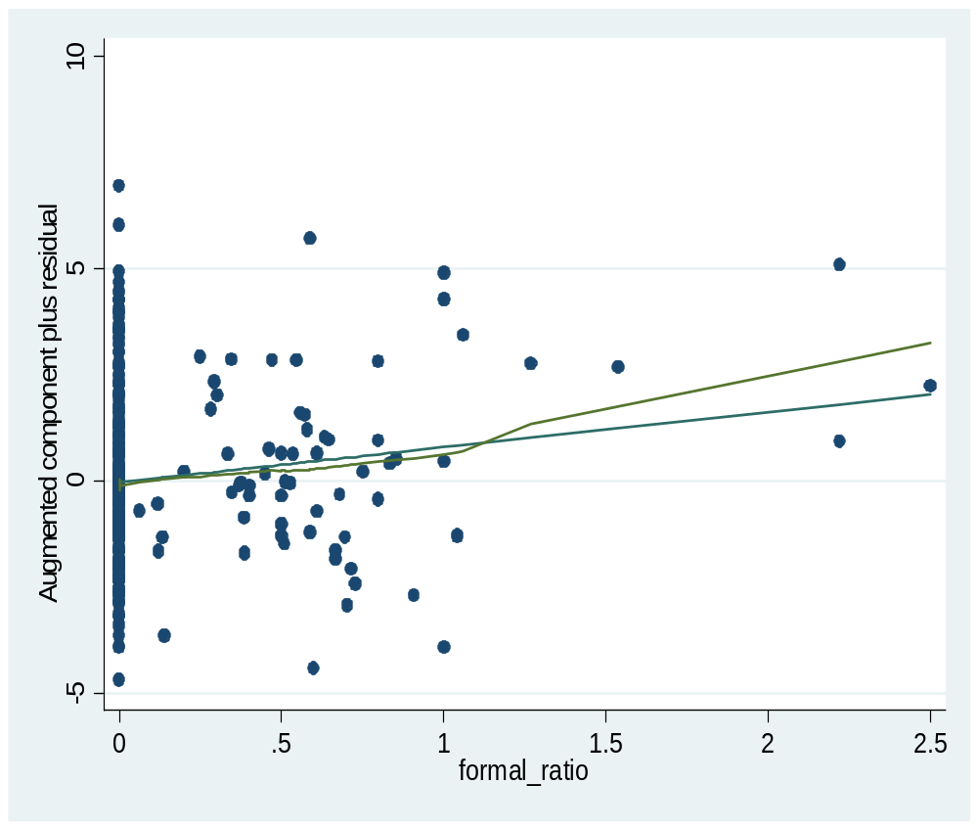

Figure 4.1: Linear Regression Scatter Plots Formal Financial Institutions Credit Ratio
Source: Data analysis (2020)

Moreover, the graphical method was also used in testing/checking linearity of the data collected. Using panel regression with the help Stata 13 tool and the scatter plot command. Residual assessment for semi formal financial institutions credit ratio was tested and the nature of the residual output are shown in figure 4.2. The resulted scatter plot figure 4.2 shows no serious violation of linearity and the scatter plots for the argumented component plus residuals was linear in nature. This scatter plot indicates that all residuals linearly follow the regress line. Hence the linearity was mate.
Linear Regression Scatter Plots for semi formal financial institutions credit ratio.
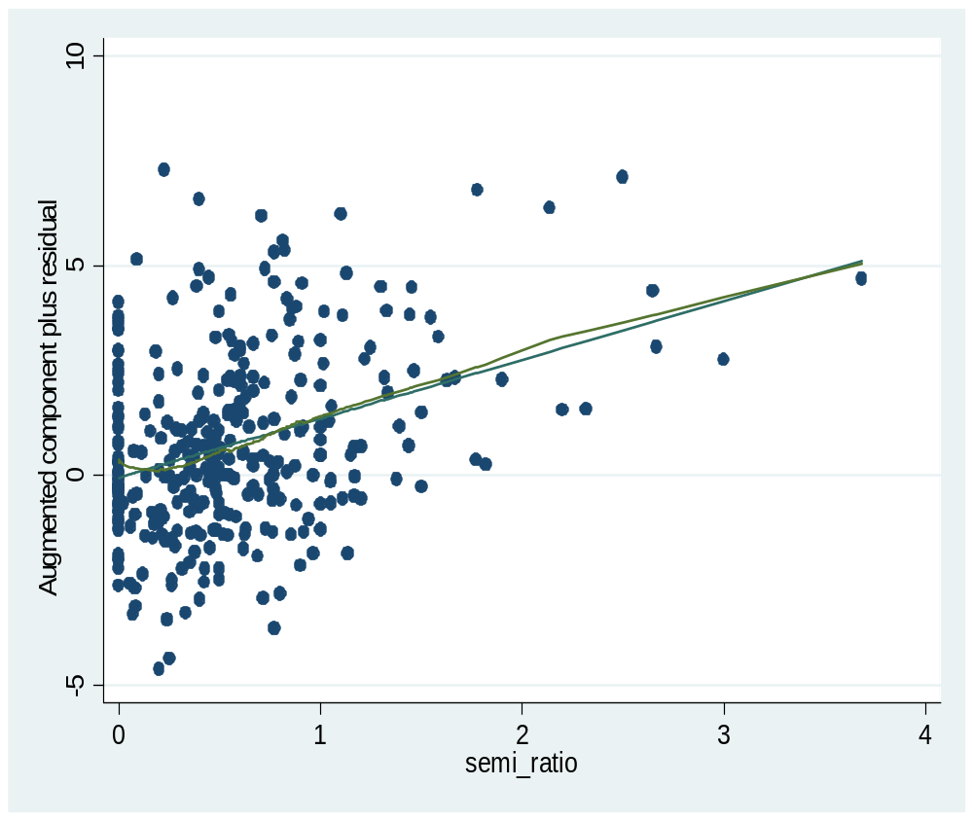

Figure 4.2: Linear Regression Scatter Plots Semi Formal Financial Institutions Credit Ratio
Source: Data analysis (2020)

Lastly, the graphical method was used in testing/checking linearity of the data collected. Using panel regression with the help Stata 13 tool and the scatter plot command. Residual assessment for informal credit ratio was tested and the nature of the residual output is shown in figure 4.3. The resulted scatter plot figure 4.3 shows no serious violation of linearity and the scatter plots for the argumented component plus residuals was linear in nature. This scatter plot indicates that all residuals linearly follow the regress line. Hence the linearity was mate.

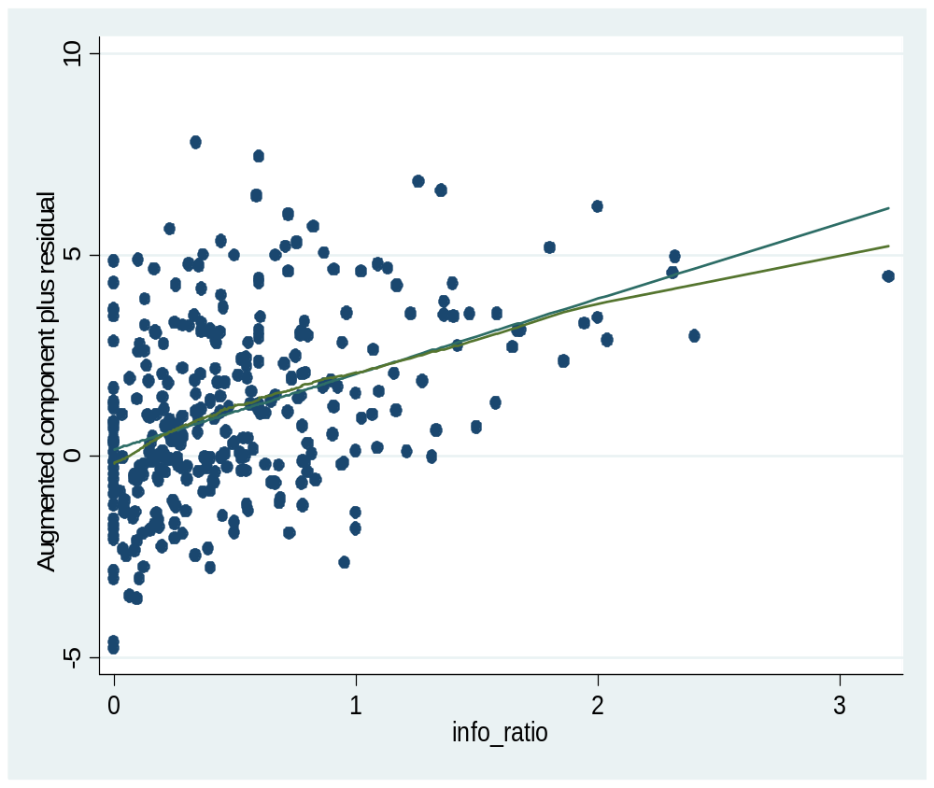

Figure 4.3 Linear Regression Scatter Plots Informal Credit
Source: Data analysis (2020)

4.3.2 Results from Extreme Values Testing
Outliers are data points with extreme value that could have a negative effect on our estimators. According to Hair et al., (2010), outliers are data points which are extreme and have a unique combination of characteristics exclusively distinctly from other observations. Therefore, ignoring them can result in a loss of precision and render the results biased. Rhoads (2012) argued that a value is missing completely at random if the probability that a data point is missing depends on neither observed nor unobserved variables. In this study, outliers’ variables was tested/checked using regression models with the help of Stata 13 tool and the ovtest command was used.
Cheema, (2014) argue that when data is missing completely at random; it is safe to remove it from the dataset. This study utilized secondary data for credit facilities and maize productivity. However, the checklist was also used to collect individual’s missing information. Out of one hundred and twenty checklists, thirteen (10.83%) checklists were dropped from the study. The remaining 107 well fulfilled individual checklist deemed to be enough for this study.

4.3.2.1 Outliers Detection Scatter Plots for Formal Financial Institutions Credit Ratio

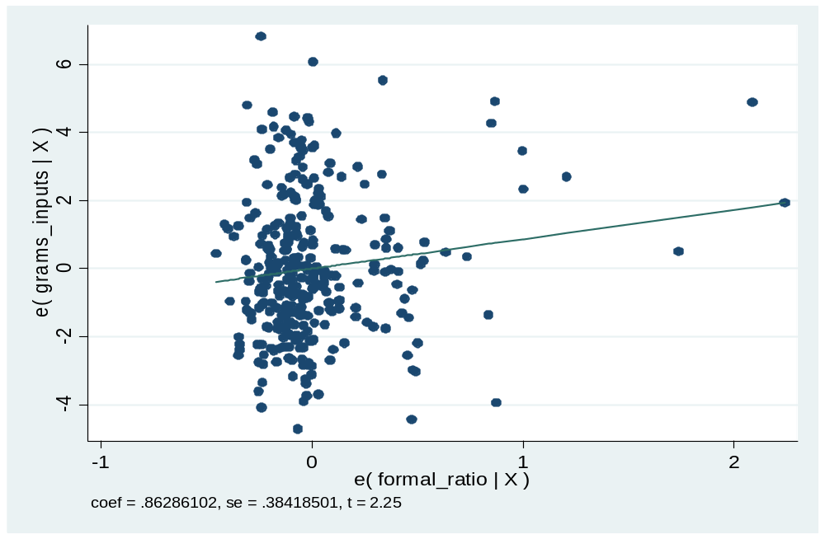

Figure 4.4: eTotal_ Productivity (grams/input) vs e_formal financial institutions credit Ration
Source: Data analysis (2020)

Moreover, in testing/checking for outlier we used the avplots command (added-variable plots). The results in appendix IV shows the regression results for outlier’s detection. This result indicates that the possible impact of outliers on the results was negligible. Residuals were also assessed on whether they were normally distributed by basically producing a normal probability plot (p-p) known as p- plot shown in figure 4.4, figure 4.5 and figure 4.6. In this case, avplot command was used to plot each variable against all others and notice the coefficients on each (appendix IV). All these three plots indicated that almost all data point was in range and were sufficiently used to assess the possibility of extreme outliers of which none was discovered. The same was applied to the profiling variables for maize productivity where no outliers observed by the researcher.

4.3.2.2 Outliers Detection Scatter Plots for Semi Formal Financial Institutions Credit Ratio
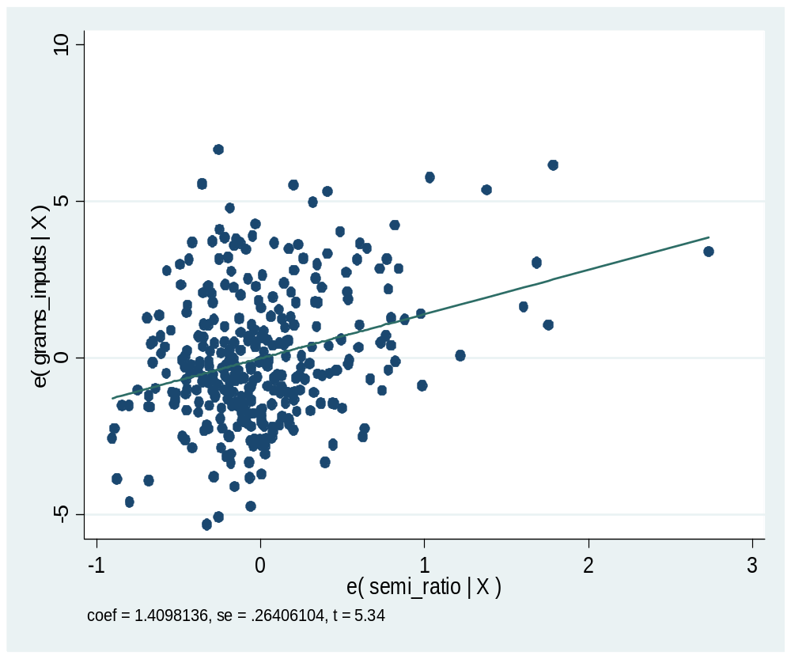

Figure 4.5 Etotal_ Productivity (Grams/Input) Vs E_ Semi Formal Financial Institutions Credit Ratio
Source: Data Analysis (2020)

4.3.2.3 Outliers Detection Scatter Plots for Semi Formal Financial Institutions Credit Ratio
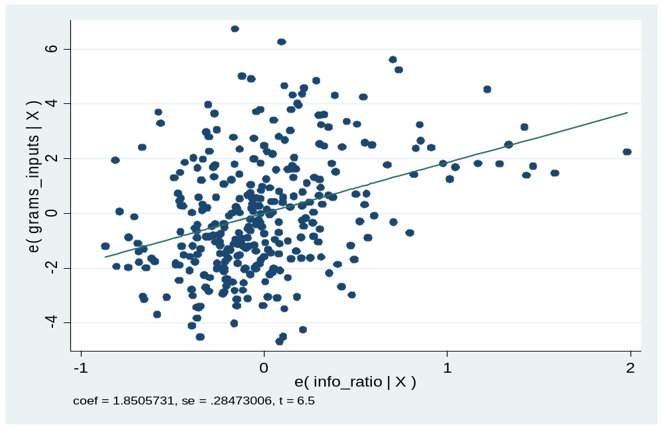

Figure 4.6 Etotal_ Productivity (Grams/Input) Vs E_Inform Credit Ratio
Source: Data analysis (2020)

4.3.3 Results from Homoscedasticity Testing
To test for homoscedasticity assumption, the regression was run first (Appendix IV) and using rvfplot, yline (0) command in Stata 13 automatically scatterplott between residuals and predicted values (fitted values) ploted. An important assumption in testing homoscedasticity is that the variance in the residuals has to be homoskedastic or constant. Additionally, residuals cannot be varied for lower of higher values of independent variable.

Figure 4.7 indicates that residuals are highly clustered at higher levels of the Rline (0). This indicates the abscense of heteroskedasticity and presence of homoskedacity hence the assumption is fulfilled.
Additionally, Breusch-Pagan / Cook-Weisberg test for heteroskedasticity a non graphical method for testing presense heteroskedasticity to the data set was tested. Table 4.2 results indicate the p-value of 0.1104. The P-value is greater than 0.05 (i.e., p > 0.05). This means the results was not significant to the tested variables. This indicated that using Breusch-Pagan / Cook-Weisberg test for heteroskedasticity; there were no heteroskedasticity hence presence of homoskedacity on which the assumption is fulfilled again.

Table 4.2: Breusch-Pagan/Cook-Weisberg Table for Testing Heteroskedasticity
Breusch-Pagan / Cook-Weisberg test for heteroskedasticity
Ho: Constant variance
Variables: fitted values of grams_inputs
chi2(1) = 2.55
P-value = 0.1104
Source: Data analysis (2020)

4.3.3.1 Homoscedasticity Testing with Scatter Plot
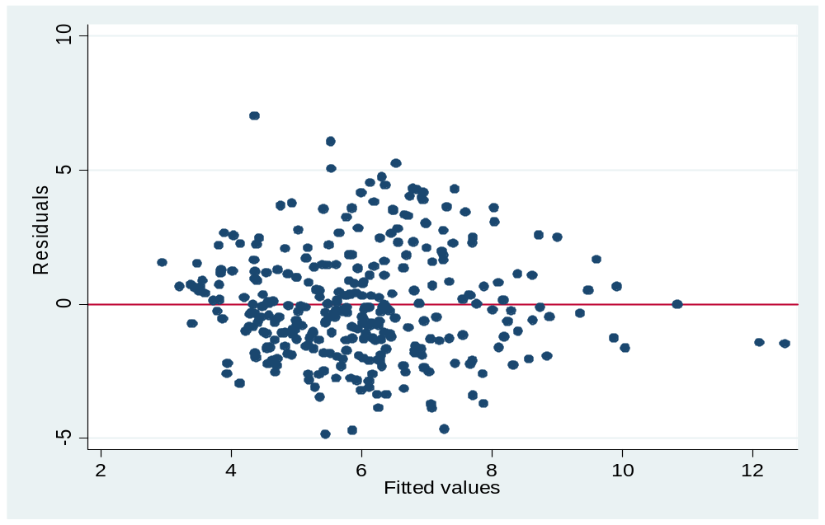

Figure 4.7: Residual vs Fitted Values
Source: Data analysis (2020)

4.3.4 Results from Multicollinearity Testing
Multicollinearity results from the circumstances where two or several variables are so highly correlated in such a way, they both essentially represent the same underlying construct, that is; what appear to be separate variables actually measure similar constructs, Hair et al., (2010). When such situation appears, only one of them should be incorporated in the same analysis, but not both. Moreover, extreme multi-collinearity is among the major causes of non-positive definiteness and solutions in multivariate analysis and creates instability in study results; hence it is of the essence that researchers control for its influence,

Kline (2011). Field (2009) argued that Multicolinearity do limits the size of the regression coefficients and obscures the importance of individual predictor variables. Therefore, two or more independent variables have a high correlation between them hence leads to a complication in separating the effects of each independent variable on the dependent variables. In dealing with extreme multicollinearity the two mechanisms available are elimination of the concerned variables or combination of them into a composite, Kline (2011). Moreover, Hair et al., (2010) argued that correlation analysis and variance inflation factor (VIF) can be used to check for multicollinearity.

However, Kline, (2011) posits that co rrelation analysis do not exactly measure the degree to which each of the independent variable is explained by the set of other independent variables and therefore opting variance inflation factor (VIF). In this study the variance inflation factor (VIF) was used to test multicollinearity. The linear regression model was run and Stata 13 command tool used to check for multicollinearity was vif and the results are shown in Table 4.3.

Table 4.3: Multicollinearity Test Results Using VIF Test
Variables | VIF | 1/VIF
Fertilizercosts | 3.662 | .300
Wards | 3.000 | .333
Divisions | 2.762 | .362
Tractorcosts | 2.750 | .364
Insecticide | 2.646 | .378
Pesticidecosts | 2.638 | .379
Seedcosts | 2.636 | .379
Fertilizer | 2.571 | .389
Perticicide | 2.561 | .390
Insecticidecosts | 2.496 | .401
Tractors | 2.337 | .428
Modernseed | 2.309 | .433
Villages | 2.089 | .479
Plantercosts | 1.911 | .523
Harvestcosts | 1.870 | .535
Weedingcosts | 1.801 | .555
educ levels | 1.720 | .581
Cleaningcosts | 1.583 | .632
Ploughs | 1.540 | .649
Farmsizes | 1.426 | .701
Ploughcosts | 1.411 | .709
semi ratio | 1.407 | .711
Landprepcosts | 1.395 | .717
Landhirecosts | 1.381 | .724
house size | 1.372 | .729
Transpcosts | 1.362 | .734
Ages | 1.357 | .737
info ratio | 1.347 | .742
Marital | 1.341 | .745
Handhoes | 1.320 | .758
Males | 1.284 | .779
Handhoecosts | 1.246 | .802
Experiences | 1.223 | .818
formal ratio | 1.168 | .856
Mean VIF | 1.910 | .
Source: Data analysis (2020)
Table 4.3 indicates that the VIF for formal financial institutions credit ratio, semi_formal financial institutions creadit ratio and informal credit ratio are 1.168, 1.407 and 1.347 respectively. The Tolerant values (1/VIF) for formal financial institutions creadit ratio, semi_formal financial institutions credit ratio and informal credit ratio are 0.856, 0.711 and 0.742 respectively. Moreover, all variables had VIF less than 5 and Tolerant values (1/VIF) are more than 0.2. Hair et al., (2010) posited that the VIF values greater than 5 and Tolerant values less than 0.2 indicates the presence of multicollinearity. Therefore, table 4.3 indicates that there was no multicollinearity issue in the current study as the Tolerant and VIF values did not exceed the threshold values.

4.3.5 Results from Normality Testing
Normal testing is another assumption of the panel regression model (OLS) that impact the validity of all tests (i, e., p-test, t-test and F-test). It shows whether the residuals behave normal. These residuals are indicated by a symbol α. Generally normal testing generates the variables called residuals α. The data normality was checked/tested using (i) graphical check which was Kernel density estimate and histogram and scatter plot for residue while (ii) the non graphical check/ test were done with Shapiro-Wilk W test.

4.3.5.1 Graphical Normality Test with Kernel Density Estimate and Histogram
The residual was assessed using both graphical method and non graphical method. Graphical method involved the Kernel density estimate and Kernel density estimate with histogram in figure 4.8 and 4.9. Another graphical method was scatter estimates shown in figure 4.10 and 4.11. Then Shapiro-Wilk W test which is non graphical method was also used in testing for the data normality.

Kernel density estimate in figure 4.8 indicated that the Kernel density estimate was same as the normal density curve. In addition to that, when the histogram, kernel density estimate and normal curve were ploted together shown in figure 4.9. The result indicated that the data were normally distributed.
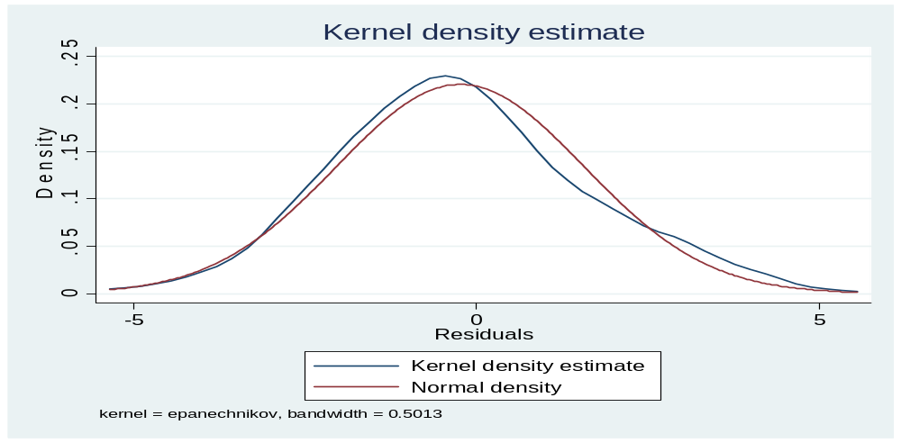

Figure 4.8 Kernel Density Estimate Test/Check
Source: Data analysis (2020)

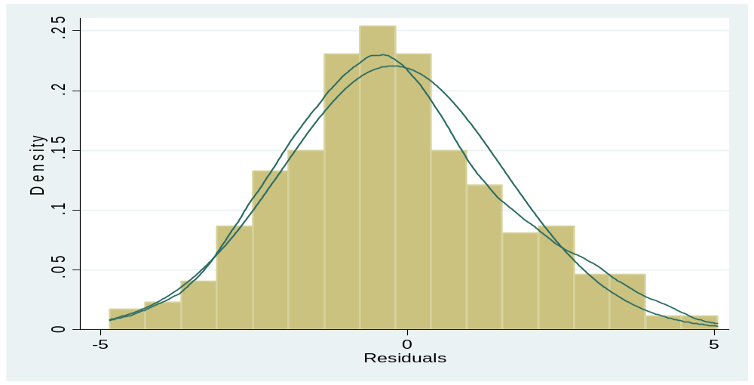

Figure 4.9 Kernel Density With Histogram Estimate Test/Check
Source: Data analysis (2020)

4.3.5.2 Normality Test / Checks with scatter Plots
The residual was also assessed using scatter plots in figure 4.10 and figure 4.11. The values of the stadardised residuals were plotted against the expected values from the standard inverse normal distribution (figure 4.10). The resulted graph indicated that all residuals were normally distributed since they all lie on residual vs inverse normal line..
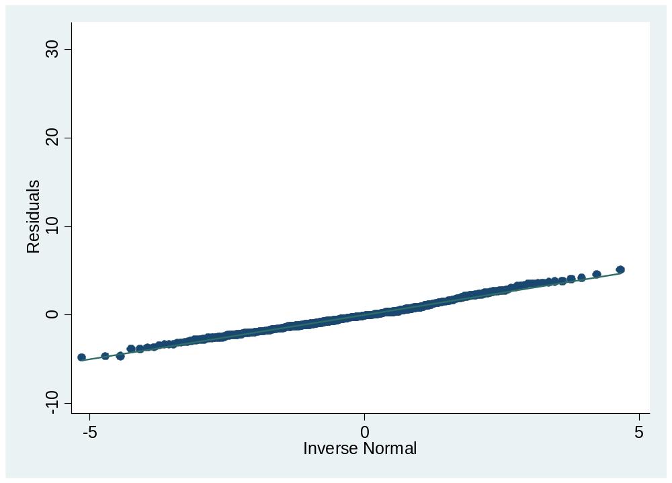

Figure 4.10 Residual Vs Inverse Normal Test/Check
Source: Data Analysis (2020)

Moreover, the residual was assessed using scatter plots for the NormalF (e_m)/s vs Empirical P[i] (figure 4.11). The values of the standardized residuals were plotted against the expected values from the standard normal distribution. The resulted graph indicated that all residuals were normally distributed since they all lie on diagonal line, signifying that all data were normally distributed.
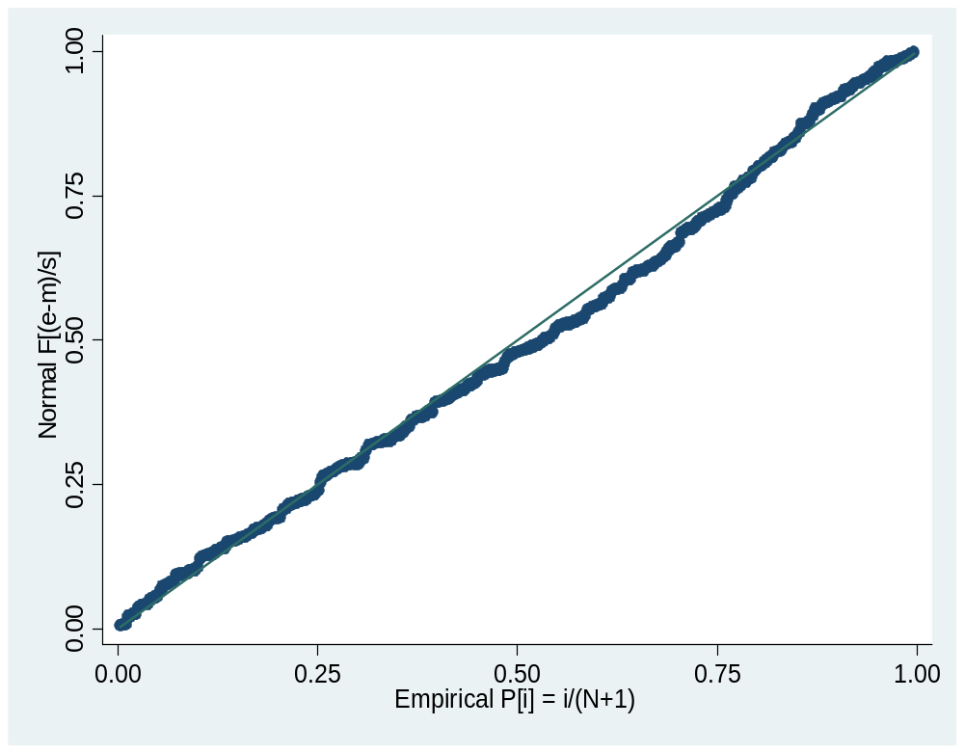

Figure 4.11 NormalF (e_m)/s vs Empirical P[i] test/check
Source: Data analysis (2020)

4.3.5.3 Non-Graphical Normality Test / Checks (Shapiro-Wilk W test)
Shapiro-Wilk test was ultilized in assessing the normality status (table 4.4). This is a non graphical test for normality. P-value results of 0.112 from Shapiro-Wilk test results shown on table 4.4 indicates that the distribution of the residual were not significant. Hence, we do not reject the null hypothesis. This concludes that the distribution of the residuals is normal.

Table 4.4 Shapiro-Wilk W Test for Normal Data
Variable | Obs | W | V | z | Prob>z
e | 321 | 0.992 | 1.679 | 1.216 | 0.112

Source: Data analysis (2020)

4.3.6 Ommited Variables and Specification Error Tests
Omitted variables test and specification error test was done by Ramsey RESET test using powers of the fitted values of the dependent variable (grams_inputs) and hat square value (_hatsq) check. This was done after running the regression models first using Stata 13 tool and the ovtest command. Table 4.5 shows the p-value = 0.000. This result indicates that all variables were significant. Hence the model has no omitted variables and no specification error.

Table 4.5: Regress Model Results for the Residuals
Source | SS | df | MS | Number of obs = 321
Model | 678.234 | 2 | 339.117 | Prob Value = 0.000
Residual | 1311.37 | 321 | 4.163 | R-squared = 0.341
Total | 1989.61 | 323 | 6.276 | Root MSE = 2.04
Source: Data analysis (2020)

Additionally, Ramsey RESET test using powers of the fitted values of dependent variable (grams_inputs) and link (specification) test was done. Table 4.6 shows Ramsey RESET test results. The result shows the p-value of 0.0837. This result indicates the p-value which is higher than the threshold of 0.05. Therefore, this concludes that we do not reject the null hypothesis (ie. we fail to reject the null hypothesis) and conclude that measurement variable for maize productivity (dependent variable) was enough and we do not need more variables. Hence, the model has no omitted variables.

Table 4.6 Ramsey Reset Test Using Powers Of The Fitted Values Of Maize Productivity
Ramsey RESET test using powers of the fitted values of grams_inputs
Ho: model has no omitted variables
F(3, 321) = 2.24
Prob –value = 0.0837

Source: Data analysis (2020)

Moreover, link test results on table 4.7 provide the hat square value of 0.692 which is higher than the p-value threshold which is 0.05. Therefore, hat square value of 0.692 concludes that there were no specification errors on the measurement variables.

Table 4.7: Link (Specification) test
grams_inputs | Coef. | Std.Err. | t | P>t | [95%Conf. | Interval]
_hat | 1.163 | 0.418 | 2.78 | 0.006 | 0.34 | 1.985
_hatsq | -0.012 | 0.031 | -0.4 | 0.692 | -0.073 | 0.049
_cons | -0.507 | 1.369 | -0.37 | 0.711 | -3.201 | 2.187
Source: Data analysis (2020)

4.4 Descriptive Statistics
Descriptive data analysis was carried out for all background information to check their statistics in relation to this study. The secondary data together with checklist informations was analysed by using the relevant models with the help of Stata 13 statistical tool. The analysis was based on a balanced panel data with 321 observations same as Kapaya (2017) who adopted the same approach. A panel of a total of three (3) years from 2018 to 2020 was constructed.

4.4.1 Individuals Demographic
Desriptive analysis was the first statistical operation which was done after secondary data collection. Respondent’s demographic analysis and interpretations was done then followed by multivariate data analysis. The respondent’s demographic involved sex, age, marital status, education level, house hold size, farming experience and farm size. Besides, the multivariate analysis involved credit facilities, maize productivity and control variables. In addition to that, the analyses consists of statistics such as mean, standard deviation, overall variation, between variation, within variation, minimum value and maximum value for the dependent, independent and control variables.

4.4.1.1 Gender of Respondents
The results in figure 4.12 for gender indicates that 46.82% female used formal financial institutions credit while 18.34% of male used formal financial institutions credit. It also indicates that 38.52% of female used semiformal financial institutions credit while 44.97% of male used semiformal financial institutions credit. Additionally, the results indicate 18.66% of female used informal credit while 36.69% of the male used informal credit. This indicates that female prefer use of formal financial institutions credit and semiformal financial institutions credit than informal credit. However, male prefer much the use of semi semiformal financial institutions credit and informal credit than the use of formal financial institutions credit.
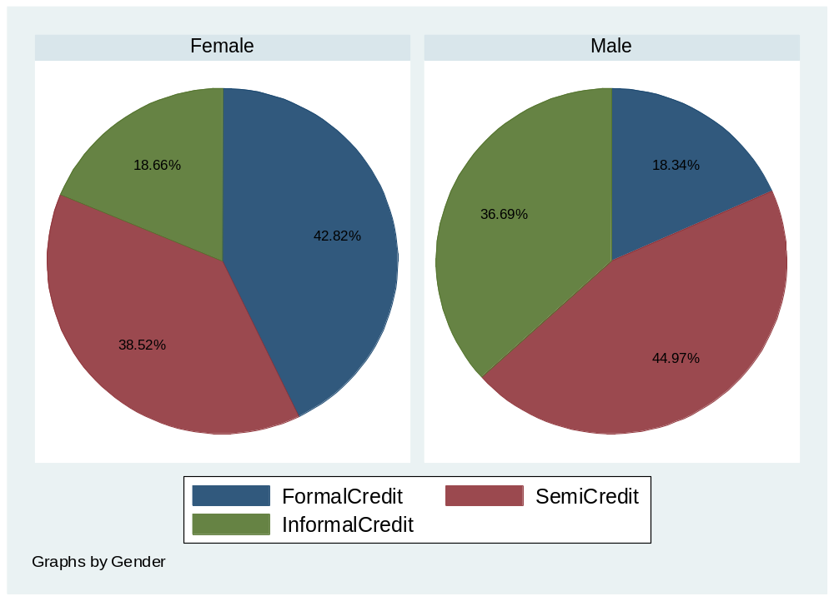

Figure 4.12 Gender of Respondent

4.4.1.2 Age Group of Individuals
The results in figure 4.13 for age shows that, 5.62% of individuals whose age are between 10 to 20 years old them use formal financial institutions credit, 61.01% uses semi formal financial institutions credit and 33.37% uses informal credit. Individuals whose age are between 21 to 30 years old, 15.41% of them use formal financial institutions credit, 45.98% uses semi formal financial institutions credit and 38.61% uses informal credit. Similarly, 7.32% of individuals whose age were between 31 to 40 years old used formal financial institutions credit, 45.01% used semi formal financial institutions credit and 47.67% used informal credit. 12.48% of individuals whose age were between 41 to 50 years old used formal financial institutions credit, 49.31% uses semi formal financial institutions credit and 38.22% used informal credit. Lastly, 60.03% of individuals whose age were 51 years old and above used formal financial institutions credit, 37.78% used semi formal financial institutions credit and 2.19% used informal credit.

These results indicate that, an average of 51.3% of individuals used semi formal financial institutions credit at the age 10 to 50 years and an average of 38.5% use of informal credit while an average of 10.2% of the respondents used formal financial institutions credit. However, it also indicates that 60.03% of individual with 51 years old and above enjoyed the use of formal financial institutions credit while only 37.78% and 2.18% used semiformal financial institutions credit and informal credit respectively. These results are in line with that of Agunleye et al., (2018) who claimed that majority of smallholder farmers enjoy the use of semiformal financial institutions credit because they are being mobilized by those institutions on how to utilize credit they are given for farming.

However, formal financial institutions do not trust young rural smallholder farmers at 10 to 50 years and see them as higher riskier to be given credit. That is why 60.03% of respondents with 51 years old and above were more trusted and used formal financial institutions credit in supporting their maize farming. These results are in harmony with Chandio et al., (2016) findings. Their results revealed that, young rural smallholder famers usually face financial problem because most of the formal financial institutions credit lender tend not to trust them, however, rural farmers with higher experience in farming are trusted and have easy way to access to the financial services.
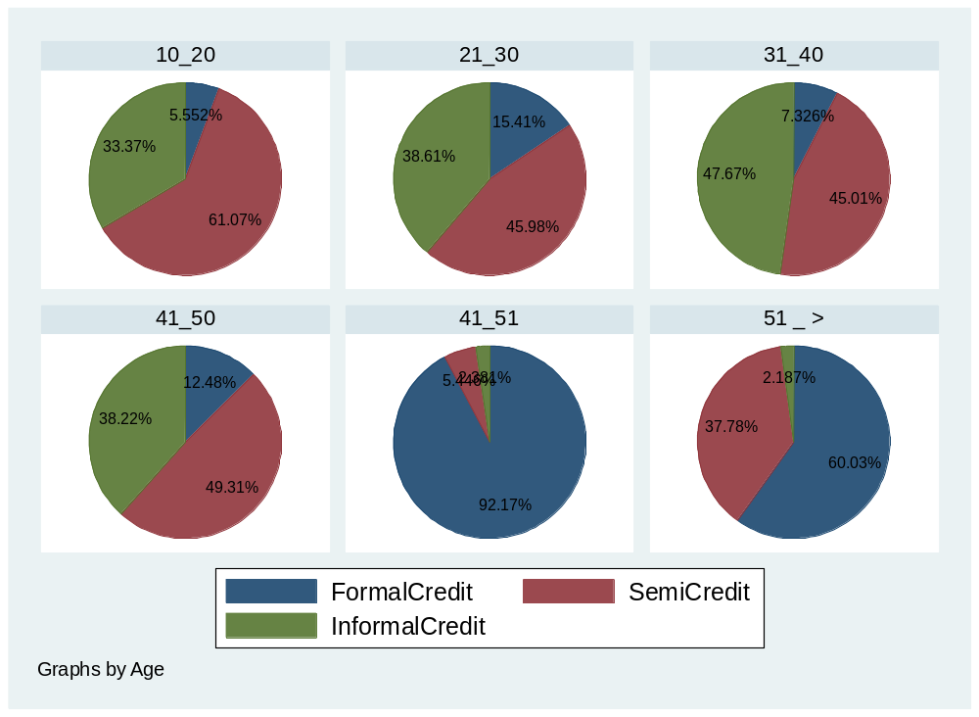

Figure 4.13: Age Group of Respondent

4.4.1.3 Marital Status of Individuals
Marital status results in figure 4.15 in indicates that 28.4%, 41.7% and 29.9% maried individual used formal financial institutions credit, semiformal financial institutions credit and on formal credit respectively. Besides, 28.69%, 40.98% and 30.33% divorced individual used formal financial institutions credit, semiformal financial institutions credit and informal credit respectively. Furthermore, 4.963%, 56.32% and 33.72% single ones used formal financial institutions credit, semiformal financial institutions credit and informal credit respectively. These results indicate that, majoriry (about 41%) of the married, divorced or single individuals prefer semiformal financial institutions credit to support maize agriculture. This is because majority of these individuals in the study area were mobilized into groups which helped them to access agricultural credit from one-acre fund and Agricultural and Marketing Cooperatives (AMCOS). These groups provided credit to group members in all the seasons and farmers enjoyed the use of this type of credit. In addition to that, these results indicate that very few (4.96%) of the single individuals prefers the use of formal financial institutions credits. This results were similar to that of Ohen et al., (2018) who argued that, rural smallholder farmers who are single are not trusted by commercial banks ( i.e., formal financial institutions) because they have less experience in farming and hence are seen to be higher riskier to be given credit.
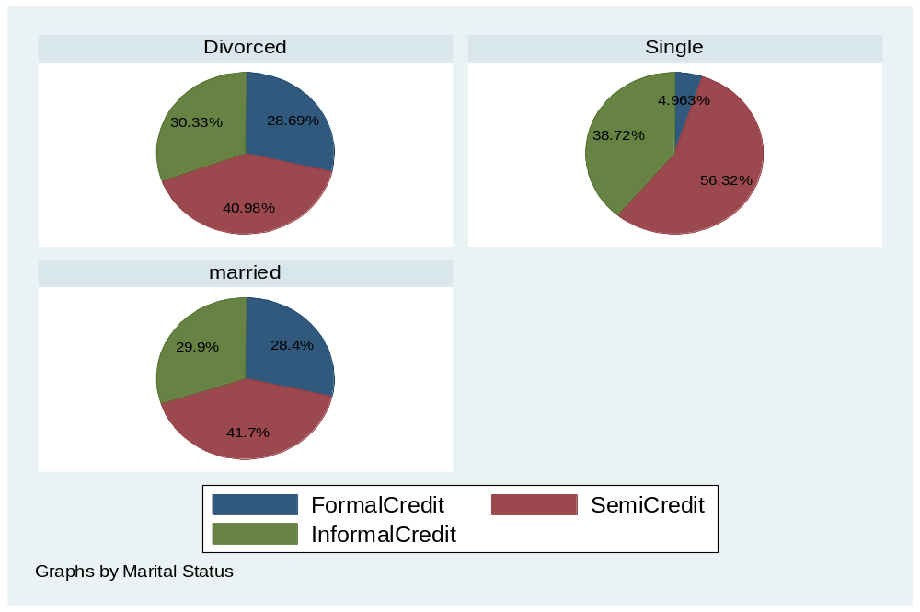

Figure 4.14 Marital Status of Respondents

4.4.1.4 Education Level of Individuals
The education level results for individuals in figure 4.15 indicates that 0%, 9.913%, 31.6%, 63.65%, 0%, and 0% of respondents who used semiformal financial institutions credit had no formal education, had primary education, had secondary education, had diploma, had degree and had master’s education respectively. Additionally, it indicates that 62.22%, 47.67%, 40.61%, 31.51%, 0% and 50% of the individual who used semiformal financial institutions credit had no formal education, had primary education, had secondary education, had diploma, had degree and had master’s education respectively.

Furthermore, 37.78%, 42.41%, 27.78%, 4.839%, 100% and 50% of the individual who used informal credit had no formal education, primary education, secondary education, diploma, degree and master’s education respectively. These results indicate that, individuals with no formal education, primary education and those with secondary education they do prefer semiformal financial institutions credit. However, individual who have no formal education did not use formal financial institutions credit and those who had a degree used only informal credit while those who had masters equally used semiformal financial institutions credit and informal credit but did not use formal financial institutions credit.
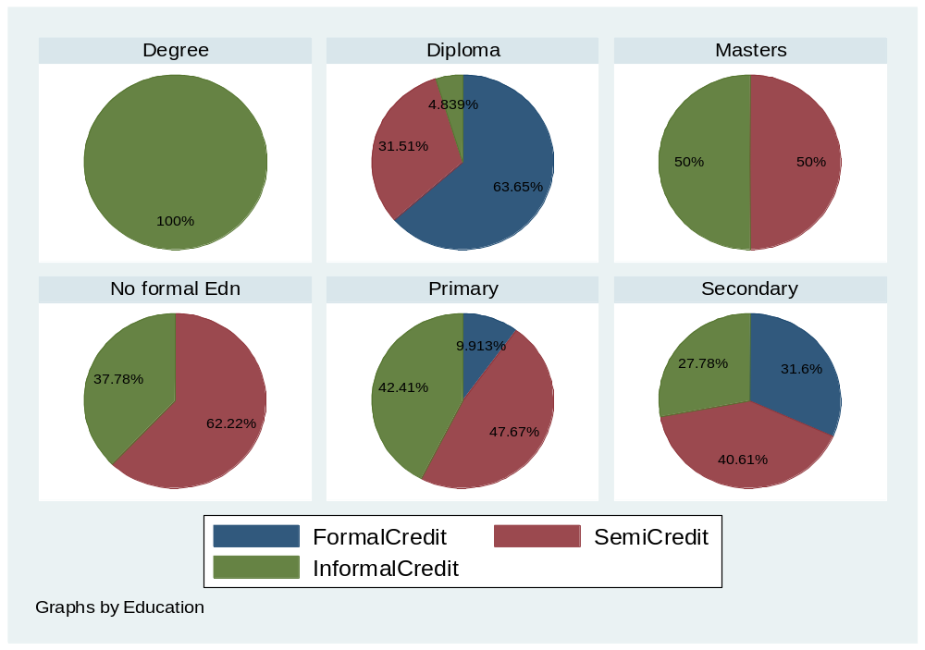

Figure 4.15 Education Level of Respondent

4.4.1.5 Household Size of Individuals
The results in figure 4.16 for individual household size indicates that, 29.55%, 21.91%, and 7.59% of individuals who used formal financial institutions credit had 0 to 5 persons, 6 to 10 persons and 10 and above persons respectively. Additionally, it indicates that 45.92%, 36.72% and 51.99% of individuals who used semiformal financial institutions credit had 0 to 5 persons, 6 to 10 persons and 10 and above persons respectively. Furthermore, 24.52%, 42.37% and 40.42% of individuals who used informal credit had 0 to 5 persons, 6 to 10 persons and 10 and above persons respectively. These results indicate that, individuals with bigger household size used more semiformal financial institutions credit. It also indicates that individuals with smaller household size used more informal credit and formal financial institutions credit.
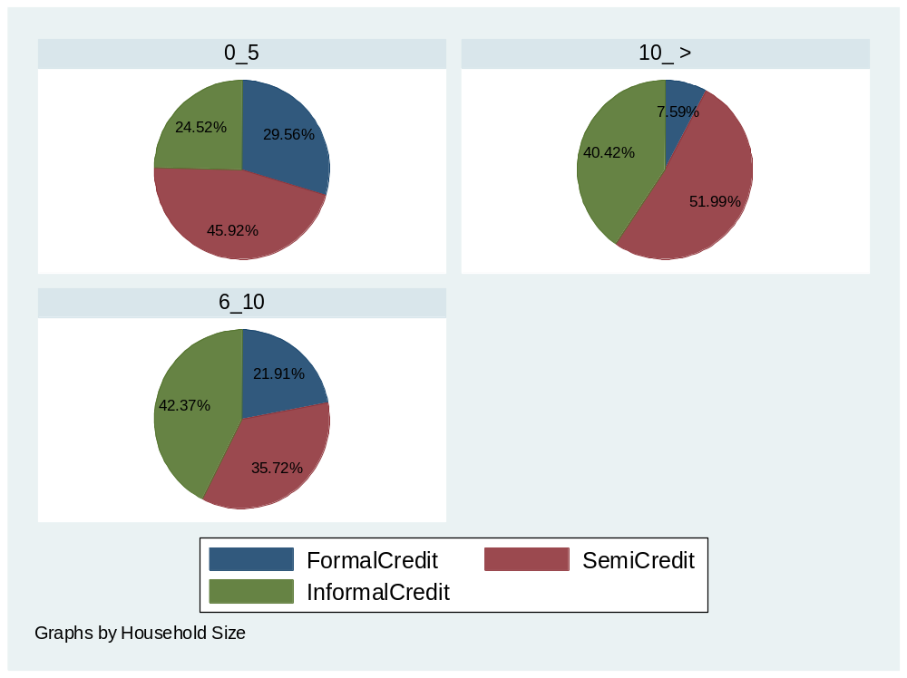

Figure 4.16: Household Size of Respondents

4.4.1.6 Farming Experience of Individuals
The results in figure 4.17 for individuals farming experience indicates that, 16.33%, 55.99% and 27.68% individuals with maize farming experience of 0 to 5 years used formal financial institutions credit, semiformal financial institutions credit and informal credit respectively. Moreover, 16.93%, 40.67% and 42.4% individuals with maize farming experience of 6 to 10 years used formal financial institutions credit, semiformal financial institutions credit and informal credit respectively. It also indicates that 36.37%, 34.48% and 30.15% individuals with maize farming experience of 11 to 20 years used formal financial institutions credit, semiformal financial institutions credit and informal credit respectively. Fourthermore, the results indicate 26.91%, 49.59% and 23.5% individuals with maize farming experience of 21 to 30 years used formal financial institutions credit, semiformal financial institutions credit and informal credit respectively.

Lastly, the results indicate 100% of individuals with maize farming experience of 31 years and above used informal credit. This shows the average of 24%, 45.1% and 30.9% of individuals with maize farming experience of 0 to 30 years, used formal financial institutions credit, semiformal financial institutions credit and informal credit respectively. It also indicates that, individuals with maize farming experience of 0 to 30 years utilize semiformal financial institutions credit than formal financial institutions credit and informal credit while those with above 31 years experience utilized informal credit.
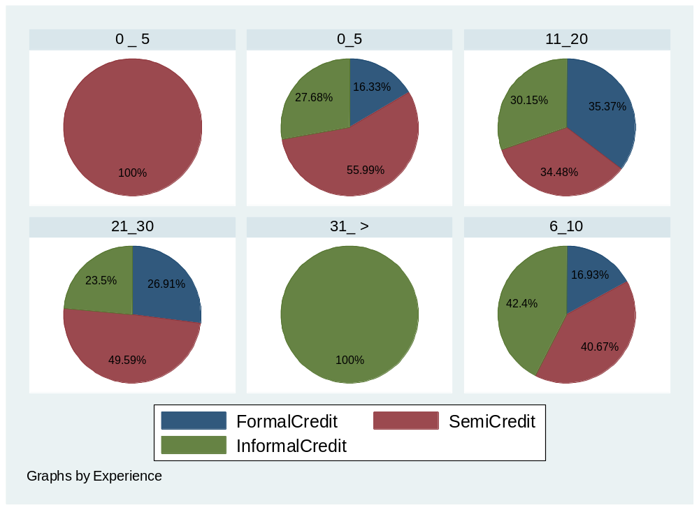

Figure 4.17: Farming Experience of Respondents

4.4.1.7 Farm Size of Individuals
The resultsin figure 4.18 indicates that 3.601%, 12.54% and 51.1% of individuals who used formal financial institutions credit had 0 to 1 acre, 2 to 5 acres and 5 to 10 acres respectively. It also shows that, 51.82%, 47.85% and 33.28%, of individuals who used semiformal financial institutions credit had 0 to 1 acre, 2 to 5 acres and 5 to 10 acres respectively. Additionally, it shows that 44.58%, 39.81% and 15.62% of individuals who used formal financial institutions credit had 0 to 1 acre, 2 to 5 acres and 5 to 10 acres respectively.

These results indicate that, individuals with bigger farm size (acres) used more formal financial institutions credit. It also indicates that individuals with moderate farm size (1 to 5 acres) used more informal credit and/or semiformal financial institutions credit.
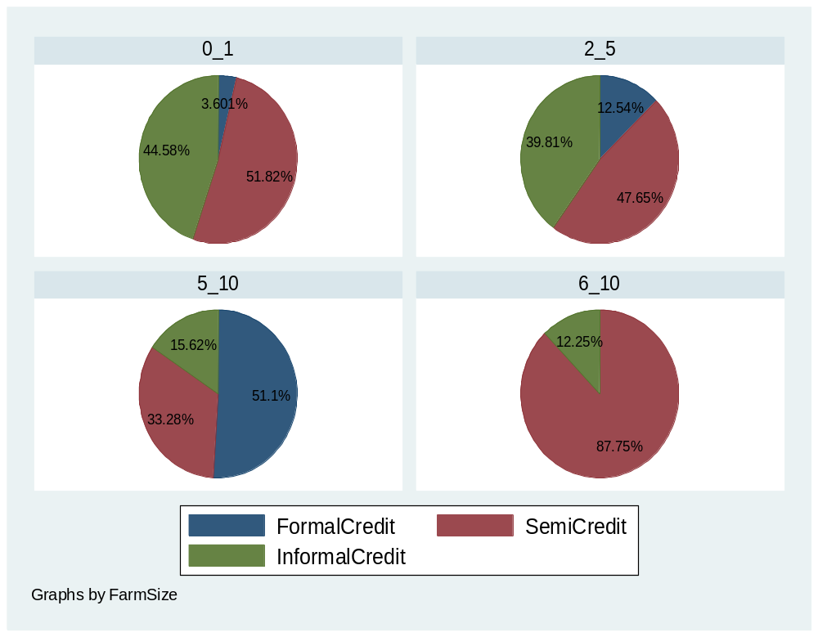

Figure 4.18: Farm Size of Respondent

4.4.2 Multivariate analysis
Table 4.8 shows the findings of multivariate analysis for credit facilities, maize productivity and control variables which are also discussed in this subsection. In addition to that, table 4.9 indicates the results of the analyses that consist of statistics such as mean, standard deviation, overall variation, between variation, within variation, minmum value and maximum value for the dependent, independent and control variables. The results in table 4.8 and table 4.9 shows the ratios used in analysis to measure and present factors that were involved.

The dependent variable which is maize productivity (symbol total prod~y) was measured by the ratio of total output (grms) over total input (Tzs). The output was the total maize produced in grammes in a particular season per acre while the input was the total money (capital injected) used in that season per acre. The independent variables included formal financial institutions credit, semi formal financial institutions credit and informal credit. These were measured from their ratios obtained by taking the total individual credit (ie. FFIs credit, semi FFIs credit or informal credit) borrowed by a farmer in a particular season over total money used (capital injected) by a farmer per acre. The analysis was based on these ratios.

Table 4.8 presents the results which shows that, semiformal financial institutions credits had the highest mean of Tanzanian shillings (Tzs) 348000 followed informal credits that have a mean of 248000 Tzs while formal financial institutions credit had a lowest mean of 217000 Tzs. The minimum value for formal financial institutions credit was 0 Tzs and the maximum value was 150000000 (ie. 1.50e + 07) Tzs, semi- formal financial institutions credit had the minimum value of 0 Tzs and maximum value of 5000000 Tzs and informal credit had the minimum value of 0 Tzs and maximum value of 2500000Tzs.

However, the mean for maize productivity was 5.294, the mean for formal financial institutions credit ratio is 0.137, the mean for semi- formal financial institutions credit ratio is 0.576 and the mean for informal credit ratio is 0.511. This indicates that on the center of the the distribution of this data highly employed semiformal financial institutions credits because they had highest average followed by informal credits. The mean for formal financial institutions credit is 0.137, this is a very minimum value compared to that of semiformal financial institutions credits and informal credits. This indicates that very few respondents utilized formal financial institutions credit.

Besides, the standard deviation was 1240000, 492000 and 257000 for formal financial institutions credit, semiformal financial institutions credits and informal credits respectively. However, semi formal financial institutions credit ratio had the highest standard deviation value of 0.543 followed by informal credit ratio with standard deviation value of 0.49 while formal financial institutions credit ratio had a lowest standard deviation value of 0.34. The highest standard deviations values for semiformal financial institutions credits ratio and informal credit ratio indicates that, the collected data are spread out over a large range from the mean of the values of semiformal financial institutions credits ratio and informal credit ratio. The lower the standard deviation of formal financial institutions credits ratio indicates that the data points tends to be very close to the mean value of the collected data.

Additionally, the minimum value for maize productivity was 0.6 and the maximum value was 11.765. The minimum value for formal financial institutions credit ratio was 0 and the maximum value was 2.5, semi- formal financial institutions credit ratio had the minimum value of 0 and maximum value of 3.684 and informal credit ratio had the minimum value of 0 and maximum value of 3.2. This indicates that on average respondents were highly employing semiformal financial institutions credits followed by informal credits while in very minimum circumstances they used formal financial institutions credit.

Likely, the total input had a mean of 748000 Tzs with minimum value of 33333.33Tzs and maximum value of 11770000Tzs. The total output mean was 3960000 gram per acre with minimum value of 450000grams and maximum value of 60000000grams. This indicates that on average respondent’s used 748000 Tzs to harvest the average amount of 3960000grams per acre. Therefore, the mean maize productivity respondents were 5.294gm/acreTzs. This mean maize productivity of respondents indicates the average amounnt of maize produced (g/acre) to the total amount of money injected per acre. In addition to that, total input credit had higher standard deviation of 5389000 Tzs and total output had a lower standard deviation of 5110000. This indicated that, the input data collected was spread out over a large range and the output data collected tend to be very close to the mean of the total output of the data collected.

Similarly, on the control variables, modern seeds were used by the respondents at an average of 1.796 with a standard deviation of 0.404. Fertilizer, pesticides, insecticides, hand hoes, plough and tractor had an average use of 1.855, 1.535, 1.689, 1.94, 1.877, and 1.035 respectively. These results indicate that, respondents were highly using fertilizer followed by the use of modern seed, insecticide then pesticides use. The results also indicate that, on average respondents are highly using hand hoes in farming followed by plough while very few of trhe respondents used tractors.

Likely, the standard deviations result of fertilizer, pesticides, insecticides, hand hoes, plough and tractor were 0.352, 0.5, 0.464, 0.237, 0.329 and 0.187 respectively. These results show that, the standard deviation for pesticide use is higher than the insecticide use followed by modern maize seed use and fertilizer use has the lowest standard deviation. Therefore, these results indicate that, majority of respondents who use pesticide in farming are highly spread out in a large range when compared to those who used insecticide, modern maize seed and fertilizers. These results also depict that, majority of the respondents who used plough for farming are highly dispersed followed by those who used hand hoes.

However, those who used tractor had very low dispersion shown to. The highest dispersion indicating that the data collected are spread out over a largest range of respondents who used hand hoe and plough while the lowest dispersion indicates that the data collected tend to be very close to the mean of respondents who used tractor. Lastly, all control variables have a minimum value of 1 and maximum value of 2. This means all control variables had binary data values and are categorical variables (i.e., have no any clear order on its use).

Table 4.8 Descriptives Statistics for Dependent, Independent and Control Variables
Variable | Obs | Mean | Std.Dev. | Min | Max
Total Prod_y (outpt_grms/inpt_Tzs) | 321 | 5.294 | 2.505 | 0.6 | 11.765
formal_ratio | 321 | 0.137 | 0.34 | 0 | 2.5
semi_ratio | 321 | 0.576 | 0.543 | 0 | 3.684
info_ratio | 321 | 0.511 | 0.493 | 0 | 3.2
Input_cost | 321 | 846000 | 1770000 | 90000 | 2.50e + 07
Input(cr~t_Tzs) | 321 | 748000 | 5389000 | 33333 | 11.77e +07
total_outputs(grams) | 321 | 3960000 | 5110000 | 450000 | 6.00e+07
Formalcredit | 321 | 217000 | 1240000 | 0 | 1.50e+07
Semicredit | 321 | 348000 | 492000 | 0 | 5000000
Informalcr~t | 321 | 248000 | 257000 | 0 | 2500000
total_credit | 321 | 813000 | 1590000 | 45000 | 2.00e+07
Modernseed | 321 | 1.796 | 0.404 | 1 | 2
Fertilizer | 321 | 1.855 | 0.352 | 1 | 2
Perticicide | 321 | 1.535 | 0.5 | 1 | 2
Insecticide | 321 | 1.689 | 0.464 | 1 | 2
Handhoes | 321 | 1.94 | 0.237 | 1 | 2
Ploughs | 321 | 1.877 | 0.329 | 1 | 2
Tractors | 321 | 1.035 | 0.183 | 1 | 2
Source: Data analysis (2020)
On the other hand, table 4.9 below, lists three different variation types of statistics, which are overall, between and within variations. The ‘overall’ statistics are ordinary statistics that are based on 321 sample observations. Overall variations have been obtained by taking the individual credit facility ratio (eg. formal_cre~o, semiformal_cre~o or informal_cre~o) injected to maize farm in a particular year (eg. 2018, 2019 or 2020) with the symbol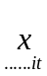 less the overall mean ( ) which is written as ( - ) . Table 4.9 provides the results of the overall mean of total maize productivity of 5.294, the standard deviation of 2.505, the the minimum value of 0.6 and maximum of 11.765 of the total maize productivity. These results indicate that, the mean maize productivity are the average amounnt of maize produced per acre(g/acre) to the total amount of money injected per acre. The standard deviation of 2.505 indicates, the output data collected was spread out over 2.5 range than the input data collected.

Moreover, the ‘between’ variation is the variation between individual’s variable. These were computed by taking the individual credit mean less the overall credit mean written as; (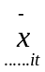 - ). Table 4.9 shows that the mean of the between variation for total productivity is 2.542, and it’s the standard deviation of the between variation is 0.983 with the minimum value of 11.8. It also shows formal financial institutions credit had between variation with mean value of 681000 and standard deviation of 124000 with minimum value of 9845783, semi formal financial institutions credit had a between variation with mean of 452000 and 0 standard deviation with minimum value of 3633333.
The informal credit had between variation with the mean of 220000 and 0 standard deviation with minimum value of 1666667. These results indicate a very high spread of data for the between variation of formal financial institutions credit and informal credit as compared to formal financial institutions credit among individuals. Similarly, the between variation of 0 standard deviation to semi formal financial institutions credit and informal credit indicates that there no variation among individuals who used these two credits as compared to formal financial institutions credit.

Moreover, formal financial institutions credit ratio, semi formal financial institutions credit ratio and informal credit ratio has a mean between variation values of 0.412, 0.564 and 0.514 respectively. These results indicate that, the average amount of money used by individuals among formal financial institutions credit and informal credit are very high compared to formal financial institutions credit among individuals. Formal financial institutions credit ratio, semi formal financial institutions credit ratio and informal credit ratio has a standard deviation of the between variation of 0 and their minimum values are 2.5, 3.0 and 3.2 respectively. These results indicate a spread of data of the between variation of formal financial institutions credit and informal credit as compared to formal financial institutions credit among individuals. It further indicates the standard deviation of 0. This indicates that, there is no dispersion between formal financial institutions credit, semi formal financial institutions credit and informal credit used by individuals.

Additionally, table 4.9 shows the results of the mean of the between variation value of the total input costs of 4.945 and the standard deviation of the between variation value of 0.959 with minimum value of 30.302. It also shows, the mean of the between variation value of total outputs of 4466.631 and the standard deviation of the between variation value of 950 with minimum value of 37533.33. These results indicate a very high spread of the between variation value of the total output as compared to the between variation value of the total input costs.

Furthermore, the ‘within’ variation are the variation within individual variable over time. In this study the ‘within variation’ is how individuals formal financial institutions credit, semi formal financial institutions credit or informal credit was changing over time (year) but not compared to individuals. Within variarions have been obtained by taking the individual independent variable less the mean of the independent variable written as ( - 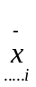). Table 4.9 indicates that total maize productivity has the within variation value of 0.967 and standard deviation of 3.258 with the minimum value of 10.302. These results indicate that, there is dispersion on maize productivity among the three seasons. Additionaly, the total output has the within variation value of 2233.945 and standard deviation of 21600 with the minimum value of 26423.09. The results also show that the total input costs has the within variation of 2.062 and standard deviation of 4.063 with the minimum value of 16.77. These results indicate that, there is dispersion of output value and the input value among the three seasons.

Furthermore, the formal financial institutions credit ratio has the mean within variation of 0.076 and standard deviation is 0.0583 with the minimum value 0.839, semi formal financial institutions credit ratio has the within variation of 0.203 and the standard deviation of 0.361 with minimum value 1.553, informal credit ratio has the within variation of 0.186 and the standard deviation of 0.158 with the minimum value of 1.479. These credit ratios results indicate that, individuals injected highly semiformal financial institutions credit and informal credit to their farms in comparison to the amount of formal financial institutions credit injected. These results also indicate that, semiformal financial institutions credit and informal credit injected to the farm were highly dispesed from the mean compared to formal financial institutions credit.

In addition to that, formal financial institutions credit has the within variation of 3.30e + 05 (i.e., 330000) and standard dedviation of 3449953 with minimum value of 3550047, semi formal financial institutions credit has the within variation of 182000 and standard dedviation of 486000 with minimum value of 1714430 and informal credit has the within variation of 129000 and standard deviation of 418000 with minimum value of 1081808. These results indicate that, semiformal financial institutions credit and informal credit were highly accessed than formal financial institutions credit. These results also indicate that, semiformal financial institutions credit and informal credit were highly dispersed from the mean than formal financial institutions credit.

Table 4.9 Descriptives Statistics for Overall, Between and Within Variations
Variable |  | Mean | Std.Dev. | Min | Max | Observations
Total Prod  (grams/inp~s) | overall | 5.294 | 2.505 | 0.6 | 11.765 | N | 321
 | between | 2.542 | 0.983 | 11.8 |  | n | 107
 | within | 0.967 | 3.258 | 10.302 |  | T | 3
Formalcr~t_o | overall | 0.137 | 0.34 | 0 | 2.5 | N | 321
 | between | 0.412 | 0 | 2.5 |  | n | 107
 | within | 0.076 | 0.0583 | 0.839 |  | T | 3
semiform_cr~t_o | overall | 0.576 | 0.543 | 0 | 3.684 | N | 321
 | between | 0.564 | 0 | 3 |  | n | 107
 | within | 0.203 | 0.361 | 1.553 |  | T | 3
Inform_cr~t_o | overall | 0.511 | 0.493 | 0 | 3.2 | N | 321
 | between | 0.514 | 0 | 3.2 |  | n | 107
 | within | 0.186 | 0.158 | 1.479 |  | T | 3
 | within | 4.81e+05 | 3587048 | 5512952 |  | =
Outpt(~gm) | overall | 3956.428 | 5110.819 | 450 | 60000 | N | 321
 | between | 4466.631 | 950 | 37533.33 |  | n | 107
 | within | 2233.945 | 2.16e+04 | 26423.09 |  | T | 3
Input(cr~t_Tzs) | overall | 7.048 | 5.389 | 0.75 | 33.333 | N | 321
 | between | 4.945 | 0.959 | 30.302 |  | n | 107
 | within | 2.062 | 4.063 | 16.77 |  | T | 3
Formcr~t | overall | 2.17e +05 | 1.24e + 05 | 0 | 1.50e+07 | N | 321
 | between | 6.81e+05 | 4154217 | 9845783 |  | n | 107
 | within | 3.30e+05 | 3449953 | 3550047 |  | T | 3
Semiformcr~t | overall | 3.48e+05 | 4.92e+05 | 0 | 5000000 | N | 321
 | between | 4.52e+05 | 0 | 3633333 |  | n | 107
 | within | 1.82e+05 | 4.86e+05 | 1714430 |  | T | 3
Informcr~t | overall | 2.48e+05 | 2.57e+05 | 0 | 2500000 | N | 321
 | between | 2.20e+05 | 0 | 1666667 |  | n | 107
 | within | 1.29e+05 | 4.18e+05 | 1081808 |  | T | 3

Source: Data analysis (2020)

4.5 Pairwise Correlation Analysis
Pairwise correlation analysis was employed so as to determine the relationship between variables without inferring cause and effect of those variables. This study employed Pearson correlation coefficient. Pearson correlation coefficient is the test statistics that measures the statistical relationship, or association, between two continous variables Creswell, (2014). It is known as the best method of measuring the association between variables of interest because it is based on the method of covariance. It gives information about the magnitude of the association, or correlation, as well as the direction of the relationship.

Pearson correlation coefficients values demands that, if the value is near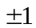, then it is said to be a perfect correlation. This means that as one variable increases, the other variable tend also to increase if positive and decrease if negative. If the coefficient value lies between 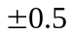and, then it is said to be a strong correlation. If the coefficient value lies between 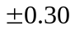and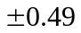, then it is said to be medium correlation. If the coefficient value lies below 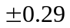 then it is said to be a small correlation and when the coefficient value is zero means there is no correlation, (Kothar, 2015).

Table 4.10 indicates the pairwise correlation for all variables in the study model (i.e., REM). The correlation analysis indicates that FFIs credit ratio, semi FFIs credit credit ratio and Informal credit ratio are statistically significant and positively related to maize productivity. This indicates that when these variables increase also maize productivity increases. The correlation results for informal credit ratio, semi FFIs credit credit ratio and FFIs credit ratio to maize productivity are +0.365*, +0.298* and +0.11* respectively. This correlation results confirms that, informal credit, semi FFIs credit credit and FFIs credit are significant to maize productivity. It also indicates that, there is medium correlation among informal credit and semi FFIs credit credit and maize productivity to the respondents. Additionally, these results indicate that, there is a small correlation among FFIs credit and maize productivity.
Moreover, the correlation results for the use of modern maize seed, pesticide, insecticide, fertilizer, handhoe, plough and tractor to maize productivity are -0.014, +0.072, +0.028, 0, +0.053, -0.063 and -0.016 respectively. This correlation results confirms that, modern maize seed, pesticide, insecticide, handhoe, plough and tractor are all not significant to maize productivity. It also indicates that, there is small correlation among modern maize seed, pesticide, insecticide, handhoe, plough and tractor to maize productivity. It further indicates that, the use of modern maize seed, plough and tractor has an inverse relationship to maize productivity for respondents. Also, the results indicate no correlation on the use of ferlizer and maize productivity to respondents. In practice this results indicates that, respondent did not use inorganic fertilizers i.e., Nitrogen, Phosphorus and Potasium (NPK). Respondents used organic fertilizers i.e., manure, composite, plant and animal remains.

In addition to that, the correlation results on the use of formal financial instititutions credit to the use of semi formal financial institutions credit, informal credit, the modern maize seed, pesticide, insecticide, fertilizer, hand hoe, plough and tractor are +0.008, -0.006, +0.031, +0.061, +0.099, + 0.053, + 0.025, -0.139* and +0.004 respectively. This correlation results cornfirms that, the correlation of using formal financial instititutions credit to the use of semi formal financial institutions credit, informal credit, the modern maize seed, pesticide, insecticide, fertilizer hand hoe and tractor are all not significant to maize productivity. It also indicates that, there is small correlation on the using formal financial instititutions credit to the use of semi formal financial institutions credit, informal credit, the modern maize seed, pesticide, insecticide, fertilizer hand hoe and tractor. It further indicates that, the correlation of using formal financial instititutions credit to the use of plough is significant and has an inverse relationship to maize productivity for individuals.

Additionally, the correlation results of the use of semiformal financial instititutions credit to the use of informal credit, the modern maize seed, pesticide, insecticide, fertilizer, hand hoe, plough and tractor are +0.229*, +0.112*, -0.059, +0.081, +0.196*, + 0.028, - 0.095, and -0.077 respectively. This correlation results cornfirms that, the correlation of using semiformal financial institutions credit to the use of informal credit, the modern maize seed and fertilizer are all significant to maize productivity and the correlation of using semiformal financial institutions credit to the use of pesticide, insecticide, hand hoe, plough and tractor are all not significant to maize productivity. It also indicates that, there is small correlation on the use of semiformal financial instititutions credit to the use of informal credit, the modern maize seed, pesticide, insecticide, fertilizer, hand hoe, plough and tractor. It further indicates that, the correlation of using semiformal financial institutions credit to the use of pesticide, plough, plough and tractor has an inverse relationship to maize productivity for respondents.

Similarly, the correlation results of the use of informal credit to the use of modern maize seed, pesticide, insecticide, fertilizer, hand hoe, plough and tractor are +0.029*, +0.154*, +0.135*, +0.154*, +0.112*, -0.08 and - 0.051 respectively. These correlation results cornfirms that, the correlation of using informal credit to the use of modern maize seed, pesticide, insecticide, fertilizer, hand hoe is all significant to maize productivity and the correlation of using informal credit to the use of plough and tractor are all not significant to maize productivity. It also indicates that, there is small correlation on the use of informal credit to the use of modern maize seed, pesticide, insecticide, fertilizer, hand hoe, plough and tractor. It further indicates that, the correlation of using informal credit to the use of plough and tractor has an inverse relationship to maize productivity for respondents.

Likely, the correlation results of the use of modern maize seed to the use of pesticide, insecticide, fertilizer, hand hoe, plough and tractor are +0.418*, +0.535*, +0.523*, +0.07, +0.048 and + 0.096 respectively. This correlation results confirms that, the correlation of using modern maize seed to the use of pesticide, insecticide and fertilizer are all significant and the correlation of using modern maize seed to the use of hand hoe, plough and tractor are all not significant to maize productivity. It also indicates that, there is small correlation on the use of modern maize seed to the use of pesticide, insecticide, fertilizer, hand hoe, plough and tractor.

On the other hand, the correlation results of the use of pesticides to the use of insecticide, fertilizer, hand hoe, plough and tractor are +0.598*, +0.208*, +0.111*, -0.003, and + 0.073 respectively. This correlation results indicates that, the correlation of using pesticide to the of use insecticide, fertilizer and hand hoe are all significant and the correlation of using pesticides to the use of plough and tractor are not significant. It also indicates that, there is small correlation on the use of pesticide to the use of fertilizer, hand hoe, plough and tractor. It further indicates that, the correlation of using pesticide to the use of plough has an inverse relationship. It also shows that, a strong correlation on the use of pesticide to the use of insecticide.
Moreover, the correlation results of the use of insecticide to the use of fertilizer, hand hoe, plough and tractor are +0.399*, +0.06, +0.018, and + 0.127 respectively. This correlation results indicates that, the correlation of using insecticide to the use of fertilizer is significant and the correlation of using insecticide to the use of hand hoe, plough and tractor are not significant. It also indicates that, there is a medium correlation on the use of insecticide to the use of fertilizer. In addition to that, the results indicate that, there is small correlation of using insecticide to the use of hand hoe, plough and tractor.

Furthermore, the correlation results of the use of fertilizer to the use of hand hoe, plough and tractor are +0.009, -0.099 and +0.078 respectively. This correlation results indicate that, the correlation of using fertilizer to the use of hand hoe, plough and tractor is not significant and the correlation of using fertilizer to the use of plough has an inverse relationship. It also indicates that, there is a small correlation on the use of fertilizer to the use of hand hoe, plough and tractor. Additionally, the correlation results of the use of hand hoe to the use of plough and tractor are +0.068, and -0.315* respectively. This correlation results indicate that, the correlation of using hand hoe to the use of plough is not significant but to the use of tractor is significant. It also indicates that, the correlation of using hand hoe to the use of tractor has an inverse relationship. Furthermore, it indicates that, there is a small correlation on the use of hand hoe to the use of plough and tractor.

Lastly, the correlation results on the the use of plough to the use of tractor is -0.349*. This correlation results indicate that, the correlation of using plough to the use of tractor is significant. It also indicates that, the correlation of using plough to the use
of tractor has an inverse relationship. Furthermore, it indicates that, there is a medium correlation on the use of plough to the use of tractor.

Table 4.10 Correlations Matrix Results
Variables | -1 | -2 | -3 | -4 | -5 | -6 | -7 | -8 | -9 | -10 |  | -11
(1) Tot. Productivity | 1
(2) formal_ratio | 0.11* | 1
 | (0.371)
(3) semi_ratio | 0.298* | 0.008 | 1
 | (0) | (0.89)
(4) info_ratio | 0.365* | -0.006 | 0.229* | 1
 | (0) | (0.914) | (0)
(5) modernseed | -0.014 | 0.031 | 0.112* | 0.029 | 1
 | (0.806) | (0.584) | (0.046) | (0.6)
(6) perticicide | 0.072 | 0.061 | -0.059 | 0.154* | 0.418* | 1
 | (0.202) | (0.275) | (0.297) | (0.006) | (0)
(7) insecticide | 0.028 | 0.099 | 0.081 | 0.135* | 0.535* | 0.598* | 1
 | (0.622) | (0.078) | (0.151) | (0.016) | (0) | (0)
(8) fertilizer | 0 | 0.053 | 0.196* | 0.154* | 0.523* | 0.208* | 0.399* | 1
 | (0.998) | (0.343) | (0) | (0.006) | (0) | (0) | (0)
(9) handhoes | 0.053 | 0.025 | 0.028 | 0.112* | 0.07 | 0.111* | 0.06 | 0.009 | 1
 | (0.346) | (0.655) | (0.624) | (0.047) | (0.216) | (0.049) | (0.288) | (0.866)
(10) ploughs | -0.063 | -0.139* | -0.095 | -0.08 | 0.048 | -0.003 | 0.018 | -0.099 | 0.068 | 1
 | (0.263) | (0.013) | (0.092) | (0.155) | (0.391) | (0.959) | (0.752) | (0.077) | (0.23)
(11) tractors | -0.016 | 0.004 | -0.077 | -0.051 | 0.096 | 0.073 | 0.127* | 0.078 | -0.315* | -0.349* |  | 1
 | (0.779) | (0.937) | (0.171) | (0.367) | (0.088) | (0.193) | (0.023) | (0.166) | (0) | (0)
* shows significance at 0.05 level
Source: Data analysis (2020

4.7.3 Farm/Farmer Related Characteristics (Control Variables).
The control variables are one which a researcher holds constant (controls) during the experiment (Saunders et al., 2012). Similarly, (Kothari, 2015) defined conrol variables as the variables that are not of primary interest (i.e., neither the exposure nor the outcome of interest) and thus constitute an extraneous or third factor whose influence is to be controlled or eliminated. Table 4.18 indicates the panel regression results for the random effect models and the group of control variables. The control variables used in this study are age, education level, household size and experience which are ordinal variables and gender which was categorical variable. Group separation of ordinal variables and categorical variables during regression was done so as to avoid multicolinearity. The regression results shown in table 4.18 for model 7 and model 8 with +0.33 and +0.53 coefficients respectively. This statistcs results indicate that, modern maize seed used was statistically not significant to maize productivity. This results also implies that an increase in use of modern maize seed by individuals increases maize productivity by 0.33 and 0.53 using model 7 and 8 respectively.

Moreover, the results shown in figure 4.21 (appendix IX) shows that, individuals who did not use modern seeds were 11.05%, 43.92% and 45.03% of those who used formal financial institutions credit, semi formal financial institutions credit and informal credit respectively. However, individuals who used modern seeds were 28.57%, 42.64% and 28.8% of those who used formal financial institutions credit, semi formal financial institutions credit and informal credit respectively. This indicates that majority of selected individuals who did not use modern seeds were those who used semi formal financial institutions credit. Very few of them used informal credit and formal financial institutions credit. It also indicates that majority of the individuals who used modern seeds were those who used semi formal financial institutions credit. Additionally, the regression results shown in table 4.18 for model 7 and model 8 indicate the coefficient values of -0.33 and -0.53 respectively. This result indicates that fertilizers use is statistically not significant and has inverse relationship to maize productivity.

Likely, figure 4.22 (appendix IX) shows that, individuals who did not use fertilizers were 14.3%, 42.73% and 42.97% of those who used formal financial institutions credit, semi formal financial institutions credit and informal credit respectively. However, individuals who used fertilizer were 27.65%, 42.78% and 29.57% of those who used formal financial institutions credit, semi formal financial institutions credit and informal credit respectively. This indicates that majority of the individuals who did not use fertilizer were those who used semi formal financial institutions credit and informal credit while only few (ie.14.3%) of those who used formal financial institutions credit did not use fertilizer. It also indicates that majority of the individuals who used fertilizer were those who used semi formal financial institutions credit followed by those who used informal credit and formal financial institutions credit.

Moreover, table 4.18 regression results for pesticide use in model 7 and model 8 are -0.02 and -0.02 respectively. These results indicate that, pesticide use is statistically not significant and has an inverse relationship to maize productivity. In addition to that, figure 4.23 in (appendix IX) shows that, individuals who did not use pesticide/insecticide were 10.55%, 52.96% and 36.49%of those who used formal financial institutions credit, semi formal financial institutions credit and informal credit respectively. However, individuals who used pesticides/insecticides were 35.34%, 37.29% and 27.37% of formal financial institutions credit, semi formal financial institutions credit and informal credit respectively. This indicates that majority of individuals who did not use pesticide/insecticide were those who used semi formal financial institutions credit followed by those who used informal credit and formal financial institutions credit. It also indicates that majority of individuals who used pesticide/insecticide were those who used semi formal financial institutions credit followed by those who used formal financial institutions credit and informal credit. These results conclude that majority of individuals who used semi formal financial institutions credit do not use pesticide /insecticide since 52.95% of individuals did not use pesticide/insecticide while 37.29% of respondents used pesticide/insecticide.

Table 4.18 regression results for hand hoe use in model 7 and model 8 are +0.08 and +0.11 respectively. This result indicates that, hand hoe use is not significant to maize productivity. This result indicates also that, a unit increase in hand hoe use by individuals increases maize productivity in rural areas by 0.08 and 0.11 respectively. Similarly, figure 4.24 in (appendix IX) shows that, individual who did not use handhoe were 13.2%, 58.61% and 28.19% of those who used formal financial institutions credit, semi formal financial institutions credit and informal credit respectively. In addition to that, individuals who used hand hoe were 27.17%, 42.18% and 30.65% of formal financial institutions credit, semi formal financial institutions credit and informal credit respectively. This indicates that majority of the individuals who did not use handhoe were those who used semi formal financial institutions credit followed by those who used informal credit and formal financial institutions credit. It also indicates that majority of individuals who used handhoe were those who used semi formal financial institutions credit followed by those who used informal credit and formal financial institutions credit. Therefore, these results concludes that majority of individuals who used semi formal financial institutions credit do not use handhoe since 58.61% did not use while 42.18% used hand hoe.

The regression results for plough use on table 4.18 for model 7 and model 8 indicates the coefficients of -0.11 and -0.23 respectively. These statistic results indicate that plough use is not significant to maize productivity. These results also indicate the inverse relationship in the use of plough and maize productivity by individuals. Similarly, figure 4.25 in (appendix IX) shows that, individuals who did not use plough were 57.19%, 30.38% and 12.43% of those who used formal financial institutions credit, semi formal financial institutions credit and informal credit respectively.

However, individuals who used plough were 19.01%, 45.88% and 35.11% of formal financial institutions credit, semi formal financial institutions credit and informal credit respectively. This indicates that majority of individuals who did not use plough were those who used formal financial institutions credit followed by those who used semiformal financial institutions credit and informal credit. It also indicates that majority of individuals who used plough were those who used semi formal financial institutions credit followed by those who used informal credit and formal financial institutions credit. Therefore, these results concludes that majority of individuals who used semi formal financial institutions credit are most likely going to use plough since 45.88% did use while 30.38% did not use.

Lastly, the regression results for tractor use on table 4.18 for model 7 and model 8 indicates the coefficients of -0.26 and -0.37respectively. These statistic results indicate that tractor use was not significant to maize productivity. These results also indicate the inverse relationship in the use of tractor and maize productivity by individuals. Similarly, figure 4.26 in (appendix IX) shows that, individuals who did not use tractor were 19.04%, 45.82%, and 35.14% of those who used formal financial institutions credit, semi formal financial institutions credit and informal credit respectively.

However, individuals who used tractor were 70.31%, 25.34% and 4.35% of formal financial institutions credit, semi formal financial institutions credit and informal credit respectively. This indicates that majority of individuals who did not use tractor were those who used semiformal financial institutions credit followed by those who used informal credit and formal financial institutions credit. It also indicates that majority of individuals who used tractor were those who used formal financial institutions credit followed by those who used semiformal financial institutions credit and informal credit. Therefore, this result concludes that majority of individuals who used formal financial institutions credit do use tractor since 70.31% did used tractor while only 19.04% did not use tractor.

Table 4.18 Farm/Farmer Related Characteristics (Control Variables).
 | (1) | (2) | (3) | (4) | (5) | (6) | (7) | (8)
 | REM | REM | REM | REM | REM | REM | REM | REM
formal_ratio | 0.40*** | 0.40*** | 0.31*** | 0.46*** | 0.46*** | 0.39*** | 0.57*** | 0.57***
 | (0.44) | (0.44) | (0.45) | (0.45) | (0.45) | (0.45) | (0.44) | (0.45)
semi_ratio | 1.45*** | 1.45*** | 1.48*** | 1.41*** | 1.41*** | 1.33*** | 1.36*** | 1.43***
 | (0.25) | (0.25) | (0.25) | (0.25) | (0.25) | (0.25) | (0.25) | (0.26)
info_ratio | 1.51*** | 1.51*** | 1.48*** | 1.47*** | 1.47*** | 1.44*** | 1.44*** | 1.50***
 | (0.27) | (0.27) | (0.28) | (0.27) | (0.27) | (0.28) | (0.28) | (0.29)
modernseed |  |  |  |  |  |  | 0.33 | 0.53
 |  |  |  |  |  |  | (0.43) | (0.43)
fertilizer |  |  |  |  |  |  | -0.23 | -0.25
 |  |  |  |  |  |  | (0.44) | (0.44)
perticicide |  |  |  |  |  |  | -0.02 | -0.02
 |  |  |  |  |  |  | (0.29) | (0.29)
insecticide |  |  |  |  |  |  | -0.20 | -0.17
 |  |  |  |  |  |  | (0.34) | (0.35)
handhoes |  |  |  |  |  |  | 0.08 | 0.11
 |  |  |  |  |  |  | (0.58) | (0.58)
ploughs |  |  |  |  |  |  | -0.11 | -0.23
 |  |  |  |  |  |  | (0.36) | (0.36)
tractors |  |  |  |  |  |  | -0.26 | -0.37
 |  |  |  |  |  |  | (1.01) | (1.04)
_cons | 4.78*** | 5.27*** | 4.93*** | 0.27 | 2.98 | 4.45*** | 5.09** | 3.67
 | (0.68) | (0.86) | (0.64) | (2.30) | (2.39) | (1.45) | (2.38) | (3.52)
Obs. | 321 | 321 | 321 | 321 | 321 | 321 | 321 | 321
r2_w | 0.22 | 0.22 | 0.22 | 0.22 | 0.22 | 0.22 | 0.23 | 0.24
r2_b | 0.27 | 0.27 | 0.36 | 0.26 | 0.26 | 0.24 | 0.30 | 0.34
r2_o | 0.24 | 0.24 | 0.33 | 0.22 | 0.22 | 0.20 | 0.25 | 0.29
rmse | 1.07 | 1.07 | 1.07 | 1.07 | 1.07 | 1.07 | 1.12 | 1.11
chi2 | 93.75*** | 93.75*** | . | 92.03*** | 92.03*** | 88.44*** | 97.20*** | 105.30***
Standard errors are in parenthesis
*** p<0.01, ** p<0.05, * p<0.1
Source: Data analysis (2020)

CHAPTER FIVE

DISCUSSION OF FINDINGS

5.1 Overview
This chapter discusses the research findings obtained from data analysis in chapter four. It compares and contrasts theoretical postulations to findings presented in chapter four. It further compares and contrasts findings in chapter four to other related empirical findings found by other researchers. It offers rationales for consistence and deviations of findings from theory and other empirical findings. It also confirms the hypotheses used in this study and suggests improvements for the model used in this study to reflect the current findings.

5.2 Descriptives Analysis
Desriptive analysis was individual’s demographic analysis and interpretations for sex, age, marital status, education level, house hold size, farming experience and farm size Moreover, the multivariate data analysis employed statistics such as mean, standard deviation, overall variation, between variation, within variation, minimum value and maximum value. The results indicated in figure 4.13 revealed that 60.03% of individuals with 51 years old and above were more trusted and used formal financial institutions credit in supporting their maize farming.These results are similar to the results of Memon et al., (2016) whose study was on the role of agricultural credit in improving agricultural productibvity in Pakistan. Their study results revealed that about 73% of the respondent who were fifty-year-old and above used formal financial institutions credit (commercial banks) as their sources of credit.
Additionally, individuals who have no formal education did not use formal financial institutions credit and those who had a degree used only informal credit while who had masters equally used semiformal financial institutions credit and informal credit but did not use formal financial institutions credit. Furthermore, individuals with bigger farm size used more formal financial institutions credit. These results are consistent with that of (Agunleye, 2018) who researched on the effect of microfinance credit on agricultural productivity and profitability to rural farmers. It also indicates that individuals with moderate farm size (1 to 5 acres) used more informal credit and/or semiformal financial institutions credit. The results also indicate that, on average individuals are highly using hand hoes in farming followed by plough while very few of the individuals used tractors.

5.3 Regression Analysis
Panel regression analysis was done to assess the relationship between credit facilities and maize productivity. Data analysis for Pearson correlations indicated that correlation was statistically significant at 0.05 levels. The correlation results also indicated a medium correlation on the use of semi formal financial institutions credit and informal credit to maize productivity. Moreover, the correlation results in figure 4.19 indicate that, there is a small correlation on the use of formal financial institutions credit to the use of semi formal financial institutions credit and informal credit.This results was in hammon with the result of Aphu et al., (2017).

Additionally, the correlation results in figure 4.19 indicate a medium correlation on the use of semiformal financial institutions credit and informal credit. These results are in line with that of Borah et al., (2019) whose research was on non-government organizations fund i.e., semiformal financial institutions fund) and its impact on agricultural productivity. The conclusion from this study was that, fund from non-government organizations increases agricultural productivity. Therefore, the current study findings are consistent with that of Borah et al., (2019) except that panel data were adopted and random effect model was used in analysis. Moreover, the current study adopts their explanation but also put forward by employing NGOs fund ratio, village community bank credit ratio, saving and credit cooperative societies ratio to determine its effects on maize productivity in three years.

5.4 Maize Productivity Determinants
The dependent variable which is maize productivity (total prod~y) was measured by the ratio of total output (grms/acre) over total input. The output was the total grammes of maize produced in a particular season per acre while the input was the total amount of money injected in that season per acre. The findings from table 4.9 indicated that the overall total output was at a mean of 3956.428 with standard deviations of 5110.819 and the overall total input was at a mean of 7.048 with standard deviations of 5.389. This indicates greater degrees of variability on the total input on output over the years to rural smallhoder farmers. These results are in harmony with Nisar et al., (2015) findings that revealed only 30% of the respondents were utilizing credit facilities for agricultural productivity. However, the results also indicated the increase of agricultural productivity by five percent.

Moreover, the results on table 4.16 shows that, farm costs such as land/farm preparation cost, plough use cost, tractor use cost, weeding cost, fertilizers use cost, pesticides use cost, harvest cost, cleaning cost and transportation cost are not significant to maize productivity. However, it also indicates that, a unit cost increase of land/farm preparation increases maize productivity by 0.35, a unit cost increase of plough use increases maize productivity by 0.05, a unit cost increase of tractor use increases maize productivity by 0.185, a unit cost increase of farm weeding increases maize productivity by 0.135, a unit cost increase of fertilizer use increases maize productivity by 0.225, a unit cost increase of pesticide use increases maize productivity by 0.15, a unit cost increase of maize harvest increases maize productivity by 0.40, a unit cost increase of maize cleaning increases maize productivity by 0.05 and a unit cost increase of maize transportation to godown/ farmers home increases maize productivity by 0.14. These results are in line with (Aphu et al., 2017 and Nisar et al., 2015) findings which revealead that, farm costs such as weeding cost, fertilizers use cost, pesticides use cost, harvest cost, cleaning cost and transportation cost are not significant to maize productivity to rural smallholder farmers but increases maize productivity.

5.5 Credit Facilities Determinant
The independent variables included formal financial institutions credit, semi formal financial institutions credit and informal credit. These were measured from the ratio obtained by taking the total individual credit (ie. FFIs credit, semi FFIs credit or informal credit) taken by a farmer in a particular season over total money used (capital injected) by a farmer per acre.

The study results on table 4.8 indicates that, respondents used semi FFIs credits ratio at an average of 0.576 followed by an average of 0.511 for informal credits ratio and the average of 0.137 for FFIs credit ratio. These study results indicated that, an increase in formal financial institutions credit ratio, semi formal financial institutions credits ratio and informal credits ratio increased maize productivity of rural smallholder farmers. These findings are consistent with that (Anigbogu et al., 2015) whose findings revealed that agricultural credit is significant and has a positive relationship with agricultural productivity.

Moreover, semi FFIs credit ratio had a standard deviation of 0.543, informal credit had a standard deviation of 0.493 and FFIs credit ratio had standard deviation of 0.34. This result indicates that majority of respondents used semi FFIs credit and informal credit and there was higher dispersion (i.e the extent to which a distribution is stretched (spread) or squeezed) to respondents who used semi FFIs credit and informal credit than those who use FFIs credits. These findings are consistent with that Duniya and Adinah, (2015) and Chiu et al., (2014) whose findings revealed that bank credit and microfinance credit has a positive and significant effect to agricultural productivity to rural farmers.

Furthermore, table 4.10 indicates the correlation matrix results for informal credit ratio of 0.365*, 0.298* for semi FFIs credit ratio and 0.11* for FFIs credit ratio to maize productivity. This result shows that informal credit, semi FFIs credit credit and FFIs credit are all positive and significant to maize productivity. This means a unit of Tzs increase of informal credit increases 0.365 units of maize productivity, a unit of Tzs increase of semi FFIs credit credit increases 0.298 units of maize productivity and a unit of Tzs of FFIs credit increases 0.11 of the total maize productivity of respondents. These findings are in line with that of Babajide, (2012) whose findings revealed that agricultural credit has a positive and significant effect to agricultural productivity.

Similarly, the pairwise graphical results in figure 4.19 indicates that, majority of residuals for the relationship of formal financial institutions credit ratio, semi formal financial institutions credit ratio and informal credit ratio to total maize productivity, lie on diagonal line. This results signifies that, an increase of FFIs credit ratio, semi FFIs credit ratio and informal credit ratio increases total maize productivity of the respondents. In addition to that, table 4.17 shows the random effect model 8 (i.e., REM8) performed much better as compared to model 1, model 2, model 4, model 5, model 6 and model 7. The results for within r square indicates that, 24% of the amount of variance of dependent variable (maize productivity) was explained within individual independent variables (FFIs credit, semi FFIs credit and informal credit) for respondents over time. In the between R square, only FFIs credit, semi FFIs credit and informal credit are compared over time.

The R square results indicated that, model 3 performed better as compared to model 1, 2, 4, 5, 6, 7 and 8. The results of model 3 indicated that 36% of the variance of dependent variable was explained between individual independent variables over time. This overall R square result indicates that, model 8 performed better as compared to model 1, 2, 3, 4, 5, 6 and 7. The model 8 results, also indicates that 29% of the variance of dependent variable are explained by the independent variables over time. The overall R square variance is based on 321 sample observations. The results are in harmony with (Sreedevi and Murugani, 2018) findings which revealed that, microfinance credit increases agricultural productivity in rural area.

In addition to that, table 4.17 shows the root mean square error (rmse) result of model 1, 2, 3, 4, 5, and 6 was 1.07, model 7 result were 1.12 and 1.11 for model 8. These rmse results of all the models are all close to zero which indicates that, the model fit much better to the collected data, Park, (2011). Moreover, table 4.19 indicates the chi2-tests results of 93.75 for model 1, model 2 and model 3, 92.03 for model 4, 88.44 for model 4, 97.20 for model 7 and 105.30 for model 8. This indicated that model 8 was much better than model 1, model 2, model 3, model 4, model 5, model 6 and model 7. This is because; the higher the results of the chi2 value indicate the model fit much better to the collected data (Park, 2011).

Therefore, our study findings strongly suggests that formal financial institutions credit ratio, semi formal financial institutions credit ratio and informal credit ratio has a significant and positive effect on maize productivity to rural smallholder farmers. These results are in line with other studies such as Chandio, (2015) whose results revealed that agricultural credit has a positive and significant impact on maize productivity.These results are also consistent with financial intermediation theory and neoclassic economic growth theory that explains bank credit as the variable which has positive and significant effect to agricultural productivity.

5.6 Farm Related Characteristics (Control Variables)
Control variables refer to variables that are not of primary interest (i.e., neither the exposure nor the outcome of interest) and thus constitute an extraneous or third factor whose influence is to be controlled or eliminated, (Saunders et al., 2012). Table 4.18 indicates the panel regression results for the random effect models and the group of control variables. The results indicates that, majority of the individuals used hand hoe in cultivating their farm with an average of 16.55% followed by those who used plough whose average was 16.01% and last was those who used tractor whose average was 8.82%. This indicates that individuals utilized the use of hand hoe and ploug lather than the use of tractor.

In addition to that, 15.31% of the individuals used modern seeds, 15.82% of the individuals used fertilizers, 14.40% of the individuals used insecticide, 13.09% used pesticide and 0% applied irrigation. This indicates that majority of individuals (85%) do not use modern maize seed, fertilizers, insecticides and pesticides. Besides, the results indicate that 0% individuals applied irrigation which means all individuals rely on seasonal rainfall. The results are however consistent with that Ngegba et al., (2016) who revealed that modern seeds and fertilizer are not significant but do increases agricultural productivity to rural farmers.

Moreover, table 4.18 regression results for REM in all group variables indicates that the use of modern maize seeds and hand hoe by individuals is insignificant to maize productivity. The results also show that increase in the use of modern maize seeds and hand hoe by individuals increases maize productivity. Additionally, the result indicates the inverse relationship in the use of fertilizer, pesticide, insecticide, plough and tractor by individuals to maize productivity in rural areas. Furthermore, the result shows that the use of fertilizer, pesticide, insecticide, plough and tractor by individuals are not significant to maize productivity in rural areas. However, these results are contrary with that of Chandio et al., (2018) who revealed that dummy variables such as fertilizer, pesticide, insecticide, plough and tractor are not significant but do increases agricultural productivity to rural farmers in Pakistan

5.7 Hypothesis Testing
In this subsection the findings are compared to the hypotheses. They are confirmed to conclude the findings and results in relation to the hypothetical predictions. Based on the results on table 4.16 and table 4.17, the findings were consistent with the postulations that there is a positive and significant relationship between formal financial institutions credit and maize productivity among rural smallholder maize farmers in Tanzania. This is because results revealed a positive and significant relationship between FFIs credit and maize productivity. When the panel regression for maize productivity and FFIs credit variable were run, the results turned out to be significant since p-value was equals to 0.000 (i.e., p – value < 0.05). The findings were thus consistent with both the financial intermediation theory and neuclasical economic growth theory. Moreover, these results were similar to that of Chandio et al., (2016) who researched on the impact of formal credit on agriculture productivity in Pakistan and they revealed that, formal credit increases agricultural productivity to rural smallholder farmers. Thus, first hypothesis was supported which stated;
H₁: Formal financial institutions credit has a positive and significant effect on maize productivity among rural smallholder farmers.

Similarly, the results in table 4.16 and table 4.17 supported a postulate that there is a positive and significant relationship between semi FFIs credit and maize productivity among rural smallholder farmers in Tanzania. This is because the results were as well positive and significant since p-value was equals to 0.000 (i.e., p – value = 0.000). The findings were thus consistent with both the financial intermediation theory and neuclasical economic growth theory (NEGT). Thus, second hypothesis was supported which stated;
H₂: Semi formal financial institutions credit has a positive and significant effect on maize productivity among rural smallholder farmers.

Lastly, the results in table 4.16 supported a postulate that there is a positive and significant relationship between informal credit and maize productivity among rural smallholder farmers in Tanzania. This is because the results were as well positive and significant since p-value was equals to 0.000 (i.e., P – value < 0.05). The findings were thus consistent with both the financial intermediation theory and neuclasical economic growth theory (NEGT). Thus, the third hypothesis was supported which stated;
H₃: Informal credit has a positive and significant effect on maize productivity among rural smallholder farmers.

5.8 Model Improvement
Based on the findings from data analysis output on table 4.17 the hypothesis is restated and new models variables relationships are depicted in Figure 5.27 In this model the dynamic nature of our findings was introduced and credit facilities dimensions (i.e. FFIs credit, semi FFIs credit and informal credit) effects on maize productivity were taken into account to reflect the dynamic nature of the model as proposed in financial intermediation theory (FIT) and neoclassical economic growth theory (NEGT) and findings. The findings indicated that the dimension of credit facilities ratios for the rural smallholder maize farmers varies over time. The theory of financial intermediation (FIT) explained that the development banks and efficient financial intermediation contribute to economic growth by channeling savings to higher productive activities like agriculture that reduce liquidity risk, (Nwanko, 2013 and Werner, 2016). Additionally, neoclassical economic growth theory (NEGT) provided an economic model of growth that outlines how steady economic growth rate results when capital (money injected to agriculture sector), labour and technology come into play, (Masoud, 2014).

The findings indicated that FFIs credit ratio, semi FFIs credits ratio and informal credit ratio vary over time and across individuals. Regression results for the random effecf model eight (REM8) on table 4.17 shows that, FFIs credit ratio has a positive and significant effect on maize productivity. It also indicates that a unit (Tzs) increases in FFIs credit ratio cause 0.57 incresease in maize productivity of respondents. In the same table REM3 indicates that Semi FFIs credit ratio has a positive and significant effect on maize productivity. It also indicates that 1.48 units incresease in maize productivity of respondents are being caused by a unit (Tzs) increases in semiFFIs credit ratio.

Similarly, REM1 and REM2 on the same table indicate that Semi FFIs credit ratio has a positive and significant effect on maize productivity. It also indicates that 1.51 units incresease in maize productivity of respondents are being caused by a unit (Tzs) increases in informal credit ratio. The results for all three-credit facilities dimension are generally consistent with financial intermediation theory and neoclassical economic growth theory (Werner, 2016).
Moreover, this study introduced formal financial institutions credit, semi formal financial institutions credit and informal credit as the capital variable to neoclassical economic growth. Capital, labour and technology are the factors of production explained in the theory of neoclassical economic growth. Additionally, financial intermediation theory was based only on bank credit which is formal financial institutions credits and how this variable improves agricultural productivity.

However, the theory did not explain the other non-bank financial institutions. Therefore, this made a new theoretical contribuition for this study. Thus, this study focuses on maize productivity and introduced credit facilities based on its three sources in addition to bank credit which are formal financial institutions credit. Thus, based on these findings the following improvements in the previous theory of financial intermediation model (Figure 2.1) are done and reflected in the new improved model (Figure 5.1).
Formal financial institutions credit
- CB, MFB, CRDB, IB and AB.

Maize productivity
- Total maize output
- Total credit input
H₁

Semiformal financial institutions credit
- NGOs, MFIs, VICOBA and SACCOS

H₂

H₃
Informal Credit
- ROSCAS, R&F, MTC, AIT and PML

Figure 5.1 Modified Conceptual Model From Financial Intermediation Theory
Source: Researcher’s own Design from both theoretical and empirical literature review (2020).

5.9 Summary of Discussion of Findings
In conclusion the estimated results indicate that, maize productivity in rural areas is varying over time and across individuals. It also indicates that all dimensions of credit facilities ratios are positively and statistically significantly related to maize productivity of smallholder farmers in rural areas. These sets of factors account for a large share of these independent variables in explaining maize productivity ratios. It is also found that firms follow dynamic adjustments in their credit facilities ratios and the results are generally consistent with financial intermediation theory (FIT) and neoclassical economic growth theory (NEGT) and partly consistent with other researcher’s empirical findings and partly differ from other researchers’ empirical findings.

CHAPTER SIX

CONCLUSION AND RECOMMENDATIONS

6.1 Overview
This chapter provides a review of the study to address the research objectives and hypothesis. It addresses the conclusions and recommendations derived from data analysis and findings and suggest the areas for further research. The same chapter provides the implication of the study by addressing the theoretical, contextual and practical implications of the results as well as the contribution of this study to the body of knowledge. Finally, the limitations of the study are also highlighted.

6.2 Conclusion
The aim of this thesis was to determine the effect of credit facilities on maize productivity of smallholder farmers in Sumbawanga rural and Mbozi districts in Tanzania. The existing studies on the effect of credit facilities to maize productivity revealed mixed results. Hence, this study was motivated by the lack of consistent evidence on one hand and relative paucity of research in the Tanzanian context on the other hand.

In terms of maize productivity, the effect of formal financial institutions credit was approached first, followed by the effect of semi formal financial institutions credit and the effect of informal credit. Following the literature, the ratio of maize production (in grammes) per acre to the total capital (i.e., money) injected per acre used to measure maize productivity. Additionally, the independent variables were measured from ratio of the individual credit facility source to the total capital (money) injected per acre.
The three panel data techniques pooled ordinary least square (POLS) model, fixed effect model and random effect model were tested in order to choose the best model for this study. The Lagrange Multiplier and Breusch-Pagan test was carried out to test the random effect model. The reveal results were that, the Random Effect Model (REM) was statistically more efficient than Fixed Effect Model (FEM). This is because null hypothesis of the Hasman test was no reject. Therefore, the conclusions are guided by its three-dimensional sources of credit facilities which are the specific research objectives and findings obtained in relation to each objective. Also, the reeaserch conclusion for each specific objectives, contribute to financial intermediation theory and neouclassic economic growth theory and are addressed in this chapter in the next paragraphs. However, the specific findings and discussions for each research objectives and hypothesis have been addressed on chapter four and five.

Objective one determined the effects of formal financial institutions credit on maize productivity to smallholder farmers in Sumbawanga rural and Mbozi districts. The correlation analysis results from table 4.10 revealed +0.11* value for formal financial institutions credit credit ratio in relation to the maize productivity. This correlation results cornfirmed that formal financial institutions credit is positively, significant and has a small correlation to maize productivity. In addition to that, the panel regression results on appendix IV revealed a positive and significant coefficient of 0.863 for formal financial institutions credit ratio. These results confirmed that a unit increase of formal financial institutions credit ratio increases maize productivity of rural smallholder farmers by 0.863 units. The results on table 4.8 also indicates that formal financial institutions credit ratio had the standard deviation of 0.34 which confirmed that there are variations (deviation of 0.34) across individuals who use formal financial institutions credit and across years for this source of credit facility.

Furthermore, the results from random effect model 7 (REM7) table 4.18 shows lower residual root mean square error value of 1.12 diminishing to1.07 and higher chi2 value of 92.03 rising up to 105.30. These results confirmed random effect model fit much better to the collected data. Thus, we conclude that formal financial institutions credit has a positive and significant effect on maize productivity to rural smallholder farmers.

Objective two determined the effects of semi-formal financial institutions credit on maize productivity to smallholder farmers in Sumbawanga rural and Mbozi districts. The correlation analysis results from table 4.10 revealed +0.365* value for semi formal financial institutions credit ratio in relation to the maize productivity. This correlation results cornfirmed that semi formal financial institutions credit is positively, significant and has a medium correlation to maize productivity.

Additionally, the panel regression results on appendix IV indicate a positive and significant coefficient of 1.410 for semi formal financial institutions credit ratio. This confirmed that a unit increase of semi formal financial institutions credit ratio increases 1.410 units of maize productivity of rural smallholder farmers. The results on table 4.8 also indicates that semi formal financial institutions credit ratio had a standard deviation of 0.543 which confirms that there are variations across respondents who used semi formal financial institutions credit and across years for this source of credit facility.

Similarly, the results from table 4.18 shows lower residual root mean square error value of 1.12 and higher chi2 value of 105.3 which confirmed that the semi formal financial institutions credit values for random effect model fit much better to the collected data. Thus, we conclude that, semi- formal financial institutions credit has a positive and significant effect on maize productivity to rural smallholder farmers.

Furhermore, objective three determined the effects of informal credit on maize productivity to smallholder farmers in Sumbawanga rural and Mbozi districts. The correlation analysis results from table 4.10 revealed +0.298* value for informal credit ratio in relation to the maize productivity. This correlation results cornfirmed that informal credit is positively, significant and has a medium correlation to maize productivity. Moreover, the panel regression results on (appendix IV) revealed a positive and significant coefficient of 1.851 for informal credit ratio. This confirmed that a unit increase of informal credit ratio increases 1.851 units of maize productivity of rural smallholder farmers. The results on table 4.8 also revealed the standard deviation of 0.493 for informal credit ratio which confirms that there are variations across individuals who used informal credit and across years for this source of credit facility.

Similarly, the results from table 4.18 shows lower residual root mean square error value of 1.12 and higher chi2 value of 105.3 which confirmed that the informal credit values of this model were significant and the model fit much better to the collected data of informal credit. As the result we did not reject the the null hypothesis. Thus, we conclude that, informal credit has a positive and significant effect on maize productivity among rural smallholder farmers.

Lastly, the panel regression results on appendix IV revealed that the p-value for all the three-independent variable (i.e., formal financial institutions credit ratio, semi formal financial institutions credit ratio and informal credit ratio) was 0.0000 (p –value = 0.000). This is the value for the model which indicates the reliability of the independent variables (x) to predict the dependent variable (y). Usually we need the p-value lower than 0.05 to show a statistically significant relationship between the independent variable (x) and dependent variable (y). Hence, the three-hypothesis confirmed have statistically significant relationship to maize productivity of the individuals.

6.3 Contribution and Implications of the Study
This subsection points out implications of this study. The implications based on theoretical, contextual and practical implication. It also helps to link findings to practical usefulness of the study.

6.3.1 Theoretical Contributions and Implications
This is one of the most important areas of contribution required by academic researches particularly doctoral researches. One of the ways to contribute to a theory is to identify how addition or deletion of a factor to the model affects the acceptance association between the variables, (Whetten, 1989). This is one of the most cited articles when it comes to what it constitutes a theoretical contribution in research. In addition to that, articles make theoretical contribution if they create systematic understanding of some phenomenon at an abstract level and application of existing theories to the business and society literature is probably still the most substantive contribution to the field, (Crane et al., 2016).

Despite the fact that, a good theoretical work is the one with an issue of originality of a contribution (i.e., a research work which offer new insights that has not been seriously debated) the other way on which empirical work can make theoretical contribution is testing the theory by using a hypothetico-deductive model that use theory which involve formulating hypothesis before testing those hypothesis with observations, (Raghuram et al., 2017).

In the current study, theoretical implication derived from the findings and discussions shows the contribution to financial intermediation theory (FIT) and neoclassical economic growth theory (NEGT) as the multidimensionality of its constructs within credit facility sources is ascertained with three dimensions having a positive and statistically significant influence on maize productivity to smallholder farmers in rural areas. Similarly, the finding emphasized that credit facilities dimensions do not affect maize productivity uniformly but rather they differ in terms of easiness on its acquisition to smallholder farmers in rural area.

The study finally corroborates the structural of financial intermediation theory by confirming that the interplay between individual credit facilities and maize productivity differ significantly from one source to another depending on how easier individual source can be acquired. Moreover, this study introduced formal financial institutions credit, semi-formal financial institutions credit and informal credit as the capital variable that adds to labour and technology and contributes to the neoclassical economic growth theory (NEGT).

In addition to that, this study corroborates the structural of financial intermediation theory by confirming that the interplay between individual credit facilities and maize productivity differ significantly from one source to another depending on how easier individual credit can be acquired. Therefore, this study introduced semiformal financial institutions credit and informal credit variables to financial intermediation theory in addition to bank credit (i.e., formal financial institutions credit) explained in the theory of financial intermediation.

6.3.2 Contextual Contributions and Implications
Contextually, this study contributes to the understanding of the relationship of credit facilities and maize productivity to smallholder farmers in rural areas in Tanzania context. This adds knowledge to the literature for smallholder maize farmers in rural areas specifically on the credit facilities dimensional sources (i.e., FFI’s credit, semi-FFI’s credit and informal credit) utilization. On the other hand, this study strengthens the contextual understanding of the association between credit facilities and maize productivity to smallholder maize farmers in rural areas. This is because there has been a debate in the literature that has divided scholars into three groups;

First, the stream which posits that, bank credit (i.e. FFI’s credit) affects maize productivity positively, (Chandio et al., 2018; Sarker, 2016; Ohen et al., 2018, Kajenthini et al., 2017). Second, the stream that postulates bank credit ( i.e. FFI’s credit) does not significantly affects maize productivity, (Kinuthia et al., 2018; Nwanko, 2008) and the third group are those argued that other variables like modern seeds, fertilizers, pesticides, insecticide, irrigation, use of plough and tractor (termed as control variables in this study) affect maize productivity, (Despande, 2017 and Chandio, 2015). However, this study has confirmed that credit facility sources (i.e. FFI’s credit, semi-FFI’s credit and informal credit) have a positive and significant relationship with maize productivity while control variable revealed to have insignificant relationship with maize productivity to smallholder farmers in rural areas.

Furthermore, majority of reviewed empirical studies had confined to bank credit and agricultural productivity regardless of the combination of all other source of credit that might have been utilized. This study, therefore have covered all dimensions of credit facility sources which can be utilized by smallholder rural farmers namely FFI’s credit, semi-FFI’s credit and informal credit. Hence the current study come up with a generalized and robust results contribution on the literatures of the effects of credit facilities variables to maize productivity using panel data analysis. To the author’s best knowledge, none of the study in Tanzania has examined maize productivity while considering this method.

Additionally, Tanzania being an emerging economy, multi-ethnic and multi-religion with more than fifty million people, is worth for studying how each of the credity facility sources affect maize productivity given its important worldwide as explained by other authors such as (Miho, 2018; Anang et al., 2016 and Maziku, 2017). Hence the findings from this study can be compared with other results from different countries in Africa and in the world and provide empirical support on the the roles played by these credit facilities on maize productivity in a diverse cultural context.

6.4 Practical Implications
This study has a number of practical implications in the literature of the effect credit facilities on maize productivity particularly in the Tanzanian context. This is important to formal financial institutions credit lender, semi formal financial institutions credit lender, inform credit lender and the government of Tanzania and other countries particularly in Africa. The findings from this study revealed that formal financial institutions credit, semi formal financial institutions credit and inform credit significantly increases maize productivity of rural smallholder farmers. Therefore, findings of this thesis are useful in informing various actors in the field of maize productivity on appropriate strategies concerning the credit facilities enhancement to rural smallholder farmers and making decisions/strategies that strengthen farmers’ access to promote a vibrant agricultural economy.

In addition to that, the findings will help credit facilities lenders to decide on the best credit facility source to smallholder rural farmer to enhance maize productivity. Lenders are henceforth expected to be be more focused by directing the ever-limited resources towards more productive undertakings. For instance, results of individual’s age from the descriptive graphs revealed in figure 4.12 in appendix VIII shows an average of 51.3% of individuals who used semi formal financial institutions credit were at the age 10 to 50 years and an average of 38.5% used informal credit while an average of 10.2% of individuals used formal financial institutions credit. It also indicacates that 60.03% of individuals with 51 years old and above enjoyed the use of formal financial institutions credit while only 37.78% and 2.18% used semiformal financial institutions credit and informal credit respectively. Hence, credit facilities lenders are expected to lender credits to proper age group of maize farmers with appropriate credit facility source.

6.5 Policy Recommendations from the Study
This study has come up with the number of recommendations that need to be addressed by part concerned for credit facilities dimensions and maize productivity for rural smallhoder farmers. These recommendations are based on policy. This study has empirically demonstrated positive relationship on effect of credit facilities to maize productivity to rural smallholder farmers. This called for protection policy which attracts adoption and usage of credit in supporting maize agriculture to smallholder farmers in rural areas. On this basis, policies that can stimulate and enhance maize productivity such as the National Agricultural Policy of 2013 and Agricultural Sector Development Strategy policy of 2015 to 2025 are provided a framework for implementation of maize agricultural sustainability and improvement. The mentioned policies are aimed at operationalizing transformation of the agricultural sector into modern, commercial, highly productive, resilient, and competitive in the national and international market which leads to achieving poverty reduction. Hence, the findings of this study suits to the mentioned policy for implementation purposes.

Additionally, the government should ensure that available policy guidelines are well implemented and others are developed that encourages farmers to participate fully in maize production and avoid “the business as usual farming” which are not beneficial to the farmers and the country. Therefore, this study recommends the policy to be reviewed to improvise farmers to access credit facilities and other capacity building strategies which will influence more participation in the sector.

Moreover, this study came up with agricultural financial inclusion growth through credit lending to smallholder farmers in rural area Tanzania. Therefore, it is recommended that, the government should set policies that encourage the increase of financial access points in rural and remote areas, reduced transaction costs, user friendly regulations to credit facilities lenders, ensuring safety of money lenders, input availability to farmers and stability as well as enrolling agricultural trustworth agents in rural areas. Furthermore, the Government of Tanzania should support small maize farmers through credit schemes on affordable interest rate and subsidize on agricultural inputs such as fertilizers, modern maize seeds, insecticide and pesticide. It will help in raising maize productivity and the standard of living of rural smallholder maize farmers.

Lastly, The Government of Tanzania through the ministry of Agriculture should collaborate with financial institutions and other agriculture stakeholders, should lunch maize crop insurance scheme for farmers as compensation in case of maize failure by draught, flood, heavy rains and pest attack, because during recent years smallholder maize farmers and tenant faced this kind of problems, thereby will help them to sustain their livelihood.

6.6 Study Limitations and Areas for Future Research
This study focused on determination of the effect of credit facilities on maize productivity of smallholder rural farmers in Sumbawanga rural and Mbozi district in Tanzania. On the other hand, scholars like (Miho, 2017; Lwesya, 2017 and Rashid, 2015) argued that rural smallholder farmers produce over 85% of total national maize production the rest being contributed by community farms, large farms both private and public. This study recommends that future studies should look into what transpires in the community farms, large farms both private and public.

In addition to that, the coverage of this study was limited to Rukwa and Songwe regions with the fact that the sensor for livestock and agriculture reported by (NBS, 2007) revealed that maize is highly grown in Southern highland part of Tanzania and the leading districts are Mbozi district followed by Sumbawanga rural district. However, this study recommends that future studies may include other regions from other zones of the country to gather more information on the effect of credit facilities in the country at large. Moreover, this study was employed panel data analysis which covered three years individual observation. However, it is suggested that other researcher may consider conducting cross-section study to ascertain the effect of credit facilities at a single point of time.

Furthermore, the same research may be replicated to other countries in the agricultural sector and compare the results. This is because experience encountered by farmers varies according to weather and seasons variations. That means, experience of maize farmers in Tanzania may not be same as any other country.

REFFERENCE
Abor, J. (2008). Determinants of the capital structure of Ghanaian firms, AERC Research Paper 176, African Economic Research Consortium.
Acemoglu, D. (2007). Introduction to modern economic growth. Massachusetts institute of technology. London: Free press.
Adams, D. W. & Delbert, A .F. (1992). Edited by informal finance in low-income countries, Colorado: Westview Press.
Ademola, A. A., Hossein, A. & Louise, M. (2017). The era of sustainable agricultural development in Africa: ‘Understanding the Benefits and Constraints’, Food Reviews: International journal of agriculture, 7(8) 63-87.
Adjognon, S.G., Saweda, L., Tasie, L.O., and Reardon, T. A. (2017). Agricultural input credit in Subsaharan Africa: Telling myth from facts. A journal homepage for food policy, 67, 93- 105.
Agunleye, (2018). The effect of access of microcredit on productivity and profitability of cassava farming in Osuna state, Nigeria. The Agro-Science Journal of Tropical Agricultuture, Food, Environmental and Extension. 17(2), 51-57.
Allen, F. and Santomero, D. (1997). The theory of financial intermediation. Journal of Banking and Finance, 21, 1461 – 1485.
Allen, F. and Santomero, D. (2001). What do financial intermediaries do? Journakl of banking and finance, 25, 271 – 294.
Alonso, E. J. (2003). Does diversification strategy matter in explaining capital structure? Some evidence from Spain. Applied Financial Economics, 13, 427-430.
Aminu, S. and Samwel, A. (2015). The impact of microfinance on agricultural production in the developing countries. The case of Ghana. International journal of academic research and reflection, 3(3), 26-44.
Amurtiya, M., Yuniyus, D. G., Mark, P., Zubairu, E. A. (2018). Analysis of rural farm household’s access to formal agricultural credit, Adamawa state, Nigeria. Internal Journal of agriculture and economics, 6(40), 947 – 954.
Anigbogu, T. U., Onugu, C. U., Igboka, G. E. and Okoli, M. I. (2015). Factors affecting cooperative farmers access to agricultural credit from microfinance banks in Awka local government authority of anambra state, Nigeria. The international journal of economics, commerce and management. 3(11), 207- 228.
Andries, A. M. (2009). Theories regarding financial intermediation and financial intermediaries. A Survey Annuala for economic Journal, 2(10), 254-261.
Aphu, E.S, Lu X, and Adator, S. W. (2017). The effects of opportunity international savings and loans credit facility on maize production and health. Journal of Agricultural Science and Food Research, JASFR 2017, 8(4), 196 – 2014.
Ariful, I., Rayhan, I., Mahmudul H. S. & Luthful K, (2014). Importance of agricultural credit for rural development of Bangladesh. International Journal of Business and Economics Research, 2(1), 68-83.
Anang, B. T., Backman, S., and Sipilainen, T. (2016). The Effect of Microcredit on Smallholder Farmers on Rice Agricultural Productivity in Ghana. Journal of Agriculture & Rural Development in Tropics and Subtropics, 11(2), 189–202.
Anetor, I., Adeola, O and Ikpesu, F. (2016). An empirical investigation of the impact of bank lending on agricultural output in Nigeria. A vector autoregressive approach. The journal of economics and sustainable development, 7(2), 131 – 143.
Apostu, A. (2010). The effects of corporate diversification, strategies on capital Structure: An empirical study on European companies, unpublished Master Dissertation, Aarhus University, Aarhus, Denmaki.
Aremu, M. A., Ekpo, I. C., Mustapha, A. M., and Adedoyin, S. I. (2013). Determinants of capital structure in Nigerian banking sector. International Journal of Academic Research in Economics and Management Sciences, 2(4), 27-43.
Awotide, B.A., Abdoulaye,T., Alene, A. and Manyong. V. M. (2015). Impact of access to credit on agricultural productivity: Evidence from smallholder cassava farmers in Nigeria. International conference of agricultural economics (ICAE) Milan, Italy August 8 – 14, 2015.
Babajide, A. (2012). Effect of microfinance on micro and small enterprises (Mase) growth in Nigeria. Journal of Asian economic and financial review. 2(4) 221- 226.
Badiru, I. O (2010). Review of Small Farmers Access to Agricultural Credit in Nigeria. International Food Policy Research Institute, 25, 1–6.
Baltagi, B. H. (2005). Econometric analysis of panel data, (2ndEdition). Chichester, John Wiley & Sons.
Baltagi, B. H. (2008). Economic analysis of panel data, (3rd Edition). New Delhi: P. Cm.
Benciveng, V.R., and Smith, B. (1991). Financial intermediation and endogenous growth review of economic studies, 58, 435 – 439.
Bhattacherjee, A. (2012). Social science research: Principles, methods, and practices. Open Access Textbooks. Book 3. Retrieved pm 30th March, 2019 from; http://scholarcommons.usf.edu/oa_textbooks/3.
Biyase, M. and Fisher, B. (2017). Determinants of access to formal credit by the poor households: Jounal Of Studia Universitatis Babeș-Bolyai Oeconomica, 62(6), 50-60.
Bora, A., Gogoi, P. B., Halim, R. A., Phukan, S. N. and Rahman, B. (2019). Non government organization and its impact on agriculture, Jorhat, Assam.Ethiopia. East African Scholars Journal of Agriculture and Life Sciences, 2(10), 46 – 57.
Carolyne, J.K and Jagongo, A. (2013). Factors influencing credit rationing by commercial banks in Kenya. International journal of humanities and social science, 3(20), 94 – 112.
Carter, M. (1989). “The impact of credit on peasant productivity and differentiation in Nicaragua”, Journal of Development Economics, 103, 13-36.
Casu, B., and Girardone, C. (2006). Bank competition, concentration and efficiency in the single Europian market. The Manchester schools Journal, 74(4), 441 – 468.
Cecchetti, S. G. (2008). Money, Banking and Financial markets. 2nd edition. New York: McGraw-Hill Irwin.
Chandio. A. A, Jiang. Y, Magsi. H. (2016). Agricultural Subsectors Performance: An Analysis of Sector-Wise Share in Agriculture GDP of Pakistan, International Journal of Economics and Finance, 8(2), 201 – 2016.
Chandio, A. A; Yuansheng, J. and Koondher, M. A. (2015). Rising Maize Productivity through Agricultural Credit; A Case Study of Commercial Bank in Pakistan. Europian journal of business and management, 7(32), 159-165.
Chandio, A. C., Habibullah, M., Abdul, R & Jam, G. M. S., (2017). Types, Sources and Importance of Agricultural Credits in Pakistan; Journal of Applied Environmental and Biological Sciences, 7(3)144-149.
Cheema J.R. (2014). Some general guidelines for choosing missing data handling methods in educational research. Journal of Modern Applied Statistical Methods 13(2), 53-75.
Chiu, V. J; Khantachavana, L.V.S and Turvey, G.C. (2014). Risk rationing and the demand of agricultural credit. A comparative investigation of Mexico and China. Agricultural finance review, 74(2), 248 – 270.
Crane, A., Henrique, I., Husted, B. W. and Mattern, D. (2016). What constitutes a theoretical contribution in the business and society field? Business and society. 55(6), 783 – 791.
Creswell, J. W. (2014). A Concise Introduction to Mixed Methods Research, (4th ed.). Thousand Oaks: SAGE Publications
Cochrane, N. and D’Souza, A. (2015). Measuring Access to Food in Tanzania: A Food Basket Approach. United States Department of Agriculture. Economic Information Bulletin. No. 135.
Dadson, A. V and Abankwa, V. (2012). Formal and informal credit demand by maize farmers in Ashant and Brong Ahafo regions of Ghana. International journal of agriculture and forestry. 2(3), 105 – 112.
Deshpande, V. (2017). State of Agriculture in India. PRS Legislative Report 2017.
Dewatripont, M. and Tirole, J. (1994). The prudential regulation of banks, London: MIT Press.
Dewatripont, M., Rochet.J. C., and Tirole, J Balancing banks. (2010). Global lessons from the financial crisis. Princeton: Princeton University press.
Diamond, D. W. (1984). Financial intermediation and delegated monitoring. Review of economic studies Journal,. 51(3), 393 – 414.
Diamond, D. W., and Dybvig, P. H. (1983). Banks runs, Deposite insurance and liquidity. Journal of political econom, 9, 401 – 419.
Diamond, D. W. & Rajan, R. G. (2001). Bank runs, deposit insurance, and liquidity. Journal of Political Economy, 9(3), 41 – 49.
Duniya, K. P. and Adinah, I. I. (2015). Analysis of cotton farmer’s accessibility to credit in northern guinea savannah of Nigeria. Asiaian journal of agricultural extension, economic and sociology, 4(4), 296 – 301.
Egwu, E. W. (2015). Factors affecting sustainable agricultural productivity in ebonyi state, Nigeria. Global journal of agricultural economics, Extension and Rural Development,3 (2), 183-197.
Enock, N. (2015). Evaluation of soil fertility and performance of maize in small holders’ maize farms in namtumbo district, Ruvuma region. Journal of business and economics. 9(6), 44 – 58.
Ekise, E. I., Nahayo, A., Mirukiro, D. J., and Nsengiyumva, B. (2013). Analysis of the impact of agricultural input subsidies voucher programme on the livelihood of smallscale maize producers in Kirehe, Rwanda. New York Science Journal, 6(9), 43 – 56.
Eric, C. (2017). The effect of credit on agricultural input and technology in maize productivity, GHANA. American Journal of Rural Development, 4(3), 134-142.
Field, A. (2009). Discovering statistics using SPSS, 3rd edition. New Delhi: Sage Publication.
Fowler, F, J. (2014). Survey Research Methods. Los Angeles, CA: Sage.
Geta, E and Hamiso, T. (2014). Access to microcredit and its effect on crop productivity and household income in Ethiopia. The global journal of current research, 5(3), 128 -134.
Gertler, M., and Kiyotaki, N. (2011). Financial intermediation and credit policy in business cycle analysis. In B. Friedman. and Woodford, M. (Editions), Handbook of monetary economics, 3A, North Holland: Elsevier.
Greener, S. (2008). Business Research Methods: Open Access Textbooks. pp 234 – 241. London: Sue Greener and Ventus Publishing.
Greener.S. L & Martelli, J. (2015). An Introduction to Business Research Methods, 2nd edition. Copenhagen: Ventus Publishing ApS.pp 103 - 111
Hair, J. F., Black, W.C., Babin, B. J. and Anderson, R.E. (2010). Multivariate data analysis. 7th edition, pp 189 – 199. Upper Saddle River, N J: Prentice-Hall.
Hair, J. F., Celsi, M., Money, A., Samoul, P. and Page, M. (2016). Essential of business research methods. 3rd edition, Pp 302 – 306. New York: Routledge.
Ibitola.O. R; Fasakin.I.J. Popoola.O.O. Olajide O.O. (2019). Determinants of maize farmer’s productivity among smallholder farmers in Oyo State, Nigeria. Greener Journal of agricultural Sciences, 9(2), 189 – 198.
Ibrahim, H. A. and Bauer, S. (2013). Access to microcredit and its impact on farm profit among ryral farmers in Sudan. International Journal of of businss and finance, 5(7), 23- 36.
Iqbal, M, Ahmad, M. and Abbas, K. (2003). The impact of institutional credit on agricultural production in Pakistan. Development review, 42, 469 – 485.
Joseph.C & Daniel, M. (2013). Study on Bank Credit and Agricultural Output in South Africa. International Business and Economic Research Journal. 12(4), 67 – 83.
Kajenthini. A and Thayaparan, A. (2017). Impact of Microfinance Loans on Paddy Production among Small Holder Farmers in Sri Lanka. Global Journal of Management and Business Research, 17(4), 23-37.
Kapaya, S. M. (2017). Capital structure variability of firms listed on the dar es salaam stock exchange: Assessing the role of product diversification. Unpublished PhD Repor. The Open University of Tanzania. Dar esa Salaam, Tanzania.
Kashyap, A., Rajan, R., and Stein, J. (2002). Banks as liquidity provider: An explaination for the coexistence of lending and deposit-taking. Journal of finance, 57, 33 – 73.
Kessler, A and Karaivanov, A. (2017). Disadvantages and advantages of informal loans, theory and evidence. 4th edition, London: Kogan page.
Kinuthia, B. K. (2018). Credit constraints and agricultural productivity in developing countries: The case of East Africa. African growth and Development policy (AGRODEP) working paper 0040. Pp 89 – 93.
Kline, R. B. (2011). Principles and Practice of Structural Equation Modeling. N.Y. Press
Kothar, C. (2015). Research Methodology: Methods and Techniques. 4th Ed., Pp 65 – 76, New Delhi: New Age International Publishers.
Kothari, C. R. (2007). Research methodology, methods and techniques, Pp 165 – 173. New Heshi: Wishwa Prakashan.
Kombo, K. D., and Tromp, L. A. D. (2006). Proposal and research writing: An introduction, Pp 203 – 217. Naairobi: Pauline publications Africa.
Krugman, P. (2015). The range of the bankers. The New York Times, (2015). 89 – 90. retrieved on 30th December, 2019 from; https://www.nytimes.com/ 2015/09/21/opinion/paul-krugman-the-rage-of-the-bankers.html.
Kudakwashe, G. M., and He, J. (2019). Impact of availability of credit to small-scale maize farmers, a case of Marondera district. International Journal of Management Sciences and Business Researc, 8(6), 38 – 52.
Kwai, M. D., and Urassa, J.K. (2015). The contribution of savings and credit cooperative societies to income poverty reduction: A case study of Mbozi district in Tanzania. Accademic journals, 7(4). 99 – 111.
Levine, R. (1997). Financial development and economic growth. View and agenda. Journal of economic literature, 35(2), 688 – 726.
Linh, N. T., Long, T. H., Chi, V. L., and Tam, T. L. (2019). Acess to rural credit markets in developing countries: The case of Vietnam. Economic and rural development journal, 36(4), 57-73.
Lwesya. F and Kibambila, V. (2017). The Role of ICT in facilitating farmers’ accessibility to extension services and marketing of maize production in mbozi district, Tanzania. International Journal of agricultural marketing, 4, 142-151.
Masoud, N. (2013). Neoclassical economic growth theory. An empirical approach. Far East journal of psychology and business, 11(3), 123 – 136.
Maziku, P. (2017). Estimating non tariff barrier costs of maize production and marketing for smallholder farmers in Tanzania: A case of Mbozi and Momba districts in Mbeya region. International journal of plant breeding and crop science, 4(2), 261 – 267.
Mbulawa, S. (2014). Determinants of capital structure choices in the Zimbabwean corporate sector. African Economic Research Consortium (AERC) Journal. 2(4), 77-89.
Mishra, A. K. and Mohapatra, U. (2017). An over view of agricultural finance in India. International Journal of Engineering Sciences and Research Technology, 6(8), 411 – 417.
Melania D. K., & Justin. K. U. (2015). The Contribution of Savings and Credit Corporative Societies to Income Poverty Reduction. The Case Study of Mbozi District, Tanzania. unpublished master dissertation, Mzumbe University, Morogoro, Tanzania.
Memon, Q.U; Jingdong, L; Shuangxi, X and Wagan, S.A. (2017). Role of agricultural credit in improving agricultural productivity of Pakistan. A case study of Qambar Shahdadkot distric, Pakistan. Jounal of developing country studies, 6((8), 604- 614.
Methew, K. and Thompson, J. (2005). The economics of banking. Chichester: 5th Ed., Pp 403 – 410. New Jersey: John Wiley and Sons.
Mgbakor. M. N., Uzendu P. O., & Ndubisi D. O. (2014). Source of Agricultural Credit to Small Scale Farmers in Azeagu Local Government Area of Enugu State, Nigeria. Journal of Agriculture and Veterinary Science, 7, 176 – 187.
Miho, A. (2018). Comparing technical efficiency of maize smallholder farmers in Tabora and Ruvuma regions of Tanzania. Asian Journal of agriculture and rural development, 9, 180 – 197.
Mishra, A. K. and Mohapatra, U. (2017). Agricultural financing in India. International journal of engineering sciences and research technology (IJESS). Vol. 6(8), 206 -218.
Mohamed, K. (2008). Access to formal and Quarse- formal credit by smsallholder farmers and artisanal fishermen. A case study of Zanzibar. Unpublished master dissertation, Zanzibar University, Tanzania.
Mustapha, A. A. (2017). Analysis of access to credit and agricultural performance in sub-saharan Africa. International journal of agricultural economics, 2, 160-164.
Mwakaje, G., Elishadai, A., and Gilabi, F. (2013). The impact of microfinance institutions on smallholder farm based on maize and sunflower in Iramba district, Tanzania. Asian Economic and Financial Review Journal, 3(2), 227- 242.
Nasir. I. (2007). Downsize of informal agricultural credit business in Pakistan. International Journal of agricultural marketing and development, 3(5), 166-187.
Nissar, A. and Chughtai, M. W. (2015). Impact of agricultural credit on production of wheat crop. Journal of agricultural marketing and development, 4(2), pp 43 – 51.
NBS, (2007). Statistical business register report 2007/2008, Pp 302 – 308. Dar es Salaam: National Bureau of statistics.
NBS, (2012). Statistical business register report 2011/2012. pp 203 – 210, Dar es Salaam: National Bureau of statistics.
NBS, (2015). Statistical business register report 2014/2015, pp 336 – 342. Dar es Salaam: National Bureau of statistics.
Ngegba, M. P. (2016). The impact of village saving and loan association (VSLA) on farm productivity in Lowe Banta chiefdom, Siera Leone. International research journal of social science and Humanities, 10(17), 200-217.
Nsubil, I. (2018). Access to bank credit by small farmer in Tanzania. A case study of Morogoro Tanzania. Unpublished master dissertation,. Mzumbe University. Morogoro, Tanzania.
Noor, K., and Dola, K. (2011). Investigating Training Impact on Farmers Performance and Perception in Malaysia. International Jounal of Humanities and Social Science, 1(6), 145-152.
Nuhu. E., Inusah, A., Ama, R. G., and Sano, Z. M. (2014). Impact analysis of microfinance on crop production in Ghana. The international journal of academic research in Accounting, Finance and management science, 4(3), 97 -108.
Nwanko, F. (2008). The impact of informal credit on agricultural production in the awka south local government authority, Anambra, State, Nigeria. A journal of cooperative economics and management., 4(1), 74-94.
Odekina, P. O. (2015). The effect of succession management on cooperate survival and goal attainment in the Nigerian oil and gas industry. Enugu: University of Nigeria.
Ogunleye, H. (2018). Effect of Access to Microcredit on Productivity and Profitability of Cassava Farming in Osun State, Nigeria. Journal of Tropical Agriculture, Food, Environment and Extension. 17(2), 51 – 58.
Ohens, S.B., Ofem, U. I., and Arikpo, D. (2018). Efficiency of cooperative societies in credit delivery to agricultural enterprises in Nigeria. International journal of environmenmtal and africulture research (IJOEAR). 4(3), 34 – 46.
Okunde, E. (2007). Accessibility of agricultural credit and inputs to women farmers of Isoya rural development project. Research journal of agriculture and biological services, 3(3), 138 -142
Olaniyi, O. A., and Adewale, J. G. (2012). Information on maize production among rural youth: A solution for sustainable food security in Nigeria. Journal of Libraries at University of Nebraska-Lincoln, 4(5), 318 – 327.
Owusu, S. (2017). Effect of access to credit on agricultural productivity: Evidence from cassava farmers in the Afigya – Kabre district of Ghana. International journal of innovative research in social sciences and strategic management techniques. 4(2), 2- 19.
Patton, M. (1997). Quantitative Evaluation and Research Methods, pp 70-83. Newbury Park: CA Sage.
Patric, F. (1996). Intention-based models of financial support in agricultuel. 14th Annual IntAgr Conference. IntAgr1996. Italy: University of Napoli Federico.
Park, H. M. (2011). Practical guides to panel data modeling: a step-by-step analysis using stata. Tutorial Working Paper, Graduate school of international relations, International University of Japan. Public management and policy analysis program (2011), Pp 20- 26.
Park, H. M. (2005). Linear regression models for panel data using SAS, Stata, LIMDER, and SPSS. Indiana University. Public management and policy analysis program (2005). Pp 36- 39
Qurat, U., Luan. J., Xiao. S., Shoaib. A., Irfan. H., Moula. B. & Shakeel. H., (2016). The role of Agricultural Credit in Improving Agricultural Productivity of Pakistan. International journal of agribusiness. 4(11), 229 -340.
Raghuram, S., Brewster, C., Chen, X., Farndale, E., Gully, S. and Morley, M. J. (2017). On theory, technique and text: Guidelines and suggestions on publishing international human resource management research. The International journal of human resource management, 28(12), 1640 -1660.
Rajeev.M. and Van, P. (2017). Financial access of the urban poor in India, spring brief in economics. Journal of the institute for social and economic change, Bengaluru, 11(6), 16 -28.
Rashid, S. (2017). Current Maize Production, Postharvest Losses and the Risk of My cotoxins Contamination in Tanzania" International Jounal of business and Social Sciences,3(6), 72-86.
Rhoads, C. H. (2012). Problems with tests of the missingness mechanism in quantitative policy studies. Statistics, Politics, and Policy. 3(1), 18- 34.
Saeed. R., Abid. H and Muhammad. T., (2014). Impact of agricultural credit on agricultural productivity in Pakistan: An Empirical Analysis; International journal of advanced research in management and social sciences, 32, 771–781.
Sarker, N. I. (2016). Role of banks on agricultural development in Bangladesh. International journal of ecology and development research, 1(1), 10 – 15.
Saunders, M., Lewis P. & Thornhill, A. (2012). Research methods for business students. 6th edition, Pp 98 – 104, New Yourk: Pearson, Essex.
Scholtens, B. and Wensveen, D. (2000). An essay on what the theory of financial intermediation does and what it does not explain. Pp 231 – 238, London. Free press. SUERF Studies, No. 2003/1.
Scotland, J. (2012). Exploring the philosophical underpinnings of research: relating ontology and epistemology to the methodology and methods of the scientific, interpretive, and critical research paradigms. International journal of English language teaching; 5(9), 9-16.
Sai. T., Zhengfei. G. & Songqing. G., (2010). Formal and informal credit markets and rural credit demand. A case of rural areas China. Annual Meeting, July 25-27, 2010, Denver, Colorado.
Saunders, M., Lewis, P., and Thornhill, A. (2012). Research Methods for Business Students, 6th edition. Pp 254 – 286, Italy: Rotolito: Lombarda.
Sarker. N. I. (2016). The role of banks on agricultural development in Bangladesh. International Journal of Ecology and Development Research, 1(1), 10-15.
Soley-Bori. M., (2013). Dealing with Missing Data: Key Assumptions and Methods of Applied Analysis. Boston University School of Public Health.
Solow, R. M. (1988). A Contribution of the theory of Economic Growth. The quartery Journal of economics. 70(1), 65 – 94.
Sreedevi, V. and Murugan, F. (2018). Performance of primary agricultural cooperative credit societies in Kanyakumari dstric–India’’ International Journal of Commerce. 6(3), 31 – 38.
Stein, J. C. (2014). Banks as patient debt investors. Philadephia, Pennysylvania: American Economic Association/American finance Association joint luncheon speech. Pp. 44 – 56.
Suleiman, R., and Rosentrater, K. (2015). Current Maize Production, Postharvest Losses and the risk of mycotoxins contamination in Tanzania. Journal of social and economic change, 9(16), 68 - 83.
Swany, V. and Tulasimara, B. K. (2013). Financial intermediaries and economic development – A study of transaction cost of borrowing for the poor. IBS- Hyderabad, No. 47516.
Tabachnick, B. G. & Fidell, L. S. (2007). Using multivariate statistics. 5th edition. Boston: Allyn and Bacon
Torres-Reyna, O. (2007). Linear regression using Stata; Data and statistical services, 3rd edition. Princeton University, pp 67 – 69.
Undry, H. (2015). The role of informal credit on agricultural productivity: An assessment of small-scale maize farmer’s ultilization of credit in Nigeria. American Jounal of experimenta agriculture, 9, 62 – 78.
Ugbajah, M.O. (2014). Provision of credit and loan facilities by Nigerian Agricultural Cooperative and Rural Development Bank (NACRDB) to Farmers: Greener Journal of Agricultural Sciences, 4(5), 20 - 44.
Victor, D. A. and Abankwah, V. (2012). Credit demands by maize farmers and factor influencing their use of informal and formal credits. International journal of agriculture and forestry, 2(3), 105 – 112.
Werner, R. A. (2016). A lost century: Three theories of banking and the conclusive evidence. International review of financial analysis, 46(10), 361 – 379.
Whettern, D. (1989). What constitutes a theoretical contribution? Academy of management journal, 4(4), 490 – 495.
Wilson, J. (2010). Essentials of business research: A guide to doing your research project, Pp. 107 – 112. New Delhi: SAGE Publications.
Winch, T. (2006). Growing Food: A guide to food production. Published by Springer, Dordrecht, Netherlands pp-333.
Woodridge, J. M. (2002). Econometric analysis of cross section and panel data, London: MIT Ptress.
Woodridge, J. M. (2009). Introductory econometrics: A modern approach, 4th edition. Southern western/ Cengage learnming Mason. OH.pp. 44- 49
Yusuph, H. O., Ishaia, P., Yusuph, H. A., Yusuph, O. and Shuaibu, H. (2014). The role of informal credit on agriculture: An assessment of small-scale maize farmers’ ultilization of credit in Nigeria. American Jounal of experimenta agriculture, 5(11), 36 – 43.
Zacharias, P. (2009). An Analysis of Entrepreneurship Education in Birmingham Business School 2007-2009. Unpublished Master Thesis. Birmingham Business School.pp. 76 – 82.
Zakharchenko, V. I., and Averchkna, T. V. (2018). Modern models of banking behaviorin the conditions of asymmetry of information. Review article. No. 3(5), 66 – 78.

APPENDICES

Appendix I: Checklist in English Version
This research checklist has been adapted from Chandio et al., (2018) with slight modification to fit this current study. The checklist is designed to obtain full picture of maize productivity in relation to the effect of credit facilities dimensions. Some individual farmer information needed to be captured in the checklist included land preparation cost, planting cost, weeding cost, and harvesting cost, maize cleaning cost, cost of transportation of maize harvest from farm to home or godown, plough cost and tractor cost.

Checklist to Rural Smallholder Maize Farmers in Mbozi and Sumbawanga Rural Districts in Tanzania
I am Dionis J. Ndolage, undertaking a research entitled ‘‘The effect of credit facilities on maize productivity of rural smallholder farmers in Sumbawanga rural and Mbozi districts in Tanzania.’’’’ in partial fulfillment of the award of Phd degree of the Open University of Tanzania. With this information, I am requesting you to freely participate in the study by sharing your insights and experience about this topic. Be free to offer your responses, since the discussion does not regard any point as false or correct. The information you provide will be kept confidential and only be used for the purpose of this research and no attempt will be made to disclose your identity.

Thank you in advance

PART A: Basic Maize Farmers Information
- Farmer Identity number …………………
- Division name …..………………………
- Ward name ………..……………..……….
- Village name ………………………………

Please put a tick (√) to the appropriate selection related to question 5 - 11
- Gender: Male ( ) Female ( )
- Age: 10 – 20years ( ) 21 – 30 years ( ) 31 – 40 years ( ) 41 – 50 years ( ) Above 51 years ( )
- Marital status: Single ( ) Married ( ) Divorced ( ) Widow ( )
- Education: No formal education ( ) Primary education ( ) Secondary education ( ) Certificate/Diploma ( ) Graduate ( ) Masters degree ( ) PhD ( )
- Household size 0-5 ( ) 6 – 10 ( ) above 10 ( )
- Experience (Number of years in maize cultivation): 0 – 5 years ( ) 6 – 10 years ( ) 11 – 20 years ( ) 21 – 30 years ( ) above 31 years
- Farm size: 0 – 1 Acres ( ) 2 – 5 Acres ( ) 5 – 10 Acres ( )
Part B: Credit Facilities (Independent Variable) Measures
Season (Years) | Credit facilities | Lender (s)/Institution (s) | Individual Credit received (Tzs) | Total individual Credit Received (Tzs)
2018 | Formal financial institution’s credit | Commercial banks
 |  | Microfinance banks
 |  | Cooperative and rural development banks
 |  | Investment banks
 |  | Agricultural banks
 | Semi-formal financial institution’s credit | Non government organizations (NGOs)
 |  | Microfinance institutions (MFIs)
 |  | Village community bank (VICOBA)
 |  | Saving and credit cooperative societies (SACCOS)
 | Informal credit | Rotating saving and credit association (ROSCAS)
 |  | Relatives and friends credit
 |  | Maize trader’s credit
 |  | Agricultural input traders
 |  | Private money lenders
2019 | Formal financial institution’s credit | Commercial banks
 |  | Microfinance banks
 |  | Cooperative and rural development banks
 |  | Investment banks
 |  | Agricultural banks
 | Semi-formal financial institution’s credit | Non government organizations (NGOs)
 |  | Microfinance institutions (MFIs)
 |  | Village community bank (VICOBA)
 |  | Saving and credit cooperative societies (SACCOS)
 | Informal credit | Rotating saving and credit association (ROSCAS)
 |  | Relatives and friends credit
 |  | Maize trader’s credit
 |  | Agricultural input traders
 |  | Private money lenders
 |  | Other credit lender(s)
2020 | Formal financial institution’s credit | Commercial banks
 |  | Microfinance banks
 |  | Cooperative and rural development banks
 |  | Investiment banks
 |  | Agricultural banks
 | Semi-formal financial institution’s credit | Non government organizations (NGOs)
 |  | Microfinance institutions (MFIs)
 |  | Village community bank (VICOBA)
 |  | Saving and credit cooperative societies (SACCOS)
 | Informal credit | Rotating saving and credit association (ROSCAS)
 |  | Relatives and friends credit
 |  | Maize trader’s credit
 |  | Agricultural input traders
 |  | Private money lenders
Sources: Compiled by the researcher from empirical literature review (2020)
Part C: Maize Productivity (Dependent Variable) Measure
Season  (Year) | Item | Used (Please tick (√)) | Not used (Please tick (√)) | Total Money used (capital injected) -Tzs | Total maize produced (output) -gm/ acre
2018 | Land hire
 | Land Preparation
 | Labour hired
 | Hoes
 | Plough
 | Tractor
 | Seeds
 | Planting
 | Weeding
 | Fertilizer
 | Pesticide/Herbicides
 | Insecticide
 | Harvesting
 | Cleaning
 | Transportation of harvest (home, godown etc.)
2019 | Land hire
 | Land Preparation
 | Labour hired
 | Hoes
 | Plough
 | Tractor
 | Seeds
 | Planting
 | Weeding
 | Fertilizer
 | Pesticide/Herbicides
 | Insecticide
 | Harvesting
 | Cleaning
 | Transportation of harvest (home, godown etc.)
2020 | Land hire
 | Land Preparation
 | Labour hired
 | Hoes
 | Plough
 | Tractor
 | Seeds
 | Planting
 | Weeding
 | Fertilizer
 | Pesticide/Herbicides
 | Insecticide
 | Harvesting
 | Cleaning
 | Transportation of harvest (home, godown etc.)
Source: Modified from Chandio et al., (2018 and Aphu et al., (2017)
Part D: Control Variables
Season (Years) | Input item | Please tick ( √ ) | Please tick ( √ )
2018 | 12. Maize type | Modern seeds used ( ) | Modern seeds not used ( )
 | 13.Pesticide | Used ( ) | Not used ( )
 | 14.Insecticide | Used ( ) | Not used ( )
 | 15.Fertilizer | Used ( ) | Not used ( )
 | 16.Irrigation | Applied ( ) | Not applied ( )
 | 17. Hoe | Used ( ) | Not used ( )
 | 18. Plough | Used ( ) | Not used ( )
 | 19. Tractor | Used ( ) | Not used ( )
2019 | 12. Maize type | Modern seeds used ( ) | Modern seeds not used ( )
 | 13.Pesticide/Herbicides | Used ( ) | Not used ( )
 | 14.Insecticide | Used ( ) | Not used ( )
 | 15.Fertilizer | Used ( ) | Not used ( )
 | 16.Irrigation | Applied ( ) | Not applied ( )
 | 17. Hoe | Used ( ) | Not used ( )
 | 18. Plough | Used ( ) | Not used ( )
 | 19. Tractor | Used ( ) | Not used ( )
2020 | 12. Maize type | Modern seeds used ( ) | Modern seeds not used ( )
 | 13.Pesticide/Herbicides | Used ( ) | Not used ( )
 | 14.Insecticide | Used ( ) | Not used ( )
 | 15.Fertilizer | Used ( ) | Not used ( )
 | 16.Irrigation | Applied ( ) | Not applied ( )
 | 17. Hoe | Used ( ) | Not used ( )
 | 18. Plough | Used ( ) | Not used ( )
 | 19. Tractor | Used ( ) | Not used ( )
Source: Modified from Chandio, et al., (2018)

Thank you for your cooperation

Appendix II: Orodha muhimu kwa Kiswahili
Orodha Muhimu Kwa Wakulima Wadogowadogo wa Mahindi Vijijini Katika Wilaya za Mbozi na Sumbawanga Vijijini Nchini Tanzania
Mimi ni Dionis J. Ndolage, nafanya utafiti kuhusu ''Athari za Mikopo ya Uzalishaji wa Mahindi ya Wakulima wadogo Vijijini katika Wilaya za Sumbawanga Vijijini na Mbozi nchini Tanzania,'' Ikiwa ni sehemu yani ya kutimiza Masharti ya Kutunukiwa Shahada ya Uzamivu (PhD) ya Chuo Kikuu Huria cha Tanzania. Kwa taarifa hii, Mimi ninakuomba wewe kushiriki kwa uhuru katika utafiti huu kutokana na maarifa yako na uzoefu wako kuhusu mada hii. Kuwa huru kutoa majibu yako, kwa kuwa majibu yatatumika kwa ajili ya kitaaluma na wala si vinginevyo. Taarifa utakazotoa ni kwa ajili ya kutumika ili kuweza kukidhi madhumuni ya utafiti huu na hivyo taarifa utakazotoa zitabaki kuwa siri baina yako na mtafiti.

Natanguliza shukurani zangu za dhati kwa ushirikiano wako

SEHEMU A: Taarifa binafsi muhimu za mkulima
1.Namba ya Utambulisho wa Mkulima ………………….………….………………
2. Jina la Tarafa…..……………………….…………………………….……………
- Jina la Kata ………………………………………………..……………..……….
- Jina la Kijiji…………..………………………………….…………………………

Tafadhari weka alama ya vema (√) katika swali la 5 - 11
- Jinsia: Mwanaume ( ) Mwanamke ( )
- Umri: Miaka 10 – 20 ( ) Miaka 21 – 30 ( ) Miaka 31 – 40 ( ) Miaka 41 – 50 ( ) Zaidi ya miaka 51 ( )
- Hali ya Ndoa: Sijaoa/Sijaolewa ( ) Nimeoa/Nimeolewa ( ) Taraka ( ) Mjane ( )
- Elimu: Sijasoma ( ) Shule ya msingi ( ) Sekondari ( ) Cheti/Stashahada ( ) Shahada ya kwanza ( ) Uzamili ( )Uzamivu ( )
- Ukubwa wa Kaya 0-5 ( ) 6 – 10 ( ) Zaidi ya 10 ( )
- Uzoefu (Jumla ya Miaka uliojihusisha katika kilimo cha mahindi): Miaka 0 – 5 ( )Miaka 6 – 10 ( )Miaka 11 – 20 ( ) Miaka 21 – 30 ( ) Zaidi ya miaka 31
- Ukubwa wa Shamba: Eka 0 – 1 ( ) Eka 2 – 5 ( ) Eka 5 – 10 ( )

Sehemu B: Kipimo cha Mikopo Waliyopata Wakulima wa Mahindi
Msimu | Vyanzo vya Mikopo | Taasisi | Kiasi cha mkopo (Tsh) kutoka; | Jumla ya Mkopo uliokopa (Tshs)
2018 | Mikopo ya taasisi rasmi za fedha  (FFI’s credit) | Benki za biashara (NBC, ACB, CRDB, nk )
 |  | Benki za microfinance (NMB, nk )
 |  | Benki za ushirika na maendeleo vijijini
 |  | Benki za uwekezaji ( TIB, nk )
 |  | Benki za kilimo ( TADB, nk )
 | Mikopo ya taasisi zisizo rasmi za fedha (Semi-FFI’s credit) | Mashirika yasiyo ya serikali (NGOs) ( world vision, nk )
 |  | Taasis ndogo za fedha (MFIs)
 |  | Benki ya jamii ya kijiji (VICOBA)
 |  | Kuhifadhi na mikopo wa vyama vya kijamii vya ushirika (SACCOS)
 |  | Wakopeshaji wa mikopo wengine
 | Mikopo ya taasisi zisizo rasmi za fedha (Informal credit) | UPATU (Rotating saving and credit association ) (ROSCAS)
 |  | Mikopo toka kwa ndugu, jamaa na marafiki
 |  | Mikopo toka kwa wafanyabiashara wa mahindi
 |  | Mikopo toka kwa wafanyabiashara wa pembejeo za kilimo
 |  | Mikopo toka kwa Wakopeshaji binafsi
2019 | Mikopo ya taasisi rasmi za fedha  (FFI’s credit) | Benki za biashara (NBC, ACB, CRDB, nk )
 |  | Benki za microfinance (NMB, nk )
 |  | Benki za ushirika na maendeleo vijijini
 |  | Benki za uwekezaji ( TIB, nk )
 |  | Benki za kilimo ( TADB, nk )
 | Mikopo ya taasisi zisizo rasmi za fedha (Semi-FFI’s credit) | Mashirika yasiyo ya serikali (NGOs) ( world vision, nk )
 |  | Taasis ndogo za fedha (MFIs)
 |  | Benki ya jamii ya kijiji (VICOBA)
 |  | Kuhifadhi na mikopo wa vyama vya kijamii vya ushirika (SACCOS)
 | Mikopo ya taasisi zisizo rasmi za fedha (Informal credit) | UPATU (Rotating saving and credit association ) (ROSCAS)
 |  | Mikopo toka kwa ndugu, jamaa na marafiki
 |  | Mikopo toka kwa wafanyabiashara wa mahindi
 |  | Mikopo toka kwa wafanyabiashara wa pembejeo za kilimo
 |  | Mikopo toka kwa Wakopeshaji binafsi
2020 | Mikopo ya taasisi rasmi za fedha  (FFI’s credit) | Benki za biashara (NBC, ACB, CRDB, nk )
 |  | Benki za microfinance (NMB, nk )
 |  | Benki za ushirika na maendeleo vijijini
 |  | Benki za uwekezaji ( TIB, nk )
 |  | Benki za kilimo ( TADB, nk )
 |  | Benki za biashara (NBC, ACB, CRDB, nk )
 | Mikopo ya taasisi zisizo rasmi za fedha (Semi-FFI’s credit) | Mashirika yasiyo ya serikali (NGOs) ( world vision, nk )
 |  | Taasis ndogo za fedha (MFIs)
 |  | Benki ya jamii ya kijiji (VICOBA)
 |  | Kuhifadhi na mikopo wa vyama vya kijamii vya ushirika (SACCOS)
 | Mikopo ya taasisi zisizo rasmi za fedha (Informal credit) | UPATU (Rotating saving and credit association ) (ROSCAS)
 |  | Mikopo toka kwa ndugu, jamaa na marafiki
 |  | Mikopo toka kwa wafanyabiashara wa mahindi
 |  | Mikopo toka kwa wafanyabiashara wa pembejeo za kilimo
 |  | Mikopo toka kwa Wakopeshaji binafsi
Chanzo: Imekusanywa na mtafiti kutoka/ kupitia maandiko upimaji (2020)

Sehemu C: Kipimo cha Mavuno Tija ya Mahindi
Mwaka (Msimu) | Gharama/Vifaa /Bidhaa tumika katika shamba | Imetumika (Tafadhali weka alama ya vema (√)) | Haikutumika ( Tafadhali weka alama ya vema se tick (√)) | Mtaji wa za mkopo ulio kutumika (Tshs) | Mavuno ya mahindi (gramu/Eka)
2018 | Gharama za Kukodi shamba
 | Maandalizi ya shamba
 | Kulipa vibarua (kazi ya kutumia vibarua)
 | Kununua jembe
 | Kukodi jembe la kuvutwa na wanyama (km ng’ombe)
 | Gharama ya trekta
 | Gharama ya mbegu
 | Gharama Kulipa wapandaji wa mbegu
 | Gharama ya palizi
 | Gharama ya mbolea
 | Gharama ya viua wanyama/wadudu wa mahindi ( Panya, nk )
 | Gharama ya viua wadudu
 | Gharama ya kuvuna
 | Gharama ya kusafisha mavuno (kuchambua)
 | Gharama ya usafirishaji wa mavuno (nyumbani, gharani nk.)
2019 | Gharama za Kukodi shamba
 | Maandalizi ya shamba
 | Kulipa vibarua (kazi ya kutumia vibarua)
 | Kununua jembe
 | Kukodi jembe la kuvutwa na wanyama (km ng’ombe)
 | Gharama ya trekta
 | Gharama ya mbegu
 | Gharama Kulipa wapandaji wa mbegu
 | Gharama ya palizi
 | Gharama ya mbolea
 | Gharama ya viua wanyama/wadudu wa mahindi ( Panya, nk )
 | Gharama ya viua wadudu
 | Gharama ya kuvuna
 | Gharama ya kusafisha mavuno (kuchambua)
 | Gharama ya usafirishaji wa mavuno (nyumbani, gharani nk.)
2020 | Gharama za Kukodi shamba
 | Maandalizi ya shamba
 | Kulipa vibarua (kazi ya kutumia vibarua)
 | Kununua jembe
 | Kukodi jembe la kuvutwa na wanyama (km ng’ombe)
 | Gharama ya trekta
 | Gharama ya mbegu
 | Gharama Kulipa wapandaji wa mbegu
 | Gharama ya palizi
 | Gharama ya mbolea
 | Gharama ya viua wanyama/wadudu wa mahindi ( Panya, nk )
 | Gharama ya viua wadudu
 | Gharama ya kuvuna
 | Gharama ya kusafisha mavuno (kuchambua)
 | Gharama ya usafirishaji wa mavuno (nyumbani, gharani nk.)
Chanzo: Marekebisho kutoka kwa Chandio na wenzake., (2018) na Aphu na wenzake, (2017).
Sehemu D: Udhibiti vigezo
Msimu | Bidhaa ingizo | Tafadhali weka alama ya vema ( √ ) | Tafadhali weka alama ya vema ( √ )
2018 | 12. Aina ya mbegu za mahindi | Nimetumia mbegu za kisasa ( ) | Sikutumia mbegu za kisasa( )
 | 13.Dawa viumbe/wadudu waharibifu wa mahindi km Panya | Nimetumia ( ) | Sikutumia( )
 | 14. Madawa ya kuulia wadudu | Nimetumia ( ) | Sikutumia( )
 | 15.Mbolea | Nimetumia ( ) | Sikutumia( )
 | 16.Umwagiliaji | Umetumika ( ) | Haukutumika ( )
 | 17. Jembe la mkono | Nimetumia ( ) | Sikutumia ( )
 | 18. Jembe la kuvutwa na wanyama | Nimetumia ( ) | Sikutumia ( )
 | 19. Trekta | Nimetumia ( ) | Sikutumia ( )
2019 | 12. Aina ya mbegu za mahindi | Nimetumia mbegu za kisasa ( ) | Sikutumia mbegu za kisasa ( )
 | 13.Dawa viumbe/wadudu waharibifu wa mahindi km Panya | Nimetumia ( ) | Sikutumia ( )
 | 14. Madawa ya kuulia wadudu | Nimetumia ( ) | Sikutumia ( )
 | 15.Mbolea | Nimetumia ( ) | Sikutumia ( )
 | 16.Umwagiliaji | Umetumika ( ) | Haukutumika ( )
 | 17. Jembe la mkono | Nimetumia ( ) | Sikutumia ( )
 | 18. Jembe la kuvutwa na wanyama | Nimetumia ( ) | Sikutumia ( )
 | 19. Trekta | Nimetumia ( ) | Sikutumia ( )
2020 | 12. Aina ya mbegu za mahindi | Nimetumia mbegu za kisasa( ) | Sikutumia mbegu za kisasa ( )
 | 13.Dawa viumbe/wadudu waharibifu wa mahindi km Panya | Nimetumia ( ) | Sikutumia ( )
 | 14. Madawa ya kuulia wadudu | Nimetumia ( ) | Sikutumia( )
 | 15.Mbolea | Nimetumia ( ) | Sikutumia ( )
 | 16.Umwagiliaji | Umetumika ( ) | Haukutumika ( )
 | 17. Jembe la mkono | Nimetumia ( ) | Sikutumia ( )
 | 18. Jembe la kuvutwa na wanyama | Nimetumia ( ) | Sikutumia ( )
 | 19. Trekta | Nimetumia ( ) | Sikutumia ( )
Chanzo: Marekebisho kutoka kwa Chandio na wenzake, (2018).

Asante kwa ushirikiano wako

Appendix III: List of Stata Commands
// data diagnostics: several tests:
asdoc regress grams_inputs formal_ratio semi_ratio info_ratio /* // main variables
*/ males females divisions wards villages districts maritals/* //categorical variables use interactions
*/ ages educ_levels house_size experiences farmsizes /* //ordinal variables
*/ modernseed - transpcosts /* //binary data
*/ if grams_inputs > 0 & grams_inputs < 12 /* // selection of data
*/ , save(TAB_1) // asdoc options
// functional form/liniearity
acprplot formal_ratio , lowess
acprplot semi_ratio, lowess
acprplot info_ratio, lowess
// testing for homoskedasticity
asdoc estat hettest, save(TAB_1) ; rvfplot, yline(0)
//ommited variable tests and specification errors tests
asdoc ovtest, save(TAB_1) ; asdoc linktest, save(TAB_1)

// multiolinearity tests
asdoc vif, save(TAB_1)
// outliers detection
avplot formal_ratio
avplot semi_ratio
avplot info_ratio
// testing for normality
predict e, resid
kdensity e if grams_inputs > 0 & grams_inputs < 10.8, normal
histogram e if grams_inputs > 0 & grams_inputs < 10.8, kdensity normal
qnorm e if grams_inputs > 0 & grams_inputs < 10.8
pnorm e if grams_inputs > 0 & grams_inputs < 10.8
**Shapiro-Wilk test for normality.
***The null hypothesis is that the distribution of the residuals is normal,
asdoc swilk e if grams_inputs > 0 & grams_inputs < 10.8 , save(TAB_1)
// descriptives
asdoc sum inputcosts - transpcosts if grams_inputs > 0 & grams_inputs < 12, title(Descriptives Table 1) save(TAB_2)
asdoc xtsum inputcosts - transpcosts if grams_inputs > 0 & grams_inputs < 12, title(Descriptives Table 2) save(TAB_2)
// univariates
asdoc univar inputcosts - transpcosts if grams_inputs > 0 & grams_inputs < 12, title(Univariates Table 3) save(TAB_2)
// pairwise correlations
asdoc pwcorr grams_inputs formal_ratio semi_ratio info_ratio /*
*/ ages educ_levels house_size experiences farmsizes males females if grams_inputs > 0 & grams_inputs < 12, star(0.05) sig save(TAB_3)
asdoc pwcorr grams_inputs formal_ratio semi_ratio info_ratio /*
*/ modernseed - transpcosts if grams_inputs > 0 & grams_inputs < 12, star(0.05) sig save(TAB_3)
graph matrix grams_inputs formal_ratio semi_ratio info_ratio /*
*/ if grams_inputs > 0 & grams_inputs < 12, /*
*/ half maxis(ylabel(none) xlabel(none))
// final analysis model selction
*** pooled OLS
asdoc regress grams_inputs formal_ratio semi_ratio info_ratio /*
*/ divisions wards villages districts ages maritals educ_levels house_size experiences farmsizes /*
*/ males females modernseed - transpcosts if grams_inputs > 0 & grams_inputs < 12, /*
*/ nest stat(r2_a, rmse, rss, F) cnames(OLS) save(TAB_4)
// F Test to test for FIXED EFFECTS:
asdoc xi:regress grams_inputs formal_ratio semi_ratio info_ratio /*
*/ divisions wards villages districts ages maritals educ_levels house_size experiences farmsizes /*
*/ males females modernseed - transpcosts i.sn i.year if grams_inputs > 0 & grams_inputs < 12 /*
*/ , nest stat(r2_a, rmse, rss, F) cnames(FE) save(TAB_4)
// B P L M test to test for RANDOM EFFECTS
asdoc xtreg grams_inputs formal_ratio semi_ratio info_ratio /*
*/ divisions wards villages districts ages maritals educ_levels house_size experiences farmsizes /*
*/ males females modernseed - transpcosts if grams_inputs > 0 & grams_inputs < 12, /*
*/re i(sn) nest stat(r2_w, r2_b, r2_o, rmse, rss, chi2) cnames(RE) save(TAB_4)
xttest0
// chooseing between FE and RE using Hausman test
quietly xi:regress grams_inputs formal_ratio semi_ratio info_ratio /*
*/ divisions wards villages districts ages maritals educ_levels house_size experiences farmsizes /*
*/ males females modernseed - transpcosts i.sn i.year if grams_inputs > 0 & grams_inputs < 12
quietly estimate store fixed_effects
quietly xtreg grams_inputs formal_ratio semi_ratio info_ratio /*
*/ divisions wards villages districts ages maritals educ_levels house_size experiences farmsizes /*
*/ males females modernseed - transpcosts if grams_inputs > 0 & grams_inputs < 12, re i(sn)
quietly estimate store random_effects
asdoc hausman random_effects fixed_effects, save(TAB_4)
****decision: RE accepted
// successiful preliminary comparative analysis models using fixed effect models (FEs)
asdoc xtreg grams_inputs formal_ratio semi_ratio info_ratio /* // main variables
*/ i.males i.divisions /* //categorical variables use interactions
*/ if grams_inputs > 0 & grams_inputs < 12 /* // selection of data
*/ , nest re i(sn) nest stat(r2_w, r2_b, r2_o, rmse, rss, chi2) cnames(RE_a) dec(2) save(TAB_5)
asdoc xtreg grams_inputs formal_ratio semi_ratio info_ratio /* // main variables
*/ females i.wards /* //categorical variables use interactions
*/ if grams_inputs > 0 & grams_inputs < 12 /* // selection of data
*/ , nest re i(sn) nest stat(r2_w, r2_b, r2_o, rmse, rss, chi2) cnames(RE_b) dec(2) save(TAB_5)
asdoc xtreg grams_inputs formal_ratio semi_ratio info_ratio /* // main variables
*/ i.villages /* //categorical variables use interactions
*/ if grams_inputs > 0 & grams_inputs < 12 /* // selection of data
*/ , nest re i(sn) nest stat(r2_w, r2_b, r2_o, rmse, rss, chi2) cnames(RE_c) dec(2) save(TAB_5)
asdoc xtreg grams_inputs formal_ratio semi_ratio info_ratio /* // main variables
*/ SumbDist i.maritals /* //categorical variables use interactions
*/ if grams_inputs > 0 & grams_inputs < 12 /* // selection of data
*/ , nest re i(sn) nest stat(r2_w, r2_b, r2_o, rmse, rss, chi2) cnames(RE_d) dec(2) save(TAB_5)
asdoc xtreg grams_inputs formal_ratio semi_ratio info_ratio /* // main variables
*/ MboziDist i.maritals /* //categorical variables use interactions
*/ if grams_inputs > 0 & grams_inputs < 12/* // selection of data
*/ , nest re i(sn) nest stat(r2_w, r2_b, r2_o, rmse, rss, chi2) cnames(RE_e) dec(2) save(TAB_5)
asdoc xtreg grams_inputs formal_ratio semi_ratio info_ratio /* // main variables
*/ ages educ_levels house_size experiences farmsizes /* //ordinal variables
*/ if grams_inputs > 0 & grams_inputs < 12 /* // selection of data
*/ , nest re i(sn) nest stat(r2_w, r2_b, r2_o, rmse, rss, chi2) cnames(RE_f) dec(2) save(TAB_5)
asdoc xtreg grams_inputs formal_ratio semi_ratio info_ratio /* // main variables
*/ modernseed - transpcosts /* //binary data
*/ if grams_inputs > 0 & grams_inputs < 12 /* // selection of data
*/ , nest re i(sn) nest stat(r2_w, r2_b, r2_o, rmse, rss, chi2) cnames(RE_g) dec(2) save(TAB_5)
asdoc xtreg grams_inputs formal_ratio semi_ratio info_ratio /* // main variables
*/ males females divisions wards villages districts maritals/* //categorical variables use interactions
*/ ages educ_levels house_size experiences farmsizes /* //ordinal variables
*/ modernseed - transpcosts /* //binary data
*/ if grams_inputs > 0 & grams_inputs < 12 /* // selection of data
*/ , nest re i(sn) nest stat(r2_w, r2_b, r2_o, rmse, rss, chi2) cnames(RE_h) dec(2) save(TAB_5)
// Graphs
. graph pie formal_ratio semi_ratio info_ratio if grams_inputs > 0 & grams_inputs < 12, by( year ) plabel(2 percent)
. graph pie formal_ratio semi_ratio info_ratio if grams_inputs > 0 & grams_inputs < 12, by( year ) plabel( 3 percent)
. graph pie formal_ratio semi_ratio info_ratio if grams_inputs > 0 & grams_inputs < 12, by( year ) plabel(_all percent)
. graph pie inputcosts outputskgs if grams_inputs > 0 & grams_inputs < 12, by( year ) plabel(_all percent)
. graph pie inputcosts outputsgrams if grams_inputs > 0 & grams_inputs < 12, by( year ) plabel(_all percent)
. graph pie formalcredit semicredit informalcredit if grams_inputs > 0 & grams_inputs < 12, by( divisions ) plabel(_all percent)
. graph pie formalcredit semicredit informalcredit if grams_inputs > 0 & grams_inputs < 12, by( wards ) plabel(_all percent)
. graph pie formalcredit semicredit informalcredit if grams_inputs > 0 & grams_inputs < 12, by( villages ) plabel(_all percent)

. graph pie formalcredit semicredit informalcredit if grams_inputs > 0 & grams_inputs < 12, by( districts ) plabel(_all percent)
. graph pie formalcredit semicredit informalcredit if grams_inputs > 0 & grams_inputs < 12, by( ages ) plabel(_all percent)
. graph pie formalcredit semicredit informalcredit if grams_inputs > 0 & grams_inputs < 12, by( maritals ) plabel(_all percent)
. graph pie formalcredit semicredit informalcredit if grams_inputs > 0 & grams_inputs < 12, by( educ_levels ) plabel(_all percent)
. graph pie formalcredit semicredit informalcredit if grams_inputs > 0 & grams_inputs < 12, by( house_size ) plabel(_all percent)
. graph pie formalcredit semicredit informalcredit if grams_inputs > 0 & grams_inputs < 12, by( experiences ) plabel(_all percent)
. graph pie formalcredit semicredit informalcredit if grams_inputs > 0 & grams_inputs < 12, by( farmsizes ) plabel(_all percent)
. twoway bar year log_tcredit if grams_inputs > 0 & grams_inputs < 12
. twoway bar sn log_tcredit if grams_inputs > 0 & grams_inputs < 12
. bar year log_tcredit if grams_inputs > 0 & grams_inputs < 12, by( ages)
unrecognized command: barr(199);
. graph bar year log_tcredit if grams_inputs > 0 & grams_inputs < 12, by( ages)

. graph bar year log_tcredit if grams_inputs > 0 & grams_inputs < 12
. graph bar year log_tcredit if grams_inputs > 0 & grams_inputs < 12, by( wards )
. graph bar year formal_ratio semi_ratio info_ratio if grams_inputs > 0 & grams_inputs < 12, by( wards )
. graph bar formal_ratio semi_ratio info_ratio if grams_inputs > 0 & grams_inputs < 12, by(wards )
. graph bar formalcredit semicredit informalcredit if grams_inputs > 0 & grams_inputs < 12, by( wards )
. graph bar formal_ratio semi_ratio info_ratio if grams_inputs > 0 & grams_inputs < 12, by( divisions )
. graph bar formal_ratio semi_ratio info_ratio if grams_inputs > 0 & grams_inputs < 12, by( villages )
. graph bar formal_ratio semi_ratio info_ratio if grams_inputs > 0 & grams_inputs < 12, by( districts )
. graph bar formal_ratio semi_ratio info_ratio if grams_inputs > 0 & grams_inputs < 12, by( ages )
. graph bar formal_ratio semi_ratio info_ratio if grams_inputs > 0 & grams_inputs < 12, by( maritals )
. graph bar formal_ratio semi_ratio info_ratio if grams_inputs > 0 & grams_inputs < 12, by( educ_levels )
. graph bar formal_ratio semi_ratio info_ratio if grams_inputs > 0 & grams_inputs < 12, by( house_size )
. graph bar formal_ratio semi_ratio info_ratio if grams_inputs > 0 & grams_inputs < 12, by( experiences )
. graph bar formal_ratio semi_ratio info_ratio if grams_inputs > 0 & grams_inputs < 12, by( farmsizes )
. graph pie inputcosts if grams_inputs > 0 & grams_inputs < 12
. graph pie inputcosts if grams_inputs > 0 & grams_inputs < 12, by( year)
. graph bar formal_ratio semi_ratio info_ratio if grams_inputs > 0 & grams_inputs < 12, by( year )
. graph pie formal_ratio semi_ratio info_ratio if grams_inputs > 0 & grams_inputs < 12, by( year )
. graph pie formal_ratio semi_ratio info_ratio if grams_inputs > 0 & grams_inputs < 12, by( year ) plabel(per)
. histogram inputcosts if grams_inputs > 0 & grams_inputs < 12, percent (bin=17, start=90000, width=1465294.1)
. histogram inputcosts if grams_inputs > 0 & grams_inputs < 12, percent
(bin=17, start=90000, width=1465294.1)
. twoway line sn inputcosts
. twoway line sn inputcosts if grams_inputs > 0 & grams_inputs < 12
. twoway line year inputcosts if grams_inputs > 0 & grams_inputs < 12
. twoway line sn outputsgrams if grams_inputs > 0 & grams_inputs < 12
. line sn outputsgrams if grams_inputs > 0 & grams_inputs < 12
. hline sn outputsgrams if grams_inputs > 0 & grams_inputs < 12
. hbar sn outputsgrams if grams_inputs > 0 & grams_inputs < 12
. graph hbar sn outputsgrams if grams_inputs > 0 & grams_inputs < 12
. graph bar inputcosts formalcredit semicredit informalcredit outputskgs if grams_inputs > 0 & grams_inputs < 12
. graph bar inputcosts formalcredit semicredit informalcredit if grams_inputs > 0 & grams_inputs < 12
. graph bar inputcosts formalcredit semicredit informalcredit if grams_inputs > 0 & grams_inputs < 12
. graph bar inputcosts total_credit if grams_inputs > 0 & grams_inputs < 12
. graph hbar educ_levels if grams_inputs > 0 & grams_inputs < 12, by( maritals)

Appendix IV: Linear Regression Table
Maize Productivity(grams_inputs) | Coef. |  | St.Err. | t-value |  | p-value | [95% Conf |  | Interval] | Sig
formal_ratio | 0.863 |  | 0.384 | 2.25 |  | 0.000 | 0.107 |  | 1.619 | **
semi_ratio | 1.410 |  | 0.264 | 5.34 |  | 0.000 | 0.890 |  | 1.930 | ***
info_ratio | 1.851 |  | 0.285 | 6.50 |  | 0.000 | 1.290 |  | 2.411 | ***
Males | 0.163 |  | 0.325 | 0.50 |  | 0.616 | 0.804 |  | 0.477
Divisions | 0.691 |  | 0.232 | 2.98 |  | 0.003 | 0.235 |  | 1.147 | ***
Wards | 0.685 |  | 0.240 | 2.86 |  | 0.005 | 1.157 |  | 0.213 | ***
Villages | 0.036 |  | 0.036 | 1.02 |  | 0.308 | 0.034 |  | 0.107
Marital | 0.065 |  | 0.383 | 0.17 |  | 0.865 | 0.688 |  | 0.819
Ages | 0.027 |  | 0.122 | 0.22 |  | 0.827 | 0.213 |  | 0.266
educ_levels | 0.112 |  | 0.157 | 0.71 |  | 0.476 | 0.422 |  | 0.197
house_size | 0.187 |  | 0.151 | 1.24 |  | 0.215 | 0.109 |  | 0.483
experiences | 0.143 |  | 0.093 | 1.54 |  | 0.124 | 0.325 |  | 0.039
farmsizes | 0.211 |  | 0.270 | 0.78 |  | 0.436 | 0.743 |  | 0.321
modernseed | 0.354 |  | 0.455 | 0.78 |  | 0.437 | 0.541 |  | 1.249
perticicide | 0.316 |  | 0.387 | 0.81 |  | 0.416 | 0.447 |  | 1.078
insecticide | 0.193 |  | 0.424 | 0.46 |  | 0.649 | 1.028 |  | 0.642
fertilizer | 0.962 |  | 0.550 | 1.75 |  | 0.081 | 2.046 |  | 0.121 | *
handhoes | 1.046 |  | 0.585 | 1.79 |  | 0.075 | 0.107 |  | 2.198 | *
ploughs | 0.533 |  | 0.457 | 1.17 |  | 0.244 | 1.432 |  | 0.366
tractors | 0.803 |  | 1.010 | 0.80 |  | 0.427 | 1.186 |  | 2.791
landhirecosts | 1.263 |  | 0.284 | 4.45 |  | 0.000 | 1.822 |  | 0.704 | ***
landprepcosts | 0.265 |  | 0.440 | 0.60 |  | 0.547 | 0.601 |  | 1.130
handhoecosts | 0.183 |  | 0.270 | 0.68 |  | 0.498 | 0.715 |  | 0.349
ploughcosts | 0.485 |  | 0.289 | 1.68 |  | 0.095 | 0.084 |  | 1.055 | *
tractorcosts | 0.273 |  | 0.976 | 0.28 |  | 0.780 | 2.194 |  | 1.648
seedcosts | 0.197 |  | 0.522 | 0.38 |  | 0.707 | 0.831 |  | 1.224
plantercosts | 0.631 |  | 0.466 | 1.35 |  | 0.177 | 1.549 |  | 0.287
weedingcosts | 1.146 |  | 0.581 | 1.97 |  | 0.050 | 0.002 |  | 2.290 | *
fertilizercosts | 1.177 |  | 0.620 | 1.90 |  | 0.059 | 0.044 |  | 2.397 | *
pesticidecosts | 0.375 |  | 0.392 | 0.96 |  | 0.340 | 0.397 |  | 1.148
insecticidecosts | 0.914 |  | 0.407 | 2.25 |  | 0.025 | 1.714 |  | 0.114 | **
harvestcosts | 0.400 |  | 0.528 | 0.76 |  | 0.449 | 0.638 |  | 1.439
cleaningcosts | 0.160 |  | 0.379 | 0.42 |  | 0.674 | 0.906 |  | 0.586
transpcosts | 0.545 |  | 0.440 | 1.24 |  | 0.216 | 0.321 |  | 1.410
Constant | 1.293 |  | 3.027 | 0.43 |  | 0.670 | 4.666 |  | 7.252
Mean dependent var |  | 5.975 |  |  | SD dependent var |  |  | 2.505
R-squared |  | 0.341 |  |  | Number of obs |  |  | 321.000
F-test |  | 4.299 |  |  | Prob > F |  |  | 0.000
Akaike crit. (AIC) |  | 1423.139 |  |  | Bayesian crit. (BIC) |  |  | 1554.810
*** p<0.01, ** p<0.05, * p<0.1
Source: Data analysis, (2020)

Appendix V: Descriptive Statiastics for Dependent, Independent, Cotrol Variables and Farm Related Costs

Variable | Obs | Mean | Std.Dev. | Min | Max
divisions | 321 | 2.374 | 0.867 | 1 | 4
wards | 321 | 2.569 | 0.874 | 1 | 4
villages | 321 | 10.286 | 4.898 | 1 | 20
districts | 321 | 1.393 | 0.489 | 1 | 2
maritals | 321 | 2.868 | 0.366 | 1 | 3
males | 321 | 1.77 | 0.421 | 1 | 2
females | 321 | 1.23 | 0.421 | 1 | 2
ages | 321 | 2.912 | 1.159 | 1 | 6
educ_levels | 321 | 4.991 | 1.009 | 1 | 6
house_size | 321 | 1.701 | 0.941 | 1 | 3
experiences | 321 | 3.686 | 1.444 | 1 | 6
farmsizes | 321 | 2.041 | 0.534 | 1 | 4
landhireco~s | 321 | 1.475 | 0.5 | 1 | 2
landprepco~s | 321 | 1.881 | 0.325 | 1 | 2
handhoecosts | 321 | 1.535 | 0.5 | 1 | 2
ploughcosts | 321 | 1.566 | 0.496 | 1 | 2
tractorcosts | 321 | 1.044 | 0.205 | 1 | 2
seedcosts | 321 | 1.83 | 0.376 | 1 | 2
plantercosts | 321 | 1.849 | 0.359 | 1 | 2
weedingcosts | 321 | 1.915 | 0.279 | 1 | 2
fertilizer~s | 321 | 1.833 | 0.373 | 1 | 2
pesticidec~s | 321 | 1.516 | 0.501 | 1 | 2
insecticid~s | 321 | 1.673 | 0.47 | 1 | 2
harvestcosts | 321 | 1.89 | 0.313 | 1 | 2
cleaningco~s | 321 | 1.799 | 0.402 | 1 | 2
transpcosts | 321 | 1.884 | 0.321 | 1 | 2
Source: Data analysis, (2020)

Appendix VI: Descriptive Statistics for Overall, Between and Within Variations for Dependent, Independent and Control Variables
Variable |  |  |  | Mean |  | Std.Dev. |  | Min |  | Max |  | Observations
divisi~s | overall |  | 2.374 |  | 0.867 |  | 1 |  | 4 |  | N |  | 321
 | between |  | 0.862 |  | 1 |  | 4 |  |  |  | n |  | 107
 | within |  | 0 |  | 2.374 |  | 2.374 |  |  |  | T |  | 3
wards | overall |  | 2.569 |  | 0.874 |  | 1 |  | 4 |  | N |  | 321
 | between |  | 0.87 |  | 1 |  | 4 |  |  |  | n |  | 107
 | within |  | 0 |  | 2.569 |  | 2.569 |  |  |  | T |  | 3
villages | overall |  | 10.286 |  | 4.898 |  | 1 |  | 20 |  | N |  | 321
 | between |  | 4.946 |  | 1 |  | 20 |  |  |  | n |  | 107
 | within |  | 0 |  | 10.286 |  | 10.286 |  |  |  | T |  | 3
distri~s | overall |  | 1.393 |  | 0.489 |  | 1 |  | 2 |  | N |  | 321
 | between |  | 0.49 |  | 1 |  | 2 |  |  |  | n |  | 107
 | within |  | 0 |  | 1.393 |  | 1.393 |  |  |  | T |  | 3
males | overall |  | 1.77 |  | 0.421 |  | 1 |  | 2 |  | N |  | 321
 | between |  | 0.426 |  | 1 |  | 2 |  |  |  | n |  | 107
 | within |  | 0 |  | 1.77 |  | 1.77 |  |  |  | T |  | 3
females | overall |  | 1.23 |  | 0.421 |  | 1 |  | 2 |  | N |  | 321
 | between |  | 0.426 |  | 1 |  | 2 |  |  |  | n |  | 107
 | within |  | 0 |  | 1.23 |  | 1.23 |  |  |  | T |  | 3
ages | overall |  | 2.912 |  | 1.159 |  | 1 |  | 6 |  | N |  | 321
 | between |  | 1.163 |  | 1 |  | 6 |  |  |  | n |  | 107
 | within |  | 0 |  | 2.912 |  | 2.912 |  |  |  | T |  | 3
maritals | overall |  | 2.868 |  | 0.366 |  | 1 |  | 3 |  | N |  | 321
 | between |  | 0.354 |  | 1 |  | 3 |  |  |  | n |  | 107
 | within |  | 0 |  | 2.868 |  | 2.868 |  |  |  | T |  | 3
educ_l~s | overall |  | 4.991 |  | 1.009 |  | 1 |  | 6 |  | N |  | 321
 | between |  | 1.004 |  | 1 |  | 6 |  | n |  | n |  | 107
 | within |  | 0 |  | 4.991 |  | 4.991 |  | T-bar |  | T |  | 3
house_~e | overall |  | 1.701 |  | 0.941 |  | 1 |  | 3 |  | N |  | 321
 | between |  | 0.931 |  | 1 |  | 3 |  | n |  | n |  | 107
 | within |  | 0 |  | 1.701 |  | 1.701 |  | T-bar |  | T |  | 3
experi~s | overall |  | 3.686 |  | 1.444 |  | 1 |  | 6 |  | N |  | 321
 | between |  | 1.449 |  | 1 |  | 6 |  | n |  | n |  | 107
 | within |  | 0 |  | 3.686 |  | 3.686 |  | T-bar |  | T |  | 3
farmsi~s | overall |  | 2.041 |  | 0.534 |  | 1 |  | 4 |  | N |  | 321
 | between |  | 0.527 |  | 1 |  | 4 |  | n |  | n |  | 107
 | within |  | 0 |  | 2.041 |  | 2.041 |  | T-bar |  | T |  | 3
landhi~s | overall |  | 1.475 |  | 0.5 |  | 1 |  | 2 |  | N |  | 321
 | between |  | 0.473 |  | 1 |  | 2 |  |  |  | n |  | 107
 | within |  | 0.17 |  | 0.808 |  | 2.142 |  |  |  | T |  | 3
landpr~s | overall |  | 1.881 |  | 0.325 |  | 1 |  | 2 |  | N |  | 321
 | between |  | 0.257 |  | 1 |  | 2 |  |  |  | n |  | 107
 | within |  | 0.195 |  | 1.214 |  | 2.547 |  |  |  | T |  | 3
handh~ts | overall |  | 1.535 |  | 0.5 |  | 1 |  | 2 |  | N |  | 321
 | between |  | 0.409 |  | 1 |  | 2 |  |  |  | n |  | 107
 | within |  | 0.295 |  | 0.868 |  | 2.201 |  |  |  | T |  | 3
ploug~ts | overall |  | 1.566 |  | 0.496 |  | 1 |  | 2 |  | N |  | 321
 | between |  | 0.43 |  | 1 |  | 2 |  |  |  | n |  | 107
 | within |  | 0.252 |  | 0.899 |  | 2.233 |  |  |  | T |  | 3
tract~ts | overall |  | 1.044 |  | 0.205 |  | 1 |  | 2 |  | N |  | 321
 | between |  | 0.183 |  | 1 |  | 2 |  |  |  | n |  | 107
 | within |  | 0.079 |  | 0.377 |  | 1.711 |  |  |  | T |  | 3
seedco~s | overall |  | 1.83 |  | 0.376 |  | 1 |  | 2 |  | N |  | 321
 | between |  | 0.339 |  | 1 |  | 2 |  |  |  | n |  | 107
 | within |  | 0.162 |  | 1.164 |  | 2.497 |  |  |  | T |  | 3
plante~s | overall |  | 1.849 |  | 0.359 |  | 1 |  | 2 |  | N |  | 321
 | between |  | 0.303 |  | 1 |  | 2 |  |  |  | n |  | 107
 | within |  | 0.197 |  | 1.182 |  | 2.516 |  |  |  | T |  | 3
weedin~s | overall |  | 1.915 |  | 0.279 |  | 1 |  | 2 |  | N |  | 321
 | between |  | 0.255 |  | 1 |  | 2 |  |  |  | n |  | 107
 | within |  | 0.138 |  | 1.248 |  | 2.582 |  |  |  | T |  | 3
fertil~s | overall |  | 1.833 |  | 0.373 |  | 1 |  | 2 |  | N |  | 321
 | between |  | 0.354 |  | 1 |  | 2 |  |  |  | n |  | 107
 | within |  | 0.112 |  | 1.167 |  | 2.5 |  |  |  | T |  | 3
pestic~s | overall |  | 1.516 |  | 0.501 |  | 1 |  | 2 |  | N |  | 321
 | between |  | 0.452 |  | 1 |  | 2 |  |  |  | n |  | 107
 | within |  | 0.222 |  | 0.849 |  | 2.182 |  |  |  | T |  | 3
insect~s | overall |  | 1.673 |  | 0.47 |  | 1 |  | 2 |  | N |  | 321
 | between |  | 0.415 |  | 1 |  | 2 |  |  |  | n |  | 107
 | within |  | 0.236 |  | 1.006 |  | 2.34 |  |  |  | T |  | 3
harves~s | overall |  | 1.89 |  | 0.313 |  | 1 |  | 2 |  | N |  | 321
 | between |  | 0.274 |  | 1 |  | 2 |  |  |  | n |  | 107
 | within |  | 0.182 |  | 1.223 |  | 2.557 |  |  |  | T |  | 3
cleani~s | overall |  | 1.799 |  | 0.402 |  | 1 |  | 2 |  | N |  | 321
 | between |  | 0.347 |  | 1 |  | 2 |  |  |  | n |  | 107
 | within |  | 0.227 |  | 1.132 |  | 2.465 |  |  |  | T |  | 3
transp~s | overall |  | 1.884 |  | 0.321 |  | 1 |  | 2 |  | N |  | 321
 | between |  | 0.271 |  | 1 |  | 2 |  |  |  | n |  | 107
 | within |  | 0.193 |  | 1.217 |  | 2.55 |  |  |  | T |  | 3

Source: Data analysi, (2020)

Appendix VII: Descriptives from REM Results for Dependent, Independent and Control Variable.

 | (1) | (2) | (3) | (4) | (5) | (6) | (7) | (8)
 | RE_a | RE_b | RE_c | RE_d | RE_e | RE_f | RE_g | RE_h
formal_ratio | 0.40 | 0.40 | 0.31 | 0.46 | 0.46 | 0.39 | 0.57 | 0.57
 | (0.44) | (0.44) | (0.45) | (0.45) | (0.45) | (0.45) | (0.44) | (0.45)
semi_ratio | 1.45*** | 1.45*** | 1.48*** | 1.41*** | 1.41*** | 1.33*** | 1.36*** | 1.43***
 | (0.25) | (0.25) | (0.25) | (0.25) | (0.25) | (0.25) | (0.25) | (0.26)
info_ratio | 1.51*** | 1.51*** | 1.48*** | 1.47*** | 1.47*** | 1.44*** | 1.44*** | 1.50***
 | (0.27) | (0.27) | (0.28) | (0.27) | (0.27) | (0.28) | (0.28) | (0.29)
SumbDist |  |  |  | 0.90**
 |  |  |  | (0.44)
MboziDist |  |  |  |  | -0.90**
 |  |  |  |  | (0.44)
males | 0.25
 | (0.50)
females |  | -0.25
 |  | (0.50)
ages |  |  |  |  |  | 0.15 |  | 0.05
 |  |  |  |  |  | (0.20) |  | (0.20)
maritals |  |  |  | 2.81 | 2.81
 |  |  |  | (2.33) | (2.33)
educ_levels |  |  |  |  |  | 0.05 |  | 0.02
 |  |  |  |  |  | (0.22) |  | (0.23)
house_size |  |  |  |  |  | 0.33 |  | 0.24
 |  |  |  |  |  | (0.23) |  | (0.24)
experiences |  |  |  |  |  | -0.18 |  | -0.21
 |  |  |  |  |  | (0.15) |  | (0.15)
farmsizes |  |  |  |  |  | -0.20 |  | -0.39
 |  |  |  |  |  | (0.43) |  | (0.43)
modernseed |  |  |  |  |  |  | 0.33 | 0.53
 |  |  |  |  |  |  | (0.43) | (0.43)
perticicide |  |  |  |  |  |  | 0.02 | -0.02
 |  |  |  |  |  |  | (0.29) | (0.29)
insecticide |  |  |  |  |  |  | -0.20 | -0.17
 |  |  |  |  |  |  | (0.34) | (0.35)
fertilizer |  |  |  |  |  |  | -0.23 | -0.25
 |  |  |  |  |  |  | (0.44) | (0.44)
handhoes |  |  |  |  |  |  | 0.08 | 0.11
 |  |  |  |  |  |  | (0.58) | (0.58)
ploughs |  |  |  |  |  |  | -0.11 | -0.23
 |  |  |  |  |  |  | (0.36) | (0.36)
tractors |  |  |  |  |  |  | -0.26 | -0.37
 |  |  |  |  |  |  | (1.01) | (1.04)
landhirecosts |  |  |  |  |  |  | -0.88*** | -0.76**
 |  |  |  |  |  |  | (0.29) | (0.30)
landprepcosts |  |  |  |  |  |  | 0.34 | 0.36
 |  |  |  |  |  |  | (0.32) | (0.33)
handhoecosts |  |  |  |  |  |  | -0.20 | -0.22
 |  |  |  |  |  |  | (0.20) | (0.20)
ploughcosts |  |  |  |  |  |  | 0.06 | -0.04
 |  |  |  |  |  |  | (0.24) | (0.24)
tractorcosts |  |  |  |  |  |  | 0.18 | 0.19
 |  |  |  |  |  |  | (0.69) | (0.73)
seedcosts |  |  |  |  |  |  | -0.16 | -0.11
 |  |  |  |  |  |  | (0.39) | (0.39)
plantercosts |  |  |  |  |  |  | -0.21 | -0.18
 |  |  |  |  |  |  | (0.32) | (0.32)
weedingcosts |  |  |  |  |  |  | 0.16 | 0.11
 |  |  |  |  |  |  | (0.43) | (0.43)
fertilizercosts |  |  |  |  |  |  | 0.08 | 0.37
 |  |  |  |  |  |  | (0.51) | (0.52)
pesticidecosts |  |  |  |  |  |  | 0.15 | 0.15
 |  |  |  |  |  |  | (0.29) | (0.29)
insecticideco~s |  |  |  |  |  |  | -0.25 | -0.21
 |  |  |  |  |  |  | (0.28) | (0.28)
harvestcosts |  |  |  |  |  |  | 0.40 | 0.40
 |  |  |  |  |  |  | (0.37) | (0.37)
cleaningcosts |  |  |  |  |  |  | 0.05 | 0.05
 |  |  |  |  |  |  | (0.30) | (0.30)
transpcosts |  |  |  |  |  |  | 0.11 | 0.16
 |  |  |  |  |  |  | (0.35) | (0.36)
_cons | 4.78*** | 5.27*** | 4.93*** | 0.27 | 2.98 | 4.45*** | 5.09** | 3.67
 | (0.68) | (0.86) | (0.64) | (2.30) | (2.39) | (1.45) | (2.38) | (3.52)
Obs. | 321 | 321 | 321 | 321 | 321 | 321 | 321 | 321
r2_w | 0.22 | 0.22 | 0.22 | 0.22 | 0.22 | 0.22 | 0.23 | 0.24
r2_b | 0.27 | 0.27 | 0.36 | 0.26 | 0.26 | 0.24 | 0.30 | 0.34
r2_o | 0.24 | 0.24 | 0.33 | 0.22 | 0.22 | 0.20 | 0.25 | 0.29
rmse | 1.07 | 1.07 | 1.07 | 1.07 | 1.07 | 1.07 | 1.12 | 1.11
chi2 | 93.75*** | 93.75*** | . | 92.03*** | 92.03*** | 88.44*** | 97.20*** | 105.30***
Standard errors are in parenthesis
*** p<0.01, ** p<0.05, * p<0.1

Appendix VIII: Histograms for the Control Variables
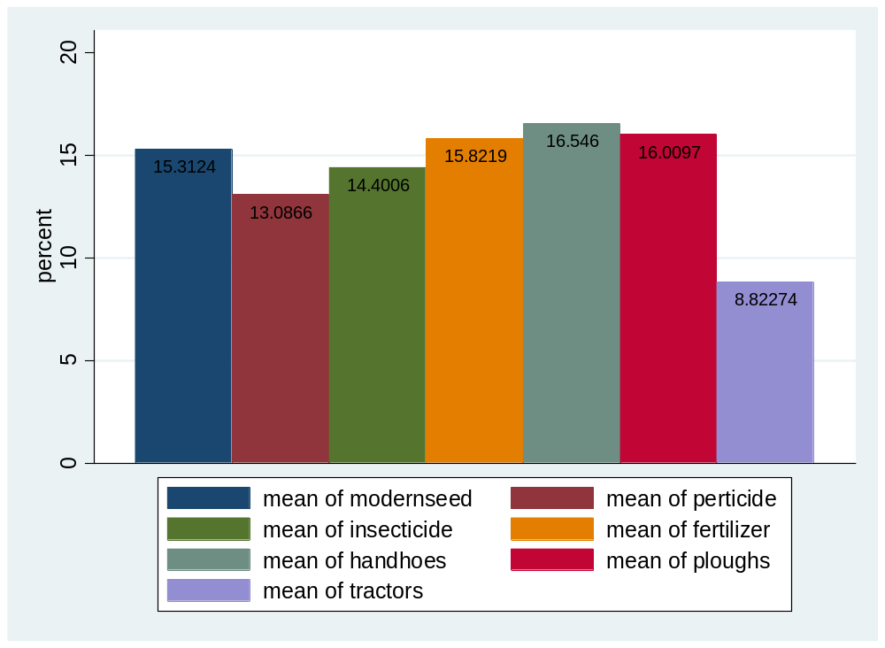

Figure 4.20 Respondents histogram for the control variables

Appendix IX: Pie Charts of the Control Variables

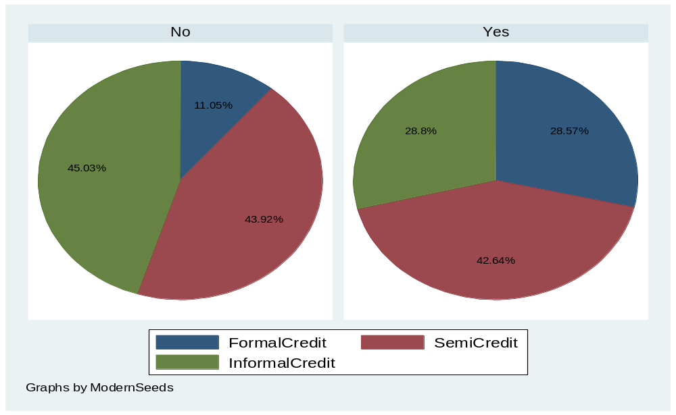

Figure 4.21: Respondents percentages for modern seeds
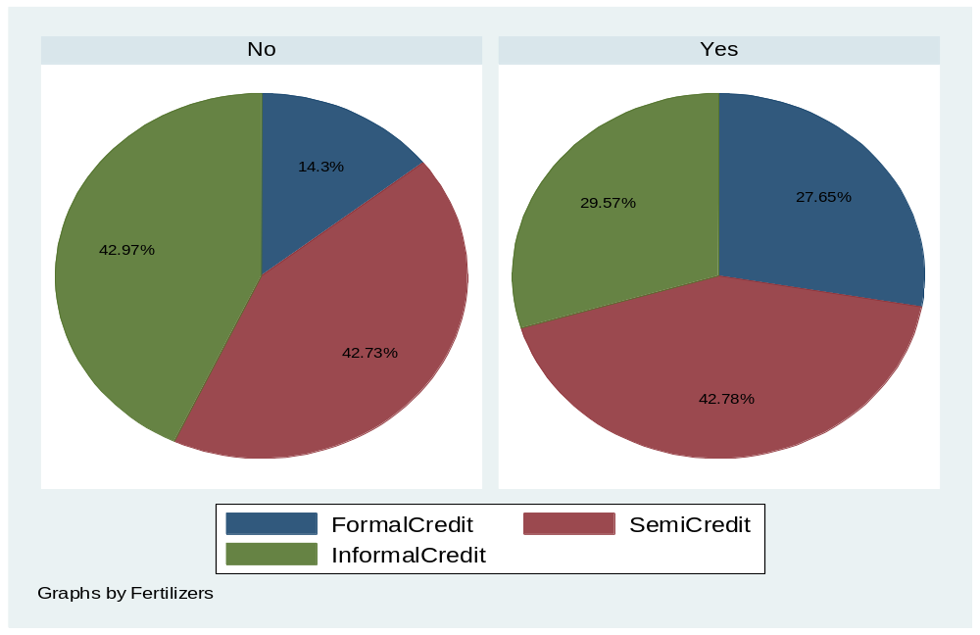

Figure 4.22: Respondents percentages for fertilizers

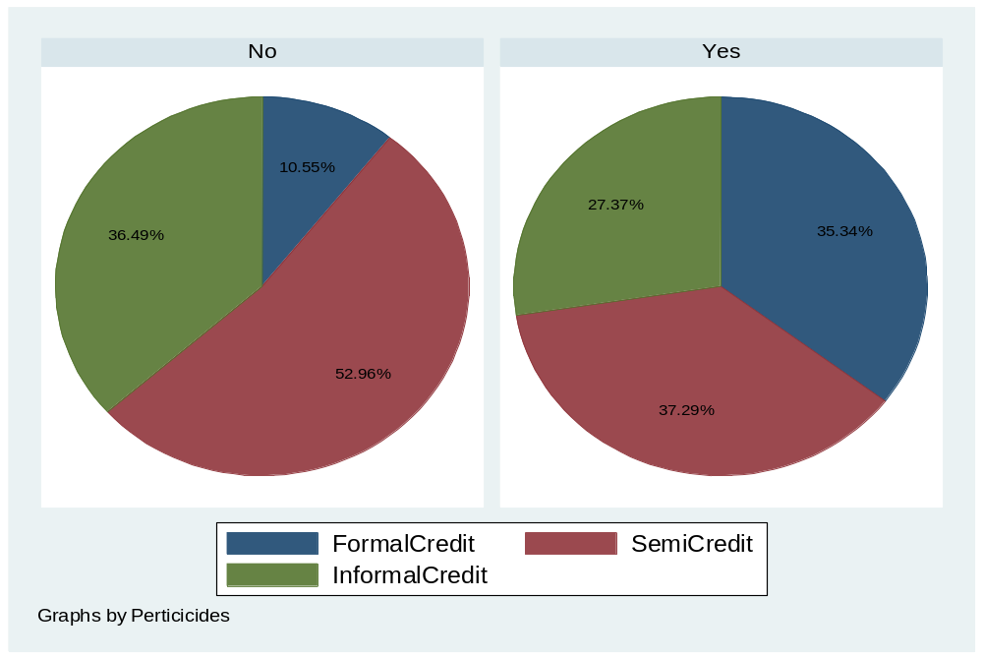

Figure 4.23: Respondents percentages for pesticides/Insecticides
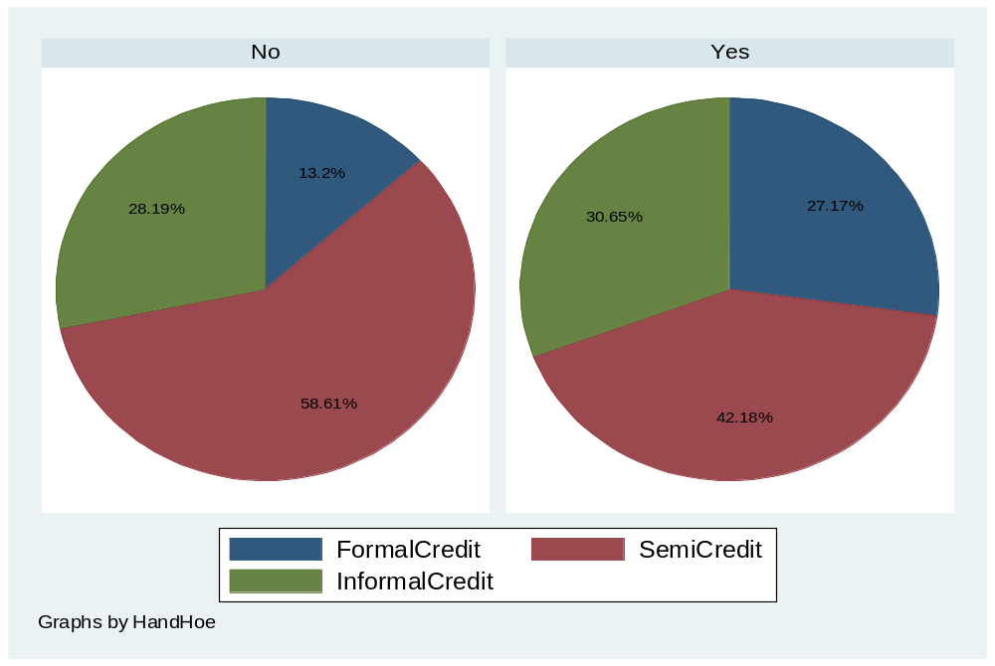

Figure 4.24 Respondents percentages for handhoe

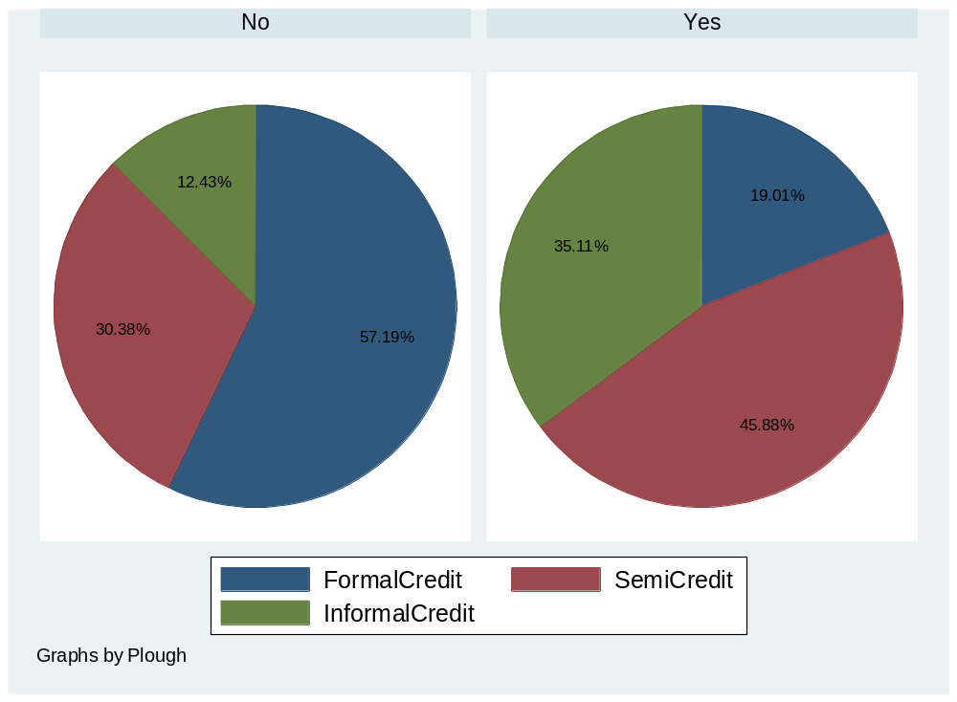

Figure 4.25: Respondents percentages for plough
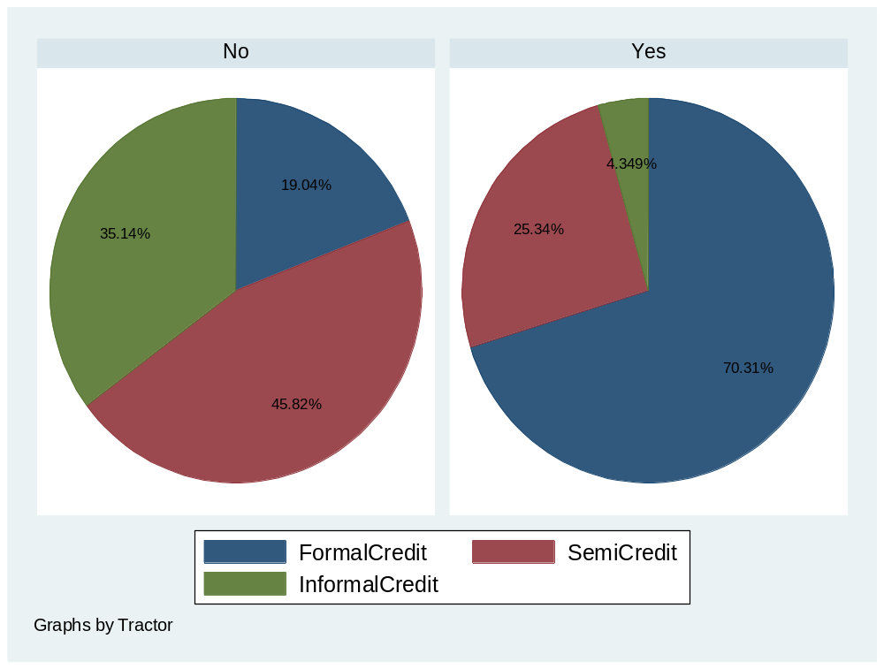

Figure 4.26 Respondents percentages for tractor

Appendix X: Map of Sumbawanga Rural and Mbozi Districts
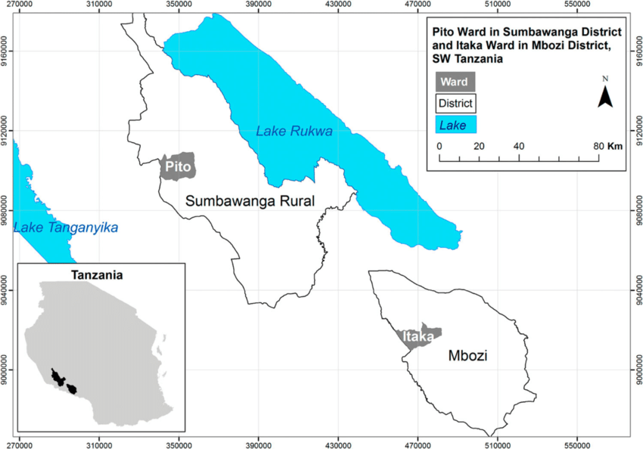
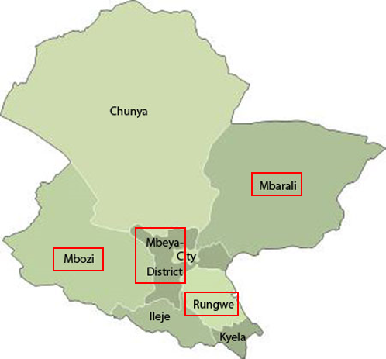
Source: (GoT, 2018)
THE OPEN UNIVERSITY OF TANZANIA

DIRECTORATE OF POSTGRADUATE STUDIES
P.O. Box 23409
Dar es Salaam, Tanzania http://www.openuniversity.ac.tz
Our Ref: PG201705106

Regional Administrative Secretary (RAS),
Rukwa Region
,P. 0. Box 128,
RUKWA.

RE: RESEARCH CLEARANCE
The Open University of Tanzania was established by an Act of Parliament No. 17 of 1992, which became operational on the 1st March 1993 by public notice No.55 in the official Gazette. The Act was however replaced by the Open University of Tanzania Charter of 2005, which became operational on 1st January 2007.In line with the Charter, the Open University of Tanzania mission is to generate and apply knowledge through research.
To facilitate and to simplify research process therefore, the act empowers the Vice Chancellor of the Open University of Tanzania to issue research clearance, on behalf of the Government of Tanzania and Tanzania Commission for Science and Technology, to both its staff and students who are doing research in Tanzania. With this brief background, the purpose of this letter is to introduce to you Mr.NDOLAGE Dionis Joseph Reg No: PG201705106 pursuing Doctor of Philosophy (Phd).We here by grant this clearance to conduct a research titled “Effect of Credit Facilities on Maize Productivity of Rural Smallholder Farmers in Mbozi and Sumbawanga Rural Districts in Tanzania”. He will collect his data at your area from 28th January 2020 to 28th December 2020.In case you need any further information, kindly do not hesitate to contact the Deputy ViceChancellor (Academic) of the Open University of Tanzania, P.O.Box 23409, Dar es Salaam.Tel:022-2-2668820.We lastly thank you in advance for your assumed cooperation and facilitation of this research academic activity.
Yours Sincerely,


Prof.Hossea Rwegoshora
For:VICECHANCELOR

