CRITICAL SUCCESS FACTORS FOR ADOPTION OF NATIONAL ELECTRONIC PROCUREMENT SYSTEM IN THE PUBLIC SECTOR IN TANZANIA

DEUS NICHODEMUS SHATTA

A THESIS SUBMITTED IN FULFILMENT OF THE REQUIREMENTS FOR THE DEGREE OF DOCTOR OF PHILOSOPHY
DEPARTMENT OF MARKETING AND ENTREPRENEURSHIP
THE OPEN UNIVERSITY OF TANZANIA

2020

CERTIFICATION

The undersigned certify that they have read and hereby recommend for acceptance by the Open University of Tanzania this thesis titled “Critical Success Factors for Adoption of National Electronic Procurement System in the Public Sector in Tanzania” in fulfilment of the requirements for the award of Degree of Doctor of Philosophy of the Open University of Tanzania.

……………………………
Dr. France A. Shayo
(Supervisor)

Date………………………

……………………………
Dr. John N. Layaa
(Supervisor)

Date………………………

DECLARATION

I, Deus Nichodemus Shatta, declare that this thesis titled “Critical Success Factors for Adoption of National Electronic Procurement System in the Public Sector in Tanzania” is my own original work and that it has not been presented and will not be presented anywhere or will not be presented to any other institution for any award.

……………………………….....
Signature

………………………………….
Date

COPYRIGHT
This thesis should not be reproduced by any means, in full or in part, except for short extract in fair dealings, for research or private study, critical scholarly review or discourse with an acknowledgement, without written permission of the Department of Marketing and Entrepreneurship on behalf of the author and the Open University of Tanzania.

ACKNOWLEDGEMENTS

First, I express my deepest appreciation to the almighty God, the source of knowledge in the pursuit of this PhD Degree. Secondly, I thank Dr. John N. Layaa of the National Institute of Transport and Dr. France A. Shayo of the Open University of Tanzania for their supervision, assistance, valuable comments and guidance throughout the process of writing the proposal and this thesis. Further, I wish to extend my appreciation and gratitude to Prof. Eliuther Mwageni, Prof. Joseph Hair and Prof. Christian Ringle for their facilitation on research methodology and quantitative data analysis workshops conducted at the National Institute of Transport and at the University of Dar es Salaam Business School. The facilitators of both workshops equipped me with knowledge and skills which I used to write this thesis.

Moreover, I acknowledge the permission that was given by many senior officials of selected procuring entities and suppliers to collect data and information of this thesis. These senior officials and their staffs took keen interest in the study and provided good cooperation in filling the questionnaires which were sent to them. Many thanks are due to my wife Magdalena Raymond, daughters Marian, Angel, Praise and friends Dr. A. Zuberi, Dr. Francis Muya, Dr. Ombeni Msuya, Dr. Robert Msigwa, Dr. Chacha Ryoba and Dr. A. Mchopa for their encouragement, material and moral support for this PhD programme.

DEDICATION

This thesis is dedicated to the almighty God, without whom this PhD programme would not have been successful. And for my loving family, whose outstanding moral and material support throughout the duration of my studies cannot be gainsaid.

ABBREVIATIONS AND ACRONYMS

AT Attitude
AT1 Attitude’ Indicator number one
AT2 Attitude’ Indicator number two
AT3 Attitude’ Indicator number three
AT4 Attitude’ Indicator number four
AT5 Attitude’ Indicator number five
E-Procurement Electronic Procurement
ICT Information and Communications Technologies
IPMA Importance-Performance Matrix Analysis
IT Information Technology
LF Legal Framework
LF1 Legal Framework’ Indicator number one
LF2 Legal Framework’ Indicator number two
LF3 Legal Framework’ Indicator number three
LF4 Legal Framework’ Indicator number four
LMICs Less-Middle-Income Countries
MGA Multi-Group Analysis
PE Performance Expectancy
PE1 Performance Expectancy’ indicator number one
PE2 Performance Expectancy’ indicator number two
PE3 Performance Expectancy’ indicator number three
PE4 Performance Expectancy’ indicator number four
PLS-MGA Partial Least Squares Multi-Group Analysis
PLS-SEM Partial Least Squares Structural Equation Modelling
PPA Public Procurement Act
PPR Public Procurement Regulation
PPRA Public Procurement Regulatory Authority
RA Relative Advantage
RA1 Relative Advantage’ Indicator number one
RA2 Relative Advantage’ Indicator number two
RA3 Relative Advantage’ Indicator number three
RA4 Relative Advantage’ Indicator number four
SmartPLS SmartPartial Least Squares
TA TANePS Adoption
TA1 TANePS Adoption’ Indicator number one
TA2 TANePS Adoption’ Indicator number two
TA3 TANePS Adoption’ Indicator number three
TA4 TANePS Adoption’ Indicator number four
TA5 TANePS Adoption’ Indicator number five
TA6 TANePS Adoption’ Indicator number six
TA7 TANePS Adoption’ Indicator number seven
TA8 TANePS Adoption’ Indicator number eight
TANePS Tanzanian National e-Procurement System
TOE Technology, Organization and Environment model
UTAUT Unified Theory of Acceptance and Use of Technology

ABSTRACT
This study aimed at examining the critical success factors influencing e-procurement adoption system in the public sector in Tanzania. In particular, the study assessed the influences and mediation effects of the legal framework, performance expectancy, relative advantage, and attitude towards e-procurement adoption. It adopted a deductive approach and a cross-sectional survey research design. Stratified sampling technique was used with a sample size of 157 respondents. Questionnaire and documentary review were used for data gathering. Some gathered data were analyzed using descriptive statistics with the help of IBM SPSS Statistics 21. Partial Least Squares Structural Equation Modeling with the help of SmartPLS 3 software was used for inferential statistical analysis. Findings reveal that the legal framework and relative advantage have indirect influences while performance expectancy has direct and indirect influences towards adoption of Tanzania National Electronic Procurement System. Additionally, attitude has direct influence towards adoption of the Tanzania National Electronic Procurement System. These findings imply that the decision of procurement experts and suppliers to adopt the system depends on awareness of all assessed critical success factors influencing the Tanzania National Electronic Procurement System. The study concludes that all assessed critical success factors have influences towards adoption of Tanzania National Electronic Procurement System. The study recommends to the government to strategize and ensure the benefits, performance expectancy and the legal framework supporting the adoption of Tanzania National Electronic Procurement System are realized by all users of the public procurement system towards its reform and expansion.
Keywords: Adoption, attitude, performance, legal framework and relative advantage

TABLE OF CONTENTS
CERTIFICATION i
DECLARATION ii
ACKNOWLEDGEMENTS iv
DEDICATION v
ABBREVIATIONS AND ACRONYMS vi
ABSTRACT. viii
TABLE OF CONTENTS ix
LIST OF TABLES xx
LIST OF FIGURES xxii

CHAPTER ONE: INTRODUCTION 1
1.1 Chapter Overview 1
1.2 Background to the Study 1
1.3 Statement of the Problem 9
1.4 Objectives of the Study 10
1.4.1 General Objective 10
1.4.2 Specific Objectives 10
1.5 Significance of the Study 11
1.6 Organization of the Study 12

CHAPTER TWO: LITERATURE REVIEW 14
2.1 Chapter Overview 14
2.2 Conceptual Definitions 14
2.2.1 E-procurement 14
2.2.2 Adoption 15
2.2.3 TANePS Adoption 15
2.2.4 Critical Success Factors 17
2.3 Theoretical Literature Review 17
2.3.1 Constructs and Relationships of TOE Model which are Known 19
2.3.1.1 Modified TOE Models 20
2.3.2 Constructs and Relationships of TOE Model which are Not Known 22
2.3.3 Criticism of the TOE Model 23
2.3.4 Constructs and Relationships of UTAUT which are Known 24
2.3.5 Constructs and Relationships of UTAUT which are Not Known 27
2.3.6 Criticism of UTAUT 28
2.3.7 Criticism of UTAUT and TOE Models in Relation to the Study 29
2.4 Empirical Literature Review 30
2.4.1 Influence of Legal Framework towards New Technologies Adoption 30
2.4.2 Influence of Performance Expectancy towards New Technologies Adoption 35
2.4.3 Influence of Relative Advantage towards New Technologies Adoption 41
2.4.4 Influence of Attitude towards New Technologies Adoption 44
2.4.5 Mediation Effects of Performance Expectancy, Relative Advantage and Attitude towards New Technologies Adoption 46
2.4.6 Perception of Procurement Experts and Suppliers on Critical Success Factors Influencing e-Procurement Adoption 48
2.5 Synthesis of Theoretical Literature Review 51
2.6 Synthesis of Empirical Literature Review 51
2.6.2 Contextual Gap 53
2.6.3 Methodological Gap 53
2.7 Model Constructs Description and Hypotheses Formulation 54
2.7.1 TANePS Adoption (TA) 55
2.7.2 Legal Framework (LF) 56
2.7.3 Performance Expectancy (PE) 58
2.7.4 Relative Advantage (RA) 59
2.7.5 Attitude (AT) 60
2.7.6 Perception 62
2.8 Conceptual Model 62
2.8.1 Hypotheses Generated from the Conceptual Model 63
2.8.2 Relationships of Constructs 65

CHAPTER THREE: RESEARCH METHODOLOGY 68
3.1 Chapter Overview 68
3.2 Research Philosophy 68
3.3 Research Strategy 69
3.3.1 Area of the Study 69
3.3.2 Unit of Analysis 70
3.3.3 Survey Population 70
3.3.4 Sample Size 70
3.3.5 Sampling Frame 71
3.3.6 Sampling Design and Procedures 71
3.4 Variables and Measurement Procedures 72
3.5 Data Collection Methods and Tools 73
3.5.1 Survey and Questionnaire 73
3.5.2 Documentary Review 74
3.6 Measurement of Respondents’ General Information and Variables 74
3.6.1 Measurement of Respondents’ General Information 74
3.6.2 Measurement of Dependent and Independent Variables 75
3.7 Data Processing and Analysis 75
3.8 Assumptions Underlying PLS -SEM 76
3.8.1 The Good Neighbor Assumption (GNA) 76
3.8.2 The Distribution of Variable Assumption 77
3.8.3 Missing Values and Outliers Assumptions 77
3.8.4 Relationships with Good Theoretical Support Assumption 77
3.9 PLS- SEM Algorithms 78
3.9.2 PLS-SEM Path Mode 78
3.10 Evaluation of Mediation Effects 79
3.11 Steps for Testing Mediating Effects 81
3.12 Step-by-Step Procedures Employed in SmartPLS 82
3.12.1 Importing Data File in SmartPLS 3 software 82
3.12.2 Creating a New Project and Insert Data in SmartPLS 3 software 82
3.12.3 Drawing the Conceptual Path Model in SmartPLS 3 Software 83
3.12.4 Naming and Connecting the Latent Variables in SmartPLS 3 Software ss 84
3.12.5 Aligning Indicators and Latent Variables in SmartPLS 3 Software 85
3.12.6 Executing the PLS algorithm in SmartPLS 3 Software 85
3.12.7 Bootstrapping Process in SmartPLS 3 Software 85
3.12.8 Multi-Group Analysis (MGA) in SmartPLS 3 Software 86
3.13 Global Goodness of Fit Criterion and Prediction for PLS SEM 87
3.14 PLS-SEM Evaluation Procedures for Reflective Models 88
3.8 Assessing Reflective Measurement Models 89
3.8.1 Examining the Indicator Loadings (Reliabilities) 89
3.8.2 Assessing Internal Consistency Reliability 89
3.8.3 Assessing the Convergent Validity 90
3.8.4 Assessing the Discriminant Validity 90
3.9 Evaluation of the Structural Model Procedures 91
3.9.1 Assessing Reflective Structural Models 92
3.9.1.1 Assessing Collinearity 92
3.9.1.2 Examining the R2 Value of the Endogenous Constructs 92
3.9.1.3 Examining the f2 Effect Size 93
3.9.1.4 Examining the Q2 values of the Endogenous Constructs 93
3.9.1.5 Examining the Statistical Significance and Relevance of the Path Coefficients 94
3.9.1.6 Importance-Performance Matrix Analysis (IPMA) 94
3.10 Reliability of Data 95
3.11 Validity of Data 96
3.12 Technique of Handling Missing Values 96
3.13 Techniques of Identifying and Handling Outliers 96
3.14 Ethical Considerations 97

CHAPTER FOUR: DATA ANALYSIS AND FINDINGS 98
4.1 Chapter Overview 98
4.2 Findings from Pilot Study 98
4.2.1 Pilot Study Findings for Assessing Reflective Measurement Models 99
4.2.1.1 Internal Consistency Reliability 99
4.2.1.2 Constructs’ Convergent Validity 100
4.2.2 Pilot Study Findings for Assessing Reflective Structure Models 101
4.2.2.1 Examining Coefficient of Determination (R2) 101
4.2.2.2 Examining the Size of Path Coefficient 101
4.2.2.3 Examining the Significance of Path Coefficient 102
4.3 Findings from Main Study 105
4.3.1 Rate of Respondents 105
4.3.2 Demographic Characteristics of the Respondents 107
4.3.2.1 Sex of the Respondents 107
4.3.2.2 Age of the Respondents 107
4.3.2.3 Education of the Respondents 108
4.3.2.4 The Type of Respondents 108
4.3.2.5 Experience of Respondents 109
4.3.2.6 Mean and Standard Deviation of the Respondents’ Age 110
4.3.2.7 Education Level of Respondents against Type of Respondent 110
4.3.2.8 Mean and Standard Deviation of the Respondents’ Experience 112
4.3.3 Data Analysis for Specific Objectives 113
4.3.3.1 Assessing Reflective Measurement Models 113
4.3.3.1.1 Indicator’s (Loadings) Reliabilities 113
4.3.3.1.2 Internal Consistency Reliability and Convergent Validity Results 114
4.3.3.1.3 Discriminant Validity Results by using HTMT 115
4.3.3.2 Assessing Structural Models 116
4.3.3.2.1 Collinearity Statistics (VIF) 116
4.3.3.2.2 Assessing R2 Value of the Endogenous Constructs 117
4.3.3.2.3 F Squared Effect Size (f2) 117
4.3.3.2.4 Q Squared for Endogenous Constructs for Prediction 118
4.3.3.2.5 Assessing Relevance of the Path Coefficients 120
4.3.3.2.6 Statistical Significance of the Hypothesized Relationships 120
4.3.3.2.7 PLS-Multi-Group Analysis of the Hypothesized Perception 123
4.3.3.2.7.1 PLS-Multi-Group Analysis for Outer Loadings of the Indicators 123
4.3.3.2.7.2 PLS-Multi-Group Analysis for Indirect Effects Constructs 125
4.3.3.2.7.3 PLS-Multi-Group Analysis for Total Effects of the Constructs 126
4.3.3.2.8 Assessing Importance-Performance of the Constructs and Indicators 127
4.3.3.2.8.1 Assessing Importance-Performance of the Indicators 127
4.3.3.2.8.2 Assessing Importance-Performance of the Constructs 128

CHAPTER FIVE: DISCUSSION OF FINDINGS 130
5.1 Chapter Overview 130
5.2 Influences of Hypothesized Critical Success Factors towards TANePS Adoption 130
5.2.1 Direct and Indirect Influences of Legal Framework towards TANePS Adoption 131
5.2.2 Direct and Indirect Influences of Performance Expectancy on TANePS Adoption 133
5.2.3 Direct and Indirect Influences of Relative Advantage on TANePS Adoption 135
5.2.4 Direct Influence of Attitude on TANePS Adoption 137
5.3 Perception of Procurement Experts and Suppliers on Critical Success Factors Influencing TANePS Adoption 138
5.4 Comparison of Overall Explanatory Power of the Final Conceptual Model 140
5.5 Comparison of Direct and Indirect Path Coefﬁcients and P-values 143

CHAPTER SIX: SUMMARY OF FINDINGS, CONCLUSIONS AND RECOMMENDATIONS 149
6.1 Chapter Overview 149
6.2 Summary of Findings 149
6.2.1 Direct Influence of Legal Framework towards TANePS Adoption 149
6.2.2 Direct Influence of Performance Expectancy towards TANePS Adoption 149
6.2.3 Direct Influence of Relative Advantage towards TANePS Adoption 150
6.2.4 Direct Influence of Attitude towards TANePS Adoption 150
6.2.5 Mediation Effects of Performance Expectancy, Relative Advantage and Attitude towards TANePS Adoption 150
6.3 Implications of the Results 151
6.3.1 Direct Influence of Legal Framework towards TANePS Adoption 151
6.3.2 Direct Influence of Performance Expectancy towards TANePS Adoption 151
6.3.3 Direct Influence of Relative Advantage towards TANePS Adoption 152
6.3.4 Direct Influence of Attitude towards TANePS Adoption 152
6.3.5 Mediation Effects of Performance Expectancy, Relative Advantage and Attitude towards TANePS Adoption 152
6.3.6 Theoretical Knowledge Implication of the Study Findings 153
6.3.6.1 Justification of Theoretical Implication of the Study Findings 154
6.3.6.2 Variations of Overall Explanatory Power 155
6.3.6.3 Variations of Percentage of Supported Hypothesized Relationships 156
6.3.6.4 Variations of Overall Explanatory Power for Direct Relationships Only 156
6.3.7 Empirical Implications of the Study Findings 161
6.3.8 Practical Implications of the Study Findings 162
6.3.9 Policy Implications of the Study Findings 163
6.4 Conclusions 163
6.4.1 Direct Influence of Legal Framework towards TANePS Adoption 163
6.4.2 Direct Influence of Performance Expectancy towards TANePS Adoption 164
6.4.3 Direct Influence of Relative Advantage towards TANePS Adoption 164
6.4.4 Direct Influence of Attitude towards TANePS Adoption 164
6.4.5 Mediation Effects of Performance Expectancy, Relative Advantage and Attitude towards TANePS Adoption 165
6.4.6 Perception of Procurement Experts and Suppliers on Critical Success Factors Influencing TANePS Adoption in the Public Sector 165
6.5 Limitations and Delimitations of the Study 166
6.6 Recommendations of the Study 167
6.6.1 Recommendations to the Government 167
6.6.2 Recommendations to the PPRA 168
6.6.3 Recommendations to the Policymakers 168
6.6.4 Recommendations to Procurement Experts and Suppliers 169
6.7 Areas for Further Research 170

REFERENCES 173

APPENDICES 185

APPENDIX A: QUESTIONNAIRE 185
APPENDIX B: RESEARCH CLEARANCE LETTER 188
PENDIX C: LIST OF PROCURING ENTITIES IMPLEMENTING TANePS 189
APPENDIX D: LIST OF ACCEPTANCE LETTERS 191
APPENDIX E: LIST OF SOME SUPPLIERS IMPLEMENTING TANePS 203
APPENDIX F: LIST OF E-MAIL OF SOME SUPPLIERS RESPONDED 205
APPENDIX G: TIME AND RESEARCH BUDGET FOR PhD PROGRAM 206
APPENDIX H: RESEARCH FINDINGS 207
APPENDIX I: PUBLISHED PAPERS 217
APPENDIX J: PAPERS ACCEPTED FOR PUBLICATION 218

LIST OF TABLES
Table 2.1: Theories’ Emphasis against Missing Important Aspects 29
Table 2.2: Existing Empirical Literature Related to E-Procurement Adoption 50
Table 2.3: Hypotheses Generated from the Conceptual Model 64
Table 2.4: Constructs and Survey Items 67
Table 3.1: Sampling Frame 71
Table 3.2: Variables, Indicators, Level of Measurement, Data Analysis Method and Tool. 73
Table 3.3: Evaluation of the Measurement Model Using the Criteria 91
Table 3.4: Evaluation of the Structural Model Using the Established Criteria 95

Table 4.1: Hypotheses Tested for Pilot Analysis 104
Table 4.2: Respondents’ Rate 107
Table 4.3: Demographic Characteristics of the Respondents (n=157) 109
Table 4.4: Education Level of Respondents against Type of Respondents 111
Table 4.5: Internal Consistency Reliability and Convergent Validity Results 115
Table 4.6: Discriminant Validity Results 115
Table 4.7: Collinearity Statistics (VIF) 116
Table 4.8: f Squared Value 118
Table 4.9: The Values of Q Squared for Endogenous Constructs 119
Table 4.10: Hypotheses Tested from the Conceptual Model 122
Table 4.11: PLS-Multi-Group Analysis for Outer Loadings of the Indicators 124
Table 4.12: PLS-Multi-Group Analysis for Indirect Effects of the Constructs 125
Table 4.13: PLS-Multi-Group Analysis for Total Effects 126
Table 5.1: Studies on IT Adoption with Variations/Similarities of Model vs R2 142
Table 5.2: Summary of Results Generated from the Final Conceptual Model 147

LIST OF FIGURES
Figure 2.1: Three Context Group Elements of TOE and their Implications 20
Figure 2.2: Modified TOE Model by Hue (2019) 21
Figure 2.3: Modified TOE Model by Chege and Wang (2020) 22
Figure 2.4: Unified Theory of Acceptance and Use of Technology (UTAUT) 25
Figure 2.5: Modified UTAUT by Chen et al. (2011) 26
Figure 2.6: Modified UTAUT by Dwivedi et al. (2017) 27
Figure 2.7: Conceptual Model 63

Figure 3.1: PLS Mode A 79
Figure 3.2: Concept of Mediation Effects Evaluation Procedures 79
Figure 3.3: Mediator Analysis Procedure Number Two 80
Figure 3.4: Mediator Analysis Procedure Number Three 81

Figure 4.1: Constructs’ Reliability by Composite Reliability 100
Figure 4.2: Constructs’ Convergent Validity 100
Figure 4.3: Endogenous Constructs’ Coefficient of Determination (R²) 101
Figure 4.4: The Size of Path Coefficients of the Research Model 102
Figure 4.5: Significance of Path Coefficient after Running Bootstrapping 103
Figure 4.6: Mean and Standard Deviation of the Respondents’ Ages 110
Figure 4.7: The Mean and Standard Deviation of the Respondents’ Experience 112
Figure 4.8: Indicator’s (Loadings) Reliabilities 114
Figure 4.9: R2 Value of the Endogenous Constructs 117
Figure 4.10: Q Squared for Endogenous Constructs for Prediction 119
Figure 4.11: Path Coefficients 120
Figure 4.12: Statistical Significance of the Hypothesized Relationships 121
Figure 4.13: Importance-Performance of Constructs and Indicators 127
Figure 4.14: Importance-Performance Map (TA) (Indicators Unstandardized Effects) 128
Figure 4.15: Importance-Performance Map (TA) (Constructs Unstandardized Effects) 129

Figure 5.1: Final Conceptual Model for TANePS Adoption 146
Figure 6.1: Extended TOE Model 154
Figure 6.2: The Changes of the Overall Explanatory Power 155
Figure 6.3: The Changes of the Supported Hypothesized Relationships 156
Figure 6.4: Overall Explanatory Power for Modified Model 157
Figure 6.5: Supported Hypothesized Relationships Modified Model 158
Figure 6.6: Recommended Conceptual Model for New Technology Adoption 171

CHAPTER ONE

INTRODUCTION

1.1 Chapter Overview
This chapter comprises the background to the study, statement of the problem, objectives of the study, significance of the study, and organization of the study.

1.2 Background to the Study
In the new global economy, new technologies adoption has become a central issue and has attracted many researchers from developed and developing countries (Adjei-Bamfo et al., 2020; Adjei-Bamfo & Maloreh-Nyamekye, 2019; Kassim &Hussin, 2013; Klabi, Mellouli, & Rekik, 2016; Malekia, 2018; Masele, 2014; Pitso, Kabanda, &Kapepo, 2018; Shatta, Shayo, & Layaa, 2020a; Suleiman, 2015; Tutu, Kissi, Osei-Tutu, & Desmond, 2019; Watuleke, 2017; Zhang, Sun, Yang, & Wang, 2020). In addition, many countries around the world are increasingly becoming focused on improving their public procurement systems both in terms of their legal frameworks and their practical procedures towards e-procurement adoption and sustainable public procurement (Adjei-Bamfo & Maloreh-Nyamekye, 2019; Schooner et al., 2008),

However, there has been an inconclusive debate by researchers on the critical success factors influencing new technologies adoption including e-procurement adoption in the public sector (Adjei-Bamfo et al., 2020; Adjei-Bamfo & Maloreh-Nyamekye, 2019; Kassim &Hussin, 2013; Mohammed, Ibrahim, Nilashi, & Alzurqa, 2016; Pitso et al., 2018; Shale, 2014; Shatta et al., 2020a; Suleiman, 2015; Tutu et al., 2019; Watuleke, 2017; Zhang et al., 2020). Some studies point out coercive pressure (legal framework) of the country, perceived performance expectancy of the system, relative advantage (perceived benefits) of the system and the attitude of top management and users of the new system as the most critical success factors influencing e-procurement adoption (Iles, 2017; Suleiman, 2015; Monczka & Carter, 2015; Kassim & Hussin, 2013). Other studies contend that internal needs, improved customer relations, reduction of labour costs, employees and management commitment to success of adoption; reliability of information technology and supplier performance; monitoring the performance of e-procurement systems; user acceptance of e-procurement systems and top management support, the benefits of e-procurement in enhancing efficiency in delivery; effective communication and eliminating geographic barriers are critical success factors influencing e-procurement adoption (Ibem et al., 2016; Mose et al.,2013; Watuleke, 2017; Mgidlana, 2013).

The debate by authors on critical success factors influencing new technologies adoption has led to variations of the overall explanatory power of research models intending to use new technologies (Adjei-Bamfo et al., 2020; Kassim & Hussin, 2013; Klabi et al., 2016; Masele, 2014; Shatta et al., 2020a; Taluka, 2016). Likewise, the differing views of authors on the critical success factors influencing new technologies adoption have led to similarities of the overall explanatory power of research models for intention to use new technologies (Aboelmaged, 2010; Zhang et al., 2020). Currently, there exists no agreed critical success factors, theory or methodology to explain new technologies systems adoption and this situation has attracted this study to debate on critical success factors for adoption of electronic procurement system in public sector.

On the other hand, studies concerning e-procurement adoption in most developing countries particularly in Africa have revealed common challenges and barriers of e-procurement adoption (Bawole & Adjei-Bamfo, 2019; Pitso et al., 2018). The common challenges and barriers include lack of legal frameworks which support e-procurement adoption, lack of perceived benefits of e-procurement system among users, lack of awareness of e-procurement performance expectancy among key users and diverse attitude of users towards e-procurement adoption (Adjei-Bamfo & Maloreh-Nyamekye, 2019; Ibrahim, Bawole, Obuobisa-Darko, Abubakar, & Kumasey, 2017; Latif, 2014; Pitso et al., 2018; Shatta, Shayo, & Layaa, 2020b; Suleiman, 2015; Tutu et al., 2019). The existing empirical studies and theories recognize the critical role played by legal framework, performance expectancy, relative advantage (perceived benefits) and attitude in influencing new technologies adoption (Suleiman, 2015; Tornatzky &Fleischer, 1990; Venkatesh et al., 2003).

However, these existing empirical studies and theories have consistently shown inadequate consideration of mediation effects of the critical success factors influencing new technologies adoption (Masele, 2014; Suleiman, 2015; Taluka, 2016; Tornatzky &Fleischer, 1990; Venkatesh et al., 2003). On the other hand, it is important to consider mediation effects of critical success factors influencing new technologies adoption because they are the foremost determinants of theoretical knowledge contribution in the study, source of explaining comprehensively the phenomena under the study and are determinants of extension of the theory or model adopted by a given study (Hair et al. 2018). Taking into account the complexity of e-procurement adoption, the debate of prior researchers on critical success factors influencing e-procurement adoption and the importance of mediation effects on new technologies adoption, it was valuable for this research to be conducted on this topic to address the complexity of e-procurement adoption by using mediation effects of the critical success factors and theorizing procedures (Hair et al. 2018; Zhou, Shafiq, Adeel, Nawaz, & Kumar, 2017). This study attempts to examine on the perceived critical success factors influencing Tanzania National electronic Procurement System (TANePS) adoption in the public sector drawing on two schools of thought: the first one is the Technology, Organization and Environment (TOE) model by Tornatzky and Fleischer (1990) which includes legal framework, relative advantage (perceived benefits) and attitude as critical success factors for new technologies adoption.

Secondly, the Unified Theory of Acceptance and Use of Technology (UTAUT) by Venkatesh, Morris, Davis, & Davis (2003) which includes performance expectancy as one of the critical success factors for new technologies adoption. These critical success factors for new technologies adoption from TOE model and UTAUT have been used in many empirical studies to predict and understand the adoption of new technologies including e-procurement adoption (Chen, Kuan, Lee, & Huang, 2011; Dwivedi, Rana, Jeyaraj, Clement, & Williams, 2017; Kassim &Hussin, 2013; Masele, 2014; Shatta et al., 2020a; Taluka, 2016; Xu, Ou, & Fan, 2015; Zhang et al., 2020). TOE model by Tornatzky and Fleischer (1990) suggests that legal framework, relative advantage, and attitude are thought to inﬂuence new technologies adoption and UTAUT by Venkatesh et al. (2003) suggests that performance expectancy is thought to inﬂuence new technologies adoption. However, value addition for new technologies adoption (i.e. e-procurement adoption) includes paperwork reduction, better compliance, reduction of errors, reduction of ordering cost, reduction of cycle time, standardized procedures, achieve competitive bids, increased transparency and increased fairness (Masele, 2014; Suleiman, 2015; Taluka, 2016; Tornatzky &Fleischer, 1990; Venkatesh et al., 2003).

Coercive pressure (legal framework) is a major determinant of the intention to use new technologies adoption systems, which in turn generates the actual usage behaviour (Shatta et al., 2020a; Tornatzky &Fleischer, 1990). The underlying principle is that organizations make decisions rationally and systematically on the basis of the system available (Tornatzky &Fleischer, 1990; Zhang et al., 2020). However, there is a number of cross-sectional studies in the context of new technologies adoption particularly e-procurement adoption which hypothesized coercive pressure (legal framework) to inﬂuence directly behavioural intention to use a new technology system (Ibrahim, Bawole, Obuobisa-Darko, Abubakar, & Kumasey, 2017; Shatta et al., 2020b). However, less attention has been paid with regard to the indirect legal framework influences through performance expectancy, relative advantage and attitude behavioural intention to use a new technology system. Legal framework in procurement perspective is defined as the entire set of legal instruments that contains rules concerning the process of acquiring goods, works and services by public sector entities which includes institutional arrangements required to ensure the proper adoption of these rules or laws, Acts, Decrees, Circulars or Regulations (Mrope, 2018).

Performance expectancy is also thought to inﬂuence the new technology adoption (Venkatesh et al., 2003). This argument was supported by Aboelmaged (2010) who asserted that the easier it is to use technology, the greater the expected beneﬁts from the technology with regard to performance enhancement. The underlying principle is that individuals make decisions rationally and systematically on the basis of the system available (Masele, 2014; Taluka, 2016; Venkatesh et al., 2003). Nevertheless, there is a growing body of literature in the context of new technologies adoption which hypothesized performance expectancy to inﬂuence directly behavioural intention to use a new technology system in public and private sectors (Masele, 2014; Shatta et al., 2020a; Taluka, 2016). However, less consideration has been shown by the growing body of literature in the context of new technologies adoption which hypothesized the indirect performance influences through relative advantage and attitude behavioural intention to use a new technology system (Shatta et al., 2020a). Performance expectancy is defined as a degree to which using technology will provide benefits to consumers in performing certain activities, and is theorized to influence behavioural intention to use technology (Venkatesh et al., 2012).

In addition, relative advantage is thought to inﬂuence the new technologies adoption (Rogers, 2003; Tornatzky & Fleischer, 1990). The easier it is to use technology, the greater the expected beneﬁts (relative advantage) from the new technology adoption (Aboelmaged, 2010). Nonetheless, there is a considerable amount of literature which has been published in the context of new technologies adoption and hypothesized relative advantage to inﬂuence directly behavioural intention to use a new technology system (Shatta et al., 2020b; Shatta et al., 2020c). However, less contemplation has been shown by the growing body of literature in the context of new technologies adoption which hypothesized relative advantage influences indirectly through attitude behavioural intention to use a new technology system (Shatta et al., 2020d). Relative advantage is the extent to which the innovation is viewed by users to be better than the existing idea; i.e. perceived cost and benefits (Rogers, 2003).

Attitude is believed to inﬂuence the new technologies adoption and is a major determinant of the intention to use new technologies adoption (Tornatzky & Fleischer, 1990). Nonetheless, there are sufficient empirical studies in the context of new technologies adoption routinely e-procurement adoption which hypothesized attitude to inﬂuence behavioural intention to use a new technology system in public and private sectors (Dwivedi et al., 2017; Kassim &Hussin, 2013; Masele, 2014; Shatta et al., 2020b). However, less observation has been shown by the growing body of literature in the context of new technologies adoption which hypothesized attitude mediates legal framework, performance expectancy and relative advantage towards behavioural intention to use a new technology system (Shatta et al., 2020c; Shatta et al., 2020d). Attitude is defined as an individual’s positive or negative feelings about performing the target behaviour (Dwivedi et al., 2017).

TANePS adoption is influenced by the legal framework (coercive pressure), performance expectancy of the system, relative advantage (perceived benefits) of the system, the attitude of users of the system towards its reform and adoption (Shatta et al., 2020a). TANePS adoption is defined as a decision by the Government of Tanzania to make complete use of an innovation and ICT to conduct public procurement functions (Shatta et al., 2020c). The Government of Tanzania, beginning in the mid-1990s, has initiated a number of procurement reforms in its public procurement system with the aim of making it more efficient and transparent (URT, 2012). The basic barrier and challenges which faced the country towards e-procurement adoption included lack of legal framework (Public Procurement Act and Public Procurement Regulations) which supported e-procurement adoption, lack of perceived benefits of e-procurement system among top management and users, lack of awareness of e-procurement performance expectancy among key users (procurement experts and suppliers) and diverse attitude of the top management and users towards e-procurement adoption (Suleiman, 2015; URT, 2011).

In addition, lack of internet infrastructure and reliable electricity were also basic challenges towards e-procurement adoption (Suleiman, 2015). However, repealing of the Public Procurement Act (PPA) of 2004 and its Public Procurement Regulation (PPR) of 2005 in 2011 and 2013 respectively was an important step to bridge the barrier towards Tanzania National e-Procurement System (TANePS) adoption (URT, 2016). In addition, training of procurement experts from selected procuring entities and suppliers with regard to the performance and benefits of TANePS was another important stage for changing the attitude of procurement experts and suppliers towards its piloting and adoption (Shilla, 2019; URT, 2018).

1.3 Statement of the Problem
Regardless of the training conducted for procurement experts and suppliers on performance and benefits of TANePS, 30.9 per cent of the trained suppliers for piloting the system in the country were reluctant to register in the system and 1.2 per cent of registered suppliers deregistered from the system (URT, 2018; URT, 2019). Likewise, 63.4 per cent of the selected procuring entities for piloting TANePS were not implementing the system (Shilla, 2019; URT, 2019) and 60 per cent of the trainees (staff from procuring entities) did not understand the performance of the system during massive training (Shilla, 2019). This phenomenon posed a serious problem which has not been addressed by the current empirical studies. Therefore, there was a need to understand the perceptions of procurement experts and suppliers that exist on critical success factors influencing TANePS adoption. What was not yet clear was about the critical success factors and their mediation effects towards TANePS adoption.

Most of the previous studies related to e-procurement adoption in developing countries (Adjei-Bamfo et al., 2020; Adjei-Bamfo & Maloreh-Nyamekye, 2019; Ibrahim et al., 2017; Mgidlana, 2013; Pitso et al., 2018; Tutu et al., 2019; Watuleke, 2017), Tanzania in particular (Malekia, 2018) focused on critical success factors which were not in line with the basic challenges faced by many developing countries towards e-procurement adoption. In addition, prior studies focused on either buyer perspective or on supplier perspective and less attention was paid to the focus of both perspectives. Furthermore, prior studies had shown less consideration of mediation effects of the critical success factors to address the complexity of e-procurement adoption. Above all, neither TOE model nor UTAUT has been found to provide a concrete model which explains the mediation effects or the two perspectives (organization perspective (procuring entity i.e, buyer) and individual perspective (i.e, supplier) of which this study has addressed to comprehend the existing problem and fill the empirical and theoretical gaps.

1.4 Objectives of the Study

1.4.1 General Objective
The general objective of this study was to examine the perceived critical success factors and their mediation effects towards TANePS adoption.

1.4.2 Specific Objectives
The following were the specific research objectives of the study:
- To assess the direct influence of legal framework on TANePS adoption
- To assess the direct influence of performance expectancy on TANePS adoption.
- To assess the direct influence of relative advantage (perceived benefits) on TANePS adoption.
- To assess the direct influence of attitude on TANePS adoption.
- To assess the mediation effects of performance expectancy, relative advantage and attitude towards TANePS adoption.

1.5 Significance of the Study
The study findings would generate new knowledge which is useful to researchers, development planners, public procurement policymakers, donors and procurement practitioners especially the key players of the public procurement process. The study is also relevant to the community because suggestions which have been provided in this study might be useful to avert corrupt practices in the public procurement processes. Moreover, this study may boost the efforts of the Government and PPRA in reviewing training approach concerning the benefits, performance and legal framework which governs TANePS adoption, hence bring better operation in the whole country. The study also would enable the Government leaders and policymakers to have a framework of analysis for decision making with regard to the public procurement key stakeholders’ (buyers’ and suppliers’) perception on TANePS adoption. Furthermore, the findings of this study would help to add the missing literature regarding buyers’-suppliers’ perspectives on e-procurement adoption.

In addition, the findings of this study would be of significant contribution in terms of theoretical knowledge by introducing a new integrative model with direct-indirect relationships of its constructs that accommodates buyers’-suppliers’ perspectives of which the existing theories and models are lacking. Empirically, the study of two perspectives and the approach of deductive forecasting-comparison research relations would be added in the existing literature. Also, the findings and recommendations of this study were anticipated to improve the adoption of TANePS in all procuring entities in the country.

1.6 Organization of the Study
This thesis report comprises of six chapters, which include Chapter One for the introduction to the topic of the thesis. This chapter introduces the overview of the thesis, background of the study, statement of the problem, research objectives, significance of the study and the organization of the thesis. Moreover, the chapter contains information that provides a clear picture of the thesis, what this thesis means and how it has been approached. Chapter Two is for literature review (theories and empirical). The review of literature covers seven main parts; conceptual definitions, presentation of the underpinning conceptual framework of the study, review of previous studies on the critical success factors influencing e-procurement adoption and success of the public e-procurement system, research gap, synthesis of conceptual and empirical literature review, a conceptual model of the study and the operational definitions of the constructs. Chapter Three is for research methodology. In this chapter, it is clearly described how data and information were collected, analysed, and presented.

The chapter covers research philosophy, research strategy, survey population, area of the research, sampling design and procedures, sample size, variables and measurement procedures, methods of data collection, data processing and analysis, reliability and validity of data, expected results of the study, ethical considerations, limitations and delimitations of the study. Chapter Four is for research findings. This chapter presents findings and data analysis. The collected data for respondents’ general information was analysed by using descriptive analysis with the help of BM SPSS statistics version 21 software and the findings were presented in the form of frequency distribution tables, mean and standard deviation scores. The collected data for specific objectives were analysed using PLS-SEM with the help of SmartPLS 3 software. Chapter Five is for discussion of the research findings. This chapter presents the discussion of findings basing on the research objectives of the study. In addition, the study showed the similarities and the differences in the findings of this study and the previous studies. Chapter Six is for the summary, conclusions and recommendations of the study based on the specific research objectives. To address these objectives, an integrated final model showing the relationships between the critical success factors and TANePS adoption was tested and validated.

CHAPTER TWO

LITERATURE REVIEW

Chapter Overview
The review of literature covers nine main parts; conceptual definitions, presentation of the underpinning theoretical framework of the study, review of empirical studies, synthesis of theoretical review, synthesis of empirical literature review, research gaps, model constructs description and hypotheses formulation, a conceptual model of the study, and the operational definitions of the constructs.

2.2 Conceptual Definitions
E-procurement, adoption of a new system, and critical success factors have been well-defined from various viewpoints in the literature and the framework of this study.

2.2.1 E-procurement
Morris (2000) defines e-procurement as: “a sequence of steps from the system of the buying company strategy to the actual adoption of a web-based totally shopping machine” (Morris, 2000, p: 1). Similarly, Davila, Gupta, and Palmer (2003) define the e-procurement era as: “any technology designed to help the organizational acquisition of goods over the internet” (Davila, Gupta, and Palmer, 2003, p: 2). Chaffey (2007) defines it as: “e-procurement needs to be directed at enhancing performance for each of the ‘five rights’ of purchasing, which are sourcing objects at the proper vicinity, shipping on the right time, proper first-rate, right amount, from the proper supply” (Chaffey, 2007, P: 1). URT (2011) defines e-procurement as: “the use of information and communication technology by the Government in conducting procurement functions” (URT, 2011, p:10). In the context of this study, the definitions of e-procurement by Morris (2000) and URT (2011) have been contextualized to reflect the current public procurement cycle and the paradigm shift to e-procurement which involves a series of steps from the formulation of the procurement strategy to the actual adoption of an internet-based public procurement system by the Government in conducting procurement functions.

2.2.2 Adoption
Klein, Conn, and Sorra (2001) define adoption as: “a decision to apply an innovation inside the employer (Klein, Conn, & Sorra, 2001, p: 1). Rogers (2003) defines adoption as: “a decision to make complete use of an innovation that consists of five phases of awareness, interest, assessment, trial, and embracing” (Rogers, 2003, p:177). Woodside and Biemans (2005) describe adoption as: “the decision-making procedure of a man or woman unit of adoption to apply products or services” (Woodside & Biemans, 2005, p:1). In the context of this study, the definition of adoption by Rodgers (2003) has been adopted as it displays the reason of the training conducted by PPRA which was to create awareness and interest to procurement experts and suppliers with regard to the overall performance and benefits (relative advantage) of TANePS adoption in the public sector.

2.2.3 TANePS Adoption
URT (2011) defines e-procurement as: “the use of information and communication technology by the Government in conducting procurement functions” (URT, 2011, p:10). Rogers (2003) defines adoption as: “a decision to make complete use of an innovation that consists of five phases of awareness, interest, assessment, trial, and embracing” (Rogers, 2003, p:177). In addition, Rogers (2003) defines the rate of adoption as “the relative speed with which an innovation is adopted by members of a social system” (Rogers, 2003, p:221). Ibem, Aduwo, Tunji-Olayeni, Ayo-Vaughan, and Uwakonye (2016) define e-procurement adoption as: “the actual use of web-based technologies tools or processes to support the execution of some or all aspects of construction procurement activities” (Ibem, Aduwo, Tunji-Olayeni, Ayo-Vaughan, & Uwakonye, 2016, p: 54).

In the context of this study, e-procurement adoption is a choice to make full use of an innovation which consists of a series of steps of recognition, interest, evaluation, trial, and embracing from the method of the procurement approach to the real adoption of an internet-based procurement system via the government in accomplishing procurement capabilities. This definition has been contextualized from the definitions of e-procurement by Morris (2000), URT (2011) and the definition of adoption by Rogers (2003) because the combination of these definitions reflects the background of e-procurement adoption initiatives in Tanzania and the purpose of the training which was conducted by PPRA during piloting TANePS adoption in the country.

TANePS adoption in the context of this study is a decision by the Government to make complete use of an innovation and ICT to conduct procurement functions. This definition has been contextualized from the definitions of URT (2011) and Rogers (2003) because TANePS was developed in accordance with the requirements of the public procurement act of 2011 and its amendment of 2016. Notably, the training which was conducted by PPRA during piloting TANePS aimed at creating awareness and interests to the key stakeholders (procurement experts and suppliers) before embracing the system (Rogers, 2003; URT, 2011; URT, 2019). On the other hand, rate of TANePS adoption is the relative speed with which an innovation is fully adopted by suppliers and procuring entities in Tanzania.

2.2.4 Critical Success Factors
Watuleke (2017) asserts that: “Critical success factors represent a number of factors that determine a successful adoption of an e-procurement system in an institution; oversight of such may make adoption problematic” (Watuleke, 2017, p:58). Critical success factors in the context of this study are limited number of important factors (legal framework, performance expectancy, relative advantage and attitude) that determine the adoption of TANePS.

2.3 Theoretical Literature Review
The prevailing theoretical literature affords a widespread amount of educational studies analyzing the determinants of latest technologies adoption and application amongst customers of technology (Masele, 2014; Taluka, 2016; Tornatzky & Fleischer; 1990; Venkatesh et al., 2003; Zhang et al., 2020). Technology, Organization, and Environmental (TOE) model by Tornatzky and Fleischer (1990) and the Unified Theory of Acceptance and Use of Technology (UTAUT) by Venkatesh et al. (2003) are among these theories and models that have gained attention and conﬁrmation in a huge range of regions and programs to recognize end-consumer’s intention to apply new technology and systems (Masele, 2014; Shatta et al., 2020b; Taluka, 2016; Zhang et al., 2020).

Although the TOE model and UTAUT were broadly applied to have a look at the adoption and recognition of recent technology, neither TOE nor UTAUT has discovered a concrete model which explains the indirect relationships of its constructs towards new technology adoption by considering two perspectives which are organization (procuring entity i.e. buyer) and individual (i.e. supplier)). This study has focused on integrating TOE model’ constructs and UTAUT construct towards TANePS adoption to fill the existing theoretical gap (Shatta et al., 2020b).

The justification for adopting the Unified Theory of Acceptance and Use of Technology (UTAUT) by Venkatesh et al. (2003) and the Technology, Organization, and Environmental (TOE) by Tornatzky and Fleischer (1990) is to achieve the specific objectives of the study which had been connected to the common barriers and challenges for e-procurement adoption in developing countries including Tanzania. Perceived performance expectancy of the system is one of the determinants of UTAUT which supports the adoption of new technologies. Likewise, coercive pressure (legal framework), perceived benefits (relative advantage) of the gadget, users’ mind-set, and the mind-set of top management are some of the factors of the TOE which assist new technologies adoption. Therefore, TOE and UTAUT were relevant model and theory respectively with reference to the focal point of this study.

2.3.1 Constructs and Relationships of TOE Model which are Known
The TOE model by Tornatzky and Fleischer (1990) has three context groups: organizational, technological and external environment. Technological factors include: perceived benefits (relative advantage), technological infrastructures, technological complexity, and technological compatibility. Organizational factors include: organization size, management knowledge, management attitudes and user involvement. Environmental factors include coercive pressure (legal framework), normative pressure and mimetic pressure (Suleiman, 2015).

The organization context in other words includes organization attributes such as organization turnover, size, centralization, formalization, and the presence of innovation enabling processes such as informal communication and strategic behaviour of top management, quality of its human resources, and amount of slack resources available internally and complexity of the organization's managerial structure (Masele, 2014; Zhang et al., 2020).

TOE framework provides an analytical lens to examine the adoption of innovative technologies at the organizational level (Zhang et al., 2020). Researchers adapted the general framework with specific technological, organizational, and environmental factors to study business adoption of green technologies in different contexts (Aboelmaged, 2018; Chege & Wang, 2020; Ferreira, Fernandes, & Ferreira, 2020; Hue, 2019). The success of organizational innovation largely depends on the availability of different resources critical to its execution (Zhang et al., 2020). However, how smooth organizations implement innovations depends on technological benefits, organizational capabilities and environmental pressures (Xu et al., 2015). Therefore, technological, organizational, and environmental factors are also the resources needed for the success of new technologies adoption and these three-context group of determinants are theorized to cooperate with each other and inﬂuence new technologies acceptance choices (Masele, 2014; Zhang et al., 2020). In addition, the factors from each group depend on the type of technology, the perceived advantage that technology has, and ease of use associated with that technology (Masele, 2014). Figure 2.1 shows the three context group elements of TOE and their implications.
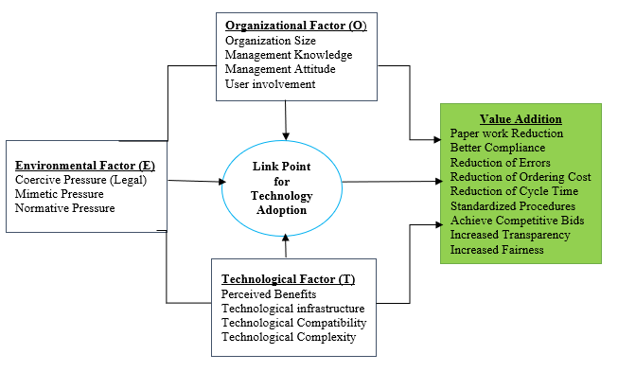
Figure 2.1: Three Context Group Elements of TOE and their Implications
Source: Adapted from Suleiman, 2015

2.3.1.1 Modified TOE Models
Previous studies had generally not applied all constructs from TOE model as found in Tornatzky and Fleischer (1990). Most prior studies had been employing only some of the constructs from each element of TOE model towards new technologies adoption (Aboelmaged, 2018; Chege & Wang, 2020; Hue, 2019; Kassim & Hussin, 2013; Zhang et al., 2020). For example, the study by Kassim and Hussin (2013) adopted the TOE model to examine the level of e-Perolehan system achievement and the influences that subsidize to this achievement, as professed by the Government employers but the study included only attitude of users, learning of organization, expectation of suppliers, compatibility of the system and imitative pressure. The study by Hue (2019) also adopted the TOE model to explore the influence of these factors on the innovation decision of firms in the context of a developing country. Figure 2.2 presents a modified model of this study which ignored some constructs from the original TOE model.

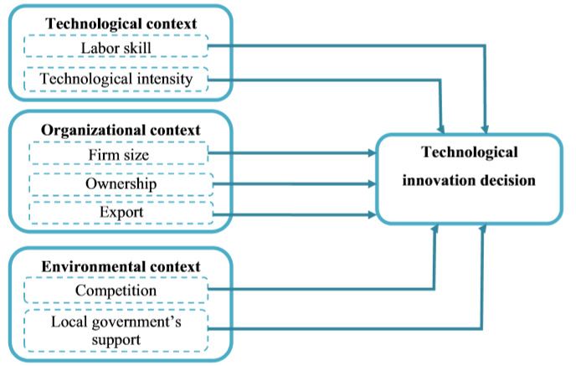
Figure 2.2: Modified TOE Model by Hue (2019)
Source: Hue (2019).
Apart from the studies by Hue (2019), Kassim and Hussin (2013), the study by Chege & Wang (2020) adopted TOE model to evaluate the association between technology innovation, environmental sustainability and its impact on small business performance in the context of one of the developing African countries. Figure 2.3 presents a modified model of this study and did not consider some constructs from the original TOE model.
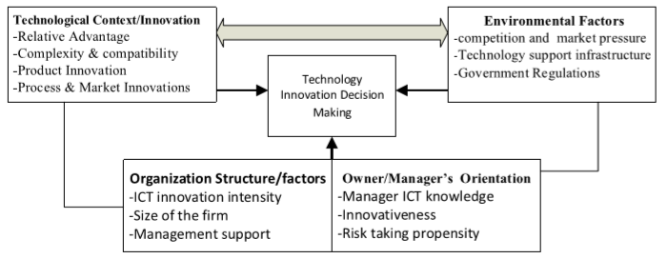
Figure 2.3: Modified TOE Model by Chege and Wang (2020)
Source: Chege and Wang (2020)

A possible reason why prior studies may not have utilized all constructs from the original TOE model is because some of the constructs might not be useful in their research problems towards new technologies adoption and use context (Hwang, Huang, & Wu, 2016). Basing on this fact, the current study has adopted TOE model and UTAUT in order to suit its research problem and objectives with regard to TANePS adoption.

2.3.2 Constructs and Relationships of TOE Model which are Not Known
Not all authors in literature including the author of the current study believe that the TOE model encourages the researcher to take the broader context into account in which innovation takes place (Oliveira & Martins, 2011; Masele, 2014; Shatta et al., 2020b). Grounding on this fact, some constructs which are powerful in the process of adopting new technology might have not been considered by TOE model. For example, the current study argues that performance expectancy is one of the powerful constructs which TOE model is not explaining in technological factor as one of its elements which influences new technologies adoption.

With that note, the current study considers performance expectancy, legal framework, relative advantage and attitude as key constructs for TANePS adoption which TOE model does not consider one of these key constructs in technological factor. This argument was justified by the current study in relation to TANePS adoption (Shatta et al., 2020b).

2.3.3 Criticism of the TOE Model
TOE model has been criticized by different scholars with regard to its application in studies relating to new technologies adoption. For example, TOE model has been disapproved that it does not reflect the individual’s viewpoint (Oliveira & Martins, 2011). This criticism was not valid in relation to TANePS adoption because the current study included suppliers’ perspectives from the private sector. Some authors criticized that it does not provide concrete model describing the factors which inﬂuence the organizational adoption decision (Bose & Luo, 2012). This argument was valid and was justified by developing a complex and new concrete model with direct and indirect relationships towards TANePS adoption. Variation of authors’ views with regard to TOE model application in studies concerning adoption of new technologies posed a need for conceptualization of a new integrative model with direct and indirect relationships of its constructs. However, the TOE model was relevant to this study because it contains the determinants of the legal framework, relative advantage, and attitude for TANePS adoption that link with the constructs for specific objectives one, three, and four of the current study.

2.3.4 Constructs and Relationships of UTAUT which are Known
UTAUT was developed by Venkatesh et al. (2003) after reviewing Combined Theory of Planned Behavior/Technology Acceptance Model (TPB/TAM), Model of PC Utilization (MPCU), Diffusion of Innovation Theory (DIT), Social Cognitive Theory (SCT), Motivational model (MM), Technology Acceptance Model (TAM), Theory of Reasoned Action (TRA) and Theory of Planned Behavior (TPB) (Chen et al., 2011). In addition, data from four organizations with three points of measurement, Venkatesh et al. (2003) found that the eight models explained between 17 and 53% of the variance in users’ intention to use Information Technologies (IT). Nevertheless, the UTAUT outstripped all the eight models using the same data explaining about 70% of variance in behavioural intention (Dwivedi et al., 2017).

According to Venkatesh et al. (2003), two direct determinants of technology use: ‘intentions to use’ and ‘facilitating conditions’ were postulated. ‘Intention to use’ was influenced by ‘performance expectancy’, ‘effort expectancy’ and ‘social influence’ and together with ‘facilitating conditions’ are four key constructs that are direct determinants of usage intention and behaviour. Gender, age, experience and voluntariness of use act as moderators of the impact of the four key constructs on usage intention and behaviour (Venkatesh et al., 2003; Chen et al., 2011). One major difference between UTAUT and its pioneers is that UTAUT proposed four moderators to further enhance the predictive power of the model and has been used extensively in explaining the adoption of technologies by individuals (Dwivedi et al., 2017). Figure 2.4 shows the four direct determinants and the moderators of the existing original UTAUT.

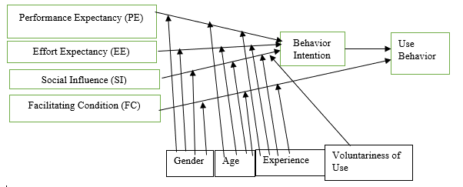
Figure 2.4: Unified Theory of Acceptance and Use of Technology (UTAUT)
Source: Venkatesh et al. (2003).

2.3.4.1 Modified UTAUTs
Prior studies have generally not applied the complete UTAUT model as found in Venkatesh et al. (2003) and most studies employed only a subset of the model and that moderators were typically dropped or replaced by other moderators (Chen et al., 2011; Dwivedi et al., 2017; Masele, 2014; Taluka, 2016; Venkatesh et al., 2012). Among the studies that included moderators, few studies modelled the same four moderators as proposed by the original UTAUT model (Kiwanuka, 2015). A potential reason why prior studies may not have utilized moderators is because there may not be any variation in the moderator for the adoption and use context (Chen et al., 2011). Prior literature has highlighted several individual characteristics including attitude, computer self-efficacy, and personal innovativeness as important aspects in new technologies adoption (Dwivedi et al., 2017). Figure 2.5 presents a modified UTAUT of the new technology acceptance and use with an indication for the role of attitude and other new moderators.

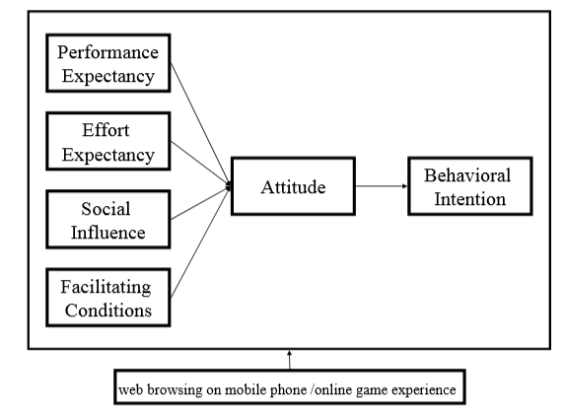
Figure 2.5: Modified UTAUT by Chen et al. (2011)
Source: Chen et al. (2011)

While realising the significance of attitude in the acceptance of new technologies by individuals, prior studies also realized the significance of indirect relationships among constructs in the models of technology adoption. Figure 2.6 presents a modified UTAUT of the new technology acceptance and use with an indication for the role of attitude and indirect relationships in this study. However, moderators were typically dropped (Dwivedi et al., 2017).

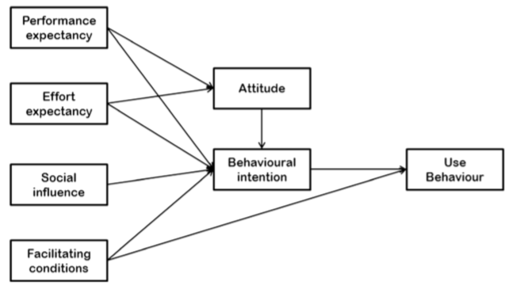
Figure 2.6: Modified UTAUT by Dwivedi et al. (2017)
Source: Dwivedi et al. (2017).

2.3.5 Constructs and Relationships of UTAUT which are Not Known
UTAUT is one of the newest and the strongest theories attempting to explain end user’s acceptance and use behaviour of information technology and it has been applied and tested empirically in different domains and recommended for its ability to predict adoption of ICT by individuals (Dwivedi et al., 2017; Taluka, 2016). However, there has been a difference between private (individuals) and public resources information system use with implications for how users approach technological systems (Masele, 2014). The difference noted by Masele (2014) between private and public resources use of information system was considered in the current study. The legal framework was used in the current study to harmonize the difference and was used to check if it impacted on performance expectancy of suppliers from the private sector and procurement experts from the public sector and later to actual use of TANePS.

Therefore, the role of legal framework to influence TANePS adoption indirectly through performance expectancy was a new relationship which the original and the existing extended UTAUTs do not explain. Likewise, the indirect influence of performance expectancy towards TANePS adoption through relative advantage was a new relationship which the original and the existing literature with extended UTAUTs do not comprehend. In addition, the current study argues that moderators of gender, age, experience and voluntariness have no impact on key constructs of this study towards TANePS adoption which the original UTAUT is explaining to the contrary while the existing extended UTAUTs support the argument of dropping moderators.

2.3.6 Criticism of UTAUT
The UTAUT has been vigorously challenged in recent years by a number of writers. For example, Dwivedi et al. (2017) noted that UTAUT is useful in studies that explore innovation adoption by individuals. This criticism was invalidated by the current study which examines critical success factors influencing TANePS adoption in the public sector. Nevertheless, the theory was relevant to the current study because one of its determinants (performance expectancy) was employed to examine the determinants for TANePS adoption.

2.3.7 Criticism of UTAUT and TOE Models in Relation to the Study
In order to fill the existing theoretical gap in literature, this study thought to link the constructs of legal framework, relative advantage and attitude from TOE model with performance expectancy from UTAUT. The aim was to check if the constructs impacted on attitude of procurement experts from public sector (organizations) and suppliers (individuals) from private sector and later to actual use of TANePS. The impact was realized and invalidated the criticisms of UTAUT and TOE model thus they are only suitable for studies related to individuals (private) and organizations (public) respectively. Table 2.1 shows an emphasis of UTAUT theory and TOE model against the missing important aspects in relation to this study.

Table 2.1: Theories’ Emphasis against Missing Important Aspects
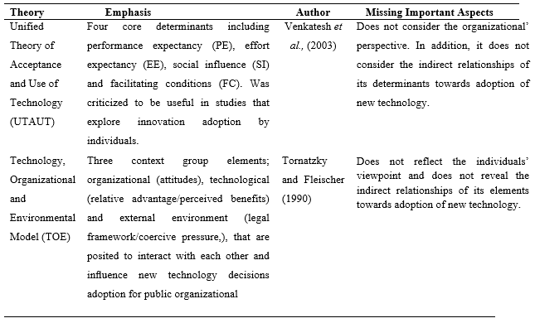
Source: Literature Review, 2020

2.4 Empirical Literature Review
Studies concerning new technologies adoption in developed and developing countries have been revealing diverse critical success factors which determine the success of new technologies adoption. This section presents the influences (legal framework, performance expectancy, relative advantage and attitude) of critical success factors towards new technologies adoption which are related to the objectives of the current study.

2.4.1 Influence of Legal Framework towards New Technologies Adoption
Previous research of recent technology adoption has now not handled how legal framework interacts with other variables that are believed to be connected towards the success of new technologies adoption (i.e, e-procurement adoption). For instance, the study by Suleiman (2015) turned into performed to explore the elements influencing the adoption of digital procurement in Tanzanian public institutions. This study by Suleiman (2015) based on the TOE framework which includes technological factors (perceived benefits, technological infrastructures, technological complexity, and technological compatibility), organizational elements (company size, management understanding, control attitudes, person involvement), and environmental elements (coercive strain, normative stress, mimetic pressure).

The findings with regard to this study showed that the coercive pressure (the legal framework which protected the general Public Procurement Act of 2011 and its Public Procurement Regulation of 2013) were not absolutely used by then to enforce the procuring entities and suppliers to start the usage of e-procurement in the public zone. However, the study recommended; first, the authorities of Tanzania needed to improve the legal infrastructure along with privacy regulation, e-signature, and different cybercrime regulations for the country to lessen the legal through e-procurement. Secondly, there ought to be an endured focus on improving technical infrastructure for full operation of e-procurement, strategies, and inner systems which support e-procurement and lastly, the study advised that for further research, one could take cognizance on best one element amongst technological or organizational or environmental elements in place of using all three elements. The study by Suleiman (2015) did not keep in mind the legal framework as the foremost determinant which stimulates other determinants in adopting e-procurement of which the current study is explaining otherwise in terms of its power and relations with other critical success factors toward TANePS adoption.

Other studies that did not recall the legal framework as dominant critical success elements in influencing e-procurement adoption in the public region consist of the study by Azanlerigu and Akay (2015) which changed into performed to take a look at the prospects and challenges of e-procurement in some selected public institutions. A questionnaire was used to gather statistics from sixteen public institutions and Analysis of Variance (ANOVA) was used to analyze collected data. The findings confirmed challenges confronted by public establishments with cognizance to e-procurement adoption had been worker incompetence, insufficient legal framework, inadequate technological infrastructure, and security of procurement transaction data. It turned into encouraging that education on e-procurement for brand new group of workers become a requirement. Notably, encouraging the mixing of buyers and the suppliers became necessary. In addition, the study by Ibrahim et al. (2017) aimed to research the efficacy of public procurement laws in ensuring cost for cash in a developing country context. The study employed a qualitative case and looked at a technique involving three nearby authorities’ companies in Ghana. The study used purposive and stratified random sampling techniques in deciding on respondents who were interviewed via focused organization discussions. Semi-structured and open-ended questionnaires were used to collect facts. The study utilized an interpretivist paradigm.

The study found out that the presence of a legal framework and regulatory framework does not assure compliance and cost for cash in the public procurement process due to the fact that compliance always does not translate into value for cash especially in developing countries. The study advocated that public procurement entities in growing countries ought not to depend on the compliance of legal framework and regulations to stand as a micro-management device for accomplishing accountability and value for money gains. This study challenged the dominant assumptions within the public procurement control evaluation by way of drawing interest to the fine of stated compliance and its implication for fee for cash.

The study by Jeptoo and Karanja (2017) wanted to discover whether government buildings have an effect on the adoption of e-procurement in state companies. This study was guided by the institutional theory which incorporates: coercive pressure (legal framework), normative pressure, and mimetic pressure. The constructs of the institutional theory had been used to provide an explanation for their influences towards e-procurement adoption. The study adopted a descriptive studies design and data collection tool was a questionnaire. Facts analysis strategies involved descriptive and inferential statistics. The collected data were analyzed qualitatively and quantitatively by using content analysis and IBM SPSS statistics version 23 respectively. The study findings revealed that the constructs of institutional theory had tremendous effects on e-procurement adoption. The study recommended that the governments of developing international locations to advance, adapt, and impose regulations to sufficiently manage the application of e-procurement.

The qualitative study by Adjei-Bamfo and Maloreh-Nyamekye (2019) turned into conducted to expose the drivers and blessings of sustainable public procurement in developing international locations. The findings revealed that drivers towards accomplishing sustainable public procurement include: evaluation of the status of the legal framework, reviewing the legal framework and engaging in market evaluation, getting ready the sustainable public procurement policy plan, schooling stakeholders, and subsequently adoption of the new technologies which include e-procurement adoption.

The findings of this study by Adjei-Bamfo and Maloreh-Nyamekye (2019) were in some way supported by the qualitative study by Adjei-Bamfo et al. (2020) which assessed readiness for adopting a full e-procurement system in the public sector and Less-Middle-Income Countries (LMICs). This study used interviews to gather information pertaining to the key readiness determinants for a complete public zone e-procurement system adoption. The study findings discovered that online offerings, telecommunication infrastructure, and human capital for ICT were the key determinants for readiness for a complete e-procurement adoption within the public sector. The indicators of human capital for ICT include the ability of stakeholders, policy guides, and technical support. The study had signiﬁcant implications for shaping the procedure-orientated control of presidency e-procurement initiatives toward socio-economic development in LMICs. The study by Mohammed et al. (2016) aimed at exploring the elements that have an impact on adopting cloud computing as part of public area groups’ options to put in force e-government offerings. The study followed the Fit-Viability version and the diffusion of innovation theory. An established questionnaire turned into used to gather data. The sample size was 296 IT personnel hired in public corporations.

The findings discovered the factors affecting two dimensions, fit and viability, to decide to adopt cloud computing in an e-authorities context. The viability size changed into encouraged through technological readiness (IT infrastructure and IT policy and rules) and financial factors (return on investment and asset specificity). However, Masele (2014) hypothesized that coercive pressure (legal framework) had an impact on an enterprise’s responsibility to green e-commercial enterprise reputation. For that reason, the higher the coercive pressure, the much more likely the employer commits itself to green e-enterprise. Nevertheless, the study by Masele (2014) did not show the indirect relationships of the legal framework with other critical success factors towards green e-business adoption.

Studies by Adjei-Bamfo et al. (2020), Adjei-Bamfo and Maloreh-Nyamekye (2019), Azanlerigu and Akay (2015), Ibrahim et al. (2017), Jeptoo and Karanja (2017), Masele (2014), Mohammed et al. (2016) and Suleiman (2015) would have been more suitable if they had shown legal framework as a foremost determinant that impacts other determinants towards implementing new technologies in public sector. A systematic approach would identify how legal framework interacts with other variables that are believed to be linked towards success of new technology adoption in the public or private sector. In the current study which examines the perceived critical success factors influencing TANePS adoption, the author expected to come up with a systematic approach which will make legal framework to interact with other constructs towards success of new technology adoption in the public sector.

2.4.2 Influence of Performance Expectancy towards New Technologies Adoption
Among the weaknesses of many studies concerning e-procurement adoption is that they do not take into account the influence of performance expectancy towards e-procurement adoption in the public sector context. For example, the qualitative study by Mgidlana (2013) did not consider the influence of performance expectancy and aimed to establish the factors that influence an organization’s adoption of e-procurement technologies. Mgidlana’s (2013) findings revealed that e-procurement adoption is driven by three critical success factors: internal needs, improved customer relations and reduction of labour costs. This study recommended that top management support, end-user buy-in and allocation of financial resources can influence the adoption of e-procurement in private organizations.

Moreover, a study by Mose et al. (2013) had three objectives: to ascertain the extent to which large scale manufacturers in Nairobi have adopted e-procurement; to determine the critical success factors influencing the success of e-procurement in large manufacturing firms in Nairobi and to establish the challenges that face e-procurement adoption in large scale manufacturing firms in Nairobi. The study by Mose et al. (2013) used a cross-sectional survey of the large manufacturing companies operating in Kenya and adopted a descriptive approach in trying to establish the factors that influence the success of e-procurement projects. The study used a sample size of 46 respondents from a list of 455 large manufacturing companies.

A questionnaire was used to collect data from the respondents and the collected data were analysed using descriptive statistics with the help of IBM SPSS statistics version 21. The study findings revealed that workers and organization obligation to achievement of adoption; trustworthiness of data and seller performance; intensive care of e-procurement systems were identified as determinants of e-procurement adoption. The study recommended that large scale manufacturers in Nairobi need to incorporate all the e-procurement activities into the system; they need to find out ways of encouraging employees to make use of e-procurement systems as well as find ways of addressing the factors that are critical to the success of e-procurement. This will enable them to improve adoption of e-procurement (Mose et al., 2013).

The study by Tutu et al. (2019) aimed at evaluating the critical factors for the adoption of e-procurement. The study used a survey which involved 60 procurement professionals. The mean score ranking test was employed to determine the factors that were significant to the adoption of e-procurement. The findings of this study revealed that availability of the internet, power stability, capacity enhancement of procurement officers and availability of infrastructure were important critical factors when it comes to execution of e-procurement while the mandatory use of e-procurement, technical interoperability, budgetary control among others were of less importance. This study recommended the useful factors that would guide the stakeholders and policy makers in e-procurement adoption without considering first the legal framework as one of the important critical factors when it comes to execution of e-procurement in the public sector.

Shale (2014) examined the role of e-procurement strategy on the performance of State corporations in Kenya but did not consider the influence of performance expectancy as one of the critical success factors. A cross-sectional survey was used in this study. A descriptive statistic assisted by IBM SPSS Statistics version 21 to compute percentages of respondents’ answers was used. Inferential statistics using multiple regression and correlation analysis were applied to examine the relationship between research variables. The study findings revealed that customer service level, procurement cost reduction, inventory optimizations, buyer / supplier collaboration and audits and compliance strategies significantly affect performance of State corporations. The study recommended that State corporations should have a good e-procurement software system as it would help them greatly reduce the time and effort required to complete purchasing transactions by eliminating traditional paper chain of requisitions, approvals, receiving and payment reconciliation (Shale, 2014).

However, the study by Taluka (2016) considered only the direct influence of performance expectancy but did not consider its indirect influence towards adoption of mobile payment services as a new technology. This study was conducted to examine factors influencing adoption of mobile payment services in rural Tanzania, specifically to assess the influence of performance expectance, effort expectance, social influence, facilitating conditions and perceived trust on consumers’ behavioural intention by using UTAUT. Survey method was used to collect data in Coast region from a sample of 99 respondents. Partial Least Square Structure Equation Modelling (PLS-SEM) analysis was conducted to test the established research model.

Findings revealed that perceived trust was the strongest predictor followed by effort expectance and together they predicted 76 percent of rural consumers’ behavioural intention to use mobile payment services (Taluka, 2016). Influence of effort expectance was found to be weak, whereas influences of other two factors namely, facilitating conditions and performance expectancy, were found to be statistically insignificant. The study recommended that mobile payment service providers should act kindly and with integrity towards consumers and regulators in order to improve regulatory environment and to ensure consumer protection. The main weakness of the study by Taluka (2016) is a failure to address the indirect relationships of performance expectancy with other constructs towards new technology adoption of which the current study has taken into consideration.

Likewise, Masele (2014) considered only the direct influence of performance expectancy towards e-business adoption in tourism context and theorized that the higher the performance expectancy amongst small and medium tourism initiatives, the higher the effect on intent to implement and use green e-business. The results revealed that impact of performance expectancy was statistically insignificant on green e-business adoption. This study did not take into account the indirect relationships of performance expectancy with other constructs towards e-business adoption and did not base on public procurement arena system. The study by Chen et al. (2011) aimed at exploring consumer acceptance after implementing the system based on the “Unified Theory of Acceptance and Use of Technology” (UTAUT) model. The purpose of this study was empirically to examine how UTAUT helped online game companies understand consumer intention to play online games through mobile phones.

On the other hand, this study was conducted in order to understand how consumers gained experience of playing online games and web browsing on mobile phones. The consumer’s experience of playing online games and web browsing on mobile phones were moderating roles. This study used the questionnaire method to collect data and applied the Structural Equation Modelling (SEM) to examine consumer attitude toward using technology. The findings revealed that influence of performance expectancy was statistically significant on attitude towards consumer intention. Hence, online game prior experience was moderating effect on the importance of performance expectancy as determinants of attitude.

However, this study did not take into account the direct relationship of performance expectancy on consumer intention. The study by Dwivedi et al. (2017) first formalized an alternative theoretical model for explaining the acceptance and use of information system (IS) and information technology (IT) innovations. This study used a combination of meta-analysis and structural equation modelling (MASEM) techniques. The meta-analysis of this study was based on 1600 observations on 21 relationships coded from 162 prior studies on IS/IT acceptance and use of technologies. This study considered both the direct and indirect influences of performance expectancy towards behavioural intentions and usage of IT. Nevertheless, this study did not take into account the influence of legal framework on performance expectancy towards behavioural intentions. The studies by Chen et al. (2011), Dwivedi et al. (2017), Mgidlana (2013), Masele (2014), Mose et al. (2013), Shale (2014), Taluka (2016), Tutu et al. (2019) would have been more convincing if the authors had considered the influence of legal framework on performance expectancy as mediator towards new technologies adoption. In addition, authors would have been more convincing if they had considered indirect influence of performance expectancy through relative advantage towards new technologies adoption.

2.4.3 Influence of Relative Advantage towards New Technologies Adoption
The main weakness of many studies concerning e-procurement adoption is failure to address the indirect influence of relative advantage through attitude towards e-procurement adoption. For example, Ibem et al. (2016) intended to fill the knowledge gap through investigating the factors influencing e-procurement adoption based on the data sourced in a questionnaire survey involving 213 organizations. The survey was conducted between June and November 2015. Descriptive statistics as well as factor and categorical regression analyses were used to analyse data. Results showed that, three most important factors influencing the adoption of e-procurement were: the benefits of new technology; operational statement among project team members and eliminating geographic barriers.

In addition, twenty-nine factors were investigated in seven different dimensions of which the benefits of e-Procurement use; level of awareness on e-Procurement in construction; and the availability and cost of e-Procurement applications emerged as the three most significant predictors of e-Procurement adoption in the survey. This study failed to consider the indirect influence of the benefits of e-procurement by linking with the level of awareness. In connection to that, Malekia (2018) carried out a study whose aim was to understand advantages of e-procurement. Questionnaires were administered to 155 public officials already using e-procurement and data were processed using SPSS software. The findings revealed that e-procurement results into reduction of corruption and improved monitoring and accountability (Malekia, 2018). This study recommended future research should try to use two groups, with one experimental group of participants involved in e-procurement sector and a control group of participants in public procurement sector. Furthermore, Watuleke (2017) aimed at understanding the concept of e-procurement, its evolution and adoption in the market economy as well as higher education. The findings revealed that a successful adoption of e-procurement would require the following critical success factors: top management support; user acceptance of e-procurement systems; employees and management commitment to success of adoption; reliability of information technology and supplier performance and monitoring the performance of e-procurement systems. Other critical success factors identified were: training of staff in procurement practices; risk perception and continuous measurement of the key benefits, best practices and actual selection of the system.

The study by Mohammed et al. (2016) aimed at exploring the factors that influence adopting cloud computing as a part of public sector organizations’ alternatives to implement e-government services. The study adopted the Fit-Viability Model and Diffusion of Innovation Theory. A structured questionnaire was used to collect data. The sample size was 296 IT staff employed in public organizations. The results of the study showed that the fitness of cloud computing to e-government tasks is affected by factors such as relative advantage, compatibility, trialability and security, but was not affected by the complexity of the technology. The findings by the study of Mohammed et al. (2016) were supported by Xu et al. (2015) who developed and tested an integrated model of Enterprises Resource Planning (ERP) assimilation and value in Chinese firms. The empirical results of this study showed that relative advantage, top management support, organization fit, financial commitment, complexity, compatibility and competitive pressure were significant predictors for ERP assimilation. In addition, the study found that the linkage from ERP assimilation to ERP value was statistically significant. Furthermore, the study revealed that, the strength of the antecedents of ERP assimilation and value varies dramatically across different firm ownership types. The findings of this study also emphasized and validated the importance of ERP assimilation in improving firm performance, and provided evidence for the continued debate on ERP payoff and information technology productivity paradox. These findings provided insights into how ERP assimilation and ERP value are influenced by contextual elements, and how the impacts may vary across different ownership types.

The study by Pitso et al. (2018) aimed at identifying the perceived beneﬁts and contextual challenges posed during the adoption of an E-Procurement system in the electricity sector. This study adopted an interpretivist approach and it identiﬁed two keys: perceived beneﬁts of efﬁciency and transparency. However, the challenges facing the electricity sector included lack of adequate training, system failure, employee resistance and lack of project management skills by top management. In public sector the study identified the following key challenges: lack of staff training and ICT expertise in conformance to regulation and lack of perceived benefits. Studies by Ibem et al. (2016), Malekia (2018), Mohammed et al. (2016), Pitso et al. (2018), Watuleke (2017) and Xu et al. (2015) would have been more interesting if the authors had explained the indirect influences of the key benefits towards new technologies adoption, e-procurement in particular.

2.4.4 Influence of Attitude towards New Technologies Adoption
Another weakness of many studies concerning e-procurement adoption is failure to analyse both the influence and linkage of buyers’-suppliers’ attitude towards e-procurement adoption. For example, the study by Kassim and Hussin (2013) aimed at investigating the level of e-Perolehan system success and the factors that contribute to this success, as perceived by the Government users. The structural equation modeling was used to predict the results. System compatibility, users’ attitude and mimetic pressures were found to be the main significant critical success factors of the e-Perolehan system in Malaysia. However, the study failed to show the linkage of buyers’-suppliers’ attitude towards e-Perolehan system adoption of which the current study is explaining clearly the influence and linkage of buyers’-suppliers’ attitude towards TANePS adoption.

The study by Ombat (2015) used a total of 97 participants who were selected by simple random sampling but did not consider the influence and linkage of buyers’-suppliers’ attitude towards e-procurement adoption. Questionnaires were used as instruments for data collection and the collected data were then processed and analysed using descriptive statistics. The findings were presented through percentages, means, standard deviations and frequencies. It was further recommended that procuring entities should be aware of the risks posed by the e-systems and should practice lots of internal controls for risk management and limit quality related problems. Finally, the management of these financial institutions needed to commit to staff training for both end users and procurement staff in order to keep the dynamism of e-procurement (Ombat, 2015).
In addition, the study by Chen et al. (2011) aimed at exploring consumer acceptance after implementing the system based on “the Unified Theory of Acceptance and Use of Technology” (UTAUT) model. The purpose of this study was empirically to examine how UTAUT helped online game companies understand consumer intention to play online games through mobile phones. On the other hand, this study was conducted in order to understand how consumers gained experience of playing online games and web browsing on mobile phones. The consumer’s experience of playing online games and web browsing on mobile phones were moderating roles. This study used the questionnaire method to collect data and applied the Structural Equation Modelling (SEM) to examine consumer attitude toward using technology. The findings revealed that influence of attitude was statistically significant on consumer intention.

The purpose of the study by Aboelmaged (2010) was to predict e-procurement adoption through integrating the constructs of the technology acceptance model and the theory of planned behaviour. The study used questionnaires to collect data and structural equation modelling to analyse the data collected. The study used a sample size of 316 respondents. The findings of the study discovered that the anticipated model had good descriptive influence with a reasonably strong empirical support, in predicting users’ intentions to use e-procurement technology. Behavioural intention toward e-procurement technology was mainly strongminded by user’s attitude and additionally inﬂuenced by perceived usefulness and subjective norm. The study provided procurement system developers and managers with a useful adoption model that demonstrated the signiﬁcance of perceived usefulness of e-procurement system in inﬂuencing the adoption decision. This study highlighted the importance of maximizing the beneﬁts of e-procurement system for potential users to facilitate the adoption process in public and private sectors. The study recommended that system developers and procurement managers should also consider the role of social inﬂuences, such as those from supply chain partners, in the adoption process and how such inﬂuences may facilitate or inhibit e-procurement adoption process. The study by Dwivedi et al. (2017) first formalized an alternative theoretical model for explaining the acceptance and use of information system (IS) and information technology (IT) innovations. This study considered the direct influence of attitude towards behavioural intentions and usage of IT. The findings revealed that influence of attitude was statistically significant on behavioural intentions and usage of IT.

Nevertheless, studies by Aboelmaged (2010), Chen et al. (2011), Dwivedi et al. (2017), Kassim and Hussin (2013) and Ombat (2015) did not take into account the influences of legal framework and relative advantage on attitude towards behavioural intentions and usage of IT. These studies would have been more motivating if the authors had included the influences of legal framework and relative advantage on attitude towards new technologies adoption.

2.4.5 Mediation Effects of Performance Expectancy, Relative Advantage and Attitude towards New Technologies Adoption
This study provides new understandings of mediation of performance expectancy, relative advantage and attitude. The mediation of these constructs aimed at extending the TOE model of which the previous studies did not pay more attention for including one construct from UTAUT in a group of constructs from TOE. For example, studies by Chen et al. (2011) and Dwivedi et al. (2017) highlighted the mediation of attitude only towards new technology adoption and they did not consider the mediation effects of performance expectancy and relative advantage towards new technology adoption. In addition, the mediation of performance expectancy, relative advantage and attitude in this current study aimed at explaining comprehensively the phenomena of failure of some trainees to understand the performance of TANePS, failure of some suppliers to register in the system and failure of some procuring entities to adopt TANePS.

Above all, the mediation effects of performance expectancy, relative advantage and attitude have shown new theoretical knowledge contribution of which other past schoolers did not reveal. Studies by Ibem et al. (2016), Malekia (2018), Mohammed et al. (2016), Pitso et al. (2018), Watuleke (2017), Xu et al. (2015), Aboelmaged (2010), Chen et al. (2011), Dwivedi et al. (2017), Kassim and Hussin (2013), Ombat (2015), Mgidlana (2013), Masele (2014), Mose et al. (2013), Shale (2014), Taluka (2016), Tutu et al. (2019) Adjei-Bamfo et al. (2020), Adjei-Bamfo and Maloreh-Nyamekye (2019), Azanlerigu and Akay (2015), Ibrahim et al. (2017), Jeptoo and Karanja (2017), Mohammed et al. (2016) and Suleiman (2015) would have been more interesting if authors had shown mediation effect as a foremost determinant of theoretical knowledge contribution, source of explaining comprehensively the phenomena and a determinant of extending the theory or model towards adoption of new technologies in public or private sector.

A new systematic approach of this study has identified how performance expectancy, relative advantage and attitude mediate other constructs that are believed to be linked with, towards success of new technology adoption (TANePS) in the public sector. This kind of approach is missing in the current theoretical and empirical literature.

2.4.6 Perception of Procurement Experts and Suppliers on Critical Success Factors Influencing e-Procurement Adoption
The diverse nature of the insights on critical factors influencing the success of e-procurement adoption among buyers and suppliers has attracted a limited number of researchers who wanted to understand the reasons of this diversity (Gambo, Dodo, & Yusuf, 2019). The general objective of this study provides new insights on perception of procurement experts and suppliers with regard to the critical success factors for e-procurement adoption in the public sector of which the existing empirical studies have not focused adequately. For example, the study by Makoba et al. (2017) aimed at assessing the potential risks of e-procurement adoption in the construction industry. Information was sourced by using questionnaires and interviews from construction contractors, expert advisors, public and private procuring entities. 43 respondents were provided questionnaires and 16 respondents were interviewed. Respondents were taken from both public and private entities.

Findings identified various risks of e-procurement adoption in building firms including: outbreaks of computer viruses and worms, untrustworthy internet services, info outflow, mismatch of technology and expertise of users. Plans which were acknowledged by Makoba et al. (2017) in the direction of moderation of such jeopardies comprised: building firms working out respectable administration and intensive care of their ICT schemes, funding of the country’s procurement procedures to e-procurement by building firms and control of respectable e-procurement services. The study suggested that building firms must agree to take technological variations and be familiar with e-procurement.

On the other hand, Gambo et al. (2019) assessed stakeholders’ perception of the risk factors associated with the adoption of e-procurement in the industry. This study adopted a quantitative research method and structured questionnaire was a tool to assess the perception of key stakeholders including clients, contracting and consulting firms. The data were analysed using descriptive statistics. Furthermore, the analysis of variance (ANOVA) was used to evaluate the significant difference of the stakeholders’ perception. Findings revealed that prominent risk factors associated with the adoption of e-Procurement include: lack of training on the adoption of e-Procurement techniques, unreliable Internet and telephone connectivity, lack of clear understanding of e-Procurement technologies and security. This study was expected to influence the policy makers’ strategies in improving the adoption and practice of e-Procurement in developing countries.

The studies by Gambo et al. (2019) and Makoba et al. (2017) would be more interesting if authors would forecast the critical success factors and then compare the perception of the respondents from public and private sectors (Shatta et al., 2020c). Therefore, the current study is thought to make a major contribution to the existing empirical studies regarding e-procurement adoption by indicating the perception of procurement experts and suppliers on critical success factors influencing TANePS adoption in the public sector with a deductive approach which bases on forecasting and comparison relations. Table 2.2 shows the empirical literature related to e-procurement adoption against the missing important aspects.

Table 2.2: Existing Empirical Literature Related to E-Procurement Adoption
 | Title and Focus | Author (s) Country |  |  |  | Missing Literature (Gap)
An e-government framework for assessing readiness for public sector e-procurement in a lower-middle income country: Buyers’ perspective and qualitative approach |  |  | Adjei-Bamfo et al. (2020) | Ghana | Suppliers’ perspective, mediation effect and quantitative approach were not considered
The ‘baby steps’ in mainstreaming sustainable public procurement in Ghana: Buyers’ perspective and quantitative approach |  |  | Adjei-Bamfo and Maloreh-Nyamekye (2019) | Ghana | Suppliers’ perspective and Forecasting based approach was not considered
Public Procurement for Public Financial Management in Africa: Agency Theory Lenses: Buyers’ perspective and qualitative approach |  |  | Bawole and Adjei-Bamfo (2019) | Ghana | Suppliers’ perspective and quantitative approach were not considered
Assessment of stakeholders’ perception of risk factors associated with the adoption of e-procurement in the Nigerian construction industry: Buyers’-Supplier’s perspective and quantitative approach-ranking and comparison relations  The legal regime and the compliance façade in public procurement in Ghana: Buyers’ perspective and quantitative approach |  |  | Gambo et al. (2019)  Ibrahim et al. (2017) | Nigeria  Ghana | Forecasting based approach was not considered  Suppliers’ perspective and forecasting based approach was not considered
Effect of governance structure on e-procurement adoption by state corporations in Kenya: Buyers’ perspective and quantitative approach-ranking based relation  Exploring E-Procurement Adoption in the Context of a Developing Country: Buyers’ perspective and qualitative approach  Adoption of E-procurement and Value Addition: Tanzania Context: Buyers’ perspective and quantitative approach-ranking  Evaluating critical factors for the adoption of e-procurement in Ghana: Buyers’ perspective and quantitative approach-ranking relation  E-procurement: Evolution and Adoption. A Review of Literature: Buyers’ perspective and qualitative approach |  |  | Jeptoo & Karanja (2017)  Pitso et al. (2018)  Suleiman (2015)  Tutu et al. (2019)  Watuleke (2017) | Kenya  Lesotho  Tanzania  Ghana  Uganda | Suppliers’ perspective and comparison relation were not considered  Suppliers’ perspective and quantitative approach were not considered  Suppliers’ perspective, forecasting and comparison relations were not considered  Suppliers’ perspective, forecasting and comparison relations were not considered  Suppliers’ perspective and quantitative approach were not considered
Source: Literature Review, 2020

2.5 Synthesis of Theoretical Literature Review
In reviewing the theoretical literature, it was noted that at this time, researchers combine UTAUT or TOE model with external theories or models or other variables in order to address weaknesses of the theory (Kiwanuka, 2015; Masele, 2014; Shatta et al., 2020a; Taluka, 2016). It has been argued that it is essential to use at least two theories to attain a better understanding of multidimensional new information technology adoption due to the limitations that one theory or model may have (Kiwanuka, 2015; Oliveira & Martins, 2011). Currently, there exists no collectively accepted theory to explain new technologies systems adoption and this situation has left researchers in a “theoretical confusion” because scholars have been developing their own theories or extending the existing ones to cater for their research problems (Chen et al., 2011; Dwivedi et al., 2017; Masele, 2014; Shatta et al., 2020b; Taluka, 2016; Venkatesh et al., 2012). For example, the study by Taluka (2016) developed a model by using all constructs from the original UTAUT. However, one construct was added to furnish the research problem. Likewise, the study by Masele (2014) developed a model by using constructs from UTAUT, TOE and Institutional Theory to outfit for research problem. In addition, the study by Shatta et al. (2020b) developed a model by using one construct from the original UTAUT and three constructs from TOE model to address the research problem and achieve its objectives.

2.6 Synthesis of Empirical Literature Review
In reviewing the prior empirical studies, it was noted that authors have diverse perception on determinants of e-procurement adoption. The diverse perception has led to variations of the overall explanatory power of research models. In addition, there exists no collectively accepted focus or methodology to address the challenges associated with e-procurement adoption. This situation has left researchers in a “contextual and methodological confusion” because the majority of authors of the previous studies have been focusing only on buyers’ perspectives. However, the suppliers’ perspectives or both perspectives have not been considered adequately. Furthermore, there is inconclusive debate by positivists and interpretivists with regard to the appropriate approach in conducting studies related to e-procurement adoption. This state has led the current study to focus on positivism philosophy and accommodate two perspectives: (buyers’ perspective and suppliers’ perspective).

2.7 Theoretical, Contextual and Methodological Gaps
Diverse views regarding the application of TOE model and UTAUT in prior studies, variations of interpretations of the critical factors which determine the success of e-procurement adoption, various methodologies for conducting studies relating to e-procurement adoption has left theoretical, contextual and methodological gaps for further research.

2.6.1 Theoretical Gap
The existing theory adopted in the current study (UTAUT) and the model employed (TOE) were clarifying inadequately the model for combined perspectives (individual and organizational perspectives). The current study developed an integrative model and comprehensively explains the combined perspectives by using direct and indirect relationships of the constructs from TOE model and UTAUT of which the original UTAUT and TOE do not explain clearly. The constructs legal framework, relative advantage and attitude from TOE model and the construct performance expectancy from UTAUT were integrated and thought to influence directly and indirectly TANePS adoption. The direct and indirect relationships of these constructs are not comprehended clearly in the current original and modified TOE models and UTAUTs.

2.6.2 Contextual Gap
Most of the previous literature regarding e-procurement adoption focused on buyers’ perspectives and few focused on suppliers’ perspectives. Also, studies which combined both suppliers’ and buyers’ perspectives on determinants determining e-procurement adoption were inadequate. This posed a need for further research. For the purpose of filling the identified gap, this study has included both perspectives of buyers and suppliers in examining the determinants determining TANePS adoption, a substance that the existing empirical literature is not explaining sufficiently.

2.6.3 Methodological Gap
Most of the previous studies on e-procurement adopted inductive approach (Adjei-Bamfo et al., 2020; Mgidlana, 2013; Pitso et al., 2018; Tutu et al., 2019; Watuleke, 2017) and very few studies on e-procurement adopted deductive approach and mixed approach (Gambo et al., 2019; Jeptoo & Karanja, 2017; Kassim & Hussin, 2013; Makoba et al., 2017). In addition, most of the previous studies which adopted deductive approach focused on ranking relation (Jeptoo & Karanja, 2017; Ombat, 2015; Suliman, 205) and forecasting relation (Aboelmaged, 2010; Kassim & Hussin, 2013); very few focused on both ranking and comparison (Gambo et al., 2019), hence inspired further research to consider both forecasting and comparison relations, a substance which the current empirical literature is explaining inadequately.

For the purpose of filling the existing methodological gap, the current study has adopted deductive approach and has focused on both forecasting and comparison relations. Furthermore, the current study has considered PLS-SEM in data analysis because it is more flexible than other data analysis methods adopted by previous studies in terms of ability to accommodate both formative and reflective models, direct and indirect relationships. PLS-SEM also can determine the significant differences of the perception of groups for example, buyers’ and suppliers’ perception from a complex model with direct and indirect path coefficients by using multi-group analysis.

2.7 Model Constructs Description and Hypotheses Formulation
This study employed one critical success factor influencing adoption of new technology from UTAUT (performance expectancy) and three critical success factors influencing adoption of new technology from TOE model (legal framework, relative advantage (perceived benefits) and attitude). It has also explained four endogenous constructs and one exogenous construct. Endogenous constructs involved performance expectancy, relative advantage (perceived benefits), attitude and TANePS adoption. The exogenous construct was legal framework. In the following section, the conceptualizations of constructs and proposed hypotheses are presented.

2.7.1 TANePS Adoption (TA)
TANePS adoption is a decision by the Government to make full use of innovation and ICT to conduct public procurement functions. E-procurement in the public sector comprises the following success factors; service performance, efficiency, transparency and information quality (Kassim & Hussin, 2013). However, success of new technology adoption depends on many important critical success factors and resources including performance expectancy, technological, organizational, and environmental factors (Dwivedi et al., 2017; Zhang et al., 2020). In the context of this study, TANePS adoption depends on legal framework (environmental factor), performance expectancy of the system, relative advantage (technological factor) of the system, the attitude (organizational factor) of top management and users (Kassim & Hussin, 2013; Rogers, 2003; Suleiman, 2015; Venkatesh et al., 2012).

According to TOE model by Tornatzky and Fleischer (1990), value addition for e-procurement adoption include: paper work reduction, better compliance, reduction of errors, reduction of ordering cost, reduction of cycle time, standardized procedures, achieve competitive bids, increased transparency and increased fairness. For validation of the existing empirical studies’ findings and TOE model suggestion with regard to value addition of e-procurement adoption, this study proposed that TANePS would be influenced by legal framework, performance expectancy, relative advantage and attitude (Tornatzky & Fleischer, 1990; Venkatesh et al., 2003). The value additions of TANePS were proposed to be service performance, efficiency, transparency and information quality (Kassim &Hussin, 2013; Tornatzky & Fleischer, 1990).

2.7.2 Legal Framework (LF)
Mrope (2018) defined legal framework in procurement perspective as the entire set of legal instruments that contains rules concerning the process of acquiring goods, works and services by public sector entities which includes institutional arrangements required to ensure the proper adoption of these rules or laws, Acts, Decrees, Circulars or Regulations such as PPA 2011 and its amendment of 2016; PPR 2013 and its amendment of 2016. According to TOE model by Tornatzky and Fleischer (1990), coercive pressure (legal framework) is a major determinant of the intention to use new technologies adoption systems, which in turn generates the actual usage behaviour.

The underlying principle is that organizations make decisions rationally and systematically on the basis of the system available. The existing empirical studies in the context of new technologies adoption which hypothesized coercive pressure (legal framework) to directly and signiﬁcantly inﬂuence behavioural intention to use a new technology system revealed similar findings (Adjei-Bamfo et al., 2020; Adjei-Bamfo & Maloreh-Nyamekye, 2019; Azanlerigu & Akay, 2015; Ibrahim et al., 2017; Jeptoo & Karanja, 2017; Masele, 2014; Suleiman, 2015). For example, Masele (2014) verified beyond reasonable doubt that coercive pressures (legal frameworks) are unavoidable if obligation towards adoption of new technology was to be coached for helping community paybacks.

In addition, Azanlerigu and Akay (2015) discovered that legal framework is a foundation for any commercial transaction whether in the public sector or private dealings. For validation of the model suggestion and the existing empirical studies’ findings, this study hypothesized the direct and indirect influences of legal framework towards TANePS adoption. The indirect influences towards TANePS adoption in public sector were mediated by performance expectancy, relative advantage and attitude because amending first the legal framework (PPA of 2004 and its PPR 2005) to support the introduction of the system was inevitable (Schooner et al., 2008; URT, 2016). Therefore, the training conducted by PPRA on performance and benefits of TANePS to change the attitude of procurement experts and suppliers was influenced by the amendment of legal framework. On the other hand, TANePS was positively and directly influenced by the support of the current PPA of 2011 and its PPR of 2013 (Shilla, 2019; URT, 2018; URT, 2019).
H_{1a}: Legal framework (LFs) positively and directly influences TANePS adoption.

H_{1b.} In the presence of mediation effect of Performance Expectancy (PE), Legal framework (LFs) positively and indirectly influences TANePS adoption.

H_{1c:} In the presence of mediation effect of Relative Advantages (RA), Legal framework (LFs) positively and indirectly influences TANePS adoption.

H_{1d:} In the presence of mediation effect of Attitude (AT), Legal framework (LFs) positively and indirectly influences TANePS adoption.

2.7.3 Performance Expectancy (PE)
Venkatesh et al. (2012) defined performance expectancy as a degree to which using technology will provide benefits to consumers in performing certain activities, and is theorized to influence behavioural intention to use technology. On the other hand, UTAUT theory by Venkatesh et al. (2003) suggests that performance expectancy is thought to inﬂuence the new technology adoption. This argument of theory was supported by Aboelmaged (2010) who asserted that the easier it is to use a technology, the greater the expected beneﬁts from the technology with regard to performance enhancement. The underlying principle is that individuals make decisions rationally and systematically on the basis of the system available.

The direct influence of performance expectancy towards new technology adoption has also been tested by the existing empirical studies towards new technologies adoption (Chen et al., 2011; Dwivedi et al., 2017; Masele, 2014; Taluka, 2016). For example, the studies by Masele (2014) and Taluka (2016) revealed that performance expectancy (PE) was not statistically significant towards mobile phones and green e-business adoption respectively. However, the studies by Chen et al. (2011) and Dwivedi et al. (2017) showed that performance expectancy (PE) had direct influences and were all statistically significant towards new technology adoption. In addition, the study by Dwivedi et al. (2017) showed that performance expectancy (PE) had direct and indirect influences and were all statistically significant towards new technology adoption. For validation of these findings, this study proposed the direct and indirect influences of performance expectancy towards TANePS adoption. The indirect influences of performance expectancy towards TANePS adoption were mediated by relative advantage and attitude because changing of mindset of users of the system depends on the understanding of the performance and benefits the system brings to the community (Latif, 2014).
H_{2a}: Performance expectancy (PE) positively and directly influences TANePS adoption.

H_{2b}: In the presence of mediation effect of Relative Advantage (RA), Performance Expectancy (PE) positively and indirectly influences TANePS adoption.

H_{2c}: In the presence of mediation effect of Attitude (AT), Performance Expectancy (PE) positively and indirectly influences TANePS adoption.

2.7.4 Relative Advantage (RA)
Relative advantage is the extent to which the innovation is viewed by users to be better than the existing idea; i.e. perceived cost and benefits (Rogers, 2003). However, perceived benefits include direct and indirect benefits like reduction in transaction errors and costs, improved data accuracy and faster tendering process (Suleiman, 2015). TOE model by Tornatzky and Fleischer (1990) suggests that relative advantage is thought to inﬂuence the new technologies adoption. The easier it is to use a technology, the greater the expected beneﬁts (relative advantage) from the new technology adoption (Aboelmaged, 2010).

The influence of relative advantage towards new technologies adoption has also been validated by studies related to new technologies adoption context (Ibem et al., 2016; Malekia. 2018; Mohammed et al., 2016; Pitso et al., 2018; Watuleke, 2017; Xu et al., 2015; Zhang et al., 2020). For instance, Zhang et al. (2020) discovered that relative advantage forms the technology readiness for green innovation. In addition, Ibem et al. (2016) found that the professed paybacks of e-procurement were the reason why most firms in the building industry use it. Based on TOE model suggestion by Tornatzky and Fleischer (1990), and the studies’ findings by previous studies this study hypothesized the direct and indirect influences of relative advantage which was mediated by attitude towards TANePS adoption in public sector to validate these similar findings.
H_{3a}: Relative advantage (RA) positively and directly influences TANePS adoption.

H_{3b:} In the presence of mediation effect of Attitude (AT), Relative advantage (RA) positively and indirectly influences TANePS adoption.

2.7.5 Attitude (AT)
Attitude is defined as an individual’s positive or negative feelings about performing the target behaviour (Dwivedi et al., 2017). In the context of this study, attitude is defined as the extent to which an individual’s positive or negative feelings about TANePS and its adoption. However, Masele (2014) pointed out that each of the attitude aspects is measured in three dimensions including affection (feeling and emotion), cognition (thought and belief) and conation (action and behaviour). Basing on pointed dimensions, this study included the aspects related to like or dislike of the TANePS; willing to learn or not willing to learn about the application of the TANePS; committed or not committed to use the TANePS in public procurement process; frequently interact or not frequently interact with TANePS in public procurement process (Kassim &Hussin, 2013).

Furthermore, TOE model by Tornatzky and Fleischer (1990), proposes that management attitude is believed to inﬂuence the new technologies adoption and is a major determinant of the intention to use new technologies adoption. The underlying ground is that organizations make decisions realistically and analytically on the basis of the new technology to adopt. Many existing empirical studies have shown that attitude directly and signiﬁcantly inﬂuences behavioural intention to use new technologies adoption (Aboelmaged, 2010; Chen et al., 2011; Dwivedi et al., 2017; Kassim & Hussin, 2013; Ombat, 2015). However, other studies have shown that attitude has insigniﬁcantly inﬂuenced behavioural intention to use new technologies adoption (Masele, 2014). Based on TOE model proposition and the findings of the existing empirical studies, this study hypothesized the direct influence of attitude towards TANePS adoption in the public sector. On the other hand, attitude is inﬂuenced by other key elements determining technological behaviour intention to adopt new technologies which include legal framework, performance expectancy and relative advantage (Shatta et al., 2020b).

H_{4:} Attitude (AT) positively and directly influences TANePS adoption in the public sector.

2.7.6 Perception
The study by Latif (2014) revealed that some procuring entities’ staff and suppliers do hesitate to use e-procurement system due to their diverse perception. Diverse perception in this study refers to different understanding of procurement experts and suppliers on critical success factors influencing TANePS adoption in the public sector. Limited number of the existing empirical literature has shown no significant difference on respondents’ perception with regard to the determinants of e-procurement adoption (Gambo et al., 2019; Shatta et al., 2020c). For that reason, this study hypothesized that perception of procurement experts and suppliers on critical success factors influencing TANePS adoption in the public sector had no significant difference.

H_{5:} Perception of procurement experts and suppliers on critical success factors influencing TANePS adoption in the public sector has no significant difference.

2.8 Conceptual Model
The conceptual model of this study was constructed after reviewing theoretical and empirical literature. Figure 2.7 shows the integrative conceptual model with the critical success factors influencing TANePS adoption.
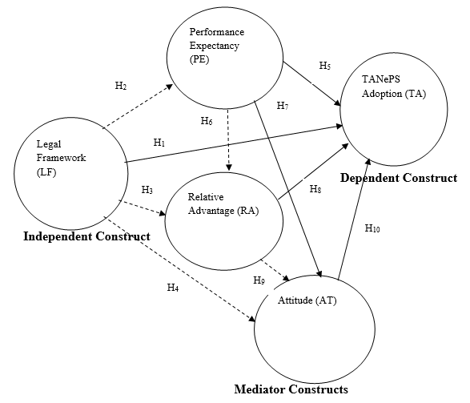
Figure 2.7: Conceptual Model
Key:
Existing Literature (relationships which exist in literature)
Theoretical Gaps (relationships which do not exist in literature)
Source: Conceptualized from Theoretical and Empirical Literature, 2020

2.8.1 Hypotheses Generated from the Conceptual Model
Table 2.3 shows the hypotheses generated from the conceptual model per specific objective. In addition, the following mathematical model was adopted which illustrates the relationship between a latent variable and its observed indicators for reﬂective measurement models: x=lY+e, where x is the observed indicator variable, Y is the latent variable, the loading l is a regression coefﬁcient quantifying the strength of the relationship between x and Y, and e represents the random measurement error (Sartedt et al., 2017).

Table 2.3: Hypotheses Generated from the Conceptual Model
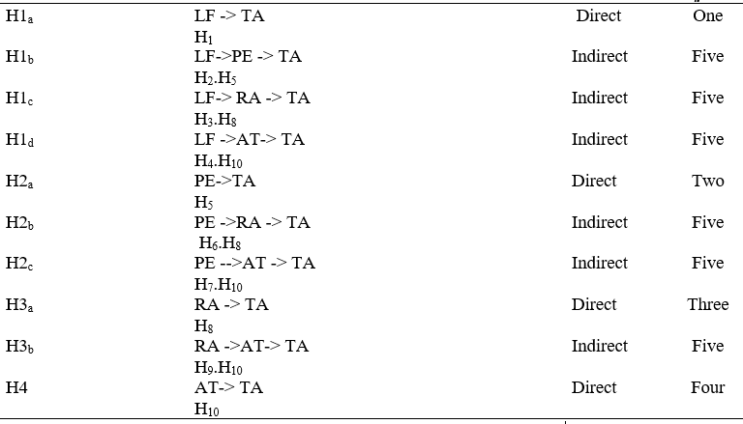
Source: Conceptualized from the Conceptual Model, 2020

Key:
H_{1a}: Legal framework (LF) positively and directly influences TANePS adoption (TA).
H_{1b.} In the presence of mediation effect of Performance Expectancy (PE), Legal framework (LF) positively and indirectly influences TANePS adoption (TA).

H_{1c:} In the presence of mediation effect of Relative Advantages (RA), Legal framework (LF) positively and indirectly influences TANePS adoption (TA).

H_{1d:} In the presence of mediation effect of Attitude (AT), Legal framework (LF) positively and indirectly influences TANePS adoption (TA).

H_{2a}: Performance expectancy (PE) positively and directly influences TANePS adoption (TA).
H_{2b}: In the presence of mediation effect of Relative Advantage (RA), Performance Expectancy (PE) positively and indirectly influences TANePS adoption (TA).

H_{2c}: In the presence of mediation effect of Attitude (AT), Performance Expectancy (PE) positively and indirectly influences TANePS adoption (TA).

H_{3a}: Relative advantage (RA) positively and directly influences TANePS adoption (TA).
H_{3b:} In the presence of mediation effect of Attitude (AT), Relative advantage (RA) positively and indirectly influences TANePS adoption (TA).

H_{4:} Attitude (AT) positively and directly influences TANePS adoption in the public sector (TA).

2.8.2 Relationships of Constructs
The assumptions made in relationships of the constructs under this study which has combined both buyers’ (procurement experts) and suppliers’ perspectives is that the legal framework, performance expectancy and relative advantage influence directly and indirectly the adoption of TANePS in the public sector. However, attitude influences directly only the adoption of TANePS in the public sector but it links other determinants of e-procurement adoption. For indirect relationships, performance expectancy, relative advantage and attitude are mediators in the adoption of TANePS in the public sector. Table 2.4 shows each construct’s definition and its survey items.

Table 2.4: Constructs and Survey Items
Construct Definition |  |  | Derivation from Literature |  |  |  | Citation
Legal Framework |  | …the entire set of legal instruments that contains rules concerning the process of acquiring goods, works and services …includes Acts and Regulations |  |  | I understand TANePS was developed in accordance with the requirement of the Public Procurement Act (PPA) 2011 and its amendment 2016 |  |  | Mrope (2018)
 |  |  |  |  | I understand TANePS supports various public procurement procedures as directed by the Public Procurement Regulation (PPR), 2013 and its amendment 2016
 |  |  |  |  | I understand the rules of TANePS application are basing on the Public Procurement Act (PPA) 2011 and its amendment 2016
 |  |  |  |  | I understand the regulations of TANePS application are basing on the Public Procurement Regulation (PPR), 2013 and its amendment 2016
Performance Expectancy |  | …is defined as a degree to which using technology will provide benefits to consumers in performing certain activities, and is theorized to influence behavioural intention to use technology |  |  | I find TANePS is user friendly in procurement process |  |  | Venkatesh et al., (2012)
 |  |  |  |  | I find TANePS helps in transaction of money more quickly
 |  |  |  |  | I find TANePS removes chances of corruption
 |  |  |  |  | I find TANePS reduces procurement cycle time
Relative Advantage |  | …is defined as the extent to which the innovation is viewed by users to be better than the existing idea; i.e. perceived benefits includes; reduction in transaction errors and transaction costs, improved data accuracy and faster tendering process |  |  | I find TANePS reduces transaction errors in public procurement process |  |  | (Rogers, 2003; Suleiman 2015).
 |  |  |  |  | I find TANePS reduces transaction costs in public procurement process
 |  |  |  |  | I find TANePS improves data accuracy in public procurement process
 |  |  |  |  | I find TANePS faster tendering process in public procurement process
Attitude |  | …in this context of study means having positive or negative mindset of buyers or suppliers towards TANePS adoption in the public sector |  |  | I like the idea of using TANePS in public procurement process |  |  | Kassim and Hussin (2013), Dwivedi et al. (2017)
 |  |  |  |  | I intend to continue learning how to use TANePS in public procurement process
 |  |  |  |  | I plan to continue using TANePS in public procurement process.
 |  |  |  |  | I will continue taking advantages of TANePS in improving my efficiency in public procurement process.
 |  |  |  |  | I will continue taking advantages of TANePS in improving my effectiveness in public procurement process.
TANePS Adoption |  | …is a decision by the Government to make full use of an innovation and ICT in conducting public procurement functions. E-procurement in the public sector comprises the following success factors; service performance, efficiency, transparency and information quality |  |  | When I use TANePS, there is better procurement services due to improved performance services |  |  | Kassim and Hussin (2013).
 |  |  |  |  | When I use TANePS, human efforts are reduced due to increased efficiency
 |  |  |  |  | When I use TANePS, bureaucratic procedures are reduced due to increased efficiency
 |  |  |  |  | When I use TANePS, processing time is reduced due to increased efficiency
 |  |  |  |  | When I use TANePS, more opportunities for potential suppliers are realized due to increased transparency
 |  |  |  |  | When I use TANePS, the information is more comprehensive due to improved information quality
 |  |  |  |  | When I use TANePS, the information is more accurate due to improved information quality
 |  |  |  |  | When I use TANePS, the information is more consistent due to improved information quality
Source: Literature Review, 2020

CHAPTER THREE

RESEARCH METHODOLOGY

3.1 Chapter Overview
In this chapter, it was clearly described how data and information were collected, analysed, and presented. The chapter covers research philosophy, research strategy, survey population, area of the research, sampling design and procedures, sample size, variables and measurement procedures, methods of data collection, data processing and analysis, reliability and validity of data and ethical considerations.

3.2 Research Philosophy
This study adopted positivism philosophy due to its deductive approach which is usually associated with hypothesis testing and explains the relationships of causes that influence outcomes (Creswell, 2009; Kumar, 2011; Saunders et al., 2009). Positivism philosophy also devises laws and forms a base for prediction and generalization. This study intended to test the relationships between critical success factors influencing TANePS and its adoption which justified the use of positivism philosophy. However, Saunders et al. (2009) explained that the philosophy adopted in the study can help to answer the research questions of the study and fulfil its objectives. It also depends on the extent of existing knowledge, the amount of time and other resources at hand as well as the philosophical underpinnings (Saunders et al., 2009). With regard to this fact, the closed ended research questions of this study were the most important determinants for adopting positivism philosophy.

3.3 Research Strategy
Basing on the philosophical underpinning of this study and the amount of time given to conduct this research, cross-sectional survey research design was adopted rather than panel survey because data were collected once from a targeted population by studying a sample of that population (Mugenda, 2003). In addition, this design is flexible in terms of data collection methods and analysis, and focuses on different organizations of data collection through different aspects of a phenomenon as questions were structured to reflect the objectives of the study (Saunders et al., 2009). This study employed a survey method because it allows quantitative data to be collected and analysed quantitatively using descriptive and inferential statistics.

3.3.1 Area of the Study
The research was conducted in Tanzania because of the initiatives shown of improving the public procurement systems which led to piloting TANePS adoption in procuring entities. In addition, 81 procuring entities situated in Arusha, Dar es Salaam, Dodoma, Mbeya and Mwanza were selected for piloting TANePS adoption during the financial year 2017/2018 (URT, 2018). Therefore, the study was conducted in those five cities of Tanzania because suppliers and procurement experts working with selected procuring entities were trained on how to use and interact with TANePS (URT, 2019). With that note, these areas were regarded to have right respondents for this study.

3.3.2 Unit of Analysis
This study used registered suppliers in TANePS and procurement experts from each selected procuring entity for piloting TANePS adoption (URT, 2018). The registered suppliers in TANePS and procurement experts were used because they were the ones who were trained on how to interact with the system in the course of supplying and acquiring goods respectively. In addition, the registered suppliers in TANePS and procurement experts were regarded to have the required knowledge and skills pertaining adoption of TANePS in the country (URT, 2019).

3.3.3 Survey Population
In order to meet the objectives of this study, the targeted population were trained procurement experts from selected procuring entities for piloting TANePS adoption and sellers of common use items who were skilled and recorded in TANePS during the financial year 2017/2018 (URT, 2018). With that note, the targeted population was 987 of whom 730 were suppliers who were trained and registered in TANePS and 257 were procurement experts who were trained with regard to TANePS application (URT, 2019).

3.3.4 Sample Size
The sample size was obtained using Yamane formula (Magigi, 2015) given by: n = N / (1 + N (e) ²) Where n=the required sample, N= Target Population, e=Level of Precision assuming a 95% confidence level and precision of ±5%, Given N=987 (URT, 2018) then n=285 (approximated). In addition, based on research model of this study, the rule of thumb suggested by Hair et al. (2018) for applying PLS-SEM and SmartPLS 3 software in data analysis was used to justify the minimum number of procurement experts and suppliers required.

3.3.5 Sampling Frame
The number of procurement experts and suppliers for sampling frame based on the ratio of the targeted population of each unit of analysis to the total targeted population times 285 per minimum number of respondents required as computed per Yamane formula (Magigi, 2015). Table 3.1 shows the sampling frame of this study obtained after computing by using Yamane formula.

Table 3.1: Sampling Frame
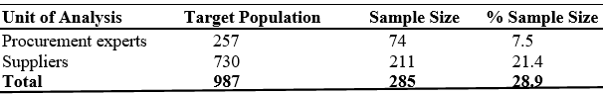
Source: Literature Review, 2020

Apart from that, the number of procurement experts and suppliers for sampling frame based on the ratio of the targeted population of each unit of analysis to the total targeted population times the minimum number of respondents required per rule of thumb suggested by Hair et al. (2018) for validating the research model of this study.

3.3.6 Sampling Design and Procedures
The study used probability (stratified) sampling. This method of sampling was used to develop the sample of the research under discussion and to meet the objectives of the study. With this context, the respondents of this study were procurement experts from selected procuring entities and suppliers who were trained for piloting TANePS adoption. Respondents were grouped into five strata (for trained procurement experts). Additionally, suppliers were grouped into two strata (registered suppliers with telephone number only and registered suppliers with both telephone number and e-mail address).

The reason for using this sampling technique was to ensure each trained procurement expert and supplier was fairly represented and reached by any means (either face to face, telephone, e-mail or google form) and fill the questionnaire. This was due to the fact that each trained procurement expert and supplier was regarded to have the required knowledge and skills pertaining to TANePS adoption in the country. In addition, each trained procurement expert from selected procuring entity and suppler for piloting TANePS adoption had an equal chance of being selected from each stratum by using rand between and v-look functions. Then, basing on the research model of this study, the instruction recommended by Hair et al. (2018) for adapting PLS-SEM and SmartPLS 3 software in data analysis was useful to govern the minimum number of procurement experts and suppliers from each stratum.

3.4 Variables and Measurement Procedures
Table 3.2 shows variables, indicators, level of measurement, data analysis method and tool.

Table 3.2: Variables, Indicators, Level of Measurement, Data Analysis Method and Tool.
 | Dependent  Variable Indicators |  | Level of  Measurement |  |  | Data Analysis  Method Data Analysis Tool
TANePS Adoption |  | Service performance, efficiency, transparency and  information quality |  | Ordinal | PLS-SEM |  | SmartPLS 3
Independent Variable |  | Indicators |  | Level of Measurement | Data Analysis  Method |  | Data Analysis Tool
Legal Framework |  | Influence of PPA 2011 and its amendment PPA 2016 on TANePS adoption and its operations  Influence of PPR 2013 and its amendment PPR 2016 on TANePS adoption and its operations |  | Ordinal | PLS-SEM |  | SmartPLS 3
Performance expectancy |  | Procurement process, payment process, chances of corruption, procurement cycle |  | Ordinal | PLS-SEM |  | SmartPLS 3
Relative Advantage |  | Reduction in transaction errors, transaction costs, improved data accuracy, faster tendering process |  | Ordinal | PLS-SEM |  | SmartPLS 3
Attitude |  | Personal opinion on the system, intention to learn,  intention to use,  intention to take advantages of the system |  | Ordinal | PLS-SEM |  | SmartPLS 3
Source: Conceptualized from the Existing Literature, 2020

3.5 Data Collection Methods and Tools

3.5.1 Survey and Questionnaire
This study employed a survey method and a questionnaire that contained a set of closed ended questions which was sent to the respective respondents with a request to answer those questions for the purpose of obtaining primary data. Basing on the conditions under which the conceptual model of this study operates, questions with objective answers were constructed reflecting the specific objectives of the study. The respondents were supposed to answer the questions on their own. The purpose of using a questionnaire in data collection was to get the original primary data which were relevant to the objectives of the study. The original primary data were important because there was no sufficient secondary data to fully undertake this study.

3.5.2 Documentary Review
The study used documents which were relevant and reflected the title of this study. Past researches and articles related to this study were important because they were used to write the literature review and establish the research gaps (theoretical, contextual and methodological). In addition, past researches and articles related to this study were important because they were used to get input for construction of the questionnaire.

3.6 Measurement of Respondents’ General Information and Variables
This section shows the measurement of variables and the general information of the respondents.

3.6.1 Measurement of Respondents’ General Information
The respondents’ general information was operationally measured by using non-parametric measurements for sex and education level. The responses were based on a nominal scale attitude questions (1= “male”, and 2= “female”; 1= “primary education”, and 7= “PhD level”). However, respondents’ general information was operationally measured by using parametric measurements for age and experience. The responses were based on a ratio scale for attitude questions of which complete age and experience were filled in the questionnaire.

3.6.2 Measurement of Dependent and Independent Variables
The dependent variable TANePS adoption (service performance, efficiency, transparency and information quality) and the independent variables legal framework (influence of PPA 2011 and its amendment PPA 2016 on TANePS adoption and influence of PPR 2013 and its amendment PPR 2016 on TANePS adoption), performance expectancy (simplification of procurement process, simplification of payment process, removal of chances of corruption, reduction of procurement cycle time), relative advantage (reduction in transaction errors, transaction costs, improved data accuracy, faster tendering process), attitude (acceptance of the system, intention to learn, plan to use, intention to take advantage) were operationally measured by using non parametric measurements. The responses were based on a five Likert scale (ordinal) questions (1= “strongly disagree”, and 5= “strongly agree”) (Masele, 2014; Taluka, 2016).

3.7 Data Processing and Analysis
Questionnaires with closed ended questions were assigned numbers to enable the process of quantitative data analysis to be more accurate and simpler. The collected quantitative data were analysed by using descriptive statistics with the help of IBM SPSS Statistics software Version 21 and by using Partial Least Squares Structural Equation Modeling (PLS-SEM) with the help of SmartPLS 3 software. Based on the complexity of the research model and data of this study, PLS-SEM was the only second-generation non-parametric multivariate method that could allow data analysis by incorporating both relationships between indicators and unobservable variables of the research model (Hair et al., 2018).

3.8 Assumptions Underlying PLS -SEM
The assumptions of PLS-SEM include the following:

3.8.1 The Good Neighbor Assumption (GNA)
This study used PLS Mode A assumption which applies the Good Neighbor Assumptions (GNA) whereby the weights and loadings linking latent variable scores and their indicators were estimated (Kock & Mayfield, 2015). The purpose of estimation was to maximize the strength of the associations among latent variables that were causally linked in a structural model (Becker, Ringle, & Sarstedt, 2018). Estimation of the latent variable was well predicted by its predecessors in the path diagram and was a good predictor for its followers in the diagram.

Therefore, the Mode A under GNA implied that the inner model, where hypothesized causal relationships among latent variables were defined, had to be taken into consideration during the calculation of latent variable scores (Hair, Hollingsworth, Randolph, & Chong, 2017a). In addition to that, the latent variable scores were also defined in part by the outer model, where associations among manifest and latent variables were specified (Hair, Hult, Ringle, Sarstedt, &Thiele, 2017b).

3.8.2 The Distribution of Variable Assumption
This study assumed that the data collected for specific objectives were non-normally distributed as recommended by Hair et al. (2018) for data analysis using PLS-SEM and SmartPLS 3.

3.8.3 Missing Values and Outliers Assumptions
This study assumed that there were no missing values and outliers because PLS-SEM operates in data analysis under the assumption that there is neither missing data nor outliers (Hair et al., 2018). However, during data entry, all missing values were assigned number 99 to alert the SmartPLS software 3 to analyse the required data only. After data entry, outliers were checked by determining the frequencies of the data set in each variable with the help of IBM SPSS statistics version 21 to ensure high quality of the findings.

3.8.4 Relationships with Good Theoretical Support Assumption
The constructs of the research model of this study were grounded by TOE model and UTAUT because PLS-SEM assumes that relationships which start with theoretical support are good in hypothesized model (Hair et al., 2014). In addition, structural theory indicates the latent variables to be considered in the analysis of a certain phenomenon and their relationships. However, the measurement theory speciﬁes how to measure latent variables (Sartedt et al., 2017).

3.9 PLS- SEM Algorithms
This study used PLS regression algorithm concept because it appears to be most regularly used in nonlinear SEM to minimize collinearity (Kock & Mayfield, 2015). In connection to that, the PLS regression algorithm no longer requires the existence of an internal model, which is one of its key defining characteristics in the context of PLS-based SEM (Sartedt et al., 2017). On the other hand, PLS regression algorithm is one of the most fantastic at minimizing collinearity amongst latent variables in a model with more than one latent variable and this applies to both reflective and formative latent variables (Hair et al., 2018).

3.9.2 PLS-SEM Path Mode
This study adopted the PLS Mode A algorithm. The justification for using PLS Mode A is based on the relationships of the constructs and their indicators of the research model for this study which began with subjective values being assigned to weights (W) and loadings (L), and the initialization of the construct (F). The vector W stores standardized weights, and the vector L stores loadings (Kock & Mayfield, 2015). These links occur in variable matrix X and the column vector F. The matrix Y incorporates the rankings of the latent variables that point at the latent variable F. (Sharma, Sarstedt, Shmueli, Kim, & Thiele, 2019). In Mode A, the matrix X “reflects” F, as illustrated in Figure 3.1:

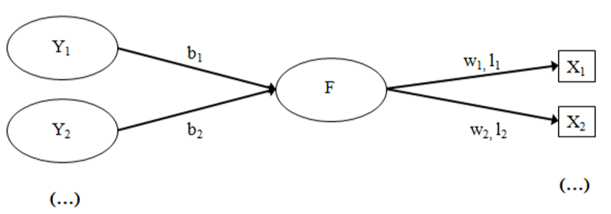
Figure 3.1: PLS Mode A
Source: Kock & Mayfield, 2015

3.10 Evaluation of Mediation Effects
This study adopted mediators that accounted for part of the relationships between predictors and outcomes (Hair et al., 2018). Figure 3.2 shows the concept of mediation effects evaluation procedure which was adopted in this study.
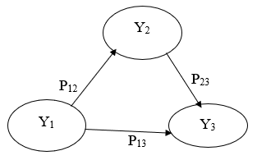
Figure 3.2: Concept of Mediation Effects Evaluation Procedures
Source: Hair et al., 2018

According to Hair et al. (2018), variable functions as a mediator when
- The differences in the levels of the independent variable account significantly for the disparities in the assumed mediator (i.e., p₁₂)
- The differences in the mediator account significantly for the disparities in the dependent variable (i.e., p₂₃), and
- When paths p₁₂ and p₂₃ are measured, a direct relationship between the independent and dependent variables (i.e., p₁₃) deviates its value significantly. P₁₃ does not have to be significant in order to test for mediation (Hair et al., 2018).

With reference to figure 3.2, the mediator analysis procedure number two was adopted in this study as shown in Figure 3.3:
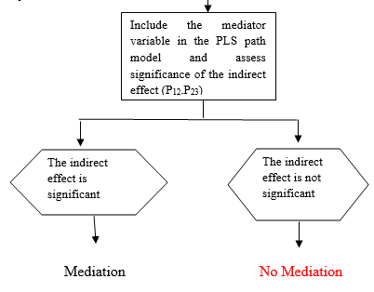
Figure 3.3: Mediator Analysis Procedure Number Two
Source: Hair et al., 2018

With reference to figure 3.2, the mediator analysis procedure number three was used in this study as shown in Figure 3.4:
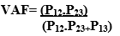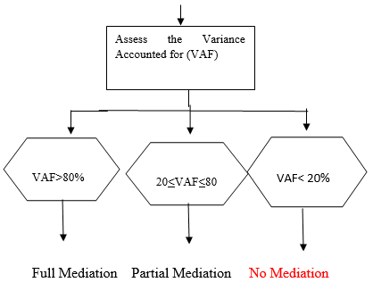
Figure 3.4: Mediator Analysis Procedure Number Three
Source: Hair et al. (2018)

3.11 Steps for Testing Mediating Effects
With reference to figure 3.2, the steps for testing mediating effects were adopted in relation to the answers of the following questions:
- Is the direct effect p₁₃ significant when the mediator variable is excluded from the PLS path model? The direct effect does not have to be significant for full mediation (Hair et al., 2018).
- Is the indirect p₁₂ · p₂₃ effect via the mediator variable significant after the mediator variable has been included in the PLS path model? If the indirect effect is insignificant then no mediation (Hair et al., 2018; Nitzl et al., 2016).
- How much of the direct effect p₁₃ does the indirect effect (i.e., p₁₂ · p₂₃) absorb? Is there a situation of partial or full mediation? According to Hair et al. (2018) the situation of partial mediation occurs when both the indirect and direct effects are significant while full mediation occurs when the direct effect is not significant and the indirect effect is significant.

3.12 Step-by-Step Procedures Employed in SmartPLS
SmartPLS 3 software was employed in this study because of its benefits and because it provides guidelines which are very clear for data analysis in application of PLS-SEM. One of the benefits of SmartPLS 3 software is that it has little limitations with sample size requirement as compared to other SEM software like AMOS. In addition, SmartPLS 3 software also does not require linearity and normality conditions (Hair et al., 2018). The procedures adopted in this study for employing SmartPLS software were as follows:

3.12.1 Importing Data File in SmartPLS 3 software
Before drawing the research model in SmartPLS 3 software, data for this study were saved in the required data file of .csv format because SmartPLS can use both data file formats (i.e., .csv or .txt) (Hair et al., 2018). After saving the data in the required file format, the downloaded and saved SmartPLS 3 software with activated key license on computer was opened by clicking on the file that runs SmartPLS 3 and the run tab to start the software. However, it was ready for creating a new SmartPLS 3 SEM project (Hair et al., 2018).

3.12.2 Creating a New Project and Insert Data in SmartPLS 3 software
To start using the software, there were two options: (i) to left click on the file pull-down menu and click on create new project, or (ii) left click on the new project icon at the top left corner (Hair et al., 2018). In creating a new project and insert the data for this study, option one was taken into consideration. Then, the name of the project in the window displayed after clicking OK. A project name TANePS Adoption was inserted after clicking OK. To import data for the project TANePS Adoption, left click on double click to import data was done and the project TANePS Adoption appeared in the window displayed on computer screen as noted by Hair et al., (2018). After double-clicking to insert data in SmartPLS 3 software, the “please choose a file” dialog box appeared; then the data file PhD was clicked from the desk top of the computer where it was located. After clicking the OK tab at the bottom of computer screen, the data file PhD was attached to the project name TANePS adoption. The icon on this file was then green which indicated that the data were correctly imported. The data file was shown on computer screen and indicated 7 missing data values because 99 was coded and assigned into each missing value to tell the SmartPLS 3 software to take care during analysis. Hair et al. (2018) noted that it is important to code all missing data in numerical so that the total number of missing values can be shown by the computer.

3.12.3 Drawing the Conceptual Path Model in SmartPLS 3 Software
To draw the conceptual path model in SmartPLS 3 software, the name of the model TANePS adoption was double clicked, then the data were moved to the lower left of the screen. The name of the data file was green ready for drawing the conceptual path model in the modelling window. Three icons at the top of the screen: select, latent variable, and connect were used. To insert latent variables, left click was done on this icon and the cursor was moved to the modelling window and left click again was performed. To draw conceptual model, the model name was clicked on to get blank modeling window. Latent variables for the structural model were now inserted in the modelling window as suggested by Hair et al. (2018). To move the latent variables to anywhere on the screen, left click was performed on select icon and cursor was moved to the modeling window.

3.12.4 Naming and Connecting the Latent Variables in SmartPLS 3 Software ss
To rename latent variables, select icon was clicked, then latent variable was right clicked, then dialog box with rename option appeared, then left click was performed on rename option. The first latent variable was renamed then click OK was done. The same procedure was performed for all latent variables (Hair et al., 2018). To attach the indicator variables to their constructs, left click, hold down and drag were done. Hold down shift button on the keyboard and left click on first variable was performed, then on last variable to highlight all variables. Hold left button down and drag measured variables were done till cursor was on top of the correct latent variable. Release left button and drop measured variables were done to attach to the correct latent variable (Hair et al., 2018). The same process to attach all measured variables to their respective latent constructs was followed. To change position of the measured variables, cursor was placed in select mode on top of measured variables and left click was conducted to place the measured variables on any side by left clicking on the desired position (Hair et al., 2018).

3.12.5 Aligning Indicators and Latent Variables in SmartPLS 3 Software
Another way to change the position of the measured variables, the cursor was placed in select mode on top of measured variables and right click was done. Then dialog box to select the side appeared by left clicking on the desired position. After clicking on align indicators right, the measured variables were now in the right-side position. Indicators were now repositioned for all constructs. However, all constructs were blue after attaching data (Hair et al., 2018).

3.12.6 Executing the PLS algorithm in SmartPLS 3 Software
After positioning all constructs and indicators to their respective position as shown in the conceptual model, the PLS algorithm was executed by clicking on calculate icon then PLS algorithm. After running PLS algorithm, the conceptual model appeared with explanation of endogenous latent variables (R²), relevance of path coefficients and indicator reliability (outer loadings). The report icon was left clicked to obtain other values including internal consistent reliability of the constructs, convergent validity and discriminant validity of the constructs, effect size of path coefficients (f²) and collinearity (VIF) (Hair et al., 2018).

3.12.7 Bootstrapping Process in SmartPLS 3 Software
This study employed PLS-SEM bootstrapping process with the help of SmartPLS 3 to generate sub-sample by randomly sampling with replacement from the original sample. Calculation of standard errors for hypotheses testing was done under an assumption that sub-sample distribution was reasonable and representable of the intended population distribution (Hair et al., 2018). Justification of employing PLS-SEM bootstrapping process in this study based on the fact that it does not assume the data are normally distributed, which implied that parametric significance tests used in regression analyses would not be applied to test whether coefficients such as outer weights and loadings were significant. Instead, PLS-SEM relies on a nonparametric bootstrap procedure to test coefficients for their significance (Hair et al., 2018). In bootstrapping, a large number of subsamples (i.e., bootstrap samples) was drawn from the original sample with replacement. Replacement meant that each time an observation was drawn at random from the sampling population, it was returned to the sampling population before the next observation was drawn (i.e., the population from which the observations are drawn always contain all the same elements) (Hair et al., 2018). Therefore, an observation for a certain subsample could be selected more than once, or would not be selected at all for another subsample.

3.12.8 Multi-Group Analysis (MGA) in SmartPLS 3 Software
Partial Least Squares Multi-Group Analysis (PLS-MGA) was employed because it is a non-parametric method which reflected the nature of data collected for this study. To find out whether significant differences were present between coefficients of the critical success factors with regard to procurement experts’ and suppliers’ perception, PLS-SEM multi-group analysis (PLS-MGA) was inevitable. PLS-MGA is an approach for comparing PLS model estimates across groups of data when the groups are known prior, and measured in the study like the type of respondents of this study (Hair et al., 2018).

3.13 Global Goodness of Fit Criterion and Prediction for PLS SEM
To compensate for PLS-SEM limitation of lacking global goodness of fit criterion, which limits its applicability in theories testing, two steps process had to be employed to assess PLS-SEM path models of this study (Henseler, & Sarstedt, 2013). The first step involved evaluation of measurement models using reliability and validity with multiple acceptable criterions. The second step involved was evaluation of the structural inner model using assessment of path coefficients, coefficients of determination (R²), effect size (f²) and Stone-Geisser's (Q²) which could be calculated using sample re-use technique as criterion of predictive relevance (Hair et al., 2018). In addition, the primary appeal of PLS-SEM was that the method made can estimate a complex model with many constructs, indicator variables, and structural paths without imposing distributional assumptions on the data (Henseler, & Sarstedt, 2013). However, more importantly, PLS-SEM is a causal predictive approach to SEM that emphasizes prediction in estimating statistical models, whose structure is designed to provide causal explanations. Furthermore, PLS-SEM is not only very appropriate for exploratory research, but the method is also useful for confirmatory research (Hair et al., 2018). Figure 3.5 shows the PLS-SEM evaluation procedures for reflective and formative models.
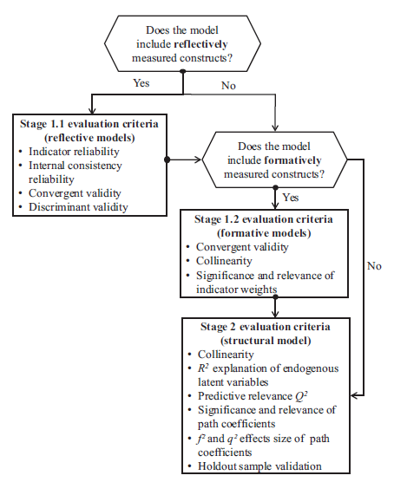
Figure 3. 5: PLS-SEM Evaluation Procedures for Reflective and Formative Models
Source: Sartedt et al. (2017).

3.14 PLS-SEM Evaluation Procedures for Reflective Models
With reference to Figure 3.8, this study adopted PLS-SEM evaluation procedures for reflective model due to the nature of the constructs and their indicators in the conceptual model of this study. Taking into account the influences of all constructs to their indicators, reflective model was appropriate for this study. In data analysis for this study, the researcher used PLS-SEM evaluation procedures for reflective models (Sartedt et al., 2017). Basing on reflective model of this study, the analysis was performed by assessing reflective measurement models and structural models.

3.8 Assessing Reflective Measurement Models
In assessing the reflective measurement models, four stages were involved: examining the indicator loadings (reliabilities), assessing the internal consistent reliability, assessing the convergent validity and assessing the discriminant validity.

3.8.1 Examining the Indicator Loadings (Reliabilities)
After executing PLS algorithm, the report for indicators loadings of the constructs of the research model for this study were above 0.708 value, which indicated that questions posed to the respondents were reliable.

3.8.2 Assessing Internal Consistency Reliability
After executing PLS algorithm, the report for composite reliability values of all constructs were between 0.60 and 0.90 and were considered “acceptable” because in exploratory research, composite reliability values 0.60 and 0.90 range from “satisfactory’ to ‘good’ (Hair et al., 2018). However, reliability values of 0.95 and above suggest the possibility of undesirable response patterns, thereby triggering inflated correlations among the indicators’ error terms. This study used composite reliability to measure internal consistency reliability of the constructs and most of the constructs’ composite reliability values were above 0.7 and less than 0.95 which suggested there was desirable response patterns.

3.8.3 Assessing the Convergent Validity
The metric used for evaluating a construct's convergent validity was the average variance extracted (AVE). In this study the average variance extracted (AVE) value was above 0.5 for all items. Therefore, each construct converged in order to explain the variance of its item.

3.8.4 Assessing the Discriminant Validity
The next step in reflective measurement model assessment was to assess discriminant validity, which is the extent to which a construct is empirically distinct from other constructs in the structural model. Henseler, Ringle, and Sarstedt (2016) proposed the heterotrait-monotrait ratio (HTMT) which is defined as the mean value of the item correlations across constructs relative to the (geometric) mean of the average correlations for the items measuring the same construct. In addition, Henseler et al. (2016) proposed a threshold value of 0.90 for structural models with constructs that were conceptually very similar, such as cognitive satisfaction, affective satisfaction and loyalty. In this study, HTMT value was less than 0.90 in all items which indicated that each construct was empirically distinct from other constructs in the structural model. Table 3.3 shows the evaluation of the measurement model using the established criteria by Hair et al. (2018).

Table 3.3: Evaluation of the Measurement Model Using the Criteria
Criteria |  | Values | Source
Indicators’ Reliability | Indicators’ Reliability should be >0.708, Note: Indicators’ Reliability with value between 0.4 and 0.7 should be considered for removal only if deletion of these indicators leads to an increase of composite reliability and AVE suggested threshold value. |  |  | Hair et al., 2018
Internal Consistency Reliability | Internal Consistency Reliability should be >0.708, Note: In Exploratory Research Internal Consistency Reliability value of 0.6 to 0.7 is considered acceptable. values 0.70 and 0.90 range from “satisfactory to good (Hair et al., 2018). However, reliability values of 0.95 and above suggest the possibility of undesirable response patterns. |  |  | Hair et al., 2018
Convergent Validity | For Convergent Validity: Average Variance Extracted (AVE) should be higher than 0.5 |  |  | Hair et al., 2018
Discriminant Validity | For discriminant validity: Heterotrait-Monotrait Ratio of Correlations (HTMT) threshold value should be less than 0.90 for structural models with constructs that are conceptually very similar, such as cognitive satisfaction, affective satisfaction and loyalty. (HTMT) threshold value of 0.85 or less is for structural models with constructs that are conceptually distinct such as work environment perception, organization commitment… or brand equity and performance. |  |  | Hair et al., 2018
Source: Literature Review, 2020

3.9 Evaluation of the Structural Model Procedures
In this study collinearity for structural model constructs was examined. After checking for collinearity, the key criteria for assessing the structural model in PLS-SEM were: the significance of the path coefficients, the level of the R² values, the f² effect size, and the predictive relevance (Q² and the q² effect size) (Hair et al., 2018).

3.9.1 Assessing Reflective Structural Models

3.9.1.1 Assessing Collinearity
Collinearity was examined to make sure it does not bias the regression results. This process is similar to assessing formative measurement models, but the latent variable scores of the exogenous constructs were used to calculate the VIF values. VIF values above 5 could indicate probable collinearity of the predictor construct (Hair et al., 2018). In this study, VIF value was less than 5 in all items which indicated that there was no collinearity in the predictor constructs.

3.9.1.2 Examining the R2 Value of the Endogenous Constructs
Since collinearity was not an issue, the next step was to examine the R² value of the endogenous construct(s). The R² measures the variance which is explained in each of the endogenous. The R² is also referred to as in-sample predictive power and it ranges from 0 to 1, with higher values indicating a greater explanatory power. As a guideline, the R² values of 0.75, 0.50, and 0.25 can be considered substantial, moderate, and weak respectively (Hair et al., 2011). However, acceptable R² values are based on the context and in some disciplines an R² value as low as 0.10 is considered satisfactory (Hair et al., 2018). When measuring a concept that is inherently predictable, such as physical processes, R² values of 0.9 might not be surprising. But the same R² values in a model that predicts human attitudes, perception, and intentions could likely indicate overfit (Hair et al., 2017a). In this study, R² values for all endogenous constructs were more than 0.25 which indicated that the exogenous construct was able to determine the variations of the endogenous constructs in the structural model by more than 25 per cent towards TANePS adoption.

3.9.1.3 Examining the f2 Effect Size
The next step was to examine the f² effect size. Hair et al. (2018) assert that researchers can also assess how the removal of a certain predictor construct affects an endogenous construct’s R² value. This metric is the f² effect size and is somewhat redundant to the size of the path coefficients. More precisely, the rank order of the predictor constructs' relevance in explaining a dependent construct in the structural model, is often the same when comparing the size of the path coefficients and the f² effect sizes. In such situations, the f² effect size should only be reported if requested by editors or reviewers (Hair et al., 2018). Otherwise, the researcher may report the f² effect size to explain the presence, for example, of partial or full mediation (Nitzl et al., 2016). As a rule of thumb, values higher than 0.02, 0.15, and 0.35 depict small, medium and large f² effect sizes (Hair et al., 2018). In this study, f² effect size value was less than 0.02 in two relationships of the constructs which indicated that the hypothesized relationships had no impact to the research model hence full mediation of the two constructs existed.

3.9.1.4 Examining the Q2 values of the Endogenous Constructs
The next step was to examine the Q² values of the endogenous constructs. The standard assessment criteria which were considered in assessing the structural model included the blindfolding-based cross-validated redundancy measure Q². In this study, the value of Q² was less than zero which indicated that the predictor construct had power to predict the outcome. To determine Q² in SmartPLS, blindfolding was used (Hair et al., 2018).

3.9.1.5 Examining the Statistical Significance and Relevance of the Path Coefficients
The next step was to examine the statistical significance and relevance of the path coefficients to assess the extent to which the data reflect the hypothesized relationships. In this study, t-statistic higher than 1.96 at significance level of 0.05 for all paths was acceptable and p-values of 0.05 or less were said to be significant.

3.9.1.6 Importance-Performance Matrix Analysis (IPMA)
The last step was to examine holdout sample validation by determining the importance and performance of the constructs and indicators of the research model. The importance-performance matrix was used in examining holdout sample validation. For good and useful research model in decision making, the constructs and their indicators should not follow under the quadrant with less important and low performance. In this study there was no indicator or construct which followed under the quadrant with less important and low performance which indicated that all constructs and indicators of the research model were important and their performance in the research model of this study was higher. To examine the holdout sample validation in SmartPLS, important-performance matrix analysis (IPMA) was used (Hair et al., 2018). Table 3.4 shows the summary of evaluation of the structural model using the established criteria.

Table 3.4: Evaluation of the Structural Model Using the Established Criteria
Criteria |  |  | Values | Source
Collinearity |  | Collinearity Statistics (VIF) value less than 5 |  |  | Hair et al., 2018
Coefficient of Determination (R²) |  | Coefficient of Determination, R², substantial>0.75, moderate >0.5 and weak>0.25. Note: acceptable R² values are based on the context and in some disciplines R² value as low as 0.10 is considered satisfactory. When measuring a concept that is inherently predictable, such as physical processes, R² values of 0.9 might not be surprising. But the same R² values in a model that predicts human attitudes, perception, and intentions could likely indicate overfit. |  |  | Hair et al., 2018
Predictive Relevance (Q²) |  | Q²> 0 |  |  | Hair et al., 2018
Size and Significance of Path Coefficient (β) |  | t-statistic higher than 1.96 at significance level of 0.05 for all paths |  |  | Hair et al., 2018
Examining the f² effect size |  | As a rule of thumb, values higher than 0.02, 0.15, and 0.35 depict small, medium, and large f² effect sizes |  |  | Hair et al., 2018
Examining holdout sample validation |  | determining the importance and performance of the constructs and indicators of the research model using importance-performance matrix. The indicator or construct should not follow under less important-low performance quadrant |  |  | Hair et al., 2018
 | Source: Existing Literature, 2020

3.10 Reliability of Data
In order to ensure reliability of the quantitative data in this study, pilot study was conducted before the actual data collection and analysis. The questionnaires were distributed to the experts apart from the targeted respondents to check the consistency of the method of data collection. SmartPLS software was used to check for internal consistency reliability of which result of composite reliability was above 0.7 and less than 0.95 which indicated that the questionnaire was good, acceptable and reliable (Hair et al., 2014).

3.11 Validity of Data
SmartPLS was used to check the validity of the questionnaire of which the Average Variance Extracted (AVE) was higher than 0.5 for convergent validity while for discriminant validity Heterotrait-Monotrait Ratio of Correlations (HTMT) criterion was less than 0.9 which implied that the questionnaire measured what agreed by all constructs to measure. In addition, each construct measured differently.

3.12 Technique of Handling Missing Values
Extra answer method was used to deal with missing values by using SmartPLS 3 software (Eekhout et al., 2012). This method replaces missing data by zero or any number which is not ranked in scale adopted (Hair et al., 2014). This study used 99 as the number which replaced the missing values. On the other hand, this method allows for systematic difference between observed and unobserved data.

3.13 Techniques of Identifying and Handling Outliers
In this study, bootstrapping method was used to handle outliers. This method estimates the parameters of a model and their standard errors from the sample, without reference to a conceptual sampling distribution (Hair et al., 2014). In addition, IBM SPSS statistics software was used to identify outliers.

3.14 Ethical Considerations
This study was subjected to ethical issues like avoiding plagiarism and respecting confidentiality of the data collected from the respondents, avoiding falsification of data, avoiding fabrication of data, keeping secrecy of respondents and voluntary participation of respondents. With this note, respondents were fully informed regarding the objectives of the study and were reassured that their answers would be treated with utmost confidentiality and be used only for academic purposes.

CHAPTER FOUR

DATA ANALYSIS AND FINDINGS

4.1 Chapter Overview
This chapter shows the analysis and the findings of the study. The gathered data for respondent’s demographics were analyzed by using descriptive analysis with the help of IBM SPSS statistics version 21 software and the results were presented in the form of frequency distribution tables, mean and standard deviation scores. The collected information and data with regard to the specific objectives of this study were analyzed by using PLS-SEM with the assistance of Smart PLS 3 software. Subsequently, significance testing results and interpretation of findings which included path coefficients and their respective significance level (p-values) were presented based on the specific objectives of this study.

4.2 Findings from Pilot Study
Based on reflective model of this study, the piloting data analysis was performed by assessing reflective measurement models (constructs’ internal consistency reliability and convergent validity) and structural models (coefficient of determination (R²), size and significance of path coefficient. The purpose of piloting data analysis was to get the overall view of the responses to the survey questions and the results.

The study utilized fifty (50) respondents for piloting from whom 15 were obtainment specialists in procurement from procuring entities and 35 were suppliers from private sector. The information investigation of 50 respondents was conceivable in light of the fact that the general guideline recommended by Hair et al. (2018) for applying PLS-SEM and SmartPLS 3 software in data analysis was valuable which requires various pointers (indicators) of the exogenous (with most extreme indicators) times ten equivalents to be the base number of the sample size for the research model assumptions to be tested (Hair et al., 2018). Then, 40 respondents were required to satisfy the base necessity of the research model of this study by utilizing PLS-SEM and Smart PLS 3 programming because of the way that the exogenous idle develop of the exploration model (legal framework) had four indicators. At that point four indicators times ten equivalent forty. The number of procurement experts and suppliers for piloting data analysis based on the ratio of the targeted population of each unit of analysis to the total targeted population times the minimum number of respondents required per rule of thumb suggested by Hair et al. (2018).

4.2.1 Pilot Study Findings for Assessing Reflective Measurement Models

4.2.1.1 Internal Consistency Reliability
SmartPLS 3 software was used to check for internal consistency reliability of which the results of composite reliability for all constructs were above 0.7 which indicated that the measurement of the instrument used was reliable. Figure 4.1 shows the results of constructs’ internal consistency reliability by composite reliability.

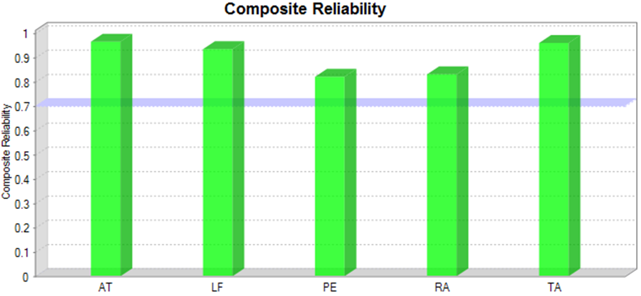
Figure 4.1: Constructs’ Reliability by Composite Reliability
Source: Survey Results, 2020

4.2.1.2 Constructs’ Convergent Validity
SmartPLS was also used to check the convergent validity in piloting data analysis of which the Average Variance Extracted (AVE) was higher than 0.5 which indicated that each construct’s validity was able to converge in order to explain the variance of its items. Figure 4.2 shows the results of constructs’ convergent validity after running PLS algorithm.

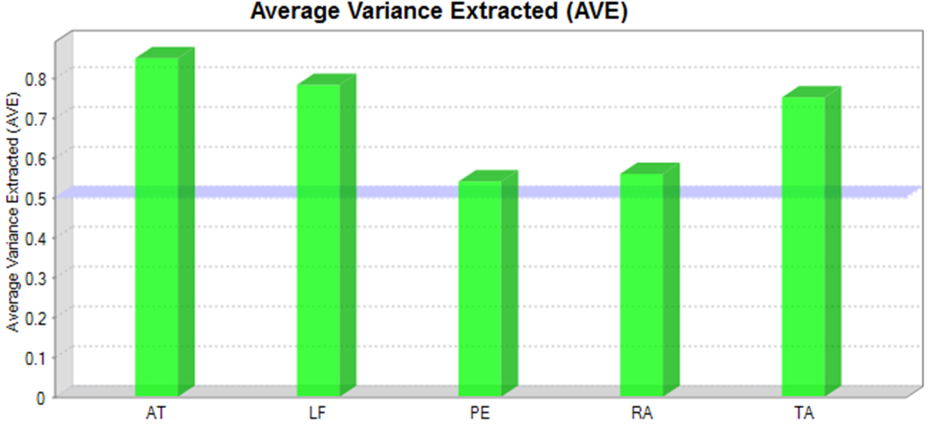
Figure 4.2: Constructs’ Convergent Validity
Source: Survey Results, 2020

4.2.2 Pilot Study Findings for Assessing Reflective Structure Models

4.2.2.1 Examining Coefficient of Determination (R2)
SmartPLS 3 software was used to check for coefficient of determination (R²). After running PLS algorithm, the results of coefficient of determination (R²) for all constructs were above 0.25 which indicated that over 25 percent of the variations in all endogenous constructs to influence TANePS adoption were caused by exogenous construct (legal framework). Figure 4.3 shows the results of endogenous constructs’ coefficient of determination (R²) and the size of path coefficient of the research model.
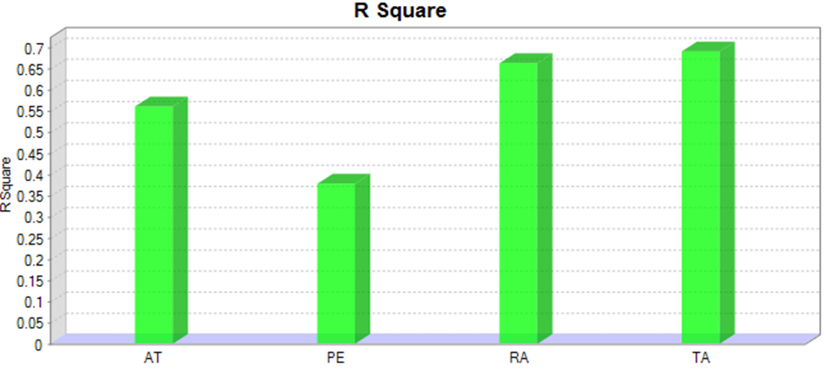
Figure 4.3: Endogenous Constructs’ Coefficient of Determination (R²)
Source: Survey Results, 2020

4.2.2.2 Examining the Size of Path Coefficient
SmartPLS 3 software was used to check size of Path Coefficients. After running PLS algorithm, the results of the size of Path Coefficients of the research model revealed that all hypothesized relationships had positive correlations. Figure 4.4 shows the results of the size of Path Coefficient of the research model indicating positive path coefficients.

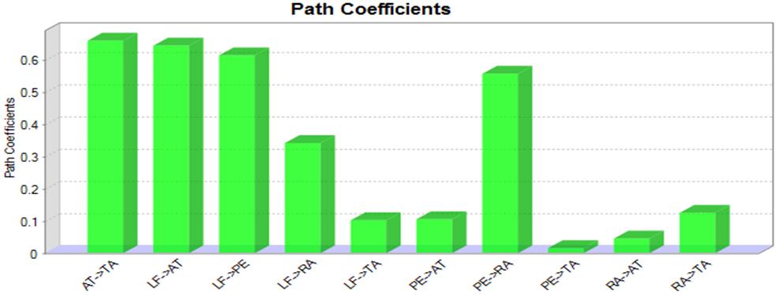
Figure 4.4: The Size of Path Coefficients of the Research Model
Source: Survey Results, 2020

4.2.2.3 Examining the Significance of Path Coefficient
The significance of path coefficient was checked after running bootstrapping in SmartPLS 3. The results showed that three hypotheses were rejected and seven hypotheses were supported which implied that 70 per cent of the hypothesized relationships were existing in real life. However, three hypothesized relationships did not exist. Figure 4.5 shows the results of significance of path coefficient.

Independent Variable Mediator Variables Dependent Variable
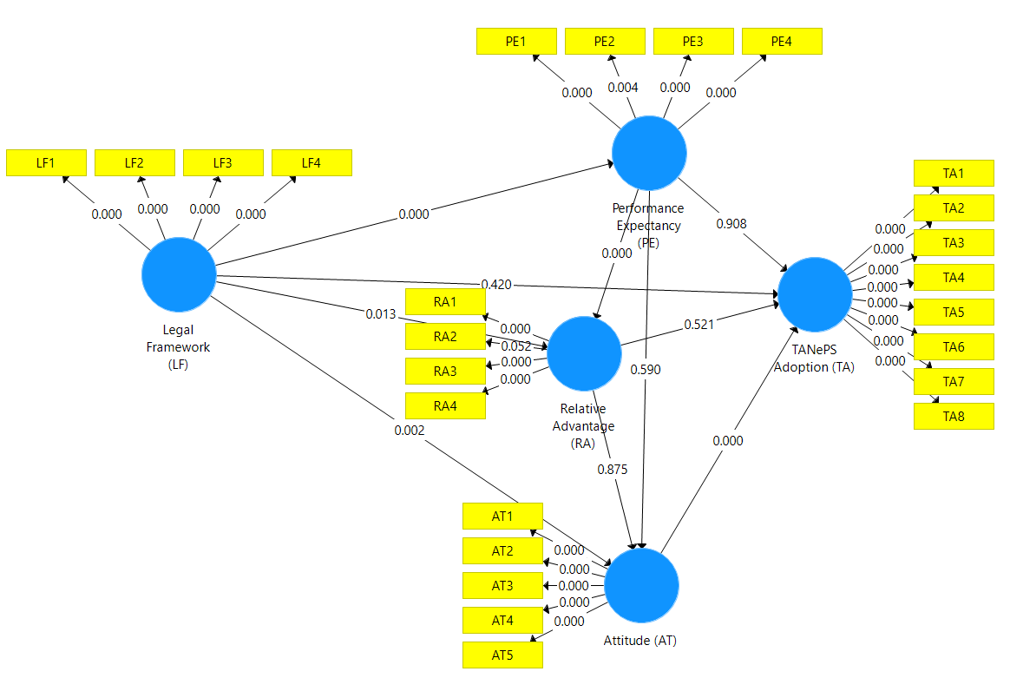
Figure 4.5: Significance of Path Coefficient after Running Bootstrapping
Source: Survey Results, 2020

The significance of path coefficient (hypotheses testing for pilot analysis) per specific objectives are shown in Table 4.1.

Table 4.1: Hypotheses Tested for Pilot Analysis
Hypothesis | Path | P-Value |  | Influence | Specific Objective
H1_{a} | LF -> TA  H₁ | 0.420 |  | Direct | One
H1_{b} | LF->PE -> TA  H₂.H₅ | 0.000 |  | Indirect | Five
H1_{c} | LF-> RA -> TA  H₃.H₈ | 0.000 |  | Indirect | Five
H1_{d} | LF ->AT-> TA  H₄.H₁₀ | 0.000 |  | Indirect | Five
H2_{a} | PE->TA  H₅ | 0.908 |  | Direct | Two
H2_{b} | PE ->RA -> TA  H₆.H₈ | 0.000 |  | Indirect | Five
H2_{c} | PE -->AT -> TA  H₇.H₁₀ | 0.000 |  | Indirect | Five
H3_{a} | RA -> TA  H₈ | 0.521 |  | Direct | Three
H3_{b} | RA ->AT-> TA  H₉.H₁₀ | 0.000 |  | Indirect | Five
H4 | AT-> TA  H₁₀ | 0.000 |  | Direct | Four
Source: Survey Results, 2020
Key:
H_{1a}: Legal framework (LF) positively and directly influences TANePS adoption (TA).
H_{1b.} In the presence of mediation effect of Performance Expectancy (PE), Legal framework (LF) positively and indirectly influences TANePS adoption (TA).

H_{1c:} In the presence of mediation effect of Relative Advantages (RA), Legal framework (LF) positively and indirectly influences TANePS adoption (TA).

H_{1d:} In the presence of mediation effect of Attitude (AT), Legal framework (LF) positively and indirectly influences TANePS adoption (TA).

H_{2a}: Performance expectancy (PE) positively and directly influences TANePS adoption (TA).
H_{2b}: In the presence of mediation effect of Relative Advantage (RA), Performance Expectancy (PE) positively and indirectly influences TANePS adoption (TA).

H_{2c}: In the presence of mediation effect of Attitude (AT), Performance Expectancy (PE) positively and indirectly influences TANePS adoption (TA).

H_{3a}: Relative advantage (RA) positively and directly influences TANePS adoption (TA).
H_{3b:} In the presence of mediation effect of Attitude (AT), Relative advantage (RA) positively and indirectly influences TANePS adoption (TA).

H_{4:} Attitude (AT) positively and directly influences TANePS adoption in the public sector (TA).

Based on the findings of the pilot data analysis in Table 4.1, the study had an overall view of the responses to the survey questions and the results. However, the piloted data for analysis were not included in the actual data analysis of the study findings. The following section shows the rate of respondents after the actual data collection.

4.3 Findings from Main Study

4.3.1 Rate of Respondents
The total actual sample size obtained in data collection for this study was 157 (55.09 per cent of expected sample size) from which 35.09 per cent of the respondents were from procuring entities and 20 per cent of the respondents were suppliers. Generally, this response rate was good and representable and conforms to Mugenda (2003) who stipulated that a response rate of 50 per cent is adequate for analysis, a response rate of 60 per cent is good and a response rate of 70 per cent and over is excellent. Based on this fact, the respondents’ rate of this study was good. These findings differ from the previous studies’ findings. For example, the study by Shale (2014) had response rate of 84.21 per cent. In addition, the study by Mrope (2018) had response rate of 84 percent similar to that of Shale (2014). The respondents’ rate of this study seems to be not similar to the previous studies’ respondents’ rate because it involved respondents from public and private sectors, of which the responses rate from private sector always is unsatisfactory as evidenced by Gupta and Narain (2012) on their study regarding adoption of e-procurement in Indian organizations. The study by Gupta and Narain (2012) revealed that 52.78 percent of the respondents were from public sector, while 41.67 per cent of the respondents were from private sector.

Though the respondents’ rate of this study differs from some previous studies, the higher statistical powers was achieved with unexpected sample size because the actual sample size collected was more than the minimum number of sample size required for this study under the general guideline proposed by Hair et al. (2014) which requires various indicators of the exogenous (with most extreme indicators) times ten equivalents to the base number of the sample size for the exploration model to be tested its theories. Table 4.2 shows the respondents rate of this study.

Table 4.2: Respondents’ Rate
Type of Respondent | Expected Actual | Percent
Procurement Expert and Supplier | 285 157 | 55.09
Source: Survey Results, 2020

4.3.2 Demographic Characteristics of the Respondents

4.3.2.1 Sex of the Respondents
Sexes of the respondents were analysed and the findings revealed that about three quarters of the respondents of this study were male and about a quarter were female. These results are comparable to the prior studies’ findings, for example, Shale (2014) revealed that 68 per cent were male while 32 per cent were female. In addition, the study by Masele (2014) revealed that respondents by gender to a great extent were imbalanced; that is, 108 out of all respondents (73 per cent) were males and the remaining 40 (27 per cent) were female. According to Masele (2014), respondents were from top management cadres, meaning that, most top positions were headed by men than women. In this study, the findings also depict unfair balance of sex as the procurement experts’ and suppliers’ posts were dominated by men. Table 4.3 shows the sex analysis of the respondents of the study.

4.3.2.2 Age of the Respondents
With regard to age, findings revealed that most of the respondents were below 50 years but were not below 21 years. This finding implied that the data of this study were provided by matured respondents and therefore, the information was regarded to be very comprehensive and genuine. Table 4.3 presents the age analysis of the respondents of the study.

4.3.2.3 Education of the Respondents
The findings with regard to education level of the respondents of the study revealed that 97.5 per cent were at least Form Four leavers. The implication of this finding is that the information and data provided by the respondents in this study were genuine and comprehensive. This argument is supported by the assumption originated from the study by Gardner and Rausser (as cited in Masele, 2014) who concluded that there is positive relationship between level of education and technology adoption. In addition, people with higher education have better access to information and knowledge that are useful to various business operations. Table 4.3 shows the education level of the respondents of the study.

4.3.2.4 The Type of Respondents
The findings revealed that about two thirds of the respondents of this study were from public sector (procurement experts) and about one third of the respondents were from private sector (suppliers). These results are parallel to the former studies. For example, Gupta and Narain (2012) on a survey on adoption of e-procurement in Indian organizations revealed that 52.78 per cent of the respondents were from public sector, 41.67 per cent were from private sector. These findings imply that in many studies which involve respondents from public and private sectors, the response rate from private sector is always less than response rate from public sector. There is evidence revealed in this study that many suppliers were reluctant to respond with regard to the questionnaires which were sent by the researcher. Table 4.3 shows the analysis of the type of respondents of the study.

4.3.2.5 Experience of Respondents
Respondents of this study had a mean experience of 10 years and 14 days in their particular fields and they had a range of one year to thirty-eight years work experience. This finding implies that the information and data provided by the respondents for this study with regard to TANePS adoption were actual and comprehensive. Table 4.3 shows the experience analysis of the respondents of the study in their fields.

Table 4.3: Demographic Characteristics of the Respondents (n=157)
Characteristics |  | Frequency | Percentage (%)
Sex | Male | 115 | 73.2
 | Female | 42 | 26.8
Age Group | 21-30 | 29 | 18.5
 | 31-40 | 58 | 36.9
 | 41-50 | 39 | 24.8
 | 51-60 | 25 | 15.9
 | 61+ | 6 | 3.8
 | Primary Education | 4 | 2.5
 | Secondary Education | 15 | 9.6
Education | Certificate Level | 5 | 3.2
 | Diploma Level | 22 | 14.0
 | Bachelor Degree | 65 | 41.4
 | Master’s Degree | 45 | 28.7
 | PhD Degree | 1 | 0.6
Respondent | Procurement Expert | 100 | 63.7
 | Supplier | 57 | 36.3
Experience | 1-10 | 109 | 69.4
 | 11-20 | 34 | 21.7
 | 21-30 | 8 | 5.1
 | 31+ | 6 | 3.8
Source: Survey Results, 2020

4.3.2.6 Mean and Standard Deviation of the Respondents’ Age
Apart from age of the respondents as shown in Table 4.3, the study also revealed that about 40 years was the mean age of the respondents. In addition, there was insignificant dispersion of years from one respondent to another due to the fact that the standard deviation from the mean age was only about 10 years. This finding implied that the ages of the respondents were not scattered and therefore, the information and data provided for this study was very comprehensive and genuine. Figure 4.6 shows the mean and standard deviation of the respondents’ ages of the study.
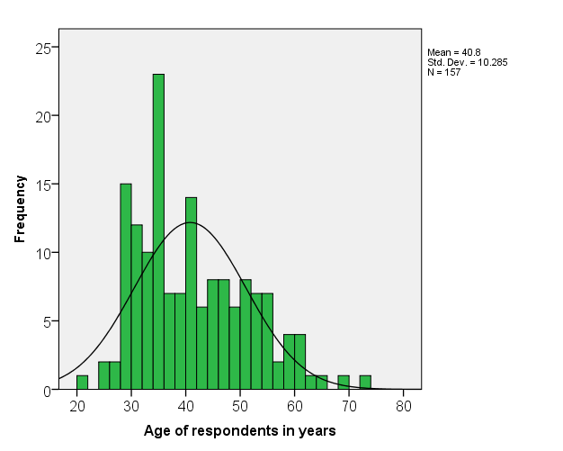
Figure 4.6: Mean and Standard Deviation of the Respondents’ Ages
Source: Survey Results, 2020

4.3.2.7 Education Level of Respondents against Type of Respondent
Apart from the education level of respondents as shown in Table 4.3, the findings concerning education level against type of respondents revealed that majority of the respondents from procuring entities had higher levels of education than suppliers. Procurement experts from procuring entities who responded in this study were as follows: eight per cent were holding diploma in procurement, 50 per cent were holding bachelor degree in procurement and 42 per cent were holding post graduate degrees related to procurement. For suppliers who responded in this study the finding revealed that 66.7 per cent were holding diplomas in different fields, certificates in various fields, certificates of secondary and primary education, 26.3 per cent were holding bachelor degree in different fields and 7.0 per cent of the respondents were holding post graduate degrees in different fields. These findings implied that the information and data provided by the respondents for this study were actual and comprehensive. Table 4.4 shows the education level of respondents against type of respondents.

Table 4.4: Education Level of Respondents against Type of Respondents
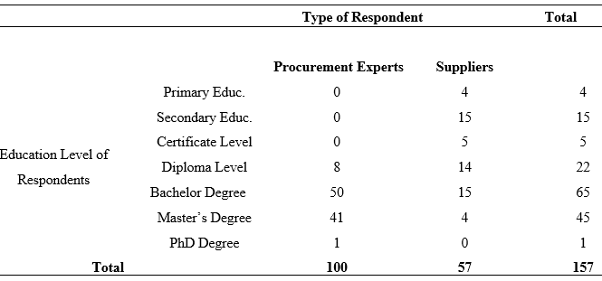
Source: Survey Results, 2020

4.3.2.8 Mean and Standard Deviation of the Respondents’ Experience
Apart from experience as shown in Table 4.3, the study also revealed that about 10 years was a mean of the respondents with regard to their experience which had good implications for the data and information collected for this study. However, there was significant dispersion of experience in years from one respondent to another due to the fact that the standard deviation from the mean was about 8 years close to its mean. Figure 4.7 shows the mean and standard deviation of the respondents’ experience.

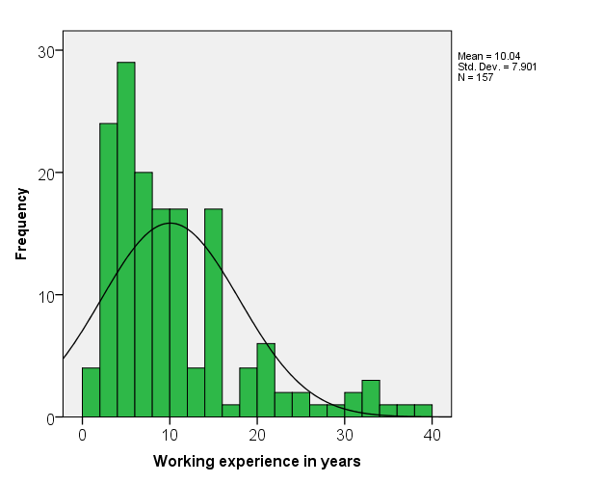
Figure 4.7: The Mean and Standard Deviation of the Respondents’ Experience
Source: Survey Results, 2020

4.3.3 Data Analysis for Specific Objectives
In analysing data for specific objectives of this study, the researcher used PLS-SEM evaluation procedures for reflective models as recommended by Sartedt et al. (2017). Basing on reflective model of this study, the analysis was performed by assessing reflective measurement models and structural models as follows:

4.3.3.1 Assessing Reflective Measurement Models

4.3.3.1.1 Indicator’s (Loadings) Reliabilities
After executing PLS algorithm, the results for indicator’s reliabilities are shown in Figure 4.8. All indicators’ loadings of the constructs of the research model are above 0.708 as recommended by Hair et al. (2018) except PE2 which was 0.617. The indicator PE2 would be considered for removal if it could affect the reliability and validity of the constructs of the research model as recommended by Hair et al. (2018). Therefore, each construct under that situation explained more than 50 per cent of the indicator’s variance, thus providing acceptable item reliability (Hair et al., 2018).

Independent Variable Mediator Variables Dependent Variable
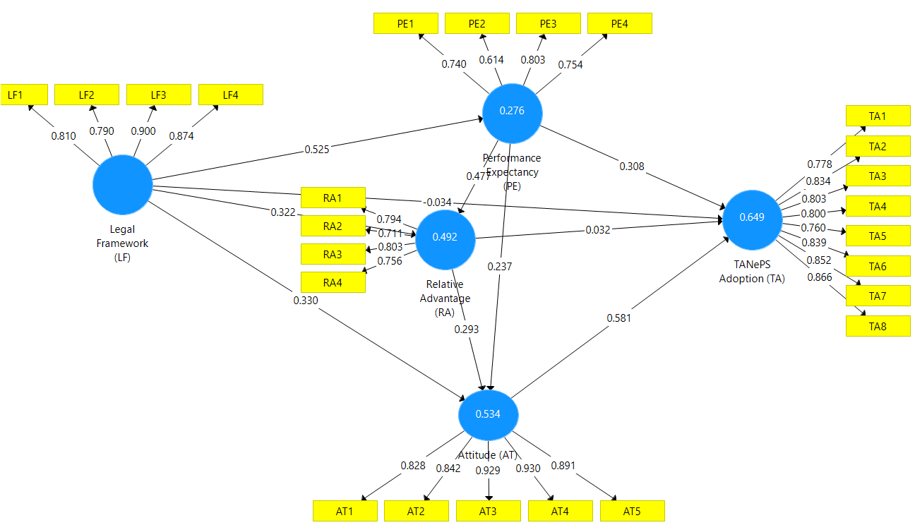
Figure 4.8: Indicator’s (Loadings) Reliabilities
Source: Survey Results, 2020

4.3.3.1.2 Internal Consistency Reliability and Convergent Validity Results
The report of PLS algorithm revealed that all constructs of the research model had above 0.7 value of internal consistent reliability and less than 0.95 as recommended by Hair et al. (2018). This situation implied that the data collected were reliable. In addition, the average variance extracted (AVE) was above 0.50 in all constructs which indicated that each construct of the research model explained 50 percent or more of the variance of the items that make up the construct. Table 4.5 shows the internal consistent reliability and constructs convergent validity of the reflective research model.
Table 4.5: Internal Consistency Reliability and Convergent Validity Results
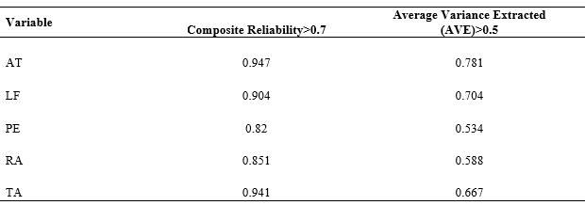Source: Survey Results, 2020

4.3.3.1.3 Discriminant Validity Results by using HTMT
After performing PLS algorithm, the results of discriminant validity from the HTMT report are shown in Table 4.6 which were less than 0.9 in all constructs as recommended for structural models with constructs that are conceptually very similar, such as cognitive satisfaction, affective satisfaction and loyalty, performance expectancy and relative advantage (Hair et al., 2018). These discriminant validity results of value less than 0.90 in each relationship of the constructs from HTMT report in this study suggested that discriminant validity was present among relationships of the constructs.

Table 4.6: Discriminant Validity Results
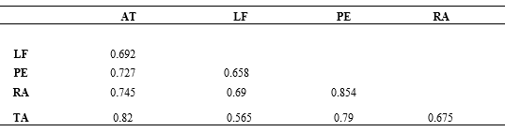
Source: Survey Results, 2020

4.3.3.2 Assessing Structural Models

4.3.3.2.1 Collinearity Statistics (VIF)
When measurement model assessment was satisfactory, the next step before assessing the structural relationships was examining collinearity to make sure it does not bias the regression results. This process is similar to assessing formative measurement models, but the latent variable scores of the exogenous constructs were used to calculate the VIF values.

VIF values above 5 are indicative of probable collinearity issues among the predictor constructs, but collinearity problems can also occur at lower VIF values of 3 to 5. Ideally, the VIF values should be close to 3 and lower. If collinearity was a problem, a frequently used option was to create higher order models that can be supported by theory (Hair et al., 2017b). Table 4.7 shows VIF values for inner model which was less than 5 indicating that there were no multicollinearity problems among predictor constructs.

Table 4.7: Collinearity Statistics (VIF)
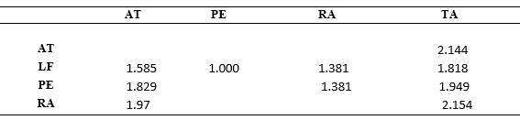
Source: Survey Results, 2020

4.3.3.2.2 Assessing R2 Value of the Endogenous Constructs
After execution of PLS algorithm, the results of value of the endogenous constructs (R²) are shown in Figure 4.9 which indicated that R² value in each endogenous construct was more than 0.25 as recommended by Hair et al. (2018). R² values measured the variance which is explained by the exogeneous construct in each of the endogenous construct. In this study, over 25 percent of the variation of each endogenous construct (performance expectancy (PE), relative advantage (RA), attitude (AT) and TANePS adoption (TA)) was influenced by the exogeneous construct which was legal framework (LF).

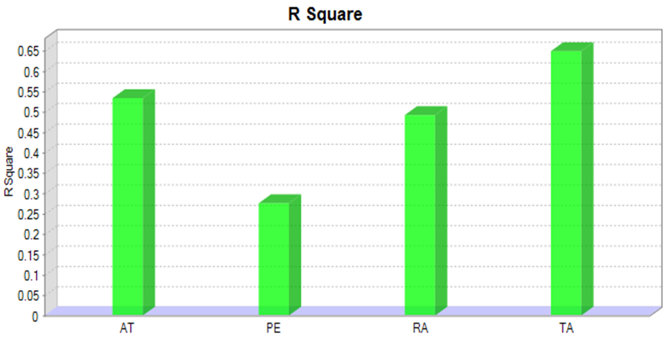
Figure 4.9: R2 Value of the Endogenous Constructs
Source: Survey Results, 2020

4.3.3.2.3 F Squared Effect Size (f2)
After effecting PLS algorithm, Table 4.8 shows the f² effect size of partial and full mediation of the constructs in this research model of the study. As a rule of thumb, values higher than 0.02, 0.15, and 0.35 depict small, medium, and large f² effect sizes (Hair et al., 2018). In this study, f² value was 0.01 in two relationships (legal framework (LF) and TANePS adoption (TA), relative advantage (RA) and TANePS adoption (TA)) which indicated that there was full mediation among constructs with both direct and indirect relationships (i.e., legal framework and relative advantage were full mediated). The value of f² which was more than 0.02 indicated the presence of partial mediation of the construct with both direct and indirect relationships (i.e., performance expectancy was partially mediated).

Table 4.8: f Squared Value
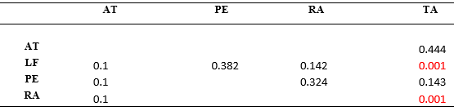
Source: Survey Results, 2020

4.3.3.2.4 Q Squared for Endogenous Constructs for Prediction
After completing the blindfolding from SmartPLS 3, Figure 4.10 shows Q squared for endogenous constructs for prediction.

Independent Variable Mediator Variables Dependent Variable
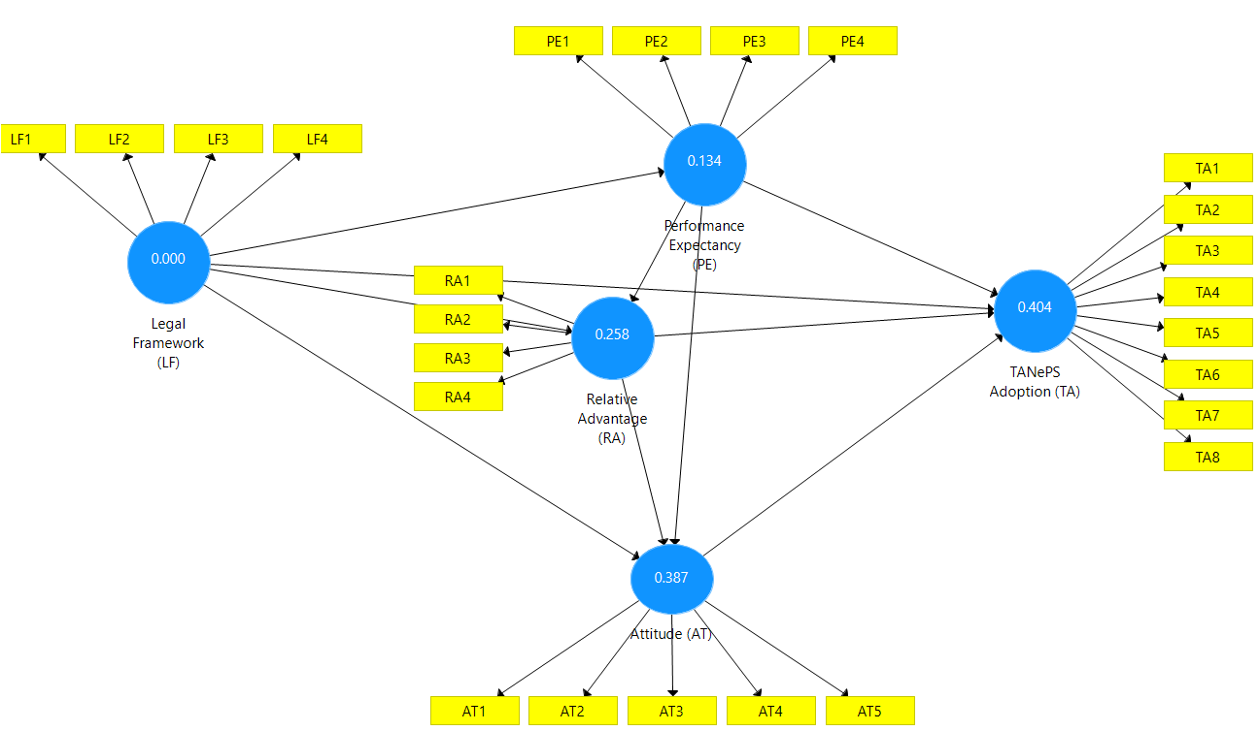
Figure 4.10: Q Squared for Endogenous Constructs for Prediction
Source: Survey Results, 2020

Furthermore, after opening the report of blindfolding from SmartPLS 3, Table 4.9 shows the values of Q² for each endogenous construct. In this study, Q² value was less than zero in all endogenous constructs which indicated that the exogenous construct (legal framework) had power to predict the endogenous constructs.

Table 4.9: The Values of Q Squared for Endogenous Constructs
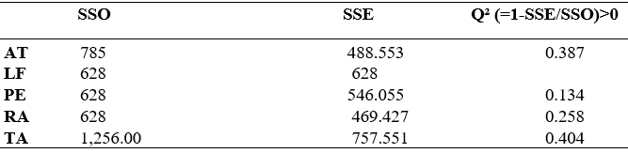
Source: Survey Results, 2020

4.3.3.2.5 Assessing Relevance of the Path Coefficients
After performing PLS algorithm, the report from SmartPLS 3 for relevance of the path coefficients of the research model is shown in Figure 4.11. In this study, the path coefficients of nine hypothesized relationships were positive and only one path coefficient of hypothesized relationship was found negative. The negative path coefficient implied that an increase in one standard deviation of the legal framework converted into the diminished step of TANePS adoption. For the positive way coefficients, it implied that an increase in one standard deviation of the determinants converted into an increase in the step of TANePS adoption.

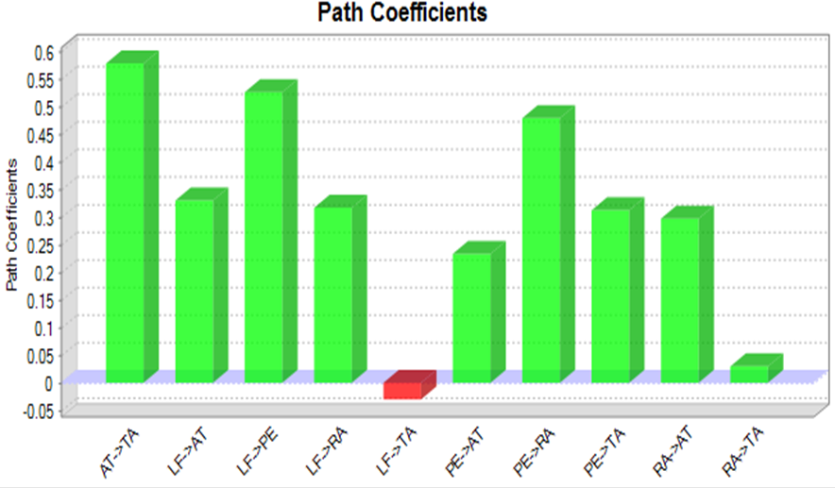
Figure 4.11: Path Coefficients
Source: Survey Results, 2020

4.3.3.2.6 Statistical Significance of the Hypothesized Relationships
After running bootstrapping in SmartPLS 3, the results of the statistical significance are shown in figure 4.12 of which two direct hypothesized relationships were not supported and eight hypothesized relationships were supported. These results indicated that the conceptual research model of this study can be used in decision making because eighty (80%) per cent of the theorized associations appeared to exist in real life.

Independent Variable Mediator Variables Dependent Variable
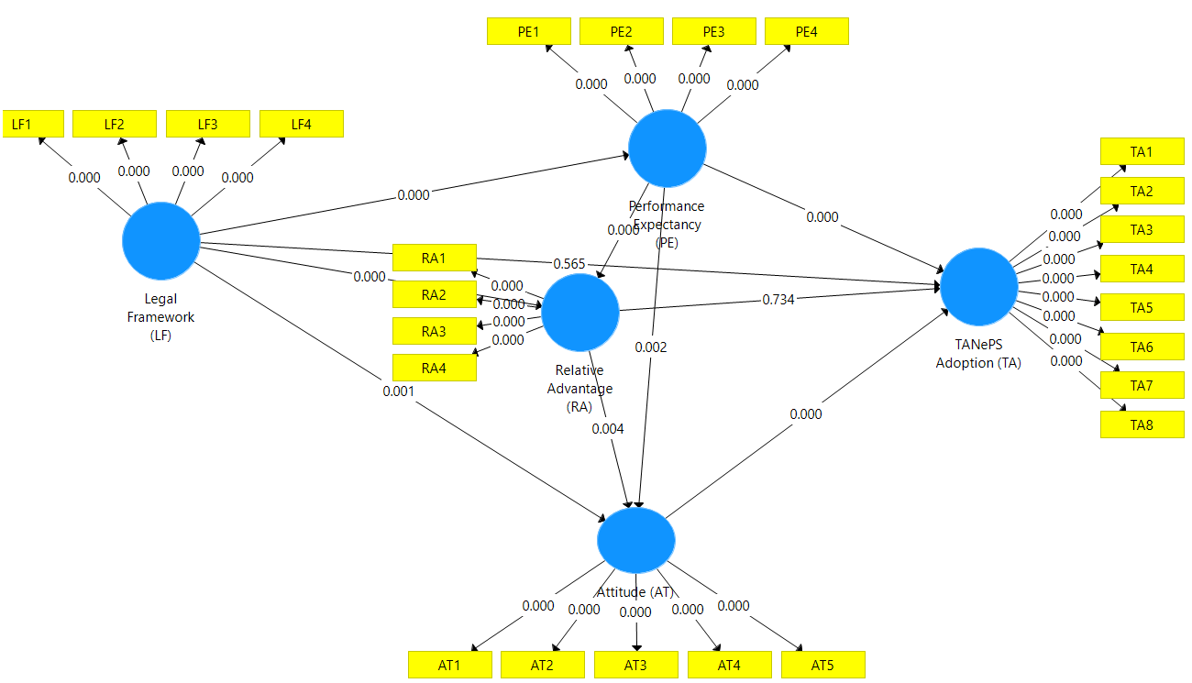
Figure 4.12: Statistical Significance of the Hypothesized Relationships
Source: Survey Results, 2020

From the results of the hypothesized relationships in Figure 4.12, the specific objectives one to ten were achieved and the findings of their corresponding hypotheses are shown in Table 4.10.

Table 4.10: Hypotheses Tested from the Conceptual Model
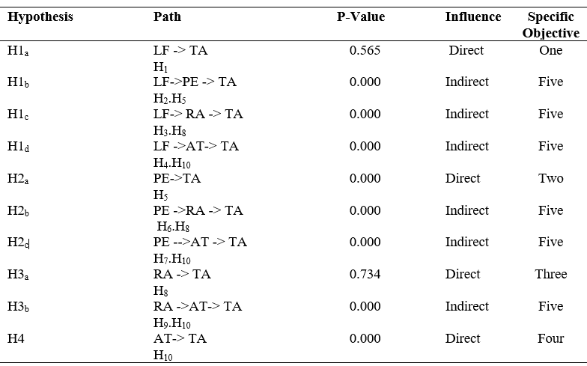
Source: Survey Results, 2020
Key:
H_{1a}: Legal framework (LF) positively and directly influences TANePS adoption (TA).
H_{1b.} In the presence of mediation effect of Performance Expectancy (PE), Legal framework (LF) positively and indirectly influences TANePS adoption (TA).

H_{1c:} In the presence of mediation effect of Relative Advantages (RA), Legal framework (LF) positively and indirectly influences TANePS adoption (TA).

H_{1d:} In the presence of mediation effect of Attitude (AT), Legal framework (LF) positively and indirectly influences TANePS adoption (TA).

H_{2a}: Performance expectancy (PE) positively and directly influences TANePS adoption (TA).
H_{2b}: In the presence of mediation effect of Relative Advantage (RA), Performance Expectancy (PE) positively and indirectly influences TANePS adoption (TA).

H_{2c}: In the presence of mediation effect of Attitude (AT), Performance Expectancy (PE) positively and indirectly influences TANePS adoption (TA).

H_{3a}: Relative advantage (RA) positively and directly influences TANePS adoption (TA).
H_{3b:} In the presence of mediation effect of Attitude (AT), Relative advantage (RA) positively and indirectly influences TANePS adoption (TA).

H_{4:} Attitude (AT) positively and directly influences TANePS adoption in the public sector (TA).

4.3.3.2.7 PLS-Multi-Group Analysis of the Hypothesized Perception
Multi-group analysis in PLS SEM is used to compare parameters, typically structural path coefficients, between two groups (Hair et al., 2018). In this study, two groups (procurement experts and suppliers) were compared with regard to their perception on critical success factors influencing TANePS adoption. The study hypothesized that the perception of procurement experts and suppliers on critical success factors influencing TANePS adoption has no significant difference.

4.3.3.2.7.1 PLS-Multi-Group Analysis for Outer Loadings of the Indicators
After effecting multi-group analysis (MGA) in SmartPLS 3, Table 4.11 shows the PLS-multi-group analysis results for outer loadings of indicators. However, two relationships of two indicators from attitude (AT) construct (AT2 <- AT and AT3 <- AT) had significant differences (both had p-values < 0.05) between the two groups (procurement experts and suppliers). The two indicators (AT2 and AT3) were related to the questions which wanted respondents to answer with regard to their mindset to continue learning about TANePS and to continue using TANePS in public procurement process. These significant differences between the two groups implied that some procurement experts and suppliers were interested in learning and using TANePS in public procurement process while some procurement experts and suppliers were not interested in learning and using TANePS in public procurement process.

Table 4.11: PLS-Multi-Group Analysis for Outer Loadings of the Indicators
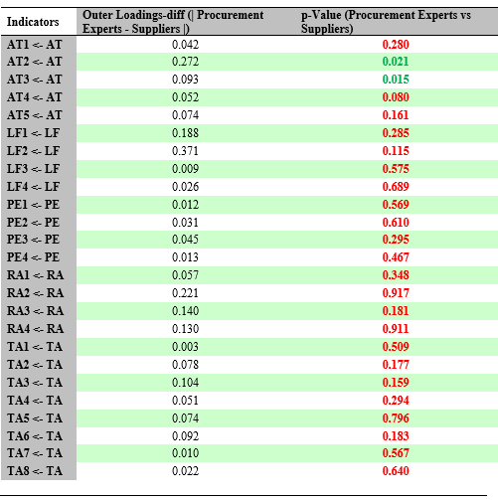
Source: Survey Results, 2020

4.3.3.2.7.2 PLS-Multi-Group Analysis for Indirect Effects Constructs
After effecting multi-group analysis (MGA) in SmartPLS 3, Table 4.12 shows the PLS-multi-group analysis for indirect effects of which no significant differences between the two groups were observed. The indirect relationships between legal framework (LF) and attitude (AT) had p-value > 0.05, legal framework (LF) and relative advantage (RA) had p-value > 0.05, legal framework (LF) and TANePS adoption (TA) had p-value > 0.05, performance expectancy (PE) and attitude (AT) had p-value > 0.05, performance expectancy (PE) and TANePS adoption (TA) had p-value > 0.05, relative advantage (RA) and TANePS adoption (TA) had p-value > 0.05. The implication is all indirect relationships of the conceptual model of this study were perceived the same by the two groups (procurement experts and suppliers).

Table 4.12: PLS-Multi-Group Analysis for Indirect Effects of the Constructs
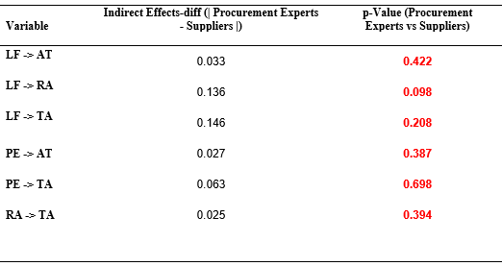
Source: Survey Results, 2020

4.3.3.2.7.3 PLS-Multi-Group Analysis for Total Effects of the Constructs
After carrying out multi-group analysis (MGA) in SmartPLS 3, Table 4.13 shows the PLS-multi-group analysis results for total effects for the constructs of the conceptual model of this study. The results of the analysis revealed significant differences between the two groups for the direct relationship between the perception of procurement experts and suppliers on legal framework (LF) and TANePS adoption (TA) (p-value< 0.05).

Table 4.13: PLS-Multi-Group Analysis for Total Effects
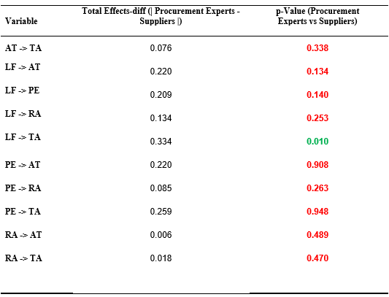
Source: Survey Results, 2020

4.3.3.2.8 Assessing Importance-Performance of the Constructs and Indicators
After running Importance Performance Matrix Analysis (IPMA) in SmartPLS 3, the results of importance-performance of the exogeneous and endogenous constructs and their indicators are shown in Figure 4.13.

Independent Variable Mediator Variables Dependent Variable
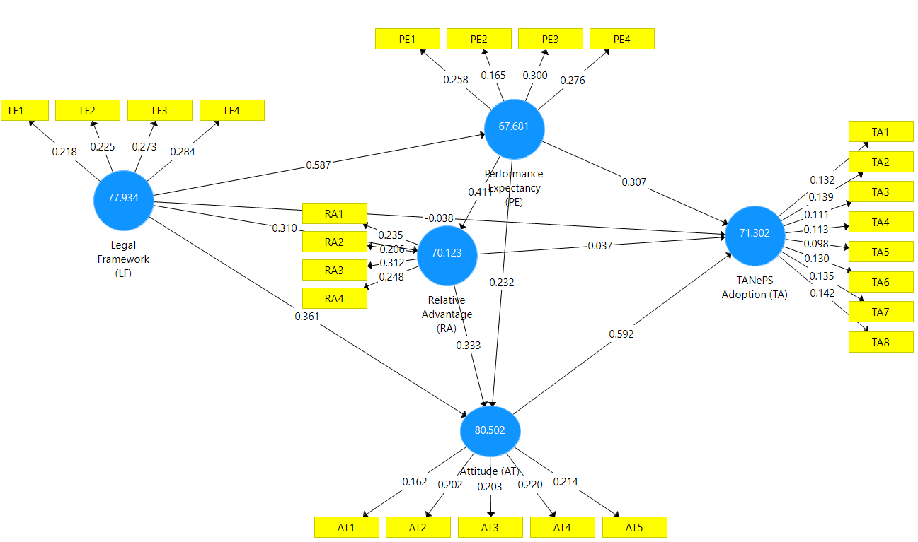
Figure 4.13: Importance-Performance of Constructs and Indicators
Source: Survey Results, 2020

4.3.3.2.8.1 Assessing Importance-Performance of the Indicators
After opening the report for importance performance matrix analysis (IPMA) in SmartPLS 3, the results of importance-performance of the indicators of legal framework, performance expectancy and attitude are shown in Figure 4.14. The position of these indicators in the first quadrant of the matrix shown in the Figure 4.14 implied that they are more important and their performances are highly needed in the existence of the research model of this study. However, the indicators of the construct “relative advantage” are not more important but they have high performances for the existence of the research model of this study.

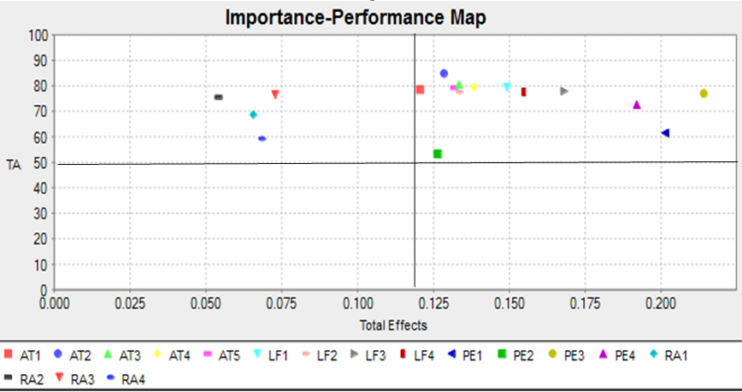
Figure 4.14: Importance-Performance Map (TA) (Indicators Unstandardized Effects)
Source: Survey Results, 2020

4.3.3.2.8.2 Assessing Importance-Performance of the Constructs
The positions of legal framework, performance expectancy and attitude in Figure 4.15 after opening the report for importance performance matrix analysis (IPMA) in SmartPLS 3 were considered to be the most important and their performances are highly needed in the research model of this study. This is due to the fact that the first quadrant of the matrix in Figure 4.15 shows the most important and the highest performance construct in research model of this study. However, based on the position of the construct “relative advantage” in the fourth quadrant of the matrix in Figure 4.15, it is clear that it is not more important but highly needed in terms of its performance for the existence of the research model.
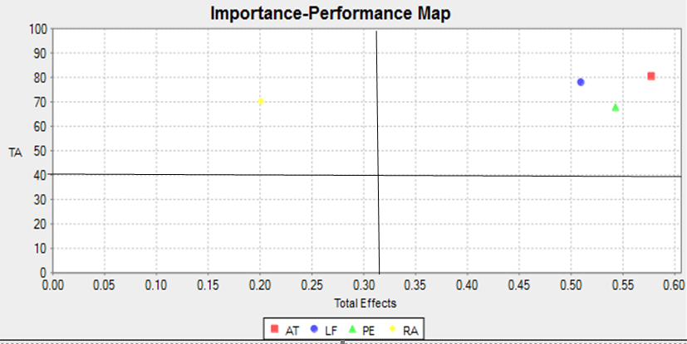
Figure 4.15: Importance-Performance Map (TA) (Constructs Unstandardized Effects)
Source: Survey Results, 2020

CHAPTER FIVE

DISCUSSION OF FINDINGS

5.1 Chapter Overview
This study aimed at examining comprehensively the critical success factors that influence e-procurement adoption in the public sector. In order to achieve this goal, both available empirical literature and relevant theories/models were extracted and came up with an integrative conceptual model explaining the critical success factors influencing TANePS adoption in the public sector of which the current empirical studies and models are enlightening ineffectively. This chapter presents discussion of findings basing on specific research objectives from which the conceptual model of the study was developed. The specific research objectives of the study were: to assess the direct influence of legal framework on TANePS adoption; to assess the direct influence of performance expectancy on TANePS adoption; to assess the direct influence of relative advantage (perceived benefits) on TANePS adoption and to assess the mediation effects of performance expectancy, relative advantage and attitude towards TANePS adoption.

5.2 Influences of Hypothesized Critical Success Factors towards TANePS Adoption
In order to achieve the objectives of this study, a number of hypotheses were theorised as depicted here under.

5.2.1 Direct and Indirect Influences of Legal Framework towards TANePS Adoption
In this study, the legal framework was hypothesized to positively and directly influence TANePS adoption. The results showed a negative path coefficient which implied that an increase in one standard deviation of the legal framework converted into a reduction in the rate of TANePS adoption. Besides, it was found statistically insignificant in light of the fact that its p-value was > 0.05 which inferred that the relationship doesn't exist in real life and it doesn't influence procurement experts' and suppliers’ choices to embrace and use TANePS. On the other hand, legal framework was hypothesized to positively and indirectly influence TANePS adoption through performance expectancy, relative advantage, and attitude. The results showed positive path coefficients which implied that an expansion in one standard deviation of the legal framework converted into an expansion of the rate of TANePS adoption and all indirect relationships were found statistically significant (p-values were all < 0.05) which implied that the relationships exist in real life.

These findings are similar to the previous studies by Suleiman (2015), Azanlerigu and Akay (2015), Jeptoo and Karanja (2017), Ibrahim et al. (2017), Adjei-Bamfo and Maloreh-Nyamekye (2019), Adjei-Bamfo and Maloreh-Nyamekye (2019), Tutu et al. (2019) and Adjei-Bamfo et al. (2020). For example, the study by Azanlerigu and Akay (2015) revealed that legal framework is a basis of any business transaction whether in the public sector or private businesses and defines the obligations and responsibilities of the partners transacting business with the objectives of fulfilling each other’s desired goal. However, the weakness of the legal framework may inhibit the adoption and growth of e-procurement initiatives (Ibid). In addition, Masele (2014) argued that coercive pressure (legal framework) may include; strict regulations, policies, sanctions and penalties against unfriendly behaviours. Moreover, the findings indicated that the relationship was statistically significant because p-value was less than 0.05. The study by Masele (2014) proved beyond reasonable doubt that coercive pressures (legal frameworks) are inevitable if commitment towards adoption of new technology was to be instructed for serving public benefits.

Above all, the TOE model also postulated coercive pressures (legal framework) to influence new technologies adoption in the public sector for public gain. Although these findings are similar with some other previous studies with regard to new technologies adoption for public benefits or private gains, the current study has added new knowledge with regard to the influence of legal framework on TANePS adoption through performance expectancy, relative advantage and attitude in two perspectives; public and private sector gains of which the existing theories and empirical studies are revealing vainly. The critical success factor of legal framework from TOE to influence positively and indirectly the adoption of new technology (TANePS) in the public sector after interacting with performance expectancy from UTAUT, relative advantage and attitude from TOE, is a substance which is missing in the current literature.

5.2.2 Direct and Indirect Influences of Performance Expectancy on TANePS Adoption
In this study, performance expectancy was proposed to positively, directly and indirectly influence TANePS adoption. The results of both direct and indirect influences showed positive path coefficients which implied that an increase in one standard deviation of the performance expectancy converted into an increment of the rate of TANePS adoption and both relationships were found statistically significant (p-values were < 0.05) which implied that the relationships exist in real life. These results are parallel to the previous studies of Chen et al. (2011) and Dwivedi et al. (2017) which indicated that the direct and indirect influences of performance expectancy to new technologies adoption through attitude was statistically significant. However, the findings of the current study contrast from some prior studies.

For example, Taluka (2016) revealed that performance expectancy (PE) was found statistically insignificant towards Behavioural Intention to utilize Mobile Payment (β = 0.069, p = 0.443) at α =0.05. These results implied that an increase in one standard deviation in performance expectancy converts into 0.069 increment in Behavioural Intention to utilize Mobile Payment (BI) for the total model but the relationship does not exist in real life. The study by Taluka (2016) reasoned that performance expectancy being immaterial could propose that buyers don't just depend on performance expectancy so as to embrace and utilize portable payment directions. However this factor additionally doesn't influence buyers' choices. In addition, the study by Masele (2014) characterized performance expectancy as the degree to which an individual accepts that utilizing a specific framework will upgrade their activity execution. A similar report set that the higher the performance expectancy among the small and medium travel industry undertakings, the higher the effect on expectation to embrace and utilize green e-business. These results indicated the immaterial influence of performance expectancy on green e-business reception because of the way that the p-value was more prominent than 0.05, while the path coefficient was under 0.2, suggesting that, it was less significant for conversation and accordingly, it was disposed of.

Despite the fact that these results of the current study vary with some other prior studies on innovation reception for private advantages, the UTAUT hypothesized performance expectancy will in general apply impact on new advances adoption in private divisions. In this way, the current study has added new information with respect to the impact of performance expectancy on new innovation (TANePS) adoption in two points of view; public and private divisions of which the current theories and prior studies are lighting up incapably. The determinant of performance expectancy from UTAUT to influence positively, directly, and indirectly the reception of new innovation (TANePS) in the public to cooperating with relative advantage and attitude from TOE is a substantial miss in the existing theories and models.

5.2.3 Direct and Indirect Influences of Relative Advantage on TANePS Adoption
In this study, the relative advantage was hypothesized to positively, legitimately, and by implication impact TANePS adoption. The results revealed positive way coefficient for the immediate impact which implied that an increase in one standard deviation of relative advantage converted into an increase of the pace of TANePS adoption yet the relationship was found not statistically significant in light of the fact that p-value was > 0.05 which inferred the relationship doesn't exist in real life. In the event that relative preferred position is irrelevant, it could propose that procurement experts and suppliers don't just depend on the overall advantage of TANePS so as to adjust and utilize the system thus this factor doesn't impact directly procurement experts' and suppliers' choices to receive the new public procurement system.

This reality additionally implied that comprehension of the upsides of new innovation alone without change of outlook (attitude) doesn't impact partners' choices to embrace the new innovation. On the other hand, the relative advantage was proposed to positively and indirectly influence TANePS adoption. These results revealed positive path coefficient which implied that an increase in one standard deviation of relative advantage converted into an increase of the rate of TANePS adoption and it was found statistically significant (its p-value was < 0.05). These results implied that the relationship exists, all things considered. These discoveries relate to the past studies' findings by Xu et al. (2015), Ibem et al. (2016), Mohammed et al. (2016), Watuleke (2017), Pitso et al. (2018) and Malekia (2018) which uncovered that the apparent advantages of new advances impacted the choices of clients to receive the innovations. For instance, the study by Ibem et al. (2016) proposed that the choice to embrace e-procurement by associations in the Nigerian development industry was incompletely impacted by the related advantages in upgrading effectiveness in venture conveyance, disposing of geographic obstructions to investment in obtainment exercises and improving successful correspondence among venture colleagues. Moreover, the study by Intharaksa (2009) uncovered that one of the essential ascribes of advancement saw to accelerate the electronic guidance step of adoption was a relative advantage.

Despite the fact that these discoveries are like some different previous studies on innovation reception for open and private advantages, the TOE hypothesized relative advantage as a feature of mechanical factor which impacts new advancements adoption in the organizational context. Along these lines, the current study has contributed new information with respect to the impact of relative advantage on new innovation (TANePS) adoption in two viewpoints; open and private divisions of which the current theories and prior studies are enlightening ineffectively. The determinant relative advantage from TOE model to impact positively and indirectly the adoption of new innovation (TANePS) in the wake of interfacing with attitude from TOE is a significant miss in current writing since concentration on buyer-supplier point of view are as of now insufficient.

5.2.4 Direct Influence of Attitude on TANePS Adoption
In this study, attitude was postulated to positively and directly influence TANePS adoption in the public sector. The findings revealed positive path coefficient which meant that an increase in one standard deviation of the attitude translated into increase of the rate of TANePS adoption and it was found statistically significant (its p-value was < 0.05) which meant that the relationship exists in real life. If attitude is significant in direct relationship and it mediates other critical success factors (legal framework, performance expectancy and relative advantage), this suggests that procurement experts and suppliers only rely on change of their attitude in order to adopt and use TANePS, hence this factor influences directly procurement experts’ and suppliers’ decisions to adopt and use the new procurement system.

These findings are similar to those of Aboelmaged (2010), Chen et al. (2011), Kassim and Hussin (2013), Ombat (2015) and Dwivedi et al. (2017) that revealed user attitude has always been found to have a strong, direct and positive effect on behaviour and there is a link between attitude and behaviour. In fact, user attitude is the fundamental attribute in attitudinal research and has been supported in a wide variety of settings. In addition, Kassim and Hussin (2013) assert that attitude is still significant in determining the public e-procurement system use among the agencies and this can be clarified by feelings of the top management as one of the users, and the perception from other users on the system like suppliers that are accumulated to form a cumulative decision that either accelerate or hold up the user decision (Kassim & Hussin, 2013). On the other hand, there are studies which have shown that attitude has insigniﬁcantly inﬂuenced behavioural intention to use new technologies adoption (Masele, 2014). Although these findings of the current study are similar with some other studies on technology adoption for public benefits, the TOE postulated top management attitude as part of organizational factors which influence new technologies adoption in the public sector. Therefore, this study has contributed new knowledge with regard to the influence of attitude on new technology (TANePS) adoption in two perspectives; public and private sector of which the existing theories and empirical studies are indecisively informative.

The critical success factor “attitude” from TOE model has been shown in this study as a link of legal framework, performance expectancy and relative advantage in the process of adopting new technology for public and private gains is considerably missing in the existing literature because studies which focus on buyer-supplier perspectives with indirect relationships of the critical success factors influencing e-procurement adoption are currently insufficient.

5.3 Perception of Procurement Experts and Suppliers on Critical Success Factors Influencing TANePS Adoption
In this study, perception of procurement experts and suppliers on critical success factors influencing TANePS adoption was postulated to have no significant difference. The findings revealed that the perception of procurement experts and suppliers on indicators of the critical success factors influencing TANePS adoption in the public sector had no significant difference. This is due to the fact that twenty-three (23) out of twenty-five (25) of the indicators of all constructs of the research model had p-values > 0.05. These findings implied that ninety-two (92) per cent of the indicators of the constructs of the conceptual model for this study were perceived the same by the two groups (procurement experts and suppliers). In addition, the findings of the current study are similar with the previous study by Gambo et al. (2019) whose findings revealed that the perception of clients, contracting and consulting firms had no significant differences on e-procurement adoption.

In addition, for all indirect relationships of the constructs in the research model of the current study, the perception of procurement experts and suppliers had no significant differences. This situation meant that all indirect relationships of the conceptual model of this study were perceived the same by the two groups (procurement experts and suppliers) of which the existing theoretical and empirical literature is silent. For example, studies by Malekia (2018), Watuleke (2017), Makoba et al. (2017), Ibem et al. (2016), Taluka (2016), Azanlerigu and Akay (2015), Ombat (2015), Suleiman (2015), Masele (2014), Shale (2014), Mose et al. (2013), Mgidlana (2013), Kassim and Hussin (2013), Gupta and Narain (2012) and Intharaksa (2009) have not said anything with regard to the indirect relationships of the constructs in adopting new technology.

Likewise, UTAUT and TOE model have not cleared the existence of the perception of two groups with indirect relationships among their constructs of which the new model of the current study has cleared by combining one construct from UTAUT and three constructs from TOE model. However, 90 per cent of the perception of procurement experts and suppliers with regard to the constructs in the total effects had no significant differences. These findings implied that the constructs and the conceptual model of the current study are valid to the buyer perspective or supplier perspective or both buyer and supplier perspectives in conducting studies related to evolution of the public procurement systems from traditional procurement to e-procurement context. These findings of the current study are similar to the limited previous studies like the study by Gambo et al. (2019) which assessed stakeholders’ perception of the factors associated with the adoption of e-Procurement. Gambo et al. (2019) included clients, contracting and consulting firms of whom their perception on e-procurement adoption had no significant differences.

5.4 Comparison of Overall Explanatory Power of the Final Conceptual Model
The results of this study provide support for the research model shown in Figure 4.6 for path coefficients and R² values of endogenous constructs. The overall explanatory power of the conceptual model of this study was R ² value of 64.9 per cent for intention to use TANePS. When compared to the previous studies’ findings, this value for R² of the current study is relatively higher in terms of percentage. For example, studies by Zhang et al. (2020) and Aboelmaged (2010) both had R² of 62 per cent for intention to use green innovation and e-procurement adoption respectively. Furthermore, the overall explanatory power of the conceptual models of the studies by Kassim and Hussin (2013), Xu et al. (2015) and Shatta et al. (2020a) were 56.8 per cent, 64.7 per cent and 64.2 per cent respectively for intention to use new technologies adoption. This ﬁnding suggests that the research model of the current study which was developed through integrating three constructs from TOE model and one construct from UTAUT model is capable of explaining a relatively higher proportion of variation of intention to use e-procurement than the previous research models. The reason may be related to the use of performance expectancy construct from UTAUT which had both direct and indirect inﬂuences on behavioural intentions towards TANePS adoption.

The studies by Kassim and Hussin (2013) and Zhang et al. (2020) both used the constructs from TOE model only while the study by Aboelmaged (2010) used the constructs from TAM and TPB models which may not be more powerful compared to the constructs from UTAUT. This argument is justified by the previous studies on new technologies adoption which used UTAUT. For example, the study by Taluka (2016) used all four constructs from UTAUT model and one construct was added from the empirical studies and, its R² value for intention to use mobile phones was 71.8 per cent. In addition, the study by Masele (2014) used constructs from TOE model, UTAUT and Institutional theory, and its R² value for intention to use green e-business was 79.1 per cent. Basing on variations of R² value to increase when UTAUT is adopted in research related to new technologies adoption, therefore, constructs from UTAUT have more power for the variation of intention to use new technologies when compared to other constructs from other models or theories. Table 5.1 shows some studies on IT adoption with variations and similarities of theory/model against R².

Table 5.1: Studies on IT Adoption with Variations/Similarities of Model vs R2
 | Analyzed Construct | Theory/Model R² (%) |  |  |  | Author
- Ease of Use  - Subjective Norm  - Attitude  - Behavioural Control  - Usefulness |  |  | TAM&TPB | 62 | Aboelmaged (2010)
- User Attitude  - Organizational Learning  - Supplier Expectation  - Mimetic Pressure  - System Compatibility |  |  | TOE | 56.8 | Kassim and Hussin (2013)
- Performance Expectancy  - Effort Expectancy  - Facilitating Conditions  - Normative Pressure  - Mimetic Pressure  - Coercive Pressure  - Attitude  - Organizational Support  - Self-Efficacy  - Performance Expectancy  - Coercive Pressure (legal Framework)  - Attitude  - Relative Advantage (Perceived Benefits) |  |  | TOE, UTAUT& Institutional Theory  TOE & UTAUT | 79.1  64.2 | Masele (2014)  Shatta et al.(2020a)
- Performance Expectancy  - Effort Expectancy  - Social Influence  - Facilitating Conditions  - Perceived Trust  - Relative Advantage  - Compatibility  - Complexity  - Top Management Support  - Organization Fit  - Financial Commitment  - Competitive Pressure  - Technology Readiness  - Organization Readiness  - Environment Readiness |  |  | UTAUT  TOE  TOE | 71.8  64.7  62 | Taluka (2016)  Xu et al. (2015)  Zhang et al. (2020)
Source: Literature Review, 2020

5.5 Comparison of Direct and Indirect Path Coefﬁcients and P-values
In comparing direct path coefﬁcients of the hypothesized relationships for intention to use TANePS from Figure 4.8 and 4.10, attitude construct emerged as the most powerful predictor (β-value=0.577, p-value=0.000) of the intention to use TANePS relative to other factors. This finding records out the importance of changing the attitude of procurement experts and suppliers to ensure successful adoption of TANePS. This study indicates that attitude is a determinant factor of intention for procurement experts and suppliers to use TANePS.

The second construct in comparing the direct path coefﬁcients of the hypothesized relationships for intention to use TANePS was performance expectancy (β-value=0.312, p-value=0.000) of the intention to use TANePS. This result is not similar to the ﬁndings reported in Masele (2014) and Taluka (2016), which indicated that performance expectancy has insigniﬁcant direct inﬂuence on behavioural intention towards new technologies adoption.

The third construct in comparing the direct path coefﬁcients of the hypothesized relationships for intention to use TANePS was relative advantage (β-value=0.030, p-value=0.723) of the intention to use TANePS. This result is not similar to the ﬁndings reported by Zhang et al. (2020) which indicated that relative advantage has direct inﬂuence on behavioural intention toward green innovation.

The fourth construct in comparing the direct path coefﬁcients of the hypothesized relationships for intention to use TANePS was legal framework (β-value= -0.030, p-value=0.566). This ﬁnding does not reﬂect the findings reported by Masele (2014) which specified that legal framework has direct inﬂuence on behavioural intention toward green e-business adoption.

The first construct in comparing the indirect path coefﬁcients of the hypothesized relationships for intention to use TANePS was legal framework (β-value=0.526, p-value=0.000) of the intention to use TANePS through performance expectancy. This ﬁnding is similar to the findings of Masele (2014) which specified that legal framework has direct inﬂuence on behavioural intention toward green e-business adoption. The second construct in comparing the indirect path coefﬁcients of the hypothesized relationships for intention to use TANePS was performance expectancy (β-value=0.479, p-value=0.000) of the intention to use TANePS through relative advantage. This ﬁnding does not reﬂect the findings reported in Masele (2014) and Taluka (2016) which specified that performance expectancy has insignificant inﬂuence on behavioural intention toward new technologies adoption.

The third construct in comparing the indirect path coefﬁcients of the hypothesized relationships for intention to use TANePS was legal framework (β-value=0.330, p-value=0.001) of the intention to use TANePS through attitude. This ﬁnding reﬂects the findings reported by Masele (2014) which specified that legal framework has significant inﬂuence on behavioural intention toward new technologies adoption.

The fourth construct in comparing the indirect path coefﬁcients of the hypothesized relationships for intention to use TANePS was legal framework (β-value=0.317, p-value=0.000) of the intention to use TANePS through relative advantage. This ﬁnding is similar to the findings stated by Masele (2014) which detailed that legal framework has significant inﬂuence on behavioural intention toward new technologies adoption.

The fifth construct in comparing the indirect path coefﬁcients of the hypothesized relationships for intention to use TANePS was relative advantage (β-value=0.297, p-value=0.005) of the intention to use TANePS through attitude. This result is similar to the ﬁndings testified in Zhang et al. (2020), which showed that relative advantage has signiﬁcant direct inﬂuence on behavioural intention toward new technologies adoption.

The sixth construct in comparing the indirect path coefﬁcients of the hypothesized relationships for intention to use TANePS was performance expectancy (β-value=0.233, p-value=0.003) of the intention to use TANePS through attitude. This result is not similar to the ﬁndings reported in Masele (2014) and Taluka (2016), which indicated that performance expectancy has insigniﬁcant direct inﬂuence on behavioural intention toward new technologies adoption. The proposed model of this study was approved through testing the connections which were existing in the empirical studies and in UTAUT and TOE model. From this proposed model, ten (10) assumptions were figured of which 80 per cent of them had positive way coefficients and were statistically significant showing that the predicted connections exist, in actuality.

However, PLS-multi-group analysis results in this study implied that the constructs and the conceptual model of this study were valid to the buyer perspective or supplier perspective or both buyer and supplier perspectives in conducting studies related to evolution of the public procurement systems from traditional procurement to e-procurement context. The final conceptual model of this study has accommodated determinants from UTAUT and TOE model which are valid to buyer-supplier perspectives. Additionally, the conceptual model is valid when researchers use a method for data analysis which accommodates direct and indirect relationships like PLS-SEM with the assistance of SmartPLS 3 programming. Figure 5.1 shows the final conceptual model for TANePS adoption.
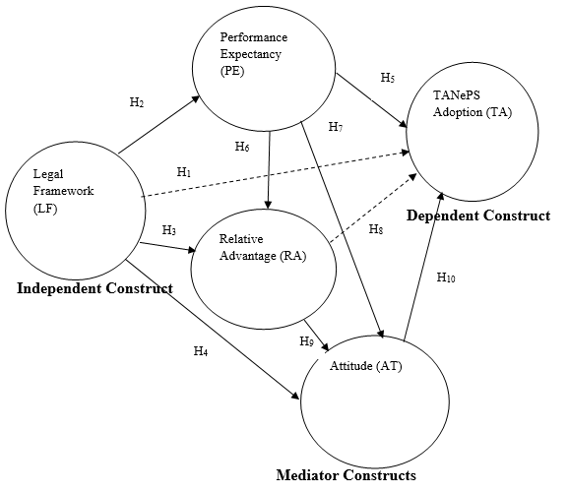
Figure 5.1: Final Conceptual Model for TANePS Adoption
Key:
Supported Hypotheses
Not Supported Hypotheses
Source: Tested and Validated Conceptual Model, 2020

Table 5.2 shows the summary of hypotheses’ results generated from the final conceptual model.

Table 5.2: Summary of Results Generated from the Final Conceptual Model
Hypothesis | Path | Influence |  | Remark | Specific Objective
H1_{a} | LF -> TA  H₁ | Direct |  | Not Supported | One
H1_{b} | LF->PE -> TA  H₂.H₅ | Indirect |  | Supported | Five
H1_{c} | LF-> RA -> TA  H₃.H₈ | Indirect |  | Supported | Five
H1_{d} | LF ->AT-> TA  H₄.H₁₀ | Indirect |  | Supported | Five
H2_{a} | PE->TA  H₅ | Direct |  | Supported | Two
H2_{b} | PE ->RA -> TA  H₆.H₈ | Indirect |  | Supported | Five
H2_{c} | PE -->AT -> TA  H₇.H₁₀ | Indirect |  | Supported | Five
H3_{a} | RA -> TA  H₈ | Direct |  | Not Supported | Three
H3_{b} | RA ->AT-> TA  H₉.H₁₀ | Indirect |  | Supported | Five
H4 | AT-> TA  H₁₀ | Direct |  | Supported | Four
Source: Final Conceptual Model, 2020
Key:
H_{1a}: Legal framework (LF) positively and directly influences TANePS adoption (TA). Not Supported
H_{1b.} In the presence of mediation effect of Performance Expectancy (PE), Legal framework (LF) positively and indirectly influences TANePS adoption (TA). Supported
H_{1c:} In the presence of mediation effect of Relative Advantages (RA), Legal framework (LF) positively and indirectly influences TANePS adoption (TA). Supported
H_{1d:} In the presence of mediation effect of Attitude (AT), Legal framework (LF) positively and indirectly influences TANePS adoption (TA). Supported
H_{2a}: Performance expectancy (PE) positively and directly influences TANePS adoption (TA). Supported
H_{2b}: In the presence of mediation effect of Relative Advantage (RA), Performance Expectancy (PE) positively and indirectly influences TANePS adoption (TA). Supported
H_{2c}: In the presence of mediation effect of Attitude (AT), Performance Expectancy (PE) positively and indirectly influences TANePS adoption (TA). Supported
H_{3a}: Relative advantage (RA) positively and directly influences TANePS adoption (TA). Not Supported
H_{3b:} In the presence of mediation effect of Attitude (AT), Relative advantage (RA) positively and indirectly influences TANePS adoption (TA). Supported
H_{4:} Attitude (AT) positively and directly influences TANePS adoption in the public sector (TA). Supported

CHAPTER SIX

SUMMARY OF FINDINGS, CONCLUSIONS AND RECOMMENDATIONS

6.1 Chapter Overview
This chapter presents the summary of findings, conclusions and recommendations based on the specific research objectives of the study. To address these objectives, an integrated final model showing the relationships between TANePS adoption and critical success factors influencing the new system was validated.

6.2 Summary of Findings

6.2.1 Direct Influence of Legal Framework towards TANePS Adoption
The first specific research objective of the study intended to assess the direct influence of legal framework towards TANePS adoption. Findings revealed negative path coefficient and was statistically insignificant. This meant that an increase in one standard deviation in legal framework translated into a decrease in TANePS adoption in the public sector and the relationship does not exist in real life.

6.2.2 Direct Influence of Performance Expectancy towards TANePS Adoption
The second specific research objective of the study was to assess the direct influence of performance expectancy towards TANePS adoption. The finding revealed that performance expectancy influences directly TANePS adoption because there was positive path coefficient and was found statistically significant. This meant that an increase in one standard deviation of performance expectancy translates into an increase in TANePS adoption and the relationship exists in real life.

6.2.3 Direct Influence of Relative Advantage towards TANePS Adoption
The third specific research objective of the study assessed the direct influence of relative advantage (perceived benefits) towards TANePS adoption. The findings revealed positive path coefficient but it was found statistically insignificant. This finding meant that an increase in one standard deviation of relative advantage translates into an increase in TANePS adoption but the relationship does not exist in real life.

6.2.4 Direct Influence of Attitude towards TANePS Adoption
The fourth specific research objective of the study assessed the direct influence of attitude towards TANePS adoption. The findings revealed that attitude had direct influence on TANePS adoption because it revealed positive path coefficient and was found statistically significant. This meant that an increase in one standard deviation of attitude translated into an increase in TANePS adoption and the relationship exists in real life.

6.2.5 Mediation Effects of Performance Expectancy, Relative Advantage and Attitude towards TANePS Adoption
oIn this study, the fifth specific objective was to assess the mediation effects of performance expectancy, relative advantage and attitude towards TANePS adoption. Therefore, othe olegal oframework owas ohypothesized oto opositively oand oindirectly oinfluence oTANePS oadoption othrough operformance oexpectancy, orelative advantage and attitude. In addition, operformance oexpectancy owas oproposed oto opositively, oindirectly oinfluence oTANePS oadoption through relative advantage and attitude. Likewise, the relative advantage was proposed to positively and indirectly influence TANePS adoption through attitude. The oresults showed positive path ocoefficients in all indirect influences which oimplied othat oan oexpansion oin oone ostandard odeviation oof othe olegal oframework, performance expectancy and relative advantage indirectly converted ointo oan oexpansion oof othe orate oof oTANePS oadoption. In addition, all indirect influences were ofound ostatistically osignificant owhich oimplied othat the orelationshipsoexist in real life.

6.3 Implications of the Results

6.3.1 Direct Influence of Legal Framework towards TANePS Adoption
The first specific research objective of the study intended to assess the direct influence of legal framework towards TANePS adoption. Basing on the finding of this study, legal framework does not influence TANePS adoption directly. This finding implied that procurement experts and suppliers do not only rely on what the legal framework says in order to adopt and use TANePS. Therefore, this critical success factor does not influence directly procurement experts’ and suppliers’ decisions to adopt and use TANePS.

6.3.2 Direct Influence of Performance Expectancy towards TANePS Adoption
The second specific research objective of the study was to assess the direct influence of performance expectancy towards TANePS adoption. For performance expectancy being significant for the direct influence, it implied that procurement experts and suppliers do only rely on performance expectancy of the system in order to adopt and use TANePS; hence, this critical success factor influences directly buyers’ and suppliers’ decisions to adopt and use TANePS.

6.3.3 Direct Influence of Relative Advantage towards TANePS Adoption
The third specific research objective of the study assessed the direct influence of relative advantage (perceived benefits) towards TANePS adoption. Basing on the finding of this study, relative advantage does not directly influence TANePS adoption. This finding implied that procurement experts and suppliers do not only rely on the relative advantage of the system in order to adopt and use TANePS. Therefore, this critical success factor does not influence directly procurement experts’ and suppliers’ decisions to adopt and use TANePS.

6.3.4 Direct Influence of Attitude towards TANePS Adoption
The fourth specific research objective of the study assessed the direct influence of attitude towards TANePS adoption. For attitude being significant for the direct influence, it implied that procurement experts and suppliers do only rely on changing their attitude in order to adopt and use TANePS; hence, this critical success factor influences directly procurement experts’ and suppliers’ decisions to adoption and use TANePS.

6.3.5 Mediation Effects of Performance Expectancy, Relative Advantage and Attitude towards TANePS Adoption
The fifth specific objective was to assess the mediation effects of performance expectancy, relative advantage and attitude towards TANePS adoption. The findings revealed positive path coefficients and all relationships were found statistically significant. These findings implied that procurement experts and suppliers only indirectly rely on what the legal framework says, understanding the performance of the system and relative advantage of the system in order to adopt and use TANePS. Therefore, mediation effects influence indirectly procurement experts’ and suppliers’ decisions to adopt and use TANePS. On the other hand, changing the mindset of procurement experts and suppliers is paramount when it comes to e-procurement adoption. The change of mindset towards TANePS adoption depends on common understanding of the legal framework, performance expectancy and the benefits of the system it brings to the suppliers and procurement experts.

6.3.6 Theoretical Knowledge Implication of the Study Findings
This study argues that performance expectancy is one of the powerful constructs which TOE model did not consider in technological factors as one of the determinants for adopting new technologies. This argument is valid and has been justified by this study. Taking into account the relationships between performance expectancy and legal framework, relative advantage and attitude for TANePS adoption, the findings revealed that performance expectancy had both direct and indirect influences towards TANePS adoption while legal framework and relative advantage (perceived benefits) had indirect influences. Attitude had direct influence only towards TANePS adoption. Since performance expectancy influences new technology adoption both directly and indirectly, then, this study suggests that it should be added in technological factors list in TOE model. In addition, this study used procurement experts from public sector and suppliers from private sector as unit of analysis which implied that the criticism of TOE model that it is useful only for studies concerning organizations has been invalidated. For that reason, TOE model can be used in studies regarding private (individuals) or organizations or both. Figure 6.1 shows the extended TOE model for both studies regarding individuals and organizational perspectives.
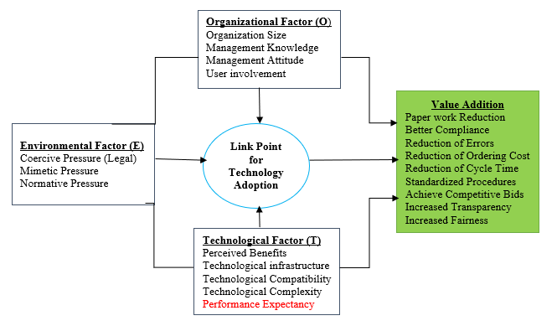
Figure 6.1: Extended TOE Model
Source: Modified TOE Model, 2020

6.3.6.1 Justification of Theoretical Implication of the Study Findings
The final conceptual model for this study used four constructs of which three of them were from TOE model and one of them from UTAUT model. For that matter, constructs from TOE model were dominant in this study and the contribution was expected to come from the construct performance expectancy from UTAUT. Basing on the fact that the overall explanatory power of the conceptual model of this study was contributed by the construct performance expectancy from UTAUT model, then, justification of its contribution was realized after dropping that construct from the final model and then SmartPLS algorithm and bootstrapping were executed.

6.3.6.2 Variations of Overall Explanatory Power
After executing SmartPLS algorithm to the modified model for justification, findings revealed that the overall explanatory power of the modified conceptual model dropped from 64.9 to 60.2 per cent compared to the proposed conceptual model of this study. Figure 6.2 shows the changes of the overall explanatory power of the conceptual model after dropping the construct performance expectancy.

Independent Variable Mediator Variables Dependent Variable
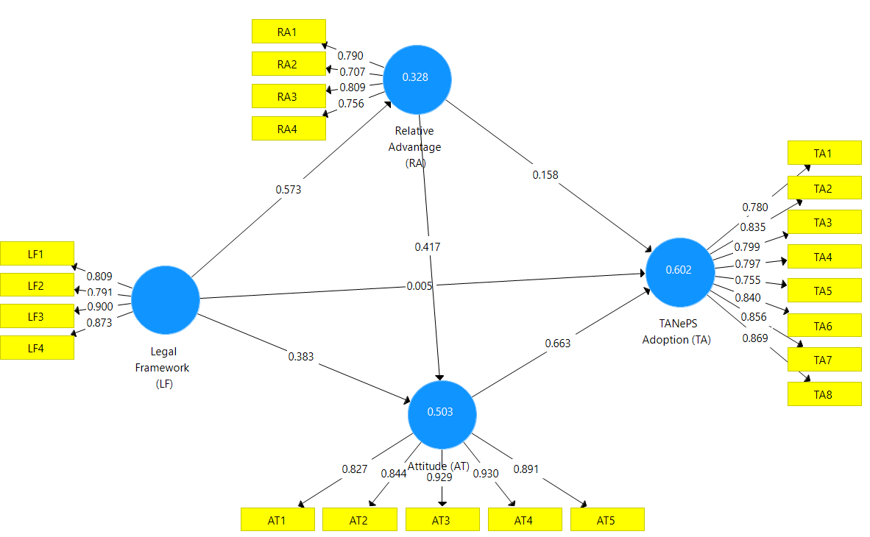
Figure 6.2: The Changes of the Overall Explanatory Power
Source: Survey Results, 2020

6.3.6.3 Variations of Percentage of Supported Hypothesized Relationships
Apart from variations in overall explanatory power of the model after dropping the construct performance expectancy from the proposed conceptual model, the percentage of the supported hypothesized relationships also dropped from 80 per cent to 66.7 per cent compared to the proposed conceptual model of this study. Figure 6.3 shows the changes of the supported hypothesized relationships after running bootstrapping when compared to the findings of the proposed conceptual model.

Independent Variable Mediator Variables Dependent Variable
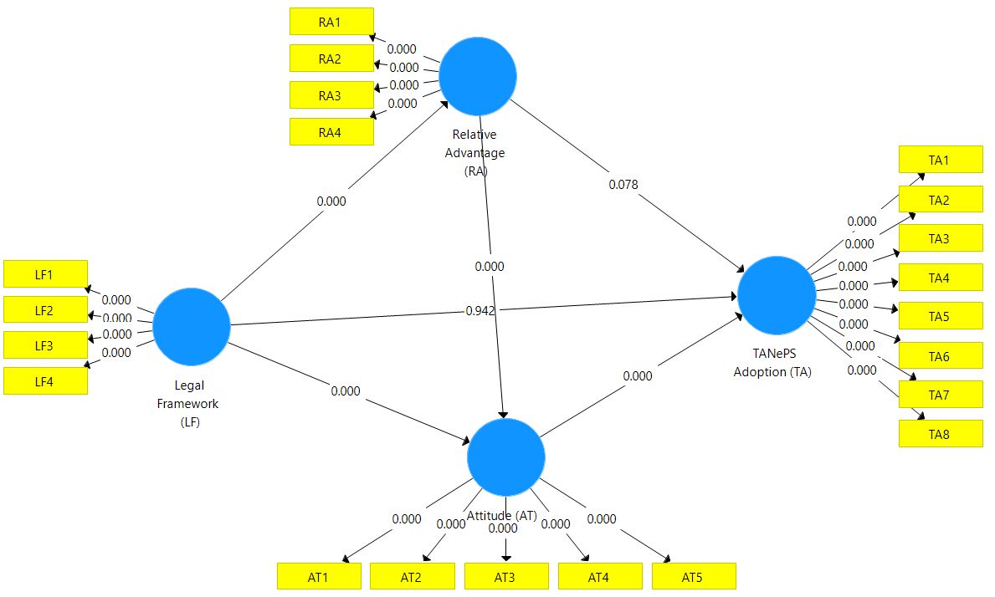
Figure 6.3: The Changes of the Supported Hypothesized Relationships
Source: Survey Results, 2020

6.3.6.4 Variations of Overall Explanatory Power for Direct Relationships Only
This study proposed direct and indirect relationships of the constructs in the conceptual model which was contrary to the relationships of the existing constructs from original TOE and UTAUT models. The indirect relationships were considered as contribution to the existing theoretical literature. Justification of the contribution of the indirect relationships was revealed after executing SmartPLS algorithm for modified model with only direct relationships of its constructs compared to the proposed conceptual model. The findings revealed an insignificant increase of the overall explanatory power of the modified conceptual model from 64.9 to 65.2 per cent compared to the proposed conceptual model. Figure 6.4 shows the changes of the overall explanatory power of the conceptual model after executing SmartPLS algorithm.

Independent Variables Dependent Variable
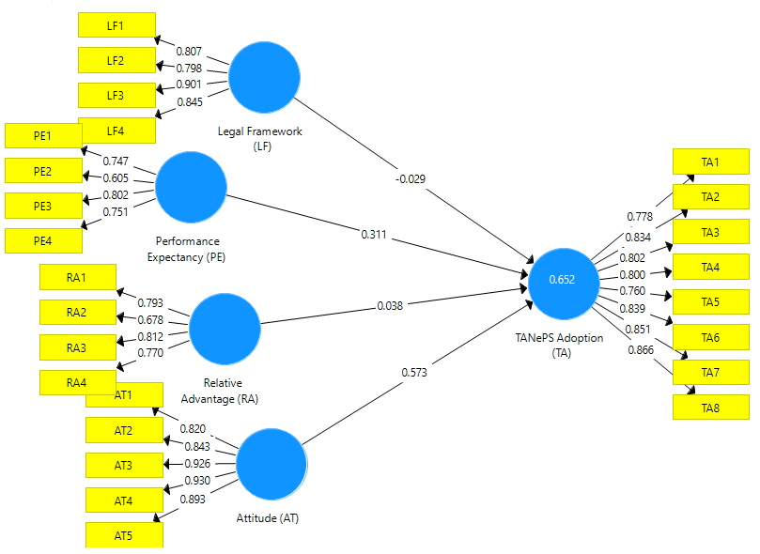
Figure 6.4: Overall Explanatory Power for Modified Model
Source: Survey Results, 2020
6.3.6.5 Variations of Percentage of Supported Hypothesized Relationships
Apart from slight variation in overall explanatory power of the modified model with direct relationships, the percentage of the supported hypothesized relationships dropped from 80 to 50 per cent when compared to the findings of the proposed conceptual model of this study after running bootstrapping. Figure 6.5 shows the changes of the supported hypothesized relationships.

Independent Variables Dependent Variable
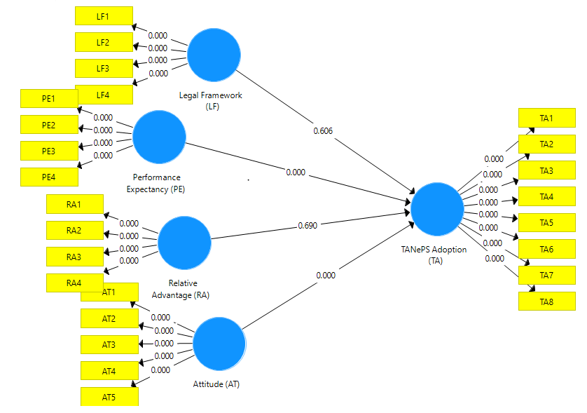
Figure 6.5: Supported Hypothesized Relationships Modified Model
Source: Survey Results, 2020

6.3.6.6 Overall Comparison of the Proposed Model and the Modified Models
The proposed conceptual model of this study can be used by other scientists in other fields related to new technologies adoption to solve problems with regard to the challenges of changing the mindset of people expected to use new technologies. Apart from that, the proposed conceptual model can answer the following questions related to the problem statement of this study. Firstly, why did some of the trained suppliers not register with TANePS? Secondly, why did some of the selected procuring entities not implement TANePS after piloting the system? Thirdly, why were some of the registered suppliers deregistered from TANePS? And why did some of the trained procurement experts from all procuring entities in the country not understand the performance of the system during mass training? Apart from answering the questions, the proposed conceptual model can suggest the solutions to all problems related to those questions.

On the other hand, the modified model with no performance expectancy construct can do the same as the proposed conceptual model except the answer to the last question which is “why did some of the trained procurement experts from all procuring entities in the country not understand the performance of the system during mass training?” Also, the modified model with no performance expectancy construct cannot suggest any solution to the problem related to performance of TANePS. However, the modified model with only direct relationships of its constructs can answer only all those questions as the proposed conceptual model but it cannot suggest any solutions pertaining to the problems related to the hypothesized relationships which were not supported.
6.3.6.7 Implication of UTAUT and TOE Model to the Study Findings
The specific objectives of this study were guided by critical success factors influencing the adoption of new technology (TANePS) from UTAUT and TOE Model. With regard to hypotheses H_{1a} to H_{1d} with critical success factor legal framework from TOE model, it is therefore concluded that, the positive and indirect relationships between legal framework and TANePS adoption were contributed by UTAUT and TOE Model due to the fact that the legal framework was mediated by the critical success factor from UTAUT ‘performance expectancy’ and other two; relative advantage and attitude from TOE Model. In addition, hypotheses H_{2a} to H_{2c} regarding a critical success factor from UTAUT ‘performance expectancy’ which had positive path coefficients for direct and indirect relationships with TANePS adoption and the relationships were statistically significant.

The indirect relationship was mediated by relative advantage and attitude from TOE Model which implied that the interactions and relationships of performance expectancy in conceptual research model were contributed by the UTAUT and TOE Model. The hypotheses H_{3a} to H_{3b} were guided by a critical success factor from TOE Model ‘relative advantage’ which had positive path coefficient in direct and indirect relationships with TANePS adoption. However, the direct relationship was statistically insignificant and the indirect relationship was statistically significant which implied that the indirect relationship exists in real life but the direct relationship does not exist. The indirect relationship was mediated by attitude from TOE Model which implied that the interaction and relationship of relative advantage in research model was contributed by TOE Model.
The hypothesis H₄ was guided by a critical success factor from TOE Model ‘attitude’ which had positive path coefficient for direct relationship with TANePS adoption and the relationship was statistically significant which implied that the direct relationship exists in real life. In addition, attitude construct mediated legal framework, performance expectancy and relative advantage which implied to be the link towards TANePS adoption. The direct relationship of attitude in this research model and its linkage to other critical success factors towards TANePS adoption were contributed by the TOE Model and UTAUT from which the critical success factors were derived. The general objective was guided by all critical success factors which were derived from UTAUT and TOE Model. For that reason, the comparison of the perception of procurement officers and suppliers on critical success factors influencing TANePS adoption in the public sector was contributed by the TOE Model and UTAUT because all constructs of the research model for this study were derived from them.

6.3.7 Empirical Implications of the Study Findings
Taking into consideration the focus of previous empirical studies conducted in developing countries and the focus of this study, it is therefore concluded that the empirical gap which was existing has been filled due to the fact that, this study has included both the perception of buyers (procurement experts from procuring entities) and suppliers on the critical success factors influencing e-procurement (for example TANePS) adoption a substance that the existing empirical literature was explaining insufficiently. Furthermore, the integrated conceptual model with critical success factors influencing positively, directly and indirectly the adoption of new technology (TANePS) for buyers’ and suppliers’ perspectives has been well comprehended in this study of which the existing empirical studies are explaining the indirect relationships inadequately. The indirect relationships between performance expectancy from UTAUT and legal framework, relative advantage and attitude from TOE model have been sufficiently comprehended in this study, a substance that the existing empirical literature was missing. In this study, positivism philosophy and deductive-forecasting-comparison approach and research relations respectively were adopted, PLS SEM with the help of SmartPLS 3 were adopted in data analysis of which the existing empirical literature related to e-procurement adoption used them insufficiently.

6.3.8 Practical Implications of the Study Findings
The final integrated model has practical implications in terms of applicability of TANePS in the public sector. With reference to the relationships of the legal framework with other critical success factors influencing TANePS adoption, the final integrated model of this study suggests that, legal framework should not be used directly in the process of adopting new technology (TANePS) particularly when suppliers (private sector) are involved in Government business. Instead, the legal framework should be used indirectly after significant change of the mindset of the traditional suppliers and the procurement experts working with procuring entities. The significant change of the mindset can be done through training with regard to the performance expectancy and the benefits TANePS brings to the supplier community, and also to the Government at large. For relative advantage being statistically significant in indirect relationship only and being statistically insignificant in direct relationship could suggest that buyers and suppliers during TANePS adoption, expansion and reform do not only rely on relative advantage of the system in order to adopt and use the new system. Hence, this critical success factor influences more buyers’ and suppliers’ decisions to adopt and use TANePS after changing their attitude.

6.3.9 Policy Implications of the Study Findings
The final integrated model of this study has implications to the public procurement policy with regard to the basic critical success factors influencing TANePS adoption, expansion and reform of the system in the public sector. This study has identified legal framework, performance expectancy, relative advantage and attitude as basic critical success factors influencing TANePS adoption. The public procurement policy makers need to take into consideration these critical success factors during expansion and reform of TANePS. The existing public procurement policy needs amendments to be made to accommodate the basic critical success factors identified in this study.

6.4 Conclusions

6.4.1 Direct Influence of Legal Framework towards TANePS Adoption
The direct influence of legal framework towards TANePS adoption had negative path coefficient and was found statistically insignificant; it is concluded that legal framework does not directly influence TANePS adoption. One of the reasons could be suppliers are not directly bonded by the legal framework in supplying goods in procuring entities. Suppliers have options to do or not to do business with procuring entities.

6.4.2 Direct Influence of Performance Expectancy towards TANePS Adoption
The direct influence of performance expectancy towards TANePS adoption had positive path coefficient and was found statistically significant; it is then concluded that performance expectancy directly influences TANePS adoption. This is due to the fact that change of mindset of suppliers and procurement experts towards adoption and use of TANePS depends on understanding of the performance expectancy and the benefits the system brings to the community.

6.4.3 Direct Influence of Relative Advantage towards TANePS Adoption
The direct influence of relative advantage (perceived benefits) towards TANePS adoption had positive path coefficient but it was found statistically insignificant; it is therefore concluded that relative advantage does not directly influence TANePS adoption. This is due to the fact that suppliers and procurement experts do not rely only on the benefits the system brings to the society in their decisions to adopt the system but also rely on their personal benefits.

6.4.4 Direct Influence of Attitude towards TANePS Adoption
The direct influence of attitude towards TANePS adoption had positive path coefficient and was found statistically significant. This study concludes that attitude directly influences TANePS adoption. However, the change of mindset towards TANePS adoption depends on common understanding of the legal framework, performance expectancy and the benefits of the system to the suppliers and procurement experts.

6.4.5 Mediation Effects of Performance Expectancy, Relative Advantage and Attitude towards TANePS Adoption
Basing on the oresults of mediation effects of performance expectancy, relative advantage, and attitude which showed positive path ocoefficients and were all found ostatistically osignificant, it is therefore concluded that legal framework was fully mediated by performance expectancy, relative advantage and attitude because the direct influence of legal framework was found ostatistically insignificant. On the other hand, performance expectancy was partially mediated by relative advantage and attitude because the direct influence of performance expectancy was found ostatistically significant. Furthermore, relative advantage was fully mediated by attitude towards TANePS adoption because the direct influence of relative advantage was found ostatistically insignificant.

6.4.6 Perception of Procurement Experts and Suppliers on Critical Success Factors Influencing TANePS Adoption in the Public Sector
The general objective of the study was to examine the perceived critical success factors influencing TANePS adoption in the public sector. The findings revealed that perception of procurement experts and suppliers on hypothesized critical success factors influencing TANePS had no significant difference by 90 percent. Accordingly, this study concludes that the perception of procurement experts and suppliers on critical success factors influencing TANePS adoption in the public sector has no significant difference.

6.5 Limitations and Delimitations of the Study
One of the problems the researcher faced during the research undertaking was the issue of getting the selected procuring entities for piloting TANePS adoption and the registered suppliers in TANePS. This problem was mitigated by the list of selected procuring entities for piloting TANePS adoption and the registered suppliers in TANePS with their addresses, (for selected procuring entities) e-mails and phone numbers (for registered suppliers) provided by PPRA. In addition, it was difficult to get data on time from the expected respondents since some of the respondents worked in the public sector (where there is formal procedure of getting data) and some worked in the private sector (where there is both formal and informal procedures of getting data). Furthermore, some respondents thought that the answers they provided could be used against them. This problem was mitigated by submitting to them the research clearance letter provided by the Open University of Tanzania, the list of procuring entities selected for piloting the TANePS and the list of registered suppliers in TANePS. Moreover, the questionnaire had an introduction part which assured the respondents that their answers would be treated confidentially and would be used only for academic purposes.

Another problem the researcher faced during the study was the issue of getting the expected sample size of 285. The researcher managed to collect only 157 total sample size of whom 100 were procurement experts from selected procuring entities and 57 were suppliers. In order to ensure high quality of findings in data analysis, the researcher opted to use PLS-SEM with the help of SmartPLS 3 software which mitigated the problem of poor quality of findings in data analysis because it uses a small sample when compared with other SEM methods which are co-variance based.

6.6 Recommendations of the Study

6.6.1 Recommendations to the Government
The Government must have a clear strategy to overcome the barriers to change of some suppliers’ and procurement experts’ attitude and must have greater commitment towards the adoption of TANePS in all procuring entities in the country. Part of the strategy is to involve in a severe assessment of the current situation of the TANePS adoption in all procuring entities whose staff (procurement experts) have been trained on the application of the system. In addition, all potential suppliers, service providers and contractors who did not register in TANePS should be well trained on the application of the system for the purpose of attracting them to participate in tendering process through TANePS. The PLS Multi-Group Analysis results indicated that the perception of procurement experts and suppliers on critical success factors influencing TANePS adoption were similar by 90 percent. Because the two groups are similar in their perception on relationships of legal framework, performance expectancy, relative advantage and attitude towards TANePS adoption, the Government should include all suppliers in massive training pertaining to the legal framework that governs TANePS adoption, expansion and reform.

6.6.2 Recommendations to the PPRA
Study findings and the final integrated conceptual model of this study suggest that the PPRA should ensure that the benefits, performance expectancy and the legal framework supporting TANePS adoption are realized by all parties involved in order to significantly change the mindset of all suppliers and procurement experts in the country. This can be done through active and continuous promoting TANePS and training of procurement experts and suppliers on performance expectancy and the benefits the system brings to the supplier community, the procuring entities and also to the Government at large. Taking into account the findings regarding education level for procurement experts and suppliers in Table 4.3, the number of days for training suppliers should be more than the number of days for training procurement experts because majority of suppliers have low education level compared to procurement experts. In addition, training pertaining to TANePS performance and its benefits to suppliers should be provided in order to avoid diverse insights on TANePS adoption and use in the process of tendering. Moreover, the PPRA should give extra attention to prevent suppliers from dropping out of TANePS, by increasing the attractiveness of the system through ensuring it has user-friendly, easy-to-control and informative interfaces, fast website access and short transaction times.

6.6.3 Recommendations to the Policymakers
Policymakers need to restructure the ICT and public procurement policies to be in line with e-procurement adoption using the final model of this study. The final integrated model of this study has implications in public procurement policy with regard to the basic critical success factors influencing TANePS adoption, expansion and reform of the system in the public sector. This study has identified legal framework, performance expectancy, relative advantage and attitude as basic critical success factors influencing TANePS adoption. The public procurement policy makers should take into consideration these critical success factors during expansion and reform of TANePS because the IPMA results revealed that legal framework, performance expectancy and attitude have higher importance and higher performance. Relative advantage has low importance but it has higher performance in the final integrated conceptual model of this study. These critical success factors are supposed to be taken into consideration during training of stakeholders with regard to TANePS expansion and reform in all procuring entities in the country. Failure to consider those factors during training of stakeholders in expansion and reform of TANePS may make adoption, expansion and reform of the new system more challenging. Based on PLS Multi-Group Analysis results, the public procurement policy makers should formulate the policy related to training and educating all procurement experts and suppliers pertaining to the legal framework that governs TANePS adoption, expansion and reform.

6.6.4 Recommendations to Procurement Experts and Suppliers
Procurement experts and suppliers are required to have commitment in learning the application of TANePS. Basing on the findings regarding education level for procurement experts and suppliers in Table 4.3, majority of suppliers have low education level compared to procurement experts. However, commitment in learning the application of TANePS is the determinant of understanding its performance and benefits it brings to the suppliers and procurement experts in the country. Procurement experts and suppliers are advised to use YouTube to learn the application of TANePS.

6.7 Areas for Further Research
Basing on the results of some studies on IT technologies adoption shown in Table 5.1 with regard to the power of the constructs from UTAUT and the hypothesized relationships which were found statistically significant in proposed conceptual model, this study recommends future research to use the legal framework to influence indirectly other three constructs from UTAUT (effort expectancy, social influence and facilitating condition) towards new technology adoption of which this study did not consider. The relationships of three constructs from TOE and four constructs form UTAUT may improve the overall explanatory power of the conceptual model for new technologies adoption. Figure 6.6 shows the recommended conceptual model for new technology adoption.
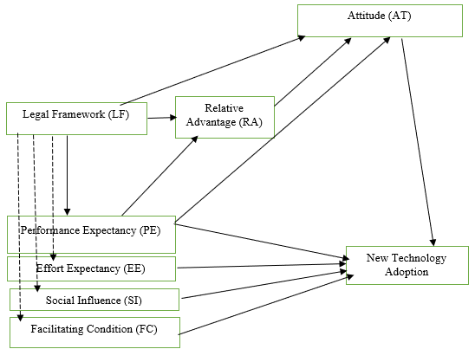
Figure 6.6: Recommended Conceptual Model for New Technology Adoption
Key:
Existing Literature
Call for Further Research
Source: Recommended Conceptual Model, 2020

In addition, this study based on deductive approach. With that note, the study proposes inductive or mixed approach for future studies. The assumption is that given this study’s stated implications to the theories, empirical literature and to the practical, it is anticipated that the situation will change not only in ways procurement experts and suppliers will interact with TANePS but also the believable message that they pose in the respective change of their mindset. This study included only the perception of 100 procurement experts from selected procuring entities based in five cities in the country and 57 suppliers who were trained for piloting the TANePS adoption. It is therefore recommended that further research may increase the sample size of procurement experts and suppliers from other developing countries.

In this study, attention has been paid to the application of reflective model with constructs inducing the indicators. It is therefore recommended that further research would be necessary to apply formative model with specified constructs which are induced by the indicators and have received considerable attention in the recent past. Lastly, the data of this study were limited to procurement experts and suppliers from one country implementing the new public procurement system. Therefore, the model of this study is recommended to be tested in other developing countries to see its applicability and if it can be generalized for e-procurement adoption in the public sector.

REFERENCES
Aboelmaged, M. (2018). The drivers of sustainable manufacturing practices in Egyptian SMEs and their impact on competitive capabilities: A PLS-SEM model. Journal of Cleaner Production, 175, 207-221, doi: https://doi.org/ 10.1016/j.jclepro.2017.12.053.
Aboelmaged, M. G. (2010). Predicting e-procurement adoption in a developing country, an empirical integration of technology acceptance model and theory of planned behaviour. Industrial Management & Data Systems, 110 (3), 2392-414, Emerald Group Publishing Limited, DOI 10.1108/02635571011030042
Adjei-Bamfo, P., & Maloreh-Nyamekye, T. (2019). The ‘baby steps’ in mainstreaming sustainable public procurement in Ghana: A double-agency perspective. Journal of Public Aﬀairs, e1902, https://doi.org/10.1002/pa.1902
Adjei-Bamfo, P., Domfeh, K., A., Nyigmah-Bawole, J., Ahenkan, A., Maloreh-Nyamekye, T., Adjei-Bamfo, S., & Darkwah, S. A. (2020). An e-government framework for assessing readiness for public sector e-procurement in a lower-middle income country. Journal of Information Technology for Development, DOI: 10.1080/02681102.2020.1769542
Azanlerigu, J.A. & Akay, E. (2015). Prospects and challenges of e-procurement in some selected public institutions in Ghana. European Journal of Business and Management, 7 (29).
Basheka, C. B., Oluka, N. P. &Mugurusi, G. (2012). Adopting new approaches for public procurement efficiency: critical success factors (CSFS) for the adoption of e-procurement in Uganda’s public sector. International Journal of Procurement Management, 5 (6).
Bawole, J. N., & Adjei-Bamfo, P. (2019). Public procurement for public financial management in Africa: agency theory lenses, Global Encyclopaedia of Public Administration, Public Policy and Governance, https://doi.org/10.1007/978-3-319-31816-5_3860-1
Becker, J.-M., Ringle, C. M., & Sarstedt, M. (2018). Estimating moderating effects in PLS-SEM and PLSc-SEM: interaction term generation*data treatment. Journal of Applied Structural Equation Modeling, 2(2), 1-21.
Bose, R. &Luo, X. (2012). Green IT adoption: a process management approach, International Journal of Accounting & Information Management, 20(1), 63 - 77 http://dx.doi.org/10.1108/18347641211201081
Chaffey, D. (2007). E-business and e-commerce management: Strategy Adoption and Practice (3rded.). Pearson Education Limited, Harlow (UK).
Chege, S. M., & Wang, D. (2020). The influence of technology innovation on SME performance through environmental sustainability practices in Kenya. Journal of Technology in Society, 60, 101210, doi: https://doi.org/10.1016/j.techsoc. 2019.101210
Chen, L.S., Kuan, C.J., Lee, Y., & Huang, H. (2011). Applicability of the UTAUT model in playing online game through mobile phones: moderating effects of user experience, IEEE Int'l Technology Management Conference.
Creswell, J.W. (2009). Research design: Qualitative, quantitative, and mixed methods approaches (3rd ed.). Singapore: SAGE Publications Asia-Pacific Pte. Ltd.
Davila, A., Gupta, M. & Palmer, R. (2003). Moving procurement systems to the internet: the adoption and use of e-procurement technology models, European Management Journal, 21 (1), 11-23.
Dwivedi, Y. K., Rana, N.P., Jeyaraj, A., Clement, M., & Williams, M.D (2017). Re-examining the Unified Theory of Acceptance and Use of Technology (UTAUT): towards a revised theoretical model, DOI 10.1007/s10796-017-9774-y.
Eekhout, I., Michiel, R., Boer, B., Jos, W., Twisk, R., Henrica, C. W. de Vet &Martijn, W. H. (2012). Missing data: a systematic review of how they are reported and handled. Epidemiology, 23 (5), 729-732.
Ferreira, J. J. M., Fernandes, C. I., & Ferreira, F. A. F. (2020). Technology transfer, climate change mitigation, and environmental patent impact on sustainability and economic growth: A comparison of European countries. Technological Forecasting and Social Change, 150, 119770, doi: https://doi.org/10.1016/ j.techfore.2019.119770.
Gambo, M. M., Dodo, M., & Yusuf, H. (2019). Assessment of stakeholders’ perception of risk factors associated with the adoption of e-procurement in the Nigerian construction industry, West Africa Built Environment Research (WABER) Conference Proceedings, Accra, Ghana, 188-199, DOI: https://doi.org/10.33796/waberconference2019.13
Gupta, M. & Narain, R. (2012). A survey on adoption of e-procurement in Indian organizations, International Journal of Indian Culture and Business Management, 5 (1).
Hair, J. F., Ringle, C. M. & Sarstedt, M. (2011). PLS-SEM: Indeed, a silver bullet. The Journal of Marketing Theory and Practice, 19 (2), 139–152.
Hair, J. F., Ringle, C. M. & Sarstedt, M. (2014). PLS-SEM: Indeed, a silver bullet. The Journal of Marketing Theory and Practice, 19 (2), 139–152.
Hair, J. F., Hollingsworth, C. L., Randolph, A. B., & Chong, A. Y. L. (2017a). An updated and expanded assessment of PLS-SEM in information systems research. Industrial Management & Data Systems, 117(3), 442-458.
Hair, J. F., Hult, G. T. M., Ringle, C. M., Sarstedt, M., & Thiele, K. O. (2017b). Mirror, mirror on the wall: a comparative evaluation of composite-based structural equation modeling methods. Journal of the Academy of Marketing Science (JAMS), 45(5), 616–632.
Hair, J.F., Risher, J.J., Sarstedt, M. & Ringle, C.M. (2018). When to use and how to report the results of PLS-SEM. European Business Review, https://doi.org/ 10.1108/EBR-11-2018-0203
Henseler, J., Ringle, C. M., & Sarstedt, M. (2016). Testing measurement invariance of composites using partial least squares. International Marketing Review, 33(3), 405-431.
Henseler, J., & Sarstedt, M. (2013). Goodness-of-fit indices for partial least squares path modeling. Computational Statistics, 28(2), 565-580.
Hue, T. T. (2019). The determinants of innovation in Vietnamese manufacturing firms: an empirical analysis using a technology–organization–environment framework. Eurasian Business Review, 9(3), 247-267, doi:10.1007/s40821-019-00125-w.
Hwang, B., Huang, C., & Wu, C. (2016). A TOE approach to establish a green supply chain adoption decision model in the semiconductor industry, Journal of Sustainability, doi:10.3390/su8020168.
Ibem, E.O., Aduwo, E.B., Tunji-Olayeni, P., Ayo-Vaughan, E.K. & Uwakonye, O.U. (2016). Factors influencing e-procurement adoption in the Nigerian building industry. Journal of Construction Economics and Building, 16 (4), 54-67.
Ibrahim, M., Bawole, J. N., Obuobisa-Darko, T., Abubakar, A., Kumasey, A. S. (2017). The legal regime and the compliance façade in public procurement in Ghana, International Journal of Public Sector Management, 30 (4), doi: 10.1108/IJPSM-09-2016-0156.
Iles, J. (2017). How is e-procurement related to the success of U.S. Cities’ Sustainable Purchasing Policies? Arizona State University, ASU School of Sustainability
Intharaksa, U. (2009). Using diffusion of innovation theory to explain the degree of faculty adoption of web-based instruction in a Thai university, (PhD thesis). Faculty of the Graduate College of the Oklahoma State University.
Jeptoo, N. & Karanja, K. (2017). Effect of governance structure on e-procurement adoption by state corporations in Kenya. International Academic Journal of Procurement and Supply Chain Management, 2(3), 76-9. Retrieved from http://www.iajournals.org/articles/iajpscm_v2_i3_76_91.pdf
Kassim, E. S. & Hussin, H. (2013). A success model for the Malaysian Government e-procurement system: the buyer perspective. International Journal of Electronic Government Research (IJEGR), 9(1).
Kiwanuka, A. (2015). Acceptance process: the missing link between UTAUT and Diffusion of Innovation Theory. American Journal of Information Systems, 3, (2), 40-44, doi: 10.12691/ajis-3-2-3.
Klabi, H., Mellouli, S., & Rekik, M. (2016). A reputation based electronic government procurement model. Government Information Quarterly, http://dx.doi.org/10.1016/j.giq.2016.01.001.
Klein, K. J., Conn, A. B. & Sorra, J. S. (2001). Implementing computerized technology: an organizational analysis. Journal of Applied Psychology, 86 (5), 811–824.
Kock, N. & Mayfield, M. (2015). PLS-based SEM algorithms: the good neighbour assumption, collinearity, and nonlinearity, Information Management and Business Review, 7 (2), 113-130.
Kumar, R. (2011). Research methodology. A step-by-step guide for beginner (3rdEd.), Sage, New Delhi.
Latif, F. B. (2014). The adoption of electronic procurement in Turkey. Advances in Economics and Business, 2 (2), 85-91, DOI: 10.13189/aeb.2014.020204
Magigi, W. (2015). Research proposal development and report writing, pathway for success in higher learning institutions (1stEd.), Safi Publishers, Moshi.
Makoba, N. Nyamagere, G. & Eliufoo, H. (2017). E-procurement risks and mitigation: the case for Tanzania construction companies. International Journal of Construction Engineering and Management, 6 (4), doi: 10.5923/j.ijcem.20170604.06.
Malekia, D. (2018). E-Procurement as anti-corruption tool in public procurement in Tanzania. European Journal of Business and Management, 7 (14).
Masele, J. J. (2014). Adoption of green e-business applications for sustainable tourism development in developing countries the case of Tanzania (PhD thesis). Department of Business Informatics I, VLBA-University of Oldenburg, German.
Mgidlana, L.M. (2013). Factors affecting the adoption of e-procurement technologies from the supplier perspective (Masters’ Research Project). Gordon Institute of Business Science, University of Pretoria, South Africa.
Mohammed, F., Ibrahim, O., Nilashi, M., & Alzurqa, E. (2016). Cloud computing adoption model for e-government adoption. Information Development Journal, DOI: 10.1177/0266666916656033.
Monczka, R. M. & Carter, P. L. (2015). Strategic performance measurement for purchasing and supply. Tempe AZ, CAPS: Centre for Strategic Supply Research.
Morris, A. (2000). E-Procurement: Streamlining processes to maximize effectiveness. Luminant Worldwide Corporation SUA.
Mose, J. M., Njihia, J. M. & Magutu, P. O. (2013). The critical success factors and challenges in e-procurement adoption among large scale manufacturing firms in Nairobi, Kenya. European Scientific Journal, 9 (13), 1857- 7431
Mrope, P.N. (2018). Determinants of performance of procurement departments in public entities in Tanzania (PhD thesis). Jomo Kenyatta University of Agriculture and Technology, Kenya.
Mugenda, O. M. (2003). Research methods: quantitative and qualitative approaches: African Center for Technology Studies Press, Nairobi:
Mwangi, G.P., Kiarie, D. & Kiai, R. (2018). Integrated financial management information system, procurement performance and customer satisfaction in the county Government of Nyeri, International Journal of Supply Chain Management, 3 (1), 127-45.
Nitzl, C., Roldán, J. L., & Cepeda Carrión, G. (2016). Mediation analysis in partial least squares path modeling: helping researchers discuss more sophisticated models. Industrial Management & Data Systems, 119(9), 1849-1864.
Oliveira, T., & Martins, M. F. (2011). Literature review of information technology adoption models at firm level, The Electronic Journal Information Systems Evaluation, 14 (1). Retrieved from www.ejise.com
Ombat, K. O. (2015). Relationship between e-procurement systems and performance of procurement function in commercial banks in Kenya. International Journal of Economics, Commerce and Management, United Kingdom, 3 (12).
Pitso, N., Kabanda, S., & Kapepo, M. (2018). Exploring e-procurement adoption in the context of a developing country: the case of Lesotho, e-infrastructure and e-services for developing countries. AFRICOMM 2017. Lecture Notes of the Institute for Computer Sciences, Social Informatics and Telecommunications Engineering (250), pp. 315–326). Springer. https://doi.org/10.1007/978-3-319-98827-6_30
Rogers, E.M. (2003). Diffusion of Innovations (5th ed.). Free Press, New York.
Rotich, G.K. & Okello, B. (2015). Analysis of use of e-procurement on performance of the procurement functions of county governments in Kenya. International Journal of Economics, Commerce and Management United Kingdom, 3 (6),
Samir, K. (2008). Role of e-procurement in steel industry with a case study on Visakhapatnam steel plant, International Centre for Promotion of Enterprises, Ljublajna, India.
Sarstedt, M., Ringle, C. M. & Hair, J. F. (2017). Partial least squares structural equation modeling, DOI: 10.1007/978-3-319-05542-8_15-1.
Saunders, M. Lewis, P. & Thornhill, A. (2009). Research methods for business students (5th ed.). Pearson Education Limited, England.
Schooner, L. S., Gordon, I. D. & Clark, L. J. (2008). Public procurement systems: unpacking stakeholder aspirations and expectations. GW Law Faculty Publications and Other Works, 111
Shale, N. I. (2014). Role of e-procurement strategy on the performance of state corporations in Kenya (PhD thesis). College of Human Resource Development, Jomo Kenyatta University of Agriculture and Technology, Kenya.
Sharma, P. N., Sarstedt, M., Shmueli, G., Kim, K. H., & Thiele, K. (2019). PLS-based model selection: The role of alternative explanations in information systems research. Journal of the Association for Information Systems, 20(4), 4.
Shatta, D. N., Shayo, F. A. & Layaa, J. N. (2020a). Determinants of e-procurement adoption model for green procurement in developing countries: experience from Tanzania. International Academic Journal of Procurement and Supply Chain Management, 3(2), 1-18. Retrieved from http://www.iajournals.org/ articles/iajpscm_v3_i2_1_18.pdf.
Shatta, D. N., Shayo, F. A. & Layaa, J. N. (2020b). Influence and linkage of buyers’-suppliers’ attitude towards e-procurement adoption in developing countries: Tanzania context. International Journal of Applied Research in Management and Economics, https://doi.org/10.33422/ijarme.v3i1.282 .
Shatta, D. N., Shayo, F. A., Layaa, J. N., & Mchopa, D. A. (2020c). Stakeholders’ perception on critical success factors influencing electronic procurement adoption in developing counties: experience from Tanzania, American Scientific Research Journal for Engineering, Technology, and Sciences (ASRJETS), 71(1), 61-86. Retrieved from https://asrjetsjournal.org/index.php/ American_Scientific_Journal/article/view/5985/2205
Shatta, D. N., Shayo, F. A., Mchopa, A. D., & Layaa, J. N. (2020d). The Influence of Relative Advantage Towards e-Procurement Adoption Model in Developing Countries: Tanzania Context. European Scientific Journal, ESJ, 16(28), 130. https://doi.org/10.19044/esj.2020.v16n28p130
Shilla, P. (2019, December, 28). Highlights of Tanzania National e-Procurement System. Paper presented at the twelfth East African Public Procurement Forum, Arusha, Tanzania.
Suleiman, M. (2015). Adoption of e-procurement and value addition: Tanzanian context. European Journal of Business and Management, 7(14).
Taluka, E.A. (2016). Understanding factors influencing consumer behavioural intention to use mobile payment services in rural Tanzania: a case of Pwani region (Masters dissertation). University of Dar es Salaam, Tanzania.
Tornatzky, L. & Fleischer, M. (1990). The process of technology innovation, Lexington, MA, Lexington Books
Tutu, S. O., Kissi, E., Osei-Tutu, E. & Desmond, A. (2019). Evaluating critical factors for the adoption of e-procurement in Ghana, Int. J. Procurement Management, 12 (1), 1-14.
United Republic of Tanzania (2019). Public Procurement Regulatory Authority Annual performance evaluation report for 2018/2019 financial year
United Republic of Tanzania (2018). Public Procurement Regulatory Authority Annual performance evaluation report for 2017/2018 financial year
United Republic of Tanzania (2016). National Information and Communications Technology Policy, Government Printers, Dar es Salaam.
United Republic of Tanzania (2013). Public Procurement Regulations of 2013 and its amendment 2016, Government Printers, Dar es Salaam.
United Republic of Tanzania (2012). The National Public Procurement Policy, Government Printers, Dar es Salaam.
United Republic of Tanzania (2011). Public Procurement Act (Act No. 21) of 2011 and its amendment 2016, Government Printers, Dar es Salaam.
Venkatesh, V., Thong, J. Y. L., & Xu, X. (2012). Consumer acceptance and use of information technology: extending the unified theory. MIS Quarterly, 36 (1), 157–178.
Venkatesh, V., Morris, M. G., Davis, G. B. & Davis, F. D. (2003). User acceptance of information technology: toward a unified view", MIS Quarterly, 27 (3), 425-478.
Watuleke, J. (2017). E-procurement: evolution and adoption. a review of literature, IJRDO-Journal of Educational Research, 2456-2947.
Wong, K. K. (2013). Partial least squares structural equation modelling (PLS-SEM) techniques using SmartPLS. Marketing Bulletin Journal, 24 (1), 1–32.
Woodside, A. G. & Biemans, W.G. (2005). Modelling innovation, manufacturing, diffusion and adoption/rejection processes. Journal of Business and Industrial Marketing, 20 (7), 380–393.
Xu, W., Ou, P., & Fan, W. (2015). Antecedents of ERP assimilation and its impact on ERP value: A TOE-based model and empirical test. Information Systems Frontiers, 19(1), 13-30, DOI 10.1007/s10796-015-9583-0
Zhang, Y., Sun, J., Yang, Z. & Wang, Y. (2020). Critical success factors of green innovation: Technology, organization and environment readiness. Journal of Cleaner Production, doi: https:// doi.org/10.1016/j.jclepro.2020.121701.
Zhou, J., Shafiq, M.N., Adeel, A., Nawaz, S., &Kumar, P. (2017). What is Theoretical Contribution? A Narrative Review

APPENDICES

APPENDIX A: QUESTIONNAIRE
Dear respondent;
I am Deus Nichodemus Shatta a PhD candidate at Open University of Tanzania conducting an academic research which is titled “Stakeholders’ Perception on Critical Success Factors Influencing Electronic Procurement Adoption in Tanzanian Public Sector”. I humbly request for your participation in this study. Your opinion is extremely important and I declare that all data and information obtained from your organization in the course of my research will be maintained secrecy and confidentiality, and will not be used for any other purpose apart from my academic endeavours. Thank you for your time and be blessed.
Part A: Respondent’s General Information
Please indicate your Sex by ticking (√) Male [ ], Female [ ]
Please indicate your age (complete years) [ ]
Please indicate your position, ______________________________
Please indicate your highest education level attained by ticking (√)
Standard Seven [ ], Secondary level [ ], Certificate [ ], Diploma [ ], Degree [ ], Masters [ ], PhD [ ]
Please indicate your profession, ______________________
Please indicate your Institution/company by ticking (√)
Procuring Entity [ ] Supplier [ ]
Please indicate your experience in working with similar job ________________
Part B: Statement Related to the Research: Please indicate by ticking (√) the extent to which you agree or disagree with each statement as applied to your organisation

 | Survey Item on Legal Framework (LF) | Strongly Disagree | Disagree | Neutral | Agree | Strongly Agree
LF_1 | I understand TANePS was developed in accordance with the requirement of the Public Procurement Act (PPA) 2011 and its amendment 2016
LF_2 | I understand TANePS supports various public procurement procedures as directed by the Public Procurement Regulation (PPR), 2013 and its amendment 2016
LF_3 | I understand the rules of TANePS application are basing on the Public Procurement Act (PPA) 2011 and its amendment 2016
LF_4 | I understand the regulations of TANePS application are basing on the Public Procurement Regulation (PPR), 2013 and its amendment 2016
 | Performance Expectancy (PE) | Strongly Disagree | Disagree | Neutral | Agree | Strongly Agree
PE_1 | I find TANePS is user friendly in procurement process
PE_2 | I find TANePS helps in transaction of money more quickly
PE_3 | I find TANePS removes chances of corruption
PE_4 | I find TANePS reduces procurement cycle time
 | Relative Advantage (RA)
RA_1 | I find TANePS reduces transaction errors in public procurement process
RA_2 | I find TANePS reduces transaction costs in public procurement process
RA_3 | I find TANePS improves data accuracy in public procurement process
RA_4 | I find TANePS faster tendering process in public procurement process
 | Survey Item on Attitude Toward TANePS (AT)
AT_1 | I like the idea of using TANePS in public procurement process
AT_2 | I intend to continue learning how to use TANePS in public procurement process
AT_3 | I plan to continue using TANePS in public procurement process.
AT_4 | I will continue taking advantages of TANePS in improving my efficiency in public procurement process.
AT_5 | I will continue taking advantages of TANePS in improving my effectiveness in public procurement process.
 | Survey Item on TANePS Adoption (TA)
TA_1 | When I use TANePS, there is better procurement services due to improved performance services
TA_2 | When I use TANePS, human efforts are reduced due to increased efficiency
TA_3 | When I use TANePS, bureaucratic procedures are reduced due to increased efficiency
TA_4 | When I use TANePS, processing time is reduced due to increased efficiency
TA_5 | When I use TANePS, more opportunities for potential suppliers are realized due to increased transparency
TA_6 | When I use TANePS, the information is more comprehensive due to improved information quality
TA_7 | When I use TANePS, the information is more accurate due to improved information quality
TA_8 | When I use TANePS, the information is more consistent due to improved information quality

APPENDIX B: RESEARCH CLEARANCE LETTER


PENDIX C: LIST OF PROCURING ENTITIES IMPLEMENTING TANePS
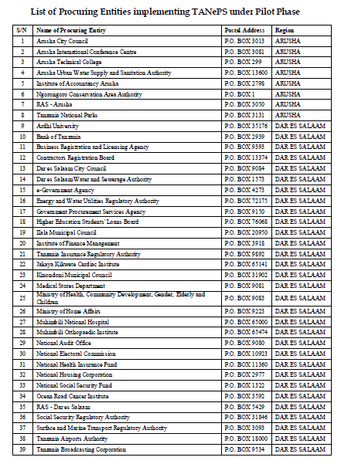

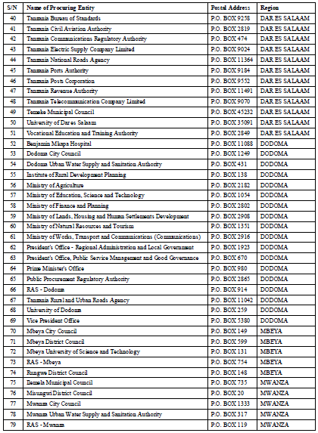

APPENDIX D: LIST OF ACCEPTANCE LETTERS























APPENDIX E: LIST OF SOME SUPPLIERS IMPLEMENTING TANePS

LIST OF SOME SUPPLIERS IMPLEMENTING TANePS UNDER PILOT PHASE
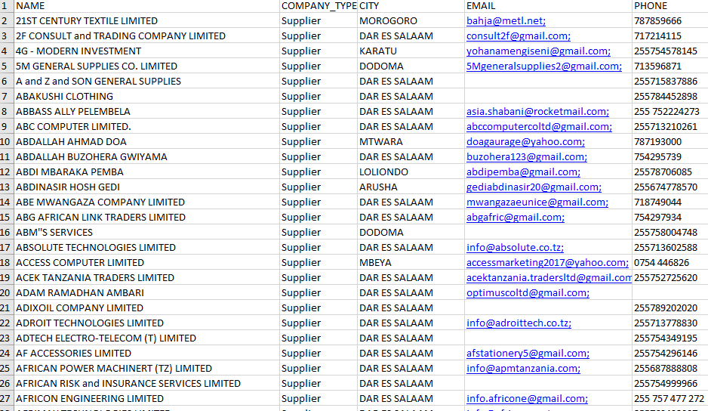


APPENDIX F: LIST OF E-MAIL OF SOME SUPPLIERS RESPONDED
LIST OF E-MAIL OF SOME SUPPLIERS RESPONDED THROUGH GOOGLE FORM
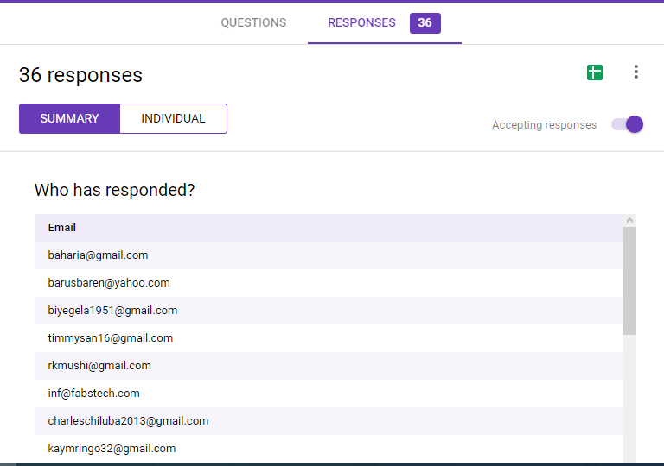


APPENDIX G: TIME AND RESEARCH BUDGET FOR PhD PROGRAM

Table for Plan of Activities in PhD Program
Activities |  | Years
 |  | 2018 |  |  |  |  |  |  |  |  |  |  |  | 2019 |  |  |  |  |  |  |  |  |  |  |  | 2020
 |  | J | F | M | A | M | J | J | A | S | O | N | D | J | F | M | A | M | J | J | A | S | O | N | D | J | F | M | A | M
1 | Preparation of Concept Note and Proposal for PhD Thesis
2 | Defence of PhD Proposal
3 | Data Collection and Data Analysis
4 | Writing and Defence for PhD Thesis
Source: Researcher’ Time Frame, 2018

Estimated Research Budget
Table for Estimated Research Budget
Item | Quantity | Unity Cost  (TZS) | Total Cost  (TZS)
University Fee | 3 Years | 6,500,000 | 6,500,000
Meal Allowance | 3 Years | 3,600,000 | 10,800,000
Research Allowance | 3 Years | 5,000,000 | 15,000,000
Books and Stationary Allowance | 3 Years | 500,000 | 1,500,000
Total | N/A | N/A | 32,800,000
Source: Researcher’ Budget, 2018

APPENDIX H: RESEARCH FINDINGS
Sex of Respondents
 |  | Frequency | Percent | Valid Percent | Cumulative Percent
 | Male | 115 | 73.2 | 73.2 | 73.2
 | Female | 42 | 26.8 | 26.8 | 100.0
 | Total | 157 | 100.0 | 100.0

Outer Loadings
 | Original Sample (O) | Sample Mean (M) | Standard Deviation (STDEV) | T Statistics (|O/STDEV|) | P Values
AT1 <- AT | 0.828 | 0.826 | 0.034 | 24.138 | 0.000
AT2 <- AT | 0.842 | 0.838 | 0.047 | 17.764 | 0.000
AT3 <- AT | 0.929 | 0.929 | 0.018 | 51.041 | 0.000
AT4 <- AT | 0.93 | 0.93 | 0.014 | 68.325 | 0.000
AT5 <- AT | 0.891 | 0.889 | 0.025 | 35.765 | 0.000
LF1 <- LF | 0.81 | 0.811 | 0.064 | 12.746 | 0.000
LF2 <- LF | 0.79 | 0.787 | 0.056 | 14.047 | 0.000
LF3 <- LF | 0.9 | 0.9 | 0.021 | 43.618 | 0.000
LF4 <- LF | 0.874 | 0.872 | 0.034 | 25.478 | 0.000
PE1 <- PE | 0.74 | 0.741 | 0.049 | 15.227 | 0.000
PE2 <- PE | 0.614 | 0.605 | 0.079 | 7.793 | 0.000
PE3 <- PE | 0.803 | 0.807 | 0.027 | 29.768 | 0.000
PE4 <- PE | 0.754 | 0.749 | 0.053 | 14.242 | 0.000
RA1 <- RA | 0.794 | 0.795 | 0.038 | 20.634 | 0.000
RA2 <- RA | 0.711 | 0.706 | 0.097 | 7.3 | 0.000
RA3 <- RA | 0.803 | 0.803 | 0.045 | 17.975 | 0.000
RA4 <- RA | 0.756 | 0.756 | 0.053 | 14.394 | 0.000
TA1 <- TA | 0.778 | 0.777 | 0.042 | 18.493 | 0.000
TA2 <- TA | 0.834 | 0.834 | 0.033 | 25.368 | 0.000
TA3 <- TA | 0.803 | 0.804 | 0.038 | 20.975 | 0.000
TA4 <- TA | 0.8 | 0.801 | 0.039 | 20.323 | 0.000
TA5 <- TA | 0.76 | 0.759 | 0.048 | 15.859 | 0.000
TA6 <- TA | 0.839 | 0.835 | 0.043 | 19.435 | 0.000
TA7 <- TA | 0.852 | 0.852 | 0.03 | 28.513 | 0.000
TA8 <- TA | 0.866 | 0.867 | 0.029 | 30.298 | 0.000

Age Group of Respondents
Valid PercentCumulative Percent
ValidFrequencyPercent |  | 21-30 | 29 | 18.5 | 18.5
18.5 | 31-40 | 58 | 36.9 | 36.9 | 55.4
18.5 | 41-50 | 39 | 24.8 | 24.8 | 80.3
18.5 | 51-60 | 25 | 15.9 | 15.9 | 96.2
18.5 | 61+ | 6 | 3.8 | 3.8 | 100.0
18.5 | Total | 157 | 100.0 | 100.0

Experience of the Respondents in Group
 |  | Frequency | Percent | Valid Percent | Cumulative Percent
Valid | 1-10 | 109 | 69.4 | 69.4 | 69.4
Valid | 11-20 | 34 | 21.7 | 21.7 | 91.1
Valid | 21-30 | 8 | 5.1 | 5.1 | 96.2
Valid | 31+ | 6 | 3.8 | 3.8 | 100.0
Valid | Total | 157 | 100.0 | 100.0

Education of the Respondents
 |  | Frequency | Percent | Valid Percent | Cumulative Percent
 | Standard Seven | 4 | 2.5 | 2.5 | 2.5
 | Secondary Level | 15 | 9.6 | 9.6 | 12.1
 | Certificate Level | 5 | 3.2 | 3.2 | 15.3
 | Diploma Level | 22 | 14.0 | 14.0 | 29.3
 | Degree Level | 65 | 41.4 | 41.4 | 70.7
 | Master’s Degree | 45 | 28.7 | 28.7 | 99.4
 | Ph.D Level | 1 | .6 | .6 | 100.0
 | Total | 157 | 100.0 | 100.0

Type of Respondents
 |  | Frequency | Percent | Valid Percent | Cumulative Percent
 | Procurement Expert | 100 | 63.7 | 63.7 | 63.7
 | Supplier | 57 | 36.3 | 36.3 | 100.0
 | Total | 157 | 100.0 | 100.0

Work Experience of the Respondents in years.
 | N | Minimum | Maximum | Sum | Mean | Std. Deviation
Experience of Respondents | 157 | 1 | 38 | 1577 | 10.04 | 7.901
Valid N | 157
Source: Field Data, 2019
Education Level of Respondents against Type of Respondent Cross Tabulation
 |  | Type of respondent |  | Total
 |  | Procuring Entity’ Staff (Procurement Experts) | Supplier | Total
Education Level of Respondents | Standard Seven | 0 | 4 | 4
Education Level of Respondents | Secondary level | 0 | 15 | 15
Education Level of Respondents | Certificate Level | 0 | 5 | 5
Education Level of Respondents | Diploma Level | 8 | 14 | 22
Education Level of Respondents | Degree Level | 50 | 15 | 65
Education Level of Respondents | Master’s Degree | 41 | 4 | 45
Education Level of Respondents | Ph.D Level | 1 | 0 | 1
Total |  | 100 | 57 | 157

Path | Specific Indirect Effects
LF -> PE -> AT | 0.124
LF -> RA -> AT | 0.094
PE -> RA -> AT | 0.140
LF -> PE -> RA -> AT | 0.073
LF -> PE -> RA | 0.250
LF -> AT -> TA | 0.192
PE -> AT -> TA | 0.138
LF -> PE -> AT -> TA | 0.072
LF -> RA -> AT -> TA | 0.055
RA -> AT -> TA | 0.170
PE -> RA -> AT -> TA | 0.081
LF -> PE -> RA -> AT -> TA | 0.043
LF -> PE -> TA | 0.162
LF -> RA -> TA | 0.010
PE -> RA -> TA | 0.015
LF -> PE -> RA -> TA | 0.008

Total Indirect Effects
 | Original Sample (O) | Sample Mean (M) | Standard Deviation (STDEV) | T Statistics (|O/STDEV|) | P Values
LF -> AT | 0.292 | 0.29 | 0.068 | 4.27 | 0.000
LF -> RA | 0.25 | 0.255 | 0.046 | 5.403 | 0.000
LF -> TA | 0.542 | 0.543 | 0.081 | 6.687 | 0.000
PE -> AT | 0.14 | 0.142 | 0.055 | 2.528 | 0.012
PE -> TA | 0.234 | 0.238 | 0.063 | 3.724 | 0.000
RA -> TA | 0.17 | 0.163 | 0.053 | 3.186 | 0.002

Total Effects
 | Original Sample (O) | Sample Mean (M) | Standard Deviation (STDEV) | T Statistics (|O/STDEV|) | P Values
AT -> TA | 0.581 | 0.571 | 0.093 | 6.264 | 0.000
LF -> AT | 0.622 | 0.619 | 0.078 | 8.002 | 0.000
LF -> PE | 0.525 | 0.529 | 0.08 | 6.564 | 0.000
LF -> RA | 0.572 | 0.568 | 0.084 | 6.815 | 0.000
LF -> TA | 0.508 | 0.507 | 0.082 | 6.212 | 0.000
PE -> AT | 0.377 | 0.378 | 0.081 | 4.664 | 0.000
PE -> RA | 0.477 | 0.484 | 0.064 | 7.511 | 0.000
PE -> TA | 0.543 | 0.542 | 0.077 | 7.069 | 0.000
RA -> AT | 0.293 | 0.294 | 0.104 | 2.819 | 0.005
RA -> TA | 0.203 | 0.212 | 0.11 | 1.841 | 0.066

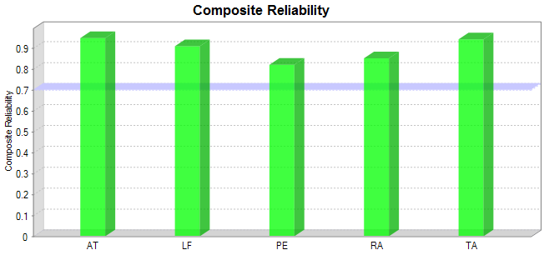
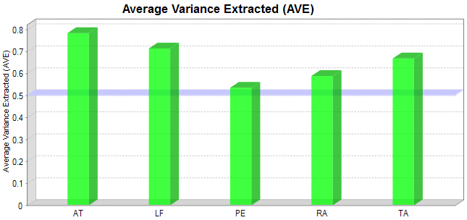
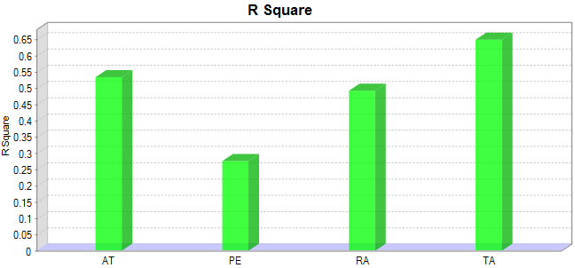

PLS-MGA
Indicators | Outer Loadings-diff ( | Procurement Experts - Suppliers |) |  | p-Value(Procurement Experts vs Suppliers)
AT1 <- AT | 0.042 |  | 0.280
AT2 <- AT | 0.272 |  | 0.021
AT3 <- AT | 0.093 |  | 0.015
AT4 <- AT | 0.052 |  | 0.080
AT5 <- AT | 0.074 |  | 0.161
LF1 <- LF | 0.188 |  | 0.285
LF2 <- LF | 0.371 |  | 0.115
LF3 <- LF | 0.009 |  | 0.575
LF4 <- LF | 0.026 |  | 0.689
PE1 <- PE | 0.012 |  | 0.569
PE2 <- PE | 0.031 |  | 0.610
PE3 <- PE | 0.045 |  | 0.295
PE4 <- PE | 0.013 |  | 0.467
RA1 <- RA | 0.057 |  | 0.348
RA2 <- RA | 0.221 |  | 0.917
RA3 <- RA | 0.140 |  | 0.181
RA4 <- RA | 0.130 |  | 0.911
TA1 <- TA | 0.003 |  | 0.509
TA2 <- TA | 0.078 |  | 0.177
TA3 <- TA | 0.104 |  | 0.159
TA4 <- TA | 0.051 |  | 0.294
TA5 <- TA | 0.074 |  | 0.796
TA6 <- TA | 0.092 |  | 0.183
TA7 <- TA | 0.010 |  | 0.567
TA8 <- TA | 0.022 |  | 0.640
PLS-MGA
Construct | Indirect Effects-diff ( | Procurement Experts - Suppliers |) |  | p-Value(Procurement Experts vs Suppliers)
AT -> TA
LF -> AT | 0.033 |  | 0.422
LF -> PE
LF -> RA | 0.136 |  | 0.098
LF -> TA | 0.146 |  | 0.208
PE -> AT | 0.027 |  | 0.387
PE -> RA
PE -> TA | 0.063 |  | 0.698
RA -> AT
RA -> TA | 0.025 |  | 0.394

 | PLS-MGA
Construct |  | Path Coefficients-diff ( | Procurement Experts (1.0) - Suppliers (2.0) |) | p-Value(Procurement Experts (1.0) vs Suppliers (2.0))
AT -> TA |  | 0.076 | 0.338
LF -> AT |  | 0.220 | 0.134
LF -> PE |  | 0.209 | 0.140
LF -> RA |  | 0.134 | 0.253
LF -> TA |  | 0.334 | 0.010
PE -> AT |  | 0.220 | 0.908
PE -> RA |  | 0.085 | 0.263
PE -> TA |  | 0.259 | 0.948
RA -> AT |  | 0.006 | 0.489
RA -> TA |  | 0.018 | 0.470

Bootstrapping Results in PLS-MGA
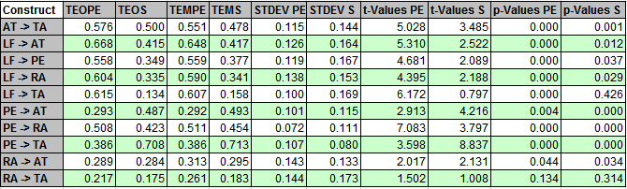

Bootstrapping Results in PLS-MGA for Outer Loadings
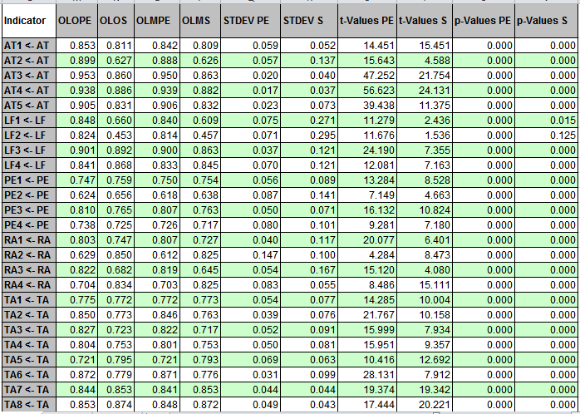
Bootstrapping Results in PLS-MGA for Outer Weights
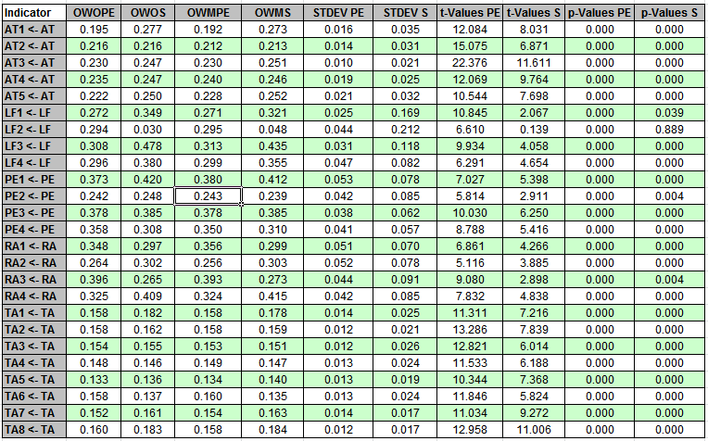

Bootstrapping Results in PLS-MGA
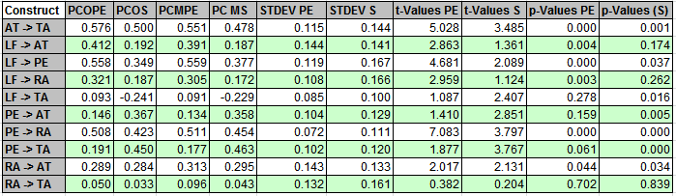

PLS-MGA

Indicators | Outer Loadings-diff ( | Procurement Experts - Suppliers |) |  | p-Value (Procurement Experts vs Suppliers)
AT1 <- AT | 0.042 |  | 0.280
AT2 <- AT | 0.272 |  | 0.021
AT3 <- AT | 0.093 |  | 0.015
AT4 <- AT | 0.052 |  | 0.080
AT5 <- AT | 0.074 |  | 0.161
LF1 <- LF | 0.188 |  | 0.285
LF2 <- LF | 0.371 |  | 0.115
LF3 <- LF | 0.009 |  | 0.575
LF4 <- LF | 0.026 |  | 0.689
PE1 <- PE | 0.012 |  | 0.569
PE2 <- PE | 0.031 |  | 0.610
PE3 <- PE | 0.045 |  | 0.295
PE4 <- PE | 0.013 |  | 0.467
RA1 <- RA | 0.057 |  | 0.348
RA2 <- RA | 0.221 |  | 0.917
RA3 <- RA | 0.140 |  | 0.181
RA4 <- RA | 0.130 |  | 0.911
TA1 <- TA | 0.003 |  | 0.509
TA2 <- TA | 0.078 |  | 0.177
TA3 <- TA | 0.104 |  | 0.159
TA4 <- TA | 0.051 |  | 0.294
TA5 <- TA | 0.074 |  | 0.796
TA6 <- TA | 0.092 |  | 0.183
TA7 <- TA | 0.010 |  | 0.567
TA8 <- TA | 0.022 |  | 0.640
PLS-MGA
Construct | Indirect Effects-diff ( | Procurement Experts - Suppliers |) |  | p-Value(Procurement Experts vs Suppliers)
AT -> TA
LF -> AT | 0.033 |  | 0.422
LF -> PE
LF -> RA | 0.136 |  | 0.098
LF -> TA | 0.146 |  | 0.208
PE -> AT | 0.027 |  | 0.387
PE -> RA
PE -> TA | 0.063 |  | 0.698
RA -> AT
RA -> TA | 0.025 |  | 0.394

APPENDIX I: PUBLISHED PAPERS

Shatta, D. N., Shayo, F. A. & Layaa, J. N. (2020a). Determinants of e-procurement adoption model for green procurement in developing countries: experience from Tanzania. International Academic Journal of Procurement and Supply Chain Management, 3(2), 1-18, available at http://www.iajournals.org/articles/ iajpscm_v3_i2_1_18.pdf.
Shatta, D. N., Shayo, F. A. & Layaa, J. N. (2020b). Influence and linkage of buyers’-suppliers’ attitude towards e-procurement adoption in developing countries: Tanzania context. International Journal of Applied Research in Management and Economics, available at https://doi.org/10.33422/ijarme.v3i1.282 .
Shatta, D. N., Shayo, F. A., Layaa, J. N., & Mchopa, D. A. (2020c). Stakeholders’ perception on critical success factors influencing electronic procurement adoption in developing counties: experience from Tanzania, American Scientific Research Journal for Engineering, Technology, and Sciences (ASRJETS), 71(1), 61-86, available at https://asrjetsjournal.org/index.php/ American_Scientific_Journal/article/view/5985/2205

APPENDIX J: PAPERS ACCEPTED FOR PUBLICATION

Shatta, D. N., Shayo, F. A. & Layaa, J. N. (2020). Legal framework influence towards e-procurement adoption model in developing countries: buyers’ - suppliers’ perception in Tanzania, International Journal of Applied Research in Management and Economics.

