INVESTIGATION OF THE INFLUENCE OF GOVERNMENT POLICIES ON ENTREPRENEURSHIP PERFORMANCE IN TANZANIA A CASE OF KINONDONI MUNICIPAL

HAROUN MTEBENE

A DISSERTATION ATTACHMENT REPORT SUBMITTED IN PARTIAL FULFILMENT FOR DEGREE OF MASTER OF BUSINESS ADMINISTRATION OF THE OPEN UNIVERSITY OF TANZANIA

2011

CERTIFICATION

I, the undersigned certify that I have read the dissertation entitled “Challenges and success of entrepreneurship performance in Tanzania: A case study of Kinondoni Municipal” and found it to be in a form acceptable for examination.

……………………………………………………………………..

Dr. Mutagwaba

SUPERVISOR

Date: ……………………………………..

COPYRIGHT

© All rights reserved. No part of this thesis/dissertation may be reproduced, stored in any retrieval system, or transmitted in any form by any means, electronic, mechanical, photocopying, recording or otherwise without prior written permission of the author or the Open University of Tanzania in that behalf.

DECLARATION

I, Mtebene Haroun, declare that this proposal is my original work and it has not been submitted for a similar degree in any other institution or university. Where the work of other authors has been used, relevant quotations have been made.

Signature:………………………………………..…………………………….

Date: ……………………………………………………

DEDICATION

I dedicate this work to my late Father who during his life time encouraged me to work harder till I will be honored a higher degree level.

TABLE OF CONTENTS

CERTIFICATION ii
COPYRIGHT iii
DECLARATION iv
DEDICATION v
TABLE OF CONTENTS vi
LIST OF TABLES ix
ABSTRACT xi
ACKNOWLEDGEMENTS xii

CHAPTER ONE 1
INTRODUCTION 1
1.0 Background Information 1
1.1 Statement of the Problem. 3
1.2 Objectives 5
1.2.1 General Objectives 5
1.2.2 Specific Objectives 5
1.3 Research Questions 5
1.3.1 General Question 5
1.3.2 Specific Questions. 5
1.4 Significance of the Study 5

CHAPTER TWO 7
2.0 Definition of key Terms 7
2.1 Meaning of Entrepreneurship 7
2.1.1 Meaning of Intrapreneurship 9
2.2. Theoretical basis of the Research 10
2.2.1. Entrepreneurship in Tanzania 10
2.2.2. Small Business Enterprises 11
2.2.3. Role of Small Business Firms in Society 12
2.2.4 Issues and Barriers for Realizing Entrepreneurial Potentials 12
2.2.5 Strategies for Pro-Poor Business Development 13
2.3. Empirical Evidence 15
2.4. Conceptual Framework 17

CHAPTER THREE 20
RESEARCH METHODOLOGY 20
3.1 Research Design 20
3.2 Survey Population/unit of Inquiry 20
3.3 Sample Size 20
3.4 Sampling Method 21
3.5 Data Collection 21
3.5.1 Primary Data Collection 21
3.5.2 Interview 22
3.5.3 Observation 22
3.5.4 Secondary Data Collection 22
3.5.5 Data Presentation Technique. 22

CHAPTER FOUR 23
4.1. DATA ANALYSIS, PRESENTATION AND DISCUSSION 23
4.2. Introduction 23
4.3. Factors Inhibiting Entrepreneurship Performance 25
4.4. Assessment of Entrepreneurship and SMEs Policy in Tanzania 26

CHAPTER FIVE 35
CONCLUSION 35
5.0 Conclusion 35
5.3. Policy Recommendations 35
APPENDICES 37
6.0 REFERENCES 43
7.0 Questionnaire 46

LIST OF TABLES

Table 1: Respondents Age and Entrepreneurship Experience 23
Table 2: Correlation: Respondents Age and Entrepreneurship Experience 24
Table 3: Respondents Gender and Type of SMEs Owned 25
Table 4: Policy Strategies: Licensing Procedures, Tax System and Copyright Law 27
Table 5: Policy Strategies: Premises for SMEs, Allocating Buildings and Public Education 28
Table 6: Policy Strategies: Education, Information Centers and ICT Training 29
Table 7: Policy Strategies: SMEs Census, Networking and Joint Ventures Facilitation 29
Table 8. Policy Strategies: Small-Large Business Linkages, Marketing Agencies and Facilitation 30
Table 9: Policy Strategies: Exhibition Centers, Meeting Standards and Trade Issues 30
Table 10: Policy Strategies: Financial Institutions, Products and Access for SMEs 31
Table 11: Policy Strategies: Financing, Associations and Service Providers 32
Table 12: Policy Strategies: Policy Monitory, Environmental and Waste Management Issues 32
Table 13: Policy Strategies: Addressing Woman and Disadvantaged Groups Issues 33
Table 14: SMEs Policy Inhibits Entrepreneurial Performance 34
Table 15: SMEs Policy Facilitates Entrepreneurial Performance 34

LIST OF APPENDICES

Appendix 1: Respondents Gender and Educational Level 37
Appendix 2: Respondents Gender and Type of SMEs Owned 38
Appendix 3: SMEs Policy Inhibits Entrepreneurial Performance 39
Appendix 4: Cross Tabulation: Type of SMEs owned and Views that SMEs Policy Inhibits Entrepreneurial Performance 40
Appendix 5: SMEs Policy Facilitates Entrepreneurial Performance 41
Appendix 6: Cross Tabulation: Type of SMEs owned and Views that SMEs Policy Facilitates Entrepreneurial Performance 42

ABSTRACT

Entrepreneurship has been seen as a hub in generating income for the majority of urban dwellers with no formal paid employment. The full potential of the SME sector has yet to be tapped due to the existence of a number of constraints hampering the development of the sector. It is for this reason that SME Development Policy was formulated so as to address the constraints and to tap the full potential of the sector. This policy will serve as guidelines to all stakeholders and thus stimulate new enterprises to be established and existing ones to grow and become more competitive. In view of the importance of entrepreneurship this study is trying to investigate the influence of Government policies in entrepreneurship performance in Tanzania cited Kinondoni Municipality. The methodology used was case study. The population of the study was exhibited on different characteristics based on age, gender, educational level, and psychological indices. Total of 30 respondents were drawn from different entrepreneurs who deal with small businesses. The stratified sampling technique was employed in selecting respondents. The population was stratified according to gender and type of business owned, data was analyzed through SPSS. Based on study findings factors which inhibit entrepreneurial performance are marketing, capital and premises problems. These needed to be re-addressed in government policy and improved in order to facilitate entrepreneurial performance. For the case of Government policies, both ways the policy has been viewed by respondents as both facilitating and inhibiting entrepreneurial performance. Recommendations that are advanced by the researcher are workable policy on ensuring a sustainable and reliable market is to be put in place; direct market and marketing instruments need to be addressed in the policy so that the strategies implementation can have direct effects on the specific problems at hand. Efforts to address the problems of financing needs, education and training, capital needs, simplification of business working environment and registration processes to be addressed clearly and more realistically in the policy statement and strategies as the current policy
did not seem to be completely effective.

ACKNOWLEDGEMENTS

My first acknowledgements goes to Dr. Mutagwaba for his kindness to accept my proposal and to take part as my supervisor after the sudden death of my former supervisor Dr. Katunzi may almighty God rest his soul in peace.

My second acknowledgement again goes to Dr. Mutagwaba for spending his valuable time as my supervisor in advising me tirelessly from the development of the proposal up to this stage and his relentless efforts made this work to conform to the standards required by the Open University of Tanzania.

Thirdly, I would like to express my gratitude to both all entrepreneurs working at Mwenge, Ubungo bus Terminal and Tegeta market place for their immeasurable support granted during the whole period of data collection. I assertively say that without their support this dissertation would never have been a success.

Lastly, I would like to express my gratitude, in a very special way, to my family which during my absence suffered in one way or another but prayed for my success.

CHAPTER ONE

INTRODUCTION

This chapter describes the background information, statement of the problem, research objectives, research questions and significance of the study in which the research is based on.

1.0 Background Information
Historical perspectives of the state of entrepreneurship in Tanzania have thoroughly been presented by Rutashobya (1998). The general view is that for many years since independence, African public policies (including Tanzania) were not conducive to entrepreneurship development. This lack of good policies has generally been in the low levels of entrepreneurship, which has further resulted in Africans underdevelopment (Rutashobya, 1998). Most Tanzanians make their living on subsistence agriculture and small medium enterprise (SMEs) activities. It is estimated that SMEs contribute 35% to GDP and 20% of the total labour force (Wangwe, 1999). Small Medium Enterprise Entrepreneurs in Tanzania are considered to be potential in creating jobs and contributing towards the economic growth. The SME sector contains businesspersons from different entrepreneurial background and skills.

In recognition of the SME and small business the government formulated small and medium enterprise Development policy in 2003 to support the development of this sector. Also the government emphasized the importance of informal sector as part of SMEs in achieving the war against poverty (Kato, 1996). It is a recognized fact that the natural habitat of entrepreneurship is in the small businesses. Therefore entrepreneurship has a lot to do with development of small business. As is the case with entrepreneurship, small enterprises can not be defined with unanimity.

The SME sector is an area where the poor may not only make out a living, but also get most of their
goods and services at prices they can afford. Over 90 per cent of operators get credit, training, information, water and sanitation from the sector. In Dar es Salaam, the capital city of Tanzania, over 90 per cent of poor communities get water and sanitation services from the SME sector (URT, 1995). So any positive or negative developments in the sector will have a direct corresponding effect on the livelihoods of the community. Different researchers tried to focus on problems facing entrepreneurship development in Tanzania. Mfaume; Wilhelm Leonard (2004) focus on Small business entrepreneurship in Dar es salaam – Tanzania exploring problems and prospects for future development. They focused on crime and entrepreneurship in Tanzania urban areas, tried to unfold various issues that cluster and affect the development of small business entrepreneurship in Tanzania.

Kuzilwa (2005), point out the role of credits for small business success. It clearly examines the role of credit in generating entrepreneurial activities. Olomi (2006) on his policy dialogue seminar paper points the opportunities and challenges for Rural SME’s development in Tanzania. From above studies it clearly shown that still there is a need to research more on SME’s police on entrepreneurship development in Tanzania because many researchers concentrate on the challenges of entrepreneurship performance but they have not focus on the possible solution especially on the SME police, is it worth to entrepreneurs?, does the existing policies enhance entrepreneurship performance as the business environment is uncontrollable.. In this study the researcher makes an attempt to conduct an investigation of the influence of Government policies on entrepreneurship performance cited Kinondoni Municipal.

This study was therefore concentrated on different small businesses that are conducted in Dar es salaam Kinondoni municipality due to time and fund constrains. Inference was drawn from the results. Businesses, which were studied range from small shops, agro-processing, saloons, cafeteria, guesthouses, stationary services and bars. The study helped to stimulated economic growth since there is no way the country will develop without passing through small business or informal sector. Also the study contributed in understanding different methods of acquiring entrepreneurial skills in Tanzania.

The purpose of this paper therefore is to present some empirical evidence of investigation of the influence of Government policies on entrepreneurship performance especially on small business based on the findings of the case study unity of enquiry conducted at Kinondoni Municipal. The study is divided in five main parts. This introduction is the first chapter. The second one is literature review recently from 2008 to date. The intention here is to try to give some insights briefly on what the literature says on challenges and success so far and the views of other researchers on entrepreneurship development. The third chapter is the context methodology that underpinned the main study. The fourth chapter presents various empirical evidences and discusses data analysis, presentation and discussions on examining the inhibiting factors for low level of entrepreneurship performance and whether the existing government policies enhance entrepreneurship in Tanzania as cited Kinondoni municipality. Chapter five which is last focus on conclusions and Policy recommendations based on related research objectives. The study was therefore intended to investigate the influence of Government policies on entrepreneurship performance in Tanzania cited Kinondoni Municipal.

1.1 Statement of the Problem.
The research on the determinants of the entrepreneurship success is extensive. However the results are far from being conclusive. This is partially due to the lack of theoretical grounding as well as differences in the unit of analyses, growth indicators and research time frame. Consequently, Davidsson and Wiklund (1999) correctly point out that the knowledge about what facilitates and hinders entrepreneurship is still scattered and limited despite an extensive research. In addition, a large number of empirical studies have not given a very high yield of generalizable knowledge,
Davidsson et al, (2006).

Although the environmental factors play an important role in the small business growth and development, other factors should not be neglected either. Surely, a significant potential for SME growth is located internally within the firm. Previous studies have explored the characteristics of the entrepreneur as important factors influencing the growth of the firm. Human capital and intentions for growth are among most frequently mentioned entrepreneur related factors, influencing firm growth. However most of the empirical evidence comes from western developed economies whereas little research is conducted in developing countries like Tanzania. Departing from this Honig (2001) correctly underlines that “our understanding on the influence of human capital in transitional environment is quite limited”. Consequently the need for additional research departing particularly from human capital theory in transitional environment is still apparent.

It is well recognized that most of the new firms die young. However, various studies uphold that those new firms that survive and achieve a fast growing stage have significant effects in the economy ( Birch, 1979; Storey, 1994; Delmar, 1997) and that fast growth is an indicator of the firm’s overall success (Ficsher and Reuber, 2003). Hence there has been an interest in understanding the determinants of growth within small and medium-sized enterprises (SMEs), especially with regards to the fast growing firms (for recent reviews see Davidsson et al, 2005; Gilbert et al, 2006).

So far it is almost an established fact, that in western economies fast growing firms account for a disproportionately large amount of jobs created. In the United Kingdom, 4% of new start-up survivors were responsible for 50% of jobs created by all new firms 10 years later Storey (1994). In the U.S., 3% of the fastest growing firms, generated over 70% of the new jobs created by new firms between 1992 and 1996 (Autio et al 2007). In view of the importance of entrepreneurship development to the National economy in Tanzania, the study was intended to examine the significant factors that influence entrepreneurship and how the Government policies enhance the development of entrepreneurship in Kinondoni Municipal.

1.2 Objectives

1.2.1 General Objectives
Primarily, the study was attempting to unveil the factors that influence the performance of entrepreneurship in Tanzania.

1.2.2 Specific Objectives
Specifically, the study aimed at,
(a) Examining the Government policies which must be adopted to improve entrepreneurship performance
(a) Assessing whether the existing Government policies enhance entrepreneurship in Tanzania.

1.3 Research Questions

1.3.1 General Question
What are the significant factors that influence entrepreneurial performance in Tanzania?

1.3.2 Specific Questions.
(a) To what extent do the existing Government policies enhance the practice of entrepreneurship in
Tanzania.
(b) What Government policies strategies must be adopted to improve entrepreneurship performance?

1.4 Significance of the Study
Firstly, in Tanzanian context, the importance of this research lies in the fact that, it is a debate continuation on what entrepreneurship leadership should be doing to promote, nurture, grow and develop new ventures. The study also provides and initiates debate for policy makers and regulators concerning what some of the institutions supporting entrepreneurship should be doing to promote new venture development in Tanzania.

Secondly, for the academia, it offers results from rather a distinctive setting covering several topics within a broad domain of entrepreneurship. Certainly the results derived from the study are now useful in furthering our understanding of entrepreneurship. Thirdly, for the entrepreneurs provided valuable insights on the determinants of growth and barriers for doing business. Individuals considering starting a business might become interested to evaluate their ambitions according to the model developed and to foresee the obstacles which they might face if they decide to start the business

CHAPTER TWO

LITERATURE REVIEW

This part reviews the issues of Entrepreneurial performance and entrepreneurship in Tanzania and other countries all over the world. It explains the literature review, covering both the theoretical and empirical parts.

2.0 Definition of key Terms

2.1 Meaning of Entrepreneurship
The entrepreneurship has played an important role in the academic literature for 250 years. While there remains a broad consensus about the central role of entrepreneurship in the economy, the theoretical and conceptual models of entrepreneurship vary widely. Theoretical models of entrepreneurship are weak or non-existent, and the term entrepreneur is still vaguely defined, even though entrepreneurship scholars seem obsessed with defining the word entrepreneur (Bull and Willard, 1993). Scholars have long disagreed about the definition of entrepreneurship. Defining entrepreneurship and developing a theoretical model present two related problems; defining entrepreneurship is hindered by difficulties in conceptualizing and quantifying theoretical models of the entrepreneurial process, while the lack of a consensus definition hinders theoretical model development. No theory of entrepreneurship has been developed that explains or predicts when an entrepreneur, by any definition, might appear or engage in entrepreneurship (Low, 2009)

Many different functional definitions or theories of entrepreneurship have been proffered, likely because entrepreneurship is a dynamic and complex phenomenon with multiple purposes. This complexity makes it impossible to capture the totality of entrepreneurship without using a multi-component definition (Iversen et al., 2008). The definition of entrepreneurship possesses three key elements which are ownership of a firm, risk taking and innovation (Low, 2009). Firstly, ownership or operation of a firm is an important attribute of entrepreneurship. It is not sufficient to define entrepreneurship, but it is necessary in defining entrepreneurship. The exploitation of entrepreneurial ideas must take place within a firm, as there is no market for entrepreneurship as a result, owning or operating a firm, particularly a small firm, is one of the most widely used definitions of entrepreneurship. The owner or operator of a firm is the firm’s leader. (Goetz and Rupasingha, 2008)

Secondly; risk and uncertainty bearing are important attributes of entrepreneurship because they distinguish entrepreneurs from wage and salary workers. Entrepreneurs may be richly rewarded with rents due to innovation and early adoption, but to be rewarded, they must bear the associated risk and uncertainty. Moreover, risk bearers retain only net profits, after outstanding obligations are paid. Thirdly, Innovation is a crucial component of entrepreneurship because it is closely connected with the ability to deal with market disequilibria. Many theoretical definitions of entrepreneurship incorporate initiating innovation and/or recognizing market opportunities. Market opportunities and reallocating resources in response to these market opportunities is entrepreneurship, not initiating innovation. Entrepreneurship is efficient reallocating resources and dealing with disequilibria in the market to maximize profit (Klein and Cook, 2006; Iversen et al., 2008)

On the other hand, the concept is narrower than the traditional one that it does not include all heads of firms or managers of industrialists, who merely may operate an established business, but only those who actually perform that function. But whatever the type, everyone is an entrepreneur only when he actually “carries out new combinations,” and loses that character as soon as he has built up his business, when he settles down to running it as other people run their businesses

Schumpeter (1934) defined what he meant by entrepreneurship (“enterprise”) and then concluded
that those who perform the functions of entrepreneurship are “entrepreneurs.” His definition captured several key elements that separate entrepreneurship from general management. First, and foremost, entrepreneurship involves the creation of an organization to pursue a discontinuous opportunity. Second, Schumpeter did not limit this pursuit to new ventures, he also allowed for entrepreneurship to exist within established organizations. Third, Schumpeter alluded to the fact that one becomes an entrepreneur when they act. Finally, entrepreneurships defined by the nature of the actions performed, and a transition occurs at some point from entrepreneurship to general management as the nature of the organization and the actions of the individual change. Timmons (2000) defined entrepreneurship as the process of creating or seizing an opportunity and pursuing it, regardless of the resources currently.

According to Olomi (2006), Entrepreneurship is often associated with starting and running a business. However, the broader meaning of entrepreneurship is a way of thinking, reasoning, and acting that results in the creation, enhancement, realisation, and renewal of value for an individual, group, organization, and society. At the heart of this process are the creation and/or recognition of opportunities followed by the will and initiative to seize these opportunities. The behaviours associated with entrepreneurship are need for achievement, calculated risk-taking, initiative, growth seeking, a strong drive and determination, networking, opportunism, etc. Taking this broader view in mind, not all business start-ups constitute entrepreneurship because not all founders display these behaviours. At the same time, entrepreneurial individuals are found in all kinds of contexts and endeavours.

2.1.1 Meaning of Intrapreneurship
Intrapreneurship is the practice of entrepreneurship by employees within an organization. An entrepreneur takes substantial risk in being the owner and operator of a business with expectations of financial profit and other rewards that the business may generate. On the contrary, an Intrapreneur is an individual employed by an organization for remuneration, which is based on the financial success of the unit he is responsible for. Intrapreneurs share the same traits as entrepreneurs such as conviction, zeal and insight. (Bull &Willard, 2003) As the intrapreneur continues to expresses his ideas vigorously, it will reveal the gap between the philosophy of the organization and the employee. If the organization supports him in pursuing his ideas, he succeeds. If not, he is likely to leave the organization and set up his own business.

2.2. Theoretical basis of the Research

2.2.1. Entrepreneurship in Tanzania
A historical perspective of the state of entrepreneurship in Tanzania has thoroughly been presented by Rutashobya (1998). The general view is that, for many years since independence, African public policy (including Tanzania), was not conducive to entrepreneurship development. The situation was compounded by the fact that even before independence; modern entrepreneurship was dominated by foreigners with African playing only an insignificant role. This lack of conducive policy has generally been reflected in the low level of entrepreneurship which has further resulted in Africa’s underdevelopment, the present crises and the high levels of unemployment (Rutashobya, 1998). Paakkari (1992) has argued that the main reason for weak development of African owned business in Tanzania “has been more the lack of conducive enterprise environment than a lack of entrepreneurship itself”. The findings by the World Bank sectoral survey on furniture, construction and horticulture showed an existence of abundance supply of indigenous (African) entrepreneurs in Tanzania (World Bank, 1991).

However, due to historical reasons and Tanzanian’s own policies in the 1970s and early 1980s, entrepreneurship has been and still is dominated by migrant from south Asia as evidenced by the fact that about 90%of private industry and trade outside the informal sectors are dominated by them (Paakkari 1992). Indigenous entrepreneurship is therefore still at its infancy and is mainly limited to
small scale businesses (Rutashobya, 1998).

2.2.2. Small Business Enterprises
The definition of small enterprises vary greatly, some of the definitions use the number of employees while others use amount of fixed assets ( Minga, 1998). Yet others refer to the way decisions are made in small business. Typology in the field of entrepreneurship and small business is still confusing. Hornaday (1992, 19-20) states that not every small business is entrepreneurial nor represents entrepreneurship. The argument on representing entrepreneurship refers to the ability of new firms to create innovation. Specifically the set of small businesses includes a wide variety of enterprises starting from self-employed and craftsmanship to innovative, high-tech oriented growth companies (Vesper, 1980). These companies are vastly different even if they share some similar objectives. For a self-employed worker the main expectation and objective may be to employ him or herself and enjoy the decent level of income and standard of living. He or she is mostly interested in “participating in the market” dimension, not in other dimensions of entrepreneurship

In the Tanzanian context the definitions of small enterprise are based on the number of capital and employees .Based on the number of employees, the definition of small enterprise ranges from firms with 5 or 10 to firms with 10, 20 or 50 employees .Small in one does not necessary mean small in other sector, (Temu 1998). Morris Somerset (1971), the encouragement of small firms especially in industry is vitally important, that these firms cannot succeed without entrepreneurial skills. So Morris still insists that there is no small business that can be separated with entrepreneurial skills. Also Morris said that without entrepreneurial bustle of activities on a small scale, the set pieces of development will stand apart like parlour furniture, too grand to be used. The ability of country economy to generate wealth from its own resources will depend most of all on its intermediate level of business, this is because small scale manufacturing is not merely a transitional stage in industrial development, but act everywhere and all the time to integrate and adapt the part of the economy. Entrepreneurship is therefore essential above all intermediate business in developing countries, since here the coordination of opportunities and resources cannot be prescribed by any humane and realistic plane, (Morris 1971, 4-5).

2.2.3. Role of Small Business Firms in Society
According to Lall, (1995), Young (1993) and Bagachwa, (1995) SSE have a lot of roles to play in society which include, small business contribute towards job creation and employment. It has a strategic importance towards poverty alleviation therefore stimulate economic growth and development and improving standard of living and social development.

2.2.4 Issues and Barriers for Realizing Entrepreneurial Potentials
A host of problems make it difficult for SME’s to exploit the existing potentials for further employment and wealth creation. The most serious impediment is the limited capacity of people who start and operate the businesses, in terms of the attitudes, motivation, exposure, skills and experiences. Retirees and retrenches are unprepared to use their skills and exposure to build successful SME’s, due to lack of relevant attitudes and skills. Graduates from higher learning institutions could join the sector and make it more vibrant, but these are not psychologically and functionally prepared to start and develop small businesses because the curricula is designed to produce graduates for highly specialized white collar jobs. At the same time, services related to entrepreneurship development are underdeveloped and not readily available or affordable to SME’s. The institutions and associations supporting SME’s are weak, fragmented uncoordinated. Their services are quite basic; mainly focusing on helping the poor. There are hardly any initiatives for targeted, comprehensive and sustained support specifically to facilitate upward mobility of micro and small enterprises. Among the post-secondary training institutions, initiatives to build capacity for producing graduates with the skills and attitudes to start and run SME’s and effectively supporting enterprise development are still embryonic. Local governments, which could play a critical role in supporting SME’s also, face a number of weaknesses. Access to finance is always mentioned by potential and existing SME operators as the most serious barrier to business start-up or growth. This is because the formal financial sector is yet to evolve functional models which enable them to provide services, especially to the growth oriented section of the micro and small enterprise sector. Micro and small enterprises operate from temporary, illegal sites or premises because there are not adequate appropriately serviced areas where they can locate and operate from.

The regulatory framework is tailored to the capacities of large companies and hence is not too expensive and cumbersome to micro and small enterprises. This automatically discourages start-ups and condemns businesses that dare to start to the informal sector. It takes a very bold and determined person, who also has networks or resources to complete this process. As a result, a large majority remain informal. Because of their lower capacities, women, the disabled and youth are disproportionately disadvantaged by these barriers. The implication of the foregoing is that, much more needs to be done to create conditions that make formal business affordable to the majority of operators, including men, women, the youth and the disabled.

2.2.5 Strategies for Pro-Poor Business Development
Improving the business environment is absolutely essential. However, alone, this measure will not quickly propel a critical mass of Tanzanians micro and small businesses into successful businesses that create significant incomes, quality jobs and contributes meaningfully to government revenue. This is because the constraints to reaching this level are far greater and far most complex that it is often imagined. It is also recognized that they multi-faceted and require a more comprehensive intervention such as
(a)Regulatory reforms
The ongoing reforms in the business environment need to be expedited. The reforms should come up with multi-tier regulatory mechanisms depending on the size and complexity of the operations. Care should however be taken to minimise the possibility of these tiers being growth or formalisation traps.
(b) Meso-level institutional building
There is a need to build strong institutions which are able to strategically and pro-actively address the needs of micro and small enterprises. Currently, support provided is very basic (not strategic) and of low quality. The following could be done to strengthen this capacity. Each local government should be required to have a private sector development programme. A business development department need to be introduced, possibly substituting the traditionally routine role of the Trade Officer. It is recommended to introduce inter-local authority “business development” and “investment climate” competitions and awards.

There is need to review the role and mandate of SIDO – preferably to make it a very strong agency for strategically building capacity of entrepreneurs and grassroots BDS providers, and withdrawing from direct support to entrepreneurs whenever possible, so that it concentrates its efforts on building capacity of others institutions. It might also be wise to re-organise SIDO so that there are different departments dealing with industry, commercial agriculture, fisheries, livestock, etc. Alternatively multiple agencies could be established. There is a strong need to invest in designing appropriate curriculum, including building the capacity of learning facilitators to deliver it in an effective way. The curriculum should among others, promote more interactions between schools and colleges on one hand and micro and small businesses in their surroundings on the other
(c ) Enhancing access to financials services for the poor
In order to enhance access to finance, the following measures can be taken:
Government should encourage financial institutions to downscale to provide services to micro and small businesses. This can be done by, for example meeting the cost of human resource development to prepare competent bank staff who can work with SMEs. Government can work with other actor’s s to develop innovative/special financial schemes for innovative ideas with great
potential through contests, venture capital funds for small businesses, etc

2.3. Empirical Evidence
The first empirical study concerned with the relation between entrepreneurship and economic growth is embedded in several strands of the economic literature. A first strands of literature involves the general understanding of the role of entrepreneurship in the modern economy. Seminal contributions were made by Schumpeter (1934), Knight (1921) and Kirzner (1973).These economists stress different aspects of the role of the entrepreneur. While Schumpeter stresses the innovating aspect, Knight stresses the risk assuming aspect. Kirzner, finally, stresses the role of the entrepreneur in leading markets to equilibrium.

Acs (1992) discusses the contribution of small firms in modern economies. They claim that small firms play an important role in the economy as they are agents of change by their entrepreneurial activity, as they are a source of considerable innovative activity, as they stimulate industry evolution and as they create an important share of the newly generated jobs. The role of small firms and entrepreneurship in stimulating economic growth is complex, because various intermediate variables are at play. Examples of such variables are entry and exit of firms (competition), innovation and variety of supply. Economists have started to build theoretical frameworks which try to capture the role of he intermediate variables.

Entrepreneurially, SMEs tend to operate in a niche market which large firms can not economically enter due to unattractive return on investment. Perhaps, as a result of the association with entrepreneurial activity and innovation, SMEs serve an important “seedbed” role for the growth of new industries and the establishment of future large companies (Howard 1997).

Ibielski (1997) summarized the overall importance of SMEs and quoted in Hashim and
Abdullah 2000, p. 193 as follows:

“[SMEs] are mighty minnows , reflecting the competitive spirit that a market economy needs for efficiency ,they provide an outlet for entrepreneurial talents , a wider range of consumer goods and services , a check to monopoly inefficiency , a source of innovation and seedbed for new industries , they allow an economy to be adaptable to structural change though continuous initiatives embodying new technologies ,skills , processes or products.
Source: Wang, Walker and Redmond, 2009

Small and Medium sized enterprises are very heterogeneous groups and yet they generally tend to have a high risk profile due to limited market powers, lack of business management skills, absence of adequate accounting tracks records, insufficient assets as well as lack of business planning knowledge. SMEs typically suffer from weak entrepreneurial skills as well as deficiencies in accounting, production management and business planning. In addition, SMEs are also characterized by high administrative costs and uncertainties about their future performance. With globalization in play , SMEs have been exposed to a cut-throat and stiff competition that if not planned and managed well, could shutter business prospects, and dreams SMEs have, late alone the entailed benefits which Tanzania as country is highly in need of.

Secondly, Morris and Kuratko (2002) summarize their findings dealing with entrepreneurship and start-ups through an outline of strategic implications of both entities. Their research points out that sustainable entrepreneurial activity becomes more of a reality through the resource allocation of an established or well-funded organization.
Through a resource based view the authors point out some significant strategic advantages that an Entrepreneurship based organization possesses over a start-up organization or individual entrepreneur. Some of these characteristics include: research and development resources, financial resources, management think-tank resources, outsourcing / business alliance resources, firm portfolio resources, and natural economies of scale resources. However, the study could provide in depth understanding on key factors influencing entrepreneurship.

Thirdly, Entrepreneurs’ personality traits have also been identified to have impact on organizational performance (Robinson & Sexton, 1994). Studies also found that personality traits such as locus of control and ambiguity tolerance influenced the business success directly and the business process indirectly (Entrialgo, Fernandez, & Vazquez, 2000). Kiggundu (2002) later added demographic variables to his study and found that personality traits have direct influence on the success of African entrepreneurs. Although studies on personality traits have played an important role in contributing to the success of entrepreneurs worldwide, nevertheless, personality traits have been criticized both on theoretical and empirical ground in the studies of entrepreneurship. Gartner (1988) in his research article entitled “Who is the entrepreneur?” mentioned that asking “Who” is the wrong question, but rather the personality of entrepreneur is only related to the success of business start-up through more specific mediating processes. This is due to the fact that these factors are not relevant if there is no action and initiative taken by the entrepreneurs. However this study, has overlooked other vital influences on entrpreneurship lkike ethnicity, family suport, and Education.

2.4. Conceptual Framework
The process of acquiring entrepreneurial performance involves different steps and different factors which are involved in the process. It is anticipated that entrepreneurial performance is influenced by factors such as troubled childhood, small business experience, ethnicity, level of education and entrepreneurial education.
Troubled childhood
It is anticipated that people tend to be self-employed and become successful because of troubled
childhood. In troubled childhood children tend to be lacking security or abused, low self-esteem, lack of confidence therefore growing in such an environment some people to have repressed wishes toward those in control thereby influencing their performance in entrepreneurial activities.

Small business Experience
An individual’s managerial experience as well as previous entrepreneurial experience is considered to be incentives for one to become a successful entrepreneur. Previous experience as an employee in an enterprise also is thought as a driving force toward enhancing entrepreneurial performance because employee will have greater probability of copping experience from where he/she is working.

Ethnicity
An ethnic origin of a person is said to influence the choice between paid employment and self-employment as well as performance in self-employment. Some ethnic group like Chagga in Tanzania, Ibo in Nigeria and Kikuyu in Kenya they are thought to have entrepreneurial skills. These ethnic are spread all over the countries to the extent that they are less integrated in societies in which they work and therefore less likely to be constrained by dominant values shared either by their own ethnic group or by their host.

Level of education
It is anticipated that level of education acquired by an individual have an influence in entrepreneurial performance because apart from one bean creative thinker, education foster conformity and low tolerance for ambiguity, leading to thought and behaviour process that refuse to admit tolerance and social values that preclude.
Entrepreneurial Education
It is agreed that there is positive association between taking entrepreneurship course and becoming
self employed. It is also thought that student who take entrepreneurship course tend to be less conforming, more impersonal, more risk taking , more welcoming of change, have higher energy level, a profile similar to that of successful entrepreneurs. Also entrepreneurship course will attract those who have entrepreneurial qualities or alternatively more students towards entrepreneurial archetype by challenging assumptions and encouraging the development of competencies required.

Ethnic origin
(d)
Small business experience
(c)
Troubled childhood
(b)

Entrepreneurial skills
(a)

Level of education
(f)
Entrepreneurial Education
(e)

Figure 1: A Conceptual Framework of factors influencing Entrepreneurial performance

CHAPTER THREE

- Is a dependent variable where from (e) – (f) is Independent variables

RESEARCH METHODOLOGY
This chapter describes how the study was designed and carried out. It explains the sampling methods used procedure for data collection which adopted and the tool the researcher used in its analysis to come up with the conclusions.

3.1 Research Design
According to Kothari, (1990) research design is the arrangement of condition for collection and analysis of the manner that aims to combine relevance to purpose with economy in procedure. The case study approach was employed on this study, to describe and assess in depth on challenges and success of the entrepreneurship performance in Tanzania.

3.2 Survey Population/unit of Inquiry
Kothari (2004) contends that, a unit of inquiry is an elementary unit, a group or cluster of such units forming the basis of analysis within the sample frame. In this research, the population of the study was exhibited on different characteristics based on age, gender, educational level, and psychological indices.

3.3 Sample Size
Respondents were chosen from Ubungo bus terminal, Tegeta and Mwenge central Market. Ubungo terminal and Tegeta provided 15 respondents, while Mwenge central market provided 15 respondents. Total of 30 respondents were drawn from different entrepreneurs who deal with small businesses such as retail shops, selling cooked food, tailoring mat and hair dressing salons and hair
cutting salons.

3.4 Sampling Method
The stratified sampling technique was employed in selecting respondents. The population was stratified according to gender and type of business owned. In gender the population was stratified into two groups of male and female, where each group had 15 respondents. Then groups were stratified again according to type of business owned, where each group of business provided 5 respondents. This technique was designed to produce more representative and accurate samples because the study comprises distinct groups based on gender and the various activities done by the respondents.

3.5 Data Collection
Data for this study were collected using both primary and secondary method

3.5.1 Primary Data Collection
The primary data were collected through in-depth face to face interviews by using structured questionnaire; the questionnaires were used to collect information due to the following reasons, the population used most of them can read and write, it gives uniform answers and hence make easy to analyze data collected and saves time and cost where more information can be collected. (Saunders et al, 2003).

This method of data collection is quite popular, particularly in case of big inquiries. Questionnaires were circulated to selected respondents with an intention to assess five dimensions of personality: Need for achievement, Autonomy, Drive and Determination, Risk Taking and Creativity. The Questionnaire were distributed to different entrepreneurs undertaking the stated economic activities the questionnaires was used to collect information on the challenges and success on the entrepreneurship performance in Tanzania.

3.5.2 Interview
Young (1993) defines interview as a systematic method by which one person enters more or less
imaginatively into the inner life of another who is generally comparative stranger to him. An interview is advantageous because it has a high return rate (Kidder, 1981) .It helps to clarify ambiguous responses and fill in missing gap. An interview guide was used to solicit answers from respondents, in which the researcher read the questions to the respondent and recorded the answers.

3.5.3 Observation
According to Rwegoshora (2006) observation is the classic method of scientific enquiry. Through this method, we collect, adapt and proceed for further study. It was deliberate study through the eye-may was used as one of the method for scrutinizing collective behaviour and complex social institutions as well as the separate unit composing of totality.

3.5.4 Secondary Data Collection
Various data sources including dissertations and professional books were used. In additional to that also various leaflets were used as the source of data such as academic literatures, various reports and journals

3.5.5 Data Presentation Technique.
The research was analysed both qualitatively and quantitatively. The quantitative techniques enabled the researcher to compute data, summarize and then display those using percentages and averages. Both the Microsoft excels and the Statistical Package for Social Science (SPSS version17.0) was used in facilitating the analysis and presentation of the findings of the research. The SPSS enabled the researcher cross tabulate different variables much easier than the Microsoft excel. The Microsoft excels presented data in graphical form.

CHAPTER FOUR

4.1. DATA ANALYSIS, PRESENTATION AND DISCUSSION

4.2. Introduction
This study was based on the analysis of the following research objectives re-listed below. The analysis included a sample of 30 respondents drawn from entrepreneurs in Dar es Salaam region, in Kinondoni district. These entrepreneurs were involved in various businesses activities.
(a) Examining the inhibiting factors for low level of entrepreneurship performance of entrepreneurs
(b) Assessing whether the existing Government policies enhance entrepreneurship in Tanzania.
The analysis of the data was based on a sample of 30 respondents. The respondents ages ranged were 51 years, which is between the youngest and the oldest. The average age was 33 years indicating that on average the entrepreneurs surveyed were matured. The standard deviation was 11.7 indicating a greater diversity in the sampled population. Experience in entrepreneurship on the other hand was analyzed. In terms of length of time in entrepreneurship, the average years of experience in entrepreneurship were 11.5 years which is a long experience in entrepreneurship. The standard deviation was 7.5 indicating a greater diversity in the sample variation. Other statistics were as summarized in the table 1 below.

Table 1: Respondents Age and Entrepreneurship Experience
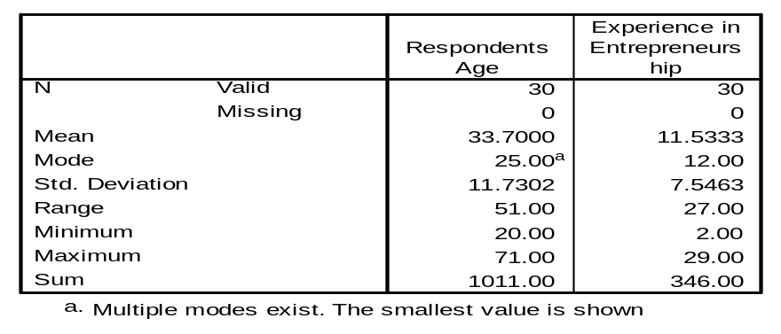
Source: Research findings, 2011
The analysis indicated that, there is a strong correlation between the respondents’ age and their experience in entrepreneurship activities in years. A correlation of 0.7 is found and was significant at a 0.01 level of significance. Table 2 summarizes the findings.

Table 2: Correlation: Respondents Age and Entrepreneurship Experience
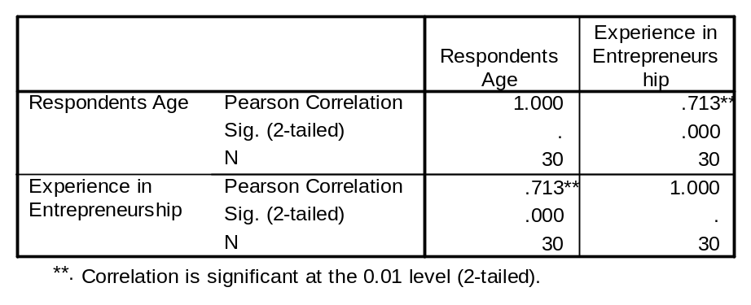
Source: Research findings, 2011

The respondents’ gender and educational level were analyzed. There were 60% of male respondents with primary education level which was the majority in this gender category. The rest of males had secondary, college and vocational level of education. As compared to males, 65% of female respondents had secondary level education. In all cases females were the majority and had a composite of 66.7% against male in the sample total.

Table 3: Respondents Gender and Educational Level
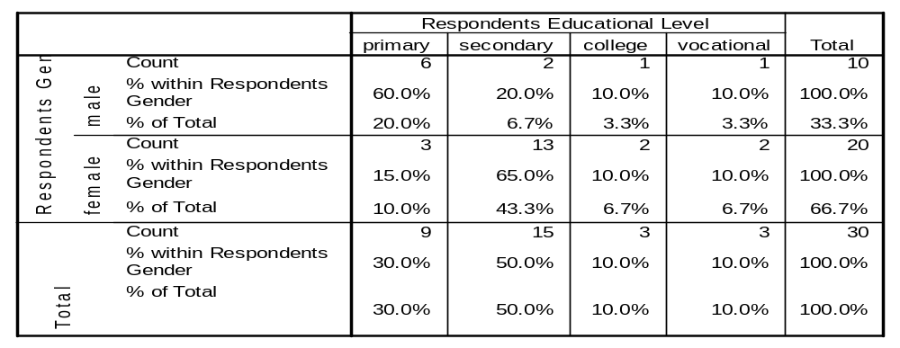
Source: Research findings, 2011
The types of SMEs owned by respondents ranged from manufacturing to service provisions as indicated in the table 4 below. The male category had 60% of them involved in manufacturing while the female category had 35% of them involved in accommodation, cafes and restaurants; these were the majority among their respective categories. However, the majorities in terms of both categories of gender were involved in manufacturing; they were 36.7% of total.

Table 3: Respondents Gender and Type of SMEs Owned
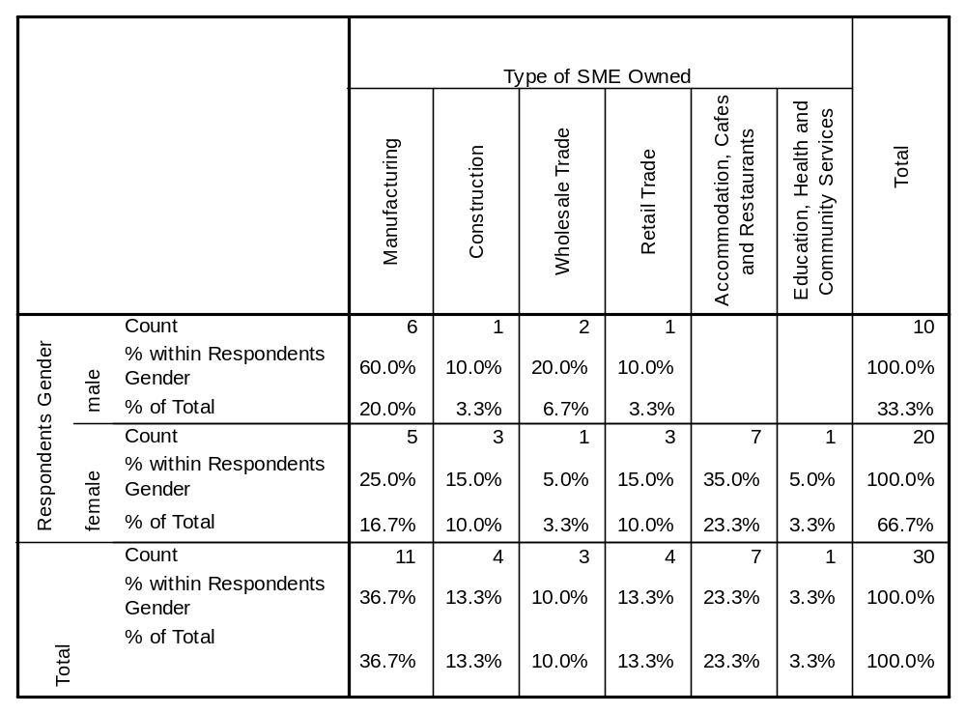
Source: Research findings, 2011

4.3. Factors Inhibiting Entrepreneurship Performance
This section is based on the analysis of factors that inhibit entrepreneurial performance among SMEs. The analysis was based on the following objectives.
Objective One: Examining the inhibiting factors for low level of entrepreneurship performance of entrepreneurs.
Three set of factors were cited as inhibiting entrepreneurial success. They are listed and described below as follows;
Market and marketing are key factors in success and sustenance of entrepreneurial business. There are many breed of market and marketing related problems that trim down entrepreneurial development. These are cited as; lack of a permanent market for entrepreneurs’ products; few available markets are poor, the markets are not sustainable, reduction in number of customers, curtailment of some important customers and few products are cited as the biggest factor that inhibit entrepreneurial success. Capital as a multifaceted inhibitor was ranked second as an important factor that hinders entrepreneurial development. The multiple faces of this versatile factor were cited as; insufficient operating capital, the small capital that comes does not come in time, unsustainable capital, capital depreciation, small capital problems, and absence of sponsors.

The last important factor was premises. This manifested itself in terms of insufficient premises, difficulty business environment, expensive premises rents close to markets, and unregulated business premises for SMEs and lack of certainty in business environment.

4.4. Assessment of Entrepreneurship and SMEs Policy in Tanzania
This section is based on assessing the government policy on SMEs and entrepreneurship. To guide this analysis, the re-listed research objective below was used. Several Policy Strategies were assessed based on a rank of 1 to 5, where 1 is the most contribution/effectiveness/help and 5 the least contribution/effectiveness/help.
Objective Two: Assessing whether the existing Government policies enhance entrepreneurship in Tanzania. The following are government Small and Medium Enterprises (SMEs) policy strategies. The study assessed them by rating the policy strategies in terms of how they have helped entrepreneur and SMEs to develop. The respective tables that follow address the various Policy Strategies and how the respondents have ranked them and thus rated them based on their views on those issues as they directly affect them in their entrepreneurship activities within their localities in Kinondoni district.

In the Table 5 below, three Policy Strategies are addressed; simplification of licensing procedures is one of the issues that the government wanted to achieve especially during issuing of business licenses and permits for entrepreneurs. Based on a sample of 30 entrepreneurs, 63% of respondents indicated that this policy strategy did not help them in their entrepreneurship activities. On the other hand simplification of tax system and provision of tax incentives were ranked at 4 by 60% of entrepreneurs, while education of entrepreneurs on copyright law was ranked at 3 by 70% of entrepreneurs. The overall ranking for all the three policy strategies indicate that entrepreneurs were not satisfied by the policy strategies on these area and that they did not help them in an effort to develop their entrepreneurial activities, thus these strategies did not favour their businesses, thus there is a need for the government to assess these strategies they do not yield better results.

Table 4: Policy Strategies: Licensing Procedures, Tax System and Copyright Law
Policy Strategies | Simplification of Licensing Procedures |  | Simplification of Tax System and Provision of Tax Incentives |  | Educating Entrepreneurs on Copyright Law
Rank 5 | 19 | 63% | 10 | 33% | 1 | 3%
Rank 4 | 7 | 23% | 18 | 60% | 6 | 20%
Rank 3 | 3 | 10% | 1 | 3% | 21 | 70%
Rank 2 | 1 | 3% | 0 | 0% | 2 | 7%
Rank 1 | 0 | 0% | 1 | 3% | 0 | 0%
Total | 30 | 100% | 30 | 100% | 30 | 100%

Source: Research Data, 2011

SMEs Policy strategies that follow (in table 6.) aimed at addressing the problems of premises for
entrepreneurs and promoting entrepreneurship through public education. Strategy that involved
local authorities developing premises for SMEs owners was ranked at 5 by majority of the sample which constituted 57% of all respondents, indicating that the entrepreneurs have a low opinion as to the success of this strategy in making premises for entrepreneurs are available. Similarly another strategy was to allocate unutilized buildings to SME owners, again by the same percentage it was lowly rated indicating that, these two strategies that aimed at providing premises for entrepreneurs are not successful. Another strategy aimed at promoting entrepreneurship through public education. A majority of 60% of respondents ranked the strategy second, indicating that the strategy was successful in promoting and enhancing entrepreneurship.

Table 5: Policy Strategies: Premises for SMEs, Allocating Buildings and Public Education
Policy Strategies | Local Authorities Developing Premises for SME-Owners |  | Allocating Unutilized Buildings to SME-Owners |  | Promoting Entrepreneurship through Public Education
Rank 5 | 17 | 57% | 17 | 57% | 2 | 7%
Rank 4 | 7 | 23% | 8 | 27% | 2 | 7%
Rank 3 | 2 | 7% | 3 | 10% | 6 | 20%
Rank 2 | 3 | 10% | 2 | 7% | 18 | 60%
Rank 1 | 1 | 3% | 0 | 0% | 2 | 7%
Total | 30 | 100% | 30 | 100% | 30 | 100%

Source: Research findings, 2011

In addition to public education provision, the following strategies (table 7) were also assessed for their success in enhancing entrepreneurship; provision of education for new entrepreneurs was ranked second by majority of 43% respondents in enhancing entrepreneurship and ranked third by 40% of them. Thus this strategy was considered to be successful on average. Establishment of information centers for entrepreneurs was another strategy; this strategy was not considered as contributing in enhancing entrepreneurship and SMEs development. Another strategy was training on ICT for entrepreneurs; this policy strategy was similarly considered ineffective.
Table 6: Policy Strategies: Education, Information Centers and ICT Training
Policy Strategies | Provision of Education for New Entrepreneurs |  | Establishment of Information Centers for Entrepreneurs |  | Training on ICT for Entrepreneurs
Rank 5 | 2 | 7% | 5 | 17% | 11 | 37%
Rank 4 | 3 | 10% | 18 | 60% | 6 | 20%
Rank 3 | 12 | 40% | 4 | 13% | 10 | 33%
Rank 2 | 13 | 43% | 3 | 10% | 2 | 7%
Rank 1 | 0 | 0% | 0 | 0% | 1 | 3%
Total | 30 | 100% | 30 | 100% | 30 | 100%
Source: Research Data, 2011

A set of another three strategies was to conduct census for SMEs, to enhance networking between SMEs and technology providers and to facilitate joint venture for technology upgrade and transfer. All of the three strategies were lowly rated and were not considered as successful in enhancing and promoting entrepreneurship and SMEs development. (Table 8)

Table 7: Policy Strategies: SMEs Census, Networking and Joint Ventures Facilitation
Policy Strategies | Conduct a census for SMEs |  | Enhancing Networking between SMEs and Technology Providers |  | Facilitate Joint Venture for Technology Upgrade and Transfer
Rank 5 | 5 | 17% | 16 | 53% | 12 | 40%
Rank 4 | 17 | 59% | 11 | 37% | 10 | 33%
Rank 3 | 7 | 24% | 3 | 10% | 5 | 17%
Rank 2 | 0 | 0% | 0 | 0% | 2 | 7%
Rank 1 | 0 | 0% | 0 | 0% | 1 | 3%
Total | 29 | 100% | 30 | 100% | 30 | 100%
Source: Research finding, 2011

The following three SMEs and entrepreneurship strategies; to promote small-large business linkage, to strengthen marketing agencies and institutions and to facilitate SMEs participation in local and foreign markets, were rated. The results were mixed and it was difficult to determine the success of these strategies as the respondents’ rates were dispersed and inconsistent. (Table 9).

Table 8. Policy Strategies: Small-Large Business Linkages, Marketing Agencies and Facilitation
Policy Strategies | Promote Small--Large Business Linkages |  | Strengthen Marketing Agencies and Institutions |  | Facilitation of SMEs Participation in Local and Foreign Markets
Rank 5 | 9 | 30% | 5 | 17% | 4 | 13%
Rank 4 | 12 | 40% | 7 | 23% | 2 | 7%
Rank 3 | 2 | 7% | 14 | 47% | 3 | 10%
Rank 2 | 7 | 23% | 4 | 13% | 19 | 63%
Rank 1 | 0 | 0% | 0 | 0% | 2 | 7%
Total | 30 | 100% | 30 | 100% | 30 | 100%
Source: Research Data, 2011

On the other hand, the following three policy strategies; to establish SMEs exhibition centers, to facilitate SMEs to meet standards and to facilitate training on trade issues, had an almost unanimous rate the strategies did not help or were not effective in promoting entrepreneurship development. (Table 10).

Table 9: Policy Strategies: Exhibition Centers, Meeting Standards and Trade Issues
Policy Strategies | Establish SMEs Exhibition Centers |  | Facilitate SMEs to Meet Standards |  | Facilitate Training on Trade Issues
Rank 5 | 23 | 77% | 5 | 17% | 4 | 13%
Rank 4 | 5 | 17% | 20 | 69% | 16 | 53%
Rank 3 | 1 | 3% | 4 | 14% | 10 | 33%
Rank 2 | 0 | 0% | 0 | 0% | 0 | 0%
Rank 1 | 1 | 3% | 0 | 0% | 0 | 0%
Total | 30 | 100% | 29 | 100% | 30 | 100%

Source: Research findings, 2011
Several other strategies were developed that aimed at facilitating financing for SMEs. These strategies are; to facilitate SMEs window in financial institutions, to promote innovative financial products for SMEs and simplification of bank access for SMEs. With the exception of simplification of Bank access, the previous strategy in this set were lowly rated indicating their ineffective in enhancing entrepreneurship and SMEs. Simplification of banking procedures to improve access to finance for SMEs was considered a successful.

Table 10: Policy Strategies: Financial Institutions, Products and Access for SMEs
Policy Strategies | Facilitation of SMEs Window in Financial Institution |  | Promote Innovative Financial Products for SMEs |  | Simplification of Bank Access for SMEs
Rank 5 | 4 | 13% | 16 | 53% | 1 | 3%
Rank 4 | 8 | 27% | 5 | 17% | 1 | 3%
Rank 3 | 12 | 40% | 7 | 23% | 5 | 17%
Rank 2 | 6 | 20% | 1 | 3% | 18 | 60%
Rank 1 | 0 | 0% | 1 | 3% | 5 | 17%
Total | 30 | 100% | 30 | 100% | 30 | 100%

Source; Research findings, 2011

A policy strategy aiming to promote financial institutions geared towards financing SMEs was rated averagely, there were mixed response as to whether promoting financial institutions would enhance SMEs financing. Other strategies were to support association of entrepreneurs to strengthen them and strengthening and networking of service providers of SMEs which were considered as ineffective in enhancing entrepreneurship (Table 12).

Table 11: Policy Strategies: Financing, Associations and Service Providers
Policy Strategies | Promote Financial Institutions for Financing SMEs |  | Support Association of Entrepreneurs |  | Strengthening and Networking of Service Providers of SMEs
Rank 5 | 0 | 0% | 16 | 53% | 11 | 37%
Rank 4 | 6 | 20% | 10 | 33% | 16 | 53%
Rank 3 | 20 | 67% | 3 | 10% | 3 | 10%
Rank 2 | 4 | 13% | 1 | 3% | 0 | 0%
Rank 1 | 0 | 0% | 0 | 0% | 0 | 0%
Total | 30 | 100% | 30 | 100% | 30 | 100%
Source: Research findings, 2011

Another set of strategies were; monitoring of SMEs policy, education on SMEs-environmentally related issues and encourage proper waste management. These policy strategies were lowly rated and the entrepreneurs indicated that these strategies were not effective in promoting entrepreneurship and SMEs.

Table 12: Policy Strategies: Policy Monitory, Environmental and Waste Management Issues
Policy Strategies | Monitoring of SMEs Policy |  | Education on SMEs--Environmental Related Issues |  | Encourage Proper Waste Management
Rank 5 | 16 | 53% | 3 | 10% | 4 | 13%
Rank 4 | 8 | 27% | 8 | 27% | 15 | 50%
Rank 3 | 4 | 13% | 16 | 53% | 7 | 23%
Rank 2 | 0 | 0% | 3 | 10% | 1 | 3%
Rank 1 | 2 | 7% | 0 | 0% | 3 | 10%
Total | 30 | 100% | 30 | 100% | 30 | 100%

Source: Research Data, 2011
The last four strategies differed; these were; facilitate special programmes for women and disadvantaged groups, addressing factors that affect women and disadvantaged groups, create SMEs- HIV& AIDS related issues awareness and lastly support potential vulnerable groups in SMEs. In table 14, the second strategy was considered ineffective in promoting entrepreneurship. The third and fourth strategies were considered effective in enhancing entrepreneurship as they were rated highly.

Table 13: Policy Strategies: Addressing Woman and Disadvantaged Groups Issues
Policy Strategies | Facilitate Special Programmes for Women & Disadvantaged Groups |  | Addressing Factors that Affect Women & Disadvantaged Groups |  | Create SMEs--HIV&AIDS Related Issues Awareness |  | Support Potential Vulnerable Groups in SMEs
Rank 5 | 6 | 20% | 18 | 60% | 0 | 0% | 0 | 0%
Rank 4 | 12 | 40% | 4 | 13% | 1 | 3% | 1 | 3%
Rank 3 | 5 | 17% | 6 | 20% | 1 | 3% | 2 | 7%
Rank 2 | 6 | 20% | 1 | 3% | 11 | 37% | 18 | 60%
Rank 1 | 1 | 3% | 1 | 3% | 17 | 57% | 9 | 30%
Total | 30 | 100% | 30 | 100% | 30 | 100% | 30 | 100%

Research findings, 2011

The entrepreneurs view on the policy as to what extent it inhibits entrepreneurial performance were rated based on the 0—25%, 26—50%, 51—75% and 76—100% scale. About 73% of respondents indicated that the policy inhibited entrepreneurial performance by 0—25% range. That being the case it did not mean that the policy facilitated entrepreneurial performance by the complement percentage range that is 26—100% because inhibiting and facilitating are mutually independent rather than complementary. In table 15 below the rest of the analysis are summarized.
Table 14: SMEs Policy Inhibits Entrepreneurial Performance
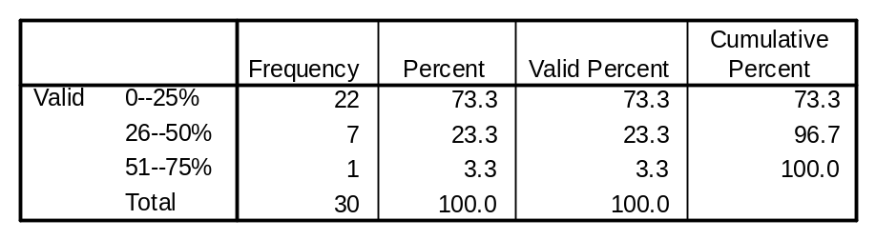
Source: Research findings, 2011

The entrepreneurs view on whether the policy facilitates entrepreneurial performance was rated on the same scale, as in the previous case (that rated views on whether the policy inhibits entrepreneurial performance), in table 16 below, respondents indicated that; about 87% of respondents indicated that the policy facilitated entrepreneurial performance by 26—50%.

Table 15: SMEs Policy Facilitates Entrepreneurial Performance
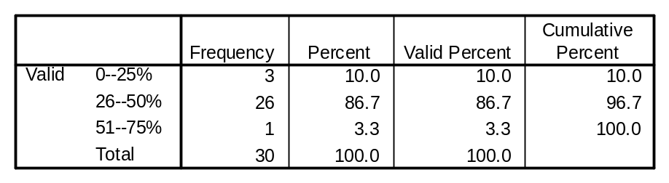
Source: Research findings, 2011

CHAPTER FIVE

CONCLUSION

5.0 Conclusion
From the research findings we observed three factors that inhibit entrepreneurial performance which are marketing, capital, and premises problems. These needed to be re-addressed well in government policy in order to facilitate entrepreneurial performance.

For the case of SME’s policies we have investigated that some of the policies to some extent do facilitate but on the other hand some inhibit entrepreneurship performance. From the research findings some of the strategies which prove successfully are promotion of entrepreneurship through public education, provision of education for new entrepreneurs, SME’s networking, and simplification of banking procedures. Respondent’s reply that Government has taken good effort on promotion entrepreneurship through exhibitions, radio, TV, conducting seminars and they have started a syllabus although is only for University students at the same time University of Dae es salaam is having a special entrepreneurship centre. Policies which we have not done well so far are simplification of licensing procedures, tax system and provision of tax incentives, education on copyright law, ICT training. So, some of the policy needs to be addressed in order to improve the current policy so that more policy impacts can be felt for the benefit of entrepreneurship and SMEs development.

5.3. Policy Recommendations
Most of the policy strategies are indirectly aimed at assisting the entrepreneurs and SMEs, thus there is a need to have policy strategies that directly address the problems that these entrepreneurs face rather than looking at them from desktop point of view. Based on this study’s findings, the following are the policy recommendations that are advanced by the researcher in order to address entrepreneurs’ problems;
- Workable policy on ensuring a sustainable and reliable market is to be put in place; direct market and marketing instruments need to be addressed in the policy so that the strategies implementation can have direct effects on the specific problems at hand.

- Efforts to address the problems of financing need to be addressed clearly and more realistically in the policy statement and strategies, there is a need to develop more financial products and possibly controlling for the exorbitantly high interest rates that do not match the risks and profit the entrepreneurs gets. Policy strategy on how to increase and maintain entrepreneurs’ capital need to be contained and implemented, education and training on these issues need to be addressed as the current policy did not seem to be completely effective.

- Simplification of business working environment and registration processes need to be realistically addressed, screening of problems in this area and developing workable policy strategies are of paramount importance for SMEs and entrepreneurship to flourish.

APPENDICES

Appendix 1: Respondents Gender and Educational Level
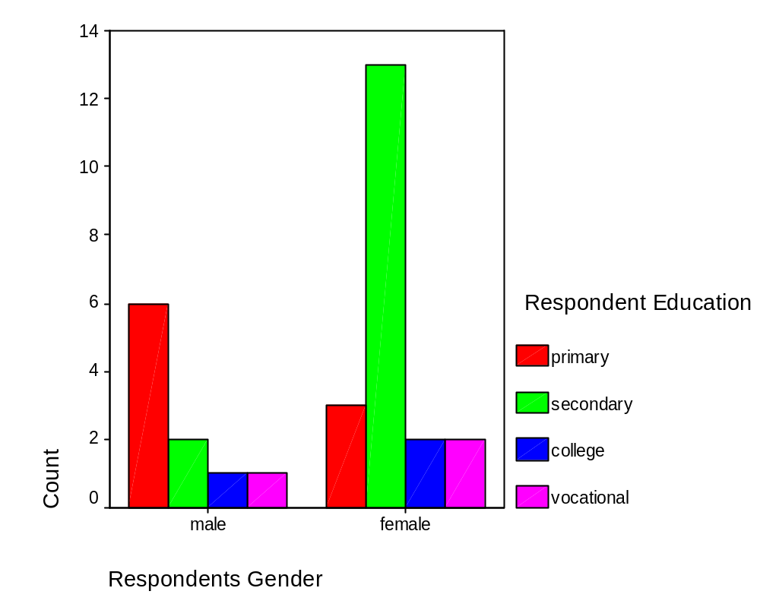
Source: Research findings, 2011

Appendix 2: Respondents Gender and Type of SMEs Owned

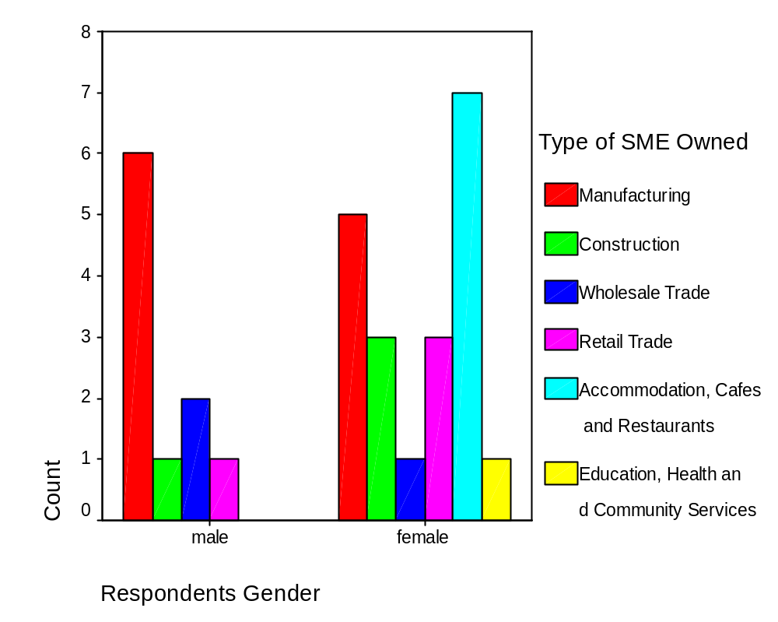
Source: Research findings, 2011

Appendix 3: SMEs Policy Inhibits Entrepreneurial Performance

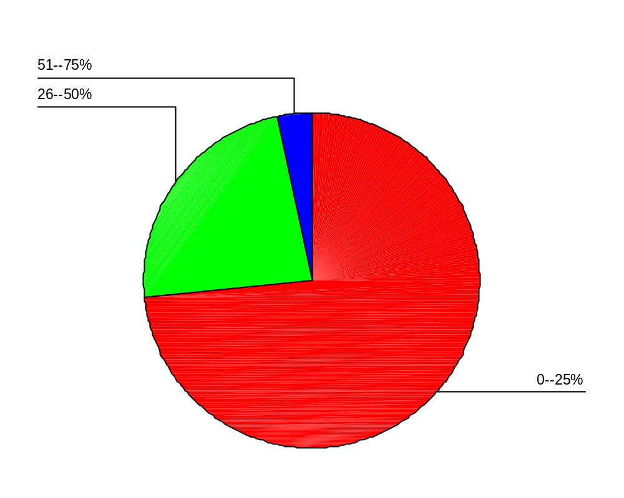
Source: Research findings, 2011

Appendix 4: Cross Tabulation: Type of SMEs owned and Views that SMEs Policy Inhibits Entrepreneurial Performance

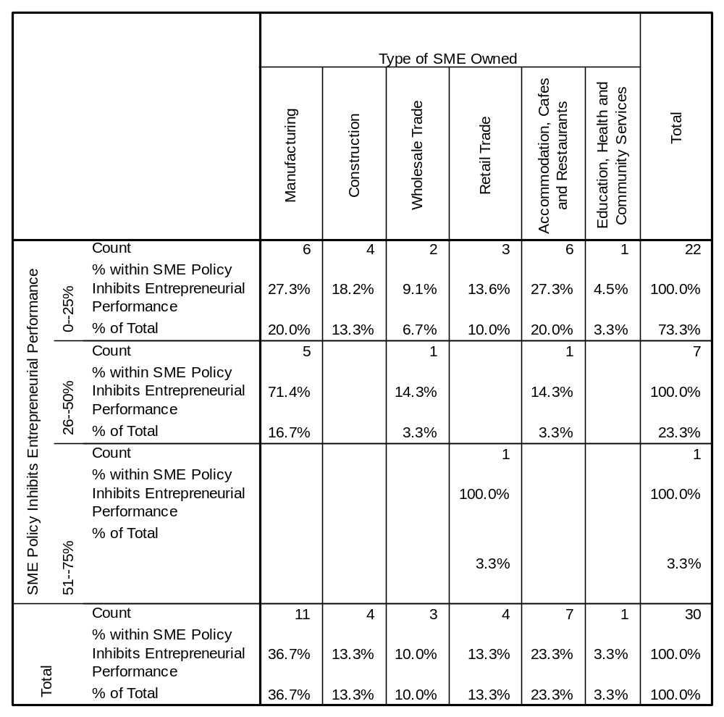

Source: Research findings, 2011

Appendix 5: SMEs Policy Facilitates Entrepreneurial Performance
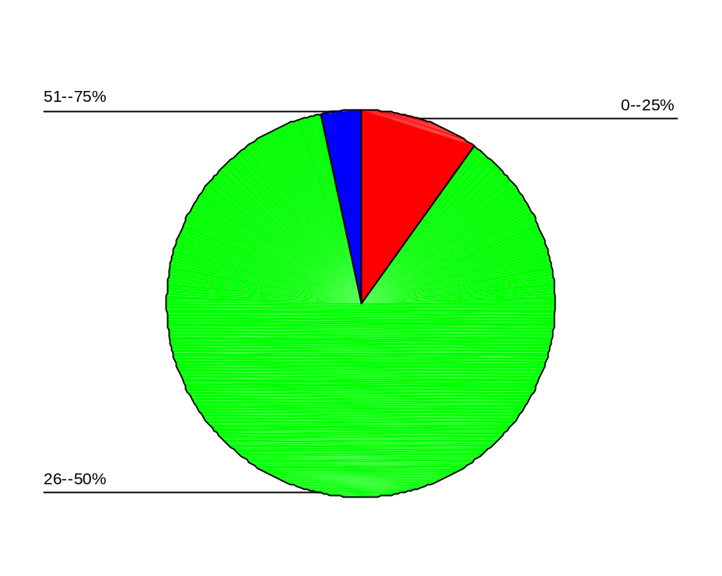
Source: Research findings, 2011

Appendix 6: Cross Tabulation: Type of SMEs owned and Views that SMEs Policy Facilitates Entrepreneurial Performance

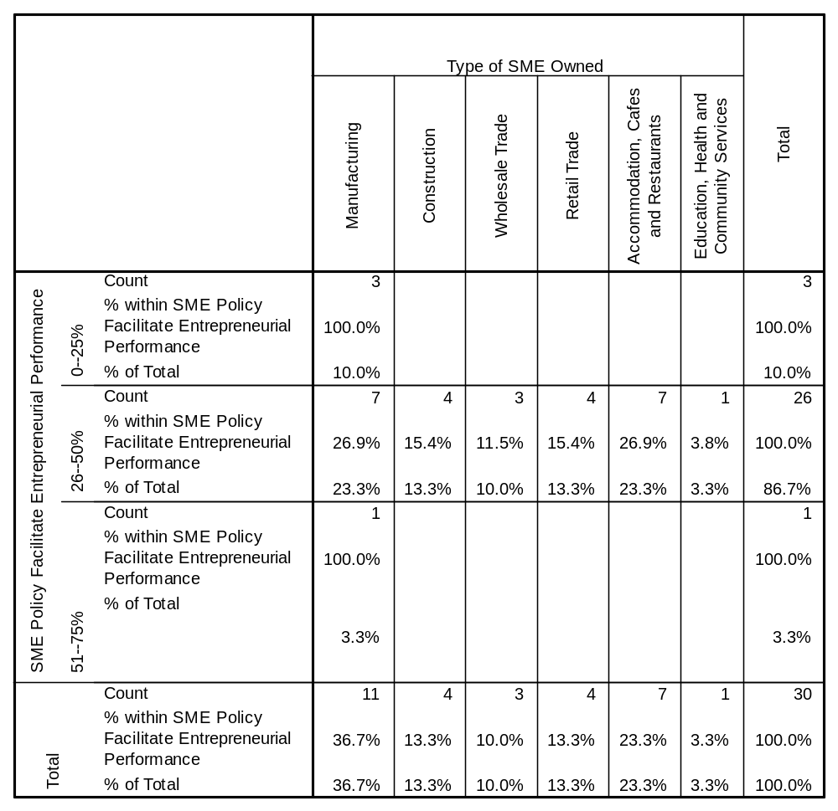
Source: Research findings, 2011

- REFERENCES

Anderson, M Laidley, L and Morrison, B (1995) Entrepreneurship, Entrepreneurship extension centre (Exe) College of Arts, Science and Technology Jamaica W.I
Bull, I. & Willard, G. E. 1993, towards a theory of entrepreneurship. Journal of Business Entrepreneurship,7 (3), 239-258.
David, B, (September, 2000). Technopreneurial.com: The supply of Entrepreneurship and Economic Development [http:www.technopreneurial.com/articles/history.asp] site visited On 15/10/2005
Davidsson, 1989. Continued Entrepreneurship and the Small Firm Growth: Ph.D. Dissertation, Stockholm School of Economics.
Davidsson, P., Delmar, F. and Wiklund, J. (2006). Introduction. In: P. Davidsson, F. Delmar and Wiklund. J. (Eds.), Entrepreneurship and the Growth of Firms (pp. 1-20). Cheltenham: Elgar
Fumbuka,N ,(2002). Unemployment on the rise: Kigoda, Dodoma Daily News,June 14 Gartner, W. B. (1988). Who is an entrepreneur? Is the wrong question.
Hanna-Andesson, C. 1995. “SIDA’s Support to Women Small Scale Enterprises in Tanzania”, In L. Dignard and J. Havet (eds) Women in MSEs Development, IT Publication, UK.
ILO (2002) Women Entrepreneurs in Tanzania. University of Dar es Salaam Entrepreneurship Centre (UDEC)
International Labour Organization (ILO, 1983), “Resolution and concerning statistics of Employment in the informal sector, ILO governing body. Geneva ILO
John, A et al (1995). Examining the Impact of Culture on Entrepreneurial Propensity: An Empirical Study of Prospective American and Egyptian Entrepreneurs. Academy of Entrepreneurship Journal, Volume 1
John L.V, Stephen F and Thomas. M Box (1995). Thai Entrepreneurs. Academy of Entrepreneurship Journal, Vol.1, fall 1995
Kato, C.I. Sekwao, C.M and Mina V.R (Des) (1996) Entrepreneurship Education Trainers Guide. Interpress Dar-es-salaam.
Marku, V (1997). Helsinki School of Economics and Business Administration: The Role of Different . Theories in Explaining Entrepreneurship.
[http://www.usasbe.org/knowledge/proceedings/1997] site visited on 23/10/2005
Massawe, D. “SME Development in Tanzania” Presented at the Workshop on Formalisation of the
Informal Sector held at the Sheraton Hotel, Dar es Salaam on February 19th.
Minga, N.M . (1998), Impact of structural Adjastment Programmes on Small scale enterprises in Tanzania. Acase study of Agro-based enterprises in Dar-es-Salaam Region. Msc.thesis (Unpublished).
Morris, Somerset (1971) African Business men. Western Printing Service Ltd. Great Britain Nick .P (1977). Small enterprise development: policies and programmes. ILO.Geneva
Mwanyika, E.E (2001) impact Assessment of Entrepreneurship Development on Rural Womens Micro- enterprises in Muheza and Handeni District. Msc.thesis Unpublished
Rutashobya, L.K (1998) Women Entrepreneurship in Tanzania, Entry and Performance Barriers.
OSSREA. Gender issues Research Report service No: 9
Schumpeter, J. A. 1934. The Theory of Economic Development. New York: Oxford Smallbone, D. and Welter, F. (2001). “The Role of Government in SME Development in Transition
Economies”, International Small Business Journal, 19, pp. 63 – 77
Temu, S.S (1998), Impact of financial institutions reforms on SME`s financing in Tanzania and Kiggundu, M. N. (2002). Entrepreneurs and entrepreneurship in Africa: small business management, Dar-es-salaam
URT. 1995. Dar es Salaam Informal Sector Survey (DISS). Planning Commission and Ministry of Labour. United Republic of Tanzania (UTR). Dar es Salaam. Unpublished report.
VETA (2000) Integrated Training for Entrepreneurship Promotion (INTEP) Reaching the Target Groups in the Informal Sector, Veta, Dar-es-salaam
Wangwe, (1999). Micro and Small Enterprise Development and Employment Implications.
[http://www.tanzaniagateway.org /Specials/] site visited on 25/11/2005
Wison ,F (Dec, 2004) .Journal of Development Entrepreneurship: [http://www.findarticles.com/p/articles] site visited on 20/10/2005

7.0 Questionnaire
I Haroun Mtebene from Open University of Tanzania; I’m conducting a study on the challenges and success of entrepreneurship in Tanzania. The following is a set of questions from which I request you to answer as appropriate without biases. Your responses will be kept confidential and used only in the analysis of the findings for research purposes only. Thank you for your time.
Please indicate as appropriate by ticking the following questions
gender; i) male--------- ii) female-----------
educational level i) primary------------ii) secondary---------iii)tertiary---------iv) technical---------v) uneducated----------------vi) some combinations of above-------- please state--------------
age--------- (specify)
experience in entrepreneurship (years)---------------
type of business (industry) you own (mention type after ticking below) ------------------------------
i) Manufacturing ------------
ii) Construction ----------
iii) Wholesale Trade -----------
iv) Retail Trade ---------------
v) Accommodation, cafes and restaurants --------------
vi) Transport and storage, finance, insurance ------------
vii) Communication, property, business services ------------
viii) Education, health and community services -----------
ix) Cultural and recreational services ----------
All other industries (mention) ------------

What are the factors that influenced you to start business? (Mention them)
--------------------------
--------------------------
What are the factors that inhibit you and your business in entrepreneurship performance?
(Mention them)
----------------------------
----------------------------
What are the factors that facilitate you and your business in entrepreneurship performance? (Mention them)
----------------------------
----------------------------
The following are government Small and Medium Enterprises (SMEs) policy strategies. Assess by rating the policy strategies in terms of how they have helped you as an entrepreneur and your business to develop as an entrepreneur. Use 1 to 5 criteria. 1 is the most contribution/effectiveness/help and 5 the least contribution/effectiveness/help by indicting a tick in the box.
s/n | Entrepreneurship and SMEs policy strategies | 1 | 2 | 3 | 4 | 5
A | Simplify business registration and licensing procedures
B | Simplify tax system and introduce tax incentives to nurse SMEs
C | Train and sensitise SMEs on intellectual property rights
D | Local Authorities to allocate and develop land for SMEs
E | Identify and allocate underutilized public buildings to SMEs
F | Inculcate through education, training and other Programmes values and  attitudes that are conducive to development of entrepreneurship
G | Facilitate tailor-made business training Programmes for start-ups and for  strengthening existing businesses
H | Set up of business centre so as to ensure that SME operators at all  levels have access to information at affordable costs
I | Support training on information technology e.g. E-commerce
J | Conduct a census for SMEs
K | Establish mechanism for enhancing networking between SMEs and  technology providers
L | Facilitate joint ventures aimed at enhancing technology upgrading and  Transfer
M | Promote business linkages between large and small enterprises
N | Strengthen marketing agencies and institutions that support SMEs
O | Facilitate SMEs participation in local and international markets through  trade fairs and missions
P | Establish SMEs exhibition centre
Q | Facilitate SMEs to meet standards
R | Facilitate training on trade issues i.e multilateral trading systems and  regional trading arrangements
S | Facilitate opening up of SME windows in financial Institutions
T | Promote innovative financial products for SMEs such as hire purchase  scheme, leasing, inventory financing, venture capital SMEs and, Saving and  Credit Schemes
U | Promote improving access of SMEs to bank financing through  simplification of procedures
V | Mobilise resources and promote development of new financial institutions  for financing SMEs.
W | Support establishment and strengthening of Associations of SMEs
X | Facilitate strengthening and networking of service providers of SMEs
Y | Strengthen Government capacity to coordinate monitor and evaluation of the  Policy
Z | Facilitate creation of awareness on environmental issues to SMEs and their  service providers
Aa | Encourage proper waste management including recycling techniques
Bb | Facilitate SME service providers to design special Programmes for women  and disadvantaged groups.
Cc | Identify factors inhibiting women and other disadvantaged groups from going  into business and design Programmes which will address those factors
Dd | Create awareness on HIV/AIDS related matters amongst the SME  Operators
Ee | Support potential vulnerable groups to engage in income generating  Projects

What are the government policies strategies mentioned above (in number 5) that inhibit you in your entrepreneurship performance? Rank only 5 of them according to their most impact by indicating their letters A to Ee.
------------------------------------

What are the government policies strategies mentioned above (in number 5) that facilitate you in your entrepreneurship performance? Rank only 5 of them according to their most impact by indicating their letters A to Ee.
------------------------------------
------------------------------------
Based on your entrepreneurial experience in Tanzania, to what extent to you think
Government policies generally inhibit or facilitate entrepreneurial performance in
Tanzania? Indicate your preference by ticking below;
Inhibits
0-25%
26-50%
51-75%
76-100%
Facilitates
0-25%
26-50%
51-75%
76-100%
Please indicate below some of suggestions on how these problems can be rectified.
------------------------------------------------
------------------------------------------------

Thank you, for your time and participation!

