**UTILISATION OF EDUCATIONAL MANAGEMENT INFORMATION SYSTEM (EMIS) FOR ENHANCING EFFECTIVE SCHOOL MANAGEMENT: A CASE STUDY OF SCHOOLS OF EXCELLENCE INNYARUGENGE DISTRICT, RWANDA**

**HARERIMANA JEAN PAUL**

**A THESIS SUBMITTED IN FULFILMENT FOR THE REQUIREMENTS OF THE DEGREE OF DOCTOR OF PHILOSOPHY (PhD)**

**DEPARTMENT OF EDUCATION POLICY, PLANNING AND ADMINISTRATION**

**OF THE OPEN UNIVERSITY OF TANZANIA**

**2020**

# **CERTIFICATION**

The undersigned certify that they have read and hereby recommend for acceptance by the Open University of Tanzania, a thesis entitled: “Utilisation of Educational Management Information Systems (EMIS) for Enhancing Effective School Management: A Case Study of Schools of Excellence in Nyarugenge District, Rwanda”, in partial fulfilment of the requirements for the award of the Doctor of Philosophy Degree of the Open University of Tanzania.

……………………………………………..

Dr. Michael Ng’umbi

(1st Supervisor)

……………………………………………..

Date

……………………………………………..

Prof. Elinami Swai

(2nd Supervisor)

……………………………………………..

Date

# **COPYRIGHT**

No part of this thesis may be reproduced, stored in any retrieval system, or transmitted in any form by any means, electronic, mechanical, photocopying, recording or otherwise without prior written permission of the author or the Open university of Tanzania in that behalf.

# **DECLARATION**

I, Harerimana Jean Paul, do hereby declare that this thesis is my own original work and that it has not been submitted and will not be submitted for any academic award in any other University for a similar or any other degree award.



……………………………………………..

Signature

06/10/2020

……………………………………………..

Date

# **DEDICATION**

To all my family members

All my friends

Everyone who contributed to my work

This thesis is dedicated.

# **ACKNOWLEDGEMENT**

The present study is a result of combined efforts, experiences and commitment. This study could not have been completed without special support and patience from special individuals.

Firstly, much appreciation and thanks go to my supervisors, Dr. Michael Ng’umbi and Prof. Elinami Swai, for their academic expertise, advice, guidance, perseverance, dedication, contribution, and commitment to the completion of this study. Secondly, my special thanks go to Dr. Cosmas Mnyanyi for his kindness and academic support during my studies and my stay in the Open University of Tanzania.

Lastly, I wish to thank all staff of the Open University of Tanzania for their esteemed services and support as an international student.

# **ABSTRACT**

The purpose of this study was to investigate the impact of Educational management information systems (EMIS) on school management. The study adopted the positivism paradigm, and a descriptive survey design. The study used questionnaire, observation sheet, and documentary analysis techniques for data collection. Findings revealed the high availability of EMIS infrastructure and its accessibility, with limitations of low and slow provision of internet, duplication of data due to use of multiple systems, and staff sharing User right. The study also found that schools used EMIS in school management activities with areas of improvement in delays of approvals and use of data in audit. The study established a positive relationship between use of EMIS and effective school management. However, the findings revealed challenges met in the EMIS implementation including low internet connection, lack of EMIS Strategic development Plan, limited access to EMIS, and lack of regular EMIS technical support, Training, and user guide at school level. It was recommended to staff to avoid sharing user right for security purposes. Schools to avail strong internet, provide EMIS experts to school staff, and organised follow-up activities. It was therefore recommended to Ministry of Education to link data from various EMIS systems to avoid duplication and ensure quality of data, and to urgently develop EMIS Strategic development Plan. The Practical contribution of the study includes the provision of information to the school managers about EMIS resources; enlightenment on ways forward to minimise challenges; and sharing the best practices of EMIS implementations.

Keywords: *Educational Management Information System (EMIS); Schools of Excellence; School financial and non-financial Management.*

# **TABLE OF CONTENTS**

CERTIFICATION ii

COPYRIGHT iii

DECLARATION iv

DEDICATION v

ACKNOWLEDGEMENT vi

ABSTRACT vii

TABLE OF CONTENTS viii

LIST OF TABLES xiii

LIST OF FIGURES xiv

ABBREVIATIONS AND ACRONYMS xv

CHAPTER ONE 1

GENERAL INTRODUCTION 1

1.1 Introduction 1

1.2 Background to the Study 1

1.3 Statement of the Problem 9

1.4 Research Objective 11

1.4.1 The Purpose of the Study 11

1.4.2 Specific Research Objectives 11

1.5 Research Questions 12

1.6 Relevance of the Research 12

1.7 Delimitation of the Study 15

1.8 Limitation of the Study 15

1.9 Conceptual Framework 16

1.10 Operational Definition of Key concepts 19

1.11 Organisation of the Work 21

CHAPTER TWO 22

LITERATURE REVIEW 22

2.1 Introduction 22

2.2 Concept of MIS and EMIS in Education 22

2.3 Components and Infrastructure Supporting EMIS 25

2.4 Theoretical Framework 28

2.4.1 Resource Orchestration Theory (ROT) 28

2.4.2 Lazy User Model (LUM) 29

2.4.3 Information Technology Approach 30

2.4.4 Task-Technology Fit (TTF) 31

2.4.5 Unified Theory of Acceptance and Use of Technology 32

2.5 EMIS and Effective School Management 33

2.5.1 EMIS and School Financial Resource Management 34

2.5.2 School Non-Financial Resource Management 35

2.6 EMIS Trainings and Staff Technical Competence 36

2.7 Relationship between EMIS and School Management 38

2.8 Challenges of EMIS Implementation 42

2.9 Factor Supporting EMIS Development and Implementation 47

2.10 EMIS Development and Policy in Rwanda 51

2.11 Research Gap Identification 52

2.12 Summary 53

CHAPTER THREE 55

RESEARCH METHODOLOGY 55

3.1 Overview 55

3.2 Research Paradigm and Approach 55

3.3 Research Design 56

3.4 Research Area 58

3.5 Description of Target Population 58

3.6 Sample Size and Sampling Procedures 61

3.7 Data Collection and Instruments 63

3.5.1 Questionnaires 63

3.5.2 Observation Checklist 64

3.5.3 Documentary Analysis 64

3.6 Pilot Study 65

3.7 Validity of Instruments and Reliability of Research 65

3.7.1 Validity of the Instruments 65

3.7.2 Reliability of Instruments 66

3.8 Data Processing, Presentation, and Analysis 69

3.10 Ethical Issues 71

3.11 Summary 72

CHAPTER FOUR 73

DATA ANALYSIS AND PRESENTATION 73

4.1 Introduction 73

4.2 Response Rate 73

4.3 Demographic Characteristics of Participants 74

4.3.1 Gender of Respondents 74

4.3.2 Work experience 75

4.3.3 Education Level of Respondents 76

4.3.4 Age of Respondents 77

4.4 Presentation of Findings 78

4.4.1 Standing of Existing School Infrastructure and Components of EMIS 78

4.4.2 The Impact of EMIS on School Management Activities 82

4.4.3 Impact of Delivered Trainings of EMIS on School Managers and Staff 89

4.4.4 Challenges Inhibiting Implementation of EMIS in SchoolManagement 91

4.4.5 Relationship between the use of EMIS and Effective School Management 94

4.5 Summary of Findings 99

CHAPTER FIVE 105

DISCUSSION OF FINDINGS 105

5.1 Introduction 105

5.2 Standing of School Infrastructure and Components for EMIS 105

5.3 Impact of EMIS on School Management Activities 108

5.3.1 Impact of EMIS on Non-financial School Management Activities 108

5.3.2 Impact of EMIS on Financial School Management Activities 111

5.4 Impact of EMIS Delivered Trainings on School Managers and Staff 113

5.5 Challenges Inhibiting Implementation of EMIS 117

5.6 Relationship between the Uses of EMIS and Effective School Management 121

CHAPTER SIX 127

CONCLUSIONS AND RECOMMENDATIONS 127

6.1 Introduction 127

6.2 Conclusion 127

6.3 Contribution to Knowledge 131

6.4 Recommendations 133

6.4.1 Recommendations for Action 133

6.4.2 Recommendations for Further Studies 137

REFERENCES 138

APPENDICES 160

# **LIST OF TABLES**

Table 1.1: ICT and EMIS Development in Education in Rwanda 6

Table 2.1: Categories of MIS Implementation Challenges 42

Table 3.1: Targeted Secondary Schools of Excellence in Nyarugenge District 59

Table 3.2: Target population in Schools of Excellence in Nyarugenge District 60

Table 3.3: Summary of Sample Size 62

Table 3.4: Alpha Coefficient for the Reliability Tests 68

Table 3.5: Data Processing, Presentation, and Analysis 69

Table 4.1: Response Rate 74

Table 4.2: School Infrastructure and Components for EMIS 79

Table 4.3: Impact of EMIS on School Non-Financial Management Activities 83

Table 4.4: Impact of EMIS on School Financial Management Activities 86

Table 4.5: The Impact of Delivered EMIS Trainings on School Managers/Staff 89

Table 4.6: Challenges Inhibiting the Implementation of EMIS 92

Table 4.7: Relationship between the use of EMIS and School Management 95

Table 4.8: Correlation between the use of EMIS and School Management 97

# **LIST OF FIGURES**

Figure 1.1: Conceptual Framework 17

Figure 2.1: The Meaning of Management Information System (MIS) 22

Figure 2.2: Conversion of data into information 23

Figure 2.3: Components of MIS 25

Figure 4.1: Gender of Respondents 74

Figure 4.2: Work experience of the respondents 75

Figure 4.3: Education Level of Respondents 76

Figure 4.4: Age of Respondents 77

# **ABBREVIATIONS AND ACRONYMS**

EMIS Educational Management Information System

ESSP Education Sector Strategic Plan

ICT Information Communication Technology

MINECOFIN Ministry of Finance and Economic Planning

MINEDUC Ministry of Education

MIS Management Information System

SDMS School data management system

SMIS School Management Information System

TMIS Teacher Management Information System

UNECA United Nations, Economic Commission for Africa

UNESCO United Nations Educational, Scientific and Cultural Organisation

RMSA-TCA Rashtriya Madhyamik Shiksha Abhiyan Technical Cooperation Agency

AEPM Academy of Educational Planning and Management

# **CHAPTER ONE**

# **GENERAL INTRODUCTION**

## **1.1. Introduction**

This chapter provides an overview of the use of Educational management information system (EMIS) in the management of educational institutions. The study background explains the usefulness of EMIS in management of educational institutions. The chapter also goes through the challenges and issues related to the implementation of Educational management information system (EMIS) technology in school management. Additionally, it describes the evolution of technology in Rwandese education and the issues related to its implementation. The statement of the problem, purpose, specific objectives, and research questions of this research are also indicated. The chapter therefore concluded by providing the significance of the study, the limitations, scope and the organisation of the entire study.

## **1.2. Background to the Study**

In this decade, the use of modern technological facilities in the world has been remarkably inseparable to our lives as it touches a great number of aspects of our daily activities. Incontestably, the importance of technology becomes more relevant and evident for effective management of schools. A study revealed that the information communication technology (ICT) makes academic activities easily managed and accomplished. ICT makes management of school activities effective and more productive (Oye,Iahad, &Rabin, 2011). Educational Management Information System (EMIS) has significantly improved effectiveness in school management.

EMIS as a system plays the major role in management of the educational institutions. MIS converts data into information, communicated in an appropriate form to managers at levels of an organisation (Al-Mamary, Shamsuddin, & Aziati, 2013). The idea of MIS becomes popular in 1990’s when companies were competing to meet information requirements of managers at all level (Broadbent, LLoyd & Dampney, 1992). As known, the information contributes to effective decision making and planning (Patterson, 2005). The use of Educational management information systems (EMIS) raised the effectiveness of educational institutions and school management.

Educational management information system (EMIS) has significantly brought enormous inputs and transformations to data and information management in education. Educational institutions recognise the value of information and data in decision making. The education system relies on accurate, timely and complete education data and information in order to function properly (Rashtriya Madhyamik Shiksha Abhiyan Technical Cooperation Agency (RMSA-TCA, 2015).

Schools and education institutions were not left behind schedule in the use of Educational management information systems (EMIS) for effective management of the educational information and data. EMIS plays an important role in effective school management. EMIS is crucial for the purposes of decision making, managing, planning and evaluating the education systems (Akaranga & Makau, 2016). A study also demonstrates that there is a significant relationship between the usage of Educational management information systems (EMIS) and the effective management of educational institutions (Adeyemi, 2011). EMIS is demonstrated as a tool which impacts on every aspect of school management activity. EMIS leads to changes in work and changes in the organisation of work (UNESCO, 2002). This proves the significant impact of the Educational management information systems (EMIS) tools on effective school management.

Additionally, the integration of technology in education has brought a lot of input in education for enhancing effective educational management. The integration of television, telephone, and computer technologies has also changed the way we live (Barron, *et al.,* 2002). Integrating new technologies is not a cure-all for education, but indicators show that new technologies can help in restructuring our school with a wide variety of activities such as educational governance, supervision, support services, infrastructure, finance, budgeting, accounting, personnel selection and training system monitoring and evaluation, facilities procurement and management, equipment maintenance, and research (Thomas, 1987).

The use of EMIS in school management brought changes and effectiveness in management of schools and education institutions. There is a significant role of EMIS in school data management and decision making. The findings revealed that EMIS is essential in capturing, processing, storing, retrieving, updating and devising data and information which is essential for the smooth running of the school management (Akaranga & Makau, 2016).

In management of schools, EMIS has become a must attend management tool. Due to its importance, EMIS policies and implementation strategies were developed by various educational institutions and school across countries. The study conducted in USA schools by Breiter and Light (2006) confirmed that EMIS enables effective school information storage, retrieval, and effective decision making. Chitolie-Joseph (2011), in his study conducted in Caribbean, also discovered that EMIS is useful for maintaining students and staff records, keeping school accounts, preparing students’ report cards, and timetabling. Ziad (2013), moreover, revealed that EMIS plays an important role in the performance of the organisation. Furthermore, the study carried out in Nigeria reveals that EMIS is the key tool and at the heart of educational management in all institutions (Adeyemi, 2011).

The East African countries have also put in place policies regarding the use of EMIS to strengthen the effectiveness of school management. In Kenya, the Ministry of Education in 2005, established EMIS policy which aimed at establishing an EMIS in schools (Farrell & Isaacs, 2007). According to this policy, the initial objective of EMIS was to harmonise and integrate information systems to support timely collection, processing, dissemination, and use of education data for management to identify necessary interventions to achieve relevant and quality education (Wamakote, 2010).

Besides, the investment landscape of ICT, Tanzania is best viewed through the different ICT initiatives that have been introduced in the country (Hare, 2007). Notable among these are the EMIS, e-schools programme, ICT implementation in teachers’ colleges, and the Computers for Schools project. Tanzania also developed EMIS policy and guidelines. In Tanzania, The EMIS is a national project planned to provide educational data in six categories: (1) baseline education statistics and demographics, (2) human resource information, (3) infrastructure and assets, (4) school performance, (5) financial management information, and (6) documents such as research and field reports, policies (Wamakote, 2010). In his study on EMIS in Tanzania, Luena (2012) found that EMIS played a significant role in the provisionof quality education through quality data and statistics enabling sound educational policies and decisions.

Additionally, The Ugandan government’s most significant ICT investment in the educational sector is the EMIS which aims at providing quality education statistics in a timely, cost-effective and sustainable manner (Ang’ondi, 2010). This is done through data capture on school facilities and pupil details which is coordinated at the district level and uploaded to the system for national compilation and processing. Districts have been equipped with internet-connected computers and associated peripherals and officials trained in their use (Uganda, Ministry of Education ICT Policy, 2005).

On the other hand, Rwanda like other countries took advantages of technology in all aspects of development process.For this development process to be a success, Rwanda has embraced the future and exploit innovations in Science and technology to complement its cultural strengths (Ministry for Finance and Economic Planning, 2010).With reference to Education Sector Strategic Plan, EMIS is recognised to be an important tool that enables effective school management in Rwanda. Much investment has been done for successfully implementation (Ministry of Education, 2013).

**Table 1.1: ICT and EMIS Development in Education in Rwanda**

**Source**: Research Data (2018)

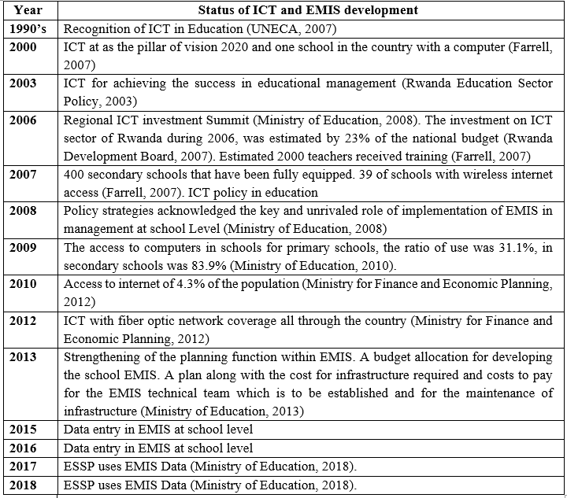

Table 1.1 shows the development of ICT and EMIS in education in Rwanda. Starting from 2008, EMIS was among the key strategies for effective school management. According to the Ministry of Education (2008) in the Policy Statement, ICT focused on four major areas in the Ministry of Education including: The first and foremost is preparing all sectors of the education system to understand the investment in and value of technology; secondly is preparing schools to accept technology, procuring and installing the technology. Thirdly, is to implement Educational Management Information System (EMIS) and providing ongoing technical support; and lastly developing and Managing content and integrating the Curriculum. Taking advantage of the third major area targeted by the ICT policy in education, the Ministry of Education, decided to continually improve the implementation and investment in EMIS due to its significant impact on the school management.

Tripathi (2011) in his study stated that MIS gives a significant impact on the important function of top management. It is also used to generate the reports with the help of advanced technology having maximum characteristics of good information by which the decisions are to be taken related with the functionality of management decisions. According to Lordon (as cited in Tripathi 2011), “MIS is one of the important functions of management. In the 21st century the organisations need the information, which is accurate, timely and reliable. The MIS plays an important role in providing the information required for crucial decision making which affects directly to the performance of the organisation”. Thus, the development of an information system requires a significant financial and human resource investment, an investment which, in contexts of deprivation, can only be justified if the benefits gained clearly outweigh the costs (Sultana, 2013). In the same line, the Ministry of Education in Rwanda decided to invest in modern technology facilities considering its relevance and benefits to school management.

Ministry of Education (2010) acknowledged the role of EMIS and stated that EMIS facilitated access to timely and accurate management data that is a pre‐requisite for effective monitoring. MINEDUC works with all education institutions, the National Institute of Statistics and the Districts to collect qualitative and quantitative management data to inform policy development and to evaluate progress. The Ministry of Education (2010) further added that an Educational Management Information System (EMIS) has been developed to collect primary source data relating to all education institutions.

The EMIS enables MINEDUC to monitor education activities at school, district and national levels, and to aggregate and disaggregate information by various criteria such as enrolment, transition, completion, repetition, drop‐out rates, textbook and student/teacher ratios, examination results and teacher qualifications. This process will support their school level planning and prioritising. Currently, Ministry of Education through Education Sector Strategic Plan (ESSP) uses EMIS Data for planning and decision making (Ministry of Education, 2018).

To cope with the implementation of Educational Management Information System (EMIS), the Ministry of Education purposes to improve the use of information systems precisely the Educational Management Information System (EMIS) by specifically organising training for raising the staff capacities and skills on use of EMIS in school management in order to mount reforms, and coordinate implementation (Ministry of Education, 2013). Taking into consideration much effort and huge financial investment in the implementation of Educational Management Information System (EMIS) in school management, it is a boundless opportunity to assess the extent to which Educational Management Information System (EMIS) use has influenced school management.

The implementation of Educational Management Information System (EMIS) has not been a smooth journey. It requires continuous improvement and investment. The study identified three major challenges of use of technology in education management namely the proficiency with technology, barriers to adoption, and reliability of technology (Bulter & Sellbom, 2002). During their study in Nigerian schools, Aduwa-Ogiegbaen and Iyamu (2005) also found that there are several obstacles to the successful use of information and communication technology in secondary schools namely cost, weak infrastructure, lack of skills, lack of relevant software and limited access to the Internet. This indicates that technological facilities are very useful and helpful on one side and challenging on the other side.

The schools of excellence, as a case of this study, are the pioneers in the implementation of EMIS. In fact, Schools of excellence in every District serves as an example and models of the best practices and learning experience to other schools. The best practices and the situation in those schools can constitute a model to other schools in the implementation of EMIS. The implementation of EMIS purposes the development and effective management of school resources for informed decision making. EMIS implementation is not a smooth journey without inhibitions. Despite much effort and investment in EMIS, The Ministry of Education is still facing managerial, technical, personnel, and organisational challenges in its implementation for management of school resources (Ministry of Education, 2013).

## **1.3. Statement of the Problem**

Despite much determination and investment in EMIS, gaps in collection, analysis, and utilisation of school data, inadequate school EMIS infrastructures and capacity building of staff to run EMIS have been a major concern of the Ministry of Education (Ministry of Education, 2018).Additionally, deficiency in quality of data and information in school management in Rwanda has persistently been a major concern of the stakeholders in education sector (Ministry of Education, 2020). Insufficient capacity and gaps in the use of EMIS in the key areas of planning, finance, and statistics in the school management in Rwanda have raised the concern (Ministry of Education, 2010). This situation negatively affected the areas of planning, finance, and statistics in education.

Correspondingly, Sultana (2013) in his study also identified the challenges faced in the implementation of EMIS specifically financial constraints, buying and provision of materials (internet, servers, and equipment), software, technical challenges, and insufficient training and development of staff. To deal with those challenges, the Ministry of Education decided to continually improve the investment and strengthen the implementation of EMIS in management fall schools across the country by increasing the budget, completing the existing contract for EMIS development, decentralising infrastructure required in line with implementation, establishing EMIS team for maintenance of infrastructure, by distributing hard and softwares to schools and conducting trainings of school managers across the country in order to reinforce its implementation (Ministry of Education, 2013).These challenges have led to the inadequacy in the implementation of EMIS.

The extent to which the magnitude of alarming situation was demonstrated, the Ministry of Education in Rwanda on the other hand decided to strategically act and make plans. Due to deficiencies in implementation of EMIS in school management, research on impact of use of EMIS on school management required more responsiveness and it constituted an attempt to find out solutions. In this case, there was a need to carry out a study to analyse the standing of components and school infrastructures for EMIS, assess the impact of EMIS’ use on the school management, the impact of delivered trainings to school managers and identify alternative solutions to minimize challenges in the implementation of EMIS in schools.

## **1.4 Research Objective**

This study was guided by the purpose of the study objective and specific objectives.

### 1.4.1 The Purpose of the Study

The main purpose was to investigate the impact of Educational Information Management System (EMIS) on effective school management in Schools of Excellence in Nyarugenge District.

### 1.4.2 Specific Research Objectives

The research was guided by the following objectives:

1. To analyse the standing of existing school infrastructure and components for Educational Management Information System (EMIS) in Schools of excellence;
2. To evaluate the impact of Educational Management Information System (EMIS) on school financial and non-financial management activities in Schools of excellence;
3. To assess the impact of delivered trainings of Educational Management Information System (EMIS) on school managers and staff in in schools of excellence;
4. To examine challenges inhibiting the implementation of Educational Management Information System (EMIS) in school management in schools of excellence;
5. To establish the relationship between the uses of Educational Management Information System (EMIS) and effective school management.

## **1.5. Research Questions**

The research was guided by the following questions:

1. What is the standing of existing school infrastructures and components for Educational Management Information System (EMIS) in schools of excellence?
2. What is the impact of Educational Management Information System (EMIS) on school financial and non-financial management activities in schools of excellence?
3. What is the impact of delivered training of Educational Management Information System (EMIS) on school managers and staff in schools of excellence?
4. What are challenges inhibiting the implementation of Educational Management Information System (EMIS) in school management in schools of excellence?
5. What is the relationship between the use of Educational Management Information System (EMIS) and effective school management?

## **1.6. Relevance of the Research**

This study was carried out mainly in order to investigate the impact of EMIS on school management and examine the challenges that schools facedduring the implementation of Educational Management Information System (EMIS) in school management. The findings are beneficial to all stakeholders in education and researchers in education. Benefiting to the study are the various sectors as follows:

* + 1. **School and Educational Managers**

This study is a significant endeavor to educational managers and the direct output is a guide to them on how to implement EMIS in the management of financial and non-financial resources and activities such budgeting, accounting, financing, students ‘enrollment, results processing, communication and reporting just to mention few in their educational institutions for effective and efficient management in order to overcome barriers and obstacles in management. This study also contributed to a better understanding of the role of establishment of EMIS infrastructures required like computers, internet, and well-trained staff. It highlights the main challenges faced in the implementation of EMIS which includes low internet, untrained staff, lack of regular EMIS support, shortage of EMIS technicians, lack of clear guidelines, and EMIS strategic development policy, delay in entering and approval of data, and sharing EMIS user right . It also provides useful guidelines on the effective use of EMIS as a powerful and resourceful tool for successful management.

* + 1. **Stakeholders in Education**

Secondly, this study is a benefit and demonstrates the potential uses of EMISin all school daily life to educational managers and stakeholders in the specific areas such as the precision in the retrieval of targeted data with greater speed and accuracy, in the increase of the amount of data held ready for use; and the organised filling and analysis of data; reducing time spent on mechanical tasks such as rewriting, producing graphs; and making easier the process of sharing information and ideas with other educational institutions and stakeholders. The study demonstrated areas of improvement where educational stakeholders can intervene. The areas of intervention include support in training of EMIS staff, provision of computers and maintenance support, participation in the development of EMIS strategic policy.

* + 1. **Ministry of Education and Policy Makers**

Thirdly, this study is helpful to the Ministry of Education and policy makers in the sense of identifying and overcoming unexpected challenges that already exist in secondary schools which can hinder the process of implementing the Educational information management system (EMIS). Additionally, the exchange of data and communication is facilitated by using EMIS. And importantly, this research directs the partners in education to what could be the successful EMIS which can lead to the better success in management of secondary schools and educational institutions.

Lastly, Ministry of Education and policy makers is given a picture and window on how to improve EMIS in management of secondary schools and develop EMIS policy. The areas of improvement pinpointed by the study include EMIS training on data entry and analysis, provision of clear guidelines, EMIS strategic policy development, provision of EMIS basic resources like computers, network, electricity, and EMIS expert as a support. Additionally, link different EMIS systems available in schools to avoid duplication and redundancy of data in systems. Duplication of data affects quality of data and it is time and energy consuming on behalf of school leaders and staff.

* + 1. **The Researchers**

The findings of this study are beneficial to current researchers and future researchers on EMIS. This study constitutes the basis of new theory which can guide their research project and work toward the refined findings and contribution to the new knowledge. The study therefore confirmed the effectiveness of EMIS theories namely resource orchestration theory and the Unified Theory of Acceptance and Use of Technology (UTAUT).The confirmation of the two theories constitutes a solid basis to EMIS area of research.

## **1.7. Delimitation of the Study**

The study was delimited to secondary schools, Schools of Excellence, in Nyarugenge District in Rwanda. Four schools of excellence, Lycée de Kigali, College Sainte Andre, Lycée Notre Dame de Citeaux, and College de Butamwa, were the cases of this study. The study was focuses on school managers and teachers who interact with EMIS in school management activities.

## **1.8. Limitation of the Study**

The most important limitation of this study was the powerlessness of the researcher to fully participate and spent enough time as required in all school management activities where EMIS is used. As known, EMIS information is utilised depending on the types of information needed, the decision to be made, administrative level of education and the specific period of intervention. This was impossible to fully participate in school management activities because the researcher is not a secondary school manager or teacher who daily interacts with EMIS. As way of mitigating limitations, the study relied on triangulation of questionnaires’ responses, documentary analysis, and direct observations.

## **1.9 Conceptual Framework**

The study on use of EMIS for effective school management needed a sophisticated conceptual framework for assisting the researcher to remain focused on the crucial components during the research planning, data collection, and data analysis. A conceptual framework can be thought of as a map or travel plan (Sinclair, 2007). According to Miles and Huberman (1994), “a conceptual framework as a visual or written product, one that explains, either graphically or in narrative form, the main things to be studied—the key factors or indicators, concepts, or variables and the presumed relationships among them”. It is difficult to explain a concept or reason without having a visual understanding its constructs (Rodgers, 2000).

As Rodgers (2000) reveals, the first step in solving most problems is to visualise the various components of the problem and their relation to each other’. He explains how a simple diagram that can be seen with the eye can focus the thinking and stimulate the development of a mental image of the problem. Additionally, Maina (2013) further stated that a clearly articulated conceptual framework has potential usefulness as a tool to scaffold research and assist a study to make meaning of subsequent findings.

Figure 1.1conceptual framework was used as a conceptual framework to this study. Thus, it is conceived from system’s approach, input-output model proposed by Ludwig Van Bertalanffy. The selection of the input-output model in this study is based on the view that the quality of input which is EMIS can significantly impact the quality of output in case of school management. This argument is supported by Barron et al. (2002) who stated that the integration of technology in education has brought a lot of input in education for enhancing effective school management.

Information systems are made up of interrelated components: People, hardware, software, data, and networks. People resources include end users and IS specialists, hardware resources consist of machines and media, software resources include both programmes and procedures, data resources include data and knowledge bases, and network resources include communications media and networks (O’Brien & Marakas, 2011).

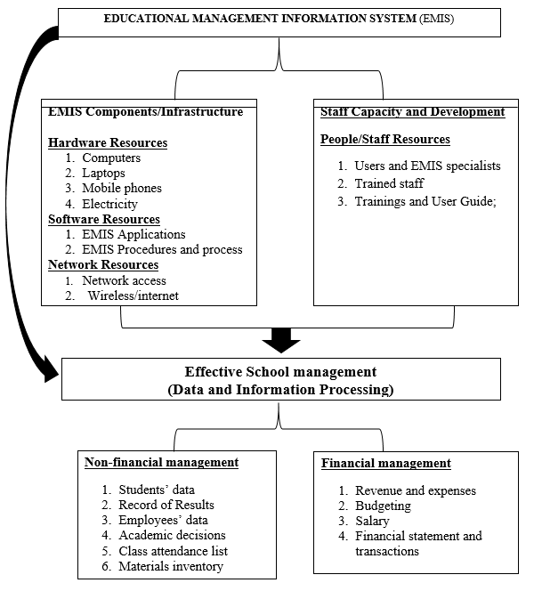

**Figure 1.1: Conceptual Framework**

**Source:** Researcher (2018)

Figure 1.1 conceptual framework shows the connection between EMIS and effective school management. EMIS has four main variables namely hardware, software, people, and network resources. Those resources were revealed as factors for successful implementation of EMIS (O’Brien & Marakas, 2011). This coincided the main target of this study which purposes investigating the impact of use of EMIS on effective school management. It describes EMIS as an independent variable which has four broad components of sub-variables: Hardware, software, people, and network resources.

According to Figure1.1, hard ware resource was conceptualised as computers, laptops, modems, electricity and mobile phones. Besides, software resources are conceptualised as EMIS specialised software and procedures. Then network resources include communication media and internet network. Furthermore, People resources include EMIS users and EMIS specialist, trained staff, trainings and use guide which are essential resources in the implementation of EMIS for effective school management. This signifies that EMIS resources and components can significantly influence the outcome in school management.

On the other hand, Figure 1.1 illustrates school management as a dependent variable. School management was conceptualised as data and information processing resources in two broad categories of indicators namely financial and non-financial management. Thus, non-financial management comprises, students’ enrollment and data management, mark reports processing and keeping, employer-employees communication, employees’ data management, training delivery and management, e-learning, Report delivery, meeting records taking, and learning and teaching activities. Additionally, financial management also contains revenue and expenses, budgeting, students’ fees payment, salary management, financial statement and transactions. Consequently, the effective and efficient management of data is considered an integral part of organisational strategy (O’Brien & Marakas, 2011).

This conceptual framework demonstrated the relationship between EMIS and effective school management. The displayed independent variables, EMIS variables namely hardware resources, software, people, network, can positively or negatively affect school management, conceptualised as a dependent variable, data and information processing resources.

## **1.10 Operational Definition of Key concepts**

**Modern technology**: the term modern technology refers to the computer-supported technology which includes the instrument and tools based on the computer used in school management namely hardware devices (Laptops, desktop, IPad, Projectors, Scanning, Printing machine, finger printers, and Mobile phones) and Software applications(Internet services, Whatsapp messenger, Short message services, and Management information system (MIS).

**Technological Facilities**: technological tools like computer and other computer related devices. This includes soft wares (EMIS) as well as hard wares of computers.

**Secondary school**: the term refers to the high school level form senior one to senior six. This level includes both Ordinary and advanced level. Simply, Secondary Education of six years.

**School management:** the term refers to the coordination of the proper use of financial and non-financial school resources. The resources include Non-financial management(Students’ enrollment and data, Mark reports processing and keeping, Employer-employees communication, Employees’ data keeping, Training delivery and management, Report delivery, Meeting records taking) and Financial management (Revenue and expenses, Budgeting, Students’ fees payment, and Salary management).

**Information and communications technology (ICT)**: the term denotes any communication device or application, encompassing radio, television, cellular phones, computer and network hardware and software, satellite systems, as well as the various services and applications associated with them, such as video conferencing and distance learning.

**School of excellence**: the term denotes public secondary schools selected by the government to be the centres of excellence in each district. The schools have the two levels, ordinary and advanced level (from senior 1 to senior 6). The schools are boarding schools and well equipped with modern infrastructures and facilities. The schools receive students who are top performers in national examinations from across the country. The purpose of these schools is to be used as centres where teachers andstudents from other schools around come and utilised high-quality facilities and resources available such as well-equipped ICT and computer laboratories, libraries and science laboratories.

**Educational Management Information System (EMIS):** EMIS is an integrated system of hardware and software that performs various educational management tasks such as maintaining school records, performing transactions, report generations and consolidation of the important information for decision making. For instance, EMIS can be named differently according to the designers such as School Data Management Information System (SDMS) or School Management Information System (SMIS).

## **1.11. Organisation of the Work**

This research project will be composed of six chapters. Chapter one provides an overview of the study including background to the study, the statement of the problem, the purpose of the research, research questions, the significance of the study, and the operational definition of key terms. Chapter two also embraces the literature review, theoretical framework, conceptual framework, and the empirical data related to the current proposed research. Chapter three presents the research methodology, design, sampling, data collection, ethical issues and data analysis techniques. Chapter four is the presentation and interpretation of findings. Chapter five consists of discussion of results and findings. Lastly Chapter five contains the conclusions, recommendations and the contributions of the study.

# **CHAPTER TWO**

# **LITERATURE REVIEW**

## **2.1 Introduction**

This chapter embraces the ideas of other researchers and writers in seven sections. The literature was reviewed on the concept of EMIS in education, the components and infrastructures supporting EMIS, the theoretical framework, empirical literature were also reviewed on EMIS and effective school management, EMIS and school financial and non-financial management, relationship between EMIS and school management, challenge of EMIS implementation. Furthermore, the literature related on factors supporting effective implementation of EMIS, EMIS policy in Rwanda, and summary of gaps of literature.

## **2.2. Concept of MIS and EMIS in Education**

The concept of EMIS is an adoption of Management Information System (MIS). EMIS is MIS applied to education management. Therefore, MIS mainly includes three important terms: Management, information, and systems. To understand the meaning of this term it is very crucial to understand the meaning of management, information, and systems (Al-Mamary & Aziati, 2014).

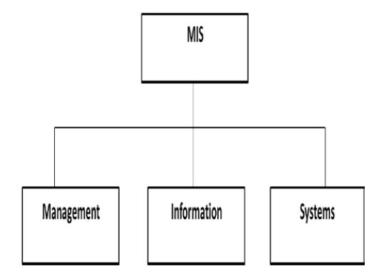

**Figure 2.1: The Meaning of Management Information System (MIS)**

**Source:** Al-Mamary and Aziati (2014)

**Management:** Management is an attempt to coordinate the effort of human and material input in order to achieve set objectives (Ahmed, 2007). It is also defined as a process to achieve organisational goals efficiently and effectively through planning, organising, directing and controlling organisational resources (Al-Mamary & Aziati, 2014).

**Information:** Information is known as data that have been converted into a meaningful and useful context for specific end users. Thus, information is generated through the transformation of data (Al-Mamary & Aziati, 2014).

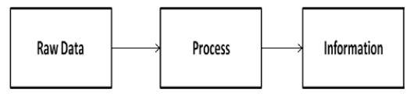

**Figure 2.2: Conversion of data into information**

**Source:** (Al-Mamary & Aziati, 2014)

**System:** A system is a set of interrelated components, with a clearly defined boundary, working together to achieve a common set of objectives by accepting inputs and producing outputs in an organised transformation process (Al-Mamary & Aziati, 2014). Systems have three basic functions: (i) Input which involves capturing and assembling elements that enter the system to be processed. (ii) Processing that involves transformation processes that convert input into output. (iii) Output which involves transferring elements that have been produced by a transformation process to their ultimate destination (O’Brien & Marakas, 2011).

MIS is basically concerned with the process of collecting, processing, storing and transmitting relevant information to support the management operations in any organisations (Ajayi & Fadekemi, 2007). MIS makes management operations easier to collect, store and process the data and retrieve information easily when needed, which increases the efficiency of these companies (Al-Mamary & Aziati, 2014). In education, information is crucial for the purposes of managing, planning and even evaluating the education system. Therefore, MIS has been used in the field of education, adopted in all fields of knowledge and practice thus giving rise to EMIS (Akaranga, & Makau, 2016).

An EMIS is an organised group of information, a centre or a unit that collects, stores, integrates, processes, organises, analyses, manages and distributes information for educational planning and management. It includes the concept of comprehensive data, which are accessible by computer and available for analysis, for processing and decision-making purposes. It is responsible for the promotion and use of information for policy planning and implementation, decision-making, and the monitoring and evaluation of an education system. It provides timely, cost effective and user appropriate information to support educational planning and management (Connal, 2005). He added that data systems are designed to collect, compile, collate and analyse school level data (variables include students, teachers, facilities, finance, and school locations). These systems are often called Educational Management Information Systems (EMIS).

An EMIS is a comprehensive system that brings people, practices and technology to provide quality education statistics in timely, cost-effective, and sustainable manner, at every administrative level, and to support selected operation functions.” (Bernbaum & Moses, 2011). EMIS also refers to the systems and processes used to collect, process and manage information about the Education system. A comprehensive EMIS is defined as not only including administrative and pupil data, but also financial, human resources, and learning data (Abdul-Hamid 2014). This information system for managers of the education system focuses on data collection, storage, integration, analysis and dissemination (UNESCO, 2003).

## **2.3. Components and Infrastructure Supporting EMIS**

MIS is a set of components which interact to produce information, which include hardware, software, data, procedures, and people, whereas these components can be found in every information system (Kroenke, 2007). Additionally, MIS, EMIS applied to education, consists of hardware, software, data, procedures, and people. Hardware refers to computers, storage disks, keyboards, and communication devices while software is relevant to processing programmes. Data or information is included texts, words, sentences, and paragraphs in reports. Furthermore, procedures refer to the methods for using the programme and involved activities. The last element is people. The important role of the *five components* is that MIS is not only computers, programmes, and communication devices, but it also focuses on the assembly of hardware, software, data, procedures, and people; in other words, information system means a system of communication between people (Kroenke, 2007; Davies, 2009).

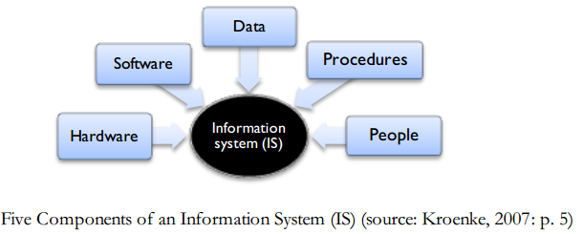

**Figure 2.3: Components of MIS**

According to Heidarkhani, Khomami, Jahanbazi, and Alipoor (2013) indicated management information system is kind of organisational information computer systems, that take internal information from operating processing system and summaries them to Meaningful and useful forms as management reports to use in performing management duties. Advancements in computer software and web-based platforms in the past two decades have allowed for EMIS to be more accessible, affordable and efficient. EMIS tools are primarily open source for large systems, thus allowing multiple individuals to each individual school to contribute information. EMIS can be accessed through installed software or web-enabled tools, increasingly on laptops and smaller devices, such as netbooks and tablets that require less electricity and requirements for cooling and security (Bernbaum & Moses, 2011).

Bernbaum and Moses added that Mobiles or smartphones, as support to EMIS are capable of transmitting data through SMS and specialised applications. Mobile phones are irreplaceable particularly for schools in rural areas without electrification. MIS contains infrastructure, application systems, and personnel who employ information technology to deliver information and communications services for transaction processing/operations and administration/management of an organisation” (Baskerville, Stage, & DeGross, 2000). Hence, the main EMIS components and infrastructures to properly function includes hardware devices, software programmes, procedures, supporting staff, internet, electricity, and data.

Additionally, Information systems (IS) are made up of interrelated components People, hardware, software, peripherals, and networks (O’Brien & Marakas, 2011)

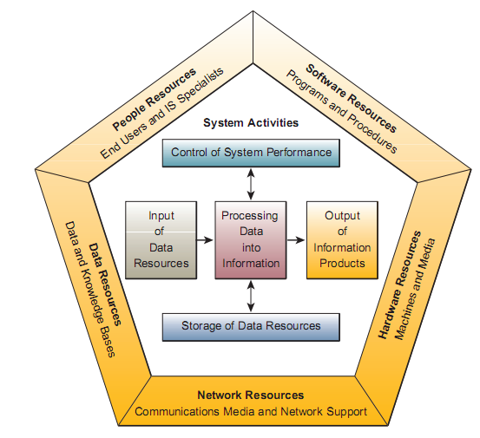

**Figure 2.3: The Components of an Information System**

**Source:** (O’Brien & Marakas, 2011)

Figure 2.4 illustrates an information system model that expresses a fundamental conceptual framework for the major components and activities of information systems. An information system depends on the resources of people (end users and IS specialists), hardware (machines and media), software (programmes and procedures), data (data and knowledge bases), and networks (communications media and network support) to perform input, processing, output, storage, and control activities that transform data resources into information products (O’Brien & Marakas, 2011). All information systems rely on people, hardware, software, data, and network resources to perform input, processing, output, storage, and control activities that transform data resources into information products. People, hardware, software, data, and networks are the five basic components and resources of successful information systems.

## **2.4 Theoretical Framework**

This research was based on the following major theories: Resource Orchestration Theory (ROT), Lazy User Model (LUM), Information Approach, the Task Technology Fit (TTF) Theory, and the Unified Theory of Acceptance and Use of Technology (UTAUT). These theories are all centered on role of EMIS resources including people, hardware, software, data, and networks in the process of EMIS successful implementation to perform input, processing, output, storage, and control activities that convert data resources into useful information.

### 2.4.1 Resource Orchestration Theory (ROT)

Etymologically, Orchestration is the use of various combined musical instruments to get a sonorous effect. An analogy for resource orchestration can be music orchestration, which is the art of composing for an orchestra. In the process of implementing an IS project, many kinds of resources exist and contribute toward attaining the project objectives. Nonetheless, resources have impacts on each other. The term resource orchestration is used to explain the outcome of all resources as a united concept.

Resource orchestration simply means an arrangement of organisational resources which lead the organisation to perform an EMIS project (Dwivedi, Wade, & Schneberger, 2012). Barney (1991) classified resources as being physical, human, and organisational. Resource orchestration theory (ROT) analyses how selection and structuring of human, social, network, financial, and technological resources can be used to exploit opportunities and gain competitive advantage, achieve growth, and create value (Sirmon, Hitt, Ireland, & Gilbert, 2011).

Resource orchestration (ROT) involves structuring, bundling, and leveraging of resources as three broad processes. There are several sub-processes within each process. Structuring involves acquiring, accumulating, and divesting. Bundling involves stabilising, enriching, and pioneering. Leveraging involves mobilising, coordinating, and deploying (Sirmon, et al., 2011). ROT extends this argument to assert that firms must know how to accumulate, bundle, and leverage resources in order to generate sustainable returns (Ahuja & Chan, 2017).

Thus, EMIS successful implementation depends on combination five basic resources: People, hardware, software, data, and network resources. People resources include end users and EMIS specialists, hardware resources consist of machines and media, software resources include both programmes and procedures, data resources include data and knowledge bases, and network resources include communications media and networks. EMIS uses resources of people, hardware, software, data, and networks to perform input, processing, output, storage, and control activities that convert data resources into information products (O’Brien & Marakas, 2011).

### 2.4.2. Lazy User Model (LUM)

Collan and Tetard (2007) futher developed another theory called Lazy User model. The philosophy of the model was to insist on the role of the user in the technology acceptance process where majority of the current popular models are technology focused. Lazy User Model takes the needs and characteristics of the user into consideration and even further sees them as the main players in the technology acceptance and perhaps choosing procedure. According to the model user has the tendency to choose the solution that least demand effort (Collan & Tetard, 2007).

This model recognises that EMIS should take into consideration of the needs of the users and become simple interactive to the users for enabling effective use and adoption. Regarding the complexity of information needed in school management, Education managers need a user-friendly technology that demands less effort in utilisation and decision making. The more EMIS is User-friendly, the more is effectively used and successfully adopted in school management activities. This can successfully lead to the implementation in the management, planning, and decision making.

### 2.4.3. Information Technology Approach

Information technology approach stems from the impact of information technology and the internet on the conduct of organisations, managers and workers alike. This is also due to the impact of information technology on the conduct of organisations with regards the managerial evolution and revolution in response to dynamic environmental changes that are taking place (Jegak, *et al.,* 2009). This shows that EMIS significantly transformed school management by making it faster and effective for planning and decision-marking. Thus, EMIS has reduced the mechanical works and transformed it to electronic ones which are time saving and cost effective. However, this theory ignores the huge financial and human resource investment and maintenance budget in EMIS that educational institutions engage in the implementation. Regardless all expenses to EMIS implementation, EMIS has considerably influenced the effective school management.

### 2.4.4 Task-Technology Fit (TTF)

The task technology fit (TTF) theory states that once the technology fits the tasks that the user must perform can affect individual performance in positive way (Goodhue & Thompson, 1995). According to Goodhue and Thompson (1995), the task technology fit (TTF) theory is the degree to which a technology assists an individual in performing his or her portfolio of tasks and, more specifically, the correspondence between task requirements, individual abilities and the functionality of the technology.

Goodhue and Thompson (1995) further stated that in order to measure the task technology fit, four components affecting performance were identified. First and foremost, Task characteristics which includes non-routineness, interdependence and job title. Secondly, technology characteristics measured focusing on the information system used, as well as the department in which they are used. Thirdly, the utilisation comprises the proportion of times users choose to utilise systems, or the perceived dependence on a system, and lastly performance impact on effectiveness, productivity and performance. Therefore, the technology can impact on the educational management if the design successfully fits the tasks which are done by different users or departments.

EMIS has been specifically designed to support school managers’ responsibilities in order to effectively handle school activities and data for effective school management. Therefore, EMIS has demonstrated a significant impact on the effective school management in financial (budgeting, bookkeeping, procurement, logistics and auditing) and non-financial management activities (enrolment, keeping students’ data and records, maintaining attendance lists, and staff records). EMIS practically transformed school management in terms of planning, evaluation, data management, and decision-making.

### 2.4.5 Unified Theory of Acceptance and Use of Technology

The unified theory of acceptance and use of technology (UTAUT) was proposed by Venkatesh in 2003. The theory seeks to explain the user intention to use an information system, as well as the subsequent behaviour of users. The UTAUT theory holds that there are four main factors determining user behaviour and eventually the user acceptance. These four factors are performance expectancy, effort expectancy, social influence and facilitating conditions (Venkatesh, Michael, Gordon, & Fred, 2003).

According to Venkatesh, et al., (2003), the first of the four constructs, performance expectancy, is the degree to which an individual believes that using the system will help him or her to attain gains in job performance. The effort expectancy regards that the ease of use is actually a determinant of the use of a system or service. The third construct, social influence, signifies the degree to which an individual perceives that important others believe he or she could use the new system. Lastly, facilitating conditions are defined as the degree to which an individual believes that an organisational and technical infrastructure exists to support use of the system. This shows that school leaders can promote the use of technology in schools by establishing the following: making the use of technology a priority; establishing a technological infrastructure; focusing on development and; creating training opportunities and support for staff (Chitolie-Joseph, 2011).

The theory supports the unified and combined efforts for achieving the effective implementation of EMIS in any school. This means that EMIS can recognise the activity performed by each user to fit his purpose. Schools are invited to put in place facilitating conditions and resources (financial and non-financial resources) to achieve the best results in the implementation of EMIS in school management. No part of resources can be ignored for fully and successfully implementation of the EMIS for enabling effective school management.

## **2.5 EMIS and Effective School Management**

EMIS significantly influences effective school management. The primary purpose of MIS is to help an organisation achieve its goals by providing managers with insight into the regular operations of the organisation so that they can control, organise, and plan more effectively (Babu & Sekhar, 2012). In addition, MIS provides the right information to the right person in the right format at the right time. MIS plays a strategic role in the life of organisations, it provides the management with appropriate information and in the right place and time to help the management to do various functions of planning, organising, directing and control and decision-making (Al-Najjar, 2010). Every organisation in this era needs MIS to keep track of all business activities (Nowduril, 2012). Managers cannot ignore MIS because they play such a critical role in contemporary organisations. Today’s systems directly affect how managers decide, plan, and manage their employees, and, increasingly, they shape what products are produced, and where, when, and how.

EMIS is a key ingredient for effective school management. EMIS has the following major functionality: (1) maintains student records including biographies, attendance, achievement, discipline and accounts; (2) maintains staff records; (3) produces standard reports; (4) keeps school accounts; (5) prepares student report cards and transcripts; (6) tracks incidences and attendance and; (7) performs scheduling and timetabling (Chitolie-Joseph, 2011). EMIS uses the data for assessing school performance, improving accountability, and managing resources. An effective EMIS is utilised in decision making by all users (parents, students, teachers, principals, and policy makers) across the education system to access school information. EMIS aims to help schools improve data collection, data and system management, and data use in decision making (World Bank Group, 2017). EMIS is mainly used in financial and non-financial management of schools.

### 2.5.1. EMIS and School Financial Resource Management

EMIS plays an important role in school financial management. EMIS accumulates and analyses financial data in order to make good financial management decisions in running the Education System (RMSA-TCA, 2015). Outputs generated by an EMIS include accounting reports, operating and capital budgets, working capital reports, cash flow forecast, and various What-If Analysis reports. The evaluation of financial data may be performed through ratio analysis, trend evaluation, and financial planning modelling. Financial planning and forecasting are facilitated by EMIS.

EMIS provides budgetary, financial accounting data and cost standards for all types of expenditures (Cuartero & Role, 2018). EMIS includes financial data such as budget and revenues spending, cash transfers and subsidies, unit cost per student (World Bank Group, 2017). A good EMIS supports adequate reporting, policy decisions, fiduciary responsibilities, and preparation of auditable financial statements for the Education System. An effective EMIS can include modules for general ledger, budgetary accounting, accounts payable, accounts receivable, payroll system, budget development; procurement; project ledger; asset management (RMSA-TCA, 2015). It is important to capture all financial contributions to the school as well as to record the expenditure along expenditure budget lines. It is important to understand what funds the school receives and how it expends funds. This will allow proper analysis of the school financial management (RMSA-TCA, 2015).

### 2.5.2 School Non-Financial Resource Management

EMIS significantly contributes to the management of school non-financial resources. EMIS enables schools to be cost‐efficient and effective in their education Planning and service delivery. EMIS helps policy makers manage an education system to produce quality outputs (Cuartero & Role, 2018). EMIS Data and information generates statistics on the flow and stock of students for each type of level of education, cross-classified by grade or year, sex and age. EMIS also serves as source of data and information on personnel retirement, accumulation or utilisation of leave credits, recruitment, placement, training, promotion, and disciplinary action (Cuartero & Role, 2018).

EMIS plays a significant role in helping the education policymakers, decision-makers, and managers to make timely and good decisions. In general, for every EMIS data collection exercise, four categories of data are collected. They are basic school information, basic teacher information, basic non-teacher information, and student enrolment information (Mohamed, et al, 2009). EMIS is also used to manage physical facilities. This enables the schools to obtain information regarding the number and status of school sites, buildings and school equipment (Cuartero & Role, 2018). The schools can easily obtain the academic and administrative data. This includes school and individual level demographic data on schools, students and teacher’s health attendance (enrollment, repetitions, dropout, progression, etc.). EMIS also enables schools to manage human resource data. This entails staff general demographics, salaries, performance evaluations, professional development (World Bank Group, 2017).

Additionally, et al., 2006) stipulate that a school information system is an information system based on one or more computers, consisting of a data bank and one or more computer applications which altogether enable the computer-supported storage, manipulation, retrieval, and distribution of data to support school management. This emphasised that EMISplays a great role in aspect of administrative support functions namely tracking students’ attendances, test scores, students’ data, teaching staff and administrative data, professional development, finance, budgeting, external data reporting, and salary management.

## **2.6. EMIS Trainings and Staff Technical Competence**

Training and Technical competence of staff are the key to the successful implementation of EMIS. Experts to train and use EMIS are needed for a smooth implementation of EMIS. Schools require more opportunities for training EMIS staff and data users (World Bank Group, 2017). Providing training and support to school managers and decision-makers in their efforts to effectively use and analyse the data that the EMIS is at the heart of the success. Training in the use of the EMIS must be given to whoever is responsible for managing and using the system. This point reiterates the need for a budget to undertake these tasks (Chitolie-Joseph, 2011).

Throughout the process of EMIS implementation, school administration must emphasise sustainability and continuous improvement through training and building capacity to support, use and improve the system into the future (RMSA-TCA, 2015). EMIS staff and data providers often find them handicapped because of lack of training on using the system. Schools must focus on creating a policy enabling continuous training for data users (including EMIS staff, principals, teachers, and parents) to analyse information and generate necessary reports that can be used by decision makers across the system to assist in development of new policies and other key strategic decisions (World Bank Group, 2017). Schools requires to facilitate capacity building, support and training on collection, processing and analysis, dissemination and use of information at all levels of education (Gxwati, 2011).

EMIS user guide Manual is needed for continuous professional development. An operational manual can guide EMIS staff on how to collect and manage education data. It contains basic information such as definitions of EMIS concepts, indicators collected, and metadata (World Bank Group, 2017). Technical competence concerning the EMIS can be ensured through provision of the training in the use of the system to new and continuing teaching and administrative staff (Chitolie-Joseph, 2011). EMIS should facilitate capacity building, support and training on collection, processing and analysis, dissemination and use of information at all levels of education (Gxwati, 2011).

Luena (2012) contended that staff needs more training and sensitisation to be able to accept and access EMIS data. It can be more feasible to conduct orientation programmes and training sessions regularly for the management staff in order to familiarise them with all areas of EMIS specialties that might help to nurture a sense of ownership and make them consider EMIS among the ministry’s key priority areas that need allocation of a considerable amount of funds and other resources that can sustain its functions.

## **2.7 Relationship between EMIS and School Management**

There is a significant relationship between EMIS and effective school management. There are many roles of EMIS in any school, for example to increase an operation’s efficiency, to process transactions, to provide decision support, to monitor and evaluate employees’ performance, and to maintain documentation and communication channels (Gurbaxani & Whang, 1991). MIS can help all kinds of businesses improve the efficiency and effectiveness of their business processes, managerial decision making, and workgroup collaboration, which strengthens their competitive positions in rapidly changing marketplaces.

Information technologies and systems are, quite simply, an essential ingredient for business success in today’s dynamic global environment (O’Brien & Marakas, 2007). Therefore, responsibility for systems cannot be delegated to technical decision makers (Laudon & Laudon, 2006). MIS hasbecome as integrated into our daily organisation management activities as accounting, finance, operations management, marketing, human resource management, or any other major business function. MIS and technologies are vital components of successful organisations. Some would say they are business imperatives.

EMIS provides reports to various educational managers which in turn help predicting the future performance of the organisation (Nowduril, & Al-Dossary, 2012). Uses of EMIS information include, but are not limited to, informing monitoring and planning of the education sector through indicators that monitor the performance of an education system and to manage the distribution and allocation of educational resources and services (RMSA-TCA, 2015).

EMIS can potentially provide a powerful management tool capable of contributing to the improvement of educational performance. It enables decision makers to identify problem areas, reduce operational costs and provides a systematic way of addressing educational challenges. If effectively implemented, the EMIS can raise educational awareness, motivating employees to search for innovative solutions and increasing educational efficiency (Gunningham, 2007). In addition, another major function of the EMIS, other than collecting, storing and processing information, is to facilitate detailed analysis and synthesis of data in order to draw upon the most relevant information to help in educational planning and policy decision-making (Carrizo et al. as cited in Ahmed, 2007. The EMIS causes a shift from how to measure and analyse, to what to measure and how to present the information to management (Chapman & Boothroyd, 1988).

The main purpose of an EMIS is to integrate information related to the management of educational activities, and to make it available for the decision makers, as well as the other parties, to use in helping them to make the correct decision (Connal, 2005). In other words, the purpose of an EMIS is to provide the necessary information to the right person, at the right time, for use in management decisions (Yuen & Duo, 1989).

EMIS is an important procedure in capturing, processing, storing, retrieving, updating and deriving up to date information that is essential in managing the daily functions of schools. This facilitates follow up activities on routine-based matters which are vital in effective school planning and improvement (Akaranga, & Makau, 2016). EMIS improves management, planning, monitoring and evaluation of the education system. EMIS plays a significant role in the effective school management and enables access to information and data that supports resource allocation, education policy and planning, local, national and international reporting, education administration innovation, efficient administrative practices, and strengthened accountability (RMSA-TCA, 2015).

EMIS ultimately support the management, planning, monitoring and management requirements of all stakeholders: school managers and administrators, parents and local communities, department of education - national, state, district and block, department of finance, statistical bodies, development partners such as non-government organisations (NGOs) and private schools (RMSA-TCA, 2015). Bernbaum and Moses (2011) also emphasised on the contribution of EMIS to effective school management in the areas of education planning, decision making, schools census, secondary school attendance, information on student–teacher ratios and class sizes.

Heidarkhani et al. (2013) on the other hand pointed out the role of EMIS in school management in the areas of communication, accurate monitoring and gathering data more reliable, faster processing and converting data into managers’ information, planning, organising, leading and motivating and controlling. They added that EMIS does management actions with the utmost accuracy efficiency within very less time in organisation.

Billeh (2001) confirmed the role of EMIS in school management of statistics in data collection, verification, computerisation, classification and categorisation on a scientifically consistent basis. He pointed out four major functions of EMIS in school management as follows: firstly, facilitating data circulation and accessibility by educational decision-makers as well as educational specialists, researchers and other parties concerned with educational development and qualification. Secondly, translating the educational situation in different types of educational institutions into statistical figures and enabling educational planners and policymakers to explore the future perspectives through comprehensive statistical indicators.

Thirdly, standardising the data pertaining to different directorates and educational departments according to their respective needs and data computerisation by special software for easy access as required. Fourthly, retrieving numerical reports of qualitative indicators through cross-tabulation of several variables from the educational questionnaires and the publication of annual educational statistical reports. Therefore, EMIS is potentially considered to be a powerful management tool capable of contributing to the improvement of effective school management. It enables education decision makers to identify problem areas, reduce operational costs and provides a systematic way of addressing educational challenges.

## **2.8. Challenges of EMIS Implementation**

EMIS implementation and development is not a smooth journey. It is a challenging journey with several obstacles. Beaumaster (1999) identified and categorised problematics issues regarding the IS implementation. These issues create or worsen the implementation process. The more specific categorisation of the issues can be viewed as management process issues (budgeting, personnel, and general management), organisational environment issues (organisational culture, change, and behaviour), leadership issues (hardware and software considerations), technical systems issues, and personnel issues.

**Table 2.1: Categories of MIS Implementation Challenges**

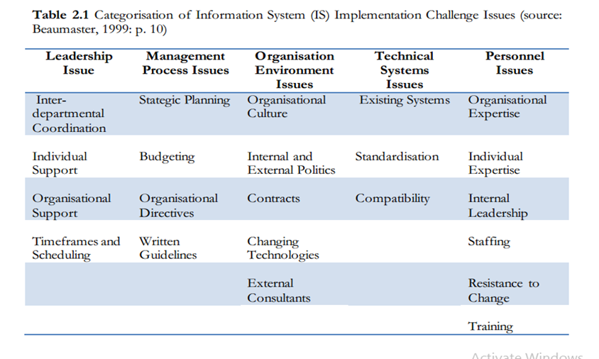

**Source:** Bcaumaster, (1999)

Four other categories of challenges also were identified: weak data systems; human resource constraints; non-use of education data; and issues in education data reporting (Baghdady & Zaki, 2019). In some schools, lack of proper structure in the country, lack of knowledge and inadequate training of the staff were identified as the shortcoming of the EMIS (Saxena, 2014). Unfortunately, many countries have invested resources in building Educational Management Information Systems, but these systems are often not institutionalised, lack a guiding vision, and are not incorporated into strategic planning processes (Cuartero & Role, 2018). Lack of data awareness, Internet access, and limited communication and training prevent most stakeholders outside of central level from accessing and using EMIS (World Bank Group, 2017).

In the pursuit of quality education for all, the significance of timely, cost effective, and accurate data in evaluating education policy, determining education planning, and monitoring of the progress towards attainment of development goals is increasingly important. The quality of education and monitoring and evaluation require updated and relevant data with the leadership of the school head to make decision making effective (Cuartero & Role, 2018). However, the costs incurred on activities such as software upgrades, training, and system maintenance are not covered in the budget.

EMIS budget should include the following categories: (a) data collection, (b) auditing, (c) staffing, (d) training and professional development, (e) data dissemination, (f) infrastructure, and (g) regular maintenance of system (World Bank Group, 2017). The results of also indicates the factors such as technical, software, training and support, EMIS leadership and EMIS access, all affected the use of the EMIS (Chitolie-Joseph, 2011). Additionally, less attention to procurement of appropriate hardware and software. Inadequate funding ultimately results in poor training and support of system users (Gxwati, 2011). Billeh (2001) also discovered the key finance problems related buying the equipment, and softwares.

Weak data systems are also another challenge in EMIS implementation. The quality and strength of the systems vary country; however, policy and legislative changes are required to further strengthen EMIS by closing data gaps, improving data coverage, ensuring the decentralisation of national EMIS at the provincial level, and better securing the capacity of EMIS staff (UNESCO, 2015).Common problems with sustaining credible EMIS, as noted in Malawi and Uganda, were lack of enough funds for EMIS; misalignment of activities and unrealistic EMIS goals; inconsistent leadership overseeing EMIS staff and missed integration opportunities (Abdul-Hamid as cited in Baghdady & Zaki, 2019). Databases are not electronically linked between the districts, provinces and the central EMIS office, with the disadvantage being that sometimes information can only be accessed at the head EMIS office thus preventing provinces and districts from conducting their own analysis. In other cases, servers for the EMIS were in another country and the EMIS unit had to request the company to extract and produce national statistical outputs (UNESCO, 2017).

Human resources and technical competence were revealed to be important challenges. In their study, Bernbaum and Moses (2011) also documented challenges faced using EMIS in school management, specifically the turnovers in the position of school mangers, problems related to access of funds, problems of internet connectivity at the district and school level, and limited capability among staff and users to interpret data. A recurring challenge across the region is the high turnover of qualified EMIS staff in the Ministries, particularly planning directors. This largely has to do with low salaries making it difficult to attract and retain qualified personnel (Baghdady & Zaki, 2019).

Technologies involved in EMIS require technical expertise that is not always available within the government or from local contractors (Bernbaum & Moses, 2011). There is acute shortage of trained personnel in application software, operating systems, network administration and local technicians to service and repair computer facilities. Those who are designated to use computers in Nigeria do not receive adequate training, at worst, do not receive any training at all (Okebukola, 1997).

It was observed a Non-use of education data from EMIS. evidence has shown that data have not been consistently utilised by senior officials and policymakers within ministries of education. The non-use of data can occur when there is a lack of capacity to make data available or because senior ministerial staff choose not to use data that contradict official views or out of fear it will damage their credibility or subject them to heavy pressure from the executive branch of government (Bernbaum & Moses, 2011).

Shooebridge (2006) identified challenges related to inadequate fund for EMIS development and maintenance, insufficient equipped computer laboratories, data entry, the integration challenge has to do with organisational constraints. EMIS in Nigeria faces problems in the implementation of EMIS corresponding to lack of capacity, limited commitment from stakeholders and difficulties associated with the collection of survey data (Chapman and Mahlck as cited in Stephen & Cummings, 2009).

Critical factors limiting the development of EMIS are threefold: (i) knowledge and skills to lead and manage EMIS development; (ii) knowledge and skills to use technology; and (iii) knowledge and skills to use data effectively for decision making, policy analysis and planning (Academy of Educational Planning and Management(AEPM), 2007). Continuing challenges to the integration of technology in teacher education programmes include availability and access to equipment, funding limitations, training, and instructional and technical support (Duhaney, 2001). Thus, schools need to make sure that all challenges are dealt with efficacy to avoid the failure of the development and implementation of EMIS.

A report demonstrated various challenges encountered in the implementation of EMIS in Rwanda. Those challenges include: (i) The data collection and reporting of EMIS, (ii) Data integration from various EMIS systems and difficulty to harmonise which affect data quality, (iii) Lack of adequate staff and institutional capacity to effectively manage, analyse and report on the data collected, (iv) limited provision for checking data quality across the systems, (v) limited availability of ICT resources at schools, sectors and districts, (vi) current information systems are very weak in tracking assets, labs, learning objects, library resources, attendance, planning and scheduling and interaction between students, teachers and school management. (vii) A significant data gap also exists in the information that is relevant to assessment, human resources management, procurement and school inspection (Ministry of Education, 2020). This shows that the process of EMIS implementation in Rwanda has not been a smooth journey. It faces various challenges that hinder the process which require an investigation through a study.

## **2.9 Factor Supporting EMIS Development and Implementation**

There are important critical factors that support effective EMIS development and implementation. EMIS implementation is a long process that needs to be supported to be a success. EMIS development is a long-term undertaking which needs take-off funds for training, maintenance and to acquire the necessary hardware and software (Mugerezi, 2002). Tripathi and Vidyapeeth (2011) stressed that, in life cycle approach, the MIS development is carried out through different phases. Those phases are feasibility study, analysis, design, implementation and review. The choice of MIS design is decided based on nature of the system and its applications. Thus, the MIS is developed over time as the business increases. Jawadekar (1998) noted that the development process of MIS relates with the long-term business plans of the organisations. MIS requires resources like capital, time and capacity.

Bernbaum and Moses (2011) stated that the workable implementation of EMIS depends on three factors. Firstly, the right people, motivated to perform and skilled in their work. Secondly, the right processes that reduce duplication and reinforce accuracy and accountability. Thirdly, the right technology, appropriate to the state of the country, and the reliability of its infrastructure. Bernbaum & Moses added that people are frequently the slowest to change and the hardest to affect directly. Both technology and processes can be altered quicker, but people can delay reinstituting new value structures and working methods. They further mentioned that people-related issues typically are resolved through modeling good behaviour in terms of skills use, work habits, and approaches to learning new skills, making appropriate technical assistance available when needed to keep a small problem from festering and becoming bigger background, and training repeatedly and sufficiently until concepts and practices are reinforced.

Curlee and Tonn (1987) revealed three reasons that can make MIS failure or a success. The reasons are related to MIS technological facilities adequacy, availability of qualified staff and conflict from organisation goals, purpose and MIS. He also mentioned that technological facilities adequacy refers to the capital components that are composing MIS, hardware and software components. The labor availability can also be another factor that can lead to the success or failure of MIS. When the level or skills of users is low this can significantly impact on the results and the whole process of using MIS. He further mentioned that the implementation of MIS needs adequate preparation and resources in terms of time, educational materials, and instructors for training system users.

Another dimension to be considered is the timing and availability of training for users Curlee and Tonn (1987). He recognises that the more sophisticated or intellectual technology is, the more sophisticated and ongoing adaptive training will be necessitated. He mentioned that the users will be more dedicated to the use of MIS depending on the functions or responsibilities that they fulfill in the organisations. This means that the users will fulfill the duties with MIS considering their level of understanding organisation objectives.

Mpofu (2010) on the other side pointed out the factors that lead to the success or failure of MIS. The first factor is the presence of a policy statement within countries or organisation spelling out the importance hence the need for the implementation of MIS. Policies with set milestones are critical but there must be a system in place to monitor and evaluate progress, benefits, difficulties, experiences, effectiveness and efficiency of the system. This allows either change of course or fine tuning where necessary. The second factor that directly hinders success or cause the failure of an MIS in the livestock sector is infrastructure. This is in terms of telecommunication infrastructure to enable transfer of data and information via telephones (fixed and or mobile), and internet. The third factor is to avail information to users and train users. Therefore, MIS should be clear to all users and interconnections between users.

Lyytinen and Hirschheim (1978) identified major groups of MIS failure reasons. First and foremost, Technical and operational reasons: lack of sophisticated technology. Secondly, Individual reasons: lack of fit of the IS to users’ capabilities (cognitive style, stress adaptation, motivation). Thirdly, user-based reasons: Users’ insufficient skills and capabilities, and their limited knowledge of computing. Lastly, Implementation reasons: lack of sufficient attention to organisational implementation. This shows that MIS infrastructures and facilities, training for users and resources either financial or non-financial are required for suitable implementation of MIS.

Heidarkhani, et al., (2013), in their study on MIS, found many factors that can be the cause of failure or success to the implementation and use of MIS. These factors are financial resources, expert personnel, skilled, motivated and qualified staff, low level of users, and poor provision of hardware and software facilities. DeLone and McLean (1992) found the factors that contribute to MIS success. One result of their work was a taxonomy, which classifies MIS success into the following six categories system quality, information quality, use, user satisfaction, individual impact and organisational impact.

According to Gxwati (2011), EMIS development and implementation philosophy requires consideration of the following: (1) Appointment of an EMIS experts; (2) Development of an information systems strategy, (3) Training programmes: Without training provided to clients the information system is faced with challenges; (3) Take-off funds: the development and implementation of EMIS require a sustained budget to ensure that the information system will not be a ghost. Management must make sure that enough funds are allocated to develop and implement the EMIS of an organisation; (4) Management support: the support of management is critical for the development and maintenance of EMIS.

Billeh (2001) revealed that the development and implementation of educational management information system requires a significant financial and human resource investment, an investment which, in contexts of deprivation, can only be justified if the benefits gained clearly outweigh the costs. Fundamental for EMIS success is a comprehensive and ongoing capacity building programme for Ministry of Education staff at multiple levels those factors in the inevitable staff turnover and ensures that existing staff acquire new skills as new requirements emerge through intensive staff-training programme.

## **2.10 EMIS Development and Policy in Rwanda**

Rwanda promulgated its national ICT policy in 2000 with 10 pillars: ICT in education, human capacity development, infrastructure, equipment, and content, economic development, social development, E-government and e-governance, private sector development, rural and community access, legal, regulatory, and institutional provisions and standards, national security, law, and order (Farrell, 2007). Ministry of Education (2010) stated the role of use of technology in Management of information and data as access to timely and accurate management data is a pre‐requisite for effective school management and monitoring.

Ministry of Education and Ministry of Finance and Economic Planning established EMIS through School data management system (SDMS). The School data management system is a web-based application designed by the Ministry of Finance and Economic Planning (MINECOFIN) and Ministry of Education. The main objective of SDMS is to strengthen the Public Financial Management systems. It aims at improving Students’ Data management, processing of school financial transactions and it allows easy and timely access to reliable information for the allocation of capitation grant and school feeding money to schools. SDMS ensures improved efficiency and effectiveness in government financial management, increases availability of comprehensive financial information, planning, and budgeting process at school level (Ministry of Finance and Economic Planning, 2019).

EMIS has been developed to collect primary source data relating to all education institutions. The EMIS enables MINEDUC to monitor education activities at school, district and national levels, and to aggregate and disaggregate information by various criteria such as enrolment, transition, completion, repetition, drop‐out rates, textbook and student/teacher ratios, examination results and teacher qualifications. All authorised education officers at national and district level have access to the data in EMIS which will reduce the need to request information from schools, districts and agencies. Schools will also be able to access information to enable them to measure their performance against other schools. This process supports school level planning and prioritising (Ministry of Education, 2010).

EMIS development is a long-term undertaking which needs take-off funds that must be increased annually for training, maintenance and to acquire the necessary hardware and software (Mugerezi, 2002). Despites much investment in EMIS development and implementation, they remain plenty of challenges related to the extent and quality of ICT infrastructure and access to the internet by all schools, computer hardware, the skilled resource pool is small, gaps in analysis of data, and scarce financial resources(Farrell, 2007).

## **2.11 Research Gap Identification**

The reviewed literature provided a detailed discussion on the key variables of interest in this research. However, there are few gaps in the reviewed literature to be addressed. Researches have been conducted on EMIS and Effective school Management by various researchers in different countries. Firstly, the researcher did not find a similar study carried out in Rwandan context establishing relationship between EMIS and effective secondary school management. Secondly, studies have been carried out to demonstrate use of EMIS for enhancing effective school management leaving out the standing of components and infrastructures of EMIS and the specific role of EMIS in both financial and non-financial management of secondary schools in Rwanda.

Thirdly, there was a growing concern to assess the impact of EMIS user proficiency or technical competence and the effectiveness of delivered trainings on school managers and staff in secondary schools in Rwanda. Lastly, there was an urgent need to disclose and figure out the challenges and propose solutions to the Ministry of Education in Rwanda for effective implementation of EMIS. This provides a unique opportunity to investigate the impact of EMIS on effective school management in secondary school in Rwanda. The results from this research including recommendations are intended to bridge the research gap.

## **2.12 Summary**

The main literature reviewed is relevant and key to this study. The first part discussed the key concepts of MIS and EMIS. Secondly, part two discussed the components of EMIS. The third deliberated theoretical framework based on four theories the task technology fit (TTF) theory, lazy user model, the unified theory of acceptance and use of technology (UTAUT). Additionally, the task technology fit (TTF) theory recognizes that the degree to which technology fits the users’ tasks. This can assist and increase individual performance in a positive way. The unified theory of acceptance and use of technology (UTAUT) stated that the users’ intention must be clear and clearly defined in order to effectively use an information system.

The last part of the literature review dealt with empirical analysis. The empirical analysis discussed about Factors that support implementation of EMIS relationship between EMIS and effective School management. It also reviewed EMIS and policy in Rwanda, Africa and other countries. The part also dealt with challenges faced by educational institutions in the implementation of EMIS.

# **CHAPTER THREE**

# **RESEARCH METHODOLOGY**

## **3.1 Overview**

This chapter provides the research framework and design within which data were collected and analysed. It specifies the research paradigm, design employed, target population, the area of the study, sample size and characteristics, instruments and techniques used for data collection. It also displays research variables, data processing and Data analysis techniques.

## **3.2 Research Paradigm and Approach**

This study adopted a positivism paradigm. The positivist paradigm of exploring social reality is based on the philosophical ideas of the French Philosopher August Comte. According to Comte, observation and reason are the best means of understanding human behaviour; true knowledge is based on experience of senses and can be obtained by observation and experiment. At the ontological level, positivists assume that the reality is objectively given and is measurable using properties which are independent of the researcher and his or her instruments; in other words, knowledge is objective and quantifiable.

Positivistic thinkers adopt scientific methods and systematize the knowledge generation process with the help of quantification to enhance precision in the description of parameters and the relationship among them. Positivism is concerned with uncovering truth and presenting it by empirical means (Henning, Van Rensburg & Smit, 2004). The researcher applied the positivist principles by collecting objective data and analysing data using empirical means. The study was based on objective and quantifiable data to make general conclusions.

This study adopted the positivist paradigm by setting research instruments to be objective and able to collect quantifiable data. The research was designed to produce the empirical generalizations by employing quantitative methods for the collection and analysis of data. Responses, and observations from the respondents were collected and quantified into quantitative data in terms of frequencies, percentages, mean, and standard deviation to enhance precision. The research enabled the measurement of correlation between the dependent and independent variables.

## **3.3. Research Design**

There is no single blueprint for planning research. Research design is governed by the notion of fitness for purpose. The purposes of the research determine the methodology and design of the research (Cohen et al., 2007).The purpose of this study is to investigate the impact of use of EMIS on effective school management in schools of excellence in Nyarugenge District. This study therefore followed descriptive-survey design based on the principles of the quantitative design. The researcher adopted descriptive survey design with intention of ensuring that situation is fully described in order to acquire more substantial and reliable information about the use of EMIS in school management related activities for making reliable conclusions.

The descriptive survey design was used to identify variables, collect responses from respondents and examine relationships among them. However, this design did not change or manipulate variables. Major forms of this research, descriptive-survey design, were relationship studies between two variables namely independent and dependent variables (Ary, Cheser, & Sorensen, 2010). The study used instruments such as questionnaires, documentary analysis and interviews to gather information from groups of individuals. The main purpose was to describe and represent the existing conditions and situation.

According to Aggarwal (as cited in Salaria, 2012), a descriptive survey research is dedicated to the gathering of information about prevailing conditions or situations for the purpose of description and interpretation. This type of research method is not simply amassing and tabulating facts but includes proper analyses, interpretation, comparisons, identification of trends and relationships. Lodico, Spaulding, and Voegtle (2006) stated that “these descriptions are then summarised by reporting the number or percentage of persons reporting each response”. Creswell (2009) explained that a descriptive survey design provides a description of trends, attitudes, or opinions of a population by studying a sample of that population. From sample results, the researcher generalizes or makes claims about the population.

The descriptive survey design also was used to ensure that characteristics of variables of interest in a situation are described based on the data for both primary and secondary sources. This study collected the data from respondents, about numeric description of trends, attitudes, and opinions. Hence, data were presented in tables, figures, percentages, and numbers and narrative forms. Finally, data was interpreted, and analysed to demonstrate relationship between variables including EMIS and effective school management. Lastly, data described and discussed were used to draw conclusions and recommendations.

## **3.4 Research Area**

This study was carried out in an educational setting. It touched more specifically in the area of use of technology for effective school Management in Education sector. This research area was in Nyarugenge District, Kigali City, Rwanda. Nyarugenge District is in the West of Kigali City. Nyarugenge District has primary and secondary schools. Specifically, the study was conducted in four schools named Schools of Excellence or Centres of Excellence. The study area, Schools of Excellence in Nyarugenge District, was chosen due to interest of the researcher in the area of use of EMIS, and a will to contribute towards EMIS field by providing solutions to the challenges of the use of EMIS. Additionally, the interest due to available resources, accessibility and availability of data and information related to use of EMIS for school management in Schools of Excellence in Nyarugenge District with consideration of research timeframe, and nature of degree specialisation in Educational policy, planning and administration.

## **3.5 Description of Target Population**

According to Ary, Cheser, and Sorensen (2010), “the population refers to the larger group to which a researcher wishes to generalize; it includes all members of a defined class of people, events, or objects”. In other words, the target population refers to the large group to which the researcher wishes to generalize the results of the study. The population refers to the group to which the researcher would ultimately like to generalize or apply the results of the study (Lodico, Spaulding, & Voegtle, 2006). Best and Kahn (2007) also stated that a population is any group of individuals who have one or more characteristics in common that are of interest to the researcher. The population may be all the individuals of a particular type or a more restricted part of that group”. In this study, the target population was the secondary school management board and teaching staff that participate in the day-to-day school management activities in four schools called Schools of Excellence or Centres of Excellence described in the background of the study.

**Table 3.1: Targeted Secondary Schools of Excellence in Nyarugenge District**

|  |  |
| --- | --- |
| **Targeted school** | |
| **Schools of Excellence** | |
| 1. | Lycée de Kigali |
| 2. | Lycée Notre Dame de Citeaux |
| 3. | College de Saint Andre |
| 4. | College de Butamwa |

**Source:** Survey Data (2018)

Table3.1 indicates that the study was conducted in four secondary four Schools of Excellence or Centres of Excellence. The four schools include Lycée de Kigali, Lycée Notre Dame de Citeaux, College de Saint Andre, and College de Butamwa. All schools are located in Nyarugenge District.According to the Ministry of Education (2008), under School management training manual for secondary school Head teachers, indicated that the School administration and management has the responsibility of managing human, material, financial, legal and technological resources.

Furthermore, MINEDUC (2008), under The School management training manual for secondary school Head teachers, identifies the secondary school administrative and management staff as the staff in charge of the general administration and management of the school. The secondary school administrative and management staff is constituted of the Head teacher, the “Prefet” of studies (also called deputy head teacher in charge of studies), the “Prefet” of discipline (discipline master), the Bursar, and the Secretary. PRIMATURE (2016) also outlines the secondary school management authorities as follows: Headmaster; Deputy Headmaster in charge of studies; Deputy Headmaster in charge of discipline; the Bursar; and the Secretary.

**Table 3.2: Target population in Schools of Excellence in Nyarugenge District**

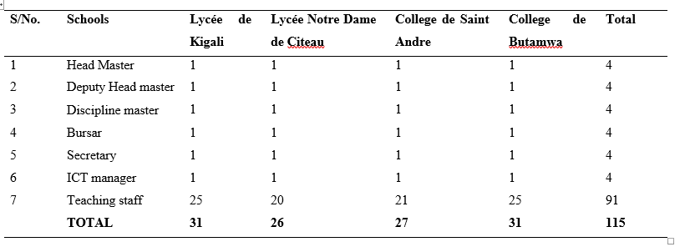

**Source:** Research Data (2018)

Due to the purpose and the nature of the study, the target population includes 6 permanent staff from each school of excellence namely Headmaster; Deputy Headmaster in charge of studies; Deputy Headmaster in charge of discipline; the Bursar; ICT Manager and the Secretary. In 4 schools, the school management board members who involved in day to day management activities in 4 secondary schools which makes 24 respondents. Additionally, the target population also includesthe 91teaching staff who are also involved in non-financial school management activities, like accessing students, data base and information for more organising learning environment is included to exhaust and reach useful source of information. Total estimated target population in four schools of excellence is raised to 115 respondent who constituted the set of participants and respondents to this research.

## **3.6 Sample Size and Sampling Procedures**

A sample is a group selected from a population for observation in a study. Similarly, a sample has been defined as a group chosen from a larger population with the aim of yielding information about this population as a whole is termed as sample. It is a miniature picture of the entire group or aggregate from which it has been taken. It is a smaller representation of a larger whole(Ary, Cheser, & Sorensen, 2010). A good sample not only needs to be representative; it needs also to be adequate or of sufficient size to allow confidence in the stability of its characteristics (Salaria, 2012). Due to the nature of the study, purpose and objectives, the study used both purposive sampling and simple random sampling type.

Ary, et al., (2010) explains that “purposive sampling, also called judgment sampling, refers to sample elements judged to be typical, or representative, are chosen from the population”. The researcher selected the key respondents in a position to hold the useful information about EMIS technological facilities to the study. Hence, the purposive sampling was used to select school management board and IT managers. For teaching staff, the study employed simple random sampling because all member of that part of population have an equal and independent chance of being included in the random sample (Ary, Cheser, & Sorensen, 2010).

Singh and Masuku (2014) points out the sample size criteria in any research sampling procedure. They further state that in addition to the purpose of the study and population size, five criteria usually need to be specified to determine the appropriate sample size: Analysis, variation, precision, availability and cost of investigations. In the same line, Yamane (as cited in Kasunic 2005) provides a simplified formula for proportions called Slovin’s formula to calculate sample sizes. The formula was utilised to find out the sample of this study. This simplified formula assumes a 95% confidence level and the maximum variance (p = 0.5). The formula is as follows:



Where,

**n** is the sample size.

**N**  is the population size

**e** specifies the desired level of precision, where precision e = 1- precision

p = 0.5

Applied to this study,

In this study, N (the population size) is 115

**e** = margin of error =1-0.95 = 0.05

**n** (The sample size) =115/1+115(0.05) ²=90

**Table 3.3: Summary of Sample Size**

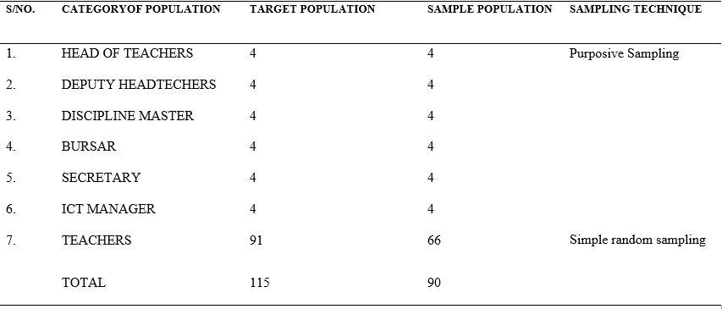

**Source:** Research Data (2018)

Table 3.3 shows the category of the population, the target population, the sample size, and sampling technique used. The target population was 115 participants in all four schools of excellence. According to the formula provided by Yamane (as cited in Kasunic 2005), the table also shows that the sample size of this study was 90 personnel, from Nyarugenge District, in four targeted schools of excellence. Both purposive and simple random sampling techniques were used to select the participants in this study from four schools of excellence in Nyarugenge District depending on the category where they belong. Purposive sampling was used for Head-teachers, Deputy Headteachers, Discipline Master, Bursar, Secretary, and IT manager due to their uniqueness and one stand role in the school and information they possess on the use of EMIS. Then, Simple random sampling was used for selection of teachers to fit their number into the sample size.

## **3.7 Data Collection and Instruments**

Data are described as the information obtained during an investigation or a study (Polit & Hungler, 1999). In this study, data were collected using though the main three instruments: Questionnaires, Observation Checklist, and Documentary analysis.

### 3.5.1 Questionnaires

A questionnaire refers to an instrument in which respondents provide written responses to questions or mark items that indicate their responses (Ary, Cheser, &Sorensen, 2010). The major research instrument used in this study is self-administered questionnaire. Questionnairewere designed using a Likert scale of 1-5 (Strongly Agree; Agree; Neutral; Disagree; and Strongly Disagree). Thus, questionnaires were distributed to head teachers, deputy head teachers, discipline masters, secretaries, bursars, teaching staff membersand ICT manager in all selected schools. This instrument enabled the researcher to collect information from different particular mentioned groups about the standing of components, school infrastructures for EMIS, EMIS’ use in the school management, the impact of delivered trainings, and challenges in the implementation of MIS in schools.

### 3.5.2 Observation Checklist

The observation checklist was used when collecting information about the standing of existing school infrastructure and components EMIS in Schools of excellence and the impact of EMIS on school management activities. It was to confirm the existence of school infrastructure and components of EMIS. Additionally, observation checklist was used to validate the performance of EMIS in school management activities.

### 3.5.3 Documentary Analysis

Documentary analysis refers to the systematic examination of documents to investigate specific topics or themes (Ary, Cheser, & Sorensen, 2010). This data collection technique was useful for analysing and collecting secondary data from the documents which contain the ICT policy, EMIS policy and plans, training for EMIS conducted and their objectives in relation to the implementation of technology in schools. The documents gave more information about the trainings conducted by Rwanda Education Board on EMIS.

## **3.6 Pilot Study**

A pre-testing of instruments was conducted, before the implementation of research instruments, in order to test the usefulness of data collection instruments. The pilot study mainly focused on the group with same interest and role in the selected schools. Thus, the pilot test helped the researcher to avoid the limitations, ambiguity, minimise errors and weaknesses in questionnaire administered. After that, some corrections were made on the questionnaire.

## **3.7 Validity of Instruments and Reliability of Research**

This study relied on the principles of measurement of validity and reliability.

### 3.7.1 Validity of the Instruments

Validity is defined as the extent to which an instrument measured what it claims to measure. The focus of recent views of validity is not on the instrument itself but on the interpretation and meaning of the scores derived from the instrument (Ary, et al., 2010). According to Joppe (in Golafshani, 2003), “validity determines whether the research truly measures that which it was intended to measure or how truthful the research results are. In other words, does the research instrument allow you to hit "the bull’s eye" of your research object? Researchers generally determine validity by asking a series of questions and often look for the answers in the research of others”. In this study, to ensure that the validity is respected, the researcher used piloting tests feedback, peer discussion, member checking, and proof-reading instruments.

A pilot study was carried out to test the worth of the research instruments. The pilot study feedback was used to review the research instruments to fit the purpose of the study in order to minimise data collection and analysis barriers and errors. On the other hand, to ensure the research validity, questions from questionnaires were scrutinized by the research supervisor, the expert in educational management and ICT, grammatically corrected and checked to avoid ambiguity, and confusion in responses. The language of questions was simplified and made understandable to all respondents. Questions were focused on the purpose and specific objectives of research to avoid deviation from the desired target.

The validity also was ensured through peer discussion; proof reading of instruments, and member checking or external audit of instruments. This allowed the researcher to get feedback about instruments designed from expert in the domain. Besides, the statistical relationship between EMIS and school management was determined by means of Pearson’s correlation. As a result of correlation analysis of EMIS components and school management, the results indicated that many constructs recorded a mean positive correlation(*r* (90) =.336, p<.01). This was an indication that there was a significant positive relationship between EMIS and effective school management

### 3.7.2 Reliability of Instruments

Reliability or precision is the extent to which results are consistent over time and an accurate representation of the total population under study is referred to as reliability and if the results of a study can be reproduced under a similar methodology, then the research instrument is considered to be reliable Joppe (as as cited in Golafshani, 2003). If a measure consistently gives the same scores, it has high reliability, and a great precision (McMillan, 2016). Additionally, Charles (as cited in Golafshani, 2003) adheres to the notions that consistency with which questionnaire [test] items are answered, or individual’s scores remain relatively the same can be determined through the test-retest method at two different times. This attribute of the instrument is actually referred to as stability. If we are dealing with a stable measure, then the results should be similar. A high degree of stability indicates a high degree of reliability, which means the results are repeatable. The research used various methods to ensure reliability including objective questionnaires, triangulation, external audit, and confirmability.

To ensure internal consistency in this study, the questions from questionnaires reflected the objectives of the study. The questions on observation schedule on the same concept or objectives were grouped and categorised together while designing research instruments for enabling respondents to have the same view in mind during the responding process. Triangulation method was used to ensure the reliability by comparing data from different sources including questionnaires, observation schedule, and documentary analysis. This strategy allowed the researcher to compare the consistency of findings and draw conclusions to the study.

The external audit strategy was used by involving experts in the analysis. Peer checking, peer debriefing or external audit as a strategy of using a panel of experts or an experienced colleague to re-analyse some of the data as ways of ensuring that the researcher has analysed the data correctly (Sandelowski, 1993). The feedback of expert made the study credible and reliable. Lastly, confirmability strategy was used to compare the study results with other scholars’ findings. Confirmability is the degree to which the results of the inquiry could be confirmed or corroborated by other researchers (Baxter & Eyles, 1997).

**3.7.2.1. ReliabilityTesting**

Additionally, Cronbach’s alpha, as a convenient test, was used to estimate the reliability or internal consistency. To ascertain internal consistency of the items for each sub measurement, Cronbach’s alpha scale was calculated with SPSS for each objective’s sub measurement based on the following equation:

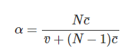

From this formula It is noted that if you increase the number of items, you increase Cronbach’s alpha. Additionally, if the average inter-item correlation is low, alpha will be low.  As the average inter-item correlation increases, Cronbach’s alpha increases as well (holding the number of items constant). The closer the coefficient is to 1.0, the greater is the internal consistency of the items (variables) in the scale. A general accepted rule is that **α of 0.6-0.7** indicates *an acceptable level of reliability*. The results were as shown in Table 3.4.

**Table 3.4: Alpha Coefficient for the Reliability Tests**

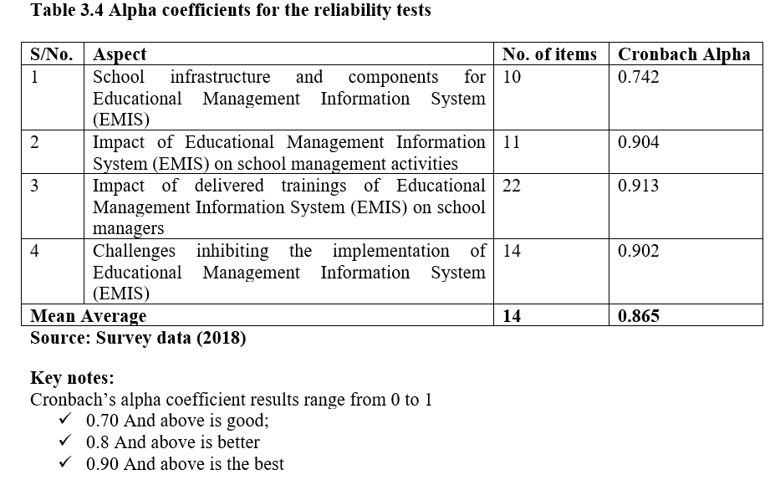

The results of Table 3.4 demonstrate that the mean average of reliability coefficient is 0.865. Cronbach’s alpha coefficient results were better. This shows that each of the sub measurements was reliable enough for the study.

## **3.8 Data Processing, Presentation, and Analysis**

After the data collection authorisation and data collection procedures, questionnaires were gathered for data entry, processing, presentation and analysis. Figure 3.5 displays data processing, analysis, and presentation process.

**Table 3.5: Data Processing, Presentation, and Analysis**

**Source**: Research Data (2018)

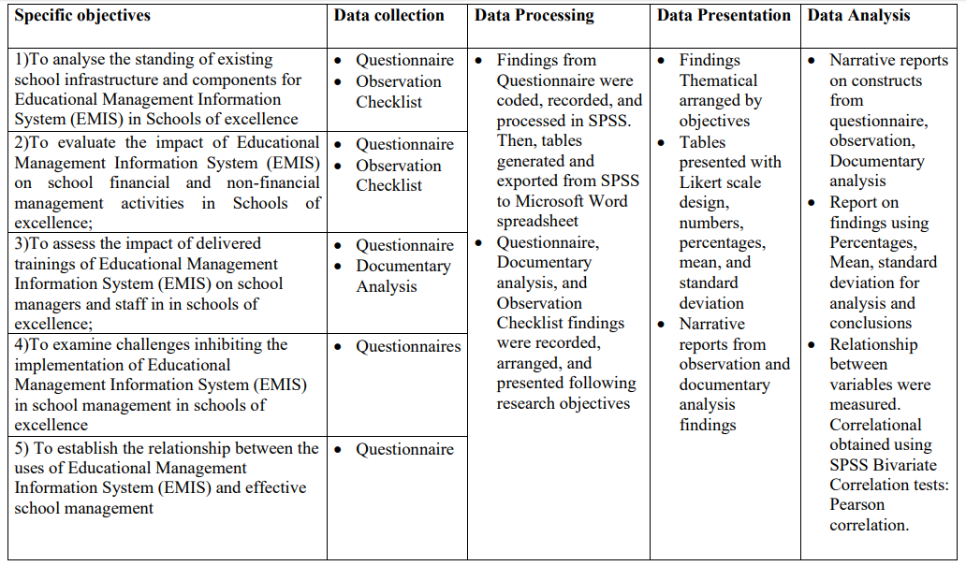

Data processing involved putting together collected and gathered instruments which included questionnaires, observation checklists, and documentary analysis. Data from questionnaires were coded and recorded using Statistical Package for Social Sciences (SPSS) software programme. Data were recorded following the order of the five objectives of the research to facilitate the easy retrieval and table generation and presentation. Tables of findings were generated for interpretation and analysis. On the other hand, data from observation and documentary analysis were also arranged according to research objectives for facilitating their presentation and interpretation.

Data presentation process started by using generated and exported tables of findings from Statistical Package for Social Sciences (SPSS) software programme to the Microsoft word document for easy and clear presentation. Then, findings were presented using tables and figures. Findings in tables were arranged, grouped and presented thematically according to research objectives to facilitate the researcher’ s interpretation and analysis. The findings were presented in tables reflected the responses from respondents using a Likert scale design of 1-5 (Strongly Agree; Agree; Neutral; Disagree; and Strongly Disagree). The findings were quantitatively presented using descriptive and inferential statistics: Numbers, percentages, mean, standard deviation, overall mean, and correlational values using SPSS Bivariate Correlation tests: Pearson correlation.

Additionally, Data analysis and interpretation were based on arrangement of constructs in three main groups that include strong, moderate, and low agreement. Using the narrative reports, the percentage, standard deviation, and mean allowed the research to categorise and interpret findings. Based on triangulation of findings from instruments, Data from observation and documentary analysis were also interpreted and analysed to support the quantitative findings as a way of making complete conclusions. Then, the overall mean, observations, and document information allowed the research to draw conclusions. Then the inferential statistics was used to allow the researcher to establish relationship between Educational management information systems (EMIS) and school management. Relationship between variables was measured. Correlational values were obtained using SPSS Bivariate Correlation tests: Pearson correlation. Correlational values allowed the researcher to draw conclusions.

## **3.10 Ethical Issues**

Ethical issues are a set of standards designed specifically to guide the work of researchers, specifying their obligations to their subjects and their profession. Ethical principles lead all the activities related to this study (Ary, Cheser, & Sorensen, 2010). The researcher used all the required and acceptable procedures to ensure that the ethical issues are taken care of. The procedures include obtaining the permission to conduct the study, confidentiality of the data collected, informed consent, respect toward research environment, accurate interpretation and presentation of data, and respect of participant’s privacy.

The researcher obtained the permission to conduct the study and collect data from both the Open University of Tanzania and Nyarugenge district Authority. The confidentiality of the data collected was also given more attention by the researcher. The research avoided to publish the confidential information without permission. The researcher respected the participant’s privacy by not putting their names in the study. This was done through respect of anonymity of participants. Researcher guaranteed the participants that the research information is only utilised for academic purpose and principles of privacy be followed. Then, the questionnaires were not carried the names of respondents to avoid the divulgation of the identity of participants. The participants were not forced to answer the questions. They voluntarily participated in research.

Additionally, the cover of the questionnaire introduced to the participant the purpose of the study. The researcher also enclosed the introductory paragraph that states the purpose of research from the office in charge of research and the authorisation letter from the Mayor of the district. The wording of questions did not contain sexism words. Respect toward research environment was ensured. The researcher respected and complied with the availability and school regulations for guests and visitors, accurate interpretation and presentation of data. Besides, the researcher maintained the accurate interpretation and presentation of data. The researcher also remained honest and professional in reporting the findings and results.

## **3.11 Summary**

This chapter discussed the research paradigm and design that were employed to carry out this study. The chapter also described location of the study, target population, sampling techniques and sample size. This chapter concluded by describing research instruments and data collection procedures, methods of data analysis, and ethical considerations.

# **CHAPTER FOUR**

# **DATA ANALYSIS AND PRESENTATION**

## **4.1 Introduction**

This chapter presents the research findings and analysis. The study investigated the impact of EMIS on effective school management in schools of excellence. The data were collected through questionnaires, documentary analysis, and observation schedule. Findings were presented thematically to respond to the five specific objectives of this study. The study sought to provide answers to five specific objectives: (i) To analyse the standing of existing school infrastructure and components for EMIS in Schools of excellence; (ii)To evaluate the impact of Educational Management Information System (EMIS) on school financial and non-financial management activities in Schools of excellence; (iii) To assess the impact of delivered trainings of EMIS on school managers and staff (iv) To examine challenges inhibiting the implementation of EMIS in school management; (v) To establish the relationship between the uses of EMIS and effective school management.

## **4.2 Response Rate**

All the participants of this study were expected to contribute by responding to the questionnaires. The participants included Headteachers, Deputy Headteachers, IT Managers, Administrative Assistants, Discipline Masters, Bursars and Teachers. As can be seen in Table 4.1, 90 participants were sampled and participated as planned. The response rate was at 100 percent of the respondents participated. This indicates that the response rate was equal to the sampled participants in this study. Without any failure as planned by the researcher, all participants were involved.

**Table 4.1: Response Rate**

**Source:** Research Data (2018)

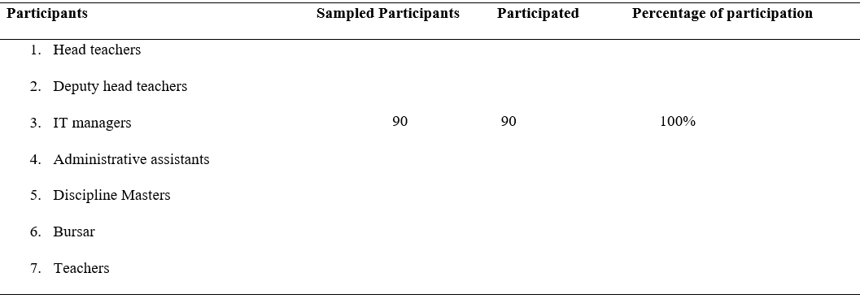

## **4.3 Demographic Characteristics of Participants**

Demographic characteristics of participants in this study includes the gender, work experience, marital status, education, and job occupations of respondents.

### 4.3.1 Gender of Respondents

Gender that constituted the subject of this study included both male and female. Both male and female participated in this study as shown by Figure 4.1.

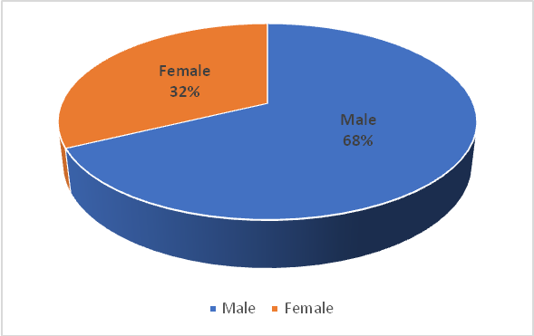

**Figure 4.1: Gender of Respondents**

**Source:** Field Data (2018)

Figure 4.1 indicates that male constituted a bigger number of respondents (67.8%) compared to female participants which represented 32.2%. This indicates that the majority were male participants. This confirms the National education statistics that males staff holds the majority of the staff in Secondary school in Rwanda. In 2018, male staff were the majority 20,636 (68.7%) and female staff were 9,404 (31.3%) of the staff in secondary schools in the country, Rwanda (Ministry of Education, 2018).

### 4.3.2 Work experience

The work experience of the respondents was grouped into three groups of years of experience. The first group is of experience between 0 and1years. The second group ranged between 2-4years. The last group was of interval ranging between 5 and above years of experience as shown in Figure 4.2.

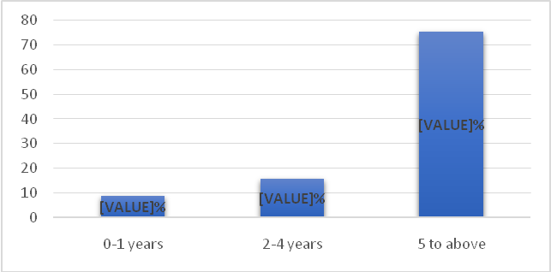

**Figure 4.2: Work experience of the respondents**

**Source:** Field Data (2018)

The highest proportion of respondents of 75.6%, as shown in Figure 4.2, was of age range group of staff between 5 to above years of work experience. The following group of 15.6 % was of age group ranging between 2 to 4 years of work experience. The lowest group of respondents in terms of year of experience was between 0 to 1 with 8.9%. These findings indicate that majority of staff in schools of excellence in Nyarugenge District are more than five years experienced in the profession. EMIS was not a new concept to majority of respondents. The experience of respondents gave the credibility to data and information collected.

### 4.3.3 Education Level of Respondents

The education of respondents was categorised in 5 levels. The respondents who hold the senior six certificates which means they completed the secondary education. The respondents with diploma who completed 2 years of the university education. Then the staff with bachelor’s degree that completed 3 to 4 years of the university education. The staff with Postgraduate Diploma in Education. Last category includes the staff with Master and PhD in education.

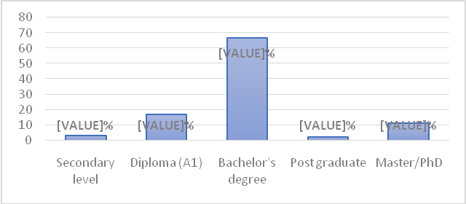

**Figure 4.3: Education Level of Respondents**

**Source:** Field Data (2018)

As can be seen in Figure 4.3, majority of the respondents (66.7 %) held bachelor’s degree. The respondents with secondary education level represented 3.3 %. The respondents with Diploma education level represented 16.7%. Postgraduate Diploma education level was 2.2%. The respondents with Master and PhD education level was 10%. The qualification of teaching in a secondary school requires that a teacher should have at least Diploma level when teaching Ordinary level and at least bachelor when teaching advanced level. These results indicated that the majority 97% were qualified to teach in secondary schools and they had experience in the use of ICT as the compulsory subject taught in all higher learning institutions training teachers. However, the 3.3 % of staff included the non-teaching and supporting staff to the positions of secretary, administrative assistant, and in charge of discipline.

### 4.3.4 Age of Respondents

The age of respondents was recorded in three categories. The first category was a range of 18 to 25 years old. The second category was between 26 to 35 years old. The third category was between 36 to above years old.

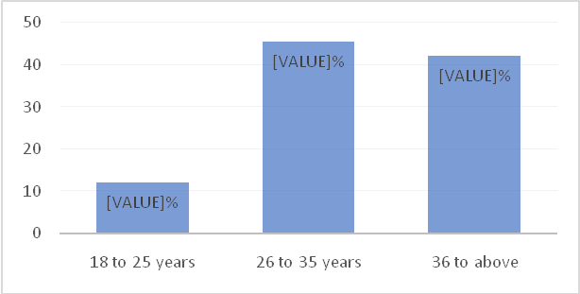

**Figure 4.4: Age of Respondents**

**Source:** Field Data (2018)

As shown in Figure 4.4, 45.6% of the respondents ranged between 26 and 35 years old. The following category of 36 to above represented 42.2% of the respondents. The category of that constituted few was between 18 and 25 years that represented 12.2%. The findings indicated that 57.8% of age group of respondents ranged between 18 and 35 years old. This is an upright indicator that the group was young to manipulate and use sophisticated technologies in education.

## **4.4 Presentation of Findings**

This section presents the findings according to the study objectives. This study had five specific objectives addressed. The study provided answers to five specific objectives: (i) To evaluate the standing of existing school infrastructure and components for EMIS in Schools of excellence; (ii) To examine the impact of EMIS on school management activities; (iii) To assess the impact of delivered trainings of EMIS on school managers; (iv) To examine challenges inhibiting the implementation of EMIS in school management; (v) To establish the relationship between the uses of EMIS and effective school management. For each case the frequencies, percentages, weighted mean, and standard deviation was used to present and analyse data and appropriately reporting findings following objectives.

### 4.4.1 Standing of Existing School Infrastructure and Components of EMIS

The standing of existing school infrastructure and components of EMIS presented and analysed included personal computers, school office computers, EMIS software, internet connectivity, modem, electricity, wireless internet, and EMIS user right. The scale had 10 items or statements. The analysis was done using the responses to the statements of questionnaire related to the respondent’s position on the standing of existing school infrastructure and components of EMIS. The responses were presented in a Likert scale of 1-5 (Strongly Agree; Agree; Neutral; Disagree; and Strongly Disagree). The respondents were requested to rate their level of agreement or disagreement, to the below statements on school infrastructure and components of EMIS in Table 4.2, indicating strongly agree; agree; neutral; disagree; and strongly disagree. The results were as shown in Table 4.2.

**Table 4.2: School Infrastructure and Components for EMIS**

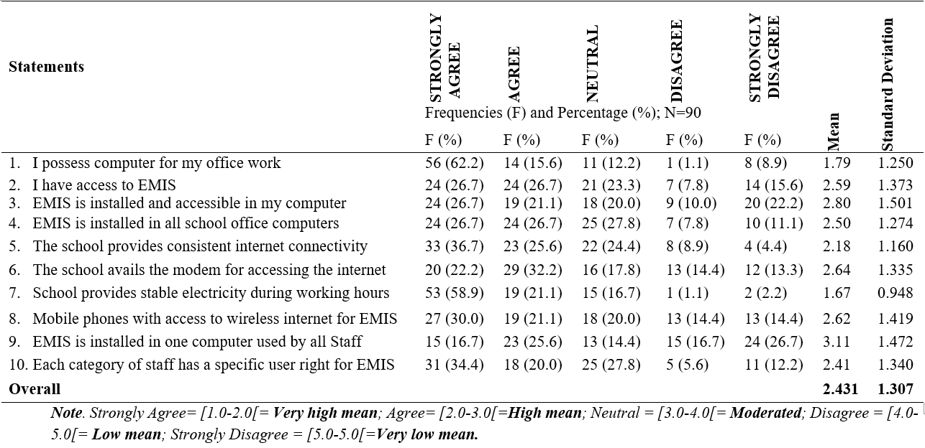

**Source:** Field Data (2018)

As indicated in Table 4.2 most of the respondents fell in the category of those who agreed and strongly agreed with the constructs that were used to determine the level of existing school infrastructure and components for EMIS. Many of the respondents (62.2%: µ =1.79) strongly agreed with the statement “I possess computer for the office work”. The most notable components of infrastructure which respondents strongly agreed and agreed with included: the accessibility to EMIS (53.4%), the installation of EMIS in accessible computers (53.4%), EMIS is installed and accessible in my computer (47.8%); The school provides consistent internet connectivity (62.3%); The school avails the modem for accessing the internet (54.4%); School provides stable electricity during working hours (70.0%); The possession of mobile phones with access to wireless internet for EMIS (51.1%). Each category of staff has a specific user right for EMIS (54.4%).

On the other hand, some respondents strongly disagreed and disagreed with the constructs that were used to determine the standing of existing school infrastructure and components for EMIS. The most prominent responses with moderated percentages of those who strongly disagreed and disagreed included: EMIS is installed and accessible in my computer (32.2%); The school avails the modem for accessing the internet (27.7%); Mobile phones with access to wireless internet for EMIS (28.8%), EMIS is installed in one computer used by all Staff (43.4%).

As a result, the overall average mean of responses was 2.431 (SD=1.307) on the constructs that were used to analyse the standing of existing school infrastructure and components for EMIS operations. The overall average mean fell in the range of high mean. This indicated that many of the respondents agreed with the most constructs used to analyse the standing of existing school infrastructure and components for EMIS operations. This was an indication that schools are ready for EMIS operations and EMIS infrastructure and components existed in the schools of excellence in Nyarugenge District, Rwanda. Although, some respondents gave a moderated level of responses in terms of EMIS installation and accessibility in my computer, modem availability for accessing the internet, and mobile phones with access to wireless internet.

Findings made by the researcher from observation showed that EMIS software is accessible online through school computers when connected to internet. EMIS software used by schools is named The School Data Management System (SDMS). SDMS is a web-based application designed by the Ministry of Finance and Economic Planning (MINECOFIN) and Ministry of Education. It was observed that all the schools were also connected to internet including computer laboratories. It was also observed that some schools were concurrently using more than one types of EMIS software in the schools depending on the task they perform. For instance, all schools visited they run SDMS, School data management system (SDMS), Teacher Management Information System (TMIS),school management information system (SMIS) and some schools also use Computerised System for school management (COSYM). It was observed that there was duplication of information in those different EMIS software used, yet one system can capture all the information.

Further findings from observations indicated that the Ministry of Education through Rwanda Education Board provided 105 laptops to schools of excellent to support the implementation of ICT. This meant those 100 laptops for Computer laboratory and five (5) laptops for teachers to support teaching and learning. Teachers could borrow the computers at their wish when needed. However, there were challenges related to slow internet connectivity to access SDMS web-based application online. During the day, the internet was slow due to the high number of SDMS users. In some schools, the EMIS user right was shared among the staff to allow fast and quick Data entry which does not constitute a secured practice in the use of EMIS. This seems to violate EMIS protection and professional ethics.

### 4.4.2 The Impact of EMIS on School Management Activities

The impact of EMIS on school management was presented and analysed in two categories. The two categories of impact of EMIS on school management activities included the impact of EMIS on school non-financial management activities and Impact of EMIS on school financial management activities. The analysis was done using the responses to the statements in questionnaires related to the respondent’s position on the impact of EMIS on school management. The responses were presented in a Likert scale of 1-5 (Strongly Agree; Agree; Neutral; Disagree; and Strongly Disagree). The respondents were asked to rate their level of agreement or disagreement indicating strongly agree; agree; neutral; disagree; and strongly disagree.

#### 4.4.2.1 Impact of EMIS on School Non-Financial Management Activities

The results of the impact of EMIS on school non-financial management activities were presented in 12 items or statements. The items included the use of EMIS in admission, registration, and enrolment of new students, students Data and result capturing and reporting, students and staff biographical data. The items also included class attendances, academic, discipline decisions, submission of school reports, school materials recording, and non-financial auditing exercise. Results were shown in Table 4.3.

Table 4.3, the results indicated that respondents strongly agreed and agreed with the constructs that were used to assess the impact of EMIS on school non-financial management activities. The most notable responses with high percentages of those who strongly agreed and agreed included:

**Table 4.3: Impact of EMIS on School Non-Financial Management Activities**

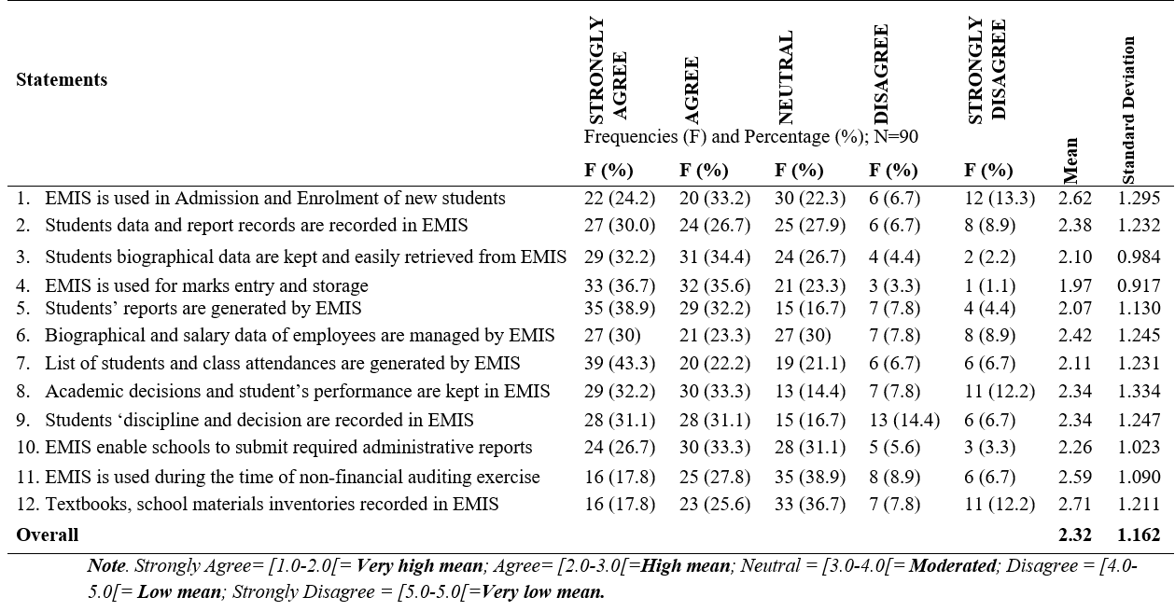

**Source:** Field Data (2018)

EMIS is used in Admission and Enrolment of new students (57.4%, µ=2.62, SD=1.295); Students data and report records are recorded in EMIS (56.7%, µ=2.38, SD=1.232); Students biographical data are kept and easily retrieved from EMIS (66.6%, µ=2.10, SD=0.984); EMIS is used for marks entry and storage (72.3%, µ=1.97, SD=0.917); Students’ reports are generated by EMIS (71.1%, µ=2.07, SD=1.130); Biographical and salary data of employees are managed by EMIS (53.3%, µ=2.42, SD=1.245); List of students and class attendances are generated by EMIS (65.5%, µ=2.11, SD=1.231); Academic decisions and student’s progressive performance are kept in EMIS (65.5%, µ=2.34, SD=1.334); Students ‘discipline and decision are recorded in EMIS (62.2%, µ=2.34, SD=1.247); EMIS enable schools to submit required administrative reports ( 60.0%, µ=2.26, SD=1.023).

Additionally, the most notable responses with moderated agreements on the constructs included: EMIS is used during the time of non-financial auditing exercise (45.6%, µ=2.59, SD=1.090); Textbooks, school materials inventories recorded in EMIS (43.4%, µ=2.71, SD=1.211). On the other hand, some respondents strongly disagreed and disagreed with the constructs that were used to assess the impact of EMIS on school non-financial management activities. The most prominent responses with moderated percentages of those who strongly disagreed and disagreed included: EMIS is used in Admission and Enrolment of new students (20.0%); Academic decisions and student’s performance are kept in EMIS (20.0%); Students ‘discipline and decision are recorded in EMIS (21.1%); Textbooks, school materials inventories recorded in EMIS (20.0%).

As a result, the overall average mean of responses on the constructs used to assess the impact of EMIS on non-financial school management activities was 2.32 (SD= 1.162). The overall average mean is a high mean. This showed that many of the respondents agreed with the constructs used to determine the effect of EMIS on the non-financial school management activities. This is a significant indicator that EMIS is used in academic activities to enhance the effective school management. EMIS remained the important technological facility for effective school management. Regardless the areas of improvement in admission and enrolment of new students, academic decisions and student’s performance recording, students’ discipline and decision recording in EMIS, textbooks, school materials inventories recorded in EMIS.

Findings from observation by the research indicated that schools recorded academic data in EMIS through SDMS web-based application which was accessible online. It was observed that student personal information was recorded. This included names, gender, disability, residence sector, district, province, names of mother and farther, nationality, classes, options, contact person addresses, and other relevant information. EMIS was also used to capture data of new students as well as continuing students. Those data included academic decisions related to promotion, repetition, and exclusion.

It was observed that EMIS was used for student transfer approval process by both the receiving and transferring school. However, the transfer may delay due to the delay of approval process in EMIS. Further observations showed that staff data were recorded. Staff biographical and disaggregated data were recorded in EMIS. Teacher transfer approval was done through EMIS. This process may take time which can result in delay when all concerned departments did not approve the teacher transfer on time.

Additionally, the school assets including library books, materials, textbooks, infrastructure, and classrooms were recorded in EMIS. Consequently, it was observed that the records of academic data were included in and linked to the annual performance contract evaluation process between the schools and the District Authorities. The EMIS recorded data were used to determine the school capitation grant assigned to schools. This motivated the schools to record data on time to meet the objectives in their performance contract between the schools and the District Authorities.

#### 4.4.2.2 Impact of EMIS on School Financial Management Activities

The results of the impact of EMIS on school financial management activities were presented in 10 items or statements. The items included the use of EMIS in managing revenues and expenses, monitor the students’ school fees payment, planning and monitoring school budget, EMIS and direct link to school bank accounts, staff salaries, financial statement, financial auditing exercise, and financial capacity of repairing EMIS.

**Table 4.4: Impact of EMIS on School Financial Management Activities**

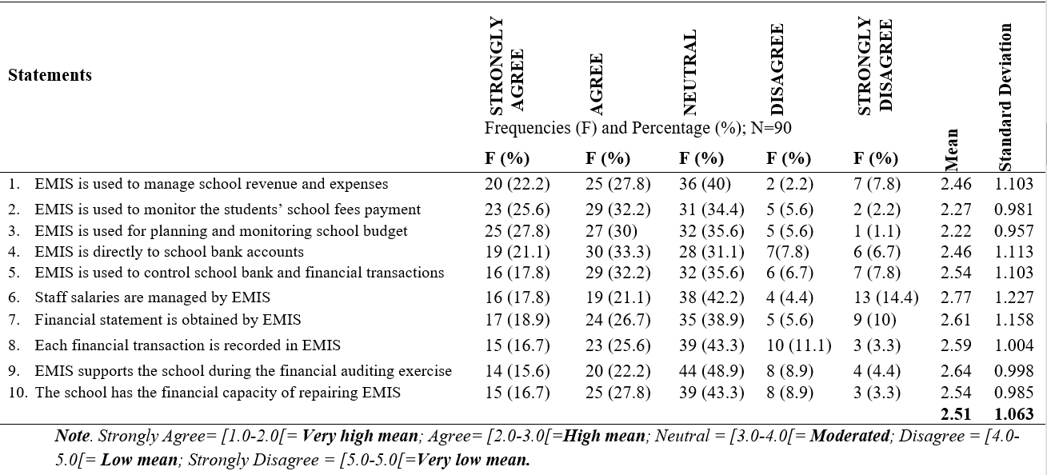

**Source:** Field Data (2018)

The results in Table 4.4 indicated the position of the respondents who agreed and disagreed with the constructs used to assess the impact of EMIS on school financial management activities. The most notable responses with high percentages of those who strongly agreed and agreed embraced: EMIS is used to manage school revenue and expenses (50.0 %, µ=2.46, SD=1.103); EMIS is used to monitor the students’ school fees payment (57.8%, µ=2.27, SD=0.981); EMIS is used for planning and monitoring school budget (57.8%, µ=2.22, SD=0.957); EMIS is directly linked to school bank accounts (54.4%, µ=2.46, SD=1.113); EMIS is used to control school bank and financial transactions (50.0%, µ=2.54, SD=1.103).

On the other hand, the most notable responses with moderated agreements on the constructs included: Staff salaries are managed by EMIS (38.9%, µ=2.77, SD=1.227); Financial statement is obtained by EMIS (45.6%, µ=2.61, SD=1.158); Each financial transaction is recorded in EMIS (42.3%, µ=2.59, SD=1.004); EMIS supports the school during the financial auditing exercise ( 37.8%, µ=2.64, SD=0.998); The school has the financial capacity for repairing EMIS ( 44.5%, µ=2.54, SD=0.985).

Hence, the overall average mean of responses on the constructs used toexamine the impact of EMIS on school financial management activities was 2.51 (SD=1.063). This shows many respondents agreed with the constructs used to examine the impact of EMIS on school financial management activities. This is an indication that EMIS was used for effective school financial management operations. However, some respondents provided a moderated level of responses in term of staff salaries’ management in EMIS, financial statement processes in EMIS, financial transaction records in EMIS, EMIS support for the school during the financial auditing exercise, and the school financial capacity for repairing EMIS.

Findings from observation by the researcher showed that financial operations were recorded in EMIS. The school budget was recorded in EMIS. The Ministry of Education and Ministry of Finance and Economic Planning used data existing EMIS to allocate fund to schools depending on the number of students and staff existing in the schools. Schools reported financial operations before the start of the new financial year which meant July of every year.

However, findings from observation indicated that school finance managers did not avail information to teachers on students’ fees payment list.Some school finance managers were not able to provide bank statement and information about specific students who made payment. It was observed that Ministry of Finance and Economic Planning and Ministry of Education did not fully provide guidance on financial recording to school finance managers. There was no EMIS user guide on financial aspect in all schools. This is an indication that they needed more training on financial recording in EMIS.

Findings from documentary analysis indicated that the main objective of SDMS is to strengthen the Public Financial Management systems. It will improve student management, processing of school financial transactions and will allow easy and timely access to reliable information for the allocation of capitation grant and school feeding money to schools. SDMS will ensure improved efficiency and effectiveness in government financial management, will increase availability of comprehensive financial information, planning, and budgeting process at school level (Ministry of Finance and Economic Planning, 2019).

### 4.4.3 Impact of Delivered Trainings of EMIS on School Managers and Staff

The impact of the trainings of EMIS on school managers and staff was presented in 11 items. The items included the participation in trainings, the skills gained from EMIS trainings, duration of the training, the training strategies, the needs of more trainings, the training manual and user guide, the importance of the training, and the follow-up of the trainers to make sure that trainees were smoothly and effectively implementing the skills gained from the training of EMIS.

**Table 4.5: The Impact of Delivered EMIS Trainings on School Managers/Staff**

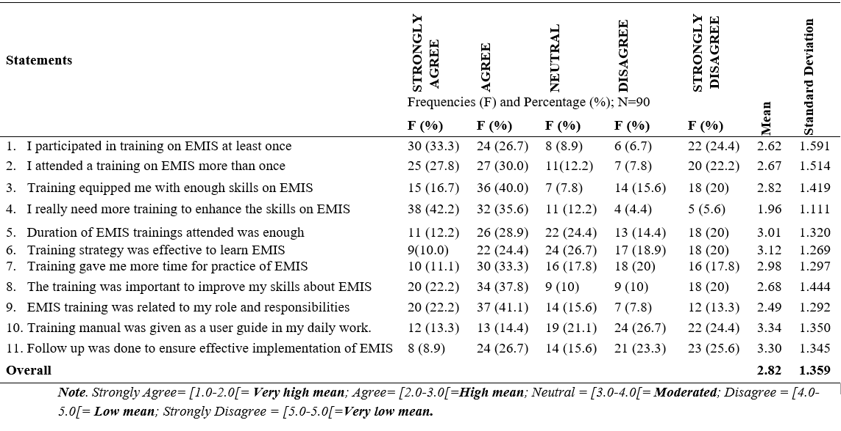

**Source:** Field Data (2018)

As shown in Table 4.5, the results indicated that the percentages of respondents who agreed and disagreed with the constructs used to examine the impact of EMIS delivered trainings on school staff members. The most notable responses with high percentages of those who strongly agreed and agreed comprised: I participated in training on EMIS at least once (60.0%, µ=2.62, SD=1.591); I attended a training on EMIS more than once (57.8%, µ=2.67, SD=1.514); Training equipped me with enough skills on EMIS ( 56.7%, µ=2.82, SD=1.419); I really need more training to enhance the skills on EMIS ( 77.8%, µ=1.96, SD=1.111); The training was important to improve my skills about EMIS ( 60.0%, µ=2.68, SD=1.444); EMIS training was related to my role and responsibilities (63.3%, µ=2.49, SD=1.292).

On the other hand, the most notable responses with moderated agreements on the constructs included: Duration of EMIS trainings attended was enough (41.1%, µ=3.01, SD=1.320); Training gave me more time for practice of EMIS (42.4%, µ=2.98, SD=1.297). However, the results indicated the percentages of respondents who disagreed with the constructs used to examine the impact of EMIS delivered trainings on school staff members. The most notable responses with high percentages of disagreements on the constructs included: Training strategy was effective to learn EMIS (38.9%, µ=3.12, SD=1.269); Training gave me more time for practice of EMIS ( 37.8%, µ=2.98, SD=1.297); Training manual was given as a user guide in my daily work (51.1%, µ=3.34, SD=1.350); Follow up was done to ensure effective implementation of EMIS (48.9%, µ=3.30, SD=1.345).

As a result, the overall average mean of responses on the constructs used to examine the impact of EMIS delivered trainings on school staff members was 2.82 (1.359). The overall average scored in high mean range. This showed that many respondents agreed with the constructs used to evaluate the impact of EMIS delivered trainings on school staff members. This is an indication that EMIS trainings were conducted and staff members participated to increase the skills on the utilisation of EMIS. Although, some participants provided responses with high percentages of disagreements on training strategy effectiveness, training timeline for practice, provision of training manual as a user guide in my daily work and trainers’ follow up to ensure effective support and implementation of EMIS.

Findings made from invitation letters and training manual showed that Ministry of Education and Rwanda Education Board organised trainings on EMIS academic, infrastructure and finance modules. Further findings from documentary analysis indicated that trainings and user manual were provided as guidance tool in using academic, and infrastructure modules (Ministry of Finance and Economic Planning, 2019).Finance modules were not available in schools as user guides. It was observed that the staff using EMIS needed more regular support on academic and finance module aspects due to EMIS improvement made on SDMS web-based application for effective implementation.

### 4.4.4 Challenges Inhibiting Implementation of EMIS in SchoolManagement

The challenges that inhibited the implementation of EMIS were displayed in 14 items. The challenges related to the staff skills, the staff support from IT managers, induction of new staff, related to internet connection, EMIS budget, related to computers and electrical power. The challenges also presented were related to EMIS trainings, technical challenges, IT manager and staff turnover, and the entry of students’ data in EMIS.

**Table 4.6: Challenges Inhibiting the Implementation of EMIS**

**Source:** Field Data (2018)

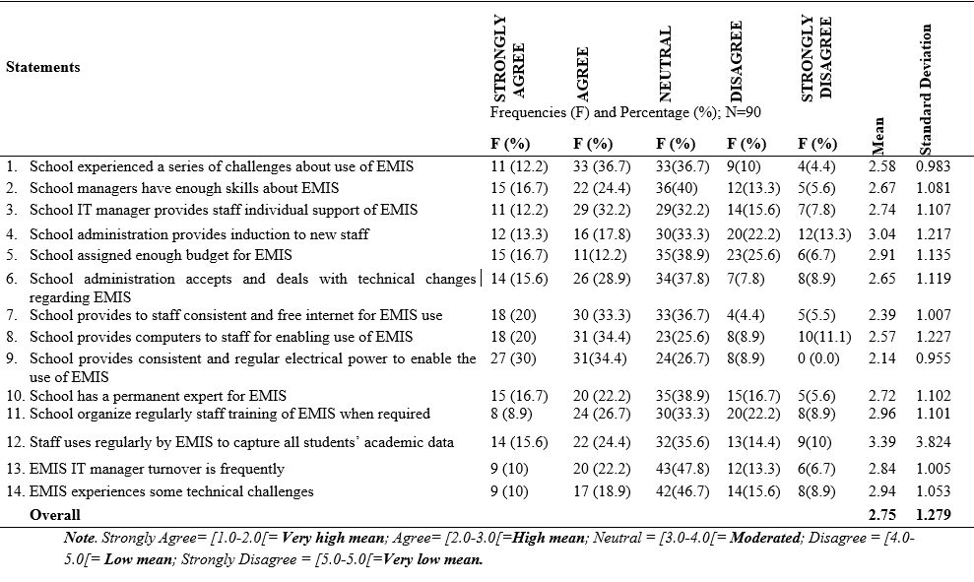

As shown in Table 4.6, the results indicated that the percentages of respondents who agreed and disagreed with the constructs used to examine the challenges inhibiting the implementation of EMIS. The most prominent responses with high percentages of those who strongly agreed and agreed comprised of : School provides to staff consistent and free internet for EMIS use (53.3% µ=2.39, SD=1.007); School provides computers to staff for enabling use of EMIS (54.4%, µ=2.57, SD=1.227). On the other hand, the most notable responses with moderated agreements on the constructs included: School experienced a series of challenges about use of EMIS (48.9%, µ=2.58, SD=0.983); School managers have enough skills about EMIS (41.1%, µ=2.67, SD=1.081); School IT manager provides staff individual support and guidance on EMIS ( 44.4%, µ=2.74, SD=1.107); School administration accepts and deals with technical changes regarding EMIS (45.5%, µ=2.65, SD=1.119); Staff uses regularly by EMIS to capture all students’ academic data (40.0%, µ=3.39, SD=3.824).

Despite high and moderated agreements on the constructs, the results indicated the percentages of respondents with low agreement on the constructs used to to examine the challenges inhibiting the implementation of EMIS. The most noteworthy responses with low agreements on the constructs included: School administration provides induction to new staff (31.1%, µ=3.04, SD=1.217); School assigned enough budget for EMIS (28.9%, µ=2.91, SD=1.135); School has a permanent expert for EMIS (38.9%, µ=2.72, SD=1.102); EMIS IT manager turnover is frequently (32.2%, µ=2.84, SD=1.105); EMIS experiences some technical challenges (28.9%, µ=2.94, SD=1.053).

Subsequently, the overall average mean of responses on the constructs used to examine the challenges inhibiting the implementation of EMIS was 2.75 (SD=1.279). The overall average mean scored is a high mean. The results showed that the participants agreed with the constructs. However, some participants gave responses with a low level of agreements on constructs in terms of provision of induction to new staff by school administration, assigning school budget for EMIS operations, permanent expert for EMIS, frequency of IT manager turnover, and EMIS technical related challenges. This was an indication that schools faced a number of challenges during EMIS operations.

Findings from observation made by the researcher indicated that schools faced personnel, technical, and capacity building challenges. There were no EMIS experts, except Teacher of IT in schools to provide regular support. Schools used teachers of IT to provide the technical support of EMIS to other staff using EMIS. There was frequent IT manager turnover. Some staff was trained on how to use EMIS and other staffs was invited to assist without attending any EMIS training due to the huge work of data entry. It was observed that internet connection was low during the day and fast in the night. This made staff working overnights when entering data in EMIS.

### 4.4.5 Relationship between the use of EMIS and Effective School Management

The relationship between the use of EMIS and effective school management was presented using 7 items. The relationship included the role of EMIS in the improvement of the school management process and activities, the use of EMIS in financial management activities of the school, EMIS as a key player in students’ data management. Additionally, the role of EMIS in management of financial transactions was displayed.

Table 4.7 the results indicated that the percentages of respondents who agreed and disagreed with the constructs used to establish relationship between the use of EMIS and effective school management. The most prominent responses with high percentages of those who strongly agreed and agreed included: EMIS improved school management process (84.4%, µ=1.84, SD=0.733); EMIS support in the management of students’ data and information (77.4%, µ=2.03, SD=0.771); EMIS allow to save time in the data processing and retrieval (81.1%, µ=2.34, SD=4.317); EMIS is a very supportive system in the management of Financial transactions (66.7%,µ=2.03, SD=0.800); Students ‘school fees payment and transactions are effectively controlled using EMIS (62.2%, µ=2.19, SD=0.860). On the other hand, the most notable responses with moderated agreements on the constructs included: EMIS facilities assist in non-financial management roles and responsibilities (59.7%, µ=2.40 SD=0.969); Teaching staff and students’ data are effectively managed by EMIS (56.6%, µ=2.37 SD=0.1.033).

**Table 4.7: Relationship between the use of EMIS and School Management**

**Source:** Field Data (2018)

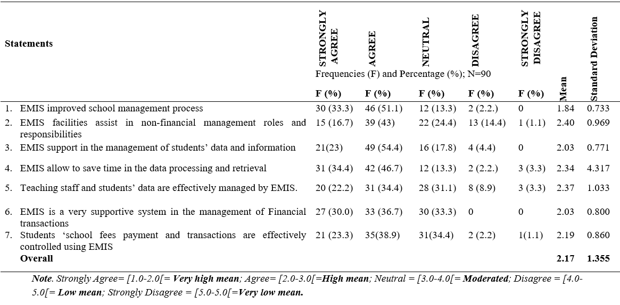

As a result, the overall average mean of responses on the constructs used to establish relationship between the use of EMIS and effective school management was 2.17 (SD=1.355). The overall average mean recorded is a high mean. The most prominent responses recoreded high percentages of those who strongly agreed and agreed on the constructs used to establish relationship between the use of EMIS and effective school management. This is an indicator that there is a significant relationship between use of EMIS and effective school management.

#### 4.4.5.1 Correlation between the Use of EMIS and Effective School Management

Pearson correlation analysis was used to test the extent to which the independent variables of EMIS influenced the dependent variables of school management. The independent variables included components of EMIS, computer and its components, EMIS software, and internet connectivity. The dependent variables, on the other hand, included students and staff biographical data, school materials inventory, and school revenue and expenses record management. The results of the correlation analysis were as shown in Table 4.8.

As it can be seen in table 4.8, the results indicated the correlation between the independent variables of EMIS and the dependent variables of school management. A Using SPSS, Pearson’s correlation was run to determine the statistical relationship between EMIS and school management. The results indicated the constructs with strong positive correlations. The constructs with strong positive correlations included: Results indicated a strong positive correlation between EMIS software installed in computers and the internet connectivity (r (90) =.461, p<.001).

**Table 4.8: Correlation between the use of EMIS and School Management**



**Source:** SPSS (2018)

*Note*: Pearson’ s coefficient (*r*) shows the strength of the relationship (0.8 or above= very strong; 0.5 or above= strong; 0.3 or above= medium; less than 0.3= weak)

There was also a strong correlation between EMIS software installed in computers and students’ biographical information (*r* (90) =.326, p<.001). Results therefore indicated that there was a moderated positive correlation between computers/its components and EMIS software installed into computers (r (90) =.343, p<.01). On the other hand, it was found a moderated positive correlation between EMIS software installed in computers and school revenue and expenses records management (*r* (90) =.320, p<.01). Additionally, there was a moderated positive correlation between EMIS software installed in computers and school materials inventories (*r* (90) =.258, p<.05). Correlational analyses were used to examine the relationship between internet connectivity and computers including its components. It was found a moderated positive correlation between internet connectivity and computers including its components (*r* (90) =.276, p<.01). Internet connectivity positively correlated with students’ biographical data (*r* (90) =.377, p<.01).

It was found a strong positive correlation between students’ biographical data and staff biographical data (*r* (90) =.451, p<.01). Additionally, there was a moderated positive correlation between students’ biographical data and school material inventories (*r* (90) =.336, p<.01). Results indicated that there was a weak positive correlation between students’ biographical data and school revenue and expenses records management (*r* (90) =.247, p<.05). Staff biographical data were statistically and positively correlated with school revenue and expenses records management (*r* (90) =.227, p<.05). Results also indicated that there was a moderated positive correlation between school material inventories and school revenue and expenses records management (*r* (90) =.352, p<.01).

Hence, the statistical relationship between EMIS and school management was determined by means of Pearson’s correlation. As a result of correlation analysis of EMIS components and school management, the results indicated that many constructs recorded a positive correlation with a mean positive correlation of (*r* (90) =.336, p<.01). This is an indication that there was a significant positive relationship between EMIS and effective school management.

## **4.5 Summary of Findings**

The findings under each specific objective were as follows:

1. The first objective of this study sought to analyse the standing of existing school infrastructure and components for EMIS in schools of excellence in Nyarugenge District, Rwanda. The findings showed that schools of excellence were ready for EMIS operations with the support and availability of EMIS infrastructure and components existed in the schools of excellence in Nyarugenge District, Rwanda. Further findings from observations indicated that the Ministry of Education through Rwanda Education Board provided 105 laptops to schools of excellent to support the implementation of EMIS. As a result, the most notable components of infrastructure which respondents strongly agreed and agreed with included the accessibility to EMIS, the installation of EMIS software in accessible computers, EMIS software is installed and accessible in my computer, the school provides consistent internet connectivity, the school avails the modem for accessing the internet, school provides stable electricity during working hours, the possession of mobile phones with access to wireless internet for EMIS, and staff has a specific user right for EMIS. This was an indication that schools were ready for EMIS operations with the support in place of EMIS infrastructure and components existed in the schools.

Despite the high level of agreement of respondents with the most constructs, it was also found that some respondents gave a moderated level of agreement of responses in terms of EMIS installation and accessibility, modem availability for accessing the internet, and mobile phones with access to wireless internet. It was observed the internet connection was low and slow in schools of excellence during the day. This can constitute a limited access to EMIS. This is an indication that limited access to some components of EMIS infrastructure can result into ineffectiveness in use of EMIS in secondary schools of excellence in Nyarugenge District, Rwanda.

1. This current study found that there was a positive impact of EMIS on non-financial school management activities in schools of Excellence in Nyarugenge District, Rwanda. The most notable responses with high level of agreement for the use of EMIS in non-financial management of schools were the use of EMIS in admission and enrolment process of new students , students data and report records in EMIS, students biographical data kept and easily retrieved from EMIS, EMIS use for marks entry and storage, students’ reports are generated by EMIS, biographical and salary data of employees are managed by EMIS, students and staff transfers, list of students and class attendances generated by EMIS, academic decisions and student’s progressive performance kept in EMIS; Students ‘discipline and decision recorded in EMIS, EMIS enable schools to submit required administrative reports. However, there were the notable responses with moderated agreements on the constructs included: EMIS was used during the time of non-financial auditing exercise, and textbooks, school materials inventories recorded in EMIS. This can constitute an obstacle to the effective school management. Therefore, there were significant indicators that EMIS was used in academic activities to enhance the effective school management. EMIS was revealed to be the important technological facility for effective school management.

The findings also revealed that EMIS was used in financial management in schools of excellence in Nyarugenge District. The most notable responses with high percentages of agreement embraced: EMIS is used to manage school revenue and expenses; EMIS is used to monitor the students’ school fees payment; EMIS is used for planning and monitoring school budget; EMIS is directly linked to school bank accounts; EMIS is used to control school bank and financial transactions. However, some respondents provided a moderated level of agreement with responses in term of staff salaries’ management in EMIS, financial statement processes in EMIS, financial transaction records in EMIS, EMIS support for the school during the financial auditing exercise, and the school financial capacity for repairing EMIS.

A good EMIS supports adequate reporting, policy decisions, fiduciary responsibilities, and preparation of auditable financial statements for the Education System. Further findings from observation indicated that school finance managers did not avail information to teachers on students’ fees payment list. Some school finance managers were not able to provide individual payment of tuition fees. Findings from observation confirmed that Ministry of Finance and Economic Planning and Ministry of Education did not fully provide guidance on financial recording to school finance managers. There was no EMIS user guide on financial aspect.

1. These study findings revealed that EMIS trainings were conducted to enhance the knowledge, attitude, and skills of School managers and staff. The results indicated that there is high level of agreement on the participation and effectiveness of the EMIS trainings. On the other hand, there were the most notable moderated level of agreements were duration of EMIS trainings attended was enough, and Training to give more time for practice of EMIS. However, the results indicated the level of disagreement with some constructs used to examine the impact of EMIS delivered trainings on school staff members. The most notable responses with high percentages of disagreements on the constructs included: training strategy was effective to learn EMIS; training gave me more time for practice; Training manual was given as a user guide in my daily work; Follow up was done to ensure effective implementation of EMIS. EMIS user guide Manual is needed for continuous professional development. It was found that there was a need to improve on training strategy to effectively learn EMIS and follow up to ensure effective implementation of EMIS. There was a need of EMIS user guide Manual for continuous professional development.

Findings made from documentary analysis such as invitation letters and training manual showed that Ministry of Education and Rwanda Education Board organised trainings on EMIS academic, infrastructure and finance modules. Further findings from documentary analysis indicated that trainings and user manual were provided as guidance tool in using academic, infrastructure and finance modules (Ministry of Finance and Economic Planning, 2019). It was observed that the staff using EMIS needed regular more support on academic and finance module aspects due to EMIS improvement made on SDMS software for effective implementation.

1. It was found that there were challenges inhibiting the appropriate implementation of EMIS in school management. The results showed that the participants agreed with the constructs that there were challenges faced in the implementation of EMIS. Findings indicated that schools faced personnel, technical, and capacity building challenges. There were no EMIS expert, except Teacher of IT in schools to provide regular support. Schools used teachers of IT to provide the technical support of EMIS to other staff using EMIS. There was frequent IT manager turnover. Some staff was trained on how to use EMIS and other staffs was invited to assist without any EMIS training due to the huge work of data entry. It was observed that internet connection was low during the day and fast in the night. This made staff working overnights when entering data in EMIS.
2. The results indicated the positive correlation between the independent variables of EMIS and the dependent variables of school management. The results indicated the constructs with strong positive correlations. Pearson’s correlation was run to determine the statistical relationship between EMIS and school management. Pearson correlation analysis was used to test the extent to which the independent variables of EMIS influenced the dependent variables of school management. The results indicated the positive correlation between the independent variables of EMIS and the dependent variables of school management. The results indicated the constructs with strong positive correlations. it was found a moderated positive correlation between EMIS software installed in computers and school revenue and expenses records management (r (90) =.320, p<.01). Additionally, there was a moderated positive correlation between EMIS software installed in computers and school materials inventories (r (90) =.258, p<.05). Internet connectivity positively correlated with students’ biographical data (r (90) =.377, p<.01).It was found a strong positive correlation between EMIS and staff or students’ biographical information.

The current study also revealed a moderated positive correlation between EMIS and school revenue and expenses records management. This was an indication that there was a significant positive relationship between EMIS and effective school management. As results of correlation analysis of EMIS and school management, the results indicated that many tested constructs recorded positive correlations.

# **CHAPTER FIVE**

# **DISCUSSION OF FINDINGS**

## **5.1 Introduction**

This chapter presents the discussion of the findings presented in the previous chapter four. The findings were thematically presented to respond to five objectives of the study. This chapter is divided into five sections. Each section responding to each research objective. The general objective was to investigate the impact of EMIS on Effective school management. The specific objectives were as follows: (i) to analyse the standing of existing school infrastructure and components for EMIS in Schools of excellence; (ii) to evaluate the impact of Educational Management Information System (EMIS) on school financial and non-financial management activities in Schools of excellence; (iii) to assess the impact of delivered trainings of EMIS on school managers; (iv) to examine challenges inhibiting the implementation of EMIS in school management; (v) to establish the relationship between the uses of EMIS and effective school management.

## **5.2 Standing of School Infrastructure and Components for EMIS**

The first objective of this study sought to analyse the standing of existing school infrastructure and components for EMIS in schools of excellence in Nyarugenge District, Rwanda. The findings showed that schools were ready for EMIS operations with the support of infrastructure and components existed in the schools of excellence in Nyarugenge District, Rwanda. The overall average mean of responses on the constructs that recorded onanalysing the standing of existing school infrastructure and components for EMIS operationswas 2.431 (SD=1.307). The overall average mean fell in the range of high mean. This indicated that many of the respondents agreed with the most constructs used to analyse the standing of existing school infrastructure and components for EMIS operations. This was an indication that schools were ready for EMIS operations with the support in place of EMIS infrastructure and components existed in the schools.

As a result, the most notable components of infrastructure which respondents strongly agreed and agreed with included the accessibility to EMIS, the installation of EMIS software in accessible computers, EMIS software is installed and accessible in my computer, the school provides consistent internet connectivity, the school avails the modem for accessing the internet, school provides stable electricity during working hours, the possession of mobile phones with access to wireless internet for EMIS, and staff has a specific user right for EMIS. Further findings from observations also indicated that the Ministry of Education through Rwanda Education Board provided 105 laptops to schools of excellent to support the implementation of ICT. This meant those 100 laptops for Computer laboratory and five (5) laptops for teachers to support teaching and learning. Teachers could borrow the computers at their wish when needed.

This current study found that EMIS through SDMS web-based application was accessible using computers and mobile phones with access to the internet connectivity. The schools also availed electricity to enable the EMIS appropriate school management operations. These findings corroborate the findings of a study conducted by Bernbaum and Moses on EMIS components. Bernbaum and Moses (2011) stipulated that EMIS was accessed through installed software or web-enabled tools. The study added that EMIS increasingly was on laptops and smaller devices, such as netbooks and tablets that require less electricity and requirements for cooling and security. Bernbaum and Moses added that Mobiles or smartphones, as support to EMIS were capable of transmitting data through SMS and EMIS specialised applications. Mobile phones were irreplaceable particularly for schools in rural areas without electrification.

The current findings also were consistent with those of the study that was conducted to determine the extent of effectiveness on the implementation of EMIS as part of effective educational management functions in public elementary schools of Surigao Del Sur Philippines. The study revealed that EMIS employs ICT facilities namely computers, mobile phones, and internet connection to effectively and appropriately package EMIS as data bank of the school which address the urgent need of data and information (Cuartero & Role, 2018).

The reason for determining accessibility to ICT is that the influence of technology on school management is largely dependent upon the accessibility of ICT resources to the end users since the frequency of use would be higher for those who have access to those facilities (Kiptalam & Rodrigues, 2010). This is a view shared by Tearle (2004) who asserts that access to ICT infrastructure is one of the practical factors that affects the use of technology in the school management processes. These current findings were in consonance with the findings made by Odhiambo (2017) in his study on influence of the use of EMIS on management of secondary school in Nairobi City, Kenya. His findings showed that schools with basic ICT infrastructure had good access to EMIS and were therefore in a good position to use EMIS to facilitate the effective management processes.

Despite the high level of agreement of respondents with the most constructs, it was also found that some respondents gave a moderated level of agreement of responses in terms of EMIS installation and accessibility, modem availability for accessing the internet, and mobile phones with access to wireless internet, duplication of data, and staff sharing user right to access EMIS.It was observed the internet connection was low and slow in schools of excellence during the day. This can constitute a limited access to EMIS. Odhiambo (2017) revealed that among the challenges that school managers faced were accessing EMIS facilities which resulted into competition for use that can limit effective EMIS operations. This finding also agrees with a study conducted by Sicilia (2005) who found that limited access to ICT facilities would limit EMIS operations. This is an indication that limited access to EMIS infrastructure and components can result into ineffectiveness in use of EMIS in secondary schools of excellence in Nyarugenge District, Rwanda.

## **5.3 Impact of EMIS on School Management Activities**

The second objective was to evaluate the impact of EMIS on school management activities: Non-financial school management and financial school management activities.

### 5.3.1 Impact of EMIS on Non-financial School Management Activities

This current study found that there was an impact of EMIS on non-financial school management activities in schools of Excellence in Nyarugenge District, Rwanda. As results indicated, the overall average mean of responses on the constructs used to assess the impact of EMIS on non-financial school management activities was 2.32 (SD= 1.162). The overall average mean was a high mean. This showed that many of the respondents agreed with the constructs used to determine the effect of EMIS on the non-financial school management activities. This is a significant indicator that EMIS was used in academic activities to enhance the effective school management. Therefore, EMIS was revealed to be the important technological facility for effective school management.

The most notable responses with high level of agreement for the use of EMIS in non-financial management of schools were the use of EMIS in admission and enrolment process of new students , students data and report records in EMIS, students biographical data kept and easily retrieved from EMIS, EMIS use for marks entry and storage, students’ reports are generated by EMIS, biographical and salary data of employees are managed by EMIS, students and staff transfers, list of students and class attendances generated by EMIS, academic decisions and student’s progressive performance kept in EMIS; Students ‘discipline and decision recorded in EMIS, EMIS enable schools to submit required administrative reports.

The current study findings were in consonance with the findings of Chitolie-Joseph (2011) which revealed that EMIS is a key ingredient for effective school management. In his study on the use of EMIS in secondary schools in St. Lucia in Caribbean, Chitolie-Joseph found that EMIS has the following major functionality: (1) maintains student records including biographies, attendance, achievement, discipline and accounts; (2) maintains staff records; (3) produces standard reports; (4) keeps school accounts; (5) prepares student report cards and transcripts; (6) tracks incidences and attendance and; (7) performs scheduling and timetabling. The findings also confirmed those of Cuartero and Role (2018) who found that EMIS supported policy makers to manage an education system to produce quality outputs. EMIS Data and information generated statistics on the flow and stock of students for each type of level of education, cross-classified by grade or year, sex and age. They added that EMIS also serves as source of data and information on personnel retirement, accumulation or utilisation of leave credits, transfers, recruitment, placement, training, promotion, and disciplinary action (Cuartero & Role, 2018).

The findings, indicating biographical and salary data of employees and students’ biographical data managed by EMIS, supported the findings made by Mohamed et al. (2009) which revealed that EMIS data collection exercise consisted of four categories of data which were basic school information, basic teacher information, basic non-teacher information, and student enrolment information. The schools can easily obtain the academic and administrative data. This includes school and individual level demographic data on schools, students and teacher’s health attendance (enrollment, repetitions, dropout, progression, etc.). EMIS also enables schools to manage human resource data. This entails staff general demographics, salaries, performance evaluations, professional development (World Bank Group, 2017). Cash (2015) also specified that EMISwas for generating report cards, facilitating school administrative tasks and monitoring.

The most notable responses with moderated agreements on the constructs included: EMIS was used during the time of non-financial auditing exercise, and textbooks, school materials inventories recorded in EMIS. This can constitute an obstacle to the effective school management. The study findings confirmed that EMIS is used to manage physical facilities. This enables the schools to obtain information regarding the number and status of school sites, buildings and school equipment (Cuartero & Role, 2018). The study findings were consistent with the findings of the World Bank (2017). The schools can easily obtain the academic and administrative data. This includes school and individual level demographic data on schools, students and teacher’s health attendance (enrollment, repetitions, dropout, progression). EMIS also enabled schools to manage human resource data. This entails staff general demographics, salaries, performance evaluations, professional development (World Bank Group, 2017).

### 5.3.2 Impact of EMIS on Financial School Management Activities

The findings revealed that EMIS was used in financial management in schools of excellence in Nyarugenge District. The overall average mean of responses on the constructs used toexamine the impact of EMIS on school financial management activities was 2.51 (SD=1.063). This indicated the high mean of level of agreement. Many respondents agreed with the constructs used to examine the impact of EMIS on school financial management activities. This is an indication that EMIS was used for effective school financial management operations.

Further findings from observation indicated that school finance managers did not avail information to teachers on students’ fees payment list. Some school finance managers were not able to provide individual payment of tuition fees. Findings from observation confirmed that Ministry of Finance and Economic Planning and Ministry of Education did not fully provide guidance on financial recording to school finance managers. There was no EMIS user guide on financial aspect.

The most notable responses with high percentages of those who strongly agreed and agreed embraced: EMIS is used to manage school revenue and expenses; EMIS is used to monitor the students’ school fees payment; EMIS is used for planning and monitoring school budget; EMIS is directly linked to school bank accounts; EMIS is used to control school bank and financial transactions. The findings corroborated findings of RMSA-TCA (2015) which revealed that EMIS plays an important role in school financial management. EMIS accumulates and analyses financial data in order to make good financial management decisions in running the Education System.

Outputs generated by an EMIS include accounting reports, operating and capital budgets, working capital reports, cash flow forecast, and various What-If Analysis reports. The evaluation of financial data may be performed through ratio analysis, trend evaluation, and financial planning modelling. Financial planning and forecasting were facilitated by EMIS. EMIS provided budgetary, financial accounting data and cost standards for all types of expenditures (Cuartero & Role, 2018). EMIS included financial data such as budget and revenues spending, cash transfers and subsidies, unit cost per student (World Bank Group, 2017).

However, some respondents provided a moderated level of agreement with responses in terms of staff salaries’ management in EMIS, financial statement processes in EMIS, financial transaction records in EMIS, EMIS support for the school during the financial auditing exercise, and the school financial capacity for repairing EMIS. A good EMIS supports adequate reporting, policy decisions, fiduciary responsibilities, and preparation of auditable financial statements for the Education System. Further findings from observation indicated that school finance managers did not avail information to teachers on students’ fees payment list. Findings from observation confirmed that Ministry of Finance and Economic Planning and Ministry of Education did not fully provide guidance on financial recording to school finance managers. There was no EMIS user guide on financial aspect. A study found that an effective EMIS included modules for general ledger, budgetary accounting, accounts payable, accounts receivable, payroll system, budget development; procurement; project ledger; asset management (RMSA-TCA, 2015).

## **5.4 Impact of EMIS Delivered Trainings on School Managers and Staff**

The third objective was to assess the impact of EMIS delivered trainings on school managers and staff. As indicated by results, the overall average mean of responses on the constructs used to examine the impact of EMIS delivered trainings on school managers and staff members was 2.82 (SD=1.359). The overall average of mean scored was a high mean. This revealed that many respondents agreed with the constructs used to evaluate the impact of EMIS delivered trainings on school managers and staff members. This was an indication that EMIS trainings were conducted and staff members participated to increase the skills on the utilisation of EMIS.

These study findings revealed that EMIS trainings were conducted to enhance the knowledge, attitude, and skills of School managers and staff. The results indicated that there is high level of agreement on the participation and effectiveness of the EMIS trainings. It was found that respondents participated in training on EMIS at least once (60.0%) and more than once (57.8%). The EMIS Training equipped trainees with enough skills on EMIS (56.7%). The trainings were important to improve the skills about EMIS (60.0%). Then, EMIS training was related to the role and responsibilities of participants (63.3%). Participants expressed the need of more training to enhance the skills on EMIS (77.8%).

The current study findings confirmed the findings other researchers. Polizzi (2011) revealed that a training is one of variables associated with supportive behaviour for EMIS use in management. In the same line with the findings, a study conducted by Pelgrum and Plomp (1993) found that the amount of training received correlated with the extent to which ICT is used in management practices. In confirmation of the findings, a study stated that professional development would increase managerial and administrative performance (Brockmeier, Pate & Leech, 2010). Schools requires more opportunities for training EMIS staff and data users (World Bank Group, 2017). Providing training and support to school managers and decision-makers in their efforts to effectively use and analyse the data that the EMIS is at the heart of the success. Training in the use of the EMIS must be given to whoever is responsible for managing and using the system. This point reiterates the need for a budget to undertake these tasks (Chitolie-Joseph, 2011).

Throughout the process of EMIS implementation, school administration must emphasise sustainability and continuous improvement through training and building capacity to support, use and improve the system into the future (RMSA-TCA, 2015). EMIS staff and data providers often find themselves handicapped because of lack of training on using the system. Schools must focus on creating a policy enabling continuous training for data users (including EMIS staff, principals, teachers, and parents) to analyse information and generate necessary reports that can be used by decision makers across the system to assist in development of new policies and other key strategic decisions (World Bank Group, 2017). Schools requires to facilitate capacity building, support and training on collection, processing and analysis, dissemination and use of information at all levels of education (Gxwati, 2011).

On the other hand, the most notable responses with moderated level of agreements were duration of EMIS trainings attended was enough (41.1%), and Training to give more time for practice of EMIS (42.4%). However, the results indicated the level of disagreement with some constructs used to examine the impact of EMIS delivered trainings on school staff members. The most notable responses with high percentages of disagreements on the constructs included: Training strategy was effective to learn EMIS (38.9%); Training gave me more time for practice of EMIS ( 37.8%); Training manual was given as a user guide in my daily work (51.1%); Follow up was done to ensure effective implementation of EMIS (48.9%). EMIS user guide Manual is needed for continuous professional development. An operational manual can guide EMIS staff on how to collect and manage education data. It contains basic information such as definitions of EMIS concepts, indicators collected, and metadata (World Bank Group, 2017).

Findings made from invitation letters and training manual showed that Ministry of Education and Rwanda Education Board organised trainings on EMIS academic, infrastructure and finance modules. Further findings from documentary analysis indicated that trainings and user manual were provided as guidance tool in using academic, infrastructure and finance modules (Ministry of Finance and Economic Planning, 2019). It was observed that the staff using EMIS needed regular more support on academic and finance module aspects due to EMIS improvement made on SDMS software for effective implementation.

It was found that there was a need to improve on training strategy to effectively learn EMIS and follow up to ensure effective implementation of EMIS. These findings were in consonance with those of Cash (2015) who indicated that there was a need for training so that decision-makers become aware of the range of uses and possible benefits of EMIS. New technology requires new knowledge. Thus, steps should be taken to ensure that school leaders are provided with appropriate training on how to operate EMIS and how to align the technology into the existing practices. This contention is supported by a previous study (North, et al., 2000) which found that schools find it increasingly difficult to provide effective in-service training to meet professional development needs of teachers due to coats involved and absence of key staff from normal duties when teachers are released to go for such trainings. Topracki (2006) also found that insufficient training of school staff caused a serious challenge to use of EMIS in some management activities. Similarly, Bauer and Kenton (2005) argued that the reason teachers did not use technology on a consistent basis was due to lack of appropriate software and skill levels.

Besides, some respondents expressed a contrary view. Some respondents provided responses with high percentages of disagreements on training strategy effectiveness, training timeline for practice, provision of training manual as a user guide in my daily work and trainers’ follow up to ensure effective support and implementation of EMIS. EMIS user guide Manual was needed for continuous professional development. These findings corroborated those of the World Bank Group (2017) that found that an operational manual can guide EMIS staff on how to collect and manage education data. It contains basic information such as definitions of EMIS concepts, indicators collected, and metadata (World Bank Group, 2017).

Technical competence concerning the EMIS can be ensured through provision of the training in the use of the system to new and continuing teaching and administrative staff (Chitolie-Joseph, 2011). EMIS should facilitate capacity building, support and training on collection, processing and analysis, dissemination and use of information at all levels of education (Gxwati, 2011). Luena (2012) contended that staff needs more training and sensitisation to be able to accept and access EMIS data. It can be more feasible to conduct orientation programmes and training sessions regularly for the management staff in order to familiarise them with all areas of EMIS specialties that might help to nurture a sense of ownership and make them consider EMIS among the ministry’s key priority areas that need allocation of a considerable amount of funds and other resources that can sustain its functions.

## **5.5. Challenges Inhibiting Implementation of EMIS**

The fourth objective was to examine challenges inhibiting the implementation of EMIS in school management.It was found that there were challenges inhibiting the appropriate implementation of EMIS in school management. Subsequently, the overall average mean of responses on the constructs used toexamine the challenges inhibiting the implementation of EMIS was 2.75 (SD=1.279). The overall average mean scored is a high mean. The results showed that the participants agreed with the constructs that there were challenges faced in the implementation of EMIS. However, some participants gave responses with a low level of agreements on constructs in terms of provision of induction to new staff by school administration, assigning school budget for EMIS operations, permanent expert for EMIS, frequency of IT manager turnover, and EMIS technical related challenges.

The most prominent responses with high percentages of agreement on challenges were as follows : School provides to staff consistent and free internet for EMIS use; School provides computers to staff for enabling use of EMIS. These findings confirmed those of Beaumaster (1999) who identified and categorised problematic issues regarding the MIS implementation. These issues create or worsen the implementation process. The more specific categorisations of the issues can be viewed as management process issues (budgeting, personnel, and general management), organisational environment issues (organisational culture, change, and behaviour), leadership issues (hardware and software considerations), technical systems issues, and personnel issues. The results of also indicates the factors such as technical, software, training and support, EMIS leadership and EMIS access, all affected the use of the EMIS (Chitolie-Joseph, 2011).

On the other hand, the most notable responses with moderated agreements on the constructs included: School experienced a series of challenges about use of EMIS; School managers have enough skills about EMIS; School IT manager provides staff individual support of EMIS; School administration accepts and deals with technical changes regarding EMIS; Staff uses regularly by EMIS to capture all students’ academic data.

Despite high and moderated agreements on the constructs, the results indicated the percentages of respondents with low agreement on the constructs used to to examine the challenges inhibiting the implementation of EMIS. The most noteworthy responses with low agreements on the constructs included: School administration provides induction to new staff; School assigned enough budget for EMIS; School has a permanent expert for EMIS; EMIS IT manager turnover is frequently; EMIS experiences some technical challenges.

Findings from observation made by the researcher indicated that schools faced personnel, technical, and capacity building challenges. There were no EMIS expert except Teacher of IT in schools to provide regular support. Schools used teachers of IT to provide the technical support of EMIS to other staff using EMIS. There was frequent IT manager turnover. Some staff were trained on how to use EMIS and other staff were invited to assist without any EMIS training due to the huge work of data entry. It was observed that internet connection was low during the day and fast in the night. This made staff working overnights when entering data in EMIS.

The current findings showed that there was a frequent staff turnover in the schools and School does not assign enough budget for EMIS operations which resulted into EMIS technical challenges. These findings were consistent with the findings of other researchers. These findings concur with those of study of Bernbaum and Moses (2011) who identified challenges that schools faced using EMIS in school management. They found the high turnover in the position of school managers and EMIS technicians, problems related to access of funds, problems of internet connectivity at the district and school level, and limited capability among staff and users to interpret data. It was also found that there was a recurring challenge across the region is the high turnover of qualified EMIS staff in the Ministries, particularly planning directors.

Additionally, less attention to procurement of appropriate hardware and software. Inadequate funding ultimately results in poor training and support of system users (Gxwati, 2011). The findings also were in agreement with Billeh (2001) who discovered that the important challenges in the use of EMIS were revealed as the finance problems related to buying the equipment, and softwares for EMIS operations.

In the same line, Shooebridge (2006) identified challenges related to inadequate fund for EMIS development and maintenance, insufficient equipped computer laboratories, data entry; the integration challenge has to do with organisational constraints. The study conducted in Nigeria found that EMIS in Nigeria faced problems in the implementation of EMIS corresponding to lack of capacity, limited commitment from stakeholders and difficulties associated with the collection of survey data (Chapman and Mahlck as cited in Stephen & Cummings, 2009).

Critical factors limiting the development of EMIS are threefold: (i) knowledge and skills to lead and manage EMIS development; (ii) knowledge and skills to use technology; and (iii) knowledge and skills to use data effectively for decision making, policy analysis and planning (AEPM, 2007). Continuing challenges to the integration of technology in teacher education programmes include availability and access to equipment, funding limitations, training, and instructional and technical support (Duhaney 2001).

## **5.6 Relationship between the Uses of EMIS and Effective School Management**

The fifth objective sought to establish the relationship between the uses of EMIS and effective school management.As a result, the overall average mean of responses on the constructs used to establish relationship between the use of EMIS and effective school management was 2.17 (SD=1.355). The overall average mean recorded was a high mean. The most prominent responses recorded high percentages of those who strongly agreed and agreed on the constructs used to establish relationship between the use of EMIS and effective school management. This is an indicator that there was a positive significant relationship between use of EMIS and effective school management.

Besides, Pearson’s correlation was run to determine the statistical relationship between EMIS and school management. Pearson correlation analysis was used to test the extent to which the independent variables of EMIS influenced the dependent variables of school management. The results indicated the positive correlation between the independent variables of EMIS and the dependent variables of school management. The results indicated the constructs with strong positive correlations. The constructs with *strong* positive correlations included: Results indicated a *strong* positive correlation between EMIS software installed in computers and the internet connectivity (*r* (90) =.4.61, p<.001). There was also a strong correlation between EMIS software installed in computers and students’ biographical information (*r* (90) =.326, p<.001). Results therefore indicated that there was a moderated positive correlation between computers/its components and EMIS software installed into computers (r (90) =.343, p<.01).

On the other hand, it was found a moderated positive correlation between EMIS software installed in computers and school revenue and expenses records management (*r* (90) =.320, p<.01). Additionally, there was a moderated positive correlation between EMIS software installed in computers and school materials inventories (*r* (90) =.258, p<.05). Correlational analyses were used to examine the relationship between internet connectivity and computers including its components. It was found a moderated positive correlation between internet connectivity and computers including its components (*r* (90) =.276, p<.01). Internet connectivity positively correlated with students’ biographical data (*r* (90) =.377, p<.01).

It was found a strong positive correlation between students’ biographical data and staff biographical data (*r* (90) =.451, p<.01). Additionally, there was a moderated positive correlation between students’ biographical data and school material inventories (*r* (90) =.336, p<.01). Results indicated that there was a weak positive correlation between students’ biographical data and school revenue and expenses records management (*r* (90) =.247, p<.05). Staff biographical data were statistically and positively correlated with school revenue and expenses records management (*r* (90) =.227, p<.05). Results also indicated that there was a moderated positive correlation between school material inventories and school revenue and expenses records management (*r* (90) =.352, p<.01).

It was found a strong correlation between EMIS and staff or students’ biographical information. These findings agreed with the findings of other researchers. The findings concur with Bernbaum and Moses (2011) who revealed the contribution of EMIS to effective school management in the areas of education planning, decision making, schools census, secondary school attendance, information on student–teacher ratios and class sizes. The findings also corroborated Heidarkhani et al. (2013) who found out the role of EMIS in school management in the areas of communication, accurate monitoring and gathering data more reliable, faster processing and converting data into managers’ information, planning, organising, leading and motivating and controlling. They added that EMIS does management actions with the utmost accuracy efficiency within very less time in organisation.

Billeh (2001) confirmed the role of EMIS in school management of statistics in data collection, verification, computerisation, classification and categorisation on a scientifically consistent basis. He pointed out four major functions of EMIS in school management as follows: firstly, facilitating data circulation and accessibility by educational decision-makers as well as educational specialists, researchers and other parties concerned with educational development and qualification. Secondly, translating the educational situation in different types of educational institutions into statistical figures and enabling educational planners and policymakers to explore the future perspectives through comprehensive statistical indicators.

Thirdly, standardising the data pertaining to different directorates and educational departments according to their respective needs and data computerisation by special software for easy access as required. Fourthly, retrieving numerical reports of qualitative indicators through cross-tabulation of several variables from the educational questionnaires and the publication of annual educational statistical reports.

The current study also revealed a moderated positive correlation between EMIS and school revenue and expenses records management. Additionally, there was a moderated positive correlation between EMIS and school materials inventories. These findings were in consonance with findings of other researchers. In their study, Gurbaxani and Whang (1991) found that EMIS increased operations efficiency, to process transactions, to provide decision support, to monitor and evaluate employees’ performance, and to maintain documentation and communication channels. EMIS improves management, planning, monitoring and evaluation of the education system. EMIS showed a significant role in the effective school management and enables access to information and data that supports resource allocation, education policy and planning, local, national and international reporting, education administration innovation, efficient administrative practices, and strengthened accountability (RMSA-TCA, 2015).

As results of correlation analysis of EMIS and school management, the results indicated that many constructs recorded positive correlations. This is an indication that there was a significant positive relationship between EMIS and effective school management. These findings confirmed those of various researchers. EMIS provides reports to various educational managers which in turn help predicting the future performance of the organisation (Nowduril& Al-Dossary, 2012). Uses of EMIS information include, but are not limited to, informing monitoring and planning of the education sector through indicators that monitor the performance of an education system and to manage the distribution and allocation of educational resources and services (RMSA-TCA, 2015).

EMIS potentially provides a powerful management tool capable of contributing to the improvement of educational performance. It enables decision makers to identify problem areas, reduce operational costs and provides a systematic way of addressing educational challenges. If effectively implemented, the EMIS can raise educational awareness, motivating employees to search for innovative solutions and increasing educational efficiency (Gunningham, 2007).

In addition, another major function of the EMIS, other than collecting, storing and processing information, is to facilitate detailed analysis and synthesis of data in order to draw upon the most relevant information to help in educational planning and policy decision-making (Carrizo et al. as cited in Ahmed, 2007). The EMIS causes a shift from how to measure and analyse, to what to measure and how to present the information to management (Chapman & Boothroyd, 1988).

The main purpose of an EMIS is to integrate information related to the management of educational activities, and to make it available for the decision makers, as well as the other parties, to use in helping them to make the correct decision (Connal, 2005). In other words, the purpose of an EMIS is to provide the necessary information to the right person, at the right time, for use in management decisions (Yuen and Duo, 1989). EMIS is an important procedure in capturing, processing, storing, retrieving, updating and deriving up to date information that is essential in managing the daily functions of schools. This facilitates follow up activities on routine-based matters which are vital in effective school planning and improvement (Akaranga, & Makau, 2016).

EMIS ultimately supported the management, planning, monitoring and management requirements of all stakeholders: school managers and administrators, parents and local communities, department of education - national, state, district and block, department of finance, statistical bodies, development partners such as non-government organisations (NGOs) and private schools (RMSA-TCA, 2015). Therefore, EMIS is potentially considered to be a powerful management tool capable of contributing to the improvement of effective school management. It enables education decision makers to identify problem areas, reduce operational costs and provides a systematic way of addressing educational challenges. As results of correlation analysis of EMIS and school management, the results indicated that many constructs recorded positive correlations. This is an indication that there was a significant positive relationship between EMIS and effective school management.

# **CHAPTER SIX**

# **CONCLUSIONS AND RECOMMENDATIONS**

## **6.1 Introduction**

This chapter presents the conclusions and recommendations drawn fro the findings of this study. The main purpose of this study was to investigate the impact of EMIS on school management activities. The drive of this study was three-folded: (1) To provide information to the school managers about basic requirements for a successful use of EMIS as way of enhancing its effectiveness in school management; (2) To enlighten ways forward to minimise challenges that can hinder the process of EMIS implementation in secondary schools; (3) To shed light on the best practices of EMIS implementations in school of excellence in Nyarugenge district, Rwanda.

## **6.2 Conclusion**

The main objective was to investigate the impact of EMIS on Effective school management. The study was guided by five specific objectives and subsequently answered five questions. The study aimed at : (i) analysing the standing of existing school infrastructure and components for EMIS in Schools of excellence;(ii) evaluating the impact of EMIS on school management activities;(iii) assessing the impact of delivered trainings of EMIS on school managers, (iv) examining challenges inhibiting the implementation of EMIS in school management, and (v) establishing the relationship between the uses of EMIS and effective school management. Based on the findings, the major conclusions were made as follows:

1. This study sought to analyse the standing of existing school infrastructure and components for EMIS in schools of excellence in Nyarugenge District, Rwanda. The findings showed that schools were ready with the support of basic required infrastructure and components existed for EMIS operations in the schools of excellence in Nyarugenge District, Rwanda. This was an indication that schools were ready for EMIS operations with the support in place of EMIS infrastructure and components existed in the schools. The most notable components of infrastructure that were found available and accessible for EMIS operations included the installation of EMIS software in computers, provision of consistent internet connectivity and stable electricity during working hours. Staff possessed mobile phones with access to wireless internet and were able to access EMIS, and They have specific user right for EMIS depending on their responsibilities.

However, it was also revealed that internet network was low and slow which made them work over night when internet network is not overloaded. This can constitute a limited access to EMIS at wish. It was also revealed that there was duplication of information in different EMIS software used in schools, yet one system can be used to capture all the information. It is time and effort consuming process which can affect the quantity and quality of available of data. Results also showed that the EMIS user right was shared among the staff to allow the entry of data which does not constitute a secured practice in the use of EMIS.This resulted into ineffectiveness for use that can limit effective EMIS operations in secondary schools of excellence in Nyarugenge District, Rwanda.

1. This study intended to evaluate the impact of EMIS on school management activities: Non-financial school management and financial school management activities. This current study found that there was a positive impact of EMIS on non-financial school management activities in schools of Excellence in Nyarugenge District, Rwanda. The most notable outstanding areas of EMIS use and intervention were admission and enrolment process of new students , students data and report records in EMIS, data of employees, students and staff transfers, list of students and class attendances, academic decisions and student’s progressive performance, and submission of required administrative reports to the sector, district, and Ministerial level. This is a significant indicator that EMIS was used in academic activities to enhance the effective school management. However, it was found the areas of improvement. The most notable areas of improvement included the use of EMIS to respond to the requirements during the time of non-financial auditing exercise, and textbooks’ recording, school materials inventories recording. If not addressed, this can constitute an obstacle to the implementation of EMIS for effective school management.

The study also revealed that EMIS was used in financial management in schools of excellence in Nyarugenge District. The most outstanding areas of EMIS use were management of school revenue and expenses, monitoring the students’ school fees payment, planning and monitoring school budget, control school bank and financial transactions. However, the areas of improvement to be dealt with were identified as staff salaries’ management, EMIS support for the school during the financial auditing exercise, and the school financial capacity for repairing EMIS.

1. This study sought to assess the impact of EMIS delivered trainings on school managers and staff. The study revealed a positive impact of EMIS delivered trainings on school managers and staff members. There was an indication that EMIS trainings were conducted and staff members participated. It can be concluded EMIS trainings were conducted to enhance the knowledge, attitude, and skills of School managers and staff. However, areas of improvement were identified. These areas included training sessions to give more time for practice of EMIS, training strategy to be improved, training manual to be provided given as a user guide for daily work, follow up to be done to ensure effective implementation of EMIS and required individual support in their respective schools. Thus, it was found that there was a need to improve on training strategy to effectively learn EMIS and follow up to ensure effective implementation of EMIS.
2. This study furthermore intended to examine challenges inhibiting the implementation of EMIS in school management. It was found that there were challenges inhibiting the appropriate implementation of EMIS in school management. Challenges identified included provision of consistent and internet to staff for EMIS use, provision of staff individual support of EMIS by school IT manager, provision of induction to new staff, inconsistent school budget for EMIS, availability of permanent expert for EMIS to support schools, and high turnover of IT manager. It can be concluded that if the challenges are not addressed, this can constitute an obstacle to the EMIS implementation for effective school management. This can resultinto ineffectiveness for use that can limit effective EMIS operations in secondary schools of excellence in Nyarugenge District, Rwanda.
3. This study sought to establish the relationship between the uses of EMIS and effective school management. Pearson correlation analysis was used to test the extent to which the independent variables of EMIS influenced the dependent variables of school management. The results indicated the positive correlation between the independent variables of EMIS and the dependent variables of school management. It was found a strong correlation between EMIS and staff or students’ biographical information. These findings agreed with the findings of other researchers. The current study also revealed a moderated positive correlation between EMIS and school revenue and expenses records management.

Additionally, there was a moderated positive correlation between EMIS and school materials inventories. As results of correlation analysis of EMIS and school management, the results indicated that many constructs recorded positive correlations. This is an indication that there was a significant positive relationship between EMIS and effective school management. It can be concluded that EMIS is potentially considered to be a powerful management system capable of contributing to the improvement of effective school management and educational system.

## **6.3 Contribution to Knowledge**

This study provides two sets of contributions to the existing body of knowledge in EMIS. The contribution can be categorised as follows: Theoretical and Practical contributions. The first set of contribution is theoretical in nature, leading to the confirmation of existing theory. The second set is practical in nature, resulting in guidelines for practitioners in the fields of EMIS applied to school management.This study brought new insights in the implementation of EMIS for effective school management.

This study contributes to the theoretical domain of knowledge by confirming existing theory. This study confirmed availability and accessibility of EMIS infrastructure in secondary school of excellence. This study found that effective EMIS implementation required basic infrastructures. It also requires technical support and training to positively change the staff behaviours and perception. The results of this study confirmed the unified theory of acceptance and use of technology (UTAUT) was proposed by Venkatesh (2003). The theory seeks to explain the user intention to use an information system, as well as the subsequent behaviour of users.

The UTAUT theory holds that there are four main factors determining user behaviour and eventually the user acceptance. These four factors are performance expectancy, effort expectancy, social influence and facilitating conditions (Venkatesh, Michael, Gordon& Fred, 2003). This shows that school leaders can promote the use of technology in schools by establishing the following: making the use of technology a priority; establishing a technological infrastructure; focusing on development and; creating training opportunities and support for staff (Chitolie-Joseph, 2011).

Finally, the study made a practical contribution in terms of guidelines for practitioners in the fields of EMIS applied to school management. This study confirmed the adoption of EMIS in secondary school management. This study could inform practitioners about the critical factors for EMIS implementation. Specifically, the study brought out the following results as the key to the successful implementation of EMIS in secondary schools: EMIS basic infrastructures, human capacity development, and highlights of EMIS role in school management.

The practical contribution of this study is three-folded: (1) Provision of information to the school managers about basic requirements for the successful implementation of EMIS as way of enhancing its effectiveness in school management; (2) Enlightenment on ways forward to minimise challenges that can hinder the process of EMIS implementation in secondary schools; (3) Sharing and communicating the best practicesof EMIS implementation in schools regarding the useful strategic guidelines and staff training development needs.

## **6.4. Recommendations**

Based on the findings of this study, recommendations for action and further research were made:

### 6.4.1. Recommendations for Action

The findings showed that schools were ready with the support of basic required infrastructure and components existed for EMIS operations in the schools of excellence in Nyarugenge District, Rwanda. However, it was also revealed that internet network was slow which made them work over night when internet network is not overloaded. This can constitute a limited access to EMIS at wish. This resulted into ineffectiveness for use that can limit effective EMIS operations in schools of excellence. It is therefore recommended that school managers should acquire and look for alternative internet providers with high speed to allow staff to use EMIS at wish in their respective office during the working day.

Findings revealed that there was duplication of information in different EMIS software used in schools, yet one system can be used to capture all the information. It is time and effort consuming process which can affect the quantity and quality and availability of data. It is recommended to the Ministry of Education to harmonise and establish a linkage between EMIS systems available in schools to avoid duplication and redundancy of data for saving time and effort of school managers.

Results showed that the EMIS user right was shared among the staff to allow the quick and fast entry of data which does not constitute a secured practice in the use of EMIS. It is recommended to Ministry of Education and the school to determine and assign specific user right to staff considering the limit if their roles and responsibilities to avoid sharing user right for EMIS security purpose.

Findings demonstrate that teacher and student transfer approval was done through EMIS. In some schools, this process may take time which can result in delay when all concerned departments did not approve the teacher and studenttransferon time. This situation affected smooth advancement of operations in other schools due to delays. It is recommended to school managers to day-to-day check the waiting approvals to minimise delays and accumulation of approvals.

This current study found that there was a positive impact of EMIS on non-financial school management activities in schools of Excellence in Nyarugenge District, Rwanda. However, it was found the areas of improvement. The most notable areas of improvement included the use of EMIS to respond to the requirements during the time of non-financial auditing exercise, and textbooks’ recording, school materials inventories recording. If not addressed, this can constitute an obstacle to the implementation of EMIS for effective school management. It is recommended to school managers to ensure that staff in charge properly record textbooks and material inventory in EMIS on time to facilitate and meet the requirements atthe time of non-financial auditing exercise.

The study also revealed that EMIS was used in financial management in schools of excellence in Nyarugenge District. However, the areas of improvement to be dealt with were identified as staff salaries’ management, EMIS support for the school during the financial auditing exercise, and the school financial capacity for repairing EMIS. It is recommended that staff salaries’ management in charge ensure that this information is properly recorded and available to teachers at wish. IT managers are recommended to ensure that EMIS support for the school during the financial auditing exercise. It was also recommended to school managers to provide on timely financial capacity for repairing EMIS on time when needed to avoid disruption of school operations.

The study revealed a positive impact of EMIS delivered trainings on school managers and staff members. However, areas of improvement were identified as training strategies and follow-upon staff trained. It was recommended to school leaders that they should increase training sessions for staff and vary strategies to give more time for practice of EMIS and follow up to be done to ensure effective implementation of EMIS and required individual support in their respective schools.

Findings show that training manuals were not available to all users in all schools. It is recommended to Ministry of Education to provide an EMIS user guide specifically academic and finance user guide. It can be provided as an online resource which is accessible on web that can be downloaded at the wish of the users. Also found that there were challenges inhibiting the appropriate implementation of EMIS in school management. It is recommended to school leaders that they should minimise the challenges to avoid ineffectiveness that can limit effective EMIS operations in secondary schools of excellence. These challenges identified included provision of consistent and internet to staff for EMIS use, provision of staff individual support of EMIS by school IT manager, provision of induction to new staff, inconsistent school budget for EMIS, availability of permanent expert for EMIS to support schools, and high turnover of IT manager.

It is recommended to Ministry of Education to provide and avail regular online EMIS support when needed by school managers and staff through available permanent expert for EMIS to support. School leaders should provide and conduct induction to new staff who are the EMIS users for proficiency and competence development.

It was found that the EMIS system used SDMS is not always open and accessible at user wish. This situation does not allow users to update some information daily. Researches and Policies depend on updated information. It is recommended to the Ministry of Education to allow school leaders to update some sensitive information on important changes in schools when required.

It was found that Tanzania and Kenya had established EMIS Strategic development Plan. This situation constitutes the best practices and a learning experience to Rwanda in order to successfully implement EMIS in schools. It was discovered that there was no EMIS Strategic development Plan at the level of the Ministry of Education in Rwanda to guide schools on the effective implementation of EMIS. It is recommended to the Ministry of Education in Rwanda to develop EMIS Strategic development Plan.

### 6.4.2. Recommendations for Further Studies

Although this research contributed to the body of the knowledge in the field of EMIS and school management, it had limitations. This study was carried out in public secondary schools of excellence in Nyarugenge District, Rwanda. Additional studies needed to be carried out within other contexts. This section describes four areas for investigation in the future.

1. Conduct a similar study on the use of EMIS and school management in private secondary schools in Rwanda;
2. Undertake the similar study on Use of EMIS school management in all secondary schools in Rwanda;
3. Conduct a study on EMIS and Policy planning and implementation in Rwanda.
4. Conduct a comparative study on the Use of EMIS in Public schools and Private schools.

# **REFERENCES**

Abdul-Hamid, H. (2014). SABER EMIS Framework Paper. Paris: World Bank.

Adeyemi, T. O. (2011). The Impact of information communication and technology (ICT) on the effective management of Universities in South-west Nigeria. *American Journal of Social and Management Sciences*, *2*(3), 248-257.

Adeyemi, T.O. & Olaleye, F. O. (2010). Information Communication and Technology (ICT) for the Effective Management of Secondary Schools for Sustainable Development in Ekiti State, Nigeria. *American-Eurasian Journal of Scientific Research*, *5*(2), 106-113.

Adu, E. O, & Olatundun, S. A. (2013). The use and management of ICT in Schools: Strategies for SchoolLeaders, *European Journal of Computer Science and Information Technology*, *1*(2), 10-16.

Aduwa-Ogiegbaen, S. E., & Iyamu, E. O. S. (2005). Using Information and Communication Technology in Secondary Schools in Nigeria: Problems and Prospects. *Educational Technology & Society*, 8(1), 104-112.

AEPM, (2007). *Educational Management Information System*. Pakistan: Government of Pakistan.

Ahmed, A. K. A. (2007). ICT and Education: A Study of How an Educational Management Information System (EMIS) can be Effectively Implemented in the Ministry of Education in the Kingdom of Bahrain, *u*npublished Master Thesis, Leeds University, United Kingdom.

Ahuja, S. & Chan, Y. E. (2017). Resource Orchestration for IT-enabled Innovation. *Kindai Management Review, 5*(1), 78-96.

Ajayi, I. A. & Fadekemi, O. F. (2007). The Use of Management Information Systems (MIS) In Decision Making in The South-West Nigerian Universities. *Educational Research and Review*, *2* (5), 109-116.

Akaranga, S. I. & Makau, B. K. (2016). The Hermeneutics of Educational Management Information Systems for Kitinga Primary School in Mwingi Central – Kenya. *Journal of Education and Practice*, *7*(35), 36-40.

Al Musawi, A. (2011). Redefining technology role in education. *Creative Education*, *2* (2), 130-135.

Albirini, A. (2007). Cultural perceptions: the missing element in the implementation of ICT in developing countries*, International Journal of Education and Development*, *2* (1), 49-65.

Al-Mamary, Y. H., & Aziati, A. S. N. (2014). The Meaning of Management Information Systems and its Role in Telecommunication Companies in Yemen. *American Journal of Software Engineering, 2* (2), 22-25.

Al-Mamary, Y. H., Shamsuddin, A., & Aziati, N. (2014). The Meaning of Management Information Systems and its Role in Telecommunication Companies in Yemen. *American Journalof Software Engineering*, *2* (2), 22-25.

Al-Mamary, Y.H., Shamsuddin, A., Aziati, N. (2013). The Impact of Management Information Systems Adoption in Managerial Decision Making: A Review. *Management Information Systems, 8* (4), 10-17.

Al-Najjar, F.G. (2010). *Management Information Systems Managerial Perspective*. USA: Daralhamed for Publishing and Distribution.

Anao, A. R. (2003). Society, knowledge incubation and management - Lagos. *The Guardian Newspapers,* November 11, 75.

Ang’ondi, E. K. (2010). National policy for using ICT to support teaching and learning in primary and secondary schools in East Africa: Eastern Africa: Centre for Commonwealth Education & Aga Khan University Institute for Educational Development, Research Report No. 1.

Ary, D., Cheser, L. J. & Sorensen, C.K. (2010). *Introduction to Research in Education,* (8th ed.). Wadsworth: Cengage Learning.

Asemi, A., & Safari, A., & Zavareh, A.A. (2011). The Role of Management Information System (MIS) and Decision Support System (DSS) for Manager’s Decision-Making Process. *International Journal of Business and Management*, *6* (7), 164-173.

Awotua-Efebo, E.B. (1999). *Effective teaching: Principles and practice*. Port Harcourt, Nigeria: Paragraphics.

Babu, K.V.S.N.J., & Sekhar, B.M.R (2012). MIS. Vs. DSSS in Decision Making, *Global Journal of Management and Business Research*, 12(16), 1-8.

Baghdady, A. & Zaki, O. (2019). *Secondary Education Governance in Sub-Saharan Africa*. Quatar Foundation:Mastercard Foundation

Balraj, P. L. & Pavalam, S. M. (2012). Integrating ICT in Agriculture for Knowledge-BasedEconomy, *Rwanda Journal for Mathematical Sciences, Engineering and Technology,* 27(5)*,* 2305-2678.

Baran, E. (2014). A Review of Research on Mobile Learning in Teacher Education. *Educational Technology & Society*, 17(4), 17–32.

Barney, J. (1991). Firm resources and sustained competitive advantage. *Journal of Management*, 17(3)*,* 99-120.

Barron, A.E., Orwig, G.W., Ivers, K.S.,& Lilavois, N. (2002) *Technologies for Education: APractical Guide*. Greenwood: Libraries Unlimited, a Division of Greenwood Publishing Group.

Baskerville, R., Stage, J. & DeGross, J. I. (2000). *Organisational and social perspectives on information technology,* (1st Ed.). London: Kluwer.

Bauer, J., & Kenton, J. (2005). Toward technology integration in schools: Why it isn’t happening. *Journal of Technology and Teacher Education,* 13(4), 519- 546.

Baxter, J. & Eyles, J. (1997). Evaluating qualitative research in social geography: Establishing ‘rigour’ in interview analysis. *Transactions of the Institute of British Geographers,* 22(4), 505-525.

Beaumaster, S. (1999). Information technology implementation issues: an analysis. Unpublished manuscript, Faculty of the Virginia Polytechnic Institute and State University, Zanzibar.

Bee, R. & Bee, F. (1999). *Managing Information and Statistic*. Trowbridge: Cromwell Press.

Bee, R., & Bee, F. (2003).*Managing Information and Statistics*. London: CIPD Publishing.

Bernbaum, M. & Moses, K. (2011). *EQUIP2: Lessons Learned in Educational Management Information Systems*. USA: USAID.

Bertalanffy, L. V. (1971). *General Systems Theory, Foundation Development, Applications.* London: Penguin

Best, J. W. & Kahn, J.V. (2007). *Research in Education*. New Delhi: Prentice Hall

Billeh, V. (2001). *Educational management and information systems and decision making: Education Development Through Utilisationof Technology*. Beirut: Unesco Regional Office & United Arab Emirates

Blythe, S. (1997). Thinking About Networked Computers in Writing Center Practice. *The Writing Center Journal*, *17* (2), 89-110.

Boar, B. H. (1993). *The art of strategic planning for information technology*. New York: John Wiley & Sons, Inc.

Bottino, R. M. (2003). *ICT, National Policies, and Impact on Schools and Teachers' Development*. Australia: Darlinghurst Inc.

Breiter, A., & Light, D. (2006). Data for School Improvement: Factors for designing effective information systems to support decision-making in schools. *Educational Technology & Society*, *9* (3), 206-217.

Broadbent M. Hansell A. LLoyd P. & Dampney C. N. G. (1992). Managing Information Systems in Australia and New Zealand: Requirements for the 1990's. *The Australian Computer Journal,* 24 (1), 1-11.

Brockmeier, E., Pate, J. & Leech, D. (2010). Principals’ use of computer technology. *Journal of Technology Integration in the Classroom,* 2(3), 85– 90.

Brynjolfsson, E. & Hitt, L. M. (2000). Beyond computation: Information technology, organisational transformation and business performance. *Journal of Economic Perspectives,* 14(4), 23-48.

Butler, D. L. & Sellbom, M. (2002). Barriers to Adopting Technology for Teaching and Learning. *Educause Quarterly*, 25(2), 22-28.

Cairncross, F. (2001). *The Death of Distance: How the Communications Revolution is Changing Our Lives*. Boston, MA: Harvard Business School Press.

Cairncross, F. (2002). *The Company of the Future: How the Communications Revolution is Changing Management*. Boston, MA: Harvard Business School Press.

Carlson, S. & Firpo, J. (2001). *Integrating computer into teaching: Findings From a 3-years Programmes in Twenty Development Countries.* Larchmont, NY: Mary An Liebert, Inc.

Carnoy, M. (2004). *ICT in Education: Possibilities and Challenges*. Inaugural Lecture of the 2004-2005 Academic Year. October 2004, pp.1-15

Cartelli, A. (2007). Socio-technical theory and knowledge construction: towards new pedagogical paradigms.*Issues in informing science and information technology*, *4*(3), 1-14.

Carter, M. (2001). Universities begin to e-learn the ropes; e-learning was hyped as the next big thing, but technology restrictions have meant that universities are adopting a softly approach instead. *The independen*t, *9*(2), 9-11.

Cash, J. A. (2015). *School leaders and the implementation of educational management information system (EMIS) in the Bahamas: A Case Study of Six Principals* (Unpublished Doctoral thesis), University of Sussex, United of Kingdom.

Castells, M. (1996). *The rise of the network society*. London: Blackwell.

Chan, S. L. (2000). Information technology in business processes*. Business Process*  
*Management Journal, 6*(3), 224–237.

Chapman, D. & Mahlck, K. (1997). *Changing what happens in schools: central-level initiatives to improve school practices in chapman*. Paris: International Institute for Educational Planning.

Chapman, D. W. & Boothroyd, R. A. (1988). Threats to data quality in developing country settings. *Comparative Education Review*, *32* (5), 416-420.

Chitolie-Joseph, E. (2011). An *investigation into the use of the educational management information system(EMIS) in secondary schools in St. Lucia – The case of one secondary school*. (Unpublished Doctoral Education thesis), University of Sheffield, England.

Clyde, A. (1995). Computers in school libraries: The internet and Australian schools. *Access, 9*(2), 26-28.

Cochrane, T. D. (2012). Critical success factors for transforming pedagogy with mobile Web 2.0. *British Journal of Educational Technology, 45*(1), 65–82.

Cohen, L., Manion, L., & Morrison, K. (2007). *Research methods in education: Sixth edition*. London & New York: Routledge: Taylor & Francis Group*.*

Connal, C. (2005).*NFE-MIS handbook developing a sub-national non-formal education management information system*. France Paris: UNESCO.

Crescente, M. L. & Lee, D. (2011). Critical issues of M-Learning: design models, adoption processes, and future trends. *Journal of the Chinese Institute of Industrial Engineers*, *28*(2), 111–123.

Creswell, J.W. (2009). *Research design qualitative, quantitative, and mixed methods approach (2nd edition).* New York*:* SAGE Publications, Inc.

Cuartero, O. L. & Role, M. (2018). Educational management information system (EMIS) in public elementary school. *International Journal of Scientific Research and Management*, 6(6), 452-462.

Davies, P. B. (2009). *Business information systems*. New York: Palgrave Macmillan.

DeLone, W. H. & McLean, E. R. (1992). Information systems success: the quest for thedependent variable.*Information Systems Research*, 3(1), 1-10.

Dublin, L. (2003). Nine e-learning myths. *The eLearning Developers Journal, 3(1)*, 1-10.

Duhaney, D. C. (2001). Teacher education: Preparing teachers to integrate  
technology. *International Journal of Instructional Media*, *28*(1), 23–30.

Dwivedi, Y. K., Wade, M. R., & Schneberger, S. R. (2012). *Information systems theory: explaining and predicting our digital society.* New York, NY: Springer Science Business Media, LLC:

Ekanayake, S. Y., & Wishart, J. (2014). Integrating mobile phones into teaching and learning: A case study of teacher training through professional development workshops. *British Journal of Educational Technology, 46*(1), 173-189.

Emmanuel, G. & Sife, A. S. (2008)*.* Challenges of managing information and communication technologies for education: experiences from Sokoine national agricultural library. *International Journal of Education and Development using Information and Communication Technology*, *4*(3), 137-142.

Farrell, G. & Isaacs, S. (2007). *Survey of ICT and education in Africa*. Washington, DC: infoDev/ World Bank.

Farrell, G. (2007). Survey of ICT and education in Africa: Rwanda country report. Rwanda: MINEDUC.  Retrieved from[www.infodev.org](http://www.infodev.org).

Feenberg, A. (1991). *The critical theory of technology*. New York: Oxford University Press.

Feenberg, A. (2002). *Transforming technology: A critical theory revisited*. New York: Oxford University Press

Ferry, B. (2009). *New technologies, new pedagogies: Mobile learning in higher education.* Wollongong: University of Wollongong.

Fishman, B. & Zhang, B. (2003). Planning for technology: The link between intensions and use. *Educational Technology,* 43(4), 14-18.

Fisser, P. (2001). Using information and communication technology: A process of change in higher education,unpublished Doctoral Dissertation, University of Twente, Netherlands.

Golafshani, N. (2003). Understanding reliability and validity in qualitative research. *The Qualitative Report,* 8(4), 597-607.

Goodhue, D. L., & Thompson, R. L. (1995). Task-technology fit and individual performance. *MIS Quarterly*, 19(2), 213-236.

Greaves, T.W., Hayes, J., Wilson, L., Gielniak, M.,& Peterson, E.L. (2012). *Revolutionizing education through technology: The project red roadmap for transformation*. United States of America: International Society for Technology in Education.

Gunningham, N. (2007). Incentives to improve farm management: EMS, supply-chains and civil society. *Journal of Environmental Management*, 82(2), 302-305.

Gurbaxani, V. & Whang, S. (1991). The impact of information systems on organisationsand markets. *Communication of the ACM*, 34(1), 59–73.

Gxwati, N.I. (2011). The educational management information system of the Free State department of education: a systems analysis,unpublished doctoral Thesis, Stellenbosch University, South Africa.

Haiyan, A &Herstein, J. (2003). *Educational management information system: integrated data and information and their implications*. New Olean: International Education Society.

Hare, H. (2007). Survey of ICT in education in Tanzania. Washington, DC: infoDev/World Bank.

Heidarkhani, A. & khomami, A. A. & Jahanbazi, Q. & Alipoor, H. (2013). The role of management information systems (MIS) in decision-making and problems of its implementation. *Universal Journal of Management and Social Sciences*, 3(3), 78-89.

Henning, E., Van Rensburg, W. & Smit, B. (2004). *Finding your way in qualitative research*. Pretoria: Van Schaik Publishers.

Hepp, K. P., Hinostroza, S. E., Laval, M. E., & Rehbein, L. F. (2004). *Technology in schools: education, ICT and the knowledge society*. Kigali: World Bank

Jegak, U, Raduan, C. R, Haslinda, A, & Alimin, I. I, (2009). Management, strategic management theories and thelinkage with organisational competitive advantage from there source-based view. *European Journal of Social Sciences,* 11(3), 52-54.

Johnson, L., Smith, R., Willis, H., Levine, A., & Haywood, K. (2011)*.* The 2011 horizon report. Austin, TX: The New Media Consortium.

Kasunic, M. (2005). *Designing an effective survey*. Carnegie Mellon University, USA.

Kearney, M. & Maher, D. (2013). Mobile learning in math teacher education: Using iPads to support pre-service teachers’ professional development. *Australian Educational Computing,* 27(3), 76–84.

Kiptalam, G., & Rodrigues, A. (2010). Internet utilisation: a case of connected rural and urban secondary schools in Kenya. *Journal of Sociological Research, 4(*1*),* 49-63.

Koert, R. V. (2000). *Providing content and facilitating social change: Electronic media and rural development (Based on case material from Peru)*. First Monday. Retrieved on 20th March, 20018 from; from [http: //firstmonday](http://firstmonday).org/issues/issue5_2/vankoert/index.html

Kroenke, D. M. (2007). *Using MIS (2nd ed.)*. Upper Saddle River, New Jersey: Pearson & Prentice Hall.

Kukulska-Hulme, A., Sharples, M., Milrad, M., Arnedillo-Sánchez, I., & Vavoula, G. (2009). Innovation in mobile learning: A European perspective. *International Journal of Mobile and Blended Learning,* 1(1), 13–35.

Kulshreshtha, V. & Maheshwari, S. (2012). Benefits of management information system in blood bank. *International Journal of Engineering and Science,* 1(12), 5-7.

Kumar, M. (2011). Impact of the evolution of smart phones in education technology and its application in technical and professional studies: Indian perspective. *International Journal of Managing Information Technology (IJMIT)*, 3(3), 26-30.

Laudon, K. & Laudon, J. (2006). *Management information systems: Managing the digital firm* (9th ed.), London: Prentice Hall.

Lim, C.-P., Zhao, Y., Tondeur, J., Chai, C.-S., & Tsai, C.-C. (2013). Bridging the gap: technology trends and use of technology in schools. *Educational Technology & Society*, 16(2), 59–68.

Lim, F. P. C. (2013). Impact of information technology on accounting systems.*Asia-pacific Journal of Multimedia Services Convergent with Art, Humanities, and Sociology*, 3(2), 93-106.

Lodico, M. G., Spaulding, D. T., Voegtle, K. H. (2006). *Methods in educational research: From theory to practice* (2nd ed.), San Francisco: Jossey-Bass.

Love, N. & Fry, N. (2006). Accounting students’ perceptions of a virtual learning environment: springboard or safety net. *Accounting Education: An International Journal,* 15(2), 151- 166.

Luena, A. M. (2012). Strengthening the educational management information system (EMIS) in Tanzania: Government actors’ perceptions about enhancing local capacity for information-based policy reforms, unpublished Master Thesis, University of Massachusetts, Amherst, USA.

Lyytinen, K.,& Hirschheim R. (1988).Information systems failures– a survey and  
classification of the empirical literature. *Oxford Surveys in Information*  
*Technology*, *4*(1), 257-309.

Maina, M. W. (2013). An assessment of the effects of the importation of secondhand clothes on the growth of textile industry in Kenya. *International Journal of Social Sciences and Entrepreneurship,* 1(3), 543-556.

Martha, K. (2005*). Factors affecting academic performance of undergraduate students at Uganda Christian University*, unpublished Master Dissertation, Makerere University, Uganda.

McMillan, J. H. (2016). *Educational research: Fundamentals for the consumer* (7th. Ed.). Boston: Pearson.

Miaoulis, G. & Michener, R. D. (1976). *An introduction to sampling*. Dubuque, Iowa: Kendall & Hunt Publishing Company.

Miles, B. M. & Huberman, A. M. (1994). *Qualitative data analysis: An expanded source book.* (2nd ed.), USA: Library of Congress cataloging-in- Publication data.

Minister for Finance and Economic Planning. (2012). *Republic of Rwanda: Rwanda vision 2020, revised 2012*. Kigali: MINECOFIN.

Ministry in charge of ICT in the Office of the President, (2015). *National ICT strategy and plan NICI – 2015*. Kigali: Ministry of ICT.

Ministry of Education (2005). *Policy framework for education and training*. Nairobi: Government Printer.

Ministry of Education (2013).*Education sector strategic plan (ESSP) 2013/14-2017/18*. Kigali: MINEDUC

Ministry of Education, (2016). *Implementation framework for ICT in education*. Kigali: MINEDUC.

Ministry of Education, (2020). *An architecture for the integrated educational management information system: Report*. Kigali: Government of Rwanda

Ministry of Education. (2003). *Rwanda education sector policy, 2003*. Kigali: MINEDUC.

Ministry of Education. (2008). *Education sector strategic plan 2008-2012.* Kigali: MINEDUC.

Ministry of Education. (2008). *ICT in education policy*. Kigali: MINEDUC.

Ministry of Education. (2008). *School Management: Training manual for secondary school Head teachers*. Kigali: MINEDUC.

Ministry of Education. (2010). *Education sector strategic plan (ESSP) 2010-2015*. Kigali: MINEDUC.

Ministry of Education. (2015). *Education statistical yearbook (2014)*. Kigali: MINEDUC.

Ministry of Education. (2018). *Education sector strategic plan 2018/19 to 2023/24*. Kigali, Rwanda: MINEDUC.

Ministry of Finance and Economic Planning, (2015). *National institute of statistics of Rwanda: Fourth population and housing census, Rwanda, 2012district profile*. Kigali: National institute of statistics of Rwanda.

Ministry of Finance and Economic Planning. (2019). *School data management system: training and user manual for academic, infrastructure and special programmes modules*. Kigali: MINECOFIN.

Ministry of youth and ICT. (2015). *Smart Rwanda master plan 2015 ~ 2020: A prosperous and knowledgeable society through smart ICT*. Kigali: Ministry of youth and ICT.

Mohamed, A., Abdullah, N., AbduL, K., May-Lin, Y., Rahman, S. A. & Arshad, N. H. (2009). Data completeness analysis in the Malaysian educational management information system. *International Journal of Education and Development using Information and Communication Technology, 5*(2), 106-122.

Moursund, D. & Bielefeldt, T. (1999). Will new teachers be prepared to teach in a digital age? A national survey on information technology in teacher education. Santa Monica, USA: International Society for Technology in Education & Milken Exchange on Education Technology.

Mpofu I. (2010). *Success and failure factors of management information systems in the livestock industry of developing countries*, unpublished Master Thesis, Umutara Polytechnic University, Rwanda.

Mugerezi, E. (2002). *EMIS implementation in municipalities*. Nairobi: Nairobi City Council GIS Planning and Management.

Mustafa, K. (2005). Implications of learning theories for effective technology integration and pre-service teacher training: A critical literature review. *Journal of Turkish Science Education*, 2 (1), 1-10.

Nardi, B. A., & O’Day, V. (1999). *Information ecology: Using technology with heart.* Cambridge, MA: MIT Press.

Nath, R. P., & Badgujar, M. (2013). Use of management information system in an organisation for decision making. *ASM's International E-Journal of Ongoing Research in Management and IT*, 2(6), 160-171.

Newhouse, C. P., Williams, P. J., & Pearson, J. (2006). Supporting mobile education for pre-service teachers*. AustralasianJournal of Educational Technology, 22*(3), 289–311.

North, J., Strain, M. & Abbot, L. (2000). Training teachers in computer-based management information systems. *Journal of Computer assisted Learning*, *16*, 27-40

Nowduri, S. & Al-Dossary, S. (2012). Management information systems and its support to sustainable small and medium enterprises. *International Journal of Business and Management*, *7*(19), 125-131.

Nyarugenge District, (2013). *City of Kigali district development plan (2013-2018).* Kigali: Nyarugenge District Planning Department.

O’Brien, J. A. & Marakas, G. M. (2007). *Management information systems,* (10th ed.)New York: McGraw-Hill/Irwin.

O’Brien, J. A. (2002). *Management information systems – Managing information technology in the e-business enterprise. 5th ed*. New York: McGraw-Hill.

O’Brien, J. A. (2004). *Management information systems: Managing information technology in the business enterprise* (6th Ed.). New York: McGraw-Hill/Irwin.

O’Brien. J. A. & Marakas, M. G. (2011). *Management information systems,* (10th ed.). New York: McGraw-Hill/Irwin.

Odhiambo, F. O. (2017). *Influence of the use of educational management information system on management of secondary school in Nairobi City, Kenya*. Unpublished Doctoral Thesis, University of Nairobi, Kenya.

Office of the Auditor General of State Finances, (2014). *Report of the auditor general of state finances for the year ended 30 June 2014.* Kigali: Office of the Auditor General of State Finances.

Okebukola, P. (1997). Old, new and current technology in education. *UNESCO Africa, 14* (15), 7-18.

Orhun, E. (2003). Computer-based cognitive tools in teacher training: The COG-TECH projects. *Turkish Online Journal of Educational Technology*, *2*(3), 1-10.

Oye, N.D., Iahad, N. A. & Rabin, Z, A. (2011). A model of ICT acceptance and use for teachers in higher education. *Institutions International Journal of Computer Science & Communication Networks*, 1(1), 22-3.

Pacey, A. (1983). *The Culture of Technology*. Basil: Blackwell.

Patterson, A. (2005). *Information systems - Using information*. Scotland: Learning and Teaching Scotland.

Pelgrum, W. J. & Plomp, T. J. (1993). *The IEA study of computers in education: implementation of an innovation in 21 education systems.* Oxford: Pergamon Press.

Polizzi, G. (2011). Measuring school principals’ support for ICT integration in Palermo, Italy. *The National Association for Media Literacy Education’s Journal of Media Literacy Education,* 3(2), 113-122.

PRIMATURE. (2016). *Official gazette*. Kigali: PRIMATURE.

Raymond, F. B. (2000). Delivering distance education through technology: a pioneer’s experience. *Campus-Wide Information Systems,* 17(2), 49.

Reddy, G. S., Srinivasu, R., Rikkula, S. R. & Rao, V. S. (2009). Management information system to help managers for providing decision making in an organisation. *International Journal of Reviews in Computing*,1(3), 1-6.

RMSA Technical Cooperation Agency (RMSA-TCA). (2015). *Guidelines to develop education management information system (EMIS) for state school education department: Highlighting design, implementation and quality assurance processes*. London: UK Department of International Development (DFID).

Rodgers, N. (2000*). Learning to reason: An introduction to logic, sets, and relations*. USA: John Wiley and Sons.

Rodriguez, F., & Wilson, E. (2000). Are Poor Countries Losing the Information Revolution? Info Dev Working Paper. Washington DC: World Bank.

Salaria, N. (2012). Meaning of the term- descriptive survey research method. *International Journal of Transformations in Business Management* (IJTBM), 1(6), 2231-6868.

Salehi, H & Salehi,Z. (2012). Challenges for using ICT in education: Teachers’ insights. *International Journal of e-Education, e-Business, e-Management and e-Learning*, 2(1), 40-43.

Salomon, G. (1989). Computers in Curriculum. Oxford: Pergamon Press

Sandelowski, M. (1993). Rigor or rigor mortis: the problem of rigor in qualitative research revisited. ANS. *Advances in nursing science,* 16(2), 1-8.

Sarfo, F. K., & Ansong-Gyimah, K. (2010). The perceptions of students, teachers, and educational officers in Ghana on the role of computer and the teacher in promoting the first five principles of instruction. TOJET: *The Turkish Online Journal of Educational Technology*, 9(3), 12-18.

Sarrab, M., Elgamel, L., Aldabbas, H. (2012). Mobile learning (M-learning) and educational environments. *International Journal of Distributed and Parallel* Systems (IJDPS)*3* (4), 13-24.

Saxena, H. A. J. P. (2014). Management Information System for Education. *IOSR Journal of Research & Method in Education, 4* (1), 36-44.

Schuck, S., Aubusson, P., Kearney, M. & Burden, K. (2013). Mobilising teacher education: A study of a professional learning community. *Teacher Development, 17*(1), 1–18.

Sharma, R. (2003). Barriers in using technology for education in developing countries', Singapore schools. *Computers & Education, 41* (1), 49-63.

Shooebridge, J. (2006). *Educational management information system: case studies and lessons learnt of Nigeria*. Lagos: InfoDev.

Sicilia, C. (2005). *The challenges and benefits to teachers' practices in constructivist learning: environments supported by technology.* Unpublished Masters Thesis, McGill University, Canada.

Sinclair, M. (2007). Editorial: A guide to understanding theoretical and conceptual frameworks. *Evidence Based Midwifery* 5(2), 39-42.

Singh, A.S.,& Masuku, M.B. (2014). Sampling techniques & determination of sample size in applied statistics research: An overview. *International Journal of Economics, Commerce and Management, United Kingdom*, 11(1), 1-22.

Sirmon, D. G., Hitt, M. A., Ireland, R. D. & Gilbert, B. A. (2011). Resource orchestration to create competitive advantage breadth, depth, and life cycle effects. *Journal of Management,* 37(5), 1390–1412.

Smith, D. (1989). *Microcomputers in schools*. Oxford: Pergamon Press.

Spence, M. & Haughey, M. (2005). Issues and challenges of instructional technology specialists in Alberta colleges. *Canadian Journal of Learning and Technology,* 31(2), 2-6.

Stephen, H. & Cummings, M. (2009). Challenges of Management Information System, Sustainability reporting and KPI services, retrieved on 20th March, 2019 from; http/www.ehow.com/list 6869907.

Strassman, P. (1997). *The squandered computer: evaluating the  
business alignment of information technologies*. New Canaan, CN: Information Economics Press.

Sultana, G. S. (2013). An EMIS for Palestine – the educational management information system in the west bank and Gaza strip*. Mediterranean Journal of Educational Studies,* 7(2), 61-92.

Tearle, P. (2004). A theoretical and instrumental framework for implementing change in ICT in education. *Cambridge Journal of Education,* 34(3), 331-351.

Thomas, S., DeVoss, D. & Hara, M. (1998). Toward a critical theory of technology and writing. *The Writing Center Journal*, 19 (1), 1-5.

Tiles, M. & Oberdiek, H. (2005). *Living in a technological culture: Human tools and human values*. New York: Routledge.

Tomei, L. A. (2005). *Taxonomy for the technology domain*. USA: Information Science Publishing.

Toprakci, E. (2006). Obstacles at integration of schools into information and communication technologies by taking into consideration the opinions of the teachers and principals of primary and secondary schools in Turkey*. Journal of Instructional Science and Technology*, 9(1), 1-16*.*

Tripathi, K. P. & Vidyapeeth, B. (2011). A study of information systems in human resource management (HRM). *International Journal of Computer Applications*, 22(8), 175 – 188.

Tripathi, K. P. (2011). A study of information systems in human resource management (HRM)*. International Journal of Computer Applications,* 22(8), 75 – 87.

UNESCO, (2017). *Global education monitoring report (2017/2018) accountability in education: Meeting our commitments*. Paris: UNESCO Publishing.

UNESCO, (2003a). *Educational Management Information Systems: A guide for young managers*. Paris: UNESCO.

UNESCO, (2002). *Information and communication technology in education: a curriculum for schools and programmes of teacher development*. Paris: UNESCO.

UNESCO, (2003).*Use of the internet in education. Institute for information technologies in education: education-service*. Paris: UNESCO.

United Nations University, (2006). UNU-IAS and the republic of Rwanda’s ministry of science, technology and scientific research. Republic of Rwanda’s policy on science, technology and innovation, UNU-IAS Report, United Nations University, USA.

United Nations. Economic Commission for Africa, (2007). *E-strategies: national information and communication infrastructure (NICI): Best practices and lessons learnt*. Addis Ababa: UN. ECA.

Venkatesh, V., Michael G. M., Gordon B. D. & Fred, D. D. (2003). User acceptance of information technology: toward a unified view. *MIS Quarterly*, 27(3), 425- 478.

Virvou, M. (2004). *Mobile authoring and management of educational software applications: usefulness and usability for teachers*. Switzerland: Lugano.

Visscher, A. J. (1996). *Information technology in educational management as an emerging discipline in University of Twente*. The Netherlands: Elsevier Science Ltd.

Wamakote, L. (2010). *National government investment in ICT initiatives in primary and secondary schools in east Africa*. Nairobi: Aga Khan University Institute for Educational Development.

Wang, Y. S., Wang, Y. M., Lin, H. H. & Tang, T. I. (2003). Determinants of user acceptance of Internet banking: An empirical study. *International Journal of Service Industry Management,* 14(2)*,* 501–519.

Weijrich, H. & Koontz, H. (1993). *Management: A global perspective,* (10th Ed.). New Delhi: Tata McGraw.

Word Bank Group. (2017). *The systems approach for better education results country report (SABER): Educational management information systems*. Republic of Tajikistan: Washington D.C.: World Bank.

Yamane, T. (1967). *Statistics: An introductory analysis*, 2ndEd. New York: Harper and Row.

Yang, N. & Arjomand, L. H. (1999). Opportunities and challenges in computer- mediated business education: An exploratory investigation of online programmes. *Academy of Educational Leadership Journal,* 3(2), 17-29.

Yuen, A., Law, N. & Wong, K. (2003). ICT implementation and school leadership: Case studies of ICT integration in teaching and learning. *Journal of Educational Administration,* 41(2), 158-170.

Zhao, Y., Alvarez-Torres, M., Smith, B. & Tan, H. S. (2004). The non-neutrality of technology: a theoretical analysis and empirical study of computer mediated communication technologies. *Journal of Educational Computing Research*, 30(2), 23-55.

Zuboff, S. (1988). *In the age of the smart machine: The future of work and power*. New York: Basic Books.

# **APPENDICES**

## **Appendix 1: Data Collection Instruments**

**Questionnaire for School Deputy Headmasters/Teachers/ITManager/Teachers/Secretary**

The aim of this questionnaire is to collect information from school management board about the use of Educational management information systems (EMIS) for effective school management in Schools of Excellence also called centres of excellence in Nyarugenge District. Data collected will be purely academic and confidential. Data will not be used for any other purpose. Kindly, assist and provide accurate and real information to make this research a success. There are no wrong answers.

**INSTRUCTION**

Make a tick (√) in the appropriate block in response to each question.

**SECTION A. BIOGRAPHCAL DATA OF RESPONDENTS**

1. Gender:
2. Male
3. female
4. Name of the school…...............................................................................................
5. Work experience
6. 0-1:
7. 2-4:
8. 5 and above
9. Formal Education level:
10. Secondary certificate(A2):
11. Diploma(A1):
12. Bachelor’s degree (A0)
13. Postgraduate/Master/PhD
14. Degree or certificate specialisation: …………………………………………………

……………………………………………………………………………………….………………………………………………………………………………………..

1. Age:
2. 18-25
3. 26-35
4. 35 and above
5. Whatisyour work occupation?

A. Headteacher B. Deputy head teacher C. Discipline Master D. IT manager



E.Bursar F. Secretary/administrative assistant G. Teacher



1. Marital status:

single …….. Married … other ……….



**SECTION B**

Please, indicate your level of agreement about **standing of existing school infrastructure and components for Educational information management system (EMIS) in Schools of excellence**. Make a tick **(√)** in the appropriate block in response to each question.

**1**=strongly agree **(SA);2**= agree **(A)**;**3**= neutral **(N)**;**4** = disagree (**D**);**5**=strongly disagree (**SD**).

|  |  |  |  |  |  |  |
| --- | --- | --- | --- | --- | --- | --- |
|  | **STATEMENTS** | **SA** | **A** | **N** | **D** | **SD** |
| **1** | **2** | **3** | **4** | **5** |
| 1 | I possess a computer for my work |  |  |  |  |  |
| 2 | I have access to Educational Management Information System (EMIS) |  |  |  |  |  |
| 3 | Educational Management Information System (EMIS) software is installed in my computer or accessible in school laboratory computers. |  |  |  |  |  |
| 4 | Educational Management Information System (EMIS) is installed in all administrative office computers |  |  |  |  |  |
| 5 | The school has consistent internet connectivity for every day. |  |  |  |  |  |
| 6 | The school avails modem for accessing internet at wish. |  |  |  |  |  |
| 7 | The school has stable and consistent electricity during working hours |  |  |  |  |  |
| 8 | Mobile phones with access to wireless internet available to every staff to facilitate the use of Educational Management Information System (EMIS) |  |  |  |  |  |
| 9 | Educational Management Information System (EMIS) software is installed in *only*one school computer used by all staff. |  |  |  |  |  |
| 10 | Each category of staff according to their roles and responsibilities (headmaster, bursar, secretary, teacher, IT managers, and discipline master) has a specific *User right* for Educational Management Information System (EMIS). |  |  |  |  |  |

**SECTION C**

Please, indicate your level of agreement about **impact of delivered training of Educational information management system (EMIS) on school managers and staff**

Make a tick **(√)** in the appropriate block in response to each question.

**1**=strongly agree **(SA);2** = agree **(A)**; **3**= neutral **(N)**; **4** = disagree (**D**); **5**=strongly disagree (**SD**).

|  |  |  |  |  |  |  |
| --- | --- | --- | --- | --- | --- | --- |
|  | **STATEMENTS** | **SA** | **A** | **N** | **D** | **SD** |
| **1** | **2** | **3** | **4** | **5** |
| 1 | I participated in trainings of Educational Management Information System (EMIS) once. |  |  |  |  |  |
| 2 | I attended the training of Educational Management Information System (EMIS) or school management information system more than one time. |  |  |  |  |  |
| 3 | The training equipped me with enough skills about use of Educational Management Information System (EMIS) or school management information system |  |  |  |  |  |
| 4 | I really need more training to enhance my skills of Educational Management Information System (EMIS).or school management information system |  |  |  |  |  |
| 5 | Duration of EMIS training was enough to capture all steps for effective use |  |  |  |  |  |
| 6 | The training strategy was effective enough to learn Educational Management Information System (EMIS).or school management information system. |  |  |  |  |  |
| 7 | The training gave me more time for practice of Educational Management Information System (EMIS) or school management information system. |  |  |  |  |  |
| 8 | The training was important to improve my user capability of Educational Management Information System (EMIS) or school management information system for effective school management. |  |  |  |  |  |
| 9 | Educational Management Information System (EMIS) training objectives and content were related to my roles and responsibilities. |  |  |  |  |  |
| 10 | I received training manual and a user guideafter the training |  |  |  |  |  |
| 11 | Follow-up has been done by trainers to ensure that the smooth implementation of EMIS |  |  |  |  |  |

**SECTION D**

Please, indicate your level of agreement about impact of Educational information management system (EMIS) on non-financial management activities

Make a tick **(√)** in the appropriate block in response to each question.

**1**=strongly agree **(SA);2** = agree **(A)**; **3**= neutral **(N)**; **4** = disagree (**D**); **5**=strongly disagree (**SD**).

|  |  |  |  |  |  |  |
| --- | --- | --- | --- | --- | --- | --- |
|  | **STATEMENTS** | **SA** | **A** | **N** | **D** | **SD** |
| **1** | **2** | **3** | **4** | **5** |
| 1 | Educational Management Information System (EMIS) or school management information system is used during periodfor new students enrolment and updating data of continuing students. |  |  |  |  |  |
| 2 | Students’ data and report records are kept in Educational Management Information System (EMIS) for *easy retrieval* when needed for decision making. or school management information system |  |  |  |  |  |
| 3 | Students biographical data (names, date of birth, Guardians/parents’ names, sex, cell, sector, districts, province, and country of origin) are easily found or retrieved from Educational Management Information System (EMIS)or school management information system when required |  |  |  |  |  |
| 4 | Educational Management Information System (EMIS) is used for students’ marks entry and storageor school management information system |  |  |  |  |  |
| 5 | Students’ reports are generated by Educational Management Information System (EMIS)or school management information system. |  |  |  |  |  |
| 6 | Biographical and salary data for employees are managed by Educational Management Information System (EMIS). or school management information system |  |  |  |  |  |
| 7 | Lists of students per class are generated by Educational Management Information System (EMIS) in case needed. or school management information system |  |  |  |  |  |
| 8 | Academic decisions (pass, repeat, exclusion) and records of students’ performance are kept in Educational Management Information System (EMIS)or school management information system |  |  |  |  |  |
| 9 | Students ‘disciplinary cases and decisions are recorded and kept in Educational Management Information System (EMIS). or school management information system |  |  |  |  |  |
| 10 | Educational Management Information System (EMIS) or school management information system enables Sector Education Officer, District Director of Education, and Rwanda Education Board Administrators to access my school records and progressive reports. |  |  |  |  |  |
| 11 | Educational Management Information System (EMIS) or school management information system is used for non-financial records for auditing exercise. |  |  |  |  |  |
| 12 | Textbooks, school materials, and laboratory inventories are kept in Educational Management Information System (EMIS) for easy retrieval and reports. or school management information system |  |  |  |  |  |

**SECTION E**

Please, indicate your level of agreement about impact of Educational information management system (EMIS) on school financial management

Make a tick **(√)** in the appropriate block in response to each question.

**1**=strongly agree **(SA);2** = agree **(A)**; **3**= neutral **(N)**; **4** = disagree (**D**); **5**=strongly disagree (**SD**).

|  |  |  |  |  |  |  |
| --- | --- | --- | --- | --- | --- | --- |
|  | **STATEMENTS** | **SA** | **A** | **N** | **D** | **SD** |
| **1** | **2** | **3** | **4** | **5** |
| 1 | Educational Management Information System (EMIS) or school management information system is used to manage revenue and expenses for the school |  |  |  |  |  |
| 2 | Educational Management Information System (EMIS) or school management information system is used for monitoring students’ school fees payment |  |  |  |  |  |
| 3 | Educational Management Information System (EMIS) or school management information system is used for planning and monitoring school budget implementation |  |  |  |  |  |
| 4 | Educational Management Information System (EMIS) or school management information system is directly connected to the school bank accounts |  |  |  |  |  |
| 5 | Educational Management Information System (EMIS) or school management information system is used to control school bank accounts financial transactions |  |  |  |  |  |
| 6 | Salaries of teaching staff and non-teaching staff are managed by Educational Management Information System (EMIS) or school management information system. |  |  |  |  |  |
| 7 | Financial statement of the school is obtained using Educational Management Information System (EMIS) or school management information system. |  |  |  |  |  |
| 8 | Each financial transaction is recorded in Educational Management Information System (EMIS). or school management information system |  |  |  |  |  |
| 9 | Educational Management Information System (EMIS) or school management information system supports the school during the time of financial auditing exercise. |  |  |  |  |  |
| 10 | The school has the financial capacity of repairing Educational Management Information System (EMIS) in case of malfunction. or school management information system |  |  |  |  |  |

**SECTION F**

Please, indicate your level of agreement about **challenges inhibiting the implementation** of Educational information management system (EMIS) in school management

Make a tick **(√)** in the appropriate block in response to each question.

**1**=strongly agree **(SA);2** = agree **(A)**; **3**= neutral **(N)**; **4** = disagree (**D**); **5**=strongly disagree (**SD**).

|  |  |  |  |  |  |  |
| --- | --- | --- | --- | --- | --- | --- |
|  | **STATEMENTS** | **SA** | **A** | **N** | **D** | **SD** |
| **1** | **2** | **3** | **4** | **5** |
| 1 | The school experienced a series of challenges in the implementation of Educational Management Information System (EMIS). |  |  |  |  |  |
| 2 | The school managers have enough skills of use of Educational Management Information System (EMIS). or school management information system |  |  |  |  |  |
| 3 | The school management providesmanager staff individual support of EMIS when needed. |  |  |  |  |  |
| 4 | The school management provides induction, training and support for staff to master the use of Educational Management Information System (EMIS)or school management information system. |  |  |  |  |  |
| 5 | The school assigned enough budget for Educational Management Information System (EMIS)or school management information system maintenance. |  |  |  |  |  |
| 6 | The school management accepts and deals with technological changes regarding Educational Management Information System (EMIS) or school management information system use and maintenance. |  |  |  |  |  |
| 7 | The school provides to staff consistent and free internet for Educational Management Information System (EMIS) or school management information system utilisation. |  |  |  |  |  |
| 8 | The school provides computers for staff to use of Educational Management Information System (EMIS). or school management information system |  |  |  |  |  |
| 9 | The school provides consistent and regular electrical power to enable the use of Educational Management Information System (EMIS). |  |  |  |  |  |
| 10 | The school has an expert for Educational Management Information System (EMIS). |  |  |  |  |  |
| 11 | The school organises regularly staff training of Educational Management Information System (EMIS). |  |  |  |  |  |
| 12 | Staff uses regularly Educational Management Information System (EMIS). |  |  |  |  |  |
| 13 | Educational Management Information System (EMIS) IT manager turnover is frequently observed. |  |  |  |  |  |
| 14 | Educational Management Information System (EMIS) or school management information system experiences some technical challenges or stops working for a given period due to some reasons. |  |  |  |  |  |

**SECTION G**

Please, indicate your level of agreement about the use of Educational management information systems (EMIS) and effective school management.

Make a tick **(√)** in the appropriate block in response to each question.

**1**=strongly agree **(SA);2** = agree **(A)**; **3**= neutral **(N)**; **4** = disagree (**D**); **5**=strongly disagree (**SD**).

|  |  |  |  |  |  |  |
| --- | --- | --- | --- | --- | --- | --- |
|  | **STATEMENTS** | **SA** | **A** | **N** | **D** | **SD** |
| **1** | **2** | **3** | **4** | **5** |
| 1 | Technology improved my school management process |  |  |  |  |  |
| 2 | Technological facilities assist in non-financial management roles and responsibilities |  |  |  |  |  |
| 3 | Technological facilities support in the management of students’ data and information |  |  |  |  |  |
| 4 | Technological facilities allow to save time in the data processing and retrieval |  |  |  |  |  |
| 5 | Teaching staff and students’ data are effectively managed by technological facilities and can be retrieved when required without failure |  |  |  |  |  |
| 6 | Technological facilities are very powerful in the management of Financial transactions |  |  |  |  |  |
| 7 | Students ‘school fees payment and transactions are effectively controlled using technological facilities |  |  |  |  |  |

## **Appendix 2: Observation Sheet**

**Observation Check List**

**School: ______________________________________**

|  |  |  |  |
| --- | --- | --- | --- |
|  | **Item** | **Descriptive Field Notes** | **Reflective Field Notes** |
| 1 | Computers for office work available/accessible. |  |  |
| 2 | EMIS software is installed in computers. |  |  |
| 3 | Internet connectivity available. |  |  |
| 4 | Modem for accessing internet available |  |  |
| 5 | Mobile phones with access to internet available |  |  |
| 6 | EMIS right for each category of staff according to roles and responsibilities: headmaster, bursar, secretary, teaching staff, secretary, IT managers, and discipline master |  |  |
| 7 | An expert for supporting staff in the use of EMIS |  |  |
| 8 | after EMIS training have you been given a training book for user guide |  |  |
| 9 | Students biographical data (Names, date of birth, parents’ names, sex, districts, country of origin) in EMIS |  |  |
| 10 | Students’ results statement or reports in EMIS |  |  |
| 11 | Biographical and salary data for employees in EMIS. |  |  |
| 12 | Class attendances and lists of students in EMIS. |  |  |
| 13 | Academic decisions and progress related to students’ performance (pass, repeat, exclusion, leave,) captured in EMIS. |  |  |
| 14 | Students ‘disciplinary cases and decisions in EMIS. |  |  |
| 15 | Reports to the sector, district, and Rwanda Education Board administrators in EMIS. |  |  |
| 16 | All the inventories related to textbooks, school materials in EMIS. |  |  |
| 17 | All statistics related to student’s gender, population, attendances in EMIS. |  |  |
| 18 | Payroll of teaching staff and non-teaching staff in EMIS. |  |  |
| 19 | Financial statement or transactions recorded in EMIS. |  |  |
| 20 | Staff biographical and professional Data recorded in EMIS. |  |  |

## **Appendix 3: Documentary Analysis Guide**

The documentary analysis guide will be useful for collecting secondary data from the official documents which contain the policy, user guide, guidebooks for trainings conducted and their objectives in relation to the implementation of technology in schools. The documents will give more information about the EMIS policy and trainings conducted by Rwanda Education Board on Educational management information system.

|  |  |  |
| --- | --- | --- |
|  | **ITEM** | **Descriptions/Comments** |
| 1 | Educational Management Information System (EMIS) in school management policy and objectives |  |
| 2 | Educational Management Information System (EMIS) in school management: training dates and themes |  |
| 3 | Educational Management Information System (EMIS) in school management training objectives |  |
| 4 | Educational Management Information System (EMIS) in school management training content and facilities |  |
| 5 | Educational Management Information System (EMIS) in school management training expected outcomes |  |
| 6 | Targeted groups of Training on Educational Management Information System (EMIS) in school management |  |
| 7 | Estimated number of trainees for Educational Management Information System (EMIS) in school management software in your school. |  |
| 8 | Trainers’ qualifications and experiences of EMIS. |  |
| 9 | Estimated frequency of training conducted and duration |  |
| 10 | Estimated number of schools that received Educational Management Information System (EMIS) in school management software |  |
| 11 | Challenges faced by Rwanda Education Board in the implementation of Educational Management Information System (EMIS) in school management |  |

## **Appendix 4: Research Clearance**



## **Appendix 5: Letter to Conduct Research in Nyarugenge District**

