FACTORS LEADING TO EMPLOYEE’S TURNOVER AMONG
ZANZIBAR GOVERNMENT INSTITUTIONS

ALLY, FARIDA OMAR
HD/B/612/T.08

A THESIS SUBMITTED IN THE PARTIAL FULFILLMENT OF THE REQUIREMENTS FOR THE DEGREE OF MASTER OF
HUMAN RESOURCE MANAGEMENT OF
OPEN UNIVERSITY OF TANZANIA

2011

CERTIFICATION

The undersigned supervisor certify that he has read the student’s research paper entitled “Factors Leading to Employees’ Turnover Among Zanzibar Government Institutions” and hereby recommend it to be accepted by the Faculty of Business Administration in Master Degree of Human Resources Management in the Open University of Tanzania.

Name of Supervisor
Dr. Hamed R. H. Hikmany
Deputy Principal for Academic Affairs,
University College of Education,
Zanzibar.

Signature ………………………………………
Date. …………………………………………..

STATEMENT OF COPYRIGHT
No part of this thesis/dissertation may be reproduced, stored in any retrieval system, or transmitted in any form by any means, electronic, mechanical, photocopying, recording or otherwise without prior written permission of the author or the Open University of Tanzania in that behalf.

………………………
Farida O. Ally
Researcher.

DECLARATION

I, Farida O. Ally declare that, this thesis is my own original work, and that it has not been submitted for a similar degree in any other University.

DEDICATION
Special dedication is to my husband Masoud Ibrahim for his valuable support during the whole period of this thesis.

ABSTRACT

This research paper analyzes the factors leading to employees’ turnover within Zanzibar Government Institutions specific in semi Autonomous institutions. Various researches reviewed show that job satisfaction, leadership, pay, rewards and incentives, motivation, career development and employees’ participation in decision making are the main factors that are related to employee turnover rates. This study therefore examines as to whether the said factors might be the contributing factors to high staff turnover rate in Zanzibar Government Institutions or not.

The study has shed light to factors that lead to increasing turnover rate in Zanzibar Government Institutions. Ways that can be used by planners especially Department of Human Resources Planning Zanzibar and President’s Office-Public Service and Good Governance to retain competent workers as recommended by Zanzibar Public Service Reform Program (ZPRSP 2010) are also highlighted.

The data collected from standardized questionnaire, interviews and Focus Group Discussion (FGDs) is analysed by using both statistical and descriptive methods.
The researcher found that low salary, lack of motivation, incentives and rewards are the major causes of employees to leave government institutions and turn either to Tanzania Mainland Institutions or corporatives.

ACKNOWLEDGEMENT

Preparation of research paper needs time, advice, tolerance and guidance from different people. Considering the situation expressed above, I would like to give my sincere thanks to those people who tirelessly supported me during the whole period of preparation of this research paper.

First of all, I would like to take this opportunity to express my sincere thanks and gratitude to DR.Hamed R. H. Hikmany my research supervisor whose invaluable assistance, guidance and tolerance made the completion of this research paper possible.

My sincere thanks should also be to my beloved sister Ms. Maimuna O.Ally, Mr. Rashid A. Omar and my children for their assistance, encouragement and moral support during the whole period of the research work.

Thanks are due to the Former Executive Director of Zanzibar AIDS Commission (ZAC) Mrs Asha Ali Abdalla, Wakf Commission’s Personnel Officer Mr. Ali Idarous, former Commission for Tourism’s (ZCT) Personnel Officer Mr.Ali B. Is-hak, Management of the Commission for Agriculture and Extension Services and the Management of Labour Commission for their cooperation especially during data collection process.

I would particularly wish to express my sincere gratitude to the Management in the former Ministry of Labour, Youth, Women and Children Development and the current Ministry of Labour, Economic Empowerment and Corporatives (MLEC) for financial and materials support.

Finally, I would like to thank all staff of the MLEC who in one way or another facilitated my work during my research process up to its completion.

TABLE OF CONTENTS

PARTICULAR PAGE NUMBER.

CERTIFICATION…….…………………………………………………………..ii
STATEMENT OF COPYRIGHT……...……………………………………….....iii
DECLARATION………………………….…………………………………..…..iv
DEDICATION……………………………….………………………………..…..v
ABSTRACT…………………………………………………………………...…..vi
ACKNOWLEGEMENT………………………….……………………………….vii
TABLE OF CONTETS…………………………………………………...………..ix
LIST OF TABLES AND FIGURES……………………………...……………….xii
LIST OF ABREVIATIONS………………………………………………………xiv

CHAPTER 1
INTRODUCTION
- Background………………………………………..………………………1
1.1 Statement of Problem……………………………..…….…………………2
1.2 General Objective………………………………………….………………4
1.3 Specific Objectives…………………………………………….…………..5
1.4 Research Questions……………………………………………….……….5
1.5 Significance of the Study………………………………………………….5

CHAPTER 11
LITERATURE REVIEW
2.1 Introduction ……………………………………………………………....7
2.2 Conceptual Frame work…………………………………………………..8
3.3 Recruitment Procedures in Zanzibar………………………………...........10
2.2 Factors leading to Employee's Turnover………………….………..……..11
2.3 Development of Retention Plans…………………………………….........18

CHAPTER III
RESEARCH METHODOLOGY
3.0 Research Design…………………………………………………………..20
3.1 Study Population………………………………………………………….20
3.2 Sample Size and Technique……………………………………………….20
3.3 Data Collection Tools……………………………………………………..21
3.4 Data Analyzing Procedures……………………………………………… 24
3.0 Limitations………………………………………………….……………. 25
CHAPTER IV
ANALYSISI OF FINDINGS
4.1 Key Findings………………………………………….…………………. 26
4.2 Existing Employment Structure and Turnover Rate……………..……….26
4.3 Demographic Characteristics……………………………………………..30
4.4 Method Used by Respondents to Obtain Jobs in the Organisation……….31
4.5 Individual Decision to Join Organization…………………………….......31
4.6 Assessment of Recruitment Process……………………………………...35
4.7 Respondents’ Expectations……………………………………………... 42
4.8 Measures Taken by Management to Control Unnecessary Turnover…….46
4.9 Negative Situations Observed in Government Institutions……………….47
4.10 Contributing Factors of Employees Turnover…………………………….52
  - Job Satisfaction…………………………………………………………..56

  - Ways Used by Management to Retain Employees……………………...58
  - Employee's Future Plan………………………………………………….61
  - Opinion to Save the Situation…………………………………………...62
  - Dropouts Current Organization and Their Reasons to Quit……………..63

CHAPTER V
CONCLUSION AND RECOMMENDATIONS
  - Conclusion……………………………………………………………….66
  - Recommendations……………………………………………………….67
  - References……………………………………………………………….70
APPENDIX A…………...................................................................................73
APPENDIX B……………………………………………………………….…74
APPENDIX C……………………………………………………………….…76
APPENDIX D……………………………………………………………….…78
APPENDIX E……………………………………………………………….…82
APPENDIX F…………………………………………………………………..85
APPENDIX G……………………………………………………………….…87

LIST OF TABLES AND FIGURES

Table No. Title Page No.
Table I Respondents by Organisation……………………………………21
Table II Number of Respondents by Sex…………………………………22
Table III Respondents by Age……………………………………………..23
Table IV Respondents by Age and Sex (Dropouts)………………………..24
Table V Wakf and Trust Commission……………………………………..27
Table VI Zanzibar AIDS Commission……………………………………..27
Table VII Commission for Agriculture and Extension Services……………28
Table VIII Commission for Tourism…………………………………………28
Table IX Labour Commission ……………………………………………29
Table X Respondents’ Period of Services by Age………………………. .30
Table XI Respondents Decision to Join Organization……………………..32
Table XII Respondents’ Decision to join the Organisation by Age …… ….34
Table XIII Organizational Respondents’ Awareness on
Working Condition………………………………………….… ..40
Table XIV Negative Situation Observed by Dropouts………………….…...47
Table XV Employees’ Satisfaction by Age ………………………………57
Table XVI Respondents’ Future Plans by Age………………………….… ..61

Figure 1 Employee’s Turnover Frame Work …………………………..…9
Figure 2 Employees’ Awareness of Working Condition………………….38
Figure 3 Respondents on Interview and Selection Procedures………… ...41
Figure 4 General Expectations of Respondents (Existing Employees)…...43
Figure 5 General Expectations (Dropouts)……………………………..…44
Figure 6 Employees’ Responses on Meeting Expectations…………….....45
Figure 7 Respondents’ Reason for Unmet Expectations………………....46
Figure 8 Negative Situations Observed by Employees…………………..48
Figure 9 Contributing Factors of Employees’ Turnover………………….52
Figure 10 Respondents on Factors Contributing Employees’ Turnover (Dropouts)………………………………………………………56
Figure 11 Respondents’ Leading Factors on Satisfaction (Dropouts)…… .58
Figure 12 Respondents' Opinion to Save the Situation…………………….63
Figure 13 Respondents Reasons for Application to
Current Organization…………………………………………….64
Figure 14 Respondents' Achievement on Planned Objectives……………..65

LIST OF ABREVIATIONS

CFT……………………………... | Commission for Tourism
CSD…………………………….. | Civil Service Department
KRA……………………………. | Key Result Area
MLEC………………………….. | Ministry of Labour, Economic Empowerment and Co-operatives
PERCENT……………………… | Percentage
RGoZ…………………………… | Revolutionary Government of Zanzibar
ZAC…………………………….. | Zanzibar AIDS Commission
ZPSRP………………………….. | Zanzibar Public Service Reform Programme

CHAPTER I
INTRODUCTION
- BACKGROUND
Zanzibar is a semi-autonomous state within the United Republic of Tanzania, comprises of two main islands – Unguja and Pemba, which lies about 40km and 60km respectively off the eastern cost of mainland Tanzania. Zanzibar is the most densely populated part of East Africa with a population of over 1.2 million. Zanzibar has its own Government with its President as a leader of these two islands. It has 13 Ministries with 15 semi autonomous institutions that include Commissions, Authorities and Boards.

Zanzibar Government that has about 28,812 civil servants (Civil Service Department 2009/10 Budget) faces a problem of technical personnel and national professionals (Manpower report 2001/2002). Despite of the Government of Zanzibar to provide free lower and higher education to its population the problem is continuing to resists.

This imbalance situation is contributed by many factors including the problem of increasing labour turnover in some of its ministries. Recently, there is a problem in government ministries to employees to shift now and between private sectors, union Government institutions and elsewhere. In short they move to where the green pasture is ready for them, thereby leaving Zanzibar Government establishments suffer due to lack of insufficient and competent workers. At this time whereby Revolution Government of Zanzibar (RGoZ) is in the process of reviewing civil service management and implement its comprehensive Public Service Reform Program, it is not fair to let this situation to continue at the same level, but rather to find out those factors leading to employee’s turnover and dealing with them effectively.

It should be noted that, employees are among important and scarce resources; whereby their knowledge and experience lead to sustainability of organization and determine the organization’s position in labour market (Sisk, et al 1981). There is also a consensus from empirical evidence that the human resource is a valuable asset of any organization including civil servants (Livinga et. al. 2009). Due to the important of human resources, this is why human side of an organization nowadays is also regarded as capital. Despite the variability of employee turnover in Zanzibar Government institutions but it is better to consider the factors of it immediately to avoid unnecessary costs. Bearing in mind with the above concept, the study aims to find those factors and make recommendation to Zanzibar Government, to take appropriate action on factors leading to employees’ rate of turnover in Government institutions by creating suitable plan and techniques, to ensure that employees are retained and that the employees’ turnover rate is controlled.

1.1. Statement of Problem
Zanzibar Government’s intention and target is to improve its services of seeking, delivering high quality, affordable public service, maintain the capacity and ability, ensure availability of adequate quantity and quality of personnel at a time (DAI Europe, 2007). To achieve this goal, it needs qualified, skilled and experienced employees who are retained for a time in a certain organization to perform job effectively and efficiently.

To go with this target Zanzibar Government authorize approved consultants’ who did thorough study on Public Services on which finally in July 2009 Situational Analysis on the State Public Reform in Zanzibar reported. The analysis covers many areas including Human Resources Management Reform. According to this report, the effectiveness and efficiency in the delivery of services largely depends on the manner and extent to which the key practice area in Human Resources Management are carried out in the civil service entity. The data collected in this report gives highlights on weak areas and reform challenges in public sectors including human resources in public services. Among the pointed areas are reviewing of scheme of service and to make proper selection and recruitment decisions and analysis of staff turnover and stability rates.

In connection to the above Government target and implementation of key pointed areas shown in Situational Analysis Report (2009), Chief Secretary of Zanzibar Revolution Council, Dr. Abdulhamid, announced that, the preparation of scheme of service had been completed (Zanzibar Leo No. 2931,of 30 th Jan. 2010). According to him, the purpose of this exercise is to retain qualified workers and reduce rate of employee’s turnover within Government establishments (Mwajuma, A., 30 January, 2010). Simultaneously, Civil Service Department starts to have control by recruiting only graduates to most of their posts, expecting them to remain permanently, offering and providing better, efficient and effective services.
Those serious actions are being taken after observing that the planned objective may not be achieved, because most of the qualified recruited employees continue to quit the job after six months or one year from the date of employment. In so doing, the Government recruits new employees for vacant posts every year; a situation, which leads to increased ministerial turnover rate, direct and indirect costs.

In order to control this situation, there is a need to find out sources or factors that attribute to this occurrence from both parties employees and employer. There is a little that an organization can do to manage turnover unless there is an understanding of factors leading to such situation. This study aims to explore those factors, which lead to increase turnover. It is expected that the data analysed will provide relevant information that may provide guidance on how to solve the said problem. The researcher selects Labour Commission, Commission for Tourism, Wakf Commission, Zanzibar AIDS Commission and Commission for Agriculture Research and Extension Services to be the area of this study. The researcher selects these organizations that exists for five years and above in order to obtain a fair representation in a given time period.

1.2. General Objective
The objective of this study is to explore the factors leading to increasing employee rate of turnover among Zanzibar government institutions.
1.3 Specific Objectives
- To investigate the effectiveness of recruitment/selection procedures.
- To find out control measures taken to avoid unnecessary employees’ turnover.
- To examine employees’ participation in decision-making process.
- To assess ways used by management to retain employees (i.e. retention plan, development plan, motivation packages, supervision, salary and other incentives).

1.4 Research Questions
- What procedures are taken in the selection and recruitment process?
- What control measures are taken by management to avoid unnecessary turnover?
- Does management involve employees in decision-making process?
- What are different ways used by management to retain employees?

1.5 Significance of the study
The significance of the problem of finding factors lead to employee’s turnover arises from the intended goal of Revolution Government of Zanzibar (RGoZ) of having efficient and competent institutions that may deliver effective and efficient public service; as well as ability to attract and retain qualified and competent technical and professional personnel. At this juncture Zanzibar Public Reform Service Program, (2009), has been designed the Mission of the Public Service to be “To deliver quality services to the people in an efficient and effective manner with the highest standard of courtesy and integrity”. The Program needs to be further equipped with relevant information that shall enable planners to deliver strategies which will leads to Government Institution to deliver better service than ever. In so doing the study will shed light factors that leads to increasing turn over rate in Zanzibar Government Institutions and suggested ways that can be used by planners especially Department of Human Resources Planning Zanzibar to retain competent workers so as to reach the proposed Mission.

Not only that but also, the study findings will be used as an added document in implementing Public Service Reform in Zanzibar in its Medium term Perspective (2010/2011 to 2014/2015) by proposing proper strategies including, reward plan, retention plan, career development plan etc. and make Zanzibar Government to be the employer of choice for many years to come.
Another significant of this study will attempt to analyses on how RGoZ will reduce recruitment costs through institutions’ recruitment and selection process by advising proper procedures that will assist effective recruitment procedure and finally reduction of employees’ turnover. According to Griffeth, et al. (2000), employees’ turnover leads to administrative and training costs.
Theoretically, the study finding is expected to give additional knowledge on contributing factors or reasons for turnover rate to learners as well as a base line for researchers who wish to do research on this topic for further study. On top of that the findings are expected to assist human resource managers who wish to improve performance and decreases labour turnover in their workplaces.

CHAPTER II
LITERATURE REVIEW
2.1 INTRODUCTION
Employees’ turnover is among the problem facing many organizations in Zanzibar, although its rate differs from one organization to another. The problem is also stated as a threat in Situation Analysis Report for Human Resources Development Policy 2006. There are those with high rate, which indicate inadequate inventory level, which may lead to loss, while those with minimum rate are likely to enjoy greater competitive advantage than those whose rate is relatively high. High rate of employees’ turnover in an organization is a critical problem and disturbing; hence it impacts on production, lowers morale, growth and development of an organization. It should be bared in mind that the higher turnover rate, the more replacement costs and inefficiency of organization service or production (Torrington, et al, 2002). In fact employees’ turnover plays a pivot role in reducing quality, increasing recruitment costs and reducing marketability of an organization (Khan, 2006).

This literature review will be on employees’ turnover and determine the factors that lead to this occurrence in government institutions in Zanzibar. Due to the fact that the problems of employees’ turnover is experienced in many countries in the world especially the third World countries, the review aims to highlight different factors leading to this phenomena as reported by different authors and studies all over the world. There is no doubt that the findings from different researchers differ geographically and institutionally, but the researcher feels that the data will give support to study findings.
In the real situation, employment in Zanzibar is still dominated by public services although private sector is advancing after liberalization policy and government opening up in the 1980’s. It is a fact that more than 70 percent of the total formal employment is absorbed by public sector (Situation Analysis Report for Human Resources Development Policy (2006).

2.2 Conceptual Framework
Generally, the concept of employee’s turnover refers to the movement of employees, in and out of a business. The term labour turn over is also defined as the rate at which employees leave the factory or company (Hornby, 1996). Others define it as the rate at which an employer gains and loses of employees. (www.wisegreek.com/ ). According to Cascio, (1995), labour turn over is any permanent departure beyond organizational boundaries.

However, the term is commonly used to refer only to wastage or the number of employees leaving. It can be measured by using simplest method which can be calculated by taking the number of leavers in a period (usually in a year) as a percentage of the number employed during the same period. It is commonly known as a “crude wastage” or separation rate” (Gupta, 2007). It can also be calculated by using accession method that is by taking number of employees joining in the organization divide by number of employees at the beginning plus number of employees at end of the year (ibid).

This study will base on the concept of satisfaction and dissatisfaction, mentioned by Taylor, (2002) that dissatisfaction leads to employees’ turnover, hence most of the dependent variables of this study are due to employees’ satisfaction rather than other factors.

The diagram below, introduced by the researcher, depicts that, motivation, career development, employees’ participation and reward and other incentives may lead to employees’ satisfaction and then reduction of employees’ turnover. The data that will be collected in this study will be supportive to this introduced framework.

Figure I

Employees’ Turnover Frame Work

Motivation
Reward and Incentives
Career Develop. Opportunities
Employees’ participation

Employees’ satisfaction

Reduce Employees’ turnover

Source: Developed By Researcher, (2010)

2.3 Recruitment Procedures in Zanzibar
Currently, human resources’ allocation, development and utilization in Zanzibar Government institutions is done through the Civil Service Department (CSD). This is the Government agent to approve all requests for filling vacant positions in the civil service and parastatals. The process begins from and every sectoral Ministry to prepare its manpower requirement plan annually in the form of nominal roll. The manpower requirement plan is then submitted to the Civil Service Department where recruitment and allocation of manpower is made according to needs and requirements of a particular MDA. However, the Civil Services Department will employ measures such as available financial resources, national plan, policy and objectives (Zanzibar Manpower Survey Report 2001/2002) to reach a decision. According to the Situational Analysis on the State of Public Reform Program (2009), the current recruitment and selection process shows many gaps that need immediate action to save the said situation. In this respects a comprehensive program known as “Zanzibar Public Service Reform Programme” has been initiated with the support of the World Bank. Concerning the existing recruitment procedure, the program aims to re-engineer the existing recruitment procedures and tools and place in use by June 2013 (ZPSRP, 2010).

Zanzibar Government Institutions have their incentives and rewards system paid to their employees. According to Situation Analysis Report for Human Resources Development Policy (2006), those incentives and rewards are as follows:
- House Allowance
- Transport Allowance
- Entertainment Allowance
- Electricity Allowance
- Fuel Allowance
- Teaching Allowance
- Telephone Allowance
- Responsibility Allowance
- Sensitive work Allowance
- Non Practical Allowance
- Lawyers Allowance
Studies show that, the above-mentioned incentives and rewards given to government’s employees in Zanzibar are inadequate to retain qualified staff (Livinga et al 2009).

Other studies have demonstrated that a variety of factors influence employees’ turnover but there is no empirical evidence that shows specific reasons on labour turnover in Zanzibar. Possibly it is caused by ineffective recruitment and selection procedures and unattractive pay packages or other factors as shown in the report although these may be possibly symptoms of it.

2.4 Factors Leading to Employee’s Turnover
Employee’s turnover is not always constant; it varies from time to time, and it is contributed by a number of leading factors. There are those whose occurrences are due to “motivation, incentives, boredom, participation, etc. while others are caused by employee performance, ability to work, employer satisfaction” (Torington, et al. 2005). According to Khatri (2005), among those factors three are controllable (e.g. job satisfaction, organization commitment and justice) and remaining two are uncontrollable (e.g. job hopping and alternative employment opportunities).

There are many factors leading to employees’ turnover, but the problem of dissatisfaction with work on the organization is argued as the common factor of unwanted turnover. According to Taylor (2002), most of the employees who will not satisfied may seek alternative places when they no longer enjoy working for their current employer. It is agreed that most of employees who leave job voluntarily are not satisfied with their engagement due to different factors. Authors and researchers explain factors that lead to employees’ turnover differently, although in general they categorizes them as follows:

(i) Functional Factors
According to Torington, et al. (2002), this category includes all resignations that are welcomed by both employer and employee alike. The major examples are those, who stem from an individual’s poor work performance or failure to fit comfortably with an organisational or departmental culture. While such resignations are less damaging than others from an organisation’s point of view they should still be regarded as lost opportunities and as an unnecessary labour turnover and cost. Failure to select high caliber employees due to ineffective recruiting procedures may result in poor job and organization fit, which in turn increases turnover and the associated costs (Tracey, et al. 2008). Several researchers have drawn attention to the importance of the recruitment and selection process in reducing high turnover during the early months of employment (Wanous, 1992, Hom and Griffeth 1995). Organisations should make sure that the job advertisement shows clearly and in realistic words, which will not mislead candidates, about the nature of the work that they will be doing. Realistic job previews are most important when candidates are entering in the organization. It is also stressed by Sturges and Guest (1999), that unmet expectations is one among the explanation for staff turnover in their work places. The concern here is that, the recruitment procedure should be done properly, ensuring that the right person with the right qualification are the selected person to fill the vacant post. Employers should ensure that best candidates are selected and avoid minimum pay candidate with lower qualifications (Rothwell, 2003). It is true that a new employee always has his objectives when joining the institution, thus the idea to quit the job after a few days is due to observes changes that could lead to dissatisfaction. The experience of having one’s high hopes of new employment dashed by the realisation that it is not going to be as enjoyable or stimulating as anticipated is a major cause of job dissatisfaction, and hence of high staff turnover (Torrington, et al. 2005).

(ii) Push Factors
This is a category of factors leading to employees’ turnover, which includes insufficient development opportunities, boredom, ineffective supervision, and poor levels of employee involvement and straightforward personality where clashes are the most common precipitating factors (Torington, et al. 2005). Organisations need better supervision in order to control their staff and a bad relationship with their immediate supervisor is a common factor of employees, turnover (Torington, et al. 2002).

Career advancement to employees is an important factor to consider. Many employees choose to leave just because they do not see the sign of developing their career (Davis, 2005). There are broader notions of career development; some employees wish to move into new areas of work for which there are better opportunities elsewhere, the chance to work with particular people, and more practical questions such as commuting time (Shehan, 2005). If there is no opportunity to voice concerns, employees who are unhappy will inevitably start looking elsewhere (Torington, et al. 2002). An employer should have take serious action to their employees, to reduce negative perception that they were not being given sufficient career development opportunities and bad relationship with their immediate supervision.

Employers have got a big role to play in order to reduce labour turnover in their organizations, this is by involving them in decision-making process. Participation in decision-making has a big impact in retaining employees, by so doing employees will feel that they are part and parcel of an organization. Not only that, but also appreciation of their contributions in one-way or another will boost an organization’s development. Employees choose to quit from one organization to another because they do not believe that their work is appreciated and that the company values their contribution (Sheridan, 1998). There is no doubt that, involving employees on allocation of organization resources and distribution of their benefits should reduce employees’ turnover (Davis, 2005). An employer who allows individual employees to choose how they make up their own remuneration package will generally be more attractive than those who do not (Torrington, et al. 2005).

(iii) Pull Factors
This category includes the attraction of rival employers, which means pay levels and opportunities offered to employees. Employees always need attractive or a broadly comparable packages, opportunities and other incentives. The emphases here are on effective communication of any ‘unique and attractive organization’ and of the extent to which opportunities comparable to those offered elsewhere are given (Torington, et al. 2002).

Pay is often a factor; employees leave in order to improve their living standards. Pay is said to be the factor to retain employees, although there is a debate on it. Raising pay levels may thus result in greater job satisfaction where people are already happy with their work, but it will not deter unhappy employees from leaving (Sturges and Guest, 1999). There is questionnaire-based evidence that suggests that pay is a good deal less important than other factors in a decision to quit one’s job (Bevan et al. 1997, Hiltrop 1999,). However the consensus among researchers specializing in retention issues is that pay has a role to play as a satisfier, but that it will not usually have an effect when other factors are pushing an individual towards quitting.

Attractive or comparative package to employee are among the agreed motivators and factors to reduce employees’ turnover. Employees are more attracted with highly motivated corporation for advancement of their career (Stovel, M. et al. 2002). In such conditions it is argued that, though motivation factors may have come to the fore, there is a danger that the more fundamental hygiene factors or safety needs of employees are neglected. Managers also need to monitor both the extrinsic and intrinsic sources of job satisfaction available to employees. These activities could assist in maintaining and increasing job satisfaction, reduce labour turnover and commitment to the organization (William, K., et al. 2004).

According to Herzberg (1966), satisfaction and dissatisfaction on the job come from two different sets of factors. One set is referred to as the “motivating” factors, which are related to internal satisfaction that include Recognition, Achievement, Responsibility, Opportunity for advancement, and the job itself. In fact when someone is internally satisfied it is not easy to quit the job, for that reason an organization should emphasis on motivating factors which will reduce employees’ turnover. Paying employees well may motivate them to stay with the organization longer. That is why there is a positive relationship between employee performance, motivation, and turnover (Khaila, S., 2003). Employees may stay longer with organizations if they are well paid and motivated (Gunu, 2008).

Herzberg (1966), theorized other set as “hygiene” factors, on which include, salary, company policies, and Working conditions. For him salary is observed as a ‘hygiene factor’ rather than a motivator. This means it can be a cause of dissatisfaction at work, but not of positive job satisfaction. Working conditions is also a factor, especially to graduate employees.
Incentives and rewards is also agreed as a factor for employees turnover, taking into consideration that everyone is working under a specific goal in order to meet his/her needs and wants. With respect to this statement, employers should find means of motivating their employees by introducing incentives and rewards system which will top-up their income to satisfy their needs, simultaneously use it as the way to reduce employees’ turnover of a certain organization. Employees want to feel as if they are being adequately rewarded for the job they are performing in a company. Employers who offer the most attractive reward packages have lower attrition rates than those who pay poorly (Gomez-Mejia and Balkin, 1992). It is agued that organization in which particular incentives such as staff discounts, holiday entitlements and private healthcare schemes are practiced, are more likely to have a low staff turnover than those which simply pay higher base wages. Veldhuizen, (2006), generalize that “To reduce turn over rate, employers should address that effects of overall company moral and apply the following by:
(a) Offering competitive compensation and employee benefit.
(b) Flexibility with work and family balance.
(c) Performance reviews incentives holiday or such holiday.”

There are many kinds of incentives used by different organizations, among those are: Health Insurance and Life Insurance. These days, these two types of insurances are very important and are used by many organizations as the way to attract employees. Another kind is “Tuition reimbursement” that aims to help some employees who wish to continue with their education. Employers are considering it better to refund all or part of employees’ tuition fees when they finish their course successfully. Employer may also create a corporate culture of selecting “Employee of the Month” (or quarter), which will ensure reward to employees who excel above and beyond their objectives or duties.

(iv) Outside Factors
On top of the above categories, there is a small category that is called as “outside factors”, this relate to situations in which someone leaves for reasons that are largely unrelated to their work. The most common instances involve people moving away when a spouse or partner is relocated. Others include the wish to fulfill a long-term ambition to travel, pressures associated with juggling the needs of work and family and illness. This category of employees’ turnover is also known as voluntary turnover (Stovel, et al. 2002).

2.5 Development of Retention Plans
Labour turnover is not a disease but is a symptom or a signal that something is wrong somewhere in your organization. Employers are always profit oriented, most of them are not encouraging their employees or use hard approach in managing their employees, in the sense that they measure them as like other resources; if that is the case employees will quit the organization now and then (Turner, 2002). To save the situation, it needs to concrete methods to reduce it by improving the organization’s retention plans and reduce the high cost of replacing the new staffs (Curry, 2006).
Pension plans are important since they will reduce worry about employees’ financial future when reaching retirement age. Employees are no exception, and many will seek out an employer who can offer a pension or retirement plan (Taylor, 2000). Potentially the same is true of pension schemes, which are associated with relatively high levels of staff retention.

Apart from that, organisation should develop to have Reward and Incentive Plan that will assists to motivate new employees. In addition to that, Career Develop Plan, which will enhance employees to develop their career through training and alike are equally important (Armstrong, 2006).

For the employer who loses people by lower pay there are two main ways to plan and implement in order to attack the situation. First, there is a need to be aware of what other employers are offering and to ensure that as far as possible at least a broadly comparable package of pay and opportunities is offered. Many organizations use pay rates as their prime weapon in retaining staff (Cappelli, 2000). The second requirement involves trying to ensure that employees appreciate what they are currently being doing.

CHAPTER III

RESEARCH METHODOLOGY
3.0 Research Design
This research is a case study research, on which its data was collected from different sources. Secondary data had been collected from documents and publications and that data collected from it used to support the study finding while primary data had been collected direct from employees in all selected Commissions.

3.1 Study Population
The study population will be all 15 existing government semi autonomous establishments in Zanzibar Government (Appendix A).

3.2 Sample Size and Technique
The sampled semi autonomous establishments of the study are the Commission for Tourism (CFT), Labour Commission, Zanzibar AIDS Commission (ZAC), Wakf Commission and Commission for Agriculture Research and Extension Services. These Commissions which are estimated to have about 464 employees in total are selected on the basis of their importance and duration of their establishment (Appendix B). Employees’ education qualifications for each of the Commission are illustrated in appendix C.

3.3 Data Collection Tools
Data were collected using interview with all 5 heads of the selected commissions. The processes started after seeking ethical clearance and consent from all leaders of the said institutions; giving them introduction and purpose of the study. All heads of the Commission confirmed to receive questionnaires and agreed to participate in the interview. In addition to that, a total of 100 questionnaires were distributed to employees of those institutions and 84 of them responded. Table I, II and III below, provide details of different categories of the respondents.

Table I

Respondents by Organisation
S/N0. | Organisation | Frequency | Percent
1 | Commission for Agriculture and  Extension Services | 29 | 34.5
2 | Labour Commission | 24 | 28.6
3 | Commission for Tourism | 13 | 15.5
4 | Wakf Commission | 10 | 11.9
5 | Zanzibar AIDS Commission | 8 | 9.5
 | Total | 84 | 100.0

Table II

Number of Respondents by Sex
S/No | Organisation | Sex |  | Total
S/No | Organisation | Male | Female | Total
1 | Commission for Agriculture and Extension services | 19 | 10 | 29
2 | Labour commission | 15 | 9 | 24
3 | Commission for Tourism | 12 | 1 | 13
4 | Wakf Commission | 8 | 2 | 10
5 | Zanzibar AIDS Commission | 4 | 4 | 8
 | Total | 58 | 26 | 84
 | Percent | 69% | 31% | 100%

Table III
Respondents by Age
Name of Organisation | Age |  |  | Total
Name of Organisation | 25 to 40 | 41 to 55 | Above 55 | Total
Commission for Agriculture and extension services | 19 | 9 | 1 | 29
Labour Commission | 19 | 4 | 1 | 24
Commission for Tourism | 7 | 6 | 0 | 13
Wakf Commission | 5 | 5 | 0 | 10
Zanzibar AIDS Commission | 5 | 3 | 0 | 8
TOTAL | 55 | 27 | 2 | 84

There were also16 questionnaires distributed to leavers (dropouts) from 3 commissions; Commission for Labour, Commission for Tourism, and Wakf Commission where 10 out of the total responded. Unfortunately all 10 respondents were previously employed by the Commission for Labour. Table IV below shows age and sex of those dropouts as follows:

Table IV
Respondents by Age and Sex (Dropouts)
 |  | Age | Sex |  | Total
 |  |  | Male | Female
 |  | 25-40 | 5 | 2 | 7
 |  | 41-55 | 2 | 0 | 2
 |  | above 55 | 1 | 0 | 1
 |  | Total | 8 | 2 | 10
 |  | Percent | 80% | 20% | 100%

In addition to that, data was collected from 100 respondents from four Focus Group Discussions (FGDs), combined different employees from all selected institutions. There were 30 employees from Commission for Agriculture and Extension Services, 30 employees from Commission for Tourism, 30 respondents from Commission for Labour and 10 from Wakf Commission. The groups had 65 males and 35 females of different age groups.

3.4 Data Analyzing Procedures
After collection of data from respondents, through questionnaires, interview, and contribution from Focus Group Discussion, the researcher analyzed data by using decision analysis techniques. The findings are presented in different ways, that is tables, graphs and pie charts. This assists the researcher to achieve a better conclusions and recommendations of the study problem.
3.5 LIMITATIONS
The researcher faced some limitations while conducting the study, they are:-
- Data collection process takes longer than what was anticipated due to respondents delaying to fill the distributed questionnaires. Some commissions had to be visited more then once in order to obtain the employees for group discussion process and collection of supported information.
- Delaying to get fund from sponsor, this leads to researcher not to submit the research paper at appropriate time.

CHAPTER IV

ANALYSIS OF FINDINGS
4.1 KEY FINDINGS
This section shall present the key findings of the study in relation to leading employees turnover factors in Zanzibar Government institutions as portrayed by different categories of respondents. The findings shall be presented systematically and interpreted by tables, charts and graphs in a summary form.

Likewise, the analysis shall base on responses derived from questionnaires to employees, employers and leavers; interview to directors and discussion with members of the five selected government establishments in Zanzibar. Where necessary, observations and findings shall relate to literature review (chapter II).

4.2 Existing Employment Structure and Turnover Rate
Five years’ data were collected from five institutions for the purpose of determining their existing employees’ turnover rates. The study findings show that employees’ turnover rate differs between institutions within Zanzibar Government. The tables shown on page 30 to 34 are the compilation of 5 years employees’ data from the selected institutions.

Rate of Employees’ Turnover During Past 5 Years
Table V
Name of organization: WAKF and Trust Commission
Major Activity: Dealing with Wakf and Trust Properties
Year | Number of Employees |  |  | Number of Leavers |  |  | Employees Turnover Rate
 | Male | Female | Total | Male | Female | Total | Male | Female | Total
2005/2006 | 40 | 19 | 59 | 2 | - | 2 | 5.0% | - | 3.4%
2006/2007 | 42 | 18 | 60 | - | - | - |  | - | -
2007/2008 | 41 | 19 | 60 | - | - | - |  |  | -
2008/2009 | 44 | 20 | 64 | 3 | 1 | 4 | 6.81% | 5% | 6.3%
2009/2010 | 41 | 20 | 61 | 1 | - | 1 | 2.43% | - | 1.6%
Total | 208 | 96 | 304 | 6 | 1 | 7 | 2.88% | 1.04% | 2.30%
SOURCE: Statistics Unit - WAKF and Trust Commission (2010)

Table VI
Name of organization: Zanzibar AIDS Commission
Major Activity: Coordination of the National Response to HIV and AIDS
Year | Number of Employees |  |  | Number of Leavers |  |  | Employees’ Turnover Rate
 | Male | Female | Total | Male | Female | Total | Male | Female | Total
2005/2006 | 11 | 13 | 24 | - | - | - | - | - | -
2006/2007 | 12 | 13 | 25 | - | - | - | - | - | -
2007/2008 | 16 | 13 | 29 | - | - | - | - | - | -
2008/2009 | 15 | 13 | 28 | 1 |  | 1 | 6.6% |  | 3.57%
2009/2010 | 16 | 14 | 30 | 1 |  | 1 | 6.25% | - | 3.33%
Total | 70 | 66 | 136 | 2 | - | 2 | 2.85% | - | 1.47%
SOURCE: ZAC Nominal Rolls 2010 (Human Resources Section)
Table VII
Name of Organization: Commission for Agriculture and Extension Services.
Major Activity: Researc0h and Extension Knowledge to Farmers
Year | Number of Employees |  |  |  | Number of Leavers |  |  | Employees’ Turnover Rate
 | Male | Female |  | Total | Male | Female | Total | Male | Female | Total
2005/2006 | 45 | 93 | 138 |  | - | - | - | - | - | -
2006/2007 | 94 | 112 | 206 |  | - | - | - | - | - | -
2007/2008 | 68 | 154 | 222 |  | - | - | - | - | - | -
2008/2009 | 87 | 182 | 269 |  | - | - | - | - | - | -
2009/2010 | 79 | 160 | 239 |  | - | - | - | - | - | -
Total | 373 | 701 | 1074 |  | - | - | - | - | - | -
SOURCE: Commission for Agriculture and Extension Services (Human Resource Section) – 2010

TABLE VIII
Name of Organization: Commission for Tourism – Zanzibar
Major Activity: To deal with all Tourists matters in Zanzibar

Year | Number of Employees |  |  | Number of Leavers |  |  | Employee Turnover Rate
 | Male | Female | Total | Male | Female | Total | Male | Female | Total
2005/2006 | 64 | 27 | 91 | 2 | - | 2 | 2.70% | - | 2.19%
2006/2007 | 57 | 25 | 82 | - | - | - | - | - | -
2007/2008 | 53 | 26 | 79 | 4 | 1 | 5 | 7.54% | 3.84% | 6.32%
2008/2009 | 53 | 26 | 79 | 1 | - | 1 | 1.88% | - | 1.26%
2009/2010 | 49 | 25 | 74 | 1 | - | 1 | 2.04% | - | 1.35%
Total | 276 | 129 | 405 | 8 | 1 | 9 | 2.89% | 0.77% | 2.22%
SOURCE: Commission for Tourism (Human Resources Section)- 2010

Table IX
Name of Organisation: Labour Commission
Major Activity: Dealing with labour matters in Private Institutions
Year | Number of Employees |  |  | Number of Leavers |  |  | Employee Turnover Rate
 | Male | Female | Total | Male | Female | Total | Male | Female | Total
2005/2006 | 38 | 15 | 53 | - | 1 | 1 | - | 6.66% | 1.9%
2006/2007 | 40 | 15 | 55 | 1 | - | 1 | 2.5% | - | 1.8%
2007/2008 | 41 | 18 | 59 | 8 | 3 | 11 | 19.5% | 16.66% | 19%
2008/2009 | 31 | 15 | 46 | 4 | 2 | 6 | 12.9% | 13.33% | 13%
2009/2010 | 31 | 19 | 50 | - | 1 | 1 | - | 5.26% | 2%
Total | 181 | 82 | 263 | 13 | 7 | 20 | 7.18% | 8.53% | 7.06%
SOURCE: Labour Commission Zanzibar (Human Resources Section) 2010

Referring to the above tables, the employees’ turnover rate seems to be at moderate level in the four institutions (Commission for Tourism, Commission for Labour, Zanzibar AIDS Commission and Wakf Commission), while the Commission for Agriculture and Extension Service reported that there are no employees who left the offices during the five years period.

Despite this information, data collected from interviews (question number 1) show that there are 8 employees from the Commission for Agriculture and Extension Service who have taken unpaid leave between 6 to 8 years while others for 3 to 5 years.

It may be advised to the Ministry concerned with Civil Services to review governing laws and regulations specific on those articles concerning leave without pay for Government Employees. To a certain extant leave without pay creates loss in government institutions because the organisations are not allowed to fill job positions held by those who are on leave without pay during the whole period.

4.3 Demographic Characteristics
The demographic characteristics and descriptive statistics of the sample are presented in tables II, III, IV, and I for employees of all selected institutions and dropouts. The average ages of the respondents were 25 – 40 years while male respondents show that they lead by having 69% of respondents. This situation shows that, despite of government policy of having gender balance in its institutions there is still a gap between male and female employees. The researcher includes these important parties in order to justify the impact of age and sex on employees’ turnover.
Table X
Respondents’ Period of Service by Age
 | Employees |  | Dropouts
Years | Frequency | Percent | Frequency | Percent
0-1year | 9 | 10.7 | 3 | 30.0
2-5 years | 17 | 20.2 | 2 | 20.0
6-10 years | 25 | 29.8 | 1 | 10.0
11- 15 years | 5 | 6.0 | 1 | 10.0
16-20 years | 8 | 9.5 | 1 | 10.0
21 and above | 20 | 23.8 | 2 | 20.0
Total | 84 | 100.0 | 10 | 100.0

4.4 Method Used by Respondents to Obtain Jobs in the Organisation
According to the literature review on the current employment procedures it was found that institutions send their employment needs to the Civil Servant Department. Employees are interviewed in order to get a clear picture on the actual practice as to how prospective recruits join different government institutions; whether they applied or nominated. The results on this question show that 36 respondents (equivalent to 43%) of the existing employees and 4 respondents which is equivalent to 40% of dropouts were nominated while 48 respondents (57%) of the existing employees and 60% of dropouts joined the organization through normal applications. This situation portrays that there is no specific method or guidance used by Civil Servant Department in recruiting employees as both methods are used simultaneously.
4.5 Individual Decision in Joining Organization
People have always had specific reasons to join certain organization. The study found that respondents’ decision to join organization differ as shown in figure XI below.

Table XI

Respondents Decision to Join Organization
S/No | Individual decisions | Employees |  | Dropouts
S/No | Individual decisions | Frequency | Percent | Frequency | Percent
1 | Career development | 10 | 11.9 | 2 | 20
2 | No other alternative | 11 | 13.1 | 1 | 10
3 | Direct employment | 8 | 9.5 | 4 | 40
4 | Generating income | 9 | 10.7 | 3 | 30
5 | Interest | 13 | 15.5 | - | -
6 | Profession | 28 | 33.3 | - | -
7 | Transfer | 5 | 6.0 | - | -
 | Total | 84 | 100.0 | 10 | 100.0

Table XI above shows that the major reason for employees who joined the organization due to their professions covers about 33% of the respondents. This situation indicates that there is a possibility for employees who join government institutions because of their professions to quit the job at early stage, hence nothing had convinced them to join that job except their expertise. This category consists of graduates from universities and colleges for different years. The motivation to join such organizations for this category of employees lies in their expectations to fulfill their basic needs and career advancement. Career Development Plans, salary and incentives are the appropriate ways to maintain this important group of workforce in the organization for a longer period of time.
The category of respondents who joined the institutions just because of their interests and providing service is 15.5%, while those who had no other alternative in joining the organizations stands at 13% and 10% employees and dropouts respectively. The data also shows that 11.9% and 20% of employees and dropouts decided to join the organisation so as to develop their career.

The analysis shows that about 10.7% of the existing employees and 40% of dropouts’ respondents are from the category of those who are directly posted to that job by Civil Service Department. In analysing the percentage of dropouts in this category, the current procedure of Civil Servants Department to allocate direct graduates in government institutions seems to have problem to some extent.
Furthermore, there are respondents that comprise more than 9 percent who joined the organization with the main aim to generate their income that they expected to get from salary and other benefits. Besides, 30% of the dropouts are those who decided to join the organization with this same goal. In other words employees joining government institutions with main purpose of getting high salary and other income benefits will be on high position to quit when their expectations are not met.

There is a possibility for this category also to think on quitting in government institutions due to the real situation of low salary grades and incentives in Zanzibar Government Institutions. According to Situation Analysis (2009), salary grades in Public Organizations in Zanzibar seem to be relatively low and do not serve as a motivational device for civil servants compared to other private and Union Government Institutions.
Finally, there is a small portion of 6% who join the organisation by normal transfer. The group covers accountants and auditors whose transfers are controlled by the Accountant General through the Ministry of Finance and Economic Affairs.

In consideration to the collected data as shown in the table XII below, the said category covers more respondents whose age is between 25 – 40 years than other age categories, indicating an obvious situation of the possibility of youth professionals to quit government institutions. If this situation persists, continuity and sustainability in public services will be lost. The end result is having poorly experienced and skilled personnel who would not make any improvement in services delivery.

Table XII
Respondents’ Decision to Join the Organisation by Ages
Age | Reasons to Join the Organisation
 | Career development | No other alternative | Direct employment | Generating Income | Interest | Profession | Transfer | Total
25 - 40 | 7 | 6 | 4 | 5 | 8 | 21 | 3 | 55
41 - 55 | 3 | 5 | 3 | 3 | 5 | 6 | 2 | 27
Above 55 |  |  | 1 |  |  | 1 |  | 2
Total | 10 | 11 | 8 | 9 | 13 | 28 | 5 | 84
4.6 Assessment of Recruitment Process
The recruitment process is the first and important process in the organization by which, if properly organized, leads to the organization to have the right persons at the right place. It is also mentioned in Chapter II that the problem of ineffective recruitment process may cause employee to quit the organization at earlier stage. From this point of view the researcher inserted the question of recruitment in this study so as to see whether there are some loopholes in the said process that contribute to increasing rate of employees’ turnover in Zanzibar Government institution or not.

In order to measure “effectiveness of recruitment process” respondents were asked to give their views regarding advertisement, interviewing, selection and finally orientation. Many questions in this part are directed to the management due to their responsibility for recruitment process. The data collected by researcher shows that there are some gaps on the implementation, and thus its analysis will be supportive to the Situation Analysis on the State of Public Service Reform (2009), which argue that review of documents and interviews did not reveal significant changes in the manner recruitment and selection function are carried out. In this regard the analysis pointed out some flaws on which the Revolution Government of Zanzibar (RGoZ) was advised to consider them seriously so as to have efficient and effective recruitment process in the organizations. Among the pointed out areas are:
- Lack of Policy that guides recruitment in civil service.
- Civil Service Department is not based on transparent criteria hence posts are not publicly advertised.
- Lack of/ No job analysis in order to delineate job specifications and job descriptions for all jobs in the civil service.

Advertisement
Respondents were asked about vacant positions, and whether they are advertised or just filled by decision makers of the institutions; that includes Commissioners and Directors. The results show that among the five Commissions only one institution (i.e. ZAC) uses advertisement on the media including newspaper. The remaining four Commissions which is equivalent to 80 percent of the respondents said that the advertisement for job vacancies is only done on special cases and for special posts via radio and news papers. For other posts the applicants are referred to the Civil Service Department.

To a certain degree, this tried and tested formula indicates that there is low competition among applicants in government institutions; hence advertisement is stifled and bearing in mind that not all Zanzibar’s graduates are aware on the process of recruitment in Public Services; and since jobs are not advertised the entire pool of graduates is not informed about vacant positions. This way of ignoring advertisement of vacant posts may impact Zanzibar Government institutions to continue suffering with lack of competent workers forever.

In considering the above, the researcher continues in asking through Focus Group Discussion as to whether their organizations use internal advertisement as an alternative way to fill the vacant posts to members of organization who qualifies on that job/post or not. The majority argued that it is a new phenomenon to them and never practiced in their organizations. Employees, especially of lower cadres responded that they are not aware on the process used to fill vacant posts in their organizations. Under normal circumstances, the management may use this ordinary way of internal recruitment as a promotion and incentive method to its employees.

These findings reveal that employees do not have much information on recruitment policy. Specifically, the management seems to have no transparency and corporation between them and lower level employees. This implies that internal recruitment, which is among the way that might be used to career advancement and retention, is not well practiced in government institutions.

Job Description
In order to measure the context of the advertisement by the organisation, respondents were asked about Job description as part of job advertisement. Normally, job specification should indicate professional qualification, working condition and in other case payment grades for the posts. This question was asked to both management and employees.

The management explained that working conditions are specified in all posts advertised in the media while those sent to the Civil Service Department do not include this section. On the other hand the data shows that 63 % of the respondents were not aware on working conditions before they joined the organization. In addition to that, the results of Focus Group Discussion showed that 100% of the groups were neither aware on working conditions nor salary grade prior to joining the institution.

The current procedure of the Civil Servants Department to allocate graduates without introducing them to the working conditions including pay and job specification may continue to be a leading factor of increased employees’ turnover in Zanzibar Government Institutions.

The figure 2 below shows result of respondents on awareness of working conditions before joining the organization.

Figure 2
Employees’ Awareness of Working Condition
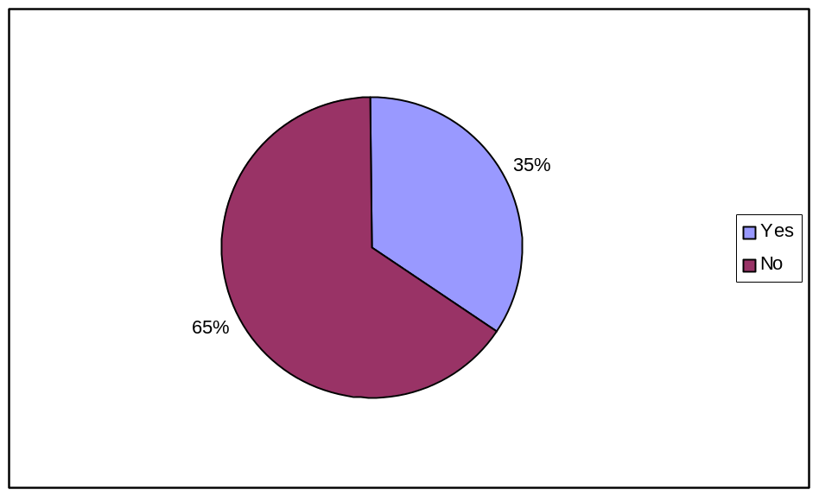

To clear doubt on the issue of job specification, the researcher goes further institutionally to see whether the observed situation covers all institutions or not.

The result show that 75% of the respondents from Zanzibar Aids Commission were clear on job specification (required qualification and working condition) before joining the organization, while others only 24%, 33%, 30%,7%, and 40% of respondents from Commission for Agriculture and Extension Service, Labour Commission, Commission for Tourism and Wakf Commission respectively were clear on the above issue. Observing the existing situation, we may justify that in an organization where employees are aware of their working condition there is less rate of turnover compared to those where such information is not made available. The table XIII below shows the respondents awareness on working condition.

Table XIII

Organizational Respondents’ Awareness on Working Condition
 |  |  | Organisation |  | Results
 |  |  |  |  | No |  | % |  | Yes |  | % |  | Total
 |  |  | ZAC |  | 2 |  | 25 |  | 6 |  | 75 |  | 8
 |  |  | Commission for Agriculture and Extension. Services |  | 22 |  | 76 |  | 7 |  | 24 |  | 29
 |  |  | Labour Commission |  | 16 |  | 67 |  | 8 |  | 33 |  | 24
 |  |  | Commission for Tourism |  | 9 |  | 69 |  | 4 |  | 31 |  | 13
 |  |  | Wakf Commission |  | 6 |  | 50 |  | 4 |  | 40 |  | 10
 |  | Total |  | 55 |  | 65 |  | 29 |  | 35 |  | 84

Interview and Selection Procedures
Furthermore, the analysis shows that in most cases all recruited employees are interviewed, although there are some cases where the employees join organization without this important process. The figure 3 below shows that 69% of the respondents were interviewed before joining the organizations while 31% of them were not.

Figure 3
Employees’ Respondents on Interview Process
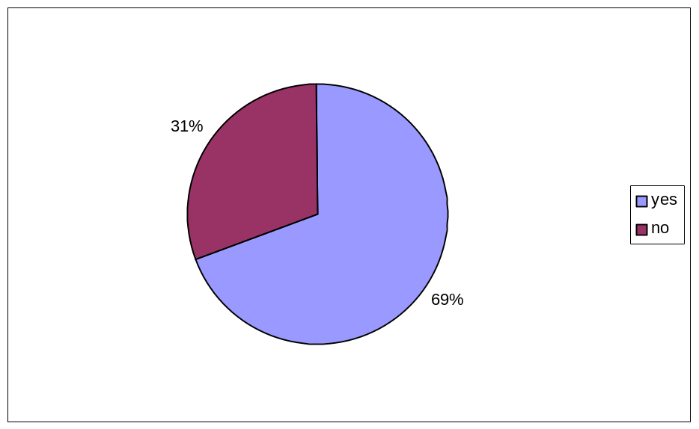

Management Selection Procedure
Within this context of interview, the researcher observes that there is no uniformity among Government Institutions on how to carry out this critical and important process.

The analysis showed that 60% of the study population uses Interview panel to interview new applicants while 20% of them still apply a traditional procedure of using personnel officer of a Ministry to conduct an interview. The remaining 20% showed that they use Interview panel in collaboration with their Executive Committee or Board in this process. The data also shows that, accountants, tutors, administrators and internal auditors are the common cadres that were not interviewed on their first appointment while most of the clerks and officers were interviewed.

In some organizations members of interview panel or personnel officers take physical checking on original certificates of the applicants before continuing with the interview process. The data shows that, 20% of the institutions have the tendency of asking the applicants to provide three names of three professionals’ referees to support their applications. More over organizations consult the National Examination Council of Tanzania for further clarification of certificates.

The organizations also apply the rule of probation period for 6 months as per Employment and Labour Relation Act N0. 11 (2005); or a period of 12 months as directed by General Order (G.O) before employee’s confirmation.

Orientation
The researcher questioned to organization’s management about orientation to new staff. All institutions’ leaders agree that they conduct orientation to new entrants from the beginning or early period of their employment, although ways used on orientation differ from one organization to another.

4.7 Respondents’ Expectations

The employees were asked about their expectations while joining the organization and whether they are met or not. This question aimed to see whether unmet expectations have an impact to employees’ turnover or not. The diagram below shows the respondents’ expectations.

Figure 4
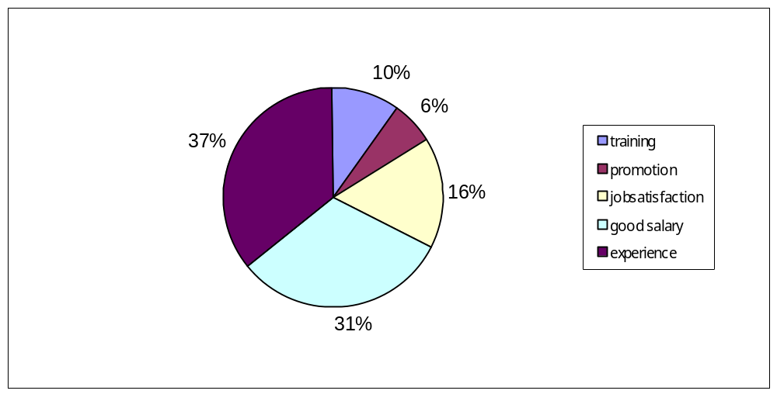General Expectations of Respondents (Existing Employees)

In referring to the above chart, the data shows that the main expectations of the respondents (existing employees) in general, is getting more experience, enjoying a good salary and job satisfaction while working in the organization. On the other hand training and promotion are the minor expectations to most of the respondents.

Furthermore, the figure below which presents the respondents’ expectations of dropouts shows that 33%, 24 % and 19% of those who leave the government institutions are those whose main expectations are good salary, getting promotion and job satisfaction respectively.

Figure 5
General Expectations (Dropouts)
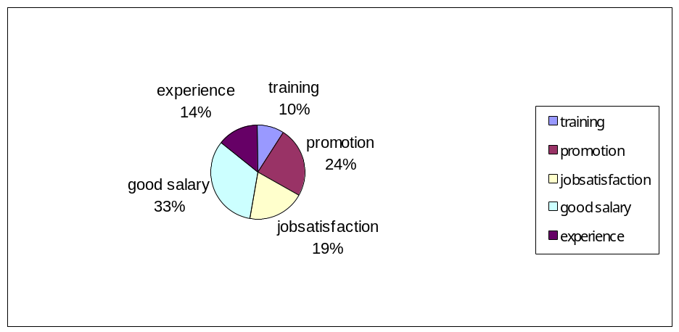

The results show that the main expectation among majority of employees in the Focus Group Discussions is good salary and job satisfaction. This is similar to results shown by dropouts.

Employees were asked as to whether the said expectations are met or not. This question was raised to support human resources philosophy, which states that unmet expectation is among the factor of employees’ turnover (Sturges and Guest 1999). The data collected on unmet expectations shows that 48% of respondents did not meet their expectations; while 52% agree that they met their expectations as shown in Figure 6 below.

Figure 6

Employees’ Responses on Meeting Their Expectations
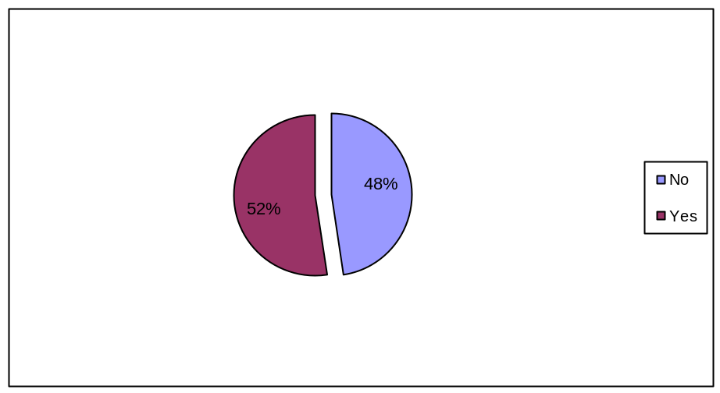

Despite the existing employees’ respondents, the data collected show that 100% of dropouts are those who unfortunately did not meet their expectations. On average about 33% of them were on the same category of “expecting good salary and incentives.” The situation implies that unmet expectations contribute on employees’ turnover in Zanzibar Government Institutions.

In examining this issue further, respondents were asked on “hindrances of fulfilling their expectations.” The data show that 60 (72%) respondents among the existing employees and 8 (80%) dropouts agree that lack of scheme of service hinder their expectations. On the other hand 24 (28%) existing employees and 2 (20%) dropouts said that an unfavorable working condition hinders their expectations. The figure 7 0n page 52 illustrates respondents’ situation of unmet expectations.

Figure 7
Respondents’ Reasons for Unmet Expectation
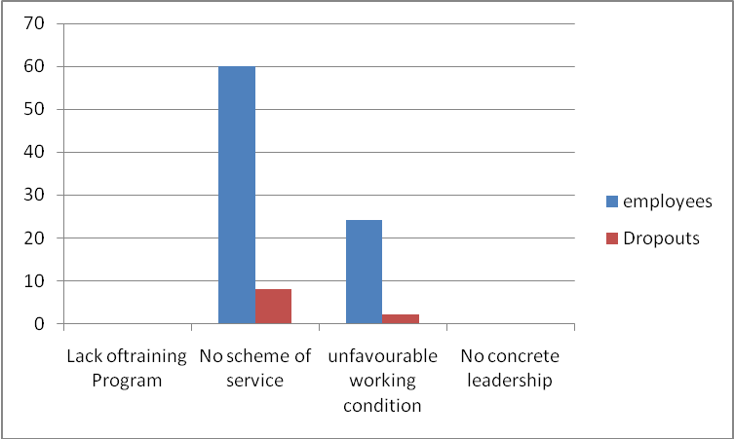

4.8 Measures Taken by Management to Control Unnecessary Turnover
Management through interview question number (2) was further asked about the control measures they use to ensure unnecessary employees’ turnover. In fact the directors and commissioners of all institutions agree that they are conversant with all control measures that should be taken to ensure unnecessary turnover. The following measures were mentioned: -
- Keep conducive working condition
- Develop motivation and incentive packages
- Develop and implement career advancement plan
- Introduce job scope, roles and responsibilities
- Pay good salary
Despite the management awareness on the above-mentioned measures, there are some hindrances on their implementation. The Commissions have no mandate to implement their own proposals concerning employees’ salaries or other packages without the intervention of the Government. Currently Government salaries and other allowances are formulated by the Civil Service Department and introduced for implementation by all MDAs.

4.9 Negative Situations Observed In Government Institutions
Besides, the above hindrances mentioned by management on implementation of control measures, there are other control measures that should be clarified at organizational level. For instance the management has the responsibility in ensuring a conducive working environment, clear job descriptions and responsibilities, appropriate utilization of skills acquired by employees and involvement of employees in decision-making. The dropouts and employees were asked on the negative situations observed to see how management activates internally those negativities. This question generated different responses from the two groups.

According to dropouts’ responses low salary, lack of participation and promotion was the leading negativities as shown in the table XIV below.

Table XIV

Negative Situation Observed by Dropouts
Negative Situation Observed | Frequency | Percent
Low salary | 6 | 60.0
Lack of Participation | 3 | 30.0
No promotion | 1 | 10.0

The analysis from employees’ data shows that participation, matching of skill acquired versus work done by employees and lack of job description are the leading negative factors within the management as indicated in the diagram overleaf.

Figure 8
Negative Situations Observed by Employees

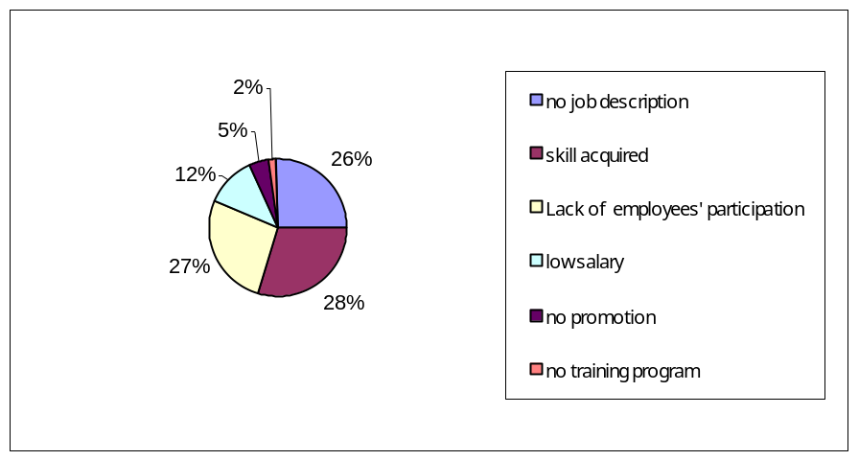

The following section illustrates important aspects regarding work situations.
a) Job Description
A question was asked on important issues concerning individual job requirements. Job description was indicated to be important as it guides employee to know their roles and responsibilities. The analysis shows that 26% of the job respondents do not have job descriptions. This situation shows that employees are working in an ambiguity situation hence they do not know their roles, job scope and whom to be accounted for.

Under normal circumstances, hard working employees plan their day-to-day activities, this issue of not having job directions; can be taken as a starting point to search to different place. Not only that but also the situation may lead to negative perception to management, and sometimes feeling that the organization they joined is just a way of wasting their time and knowledge which finally result in leaving the job after a short time.

In probing this issue to discussion groups, there were some respondents who had been working in these organizations for many years without knowing their roles and responsibilities. Among this group there are some employees who describe that they were given job descriptions while working. Within this context it is possible that employees work in a disorganized environment. To some extent this situation may automatically lead to misunderstanding among employees, inefficiency, lowering employees’ morale and finally leave the organization.

Due to the importance of job description as the governing tool to employee, the researcher include it in the list of factor in question number 9 on questionnaire for leavers and 11 on questionnaire for employees and for directors to see its repercussion on labour turn over. According to the responses, the question of clear job descriptions and division of labour at this level is insignificant as factors leading to employees turn over in Zanzibar Government. Only 6% and 7% among existing employees and dropouts put these two categories as factors for employees’ turnover (see figure 9 on page 60) and 10 on pg 64). More over the situation should be taken into consideration by making arrangement that will assist new employee to know their job descriptions from the beginning of employment contract.

b) Utilization of Skills Acquired
Among the important things is to ensure appropriate utilization of human resources. In considering its importance the researcher asked the question as to whether the employees fully utilize their skills acquired or not. The results show that 28% of respondents’ skills are underutilized. To some extent this may cause boredom to some employees and sometimes leads to voluntary turnover.

c) Lack of Employees’ Participation
A question was asked to employees to see whether they are participating in decision-making or not. The response data show that 27% of existing employees and 30% of dropouts do not participate in decision-making. It seems that many employers or management are not consistent in applying the principles of human resource management in their organisation. They are not considering the whole issue of participation as the way to improve cooperation between managers and their employees.

At some point, it may be possible that the management decisions are in top-down system as employees receive directives and orders from leaders without the chance to share ideas. The question of participation is among the key points to be observed in this study in which the researcher expects to get results as to whether it has contribution on employees’ turnover rate in Zanzibar Institutions.
The same question (see interview question number 3) was also asked to the management in order to see how well employees’ participation in the organization is practiced. The management agrees that their employees participate in decision-making process in different ways. It was observed that management of internal decisions process in the institutions is through administrative meetings in which majority of its members are taking part. The structures of the organization committees do not give adequate opportunities to employees to make contributions. The representatives from lower cadres in some of the committees are just members who are there to present their problems and not contributions on management issues.

d) Low Salary
In continuing to the question of negative situation observed by employees, the analysis shows that Low salary is among the major negative factors observed by 60% of dropouts while to the existing employees it is about 12%. The implication is that most of dropouts join the institutions with the intention of getting high salary, while the remaining existing employees obviously had either prior information on low salary issued by Zanzibar Government Institutions or lack of alternative job because of their education level which force them to remain in the institutions for longer period.
e) Promotion and Training Program
According to figure 8 (see page 55) and table XIV on page 54, these two categories seems to be of less concern to employees while joining the organization hence only 5% and 10% of existing employees and dropouts on promotion and 2% on Training Program agree that it is a factor for employees turnover. The above data indicates that employees are not aware on their career or promotion while working in a certain organization.

4.10 Contributing Factors of Employees Turnover
As it is shown in the main objective of this study that is to find out factors that lead to employees’ turnover in Zanzibar Government Institutions, the researcher framed out the question and categorised it into the possible factors to the concerned subject. This question was asked to all respondents, management, employees and dropouts. The respondents asked to select three important contributing factors which leads to employees’ turnover, the general data for all respondents portion on the categorized factors by employees are as shown in figure 9 over-leaf.

Figure 9
Contributing Factors of Employees’ Turnover
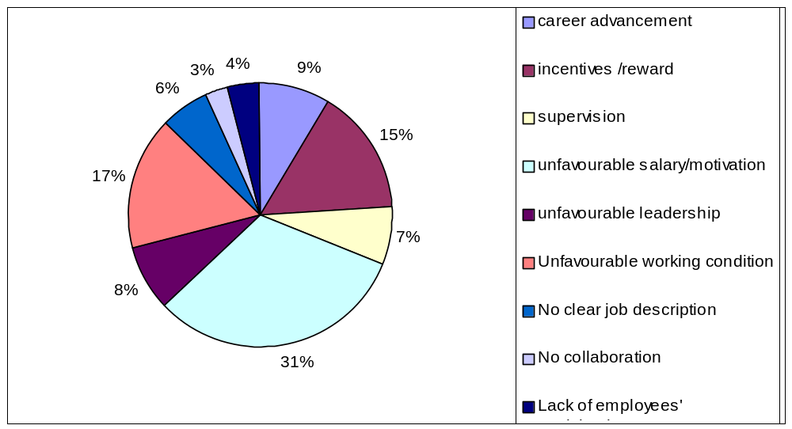

a) Lack of Career Advancement
It has been said in the second chapter that training and development has a complex relationship with labour turnover. Studies have been pointed out indicating that organisations that provide mobility of the professional skills of the employees can anticipate a lower turnover rate (Tracey at el, 2008). However, there are also studies that show employees tend to have a greater possibility of succumbing to voluntary turnover (Khatri, 2005). Referring to the above figure, these points seem to have a reflection.

About 9% of the existing employees and 4% of dropouts (see figure 10 on page 64) show that career advance is among the contributing factors of employees’ turnover.

b) Lack of Incentive and Rewards
Many authors agreed that incentive and reward that are categorised as pull factors might be used as an alternative way to retain qualified and experienced employees in an organization. As shown in figure 9 that 15% of employees agree that incentive and reward are the contributing factors. On top of that, the data collected from dropouts as illustrated in figure 10 page 64 show that 36% agree that incentive and rewards are among the factors that lead to quit from previous organisations. Furthermore, the data collected at the management level for all 5 organisations show that lack of incentives/rewards is the second important factor contributing to employees’ turnover. From these findings it is clear that incentive and reward in Zanzibar Government Institutions is meager or never practiced.

c) Lack of Supervision
The question of supervision is asked by researcher in order to see its contribution on rate of turnover issue of employees’. Similarly, the employees were asked this question as whether or not their supervisors make them feel valued and appreciated, bearing in mind that a bad relationship with supervisor is a common factor of employees’ turnover. The data from figure 9 on page 60 shows that 7% of the respondents agree that lack of
supervision is among the contributing factor of employees’ turnover, while dropouts and management are silence in this contributing factor. In analysing this situation it shows that the question of supervision in Zanzibar Government Institutions is not a serious issue in labour turnover although it needs improvement in its implementation.
d) Unfavourable Salary and Motivation
Salary and motivation in many organizations seem to be of high priority to almost all respondents. The data collected give clear picture on this component indicating salary and motivation to be the first contributing factor of employees’ turnover. About 31% of the existing employees (see figure 9 on page 60) and 36% of the dropouts (see figure 10 on page 64) agreed on this assertion. Apart from employees, data from all managements also show that they see unfavorable salary and motivation packages as the first contributing factors of employees’ turnover.
These findings are supported by a discussion on chapter II where it has indicated that salary and motivation are very important elements to ensure retention and also they are among the most observed negative factors leading to employees’ turnover. For instance, the Chapter II indicates that voluntary turnover is directly affected by wages and career opportunity. In the same manner, there is a positive relationship between employee performance, motivation and labour turnover.

e) Unfavourable Leadership
It is common knowledge that leadership in an organisation has contribution in employees’ retention. The data collected from this category though indicate otherwise as only 7% and 4% of existing employees and dropouts respectively agree, it may still be a factor for employees’ turnover.

f) Unfavourable Working Condition
As indicated by the respondents that among the reasons for unmet expectation are unfavorable working condition. The following question was asked in order to see that if “unfavourable working condition” can contribute to labour turnover rate or not. The data shows that 16% of the respondents and 14% of the dropouts agree that unfavorable working condition is among the factor leading to employees’ turnover.

g) Collaboration
“Team work” seems to be a new phenomenon in many Zanzibar organizations as most employees did not respond to this question. According to the data collected the few that responded (3%) agreed that it is a leading factor of employees’ turnover.
h) Lack of Employees’ Participation
The level of participation in organization has contribution in performance. However, the data collected shows that 4% of existing employees positively agree that it is among the contributing factor, see figure 10 below.

Figure 10
Respondents on Factors Contributing Employees’ Turnover (Dropouts)
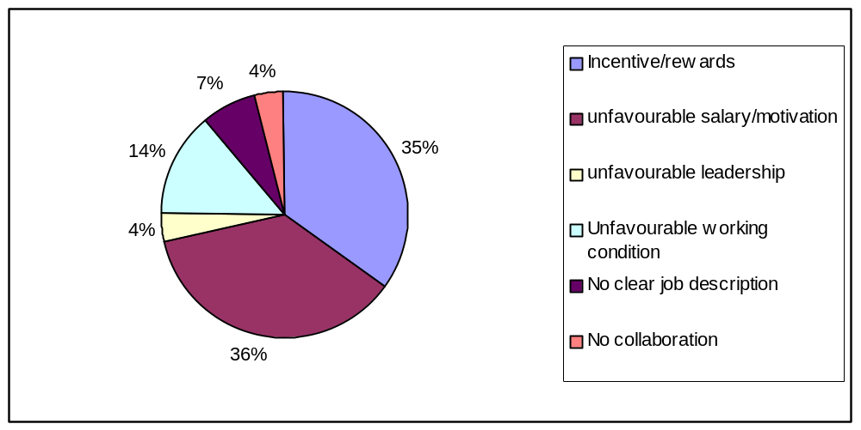

4.11 Job Satisfaction
A question on job satisfaction was asked to employees in order to have a clear picture on existing employees if they are satisfied or not. The data collected is categorized age wise so as to know what age group of the workforce is more satisfied and which is not.

As indicated in Chapter Two job satisfaction indirectly affects the labour turnover in an organisation. Specifically, when employees have low job satisfaction, they tend to leave the company and look for more interesting work. It was mentioned in Chapter Two that there is a strong link between the concept of satisfaction and organisational commitment. Table XV and Figure 11 below illustrate the findings.

Table XV
Employees’ Satisfaction by Age
Age | Yes | No | Total
25 to 40 | 41 | 14 | 55
41 to 55 | 16 | 11 | 27
above 55 | 2 |  | 2
Total | 59 | 25 | 84

The analysis shows that 41 respondents, equivalent to 75% age range from 25 to 41 years are satisfied with their job while 14 respondents (25 % of the same age group) are not. Furthermore 16 respondents equivalent to 59% whose age is 41 – 55 years are satisfied and 8 among them, equivalent to 41% are not. Finally, the group ranging from 55 years and above (100%) is satisfied with their jobs.

The question of job satisfaction when presented before the Focus Group Discussion provides mixed results. The findings indicate that most of them are not satisfied with their jobs, although there is a small group claiming to be satisfied with their jobs.

The researcher also asked a similar question to leavers in their current organization. The data shows that 100% are satisfied with their new jobs and the factors that lead to their satisfaction are mentioned as good salary and incentives (62%), training (19%), promotion (13%) and job satisfaction (6%) as shown on figure 11 below.

Figure 11
Respondents’ Leading Factors on Satisfaction (Dropouts
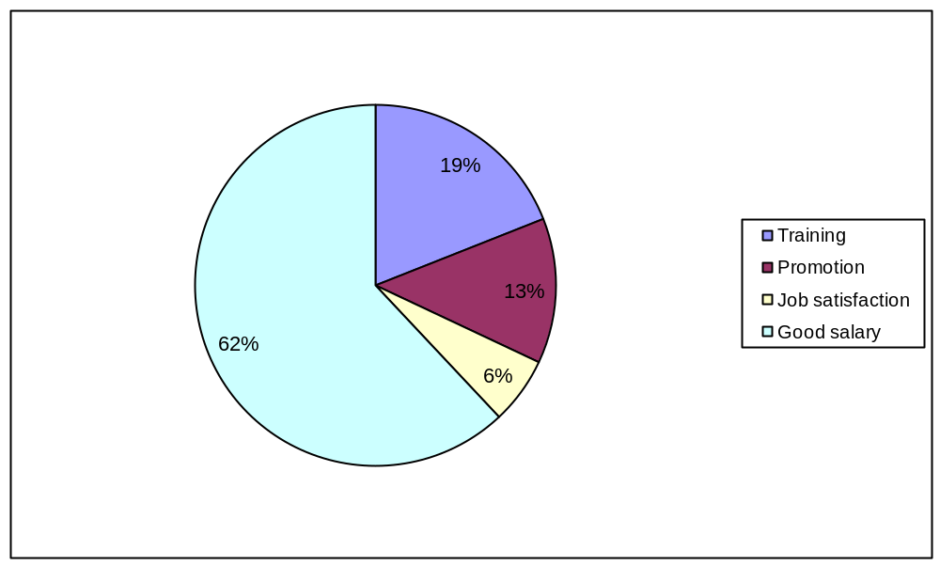

4.12 Ways Used by Management to Retain Employees
This is an interview question number 4 asked by the researcher to the management to find out different ways they are using to retain employees. Although the study results shown from the beginning of this chapter, that the labour turnover rate of the institution differs from one institution to another, but generally this question have same answer from all respondents. According to the leaders of the institutions, they have good proposals to arrest staff turnover, for instance increasing staff salary, promotion and increment but because of lack of autonomy in those commissions these proposals do not materialize because they need approval from the central government.

Despite those constraints, institutions always develop their future plans to save the situation. The following is an account relating to selected institutions:-
a) Zanzibar AIDS Commission
Zanzibar AIDS Commission (ZAC) has low employees’ turnover. It plans to have Staff Establishment and Scheme of Service that would ensure appropriate incentive for their staff. Zanzibar AIDS Commission is also finalizing Human Development Resource Policy that, among other things, would address issues of motivation in general including staff development plan. These are the strategies employed to retain professional staff.
b) Wakf Commission
The Wakf Commission falls under religious institutions. They are in the process of recruiting competent workers to improve efficiency and effectiveness of the organisation. The Wakf Commission has prepared a Draft Incentive Package that will need the approval of Civil Service Department.
c) Commission for Tourism
The management of this organization planned to review and to use effectively their Scheme of Service as the way to retain the qualified employees. This institution has its scheme of service that was introduced in the year 2000 containing two parts, salary grade and allowances. Unfortunately they have authorization of new salary grades but not allowances. There is a proposal to change the Commission and establish Board of Tourism with more powers and autonomy. This proposed change might upgrade its status and increase government income.
d) Commission for Agriculture, Research and Extension Service
As with other institutions, in order to solve this problem of employees’ turnover, the commission planned to prepare organizational scheme of service, submit it to proper channels for approval and finally implement it continuously as a way to retain and motivate qualified workers.
Apart from that, they also plan to develop training program for the existing staff and implement it properly. Currently the Commission is looking for sponsorship from different international donors to support staff training programme.
e) Labour Commission
The existing employees’ turnover rate of this commission seems to be high compared to others. The Labour Commission is planning to write a paper to Zanzibar Government to allow them to be independent with full autonomy like other commissions. Due to global changes on labour matters, effectiveness of the Labour Commission will need competent and qualified workers for their day-to-day activities.
The Labour Commission is in the process to restructure their institution, review job descriptions and conduct Training Needs Assessment that will finally feed into development of a Training Program. Likewise, the Labour Commission plans to develop Incentive and Motivation Plan that will fit with the current global labour market. There is currently a consultation between the Commission for Labour and Ministry of Finance regarding retention of revenue collected. The aim is to raise resources that will improve implementation of their planned objectives.
4.13 Employees’ Future Plan
The question of future plan is also asked to employees in order to determine as to whether or not the employees have high intention to quit or to remain in the organization. The responses are summarised in Table XVI below.

Table XVI Respondents’ Future Plans by Age
Age | Leave for better opportunities | Remain in the same organization | Remain in same organization but change responsibilities | Total
25 to 40 | 36 | 15 | 4 | 55
40 to 55 | 14 | 6 | 7 | 27
above 55 | 2 | - | - | 2
Total | 52 | 21 | 11 | 84
Percent | 61.9% | 25% | 13.1% | 100%
The table above basically indicates that most employees (62%) plan to quit the organization at any time if they get better working place. Life difficulties and low salary is apparently understandable and seemingly a bearable reason for this intention. In the same manner, 25% of the employees aim to remain in the same organization but change
their responsibilities as an alternative way of remaining in the organization. However, a small percentage (13 %) does not have plans to quit the organization.
The other observed important factor is that the intention to quit the existing organisations covers all age groups of employees. The young blood whose age range is from 25 to 40 years have greater propensity to change places of work.
4.14 Opinion to Save the Situation
Dropouts were asked on their opinions to save this situation and reduce employees’ turnover. The findings show that many respondents think that good salary and motivation to employees may reduce employees’ turnover in government institutions while others think that training, promotion, job satisfaction and teamwork have contribution. Figure 12 on page 72 shows their categorized opinion.

Figure 12
Respondents’ Opinions to Save the Situation
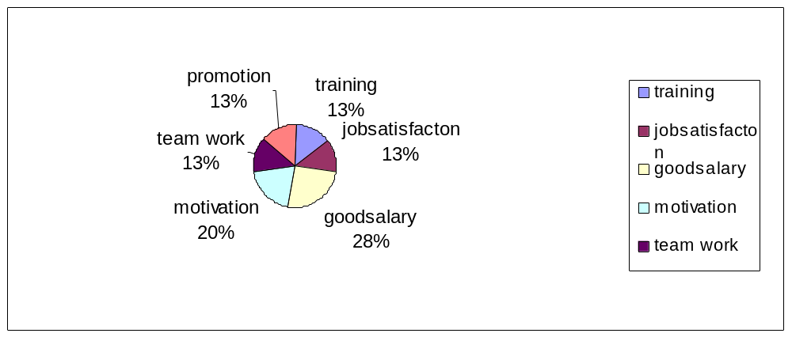
4.15 Dropouts Current Organisation and Their Reasons to Quit
Sets of questions were formulated to dropouts to identify their current organisations and the reason for joining and whether their planned objectives were achieved. The findings shows that six respondents are working in the Immigration office, two respondents at the Institute of Social Work Dar-es-Salaam, one at Zanzibar Electrical Company (ZECO) and one at ZANTEL Dar-es –salaam.
The data collected from respondents concerning their desire to get employed in the current organisation shows that good salary and motivation packages (33%) and incentives and rewards (33%) are the major reasons while conducive working condition (17%). Career development and participation (7% and 10 %) respectively are second reasons for them to change job (see figure 13 on page 73).
Figure 13
Respondents’ Reasons for Application to Current Organisation
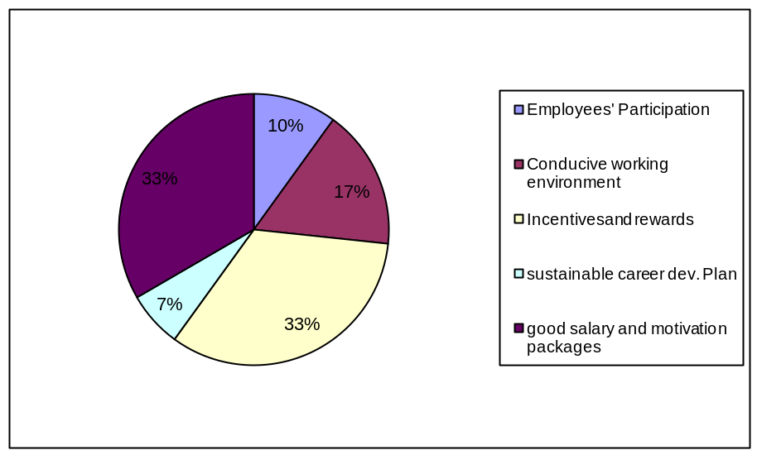
On the other hand, the collected data on the planned objectives of the respondents indicate that 100% of them achieved their planned objectives, with high percentage on good salary and incentives (70%) followed by promotion, training, job satisfaction and teamwork by 20, 6%, 2% and 2% respectively (See figure 14). The findings imply that there is big gap on payment packages between Zanzibar Government institutions, corporatives and Tanzania Mainland institutions.

Figure 14
Respondents’ Achievement on Planned Objectives.
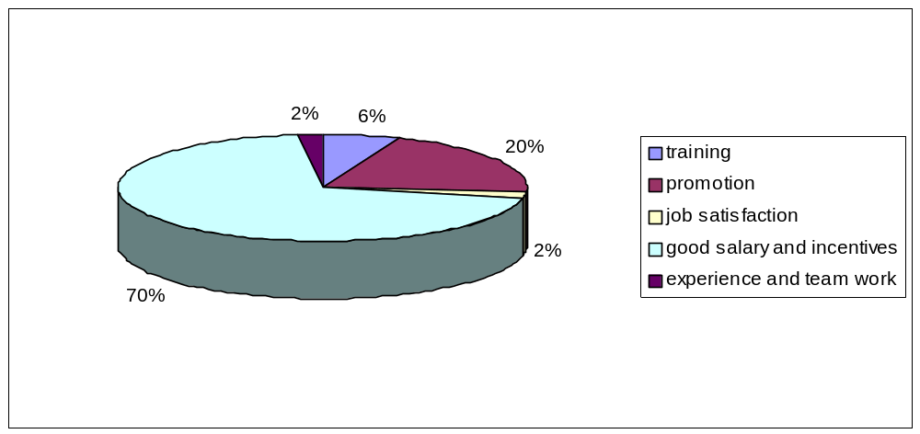

CHAPTER V
CONCLUSION AND RECOMMENDATIONS

5.1 Conclusion

The issue of labour turnover has become one of the most important discourses in recent organizational studies. The discussions above are a mere addition to this amalgam of factors leading to employees’ turn over in Zanzibar Government institutions and proposed recommendations on how to retain or save the stated situation. The following are summary of analysis of findings of this study:

- There is a loophole in General Order concerning leave without pay for employees.
- The findings also show that recruitment process in Zanzibar Government Institutions is ineffective because of unspecified working condition during recruitment process that seems to be the source of employees’ turnover at earlier stage.
- Lacks of scheme of service and Training Program in many Zanzibar Government institutions are among the hindrances of employees’ expectations.
- Push factors such as career advancement, ineffective supervision, poor involvement in decision making process and boredom which are normally caused by unfavorable leadership or under utilization of skills acquired by employee also have significant influence in labour turnover.
- Institutional motivation and incentive plans proposed by Government Establishments cannot be implemented due to lack of a defined decision making process.

Pull factors such as pay, attractive packages and incentive and rewards are the most leading factors to employees’ turnover in Zanzibar Government institutions.

The comparison of payment packages among institutions has a major influence on labour turnover.

5.2 Recommendations

Based on the conclusion as well as analysis made in the previous chapters, the following recommendations are proposed:
- There is a need for Zanzibar Government to review General Order and make amendment to all articles that give loopholes to employees through leave without pay in order to reduce unnecessary costs to Government. The question of General Order that for the time being used as reference for all public service management matters, in general is indicated as a Key Results Area (KRA) in Zanzibar Public Service Program (2010), which is addressed as “formulation and implementation of Public Service Management Regulations” as measures that need to be taken to improve the management of human resources.
- Zanzibar Government through the Presidents’ Office Public Service and Good Governance should prepare appropriate guidelines on recruitment procedures to be followed by Ministries that will lead to effective recruitment process.
- The President’s Office Public Services and Good Governance should change the current way of filling organizations’ vacant posts. They should take a role of regulatory board only and let individual Ministries to recruit their own work force.
- Despite the revised salary structure made by government and rationalization of allowances and consolidated into pay in 2007, still pay levels continue to remain unattractive especially for technical and professional staff. (Zanzibar Public Service Reform Programme 2010). At this stage the Revolutionary Government of Zanzibar (RGoZ) through President’s Office - Public Service and Good Governance should institutionalize and speed up the implementation of newly developed scheme of service to increase employees’ morale and reduce inefficiency at working places.
- The on-going process of reviewing salary payment for Zanzibar Government employees should base in reality; as evidenced by the fact that Zanzibar public servants earn less than their counter-parts in neighbouring countries and current pay levels do not match minimum cost of living (Zanzibar Public Service Reform Program 2010) the result of this is to avoid pay differences between Tanzania Mainland organizations and Zanzibar and automatically reduce employees’ turnover rate.
- Special efforts should be done to ensure that appropriate motivation and career development plans are developed and implemented accordingly. To have sustainable plans will assists competent workers to remain and attract qualified ones to join in Zanzibar institutions.
- Zanzibar Public Service Reform Programme (ZPSRP 2010) also focus to strengthen institutions and develop human resources, it is true that the results of it give hints on how to start. It is time for the Revolutionary Government of Zanzibar to go thorough on all recommended area in the Program so as to ensure Zanzibar establishments match with autonomy given to them in order to get better and meaningful results as introduced in Mission and objectives of those establishments.

REFERENCES

Abdulhamid, Y. M, (2010). “Marekebisho ya Muundo wa Utumishi wa
Umma Zanzibar yanakamilishwa”. Zanzibar Leo Issue No. 2932 dated 31st January 2010.
Amstrong, M. (2006). Human Resources Management Practice. (10th Edition): Kogan Page Ltd, London.
Bevan, S. Barber, L. and Robinson, D. (1997). Keeping the Best: A practical guide to retaining key employees: Institute for Employment Research. Brighton.
Cappelli, P. (2000). ‘A market-driven approach to retaining talent’,Harvard BusinessReview, January/February.
Cascio, W. F. (1995). Managing Human Resources, Productivity, quality of work life, Profit: McGraw-Hill College.
Civil Service Department (2009). Budget Speech. 2009/10. Zanzibar Printing Press.
Curry, K. (2006).Reducing turnover, Increasing Retention. Dallas Business JournalISN.39, Available a http://www.enewsbuilder.net/peoplereport/(Accessed 26/11/2009)
DAI Europe Ltd. (2007). Final Report of Consulting Services for a comprehensive Review of Public Sector Employment and wage Bill Issues: For the Government of Zanzibar, Printing Press.
Davis, J. M., (2005). The Myth of Zero Turnovers, High Performance Guide, Available at www.valitusgroup.com/the_myth_of_zero_turnover.php (Accessed 25/10/2009).
Department of Human Resources Planning (2001). Zanzibar Manpower Survey Report (2001/2002):Ministry of Finance and Economic Affairs, Zanzibar.
Department of Human Resources Planning (2010). Zanzibar Public Service Reform Program (2010), Revolutionary Government of Zanzibar
Department of Human Resources Planning (2001). Zanzibar Manpower Survey Report (2001/2002): Ministry of Finance and Economic Affairs, Zanzibar.
Department of Human Resources Planning (2010). Zanzibar Public Service Reform Program (2010), Revolutionary Government of Zanzibar
Griffeth, R. and Hom, P. (2001). Retaining Valued Employees, Research on HRM, Available at www.amazon.com.uk (Accessed on 3rd March 2010).
Gomez-Mejia, L. and Balkin, D. (1992). Compensation, Organizational Strategy and Firm Performance: Cincinnati, Ohio, South Western College Publishing.
Gunu, O. M. (2008). Job Performance Vs Employee’s turnover. Available at knoll.google.com.(Accessed 3/3/2010).
Gupta, C. B. (2007). Human Resources Management: Sultan Chand & Sons. New Delhi.
Herzberg, F. (1966). Work and the Nature of Man: Cleveland, Ohio, World Publishing.
Hiltrop, J.-M. (1999).The quest for the best human resource practices to attract and retain talent European Management Journal, Vol. 17.
Hom, P. and Griffeth, R. (1995): Employee Turnover. Cincinnati, Ohio: South Western College Publishing.
Hornby, A. S. (1996). Oxford Advanced Learners’ Dictionary 5th Edition: Oxford University Press.
Khaila, S. (2003). Factors influencing Turnover:Available at www.sigmassmentsystem.com/articles/emp.turnover (Accessed 2/3/201 0).
Khatri, N. (2005). Employee Turnover: Bad attitude or Poor Management, Available at www.3.ntu.edu.sg./nbs (Accessed 2nd February 2010).
Khan, A. (2006): Managing Staff Turnover in off show Call Center: Accessed at www.alifreessays.com/. (Research paper Accessed 6th March, 2010)
Livinga, A. J.,Bana, B. B. and Mnoga, A. (2009). Situation Analysis on the State of Public Service Reform. Revolutionary Government of Zanzibar.
Rothwell, W. J. and Kazanas, H. C. (2003). Human Resource-Strategic Planning for Personnel Management (Second Edition): HRD Press, Amherst, Massachusettso 1002.
Shehan, T. O. (2005). How to retain employees Available at FedExOffice.Com. (Accessed 26/10/09).
Sheridan, J. E. (1998). How to reduce Employees’ Turnover. Available at www.enewbuilder.net/peoplereport/e_article000617464.cfm?x=b11,0,w (Accessed 2/2/2010).
Sisk, H. L. and William, J. C. (1981). Management and Organization (fourth Edition. South-Western Publishing Co, USA.
Department of Human Resources Planning (2006). Zanzibar Situation Analysis Report for Human Resources Development Policy: Ministry of Finance and Economic Affairs, Zanzibar.
Stovel, M. and Bontis, (2002). “How can Managers reduce employee ntention to quit?” Journal of Intellectual Capital.
Taylor, S. (2002). The Employee Retention Handbook: London: CIPD.
Tracey, J. Bruce; Hinkin, Timothy, R. (2008). Contextual Factors and Cost Profiles Associated with Employee Turnover. (HR). Available at www.revisionguru.co (Accessed 26/3/2010)
Torington, D. Hall, L. and Stephen Taylor (2002).Human Resource Managemen(Fifth Edition).Pearson Education Ltd.
Torington D. Hall, L. and Stephen Taylor (2005). Human Resource Management (sixth Edition), Pearson Education Ltd.
Turner, P. (2002). Human Resource Forecasting and Planning: Chartered Institute of Personnel and Development. Camp Road, London
Veldhuizen, J. (2006). ‘Staff Turnover In Health Institute’ Available at www.wisegreek.com/what employee tern over.htm (Accessed 1st March 2010)
Wanous, J.P. (1992). Recruitment, Selection, Orientation and Socialization of Newcomers: Reading Mass. Addison Wesley.
William. K. and Johnson B. (2004): Introducing Management a development Guide: Elservier Butterworth-Heinmann, Oxford- UK.

Zabarauskaite, R. (2007). Factors Determining Rate of Turnover in Companies Research Paper from Institute of Labour and Social Research, Available at www.esalasemanager.com/118.html

APPENDIX A

LIST OF SEMI AUTONOMOUS INSTITUTIONS

S/No. | NAME | PARENT MINISTRY | STATUS
1 | Labour commission | Ministry of Labour, Youth Women and Children Development | Service
2 | Zanzibar Aids Commissions | Ministry of Health and Social Welfare | Service
3 | Commission for Tourism | Ministry of Tourism Trade and Investment | Tourist service
4 | Karume Technical Institute | Ministry of Education and Vocational Training | Education
5 | Law Review Commission | Ministry of State President Office Constitutional Affairs and Good Governance | Service
6 | Zanzibar Investment and Promotion Agency | Ministry of Tourism Trade and Investment | Authority
7 | Zanzibar Electoral commission | Ministry of State President’s Office Constitutional Affair and Good Governance | Service
8 | Wakf commission | Ministry of State President’s Office Constitutional Affair and Good Governance | Service
9 | Stone Town Conservation Authority | Ministry of Water, Construction, Energy and Land | Authority
11 | Zanzibar Port Authority | Ministry of Communication and Transport | Authority
12 | Zanzibar Revenue Board | Ministry of Finance | Board
13 | Civil service commission | Presidents’ office | Service
14 | Zanzibar Water Authority | Ministry of Water, Construction, Energy and Land | Authority
14 | Vocational Education Training Authority | Ministry of Education and Vocational Training | Authority
15 | Commission for Agriculture Research and Extension Service | Ministry of Agriculture Livestock and Environment | Service

APPENDIX B

LIST OF SELECTED COMMISSIONS AND REASON FOR THEIR SELECTION

S/NO | NAME | REASONS FOR SELECTION
1 | Labour Commission | It is a Government Agency that deals with employment in private sectors. In order to effectively accomplish these important roles, the Commission needs qualified employees in most of their duties. The researcher was convinced to investigate this institution to see how the Commission is running its services to deal with the recently emerged problem of employees’ turnover.  The Commission has been operating for more than 10 years
2 | Commission for Agriculture Research and Extension Services | Agriculture is among the important sector that needs experienced workers and experts to ensure its existence and to boost Government revenue that will leads to poverty reduction. The researcher selects this commission due to its priority of being the backbone of Zanzibar economy.
3 | Commission for Tourism | It is the government agent for ensuring sustainability of Tourist Destination (market) in Zanzibar. The goal is to ensure better services are delivered to all tourists. Due to this specific importance of the commission, the researcher feels that it is better to include it in the study from the beginning so as to know its employees’ turnover rate and different ways used to retain qualified, competent and experienced employees. The analysis of the data collected will be the blue print to the new Government establishments.  Commission for Tourism is an old institution that was established in 1993.
4 | Zanzibar AIDS Commission | It is an establishment with small number of employees, but it operates many activities that need active and expertise workers with to support those activities. The researcher was convinced to find out the rate of employees’ turnover in this commission that deals with world’s most unsolved problem (HIV/AIDS).
5 | Wakf Commission | This commission is mostly dealing with religious matters. The researcher observes that by including this commission in research sample will have a wider range of the kinds of institutions involved for comparison.

APPENDIX C
Education Qualification of Employees by Organisation

Commission for Agriculture and Extension Services

Sex | Professionals | Skilled | Un skilled | Total
Male | 29 | 109 | 20 | 158
Female | 8 | 63 | 10 | 81
Total | 37 | 172 | 30 | 239

Wakf Commission

Sex | Professionals | Skilled | Un skilled | Total
Male | 7 | 12 | 21 | 40
Female | 1 | 10 | 8 | 19
Total | 8 | 22 | 29 | 59

Commission for Tourism

Sex | Professionals | Skilled | Un skilled | Total
Male | 13 | 15 | 23 | 51
Female | 3 | 14 | 7 | 24
Total | 16 | 29 | 30 | 75

Zanzibar AIDS Commission

Sex | Professionals | Skilled | Un skilled | Total
Male | 9 | 1 | 7 | 17
Female | 8 | 4 | 1 | 13
Total | 17 | 5 | 8 | 30
Labour Commission

Sex | Professionals | Skilled | Un skilled | Total
Male | 14 | 12 | 10 | 36
Female | 13 | 5 | 7 | 25
Total | 27 | 17 | 17 | 61

APPENDIX D

FACTORS LEADING TO EMPLOYEES’ TURNOVER AMONG ZANZIBAR GOVERNMENT INSTITUTIONS

This Questionnaire is for the study about the factors leading to employees’ turnover in Zanzibar Government Institutions. The findings of this study will be used to justify the problem of recent increase employees’ turnover. Data will be collected from Commission for Tourism, Commission for Labour, Zanzibar AIDS Commission, Commission for Agriculture and Extension Service and Wakf Commission as a case study. It is a part and parcel of requirement for the award of Master in Business Administration awarded by Open University in Tanzania.

Please, provide appropriate answers on the questions contained in this Questionnaire without giving your name. The information given will be treated in confidentiality.

QUESTIONNARE FOR LEAVERS (DROP OUTS)

SECTION A:

- BACK GROUND INFORMATION

Male
Female
Sex (Place a “Tick” in the box).

Age…………Years

Profession…………………………………………………………………….

SECTION B

2. What is your Previous Organization? ………………………………………..

Occupation. …………………………….…

3. What made you decide to apply for position in that organization?
………………………………………………………………………………………….

4. For how long did you work in that organization?
………………………………

5. What were your expectations when you first joined the organization? (Select only three most important expectations and then “tick”).

- Training (b) Promotion (c) Job satisfaction (d) Good salary and incentives (e) Experience and team work
Yes
No

6. Were those expectations met?

7. If No what reasons do you think hinder your expectations?
- Lack of training program
- No scheme of service
- Unfavorable Working condition
- No concrete Leadership

8. What negative situation did you experience while working for the previous organization? ( Select only three important situations)

- Job description does not match with what actually doing
- Skill acquired is not fully utilized.
- Lack of employees’ participation in decision making
- Low salary
- No Promotion
- No training Program

SECTION C

9. What factors contributed to your decision to quit? (Select three important factors).

9.1 Lack of Employees’ Participation
  - Unfavorable Working Condition
  - Lack of Incentives/Rewards.
9.4 Lack of Career Development Plan
9.5 No Supervision.
9.6 No concrete leadership.
9.7 Low salary and no Motivation Packages

9.8 No clear job description and division of labour
9.9 No collaboration

10. What is your opinion to save the situation in your previous organization?
- Provide training opportunities
- Promotion
- Job satisfaction
- Good salary and incentives
- Experience and team work

SECTION D

11. What is your current Organisation?

…………………………………………………………………..

12. For how long are you working in this organization?
………………………………………………………………………………………

Occupation………………………………………..

13. What made you apply for a job in this Organization?

  - Employees’ Participation
  - Conducive Working Condition
  - Incentives/Rewards
  - Sustainable Career Development Plan
13.5 Supervision.
13.6 Fair and justice leadership.
13.7 Good salary and Motivation Packages
13.8 Clear job description and division of labour

14. Are you satisfied with your current job – position?
Yes
No

15. If yes what factors lead to your satisfaction?
- Training (b) Promotion (c) Job satisfaction (d) Good salary and incentives (e) Experience and team work
16. Have you achieve your planned objectives?

If yes what are those achievements?

- Training opportunities (b) Promotion (c) Job satisfaction (d) Good salary and other incentives (e) Experience and team work

RECOMMENDATION:

17. Can you recommend this organization to a friend as a best place to work?
Yes
No

Give three important reasons.………………………………………………….………

1………………………………………………………………………………….

2……………………………………………………………………………………..

3………………………………………………………………………………………………………………………………………………………………………………

Thanks.

APPENDIX E

FACTORS LEADING TO EMPLOYEES’ TURNOVER AMONG ZANZIBAR GOVERNMENY INSITUTIONS

This Questionnaire is for the study about the factors leading to employees’ turnover in Zanzibar Government Institutions. The findings of this study will be used to justify the problem of recent increase employees’ turnover. Data will be collected from Commission for Tourism, Commission for Labour, Zanzibar AIDS Commission, Commission for Agriculture and Extension Service and Wakf Commission as a case study. It is a part and parcel of requirement for the award of Master In Business Administration awarded by Open University in Tanzania.

Please, provide appropriate answers on the questions contained in this Questionnaire without giving your name. The information given will be treated in confidentiality.

QUESTIONNARE FOR EMPLOYEES

SECTION A:

1. BACK GROUND INFORMATION

NAME OF ORGANIZATION ………………………………………………………..

TITLE ……………………………………………………………………………………

AGE …………YEARS
Male
Female

Sex (Place a “tick in the box)

PERIOD OF SERVICES ……………………………………………………………………

SECTION B

- How did you join this organization? Select one:

Nominated

Applied

3. What made you decide to apply for a position in this organization?
………………………………………………………………………………………………

………………………………………………………………………………………………

4. Did you have clear job specification on working condition before your application?
Yes
No

5. If No; were these given after being employed?

Yes
No
6. Were you given an interview before joining the organization?

7. What were your expectations when you first joined the organization? (Select only three important expectations)

(a) Training (b) Promotion (c) Job satisfaction (d) Good salary and
incentives (f) experience and team work

8. Were those expectations met?

9. If No what reasons do you think hinder your expectations?

a) Lack Training Program
b) No Scheme of service
c) Unfavorable working condition
d) No concrete Leadership

10. What negative situation did you experience while working for the organization?
- Job description does not match with what actually doing
- Skill acquired is not fully utilized.
- Lack of employees’ participation in decision making
- Low salary
- No Promotion
f) No training Program

11. Place a tick to three important factors that may cause you to
Quit).

11.1 Lack of Career advancement.
11.2 Lack of incentives/Rewards.
11.3 Lack of Supervision
11.4 Unfavorable Salary and motivation Packages
11.5 Unfavorable Leadership.
11.6 Unfavorable working condition
11.7 No clear job description and division of labour
11.8 No collaboration
11.9 Lack of employees’ participation in decision-making

12. Are you satisfied with your job.
Yes
No

- What is your future plan? (Select any one)

a) To leave for better opportunities

b) To remain in the same organization within the same organization but change
Responsibilities

c) To remain within the organization and same responsibilities

SECRTION C

10. What kind of organization do you intend to work for in the future?
………………………………………………………………………………………
……………………………………………………………………………………………………………………………………………………………………………..
………………………………………………………………………………………

Thanks.

APPENDIX F

FACTORS LEADING TO EMPLOYEES’ TURNOVER AMONG ZANZIBAR GOVERNMENT INSTITUTIONS

This Questionnaire is for the study about the factors leading to employees’ turnover in Zanzibar Government Institutions. The findings of this study will be used to justify the problem of recent increase employees’ turnover. Data will be collected from Commission for Tourism, Commission for Labour, Zanzibar AIDS Commission, Commission for Agriculture and Extension Service and Wakf Commission as a case study. It is a part and parcel of requirement for the award of Master In Business Administration awarded by Open University in Tanzania.

Please, provide appropriate answers on the questions contained in this Questionnaire without giving your name. The information given will be treated in confidentiality.

QUESTIONNARE FOR DIRECTORS AND COMMISSIONERS

1. Title of the Organization ………………………………………………………..

2. Size of employment:

 | Male | Female | Total
Professionals
Skilled
Unskilled
Total

3. Are vacant posts advertised in your organization?
If (yes) what kind of Media is used?
- News Paper
- Radio
- TV
- Internet.

4. If (No); how are those vacant positions are filled?

……………………………………………………………………………………………………………………………………………………………
Yes
No
5. Are working conditions specified in Advertisement?

6. What is the selection procedure for applicants?
- Interview Panel.
- Board Members
- Personnel officers.

7. What control measures are taken to ensure that the right person is selected?……………………………………………………………………………………………………………………………………………………………………………………………………………………………………………………………………………………………………………………………………………………………………………………………………..

8. How frequent do employees leave your organization in a year?

Low

Moderate

High

9. Are the selected persons given orientations before starting their new job?
Yes
No

Yes
No

10. Are employees involved in decision-making activities?

11. What factors do you thinks contribute your employees leave the Organization?
9.1 Lack of Career advancement.
9.2 Lack of incentives/Rewards.
9.3 Lack of Supervision
9.4 Unfavorable Salary and motivation Packages
9.5 Unfavorable Leadership.
9.6 Unfavorable working condition
9.7 No clear job description and division of labour
9.8 No collaboration

12. What is your future plan to ensure the retention of your employees?
- Introduce and Implement Training Program.
- Introduce and Implement Motivation Program.
- Enforce Incentive/Rewards Plans.
- Improve Pension Plans.

Thanks.
APPENDIX G

INTERVIEW QUESTIONS

TO MANAGEMENT

  - How many employees are in leave without pay?

  - What control measures used by management to ensure unnecessary employees’ turnover?

  - How employees involved in decision-making process?

  - Which management ways used as means to retain employees?

