THE IMPACT OF POPULATION GROWTH ON MANAGEMENT OF NATURAL FOREST RESOURCES IN BUCHANCHARI BASIN, MARA REGION

PAUL JUMA BASONDOLE

A DISSERTATION SUBMITTED IN PARTIAL FULFILMENT OF THE REQUIREMENTS FOR THE DEGREE OF MASTER OF ARTS IN NATURAL RESOURCES ASSESSMENT AND MANAGEMENT (MANRAM)
DEPARTMENT OF GEOGRAPHY
OF THE OPEN UNIVERSITY OF TANZANIA
2020

CERTIFICATION
The undersigned certifies that he has ready and hereby recommends for acceptance by the Open University of Tanzania a dissertation titled, “The impact of Population Growth on Management of Natural Forest Resources in Buchanchari Basin, Mara Region” in partial fulfillment of the requirements for the degree of Masters of Arts in Natural Resource Assessment and Management of the Open University of Tanzania.

………………………………………
Prof. Jumanne D. Kalwani
(Supervisor)

…………………………………..
Date

COPYRIGHT
No part of this dissertation may be reproduced, stored in any retrieval system, or transmitted in any form by any means, electronic, mechanical, photocopying, recording or otherwise without prior permission of the author or the Open University of Tanzania in that behalf.

DECLARATION
I, Paul Juma Basondole, do hereby declare that this dissertation is my own original work and that it has not been presented and will not be presented to any other University for a similar or any other degree award.

…………………………………
Signature

………………..……………
Date

DEDICATION
This dissertation is dedicated to my mother Ester Mgema Sweya who imparted to me the power of patience throughout out my study. Moreover, it is dedicated to my fiancée, Grace Lazaro for her consistent encouragement.

ACKNOWLEDGEMENTS
Praise and honor be to God almighty our Father for his unfailing love and grace during the period of writing this thesis. I wish to recognize and acknowledge with special thanks the efforts of my research supervisor Prof. Jumanne Kalwani for his guidance, counseling and positive criticism and encouragement. Dr. C. B. M. Haule, his excellent inputs in methodology. Particularly acknowledge all lecturers who prepared me well in various units especially Prof. D. Ngaruko, Dr. S. Gwalema, Dr. A. Wawa, Dr. J. Msindai, and Dr. E. Mhache for their in exhaustive advice and moral supports to this work. Special appreciation goes to the following Dr. Reguli Mushy postgraduate coordinator, Prof. H. Rwegoshora, the Director of Postgraduate Studies and Prof. B. Maduhu.

Furthermore, I must thank most sincerely the respondents for their co-operation in filling in the questionnaires within allocated time. I thank you for your thole and kindness gave me to advance my academic developments. In a special way I acknowledge my institution for giving me support to undertake this study, to all my colleagues at my work place who made it possible for me to attend the course. I would like to pass my great gratitude and thanks to Kaanya. H. G., Emmanuel R, Galani L. G., Makwasa, R., VE Officer, DLNR Officer, District Executive Director, VNRC, Village leaders, The Village Council, and village natural resources members that were involved indirectly or directly in this work so that my study became a successful. To all who participated in one way or another for the completion of this proposal I shall be grateful to them forever.

ABSTRACT
This study assessed the impact of Population Growth on Forest Management of Natural Resources in Buchanchari Basin, Mara Region. Aimed to examine the trend of population growth in Mara Region over the past 35 years the socio-economic factors affecting forest resources. The research methods adopted in data collection were quantitative, observation, document any review and in depth interview. The Targeted population was local communities and forest officials. IBM-SPSS was employed to analyze data, MS excel and SPP used to analyzise data in numerical form while descriptive giving frequencies and percentages were presented in various forms particularly by using tables, graphs and charts. Mushroom of studies revealed that World population has experienced a continuous growth since the end of the Great famine of 1315-1317 and the Black Death in 1350 near in 370 million. Furthermore this study has revealed that among of challenges which restrain effective management of Natural Forest Resources in Buchanchari Basin were little community participation on how to protect forest, lack of clear forest laws, lack of education and shortage of alternative sources of fuel, possible mitigation measures are the provision of sufficient education about environment, afforestation and reforestation and controlling of cutting down of trees, the provision of alternative sources of energy cheap and affordable and the integration of other stakeholders whom are affected by forest exploitation. The study recommends that; awareness rising on family planning should be promoted, land plan use developed PFM actively established with equal benefit sharing among the actors. Likewise, the policy and regulations should be reviewed to favour forest adjacent community’s needs.

Keywords: Aquaculture, Conservation, Deforestation, Degradation.

TABLE OF CONTENTS
CERTIFICATION ii
COPYRIGHT iii
DECLARATION iv
DEDICATION v
ACKNOWLEDGEMENTS vi
ABSTRACT viii
TABLE OF CONTENTS ix
LIST OF TABLES xiii
LIST OF FIGURES xiv
LIST OF ACRONYMS AND ABBREVIATIONS xv
CHAPTER ONE 1
INTRODUCTION 1
1.1 Overview 1
1.2 Background to the Research Problem 1
1.2 Statement of the Research Problem 4
1.3 Objectives of the Study 6
1.3.1 Main Objective 6
1.4 Research Questions 6
1.5 Significance of the Study 6
1.6 Limitations of the Study 7
1.7 Scope of the Study 8
1.8 Delimitation of the Study 8
CHAPTER TWO 10
LITERATURE REVIEW 10
2.1 Overview 10
2.2 Operational Definitions of Terms 10
2.3 Theoretical Review of the study 11
2.3.1 Concept of Human Population Growth and Natural Resources Demand 11
2.3.2 The Environmental Kuznets Curve 11
2.3.3 Theory of Agricultural Development 14
2.3.4 Planned Behavior 16
2.4 Empirical Literature Review 18
2.4.1 Global trends of Population Growth and Forests 18
2.4.2 Urbanization and Deforestation 19
2.5 Conceptual Framework of the Study 20
2.6 Research Gap 21
CHAPTER THREE 23
RESEARCH METHODOLODY 23
3.1 Overview 23
3.2 Research Design 23
3.3 Population 23
3.3.1 Sampling Techniques and Sample Size 23
3.3.2 Sampling Techniques 23
3.3.4 Sample Size 24
3.3.5 Data Collection Methods 24
3.3.6 Tools and Methods 24
3.4 Validity and Reliability of Data 26
3.5 Study Area Description 26
3.6 Climate 26
3.7 Ethical Considerations 27
3.8 Methods of Data Analysis 28
CHAPTER FOUR 29
FINDINGS AND DISCUSSIONS 29
4.1 Overview 29
4.2 Socio-economic Characteristics of the Respondents 29
4.3 Sex and Marital Status of the Respondents 29
4.4 Age of Respondents 30
4.5 Ethnicity 31
4.6 Respondents' Level of Education 33
4.7 Origin and Reasons for Settling in the Village 33
4.8 Economic Activities 34
4.9 Trends of Population Growth 35
4.10 Trends of Population Growth in the Study Area 35
4.11 Effects of Population Growth in Natural Forest Resources 37
4.12 Measures Taken to Control Effects of Population Growth on Natural Resources 39
4.13 Access to and the Socio-Economic Uses of Forest Resources 41
4.14 Access to Forest Products 41
4.15 Demand for Forest Products 44
4.16 Alternative Sources of Forest Products 44
4.17 Evaluate the Interventions Measures Used to Manage Forest Resources 46
4.18 Conservation challenges facing the Reserved Forest 46
4.19 Forest Cover Change 49
4.20 Forest Management System Practice 53
4.21 Forest Management Challenges 55
4.22 Summary of the Chapter 57
CHAPTER FIVE 59
SUMMARY AND RECOMMANDATIONS 59
5.1 Overview 59
5.2 Summary 59
5.3 Recommendations 61
5.4 Recommendations for Further Research 63
REFERENCE 64
APPENDICES 77

LIST OF TABLES
Table 4.1: Gender and Marital Status of Respondents 30
Table 4.2: Age of the Respondents 31
Table 4.3: Household size of the Study Area 32
Table 4.4: Measure to Control the effects of Population Growth on Natural Resources 40
Table 4.5: Forest Cover Change Buchanchari Forest Reserve 50

LIST OF FIGURES
Figure 2.1: Kuznets Curve 12
Figure 2.2: The theory of Agricultural Development 15
Figure 2.3: Enhrlich Theory on Population Relation to the Resources 16
Figure 2.4: Malthus Theory on Population 17
Figure 4.1: Household Size of the Study Area 32
Figure 4.2: Origin of the Respondents 34
Figure 4.3: Major Economic Activities of the Respondents 35
Figure 4.4: Population Trends in Serengeti District from 1978 to 2012 36
Figure 4.5: Effects of Population Growth on Natural Forest Resources 39
Figure 4.6: Community Forest Demand 44
Figure 4.7: Alternative Sources of Forest Products 45
Figure 4.8: Livestock Disposes Reserved area in Southern part of Mara River in Buchanchari Basin 47
Figure 4.9: Illegal deforestation As Observed at Buchanchari Village in West North part of Buchanchari Basin 49
Figure 4.10: Natural area Conserved for traditional use in East western Part of Buchanchari Basin 50
Figure 4.11: North East part of Kenyamonta Reserved Area 51
Figure 4.12: North East part of Kenyamonta Reserved Area 52
Figure 4.13: Reserved area Southern part of Buchanchari Basin for Sustainable use 53
Figure 4.14: Participatory Forest Management planning, Implementation, Monitoring and Evaluation and also intensive A Forestation Practice 54

LIST OF ACRONYMS AND ABBREVIATIONS
DLNRO District Land and Natural Resources Officer
EMA Environment Management Act
FAO Food and Agriculture Organization
HAS Hifadhi Ardhi Serengeti
IBM International Business Machine
IPCC Intergovernmental Panel on Climatic Change
MEA Millennium Ecosystem Assessment
MKUKUTA Mkakati wa Kukuza Uchumi na Kupunguza Umasikini Tanzania
MLF Ministry of Livestock and Fisheries
MLHS Ministry of Lands, Housing and Human Settlements
MNRT Ministry of Natural Resources and Tourism
NAP National Action Programme
NEMC National Environment Management Council
NEP National Environment Policy
NMECA Northern Mara Environmental Conservation Area
PEI Poverty Environmental Issues
PFM Participatory Forest Programme
PTM Program ya Taifa ya Misitu
REPOA Research on Poverty Alleviation
SDC Serengeti District Commission
SOFO State of the World's Forests
SPSS Statistical Package for Social Sciences
TFCG Tanzania Forest Conservation Group
TFS Tanzania Forest Services
VEO Village Executive Officer
VNRC Village Natural Resource Committee
UNEP United Nations Environmental Programme
WB World Bank
WWW World Wild Life

CHAPTER ONE

INTRODUCTION

1.1 Overview
Natural Forest resource management has changed substantially over past 35 years; overall, this period has a series of positive developments. Even though, globally, the extent of the world's forests continues to decline as human populations continue to grow and demand for food and land increases, the rate of net forest loss has been cut by over 50 percent. For example, in Asia continent various countries had lost trees particularly Vietnam, China, India and Japan. It is estimated that forest cover declined by just over 1million hectares per year during 1990's (FAO, 2013). Despite the strong measures taken to rescue the destruction of natural forests by public participation yet still in Asia continues to be the greatest challenge to forestry.

1.2 Background to the Research Problem
Furthermore the Congo Basin forest is the World's second -largest contiguous block of tropical forest ,the basin encompasses 400million hectares,200 million of which are covered by forest ,with 90percent being tropical dense forests ,more than 99percent of the forested area is primary forest or naturally regenerated forest ,as opposed to plantations .However similarly deforestation is major challenge facing Congo Basin influenced by industrial demand, food and building materials (Lescuyer, 2012).

Over the past two decades, Congo Basin has engaged in policies of sustainable forest management and conservation in 2010 a law for the conservation of forest and fruits trees was introduced, the law includes ecological, economic and institutional components at the same time the law created the General Forestry Directorate (DGF) and defined its role in national forest management. However, only the forest protection aspects of this law had been implemented, which made harvesting of trees very difficult because the permission from the headquarters of the DGF had to be obtained, even if only single fruit tree was to be cut.

After the earth summit in Rio de Janeiro in 1992, all of the Basin countries revised their forest laws in order to bring them into compliance with sustainable forest management (Wesseige, 2009).Additionally, in East Africa still the problem prevails has been pinpointed by scholars over population is the major problem drawback sustainable natural resource management in Buchanchari Basin (Maduhu, 2017), in fact Population dynamics in Tanzania has caused outbreak of problems including high pressure on natural resources such as land, water and forest. The country is flourished with forests, grasslands, wetlands and woodlands which play big roles to the economic and social development of the country (Dublin, 1991).

Deforestation is the direct human-induced conversion of forested land to non-forested land (UNFCCC, 2001). Deforestation implies the long-term or permanent loss of forest cover and implies transformation into another land use. Such a loss can only be caused and maintained by continued human- induced or natural perturbation. Globally around 13 million hectares of forests were converted to other uses or lost through natural causes each year between 2000 and 2010 as compared to around 16 million hectares per year during the 1990s (FRA, 2010).
Forests play a critical role in enhancing the quality of life, guaranteeing the existence of other species and the functioning of the planet’s natural systems. They support the poor in reducing their vulnerability to economic and environmental shocks. The livelihoods of about 1.6 billion people, over 25% of the world population living in extreme poverty are sustained by forests particularly in Less Developed Countries (FAO, 2014).

Deforestation rates in Tanzania are quite between 1990 and 2005 an estimated 412,000 has per annum were cleared, equivalent to about1.1% of total forest area Government estimate quote a rate of deforestation of 300,000 hectare to 400,000 per annum (MLNR, 1989) stipulated. Nevertheless, of techniques were taken by Non-Governmental Organization, Population growth direct causes heavy deforestation for Clearing for agriculture, overgrazing, wildfires, charcoal making, persistent reliance on wood fuel for energy, over-exploitation of wood resources and lack of land use planning (Reliance on wood fuel and charcoal for energy supply have been identified as a key driver behind national rates of deforestation and degradation, and it presents a real challenge, as almost all domestic (rural and urban) energy consumption are derived from these sources (Miles, 2000).

According to the United Nations (2012), Tanzania had a population of 44,929,002 compared to 34,443,603 in 2002. In Eastern Serengeti for example, the woodland forest has been reduced by about 50% while in Western Mara an estimated average of about 9,000 hectares of forest has been cleared annually between 20000 and 2015 (Temu, 2001). The rate of forest loss is increasing, at an average of 1.5% per year after 1999, to an average loss of 3.8% per year currently (TFCG, 2009). The forest cover in the Eastern Mara has been much reduced due to agriculture expansion, population increase and commercial logging (Binggeli, 2006). In Shenyang region, about 3.5 million hectares of forest is estimated to have been lost between 2000 and 2004 (Mnara, 2007).

The factors that cause deforestation are expansion and clearance for small scale and commercial agriculture, food, felling for domestic and agricultural fuel wood, charcoal, building poles, and exports, indiscriminate bush clearing and bush fires for various reasons and overgrazing (Ruto, 2002). Over a period of 5000 years, the cumulative loss of forest land worldwide is estimated at 1.8billion hectares an average net loss of 360000hactares per annum. Population growth and the burgeoning demand for food, fiber and fuel have accelerated the pace of forest clearance and the average annual net loss of forest has reached about 5.2 million hectares in the past ten years(FAO, 2010b).Although the need of to manage forests and forest-based commodities gave rise to some of the earliest laws, most societies found it extremely challenging to manage forests sustainably.

1.2 Statement of the Research Problem
Overpopulation is a core problem fueling unsustainable natural resources management in Buchanchari Basin, Mara Region. Rural environmental problems are normally considered as problem that requires long-term solutions which most African nations can barely afford. Among those problems is a deforestation issue which is a more critical problem as it directly linked with safety and environment. In recent years, deforestation found to be increasing in those rural areas which are found near Serengeti National Parks areas (Kideghesho, 2015). It is driven by the demand for land for growing a variety of crops and for grazing. An added pressure on forest resources in Serengeti is that wood is the main source of fuel about 80percent of all wood used in the region is for fuel (Adam, 2010). And actuate fuel wood shortage affects large areas of eastern Serengeti.

Buchanchari Basin, has 281 hectares of land covered with both natural and exotic forests, many of which are being harvested annually with little replaced, the natural forest reserves of shrubs, grasses, woodlands, including scerophyll are found to be depleted as majority of residents exploit forest resources for economic activities such as charcoal production, agriculture expansion and overgrazing, these forest reserves are found on village and general land with no properly defined management regime (where deforestation and degradation is the most severe) (URT, 2012).

The forest has been excessively exploited for firewood collection, timber harvest, and collection of natural medicine firing of the forest for agriculture expansion has reduced a large area of Buchanchari forest (Sichinga, 2011). Despite efforts made to combat deforestation by government, other NGOs such as NMECA and project such as HAS still the deforestation is found to be increasing as there is a little knowledge on causes of deforestation in the area (HAS, 2010), this study therefore, is intended to assess effects of socio-economic activities on deforestation. The study focuses on rural Tanzania, particularly, Buchanchari Basin in Mara Region where deforestation rate is tending to increase at alarming rate.

1.3 Objectives of the Study

1.3.1 Main Objective
The overall objective of this study is to assess the impact of population growth on natural forest resources management in Mara Region.

1.3.2 Specific Objectives
Specifically the study aim to achieve the following objective:
- To examine the trend of population growth in Buchanchari Basin over the past 35years.
- To examine impact of the socio-economic factors on forest natural resources uses in Buchanchari Basin.
- To evaluate the intervention measures used to manage forest natural resources in Buchanchari Basin.

1.4 Research Questions
- What is the population trend growth of Buchanchari Basin over the past thirty years?
- What is impact of socio-economic factors on managing forest natural resources in Buchanchari Basin?
- What are interventions measures used to manage forest natural resources in Buchanchari Basin?

1.5 Significance of the Study
The findings of this study will address population growth in relation to managing of forest resources. The knowledge found would be useful and beneficial to policy makers, planers, environmentalists, administrators and other stakeholders in the forest sector, in improving ways to reduce the problem of deforestation. The findings would also contribute to and stimulate other studies as one of the ways to get more in formation about deforestation in the semi desert and for academician this research will enable scholars on doing research as this can be part of reference for reviewing also it assists the researcher to understand the implication of population growth towards management of forest resources.

The study will be also able to identify the needs of managing forest resources in Buchanchari Basin, Mara Region as among of the potential areas for government intervention through providing reliable policies and will help to realm these natural resources. Also, the research intends to add more knowledge on issues relating to managing of forest resources and its application in the community. Furthermore this study will help national and international departments to understand the response of their managing forest resources.

1.6 Limitations of the Study
This study encountered some of setbacks which included getting reliable information of population change in the study area. Likewise, the problem of respondent’s memory, especially on the historical background of the forest uses and management was also a hindrance to collecting data and other respondents were not ready to respond any question asked and pretended to be dumb. Some respondents failed to respond to the questionnaires truthfully due to fear of victimization leading to obtaining erroneous data. This problem was taken care of by accompanying the questionnaire with the letter of transmittal which assured them that any information they gave would be treated with a lot of confidentiality. Also, this challenge was rectified by using Villages Leaders, VEO to distribute and collects the questionnaires from their respective areas of control and interview method was used.

1.7 Scope of the Study
This study was restricted to assessing the effects of population growth on Management of Forest Natural Resources at Buchanchari Basin.

1.8 Delimitation of the Study
This study was taken in Serengeti District, Ngoreme division. However, the research based on the village around Buchanchari Basin. An area of approximately 30km square mainly rural population dominated was used for this research. The interviewees were residents of the four sub-locations. The respondents were all adults of 18 years and above, the study focused on forest officers and administrators of Buchanchari Basin.

1.9 Organization of the Study
This dissertation is organized in five chapters .Chapter one introduces the study by giving background to the research problem, statement of the problem, research objectives, research questions, significance of the study, limitation of the study, delimitation of the study and scope of the study. Furthermore it presents the literature review related to the study presented chapter two by providing the providing the operational definitions of the terms, theoretical Review of the study, empirical literature review, conceptual frame work of the study and research gap. Chapter three presents the research methodology adopted in conducting in the study it encompasses the overview, research design, research area, population, sample size, sampling techniques, method of data collections and analysis, ethical considerations. Chapter four includes the research finds and conclusion. Hence chapter five covers the conclusions and recommendations.

CHAPTER TWO

LITERATURE REVIEW

2.1 Overview
This chapter reviews published and unpublished literature related to the study objective. The framework that guided this study has been discussed. The study will also cover, theoretical literature review and empirical literature review, finally research gap is given.

2.2 Operational Definitions of Terms
2.2.1 Aquaculture is a cultivation of aquatic products such as fish, plants and other aquatic animals (Douglas, 2006).
2.2.2 Conservation refers to the act of trying to protect or preserve something or the limiting of how much of a resource you use (Peter, 2005).
2.2.3 Deforestation is the conversion of forest to an alternative permanent non-forested land se such as agriculture grazing or urban development (Kooten,2000). Deforestation is primarily a concern for the developing countries of the tropic as it is shrinking areas of the tropical forests, causing loss of biodiversity and enhancing the greenhouse effect.

2.2.4 Degradation is the process of wearing down of the land by the erosive action of water, wind or ice (Alley, 2000).
2.2.5 Environmental protection is the practice of protecting the natural environment by individuals, organizations and governments (OCR, 2010).
2.2.6 Forest conservation refers to the retention of existing forest or creation of new forest according to afforestation standard (Baird, 2009).
2.2.7 Forest is large area dominated by trees; forests account for 75% of the gross primary production of the earth’s biosphere and contain 80% of the plant biomass (Agyei, 2013).
2.2.8 Implementation is the carrying out, execution or practice of a plan, a method or any design for doing something (Miller, 2005)
2.2.9 Management is the state of controlling or handling or administering an organization, however. Management deals with plan, organize, command, coordinate and controlling (Gideons, 1981).

2.2.10 Policy a plan or action as government or business intended to influence and determine decisions, actions and other matters (John, 1982).
2.2.11 Population growth is the increase of size of number of people in a given geographical unit (Colin, 1978).
2.2.12 Population refers to collection of humans in a particular geographical area. Population is usually determined by a process called census pinpointed by sociologist (Gordon, 2000).

2.3 Theoretical Review of the study
The study is governed by Theory of Planned Behavior, Environmental Kuznets Curve. The theory of Agricultural Development and Neo-Malthusians theories, they all discuss the human population growth and natural resources in different perspectives.

2.3.1 Concept of Human Population Growth and Natural Resources Demand

2.3.2 The Environmental Kuznets Curve
The Environmental Kuznets Curve (1955) suggests that economic development initially leads to deterioration in the environment but after certain lave of economic growth a society begins to improve its environment. Furthermore Environmental Kuznets Curve explains the relationship between economic development and environmental degradation. More specifically that as the economy grows, initially the environment suffers but eventually the relationship between the environment and the society improves (Kuznets, 1950s).Generally, the link between levels of income and environmental degradation is quite weak. It is possible the economic growth will be compatible with an improved environment, but it requires a very deliberate set of policies and willingness to produce energy and goods in most environmentally friendly way.
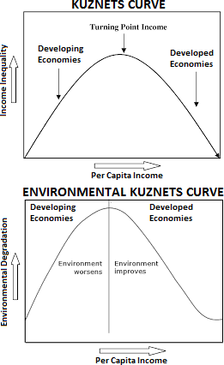

Figure 2.1: Kuznets Curve
Source: David R (2005).

The curve is represented by an inverted U-curve. The graph's Y-axis is labeled as inequality while time or capital income is depicted by the X-axis (Prateek, 2019), in other hand, the theory suggests that as a nation is going through industrialization, and mechanization of agriculture the nation's economy will naturally move towards cities and environmental degradation. In equally is expected to decrease when rural populations move towards cities.

Strengths of Environmental Kuznets Curve Hypothesis;
- Improved technology, the primary driving force behind long term economic growth influence improvement of technology.
- Empirical evidence of dealing pollution levels with economic growth. Studies found that higher economic growth in the US led to the increased to use of cars but the same time regulation adopted, level of air pollution declined.
- Industrialization ,initially economic development leads to shift from crude farming to manufacturing ,however increased productivity and rising real income seen a third shift from industrial to the service.

Weaknesses of Environmental Kuznets Curve Hypothesis;
- Growth of economic leads to greater resource use.
- Countries with highest GDP have highest levels of Co₂ emission for US the theory doesn’t reveal out.
- Application of the EKC is debatable when it comes to other pollutants, some natural resources use and biodiversity conservation for example energy and resources.

Application of Environmental Kuznets Curve Hypothesis;
The Kuznets Curve implies that as a nation undergoes industrialization influence mechanization of agriculture, the centre of all the nations will shift to the urbanization.

2.3.3 Theory of Agricultural Development
Ester Boserup’s theory of Agrarian change argues that population growth is the prime cause of agricultural change is of great importance. The theory of Agricultural development posed by Ester is more subtle and complex that of any her predecessors she sees population pressure as a major cause of changes in land use, agricultural technology, land tenure system and settlement form.Boserup argues that population growth is independent of food supply.

Strengths of Theory of Agricultural development;
- Describe how the food supply increases as the impact after of the huge growth of population.
- Increase in food supply comes with increase in technological advancement, Boserup attempts to probe into the coming agricultural development due to some kind of compulsion of population. This development of patterns and techniques of cultivation is governed by the population growth.

Criticism of Boserup’s Theory;
- Boreup has exposed the hope that in present day underdeveloped economies growing population can be absorbed in the agricultural sector, this idea can be true to some countries like USA.
- Boserup has attempted to show that cultivation becomes more intensive when population increases and become extensive in character when population falls.
- Boserup has absolutely ignored the unfavorable effects of growing population on agriculture.

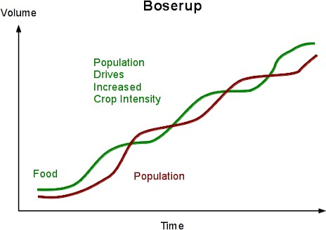Neo-classical economist Ester Boserup explained differently to Simon Kuznets views on human population pressure and natural resources (land productivity). She observed that people would actively intensify land productivity or increasing agricultural yields such as multi-cropping, irrigation, soil conservation and application of better technologies all these would compensate human population growth.

Figure 2.2 The theory of Agricultural Development
Source: France M (2010)

Boserup observed that when population density is high, land tends to be used intermittently, with heavy reliance on fire to clear fields, therefore use of fire to clear fields leads to depletion of covered grass, bushes finally environmental degradation occurs.

2.3.4 Planned Behavior
Enhrlich (1968), a biologist which state that the rate of population growth was out stripping agricultural growth and the capacity for renewal of Earth’s resources. This means that the rate of population growth will affect the capacity of the natural resources to generate and induced pressure to forest management effort established.
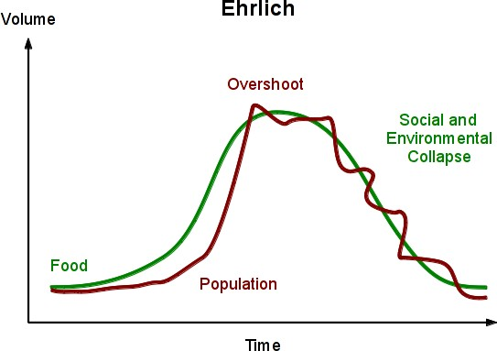

Figure 2.3: Enhrlich Theory on Population Relation to the Resources
Source: Pierre,D (2009).

The implication of this graph shows that the more population increase, the more demand increases too. According to Enhrlich (2011) the world's population increase on the earth would cause more damage than previous. As of 2013, Dolan(2000)continues to support the idea of biologist that population increase bear environmental catastrophe.
Application of Theory in Today’s World: Generally, this study used the theory of Malthusians proposed by Dolan(2000) because it is directly related the impact of population growth to natural resources depletion which resulted from poor management of the forest.
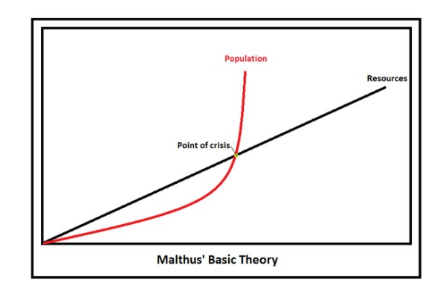

Source:Sachs(2008)
Figure 2. 4 Malthus Theory on Population
Source: Malthus. (1798)

Figure 2.4: Population is Growth

Figure.2.4 shows that population is growing in a geometrical rate 2,4,8,16,32,64,128,256 while the food supply on the other hand increased only in arithmetic mean 2,4,6,8,10.Malthus concluded that'' the power of the population is indefinitely greater than the power in the earth to produce subsistence for man' 'In short Malthus theory predicts that if population grows much faster than food production ,the growth is checked in the end by famine ,diseases, war, deforestation a process that is called Malthus crisis.

Furthermore, more environmental effects of meeting natural resources demands ,intensive agricultural uses, a lot of chemicals such as herbicides, pesticides and fertilizers which can build upon the soil and run off of water system, increased mechanization in farming causes the removal of hedgerows to enlarge fields, rainforests are destroyed to provide fuel supplies (Mba, 2018).Therefore, conserve the natural resources for the future generations, sustainable management of the natural environmental is necessary.

2.4 Empirical Literature Review

2.4.1Global trends of Population Growth and Forests
Global deforestation sharply accelerated Global climate change as well as extinction of terrestrial species and disturbances of ecological system (Wilson &Robert, 2002). It has been estimated that about half of the Earth’s mature forests between 7.5 million and 8 million km2 (2.9 million to 3 million sq. mi) of the original 15 million to 16 million km2 (5.8 million to 6.2 million sq. mi)that until 1947 covered the planet have now been destroyed (Ron, 2006). According to Skol(1990) The total area remaining as tropical rainforest is even smaller now, as rainforests are being removed at a rate of 100,000 to 200,000 km2 per year, with approximately the same area being greatly disturbed. Some say, several times as much,

Pimm (2001)estimate the deforestation rate at 142,000 km annually. Furthermore Minister of Natural Resources and Tourism of United Republic of Tanzania, Kigwangala (2019) argued that natural resources extinction such as mammals, Birds, reptiles and higher plants had been fueled with rapid population growth. In addition according to MEA(2005)loss of Biodiversity is a growing trend in virtually all Earth ecosystems The Millennium Ecosystem Assessment document shows that losses of biodiversity and the related changes in the environment have been more rapid in the past 50 years than ever before in human history many animal and plant populations have declined in numbers ,geographical distribution, or both, species extinction is a natural part of Earth's history ,however the current losses are the outcomes of rapid human population growth, similarly human activities have increased the extinction rate by at least 100 times more than the natural rate.

2.4.2 Urbanization and Deforestation
Urbanization, is the process of transforming natural landscapes (such as wetlands and forests) to build environments (Antrop,2000). The UN-HABITAT’s report on the State of the World’s Cities indicated that half of the world’s population was already living in cities. The proportion of the national population living in urban areas increased from 25% in 2002 to over 30% in 2012. Minister of Lands, Housing and Settlements when was address mass said rapid population density has influenced intensive depletion of forest in Dar es Salaam and other parts of Tanzania (Lukuvi, 2019).

The urbanization and population growth have implications on forests and woodlands. Building materials and furniture (timber) are obtained from rural areas. Furthermore, urbanization creates high demand for fuel wood, especially charcoal(URT, 2009).It is estimated that the amount of charcoal consumed in Dar es Salaam to be 1904 tons per day or 694,960 tons per year (Msuya, 2011). As the world population continues to grow geometrically (adopted Malthusian Theory), great pressure is being placed on arable land, water, energy, and biological resources to provide an adequate supply of food, building materials while maintain the integrity of an ecosystem being difficult (Pimentel et al 1994).

2.5 Conceptual Framework of the Study
Rapid Population Growth

Natural forest resources uses
- Charcoal production
- Building materials
- Firewood demands

Land shortage
- Overgrazing
- Farm expansion
- Forest encroachment

FOREST DETERIORATION

Impact of population Growth
- Soil erosion
- Loss of biodiversity
- Drought
- Climate changes

Figure 2.5: A Conceptual Framework of Population Growth and its Impact
Source: Own construct

Moreover, the rapid increase of human population has led to urbanization which is putting an incredible strain on our environment while developed countries continue to pollute the environment and deplete its resources, developing countries are under increasing pressure to complete economically and their industrial advancements are damaging as well. The demands that this growth places on our global environment are threatening the future of sustainable life on the earth. One of the largest environmental effects of human population growth is the problem of global warming, some scientists fear the global warming will lead to rising sea levels and extreme weather conditions in the future (Mittal, 2013).

More people require more resources, which mean that as the population increases, the earth’s resources deplete more rapidly ,this result of this depletion is loss biodiversity as humans strip the Earth of resources to accommodate rising population numbers. In order to support the growing population forests are being destroyed at an alarming rate. Humans also continue to put a great demand on the natural resources of our planet, many non-renewable resources are being depleted due to the unrestrained use of fuel and energy (PRB,2001).

Many parts of the world also suffer from a shortage of food and water, The environment on the earth is suffering from the of global population, the depletion of resources and biodiversity, the production of waste, and the destruction of natural habitat are serious problems that must be addressed in order to ensure that life on earth will be sustainable throughout the next century. The increasing World population has tremendous pressure on land use and other natural resources causing damages to the ecological domain ,the increased crop production over the years has also accelerated the removal of plant nutrient four times during the last decades thereby reducing soil nutrient and stability (WB ,2010)

2.6 Research Gap
Mushroom of studies had been undertaken in different regions, geographical locations and various research methods were applied (Madulu, 2001 and Mafupa 2006). However, there were key issues that have not yet been addressed, concerning the rapid population growth of human population relation to forest management policies. In Tanzania there no clear study which has tried to address on how to curb rapid population growth particularly in rural areas, in fact politicians are backing up spread of population due their populist interest .Without considering its long term impact to limited resources specifically on critical issue of limited land and access to forest products .

Family planning has not yet been achieved particularly in rural areas where the fertility rate is high according to National Population and Human Settlement Census (NBS, 2012). Furthermore, the forest policy contradicts itself on proper forest management practices to be applied to the community. These were the gaps in which the study addressed and suggested some potential resolutions.

CHAPTER THREE

RESEARCH METHODOLODY

3.1 Overview
This chapter presents information on the profile of the study area including its location and major characteristics of the study districts. The chapter further provides the explanation on how the study will be conducted including sampling procedures, data types and their sources, data collection techniques and the methods used for processing and analyzing data.

3.2 Research Design
This study employed a case design, Wellington (2000) argues that case study design allows the researcher to investigate research questions in depth for a short time. The rationales of using this research design is firstly aimed to obtain complete and accurate information of the study, secondly contribute in providing protection against bias and maximize reliability, thirdly show the concern for the economical completion of the research study (Kothari, 2004).

3.3 Population
According to 2012 census report, the region has a population of 1,743,83 people, the district 249,466 people (NBS, 2012).

3.3.1 Sampling Techniques and Sample Size

3.3.2 Sampling Techniques
According to Meshack (2011) sampling is the process of drawing a sample from a larger population. Therefore, sampling is a process of getting the number of units about which one would wish to make inferences. Random sampling will be used in this study, in order to be able to draw valid units from a sample in relation to its respective population. A simple random sampling is a way of selecting subjects in which every unit in the population has an equal chance of being chosen.

3.3.4 Sample Size
The total number of households in the three expected to be selected, amounted to 100 households (NBS, 2012). Due to time and financial constraints it was impossible to go through every household. The sample size of the study was selected based on confidence level 95%, Confidence interval 5 (Leakey et al 2017).

3.3.5 Data Collection Methods

3.3.6 Tools and Methods
These are ways or techniques of collection of data which were used such as interview, observation, questionnaire and documentation methods where the researcher chooses to collect data from the respondents (Kothari, 2004).

3.3.6.1 Questionnaire Tool
It has been observed that questionnaire has ability to collect large amount of information in a reasonable time. The instrument is chosen because the target population is considerable of literate. Questionnaires administered to the 50 head of households the study use both closed ended and opened ended questionnaires. The study uses this method because it is easy to collect a lot of information, requires a short time, also it ensures there is no bias on the side of researcher and respondents.

3.3.6.2 Observation Method
The study adopted observation as data collection methods include direct access to research phenomena, observed observation of deforestation. The main advantage of this method is flexible, and bias is eliminated, the information obtained under this method relates to what is currently happening, it is not complicated by either the past behavior or future intentions or attitudes (Kothari,2004). Through this method researcher observed a lot of stumps in the area, charcoal production sells, cows grazing fire wood and charcoal selling taking place around villages’ forest reserve.
In a nut shell Observation is a common method used in all sciences, whether physical or social, so it has greater universality of practice and it is very easily followed and accepted.

3.3.6.3 In-Depth Interview Method
The study used structure interview which will involve setting a pre-determined question. The advantages of this method is to enable to get more information with more details about forest management also it will be more flexible that the researcher can be ductile or manageable to change the question according to the level of people in terms of language and education of respondents (Kothari, 2004).

3.3.6.4 Documentary Review
The documentary review in this study was adopted through use of official documents Serengeti District reports, Tanzania Forest Conservation Group Reports, The Open University of Tanzania, internet, website, directories, past dissertations, journals and articles.

3.4 Validity and Reliability of Data
Validity is based on determining whether the findings are accurate from the point view of the researcher, the participant or the readers of an account ( Creswell, 2000). Validity will be determined through seek other relevant evidence that confirms the answers we have found without measuring tools. What is relevant, evidence often depends upon the nature of the research problem and the judgment of the researcher. Reliability has to do with the accuracy and precision of a measurement procedure. Reliable measuring instrument does contribute to validity, but are liable instrument need not be a valid instrument. This study increased reliability of the study through Environmental Kuznets Curve. It is also used International Business Machine (IBM)-SPSS software in coding and analysis the data and minimization of errors and bias in the study.

3.5 Study Area Description
This study was carried out in Serengeti district, Mara region, Tanzania. It extends between latitude 1º and 2ºsouth and between longitude 33º and 35º east.

3.6 Climate
This area has dry savannah type of climate which is characterized by along dry season lasting between June to October and a short single wet season November to May. The maximum temperature of this area is 29.32oc and minimum of 27.68oc the average rainfall is 540-860mm annually. Rainfall is not only relatively low but also unpredictable in frequency and amount. It is this unreliable rainfall which has imposed erosion risk in traditional agriculture and which represents a serious constraint on efforts to improve crop yields.
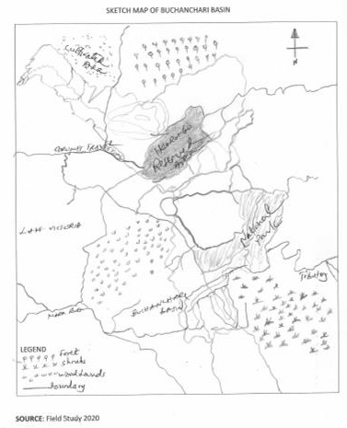

Figure 3.1: Skatch Map of Buchanchari Basin

The Buchanchari Basin is mostly covered with natural vegetation, the most prevalent landscape seen in the natural vegetation is the ''savannah type'' most commonly found in this area and scattered woodlands and wooded grasslands. Altitude in the Buchanchari Basin range 3,020 feet to 5,070feet according.

3.7 Ethical Considerations
According to Creswell (2012), researchers must consider ethical issues when their intended research involves human beings. In this study, the researcher followed all steps to maintain ethics concerning the study. To begin with the approval letter was requested from the Vice Chancellor of the Open University of Tanzania. The letter introduced the researcher to all authorities where the study was conducted.

Another main ethics that was considered in conducting this research study was the issue of confidentiality. Creswell (2012) claimed that confidentiality might be maintained using unnumbered questionnaires and checklists that could potentially protect the anonymity and privacy of the respondents. A written guarantee was also given to the participants that the data collected would remain confidential and that means only the researcher and the research supervisor would have access to it.

3.8 Methods of Data Analysis
According to Kothari (2004), the collected raw data were edited to detect errors, omission and coded for efficient analysis .The raw data from the questionnaires were coded and analyzed and entered into computer using IBM-Scientific Package for Social Science (SPSS) program.Ms excel and SPSS was used for analysis of information obtained in numerical form. Descriptive statistics giving frequencies and percentages were presented in various forms particularly by using tables, graphs, charts and percentage .Different data were tabulated in order to establish their relations. The qualitative data was analyzed using the content –structural analysis. The content structural analysis was used to analyze in detail the components of verbal discussions held with key informants .This helped the researcher in ascertaining values and attitudes of respondents (Kajembe, 1994).

CHAPTER FOUR

FINDINGS AND DISCUSSIONS

4.1 Overview
This chapter describes the analysis of data followed by a discussion of the research findings. The findings relate to the research questions that guided the study. Data were analyzed to identify, describe and explore the relationship between the effects of Population Growth on Forest Management of Natural Forest Resources. It consists of five subsections which are socio-economic characteristic, trend of population growth in the study area, effects of population growth socio-economic use of the forest resources and forest management system practices.

4.2 Socio-economic Characteristics of the Respondents

4.3 Sex and Marital Status of the Respondents
The study sample had a total of 100 households whereby 38% of the respondents were women and 62% were men see Table 4.1. The sample comprised more men than women because most of the households are headed by men. Men and women have different knowledge of, access to, and control over natural resources, and different opportunities to participate in decisions regarding natural resources use. Due to their different roles and responsibilities, women and men have varying interests and motivations to conserve, protect or manage their resources. In most regions of the world,

Men play a greater role than women in the exploitation of natural resources for commercial purposes, such as logging, grazing livestock, finishing, and hunting mining and extracting various tree products. Men are therefore, more destructive than women but negatively affected when natural resources are depleted. Therefore, due to more of the respondents being men, it reviews that most of the decision redone by men and when it comes natural resources management the effect on exploitation will be higher than in the areas where most of the household are controlled by women (Chacha, 2017).

The marital status of the sampled households presented in Table 4.1. About 93% of respondents were married. 4% were single, divorced were 1% and 2% were widows. This study found that most of the households in the study area are headed and managed by married couples. This implies that there high marriage rate, which led to an increase in birth rate per woman and as a result led to an increase in population.

Table 4.1: Gender and Marital Status of Respondents
Characteristic | Gender and Marital status | Respondents | Percent
Gender | Male | 62 | 62%
 | Female | 38 | 38%
Marital Status | Married | 93 | 93%
 | Single | 4 | 4%
 | Divorced | 1 | 1%
 | Widow | 2 | 2%
Source: Field Survey data (2020)

4.4 Age of Respondents
The findings showed that the age of the respondents ranged from 18 to 75 years Table 4.2 shows respondents' age distribution of the study sample. A large number of respondents about 69% were aged between 40 and 59 years. About 9% of the interviewed respondents were over 60 and 22% were between 18 and 39years.

Table 4.2: Age of the Respondents
Characteristic | Age group | Respondents | Percent
Age | 18 - 39 | 22 | 22%
 | 40 - 59 | 69 | 69%
 | 60 and above | 9 | 9%
 | Total | 100 | 100%
Source: Field Survey Data (2020).

It was therefore, revealed from the household interviews that most of the respondents were still able-bodied people, being in their early Middle Ages and middle age years (40 - 55) who could actively participate in various livelihood activities. Shackleton (2004) remarked that age affects the type and amount of resources utilized, and it also affects the household's labor supply, which in turn affects natural resource use and its control over labor and its products and access to natural resource use and its control over labor and its products and access to natural resources.

4.5 Ethnicity
The study found out that the area comprised of three main ethnic groups, namely the Ngoreme, Luo and the Kurya. The Majority of respondents (75%) were the Ngoreme people, whereas the remaining 20% were the Kurya and Luo 5% (Figure 4.1). Similarly, the study reported that the Ngoreme formed 75% of population in North West Mara River Basin (Mirumbe, 2018). In the recent years some wards like Busawe and Ngoreme have been receiving other ethnic groups who are coming for to work and this has a significant in forest management and forest product utilization.
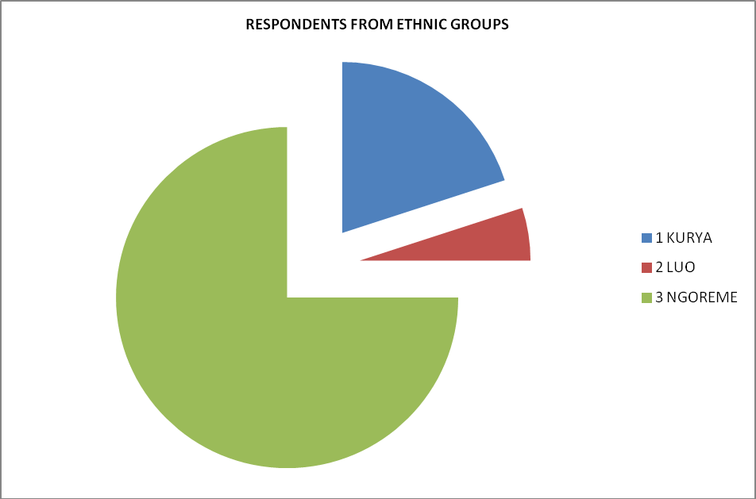

Figure 4.1: Household Size of the Study Area
Source: Field Study Data (2020)

The mean household's sizes were 9 people, with a range of 7 to 9 people (73%). (Table 4.3). According to the National Population and Housing Census of 2012 (URT, 2012), the mean household size in Serengeti district was reported to be 5 people. This implies that the household size in the study area is above the average reported, that means that there is high number of people per household which increases the demand for forest products.

Table 4.3: Household size of the Study Area
Household Size | Respondents | Percent
2 – 5 | 19 | 19%
5 – 9 | 73 | 73%
10+ | 8 | 8%
Total | 100 | 100%
Source: Field Survey Data (2020)

4.6 Respondents' Level of Education
The respondents Level of education varied. It shows that about 89% of respondents in the study area completed primary school, 7% had secondary education and 4% had no formal education. The illiteracy level in the study area is lower about 4% compared to the national average of 19.6% (URT, 2015). This indicate that the level of understanding is high in this area because formal education can broaden the understanding of the individual when it comes to adopting useful skills and technologies for conservation that have come from outside the community.

Education can promote sustainable utilization of those resources for nutritional and health status (Mbwambo, 2000). Similarly according to Katan (1999) who found out that the increase in education level increases the level of awareness and thereby creates positive attitudes; this is crucial at all levels in order to enhance the participation of all stake holders.Kalineza (2000) observed that knowledgeable farmers are expected to adopt new techniques quicker compare to those unknowledgeable.

4.7 Origin and Reasons for Settling in the Village
The majority of the respondents (88%) were born in the village, while 12% had migrated into the village from within the District (Figure 4.2). Those who in-migrated into the village (about 2%) gave one reasons for settling in the village which is marriage. The majority of the people from this areas are migrating to other area due to scarcity of land, no in-mmigrant to villages are expected for the few government staffs coming for employment purposes this is due to lack of enough area for cultivation.
ORIGIN OF THE RESPONDENTS
1M-MIGRANTS 2NATIVES
12%
88%

Figure 4.2: Origin of the Respondents
Source: Field Survey Data (2020)

4.8 Economic Activities
The study revealed that respondents in the study area were engaged in different economic activities such as crop production, wage paid casual labour and petty business. Data on occupational activities show that 94% of the respondents interviewed reported to be engaged in crop production as their first main economic activity (Figure 4.3). This implies that majority of the households depend on farming as their main economic activities. Due presence of high number of farmers on the study area this can lead them to cultivation fragile soils such as wetland, highlands, and forests.

When farmland expands toward fragile lands in order to keep pace with the needs of a growing population, it leads to deforestation, erosion, and desertification. Agriculture remains the main economic activity in West East Mara River (Nyambiza & Lyava, 2013). Furthermore, casual labor, wage employed and petty business constituent of 3%, 1% and 2% respectively (Figure 4.4). This implies that very few people are employed in the study area or engaged on business this has significant effect of forest management as many people will depend on forest due to lack of employment or activity to perform. The similar study has been conducted in West East Mara River whereby it was revealed that 11%own kiosk, 2% masonry, 2% food vending business, 2% selling alcohol (Nyambiza &Lyava, 2013).

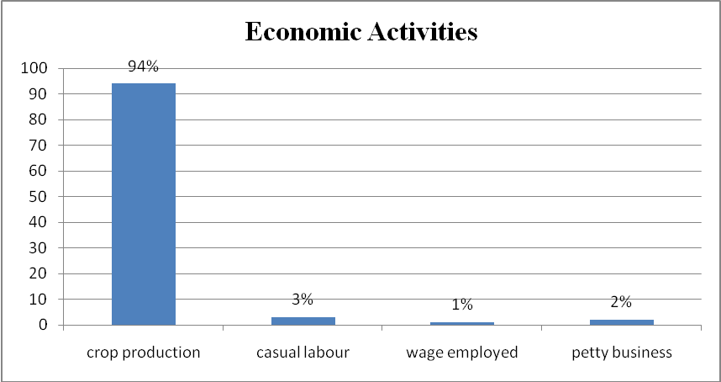Figure 4.3: Major Economic Activities of the Respondents
Source: Field Survey Data (2020)

4.9 Trends of Population Growth

The study intended to examine the trend of population growth the study area. It examines population change and growth rate from census records of 1978, 1988, 2002 and 2012. Moreover, it revealed the impact of population growth on forest resource management and measures taken to control population growth.

4.10 Trends of Population Growth in the Study Area
Mara region as revealed by 2012 population census was one of the regions with fast population in the country and Serengeti district with land area of 30,00 Sq. Km is the least populated district in Mara Region with population density of 120.4 persons per sq. km. Furthermore, NBS(2012) observed more marked variations at district and ward levels with a higher concentration of people in some regional, districts and wards than others. Figure 4.4 shows the population of Serengeti District the way it had increased from 689 in 1978 to 249,466 in 2012 almost doubled the number of people in the district (NBS, 2012).

249,466
Population
Year
176,057
111,689
689

2012
2002
1988
197888888
3
2
1

Figure 4.4: Population Trends in Serengeti District from 1978 to 2012
Source: Census, NBS (1978, 1988, 2002, 2012)

Population density in the Buchanchari Village is high as 20.5 persons per square Kilometer (UN, 2012). This high population growth has led to increasing demands for agriculture production and settlement hence results in unsustainable management of the forest. The study is similar to Soin et al (2002a) who revealed that densely populated areas had led to disappearance of ecological systems; the evidence is the Southern Part of Gantamome Hilly which covers the part of the Busawe ward. Recently, land use change analysis showed a vast expansion of agricultural production over marginal land downward the basin of Mara River, extending further into the uncultivated land, has caused the disappearance of vegetation cover, this is due to the clearing of forest and natural bush resulting to ecological species disappearance includes the black rhinoceros, the Desperate shrew, Pemba flying fox, Abbotts Duiker, Rondo Dwarf Galago.

In fact researchers are studying three different drivers of the pressure on the Buchanchari Basin - Serengeti ecosystem, one of the drivers is climate change, in recent years the climate has become warmer, the dry season longer and the rains more powerful resulting to washouts and soil erosion, the wet season has also shifted, all these factors create challenges for vegetation, animals and human in the area (EU, 2019). Furthermore, high population growth rate in Tanzania have had significant environment implications in many areas, the environment has been degraded to the extent that it can no longer support ecological balance and provision of necessary resources to present and future Population (UNFPA, 1991; FAO, 1992).

4.11 Effects of Population Growth in Natural Forest Resources
The study revealed that the effect of population growth has resulted to several forest management challenges whereby the respondents mentioned that 54% resulted to illegal forest tree cutting in the study area (Figure 4.5) .The study is supported by Mwita (2007) who reported that the most common human activities triggering degradation in Kisaka forests include, clearing for the new farm land, pit owing illegal timber harvesting, collection of building poles, cutting trees for medicine , collecting fuel wood, and mining activities, likewise Ndagales (2007) conducted study at Iseresere Nature Reserve found that forest degradation of tree species including tropical forest , Ocotea, woodlands and Podocarpus, shrubs was rampant due to illegal selective commercial logging, subsistence harvesting of tree for building poles and fuel wood collection.

Moreover, the study revealed that 25% of the respondents utilized marginal land for agriculture and grazing due to high population. The study is similar to that conducted to Shishira &Yando, 1998;Madulu, (2001) which reported that high population growth has resulted in increasing opened up of farmers in the marginal areas and even in the protected area in an effort to earn living. Furthermore, Saunders reported that Degradation of forest edges arise from small-scale agriculture inevitably leads to fragmentation, and eventually deforestation. This deforestation results in isolation of forest patches, causing transformation of microclimate regimes.

Moreover, the study revealed that increase in population has led to forest encroachment by 21% The study is supported by Shishira and Yando, (1998), who reported that the increasing pressure around the forest reserve is likely to lead to encroachment into the forest reserve, hence threatening its sustainability. Likewise, Madulu (2001) reported that forest clearing for agriculture expansion has been rampat around the Ikorongo Game Reserve in Serengeti District. Moreover, Kale (1998) reported that in 1980, about 200hectre of Grumeti forest reserve, water catchment forest, were encroached by farmers. In addition, South West of Buchanchari Basin more than 10 hectre (figure 4.5) natural forest resources are highly depleted due to fuel demand agricultural purpose, in fact this is consequences resulted from population growth (Mwita, 2019).

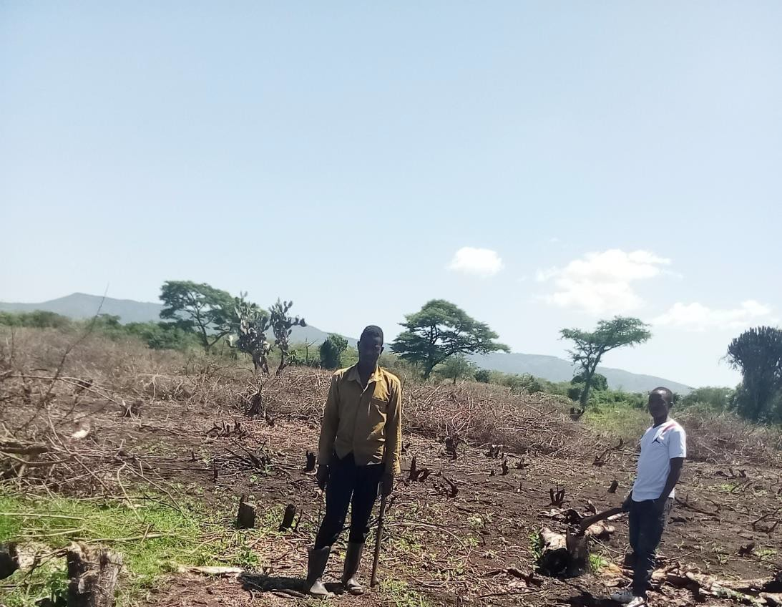Figure 4.5: Effects of Population Growth on Natural Forest Resources
Source: Field Survey Data (2020)

4.12 Measures Taken to Control Effects of Population Growth on Natural Resources
Due to the increase in population and its effect in natural resources several measures have been taken to rescue the situation. The result has revealed that 46% practiced improved agriculture and conservation techniques as the way of maximizing crop production in small area pressure to forest. The result from end-line survey conducted by TFCG revealed that 32% of famers in West Mara River were applying conservation agriculture methods.

The focus of conservation agriculture is on soil moisture management, crop rotation, permanent cover crops which apparently contributed to increased crop production (Nambiza &Lyatora, 2013). This implies that there is low adoption rate of people on use of improved agriculture practices which required more training and awareness to improve the situation. Nevertheless about 22% mentioned that some villagers have been shifted to other Districts like Butiama where they can have enough land for cultivation. Likewise, many people especially youth abandon Serengeti district are moving to mining sites like Nyamongo and Buhemba because they become landless due to overpopulation (SDC, 2010).

A similar problem happens in Simiyu whereby the region has high population density that increases pressure on land resources. A recent study commented that 48% of the household in Simiyu had insufficient quantities of land resources to sustain their live hoods for agricultural for agricultural activities and settlement expansion (Maridi, 2017). These forced the people of Simiyu to move to other areas looking for settlement and farm fields and grazing area for their cattle. Likewise, landlessness has also been reported by Masanja (2016) which has led to some people migrating to the lowlands and urban centres due to increases in population.

Table 4.4: Measure to Control the effects of Population Growth on Natural Resources
Characteristics | Percent
Family Planning | 17
Shifting to other area | 42
Improving agriculture and soil conservation techniques | 39
No measure taken | 2
Total | 100
Sources: Field Survey Data (2020)

This study shows that 17% revealed that they are using Family Planning methods to ensure the number of children matches with the available resources and 2% mentioned that there is no measure taken (Table 4.4). Data from the two most recent Demographic and Health Surveys indicated the modern family planning methods increased from 20% among married woman in 2004 -2005 to 14% in 2010. Nevertheless 25% of married women were found to have unmet need for family planning means they want to space their next birth or stop childbearing entirely but were not using contraception. in response, efforts were intensified to realize the goal of National Family Planning Coasted implementation program 2010-2015 to raise contraceptive prevalence rate to 60% (MoSHW, 2013). This shows that the adoption rate of the family planning methods is almost the same as the National rate of 17%, which implies that the study areas are aware on the important of family planning.

4.13 Access to and the Socio-Economic Uses of Forest Resources
This part presents the results and discussion on the access to forest products and uses in the study area. The first part covers the results and discussion on the access to forest product in the study area. The second part presents the results and discussion on the demand for forest products in the study area. The last part presents the alternative sources of forest products.

4.14 Access to Forest Products
The study revealed that 84% of the respondents collect firewood from the forest. This implies that fire wood is the major source of cooking fuel in the study area. Fire wood is the cheapest source of energy in Tanzania, approximately 90% of the population uses firewood and charcoal for their cooking and heating needs (Monela, 1999). Even more so in Buchanchari village where approximately 99% of the people use fire wood to cook (Kaale, 1983). Lusambo (2009) reported that in Tanzania energy balance is dominated by biomass-based fuels, particularly wood fuel. (Firewood and charcoal) which account for >90%of primary energy supply.

The findings are similar to Giliba (2010) who reported that 92% of NTFPs collected from the forest were firewood in Mbulu and Babati districts. The finding similar to Msaliwa (2013) who reported that 98% of people in Butiama district use firewood as the main source of energy. Furthermore, the findings similar to Hakizimana (2018) who reported that Burundi97% of the rural households use firewood as the major source of cooking fuel. Further findings show that forest increased demanded to shipping for legal also paper and commercial use have a great contribution for forest demand (Brankika, 2018)
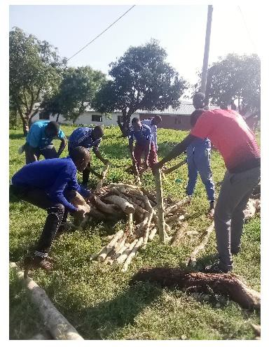Figure 4.6: Firewood Collections for Charcoal Burn
Source: Field Study Data (2020)

The collection of fire woods done by young villagers purposely for charcoal burn has been seen in (Figure 4:9:1),however the influences of charcoal production activities is been resulted from population growth and its environmental effects are heavy as seen in Buchanchari village, in fact charcoal is a lightweight black carbon residue produced by removing water and other volatile constituents from plants, in fact charcoal production has fueled in emissions of greenhouse gases according WMO (2009),there was production of 71.2 million tones for carbon monoxide and 1.3million tones for methane.

Likewise, the study revealed that 9% of the respondents depend on forest for medicine or herbs for medication. This implies that very few households depend on forest for medicine probably this is because of the availability of dispensaries and health centres surrounding Buchanchari village. Hospitals which are found nearby the villages or the medicine inside the forest have been finished due to over utilization. The findings are similar to observation done by Mogaka et al, (1992) who reported that plants from forest have significant proportion of medicine value that can be useful to surrounding population. This could probably be due to the reasons that firewood is the only cheaper, available and affordable primary source of energy in the study area.

Furthermore, the study shows that 15% of the respondents depend on forest for vegetables (Bituro, 2008). This implies that very few households depend on forest for vegetables probably because the majority of the villagers are practicing vegetables farming which have observed on the side of the river line. This study is similar to Katrins (2000), who reported that the most vegetable are collected and used in four days a week on average 2% revealed that they collected and used in four days a week on average 2% revealed that they collect fruits from the forest.

4.15 Demand for Forest Products
During the study, 95% of the sampled household reported that there is a high demand for forest product while 5% revealed that there were not by comparing with 10 years back. (Figure4.7).The study further reviewed the reasons for high demand is due to increase in population and illegal harvesting inside the forest reserve. The study is similar to NAFORMA (2015) reported that forest area in Tanzania has decreased from 3ha/capital in the early 1980 to 1.1 ha/capital in 2012 due to the increase in population. That means there is 1Cm3of woodland per person per year available from legal accessible sources in Tanzania in additional more forest are degraded than were in the early 1980's. This implies that there will be more demand of forest products due to the increased degrading of the forest.

Figure 4.6: Community Forest Demand
FOREST RESOURCES DEMAND
1FIREWOOD 2CHARCOAL

5%
3 TIMBER
20%
75%

Source: Field Survey Data (2020)

4.16 Alternative Sources of Forest Products
Apart from the forest other areas where they can get forest product from respondent’s own wood lots, small parched around their farm field and general land. The sample of respondents revealed that 80% owned small wood lots of an area of 0.5 to 3 acre while 20% of the respondents they do not own any wood lots. The study shows that many households have woodlots in the study area. This is because the demand for forest product is very high in the area and a lot of awareness has been conducted in the study area about tree planting.

Most of the planted trees in woodlots technology were exotic species like Gravillearobusta, Eucalyptus and Acrocarpus species. Basically, these species were introduced in order to meet critical fuel wood demands for domestic uses and maintenance of conditions allowing for sustained agriculture and livestock production (Mnzava, 1980,Kaale, 1984). The study is similar to Indoor, (2011) who estimated that there is about 80,000 to 140,000ha in total of village (woodlots) and farm plantation in Tanzania. nd.
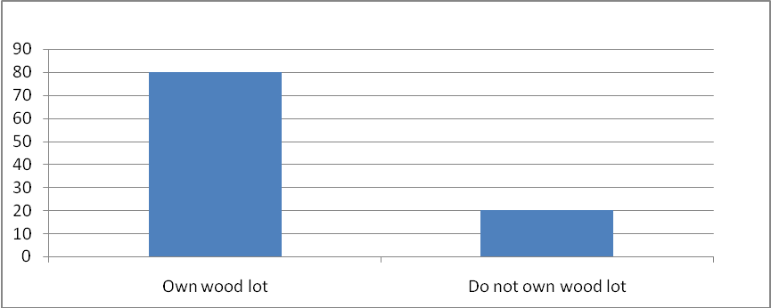

Figure 4.7: Alternative Sources of Forest Products
Source: Field Survey Data (2020)

Furthermore, FDB (2005) reported the similar study that tree planting became an entrenched practice by people and when seedlings were not available from local authorities’ nurseries, residents used seedlings self-germinating under existing trees. A few individuals also established small nurseries to produce seedling for their own requirements and also for sale to other farmers. This implies the households in the study area highly motivated in tree planting to offset the challenges of forest products demand.

4.17 Evaluate the Interventions Measures Used to Manage Forest Resources
Intervention measures have been developed and used to facilitate natural forest management these methods include inducement of natural regeneration, enrichment planting, protection of regeneration against weeds, fires and grazing/browsing, improve forest quality, tree improvement but have poor results.

4.18 Conservation challenges facing the Reserved Forest
The study area experienced conservation challenges on the reserved areas whereby 48% of the household’s respondent revealed that illegal tree cutting and overgrazing is the main conservation challenges. This implies that illegal tree cutting has greatly influenced the natural resource management in Buchanchari Basin. Apart from increased demand for agriculture practiced due to increase in population, shifting agriculture in the past and lack of traditional among the local people for protecting the trees are principle causes of illegal tree cutting (Huwe, 1998). It also shows that the continuous illegal tree cutting in Buchanchari Basin has led to land degradation. This attributed to poor land husbandry, increase erosion and decline of soil fertility and no limited use of fertilizer. The impact of this is declining of crops yields, increased food insecurity and reliance of food aid, poor nutrition and increased dependence on forest for livelihoods (Mwihomeke, 2002).
Rapid deforestation in Buchanchari Basin has been driven by settlement, small scale logging, fire wood collection, substance agriculture, large scale agriculture such as tea plantations as well as monocultures of exotic. Eucalyptus, pines or cypress; mining and other uses (Hall et al. 2009). With the estimated 67% deforestation in East Buchanchari Basin 73% deforestation in the nearby West Buchanchari Basin over the last 150 years (Newmark, 2002). This implies that the area experience high rate of deforestation due to high demand of forest for different uses.
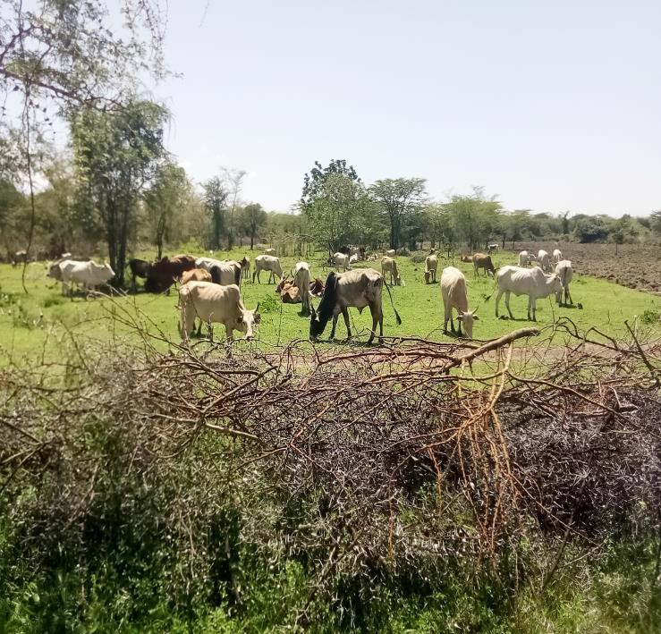

Figure 4.8: Livestock Disposes Reserved area in Southern part of Mara River in Buchanchari Basin
Source: Field Study Data (2020)

Likewise the study revealed that 26% forest encroachment as the management challenges which affect the area (Figure 4:9) resulting in the reduction of forest cover, biodiversity loss and land degradation even ecosystems highly adverse. This implies that the study reveals that area has been affected by forest encroachment and this probably happen due to high population growth and shortage of grazing area and cultivation land.
According to (MNRT, 2016) reported the similar issue that encroachment and over-utilization has been taking place in the forest reserves which are under jurisdiction of the central and local government. Moreover, local people considered protected or reserved areas as constraints to their livelihoods, since it was not possible to create rigid separation between lands used by local people to obtain natural grazing. Rapid population growth of Buchanchari Basin has caused overgrazing which has an environmental hazard whereby wildlife or livestock excessively feeds on pasture, it is also the practice of grazing livestock on vegetation causes soil erosion, loss of valuable species, land degradation, this challenge is highly encouraged lack of proper animal management and improper land use, (Rinkesh, 2018).

Resource products and those designated by governments as protected areas, encroachment, poaching and degradation wee invertible (Primack, 2002).This is also supported by Hoffmann (2000) who explained that agricultural expansion and overgrazing, consequent land degradation occurs, that fueled with overgrazing and intensive deforestation. Overgrazing and deforestation are inseparable predicaments as experienced in the Southern Mara River Basin and in Buchanchari Basin in Serengeti District in numerous locations seen pastoralists and peasants indulging.

The study also revealed that mining contributes to 10% of forest destruction in the study area. Small -scale artisanal miners have invaded the forests, causing severe environmental destruction by felling valuable old indigenous trees to dig up gold. Also, it destroys water sources and wetlands. This is supported by Mafupa (2006) who reported that in East Africa severe encroachment and exploitation of mining activities destroying the forest that occurs in fragmented parche.
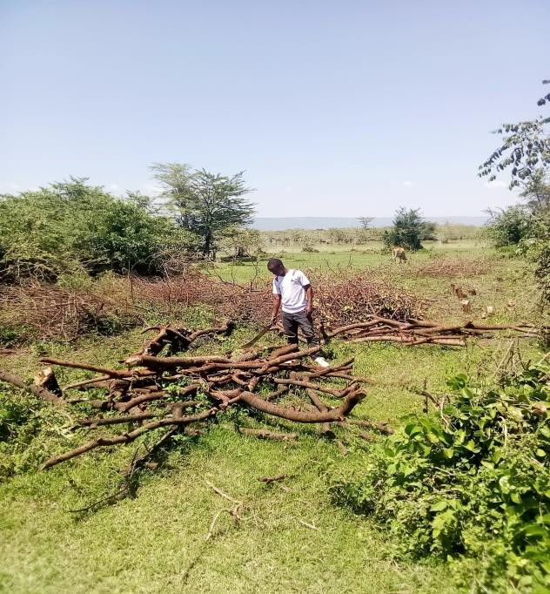

Figure 4.9: Illegal deforestation As Observed at Buchanchari Village in West North part of Buchanchari Basin
Source: Field Study Data (2020)

Social activities are major factors for depletion of forest and ecological imbalance ,we witnessed illegal cutting of trees in the forests of Buchanchari, Iseresere which has resulted to the disappearance of wetlands, grasslands, Acacias, wild date palm or phoenix reclinata, strangle fig, sausage tree, yellow fever tree, umbra tree or acacia tortilis, toothbrush tree (salvadorapersica) and balanites tree (SSR,2016).Illegal logging is a pervasive problem ,causing enormous damage to forests ,local communities are major devastators of the environment (Chacha, 2020).

4.19 Forest Cover Change
Data from the Land image taken between 2002 and 2012 shows a vegetation cover change caused by deforestation by 0.87%, grassland change by 4.4% and Hilly and Lowland forest 94.73% (Table 4.5). From the analysis Ground photograph, deforestation rate is minimum in the study area as it has shown in the figure 4.12 below. The data obtained from Terrestrial photograph differ from the obtained surveyed data which sow high deforestation rate in the study area.

Table 4.5: Forest Cover Change Buchanchari Forest Reserve
Land cover name | Area (Ha) | % of the total area
Lowland forest | 55.29 | 16.97
Deforestation | 67.41 | 63.73
Grasslands | 18.22 | 14.4
Commiphora | 4.1 | 5.9
Total | 139.02 | 100

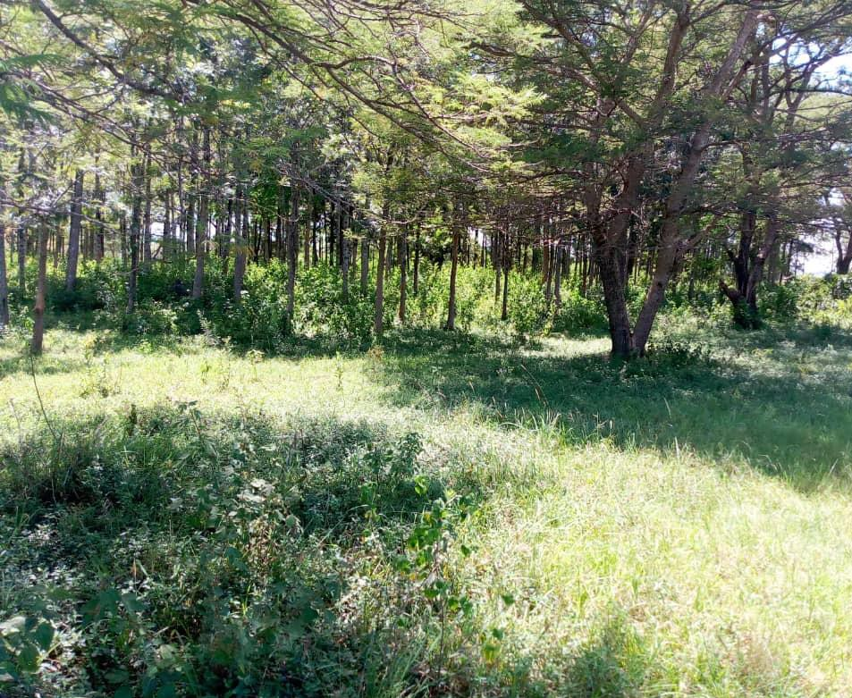Figure 4.10: Natural area Conserved for traditional use in East western Part of Buchanchari Basin
Source: Field Study Data (2020)
This variation is due to the fact that the image shows only the front view simply because the objects were taken when the camera was at the same level as the object being photographed. Likewise, selective trees seen whereby different tree species are selected according to the use’s examples fire wood and grasslands. This is similar to finding conduced in East Arc explain eight of the top eleven most commonly cut species are known to be good sources of timber and fuel wood (Shulman, 1998:Mwita, 2017).

Furthermore, according to Serengeti Forest Officer about more than 20ha every year are depleted for different purposes, in fact this illegal tree cutting has been reported from different areas of Serengeti's forest depletion and 1200cm3 of reserves has been confiscated between 2015 and 2016. Likewise, Halter (2016) observed the stem cut density of 180 stems/ha (>20cm diameter) in Buchanchari Basin and Ikoma II forest reserve which also supported by Schulman(2008) who found that the stem cut density in Valley forests to be 200-300 stems/ha.
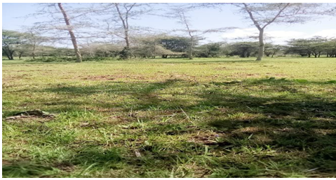

Figure 4.11: North East part of Kenyamonta Reserved Area
Source: Field Study Data (2020)

Study conducted by Newmark(2002) revealed that over 2000 year ago the forest cover for Eastern Arc Hilly has changed from 23,000 km2 to 15,000km2 by mid 1900s. Losses were greatest, relative to original cover in Machochwe Hills (98%),Rugabure (90%), Marotonga (89%) and Buchanchari (84%). Furthermore, based on Tabor et al (2010) findings deforestation rate for Tanzania protected area are-0.05% per year whereas rate of outside the protected areas are 0.26% per year. 12% of deforestation occurred inside the protected area.
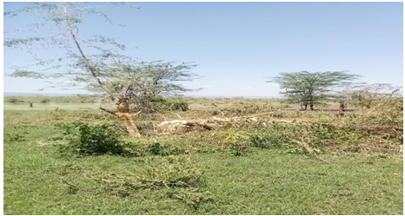

Figure 4.12: North East part of Kenyamonta Reserved Area
Source: Field Study Data (2020)

From these images (Figure 4.12 and Figure 4.13), it was shown that 31 hectares of forests has been degraded in Kenyamonta reserved area between 2002 and 2012. This is similar to study conducted by Achieng and Chacha (2009) who reported that in East West Serengeti for example, the Nyansurura forest has been reduced by about 60%whileintheWesternSerengeti, an estimated average of about 7,000ha of forest has been cleared annually between 2016 and 1980. Likewise, NEMC(2005) estimated that over 82.6% of the Buchanchari forests have been cleared since 2005. Finding by Kashaigilia(2013) in Tanzania revealed that during the period 1980 - 1995 and 1995 - 2010, closed forest decreased by 635.5ha (- 11.9%) and 1674.9 ha (31.3%), respectively.
Hansen (2004) observed that the tree cover of the world had decreased between 1984 and 1997 and the annual deforestation rate in tropical Africa was about 0.09%. In his study to identify and map deforestation using Land sat images and Global inventory Modeling and Mapping Studies (GMMS) data from 1980s to 2000s Wur (2011) found that Kenya still remained at the deforestation rate of about 0.3% per year. Large loss of forest area was indicated for Tanzania and Uganda, about 1.2% and 2.7% per year, respectively.

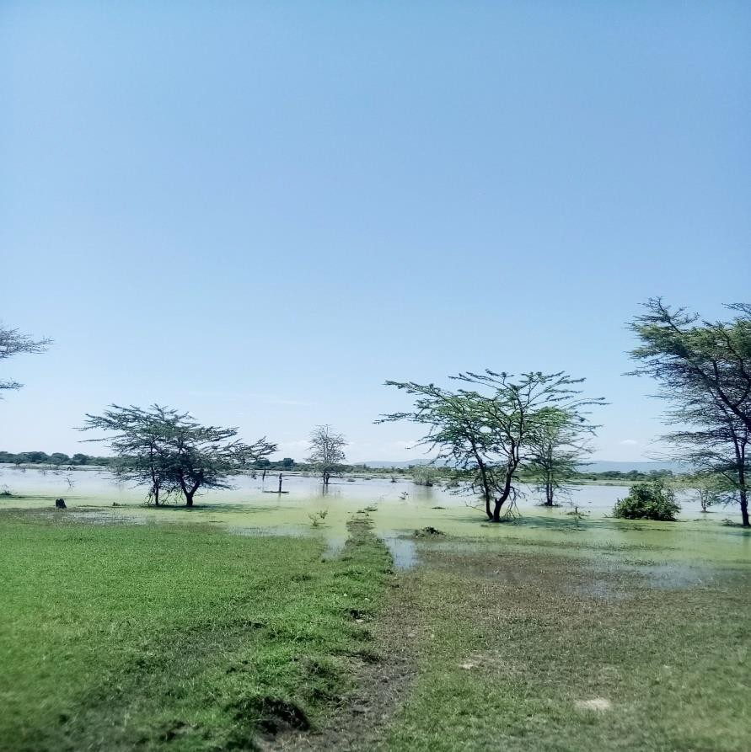Figure 4.13: Reserved area Southern part of Buchanchari Basin for Sustainable use
Source: Field Study Data (2020)

4.20 Forest Management System Practice
The survey revealed two types of management system which are Joint forest management system and Community base forest management system, Figure 4.14 show that 71% of respondents revealed to practices joint Forest Management System, 25% both community and joint forest management system, 4% Managed by Government. In 1963 which promoted substantial change in the way forests are managed (MNRT, 1998a).The policy aims to promote participation in forest management through the establishment of VLFRs, where communities are both managers and owners of forests, as well as through JFM, where local communities co- manage NFRs or LAFRs with central and local government authorities. As it was revealed the study area practiced both Joint forest management and community forest management as it was stipulated in the Forest Policy.

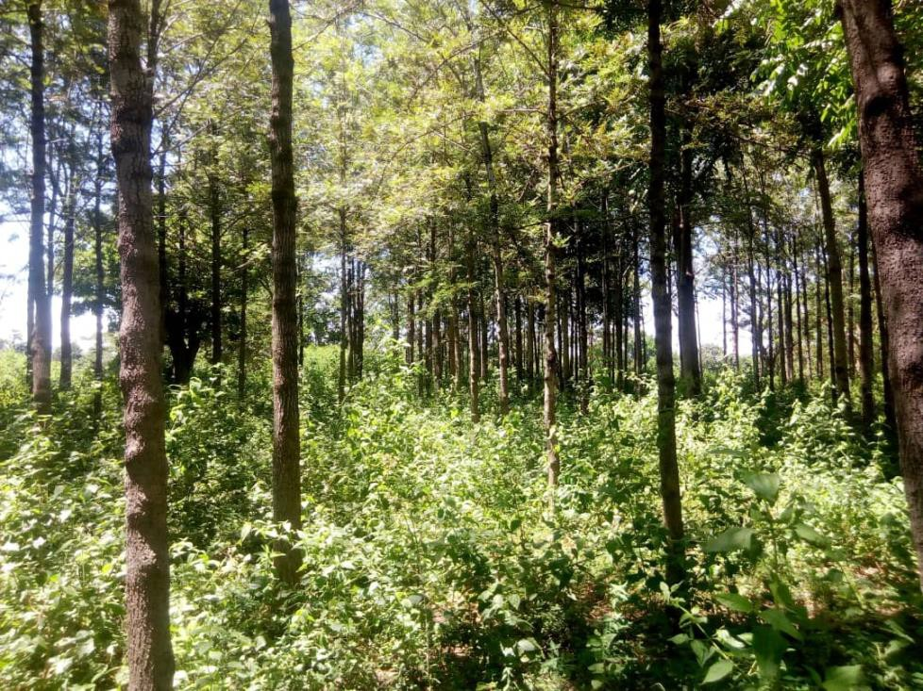

Figure 4.14: Participatory Forest Management planning, Implementation, Monitoring and Evaluation and also intensive A Forestation Practice
Source: Field Study Data (2020)

Also sharing of benefit (Bromley & Ramadhan, 2006). Participation of communities to forest management enables sustainable flow of forest products which improves the livelihoods of communities surrounding the forest through creating awareness to them (Ally, 2003).According to Kess (1998), recommended approaches in participatory forest management vary from one locality to another depending on group interests.
Also it argued that local community interest in participatory management of forest is influenced by the need for forest product, by cultural factors and in the option of using forests as source of household food and income or employment (Kess, 1998).In 2002,Forest Act No.14 of 2002 (CAP323, 2002)was enacted ,the overall goal of the National Forest Policy is to enhance the contribution of the forest sector to the sustainable development of Tanzania and the conservation and management of her natural resources for the benefit of present and future generations (NGO’S, 2008).

4.21 Forest Management Challenges
The study area experienced several challenges regarding forest management about 36% of the respondents mentioned management plan, Joint agreement and by law developed were not being approved by the government (Figure 4.15). The implementation of Joint Forest Management, legalized through the signing of Joint management Agreements, management plan and bylaws which has been more uncertain to the study area. Only the management plan and bylaws for community and village forest reserve have been signed but none of the Joint agreement, management plan and bylaws for community and village forest reserve have been signed but none of the Joint agreement, management plan and bylaws in the forest reserve have been signed which cause problem on the implementation and management of the forest.

Likewise, 28% of the respondents mentioned benefit sharing between Government and community not clear (Figure 4.15). The issue of benefit sharing is not clear on the joint management agreement this is largely because of the fact that the law remains silent on how the e benefits of forest management can be equitably shared with participating communities. In many cases, benefit-sharing arrangements remain in a legal limbo-with de facto management at the local level taking place, in return for vague promises about benefits at a later date. Clearly, this is a situation that cannot be sustained indefinitely. Without benefits reaching a level that equal or exceed the costs being borne, in terms of local forest management, the long-term future of joint Forest Management remains uncertain (Bromley and Idd, 2009).

Furthermore,22% mentioned poor law enforcement (Figure 4.15). The study also observed the existence of weak forest management systems (in particular the lack of effective implementation of forest management laws), and the lack of a formal mandate to control the use of forest products within the village were reported to constrain the management of forest resources. For instance, it was reported by key informants (members of the VNRC) that district natural resource officers were unwilling to give them a formal mandate to enforce laws and control the use of forest products. Thus, this constrains efforts geared at the sustainable management of forest resources, in particular by controlling deforestation caused by cutting trees for building materials and timber.

This concern is also reported by Bromley and Ramadhan (2006), who asserted that those responsible for disseminating and implementing laws, such as district technical staff, may be unwilling to divest themselves of power and give it to villagers. Also,Shemdoe (2003) reported the existence of governance structures with cultural back ground (Informal local governance structures) and those with political background (formal local governance structures) in his study villages around Lake Manyara National Park Tanzania. Therefore, good governance is needed in order to enable community to manage forest in sustainable way.

Moreover, 10% of the respondent mentioned low awareness about forest conservation practices (Figure 4.15). community involvement in forest management need be enhanced through increasing awareness, education and empowerment(Paul, 2007).Similarly Anim (1999) reported that awareness on land degradation and perception of the benefits to accrue out of the forest management practices are crucial factors for investment and adoption of conservation measures. Kajembe (2004) emphasized that to ensure full participation in PFM programmes, stakeholder at community level need essential skills and sensitization about their rights responsibilities and expected return.

About 4% of the respondents mentioned low understanding about forest policy and Act (Figure 4.15) which contributed to poor management of the forest. According to National Forest Programme (NFP) of Tanzania it emphasizes the need for awareness creation in forest management among all stakeholders to ensure effective involvement in the implementation of the National Policy and Forest Act (Ally, 2003).

4.22 Summary of the Chapter
The present chapter has dealt with the study findings, results and discussion. This chapter particularly dwelt on descriptive analysis of sample characteristics as well as the quantitative of the study variables. The data presentation and analysis focused on testing the three research questions to achieve the desired objectives of the study. The qualitative analysis was used to examine the relationship of the interested variables.

CHAPTER FIVE

SUMMARY AND RECOMMANDATIONS

5.1 Overview
This chapter presents conclusions of the study findings, results and discussion presented in chapter four. Finally, the chapter presents recommendations for administrative action and for further study.

5.2 Summary
This section gives the conclusions of the findings and results related to population growth, forest management, social economic factors relating forest uses, benefit sharing and Policy, legislative and regulatory measures-enforcement and compliance. The finding revealed that forests in the study are poorly managed and communities do not adhere to government laws, rules and regulation. Forest has been under pressure due to illegal activity such as tree cutting, fire wood collection, and forest encroachment and mining. The evidence showed that rapid urban population growth has led to poor forest management in the study area because the demand and supply of the natural resource requirement do not balance.

The first objective of this study examined the trend of population growth in Mara Region over the past thirty years. The study has shown the population of Mara Region has doubled tremendously (Mwita, 2015) while the population of Serengeti District raise from 689 in 1978 to 249,466 in 2012 .High population density in the study area resulted to shortage of land for cultivation as the result lead to forest encroachment and illegal activity inside the forest. The basis of objective two was to examine the socioeconomic factors affecting forest resources uses. The study assessed the factors affecting the resource uses in the study area and it has found that about 84% of the community depends on forest for fire wood while the 93% revealed that there is high demand for forest products like medicine, firewood, poles in the study area.

The finding from the study area revealed high demand for forest product to support their social and economic needs which required attention from the conservationists to find the alternative solution for it. The study area is surrounded with reserved forest owned by the government, but due to adjacent community population growth; high demand of the forest products and poor forest management practices has led to high pressure to the forest. Some measure should be taken to resolve this such as introduction of agro forestry practices and woodlots establishment.

The third objective of the study was to evaluate forest management intervention measures taking place in the study area. The focus was on observing forest management system existing in the study area. The finding revealed that proper forest management practices do not exist in the study area, although participatory policies have been adopted, JFM model does not adequately grant local actors the real decision-making authority to participate actively and effectively in natural resource management. This is because the JFM model dictate the limit of local actors’ participation and the vision of resource management remains rather resource state-centric, with very little room for local actors to accurate their own interests.

None of Joint forest agreement which explain the distribution of the benefit sharing has been signed, as the result community they don't fill as part of the management. The responds from the key informant revealed that the study area has weak forest management system, poor laws enforcement and lack of cooperation between the community and Forest departments. This has resulted on continuously uptake of the forest products from the forest reserve.

5.3 Recommendations
The following recommendations were drawn on the basis of this study:
- The study recommends that family planning education and campaigns should be strengthened in Serengeti District, so as to reduce human population pressure over the land. Likewise, the district should re-mobilize, re-encourage and sensitize people to move to unoccupied/vast land especially in Buchanchari Basin and Nyiboko valley or to establish employment opportunities that will attract people to settle and work on these suggested areas. The district should develop land use plan to each village which will show equal distribution land according to the use. Furthermore, the community should be trained on optimal utilization of available land using improved agriculture practices.
- Social economic benefits of the forest should be considered during the initial stage of the development of the management plan, this included high cultural, spiritual, or recreational value, employment, value generated from the processing and trade of forest products, and investments in the forest sector. Maintaining and enhancing these functions is a part of sustainable forest management, hence information on status and trends in socio- economic benefits is essential.
- Ministry of Natural Resource and Tourism should ensure that PFM is actively implemented and the challenge of benefit sharing between government and forest adjacent community is resolved. Active Joint forest Management will control harvesting and utilization of the forest product and maintained sustainably. Community forest management should be promoted because it gives community responsibility to protect their own forests and the right to use them in sustainable manner which lead to improvement of forest condition.
- The study recommended that government could develop the mechanisms whereby National and international beneficiaries of the environmental services of forests have to pay for such services. There has been some success in devising schemes to collect payments for environmental services like carbon sequestration, biodiversity conservation and catchment protection. This success can further be more realized by integrating participatory mode of management with these collection schemes to ensure rights and tenure with equity in resource and benefit sharing for improving the livelihood of the rural poor who actually are the primary stakeholders of conservation and management. All parties with an interest in the fate of the forest should be communally involved in planning, management and profit sharing.
- Wide variety of policy statements and legislative and regulatory measures have been established to protect forests but need to be effectively enforced. New modifications/ adjustments are of course needed for site specific conditions. Laws, policy and legislation should be such that they encourage local people and institutional participation in forestry management and conservation along with safeguarding indigenous people's tradition rights and tenure with rightful sharing of benefits. Many formal and informal enforcement/compliance mechanisms can be used to protect forests. These approaches include negotiation, warnings, cancelling work orders, notices of violation, fines, arrests and court action.
- Despite of efforts taken with stoke holders, local-communities ,Environmentalists, Meteorologists and commentators , Intensive cooperation and unity between these ministries Ministry of Livestock and Fisheries, Ministry of Minerals, Ministry of Energy, Ministry of Lands, Housing and Human Settlements ,Ministry of Natural Resources and Tourism ,ministry of Water and Irrigation, Ministry of Information, Culture, Artists and Sports, Ministry of Education, Science ,Technology and Vocational Training, and lastly Ministry of State in the President's Office Union Affairs and Environment hopefully will abate or minimize challenges encounter forest resource management.

5.4 Recommendations for Further Research
This study dealt only with the assessment of the effects of population growth on forest resources management in Buchanchari Basin-Serengeti, Tanzania. It is suggested that, further research should be done to assess the social-economic effects of population growth or other related aspect on population and sustainable utilization of the forest products.

REFERENCE
Adam, H. (2010). Alternative to deforestation steps towards sustainable use of the rain forest. Bukavu: UR Publishers Corporation.
Agei,O. L. (2000). Forest Resources southern Turkana, unpublished masters thesis, Kenyatta University, Nairobi, Kenya.
Agyei, A. (2013). Population and deforestation in sub-saharan Africa. UNP press.
Ajzen, I. P. (1985). From intentions to actions: A theory of planned behavior. Springer Publishers.
Ally, I. (2003). Assessment and testing in environmental conservation. Illus: Macknon Publisherss Limited.
Antrop, C. (2000). Pastoralism and crop cultivation in reserved areas. Reflection in East Africa. Unpublished Master's dissertation, Nairobi University, Nairobi, Kenya.
Anim, F. D. K. (1999). A note soil conservation, journal of Agricutural Economics, 50(2), 336-345.
Baird, J. M. & Platteau (2009). Environmental Ethics and phylosopphy, Oxford: clarendon
Binggeli, P. (2006). Introductory environmental conservation. London: Oxford Publishers.
Bituro, M. (2008). Economic co-operation and development. Journal for Rulal Development, 15(3), 307-315.
Brankika, M. (2018). Report for central environmental authority, evaluative measures policy making. draft report.
Krongkaew, M. (2009). Industrialization and its consequences. London: Palgrave Macmillan.
Community Aquired Programme, (2002). The land registration legislation/ regulation: Non governmental organization. New York: New Age International Publshers.
Chacha, L. & Achieng, O. (2009). Basic statistics and cartographic techniques in geography. Nairobi: Kenyata university press.
Chacha, W. M. & Amon R (2017). Population challenge, Serengeti district, Mara basin development. Journal for Nature Conservation, 42(2), 2-10.
Chacha, M. R. & Manko, E. B. (2019). Wildlife management in Serengeti district and social development pattern. Nairobi: Nairobi University.
Colin, P. R. (1978). Demographic World Population History: A case study of India's prospects. Unpublished masters dessertation, Princeton University.
Creswell, J. W. & Iller, M. (2000). Determining validity in qualitative inquary: Qualitative study in Sierra Leone. Theory into Practice Journal, 39(3), 124-130.
Creswell, J. W. (2012). Educational research: Planning, conducting and evaluating quantitative and qualitative research. Boston: Pearson Education Ink.
Dolan, B. (2000). Malthus, Medicine & Morality: Malthusianism after 1978. Leiden: Brill/Rodopi Publishers.
Douglas, A. J. & Hoover, E. M. (2005). Environmental Conservation, Worrld Bank, retrieved on 13rd March, 2019 from; www.tzone.org.pdf/factor.
Dublin, H. (1991). The dynamic of the Serengeti-Mara woodland: An historic perspective, forest conservation and history. Journal of Forest Conservation and History, 35(4), 169-78.
Enhrlich, P., Richard, H., & Laurent, H. (2011). Intervation ecology: Applying ecological science in twenty-first century. Journal of Bio Science, 61(6), 442–450,
Enhrlich, P. (1968). Development and povert in German. Kansas: Gottingen Publishers.
European Union (EU), (2019). Report for European Environmental Agency, EEA Report No 10/2019.
Food and Agriculture Organization (FAO) of the United Nations, (1992). National Parks and Wildlife Conservation Act,2029(1973). Retrieved on 19th February, 2020 from; https://www.aec-fncci.org.
Food and Agricultural Organization (FAO), (2010). Rretrieved on 10th February, 2020 from; Report for mult improvement in forest for less developed countries. www.fao.org.
Food and Agriculture Organization (FAO), (2013). Report on sustainable forest management in changing climate. Retrieved on 19th February, 2020 from; www.fao.org/plantedforest.
Food and Agricultural Organization (FAO), (2014). Report for empowering women farmers in Siera Leone; Food stability and hanger alleviation: African Countries.
Fluid Development Bearing (FDB), (2005). Geographical pattern in its relation to temperature sensitivity discourse, Multi Craft International Journal of Engineering, Science and Technology, 7(2), 21–36.
Forest Resources Assessment (FRA)., (2010). The global forest resources assessment hand book. FRA: Blond Publishers.
Gideons, B. (1981). Rocks and land scapes of the national parks of southern queensland. Journal of Forest Conservation and History, 49(1), 461-471.
Giliba, R. (2010). What is the canediaen environmental assessment Act: Report of the environmental impact assessment.
Gordon, B. Z (2000). Forest conservation in eastern Kenya. Journal for Nature Conservation, 26(3), 21-23.
Hakizimana, M. H. (2018). Effect of population on natural resource. Paperback: UPT Publishers.
Halter, S. U. (2016). Environmental issues. New York: New International Publishers.
Hansen, J. (2004). Green house gas growth rates-USA. WI: World Publishers.
Hifadhi ya Ardhi Shinyanga (HAS), (2010). Report on Shinyanga soil conservation programme: A restored Ngitili systemin the Shinyanga region-Tanzania.
Hoffmann, E., Gabriel, N., & Yoshihiro., K. (2000). Generated sulphur dioxide/ magnesium exchange reaction. London: Longman Publishers.
Huwe, S. & Netter, P. (1998). Changes in cortisol secretion during shift look. Journal of Ergonomics, 41(5), 610–621.
John, I. A. & Florence, C. (2000). Implemerntation of policy in Suharan countries, SADC.
Kaale, K. (1984). The essential guide to doing environmental conservation. New York: Pearson Education South Asia Pte Ltd.
Kaale., K. (1983). Effectiveness of international environmental regme. Hardcover: MIT press.
Kajembe, M.. (2004). Challenges of policies of environmental protection and sustainable development. Journal of Forestry and Nature Conservation, 36(3), 56-66.
Kale, S. (1998). Factors for influencing depletion of forest resources. Nairobi: Kenyata University Publication.
Kalineza, H. (2000). Factors influencing adoption of soil conservation technologies in Tanzania. Journal of Agriculture Economics, 17, 89-105.
Kashaigilia, T. J. (2013). Economic development for sustainable World link. Nairobi: Nairobi Press.
Katan, J. (1999). Coping strategies against deforestation of social-economic factors with special attention to gender-based indigeneous knowledge in Mwanza district, unpublished master's dissertation, Sokoine University of Agriculture, Morogoro, Tanzania.
Katrins, W. (2000). Qualitative research in environmental development. New York: Mc. Gregory Publishers.
Kess, F. (1998). Economic and social research foundation. Dar es salaam: LDT Publishers.
Kideghesho, J. (2015). Factors and ecological impacts of the Serengeti ecosystem in Northern Tanzania. African Journal of Environmental Assessment and Management, 11(2), 7-32,
Kigwangala, H. (2019). Land conflict and economic activities, tourism andenvironment, Kigwangalla.blogspot.
Kothari, C. (2004). Research methodology, methods and techniques, 2nd Ed., New Delhi: New Age International Publshers.
Kuznets S. (1955). Report for economic growth and income inequality. American economic review. retrieved on 12th April, 2020 from; www.sciepub.com/reference/46496.Economic Growth and Develpment.
Kuznets, S. (1950). Economics development and migration in America and beyond. New Jersey: Transcation Publishers.
Leakey, R. R. B. & Kate, S. (2017). Agroforestry Tree Products (AFTP): Targeting reduction and enhanced livelihoods. California: Academic Press.
Lescuyer, D. (2012). Overpopulation and natural resources management. Nairobi: Kenyata university press.
Lukuvi, W. (2019). Land and human settlement, Daily news Ltd, Nelson Mandela. 01/06/2019, 26–27.
Lyatora & Nambiza. (2013). Climate change - Tanzania forest conservation group. CA: Academic Publishers.
Lyava, N. (2013). Social- economic, cultural and social based factors affecting forest in Samburu district, unpublished masters dissertation. Nairobi: Kenyata University.
Madulu, N. F. (2001). Popultion Dynamics sustainable Conservation of protected Area in Tanzania. The case of Swagaswaga Game reserve in Kondoa District, READ NO 2, Report in Impact Assessment and Development, Applied Environmental Impact Assessment, Uppsala University, Sweeden.
Maduhu, Y. (2017). Small farming in rural areas, Closing and Strengthen Economic Resilence in Tanzania Povert Alleviation. Journal of Agriculture and Human Values, 9, 1219–1235.
Madulu.M (2001). Vertebrate paleontology clearance habitat. Western Cape: Starling Press.
Mafupa, C. J(2006). Impact of human disturbances in Miombo Woodlands of Igomba river forest reserve,Nzega district, unpublished Mater'sc Degree Dissertation, Morogoro, Sokoine University of Agriculture.
Maridi, M. (2017). Exploitation of forest resources in southern Sudan western Equatorial. draft paper.
Maro, P. (1983). Population of Tanzania, 1978 population census, vol viii, Bereau of statistics, and Ministry of planning and Economics Affairs, Dar es Salaam: Government printer.
Maro, M. M. (2019). The role of women in the society Lake zone, Journal for rural development and sustainable development.
Masanja, M. (2016). Factors for population density in Lake Zone, Mwanza, unpublished Master's Degree dissertation, SAUT- Marimbe, Tanzania.
Mba, E. (2018). Assessment of environmental impact of deforestation in Enugu, Nigeria. Journal of Resources and Environment, 8(4), 66-76.
Mbwambo, F. (2000). Methods and importance of environmental conservation. Academic Publishers.
Meshack, O. (2011). Microbial quality of un regulated herbal medicine products, unpublished Master's Degree Dissertation, Kenyata University, Nairobi, Kenya.
Miles, M. (2000). Fundamental of soil development. New York, NY: New York Publishers.
Ministry of Land, Natural Resources and Tourism (MLNRT). (1989). Report for threats to natural resources.
Ministry of Natural Resources and Tourism (MNRT). (1998). Tanzania Wild life assessment. TLP Publishers.
Ministry of Natural Resources and Tourism (MNRT), (2016). Wildlife management in Tanzania. Arusha: East Africa Publishers.
Mirumbe, M. (2018). Forest natural resources controversy in sub-saharan countries unpublished Master's Degree Dissertation, Kenyata University, Naiorobi, Kenya.
Mittal, A. K., Chisti , Y. & Banerjee, U. C. (2013). Synthesis of metalic Nanoparticles using Plant Extracts, Biotechnoly Advances, 31, 346-355
Mnzava, C. (1980). Unplanned urbanization economics and social vulnerable (Bachelor's Degree Dissertation). University of Dar Es salaam.
Mnzava, S. (2007). Factors for economic development(Master's degree dissertation). Tanzania International University.
Mogaka., Hezron., & John, H. (1992). Substences hunting in Arabuko - Sokoke forest, Kenya. Journal for Nature Conservation, 48(4), 45-55.
Monela, P. (1999). Routes of transport and communication. Nampula Publishers.
MoSHSW, B. (2013). Economic revolutionary (2nd editio). Oxford University Press.
Msaliwa, P. (2013). Assessment of population growth on managing forest reserves in less developed countries - Tanzania, unpublished Master's degree dissertation, Sokoine University of Agriculture, Morogoro, Tannzania.
Msuya, E. (2011). World aquaculture: The case of dissertation and thesis. PhD thesis, University of Dar Es salaam, Tanzania.
Multilateral Environment Agreement (MEA), (2005). Report for multilateral environment agreement, MEA.
Mwihomeke, S. T. & Mabula, T. (2002). Assessment of the impact of participatory forest management on forest condition in Tanzania.
Mwita, D. (2007). Natural resources controversy in sub-saharan countries, Unpublished Master's degree dissertation, Makerere University, Nairobi, Kenya.
Mwita, E. (2017). Tanzanian pastoral community over time. Dar es Salaam: Al Pearson Publishers.
Mwita, M. & Chacha, R. (2015). The ecobnomic of Land Degradation Eastern Mara,Dar es Salaam: Government printer.
National Bureau of Statistics (NBS), (2012). Report for national population and human settlement census: Tanzania bureau of statistics. retrieved from; https://www.nbs.go.tz/.../census...statistics/75-basic-facts-and-figures-on- human-settlements-2012-tanzania-mainland-Accessed 23th March 2020.
National Forest Monitoring and Assessment of Tanzania Mainland (NAFORMA). (2015). Estimate construction and development perceptions. Kluuver Publishers.
Ndagales, P. (2007). Raise awereness on protection and management of natural resources. Journal of Biological Conservation, 34, 242–250.
Newmark, W. (2002). Conserning biodiversity in East Africa forest: A ecological study of the eastern arc mountains. New York, NY: Springer Publishers.
Non Government Organizations (NGO’S), (2008). National report on the implementation of the convention on biological development and diversity variation. retrieved on 21st March, 2020 from; https://www.cbd.int/doc/ world/tz/tz-nr-02-en.pdf.
Paul, C. (2007). The anthropecene: Are human now overwhelming the great forces of nature? A Journal of the Human Environment, 36(5), 65.
Pimentel, D. & Xuewen, H. (1994). Impact of population Growth on Food Supplies and Environment. Comstock Hall,Cornell University
Pimm, F. (2001). Earth science. Durham: North Carolina Publishers.
Population Reference Bereau (PRB), (2001). Library of Congress,Washington D.C. retrieved on 20th Feb., 2020 from; http://www.prb.org/.
Prateek, K. (2019). Migration and immigration in India. New Delhi: Rajir Publishers.
Primentel, R. Y. & Wright, B. (1994). Natural Resources and optimum human population, Cornell University, retrieved on 20th July, 2019 from; http//www.naturreources.block .population.
Primack, R. (2002). Essentials of conservation, (3rd Ed.). Sunderland: Sinauer Associates Inc.
Ramadhan, A. & Bromley, B. (2006). Critical analysis and evaluation of forest resources (4th ed). Dar es salaam: Ruvu Publishers Co. L.t.d.
Rinkesh, R. (2018). Factors for deforestation. London:Amazon services LLC, associates program ltd.
Ron, C. (2006). Physical geography are land management. American Academy of Achievement, 35(3), 49-56.
Ruto, W. (2002). Illegal settlers in Mau forest. Nairobi: Kenyata University Press.
Saunders. (1991). Forest are exploited in less developed counties. Review of Equatorial Research, 60(7), 1977–83.
Schulman, P. (2008). Reliability management. New Delhi: Chand Publishers LTD.
Security Sectors Resources. (2016). Report for investigation into environmental impacts: Australian Government, retrieved on 12th February, 2019 from http//www.reportw.intro.enviromment .ecomtr.
Serengeti District Conservation (SDC), (2010). Transforming ambition into reality, creation of wildlife for National demand. Population and Environment, 19(1), 9-15.
Shackleton, (2004). Africaclimate and development initiative, unpublished Master's degree dissertation. University of Cape Town, SA.
Shemdoe, R. (2003). Human and physical geography and its patterns. Nairobi: Kenyata university press.
Shulman, L. (1998). Factors facilitating the deforestation in East Africa.
Sichinga, H. (2011). Protection of land and its habitat, Monze: Rusangu University Press.
Skol, L. (1990). Royal society of geography. The Royal Geographical Society, 34(1), 3-11.
Soin, K., Seal, W. & Cullen. J. (2002). Organizational change, institutional perspective. Management Accounting Research, 13(2), 249-271.
Tanzania Forest Conservation Group (T FCG), (2009). Comprehensive exploitation of forest in rural areas. The Arc Journal.
Temu. (2001). Human geography for tropical development. Dar es salaam: Ruvu Publishers Co. L.t.d.
The United Nations Framework on Climate (TUNFC), (2001). Bonn Climate Change Conference. retrieved on 04th January, 2020, from, https:/www.annnunfccc/conference.Accessed on 04/01/2020.
Thompson, C. (2011). Does participating in physical activity in outdoor natural environments have greet effects. Journal of Epidemiology & Comunity Health, 45(5), 1761-1772.
United Nations (UN). (2012). World population prospectus: Population division.
United Nation Population Fund Activities (UNPF), (1991). World heritage. London: Cassel Publishers.
United Republic of Tanzania (URT). (2012). Fifth national report on the implementation of the convention on biological diversity. retrieved on 15th February, 2020 from; www.sprep.org/attachments/VirLib/FSM/5th-national-report-cbd-2012.pdf.
United Republic of Tanzania (URT), (2015). Fifth national report on the implementation of the convention on biological diversity. Retrieved on 17th March, 2020 from; www.sprep.org/attachments/VirLib/FSM/5th-national-report-cbd-2015.pdf.
United Republic of Tanzania (URT), (2009). Report for National five year development plan, URT.
Van, K. (2000). Forest management. London: England Mandarin ltd Publishers.
Wellington, B. (2000). Climate factor in Uganda, unpublished master's dissertation, Guru University. Gujarat, India.
Wesseige, A. (2009). Deforestation and management of resources. Washington publishers.
Word Bank, (2010). The Economy Wide Impact of Environment depletion mimeo-India, retrieved on 12th April, 2020 from; https//data.worldbank.org.
World Meteorogical Organization (WMO), (2009). Report for deforestation on natural habitat, Tanzania and other periphery countries, WMO.
Wur, L. T., & Bokkers, E. A. (2011). Environmental modelling. London: Longman Publishers.
Yando, A. & Shishira, E. (1998). Environmental sustainability. Canbera: Croom Helm Pubishers.

APPENDICES

Appendix I: Questionnaire for the households or local communities
Interviewers start by clarifying the objective of the research, and reassuring the respondent that all information they provide will be strictly confidential and will not be used against them and that they should feel to talk about all benefits derived from the forest, even those that are illegal Effects of Population Growth on Management Forest NaturalResources.
Question ID Date Region

District Division Ward

PersonalParticulars
  - Name ofRespondent
  - Age
  - Sex (1)Male (2)Female
  - Marital status: ___ (1) Married (2) Single (3) Divorced (4) Widow (5) Widower
  - Education Level____ (1) University Level (2) College Level (3) Advance Secondary Level (4) Ordinary Secondary Level (5) primary School Level (6) No formalEducation.
  - Main Occupation___(1) Livestock keeping (2)Farming (3) Businessman/woman (4) Both 1 and 2 (5) Others(specify).

To identify economic factors for deforestation.
    - Do you understand the meaning of forest resourcemanagement?
(1)Yes(2)No

    - Is there any measure taken to protect forest natural resource found in your area or community? (1) Yes (2)No
- If yes, name them…………………………….
    - What is the situation of the forest in your area orcommunity?
(1) Good (2) Bad.
4. (ii). Do you understand the meaning of deforestation? (1) Yes (2)No
(ii). Tick the correct answer
Deforestation includes: (1) Cutting down of trees and burning of bushes
(2) Keeping large number of animals
(3) Demand for timber production and charcoal
(4) Poor agriculture practices and ideology
(5) Both of above answer are correct.
5. Are there any socio-economic relate to forest resource in your local area/ Yes/no?
If yes mention them ………………….
- In your area is there any case of deforestation? (1) Yes (2)No
- At what rate and extant of deforestation is in your area or community?
(1) High (2) Low (3) Moderate.
- What causes high population growth? (Mention any 5causes)

- Mention five economic influence failure of managing forester sources.

- Mention five social effects of population growth towards forester source

- Mention five economic effects of rapid population rise to the forest resource.

D. Examine the mitigation measure and suggestion towards population.
Are you aware on the population growth (1) Yes (2)No.?
I) If yes, what is it?
- What measures will you take to solve the problem of population growth? (Mention any5).

- Did you participate in any activity(s) that help in eradicate population growth? (1) Yes (2)No
If yes, mention activity(s):
- What measures will community take after the problem emerges soon? (Mention any5).

- What is mitigation measure should be done by government to solve the problem of population growth? (Mention any5).

Appendix II:

Interview for the Local government Leaders and forester officer

Interviewers start by clarifying the objective of the research, and reassuring the respondent that all information they provide will be strictly confidential and will not be used against them and that they should feel to talk about all benefits derived from the forest, even those that are illegal Effects of Population Growth on Management Forest Natural Resources.
Question ID Date Region
District Division Ward

A. Personal Particulars
- Name of Respondent
- Age
- Sex (1)Male (2)Female
- Marital status: _____________(1) Married (2) Single (3) Divorced (4) Widow (5) Widower
- Education Level: (1) University Level (2) College Level (3) Advance Secondary Level (4) Ordinary Secondary Level (5) Primary School Level (6) No formal Education.
- Main Occupation____ (1) Livestock keeping (2) Farming (3)Business man/woman(4) Both 1 and 2 (5) Others (specify).
- What is the existing forest management system in your village?
- What are the existing rules or regulations for accessing such forest?
______________________________________________________________
______________________________________________________________
- Which institutions are responsible for the forest resources management
Name…………………………….. role…………………………………………
- How is community involved in forest resources management?
_______________________________________________________________
______________________________________________________________

- What challenges are faced in accessing and utilization of forester sources
______________________________________________________________
______________________________________________________________

- How are benefits from forest resources management shared by the community
_____________________________________________________________
_____________________________________________________________

- What should be done to overcome these problems?
________________________________________________________________________________________________________________________________________________________________

Thanks for Cooperation

Appendix III: Clearance letter
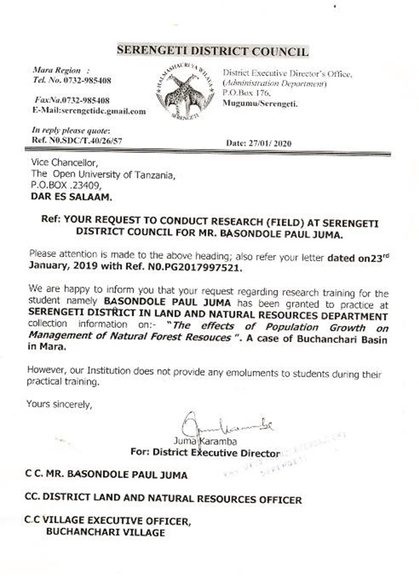

Appendix IV: Permission Letter of Executive District Director of Serengeti
