IMPROVING INCOME OF AMAN GROUP MEMBERS THROUGH VEGETABLES PRODUCTION IN KINONDONI, DAR ES SALAAM TANZANIA

`

ANENSE SADIKI KIUYE

A PROJECT SUBMITTED IN PARTIAL FULFILLMENT OF THE REQUIREMENTS FOR THE DEGREE OF MASTER OF COMMUNITY ECONOMIC DEVELOPMENT
DEPARTMENT OF COMMUNITY ECONOMIC DEVELOPMENT
THE OPEN UNIVERSITY OF TANZANIA
2020

CERTIFICATION
The undersigned certifies that he has read and hereby recommend for acceptance by the Open University a dissertation titled: “Improving Income of Aman Group members through Vegetables Production in Maliasili Street (Amani Group), Kinondoni, and Dar es Salaam Tanzania in partial fulfillment of the requirements for the degree of Master of Community Economic Development of the Open University of Tanzania.

…………………………………
Dr. Felician Mutasa
(Supervisor)

………………………………
Date

COPYRIGHT
This project report is a copyright material protected under the Berne convention, the copyright Act 1999, and other International and National enactments, in that behalf an intellectual property. It may not be reproduced by any means, in full or in part, except for short extract in fair dealing, for research or private study, critical scholarly review or discourse with own acknowledgement, without written permission of the Open University Authority, on behalf of researcher.

DECLARATION

I ANENSE SADIKI KIUYE do hereby declare to the Open University of Tanzania that, the work presented in this report is my own creation and has not been submitted for any Degree award by any one in any other University.

……………………………………..
Signature

……………………………………
Date

DEDICATION
This research work is mostly dedicated to my dearest almighty GOD for shading light on my thoughts and movements, the light that enabled me to produce this dissertation.
Also, I dedicate this dissertation to my Husband Patrick and my daughter Faith for their assistance in the whole process of undertaking the Project spiritually as sometimes they missed my presence this is because of being too occupied with field activities including data collection, analysis, interpretation and other related Project logistical issues.

ACKNOWLEDGEMENT

Foremost I would like to convey heartfelt thanks to God for HE my dream come true. I would like to acknowledge the support I received from a number of individuals while undertaking my project.

First, I would like to thank my supervisor Dr. Harieth who worked untiringly with patient and tolerance, professional advice was a tool in giving me guidance in the course of undertaking this project . I wish them good luck in very aspect of their lives in the future.

I would like to thank Dr. Mutasa for his insight, support always guidance, may he be blessed, and also many thank to Mr. Tom for his great support encouragement and care extremely valued. To all my friends Eva and Haika thank you so much for your support and love to me.

Finally, I would like to thank my whole family for their total support, encouragement and prayers throughout my project.

ABSTRACT
A conceptual framework showing the households and social implications of community low income was elicited from a qualitative and quantitative study of 75 households from a heterogeneous low income population of Maliasili Street; the study was designed to increase understanding of the experience of low community income in order to contribute to its solution. According to the respondents' description, the experience of low income is characterized by two categories of manifestations, i.e., the core characteristics of the phenomenon and a related set of actions and reactions by the household. This second category of manifestations is considered here as a first level of consequences of low income. These consequences at the household level often interact with the larger environment to which the household belongs. On a chronic basis, the resulting interactions have certain implications that are tentatively labeled social implications in this paper. Their examination suggests that important aspects of human development depend on households. It also raises questions concerning the nature of socially acceptable practices of vegetables are produced, and how such acceptability can be assessed. Guidelines to that effect are proposed.

TABLE OF CONTENTS
CERTIFICATION ii
COPYRIGHT iii
DECLARATION iv
DEDICATION v
ACKNOWLEDGEMENT vi
ABSTRACT vii
LIST OF TABLES xiv
LIST OF FIGURES xv
CHAPTER ONE 1
PARTICIPATORY NEEDS ASSESSMENT 1
1.1 Background Information 1
1.2 Community Profile 2
1.2.1 Economic Activities in the Area 3
1.2.1.1.Horticulture 4
1.2.2. Employment 4
1.2.4 Infrastructure 4
1.2.4.1 Roads 4
1.2.4.2 Telecommunication 4
1.2.4.3 Power and Water Supply 5
1.2.5 Social Services 5
1.2.5.1 Education 5
1.2.5.2 Health Facilities 5
1.3 Community Needs Assessment (CNA) 6
1.4 General Objective 7
1.5 Research Questions 7
1.6 Research Methodology 7
1.6.1 Research Design 8
1.6.2 Sampling Techniques 8
1.6.3 Area and Population of the Study 8
1.6.3.1 Sample Selection and Size 9
1.6.3.2 Methods of Data Collection 9
1.6.3.2.1 Interview 9
1.6.3.2.2 Observation Method 10
1.6.3.2.3 Questionnaire Method 10
1.6.3.2.4 Documentary Review 11
1.6.4 Data Analysis 11
1.7 Community Needs Assessment Findings 12
1.1.1 Findings on Personal Particulars 12
1.7.2 Finding Major Community Needs 15
1.7.3 Community Income Situation 15
1.7.3.1 Vegetable producers Economic Status 16
1.8 Community Needs Prioritization/Leveling of Needs 19
1.9 Conclusion 21
CHAPTER TWO 22
PROBLEM IDENTIFICATION 22
2.1 Background to Research Problem 22
2.2 Problem Statement 22
2.3 Project Description 22
2.3.1 Target Community 23
2.3.2 Stakeholders 23
2.3.3 Project Goals in CED Terms 25
2.3.4 Project Objectives 25
2.3.4.1 General Objective 25
2.4 Host Organization 26
2.4.1 Mission Kinondoni Municipal 26
2.4.2 Organization Structure of Kinondoni Municipal 26
2.4.3 Organization SWOC Analysis (Amani Group) 27
2.4.4 Role of the MCED Student in the Project 27
2.4.5 Roles of the Amani Group 28
2.4.6 Local Government Authority’s Roles 28
CHAPTER THREE 29
LITERATURE REVIEW 29
3.1 Introduction 29
3.2 Theoretical Literature 29
3.2.1 Definition of Concepts 29
3.2.2 Production 29
3.2.2 Income Generation 29
3.2.3 Impact of Microenterprise Development to Youth Economic Development in Tanzania 30
3.2.4 Challenges Facing Agriculture SME’sin Tanzania 31
3.2.4.1 Lack of Financial Support 32
3.2.4.2 External Market 32
3.2.4.3 Middlemen in Local Market 33
3.2.5 Overview of Vegetable Market in Dar es Salaam 34
3.2.6 Vegetable Market Overview in Tanzania 35
3.3 Empirical Literature Review 37
3.2.1 Agriculture Related Policies 40
3.2.2 Agricultural Sector Development Strategy 41
3.4 Research Gap 43
CHAPTER FOUR 45
PROJECT IMPLEMENTATION 45
4.1 Introduction 45
4.2 Project Outputs 45
4.3 Project Planning 46
4.3.1 Implementation Plan 46
4.4 Logical Framework 50
4.4.1 Inputs 52
4.4.2 Staffing Pattern 53
4.4.3 Project Budget 53
4.5 Project Implementation 55
4.5.1 Project Implementation Report 55
4.5.2 Project Implementation Ghantt Chart 60
CHAPTER FIVE 63
PROJECT PARTICIPATORY MONITORING, EVALUATION AND SUSTANABAILITY 63
5.1 Introduction 63
5.2 Participatory Monitoring 63
5.2.1 Monitoring Information System 64
5.2.2 Participatory Monitoring Methods 64
5.2.3 Participatory Monitoring Plan 65
5.2.4 Participatory Evaluation Method 65
5.2.5 Project Evaluation Summary 68
5.3 Project Sustainability 71
CHAPTER SIX 73
CONCLUSION AND RECOMMENDATIONS 73
6.1 Introduction 73
6.2 Conclusion 73
6.3 Recommendations 75
REFERENCES 76
APPENDIX 79

LIST OF TABLES
Table 1.1: Number of Schools 5
Table 1.2 Number of Health Facilities 5
Table 1.3: Respondents Distribution 9
Table 1.4: Sex of Respondents 12
Table 1.5: Age of Respondents 13
Table 1.6: Education Level of Respondents 14
Table 1.7: Source of Income of Respondents 14
Table 1.11: Respondents Economic Status 17
Table 1.12: Pair Wise Table Matrix showing Community Needs Prioritization 19
Table 2.1: Table showing Roles and Expectation of Project Stakeholders 24
Table: Project Output 45
Table 4.2: Project Implementation Plan 47
Table 4.3: Logical Framework 50
Table 4.4: Project Budget 53
Table 4.5: Project Implementation Gantt Chart 61
Table 5.1: Participatory Monitoring Plan 66
Table 5.2: Evaluation Table 69

LIST OF FIGURES

Figure:4.2 Picture showing MCED student with on duty Amani group members 58
Figure:4.3 Picture showing vegetables produced 59
Figure:4.4 Picture showing produced vegetables harvested and ready to be sold 60

CHAPTER ONE

PARTICIPATORY NEEDS ASSESSMENT

Background Information

This chapter provides an overview of Participatory Needs assessment which was conducted at Maliasili Street, Kinondoni District in Dar Es Salaam. The studies disclose serious economic, health and social challenges taking place in Maliasili Street. Community experience low income generating activities for their livelihood wellbeing. This leads to poverty and difficultness to meet their daily household needs. Low income generating activities lead to low household income, failure to have three meals per day resulting to malnutrition, increasing the transmission rate of HIV/AIDS as inhabitants engage into prostitution for the aim of seeking earnings for living and among others.

This project proposal is intended to improve households’ income in Maliasili Street through education and creating awareness of vegetable production. The proposed project will concerned with addressing the continual households’ low income in Maliasili Street. The effort focuses on furthering, economic, social and all fields that encompass the creation of a real developed Maliasili vegetable production society.

For many years, Maliasili households keep on lagging behind upon development though of availability of different opportunities. Nevertheless people are poorly live though of the great and rich fertile land and water available throughout the year. So many questions have to be asked for why poverty doesn’t leave these territories while they are living on an area full of all resources needed for vegetable production, why Maliasili is always in the list of Villages with high records of poverty, why children keep on suffering from malnutrition while their parents can produce different vegetables, and why there is still a high rate of HIV/AIDS transmission.

This raises a major concern for need to improve income through starting vegetables production. This can be done individually or at a community level. By having a proper and improved production, households will assure themselves for the sustainable income generation activity. Children will no longer suffer from malnutrition as the food for consumption will be available and their parents will be able to purchase other basic needs like shelter, clothes, education, and medical care among others because of money earned from selling their produced vegetables. All these will ensure Sustainable Community Economic Development for Maliasili Street.

Community Profile

Amani Group one among many of community groups found in Maliasili Street. Amani Group was established purposely to facilitate the improvement of income in Maliasili Street and the community as a whole for the sustainable community economic development. Its establishment came through sensitization done by MCED student upon improving income situation in the street. The group is formed by 15 women and 11 men who were already to work together. Group roles are to sensitize the whole community of Maliasili upon vegetables production, seeking market for produced products and managing the group fund for the development of the group and its members individually.

The management team of the project is headed by a chairperson who has a responsibility of chairing all the group programs. Following the chairperson is the secretary of the project whose responsibilities includes taking the records in every programs or activities taking place. Other positions include project treasurer who keep financial records, ensures vegetable harvested, stored and sold are handled correctly with the assistance of two clerks. Alongside with all mentioned above, the rest members play a role of being a faithfully members.

The Maliasili Street inhabitants are mainly Islam and Christians. The road network is good as most parts are passable during the dry and rainy season. The street has been connected with electricity from National Grid.

Economic Activities in the Area

The economy is natural resource based, and the main source of Livelihood is horticulture, formal and informal employment. 70% of the total population finds employment in small scale industries such as metal works, in Lumbering transportation and in social and administrative service. Different Commercial activities such as shops and restaurants are also important sources of livelihood.

1.2.1.1.Horticulture
Most of individuals in Maliasili Street are dealing with horticulture. This is all about production of garden crops generally fruits, vegetables and ornamental plants.

1.2.2. Employment
The proportion of population which engaged in formal sector is low as compared to that of informal sector. Small scale industries dealing with electrical and metal work, carpentry workshop, Non-governmental organizations, garages and transportation companies together with Council Offices, Hotel and Banks provide employment opportunities to Maliasili Community

Infrastructure

Roads

At present, only 89% of the Road networks are passable throughout the year. Tarmac roads are available in Maliasili Street while the earth Roads are often difficult to pass-through during the wet season.

Telecommunication

The telecommunication system links Maliasili Street with the rest of the World. There are cellular telephone services which are provided by 6 telecommunication companies namely TTCL, Airtel, Vodacom, TIGO, Halotel and Zantel. There also the accessibility of digitalized television broadcasting.

1.2.4.3 Power and Water Supply

There is power which is supplied by TANESCO. There is accessibility of clean water from bore holes Wells. Community members access it through their respective domestic water point.

Social Services

Education

Maliasili Street has 13 primary schools.

Table 1.1: Number of Schools
Schools | Private owned | Public owned | Total
Primary schools | 12 | 1 | 13
Secondary schools | 0 | 0 | 0

Source: Research Finding, 2019

1.2.5.2 Health Facilities

The Maliasili Street has 6 health facilities (Dispensaries). These Dispensaries 3 are public owned.

Table 1.2 Number of Health Facilities
Health facilities | Private owned | Public owned | Total
Dispensaries | 3 | 3 | 6

Source: Research Finding, 2019

1.3 Community Needs Assessment (CNA)
The process of community needs assessment involves variety of procedures to involve all stakeholders in the society that the project of intervention is taking place. The term refers to as a formal step by step process in order to understand the most pressing needs in the society and finding the solution in a participatory manner, meaning that the project should be people centered and not otherwise. "(Welo, 2012). The need assessment involves the people specifically in initial planning the determining the baseline information for the study and planning what is necessary and important to that society. And identify the measures that are necessary for the society or the community (Gao, 2017). As a part of process in community planning it can involve religious institutions in the area, schools, non-governmental organizations and other institutions that are the key stake holders in the project without considering whether they are primary of secondary stakeholders only with the aim to improve project performance. By critically analyzing the problem it is possible to find better solution to major problems facing the society.

The process of needs assessment often renders to positive results only if the all participant in the meeting are involved and participate in a focus to eliminate the most problem that is facing such (Pius, 2014). In Maliasili Street the process was conducted in by the students and Maliasili people b in a meeting/ focus group discussion involving all people and every respondent had part in participation on the discussion. The meeting had only one objective and that was to identify the most pressing problem in the community and rank them against many that are mentioned to choose the best among by voting each until the final problem receives the highest votes.

1.4 General Objective

The CNA is intended to fulfill the following specific objectives:-
    - To examine demographic characteristic of Maliasili people.
    - To identify income generating activity and the priority needs of the Amani group in Maliasili Street.
    - To identify the intervention to improve community income of Amani group in Maliasili Street.

1.5 Research Questions

The study questions in which the questionnaire was depicted were as follows;
    - What are the demographic characteristics of Maliasili people?
    - What are the economic generating activities and priority needs of Amani group in Maliasili Street?
    - What are the possible interventions that can be undertaken to address the identified need?

1.6 Research Methodology

1.6.1 Research Design

A sample survey and cross sectional study designs based on qualitative data and quantitative data collections methods were employed to gather primary data while secondary data were sought through documentary review. Interviews and observation were the major sources of qualitative data. The questionnaires formed the basis for gathering quantitative data that was presented in a descriptive and statistical manner using percentages ratio and mean in tables, charts and graphs.

1.6.2 Sampling Techniques

The population sample was derived using purposive and random sampling given the homogenous nature of the population. Data collection procedure was that; the first step involved the researcher to acquire a letter seeking permission to carry out the study. There was training of target respondents that had been selected on how to answer different questions. Different data collection methods were simultaneously used when some results from one method could be used to cross check the other. This gave consistent results that were depended upon to analyze the study.

1.6.3 Area and Population of the Study

The study took place in Maliasili Street. A total of forty vegetables producers formed 53.3% of the total respondents, twenty vegetables traders 26.7% of the total respondents, ten Agricultural Officers, participated and formed 13.3% of the total respondents, four local food vendors formed 5.3% of the total number of respondents and one Street Executive Officer and formed 1.4% of the total number of respondents. A total population of seventy five respondents constituted the sample size as elaborated in a Table 1.3.

Table 1.3: Respondents Distribution
Category | Population | Percent | Valid Percent | Cumulative Percent
Vegetable Producers | 40 | 53.3 | 53.3 | 53.3
Vegetable Traders | 20 | 26.7 | 26.7 | 80
Agriculture Extension Officers | 10 | 13.3 | 13.3 | 93.3
Local food vendors | 4 | 5.3 | 5.3 | 98.6
Village Executive Officer | 1 | 1.4 | 1.4 | 100
Total | 75 | 100 | 100

Source: Research Finding, 2019

1.6.3.1 Sample Selection and Size

The study involved purposive random sampling. A total of forty vegetable producers were chosen from Maliasili Street, and twenty vegetables middlemen were selected for the study. Ten Agricultural Officers, four local food vendors and one Village Executive Officer were selected. In all a total of seventy five respondents were got to constitute the sample size.

1.6.3.2 Methods of Data Collection

The study employed a range of methods to collect data. Primary was collected using qualitative and quantitative research designs where interviews and observation were used to collect qualitative data and questionnaires for quantitative data. Secondary data was sought through documentary review from different libraries.

1.6.3.2.1 Interview

The CNA used structured and unstructured interviews where face to face questions were administered to the target respondents. Interviews were held with forty respondents because they were manageable given the limited time and resources. Structured interviews consisted of a topic and list of questions administered in an organized way whereas unstructured interviews were basically meant for respondent who felt suspicious about the study. These were administered in a conversation form and the respondents were not informed that they were under interviews.

1.6.3.2.2 Observation Method

Here the researcher personally monitored the economic activities of residents in Maliasili Street. An observation checklist was used and it included items such as, viewing the general social welfare of vegetable producers in Maliasili Street, the economic potential of Maliasili Street and its inhabitants, the statistical vegetable production, preservation, selling and the general views of producers in Maliasili Street.

1.6.3.2.3 Questionnaire Method

A set of well purposively selected questions to examine topics related to the study objectives. Both open ended and close ended questions were distributed to thirty five respondents since this were presumed manageable due to limited resources and time. The respondents were required to answer these questions in three days and return them for interpretation. Questionnaires were employed because of the different views held by different respondents were known and integrated into the study; these clarified the magnitude of the problem. Given that information was written down, this enabled the researcher to always refer to it whenever it was needed. This helped to given constant results whenever they were needed for analysis of events in the study.

1.6.3.2.4 Documentary Review

The researcher reviewed different documents from different libraries reviews literature related to the study basing on the objectives of the study. Related data gave a procedure on making questionnaires, interviews, and observation checklist. Documentary review was important in ways such as; respondents who would have become biased with the intentions of the study as well as the findings were avoided since literature reviewed was used as a source of reference and the different ideas by different authors and editors helped in relating the different parts of the study which made it a unit.

1.6.4 Data Analysis

The quantitative data generated through the questionnaires was analyzed manually to generate mean, rations and percentages. This was used to establish the magnitude of the problem of the study. Further, the quantitative and qualitative data was presented in a descriptive form that involved diagrams like charts, graphs and tables. Qualitative data was generated through the description of emerging issues. The data from questionnaires was first inspected and edited in order to discover items misunderstood, detect gaps and discarded off data that never generated enough information.

1.7 Community Needs Assessment Findings
The findings from the CNA in Maliasili Street are presented below based on the method and type of data collection. Through the questionnaire the researcher managed to get information on personal particulars and general views on various issues regarding economic development. Gathering of information using the questionnaire the researcher prepared fifty questionnaires but managed to collect only forty.

The findings from the questionnaire show the respondents sex, age, level of education, source of income, needs identified on CNA, and community economic status. Thereafter, follows the general overviews on economic activities.

Findings on Personal Particulars
Table 1.4 shows the sex of respondents. The researcher met both males and females so that can get the reality of the community basing on gender. The intention behind is to examine how gender is affect by the community problem identified. Researcher succeeded to involve 44 males equivalent to 58.7% and 31 females equivalent to 41.3%. This implies that poverty affects both females and males.

Table 1.4: Sex of Respondents
Characteristic | Frequency | Percent | Valid Percent | Cumulative Percent
Males | 44 | 58.7 | 58.7 | 58.7
Females | 31 | 41.3 | 41.3 | 100
Total | 75 | 100 | 100
Source: Field Survey 2019

Table 1.5 indicates that 50.7% of the respondents aged between 18 - 35 while those between 36 - 45 have 33.3%. This means that majority of the respondents who engage in vegetable production activities are youths and this ensured availability of working force throughout the production season.

Table 1.5: Age of Respondents
Characteristic | Frequency | Percent | Valid Percent | Cumulative Percent
18 – 35 | 38 | 50.7 | 50.7 | 54.7
36 – 45 | 25 | 33.3 | 33.3 | 88
46 + | 12 | 16 | 16 | 100
Total | 75 | 100 | 100

Source: Research Finding, 2019

Table 1.6 reveals that only 26.7% were tertiary level, 36% were secondary school

level, 37.3% were primary school. This means that primary and secondary leavers

are mostly involved in vegetables production.

Table 1.6: Education Level of Respondents
Characteristic | Frequency | Percent | Valid Percent | Cumulative Percent
Primary Education | 28 | 37.3 | 37.3 | 37.3
Secondary Education | 27 | 36 | 36 | 73.3
Tertiary Education | 20 | 26.7 | 26.3 | 100
Total | 75 | 100 | 100
Source: Research Finding, 2019

Table 1.7 shows that out of 75 participants 40 are directly involved in vegetable production, followed by business by 20 participants, and 15 participants are employed in a formal sector. The findings above revealed that 53.3% of interviewed community is engaged in vegetable production, which means is the main source of income. 26.7% engaged in business and this stands as the second source of income. 20% engaged in Employment.

Table 1.7: Source of Income of Respondents
Characteristic | Frequency | Percent | Valid Percent | Cumulative Percent
Vegetable Production | 40 | 53.3 | 53.3 | 53.3
Business | 20 | 26.7 | 26.7 | 80
Employed | 15 | 20 | 20 | 100
Total | 75 | 100 | 100

Source: Research Finding, 2018

1.7.2 Finding Major Community Needs
Table 1.8 shows that among four needs identified by the community during CNA, the “Improving Community Income through vegetable production” was ranked as the first need this needs to be addressed. This was supported by 35 respondents out of 75, followed by improving health and access to medical dispensary supported by 22 out of 75 respondents; cultivation of coconut supported by 13 out of 75 respondents and lastly was access to nearby schools supported by 5 out of 75 respondents.

S/N | Need | Frequency | Percent | Valid Percentage | Cumulative Percent
 | Coconut cultivation | 13 | 17.3 | 17.3 | 17.3
2. | Improving health and access to medical dispensary | 22 | 29.3 | 29.3 | 46.6
3. | Improving Community income through vegetable production | 35 | 46.7 | 46.7 | 93.3
4. | Access to nearby primary school | 5 | 6.7 | 6.7 | 100
 | Total | 75 | 100 | 100

Source: Research Finding, 2019

Community Income Situation
Community Income means that the ability and amount of earning a household can earn for living in a particular time mostly per day or month. The CNA revealed that Community Income in Maliasili Street is very low. This is not caused of poor harvests but the main cause is poor production of vegetables which leads to low quality of vegetables which in turn cannot afford to stand at the highest price at the market.

Low community income increases impaired physical and cognitive abilities of children. This increases the number of children dropout from school and their poor performance academically. Number of inhabitants engaging themselves in dirty activities is increasing day after day. Robbery, prostitution among others is taking place daily.

Vegetable producers Economic Status

Table 1.11 shows that 35 respondents equivalent to 87.5% have a lower economical

status, 3 respondents have a middle economic status and only 2 respondents equivalent to 5% have a moderate economic status. This implies that the more the
household can improve the vegetable production the well-off they become. The study found that farmers are forced to sell their vegetables at low price because they are at the lowest quality. They are forced to sell at the price of 200/= - 500/= per kilogram and if they could afford to have an improved production, they could sell each kilogram at 2,000 – 4,000/= at the market. This is normally happens throughout the year. CAN reveled that presence of low community income leads community to poverty by being weak and unable to be productive. Being poor, the community fails to participate or contribute in different development programs.

Table 1.11: Respondents Economic Status
 | Frequency | Percent | Valid Percent | Cumulative Percent
Lower | 35 | 87.5 | 87.5 | 87.5
Middle | 3 | 7.5 | 7.5 | 95
Moderate | 2 | 5 | 5 | 100
Total | 40 |  | 100

Source: Research Finding, 2019

Low community income leads to inaccessibility to sufficient calories and nutrients, the body slows down, making it difficult to undertake the work needed to produce. Without good health, the body is also less able to make use of the food that is available. A hungry mother will give birth to an underweight baby, who then faces a future of stunted growth, frequent illness, learning disabilities and reduced resistance to disease.
Low community income increases impaired physical and cognitive abilities of children. This increases the number of children dropout from school and their poor performance academically. Number of inhabitants engaging themselves in dirty activities is increasing day after day. Robbery, prostitution among others is taking place daily. Rural to urban migration is not controlled.

Poor saving skills for little amount earned from selling their vegetables cannot be saved for long. CNA revealed that the long last of the cash earned is only a week. This leads to emptiness and in need of other basic needs such as food, clothes and shelters.

The researcher took an ample time to identify different needs which should be addressed. These needs are those which touch everyone or large group of people in a targeted community. After a long and thoroughly discussion needs identified were improve Coconut cultivation, Improving health and access to medical dispensary, Improving Community income through vegetable production and Access to nearby primary school. After identification of the needs, researcher conducted a pairing processes of the needs identified in the community which required to be addressed. The needs were paired to each other so that the community can prioritize and come out with the need which must be addressed first. During the pairing of needs to each other, the need which seemed to be tackled first scored 1 point and at the end of the process the need with the highest points is the one which is prioritized to be addressed first. Through this process the Community identified the need to be addressed and come out with the full rank of which problem should be addressed first.

Community Needs Prioritization/Leveling of Needs
The table below shows pair wise matrix need prioritization of Amani project.
Table 1.12: Pair Wise Table Matrix showing Community Needs Prioritization
Problems | Coconut cultivation | Improving health and access to medical dispensary | Improving Community income through vegetable production | Access to nearby primary school | Score | Ranking
Coconut cultivation |  | Improving health and access to medical dispensary | Improving Community income through vegetable production | Coconut cultivation | 2 | 3
Improving health and access to medical dispensary | Improving health and access to medical dispensary |  | Improving Community income through vegetable production | Improving health and access to medical dispensary | 3 | 2
Improving Community income through vegetable production | Improving Community income through vegetable production | Improving Community income through vegetable production |  | Improving Community income through vegetable production | 4 | 1
Access to nearby primary school | Coconut cultivation | Improving Community income through vegetable production | Improving Community income through vegetable production |  | 1 | 4

Table 1.12 shows that among four needs identified by the community during CNA, the “Improving Community Income through vegetable production” was ranked as the first need this needs to be addressed. In each pair it was a prime need to be addressed and scored 4 scores followed by improving health and access to medical dispensary which scored 3 scores; followed by cultivation of coconut which scored 2 scores and lastly was and lastly was access to nearby schools which scored 1 score.

Conclusion
This chapter dealt with Community Needs assessment conducted in Maliasili Street with the intention of Improving Community Income in Maliasili Street through vegetable production. The CNA was conducted from March to June 2019. The researcher used participatory for the sake of carrying out field survey and acquire more from community. The CNA findings were compiled and analyzed using the SPSS and all the findings were presented and analyzed in the report above. The findings revealed that Maliasili households lack the adequate and improved means of vegetables production which leads to the rise of community low income.

CNA come up with the intervention to help the community solve the problem. The intervention is to make sure that the community is adopting the improved means of vegetables production and this will assure the Community Income together with other respective benefits of assurance of Community Income throughout a year.

CHAPTER TWO

PROBLEM IDENTIFICATION
  - Background to Research Problem
This chapter explains in deep the identified problems in the previous chapter as the main community problem. Through participatory approach, community itself prioritized them and agreed which should be addressed first and how. According to the findings, community identified four problems which considered as barriers to their well-being. They mentioned the Improving Community Income through vegetable production, improving health and access to medical dispensary, cultivation of coconut and access to nearby schools. After passing the ranking of the problem identified, the community comes up with the Improving Community Income through vegetable production.

  - Problem Statement

Several projects have been implemented in Maliasili Street but most of them failed because they didn’t involve the community participation. To avoid this, the researcher allowed the community to involve fully, freely and respect their opinions. Finally the researcher came up with the project of Improving Community Income through vegetable production.

  - Project Description
The project aims at improving household income in the community. This vegetable production can attained through utilizing improved means of vegetables production. Since the households economic status is low and individually cannot afford to produce, the researcher organized a community to join and jointly cultivate. The project aims at improving community income which will in turn improve the households’ health, economy and social status. To make this easy a group of 20 members were formed and registered by Community Development Department as Amani Group.

    - Target Community
The target community of this project is Maliasili Street community. A registered group formed consisted of 20 members with the same vision was ready to secure their future income status. To assure the project sustainability, the researcher joined the efforts with Local Authority as the host organization.

    - Stakeholders
Stakeholders are those people or organizations who are having the same self-drives upon solving the identified and prioritized community problem. The community in collaboration with the researcher identified these key stakeholders who played a significant role. They were Amani Group members, Local Government Authority and MCED student. All these play a great role in their area of operation to contribute to the target group sustainable goals. Below is a summary of their role and expectations in the group:

Table 2.1: Table showing Roles and Expectation of Project Stakeholders
Name of stakeholder | Role of the stakeholder | Expectation
Amani Group | - Beneficiaries  - Implementers of the project | - Increased the quality and quantity of the vegetable produced.  - Increased the household income of the project members  - Increase income of the community
Local Government Authority | - Project supervision  - Monitoring and evaluation of the project  - Provision of technical advice.  - Provision of legal support.  - Provision of technical advice | - Purchased of cultivation materials.  - Ensured the smooth running of the project  - Increased the quality and quantity of the vegetable produced.  - Increased the household income of the project members  - Registering the group implementing the project  - Smooth running of the project.
MCED Student | - Technical advices  - Identification of trainers and donor for the Project.  - Monitoring and evaluation of the project  - Provision of technical advice. | - Increased the production of crops  - Improving income of the community  - Increased the household income of the project members

Source: Field Findings 2018

    - Project Goals in CED Terms
The project goal is to improving community income through improved vegetables production in Maliasili street (Amani group), Kinondoni. The production will facilitate the growth of income to the community.

    - Project Objectives
      - General Objective
The general objective of this project is improving community income through improved vegetables production in Maliasili street (Amani group), Kinondoni by March 2019. For these goals to be undergone, the following specific objectives will be met:-
    - To sensitize 450 community members on Vegetables production and establish ant – poverty group by March 2019.
    - To train 25 Amani group members with the improved Vegetable production skills by March 2019.
    - To cultivate area of two hectors for improved vegetable production by April 2019.
    - To earn Tshs 28,000,000/= through selling of vegetables by June 2019.

  - Host Organization

The host Organization is Kinondoni Municipal Council

    - Mission Kinondoni Municipal

To provide socio-economic services through effective and efficient use of resources, and adhering to good governance for the well-being of the community.

    - Organization Structure of Kinondoni Municipal
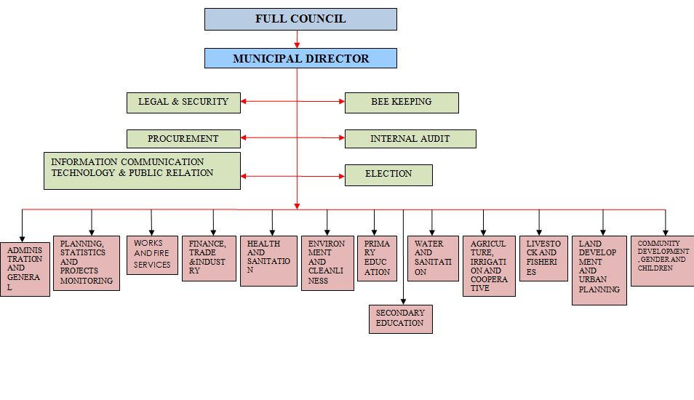

    - Organization SWOC Analysis (Amani Group)
NO | Strengths | Weaknesses | Opportunities | Challenges
1. | High motivation among the members | Limited skills among the members | - Willingness of the members to learn  - Professional experts are ready to volunteer | Poor Norms and culture of the community which hinder women to participate in community programs
2. | Presence of Local Government Authority which is ready to provide technical support | Fund management skills being low among the members | Readiness of the group members to raise Fund | Fear of the assurance to manage the fund accordingly

Source: Field Findings 2019

    - Role of the MCED Student in the Project
- Mobilize and create awareness to Maliasili community on food security.
- To facilitate training on the vegetable production.
- Collaborate with Community leaders, trainers and LGA staffs to conduct monitoring and evaluation.

    - Roles of the Amani Group
- To attend training provided by student and other trainers.
- To help create awareness to Maliasili Community and give assistance where necessary.
- To record and document all the knowledge and skills provided by the trainers.
- To participate in the implementation and evaluation of the project.

    - Local Government Authority’s Roles
The roles of the Local Government Authority in the project include:
- Making sure that all materials are in place at a time they are needed.
- Participating in stakeholder meeting
- Advise MCED student on project progress.
- To attend the entrepreneurial project management training
- To purchase equipment required for project to take off.
- To technically advice.

CHAPTER THREE

LITERATURE REVIEW

3.1 Introduction
Chapter three presents different literatures and issues pertaining community income generation through vegetable production. The chapter contains summarization of the chapter empirical and literature, conceptual definitions and others. The chapter intends to find out what is missing from other materials so that to create the gap for this study.

Theoretical Literature

Definition of Concepts

3.2.2 Production
Production is the situation where by materials are transformed from raw or unprocessed inputs that should be processed and produce a better product. Different resources are employed in the process to ensure that the products are made in the fashionable manner and outputs such as knowledge ideas and information are produced as the end result of such possess(Annie, 2007). This research defines the word production as the process whereby the unprocessed materials undergo production to produce better product.

Income Generation
The term income making or generation is defined as the process where by serving opportunities resulted from production is gaining good amount of profit in certain specific time. There are various means by which people can create income such as work salaries, bank and financial institutions interests, salaries and work wages that are given or earned in certain specific time (Mollel, 2013). This study identify income generation as the process of making profit by using legal means such as employment, entrepreneur, rent, wages and other similar sources.

Theoretical Literature Review

Impact of Microenterprise Development to Youth Economic Development in Tanzania
Bradshaw (2013) demonstrates that the most influential evidence on the importance of youth to economic development has come from research used to support the World Bank’s ‘Youth Mainstreaming Strategy’ launched in 2001. That research highlighted that societies that discriminate by gender tend to experience less rapid economic growth and poverty reduction than societies that treat males and females more equally, and that social gender disparities produce economically inefficient outcomes (World Bank 2001).
The primary pathways through which gender systems affect growth are by influencing the productivity of labor and the allocative efficiency of the economy (World Bank 2002). In terms of productivity, for example, if the access of youth farmers to productive inputs and human capital were on a par with men’s access, total agricultural output could increase by an estimated 6 to 20 percent (World Bank 2001). In terms of allocative efficiency, while increases in household income are generally associated with reduced child mortality risks, the marginal impact is almost 20 times as large if the income is in the hands of the mother rather than the father (WBGDG 2003).
It is important to note that while gender equality will help bring economic growth, economic growth will not necessarily bring gender equality. Advancing gender equality requires strengthening different dimensions of youth’s autonomy: economic and political autonomy, full citizenship and freedom from all forms of violence, and sexual and reproductive autonomy (Alpízar Durán, 2010).

Challenges Facing Agriculture SME’sin Tanzania
On the other hand, financial challenge has been the issue in many startups and small businesses for long time. This project will seeks financial loan from banks and other financial institutions to cover up the expenses through the formal business plan and projected cash flow the project is sure to secure enough fund to finance the project. After the initial funding the project expect to run using its own finance made from the profit and hence create its sustainability for a very long time. This approach will ensure that the productions cuts off the interests that are charged by the banks and financial institutions and hence lower the price of the produce. This project intends to cut off all extra expenditure to ensure the products are of high quality but also very affordable and dependable.

Vegetable production like many other project have some few setbacks that might hinder the project. There has been market fluctuation that on one way or the other has the impact on the local market in which most of the produce may not be properly be regulated by the middlemen. There is also the risk of seasonal demand of need for certain produce in seasons in restaurants and hotels that has high fluctuation of tourist in certain times.

Lack of Financial Support
Only financial support that small and medium farmers get is through own small SACCOS which is not enough to fund most of the farmers adequately. Financial constraints might hinder this projected idea since it requires high capital investment that it future output and impact to the society is not realized overnight.

External Market
The last risk that this project is likely to face is high importation of cheap produce that might hinder the local market at the time where the production is still low. Like many other potential ideas they are run by large organization and investments that produce in bulky and hence cheap compared to the small and medium enterprises operating locally, therefore at the end the market is crippled with and then business fails.

Lastly there are issues of large companies introducing many vegetable products in the market at lower price in order to cripple the local markers. This project will not only enter into contract with buyers but it will produce at lower expenses by cutting off much unnecessary expenditure in order to have the lower price. With lower price yet profitable in the market it is very possible to be ahead of the market by taking the advantage of being local produce.

Middlemen in Local Market
Despite such shortcoming the project intends to do many things in order to combat the intended setbacks that would destroy the program. For the case of middlemen who tend to regulate the price in local markets the project intends to reduce the barriers created and deal direct with the final users, this will not only lower the price of the produce by cutting of the middlemen expenses but it will create customer loyalty and good relationship between the users and the farmers. As stated above there are challenges associated with seasonal demand for certain products and this can pose a problem to the business. This intervention intends to enter into contracts with buyers in restaurants, hotels and supermarkets and arrange what type of vegetables is needed in what time and in which season so that there can be a correct estimates in the farm to feed the market. This approach is very essential to both buyers and sellers as it ensures the proper management and ensure good supply and demand.

Therefore due to many setback and problems that might rise along the way this project will conduct SWOT analysis and identify the strength, weakness, opportunity and threat that might rise. The project will then categories all the threats and identifies all the possible ways to mitigate those threats starting for the stronger threat to the weaker threat. This will help the project run smoothly with predetermined ways to mitigate all the potential problems that may hinder the production of vegetables.

Overview of Vegetable Market in Dar es Salaam
Most crops that are to be planted are mostly vegetables demanded by the market everywhere. The program expects that the high needs of vegetables in big hotels and restaurants in Dar es Salaam will put their order in place and purchase all the products. The need for the vegetables in dares Salaam is very high compared to other regions in Tanzania. The idea will have to provide 95% of the demand in the market. Therefore it will have simple, straight forward vegetable product that will meet the needs of projected 95% of the target customers. Meanwhile we will ensure that the products are comparable and even better with the best that other fellow competitor’s offers. In other way, the enterprise eyes for its product not to be superseded by other competitors.

The Dar es Salaam is huge city with approximately seven million people with deficit of vegetables product in their meal. In most of time the hotels tend to order fruits and vegetables from neighboring countries such as South Africa and Kenya due to inadequate local production. The project also intends to sell the vegetable in outside market such as Comoro.

The target markets in Dar es Salaam are of two types; specific and non-specific. Specific and nonspecific market these are formal and informal markets that has promise to purchase the product these include moles and supermarkets, and local markets. The targeted market shows the great need for the product that exceed to the point that the industry need to order the products from outside countries due to lower local supply.

Vegetable Market Overview in Tanzania
Vegetable market in Tanzania is mostly characterized by seasonal need for certain product with demand rising in hotel where as in local market and international market being unstable. In supermarkets and hotels the fluctuation is always low due to the scheduled customers and their predictability. It is quite good to depend on the on the restaurants and hotels in vegetable products due to the nature of the product. The perishable goods are very difficult to store in a long time therefore the predictability of market is of great importance. Besides understanding the structure of the markets structure in this country there are quite impediment that the farmers, also the goods depends on the mechanism set to transferred from one stage to another for instance from the farms to buyers or consumer.

The market is expected to respond positive to the product due to the high demand. The pre-market analysis was done to determine the need for vegetable and baseline results indicated huge deficit of vegetables, poor supply chain, low quality of the product and seasonal production, all these shows that there is high response to the products. The supply chain from production, type of vegetable to grow with what percentage, how to bring it to the market, how to meet the buyers is a challenge to many youth but the response to the market is very welcoming.

The baseline information collected from local farmers and traders indicated that there are some few setbacks when it comes to vegetable production business. Initially the price of vegetable in Tanzania is not settled of market price value rather it is due to the power of negotiation between the seller and the buyer. Also it was revealed that in marketing the product in local markets brokers and middlemen plays a huge part in setting the price of products in local market. This issue can have the negative effect of market if the price is set by the brokers and middlemen is high and the buyers can afford of chooses other alternatives. The study indicates that many middlemen are required to facilitate trade and match the potential buyers and sellers to each other. Each of the market actors plays a unique role in trade facilitation and is also constrained by a unique set of market impediments. Thus, understanding the supply chain for the large marketing channels, i.e. national and export markets becomes invaluable in designing policy instruments to enhance trade in Tanzania. But despite that evidence the middlemen have had the tendency to reduce the market price or to increase it from time to time. Survey from the few respondents indicated that they are not happy with that situation and they would prefer to deal direct with buyers.

The vegetable production in Tanzania is characterized with low competition compared to other agriculture production. The national agriculture survey indicates that there is very low productivity of vegetable and fruits with exception of seasonal fruits which also affect only local markets due to it low quality. The only true competitors are South African traders importing product that some of them are of same quality and low product. However the production of the product is expected to use very low expenses in order lower the cost as well as lowering the market price so as to be ahead of the competitors.

Empirical Literature Review
Mbonaso et al (2012) evaluated the degree of acceptances of sweet vegetable invention technology by growers in southeast agro-ecological zone of Nigeria. The result revealed 79.63% were cognizant of technology, 20.37% were not. He also went further to highlight the limits to improved acceptance of the technology as lack of land, difficulty in assimilating sweet vegetable production technology into prevailing production system, low customer preference linked with vegetable products, absence of market, inaccessibility of vegetable vines, and high price and UN obtain ability of agrochemicals. It endorsed the improvement of less complex technologies by investigators.

Tonucci and Rissotto (2001) made the observation in their comparative study of youth participation projects in Italy. Most youth participation initiatives addressed concerns that are mutually held by youth and adults. Across the references reviewed for the study, youth chose to research and work toward solutions for diverse community concerns that included housing, graffiti, tenant-landlord problems, vacant lots, natural areas, toxic sites, library services, and drug and alcohol abuse. Moreover, his study could not examine the opportunities available to youths in participating in development projects in their areas when needed.

According to the international vegetable Centre (Lima, Pere, report (2009), Peru preserve the major bank of vegetable genetic factor globally. More studies in Lima documented that two hector offer 2 to 3 times more starches than maize. A research conducted by the French Agricultural Research Centre for International Development (CIRAD) in France (2002), acknowledge a cross breed called “Africa” and was a great achievement, retailed in urban Africa markets. It had short maturity period of 12 to 16 weeks, value-added produce with numerous roots and a very high resistance to disease, shelf life of 4 weeks which pleased consumers (UNCTAS, 2012).

In Vietnam, vegetable statistics exhibited a great chance for improved productivity from vegetables was in more effective and efficient usage of current technologies (CIP, 1999-2000). Ahaluri (2003) suggested that vegetable is grown during the rainy season and mainly eaten in India. Total vegetable production was high but its yield was low. Accessibility of certified varies on sustainable base was the main issues. He further recommended that plans needed to be put in place to enable that certified virus are obtained all year around.

According to Low et al (2007) a study in Mozambique vegetable was evaluated with the purpose to increase Vitamin A, intake and serum retinol concentrations in infants. It is highly nutritious food and has been shown to have specific health benefits, provides energy and drought resilient making it an exceptional food security crop. Recent experiment in Mozambique shows that acceptance of is limited by obtain ability of vines and concentration of extension services (Mazuze, 2005).

Fischler (2000) explained the special value of literature reviews of empirical studies of planning practice, especially when the practice is innovative such as is the situation with youth participation. Knowles-Yánez (2005) applied this method to catalog the ways in which the field of planning interacts with youth. She found that scholars study youths’ views of their communities and capacity for expressing them, educators teach youth about planning practice, and process organizers engage youth in community development, often because the organizers recognize the right of youth to have their voices heard. Knowles-Yánez (ibid.). However, their studies could not explore the impact of youth participation in development projects in their areas.

On the other hand, Cavet and Sloper (2004) reviewed the “grey literature” concerning youth participation in decision-making regarding health care and services for the disabled in the United Kingdom to draw conclusions about the extent of participation, barriers and facilitating factors, and impacts on services. It was found that youths encountered structural, administrative and social barriers towards their development engagements. In addition, Maric et al., (2010) in his study emphasizes that effective involvement of stakeholders lead to project effectiveness. It means producing and delivering the right thing to the stakeholders. When efficiency is attained output will deliver to possible minimum cost. He found that effective involvement of people strengthens their empowerment.

It is through financial management practices, direct employment, project planning and implementation involvement through the decision making process, the community will own the project themselves. Likewise, (Samuel, 2014) in his study argues that community participation involving youths enhance educative and economic efficiencies. This means allocating resources in accordance with user’s preference. This will enable even the donor agencies to adjust resources in response to community needs. However, their studies could not determine the challenges facing youths in participating in development projects of their own.

Agriculture Related Policies
Several other policies have a bearing on the development of agriculture. The overall aim of the National Land Policy is to promote and ensure a secure land tenure system, encourage the optimal use of land resources, and facilitate broad-based socio-economic development without endangering the ecological balance of the environment. Water Policy; One of its objectives of the Water Policy is to establish a multi-sector platform and framework for participatory agreements on the allocation of water use in a coordinated and rational manner.

This will eventually ensure that the interests and rights of various water users, particularly the requirement of catchments, crops and livestock, are taken into account during the process of allocating water. The National Micro-finance Policy forms the long-term basis for developing an efficient and effective micro-financial system and provides a framework for empowering farmers and livestock keepers through access to credit. The Gender Policy of 2000 aims to mainstream gender issues in all aspects of policy, planning, resource allocation and implementation. Special attention is directed towards ensuring that women have access to land, other productive resources, training and labor saving technologies. Nevertheless, it will be important under ASDS to formulate special programs to enhance women’s access to technology, training and credit. The Government has also enacted a National Environment Policy, which lays the foundation for coordinated, multi-sectoral action in this field.

Agricultural Sector Development Strategy
Tanzanian agriculture, like the entire economy, is in a transition from being a command- to a market based production system. The transition process started in the mid-1980s as part of the economic adjustment and structural reform programs supported by the development partners. Despite some impressive macroeconomic achievements resulting from the reform programs, agricultural growth and rural poverty reduction continue to present daunting challenges. In response to these and other pertinent development issues, the Government recently adopted the Tanzania Development Vision 2025 (TDV) to provide broad guidance on the strategic goals of social and economic development in the country.

The TDV envisages raising the general standard of living of Tanzanians to the level of a typical medium-income developing country by 2025, in terms of human development. It identifies three priority goals: ensuring basic food security, improving income levels and increasing export earnings. Agriculture is one of the priority sectors for achieving these goals (URT, 2015). Subsequent to the TDV, Government, with the support of the development partners, has initiated a national strategic policy framework aimed at progressively achieving the Vision’s goals in the country.

The completion of a Poverty Reduction Strategy Paper (PRSP) in 2000 was a contribution to this. Poverty reduction has become the overarching priority objective in the national economy and the PRSP provides the medium term national framework for this focus. The PRSP recognizes that agriculture is critical to poverty reduction (URT, 2014) In the rural sector, these poverty reduction objectives will be achieved through a Rural Development Strategy (RDS) and a complementary Agricultural Sector Development Strategy (ASDS). The RDS will cover the entire rural sector, including agriculture, non-farm economic activities, social services, and economic and social infrastructures (URT, 2015).

Globally, Tanzania is a showcase for public-private partnership in agricultural growth, Exemplified by the development of its Southern Agricultural Growth Corridor (SAGCOT). The Government of Tanzania and the G8 members commit to the “New Alliance for Food Security and Nutrition” and to working together to generate greater private investment in agricultural development, scale innovation, achieve sustainable food security outcomes, reduce poverty and end hunger (URT, 2016). The Government of Tanzania intends to pursue the policy goals set out below in order to build domestic and international private sector confidence to increase agricultural investment significantly, with the overall goal of reducing poverty and ending hunger.
The Government of Tanzania intends to focus its efforts, in particular, on increasing stability and transparency in trade policy; improving incentives for the private sector; developing and implementing a transparent land tenure policy; developing and implementing domestic seed policies that encourage increased private sector involvement in this area; and aligning the National Food and Nutrition Policy with the National Nutrition Strategy (URT, 2016). The Government of Tanzania reaffirms its intention to provide the human and financial resources and the mechanisms for dialogue with the private sector, farmers and other stakeholders, and across government ministries that are required for the achievement of tangible and sustainable outcomes, the acceleration of Tanzania’s development, and the delivery of tangible benefits to smallholder farmers (URT, 2014).

Research Gap
The problem of poverty and poor employment opportunities for people has devastated the country and has for a long time been a cause of concern to the government (Ajani, et al., 2015). Youths suffer high unemployment due to lack of opportunities, physical and psychological challenges resulting from poverty. Some youths respond to these challenges by engaging in criminal or violent behavior while others suffer from despair or depression (Onucheyo, 2009). Youth are 27% of the world’s population and 33% of the population in Africa who are unemployed seek the opportunity in improving their lives through any chance that can better themselves and community around These problems associated with unemployment can be solved by empowering the people through agricultural development programmes which will enable them to have opportunities for self-employment in agriculture (Ajani, et al., 2015).Therefore without the new ideas to rise the living standards with something that can be produced in every peoples’ surroundings it is very difficult to escape poverty and rise income in such environment.

Therefore there been many intervention from different sector but still the problem of poverty, unemployment is very high to the rising number of youth in street. With massive uncultivated land and poor knowledge of cultivation and what to cultivate has block the chances to improve the livelihood of youth in Tanzania. Therefore this intervention seek to improve community lives through agri-preneur through engaging in vegetable production as a means of improving their lives at Malisili area in Dar es Salaam

CHAPTER FOUR

PROJECT IMPLEMENTATION

Introduction
Project implementation is a systematic plan that intends to schedule how the activities will be performed in a specified period of time. Project implementation indicated the resources and inputs that are required to ensure the implementation of such activities. It reveals the description of each individual who participates in the implementation. It further shows the actual products, staffing and budget details. Presentation presented by both narrative and tabulation forms.

Project Outputs
The project outputs were accomplished by sequence of activities that responded to the project objectives. In a period of four months of project duration, the project productively prepared, performed and accomplished the following activities and outputs.
Table: Project Output
Objective | Output | Activity
To sensitize 450 community members on Vegetables production and establish ant – poverty group by March 2019 | 1. Hiring venue and Public addressing system for sensitization  2. Registered ant-poverty group | 1. Conducting a sensitization meeting with a Maliasili community.  2. Registering a group to a Local Government Authorities
To train 25 Amani group members with the improved Vegetable production skills by March 2019. | 1. Training materials on vegetable production  2. 25 group members trained in vegetable production | 1.Outsource the expert  2.Conducting the training  3. Schedule the timetable and duty for each group member
To cultivate area of two hectors for improved vegetable production by April 2019. | 1.Improved vegetables production farm  2. A set of agricultural tools acquired | 1. To write an application letter for a cultivation land to Maliasili Street authority.  2. To facilitate the capital to purchase the raw materials.  3. To sign the contract of getting capital from the Maliasili Local Government Authority  4. To arrange farming specifications  5.Purchasing agricultural materials  6. Cultivation of area for improved vegetable production
To earn Tshs 28,000,000/= through selling of vegetables by June 2019. | Tshs 28,000,000/= was earned by  the group after selling vegetables at the supermarkets | 1. To link youth farmers with reliable market for vegetable produced.  2. Take record of each vegetable sold  3. Take record of every member’s contributions for the welfare of the project

Project Planning

The project planning covers implementation plan, staffing pattern and project budget. It provides the information on all activities, people who involved in the implementation of the project, time taken and resources utilized.

Implementation Plan
Implementation plan is planned in such a way that all activities intended to be taken to accomplish the project objectives. The PIP involves four main stakeholders who were Amani Group in Maliasili Street, Local Government Authority and MCED student.

Table 4.2: Project Implementation Plan
Specific objective | Output | Activity | Resource | Responsible  Person/Institute | Time Frame
 |  |  |  |  | Mar | Apr | May | Jun
To sensitize 450 community members on Vegetables production and establish ant – poverty group by March 2019 | 1. Hiring Venue and public addressing system for sensitization | 1.Sensitizing community on improved vegetable production | Personnel, Stationary and Transport | MCED student, Local Government Authority
 |  | 2.Haring of training space | Fund | Amani group, MCED student, Local Government Authority
 | 2. Registered group with registration certificate | 1. Register the group | Personnel, Stationary and fund | Amani group, MCED student, Local Government Authority
To train 25 Amani group members with the improved Vegetable production skills by March 2019. | 1. Training materials on vegetable production | 1.Outsource the expert | Fund, Personnel | Amani group, MCED student, Local Government Authority
 |  | 2.Conducting the training | Stationary, personnel | Amani group, MCED student, Local Government Authority
 | 2. 25 group members trained in vegetable production | 1. Schedule the timetable and duty for each group member | Stationary, personnel | Amani group, MCED student, Local Government Authority
To cultivate area of two hectors for improved vegetable production by April 2019. | 1. Improved vegetables production farm | 1. To write an application letter for a cultivation land to Maliasili Street authority. | Stationary, personnel | Amani group, MCED student, Local Government Authority
 |  | 2. To facilitate the capital to purchase the raw materials. | Stationary, Fund, personnel | Amani group, MCED student, Local Government Authority
 |  | 3. To sign the contract of getting capital from the Maliasili Local Authority | Stationary, Personnel | Amani group, MCED student, Local Government Authority
 |  | 4.To arrange farming specifications | Personnel, stationary | Amani group, MCED student, Local Government Authority
 |  | 5.Purchasing agricultural materials | Fund, Transport, personnel | Amani group, MCED student, Local Government Authority
 |  | 6. Construction of crops bank | Fund, personnel | Amani group, MCED student, Local Government Authority
 | 2. A set of agricultural tools acquired | 1. Take record of each members’ participation | Stationary, personnel | Amani group, MCED student
 |  | 2.Cultivating area for improved vegetable production | Fund, personnel | Amani group, MCED student, Local Government Authority
To earn Tshs 28,000,000/= through selling of vegetables by June 2019. | 1.Tshs 28,000,000/= was earned by the group after selling vegetables at the market | 1. To link youth farmers with reliable market for vegetable produced. | Stationary, personnel | Amani group, MCED student, Local Government Authority
 |  | 2. Take record of each vegetable sold | Stationary, personnel | Amani group, MCED student
 |  | 3. Take record of every member’s contributions for the welfare of the project | Stationary, personnel | Amani group, MCED student

Source: Research Data, 2019

Logical Framework
Logical Framework is a management tool used for effective planning and implementation of developmental projects. It provides clear, concise and systematic information about a project through a framework.

Table 4.3: Logical Framework
Hierarchy of objectives | Objectively verifiable indicators(OVIs) | Means of verification (MOV) | Assumptions
Goal: Improving community income of Amani group through vegetables production in Maliasili Street, for the sustainable community development | Improving community income at the end of the project | Supervision of individuals from the beginning to the end of the projects. | Households are aware of the important of improving vegetable production
Objective 1.To sensitize 450 community members on Vegetables production and establish ant – poverty group by March 2019.
Output1.1: Training materials on various topics. | 450 members trained on improved vegetable production | Project Progressive report | Community members become aware of improving vegetable production
Activities
- Sensitizing community on improving vegetable production | Number of participants  Number of sensitization meeting covered. | Participation forms  Sensitization evaluation report | Community gain knowledge on f improving vegetable production
- Hiring of training place | Number of participants  Number of training sessions covered. | Participation forms  Training evaluation report | Community gain knowledge on improving vegetable production
- Registering the group | Number Amani group member attended the training. | Certificate of Registration | Recognition of Amani group to commence its program
Objective 2:To train 25 Amani group members with the improved Vegetable production skills by March 2019
Output 2: Training materials on various topics. | Number of Amani group members attended the training | Participation forms  Sensitization evaluation report | Amani Group members gain knowledge on improving vegetable production
Activities
1.Outsource the expert | Signing MOU with Expert | Progressive report | Amani Group members gain knowledge on improving vegetable production
2.Conducting the training | Number Amani group member attended the training. | Participation forms  Training evaluation report | Amani Group members gain knowledge on improving vegetable production
3.Schedule the timetable and duty for each member | Duty Roaster | Presence of Schedule for each member duty in the farm | Amani Group members gain knowledge on improving vegetable production
Objective 3: To cultivate area of two hectors for improved vegetable production by April 2019.
Output 3. Cultivation of two hectors for improved vegetables production and Acquiring a set of agricultural tools | Signing MOU with Local Government Authority  Formulation of farming contract. | Project progressive report. | Every member participate in cultivation
Activities
1.To write an application letter for a cultivation land to the village authority | Writing an application letter | An application letter | Willingness of local authority to offer land for cultivation
2. To facilitate the capital to purchase the raw materials. | Availability of capital | Presence o f raw materials | Willingness of MCED student to request for capital
3.To sign a contract of getting Agriculture Extension Officers From Local Government Authority (Kinondoni Municipal) | Two Agriculture Extension Officers offered from the host organization | Report of the offered Officers | Willingness of host organization to give the skilled man power.
4.Cultivation | Number of equipments purchased | Purchased receipts. | Willingness of MCED student and Amani group members to purchase
Objective 4:To earn Tshs 28,000,000/= through selling of vegetables by June 2019.
Output 4. Tshs. 28,000,000/= was earned by the group after selling vegetables at the markert | Availability of 28,000,000/= | Receipts for the purchase | Presence of receipts
Activity
- Record of vegetable sold | Presence cash flow book | Cash flow report | Cash earned
- Record of each member’s contributions for the wellbeing of the group | Presence of contribution flow book | Contribution report | List of Contributors

Source: Research Data, 2019

Inputs
Inputs, in simple terms, are those things that used in the project for implementation. This included human resource (personnel), finances in the form of money, machinery, equipment, and services necessary for carrying out activities among others. Inputs ensure that it is possible to deliver the intended results of a project.

Staffing Pattern
Amani Group was established purposely to facilitate the improvement of community income in Maliasili Street and the community as a whole for the sustainable community economic development. The management team of the project is headed by a chairperson who has a responsibility of chairing all the group programs. Following the chairperson is the secretary of the project whose responsibilities includes taking the records in every programs or activities taking place. Other positions include project treasurer who keep financial records, ensures crops in and crops out are issued correctly with the assistance of two clerks. Together with all mentioned above, the rest members play a role of being a faithfully members. CED student is a coordinator while the Local Government Authority is funder and guider.

Project Budget
The table bellow presents the budget covered in this project.

Table 4.4: Project Budget
Specific objective | Output | Activity | Input | Quantity | Unity Price | Unit Cost
To sensitize 450 community members on Vegetables production and establish ant – poverty group by March 2019 | 1. Hiring Venue and public addressing system for sensitization  2. Registered group with registration certificate | 1.Sensitizing community on improved vegetable production  2.Haring of training space  3.Register the group | Venue | 2 | 150,000/= | 300,000/=
 |  |  | Transport (Fuel) | 50-Litre | 2150 | 107,500/=
 |  |  | Venue | 2 | 250,000/= | 500,000/=
To train 25 Amani group members with the improved Vegetable production skills by March 2019. | 1. Training materials on vegetable production  2. 25 group members trained in vegetable production | 1.Outsource the expert  2.Conducting the training  1. Schedule the timetable and duty for each group member | Stationary | 25 | 5,000/= | 125,000/=
 |  |  | Transport (Fuel) | 50-Litre | 2150/= | 107,500/=
 |  |  | Application form | 50 | 500/= | 25,000/=
To cultivate area of two hectors for improved vegetable production by April 2019. | 1. Improved vegetables production farm  2. A set of agricultural tools acquired | 1. To write an application letter for a cultivation land to Maliasili Street authority.  2. To facilitate the capital to purchase the raw materials.  3. To sign the contract of getting capital from the Maliasili Local Authority  4.To arrange farming specifications  5.Purchasing agricultural materials  6.Cultivating area for improved vegetable production | Training Personnel | 3 | 300,000/= | 900,000/=
 |  |  | Personnel | 5 | 150,000 | 750,000/=
To earn Tshs 28,000,000/= through selling of vegetables by June 2019. | 1.Tshs 28,000,000/= was earned by the group after selling vegetables at the market | 1. Take record of each members’ participation  2. To link youth farmers with reliable market for vegetable produced  3. Take record of each vegetable sold  4. Take record of every member’s contributions for the welfare of the project | Stationary | 30 | 2,000/= | 60,000/=
 |  |  | Refreshments | 30 | 15,000/= | 450,000/=
 |  |  | Stationary | 30 | 2,000/= | 60,000/=
 |  |  | Transport (Fuel) | 60 | 2160/= | 129,000/=
 |  |  | Personnel | 5 | 200,000/= | 1,000,000/=
 |  |  | Stationary | 30 | 2,000/= | 60,000/=
 |  |  | Transport | 3 CARS | 250,000/= | 750,000/=
 |  |  | Personnel | 2 | 1,000,000/= | 2,000,000/=
 |  |  | Materials | 540 | 3,500/= | 1,890,000/=
 |  |  | Personnel | 2 | 150,000/= | 300,000/=
 |  |  | Transport | 3 CARS | 250,000/= | 750,0000/=
 |  |  | Stationary | 30 | 2000/= | 60,000/=
 |  |  |  |  | Total | 10,500,000.00

Source: Research Data, 2019

Project Implementation

Project Implementation Report
The drive behind this project is to improve community income through construction of improved vegetable production for the sustainable community economic development in Maliasili Street. The implementation followed the sequential order of activities that resulted into project objectives achievement. Mobilizing the community on the importance of enhancing food security was the first project activity to be conducted. This started in Street Development Committee (SDC) where all street leaders and influential elders involved. The MCED student took an abundant time to elaborate the reason of being there which is improving community income in the village. After a long session of clarifying the aim of the project SDC was ready and accepted the project.

Street General Assembly was conducted at the street so that the whole village could be elaborated and explained about the project intended to be implemented. The meeting started with the introduction and followed by MCED student to deeply share the importance of improving community income in the street. Community was taught on how they can improve their income through improving the vegetables production. They were told that the production could be done individually or jointly and MCED student preferred to jointly production which will serve 20 to 30 households.

These 20 – 30 villagers who are ready to join and form a group which will be registered and conduct their programs on improved vegetable production. 25 villagers voluntarily accepted to join a group. After all these the SGA was closed and permitted the MCED student to now focus on the group formed. The members chose their group to be called Amani Group and elect their leaders. A group formed got a short time meeting with MCED Student and planned for the followed activities.

MCED student spent a day on preparing and purchasing training materials and other training requirements. While preparing required requirements MCED students assisted the group to construct their constitution and all procedures for group registration at the Community Development Office. MCED student also outsource the expert from Agriculture and Cooperative Department who conducted the training session on improved vegetable production.
The 4 days training based on the best ways on vegetables production all the process from farms preparation to selling. After the training session the MCED student assisted the group member to formulate a timetable and duties for each member which will guide them during implementation of the project. MCED student invited a District Agriculture, Irrigation and Cooperatives Officer so that can assist on estimation upon cultivation of the farm at least is to be able to produce 14 tons of vegetables. After 3 days the DAICO submitted the proposed plan and expenses for the cultivation of farm.

A total of Tshs. 4,663,200/= was presented as the total cost for the cultivation of the farm. The MCED student took a session with the group member and discussed on how this figure could be raised. After a long discussion the following were agreed:-
- Each member to contribute Tshs. 180,000/= which made a total of 4,500,000/=
- MCED student to seek skilled manpower from Host organization which through their involvement will be able to cover the technical expenses.
- Government Local Authority to contribute a piece of land for production.

With the assistance from Community Development Department and the Agriculture, Irrigation and Cooperative Development, MCED Student was able to pursue Local Authority to cover the technical expenses by accepting to appoint two Agriculture Extension Officers to join to the project and take all technical responsibilities towards improved vegetable production. This saved a total of 6,0000,000/= which were supposed to be covered by Amani group.
MCED student, Amani group, with the assistance from DAICO arranged the agricultural material specifications for purchasing process and starts cultivation. The cultivation last for a month, during the cultivation Mani group members were assigned to contribute their manpower so as to minimize cost. While all these activities took place all group members were doing their other households’ activities as normal.
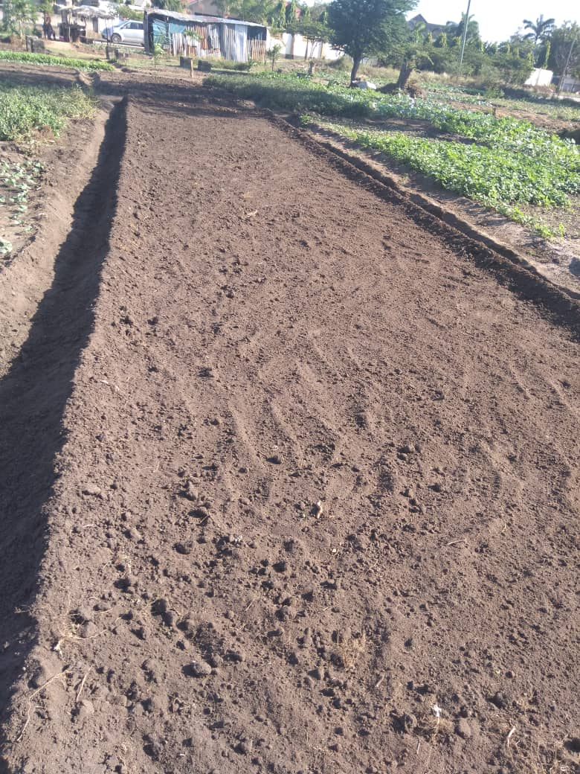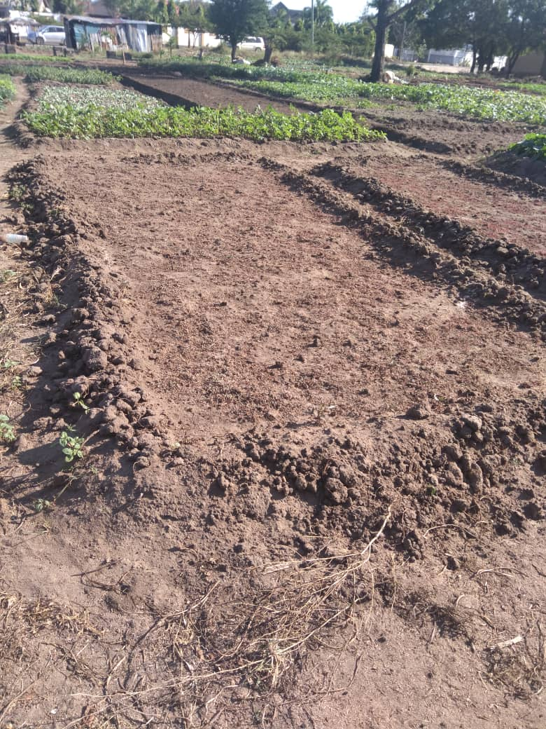
Figure:4.1 Picture showing site preparation for vegetables production
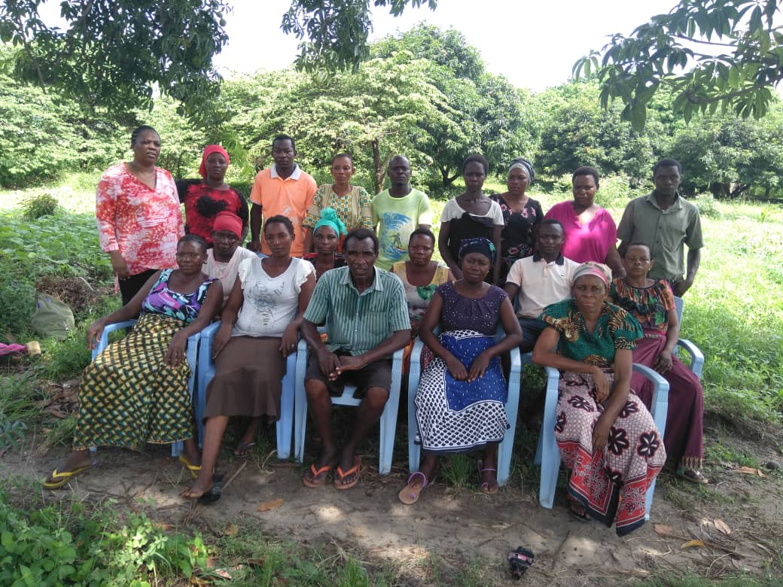
Figure:4.2 Picture showing MCED student with on duty Amani group members

After 1 month the cultivation was ready together with the installment of drop irrigation system for irrigation. Moving of vegetables from the nursery followed and farm supervision were set through duty for each group member to follow. This accompanied by Agriculture Extension Officers who keep on assurance of implementing of the improved methods of vegetables production throughout the production.
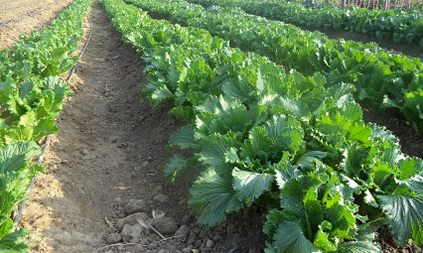
Figure:4.3 Picture showing vegetables produced

During May of 2019 the MCED student with the members of the group to chip into market places for seeking a market for their produced vegetables. The target was to supply them to the supermarkets and sell to local vendors who take cover at the evening markets at the City Centre.
Figure:4.4 Picture showing produced vegetables harvested and ready to be sold
In order to ensure sustainability of the project even after project period there was a need to make sure that the project is empowered with the members’ contributions after selling their products this will guarantee the long last of the project. Members also acted as the agent for sensitizing the rest of the community to improve the production of vegetables and formation of other groups will best practice as what Amani group did.

Project Implementation Ghantt Chart
This section covers the project implementation report where details on how the activities were carried out and the project implementation Ghantt which indicates time used in project activities implementation.

Table 4.5: Project Implementation Gantt Chart
Specific objective | Output | Activity | Time Frame
 |  |  | Mar | Apr | May | Jun
To sensitize 450 community members on Vegetables production and establish ant – poverty group by March 2019 | 1. Hiring Venue and public addressing system for sensitization | 1.Sensitizing community on improved vegetable production
 |  | 2.Haring of training space
 | 2. Registered group with registration certificate | 1. Register the group
To train 25 Amani group members with the improved Vegetable production skills by March 2019. | 1. Training materials on vegetable production | 1.Outsource the expert
 |  | 2.Conducting the training
 | 2. 25 group members trained in vegetable production | 1. Schedule the timetable and duty for each group member
To cultivate area of two hectors for improved vegetable production by April 2019. | 1. Improved vegetables production farm | 1. To write an application letter for a cultivation land to Maliasili Street authority.
 |  | 2. To facilitate the capital to purchase the raw materials.
 |  | 3. To sign the contract of getting capital from the Maliasili Local Authority
 |  | 4.To arrange farming specifications
 |  | 5.Purchasing agricultural materials
 |  | 6. Construction of crops bank
 | 2. A set of agricultural tools acquired | 1. Take record of each members’ participation
 |  | 2.Cultivating area for improved vegetable production
To earn Tshs 28,000,000/= through selling of vegetables by June 2019. | 1.Tshs 28,000,000/= was earned by the group after selling vegetables at the market | 1. To link youth farmers with reliable market for vegetable produced.
 |  | 2. Take record of each vegetable sold
 |  | 3. Take record of every member’s contributions for the welfare of the project

CHAPTER FIVE

PROJECT PARTICIPATORY MONITORING, EVALUATION AND SUSTANABAILITY

Introduction
This chapter covers participatory monitoring, participatory evaluation and project sustainability. These are done to ensure the long lasting life of the project. This is the consistent systematic collection and analysis of information to footpath the progress of project implementation against pre-set targets and objectives. It aims to answer the question “did we deliver?” Monitoring clarifies program objectives, links activities and their resources to objectives, translates objectives into performance indicators and sets targets, routinely collects data on these indicators, compares actual results with targets and reports progress to implementers and alerts to problems.

Monitoring gives information on where a project is at any given time (or over time) relative to respective targets and outcomes. Monitoring focuses in particular on efficiency and the use of resources. While monitoring provides records of activities and results, and signals problems to be remedied along the way, it is descriptive and may not be able to explain why a particular problem has arisen, or why a particular outcome has occurred or failed to occur.

Participatory Monitoring
Participatory monitoring is a process of collecting, processing and sharing data to assist project participants in decision making and learning. The purpose is to provide all concerned with information as to whether group objectives are being achieved. Implementing agencies and donors also require data on progress toward overall project objectives. This process considers Local stakeholders are active participants, not just sources of information. It is the systematic recording and periodic analysis of information that has been chosen and recorded by insiders with the help of outsiders. The main purpose is to provide information during the life of the project, so that adjustments and/or modifications can be made if necessary. Throughout the project the MCED Student made sure that all Amani group members are involved in each stage. Tools used during the monitoring also emphasized a fully participation of the implementers.

Monitoring Information System
MIS is for analyzing information to track progress against set plans and check compliance to established standards. EIS is for identifying and reflecting upon the effects of what has been done, and judging their worth.

Participatory Monitoring Methods
Three participatory methods were applied in monitoring the project implementation. These are structured interviews, direct observation and Focus Group Discussion. Structured interviews were used to gather information about production of the vegetables, market searching and other information regarding to vegetables production. Observation is a classical method of social science inquiry where eyes were used rather than ears in observing and noting how group members participated in vegetable production, how the group supervises the whole process of selling (Record of what comes in and out). The MCED student also monitored the progress through focus group discussion where Amani group members together with the Local Authority representative got an enough time to discuss on the progress of the project. In all these methods Amani group members were asked to comment whether every activity was implemented according to the plan and if there is need to reverse the implementation plan. During the discussion every member was given an opportunity to assess how resources are used in project operations and hence responses were recorded for further analysis. The MCED student acted as a facilitator to keep the discussion on.

Participatory Monitoring Plan
The purpose of participatory monitoring was to monitor project objectives, activities and outcomes of the project. It also monitored project inputs, assessed if the action plan was implemented as planned and whether the project stakeholder were kept informed of the progress, challenges and lessons learnt during the project implementation. Table 5.1 indicates participatory plan as agreed by the team involved in project operations.

Participatory Evaluation Method
Participatory evaluation involved the group members to focus on how the project is implemented. This involvement can occurred at all the stage, from the evaluation design to the data collection and analysis and the reporting of the study.

Table 5.1: Participatory Monitoring Plan
Specific objective | Output | Activity | Indicator | Data Source | Method | Responsible  Person/Institute | Time Frame
To sensitize 450 community members on Vegetables production and establish ant – poverty group by March 2019 | 1. Hiring Venue and public addressing system for sensitization | 1.Sensitizing community on improved vegetable production | Training Report  Payment receipt | Training reports and list of participants | Meeting | MCED student, Local Government Authority | March 2019
 |  | 2.Haring of training space |  |  |  | Amani group, MCED student, Local Government Authority
 | 2. Registered group with registration certificate | 1. Register the group | Certificate of registration | Certificate | Meeting | Amani group, MCED student, Local Government Authority | March 2019
To train 25 Amani group members with the improved Vegetable production skills by March 2019. | 1. Training materials on vegetable production | 1.Outsource the expert | Training report  Duty roster | Training reports and list of participants | Meeting  Focus group Discussion | Amani group, MCED student, Local Government Authority | April – May 2019
 |  | 2.Conducting the training |  |  |  | Amani group, MCED student, Local Government Authority
 | 2. 25 group members trained in vegetable production | 1. Schedule the timetable and duty for each group member |  |  |  | Amani group, MCED student, Local Government Authority
To cultivate area of two hectors for improved vegetable production by April 2019. | 1. Improved vegetables production farm | 1. To write an application letter for a cultivation land to Maliasili Street authority. | List of cultivation materials purchased | Budget and items bought | Outsourcing | Amani group, MCED student, Local Government Authority
 |  | 2. To facilitate the capital to purchase the raw materials. |  |  |  | Amani group, MCED student, Local Government Authority
 |  | 3. To sign the contract of getting capital from the Maliasili Local Authority |  |  |  | Amani group, MCED student, Local Government Authority
 |  | 4.To arrange farming specifications |  |  |  | Amani group, MCED student, Local Government Authority
 |  | 5.Purchasing agricultural materials |  |  |  | Amani group, MCED student, Local Government Authority
 |  | 6. Construction of crops bank |  |  |  | Amani group, MCED student, Local Government Authority
 | 2. A set of agricultural tools acquired | 1. Take record of each members’ participation |  |  |  | Amani group, MCED student
 |  | 2.Cultivating area for improved vegetable production |  |  |  | Amani group, MCED student, Local Government Authority
To earn Tshs 28,000,000/= through selling of vegetables by June 2019. | 1.Tshs 28,000,000/= was earned by the group after selling vegetables at the market | 1. To link youth farmers with reliable market for vegetable produced. | Cash flow ledger | Amount of vegetable sold | Progressive report | Amani group, MCED student, Local Government Authority | June 2019
 |  | 2. Take record of each vegetable sold |  |  |  | Amani group, MCED student
 |  | 3. Take record of every member’s contributions for the welfare of the project |  |  |  | Amani group, MCED student

Source: Research Findings, 2019

Project Evaluation Summary
Project evaluation dealt with questions of cause and effect. It accessed or estimated the value, worth or impact of an intervention and is typically done on a periodic basis – perhaps annually or at the end of a phase of a project or program. It answers the question “What has happened as a result?” Evaluation Analyzed why intended results were or were not achieved, Assessed specific casual contributions of activities to results, Examined implementation process, Explored unintended results, provided lessons, highlighted significant accomplishments or program potential and offered recommendations for improvement. Evaluation looked at the relevance, effectiveness, efficiency and sustainability of an intervention. It provided evidence of why targets and outcomes have or have not being achieved and addressed issues of causality. The details of the evaluated activities have been indicated in following table.

Table 5.2: Evaluation Table
Specific objective | Output | Activity | Performance Indicators | Expected outcome | Actual Indicator
To sensitize 450 community members on Vegetables production and establish ant – poverty group by March 2019 | 1. Hiring Venue and public addressing system for sensitization | 1.Sensitizing community on improved vegetable production | Training report  List of material purchased  Certificate of registration | Positive response  Acquirement of the certificate | Community members attended the meeting  A grou
 |  | 2.Haring of training space
 | 2. Registered group with registration certificate | 1. Register the group
To train 25 Amani group members with the improved Vegetable production skills by March 2019. | 1. Training materials on vegetable production | 1.Outsource the expert | Training report  Duty Roster | Positive Response | Group members trained
 |  | 2.Conducting the training
 | 2. 25 group members trained in vegetable production | 1. Schedule the timetable and duty for each group member
To cultivate area of two hectors for improved vegetable production by April 2019. | 1. Improved vegetables production farm | 1. To write an application letter for a cultivation land to Maliasili Street authority. | List of cultivation materials purchased | Positive Response | Well prepard budget and timely purchase of the cultivation materials.
 |  | 2. To facilitate the capital to purchase the raw materials.
 |  | 3. To sign the contract of getting capital from the Maliasili Local Authority
 |  | 4.To arrange farming specifications
 |  | 5.Purchasing agricultural materials
 |  | 6. Construction of crops bank
 | 2. A set of agricultural tools acquired | 1. Take record of each members’ participation
 |  | 2.Cultivating area for improved vegetable production
To earn Tshs 28,000,000/= through selling of vegetables by June 2019. | 1.Tshs 28,000,000/= was earned by the group after selling vegetables at the market | 1. To link youth farmers with reliable market for vegetable produced. | Cash Flow | Positivr Responce | Well Prepared record keeping book
 |  | 2. Take record of each vegetable sold
 |  | 3. Take record of every member’s contributions for the welfare of the project

Source: Research Findings, 2019

5.3 Project Sustainability
Sustainability refers to the ability of a project to continue its operation or program far into the future. It may end eventually, but the impact should continue. A project or organization can be sustainable in three main categories: organizational, financial, and community sustainability.
Organizational and community sustainability: Community sustainability is how the community carries out the project activities even after the MCED Student and Local Authority leave. Financial sustainability is how the financial support required for the project or the organization will continue after the grant has ended. Organizational sustainability is how the group itself continues to function after the project. The sustainability of the project is guaranteed as there are assurances of favorable production conditions for crops production. This will facilitate the improved income for each member. Above all the readiness of the community particularly Amani group ensured MCED student that the project will last.

Financial: Community has witnessed the significance of improving vegetables production after seeing Amani group members benefited from assured themselves for improved community income and earned more money after selling their vegetables. This persuades more community members to come together and form many other groups for improving their community income status.

CHAPTER SIX

CONCLUSION AND RECOMMENDATIONS

Introduction
The section highlights what has been presented from first chapter. This section will solely conclude and revealed several recommendation for sustainability purposes. The literature review, implementation plans methods used and needs assessments are concluded in this chapter to bring the meaningful conclusion. The chapter also indicates the better measures that should be undertaken to ensure sustainability and the progress of the project in the future.

Conclusion
The project is implemented by Community in Maliasili Street people with the facilitation of student who assisted technical issues as well as connection of market and training of manpower thus the main project implementers. The researcher was the project facilitator providing advises. The improving of income of community through vegetable cultivation project started in April 2019, where participants were trained on cultivation and management of vegetable production. It was planned by July 2019 the project would accomplish its activities expect evaluation. The planned project product is the generation of income through vegetable cultivation. However this is yet to be more evidenced after project final evaluation by the end of July 2019. It is anticipated that Maliasili Community people will improve and increase their income in terms of their basic needs and savings for other obligations.

Participatory needs assessment conducted in Maliasili Street. Several approaches was used to carry out participatory needs assessment to identify the best intervention that suits Maliasili people. Different tools and approaches were employed such as focus group discussion, Interview, and questionnaire to ensure that there is triangulation of information and the intervention that was chosen really involved the majority of people. Information was analyzed careful to rally identify the needs of Maliasili people.

The study also conducted set of evaluation to determine the progress of the project and to ensure the future sustainability is there. Therefore there study studied the baseline information for the intervention midline evaluation as well as final evaluation to understand what has been learned from the study and if there were some changes that could use to revive the next projects.

The implementation of the project brought the joy of effectiveness of the host organization that is now able to perform targeted objectives within the organization. The idea for this project leaned on the fact that ‘knowledge is power. At this end of the project, the implementers are confident that all will continue to be well even after the expiry of the phase for the organization members are able to work happier and very effective different from how they worked before.

The implementation of the project was quite successful as most of deliverable outputs and outcomes were actually achieved and the monitoring will continue to be well done by the community members after they have achieved the desired output and outcome. There was no unexpected outputs which could greatly affect the ability to complete the project and achieve the intended goal and the specific project objectives. However the project forestalls achieving specific objectives on successful completion of improved income of members through vegetable cultivation. Maliasili members practiced vegetable cultivation that will add value to their standards of living through income.

Recommendations
There are some issues emerged during project implementation which will need appropriate and separate attention. These are brought forward here by way of suggestions and lessons learnt as follows:-
- The NGO must be empowered to ensure future success
- There is a need of investing much time and resource to create ongoing programs of trainings to small and medium farmers on their roles and responsibilities and make them current catch-up with agriculture science and technology at the global.
- There should be procedures for punishment or to recommend close of activities until the identified gaps are worked on, this will be a good control for quality assurance and the services rendered by the community.
- There is a need for local farmers to generate internal resources from friends, families and trough small business to diversify their agriculture rather than to rely on donors hundred as this normally leads to the implementation projects basing on the donor demand/interest without taking into consideration community needs at that right moment.
REFERENCES
National Bureau of Statistics (2017). Annual Agriculture Survey Report. Tanzania.

URT. (2016). Tanzania Agriculture Statistics Strategic Plan (2014/15-2018/19).

Youth in farming (2011). Fifteen Reasons Youth in Africa do not Like a Career in Agriculture, Tanzania

Afande, O. F., Maina, N.W., and Maina P. M. (2015). Youth Engagement in Agriculture in Kenya: Challenges and Prospects. Journal of Culture, Society and Development, Volume 7, Iss: 2.

Ajani, E. N., Mgbenka, R. N. and, Onah, O. (2015). Empowerment of Youths in Rural Areas through Agricultural Development Programmes: Implications for Poverty Reduction in Nigeria. International Journal of Research in Agriculture and Forestry, volume 2, Issue 2, PP 34-41.

Babbie, E. (2001). The practise of social Research. Belmont: Thomson Wadsworth.

Babbie, E. A. (2004). The practise of social Research. Belmont: Thomson Wadsworth.

Creswell.J. (2003). Research Design. Qualitative, Quantitative and Mixed Methods Approach, 2nd ed. University of Nebraska: Sage Publications.

Kothari, C. (2004). Research Methodology, Methods and techniques. India: New age international Ltd.

Mangal H. (2009). Best practices for youth in agriculture: The Barbados, Grenada and Saint Lucia Experience. Final report.

Mbeine E. (2012). How can we attract the Ugandan youth to agriculture?, FIT Uganda Ltd.

Okoboi, G. and Barungi, M. (2012). Constraints to Fertilizer Use in Uganda: Insights from Uganda Census of Agriculture 2008/9. Journal of Sustainable Development; Vol. 5, No. 10; Canadian Center of Science and Education.

Onucheyo, E. (2009). Political decision in the Nigerian agricultural industry, Kongo-Zaria. Tamaza Publishing Co. Ltd.

Samuel, B. O. (2014) Entrepreneurship education and job creation for tourism graduated in Ghana. Journal of Education and Training, Vol. 56: 8.

Saunders, M., Lewis, P. and Thornhill, A. (2007). Research methods for business students. 4th ed. London: Prentice Hall.

URT. (2014). Agricultural Sector Development Strategy-II, 2015/2016-2024/2025.

URT. (2015). Agricultural Sector Development Program Phase Two (ASDP II). Government Programme Document.

World Bank (2008). Agriculture Annual Indicators Survey in Africa. Agriculture Report. Washington.

World Bank. (2009). Africa development indicators - 2008/2009: Youth employment in Africa the potential, the problem, the promise. Washington DC: World Bank.

Zhao, Y. (1999). Labor migration and earnings differences: The case of rural China, Economic Development and Cultural Change, Vol. 47, No. 4, 767-782.

APPENDIX
Annex 1-Sample Invoice sent to min supermarket
