AN ASSESSMENT OF THE EFFECTIVENESS OF NON-GOVERNMENTAL ORGANIZATION IN IMPROVING THE LIVING STANDARD OF PEOPLE IN ARUSHA DISTRICT COUNCIL

JUSTIN LEVERAN MUSHI

A DISSERTATION SUBMITTED IN PARTIAL FULFILMENT OF THE REQUIREMENTS FOR THE DEGREE OF MASTER OF HUMANITARIAN ACTION, COOPERATION AND DEVELOPMENT (MHACD)
DEPARTMENT OF POLITICAL AND PUBLIC ADMINISTRATION
OF THE OPEN UNIVERSITY OF TANZANIA
2020

CERTIFICATION
The undersigned certificates that he has read and hereby recommends for acceptance by The Open University of Tanzania, a dissertation entitled; “An Assessment on Effectiveness of Non-Governmental Organizations (NGOs) in Improving the Living Standards of People in Arusha District Council” in partial fulfillment of the requirements for the award of Degree of Masters in Humanitarian Action, Cooperation, and Development (MHACD).

……………………………………….
Dr. Emmanuel Mallya
(Supervisor)

………………………………….
Date

COPYRIGHT
No part of this dissertation may be reproduced, stored in any retrieval system, or transmitted in any form or by any means, electronic, photocopying, recording or otherwise without prior written permission of the author or The Open University of Tanzania on that behalf.

DECLARATION
I, Justin Leveran Mushi, do hereby declare that this dissertation is my original work and that it has not been presented and will not be presented to any other University for a similar or any other degree award.

…………………………………….
Signature

……………………………….
Date

DEDICATION
This dissertation is dedicated to the following people and institutions for their efforts and contribution to my life and the lives of poor people. To my mother, beloved mother, Janeth Moshi, the greatest inspiration for love and humanity which inspired my academic focuses on humanitarian courses.

To my beloved wife, Beatrice Mushi the source of my focus, inspiration, created a loving home which directed my focus on this work. To my friend, mentor and spiritual Father Rev. Godbless Mamkwe and the family, the moral, spiritual and financial support of yours, created in me the sense of helping others, volunteerism and the great love for mankind.

To all effective Non-Governmental Organizations, those strive to change the poor living condition of people in both rural and urban areas, and trying to create the better environment for human race. Your effort counts a lot to the lives of poor people.

ACKNOWLEDGMENTS
Everything we accomplish in life is a combined efforts and product of many people who have contributed to what we have done and who we have become. This work is the result of the very fact aforementioned. I am profound grateful for all great people who have made this work possible. I want to acknowledge the tireless efforts of the following people toward accomplishment of this work:

My supervisor Dr. Emmanuel Mallya, for his guidance, encouragements, academic critics, and being the academic role model, his efforts are vast. It was in need a pleasure and time to remember working under his supervision. To the Staffs in the department of political science and public administration of the Open University of Tanzania, for their guidance and tireless effort on teaching and coordinating all the academic activities which facilitated the successful completion of the coursework.

Reverend Godbless Mamkwe and his family, for his financial support during my secondary school studies; the support enabled me to become what I have become today. To all my research participants who devoted their time to answer my questioners and interviewed; I thank you, without your devotion this work would have been impossible. Finally but with great importance, I would like to thank God Almighty for putting in place the aforementioned people in my life, I would also like to thank God for my friends, classmates and staff mates for their support and encouragement.

ABSTRACT
NGOs for years have become trusting entities for fostering development in developing countries. Countries have continued cooperating with these entities and mainstreaming their agendas of development with these NGOs. The aim of this study, therefore, was in line with the trust and consideration given to NGOs towards development. The Arusha District Council was used as a case study to study the effectiveness of NGOs in improving the living standards of people in rural areas. 80 Random Purposive sampling was used. The study used questionnaires, documentary reviews, and interviews as its research instruments. The descriptive analysis of the data was used to analyze the data collected. The findings of the study revealed that NGOs are effective in improving the living standards of people in Arusha District Council. It has been also shown that the effectiveness of these NGOs operating in Arusha District Council were due to the factors such as the serious follow up of the NGOs on the projects they initiated, cooperation of the community leaders in the implementation of the projects on their areas, the good relationship between government and NGOs, and the willingness of the community members to engage in the programs of NGOs. However, the good and effective use of funds by NGOs is not satisfying as 32% of the beneficiaries are still with doubts on the fund management by NGOs, there is still unsatisfying participation of the ordinary people in community to identifying areas for NGOs to focus on their efforts, NGOs lack enough financial resources to carter the administrative needs. Lastly, the NGOs with the same mission are overcrowded on one area and leave other areas with limited operations or without their operations at all.

Keywords: Non-Governmental Organization, Living Standard, Development & effectiveness.
TABLE OF CONTENTS
CERTIFICATION ii
COPYRIGHT iii
DECLARATION iv
DEDICATION v
ACKNOWLEDGMENTS vi
ABSTRACT vii
TABLE OF CONTENTS viii
LIST OF TABLES xiii
LIST OF FIGURES xiv
LIST OF ABBREVIATIONS xv
CHAPTER ONE 1
BACKGROUND INFORMATION 1
1.1 Introduction 1
1.2 Profiles of NGOs Studied 2
1.2.1 Ace-Africa 2
1.2.2 The Convoy of Hope 4
1.2.3 SOS-Village Children’s Tanzania (Arusha) 6
1.2.4 Pact-(KizaziKipya Project) 7
1.3 Statement of the Problem 8
1.4 Research Objectives 10
1.4.1 General Objective 10
1.4.2 Specific Objective 10
1.5 Research Questions 11
1.6 Scope of the Study 11
1.7 Significance of the Study 12
1.8 Limitation of the Study 12
1.9 Delimitation of the Study 13
1.10 Chapter Summary 13
CHAPTER TWO 14
LITERATURE REVIEW 14
2.1 Introduction 14
2.2 Theoretical Literature Review 14
2.2.1 Non- Governmental Organization 14
2.2.2 Organizational Effectiveness 16
2.2.3 The Standard of Living 18
2.2.4 History of Non – Governmental Organizations in Africa 20
2.2.5 Legal Personality of NGOs in Tanzania 21
2.2.6 The Relationship between state and Non-Governmental Organization 21
2.2.7 Non-Governmental Organization and Development 23
2.2.8 Rural Development and Empowerment 25
2.3 Empirical Literature Review 27
2.4 Synthesis and Research Gap 30
2.4.1 Synthesis 30
2.4.2 Research Gap 30
2.3.3 Conceptual Framework 31
CHAPTER THREE 33
RESEARCH METHODOLOGY 33
3.1 Introduction 33
3.2 Research Design 33
3.3 Study Location 34
3.4 Study Population 35
3.5 Sample Selection 36
3.5.1 Sample Size 36
3.5.2 Sampling Technique 36
3.6 Sources of Data 37
3.6.1 Primary Source 37
3.6.2 Secondary Source 37
3.7 Data collection and Instrumentation 37
3.7.1 Questionnaires 37
3.7.2 Interview 38
3.7.3 Documentary Review 39
3.8 Data Analysis 39
3.9 Informed Consent of Respondents and Ethical Consideration 39
3.10 Confidentiality of the Information Sources 40
3.12 Chapter Summary 40
CHAPTER FOUR 41
DATA PRESENTATION, ANALYSIS AND DISCUSSION 41
4.1 Introduction 41
4.2 Demographic Features of the Respondents 41
4.2.1 Number of Years of the Respondents in the Office 42
4.2.2 Academic Qualification of the Respondents 43
4.3 The Extent to which NGOs have been Effective in Improving the Living Standards of People in Rural Areas in Arusha District Council 43
4.3.1 Awareness of the Community Members on the activities of NGOs in their Localities 44
4.3.2 Commitment of NGOs in Serving the Interest of the Public 45
4.3.3 The Benefits of NGOs’ Activities to the Community 46
4.3.4 The Effective Management of Funds by NGOs 47
4.3.5 The Involvement of the Community Members in the Identification Processes of NGOs’ Programs 47
4.2.6 Participation of the Community Members on the Programs of NGOs 48
4.3.7 The Relationship between NGOs and Government 49
4.3.8 General Views of the Public on the Extent to Which NGOs Have Been Effective In Improving the Living Standards of People in ADC 50
4.4 Strategies Employed by NGOs in Realizing their Objectives in Arusha District Council 51
4.5 The Sustainability of the NGOs Outcomes in Improving the Living Standard of People in Arusha District Council 54
4.6 Challenges facing NGOs in Implementation of Their Activities Effectively in Arusha District Council 54
4.7 Discussion of Research Findings 56
4.7.1 The Extent to which NGOs have been Effective in Improving the Living Standards of People in ADC 56
4.7.2 Strategies Employ by NGOs in Arusha District Council that Makes them Effective in Improving the Living Standards of People in ADC 63
4.7.3 Sustainability of the NGOs Activities in Improving the Living Standards of People in ADC 64
4.8 Chapter Summary 65
CHAPTER FIVE 66
SUMMARY, CONCLUSIONS AND RECOMMENDATIONS 66
5.1 Introduction 66
5.2 Summary of the Study 66
5.3 Summary of the Findings 67
5.3.1 The Extent to which NGOs have been Effective in Improving the living standard of people in Arusha District Council 67
5.3.2 The Strategies Employed by NGOs in Realizing their Objectives in Arusha District Council 71
5.3.3 Sustainability of the NGOs Activities in Improving the Living Standards of People in ADC 71
5.4 Conclusion 72
5.4 Recommendations 72
5.4.1 Recommendations for Action 73
5.4.2 Recommendations for Further Research 74
REFERENCE 75
APPENDICES 78

LIST OF TABLES
Table 4.1: Respondents Distribution 36

LIST OF FIGURES
Figure1.1: SOS Children’s Village Impact 7
Figure 2.1: Framework for Wellbeing Indicators 19
Figure 2.1: Conceptual Framework 32
Figure 3.1: Arusha Region Administrative Map 35
Figure 4.1: Distribution of Respondents on the Number of Years in their Offices 42
Figure 4.2: Distribution of Academic Qualification of the Respondent 43

LIST OF ABBREVIATIONS
ADC Arusha District Council
NGO Non-Governmental Organization
PPP Public Private Partnership
UN United Nations
WCDO Ward community development officer
WEO Ward executive officer
WHO Ward Health Officer
SES Socio-Economic Status

CHAPTER ONE

BACKGROUND INFORMATION
  - Introduction
Tanzania, like many developing countries, has its segment of problems associated with developing its rural areas where the majority of its population lives. Non- Governmental Organizations (NGO’S) have shown a contribution to the development processes of these rural areas. Their initiatives, strategies, and programs have changed the lives of many people in these areas. Helmet (2005) argued that non-profit organizations have become a part of community building and empowerment.

Tanzania NGOs’ report of 2015, reported that the NGOs have continued to play a very crucial role in complementing the government efforts on improving the living standard of people in different sectors. The contribution of NGOs in its reality is of the highest importance as the NGOs are involved in almost all sectors of the economy.

Several examples can be drawn around the world showing the significance of the NGOs on development. Helmet (2005) identifies that policymakers and rural and urban planners use NGOs and community organizers for development. In other words, the contribution of NGOs is vast and has to be studied very closely for it to be more effective and contribute more on the development processes of the people and especially to the people in rural areas in which data suggest that the rural areas are much populated as compared to the urban areas and they have a large number of poor people. For example in Tanzania the rural areas have got the number of 31.6 million people as compared to the urban areas which are populated by the number of 13.3 million people; this is according to the national bureau of statistics (NBS).

And according to the World Bank (2011/12) around 12 million people are still below the poverty line in Tanzania, out of which 10 million people are in rural areas. For any initiative to end poverty in a country such as Tanzania with the above-mentioned facts much concentration has to be put on the rural areas. In other words, if NGOs intend to end poverty and improve the living standards of people in developing countries the focus should be on the rural areas. This study is, therefore, concentrating on the effectiveness of these NGOs in improving the living standards of people in rural areas by taking Arusha District council as a case study.

NGOs in Tanzania are operating under the NGOs Act of 2002 and its amendment of 2005. There are about more than six thousand NGOs operating in Tanzania. Majority of which are urban-based. These NGOs are coordinated under the ministry of health, community development, gender, elderly and children. This ministry has got a department that is responsible for all the activities done by the NGOs among which are the registration of these NGOs. Apart from this governmental framework, NGOs have by themselves organized under the umbrella of TANGO which is the Tanzania Non –Governmental Organizations.

  - Profiles of NGOs Studied

1.2.1 Ace-Africa
Ace Africa is NGO that has operated in Kenya since 2003 and in Tanzania since 2008. Ace operates with the community, government and local partners to improve health, education and economic development. So far Ace has served 1,650,325 children and their families in all countries with its activities. (Ace website 2020)

What is Ace-Africa doing?
Ace Africa works with defenseless, marginalized people in Kenya and Tanzania. It builds resilient, inclusive communities, helping them access social services. It improves food and economic security, health and education by developing long-term sustainable solutions in three programming areas: Child Development, Community Health & Wellbeing and Community Livelihoods. Ace-Africa aids children, women, men, young people and communities where poverty, food insecurity and high rates of HIV/ AIDS are rampant. It works where children are defenseless and access to government services is imperfect or nonexistent.

Ace Africa has already reached over 50,000 direct beneficiaries since it commenced its work in Tanzania 2008. In its Annual Review (2018) it indicated that, with the partnership with the Ministry of Health it was the largest provider of HIV testing services in Arusha District, testing 9,591 people. It offered to over 15,000 school children with life skills and sexual health education. By using Child Protection Program, Ace-Africa educated 22,000 people on child rights and protection. It has also, Child Protection Teams through which 3,104 cases of abuse were reported and 82 per cent were resolved.

Ace –Africa has three programs areas;
- Child Development – deals with improving the health and well-being of children, and protecting their rights.
- Community Health & Well-being- deals with improving access to quality health care services.
- Community Livelihoods- aimed at improving food security and income to defenseless children and their families.

1.2.2 The Convoy of Hope
In 1994 the Convoy of Hope was founded by the Donaldson family. In the present day, more than 130 million people have been served all over the world by the Convoy of Hope. The organization operates through churches, businesses, government agencies, and other nonprofits to provide assistance and hope to those who are helpless and vulnerable.

In Tanzania, the feeding program and other programs by the Convoy of Hope were established in 2013, and at this time the organization is feeding more than 3,030 children at seven program centers, Arusha District Council is included. It has also implemented Girls’ Empowerment and Economic Empowerment programs. The Economic Empowerment programs in Tanzania provide women with monetary education, vocational training, cooperative saving groups, and start-up capital.

Convoy of Hope reaching the vulnerable through;
Community event: this is an act of compassion aimed at helping families in need. The events include local churches, businesses, community service, and health organization collaborating with the Convoy of Hope to provide health services, a hot meal, groceries; new children’s shoe, veteran services, a kid’s zones,and much more. Roughly $1 million worth of goods and services are provided to the 5,000 to 10,000 people with needs.

Children’s Feeding: The Convoy of Hope has a conviction that feeding children nutritious meals unlocks doors to provide them and their families with education, clean water, job and agricultural training, a sense of hope, and much more. At the moment more than 300,000 children are benefiting in eighteen countries in Africa and Asia, Tanzania included. (As of 31/12/2019).

Disaster services: the Convoy of Hope through its eight international warehouses with specialization in disaster response employ their highly –trained teams of staff and volunteers in responding quickly and effectively. Millions of people affected by natural and man-made disasters are served every year.

Women’s empowerment: Convoy of Hope supports women around the world to appreciate their value and reach their prospective through job training and education. As a consequence, many joiners in Women’s Empowerment program are now own businesses that allow them to better feed and care for their children. 9,043 Women's Empowerment program participants in 2019 and 19,400 women trained in ten countries in which there are women empowerment initiatives Tanzania included specifically Arusha rural.

Agriculture: Through Agriculture program, Convoy of Hope equips vulnerable farmers and families with the skills, tools, and seeds they need to produce life-sustaining crops. Each year tens of thousands of meals are harvested each for children’s Feeding program, which in turn generates income for local farmers.

1.2.3 SOS- Village Children’s Tanzania (Arusha)
SOS Village Children’s was started operating in Tanzania in 1991 where the first children were able to move to their new families in SOS Village. Currently, there are four SOS Children’s Villages in Tanzania. Apart from these villages the organization in cooperation with local agencies, runs family strengthening programs to allow families to effectively care for their children. The support rendered varies according to the local desires but includes: food packages, basic vocational training, and income generating projects, and legal advice and assistance.

SOS Children’s Village Arusha
The SOS Children's Village Arusha is located on the border of Arusha City Council, some 13 km away from the city centre, on the highway to Nairobi, Kenya. Village has 10 family houses. It has also Primary and Secondary School in which SOS Village children are schooling. If working to capacity, up to 500 students can be taught in the secondary school.

Generally, SOS Children Village Arusha has 4063 beneficiaries. The organization has the following four approaches for helping the deprived;
Quality Care: These are alternative Care and strengthen family
Safeguard Children: committed to safeguard children, report a child safety concern
Advocacy: children’s rights, sustainable features and youth participation.
Teaching and training: child-centered education, youth employability and opening doors to education.
Emergence: protecting children in emergencies.
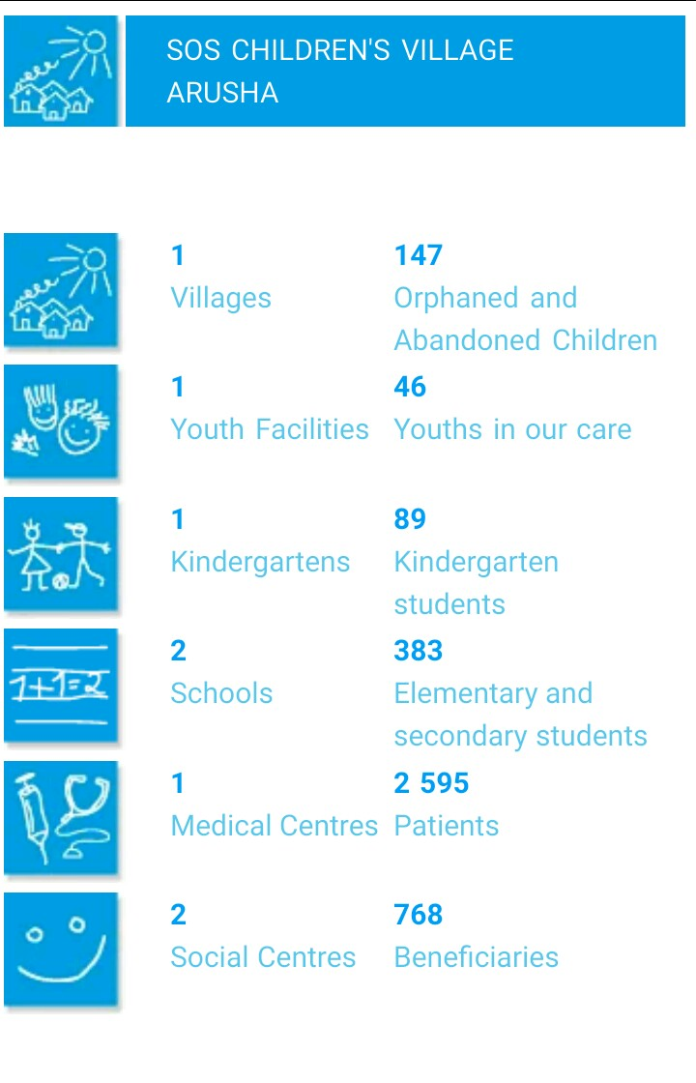

Figure1.1: SOS Children’s Village Impact
Source: SOS Children’s Village Arusha- Website

1.2.4 Pact-(KizaziKipya Project)
Pact’s work in Tanzania focuses on improving the lives of orphans and vulnerable children, especially those affected by HIV and AIDS. With the unique integrated approach, the efforts are also strengthening families and local economies, institutions and organizations – impacts that will benefit Tanzania for generations to come.Because the majority of Tanzania’s vulnerable children live in female-headed households, Pact employs award-winning WORTH model, in which small groups of women save together and make low-interest loans to one another that help them launch or expand small businesses. With increased income – plus business and other training provided by Pact – women are better able to care for their children.
Pact is also improving access to health and HIV services for children and adolescents, including those who are hard to reach. Pact has built the capacity of local authorities and community organizations to manage services for vulnerable children and helped launch trained vulnerable-children committees and district child protection teams.

The KizaziKipya project, or New Generation, is working to transform the lives of vulnerable Tanzanian children and young people, particularly those affected by HIV. This five-year project builds on years of collaboration between Pact and USAID in Tanzania that already has made a significant, measurable difference for the country’s youth. KizaziKipya's planned outcomes include better financial resources for parents and caregivers of orphans and vulnerable children (OVC), as well as improved access to health and HIV services for children and adolescents, including those who are hard to reach. The project is working across all regions of Tanzania. Partners include the Elizabeth Glaser Pediatric AIDS Foundation, the Aga Khan Foundation, Railway Children Africa and the Ifakara Health Institute. KizaziKipya reached 812,666 OVC, as well as their caregivers with at least one service. Services aim to build self-sufficiency of households to provide for their needs without the need for future donor support. Independence is measured when the entire household can be deemed healthy, safe, schooled and stable.

1.3 Statement of the Problem
Tanzania has witnessed the emergence of many NGOs in different areas of life; health, education, water, environment, capacity building and advocacy for women empowerment. These NGOs for years have been said to improve the lives of people in different spheres of life. Researches have been done to examining the contribution of these NGOs in improving people’s lives. Melenya (2016) commented that NGOs remained a principal channel for donors’ investment and hence one of the crucial sources of information and expertise on poverty and poverty alleviation.

Melanya also noted that urban poverty alleviation has become a major area of attention for the international donors’ community. NGOs have been receiving high attention in the international community and by the donors as an agent of social change and hence receive a lot of assistance to realize the changes in people’s lives. Lewis (2016) argued that NGOs influenced the lives of people through the world and hence it is important to look into their work and understand what impacts they truly have. Lewis also argued that the work done by these NGOs may not be sustainable but it often does provide people with the material need they otherwise would not have.

REPOA (2007) commented that NGOs are with the feelings that they were having a largely positive impact on policy making and implementation processes. It was also reported that over 80% of surveyed NGOs considered their work to be closely aligned to poverty reduction efforts or socio-economic development. Mushi (2011) wrote a thesis that examined the contribution of NGOs in the development of Tanzania through the engagement in policy influence in which the focuses were on answering five questions one of which was on the extent to which NGOs are leading people to real social change and sustainable development. In this work, he commented that people in reality do not know exactly what NGOs are doing although the NGOs themselves claim to be speaking for the people. He had the feeling that nothing is happening and NGOs staffs cannot deliver.

Apart from these studies being made, little has been examined on the effectiveness of these NGOs in changing people’s lives and improving their living standards (poverty reduction) especially in rural areas in Tanzania. As was stated earlier, any efforts toward changing people’s lives especially in third world countries in which the majority of their population are rural base the focus should be on these rural areas. The studies cited above have concentrated on the work of NGOs in general without focusing closely on the rural area. They have also put much attention to NGOs themselves without having another closer look at the beneficiaries of these NGOs activities and operations.

Consequently, this study is trying to fill in the gap of knowledge about the effectiveness of NGOs in improving the living standard of people in Rural Tanzania. An increase of this knowledge will help the policymakers making more effective policies when focusing on improving the living standards of people.

1.4 Research Objectives

1.4.1 General Objective
The study was mainly intended to assess the effectiveness of NGOs in improving the living standard of people in rural areas.

1.4.2 Specific Objective
Specifically, the study was intended at achieving the following objectives:
- To examine the extent to which NGOs have been effective in improving the living standard of people in Arusha District Council.
- To examine the strategies employed by the NGOs in realizing their objectives in Arusha District Council.
- To examine the sustainability of the NGOs programs in improving the living standard of people in Arusha District Council.

1.5 Research Questions
In aligning with the specific objectives; the study was intended to answer the following questions;
- To what extent have NGOs been effective in improving the living standard of people in Arusha District Council?
- What are the strategies employed by the NGOs in improving the living standards of people in Arusha District Council?
- How sustainable are NGOs programs in improving the living standards of people in rural areas?

1.6Scope of the Study
The overall objective of the study was to study the effectiveness of Non-Governmental Organizations (NGOs) in improving the living standards of people in rural areas. The study studied community leaders and beneficiaries of Kiutu, Oltrumet, Moivo, Kimnyaki, Olerien and Kiranyi wards of Arusha District Council and four NGOs working in Arusha District Council. The NGOs studied were; The Convoy of Hope, Arusha SOS Village, Ace-Africa and Pact-Under “KIZAZI KIPYA PROJECT”. These NGOs are affiliated with Education, Health and Capacity Building.

1.7 Significance of the Study
The study was intended to examine the effectiveness of the NGOs in improving the living standard of people in rural areas by using the Arusha District Council as the case study. This study is therefore significant in the following ways; firstly, the study maybe a useful tool for making some policies that may affect the rural areas’ people. In other words, the policymakers will have the reference point for the effectiveness of the NGOs in development initiatives and hence be in a very good position of whether incorporating NGOs in the developmental programs or not.

Also, the findings of this study are expected to help the NGOs’ donors and government on viewing the activities of the NGOs in changing the people’s lives especially in rural areas and to find better ways of making them more effective. Secondly, the study will be serving as the literature for the researchers who want to research the activities of NGOs or those who want to do more study on the effectiveness of NGOs in rural areas. Thirdly, the study has identified some of the challenges facing the NGOs in the implementation of their objectives. The challenges identified will enable the stakeholders of the NGOs to find some ways of addressing them to make these organizations more effective in dealing with their activities of improving the lives of people through different areas of life.

1.8 Limitation of the Study
One of the serious limitations of the study was the poor response and delay from the respondents as the majority of them were busy with the day to day activities of their offices especially government officials, NGOs staffs and local leaders. Another limitation was the strict protocol on getting data from both government departments and Non-Governmental organizations. However, in spite of the avowed limitations, the researcher was able to obtain the required information that answer the key research questions by following the protocols required, being patient and waiting for the respondents’ reasonable time thus satisfying the objectives of the study.

1.9 Delimitation of the Study
Researcher used Arusha District Council as a case study to minimize cost due to the limited budget of studying all rural areas in Tanzania. The following NGOs, The Convoy of Hope, Ace Africa, Pact- “Kizazi Kipya Project” and SOS-Village Arusha were selected so as to minimize cost due to their activities falling on all the threes or on two scopes of this study which are Education, Capacity Building and Health.

1.10 Chapter Summary
The chapter highlighted the background of the study, and a brief profile of the Non-Governmental Organization in Tanzania, the statement of the problem and the study objectives. The chapter that follows is the review of the literature relating to the study and the theoretical framework.

CHAPTER TWO

LITERATURE REVIEW

2.1 Introduction
The chapter presents a theoretical literature review, empirical study, the conceptual framework under which major concepts are discussed and defined these includes Non-Governmental Organizations, the effectiveness of an organization, the standard of living, NGOs in Tanzania, Legal Personality of NGOs in Tanzania, State and NGOs, NGOs and Development, Development and empowerment of rural areas.

2.2Theoretical Literature Review

2.2.1 Non- Governmental Organization
NGOs Act (2002) defines Non- governmental organizations as the voluntary groups of individual or organizations which are free, not align with any political party, not for profit-making and organized whether at local, national or international level for the aim of promoting economic, environmental, social or cultural development and lobbying or advocating on different issues of the public interest.According to the amendment of 2019 on the NGOs Act of 2002, NGOs are now defined as;
“a voluntary grouping of individuals or organizations which is non-partisan or non-profit sharing established and operates for the benefit or welfare of the community or public, organized at the local, national or international levels for the purpose of enhancing or promoting economic, environmental, social or cultural development or protecting environment, good governance, law and order, human rights and lobbying or advocating on such issues”

In other words, NGOs have got some characteristics that differentiate them from other organizations. These characteristics are that they must be formal, private, non-partisan; non-profit making, self-governing or independent and voluntary and the amendments of 2019 inserts that NGOs’ activities have to be for the benefits and welfare of the community.

Helmut (2005) commented that the nonprofit sector is the sum of private, voluntary and nonprofit organizations and associations and they sometimes known as the third sector. The NGOs are sometimes known as the third sector as the first sector is considered to be government and its institutions and the second is the private sector.
Issa (2004) on his thesis commented that NGOs do play an intermediary role between the poor, the private sector and the state. And that they are aiming at providing services which the poor lack. In other words, the NGOs are for the common good, the structure and organize themselves to meet the common good in a way that they do not involve themselves in the struggle for governmental power, and making a profit.

World Bank defines NGOs as private organizations whose activities are to relieve sufferings, promote the wellbeing of the poor, safeguard the environment, offer basic social services or promote community development. Under the view of the World Bank, the NGOs are defined by their activities, which are mainly based on the very crucial role of helping the poor and advocating for development. This very role and the structure of these organization as mentioned earlier are the salient features which differentiate NGOs from other organizations which performing the same roles as explained by the World Bank (WB).

Hilary (2012) describes NGOs as independent of both the government and the business sector and that their mandate is to promote the public interest and serve the public good rather than make a profit or advance the interests of a narrow group of people. An effective NGO is one that is serving the interest of the public and the one which is not designed for profit-making. In other words, an effective NGO is measured through the way it advances the interests of the public.

2.2.2 Organizational Effectiveness
The term effectiveness according to Oxford English Dictionary 3rd edition is successfully producing the results that you want. The effectiveness of NGOs is on producing the results that are needed. In other words, NGOs are governed by their objectives; the essence of their being and so to be effective is to meet that essence. In other words, NGOs can be categorized as effective only if they do meet their desired objectives.

According to Oghojafor et al (2012) organizational effectiveness is a multifaceted and argumentative concept as no two authorities agree on what constitutes effectiveness or on how it is measured; although they all agree that it involves, attention to goals and satisfaction of beneficiaries and relationship with the external environment. Generally, effectiveness refers to the extent to which an organization is able to achieve its goals.

Giti et al (2012) came up with four approaches for measuring the effectiveness of an organization. These are:
Goal Approach: This is the first extensively used approach in organizational effectiveness; its focus is on the output to figure out the essential operating objectives like profit, innovation and final product quality. The approach is looking at the essence of the organization being; the reason for the organizational existence. In this, there should be a general agreement on the specific goals and the people involved should feel committed to fulfilling them.

The system resource approach:This approach explains the effectiveness from the point of view of the ability to obtain necessary resources from the environments outside the organization. The system resource approach can be effective if there is a relation between the resources which an organization receives and the goods or services it produces. In other words, this approach is trying to figure out whether the organization is able to mobilize resources outside the organization to fulfill its objectives and goals.

The process approach: The third approach is known as the process approach which pays attention to the transformation process and is dedicated to seeing to what extent the resources are officially used to give services or produce goods. The focus here is to measure the use of the resources mobilized in attaining the desired goals of an organization.

The strategic constituency approach: the strategic constituency approach deals with the effect of the organization on the main stakeholders and their interests. Based on this approach, effectiveness refers to the minimal satisfaction of all of the strategic constituencies/beneficiaries of the organization. Strategic constituency/ beneficiaries involve all the people that are somehow connected to the organization. These people may have different roles such as the users of the services or products of the organization, the resource providers, and facilitators of the organization’s output, the main supporters and the dependents of the organization. In this study,the focus will be put on the above-discussed approaches in examining the effectiveness of NGOs in improving the living standards of people in rural areas; these approaches are goal approach, system resources approach, the process approach and strategic constituency approach.

2.2.3 The Standard of Living
According to the Tanzania vision 2025, on the standard of living or high quality live hood state that;
“a nation’s development should be people-centered based on sustainable and shared growth and be free from abject poverty; For Tanzania, this development means that the creation of wealth and its distribution in the society must be equitable and free from inequalities and all forms of social and political relations which inhibit empowerment and effective democratic and popular participation of all social groups (men and women, boys and girls, the young and old and the able-bodies and disabled persons) in the society.”

In other words, the standard of living can be defined as based on the highlights given under the Tanzania vision of 2025 in which the standard of living must be achieved through people-centered and that the creation of wealth and its distribution in the society must be equitable and free from inequalities. It is an undeniable fact that the standard of living is related much to human development. In which for the community to have at least a satisfying human development education and health should be included in the measurement.

New Economics Foundation (2008) defines the living standards of people (well-being) as a dynamic state, in which the individual is able to develop their potential, work productively and creatively, build strong and positive relationships with others, and contribute to their community. This is when an individual is able to realize his personal and socialgoals and achieve a sense of purpose in society.

OEDCD (2013) describes three pillars for understanding peoples’ well-being or standards of living as follows:
Material living conditions (or economic welfare), which determine people’s utilization possibilities and their domination over resources.
Quality of life, which is defined as the set of non-monetary attributes of individuals that shapes their opportunities and life chances, and has an intrinsic value under different cultures and contexts.
The sustainability of the socio-economic and natural systems where people live and
Work; which is important for well-being to last over time, sustainability depends on how current human activities impact the stocks of different types of capital (natural, economic, human and social) that underpin well-being.
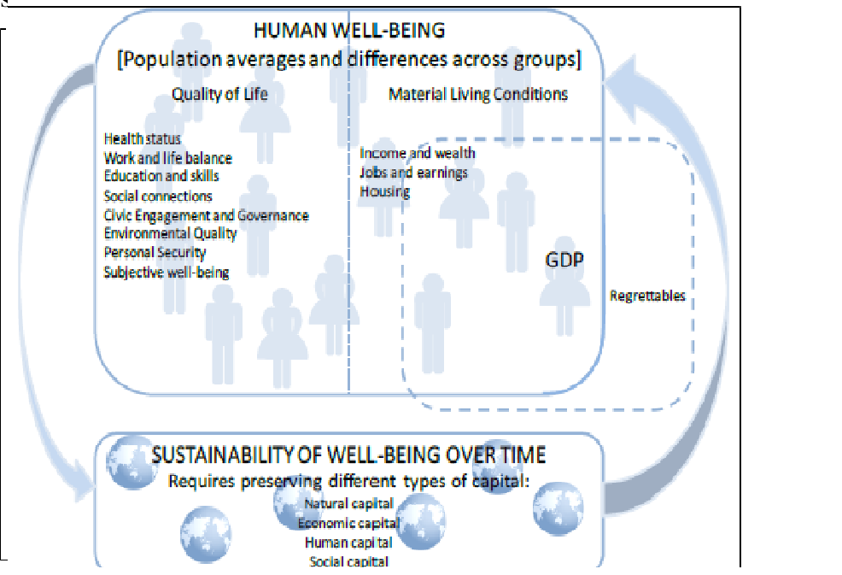

Figure 2.1: Framework for Wellbeing Indicators
Source: OECD (2011
The study is mainly focused on examining the effectiveness of NGOs on improving the material conditions of people- their command over nature, their sustainability on soci0-economic and natural systems and their quality of life.

2.2.4 History of Non – Governmental Organizations in Africa

World Bank (1991) suggested that:

“Although NGOs have only recently emerged into the development of limelight, they are not a recent phenomenon. Nor is their relevance to national development processes recent. If we accept that all nongovernmental, nonprofit organizations are properly classified as NGOs, we may safely conclude that they were the earliest form of human organization.Long before there were governments, people organized themselves into groups for mutual protection and self-help”

This reveals that NGOs were there ever before the emergence of government; they were there as long as a human being is not fully sufficient but requires some assistance in one way or another. Non – governmental organization has a long history in Africa. The official and recognized presence of NGOs in Africa dates back to the colonial era where they provided social welfare services to those people who are neglected by the state.

Michael (2014) in this era Africans who were not provided with social services by the colonial governments were provided with them by the NGOs operated in Africa. The presence of NGOs in Africa is relating much to the existence of NGOs in Tanganyika and later on in Tanzania. Besides, Michael commented that the NGOs in this era were best known as missionary society based. They were associated much with the work of missionaries and much of their work was on charitable activities more than on advocacy.

Davis (2014) argued that the acronym NGO dates back during the establishment of the United Nations (UN) system in 1945. This suggests that NGOs were under operation in Africa even before the establishment of the United Nations (UN), in other words, the establishment of the UN gave the activities of NGOs more credit and make their activities official. In other words, if NGOs got their genesis from the charitable works or helping others spirits we could say that even before the coming of European in Africa, Africans were helping one another in different sectors of lives. What missed in the African charitable activities was just the name, Non- Governmental Organization.

2.2.5 Legal Personality of NGOs in Tanzania
NGOs in Tanzania are regulated and managed by the legislation of 2002, titled NGOs Act of 2002 and its amendments of 2019 under Miscellaneous Act No. 3 of 2019.This act has stipulated the administration and coordination of NGOs, the procedure of their registration, level of registration and the authority of registrar/director and minister responsible for the NGOs. In reality NGOs in Tanzania have got some mandate to operate freely but with some strong restriction and monitoring from the government. This is evident from the power given to the minister responsible for NGOs whose power is to give some directives on the registration of NGOs. In other words, the registrations of NGOs are just determined by the minister’s decision and this endangers the activities of the NGOs in Tanzania.

2.2.6 The Relationship between state and Non-Governmental Organization
In Tanzania, the relationship between NGOs and the government keeps on improving. Theresearch done by REPOA (2007) reported that the relationship between NGOs and the government of Tanzania is expanding and improving; characterized by increasing communication, interaction, and trust. This expanding relationship is vividly evidenced by the improving effectiveness of the NGOs in different areas. In another way round this relationship is commented by different scholars to be not as good as it’s supposed to be. Miriam and Costa (2013) commented that the relationship between state and NGOs has not been friendly always; the relationship has been of lack of mutual relationship and trust. In another way, they argued that;
“The fact that NGOs have had a significant impact in Africa, a partnership between the state and NGOs can realize sustainable development through working together. The state should provide a favorable environment for NGOs to operate and work in collaboration with the state in service provision in critical areas”.

The significance of the NGOs in Africa and particularly in Tanzania in improving the living standard of people in different areas of lives have to be in line with the positive relationship with the state. The partnership between the state and the NGOs could facilitate the effectiveness of NGOs. As Campbell (1996) said;
“The relationship between the host country and NGOs is and that determine the scope which an NGO can reach”

The positive relationship between the state and the NGOs in its essence enables NGOs to perform their activities effectively and realize their objectives and goals. However, it has been argued that the relationship between the state and the NGOs is in jeopardy due to the fear that has been generated by most of the government toward the hidden objectives of the NGOs as Miriam and Costa (2013) said;
“NGOs are accused of being responsible for foreign penetration based on allegations that they pursue political interests of their home countries or those of the international community as their agenda”
The challenge of the relationship is the fear of losing the sovereignty of a particular country. The majority of these nations failed to realize that, governments in today’s world have to share some of her powers for the betterment of the populace. Consolidating powers that led to the restriction and control of NGOs to a larger extent led to the ineffectiveness of the NGOs in their operation. Therefore, the effectiveness of NGOs can be the result of a mutual, friendly and partnership kind of relationship. State with its powers upon the NGOs if intended to restrict NGOs would, in reality, prohibit the effective operation of NGOs especially in changing and improving the living standard of people.

2.2.7 Non-Governmental Organization and Development
Non- Governmental Organization for a long time in the history of developing countries have contributed a lot to the development process by being the gap filler on the gap left by the incapacity of the governments of the developing countries on providing social services and stimulating the development. Nicola B. and David H. (2012) across the developing world, states with limited finances and riddled by poor governance and corruption have failed to lead to development for all their citizens. Nicola and David continued to comment that with this context, an alternative form of development has been pursued, and since the 1980s, non-governmental organizations (NGOs) have been increasingly advocated as a means through which the gulf between citizens’ needs and existing services can be bridged. In reality, the NGOs have helped in stimulating the development in developing nations and to some extent managed to minimize the gap between the services provided and the needs of the people.
Mwansa (1995) the NGOs’ contribution has been demonstrated by the extent to which they have empowered the disadvantaged at personal, group or community levels. Mwansa continued to say that;
“On certain occasions, NGOs have provided services for which the needs persist even beyond the public services or have developed programs to meet emerging needs not yet within the scope of the public services”

The relationship between Non-Governmental Organization (NGOs) and development is evidently on the activities done by the NGOs from the grassroots levels to the national and even global levels. The activities of NGOs that are relating to relief services though may not be seen strongly as the contribution toward development but the real sense; the relief services are developmental activities in its silent form. In which the relief services enable the affected populace with immediate help after a disaster which is the near-future enable the populace to sustain it. Another activity of the NGOs is on the provision of services like health and education in which these services contribute much toward the development of serviced people.

The services like education create skilled labor and stimulate other sectors of the economy to contribute to development; health services keep people out of diseases which are one of the greatest barriers to development. The advocacy and capacity building, on the other hand, does the same in the development of the people. As Mwansa commented the activities of NGOs tend to focus on the poor, disadvantaged or marginalized segment of the population especially in rural areas. In other words, development on the view of the NGOs is the improvement of the living standard of people especially the poor and disadvantageous people.
In other words the effectiveness of their activities has to be measured by using the criterion of how well they have contributed on the improvement of the living standard of people and end or minimize suffering to the lives of people in which to a majority the sufferings are created by the poverty- inability to sustain their lives.

2.2.8 Rural Development and Empowerment
The rural development refers to the increasing capacity of production and improvement of the living standards of people in rural areas. The rural development, in other words, is connected to the improvements in different areas of socio-economic affairs of the people in rural areas. As has been identified earlier, rural areas lead in terms of the number of poor people, that is to say, the rural areas contributed to highest the poverty rate of the nation –Tanzania.

Concerning the level of poverty in rural areas, it is a convincing argument to argue that these areas require some mechanism to empower the populace who are dwelling in poverty. Rural people need to be empowered in different areas of the economy. NGOs on one side are engaging in the very task of empowering the rural people with different initiatives like providing different training, capacity building and providing direct social service.

According to Lubawa (1985), rural development involves a process of mobilizing and organizing the rural population to undergo socio-economic changes that enable change in the living conditions of people in these areas. The people are both subjects and the objects of the development processes. According to Lubawa, rural development should be people-centered that every strategy to improve their lives should be coming from the people. The involvement of people in their development makes them more engaged and makes a serious concern on every approach planned for development.

Moreover, Johnston and Clerk 1982 as cited in Lubawa (1985) pointed out three key areas for rural development, these areas are;
- Production-oriented intervention deals with agriculture development and rural employment opportunities
- Consumption- oriented interventions, dealing with health, nutrition and family planning
- Organization- oriented interventions, dealing with rural institutional structures and managerial procedures.

This is what NGOs and other agencies for development should focus on improving the living standards of people in rural areas, they should pay attention to production that is maximizing productions in rural areas and hence enabling the populace to manage their own lives with minimal support from these agencies of development. Also, another focus should be directed towards consumption in which the words of Johnston and Clerk are to be interested in the issues of health, nutrition, and family planning. Health, nutrition, and family planning in its essence are to improve the manpower in these areas so that they could be in a very better position to engage in production. Lastly, is on leadership and management in which the focus is directed towards improving the mechanism that is necessary for production – the supervision mechanism. Here, institutional structures and managerial procedures are of the highest interest

2.3 Empirical Literature Review

The following are collections and analysis of data based on direct observation or experience on effectiveness of NGOs in improving the living standards of people.
Khamis (2012) conducted a study on the assessment of the contribution of the NGOs in the delivery of health services in Zanzibar. The results of the study explained that the involvement of the NGOs in the delivery of the health services has improved the quality, equity and accessibility of health services. Hence, NGOs can be more effective, more efficient and cost-effective than government in performing certain services especially in reaching the poor and vulnerable societies.

Mganilwa (2018) has done a study on the fund management practices in NGOs in the Tabora region in Tanzania. Thefindings indicated that fund management practice at NGOs was regular and funds aremanaged well. The fund management is the revelation of the effectiveness of NGOs in adhering to their goals and objectives. Kanza (2014) researched on the evaluation of the feasibility of NGO activities to strengthen Socio-Economic Status of youth living with HIV, A case study of PASADA in Temeke Municipality.

The study had the following objectives: (i) establishing the methods used by the NGO to prepare youth living with HIV to become economically independent (ii) finding out challenges faced by the NGO in supporting youth living with HIV/AIDS economically and to gather views of youths living with HIV/AIDS on activities and micro-projects that is of benefit to their social-economic well- being. The study revealed that HIV/AIDS is a social, cultural, and economic problem, with which the young people are in particular severely affected by the epidemic, and the NGO’s capacity to assist youths living with HIV was about 70% but, it was learned that PASADA’s source of support was to come to an end in 2016.Hence, concluded that locally sought Community Based Support has a better chanceof improving SES of youths living with HIV at a community level.

Malambughi (2017) conducted a study on the contributions of NGOs to students with hearing impairments in inclusive secondary schools in Mufindi district, Tanzania. The findings of the study revealed that NGOs are contributing to educational materials, however, the materials do not cater to all of the educational needs required. The active contribution of the NGOs in Mufindi to the students with impairments is another testimony on the effectiveness of NGOs in addressing challenges facing the community they serve. This is to serve the common goal of every NGO which is to provide protection –assisting the needy.

Ali Haji (2015) set out a study on the resource mobilization capacity of local NGOs in Mkoani district- Pemba, Tanzania. The results of the study were that 73.3% of local NGOs are lacking in resource mobilization capacities in terms of human, financial, material, policies and guidelines as well as office space. Whereas 26.7% have average resource mobilization capacities as a result, they fail to deliver on their programming. The mobilization of resources is the ability of NGOs to access fund, which enables them to finance different activities and reach their goals and objectives.
Eliraha (2017) conducted a study on the factors influencing family planning projects implementation success by NGOs in Arusha Region. The study finding shows that (83%) of the participants are familiar with the family planning project implementation success within the Organization. Apart from the findings, the researcher recommended that Organizations should re-consider the importance of sharing the project progress through both meetings and reports.

Mary Mwangi (2014) studied the effects of financial accountability on the efficiency of the Non-Governmental Organization in governance sector in Nairobi County.The study recognized that financial accountability has encouraging and significant effect on the effectiveness of nongovernmental organizations in the governance sector in Nairobi County. Moreover, the study found that individually and combined, financial accountability, staff experience, and organization of NGOs have a positive effect on NGO efficiency.

KainunulaPriscus (2014) studied the influence of NGOs in the Vulnerable Children, Youth above 20 Years Bicycle Assembling and Selling Project in Nshamba and Biilabo Wards Muleba District. The results of this study found that the support provided by NGOs to vulnerable children has brought changes even though it is not enough to satisfy all needs. As now vulnerable you are able to access social services which prior to the project it was difficult.

Henry KarutiKanyinga (1990) conducted a research on the role of Non-Governmental Organizations (NGOs) in creating local capacity for development: The case of Meru District- Kenya. The results of this study were that NGOs' projects beneficiaries are involved in the projects in different ways as according to the circumstances at hand.

2.4 Synthesis and Research Gap

2.4.1Synthesis
This chapter presented the theoretical review on the effectiveness of NGOs on improving the living standards of people in rural areas. Also, it tells about the general history and trends of NGOs’ activities and its contribution to society, especially the marginalized ones. Finally, some empirical examples from different research which explain that most of the NGOs are dealing with different activities with different capacities in improving the living standards of its beneficiaries were cited. The study on the empirical review section was mostly concentrated on one of the NGOs’ contributions be it on health, education or capacity building and sight their contributions with minimal focus on their effectiveness- adhering to their essence of being in general. So the focus of this study was to assess the effectiveness of NGOs in improving the living standards of people in rural areas through education, health and capacity building.

2.4.2 Research Gap
In searching for the empirical studies about this study, most of the research revealed that NGOs have seen contributing to improving the living standards of people in different areas of life specifically; none of the studies above has studied the effectiveness of these contributions given by NGOs in different sectors of life. This indicates that there is a problem because these studies are dealing with what is given by NGOs with little concentration on their effectiveness. Therefore this study was specifically focused to assess the effectiveness of NGOs on improving the living standards of people in rural areas, specifically in the Arusha District Council.

2.3.3 Conceptual Framework
In examining the effectiveness of NGOs, the major yardsticks were used is to measure the outputs of the organization that correlate with the essence of its existence. The outputs, however, are achieved after the various inputs into the NGOs undergo what is referred to as administrative and organizational processes. The inputs into NGOs include finance, staff, materials, transport means, equipment/facilities, and information as to mention the few. Thus, the NGOs outputs, in this case, denoted by the effectiveness of NGOs in improving the living standards of people in rural areas; if the NGOs are determined to adhere to their missions and the essence of their being (effective) then output (improvement of the living standards of people in rural areas) should be realized and vice versa. This study seeks to establish the relationship that exists in the effective operation of NGOs’ activities and their mission and the bearing it has on the improvement of the living standards of people in rural areas.

Keywords are outputs, improvement of the living standards of people in rural areas and outputs (finance, trained staff, transport means, facilities/materials, and information) output is influenced by how NGOs inputs interact. In conceptualizing the researcher will attempt to point out how the interaction of the NGOs’ inputs (finance, trained staff, transport means, facilities/materials, and information) with rural people may affect the NGOs’ outputs (improvement of the living standards of people in rural areas

INPUTS
- Human resources
- Financial resources
- Office equipments
- Information
PROCESS
-Designing programs that can improve lives.
- Implement the designed programs
-Making a follow up
- Maintaining a good relationship with government.
- Involving the community on the programs
- Encourage participation of the beneficiaries
- Effective management of funds
- Resource mobilization
-Reporting on the activities done

OUTPUTS

-Improved, quality and accessible education
-improved health service delivery
-empowered people

Figure 2.1: Conceptual Framework

CHAPTER THREE

RESEARCH METHODOLOGY

3.1 Introduction
This chapter shows the methods and approaches used in the study. These methods and approaches are the ones that enabled this work to be possible. The study was intended to investigate the effectiveness of Non-Governmental Organizations (NGOs) in improving the living standard of people in rural areas by using the Arusha District Council as the case study. The questions intended to be answered in this investigation were three:
- To what extent NGOs have helped in improving the living standards of people in the Arusha District Council?
- What are the strategies employed by the NGOs in improving the living standards of people in the Arusha District Council?
- Is the work of the NGOs improving the living standards of people in rural areas sustainable?

The study used questioners, interviews and documentary reviews to answer these questions.

3.2 Research Design
Saunders et al (2009) defined research design as a general plan of how you will go about answering your research question(s). That is to say, the research design is a plan on how and where data can be collected, and how can be analyzed; Saunders et al argued again that the research design specifies the sources from which one intends to collect data, and consider the constraints that one will inevitably have like the access to data, time, location and money as well as discussion over ethical issues.

The study employed a case study by using the Arusha District Council to assess the effectiveness of Non-Governmental Organizations (NGOs) in improving the living standard of people in rural areas. The choice of this design was motivated by the fact that this design incorporates the in-depth investigation of the subject matter, the researcher who is focusing on the effectiveness of something has to choose a design that will enable his work to investigate the subject deeply for the aim of coming up of the shreds of evidence on effectiveness or ineffectiveness. Kombo and Tromp (2006) suggested that:
“The case study seeks to describe a unit in detail, in context and holistically”.

The study aimed at investigating the effectiveness of the NGOs in improving the living standard of people in rural areas; hence due to the vastness of the rural areas in Tanzania it was important for a particular area to been chosen for the study in which with its characters may suggest the realities in other rural areas in Tanzania; hence the Arusha District Council was chosen as the case study. Although the case study does not always give out the reality on the other cases which were not studied in some cases it does. As the Collin F. et al (2010) commented:
However, it is not true to claim that case studies lack generalisability. The power of the case study lies in its capacity to provide insights and resonance for the reader.

3.3 Study Location
The study location is an area meant for sampling subjects for a study. Kombo and Tromp (2006) suggested that the selection of a research site or location is essential as it influences the usefulness of the information produced. The study was carried out in the Arusha Region, Tanzania. The purposive sampling was used to select the Arusha District Council as the study site since it is located in rural areas and has enough number of NGOs operating in the sectors of education, health and capacity building.

3.4 Study Population
The study population is the group of subjects from which samples are taken for being studied. Kombo and Tromp (2006) a population is a group of individuals, objects or items from which samples are taken for measurement, it refers to an entire group of persons or elements that have at least one thing in common. The Arusha District Council comprises 27 wards with an estimated population of 323,198 according to the census of 2012from which 6 wards (Kiutu, Oltrumet, Moivo, Kimnyaki, Olerien, and Kiranyi)leaders were taken as subjects. In these wards, more than 10 NGOs are actively operating in different sectors of socio-economic.
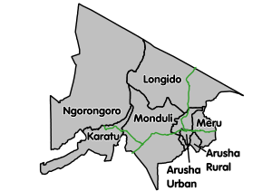

Figure 3.1: Arusha Region Administrative Map
Source: Domestic Tourism Safari

3.5 Sample Selection

3.5.1 Sample Size
Kothari (2004) defined the size of the sample as the number of items to be selected from the universe to constitute a sample. Kothari also comments that the size of the sample should neither be excessively large, nor too small. It should be optimum. The study studied 20 respondents from Non-Governmental Organizations which are The Convoy of Hope, Ace Africa, Pact- “Kizazi Kipya Project” and SOS-Village Arusha (Education, Health and capacity building affiliated NGOs) and 20 respondents from governmental officials (officials from the department of community development in the level of the district, Ward executive officers (WEO), Ward Education Officers, Ward Health Officers (WHO) and Ward Community Development officers (WCDO) and 40 respondents from the general community – Beneficiaries.

Table 4.1: Respondents Distribution
1. | Government Officials | 20
2. | NGOs affiliated with Education, capacity building, and health | 20
3. | Beneficiaries | 40
 | Total | 80
Source: Researcher 2019

3.5.2 Sampling Technique
The sampling technique was solely purposive. People who were studied were picked purposively. These were government officials, NGO workers and people from the public (beneficiaries). All subjects studied were aware of the activities performed by the NGOs and the contribution of NGOs in people’s development. The knowledge demonstrated and the information given by these people were very essential to this study.

3.6 Sources of Data

3.6.1 Primary Source
Primary data these are data originated directly from the actual respondents being studied. Kombo and Tromp (2006) commented that the primary data is information gathered directly from respondents. These are through the questionnaire, interviews, focused group discussions, observation, and experimental studies. The study used questionnaires and interviews to collect the primary data from Non –Governmental Organizations, government officials, and beneficiaries.

3.6.2 Secondary Source
These are the data that are named by Kombo and Tromp (2006) as “Desk research” in which the information stored in documents or on electronic devices is studied. The study collected the information documented on the activities of the Non-Governmental Organization (NGOs) in the Arusha district council and from the respective NGOs studied. The information provided enough information relating to the activities of NGOs and their contribution toward improving the living standard of people in rural areas.

3.7 Data collection and Instrumentation

3.7.1 Questionnaires
According to Kothari questionnaire technique of collecting data is defined as;
“A number of questions printed or typed in a definite order on a form or set of forms. The questionnaire is mailed or given to respondents who are expected to read and understand the questions and write down the reply in the space meant for the purpose of the questionnaire itself.”
The respondent in the study was provided with the questionnaire to respond to some questions which were intended to meet the objectives of the study which was to study the effectiveness of Non-Governmental Organization (NGOs) in improving the living standard of people in the rural areas. 80 questionnaires were provided to respondents as follows; 20 were given to respondents from government, 20 to the NGOs’ officials and 40 to the beneficiaries. The rationale of using questionnaires based on the benefit of the method as explained by Kothari (2006) as follows:
- There is a low cost even when the universe is large and is widely spread geographically.
- It is free from the bias of the interviewer; answers are in respondents’ own words.
- Respondents have adequate time to give well thought out answers.
- Respondents, who are not easily approachable, can also be reached conveniently.
- Large samples can be made use of and thus the results can be made more dependable and reliable.

3.7.2 Interview
An interview is a discussion between two or more people over a certain matter, this discussion is always purposive. The discussion which is not purposive over a certain matter is just a discussion and not an interview. Although an interview is just a discussion between two or more people it has to be planned prior. Saunder at el (2009) use of interviews can help a researcher to gather valid and reliable data that are relevant to the research question(s) and objectives. Kothari (2014) the interview method of collecting data involves presentation of oral-verbal stimuli and reply in terms of oral-verbal responses. The study employed an interview method in which 30 people from NGOs, Government and beneficiaries were interviewed. Their responses nourished the study greatly. These interviews strengthen the results obtained from the questionnaires as all of the interviewees answered questionnaires also.

3.7.3 Documentary Review
The documentary review method was employed to study the secondary data, publications such as reports and other documents which were relating to the research objective of studying the effectiveness of Non- Governmental Organization (NGOs) in improving the living standards of people in rural areas by using Arusha District Council as the case.

3.8 Data Analysis
Kombo and Tromp (2006) data analysis refers to examining what has been collected in a survey or experiment and making deduction and inferences. The information acquired was both qualitative and quantitative. Hence, explanatory, confirmatory and cross-tabulation methods of analyzing data were used. But mostly, the explanatory method was much used due to the nature of the research which was mainly qualitative.

3.9 Informed Consent of Respondents and Ethical Consideration
After collection of research clearance letter from the University headquarter, the letters was channeled to respective subjects for the study and make an appointment basing on their consent. Respondents communicated with the researcher and make an appointment for the investigation or study planned.
The collection of data seriously considered human rights and the respect of human dignity. None of the subjects was violated his/her rights during the process of collecting data. All research ethics were of the highest consideration during this study.

3.10 Confidentiality of the Information Sources
The researcher promised all respondents that the information given will be treated confidentially. And the promise was kept, in which none of the respondent names is mentioned in the study and if necessary the initials are used to keep the source of the information confidential.

3.12 Chapter Summary
The chapter, in a nutshell, focuses on the methodology which was used in the study. The chapter highlighted the research design in which the case study was used, the sample size, population, the research instruments – questionnaires, interviews, and documentary reviews were used.

CHAPTER FOUR

DATA PRESENTATION, ANALYSIS AND DISCUSSION

4.1 Introduction
This chapter represents analyses and discusses the data collected in the field relating to the effectiveness of Non-Governmental Organization (NGOs) in improving the living standards of people in localities. As pointed earlier three data collection techniques questionnaires, interviews, and documentary reviews were used and descriptive data analysis was used to analyze the data. The presentation, analysis,and discussion of the collected data were done in line with the following specific objectives of the research.
- To examine the extent to which NGOs have been effective in improving the living standard of people in Arusha District Council.
- To examine the strategies employed by the NGOs in realizing their objectives in Arusha District Council.
- To examine the sustainability of the NGOs programs in improving the living standard of people in Arusha District Council.

4.2 Demographic Features of the Respondents
An understanding of the demographic characteristics of the people involved in the study is very important as it adds value to the results of the research. The responses given were highly determined by the demographic characteristics of the respondent. Due to this fact the demographic characteristic of a number of years of the respondent in the office, gender and education were investigated.

4.2.1 Number of Years of the Respondents in the Office – (government and NGOs)
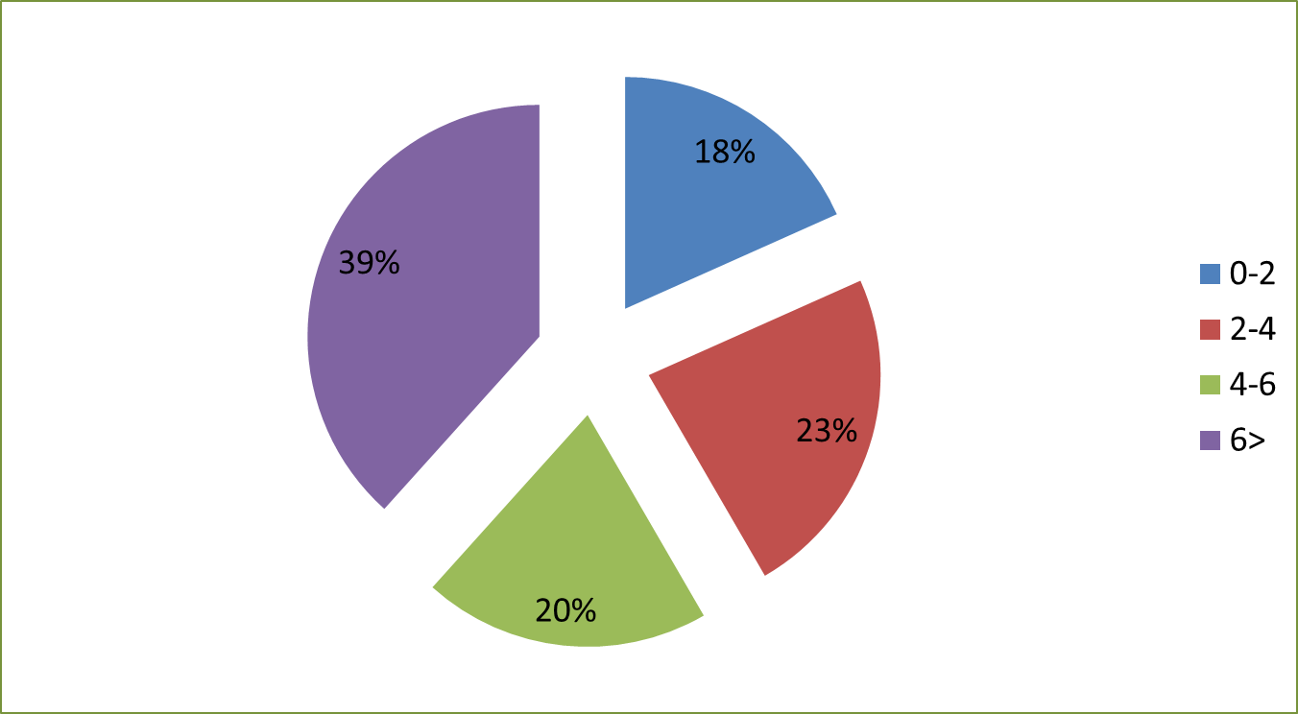The number of the years of the respondents (from NGOs and governmental offices) in the office was studied for the aim of validating the responses as the more the number in office more the experience on the issues relating to NGOs operation. Out of all respondents, those work under their current offices for 0- 2 years were 18.3%, 2-4 years were 23.3 %, 4-6 years were 20% and 6 years and above were 39%.This signifies that the majorities of the respondent studied are highly experienced in the issues of Non- Governmental Organizations (NGOs) and were the right subjects for the study. 81.6% of the respondents worked in their offices for more than two years and 18.4% worked for their offices for less than two years. This is shown in Figure 4.1.

Figure 4.1: Distribution of Respondents on the Number of Years in their Offices

Source: Field data (2019)

4.2.2 Academic Qualification of the Respondents
The respondents that were studied were having the following distribution on their academic qualification; those who have the Bachelor’s degree were 23%, diploma 23%, certificate 13% secondary 25%, and 16% is for those with masters’ degrees. This distribution suggests that the majority of the studied subjects were having a reasonable education and hence provided accurate data on the study as intended. The distribution is clearly shown in figure 5.

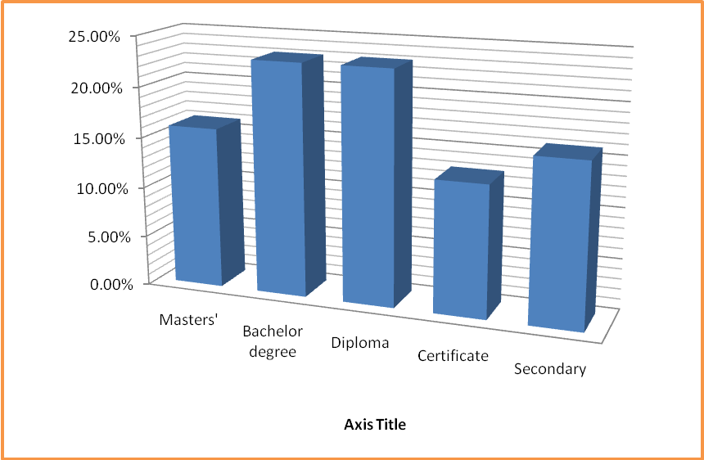

Figure 4.2: Distribution of Academic Qualification of the Respondent
Source: Field Data (2019)

4.3 The Extent to which NGOs have been Effective in Improving the Living Standards of People in Rural Areas in Arusha District Council
This section represents the views of the respondents on the extent to which NGOs have been effective in improving the living standards of people in the Arusha District Council. In its essence, the section tries to answer these questions “To what extent have NGOs been effective in improving the living standard of people in Arusha District Council”
Here the researchers assumed that NGOs have been effective in improving the living standards of people in rural areas and especially in ADC. Therefore, the researcher posed different questions to explore to what extent NGOs have been effective in improving the living standards of people in the Arusha District Council.

4.3.1 Awareness of the Community Members on the activities of NGOs in their Localities
The researcher was interested to assess the awareness of the community members on the activities being implemented by NGOs in their areas. Be it in Protection- Providing relief to victims of disaster and support the poor, Prevention- Reducing people’s vulnerability through income diversification and reserves, Promotion- increasing people’s chances and opportunities and lastly transformation-redressing social, political and economic exclusion or oppression. It has to be known that NGOs are for the public and their activities should be on serving the public and hence effective NGOs, its’ program and activities are known to the public it serves. Only beneficiaries were studied on their awareness of the activities and programs of NGOs in their areas.

The respondents were requested to tell whether they are aware of the activities of NGOs going on their areas and if responding affirmatively to the question they were requested to point out those activities and programs in their areas. 90% of the respondents responded that they were aware of the activities and programs of NGOs going on in their areas. While 90% were affirmative to the question only 55.5% of those who were affirmative to the question were able to point out some of the activities of NGOs going on in their areas and 44.4% were unable to point out.
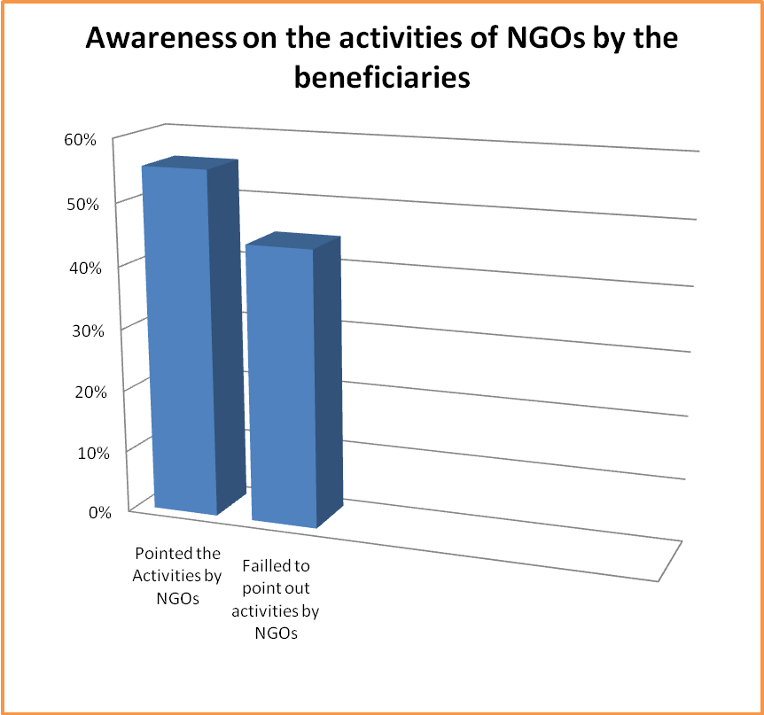
Figure 4.3: Distribution of Awareness of the Public on the Activities of NGOs in their Areas
Source: Field Data (2019)

4.3.2 Commitment of NGOs in Serving the Interest of the Public

Basing on the essence of being of the NGOs, it is very essential for them to be committed on serving the interest of the people. The commitment on serving the interest of the people enable NGOs to realize their objectives and hence being effective on serving the public as the public is on the center of the NGOs’ programs and agenda. Hence, in assessing the extent to which NGOs have been effective in their role their commitment has to be in line for the assessment. The respondents were requested to air their views on the commitment of NGOs in their areas on improving the living standard of people in ADC. All of the respondents were the beneficiaries (public) of the activities of NGOs.

The respondents were requested to assess the commitment of NGOs in improving the living standard of people (Serving the interest of the public) in ADC. 75% of the respondents said that NGOs are committed to serving the interests of people and 25% of the respondents commented that NGOs are never committed to the interest of the people. The results reveal that the majority beneficiaries of the NGOs’ activities are satisfied with the commitment of NGOs in improving the living standard of people in ADC; however, few others who are not satisfying with the commitment of the NGOs in improving the living standard of people in ADC.

Figure 4.4: Distribution of Respondents on the Commitment of NGOs in Serving the Public
Source: Field Data (2009)

4.3.3 The Benefits of NGOs’ Activities to the Community
Thirdly, NGOs are effective if the public is benefiting from their activities and their program is making sense to the public, thus in assessing NGOs’ effectiveness, it is ideal to test whether the community members are benefiting from the NGOs’ activities and NGOs programs making sense to the public. Also, in this, the beneficiaries of NGOs were studied and requested to tell whether the NGOs’ programs are making sense to them. This question aimed to test if NGOs’ activities have an impact and make sense to the lives of people as a means to assess NGOs’ effectiveness. 95% of the respondents responded that NGOs’ programs and activities make sense to them and 5% commented that the NGOs’ activities make no sense to them. The respondents who said NGOs activities make no sense were requested to tell why they think these activities do not make sense. Their responses were; NGOs activities do not make sense because “most of their activities do not touch the lives of all people but the few”, “NGOs are located in some places while other areas are not affected by their activities,” “Their activities are specifically for some issues in the community and other serious issues are not given consideration”

4.3.4 The Effective Management of Funds by NGOs
Fourthly, it is on the funds allocated on the different projects. Are they effectively used? The respondents were requested to assess the good use of NGOs finance as the instrument of assessing the effectiveness of NGOs in improving the living of people in ADC. Here, only beneficiaries were studied and responded as follows; 67.5% of the respondents commented that there is a good use of financial resources in NGOs and 32% commented that there is no good use of financial resources in NGOs.

4.3.5 The Involvement of the Community Members in the Identification Processes of NGOs’ Programs
The idea here is that people who are served by NGOs are the ones who are aware of their sufferings and where to be assisted and helped to improve their lives. The respondents in this responded as follows, 18% of the respondents responded that to a very large extent the community members are participating in deciding on initiating the programs that affect their lives, 48% commented that to a large extent community members are participating in making decision, 17% of the respondents responded that in a moderate extent the community members are involved in making the decisions relating to the programs initiated by NGOs, 17% of the respondents responded that to a small extent the community members are involved in making decisions over the programs initiated by NGOs in their areas. Figure 6 below summarizes the results.

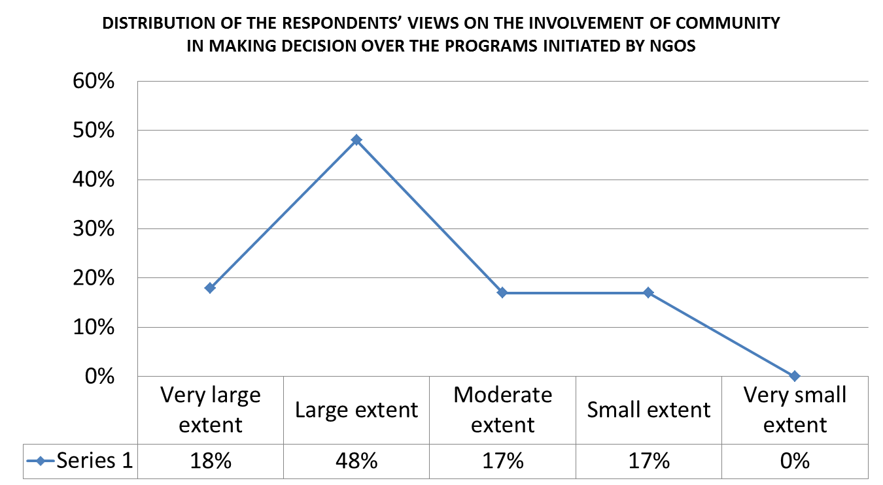

Figure 4.5: Distribution of Respondents on the Involvement of the Community Members in making Decision over the Programs Initiated by NGOs in their Areas
Source: Field Data (2019)

4.2.6 Participation of the Community Members on the Programs of NGOs
Another important area of investing the extent of the NGOs effectiveness in improving the living standard of people in ADC is on the participation of the community members on the programs initiated by the NGOs; the respondents’ responses suggested that the community members are willing to take part in on the programs initiated by NGOs to a large extent as illustrated here in details. Those who responded that community members are willing to a large extent were 50% of the respondents, very large extent 25, moderate extent was 16.6%, small extent was 8.3% and none of the respondents gave a response to comment that community members to a very small extent participate in NGOs programs.
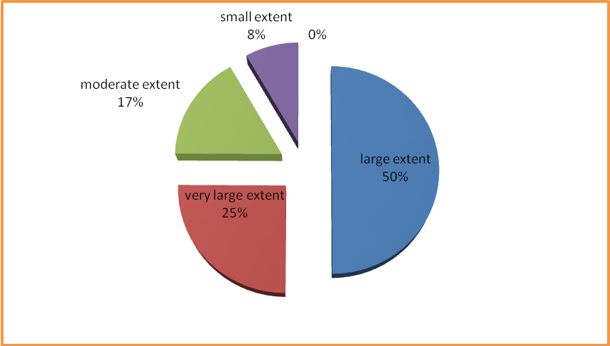
Figure 4.6: Distribution of Respondents on the Participation of Community Members on the Programs by NGOs
Source: Field Data (2019)

4.3.7 The Relationship between NGOs and Government
An additional area that can test the extent of NGOs’ effectiveness in improving the living standard of people in ADC is on the relationship between NGOs and the government. The good relationship between NGOs and government is very essential in ensuring the effectiveness of NGOs. The poor relationship can hinder the effectiveness of NGOs in realizing the objectives. In this the responses were as follows; 81% of the respondents responded that the relationship between government and NGOs is to a very large extent friendly, 13% responded that the relationship is to a large extent friendly, 6% the relationship is to a moderate extent friendly. This data suggests that there is a good relationship between the government and NGOs which help the NGOs to be effective in implementing their objectives see Figure 4.4.

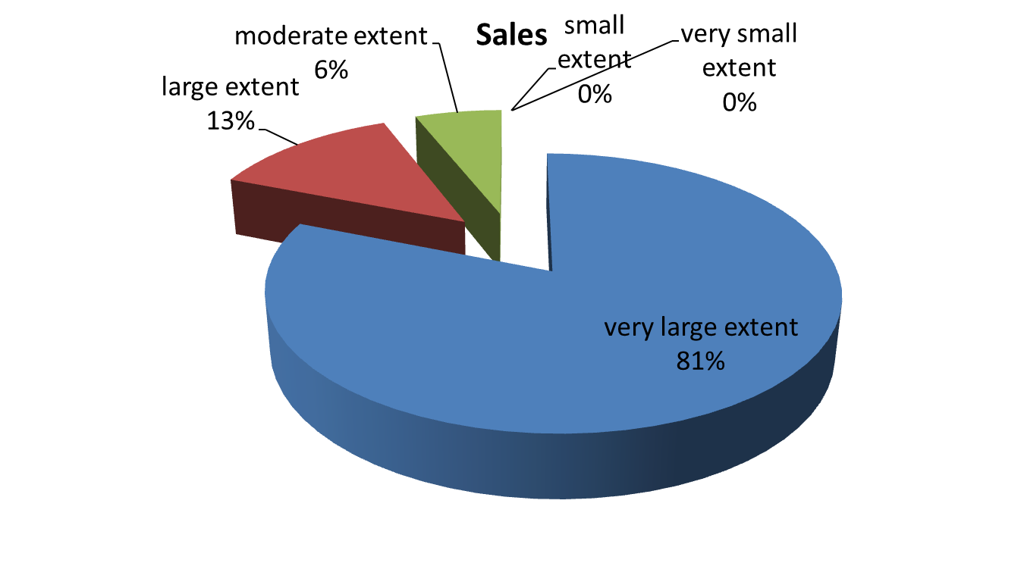

Figure 4.7: the Distribution of Respondents on the Relationship between NGOs and Government in ADC
Source: Field data (2019)

4.3.8 General Views of the Public on the Extent to Which NGOs Have Been Effective In Improving the Living Standards of People in ADC
In general, the researcher was interested on general view of the public and NGO officials on the extent to which NGOs are effective in improving the living standards of people in ADC. The respondents responded as follows; 23% of the respondents commented that to a very large extent NGOs are effective in improving the living standards of people in ADC, 29% responded that to a large extent NGOs have been effective in improving the living standard people in ADC, 25% commented that NGOs to a moderate extent have been effective in improving the living standard of people in ADC, 24% responded that NGOs in small extent have been effective in improving the living standards of people in ADC. The results suggest that the public is of the view that NGOs are effective in improving the living standard of their lives.
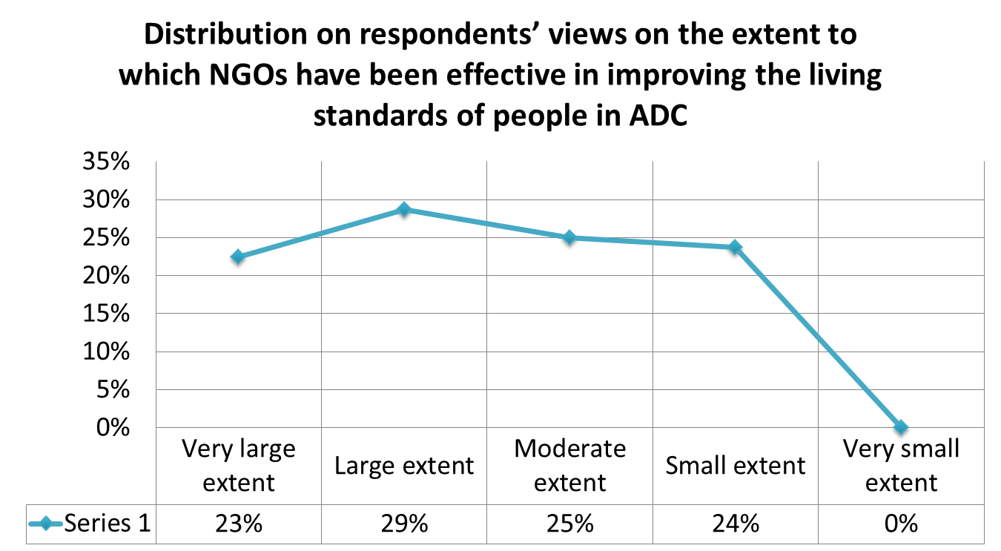Figure 4.8: Distribution of the Respondents on their Views on the Extent to Which Ngos Have Been Effective In Improving the Living Standard of People in Arusha District Council (ADC)
Source: Field Data (2019)

This is also suggested in the study done by Kweyamba (2018) on Non-Governmental Organizations’ Funding and its implication for service delivery in Moshi Municipality, Tanzania. The finding of the study suggested that individual beneficiaries of NGOs had a positive attitude towards service delivery by NGOs. Delivery of service on time and services targeting recipients’ needs were the most important factors shaping the attitude of beneficiaries towards service delivery.

4.4 Strategies Employed by NGOs in Realizing their Objectives in Arusha District Council

For an NGOs to be effective has to have strategies in place that enabled it to realize it is objectives. Therefore, on studying the effectiveness of the NGOs in improving the living standards of people in the Arusha District Council the researcher was interested to know the strategies used by the NGOs in realizing their objectives in Arusha District Council. Some of the strategies mentioned by the officials in the NGOs were the use of training, direct provision of the required services, renovating the government programs, training services providers through seminars, project follows up, reporting to donors and adhering to their reasonable requirements, mobilizing resources, good use of the resources and building capacity to social services providers.

This is in line with the study conducted byMukanga (2011) on the sustainability of strategies adopted by international NGOs in Nairobi, Kenya in which Mukanga showed the following strategies that are employed by NGOs; building a stronger partnership between the public and private sector, having well-defined policies and procedures, a good relationship with donors by improving donors reports and comply with donors requirement which guarantees donors support, engage in income-generating activities (resource mobilization), staff training and development, institutional building, good management practice, remaining on core business area of the organization, linking with government, regular proposal development and cost reduction.

The interviewed participants (10 NGOs’ staff and leaders) as mentioned above, highlighted some of the strategies they employ in improving the living standards of people in ADC. They were with the view that if the strategies mentioned are in place NGO can be effective in attaining its objectives and mission. Apart from the responses given by the interviewed NGO leaders and staff the researcher also, investigate some of the strategies which are visible to the public to test their reliability by studying the beneficiaries especially on the follow up of the NGOs projects by the NGOs.

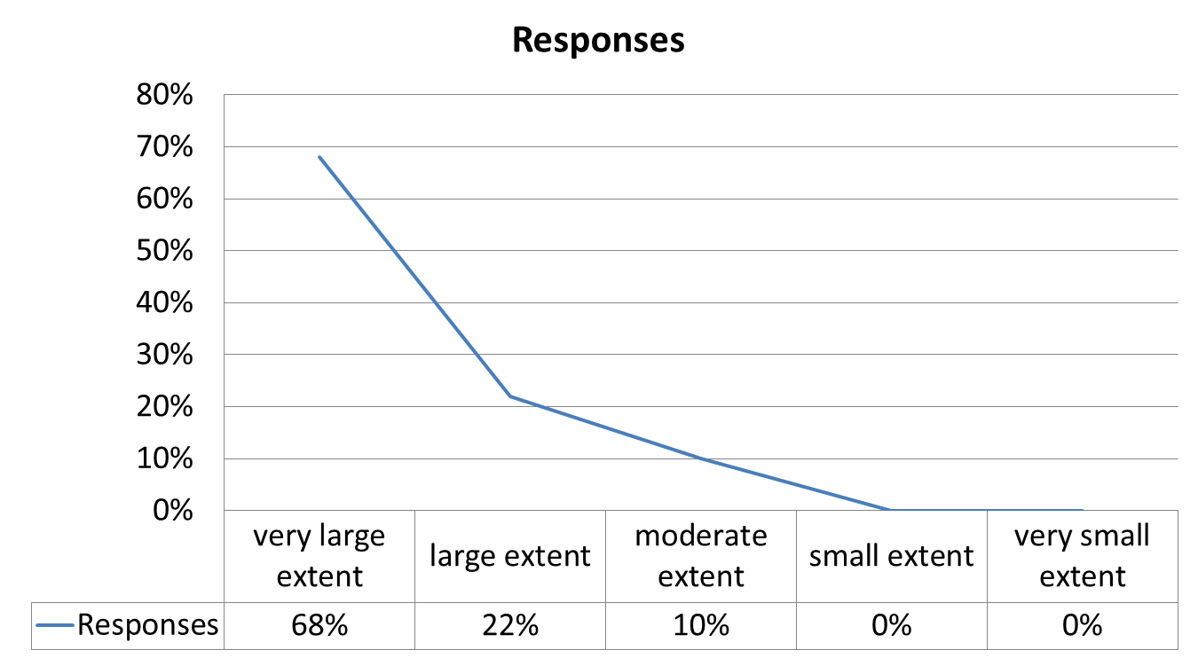The responses of the respondents on the follow up of the projects by the NGOs were as follows; 68% commented that to a very large extent the NGOs make a follow up on the projects in the implementation and already implemented, 22% commented that to a large extent NGOs are making follow up on the projects, 10% of the respondents commented that NGOs to a moderate extent are making follow up on the projects they have initiated and those in implementation. None of the respondents commented that NGOs are to a small or a very small extent making follow up on the projects initiated or in implementation. The results are illustrated in details below;

Figure 4.9: The Distribution of Respondents on the Follow up of NGOs on their Projects
Source: Field Data (2019)

The data suggest that NGOs are very serious follow up on projects put in place hence contribute to the effectiveness of NGOs in ADC.

4.5 The Sustainability of the NGOs Outcomes in Improving the Living Standard of People in Arusha District Council
For NGOs to be effective, the sustainability of their impact or outcome is compulsory. It is expected that NGO outcomes should be impactful and sustainable to the beneficiaries. The main objective of the study was to assess the effectiveness of NGOs in improving the living standards of people in the Arusha District Council (ADC); one of the indicators of the effective NGO is its long-lasting impact (sustainability) to the society. Here, beneficiaries and public officials were studied and their results were; 87% of the respondents responded that the outcome of NGO programs has a long impact on the lives of people and 13% responded that NGO outcomes have got no long impact on the lives of people in ADC.

Apart from the views by the beneficiaries also NGOs pointed out their strategies that enabled their impacts to be sustainable. Some of these strategies are; coming up with projects that maximize the ability of people by empowering them to act on their own and having constant trainings and financial assistances to the group of people who have received trainings to start up their own businesses or activities.

4.6 Challenges facing NGOs in Implementation of Their Activities Effectively in Arusha District Council
Apart from the core objectives of the study as their findings presented above, the researcher was interested to know the challenges that are affecting the effectiveness of NGOs in the Arusha District Council. It was revealed that although NGOs are trying tirelessly to accomplish their objectives they are faced with a lot of challenges that make them less effective. The researcher investigated the NGOs staff through interview and they pointed out the following as the challenges that affect negatively the effectiveness of NGOs in improving the living standards of people in Arusha District Council:

Difficult to access rural areas due to poor infrastructures and hence make these areas too remote: Arusha District Council is facing the challenge of having poor infrastructures this challenges has impaired the activities of the NGOs as these NGOs need to reach to these areas and identify the issues which are to be addressed also to make a follow up on ongoing projects in these areas.

Serious government interference and hence minimize the capacity of NGOs to perform their activities as planned and with freedom: one of the challenge raised by the NGOs was that there is strictly protocol and serious government procedure’s for the NGOs activities which sometimes led to the postponement of the activities planned.

NGOs with the same programs crowded on one area and leave other areas unreached: In Arusha District Council majority of NGOs are much concentrated on North western parts and leave other areas with a very little focus apart from the truth that even the rest of the areas are in need of the services rendered by NGOs.

Lack of reliable data on the activities of NGOs and on the areas that need NGOs’ attention; reliable data on the activities of the NGOs would be much helpful in making NGOs more effective and also, minimize concentration of many NGOs on one area or on projects that are already under implementation. The problem of lacking enough fund; NGOs have pointed that one of the challenge is lack of enough funds which in turn made them failed to realize their objectives and serve interest of the public.

Lastly, the researcher was interested to know generally from the people studied whether NGOs have effectively improved the living standards of people in rural areas. Out of 80 respondents, 78 respondents responded that NGOs has been effectively contributing to improving the living standards of people in theArusha District Council. This validates the above-presented data on different issues relating to the effectiveness of NGOs in improving the people’s living standards in the Arusha District Council.

4.7 Discussion of Research Findings

This section provides a discussion of the findings. The section presents the findings of the study in brief and further discusses these findings concerning the literature reviewed in this study. Generally, there is a high degree of coincidence between the study findings and the literature which has been reviewed.

4.7.1 The Extent to which NGOs have been Effective in Improving the Living Standards of People in ADC

Under this objective of assessing the extent of NGOs’ effectiveness, there were seven areas of focus. These areas were;

4.7.1.1 Awareness of the Community Members on the Activities of NGOs in their Localities

On the awareness of the community members on the activities being implemented in their areas, the beneficiaries were studied (40 respondents). The finding was that 90% of the beneficiaries responded that they were aware of the activities implemented on their areas by NGOs, while 10% were unaware of the activities implemented in their areas. While 90% of the respondent responded that they were aware of activities by NGOs implemented in their areas, 44.4% failed to point out some of the activities by NGOs in their areas. This corresponds with the findings of the study done by Rehema, (2017) on factors influencing family planning project implementation success by NGOs in the Arusha Region.

The findings suggested that (83%) of the participants are conscious with the family planning project implementation success within the Organization. The familiarity of the project implemented or activities of NGOs by the community members and NGOs staff is very essential in making the NGOs effective in implementing their objectives and mission. NGOs need to keep on ensuring that their activities and programs are well familiar to the community or beneficiaries so that they could participate actively in the implementation and hence achieving the goal intended.

4.7.1.2 The Commitment of NGOs on Serving the Interest of the Public

NGOs in its essence are in the mission of serving the interest of the public. Under this, the findings were that 75% of the respondents commented that NGOs are serving their interests and are committed while 25% responded that NGOs are never committed to serving the public. This is in line with the results of the study done by Priscus (2014) on the Influence of NGOs in the Vulnerable Children, Youth above 20 Years Bicycle Assembling and Selling Project in Nshamba and Biilabo Wards Muleba District.

The result of this study found that the support provided by NGOs to vulnerable children has brought changes even though it is not enough to satisfy all needs. The changes brought by the support by the NGOs suggest the commitment of NGOs in improving the living standard of people. The findings of the study reveal that NGOs are serving the interest of people and that although their assistance is not enough and reaching everyone in the society it has a positive contribution to the society in general. It can be suggested that because the support of NGOs seems not enough and catering to the needs of all; NGOs are advised to put in action programs that can touch the majority in the society so that to have a very large impact on the lives of people.

4.7.1.3 The Benefits of NGOs Activities to the Community

Are community members benefiting from the NGOs’ activities and programs? The findings were 95% of the respondents reveal that they are benefiting to the activities and programs of NGOs while 5% they are not benefiting from the activities and programs of NGOs due to the following issues they pointed out; Most of the activities do not touch the interest of the many but few, Location of NGOs – the majority are not touched due to the remoteness of NGOs in their areas, selection of social issues by NGOs and leave other important issues untouched. This is also in line with the research done by Priscus (2014) on the Influence of NGOs in the Vulnerable Children, Youth above 20 Years Bicycle Assembling and Selling Project in Nshamba and Biilabo Wards Muleba District.

The result of this study found that the support provided by NGOs to vulnerable children has brought changes even though it is not enough to satisfy all needs. The findings of this study and that of Priscus (2014) suggest that the community members are benefiting from the activities of the NGOs in their areas. The support is given to vulnerable children; although it does not benefit every individual, in particular, it benefits the community in general. The benefit of a certain group in a society is the benefit of the entire society if it helps to minimize the burden of society in assisting that group or in addressing the challenges brought by the group. The clear fact is that the problem of one member in a society is the problem of all indirectly. However, as suggested above, NGOs have to come up with programs that affect the majority so that to have a large impact and a rapid transformation of the society they serve.

4.7.1.4 The Effective Management of Funds by NGOs

Under this quest, the beneficiaries of NGOs were studied and were with the following responses 67.5% of the beneficiaries of NGOs responded that there is a good use of funds and 32% responded that there is bad use or misuse of funds. This correlates with the research done in one of the East African cities (Nairobi) by Mary (2014) on the effects of financial accountability on the efficiency of Non-Governmental Organizations in the governance sector in Nairobi County. The study found that financial accountability has a constructive and significant effect on the effectiveness of non-governmental organizations in governance sector in Nairobi County.

Moreover, the study found that individually and combined, financial accountability, staff experience, and organization of NGOs have a positive effect on NGO efficiency. NGOs with flat hierarchy were found to have a better flow of information which promotes financial accountability and consequently the efficiency of the NGOs. The findings of this study reveal the importance of financial accountability to the effectiveness of NGOs. The NGOs are not for profit-making hence the resources accumulated have to be utilized in line with the objectives of NGOs and their essence of being.

NGO leaders have to be very keen on managing the resources donated and mobilized for the aim of maintaining their being and support from donors whom in turn led to the effectiveness in helping and addressing vulnerable people’s challenges. The 32% of the respondents who have pointed out that NGOs resource are not well used or there is a misuse of resources is an alarming alert to NGOs. NGOs have to restructure and improve their fund management systems so that to stop if any the misuse of the fund mobilized.

4.7.1.5 Involvement of the Community Members onthe NGOs’ Programs

On the involvement of the community members on the NGOs’ programs in initiating and/or in participating in making decisions over the programs initiated by NGOs in their areas; the findings were 18% of the respondents responded that to a very large extent the community members are participating in making decisions, 48% commented that to a large extent the community members are involved in making decisions, 17% to moderate extent community members are involved in making decisions, 17% to small extent community members are involved in making decisions. This corresponds to the study by Kanyinga (1990) on the role of Non-Governmental Organizations (NGOs) in creating local capacity for development.

The study has found that NGOs' projects beneficiaries are involved in the projects mainly through their resource contributions. Their involvement has been found to have some bearing or constructive relationship with the making of local capability, even though participation alone is not the utmost factor in the making of local capability. The participation of the community member in identifying their priorities and assistance they need is vital in counting the effectiveness of NGOs; an NGO can initiate a project which is not needed by the community. For NGOs to be effective they have to know what are the real needs of the society they want to serve and plan to carter to those needs this is possible only if there is clear participation of the community members in identifying their priorities and initiating the programs. As suggested by the findings of this study in Arusha NGOs they are in good track as the majority of participants revealed that they do participate in the initiation of the projects implemented by NGOs in their areas. However, more has to be done in the issues of participation in identify areas for assistance, as it seems that the other large number is left out in the process.

4.7.1.6 Participation of the Community Members on the Programs by NGOs
On the participation of the community members on the programs initiated and implemented by NGOs in ADC; the study reveals that community members are participating in the programs initiated by NGOs in their areas. The result is in line with the conclusion made on the study conducted by Mwansasu (2011) on the sustainability of NGO Support Water Supply Projects: The case of ELCT Konde Diocese shallow wells projects in the Mbozi, District, Tanzania. The study concluded that the people in Mbozi District with the collaboration of their village government leaders play a vital role and are highly responsible for the management, more of the shallow wells project. In that, they feel part and parcel of the project.

The efficiency of NGOs relies on the participation of people in their programs, as the findings reveal NGOs in Arusha DC has the advantage of having good participation of beneficiaries on their programs initiated. This is a capital for NGOs in Arusha DC to use it to their advantage for them to reach many people in these areas and to contribute effectively to the improvement of peoples’ lives.

4.6.1.7 The Relationship between NGOs and the Government

Under the relationship between NGOs and government in Arusha District Council; the findings of this study reveal that there is a friendly relationship between NGOs working in Arusha District Council and the government in ADC. This corresponds with a study done by Mallya(2009) on Civil Society Organizations, Incompetent Citizens, the State and Popular Participation in Tanzania, here he reveled that NGOs, have compromised their autonomy, becoming close allies and partners of the state.

The predicament is that if they do not do this they cannot help the people they claim to help and if they do they are seen to be usurping the power of the people. Hence, focus and the order of today are that NGOs are trying to their level best to maintain a positive relationship with the government so that to attain their objectives of serving the people. Generally, the findings suggest that NGOs are effective in improving the living standards of people in the Arusha District Council. The positive relationship between NGOs and Government in Arusha DC is the asset to be utilized effectively by NGOs in realizing their mission in these areas.

4.7.2 Strategies Employ by NGOs in Arusha District Council that makes them Effective in Improving the Living Standards of People in ADC
It has been noticed that NGOs in Arusha District Council, are having different strategies for ensuring their effectiveness in improving the living standards of people. The findings suggested that NGOs in ADC are using the training of both their officials and public official for them to provide services, training the public on a variety of issues, renovating government projects, making a close follow up on the projects initiated, reporting accordingly to donors and adhering to their reasonable requirements so that to guarantee their continuous support, campaigning over different issues, keep on maintaining a good relationship with the government, mobilizing resources and maintaining good use of the resources.

The above strategies are essential for any NGO for it to be effective in meeting its objectives and mission. For instance, the maintenance of a good relationship with the government and the assurance of good relationship of NGOs and their donor helps much in ensuring a smooth implementation of the NGOs programs which contributes to NGOs’ effectiveness.The strategies employed by NGOs in Arusha District Council results in sustainable improvement.

90% of the community leaders studied commented that even after the end of NGOs’ support villagers continued with their lives as if NGOs were still supporting them. This pointed out another success of NGOs and proves their effectiveness. People being able to sustain their lives even with no longer support from NGOs is the success that can draw the attention of development partners and the government to invest more in NGOs’ activities morally and financially.
In checking whether what has been said by NGOs is what they are doing in their field the researcher took one of the strategies mentioned by NGOs’ staffs (making follow up on the project initiated and those completed) and ask the beneficiaries if that is what NGOs their doing. The findings were; 68% of the beneficiaries said that NGOs are at very large extent making a follow up on their project either in progress or the completed ones, 22% of the beneficiaries commented that NGOs to large extent making a follow up on their projects in progress and those completed, 10% commented that NGOs in a moderate extent there are doing follow up on their projects completed ones and those in progress. It has been noted that the NGOs in Arusha District Council have a very satisfying mechanism for making follow up on the project initiated.

The habit or culture of making a follow up to the projects initiated is one of the necessary factors for effectiveness. Follow up gives feedback which is an essential tool for improvement and creativity. NGO that makes follow up ensures its survival as it can improve itself regularly. Hence, if NGOs in Arusha District Council are making follow up as the findings suggest; are in action ensuring their effectiveness in serving the public.

4.7.3 Sustainability of the NGOs Activities in Improving the Living Standards of People in ADC
It has been found that, from the beneficiaries and public officials, NGOs’ outcomes or activities are sustainable. In other words, they have a long- lasting impact on the community. 87% of the respondents responded that NGO outcomes/activities have a long-lasting impact on their lives and to the lives of the community members. This is in line with the study done by Khamis (2012) on the assessment of the contribution of NGOs in the delivery of health services in Zanzibar. The result of the study revealed that NGOs has improved the quality, equity, and accessibility of health services.

Also, in the study by Kainunula Priscus (2014) on the influence of NGOs in the vulnerable children, youth above 20- year bicycle assembling and selling project in Nshamba and Biilabo wards Muleba District. The results revealed that the support by NGOs has brought changes, with this support vulnerable youth are now able to access social services. The improvement of health services in Zanzibar and the access to social services by vulnerable youth in Muleba District signify the sustainability of NGOs in these areas. The sustainability of the outcome of the NGOs as revealed shows that NGOs are sustainable and helps much in improving the living standards of people in these areas and have a long impact to people lives.

4.8 Chapter Summary
This chapter has the analysis of data, presentation of research findings and discussion. Research objectives were used to present the findings. Tables, charts, and percentages were used for the presentation of the research findings. The research objectives enabled to establish how NGOs have been effective in improving the living standards of people in Arusha District Council.

CHAPTER FIVE

SUMMARY, CONCLUSIONS AND RECOMMENDATIONS

5.1Introduction

This chapter will present a summary of the purpose, methodology, and results of this study. Then, conclusions will be discussed based on researcher insights gained concerning study findings and limitations. Besides, the recommendation is presented.

5.2Summary of the Study
The purpose of this study was to assess the effectiveness of NGOs in improving the living standards of people in rural areas. The study used a case of the Arusha District Council. The study studied 80 subjects, with the following distribution; 20 government officials/leaders, 20 NGOs staff, 40 beneficiaries. To achieve the objective of this study the following specific objectives were formulated: to examine the extent to which NGOs have been effective in improving the living standard of people in Arusha District Council, to examine strategies that make NGOs effective in realizing their objectives and to examine the sustainability of the NGOs programs in improving the living standards of people in Arusha District Council.

To achieve the specific objectives, the following research questions were employed to guide data collection for the realization of specific objectives: to what extent NGOs have been effective in improving the living standards of people? What are the strategies that make NGOs effective in improving the living standards of people? How sustainable are NGOs’ activities in improving the living standards of people? The data collected in each of the research questions contributed to the assessment of the specific objectives. These, in turn, contributed to the assessment of the general objective of the study. In general, the NGOs are effective in improving the living standards of people in the Arusha District Council according to the sample that the researcher used to reflect the whole community.

5.3 Summary of the Findings
The following were the findings of the study presented as per study objectives and research questions:

5.3.1 The extent to which NGOs have been effective in improving the living standard of people in Arusha District Council
The first research objective sought to examine the extent to which NGOs have been effective in improving the living standards of people in ADC. The researcher in assessing the extent of effectiveness of NGOs in improving the living standards of people in ADC posed different questions to explore the extent to which NGOs have been effective in improving the living standards of people in the Arusha District Council.

5.3.1.1 Awareness of the Community Members on the Activities of NgOS in Their Localities
The data from questionnaires from beneficiaries (40 respondents) revealed that:
- The beneficiaries of the NGOs’ activities are aware of the activities going on in their areas. This means that NGOs are truly working in these areas and touch the lives of people in these areas.
- Basing on the fact from the respondents who were aware of the activities by the NGOs in their localities; it was revealed that 44.4% of those respondents who were aware of the activities by NGOs in their areas were unable to point out some example of the NGOs activities found in their areas. This revealed that; although people are confident with the NGOs working in their areas, their activities are not directly affecting their lives. They see NGOs’ impact on the lives of others.
- Also, 55.5% of the respondents who were aware of the activities by NGOs in their localities were able to point out the activities of the NGOs in their areas. This reveals that 55.5% are either touched directly by the NGOs’ activities or they are eyewitnesses of these activities on their areas.

5.3.1.2 The Commitment of NGOs on Serving the Interest of the Public
The data from the questionnaires administered to beneficiaries of the NGOs activities and documentary review revealed that;
- NGOs are committed to serving the interest of the public as 75% of the beneficiaries commented that NGOs are committed. Hence, are satisfied with the services rendered by the NGOs in their areas.
- While 75% of the respondents are satisfied with the services and commitment of NGOs, 25% are never satisfied with how NGOs are working and their commitment.
- The commitment of NGOs is seen on their plans and programs that are seriously addressing the challenges faced by the community members and find a solution and a way to minimize the intensity of the problems this is evidence from the documents studied from these NGOs and government offices.

5.3.1.3 The Benefit of NGOs’ Activities to the Community
The results from the questionnaire and interviews on the benefit of NGOs’ activities to the community reveal that;
- Community is benefiting from different activities and programs by NGOs and hence, the NGOs are serving the interest of the public.
- While 95% of beneficiaries revealed that NGOs activities are beneficial to the community, 5% revealed that the NGOs activities are not beneficial due to some issues that they raised out, which are most activities of NGOs are touching few members of the community- the selected few, few issues in the community are selected as the target of the NGOs and many other issues are left out, and NGOs are located distant from their communities and hence do not know what to put as their agenda they just get their agenda from people who do not know the real needs of the people.

5.3.1.4 The Effective Management of Funds by NGOs
The questionnaires were administered to the beneficiaries of the NGOs’ activities to get their views on the management of funds by NGOs. The results revealed that
- 67.5% of the beneficiaries commented that NGO funds are well managed while 32% of the beneficiaries commented that NGO funds are not well managed.
- The above results point that NGOs are well managing their funds, although there are still some doubts in the community.
- The effective management of these funds enabled NGOs in this area to be effective in serving the public.

5.3.1.5 Involvement of Community Members on the NGOs Activities/Programs
The questionnaires were given to beneficiaries to assess their involvement in NGO activities, especially in project identification. The results revealed that;
- Community members are involved in making a decision and project identification initiated and implemented by NGOs in their areas either directly or through their representatives (leaders)
- Although there is an involvement of the community on NGOs’ activities, few normal people are involved. The majority of those involved are the leaders in these areas due to some factors like education and technical know-how.

5.3.1.6 Participation of the Community Members on the Programs by NGOs
The results of questionnaires, documentary review and interview revealed that; Community members are actively participating in the activities initiated and planned by NGOs in their areas. The participation of the people in the activities initiated by NGOs contributed much to the effectiveness of NGOs in improving the living standard of people in the Arusha District Council.

5.3.1.7 The Relationship between NGOs and the Government
The interview and questionnaires administered to NGOs official and government officials and readers revealed that;
- The relationship between NGOs and Government is friendly which smoothed the activities of NGOs in ADC.
- NGOs are determined to maintain a good relationship with the government so that to reach the targeted population easily and effectively serving the public.

5.3.2 The Strategies Employed by NGOs in Realizing Their Objectives in Arusha District Council
The second objective of the study was to examine the strategies employed by NGOs in realizing their objectives in ADC. The NGOs officials were studied and the results revealed the following;
- NGOs are training public servants, NGOs staffs and the selected portion of the general public on varieties of issues.
- Renovation of the existing or the end projects of the government and making them more impactful to the public.
- NGOs have a close follow-up of their projects which in reality has increased its efficiency.
- NGOs are reporting accordingly to their donors and adhering to their reasonable requirements for mobilizing resources.
- NGOs are doing campaigns over different issues in the community for the aim of making people aware of the issue in question.
- NGOs are striving on keeping maintaining a good relationship with the government to ensure their smooth operations.

5.3.3 Sustainability of the NGOs Activities in Improving the Living Standards of People in ADC
The third objective of the study was to examine the sustainability of the NGOs’ programs and activities in improving the living standard of people in ADC. The beneficiaries and public officials were supplied with the questionnaires and interviewed. The results revealed that; 87% of the respondents responded that NGOs’ activities are sustainable that is they have a long impact on the lives of people

5.4 Conclusion
This research aimed to examine the effectiveness of NGOsin improving the living standards of people in the Arusha District Council. Based on a quantitative and qualitative analysis of the findings it can be concluded that NGOs in ADC are effective in improving the living standards of people on education, health and capacity building. The results indicated that to a great extent NGOs in Arusha District Council are effective in improving the living standards of people and that people are benefiting from the programs and activities by NGOs, the strategies employed by NGOs help in realizing their objectives (Improving peoples’ lives) and that the outcomes of the NGOs activities have a long impact to the lives of people.

The findings of this study are in line with the views the researcher had on the effectiveness of NGOs in improving lives before conducting this study. The findings of this study imply that NGOs are trusting development partners and they have a great contribution to improving lives. The sustainability of their projects and the outcomes guarantee the transformation desired in most of the developing countries and especially in their rural areas in which the majority of its inhabitants are poor and depending on one sector of the economy.

5.4 Recommendations
Basing on the findings and conclusions of the study, the following recommendations for action and further research are made:

5.4.1 Recommendations for Action
- More programs that can touch many more people have to be identified and formulated so that the people like the 5% of the study who do not see the work of NGOs directly affecting their lives they can be touched and affected positively by the NGOs.
- The NGOs has to strengthen their fund management systems in increasing transparency on the use of fund to minimize the negative attitudes of some people in the community about the use of funds.
- NGOs have to use effectively the trust they have from the community by maximizing their activities in terms of the number of the marginalised people served and issues they address and reaching more vulnerable and disadvantageous people.
- NGOs should continue working closely with the community leaders and the government in general in serving the public and on project identification.
- One of the challenges pointed out by the NGO officials is the lack of enough funds. NGOs are recommended to strengthen their fund mobilization campaign and reaching more people who are willing to involve in support NGOs, also government under the Ministry of Health, Community Development, Gender, Elderly, and Children has to identify the NGOs that are effective, and publishing their activities and their impact to the marginalized people so that they could attract more donors.
- Ministry responsible for NGOs (Ministry of Health, Community Development, Gender, Elderly, and Children) has to continue giving out reports on the activities by NGOs but their reports should based much on how these activities and outcomes of NGOs have a long-lasting impact to the community and marginalized people as the majority of reports given are on the performance of NGOs with little concentration on the sustainability of the outcomes.

5.4.2 Recommendations for Further Research
In light of the study findings, the following recommendations are presented for further research:
- This study assessed the effectiveness of NGOs in improving the living standard of people in Arusha District Council; hence, it limited itself on the effectiveness of NGOs on education, health and capacity building and the NGOs studied are affiliated to these areas, it is therefore recommended for the same study to be conducted on specifics (either Education, Health, Capacity building). This will give a depth picture of how NGOs are effective in improving the living standards of people in rural areas.
- On assessing the effectiveness of NGOs in improving the living standards of people in Arusha District Council, the study was having the objective of examining the sustainability of the activities of NGOs; hence, it just studied the sustainability in a general picture, it is therefore recommended for the study on the sustainability of the activities done by NGOs on the same study location- Arusha District Council.

REFERENCE
Banks, N, & Hulme, D, (2012). The role of NGOs and civil Society in development and poverty reduction, University of MANCHESTER, Paperback: Brooks World Poverty Institute.
Campbell, W. (1996). The potential for donor mediation in NGO-State relations: An Ethiopian Case study. IDS Working Paper 33.
David, L. & Nazneen, K. (2009). Non-Governmental Organization and Development, London: Tyler and Fransis group.
Eliraha, R. S. (2017). The Factors Influencing Family Planning Projects Implementation Success by NGOs in Arusha Region. Unpublished Masters thesis, The Open University of Tanzania, Dar es Salaam, Tanzania.
Helmut, K. (2005). Non-Profit Organizations- Theory, Management, Policy, Routledge, Tyler and Fransis group, London &New York
Hofisi, M. & Costa, H. (2013). State-NGO Relation in Africa. Mediterranean Journal of Social Sciences, 4(10), 291-298.
Issa, H. (2004). The Present and Potential Role of Non-Governmental Organizations in Agricultural and Rural Development in Tanzania. unpublished PhD Thesis, University of Bremen, Germany.
Kainunula, E. P. (2014). Influence of NGOs in the Vulnerable Children, Youth above 20 Years Bicycle Assembling and Selling Project in Nshamba and Biilabo Wards Muleba District. Masters thesis, The Open University of Tanzania, Dar es Salaam, Tanzania.
Kanyinga, H. K. (1990). The role of Non-Governmental Organizations (NGOs) in creating local capacity for development: The case of Meru District- Kenya. Masters thesis, University of Nairobi, Kenya.
Kombo, D. K. & Tromp, D. L. A. (2006). Proposal and Thesis Writing, Nairobi: Paulines Publications Africa.
Kothari, C. R. (2004). Research Methodology-Methods and Techniques, New Age International (P) Ltd. Publishers.
Kweyamba, T. (2018). Non-Governmental organizations’ funding and its implication for service delivery in Moshi Municipality, Tanzania. Unpublished PhD thesis, Sokoine University of Agriculture. Morogoro, Tanzania
Lubawa, (1985). Rural Development Strategies: The Case of Tanzania, masters Graduate Research, Master's Degree Plan B Papers 11186, Michigan State University, Department of Agricultural, Food, and Resource Economics.
Mallya, E. T. (2009). Civil society organizations, incompetent citizens, the state and popular participation in Tanzania. Journal of African Elections, 8(2), 102-122.
Mwadini, A. H. (2015). Assessment of Resource Mobilization Capacity of Local Non-Governmental Organizations: The Case of Mkoani District, Pemba. Unpublished Masters thesis, The Open University of Tanzania, Dar es Salaam, Tanzania.
Mwangi, M. W. (2014). The effects of financial accountability on the efficiency of Non-Governmental Organization in governance sector in Nairobi County. Master’s thesis, University of Nairobi, Kenya.
Mwansa, K. (1995). Participation of Non-Governmental Organizations in Societal Development Processes in Africa. Journal of Social Development in Africa, 10(1), 65-78.
OECD, (2013). “Economic well-being”, in OECD Framework for Statistics on the Distribution of Household Income, Consumption and Wealth, OECD Publishing, Paris.
REPOA, (2007). Tanzanian Non-Governmental Organisations - Their Perceptions of Their Relationships with the Government of Tanzania and Donors, And Their Role in Poverty Reduction and Development, Dar es Salaam: Mkukina Nyota Publishers.
Tanzania NGOs Act of 2002 with its amendments of 2019
Tanzania vision, 2025.
URT, (2015). Report on Contribution of NGOs in Development, URT.

APPENDICES
Appendix 1:
Questionnaire for Non-Governmental Organization staff
Section A: Background information
- What is your highest academic qualification?
- Degree ( )
- Diploma ( )
- Certificate ( )
- Secondary ( )
- Other (s) specify ………………………………………………………………
- How long have you been working with this NGO?
- 0-2 years ( )
- 2-4 years ( )
- 4 -6 years ( )
- 6 and above ( )

SECTION B:
The effectiveness of NGO in improving the living standard of people in rural areas; Case of Arusha District Council, Tanzania (Please respond as instructed on each question)
- To what extent of the relationship between NGOs and the government is good/friendly? (Tick (V) where appropriate.
To a very large ( ), To a large extent ( ), To a moderate extent ( ), To a small extent ( ) To a very small extent ( )
- What are the strategies employed by your organization in realization of its objectives?
- …………………………………………………………………………
- …………………………………………………………………………
- …………………………………………………………………………
- …………………………………………………………………………
- …………………………………………………………………………..
- ………………………………………………………………………….
- Has NGOs improved the living standards of people in Arusha District Council? Yes ( ) No ( ), Specify your answer, How?
…………………………………………………………………………………………
- What are the challenges facing your organization in being effective in improving the living standard of people in rural area?
…………………..…………………………………………………………………….
…………………………………………………………………………………………………………………………………………………………………………………………………………………………………………………………………………….
Thank you for your participation!

Appendix 2:Questionnaire for Government Officials
Section A: Background information
- What is your highest academic qualification?
- Degree ( )
- Diploma ( )
- Certificate ( )
- Secondary ( )
- Other(s)specify
………………………………………………………………………………………
- How long have you been working in this office?
- 0-2 years ( )
- 2-4 years ( )
- 4 -6 years ( )
- 6 and above ( )
- How many NGOs are there in your area? …………………………

SECTION B:
The effectiveness of NGO in improving the living standard of people in rural areas in Arusha District Council (please respond according to the instruction given on every question)
- To what extent of the relationship between NGOs and the government is good/friendly? (Tick (V) where appropriate).
To a very large ( ), To a large extent ( ), To a moderate extent ( ), To a small extent ( ) To a very small extent ( )
- Do you think NGO’s programs and activities having long impact on the lives of people in your area? Yes ( ) No ( ) (tick v where appropriate)
If Yes How? ………………..
- Is there a commitment of NGOs in improving the living standard of people in your area? ……………………..
- Do you think that NGOs activities making sense to the lives of people in your area? Yes ( ) No ( )
If yes, tell how…………………………………………………………………….
……………………………………………………………………………………
- Is the community members involve in identification of NGOs programs in your area? Yes ( ) No ( )
If yes how are they involved? ……………………………………………………..
………………………………………………………………………………………..
- Is there a participation of the community members on the activities of NGOs? Yes ( ) No ( )
If yes, how are the community members participate on the NGOs’ activities?
……………………………………………………………………………………
- Has NGOs improved the living standards of people in Arusha District Council? Yes ( ) No ( ), Specify your answer, How?
…………………………………………………………………………………………
Thank you for your participation!

Appendix 3: Questionnaire for Beneficiaries of NGOs activities
Section A: Background information
1. Please indicate your gender.
a) Male ( )
b) Female ( )
2. What is your highest academic qualification?
a) Degree ( )
b) Diploma ( )
c) Certificate ( )
d) Secondary ( )
e) Other(s) specify ………………………………………………………

SECTION B:
The effectiveness of NGO in improving the living standard of people in Arusha District Council (Tick the appropriate)
3. Do you know the activities of NGOs going on in your areas? Yes ( ) if yes what are they? ……………………………………………………………………………
…………………………………………………………………………………………………………………………………………………………………………………………………………………………………………………………………….
No ( )
4. Do the programs of NGOs make sense to you? Yes ( ) No ( ) if No state why?
…………………………………………………………………………………………………………………………………………………………………………….
5. is there a general community participates in initiating the programs implemented by NGOs that affects their lives? Yes ( ) No ( )
6. To what extent have the outcomes of NGOs programs achieved? Very large extent ( ) Large extent ( ) Moderate extent ( ) low extent ( )
7. Are the outcomes of NGOs activities have long impact on the lives of people? Yes ( ) No ( )
8. Are the services given by NGOs are of quality? Yes ( ) No ( )
9. How many are benefiting on the activities of NGOs? Many people ( ) Few people ( ) Very few ( ) No one in my community ( )
10. There is a good use of financial resources by NGOs. Yes ( ) No ( )

……………….Thank you for your participation!!!!!!……………

Appendix 4: Documentary Review Guide

Type of information required | Details | Comments
- The impact of NGOs in the lives of people.  - The profile of NGOs studied  - Contribution of NGOs in development | - The number of people served and benefited from the activities of NGOs  - Profile of NGOs studied- Ace-Africa, Pact-KizaziKipya Project, Convoy of Hope, SOS Children Village –Arusha.
Appendix 5: INTERVIEW SCHEDULE FOR NGOs STAFF
1. Sex: .............................................
2. Position: …………………………..........................................................
3. Job experience: ........................................................................................
4. What are your objectives and mission?
5. How are you realizing your objectives? Is there any specific strategies?
6. How is your relationship with the government of Arusha District Council?
7. Do you think the NGOs contributions are adequate to meet the needs of vulnerable people? YES / NO. Give reason(s) for your response
8. How many people have been supported by your organization in ADC?
9. What do you think are the challenges facing NGOs in improving the living standard of people in Arusha District Council?
13. What can be done more to improve the effectiveness of NGOs in improving the living standards of people in Arusha District Council?
14. Any other comment(s)?

