DETERMINANTS OF SUCCESSFUL IMPLEMENTATION OF DONOR FUNDED PROJECTS IN TANZANIA

JOSEPHINE STEPHEN MSANGI

A DESSERTATION SUBMITTED IN PARTIAL FULFILMENT FOR THE REQUIREMENTS OF THE DEGREE OF MASTAR OF PROJECT MANAGEMENT (MPM)
DEPARTMENT OF MARKETING AND ENTREPRENEURSHIP
OF THE OPEN UNIVERSITY OF TANZANIA
2020

CERTIFICATION
The undersigned certifies that has read and hereby recommend for the acceptance by the Open University of Tanzania the dissertation entitled; “Determinants of Successful Implementation of Donor Funded Projects in Tanzania” in partial fulfillment of the academic requirements for the award of Master’s Degree of Project Management (MPM) of the Open University of Tanzania.

…………………………………….
Dr. Saganga Kapaya
(Supervisor)

………………………………..
Date

COPYRIGHT
No part of this dissertation may be duplicated, held in any retrieval system, or conveyed in any form or by any means being mechanical, electronic, photocopying or recording without prior written approval of the author or the Open University of Tanzania.

DECLARATION
I, Josephine Stephen Msangi, do hereby declare that this dissertation is my own original work. It has not been presented and will not be presented to any other University or High Learning Institutions for a similar or any other degree award.

…………………………….
Signature

………………………………
Date

DEDICATION
This Dissertation is dedicated to my family, my children Stephen and Mariam for their hearty encouragement; support and patient during the period of study. God bless you.

ACKNOWLEDGEMENT
I thank the almighty God, the Creator of heavens and earth. Frankly speaking, who has been with me from the beginning of this work, enlivening me and carrying me through all challenges and hurdles. Indeed, He is worthy of all praise and glory!!

My sincere thanks and endless gratitude are all extended to my supervisor Dr. SagangaKapaya, who diligently has been there for me, supporting me through and through to ensure the endurance of my academic dream. My gratitude also goes to my family, relatives who determinedly enhanced up my academic aspiration. I hope that your benign support and silent prayers be awarded abundantly.

I thank all staff members from various projects of Arusha, Kilimanjaro and Dar es Salaam for their cooperation. Thank you for your support and cooperation during the data collecting. Your tireless endeavor benefited me extremely. To all those who have encouraged me in pushing forward this work, I absolutely thank you very much indeed.

ABSTRACT
The main research objective is to examine or investigate the determinants of successful implementation of donor funded projects in Tanzania. The determinants are defined by four attributes: Knowledge in management, rationality, risk management and monitoring and evaluation. In this study, the successfulness of the donor funded projects was considered or reflected by the combination effect of these four attributes. The researcher conducted descriptive research for 30 projects in Arusha, Kilimanjaro and Dar es Salaam regions. Data were obtained from 156 donor funded project staff, selected by purposive sampling techniques covering projects managed within the government and outside the government systems using a questionnaire. Data were analyzed by descriptive statistics. The findings show that the combination attribute defining the successful implementation of donor funded projects is related by 67% (R²=0.675937) to the four attributes when considered independently. The results also indicated that, the entire four attributes are significantly associated with successful implementation of Donor Funded Projects (p value <0.005 under 95% confidence). This indication is relevantly suggesting the importance of optimum implementation and possible adjustments that can be made to improve the current situation for better performance of donor funded projects in Tanzania.
Keywords: Project Implementation, Risk management, Monitoring and Evaluation, Rationality, Management.

TABLE OF CONTENTS
CERTIFICATION ii
COPYRIGHT iii
DECLARATION iv
DEDICATION v
ACKNOWLEDGEMENT vi
ABSTRACT vii
TABLE OF CONTENTS viii
LIST OF TABLES xii
LIST OF FIGURES xiii
CHAPTER ONE 1
INTRODUCTION 1
1.1 Background of the Study 1
1.1.1 Regulation of DFPs in Tanzania 1
1.1.2 Implementation of DFPs in Tanzania 2
1.1.3 Donor Funded Project Development Contribution in Tanzania 3
1.2 Background of the Problem 5
1.2.1 Poverty Overview 5
1.2.2 Statement of Problem 7
1.3 The General Objective of the Study 9
1.3.1 Specific Objectives 9
1.4 Research Questions 10
1.5 Significance of this Study 10
1.6 Scope of the Study 11
1.7 Organization of the Study 11
CHAPTER TWO 13
LITERATURE REVIEW 13
2.1 Introduction 13
2.2 Definition of key Concepts 13
2.2.1 Knowledge Management 13
2.2.2 Risk Management 13
2.2.3 Rationality 14
2.2.4 Monitoring and Evaluation 14
2.3 Theoretical Framework 15
2.3.1 Existence of Donor Funded Projects 15
2.3.2 Monitoring and Evaluation tools of Projects 16
2.3.3 The Relationship between Risk Management and Successful Project Implementation 18
2.3.4 The Relationship between Rationality and Successful Project Implementation 20
2.3.5 The Relationship between KM and Successful Project Implementation 22
2.4 Empirical Literature Review 24
2.5 Research Gap 27
2.6 Conceptual Framework 27
CHAPTER THREE 31
METHODOLOGY 31
3.1 Introduction 31
3.2 Research Design 31
3.3 Strength and Weaknesses of Descriptive Cross Section Research Design 31
3.4 Research Philosophy 31
3.5 Research Strategies 32
3.6 Surveyed Population 32
3.7 Area of Study 33
3.8 Sampling Procedure 33
3.9 Data Collection Method 33
3.10 Data Processing and Analysis 34
3.11 Variables and Measurement Procedures 34
3.12 Ethical Issues Considerations 34
3.13 Reliability of the Instruments 35
3.14 Validity 35
3.15 Limitations of the Study 36
CHAPTER FOUR 37
RESULTS AND DISCUSSION 37
4.1 Introduction 37
4.2 The Response Rate 37
4.3 Age of Projects 39
4.4 Category of Projects 39
4.5 Number of Employees Response 40
4.6 Source of Funding 41
4.7 Attribute Scores 41
4.8 Discussion 42
CHAPTER FIVE 47
CONCLUSION AND RECOMMENDATIONS 47
5.1 Introduction 47
5.1.1 Summary of Findings 47
5.1.2 Implication of the Results 47
5.2 Conclusion 47
5.3 Recommendations 48
5.3.1 Recommendation to Researchers 48
5.3.2 Recommendation to Policy Makers 49
5.3.3 Recommendation to Educators and Learning Institutions 49
5.4 Limitations of the Study 50
5.5 Areas of Further Research 50
REFERENCE 51
APENDIX 58

LIST OF TABLES
Table 2.1: Summary of Empirical Literature Review 29
Table 4.1: Questionnaire Response 38
Table 4.2: Attribute Score 42
Table 4.3: Regression Analysis 42

LIST OF FIGURES
Figure 2.1: Conceptual Framework of the Study 28
Figure 4.1: Age of Project Response 39
Figure 4.2: Category of Projects 40
Figure 4.3: Number of Employees response 40
Figure 4.4: Sources of Funding Response 41

LIST OF ABBREVIATIONS
CSF Critical Success Factors
DFP Donor Funded Projects
KM Knowledge Management
KOSFIP Kimira – Oluch Small holder Farm Improvement Project
ME Monitoring and Evaluation
UN United Nations
FAO Food and Agriculture Organization
CAG Controller and Auditor General
SPSS Statistical Package for Social Sciences
MS Microsoft

CHAPTER ONE

INTRODUCTION

1.1 Background of the Study
This chapter will cover the background of the study, statement of the problem, general and specific adjectives of the study, research questions, and significance of the study and scope of the study.

1.1.1 Regulation of DFPs in Tanzania
It is valid that most of the donor funded projects pass through Governmental and Non-governmental organization for implementation. As of 2007, 45% of donor funded projects were implemented by local NGOs while 50% were implemented by international NGOs and only 5% were implemented by governmental organizations. During the implementation, DFPs observe laws and regulation as provided by the internal affairs registrar as enacted from the constitution of the United Republic of Tanzania. The regulation insists on observing all the required instructions and recommendations required by the ministry and all other responsible institutes(The World Bank Group, 2017).

This setting, leads to a combined action in the implementation of DFPS between the organization in charge and the government institutes responsible for regulation. For example, all health-related projects including research must obtain clearance from National Institute for Medical Research (NIMR) prior to implementation. This is among the regulation steps that will observe: ethical clearance, rights of participants and proper management of human biological materials. The same applies to projects touching other sectors, clearance must be obtained parallel with agreement to follow and observe all regulation regarding the conduct. In 2016, it was declared that all DFPs concerned with publishing any statistical information must seek clearance from National Bureau of Statistics. This step was critical in monitoring DFPs concerned with statistics, to ensure that valid and reliable data is produced for better future utilization(The World Bank Group, 2017).

1.1.2 Implementation of DFPs in Tanzania
Donor funded projects is among the major development pillar of sustainable development in Tanzania. DFPs contribute in the efficient implementation of annual development goal with respect to proper utilization of resources for broad benefit of the nation. It was estimated that, DFPs alone contribute to 10% employment between the year 2012 and 2016. As indicated by the CAG, that the implementation of DFPs have a great improvement since 2011 to 2017 by 34% increase of success. The report also indicated the improved yield of DFPs in data and information, coverage and regulation observation(Annual general report of the Controller and Auditor General (CAG), 2017).

The aim is to improve implementation environment of DFPs in country for broadening sectorial coverage. Implementation improvement will include formulating sustainable policies and regulation that will attract more investors and donors. This step will increase the employment curve, while covering many sectors leading to a bundled development step up. Proper management and implementation of DFPs is concomitant with sustainable development and reliable sources of funds. Previous reports suggest that: proper feasibility studies are among the critical tools that will establish smooth take off way for all DFPs that need to be conducted. In that case, it was suggested that more should be done to facilitate extensive feasibility research that will provide information to all stake holders for better implementation strategies(Heeks and Stanforth, 2014).

1.1.3 Donor Funded Project Development Contribution in Tanzania
Donor Funded Projects have been a pillar of development in third world countries for centuries. Through Governmental and Non-Governmental organizations, DFPS have paved a way for several policies and strategies in various sectors in Tanzania. Since the formation of NGO act of 2002, projects facilitated by the donor funded projects have increased from 23% in 2003 to 56% in 2016. For the government facilitated projects, the increase is significant from the year 2005 to 2015 by 23.5% where the government has provided funds for health projects, infrastructure construction and Agriculture alone(Heeks and Stanforth, 2014).

Donor Funded projects for example, have contributed by 42% development and improvement in Agriculture sector in Tanzania by the year 2014. This contribution is critical since more than 70% of the nation’s income is dependent on Agriculture. Not only in Agriculture sector, but also in Health sector where DFPs have contributed greatly in health research especially in HIV and Malaria. DFPs contribute to more than 40% of funds utilized in health research and development of health systems in Tanzania(Lange, Wallevik and Kiondo, 2001; Tanzania, 2017).

DFPs have also played a huge role in development of efficient policies and management strategies in Environmental conservation since the 90’s. In this this sector, DFPs through several organizations and governmental institutions, several major projects concerning Environmental conservation have been launched and implemented successful since 2001 in mining areas, public service station and water sources conservation. In the year 2004, a major project was launched in Buzwagi mining areas emphasizing on conservation of environment through planting trees and land rehabilitation. The project was funded by external donors together with the government and it was 96% successful in implementation. This project, served as a comer stone for many other projects and environmental rehabilitation programs in the country (Issa, 2004).

In education sector, DFPs have played a huge role in development and establishment of reliable education policies, innovation strategies and outreach programs at various levels. In this sector, DFPs alone have contributed to more than 36% in education infrastructure development in the country. Since 2002, DFPs have facilitated various out-reach programs in the country especially for girls and young women in rural areas. The contribution is also significant in promoting education equality and right in the country by facilitating awareness and supportive policies (Issa, 2004; Brinkerhoff and Wetterberg, 2016).

In social sector, DFPs have contributed largely on implementation of supportive programs in several organizations and institutions. Projects focused on family planning, poverty eradication, gender abuse and human rights have been implemented successful in the country for the past 15 years. There is a significant increase in social development projects, due to the tectonic shift in economy, cultures and traditions in the country. Reports predict a 34% increase in social development donor funded projects by the year 2025(Bayiley and Teklu, 2016).

Background of the Problem

1.2.1 Poverty Overview
World Bank report of 2010/2012 indicated that poverty is still a major issue in concern. The report indicated an estimation of 40% poverty in community. The report indicated the increase of poverty by 23% in 10 years. This indication is concomitant with the existence of Donor funded projects implementing several objectives in the course of reducing poverty. The report went further and illustrated the associative factors of poverty in the country; larger families, lower education and low access to infrastructure being among the major factors of poverty in Tanzania (NACP, 2007).

The report also indicates the importance of donor funded projects and their contribution in alleviating of poverty and improving the life standard of people in country. It was indicated further that, health, education, infrastructure and social development projects to be among the most implemented in the country. More efforts are required for a joint measure from all stake holders in combating poverty, with a strategic planning and management of all the DFPs implemented in the country for better performance and maximum efficiency (Bayiley and Teklu, 2016).

For centuries developing countries have depended on donor-funded for implementation of several development projects. World Bank, has funded more than 15 African countries for more than 4 decades(Kilby, 2000).The United Nations 2015 millennium development goals report highlighted the contribution of Donor Funded Projects in the development of health, agriculture and social development sectors in developing countries to be of tantamount importance. The report revealed that DFPs contribute by 52% in health services alone, in providing several services in hospitals and in communities(Shao, 2013).

Shao conducted a study and identified the drop in fund donations from 72% in 2009 to 56.5% in 2012. The study highlighted several probable causes reflecting political and management perspective. Moreover, it was suggested that Risk management and management knowledge contributed under management perspective for more than 24% in the failure of donor-funded projects in Tanzania alone in 2011(Shao, 2011). Bayiley indicated the evidence of a continued drop of donor funds from USAID, UN and other organization for Eastern Africa countries from 2013 to 2016. The report predicted that more projects will fail to reach the expected target if the indicated contributing remains steady. It was specified that monitoring and evaluation were among the attributes poorly performed in several projects mainly health and social development projects(Bayiley and Teklu, 2016).

The performance of donor-funded projects in terms of objectives, outputs, and relevant accomplishments is a major discussion in several developing countries. The argument on the performance of DFPs is not yet progressive due to the lack of enough information that can lead to concrete conclusions on what corrective actions to be taken (Clark et al., 2003).A report by Islam in 2007 revealed that DFPs are contributing about 46% in employment and development in general in Eastern and Central Africa. This contribution is now threatened due to the unsuccessful implementation of donor-funded projects in more than 11 countries in Southern Sahara(Islam, 2007). It is therefore clear as indicated by literature that, there is a continuous drop of funds donation due to the poor performance of donor-funded projects. It is important to launch investigations on the contributing factors so that corrective actions can be taken into action.

1.2.2 Statement of Problem
Donor funded projects for centuries have been a beacon of development and stability in developing countries. With time in implementation, reports have indicated a gradual developing failure and unsuccessful implementation due to poor resource management, social factors and political oriented factors. It was then suggested that, studies regarding implementation of DFPs should be carried out to reveal the loopholes and implementation gaps that lead to the failure.

In Africa, it was indicated that; there is a significant drop in donor funds leading to closedown of several donor funded projects and increasing unemployment rates. The significant drop was contributed by poor project sustainability, poor resource management and unsupportive policies. Later, in 2001 a joint action was called to influence effective implementation of donor funded projects and management policies with respect to project sustainability(Muluh, Kimengsi and Azibo, 2019).

In Eastern Africa, donor funded projects successful implementation is among major threat to international aid. Political influence, social factors and poor policies are mentioned as major challenges in implementation of donor funded projects. Parallel to mentioned factors, the impact of attributes pertaining to successful implementation is not well understood. The impacts of attributes like: Risk management and Monitoring and Evaluation are not well exposed to project practitioners (Park and Park, 2019).
According to Tanzania Controller and Audit general office report of 2017, it was indicated that; 65% of donor-funded projects mainly in health and agriculture failed to reach the expected target between 2014 and 2017 alone. In the report, several factors implicating the failure were listed including Poor project management, poor risk assessment, and inadequate monitoring and evaluation. The report suggested more efforts should be done in the observed areas for better results in the future (Annual general report of the Controller and Auditor General (CAG), 2017).

World Bank report of 2017 for Tanzania indicated that there is a 42% drop in fund donations due to unsuccessful projects implemented in the country. The report highlighted the failure to have rooted in poor management, inadequate monitoring and evaluation, and inconsiderable rationality. In combination, these attributes brought a drop of about 32% of the total drop for donor funds (Kilby, 2000). Mujabi in 2015 in Uganda, conducted a study and indicated that; the application rationality, risk management, and KM have contributed to more than 63% on the success of donor-funded projects. It was also indicated that, 22% of the impended projects at the edge of failing due to poor performance in management and monitoring and evaluation. The study also suggested more information should be gathered to reveal more on the impacts of these attributes (Mujabi et al., 2015a).

Ngugi in 2018 in Kenya, revealed that some of the donor-funded projects in the country are considered to be useless and non-operational in relation to their objectives. In that study it was also revealed that; there was not enough emphasis and concertation on; Management knowledge, Risk management, rationality and monitoring, and evaluation. It was then suggested that; more studies and investigations should be launched based on the mentioned attributes, for corrective actions(Annita Ngugi and Stephen Wanyonyi, 2018).

Previous studies indicate that: there is inadequate information on the attributes that influence the effective implementation of DFPs in Tanzania and developing countries in general. More research on risk management, knowledge in management, Monitoring and Evaluation and Rationality, to shade light on more implementation loop holes that lags the effectiveness of Donor Funded Projects. Donors and other stake holders in DFPs need all the necessary information prior to implementation of projects for proper management and planning of resources and project activities. It is therefore important to investigate and to scale the impact of these attributes in the successful implementation of donor-funded projects for efficient corrective action. This step will drastically add to the efforts for improving the performance of donor-funded projects in the country.

1.3 The General Objective of the Study
In this study, the major objective is to investigate the relationship between four instrumental attributes; risk management, Knowledge in management, rationality, and Monitoring and Evaluation in the successful implementation of donor-funded projects in Tanzania.

1.3.1 Specific Objectives
- To determine how risk management affects the successful implementation of donor-funded projects in Tanzania;
- To determine how rationality affects the successful implementation of donor-funded projects in Tanzania.
- To determine how management knowledge affects the successful implementation of donor-funded projects in Tanzania.
- To determine how monitoring and evaluation affect the successful implementation of donor-funded projects in Tanzania.
- To determine how each of the four attributes is respectively related to the successful implementation of donor-funded projects in Tanzania.

1.4 Research Questions
- How does risk management affect the successful implementation of donor-funded projects in Tanzania?
- How does rationality affect the successful implementation of donor-funded projects in Tanzania?
- How does management knowledge affect the successful implementation of donor-funded projects in Tanzania?
- How do monitoring and evaluation affect the successful implementation of donor-funded projects in Tanzania?
- How does each of the four attributes are respectively related to the combination effect reflecting the successful implementation of donor-funded projects in Tanzania?

1.5 Significance of this Study
Considering the target set in Tanzania 2015/2020 development plan by the Ministry of Finance and Development, it is important to investigate the downfall of donor-funded project performance for necessary corrective actions. This study will highlight the impact of rationality, risk management, knowledge of management and monitoring and evaluation on the performance of donor-funded projects in the country. This module will then provide necessary information that can be used to set corrective actions that will improve the performance of DFPs. On the other hand, donors, the government and other relevant stakeholders will take into action in making sure that consistency in the successful implementation of donor-funded projects. This step will ensure the quality management of donor-funded outputs as suggested in the 2019 World Bank Systematic Country diagnostic report.

1.6 Scope of the Study
The study examined the relationship between successful project implementation and the four attributes covering projects conducted in Dar es Salaam, Arusha and Kilimanjaro region as sample number was accommodated. The study utilized non-probability sampling, in which all projects were selected basing on registration database of projects funded by the government and non-governmental aids (minister of Internal affairs, donor funded projects registrar 2017 update).

1.7 Organization of the Study
Chapter one presents background of the study problem, problem statement, objectives of the study, scope of the study, and significance of the study and organization of the study. Chapter two covers the theoretical literature review, empirical literature review, the study gap and the conceptual frame work. Chapter three, methodological chapter covers the description of the study area, study design, study philosophy, sampling design, data collection and analysis techniques, variables and measurement, data validity and reliability and ethical issues consideration. Chapter four contains data presentation, while chapter five covers the summary of findings, conclusion, recommendation, contribution of the study to the theories and the direction for the future study.

CHAPTER TWO

LITERATURE REVIEW

2.1 Introduction
This chapter presents the literature review and theoretical frame work, empirical research and research gap. Its commencers by defining concepts used in this study followed by theoretical frame work, empirical studies finalizing with the research gap.

2.2 Definition of key Concepts

2.2.1 Knowledge Management
Knowledge Management (KM) is the process of creating, sharing, using and managing the knowledge and information of an organization. It refers to a multidisciplinary approach to achieving organizational objectives by making the best use of knowledge. Knowledge is not easily measured or audited, so organizations must manage knowledge effectively in order to take full advantage of the skills and experience inherent in their systems and structures as well as the tacit knowledge belonging to the employees of the firm. Prior studies defining knowledge management are shown in Table 2.1. Knowledge management is a managerial activity which develops, transfers, transmits, stores and applies knowledge, as well as providing the members of the organization with real information to react and make the right decisions, in order to attain the organization’s goals (Kanagasabapathy, 2006).

2.2.2 Risk Management
Risk management is a process of understanding and managing the risks that the entity is inevitably subject to in attempting to achieve its corporate objectives. For management purposes, risks are usually divided into categories such as operational, financial, legal compliance, information and personnel. One example of an integrated solution to risk management is enterprise risk management (Bodnar et al., 2012).

2.2.3 Rationality
A project rationale is an argument in favor of implementing the proposed project by your organization. It gives a detailed explanation of why the project is required in the area. In other words, it describes the issues and problems the community is facing and how your organization and the proposed project will address them with the funding support expected from the donor. This section of the proposal can be very crucial because it is here that you need to convince the funder that why it is absolutely necessary to get the grant for implementing the project.

2.2.4 Monitoring and Evaluation

2.2.4.1 Monitoring
Monitoring can be defined as the ongoing process by which stakeholders obtain regular feedback on the progress being made towards achieving their goals and objectives. In the more limited approach, monitoring may focus on tracking projects and the use of the agency’s resources. In the broader approach, monitoring also involves tracking strategies and actions being taken by partners and non-partners, and figuring out what new strategies and actions need to be taken to ensure progress towards the most important results. Project monitoring is the continuous and periodic review and overseeing of the project to ensure that input deliveries, work schedules, target output and other required actions proceed according to project plan (Njama, 2015).

2.2.4.2 Evaluation
Evaluation is a rigorous and independent assessment of either completed or ongoing activities to determine the extent to which they are achieving stated objectives and contributing to decision making. Evaluations, like monitoring, can apply to many things, including an activity, project, program, strategy, policy, topic, theme, sector or organization. The key distinction between the two is that evaluations are done independently to provide managers and staff with an objective assessment of whether or not they are on track. They are also more rigorous in their procedures, design and methodology, and generally involve more extensive analysis. However, the aims of both monitoring and evaluation are very similar: to provide information that can help inform decisions, improve performance and achieve planned results.

Evaluation attempts to determine as systematically and objectively as possible the worth or significance of an intervention, strategy or policy. Evaluation findings should be credible, and be able to influence decision-making by program partners on the basis of lessons learned. For the evaluation process to be objective, it needs to achieve a balanced analysis, recognize bias and reconcile perspectives of different stakeholders (including intended beneficiaries) through the use of different sources and methods (Bayer and Waters-Bayer, 2002).

2.3 Theoretical Framework

2.3.1 Existence of Donor Funded Projects
Developing countries launch many projects aimed at enhancing development and accelerating economic growth. As part of this effort, they receive external assistance from bilateral and multilateral sources to create infrastructure and broaden the delivery of public services. Many projects, however, have not been adequately sustained because of various factors, and thus investment in them has led to fewer positive results (Bräutigam, 2000; Acharya, Dai Lee and Man im, 2006; Knack and Rahman, 2007)adds that international donors have played a significant role in assisting ministries of public sector to implement sectorial systems and reform strategies in developing countries.

With increased involvement of donor agencies in public sector reform efforts, two concerns have gained paramount importance and attention: effectiveness and sustainability. Dempster et al (1998) notes that, in its simplest terms sustainability is the ability of an activity or system to persist(Dempster, 1998). The heightened attention of international development assistance organizations to sustainability is in part, an offshoot of the increased focus on outcome-based funding in development assistance work. Dempster emphasizes that outcomes must be evident and must be long enough to have an impact. The lack of sustainable impact is widely seen as a key threat to continued flow of international development assistance.

2.3.2 Monitoring and Evaluation tools of Projects
Project monitoring is the continuous and periodic review and overseeing of the project to ensure that input deliveries, work schedules, target output and other required actions proceed according to project plan (Njama, 2015). Evaluation attempts to determine as systematically and objectively as possible the worth or significance of an intervention, strategy or policy. Evaluation findings should be credible, and be able to influence decision-making by program partners on the basis of lessons learned. For the evaluation process to be objective, it needs to achieve a balanced analysis, recognize bias and reconcile perspectives of different stakeholders (including intended beneficiaries) through the use of different sources and methods (Guijti, 2006).

Community participation in monitoring and evaluation is defined as the collective examination and assessment of the program or project by the stakeholders and beneficiaries. It takes into account the importance of taking local people’s perspective and giving them a greater say in planning and managing the evaluation process. Local people, community organizations and other stakeholders decide together how to measure results and what actions should follow once this information has been collected and analyzed (Gitonga, 2012).

The effectiveness and sustainability of Participatory Monitoring and Evaluation requires that it be embedded in a strong commitment towards corrective action by communities, project management and other stakeholders in a position to act. Monitoring and Evaluation, is particularly important to sustainability since it allows an on-going review of project effectiveness (Hodgkin, 1994). Indicators should be monitored to ensure communities are maintaining an adequate Monitoring and Evaluation of donor funded projects. Such indicators must be established early in the baseline survey report before the project and used in monitoring activities to assure that actions are carried out when needed.

Monitoring and Evaluation should involve beneficiaries, giving them the opportunity to decide on the criteria of success. Evaluations should be used as a management tool to identify any deficiencies and develop an action plan for sustainability. According to Karanja (2013), monitoring enables management to identify and assess potential problems and success of a program or project. It provides the basis of corrective actions, both substantive and operational to improve the program or project design, manner of implementation and quality of results. In addition, it enables the reinforcement of initial positive results. It is a major aspect that cannot be overlooked because it determines the sustainability of any venture or project.

According to Standish Group Project Chaos Report (2005), one of the reasons for project failure is lack of project monitoring and control. The success and sustainability of any project or program largely depend on constant feedback about project ongoing activities. Stakeholder analysis is usually used to identify different types and forms of monitoring and evaluation information demanded by different stakeholders with varying degrees to different types of information in relation to their needs and interests.

2.3.3 The Relationship between Risk Management and Successful Project Implementation
It seems logical to assume that risk management is more necessary in large, international, complex, innovative environments. The empirical results confirm that project management practice of risk management conforms to these assumptions; practitioners use more risk management in such contexts. The same had been assumed concerning unpredictable environments, but findings by Besner and Hobbs (2012) show that this assumption requires verification. According to Besner and Hobbs (2012), risk management practice seems to be usable more in well-defined environments than in unpredictable environments such as Tanzania. However, risk management relies on the identification of events having an impact on project objectives and on the measure of the probability and impact of these events(Besner and Hobbs, 2012).

In this study, we are arguing that in highly uncertain context like Tanzania, a situation in which it is difficult to predict future events, and also given the nature of all projects where implementation is designed to be in the future, risk becomes an important aspect determining success. Succeeding in project implementation requires that one identifies the risk factors so that features of projects which have been identified as necessary to be achieved are not hampered in order to create excellent results. If the CSFs are not present or taken into consideration, one can largely expect that risks will be experienced which act as barriers to overall success outcomes (Bayiley and Teklu, 2016).

Several authors have investigated project CSFs. The lists of CSFs presented include some regular items that are related to the level of project uncertainty. A superior definition of the project has been identified as a CSF through better identification of the project goals, mission, requirements or specifications (Besner and Hobbs, 2012; (Bodnar et al., 2012). The relationship between uncertainty and failure (or between certainty and success) appears to be well established, but the association between risk management and success is not as clear (Besner and Hobbs, 2012). Bakker (2010) present clear indications of the influence of individual project risk management activities on the success of IT projects(de Bakker, Boonstra and Wortmann, 2010). Zhou and Benton (2007) also find a clear link between these variables when analyzing construction projects(Zhou and Benton, 2007).

But Raz, et al. (2002) and Bannerman (2008) did not find a clear relation between risk management and success(Raz, Shenhar and Dvir, 2002; Bannerman, 2008). Risk professionals from the Project Management Institute (PMI) risk management SIG (Voetsch et al., 2004), also found that despite the high visibility and favorable perception of risk management in their institutions, a significant gap exists between concern for risk management and resource allocation and staff training; a lot of people talk about risk, but not so many do something about it(Voetsch, Cioffi and Anbari, 2004). The above discussion indicates that there is lack of consensus in the existing empirical works, hence the need for further investigation especially in uncertain contexts such as Tanzania.

2.3.4 The Relationship between Rationality and Successful Project Implementation
While organizational rationality refers to a collection and concerted construction of roles, norms, work order legitimations and controlling mechanisms at the work place into a common vision(Dissanayake and Takahashi, 2006); its role on project success has not been investigated adequately especially in situations of high uncertainty such as developing countries. Rationality emanates from the concepts of structuring roles, responsibilities and overall organizational hierarchy so that work processes are predictable as is the case with bureaucratization(Ritzer, 2009).
The purpose of formal rationality and its connection with bureaucracy lies in its disinterested application to every case (Gross, et al., 2013). An influential work on rationality is by(Ritzer, 2009). He describes the rationality of an organization as McDonaldization, drawing his illustration from the fast-food chain McDonald. McDonaldization means that each individual is not left with the task of finding the most favorable solution, but that the organization presents rules, standards and procedures to ensure that the work and decision making of the organization are carried out in a particular and rational way.

According to Andersen,et al. (2009), McDonaldization might look as a rather particular definition of rationality, but that the concept is applicable to many types of organizations(Andersen, Dysvik and Live Vaagaasar, 2009). Ritzer (2008) states that formal organizational rationality consists of four dimensions: efficiency, predictability, calculability and control. People who work in formal rational systems function more efficiently(Ritzer, 2009).

They are trained to do the things in a particular manner. Predictability means that we know what we can expect. Calculability is about the spread of quantification, measurement and calculation through an organization. In a company of formal rationality, control is exerted over the employees. In this study, we adapt the concept of formal organizational rationality (Ritzer, 2008), but we may for the sake of convenience mainly refer to it as organizational rationality. Finnish researchers (Artto et al., 2008)have theoretically shown that the autonomy of a project (how independent the project is of base organization and stakeholders) affects its strategy and consequently the way it approaches its work.
Turner et al (2002) reveals that successful project implementation is a result of setting clear goals, objectives and management and organizational construction(Rodney,et al., 2009). Simon, et al. (1950), observed that in the broadest sense “efficiency” is “often used as a virtual synonym for rationality” (p. 490). This helps us connect this noble concept with project success. They further noted that the rational model views the organization as an instrument of efficiency, a deliberate and rational means for attaining known goals(Simon, 1952).

However, Hao (2002) argues that bureaucratic government systems, standards and complex approval procedures have taken a risk common to projects in developing countries.In Tanzania, most of the base project organizations are government units, departments or ministries and bureaucratization (Ritzer, 2008)) might pose some challenges on project outcomes(Ritzer, 2009). The current study would like to extend the view on what is determining how project management is carried out.

2.3.5 The Relationship between KM and Successful Project Implementation
Knowledge has become an area of rising interest in organizations and a source of competitive advantage which is acknowledged by many authors such as Eisenhardt and Santos (2002), cited in (Thomas, Carbery and Murphy, 2007).It was Nonaka (1991, p. 91) who said that “In an economy where the only certainty is uncertainty, the one sure source of lasting competitive advantage is knowledge.” In turn, when discussing KM, it is necessary to make the following assumptions regarding knowledge: “knowledge is worth managing, organizations benefit from Managing knowledge, knowledge can be managed”(Nonaka, 1994; Kathy A. Stewart, 2019).
Thus, Fong, et al. (2005, p. XIII) claimed that effective KM can be considered as an instrument in a project environment for reducing project time, increasing product quality and avoiding of making same mistakes. According to Besner and Hobbs (2012), for a project to succeed, it requires various CSFs(Fong, 2005; Besner and Hobbs, 2013). Mosse and Farrington (1998) noted the importance of social relationships, and the organizational politics of information distribution and its use in the context of development projects as being critical to project success and continuous learning in project organizations(Mosse, 1998).

Garvin (1993) prolonged the linkage by attaching KM to long-term learning when he contended that “a learning organization is one that is not only capable of creating, acquiring, and transferring knowledge, but also able to modify its behavior to replicate new knowledge and insights.” Bellanet (2000) has pointed out that the overarching goal of many project-based development agencies’ work requires KM which should not only contribute to internal efficiency but also to issues such as improved responsiveness, partnership, customer satisfaction, project sustainability and policy influence. Baumann and Oden (1999) found that leverage from the knowledge resource base may come in the form of “pay for knowledge,” product and service improvement and enhancement.

Therefore, knowledge has become a pivotal asset to be deployed in being creative, innovative and pursuing a qualitative competitive advantage (Kanter, 1995; Leonard-Barton, 1995; Kim and Mauborgne, 1999; Nonaka et al., 2001). Sammon et al. (2004) argue that the degree to which project organizations prepare themselves in terms of knowledge androle construction for their projects’ implementation has a bearing on whether they encounter problems or not during implementation and ultimately, whether they achieveany of the benefits they sought to achieve. It is thus no accident that such a resourceful initiative is needed for organizational strategy and successful project implementation.

However, drawing from the extant literature, there appears to be little empirical work that investigates a relationship between KM and successful implementation of projects especially in developing countries such as Tanzania. By and large, theoretical literature dealing with concepts and definitions is what appears to be dominant. Very frequently projects in developing countries fail or are challenged due to their incapability to get the right knowledge to the right people at the right time, and help people on the project share and put information into action in ways, which improve project performance. Previous studies have not clearly identified nor demonstrated the relationship between the management of projects and the use of KM processes (Al-Zayyat et al., 2009).Thus, this study embarks on investigating the link between KM and project implementation outcomes using evidences from Sub-Saharan Africa; a case of Tanzania.

2.4 Empirical Literature Review
Mukuni et al (2014), investigated the implementation challenges for donor-funded projects in Zambia and found out that; political influence, project implementation policies and risk management to be the most contributing factors for the underperformance of donor-funded projects in the country. The study went further and highlighted more on how organization and management systems of donor-funded projects contribute to the successful implementation of projects. It is vivid that, the study did not cover on the effect of risk management, rationality, knowledge in management and monitoring and evaluation on the successful implementation of donor-funded projects. However, this study will cover that gap by shading more light on the impacts of those attributes in the successful implementation of donor-funded projects(Joseph and Bill, 2014).

Hofisi et al (2013) conducted a study on the sustainability of donor-funded projects in Malawi. The study aimed at identifying factors that contribute to the failure of donor-funded projects to continue after the donors have withdrawn support. The study reported that; weak in-country implementation policies and strategies contribute to more to the underperformance of donor-funded projects than management and social factors combined. Also, the report suggested more studies should be done to investigate the factors affecting the performance of donor-funded projects reflecting knowledge in management, risk management and political influence(Hofisi and Chizimba, 2013).

A study conducted by Seppey et al (2017), to evaluate the sustainability of donor-funded projects in Mali. The study focused on investigating the influence of individual implementation contexts; resources required for the implementation of DFPs, Evaluation of the integration capacity, DFPs staff proficiency and management strategies. The report concluded that; despite tantamount efforts of several donors to finance projects in the country, the sustainability of DFPs will not be archived. Although the study illustrated the importance of sustainability determinants together with their impact on the successful implementation of DFPs, little is still known on the influence of risk management, rationality, knowledge in management and monitoring and evaluation on the successful implementation of donor-funded projects. However, this study aims to cover that gap by investigating the influence of those attributes in the successful implementation of donor-funded projects(Seppey et al., 2017).

Oganyo (2015) conducted a study on the factors influencing the implementation of donor-funded projects in government ministries. The study was focused on illustrating the influence of donor's conditions, procurement-related factors and project management skills in the implementation of donor-funded projects. Despite the significant efforts, the study did not cover on the influence of risk management, rationality and monitoring and evaluation. Conducting this study will cover that gap and provide more information on the influence of the attributes in the successful implementation of donor-funded projects in Tanzania(John Oganyo, 2015).Gicovi (2019), conducted a study to investigated the influence of team management in the performance of donor-funded community-based projects in Kenya and found out that; There is a stable association between team management and successfulness of donor-funded projects. Despite the uncovered link, the study did not cover other significant factors and attributes that play hand in hand in the implementation of donor-funded projects as far as performance is concerned.

Moreover, the study concentrated on revealing the influence of communication, good management practices, team social connection and team dispute resolution. It is vivid that the study extended efforts on revealing the influence of social-related factors of staff members in donor-funded projects in performance of donor-funded projects. It is therefore important to conduct this study to reveal more on other professional and management practices influence the performance of donor-funded projects in Tanzania(Nicasio Gicovi and John Rugendo, 2019).

2.5 Research Gap
Several studies conducted by researchers focused on examining the influence of social, economic factors, and team management on successful implementation of donor funded projects. The scale of focus did not examine the neither the influence nor the impact of four attributes in the implementation of donor funded projects. The broad scope of the attributes was covered by Mujabi et al (2015) in Uganda only, indicating the need to conduct such studies in other countries to understand the influence of the four attributes for proper and efficient corrective actions.

The current irregular equilibrium and identified failure of DFPs in country stimulated the need to conduct this study in Tanzania to reveal the existing association of this four attributes and successful implementation of donor funded projects. This study covered the identified gap by revealing the current situation regarding the influence of risk management, Knowledge in management, rationality and Monitoring and evaluation in the successful implementation of donor funded projects in Tanzania. The study covered three regions leading in conducting donor funded projects (Dar es salaam, Kilimanjaro and Arusha) aiming at harvesting elite information on the impact of four mentioned attributes in successful implementation of donor funded projects.

2.6 Conceptual Framework
Adopting from Mujabi et al (2015), when considering the combined impact of risk management, knowledge in management, rationality and Monitoring and evaluation in the successful implementation of donor funded projects, the frame work to attain success will depend on optimum implementation of the four attributes independently.

The frame-work below (Figure 2.1) demonstrates the theory in consideration for this study. This frame-work enabled efficient harvest of information regarding the performance of donor funded projects in Tanzania.
Risk management

Optimum Performed

Successful Implementation of Donor funded projects (DFPs)
Monitoring and Evaluation (ME)

Rationality

Knowledge in Management (KM)

Figure 2.1: Conceptual Framework of the Study
Source: Author (2019) Adopted from Mujabi et al (2015)

Table 2.1: Summary of Empirical Literature Review
Author and Year | Location | Title | Data analysis and methods | Findings | The gap in relation to the current study
Mukuni et al (2014) | Zambia | Implementation challenges for donor funded projects | Correlation and Chi-Square | Political influence, project implementation policies and risk management to be the most contributing factors for underperformance of DFPs. | The study did not cover the influence of Risk management, M&E, KM and Rationality in successful implementation of DFPs.
Seppey et al (2017) | Mali | The sustainability of donor funded projects in Mali | Regression analysis | Sustainability of Donor Funded projects will not be archived | Study covered on Evaluation of integration capacity, DFPs staff proficiency and management strategies but did not cover on the influence of Risk management, M&E, KM and Rationality in successful implementation of DFPs.
Gicovi et al (2019) | Kenya | The influence of team management in the performance of DFPs | Correlation and Regression | There is a strong association between team management and successfulness of DFPs | The study concentrated on social related factors and their impacts in successfulness implementation of DFPs. The study did not cover on other factors.
MujabiShafic (Et al 2015) | Uganda | Determinants of successful Implementation of Donor Funded Projects in Uganda | Correlation and Regression analysis. | The variables are critically related to the successfulness implementation of donor funded projects | It was done in Uganda universities but not in donor funded projects in Tanzania
Wanjiru W, Elizabeth (2013) | Kenya | Determinants of effective Monitoring and evaluation systems in Non-governmental organizations. | Correlation and Regression analysis. | There are difficulties in the application of the M&E systems, which was mainly attributed to the tools and techniques used. | Researcher did not explore other factors which affect the effective implementation of donor funded projects. In addition, the researcher also concentrated in non-governmental organization, not considering governmental funded projects
Oganyo et al (2015) | Kenya | Factors influencing te implementation of DFPs in government ministries; A case of ministry of transport and Infrastructure. | Chi- square, Regression | Donors conditions, procurement related factors and project management skill are associated with successfulness implementation of DFPs. | The study did not cover the influence of Risk management, M&E, KM and Rationality in successful implementation of DFPs.
Hofisi et al 2013 | Malawi | The sustainability of donor funded projects in Malawi | Regression analysis | Weak in country implementation policies and strategies contribute to more the underperformance of DFPs than management and social factors combined. | The study covered on policies, social and management factors but did not cover the influence of Risk management, M&E, KM and Rationality in successful implementation of DFPs.

CHAPTER THREE

METHODOLOGY

3.1 Introduction
This chapter is concerned with the methodology in which this research will be conducted. This involves the research design and its strengths and weaknesses, research philosophy that guide this research, the research strategy, data collection and data analysis methods, ethical issues consideration, reliability and validity as well as limitation of the study.

3.2 Research Design
The research is a plan of collecting and utilizing data so that desired information can be gathered with sufficient diligence or so that a hypothesis can be structured. It constitutes the blueprints for the collection, measurement and analysis of data (Kothari, 2009).

3.3 Strength and Weaknesses of Descriptive Cross Section Research Design
Descriptive research design by definition is the design used to clarify data and features of variables of population in a brief and systematic manner (Dudlock, 1999). The design can also be used to examine the connection or association between variable in the case of descriptive correlational design which is called explanatory.

3.4 Research Philosophy
Research philosophy provides the author with a specific direction to conduct the research, offering a frame work of theories, methods and ways of defining data (Collis and Hussey, 2003). Saunders et al. (2003) provided the frame work called the ‘Research Onion’, where the outer circle of the “onion” is the research philosophy and from there, by choosing the appropriate philosophy the entire research design takes shape. Hence, choosing the right philosophy is important not only for the research design but, also, for the data collection and analysis which follow. There are two kinds of research philosophies which are relevant for conducting research.

3.5 Research Strategies
The research used quantitative descriptive research strategy. Quantitative research strategy is concerned with the quantity of things or people. It asks questions such as what are the statistical patterns. It generally takes the form of numbers and their analysis involves counting or quantifying to draw conclusions (Kothari, 2003). Larger sets of data are involved than is the case with qualitative research and statistically rigorous techniques are used to analyse data (Kothari, 2003).

The strength of quantitative strategy lays in its use of the larger sample sizes that often make the conclusions from quantitative research generalizable, application of statistical methods mean that the analysis is often considered reliable and appropriate for situations where systematic, standardized comparisons are needed (Kothari, 2003). Quantitative research however, has some limitations including inability to shed light on the full complexity of human experience or perceptions, cannot explore why and how phenomenon happens and may give a false impression of homogeneity in a sample (Kothari, 2003).

3.6 Surveyed Population
This study involved 156 participants from 30 donor funded projects. The donor funded projects were selected from operational zones as indicated by ministry of internalaffairs. Sample method was purposive sampling aimed for projects which were managed by government organizations or Non-governmental organization. The projects were grouped according to specific categories.

3.7 Area of Study
This study covered three respective regions; Arusha, Kilimanjaro and Dar es Salaam. These regions were selected due a good concentration of donor funded projects under serval organizations including government funded. According to Ministry of Internal Affairs, these regions have a wide variety of projects operating under donor and government funds reflecting more than 48.5% of all registered organizations. The research targeted these study areas due to easy access and out-reaches in terms of cost efficiency.

3.8 Sampling Procedure
The research used the non-probability sampling to select the donor funded project staff in Arusha, Kilimanjaro and Dar es Salaam. Specifically, the research used purposive sampling method to select 156staff to respond to questionnaires. The researcher used purposive sampling as it is the method that selects the staff in a proper position with expected knowledge on the examined attributed.

3.9 Data Collection Method
In this study, data collection was performed using questionnaires directed to collect required information for the areas of interest. The information was then harvested and entered into data collection tool in MS excel.

3.10 Data Processing and Analysis
Data were processed and organized using Microsoft excel V23.0.1 and analyzed using STATA V16 2019. Independent and dependent variable were matched to investigate if there is any association utilizing Regression analysis, and a p-value of less than 0.05 will be considered statistically significant.

3.11 Variables and Measurement Procedures

3.11.1 Independent variable
Independent variable can be referred as presumed cause in an experimental study (Campbell, 2014). In the case of this study the independent variables are; Monitoring and evaluation, knowledge management, risk management and rationality attributes. Attributes were measured using knowledge scale in the questionnaire.

3.11.2 Dependent Variables
Campbell (2014) defined dependent variable as a presumed effect in an experimental study. It is an outcome that is brought forth by the prediction of independent variables. In this study the researcher employed knowledge scale (0 to 5 magnitude scale) in the questionnaire measuring the combination of the four attributes reflecting the successfulness implementation of donor funded projects in Arusha, Kilimanjaro and Dar Es Salam regions.

3.12 Ethical Issues Considerations
Ethics is defined as standard of behavior of people and their relationship (Blumberg et al., 2005). Research ethics requires a researcher to follow applicable guidelines and rules for protecting participants’ ignominy as well as publishing relevant and ethical oriented material (Fouka and Mantzorou, 2011). In this study the researcher observed ethics guidelines including confidentiality, privacy, plagiarism inconspicuousness and beneficence. This involved attainment of the introduction letter from the Open University of Tanzania which is the recognized research body by the Tanzania commission of science and technology.

3.13 Reliability of the Instruments
Reliability refers to the ability of an instrument to produce consistent results (Creswell et al., 2003). The method is reliable if it yields the similar results when repeated (Best and Khan, 2006). Also, it is concerned with the correlation of the findings given by similar respondents but in different times. Reliability is grounded in three major dimensions such as test and retest, equivalent forms and internal consistency of the data (Kothari, 2003).

In this study the reliability was ensured by conducting a pilot study in which 30 questionnaires were administered to donor funded projects staff in Kilimanjaro. In one week, time the same procedure was done to the same respondents. The results were calculated by using Cronbach’s Alpha Coefficient, whereby a value of the Cronbach’s alpha coefficient of 0.7 indicates significantly high reliability of the data instruments. Cronbach’s Alpha is used to measure coefficient of reliability of research tools on well how the items in a dataset are positively correlated to one another (Sekeral, 2003).

3.14 Validity
Validity refers to as a method for measuring how truthfully the research instrument can measure intended data and how openly research findings are (Joppe, 2000). In other words, validity can be defined as the extent to which research tool is reliable. However, an instrument can be reliable without being valid (Kimberlin and Winetrstein 2008). Researcher conducted test-retest pilot study to ensure validity of the data tools. Twenty (30) Questionnaires were distributed and administered to the respondents. After one-week same procedure was repeated to the same participants. According to Lee et al. (2016), it is important to pre-test data collection instruments as it ensures reliability and validity of the tools before the main survey.

3.15 Limitations of the Study
Inadequate funds may be one of factors which affect the quality and quantity of data collected during the study. This laden the researcher to conduct the study more effectively because the researcher was not able to meet as many respondents as a larger sample compared to resource, funds would be sufficient. Budget was used by the researcher as to minimize the problem by exceeding the required budget. The researcher suggests the area for further study to focus on the challenges facing implementation of donor funded projects. Moreover, this study adopted questionnaire for data collection, others could adopt focus group discussing method and interview to study the factors influencing government budget implementation.

CHAPTER FOUR

RESULTS AND DISCUSSION

4.1 Introduction
This chapter presents the findings and analysis made from the data collected. The general objective of this research was to examine the relationship between successful project implementation and the four attributes; risk management, monitoring and evaluation, organizational rationality and Knowledge of Management. To achieve the general objective, the study was guided by the four specific objectives. The first objective was to determine how risk management affects successful implementation of donor-funded projects in Tanzania. The second objective was to determine how rationality affects successful implementation of donor-funded projects in Tanzania. The third objective was to determine how knowledge of management affects successful implementation of donor-funded projects in Tanzania. The fourth objective was to determine how monitoring and evaluation affects successful implementation of donor-funded projects in Tanzania. Finally, the researcher wanted to determine how each of the four attributes are respectively related to the combination effect reflecting the successful implementation of donor funded projects in Tanzania.

4.2 The Response Rate
The findings were collected through questionnaires which were distributed to 165 sampled donor funded project staff, whereby 156 respondents to whom the questionnaires were given, filled in and returned the questionnaire contributing to 95% response rate. This commendable response rate was attributed to the data collection procedures, where the researcher personally administered questionnaires and waited for respondents to fill in, and picked the questionnaires once fully filled. The response rate demonstrates the willingness of the respondents to participate in the study. The collected data were analyzed by using Microsoft excel computer programs, as this was an appealing and simple means of presenting the findings from the researcher’s point of view. In this way, data were coded, tabulated and presented simple bar graphs in each case descriptive statistical parameter like the central tendency such as means, and media and the dispersion of data from the mean such as range, variance and standard deviation were calculated and presented.

Table 4.1: Questionnaire Response
DFP MANIFESTATION |  | frequency(f) | Percentage (%)
Age of Project | Less than 2 Years | 52 | 33
 | 3-6 Years | 75 | 48
 | 6-10 Years | 23 | 15
 | Over 10 Years | 6 | 4
 | Total | 156 | 100
Category of Project | Social development | 57 | 37
 | Health | 53 | 34
 | Agriculture | 11 | 7
 | Construction | 3 | 2
 | Education | 21 | 13
 | Poverty eradication | 11 | 7
 | Total | 156 | 100
Number of Employees | Less than 10 | 37 | 24
 | 11 to 25 | 40 | 26
 | 26 to 50 | 17 | 11
 | 51 to100 | 38 | 24
 | Over 100 | 24 | 15
 | Total | 156 | 100
Source of Funding | Donor through | 77 | 49
 | Donor directly | 56 | 36
 | Gov’t | 23 | 15
 | Total | 156 | 100
Source: Researcher 2018.

4.3 Age of Projects
Age of projects was expressed in the following Histogram diagram, showing the distribution of time elapse of Donor Funded Projects. “Age of project” distribution shows that 48% of Donor Funded projects in the study take between 3 to 6 years of implementation. On the other hand, 33% of the Donor Funded Projects in the study take less than 2 years of implementation.

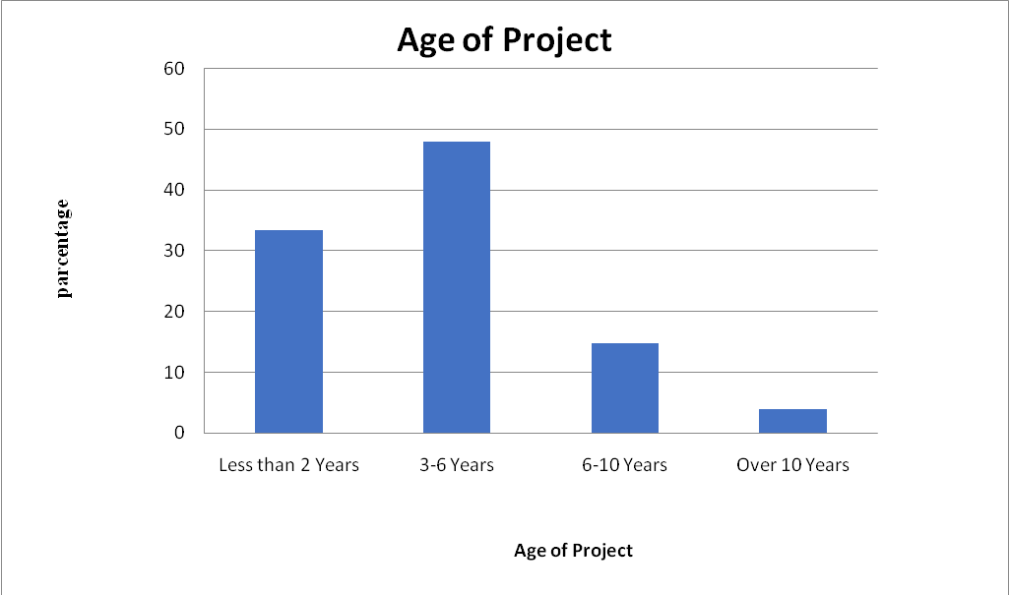
Figure 4.1: Age of Project Response
Source: Field Data (2018)

4.4 Category of Projects

Observing the category of the Donor Funded projects we observed that, the most common project category was social development followed by health projects accounting for 37% and 34% of the total participants respectively. Agriculture and poverty eradication projects accounted for an even distribution in the study population (7%). The least project category performed among the study population was construction projects accounting for 2% of the total projects performed by the study population.
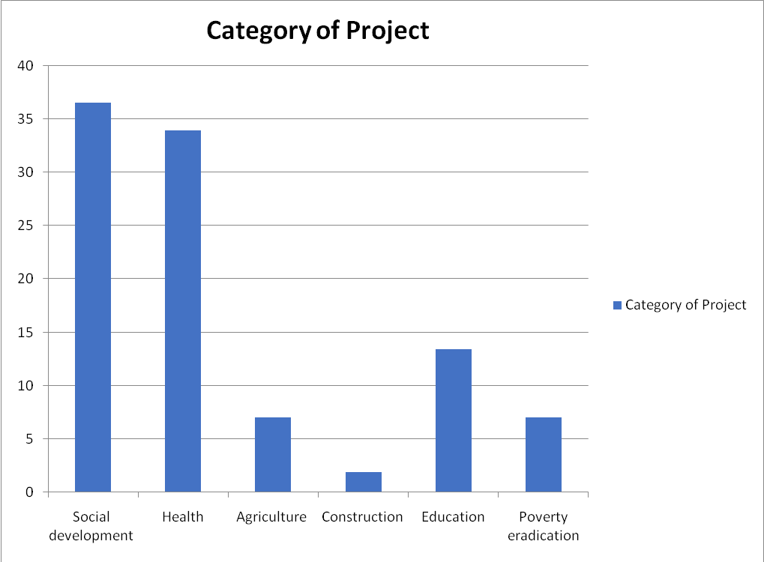
Figure 4.2: Category of Projects
Source: Field Data (2018)

4.5 Number of Employees Response
Observing the Number of Employees from the Donor Funded Projects in our study, 26% employed 11 to 25 staff. Only 11% of the DFPs employ 26 to 50 staff.
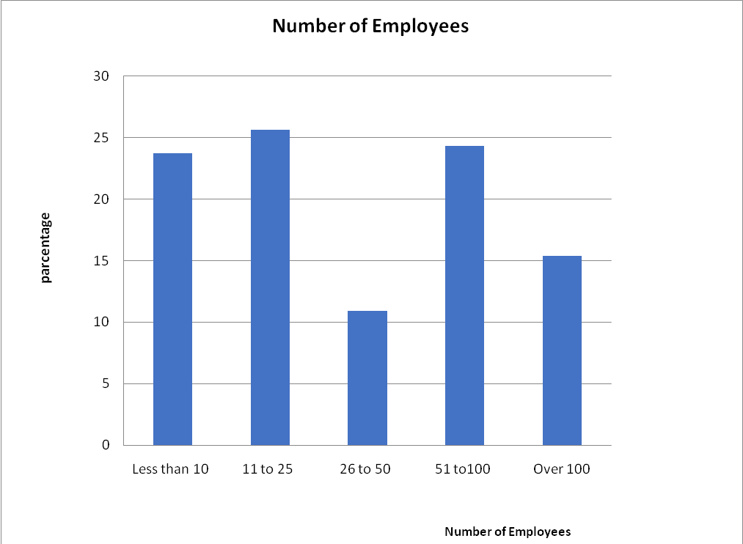
Figure 4.3: Number of Employees response
Source: Field data (2018)

4.6 Source of Funding
We found out that, 49% of the Donor Funded projects in this study are funded by Donor Through. The Government funded only 15% of the projects.

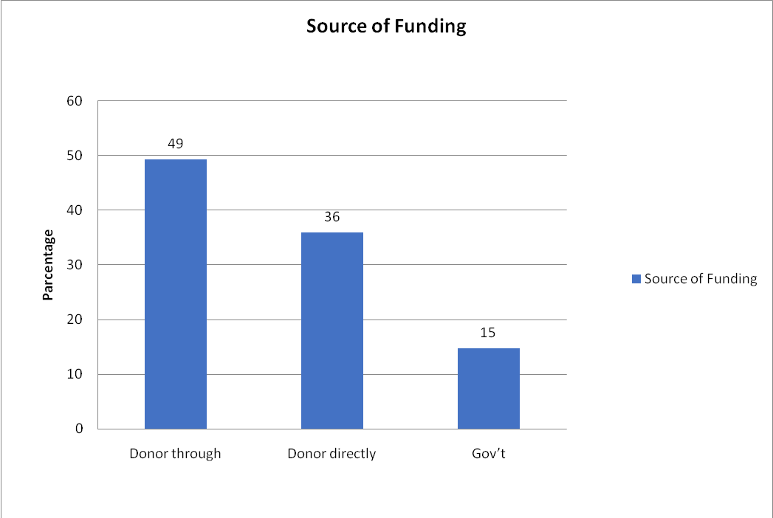
Figure 4.4: Sources of Funding Response
Source: Field data (2018)

4.7 Attribute Scores
In the study, project staff were evaluated their knowledge or understanding concerning the Four Attributes in the study. This study considered the combination of the four attributes as the successful implementation of DFPs. Each attribute was tested for the degree of contribution to the combination factor of all the four attributes.
Table 4.2: Attribute Score
QUESTIONNAIRE SCORE ANALYSIS
 | Monitoring and Evaluation |  | Risk Management |  | Rationality |  | Knowledge in Management |  | Combination
 | f | % | F | % | f | % | F | % | f | %
No Knowledge | 7 | 4.5 | 15 | 9.6 | 17 | 10.9 | 15 | 9.6 | 16 | 10.3
Have idea | 15 | 9.6 | 6 | 3.8 | 10 | 6.4 | 10 | 6.4 | 6 | 3.8
Little knowledge | 28 | 17.9 | 28 | 17.9 | 30 | 19.2 | 30 | 19.2 | 27 | 17.3
Satisfactory Knowledge | 53 | 34.0 | 42 | 26.9 | 47 | 30.1 | 37 | 23.7 | 51 | 32.7
Professional Understanding | 34 | 21.8 | 42 | 26.9 | 32 | 20.5 | 37 | 23.7 | 33 | 21.2
Excellent Specialized Knowledge | 19 | 12.2 | 23 | 14.7 | 20 | 12.8 | 27 | 17.3 | 23 | 14.7
TOTAL | 156 | 100 | 156 | 100 | 156 | 100 | 156 | 100 | 156 | 100
Source: Field data (2018)

Table 4.3: Regression Analysis
Regression Statistics
Multiple R | 0.987895
R Square | 0.675937
Adjusted R Square | 0.489687
Standard Error | 3.421544
Observations | 6
ANOVA
(Analysis of Variance)
 | Df | SS | MS | F | Significance F
Regression | 4 | 474.8150633 | 118.7038 | 10.14 | 0.230815329
Residual | 1 | 11.70696168 | 11.70696
Total | 5 | 486.522025
 | Coefficients | Standard Error | t Stat | P-value | Lower 95%
Intercept | 32.91701 | 5.634982389 | 0.51766 | 0.0278 | 74.51625035
Monitoring and Evaluation | 0.0197047 | 0.446007552 | 0.03822 | 0.0375 | 5.684110025
Risk Management | 0.067191 | 0.941999753 | 0.071328 | 0.0395 | 11.90205107
Rationality | 1.042435 | 0.729548864 | 1.428876 | 0.0456 | 8.227362339
Knowledge in Management | 0.082442 | 1.035782755 | 0.079594 | 0.0483 | 13.07842591
Source: Field data analysis 2018

4.8 Discussion
Our study aimed at determining the relationship between successful implementation of donor funded projects with rationality, Risk management, knowledge in management and M&E. For centuries developing countries are the primary beneficiaries of international aid, implementing projects in various sectors. Since 1980’s extensive debates have risen concerning the sustainability and successful implementation of these projects. Reports indicated that, it is necessary for the projects practitioners to understand the attributes that influence the successful implementation of projects reflecting resources and policies in countries (Muluh, et al., 2019).

In our study we found out that, most of the projects are implemented in 3 to 6 years’ time elapses while very few are implemented over 10 years period of time (48% Vs 4%). This indication illustrates that, most projects take short time and are not sustainable. This indication is similar to previous studies, which insinuated most projects are short time oriented in implementation compared to middle income countries which have projects with extended time of implementation (John Oganyo, 2015; Mujabi et al., 2015b). Similarities in our findings might be contributed to resemblance in sample sizes and study settings.

Furthermore, our study indicated that, social development and health projects are the most common projects in implementation compared to construction projects which are the least in implementation (37% Vs 2%). The findings are parallel to the ideal budget by donors and governmental institutions on construction of infrastructures like roads and sewage systems. Constructions costs more compared to social development and health projects. These findings are similar to previous studies and reports which indicate that, social developments and health projects to be the common implemented projects in developing countries (Bräutigam, 2000; Mujabi et al., 2015b; Suhardiman, Clement and Bharati, 2015; Bayiley and Teklu, 2016). The observed similarity is contributed by sample sizes estimations, study settings and inclusion criteria.

Considering number of employees, in our study we found that; most projects employ 11 to 25 employees (26%). Fewer projects employ 26 to 50 employees (11%). Only 15% of donor funded projects participated in our study employed more than 100 employees at time of implementation. In long term consideration, DFPs still serve as one of the most temporary employment sectors in the country. On the other hand, projects executed by government organizations tend to offer permanent employment through government organizations and public service recruitment secretariat (Annual general report of the Controller and Auditor General (CAG), 2017). This indication is quite similar with some previous studies, which indicate the rate of employment in DFPs to be 11 to 25 employees, with temporary contracts (Kimweli, 2013; Tanga and Mundau, 2014; John Oganyo, 2015).

On the other hand, a study done in Cameroon indicated slightly different results by highlighting the common rate of employment in DFPs implemented in Cameroon to be 30 to 100 employees. The report went further and indicated that, health and education projects to be the leading implementation and employing (Muluh, Kimengsi and Azibo, 2019). Our study also indicated that 49% of the project’s source of funds were donor through, 36% being donor directly and only 15% were government funded. This indication reveals that, despite the government being the sole regulator of DFPs, the contribution is smaller when equating with policies and development goals(Bank, 2016; Annual general report of the Controller and Auditor General (CAG), 2017). This indication is reflecting the paramount donation channel that has served DFPs for centuries in developing countries. As indicated in previous studies that, funds pass through NGOs and other institutions during implementation and management of DFPs(Besner and Hobbs, 2012).

Our results indicated that there is strong relationship (R²=0.675937) between successful implementation of donor funded Projects. In this manner, the strength of combination attribute to the successful implementation greatly depends upon the DFPs staff knowledge of the four attributes. Considering the attributes in all 30 projects in our study, Monitoring and Evaluation is associated with the successful implementation of DFPs (p value=<0.050). Our results indicate the importance and impact of M&E in the implementation of DFPs.

In our study knowledge in management is also associated with the successful implementation of DFPs. According to our study, knowledge in management is a good contributor to the successful implementation of the projects. Our study shows that, rationality has a great contribution to the successful implementation of Donor Funded projects in Tanzania. This indicates that; successful implementation of Donor Funded Projects in Tanzania, is greatly depending on the Rationality attribute basing on exposure of project staff (P Value <0.05).

Our study also shows that, Risk Management is another major contributing factor to the successful implementation of the Donor Funded projects in Tanzania. The study identified that a good number of staff working in Donor Funded Projects are exposed and aware of Risk Management. Our results align with the results of the study done by Mujabi et al (2015), who indicated the significant association of the attributes in question with successful implementation of DFPs (p value= <0.05). The study went further and indicated the importance of employing the four attributes in successful implementation DFPs. Another study done by Gicovi et al (2019) indicated similar results in Knowledge in management indicating the significance of KM in successful implementation of DFPs. The study indicated KM as a major tool in successful implementation of DFPs especially in developing countries.

Wanjiru et al (2013) indicated only the impact of M&E in the successful implementation of DFPs. The results indicated loop holes in implementation leading to poor performance of DFPs. The study recommended on strengthening the application of M&E for better results of DFPs. On the other hand, our results are different from Oganyo et al (2015) who indicated that the major influence of successful implementation of DFPs is procurement related factors, donor conditions and project management skill. The observed difference is contributed by difference in objectives, sample size and study settings.

CHAPTER FIVE

CONCLUSION AND RECOMMENDATIONS

5.1 Introduction
This chapter is providing conclusion and recommendation. The researcher suggested some specific measures and research extension that can take to cover some gaps as observed in the study. This section will gather the researcher view and overall examination view for all 30 donor funded projects in, Arusha Kilimanjaro and Dar es Salaam.

5.1.1 Summary of Findings
Generally, our study indicated the critical association of these four attributes to the successfulness implementation of DFPs. This indicated the importance of optimum application of the four attributes and necessary adjustments for a better outcome of Donor funded projects. Our study also indicated the distribution of knowledge concerning the four attributes in staff working in donor funded projects, it is therefore necessary to create more exposure to staffs for better performance.

5.1.2 Implication of the Results
Considering the distribution of DFPs age, category of projects, number of employees and sources of funding; more efforts need to be applied in the implementation of donor funded projects to cover the loop holes and improve efficiency. The association bolded in this study implies that, these four attributes are important in successful implementation of donor funded projects in Tanzania.

5.2 Conclusion
In order to improve the implementation of donor funded projects in Tanzania, it was necessary to investigate the attributes that have a direct effect to these projects. By understanding the contribution of each factor to the combination force of the attributes, project implementers can identify areas needing immediate attention and corrective actions.

The results show that there is significant relationship between these four attributes to successful implementation of donor funded projects in Tanzania, showing their effect when considered in combination. Considering the combination effect of these attributes was of great importance since the successful implementation of donor funded project is determined by strength of application of these four attributes independently. Therefore, identifying the weak links in any of these four attributes and properly applying the necessary corrective actions, will strengthen the combination effect leading success implementation of Donor Funded projects.

5.3 Recommendations
This study covered the necessary professional and management attributes that operate in the implementation of Donor funded Projects in Tanzania. It is also necessary to examine and explore the influence of culture and traditions of the scheme assisting or hindering project implementations.

5.3.1 Recommendation to Researchers
More research should also be done to study the influence of person views and ideas that reflect the whole psychological reviews of project implementers and other workers as far as DFPs are concerned. There is also a need to extend further studies on other factors that influence the implementation of donor funded projects linking political influences redirecting the aspects of these projects. It is also important, to conduct more research on the influence of social factors and geo-sociological patterns that affect or impact the implementation of donor funded project. Covering this gap in donor funded projects executed in Tanzania will greatly improve the outputs of DFPs in Tanzania. The researcher also recommends that, further examination to be conducted on how Donors direct professional participation affect the successfulness of donor funded projects in Tanzania, with respect to accessing feasibility of the project. Covering this gap will show the donors vivid situations and implementation conditions.

5.3.2 Recommendation to Policy Makers
It valid and vivid that strong policies will serve as pillars for successful implementation of donor funded projects in country. Policies that support the implementation through considering social and political factors. Also, policy makers should establish interactive grounds between project implementers, practitioners and regulating agencies for smooth management and implementation. Policies should be enacted to consider the impacts of risk management, monitoring and evaluation, rationality and knowledge in management to facilitate smooth environment in implementation of Donor funded projects. Furthermore, policies enacted should be open and attractive for donors and practitioners as far as implementation are concerned.

5.3.3 Recommendation to Educators and Learning Institutions
The fundamentals of project implementation should be imparted to project practitioners at reserved levels as required. Understanding these fundamentals will expose the practitioners early and prepare them for implementation challenges and methods to combat them. More over scholar should conduct more research in project implementation in developing countries, in order to understand the newly arising challenges, areas of adjustments and renovation for better performance.

5.4 Limitations of the Study
Despite the observed findings, the study was limited to inadequate resource to cover more areas as far as DFPs are concerned. The study involved a small sample size compared to the population in consideration. This limited the information and the distribution of variables observed in this study.

5.5 Areas of Further Research
More research should be conducted on the influence of political factors on the implementation of donor funded projects. Also, Studies should be conducted on the influence of culture and tradition of the targeted group on the implementation of Donor funded projects.

REFERENCE
Acharya, N. K., Dai-Lee, Y. & Man-im, H. (2006). ‘Conflicting factors in construction projects: Korean perspective’, Engineering, Construction and Architectural Management, 13(6), 543–566.
Andersen, E. S., Dysvik, A. & Vaagaasar, A. (2009). ‘Organizational rationality and project management’, International Journal of Managing Projects in Business, 2(4), 479–498.
Ngugi, A. K. & Stephen Wanyonyi, L. (2018). ‘Factors influencing performance of donor funded projects: Case of Embu Water and Sanitation Company, Embu county’, Kenya. International Academic Journal of Information Sciences and Project Management, 3(2), 317–330.
Annual general report of the Controller and Auditor General (CAG) (2017). Dar es Salaam. Available at: www.nao.go.tz (Accessed: 21 February 2020).
Artto, K. & Martinsuo, M. (2008). Project strategy: strategy types and their contents in innovation projects, International Journal of Managing Projects in Business, 1(1), 49-70.
de Bakker, K., Boonstra, A. & Wortmann, H. (2010) ‘Does risk management contribute to IT project success? A meta-analysis of empirical evidence’, International Journal of Project Management, 28(5), 493–503.
Bank, W. (2016). World Development Indicators 2016, World Bank.
Bannerman, P. L. (2008). Risk and risk management in software projects: A reassessment, Journal of Systems and Software, 81(12), 2118–2133.
Bayer, W. & Waters-Bayer, A. (2002). Participatory Monitoring and Evaluation (PM&E) with pastoralists: a review of experiences and annotated bibliography. Retrieved 12th July, 2020 from; http://www.etcint.org.
Bayiley, Y. T. & Teklu, G. K. (2016). Success factors and criteria in the management of international development projects: Evidence from projects funded by the European Union in Ethiopia’ International Journal of Managing Projects in Business, 9(3), 562–582.
Besner, C. & Hobbs, B. (2012). An Empirical Identification of Project Management Toolsets and a Comparison among Project Types, Sage CA: Los Angeles, Project Management Journal. SAGE Publications43(5), 24–46.
Besner, C. & Hobbs, B. (2013). Contextualized project management practice: A cluster analysis of practices and best practices, Project Management Journal, 44(1), 17–34.
Bodnar, G. M. (2012). Managing Risk Management, Journal of international Money and Finance, 12 (1), 29-45.
Bräutigam, D. (2000). Aid Dependence and Governance, Washington: Almqvist & Wiksell International.
Brinkerhoff, D. W. & Wetterberg, A. (2016). Gauging the Effects of Social Accountability on Services, Governance, and Citizen Empowerment, Public Administration Review, 76(2), 274-286.
Clark, N. (2003). Research as capacity building: The case of an NGO facilitated post-harvest innovation system for the Himalayan Hills, World Development, 31(11), 1845-1863.
Dempster, M. (1998). A self-organizing systems perspective on planning for sustainability, Waterloo: University of Waterloo.
Dissanayake, K. & Takahashi, M. (2006). The Construction of Organizational Structure: Connections with Autopoietic Systems Theory, Contemporary Management Research, 2(2), 105-116.
Fong, P. (2005). Presenting a Research Proposal: The Examiners Expectation, International Studies of Management and Organization, 35(1), 10-27.
Gross, M. A., Hogler, R. & Henle, C. A. (2013). Process, people, and conflict management in organizations: A viewpoint based on Weber’s formal and substantive rationality, International Journal of Conflict Management. Emerald Group Publishing Limited, 24(1), 90–103.
Heeks, R. & Stanforth, C. (2014). Understanding Development Project Implementation: An Actor-Network Perspective, Public Administration and Development, 34(1), 14-31.
Herbert, A. & Simon, D. W. (1952) ‘Public administration. By Herbert A. Simon, Donald W. Smithburg and Victor A. Thompson. New York, Alfred A. Knopf, Inc., National Municipal Review, 41(2), 120–120.
Hofisi, C. & Chizimba, M. (2013). The sustainability of donor funded projects in Malawi, Mediterranean Journal of Social Sciences, 4(6), 705–714.
Islam, M. M. (2007). Sustainability Failure Of Donor-Supported Organisational Reforms In Agricultural Extension A Bangladesh Case Study.
Issa, F. (2004). The Present and Potential Role of Non-Governmental Organisations in Agricultural and Rural Development in Tanzania, PhD thesis, University of Bremen.
Olima, J. O. (2015). Factors influencing implementation of donor funded projects in Government Ministries: A case of Ministry of Transport and Infrastructure-kenya, unpublished masters dissertation, Nairobi, Kenya.
Joseph, M. & Bill, P. (2014). Implementation challenges of a donor funded development project: Lessons learned through a deep-end strategy while implementing a development program in Zambia, Journal of African Studies and Development, 6(1), 1–7.
Kanagasabapathy, K. (2006). Empirical investigation of critical success factor and knowledge management structure for successful implementation of knowledge management system: A case Study in Process Industry. retrieved on 12th January, 2020 from; KKRR41106.pdf.
Kathy, A. S. (2019). The DATA BASE for advances in information systems and impact, Data Base for Advances in Information Systems, 1, 3–6.
Kilby, C. (2000). ‘Supervision and performance: The case of World Bank projects’, Journal of Development Economics, Journal of Development Economics, 62(1), 233-259.
Kimweli, J. M. (2013). The Role of Monitoring and Evaluation Practices to the Success of Donor Funded Food Security Intervention Projects A Case Study Of Kibwezi District, International Journal of Academic Research in Business and Social Sciences, 3(6), 9-19.
Knack, S. & Rahman, A. (2007). Donor fragmentation and bureaucratic quality in aid recipients, Journal of Development Economics, 83(1), 176-197.
Lange, S., Wallevik, H. & Kiondo, A. (2001). Civil society in Tanzania, CMI report, R. 2000:6.
Mosse, D. (1998). Process documentation and process monitoring: cases and issues, Routledge.
Mujabi, S. (2015a). Determinants of successful implementation of donor-funded projects in Uganda, International Journal of Social Economics, 42(12), 1139–1154.
Mujabi, S. (2015b) ‘Determinants of successful implementation of donor-funded projects in Uganda’, International Journal of Social Economics, 42(12), 1139–1154.
Muluh, G. N., Kimengsi, J. N. & Azibo, N. K. (2019). Challenges and Prospects of Sustaining Donor-Funded Projects in Rural Cameroon, Sustainability (Switzerland), 11(24), 1–25.

NACP, (2007). The Tanzania Mainland Revised National Accounts Estimates -Base Year, 2007 Report.
Nicasio, G. N. & Rugendo, J. C. (2019). Influence of Team Management Practices on Performance of Community-Based Projects in Embu County, Kenya, European Scientific Journal ESJ, 15(10), 1857 – 7881.
Njama, A. W. (2015). Determinants of Effectiveness of A Monitoring And Evaluation System For Projects : A Case of Amref Kenya Wash Programme By Amos Weru Njama A Research Project Report Submitted in Partial Fulfillment of the Requirement for the Award of the Degree of Master’. University of Nairobi.

Park, J.-D. & Park, J. D. (2019). Law and Mediation Offices of Clarissa Park, Los Angeles: Mediate.
Raz, T., Shenhar, A. J. & Dvir, D. (2002). Risk management, project success, and technological uncertainty, Aaron J. Shenhar and Dov Dvir., 32(2), 101–109.
Ritzer, G. (2009). The Arts of Ethics in the Information Society, Annals of the Association of American Geographers 99(2), 435–437.
Rodney, T. J., Ledwith, A. & Kelly, J. (2009). Project management in small to medium-sized enterprises: A comparison between firms by size and industry, International Journal of Managing Projects in Business, 2(2), 282–296.
Seppey, M. (2017). Donor-funded project’s sustainability assessment: a qualitative case study of a results-based financing pilot in Koulikoro region, Mali’, Globalization and health, 13(1), 86..
Shao, R. S. (2011). sustainability of donor-funded community projects under dadps in tanzania: a case of selected local chicken improvement sub-projects in morogoro municipality a dissertation submitted in partial fulfilment of the requirements for the degree of master of ag. Morogoro, Tanzania.
Shao, R. S. (2013). United nations millenium development goals, Australian Journal of Pharmacy, 1, 87–88.
Suhardiman, D., Clement, F. & Bharati, L. (2015) ‘Integrated water resources management in Nepal: key stakeholders’ perceptions and lessons learned’, International Journal of Water Resources Development, 31(2), 1-10.
Tanga, P. T. & Mundau, M. (2014). The impact of donor-funded community empowerment projects on poverty alleviation in Zimbabwe, Perspectives on Global Development and Technology, Perspectives on Global Development and Technology 13(4), 465-480.
The World Bank Group For Official Use Only United Republic Of Tanzania Systematic Country Diagnostic ‘To The Next Level Of Development’ (Kufika Kwenye Ngazi Nyingine Ya Maendeleo) (2017).
Thomas, G. N., Carbery, R. C. and Murphy, E. M. (2007). Managing intentionally created communities of practice for knowledge sourcing across organisational boundaries Insights on the role of the CoP manager, Learning Organization, 14(1), 34–49.
Voetsch, R. J., Cioffi, D. F. & Anbari, F. T. (2004). Project risk management practices and their association with reported project success, Proceedings of Sixth IRNOP Project Research Conference, (August), pp. 4–7, at Turku, Finland.
Zhou, H. & Benton, W. C. (2007). Supply chain practice and information sharing, Journal of Operations Management, 25(6), 1348–1365.

APENDIX
Questionnaire

Questionnaire No: _________________________________

INTRODUCTION
My name is Josephine Stephen Msangi, a postgraduate student pursuing Masters in Project Management (MPM) at the OPEN UNIVERSITY OF TANZANIA. Under this manner, I am conducting a research on “Determinants of successful implementation of donor funded projects in Tanzania” taking three regions: Dar es Salaam, Kilimanjaro and Arusha as selected study areas. Responding to this questionnaire is VOLUNTARY and dismissing your response is at your will. All the information provided are strictly confidential. (Refer to the confidentiality statement)

ACKNOWLEDGEMENT
I would like to extend my cordially gratitude and appreciation for your dedicated time to participate in this research. All the information you will provide in this questionnaire are termed as confidential and closed information for this research only. By responding to this questionnaire, you will provide vital information that will assist in improving the efficiency of Donor funded Projects boosting development in our country.
Again, I thank you in advance for your participation.

Josephine Stephen Msangi.
CONFIDENTIALITYSTATMENT
All the information provided in this questionnaire are termed as confidential and closed in mentioned purpose only. All personnel are required to use numbers as indicated in the top right corner of this questionnaire form.

INSTRUCTIONS
- Please read the questions properly and answer as required.
- Please answer with veracity and integrity.
- PLEASE DON’T WRITE YOUR NAME in any page of this questionnaire.
- Please use a “tick mark” for indicating your answer, for YES/NO box and for scale indication.
- Please observe the "0-5” scale of magnitude as defined below:
0 | 1 | 2 | 3 | 4 | 5
You don’t have any knowledge on the referred matter | You have an Idea of knowledge on the referred matter. | You have little understanding and knowledge on the referred matter. | You have satisfactory knowledge and understanding on the referred matter. | You have high and professional understanding and knowledge on the referred matter. | You have excellent specialized knowledge on the referred matter.

No: _________________________________
- Please indicate (using) the region in which the Project was conducted.
□ Arusha □ Kilimanjaro
□ Dar es salaam
- Basing from the location in question 1, please indicate the type of the project conducted.
□ Social development □ Agriculture
□ Health □ Construction
□ Education □ Poverty eradication
- Please indicate the “age of project”
□ Less than 2 years
□ 3 to 6 Years
□ 6 to 10 years
□ Over 10 years
No: _________________________________
- Please indicate the range of “number of employees”
□Less than 10
□11 to 25
□26 to 50
□51 to 100
□over 100
- Please indicate sources of funding,
□Donor through
□Donor directly
□Government
- Please indicate your position in the project executed.
□Administrator □Project Manager
□Project Coordinator □Field officer
□Team Leader □Others
No: _________________________________
- Do you have any knowledge on “Monitoring and evaluation” of DFPs?
□Yes □No

If ‘’Yes’’ please indicate your knowledge/ Exposure level using a (0-5) scale by putting a “tick mark”
0 | 1 | 2 | 3 | 4 | 5

- Do you have any knowledge/ understanding on risk management on donor funded projects?
□Yes □No

If ‘’Yes’’ indicate your knowledge/ Exposure level using a (0-5) scale putting a “tick mark”
0 | 1 | 2 | 3 | 4 | 5

- Do you have any knowledge/ understanding of “Rationality” and Successful implementation of DFPs?
□Yes □No
If “Yes” using a (0-5) Scale please indicate your knowledge/exposure level putting a “tick mark”
0 | 1 | 2 | 3 | 4 | 5

- Do you have any knowledge /understanding in knowledge in management (KM)?
□Yes □No
If “Yes’’ using a (0-5) Scale please indicates your knowledge/understanding level putting a “tick mark”
0 | 1 | 2 | 3 | 4 | 5

NOTE: If you answered “YES’’ for question 6 to 9, please answer question 10.
- Do you have any knowledge/understanding on how the combination of: Monitoring and evaluation, Risk Management, Rationality and Knowledge in Management (KM) affects successful implementation of Donor Funded Projects?
□Yes □No
If “Yes’’, using a (0-5): scale please indicate your knowledge/understanding putting a “tick mark”.
0 | 1 | 2 | 3 | 4 | 5

