**IMPACT OF MONITORING & EVALUATION SYSTEM ON DISASTER PREPAREDNESS & RESPONSE IN COMMUNITIES AROUND REFUGEES IN TANZANIA**

**EMMANUEL Z. MUGHAMBA**

**A DISSERTATION SUBMITTED IN PARTIAL FULFILMENT OF THE REQUIREMENTS FOR THE DEGREE OF MASTER OF MONITORING AND EVALUATION (MAME)**

**DEPARTMENT OF ECONOMICS**

**THE OPEN UNIVERSITY OF TANZANIA**

**2020**

**CERTIFICATION**

The undersigned certifies that he has read and hereby recommends for acceptance by The Open University of Tanzania a thesis titled; “Impact of Monitoring & Evaluation system on Disaster Preparedness & Response in Communities around refugees Tanzania,in partial fulfilment of the requirements for the award of the Master degree in Monitoring and Evaluation.

…………………………………….

Dr. Christopher Awinia

(Supervisor)

……………………………………

Date

**COPYRIGHT**

No part of this thesis may be reproduced, stored in any retrieval system in any form by any means, electronic, mechanical, photocopying, recording without prior permission of the author or The Open University of Tanzania in that behalf.

# DECLARATION

I, Emmanuel Z. Mughamba, do hereby declare to the Senate of the Open University of Tanzania that this dissertation is my own original work and that it has not been submitted and will not be submitted to any other University for a similar or any other degree award.

…………………………………………

Signature

………………………………

Date

**DEDICATION**

This work is dedicated to God Almighty; my father Zawadi G. Mughamba & mother Estrida Semu Mshana; brothers Godson & Moses and sister Lukundo.

# ACKNOWLEDGEMENT

Firstly, I thank my Almighty God, who protected me during the period of conducting this study, and gave me strength and ability to work on my research conclusively; without Him, this study could hardly succeed up to this stage. Secondly and meekly, I express my sincere gratitude to all respondents, particularly Community around the camp, Government LGAs and Central, Religious leaders, implementing partners and all other stakeholders who spared their precious time to volunteer information needed in this study.

Thirdly, I would like to recognize with thanks all lecturers and staff at the Open University of Tanzania who time and again ensured that I learn and commit valuable time for the master degree studies; I highly appreciate and acknowledge their devotion. In this representation, I wish to express my deepest gratitude to my research supervisor Dr. Christopher Awinia who committed most of his time in making regular follow up of the research progress, reading the draft of my work several times and making corrections and giving necessary advice when and where it was needed. I really appreciate his concern and commitment he expressed towards my work and his patience and tolerance he had shown throughout the period of this study. His guidance, encouragement, advices and contribution are highly appreciated and will remain unforgettable in my life.

Forth, I wish to extend my thanks to my father Zawadi G, Mughamba & mother-Estrida Semu Mshana who tirelessly prayed for me to full commitment because of the degree requirements. Their encouragement, spiritual, financial and moral support are highly appreciated. I also appreciate their advices on my vision which provided me a great motivation during the whole period I was pursuing my studies; without my Family moral and spiritual support, this study would not have been accomplished. Fifth, I would like to express my sincere respects to my elder & young brothers Godson and Moses and beloved sister Lukundo for their love, teases, jokes and encouragement which highly motivated me to this end.

Sincere gratitude and appreciation to all class mates whom we used to study and discuss together. Their encouragement, academic and moral support; the sleepless nights we worked together during studies and all funnies we had in class will always be honored and remembered. Lastly, I thank all institutions and individuals I consulted who enthusiastically cooperated and committed their time for this study. Profound gratitude is extended to them in recognition of their love and help to students pursuing studies for intellectual property.

May God bless you all.

**ABSTRACT**

The research study examined the impacts of Monitoring & Evaluation system on Disaster Preparedness & Response in communities around refugees in Tanzania. The study had three (3) specific objectives which hinge/articulate on monitoring and evaluation with a logical framework tool whether it is; one, adequate; two, effective; three, through IPs, impacts the DPR in communities around refugees. The study adopted one theory known as right based theory’ (refer subsection 2.3), which was relevant in maintaining good human right(s) and sustainability of good governance that ensured the wellbeing of mankind. The study focused on the use of the M&E logical frame work as the approach to be used to reduce or combat disaster issues. Research Methodology included different methods and instruments used in data collection; respectively in: study area and its characteristics; research design including population and sampling frame; research steps and process; and lastly ethical issues and limitations. The study noted factors that impacted community around refugees’ camps through IPs services to DPR programs/projects. Primary data were collected through interviews; and analyzed using descriptive statistics and Likert scaled variables were analyzed by means of Statistical Package for Social Science Version 20. The study was based on explorative design. Conclusion is that M&E with LF is a potential (adequate and effective) and sensitive tool to all programmatic aspects for programs and projects including governance; and more so in the ‘Disaster Preparedness and Response (DPR) aspects; and recommends to the community, organizations including UN bodies, government and offices to use it.

Keywords: *Impact, Monitoring and Evaluation, Disaster Preparedness & Response.*

**TABLE OF CONTENTS**

**CERTIFICATION ii**

**COPYRIGHT iii**

**DECLARATION iv**

**DEDICATION v**

**ACKNOWLEDGEMENT vi**

**ABSTRACT viii**

**TABLE OF CONTENTS ix**

**LIST OF TABLES xiii**

**LIST OF FIGURES xiv**

**LIST OF ABBREVIATIONS xv**

**CHAPTER ONE 1**

**INTRODUCTION 1**

1.1 Chapter Overview 1

1.2 Background to the Research Problem 1

1.2.1 Refugees Worldwide 1

1.2.2 Refugees in Africa and East Africa 3

1.2.3 Refugees in Tanzania 3

1.2.4 Worldwide Refugees’ Impact(s) 4

1.2.5 Africa and East Africa Refugees’ Impact 5

1.2.6 Impacts of Refugees in Tanzania 6

1.2.7 Why Do Impacts Occur? 8

1.3 Statement of the Research Problem 9

1.4 Definition of Terms 10

1.5 Research Objectives 12

1.5.1 Main Objective 12

1.5.2 Specific Objectives 13

1.6 Research Questions 13

1.7 Significance of the Study 13

**CHAPTER TWO 15**

**LITERATURE REVIEW 15**

2.1 Introduction 15

2.2 Theoretical Review 15

2.2.1 Theory of the Study-‘Rights Based Theory’ 16

2.3 Scope of the Study 17

2.4 Empirical Literature Review 20

2.5 Research Gaps Synthesis 41

2.6 Conceptual Versus Theoretical Framework 42

2.6.1 Variables and Measurement Procedures 46

**CHAPTER THREE** 47

**RESEARCH METHODOLOGY** 47

3.1 Research Overview 47

3.2 Area of the Research 47

3.3 Survey Population - Population Age Range 47

3.3.1 Gender 48

3.4 Sampling Design 48

3.4.1 Sampling Procedures 48

3.4.2 Convenience Sampling 49

3.4.3 Purposeful Sampling 50

3.4.4 Sample Size 50

3.5 Qualitative Approach 51

3.6 Quantitative Approach 51

3.7 Data Collection 52

3.8 Data Instruments 52

3.9 Methods of Data Collection 52

3.10 Data Processing 55

3.10.1 Data Analysis 55

3.11 Informed Consent 55

3.12 Limitations of the Study 57

**CHAPTER FOUR** 58

**RESEARCH FINDINGS, RESULTS AND DISCUSSION** 58

4.1 Chapter Overview 58

4.2 Characteristics of the Respondents 58

4.2.1 Gender: Inclusion, Age, Status and Sex 58

4.2.2 Sex 60

4.2.3 Respondents Gender and Age Category 61

4.2.4 Education Level 62

4.2.5 M&E with LF Empirical Snapshot in the UN and Tanzania 63

4.3 Research Findings Based on the three Specific Objectives of the Main Objective 64

4.3.1 Objective Number One 64

4.3.2 Specific Objective Number Two 68

4.3.3 Specific Objective Number Three 71

**CHAPTER FIVE** 80

**OVERVIEW, FINDINGS.** 80

5.1 Introduction of Chapter 80

5.2 Overview 80

5.3 Summary of the Findings 81

**CHAPTER SIX** 87

**CONCLUSION AND RECOMMENDATIONS** 87

6.1 Conclusion 87

6.2 Recommendations 88

6.2.1 Main Recommendation 89

6.2.2 Specific Recommendations 89

6.3 Areas For Further Study 91

**REFERENCES** 94

**APPENDICES** 97

**LIST OF TABLES**

Table 2.1: Refugees Timeline Events 25

Table 3.1: Sample Size 50

Table 4.1: Respondents’ Demography 60

Table 4.2: Gender Composition Demographically 61

Table 4.4: Gender and Age Category/Interval 61

Table 4.5: Respondents Education Level 63

Table 4.6: Community/Stakeholders Opinions to Project DPR Implementation 66

Table 4.7: Advantages from M&E through LF Efforts used to Implement the DPR 68

Table 4.8: Disadvantages Encountered if M&E through LF is not Used 70

Table 4.9: Impact from use of M&E with Logical Frame 70

Table 4.10: Livelihood Impacts Results from Non-Use of M&E Logical Frame 73

Table 4.11: Impacts of M&E with Logical Framework Use to Specific Projects 75

Table 4.12: Negative Impact(s) Associated to Non-Use of M&E Logical Frame 77

**LIST OF FIGURES**

Figure 2.1: Conceptual and Theoretical Framework 43

Figure 2.2: Theoretical Framework 45

Figure 4.1: Gender 1nclusions 59

Figure 4.2: Response by Sex 59

Figure 4.3: Number of Respondents by Gender and Age Category/Interval 62

Figure 4.4: IPs that Use or not use M&E through the LF 65

Figure 4.5: IPs Extent of use M&E through the LF 65

Figure 4.6: Community/Stakeholders Opinions to Project Implementation 66

Figure 4.7: Efforts used in the Implementation through the Logical Framework Approach 69

Figure 4.8: Challenges Encountered if M&E through LF is not Used 70

Figure 4.9: Impact of Resulting from the Use of Logical Frame 72

Figure 4.10: General Impacts Resulting from Non-Use of M&E Logical Frame 73

Figure 4.11: Impact of M&E Logical Framework Use to Projects 75

Figure 4.12: Impact(s) Associated to Non-Use of M&E Logical Frame (LF) 77

**LIST OF ABBREVIATIONS**

CERF Central Emergency Response Fund (UN)

DEV Development

DRC Democratic Republic of Congo (Former Zaire)

DPR Disaster Preparedness and Response

DPRP Disaster Preparedness and Response Plan

DITT/CITT Disaster or Conflict Indicator Tracking Table

FAO Food and Agricultural Organization

IPs Implementing Partners

IRC International Rescue Committee

IOM International Organization for Migration

LOGFRAME Logical Frame work

LF Logical Framework

LGA Local Government Authority

M&E Monitoring and Evaluation

MHA Ministry of Home Affairs

MSF M’edecinsSansFronti’eres

NRM National Resistance Movement

OAU Organization for African Unit

oPt occupied Palestinian territory (oPt)

RPF Rwandan Patriotic Front

RTLM Radio Television Libres Des Mille Collines

SPSS Statistical Package for Social Sciences

TRCS Tanzania Red Cross Society

TRCs Tanzania Red Cross staff

TRC Tanzania Red Cross and Crescent

UN United Nations

UNICEF United Nations International Children’s Emergency Fund

UNHCR United Nations High Commission for Refugees

UNAMIR United Nations Assistance Mission for Rwanda

NGOs Non-Government Organizations

PSOs Public Service Organizations

**CHAPTER ONE**

**INTRODUCTION**

**1.1 Chapter Overview**

Chapter one of this study or research presents the background information. It is organized into sub-sections of: background to the study which include: refugees-worldwide, Africa, East Africa, Tanzania and the study area in Kigoma region, Kasulu district at Nyarugusu refugees’ camps; the respective regional impacts and lastly the host community in Tanzania; statement of the research problem, research objectives, research questions, and significance of the study.

**1.2 Background to the Research Problem**

**1.2.1 Refugees Worldwide**

According to UN Report NewYorkTimes: Number of Refugees Worldwide Has Doubled in a Decade, U.N. Report Says. Nearly 80 million people, or 1 percent of humanity, now qualify as refugees, asylum seekers or internally displaced.Some 73 percent of refugees seek asylum in a neighboring country, defying the populist notion that they flood to the West, Mr. Grandi said.“This continues to be a global issue, an issue for all states but an issue that challenges most directly the poorer countries, not the rich countries — in spite of the rhetoric,” he said of the displacement.

By Region (UN major area), Refugees total population of concern (globally/worldwide) is 74,791,939; and by territory of asylum, by UN region, 2008-2018 is: Africa 27,215,648; Asia 28,503,516; Europe 6,091,713; Latin America & Caribbean 11,620,790; Northern America 1,228,940; and Oceania is 131,332.Globally/worldwide total refugees in 2008 were 33,924,476 (Africa 10,176,423) and in 2018 were 74,791,939 (Africa 27,215,648) indicating that the scourge of refugees is escalating (refer: table # 13 in appendixes).

According to the High commissioner of refugees as of January 2019, 70.8 million (41.3 million Internally displaced people 25.9 million registered (20.4 million under UNHCR 5.5 million under 3.5 million asylum seekers) had been displaced worldwide  And the Main causes of crises that result to refugees include: (1) War and civil war, (2) Human rights violations, (3) Environment and climate, (4) Economic hardship, (5) Gender based violence, (6) Exploits of displaced people, (7) Political responses.

For the purpose of this study, the researcher recognized the eighth (8) and ninth (9) items as other refugee causes

(8)……Descendants of refugees retain refugee status

Under international law and the principle of family unity, the children of refugees and their descendants are also considered refugees until a durable solution is found.

(9)………. Protracted refugee situations are the result of the failure to find political solutions to their underlying political crises.

In the past decade, global refugee population has more than doubled, with more than 25 million refugees living in host communities around the world. We are now at the highest population on record, with 67% of the world's refugees come from just 5 countries. Jan 8, 2020.

**1.2.2 Refugees in Africa and East Africa**

Africa total refugees in 2008 were 10,176,423 and in 2018 were 27,215,648; (according to UN major region areas per Un reference above-globally or worldwide) indicating that the scourge of refugees is equally escalating in Africa.Though poor, Uganda is the largest refugee-hosting country in Africa, with over a million refugees, most of them from South Sudan, the Democratic Republic of the Congo (DRC), Burundi and Somalia. Kenya, Sudan, DRC and Ethiopia are also among the top refugee-hosting countries on the continent.

**1.2.3 Refugees in Tanzania**

Tanzania country is home to the world's third largest refugee camp, Nyarugusu. This influx was caused by ethno-political violence and civil war in these countries, which forced tens of thousands to flee and seek refuge; currently assisted approximate to 350,000 refugees in Nyarugusu, Nduta and Mtendeli camps. the Tanzania Refugee Response Plan (RRP) anticipates a total of 258,280 refugees, of which 122,000 are from Burundi and 136,280 from the DRC, by the end of 2019. By the end of 2020, the projected refugee population is 182,731 refugees, comprising 31,000 Burundians and 151,731 Congolese refugees. Mar 18, 2019 - The United Republic of Tanzania was host to 330,755 refugees and asylum-seekers by 31 October 2018, mainly from Burundi (245,9641) and ...

The researcher experienced difficulties to get country specific refugees data and impacts; so, the available information was discussed with reference to the research/study objectives.

**1.2.4 Worldwide Refugees’ Impact(s)**

Worldwide/Global refugees’ impact

1. **Positive Impacts**

Refugees’ worldwide/global impacts are ether positive or negative; and all happen concurrently. Refugees can bring skills and contribute to the human capital stock, as well as stimulate trade and investment. Refugees may also create employment opportunities, and attract aid and humanitarian investments in, for example, infrastructure, which would benefit refugees as well as the society as a whole.Sep 28, 2017. Eonomic impacts of refugees today for example; U.S. efforts to resettle refugees fulfill an important humanitarian mission while also providing significant economic benefits to country. Refugees contribute billions of dollars each year to the economy through consumer spending and business start-ups, resulting in a net positive fiscal impact.Jun 14, 2018.

1. **Negative impacts**

Like positive impacts, negative impacts are also not country specific but equally depend on the socio-economic level. The worldwide empirical literature searched, did not detail negative impacts but just a mention; so the opposite of the positive impacts recorded would hold geographically for country specific impacts that are on the negative side.

At the UNHCR 24th meeting of the Standing Committee (Programme) in June 2002,

Delegations at the meeting acknowledged the significant socio-economic impact of massive refugee populations on host countries and urged UNHCR to undertake an analysis of implications of the long-term presence of refugees in order to address its consequences and ease the burden on host countries. They also underlined the importance of assessing the contributions of host developing countries, particularly of those countries hosting protracted refugee situations.

Various studies have indicated that, while there are significant differences between countries, the impact of forced displacement falls most heavily on developing countries. During 1997-2001, developing countries hosted some 66 per cent of the global population of concern to UNHCR; the share of the 49 Least Developed Countries (LDCs) alone amounted to almost 30 per cent.

* + 1. **Africa and East Africa Refugees’ Impact**

Refugees in Africa impacts are also positive or negative; and all happen concurrently. They are the same as in 2.1.1 above but the extent are country specific and depend on the community and the level of aid/assistance (adequacy and effectiveness) from the international donors including UN bodies.A case study of Kakuma host community in Kenya; by Kristoffer Andre Grindheim(2013); the research revealed that hosts experiences of camp impacts are much related to how their relationship with the refugee population develops; the impacts identified are both positive and negative. Positive impacts included: Access to food, Job and business opportunities, Access to water, Education opportunities, Humanitarian assistance, Market opportunities, and Medical services. Reported negative impacts relate to insecurity and conflicts between refugees and the host community; these included: Disrespecting culture/nationality, Loss of land, Prostitution/sexual exploitation, Conflict, and Insecurity.

* + 1. **Impacts of Refugees in Tanzania**

Tanzania is among East African countries; and as pointed earlier, impacts are positive and negative but also are country specific. Tanzania is one of the developing countries that host refugees and has experienced long-term economic, social, political and environmental impacts. From the moment of arrival, refugees compete with local citizens for scarce resources such as firewood, water, food, housing and medical services. there has been little academic research about the impact of refugees on host ... implications of the refugee presence for host communities in western Tanzania. (BE Whitaker - ‎1999).

Mission co-led by the Regional Directors of UNICEF and UNHCR, that took place from 25 October to 3 November 2002 noted that there has been significant impact, both positive and negative, on the western regions of the United Republic of Tanzania, as a result of the presence of refugees. Security was the major concern expressed by the local community. The presence of large numbers of refugees in a sparsely populated and remote area of the country has increased competition between the refugee population and the local community for resources and socio-economic benefits. This in turn has resulted in increased criminal activity (theft, armed robbery, murder and sexual and gender-based violence).

Moreover, the presence of refugees has had a considerable impact upon the environment. Significant deforestation, increased use of water resources and diminishing wildlife populations have been recorded. Deforestation and increased cultivation have also contributed to soil erosion. The mission also noted that the presence of refugees has had a positive impact on local communities of increased levels of government and bilateral donor support aimed at the development of local infrastructure, roads, transport and communications, water supplies, schools and health care; enabling local businesses and farmers to increase and diversify their outputs; employment opportunities for Tanzanian nationals; availability of a refugee workforce with considerable agricultural experience has encouraged greater levels of productivity in the area.

According to Centre for Development and Population Activities; CEDPA(1994); pp 57 & 61, monitoring provides managers with information needed to analyze the current situation, identify problems and find solutions, discover trends and patterns, keep project activities on schedule, measure progress towards objectives, formulate/revise future goals and objectives, make decisions about human, financial, and material resources….;therefore, monitoring is the process of routinely gathering information on all aspects of the project; while the purpose of Evaluation is to: find out how effective the project is; see whether objectives have been achieved; learn how well things are being done; learn from experience so future activities can be improved. Thus/in other words, evaluation is the process of gathering and analyzing information to determine 1) whether the project is carrying out its planned activities and 2) the extent to which the project is achieving its stated objectives through these activities. The difference between monitoring and evaluation is on timing, focus and level of detail.

From the preceding, "Monitoring & Evaluation system on Disaster Preparedness &Response is a system that is adopted to design and monitor impacts in communities in disasters; and a community (communities) is defined as a group of people living together in one place, especially one practicing common ownership or the people of an area or country considered collectively; society; and a refugee is a person who has been forced to leave their country in order to escape war, persecution, or natural disaster; (The Concise Oxford Dictionary; Tenth edition- on CD ROM 2001-Version 1.1(Oxford University Press 1999-2001).

**1.2.7 Why Do Impacts Occur?**

From the Research Design-Whether Monitoring and Evaluation through Logical framework on DPR impacts communities around refugees’ camps; thisresearch was designed to assess whether monitoring and evaluation on disaster preparedness and response impacts the communities around refugees’ camps; that is, the impact levels before installing a “monitoring and evaluation (ME) system”; that evaluates the levels reached to see or identify change or emerging impact after installing the ME system. The refugees’ implementing partner’s evaluation method(s)/approach(es) used as compared (contrasted) to the logical framework (Logframe [LF]) approach which identified the impact indicators evaluated(measured).

**Why do Refugees in Camps Impact the Host Community?**

Refugees in camps impact the host community depending on:

**A: Refugees- Refugees Recent Past**

1. Way back home the level of impact indicators at a tranquility/peaceful status;
2. **Current Status**: (a) running for refuge, and (b) in the camp before interaction with host community; all impact indicators originate from refugees’ countries of origin coupled with camps hosting preparedness and response.
3. **Post Current**: This dire situation (ii above) is fully evacuated/poured to a host community which is at a tranquility status (it’s like pouring hot/boiled water to someone)

**B: Host Community**

1. Impact indicators levels at a tranquility status (that is before living/encountering with the refugees).
2. Impact indicators (host community impact level(s) reached) levels after encountering with the refugees.

**Evidence of Causes of Conflicts in Host Countries between Refugees and Host Community**

Among the causes of conflicts between refugees and host communities are or are competing for livelihood opportunities and imbalance of humanitarian assistance; the same reason that gave rise to refugees in their countries of origin. There are some evidences (Kristoffer Andre Grindheim, 2013) that, “The conflicting relationship between hosts and refugees in Kakuma emphasizes the importance of identifying main more coexistence. Generally, the limited livelihood opportunities in the refugees’ countries of origin and the host community coupled with the imbalance of humanitarian assistance are the greatest challenges for promoting coexistence; hence the impacts and need for strategic initiatives to resolve or minimize their cause.

**1.3 Statement of the Research Problem**

The research problem source is therefore threefold in that the refugees who impacts the host community originate from neighboring countries; and secondly, that impacts are in both the refugees’ countries of origin and the host neighboring countries like Tanzania. The third, is the headquarters of international implementing partners’ (IPs) coordination role and effectiveness. The problem therefore hinges monitoring and evaluation systems in the respective continuums. This study is dealing with ‘impacts in the community around refugees’ camps in Tanzania.

The study therefore has suggested/recommended strategic measures or initiatives to the three stakeholders (Host countries, neighboring countries, and the headquarters of International community including Implementing Partners [IPs]) to plant durable sustainable actions leading to sustainable and harmonious periodical changes of political power in the neighboring countries; so that, in the event of disaster caused by war or conflicts, the refugees host countries have permanent International facilities that can host refugees to avoid/minimize negative impacts to host/recipient communities.

**1.4 Definition of Terms**

Because the research title is "Impact of Monitoring & Evaluation system on Disaster Preparedness& Responses in communities around refugees in Tanzania"; it is important to define the critical terminologies underpinning the study. The following definitions therefore will often be referred to inform the research.

**Monitoring and Evaluation:** Roger Edmunds and Tim Marchant (2008); Official Statistics and Monitoring and Evaluation Systems in Developing Countries comments that Monitoring and evaluation are related but different functions;

Monitoring is about good project and programme management. Evaluation is about assessing, arriving at a judgment on the activity using the monitoring data, statistics, and whatever additional data generated quantitatively or qualitatively is necessary. It will ask questions beyond the monitoring indicators about the policy relevance of the programme and its effectiveness in meeting stated objectives and even whether these objectives are appropriate.

The process of defining a logical framework (or “logframe”), including the selection of M&E indicators, is now part and parcel of the design process of most development programmes. It is an activity that, ideally, should involve all major stakeholders…The logframe is well known as a tool for project design and is a useful aid to better understand the logic that defines the development process. It can be applied at the level of the project or at the level of national strategies. It has, however, a second application, which is to provide the framework for developing a project M&E system that includes all stages of the project from beginning to completion and beyond.

Once the logic of the project had been defined using the logframe, it is then, in principle, a relatively simple process to identify key linkages and processes and based upon this to design information systems that can monitor progress at each of the four levels. This idea has immense appeal because, whatever the size and complexity of the programme, it helps to reduce the information needs for monitoring the project’s success down to a relatively small number of key indicators needed to monitor each of the four levels: inputs, outputs, outcomes, and impact. **Other relevant Definitions for this Study include: Disaster, and Refugee Q1: What is a Disaster; and Q2: Who is a Refugee?**

Disaster: A disaster is a serious disruption of the functioning of a community or a society involving widespread human, material, economic or environmental loss and impacts, which exceeds the ability of the affected community or society to cope using its own resources. “…All disasters are hence the result of human failure to introduce appropriate management measure”. Historical information can be used to anticipate impacts of refugees in camps to the host community around camps with a desire to install durable structures (policies & facilities) to avoid or minimize it to save lives in the event of a potential refugees’ incidence.

Who is a Refugee? According to the UN 1951**.** Convention relating to the status of refugees adopted (in Article 1.A.2) the following definition of refugee" to apply to any person who "owing to well-founded fear of being persecuted for reasons of race, religion, nationality, membership of a particular social group or political opinion, is outside the country of his nationality and is unable or, owing to such fear, is unwilling to avail himself of the protection of that country; or who, not having a nationality and being outside the country of his former habitual residence as a result of such events, is unable or, owing to such fear, is unwilling to return to it."

**1.5 Research Objectives**

**1.5.1 Main Objective**

To assess impact of monitoring & evaluation on refugees’ disaster preparedness & response in community around refugees’ camps Tanzania

## 1.5.2 Specific Objectives

1. To assess the adequacy of Monitoring & Evaluation system(s) and procedures in disaster preparedness and response in Community around refugees Tanzania.
2. To find out effectiveness of the Logical framework in Monitoring & Evaluation procedure and processes in the community around refugees in Tanzania.
3. To assess the impact(s) of monitoring and evaluation system/approach through the Logical frameworks on services/support made by different organizations (implementing partners [IPs]) in the community around refugees areas.

## 1.6 Research Questions

1. What is the level of adequacy of Monitoring & Evaluation system(s) and procedures in disaster preparedness and response in Community around refugees Tanzania
2. What is level of effectiveness of the Logical framework in Monitoring & Evaluation procedure(s) and processes in the community around refugees in Tanzania
3. What is/are the impact(s) of the Logical frameworks monitoring and evaluation system/approach on services/support made by different organizations (implementing partners [IPs]) in the community around refugee’s areas.

## Significance of the Study

1. The study is important in the sense that it will raise awareness on monitoring and evaluation to the society and surrounding community concerning disaster preparedness and response to the refugees’ community around camps.
2. The study will also make the society and community surrounding the camps to realize the kind of resources to be mobilized and together formulate sustainable monitoring and evaluation strategies to be used to promote awareness on the disaster preparedness and responses.
3. The study is significant because it will add value to monitoring and evaluation to evaluate respective disaster professionals as it will contribute knowledge that will enhance prediction to advocate for timely disaster preparedness and responses in community around refugees camps in Tanzania.
4. The study will help in the management of how to plan for good utilization of the resources to the international community and UN bodies; local society and environment around the refugees’ community.
5. The study will further add its significance to policy makers in the recommendations to be made which will help policy makers to develop policies that are more focused to avoid disasters and or promote timely disaster preparedness and response to refugees ‘camps.
6. The significance of this study will further through recommendations made based on an M&E system-logical framework (“Logframe”/LF) reflect the realities of refugees’ impact to social life of the host community and hence come up with realistic and implementable plans that are feasible and friendly to the host community around refugees camps to improve its life and hence Tanzania as a country.

**CHAPTER TWO**

# LITERATURE REVIEW

**2.1 Introduction**

This section reviews different literatures relating to Disaster preparedness and responses including the concept of Monitoring & evaluation, conceptual and theoretical frame works, challenges faced by the community concerning refugees’ disasters, efforts/ services which have been made by different organizations (implementing partners [IPs] including UN bodies) to address the refugees’ disaster issues; this chapter, identifies knowledge gap which the study seeks to fill.

**2.2 Theoretical Review**

The conceived concept was that if a Logical framework approach was used to design programs/projects through the resources, inputs, activities and outputs, then, the anticipated objective results (outcome and impacts) could be a reality in several and/or years to come. Therefore, the expected objective results could depend on the level of efforts exercised in the use of Logframe (LF) in designing; and subsequent periodical monitoring and evaluation. Benefits of the Logframe (LF) approach was manifested when there was a sound ‘Management Information System (MIS)’. According to The Centre for Development and Population Activities (1994), Management Information System (MIS) is established in order to ensure access to complete, timely, and accurate information for monitoring a project.

So, a management or monitoring information system (MIS) can be defined as a system designed to collect and report information on a program and project activities to enable a manager to plan, monitor, and evaluate the operations and performance of the program and projects. And, Evaluation Information System (EIS) is the process of gathering and analyzing information to determine 1) whether the project is carrying out its planned activities and 2) the extent to which the project is achieving its stated objectives through these activities.

* + 1. **Theory of the Study-‘Rights Based Theory’**

The theory adopted for this study is the ‘Rights Based Theory’ summarized in hereunder. However, the researcher found it imperative to define what ‘a theory is’ before the ‘theory of the study’.

**A theory:** is a set of ideas when considered together help to explain certain phenomenon and allow people to predict behavior and other events. These theories differ from other types of knowledge in that they allow one to organize knowledge and put into practice on a particular issue. Without theories, knowledge about human behavior and social issues would remain stagnant and one would not be able to make connections among related facts and information to form ideas that could help to advance knowledge about human behavior and social issues. It is within these contexts; an attempt is made to review various theories related to social protection.

**Rights Based Theory; Theory Used in the Study:** The right based theory is among the guideline that analyzes social protection related to different risks in the societies. In this theory, much emphasis has been made in the social rights (Munro, 2000). The social rights focuses on the obligation of the state to protect its citizens on the assumptions that citizens possess social rights that are legally made to be protected by the state. Thus all these were well stipulated in the Universal Declaration of Human Rights (UN, 1948) and Social and Cultural Rights (UN, 1996). However, in human rights of all people are recognized by Tanzania Constitution article 12-1, up to 30-1-5 stipulates that “the state authority shall make appropriate provisions for realization of a person’s rights to people and enjoy social welfare including accessing human right and they must be recognized by all people. Hence Constitution of the United Republic of Tanzania, 1977). Thus Tanzania’s laws such rights included: rights for adequate standard of living, involvement, self-determination and decision making, education, recognition, respected, loved, cared and protected.

Human rights are also set by National Social Workers Association (1996) and Tanzania Association Social Workers Organization (2014). Social workers code of ethics state that Social workers should respect, dignity and worth of the person and promotes social justice in particular when working with vulnerable groups (Mabeyo.ZM, 2014). In this perspective, all citizens should have equal rights, protection, opportunities, obligations and social benefits such as education, economic rights and health services.

**2.3 Scope of the Study**

**General purpose of the study:** The research study focused on the examination of the impacts of Monitoring & Evaluation system on Disaster Preparedness & Response in communities around refugees in Tanzania, Kigoma region in Kasulu. Population sample of the study: The population sample this study was total number of respondents were 99 as follows: community were 25 (26%), key informants 25(25%), GVT Officials 25 (25%), private sectors and NGOs ware 24(24%).

The study topics and/or theories discussed: Rights Based Theory analyzes social protection related to different risks in the societies, this theory, much emphasis has been made in the social rights which focuses on the obligation of the state to protect its citizens on the assumptions that citizens possess social rights that are legally made to be protected by the state.

The geographical location of the study: The study was conducted in Tanzania, Kigoma region at Kasulu in the community area surrounding Nyarugusu refugee camps.

**2.3.1 Study Focus and process-Organization Strategies Brief**

The main objective of the study is to assess impact of monitoring & evaluation on refugees’ disaster preparedness & response in community around refugees’ camps Tanzania; so, the organization of the study set three specific objectives achieved to PSO, NGO and community to minimize/avoid surprises along the way in implementing different activities within the program or projects and create sustainable environment for the program/project lifespan and the community. Therefore, monitoring &evaluation logical framework (M&E and LF) was assessed always in light of setting and achieving objectives.

The question was whether the PSO, NGOs, and community that used M&E logical framework in programs and projects achieved the intended objective(s) by assessing the adequacy, effectiveness, and impact of the approach, the study of M&E and LF use has shown/revealed its potential that strengthened management information system(s) that were in line with strategic management plans supported informed decisions respective to level(s) and timely necessary controls that guided effectively to desired/planned achievements per the logical framework processes; that is inputs, output, outcome, and impact.

**2.3.2 The Study is Organized into Six (6) Chapters**

From reference above, research/study focused on the examination of the impacts of Monitoring & Evaluation system on Disaster Preparedness & Response in communities around refugees in Tanzania. The study is based on explorative design with mixed approach (qualitative and quantitative). The research is presented/organized in the form of chapters. Chapter one discussed the introduction and background of the study, the statement of the problem, the objectives, the research questions and the definition of terms. Chapter two discussed the related literatures that include theories, the factors which cause refugees and literatures relating to Disaster preparedness and response impacts with and without use of M&E through LF including the concept of disaster, awareness, conceptual and theoretical frame works; and the research gap.

Chapter three discussed the research methodology that include research design study area, the research type, the targeted population, the sample size of the research, research instrument, data collection, data analysis, data presentation, research ethics, validity and reliability. Chapter four present data analysis, findings, and discussions on the findings. Chapter five presented conclusion, Chapter six recommendations and area of further studies/research. Then the last part presented references and appendices. The study involved primary data which were collected using three methods: structured interviews, Questions and documentation. The data were collected and presented in figures and tables; also maps are attached. The study also involved secondary data which were collected from various IPs database/Libraries and internet.

**Mindset of the researcher on Literature Review:** The results of the research depended on the monitoring and evaluation level of effort exercised; (1) if the Implementing Partner had a strong or an effective M&E through LF system, positive impacts are big; and small or no negative impacts but if the Implementing Partner had a weak or an ineffective M&E system, positive impacts are small and or big negative impacts; (2) Naturalized refugees unofficially and normally go to their countries of origin because the host country and the refugees’ countries of origin are bordering; these were the source of information on how to mediate or mitigate in their countries; (3) The Implementing Partners (IPs) in both countries accumulated strategic information/data through M&E systems to be shared at the international level/offices through programs or projects to mediate for peace; (4) The International Implementing Partners (IIPs) office acted as a hub to synthesize information from the host and neighboring countries to mediate for peace permanently.

**2.4 Empirical Literature Review**

War is a conflict between relatively large groups of people, which involve physical force inflicted by the use of weapons. Warfare has destroyed entire cultures, countries, economies and inflicted great suffering on humanity. Other terms for war can include armed conflict, hostilities, and police action. Acts of war are normally excluded from insurance contracts and sometimes from disaster planning. Respective to the three (3) specific objectives, the process of ensuring that an organization or government has;

Specific objective no:1-Assessed the adequacy of Monitoring & Evaluation system(s) and procedures in disaster preparedness and response in Community around refugees Tanzania is that it has:

1. Complied with the preventive measures that are Gender inclusive in any activities in programs/project concerning disaster preparedness and responses in refugees’ community and camps, (b) ensured that it is in a state of readiness to contain the effects of a forecasted disastrous event to minimize loss of life, injury, and damage to property, overseeing challenges during implementation of disaster preparedness and responses in refugees’ camps; If, by not using logical framework approach (c) can provide rescue, relief, rehabilitation, and other services in the aftermath of the disaster, by overseeing the Monitoring and Evaluation (ME) efforts made by different organizations in implementation of disaster preparedness and responses in refugee’s community and camps through use or not use of logical framework approach (e) has the capability and resources to continue to sustain its essential functions by looking at the positive and negative impact(s) without being overwhelmed by the demand placed on them.

Respective to objective one (1) is the empirical literature relating to adequacy of the Monitoring & Evaluation system(s) and procedures in disaster preparedness and response in Community around refugees.

The UNOCHA/OCHA Scenario: UNOCHA/OCHA is the part of the United Nations Secretariat responsible for bringing together humanitarian actors to ensure a coherent response to emergencies. Among other critical components, UNOCHA/OCHA is charged with program monitoring and evaluation which is manifested in the HPC (Humanitarian Programme Cycle) scenario analysis which consists of five elements coordinated in a seamless manner, with one step logically building on the previous and leading to the next. These elements are; need assessment and analysis strategic response planning; resource mobilization; implementation and monitoring; operation review and evaluation’’

“UNOCHA-OCHA also ensures there is a framework within which each actor can contribute to the overall response effort”. Therefore, all ‘Disaster implementing agencies’ operates after their approval by/under UNOCHA that they are compliant to the UNOCHA operational requirements. Reference made to Participants at “The 2017 Global Humanitarian Policy Forum at the UN in New York. Credit: UNOCHA/Paolo Palermo, UNOCHA had “Five action to move Humanitarian closure to 2030 Agenda no: v relates critically with this study; “Do more to prevent crises”.

“Do more to prevent crises” requires among many, unfailing programming approaches and efforts; the Logical Frameworks (Logframe). The OCHA meeting remarked that “Central to discussions was the recognition that achieving the 2030 Agenda will require continued, significant effort to adapt the international aid system, particularly to facilitate better connectivity between humanitarian and development action. As David Miliband, President and CEO of the International Rescue Committee, said;

*“The humanitarian sector has extraordinary entrepreneurialism, bravery and effectiveness…but rely on heroism rather than effective systems. We need major change: we need to redefine the humanitarian system, as well as revitalize it, because we are living in a world where refugees are displaced for more than 10 years, where 60 per cent of refugees are kids.” Participants repeatedly emphasized the importance of investing more in prevention and of finding political avenues to end conflicts. As David Miliband put it: “I am deeply alarmed by the crisis of diplomacy. At this year’s General Assembly, where was the all-night session to end the conflict in Yemen? It takes politicians to stop the killings…The reason 65 million people are fleeing for their lives is a crisis of diplomacy.”*

**Tanzania:** Kigoma region is one of the regions bordering neighboring countries in the west. The western side neighboring countries include Rwanda, Burundi, Congo DRC (Zaire), and Zambia. These neighboring countries have had political uprisings or hazards or disasters which often event-wise gave rise to refugees who to a greater extent come to Tanzania because of its political stability. Because of Tanzania friendly stance with neighbors, it has always mediated for peace; and eventually end a victim to host permanently (give citizenship) refugees who do not want to return to their countries of origin.

The region has lakes adjoining political boundaries, hence unauthorized border entries for various reasons including fishing and business in the border markets are a common place for the business class. This relationship is commonly disrupted when ethnic, political, or civil unrest in any bordering country happens because massive influxes of refugees run to save their lives; and naturally they run to friendly neighboring countries; and Tanzania has been holding a lot of refugees from these countries; and even when a particular country has calmed to ensure their security, a good number do not want to go to their countries of origin.

When a country’s ethnic, political, or civil unrest starts, international community may start to mediate for peace if it has reliable/true official information; however, if it abruptly starts the international community will mediate, but the situation becomes more fluid and fragile leading to unpredictable impacts.

The cause for the nationals/citizens unrest in this region is known largely to be political power oriented to guard certain ethnic groups because of ethnic interests. The monitoring and evaluation research problem source is thus threefold in that refugees originate from neighboring countries; secondly, refugees impacts the host neighboring countries like Tanzania; and thirdly, headquarters of international community including implementing partners’ (IPs) coordination role and its effectiveness; and whether monitoring and evaluation systems may impact in the respective continuums (refugees’ countries of origin, refugees’ host countries, and international organizations). This study is dealing with ‘whether monitoring and evaluation impacts community around refugees’ camps in Tanzania.

The research to the problem desires a resource base strategic monitoring and evaluation solution or contribution through strategic initiatives and planning in the respective communities, political, ethnic uprisings, conflicts or war prone neighboring countries (see/refer Figure 2); the amplified theoretical framework) that affect/impacts the host community: politically, socially, economically and environmentally. Tabular analytical presentation of the neighboring countries historical conflicts or war disasters or hazards that resulted to refugees is presented as follows:

**Table 2.1: Refugees Timeline Events**

|  |  |  |  |  |  |  |  |  |
| --- | --- | --- | --- | --- | --- | --- | --- | --- |
| Serial number of disaster events (to the right) | 1 | 2 | 3 | 4 | 5 | 6 | 7 | Current Year |
| Timeline-Conflicts or Disasters dates | >1899 | 1919 | 1935 | 1959 | 1972 | 1994 | 2015 | 2020 |
| Years between incidences |  | 20 | 16 | 24 | 23 | 22 | 22 |  |
| Population age up to 2020 with Institution memory | 118 | 98 | 85 | 61 | 48 | 27 | 5 |  |
| Time of Survey (Research date) |  |  |  |  |  |  |  |  |
| Proposed "Sample ages" because of envisioned memory capacity |  |  | 85 | 61 | 48 | 27 | 14 |  |
| For Disaster/Conflicts events (Country wise)-Indicator Tracking Table (DITT)/(CITT) refer Table 1b.Timeline-DITT or CITT-of Refugees' incidences in neighboring countries western Tanzania. |  |  |  |  |  |  |  |  |

**Source**: Research Findings, 2020

Table 1.1 in its last row refers Table-13, which reveal an experience of refugees’ incidences: from 1959 to 2016; Rwanda had seven (7), Burundi had nine (9); but Congo DRC had only one (1) relatively indicating a governance or political stability in Congo DRC.

What writers, researchers and authorities say is that refugees events historically have been interpreted or tabulated in a timeline of disasters or hazards which suggest a crude projection that it is unlikely that the scourge or recurrence of refugees will end in the near future; the recent Burundi uprising of 2015 is just five (5) years and refugees’ influx to Tanzania since then has not stopped. The study has made recommendations with a monitoring and evaluation base to identify impacts through a Logical Framework/tool with a view to address disaster Preparedness and response of impacts to community around refugees’ camps.

**Evidence of causes of Conflicts and War Disasters in Bordering Countries:** Causes of conflict or war in bordering countries leading to refugees into neighboring countries include competing for livelihood opportunities and imbalance of humanitarian assistance. “In both Rwanda and Burundi, the economy is substantially dominated by the state. There is very little of a private sector. Because of this, winning or losing political power takes on an astonishing importance. …in the United States or in Western Europe, if a politician loses power he has many choices. He or she can write memoirs, become a college professor, become a TV commentator, go back to the law firm, there are lots of choices.

But in the context of Rwanda/Burundi, a politician who loses power has very few avenues to continue playing a role of importance, continue to enjoy the kind of wealth and privileges which really only state association can bring. This gives us some sense of the ruthlessness with which political power is contested and that forms a special element of the context of the genocide and the massive slaughter in Rwanda and Burundi”.

In the aftermath of the Rwandan genocide, many prominent figures in the international community lamented the outside world’s general obliviousness to the situation and its failure to act in order to prevent the atrocities from taking place. As former U.N. Secretary-General Boutros Boutros-Ghali told the PBS news program “Frontline”: “The failure of Rwanda is 10 times greater than the failure of Yugoslavia. Because in Yugoslavia the international community was interested, was involved. In Rwanda nobody was interested.” Attempts were later made to rectify this passivity.

**Migration Policy Institute (MPI)-Europe report:** Amid growing skepticism …, and refugees in particular. Yet, as a new Migration Policy Institute (MPI) Europe report notes, the resettlement field lacks a tradition of comprehensive monitoring and evaluation, meaning that the evidence base available to inform policymakers’ actions is exceedingly thin.…lack of data on the integration outcomes of refugees and which integration investments produce the best results….‘Only a small proportion of the resettlement programmes across the globe have been subjected to thorough evaluation and, even then, often only in relation to a singular event or point in time’, write researchers Hanne Beirens and Susan Fratzke; ‘External analysts who approach the subject find few data sources other than government reports that enumerate programme inputs and outputs (e.g., expenditures and persons resettled), but fall short of capturing the process that led from one to the other’. globally the number of refugees is increasing instead of decreasing; “With a growing number of countries taking up refugee resettlement—the number has risen from 16 in 2005 to 28 in 2015—improved data collection and analysis are essential as policymakers make the case to their publics that these programmes meet stated goals and the investments are effective ones”.

**Early Warning (EW) and Early Warning Systems (EWs)**

Impacts to community around refugees’ camps are also dependent on the host community knowledge, exposure, experience and understanding on the early warning (EW &EWS) which help to respond objectively to disaster waves to save lives.

**Early Warning (EW):** The term 'early warning' is used in many fields to describe the provision of information on an emerging dangerous circumstances where that information can enable action in advance to reduce the risks involved.

**An Early Warning System (EWS):** EWS can be defined as a set of capacities needed to generate and disseminate timely and meaningful warning information of the possible extreme events or disasters (e.g. floods, drought, fire, earthquake and tsunamis) that threatens people ‘s lives. The purpose of this information is to enable individuals, communities and organizations threatened to prepare and act appropriately and in sufficient time to reduce the possibility of harm, loss or risk.

Reference made to a paper by Juan Carlos Villagran de León and Janos Bogardi (2/2006, pp 24), titled entwicklung & ländlicherraum claims that… a complete and effective, people centered early warning system – EWS comprises four inter-related elements: spanning knowledge of hazards and vulnerabilities through to preparedness and capacity to respond. A weakness or failure in any one of these elements could result in failure of the whole system. Best practice EWS have strong inter-linkages between all elements in the chain. ... For effective early warning systems, ‘good governance’s critical and is encouraged by robust legal and regulatory frameworks and supported by long term political commitment and integrated institutional arrangements.

EW partners concerned with the different elements have to meet regularly to ensure that they understand all of the other components and what other parties need from them. The four elements are: (i) Risk Knowledge-Prior knowledge of the risks faced by communities; (ii) Dissemination-Dissemination of understandable warning to those at risk. (iii) Warning Service-Technical monitoring and warning service. (iv) Response Capability-Knowledge and preparedness to act by those threatened.

**Tanzania Vulnerability and Early Warning:** According to Ashery Mkama (2015), Strategies Put in Place to Mitigate Disaster Risks, [Tanzania Daily News (Dar es Salaam)](http://dailynews.co.tz/)10/02, pp4 “Tanzania is vulnerable to repeated natural disasters, shifts in agricultural productivity due to climate change, declining environmental sustainability and food insecurity. These challenges require well-organized, multi-sector emergency early warning and preparation systems”. The author of the article comments/writes that, “…the policies, strategies, plans and structures needed to support disaster management in Tanzania are in place. However, careful analysis reveals widespread weaknesses in prevention and disaster mitigation strategies, preparedness, emergency responsive capacity and sustainable recovery options. In Tanzania, Emergency and Disaster response is centrally coordinated to ensure attention from the highest level of the executive branch”.

“According to unicef evaluation report (2011), Tanzania: Strengthening National Disaster Preparedness and Response Capacity -End of Programme Evaluation; under findings and conclusions commented that, **…**Tanzania, like many countries in Africa and elsewhere, traditionally responded to emergencies as they occurred - and then did not really address the need again until some further situation presented itself. The comment clearly indicates that prediction of disasters through indicators sought from a logical framework approach, monitoring and evaluation, is either not in use or known hence weak or inappropriate response.

Successful implementation of the humanitarian programme cycle (HPC) is dependent on effective emergency preparedness, effective coordination with national/local authorities and humanitarian actors, and information management. In essence therefore, ‘monitoring and evaluation’ is critical for a country which needs an elaborate vibrant surveillance mechanism for preparedness, Early Warning (EW), and response on continuous basis would mirror the UNOCHA five (5) functions and the HPC core elements; including four elements of people-centred Early Warning Systems. The fact that Tanzania does not clearly reflect the UNOCHA functions, HPC core elements, and the EW four elements, it is yet to have an elaborate surveillance mechanism for Preparedness, Early Warning (EW), and response on continuous basis hence unassessed/unmonitored impacts to the community around refugees’ camps.

Specific objective no: 2-EnsuredEffectiveness of the Logical framework in Monitoring & Evaluation procedure, how it impacts the community around refugees in Tanzania**;** (a) assessed the present stakeholders’ inclusion of the community in any GVT, UN bodies and NGOs activities in programs/project concerning disaster preparedness and responses in refugees’ camps, (b) Monitoring and Evaluation (ME) efforts made by different organizations in implementation of disaster preparedness and responses in refugees’ camp through use of logical framework approach? (c) checkedthe impact resulting from the use of logical frame.

**Recurrence of refugees’ influxes to Tanzania:** Historically, there has been recurrence of refugees’ influxes to Tanzania in the western-side part due to ethnic conflicts/turmoil’s in countries like Rwanda, Burundi, and Congo; these recurrence events have seen the camps in Kigoma in the respective periods (influx time) always full; suggesting major or substantial impacts to the surrounding communities. The implementing partners who have been involved in the various or specific refugees’ events have attended specific refugees’ interventions or needs using various monitoring and evaluation approaches or methods hence addressing specific objectives leading to specific outcomes and impacts in the refugees’ camps and community around the camps. This research/study therefore assessed monitoring and evaluation used identified the respective reverberation of impacts on the community around camps; and disclosed them to stakeholders for attention with a view to address them; that is to reduce or eradicate the negative impacts and foster positive impacts.

This research conceived that, the sting, extent or level of impact to the community around camps is sought from the effort level(s) of monitoring and evaluation exercised by the implementing partners coupled with the level of the refugees’ panacea (solution or remedy for all difficulties originating from refugees’ countries of origin). Researches on impacts related to “Monitoring & Evaluation system on Disaster Preparedness & Response impacts communities around refugees” in camps have been difficult to find in the internet and elsewhere, however, by sheer luck obtained one titled “Exploring the impacts of refugee camps on host communities”;

A case study of Kakuma host community in Kenya; by Kristoffer Andre Grindheim(2013); the research revealed that hosts experiences of camp impacts are much related to how their relationship with the refugee population develops; the research generally indicated an element of extent but does/did not point the initial stage evolving exponentially to the end depending on the relationship of the hosts and refugees. The impacts identified are both positive and negative. Positive impacts included: Access to food, Job and business opportunities, Access to water, Education opportunities, Humanitarian assistance, Market opportunities, and Medical services. Reported negative impacts relate to insecurity and conflicts between refugees and the host community; these included: Disrespecting culture/nationality, Loss of land, Prostitution/sexual exploitation, Conflict, and Insecurity.

**Naturalization and Local Settlement of Refugees in Tanzania:** Tanzania is one of the African countries with the highest influxes of refugees from neighboring states. After decades of hosting Burundians, Congolese, Rwandans, and others displaced from other countries, the government is implementing a new approach in order to find long- lasting solutions for refugees. According to ‘World Development Report (2011), the Impacts of refugees on neighboring countries is a development challenge. Contrast the recent Burundi uprising of 2015 is just 5 years (after the background note)and refugees’ influxes to neighboring countries like Tanzania, were continuing up to 2017 (refer 2.6). So, naturalization of refugees is not a long lasting solution to refugees in the neighboring countries; a research gap.

**Management and Coordination Problems:** Management and coordination problems are signs of weak planning, monitoring and evaluation of any project or program. Management and co-ordination problems of refugee programmes in Kigoma - A familiar tale? The upsurge of violence in Eastern Zaire towards the end of 1996 led to an influx of Zairian refugees into the Kigoma area of Tanzania…. The ‘World Development Report (2011)’ expressed particular concern about the operational performance of both UNHCR and a number of implementing NGOs. One problem identified was the way UNHCR selected NGOs and assigned tasks, citing instances of duplication of tasks leading to confusion and tension between the various NGOs and UNHCR.

“The report identified specific problems and weaknesses with NGO implementing partners. …insufficient NGO capacity to manage all sectoral activities in a camp; complacent attitudes of some NGOs in not adhering to standard guidelines and protocols leading to weak interventions in the nutrition sector (the report partly links this with the fact that particular NGOs were self- funded and were therefore able to ignore UNHCR directives); and the need for greater NGO headquarter support for field level staff”.

According to Médecins Sans Frontières (MSF), DAR ES SALAAM/ GENEVA/NEW YORK, MARCH 1, 2017—wrote that “Much greater efforts are needed to meet the humanitarian needs of Burundian refugees arriving by the thousands each month in crowded camps in [Tanzania](http://www.doctorswithoutborders.org/country-region/tanzania), …nearly 19,000 people crossed into Tanzania in January—the most in a single month since May 2015, according to the United Nations refugee agency (UNHCR). About 290,000 refugees, more than three-quarters of whom are Burundian, are now crammed into three camps: Nyarugusu, Mtendeli, and Nduta. Already considered full in November, "Nash said. A recent decision by the Tanzanian government to stop granting prima facie refugee status to Burundians arriving in the country may also have implications for efforts to meet shelter, medical, and hygiene needs. From the time the emergency began in April 2015, all Burundians arriving into Tanzania have been automatically granted refugee status.

The recent decision means new arrivals will now have their refugee status determined individually, a process that may affect the humanitarian assistance that can be made available to them. "Tanzania in recent years has generously hosted hundreds of thousands of refugees fleeing acute crises," Nash said. "International donors need to drastically increase their support. At the same time, the Tanzanian government must ensure it continues to respect refugee conventions and provides safe refuge for as long as people continue to flee”.

The above delineated extensive literature review confirms the trend (see 1.1-background to the study) of the recurring war or ethnic conflicts in neighboring countries resulting to refugees disasters that usher amorphous situations which demand wisdom and strategic measures or initiatives on the countries where refugees are originating from; otherwise the decades long experienced ethnic/tribal conflicts will continue siphoning refugees; sending with them impacts including a hatred spirit which, overtime contaminate or spread leading to ethnic uprisings to refugees’ host countries; suggesting a strategic planning using methodologies that deploy among other approaches the Logical framework; with periodical (yearly indicators tracking table), learning from and resolving uprisings.

Country peace/tranquility is a God given gift which every country or individual can acquire or work it out through repentance and love to God Almighty through His commandment of loving our neighbors, King James Bible Free 1.9.16.(Matthew 22:36-39). To truly observe God’s commandments is a deliberate commitment/effort of individuals; and hence of a nation to respective country good governance. On the other hand, the international community will be observing the country improving from such disastrous events; to the contrary is what Tanzania repeatedly is experiencing or laboring for decades ‘caring / hosting refugees’ years in years out.

Specific objective no: 3-Assessed impact of services made by different organizations (implementing partners [IPs]) in the community around refugee’s areas if they are compatible with the Logical framework monitoring and evaluation system/approach; (a) assessed impacts arising the organizationextent of use of logical frame work. (b) Also assessed the efforts made by different organizations in the implementation of disaster preparedness and responses in refugee’s camp through use of logical framework approach.

**Refugees’ impact empirical literature in host countries:** Impacts of refugees worldwide in host countries has been a serious concern repeatedly debated and reported in news’ papers internationally, UNOCHA/OCHA, UN, and the related international bodies and organizations. According to: UNHCR Standing Committee (6 January 1997); Social and economic impact of large refugee populations on host developing countries; EC/47/SC/CRP.7; The presence of refugees compounds the already prevailing economic, environmental, social and, at times, political difficulties in these countries.

Often such countries are confronted by a combination of all four of these factors. Always their impact is substantial. In many refugee situations, problems are aggravated when refugees are a substantial proportion of the local, if not national population. In Nepal, in the district of Jhapa, 90,000 refugees represent over 13 per cent of the local population; in Ngara, in the United Republic of Tanzania, the recent refugee influxes meant that the local population was outnumbered by a ratio of approximately 4: 1; i.e. there were some 700,000 refugees among a local population of 186,000. Also, according to Australian Multilateral Assessment (UNOCHA) (March 2012, pp.2); given UNOCHA’s coordination mandate, assessing and reporting on the impact and results from its work is more difficult than for many organizations. The annual report includes a range of reporting on results, but these primarily focused on inputs and processes, rather than the impact of UNOCHA’s work. The indicators and targets used to report on progress against UNOCHA’s objectives also relate mainly to inputs and processes.

And since UNOCHA/ OCHA also ensures there is a framework within which each actor can contribute to the overall response effort; therefore, all implementing partners in ‘disaster preparedness and response’ in any event are subject to UNOCHA/OCHA’s approval. The UNOCHA/OCHA inherent planning approaches/methods (inputs and output processes) could also influence its implementing partners; and refugees leading to impact communities around refugees’ camps. Equally, the heavy price (impact) that host countries have to pay in providing asylum to refugees is now widely recognized. The rhetoric of international solidarity, however, is not always matched by support in addressing the negative impacts that large scale refugee movements have on these countries. The obvious and desired approach is to prevent refugee situations from arising in the first place.

**Refugees’ Impacts Historically in Africa/East Africa (EA) – Uganda:** According to [Impact of refugees on Uganda’s population and political explosion](http://kashambuzi.com/impact-of-refugees-on-ugandas-population-and-political-explosion/); Posted on [October 19, 2010](http://kashambuzi.com/impact-of-refugees-on-ugandas-population-and-political-explosion/) by [Eric Kashambuzi](http://kashambuzi.com/author/eric/). Uganda has also become home to refugees from Eritrea, Ethiopia, Kenya and increasingly Somalia who are not only adding to population growth but also according to reports boosting National Resistant Movement (NRM) support. It is possible that NRM ignores the issue of refugees and illegal immigrants because it stands to benefit. This inaction by government calls for researchers and reporters (Ugandans and foreigners) to fill the gap by highlighting the impact of refugees and illegal immigrants on Uganda’s population growth and political developments so government authorities can debate the issues and take appropriate action. Uganda policy makers who occasionally defend their inaction by claiming they did not know have now been alerted to the potential for demographic and political explosion arising in part from refugees and immigrants. Cote d’Ivoire’s experience should serve as a useful lesson.

Impact indicators confirming disasters’ events in refugees’ countries of origin-Activities engaged in by Respective Neighboring Countries Citizens before ‘Running out’ as Refugees: For the Burundi in 2015, the Burundians engaged in protesting against violation of constitution for the then incumbent president to run for a third term, violence and human rights, abuses (protesters against ruling party followers) within Burundians were harassments like rapes, looting, refugees in neighboring countries wanting to return hope to seize power, rumors and ethnic propaganda; all these activities happened amidst main country economic activities, business and market places, farming, office work environment. Historically, these same activities have repeatedly happened from the same causes in turn causing refugees. DRC, Rwanda, Somalia, and Sudan have had or are experiencing the same things. Exiled refugees cause inter-territorial wars with intent to regain regime.

**Refugees in the Great Lakes Region:** Mixed movements from the Great Lakes region are to date poorly documented. The cycle of violence in the DRC since the mid-1990s has generated large numbers of refugees and asylum seekers. Tanzania, Uganda, Rwanda and Burundi all host sizeable Congolese refugee populations (approximately 60,000 each in Tanzania, Uganda and Rwanda, and over 20,000 in Burundi).

According to NAVAL postgraduate school Monterey, California Thesis: A Cause for Concern? The Spread of Militant Islam in East Africa; pp 3-4; (December 2015). “The root causes (of refugees) are numerous and sometimes complex even within a single dispute. They include ethnic, language and cultural differences, arbitrary boundaries, religion, ideology, competition for scarce resources including pasturage and water, unequal sharing of resources controlled by the state, and the sheer desire for power.” Meanwhile, local factors affecting the spread of militant Islam are often overlooked or misinterpreted by outsiders.

**Knowledge Gaps from the empirical data synthesis:** According to UNHCR Standing Committee (6January 1997) paper titled Social and economic impact of large refugee populations on host developing countries Social and economic impact of large refugee populations on host developing countries  
EC/47/SC/CRP.7; noted that, **t**he heavy price that host countries have to pay in providing asylum to refugees is now widely recognized. The rhetoric of international solidarity, however, is not always matched by support in addressing the negative impacts that large scale refugee movements have on these countries. The obvious and desired approach is to prevent refugee situations from arising in the first place.

“Among the key research gaps are: lack of data on the integration outcomes of refugees and which integration investments produce the best results…“Only a small proportion of the resettlement programmes across the globe have been subjected to thorough evaluation and, even then, often only in relation to a singular event or point in time”, write researchers Hanne Beirens and Susan Fratzke.

‘External analysts who approach the subject find few data sources other than government reports that enumerate programme inputs and outputs (e.g., expenditures and persons resettled), but fall short of capturing the process that led from one to the other’. With a growing number of countries taking up refugee resettlement—the number has risen from 16 in 2005 to 28 in 2015; improved data collection and analysis are essential as policymakers make the case to their publics that these programmes meet stated goals and the investments are effective ones.

Type of Refugees in East African Countries;

The main refugees’ source’ types are political and inadequate or poor governance. Eastern African countries which are the main sources of refugees are Rwanda, Burundi, Democratic Republic of Congo [DRC], Somalia, Sudan to their neighboring countries: Uganda, Kenya and Tanzania. Nationals/citizens in these countries are triggered by politics and inadequate or poor governance; embedded with: ethnic, economical, land issues, floods, drought, and globalization. Respective countries constitutions are not honored leading to or igniting civil wars.

Refugees’ Causes;

1. Global-surveillance and refugees’ causes

A paper presented at the International Conference "The Refugee Convention, Where to from Here?" convened by the [Centre for Refugee Research](http://www.crr.unsw.edu.au/) (Sydney, December 2001), summarized the refugee causes that, “….. in most developing countries refugee causes are: Historical legacies (Colonialism), Political legacies, Ethnic legacies, Economic legacies, Environmental legacies and Globalization legacies”.

(b) Other identified causes of escalated national and civil conflicts and wars include:

1. Failure of respective UN offices and international community/bodies to take timely decisions. On November 10, 2014, the UN Secretary-General’s Special Adviser for the Prevention of Genocide, [Adama Dieng](http://news.yahoo.com/un-genocide-envoy-warns-burundi-tensions-163446015.html) warned that elections upcoming in Burundi in 2015 could devolve into a situation similar to the Rwandan genocide. After meeting with Burundian politicians and civil society leader, Dieng [warned](http://news.yahoo.com/un-genocide-envoy-warns-burundi-tensions-163446015.html) that “the worst could happen” if political tensions are allowed to escalate.
2. Despite full or adequate information through Local and International EW and EWs, there was failure of respective international countries like US, UK, Germany, France, and others to take timely decisions to intervene to avoid genocide or massacres.
3. Lack of interest of a particular country for reasons including economic or political interest.
4. Media (Local and International)-failure to communicate truthfully and correctly perpetuates or escalates civil and political wars
5. Refugees implementing partners’ unaware supporting refugees in camps recruited as military personnel to seize regime in their countries of origin.
6. The Militarization of the Refugee Camps.

The political leadership in the refugee camps took charge of humanitarian aid by fronting their men as “elected leaders” to lead the food distribution in the camp. The political leaders would then punish their rivals and enemies by withholding aid from them and rewarding their supporters. From the preceding refugees’ causes, a logical framework (Log frame) planning may logically cast visionary actions based on ensuing indicators to timed critical decisions taken concurrently like -(1) Diplomatic discussions to continue/be exercised until a peaceful solution is sought; and or (2) a Military intervention to be made if the incumbent regime does not honor the respective country constitution.

Note: ‘time factor’ is the answer; if diplomacy works timely “PEACE” will have been sought/obtained, but if diplomacy doesn’t work or takes a longer route, that is a lot of time; military intervention will work to arrive at “PEACE”. This option is critical because “LOSS OF LIVES” is a worst scenario. Fatmata Lovetta Sesay (2002, vol.21) commented that “…the most vulnerable people, deserve special attention; they are the visible sign of broader problems which must be addressed if we are to continue working successfully towards peace and sustainable development”.

**2.5 Research Gaps Synthesis**

From the preceding extensive empirical literature review and above paragraphs, it is evident that the research gaps are:

1. Lack of data; and for the meagre data available lack the process that led from one to another;
2. Management and Coordination problems, as former U.N. Secretary-General Boutros Boutros-Ghali told the PBS news program “Frontline”: “The failure of Rwanda is 10 times greater than the failure of Yugoslavia. Because in Yugoslavia the international community was interested, was involved. In Rwanda nobody was interested.” Attempts were later made to rectify this passivity.
3. The other gap is that “The obvious and desired approach is to prevent refugee situations from arising in the first place”.

Refugees’ incidences are growing (instead of decreasing) such that the countries taking up refugee’s resettlement has increased from 16 in 2005 to 28 in 2015 (just ten years) and refugee’s resettlement rose from: Worldwide 33,924,476, (Africa 10,176,423) in 2008 to 74,791,939 and 27,215,648 respectively in 2018; (refer chapter 1 pg. 16) indicating need for strategic programming approaches in the refugees’ countries of origin and host countries.

UNOCHA and its respective actors like UNHCR and others are dealing with refugees; an aftermath, instead of before math. However, both need a strategic approach or initiatives for positive impacts and refugees’ scourge secession.

**2.6 Conceptual Versus Theoretical Framework**

The two, Conceptual framework and Theoretical framework are in Figure 1 which indicates the positioning and application of the M&E with LF conceptually and theoretically. Conceptually, M&E with LFwas subjected/applied/exerted to all services/interventions by the Implementing Partners (IPs); while theoretically M&E with LF was subjected/applied/exerted to all identified gaps (refer 2.12.1 above) to be filled as indicated in figure 1 to reveal the amount of objective measure of change in naturalized refugees’ in the community.

|  |
| --- |
| Conceptual Framework  **Impact to Refugees (Positive and Negative)**  **DPR services through partners (TRC/UHNCR/ OTHERs)**  **ME system (Logframe)in Community around camps in Tanzania**  Theoretical Framework  **Services provided as measured by questionnaires**  **Amount of objective measures including detail – Log frame**  **ME system in community naturalized refugees’ demands [i, ii, iii, and iv].** |

**Figure 2.1: Conceptual and Theoretical Framework**

The Figure 2; reveals two (2) main variables, namely; one; the independent variable: Monitoring & Evaluation system on disaster preparedness & Responses; and two; the dependent variable: Impact in communities around refugees Tanzania. The main variables were questioned/included in questionnaires to measure the monitoring and evaluation efforts and impacts (for thorough comprehension please see figure 2,the amplified conceptual and theoretical framework in appendix pages) arising from such efforts in the community.

The result(s) are revealed in the research report as findings, conclusions and recommendations. The result(s) arise from four (4) scenarios namely; (i) if the Implementing Partner (IP) had a strong or an effective M&E system, positive impacts were big and or small or no negative impacts but if the Implementing Partner had a weak or an ineffective M&E system, positive impacts were small and or big negative impacts; (ii) Naturalized refugees often unofficially go to their countries because the host country and the refugees’ countries of origin are bordering; these were the source among other sources, of periodical information on how to mediate or mitigate in their countries; (iii) The Implementing Partners (IPs) in both countries would accumulate programs and other strategic information/data through M&E systems to be shared at the international level/offices who mediate for peace; (iv) If, the International Implementing Partners (IIPs) office act as a hub to periodically synthesize information from the host and neighboring countries to mediate for peace permanently.

In this regard therefore, the researcher anticipates that; (i) where, there wasno monitoring system at all there will be big negative impacts in all the categories; (ii) where there was a monitoring system other than the Logical framework approach in which case, details will not be as comprehensive and will fail to detail relevant and desired impacts (iii) There wasa Logical framework approach but not firmly deployed; here, the reasons for failure to deploy it fully could be among others, personnel incompetence coupled with un-firm decisions; and (iv) There was a Logical framework approach fully and firmly deployed (decisions and comprehensive strategic data records); in this, personnel addresses fully the Logical frameworks requirements leading to expected strategic outcomes and impacts.

|  |
| --- |
| **Neighboring/Bordering countries**  **Implementing Partners (IPs)**  **Programs-services and M&E**  **systems**  **Congo, Burundi, Rwanda**  (Bordering/Neighboring countries)  **Refugees**  **International**  I**mplementin**g Host Community at **Nyarugusu (Kasulu; Kigoma region) Tanzania.**  **Partners (IIP)**  Refugees camps Promoting  **Refugees** ‘establishment and Impact on Positive outcomes coexistence between Host  **naturalized** Refugees influx Host community community and Refugees   * Economic * Social * Cultural * Political * Environmental   **Implementing**Normal development  **Partners (IPs)** programs to community Source of conflicts  ‘**services and** Between Host community  **M&E systems** And Refugees |

**Figure 2.1: Theoretical Framework**

**Source: A**mplified from Figure 1.1)

**2.6.1 Variables and Measurement Procedures**

From Figure 2.1 (see appendix page); the amplified conceptual and theoretical framework come the variables. The conceptual and theoretical framework reveals two (2) main variables, namely; one (1) the independent variable: Monitoring & Evaluation system on disaster preparedness & Responses; and two (2) the dependent variable: Impact in communities around refugees Tanzania. From these main variables will be questions in questionnaires to be administered to respondents to measure the monitoring and evaluation efforts and the impacts arising from such efforts in the community. The result will be revealed in the research report as findings, conclusions and recommendations.

Because the nature of the study is explorative, which combines both qualitative and Quantitative approaches was used. Qualitative approach was used in data collection acquired feelings, perceptions and opinion of respondents regarding measures taken by implementing partners of disaster preparedness and responses in community around refugees Tanzania. The study also used quantitative approach and got occurrences on the number of respondents on specific research questions <https://en.wikipedia.org/wiki/Research>.

**CHAPTER THREE**

**RESEARCH METHODOLOGY**

**3.1 Research Overview**

This chapter explains different methods and instruments used in data collection for the study. The chapter is divided into four main parts. The first part explains/gives description of the study area and its characteristics in relation to disaster preparedness and response (awareness/education services). Second part explains research design which is opted to facilitate operation of the study. This included the selection of sampling frame which represent the total population within study area. The third part explains different steps that were followed during research process to arrive at the results; that is, methods employed and data collected. The fourth part considered limitations and ethical issues that ensured that the research process are well done.

**3.2 Area of the Research**

The study was conducted in Tanzania, Kigoma at Kasulu in the community surrounding the Nyarugusu refugee camp that included Nyarugusu itself, Kasulu Mjini, Herushingo, Kigadie, Herujuu, Kitanga, Kiyungwe, and Bushaka. This area had been selected to be the area of the study because it has big number of refugees who came from neighboring countries like Rwanda, Congo and Burundi; and these refugees are served in camps by different organizations.

**3.3 Survey Population - Population Age Range**

The continuum of relevant age for this study is from nine (9) years to eighty nine (89); however, some elders between seventy six (76) years and above take long time to respond because one has to remember or memorize; after thorough consideration through cost benefit analysis and prudence, the researcher found that the best judgment or choice age range for the study to be between nine (9) years and seventy (75) years. Questionnaires administered were thus divided into the following categories: Youth 18-35; Adults 36-60; Old 61-75.

**3.3.1 Gender**

This study considered gender representation when taking samples. The researcher strived to get respondents per the planned gender ratio but ultimately it stood at a ratio of: Male: Female at 57%: 43%; so, the study results are based on this data free from bias and which is the representation of the community under study.

**3.4 Sampling Design**

The sample size was the critical issue in this study. As Creswell (2008) said, it entails the number of entities in a subset of a population selected for the study and data analysis. In this study the explorative design was adopted it helped to understand the contribution that had been done by partners in implementing disaster preparedness and responses in Tanzania. The explorative design was appropriate because it helped the study to interview different categories of respondents and acquired different information which assisted the study to discover the contribution that had been made by different implementing partners in disaster preparedness and responses in host community around refugees in Tanzania.

**3.4.1 Sampling Procedures**

The study deployed sampling techniques and got the right respondents with similar characteristics that represent the population under the study that produced the right information which met research objectives. As Bryman (2008) said, sampling techniques are employed because all scientific researches focus on a small segment (sample) of a bigger population. Similarly, the study used sampling techniques to reduce the population to manageable range because the study population was relatively large and cannot reach each individual; so, different sampling techniques were used and got a representative sample. Based on that, the study also employed other sampling techniques and obtained a sample population who provided information to research objectives and research questions.

The study also used convenience and purposeful sampling and collected adequate data. Convenient sampling was used by selecting respondents who were available and those who happened to be closer to the study. In addition to that, purposive sampling which is non-probability sampling was subjected to respondents basing on own judgment. However, the selections of these respondents were based on specific knowledge vested in or held by respondents, like key informants (KI) that fulfill the study desired information.

**3.4.2 Convenience Sampling**

Convenience sampling was also among the methods that were used in the study with the aim of getting persons who were available and were closer to the study area. The use of this method, community members’ friends, neighbors, and relatives who showed interest and agreed to cooperate to research questions were included in the study population. As Davies (2007) stated, this technique was also be used in order to get different categories with different understanding and obtained general public opinion, perception and experience of the partner’s effort in disaster preparedness and responses issue in Tanzania.

**3.4.3 Purposeful Sampling**

In this study, category of respondents who were purposely included in this study, are Community around refugees’ camps, Private sector including NGOs, key informants and government officials. Each of these categories were selected based on wide range of experience, knowledge and feelings on issues regarding disaster preparedness and responses in Tanzania. For instance, the government officials, key informant and community provided information related to the strategies and collaborated with the private sector to preparedness and responses.

**3.4.4 Sample Size**

The sample size was the critical issue in this study. As Creswell (2008) said, it entails the number of entities in a subset of a population selected for the study and data analysis. In this study the total number of respondents was 99 as detailed in the table no. 2 below where by community were 25 (26%), key informant 25(25%), GVT Official 25 (25%), private sectors, and NGOs ware 24(24%).

**Table 3.1: Sample Size**

|  |  |  |
| --- | --- | --- |
| **Respondent** | **Total** | **Percent (%)** |
| Community | 25 | 26% |
| Key Informant | 25 | 25% |
| GVT | 25 | 25% |
| Private & NGOs | 24 | 24% |
| Total | 99 | 100% |

**Source:** Researcher data, 2020

**3.5 Qualitative Approach**

In this study, qualitative approach was applied with the purpose of gaining awareness into respondent’s sentiments, views, perception, feelings and attitudes on measures used by implementing partners in disaster preparedness and responses in community around refugees Tanzania. This approach as Kahn (2001) and Kothari (2009) argued that it is flexible and was used at different levels. The strength of this method is that, it enabled respondents to be free and expressed their opinions, feelings and experience on efforts made by the implementing partners in the implementation of disaster preparedness and responses.

**3.6 Quantitative Approach**

Unlike qualitative approach, quantitative technique was applied to show frequencies and number of respondents with certain characteristics who were involved in this study. The study also used this method and got easiest way of asking identical questions to different categories of study population and made comparison of responses and analysis on information related with measures that supported strategies made by partners in the disaster preparedness and responses in Tanzania.

Since the study aimed at getting various opinions, perceptions and different views about the implementer’s efforts towards implementing disaster issues, explorative design method as mentioned above was applied in order to acquire wanted information. In this sense therefore, both: qualitative and quantitative approaches were used. Qualitative approach was applied to explore sentiments, views, perception, feelings and altitudes; while quantitative technique complemented qualitative in terms of presenting figures.

**3.7 Data Collection**

The data collection for this study involved various methods and instruments as described below.

**3.8 Data Instruments**

Data instruments or tools used to collect data included: Questionnaires (structured & unstructured), Documentary (secondary data) review, Observation (primary data). In this study, the researcher used primary data and secondary data. Within these two main data there are different Methods of data collection which involved various tools used that accessed information needed. The study relied on two major sources that is, the primary and secondary source. Whereas the primary source included actual data collected from the field, the researcher also used other techniques and gathered relevant information; on the other hand, secondary data was collected from different but relevant documents. These included books, journals and reports from various institutions. The following sections describe different methods used for the data collected.

**3.9 Methods of Data Collection**

Field visits were done and various methods of data collection used with various tools that accessed information needed for the study both primary and secondary data. A Likert Scale approach was used to scale responses in survey, specifically primary data collected through interview method using self-administered structured questionnaires to measure the attitude of the respondents who were asked to indicate the level of agreement or disagreement with the statements related to the study where symmetry of categories is presented with clearly defined linguistic qualifiers. The purpose was to identify the attitude of people by asking them the extent to which they agreed or disagreed (1 = Strongly Disagree, 2 = Disagree, 3 = Not Sure, 4 = Agree, 5= Strongly Agree) towards the given statements. Secondary data were also collected from relevant documents. Therefore, the various types of methods used included: Observation, Interview, Questionnaires, and Documentary Review.

**3.9.1 Observation**

This method was used and enabled the study to get observation of the phenomenon in their setting. As Creswell (2008) argued, observation method assists the study to observe actions, interaction, words spoken by people towards disaster preparedness and responses. Generally, this type of a method enabled the study to come up with firsthand information that was not interrupted with other factors that can disrupt objectives of the study (Creswell, 2008).

**3.9.2 Interview**

The researcher interviewed different respondents from naturalized Refugees as citizens, Community and implementing partners’ officials. This method assisted the study to face respondents and interrogated individuals and groups of respondents and got detailed information about implementer’s contribution to disaster preparedness and responses. The study used both structured and unstructured questions which are guided by research objectives which facilitated the study to have reliable and enough information. With this method interviewer was able to interview respondents and got right information useful for the study.

**3.9.3 Structured Interview**

The study also adopted ‘Structured interview’ because of its strength in capturing realistic information from both formal and informal setting (Kothari, 2011). The method involved facing respondents and interrogated them by using specified guiding questions. The interview process involved both closed and open-ended questions aiming at obtaining much information from the respondents including different partners, naturalized Refugees as citizens and the refugees’ host community. Such type of interview assisted interviewees to be more focused in expressing feelings, sentiments (ideas) and opinion over the mechanisms used by implementers to provide the services concerning disaster issues in Tanzania.

**3.9.4 Unstructured Interview**

The unstructured interview method was also used to gather information from the respondents which included naturalized Refugees as citizens and community members. The unstructured interview in this case, was useful in the study because it enabled free discussion and assisted the study to obtain information which covered gaps that were not filled when using other methods during data collection.

**3.9.5 Documentary Review**

Documentary review method involved reviewing different literatures related to the study problem. Such sources included reports, books, newspapers, periodicals and journals built a base of understanding and got relevant and adequate information on disaster preparedness and responses and the contribution of the IPs in the provision of the respective services in Tanzania. This method is also known as secondary data source of information which contains data that has already been collected by different researchers and passed through the statistical process (Kothari, 2011).

**3.10 Data Processing**

Data Processing: The field filled Questionnaires were thoroughly reviewed to sport errors in recording, coded and data for corrective measures; they were finally entered into the computer. Furthermore, the data in the computer was run to detect errors and omissions which were cleaned or mended before or prior to analysis.

**3.10.1 Data Analysis**

Descriptive statistical analysis was used to analyze variables in all objectives. It was also used to analyze frequencies and percentage. Distribution for variables under study were analyzed by a Statistical Package for Social Science (SPSS) version 20. The data was then interpreted to address the study objectives.

**3.11 Informed Consent**

The researcher sought permission from respondents before data collection to avoid misunderstanding on the study. This is in line with David, (2008) who pointed out that Obtaining informed consent for research study open and truthful communication between the researcher and the study participants prior to any study. Getting respondent’s permission initiated good rapport and cooperation in data collection. And it builds up trust and assurance of confidentiality. In the process of seeking permission, the study explained respondents about the nature of the study.

**3.11.1 Confidentiality**

One of ethical principles of social work is to respect the client’s right and maintaining individual privacy. Social workers were not allowed to solicit private information from clients unless it is essential for providing services or conducting social work evaluation. It is within this context that maintaining confidentiality of respondents were assuring and maintained during the study and respondents were assured that, the gathered information was only used for the study purposes.

**3.11.1.1 Validity, Reliability and Limitations**

In a qualitative study validity and reliability are the terms that are used to measure the quality of the study. At this stage it is where the reliability of the project can be assessed.

**Validity:** According to Stake (2003: 134) a good case study research follows disciplined practices of analysis and triangulation to tease out what deserves to be called experiential knowledge from what is opinion and preference. The study took lengthy time in collecting data with a followed observation, questionnaire and interview so as to collect rich and valid data. Both long term involvement and interviews, questionnaires, observation enabled the study to collect data that were detailed and varied enough that provided a full and revealing picture of what was going on (Maxwell, 2005). Validity of the study went along with the theory and ethical issues as stated above.

**Reliability:** This is an accuracy of work in research. For the research to be reliable it must prove that if it was done on a similar group of respondents in a similar context similar results would be found. According to Gall et al (2007) reliability was used to measure quality of the research in quality pattern. Through interview with unstructured questions and observation methods which were used and repeat the same question as the evidence of reliability. Using multiple methods like direct observation, questionnaire and interview ensured reliability due to the fact that the greater number of methods used the more accurate the findings became effectively. During data collections process the study ensured that phone contacts are kept between the respondents and the researcher which help the study to continue asking for more information and clarifications in areas which seems to be necessary.

## 3.12 Limitations of the Study

Data collection was done during working hours when most of the respondents were at work. This fact made some of the respondents to produce information but others were busy with daily livelihood and economic activities that limited them to volunteer to produce information needed for the study. The researcher therefore, postponed the interview sessions; and agreed to visit respondents at their suitable time in order to conduct the study as per respondent’s time schedules.

1. Some respondents were not clear in responding to research questions and that lead the researcher not getting the right information needed for the study. In order to overcome this problem, the study avoided straight questions and was using indirect questions which allowed respondents to be free to express their feelings and opinions.
2. It was difficult to memorize and record everything said by the respondents. This problem led the study to miss some of the information needed for the study. In order to overcome that, the study had to seek respondent’s consent to record directly what was said.

**CHAPTER FOUR**

**RESEARCH FINDINGS, RESULTS AND DISCUSSION**

**4.1 Chapter Overview**

This chapter attempts to extensively discuss the findings of the study. It discusses the respondent’s characteristics, major findings and supplementary evidences, interpretation of findings and compare the results with the related literature review. The chapter has been divided into subchapters depending on the three specific objectives of the study. Each subchapter has been devoted for presenting the results pertaining to an objective. The sub-chapters are well balanced, mutually related and arranged in logical sequence.

**4.2 Characteristics of the Respondents**

In social sciences research personnel characteristics of respondents have very significant role to play in expressing and giving the responses about the problem.

**4.2.1 Gender: Inclusion, Age, Status and Sex**

From chapter three (3) above, for any study to have valid and reliable results or findings, gender inclusion, respective respondents’ age at a given range including the respondents’ status has been accounted. This consideration has a strong convincing power on the results notwithstanding whether they are positive or negative. In this strength therefore the study established gender: inclusion, its age and range, status, and sex. The study results or findings are therefore: valid, and reliable because the source of information is sought from a wide trust worth range. The hereunder graphs and chart are based on data obtained from the selected sample of 99. Age categories are: 18-35, 36-60, and 61-75; respondents’ status include: community, key informant, Government, NGOs and Organizations; Sex: male and female. Other data tables and graphs are in attached Appendices and worksheets.

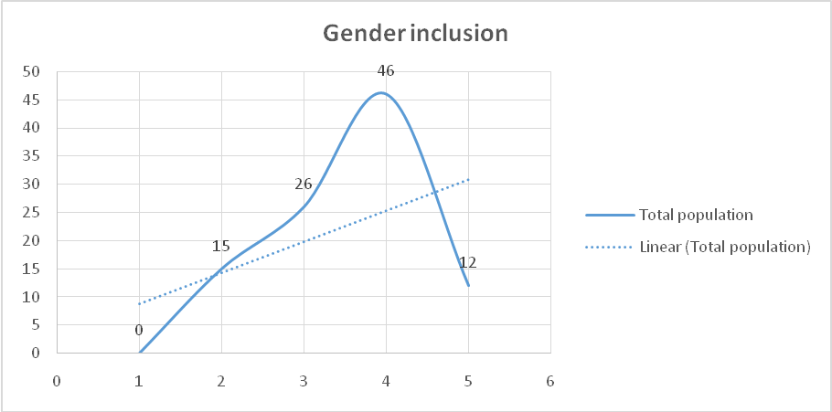

**Figure 4.1: Gender 1nclusions**



**Figure 4.2: Response by Sex**

Therefore, the demographic characteristics of the respondents were analyzed and categorized based on their Sex, Age, and their status like: key informant, community and officials.

**Table 4.1: Respondents’ Demography**

|  |  |  |
| --- | --- | --- |
| **Respondent** | **Total** | **Percent (%)** |
| Community | 25 | 26% |
| Key Informant | 25 | 25% |
| GVT | 25 | 25% |
| Private sectors & NGOs | 24 | 24% |
| Total | 99 | 100% |

*Source: researcher, 2020*

**4.2.2 Sex**

Information on the basic characteristics of males and females interviewed in this study is essential for interpretation of findings presented and it provides an approximate indication of the representativeness in the study. The study described sex of the respondent to understand the issues related and decision making processes or planning and implementing at all levels. Not only that, but also sex is very important in communication, stakeholder engagement and preferences for the uptake of interventions.

Sex influence the way in which an implementation strategy works, for whom, under what circumstances and why. There is emerging evidence that programmer theories may operate differently within and across sexes and other inter sectionals characteristics under various circumstances. Furthermore, without proper study, implementation strategies may inadvertently exploit or ignore, rather than transform thinking about sex related factors. The following table reveals respondents gender/sex (Male 58%, Female 42%) composition to avoid or minimize bias. Female key informants were not easily available; so ratio of key informants: female to male was 8/17 (47%/53%); see table hereunder-Key Informant line.

**Table 4.2: Gender Composition Demographically**

|  |  |  |  |  |
| --- | --- | --- | --- | --- |
| **Respondent** | **Male** | **Female** | **Total** | **Percentage** |
| Community | 13 | 12 | 25 | 25% |
| Key Informant | 17 | 8 | 25 | 25% |
| GVT Officials | 14 | 11 | 25 | 25% |
| Private sector and NGOs | 13 | 11 | 24 | 24% |
| **Total** | 57 | 42 | 99 | 100% |

**Source**: researcher, 2020

**4.2.3 Respondents Gender and Age Category**

At all ages whether at work or in our personal lives, mankind makes decisions on regular basis. Various researches suggest that older adults’ better emotion regulation may well contribute to their ability to make better decisions and resist the “sunk cost bias”. In this study, gender and age are among the most important characteristics in understanding their views about a particular problem. Old age indicates level of maturity of individuals and in that sense, age becomes more important to examine the response. Therefore, the study describes the respondent’s gender and age as they are related to maturity and immaturity of the answers given. Gender ratio is: Male 57% and Female 43%. For age % see the table.

**Table 4.4: Gender and Age Category/Interval**

|  |  |  |  |  |
| --- | --- | --- | --- | --- |
| Age Interval | Male | Female | Total | Percent (%) |
| 18-35 | 19 | 14 | 33 | 33% |
| 36-60 | 26 | 22 | 48 | 48% |
| 61-75 | 11 | 7 | 18 | 18% |
| Total | 56 | 43 | 99 | 100% |
| % | 57% | 43% | 100% |  |

**Source:** researcher, 2020

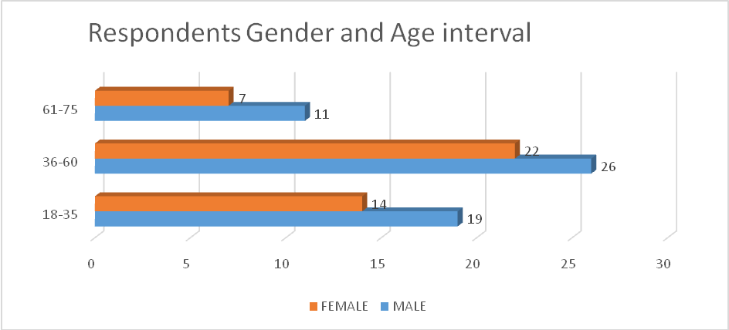

**Figure 4.3: Number of Respondents by Gender and Age Category/Interval**

**4.2.4 Education Level**

**Education Level (Community, Key informants, Private, NGOs, and GVT officials):** Education gives us a knowledge of the world around us and changes it into something better. It develops in us a perspective of looking at life. It helps us build opinions and have points of view on things in life. Education is also one of the most important characteristics that might affect person’s attitude and the way of looking and understating any particular social phenomenon. In that way, ability of a person to learn, adopt and implementing good practices in disaster preparedness and responses in the community around refugees Tanzania, and reasonably to process information is related to education of the respondent. Hence the response of an individual is likely to be determined by his education status and therefore it becomes imperative to know the education background of the respondents.

**Table 4.5: Respondents Education Level**

|  |  |  |  |  |  |  |
| --- | --- | --- | --- | --- | --- | --- |
| **Respondents education level** | Male | Percent (%) | Female | Percent (%) | Population | |
| Total (#) | Percent (%) |
| Did not attend school | 1 | 2% | 0 | 0 | 1 | 1% |
| Primary school | 8 | 14% | 4 | 10% | 12 | 12% |
| Secondary education | 9 | 16% | 7 | 17% | 16 | 17% |
| Vocation | 15 | 26% | 10 | 24% | 25 | 25% |
| College/university | 24 | 42% | 21 | 50% | 45 | 45% |
| I don’t know | 0 | 0 | 0 | 0 | 0 | 0% |
| **Total** | 57 | 100% | 42 | 100% | 99 | 100% |

**Source:** researcher, 2020

**4.2.5 M&E with LF Empirical Snapshot in the UN and Tanzania**

Various efforts have been made by the UN and also Tanzania Government itself to make sure that there is use of Logical framework in different approaches. ``Several studies have evaluated the short-term cost of natural disasters. An exhaustive assessment of the short-term costs must include both direct costs (damage to buildings, crops, social infrastructure) and indirect costs (like lost output and investment, macroeconomic imbalances, and increased indebtedness).

The World Bank estimated that from 1990 to 2000, natural disasters have caused damage representing between 2 to 15 percent of an exposed country’s annual GDP (World Bank 2004). With such large costs—in many countries much larger than their aid budgets, and in some cases larger than the country’s investment rate it is important to focus, more than has been the case so far, on the impact of natural disasters, their relationship to economic development priorities and strategy, and better coping mechanisms” This knowledge or understanding is not an exception to man-made disasters or hazards. This study wanted to find out effort of government and implementing partners in the implementation by using Logical framework approach. And within this context various respondents were interrogated to give their opinion. Monitoring and Evaluation (M&E) efforts used in the implementation of disaster preparedness and response in refugees’ camps through the Logical Framework (LF) approach.

**4.3 Research Findings Based on the three Specific Objectives of the Main Objective**

**The main objective of the study is to** assess the impact of use of monitoring & evaluation through logical framework (M&E-LF) on refugees’ disaster preparedness & response in community around refugees’ camps Tanzania.

**4.3.1 Objective Number One**

To assess the adequacy of Monitoring & Evaluation system(s) and procedures in disaster preparedness and response in Community around refugees Tanzania.

Respondents relevant to objective no:1 were revealed in questionnaire questions no: 11,12, and 13; data indicated that there are IPs that use M&E through the LF and some do not use.

**IPs that use or not use M&E through the LF:** Respondents for question 11-i) showed IPs that use M&E through the LF are 64% of the total. One would say they are the majority and could change/impact substantially the community; but we cannot ascertain the exponential effect of the ones not using the M&E through the LF. On the other hand, (b) IPs that do not use the M&E through the LF are 36%; the fact that non-use has substantial negative impacts; can even affect substantially the ones with 64% depending on the responsibilities vested on the particular IP; for example lead or head entrusted with governance. The study advises that all IPs need to use the M&E through the LF to avoid the effects for non-use. The following Graph 13 represents this observation.

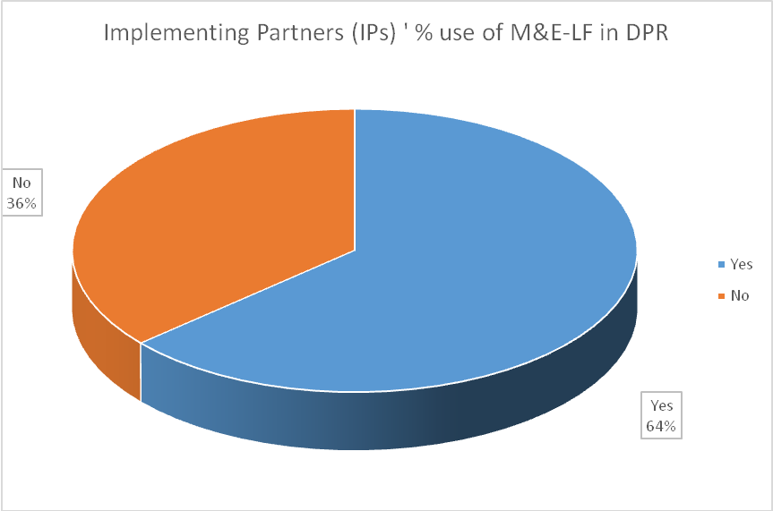

**Figure 4.4: IPs that Use or not use M&E through the LF**

**IPs Extent of use for Ones that use M&E through the LF:** The respondents responses for question 11-ii); revealed extent of use (number and %) as follows: very low (5 /5%), low (19 /19%), average (13/13%), high (27/27%) and very high (35/ 36%). The total for very low and low is 24%; while high is 76% (from average to very high).

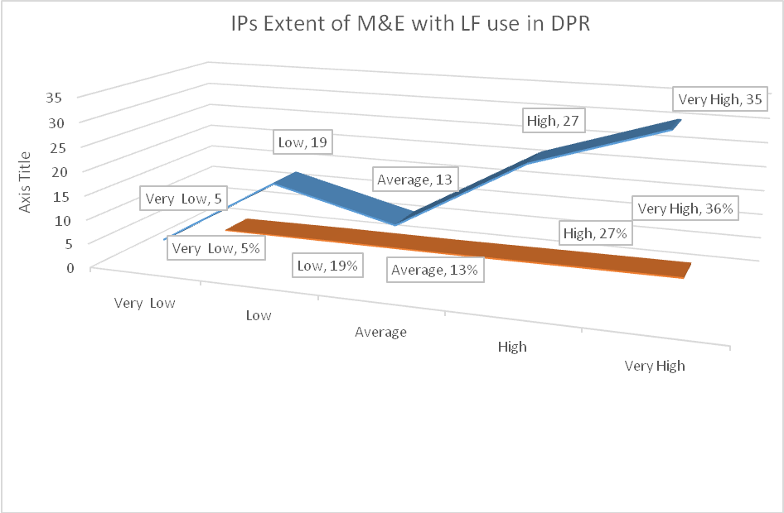

**Figure 4.5: IPs Extent of use M&E through the LF**

The Figure 4.5 reveals that IPs that do not use fully the M&E LF approach are 24%; these can affect the other sectors which use (76%) exponentially and substantially depending on the responsibilities vested on the particular IP; for example lead or head entrusted with governance. The study advises that all IPs strive to fully use the M&E through the LF to avoid the substantial negative impacts/effects arising from partial use.

**Community Inclusion/Involvement/Engagement (Qs-12):** Community programs/ projects normally perform well if the respective communities are well engaged or involved. Community engagement or involvement may include: opinions, workforce (labor), and money (funds) to a lesser extent. The data in the table below reveals how the community was engaged in just one aspect of giving its opinions on the interventions undertaken.

|  |  |  |  |  |  |  |
| --- | --- | --- | --- | --- | --- | --- |
| How often does community give their opinions? | Very Low | Low | Average | High | Very High | Total |
|  | 9 | 39 | 31 | 20 | 0 | 99 |

**Table 4.6: Community/Stakeholders Opinions to Project DPR Implementation**

**Source:** researcher, 2020

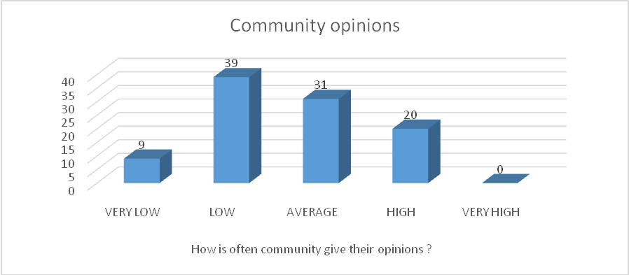

**Figure 4.6: Community/Stakeholders Opinions to Project Implementation**

Figure 4.8 drawn from Table 4.9 shows how the community was involved to give its opinions within different projects or activities that were implemented and all concerns regarding disaster preparedness and responses around the refugees’ camps. From the respondent’s data Figure 4.8 it is apparent that the low ebb of inclusion is 48; while the other ebb, that is from average to very high (average 31, high 20, and very high zero (0)) accounts for (51) a very thin margin between the two of inclusion of only 3. For projects and programs implemented in communities, under normal circumstances, if a community is highly involved positive impacts are high because of the deployed community hidden potential; however, in this upper ebb scenario from average, high score is 20 but zero (0) for very high. The respective responses for community involvement/inclusion are: on the upper ebb-Average score was 31, High score was 20) and Very High was zero (0); and on the lower ebb- Low scored 39, Very Low scored 9; hence a thin margin of two (3); very close to 50%; indicating a scenario of “tossing a coin=whose results are either: Yes or No”; which may negate community inclusion/involvement on crucial issues; hence leading to negative impacts.

The study advises that community involvement or engagement is to a lesser extent on: giving its opinions, contributes funds, and provide/give workforce (not with standing the level of the amount; what counts is the desire for ownership).

**Gender: Inclusion, Age, Status and Sex (QS-13):** For respondents’ characteristics, subsections 4.2.1, Figures 4.1 & 4.2 are based on data obtained from selected gender sensitive sample of 99. Age categories are: 18-35, 36-60, and 61-75; respondents’ status include: community, key informant, Government, NGOs and Organizations; respondents’ gender/sex (Male 58%, Female 42%) composition to avoid or minimize bias. Female key informants were not easily available; so ratio of key informants: female to male was 8/17 (47%/53%). For respondents Gender and Age Category/Interval refer Table 4.3; for Gender Composition Demographically refer Table4.2 with ratio is: Male 57 and Female 42.Education Level for respondents (Community, Key informants, Private, NGOs, and GVT officials) was also picked; refer subsection 4.2.1.3

**4.3.2 Specific Objective Number Two**

To assess effectiveness of the Logical framework in Monitoring & Evaluation procedure and processes in the community around refugees in Tanzania. The analysis based on the question number 14, 15.

**Advantages of Use of M&E through LF Efforts Used to Implement the DPR:** The specific objective number two data in the Table 4.8 from which the Figure was drawn shows the effectiveness arising from the efforts exerted using the M&E Logical framework that improve project design. Average score was 18, High score 39 and Very High 39, giving a total of 96; while Low score was only 3 and Very Low was zero (0). On fostering the project performance, efforts exerted through use of the M&E Logical framework, respondents revealed scores of: Average 10, High 43 and Very High 43, while Low score was 3 and Very Low zero (0).

**Table 4.8: Advantages from M&E through LF Efforts used to Implement the DPR**

|  |  |  |  |  |  |  |
| --- | --- | --- | --- | --- | --- | --- |
| Key informant, Private sectors, GVT Official, and Community | Key informant | Private sectors | GVT Official | and Community | Key informant | Private sectors |
| Improving project design, | 0 | 3 | 18 | 39 | 39 | 99 |
| Fostering project performance | 0 | 3 | 10 | 43 | 43 | 99 |
| Facilitating project management | 0 | 3 | 12 | 40 | 44 | 99 |

**Source:** researcher, 2020

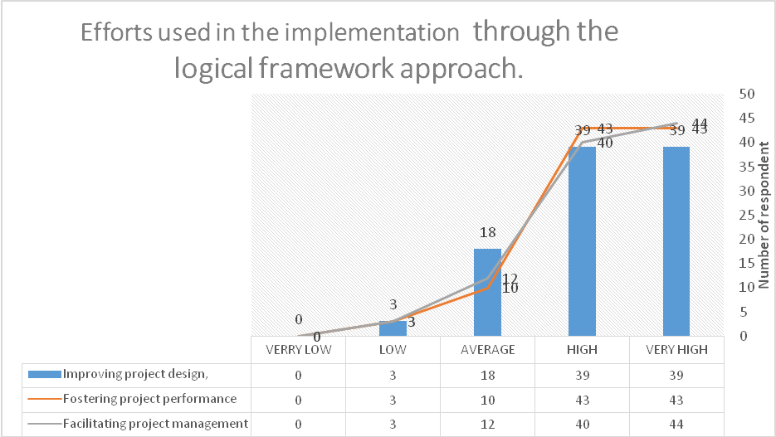

**Figure 4.7: Efforts used in the Implementation through the Logical Framework Approach**

More so, use of the M&E logical framework help to facilitate project management as revealed by the respondents; that is, Average score was 12, High was 40 and Very High 44, Low score was 3, and Very Low zero (0). The three scenarios indicate big number (96 out of 99) of respondents have agreed that use of M&E logical frame work has significant advantages that improve (effectiveness) project design, foster project performance, and facilitate project management. So, programmers for programs/projects are advised to use the ME Logical framework approach because of its significant advantages.

**Disadvantages Encountered if M&E through LF is not used:** A situation analysis conducted, refer Table 4.5, 4.6 and Figure 4.4 and 4.5 (just below here) arising from QS-15 indicate an unbearable situation (negative [high]) of a total average of the following categories: Vague planning, Absence of time dimension, and Improper use and static nature of the Log frame (93/99=94%0) born by or arising from non-use of M&E through LF. For the initial inquiry, M&E challenges encountered if Logical framework (LF) approach is not used during implementation of disaster preparedness and response in refugees’ camps; the following table was drawn from data collected from respondents.

**Table 4.8: Disadvantages Encountered if M&E through LF is not Used**

|  |  |  |  |  |  |  |
| --- | --- | --- | --- | --- | --- | --- |
| **Key informant, Private sectors, GVT Official, Community** | Very Low | Low | Average | High | Very High | Total |
| Vague planning, | 1 | 0 | 14 | 37 | 47 | 99 |
| Absence of a time dimension, | 4 | 12 | 30 | 35 | 18 | 99 |
| Improper use and static nature of the log frame | 0 | 1 | 23 | 32 | 43 | 99 |

**Source**: researcher, 2020

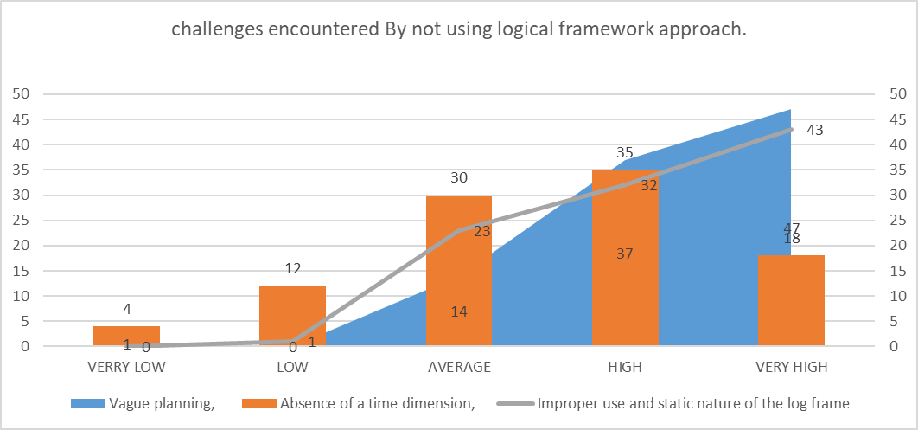

**Figure 4.8: Challenges Encountered if M&E through LF is not Used**

The above data table from which the Graph/Chart is drawn shows that efforts exerted without using the M&E logical framework does not improve the project because there will be no sound plans, thus vague plans. Respondents confirmed this when the scores revealed that there will be vague plans as follows:

Average was 14, High 37 and Very High 47, Low zero (0) and Very Low was one (1). In the case of Absence of a time dimension, Respondents indicated that non-use of M&E logical frame work the program will fail to be evaluated because any evaluation is based on time factor. The scores for ‘Absence of a time dimension’ are: Average score was 30, High score was 35) and Very High is 18, Low score were 12 and Very Low were four (4). Again, non-use of the M&E logical framework managed to prove that the improper use and static natureof the tool may lead to big damage to any project or program. Respondents had Average score of 23, High score of 32 and Very High 43, while Low score had one (1) respondent and Very Low was zero (0).

From these scenarios a big number of respondents scored significantly from average on all the three: Vague planning (98/’99), Absence of time dimension (83/99), and Improper use and static nature of the LF (98/99); indicating that they have agreed that non-use of M&E logical frame work will result to poor: project planning, management and performance; an overall average of poor results of 93%. This leads to poor decision-making; hence hindrance to good project performance; which can or may lead to conflicts. Programmers for programs/projects are advised to use the M&E –LF.

**4.3.3 Specific Objective Number Three**

To assess the impact(s) of monitoring and evaluation system/approach through the Logical frameworks on services/support made by different organizations (implementing partners [IPs]) in the community around refugees areas. The analysis prove the following result.

**Impact from use of ME and Logical Frame (LF) Work Approach during Disaster Preparedness and Response to the Community/Area around Refugees’ Camps:** M&E logical framework use impacts Community high level categories-ME and Logical frame (LF) work approach use impacted positively and substantially disaster preparedness and response to the community/area around refugees’ camps. Data (in bracket from average to very high) collected evidence this in the respective community categories of: economic 99%(98/99), social 96%(95/99), cultural 99%(98/99), political 97%(96/99), and environment 100%(99/99).

**Table 4.9: Impact from use of M&E with Logical Frame**

|  |  |  |  |  |  |  |
| --- | --- | --- | --- | --- | --- | --- |
| Impact resulting from the use of logical frame in the following categories | Very Low | Low | Average | High | Very High | Total |
| Economic | 1 | 0 | 14 | 37 | 47 | 99 |
| Social | 0 | 4 | 37 | 35 | 23 | 99 |
| Cultural | 0 | 1 | 23 | 32 | 43 | 99 |
| Political | 0 | 3 | 17 | 34 | 45 | 99 |
| Environmental | 0 | 0 | 13 | 27 | 59 | 99 |

**Source**: researcher data, 2020

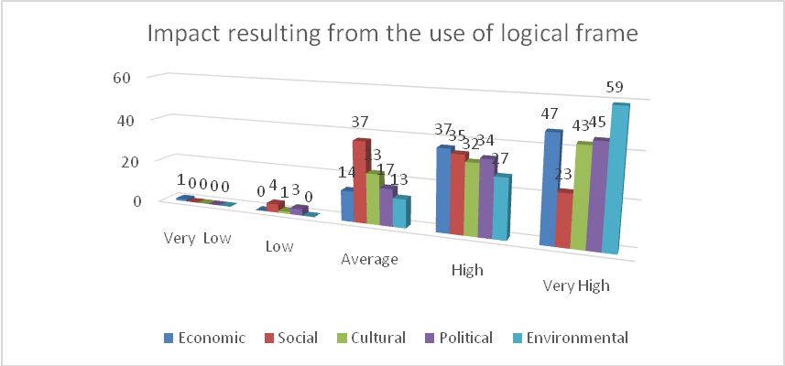

**Figure 4.9: Impact of Resulting from the Use of Logical Frame**

**Impact Resulting from Non-Use of ME and Logical Frame (LF) Work Approach during Disaster Preparedness and Response to the Community/Area around Refugees’ Camps**

**(a) Livelihood Impacts Results from Non-Use of M&E Logical Frame**

The study also checked the effect of non-use of ME through the LF to reveal impacts based on respondent’s feelings and responses to the five high level community livelihood categories of: Economic, Social, Cultural, Political and Environmental. The table below and graph/chart reveal significant/substantial low (negative impacts as opposed to use of ME and LF) impacts for non-use of the Logical Frame work approach tool to projects and programs.

**Table 4.10: Livelihood Impacts Results from Non-Use of M&E Logical Frame**

|  |  |  |  |  |  |  |
| --- | --- | --- | --- | --- | --- | --- |
| **Impact resulting from non -use of logical frame work approach in the following categories** | Very Low | Low | Average | High | Very High | Total |
| Economic | 37 | 47 | 14 | 1 | 0 | 99 |
| Social | 35 | 30 | 25 | 9 | 0 | 99 |
| Cultural | 38 | 43 | 15 | 3 | 0 | 99 |
| Political | 34 | 45 | 18 | 2 | 0 | 99 |
| Environmental | 27 | 59 | 13 | 0 | 0 | 99 |

**Source:** Research data, 2020

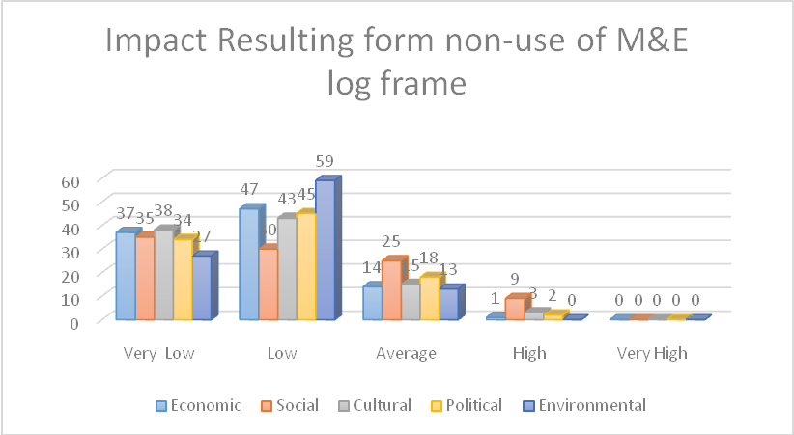

**Figure 4.10: General Impacts Resulting from Non-Use of M&E Logical Frame**

From the above Table and Graph/Chart 8, one sees that through non-use of M&E logical frame work prove projects end with poor results because community change to positive side was significantly low; refer to the following explanation(s) on the respective categories: On economic respondents scored: Average 14, High one (1) and Very High was zero (0), but Low scored at 47 and Very Low 37. The Social aspect scored: Average at 25, High 9, Very High was zero (0 while Low scored 30 and Very Low was 35.

The Cultural category had: Average score of 15, High 3, Very High zero (0), while Low score was 43 and Very Low was 38. Political matters scored: Average 18, High 2 and Very High zero (0), while Low score only 45 and Very Low 34. The Environment continuum had an Average score of 13, both High and Very High had zero (0), while Low score 59 and Very Low was 27. Therefore, Respondents indicated substantial impacts (see figures in bracket) on the lower ebb (Low and Very Low) as opposed to use of M&E through use of LF on the five high level community livelihood categories of: Economic (84/99), Social (65/99), Cultural (81/99), Political (79/99) and Environmental (86/99). Refer table 14 and graph 11 to confirm the significant/substantial low (negative impacts as opposed to use of ME and LF) impacts for non-use of the Logical Frame work approach tool to manage projects and programs.

**Specific Sectors –effect/ Impact through use of M&E Logical Framework:** The researcher conceived an idea of testing the effect of specific sectors from the use of the Logical frame tool. In this area, nine specific sectors were identified, these are; access to food, Job opportunities, Business opportunities, Access to water, Education opportunities, Humanitarian assistance, Market opportunities, Medical services and Governance. The table and graph/chart revealed the following results.

**Table 1.11: Impacts of M&E with Logical Framework Use to Specific Projects**

|  |  |  |  |  |  |  |
| --- | --- | --- | --- | --- | --- | --- |
| Positive Impact Associated with the use of M&E Logical frame work by different organizations in community around Refugees. | Very Low | Low | Average | High | Very High | Total Population |
| Access to food | 5 | 11 | 22 | 32 | 29 | 99 |
| Job opportunities | 0 | 3 | 26 | 40 | 30 | 99 |
| Business opportunities | 2 | 16 | 21 | 37 | 23 | 99 |
| Access to water | 3 | 13 | 33 | 47 | 3 | 99 |
| Education opportunities | 0 | 11 | 23 | 35 | 30 | 99 |
| Humanitarian assistance | 2 | 12 | 27 | 32 | 26 | 99 |
| Market opportunities | 0 | 13 | 27 | 32 | 27 | 99 |
| Medical services | 0 | 17 | 30 | 40 | 12 | 99 |
| Good governance | 0 | 0 | 16 | 49 | 34 | 99 |

**Source:** Research data, 2020

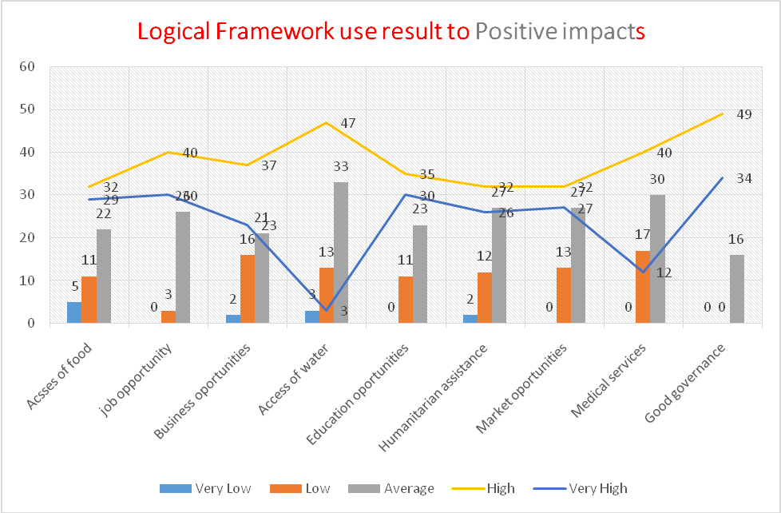

**Figure 4.11: Impact of M&E Logical Framework Use to Projects**

From above Table 4.11 and Figure 4.9, they revealed that through the use of M&E logical frame work there is equally significant positive impacts on the project because the projects end up with higher results and community change to positive side are high; refer to the following respondent’s results. Scores stand at: Access of food- Average score was 22, High 32, Very High 29, Low score was 11 and Very Low was five (5). For Job opportunities, Average score was 26, High was 40, Very High stood at 30, Low at 3 and Very Low was zero (0).

The sector for Business opportunities also indicated substantial positive scores as follows- Average score was 21, High score stood at 37, Very High at 23, while Low score 16 and Very Low was two (2). Access to Water manifested Average score as 33, High score was 47 and Very High at 3, Low score was 13 and Very Low was three (3). Education opportunities scores were: Average 23, High 35, Very High 30, Low 11, and Very Low was zero (0). Humanitarian assistance scores stood at: Average 27, High 32, Very High 26, Low 12 and Very Low was two (2). Market opportunities had the following scores: Average 27, High 32, Very High 27, Low score 13 while Very Low was zero (0). Respondents on Medical services scored as follows: Average at 30, High 40, Very High 12, Low 17 and Very Low was zero (0). Good governance-scores were: Average 16, High 49, Very High are 34, while both Low and Very Low scores were (0).

From the above scores per range, the researcher curiosity divided the scores into two: Low and High (which included the average); the respondents impacts in specific sectors from the use of the Logical framework tool/approach. In this area of the nine specific sectors, respondents responded as follows, figures in bracket: access to food (83/99), Job opportunities (96/99), Business opportunities (81/99), Access to water (83/99), Education opportunities (88/99), Humanitarian assistance (85/99), Market opportunities (86/99), Medical services (82/99) and Governance (99/99).

From the study it is evident that use of the Logical Frame work approach to projects and programs impacts are big/significant because of the timeline and periodical remedial measures in the inputs, outputs, that resulted to favorable outcomes and impacts at project/program levels

**Negative Impact(s) Associated to Non-Use of M&E Logical Frame (LF):** The study noted Increases of Negative impact(s) associated to non-use of M&E Logical Frame work by different organizations in the Community around Refugees. For the five (5) specific sectors evaluated, the results details are revealed in the following table and graph with respective explanations.

**Table 4.12: Negative Impact(s) Associated to Non-Use of M&E Logical Frame**

|  |  |  |  |  |  |  |  |  |  |  |  |  |  |  |
| --- | --- | --- | --- | --- | --- | --- | --- | --- | --- | --- | --- | --- | --- | --- |
| Negative impact(s) associated to non-use of M&E Logical Frame work by different organizations in the Community around Refugees. | | | | | Very Low | Low | | Average | | High | | Very High | Total Population | |
| Disrespecting culture/nationality | | | | | 0 | 15 | | 24 | | 28 | | 32 | 99 | |
| Land degradation | | | | | 0 | 8 | | 13 | | 41 | | 37 | 99 | |
| Loss of land to naturalized refugees | | | | | 0 | 7 | | 21 | | 32 | | 39 | 99 | |
| Gender based violence and sexual exploitation | | | | | 0 | 0 | | 27 | | 39 | | 33 | 99 | |
| Conflict and insecurity | | | | | 0 | 14 | | 25 | | 37 | | 23 | 99 | |
| |  | | --- | |  | |  |  |  |  | | |  | |  | |  | | |  |
|  |  |  |  |  | | |  | |  | |  | | |  |

**Figure 4.12: Impact(s) Associated to Non-Use of M&E Logical Frame (LF)**

From the above Table 4.12 and Figure 4.10 it is apparent that non-use, the M&E logical frame work increases the negative impact(s) on project(s) because projects/programs will not be forewarned through periodical emerging indicators (from a baseline or benchmark) leading to increased negative impacts and poor results in the community. In this case if: Very low was a baseline or a bench mark, the negative impacts by nature would increase because of failure to get periodical warning to help intervene. In this case therefore, non-use meaning absence of the LF approach will end up periodically with increased negative impacts from ‘Very Low’.

This is confirmed by all the cases of: Disrespecting culture/nationality the impacts increased progressively from/to: Very Low was zero (0), Low score was 15, Average stand 24, High score 28, and Very High 32; Land degradation, the impacts increased progressively from/to: Very Low was zero (0), Low score was 8, Average stand 13, High 41, and Very High 37. Loss of Land, also the impacts increased progressively from/to: Very Low was zero (0), Low score was 7, Average stand 21, High 32, and Very High 39. The same trend was also observed in the case of Gender based violence and sexual exploitation: the impacts increased progressively from/to: Very Low was zero (0), Low score was zero (0), Average stand 27, High 39, and Very High 33. The same trend was also observed in the case of Conflict and insecurity: the impacts increased progressively from/to: Very Low was zero (0), Low score was 14, Average stand 25, High 37, and Very High 23.

For the five (5) specific sectors evaluated, the results from the average score to very high were as follows: Disrespecting culture/nationality (84/99), Land degradation (91/99), Loss of land to naturalized refugees (92/99), Gender based violence and sexual exploitation (99/99), Conflict and insecurity (85/99). Therefore, Non-use of the M&E Logical framework approach increases the ‘Negative impacts” because there is no warning and remedial measures through progressive indicators in the respective LF levels of: input, output, outcome and impact.

**CHAPTER FIVE**

**OVERVIEW, FINDINGS.**

**5.1 Introduction of Chapter**

Chapter five presents a brief overview, summary of findings, conclusion and recommendations of the study about “Impact of Monitoring & Evaluation system on Disaster Preparedness & Response in communities around refugees’ in Tanzania”. The first part of this chapter is a brief overview, the second part is summary of the study that summarizes all findings of this study. The third part is the conclusion that gives issues which emerged during the study. The fourth part presents the recommendations related to the measures to be taken by implementing partners (IP) with the intention of impacting positively communities around refugees’ camps in Tanzania.

This research therefore established that "Monitoring &Evaluation system on Disaster Preparedness & Response impacts communities around refugees in Tanzania" The research briefly looked into the planning methods, approaches and tools on inputs and output processes (included secondary data); that led to further establish outcome(s) and impact(s); the approach used is the “Logical Framework in Monitoring & Evaluation system used on Disaster Preparedness & Response and impacts in communities around refugees in Tanzania"

**5.2 Overview**

This research/study has contributed to the body of knowledge on how the global scourge of refugees can be monitored for timely decisions. Global efforts through UNHCR and its implementing partners have worked for decades; but are working on “aftermath” that is “after event”. Refugees’ issues need firm approaches that result to positive impacts of international support bodies to reduce or avoid man made wars, ethnic, and tribal conflicts from whatever cause. Hence the researcher has contributed knowledge leading to that end.

A considerable number of items were covered by this study on the assessment of the impact of Monitoring & Evaluation system through a Logical framework approach on disaster preparedness & responses in Communities around refugees in Tanzania.This study assessed the impact of monitoring & evaluation system on disaster preparedness & responses; specifically, it describes the effectiveness of monitoring function and strategies used by Governments and organizations in implementing strategies, programs and projects, using monitoring and evaluation logical framework. Furthermore, the study explains the challenges faced by the Government and organizations’ of implementing without using logical frame work approach as their Monitoring and evaluation system approach.

The chapter intends to give pertinent conclusions borne out of the analysis and a discussion of the data used in the study; it also provides specific and practical recommendations for action from the findings and conclusions.

**5.3 Summary of the Findings**

The data collected, analyzed and discussion made in chapter four (4) by this study from all respondents (Key informant, Private sectors, GVT Official, community), reveal that Monitoring and Evaluation (ME) efforts used in the implementation of disaster preparedness and response in refugees’ camps through the logical framework approach impacts the Community.The study came up with several main findings. From the study design, the findings are grouped into the specific objectives and are characterized bytwo main score categories Low and High; [(Low=Low and Very Low); and (High= average, high and very high)].

**5.3.1 Specific Objective Number One**

To assess the adequacy of Monitoring & Evaluation system(s) and procedures in disaster preparedness and response in Community around refugees Tanzania.

**Findings include:**

a. **O**n IPs that use or not use M&E through the LF, **r**espondents to question showed IPs that use M&E through the LF are 64% of the total; and those IPs that do not use the M&E through the LF are 36%. The fact that non-use has substantial negative effectsthat can even affect exponentially the positive ones with 64% depending on the responsibilities vested on the particular IP; for example lead or head entrusted with governance. The study recommends/advises that all IPs need to use the M&E through the LF to avoid the effects of non-use.

b. For the ones that use, IPs Extent of use of M&E through the LF,

the respondents responses revealedtotal extent of use for very low and low is 24%; while high is 76% (from average to very high).Again, these can affect the other sectors which use (76%) exponentially and substantially depending on the responsibilities vested on the particular IP. The study recommends/advises that all IPs strive to fully use the M&E through the LF to avoid the substantial negative effects arising from partial use.

c. For Community Inclusion/Involvement/Engagement

The respective respondent’s total responses for community involvement/inclusion on the upper ebb-are fifty-one (51) while those on the lower ebb- are forty-eight (48); hence a thin margin of three (3); very close to 50%; indicating a scenario of “tossing a coin=whose results are either: Yes, or No”; which negated community inclusion/involvement on crucial issues; hence leading to negative impacts.

Community involvement or engagement to a lesser extent include giving its opinions, contributes funds, and provide/give workforce (notwithstanding the level of the amount; what counts is the desire for ownership). The study recommends that the community is involved in all livelihood sectors for program/project sustainability.

c, Reference to Gender: Inclusion, Age, status and Sex-and Respondents Characteristics

Refer Table for details of Gender and Age Category/Interval (Male 57% and Female 43%); also refer gander table for details of Gender Composition Demographically (population=99[males 57 and female was 42])

**5.3.2 Specific Objective Number Two**

To find out effectiveness of the Logical framework in Monitoring & Evaluation procedure and processes in the community around refugees in Tanzania.

For effectiveness of specific objective two

**Advantages of use of M&E through LF efforts used to implement the DPR, the** M&E logical framework - Efforts exerted using the M&E logical framework on ‘program/project improved program/project: design, performance, and management. All the three scenarios of program/project separately scored a total of: High 96; and Low was 3; that is (96 out of 99) 97% each. The score indicate that a big number of respondents have agreed that use of M&E logical frame work has significant advantages that improve program/project design, foster program/project performance, and facilitate program/project management. So, the researcher recommends/advises that programs/projects programmers use the ME Logical framework approach because of its significant advantages.

**Disadvantages/Challenges Encountered if M&E through LF is not used:** Data discloses disadvantages or challenges encountered if M&E through LF is not used On Challenges-From the three main challenges identified/scenarios a big number of respondents scored significantly from average on all as follows: Vague planning 99%(98/99), Absence of time dimension 84%(83/99), and Improper use and static nature of the LF 99%(98/99); indicating that they have agreed that non-use of M&E logical frame work result to poor program/project planning, management and performance. This also results to poor decision-making and hindrance to good program/project performance; which lead to conflicts.

**5.3.3 Specific Objective Number Three**

To assess the impact(s) of monitoring and evaluation system/approach through the Logical frameworks on services/support made by different organizations (implementing partners [IPs]) in the community around refugees areas.

1. Reference to Impact from use of ME and Logical Frame (LF) Work Approach during Disaster Preparedness and Response to the Community/Area around Refugees’ Camps
2. M&E logical framework use impacts Community high level categories-ME and Logical frame (LF) work approach use impacted positively and substantially disaster preparedness and response to the community/area around refugees’ camps. Data (in bracket from average to very high) collected evidence this in the respective community categories of: economic 99%(98/99), social 96%(95/99), cultural 99%(98/99), political 97%(96/99), and environment 100%(99/99).
3. Reference to interviews revealed Impacts Resulting from Non-Use of ME and Logical Frame (LF) Work Approach during Disaster Preparedness and Response to the Community/Area around Refugees’ Camps.
4. The M&E logical framework non-use impacts Community main livelihood categories. The study respondents’ results on the non-use of ME through the LF revealed very big or substantial impacts on the lower ebb. Respondents indicated substantial impacts
5. Refer to Specific Sectors –effect/ Impact through use of M&E Logical Framework
6. Findings on nine (9) specific livelihood sectors from the use of M&E and LF tool, the researcher curiosity also invited respondents to ascertain impacts in specific sectors from the use of the Logical frame tool. In this area, the nine (9) specific sectors responses were big/substantial. From the study it is evident that use of the Logical Frame work approach to projects and programs has positive impacts which are significant because of the timeline and periodical remedial measures in the input, output, outcome and impact of programs/projects at all levels.
7. Refer to Negative Impact(s) Associated to Non-Use of M&E Logical Frame (LF)
8. The M&E logical framework non-use impacts Community specific livelihood categories. The study noted substantial (high) Negative impact(s) associated to non-use of M&E Logical Frame work by different organizations in the Community around Refugees. For the five (5) specific sectors evaluated, the results from the average score to very high were as follows: Disrespecting culture/nationality 85%(84/99), Land degradation 92%(91/99), Loss of land to naturalized refugees 93%(92/99), Gender based violence and sexual exploitation 100%(99/99), Conflict and insecurity 86%(85/99). Therefore, Non-use of the M&E Logical framework approach result to and increases the ‘Negative impacts” because there is no warning and remedial measures through emerging progressive indicators in the respective LF levels of: input, output, outcome and impact.

**CHAPTER SIX**

**CONCLUSION AND RECOMMENDATIONS**

**6.1 Conclusion**

The study employed explorative research design to provide quick snapshot of what is going on with the variables of interest where Government officials, UN bodies (UNHCR), Private sector including NGOs, and Community around refugee’s camp were given an opportunity to be in the sample selected to provide information. Both primary and secondary information were used in this study. Primary data through questionnaire were analyzed using Statistical Package for Social Science Version 20 and the results were presented using tables and graphs/charts. The major argument being to what extent is the use of Logical framework approach impacting the community around refugee’s camp.

**Respective to the three study specific objectives; on study objective:**

1. That, Logical framework (LF) use in Monitoring & Evaluation is adequate in all mankind livelihood aspects.
2. The M&E with LF tool is effective because it is flexible in all programmatic requirements. Disciplined periodical data collection and interpretation is required to make timely decisions including leadership visionary and strategic plans for governments, organizations, and religious institutions because all use programs and projects to meet their desires.
3. The analysis of all responses revealed that, majority proved that use of Logical framework has potential and substantial impacts (refer 5.2)to different levels of projects and programs; and more so in this study case of Communities around refugee’s camps in Tanzania. All respondents through questionnaires have proved that monitoring & evaluation (M&E) impacts refugees’ disaster preparedness & response in community around refugees’ camps Tanzania.

Therefore, the Government and organizations (IPs) and even religious institutions are advised to use the M&E system with the Logical framework (LF) approaches/tool to make/facilitate projects and programs periodical assessment to: plans, management, and leadership for sound decision purposes; the approach is always flexible and on a timeline basis because it is based on: input, output, outcome and impact; so when the Government and organizations prefer to use it relevant interpretations including predictions are feasible in any working environment including governance.

1. Non-use of the Monitoring and Evaluation through the logical framework (M&E with LF) lands any office, program/project to undesired situations (negative impacts) including conflicts and disasters at a terminal stage. The M&E with LF serves as a warning to all office bearers of governments, organizations including UN bodies and religious institutions.

**6.2 Recommendations**

Recommendations are advises arising from the study findings to respective Stakeholders, Academic institutions, Leadership, and Community with a view to take appropriate action to remedy the: 1) current situation, 2) future-through visionary actions including strategic plans and 3) as a reference for further studies of the uncovered research gaps. The recommendations herein are targeting to benefit all refugees stakeholders, academic institutions, and organizations in respective sectors. In this case the respective government, organization, and community are required to take responsibilities in order to implement all the recommendations to ensure a health status of the respective/target; that is community, organization, or office.

**The Study Main Recommendation is the Use of M&E and Logical Framework**

The Study Has Come Up with One Main Recommendation, and other Five (5) Specific Recommendations.

**6.2.1 Main Recommendation**

The study recommends use of M&E and Logical Framework to projects and programs because of its flexible nature and effectiveness. Monitoring and Evaluation (ME) efforts used in the implementation of disaster preparedness and response in refugees’ camps through the Logical framework approach impacted substantially the Community around refugees’ camps. Hereunder are impacts in the respective specific objectives.

**6.2.2 Specific Recommendations**

The study has five (5) specific recommendations that:

1. For specific objective one(1), if M&E and Logical Framework tool/approach is used well, there are significant advantages that improve project design, foster project performance, and facilitate project management; hence leadership. Specifically, and to mention a few, it results to: high level of trust, sharing of information, community involvement/engagement, transparence, good change management with visionary thinking and good future projections; further, there shall be no conflicts and tension; neither working in silos. So, governance issues are enhanced to avoid conflicts. Therefore; the researcher recommends/advises the government, community, organizations, even religious bodies to use the ‘Monitoring and Evaluation through the Logical Framework tool/approach (M&E and LF) to reap its potential.
2. Respective to specific objective two (2), the flexible nature of the M&E and Logical Framework tool/approach it can be used at the levels of: input, output, outcome, and impact; it therefore requires a strong commitment of all responsible stakeholders: government, community, organizations, and people/staff at all levels from the community to leadership where policies are hatched. Resources are not given to non-effective or non-performing organs Non-use of M&E and Logical Framework tool/approach for any one including community through leadership is that there will be vague plans and lack of time dimension leading to failure; the results are clear from the study. More so, with full knowledge of the M&E and Logical Framework (LF) tool/approach, no one, government, organization, or community will commit resources because plans will not be realized.

**For objective number three (3)**

1. The study discovered that there are abundant positive livelihood impacts and recommends that organizations, government, offices and even religious institutions to use the ‘monitoring and evaluation through the logical framework to reap the positive livelihood impacts.
2. Also, the study discovered that IPs to the extent of 36% did not use the M&E LF; and the fact that non-use has substantial negative impacts; can even affect substantially the ones that use (64%) depending on the responsibilities vested on the particular IP; for example lead or head entrusted with governance. The study recommends/advises that all IPs need to use the M&E through the LF to avoid the substantial negative impacts/effects arising from non-use.
3. The study also discovered that IPs that do not use fully the M&E LF can affect respective sectors exponentially. 24% of the IPs used the approach below average; and this can even affect substantially the ones that had 76% extent of use depending on the responsibilities vested on the particular IP; for example lead or head entrusted with governance. The study recommends/advises that all IPs strive to fully use the M&E through the LF to avoid the substantial negative impacts/effects arising from partial use.

**6.3 Areas For Further Study**

The study has come up with five (5) areas for further studies detailed from (i) through (v). The research results are based on the community hosting refugees at Kigoma region, Kasulu district, Nyarugusu area around refugees’ camps; which is bordering with refugees countries of origin-Rwanda, Burundi, and Congo; and the respective implementing partners lead by UNHCR in Tanzania.

1. Because the M&E and Logical Framework tool/approach is not country/ community/organization/office specific, other researchers can conduct comparative studies with a view to help neighboring/bordering countries to Tanzania and other stakeholders (IPs) to improve livelihood; avoid conflicts leading to disasters with emerging refugees.
2. It is further recommended/suggested that researchers can extend globally and country specific studies related to reasons giving rise to refugees. The need is confirmed by international community/organizations as: (a)Reference made to Participants at “The 2017 Global Humanitarian Policy Forum at the UN in New York. Credit: UNOCHA/Paolo Palermo, UNOCHA had “Five action to move humanitarian closure to the 2030 agender no v relates critically with this study; “Do more to prevent crises”, (b) The ‘World Development Report (2011)’ expressed particular concern about the operational performance of both UNHCR and a number of implementing NGOs. One problem identified was the way UNHCR selected NGOs and assigned tasks, citing instances of duplication of tasks leading to confusion and tension between the various NGOs and UNHCR, (c) Fatmata Lovetta Sesay (2002, vol.21) commented that “…the most vulnerable people, deserve special attention; they are the visible sign of broader problems which must be addressed if we are to continue working successfully towards peace and sustainable development”. UNOCHA/OCHA-“Central to discussions was the recognition that achieving the 2030 Agenda will require continued, significant effort to adapt the international aid system, particularly to facilitate better connectivity between humanitarian and development action. As David Miliband, President and CEO of the International Rescue Committee, said:

*“The humanitarian sector has extraordinary entrepreneurialism, bravery and effectiveness…but relies on heroism rather than effective systems… We need major change: we need to redefine the humanitarian system, as well as revitalize it, because we are living in a world where refugees are displaced for more than 10 years, where 60 per cent of refugees are kids.” Participants repeatedly emphasized the importance of investing more in prevention and of finding political avenues to end conflicts. As David Miliband put it: “I am deeply alarmed by the crisis of diplomacy. At this year’s General Assembly, where was the all-night session to end the conflict in Yemen? It takes politicians to stop the killings…The reason 65 million people are fleeing for their lives is a crisis of diplomacy.”*

1. Also, because the LF tool/approach is flexible, can be specific to: projects, organizations and offices, so, studies/researches can be conducted that target: design, performance, management, and leadership; referring to governance.
2. Community involvement-is also an area for further study in the sense that community will be aggressive in its programs if it is well engaged at all levels of: input, output, outcome, and impact. So, Community engagement or involvement may include: opinions, workforce (labor), and money (funds) to a lesser extent. The data collected revealed how the community was engaged in just one aspect of giving its opinions on the interventions undertaken; also supporting the issue of vague planning.
3. Another area of further study/research is where an IPs does not use fully the M&E LF can affect respective sectors exponentially. From this study, if 24% of the IPs used the approach below average; these can affect substantially the ones that had 76% extent of use depending on the responsibilities vested on the particular IP; in this case the 24%. For example if the IP is the lead or head entrusted with governance; this means that the project or program will be led by a myopic official. The researcher recommends/advises further research/study on impacts of partial use of the M&E through the LF for an IP entrusted with sensitive responsibilities like governance and its impact/effect to avoid substantial negative impacts/effects to other IPs.

**REFERENCES**

Ashery, M. (2015). Strategies Put in Place to Mitigate Disaster Risks, Tanzania *Daily News* 10/02, pp 4, 2015.

Berlatsky, N. (2017). The Western belief that refugees are a burden is the root cause of today’s global crisis. Retrieved on 12th April, 2020 from; https://qz.com/1063280/the-western-belief-that-refugees-are-a-burden-is-the-root-cause-of-todays-global-crisis/.

Bryman. A. (2012), *Social Research Methods*, (4ed). Paperback: Amazon.

Cresswell, J. W (2012). *Education Research: Planning, Conducting and Evaluating Quantitative and Qualitative Research*, 4th Ed.  Boston: Pearson Education.

Education for all: The 2000 Assessment Report, Dar es salaam, Tanzania.

# Feeny, E. (2017). From Early Warning to Early Action in Somalia: What can we learn to support early action to mitigate humanitarian crises? Discussion paper, OXFAM.

Fisher, M. & Mwase, N. (2011). Evaluation report Tanzania: Strengthening National Disaster Preparedness and Response Capacity - End of Programme. Unicef.

Gall, M. D., Gall, J. P. & Walter, R. B. (2007). *Education Research: An Introduction*, 8th Ed., New York: Pearson Education, Inc.

Green, A. (2015). Violence in Burundi triggers refugee crisis. *World Report,* 386(9994), 639-640.

Hooper, K., Desiderio, M. V. & Salant, B. (2007). Improving the Labour Market Integration of Migrants and Refugees, paper produced for the Partnership on Inclusion of Migrants and Refugees, part of the Urban Agenda for the EU.

Hugo, S. (2012). IASC Real-Time Evaluation of the Humanitarian Response to the Horn of Africa Drought Crisis in Somalia, Ethiopia and Kenya Synthesis Report, Inter-Agency Standing Committee, IASC.

Karen F. A. & Auspos, C. (2006). Community Theories, Practice and Evidence. Washington DC: Aspen Institute.

Kothari, C. R (2011), *Research Methodology Methods and Techniques Pub*. Delhi India: New Age International (P) LTD.

Kristoffer, A. G. (2013). Exploring the impacts of refugee camps on host communities: A case study of Kakuma host community in Kenya. Unpublished masters thesis, University of Agder, Kristiansand, Norway.

Larseru, S. (2009). Electoral violence - early warning tools. Consoldated replies. Retrieved on 12th May, 2020 from; http://aceproject.org/electoral-advice/archive/questions/replies/23249516.

Lincoln, B. & Killam, J. (2013). ASC Real-Time Evaluation of the Humanitarian Response to the Horn of Africa Drought Crisis in Somalia, Ethiopia and Kenya.

Maxwell, J. A. (2005). *Qualitative Research Design. An Interactive Approach*. London: Sage Publications Inc.

Misachi, J. (2017). The Great Lakes Refugee Crisis, *WordAtlas* on April 25th 2017.

Mnangagwa, E. D. (2017). Mnangagwa-s-full-statement, *Dairynews*, on 21st November, 2020.

Naing, M. (2017). Early Warning Characteristics of Monitoring and Evaluation Systems on the “Functionality” of Municipal Service Delivery Processes. Unpublished PhD thesis, University of the Witwatersrand, Johannesburg, South Africa.

Peercy C. L. (2013). *Burundi. In: Local Leadership in Democratic Transition. Rethinking Peace and Conflict Studies*. London: Palgrave Macmillan.

# Sesay, F. L. (2002). The most vulnerable people in society deserve better from us, *Nurs N Z.,* 19(3), 43.

Simon, B. (2009). Rwandan refugees pushed to return to a home they consider unsafe. Contribution, Nakivale Refugee Camp & Kampala, Uganda.

Tingum, E. N. (2015). Planning for Monitoring and Evaluation. Lesson 1 Basic Concepts on M&E and Definitions. The Open University of Tanzania, Department of Economics, Dar es Salaam, Tanzania.

UNHCR, (1997). Social and economic impact of large refugee populations on host developing countries Social and economic impact of large refugee populations on host developing countries, Standing Committee, (paper, EC/47/SC/CRP.7.

Uvin, P. (1999). Ethnicity and Power in Burundi and Rwanda Violence, *Comparative Politics,* 31(3), 253-271.

World development report, (2011). The Impacts of Refugees on Neighboring Countries: A Development Challenge.

**APPENDICES**

**APPENDIX 1: QUESTIONNAIRES**

"Impact of Monitoring & Evaluation system on Disaster Preparedness & Response in communities around refugees in Tanzania"

|  |  |  |
| --- | --- | --- |
| **STATUS** | **NAME** | **Phone #s** |
| Supervisor |  |  |
| Scholar: | Emmanuel Z Mughamba | +255786397259 |
| Enumerator code [EC-0x] |  |  |

*This questionnaire is targeting THE IMPLIMENTERS OF DISASTER PREPAREDNESS AND RESPONSE SERVISES with institution (and secondary information) memory regarding refugees in Kigoma region; and in particular Kasulu district in the years 1972 to-date (that is 2018).*

[Enumerator] Use this guide to introduce yourself and the purpose of the study.

My name is (….….………… ………………….) I am a colleague/friend/ to one studying at the Open University of Tanzania. Please, can I talk to you/ can you fill this questionnaire.

The purpose of this study is to get information in your: office/area as staff or community member(s) who has/have ample memory and knowledge (both institution and secondary) of the people or community in Tanzania at Kigoma region, Kasulu district and in particular your area who have been afflicted or impacted (positively or negatively) by the refugee disaster in neighboring countries like Rwanda, Burundi and Congo.

This study is free from duress and information you give will be kept confidential; it will not be released to whoever. The information you give will be used to prepare a scholarly report which does not mention any name of the respondent. Therefore, in no way can any person know that you gave such information.

If you please, I request that you provide time (of about 25 minutes) for this study/interview. If one has agreed check the box. By tick [√]

Please do not suggest in any way that the results of the study will lead to getting any provisions because it will bias the study results.

Demographic Information

|  |  |  |  |
| --- | --- | --- | --- |
| QS-01 Study date:  ___/___/___  *(DD/MM/YYY)* | QS-02 Village name _________ | QS-03 # Ward  ___________ | QS-04: # Name…………………………  Mob. #...................................... |

|  |  |  |  |  |
| --- | --- | --- | --- | --- |
| QS-05 | QS06 | QS-07 | QS-08 | QS-09 |
| Name | Tribe | Gender | Age/Date of birth | Nationality/Naturalized |
|  |  |  |  |  |

|  |  |  |
| --- | --- | --- |
| QS-10 | **Which education level did you (respondent) reach?**  0 = Did not attend school,  1 = Pre-school,  2 =Primary School 1-4  3 = Primary School 5-7;  4 =Secondary Education-Form 4  5 =Secondary Education-Form 6  6 =Vocational college  7 =College/ University college;  8 =I do not know |  |

The following statements and or questions relate to your understanding, perceptions and expectations about “disaster preparedness & Response” issues, and or the service offered by the Ministry of Home Affairs (MHA) and its Partners. Rate or rank your agreement with each of the statement by using the scale of 1-5; also, as provided in the tables below. Put the Number OR Letter that corresponds best to your answer. And also suggest as per question needs.

|  |  |  |
| --- | --- | --- |
| QS-11 | Measurement of the organization on the use logical frame work (Adequacy) | |
| I | Does your organization use M&E logical frame work? Yes/ No |  |
| II | If Yes, to what extent? | |
|  | (Rank bellow); Rank:1=(VL)-Very Low, 2=(L)-Low, 3=(A)Average, 4=(H)-High, 5=(VH)-Very High/(Excellent) |  |

|  |  |  |
| --- | --- | --- |
| QS-12 | Measure the present stakeholders’ Community inclusion in any GVT & NGOs activities in programs /projects concerning disaster preparedness and responses in refugees’ camps. (Adequacy) | |
|  | (Rank bellow); Rank:1=(VL)-Very Low, 2=(L)-Low, 3=(A)Average, 4=(H)-High, 5=(VH)-Very High/(Excellent) | |
| I | How often do stakeholders’ give their opinions? |  |

|  |  |  |
| --- | --- | --- |
| QS-13 | Measure the present Gender inclusion in any activities in programs/projects concerning disaster preparedness and responses in refugees’ camps. (Adequacy) | |
|  | (pick number and rank bellow); Rank:1=(VL)-Very Low, 2=(L)-Low, 3=(A)Average, 4=(H)-High, 5=(VH)-Very High/(Excellent) | |
| I | Total population |  |

|  |  |
| --- | --- |
| QS-14 | How do you rank Monitoring and Evaluation (ME) efforts made by different organizations in implementation of disaster preparedness and responses in refugee’s camp through use of logical framework approach? : (Effectiveness) |
|  | (pick number and rank bellow); Rank:1=(VL)-Very Low, 2=(L)-Low, 3=(A)Average, 4=(H)-High, 5=(VH)-Very High/(Excellent) |
|  | * Improving project design, |
|  | * Fostering project performance |
|  | * Facilitating project management |

|  |  |  |  |  |
| --- | --- | --- | --- | --- |
| QS-15 | | Rank to what extent are/have the following items been encountered as challenges during implementation of disaster preparedness and responses in refugees’ camps; By not using logical framework approach. (Effectiveness)  (pick number and rank bellow); Rank:1=(VL)-Very Low, 2=(L)-Low, 3=(A)Average, 4=(H)-High, 5=(VH)-Very High/(Excellent) | | |
|  | | * Vague planning, | | |
|  | | * Absence of a time dimension, | | |
|  | | * Improper use and static nature of the logframe . | | |
| QS-16 | Impact resulting from the use of logical frame  (Rank bellow); Rank:1=(VL)-Very Low, 2=(L)-Low, 3=(A)Average, 4=(H)-High, 5=(VH)-Very High/(Excellent) (Impact) | | |
|  | Economic | |  |
|  | Social | |  |
|  | Cultural | |  |
|  | Political | |  |
|  | Environmental | |  |

|  |  |  |
| --- | --- | --- |
| QS-17 | RANK POSITIVE IMPACT ASSOCIATED WITH THE USE OF M&E LOGICAL FRAME WORK BY DIFERRENT ORGANISATION IN COMMUNITY AROUND REFUGEES (Impact) | |
|  | (pick number and rank bellow); Rank:1=(VL)-Very Low, 2=(L)-Low, 3=(A)Average, 4=(H)-High, 5=(VH)-Very High/(Excellent) | |
| I | Accesses of food |  |
| II | job opportunity |  |
| III | Business opportunities |  |
| IV | Access of water |  |
| V | Education opportunities |  |
| VI | Humanitarian assistance |  |
| VII | Market opportunities |  |
| VIII | Medical services |  |
| IX | Good governance |  |

|  |  |  |
| --- | --- | --- |
| QS-18 | NEGATIVE IMPACTs ASSOCIATED WITH THE USE OF M&E LOGICAL FRAME WORK BY DIFERRENT ORGANISATION IN COMMUNITY AROUND REFUGEES (Impact) | |
|  | (pick number and rank bellow); Rank:1=(VL)-Very Low, 2=(L)-Low, 3=(A)Average, 4=(H)-High, 5=(VH)-Very High/(Excellent) | |
| I | Disrespecting culture/nationality |  |
| II | Land degradation |  |
| III | Loss of land to naturalized refugees |  |
| IV | Gender based violence and sexual exploitation |  |
| V | Conflict and insecurity |  |

|  |  |
| --- | --- |
| QS-19 | Is there any other information you would like to add to this scholarly study? (Other) |
|  | 1. 1; YES 2; NO |
|  | 1. If yes give details below. |
|  |
|  |

End/Finishing:

Dear Respondent, thank you for your time and the responses you have made; I wish you well and may God bless you.

**APPENDIX 2: TIMELINE OF REFUGEES' INCIDENCES IN NEIGHBORING COUNTRIES WESTERN TANZANIA**

**Table 1a: Refugees Timeline Events**

|  |  |  |  |  |  |  |  |  |  |
| --- | --- | --- | --- | --- | --- | --- | --- | --- | --- |
| Table 1:B |  |  |  |  |  |  |  |  |  |
|  |  |  |  |  |  |  |  |  |  |
|  | TIMELINE OF REFUGEES' INCIDENCES IN NEIGHBORING COUNTRIES WESTERN TANZANIA | | | | | | | | |
|  |  |  |  |  |  |  |  |  |  |
|  |  | Disaster/Conflict events- Refugees' -Indicator Tracking Table (DITT/CITT) | | | | | | |  |
|  |  |  |  |  |  |  |  |  |  |
| Country\Timeline | B/f < 1955 | 1956-1965 | 1966-1975 | 1976-1985 | 1986-1995 | 1996-2005 | 2006-2015 | 2016-2025 | Total |
|  |  |  |  |  |  |  |  |  |  |
| Rwanda |  | 2 | 2 |  | 3 |  |  |  | 7 |
| Burundi |  | 1 | 2 | 1 | 2 | 1 | 1 | 1 | 9 |
| Democratic Republic of Congo |  |  |  |  |  | 1 |  |  | 1 |
|  |  |  |  |  |  |  |  |  |  |
|  |  |  |  |  |  |  |  |  |  |
| Webs (few) for reference for above data | | | |  |  |  |  |  |  |
|  |  |  |  |  |  |  |  |  |  |
| http://www.bbc.com/news/world-africa-13087604 | | | | |  |  |  |  |  |
| http://courses.wcupa.edu/jones/his311/timeline/t-rwanda.htm | | | | | |  |  |  |  |
| http://www.dw.com/en/crisis-in-burundi-a-timeline/a-18446677 | | | | | |  |  |  |  |
| http://combatgenocide.org/?page_id=893 | | | |  |  |  |  |  |  |
|  |  |  |  |  |  |  |  |  |  |

*Table 13: Refugees population by territory.*

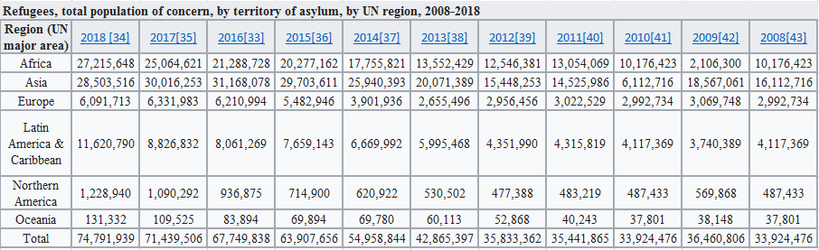

Ref; https://en.wikipedia.org/wiki/Refugee_crisis

**APPENDIX 3: LIST OF MAPs**

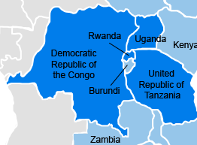

***Map no: 1***

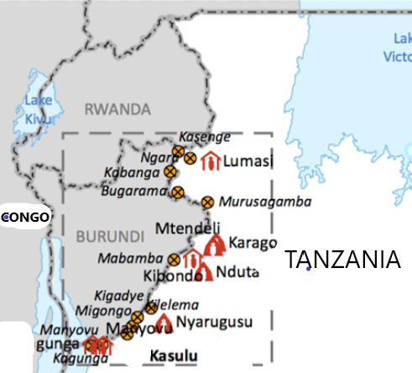

***Map no: 2***