ASSESSMENT OF TENURE SECURITY AND COMPULSORY LAND ACQUISITION MECHANISMS IN PERI-URBAN AREAS OF DODOMA CITY: A CASE OF MSALATO AND NG’HONG’HONA

YUSTINA KAKAY AMO

A DISSERTATION SUBMITTED IN PARTIAL FULFILMENT OF THE REQUIREMENTS FOR DEGREE OF MASTER OF ENVIRONMENTAL HEALTH SCIENCE (MES-HEALTH)
DEPARTMENT OF ENVIRONMENTAL STUDIES
OF THE OPEN UNIVERSITY OF TANZANIA

2020

CERTIFICATION
The undersigned certifies that he has read and does hereby recommend for acceptance by The Open University of Tanzania a dissertation titled; “Assessment of tenure security and compulsory land acquisition in peri-urban areas of Dodoma City, a case of Msalato and Ng’hong’hona,” in partial fulfillment of the requirements for the degree of Master of science in environmental studies of the Open University of Tanzania.

…………………………………..
Dr. James Kisoza
(Supervisor)

……………………………
Date

COPYRIGHT
No part of this research dissertation may be reproduced, stored in any retrieval system, or transmitted in any form or by any means, be it electronic, mechanical, photocopied, recorded or otherwise without the prior permission of the author or the Open University of Tanzania in his behalf.

DECLARATION
I, Yustina Kakay Amo, do hereby declare to the senate of The Open University of Tanzania, that this is my own original work and that to the best of my understanding it has not been presented before, anywhere for any purpose or for a degree or similar award at any other university.

……………………..…....
Signature

……………………..…....
Date

DEDICATION
This piece of work is dedicated to my dear husband Philip together with our beloved children Dorcas, Paul and Grace who missed my presence for sometimes, and were fully dedicated into prayer for my success.

ACKNOWLEDGEMENT
The production of this piece of work, is a result of contributions from many people whose financial and in-kind contributions have made this work a success. First of all, I would like to thank God, the father of my Lord and Saviour, Jesus Christ for his grace and continuous care to my life and this work in particular.

Second I sincerely thank Dr. J. Kisoza for his tireless support of this work since the inception of an idea, up to this point of submitting a dissertation report. My due gratitude is also extended to the coordinator of our program and the entire community of Open University of Tanzania, for their cooperation to my studies in the whole period of my registration as a student in this University. Land officer and the town planner for Dodoma city Council, together with community members in Msalato and Ng’hong’hona, disserves my appreciation for their remarkable cooperation during data collection process.

Special appreciation goes to my sweet husband, Philip and our children who offered me not only financial support to cater for my studies’ costs, but were always there with me for encouragement and sympathy. I will always appreciate you all for leaving your remarkable footprints in my academic journey.

ABSTRACT
The study imed at assessing tenure security in the context of implementation of the compulsory land acquisition (CLA) process Msalato and Ng’hong’hona wards in Dodoma city. It was specifically aiming at examining the role of various actors involved in tenure security matters, examining how CLA was implemented, and examining how institutional and legal frameworks was applied in safeguarding tenure security for landholders during CLA implementation. Crosse-sectional survey is a research approach that was chosen to undertake this study. A combination of purposive sampling, multistage sampling, proportional sampling and simple random sampling were used to draw a study sample. In data collection process, observation, focus group discussions and interview were used while analysis was done by the use of SPSS software. The information obtained show that tenure insecurity has been contributed by many factors including failure of some actors in protecting property rights; low levels of awareness on the property rights among actors. It was recommended that there must be some local based mechanisms of helping people know some laws and regulations governing sensitive resources like land without which, their tenure security will be in jeopardy. Also members of the planning authorities should make sure that they properly conform to the land laws when a decision of acquiring land for public purpose is sought. It is also recommended that there must be some changes in the regulations governing compensation arrangements such that, the displaced individuals should be offered an alternative property with comparable size and quality instead of offering money as the only medium of compensation.
Keywords: Compulsory Land Acquisition, Tenure and Tenure Security.

TABLE OF CONTENTS
CERTIFICATION ii
COPYRIGHT iii
DECLARATION iv
DEDICATION v
ACKNOWLEDGEMENT vi
ABSTRACT vii
TABLE OF CONTENTS viii
LIST OF TABLES xii
LIST OF FIGURES xiii
LIST OF ABBREVIATIONS xv
CHAPTER ONE 1
INTRONDUCTION 1
1.1 Background Information 1
1.2 Statement of the Problem 3
1.3 General Objective 4
1.3.1 Specific Objectives 4
1.5 Conceptual Framework 4
CHAPTER TWO 8
LITERATURE REVIEW 8
2.1 Chapter Overview 8
2.2 Review of Concepts 8
2.2.1 The Concepts of Land Tenure and Tenure Security 8
2.2.2 Compulsory Land Acquisition 10
2.2.3 Concept of Community Participation 11
2.3 Historical Trajectory of Land Tenure in Tanzania since Colonial Period 12
2.3.1 Pre-Colonial Era 12
2.3.2 Tenure Security during Colonial Period 13
2.3.3 Tenure Security in Post-Colonial Era 15
2.4 Theories Relevant to Tenure Security 18
2.5.1 Land Delivery Theory 18
2.4.2 Theory of Power Relations 20
2.5 Empirical Review 21
2.6 Review of Policy and Laws Governing Tenure Security 23
2.6.1 Tenure Security in the Land Policy of 1997 23
2.6.2 Tenure Security in the Human Settlement Development Policy of 2000 25
2.6.3 CLA Process and Tenure Security in Tanzanian Land Laws and Regulations 26
2.7 Knowledge Gap 29
CHAPTER THREE 30
RESEARCH METHODOLOGY 30
3.1 Description of the Study Area 30
3.2 Research Design 31
3.3 Sampling Design 31
3.4 Data Collection Methods 34
3.4.1 Observation Method 34
3.4.2 Interview Method 34
3.4.3 Focus Group Discussion Method 35
3.5 Data Analysis and Presentation 35
CHAPTER FOUR 36
PRESENTATION AND DISCUSSION OF FINDINGS 36
4.1 Chapter Overview 36
4.2 Overview of the Data Collection Process 36
4.2 Awareness and Roles Played by Different Actors on Tenure Rights 37
4.2.1 Awareness of Landholders on Land Rights 38
4.2.2 Roles Played by Different Actors in Protecting Tenure Security During CLA 41
4.3 Implementation of CLA in the Study Areas 44
4.3.1 CLA in Msalato 45
4.3.2 CLA in Ng’hong’hona 48
4.4 Effects of CLA to People’s Lives 50
4.4.1 Interrupted Social Networks 50
4.4.2 Loss of Properties 51
4.4.3 Mechanisms of Re-Settling in New Areas 53
4.5 Local Institutions and Compliance to Laws Governing CLA 54
4.5.1 Local Institutions 54
4.5.2 Compliance to CLA Governing Laws 56
CHAPTER FIVE 61
CONCLUSIONS AND RECOMMENDATIONS 61
5.1 Conclusions 61
5.2 Recommendations 63
REFERENCES 65
APPENDECIES 68

LIST OF TABLES
Table 4.1: Respondents’ Distribution according to some selected Demographic Characteristics 36
Table 4.2: Landholders’ Opinions on the Amount of Compensation given 47
Table 4.3: Comparison between Actual Compensation given and Real Market Value for the Expropriated Properties 57
Table 4.4: Type of Compensation Paid to Displaced Landholders 59

LIST OF FIGURES
Figure 1.1: Conceptual Framework for the Study 6
Figure 3.1: Location Map for the two selected Wards in Dodoma City 30
Figure 4.1: Percentage of Landholders who Participated in different Stages of CLA Process 44
Figure 4.2: Time taken between Property Valuation and Compensation in Msalato expressed in Months 46
Figure 4.3: Time lapsed from Property Valuation to Compensation in Ng’hong’hona expressed in Months 49
Figure 4.4: Part of the Land Expropriated for Establishment of the University of Dodoma 52
Figure 4.5: A Rapidly Gentrifying Settlement Southern Part of Collage of Education, UDOM 53
Figure 4.6: Land Disposal Mechanisms preferred and Actual Experience among Landholders 55

LIST OF ABBREVIATIONS
CLA Compulsory land Acquisition
URT United Republic of Tanzania
FAO Food and Agricultural Organization of the United Nations

CHAPTER ONE

INTRONDUCTION

1.1 Background Information
Security of land tenure for peri- urban areas has been an issues of major concern and has been resonating in hot debates over the years for many countries in the world (Mudenda, 2006 and Komu, 2002). The severity of the problem has shown to be more in developing countries than in developed countries due to dynamics that are existing in peri urban areas and questionable integrity of many officials involved in land administration matters (Anim-Odame, 2011) together with fragile institution on land governance (Msangi, 2011).

In developing countries especially those in sab Saharan Africa, the security of tenure especially in peri- urban areas has always been in jeopardy whenever compulsory land acquisition (CLA) is implemented. In Zambia for example, Larbi, (2008) reported that many of the complaints raised by landholders in CLA cases, were associated with inadequate involvement of the people whose land is acquired for public interest and how the definition of “public interest” was used in acquiring privately held land. Larbi, (2008); purposes for which land was acquired in most of the CLA cases in Ghana was not really public as required by the law.

In Rwanda and Zambia, some cases of limited participation of landholders in the acquisition process and inadequate compensation has vastly been reported by many scholars like Komu, (2002), Mudenda (2006) and Kombe and Kreibich, (2006). In Tanzania, tenure security for privately held land especially under the customary and neo-customary tenure regime, has always been at risk whenever CLA is implemented in peri urban areas. Peri-urban areas becomes victims to CLA process perhaps due to various dynamics taking placein these areas which include; changing of tenure arrangements from customary tenure (when peri-urban areas are typically village land) to neo- customary (when peri-urban land is in transition between customary and neo- customary) then to statutory tenure, when peri- urban land is totally transformed into an urban land through cadastre procedures and standards (Kombe and Kreibich, 2006).

The dynamics of land tenure systems happening in peri-urban areas have always been associated with influence (whether positive or negative) on tenure security of peri-urban dwellers especially when compulsory land acquisition is executed (Larbi, 2008; Kombe, 2010 and Msangi, 2011). Dodoma which is the most rapidly urbanizing city in Tanzania, is not spared from issues of tenure security due to many CLA cases taking place in trying to acquire land for fixing some infrastructures and other public purposes.

The most interesting cases in Dodoma is the implementation of CLA in Msalato which was meant to acquire land for the construction of an international airport and in Ng’hong’hona where land was sought for the construction of the university of Dodoma. The two CLA cases demanded huge chunk of land which necessitated eviction of many people from their privately held land. Lamentation has been heard from many displaced landholders about their dissatisfaction on the compensation given (Lupala and Chiwanga, 2014). These lamentations indicated a call for an investigation to find out how CLA was conducted and the way tenure security was handled in the whole process as required by the law.

1.2 Statement of the Problem
The people living in peri urban areas of Tanzania, especially in peri urban areas around Dodoma city are subjected to very dynamic condition of landtenure regimes and security. The underlying cause for such dynamism is rapid expansion of Dodoma city following the official shift of capital functions from Dar es salaam to Dodoma city; as such peri urban land is increasingly under transition shifting from one tenure regime to another - from customary to neo customary and ultimately to statutory tenure(Kombe, 2010). The rapid expansion and extension of city’s boundaries have implications on tenure security of land in peri-urban areas, because of imperfect land markets taking place in these areas and compulsory land acquisition CLA which is exercised by the government when it is seeking privately held land for public interest (Larbi, 2008).

The dissatisfaction shown by peri-urban land owners is especially directed towards compulsory land acquisition and rarely directed to informal land markets, because in the land markets, there are always mutual agreements between landholders and land seekers. The perceptions of landholders towards CLA is in most cases negative, since community members have been seen demonstrating a sense of dissatisfaction (Lupala and Chiwanga 2014), which suggests that something must be wrong with regard to how their tenure security is addressed when compulsory land acquisition is deployed. Many researchers like Kombe, (2010), Larbi, (2008), and Msangi (2011), have questioned the way in which CLA process is handled, as they noted that, CLAhas not been done according to the prescribed land laws in many areas where it has been implemented.
In addition, Lupala and Chiwanga, (2014) and Msangi (2011) investigated the way in which community members are involved in CLA process and observed some illicit treatment of landholders. Since compliance with the land laws and community participation are among key components in ensuring tenure security, it is imperative to investigate how the general tenure security is handled when CLA is implemented. Less is currently known in the literature about how security of tenure (especially in Dodoma) has been handled in all the CLA cases deployed in areas sought for public purposes. It is though this paucity in information that this study was conducted in Msalato and Ng’honghona wards.

1.3 General Objective
To assess the tenure security and compulsory land acquisition mechanisms in peri-urban areas in Dodoma city.

1.3.1 Specific Objectives
- To explore the current status of tenure security and the way in which it has been addressed by various actors during CLA process
- To examine the way in which CLA was executed in in Msalato and Nghonghona and its effects to people’s lives
- To examine the extent at which various institutions complied with the land laws/regulations during CLA implementation

1.5 Conceptual Framework
This study conceptualises tenure security of land, as a function of a number of issues that can technically be categorised into four groups namely land, people, legal aspects and institutions governing land transfer and rights (FAO, 2009). Land is considered as the central subject in security of tenure as everything defining security is associated with it. The people are the subjectof security of tenure, because their interaction with land and other aspects like institutions and legal frameworks defines the security of tenure URT, (1977), Larbi, 2008 and Kombe, 2010. With people, this study investigated the rights and privileges over the land that the people in the study area enjoy without infringement. Such rights have been defined in the laws (URT, 1977) and other scholars like Komu, (2002), Larbi, 2008 and Kombe, 2010; which include but not limited to transfer rights, use rights and mortgage rights.

Legal issues in this study refers to policies, laws, by-laws and rules governing land development and control. The deployment of legal aspects during CLA may result to either protection or infringement of tenure security, depending on how they are applied (Kombe and Kreibich, 2006). Institutions like Local Government Authorities, land transaction brokerages and land tribunals existing in peri urban areas play significant role in enhancing security of land tenure if office bearers operate in ways of justice and integrity Kombe, (2010). The inclusion of this aspect in this study will allow a researcher to check how these institutions have been involved in securing tenure security of the land occupiers. The diagram below shows the conceptual relationship between variables under investigation

Compulsory land acquisition has been conceptualised as a product of legal aspects and institutional frameworks as well as an influencing factor to the security of land tenure. The Land Act of 1999 section 60 (2b), Physical Planning Act of 2007, and section three of the Land Acquisition Act No 47 of 1967, give the President powers (who may delegate that power to other authority) to acquire land required for public use. This section (Section three of the Land Acquisition Act No 47 of 1967) states that
The president may, subject to the provisions of this Act, acquire any land for any state or term where such land is required for any public purpose
People
Use rights
Transfer rights
Mortgage rights
Land
Administration
Cadastre status
Current use
Legal aspects
Land development related policies
Laws governing land development and control
Rules and bylaws
Institutions
Local Government Authorities
Land transaction brokerages
Land tribunals
Tenure Security
Compulsory land acquisition
Community participation mechanisms
Compensation mechanisms

Figure 1.1: Conceptual Framework for the Study
Source: Adopted from FAO, (2009) and modified by the researcher
On the other hand, CLAhas been abused by some members of the planning authorities such that it jeopardises the security of land tenure for the displaced landholders. The ways in which CLA has been misused by planning authorities include delayed and inadequate compensation (Kombe and Kreibich, 2006); little or non-participation of the people for whom land is expropriated (Larbi, 2008 and FAO, 2009) and the technocratic feeling that community members have nothing to contribute to the planning for land development where Lupala and Chiwanga, (2015) refered to it as “professional chauvinism”. The misuse of CLA process has a lot of implications to security of tenure especially to fragile communities of peri-urban areas which face many dynamics associated with urban expansion and subsequent engulfing of the formally rural defined land.

CHAPTER TWO

LITERATURE REVIEW

2.1 Chapter Overview
This chapter presents the theoretical reflection from various literatures that connect to the study in question. Literature review expounds the study into the depth and breadth of knowledge reference by helping a researcher to cultivate deep understanding of the study in question and therefore approach it in a way that give credible data for knowledge generation. The chapter is divided into four subsections namely concepts in CLA and tenure security, historical backgournd of land tenure in Tanzania, review of some theories relevant tenure security and land acquisition, empirical review on land tenure in Tanzania and review of current policies and laws governing land tenure in Tanzania.

2.2 Review of Concepts
The concepts used by this study include land tenure, tenure security, peri-urban and compulsory land acquisition. These concepts may have different meaning and implications to different contexts; as such, the meaning and implications of these concepts to this study are described hereunder.

2.2.1 The Concepts of Land Tenure and Tenure Security
Concepts of land tenure and tenure security are concurrently used when describing land administration practices of an area. According to FAO, (2009); land tenure refers to the relationship (whether legally or customarily defined) between people with respect to land. For each parcel of land, land tenure defines who owns the land, the duration at which the owner is privileged to hold land and the conditions which define how the owned land will be used. According to Feininger et al, (2012) land tenure security refers to a bundle of rights through which sitting land occupiers enjoy over a given piece of land for a given period of time. These rights include rights to acquire a property, rights to use and rights to dispose or transfer a property from one occupier to another (ibid).

Land tenure can therefore be regarded as an institution invented by community members to regulate behaviours of the people when it comes to their interaction to land matters. As such, land tenure deals with overriding interests, competing interests, complementary interests and overlapping interests over the land. Security of land tenure on the other hand refers to the assurance that land holders will have their various rights and privileges over land recognised by others, safeguarded and protected especially in times of land conflicts and associated challenges (Deininger et al, 2012). The rights entitled to land holders whether customarily or by statutory arrangements include rights to use, rights to exclude people who are not authorized from using the land, rights to control the use of land, rights to mortgage land, rights of being protected from illegal expropriation of land, transfer rights, and rights to lease the land just to mention a few (FAO, 2009).

It is required by the law that every landholder in whatever tenure arrangements, must be protected such that he/she enjoys these rights in a manner that does not violet the existing land laws of the country, while being responsible to respond to all obligations attached to landholders like paying land rents, property taxes and other levies as defined by the law. This study is intending to investigate the extent to which these rights and duties have been experienced by peri urban land holders in the study area.

2.2.2 Compulsory Land Acquisition
Compulsory Land Acquisition (CLA) is one among the instruments commonly used by the state to access land from occupiers required for public interest (Kombe, 2010:3). According to the Land Acquisition Act of 1967 section 4 (1), acquisition of land for public use includes exclusive use by the government, or general public uses including improvement of public utilities such as trunk roads, planning of new commercial/business centres, residential and other land use required for expansion of a city or municipality (URT, 1967:4). In Tanzania, compulsory land acquisition has been effected in different urban areas especially those with rapid spatial expansion like Dodoma, Dar es Salaam and other urban centres.

CLA is the prerogative of the state such that; governments across the world have powers to acquire private properties without necessarily the consent of its owner or occupiers in order to benefit the general community (FAO, 2009). This power is technically known as the “Power of Eminent Domain”, and is exercised by the state through the President or other legally recognised public body (Kombe, 2010). In some countries like Tanzania, the power of eminent domain is exercised by the President who is also the custodian of the land on behalf of the Tanzanians (URT, 1977). On its essence, this power is necessary for socio-economic development and the protection of the natural environment (FAO, 2009). Nevertheless, the way in which many governments of the developing countries exercise this right especially for planned urban expansion, seems to undermine the rights of sitting land occupiers because the process is done under questionable degree of equity and transparency; and often inadequate or no compensation is paid (Larbi, 2008).

2.2.3 Concept of Community Participation
Community participation is a concept that has been defined differently by different scholars. The World Bank for example, defines it as an active process by which beneficiary/client groups influence the direction and execution of a development project with a view to enhancing their wellbeing in terms of income, personal growth, self-reliance or other values they cherish (World Bank, 1987). Toker (2007) and Hamdi (1991) define participation as the process of involving people, professionals, families, community groups and government officials in social and physical development of the environment they live.

Relating “Community Participation” to power and decision-making, Arnstein (1969) defines community participation as redistribution of power to enable the have-nots, who are often excluded from political and economic processes, to take part in determining how information is shared, goals and policies are set, resources are allocated and how programmes are operated. Arnstein (1969) and the World Bank (1987) tried to theorize the concept of community participation and eventually came up with a hierarchical arrangement of styles of community participation in what they called “Participation Ladder”.

The objective of manipulation and therapy is not to enable people to participate in planning, but rather cure participants from the sufferings they have experienced as a result of exclusion in the process. Information sharing and consultation only allows the have-nots to hear and have a voice i.e. can hear and be heard, however they are devoid of powers to ensure that their voices and views will be heeded by the power bearing entities, as such there is no assurance of changing the status-quo. Placation is a higher-level tokenism where the have-nots can advise but the rights to decide remains with power holders. Partnership, delegation of powers and citizen control gives community members an increased degree of decision-making which apart from enhancing Partnership, it enables citizens to negotiate and engage in trade-offs with power holders. With delegated powers and citizen control, the have-nots spear heads decision-making or attain full managerial power (Toker, 2007). The level at which community members get involved in CLA process, has a significant influence on either smooth or quarreled land delivery process.

2.3 Historical Trajectory of Land Tenure in Tanzania since Colonial Period

The history of Tanzanian land tenure can strategically be explained in three phases namely; pre-colonial epoch, during colonization and post-colonial era. Each of these epochs had its own way of determining and defining various rights of land resource. The three phases are expounded below

2.3.1 Pre-Colonial Era
The land tenure system in Tanzania back in the era of before colonialism was primarily managed by customary laws of different tribes in the then, Tanganyika. In each tribe, there used to be leaders (Chiefs) who had powers of land administration and were trusted by community members to have the general leadership of land and settling land disputes thereof (IFAD, 2006). The title (which implies tenure security) was based on traditions and customs of respective tribes. Ownership of land was communal, owned by family, clan or tribe (URT, 1994).
During this period, access to land was disproportionately enjoyed by male members of many communities while female members were believed to remain aliens to their families until when they get married, where their husbands’ land would be theirs. Tenure security during this period was guaranteed and the rights were only transferable to members of the clan through inheritance URT, 1994 and LizAlden, (2003). The guarantee of tenure security and mechanisms for rights transferability were determined by clan Chiefs in liaison with elders of the communities who are knowledgeable enough about the respective clan land (ibid). The power that Chiefs had on managing land continued until the colonial time when these powers were re-defined by Germany and later British as colonial masters in consecutive period.

2.3.2 Tenure Security during Colonial Period
When the Germany took power and colonizing Tanganyika, they issued an Imperial Decree in 1985 which declared that all Tanganyika land, whether occupied or not was treated as un-owned crown land and vested in the Empire, except claims of ownership by private persons, chiefs or native communities which could be proved. The difference between claims and occupation was such that; claims were to be proved by documentary evidence while occupation by the fact of cultivation and possession (IFAD, 2006).

In practice only settlers engaged in plantation agriculture such as sisal, coffee, rubber and cotton, etc, could prove their title and enjoyed security of tenure. The indigenous people could not prove ownership. Hence, they were left with permissive rights of occupancy (ibid). The permissive rights of occupancy had not any security because whenever land was sought for, by the Germany Imperial.
When the British took over from the Germany dominion over Tanganyika, they passed their major land tenure legislation in 1923 called the Land Ordinance Cap. 113 which declared all lands, whether occupied or unoccupied as public lands, except for the title or interest to land which had been lawfully acquired before the commencement of the Ordinance (URT, 1994). Since the enactment of this Ordinance, all land and interests were vested under the control of a Governor, while all people were considered tenants and their tenancy had some time limits beyond which, the renewal had to be approved by the Governor. The Land Ordinance enacted by the British regime, recognized both deemed rights of occupancy and granted rights of occupancy.

Deemed rights of occupancy was a tenure arrangement given to natives who owned land before the enactment of the Land Ordinance of 1923, while granted rights of occupancy were given to the foreigners to enable them have access to and ownership of land through granted title deeds (IFAD, 2006 and Rugemeleza 2008). The incoming of granted rights of occupancy brought foreigners (mostly from Britain) in Tanganyika and collected huge chunksof land in such a way that indigenous people lost the ownership and control over their land which shifted to the political sovereign (ibid). For this very reason, small producers had to turn into casual labourers in settlers’ farms which formerly they used to own.

In addition, deemed rights of occupancy (which encompassed the natives) were not formally documented in the statutes (legal framework of the state), rather were known by and through customary norms, while granted rights of occupancy was documented in statutes that guided the management of Tanganyika by that time (URT, 1994). Explaining it in tenure security perspectives; many indigenous Tanganyika had completely lost their tenure security because since the Governor who was given an ultimate decision over the land (through the powers of eminent domain) was British, and the granted rights were especially meant for British; there could be no way natives’ rights over land be guaranteed. This condition went on until independence in December 1961.

2.3.3 Tenure Security in Post-Colonial Era
It is important to notice that, the country Tanzania we know today, was not existing until 26 April 1964 when the Republic of Tanganyika got united politically with Islands of Zanzibar to form the United Republic of Tanzania, commonly known as Tanzania. When Tanganyika got her independence in 9th October 1961, it inherited the legal systems and land policy from Britain with some little adjustments to customize it for the use in an independent Tanganyika(URT, 1994). As it was during British rule in Tanganyika, all land during independent Tanganyika was declared a public property and the ultimate decision about its utilization was vested to the president as a custodian on behalf all citizen (URT, 1977). The deemed rights under customary tenure arranges was also retained as it was during British rule, where land ownership and transferability is determined by local leaders under the customary arrangements in respective localities.

The basic principle of customary land tenure is that land is held for use, and as long as it is used, the occupier maintains control over it. After independence no fundamental changes happened rather just replacement of the governor to president who become the custodian of all land. The country underwent different periods of changes in policies, laws and development plans and programs. This included Arusha Declaration in 1967 which proclaimed the socialism and self-reliance policy, and the Compulsory Land Acquisition Act of 1967, which laid the foundation of powers of eminent domain. Powers of eminent domain, is terminology describing the powers vested to President on behalf of the people to make critical decisions about land such as changing land uses and revoking private rights for the public purpose (Kombe, 2010 and Komu, 2002).

The Ujamaa Village Act of 1975 which stated village land to be owned collectively by the all villagers under customary arrangements. The enactment of compulsory land acquisition Act of 1967 was meant among other things, to all the public to get access to whatever land which is deemed useful for public purposes (like construction infrastructure) to get that land from private holders by using powers of eminent domain which are vested to the president. It important to underscore however that, the law provide restrictions to how powers of eminent domain should be exercised lest, people’s rights are infringed (URT, 1967).

In protection of rights of private landholders, the law requires that a person in whom land is expropriated, should be given prompt and fair compensation such that he/she may re-establish the expropriated property somewhere without losing or gaining anything in the expropriation process (URT, 1967, 1977, 1999 and 2007). Tanzania made some fundamental changes from the year 1995 by making major reforms in the policy and laws governing land management and development. Such reforms include preparation of the National Land Policy of 1997, Land Act No 4 and Village Land Act No 5 of 1999, the Human Settlement Development Policy of 2000, and the Urban Planning Act of 2007. All these legal and policy instruments brought substantial changes in land tenure in Tanzania. For example, before enactment of the Land Acts No 4 & 5, bare land had no value, which led to zero compensation when compulsory land acquisition was done.

These laws now, requires that whenever the government wants to exercise the powers of eminent domain to acquire privately held land, compensation should consider bare land, and the determination of the compensation rate should be based on the prevailing market price of the same (URT, 1999). In addition, the laws recognize indirectly the existence of quasi-customary tenure, which are very common in peri-urban areas where it falls somewhere between statutory and customary tenure arrangements. The law requires that, whenever land is appropriated by the government from private holders under any tenure arrangements, such landholder should be compensated.

Quasi-customary or neo-customary tenure exists when customary landholder decide to parcel his/her land and sell it to another person who may or may not be originating from the same locality as defined by customary tenure arrangements. Since customary tenure (deemed rights of occupancy) and statutory tenure (granted rights of occupancy) have legal identity (land titles), landholders under these tenure regimes are always secured. The problem is with landholders under the neo-customary which lacks legal identity and the development procedures which are hardly in agreement with standard procedures for development of an urban land. The de facto mechanisms with these landholders usually do not adhere to the normal urban procedure for land development (acquisition – plan&survey – service – develop), usually the development procedures under neo-customary tenure follows this path; acquisition – develop&service – plan&survey (Kombe, 2010). It is this inconformity to the urban development procedure that have always rendering landholders under this regime victims of the eviction and oppressed compensation problems (Komu, 2002, Msangi, 2011 and Lupala and Chiwanga, 2014)

2.4 Theories Relevant to Tenure Security
This section has reviewed theories that have some description about land delivery and tenure security. The theories reviewed in this section include the land delivery theory and theory of power relations.

2.5.1 Land Delivery Theory
Land delivery theory was developed by the International Federation of Surveyors and it explains that the demand for land is primarily created by two aspects namely social and economic forces (FIG, 2010). The theory further asserts that, a demand created thereof, may be by and for the public interest, private sector development or change of land use. Thus, land delivery is concerned about how to make land available for various economic and social needs (FIG, 2010). The major prepositions of land delivery theory are based on the two models (market-based and human-based models) explaining how land is delivered from sitting land occupiers for other uses.

The market-based model assumes that the operations of the forces of supply and demand would best determine the amount of compensation for one to deliver his/her property. This model further explains that, unless compensation rates tally with the market prices of the properties deemed for expropriation and paid in the right time; landholders will hardly deliver their land and if the government deploys CLA instrument in this situation, violence is inevitable. Drawing from this preposition and fitting it into Msalato and Ng’hong’hona context, this study investigated among other things the rates and time for which compensation was given to the people whose land was expropriated for public purpose through CLA mechanism. In this way, it was possible to examine how tenure security was handled when CLA was implemented in the study areas.

The human-based model on the other hand seeks to protect the owners and occupiers of land from adverse impacts of acquisition by recognising entitlements of all displaced landholders with or without legal rights i.e. including squatters and encroachers. Human-based model requires that resettlement assistance should be given to all displaced landholders and compensation for loss of both non-land and land-assets and rights considering compensation at full replacement cost, giving relocation and livelihood assistance to physically displaced people and enhancing effective communication, consultation and enforcement to the affected community on the impact of the project before implementation.

Borrowing the idea from this model; this study checked whether CLA process in Msalato and Nghonghona considered both landholders and tenants in cases where people were evicted to another. This study considered this preposition because in many cases when CLA is exercised, only landowners (those with formal ownership over the land) are considered for compensation while leaving behind land occupiers (those with informal ownership over the land) unpaid, claiming that, since they encroached the land, they do not deserve compensation (Kombe, 2010). In addition, this study went further to investigate whether the displaced people were given relocation assistance and livelihood restoration aids as asserted by this theory.

2.4.2 Theory of Power Relations
The theory of power relations among community members or simply “power theory”; was propounded by a French postmodernist Michael Foucault who came up with his idea that “power is everywhere” (Foucault, cited in Rabinow 1991). Foucault asserts that every person has power although it may differ from one person to another or from one institution to another. Foucault challenges the idea that power is wielded by people or groups by way of ‘episodic’ or ‘sovereign’ acts of domination or coercion, but he sees it as dispersed and pervasive. ‘Power is everywhere’ and ‘comes from everywhere’ so in this sense it is neither an agency nor a structure instead it is a kind of ‘metapower’ or ‘regime of truth’ that pervades society, and which is in constant flux and negotiation (Foucault 1998: 63).

Foucault uses the term ‘power/knowledge’ to signify that power is constituted through accepted forms of knowledge, scientific understanding and ‘truth’. The key preposition about power theory is that power transcends politics and is an everyday, socialised and embodied phenomenon (Facult, 1998). This theory suggests that, everybody should recognise and appreciate powers embodied to every person regardless of the social strata in which that person or a group of people belongs. It further requires that, administrative leaders should not use coercive approach in exercising their powers to subdue the rights of local people; rather they should always seek for peaceful consensus with them, while knowing that even local people have their own powers, and if they will use such powers, governments may fail to rule. This can explain why in many countries like Egypt, and Sudan have often facing difficulties in stopping mass demonstration and violence displayed by the people.

In CLA context, this theory is very important as it may inform planning authorities on how to approach communities as they excise CLA. The implication of power relation theory may explain why implementation of CLA in many countries has resulted into endless conflicts, grievances and even assassination of people. Adopting from the explanation narrated by the power theory and reflecting it on the CLA process in Msalato and Nghonghona, this study explored the manner at which planning authorities involved community members during implementation of CLA and the way security of tenures has been observed in the whole process of CLA.

2.5 Empirical Review
Land holders of peri-urban areas has often been reported to display a sense of dissatisfaction and lamentations whenever CLA process is implementedin their areas; which suggests that something must be wrong with what is happening to the security of tenure of their landholdings (Lupala and Chiwanga, 2014 and Larbi, 2008). A number of literatures have presented the issue of how security of land tenure have been protected when CLA process was deployed.

In Rwanda, when CLA is exercised, the government tends to provide some subsidies for the eviction process by including the compensation paid by private investors in the charges associated with the preparation of land titles for land acquired from community members through CLA (UN-22 Habitat, 2011). Mudenda, (2006) reports that the processes associated with compulsory land acquisition in Zambia, is similar to Rwanda with slight difference in managing rural land, which is under the chiefdoms of traditional leaders. In Zambia, local chiefs have mandate to negotiate with investors from even outside Zambia, but they will do so, after getting a concert of the President (Mudenda, 2006). The CLA in Zambia is only done when there is an urgent need for public interests like installation of infrastructures, power lines, water utilities and other interests, which holds public umbrella.

The CLA process in Ghana, provides no room for people’s participation, but it provides room for community members to negotiate for the compensation that the government will provide. Also the process is flexible to allow aggrieved person to appeal for dissatisfaction of the process due to the acquisition purpose being of no public interest (as section 20 of the constitution provides) or unsatisfactory compensation. CLA in Tanzania is mandated by section 3 of the Land Acquisition Act No.47 of 1967, which provides power to the President to acquire any private land for public purposes. The Act further provides that this process should be preceded by prompt payment of fair and adequate compensation, and that, such a decision by the President must have the support of the National Assembly, and should be gazetted.

Experience in Tanzania shows that, the practices in application of CLA instrument has often resulted into grievances, resistance, riots and sometimes physical confrontation between state’s CLA implementing personnel and the community members from which prosperities are expropriated. Experiences from Kigamboni modern city project, 20,000 plots project, Chasimba and Kwembe areas in Dar es Salaam, have shown lots of social unrest and economic instability for many people whose properties were expropriated (Kombe, 2010 and Msangi, 2011). Also the construction of Nane grounds in Nzuguni, and establishement of Njedengwa investiment area have equally been associated with people’s lamentation claiming that they are neither involved nor given fair compensation (Lupala and Chiwanga, 2014). Komu, (2002) and Kombe and Kreibich (2006) have reported many cases of people’s complains, in Kwembe, Chasimba and Kinyerezi Dar es salaam about dissatisfaction with the amount and length of time it took for them toreceived compensation. In all these cases, land acquisition though CLA instrument was not smooth as it was expected by the legal and policy frameworks associated with that process.

2.6 Review of Policy and Laws Governing Tenure Security
This section presents a review of land related policies and Laws currently governing land tenure in Tanzania.

2.6.1 Tenure Security in the Land Policy of 1997
The Tanzanian land policy of 1997 has provided for the protection of tenure security for the land occupiers in its various sections. Section 4.2.2provides for the kind of compensation that shall be entitled to people whose land is to be acquired for public interests. The policy requires that, whenever land is sought for public interests, the affected landholder will be given compensation based on the concept of opportunity cost and shall include:
- Market value of the real property
- Disturbance allowance
- Transport allowance
- Loss of profits or accommodation
- Cost of acquiring or getting the subject land
- Any other costs or capital expenditure incurred to the development of the subject land (URT, 1997)

In addition, Section 6.3.1 recognises that when urban centres experience spatial expansion, peri-urban land (which is predominantly occupied through customary tenure) is by default used to accommodate such expansion. In this view, the policy states that; Declaration of a planning area does not automatically extinguish customary rights of the sitting land occupiers, butthe preparation and development of such plans shall be preceded with the following procedure
- All interests on land including customary land rights that exists in the planning areas shall be identified
- The due process of law will be instituted to extinguish formally existing land rights in the planning areas
- The land rights of peri-urban dwellers will be fully recognised and rights of occupancy issued
- In the case of planning areas being developed for residential purposes, existing residents will be allocated plots of land for their use and occupation only, to be developed in accordance with the provisions of the plan. In all other cases, fair, prompt and adequate compensation will paid

The statement in the sections quoted above shows that, the national land policy recognizes the rights of citing land occupiers and it requires that whenever land is compulsorily acquired for public interests such as planning process, the aggrieved landholders should be duly compensated. It also shows that declaration of a planning area without settling other conditions like compensation as described in section 6.3.1, does not automatically extinguish customary rights of the sitting land occupiers. Furthermore, section 4.2.20 of this policy, provides for the kind of compensation that aggrieved people are entitled.

Injustice attached to compensation process as described in section 4.3 of this report and in many of the CLA cases in Tanzania has been very common, as a result; acquiring land for public purpose has always been facing opposition from land occupier. Kombe, (2010); Msangi, (2011) and Komu, (2002) have reported many cases of injustice in compensating displaced landholders when CLA was implemented in different areas of Dar es Salaam region. Similarly, Lupala and Chiwanga, (2014) reported injustice with compensation process in Nzuguni and Machimbo areas of Dodoma region The review of this policy has also identified some policy gaps in the national land policy because it has not clearly stated as to when and how should community members participate in the CLA process, and when disputes occur how should the matter be handled. This kind of overlooking is worthy taking into consideration because it may give self-centred land administrators a loop to jeopardise people’s rights over their land.

2.6.2 Tenure Security in the Human Settlement Development Policy of 2000
The Human Settlement Development Policy of 2000 has highlighted issues of security of tenure in Section 4.1.1.2 (iv) which states that when land is sought for purposes of accommodating public uses associated with urban expansion, the government shall make sure that prompt, adequate and fair compensation is paid to holders of land required for such expansion. The inclusion of a policy statement that demands provision of prompt, fair and adequate compensation in the settlement policy, is an indicator that this policy not only recognise land tenure, but it has provided for the protection of the security of tenure especially when land is compulsorily acquired for public use. .The policy statements from the Land Policy and Human settlement development policy are further entailed in different laws and regulations associated with land administration and management.

2.6.3 CLA Process and Tenure Security in Tanzanian Land Laws and Regulations
In Tanzania, CLA has been mandated by Land Act Number 4 and 5 of 1999, the Physical Planning Act Number 8 of 2007, the Compulsory Land Acquisition Act Number 47 of 1967, and other national and international declarations. The Tanzanian Land Act of 1999 section 60 (2b), Physical Planning Act of 2007, and section three of the Land Acquisition Act of 1967, give the President Powers to compulsorily acquire land required for public use. The provisions given by these legal instruments show that, compulsory acquisition of land from private landholders for public interest is a legitimate and necessary action.

Although these legal instruments on one hand give overwhelming powers to the President to expropriate land from private landholders, on the other hand, they protect the rights of the people whose properties are expropriated. The Universal Declaration of Human Rights (Article 17) provides that “everyone has the right to own property alone as well as in association with others” and that “no one shall be arbitrarily deprived of his property” (FAO, 2009). In addition, the Constitution of the United Republic of Tanzania recognise and give provisions on how people’s rights should be protected during the execution of compulsory land acquisition process. Section 24 (1&2), of the Constitution of the United Republic of Tanzania states that;
“…every person is entitled to own property, and has a right to the protection of his property held in accordance with the law. It should be unlawful for any person to be deprived of property for the purpose of nationalisation or any other purposes without the authority of the law which makes provision for fair and adequate compensation…”, (URT, 1977: 25-26).

Section 179 of the Land Act (1999) and section 11(1&2) of the Land Acquisition Act (1967) provide for the protection of the rights of land holders. it can clearly been observed from the laws shown here, that tenure security is protected by the laws; although the challenges have always been manifested through interpretation and implementation of these laws. No wonder therefore, that injustice that have been experienced by the landholders in Msalato, Ng’hong’hona and in other parts of the country for years, has for a large extent, been caused by some officials responsible in executing such laws and regulations.

The Land Act No. 4 of 1999, Section 1 (1) subsections (f) and (g) as well as Section 7 of the Land (Assessment of Value of Land) Regulation of 2001 recognise market value of land as a base for compensation. It provides for payment of full and prompt compensation upon compulsory acquisition of land. Apart from recognising market value of land, it also provides for payment of market value of un-exhausted improvement, disturbance allowance, transport allowance, accommodation allowance, and loss of profit (URT, 2001a). According to the “Assessment of Value of Land Regulation”, accommodation allowance should be determined by market rent of the acquired building for the duration of 36 months. Loss of profit is payable for the displaced business activity and it should be calculated from monthly profit multiplied by 36 months. On the other hand, the disturbance allowance payable to displaced individuals should be determined by multiplying the value of land by the average percent rate of interest offered by commercial bank on fixed deposit for a period of 12 months at the time of loss of land (URT, 2001a).

It has been a common practice in many CLA cases that the major means of compensation are financial resources, but Section 10 of the Compensation Claims Regulations provide various alternative forms of compensation to displaced landholders (URT, 2001b). This regulation states that compensation may be in the form of all or a combination of:
- A plot of land of comparable quality, extent and production potential to the land lost,
- A building or buildings of comparable quality, extent and use comparable to the building or buildings lost,
- Plant and seedlings, and
- Regular supplies of grain and other basic food stuffs for a specified time

When the legal provision in the rules governing valuation and compensation procedures are compared with what was found in Nzuguni one can easily deduce the reasons for the conflicts and social unrests experienced in Nzuguni ward when CLA was implemented. It can be noted from the provisions narrated above that if compensation would have been paid as provided by the laws and regulations governing CLA process, there could have been a substantial reduction of grievances and violence from disposed landholders, if not eliminated at all. The failure of many CLA cases in paying compensation as required by the laws and regulations has been evident in many places in this country as it can be seen in Chapter two section 2.2 of this report. The persistence in this failure is probably calling for the review of these regulations guiding compensation arrangements, in case they are not implementable. Since testing of the practicability of such rules is not in the scope of this study, it is recommended that an investigative study should be done to review the rules governing compensation arrangements so that appropriate measures can be taken.

2.7 Knowledge Gap
The extensive review of literature as presented in sections 2.1.3 to 2.2.4 has revealed a number of issues whose information is not adequately covered in the current literature about Dodoma, and therefore calls for a research study. Issues like the extent at which community members are aware of their rights and obligations with respect to tenure security on one hand (Lupala and Chiwanga, 2014, Kombe, 2010 and Larbi, 2008), and the extent at which planning authorities and other institution are prepared to safeguard people’s tenure rights on the other hand (Komu, 2002).

Other issues include the extent at which planning authorities adhere to the laws governing CLA (Msangi, 2011); how CLA is applied with reference to the definition of “public interest” as provided by the law and the manner at which community members are involved in the CLA process including valuation of their properties sought for public interest (Kombe, 2010, Chiwanga, 2014 and Msangi, 2011).

CHAPTER THREE

RESEARCH METHODOLOGY
This study deployed different methodological approaches in its design, sampling approaches, data collection and analysis techniques. The reasons for the choice and the manner, at which each approach is described hereunder.

3.1 Description of the Study Area
This study was conducted in two selected wards lying in the periphery of Dodoma city namely Msalato and Ng’hong’honha (Figure 1).
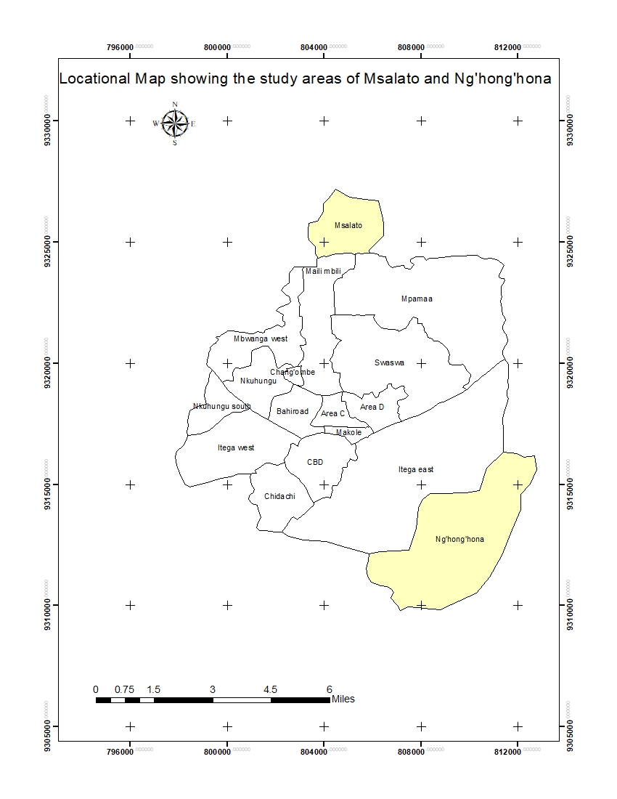

Figure 3.1: Location Map for the two selected Wards in Dodoma City
The reasons for the choice of these two wards are twofold; first these two wards lie in the periphery zone from the business district of Dodoma city and second is the experience that residents of these wards had passed through when the government had to apply CLA process in order to get land for construction of the University of Dodoma and the construction of anInternational Airport in Ng’hong’honha and Msalato respectively.

3.2 Research Design
A Cross-sectional research design was used in this study. The Cross-sectional design allows collection of information once without repetition in the study area (Kothari, 2007). According to Shakir, (2002), case studies are usually relevant when studying contemporary phenomena where the researcher has no clue of some contextual issues related to the study in question. In this regard this design was selected because tenure security is context specific phenomena since the way it is handled in each CLA process differ from one place to another, depending inter alia, tenure arrangements, community awareness to their tenure security, and willingness of planning authorities to comply with the existing land laws. In addition, since cross-sectional studies allows studying subjects once and not in repeated mode, studying tenure security in Msalato and Nghonghona requires collection of information only once to be able to know how tenure security was handled when CLA process was undertaken in that area. This fact makes cross-sectional research design being relevant for this study.

3.3 Sampling Design
A mixture of techniques such as purposive sampling, multistage sampling,(involves dividing population into groups), proportional sampling and snow ball sampling was used to draw a sample for this study. Purposive sampling was used to select two wards namely Msalato and Ng’hong’honha, because these two wards had experience with CLA process involving a number of government projects. In addition, purposive sampling was used to select key informants such as land management officers, members of the planning authorities, two officers from Dodoma city council (town planner and land officer), two members of the planning authority at ward level (ward executive officer from both Msalato and Ng’hong’honha) and twenty community members whose land was expropriated, ten from each ward.

On the other hand, snow ball sampling was used to get landholders whose land was expropriated and who had been living in areas close to the study areas of Msalato and Ng’honghona. According to Kothari, (2007), multistage sampling technique is suitable for contexts where access to the preferred sampling units involves more than one step. In this study, the sampling was done in two phases; the first phase was selection of the study areas which through purposive sampling, Msalato and Ng’hong’honha were obtained, the second phase involved selection of household heads from sampled households in each of the two study areas.

In this study, multistage sampling was used to select the “sub Wards”, where Msalato and Ng’hong’honha was selected; then from each these two sub Wards, some households were selected randomly. Proportional sampling was used to draw sub-samples from each sub Ward (i.e. from Msalato and Ng’hong’hona), based on the population of each ward. Simple random sampling was used to select households from the selected sub Wards i.e. Msalato and Ng’hong’hona. The computation of specific sub sample from each selected sub Wardwas done by using a mathematical model proposed by Yomane, (1967) which is given as shown below
n = N/ (1+Ne²)
Where
N = population size/estimated population size
n = sample size
e = confidence interval (10percent)

According to the 2012 census report, total number of households in Msalato and Ng’hong’honha are 882 and 611 respectively, which makes a total population of1,493

From n = N/ (1+Ne²)
n = 1493/[1+1493(0.1)²]
n = 1493/149.3
n = 100 households

Therefore, the sample size for this study was 100 households which were chosen proportionally from the two selected Sub Wards. The proportion of respondents from the two Sub Wards was 882/1493*100 = 59households from Msalato, and 611/1493*100 = 41households from Ng’hong’honha. Simple random sampling was used to pick households from each selected Sub Ward. According to Kothari, (2004), Simple random sampling is a technique that is used to select subjects without pre-defined conditions within the study area, unlike systematic sampling where the researcher sets out some pre-defined principles through which subjects are selected to participate in the interview process. The subjects in this selection involved heads of households within the study area.

3.4 Data Collection Methods
A number of methods including: Observation, interview and focus group discussions were used for data collection.

3.4.1 Observation Method
According to Chaturvedi, (2005), observation is a method that is suitable for collecting observable information, and the evidence was recorded in different image recording through a camera. The current land uses and plot sizes together with developments in them, are observable information where field camera was used to collect such evidences.

3.4.2 Interview Method
Interview is a method of data collection where interviewer and an interviewee are brought together for sharing information inherent to interviewee which is sought by the interviewer through an oral medium or written platforms (Chaturvedi, 2005). Other scholars like Kothari, (2004) and Yin, (2003) treats the written platforms like questionnaire to be a separate data collection methods from Interview method. Other researchers however, treats a questionnaire a tool for interview method (Robert, 1994; Chaturvedi, 2005; and Bhattacherjee 2012). This study treated questionnaire as tools for interview method and this tool was used to collect information like community awareness and perceptions, community participation in CLA process and engagement of different stakeholders in tenure security issues and CLA process. Interview was used to collect data from sampled household representatives and some key informants as presented in section 3.2

3.4.3 Focus Group Discussion Method
Focus Group Discussion (FGD) is a method of collecting information from group of individuals, usually peers, which is relevant to get detailed information on broad topics that has collectively affected members of the given peer (Chaturvedi, 2005 and Kothari, 2004). At most two groups from each ward were formed with a membership of less than 10 were formulated for conducting discussions. Those two groups from each ward, was composed of women and another group was composed of displaced landholders.

The discussion was centered on the women inclusion on access to land and its implication to their lives and the challenges associated with compulsory eviction for the groups of women and displaced landholders respectively. The discussion was guided by the checklist of issues related people’s perceptions about security of their tenure on land and how they have participated in compulsory land acquisition process.

3.5 Data Analysis and Presentation
Statistical Package and Service Solution (IBM SPSS) which was formally known as statistical package for social sciences (SPSS) version 16was used to analyse numerical data. Specifically, this study applied descriptive statistical tools like descriptive, multiple response analysis and cross tabulation. The analysis was preceded by preparation of code book for the quantified qualitative data and creation of SPSS template in the Variable View, which was followed by entering data through the Data view, while Arch GIS was used to prepare locational map for study area. Presentation of the analysed data was done through text, tables, and graphs.

CHAPTER FOUR

PRESENTATION AND DISCUSSION OF FINDINGS

4.1 Chapter Overview
This chapter presents the analysed findings and the detailed explanation of the analysis made in responding to the research questions which were raised during the research design. The chapter is subdivided into four different parts where three parts corresponds to the three research questions and one part is an introductory part which gives an overview of the respondents consulted during data collection process.

4.2 Overview of the Data Collection Process
The information presented in this chapter has been collected from various respondents (land officers, town planners, Sub Ward Executive Officer and land holders) for the purpose of triangulation of information in order to ensure validity of the collected information.

Table 4.1: Respondents’ Distribution according to some selected Demographic Characteristics
Demographic characteristics of the household representatives |  | Msalato | Ng’hong’hona | Total
Sex | Male | 42 | 30 | 72
Sex | Female | 17 | 11 | 28
Education levels | Informal education | 9 | 6 | 15
Education levels | Primary education | 30 | 25 | 55
Education levels | Secondary education | 17 | 7 | 24
Education levels | Tertiary education | 3 | 3 | 6
Age groups | 18 - 25 | 17 | 5 | 22
Age groups | 26 - 45 | 27 | 30 | 57
Age groups | 46 - 60 | 14 | 4 | 18
Age groups | Above 60 | 1 | 2 | 3
Grand Total |  | 59 | 41 | 100
Source: researcher data, 2020
As it has been explained in the methodology section, the two areas of Msalato and Ng’hong’hona were purposively selected, but the selection of individual households was done randomly from among the households in the selected study areas. The sampled household representatives was from diverse demographic characteristics as shown in table 1, where a big proportion (more than 70 percent) were males, which clearly explained by the tradition for most of Tanzanian households being headed by men. Although the number of women was relatively low; but their representation was significant, as they offered an immense cooperation during data collection exercise by being more than ready to offer information.

Education levels and age groups were also considered important demographic characteristics to assess on the respondents consulted. The result showed a mixture of various levels of education and age groups where more than 75 percent of the respondents were aged between 26-60, with either primary or secondary education. People at this age group and with this education levels, represents the majority of Tanzanian workforce (URT, 2012) and are therefore passionate for property ownership. Since this study is focusing on tenures security on the valuable resource “land”; having the relevant people in the sample is an indicator for information validity. In addition, presence of representatives from other extreme age groups and education levels, increases the validity and reliability of information obtained from them.

4.2 Awareness and Roles Played by Different Actors on Tenure Rights
This section expounds two major issues namely the awareness of different actors on the right of land holders and roles played by each actor in protecting tenure rights of land holders. Land actors in this context refer to those parties who have either direct or indirect interest on the land. Those Actors include sitting land holders, officials from the Local Government Authority (land officers and town planners), land brokers and Sub Ward leaders (the Sub Ward Chairperson and Sub Ward Executive Officer).

4.2.1 Awareness of Landholders on Land Rights
Information about the awareness of different actors on tenure security was collected in different ways to different actors. For land holders, focus group discussions were conducted in the two study areas while face to face interview was used in collecting this information from other actors like Ward Executive Officers, Town Planner and Land Officer. The results from focus group discussion showed low levels of awareness on land rights among land holders in both study areas. The discussion was conducted under three thematic areas namely awareness about land rights, personal experience with CLA process and actions taken to safeguard properties in cases of denied or robbed rights.

During discussion, participants seemed to know some of the land rights especially those embodied to granted rights of occupancy. They however had less knowledge about land rights pertaining to other land tenure like customary and neo-customary land rights. It is important to underscore in this matter, that most land holders in peri urban areas fall under neo-customary tenure (Kombe, 2006) where, although landholders in these areas do not have title deeds, but they are recognised by the Land Act number 5 of 1999 to be legal land holders. An example of a proof to people’s low levels of awareness about neo customary rights can be drawn from one participant in Ng’hong’hona when he was presenting his contribution in the discussion about rights entitled to peri-urban residents which is quoted below
“When Land Valuers came to value my property I could not dare to oppose their valuation process because I had no a granted title deed. Had I have a title deed, I could challenge their whole valuation process even to the court of law”.

This statement quoted from one of the FGD participant points out two messages; the first message is that, the amount of compensation given to this participant as a result of his expropriated property was less than the amount of compensation he was supposed to get that measures up to the market value for his expropriated property. The second message obtained from this statement is that, this land holder despite of being aware that the value assigned to his expropriated property was less than the real value, he did not challenge the process to the court of law. Section 156(4) of the Land Act no 4 of 1999 provide an opportunity for landholders to appeal to the court in case they think they have been given amount of compensation less than the real value for their expropriated properties. The statement given by the landholder in the quote above show that, little knowledge about quasi-customary tenure have kept many people from pursuing for their rights, in cases they had a feeling to have received less than the required compensation.

Sections 19-23 of the Land Act (1999) recognize the three land tenure regimes existing in Tanzania which are; statutory or granted rights of occupancy, customary regime and informal regime which are commonly known as neo-customary or quasi-customary regime (URT, 1999 and Kombe, 2010). Holders of land in any of the three forms of tenure rights are entitled for compensation when their properties are sought for public purpose through CLA. Therefore, when the response given by the landholder in a quote above is examined in the light of the provision of sections 19-23 of the Land Act of 1999, one can easily deduce that the level of awareness about tenure rights for some landholders in the study area is very law, which in turn has jeopardised their tenure security.

The group discussions on how participants perceived CLA process, dominated the whole discussion time as all participants had various lamentations especially on compensation. In Nghonghona for example, among the ten members of the FGD, seven of them gave out their complaints about compensation, while in Msalato, six among the ten members had various complains to issues related to compensation. Although lamentations varied from one discussant to another, but they all addressed issues of amount and time taken for payment of compensation to the displaced landholders. Complains about amount of compensation were based on the ground that they were given compensation below the prevailed market prices.

Another interesting thing that was noted about these complains is about delayed compensation. Some members reported that it took more than two years between property valuations to the time they were actually given their compensation. Both of these malpractices (delayed and unfair compensation) are strictly prohibited by the Tanzanian land laws. Section 1 (1) subsections (f) and (g) of the Land Act No. 4 of 1999, as well as Section 7 of the Land (Assessment of Value of Land) Regulation of 2001 recognise market value of land as a base for compensation. In addition, these regulations provide for payment of full and prompt compensation upon compulsory acquisition of land (URT, 2001a).

4.2.2 Roles Played by Different Actors in Protecting Tenure Security during CLA
The various Actors were asked to explain the role they have played in protecting tenure security of land holders especially when land was sought in compulsory terms through CLA. The responses given were compared with the roles provided by land laws for those actors and the results are presented hereunder.

4.2.2.1 Roles of Planning Authority from Dodoma City Council
The study consulted the Town Planner and Land Officer as representatives of the planning authority. The Urban planning Act number 8 of 2007 and the compulsory land acquisition Ordinance of 1967 requires planning authority to adequately involve community members from the planning area to be part of the planning team. This requirement of the law is meant inter alia, to help safeguarding the rights of land holders on one hand, and enable smooth acquisition of the land required for public purpose, on the other hand. When the town planner and land officer were asked to explain the extent to which this requirement of the land laws (allowing participation of community members in the CLA process), they both claimed to have adequately involved members in the two study areas to fully participate in the whole process since the beginning to the end. In trying to validate his response, the town planner presented a list of community members who were nominated to participate in the CLA steering committee, although he could not allow the list to go with the researcher.

The land officer on the other hand explained frankly, that community members were involved in some (not all) stages of the CLA process. He went further to accuse the former Planning Authority which was commonly known as Capital Development Authority (CDA) to be brutal to community members especially when executing CLA process. The description of the land officer is given in a quotation below
“Frankly speaking, it was a usual practice for CDA officials to override people’s rights especially during compulsory acquisition which was evidenced by people’s lamentation and fight attempts as noted in Njedengwa and Nzuguni”

The land officer went further in explaining the two cases in Nzuguni and Njedengwa (which for ethical reasons could not be presented in this report), that signified existence of constrained rights of the land holders. It should be noted however that, the current practices of handling community rights have demonstrated drastic changes, perhaps due to the changes brought by the current regime of government in power, which has identified itself to be pro-poor and development centred government. Both officers (Land Officer and the Town Planner) concluded their description that the current practices related to handling of land is very transparent and inclusive, as all officers are afraid to lose their jobs.

4.2.2.2 Roles of Sub Ward Leaders
Sub Ward Executive Officer (MEO) from Msalato had his description that coincided with the land officer from the city council who also noted some malpractices associated with handling land rights of the sitting land occupiers during CLA implementation. According to MEO for Msalato, CDA officials were disregarding not only community members, but also Sub Ward leaders when implanting CLA. He narrated a story of how land which was sought for construction of the Msalato Airport that even his office was consulted at terminal stages of the process when land valuers came for valuing properties deemed for expropriation. The quote below was recorded during his interview
“I have been a leader for this sub Ward for eight years now, and I know everything about what CDA did to my people. I cannot forget what CDA did to my young brother, because they looted his 5 acres of land with a compensation of only TZS 400,000”.

The feeling that has been expressed by the Sub Ward leader in a quote above, implies that something went wrong when CLA process was implemented in Msalato. The description given by the sub Ward leader in Msalato, coincide with the description given by land officer in section 4.2.2.1 of this report, which showed that there non-compliance to laws governing CLA process which led to people’s oppression. As a rule of thumb, the Planning Authority is required by the law to inform local leaders who are also expected to mobilise their communities to actively cooperate with the planning authority when implementing any land development scheme (URT, 2007).

4.2.2.3 Roles of the Landholders
Land holders, as other actors in the CLA process, have some roles to play in enhancing tenure security. According to the laws governing development of urban land, Landholders are expected to actively participate in the CLA process and peacefully resist eviction without prompt and adequate compensation (URT, 1967). The stages in which laws provide for community participation during CLA are plan notification, property valuation and compensation payment (URT, 1967 and 2007). The interview with landholders in the two study areas of Msalato and Ng’hong’hona revealed that more than 85 percent of sampled community members got opportunity to participate in both stages of plan notification and property valuation as it can be seen in figure 4.1
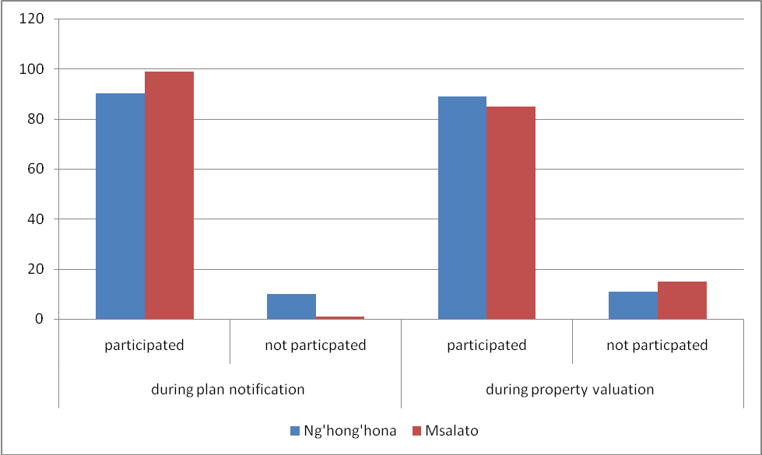

Figure 4.1: Percentage of Landholders who Participated in different Stages of CLA Process
Source: Field Data, 2019

The participation of landholders in the CLA process is meant inter alia, to provide a ground in which landholders could protect and enhance tenure security for properties they hold (Kombe, 2010). The involvement of more than 85 percent of land holders in the CLA process imply that many of these community members were given opportunity to play their role of protecting their land rights to the best level that lies to their discretion. It should however be noted that, involvement of landholders in the CLA process, does not guarantee the protection of tenure security, since other actors have their role to play in enhancing it. Although participation of landholders in this case is seemingly high, but some senses of dissatisfaction were noted from the same people that their tenure security have been messed up.

4.3 Implementation of CLA in the Study Areas
The two projects (construction of the University of Dodoma and the Msalato Airport) which were implemented in Ng’hong’hona and Msalato areas respectively, had a demand for very huge size of land which necessitated compulsory acquisition of land from the privately held land that was under customary and quasi-customary tenures regimes. The assessment of tenure security in the context of Compulsory land acquisition has been done by analysing three important issues namely the purposes for which land was acquired, the procedural tenets used in land acquisition and the compensation mechanisms for the displaced landholders. These three elements, have been used in assessing tenure security of landholders in the two communities where land was compulsorily acquired.

4.3.1 CLA in Msalato
An interview with Town Planner for Dodoma City Council revealed that more than 300 households were formally living in an area which is currently declared as an Msalato international airport, were evicted from this area to allow this public purpose (construction of an international airport) to be implemented. Constitution of the united republic of Tanzania of 1977, Compulsory Land Acquisition Act No 47 of 1967 and the Land Act No 4&5 of 1999 give directives to the planning authorities to subject any land acquired through CLA into public use/purpose. The use of focus group discussions and observation methods helped to identify the expropriated land and found that the uses for which such land was acquired had typical public purposes (i.e construction of an International Airport and construction of the University of Dodoma).

Section three of the Land Acquisition Act No.47 of 1967 directs that the compensation paid to the displaced landholders should be prompt and fair. In trying to investigate if compensation paid to displaced landholders were fair and prompt, the sampled respondents were asked to tell the time taken between the time valuation processes was done to the time at which compensation was paid, and the results showed that compensation for most of respondents was done more than two years after valuation process.

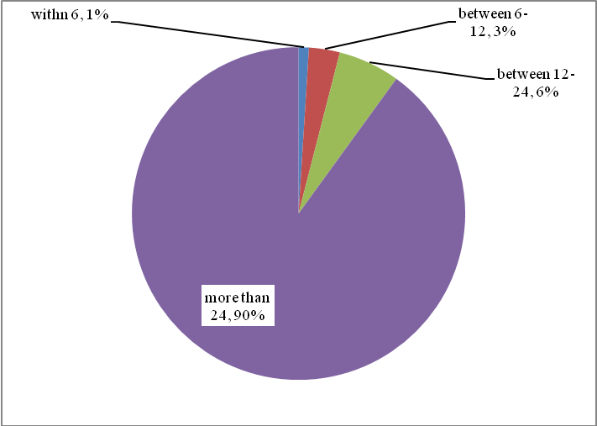

Figure 1.2: Time taken between Property Valuation and Compensation in Msalato expressed in Months
Source: Field Data, 2019

It is clearly evident from the pie chart above that, although displaced land holders were given compensation for their properties, but they got compensation very late contrary to the requirement of the constitution and the laws governing compulsory land acquisition. When respondents were asked to give their opinion about the amount of compensation they have received, their opinions were as presented in Table 4.1.

Table 4.2: Landholders’ Opinions on the Amount of Compensation given
Respondents’ opinions on the compensation given | Number and Percentage of responses on people’s opinions about the compensation given
Respondents’ opinions on the compensation given | Ng’hong’hona |  | Msalato |  | Total
Respondents’ opinions on the compensation given | number of responses | percentage | number of responses | percentage | number of responses | percentage
Very fair | 0 | 0 | 1 | 1.7 | 1 | 1
Fair | 1 | 2.4 | 4 | 6.8 | 5 | 5
Unfair | 17 | 41.5 | 20 | 33.9 | 37 | 37
Very unfair | 23 | 56.1 | 34 | 57.6 | 57 | 57
Total | 41 | 100 | 59 | 100 | 100 | 100
Source: Field Data, 2019

The results in Table 4.2 shows that more than 80 percent of the respondents were not satisfied with the amount of compensation given claiming that it was smaller than the amount required to recover their lost properties. When this result is integrated with the results shown in the pie chart (figure 4.2), one may easily realize that compensation mechanisms and the actual payment process were not in concurrence with the existing laws and guidelines providing for compensation arrangements for the displaced landholders.

The complaint about inadequate compensation has been a common phenomenon not only in Dodoma, but in other parts of the country and other developing countries. Kombe, (2010) and Komu, (2002) reported cases of delayed and inadequate compensation for landholders in Dar es Salaam when CLA was implemented. Kombe reported delayed compensation of up to five years from the time of property valuation to actual payment of the valued properties. In addition, Lupala and Chiwanga, (2014), observed the same malpractices in Nzuguni ward when CLA was implemented for the construction of the Nane Nane exhibition grounds. It is however important to notice that, in the current government regime, these malpractices are reported to decrease, as many officials of the Planning Authorities are nowadays trying to abide their practices with laws in fear of being disciplined by their higher authorities.

4.3.2 CLA in Ng’hong’hona
The displacement of landholders in Ng’hong’hona area was meant to leave an area for the construction of the university of Dodoma which is a public university. Since the land expropriated from every landholder was used for the construction of the University of Dodoma, it can therefore be concluded in this case, that the purposes for land acquisition from landholders adhered to the requirements of the law; which required any acquired land from private land holders should be used for public interests (URT, 1999). The assessment of compensation mechanisms in Ng’hong’hona revealed that the time spent between property valuation and actual payment was relatively smaller than what was experienced by landholders in Msalato area as the pie chart (figure 4.3) shows

Results in figure 4.3 shows that most of the displaced landholders (85 percent) reported to have been paid in the time that is within six months, which is within the time provided by land laws when compensation is sought (URT, 1977 and, 1999). Although compensation in Ng’hong’hona was given within the time limits provided by the law, but some complaints from some landholders were noted about adequacy of the amount of compensation given, claiming that it was by far, less than the market value for their expropriated properties.
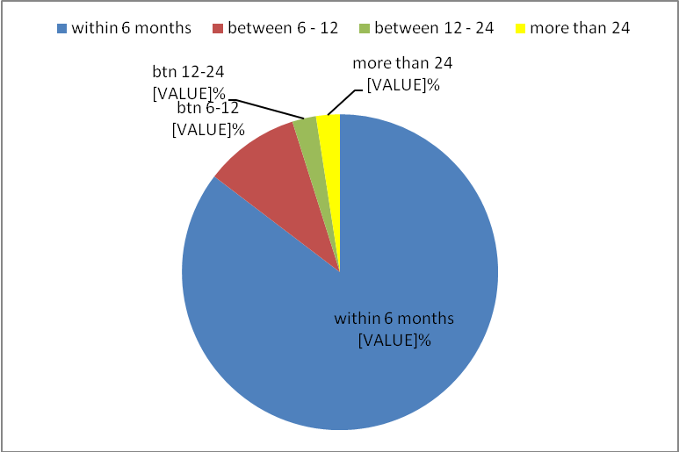

Figure 4.3: Time lapsed from Property Valuation to Compensation in Ng’hong’hona expressed in Months
Source: Field Data, 2019

The issues of delayed and unfair compensation have been common for many compulsory acquisition practices in Tanzania and other developing countries. Kombe, (2010) observed that compulsory acquisition was blamed by many displaced landholdersin Chasimba and Kwembe, Dar es salaam as the compensation was delayed up to five years from the time of property valuation to the time of actual payment of the compensation. The five years’ time is too long to guarantee displaced landholders fair and adequate compensation; given the changes in the time value for money that takes place over time. Similar observation was reported by Lupala and Chiwanga, (2014) for the similar study that took place in Nzuguni which revealed a number of mistreatment of displaced landholders which include among other thing; limited participation opportunities in the process, delayed compensations, very minimal or no compensation at all for some displaced landholders.

4.4 Effects of CLA to People’s Lives
The assessment of effects emanating from CLA process to people’s lives was done especially to the people whose land was expropriated by the government public purposes. The assessment was focused on three major areas namely social networks that landholders enjoyed before being evicted from their original areas. Other aspects which were used assessing effects include the kind of expropriated properties and the mechanisms that displaced landholders have been using in re-establishments in their new areas where they have been evicted to.

4.4.1 Interrupted Social Networks
An in-depth interview with one of the evicted landholders in Ng’hong’hona revealed the eviction process that took place in Ng’hong’hona had adverse impact to some people that can never easily be recovered in the near future. When the respondent was asked to explain at least two things that she could never forget as far as CLA process is concerned, she shade tears before she could go further with her story. Even before describing her story, the tears that was shed, gave an impression to the researcher that something terrible had happed to her. The story that she told the researcher was seemingly simple, but it had an immense implication to her. She narrated a story that in 2003 she joined a merry-go-round group of women who used to live together in a place before she was evicted to another place. According to her, the merry-go-round scheme was very helpful to her life since it was used as a source of capital for her micro-catering service (a restaurant) which had begun to boom and showing future hope for economic development.

But her eviction, led to the collapse of the social network where she had built through the merry-go-round and of course the business that had already began to excel, it eventually collapsed because where she has been evicted to, has no opportunity to establish that kind of business (a restaurant). In her own words, she narrated a story whose part is recorded (with English translated version) in the brief quote below.
…….after shading tears, she began explaining
I was supposed to be in a better economic condition by now, because I had already started catching up with my business, and it was doing great! The compensation I was given only helped me to acquire a piece of land in a place with no opportunity to turn into my business again (shading tears again), and proceed with the story …..

It was very clear from the story and emotions demonstrated by this woman, that CLA left her some lifelong scars as it disrupted her social connection and the business that was presaging future excellence in her economic life. This story is an evidence that section 4.2.2 of the land policy of 1997 (as it has been directly quoted in section 2.4.1 of this report) was ignored during payment of compensation to these people, because that section of the policy requires inter alia, calculation of the compensation should consider even opportunities lost by a person who is to be evicted.

4.4.2 Loss of Properties
During interviews with the evicted people in Ng’hong’hona, it was found that, there were some people who had planted various trees in their land, but during compensation, all trees were assigned the same value. The respondent who gave this story, went further by explaining that, he complained about this matter to the then Capita Development Authority (which was mandated to conduct CLA process), but his voice could not be heard by no one. After the failure to this struggle, he decided to accept that valuation and left his property. The photo below show some standing walls of the dilapidated house and different trees including cashew nut trees which have a very big potential of generating income for many years to come. The complaints of the owner of these trees was that, cashew nut should have been assigned relatively higher value that the rest of the trees in his field.

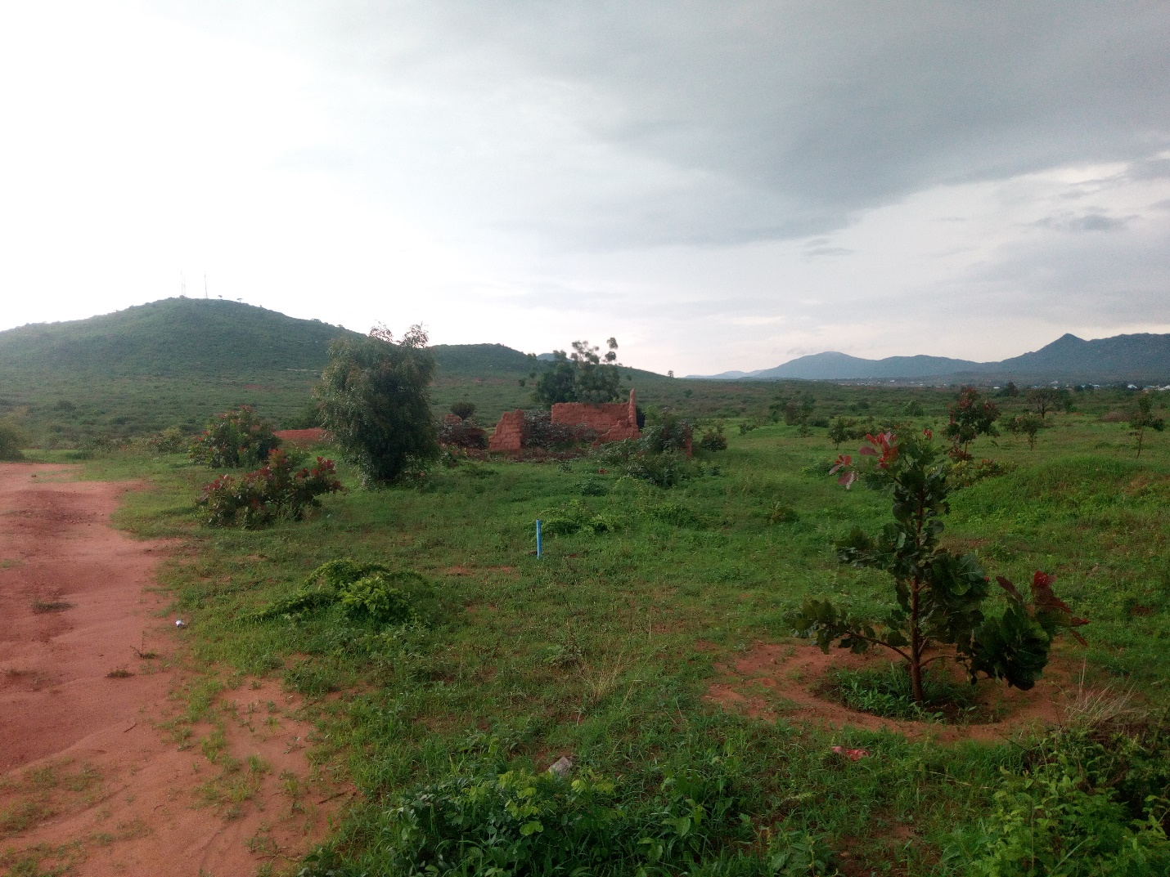

Figure 4.4: Part of the Land Expropriated for Establishment of the University of Dodoma

Evidences like this, entails that something must be done to make sure that the planning authorities adhere to the property valuation and compensation standards so that justice can be done to the people whose land is expropriated for public purposes.

4.4.3 Mechanisms of Re-Settling in New Areas
The assessment of how evicted landholders were able to re-establish themselves in new areas had mixed stories. The study revealed that, there are some displace people who managed to settle in places very close to the university boundaries, they have been able to re-establish very well, as they found another opportunity for business due to incoming of students in search of services like catering, accommodation, and socialization.
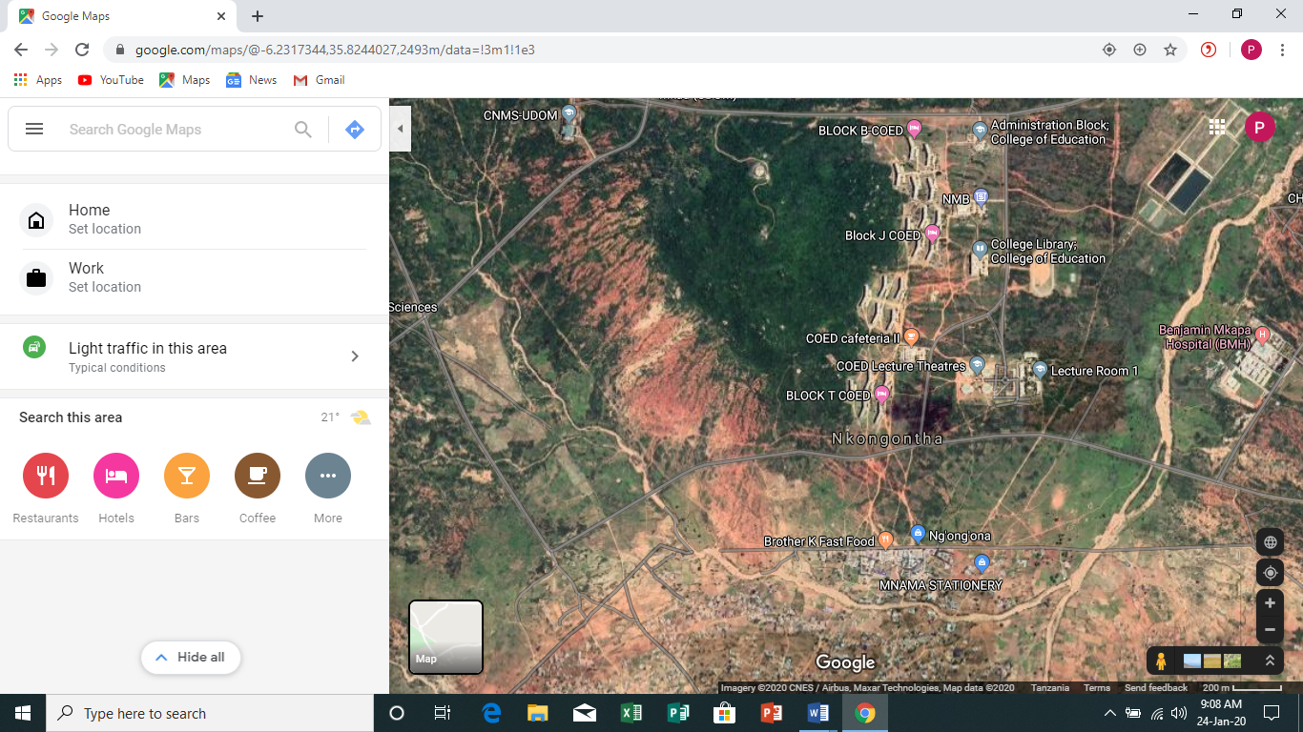 | 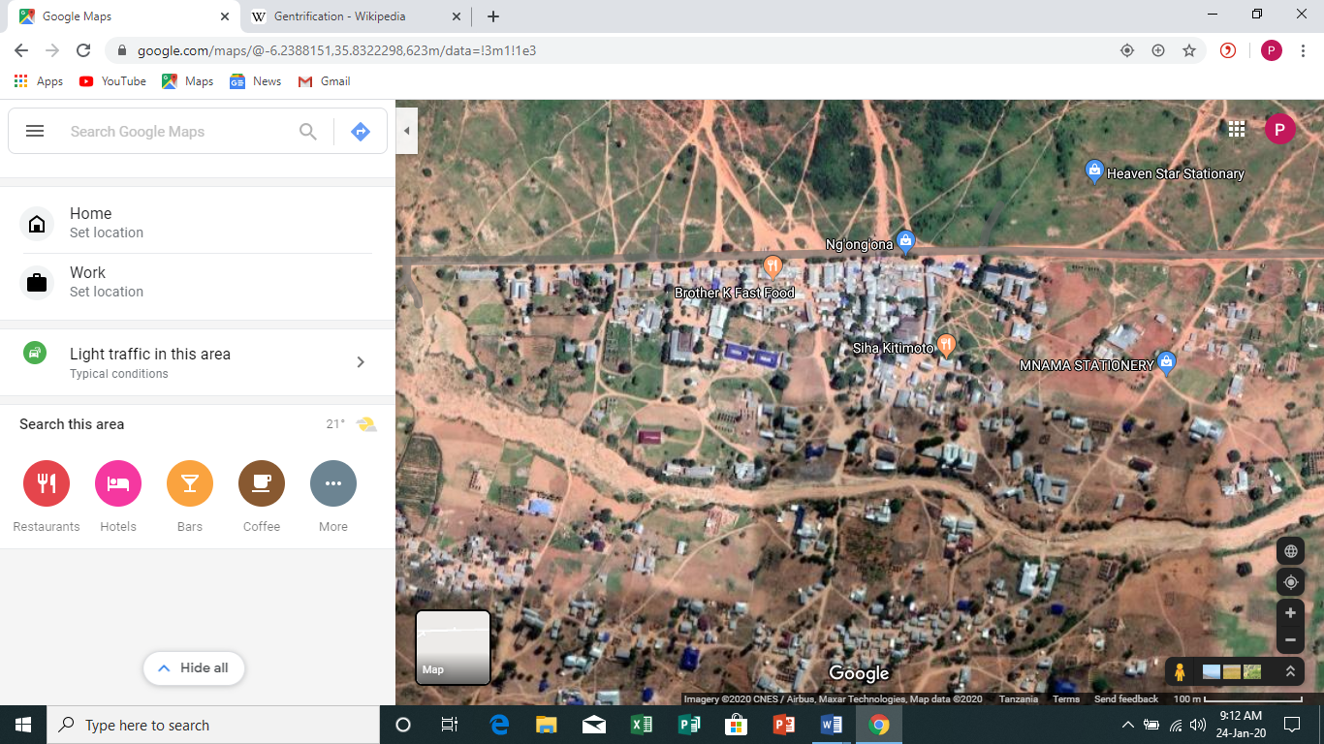

Figure 4.5: A Rapidly Gentrifying Settlement Southern Part of Collage of Education, UDOM
Source: Field Data, 2019

The photo (Figure 4.5) shows south eastern part of the university (College of Education) which lies along the University boarder. The southern part of the collage of education boarders with a rapidly gentrifying settlement known as “Kwa wajasi”, an area that has attracted many business people and entrepreneurs together, and provide a wide spectrum of services ranging from academic to social related services. The evicted landholders how managed to secure land in areas such as this, have good stories to tell because they have found life becoming better than it used to be, before their eviction.
On the other part of the story, the evicted people who could not manage to get land in areas like this are struggling to re-establish their lives. It can be drawn from this experience that whenever an eviction involves establishment of the public purpose that has a potential of attracting business opportunities, the evicted people should be given priority of the land plots surrounding that opportunity. In the context of what has happened in Msalato and Ng’hong’hona, it would be wise to consider relocating all the evicted in land plots surrounding Msalato International Airport and University of Dodoma respectively.

4.5 Local Institutions and Compliance to Laws Governing CLA
There are a number of institutions involved with land governance and administration in Tanzania ranging from national to local levels. These institutions operate in a framework of established policies, laws, and by-laws. This study examined how these institutions have played a role of safeguarding tenure security of landholders in the study areas of Msalato and Ng’hong’hona.

4.5.1 Local Institutions
Sub Ward leadership, land tribunals and brokerages are the most common local institutions and agencies operating in peri urban areas and which play roles of land transaction, mediating conflicts and thereby influencing tenure security. The confidence at which landholders have on these institutions/agencies may have implication on tenure security as felt by landholders, because the more trusted institution/agent by landholders, the more frequent it will be involved in land transaction and conflict mediation (Komu, 2002 and Kombe and Kreibich, 2006).In trying to evaluate the institution/agency which is trusted the most, by landholders, this study asked landholders the means through which they would prefer to dispose their land, and the actual means they have actually used to dispose land, and the results are as presented in the bar graphs in Figure 4.6.

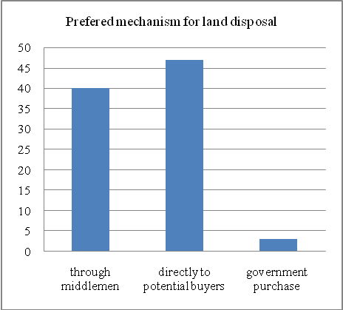 | 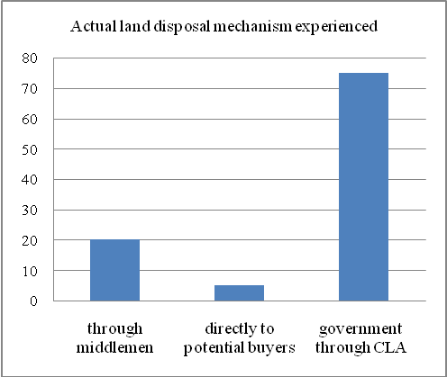

Figure 4.6: Land Disposal Mechanisms preferred and Actual Experience among Landholders
Source: Field Data, 2019

It can be observed from figure 4.4 indicates that 95 percent of landholders have confidence on either middlemen or themselves when it comes to disposing their land. This result was obtained when respondents were asked to tell the method they would prefer to sell their land if they were exposed to the three alternatives of selling through middlemen, doing it on their own directly to the buyers or government purchase that is usually paid as compensation. Assessment of the actual experience that landholders have faced is that, many people were caught with compulsory land acquisition by the government before they had made it sell their land by using approaches they prefer the most, as it can be seen in figure 7 above where more than 70 percent of the people had experienced compulsory purchase by the government.
This result suggests that many people perceive the payment rates offered by government institutions as unsatisfactory and would therefore least prefer to dispose their land through this alternative. Similar result was also reported by Lupala and Chiwanga, (2014) when they were making assessment on people’s opinion about their experience with government officers during compulsory land acquisition. Many people have a feeling of unsecured tenure due to many reasons as observed by researchers which include prolonged bureaucratic procedures in securing title deeds and building permits, unfair or no compensation at all, non-participatory approaches in making decision on matters related to land and assigning uses without public interest for the compulsory acquired land (Kombe, 2010, Lupala and Chiwanga, 2014 and Komu, 2002).

It is important however to notice that, in the current political regime in Tanzania, there has been drastic changes in the performance of civil service, due to disciplinary measures that the current regime is undertaking to less performing civil servants; which give hope that unnecessary delays especially those associated with compensation may be corrected in the near future.

4.5.2 Compliance to CLA Governing Laws
Since institutions and agencies described in part 4.4.1 operates through laws and regulations, it was imperative therefore for this study to investigate the extent at which laws governing CLA process have been complied by actors especially planning authority. The assessment on compliance to the laws focused on the type of compensation paid, rate of compensation per square meter, and the purposes for which land was compulsorily acquired.

Table 4.3: Comparison between Actual Compensation given and Real Market value for the Expropriated Properties
Name of the compensation beneficiary | size of the expropriated land | Comparative incomes between compensation paid v/s income could have been obtained through market prices
Name of the compensation beneficiary | size of the expropriated land | Value by  Compensation rates | Value by  market prices
Sophia Jeremiah Njiba | 6972m² (1.7acre) | 732,000 | 5,100,000
Yudith Chilawa Chibago | 12,193m² (3 acres) | 1,280,000 | 9,000,000
James Maduma Mgongo | 825m² (0.2 acre) | 87,000 | 600,000
Yakobo Chipeta | 13,932m² (3.4 acre) | 1,449,000 | 10,200,000
Source: Field Survey, 2019

The reports in WEO’s office showed that the rate used to compensate for the bare land was TZS 100 per square meter, which is equivalent to TZS 490,000 per acre. Compensation also included 5 percent (disturbance allowance) in addition to the compensation given for expropriated bare land. In total therefore, if a person gave his/her one acre of land, the compensation payable to the dispossessed landholder was 490,000+0.05(490,000) = 514,000.This valuation was done in 2008 and the actual payment was done in 2014 where the market value for an acre of land in Msalato and Ng’hong’hona were about TZS 3,000,000 and TZS 2,000,000 respectively. An interview with some some landholders and the corresponding compensation they actually received is presented in Table 4.3.

It can be observed from the figures shown in table 5 above that the amount of compensation given to the displaced landholders are by far, less than the prices offered by the market. The Land Act No. 4 of 1999, Section 1 (1) subsections (f) and (g) as well as Section 7 of the Land (Assessment of Value of Land) Regulation of 2001 recognise market value of land as a base for providing compensation to the displaced landholders. The difference between the amount of compensation paid to the displaced landholders and the market value of the expropriated land can be explained by, among other factors, the time gap between the time at which property valuation was done and the time at which compensation was actually paid.

Delayed compensation has been a common problem for most of the CLA cases done in different parts of the country. Komu, (2002), for example, reported that some landholders in Dar es Salaam got paid their compensation five years after valuation exercise. In addition, Larbi, (2008) and Msangi, (2011) also observed similar mistreatment of land holders in Ghana and Dar es salaam Tanzania respectively. Another challenging issue confronting landholders during compensation, is the type of compensation paid. Section 10 of the Compensation Claims Regulations of the year 2001, provide various alternative forms of compensation to displaced landholders (URT, 2001b). This regulation states that compensation may be in the form of all or a combination of:
- A plot of land of comparable quality, extent and production potential to the land lost,
- A building or buildings of comparable quality, extent and use comparable to the building or buildings lost,
- Plant and seedlings, and
- Regular supplies of grain and other basic food stuffs for a specified time

When landholders were asked to tell the type of compensation paid when their properties were expropriated, the results obtained are presented in Table 4.4.

Table 2.4: Type of Compensation Paid to Displaced Landholders
 | Number of landholders received different types of compensation
 | Money only | Money and comparable land | Money and comparable building | Money and grains | Comparable land only | Comparable Building only | Grains only | Total
Msalato | 54 | 0 | 0 | 0 | 5 | 0 | 0 | 59
Ng’hong’hona | 20 | 0 | 0 | 0 | 21 | 0 | 0 | 41
Toal | 74 | 0 | 0 | 0 | 26 | 0 | 0 | 100
Source: Field Survey, 2019

It has been a common practice for many CLA cases to provide displaced landholders with financial resources as the only medium of compensation, unfortunately; this resource is very volatile as many people have been observed to live lifestyles that are poorer than they were before displacement (Larbi, 2008) although they received compensation. The situation becomes even worse, when the compensation rates do not match with the market value of their expropriated properties. Given the challenges associated with the time spent between property valuation and actual payment of compensation, it is highly recommended that provision of a comparable property as the means of compensation payment should be given priority.

Assessing the purpose, for which land was expropriated from landholders, was another indicator in checking for adherence to the laws governing CLA process among planning officials. Using observation method, it was found that the whole of the land acquired from individual landholders in Msalato and Ng’hong’hona was dedicated for the construction of an internal airport and university of Dodoma respectively. In both cases, the acquired land was subjected into uses that have public interests as per the requirements of the laws.
The public interest as defined by section 49 (1,a-g) of the Land acquisition Act of 1967 includes: any government scheme, development of agricultural land, provision of sites for industrial or commercial development, space for social services, construction and/or expansion of harbours/ports and planning for expansion of cities or towns. Since the two projects for which land was acquired, falls into the requirements of these laws, it is therefore agreed that the acquisition of land in both areas (Msalato and Ngh’ongh’na) has been used for public purposes just as the law provide.

CHAPTER FIVE

CONCLUSIONS AND RECOMMENDATIONS

5.1 Conclusions
The actors on tenure security for landholders include landholders themselves, officials from the Local Government Authority (land officers and town planners), land brokers and Sub Ward leaders (the Sub Ward Chairperson and Sub Ward Executive Officer). The assessment of their role on protecting tenure security was preceded by checking their awareness about property rights inherent to landholders. It was found that the level of awareness of property rights for landholders among actors of the tenure security is very low for all actors except for actors in the Local government authority. The situation is even worse among landholders and brokers who frequently interact and transact properties.

The awareness levels for Sub Ward leaders is relatively higher than those of brokers and landholders which suggest that, leaders in these Sub Wards have not yet done enough job to impart knowledge to their people about property rights and their obligations, which has been reflected to very low levels of awareness among landholders and brokers. Their action toward protection on tenure security was therefore corresponding to the level of awareness. For example, there are some landholders who were evicted from their properties even before actual payment of the compensation, but they could not dare resist as the gives them provision to undertake such kind of a decision. Interestingly, some actors like town planners and land officers, despite being perfectly aware on the property rights, but they failed to adhere to the laws which protect the rights of landholders.
Implementation of the compulsory land acquisition (CLA) in Ng’hong’hona and Msalato was found to be with a number of shortfalls, as some of the measures taken were not conforming to the laws governing CLA process (Compulsory Land Acquisition Act No.47 of 1967, Land Act No.4&5 of 1999, Urban Planning Act of 2007 and the constitution of the United Republic of Tanzania of 1977). The shortfall noted include limited opportunities for landholders to participate in the CLA process, delayed payment of the compensation, and provision of compensation rates that are by far, less than the prevailing market prices for the expropriated properties.

The time taken between property valuation to the time of actual payment for both Msalato and Ng’hong’hona was more than 12 months, which is contrary to the requirement of the laws which directs that compensation must be paid within a period which is not more than 90 days (equivalent to three months) soon after property valuation process. In addition, the compensation paid was found to be very low which, according to the opinions of more than 70 percent of the displaced land holders; was very unfair such that it could not suffice recovering of the lost properties.

Assessment of the roles played by legal and institutional frameworks on protection of tenure security revealed that all institutions (LGAs, brokerages, and Sub Ward leadership) are trying to do their roles, but public institutions (local government authorities and Sub Ward leadership) have lost credibility among landholders perhaps because of injustice that landholders have experienced especially during compulsory acquisition of their properties. Many landholders would prefer to dispose their land through brokerages than through the compulsory purchase which is normally done by the government.

5.2 Recommendations
Following the conclusions made, this study is recommending on the following
- Sub Ward leaders should strive to help landholders understand their property rights and obligations as provided by the law. This can be done through regular community meetings that are held. Also local government authorities should make arrangement of availability of simplified documents highlighting community responsibilities and rights they have over the land in which they occupy. This will help community members get acquainted with the land laws
- Local government authorities like Dodoma city council, should adhere to the laws and regulations governing implementation of the CLA process. This include adequate involvement of landholders in the process, proper negations of compensation mechanisms and payment of promptly and fair compensation just as it has been provided by the law
- Public institutions involved with land governance should make sure that they abide with the prevailing laws and regulation especially when dealing with sensitive issues like CLA process which has negative impacts to people’s livelihood if not done according to the directives of the laws.
- The Ministry of Lands and Human Settlement Development may consider initiating amendment procedures for the laws dealing with compensation such that, provision of an alternative property with comparable size and quality to the displaced landholders, be a mandatory measure for every CLA case. This measure will help avoid unjust treatment of displaced landholders especially during compensation processes.

REFERENCES
Anim-Odame, W. (2011). Compulsory Acquisition and Compensation in Ghana: Principles and Practice, Paper presented at the American Real Estate Society Conference inSeattle-Washington, USA from 13 -16 April 2011.
Arnstein, S. R. (1969). A Ladder of Citizen Participation, JAIP, 35(4), 216-224.
Bhattacherjee, A. (2012). Social Science Research: Principles, Methods and Practices, Florida. Gainesville: University of South Florida-Tampa.
Chaturvedi, K. (2005). Sampling Methods, online training material, Harlow: Prentice Hall.
Deininger, K, Selod, H. & Burns, A. (2012). The Land Governance Assessment Framework: Identifying and Monitoring Good Practice in the Land Sector, the World Bank, Washington DC.
Food and Agriculture Organization, (2009), Compulsory Acquisition of Land and Compensation, Electronic Publishing Policy and Support Branch, Rome.
Hamdi, N. (1991). Housing Without Houses: Participation, Flexibility, Enablement, New York: Van Nostrand Reinold Company.
International Fund for Agricultural Development, (2006). Land Tenure Security for poverty Reduction in Eastern and Southern Africa, A Workshop Report, Kampala 27th to 29th June 2006.
Kombe, W. & Kreibich, V. (2006). Governance of informal urbanisation in Tanzania, Dar es Salaam: Mkuki na Nyota Publishers.
Kombe, W. (2010). Land Acquisition for Public Use: Emerging Conflicts and Their Socio-Political Implications, Working Paper no. 82- Cities and Fragile States.
Komu, F. (2002). Reflection on Land Acquisition and Compensation: Lessons from Kinyerezi Resettlement Area, Paper Presented to the Workshop on Regulatory Framework for Legal Shelter in Tanzania Dar es Salaam, 12th February 2002.
Larbi, W. (2008). Compulsory Land Acquisition and Compensation in Ghana: Searching for Alternative Policies and Strategies, A paper presented at FIG/FAO/CNG International Seminar on State and Public Sector Land Management, Verona.
LizAlden, W. (2003). Community-Based Land Tenure Management: Questions and Answers about Tanzania’s, New Village Land Act, 1999. International Institute for Environment and Development, URT.
Lupala, J. & Chiwanga, P. (2014). Urban expansion and compulsory land acquisition, mechanisms and processes for community participation, Journal of Land Administration East Africa JLAE, 2(2), 206-222.
Msangi, D. (2011). Land Acquisition for Urban Expansion: Process and Impacts on Livelihoods of Peri Urban Households, licentiate thesis, Swedish University of Agricultural Sciences, Uppsala, Sweden.
Mudenda, M. (2006). The Challenges of Customary Land Tenure in Zambia, A paper that was presented at XXIII FIG Congress, Munich on 3rd April, 2006. Munich, Germany.
Republic of Ghana, (1962). State Lands Act 125, Government Printers, Accra.
Republic of Zambia, (2013). Land Acquisition Act, RZ.
Robert, K. (1994). Application of Case Study Research, Newbery: Sage publications.
Rugemeleza, N., Nelson, F. & Rodgers, A. (2008). The Evolution and Reform of Tanzanian Wildlife Management, Online journal, research gate.
Toker Z, (2007), Recent Trends in Community Design: The Eminence of Participation, Design Studies Journal, 28(3), 309 – 323.
UN-Habitat, (2011). Housing the Poor in African Cities, UN-HABITAT-Training and Capacity Building Branch, Nairobi, Kenya.
United Republic of Tanzania, (1967), Land Acquisition and Compensation Act No. 47,Government Printers, Dar es Salaam, Tanzania.
United Republic of Tanzania, (1977), The Constitution of the United Republic of Tanzania, Dar es Salaam: Government Printers.
United Republic of Tanzania, (1977), The Constitution of the United Republic of Tanzania, Dares Salaam: Government Printers.
URT, (1994), Report of the Presidential Commission of Inquiry into Land Matters Vol. I: Land Policy and Tenure Structure, Dar es Salaam, Tanzania.
World Bank, (1987). Community Participation in Development Projects: The World Bank Experience World Bank discussion papers, Washington DC.
World Fact Book, (2013), Information and Statistical Facts about Countries, Paperback: CIA.
Yin, R. (2003). Case study research, design and methods, (3rd Ed), New Delhi Sage publication Inc.
ZESCO, (2013). Resettlement Policy Framework for the Lusaka Transmission and Distribution Rehabilitation Project, unpublished project proposal, Environment and Social Affairs Department, Lusaka, Zambia.

APPENDECIES
Appendix 1: A questionnaire for heads of households
Dear respondent, I am a student from the Open University of Tanzania who is currently in field research exercise. I am here with you for the purpose of collecting some information about your personal experience with issues related to land tenure security. The information which will be inquired from you, will only be used for academic purposes, and I promise you that the information you provide will not be shared to anyone except to OUT for academic purposes. With this note, I beg you to be free to share sincere information about the subject under discussion.

Respondent’s consent for discussion: (a) I agree (b) I don’t agree [ ]
A: Preliminary information
- How old are you?………………………………………………………….
- What is your education level ………………………………………………
- What is your occupation ……………………………………………………
- How long have you been in this area? ………………………………………
- Do you own the house in which you are living? ……………………………..
- If you are a tenant, how long have you been living in this house? ……………
- Do you know some rights that you have on this property? (1) Yes (2) No …
[ ] if Yes, Can you mention them? …………………………………………………………………………………………………………………………………………………………………………………………………………………………………………………………………………………
B: Awareness and perceptions on tenure security
- Are you aware of your rights over the land you are currently owning (a) yes (no) [ ]
- If yes, can you mention some …………………………………………………………………………………………………………………………………………………………………………………………………………
- Do you have any document to validate your ownership over the land you are currently living in? (a) yes (no) [ ]
- If yes, may I see it please?
- With this document, do you feel fully secured in this land, such that you will never be evicted by anybody? (a) yes (no) [ ]
- If it happens that, somebody claims ownership over your land, explain the procedure you have to undergo in pursuit for your rights and protection of your property …………………………………………………………………………………………………………………………………………………………………………………………………………………………………….
- Have you ever encountered conflicts over any land you are owning (a) yes (no) [ ]
- If yes, how did you go about in pursuit of your rights? ………………………………………………………………………………………………………………………………………………………………………………………………………………………………………………………
C: CLA and community participation
- Have you ever been involved in any compulsory eviction? (1) Yes (2) No………[ ]
- If yes, when did that process take place….……………………………………
- Who was involved in evicting you from your property? ………………...……
- What was the reason for your eviction ……..…………………………………
- How big was your land from which you were evicted?………………………
- Have you ever heard about the Government plan to acquire this land and change into an urban neighbourhood? ………………………………………
- How have you personally get involved in that process? Can you please clarify your participation in the following areas (use the table below)
No | Stage of CLA process | The way you participated
1 | Notification about the acquisition
2 | Property valuation
3 | Property compensation
4 | Planning for the dispossessed individuals

- What other stakeholders were involved in land acquisition process (use the table below)
No | Stakeholder | Roles played
1
2
3
4
5
6
7

- Are you satisfied with the way compulsory land acquisition was deployed to you (1) Yes (2) No [ ] if no why? ……….…………………………………………………………………………………………………………………………………………………………
- If you were to recommend the best way Dodoma City Council should acquire land which you and other people own, what would you propose?
No | Recommendation | Reasons for that recommendation
1
2
3
4
5

D: compensation mechanisms and land transaction alternatives
- Have you ever sold any property? (1) Yes (2) No ……………….…[ ]
- If yes, How big was the land you sold?..……………………………………
- How much did you sell that property? …………………………………………………
- Were you satisfied with the price at which you sold your property? (1) Yes (2) No[ ]
- If no, why were you forced to sell your property at that price while not satisfied? (What forced you to do so)? ………………………………..
……………………………………………………………………………………How big was your land which was acquired when you were evicted …………………..
- What other assets did you invest in the land from which you were evicted ……………………………………………………………………………………………………………………………………………………………………
- How big is the land which was taken from you ………………….and how much were you given as a compensation for that land …………………………………………………
- How much were you given for the investment you had placed in your acquired property ……………………………………………………………………………………………………………………………………………………………………
- When was the assessment for your land done ……………………………
- When were you given compensation for your land that was taken …………… …………
- Were you satisfied with the compensation you were given(1) Yes (2) No ……[ ]
- If no why and how much could you be willing to receive? Reasons for dissatisfaction …………………………………………………………………………………………………………………………………………………………………………………………
- how much could be an alternative value for your property…...…………………

E: Cadastre status and existing land uses
- What is the current cadastre status of the land you are possessing and where you are living in ………………………………………………………………………………………………………………………………………………………………………………………………………………………………………………………………………………………………
- What are the cadastre status of other land plots you are possessing (use the table to answer this question)
s/n | Land size | Location | Cadastre status | Current uses
1
2
3
4
5
6
7

- How can you compare your current land uses and the authorised uses as highlighted in the cadastre survey
s/n | Land size | Location | Current land uses | Authorised use

F: Knowledge of the land laws
- do you know the rights you possess over the land you are currently holding (a) yes (b) no…..[ ] if yes, please explain them ……………………………………………………………………………………………………………………………………………………………………
- do you know obligations you have over the land you are currently holding (a) yes (b) no…..[ ] if yes, please explain them ………………………………………………………………………………………………………………………………………………………………………………………………………………………………………………………
- Have you ever experienced mistreatments of your land rights (a) yes (b) no ……… [ ]
- If yes, what measures did you take in claiming for your rights? ………………………………………………………………………………………………………………………………………………………………………………………………………………………………………………………………………………………………………………………………………

G: Interrupted livelihoods
- When did planning authority come here for the first time requiring land ………………
- When did they succeed to take that land ………………………………………………
- How did you used to get your living before CLA process ……………………………………………………………………………………………………………………………………………………………………
- How are you currently getting your living after CLA ……………………………………………………………………………………………………………………………………………………………………
- What are you missing the most when you compare your life before and after CLA ……………………………………………………………………………………………………………………………………………………………………
H: Experience with tenure security
- How do you perceive about your security of tenure over the piece/pieces of land you are currently holding?
No | Location of the land | Land size | Perception about security of tenure
1
2
3
4
5
6

- Has you experienced land expropriation by the government? (a) Yes (b) No [ ]
- If Yes, why did your land expropriated……………………………………….
- Were you satisfied by that expropriation (a) Yes (b) No [ ]
- If you were not satisfied by that expropriation, what measure did you undertake? ................................................................................................................................................................................................................................................................................................
- Is the measure you have undertaken, gave you expected outcomes?(a) Yes (b) No [ ]
- If no, what other measures did you undertake? ……………………………………………………………………………………………………………………………………………………………………
Appendix 2: A questionnaire for Land Brokers
Dear respondent, I am a student from the open university of Tanzania who is currently in field research exercise. I am here with you for the purpose of collecting some information about your personal experience with issues related to land tenure security. The information which will be inquired from you, will only be used for academic purposes, and I promise you that the information you provide will not be shared to anyone except to OUT for academic purposes. With this note, I beg you to be free to share sincere information about the subject under discussion.

Respondent’s consent for discussion: (a) I agree (b) I don’t agree
A: Background information
- For how long have you been a land broker......................................................?
- Which areas have you been getting many clients (land seekers and sellers) in your brokering activities here in Dodoma ……………………………………
…………………………………………………………………………………
- What are the major actors (land seekers) on land transaction? Put a mark on appropriate answers to this question
Private enterprises | [ ]
Individual people from outside Dodoma | [ ]
Individual people within Dodoma | [ ]
Government institutions | [ ]
Others mention ……………………………………………………………………………………………………………………………………………………
- According to your experience in brokering activities especially, how can you rank the actors you have mentioned in (3) above in terms the size of land acquired (i)……………………………(ii)…………………………(iii)…………..…………………(iv)………………………………
- Can you please give average price per acre of land for the last 5 years
Year | Average Price per acre of land
2019
2018
2017
2016
2015
- What is the current average price for one acre of land in Dodoma city………………….
- In your land brokering activities, what major challenges do you face ……………………………………………………………………………………………………………………………………………………………………
- How does you overcome those challenges ……………………………………………………………………………………………………………………………………………………………………
Appendix 3: A questionnaire for Town Planner
Dear respondent, I am a student from the open university of Tanzania who is currently in field research exercise. I am here with you for the purpose of collecting some information about your personal experience with issues related to land tenure security. The information which will be inquired from you, will only be used for academic purposes, and I promise you that the information you provide will not be shared to anyone except to OUT for academic purposes. With this note, I beg you to be free to share sincere information about the subject under discussion.
Respondent’s consent for discussion: (a) I agree (b) I don’t agree

A: Preliminary information
- How has been the rate of spatial expansion of Dodoma municipality over the last 10 years? (i.e. the distance at which it gets urbanized over the years) ……………………………………………………………………………………………………………………………………………………………………
- Can you mention the newly developed areas and explain how land was acquired
No | Name of the area | When was the plan implemented | How land was accessed for plan implementation | Any challenge encountered
1
2
3
4
5
6
7

- What have been the driving forces for expansion of Dodoma that is currently experiencing? ………………………………………………………………………………………………………………………………………………………………………………………………………………………………………………………………………………
- What are the main actors and the processes involved in land development with regard to formal and informal development. (use the table below to answer)
 | Main actors | Processes involved
Formal land development
Informal land development

- Have you ever exercised CLA instrument for acquiring land for public interest? Fill your responses in the this table please
S/N | The area where CLA was done | Total area (in Ha) | When | Purpose of acquiring it | How did the people react | Current use of that land
1
2
3
4
5
6
7
8
9
10

B: CLA and community participation mechanisms
- What is the procedure of acquiring land through CLA arrangements? ………………………………………………………………………………………………………………………………………………………………………………………………………………………………………………………………………………
- What has been the relationship between the government/state and community members whenever you exercised CLA ……………………………………………………………………………………………………………………………………………………………………
- What do you think could be possible causes of such relationships ……………………………………………………………………………………………………………………………………………………………………
- Can you please mention some rights that community members are entitled over the land ……………………………………………………………………………………………………………………………………………………………………
- When executing CLA, How did you accommodate those rights when executing CLA? ……………………………………………………………………………………………………………………………………………………………………
- What were the outcomes of the CLA? ……………………………………………………………………………………………………………………………………………………………………
- What do you think could be the reasons for the outcomes you have mentioned above? ……………………………………………………………………………………………………………………………………………………………………
- How did the community members participate in the CLAP? Use the table below
No | Stage of CLA process | How community members were involved
1 | Notification about the acquisition
2 | Property valuation
3 | Property compensation
4 | Planning for the dispossessed individuals

- In your opinions, does it make any sense to involve community members in the CLA process (1) Yes (2) No …………………………………………………………….[ ]
- Can you please explain your answer in (7) above ……………………………………………………………………………………………………………………………………………………………………
- In your views how would you suggest the modality of community participation when CLA is executed
  - Only be informed about government decisions and be compensated according to the laws of the land
  - Be educated, sensitized and then paid compensation according to the government laws
  - Be educated/sensitized and empowered/assisted to understand the basis of compensation
  - Other ways. Explain [ ] ……………………………………………………………………………………………………………………………………………………
- Do you think you have enough powers to acquire land required for public use through CLA? (1) Yes (2) No …………………………………… [ ]
if yes, why is it not working? ……………………………………………………………………………………………………………………………………………………………………
if no, what should be done then ……………………………………………………………………………………………………………………………………………………………………

C: CLA and Compensation processes
- When did you start the CLAP in Msalato, and Ng’hong’honha?……………
- What procedure did you use to assess property values which had to be compensated ……………………………………………………………………………………………………………………………………………………………………
- When did you start the assessment/valuation process …………………………………
- How did community members get involved in valuation process …………………………………………………………………………………
- When did you provide compensation …………………………………………………
- How bid was the land acquired through CLA …………………………………………
- How much did it cost to compensate for the acquired land …………………………….
- What was the average unit price of the land by the time of valuation …………………

Appendix 4: Observation Checklist
- Navigate through the compulsory acquired land to see the current land uses if they real conform to public interests
- The current housing conditions for the displaced landholders

Appendix 5: Focus Group Discussion guide
- Discussion on how community members were involved in the CLA process. Whether they were given opportunity to give opinions and if such opinion were taken into consideration
- Discuss on people’s feeling about their security of tenure for the land parcels they are currently holding
- Discuss on how their livelihood strategies and outcomes have changed due to the displacement from their former areas of residence

Food and Agriculture Organization
Quasi-customary regime is the tenure system operating mostly in peri-urban areas which is characterized by a hybrid of statutory and customary tenure regimes.
A merry go round is a social organized scheme where a group of few members come together, collect certain amount of many from each, and the sum is given to each member in a regular defined circle of time
This information was obtained from the conversation with brokers held on 23rd September, 2019

