DRIVERS INFLUENCING LIVESTOCK GRAZING BY COMMUNITIES IN RUAHA NATIONAL PARK

BOSCO ATANASIO KESSI

A DISSERTATION SUBMITTED IN PARTIAL FULFILMENT OF THE REQUIREMENTS FOR THE DEGREE OF MASTER OF ARTS IN MONITORING AND EVALUATION (MAME)
DEPARTMENT OF ECONOMICS
OF THE OPEN UNIVERSITY OF TANZANIA
2020

CERTIFICATION
The undersigned certify that I have read and hereby recommend for acceptance by the Open University of Tanzania, a dissertation titled; “Assessing Drivers Influencing livestock grazing in Ruaha National Park” in partial fulfillment of the requirements for the award of a degree of Master of Art in Monitoring and Evaluation of the Open University of Tanzania.

………………………………………
Dr. Felician Mutasa (PhD)
(Supervisor)

……………………………………
Date

COPYRIGHT
No part of this Dissertation may be reproduced, stored in any retrieval system, or transmitted in any form by any means, electronic, mechanical, photocopying, recording or otherwise without prior written permission of the author or The Open University of Tanzania in that behalf.

DECLARATION
I, Bosco Atanasio Kessi, do hereby declare that this dissertation is my own original work and that it has not been presented and will not be presented to any other university for a similar or any other degree award.

……............................................
Signature

……..........................................
Date

DEDICATION
I dedicate this dissertation to my beloved life partner Monica E. Ritte and my children Wilbur, Terry and Vida for their unconditional support and love during my studies.

ACKNOWLEDGEMENT
In accomplishing this Dissertation, first and foremost, I thank the almighty God for his Love and strengths he has given me as from the beginning to the completion of this work. I wish to express my deepest gratitude to all those who contributed in various ways in the enhancement of sources of this work. However, special thanks should go to my supervisor Dr. Felician Mutasa, who sincerely provided his valuable advice, inputs and constructive criticism throughout the time of writing this research. I appreciate!

My deep appreciation also goes to all my course instructors for their highly academic support. My appreciations also should go to my beloved Family for creating conducive environment to accomplish this work. I heartily admire them for their moral and material support. Their encouragement kept me move ahead and they are the cornerstones of my success. Thank you so much! I extend special gratitude to all Ruaha National Park staff for their moral and material support that they have given and showed me towards accomplishment of this Dissertation.

Lastly, I would like to thank and appreciate my colleagues of Monitoring and Evaluation 2016/2017 for their team work, Love and Courage during the whole period of study.

ABSTRACT
Livestock grazing is among the major conservation challenges in Ruaha National park. Despite different efforts deployed by RUNAPA like boots on the ground and guns, the still problem persists. Then; the study aimed at finding out and assesses what drive herders to risk their lives and bring their livestock into a heavily guarded national park. The study has the potential to orient conservation policy and practices to the root causes of the problem and thus increasing the chance of finding lasting solutions. The study employed quantitative cross-sectional descriptive designs and multi stage sampling techniques. Ninety (90) respondents from ten (10) villages were interviewed. Data from the questionnaires was processed and analyzed using SPSS. Descriptive statistics were performed to generate frequency distribution tables and pie charts. Findings indicated that herders enter and graze into the park due to inadequate land for grazing (65%), water (25%) and good pastures (10%). Study also revealed that 60% of the respondents are aware of park rules, regulations and values, whereas 40% are not. The study concluded that communities enter and graze inside RUNAPA because of scarcity of grazing land contributed by high population of livestock, inadequate community awareness and involvement in decisions; and the existence of traditions/myth that encourage grazing in the wetland. The study recommends intensification of law enforcement, intervention that focuses on changing communities’ attitudes and awareness towards conservation, design supportive program/projects that improves productivity from crop farming and livestock keeping and create a mechanism that incentivize people to convert livestock into alternative forms of capital with less environmental impact.
Keywords: Illegal Grazing, Community, National Park, RUNAPA.

TABLE OF CONTENTS
CERTIFICATION ii
COPYRIGHT iii
DECLARATION iv
DEDICATION v
ACKNOWLEDGEMENT vi
ABSTRACT vii
TABLE OF CONTENTS viii
LIST OF TABLES xiii
LIST OF FIGURES xiv
ABBREVIATIONS AND ACRONYMS xv
CHAPTER ONE 1
INTRODUCTION 1
1.1 Background of the Study 1
1.2 Statement of the Problem 4
1.3 Objectives 6
1.3.1 General objective 6
1.3.2 Specific Objectives 6
1.4 Research Questions 6
1.4.1 Specific Research Questions 6
1.5 Scope of the Study 6
1.6 Significance of the Research 7
1.7 Limitation of the Study 7
CHAPTER TWO 9
LITERATURE REVIEW 9
2.1 Chapter Overview 9
2.2 Definitions of Key Concepts 9
2.1.1 National Parks 9
2.2.2 Community 9
2.2.3 Illegal Grazing 9
2.3 Theoretical Literature Review 10
2.3.1 Expectancy Theory of Motivation 10
2.4 Empirical Literature Review 11
2.4.1 Social Cultural Factors 11
2.4.2 Community Awareness 12
2.4.3 Extent of Illegal Grazing in PAs 13
2.5 Policy Review 14
2.5.1 Wildlife and Forest Resources Governance Policy 14
2.5.2 National Wildlife Policy, 2009 15
2.6 Research Gap 16
2.7 Conceptual Framework 16
2.8 Chapter Summary 18
CHAPTER THREE 20
RESEARCH METHODOLOGY 20
3.1 Overview 20
3.2 Research Design 20
3.3 Study Area 20
3.3.1 Geographical Location - Ruaha National Park 20
3.3.2 Ethnic Groups 21
3.3.3 Population 21
3.2.4 Climate 22
3.2.5 District Economy 22
3.4 Study Population 24
3.5 Sampling Technique and Sample Size 24
3.5.1 Sample Size 24
3.6 Variables And Measurement Procedures 25
3.6.1 Independent Variables 25
3.6.2 Dependent variable 25
3.7 Data Collection 26
3.7.1 Questionnaire 26
3.8 Data Processing and Analysis 27
3.9 Validity 27
3.10 Reliability 27
3.11 Ethical Consideration 28
3.12 Chapter Summary 28
CHAPTER FOUR 30
RESULTS AND DISCUSSIONS 30
4.1 Chapter Overview 30
4.2 Demographic Characteristics of the Respondents 30
4.2.1 Age of the Respondents 30
4.2.2 Gender of the Respondents 31
4.2.3 Education Level of Participants 32
4.3 Social Cultural Factors Contributing to Illegal Grazing 32
4.3.1 Economic Activities in the Villages 32
4.3.2 The Relationship between Community Members and Ruaha National Park 34
4.3.3 Interaction with the Park Staff 35
4.4 Community Awareness and Education 36
4.4.1 Knowledge about the Park 36
4.4.2 Conservation Education 37
4.5 Extent of Grazing in Ruaha National Park 37
4.5.1 Causes for Grazing Inside the Park 39
4.5.2 Control of Grazing in the Park Area 39
4.6 Key Informants Interview 40
4.6.1 Grazing in Protected Areas 40
4.6.2 Community Awareness 43
4.7 Discussion 44
4.7.1 Social Cultural 44
4.7.2 Awareness 45
4.7.3 Extent of Illegal Livestock Grazing 46
CHAPTER FIVE 49
CONCLUSIONS AND RECOMMENDATIONS 49
5.1 Chapter Overview 49
5.2 Conclusion 49
5.3 Recommendations 51
5.4 Recommendations for Further Research 52
REFERENCES 53
APPENDICES 57

LIST OF TABLES

Table 3.1: Sample Size 24
Table 4.1: Education Level of Respondents 32
Table 4.2: Conservation Education 37
Table 4.3: Trend of Extent of Grazing in Ruaha National Park 39
Table 4.4: Measures to Control Grazing in the Park 40

LIST OF FIGURESFigure 2.1: Conceptual Framework on Drivers for illegal grazing 17
Figure 3.1: Map Indicating location of Ruaha National Park 21
Figure 3.2: Map Indicating Villages where the Study has been Conducted 23
Figure 4.1: Age of Participants 30
Figure 4.2: Gender of the Participants 31
Figure 4.3: Main Economic activities 33
Figure 4.4: Relationship between community and RUNAPA 34
Figure 4.5: Experienced interaction with Park Staff 35
Figure 4.6: Protected Areas in the Village 36
Figure 4.7: Drivers for Livestock Grazing into RUNAPA 39

ABBREVIATIONS AND ACRONYMS
CFM Community Forest Management
CCS Community Conservation Services
GDP Gross Domestic Product
GIS Geographic Information System
GN Government Notice
IUCN International Union for Conservation of Nature
JFM Joint Forest Management
KAP Knowledge Attitude and Practice
NBS National Bureau of Statistics
PAs Protected Areas
RUNAPA Ruaha National Park
SMUWC Sustainable Management of Usangu Wetlands and Catchments
SPSS Statistical Package for Social Sciences
TANAPA Tanzania National Parks
TAWIRI Tanzania Wildlife Research Institute
TZS Tanzanian Shillings
URT United Republic of Tanzania
VEO Village Executive Officer
WCS Wildlife Conservation Society

CHAPTER ONE

INTRODUCTION

1.1 Background of the Study
Many African developing countries, especially in sub-Saharan nations depend on wildlife and forest resources at large extent as a primary source of their livelihoods. Natural resources such as wildlife, oil, forest, gas and minerals are essential part of income, culture, identity and development to drive their day-to-day life. About half of the world’s population depend on natural resources directly to sustain their living (Barma et al, 2012). Cattles and other livestock graze over quarter of the planet’s total land surface and made grazing being the most ubiquitous human activity on earth (Steinfeld et al. 2006, Robinson et al. 2014).

Most rural populations use livestock as the main source of livelihood as well as an important element that links other socio-economic structure of some individual households and communities at large. Traditional livestock species for indigenous communities’ e.g. pastoral communities have existed in harsh environmental conditions as they evolved to adapt to wide range of conditions in a wide range of areas available for grazing in search of pasture, water and mineral resources. This built habit in people keep livestock with minimal inputs practices like the act of leaving livestock wander into rangelands without any restraint (Hackel, 1999)

Livestock grazing has been a contemporary issue in many climate change discussions and management practices of protected areas particularly national parks. It has been perceived to have negative ecological impacts on the ecological stability of the grazed area though at different levels. This impact emanates primarily from two sources: browsing of the ground flora; and erosion as due to hove marks (wangchuku, S. 2001). Overgrazing practices in some regions of the world have reduced or cleared vegetation on the land leading to reduced plant and animal species density and diversity, resulting into destruction of ecological succession, landscape diversity, and nutrient (Kauffman and Pyke 2001).

National Parks and other protected areas’ conservation will be adequate if the conflicting demands of environmental managers and people who exploit resources from these areas are resolved. The demand for water and pastures by pastoralists in Africa is often seen as being at variance with environmental protection and the conservation of biodiversity and natural resources (Hall, S. and Blench, R. 1997). Protected areas therefore remain the most important tool to safeguard areas of biological importance.

During the precolonial and colonial periods and prior to the creation of formal protected areas like national parks and game reserves, local communities freely existed and interacted with wildlife and forests in harmony and gained food, building materials, firewood, local medicine, and access to water and pastures for their livestock. Establishment of classical models of Protected Areas like national parks before and after independence was associated with management regimes that excluded local communities’ access to resources from those areas. This management approach was referred to as Fences and Fines (Hauleet al., 2002; Wilfred, 2010).

Management of protected areas under ‘fences and fines’ did not consider the rights, wants and needs of local communities (Masozeraet al., 2006). This resulted into escalation of illegal off-take of wildlife resources (eg, poaching) and human wildlife conflicts in many countries including Tanzania. This made a need for Community-Based Natural Resource Management (CBNRM), a model that promotes the involvement of local communities in the management and administration of Protected Areas which will result to a promising approach to ecosystem conservation by addressing environmental, social and economic issues (Kimario et al, 2020).

In the 1990s, involving communities living adjacent to protected areas was the newly introduced paradigm of conservation to advocate effective management of protected areas in various forms. These forms included Wildlife Management Areas (WMA), Community Based Forest Management (CBFM) and Joint Forest Management (JFM) in a village or government land and Community Conservation Services (CCS) by TANAPA, which focused on benefit sharing to villages residing adjacent to national parks (Wasonga et al., 2010; Dyer et al., 2014; Treue et al., 2014).

The intention behind communities’ involvement was to ensure effective management of wildlife and natural resources through control of illegal utilization, accrued benefits to local communities, increased accountability as well as transparency in decision making, and above all, to build a sense of ownership to community members on the resources surrounding them. The new approach was not meant to be an alternative but rather a complimentary to the classical approach of PAs management. Thus, it was expected that the implementation of those two approaches together would keep Protected Areas such as National Parks free from illegal activities conducted therein, livestock grazing in particular. Despite the implementation of those two conservation approaches that aimed at preventing illegal activities inside protected areas through law enforcement, benefit sharing, awareness raising etc, empirical studies indicate that there are still various human activities (farming, grazing, fishing, poaching, and deforestation) within protected areas that jeopardize wildlife and forest resources (Gandiwa, 2013).
Reports obtained from Ruaha National Park office reveal that livestock grazing within park boundaries is presently among of the challenges facing park management. For instance, from year 2012 to 2018, it was reported that more than 30,000 livestock including cattle, goats and sheep, were caught grazing illegally inside the park. This illegal grazing was assumed to be associated with poor institutional arrangement, lack of property rights, and poor governance (Brack, 2012). Therefore, understanding drivers for illegal grazing by local communities in Ruaha National parks is of paramount importance as far as park management is concerned.

1.2 Statement of the Problem
Traditionally, conservation and herding practices are seen as incompatible. As such, conservationists and herders have been embroiled in conflictual situations for a long time. Conservationists see herders' practice of moving around with their animals in search of water and pasture, leading herders to graze in protected areas, as a threat to biodiversity and lucrative tourism business (Boyd, C. etal, 1999). As a result, Tanzania wildlife conservation laws prohibit and make grazing in national parks and game reserves an offence (criminalise) and institute hefty sanctions (WCA, CAP 283, 2009). For instance, 637 herders with about 31, 210 livestock were caught grazing in Ruaha NP between July 2011 and December 2019 (Ruaha Progressive report, 2019). During this period, the park authority collected a total of Tsh. 2,228,528,000/- as fines/penalties levied against herders (Ruaha Progressive reports).

Penalties have also involved jail terms and confiscation of livestock. The cost to herders can also come in the form of “rent-seeking” in which unfaithful staff/park guards ask for payments to allow grazing in the national park. Physical violence with heavily armed park rangers is not uncommon. Clearly, taking livestock for grazing in protected areas, herders are taking huge risks and incur disproportionate cost. On top of the use of law enforcement, Tanzania National Parks through its outreach department (CCS-Community Conservation Services) has been doing efforts to involve communities in the effort to prevent unlawful entry and livestock grazing. This has been achieved through a number of programs including awareness raising and benefit sharing with the communities (Ruaha CCS reports, 2019).

Yet, cases of herders found grazing in the park are increasing rather than decreasing. In this dissertation, I ask why cases of livestock grazing persist despite the strong law enforcement and the high cost involved. So, the aim in this dissertation is to try and understand pastoral logics behind the practice of grazing livestock in protected areas. Approaching the research problem from this angle has the potential to orient conservation policy and practices to the root causes of the problem and thus increasing the chance of finding lasting solutions. This dissertation uses the case of Ruaha national park to explore the research problem.

1.3 Objectives

1.3.1 General objective
This study is intended to assess drivers of illegal grazing by local communities into Ruaha National Park of Tanzania.

1.3.2 Specific Objectives
- To identify social-cultural factors contributing to livestock grazing by communities into Ruaha National Park
- To examine community’s awareness on impact of grazing into Ruaha National Park
- To describe the extent of livestock grazing in Ruaha National Park

1.4 Research Questions

1.4.1 Specific Research Questions
- What are the pastoral logics behind grazing in National Park?
- How can policy and economic incentives reduce illegal livestock grazing?
- What is the community’s perception towards Ruaha National Park?
- What are the impacts of grazing in PA to both conservation and communities?
- What are the suitable measures to address the problem?

1.5 Scope of the Study
The targeted parties for the study were RUNAPA and Ten (10) Villages located along Ihefu and Usangu plains. Villages were selected based on their geographical location; they are located adjacent to RUNAPA boundaries. It is believed that due to this proximity, decisions or activities from one part would have impacts on the other.

1.6 Significance of the Research
Findings of this study will aid in raising community’s awareness of the importance of protecting national park resources and suggesting alternative methods of grazing without compromising sustainable natural resources conservation. The study would generate necessary information to Ruaha National park management, researchers, extension services officers, policy makers and other related stakeholders on best practise to integrate conservation and livestock keeping without conflicts/ or any adverse impacts on conservation and communities. The study will also help suggest the root causes of the problem and thus increasing the chance of finding lasting solutions.

1.7 Limitation of the Study
The study encountered some barriers due to the following factors; inadequate time for the researcher to come into contact with respondent consistently, Respondents were afraid (hesitant) of giving information since they thought it was for law enforcement purposes and lastly, difficulties in accessing some areas during the time of data collection due to heavy rains.

Delimitation: as part of mitigation measures, researcher opted to minimize his study population and hence the sample size by targeting sub villages only situated/boarders the park instead of targeting the whole population on the study villages. Community members were selected based on recommendation from a previous respondent. Researcher had to explain the essence of the research to each respondent so as to assure them confidentiality. To address the challenge associated with accessibility, researcher had to reduce the number of days that were supposed to be spent in the field to 10 from 14.

CHAPTER TWO

LITERATURE REVIEW

2.1 Chapter Overview
This chapter reviewed and covered literatures which are relevant on the stated topic. It includes Conceptual definitions, theoretical literature review, empirical literature review from various studies, policy review, research gap, conceptual framework that guided the study and chapter summary.

2.2 Definitions of Key Concepts

2.1.1 National Parks
National Parks are the most extensive type of protected areas in the World while classified as category II of the protected areas categories by International Union for Nature Conservation (IUCN) (Chape et al., 2003) which aim to protect the ecological integrity of one or several ecosystems to safeguard the interest of the present and future generations (TANAPA, 2004).

2.2.2 Community
A community is a social unit (a group of people) with communality acceptance such as norms, religion, values, customs, or identity. Communities may usually share a sense of place situated in a given geographical area (e.g. a country, village, town, or neighbourhood) or in virtual space through communication platforms.

2.2.3 Illegal Grazing
Illegal grazing/livestock incursion is the practice of placing cattle or livestock on someone's land without the permission of the landowner. This takes place on both privately owned land and public land.

2.3 Theoretical Literature Review

2.3.1 Expectancy Theory of Motivation
The expectancy theory of motivation explains the influence of individual to demonstrate certain behaviours, actions, or tasks. Motivation force is a function of three distinct perceptions including expectancy, instrumentality and valence (Grant and Shin, 2011). Expectancy is the probability within employees that, if they work hard to control illegal grazing their job performance will improve. Instrumentality is the prize employees think they will receive when job performance is improved while valence is value that individual places on the rewards which motivates to work (Grant and Shin, 2011).

This study assumes that the drivers to illegal grazing will be eradicated through reliance relationship, respect and reflection of law enforcement in wildlife and forest resources depending on spurs and staff motivation. Hence, when inputs do not match with outcomes, this will motivate employees to reduce their input; indeed, the performance/outcome of job tends to decrease. Nevertheless, the theory assumes that, both under and over gratifying employees can be detrimental to motivation. I argued that if park guards and local community are well motivated and involved in decision making they will see the need of protecting wildlife and forest resources. However, Alinon and Kalinganire (2008) pointed that, environmental governance at different levels e.g. policies at national regional or local level, affects the l, affects the on-going changes in the management of wildlife and forest resources.

2.4 Empirical Literature Review

2.4.1 Social Cultural Factors
Local poverty can be negatively or positively impacted by presence of protected areas (Adams et al., 2007). Despite that global benefits of biodiversity and ecosystem services are well recognized, local people may disproportionately bear the costs of protected areas (Adams et al., 2007). Many PAs have failed to consider important factors in management such as social, cultural, and political issues. Often communities are evicted from their indigenous land with little consultation or minimal compensation and in many instances, they are given minimal or low access to natural resources that are essential for their livelihoods (Anthony, 2007).

Consequences of conservation policies on local communities are mainly attributable to reduction of traditional use and access rights, displacement of local communities, and lack of basic social services (Torri, 2011). Nana et al. (2014) established that people living adjacent to mount Cameroon national park have been exploiting resources for generations in order to survive but the transformation of the area into a national park dispossessed them with no compensatory measures put in place to support their livelihoods.

Shortage of pasture and water sources in village lands during the dry season is one of the factors mentioned to influences local communities to practice illegal grazing in PAs, Mwakatobe et al., (2013). The trends of increasing livestock grazing in PAs threaten conservation objectives in a number of reasons. Firstly, livestock may outcompete wild herbivores due to overlap of diets resulting from overgrazing and subsequent decline in the populations of wild herbivores (Fekdu et al., 2016). Secondly, livestock may also increase soil erosion through trampling of the soil (Ba Diao, 2006).

Thirdly, increase of the risk of disease transmission due to close interactions between wild and domestic animals (Gortázar et al., 2007). Therefore, grazing in PAs has become a crucial management issue in many of Tanzania’s protected areas (Kideghesho, 2012). However, human population growth, climate change and the failure of current conservation interventions to change the behaviour of local communities or individuals remain the underlying factors behind the increase in illegal grazing (Kideghesho, 2010). The demand and manipulation of other natural resources makes the insufficiency and increase the demands of natural resources to people living around any National Park. Agriculture expansion and other land use like livestock keeping are among the biggest threat facing National Park Areas (Kiringe et. al, 2007).

2.4.2 Community Awareness
Community involvement in developing and implementing conservation strategies and in decision making process is imperative for sustainability. According to TANAPA (2004), local communities are more likely to comply and commit themselves to long-term conservation strategies when their knowledge and thoughts are obligated in protected areas decision-making processes. Involvement of local communities promotes a sense of ownership and awareness (Aswaniet al., 2004) and hence participates in natural resource management. Communities living adjacent to areas of great importance to conservation are trapped between their dependence on resources from these areas to meet their local development needs, and international pressure to protect resources which are of high international value (Van-vliet, 2010). Although it is increasingly recognized that conservation of biodiversity remains challenging if alternative livelihood solutions are not provided to local communities depending on forest resources (West et al., 2006). Global experiences show that successful integration of conservation and societal development continue to be elusive, particularly in Africa (Leleet al., 2010).

2.4.3 Extent of Illegal Grazing in PAs
Sparse human population was a favourable factor for rangelands that were mainly devoted to pastoralism and wildlife conservation. However, recent population saturation in fertile and high rainfall areas together with poverty has motivated immigration to rangelands where people can access land for pastoralists. Poverty at household level reduces ability of people to improve on existing livelihood strategies, thus forcing them to select for coping strategies that are unsustainable and ecologically destructive. Grazing area is expected to influence land fight with the protected areas positively. The more the grazing area is required then it is likely for the household to be involved in illegal grazing in national parks due to search for pasture.

A study conducted by Kidegheshoet al. (2013) found that, eviction of pastoralists from Tarangire National Park in 1996 has created tension between park managers and pastoralists because the area was used for grazing by the pastoralists. The collection of fuel wood is a dummy variable that takes a value of one if the household is depending on the game reserve and zero grazing. Those depending on game reserve for fuel wood collection are expected to engage in illegal activities because it is not allowed to collect fuel wood and grazing inside national parks. Firewood collectors collect firewood from the forest, this shows the dependence people have on the forest for their sustenance, therefore battles arise between the users and protected areas whose main goals are to conserve the forest (Ongugoet al. (2008).

Reducing illegal activities and use of wildlife and forest resources is a primary concern in most of protected areas (Geldmann, 2013). Management of protected areas depends on information on illegal and legal use of resources therein (Gray and Kalpers, 2005). The loss of biodiversity is the primary effect of land use. This includes the loss of endemic species as well as threats to habitat through soil degradation, erosion, fires and a reduction in pollination. Loss of biodiversity presents a threat to tourism, with consequent declines in tourism and local employment opportunities (Crawford, 2012 and Segan, 2012). Study conducted by Cortina-Villaret al. (2012) found that human activities in protected areas of Sierra Madre de Chiapas caused a loss of forest cover of about 12% of the total area (0.6% per year) equivalent to 53,186 ha, from 1970 to 2000. The most affected types of vegetation were the old secondary semi-evergreen rainforest and the pine-oak forest, which lost 50 and 14% of their 1970 area, respectively.

2.5 Policy Review

2.5.1 Wildlife and Forest Resources Governance Policy
The process of administration and implementation of policies, legislation, regulations, guidelines and norms relating to ownership, access, control, responsibilities and sustainable management of wildlife and forest resources refers as governance (Moore et al., 2010). Key elements of good governance include equity, justice and empowerment, predictability, rule of law, accountability, transparency, sharing and sustainability. It is reported that, state accountability and transparency in managing wildlife and forest resources is weak due to poor governance, corruption and misuse of power which result to un maintainable use of wildlife and forest resources which lead to illegal activities in the park like grazing (Burn et al., 2011; Manyika, 2013). Good governance increases efficient use of resources and community inclusiveness. However, Nyanghura (2013) shows the need to address the effect of leadership in illegal grazing in the park area.

2.5.2 National Wildlife Policy, 2009
The National Wildlife Policy (2009) advocates for conservation of wildlife and their habitats, managing and developing wildlife resources, wetlands of biological importance and prevention of illegal use of wildlife throughout the protected area networks by taking appropriate surveillance and law enforcement. In managing and developing protected areas, the policy focuses on promoting greater public awareness and understanding of wildlife related issues, generate and retain sufficient revenue from tourism activities.

Wildlife Policy goals include expanding conservation activities through increasing the scope of protected areas network, promoting local participation in wildlife conservation, integrating conservation and development, making certain that conservation is profitable and competes with alternate potential land uses, minimizing human-wildlife conflicts, fostering international cooperation and cooperation with neighbouring countries to ensure the conservation of trans-boundary ecosystems (MNRT, 2009).

2.6 Research Gap
There are various works by different researchers and practitioners from all over the world regarding livestock and conservation. However, the available literature is concerned about the effect of wildlife/conservation and livestock to one another. Very little is known about what influences/drives livestock grazing in highly guarded national parks like Ruaha. Waweru, F and Oleboo W, (2013) in their study on human-wildlife conflicts, pointed out that People and livestock do enter the park for resources not adequate outside the park during dry season. Considering the nature of Ruaha Natioanl Park along Ihefu and Usangu plains, the reasons pointed out by Waweru is not enough. This study therefore, intends to find out carry out factors contributing to livestock grazing into Ruaha national park by communities living adjacent Usangu and Ihefu areas.

2.7 Conceptual Framework
The conceptual framework has potential usefulness as a tool to support research and therefore to support a study to make meaning of succeeding findings (Smyth, 2002). Such framework was planned as a starting point for reflection about the study and its background. The framework as a research tool planned to support the study to develop awareness and understanding of the situation beneath review and to communicate. The Conceptual framework is a theorized model identifying the classical under the study and the relationships between the dependent variable and the independent variables (Mugenda & Mugenda, 2006). The conceptual framework of this study will be based on three independent variables and one dependent variable as represented in the diagram below. The study used conceptual framework in order to respond on the research questions. According to the study on factors contributing to illegal grazing in Ruaha National Park, illegal livestock grazing was conceptualized as being dependent variable whereas social-cultural factors, community awareness and extent of grazing are conceptualized as being independent variables.
Illegal Grazing Drivers

Processes
Natural Resources

Drivers for Illegal grazing
Use PAs for grazing livestock
Control of illegal grazing

Illegal Activities Practiced

Wildlife Policy
Livestock Policy
Laws, rules and regulations that governs use of land, wildlife and livestock grazing

Community awareness
Rules for protected areas
Conservation training about Pas
Community perception toward Ruaha National Park

illegal livestock grazing in the park

Social cultural Factors
Sources of income Attitudes towards livestock Conservation Strategy

Figure 2.1: Conceptual Framework on Drivers for illegal grazing
Source: Researcher’s Construct, 2020

Theory that underpin the presented conceptual framework indicates what influences illegal grazing and processes that can regulate/control illegal grazing by communities into Ruaha National Park. Grazing by livestock in the park is prohibited by laws and regulations due to impacts on vegetation and diseases transmission caused by wildlife – livestock interaction. The integration of illegal grazing with livestock policy is intended to evaluate the interrelationships between the implementation of land use plan in attaining sustainable grazing land management in villages’ adjacent Ruaha National Park. The assessment of the inter-linkages also considered that achieving sustainable use of grazing land depends much on the number of livestocks per area. In addition, the conceptual framework provided support to examine the existing relationship between livestock grazing and its impacts to the Ruaha National Park resources.

2.8 Chapter Summary
Multiple matters deliberated the attitude towards illegal grazing, the subjective norms towards illegal grazing and the perceived behavioural control over illegal grazing. While the items used to measure attitudes, subjective norm and perceived behavioural control in this study were simplified and not worded precisely as suggested by different scholars, it is believed that not only captured the essence of these concepts but reduced respondent fatigue. Tanzania is home to a vast diversity of species including a high number of endemic as well as threatened species.

The government of Tanzania has taken several actions to halt the loss of biodiversity within the country including mainstreaming biodiversity issues into national policies, expanding the network of PAs and implementing community-based conservation. Human livestock grazing and encroachment within the boundaries of PAs are among the major challenges confronting the biodiversity of Tanzania. According to different scholars, illegal grazing in PAs commonly occurs when local communities or individuals experience shortage of pasture and water sources in village lands, especially during dry seasons.

CHAPTER THREE

RESEARCH METHODOLOGY

3.1 Overview
This chapter describes the research approach, study population, sampling design, data collection techniques and analysis, validity, reliability, chapter summary.

3.2 Research Design
This study employed quantitative cross-sectional descriptive designs. The study design was appropriate for assessing drivers for livestock grazing by local communities into Ruaha National Park. The design has been selected to be used in this study because it is cost effective, efficient and has greater chance of generalization in a sense that it can be used to study an entire population on a representative sample.

3.3 Study Area

3.3.1 Geographical Location - Ruaha National Park
The park is situated in central Tanzania between 7° and 8° South of equator and 34° and 35° East of Greenwich (Mbarali District Council, 2009). It is about 130 kilometers West of Iringa. The park is part of the 45,000 km² of Rungwa-Kizigo-Muhesi ecosystem, which includes Rungwa Game Reserve, Kizigo, Muhesi Game Reserves and MBOMIPA Wildlife Management Area. Ruaha National Parks is among the 22 National Parks in Tanzania and it is the second largest with an area of 20,226km² RUNAPA borders Iringa District to the east, Dodoma to the North, Chunya to the West and Mbarali District to the South.
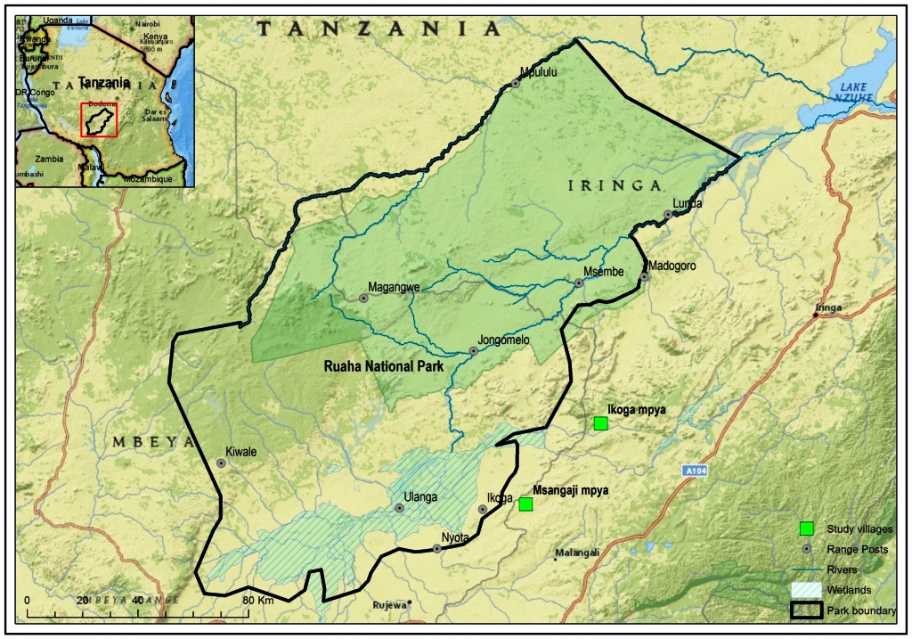

Figure 3.1: Map Indicating location of Ruaha National Park
Source: TAWIRI and RUNAPA GIS Unit, 2015

3.3.2 Ethnic Groups
The major ethnic groups are Bantu belonging to the following tribes; Sangu, Hehe, Bena and Nyakyusa (Mbarali District Council, 2009). Other small ethnic groups include Sukuma, Barbeig and Maasai who migrated from the North and they are predominantly agro – pastoralists.

3.3.3 Population
Mbarali district is among the highly populated area in the region and the country at large (Mbarali District Council, 2009). According to the 2012 Tanzania population census, Mbarali District had a total 300,517 people, whereby 145,867 are males and 154,650 were females (NBS, 2012). The district has a household size of 4.3 and sex ratio of 9:4. Comparing to the 2002 and 2012 population census, Mbarali district has experienced a population increase of 65,650 people.

3.2.4 Climate
Ruaha National Park has a bimodal pattern of rainfall seasons that begins in November to February, while the long season is between March and April. The annual mean rainfall ranges between 500 mm and 800 mm. The climate of the study villages in Mbarali districts is characterized by high intensity rainfall events (thunderstorms), controlled by the Inter-Tropical Convergence Zone (ITCZ). The area experiences a single rainy season from November to April and receives up to 1,600 mm of rain per year (WWF, 2010). The park experiences its dry season between June and October when the temperature reaches 35ºC. The mean annual temperature varies from about 18⁰C to about 28ºC (SMUWC, 2001). The vegetation of the area is predominantly woodland, wooded grassland and bush land of dense thickets of acacia and other thorny trees.

3.2.5 District Economy
The district economy depends largely on agricultural activities (Mbarali District Council, 2009). It is widely known for having large rice farms owned by the government, cooperatives or by individuals. The leading food crops in the district include maize, paddy, sunflower, groundnuts, sweet potatoes, cassava and beans. Other activities are fishing, petty business and livestock keeping. These contribute significantly to Gross Domestic Product (GDP) of the District. About 83% of the populations in Mbarali district are engaged in agriculture and livestock keeping for sustaining their livelihoods (Mbarali District Council, 2009). The Agricultural sector contributes much in District economy through provision of employment to more than 80 percent of its people (Ibid).

Before the expansion of Ruaha National Park, the district had a total land area of 15,560km². Half of the total land area is covered by forest and savanna woodlands while the rest is covered by flood plains mainly used for paddy production and wetland which was used for grazing (Mbarali District Council, 2009). However, after the expansion of Ruaha National Park, the remaining district area is about 5,000 km². (Ibid). The study focused on the southern part of Ruaha National park which covers Ihefu and Usangu plains. Study population was sampled from ten villages of Mbarali District as shown below in figure 3 below.
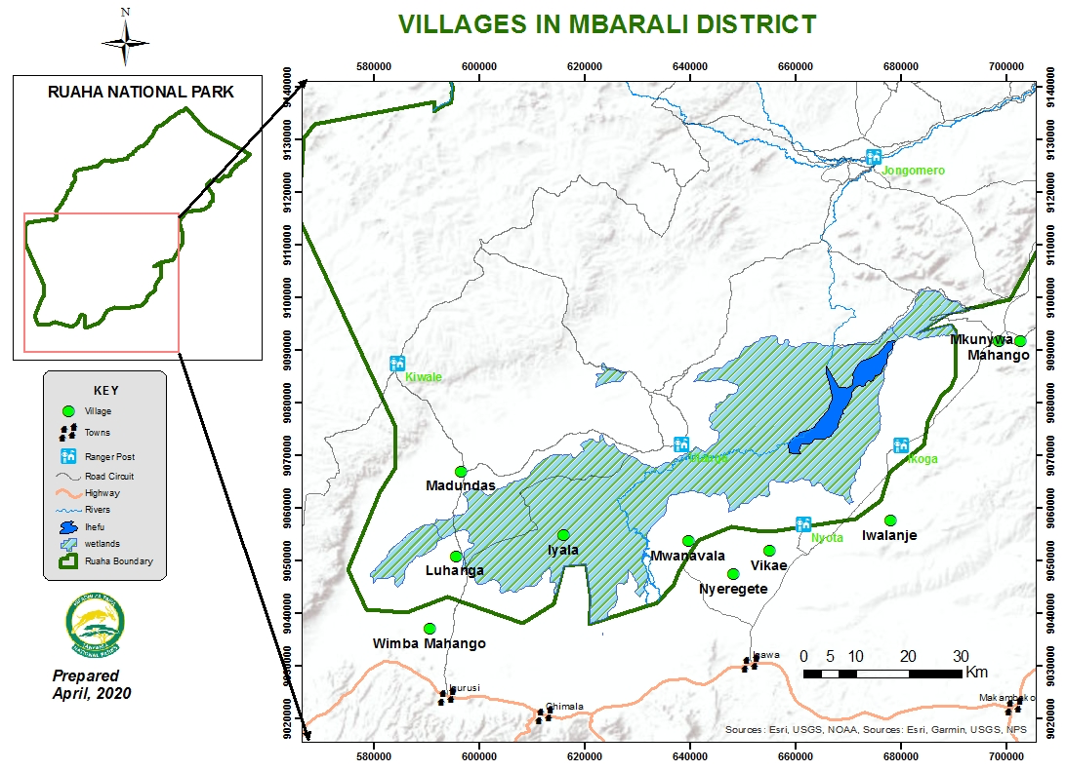

Figure 2.2: Map Indicating Villages where the Study has been Conducted
Source: RUNAPA GIS Unit, 2020

3.4 Study Population
In this research a total of 90 households (5% of targeted population) were sampled from estimated 1,800 people living in ten villages situated adjacent to RUNAPA and along Ihefu and Usangu plains. (population data from village offices reports, 2019). About 10 key informants were interviewed and in-depth interview with 5 people was conducted

Table 3.1: Sample Size
Participants | Total Number
Communities living adjacent to Park | 90
Key Informants | 10
In depth interview | 5
Total | 105
Source: researcher, 2020

3.5 Sampling Technique and Sample Size
The study employed a multi-stage sampling technique. The first stage was the selection of villages by using poll method, followed by selection of Sub-Villages and later selection of participants within the selected Sub-Villages. People living adjacent to Park (at the study area) and who are involved in livestock keeping had equal chances to participate on the study. Purposive sampling techniques was deployed in the selection of key informants (Park officials, Villagers Executive Officers, Villagers Environmental Officers and extension officers) and respondents for in depth interview.

3.5.1 Sample Size
As recommended, the size of sample should neither be excessively large nor too small but optimum (Kothari, 2004). A sample of 5% of the total households representing 90 respondents from 10 villages (in targeted sub-villages) was selected for household interviews. A sample size of 5% was considered to be a good sample since Boyd, (1998) suggested that, for a sample to be reliable and enough to contain elements of representativeness it should be at least 5% to 10%. Nevertheless, the sample size may also be calculated using the following general formula:
n =t² x p(1-p)
m²
where ‘n’ is a required sample size, ‘t’ is confidence level at 95% (standard value of 1.96), ‘p’ is an estimated percentage of population in the study area expressed as decimal and ‘m’ is a margin of error at 5% (standard value of 0.05).

Best and Kahn (2006) reasoned that a sample is a small part of a population selected for observation and analysis, the characteristics of which can enable the researcher to make certain inferences about the population from which sample was drawn. They maintain that there is no sample size that is the best; any sample can be acceptable depending on the nature of the study. However, a good sample should be that which reflects an actual profile of population from which it is drawn. The whole process of sample selection must be aimed at minimizing bias in the sample.

3.6 Variables And Measurement Procedures

3.6.1 Independent Variables
These are the ones that can be changed/controlled by dependent variable to test the effect on dependent variables

3.6.2 Dependent variable
These are the one being tested and measured in a research. Dependent variable is ‘dependent’ on independent variable.

3.7 Data Collection
The study utilised a socio-ecological survey using a structured questionnaire and supported by key informants’ interviews, in depth interview and observation (ocular) methods. The research also made use of secondary data from RUNAPA library, Public offices and other relevant sources. Primary data are the data obtained/collected direct by the researcher from the study area while secondary data are the ones not directly collected by the researcher; they are obtained through review of various documents such as work reports, previous studies and literatures.

3.7.1 Questionnaire
Primary data were collected using a structured questionnaire to all intended respondents. Respondents completed the questionnaires after being informed about the study and its purpose, assured that participation is voluntary, and reminded that the survey is anonymous and not to put their name on it. All respondents were asked to consent to participate on the study. Those who were consented were given 30 minutes to complete the questionnaire. The questionnaires pre-tested among a group of 25 people in different area which is a place where the actual research was conducted.

Data were collected from all selected respondents in the study. The questionnaire was in a simple English language and translated to Kiswahili. There was also a checklist for key informants who believed to have knowledge on the study in question. In depth interviews questions with people who believed to have a good experience with the area eg. Long term stays RUNAPA and District officials as well as Old and respected community members was also prepared.

3.8 Data Processing and Analysis
Information from the questionnaires were coded to obtain quantitative data. The obtained data were analysed using statistical package for social science (SPSS) version 20 to obtain characteristics patterns between different data variables. At the end of the discussion with key informants and in-depth interview, notes were reviewed to ensure that all major issues were covered. Descriptive statistics were performed to generate frequency distribution tables and pie chart that suits study objectives.

3.9 Validity
Validity is the degree of consistency and stability that is the same supposition can be achieved by different researcher under the same data collection methods. The validity of data involves reasonableness and correctness of data. Validity test in this study intend to see if the instrument measured what it was intended to. Validity examine whether the research focus is consistency in term of research objectives and statement problem or how truthful the research results will be (Kothari, 2003). To ensure/increase validity of the study, the triangulation of data collection was applied in order to reduce bias and verify information obtained from a single technique (Rocco et al., 2003).

3.10 Reliability
Reliability refers to consistency of the results of assessment (Nitko, 2010). According to Omari (2011), Reliability deal with consistency and stability of the phenomena; that means the extent of reproducibility of the results by the same instrument. Piloting of instruments is of paramount importance in order to maintain validity, reliability and practicability of instruments and therefore, the validity and reliability of the findings. Try out and pre-testing of instruments will be done by researcher so as to make correction for mistakes and identify the ambiguous and repeated questions which were unnecessary.

3.11 Ethical Consideration
Approval to conduct the study was obtained from the Open University of Tanzania. The letter to request permission to conduct the study was obtained and sent to Mbarali Council Administration (DED) and hence to all selected villages. All participants who involved in the study were informed of the full nature of the study and requested to sign informed consent so as to accept participating in the study. Participation was voluntary, and every participant was free to withdraw from the study at any time without a penalty. The study did not record any name of participants and instead, codes were used to maintain confidentiality.

3.12 Chapter Summary
This chapter concludes that, research design was appropriate with the topic for its advantages. The study was conducted in Ruaha National Park of Tanzania in ten Villages. Large numbers of livestock caught grazing unlawfully into the park were from those villages. Multi stage sampling technique was deployed to get the participants and 100 people participated in the study. The primary and secondary data were collected through self-administered questionnaire. Moreover, data processing was done through coding and entered in excel then transferred to the SPSS Version 20 for data analysis. This chapter focused on approaches that have been deployed in data collection and analyses of the information collected for the study.

CHAPTER FOUR

RESULTS AND DISCUSSIONS

4.1. Chapter Overview
This chapter presents results from the analysis of collected data. The first section initiated on demographic characteristics of the participants. The second part focuses on social cultural factors contributing to illegal grazing by communities into RUNAPA. The third section focuses on examining community’s awareness on issues pertaining grazing in the national park. The fourth section focuses extent of grazing inside Ruaha national park.

4.2. Demographic Characteristics of the Respondents

4.2.1Age of the Respondents
Age selection of participants in this study assumed that the individuals with ages from 18 to over 60 would be more aware of various issues concerning the study. Similar category of age group has been reported elsewhere and is regarded as the most responsible age in many ethnic groups (Cookie, (2007).
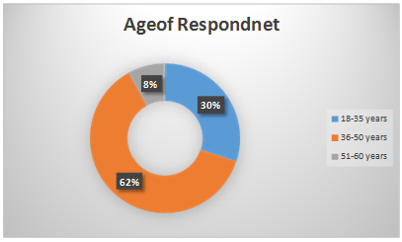

Figure 3.1: Age of Participants
Source: Field Data (2019)
It is during this time when most of them get married and assume political roles and decision-making positions in their societies (Cookie, (2007). The findings presented in Figure 4.1 show that more than half (62%) of respondents were in the age group between 36 and 50 years of age. About (30%) of the participants were in the age between 18-35 years. Findings also show that (8%) of the respondents were in the age between 51-60 years.

4.2.2 Gender of the Respondents
Based on Esplen and Jolly (2006), gender refers to the biological characteristics that define human beings as male or female. Gender is an important aspect in understanding the division of labour and resource ownership in a particular area (Hegga, 2006). The results show that most of the participants (97%) were males and the rest (3%) were females. This shows that men are the ones mostly responded to the questions and probably are the ones making decisions for the families living adjacent to Ruaha Nation Park. Gender of the respondents was studied in order to find out the scattering of the respondents by gender and their participation in illegal grazing activities (See Figure 4.2).
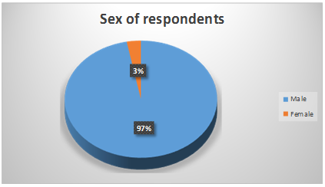

Figure 4.2: Gender of the Participants

4.2.3 Education Level of Participants
The level of education in this study was important as it gives a picture of understanding of the respondents on conservation awareness, regulations regarding grazing and social cultural issues. Results show that the study involved people from different education level. Whereas, 20% of the respondent have not gone to school, 71% attained primary Education, 7% attained secondary school education, while 2% only have attained University level Education (see Table 4.1). The differences in academic qualifications depict that participants could have given responses that are factual concerning factors influencing drivers of livestock grazing into Ruaha National Park. Studies had previously indicated that indigenous people might possess negative attitudes towards conservation of natural resources for range of reasons including: low education levels, lack of awareness about environmental issues and lack of participation (Allendorf et al., 2006)

Table 4.1: Education Level of Respondents
Variable | Frequency | Percentage (2%)
Level of Education
No Education | 12 | 20
Primary Education | 43 | 71
Secondary Education | 4 | 7
University Education | 1 | 2
Source; Field Data 2019

4.3 Social Cultural Factors Contributing to Illegal Grazing

4.3.1 Economic Activities in the Villages
To understand the source of income for dwellers of the study area, respondents were asked to mention their main economic activities. 70% of the respondents reported rice farming/agriculture and livestock keeping together (Argo pastoralism) to be their main economic activity. The rest 30% said they only do agriculture (See Figure 6 below). Rice farming requires lots of water and arable land. The type of livestock keeping (free range) performed at the area require a huge land with good pastures. Therefore, results show high dependence of land, water and good pastures to support communities’ livelihood.

Considering the nature of the area, the rate of population growth and available number of livestock, pressure to the national park boundaries is inevitable. However, Hesse (2016) said when the demand for land increase due to population growth, individualisation of land and gazettement of land for PAs, Pastoralists have adopted a different lifestyle by engaging in farming activities, agro pastoralism and increasing involvement in the market economy by purchasing grains for supplementing their diets for their lives (Hesse, 2006).
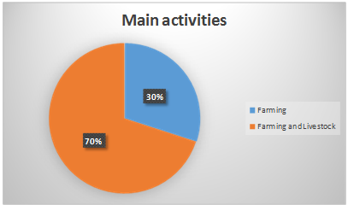

Figure 4.3: Main Economic activities
Source; Field Data (2019)

4.3.2 The Relationship between Community Members and Ruaha National Park
When Participants were asked to describe their relationship with Ruaha National Parks the results were as follows; 35% of the respondents described their relationship with the park to be moderate, (28%) described that they do not have any relationship with the park. About (25%) responded to have low connection to the Park workers. Only (8%) and (3%) described to have high and very high relationship to the Ruaha National Park staff respectively (See figure 4.4).
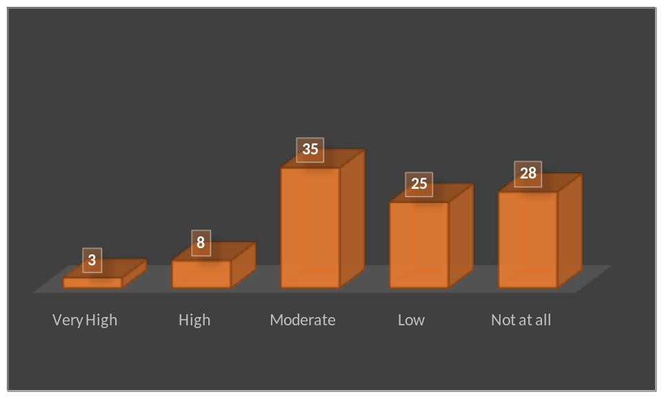

Figure 4.4: Relationship between community and RUNAPA
Source: Field Data (2019)

These results imply that community members in the study area do not have a good relationship with the park. Reasons for that could be the fact that Community members think they are denied the right to use good pastures available inside the park for their livestock. On further discussion, respondent who stated to have no good relationship with the park said it is because of unfair treatment they got from park staff when their cattle are caught grazing inside the park. Those few who stated to have good relationship with the park when asked further, they said they see some supports from Ruaha through SCIP (support for Community Initiated Projects) programs.

4.3.3 Interaction with the Park Staff
The study was also interested in finding out how is the level of interaction between Community members and Ruaha national Park Staff. On this aspect the intention of this study was to find out how often and at to what extent does community and Ruaha staff work together in various facets. So, when participants requested to respond, the responses were as follows; Big number of respondents (87%) reported to have never interacted with Park staffs in anyhow. This could mostly be because of the geographical location of the area against the number of personnel dealing with community issues.
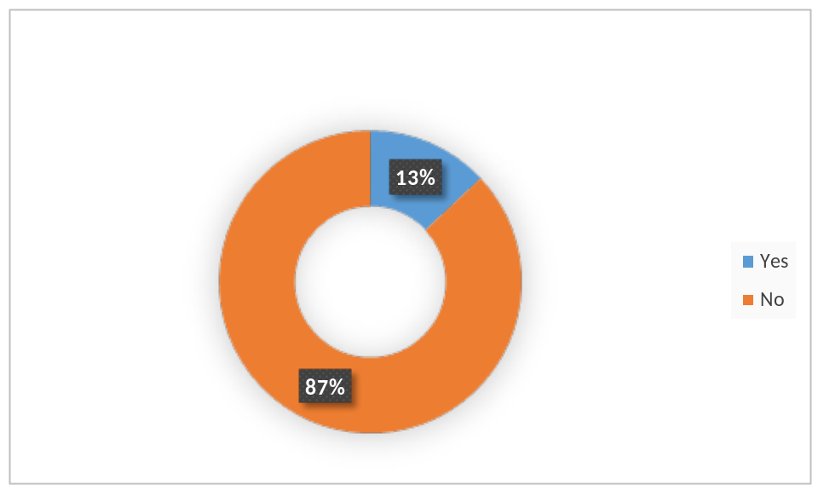

Figure 4.5: Experienced interaction with Park Staff
Source: Field Data (2020)

Ruaha has only two staff at the headquarters (more than 300kms) to deal with community issues. Only 13% of the respondents reported to have been interacted with RUNAPA staff in different occasions (see figure 8 below). Results show that despite the effort deployed by RUNAPA, still the park have not managed to get the community closer to what they are striving to achieve. There is still a gap that if filled would have an impact in community understanding/perception on Park regulations and hence reduce the extent of grazing inside the park.

4.4 Community Awareness and Education

4.4.1 Knowledge about the Park
During the survey, participants were required to answer if they are aware of the existence of the park close to their villages including park boundaries and park values. The findings revealed that (60%) of the respondents are well aware of the existence of the park itself, boundaries, values and park rules. (40%) of the respondents said they are not aware of the existence of park boundaries close to their villages.
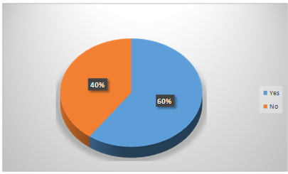

Figure 4.6: Protected Areas in the Village

PAs in Tanzania have remained a top-down and paramilitary endeavour, which does not allow local people’s opinions (Mariki, 2013). This could lead to lack of communities’ interest for park affairs. However, results depict that people who understood and aware about the existence of park boundaries close to their villages were more than half of the respondents. See figure 4.6

4.4.2 Conservation Education
Participants were required to respond to a question that asked if they have ever received any training regarding conservation education. Majority, about (82%) of the respondents said they have received some conservation training/education. However, (18%) of the respondents said they have never received such training. Participants were further asked to mention who provided training. Findings show that the said training have been provided by different officials, 75% of the respondents mentioned village leaders to be their source of education, while 25% mention Ruaha National Park staff as the source of conservation education they have received. The findings depict that RUNAPA has a mechanism for reaching out to communities but at a small scale as observed during the survey (See Table 4.2).

Table 4.2: Conservation Education
Variable | Frequency | [Percentage
Conservation Training/Education
Yes | 49 | 82
No | 11 | 18
Source of Training/Education
Village Council | 45 | 75
Park Staff | 15 | 25
Source: Field Data 2019

4.5 Extent of Grazing in Ruaha National Park
In developing countries like Tanzania, the situation of people to depend entirely on natural resources is a common phenomenon (Scherl et al., 2004; USAID, 2006). Most of the people living close to PAs are poor with few livelihood options which ultimately results to biodiversity destruction (Linkie, et al., 2007). An interview with the Mbarali Development officer revealed that in Mbarali district, people depended on Ihefu wetland mainly for farming, grazing and fishing. During the study, information about the extent of grazing was obtained from Ruaha National Park office at the department dealing with Protection of Park resources.

Community members were asked to tell as to why the keep taking their livestock into the park (which is highly guarded) for grazing. Table 4 below shows the trend of grazing extent inside the park for nine years, financial year 2011/12 to half of financial year 2019/20. The statistics are for the caught incidences only. The table shows the number of herders/pastoralists, number of livestock and amount of compound that herders have been required to pay as fine for illegally entering and grazing.

For the past nine years, a total of 637 herder caught grazing a total of 31,210 livestock and fined about 2,228,528,000 TZS. Trends show that the extent of grazing inside the park is more prominent during second quarters, which is from September to December. This period is dry season where most of the areas on community land is dry and bare and hence herders rely on park for grazing. Waweru, F and Oleleboo, L (2013) on their study similarly pointed out that livestock always found in the park in the dry season (47.7 %) compared to the wet season (5 %) and all year round (7.3 %). Trend also depicts the exponential growth of number of livestock caught from 2011 to 2019. This implies first, there could be an increase of livestock being grazed inside the park and second, the park’s ability to deal with the problem has increased.

Table 2.3: Trend of Extent of Grazing in Ruaha National Park
Financial Year | First Quarter |  |  | Second Quarter |  |  | Third Quarter |  |  | Fourth Quarter
Financial Year | Pastoralists | Livestock | Compound (TZS) | Pastoralists | Livestock | Compound (TZS) | Pastoralists | Livestock | Compound (TZS) | Pastoralists | Livestock | Compound (TZS)
2019/20 | 5 | 1384 | 138,000,000 | 5 | 1384 | 138,800,000
2018/19 | 22 | 406 | 8,300,000 | 7 | 403 | 38,860,000 |  | 1624 | 39,260,000 | 3 | 437 | 22,000,000
2017/18 | 18 | 1046 | 55,287,000 | 46 | 2414 | 220,250,000 | 11 | 587 | 57,900,000 | 35 | 3170 | 116,410,000
2016/17 | 19 | 942 | 20,120,000 | 23 | 919 | 22,070,000 |  | 2174 | 118,811,000 | 52 | 1844 | 95,270,000
2015/16 | 9 | 456 | 5,580,000 | 28 | 1250 | 26,375,000 | 37 | 1546 | 40,195,000 | 29 | 1096 | 50,700,000
2014/15 | 8 | 957 | 13,140,000 | 56 | 2061 | 812,800,000 | 41 | 1348 | 40,730,000 | 27 | 681 | 7,320,000
2013/14 | 15 |  | 10,615,000 | 9 | 629 | 6,800,000 | 28 | 1072 | 12,620,000 |  | 629 | 6,800,000
2012/13 | 4 |  | 750,000 | 11 | 269 | 9,945,000 | 9 |  | 9,110,000 | 4 |  | 1,800,000
2011/12 | 25 |  | 24,640,000 | 18 | 482 | 6,065,000 | 25 |  | 30,840,000 | 8 |  | 10,365,000
TOTAL | 125 | 5191 | 286,432,000 | 203 | 9811 | 1,281,965,000 | 151 | 8351 | 349,466,000 | 158 | 7857 | 310,665,000
Source: RUNAPA progressive reports, 2019

4.5.1 Causes for Grazing Inside the Park
On interview with communities, respondents gave three reasons (causes) to justify why they take livestock into Ruaha national park. These included inadequate land for grazing at the villages, water availability and good pastures. Majority of respondents (65%) frequented the park because of inadequate land for grazing. 25% take livestock into the park for water and the rest 10% because of good/nutritious pastures available inside the park (See Figure 10 below). On their study about Human-Wildlife Conflicts, Waweru, F and Oleleboo, L (2013) found four Causes (reasons) of livestock incursion into the Tsavo West National Park. These include grazing/pasture, water, salts and free from livestock diseases, but majority of the households (61%) visited the park for grazing/pasture for their livestock.
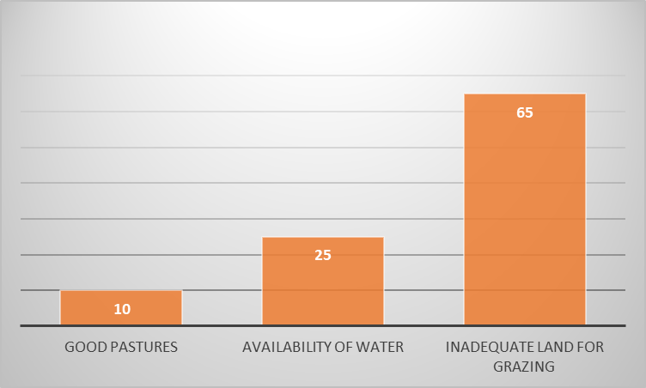

Figure 4.7: Drivers for Livestock Grazing into RUNAPA
Source: Field Data, (2019)

4.5.2 Control of Grazing in the Park Area
Respondents were required to propose control measures that will help prevent community members form unlawful grazing of livestock into Ruaha National Park. Findings revealed that (62%) of the respondents proposed awareness and education to be provided to communities especially livestock keepers. About (20%) of the respondents proposed the establishment of the reserved land for grazing in the village areas. And the rest, (18%) proposed a reduction of the number livestock held by each individual pastoralist. This will enable them to have control of their livestock within village land without being forced to trace pass into the park. See Table 4.4.

Table 4.4: Measures to Control Grazing in the Park
Variable | Frequency | Percentage
Stop grazing in the Park
Education and Awareness | 37 | 62
Reserving of grazing areas | 12 | 20
Reducing number of livestock’s | 11 | 18
Source; Field Data 2019

4.6 Key Informants Interview

4.6.1 Grazing in Protected Areas
It has been observed that along with poaching, livestock grazing is one of the greatest challenges in conservation in Ruaha National Park. Community members at the study area are mostly Agro-pastoralist doing both farming and livestock keeping. Rice farming is the major economic activity in the area, followed by maize farming and livestock keeping. Prior discussion with District personnel, it was observed that there is shortage of grazing areas for pastoralist on community/village lands. The reason for this shortage is cultivation, especially during farming/rain season when most of the land is being cultivated. Therefore, little land is available for grazing

It has also been observed that there is an increase of Human and livestock population in the whole district of Mbarali. Livestock have been increased due to high production and migration of pastoralist from other areas such as Mbeya and Makambako, and others have been migrating from as far as Shinyanga region (Mbarali District Reports, 2017). Interview with village leaders revealed that Sukuma Agro-pastoralist have a tendency of inviting their relatives/friends to come to the area. Once an invited person arrives to the area he will be given some livestock to look after for a year or so and then given wife and cattle for his own. He will continue taking care of host’s livestock and his own. If he defaults, his wife and the livestock he has been given would be taken away. This tendency has been observed to be an incentive for other pastoralist to migrate to the area.

One official stated that “Livestock in Mbarali District have exceeded the carrying capacity”. This statement implies that there is huge number of livestock compared to what the available land can accommodate. This situation might be a driving factor for some community members to be forced to graze into Ruaha National Park. Acording to Mbarali Livestock officer, Mbarali can accommodate only 65,000 livestock, but during the time of the study, livestock were estimated to be 130,000 which is two folds of the required number (Mbarali District Reports, 2017). Agro-pastoralist have also had a tradition of buying more cattle once they harvest and sell their crops. This has observed to be a contributing factor for increased number of livestock in the area, therefore, more pressure to the RUNAPA.

4.6.1.1 Land Use Plan
Officials from both RUNAPA and Mbarali pointed out that, Pastoralists are forced to risk and take their livestock into RUNAPA because of poor land use management in their village. There are no land use plans in most villages, and if exist, they are not properly implemented or not implemented at all. One official from RUNAPA said;
“We understand the challenges that exist in village land, so in collaboration with the District authority and other stakeholders like WCS, we are supporting development of Land use plans. As we speak, we have completed land use plans for Nyakezombe, Ihahi, Wimba Mahango Villages”.

4.6.1.2 Water for Livestock
Interview with village leaders revealed that most of the pastoralist caught grazing inside the park claimed to have crossed the park boundary just to take their livestock for water. This was also stated by RUNAPA official dealing with park protection. An official from RUNAPA dealing with CCS said;
“To address an issue of water for livestock in the villages, we have been liaising with Mbarali districts and the respective villages to construct water drinking points for livestock”.

So far, these efforts have managed to construct cattle traps at Shoga and Iwalanje villages which are village close to the study area. There is also an ongoing project to make water well at Nyeregete village which is also adjacent to the study area.

4.6.1.3 Boundary Dispute
Despite the fact that ignorance of law is not an excuse, there is a concern from village officials who have been interviewed that in some areas, park boundaries are not well demarcated, meaning that in some areas, beacons are not erected. Sometimes pastoralists (especially the Youngs and new comers) find themselves inside the park without knowing. One village leader (Mwanavala village) claimed,
“My people were caught on the village land; their cattle were taken by park rangers and later they were fined huge amount of money for unlawfully entry and grazing inside the park”.
Disputes concerning boundaries are also observed in most of the villages. Villages whose land portion have been annexed to RUNAPA during 2008 Park extension have a serious issue that put the relationship between RUNAPA and Community members in jeopardy. Some people have gone further to propose a ground work exercise to be conducted so as to properly translate the Government Notice (GN 28 of 2008) on ground. In Vikae, Mwanavala, Nyeregete, Iyala, Luhanga and Wimba Mahango villages, some people claim to continue to use the land (which is literally within the park) because they have not yet been compensated following the annexation of their land into Ruaha National National Park by GN 28 of 2008. Mbarali Districts reports show that the matter is being handled by Mbeya Regional Commissioner Office and the processes in ongoing.

4.6.2 Community Awareness
Interview with key informants has revealed that RUNAPA and Mbarali District have collaboratively been conducting various programs that aimed at raising community awareness on conservation. These efforts were expected to reduce illegal activities that have been conducted by communities inside the national park including livestock grazing. Nevertheless, Village leaders had different opinion. They argued that despite what RUNAPA and the District is doing to raise community awareness, they are not open
“These people do not involve us in managing the Park, which leaves communities unaware of management decisions and reasons for certain decisions that are made’. Another respondent pointed that people do not obey some of the park rules because of the secrecy during development of such rules. “We always see lots of pastoralists detained with evidence of the livestock caught inside the park; however, after few days the same people (released/fined) are repeating same practices. Rules and laws will never be effective if we are not involved in their making”. He concluded.

Pastoralist Council; It was also observed that, Apart from RUNAPA and Mbarali District, there is Mbarali Pastoralist Council that too provides support and awareness to pastoralists on various issues.
‘This council has got leadership from village to district level and has been a useful platform when it comes to issues pertaining awareness/training for pastoralist’, said a community development office of Mbarali District.

One leader from the council pointed out that pastoralists in Mbarali are faced with various challenges including shortage of grazing area, modern technology as well immigration of intruders and their livestock to their areas which lead to over population of livestock on their land.

4.7 Discussion

4.7.1 Social Cultural
Livestock contributes greatly to the measure and understanding of material wealth most pastoral communities in Tanzania (Ellis and Mdoe, 2003). Hence, wealthier households might not have sufficient access to pasture on village lands and left with no option. Alternatively, they graze their livestock in the PAs where resources are abundant. This is supported by the fact that the main reason for grazing livestock in the RUNAPA as reported by the respondents was inadequate grazing areas in the village land. Other studies similarly have showed (e.g. Coomes et al. 2004; King and Peralvo, 2010), wealthier households, rather than poorer ones were likely to enter the park and graze illegally. Considering the risks, poor families will not dare to expose their livestock to such risks as compound offence fines and livestock are confiscated.
Conservation efforts must target all parts of the causal chain from social cultural factors to attitude towards PAs. In other words, conservation strategies based purely upon economic assumptions may not be effective in changing conservation behaviours (Stern, 2008). Similarly, in their social cultural framework on regulatory compliance, integrated economic theory with theories from psychology and sociology to incorporate moral obligation and social influence in addition to the conventional benefits and costs associated with illegal behaviour. Local communities who view the authority as lawful feel a strong obligation to comply even when the goals and activities of the authority do not directly benefit them.

Myth is a folklore genre consisting of narratives or stories that play a fundamental role in a society, such as foundational tales or origin myths. The main characters in myths are usually gods, demigods or supernatural humans (Cambridge English Dictionary). The study revealed the existence of a myth that could be contributing to the illegal grazing into the park. Despite all the risk they would have faced when caught, like being compounded, taken to court or livestock being confiscated, Pastoralists still believe that it is worth taking the risk. There is a belief (myth) that pastures within or along the wetland are too nutritious to make livestock give birth two times in a year. Milk production is also believed to be very high when livestock will be fed pastures from the area. This belief /myth is so strong among pastoralists and have been spread all over the study area.

4.7.2 Awareness
Fostering positive attitudes towards PAs may be an important criterion of long-term success of PAs (Pullin et al., 2013). Identifying which factors influence community’s attitudes towards PAs is thus highly relevant for the development of conservation interventions. It is equally relevant, however, to identify which factors predict the intentions and behaviour of individuals engaging in either pro- or anti-conservation behaviours (St John et al., 2011). Results from this study demonstrated that drivers for illegal grazing are crucial in forecasting the intention and behaviours of communities on illegally grazing in RUNAPA.

Results shows that 25%, 28% and 35% of the interviewed villagers declare to have low, Not and Moderate relationship with the park respectively. Lack of relationship between RUNAPA management and Community members could lead to a communication gap between the two parties. From the results, poor relationship between RUNAPA and communities could be due to lack of community awareness of Park activities and conflicts over resources (land, pastures and water). What has happened before, has a significant impact on communities’ attitude towards RUNAPA. Ormsby and Kaplin (2005) similarly found the history of management to be one of the main factors influencing community perceptions towards the park.

4.7.3 Extent of Illegal Livestock Grazing
This study assessed drivers that influence livestock grazing by local communities into Ruaha National Park of Tanzania. The study suggested that local conditions significantly affect communities living adjacent RUNAPA. Communities illegally graze in the park due to lack of conducive environment at the village lands, Lack of community’s support to conservation efforts, lack of community’s sense of ownership towards the park as well as negative attitude of communities towards the park, especially park regulations. This is evidenced by low percentage of people who responded to have good relationship and to have interacted with park officials as seen in fig 4.6 and 4.7 above. The lack of conducive environment is explained by the shortage of grazing area, lack of enough water infrastructure for livestock, lack/or poor implementation of village land use plans and inadequate extension services as stated by majority of key informants.

Law enforcement is the main instrument for controlling illegal entry and grazing into RUNAPA (supported by Wildlife Conservation Act CAP. 283 R.E 2009 and National Park Act CAP. 282, R.E. 2002). Although, some other measures like education are also deployed. Effect of law enforcement on illegal resource extraction within PAs in developing countries remains contentious; and increasing enforcement efforts is both costly and might exacerbate conflict with local communities or individuals (Robinson et al., 2010). Study revealed existence of high fines for illegal grazing and the likelihood of being arrested and convicted. Reports show RUNAPA tend to fine (compound offence) those who pled guilty an amount up to 100,000TSZ but not exceeding 1,000,000TZS for one livestock.

The National Park Act (2002), provide a restriction for entry into the national park; Any person who commit an offence under this section shall be liable to a fine not exceeding five hundred thousand shillings or to imprisonment for a term not exceeding one years or both. It should be noted; Nielsen and Treue (2011) suggested that, fines should be high enough to discourage illegal harvesting of wildlife and forest resources in protected areas. The study also revealed presence of high population of livestock at study area. Hackel (1999) said that one of the challenges of increased population in close proximity to the borders of a PA, is the growing pressure from local people to utilize the resources therein. Livestock population is contributed by production within the area and migration of new pastoralists. This fact can explain why there is a concern about pastoralists claiming to not know park boundaries. It is obvious invaders could not know the boundaries.

CHAPTER FIVE

CONCLUSIONS AND RECOMMENDATIONS

5.1 Chapter Overview
This chapter presents the conclusion and recommendations which were based on the findings of the study. The conclusion has been drawn from findings and discussion to summarize issues that have been discussed above; while the recommendations part of this chapter presented the suggestions proposed basing the problem and the gaps identified.

5.2 Conclusion
Livestock grazing inside the park poses a significant challenge for RUNAPA. Therefore, protecting park resources need a lot of resources in terms of finances and man power. Communities living adjacent to RUNAPA rely on the good pastures available inside the park for grazing, despite the fact that RUNAPA is heavily guarded. Study concluded that there are number of factors that drive communities to graze their livestock inside RUNAPA, which includes; first, Scarcity of grazing land within villages; Mbarali Districts is dominated by farmers and agro-pastoralists that require massive land for cultivation and grazing. Thus, competition for land, especially during farming season, is inevitable.

Lack of land use plan is another explanatory for scarcity of land. Out of 10 villages that have been studied, only one village has got a land use plan, though it has been observed to be poorly managed. Secondly, large number of livestock has been noted to be a contributing driver for illegal grazing in RUNAPA. Based on study results, Mbarali Districts has confirmed to have high population of livestock that exceed the district carrying capacity. Thus, grazing inside the park is the coping mechanism for the situation.

Third, community awareness regarding various conservation issues has been found to be low. Community member place little value for the existence of RUNAPA as compared to individual benefits. Although, RUNAPA through its CCS department is putting efforts, still community awareness is very low. This can be explained by either, RUNAPA is putting less effort as compared to the intensity of the problem or much time is needed for the community to change (considering RUNAPA has started its activities along Ihefu and Usangu just 12 years after GN 28, 2008). There is more to be learnt about this.

Fourth, Lack of communities’ sense of ownership for RUAHA. Study showed that significant number of community members do not perceive to have any stake or role to play in protecting the park. Conflicts that originated from GN 28 that included some of community land to RUNAPA as well as daily confrontation between park rangers and pastoralists are main reasons for that perception. Lack of involvement of communities in decisions that would have impact on their lives has also observed to be the source for poor relationship between the two parties.

The study also concluded that Traditions and Myth have impacts on how people behave, especially when it comes to respect for the already set rules and regulations. The myth that exists among pastoralist on the quality of pastures is something not to be ignored. If Pastoralist believes that pastures inside the park can make livestock to give birth twice in a year, it will take a lot to convince them not to graze inside the park. Despite the efforts and resources, the park put in arresting and punishing the offenders, the problem still persists. This conclude that setting high punishment (high compounds) does not have desired effect if the problem of community’s attitude toward what is being conserved is not addressed.

Lastly, Contrary to a popular belief that associated poverty and illegal entry into PAs, this study has concluded that, poverty is not a driving factor that influencing communities to graze inside RUNAPA. Ellis and Mdoe (2003) noted that livestock contributes greatly to the measure and understanding of material wealth in Tanzania. Therefore, as suggested by Coomes et al. (2004), wealthier households, rather than poorer ones were likely to enter the park and graze illegally.

5.3 Recommendations
The intervention to address the challenge of illegal grazing should focus on intensifying law enforcement. Setting high punishment will have no effect if the problems of gathering evidence, investigating cases, having experienced prosecutors at the court is not similarly addressed (Ariffin, 2015). The intervention should also focus on changing communities’ attitudes towards conservation, to a more positive side. Fostering positive attitudes towards PAs may be an important criterion of long-term success of PAs (Pullin et al., 2013).

RUNAPA should consider involving communities in decisions that have impacts on communities’ affairs, such as benefit sharing and park regulations. This will help creating communities’ sense of ownership over the park. Once communities feel to own the park, they will be responsible and may support conservation efforts and thus reduce community or individual engagement in harmful behaviours such as illegal grazing (Holmes, 2003).

RUNAPA should intensify its efforts to raise community’s awareness through Education/training programs, Communities Park Visits and Public meetings. The programs should emphasis on addressing the challenge associated with the existing myths within pastoralists To address the problem of land scarcity, RUNAPA should work in collaboration with the district authority and support programs/projects to improve agricultural and livestock productivity as well as create incentives for people to either refrain from grazing or convert livestock into alternative forms of capital with less environmental impact. Land use plan should also be the key focus

5.4 Recommendations for Further Research
This study recommends that further studies on first, understanding pastoral logics behind the practice of grazing livestock in protected areas. Second, assessing factors contributing to livestock depredation patterns and its impacts on management of PA resources

REFERENCES
Allendorf, F. W., P. A. Hohenlohe, and G. Luikart (2006). Genomics and the future of conservation genetics. Nature Reviews Genetics, 11, 697– 709.
BLCC (Bakweri Land Claims Committee), (2006). African human rights commission rules on Bakweri vs Cameroon land use.
Boyd, C. Blench, R. Bourn, D. Drake, L. & Stevenson, P. (1999). Reconciling interests among wildlife, livestock and people in Eastern Africa: A sustainable Livelihood
Coomes, O. T., Barham, B. L., & Takasaki, Y. (2004). Targeting conservation–development initiatives in tropical forests: insights from analyses of rain forest use and economic reliance among Amazonian peasants. Ecological economics, 51(1), 47-64.
Ellis, F., & Mdoe, N. (2003). Livelihoods and rural poverty reduction in Tanzania. World Development, 31(8), 1367-1384.
Ervin, J. (2013). The three new ‘r’s for protected areas: repurposes, reposition and reinvest. Parks, 19.2, 75-84.
Hackel, J. D. (1999). Community conservation and the future of Africa's wildlife. Conservation Biology, 13(4), 726-734.
Hesse, C., 2006. Pastoralism: Drylands‘s Invisible Asset? International Institute of Environment Development IIED. www.iied.org. Accessed 31st 3, 2010.
Holmes, C. M. (2003). The influence of protected area outreach on conservation attitudes and resource use patterns: a case study from western Tanzania. Oryx, 37(03), 305-315.
IUCN (1994). The World Conservation Union 1994 Guidelines for protected area management categories. Gland, Switzerland: IUCNKambas National Park, Sumatra, Indonesia. Oryx 34(4), 262-274.
Kimario, F.F., Botha, N., Kisingo, A., and Job, H. (2020) Theory and practice of Conservancies:Evidence from Wildlife Management Areas in Tanzania. In Erdkunde retrieved on 23rd March, 2019 from; https://doi.org/10.3112/ erdkunde.2020.02.03ISSN0014-0015.
Kiringe J. W. & Okello M. M. (2007). The threats and their relative severity to Wildlife Protected Areas. The School for field Studies, Center for Wildlife Management Studies. Nairobi, Kenya. Retrieved on 12th October, 2019 from; http://epa.oszk.hu/02500/02583/00009/pdf/EPA02583_applied_ecology_2007_02_049-062.pdf.
Kothari, C. K. (2004). Research Methodology Methods and Techniques. New Age International Publisher, New Delh, India.
Lele, S, Wilshusen, P., Brockington, D., Seidler, R. & Bawa, K. (2010). Beyond exclusion: alternative approaches to biodiversity conservation in the developing tropics, Current Opinion in Environmental Sustainability, 2, 1–7.
Linkie, M., Dinata, Y., Nugroho, A. & Achmad Haidir, L. (2007) Estimating occupancy of a data deficient mammalian species living in tropical rainforests: Sun bears in the Kerinci Seblat region, Sumatra. Biological Conservation, 137, 20–27.
Mariki, S. B. (2013). Conservation with a human face? Comparing local participation and benefit sharing from a national park and a state forest plantation in Tanzania. Sage Open, 3(4), 2158244013512665.
Mbarali District Council. (2009). Mbarali district social- economic profile. Mbeya, Tanzania, URT.
Ministry of Natural Resources and Tourism (MNRT) (2007). The Wildlife Policy of Tanzania. Ministry of Natural Resources and Tourism. URT.
Ministry of Natural Resources and Tourism (MNRT), (1998). The Wildlife Policy of Tanzania. Ministry of Natural Resources and Tourism. URT.
National Bureau of Statistics (NBS) [Tanzania]. (2014). Tanzania National Panel Survey Report (NPS) - Wave 3, 2012 - 2013. Dar es Salaam, Tanzania. NBS.
Ormsby, A., & Kaplin, B. A. (2005). A framework for understanding community resident perceptions of Masoala National Park, Madagascar. Environmental Conservation, 32(02), 156-164.
Pullin, A. S., Bangpan, M., Dalrymple, S., Dickson, K., Haddaway, N. R., Healey, J. R., ... & Vigurs, C. (2013). Human well-being impacts of terrestrial protected areas. Environmental Evidence, 2(1), 1-5.
Rocco, S. T., Bliss, A. L., Gallagher, S. & Pérez-Prado, A. (2003). Taking the Next Step: Mixed Methods Research in Organizational Systems Ruaha Protection Reports.
Scherl, L. M., Wilson, A., Wild, R., Blockhus, J., Franks, P., McNeely, J. A. & McShane, T. O. 2004. Can protected areas contribute to poverty reduction? Opportunities and limitations. World Conservation Union, Gland, Switzerland.
St John, F. A., Edwards-Jones, G. & Jones, J. P. (2011). Conservation and human behaviour: lessons from social psychology. Wildlife Research, 37(8), 658-667.
Stern, M. J. (2008). The power of trust: toward a theory of local opposition to neighbouring protected areas. Society and Natural Resources, 21(10), 859-875.
Van-vliet, N. (2010). Participatory vulnerability assessment in the context of conservation and development projects: a case study of local communities in Southwest Cameroon. Ecology and Society, 15(2), 6.
Waweru, F. K. & Oleleboo, W. L. (2013). Human-Wildlife Conflicts: The Case of Livestock Grazing Inside Tsavo West National Park, Kenya.
West, P., Igoe, J. & Brockington, D. (2006). Parks and Peoples: The Social Impact of Protected Areas. Annual Review of Anthropology, 35, 251-277.
WWF, (2002). Living planet report.

APPENDICES
APPENDIX I: QUESTIONNAIRES
I am Bosco Kessi a student at Open University of Tanzania. I have prepared these questionnaires for the purpose of collecting data concerning my research study titled: “Assessing factors influencing drivers of livestock grazing into Ruaha National Park”. Your contribution is highly valued in making the study successful. Assurance is given that your personal information will be confidential and undisclosed.

SECTION A: DEMOGRAPHIC CHARACTERISTICS
1. Gender:
- Male ___
- Female ___
2. Age: _____
a) Below 18
b) 18 to 35
c) 35 to 50
d) 50 to 60
e) 60 and above
3. Ethnicity: ____________________
4. Education of interviewee:
- Primary __
- Secondary __
- College __
- University __
- No education __
- Other (specify) ______________
5. Place of birth:
- This Village __
- Ward __
- District ___
- Region __
- Other __
6. If you are not born in this village, why did you move here?
- Marriage __
- Employment __
- Grazing __
- Family __
- Cultivation __
- Natural resources (specify) ______________
- Other (specify) ___________
7. Main occupation of household head:
- Farming __
- Livestock __
- Natural resource__
- Wage labour __
- Own business, rental __
- Other (please specify) ______________
8. If livestock keeping is the main occupation, how many livestock do you have?
9. Where do you graze? Is the area enough? If not, how do you cope with the situation?
10. Where do you get water for your livestock? Is there enough water throughout the year? If not, how do you cope?
11. Are there any protected areas near your village?
- Yes __
- No __
12. If yes, do you know the name of the protected area?
- National Park __
- Game Reserve __
- Wildlife Management Area___
- Do not know __
- Other (specify) ___
13. What is the relationship between the people and Ruaha National Park?
- Very High ( )
- High ( )
- Moderate ( )
- Low ( )
- Not at all ( )
- I don’t know ( )
14. Have you experienced any interaction with the park staff?
- Yes __
- No __

15. If yes, which:
- Providing information __
- Purchasing supplies, food, drink etc. __
- Village meeting/training __
- Village project __
- Uncertain of purpose __
- Other (specify)_____________
16. Are there any NGOs or others organisation working in or near your village?
- Yes __
- No ___
- If yes, please specify? ____________________
17. Have you received any conservation Training (seminars, workshops)?
a) Yes______
b) No_____
18. If Yes, who conducted the training?
- TANAPA staff
- Village council __
- District council __
- Other (specify) ________________
20. How often do you receive those training?
a) Monthly
b) Quarterly
c) Annually
21. Do you know Park Boundaries?
- Yes
- Nos
22. Do you understand that it is not allowed to graze in the park
- Yes
- No
23. Have you received any benefits from Ruaha National Park?
- Yes __
- No __
- If yes, 1) please mention them
24. There are cases whereby some people graze inside the park, what could be the reason?
- Good pastures
- Availability of water
- Inadequate land for grazing on village land
- Traditional and cultural reasons
- Other (please specify) _______________________________
25. what you think should be done to stop people from grazing inside the park

APPENDIX 2
CHECKLIST FOR KEY INFORMANTS
1) What have been the human population trends in the area and what might be the causes?
2) What have been the main land uses in the area over the time?
3) Are there changes in the size of the wildlife area? If Yes, how does it affect community’s way of life?
4) What was the main concerns from villagers during Ruaha NP extension exercise
5) Who are the main livestock keepers in this area, where are they from
6) Where do livestock keepers graze and watering their livestock
7) Is there enough area and water to support their livestock? If not, how do they cop?
8) Is there any institution/project that support livestock keepers in the villages?
9) What is being done to ensure livestock get enough area to graze and enough water to drink
10) There are cases where some people graze inside Ruaha national park, why do you think they do that despite what they face when caught?
11) What should be done to stop people from grazing inside Ruaha NP

THANK YOU FOR YOUR COOPERATION

