VALUING WILLINGNESS TO PAY FOR IMPROVED PUBLIC TRANSPORT: A CASE OF COMMUTER BUSES IN DODOMA CITY TANZANIA

HUSSEIN ABDUL NYAMALIZA

A DISSERTATION SUBMITTED IN PARTIAL FULFILLMENT OF REQUIREMENTS FOR THE DEGREE OF MASTER OF SCIENCE IN ECONOMICS (MSc. ECONOMICS)
DEPARTMENT OF ECONOMICS
OF THE OPEN UNIVERSITY OF TANZANIA
2020

CERTIFICATION
The undersigned certifies that he has read and here by recommends for acceptance by The Open University of Tanzania a dissertation entitled; “Valuing Willingness to Pay for Improved Public Transport: A Case of Commuter Buses in Dodoma City Tanzania” in partial fulfillment of the requirements for the award of degree of Masters in Science in Economics (MSc. Economics)

……………………..………
Prof. Deus Ngaruko
(Supervisor)

……………………………
Date

COPYRIGHT
No part of this Dissertation may be reproduced, stored in any retrieval system, or transmitted in any form by any means, electronic, mechanical, photocopying, recording or otherwise without prior written permission of the author or The Open University of Tanzania in that behalf.

DECLARATION
I, Hussein Abdul Nyamaliza, do hereby declare that this dissertation is my own original work. It has not been presented and will not be presented to any other University or High Learning Institutions for a similar or any other degree award.

…………………………..
Signature

.....................................
Date

COPYRIGHT
No part of this dissertation may be duplicated, held in any retrieval system, or conveyed in any form or by any means being mechanical, electronic, photocopying or recording without prior written approval of the author or the Open University of Tanzania.

ACKNOWLEDGEMENT
I want to express my sincere appreciation to my supervisor, Professor Deus D. Ngaruko, Deputy Vice Chancellor (Academic) at The Open University Tanzania,and all staff from Department of Economics for their outstanding guidance, insights and motivation provided to compile this research on a topic that I am passionate about.

This study was made possible through the enthusiastic Support from each member of my Family special thanks to My father Mr. Abdul M. Nyamaliza, Mother Mwl. Amina Muliro, uncle Hamis Jumanne Muliro, Abubakar Jumannne Muliro, Young brother Abdulkadri Hamis and all classmates.

Special thanks to Lovely wife Chiku Athuman Muliro for her unwavering support and motivation.

I would also like to thank Mr. Stephen Kaiza of Equity Bank (T) Ltd, and Mr. Revocatus Nyefwe from Institute of Rural Development Planning (IRDP) for the unwavering support and motivation.

Hussein Abdul Nyamaliza

ABSTRACT
Poor transport service in public transport commuter buses has become one of the issues in big cities. The main objective of this study was to value willingness to pay for improved public transport through level seat in Dodoma city, Tanzania. Specifically, the study aimed at determining mean willingness to pay for improved public transport through level seat, identifying the effect of traveler distance on willingness to pay for improved public transport through level seat and evaluating the contribution of traveler time on willingness to pay for improved public transport through level seat. This paper employs a contingent valuation (CV) method under qualitative and quantitave research design approach to determine pupblic transport user willingness to pay (WTP) for improved public transport through level seat. A primary survey data with a total of 744 respondents composed of 304 public transport operators and 444 public transport users used for the analysis. Routes were grouped according to transport fare set by LATRA, and only group of four routes was determined such groups were for routes operating under LATRA transport fare of TSH.750, 500, 450 and 400. The results demonstrate that the mean willingness to pay for grouped routes were as follows; TSH.1100, 880, 780 and 750 per trip respectively. The results also showed that travel distance, travel time, monthly income, daladala service condition and type of transport mostly used have significant effects on the willingness to pay for improved public transport through level seat.
Keywords: Daladala, public transport & Willingness to pay.

TABLE OF CONTENTS
CERTIFICATION ii
COPYRIGHT iii
DECLARATION iv
COPYRIGHT v
ACKNOWLEDGEMENT vi
ABSTRACT vii
TABLE OF CONTENTS vii
LIST OF ABBREVIATIONSAND xv
CHAPTER ONE 1
INTRODUCTION 1
1.1 Background of the Study 1
1.2 Research Problem Statement 5
1.3 Objective of the Study 7
1.3.1 General Objective 7
1.3.2 Specific Objectives 7
1.4 Research Questions 7
1.5 Significance of the Study 7
1.6 Scope of the Study 8
1.7 Organization of the Study 9
CHAPTER TWO 10
LITERATURE REVIEW 10
2.1 Definition of Key Terms 10
2.2 Theoretical Literature Review 11
2.2.1 Willingness to Pay Theory 11
2.2.2 The Theoretical Basis of CVM 12
2.2.3 Valuation Methods 12
2.2.3 Modeling Willingness to Pay for the Improved Public Bus Service through Level Seat 13
2.3 Empirical Literature Review 15
2.4 Research Gap Identified 18
2.5 Conceptual Framework 18
CHAPTER THREE 21
RESEARCH METHODOLOGY 21
3.1 Chapter Overview 21
3.2 Research Design 21
3.2.1 Build a Commitment to Pay Bids 22
3.2.1.1 WTP Bids for Routes Operating under LATRA Transport Fare of TSH.750 24
3.2.1.2 WTP Bids for Routes Operating under LATRA Transport Fare of TSH. 500 25
3.1.1.3 WTP Bids for Routes Operating under LATRA Transport fare of TSH. 450 26
3.2.1.4 WTP Bids for Routes Operating under LATRA Transport Fare of TSH.400 27
3.3 Sampling Procedures and the Sample Size 28
3.4 Sampling Techniques 28
3.4.1 Purposive or Judgment Sampling 28
3.4.2 Simple Random Sampling 28
3.4.3 Stratified Random Sampling 29
3.4.3.1 Sampling Technique used in Drawing Sample from Public Transport Operators 29
3.5 Data Collection Methods 30
3.5.1 Primary Data 31
3.6 Data Collection and Technology 31
3.7 Model Specification 32
3.8 Data Description and Measurement 33
3.9 Data Analysis Plan 34
3.10 Data Reliability and Validity 34
CHAPTER FOUR 37
RESEARCH FINDINGS 37
4.1 Chapter Overview 37
4.2 Descriptive Statistics/Characteristics of the Respondents 37
4.2.1 Population of the Study 37
4.2.2 Sex 38
4.2.3 Marital Status 38
4.2.4 Age, Monthly income, Travel Time and Travel Distance 39
4.2.5 Educational Level 39
4.2.6 Employment Status 40
4.3 Transportation Characteristics 40
4.3.2 Commuter Buses Service Quality Condition 42
4.3.3 Service Quality in Commuter Buses (Daladala) 42
4.4 Description of Road users WTP responses on Bids under Different Routes 43
4.4.1 WTP bids on Routes operating under LATRA Transport Fare of Tsh. 750 43
4.4.2 WTP bids on Routes operating under LATRA Transport Fare of TSH.500 44
4.4.3 WTP Bids on Routes Operating under LATRA Transport Fare of TSH.450 45
4.4.4 WTP bids on routes operating under LATRA transport fare of TSH.400 45
4.5 Mean WTP on routes operating under TSH.750, 500, 450 and 400 46
4.6 Econometric Analysis 47
4.6.1 Multiple Regression Results on Routes Operating underTSH.750 47
4.5.2 Multiple Regression Results on Routes Operating under TSH.500 50
4.7 Determinants of WTP for Improved Public Transport and their Respective Signs 57
4.8 Conclusion 58
CHAPTER FIVE 59
DISCUSSION OF THE RESEARCH FINDINGS 59
5.1 Introduction 59
5.2 Valuation Results with Mean Willingness to pay for improved Public Transport 60
5.2.1 Mean or Average Willingness to pay for improved Public Transport 60
5.3 Factors affecting Willingness to pay for Improved Public Transport 61
5.3.1 Travel Distance in Kilometers 62
5.3.2 Travel Time in Minutes 63
5.3.3 Monthly Income 64
5.3.4 Type of Transport Used 64
5.3.5 Respondent’s Level of Education 64
5.3.6 Employment Status 65
5.2.7 Daladala Service Condition 66
5.2.8 Age of the Respondents 66
5.2.9 Gender or Sex of Respondents 67
5.2.10 Marital Status of Respondents 67
CHAPTER SIX 68
SUMMARY, CONCLUSION AND POLICY IMPLICATIONS 68
6.1 Introduction 68
6.2 Summary of the Study 68
6.3 Conclusion 70
6.4 Policy Implications 71
6.5 Recommendations 73
6.5.1 Supportive Strategies in Attaining Level Seat Program 73
6.6 Limitation of the Study 78
6.7 Areas for Further Research 78
REFERENCES 80
APPENDICES 87

LIST OF TABLES
Table 3.1: User’s Willingness to pay on Route with Fare Price TSH. 750 24
Table 3.2: User’s Willingness to Pay on Route with Fare Price TSH 500 25
Table 3.3: User’s Willingness to Pay on Route with Fare Price, TSH. 450 26
Table 3.4: Operator’s Willingness to be paid on Route, TSH. 450 27
Table 4.5: Multiple Regression Results on Routes operating under TSH. 750 48
Table 4.6: Represents the Econometric Results of Multiple Linear Regressions 51
Table 4.7: Multiple Regression Results on Routes Operating under TSH. 450 53
Table 4.8: Multiple Regression Results on Routes operating under TSH.400 56

LIST OF FIGURES
Figure 4.1: Sex Characteristics of Surveyed Public Transport Users in Dodoma city 38
Figure 4.2: Marital Characteristics of Surveyed Public Transport users in DOM City 38
Figure 4.3: Education level of surveyed public transport users in Dodoma city. 39
Figure 4.4: Employment Status of Surveyed Public Transport users in Dodoma City 40
Figure 4.5: Means of Transport often used in Dodoma City 41
Figure 4.6: Means of Transport often used in Dodoma City 43
Figure 4.8: WTP Bids on Routes underTSH.750/- 44
Figure 4.9: WTP Bids on routes under TSH. 450 45
Figure 4.10: WTP Bids on routes under TSH.400/-. 46

LIST OF ABBREVIATIONSAND
CVM Contingent Valuation Method
CV Contingent Valuation
DOM Dodoma
JICA Japan International Cooperation Agency
Km Kilometer
NGO’s Non-Governmental Organization
NIT National Institute of Transportation
NTP National Transportation Policy
St Saint
LATRA Land Transport Regulatory Authority
TANROADS Tanzania National Roads Agency
TSH Tanzania shillings
UDOM University of Dodoma
WTP Willingness to Pay
PSV Public Service Vehicle
TLB Transport Licence Board
IRDP Institute of Rural Development Planning
URT The United Republic of Tanzania

CHAPTER ONE

INTRODUCTION

1.1 Background of the Study
In the world, sustainable and high-quality public transport is the topic of greatest importance for government and city planners. For that case, the growing urban areas need sufficient transportation planning strategies that ensure, sustainable growth which does not distort inhabitant’s quality of life.Transport planners have been subjected as a very potential part in promoting and planning for public transport service quality since it is the part of urban growth (Zhang, 2014).One of the transport service quality that many people in the world prefers is the passenger comfort. In the world, Passenger comfort is very potential index that can be used to measure the quality of public transport services and a crucial factor in residents’ choice of traffic mode (Dell’Olio et al. 2011; Eboli and Mazzula 2010).

This is well explained in countries where the quality of life has been increasing over the years For example, in China where his people requires demand for higher level of trip comfort hence presently, traffic congestion has become ubiquitous in China’s metropolitan areas many of resident’s are comfortable with available public transport. Thus, promoting public transport through improving bus comfort attracts more passengers to use public transport services; hence this has received much attention in many of developed countries as a means of alleviating traffic congestion (Zhang et al. 2014).

Furthermore dealing with factors affecting bus comfort levels can help in improvement of transport targets and strategies among policy makers. Public transport regulation in the world contributes on efficiency and performance of the Public transport sector, but sometimes regulations can affect improvement on demand for comfort services in public transport. These regulations takes (at least) three forms. Which are prices, output, entry, and exit Transport is also subject to regulation of product quality, most notably safety (Savage 2001).

In Sub-Saharan Africa public transport varies from one country to another, most public transport operators In Sub-Saharan Africa have affected with uncomfortable services which is incorporated with commuter bus overcrowding and long-time standing to the passengers. For that case, most of people in countries with above problems use private transport. Furthermore, the rise in the use of private transport among residents has increased the level road traffic congestion in their respective cities. The rise of the above problem is due to the services provided by operators who overloads commuter buses without considering various factors including service productivity and efficiency (Barnum et al., 2007; Borger and Kerstens, 2006), both of which are closely related and linked to public transport comfort demand.

Kenya is one among sub- Saharan countries in which passengers’ comfort is highly provided, whereby level seat is one among the practice to public transport operators. Nairobi is the capital city of Kenya and the central business district with many modern buildings. It serves as the commercial hub as well as the country’s administrative headquarters. The transport sector is served by road, rail, and air. Many of Nairobi’s people live in large, low-cost apartment complexes called estates. At first, the business of transporting people commercially was a preserve of buses. Problems of commuter bus overcrowding in Nairobi is very small hence attracts many passengers to use public transport rather than private transport. Using public transport among many people has reduced the level of road traffic congestion in the city. A majority of Kenyans use public passenger service vehicles to commute to and from their respective workplaces and for intra-city or inter-town travel (Ommeh et al 2015).

An ever increasing population used the service so much so that there was an increase in the number of the 14-seater PSVs. Indeed (Ommeh et al 2015) Provides an estimate of over 80,000 PSV vehicles in Kenya, and 85% of these are 14-seater PSVs operating in the urban and rural areas. The Matatu Welfare Association further estimates that there are 15,000 matatus on about 50 routes in Nairobi, and about 80 percent of them – 12,000 – are the 14-seaters (Ommeh et al 2015). Dar es Salaam is one among the rapid growing cities in Africa (Kumar &Barret, 2008). Population growth of the city is estimated at ‘’4.3 percent’’ (NBS,2013). However, rapid expansion of the metropolitan area of the city, as highlighted Lupala (2002), has led to challenges in city planning, regulation, and operations of urban public transport services.

Dar es Salaam City development is partly influenced by the arterial road network consisting of five main radial roads and one ring road all terminating in the Central Business District. The five radial roads are Kilwa road, Nyerere Road, Morogoro Road and New and Old Bagamoyo Roads and the main ring road is the Mandela road. The total length of road based on 2005 data is about 1717 km out of which 395 or 23 percent are paved, mostly arterial roads (JICA, 2008)
Passenger comfort in the city is a big problem whereby commuter buses are highly overcrowded, few seating while many passengers taking long time standing. For that case, many passengers use their private transport which cause increase in road traffic congestion problem in the city (Kumar &Barret, 2008).Urban public transport services in the city mainly depend on road transport services (Howe &Bryceson, 2000). Reliance on road based transport services coupled with high growth of transport demand has led to inadequate supply of transport services and increased dependence on use of private cars and consequently road congestion and poor traffic flow management

The URT, National Transport Policy (2003) reiterates the fact that urban transport in Tanzania is constrained by low level of motorization to meet transport demand, journey delays due to traffic jams, vehicles, low capacity and hash behaviour of the bus crew. Provision of urban public transport services by private sector is underlined at policy level (URT, National Transport Policy (2003). However, existence of numerous individual bus operators not only constrain regulation and enforcement but also leads to uncoordinated supply of commuter bus services which does not take into account demand of the service.

In Dodoma, Dodoma routes are allocated by the regulator (LATRA), and fares are regulated through negotiations with the bus operators’ association. Otherwise, the daladala as unpredictable as their equivalents in other cities the flexibility to do so has contributed to their economic success, but at a cost to passengers. Vehicles wait at the terminal until they are fully loaded. This means that passengers wishing to board at others tops along the route often cannot do so. Many walk long distances to the terminal so as to be assured of a seat on the bus.

1.2 Research Problem Statement
Due to the fact that most countries in the world are advised to allocate few seats in commuter buses in order to allow many standing passengers, but this have brought negative impacts to the transport sector in most of the developing countries like Tanzania, whereby the increase of many standing passengers in commuter buses had led to the increase of commuter buses overcrowding level. This increase of overcrowded public commuter buses has discouraged demand for public transport vehicles among different residents with different levels of income. The rate of passengers who are shifting from using public transport and use private transport (private vehicles) has been increased. Now Dodoma city there is the increased number of people who are using private transport comparing to any other city in Tanzania like Dodoma where private vehicles are many compared to Dalaladala (commuter buses) operating in the city. The increased use of private transport vehicles in the city had led to the rise of road traffic congestion in peak hours.

Dodoma as a capital city now is dominated by Commuter buses (Daladalas) with capacity of holding 16 to 40 passengers. The present public transport fare of daladala is between 400 and 750 TSHS (Tanzania Shillings; 1 US$ = approx. 2,200 = TSH, at time of survey), independent of the travel distance. Most of daladala are overcrowded whereby daladala with capacity of; 40 seats hold 60-70 passengers, 24 seats hold 30-35 passengers and 20 seats hold 25-30 passengers. Furthermore, most of routes operating under LATRA fare of TSH 750, 500, 450 and 500 are composed of daladala with capacity ranging from 16 to 40 seats whereby no route operating under buses with same seat capacity.

The serious road traffic congestion in Dodoma is observable in times between 6:30 – 9:00 a.m. in which most workers are going to their workplaces (high traffic congestion), the times between 13:30 – 14:00 pm the duration when workers go for lunch breaks (moderate traffic congestion) and the times between 16:00 – 18:30 p.m. when most of workers go back to their home places (High level of traffic congestion).From the above facts, it can be established that most of passengers (workers and people in general) have been reporting very late at their working places like in offices, market places, schools, and hospitals, due to traffic congestion caused by the increased number of private transport vehicle users who shifted from public transport commuter buses due to lack of transport comfort, the indication of that is because in a private car with (4-6) seats you can only find two passengers, which means that residents are willing to use private vehicles which are more costly than public transport vehicles due to comfort demand.

Generally, transport comfort service among public commuter buses in Dodoma as a capital city in Tanzania is, inefficient, unreliable and not given priority. Hence this condition negatively affects the sector performance in advance. However, its impact remains largely unknown and probably not well documented so to speak. Accordingly, the study aims at ’valuing willingness to pay for improved public transport through level seat a case of comutter buses (operators and users) in Dodoma city.

1.3 Objective of the Study

1.3.1 General Objective
This study aimed at valuing willingness to pay for improved public transport through level seat.

1.3.2 Specific Objectives
- To determine mean willingness to pay for improved public transport through level seat.
- To identify the effect of traveler distance on willingness to pay for improved public transport through level seat.
- To evaluate the contribution of traveler time willingness to pay for improved public transport through level seat.

1.4 Research Questions
- What is the mean willingness to pay for improved public transport through level seat?
- Is traveler distance affect willingness to pay for improved public transport through level seat?
- Does traveler time contribute on willingness to pay for improved public transport through level seat?

1.5 Significance of the Study
The study will be very important in different aspects as explained below: The study has provided the government with the non-cost way of reducing the level of road traffic congestion by improving public transport comfort through introduction of level seat program in the city. This encourages the shift of private transport users to public transport. The study has provided mean willingness to pay as guidance to policy makers in establishing different policies that can govern public transport improvement in the city.

Also, the study finding as a supportive document has provided some basics that enable policy makers in the process of establishing other policies on transport sector. The study findings comprises of intensive information that adds knowledge to the researchers on matters patterning the importance of improving public transport in the country and how willingness to pay can be used as valuation of non-monetary service and goods. The study has provided a room to researchers in undertaking other researches on matter patterning transport. The study findings has provided regulatory Authority LATRA with best practice to ensure effective performance of public transport sector which is through promoting public transport comfort through level seat. Also, the study has directed the authority the mean willingness to pay basis for improving public transport through level seat in the city. The study is also important as a requirement for the award of Master of Science in Economics of The Open University of Tanzania.

1.6 Scope of the Study
The study was conducted in Dodoma City because has the highest level passengers, commuter overcrowding and road traffic jam considering with other growing cities and regions in Tanzania. It is also the highest populated city with many commuter transport users with huge number of employers and employees both from formal and informal sectors; who actually depend on both private and public/commuter transport. For that case, it was easy to investigate in advance the direct relationship with the commuter bus overcrowding and road traffic congestion. This study included people living and working in Dodoma City, whereby organizations from both public and private sectors were studied in order to represent all formal employees in the city of Dodoma. Also, respondents from some of higher learning institutions were included in the study. Another critical area of this study were conducted in different bus stops whereby commuter bus user such as owners, drivers, and conductors of commuter buses commonly known as daladala from different routes were included. Also, business men and women from different bus stand were also involved.

1.7 Organization of the Study
This study consists of six chapters. Chapter one as discussed above. Chapter two is composed of literature review of the study in which introduction, definition of terms, theoretical review, empirical review and the conceptual framework were covered. Chapter three give research methodology whereby research methods, research design, study area, sampling techniques, and data analysis have been elaborated, Chapter four present data and their analysis, Chapter five has discussion of the findings and lastly, chapter six cover the summary, conclusion, recommendations and further areas of study.

CHAPTER TWO

LITERATURE REVIEW

2.1 Definition of Key Terms

2.1.1 Daladala
This refers to the famous name of min bus with seats ranging from 16 to 40 used as a means for public transport. They operate under transport set by the government through its regulatory authority (Matteo 2002). Daladala are minibus share taxis in Tanzania Often overcrowded and operated at unsafe speeds, these minibuses developed as a response to an insufficient public transport system in the country while the name may be a corruption of the English word dollar, (Tripp Mari 1997)

2.1.2 Public Transport
This refers to the public transport operation in which operators holding capacity passenger’s base on seats available in a vehicle and not more than that. Under this practice, no passenger is allowed to stand in a vehicle all passengers travel while seated. Public transport is a shared passenger transport service which is available for use by the general public, as distinct from modes such as taxicab, carpooling or hired buses which are not shared by strangers without private arrangement. Public transport modes include buses, trolleybuses, trams and trains, rapid transit and ferries.

Public transport between cities is dominated by airlines, coaches, and intercity rail. High-speed rail networks are being developed in many parts of the world. Most public transport runs to a scheduled timetable with the most frequent services running to a headway. Share taxi offers on-demand services in many parts of the world and some services will wait until the vehicle is full before it starts (Roth Alisa, 2008).

2.1.3 Willingness to Pay
Willingness to Pay (WTP) refers to the desire and ability of a person to pay for something for the reason of protection, improving, and formation. Also, refers to the maximum amount an individual is willing to sacrifice in order to procure a good or avoid something undesirable.

2.2 Theoretical Literature Review
In this part, the overview of the willingness to pay theory will be discussed. This chapter will also introduce the concept of willingness to pay on the improved public transport through level seat among public transport users

2.2.1 Willingness to Pay Theory
Willingness to pay (WTP) is the maximum amount an individual is willing to sacrifice in order to procure a good or avoid something undesirable. The price of any goods transaction will thus be any point between a buyer's willingness to pay and a seller's willingness to accept. The net difference between WTP and willing to accept is the social surplus created by the trading of goods. Indifferent literature the researcher found that there are methods to value public goods. These methods are many, but some are; Hedonic pricing, Travel cost method and Contingent valuation method (CVM). Among all of the methods Contingent valuation method represent the most promising approach yet developed for determining the public's willingness to pay , and this is because the method is capable of valuing and measuring types of benefits that most of the other methods cannot measure (cf. Mitchell and Carson, 1989).

In this study, the researcher has employs CVM, whereby market scenario that resembles actual market situation for improved public transport service trough level seat has been created. Contingent valuation (CV) is a tool useful for benefit-cost analysis. It can also be used where the knowledge of the willingness to pay distribution has been altered. Furthermore the method can be used to show willingness to pay and its relationship to other variables such as age, income, and location. The weakness of this method is a possibility of getting biased information from given biased answers which include strategic bias, compliance bias, information bias and starting point bias, which can be associated with the choice of a higher (or lower) starting willingness to pay point leading to a low (high) mean willingness to pay value, and hypothetical bias . In this study, attempt was made to ensure the applicability of the CVM in the context of improving public transport service quality through level seat.

2.2.2 The Theoretical Basis of CVM
The theoretical basis of CVM is welfare economics, whose theory is related to the basic theory of individual preferences and demand goods. Contingent valuation method seeks to make judgments about the desirability of having government undertake particular policies, whose interest often lies in the potential benefits as measured from consumers' current or initial level of utility.

2.2.3 Valuation Methods
According to Mitchell (1989), goods for which ordinary market does not exist, and their price determined arbitrarily or provided freely, are considered as public goods. Accordingly, in Tanzania transport is controlled by the government through regulatory authority LATRA this shows that transport service in Tanzania is a public good or service. In literature, the researcher finds different methods to value public or non-marketable goods or services such. These include those relying on revealed preferences [indirect methods such as Hedonic pricing and the household production function (e.g. Travel cost method and averting behavior] and stated preferences (direct methods) but Contingent valuation method, being a direct valuation method, has become a common practice ( Carson et al., 2001) for assessing the economic value of public projects.

It uses surveys with respondents from a representative sample of the population affected by a project. Its flexibility facilitates valuation of a wide variety of non-market goods (including those not currently provided). Moreover, it represents the most promising approach yet developed for determining the public's willingness to pay for public goods (Mitchell and Carson, 1989) since it is capable of measuring types of benefits that the other methods cannot measure.

2.2.3 Modeling Willingness to Pay for the Improved Public Bus Service through Level Seat
Kumar et al. (2004) A discrete econometric model to capture passengers’ preference between the existing and proposed improved public bus services is used.The utility derived from the improved public bus service may be expressed as a function of several attributes. Equation (1) can alternatively be expressed as:
….……………… (2.1)

Whereby U_{ij} is the utility arising from choosing alternative j by the individual decision-maker i, X'_{ij} is the deterministic component of the utility function, X_{ij} is a vector of observable factors that influence utility, and is a parametric vector. Thus, decision maker i choose alternative j if and only if. (cf. Cranfield and Magnusson, 2003).
………….. (2.2)

Deterministic and random components are components in which the random utility model depends. Whereby, the change in utility accompanied by an improvement in bus service quality is equal to the change in the deterministic and random components. Thereafter, willingness to pay (WTP) depends on ‘’the change in the deterministic and random components of utility’’ (cf. Cranfield and Magnusson, 2003).

Moreover, WTP is predicted to vary across road users, and then road user’s characteristics would be included one among the factors that may determine willingness to pay for improved public transport (Cranfield and Magnusson, 2003).. For that case, it will then be possible to use the relationship between WTP and determinants of WTP to predict the probability of road users in between a specified lower and upper bounds (BIDS in TSH). The difference in these probabilities shows that road user’s WTP being between the defined amounts. That is,
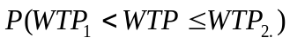…………………………..............................…. (2.3)
Where by P ( ) is the probability of road user’s, 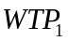 and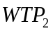 are lower and upper limits of WTP respectively.

Willingness to pay (WTP) for improved public transport were planned to involve a model that describes the probability of a particular passenger's decision to prefer the improved public bus service or not. Then a probit model was planned to be used to estimate the passenger's probability of deciding to prefer the improved public bus service:
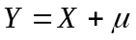…………………………….....................................………… (2.4)
Whereby Y, the dependent variable, takes 0, if the passenger does not prefer the improved service; and 1 otherwise. X is a vector of attributes characterizing the passenger and the public transport services, is vector of parameters to be estimatedand is an error term used to capture unobservable factors and its distribution is assumed to be independently and identically distributed with mean zero and variance one. Furthermore, the new multiple regression model (OLS) was also planned to be used if all respondents will be willing to pay for improved public transport. Ordinary least square (OLS) will estimate WTP and determinant affecting WTP amounts (BIDS in TSH).

2.3 Empirical Literature Review
Many studies have been conducted and proved that there is importance improving public transport through ensuring bus comfort. For instance, Vovsha et al. (2014) conducted a survey on the importance of passenger load in determining bus comfort and showed that when a probability of getting a seat by a passenger is less than 40 %, he or she feels uncomfortable. Kumar et al. (2004) evaluated ‘’the comfort perception of rural bus passengers under three travel conditions seating, standing comfortably, and standing in a crowd he came up with emphasizes that comfort perception significantly affected the generalized cost of passengers’’. He also found that the effects of Crowding do not only affect physical comfort but also psychological issues, such as nervousness, pressure, stress, and feelings of one’s confidentiality being invaded.

Another study by Eboli and Mazzulla (2010), who studied the effects of passenger load on choice of travel mode using rating and choice options; however, they considered only two levels of bus crowding: overcrowded and not overcrowded. Litman (2008), proposed that when a bus offers a comfortable riding environment, passengers’ perceived journey time is less than the actual journey time. However, the author did not examine whether passengers’ actual journey time affects comfort perception.

Also, a study titled as evaluating passenger load and in-vehicle time (Eboli and Mazzulla 2007; Shek and Chan 2008). The study largely concentrates on the influence of passenger load on comfort levels. More specifically, research attention devoted to in-vehicle time, which may also influence passengers’ comfort perception, is limited, especially in the context of quantity measurements. Where by Passengers’ judgments about certain service attributes can be considered a subjective measure of service quality, while performance measures contingent on bus operators can serve as objective measures of service quality.
Li and Hensher (2013), suggested that, in addition to using objective measures (e.g. passenger load), bus operators and authorities should conduct perception surveys to obtain information on passengers’ subjective evaluation of bus services (e.g. bus comfort).Thus, precisely evaluating passengers’ willingness to pay perceptions on improving public transport through commuter buses comfort service is necessary. Several studies on urban public transport in Dar es Salaam have been undertaken by different researchers each addressing specific objectives. And these studies have been overviewed below as follows; the study titled as comprehensive overview of the state of urban transport across major cities of Africa, Dar es Salaam being one among them conducted by Kumar et al. (2008).

This study aimed at investigating main challenges facing urban transport sector and the solutions to address them. The study focused on commercial buses, taxis, and motorcycles as means of public transport. Another study by Kanyama et al. (2004), which attempted to investigate issues related to public transport in Dar es Salaam city. The study comprised of four objectives which are investigating existing public transport planning approaches in Dar es Salaam, examining the extent of vehicle emissions and occurrences of accidents, examining constraints and potentials for the development of public participation in public transport, and identifying factors that inhibit institutional co-ordination.

Another study by Transport Corporation to Wilbur Smith Associates Inc in 1990 a study titled as urban Passenger services for Dodoma. The objectives of the study was to initiate action program to improve the viability, quality, and efficiency of bus services and estimate demand for bus services and compare with existing and potential supply. A study by Kombe et al. (2003), investigated links between public transport and the livelihoods of the urban poor in Dar es Salaam. The study took a case study approach in collecting information on travel times, conditions of buses including overcrowding and seating conditions, hygiene conditions, operators working conditions, etc.

2.4 Research Gap Identified
After reading different definitions, models and empirical literatures written by different researchers, the researcher find that most literatures reviewed show that many studies on willingness to pay, were estimating transport in the context of transport service improvements. While a large number of these studies focused on willingness to pay estimations for travel time saving, only few studies based on willingness to pay estimations for transport service improvements in other attributes of services such as customer handling, service frequency, reliability of buses to come on time, and bus overcrowding . Therefore in this study, the researcher considers public transport service improvements in a very basic aspect (level seat) which can provide a solution of the most of attributes explained above. Accordingly, unlike to most other studies, the researcher focus is on valuating willingness to pay for improved public transport through level seat.

2.5 Conceptual Framework
A conceptual framework is a research tool which postulates the relationships among study variables it helps the researcher and readers be familiar and understand how valuation of public transport users willing to pay for improved public transport through0,,ugh level depend on various variables.
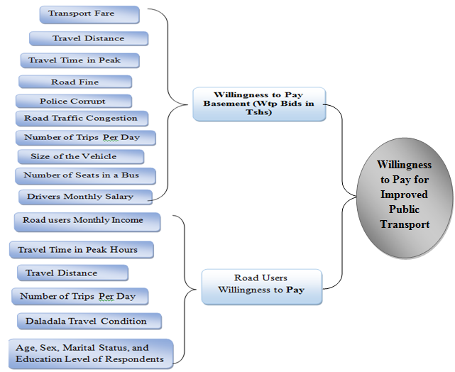

Figure 2.1: Conceptual Framework
Source: Researcher Construct, 2020
The basic features of conceptual framework include independent, variables and dependent variables. Independent variables are a variable which does not depend on others variables, and dependent variables are variables that depend on variation of other variables. In this study willingness to pay for improved public transport depends on public transport users who affected by factors such as, travel distance, travel time in peak hours, monthly income, type of transport used, employment status, daladala service conditions, daladala travel condition, and control variables such as age, sex, marital status. From the conceptual framework, dependent variable (Y) = WTP for improved public transport independent variables (Xs) are travel distance, travel time in peak hours, monthly income, type of transport used, employment status, daladala service conditions, daladala travel condition, willingness to pay basement (WTP BIDS IN TSHS) or public transport operators willingness to accept to operate under improved public transport through level seat and control variables such as age, sex, marital, education level. From the conceptual frame work Operator’s willingness to accept is affected by vehicle route, Number of trips per day, size of the vehicle, number of vehicle seats, Road fines, traffic police corruption (Mabao), road traffic congestion, daily revenue sublimated to commuter owner and drivers driving contract and TLB.

CHAPTER THREE

RESEARCH METHODOLOGY

3.1 Chapter Overview
This chapter discusses the methodology of the study, and encompasses concepts such as research designs, target population, sample size and sampling procedure, data collection instruments and data analysis procedure. Therefore, this section discusses the methodology of the study on the area surveyed, sampling procedures, data collection methods and analysis methods

3.2 Research Design
Research design is an action plan upon which the entire study is built; it also dedicates the manner in which a study is conducted and provides the road map of a study in terms of the sample, data collection instruments and analysis procedure. The research design provides complete guidelines for data collection. Selection of research approach, design of sampling plan, experiment and questionnaire are among the essence of research design. According to Adam and Kamuzora (2008), research design can be understood as a detailed work plan which is used to guide a research study to achieve specified objectives of the research.

The study design used both quantitative and qualitative approaches to collect the necessary data. Qualitative approach was used to give more description on what was obtained from intensive interviews which was quantitatively done by presenting it in tables and frequencies. An intensive interview was undertaken in order to collect data from selected groups of residence in Dodoma. The information gathered was complemented by a review of relevant documents and a review of results from empirical studies undertaken elsewhere to establish a well-documented willingness to pay for improved public transport in Dodoma city.

3.2.1 Build a Commitment to Pay Bids

In this study, the basic social, economic, social and operational characteristics of users (commuters and employees) were compiled into an interview tool. So a little more follow-up option is used to determine users (passengers and operators) willing to pay for improved passenger bus services through a social-level system. In this or that way, a complex definition of formal passenger bus services was explained through a standard seat system. Respondents were briefed on a high-quality plan to improve the quality of public transport in Tanzania in order to meet the standards required for its operations. In this section questions requiring the defendant's willingness to be paid and a willingness to use and pay were asked. According to the study the willingness to pay for the system was based on LATRA's current fare to the city of Dodoma on all different routes, and the study program included the public transport operator's willingness to accept work under improved public transport, and finally the study included user willingness to pay for improved public transport.

The steps below were used by the researcher to create a design format that could achieve the findings, keep in mind that the study included operators as a basis for bidding (prices on TSH) where users were asked to indicate if they were willing to pay or not to pay for improved public transport. The relevant steps are below. First the researcher collects routes on the basis of travel costs set by LATRA, for a specific route; All routes operating under TSH.750 are set as the first route, All routes operating under TSH.500 are set as the second route, All routes operating under TSH.450 are set as the third route and All routes operating below TSH.400 are set as the route fourth.

Second, the researcher has prepared a questionnaire aimed at investigating the amount of TSH public transport operators who are willing to be paid to accept work under improved public transport with a standard seat. In this case, questionnaires were used in which operators from a different route operating under the LATRA fare were introduced. Thirdly the information on the proposed travel costs mentioned by the road operators above has been used as a minimum for public transport users who are willing to pay (WTP) bids, sample selection of the public transport number to be included in WTP bids based on percentages, where, higher percentage responses in the great emergence of a certain price point to be included in WTP bids. Only four prices were selected from the operator's willingness to pay for the costs incurred by the operators in a particular manner as shown in the following tables.

Finally, alternatives to accounting using optional questions were prepared when respondents (users of public transport) were asked if they were willing to pay the proposed bid. If he said '' yes '', in the first bid, then the corresponding bid over the first bid was asked and if he said '' no '' in the first bid, the lower bid was less than the first bid was asked. In designing and conducting interviews, efforts are being made to reduce potential discrimination in the use of CVMs such as race interviews, assumptions, comprehension and compliance, and clarification of the situation. Before further research, the researcher made trains that explored specific routes to solve possible problems. Interview conducted helped the registrar to manage the CV survey and the wording and the formulation of the questionnaire was done.

3.2.1.1 WTP Bids for Routes Operating under LATRA Transport Fare of TSH.750
The basis on WTP on routes operating under LATRA Transport fare ofTSH.750/- is well shown on Table 3.1 in accordance to user’s willingness to pay. The below table 3.1 represents Propose amounts in TSH by which public transport operators are willing to be paid in order to operate under improved public transport through level seat on all routes operating under LATRA Transport fare of TSH.750 This table postulates amount in TSH proposed by different users under TSH.750 transport fare set by LATRA whereby their frequencies and percentages were as shown in Table 3.1.

Table 3.1: User’s Willingness to pay on Route with Fare Price TSH. 750
User's willingness to pay in TSH | Frequency | Percentage
800 | 10 | 6.37
900 | 11 | 7.01
1,000 | 28 | 17.83
1,200 | 37 | 23.57
1,300 | 16 | 10.19
1,400 | 20 | 12.74
1,500 | 33 | 21.02
1,600 | 1 | 0.64
2,000 | 1 | 0.64
Total | 157 | 100
Source: Field Data, 2020

From Table 3.1 among transport fare amounts proposed by Users were selected to be the sample representative on preparation of WTP bids, the selection were based on considering the frequencies of respondents and their respective percentage. Where by the amount in TSH with 23.57%, 21.20%, 17.83%, and 12.02% were drawn from sample observation. Therefore, WTP bids in TSH drawn from Users operating underTSH.750/- transport fare set by LATRA are Bid 1 = 1000, Bid 2= 1200/-, Bid 3= 1400/- and Bid 4= 1500/-. Then these mentioned WTP bids were used in setting dichotomous choice questions to identify public transport users mean willingness to pay for improved commuter buses transport on all routes operating under Transport fare of TSH.750 in Dodoma city.

3.2.1.2 WTP Bids for Routes Operating under LATRA Transport Fare of TSH. 500
The bases of WTP Bids for the routes operating under LATRA Transport fare of TSH.500 is shown below on Table 3.2. The Proposed willingness to be paid amounts in TSH by public transport operator’s, on all routes operating under LATRA Transport fare of TSH.500 gives WTP bids basis as shown below on Table 3.2.

Table 3.2: User’s Willingness to Pay on Route with Fare Price TSH 500
User's willingness to pay in TSH | Frequency | Percentage
800 | 3 | 20
900 | 1 | 6.67
1,000 | 5 | 33.33
1,100 | 1 | 6.67
1,200 | 2 | 13.33
1,300 | 1 | 6.67
1,400 | 1 | 6.67
1,500 | 1 | 6.67
Total | 15 | 100
Source: Field Data, 2020

From Table 3.2, the same procedure done in table 3.1 of determining the sample representative were observed, Whereby the amount in TSH with 33.33%, 13.33%, 6.67%, and 6.67% were drawn from sample observation. Therefore WTP bids in TSH drawn from Users operating under TSH.500 transport fare set by LATRA are Bid 1 = 800, Bid 2= 1000, Bid 3= 1200 and Bid 4= 1300. Then these mentioned WTP bids were used in setting dichotomous choice questions to identify public transport users mean willingness to pay for improved public transport on all routes operating under Transport fare of TSH.500 in Dodoma city.

3.1.1.3 WTP Bids for Routes Operating under LATRA Transport fare of TSH. 450
The basis of WTP Bids for the routes operating under LATRA Transport fare of TSH.450 is shown below on Table 3.3. The Proposed price to be paid in TSH by commuter bus user’s on all routes operating under LATRA Transport fare of TSH.450 gives WTP bids basis as shown below on Table 3.3. This table gives proposed Price that is willingly to be paid in TSH by public transport users on all routes operating under LATRA Transport fare of TSH.450

Table 3.3: User’s Willingness to Pay on Route with Fare Price, TSH. 450
User's willingness to pay in TSH | Frequency | Percentage
700 | 3 | 3.13
750 | 8 | 8.33
800 | 16 | 16.67
850 | 7 | 7.29
900 | 21 | 21.88
1000 | 32 | 33.33
1200 | 7 | 7.29
1300 | 1 | 1.04
1400 | 1 | 1.04
Total | 96 | 100
Source: Field Data, 2020

From Table 3.4, the same procedures used in table 3.1 of determining the sample representative were also used here; where by the amount in TSH. With 33.33%, 21.88%, 16.67%, and 7.29% were drawn from the sample observation. Therefore WTP bids in TSH drawn from operators operating underTSH.450 transport fare set by LATRA are Bid 1 = 750, Bid 2= 800, Bid 3= 900 and Bid 4= 1000. Then these mentioned WTP bids were used in setting dichotomous choice questions to identify public transport users mean willingness to pay for improved public transport on all routes operating under Transport fare of TSH.450 in Dodoma city.

3.2.1.4 WTP Bids for Routes Operating under LATRA Transport Fare of TSH.400

Table 3.4: Operator’s Willingness to be paid on Route, TSH. 450
User's willingness to pay in TSH | Frequency | Percentage
600 | 1 | 2.78
700 | 4 | 11.11
750 | 1 | 2.78
800 | 8 | 22.22
900 | 4 | 11.11
1000 | 13 | 36.11
1200 | 2 | 5.56
1300 | 1 | 2.78
1400 | 1 | 2.78
1500 | 1 | 2.78
Total | 36 | 100
Source: Field Data, 2020

The basis of WTP Bids for the routes operating under LATRA Transport fare of TSH.400 is shown below on Table 3.4. The Proposed price to be paid by Commuter buses User’s on all routes operating under LATRA Transport fare of TSH 400/-gives WTP bids basis as shown below on Table 3.4 This table gives proposed Price that is willingly to be paid in TSH by public transport users on all routes operating under LATRA Transport fare of TSH.400/-

From Table 3.4, the same procedures used in Table 3.1 of determining the sample representative were also used here; whereby the amount in TSH with 36.11%, 22.22% 11.11% and 11.11 were drawn from the sample observation. Therefore WTP bids in TSH drawn from operators operating under TSH.400 transport fare set by LATRA are Bid 1 = 700, Bid 2= 800, Bid 3= 900 and Bid 4= 1000. Then these mentioned WTP bids were used in setting dichotomous choice questions to identify public transport users mean willingness to pay for improved public transport on all routes operating under Transport fare of TSH.400 in Dodoma city.

3.3 Sampling Procedures and the Sample Size
According to this research the researcher has employed cluster sampling method, because it includes people of similar characteristics in a particular location (Miles and Huberman 1994).

3.4 Sampling Techniques

3.4.1 Purposive or Judgment Sampling
This method was used because it involves the selection of respondents who have been sentenced as appropriate in a given study. And in this case, public transport nominees and passengers from Dodoma city center were selected to take part in the study. This approach is appropriate when what is important is the exact similarity of the sample units in the study and not its general representatives to population.

3.4.2 Simple Random Sampling
A simple random is a possible sample where all members of the crowd have an equal chance of being selected to construct a sample. The use of this method gave each respondent an equal and independent opportunity to choose. This method is ideal when the sampling frame is not very large, and each unit is easily accessible as a matter for drivers and bus drivers from the prescribed route.

3.4.3 Stratified Random Sampling
In the sampling technique of this study, public and private transport was classified within their travel route, and drivers and conductors were grouped according to the route they were operating in.In these cases, a simple random sample was hired to do the research.

3.4.3.1 Sampling Technique used in Drawing Sample from Public Transport Operators
The sample used to present public transport operators under this study were drawn from the number of public transport vehicles licensed (new licensed vehicles and renewed licenses) of the year 2018/2019 by LATRA in each route as shown in below Table 3.5.

Table 3.5: Sample size for Public Transport Operators and Users in DOM used under the Study
S/N | Name of the Route | Total Vehicle Licenced | Sample Size (Operator) | Sample Size (User)
1 | St. Gema to Nanenane | 15 | 14 | 14
2 | Veyula to Nanenane | 58 | 28 | 30
3 | Nkuhungu TO SWASA | 100 | 25 | 53
4 | Mkonze to Nanenane | 50 | 15 | 30
5 | Mnada Mpya - Veyula | 96 | 29 | 32
6 | Nanenane TO UDOM TIBA | 33 | 33 | 37
7 | Nanenane TO MNADANI Mpya | 50 | 26 | 33
8 | St. Gema to Udom Tiba | 23 | 22 | 17
9 | Nkuhungu To Veyula | 45 | 24 | 28
10 | Chang'ombe to Nanenane | 22 | 20 | 37
11 | Nghongona - Chang'ombe | 44 | 19 | 38
12 | Nanenane TO Mnada Mpya | 7 | 7 | 15
13 | NKUHUNGU TO Nanenane | 25 | 21 | 19
14 | MKONZE TO Veyula | 12 | 10 | 25
15 | Msalato TO NANENANE | 11 | 11 | 32
Source: LATRA 2019.
From table 3.5, the researcher has employed sampling estimation under 5% of the degree of tolerance error which represents 95% of confidence level. The simple formula used in estimation was as follows:
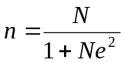 ………………………………………………………. (3.1)
Where by
Drawn sample size (selected number of public transport operators)
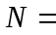Total Number of licensed vehicles on a particular route
Tolerance error (5%)

Therefore, the total of 304 public transport operators from each route were chosen to be used under this study, The number of chosen operators were based on number of licensed vehicles on a particular route by LATRA as shown on above table 3.5.

3.5 Data Collection Methods
For this study, both primary and secondary data sources were used. The type of data used in the study is the most basic and unique basis for the year 2019 found in the randomized sample initiation study with a random sample of 744 respondents composed of 304 public transport operators and 440 road transport of Tanzania, mainly in Dodoma city. The sample chosen to present contingent valuation survey was incorporated with evidences from recent research by (Fujita, Fujii, Furukawa, & Ogawa, 2005) who indicates that at least 600 samples are needed for single-bounded format and at least 400 samples for a double-bounded format to ensure statistical reliability of WTP estimations.

3.5.1 Primary Data
In this study, primary data is collected through in-person interview and mail by means of a contingent valuation questionnaire. Soliciting road users' willingness to use and pay for improved public bus service trough level seat being the major objective of the contingent valuation survey, other socioeconomic and demographic questions as well as their preferences to the forms of payment for the improved service are also included in the survey. The elicitation method in this study follows the discrete choice with a follow-up approach, in which the respondent is asked a yes or no answer question regarding his/her willingness to use as well as willingness to pay for an improved public bus service through level seat in Dodoma Tanzania. The later was followed by other question/s using a higher price if the respondent says yes until [s]he says ‘no.' Likewise, if the respondent says no, a lower price is used in the follow-up question until [s]he says ‘yes.'

3.6 Data Collection and Technology
Observation, questionnaires and interviews are common research tools used to collect data and in a special way; primary data. This study used questions and questions and discussions.

3.6.1 Interviews
In this study, this method was used to collect data from respondents' observations on the subject being studied. It used a lot of ended questions that were asked appropriately. The conversation is for drivers, conductors and road users. During the study, unstructured discussions were used when pre-determined questions were asked about the topic.

3.6.2 Questionnaire
There are different meanings of word lists, and different authors in the study (researchers) have interpreted them differently. White (2002) described as ‘’series of questions, each providing a number of alternative answers from which the respondent can choose’’. Therefore questionnaire can be viewed in terms of general terms when each person is asked to answer a set of questions in a predetermined manner. ‘’Structured and telephone questionnaires and those in which each person is asked to answer the same set of questions as the one in which the researcher was interviewed without the researcher being present included’’ (Adam and Kamuzora, 2008).

In this study, the uniquely designed dichotomous/optional questionnaires were designed in one way to support the research questions. With this tool, respondents within the study areas were in a position to answer questions related to the study. During the study, closed-ended questions were asked by the researcher and require the respondents to provide answers while the researcher fills in their ideas for the correct answer.

3.7 Model Specification
This study were planned to adopt probit model to estimate willingness to pay for improved public transport whereby WTP which is the dependent variable generates a binary outcome by considering Yes answer for those who are willing to pay and No answer for those who are willing to pay per trip (Yes = 1 and 0 0therwise). But after data collection, the researcher found that all respondents were willing to pay for improvement of public transport, thereafter WTP were then measured through using Ordinary Least Squares Models (OLS) under multiple regression models whereby the provided answers on WTP bids in TSH by respondents were used as dependent variable.

Every route had answers on how much amount respondents are willing to pay referring to bids included on dichotomous choice questions. Therefore the model explain the relationships between WTP bids and factors affecting WTP bids for improving public transport through level seat in the city.
Equation 3.2
Whereby ; Y= Dependent variable ( WTP Amount in TSH), X_{s}= Independent variables such as travel distance, travel time, daladala service condition, type of transport used, monthly income, employment status and other control variables such as age, sex, marital status, and education level of respondents. Also 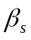= constants or coefficients of X_{s}.

3.8 Data Description and Measurement
This gives the detailed information of a particular variable used under the study whereby expected signs, means of measurement and description of a particular variable is determined under the study in Table 3.5, it indicates both discrete and binary characteristics of the variables used under the study with their respective expected signs and their standard descriptions.

Table 3.5: Data Description and Measurement
Variable Name | Description | Measurement | Expected sign
Travel distance | Distance traveled in a specific route | In Kilometers | Positive
Travel time | Time traveled in a specific route | In Minutes | Positive
Type of transport used | Type of transport highly preferred by respondents | 0 if use own private car and 2 if use daladala | Negative
Education level | Respondents levels of education | 1 if high school, 0 if university and 2 if college. | Positive
Monthly Income | Amount of revenue received per month among respondents | In Tanzania Shillings | Positive
Employed status | Type of employment of respondents | 1 if government employed and 0 if other type and 2 self-employed | Positive
Daladala service condition | Travel service condition using daladala | 1 if too bad, 0 if bad and 2 if normal | Positive
Marital status | Respondents marital status | 1 if married, 0 if single and 2 if divorced | Positive
Sex | Sex characteristics of surveyed respondents | 1 if male and 0 if female | Positive
Age | Age characteristics of respondents | In years | Positive
Source: researcher, 2020

3.9 Data Analysis Plan
With regard to this study, the data collected were sorted with precision and completeness before being analyzed. The STATA descriptive methodology was adopted.

3.10 Data Reliability and Validity
In this study contingent valuation method was employed whereby road users had to make choices through dichotomous choice questions, respondents (transport road user) was asked if he or she is willing to pay for the proposed bid (amount in TSH). If he or she says’’ yes’’, to the initial bid, then the corresponding bid greater than the initial bid were asked and if he or she says ‘’no’’ to the initial bid, then the lower bid less than the initial bid were asked. In designing and conducting the survey, attempt was made to minimize biases that may arise in using CVM such as interviewer bias, strategic, hypothetical and compliance biases, and scenario specification.

Before the main survey was conducted, the researcher made cross check trainings in order to solve inconveniences that might happen. Hence a pretest survey that helped the enumerator to administer contingent valuation survey as well as to check the wording and structuring of the questionnaire were conducted. In designing and conducting interviews, efforts were made to reduce potential biases while in use of CVMs. Before main survey was conducted, the researcher made trains that explored specific routes to solve possible problems. An interview was then conducted and helped the researcher to conduct /apply contingent valuation survey and formulation of the questionnaire.

Also, different tests patterning with multiple regression models were made in order to make validity of the data analyzed. This was done by Checking for Violation of Ordinary Least Square (OLS) Assumption in which; Multicollinearity was tested, in doing so Variance of Inflation Factor VIF was used for this test. Whereby if a Mean VIF value is greater than 10 means there might the problem of Multicollinearity and when VIF is less than 10 for each variable indicating that there is no Multicollinearity. Furthermore, the tolerance defined by 1/VIF also was used to check the degree of collinearity (Gujarat, 2009).
Another test was checking for Violation of Ordinary Least Square (OLS) Assumption in which testing for Heteroscedasticity was undertaken. After regressing Ordinary Least Square (OLS) model,hettest command was inserted into STATA 13 to check for variation invariance. The results decisions was indicated basing on Probe > chi2 thus means that if Probe > chi2 result is less than 5%, then the problem of heteroscedasticity occurs and if not then the data will have no that problem. Lastly, if either Multicollinearity or Heteroscedasticity occurred in data, then robust command were used to solve both problems.

CHAPTER FOUR

RESEARCH FINDINGS

4.1 Chapter Overview
This section presents the findings of contingent valuation survey using descriptive and econometric analysis. Also, this chapter presents type of data collected in the field. The data concerning improvement of public transport through level seat in Dodoma Tanzania.

4.2 Descriptive Statistics/Characteristics of the Respondents

4.2.1 Population of the Study
The population was composed of public transport operators (owners, drivers, and conductors), public transport users (passengers), private transport users, and government and non-government officers. A sample was used due to the cost in terms of funds, time and materials that could be used to assess the total population. Number of people considered to be public transport operators and road transport users (private and public transport). The study included 304 public transport operators and 440 public transport users or passengers. Observations, interviews, and questionnaires were conducted with specific members of the community, regarding their views on the program and their willingness to pay for it.

In this area, people were selected according to their daily routines that they used during their daily activities. The method used was a purposeful sample. Therefore, the complete sample of the study was 744 respondents. All of these were chosen randomly and deliberately. A sample of the tools was used to reduce the risk of selection and to give people an equal chance of being selected.

4.2.2 Sex
Generally, on the side of road users, the study covered about 440 respondents who participated through questionnaires and interviews. About 46percent were females, and 54 percent were males as shown on figure 4.1.
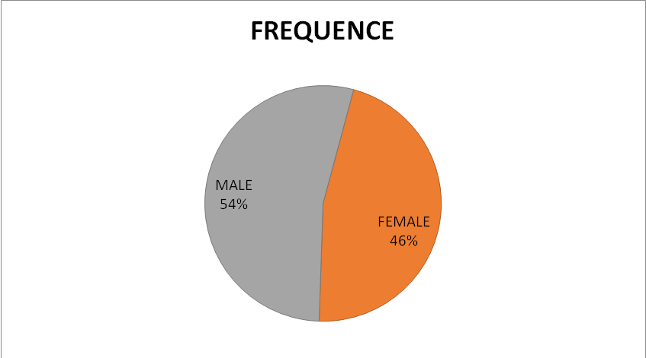

Figure 4.1: Sex Characteristics of Surveyed Public Transport Users in Dodoma city

Source: Researcher, 2020

4.2.3 Marital Status
From figure 4.2, a total of 440 passengers (road users) were surveyed for this study. About 82 percent were married respondents, 15 percent were single, and 3percent were divorced respondents.
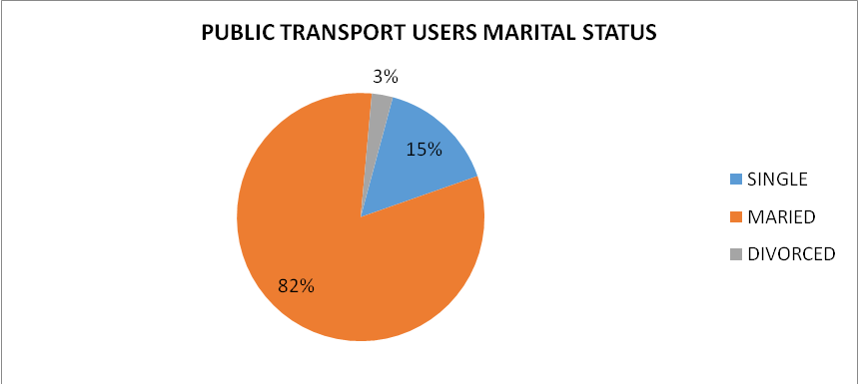

Figure 4.2: Marital Characteristics of Surveyed Public Transport users in DOM City

4.2.4 Age, Monthly income, Travel Time and Travel Distance
From below Table 4.1, a total of 440 passengers (road users) were surveyed under this study. On average, the age of the respondent were 30.6 years ranging from 21 to 52 years of age, on average monthly income of the respondents were TSH. 927 886, minimum income was TSH 6.9 x 10⁴, and maximum income was TSH.3 million On average, Travel Time (the time they spent on road with daladala) by the respondents were 90 minutes, ranging from 45 minutes to 120 minutes, the average of travel distance by the respondents were 12.5 kilometers, ranging from 8 to 20 kilometers.

Table 4.1: Represents Age, Monthly income, Travel Time, Travel Distance
Variable | Observation | Mean | std. dev | Minimum | Maximum
Age (Years) | 440 | 30.58636 | 6.653945 | 21 | 52
Monthly income (TSH) | 440 | 927886.4 | 172977 | 690000 | 3000000
Travel Time (Minutes) | 440 | 89.83 | 70.7808 | 45 | 120
Travel Distance (Kilometers) | 440 | 12.54318 | 3.26128 | 8 | 20
Source: Researcher, 2020.

4.2.5 Educational Level
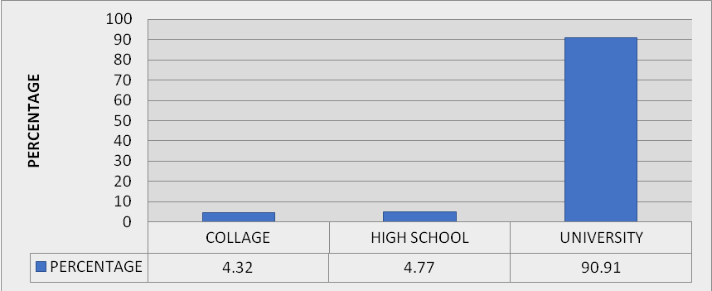

Figure 4.3: Education level of surveyed public transport users in Dodoma city.
Source: Researcher, 2020.
A total of 440 passengers (road users) surveyed for this study. Research findings indicated that 4.32 percent of respondents who participated in the study using questionnaire and the interview had college education, 4.77 percent had secondary high school education, and 90.91 percent had university education

4.2.6 Employment Status
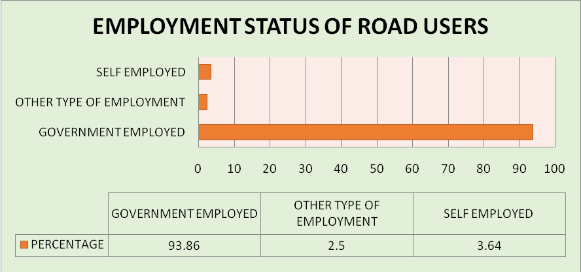
A total of 440 passengers (road users) surveyed for this study. Study finding shows that 2.5 percent of respondents has been employed in other type of employment, 3.64 percent had self-employed, and 93.86 percent of respondents have employed in government institutions.

Figure 4.4: Employment Status of Surveyed Public Transport users in Dodoma city
Source: Researcher, 2020

4.3 Transportation Characteristics
To understand the travel features that occur in Dodoma, some selected indicators are considered. These include vehicle ownership, frequently used travel routes, travel time from residence to work / study area, and travel costs, visibility of the public bus service and availability of public bus transportation.

4.3.1 Means of Transport often Used
From the 440 respondents surveyed, Sample responses show that approximately 87 percent of residents own autonomous vehicles. Depending on the mode of transportation, most 87 percent of respondents use a private car as a means of transportation, while only 10 percent use a public bus while another 3 percent use DALADALA as a means of transportation. At the family level, your private car is the most widely used mode of transportation (about 87 percent). Studies show, as it is expected that non-private modes of transportation are more popular with families than with people. Public buses are used at least. Among users who use public transport, the resident, on average, uses the public bus (travel mode) per day and spends four hours (in round trip) from the residence to work / study places using the public bus while spends 55 minutes using a taxi or private car. On the other hand, it only takes 42 minutes (round trip) from the residence to work / study areas using public transport
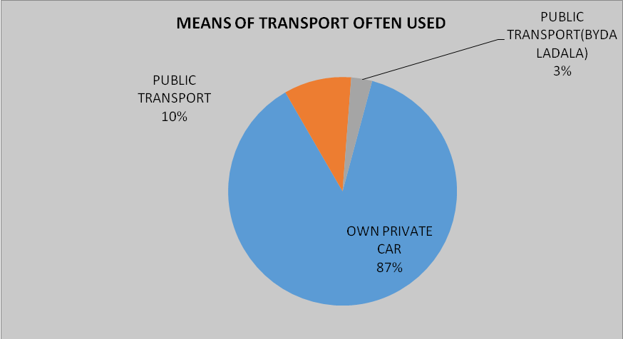

Figure 4.5: Means of Transport often used in Dodoma City
Source: Researcher 2020

4.3.2 Commuter Buses Service Quality Condition
From surveyed 440 respondents, The Sample responses show that there is about 40.45 percent of respondents who said daladala are overcrowded, 23.64 percent said there is unsafe condition for Disabled, 12.95 percent said no safe condition for children, 9.55 percent said there is many standees, 7.5 percent said no customer care, 2.05 percent said poor cleanliness.

Table 4.2: Represents travel condition with daladala in Dodoma city.
Travel condition in daladala | Frequency | Percentage
Few standees | 17 | 3.86
Many standees | 42 | 9.55
No customer care | 33 | 7.5
Not safe for disabled | 104 | 23.64
Not safe for child | 57 | 12.95
Overcrowded | 178 | 40.45
Poor cleanliness | 9 | 2.05
Total | 440 | 100
Source: Researcher 2019

4.3.3 Service Quality in Commuter Buses (Daladala)
The quality of public transport services in DodomaTanzania, is generally, rated as normal, poor or very poor. From figure 4.6, the service was rated negatively by 58 percent, rated negatively by 38 percent of respondents and typically rated at 4 percent by respondents. Depending on the specific indicators of quality service, the service is limited to the public bus all service delivery indicators. In addition to safety and comfort, standby channels, standby time, travel time and noise / fullness / smell are rated at least.
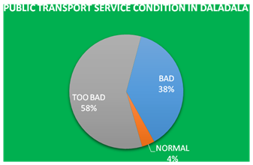

Figure 4.6: Means of Transport often used in Dodoma City
Source: Researcher 2020

4.4 Description of Road users WTP responses on Bids under Different Routes
In this part the set bids basing on operators as a benchmark are now described according to the surveyed respondents responses on particular route operating under LATRA transport fare as below follows;

4.4.1 WTP bids on Routes operating under LATRA Transport Fare of Tsh. 750
The figure 4.8 shows respondents responses on proposed willingness to pay amounts (Bids) in TSHs for the improvement of public transport in Dodoma. From 110 transport users traveling on routes operating under TSH.750 surveyed, 64 percent of respondents are willing to pay TSH.1000, 23 percent of respondents are willing to pay TSH.1200, 9 percent of respondents are willing to pay TSH.1400/-, and 4 percent of respondents are willing to pay TSH.1500 for improved public transport through level seat on routes operating under TSH.750, transport fare set by LATRA.
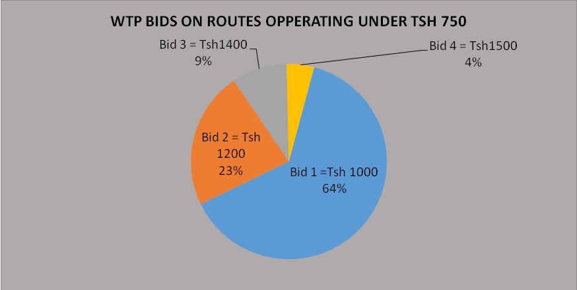

Figure 4.8: WTP Bids on Routes underTSH.750/-
Source: Researcher 2020

4.4.2 WTP bids on Routes operating under LATRA Transport Fare of TSH.500
From the above table 4.3; 110 respondents out of 440 respondents surveyed, 72.73 percent of respondents are willing to pay TSH.800, 15.45 percent of respondents are willing to pay TSH.1000, 7.27 percent of respondents are willing to pay TSH.1200/-, and 4.55 percent of respondents are willing to pay TSH.1300/- for improved public transport through level seat on routes operating under TSH.500, transport fare set by LATRA.

Table 4.3: Presenting WTP bids on Routes Operating under TSH.500
S/No | Bids in TSH | Frequency | Percentage
1 | 800 | 80 | 72.73
2 | 1,000 | 17 | 15.45
3 | 1,200 | 8 | 7.27
4 | 1,300 | 5 | 4.55
 | Total | 110 | 100
Source: Researcher 2020

4.4.3 WTP Bids on Routes Operating under LATRA Transport Fare of TSH.450
From below figure 4.9, 110 respondents out of 440 respondents surveyed, 68.18 percent of respondents are willing to pay TSH.750, 18.18 percent of respondents are willing to pay TSH.800, 9.09 percent of respondents are willing to pay TSH.900, and 4.55 percent of respondents are willing to pay TSH.1000 for improved public transport through level seat on routes operating under TSH.450, transport fare set by LATRA
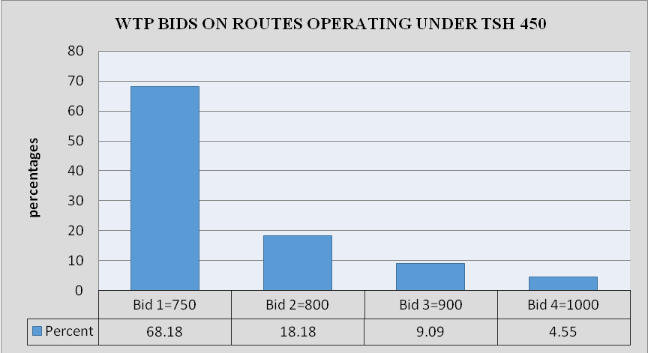
Figure 4.9: WTP Bids on routes under TSH. 450
Source: Researcher 2020

4.4.4 WTP bids on routes operating under LATRA transport fare of TSH.400
From figure 4.9; 110 respondents out of 440 respondents were surveyed, 72.73 percent of respondents are willing to pay TSH.700/-, 10 percent of respondents are willing to pay TSH.800/-, 9.09 percent of respondents are willing to pay TSH.900/-, and 8.18 percent of respondents are willing to pay TSH.1000/- for improved public transport through level seat on routes operating under TSH.400/-, transport fare set by LATRA.

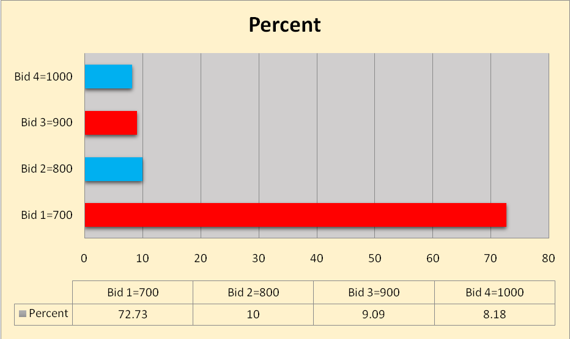
Figure 4.10: WTP Bids on routes under TSH.400/-.
Source: Researcher 2020

4.5 Mean WTP on routes operating under TSH.750, 500, 450 and 400
From Table 4.4 the mean WTP obtained is an indicator of what people are willing to pay, on average, for improved public transport through level seat per trip in the city. The mean willingness to pay were obtained according to the grouped route operating under different transport fare set by LATRA as follows; For the routes operating under TSH.750, transport users are willing to pay average amount of TSH.1100 per trip, Routes operating under TSH.500 , transport users are willing to pay average amount of TSH.880 per trip, Routes operating under TSH.450, transport users are willing to pay average amount of TSH.780 per trip, and the routes operating under TSH.400, transport users are willing to pay average amount ofTSH.750 per trip.

Table 4.4: Mean Willingness to pay on Routes operating under TSH.750/-, 500/-, 450/- and 400/-
Variables | routes operating undertsh.750 | routes operating undertsh.500 | routes operating undertsh.450 | routes operating undertsh.400
Mean WTP in TSH | 1104.545 | 882.7273 | 784.0909 | 752.7273
Number of observations | 110 | 110 | 110 | 110
Minimum bid in TSH | 1,000 | 800 | 750 | 700
Maximum bid in TSH | 1500 | 1300 | 1000 | 1000
standard deviation | 155.8559 | 150.1431 | 64.93886 | 96.45942
Source: Researcher 2020

4.6 Econometric Analysis
Tables below show the results of econometric analysis on factors affecting willingness to pay for improved public transport through level seat whereby three hypotheses have to been tested in this study for each and every route operating under different fares set by LATRA in Dodoma Tanzania. The aim of undertaking multiple regression models was to find the significance of the explanatory variables such as traveled distance, travel time, income, employment, status, age, sex, marital status and other variables are on willingness to pay for improved public transport through level seat

4.6.1 Multiple Regression Results on Routes Operating underTSH.750
Multiple Regression Table 4.5; represents the regression results on the Impact of travel distance, travel time and other factors on user’s willingness to pay for improved public transport through level seat on routes operating under LATRA Transport fare of TSH.750

Table 4.5: Multiple Regression Results on Routes operating under TSH. 750
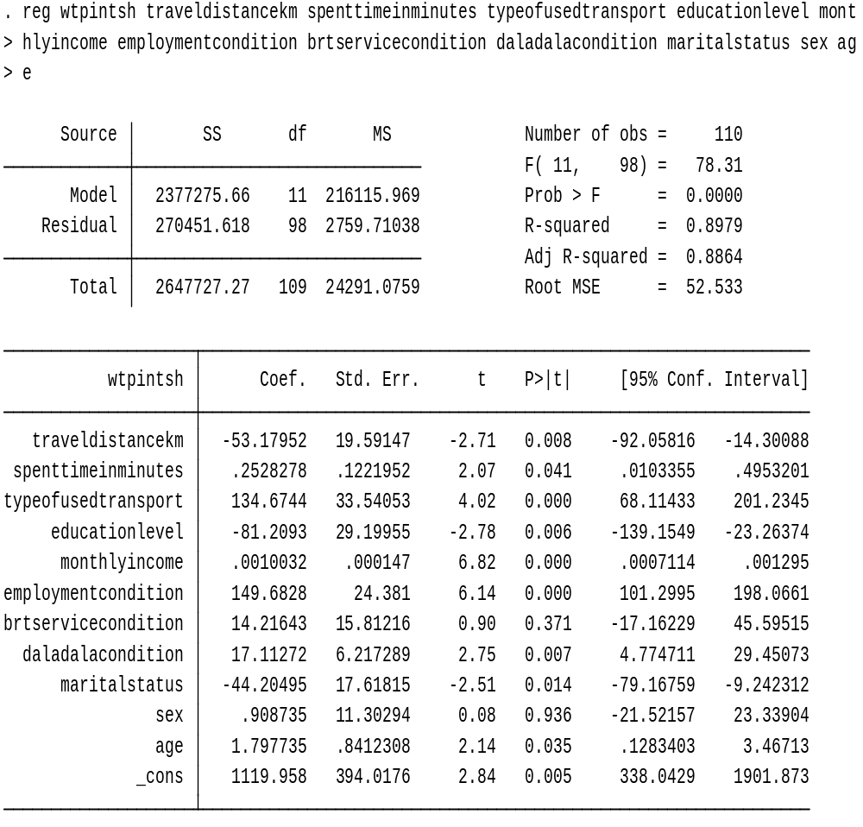
Source: Researcher 2020

The table 4.5 presents the econometric results of multiple linear regressions model for factors affecting willingness to pay for improved public transport. From the results above R-Square 89.79%. As the results above from the (Table 4.5), factors such as such as travel distance in kilometers, Spent time in daladala, type of transport used, education level, monthly income, employment condition, daladala condition, marital status, and age are significantly influence willingness to pay for improved public transport. But other explanatory variables from Table 4.5 with p- value greater than 5 percent (p=0.05) are statistically insignificance. The study also tested whether travel distance had any effect on WTP for improved public transport. The analysis produced statistically significant findings in which t-value = -2.71 and p-value = 0.008. The coefficient was negative which suggests a negative relationship between travel distance and WTP. Which means that decrease in travel distance in kilometers reduce TSH.53.18 on users WTP for improved public transport on routes operating under LATRA fare of TSH.750 keeping other factors constant.

The study investigates if spent times on road can influence user’s willingness to pay for improved public transport. The analysis results is statistically significant whereby p= 0.041 this means that road users are willing to pay for improved public transport as spent time on road increases. This means that spend time on road increases in minutes WTP for improved public transport increase by TSH 0.25 on routes operating under LATRA fare of TSH.750 keeping other factors constant. From the regression results above, education level were negatively and significantly influence WTP for improved public transport. The coefficient was 81.21, and p= 0.006, which means that WTP for improved public transport is more likely to decrease by TSH.81.21 as users education level falls (in low level of education) on routes operating under LATRA fare of TSH.750 keeping other factors constant.

As above regression results postulates employment, condition has positive relationships with WTP for improved public transport. Its coefficient is 149. 68 and p-value is 000. This shows high relationships among the two variables, which means that WTP for improved public transport is more likely to increase by TSH.149.68 as users employment condition rises on routes operating under LATRA fare of TSH.750 keeping other factors constant. From the regression results above, daladala condition is positively and significantly influences WTP for improved public transport. The coefficient was 17.11 and p= 0.007, which means that WTP for improved public transport is more likely to increase by TSH.17.11 as daladala condition improved on routes operating under LATRA fare of TSH.750 keeping other factors constant. Age was another variable seems to have positive relationships with WTP for improved public transport. From the above regression table the coefficient of age was 1.80 and p= 0.035 which means that road users are willing to pay for improved public transport as age increases. Which means that as age increases in years WTP for improved public transport increase by TSH.1.80 on routes operating under LATRA fare of TSH.750 keeping other factors constant.

4.6.2 Multiple Regression Results on Routes Operating under TSH.500
Multiple Regression table 4.8; represents the regression results on the Impact of travel distance, travel time and other factors on user’s willingness to pay for improved public transport through level seat on routes operating under LATRA Transport fare of TSH.500 From the results below a level of significance is set at 5% (0.05) and R-Square 87.05%. As the results below, type of transport used (p=0.001), education level (p=0.002), monthly income (p =0.000), marital status (p =0.000) and sex (p =0.000). But other explanatory variables with p- value greater than 5percent (p=0.05) are statistically insignificance.

Table 4.6: Represents the Econometric Results of Multiple Linear Regressions
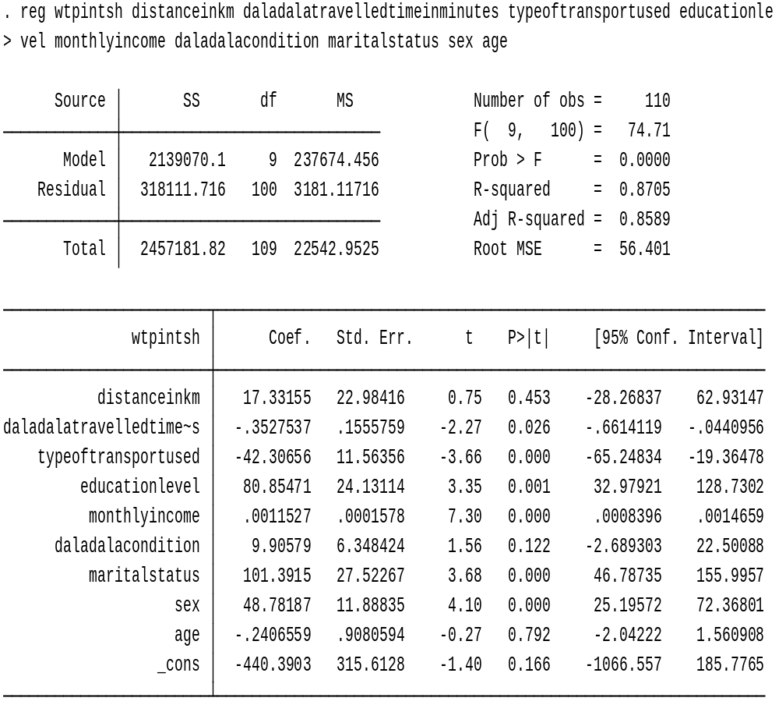
Source: Researcher 2020

From the robust regression results above, education level was positive and significantly influences WTP for improved public transport. The coefficient was 80.85 and p= 0.002, which means that WTP for improved public transport is more likely to increase by TSH.80.85 as user’s education level rise (high levell of education) on routes operating under LATRA fare of TSH.500 keeping other factors constant. Sex was another variable seems to have positive relationships with WTP for improved public transport. From the above regression table, the coefficient of sex was 48.78 and p= 0.035 which means that WTP for improved public transport is more likely to increase by TSH.48.78 as due to responses of sex status among respondents on routes operating under LATRA fare of TSH.500 keeping other factors constant.

Marital status was another variable seems to be with positive relationships with WTP for improved public transport. From the above regression table, the coefficient of marital status was 101.39 and p= 0.011 which means that WTP for improved public transport is more likely to increase by TSH.101.39 due to responses of Marital status among respondents on routes operating under LATRA fare of TSH.500 keeping other factors constant. As robust regression results above shown, income level was positive and significantly influences WTP for improved public transport. The coefficient was 0.001 and p= 0.000, which means that one unit increase in income of respondent will lead to TSH 0.001 increase on WTP for improved public transport on routes operating under LATRA fare of TSH.500 keeping other factors constant.

From regression results above, type of transport used was negative and significantly influences WTP for improved public transport. The coefficient was 42.32 and p= 0.00, which means that WTP for improved public transport is more likely to decrease by TSH 42.32 as users type of transport used, changed on routes operating under LATRA fare of TSH.500 keeping other factors constant. Generally the above regression results from table 4.6 up to table 4.6.3 represent factors affecting or influencing WTP for improved public transport through level seat on routes operating under LATRA Transport fare of TSH.500 in Dodoma Tanzania

4.6.3 Multiple Regression Results on Routes Operating under TSH.450
The table 4.7 below presents the econometric results of multiple linear regressions model for factors affecting willingness to pay for improved public transport on a routes operating route operating under TSH.450 transport fare set by LATRA in Dodoma Tanzania .

Table 4.7: Multiple Regression Results on Routes Operating under TSH. 450
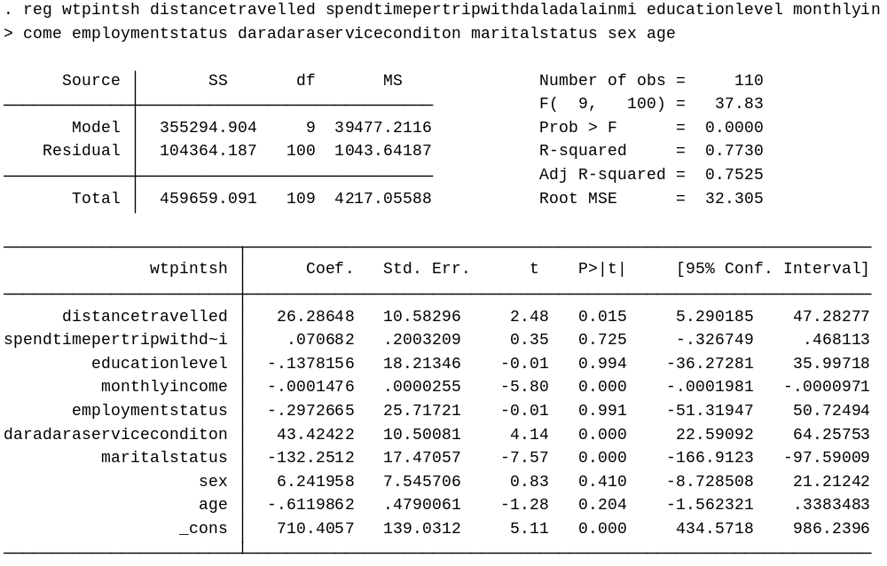
Source: Researcher 2020

Table 4.7 presents the econometric results of multiple linear regressions model for factors affecting willingness to pay for improved public transport on a route operating route operating under TSH.450 transport fare set by LATRA in Dodoma Tanzania. From the results above a level of significance is set at 5% (0.05) and R-Square 77.30%. As the results above from the table, factors such as such as travel distance in kilometers (p = 0.015), monthly income (p =0.000), daladala condition (p=0.000), and marital status (p=0.000) significantly influence willingness to pay for improved public transport on a routes operating route operating under TSH.450 transport fare set by LATRA In Dodoma. But other variables such as Spent time in daladala per trip, education level, employment status, sex and age have p- value greater than 5 percent (p=0.05) which means that they are statistically insignificance.

The analysis produced a highly statistically significant on users monthly income, whereby β= 0.0001 and p-value = 0.000.The coefficient was negative which suggests a negative relationship between monthly income and WTP. Which means that any unit increase in user’s monthly income will cause WTP for improved public transport to decrease by TSH 0.0001 on routes operating under LATRA fare of TSH.450 keeping other factors constant. The study also tested whether travel distance had any effect on WTP for improved public transport. The analysis produced statistically significant findings in which β= 26.29, and p-value = 0.015.The coefficient was positive which suggests a positive relationship between travel distance and WTP. Which means that one unit increase in travel distance (in kilometer), will lead toTSH.26.29 increase in users WTP for improved public transport on routes operating under LATRA fare of TSH.450 keeping other factors constant.

As above regression results postulates that marital status has negative relationships with WTP for improved public transport. Its coefficient is 132.25 and p-value is 000.This shows high relationships among the two variables, which means that WTP for improved public transport is more likely to decrease by TSH 132.25 due to the user marital status on routes is operating under LATRA fare of TSH 450 keeping other factors constant. From the regression results above, daladala service condition is positively and significantly influences WTP for improved public transport. The coefficient was 43.42 and p= 0.000, which means that WTP for improved public transport is more likely to increase byTSH.43.42 when daladala service condition will be improved on routes operating under LATRA fare of TSH.450 keeping other factors constant. Remained percent 22.67% is determined by error term or other factors non-significant (sex and bus service condition).

4.6.4 Multiple Regression Results on Routes operating under TSH.400
The table 4.8 presents the econometric results of multiple linear regressions model for factors affecting willingness to pay for improved public transport on a routes operating route operating under TSH.400 transport fare set by LATRA in Dodoma Tanzania. From the results a level of significance is set at 5% (0.05) and R-Square 86.65%. As the results from below table, factors such as such as marital status (p = 0.000), daladala travel condition (p = 0.012), monthly income (p = 0.013), education level (p = 0.000), and travel distance (p = 0.003)

From the robust regression results, education level was negative and significantly influences WTP for improved public transport. The coefficient was 155.59 and p= 0.000, which means that WTP for improved public transport is more likely to decrease by TSH.155.59 as users education level goes down on routes operating under LATRA fare of TSH.400 keeping other factors constant.

Table 4.8: Multiple Regression Results on Routes operating under TSH.400
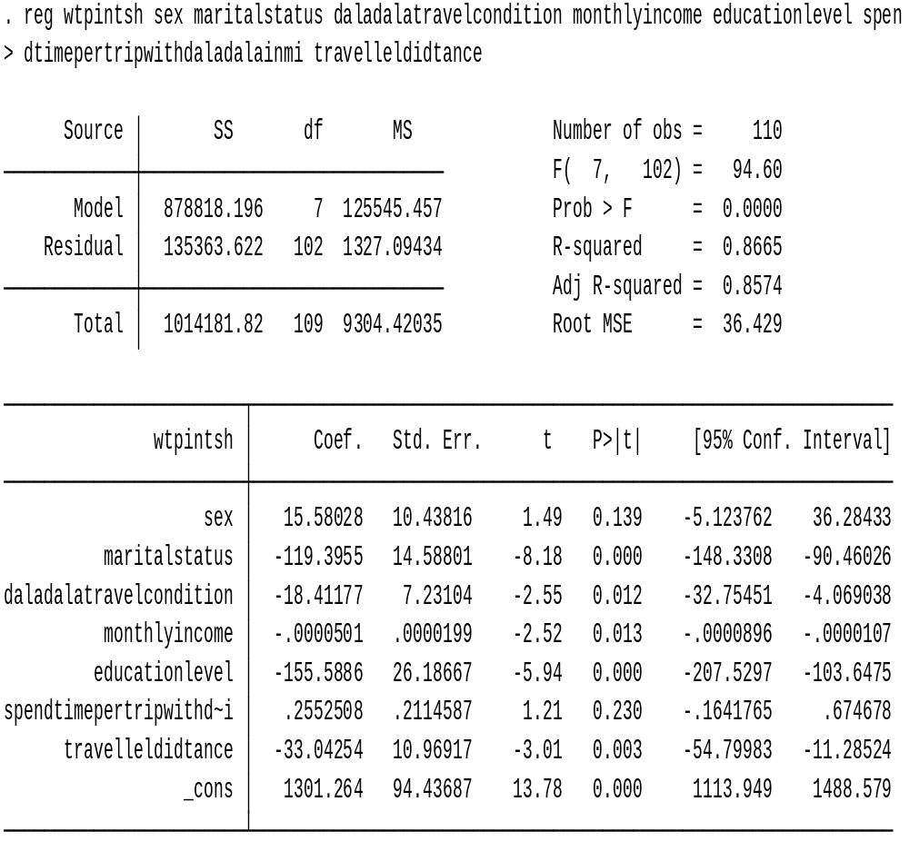
Source: Researcher 2020

Sex was another variable seems to have positive relationships with WTP for improved public transport. From the above regression table, the coefficient of sex was 15.58 and p= 0.067which means that WTP for improved public transport is more likely to increase by TSH.15.58 due to responses of sex status among respondents on routes operating under LATRA fare of TSH.400 keeping other factors constant. Marital status was another variable seems to have negative relationships with WTP for improved public transport. From the above regression table, the coefficient of marital status was 119.39, and p= 0.000 which means that WTP for improved public transport is more likely to decrease by TSH.119.39 due to responses of Marital status among respondents on routes operating under LATRA fare of TSH.400 keeping other factors constant. As robust regression results above shown, monthly income level was negative and significantly influences WTP for improved public transport. The coefficient was 0.00005 and p= 0.022, which means that one unit increase in income of respondent will lead to TSH.0.001 decrease on WTP for improved public transport on routes operating under LATRA fare of TSH.400 keeping other factors constant.

Also from robust regression results above shown, travel distance was negative and significantly influences WTP for improved public transport. The coefficient was 33.04 and p= 0.007, which means that one unit increase in distance (km) will lead toTSH.33.04/- decrease on WTP for improved public transport on routes operating under LATRA fare of TSH.400 keeping other factors constant. From regression results above, daladala condition was negative and significantly influences WTP for improved public transport. The coefficient was 18.41 and p= 0.042, which means that WTP for improved public transport is more likely to decrease by TSH.18.41 as daladala travel condition will not be improved on routes operating under LATRA fare of TSH.400 keeping other factors constant.

4.7 Determinants of WTP for Improved Public Transport and their Respective Signs
Table 4.9 explains on the regression results signs for same variables within different routes operating under LATRA transport fare of TSH.750, 500, 450 and 400

Table 4.9: Determinants of WTP for Improved Public Transport and their Respective Signs
DETERMINANTS/ FACTORS AFFECTING WTP | ROUTE  TSH.750 | ROUTE  TSH.500 | ROUTE  TSH.450 | ROUTE  TSH.400
Travel distance | Negative | Positive | Positive | Negative
Travel time | Positive | Negative | Positive | Positive
Type of transport used | Positive | Negative | NILL | NILL
Education level | Negative | Positive | Negative | Negative
Monthly Income | Positive | Positive | Negative | Negative
Employed status | Positive | NILL | Negative | NILL
Daladala service condition | Positive | Positive | Positive | Negative
Marital status | Negative | Positive | Negative | Negative
Sex | Positive | Positive | Positive | Positive
Age | Positive | Negative | Negative | NILL
Source: Researcher 2019

The table above gives regression results on the impact of several factors on WTP for improved public transport whereby the above are different signs on constants of the particular variables in a specific route.

4.8 Conclusion
This chapter provided a clear picture of the type of respondents who participated in the study. Chapter five will provide details of this assurance indicated by the respondents above. In the current context of public transport (commuter buses) in Dodoma city, many respondents are reluctant to use public buses

CHAPTER FIVE

DISCUSSION OF THE RESEARCH FINDINGS

5.1 Introduction
This chapter incorporates detailed discussion of the research outcomes. In general, the research was based on’valuing willingness to pay for improved public transport through level seat in Dodoma region. Specifically, it focused on; determining mean willingness to pay for improved public transport through level seat, identifying the effect of traveler distance on willingness to pay for improved public transport, through level seat and evaluating the contribution of traveler time on willingness to pay for improved public transport through level seat.

The aim of the research was to come up with the document that presents willingness to pay value, for improving public transport and identifying factors that hinders willingness to pay capacity, among the respondents within the region. Furthermore, the study aimed at investigating, if improving public transport through level seat can be one among the strategies that can alleviate the problem of road traffic congestion in Dodoma as a growing capital city.

Lastly, the study aimed at determining a point at equilibrium,in which both users and public transport operators will meet, in terms of required transport fare for improving public transport through level seat. Most of the data presented in this chapter are from respondents’ attitudes, views, and perceptions in relation to willingness to pay for improved public transport in Dodoma city.

5.2 Valuation Results with Mean Willingness to pay for improved Public Transport
Under this study, a total of 440 respondents surveyed were all willing to pay for improved public transport through level seat were by (their WTP >0). The main reasons given by the respondents who were willing to pay were as follows: they could afford to pay for improved public transport because the patterning transport condition is worse whereby 58% of respondents said it is too bad, 38 % of respondents said that transport condition is bad and 4% of respondents said it is normal.

They also said that they are WTP for improved public transport because even public bus services are not conducive whereby 54% of respondents of respondents said services are good, 34% of respondents said services are normal, and 12% of respondent’s services are bad. Another reason is because of travel condition of Daladala which said to be insufficient and uncomfortablewhereby 40.45% of respondents said that public transport vehicles are overcrowded, 23.64% of respondents said that public transport vehicles are not safe for disabled people, 12.95% of respondents said that public transport vehicles are not safe for their children, 9.55% respondents said that public transport vehicles have many standees, 9% of respondents said public transport vehicles have poor cleanliness, 7.5% of respondents said public transport vehicles have no customer care and 3.86% of respondents said that public transport vehicles have few standees .

5.2.1 Mean or Average Willingness to pay for improved Public Transport
As one among the main purpose of conducting CVM study is to obtain welfare measure on how much in average respondents are willing to pay (Mean WTP). The results may provide guidance to policy makers on tariff issues and the importance or advantages of improving public transport. Since the study composed of four routes operating under different transport fares, then the mean WTP is obtained according to the grouped routes operating under different transport fare set by LATRA as follows;

For the routes operating under TSH.750, transport users are willing to pay average amount ofTSH.1100 per trip, Routes operating under TSH.500, transport users are willing to pay average amount of TSH.880 per trip, Routes operating underTSH.450, transport users are willing to pay average amount of TSH.780 per trip, and the routes operating under TSH.400, transport users are willing to pay average amount of TSH.750 per trip. This implies that on average, each passenger is willing to pay the above-mentioned fares on his or her respective route per trip, to have a comfort public transport services through level seat.

5.3 Factors affecting Willingness to pay for Improved Public Transport
It is to be noted that in the final analysis, all public transport routes operating in Dodoma were grouped according to the set transport fare by LATRA thus means routes operating under the same transport fare were grouped to be as one route, and the groups were as follows; routes operating under public transport fare set by LATRA of TSH 750, TSH 500, TSH 450 and TSH 400. For each route above only 110 respondents (Road users) were surveyed. It is therefore important that the interpretation of the results is taken with caution, thus avoiding too much generalization. The hypothesis that all coefficients except the constant terms (in the four models) are simultaneously equal to zero was tested using the multiple regression models. Where by hypothesis were rejected at probability value less than. This indicates the capability of the models to explain the impact of several factors that seems to affect transport users WTP for improved public transport in the city.

From the results above table which presents the econometric results of multiple linear regressions model for factors affecting willingness to pay amount, in TSH for improved public transport. It can be seen that factors such as such as travel distance in kilometers , Spent time in daladala, type of transport used, education level, monthly income, employment condition, daladala condition, marital status and age significantly influence willingness to pay for improved public transport in Dodoma on the routes operating under different fares set by LATRA. The results on the factors affecting WTP amount in TSH from respondents in their respective routes are as follows:

5.3.1 Travel Distance in Kilometers
From regression results Travel distance, constants have negative sign, positive sign, positive sign an negative sign for routes operating under LATRA transport fare of TSH; 750, 500,450 and 400 respectively. This implies that; for all routes with negative constants, One unit increase in travel distance in kilometers reduce WTP amount in TSH among respondents (reduce amount in TSH, respondents are willing to pay (WTP) for improving public transport) in the city. This is because in these routes there is high level of road traffic congestion. Hence respondents consider much on travel time that they always spend on road rather than traveled distance thus why increase in travel distance reduces WTP. This means that transport users are less willing to pay for improved public transport as travel distance in kilometers increases. For those routes with positive constants, one unit increase of travel distance in Kilometers lead to the rise of WTP amounts in TSH for improved public transport among the respondents. Thus means that respondent’s WTP for improved public transport increases as travel distance in kilometers rise.

5.3.2 Travel Time in Minutes
From regression results Travel time, constants have; positive sign, negative sign, positive sign and positive sign for routes operating under LATRA transport fare of TSH; 750, 500,450 and 400 respectively. This implies that; for all routes with negative constant, one unit increase in travel time in minutes reduce WTP amount in TSH among respondents for improved public transport in the city. This is because in these routes there is low level of daladala overcrowding hence respondents consider much on travel distance rather than time they spent on daladala. This means that transport users are less willing to pay for improved public transport as travel time increases in minutes.

For those routes with positive constants, one unit increase of travel time in minutes lead to the rise of WTP amounts in TSH for improved public transport among the respondents. Thus means that respondent’s WTP for improved public transport increases as travel time in minutes rise. This is because most of these routes have high commuter bus overcrowding level Example Nanenane to UDOM were respondents spend long time standing in commuter buses hence travel time they spend standing attract them to pay for improved public transport through level seat.

5.3.3 Monthly Income
From regression results monthly income, constants have; positive sign, positive sign and negative sign for routes operating under LATRA transport fare of TSH; 750, 500,450 and 400 respectively. This implies that; for all routes with negative constants, one unit increase of monthly income in TSH reduce WTP amount in TSH among respondents in the city. This is because most of the respondents under these routes are using private transport vehicles. For those routes with positive constants, one unit increase of monthly income in TSH lead to the rise of WTP amounts in TSH for improved public transport among the respondents.

5.3.4 Type of Transport Used
From regression results type of transport used, constants have; positive sign and negative sign for routes operating under LATRA transport fare of TSH; 750 and 500 respectively. For all routes with negative constants, implied that type of transport used in the city is more likely to reduce respondent’s WTP for improved public transport this is because most of the surveyed respondents were using private vehicles reduce respondent'swilling to pay for public transport improvement in the city. For all routes with positive constants, implied that type of transport used in the city is more likely to increase respondent’s WTP for improved public transport example increased use of public transport heave respondents willingness to pay for public transport improvement in the city.

5.3.5 Respondent’s Level of Education
From regression results, education level from four regressions has constants with; negative sign, positive sign, negative sign and negative sign for routes operating under LATRA transport fare of TSH; 750, 500,450 and 400 respectively. For all routes with negative constants, implied that respondent’s education level is more likely to reduce user’s WTP for improved public transport. This is because most of surveyed respondents with high education level are more reluctant on private transport due to their personalities and their income status. For all routes with positive constants, implied that education level is more likely to increase respondent’s WTP for improved public transport. This is because most of the respondents with diploma and other low level of education use public transport hence felt to have improved public transport in advance.

5.3.6 Employment Status
From regression results, employment status was significant within two routes; routes operating LATRA transport fare of TSH.750 with positive sign and routes operating LATRA transport fare of TSH.450 with negative sign this is because most of the workers lived in those places example the route Nanenane to St.Gema (TSH 450) and Sabasaba to UDOM were most of the government workers and businessmen live.

The negative sign on employment status implies that employment status is more likely to reduce WTP for improved public transport. This is because most of the respondents are business men (other employment) who earn moderate amount of income. The positive sign on employment status implies that employment status is more likely to increase WTP for improved public transport this is because respondents in those routes have employed in Government organization and other organizations with stable monthly income hence will to pay for improved public transport.

5.2.7 Daladala Service Condition
From regression results, Daladala Service Condition for four regressions has constants with; positive sign, positive sign, positive sign and negative sign for routes operating under LATRA transport fare of TSH; 750, 500, 450 and 400 respectively. For all routes with negative constants, implied that daladala service condition is more likely to reduce user’s WTP for improved public transport. This is because the routes operating under TSH 400 were with moderate transport services just why respondents WTP seems decreasing. For all routes with positive constants, implied that Daladala service condition is more likely to increase respondent’s WTP for improved public transport. This is because most of the routes operating under TSH.750, 500, and 450 seem to have bad and too bad travel service condition hence respondents will to pay in order to improve those services through level seat.

5.2.8 Age of the Respondents
From regression results, age of the respondents for four regressions have constants with, positive sign, negative sign and negative sign for routes operating under LATRA transport fare of TSH; 750, 500, and 450 respectively. This implies that; for all routes with negative constant, one unit increase in age of respondents reduce WTP amount in TSH. Among respondents for improved public transport in the city.
This is because in these routes most of elder respondents usetheir private vehicles due to this their WTP decrease as age increases. For those routes with positive constants, one unit increase of respondents in Years lead to the rise of WTP amounts in TSH for improved public transport among the respondents. This is because in these routes most of respondents are youth who normally use both private and public transports. Therefore youth are willing to pay for improved public transport in the city as their ages increases WTP also increases.

5.2.9 Gender or Sex of Respondents
From regression results, Gender of the respondents for four regressions have positive sign on constants for all routes operating under LATRA transport fare of TSH; 750, 500, 450 and 500 respectively. That positivity implies that gender is more likely to increase WTP for improved public transport in the city. This means that being male or female rise respondent’s willingness to pay for improved public transport.

5.2.10 Marital Status of Respondents
From regression results, Marital status of respondents for four regressions has constants with; negative sign, positive sign, positive sign, negative sign and negative sign for routes operating under LATRA transport fare of TSH; 750, 500, 450 and 400 respectively. For all routes with negative constants implied that marital status of respondents is more likely to reduce user’s WTP for improved public transport. This is because most of the routes with negative sign have a large number of single respondents who are capable to tolerate with available transport problems in the city. For all routes with positive constants implied that marital status is more likely to increase respondent’s WTP for improved public transport. This is because most of these routes have married, widowed, and divorced who have low capacity to tolerate with public transport problems hence their WTP increase with the condition of marital status.

CHAPTER SIX

SUMMARY, CONCLUSION AND POLICY IMPLICATIONS

6.1 Introduction
In this chapter major finding, conclusion and recommendations are briefly discussed. Also, this chapter offers suggestions on areas for further study. The provision of high quality social services in Tanzania, especially in Dodoma, is the biggest challenge. In strengthening investment and economic growth and urban population growth shown over the past few years the Tanzanian government has tried to implement various strategies such as increasing the share of public transport but has not focused on strategies for decreasing public transport by private vehicles programs which Could contribute to the reduction of air pollution and noise and traffic congestion in the city of Dodoma. Due to the increasing demand for transport, public transport services require an understanding of people's willingness to use and pay for improved public transport services.

6.2 Summary of the Study
The main aim of this study was to value willingness to pay for improved public transport a case of operators and users. Specifically, the study aimed at answering questions such as what is the mean willingness to pay for improved public transport through level seat. What is the effect of traveler distance on willingness to pay for improved public transport through level seat? What is the contribution of traveler time on willingness to pay for improved public transport through level seat?

The study uses a contingent valuation survey conducted on 440 public transport users and 304 public transport operators as part of the Dodoma residents' cross section. Multiple regression model (OLS) is used to test the surveyed data. As such, this measurement results show there is a very high proportion of residents of Dodoma who are willing to use and pay for the improved public transport service. Residents' willingness to use and pay is determined by factors such as distance, travel time, Daladala service status, employment status, monthly income, education status or standard, most used travel type, vehicle ownership, and child safety through public transport service.

The result also shows that the average Dodoma resident is more likely willing to pay for the improved public transport service in routes operating under LATRA transport fare of TSH; 750,500,450 and 400. About 64 percent of respondents are willing to pay TSH.1000, 23 percent of respondents are willing to pay TSH.1200, 9 percent of respondents are willing to pay TSH.1400, and 4 percent of respondents are willing to pay TSH.1500 for improved public transport through level seat on routes operating under TSH.750, transport fare set by LATRA.

About 72.73 percent of respondents are willing to pay TSH.800, 15.45 percent of respondents are willing to pay TSH.1000, 7.27 percent of respondents are willing to pay TSH.1200, and 4.55 percent of respondents are willing to pay TSH.1300 for improved public transport through level seat on routes operating under TSH.500, transport fare set by LATRA. About 68.18 percent of respondents are willing to pay TSH.750, 18.18 percent of respondents are willing to pay TSH.800, 9.09 percent of respondents are willing to pay TSH.900, and 4.55 percent of respondents are willing to pay TSH.1000 for improved public transport through level seat on routes operating under TSH.450, transport fare set by LATRA. About 72.73 percent of respondents are willing to payTSH.700, 10 percent of respondents are willing to pay TSH.800, 9.09 percent of respondents are willing to pay TSH.900, and 8.18 percent of respondents are willing to pay TSH.1000 for improved public transport through level seat on routes operating under TSH.400, transport fare set by LATRA.

6.3 Conclusion
This study aimed at evaluating willingness to pay for improved public transport through level seat. Population preferences are scarcely taken into consideration by planners and policymakers in most developing countries, just why meeting the desires of the society in question becomes more difficult. The stated contingent valuation method through dichotomous choice questions approach and the multiple regression model used in this study can be used to integrate the views of society in planning, especially in evaluating WTP for improved public transport and what affects WTP for improved public transport through level seat.

A stated preference survey instrument was developed in which people had to make choices through dichotomous choice questions that were prepared in which respondents (public transport users) were asked if he or she is willing to pay for the proposed bid. If he or she says’’ yes’’, to the initial bid, then the corresponding bid greater than the initial bid were asked and if he or she says ‘’no’’ to the initial bid, then the lower bid less than the initial bid were asked. In designing and conducting survey, efforts are being made to reduce potential biases such as interviewer bias, assumptions, comprehension and compliance, and clarification of the situation while in use of CVMs.
The results generally revealed that road users are willing to pay the highest price for traveling in a more comfortable public transport trough level seat, followed by lower travel times and conducive daladala travel service condition. Higher preference is indicated for improved daladal services through comfort level seat by both road users who own private type of transport and those who use private transport; these In general, there are a number of factors that have contributed to agreeing / willimgness to pay for services in Dodoma's improved public bus service. Passengers are likely to pay the higher rate imposed by LATRA on routes operating under TSH.750, 500, 450, 400 if the travel time used for the road is reduced, if the distance traveled will be combined with a few public transport times the bus speed, if the bus station is close to home and work. if they believe the bus is safe for children, and if they are comfortable with the state of public transportation.

These findings are in line with the statement that people value the characteristics of goods, not the good themselves (Joewono 2009). A methodological conclusion is that the contingent valuation through dichotomous choice questions use great assure. The method made survey approach easier since the expected advantages of the approach was fully realized also this survey instrument contributed in obtaining superior responses and a higher response rate than if other approach could have been used. The survey approach is found to be most appropriate and effective to use in cases of hypothetical alternatives, particularly a in the context of a developing country with a moderate proportional of literate population.

6.4 Policy Implications
The study results indicate that when respondents asked on if they are willing to pay for improved public transport they all accepted and considered the importance of some variables related to future improved daladala service through level seat, For that case such variables are placed a premium on comfort (passenger per seat), followed by faster travel times, reasonable transport fares, safeness of daladala to both disabled and children. There was some variation based on willingness to pay amounts with respect to improved public transport.

Respondents who own private car are willing to pay higher transport fare for improved daladala transport service if that service provided will be suitable for disabilities and their children while other respondents who do not own their private transport are willing to pay moderate transport fare for improved. Such an understanding can be incorporated into the planning process to help planners to make better recommendations and operators to make appropriate investment decisions in order to provide a daladala service that is more attractive to the public.

The significance of factors that affecting WTP for improved public transport in modal choice decision making of commuter buses suggests that the LATRA would pay more attention and consider these attributes important when providing guidance in supervising public transport service in Dodoma and other cities in Tanzania. However, when implementing improved public transport through level seat, priority and particular attention should be given to the order of importance of the attributes for effective delivery of high-quality public transport service. Generally, planners and decision makers should handle travel time, daladala comfort travel services through level seat and moderate transport fare, carefully given their high significance on affecting WTP among respondents. Also, planners must consider that Dodoma population is dominated by low, moderate- and higher-income earners. Only through providing transport services characterized by better comfort, lower travel times, and lower travel fares will the proposed improved public transport through level seat be sustainable and attractive to its prospective users.

6.5 Recommendations
Since the government motive is not purely monetary profit then understanding the maximum willingness to pay amount for using an improved public bus service is very important. The results of the survey show that the general public is willing to use and pay a high price for using public buses as long as the quality has been improved. This should provide assurance to the LATRA responsible for regulating and setting the existing needs to improve public bus services. In order the Tanzania government to enhance the use of comuter bus transport, the Government must reduce transport by private vehicles through addressing strong efforts on continuing improving the public bus service quality. In doing marketing of such improved service, the residents' socioeconomic and demographic as well as some travel attributes must be considered. The government through improved improving bus will now solve many transport problems in Dodoma such problems are road traffic congestion since improved public transport will shift private vehicle users to public bus transport hence roads will remain with few vehicles. Public bus overcrowding will also be eliminated, public bus overloading, road infrastructure damages caused by bus overloading and extra.

6.5.1 Supportive Strategies in Attaining Level Seat Program
In order the government through its regulatory authority LATRA to perform effectively in improving public transport through level seat the following should be done;

6.5.1.1 Introduction of WTP policy
This is the policy that restricts certain kind of vehicles to enter or pass in most congested roads and cities during peak hours hence if a person wants to pass will be required to pay a certain amount of money. Then in doing so, the Government will discourage unnecessary using or road infrastructures, and because the available public transport vehicles will be well improved, then people will be encouraged to use them.

6.5.1.2 Establishing Near bus Stop Parking
This referred to the parking area near the public transport bus stops whereby private transport users use to pack their vehicles and enter into public transport for travel purposes , The importance of this is to allow those who are living far away from the bus stops to be coming with their private transport vehicles up to the bus stops. The essence of this will be very productive if and only if the government will first start with improving public transport through level seat or classic public transport vehicles which provide reasonable comfort transport services that is relatively as of that available when using private type of transport.

6.4.1.3 Establishing Government Education Institution Dealing with bus Conductors
As respondents clarification it seems that bus conductors discourages passengers comfort services due to lack customer care and low understanding on matters pertaining public transport, therefore for effective and efficiency performance of level seat and other improvement of public transport education must be provided and certification should be attained, Example public transport can perform effectively if we have bus conductors with certificates and diplomas of bus conductor from the established education institutions.

6.5.1.4 Avoiding Unnecessary Traffic Police Inspection in Public Transport Vehicles
Most of drivers and conductors claimed against traffic police that they are required to pay a certain amount per trip to traffic police in order to continue with the journey. This has created a bad condition of public transport performance because instead making inspection and resolve problems traffic police take money and leave problems just why most of public transport vehicles are normally inspected but still no problem resolved. For that case, the Government must insist traffic police to make inspection only when public transport vehicle is at bus stand (stop) in order to alleviate unnecessary inspection which cause wasteful of time among public transport operators.

6.5.1.5 Avoid Small Commuter bus (Daladala) with Less than 40 Seats
The study results show that most of operating daladala in the city are of less than 40 seats which hold a small number of passengers, then continuing with daladala with than 40 seats will raise operating cost among public transport operators, since we know that the essence of operators is to maximize profit, therefore operating under level seat with vehicles less than 40 seats will never bring such profit hence will discourage operators when operating under improved public transport. For that case, the government through RegulatoryAuthority (LATRA) must ensure that operating public transport vehicles are above 40 seats.

6.5.1.6 Establishing Daladala with Full Air Condition, Operating under Level Seat
From road users perceptions, most of government and non-government workers with different levels of income and different level of job status (high levels) prefer full air conditioned vehicles therefore in order to attract them joining public transport vehicles the government through its regulatory authority LATRA must ensure that some district like Dodoma Mjini have at least some daladala that operates under full air condition.

6.5.1.7 Establishing High Ranks Workers Public Transport Travel
This referred to public transport practice in which workers with the highest ranks in different organization travel together within one public vehicle. In order to avoid unnecessary utilization of government resources, the government should provide a tender to public transport operators who will be able to pick up workers from their home places to working places by setting a particular amount that will be taken off from workers’ salaries to pay for that services. Furthermore different organization with many workers should be advised to have their togetherness transport in order to avoid the essence of everyone to come with his or her own car in the working places. These conducts will reduce the rate of loaded vehicles on roads hence effective and smooth operation of public transport. Example instead of each and every worker to come with his or her own private car they will come together in a single public transport vehicle.

6.5.1.8 Making Vehicle Specification on Roads with Two Patterns
This means the situation in which roads with two going or two returning patterns are classified according to the type of vehicle allowed to pass on it. The practice of this can be well undertaken by restricting roads example allowing private transport vehicles in peak hours to use one side going road pattern and allowing public transport vehicles in peak hours to use another side going road pattern of the single road. This specialization will enable improved public transport to operate smooth and more effective.

6.5.1.8 Discouraging Inter Parking in City Centers
The government should make sure that unnecessary parking places at the city center are completely burned or are of high cost in order to discourage private transport users who normally do unnecessary travel with their vehicles during peak hours. Examples, most of the workers are attracted to come with their private cars in their working places because they are near parking places. Therefore total burn will discourage completely private transport users and shift to public transport vehicles hence smooth operation of improved public transport in the city.

6.5.1.9 Creating Special Public Transport Services to Children, Elders, and Disabled People
The government should plan to have public transport vehicles that are special for children, elders and disabled people's or public transport vehicles with conducive environment in supporting these groups. This will change the attitude of road users on daladala and public transport operation condition in general. In doing so, public transport in Tanzania mainly in Dodoma will be of international standards.

6.5.1.10 Setting Public Transport Fare at the Point of Equilibrium
This is the process of setting transport fares at the point where operators and road users cross meet or intersect. This approach can be well undertaken if and only if the purpose of the fare is for improving public transport. And the good method that can alter this approach is WTP method in which both operators and road users should be incorporated. Therefore the government through its regulatory authority LATRA must incorporate equilibrium characters when setting transport fare for improving public transport.

6.6 Limitation of the Study
In undertaking this study, the researcher faced with the following challenges; The first challenge was the time bound, As we know time is also a scarce resource hence brought challenges on carrying out comprehensive study as some of the data were not timely and quickly available. The second challenge was budget constraint since the researcher were personally funded then the available fund didn’t covered enough all expenses needed to accomplish this study effectively such expenses were payments to assistants, transport cost, meal, and stationery cost. Also, another limitation was methodology employed; hence the change of this methodology would affect the overall results of the study. Also, the methodology involved setting of amounts (Bids) that requires standard basement hence diversification of respondent’s, example road operators used as basement for setting bids that later used to collect WTP data from road users.

6.7 Areas for Further Research
By considering to the nature of the findings, the more research can be done on valuing willingness to pay for improved public transport through full air conditioned commuter buses in Dodoma. This is because since Dodoma is the fast growing city in Tanzania then as people improve the requirement of more luxury commuter buses increases.

REFERENCES
Adam, J., & Kamuzora, F. (2008). Research methods for business and social studies. Mzumbe Book Project, 138.
Barnum, D. T., McNeil, S., & Hart, J. (2007). Comparing the efficiency of public transportation subunits using data envelopment analysis. Journal of Public Transportation, 10(2), 1.
Borger, B. D., & Kerstens, K. (2007). The performance of bus transit operators. In Handbook of Transport Modelling, 2nd Edition, (pp. 693-714). Emerald: Group Publishing Limited.
Carson, R. T., Flores, N. E., & Meade, N. F. (2001). Contingent valuation: controversies and evidence. Environmental and resource economics, 19(2), 173-210.
Cranfield, J. A., & Magnusson, E. (2003). Canadian consumer’s willingness-to-pay for pesticide free food products: An ordered probit analysis. International Food and Agribusiness Management Review, 6(4), 13-30.
De Castro, M. C., Yamagata, Y., Mtasiwa, D., Tanner, M., Utzinger, J., Keiser, J., & Singer, B. H. (2004). Integrated urban malaria control: a case study in Dodoma, Tanzania. The American journal of tropical medicine and hygiene, 71(2 suppl), 103-117.
dell’Olio, L., Ibeas, A., Cecín, P., & dell’Olio, F. (2011). Willingness to pay for improving service quality in a multimodal area. Transportation Research Part C: Emerging Technologies, 19(6), 1060-1070.
Eboli, L. & Mazzulla, G. (2007). Service quality attributes affecting customer satisfaction for bus transit. Journal of public transportation, 10(3), 2.
Eboli, L., & Mazzulla, G. (2010). How to capture the passengers’ point of view on a transit service through rating and choice options. Transport Reviews, 30(4), 435-450.
Elisonguo, A. D. (2013). The social-economic impact of road traffic Congestion in Dodoma region, unpublished Doctoral dissertation, Mzumbe University, Morogoro, Tanzania.
Elshabani, A. (1981). Short range, quick response transportation planning to meet the needs of the poor in developing countries, Mzumbe University, Morogoro, Tanzania.
Forkenbrock, D. J. & Foster, N. S. (1990). Economic benefits of a corridor highway investment. Transportation Research Part A: General, 24(4), 303-312.
Fujita, Y., Fujii, A., Furukawa, S. & Ogawa, T. (2005). Estimation of willingness-to-pay (WTP) for water and sanitation services through contingent valuation method (CVM): A case study in Iquitos City, The Republic of Peru. JBICI review, 11, 59-87.
Gujarati, D. N. (2009). Basic econometrics. Tata McGraw-Hill Education.
Gwilliam, K. (2008). Bus transport: Is there a regulatory cycle. Transportation Research Part A: Policy and Practice, 42(9), 1183-1194.
Gwilliam, K. (2008). Bus transport: Is there a regulatory cycle. Transportation Research Part A: Policy and Practice, 42(9), 1183-1194.
He, L. P., Hong, X. C., Dong, J. K., Pan, J., Zhang, Z., Zhang, J., & Li, S. Y. (2014). Quantum transport evidence for the three-dimensional Dirac semimetal phase in Cd 3 As 2. Physical review letters, 113(24), 246402.
Hendriks, B. (2010). City-wide governance networks in Nairobi: Towards contributions to political rights, influence and service delivery for poor and middle-class citizens? Habitat International, 34(1), 59-77.
Hensher, D. A. & Li, Z. (2013). Referendum voting in road pricing reform: a review of the evidence. Transport Policy, 25, 186-197.
Hensher, D. A., Li, Z., & Rose, J. M. (2013). Accommodating risk in the valuation of expected travel time savings. Journal of Advanced Transportation, 47(2), 206-224.
Howe, J. & Bryceson, D. (2000). Poverty and urban transport in East Africa: review of research and Dutch donor experience.
Howe, J., & Bryceson, D. (2000). Poverty and urban transport in East Africa: review of research and Dutch donor experience.
JICA, Japan International Corporation Agency (2008). Dar es Salaam Transport Policy & System Development, Master Plan – Technical Report. Pacific Consultants International.
Joewono, T. B. (2009). Exploring the Willingness and Ability to Pay for Paratransit in Bandung, Indonesia. Journal of Public Transportation, 12 (2), 85-103.
Kanyama, C., Linden, A. & Lupala, J. (2004). Public transport in Dar-es-Salaam, Tanzania: Institutional challenges and opportunities for a sustainable transport system. Stockholm: FOI/KTH.
Kiunsi, R. B. (2013). A review of traffic congestion in Dodoma city from the physical planning perspective. Journal of Sustainable Development, 6(2), 94.
Koimur, I., Kangogo, L. K., & Nyaoga, R. (2014). Assessment of Commuter Preferences of 14-Seater Public Service Vehicles versus Alternative Modes of Public Service Transport in Nairobi City. Journal of Business Economics and Finance, 3(1), 115-132.
Kombe, W. (2003). Partnership to Improve Access and Quality of Public Transport. A case Report: Dar es Salaam, Tanzania.
Kombo, D. (2011)., K. and Tromp, DA (2006). Proposal and Thesis writing; an introduction; 2nd reprint; Pauline Publication Africa; Kenya.
Kothari, A., Edwards, N., Hamel, N., & Judd, M. (2009). Is research working for you? Validating a tool to examine the capacity of health organizations to use research. Implementation Science, 4(1), 46.
Kumar, C., Basu, D., Maitra, B. (2004). Modeling generalized cost of travel for rural bus users: A case study. J Public Transport 7, 59–72.
Kumar, A. & Barrett, C. (2008). Stuck in Traffic Urban Transport in Africa – 2008. Retrieved on 11th March, 2020 from; [http://www.eu-africainfrastructure].
Kumar, S., Tamura, K., & Nei, M. (2004). MEGA3: integrated software for molecular evolutionary genetics analysis and sequence alignment. Briefings in Bioinformatics, 5(2), 150-163.
Kutzbach, M. J. (2009). Motorization in developing countries: Causes, consequences, and effectiveness of policy options. Journal of Urban Economics, 65(2), 154-166.
Li, Z., & Hensher, D. A. (2011). Crowding and public transport: A review of willingness to pay evidence and its relevance in project appraisal. Transport Policy, 18(6), 880-887.
Litman, T. (2008). Evaluating accessibility for transportation planning. Victoria Transport Policy Institute, Victoria, Canada.
Litman, T. (2008). Valuing transit service quality improvements. Journal of Public transportation, 11(2), 3.
Lupala, J. M. (2002). Urban types in rapidly urbanising cities, Tryck hos Universitetsservice US AB, Stockholm.
Miles, M. B. & Huberman, A. M. (1994). Qualitative data analysis: An expanded sourcebook (2nd ed.). Sage Publications, Inc.
Mitchell, R. C., & Carson, R. T. (1989). Using surveys to value public goods: the contingent valuation method. Resources for the Future.
National Bureau of Statistics Tanzania, N. (2013). "2012 POPULATION AND HOUSING CENSUS. Population Distribution by Administrative Areas."
Oliveira, M., Vovsha, P., Wolf, J., & Mitchell, M. (2014). Evaluation of Two Methods for Identifying Trip Purpose in GPS-Based Household Travel Surveys. Transportation Research Record: Journal of the Transportation Research Board, (2405), 33-41.
Olvera, L. D., Plat, D., & Pochet, P. (2003). Transportation conditions and access to services in a context of urban sprawl and deregulation. The case of Dodoma. Transport Policy, 10(4), 287-298.
Olvera, L. D., Plat, D., &Pochet, P. (2003). Transportation conditions and access to services in a context of urban sprawl and deregulation. The case of Dodoma. Transport Policy, 10(4), 287-298.
Ommeh, M., Chitere, P., Orero, R., Mitullah, W. V., & McCormick, D. (2015). The politics behind the phasing out of the 14-seater matatu in Kenya.
Rizzo, Matteo (2002). "Being taken for a ride: privatization of the Dar es Salaam transport system 1983–1998" (PDF). The Journal of Modern African Studies. 40(1), 133–157.
Robert Cameron Mitchell and Richard T. Carson. Using Surveys to Value Public Goods: The Contingent Valuation Method: Resources for the Future, 1989 - 463 pages.
Savage, I. & Small, K. A. (2010). A comment on'subsidization of urban public transport and the mohringeffect.' Journal of Transport Economics and Policy (JTEP), 44(3), 373-380.
Shek, K. W., & Chan, W. T. (2008). Combined comfort model of thermal comfort and air quality on buses in Hong Kong. Science of the total environment, 389(2), 277-282.
Tobin, C. M., Darville, J. M., Thomson, A. H., Sweeney, G., Wilson, J. F., MacGowan, A. P., & White, L. O. (2002). Vancomycin therapeutic drug monitoring: is there a consensus view? The results of a UK National External Quality Assessment Scheme (UK NEQAS) for Antibiotic Assays questionnaire. Journal of Antimicrobial Chemotherapy, 50(5), 713-718.
Tripp, Aili Mari (1997). "The Daladala Bus Wars". Changing the Rules: the Politics of Liberalization and the Urban Informal Economy in Tanzania. Berkeley: University of California Press.
United Republic of Tanzania (2003) National Transport Policy, Ministry of Infrastructure and Development.
Vovsha P, Marcelo G SO, William D et al (2014) Statistical analysis of transit user preferences including in-vehicle crowding and service reliability. TRB 2014 annual meeting
Wolf, J., Bachman, W., Oliveira, M., Auld, J., Mohammadian, A. K., Vovsha, P., & Zmud, J. (2014). Applying GPS Data to Understand Travel Behavior, Volume II: Guidelines (No. Project 8-89).
Zhang K, Zhou K, Zhang F (2014) Evaluating bus transit performance of Chinese cities: developing an overall bus comfort Model. Transport Res Part A. 69, 105–112.

APPENDICES
APPENDIX I
Questionnaire Number
QUESTIONNAIRE FOR ROAD TRANSPORT USERS IN DODOMA CITY.
My Name is Hussein Abdul Nyamaliza, A Masters Student at Open University Dar es Salaam, pursuing Master degree of science in economics. I have prepared this questionnaire for the aim of collecting data on my research study titled: “Evaluating public transport operator’s willingness to accept level seat, A Case of Dodoma city.” Your contribution will be extremely grateful in making this study successful.
TRANSPORT USER’S BACKGROUND INFORMATION
(Fill the required answers in provided boxes)
NAME OF RESPONDENT
AGE (YEARS)
SEX
MARITAL STATUS SINGLE MARRIED DIVORCED
TRANSPORT USER’S JOB DESCRIPTION
(Put a tick in a box with your respective answer)
EMPLOYED IN GOVERNMENT SELF EMPLOYED OTHER TYPE OF EMPLOYMENT
TRANSPORT USER’S EDUCATION LEVEL
(Put a tick in a box with your respective answer)
PRIMARY EDUCATION LEVEL
SECONDARY EDUCATION O, LEVER HIGH SCHOOL
COLLAGE
UNIVERSITY

TRANSPORT USER’S VEHICLE OWNERSHIP DESCRIPTION
S/No | ITEM | TOTAL NUMBER AVAILABLE
1. | PUBLIC VEHICLE
2. | PRIVATE VEHICLE
3. | TRUCKS/ OTHERS
4. | NON OF THE ABOVE

USER’S MOST PREFERABLE TYPE OF TRANSPORT IN THE CITY
TYPE OF TRANSPORT | PUT A TICK IN THIS BOX
PUBLIC TRANSPORT (DALADALA )
PRIVATE TRANSPORT

Qn. Why do you prefer that type of transport you have mentioned above?
i)
ii)
Qn. If you don’t prefer any of the above tell us why?
i)
ii)
DICHOTOMOUS CHOICE QUESTIONS
- In the daily basis of your activities (example going to working place) what transport type you always prefer? (Put a tick in a box with your respective answer). Daladala Own private car
- Did you ever use Daladala in one among days when going to your working place? (Put a tick in a box with your respective answer). Yes No
- How much time in minutes did you spend using that type you have selected………
- How many kilometers did you covered when using that type you have selected? …………
- If yes how much did you paid as transport fare per trip? (Put a tick in a box with your respective answer).TSH 750 TSH 500 TSH 450 TSH 400
- If you traveled with daladala what was the travel condition did you faced? Few standees Many standees No customer care Not safe for children Overcrowded poor cleanliness
- If you traveled with daladala what was the service condition did you faced? Too bad Bad Normal
- Are you willing to pay for improving that travel condition you faced in daladala through introduction of level seat? Yes No
- How much are you willing to pay for improving public transport through level seat (here routes have grouped according to the transport fare set by LATRA)
If you traveled with daladala and paid transport fare of TSH 750, then how much amount in TSH are you willing to pay for improving travel condition you faced in daladala through introducing level seat? .( choose a letter with a correct answer).
- I am willing to pay TSH 1000
- I am willing to pay TSH 1200
- I am willing to pay TSH 1400
- I am willing to pay TSH 1500
If you traveled with daladala and paid transport fare of TSH 500, then how much amount in TSH are you willing to pay for improving travel condition you faced in daladala, through introducing level seat? .( choose a letter with a correct answer).
- I am willing to pay TSH 800
- I am willing to pay TSH 1000
- I am willing to pay TSH 1200
- I am willing to pay TSH 1300
If you traveled with daladala and paid transport fare of TSH 450, then how much amount in TSH are you willing to pay for improving travel condition you faced in daladala, through introducing level seat? .( choose a letter with a correct answer).
- I am willing to pay TSH 750
- I am willing to pay TSH 800
- I am willing to pay TSH 900
- I am willing to pay TSH 1000
If you traveled with daladala and paid transport fare of TSH 400, then how much amount in TSH are you willing to pay for improving travel condition you faced in daladala, through introducing level seat? .( choose a letter with a correct answer).
- I am willing to pay TSH 700
- I am willing to pay TSH 800
- I am willing to pay TSH 900
- I am willing to pay TSH 1000

