IMPACT OF BANKING SUPERVISION REGULATIONS ON FINANCIAL PERFORMANCE OF BANKS IN TANZANIA

JAMES SWEKE

A DISSERTATION SUBMITTED IN PARTIAL FULFILMENT OF THE REQUIREMENTS FOR THE DEGREE OF MASTER OF ARTS IN MONITORING AND EVALUATION (MAME)
DEPARTMENT OF ECONOMICS
OF THE OPEN UNIVERSITY OF TANZANIA
2020

CERTIFICATION
The undersigned certifies that he has read and hereby recommends for acceptance by the Open University of Tanzania a thesis entitled; “Impact of Banking Supervision Regulations on Financial Performance of Banks in Tanzania” in partial fulfilment of the requirements for the award of Degree of Masters of Arts degree in Monitoring and Evaluation (MAME)

………………………………………
Prof. Deus Ngaruko
(Supervisor)

………………………………..
Date

COPYRIGHT
No part of this dissertation may be reproduced, stored in any retrieval system, or transmitted in any form by any means, electronic, mechanical, photocopying, recording or otherwise without prior written permission of the author or the Open University of Tanzania in that behalf.

DECLARATION
I, James Sweke, do hereby declare that this dissertation is my own original work and it has not been presented and will not be presented to any other University for a similar any other degree award.

…………….…………………….
Signature

……………………………..
Date

DEDICATION
This work is dedicated to my family, especially to my daughter Diana and my sons Ethan, Ezekiel and Edric who I know this work will come to inspire them to do better.

ACKNOWLEDGEMENT
I would like to acknowledge the support by people without whom this work would not have completed. I acknowledge and thank Eric Anania Kabuka from NBC who assisted me in getting to know the key terms and ratios for financial soundness measures in the banking sector as well as advising me how to compute each of the performance soundness indicators if are not provided directly in the financial statements.

This work would have not been possible without help from Emmanuel Maduka and Batwel Kamnyuka, Grace Metta, Hapho Yohana Hoha and Dauson Chonjo. I wish to acknowledge and thank them for their support.

Finally, special recognition goes to my wife Pamela for her support in all aspect during the final weeks when I had to spend a few days and nights to get this job completed. She provided all that it takes for me to get this dissertation done. Her technical advice and experience, support and encouragement were indeed a reason for this accomplishment.

The list may go endless but I must extend my appreciation gesture to my office, CITS, and to all of my family members who allowed me have time to do this dissertation.

May God bless them all!

ABSTRACT
The study evaluated the impact of banking supervision regulations on financial performance of banks in Tanzania. Secondary data from BOT, descriptive and quantitative research design is used. Combined financial performance data for all banks that was obtained from BOT were used to analyse the banking sector performance from 2010-2018 dividing it into two phases of before new regulations implementation (2010-2013) and after new regulations implementation (2013-2018). The study noted that 20 out of 26 BOT regulations were implemented between 2013 and 2015. To operationalize the analysis, the banking regulations were set to be independent variable measured in a time series and the bank financial performance was set to be dependent variable, measured with ROA, ROE and NIM financial soundness indicators. Trend and regression analysis were performed on the datasets and results were presented. The result showed that there was an increasing trend of financial performance of banks in a period from 2010-2013 and a decrease trend from 2013-2018. The analysis noted high score of goodness of fit, correlation and internal consistency to conclude that there is a correlation between the declining financial performance pattern of banks and the banking supervision regulations implementation in Tanzania. The study emphasizes on participatory regulations implementation that all stakeholders be involved from initial stages in the development of the banking supervision M&E systems to attract compliance, streamlined monitoring and evaluation, enhance information sharing and informed decision making, learning, transparency, accountability and capacity building.
Keywords: Financial Performance, Regulation, Banking Supervision & Bank.

TABLE OF CONTENTS
CERTIFICATION ii
COPYRIGHT iii
DECLARATION iv
DEDICATION v
ACKNOWLEDGEMENT vi
ABSTRACT vii
TABLE OF CONTENTS viii
LIST OF TABLES xi
LIST OF FIGURES xii
LIST OF ABBREVIATIONS xiii
CHAPTER ONE 1
GENERAL INTRODUCTION 1
1.1 Chapter Overview 1
1.2 Background to the Research 1
1.3 Statement of the Research Problem 3
1.4 Research Objectives 4
1.4.1 General Research Objectives 4
1.4.2 Specific Research Objectives 4
1.4 Statement of Hypotheses 5
1.5 Relevance of the Research 5
1.6 Scope of the Study 6
1.7 Organisation of the Research 6
CHAPTER TWO 8
LITERATURE REVIEW 8
2.1 Chapter Overview 8
2.2 Conceptual Definitions 8
2.3 Theoretical Review 9
2.3.1 The Economic Theory of Regulation 9
2.3.2 Psychological Attraction Theory 11
2.3.3 How Regulation Affects Bank Stability 12
2.4 Empirical Review of Relevant Studies 15
2.4.1 General Studies 15
2.4.2 Studies in African Countries 17
2.4.3 Empirical Studies in Tanzania 18
2.5 Research Gap Identified 20
2.6 Conceptual Framework 22
2.7 Summary 24
CHAPTER THREE 25
RESEARCH METHODOLOGY 25
3.1 Chapter Overview 25
3.2 Research Design 25
3.3 Survey Population 25
3.4 Variables and Measurement Procedures 26
3.5 Data Collection Methods 26
3.6 Data Reliability and Validity 27
3.7 Data Processing and Analysis 28
3.8 Summary 28
CHAPTER FOUR 29
RESEARCH ANALYSIS, FINDINGSAND DISCUSSION 29
4.1 Chapter Overview 29
4.2 Data Presentation for the Study 29
4.3 Identification of Banking Supervision Regulations in Tanzania 29
4.4 Analysis of Financial Performance of Banks from year 2010 to 2018 31
4.4.1 Financial Performance of Banks between 2010-2013 32
4.4.2 Financial Performance of Banks between 2013-2018 34
4.5 Evaluation of Regulations and Bank Performance Relationships 34
4.6 Summary of Findings 41
CHAPTER FIVE 44
CONCLUSIONS AND RECOMMENDATIONS 44
5.1 Chapter Overview 44
5.2 Conclusions 44
5.3 Recommendations 45
5.4 Suggestions for Further Research 45
REFERENCES 47
APPENDICES 51

LIST OF TABLES
Table 2.1: Regulations Cause-Effect Problem Hierarchy 22
Table 2.2 : Variable Definition and Operationalization 24
Table 3.1: Data Collection Instrument 51
Table 4.1: Regression Analysis of Financial Performance (ROA) 2010-2013 35
Table 4.2: Regression Analysis of Financial Performance (ROE) 2010-2013 36
Table 4.3: Regression Analysis of Financial Performance (NIM) 2010-2013 37
Table 4.4: Regression Analysis of Financial Performance (ROA) 2013-2018 38
Table 4.5: Regression Analysis of Financial Performance (ROE) 2013-2018 39
Table 4.6: Regression Analysis of Financial Performance (NIM) 2013-2018 40
Table 4.7: Regression Analysis Results Summary for 2010 to 2013 Performance 42

LIST OF FIGURES
Figure 4.1: Banking Sector Financial Performance (BOT) 2010-2018 31
Figure 4.2: Banking Sector Financial Performance (BOT) 2010-2013 33
Figure 4.3: Banking Sector Financial Performance (BOT) 2013-2018 34

LIST OF ABBREVIATIONS
BOT Bank of Tanzania
CAMEL Capital adequacy, Asset quality, Management quality, Earnings capability and Liquidity
NBS National Bureau of Statistics
NIM Net Interest Margin
ROA Return on Assets
ROE Return on Equity

CHAPTER ONE

GENERAL INTRODUCTION

Chapter Overview
This chapter is a problem analysis chapter as it provides an introduction of what this research is all about. It does so by giving account of each of the sections in this chapter which include background of the study, statement of the research problem, research objectives, and research questions, relevance of the research and organization of the research.

Background to the Research
The service industry in Tanzania leads in the percentage contribution into the country GDP contributing an average of 39.7% per year in the past five years. NBS (2015) indicates that in the past five year’s period, the Financial Sector has been contributing an average of 9% to the service industry which is an average of 3.4% to the overall country GDP. Due to this contribution by the financial sector and due to the fact that the sector is a focal point of economic development of the country, a close attention to the sector is necessary if the country is to develop and maintain a healthy economy.

The financial performance of banks in Tanzania is noted to be highly mixed over time. While some of the banks have seemingly witnessed progressive growth over the past years, some have witnessed retardation to closure. The closures of those underperforming banks are a result of re-enforcement of the Bank of Tanzania’s banking supervision regulations. The Bank of Tanzania (BOT) employs strategic management approach in Monitoring and Evaluation (M&E) of Banks’ performance using a set of defined supervisory Regulations (BOT, 2012). According to Wells (2010), strategic management is the deployment and implementation of the strategic plan and measurement and evaluation of the results.

These Regulations are enforced through supervisory methodologies for risk management and financial soundness assessment to review Capital adequacy, Asset quality, Management quality, Earnings capability and Liquidity (CAMEL). In addition, BOT verifies compliance with laws and regulations and assess the effectiveness of the institutions' internal control system. According to BOT (2019), 20 out of 26 BOT regulations were implemented between 2013 and 2015. These regulations set out compliance requirements and forms the guidelines for bank supervision processes.

It is expected that the performance of banks during this period will show a specific trend proportional to these regulations coming to life. Using the available bank supervision regulations, BOT performs its Monitoring and Evaluation. As Banking Supervision regulations get enforced through Monitoring and Evaluation of banks, some impacts on the banks’ financial performance are expected. Conducting a research on the impact of the banking supervision regulations on the financial performance of banks is important at this juncture in that it will help the banking industry and policy makers to identify and quantify the impact of the regulations implemented. This will aid in the way regulations are introduced and implemented in the banking industry.

Strong monitoring and evaluation (M&E) systems provide the means to compile and integrate valuable information into the policy cycle, thus providing the basis for sound governance and accountability (Acevedo et al., 2010). Presently, there is little written about the direct impact of these regulations as introduced in the banking sector. This is a problem that requires to be addressed for the benefits of the banking industry, stakeholders and the general public and especially for the country’s economy. This research therefore is intended to cover the banking sector, specifically covering all banks in Tanzania between from 2010 to 2018 on the interesting agenda of evaluation of the impact of banking supervision regulations on financial performance of banks in Tanzania. The information to be collected and the findings to be observed shall benefit all of the aforementioned stakeholders. That is to say, the results of this research will contribute to raising awareness to the banking sector stakeholders on how the industry is affected by the regulations and hence assist in designing better ways of developing and introducing banking regulations in future.

This research has performed in Dar es Salaam region within the United Republic of Tanzania. The research involves limited field work at BOT. Since all of the information will be collected at BOT HQ in Dar es Salaam this research is conducted in Dar es Salaam.

Statement of the Research Problem
BOT through its supervisory regulations monitors and evaluate banks in order to ensure that banks are heathy in terms of financial performance and risk management. It is based on these regulations that some banks gets under BOT administration and some of which get their licenses revoked. In 2018, five financial institutions had their banking licenses revoked by the bank of Tanzania for various reasons, including financial performance. This revocation on the basis of financial performance of such banks goes back to what the banking supervision regulations dictates. There is however presently an information gap on what the actual impact of such banking supervision regulations. The impact of these regulations in the banking industry is presently not well researched and written.

Such missing information is deemed important in learning and adopting banking regulations that would bring about positive impacts to the different banking stakeholders. This is the actual problem around which a research is to be undertaken in order to obtain and analyze information that will help in learning about the impact of banking supervision regulations on financial performance of banks in Tanzania. The study is expected to describe that banking supervision is done through pre-defined supervisory regulations. It is also expected to analyze financial performance of the banking industry. Once well researched and documented, the results will aiding in making decisions about how regulations should be structured and administered as part of Monitoring and Evaluation of banks by BOT.

Research Objectives

1.4.1 General Research Objectives
The objective of this research is to evaluate the impact of banking supervision regulations on financial performance of banks in Tanzania.

1.4.2 Specific Research Objectives
The specific research objectives of this research in the period under review are:-
- To describe financial performance of banks in Tanzania from 2010 to 2018
- To correlate the bank’s financial performance with the implementation of regulations during the period of 2010 to 2018

Statement of Hypotheses
From the previous sections of this chapter, this study has established that banking supervision in Tanzania is done through pre-defined supervisory regulations. As such, the following hypothesis has been established:-
    - The financial performances of banks in Tanzania from year 2010 to 2018 have a certain pattern.
    - There is a correlation between financial performance pattern of banks and the banking supervision regulations in Tanzania between 2010 and 2018.

The main hypothesis of this study is developed to state that the introductions of bank supervision regulations are associated with a decline in financial performance of banks in Tanzania. This hypotheses need to be tested and described as part of this study.

Relevance of the Research
Because of the importance of the financial sector in Tanzania as explained by its contribution to the country’s GDP, and due to the role of acting as a backbone of the country’s economy, this study is being conducted to provide another learning opportunity on the impact of banking supervision regulations to the performance of banks in the country. It is widely acknowledged that sound financial infrastructure is a prerequisite for a sound financial system, which is in turn a key factor in increasing the economic growth potential of a country, and of a region (Ngalande, 2003). Jalilian and Kirkpatrick (2001) argues that financial services increase income growth generally, expanding the supply of financial services which can be accessed by the poor will increase income growth for the poor, thus having a direct impact on poverty reduction.

The study will advocate M&E practices, which, if adopted by BOT and banks, a casual effect would be result delivery that will build a stable financial sector. This will in turn help households, businesses and the country’s economic stability. This study is hence relevant.

Scope of the Study
Because of time limitation and because of what is aimed at being learnt extra from what other researchers has written, the scope of this study covers banks within Tanzania. The study will include statistical data obtained for the years between 2010 and 2018, both years inclusive. The focus of this study is financial performance as opposed to measuring bank’s efficiency. As such; statistical data that will be used will be solely for financial performance examination. This means that indicators or data used on this study are concerned with answering the “what” aspect of the research and not the “how” and “why”.

Organisation of the Research
This research report is organized in five chapters. The first chapter is an introduction chapter containing the background of the research, statement of the research problem, research objectives, statement of hypothesis, relevance of the research and this section, the organization of the research. Chapter two of this research report contains literature review covering conceptual definition, theoretical review, empirical review, research gap, conceptual framework, theoretical framework and statement of hypothesis. Chapter three presents Research Methodology which includes among other things research strategies for data collection and data analysis. Chapter four follows which contains research findings and discussions, and finally chapter five which contains conclusions and researcher’s recommendations.

CHAPTER TWO

LITERATURE REVIEW

Chapter Overview
This chapter consists of eight sections, the conceptual definitions which define the key terms of the study subject, theoretical review which gives out the theories that guides this study, empirical review that relates this study’s objectives and what other researchers has written about it in order to identify and justify the research gap. The chapter therefore contains as a section for research gap which introduces what needs to be researched.

It also contains a conceptual framework section detailing a transformation of this research in relation to what others has researched and written, a theoretical framework section which identify and describe the characteristics of the variables for the study, statement of hypothesis which gives out hypotheses for the variables of the research for testing and finally a summary section which gives a brief account of the literature and introduce the next chapter of the research.

Conceptual Definitions
This research is titled “Impact of Banking Supervision Regulations on Financial Performance of Banks in Tanzania”. To be able to give context of the subject and the study therefore, the terms Regulations and Financial Performance of Banks are defined and used throughout this study. According to Hertog (2010) and Posner (1974), Regulation is employment of legal instruments for the implementation of socio-economic policy objectives. Financial Performance means the state of financial soundness of a bank or the banking sector.
In the context of this study, Regulations are used in Banking Supervision as a reference point for compliance requirements and enforcements to banks. Return on Assets (ROA), Return on Equity (ROE) and Net Interest Margin (NIM) shall be used as indicators to measure financial performance. Banks with good financial performance will have the ability to exist indefinitely by generating returns while providing financial services.

Theoretical Review
    - The Economic Theory of Regulation
The economic theory of regulations attempts to explain why regulations are normally implemented in almost every sector. Regulation is employment of legal instruments for the implementation of socio-economic policy objectives (Hertog, 2010; Posner, 1974). These instruments includes taxes and subsidies of all sorts as well as explicit legislative and administrative controls over rates, entry, and other facets of economic activity and public interest as the best possible allocation of scarce resources for individual and collective goods (Posner, 1974).

According to Hendrickson (2011), there exists public-interest approach and the self-interest approach to the economic theory of regulation. Public-interest approach was followed prior to 1970, and in 1971 Stigler introduced a different way to consider the motivations behind regulation when he outlined the self-interest theory of regulation. According to the public-interest approach, a market economy may produce outcomes which are undesirable to the consumer. An example of undesirable outcomes includes monopoly. Regulations can protect the consumer from these outcomes. From this perspective bank regulation exists to safeguard the consumer, be it the depositor or borrower (Hendrickson, 2011) and the public interest theory holds that regulation is supplied in response to the demand of the public for the correction of inefficient or inequitable market practices in order to protect the benefit of the public at large(Posner, 1974).

The government regulation is the instrument for overcoming the disadvantages of imperfect competition, unbalanced market operation, missing markets and undesirable market results. Furthermore, regulation can improve the resource allocation by facilitating and stabilization of market operation's equilibrium (Hertog, 1999). Regulation increases social welfare, but it is important that for the public interest theories to work, there need be efficient government intervention. (Hertog, 2010).One assumption was that economic markets are extremely fragile and apt to operate very inefficiently (or inequitably) if left alone (Posner, 1974)

Cao (2016) gives accounts as to why banks are regulated. He argues that banking, as other industries, needs regulation on issues where free market cannot discipline itself, to create and enforce rules of the game; restrict market power and keep market competitive; correct externalities or other market failures due to moral hazard and adverse selection and to protect the interests of taxpayers. According to self-interest approach, regulation is implemented to produces benefits for the regulated group. The self Interest Theory (or Capture Theory) refers to a focus on the needs or desires (interests) of one's self. It holds that regulation is supplied in response to the demands of interest groups struggling among themselves to maximize the incomes of their members. These are proposed either by political scientists or by economists, of the interest group (Posner, 1974).
Self Interest theories explain regulation from interest group behavior. The self Interest Theory of regulation assumes that all economic agents pursue their own interest, which may or may not include elements of the public interest (Hertog, 2010). Banking scholars have applied both the public-interest and self-interest approach of regulation to the banking sector. Indeed, many banking scholars argue that bank regulation is motivated by both approaches simultaneously. That is, bank regulation serves to both protect the consumer and, at the same time, is influenced by subgroups (Hendrickson, 2011).

    - Psychological Attraction Theory
The psychological attraction theory of financial regulation argues that participants in the political process (voters, regulators, politicians, and the media) have psychological biases that are exploited by the regulatory process and affect financial regulatory outcomes. This explains why significant regulation follows bank crises (Hendrickson, 2011). Financial crisis is the most important driving force of banking regulation. The greatest output was to create central banks worldwide. Using instruments such as mitigation and prevention of excessive credit growth, market illiquidity, exposure concentration amongst others, banking regulation focuses more on safety and taxpayer protection rather than price and consumer protection, the outcome of which is financial stability and prevention of spillover effect to the real economy (Cao, 2016)

That is, psychological and social processes affect financial regulatory outcomes. Hendrickson (2011) argues that extreme events, such as bank crises, influence the regulatory debate because of the strong psychological response to such events. Furthermore, the media exploit these events with great zeal so that the process is exacerbated. One outcome is an increased demand for a regulatory response to the stimuli.

    - How Regulation Affects Bank Stability
Hendrickson (2011) gives out a model explaining five general channels to which regulations impacts individual bank stability. He argues that regulations changes the risk-taking incentives of banks to either encourage or discourage risk taking; regulations constrains the opportunities a bank has to diversify; regulations changes the profit opportunities facing bankers by altering cost and revenue opportunities; regulations influences the structure of commercial banking; and regulations changes the nature of bank competition and in the process influences bank stability.

Hendrickson (2011) gives accounts that deposit insurance serves to increase risk taking because the banker knows that, should the bank fail, the depositors will be protected. It also true that asset restrictions that historically forbid banks from investing in certain equities or in making certain types of loans minimized the banker’s ability to take on too much risk. An addition, lack of diversification certainly makes the bank position more fragile with narrow opportunities to have a diversified asset base. Ceiling on the interest rate as placed by regulations could pay to attract deposits which minimizes competition between bankers and limited the cost of obtaining deposits. As regulators determination of the size and number of banks equally influence Banks’s performance. By regulations altering the nature of bank competition means reduction of the profits and/or increases the risk taking of existing banks and limits revenue opportunities, and therefore makes banks undergo increased instability and hence more vulnerable to failure.

This study agrees with Hendrickson (2011) about the economic theory of regulation and the framework he put forward about how regulations affects bank stability. Affecting bank stability means affecting the financial performance of the banks and the banking sector at large. The study also agrees with Hendrickson (2011) that the effect can be positive or negative. Hendrickson (2011) writes that regulation may influence bank stability through regulation and regulatory policy and that the U.S. banking experience strongly suggests that regulation tends to have a negative impact on the performance of commercial banks and so are more destabilizing than stabilizing.

Non-productive regulations or failure to enforce good regulations will lead to not obtaining the intended results. Vianney (2011) and Mwongeli (2012) studied the relationship between regulations and financial performance of commercial banks in their respective countries of Rwanda and Kenya respectively. Their findings were that there was no any effect caused by the introduction of banking regulations in their countries. It is safe to conclude that it is important to have banking regulations but we cannot guarantee the outcome depending on what that regulation is and in what environment. Bad regulations would worsen the banking sector than making it better.

This study will use the economic theory of regulation and the model provided by Hendrickson (2011) throughout to demonstrate that the Bank of Tanzania (BOT) uses regulations that may have been influenced by and serves both public interest and self-interest in its supervisory role. Perhaps some of the regulations may as well been enacted to respond to psychological and social processes (the psychological attraction theory of financial regulation). Regardless of the theory behind the bank supervision regulations, this study shall look at the impact of such regulations to the financial performance of the banks. The main variables in this study therefore shall be banking supervision regulations and financial performance of banks. The banking supervision regulations however will not be analysed directly, rather the bank’s financial performances will be analysed over-time to compare financial performance of before and after enactment of most regulations between 2013 and 2015.

This study is aimed at evaluating the impact of banking supervision regulations on financial performance of banks in Tanzania. In this theoretical review, it is established that the public interest theory, self-interest theory and psychological attraction theory are theories behind the formulation of banking regulations. The literature behind each of the theories as detailed in the literature review may differ but the impact of the regulations may apply in the similar pattern. Studies around all over the world have been done by other researchers on this topic to identify how regulation impacts the banking sector as part of central bank regulations. The empirical review has detailed several of these studies.

This study believes that the change of bank supervision regulations negatively impacts the performance of banks and the banking sector at large. The relationship between the bank supervision regulations and banks’ financial performance is therefore being evaluated as part of this study. The bank performance will be measured by the bank financial soundness ratios called ROA, ROE and NIM. These ratios are determined and measured as percentages. It is expected that the higher these ratios are the better the bank performance.

Empirical Review of Relevant Studies
There are several other studies conducted about the impact of regulations on banking performance. This study groups the studies into general studies, studies done in Africa countries and empirical studies in Tanzania.

    - General Studies
Shaofang (2019), in his article "The Impact of Bank Regulation and Supervision on Competition: Evidence from Emerging Economies” did a research to investigate the influence of bank regulation and supervision in banking systems. Using the information on 23 emerging economies from 1996 to 2016, he claims that banking systems with fewer activity restrictions and (foreign) bank entry barriers are more competitive. Greater capital strictness and official supervision enhance competition in the banking industry. The greater explicit guidelines on asset diversification and deposit insurance coverage and lower private-sector monitoring are associated with more intensive bank competition.

He further reveals that, during a bank crisis, the relationship between activity restrictions, entry barriers, diversification guidelines, and competition become more pronounced, and the positive effect of foreign bank limitations, capital strictness, official supervision, and private monitoring on competitive conditions become less effective. He further claims that foreign banks are more sensitive to official supervision and private monitoring, and less sensitive to activity restrictions and diversification guidelines.

Soewarno and Ali (2016) researched on Impact of regulation and supervision on Indonesian banks’ scale efficiency between 2002 and 2011 and established that regulatory variables significantly influence banks’ scale efficiency. They further found that higher official supervisory power can result in sub-optimum banks’ scale efficiency while higher capital requirements reduce the likelihood of financial distress. As well, they concluded that market discipline is positively associated with scale efficiency, suggesting timely disclosures promote proper and effective monitoring by private agents.

Their study revealed that the tighter activities restrictions can be the incentive for banks to focus on fewer and perhaps more relevant activities. This allows banks to operate at their optimum, rather than having to simultaneously focus on too many activities. Higher entry requirements increase banks’ scale efficiency and this supports the objective of fewer, better capitalized banks in the industry. They therefore concluded that the bank regulatory and supervisory framework helps enhance banks’ scale efficiency and hence better banks’ scale efficiency lead to lower costs, higher profitability and ultimately overall banking sector stability.

Shaddadya and Moore (2018) studied the effects of financial regulation and supervision on bank stability and concluded that greater capital regulation is positively associated with bank stability. In their study, they investigated the effects of financial regulation and supervision on bank stability using panel data for 2210 banks across 47 European countries over the period 2000–2016. They used the CAMELS rating system to apply to quantile regressions. They further found that tighter restrictions, deposit insurance and excess of supervision exert an adverse effect on bank stability. As well, their findings revealed that banks in emerging countries are relatively sensitive to regulatory shocks.

Chortareas et al (2011) researched on bank supervision, regulation, and efficiency on 22 EU countries over 2000–2008 and his findings revealed that strengthening capital restrictions and official supervisory powers can improve the efficient operations of banks. They revealed that interventionist supervisory and regulatory policies such as private sector monitoring and restricting bank activities can result in higher bank inefficiency levels. Finally, they concluded that that the beneficial affects capital restrictions and official supervisory powers (interventionist supervisory and regulatory policies) on bank efficiency are more pronounced in countries with higher quality institutions.

    - Studies in African Countries
Vianney (2011) conducted a study titled 'The Relationship between Regulation and Financial Performance of Rwanda" covering 10 commercial banks in Rwanda with financial statements data analyzed for the period from 2009 to 2012. The objective of his study was to establish the relationship between Regulation and Financial Performance of commercial banks in Rwanda. A descriptive research was designed to examine the relationship of the variables and the overall finding and conclusion of the study was that all the measures of regulation used in this study are not significant determinants of financial performance of commercial banks in Rwanda. The capital requirement was found to be insignificant in explaining profitability of commercial banks, the liquidity ratio and management efficiency ratio were also found not to explain the profitability.

Mwongeli (2012) studies the effect of regulations on financial performance of commercial banks in Kenya with the objective of determining if there is a relationship between regulations and financial performance. With 43 commercial banks in Kenya sampled in the study for the period between 2010 and 2015, regulations being independent variable and financial performance being dependent variable, she measured financial performance using financial ratios such as return on capital, return on equity, return on assets, credit risk, liquidity ratio, interest coverage ratio, core capital to total risk weighted assets ratio, total capital to total risk weighted assets ratio and core capital to total deposit liabilities ratio to reach to the research conclusions. Her study covered a period of three years before the reviewed prudential guidelines for banks of 2013 came into effect and three years after. The test was carried out on each of the ratios and the findings were that there is no relationship between regulations and financial performance of commercial banks.

    - Empirical Studies in Tanzania
Lotto (2018) studied the Impact of Bank Capital Regulations on Operating Efficiency in Tanzania for the for the period between 2009 and 2015 and his findings were such that the more stringent bank capital regulations are, the more operationally efficient commercial banks in Tanzania become. This means that capital adequacy n reinforces financial stability and improves bank operating efficiency by lowering moral hazard between shareholders and debt-holders. This study suggested that increased regulations on capital requirements influence a bank’s decision to change their internal operations strategy in terms of strong corporate governance, risk assessment methods, credit evaluation procedures, employment of more qualified staff, and enhancing internal control procedures.

Lotto (2019) in his study about evaluation of factors influencing bank operating efficiency in Tanzanian banking sector, he studied the factors affecting operating efficiency of 36 commercial banks in Tanzania for the period between 2000 and 2017. Lotto (2019) claims that the liquidity of banks and capital adequacy is directly related to bank operating efficiency. He concluded that capital adequacy and liquidity do not only improve banks’ financial stability by giving a larger capital cushion and rising bank liquidity level, but also increase bank operating efficiency by lowering moral hazard between bank shareholders and debt-holders.

Yona and Inanga (2014) conducted a study on financial sector reforms in bank regulations and supervision and its impact on service quality of Commercial Banks in Tanzania. Their study focused more on impact of changes in bank regulations and supervision on competitiveness among Tanzanian commercial banks in respect of service quality. Analysis of data collected from bank customers and bank officials from 32 Tanzanian commercial banks already registered by 2010 following the financial sector reforms indicated that regulations and supervision of banks had indirect positive effect on banks improvement in services provisions

Lyambiko (2012) studied the effect of operational risk management practices on the financial performance in commercial banks in Tanzania from 2009 to 2013. The dependent variable of the study was the financial performance of the commercial banks in Tanzania and the independent variables (Credit risk, Insolvency risk, and Operations efficiency) and her study revealed that Operations risk management positively influenced returns of the commercial banks in Tanzania. This study also established that Operations efficiency were positively correlated with the financial performance of the commercial banks in Tanzania while the Credit risk and Insolvency risk rate negatively influenced the financial performance of commercial banks in Tanzania.

Research Gap Identified
From the empirical literature review, it was learnt that several researches has so far been conducted on the similar topic in the similar industry. The relativity of the researches is contrasted and some gaps are identified. Such gaps are included as part of this research. Soewarno and Ali (2016) researched on the impact of regulations and supervision on banks scale efficiency in Indonesia while Lotto (2018, 2019) conducted studies in Tanzania but focused on measuring operating efficiency as may be affected by capital regulations and other factors. This study is aimed at addressing the areas that are not touched by these researchers, which is measuring financial performance of banks in Tanzania using financial performance/soundness indicators such as Return on Asset (ROA), Return on Equity (ROE), and Net Interest Margin (NIM).

Yona and Inanga (2014) did their research on financial sector reforms in bank regulations and supervision and its impact on service quality of commercial banks in Tanzania. Unlike this research, their target area of research was on service quality, showing that financial performance was not appropriately addressed by their studies.
Shaofang (2019) researched on the impact of bank regulation and supervision on competition. The researcher targeted the emerging economies to which Tanzania was not listed. Furthermore the aim was to look at competition only which clearly shows a gap in relation to the focus of this study. This research is aimed at looking at the financial performance for banks in Tanzania. Shaddadya and Moore (2018) researched about effects of financial regulation and supervision on bank stability and across 47 European countries. Unlike Shaddadya and Moore (2018), this study is aimed at banks in Tanzania and to evaluate the bank performance in relation to supervisory regulations

Lyambiko (2012) did a research on financial performance in commercial banks in Tanzania (2009 – 2013) with respect to operational risk management practices and he focused on financial performance dependency on risk management. Unlike these studies, this study intends to look at the bank’s financial performance as influenced by supervisory regulations. Vianney (2011) and Mwongeli (2012) both studied the relationship between regulations and financial performance of commercial banks. Their studies however were targeted in Rwanda (4 years) and Kenya (6 years) respectively. This study is aimed at testing the impact of supervisory regulations on the banks’ financial performance in Tanzania for a period of 9 years from 2010 to 2018.

While the observations from the literature review indicates that a number of researchers has tried to research and document about this agenda, it is clear that little has been researched and documented precisely to evaluate the relationship between the banking supervision regulations and the financial performance of banks in Tanzania in the past ten years. This indicates that there was a need for another study to cover this gap. My study therefore focus more on reviewing the different regulations that has passed in the period of time under study and the impact they may have on the bank’s financial performance.

Conceptual Framework
Table 2. 1: Regulations Cause-Effect Problem Hierarchy
EFFECTS | Poor performance of banks and banking sector
 | >Limited revenue opportunities  >Vulnerable banks to instability and failure |  |  | >Attracted loss  >Vulnerable banks to instability and failure | >Increased costs or decreased revenue or both  >Compromised bank profitability  >Vulnerable banks to instability and failure
 | Discouraged acceptable risk taking | Discouraged acceptable risk taking | >Determined size and number of banks and branches  >Restricted market self-adjustment | >Encouraged unacceptable risk taking | >Altered market competition between banks  >Altered cost and revenue opportunities
CAUSES | >Imposed capital requirements  >Underwriting prohibited  >Imposed corporate securities restrictions  >Forbidden banks from investing in certain equities | >Restricted diversification to real estate loans, corporate equities, etc. | >Influenced bank structure  >Restricted branching | >Imposed mandatory deposit insurance | >Imposed interest rate ceiling
 | Regulations
Source: Adopted and Modified from Hendrickson (2011)
The public interest approach of the economic regulation theory gives out assumptions that regulations increases social welfare (Hertog, 2010), the economic markets are extremely fragile and apt to operate very inefficiently (or inequitably) if left alone, government regulation is virtually costless and that regulation is supplied in response to the demand of the public for the correction of inefficient or inequitable market practices in order to protect the benefit of the public at large (Posner, 1974).

All of the above assumptions of the public interest theory are hard to justify. As such, this study disagrees with these assumptions and agrees with Hendrickson (2011) that under some conditions regulation contributes to banks instability. This study therefore asserts that there is a negative relationship between bank supervision regulations and banks and banking sector performances, a relationship that is evaluated as part of this study.

Both theoretical and empirical literature reviews laid a foundation for this conceptual framework to recognize the independent and dependent variables of the study. The bank supervision regulations form the independent variable and the banks performance ratio forms the dependent variable. The independent variable will be determined over a time series when the key regulations were introduced. The selection and classification of these variables are based on the fact that the study believes that the change of bank supervision regulations negatively impacts the performance of banks and the banking sector at large.
Table 2.2: Variable Definition and Operationalization
Variable | Type of variable | Measurement | Test Approach
Banking supervision regulations (in a given time ) | Independent | Time Series | Correlation and regression analysis
Bank financial performance | Dependent | ROA  ROE  NIM | Trend analysis, Correlation and regression analysis
Source: Designed by Researcher (2019)

Summary
The literature review has highlighted the theories under which this study is based on and has defined all the variables of the study. The chapter has defined the meaning and the individual terms used in the subject under study to help the leaders have the correct perspective as they read through. This study has three hypotheses but the main hypothesis of the study states that changes in bank supervision regulations is negatively associated with financial performance of banks in Tanzania. The next chapter is about the research methodology that details all approaches to be followed in order to test the hypotheses of this study.

CHAPTER THREE

RESEARCH METHODOLOGY

Chapter Overview
This chapter covers the methodology used in the study in order to prepare, obtain, process and analyze and report data required to the evaluation of the impact of bank supervision regulations on the performance of banks in Tanzania. This chapter recognizes the objective of the study and documents the population of the study, variables and measurements, data collection methods and data processing and analysis techniques. The chapter also informs about the reliability and validity of data that are being used in this study.

Research Design
This study analyses the impact of bank supervisory regulations that are used for supervision of banks by BOT in Tanzania. The research analyzes the major bank regulations in Tanzania between 2010 and 2018 and attempt to describe the impact these regulations has caused to the banks over the years. The research design of this study is descriptive and quantitative. The reason why this study selected descriptive research design is because this study intends to describe the characteristics of financial performances under banking supervision regulations. And according to Kothari (2004), quantitative studies apply in phenomena that can be expressed in terms of quantity. The performance of banks can best be described statistically in terms of numbers and ratios which are quantitative units.

Survey Population
The population of this study is financial institutions registered in in Tanzania. Financial institutions comprises of commercial banks, microfinance banks and community banks. The dataset collected from BOT are due to a census conducted on these financial institutions over the years.

Variables and Measurement Procedures
The variables of this study are the financial performance of the banks which are expresses as ratios (percentages). The ratios are ROA, ROE and NIM. The other variable is the bank regulations. The study is interested with the results of bank regulations implementation as presented in a time series graph or time series regression. The time series graph will therefore show the timeframe (in years) on the X-axis and performance ratios on the Y-axis. The kind of information this study requires therefore are the financial performance indicators (called financial soundness indicators). The ROA, ROE and NIM of the banking sector, combining all financial institutions are obtained from BOT for the period between 2010 and 2018.

Data Collection Methods
Secondary data were collected from BOT. The data for the study variables is collected through documents/records reviews available on BOT databases as published on the institution’s websites. The secondary data from BOT are data which have already been collected and analyzed by BOT. As such, being secondary data, the nature of data collection work is simply compilation. A checklist and data collection form was therefore used as the data collection instrument. Such a checklist and data collection form is Table 3.1 under ‘Appendix I’. The secondary data was therefore used in the analysis of the banking sector financial performance over the years.
As part of data collection, understanding the hypotheses and hence knowing exactly what is needed to be collected was important. This was associated by understanding the required variable and measurement scales. The main focus was to test the main hypothesis of the study by looking at the relationship between the banking supervision regulations on the financial performance of banks. The regulations are released at particular point in time and the impact is measured through a dependent variable of financial performance in a time series.

Data Reliability and Validity
The secondary data collected from BOT were passed through Microsoft Excel for analysis and determination of data reliability and validity was conducted. From Sanders et al (2009) definition of data validity, which is the meaningfulness, appropriateness and usefulness of the inferences researchers make based on data they collect., the data collected for this study are reliable, legal, suitable and adequate for the study. The data are also valid in terms of time due the time window in which this research is conducted. The Cronbach's alpha scores was used and proved that the data used on this study has a high internal consistency as summarized on table below.

Table 3.1: Cronbach's Alpha (α) Score
Data Components | Cronbach's alpha (α) score
BOT Data 2010-2013 - (ROA, ROE, NIM) | 0.98
BOT Data 2013-2018 - (ROA, ROE, NIM) | 1.00
Source: Extracted from Figure 3.1 and Figure 4.8

The Cronbach's alpha readings below are high, meaning that the dataset obtained from BOT are highly reliable.

Data Processing and Analysis
Data was analyzed using linear regression model using Microsoft Excel. Line charts and time series regression analysis was performed in order to analyse data and come with the conclusions of this result. With error term being zero, the Linear Regression equation at any timeis given by Y = aX + b, where X is the independent variable, ‘Y’ is the dependent variable, ‘a’ is the slope or gradient of the line and ‘b’ is the intercept (the value of y when x = 0). A positive gradient suggests a positive trend or an increase while a negative gradient suggests a decline.

A regression was performed for each financial performance indicator with the data from BOT. Then a regression line for average trends of each of the financial performance indicator ratio over the years was drawn using Regression Data Analysis in Microsoft Excel. The coefficient of determination or R- Square (R²) was as well automatically calculated to explain the Goodness-of-Fit of the regression. Table 3.1 is a secondary data collection instrument. The resulting data repository is as shown on Table 4.1. In time series regression analysis, the dependence refers to the association of two observations with the same variable, at prior time points. The financial performance rations therefore were to be collected for different times.

Summary
The research methodology showed how data were obtained and analysed. Chapter four presents and discuss about the research findings.

CHAPTER FOUR

RESEARCH ANALYSIS, FINDINGSAND DISCUSSION

Chapter Overview
This chapter presents the analysis, findings and discussions of this study. The main sections in this chapter are data presentation for the study, description of banking supervision supervisory regulations, analysis of performance of banks and evaluation of regulations and bank performance relationships.

Data Presentation for the Study
This study required data in order to prove the hypothesis of the study. To be able to do that, dataset from BOT showing the banking sector’s financial performance indicators using ROA, ROE and NIM were collected. The datasets were collected and compiled from the BOT Directorate of Banking Supervision’s annual reports. The following tables are placed on Appendix II with data collected from forms and checklist located on Table 3.1 of Appendix I and as listed on Table 4.1: Banks Financial Performance Data from BOT.

Identification of Banking Supervision Regulations in Tanzania
Using desk review, it was confirmed that according to BOT (2012), the banking supervision role of the Bank of Tanzania (BOT) is performed under the Bank and Financial Institutions Act, 2006 and the Bank of Tanzania Act, 2006. To operationalize the parliamentary Acts, regulations are implemented. There were listed 26 regulations following the enactment of the Acts in 2006. The first release of the regulations came in 2011 with four regulations, then 2013 with two regulations, 2014 with thirteen regulations, 2015 with five regulations and 2017 with two regulations. One more has been implemented in 2019 and is out of the scope of this study. A complete list of regulations is attached as part of Appendix III of this research report.

The area of focus for this study is the period between 2010 and 2018. The effect of the regulations that were mainly implemented in 2013 and 2014 are therefore expected to have been vivid in the period from 2013 to 2018. Some of the key regulations implemented between 2013 and 2014 are Licensing Regulations, Capital Adequacy Regulations, Microfinance Activities, Liquidity Management Regulations, Consolidated Supervision Regulations, Prompt Corrective Actions Regulations, Management of Risk Assets Regulations, Foreign Exchange Exposure Limits Regulations, Credit Concentration and Other Exposures Limits Regulations, Bureau De Change Regulation, The Social Security Schemes Investment Guidelines, Mortgage Finance Regulations, Capital Adequacy Regulations Amendment and Microfinance Activities Regulations Amendment.

According to BOT (2019), in 2014 and 2016, a circular was provided by BOT with instructions about location of primary and secondary data centres where banks were required to maintain either one of the two in-country as opposed to maintaining them outside the country. Following those circulars, two banks were fined in July and August 2019 for violation of such directives. Between 2017 and 2018 alone, five financial institutions had their banking licenses revoked by BOT for various reasons, including financial performance. All of these actions are part of banking supervision activities implemented as part of the regulatory and compliance requirements to banks in Tanzania. This confirms that banking supervision in Tanzania is done through pre-defined supervisory regulations

Analysis of Financial Performance of Banks from year 2010 to 2018
To be able to answer the question of what the financial performances of banks in Tanzania between 2010 and 2018 are, we need data. This study provides hypothesis that the financial performances of banks in Tanzania from year 2010 to 2018 is in a certain pattern attributed to the implementation of banking supervision regulations.

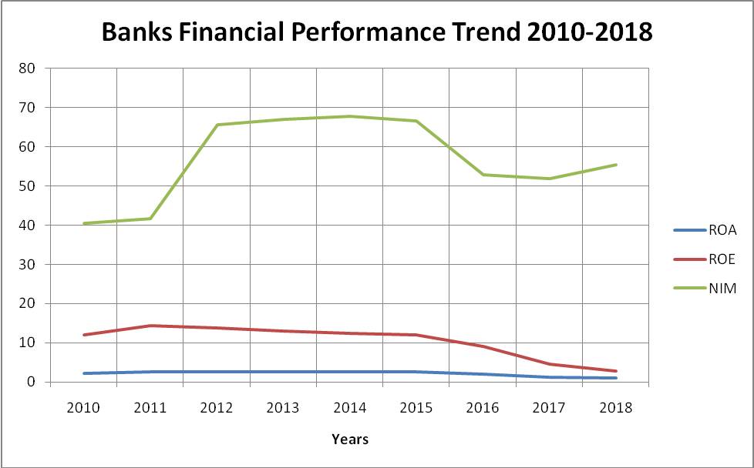
Figure 4.1: Banking Sector Financial Performance (BOT) 2010-2018
Source: Constructed from BOT Field Data (2019)

To formally test whether a linear pattern or trend occurs between the banking sector performance and the banking supervision regulations, this research had to study the timelines when key regulations were implemented.
Having studies the years when the majority of key regulations were implemented and noticed that most key regulations were implemented between 2013 and 2015, the study decided to analyse the data by running a time series graph with a time trend (measured in years) as the independent variable and financial performance ratios (ROA, ROE and NIM) as a dependent variable. Further time series regression was conducted on data.

The analysis of the time series data was done with an understanding that the past can inform the future, but not vice versa. The research also had an understanding that the data presented two sequences, the financial performance (dependent variable) and time (forms independent variable as regulations are implemented in time) that are trending in the same or opposite directions with a linear time trend that appears to be correlated for reasons related to other unobserved factors, which in this case is the introduction of banking supervision regulations.

    - Financial Performance of Banks between 2010-2013
From the regression equation Y = aX + b, where X is the independent variable, ‘Y’ is the dependent variable, ‘a’ is the slope or gradient of the line and ‘b’ is the intercept (the value of y when x = 0) a regression was performed for each financial performance indicator with the data from BOT. Then a regression line for average trends of each of the financial performance indicator ratio over the years is drawn using Regression Data Analysis in Microsoft Excel.
The coefficient of determination or R- Square (R²) was as well automatically calculated to explain the Goodness-of-Fit of the regression.
BOT data shows the performance of the industry as a whole. The data used on this analysis therefore portrays the performance of the banking industry at large.

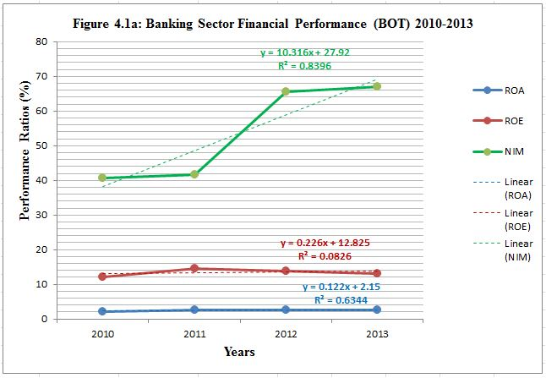
Figure 4.2: Banking Sector Financial Performance (BOT) 2010-2013
Source: Constructed from BOT Field Data (2019)

The time series graph on Figure 4.2 shows positive gradient for all of the three performance soundness indicators for the year between 2010 and 2013. This means that the banking industry performance during the four years was in the increase trend. The R² for Net Interest Margin (NIM) during the period stands out with a big positive gradient and an 83.96% confident of determination (R²), suggesting that 83.96% of the values fit the regression analysis model with 83.96% dependent variables (y-values) explained by the independent variables (x-values).
    - Financial Performance of Banks between 2013-2018

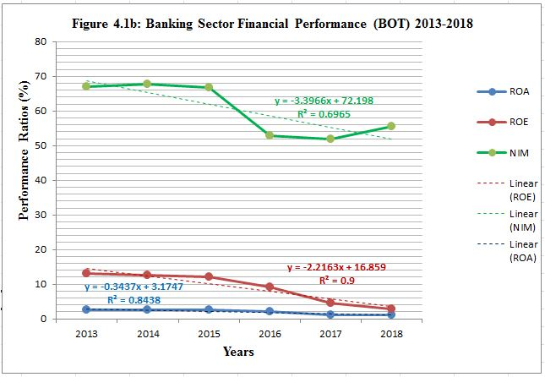
Figure 4.3: Banking Sector Financial Performance (BOT) 2013-2018
Source: Constructed from BOT Field Data (2019)

The time series graph on Figure 4.3 shows negative gradient for all of the three performance soundness indicators for the year between 2013 and 2018. This means that the banking industry performance during the six years period has been in a decreasing trend.

Evaluation of Regulations and Bank Performance Relationships
The main objective of this study is to evaluate the relationship between banking supervision regulations and the financial performance of banks between 2010 and 2018. The main hypothesis of the study is that there is a negative correlation between the financial performance pattern of banks and the banking supervision regulations in Tanzania between 2010 and 2018. The researcher hypothesized that the relationship is a declining one. The force behind the declining pattern is that the researcher believes that with 26 regulations implemented between 2011 and 2018 and 13 out these were implemented in 2014 alone, the effect must be clearly reflected in the four years stint. These regulations were rolled out following the Banks and Financial Institutions Act, 2006 and Bank of Tanzania Act, 2005.

Time series graphs depicting performance of the banking industry (banks) were plotted to show the trend lines, regression analysis equations, regression line gradients (to indicate increase or decrease in financial performance) and R² to explain the Goodness-of-Fit of the regressions. Below are more analysis of the banking sector’s financial performance increase period of 2010 to 2013 and that for the financial performance decline period of 2013 to 2018.

Table 4.1: Regression Analysis of Financial Performance (ROA) 2010-2013
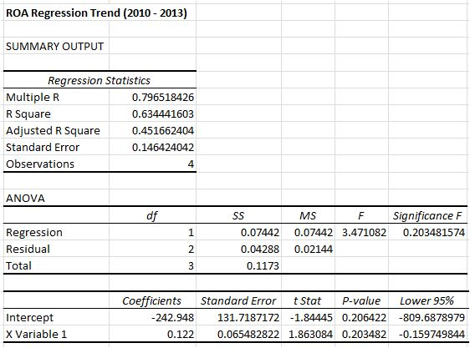
Source: Analysed from BOT Field Data (2019)
The regression results above give a value of 0.7965 Multiple R (Correlation Coefficient). This indicates the strength of a linear relationship between the variables in the regression.

An R Square of 0.6344 indicates the level of goodness of fit. This shows the percentage of points that falls on the regression line being 63.44%, meaning that 63.44% of the dependent variables (y-values) are explained by the independent variables (x-values). From the coefficient of determination value, we can predict the next years’ ROA increase 0.122% certainty. A significance F value of 0.2035is registered indicating how reliable (statistically significant) the results of the model are. Though the results indicate that the correlation between the dependent and independent variables is slightly above the 0.05 threshold, the analysis indicates that every one year, 0.122% of ROA financial performance ratio increase.

Table 4.2: Regression Analysis of Financial Performance (ROE) 2010-2013
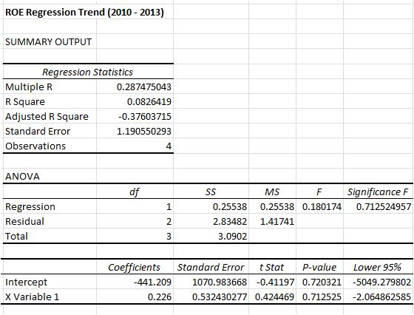
Source: Analysed from BOT Field Data (2019)
The regression results above give a value of 0.2875 Multiple R. This indicates the strength of a linear relationship between the variables in the regression. An R Square of 0.08264 indicates the level of goodness of fit. In terms of percentage, this shows the percentage of points that falls on the regression line as 8.264%, meaning that 8.264% of the dependent variables (y-values) are explained by the independent variables (x-values). A significance F value of 0.7125is registered indicating how reliable (statistically significant) the results are. The values for Multiple R, R Square and Significance F indicates that the model is weak but it is backed up by the fact that every one year, 0.226% of ROE financial performance ratio increases.

Table 4.3: Regression Analysis of Financial Performance (NIM) 2010-2013
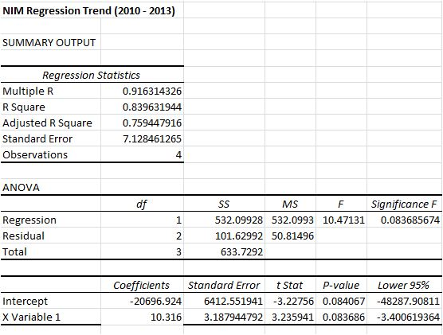
Source: Analysed from BOT Field Data (2019)
The regression results above give a value of 0.9163 Multiple R (Correlation Coefficient). This indicates the strength of a linear relationship between the variables in the regression. An R Square of 0.8396 indicates the level of goodness of fit. This shows the percentage of points that falls on the regression line, meaning that 83.96% of the dependent variables (y-values) are explained by the independent variables (x-values).

A significance F value of 0.0837 is registered indicating how reliable (statistically significant) the results are. With a smaller number, the results indicate that the correlation between the dependent and independent variables is good. The analysis indicates that every one year, 10.32% of NIM financial performance ratio increase.

Table 4.4: Regression Analysis of Financial Performance (ROA) 2013-2018
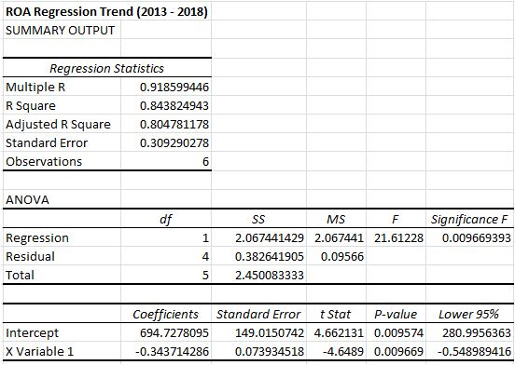
Source: Analysed from BOT Field Data (2019)

The regression results above give a value of 0.9186 Multiple R (Correlation Coefficient). This indicates the strength of a linear relationship between the variables in the regression. An R Square of 0.8438 indicates the level of goodness of fit. This shows the percentage of points that falls on the regression line, meaning that 84.38% of the dependent variables (y-values) are explained by the independent variables (x-values).

A significance F value of 0.0097 is registered indicating how reliable (statistically significant) your results are. With a smaller number, the results indicate that the correlation between the dependent and independent variables is good. The analysis indicates that every one year, 0.34% of ROA financial performance ratio decreases

Table 4.5: Regression Analysis of Financial Performance (ROE) 2013-2018
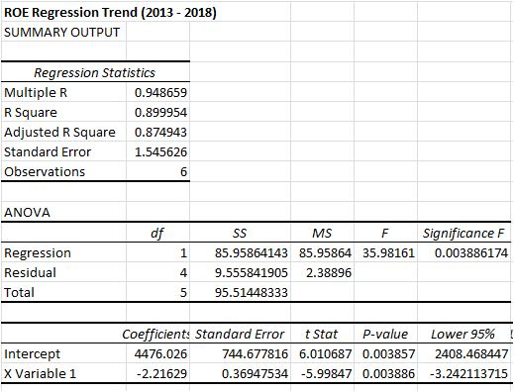
Source: Analysed from BOT Field Data (2019)
The regression results above give a value of 0.9487 Multiple R (Correlation Coefficient). This indicates the strength of a linear relationship between the variables in the regression. An R Square of approximate 0.9 indicates the level of goodness of fit. This shows the percentage of points that falls on the regression line, meaning that 90%of the dependent variables (y-values) are explained by the independent variables (x-values).

A significance F value of 0.39% is registered indicating how reliable (statistically significant) your results are. With a smaller number, the results indicate that the correlation between the dependent and independent variables is good. The analysis indicates that every one year, 2.22% of ROE financial performance ratio decreases

Table 4.6: Regression Analysis of Financial Performance (NIM) 2013-2018
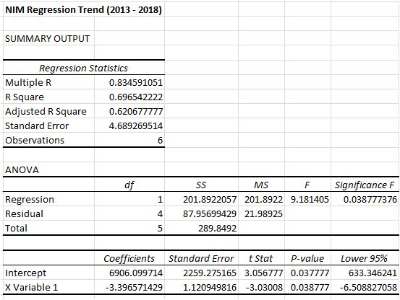
Source: Analysed from BOT Field Data (2019)
The regression results above give a value of 0.8345 Multiple R (Correlation Coefficient). This indicates the strength of a linear relationship between the variables in the regression. An R Square of 0.6965 indicates the level of goodness of fit. This shows the percentage of points that falls on the regression line, meaning that 69.65% of the dependent variables (y-values) are explained by the independent variables (x-values).

A significance F value of 0.0388 is registered indicating how reliable (statistically significant) your results are. With a smaller number, the results indicate that the correlation between the dependent and independent variables is good. The analysis indicates that every one year, 3.4% of NIM financial performance ratio decreases

Summary of Findings
‘Figure 4.1’ shows a general trend of financial performance of the banking sector from 2010 to 2018 as per the financial soundness indicators (ROA, ROE and NIM). A generally growing financial performance results for the banking sector from 2010 to 2013 and a sudden declining trend from 2013 to 2018 are observed. ‘Figure 4.2’ shows the financial performance soundness indicators with their respective R-Square. All of the financial performance indicators graphs show positive gradients or (coefficient of X Variable) from 2010 to 2013 indicating that there is a positive growth in financial performance of the banking sector.

Unlike the graph for financial performance from 2010 to 2013, the performance is in decrease trend from 2013 to 2018 as shown on ‘Figure 4.3’. The gradients for the three performance indicators are all negative, meaning there is declining trend of financial performance.

Regression Analysis performed on the data from 2010 to 2013 shows a summary of results on ‘Table 4.4’.

Table 4.7: Regression Analysis Results Summary for 2010 to 2013 Performance
Performance Ratio | Multiple R | R Square | Significance F | Coefficient of X
ROA | 0.7965 | 0.6344 | 0.2035 | 0.12
ROE | 0.2874 | 0.0826 | 0.7125 | 0.23
NIM | 0.9163 | 0.8396 | 0.0837 | 10.32
Source: Analysed from BOT Field Data (2019)

Regression analysis results for the financial performance from 2010 to 2013 gives strong Multiple R (Correlation Efficiency) for ROA and NIM at 0.7966 and 0.9163 respectively. This indicates that there is a strong linear relationship between the time variable (for when Regulations were not implemented) and the financial performance of banks. This also indicates a high data validity and reliability. The reliability is also presented by Cronbach’s alpha of 0.98 (or 98%) from BOT data which a high score of internal consistency of data. This suggests that the data is reliable. R Square of 0.6344 and 0.8396 for ROA and NIM respectively indicates a good level of goodness of fit showing the percentage of points that falls on the regression line. Significance F value of 0.1464 and 0.0837 for ROA and NIM also explains reliable (statistically significant) the result of the model are, though are slightly above the cutoff line of 0.05.

While there is weak reading for ROE to suggest the financial performance increase with Multiple R and R Square, the regression analysis report shows coefficient of X variables for the three financial performance indicators reading 0.12, 0.23 and 10.32 increase rate per year for ROA, ROE and NIM respectively. These are positive readings of gradients as may be seen on the regression analysis equations. The analysis of data as conducted in this chapter presents a picture of what the trend of bank performances has been over the years from 2010. The financial performance trend can therefore be generalized to say there is an increase in the stint four years from 2010 to 2013 and in the following six years from 2013 to 2018 there is a clear decrease.

A confounding variable is sought for in the light of the assumption that banking regulations gets implemented to help banks perform. Are the regulations implemented between 2013 and 2015 helping out improve financial performance? Why the performance was in increase before the majority of the major regulations were implemented and a clear decrease is shown after they were implemented?

The next chapter is for conclusions and recommendation about the findings noted in this chapter.

CHAPTER FIVE

CONCLUSIONS AND RECOMMENDATIONS

Chapter Overview
This chapter presents researcher’s conclusions and recommendations. The conclusions made in this chapter are based on the entire understanding of the research objectives, the literature review conducted; the research methodology opted, as well as analysis and findings of the research. The conclusions in this chapter are based on the results of the data analysed, they are not opinion driven. The recommendation thereof is therefore based on the results obtained.

Conclusions
The data analysis and result presentation of this research has shown that there was an increase in financial performance from 2010 to 2013 then it was followed by a sadden fall from 2013 to 2018. Data from BOT indicates the increase using visual graph, positive gradient (coefficients) of the financial performance indicator regression equations and generally convincing ROA and NIM readings for the Multiple R, R Square, Significance F and Coefficient of X variable. The data indicated a decline of performance of the banking sector from 2013 to 2018.

To conclude the observation of this study, while we cannot conclusively suggest that there is a causal link between the financial performance of banks and the implementation of the banking supervision regulations, the study came with two conclusions. First, looking at the results against the timing of when the major banking regulations were implemented (2013, 2014 and 2015); this research observes that the banking regulation does not assist in accelerating banks’ financial performance. The sector is seen to be in declining trend for six years consecutively despite the increase in assets and deposits of the banking sector. Second, there is a strong correlation of the bank regulation implementation and the decline in banking performance. The majority of major regulations were implemented between 2013 and 2015 where the decline in financial performance of banks also became more pronounced going forward.

Even though banking regulations in Tanzania does not seem to promote financial performance for banks, the study however acknowledges that the banking regulations are necessary in order to enforce what Cao (2016) calls “rules of the game”. This includes money laundering and fraud control.

Recommendations
This research recommends that the implementation of the regulations should be consultative and participatory with the banks and other stakeholders so that they are made part of the process in the development of the banking supervision Monitoring and Evaluation system. That way, chances for passing bad regulations will be minimal, yet the banks will have ownership of the regulations, something which will also boost compliance, streamlined monitoring and evaluation; and enhance information sharing, informed decision making, learning, transparency, accountability and capacity building in the banking sector.

Suggestions for Further Research
This study has noted that the banking supervision regulations does not accelerate the financial performance of banks, but the implementation of the banking supervision regulations is correlated with the decline in financial performance for banks. Since this study is not comprehensive in the sense that it has not tested to describe all possible factors affecting financial performance of banks in Tanzania, it suggests for a further study to be conducted in order to discover if there are some other confounding factors that may be causing the financial performance’s declining trend or otherwise conclude that there is something fundamentally wrong with banking supervision regulations that are implemented in Tanzania. The study further suggests that a deep analysis of each bank’s financial performance over time would help not only in performing triangulation but also in establishing the banking sectors segments that are the most affected ones and hence establish why.

REFERENCES
Acevedo, G. L., Rivera, K., Lima, L. and Hwang, H. (2010). Challenges in Monitoring and Evaluation: An Opportunity to Institutionalize M&E Systems. In; Proceedings of fifth conference of the Latin America and the Caribbean Monitoring and Evaluation (M&E) Network. June 2010, Washington DC, USA 206: p. xv
BOT, (2012). Supervisory Methodologies, Acts, Regulations and Circulars in Place. Retrieved on 20th July, 2019 from; [https://www.bot.go.tz/Banking Supervision/SupervisoryMethodololgies.asp].
BOT, (2017). The Directory of Banks and Financial Institutions Operating in Tanzania as at 30th June 2017. Annual Reports - For the Year Ended 30 June, 2017, BOT.
BOT, (2019). Banking Supervision. Retrieved on 20/07/2019 from; [https://www.bot.go.tz/BankingSupervision/BankingSupervision.asp].
Cao, J. (2016). Banking Regulation in Theory and Practice. Banking Regulation Toolbox. 1(1), 5-6.
Cao, J. (2016). Banking Regulation in Theory and Practice. Norges Bank Research., Munich. Theory and Practice, 145-184, 2019.
DFID, (2014). The Importance of Financial Sector Development for Growth and Poverty Reduction. Policy Division Working Paper. 1(1), 7-12.
Goodstein, L. D., Nolan, T. M. and Pfeiffer, J. W. (1992). Applied Strategic Planning - A Comprehensive Guide. San Diego: Pfeiffer & Company.
Hendrickson, J. (2011). Regulation and Instability in U.S Commercial Banking. Minnesota: University of St Thomas.
Hertog, J. (1999). General Theories of Regulation. University of Utrecht., Encyclopedia of Law and Economics, 1, 223 – 270.
Hertog, J. (2010). Review of Economic Theories of regulation. Working Papers, 10-18, Utrecht School of Economics, Utrecht.
IFRC, (2011).Project/programme Monitoring and Evaluation (M&E) guide. IFRC., Geneva. 132pp.
Jalilian, H. and Kirkpatrick, C. (2001).Financial Development and Poverty Reduction in Developing Countries. Finance and Development Research Programme Working Paper. 1(30), 6-9.
Kihwelo, P. F. (2007). Criminal justice in disrepute: An overview of treatment of accused persons and convicts in Tanzania. Open University Law Journal, 1(1), 47 - 54.
Kothari, C. R. (2004).Research Methodology; Methods and Techniques. New Delhi: New Age International (P) LTD.
Li, S. (2019). The Impact of Bank Regulation and Supervision on Competition. Emerging Markets Finance and Trade, 1(1), 4-28.
Lotto, J. (2018). The Empirical Analysis of the Impact of Bank Capital Regulations on Operating Efficiency. Factors Influencing Bank Operating Efficiency. 1(1), 8-9.
Lotto, J. (2019). Evaluation of factors influencing bank operating efficiency in Tanzanian banking sector. Factors Influencing Bank Operating Efficiency. 1(2), 6-11.
Lyambiko, M. R. (2012). The Effect of Operational Risk Management Practices on the Financial Performance in Commercial Banks in Tanzania. unpublished masters dissertation, University of Nairobi, Nairobi, Kenya.
Mwongeli, A. J. (2012). The Effect of Regulations on Financial Performance of Commercial Banks in Kenya. Unpublished masters dissertation, University of Nairobi, Nairobi, Kenya.
NBS, (2015). National Accounts. Retrieved on 21st July, 2019 from; [https://nbs.go.tz/nbstz/index.php/english/other-statistics/623-national-accounts-by-subjects].
Ngalande, E. E. (2003). The importance of financial system modernization in Africa. In; Proceedings of the Perago User Group Conference, 24-25 April, 2003, Johannesburg, USA.
Posner, R. A. (1974). Theories of economic regulation. The Bell Journal of Economics and Management Science, 5(2), 335-358.
Saunders, M., Lewis, P. and Thornhill, A. (2009). Research methods for business students. Edinburgh Gate: Mark Pearson Education Limited.
Shaddadya, A. and Moore, T. (2018). Investigation of the effects of financial regulation and supervision on bank stability. International Financial Markets, Institutions & Money. 1(1), 18-24.
Soewarno, N. and Ali, H. (2016).Impact of regulation and supervision on Indonesian banks’ scale efficiency, 2002–2011. Int. J. Economic Policy in Emerging Economies, 9(4), 11-21.
UNDP, (2002). Handbook on Monitoring and Evaluating for Results. New York: UNDP Evaluation Office.
Vianney, K. J. (2011). The Relationship between Regulation and Financial Performance of Rwanda. Unpublished masters dissertation University of Nairobi, Nairobi, Kenya.
Wells, D. L. (2010). Strategic Management for Senior Leaders - A Handbook for Implementation. TQL Office., Washington DC.
Yona, L. and Inanga, E. L. (2014). Financial sector reforms in bank regulations and supervision and its impact on service quality of Commercial Banks in Tanzania. Research Journal of Finance and Accounting, 5(4), 1-10.

APPENDICES

Appendix I: Data Collection Forms and Checklist

Table 3.1: Data Collection Instrument
Data Collection Checklist

Institution Name |  |  | ✍
::Data Collection Instrument |  |  | Document Review
 |  |  |  |  |  |  |  | ☑
Data Source |  |  |  |  |  | BOT |  |  | <>Sector Level Data  <>BOT DBS Annual Reports
Data Type |  |  |  |  |  | Ratios (%) |  |  | ROA✍ |  | ROE✍ |  | NIM✍
::Data Capturing tool |  |  |  |  |  | Fact Sheet
☑Pre-test of data collection
☑Ethical Consideration
Fact Sheet (Capture BOT data in this section)

Ratio Name |  | 2010 | 2011 | 2012 | 2013 |  | 2014 | 2015 |  | 2016 |  | 2017 |  | 2018
ROA | ✍
ROE | ✍
NIM | ✍
Comments | ✍
Source: Constructed by Researcher (2019)

Appendix II: Collected Data for Analysis
Table 4.8: Banks Financial Performance Data from BOT
 | 2010 | 2011 | 2012 | 2013 | 2014 | 2015 | 2016 | 2017 | 2018
ROA | 2.16 | 2.53 | 2.58 | 2.55 | 2.51 | 2.49 | 2.09 | 1.15 | 1.04
ROE | 12.13 | 14.47 | 13.88 | 13.08 | 12.56 | 12.16 | 9.26 | 4.67 | 2.88
NIM | 40.56 | 41.72 | 65.56 | 67 | 67.8 | 66.72 | 52.87 | 51.99 | 55.48

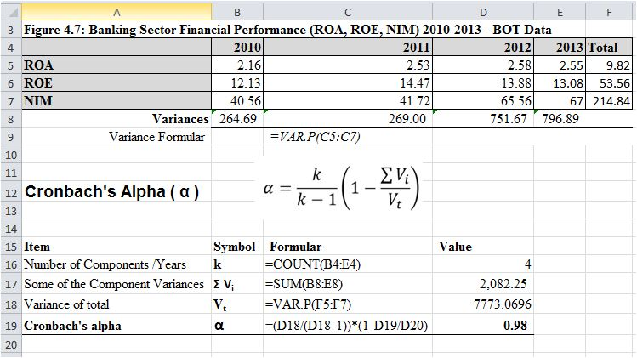
Figure 3.1:Banking Sector Performance (ROA, ROE, NIM) 2010-2013 - BOT Data
Source: Collected and Computed from BOT Field Data (2019)

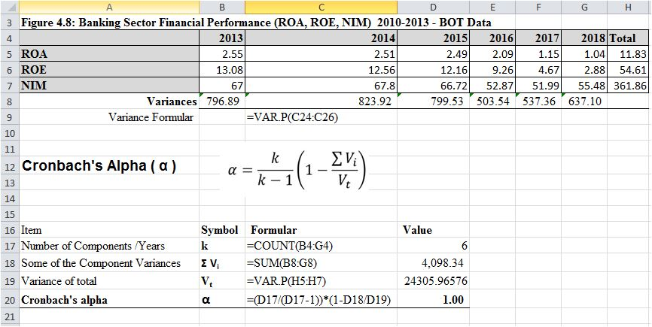
Figure 3. 2: Banking Sector Performance (ROA, ROE, NIM) 2013-2018 - BOT Data

Source: Collected and Computed from BOT Field Data (2019)

Appendix III: List of BOT Regulations
Banking and Financial Institutions (Financial Leasing) Regulations, 2011
Banking and Financial Institutions (Mortgage Finance) Regulations, 2011
Banking and Financial Institutions (Development Finance) Regulations, 2011
Banking and Financial Institutions (Tanzania Mortgage Refinance Company) Regulations, 2011
Credit Reference Bureau Regulation 2013
Credit Reference Databank Regulation 2013
The Banking and Financial Institutions (Licensing) Regulations, 2014
The Banking and Financial Institutions (Disclosures) Regulations, 2014
The Banking and Financial Institutions (Capital Adequacy) Regulations, 2014
The Banking and Financial Institutions (External Auditors) Regulations, 2014
The Banking and Financial Institutions (Microfinance Activities) Regulations, 2014
The Banking and Financial Institutions (Liquidity Management) Regulations, 2014
The Banking and Financial Institutions (Consolidated Supervision) Regulations, 2014
The Banking and Financial Institutions (Physical Security Measures) Regulations, 2014
The Banking and Financial Institutions (Prompt Corrective Actions) Regulations, 2014
The Banking and Financial Institutions (Management of Risk Assets) Regulations, 2014
Banking and Financial Institutions (Internal Control and Internal Audit) Regulations, 2014
The Banking and Financial Institutions (Foreign Exchange Exposure Limits) Regulations, 2014
The Banking and Financial Institutions (Credit Concentration and Other Exposures Limits) --------Regulations, 2014
Bureau De Change Regulation 2015
The Social Security Schemes Investment Guidelines, 2015
Banking and Financial Institutions (Mortgage Finance) Regulations, 2015
The Banking and Financial Institutions (Capital Adequacy) (Amendment) Regulations, 2015
The Banking & Financial Institutions (Microfinance Activities) (Amendment) Regulations, 2015
Bureau Regulations Amendment 2017
Guidelines on Agent Banking for Banks and Financial institutions, 2017
Bureau De Change Regulation 2019

