EFFECTS OF HUMAN RESOURCE PLANNING ON MPLOYEES’ PERFORMANCE IN GOVERNMENT AGANCIES: CASE OF HIGHER EDUCATION STUDENTS LOAN BOARD

BRIGHTON FRIDISH NGOWO

DISSERTATION SUBMITTED IN PARTIAL FULFILMENT FOR THE REQUIREMENTS OF THE DEGREE OF MASTER OF HUMAN RESOURCE MANAGEMENT (MHRM)
DEPARTMENT OF LEADERSHIP AND GOVERNANCE
OF THE OPEN UNIVERSITY OF TANZANIA
2020

CERTIFICATION
The undersigned certifies that, he has read and hereby recommends for acceptance by the Open University of Tanzania a dissertation titled: “Effects of Human Resource Planning to the Employees’ Performance in the Government Agencies: Case of Higher Education Students Loan Board” in partial fulfillment of the requirements for the Degree of Master of Human Resource Management (MHRM) of the Open University of Tanzania.

…………………….……………….
Dr. Chacha Alfred Matoka
(Supervisor)

…………………………………
Date

COPYRIGHT
No part of this dissertation may not be reproduced, stored in any retrieval system or submitted, in any form by any means, electronic, mechanical, photocopying, recording or otherwise without prior written permission of the author or The Open University of Tanzania in that behalf.

DECLARATION
I, Brighton Fridish Ngowo, do hereby declare that this dissertation is my own original work and that it has not been presented and will not be presented to any other university for a similar or any other degree award.

……………………………..……
Signature

…………….……………………
Date

DEDICATION
This dissertation is dedicated to my beloved wife.

ACKNOWLEDGEMENTS
First and foremost, I would like to convey my sincere gratitude to all who provided assistance in various ways of researching and writing this work. It is impossible to mention all of them but I am grateful for their input and assistance.

I am also indebted to my family for granting me the necessary financial and moral support throughout the course. I am profoundly gratefully to my supervisor Dr. Chacha Alfred Matoka for his best and strict supervision filled with constructive criticism, scholarly advice and comments throughout my research. I admit that without his supervisory role, this work would not have attained this form.

Finally, I wish to thank my colleagues and friends who offered me assistance and support in one way or another at various stages of my academic work. Special thanks to the respondents including staffs of Higher Education Student Loan Board (HESLB), I pray to Almighty God that he showers blessings upon them.

ABSTRACT
This study assesses the effect of HRP on employees’ performance focusing on HESLB as a case study. The research was conducted in Dar es Salaam region specifically at the headquarters of HESLB. The study selected the sample of 118 respondents where a sample was obtained through purposive sampling technique. The data was collected by using interview and distribution of research questionnaires. Data analysis was conducted by using content analysis and Statistical Packages of Social Science (SPSS). SPSS was used to run multiple regression analysis which is also based on correlation analysis in order to arrive into conclusions. The study found that there is a link between HRP and the employees’ performance. HRP which involves recruitment and selection, training and retraining, performance appraisal and compensation influences the performance of employees. It was found further that although HRP has influence to the employees’ performance, but there was average response on the efficiency of HRP policies and mechanisms employed at HESLB. It recommended the organisations especially public agencies should employ effective human resource planning policies and mechanisms which will influence the effective performance of the employees. This will also bring impact to the financial performance of the organisation because the financial performance of the organisation depends on its workforce.
Keywords: Human Resource Planning Employees Performance, Recruitment and Selection and Compensation.

TABLE OF CONTENTS
CERTIFICATION ii
COPYRIGHT iii
DECLARATION iv
DEDICATION v
ACKNOWLEDGEMENTS vi
ABSTRACT vii
TABLE OF CONTENTS viii
LIST OF TABLES xii
LIST OF ABBREVIATIONS xiv
CHAPTER ONE 1
INTRODUCTION 1

1.1 Study Overview 1

1.2 Background of the Study 1

1.3 Statement of Problem 6

1.4 General Objective 8

1.5 Specific Objectives 8

1.6 Research Questions 9

1.7 Significance of the Study 9

1.8 Organization of the Study 10
CHAPTER TWO 11
LITERATURE REVIEW 11

2.1 Introduction 11

2.2 Definition of Key Term 11

2.3 Review of Theories 16
2.3.1 Theory X, theory Y and theory Z 16

2.4 Implementation Stages of Human Resource Planning 17
2.4.1 Assessing the current Human Resource capacity 17
2.4.2 Forecasting HR requirements 17
2.4.3 Gap Analysis 18
2.4.4 Developing HR Strategies to support the Strategies of the Organization 18
2.4.5 Control and Evaluation 19

2.5 Empirical Literature Review 19
2.5.1 Review at the Globe Context 19
2.5.2 African Context 21
2.5.3 Tanzanian Context 23

2.6 Research Gap 25

2.7 Conceptual Frameworks 26
CHAPTER THREE 27
RESEARCH METHODOLOGY 27

3.1 Inroduction 27

3.2 Research Philosophy 27

3.3 Research Approach 27

3.4 Research Design and Strategy 28
3.4.1 Case Studies 28
3.4.2 Area of Study 28
3.4.3 Population of the Study Area 29
3.4.4 Sample Size and Sampling Procedures 29

3.5 Data Collection Methods 31
3.5.1 Primary Data 31
3.5.2 Data Collection Tools 32

3.6 Data Analysis 32
3.6.1 Variables and Measurements Procedures 33

3.7 Validity 33

3.8 Reliability 34

3.9 Ethical Consideration 35
CHAPTER FOUR 36
ANALYSIS AND DISCUSSION 36

4.1 Introduction 36

4.2 Sample Description 36

4.3 Descriptive Statistics for the Effect of Recruitment & Selection on Employee Performance 37
4.4 Descriptive Statistics for the Effect of Performance Appraisal System on Employees’ Performance 39
4.5 Descriptive Statistics for the Impact of Compensation on Employees Performance 40
4.6 Descriptive Statistics for Employee Performance 41

4.7 Regresion Analysis 44

4.7.1 Outliers, Normality, Linearity and Homoscedasticity Regression Assumptions Testing Results for RECRSELECT 45

4.7.2 Outliers, Normality, Linearity and Homoscedasticity Regression Assumptions Testing Results for TRAPRGM 47

4.7.3 Outliers, Normality, Linearity and Homoscedasticity Regression Assumptions Testing Results for PERFAPPSAL 48

4.7.4 Outliers, Normality, Linearity and Homoscedasticity Regression Assumptions Testing Results for EMPCOMPSATION 50
4.7.5 What are the effects of Recruitment and selection on Employees’ Performance? 51
4.7.6 4.7.2 What are the Effects of Training and Re-training Programmes towards 52
4.7.7 What are the Effect of the Performance Appraisal to the Employees’ Performance? 53
4.7.8 What are the Effects of Compensation toward the Employees Performance 54
CHAPTER FIVE 55
CONCLUSION AND RECOMMENDATION 55

5.1 Introduction 55

5.2 Conclusion 55

5.3 Recommendations 56

5.4 Limitations and Areas for Future Studies 57
REFERENCES 59
APPENDICES 63

LIST OF TABLES
Table 3.1: Study Population 29
Table 3.2: Sample Size of the Respondents 31
Table 3.3: Reliability Test 34
Table 4.5: Sample Description 36
Table 4.2: Descriptive Statistics for the Effect of Recruitment & Selection on Employee Performance 37
Table 4.3: Descriptive Statistics for the Effect of Training and Retraining Programs 39
Table 4.4: Descriptive Statistics for the Effect of Performance Appraisal System on Employees’ Performance 40
Table 4.5: Descriptive Statistics for the Impact of Compensation on Employees Performance 41
Table 4.6: Descriptive Statistics for Employee Performance 43

LIST OF FIGURES

Figure 2.1: Conceptual Frameworks 26
Figure 4.1: Histogram for Recruitment and Selection on Employee Performance 46
Figure 4.2: P-P Plot for Recruitment and Selection on Employee Performance 46
Figure 4.3: Scatter Plot for the Standardized Residual for Recruitment and Selection 47
Figure 4.4: Histogram for Training Programs on Employee Performance 48
Figure 4.5: Norma P- P Plot for Training Programs on Employee Selection 48
Figure 4.6: Scatter Plot for Training Programs on Employee Performance 49
Figure 4.7: Histogram for Performance Appraisal on Employee Performance 49
Figure 4.8: P-P Plot for Performance Appraisal on Employee Commitment 50
Figure 4.9: Scatter Plot for Performance Appraisal on Employee Commitment 50
Figure 4.10: Histogram for Employee Compensation on Employee performance 51
Figure 4.11: P – P Plot for Employee Compensation on Employee Performance 51
Figure 4.12: Scatter Plot for Employee Compensation on Employee Performance 52

LIST OF ABBREVIATIONS
EMPCOMPSATION Employee Compensation
EMPPERFORMANCE Employee Performance
HESLB Higher Education Students Loan Board
HLIs Higher Learning Institutions
LMS Loan Management System
OLAS Open Performance Appraisal
PASW Predictive Analytics Software
PERFAPPSAL Performance Appraisal
RECRSELECT Recruitment and Selection
SPSS Statistical Package for Social Science
TRAPRGM Training Programs

CHAPTER ONE

INTRODUCTION

Study Overview
This chapter introduces the study and presents the background information of the study, statement of the problem and research objectives which includes general objectives and specific objectives. It further presents the research questions, significance and organization of this study.

Background of the Study
The concept of human resource planning is old as man himself because a man started to plan since the ancient era in primitive period when no industries or firms existed. (Salaman, et al. 2005). Planning is an essential function of management, thus it was revealed in all activities which include production, development, personnel, research, marketing and finance. The importance of planning augmented even after the emerging of organizations because through planning organization goals and objective are determined (Nicoleta, et al, 2014).

The organization performance and success of the business depends on the quality of the human resources. The presence of adequate skilled workforce is an important tool which facilitates the financial performance of the organization. Employees are the ‘most valuable’ resource in any organization, they need to be empowered, motivated, developed and nurtured rather than being treated as a variable cost to be minimized. It is for this reason that a key element of the Public Service Reform Programme (PSRP) which we embarked on from 2000, and is now in its second phase, is to improve human resource management including institutionalization of human resource planning George D. Yambesi, (2010).

Planning for Human resource has a directed link with organization or business performance, and thus it hard to separate the two in implementation. Armstrong and Stephen (2014) suggested that, “Workforce planning is an integral part of business planning. The strategic planning process defines projected changes in the types of activities carried out by the organization and the scale of those activities. It identifies the core competencies that the organization needs to achieve its goals and therefore its skill and behavioural requirements. Workforce planning interprets these plans in terms of people requirements. But it may influence the business strategy by drawing attention to the ways in which people could be developed and deployed more effectively to further the achievement of business goals. It addresses issues concerning the supply of suitable people.

Furthermore, the development of human resource planning is much associated with the globalization of the trade and emerging of new economies around the world which have created a competition for talent and employees around the world. (Lamiro, 2014). Hence Organizations have to know how many people and what sort of people they need to meet present and future business requirements Armstrong & Stephen (2014). Human resource planning is the core of human resource management. It determines that the right number of people with the right skills, in the right job position at the right time is employed in the organizations. Human resource planning aids organizations to forecast, recruit and retain competent workforce in order to meet the organizational goals Umoh, & Worlu, (2017). PO-PSM, HRP manual for Public Service (2010) defines, Human Resource planning as a process of analysing and identifying the need for and availability of human resources so that the organization achieves its objectives. HR planning is a two-way operational link between high level strategy and action orientated implementation that can be regularly monitored and evaluated.

Human resource planning is the process of analyzing and identifying the availability and the need for human resources so that the organization can meet its objectives. The focus of HR planning is to ensure that the organization has the right number of human resources, with the right capabilities, at the right times, and in the right places (Gupta, 2004). Human resource planning helps work groups to implement their short and long-term organization plans. Due to the vital role of human resource to the performance of the company, human resources planning is very important part of the strategic plan of any work group (Gupta, 2009). Furthermore, it is also important to have human resource planning because the organization performance and success of the business organization depends on the quality of the human resources. The presence of adequate skilled workforce is an important tool which facilitates the financial performance of the organization. (Mehmood, et al, 2017).

Different theories reveal the need of having HRP in realizing employees’ performance. Theory X is based on authoritarian style of management. It contends that the managers assume that the employees are inherent lazy and will avoid work if they can, this they are supposed to closely supervised and comprehensive system of control need to put in place (McGregor, 1960). On the other side theory ‘Y’ believes that the employees are ambitious, self-motivated, and anxious to accept greater responsibility and exercise self-control, autonomy and empowerment. Theory ‘Y’ encourages managers to make employees to have comfortable in their work environment, help them achieve their self-actualization goals and give them guidance when required (McGregor, 1960).

Moreover, in interpreting the theory Z of motivation, William Ouch contends that employee needs to be motivated at their work place. This is through ensuring that the company has a string set of values, and offers long-range approach to training and development and high participatory style of management. This theory encourages the existence of organisation system which implements the HRP. With the implementation of HRP there will be mutual trust between employees and managements, coordination, employee involvement and commitment, and human resource development (Kopelman, 2008). In United Republic of Tanzania (URT), implementation of HRP in Public Service is well articulated public service reform programme II (PSRP), According to Josephat (2011) the emphasis on human resource planning in URT is well articulated in the institutional reforms including public service reform programme II (PSRP) that led to the establishment of the human resource planning unit within PO-PSM.

The aim is to improve human resource management including institutionalization of human resource planning (Yambesi, 2010), and thus the major concern of this study is assess the effect of HRP to public organization performance. Been legal requirement to ever Public Service Institution as per the Public Service Management and Employment Policy (2008) still Most of the Public Service organization in URT failed acquire and implement this tool because most institution marking HRP as normal Planning and never been seen as important role in HR.
Armstrong and Stephen, (2014) noted that “Workforce planning, or human resource planning as it used to be called, may be well established in the HRM vocabulary but it does not seem to be embedded as a key HR activity”. Human resource planning is also essential in personnel management of the HESLB. HESLB being a government agency which is empowered to extend loans and collect repayments for all loans issued to students, hence as requirement of Public Service Management and Employment Policy (2008), implementation of HRP at institution level it is important efficiency operation of HESLB.

In realization of the effective implementation of HRP the HESLB are required to implement Theory ‘Y’ and Theory ‘Z’ which promotes that with the existence of good human resource planning with motivates employers makes the employer brings good inputs which includes effort, loyalty, hard-work, commitment, skill, ability, support of colleagues, adaptability, flexibility, tolerance, determination, enthusiasm, trust in superiors, personal sacrifice. The staffs of an organization need to adopt to the myriad of changes which the organization is facing. The need for having HRP is to ensure the existence of enough and efficient workforce which will manage demands associated by the economic development, technological advancement and the business competitiveness environment (Shen, 2004).

It is the purpose of this study to link the effect human resource planning as an independent variable which includes Sourcing (Recruitment and Selection), training and Re-training, and Performance Management and employees’ performance as a dependent variable which includes employees commitment and ability to retain employees; employees productivity (customer satisfaction, product quality, new product development).

Statement of Problem
An organization need to have the right number of manpower in terms of high quality and quantity which is realized through existence of ongoing process of regular and structured human resource planning. The organization performance depends on its workforce (Hassan, 2016). The failure to articulate properly labour forecast, managing demand for employees and available supply in market and keep a balance between labour supply and demand predictions will pose a great problem to the organization in terms of costs and expertise, hence reduce the competitive. (Hassan, 2016).

HRP normally gives reflection to the performance of a particular Institution all of which depends on its efficiency. The efficiency of HRP is realized through effective recruitment and selection, training and development, performance appraisal and compensation system. Inefficient and ineffective HRP both have become a major problem in most group works performance in Tanzania despite of various reforms taking place in different periods by the government). It is caused by a big number of underperforming organizations as indicated in Daily News and other government reports (Nesphor, 2015). HESLB is facing challenges as it is striving to recover the outstanding loans from beneficiaries, apart technology been the central role in recovering loans, the loan portfolio managed by institution and nature of loan itself needs solid HRP. According to HESLB strategic Plan (2014/15-2016/17), unclear capacity building and succession planning for managing increase changing functions of HESLB, limited skill mix and staff numbers to accomplish and deliver what is expected were highlighted as number of obstacles which hinders the implementation of the strategic plan, also it was Noted by (Dunia, 2014), that, HESLB lacks the necessary infrastructure and human resources to effectively recover the loans due.

According to Memba and Feng (2016) confirmed that, for the period of ten years (2006 -2016) the amount of the loan not recovered was 90 billion Tanzanian shillings. HESLB put only initiatives on writing to its employers, used Debt Collection Agents, advertising the names of debtor in the newspapers and voluntary loan repayment (Nyahende, 2013; URT, 2008/2009). All these initiatives did not involve improving the working force which includes recruitment and selection, training and development, performance appraisal and compensation system.

Tanzania researchers like of (Ishengoma, 2004; Nyahende, 2013 and 2016; Mussa, 2015; Dunia, 2014; and Chatama, 2014) set their eyes understanding the performance, success, practices and challenges facing HESLB in student’s loans recovery, some researchers who shows their interest in HRP like Nesphor John Moyo (2015) Conducted research to Mlele District council- Tanzania and found that HRP has strong relationship with the performance of a particular Institution though major findings show that poor HRP has an impact on organization performance as the response from the respondents shows inadequate priority for HRP; there exist a lot of problems during process of HRP as insufficient.

Top management support, insufficient funds, as well as shortage of expertise. Adams Karia , et al (2016) contends that HRP is essential in performance of employees of public water utilities in Tanzania, it increases productivity. Ngirwa (2009) and Odinga, (2010) also focuse on training employees as a workforce for meeting the organisation goals and the employees’ needs. Waziri & Stephen, (2013) was also of the view that personnel planning develop the prediction, setting the targets and realizing arrangement of the future assurance of adequate manpower. Subsequently, limited researches has been conducted on understanding the contribution/ effect of HRP on the performance of HESLB, it have been revealed that no literatures have specifically have identified the position of HRP specifically on recruitment and selection, training and development, performance appraisal an compensation system toward the employees’ performance focusing on HESLB. Now therefore, this study to assess the effect of HRP to public organization performance focuses on selection and recruitments, training and developments, performance appraisal and compensation in facilitating the performance of employees focusing on HESLB as a case study.

General Objective
To assess the effect of human resource planning to the employees’ performance in the government agencies focusing on Higher Education Students Loan Board (HESLB)

Specific Objectives
- To determine the effect of recruitment & selection on employees’ performance.
- To examine at what extent training and re-training programmes affects employees’ performance.
- To find out the effect of performance appraisal system on employees’ performance.
- To determine the impact of compensation on employees performance.

Research Questions
- What are the effect of recruitment & selection on employees’ performance?
- Do the training and re-training programmes affects employees’ performance?
- To what extent performance appraisal system affects employees’ performance?
- What are the impacts of compensation on employees’ performance?

Significance of the Study
The finding and recommendations of this research creates awareness not only to HESLB but also to other organizations on the importance of having efficient human resource planning department to the better performance of the organization. It further reveal the importance of effective HRP policies and practices. This includes the advantages of good system to the recruitment and selection of employees; training and development of the organization workforce; performance approval; compensations to employees and general working infrastructure.

The finding and recommendations of this study calls upon the employers and employees perceptions toward the HRP and hence facilitates the efficiency in the performance of the organization. For instance, at the HESLB the efficiency of HRM facilitate the efficiency on the provision, repayment and loan recovery ratios. This may include creation of trustworthy loan boards, criteria for identifying the right loan beneficiaries, determining the appropriate loan amounts, creating the reliable databases, and institute an effective and efficient loan disbursement and recovery systems. Moreover, findings of this research may be useful to the other researcher. It is important to be used as a stepping stone in making further researches on the impact of HRP to the performance of the Public organization.

Organization of the Study
This study is divided into five chapters. Chapter one addresses on general information of the background of the study. It introduces the study and presents the background information of the study, statement of the problem, research objectives and research questions. It further states the significance, limitation and organization of this study. Chapter two deals with literature review, it contains the ideas, theories and opinions of different authors in relation to the impact of human resource planning to the performance of the organization. Chapter three covers research methodology describes the various methods employed by researcher under this study. Chapter four presents the findings of the research, research analysis and discussion. It generally presents what will be found in the field by researcher. Chapter five provides for the conclusion of the study and recommendations advanced by researcher under this study.

CHAPTER TWO

LITERATURE REVIEW

Introduction
This chapter defines key concepts and discusses theories used in this study. Moreover, it critically presents empirical literature and at the last part the researcher addresses on the research gap and conceptual framework.

Definition of Key Term

Human Resource Planning Employees Performance and Recruitment and Selection
HRP is a systematic process by which management ensures that there is adequate human resources to achieve organization objectives. It involves prospective demand for and supply of manpower and employment of skills. An organization employs human resource planning as a tool for ensuring that it has the right number and kind of workforce at the right time who are capable of completing the organization goals efficiently. HRP is an analysis of human resource needs, in order to ensure that correct numbers of workforce are available when they are required. (Mondy, et al 1996). It covers the strategies for acquisition, utilization, improvement and preservation of human resources in the organization.

HRP involves the process of determining manpower requirements and the means for meeting those requirements in order to carry out the integrated plan of the organization. HRP consists a series of activities which includes: identification of the organization’s current human resource supply which covers the number of employees, their skills or qualifications, positions, benefits and performance level; forecasting the future human resource requirements or demands; and developing talents strategies which involves conducting communications programs with the employees, relocation of employees and talent acquisition. Human resource planning means a systematic process of forecasting both the prospective demand for and supply manpower, and employment of skills with the objectives of the organization. It can also be termed as the method of reviewing the manpower necessities to ensure that right kind of skills is made available to the organization.

Employees Performance
Employee performance is the level where the employees reach work requirements. Simamora (2004). According to Hasibuan (2006), performance is a work result that one achieved in doing his works entrusted to him which are based on skill, experience, seriousness, and time. Prawirosentono (2008) also defines that performance is a work result which can be achieved by someone or a group of people in an organization, according to each authority and responsibility in order to legally reach the purpose of the involved organization, not to break the law and in accordance with moral or ethics.

Employee performance is not just tasks and work to be done just to get bonus or pay increase. It is an ongoing process where the main objective is to improve both individual and business performance Baker, (1999). Employees’ performance is a process used in most organizations in order to determine the abilities and productivity of the employees and usually employees set their objectives and goals for the upcoming period; they do the best to achieve it, monitor it and develop the right skills Vallerand, (1993). It is also a way to evaluate employees on their effectiveness at work in the organization through performance appraisals which looks at the weaknesses and strengths of the individual to determine where they might improve.

Recruitment and Selection
Recruitment is the process of finding and engaging the people the organization needs. Selection is that part of the recruitment process concerned with deciding which applicants or candidates should be appointed to jobs Armstrong and Stephen (2014). According to Famularo, as cited by Gupta (2009), personnel recruitment process involves five elements, viz., a recruitment policy, a recruitment organization, a forecast of manpower, the development of sources of recruitment, and different techniques used for utilizing these sources, and a method of assessing the recruitment program. Selection is the process of choosing qualified individuals who are available to fill positions in an organization. In the ideal personnel situation, selection involves choosing the best applicant to fill a position. Selection is the process of choosing people by obtaining and assessing information about the applicants with a view to matching these with the job requirements. It involves a careful screening and testing of candidates who have put in their applications for any job in the enterprise. It is the process of choosing the most suitable persons out of all the applicants. The purpose of selection is to pick up the right person for every job.

Training and Development
Training and development to employees means any attempt to improve current or future employee by increasing an employee’s ability to perform through learning, usually by changing the employee’s attitude or increasing his or her skills and knowledge. (Armstrong 2001). Training is the process of imparting specific skills and development is the learning opportunities designed to help employees grow. According to (Armstrong 2001) training is the formal and systematic modification of behaviour through learning which occurs as a result of education, instruction, development and planned experience. Training has the distinct role in the achievement of an organisational goal by incorporating the interests of organisation and the workforce (Stone, 2012).

Training remains a vital to enhancing employee performance. The organisational commitment or the relative strength of an individual’s identification and involvement in a particular organisation (Pool & Pool, 2007) depends on effective training and development programs. According to these authors, organisations demonstrating keen insight make provisions for satisfying the training needs of their current workforce. Cheng and Ho (2001) indicate that adequate training produces marked improvements in employee communication and proficiency of performances as well as extending retention time. When programs target communication skills with co-workers, there are significant increases in profit as well as a greater number of reported positive working relationships that are formed. Training and education have been shown to have a significant positive effect on job involvement, job satisfaction, and organisational commitment (Karia & Asaari, 2006).

Performance Appraisal
Performance appraisal of employees is the systematic evaluation of employees’ performance and potential for development during a certain period of time by supervisors or others who are familiar with their performance. It is one of the oldest and widely used management practices. Performance appraisal is an indispensable tool for an organisation because the information it provides is highly useful in decision making regarding issues such as promotion, merit increases transfer, discharge, training and development. It may also increase employee‟s commitment and satisfaction Wiese and Buckley, (1998).

The increased competitive nature of the economy and rapid changes in the external environment has forced many organisations to shift from reactive performance appraisals to proactive performance management to boost productivity and improve organisational performance (Nayab, 2011). Prasad (2005) defines performance management as the process of planning performance, appraising performance, giving its feedback, and counselling an employee or teams to improve performance. As Armstrong (2006) put it, performance management is a systematic process for improving organisational performance by developing the performance of individual and teams.

Compensation
Compensation processes are based on compensation philosophies and strategies contained in the form of policies, guiding principles, structures and procedures which are devised and managed to provide and maintain appropriate types and levels of pay, benefits and other forms of compensation. (Bob, 2011). This constitutes measuring job values, designing and maintaining pay structure, paying for performance, competence and skill and providing employee benefit. However, compensation management is not just about money, it is also concerned with that non-financial compensation which provides intrinsic or extrinsic motivation (Bob, 2011). Compensation has a motivational effect and therefore implies that having a compensation structure in which the employees who perform better are paid more than the average performing employees is vital to enhancing organisational performance (Hewitt, 2009).

Review of Theories

Theory X, theory Y and theory Z
Theory ‘X’ and theory ‘Y’ were initially explained by Douglas McGregor in his book titled ‘Human Side of Enterprise of 1960.’ Theory X is based on authoritarian style of management. It contends that the managers assume that the employees are inherent lazy and can avoid work if they can, this they are supposed to closely supervised and comprehensive system of control need to put in place. (McGregor, 1960). Under theory X it is believed that the managers does not considers the existing human resource system, HRP policies, or lack of training. On the other side theory ‘Y’ believes that the employee are ambitious, self-motivated, and anxious to accept greater responsibility and exercise self-control, autonomy and empowerment. Theory ‘Y’ encourages managers to make employees to have comfortable in their work environment, help them achieve their self-actualization goals and give them guidance when required. (McGregor, 1960).

In building theory Y, William Ouch come up with theory Z of motivation at the work place which focus is on ensuring that the company has a strong set of values, and offers long –range approach to training and development and highly participatory style of management. Although, both theories are important in human resource management, but theory Z is the most favorable because it encourages on providing relevant training and guidance to the employee so that they can achieve their career and the organizations goals. Theory Z believes on mutual trust between employees, work group, union and management; strong bond between employees and organisation; employee involvement; integrated organisation; coordination; informal control system; and human resource development. It is from this theory where the importance of having Human Resource Planning arises in ensuring that the employees’ performance meets the organizations’ goals.

Implementation Stages of Human Resource Planning

Assessing the current Human Resource capacity
This is a stage in human resource planning of determining of what the staff currently holds. I tis a stage of identification of the organization’s current human resource supply which covers the number of employees, their skills or qualifications, positions, benefits and performance level.

Forecasting HR requirements
Forecasting the future human resource requirements or demands which is based on the objectives of the organization. This also consider for other external challenges that can affect the organization. (Njabulo Khumalo, 2018). Forecasting human resource demand is the process of estimating the future human resource requirement of right quality and right number. Potential human resource requirement is to be estimated keeping in view the organisation's plans over a given period of time. Analysis of employment trends; replacement needs of employees due to death, resignations, retirement termination; productivity of employees; growth and expansion of organisation; absenteeism and labour turnover are the relevant factors for human resourced forecasting. Demand forecasting is affected by a number of external and internal factors (Gupta C.B., 2009).

Gap Analysis
This is a stage where the current human resource in the organization is compared with what the organization wants to be in future. At this stage the evaluation on the skills of the current employees and number of employees is considered then compared with what was needed to achieve your future goals (Mehmood, M., et al, (2017). Moreover, the human resource practice and policies are assessed to meet the future goals of the organization.

Developing HR Strategies to support the Strategies of the Organization
This is the last stage after determining the existing gap on the human resources needed and providing human resource strategies to cover the demands. It involves restructuring strategies. Restructuring strategies involves reducing staffs, regrouping tasks to create well designed jobs and reorganizing work group to perform more efficiently. Training and development strategies is another mechanisms which will improve the skills to encompass the new role in the organization. Recruitment strategies which involves recruiting and hiring the employees who have skills which is needed to the organization for future. Outsourcing strategies is another mechanisms of outreaching to external workforce individuals for purpose of completing certain tasks and lastly, collaboration strategies which is a mechanisms of collaborating with other organization to learn from them and to allow employees to gain skills and knowledges which is not available to their organization. (H. K. Sarmah, B. Bora Hazarika & G. Choudhury (2013).

Control and Evaluation
Control and evaluation represents the final phase in the HR Planning process. The HR Plan should include budgets, targets and standards. It also clarify responsibilities for implementation and control, and establish reporting procedures that will enable achievements to be monitored against plan. These may simply report on the numbers employed against establishment and on the numbers recruited against the recruitment targets. (Jacobson, W. S., & Sowa, J. E. (2015). But they should also report employment costs against budget and trends in wastage and employment ratios.

Empirical Literature Review

Review at the Globe Context
Nicoleta et al, (2016) organizational Strategic Planning of Human Resources, by using survey methods discovered that human resource planning is an aggregate and qualitative exercise. It also considers the skills and the quality of supply. The author further recommends that human resource planning workforce may be disaggregated into groups which is based on grades, occupation and expertise. This expedites the employees’ performance accordance with their qualifications, experience and skills in meeting the organizations’ goals. Although this literature is relevant, but it is basing on the European context. Under this study we address HRP basing on the context of Tanzania specifically at HESLB.

Mehmood, M., et al, (2017) the Impact of Human Resource Management Practices on Organizational Performance, by using survey study, found that the human resource planning is combined with resourcing strategy to produce an action plan. This means human resource planning sets the strategies or agenda of what should be done to the organization workforce to meet the goals while resourcing strategy determines how the set plans is implemented within the terms of recruitment, severance, promotion and transfers. This literature does not categorically elaborate how to make HRP have positive impacts on the organisation performance especially by considering Tanzania context. The gap which will be covered under this study.

Walker J. W., (2019) Human Resource Planning (McGraw-Hill Series in Management), by using survey study found that human resource planning seek to cover the existing manpower and the future human resources by planning on the required number of workforce and the skills, knowledge or experiences; personal characteristics; optimally motivated workforce and with desired relationship to work; a workforce which is flexible and ready for change and considering the existence of adequate human resources at a rights time with appropriate costs capable of making the organization fulfill its goals. The author have failed to clearly link how HRP impact the performance of an organisation.

Rothwell, J., (2014) Planning & Managing Human Resources: Strategic Planning for Personal Management, by using documentary review found that human resource planning is one of the major areas of human resource management. It allows the company to realize its goals, increase the effectiveness and competiveness of enterprises in the labour market. Human resource planning helps to reduce future uncertainty and to better operate the organisation. A human resource plan must ensure that there is the right number and structure of people in the right jobs at the right time. These people should meet the required business objectives. Otherwise, it is possible that business goals and plans may not be filled and also the competitors can dislodge the company from achieved market position.

African Context
Njabulo Khumalo (2018). The role of human resource planning in producing well resourced Employees’ to public. Problems and Perspectives in Management, while using the investigation used mixed methods in its data collection, where participants participated in responding the self-administered questionnaire and seven participated in one-on-one interviews. The study found that half of employees who are working for the centers of the municipality includes supervisors who lack educational attainments, as they hold only grade 12 and no development was initiated. The study recommended the whole the municipality to establish and implement a promotion policy. All necessary equipment and tools provided were insufficient, as required by the Act, to provide all services to the public. However, the author does not focus on a single organisation the gap which is covered under this study.

Dzansi, Y. A. (2016). Understanding the impact of Human Resource Management practices on municipal service delivery in South Africa, the researcher employed comparative survey. It was emphasized that all organizational initiatives need an integration with the HR practices for successfully integrating corporate strategies. When all strategic initiatives i.e. growth, better customers service, innovative production methods, improvements in after sale services, mergers, etc. possess an alignment with HR practices and policies of the organization e.g. with organizing, communicating, developing, appraising, and rewarding employees, and keeping an eye on the future capabilities of the organization, the chances of successful and better resulting implementation of strategic plans increase. The HR practices also need to be aligned with objectives of the organization. However, the researcher have failed to link categorically how HRP impact the organisation performance. This gap covered under this study.

Manwunga, A. K. (2017). The role of human resource manager in the public service in promoting professionalism and implementing the charter for public service in Africa. Addis Ababa, Ethiopia, by using a documentary review methods states that evaluating the progress of the targeted area, monitoring, assessing and presenting the results of HR performance is highly critical. It brings improvements in the skills, and capabilities of the employees and organizational learning so as to meet the future needs and demands. If an organization wants to meet future needs and requirements then the employees must be capable to perform. It would become possible only when the employees are committed to continuous learning and development and are ready to avail the career development opportunities. This literature focuses much on the obligation of the employees’ commitment to learning and development leaving other factors like recruitment and selection, employees’ approval and compensation without being considered into details. The gap which is addressed under this study.

Ngcamu, B. S. (2013). The Paradox of the Regional Centres Unit: The case of the EThekwini Municipality, while using a case study field study, contends that one of the key issues relating to HRP of this municipality was low levels of skills development and literacy, while skilled employees leave the municipal area in search of jobs in other areas. Number of complaints were exhibited from members of the community about staff and level of services they receive in these centres. Yet there was dearth in literature that provides any studies relating to how the HRP influences on quality of services delivered by employees in the public sector, especially in municipal environment.

Tanzanian Context
Adams Karia , et al (2016) The role of human resource planning on performance of public water utilities in Tanzania, by using a case study field survey the data was collected using questionnaires to employees and face to face interview with line managers. Descriptive statistic used included frequency, means, standard deviation, percentages and tables while inferential used ANVOVA and correlation analysis. It was found that HRP is seen in entirety as an effort to anticipate the future of the organization and to provide personnel to fulfil that organization and to satisfy customer’s demands.

It was further revealed a statistically significant relationship between HRP and organisation performance where it was found out that business performance is correlated with training and development, team work, compensation and incentives, human resource planning, performance appraisal, and employees’ security. The author recommends that human resource planning is a very essential practice among of the numerous human resource management practices that leads an organization to an effective and efficiency as well as high productivity. However, the researcher did not focus on the context of HESLB, the gap which is be covered under this study.

Ngirwa (2009) Human Resource Management in African Work Organizations. Dar es Saalam: reveals that organisation which desire to maintain or to enable employees to acquire the necessary knowledge, skills, experience and improve their competitive edge in today’s dynamic world requires a well-trained and developed staff for an effective and efficient provision of quality produce and services to their customers to occur. The author further recommends that training and development should be provided behavior essential for the management of enterprises in a dynamic environment. The authors have extensively elaborated on the importance HRP particularly on the training of the employees who are working force. It is from that juncture this study will focus on HRP in general focusing on HESLB.

Odinga, M. (2010). Staff Development Programs and Job Performance, by using documentary review founds that even though in practice the world is more complicated but it better to follow a notion that having a formalized mechanisms of human resource planning is very important for the workforce of the organization and its success. This literature is important to this study because it indicates the importance of having HRP. However, it does not slaborates how HRP facilitate the financial performance of the employees and an organisation.

Waziri, F., & Stephen, T. (2013). Factors Influencing Implementation of Training Programme in Public Organizations in Tanzania, by using comparative study contends that human resource planning which is sometimes referred as personnel planning it is a tool which targets to achieve the goals of an organization by developing the prediction, setting the targets and realizing arrangements which is for current and future assurance of adequate manpower. However, the author have focused much on human resource training and leaves a gap by failing to address the impact of HRP by providing a link basing specifically on the organization performance.

Viscal Kihongo (2011) Factors Inhibiting Effective Staff Training: Cases of Temeke Municipal and Kisarawe District Councils, Tanzania. The author employed a case study design with data collected from 47 respondents. The instruments used to collect data includes questionnaire and secondary information sources. The study findings indicate lack of proper training policies and programmes, lack or inadequate training fund location, lack of top management commitment towards staff training, coupled with maltipractices such as favoritism and staff training fragmentation as the main factors inhibiting affective staff training in the study area. Although the author have recommended for proper human resource planning particularly on staff training for better performance of the organisation, but the author have not addressed on other elements of HRP like recruitment and compensation which is covered under this study.

Research Gap
Basing on the literature which have been reviewed under this study it is revealed that many studies focuses on the general effects of human resource planning to the organization performance not much on the effect of human resource planning to the public organization focusing on the Higher Education Students Loan Board (HESLB). It is the intention of this study to fill the gap by addressing how HESLB is affected by its existing human resource planning. These previous studies have also been taken using different methods, from researches, questionnaires, face-face interviews, but their outcomes have not differed significantly. A possible explanation could be due to the fact that even though these studies were carried out using different methods and target population, the human resource planning mechanisms and effects remain the same. Now therefore this study will assess the effect of the HRP to the organization performance focusing on the HESLB.

Conceptual Frameworks
Independent Variables Dependent Variables
Human Resource Planning
- Recruitment & Selection
- Training and Development
- Performance appraisal
- Compensation system
Employee Performance

Figure 2.1: Conceptual Frameworks

CHAPTER THREE

RESEARCH METHODOLOGY

Inroduction
This chapter presents research philosophy, research approach, research design and strategy, data collection methods, data analysis, validity, reliability and ethical considerations while conducting research.

Research Philosophy
The researcher used positivist philosophy when conducting this research. Positivism is a philosophical theory stating that certain positive knowledge is based on natural phenomena and their properties and relations. (Levin, 1988). This philosophy is more relevant under this study because it is based on the factual knowledge. This means the research is based on the organizational performance which is assessed basing on experiences and quantifiable observations.

Research Approach
The researchers have employed deductive approach. A deductive approach is concerned with developing a hypothesis (or hypotheses) based on existing theory, and then designing a research strategy to test the hypothesis. (Babbie, E. R. 2010) Deductive means reasoning from the particular to the general. If a causal relationship or link seems to be implied by a particular theory or case example, it might be true in many cases. A deductive design might test to see if this relationship or link did obtain on more general circumstances. Deductive approach can be explained by the means of hypotheses, which can be derived from the propositions of the theory. (Wilson, J. (2010). Deduction begins with an expected pattern that is tested against observations, whereas induction begins with observations and seeks to find a pattern within them.

Research Design and Strategy
This study employed case study research design. It involves an attempt to describe relationships that exist in reality, very often in a single organization. (Cooper & Schindler, 2008). The researcher have selected Higher Education Students Loan Board as a case study. This is useful because through case study research design the researcher is capable of doing extensive examination to acquire detailed information more specifically from HESLB. This study also summarieses the key features of the key methodologies in the table, identifying their respective strengths and weaknesses. In the following sections, and justify choice of methodologies and explain how they both operate and interoperate in our research.

Case Studies
The researcher used Higher Education Students Loans Board as a case study. This for purpose of obtaining relevant data of this study which particularly addresses on the effect of human resource planning to the public organization performance specifically at Higher Education Students Loan Board. The researcher used positivist basing on the data collected and the analytical techniques employed. The researcher was much observer thus capable of getting the reality with the analysis of more variables than is typically possible in experimental and survey research.

Area of Study
The study was conducted at the headquarters of Higher Education Students Loans Board which is located in Dar es Salaam region. The selection of Higher Education Students Loans Board is based on the fact that HESLB is one of the big public organization which operates in Dar es Salaam and which provides services to all Universities in Tanzania. This area of study is also important because many Universities are in Dar es Salaam and many respondents from HESLB can be easily accessible.

Population of the Study Area
The population of the study was 167 who constitutes 132 ordinary staffs and 35 management staffs of HESLB.

Table 3.1: Study Population
Respondents | Population
Management of HESLB | 35
Ordinary Staffs | 132
TOTAL | 167
Source: Field Dat, 2020

Sample Size and Sampling Procedures
Sampling is a process or technique of choosing a sub-group from a population to participate in the study; it is the process of selecting a number of individuals for a study in such a way that the individuals selected represent the large group from which they were selected. (Ogula, 2005). Sampling technique defined as a process of selecting a number of individual or objects from a population such that the selected group contains elements representative of characteristics found in entire group Kothari (2007). In determine sample size different formula are used, Yamane (1967) suggested simplified formula for calculation of sample size from a population which is an alternative to Cochran’s formula. According to him, for a 95% confidence level and 0.5, size of the sample should be
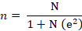
Where by
n = Sample size
N = Population
e = Level of Precisions (Level of tolerance 5% = 0.05)
1 = Constant
n = 167
1+167(0.05) (0.05)
n = 167
1.41
n = 118 respondents

The intended sample size of the study comprises of 118 respondents from the population of 167. The study used purposive sampling technique to obtain the sample size. Purposive sampling is the process in which researchers choose participants arbitrary to their unique characteristics or their experiences, altitudes, or perceptions (Cooper & Schindler, 2008).Purposeful sampling is a technique that allows a researcher to use respondents who have the required information with respect to the objective of the study (Mugenda & Mugenda 1999). It was therefore be established by the researcher that respondents who are informative, or they possess the required characteristics are handpicked. Respondents picked through this technique was only used to the heads of department and top management. This sample size was appropriate because it is large enough to provide the true picture of the situation, given time and financial resources constraints (Kalpana, 2011).

Table 3.2: Sample Size of the Respondents
Respondents | Sample Size | Population | Sampling design | Data Collection Tools
Staff Management | 30 | 35 | Purposive Sampling | Questionnaire and Interview
Ordinary Staff | 88 | 132 | Purposive Sampling | Questionnaire and Interview
TOTAL | 118 | 167
Source: Field Data, 2020

Data Collection Methods
Data collection procedures are defined as the guideline for the collection, processing and analysis of data from selected population. Kothari (2007). The task of data collection follows after a research problem has been defined and research design chalked out (Kothari, 2007). The process of data collection was done field research which was conducted at the case study. Under the primary data collection the researcher collected the first hand information. This is data collected for the first time and happens to be original in character, (Kothari 2006). These information were collected directly from the study area.

Primary Data
Kothari (2004) defines primary data as data which are collected afresh and for the first time, and thus happen to be original in character. Primary data collection method used was interviews and questionnaires as it is elaborated.

Data Collection Tools
Interviews: The researcher employed structured interview as a method of data collection. This method was employed to the respondents from HESLB offices who included ordinary staffs of HESLB and management staffs of HESLB. This method was important because it gives a wide range to the respondent in responding to the interview questions and become helpful to the researcher to acquire relevant information for purpose of this study.

Questionnaire: A questionnaire is a research instrument in a structured form which is written or printed that consists of a formal set of questions or other types of prompts designed to collect information from one or more respondents. (Cone and Foster, 2006). The researcher supplied questionnaires to some respondents as an instrument to collect data. The questionnaires was supplied to managerial officials of HESLB and other staffs of HESLB. This method gave respondents the freedom to express their opinions together with closed ended questions so as to get specific answers. The researcher used questionnaire methods because it is simple compare to interview and observation. The method is free from the bias of interviewer, less expensive and has less pressure on the respondent hence make them to be comfortable. The questionnaire is attached.

Data Analysis
The study employed quantitative data analysis. Quantitative data analysis emphasize objective measurements and the statistical, mathematical, or numerical analysis of data collected through questionnaires, and surveys, or by manipulating pre-existing statistical data using computational techniques. It focuses on gathering numerical data and generalizing it across groups of people or to explain a particular phenomenon. (Earl, 2010). The regression data analysis was be employed by researcher. Regression analysis is a set of statistical processes for estimating the relationships between a dependent variable and one or more independent variables. (Earl, 2010). The quantitative data analysis is frequency distribution and percentages, which will be used to determine the proportion of respondents choosing the various responses. The statistical package for social sciences (SPSS) version 21 was used to conduct the analyses.

Variables and Measurements Procedures
This research contains independent variables which is Human Resource Planning (Assessing the current Human Resource capacity, forecasting HR requirements, gap analysis, developing HR strategies, control and evaluation) and dependent variables organization performance (retaining of employees, employee productivity, employees effectiveness).

Validity
Validity is the extent to which a measure adequately represents the underlying construct that it is supposed to measure, (Drost, 2011). Validity is the trying to explain the truth of research findings as explained by Zohrabi, (2013). The validity is measured by empirical assessment which is where validity is based on quantitative analysis involving statistical techniques. Measure what is intended to be measured. (Field, 2005).

The researcher employed face validity which is a subjective judgment on the operationalization of a construct. Face validity is the degree to which a measure appears to be related to a specific construct, in the judgment of non-experts such as test takers and representatives of the legal system. That is, a test has face validity if its content simply looks relevant to the person taking the test. It evaluates the appearance of the questionnaire in terms of feasibility, readability, consistency of style and formatting, and the clarity of the language used. Face validity refers to researchers’ subjective assessments of the presentation and relevance of the measuring instrument as to whether the items in the instrument appear to be relevant, reasonable, unambiguous and clear (Oluwatayo, 2012).

Reliability
According to Drost (2011), reliability is the extent to which measurements are repeatable when different people perform the measurement on different occasion, under different condition, supposedly with alternative instruments which measure the construct or skill. It can also be defined as the degree to which the measure of a construct is consistent or dependable.

Table 3.3: Reliability Test
 | Variable | N  mber of items | Cronbach's Alpha
Recrselect |  | 9 | .83
Traprgm |  | 10 | .76
Perfappsal |  | 6 | .94
Empcompsation |  | 7 | .81
Empperformance |  | 29 | .74
RECRSELECT = Recruitment and Selection, TRAPRGM = Training Programs, PERFAPPSAL = Performance Appraisal EMPCOMPSATION = Employee Compensation EMPPERFORMANCE = Employee Performance
Source: Data Analysis (2020)

Reliability refers to the consistency and stability of the findings that enables the findings to be replicated (Burns & Burns, 2008). A reliability analysis using Cronbach’s alpha (α) will be conducted to estimate the reliability of the predictor variables. Cronbach’s α analysis is a useful way of determining internal consistency and homogeneity of groups of items in tests and questionnaires (Burns & Burns, 2008). The higher Cronbach’s alpha value is 7 which will show greater scale reliability

Ethical Consideration
The study took into consideration rights of the respondents, institutions and individuals who are affected by the research. Various ethical considerations comprising of confidentiality of data, behavior, and objectivity of the researcher, the use of simple language, effect of data use, analysis and report, informed consent and reaction of participants was observed. Regarding the informed consent, the subjects or respondents were informed on their rights, the purpose of the study, the procedure to be considered and the potential risks and benefits of their participation. On the other hand, the use of simple language aimed at easy understanding of the participants so as to minimize the possibility of coercion or undue influence. Also the subjects’ physical, emotional and psychological capability was taken into consideration together with the right to withdraw at any time. The respondents were further informed that their participation was voluntary and that refusal to participate would not result in any loss of benefits that the subject is otherwise entitled.

CHAPTER FOUR

ANALYSIS AND DISCUSSION

4.1 Introduction
The chapter presents the findings and an analysis of the data collected from the field. It is based on three main parts which include the presentation of sample description of the respondents, research findings and discussion of research findings.

4.2 Sample Description

Table 4.5: Sample Description
S/N |  | Frequency | Percentage | Mean | Std. Dev
1 | Age  18 - 28  29 - 38  39 - 48  49 - 59  59 and above  Total | 18  38  31  22  9  118 | 15.3  32.2  26.3  18.6  7.6  100 | 2.26 | 1.163
2 | Gender  Female  Male  Total | 73  45  118 | 61.9  38.1  100 | 1.37 | .488
3 | Education  Secondary  Bachelor Degree  Advanced Diploma  Masters’ Degree  Total | 2  79  16  21  118 | 1.7  66.9  13.6  17.8  100 | 3.47 | .803
4 | Position  Management  Other staffs  Total | 30  88  118 | 25.4  74.6  100 | 2.44 | .584
Source: Data Data (2020)

Table 4.1 shows different samples description of the respondents which is categorized basing on the age, sex, gender, education and position. The age of respondents were based on different categories where respondents aged 18 – 28 years were 18 (15.3%); 29 – 38 years were 38 (32.2%); 39 – 48 years were 31 (26.3%); 49 – 59 years were 22 (18.6%); and lastly respondents aged 59 years and above were 9 (7.6%). Thus the tabe reveals that majority of respondents (32%) were aged 29 to 38 years followed by respondents aged 39 to 48 years who constitutes 26% of respondents.

4.3 Descriptive Statistics for the Effect of Recruitment & Selection on Employee Performance

Table 4.5: Descriptive Statistics for the Effect of Recruitment & Selection on Employee Performance
Recruitment & Selection
 | N | Mean | Std. Deviation
HESLB engage in recruitment and selection of employees | 118 | 2.87 | .974
Mechanisms of selection and recruitment of employees is sufficient | 118 | 2.86 | 1.287
Recruitment and selection promotes employees performance | 118 | 3.74 | .982
It stimulates retaining of employees | 118 | 3.35 | 1.310
It promotes employees productivity | 118 | 3.46 | 1.312
Attracts effectiveness | 118 | 3.18 | 1.369
Improves employees commitments | 118 | 3.13 | 1.337
I under gone systematic procedures of recruitment before being employed by HESLB | 118 | 3.25 | 1.333
I was selected to work here because of my professional qualifications | 118 | 3.35 | 1.316
Valid N (listwise) | 118
Source: Field Data (2020)

Table 4.2 shows that there is average mean (mean score 2.87) in respect to the engagement in recruitment and selection of employees at HESLB. This is followed by average mean score of 2.86 which describes the sufficiency of the mechanisms of selection and recruitment of employees at HESLB. However, there is highest mean score of 3.74 which reveals that recruitment and selection promoted employees performance; it stimulates retaining of employees (mean score 3.35); it promotes employees productivity (mean score 3.46); attracts effectiveness (mean score 3.18); improves employees commitments (mean score 3.13); there was high mean score (mean 3.25) on the application of systematic procedures of recruitment before employment at HESLB; and lastly the table shows that the selection of employees depends on their professional qualifications (mean score 3.35).

4.3.1 Descriptive Statistics for the Effect of Training and Retraining Programs
Table 4.3 shows that there was average mean score (mean score 2.36) indicating that HESLB provides training and re-training programs to employees; employee training and re-training is efficient (mean score 2.61); the employed mechanisms for employees training and re-training impact the employees’ commitment (mean score 2.54); the table shows highest mean score of 3.64 which reveals that employees training and re-training encourages productivity; increases employees creativity (mean score 3.68); it encourages punctuality (mean score 3.50);

That HESLB can be recommended to friends and colleagues (mean score 3.22); the employees are well training and are competent with their works (mean score 3.10). There was also an average mean score of 2.66 revealing that employee acquires skills day after day when working at HESLB; and mean score 2.43 revealing that training policies at HESLB have improved the employees’ performance.

Table 4.5: Descriptive Statistics for the Effect of Training and Retraining Programs
Descriptive Statistics
 | N | Min | Max | Mean | Std. Deviation
HESLB provides training and re-training programmes to employees | 118 | 1 | 5 | 2.36 | 1.074
Employee training and re-training is efficient | 118 | 1 | 5 | 2.61 | 1.254
The employed mechanisms for employees training and re-training impact the employees’ commitment. | 118 | 1 | 5 | 2.54 | 1.231
Employees training and re-training encourages productivity | 118 | 1 | 5 | 3.64 | 1.059
Training and re-training increase employees’ creativity | 116 | 1 | 5 | 3.68 | 1.154
It also encourages punctuality | 118 | 1 | 5 | 3.50 | 1.239
HESLB can be recommended to friends and colleagues | 118 | 1 | 5 | 3.22 | 1.199
I am well trained and I am competent with my work | 118 | 1 | 5 | 3.10 | 1.329
I acquire more skills day after day when working here | 118 | 1 | 5 | 2.67 | 1.372
The training policies at HESLB have improved my performance | 118 | 1 | 5 | 2.44 | 1.151
Valid N (listwise) | 116
N = 118
Source: Field Data (2020)

  - Descriptive Statistics for the Effect of Performance Appraisal System on Employees’ Performance
Table 4.5 shows that there are average scores on the conduct of performance appraisal to the employees of HESLB (mean score 2.46); performance appraisal have a good impact to the employees creativity (mean score 2.66); performance appraisal increases the productivity of employees (mean score 2.86). It was also revealed that there was averages score in respect to the efficiency of conducting performance appraisal by HESLB; promotion of employees after conducting of performance approval (mean score 3.47); and average mean score (mean score 3.48) in respect to the respondents understanding on the conduct of performance appraisal.

Table 4.5: Descriptive Statistics for the Effect of Performance Appraisal System on Employees’ Performance
Descriptive Statistics
 | N | Min. | Max | Mean | Std. Deviation
Performance appraisal have a good impact to the employees creativity | 118 | 1 | 5 | 2.66 | 1.221
Performance appraisal increases the productivity of employees | 118 | 1 | 5 | 2.86 | 1.385
HESLB conducts appraisal to its employees often to ensure efficiency | 118 | 1 | 5 | 2.94 | 1.398
Many employees are promoted on their jobs when performance appraisal is conducted. | 118 | 1 | 5 | 3.47 | 1.394
I have a clear understanding about performance appraisal | 118 | 1 | 5 | 3.48 | 1.443
HESLB conducts performance appraisal to the employees | 118 | 1 | 5 | 2.46 | 1.400
Valid N (listwise) | 118
N = 118 ,
Source: Field Data (2020)

  - Descriptive Statistics for the Impact of Compensation on Employees Performance
Table 4.5 shows that there is average score (mean score 2.46) in respect to the conducts of compensation to the employees. This is followed by highest mean score (3.60) revealing that compensation have an impact to the performance of employees; it facilitates productivity (mean score 3.46); it encourages creativity (mean score 3.24); it promotes efficiency to the employees (mean score 3.20). It was also revealed that the employees are compensated when it is required (mean score 3.02); and lastly highest mean score (mean score 3.45) reveals that it is necessary to provide compensation to the employees for ensuring their commitment to the organization.

Table 4.5: Descriptive Statistics for the Impact of Compensation on Employees Performance
Descriptive Statistics
 | N | Min | Max | Mean | Std. Deviation
HESLB conducts compensation to the employees | 118 | 1 | 5 | 2.46 | 1.400
Compensation have an impact to the performance of employees | 117 | 1 | 5 | 3.60 | 1.225
It facilitates productivity of employees | 118 | 1 | 5 | 3.46 | 1.122
It encourages the creativity | 118 | 1 | 5 | 3.24 | 1.388
It promotes efficiency to the employees | 118 | 1 | 5 | 3.20 | 1.291
I often get compensated when required | 118 | 1 | 5 | 3.02 | 1.226
It is necessary to provide compensation to the employees for ensuring their commitment to the organization | 118 | 1 | 5 | 3.45 | 1.152
Valid N (listwise) | 118
N = 118
Source: Field Data (2020)

  - Descriptive Statistics for Employee Performance
Table 4.10 shows that there is highest score in respect to dedication, seriousness and ability of employees to take responsibility (mean score 3.72), this is followed by the high score on the employees enjoyment of professional skills and technical knowledge to carry out the work efficiently (mean score 3.68); doing work according to specific policies and procedures (mean score 3.50); employees’ feeling satisfied with the work at HESLB (mean score 3.12); employees feeling proud to work represents the motivation to make extra effort (mean score 3.86); employees desire and willingness to work outside official working hours for fast delivery (mean score 3.59); administration increase of the wages to employees who performs well their works (mean score 3.19); work quality (4.08); planning and organisaing work (mean score 3.19); employees being results oriented (mean score 3.25);

Moreover, prioritizing (mean score 3.03); work efficiency (mean score 3.03); taking initiative (mean score 3.20); accepting and learning from feedback (mean score 3.22); cooperating with others (mean score 3.42); communicating effectively (e.g., adequately expressing ideas and intentions) (mean score 3.30); showing responsibility (mean score 3.28); being customer oriented (mean score 3.25); being creative (mean score 3.33); taking on challenging work tasks (mean score 3.35); showing resiliency (coping with stress, difficult situations and adversities)(mean score 3.85); coming up with creative solutions to novel, difficult problems (mean score 3.51) keeping job knowledge up-to-date (mean score 3.42); Dealing with uncertain and unpredictable work situations (mean score 3.02); adjusting work goals when necessary (mean score 3.22).

Besides, there was low mean score in relation to underproductive work behavior displaying excessive negativity like complaining, making problems bigger than they are (mean score 1.69). It is followed by lower mean score of 1.94 in response to doing things that harm your organization (e.g., not following rules, discussing confidential information: doing things that harm your co-workers or supervisor (e.g., arguing, leaving work for others to finish) with lower mean score 1.63; and lastly there was lower mean score on purposely making mistakes (mean score 1.79).

Table 4.5: Descriptive Statistics for Employee Performance
Descriptive Statistics
 | N | Min | Max | Mean | Std. Deviation
I feel dedication, seriousness and ability to take responsibility | 118 | 1 | 5 | 3.72 | 1.240
I enjoy professional skill or professionalism and technical knowledge required to carry out the work efficiently | 118 | 1 | 5 | 3.68 | 1.212
I do my work according to specific policies and procedure | 118 | 1 | 5 | 3.50 | 1.407
I feel satisfied with the work I do at HESLB | 118 | 1 | 5 | 3.12 | 1.415
Feeling proud of the work represents a motivation for me to make extra efforts | 118 | 1 | 5 | 3.86 | 1.207
I have the desire and willingness to work outside official working hours for fast delivery | 118 | 1 | 5 | 3.59 | 1.235
The administration provides those employees who do their work tasks well with an increase in the wages or salaries | 118 | 1 | 5 | 3.19 | 1.240
Work quality | 118 | 1 | 5 | 4.08 | 1.129
Planning and organizing work | 118 | 1 | 5 | 3.19 | 1.149
Being result-oriented | 118 | 1 | 5 | 3.25 | 1.154
Prioritizing | 118 | 1 | 5 | 3.03 | 1.304
Working efficiently | 118 | 1 | 5 | 3.03 | 1.180
Taking initiative | 118 | 1 | 5 | 3.20 | 1.258
Accepting and learning from feedback | 118 | 1 | 5 | 3.22 | 1.289
Cooperating with others | 118 | 1 | 5 | 3.42 | 1.317
Communicating effectively (e.g., adequately expressing ideas and intentions | 118 | 1 | 5 | 3.30 | 1.410
Showing responsibility | 118 | 1 | 5 | 3.28 | 1.246
Being customer oriented | 118 | 1 | 5 | 3.25 | 1.473
Being creative | 118 | 1 | 5 | 3.33 | 1.514
Taking on challenging work tasks | 118 | 1 | 5 | 3.35 | 1.222
Showing resiliency (coping with stress, difficult situations and adversities) | 118 | 1 | 5 | 3.85 | 1.026
Coming up with creative solutions to novel, difficult problems | 118 | 1 | 44 | 3.51 | 3.946
Keeping job knowledge up-to-date | 118 | 1 | 5 | 3.42 | 1.143
Dealing with uncertain and unpredictable work situations | 118 | 1 | 5 | 3.02 | 1.205
Adjusting work goals when necessary | 118 | 1 | 5 | 3.22 | 1.170
underproductive work behavior 1 Displaying excessive negativity (e.g., complaining, making problems bigger than they are | 118 | 1 | 4 | 1.69 | .748
Doing things that harm your organization (e.g., not following rules, discussing confidential information | 118 | 1 | 5 | 1.94 | 1.040
Doing things that harm your co-workers or supervisor (e.g., arguing, leaving work for others to finish) | 118 | 1 | 5 | 1.63 | .737
Purposely making mistakes | 118 | 1 | 4 | 1.79 | .677
Valid N (listwise) | 118
Source: researcher, 2020

4.7 Regresion Analysis
Four regression models were run: RECRSELECT, TRAPRGM, PERFAPPSAL and EMPCOMPSATION on EMPPERFORMANCE. Results (Table 4…) show that, the total variance in RECRSELECT explained by EMPPERFORMANCE was 10 %, F (1,118) = 0.66, p < .01). EMPPERFORMANCE was negatively, and statistically significantly related to RECRSELECT (b = - .01, p < .01). The variance in TRAPRGM explained by EMPPERFORMANCE was 20%, F (1, 118) = 1.70, p < .05). EMPPERFORMANCE was negatively, and statistically significantly, related to TRAPRGM (b = - .02, p < .001). Variance in PERFAPPSAL explained by EMPPERFORMANCE was 36%, F (1,118) = 1.50 p < .001). EMPPERFORMANCE was negatively, and statistically significantly, related to PERFAPPSAL (b = -.10, p < .01). Last regression model was explained by Variance in EMPCOMPSATION explained by EMPPERFORMANCE was 10%, F (1,118) = 1.76, p < .001). EMPPERFORMANCE was negatively, and statistically significantly, related to EMPCOMPSATION (b = - . - .10, p = .001)

Table 4.5: Regression Results of RECRSELECT, TRAPRGM, PERFAPPSAL and EMPCOMPSATION on EMPPERFORMANCE
Variables | RECRSELECT | TRAPRGM | PERFAPPSAL | EMPCOMPSAT
Constant | 3.12* | 3.13*** | 3.10** | 2.98**
EMPPERFORMANCE | - .01 ** | - . 02*** | - . 36** | - .10 ***
Fstat | .06** | 1.70* | 1.50** | 1.76***
R² | .01 | .02 | .36 | .10
*p < 0.05 (two – tailed), **p< 0.01 (two – tailed) ***p < 0.001 (two – tailed)
RECRSELECT = Recruitment and Selection, TRAPRGM = Training Programs, PERFAPPSAL = Performance Appraisal EMPCOMPSATION = Employee Compensation EMPPERFORMANCE = Employee Performance

Outliers, Normality, Linearity and Homoscedasticity Regression Assumptions Testing Results for RECRSELECT
Histogram (figure 4.1) shows a bell-shaped curve of the distribution of residuals (mean is close to 0 and SD close to 1, evidencing of a normal distribution of residuals). Also, Figure 4.2 shows that, residuals plot along the diagonal line. Therefore there is no much deviation from normality. The histogram (Figure 4.1) shows some of the residuals values lying outside the ± 3 cut off, evidence of outliers. Tabachnick and Fidell (2007) suggested any value outside the cut off of |3| to be an outlier. Although there is the presence of outliers, little can be done at this point as double deletion of cases may lead to more distortion of the data. During data cleaning cases with values beyond this cut off were deleted using Mahalanobis distance results. Thus, only close monitoring and follow-up is done subsequently.
Figure 4.3 shows that case residual dots are not spread rectangularly around zero (0) to infer homoscedacististy (equality of variance). Therefore, there is a suspicion of heteroscedasticity (unequal variance in the data).
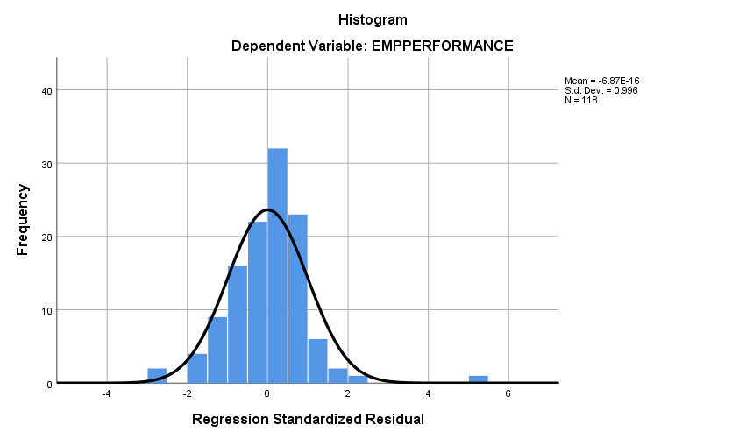

Figure 4.1: Histogram for Recruitment and Selection on Employee Performance

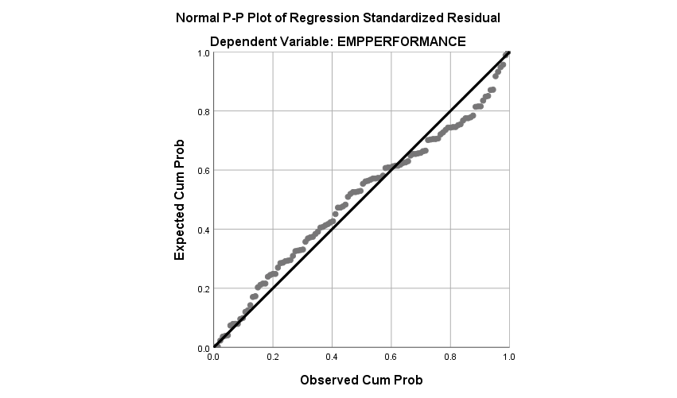

Figure 4.2: P-P Plot for Recruitment and Selection on Employee Performance
Source: Field Data (2020)

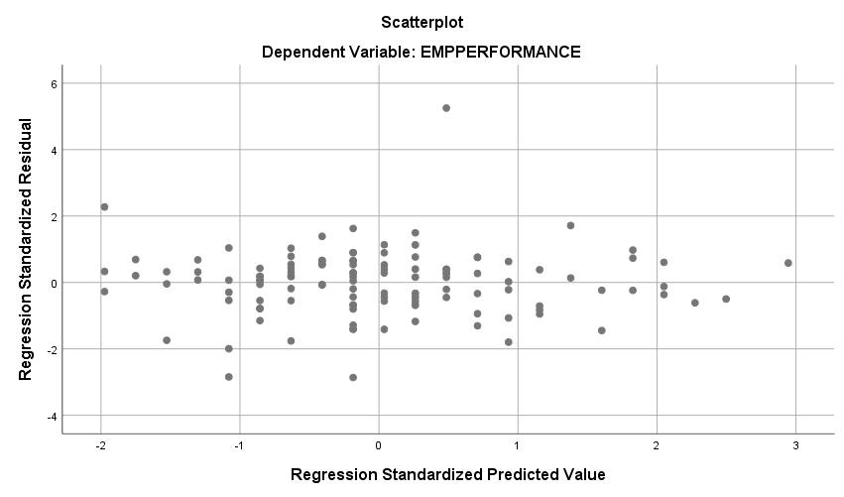

Figure 4.1: Scatter Plot for the Standardized Residual for Recruitment and Selection
Source: Field Data (2018)

Outliers, Normality, Linearity and Homoscedasticity Regression Assumptions Testing Results for TRAPRGM
Histogram (figure 4.4) shows a bell-shaped curve of the distribution of residuals (mean is close to 0 and SD close to 1, evidencing of a normal distribution of residuals). Also, Figure 4.5 shows that, residuals plot along the diagonal line. Therefore there is no much deviation from normality. The histogram (Figure 4.4) shows some of the residuals values lying outside the ± 3 cut off, evidence of outliers. Tabachnick and Fidell (2007) suggested any value outside the cut off of |3| to be an outlier. Although there is the presence of outliers, little can be done at this point as double deletion of cases may lead to more distortion of the data. During data cleaning cases with values beyond this cut off were deleted using Mahalanobis distance results. Thus, only close monitoring and follow-up is done subsequently. Figure 4.6 shows that case residual dots are not spread rectangularly around zero (0) to infer homoscedacististy (equality of variance). Therefore, there is a suspicion of heteroscedasticity (unequal variance in the data).
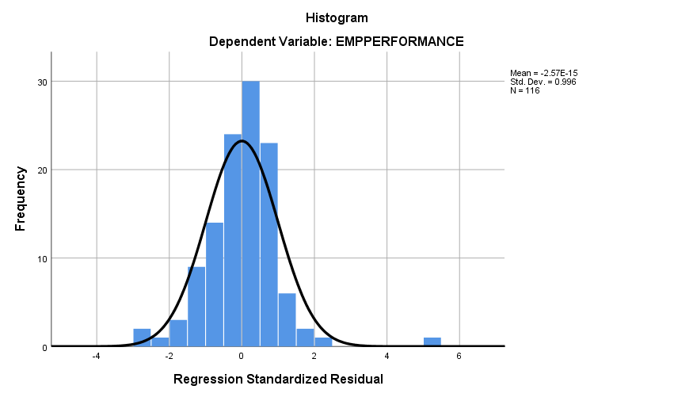

Figure 4.4: Histogram for Training Programs on Employee Performance
Source: Field Data (2020)
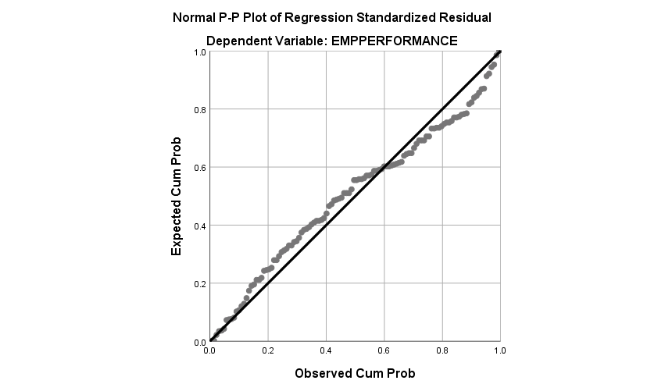

Figure 4.5: Norma P- P Plot for Training Programs on Employee Selection
Source: Field Data (2020)

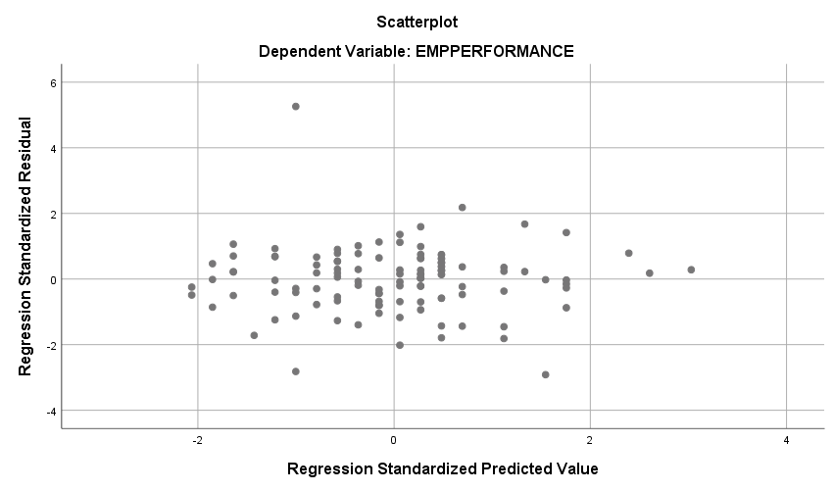

Figure 4.6: Scatter Plot for Training Programs on Employee Performance
Source: Filed Data (2020)

Outliers, Normality, Linearity and Homoscedasticity Regression Assumptions Testing Results for PERFAPPSAL
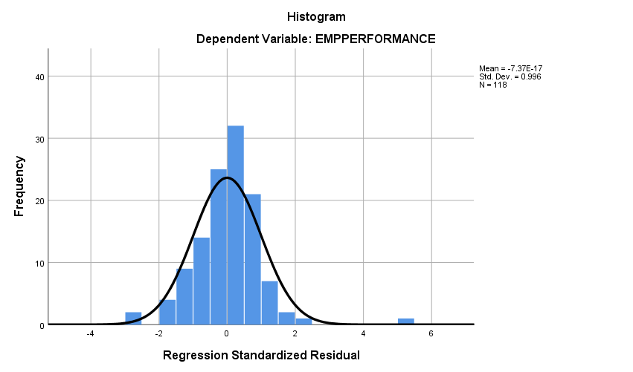

Figure 4.7: Histogram for Performance Appraisal on Employee Performance
Source: Field Data (2020)

The histogram (figure 4.7) shows a bell-curved of the distribution of residuals, Mean is close to, and SD is close to 1, evidencing of a normal distribution of residuals. Also, figure 4.8 shows that residuals are distributed along the diagonal line. Therefore, there is no much deviation from normality. The scatter plot (figure 4.9) case residual dots are not spread rectangularly around zero (0) to infer homoscedacististy (equality of variance).
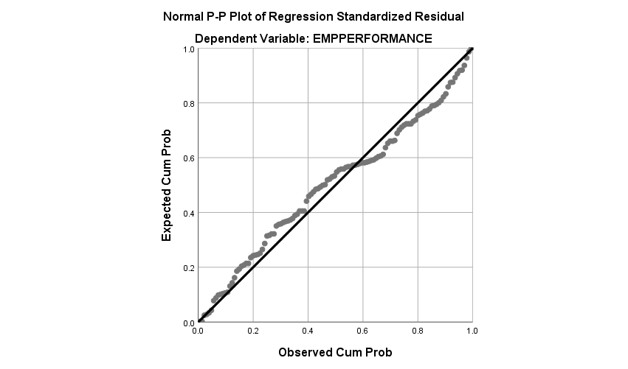

Figure 4.8: P-P Plot for Performance Appraisal on Employee Commitment
Source: Field Data (2020)
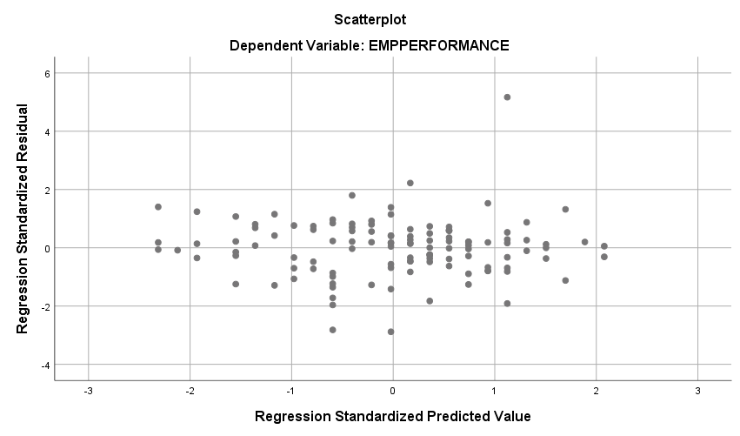

Figure 4.9: Scatter Plot for Performance Appraisal on Employee Commitment

Outliers, Normality, Linearity and Homoscedasticity Regression Assumptions Testing Results for EMPCOMPSATION
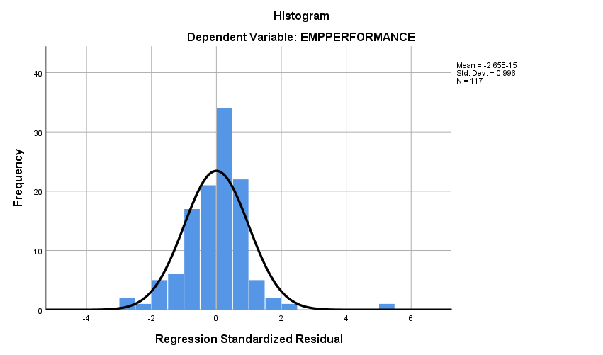

Figure 4.10: Histogram for Employee Compensation on Employee performance
Source: Field Data (2020)

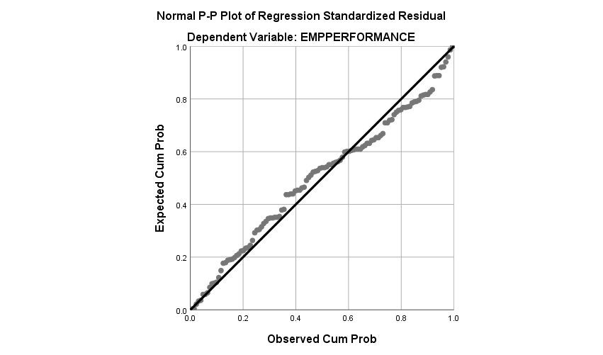

Figure 4.11: P – P Plot for Employee Compensation on Employee Performance
Source: Field Data (2020)

The histogram (figure 4.10) shows a bell-curved of the distribution of residuals, mean is close to, and SD is close to 1, evidencing of a normal distribution of residuals. Also, Figure 4.11 shows that residuals are distributed along the diagonal line. Therefore, there is no much deviation from normality. The scatter plot figure 4.12 case residual dots are not spread rectangularly around zero (0) to infer homoscedacististy (equality of variance). Therefore, there is a suspicion of heteroscedasticity (unequal variance in the data
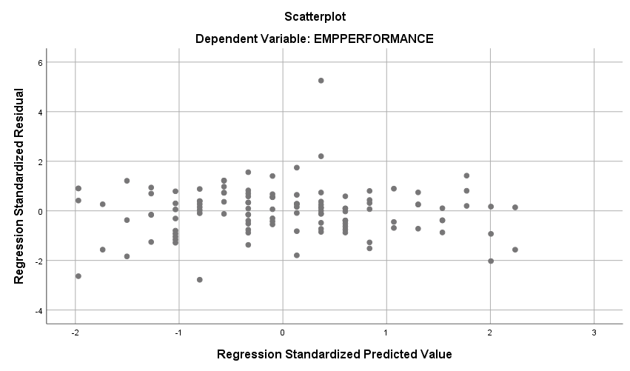

Figure 4.12: Scatter Plot for Employee Compensation on Employee Performance
Source Filed Data (2020)

Discussion: The study aimed to assessing the effects of HRP on employees’ performance in government agencies focusing on HESLB as a case study. Descriptive analysis was used to analyze the data. Focusing on the study objectives, the discussion elaborates the findings information as generated from data analysis and compares or contrasts the current findings with what has been found out in previous related studies. Contributions of each finding are shown below.

What are the effects of Recruitment and selection on Employees’ Performance?
In examining the effects of recruitment and selection on employees’ performance, it was found through regression analysis that the total variance in RECRSELECT explained by EMPPERFORMANCE was 10 %, F (1,118) = 0.66, p < .01). EMPPERFORMANCE was negatively, and statistically significantly related to RECRSELECT (b = - .01, p < .01). This reveals that selection and recruitment improves the employees’ performance at HESLB.

The recruitment and selection of the employees influences the employees’ creativity, productivity and commitments in their performance. It is consistence with theory ‘Y’ which encourages managers to make employees to have comfortable in their work environment, help them achieve their self-actualization goals and give them guidance when required. (McGregor, 1960). Moreover, this findings are in consistence with the study by (Ekwoaba et al 2015) which states that the more effectively organizations recruit and select candidates, the more likely they are to hire and retain satisfied employees. In addition, the effectiveness of an organization's selection system can influence bottom-line business outcomes, such as productivity and financial performance.

What are the Effects of Training and Re-training Programmes towards
In respect to the second question which is the effect of training and re-training programmes towards employees’ performance, the study through regression analysis found that the variance in TRAPRGM explained by EMPPERFORMANCE was 20%, F (1, 118) = 1.70, p < .05). EMPPERFORMANCE was negatively, and statistically significantly, related to TRAPRGM (b = - .02, p < .001). The findings is supported by theory ‘Z’ which contends that employee need to be motivated at their work place through ensuring that the company has a string set of values, and offers long-range approach to training and development and high participatory style of management.

Thus, training and retraining programmes affects the employees’ performance which includes influencing their commitment, productivity, creativity and punctuality. This is linked to the literature by Cheng and Ho (2001) who indicate that adequate training produces marked improvements in employee communication and proficiency of performances as well as extending retention time. When programs target communication skills with co-workers, there are significant increases in profit as well as a greater number of reported positive working relationships that are formed.

What are the Effect of the Performance Appraisal to the Employees’ Performance?
In response to the third question on the effect of the performance appraisal to the employees’ performance, the study reveals through regression analysis that Variance in PERFAPPSAL explained by EMPPERFORMANCE was 36%, F (1,118) = 1.50 p < .001). EMPPERFORMANCE was negatively, and statistically significantly, related to PERFAPPSAL (b = -.10, p < .01). This means that performance appraisal has good impact on the employees’ performance and it increases productivity. This is linked to the literature of (Nayab, 2011) which provides inter alia that performance appraisal is an indispensable tool for an organisation because the information it provides is highly useful in decision making regarding issues such as promotion, merit increases transfer, discharge, training and development. However, the study found that in practice HESLB does not conduct performance approval more often. The response of the respondents to this effect was average.

What are the Effects of Compensation toward the Employees Performance
When responding to the effects of compensation toward the employees’ performance it was revealed through regression model which was explained by Variance in EMPCOMPSATION explained by EMPPERFORMANCE was 10%, F (1,118) = 1.76, p < .001). EMPPERFORMANCE was negatively, and statistically significantly, related to EMPCOMPSATION (b = - . - .10, p = .001). This implies that HESLB conducts compensation to its employees. It was also found that compensation facilitates the performance of the employees by influencing the employees’ commitment, productivity, creativity and punctuality.

This findings is linked to the literature by (Bob, 2011) who contends inter alia that compensation constitutes measuring job values, designing and maintaining pay structure, paying for performance, competence and skill and providing employee benefit. The author further contends that compensation includes money and non-financial compensation which provides intrinsic or extrinsic motivation to the employees’ performance.

CHAPTER FIVE

CONCLUSION AND RECOMMENDATION

5.1 Introduction
The chapter presents the research conclusion, recommendations. It also presents the limitations and areas of further study.

5.2 Conclusion
The study addresses on the effects of HRP on employees’ performance in government agencies focusing on HESLB as a case study. This study is premised on the following objectives: to determine the effect of recruitment & selection on employees’ performance; to examine at what extent training and re-training programmes affects employees’ performance; to find out the effect of performance appraisal system on employees’ performance; and to determine the impact of compensation on employees’ performance.

The findings revealed that recruitment and selection is important to the employees’ performance because it influences the productivity, creativity, commitment and punctuality of an employee. It was also revealed that there was average response on the efficiency on the policy and mechanisms employed for recruitment and selection of employees at HESLB. It was also found that training and retraining programmes influences the employees’ performance by influencing their commitment, productivity, creativity and punctuality. However, the study found that there is no specific training and re-training policy at HESLB this puts an obstacle to the improvement in employees’ proficiency of performance.
It was also found that performance appraisal has good impact on the employees’ performance and it increases productivity. It provides is highly useful in decision making regarding issues such as promotion, merit increases transfer, discharge. The respondents’ reveals further that there was average appraisal of the employees’ performance. It was also found that compensation facilitates the performance of the employees by influencing the employees’ commitment, productivity, creativity and punctuality. It constitutes measuring job values, designing and maintaining pay structure, paying for performance, competence and skill and providing employee benefit. The author further contends that compensation includes money and non-financial compensation which provides intrinsic or extrinsic motivation to the employees’ performance.

5.3 Recommendations
It is recommended that organisations should implement effective recruitment and selection of employees. This is though employing HRP policies and mechanisms of recruitment and selection of employees. Effective recruitment and selection policies and mechanisms influence productivity, creativity, commitment and punctuality of an employees, hence enhance the employees’ performance. It is also recommended that government agencies should conduct often training and re-training to the employees. This can be done through conducting of seminars, providing lectures and various professional and social trainings. This influences the skills of employees and enhances their performances.

It is also recommended that the organisations should conduct performance appraisal to the employees. Through performance appraisal the information obtained is highly useful in decision making regarding issues such as promotion, merit increases transfer, discharge. Moreover, the study recommends for conduct of compensation to the emloyees. This includes the measuring job values, designing and maintaining pay structure, paying for performance, competence and skill and providing employee benefit. Compensation includes money and non-financial compensation which provides intrinsic or extrinsic motivation to the employees’ performance.

5.4 Limitations and Areas for Future Studies
This study focused on the effects of HRP to the employees’ performance. It was categorically conducted at HESLB. This study was unable to cover all areas in this research. Hence poses some limitations which emanated from scope, resources, methodological and time.
- This study focused only on Higher Education Students Loan Board (HESLB). This being the case, the population and collected data was only based on HESLB without covering other government agencies. Thus, more studies that involve larger samples are recommended to be conducted.
- The study employed quantitative approach in examining the effects of HRP towards employees’ performance. It did not apply the qualitative approach. It is recommended that other future studies may be carried out by employing a qualitative approach.
- This study focused on the managerial and other staffs working at HESLB only. It only centered on the workers at HESLB headquarters without considering other categories of respondents like students who are beneficiaries of higher education students’ loans. It is recommended that further studies be conducted to ensure all categories of beneficiaries of HESLB are involved.
- In some cases, questionnaires were not filled or just partially filled. These cases were deleted from the analysis. Some questionnaires were well filled and were returned, but they had no sign of engagement. Respondents were scribbling without putting attention to the requirements of the statements. These were deleted during data screening.
- This study employed interviews and questionnaires as a methods of data collection on the effects of HRP towards employees’ performance. It is recommended that future studies should employee other possible data collection methods like group discussion and observation.
- Perceptions of people are not static. Hence it poses difficulty in conclusion. People have feelings, attitudes, emotions that change depending on different circumstances. The result of measured perception today may not necessarily be the same next study; this problem was dealt with, making sure participants are given the freedom and ample time to respond to have reliable data.

REFERENCES
Anya, C. J. P., Umoh, G. I. & Worlu, G. (2017). Human Resource Planning and Organizational performance in Oil and Gas firms in Port Harcourt, International Journal of Academic Research, 3(9), 110-129.
Armstrong, M. & Taylor, S. (2014). Armstrong’s Handbook of Human Resource Management Practice, 13th, edition, London: Kogan Page Limited.
Babbie, E. R. (2010). The Practice of Social Research, Cengage Learning, p.52. Belmont, CA : Wadsworth.
Belu, N. & Alina, V. (2016). Organizational Strategic Planning of Human Resources, (2014): BASE. Web. 9 Mar. 2016.
Chanda, A., B. Sivarama, K. & Jie, S. (2016). Strategic Human Resource Technologies: Keys to Managing People. Retrieved on 12th March, 2020 from; http://riyawarema10.ddns.net/board/index.php?q=Strategic+Human+ Resource+Technologies+By+Ashok+Chanda&ref=https://www.google.com/
Cole, G. A. (2002). Personnel Management Theory and Practice. London: East Wilts Educational. Education.
Dunia, M. (2014). Factors affecting good performance of issuing the students’ loan: a case of Higher Education Students’ Boans Board (HESLB). Unpublished Master Dissertation, Mzumbe University, Morogoro, Tanzania.
Dzansi, Y. A. (2016). Understanding the impact of Human Resource Management practices on municipal service delivery in South Africa. African Journal of Business Management, 4(6), 995-1005.
Gulati, P. M. (2009). Research Management: Fundamental and Applied Research, New Delhi: Global India Publications.
Gupta, C. B. (2004). Textbook of Human Resource, 6th Ed., New Delhi: Sultan Chand & Sons.
Gupta, C. B. (2009). Human Resource Management, New Delhi: Sultan Chaud and Sons.
Herzberg, F. (1976). The Managerial Choice: To be Efficient and to be human. pg. 71. Homewood, IL: Dow-Jones-Irwin.
Herzberg, F., Mausner, B. & Snyderman, B. S. (1959). The Motivation to Work. New York, NY: Wiley.
Jacobson, W. S. & Sowa, J. E. (2015). Strategic Human Capital Management in Municipal Government: An Assessment of Implementation Practices. Public Personnel Management, 44(3), 317–339.
Karia, A. (2016) The Role of Human Resource Planning on Performance of Public Water Utilities in Tanzania, African Journal of Business and Management, 2(1), 72-77.
Kayode, T. (2001). The Role of Training in charge Management. Journal of the Institute of Personnel Management of Nigeria, 10(7), 24 – 31.
Khumalo, N. (2018). The Role of Human Resource Planning in Producing Well Resourced Employees to Public. Problems and Perspectives in Management, 16(4), 117-125.
Manwunga, A. K. (2017). The role of human resource manager in the public service in promoting professionalism and implementing the charter for public service in Africa. Addis Ababa, Ethiopia.
Mehmood, M., et al, (2017). The Impact of Human Resource Management Practices on Organizational Performance. International Journal of Engineering and Information Systems (IJEAIS), 1(9), 165-178.
Mullins, L. J. (2005). Management and organizational behavior, 7th Ed., Harlow: Pearson.
Ngcamu, B. S. (2013). The Paradox of the Regional Centres Unit: The case of the EThekwini Municipality, Journal of Economics and Behavioural Studies, 5(7), 432-438.
Ngirwa, C. A. (2009). Human Resource Management in African Work Organizations. Dar es Saalam: National Printing Co. Ltd.
Niazi, A. S. (2011). Training and Development Strategy and Its Role in Organizational Performance. Journal of Public Administration and Governance, 1(2), 42. 57.
Odinga, M. (2010). Staff Development Programs and Job Performance of Lecturers of Moi. Retrieved on 09th February, 2020 from; makir.mak.ac.ug/handle/ 10570/2218?show=ful.
Olivas-Lujan, M. R. & Bondarouk, T. (2016). Social Media in Human Resources Management. Bingley: Emerald Group Publishing.
Pelissier, R. (2008). Business Research Made Easy, Cape Town: Juta & Co.
Pfeifer, C., Janssen, S., Yang, P. & Backes-Gellner, U. (2011). Effects of Training on Employee Suggestions and Promotions in an Internal Labour Market. University of Lüneburg Working Paper Series in Economics No. 202.
Saeed, M. M. & Asghar, M. A (2012). Examining the Relationship between Training, Motivation and Employees Job Performance – The Moderating Role of Person Job Fit. Journal of Basic and Applied Scientific Research, 2(12), 12177-12183.
Salaman, G,, Storey, J. & Billsberry, J. (2005). Strategic Human Resource Management: Theory and Practice. London: Open University in association with Sage Publications.
Sarmah, H. K., Bora, H. B. & Choudhury, G. (2013). An investigation on effect of bias on determination of sample size on the basis of data related to the students of schools of Guwahati, International Journal of Applied Mathematics & Statistical Sciences (IJAMSS), 2(1), 33-48.
Shen, J. (2004) International Training and Management Development: Theory and Reality: A Conceptual Study. Journal of Management Development, 24, 656-666.
Snieder, R. & Larner, K. (2009). The Art of Being a Scientist: A Guide for Graduate Students and their Mentors, Cambridge: Cambridge University Press.
URT, (2008 – 2011). United Republic of Tanzania, Higher Education Students’ Loans Board – Strategic Plan. Strategic Plan (2017/2018-2021/2022).
Waziri, F. & Stephen, T. (2013). Factors Influencing Implementation of Training Programme in Public Organizations in Tanzania. Developing Country Studies, 3(10), 94-99.
Wilson, J. (2010). Essentials of Business Research: A Guide to Doing Your Research Project, New Delhi: SAGE Publications.

APPENDICES
Appendix I: Questionnaire
My name is Brighton Fridish Ngowo I am carrying out research entitled Human Resources Planning towards the employees’ performance in public organization focusing on the Higher Education Students Loan Board in fulfilment of the award of Masters of Business Administration-HRM degree of the Open University of Tanzania. Hereunder is a questionnaire which I would like you to fill up. While filling up this questionnaire, please encircle the rating number {1, 2, 3, 4, or 5} that represents your excellent level of agreement with each statement where 1 = Strongly Disagree 2 = Disagree 3 = neither Disagree nor Agree 4 = Agree 5 = Strongly Agree.
A: Personal Information
1. Age of respondent | a. 18-28 ( ) | c. 49-58 ( )
1. Age of respondent | b. 39-48 ( ) | d. 59 and above ( )
2. Sex of the respondents | a. Male ( ) | b. Female ( )
3. Level of education | a. Primary ( ) | f. Advanced diploma ( )
3. Level of education | b. Secondary ( ) | g. Master’s degree ( )
3. Level of education | e. Colleges ( ) | h. Others (please specify) ( )
4. What is your occupation? | a. Self-employed | c. Employed ( )
4. What is your occupation? | business person ( ) | d. Jobless ( )
5. What is your job position? | a. Manager ( )  b. Officer ( ) | c. Staff ( )

To determine the effect of recruitment & selection on employees’ performance. |  | SA | A | N | D | SD
 |  | 1 | 2 | 3 | 4 | 5
1 | HESLB engage in recruitment and selection of employees
2 | Mechanisms of selection and recruitment of employees is sufficient
3 | Recruitment and selection promotes employees performance
4 | It stimulates retaining of employees
5 | It promotes employees productivity
6 | Attracts effectiveness
7 | Improves employees commitments
8 | I under gone systematic procedures of recruitment before being employed by HESLB
9 | I was selected to work here because of my professional qualifications

To examine whether training and re-training programmes affects employees’ performance. |  | SA | A | N | D | SD
 |  | 1 | 2 | 3 | 4 | 5
1 | HESLB provides training and re-training programmes to employees.
2 | Employee training and re-training is efficient
3 | The employed mechanisms for employees training and re-training impact the employees’ commitment.
4 | Employees training and re-training encourages productivity
5 | Training and re-training increase employees’ creativity
6 | It also encourages punctuality
9 | HESLB can be recommended to friends and colleagues
10 | I am well trained and I am competent with my work
11 | I acquire more skills day after day when working here
12 | The training policies at HESLB have improved my performance

To find out the effect of performance appraisal system on employees’ performance. |  | SA | A | N | D | SD
 |  | 1 | 2 | 3 | 4 | 5
1 | HESLB conducts performance appraisal to its employees.
2 | Performance appraisal have a good impact to the employees creativity
3 | Performance appraisal increases the productivity of employees
4 | HESLB conducts appraisal to its employees often to ensure efficiency
5 | Many employees are promoted on their jobs when performance appraisal is conducted.
6 | I have a clear understanding about performance appraisal
To determine the impact of compensation on employees performance. |  | SA | A | N | D | SD
 |  | 1 | 2 | 3 | 4 | 5
1 | HESLB conducts compensation to the employees
2 | Compensation have an impact to the performance of employees
3 | It facilitates productivity of employees
4 | It encourages the creativity
5 | It promotes efficiency to the employees
6 | I often get compensated when required
7 | It is necessary to provide compensation to the employees for ensuring their commitment to the organization

Employee performance scale. |  | SA | A | N | D | SD
 |  | 1 | 2 | 3 | 4 | 5
1 | I feel dedication, seriousness and ability to take responsibility
2 | I enjoy professional skill or professionalism and technical knowledge required to carry out the work efficiently
3 | I do my work according to specific policies and procedure
4 | I feel satisfied with the work I do in the bank
5 | Feeling proud of the work represents a motivation for me to make extra efforts
6 | I have the desire and willingness to work outside official working hours for fast delivery
7 | The administration provides those employees who do their work tasks well with an increase in the wages or salaries
8 | Work quality
9 | Planning and organizing work
10 | Being result-oriented
11 | Prioritizing
12 | Working efficiently
13 | Taking initiative
14 | Accepting and learning from feedback
15 | Cooperating with others
16 | Communicating effectively (e.g., adequately expressing ideas and intentions
17 | Showing responsibility
17 | Being customer oriented
19 | Being creative
20 | Taking on challenging work tasks
21 | Showing resiliency (coping with stress, difficult situations and adversities)
22 | Coming up with creative solutions to novel, difficult problems
23 | Keeping job knowledge up-to-date
24 | Dealing with uncertain and unpredictable work situations
25 | Adjusting work goals when necessary
26 | underproductive work behavior 1 Displaying excessive negativity (e.g., complaining, making problems bigger than they are
27 | Doing things that harm your organization (e.g., not following rules, discussing confidential information
28 | Doing things that harm your co-workers or supervisor (e.g., arguing, leaving work for others to finish)
29 | Purposely making mistakes

