FACTORS AFFECTING FINANCIAL SUSTAINABILITY OF LOCAL NON - GOVERNMENTAL ORGANIZATIONS IN TANZANIA: A CASE OF BUKOBA MUNICIPAL COUNCIL

MARTINO ASHERI MBANGILE

A DISSERTATION SUBMITTED IN PARTIAL FULFILLMENT OF THE REQUIREMENTS FOR THE MASTER DEGREEOF HUMANITARIAN ACTION, COOPERATION AND DEVELOPMENT (MHACD)
DEPARTMENT OF POLITICAL AND PUBLIC ADMINISTRATION
OF THE OPEN UNIVERSITY OF TANZANIA
2020

CERTIFICATION
The undersigned certifies that he has read and hereby recommends for acceptance by the Open University of Tanzania a dissertation entitled “Factors Affecting Financial Sustainability of Local Non - Governmental Organizations in Tanzania: A Case of Bukoba Municipal Council” in partial fulfilment of the requirement for the Master Degree of Humanitarian Action, Cooperation and Development of the Open University of Tanzania.

……………………………………
Prof. Deus D. P Ngaruko
(Supervisor)

…………………………………
Date

COPYRIGHT
No part of this dissertation may be reproduced, stored in any retrieval system, or transmitted in any form by any means, electronic, mechanical, photocopying, recording, or otherwise without prior written permission of the author or The Open University of Tanzania in that behalf.

DECLARATION
I, Martino Asheri Mbangile, do hereby declare that this dissertation is my own original work and that it has not been presented, and will not be presented, to any other University for a similar or any other degree award.

...……………………………………..
Signature

…………………………………….
Date

DEDICATION
This work is dedicated to my late parents, my beloved late father Asheri Mbangile and my beloved late mother Atweluche Makinya who laid my educational foundation.

ACKNOWLEDGEMENTS
I am very grateful to all who have assisted me in completing this research work. First, I extend my gratitude to the almighty God who gave me a good health to accomplish this work.

Secondly, my heartfelt thanks go to Prof. Deus D.P Ngaruko, my supervisor who tirelessly made critical suggestions throughout the process of my research work. Thirdly, my sincere gratitude goes to the Open University of Tanzania for admitting me in the Postgraduate studies along with my Lecturers who provided me with academic knowledge, guidance and career experience.

Furthermore, I extend my thanks to my VSO-RISE Project Bukoba team (Michael Mwalupale and Aloyce Ndamugoba) for their support during the process of conducting this research especially their readiness to take care of my office responsibilities during my absence from the office.

In addition to that, I extend my gratitude to my family; my beloved wife Anjelina Kikoti, my beloved children Viviana Mbangile, and Valence Mbangile who heartedly supported me throughout my entire studies.

Last but not least, I wish to express my heartfelt thanks to my fellow students for their support and encouragement throughout the study period.
May the Almighty Lord award you all!

ABSTRACT
This study investigated the factors affecting the financial sustainability of local non - governmental organizations in Tanzania using a case of Bukoba Municipal Council. The study had three specific objectives which were; to explore multiple sources of financial diversification strategies used by LNGOs to ensure financial sustainability; to examine the influence of leadership competencies on strategic financial management in LNGOs; to study the influence of donor’s funding policies on the financial sustainability of LNGOs. This study adopted a descriptive case study research design with a sample size of 135 respondents. This study employed interviews, questionnaire and documentary in data collection tools. SPSS and content data analysis were employed for data analysis. The study found that sources such as social entrepreneurship activities, fundraising events, tapping international funding streams, sourcing from corporate donors and partners, owning and managing own business, consultancy as well as training for fee are commonly used, and also it was found that the majority of LNGOs’ leaders have low academic qualifications on strategic financial management. Finally, the study recommends that the LNGOs leaders should seek for training from the reputable financial institutions to upgrade their leadership competencies on strategic financial managements particularly on the capability to handle a number of projects, skills on financial governance, as well as having enough practices and approaches on strategic financial management.
Keywords: Financial, Resource Mobilization, Financial Sustainability and Local Non-Government Organizations.

TABLE OF CONTENTS
CERTIFICATION i
COPYRIGHT iii
DECLARATION iv
DEDICATION v
ACKNOWLEDGEMENTS vi
ABSTRACT vii
TABLE OF CONTENTS viii
LIST OF TABLES xii
LIST OF FIGURES xiii
LIST OF ABBREVIATIONS xiv
LIST OF ABBREVIATIONS xiv
CHAPTER ONE 1
INTRODUCTION 1
1.1 Background to the Study 1
1.2 Statement of the Research Problem 5
1.3 Research Objectives 6
1.3.1 General Objective 6
1.3.2 Specific Objectives 6
1.4 Research Questions 6
1.5 Significance of the Study 7
1.6 Scope and Limitations of the Study 8
1.7 Organization of the Study 9
CHAPTER TWO 10
LITERATURE REVIEW 10
2.1 Chapter Overview 10
2.2 Conceptual Definitions 10
2.2.1 Local Non-Government Organizations 10
2.2.2 Financial Sustainability 10
2.2.3 Resource Mobilization 11
2.3 Theoretical Review of the Study 11
2.3.1 Resource Dependence Theory 11
2.3.2 Institutional Theory 14
2.3.3 Resource Mobilization Theory 16
2.4 Empirical Literature Review 17
2.4.1 A World-Wide View 17
2.4.2 Studies Conducted in Africa 19
2.4.3 Studies Conducted in Tanzania 21
2.5 Conceptual Framework 21
2.6 Analysis of the Conceptual Framework 23
2.7 Research Gap 23
CHAPTER THREE 27
RESEARCH METHODOLOGY 27
3.1. Chapter Overview 27
3.2. Research Design and Approach 27
3.2.1 Population of the Study 28
3.2.2 Area of the Study 28
3.3 Sampling Design and Procedures 29
3.3.1 Sampling Distribution and Sampling Techniques 30
3.4.1 Sampling Size 31
3.4 Methods of Data Collection 31
3.7.1 Primary Data Collection Methods 31
3.7.2 Secondary Data Collection Method 33
3.7 Documentary Review 33
3.8. Validity and Reliability of Research Instruments 33
3.9 Data Analysis Plan 34
3.10 Ethical Considerations 34
CHAPTER FOUR 36
DATA ANALYSIS, PRESENTATION AND DISCUSSION OF THERESULTS 36
4.1 Chapter Overview 36
4.2 Response Rate 36
4.3 Socio-Economic and Demographic Characteristics of the Study 37
4.3.1 Gender/Sex of Respondents 37
4.3.2 Age of the Respondents 38
4.3.4 Education Level of Respondents 39
4.3.5 Respondents Years of Working Experience 40
4.3.6 Distribution of the Level of Funding of LNGOs under the Study 41
4.4 Descriptive Statistic Results 42
4.4.1 Multiple Sources of Financial Diversification Strategies used by LNGOs to Ensure Financial Sustainability 43
4.4.2 The Influence of Leadership Competencies on Strategic Financial Managements in LNGOs 52
4.4.3 The Influence of Donor’s Funding Policies on Financial Sustainability of LNGOs 54
4.4.4 The Financial Sustainability of LNGOs 56
4.5 Discussion of the Results 57
4.5.1 Multiple Sources of Financial Diversification Strategies used by LNGOs to Insure Financial Sustainability 57
4.5.2 The Influence of Leadership Competencies on Strategic Financial Managements in LNGOs 60
4.5.3 The influence of Donor’s Funding Policies on Financial Sustainability of LNGOs 63
CHAPTER FIVE 66
SUMMARY, CONCLUSION AND RECOMMENDATIONS 66
5.1 Chapter Overview 66
5.2 Summary of the Study 66
5.3 Conclusions 68
5.4 Recommendations 69
5.4.1 Recommendations to LNGOs 69
5.4.2 Recommendations for Further Studies 70
REFERENCES 71
APPENDICES 76

LIST OF TABLES
Table 4.1: Distribution of Respondents by Gender (n=135) 37
Table 4.2: Distribution of Respondents by Age (n=135) 38
Table 4.3: Distribution of Respondents by their Level of Education (n=135). 40
Table 4.4: Distribution of Respondents by their Work Experience (n=135) 41
Table 4.5: Distribution of the Level of Funding of LNGOs under the Study 42
Table 4.1: Distribution of Respondents by Gender (n=135) 37
Table 4.2: Distribution of Respondents by Age (n=135) 38
Table 4.3: Distribution of Respondents by their Level of Education (n=135). 40
Table 4.4: Distribution of Respondents by their Work Experience (n=135) 41
Table 4.5: Distribution of the Level of Funding of LNGOs under the Study 42
Table 4.6: The influence of Leadership Competencies on Strategic Financial Managements in LNGOs 53
Table 4.7: The Financial Sustainability of LNGOs 56

LIST OF FIGURES
Figure 2.1: A Diagrammatic Representation of the Study’s Conception 22
Figure 2.7: Field Data Showing Possible Donor’s Funding Policies on the Financial Sustainability of LNGOs in the Study Area 55
Figure 3.1: The map showing the Boundaries of the Bukoba Urban District 29
Figure 4.1: Social Entrepreneurship Activities as Part of Multiple Sources of Financial Diversification Strategies 43
Figure 4.2: A Figure Showing How Fundraising Events can influence Financial Sustainability 46
Figure 4.3: Tapping International Funding Streams as part of Multiple Sources of Financial Diversification Strategies 47
Figure 4.4: A Figure Showing How Sourcing from Corporate Donors and Partners can Influence Financial Sustainability 49
Figure 4.5: Owning and Managing own Business as part of Multiple Sources of Financial Diversification Strategies 50
Figure 4.6: A Figure Showing Consultancy and Training for a Fee as part of Multiple Sources of Financial Diversification Strategies 51
Figure 2.7: Field Data Showing Possible Donor’s Funding Policies on the Financial Sustainability of LNGOs in the Study Area 55

LIST OF ABBREVIATIONS
BUWEA Bukoba Women’s Association
CBECDF Community Based Early Childhood Development Forum
CBOs Community-Based Organizations
CIDA The Canadian International Development Agency
DFID Department for International Development
FBOs Faith-Based Organizations
FCS Foundation for Civil Society
GFEO Global Family Enlightenment Group
KACODEF Kagera Community Development Foundation
KECA Kagera Environmental Care Association
LNGOs Local Non-Government Organizations
MoHCDGEC Ministry of Health, Community Development, Gender, Elderly and Children
NEDA Neema Development Association
NGOs Non-Government Organizations
PCF Pestalozzi Children’s’ Foundation
RDT Resource dependency theory
REPOA Research on Poverty Alleviation
TADEPA Tanzania Development and Aids Prevention Association
TAMA Tanzania Agricultural Modernization Association
TWK Tujitokeze Wakulima Kagera
URT United Republic of Tanzania
UN United Nations
USAID United States Agency for International Development
WB World Bank

CHAPTER ONE

INTRODUCTION

1.1 Background to the Study
The importance of financial sustainability as a general objective for organizations and specific objective for non-governmental organizations (NGOs) of all types cannot be overstated. The ever-dwindling donor funding environment during the past couple of decades has necessitated a rethink by all organizations regarding how they build their internal capacities to enhance their ability to deliver on their respective operational mandates. The challenges faced by Local Non-Governmental Organizations (LNGOs) pose peculiar issues of concern for all concerned stakeholders on how to remain operational for the foreseeable future.

In the decade to the year 2017, there has been an increase in numbers of Local Non-Governmental Organizations (LNGOs) operating in many developing countries which are taking active roles and working towards improving livelihoods. Most of them embedded in the communities they serve because of their proximity, both physically and socially to local people. They deliver quality social services to the poorest and marginalized sectors of the society and promote sustainable development (Clark, 1991). These organizations are locally voluntary based groups which entirely independent from government and have primarily humanitarian objective rather than commercial. They reach target groups better than government institutions in the developing world.

The concept of NGOs came into use in 1945 following the establishment of the United Nations Organizations which recognized the need to give a consultative role to organizations which were classified as neither government nor member states (Willett, 2002).The public sector provides various types of subsidies to non-governmental organizations (NGOs). Government funding includes a broad range of direct and indirect support. A study by Lotsmart (2007) highlights that one-third of LNGOs funding comes from foreign aid agencies and governments through varied avenues such as contracting, subsidies and grants including government exemptions from taxation that are also considered a government subsidy.

Most embassies of economically developed countries representing their interests in developing countries also fund and support activities of domestic NGOs a result of structural adjustment programs adopted by the Tanzanian economy in the 1980s and early 1990s. The role of civil society in development and service delivery in Tanzania expanded dramatically, encouraging explosive growth in the non-government sector. The NGO Policy of 2000 and the subsequent Tanzania Non-Governmental Organizations Act of 2002 were formulated to establish the legislative framework to allow local NGOs to operate freely and effectively (REPOA,2007).

Apart from regular and mandatory registration, the local NGOs work became free of all business which led to the creation of hundreds of LNGOs which all claim to work for the good of the general public. According to the 2015 Tanzania Report on Contribution of NGOs in Development, as analyzed by Ministry of Health, Community Development, Gender, Elderly and Children (MoHCDGEC), about 6,893 NGOs local non-government organization, 38 international organization and 18 UN agencies are actively operating in Tanzania. Local Non-Governmental Organizations (LNGOs) contribute in socio-economic development of any country. In Tanzania, LNGOs are increasingly recognized by the government and treated as potent drivers of social and economic development. The Government of Tanzania cooperates with LNGOs and other stakeholders; including funders, disadvantaged people themselves, other sectors of civil society and the wider public to bring about positive change to the community (URT, 2015). Traditionally, the NGOs have relied on the benevolence, kind-heartedness and generosity of others to cover the costs of their activities through grants, aid donations and contributions. Viravaidya & Hayssen (2010) argue that today however, NGOs find it difficult to mobilize financial resources in traditional way due to bureaucratic procedures from the donor agencies and as most sources of funds are unable to meet the growing needs of these organizations, this in turn tends to rise costs associated with operations in these LNGOs.

Garcia et al., (2010) point out that, there is plenty of restrictive conditions on grants and donations and the unlikelihood of mobilizing funds over the years. This has become a challenge for NGOs to take on long planning, improve their service offerings or accomplish their full potential. As noted by Shivji (2007), some NGOs may be quite involved with and appreciated by the people whom they purport to serve, ultimately NGOs by their nature derive not only their sustenance but also their legitimacy from the donor-community, only if they operate legally and follow rules and regulations of the particular state.

As Drucker (1990) pointed out, in most cases, these organizations have to contend with the fact that they have limited income (generating opportunities). There is also a global upsurge in the formation of LNGOs (Lekorwe and Mpabanaga, 2006). This upsurge comes with competition for funding which in most cases seemingly favours larger NGOs. They completely depend on the donor funds and they generally do not have strategies or operations to diversify their sources of funds resulting in office closure by many LNGOs. Although international donors are the major sources of funding, the level of their contribution has steadily declined. This has affected operations of LNGOs in many developing countries.

In Tanzania, and generally in Bukoba Municipal Council where this study was conducted, NGOs continue to solicit funds from various sources including local grants from Organization like Foundation for Civil Society (FCS); Grants from foreign aid agencies such as USAID, DFID, CIDA, PCF and so on. Statistics indicate that many LNGOs in Tanzania still depend highly on foreign aid for them to strive which is in corresponding to the 2014 World Bank (WB) report that emphasizes on Tanzania as a country remains heavily dependent on foreign aid. Thus, it is crucial to comprehend what financial resources are existing and take steps to maximize them in a dynamic environment.

Understanding rules and regulations together with national financial policies of the state open doors for LNGOs to put together strategies on how to sustainably secure greater resources; especially financial resources which in turn will bring huge benefit to any NGOs that work together for the potential of achieving success as cited by Harir (2015). Based on this context, there is a need for local NGOs to understand government rules, regulations and strategies that might directly or indirectly influence proper and sustainable financial mobilization in local NGOs in Tanzania. Therefore, this study seeks to investigate the factors affecting financial sustainability of local non - governmental organizations in Tanzania; a case of Bukoba municipal council.

1.2 Statement of the Research Problem
The enormous developmental functions are undertaken by LNGOs demand availability of funds and effective and efficient mobilization of financial resources. With the recognition of the vital role played by NGOs at the grassroots level in the task of providing basic social services, LNGOs require more stable and secure funding. This will generally be achieved only if the state within which that NGO is operating has well-defined and structured rules and regulations. Availability of funds to NGOs is, without doubt, one of the factors that determine and lead to the growth of the sector; as most NGOs fail worldwide even after promising initial periods, owing to problems with financing as cited by Gyamfi (2015).

However, Local Non-Governmental Organizations in the development sphere continue to lack a stable financial base as a result they wither and sometimes die. The extent to which the effects are felt by LNGOs differ according to the sectors and context in which they engage and the criticality of the funding source. Turary (2002) argues that the continuity of the NGOs is determined by the continuity in raising money and its financial sustainability strategies. If the organization is not doing well financially then it won’t survive. Furthermore, when a leader with a vision launches a Local Non-Governmental Organization (LNGO), the NGO’s motivation and decision-making often become intertwined with the leader’s personality and character to the effect that it may collapse when the NGO leader departs. Tanzania has a higher percentage of inactivity and mortality of LNGOs due to unsustainable funding. As such it was worthwhile to undertake the study to investigate various factors affecting financial sustainability of local non - governmental organizations in Tanzania; a case of Bukoba Municipal Council.

1.3 Research Objectives

1.3.1 General Objective
The general objective of this study was to investigate the factors affecting financial sustainability of local non - governmental organizations in Tanzania; a case of Bukoba municipal council.

1.3.2 Specific Objectives
- To explore multiple sources of financial diversification strategies used by LNGOs to ensure financial sustainability.
- To examine the influence of leadership competencies on strategic financial managements in LNGOs.
- To study the influence of donor’s funding policies on the financial sustainability of LNGOs.

1.4 Research Questions
- What are the financial diversification strategies used by LNGOs to ensure financial sustainability?
- How do leadership competencies influence strategic financial managements in LNGOs?
- What is the influence of donor’s funding policies on the financial sustainability of LNGO?

1.5 Significance of the Study
The findings from this study will help NGOs to achieve long term sustainability. The study offers insights to help the organizations improve the quality of life among communities by responding to local needs, providing new solutions to problems which may be quite old. The surest indicator for this can be for the organization to mobilize resources to meet the local needs of the community. Every NGO can apply its resources that are used to implement projects that respond to local needs. The study can serve as a source of information to other NGOs on alternative financing sources that will help them access such information easily and help align their fund-raising strategies based on available information.

The findings from this study can help LNGOs to develop a good relationship with the donors. This relationship can help LNGOs in their endeavours for funding within the frameworks of transparency and collaboration. These factors are essential for building trust which is essential for sustainable resource mobilization. In addition, the findings of this study can help reveal the current operation trend of local NGOs in the area in terms of active ones and those which do not operate with their impact to community development issues. Besides, the implications of this study for policymaking in Tanzania are twofold.

Policymakers and diverse supporters of NGOs have key vested interests on the attainment of financial sustainability of these organizations. This study can therefore encourage such stakeholders to enhance their efforts towards promotion of institutional development for the local NGOs. The Tanzania government may as well consider the allocation of resources and other needed facilities to local NGOs that supplement government public services as well as ensure NGOs roles in strengthening civil society development. Lastly, the findings from this study can be of importance to researchers and scholars. The results can enable academicians to come up with tentative solutions and strategies in outlining the most appropriate strategies for mobilizing and sustainably retain financial resources for local NGOs.

1.6 Scope and Limitations of the Study
The study aimed at investigating the factors affecting financial sustainability of local non - governmental organizations in Tanzania. The respondents for the study involved operations managers and workers from several LNGOS within the Bukoba Municipal Council. The study explored the sources of funds and its influence on their management and governance of local NGOs activities, nature and availability of funding and its influence on retention of qualified employees and projects. The researcher struggled with financial constraints as the study is self-sponsored and that it involved traversing the entire Bukoba municipal council in search of relevant information from the respondents.

To cope with this challenge the researcher apart from using own sources of fund, was obliged to borrow money from relatives to accomplish the study. Moreover, the researcher experienced some reluctance from respondents who refrained themselves from rendering vital information in fear of prejudice and victimization. The researcher reduced this challenge by assuring them that the information will be purely for academic purposes and not for any other purposes.

1.7 Organization of the Study
The study is organized into five major chapters. Chapter one presents the introduction of the study that consists of the background of the problem, statement of the problem, the purpose of the study, objectives of the study, research questions, and significance of the study and finally organization of the study. Chapter two dwells on the review of the literature. The review has included the following aspects of the study; definition of the key or operational terms, theoretical review, empirical literature review on the international perspectives and the national perspective in particular, and finally the research conceptual framework and research gap.

Chapter three discusses the research methodology used in the study. It discusses research design, target population, sample and sampling procedures, research instruments, instruments validity and instruments reliability. Also includes data collection procedures and data analysis technique as well as ethical consideration.
Chapter four, the Data Presentation, Analysis and Interpretation, discusses the questionnaires return rate and presents all the data collected from the field. This includes the categorisation of data into appropriate groups for easy interpretation and analysis. Chapter five finally presents a summary of the findings, conclusions, recommendations and suggestions for further studies stemming from the study.

CHAPTER TWO

LITERATURE REVIEW

2.1 Chapter Overview
This chapter covers on review of key concepts, and theoretical literature review. It also presents a review of different empirical literature related to the study on the factors affecting the financial sustainability of local non – governmental organizations in Tanzania. Furthermore, the chapter covers on the conceptual framework of the study and the research gap.

2.2 Conceptual Definitions

2.2.1 Local Non-Government Organizations
LNGOs refers to local indigenous organizations that include national NGOs, Faith- Based Organizations (FBOs), and Community-Based Organizations (CBOs) whose activities fall within the functional categories of advocacy and service delivery. Such organizations are owned and run by the nationals of a particular country. An NGO is an institution that is largely independent of government and has humanitarian objectives. They are also the transnational organization in the world policy network that sets standards, propagate principles and generally represent humanity (Sera, 2010). For this study, LNGO was understood as locally formed, not for profit organizations which operates in Tanzania and specifically those found in the study area.

2.2.2 Financial Sustainability
Financial sustainability is the capacity of an NGO to generate revenues locally and/or ensuring that external donors continue to make funds available at required levels for programs (Devkota, 2010). Lewis (2011) notes that financial sustainability is gauged by net income (surplus of revenue over expenses), liquidity (cash available to make payments), and solvency (the relationship between assets and debt/liabilities). Financial sustainability also entails the capacity to develop a diverse base of funding so that the institutional structure and benefits production of an organization continue after external funding ceases (Abdelkarim, 2012). Indeed, financial sustainability is not an end in itself; it aims to ensure the organisation’s goals are reached by guaranteeing that the institution produces sufficient income to enable it to invest in its future. This study, therefore, understood financial sustainability as the ability of a local non-government organization to survive financially and to be able to implement its intended activities successfully.

2.2.3 Resource Mobilization
Resource mobilization is a process whereby both financial and non-financial resources are mobilized either externally or internally to support organization activities (Gyamfi, 2010). This is the act of persuading people or organizations to raise money for a cause. Mobilizing is the activity of collecting money to support a charity or political campaign or organization (Viravaidya & Hayssen, 2010). This study used the term resource mobilization to mean acquiring financial resources which help the organization to implement its activities.

2.3 Theoretical Review of the Study

2.3.1 Resource Dependence Theory
Resource dependence theory (RDT) is concerned with how organizational behaviour is affected by external resources the organization utilizes, such as raw materials. This theory is important because an organization’s ability to gather, alter and exploit raw materials faster than competitors can be fundamental to success. The theory originated in the 1970s with the publication of The External Control of Organizations: A Resource Dependence Perspective by Jeffrey Pfeffer and Gerald R. Salancik (1978). The basic assumption of RDT is ensuring organizational survival by minimizing any situation of uncertainty and dependency and characterizes an organization as an open system, dependent on contingencies in the external environment (Pfeffer & Salancik, 1978, p. 26).

Resource dependency theory (RDT), examines the relationship between organizations and the resources they need to operate. The theory is based upon the following belief for tenets: organizations are dependent on resources; these resources ultimately originate from the environment of organizations; the environment to a considerable extent contains other organizations; the resources one organization needs are thus often in the hands of other organizations; resources are a basis of power; legally independent organizations can therefore be dependent on each other (Pfeffer & Salancik, 1978). Local NGOs rely more on external funders (donors), face instability in the flow of funding, and deal with volatile demands (Moore, 2010).

Accordingly, organizational behaviour reflects the NGO's management of its dependence on an external resource and the ensuing demands of a donor controlling the resources. The magnitude of resource dependence often determines the financial behaviour of an NGO which in turn affect the financial sustainability of the NGOs (Scott, 2004). If an NGO fails to meet the conditions set by the external funders, the donors may withdraw the funding making the NGO face financial sustainability issues. The NGO may not be able to fund the projects due to the instability of funding flows.

To justify the significance of using this theory, the current literature scholar makes use of the RDT to describe managerial activities and organizational behaviour (Sheppard, 1995,). The work of Pfeffer and Salancik (1978), “External Control”, has been cited over 3,000 times until July 2008 since the publication and is one of the most cited works in the study of organizations (Davis & Cobb, 2010). According to Sheppard (1995), the question on how organizations can survive is especially relevant in the developing world with an increase in fierce competition, leading to uncertainty concerning the company’s continued existence (Sheppard, 1995). In other words, by keeping a high level of present resources and a high level of influence with resource providers, an organization can survive.

Several reviews and meta-analytical studies have recently explored resource dependency theory: Hillman et al. (2009); Davis and Cobb (2010). They argue that while resource dependence theory is one of many organizational studies theories characterizing organizational behaviour, it is not a theory that explains the performance of an organization per se. But resource-dependence theory predictions are still similar in many ways to those of transaction cost economics, but they also share some aspects with institutional theory.

The study needed to adopt this theory because it underpins the idea that resources are key to organizational success and that access and control over resources is a basis of power. Further to that, Resources are often controlled by organizations, not in the control of the organization needing them, meaning that strategies must be carefully considered to maintain open access to resources. Organizations typically build redundancy into resource acquisition to reduce their reliance on single-source e.g. by liaising with multiple donors and suppliers. In a sense of that, this study adopted this resource dependency theory to see how local non-government organizations in Bukoba appreciate the fundamental principles of this theory.

2.3.2 Institutional Theory
Another theory relevant to the study is the institutional theory as explained by Scott in (2004). Institutional theory is an approach to understanding organizations and management practices as the product of social rather than economic pressures. It has become a popular perspective within management theory because of its ability to explain organizational behaviours that defy economic rationality. It has been used, for example, to explain why some managerial innovations become adopted by organizations or diffuse across organizations despite their inability to improve organizational efficiency or effectiveness. The explanation, according to institutional theory, is based on the key idea that the adoption and retention of many organizational practices are often more dependent on social pressures for conformity and legitimacy than on technical pressures for economic performance Scott in (2004).

The institutional theory specifies how society expectations are met and gained by institutionalizing norms and rules. Institutional theory attends to the deeper and more resilient aspects of social structure. It considers the processes by which structures, including schemas, rules, norms, and routines, become established as authoritative guidelines for social behaviour. Its inquiries into how these elements are created, diffused, adopted, and adapted over space and time; and how they fall into decline and disuse. Although the ostensible subject is stability and order in social life, organizations must perforce attend not just to consensus and conformity but to conflict and change in social structures (Scott, 2004).

This theory provides some code of behaviour to earn, nurture and maintain societal expectations; and thus, create a positive organization-society interface. The theory is relevant to the study in that for a firm to be funded and trusted by the donors, they have to follow a certain code of conduct that meets the expectations of the society. This can be determined if the NGO leadership personnel can influence all these principles. This ensures that the NGOs are financially sustainable, and their projects funded on time.

Although the institutional perspective is one of the dominant theoretical paradigms in organization studies today (Palmer, Biggart, & Dick, 2008), the institutional approaches are often criticized as theoretically imperialistic; that is, they purport to encompass and explain everything about organizations. Thus, all external forces are commonly seen as institutional, and all behaviour in organizations is held to be a manifestation of institutional forces. Also, institutions in contemporary industrial and post-industrial societies may represent a cultural development. Hence, it is difficult to distinguish analytically between the external cultural environments of organizations and their institutional environments.

2.3.3 Resource Mobilization Theory
Resource mobilization theory emerged in the 1970s and is associated with the work of resource mobilization theorists McCarthy and Zald (1977). The theory argues that affluence and prosperity tend to foster social activities. Prosperous societies generate several resources that can aid resource mobilization (McCarthy and Zald, 1977). In resource mobilization theory, mobilization is the process of forming crowds, groups, associations, and organizations for the pursuit of collective goals. Organizations do not "spontaneously emerge" but require the mobilization of resources (Lin et al., 2003).

Resource-based theory focuses on a set of contextual processes (resource management decisions, organizational dynamics and political changes) that condition the realization of this structural potential. It takes the issues, the actors and the constraints as given, and focuses instead on how the actors develop strategies and interact with their environment to pursue their interests. The theory, therefore, employs a ‘purposive model’ of action and explains organization actions about the strategic instrumental level of action (Filly, 2005). The theory stresses the ability of an organization to acquire resources and to mobilize people towards accomplishing organization’s short term and long-term goals. In non-governmental organizations, a resource in the form of ‘money’ is the most important and crucial for organization financial sustainability. Without this resource, organizations cannot activate the other resources in their possession to achieve sustainability.

The success of any community organization agency lies in its ability to raise enough funds (monetary resources), or to convert other resources in such a way that it can be exchanged for the money, or to plan its activities into fundable projects (Tam & Kiang, 2012). Critics point out that resource mobilization theory fails to explain social movement communities, which are large networks of individuals and other groups surrounding social movement organizations, and providing them with various services (Sandelowski, 2000). Critics also argue that it fails to explain how groups with limited resources can succeed in bringing social change and that it does not assign enough weight to grievances, identity and culture as well as many macro-sociological issues (Ludwig & Pemberton, 2011).

The theory implications of the study are that LNGO financial sustainability depends on how well the NGOs mobilize resources. However, sustainable resource mobilization cannot be achieved nowadays since the donors have become more concerned about how the mobilized resources are applied; this requires financial accountability. If resources are mobilized from a large pool of donors who contribute insignificant portions, then they may not be concerned on financial accountability aspect. The theory proposes that the main determinant of financial sustainability in the NGOs is its resource mobilization and utilization effectiveness. Hence, under this circumstance, financial accountability will not affect the financial sustainability of NGOs directly.

2.4 Empirical Literature Review

2.4.1 A World-Wide View
Financial management is an essential tool for organizational sustainability, whether in paper or computerized form. Financial management enables organizations to identify all the major activities required to achieve certain organizational objectives. Financial management enables identification of the specific person responsible for ensuring that the objectives are completed successfully and within the estimated time. Financial management involves budget control, having ceilings on overheads, financial reporting, analysis of financial proposals, and stakeholders’ participation (Hassan &Forhad, 2013).

Andreas (2005) singles out the strong dependency on external funding by NGOs as a severe problem for the long-term sustainability and development of NGOs. International donors work according to their objectives and project management styles, and local NGOs have to match to their requirements to be supported financially. As NGOs have to respond to the changing needs of their local membership, the creative development of local NGOs could be constrained by the standardized assessment methods of foreign governments and international foundations (Pettey, 2008).

Many at times NGOs face dictation of priorities from donors hence organizations shift focus or are not eligible to apply for the funds as they are not meeting the donor priorities. Government policies and political climate are noted by Frostenson (2013) to increase bureaucratic red tape for NGOs mobilizing resources externally and hence cause financial instability. In practice, on occasions of political instability, donors do not release funds or at times, they reduce or impose severe measures.

According to Gyamfi (2010), Government perceptions and attitude of NGOs have not been excellent in many African countries and some organizations have been considered by the government as a danger. This scenario has in the past caused deregistration and restrictions for fund sourcing funds from external donors in many African countries.

2.4.2 Studies Conducted in Africa
Further, Obo (2009) studied financial sustainability in Ethiopia’s organizations using descriptive research design. The study sought to determine the measures put in place to ensure that the organizations were sustainable. The study found that organizations mission and vision were not clearly articulating the need for sustainability. However, strategic plans were directed to organizations self-sustainability indicating that the organizations can be sustainable by having the right structures. The study concluded that Ethiopian organizations are not operationally and financially self-sufficient except for Government-owned. The recommendation was that regulatory framework to be made more flexible and merging of organizations to be encouraged.

Ayom (2013) studied internal controls and performance in NGOs in South Sudan. The study followed a descriptive research design and dependent variable; performance of management Science for Health’s and independent variables; internal control in non-governmental organizations sector. The study found out that, the payment procedures followed by financial management sciences attracted a positive response with the majority acknowledging that it performed well. The transparency of workers and internal audit function attracted a relatively fair response with some agreeing and others not meanwhile the majority of respondents gave a negative view about the procurement process indicating it was a fraud, likewise some of them did not appreciate the budgeting process from their financial managers.
Muriithi (2014) stated that the sustainability of NGOs is influenced positively by several management factors and management capabilities. These included proper governance structures, top management that understands the purpose of the organization and take the lead in its achievement, a leadership with all the required qualification, skills, competence and experience, management that adopts staff policies that motivate and retains employees within the organization. Leadership approaches adopted also helped the organization to meet its objectives.

In recognition of the importance of financial management in ensuring organization financial sustainability, Juma (2012) examined the factors affecting the sustainability of donor-funded community development projects in Bungoma County in Kenya using a descriptive research design. The study sought to establish how audit, financial systems, technology, computerized operations, stakeholders’ involvement, donor policies and management systems affected sustainability. The study established that the project finance system affected project sustainability to a very great extent where auditing was done quarterly. The study also established that adoption of information technology affected sustainability of the project to a very great extent and that accounting systems, records management, communication and technical operations were computerized to assure adequate information.

Stakeholders' involvement in donor funded project-affected its sustainability to a very great extent. Finally, the study concluded that donor policy affected sustainability of the project at a very great extent. The study recommended that adequate finance be allocated by the project donor to ensure effective sustainability of the project and that those authorized to manage and supervise community projects be 'trustworthy and avoid corruption and embezzlement of the funds. Further, the study recommended that for the organization to be fully effective on data management and storage proper systems of information management must be embraced; and stakeholders to be involved in the conception, design, implementation and management of such projects to ensure sustainability.

2.4.3 Studies Conducted in Tanzania
Hayson (2006) researched in Tanzania to assess the sustainability of water project done by a certain organization in Singida and Dodoma primary schools. Both Qualitative and quantitative methods were used to collect information. A purposive survey was undertaken covering 38 villages in six different districts. The study revealed a positive correlation between project sustainability and fund management. Moreover, the water project in the said areas failed to sustain due to improper management of the project fund.

Saungweme (2014) from the regression analysis ascertained that sound financial management practices had the largest influence on the financial sustainability of Local Non-Government Organizations, followed by financial diversification, then own income generation and good donor relationship management. He also found the survival ratios like self-sufficiency to be very low with 22 days being the maximum. Ali (2012) concurs by stating that majority of the NGOs in Tanzania are financially unsustainable.

2.5 Conceptual Framework
As Mc Gaghieet al., (2001) put it: - A conceptual framework represents the researcher’s synthesis of the literature on how to explain a phenomenon. It maps out the actions required in the course of the study given his previous knowledge of other researchers’ point of view and his observations on the subject of research. In other words, the conceptual framework is the researcher’s understanding of how the particular variables in the study relate. Thus, it identifies the variables required in the research investigation. It is the researcher’s “map” in pursuing the investigation. The conceptual framework “sets the stage” for the presentation of the particular research question that drives the investigation being reported based on the problem statement. In the case of this proposed study, the researcher has composed the following conceptual framework as shown in Figure 2.1

Independent Variables Dependent Variable

Financial Sustainability of Local NGOs
Leadership Competence
Academic qualifications
Number of projects handled
Years of experience
Financial governance, practices & approaches
Multiple sources of Funding
Amount of own funding
Change in own funds
Institutional capacity on fund raising strategies
Social Entrepreneurship
Donor’s Funding Policies
Number of successful audits
Donor relationship management
Financial reports to Donors
Amount of back up funds
Adherence to donor priorities
Multiple sources of Funding
- Amount of own funding
- Change in own funds
- Institutional capacity on fund raising strategies
- Social Entrepreneurship

Leadership Competence
- Academic qualifications
- Number of projects handled
- Years of experience
- Financial governance, practices & approaches

Donor’s Funding Policies
- Number of successful audits
- Donor relationship management
- Financial reports to Donors
- Amount of back up funds
- Adherence to donor priorities

Figure 2.1: A Diagrammatic Representation of the Study’s Conception
Source: - Author’s Creation (2019).

2.6 Analysis of the Conceptual Framework
Figure 2.1 above illustrates the independent variables for the research which are centred on; financial Diversifications, Financial Management and Leadership & Management Competency. The proposed indicators of the applicability of variables as related to the financial sustainability of local non-government organizations would be, but not limited to the following; - multiple sources of funding, amount of own funding, change in own funds, institutional capacity on fundraising, number of successful audits, donor relationship management, financial reports to donors, amount of back up funds, adherence to donor priorities, academic qualifications, number of projects handled, years of experience and good governance practices & approaches.

The dependent variable from the above conceptual framework is the Financial Sustainability of the LNGO under the study. The researcher believes that the possibility of many programs and activities of these local non-government organizations in their pursuit of contributing to community development can rely on the above independent variables. However, other intermediate factors that lay intermittent role in enhancing financial sustainability of local NGOs include, but not limited to the prevailing political climate, legislation, policies and regulations enacted by the government to guide the sector as well as priorities set by potential donors and funding agencies.

2.7 Research Gap
Different scholars pointed out a mixture of factors, which tend to affect the financial sustainability of NGOs in the world. Norman (2012) and Kayaga (2015); state that, lack of proper mechanism of Monitoring and evaluation is one of the factors which tend to affect financial sustainability. Shayo (2013); found out that, one of the reasons for project failure and financial instability in many local non-government organizations is poor community participation. Also, Hyson (2006) and Nyakundi (2014) both explain funding factor as the cause for failure of LNGOs to sustain but no hints on whether the financial support was sustainable or not. These reports did not clearly state the financial capacities of the local NGOs involved.

The findings of these studies were accompanied by many factors, among others financial strength and sustainability, community participation, monitoring and evaluation. While other researchers focused on the above-mentioned issues, this present research intended to address various issues facing LNGOs in a different spectrum. Local Non-governmental organizations (LNGOs) are an important part of the social safety net in most countries, often providing goods and services to meet human needs that governments and/or businesses are unable or unwilling to provide. Yet LNGOs – especially those that are founded in the countries that they serve (domestic NGOs) – often struggle to secure the resources they need to operate effectively and efficiently.

This study has revealed that NGOs financial sustainability in Tanzania is still evolving. Sustainability is higher in-service delivery NGOs than in advocacy NGOs. Overall, sustainability is lowest in the financial viability dimension and highest in the service delivery dimension. Some individual NGOs maintain full-time staff and boast an orderly division of labour between board members and staff. Leading national NGOs have access to funding to strengthen their institutional capacity, even if their efforts do not do so may, have reached fruition yet. Many LNGOs, however, fail to hold management responsible for the mismanagement of funds or lack of financial accountability on the part of boards of directors. NGOs tend to lack operational plans and the formulation of strategic plans is not systematic. Local issues are not among the priorities in NGOs’ programming. Most donors fund the Operationalization of global agendas such as the Sustainable Development Goals (SDGs). NGOs end up being more accountable to donors than to their members, much less to the people they serve.

While still largely dependent on foreign donors, local NGOs also experiment with raising revenues through providing services and winning grants from local governments, especially in responding to HIV/AIDS. Other LNGOs attempt to attract dues-paying members. The depressed local economy hampers efforts to raise funds from local sources. NGOs shift their focus from one thematic area to another just to obtain donor funding. Severe budget constraints affect all local LNGOs, making them heavily dependent on grants, primarily from Western and Northern European and North American governments and foundations. Further to that, local NGOs are required to prepare annual reports of their activities and submit copies to the National Council for NGOs (NACONGO) and the Registrar of NGOs. Few NGOs keep audited accounts of their finances, however. Less sophisticated NGOs have little expertise in accounting.

The researcher hopes that the uniqueness of this report will play a big role in enhancing the understanding of these issues to make donor agencies, foundations, individual donors, community leaders, and policymakers more aware of the support NGOs need in the local context spectrum. Therefore, this present study had emphasis on assessing the factors affecting financial sustainability of local non - governmental organizations in Tanzania based on Local Non-Government Organizations found in Bukoba Municipal Council.

CHAPTER THREE

RESEARCH METHODOLOGY

3.1. Chapter Overview
This section presents an overview of the methods that were used in the study. Areas covered include the research design, population, sample and sampling techniques, ethical issues, and data collection methods and data analysis approach.

3.2. Research Design and Approach
According to Kothari (2004), a research design can be defined as a blueprint where collection and analysis of data are desirably done to fulfil the set objectives and answer the developed research questions from the research under study. Moreover, the research design is usually categorized into Exploratory, hypothesis-testing and descriptive (including case study) research design (Kothari, 2004). Bryman & Bell (2007) emphasize that good research design should provide an overall framework within which data collection and analysis can be done. This framework should therefore meet the intended objectives set in the research under study.

This study adopted descriptive case study research design because the researcher wanted to triangulate the study through full use of the potential of multiple methods as suggested by Enon, (1998). The rationale for choosing the mixed methods approach was to provide a general understanding of the research problem by combining quantitative and qualitative methods (Malhota, 2006). Additionally, since this study sought to achieve a deep understanding of the factors affecting financial sustainability of local non-governmental organizations in Tanzania in Kagera Region, the researcher employed mixed approach by employing both qualitative and quantitative approaches during the process of conducting this study. In that case, the use of mixed methods also helped in data triangulation and increased the trustworthiness of the finding as specified by Enon, (1998).

3.2.1 Population of the Study
The population of this study involved employees from12 Local Non-Governmental Organizations (LNGOs)selected from a list of available38 Local Non-Governmental Organizations found within Bukoba Municipal Council. Respondents were divided into two categories namely: - “Project and Finance Administration Managers” and “General Staff Members” who were current employees of the local non-governmental organizations under the study. This population was deemed to be a reliable representation to respond to the research questions and provide the data of the current study. A sample size of 135 respondents was deemed as an adequate size relative to the goals of the study. The sample size therefore comprised of 12 Project and Finance Administration managers and 123 General Staff members of the organizations under this study.

3.2.2 Area of the Study
The study was conducted in Bukoba which is a municipality situated in the northwest of the United Republic of Tanzania on the southwestern shores of Lake Victoria. It is the capital of the Kagera region and the administrative seat for Bukoba Urban District. According to the census (2012), the population of Bukoba Municipality is estimated to be 100,000 people. The Municipal is served by Bukoba Airport and regular ferry connections to and from Mwanza, as well as roads linking to Uganda’s Rakai District for the cross border car commuters with plans underway
for a standard gauge railway construction to fulfil the high ambitions of Uganda.
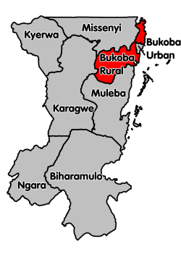

Figure 3.1: The Map showing the Boundaries of the Bukoba Urban District

Source: - www.kagera.go.tz

3.3. Sampling Design and Procedures
As for this study, the convenient sampling technique was employed. Convenience sampling is a sampling technique where subjects are selected because of their convenience, accessibility and proximity to the researcher. In all forms of research, it would be ideal to test the entire population, but in most cases, the population is just too large that it is impossible to include every individual. This is the reason why most researchers rely on convenience sampling, the most common of all sampling techniques. This technique is preferred by researchers because it is fast, inexpensive, easy and the subjects are readily available as posited by Mugenda and Mugenda, (2003).

3.3.1 Sampling Distribution and Sampling Techniques

3.3.1.1 Purposive Sampling Technique
This is a non-probability sampling technique which allowed a researcher to conveniently choose participants who might be useful in the study. As such, this study employed a purposive sampling technique as proposed by (Best, 2006) to sample respondents whereby the key informants such as Project Managers and Finance and Administration managers were selected purposively. Purposive sampling technique was employed to select key informants for the reasons that by virtue of, their position, they have the authority to provide information regarding financial sustainability of their LNGOs by their discretion. Further to that, local NGOs were selected by using purposive sampling method by making sure that they are domestic or locally operating NGOs in the study area.

3.3.1.2 Simple Random Sampling Technique
The simple random sampling technique as proposed by Best & Khan, (1989) was employed to select general staff members found in LNGOs under this study. This is a probability sampling technique which was used to avoid bias in collecting information from the general staff of the local NGOs because each employee was equally given a chance to be selected to participate in the study. Therefore, every staff in selected local NGO had an equal chance of being selected into the study. To minimize the bias in the selection process, the numbered slips of paper were systematically shuffled in a box and then one piece of paper was randomly picked by one employee at a time. This process was repeated until a required sample was obtained.

3.4.1 Sampling Size
To attain a sample size that has enough size qualified to the goals of the study, the researcher adopted Yamane’s formula which is as follows:
n=N
1+N(e)²
Where:
n is the sample size
N is the population size
e is the margin of error
204
n= 1+204 (0.05)²
n=135

3.4. Methods of Data Collection
Data collection refers to the process of gathering specific information aimed at providing a refuting some facts (Creswell, 2013). Data collection methods can be briefly defined as the tools employed by the researcher to gather information from the field. This study employed the triangulation approach whereby interview, semi–structured questionnaire and documentary review were used as methods of data collection. These tools of data collection were separated into two main categories namely: - Primary and secondary data collection tools.

3.7.1. Primary Data Collection Methods
The primary data refers to the information collected by the researchers and have not been manipulated by any other person. Such data are provided by the respondents in the sample through scheduled interactions by using well-prepared tools (Mugenda and Mugenda, 2011). As for this study, questionnaires and interview method were used to collect primary data. The choice of these tools depended on the type and availability of respondents, time available for the study and the expected effectiveness of the instruments.

3.7.1.1 Questionnaire Method
A set of the closed-ended and open-ended questionnaire (Dawson, 2002) was administered to all respondents. The questionnaire consisted of fact-oriented questions and questions about subjective experiences. Fact oriented questions were used to elicit objective information on issues such as the interviewee’s background (example age and level of education), while questions related to subjective experiences were used to gain information on different subject matters that concerns the study in question as proposed by Rwegoshora, (2008).

The questionnaires contained both closed and open-ended questions. Closed-ended questions gave the respondents options to choose from a distinct set of pre-defined responses. Open-ended questions were used to seek the views, opinions, and attitudes from the respondent which might not have been captured by the researcher. The justification for using this instrument is that questionnaires are easy to quantify and analyze, ensure confidentiality and keep track on those who may not return the questionnaire on time and need to be reminded (Bryman & Bell, 2007).

3.7.1.2 Interview Method
This study employed an interview method (Yin, 2009) to collect primary data from respondents about factors that play a role in ensuring financial sustainability in local NGOs in Bukoba Municipal Council. The researcher conducted interviews in a face-to-face and in-person approach, which involved spoken conversation between researcher and interviewees as articulated by Cresswell & Plano (2011). An interview guide for conducting interviews was prepared to direct the two ways systematic conversation between the researcher and the respondent to obtain relevant information for the study. This method was chosen because it was a suitable method for getting in-depth information concerning the study, also to supplement the data which cannot be gathered through questionnaire method.

3.7.2. Secondary Data Collection Method
The secondary data refers to the information gathered from a secondary source, in this case, there were used by other researchers as stated by (Kothari, 2004).

3.7 Documentary Review
In this study, secondary data was obtained through documentary review method (Yin, 2009) of different documents and piece of literatures from previous studies and reports analysis obtained from each of the selected local NGOs under the study.

3.8. Validity and Reliability of Research Instruments
In this study, validity, as stipulated by Kothari, (2004) was ensured through using multiple methods and sources of data (triangulation) so that the data obtained from one source could be crosschecked through the other sources. This ensured both the exploratory depth and accuracy of data is observed. Regarding the reliability of the instruments; all useful strategies were employed for ensuring reliability. All instruments for data collection were Pilot-tested including the questionnaires and interviews to ensure both the reliability and validity of the study instruments for data collection are properly constructed (Kothari, 2004).

3.9 Data Analysis Plan
Data analysis is very central in building theories from case studies and is the least codified part of the process (Dawson, 2002). It is noted that “the analysis of the empirical data aims to make sense of massive amounts of data, reduce the volume of information, identify significant patterns, and construct a framework for communicating the essence of what the data reveal (Best & Khan, 2006). In this study, the qualitative data collected through interviews and observation, open-ended questionnaires were presented and reported descriptively; while the quantitative data collected through closed-ended questionnaire and documentary review were presented in numbers, percentages, frequency distribution tables and figures.

3.10 Ethical Considerations
The following ethical principles as proposed by Dawson, (2002) were observed throughout the research process: (1) Voluntary participation of respondents. (2) Participants were informed about the purpose, procedures and the consequences of their participation in the study before they decided to participate in it. (3) Questions were carefully framed and asked in ways that avoided causing psychological harm to the participants. Before the interview, the respondents were asked if they are comfortable with the environment. (4) It was necessary to assure the participants that the information they provide would not be used for any other purposes than those explained to them when consent was sought.
Participants who would like to remain anonymous were fully assured of that. (5) Written permission to conduct this study was pursued from the area where fieldwork was conducted. A letter of introduction from the Open University of Tanzania was obtained so as it can be used to introduce the researcher to the District authority to obtain a permit to conduct the study in the district. (6) The researcher explicitly acknowledged all the literature and sources of empirical evidence used in this study. (7) The researcher ensured that when collecting the data, appropriate tools for data collection are used professionally.

CHAPTER FOUR

DATA ANALYSIS, PRESENTATION AND DISCUSSION OF THERESULTS

4.1 Chapter Overview
This chapter presents the results for the current study and its discussions. It is organized into three main sections. The first section presents a detail about socioeconomic and demographic characteristics of the study which were obtained by asking the participants to provide personal information in the first part of the questionnaire. The second section of this chapter presents research findings and the third section presents the discussion of the findings to curb research questions and responses to the objectives as stated in the first chapter of this study. It also emphases on data presentation, interpretation, and analysis based on those study objectives.

These findings show participants’ responses as they provide their in-depth information about the factors affecting financial sustainability in Local Non-governmental organizations in the study area. It highlights the detailed discussion of the findings with more or less related to the literature reviewed for this study and brings out the researchers stand and opinions in different subject matters involved in this study.

4.2 Response Rate
The study involved 156 respondents from twelve (12) local non-government organizations found in Bukoba municipal council in Kagera Region, Tanzania. A total of 135 questionnaires were returned which represented 93% of the total sample. The category of respondents who did not return the questionnaires came from the general staff population. According to Mugenda and Mugenda (2003), a response rate of 70% and over is excellent, hence, a return rate of 93% was found adequate for analysis.

4.3 Socio-Economic and Demographic Characteristics of the Study
This part presents the socio-economic and demographic information of the respondents including their gender/sex, age, education level, work experience and economic status.

4.3.1 Gender of Respondents
The gender of the respondents was equally regarded in the study. This task aimed to provide the researcher with wider participation of different gender groups. It was important to have this in mind to avoid bias and have an accurate representation of gender balance for the study to be valid. The table below presents the socio-demographic results with regards to the gender/sex of respondents who were found in the study area

Table 4.1: Distribution of Respondents by Gender (n=135)
Gender of Project and Finance Administration Managers
Respondents Gender/Sex | Frequency | Percentage
Male | 7 | 58.4
Female | 5 | 41.6
Sub Total | 12 | 100.0
Gender/Sex of General Staff Members
Respondents Gender | Frequency | Percentage
Male | 71 | 57.7
Female | 52 | 42.2
Sub Total | 123 | 100.0
Source: Field Data (2019)
Information in Table 4.1 indicates that among all finance administrators and operation managers respondents who were involved in this study, 7 were males which is equal to 58.4% while 5 were females which is equal to 41.6%. This implies that most of the operation managers who were involved in this study were males. The table further indicates that 71 general staff were males which is equal to 57.7% while 52 were females of which makes 42.2%. This implies that most of the general staff members involved in this study were males. The overall comment regarding the gender of respondents who were engaged in this study is that male respondents dominated the study.

4.3.2. Age of the Respondents
Respondents were requested to indicate their age. The purpose of this request was to ensure that various age groups are represented in this study to enhance equal participation. The table below presents the socio-demographic results with regards to the age of respondents who were found in the study area: -

Table 4.2: Distribution of Respondents by Age (n=135)
Gender of Finance Administrators and Operation Managers
Respondents Age | Frequency | Percentage
25 – 30 | 1 | 8.3
31 – 35 | 6 | 50
36 – 40 | 3 | 25
40 – Above | 2 | 16.6
Sub Total | 12 | 100.0
Gender of General Staff Members
Respondents Age | Frequency | Percentage
18 – 25 | 4 | 3.2
26 – 30 | 51 | 41.4
31 – 35 | 45 | 36.5
36 – 40 | 16 | 13
40 – Above | 7 | 5.6
Sub Total | 123 | 100.0
Source: Field Data (2019)
The results in Table 4.2 indicate that most of the respondents in the category of finance administrators and operation managers were aged between 31 to 40 years old. This might be justified by imparting on the fact that most of the Tanzanian actively engage themselves in job hunting and work in cooperate organizations when they are aged 25 and above. The results above also imply that many of the respondents involved in this study were in the active age group to be able to provide relevant information about factors affecting financial sustainability to local NGOs in the study area.

Also, table 4.2 above indicates the age categories of general staff members involved in the study. The overall results indicate that most of these general staff members involved in this study were aged between 26 to 40 years old. Moreover, the result depicts that most of those respondents were matured enough and the judgements they provided were reliable. It can be concluded that the age categories of all these respondents who participated in this study give the impression that the majority of them were in the active age groups and their participation in this study was valuable.

4.3.4 Education Level of Respondents
Respondents were requested to indicate their level of education. The purpose was to ensure that different literacy groups are represented in this study. The table below presents the socio-demographic results with regards to the educational level of respondents who were contacted in the study area. Results in the first and second categories of Table 4.3 e describe the education level of the respondents involved in this study. The results indicate that most of these respondents found in all two categories of administrators/operational managers and the general staff members have got between Certificates up to a Master’s degree in their level of education whereby majority of them holds a degree. This means that their level of educational qualifications reasonable convinces that the in-depth information they provided with regard to this study can be reliable.

Table 4.3: Distribution of Respondents by their Level of Education (n=135).
Education Level of Finance Administrators and Operation Managers
Respondents Education Level | Frequency | Percentages
Master’s Degree | 4 | 33.3
Degree | 7 | 58.3
Diploma | 1 | 8.3
Sub Total | 12 | 100.0
Education Level of General Staff Members
Respondents Education Level | Frequency | Percentages
Masters’ Degree | 4 | 3.2
Degree | 60 | 48.7
Diploma | 45 | 36.5
Certificate | 14 | 11.3
Sub Total | 123 | 100.0
Source: Field Data (2019)

4.3.5 Respondents Years of Working Experience
Respondents were requested to indicate the number of years which they have been involved in their business. The purpose was to ensure that all respondents have got enough experience to be able to provide in-depth information about factors affecting financial sustainability to local NGOs in the study area. The tables below present the results. The data in Table 4.4 indicates that most of the financial administrators and operation managers of the studied local NGOs have experiences between 4 to 9 years fulfilling their roles in their respective organizations. This implies that that most of them have served their positions long enough to have an in-depth understanding of how different factors can influence financial sustainability in their local NGOs in the study area.

Table 4.4: Distribution of Respondents by their Work Experience (n=135)
Work Experience of Finance Administrators and Operation Managers
Respondents Work Experience | Frequency | Percentage
1 - 3 years | 2 | 16.6
4 - 6 years | 6 | 50
7 - 9 years | 3 | 25
10 and above | 1 | 8.3
Sub Total | 12 | 100.0
Work Experience of General Staff Members
Respondents Work Experience | Frequency | Percentage
1 – 3 years | 60 | 48.7
4 - 6 years | 39 | 31.7
7 - 9 years | 24 | 19.5
Sub Total | 123 | 100.0
Source: Field Data (2019)

Further to that, results in Table 4.4 indicates that majority of the general staff who were contacted have experiences between 3 to 9 years in their employments. This implies that they had served in their positions long enough to have an in depth understanding of the roles played by different factors and their effects in ensuring the financial sustainability of local NGOs.

4.3.6 Distribution of the Level of Funding of LNGOs under the Study
Respondents were requested to indicate the level of funding of their business. The purpose was to assess whether all LNGOs under the study have got enough financial sustainability and experienced enough in their operation to be able to provide in-depth information about factors affecting financial sustainability to local NGOs in the study area. The tables below present the results.

Table 4.5: Distribution of the Level of Funding of LNGOs under the Study (n=12)
Response from Project Managers and Financial Administration Officers
Amount fund in TSH for 2019-2020 financial year | Frequency | Percentage
Less than 100 million | 5 | 42
Between 100 and 400 million | 4 | 33
Between 500 and 900million | 2 | 16.6
Over 1 billion | 1 | 8.3
Sub Total | 12 | 100.0
Source: Field Data (2019)

The study wanted to investigate the funding range as reported by respondents from respective organisations in 2019-2020 financial year of their projects implementations, from the study majority of the respondents indicated that their organisation had been funded for between 100 to 1 Billion million as shown in Table 4.5 above. It further indicated that there is only one organization with which its funding amount exceeded 1 billion and none of the respondents indicated to have received less than 50 million. It can be concluded that most of the LNGOs contacted in this study have more or less undergone financial stability and the responses they gave can be liable.

4.4 Descriptive Statistic Results
This section presents descriptive statistic results based on the objectives which were; to explore multiple sources of financial diversification strategies used by LNGOs to ensure financial sustainability; to examine the influence of leadership competencies on strategic financial managements in LNGOs; to examine the influence of donor’s funding policies on the financial sustainability of LNGOs.

4.4.1 Multiple Sources of Financial Diversification Strategies used by LNGOs to Ensure Financial Sustainability
The respondents were asked to indicate their response based on the following multiple sources of financial diversification strategies used by LNGOs to ensure financial sustainability. Those sources were; Social Entrepreneurship Activities, Fundraising Events, Tapping International Funding Streams, Sourcing from Corporate Donors and Partners, Owning and Managing own Business, Consultancy as well as pieces of training for a fee. Respondents were requested to indicate their level of satisfaction by ranking their answers in the given variables whereby; - 1 =Not at all, 2 = To a Little Extent, 3 = To a Medium Extent, 4 = To a High Extent and 5 = To a Very High Extent. The results are presented below;

4.4.1.1 Social Entrepreneurship Activities
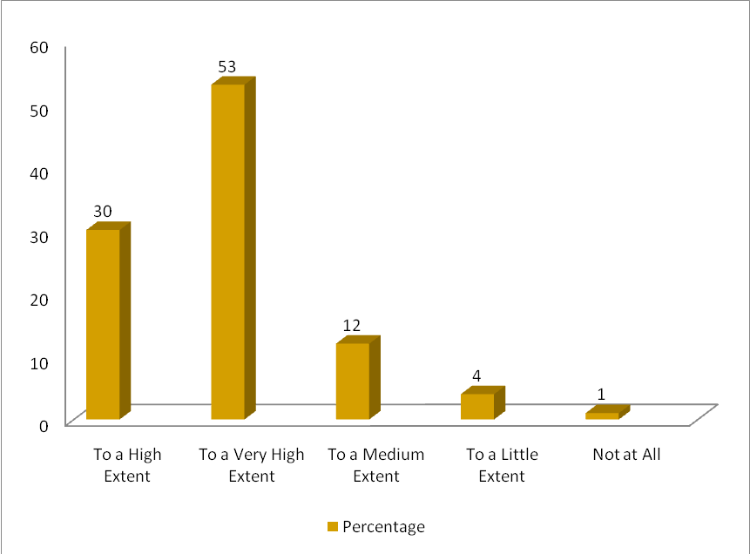

Figure 4.1: Social Entrepreneurship Activities as Part of Multiple Sources of Financial Diversification Strategies

The respondents were asked to indicate their response based on Social Entrepreneurship Activities as part of multiple sources of financial diversification strategies used by LNGOs to ensure financial sustainability. The respondents were requested to indicate their level of satisfaction by ranking their answers in the given variables whereby; - 1 =Not at all, 2 = To a Little Extent, 3 = To a Medium Extent, 4 = To a High Extent and 5 = To a Very High Extent. The results are presented on the Figure 4.1.

Figure 4.1 indicates that responses from 40 people who represented 30% of the studied population reported that to a high extent, Social Entrepreneurship Activities is part of multiple sources of financial diversification strategies used by LNGOs to ensure financial sustainability, 73 people who represented 53% of the studied population reported that to a very high extent, 16 people who represented 12% of the studied population said to a medium extent, 5 people who represented 4% of the studied population dwelled in the segment of to a little extent, while only 1 person who represented 1% of the studied population reported that not at all Social Entrepreneurship Activities are part of multiple sources of financial diversification strategies used by LNGOs to ensure financial sustainability. This was also evidenced by one of the financial administration managers who reported that: -
“We have been devoted ourselves to finding opportunities to be trained on social entrepreneurship skills and these skills have supported us as an NGO to establish income-generating activities”

Another Operation Manager from an NGO under the study commented that: -
“I can say that most of the activities that we do we operate under more than one sector by focusing on building capacity to our staff on social protection issues, social entrepreneurship skills training, business development issues, training on agricultural practices, advocacy and lobbying for resource mobilization, exhibition and demonstration of cultural groups, provision of relief assistance, poultry and beekeeping activities. This makes us social entrepreneurs”

In line with the respondents’ opinion above, the report from the Ministry of Health, Community Development, Gender, Elderly and Children (MoHCDGEC) on the contributions of NGOs on local development for the year 2015 established that only in 2015 various initiatives that were undertaken by LNGOs includes; over 3,000 trained their staff on better agricultural practices in the Onions and Garlic value chain; construction of irrigation canal for horticulture farming; over 6,000 youths from urban parts of Tanzania Mainland were trained on business development; different chambers of commerce were supported for instance Arusha and Manyara regions to establish district business strategy; women groups have been empowered to start their own business and raising awareness on preserving the localities of the products produced with local individuals.

Furthermore, as Ceasar, (2006) put it, Social Entrepreneurship (SE) is one of the methods adopted by NGOs to mobilise funds for their operations. The social enterprise is any socially responsible income-generating activity whose revenue is used to support the organization’s mission (AIDWATCH, 2008). It can be concluded that SE is an emerging financial diversification methodology where NGOs use market-based approaches to earn commercial income which can help them run their operations easily.

4.4.1.2 Fundraising Events
The respondents were asked to indicate their response based on fundraising events as part of multiple sources of financial diversification strategies used by LNGOs to ensure financial sustainability. The respondents were requested to indicate their level of responses in the given variables whereby; - 1 =Not at all, 2 = To a Little Extent, 3 = To a Medium Extent, 4 = To a High Extent and 5 = To a Very High Extent. The results are presented on the Graph below;
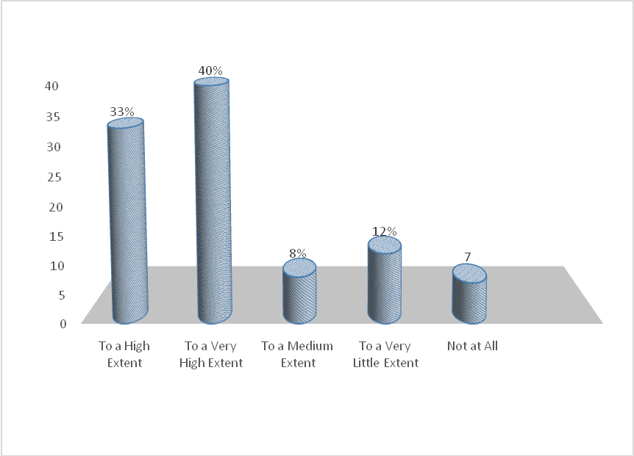

Figure 4.2: A Figure Showing How Fundraising Events can influence Financial Sustainability
Source: Field Data (2019)

Figure 4.2 indicates that responses from 44 people who represented 33% of the studied population responded that to a high extent, fund raising events are part of multiple sources of financial diversification strategies used by LNGOs to ensure financial sustainability, responses from 54 people who represented 40% of the studied population reported that to a very high extent, responses from 10 people who represented 8% of the studied population said to a medium extent, responses from 17 people who represented 12% of the studied sample reported that to a little extent, while responses from 10 people who represented 7% of the studied population they reported that not at all fundraising events as part of multiple sources of financial diversification strategies used by LNGOs to ensure financial sustainability. This was also evidenced by one of the financial administration managers who reported that;
“We host a lot of fundraising event annually and they help us get donations from various donors. In these fundraising, we are very unique to each approach we make, and we make sure it reflects the interests of the audiences”
Furthermore, the results indicate that local non-governmental organizations, if they want to maintain their financial sustainability, can benefit from fundraising activities. This is in line with Burnett (2002), who acknowledged the need for what he termed the fundraising partnership: - to work with individual donors, to consider each particular donor as different in terms of providing context, the inspiration for contribution and the general standard of care that charities provide.

4.4.1.3 Tapping International Funding Streams
The respondents were asked to indicate their response based on tapping international funding streams as part of multiple sources of financial diversification strategies used by LNGOs to ensure financial sustainability. The respondents were requested to indicate their level of responses by ranking their answers in the given variables whereby; 1 =Not at all, 2=To a Little Extent, 3=To a Medium Extent, 4 = To a High Extent and 5 = To a Very High Extent. The results are presented on the figure 4.3.

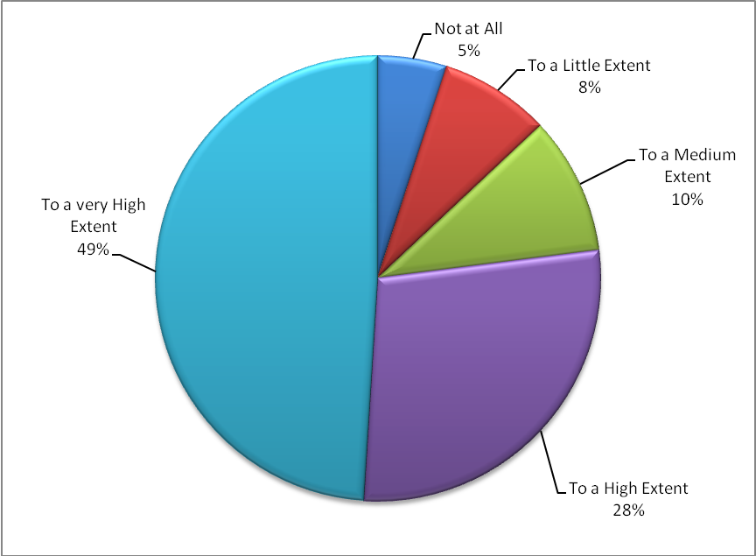

Figure 4.3: Tapping International Funding Streams as part of Multiple Sources of Financial Diversification Strategies
Source: Field Data (2019)
Figure 4.3 indicates that responses from 67 people who represented 49% of the studied population responded that to a very high extent that tapping international funding streams is part of multiple sources of financial diversification strategies used by LNGOs to ensure financial sustainability, responses from 38 people who represented 28% of the studied population reported that to a high extent, responses from 14 people who represented 10% of the studied population said to a medium extent, responses from 9 people who represented 8% of the entire studied population said to a little extent, while responses from 7 people who represented 5% of the studied population reported that not at all that tapping international funding streams as part of multiple sources of financial diversification strategies used by LNGOs to insure financial sustainability.

To support these results, it has been noted that NGOs do not have the same mission, philosophy, customer bases, initiatives, services, know-how and expertise (Kiragu & Njue 2013). In that case, the important part of planning and management for all NGOs is to ensure better financial security. To become fully autonomous from sponsors there should be an acceptable goal for a variety of NGOs when attempting to raise finances to meet overhead costs. Several NGOs also decide how noble is shortly to focus on grants and donations (Viravaidya & Hayssen, 2010). It is, therefore, necessary for each NGO director to consider different funding options and pick a suitable combination of enlisting funds, just like to decide the vital programs and executing financial diversification strategies such as tapping into international funding streams (Sera, 2010).

4.4.1.4 Sourcing from Corporate Donors and Partners
The respondents were asked to indicate their response based on Sourcing from Corporate Donors and Partners as part of multiple sources of financial diversification strategies used by LNGOs to ensure financial sustainability. The respondents were requested to indicate their level of responses by ranking their answers in the given variables whereby; - 1 =Not at all, 2 = To a Little Extent, 3 = To a Medium Extent, 4 = To a High Extent and 5 = To a Very High Extent. Figure 4.4 above indicates that responses from 45 people who represented 33.3% of the respondents under this study responded that to a high extent that Sourcing from Corporate Donors and Partners is part of multiple sources of financial diversification strategies used by LNGOs to ensure financial sustainability.
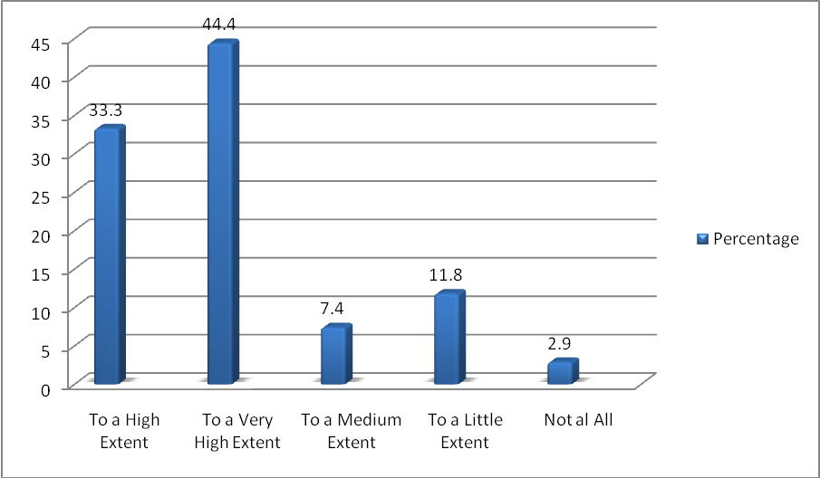

Figure 4.4: A Figure Showing How Sourcing from Corporate Donors and Partners can Influence Financial Sustainability
Source: Field Data (2019)

Responses from 60 people who represented 44.4% of the studied population reported that to a very high extent, responses from 10 people who represented 7.4% of the studied population said to a medium extent, responses from 16 people who represented 11.8% of the studied sample said to a little extent, while responses from 4 people who represented 2.9% of the studied population reported that not at all that Sourcing from Corporate Donors and Partners is part of multiple sources of financial diversification strategies used by LNGOs to insure financial sustainability.

4.4.1.5 Owning and Managing own Business
The respondents were asked to indicate their response based on Owning and Managing own Business as part of multiple sources of financial diversification strategies used by LNGOs to ensure financial sustainability. The respondents were requested to indicate their level of responses by ranking their answers in the given variables whereby; - 1 =Not at all, 2 = To a Little Extent, 3 = To a Medium Extent, 4 = To a High Extent and 5 = To a Very High Extent. The results are presented in Figure 4.5.
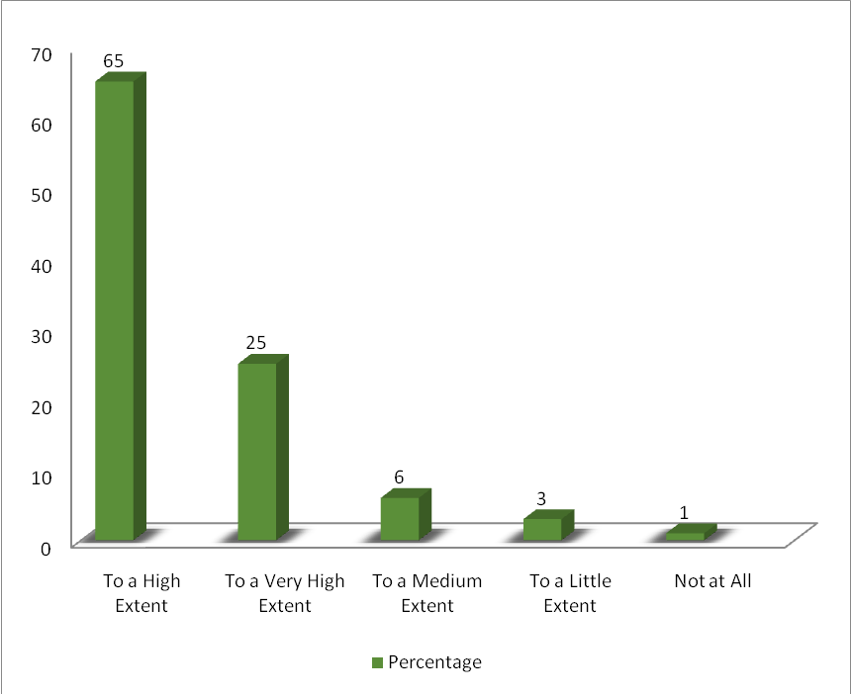

Figure 4.5: Owning and Managing own Business as part of Multiple Sources of Financial Diversification Strategies
Source: Field Data (2019)

Figure 4.5 indicates that responses from 88 people who represented 65% of the entire respondents, sample responded that to a high extent that Owning and Managing own Business is part of multiple sources of financial diversification strategies used by LNGOs to ensure financial sustainability, responses from 34 people who represented 25% of the studied population reported that to a very high extent, responses from 8 people who represented 6% of the studied population said to a medium extent, responses from 4 people who represented 3% of the studied population said to a little extent, while responses from only 1 person who represented 1% of the entire population sample of this study reported that not at all that Owning and Managing own Business is part of multiple sources of financial diversification strategies used by LNGOs to ensure financial sustainability.

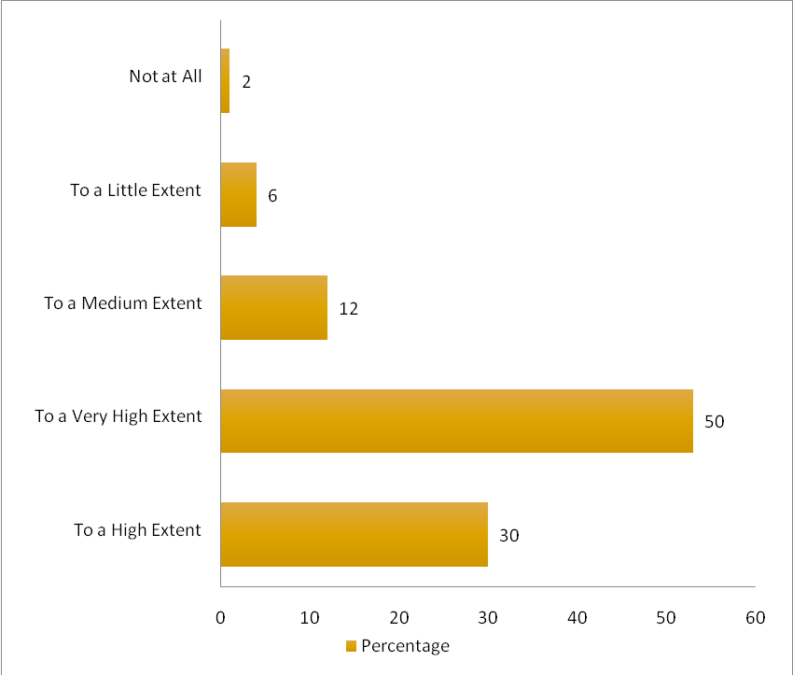
4.4.1.6 Consultancy and Training for a Fee

Figure 4.6: A Figure Showing Consultancy and Training for a Fee as part of Multiple Sources of Financial Diversification Strategies

The respondents were asked to indicate their response based on Consultancy and Training for a Fee as part of multiple sources of financial diversification strategies used by LNGOs to ensure financial sustainability. The respondents were requested to indicate their level of responses by ranking their answers in the given variables whereby; - 1 =Not at all, 2 = To a Little Extent, 3 = To a Medium Extent, 4 = To a High Extent and 5 = To a Very High Extent.

The results are presented in the Graph 4.6, Figure 4.6 indicates that responses from 40 people who represented 30% of the respondents from the entire population sample reported that to a high extent, consultancy and training for a fee can be part of multiple sources of financial diversification strategies used by LNGOs to ensure financial sustainability, responses from 68 people who represented 50% of the studied population reported that to a very high extent, responses from 16 people who represented 12% of the studied sample said to a medium extent, responses from 8 people who represented 6% of the entire population sample said to a little extent, while responses from 3 people who represented 2% of the study sample reported that not at all that Consultancy and Training for a Fee as part of multiple sources of financial diversification strategies is a part of multiple sources of financial diversification strategies used by LNGOs to insure financial sustainability.

4.4.2 The Influence of Leadership Competencies on Strategic Financial Managements in LNGOs
The respondents were asked to indicate their response based on the influence of leadership competencies on strategic financial management in LNGOs based on the statements such as the management team being qualified enough to hold their positions, management experience, training programs for both employees and management team, projects implemented under the current management team, management regularly communicating to the employees, individual in-kind gifts, membership fees and donations, as well as private charities and grants. The respondents were requested to indicate their level of satisfaction by ranking their answers in the given variables whereby; - 1 =Not at all, 2 = To a Little Extent, 3 = To a Medium Extent, 4 = To a High Extent and 5 = To a Very High Extent. The results are presented in Table 4.6.

Table 4.6: The influence of Leadership Competencies on Strategic Financial Managements in LNGOs
Leadership competencies on strategic financial managements | Frequency | Percentage
The management team is qualified enough to hold their positions | 17 | 12.5
My firm has training programs for both employees and management | 26 | 19.2
The management of my firm is highly experienced in financial managements | 31 | 22.9
My firm has had more projects implemented under the current management team | 13 | 9.6
The management in my firm regularly communicates to the employees | 14 | 10.3
The management of my firm is well trained | 20 | 14.8
My organization is encouraging individual gifts, membership charges and donations | 2 | 1.4
My organization is constantly applying for private charities and grants | 12 | 8.8
Source: - Field Data (2019)

Table 4.6 indicates that responses from 17 participants the majority of the which represent 12.5 percent of the entire studied population reported that the management team is qualified enough to hold their positions, responses from 26 participants who represented 19.2 percent of the studied population reported that their LNGOs has training programs for both employees and management, responses from 31 participants who represented 22.9 percent of the studied population reported that their LNGOs has got management team who are highly experienced, responses from 13 participants who represented 9.6 percent of the studied population reported that their LNGOs have had more projects implemented under the current management team,

Responses from 14 participants who represented 10.3 percent of the studied population reported that the management in their LNGOs regularly communicates to the employees, responses from 20 participants who represented 14.8 percent of the studied population reported that the management of their LNGOs are well trained, responses from 2 participants who represented 1.4 percent of the studied population reported that their organization embraces individual in-kind gifts, membership fees and donations, responses from 12 participants who represented 8.8 percent of the studied population reported that their organization rely on private charities and grants. These results suggest that leadership competencies have a medium contribution to strategic financial management in the studied LNGOs.

4.4.3 The Influence of Donor’s Funding Policies on Financial Sustainability of LNGOs
The third specific objective of the study was to examine the influence of donor’s funding policies on financial sustainability of LNGOs. The respondents were asked to indicate their response based on the following statement such as; the number of successful internal and external audits, Minimum amount of disallowable funds on audit reports, number of successful financial reports approved by donors, amount of back up funds, and adherence to various donor priorities. The respondents were requested to indicate their level of satisfaction by ranking their answers in the given variables whereby; - 1 =Not at all, 2 = To a Little Extent, 3 = To a Medium Extent, 4 = To a High Extent and 5 = To a Very High Extent.

Respondents were asked to put their opinions on the influence of donor’s funding policies on the financial sustainability of their LNGOs in the study area. Respondents came forward with their level of satisfaction on the variables as indicated in the figure above. Results in figure 4.9 indicate that possible donor’s funding policies on the financial sustainability of LNGOs in the study area as rated by respondents were: - number of successful internal and external audits (31%), Minimum amount of disallowable funds on audit reports (19%), number of successful financial reports approved by donors (14%), adherence to various donor priorities (26%) and amount of back up funds (10%).

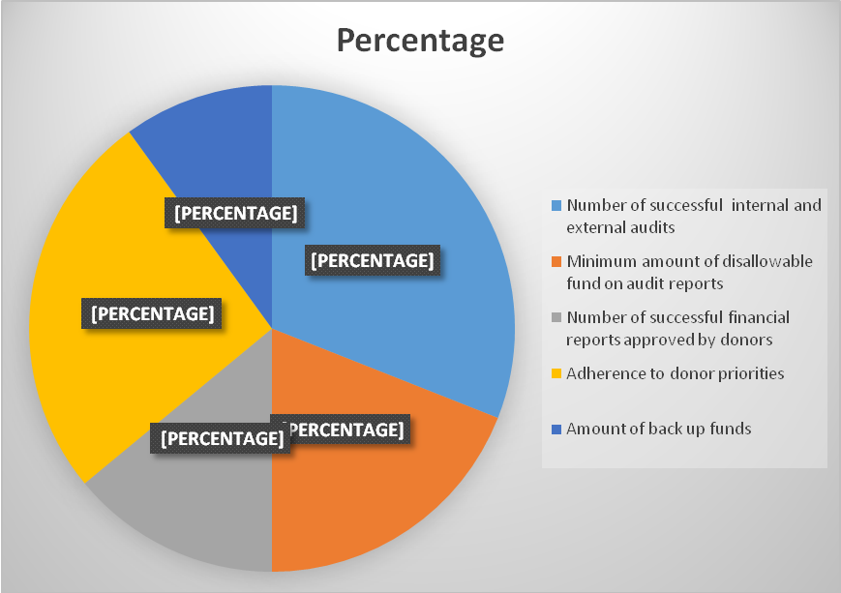

Figure 4.7: Field Data Showing Possible Donor’s Funding Policies on the Financial Sustainability of LNGOs in the Study Area
Source: - Field Data (2019)

4.4.4 The Financial Sustainability of LNGOs
This part of the study presents the influence of donor’s funding policies on financial sustainability of LNGOs. The respondents were asked to indicate their level of agreement with the following statements relating to financial sustainability in local NGOs (1- strongly disagree, 2 - Disagree, 3 - Neutral, 4 - Agree, 5 - Strongly agree). The results are presented on the Table 4.7

Table 4.7: The Financial Sustainability of LNGOs
The Studied LNGOs | Mean | Std. Deviation
Has inadequate funding to implement their projects | 4.15 | .802
Has a high level of unpaid debts by customers | 4.44 | .774
Has a high level of unnecessary expenses which are not provided in the annual budget | 4.85 | .990
Has a strategic plan on which its activities are based | 4.68 | .704
Promotes its employees | 4.84 | .766
Source: - Field Data (2019)

Table 4.7 indicates that the majority of the respondents reported with a mean of 4.15 and standard deviation of 0.802 that LNGOs have inadequate funding to implement their projects, with a mean of 4.44 and standard deviation of 0.774 that LNGOs have a high level of unpaid debts by customers, with a mean of 4.85 and standard deviation of 0.990 that LNGOs have a high level of unnecessary expenses which are not provided in the annual budget, with a mean of 4.68 and standard deviation of 0.704 that LNGOs have a strategic plan on which its activities are based, with a mean of 4.84 and standard deviation of 0.766 that LNGOs promotes its employees to increase their morale in the workplaces. These results suggest that donor’s funding policies influence financial sustainability of LNGOs.

4.5 Discussion of the Results

4.5.1 Multiple Sources of Financial Diversification Strategies used by LNGOs to Insure Financial Sustainability
The first specific objective of the study was to explore multiple sources of financial diversification strategies used by LNGOs to ensure financial sustainability. The study found out that the minority of the respondents reported that not at all Social Entrepreneurship Activities is part of multiple sources of financial diversification strategies used by LNGOs to ensure financial sustainability. It was also revealed that to a very high extent, the majority of the respondents reported that social entrepreneurship activities can be taken as part of multiple sources of financial diversification strategies used by LNGOs to ensure financial sustainability. It was further revealed that the LNGO shave been always finding opportunities to be trained on social entrepreneurship skills and these skills have been supporting us as an NGO to establish income generating activities.

Moreover, it was found that most of LNGOs’ activities that they have been doing they operate under more than one sector by focusing on building capacity to their staff on social protection issues, social entrepreneurship skills training, business development issues, training on agricultural practices, advocacy and lobbying for resource mobilization, exhibition and demonstration of cultural groups, provision of relief assistance, poultry and bee keeping activities.

In line with these results, the report from the Ministry of Health, Community Development, Gender, Elderly and Children (MoHCDGEC) on the contributions of NGOs on local development for the year 2015 established that only in 2015 various initiatives that were undertaken by LNGOs includes; over 3,000 trained their staff on better agricultural practices in the Onions and Garlic value chain; construction of irrigation canal for horticulture farming; over 6,000 youths from urban parts of Tanzania Mainland were trained on business development; different chambers of commerce were supported for instance Arusha and Manyara regions to establish district business strategy; women groups have been empowered to start their own business and raising awareness on preserving the localities of the products produced with local individuals.

Furthermore, as Ceasar, (2006) put it, Social Entrepreneurship (SE) is one of the methods adopted by NGOs to mobilise funds for their operations. Social enterprise is any socially responsible income-generating activity whose revenue is used to support the organization’s mission (AIDWATCH, 2008). It can be concluded that SE is an emerging financial diversification methodology where LNGOs use market-based approaches to earn commercial income which can help them run their operations easily.

The study also found that Fundraising Events was found to be a part of multiple sources of financial diversification strategies used by LNGOs to ensure financial sustainability. Descriptive results indicated that 55% of the majority of the respondents responded that to a high extent those fund-raising events are part of multiple sources of financial diversification strategies used by LNGOs to ensure financial sustainability. It was further revealed that the LNGOs have been hosting a lot of fundraising events/activities annually which have been helping them to get donations from various donors by making sure it reflects the interests of the target audiences.

Furthermore, the results indicate that local non-governmental organizations, if they want to maintain their financial sustainability, can benefit from fundraising activities. This is in line with Burnett (2002), who acknowledged the need for what he termed the fundraising partnership–to work with individual donors, to consider each particular donor as different in terms of providing context, inspiration for contribution and the general standard of care that charities provide. Furthermore, tapping international funding streams was also found to be a part of multiple sources of financial diversification strategies used by LNGOs to ensure financial sustainability. It was found out that 49% of the respondents responded that to a high extent that tapping international funding streams is a part of multiple sources of financial diversification strategies used by LNGOs to ensure financial sustainability.

To support these results, it has been noted that NGOs do not have the same mission, philosophy, customer bases, initiatives, services, know-how and expertise (Kiragu & Njue 2013). The important part of planning and management for all NGOs is to ensure better financial security. To become fully autonomous from sponsors may be an acceptable goal for a variety of NGOs when attempting to raise finances in order to meet overhead costs. Several NGOs also decide how noble is shortly to focus on grants and donations (Viravaidya & Hayssen, 2010). It is therefore necessary for each NGO director to consider different funding options and pick a suitable combination of enlisting funds, just like to decide the vital programs and executing financial diversification strategies such as tapping into international funding streams (Sera, 2010).
Apart from that, it was found out that sourcing from corporate donors and partners as part of multiple sources of financial diversification strategies is being used by LNGOs to ensure financial sustainability. It was revealed that 47% of the respondents responded that to a high extent that sourcing from corporate donors and partners is part of multiple sources of financial diversification strategies used by LNGOs to ensure financial sustainability.

Besides, owning and managing own business was also found as part of multiple sources of financial diversification strategies used by LNGOs to ensure financial sustainability. It was further revealed that 65% of the respondents responded that to a high extent that Owning and Managing own Business is part of multiple sources of financial diversification strategies used by LNGOs to ensure financial sustainability. Moreover, in this study, Consultancy and Training for a Fee was also found out to be as part of multiple sources of financial diversification strategies used by LNGOs to ensure financial sustainability. It was revealed that 30% of the majority of the respondents reported that to a high extent that Consultancy and Training for a Fee as part of multiple sources of financial diversification strategies is a part of multiple sources of financial diversification strategies used by LNGOs to ensure financial sustainability.

4.5.2 The Influence of Leadership Competencies on Strategic Financial Managements in LNGOs
The second specific objective of the study was to examine the influence of leadership competencies on strategic financial managements in LNGOs. During the study, the respondents were asked to indicate their response based on the influence of leadership competencies on strategic financial management in LNGOs based on the statement such as academic qualifications, the number of projects handled, years of experience, as well as financial governance, practices and approaches. The study found that the majority of the respondents reported with a percent of 12.5 of the entire studied population that the management team was qualified enough to hold their positions. These results suggest that the majority of LNGOs leaders have satisfactory academic qualifications and experienced enough on strategic financial management.

These results concur with Viravaidya & Hayssen (2010) who found out that leaders in LNGOs have low academic qualifications on strategic financial management. It was also found that capability to handle a number of projects among the majority of the LNGOs leaders were found to be at the minimal level. Descriptive results evidenced that the majority of the respondents reported that with a percent of 9.2 of the entire studied population on the capability of their firms to handle number of projects. These results suggest that there is a need to empower the LNGOs leaders on the capability to handle the number of projects as a part of strategic financial management.

It was further found out that the majority of the LNGOs leaders were found to have minimal experience in strategic financial management and managing employees in their LNGOs. It was revealed that the majority of the respondents reported with a percent of 22.9 of the entire studied population on having long experience. These results suggest that there is a need to empower the LNGOs leaders on strategic financial managements since the majority of the LNGOs leaders have less experience in strategic financial management. Moreover, it was further found out that responses from the studied population, that majority of the LNGOs leaders were found to have the management style in their LNGOs which allow them to regularly communicate with their employees. Descriptive results evidenced the majority of the respondents reported by 10.3 percent of the studied population that the management in their LNGOs regularly communicates to the employees. These results suggest that the LNGOs are active enough to communicate with the employees. These results are in line with Sera (2010) who found that the majority of the LNGOs leaders regularly communicate to the employees to supervise them on how to maintain cost-effective guidelines and procedures when managing their financial assets. The study also found out that training programmes for both employees and management in LNGOs is still very minimal.

Based on the descriptive statistic results it was revealed that the majority of the respondents reported with a percent of 19.2 that LNGOs has training programmes for both employees and management. In this case, the results depict that more efforts need to be done in offering these LNGOs on the aspect of training programmes for both employees and management. Data from field further revealed that individual donations, membership charges and various gifts from like-minded stakeholders play a role by 8.8 percent. Again, financial support from different charities and grant applications was found to be vital in maintaining financial sustainability. Several number of 11 responses who represent 8.1 of the entire studied population reported that their leaders were good in lobbying financial grants and grabbing charities and donations from various donor funding opportunities.

4.5.3 The influence of Donor’s Funding Policies on Financial Sustainability of LNGOs
The third specific objective of the study was to examine the influence of donor’s funding policies on financial sustainability of LNGOs. During the study, the respondents were asked to indicate their response based on the following the statement such as; number of successful audits, disallowable fund managements, financial reports to donors, amount of back up funds, and adherence to donor priorities.

It was further found out that the majority of the LNGOs leaders were found to have no major issues regarding donor’s funding policies on a number of successful audits which depicted have a high influence on financial sustainability in LNGOs. This was evidenced by descriptive results whereby the majority of the respondents reported with 31% that donor’s funding policies on a number of successful internal and external audits have an influence on financial sustainability for their LNGOs. These results suggest that donor’s funding policies have significant contributions on a number of successful audits have an influence on financial sustainability.

These results concur with Viravaidya & Hayssen (2010) who found out that donor’s funding policies on a number of successful audits have high contributions on financial sustainability in LNGOs. It was further found that donor relationship management policies on a number of disallowable funds on audits influence financial sustainability in LNGOs. Based on the descriptive results it was revealed that 19% of responses from the studied population regarding donor relationship management policies on number of disallowable funds during the audits have influence on financial sustainability in LNGOs. It was also found out that donor’s funding policies on financial reports approved by donors influence financial sustainability in LNGOs. It was revealed by the majority of respondents who by 14% reported that donor’s funding policies on financial reports to donors have influence on the financial sustainability of their local NGOs. These results also suggest that donor’s funding policies have significance contributions on number of successful audits have influence on financial sustainability in local NGOs. These results are in line with Kiragu & Njue (2013) who found that donor’s funding policies on financial reports to donors have influence on financial sustainability in LNGOs.

Furthermore, it was further found that donor’s funding policies on the amount of back up funds have the influence on financial sustainability in LNGOs. It was revealed that the majority of the respondents reported with 10% on donor’s funding policies regarding how the amount of back up funds have influence on financial sustainability in their local NGOs. These results suggest that backup funds policies have a high influence on financial sustainability in LNGOs. These results concur with Doppelt (2003) who found out that donor’s funding policies on amount of back up funds have high contribution to financial sustainability in LNGOs.

Furthermore, it was further found that donor’s funding policies on adhering to donor priorities have influence on financial sustainability in LNGOs. This was revealed by the majority of the respondents by 26% regarding the adhering to donor priorities to have a significant influence on financial sustainability in LNGOs. These results suggest that donor’s funding policies on adhering to donor priorities have significance contributions on the influence on financial sustainability in LNGOs. These results are in line with Knifsend & Graham (2012) who found that adhering to donor priorities have found to have a significant influence on financial sustainability in LNGOs when there is adherence to the donors’ priorities.

Finally, the study found out that donor’s funding policies have an influence on the financial sustainability of LNGOs. It was further revealed that the majority of LNGOs still have an inadequate funding to implement their projects, high level of unpaid debts by customers, high level of unnecessary expenses which are not provided in the annual budget, despite having a strategic plan on which its activities are based, as well as promoting its employees.

CHAPTER FIVE

SUMMARY, CONCLUSION AND RECOMMENDATIONS

5.1 Chapter Overview
This chapter discusses the research summary, conclusions and recommendations. Being the last chapter, it gives details about what has been done in this study and what should be done in future. Moreover, this last part of the study provides specific recommendations to NGOs administrators.

5.2 Summary of the Study
This study aimed at investigating the factors affecting financial sustainability of local non - governmental organizations in Tanzania using the case of Bukoba Municipal Council. The study developed three specific objectives which were to explore multiple sources of financial diversification strategies used by LNGOs to ensure financial sustainability; to examine the influence of leadership competencies on strategic financial managements in LNGOs; to study the influence of donor’s funding policies on financial sustainability of LNGOs.

This study adopted a descriptive case study research design because the researcher wished to triangulate the study through full use of the potential of multiple methods. The sample of the study comprised 135 respondents. This study employed the triangulation approach whereby interview, questionnaire and documentary were used. In this study, the qualitative data was collected through interviews and observation, open-ended questionnaires were presented and reported in a descriptive way; while the quantitative data was collected through closed-ended questionnaire and documentary reviews were presented in numbers, percentages, frequency distribution tables and figures. The study results were presented based on the objectives of the study. The first specific objective of the study was to explore multiple sources of financial diversification strategies used by LNGOs to ensure financial sustainability.

Based on the majority of the respondents the study found that sources such as social entrepreneurship activities, fundraising events, tapping international funding streams, sourcing from corporate donors and partners, owning and managing own business, consultancy as well as trainings for a fee were common multiple sources of financial diversification strategies used by LNGOs to ensure financial sustainability.
The second specific objective of the study was to examine the influence of leadership competencies on strategic financial managements in LNGOs. The study found that the majority of LNGOs’ leaders have low academic qualifications on strategic financial management, the low capability to handle a number of projects, low experience, as well as having enough skills on financial governance, practices and approaches.

The third specific objective of the study was to examine the influence of donor’s funding policies on financial sustainability of LNGOs. The study found out that the majority of the respondents reported that donor’s funding policies depend on a number of successful audits, donor relationship management policies on number of successful audits, donor’s funding policies on financial reports to donors, donor’s funding policies on amount of back up funds, as well as adherence to donor priorities, were found to have a high influence on financial sustainability.
Finally, the study recommends that the LNGOs leaders should seek for training from the reputable financial institutions to upgrade their leadership competencies on strategic financial managements particularly on capability to handle number of projects, skills on financial governance, as well as having enough practices and approaches on strategic financial management.

5.3 Conclusions
The study conclusions were based on the research questions developed from the objectives of the study. The first specific objective of the study was to explore multiple sources of financial diversification strategies used by LNGOs to ensure financial sustainability. Based on the results of this study, this study concludes that sources such as social entrepreneurship activities, fundraising events, tapping international funding streams, sourcing from corporate donors and partners, owning and managing own business, consultancy as well as trainings for a fee are common multiple sources of financial diversification strategies found to be the common sources used by LNGOs to ensure financial sustainability.

The second specific objective of the study was to examine the influence of leadership competencies on strategic financial managements in LNGOs. Based on the majority of LNGOs’ leaders it was concluded that the majority of LNGOs’ leaders have low academic qualifications on strategic financial managements, low capability to handle number of projects, low experience, as well as having enough skills on financial governance, practices and approaches on strategic financial managements. In this case, leadership competencies have a low influence on strategic financial managements in LNGOs.
The third specific objective of the study was to examine the influence of donor’s funding policies on financial sustainability of LNGOs. This study concluded that donor’s funding policies such on number of successful audits, relationship management policies on number of successful audits, donor’s funding policies on financial reports to donors, donor’s funding policies on amount of back up funds, as well as adherence to donor priorities, were found to have high influence on financial sustainability.

5.4 Recommendations
Based on the findings of the study, the following recommendations are made: -

5.4.1 Recommendations to LNGOs
The study conclusions were based on the research questions developed from the objectives of the study. The first specific objective of the study was to explore multiple sources of financial diversification strategies used by LNGOs to ensure financial sustainability. Since the study found that LNGOs rely much on the sources such as tapping international funding streams, fundraising events, sourcing from corporate donors and partners, this study recommends that the LNGOs should not only rely on tapping international funding streams, sourcing from corporate donors and partners, fundraising events, since these sources are unpredictable, therefore, they cannot highly guarantee to ensure financial sustainability.

In this case therefore they should rely on the social entrepreneurship activities, owning and managing their own business, consultancy as well as trainings for a fee. Since the study found that leadership competencies have low influence on strategic financial managements in LNGOs, this study recommends that the LNGOs leaders should seek for training from the reputable financial institutions to upgrade their leadership competencies on strategic financial managements particularly on capability to handle number of projects, skills on financial governance, as well as having enough practices and approaches on strategic financial managements.

Moreover, the study found out that there is a low experience on strategic financial management to the majority of the LNGOs leaders to efficiently manage their organizations, this study recommends that the LNGOs should hire or outsource the personnel with experience for strategic financial management. Besides, since the study found out that donor’s funding policies influence financial sustainability of LNGOs, this study recommends the LNGOs to be committed to the donor’s funding policies since they were found to have an influence on financial sustainability of LNGOs.

5.4.2 Recommendations for Further Studies
This study based on investigating the factors affecting financial sustainability of local non-governmental organizations in Tanzania using a case of Bukoba Municipal Council, further study is recommended to be conducted in other regions of Tanzania.

REFERENCES
Abdelkarim, N. (2012). The long-term sustainability of the Palestinian NGO sector: An Assessment. Palestine: The Welfare Association Consortium.
Ali, A. (2012). Factors influencing sustainable funding of non-governmental organizations in Kenya: A case study of Sisters Maternity Home (SIMANO) in Garissa (MBA Master’s Thesis). Nairobi University, Kenya. Andreas, D. (2005). Implementation of NGO–government cooperation policy documents: lessons learned. The International Journal of Non-for-Profit Law, 8(1), 3-5.
Ayom, A. A. (2013). Internal Controls and Performance in NGOS: A Case of Management Sciences for Health South Sudan. Unpublished Bachelor's Degree in Business Administration project, Cavendish University Uganda.
Best, J. & Khan, J. (1989). Research in Education, Englewood Cliffs (NJ): Prentice Hall.
Best, J. W. & Kahn, J. V. (1989). Research in education, (6th Edition). Englewood’s Cliffs, N.J.: Prentice Hall.
Best, J. W., & Kahn, J. V. (2006). Research in Education, (10th Ed.). Boston Pearson Education, Inc.
Bryman, A. & Bell, E. (2007). Planning a research project and formulating research questions. In: Business Research Methods. New York: Oxford University.
Clark, J. (1991). Democratizing Development: The Role of Voluntary Organizations, West Hartford, CT: Kumaran Press.
Creswell, J. (2014). Research Design: Qualitative, Quantitative and Mixed Methods Approaches (4th Ed.), London: Sage.
Creswell, J. W. (2008) Educational Research Design: Planning, Conducting, and Evaluating Quantitative and Qualitative Research, Upper Saddle River, NJ Pearson Education, Inc.
Creswell, J. W. (2013). Qualitative Inquiry & Research Design Choosing among Five Approaches, (3rd Ed.), Thousand Oaks: SAGE.
Dawson, C. (2002). Practical Research Method: A User-Friendly Guide to Mastering Research Techniques and Project. New Castle: Tarpon.
Dawson, C. (2002). Practical Research Methods, Paperback: Little, Brown Book Group.
Devkota, B. (2010). Sustainability of community-based health programmes. Community Health, 33, 175–185.
Drucker, P. (1990). Managing the Non-Profit Organization: Practices and Principles. Harpar: Business Press.
Enon, J. C. (1998). Educational Research Statistics and Management, 2nd Ed., Kampala: Makerere University Printers.
Filly, W., (2005). “Oh! So Sharp cut above the rest.” Glasgow Herald
Frostenson, S. (2013). Don’t think weekend appeals don’t work. Chronicles of Philanthropy, 25(15), 21-25.
García-Montero, L.G., Lopez, E., Monzon, A., & Pastor, I.O. (2010). Environmental Screening Tools for Assessment of Infrastructure Plans Based on Biodiversity Preservation and Global Warming (PEIT, Spain). Environmental Impact Assessment Review, 30 (1), 158-168.
Gyamfi, P. (2010). Financing Local Non-Governmental Organizations in Ghana: Issues and Challenges. Masters Thesis, Kwame Nkrumah University of Science and Technology, Nkroful, Ghana.
Harir, M. (2015). Challenges Faced by NGOs in Mobilization of Funds for Operation: The Case of United Nations Environmental Programme (UNEP).
Hassan, A. & Forhad, A. (2013). The role of NGOs in the Sustainable development in Bangladesh. Present Environment and Sustainable Development, 7(2), 1-10.
Juma, K. (2012). An Examination into Factors Affecting Sustainability of Donor Funded Community Development Projects in Bungoma County. MBA Project, Kenyatta University, Nairobi, Kenya.
Kothari, C. R. (2004) Research Methodology, Method and Techniques, Second Edition. New Delhi: New Age International Limited.
Lekorwe, D. & Mpabanaga, D. (2012). Managing Non-Governmental Organization in Botswana.
Lewis, T. (2011). Financial sustainability essentials: Course handbook. Oxford: Management Accounting for Non-Governmental organizations (MANGO).
Lotsmart, M. (2007). The DAC Guidelines: Helping Prevent Violent Conflict. Paris, France: OECD.
Ludwig, G. & Pemberton, J. (2011). A managerial perspective of dynamic capabilities in emerging markets: the case of the Russian steel industry. Journal of East European Management Studies, 16(3), pp. 215–236.
Malhotra, N.K. and Birks, D. (2006) Marketing Research an Applied Approach. 3rd Edition, Prentice Hall, Upper Saddle River.
McCarthy, J., and Zald, M., (1977). Resource Mobilization and Social Movements: A Partial Theory. The American Journal of Sociology, 82(6), 1212-1241.
McGaghie, W. C., Bordage, G. & Shea, J. A. (2001). Problem statement, conceptual framework, and research question. In: Academic Medicine, 76(9), 923-924.
Moore, D. (2010). Laws and other mechanism for promoting NGO financial sustainability. The Journal of Development Studies, 37(1), 25-56.
Mugenda, A. G. Mugenda, A. G. (2011). Social science research, theory and principles. Nairobi: Applied Research & Training Services.
Mugenda, O. M. & Mugenda, A. G. (2003). Research Methods, Quantitative and Qualitative Approaches. ACT, Nairobi.
Muriithi, C. W. (2014). Factors That Determine Sustainability of Non-Profit Organizations in Kenya, Doctoral dissertation, United States International University-Africa.
Obo, D. (2009). Microfinance in Ethiopia, Elixir or Poison? Unpublished PhD thesis, Institute of Social Studies, Hague, Netherlands.
Pettey, J. G. (2008). Ethical Fundraising: A guide for non-profit boards and fundraisers. Hoboken, N.J: Wiley & Sons.
Pfeffer, J. & Salancik, G. R. (1978). The External Control of Organizations: A Resource Dependence Perspective, Harper & Row, New York.
REPOA, (2007). Tanzanian Non-Governmental Organizations - Their Perceptions of Their Relationships with the Government of Tanzania and Donors, and Their Role in Poverty Reduction and Development.
Rwegoshora, J. (2008). A guide to social science research, Paperback: Mkuki na Nyota.
Saungweme, M. (2014). Financial sustainability of local NGOs in Zimbabwe (Unpublished Thesis). Stellenbosch University, Zimbabwe.
Scott, W. R. (2004). Institutional theory: Contributing to a theoretical research program. In K. G. Smith, & M. A. Hitt, (Eds.), Great minds in Management: The process of theory development, (pp. 460-484). Oxford: Oxford University Press.
Sera, Y. (2010). Resources for Mobilizing Funding for Development Projects. Small Grants Program, Social Development Department, World Bank International Youth Foundation, Baltimore, Maryland USA.
Shivji, I. G. (2007). Silences in NGO Discourse: The Role and Future of NGOs in Africa. Oxford: Fahamu.
Tam, K. & Kiang, M. (2012). Managerial applications of neural networks: the case of bank failure prediction. Management Science, 38, 7, 926–947.
Turary, A. (2002). Sustainability of local non-governmental organizations in Ghana, unpublished MSc thesis Department of Planning, Kwame Nkrumah University of Science and Technology, Kumasi.
United Republic of Tanzania, (2003). National Trade Policy Background Papers: Trade Policy for a Comparative Economy and Export-Led Growth. Dar es Salaam: University Press.
UTR, (2015). The 2015 Tanzania Report on Contribution of NGOs In Development, Ministry of Health, Community Development, Gender, Elderly and Children.
Viravaidya, M. & Hayssen, J. (2010). Strategies to Strengthen NGO Capacity in Resource Mobilization through Business Activities. PDA and UNAIDS Joint Publication UNAIDS Best Practice Collection.
Willett, P. (2002). “What is a Non-Governmental Organization”, Article 1.44.3.7 in UNESCO Encyclopedia of Life Support Systems. World Bank.

APPENDICES
Appendix I: Introductory Letter
My name is Martino Mbangile, a student from the Open University of Tanzania. I am conducting a research concerning the “Factors Affecting Financial Sustainability of Local Non - Governmental Organizations in Tanzania; the case of Bukoba Municipal Council”. The aim of this questionnaire is to find out the information about the same study. The researcher would like to assure you that the information you will provide is a confidential and will only be used for this research. It is also the researchers’ hope that the information that you will give here will help to investigate the factors affecting financial sustainability of local non- government organizations in Bukoba and in Tanzania as at large. Your participation is very crucial so as to achieve the objectives of this research. Please if you wish not to write your real name, just put a given name.
Appendix II: Socio-Demographic Information of Respondents
1. (Put a Tick to your appropriate position/where you belong)
Gender | Age | Occupation Area | Educational Level | Work Experience
( ) Male  ( ) Female | () 18-33  ( ) 34-49  ( ) 50-65  ( ) 66 + | ( ) Operation Manager  ( ) General Staff | ( ) Primary  ( ) Secondary  ( ) Diploma  ( ) Degree  ( ) None of the Above | () 1-3 years.  ( ) 4-6 years.  ( ) 7-9 years.  ( ) 10-13 yrs.  ( ) 14-16 yrs.  () Above 17yrs

Appendix III: Questionnaires to All Respondents
Section A: Questionnaires Regarding Multiple Sources of Financial Diversification Strategies used by LNGOs
2. To what extent do you think financial diversification in the following categories affect financial sustainability of your organization? 1 = Very great extent, 2 = Great extent, 3 = Moderate extent, 4 = little extent, 5 = No extent
Statements | Rating Scales
Corporate Donors Sourcing | 1 | 2 | 3 | 4 | 5
Social Entrepreneurship | 4 | 4 | 4 | 4 | 5
Owning and Managing Business | 1 | 2 | 3 | 4 | 5
Fundraising Activities | 1 | 2 | 3 | 4 | 5
Tapping International Funding Streams | 1 | 2 | 3 | 4 | 5
Others

Section B: The Questionnaires Regarding influence of leadership competencies on strategic financial managements in LNGOs
3. What is your level of agreement with the following statements relating to donor relationship management and financial sustainability in NGOs? 1 = Very great extent, 2 = Great extent, 3 = Moderate extent, 4 = little extent, 5 = No extent

Statements | Rating Scales
The management team is qualified enough to hold their positions | 1 | 2 | 3 | 4 | 5
The management of my firm is highly experienced | 1 | 2 | 3 | 4 | 5
My firm has training programs for both employees and management | 1 | 2 | 3 | 4 | 5
My firm has had more projects implemented under the current management team | 1 | 2 | 3 | 4 | 5
The management in my firm regularly communicates to the employees | 1 | 2 | 3 | 4 | 5
The management of my firm is well trained | 1 | 2 | 3 | 4 | 5
Individual in-kind gifts, membership fees and donations | 1 | 2 | 3 | 4 | 5
Private Charities and grants | 1 | 2 | 3 | 4 | 5
3. What is your level of agreement with the following statements relating to donor relationship management and financial sustainability in NGOs? (1- Strongly disagree, 2- Disagree, 3-Neutral, 4-Agree, 5-Strongly Agree).
(Tick where appropriate)
Statement | Rating Scales
My firm as good relations with the donors | 1 | 2 | 3 | 4 | 5
My firm has regular communication with the donors on funding | 4 | 4 | 4 | 4 | 5
My firm ensures accountability of funds from the donors | 1 | 2 | 3 | 4 | 5
My firm has a high number of return donors | 1 | 2 | 3 | 4 | 5
My firm has a donor tracking system | 1 | 2 | 3 | 4 | 5

7. Kindly circle (O) what is your level of agreement with the following statements relating to financial diversification and financial sustainability in local NGOs? (1- Strongly disagree, 2- Disagree, 3-Neutral, 4-Agree, 5-Strongly Agree)
(Tick where appropriate)
Statement | Rating Scales
My firm highly relies on donors for funding | 1 | 2 | 3 | 4 | 5
My firm is involved in financial resources generating activities | 4 | 4 | 4 | 4 | 5
My firm does fundraise from external donors | 1 | 2 | 3 | 4 | 5
Private Charities and grants. | 1 | 2 | 3 | 4 | 5

8. Kindly circle (O) which best describes your opinion of the statement above by using a scale of 1 to 5: (5 = Strongly Agree, 4= Agree, 3 = Uncertain, 2 = Disagree and 1= Strongly Disagree).
Challenges Faced in Raising Funds | Strongly  Disagree | Disagree | Uncertain | Agree | Strongly  Agree
Complex funding criteria applied to organizations | 1 | 2 | 3 | 4 | 5
Donor prejudices towards an NGO. | 1 | 2 | 3 | 4 | 5
Increased competition between NGOs for funds. | 1 | 2 | 3 | 4 | 5
Insufficient qualified staff. | 1 | 2 | 3 | 4 | 5
Lack of NGO accountability. | 1 | 2 | 3 | 4 | 5
Inadequate strategic and operational plans. | 1 | 2 | 3 | 4 | 5
Lack of communication on NGO achievements. | 1 | 2 | 3 | 4 | 5
Too many government rules and regulations in accessing resources. | 1 | 2 | 3 | 4 | 5
SECTION B: Challenges in Ensuring Leadership and Management Competence
9. To what extent do you agree that ‘management competence affect financial sustainability of my organization?
i. Strongly agree [ ] ii. Agree [ ] iii. Neutral [ ] IV. Disagree [ ] v. strongly disagree [ ]
10. What is the level of agreement that ‘my firm is financially sustainable’?
i. Strongly agree [ ] ii. Agree [ ] iii. Neutral [ ] IV. Disagree [ ] v. strongly disagree [ ]
11. What is your level of agreement with the following statements relating to leadership and management competence and financial sustainability in local NGOs? (1- Strongly disagree, 2-Disagree, 3-Neutral, 4-Agree, 5-Strongly Agree).
Statement | Rating Scales
The management team is qualified enough to hold their positions | 1 | 2 | 3 | 4 | 5
The management of my firm is highly experienced | 1 | 2 | 3 | 4 | 5
My firm has training programmes for both employees and management | 4 | 4 | 4 | 4 | 5
My firm has had more projects implemented under the current management team | 1 | 2 | 3 | 4 | 5
The management in my firm regularly communicates to the employees | 1 | 2 | 3 | 4 | 5
The management of my firm is well trained | 1 | 2 | 3 | 4 | 5
Individual In-kind gifts, membership fees and donations | 1 | 2 | 3 | 4 | 5
Private Charities and grants. | 1 | 2 | 3 | 4 | 5

12. Kindly circle (O) which best describes your opinion of the statement below by using a scale of 1 to 5: 5 = Strongly Agree, 4= Agree, 3 = Uncertain, 2 = Disagree and 1= Strongly Disagree.
Challenges Faced in Raising Funds | Strongly  Disagree | Disagree | Uncertain | Agree | Strongly  Agree
NGOs should use their assets to develop comprehensive mission driven member service packages to attract funding from membership fees. | 1 | 2 | 3 | 4 | 5
NGO project funding needs should relate to the funders expressed priorities | 1 | 2 | 3 | 4 | 5
NGOs should enter into joint contractual fee-based partnerships with public sector. | 1 | 2 | 3 | 4 | 5
NGOs should diversify their profit-making strategies that truly lead to both long term future financial growths. | 1 | 2 | 3 | 4 | 5
NGO managers must strike a balance that optimizes resource generation without compromising the quality and quantity of the services they provide to their core beneficiaries. | 1 | 2 | 3 | 4 | 5
NGOs should contract out Support Services to the Private Sector to save on costs. | 1 | 2 | 3 | 4 | 5
NGOs should promote items to earn funds while spreading the word about their mission and goals. | 1 | 2 | 3 | 4 | 5
Lack of communication on NGO achievements. | 1 | 2 | 3 | 4 | 5
Inadequate networking skills. | 1 | 2 | 3 | 4 | 5
Too many government rules and regulations in accessing resources. | 1 | 2 | 3 | 4 | 5

13. What is your level of agreement with the following statements relating to financial sustainability in local NGOs (1- strongly disagree, 2-Disagree, 3-Neutral, 4-Agree, 5- Strongly agree)?
My organization | Rating Scales
Has inadequate funding to implement their projects | 1 | 2 | 3 | 4 | 5
Has a high level of unpaid debts by customers | 1 | 2 | 3 | 4 | 5
Has a high level of unnecessary expenses which are not provided in the annual budget | 4 | 4 | 4 | 4 | 5
Has a strategic plan on which its activities are based | 1 | 2 | 3 | 4 | 5
Promotes its employees | 1 | 2 | 3 | 4 | 5

Appendix III: List of surveyed Local NGOs in Bukoba Municipal Council
No | Name
1 | JAMBO for Development
2 | TADEPA-Tanzania Development and Aids Prevention Association
3 | KADETFU-Kagera Development and Credit Revolving Fund
4 | TAMA-Tanzania Agricultural Modernization Association
5 | NEDA- Neema Development Association
6 | KECA- Kagera Environmental Care Association
7 | KACODEF- Kagera Community Development Foundation
8 | GFEO – Global Family Enlightenment Organization
9 | CBECDF - Community Based Early Childhood Development Forum
10 | TWK – Tujitokeze Wakulima Kagera
11 | Foundation Education Promotion for North West Tanzania
12 | BUWEA – Bukoba Women’s Association

APPENDIX IV: RESEARCH TIMELINE:
The research study is expected to take almost twelve (12) months subsequently to accomplish the study as from January 2019 to December 2019.
Activity | Time/Years: - (2019)
Activity | J | F | M | A | M | J | J | A | S | O | N | D
Developing of Research Problem.
Proposal Writing.
Field Data Collection.
Data Analysis.
Report Writing.
Submission of Research Report.

APPENDIX V: RESEARCH BUDGET
ACTIVITY | AMOUNT IN TZS
Research Title Formulation &Stationary. | 20,000.00/=
Writing a Research Proposal, Transport &Stationary. | 100,000.00/=
Field Research and Data Collection, Transport, Stationary Meals and Accommodation. | 500,000.00/=
Typing and Binding Research Proposal and Drafts. | 150,000.00/=
Research Report Binding, Transport and Communications. | 250,000.00/=
Total = | 1,020,000.00/=

