MOBILIZING WOMEN TO FORM INCOME GENERATING ACTIVITIES: A CASE STUDY OF BEEKEEPING PROJECT IN URKEESWA VILLAGE AT MONDULI DISTRICT

ELIBARIKI MARTIN ULOMI

A DISSERTATION SUBMITTED IN PARTIAL FULFILLMENT FOR THE REQUIREMENT FOR THE DEGREE OF MASTERS IN COMMUNITY ECONOMIC DEVELOPMENT OF THE OPEN UNIVERSITY OF TANZANIA

2011

SUPERVISOR’S CERTIFICATION

I, the undersigned, Dr. Deus Ngaruko, certify that I have read and hereby recommend this project for acceptance by the Open University of Tanzania in Partial fulfillment of the requirement for the degree of Masters in Community Economic Development (MCED).

…………………………
DEUS NGARUKO (PhD)
Date: …………………..

STATEMENT OF COPYRIGHT

“No part of this dissertation may be reproduced, stored in any retrieval system, or transmitted in any form by any means, electronic, mechanical, photocopying, recording or otherwise without prior written permission of the author or the Open University of Tanzania in that behalf”.

DECLARATION

I, Elibariki Martin Ulomi, declare that, this project paper on Mobilizing Women to form Income Generating Activities by establishing a Beekeeping project for Maasai women of Urkeeswa village in Monduli District is my own original work and it has never been submitted for the similar degree in any other University.

Mr. Elibariki Martin Ulomi Signature: ………………………

Date: ………………………

DEDICATION

This work is dedicated to My wife Helga Nkini and our lovely children
Helen Elibariki and Daniel Elibariki.

ABSTRACT

Large percent of Monduli habitats are the Maasai. This is a purely patrilineal tribe which hold tightly their culture and way of life. Knowing the fact that Maasai culture is in part discriminating women rights, hinder them on access to information, and the likes; The Ministry of Community development Gender and children open Information Windows where women can access and deliver information. Such information including women rights, entrepreneurship, health issues and legal aids concerning gender based violence, marriage issues and the likes. The objective of the study was to organize Maasai women to form and register their groups in order to combine efforts to initiate the beekeeping project as their income generating activity. In order to ensure sustainability of the project, women were provided with skills on entrepreneurship and project management; skills which they lack for running their projects. Women contribution to economic development has to be acknowledged and be supported. Women should be left free to utilize the local resources in order to run development programs. Anything they are doing should be productive, and they should realize profit out of it, for community development. Women empowerment will bring the trickledown effect to the whole community.

ACKNOWLEDGMENT

First and foremost I would like to thank the Almighty God who granted me good health and capable mind to undertake this study and accomplish this project. It is through His presence that I have reached this academic stage.

I am indebted to the Open University of Tanzania as the Institution which brought me up and featured me with the academic discipline that I can apply to foster development in our community and the nation at large. Specifically, I am indebted to Dr. Deus Ngaruko, who was working tirelessly and gave such a powerful encouragement. He provided a helping hand for us to touch the sky… to reach academic excellence which was our wish! His critics and challenges sharpen my mind to have a focus in developing this work. Be blessed Much, my dear Brother.

Dr. Pallangyo, William and Ms. Patricia Lyatuu are also not forgotten for their immeasurable support during studies. May God Almighty give you favor in due time!

I also appreciate the opportunity and support offered to me by the Women Information Centre through its window in Monduli CDTI. I appreciate the assistance and cooperation I got from Ms. Tabia Y. and Ms. Rwela E. together with the CDTI Monduli staff led by the College Principal, Mr. Mgalla S. Their constant availability to support when I needed to speak with women groups is highly valued since they contribute into the realization of this work.

I also appreciate the support I got from the women leaders especially Ms. Sakita who work tirelessly in formulate women group and assist in data collection.
I also indebted to the VEO and WEO of Urkeeswa for their support in mobilizing women to participate in establishment of this project. Their full participation assures the sustainability of this project and also it shows the acceptance of this project to the community.

Last but not least, I acknowledge the assistance of my lovely wife Helga, for her valuable moral, technical advice and financial support since the idea of undertake this study stroke into our heads, to its implementation and completion. My parents made a foundation of my education, my wife devote to build on that strong foundation!! Thank you, darling!

I am indebted to the whole family: Helen and Daniel for accommodating and bearing with me during the whole time of schooling and project compilation.
There are so many people who support me in one way or another to accomplish this study. I acknowledge your assistance and please receive a word of thanks from me.

May God Bless you All.

TABLE OF CONTENTS

SUPERVISOR’S CERTIFICATION ii
STATEMENT OF COPYRIGHT iii
DECLARATION iv
DEDICATION v
ABSTRACT vi
ACKNOWLEDGMENT vii
TABLE OF CONTENTS ix
LIST OF TABLES xiv
LIST OF FIGURES xv
LIST OF PLATES xvi
LIST OF ABBREVIATIONS xvii
CHAPTER ONE 1
PARTICIPATORY NEEDS ASSESSMENT 1
1.0 Background Information 1
1.1 Community Profile 2
1.1.1 Geographical Location 12
1.1.2 Demography 13
1.1.3 Economic Activities 14
1.1.4 Health Facilities 16
1.2 Urkeeswa Village Community Needs Assessment 16
1.2.1 Objectives of Community Need Assessment 16
1.2.1.1 General Objective 16
1.2.1.2 Specific Objectives: 17
1.2.2 CNA Research Questions 17
1.2.3 Community Needs Assessment Methodology 17
1.2.3.1 Research Design 17
1.2.3.2 Sampling Techniques 19
1.2.3.3 Data Collection Methods 20
1.2.3.3.1 Primary Data 22
1.2.3.3.2 Secondary Data 23
1.2.3.4 Data Analysis Methods 23
1.3 Community Need Assessment Findings 24
1.3.1 Economic Assessment Findings 26
1.3.2 Health Assessment Findings 28
1.3.3 Environment Assessments Findings 30
1.4 Community Needs Prioritization 31
1.5 Chapter Conclusion 35
CHAPTER TWO 36
PROBLEM IDENTIFICATION 36
2.0 Introduction 36
2.1 Background to Research Problem 36
2.2 Problem Statement 37
2.3 Project Description 38
2.3.1 Targeted Community 38
2.3.2 Stakeholders 38
2.3.3 Project Goal 39
2.3.4 Project Objectives 40
2.4 Host Organization 40
2.4.1 Organization Goal 40
2.4.2 Organization Vision 41
2.4.3 Organization Mission 41
2.4.4 Organization Activities 41
2.4.5 Organization Structure 41
2.4.6 The Organization SWOT Analysis 44
2.4.6.1 Strength 44
2.4.6.2 Weaknesses 45
2.4.6.3 Opportunities 45
2.4.6.4 Threat 46
2.4.7 The Author’s Role in the Project 46
CHAPTER THREE 47
LITERATURE REVIEW 47
3.0 Introduction 47
3.1 Theoretical Literature 47
3.2 Empirical Literature 53
3.3 Policy Reviews 55
3.3.1 Gender Policy and Strategies 56
3.3.2 Labor Relations Act 56
3.3.3 The Employment Policy 57
3.3.4 Tanzania Development Vision of 2025 57
3.3.5 National Strategy for Growth and Reduction of Poverty (NSGPR) 58
3.3.6 The Beekeeping Policy of 1998 58
3.4 Literature Review Summary 59
CHAPTER FOUR 61
PROJECT IMPLEMENTATION 61
4.0 Introduction 61
4.1 Product and Output 61
4.2 Project Planning 65
4.2.1 Project Implementation Plan 66
4.2.2 Project Inputs 67
4.2.2.1 Quantity and Cost for the Inputs 67
4.2.3 Staffing Pattern 67
4.3 Project Implementation 68
4.3.1 Project Implementation Report 68
4.3.1.2 Capacity Building Trainings 69
4.3.1.3 Formation of Viable and Sustainable IGA 70
4.3.2 Project Implementation Ghantt Chart 71
CHAPTER FIVE 72
PROJECT PARTICIPATORY MONITORING, EVALUATION AND SUSTAINABILITY 72
5.0 Introduction 72
5.1 Participatory Monitoring 72
5.1.1 Monitoring Information System 73
5.1.2 Participatory Monitoring Methods Applied 75
5.1.3 Participatory Monitoring Plan 76
5.2 Participatory Evaluation 78
5.2.1 Performance Indicators 79
5.2.2 Participatory Evaluation Methods 80
5.2.3 Participatory Evaluation Summary 80
5.3 Project Sustainability 81
CHAPTER SIX 86
CONCLUSION AND RECOMMENDATION 86
6.0 Introduction 86
6.1 Conclusion 86
6.2 Recommendations 90
REFERENCES 92
APPENDICES 95

LIST OF TABLES

Table 1: Farm Size per House Hold Unit………………………………………………….4
Table 2: Livestock Kept in Family Unit…………………………………………………...5
Table 3: Amount of Livestock per Family Unit …………………………………………..6
Table 4: Livestock Kept and Average Milk Production …………………………………..8
Table 5: Properties Owned Based on Gender ………………………………………….....9
Table 6: Reasons for School Dropout by Sex from 2002- 2008........................................11
Table 7: Monduli District Economy …………………………………………………….15
Table 8: Literacy Level of the Urkeeswa Community …………………………………..24
Table 9: Source of Income for Women in Urkeeswa Village …………………………...26
Table 10: Whether Women Attending Antenatal Clinic …...……………………………29
Table 11: Common Health Issues in the Urkeeswa village ……………………………...29
Table 12: Community Need Assessment Ranking ………………………………………34
Table 13: Project Implementation Plan ………………………………………………….66
Table 14: Quantity and Cost for the Inputs ……………………………………………...67
Table 15: The Ghantt Chart for Project Implementation ………………………………...71
Table 16: Participatory Monitoring Plan ………………………………………………...76
Table 17: Objectives and Indicators of the Project Goal ………………………………...79
Table 18: Summary: Objectives and Indicators of the Project Goal..................................80

LIST OF FIGURES

Figure 1: Map of Monduli showing Ward and villages ......................................................3
Figure 2: Farm Size per House Hold ...................................................................................4
Figure 3: Livestock Kept by the Family Unity ....................................................................5
Figure 4: Average Amount of Livestock per Household ....................................................6
Figure 5: Properties Owned Based on Gender …….……………………………………10
Figure 6: School Dropout Reasons …………………………..………………….………12
Figure 7: The Map of Arusha Region with Monduli District Highlighted ….…………...13
Figure 8: Tribes Which are Found in Monduli ……………………………..……….…...14
Figure 9: Per Capital Income of Monduli Community from 2002- 2008…………..……15
Figure 10: Time Table for CNA Activities ……………………………………………...21
Figure 11: Ability to Read and Write ……………………………………………………25
Figure 12: Symbols Representing Community Prioritized Needs ………………………32
Figure 13: Symbols Representing Community Prioritized Needs……………………….33
Figure 14: Organization Structure of Women Information Centre ...................................43

LIST OF PLATES

Plate 1: Maasai Kids at Urkeeswa Village are rearing cattle though it was a School Day and Time for School…………………………………………………..………………….10
Plate 2: Some Maasai Women from Urkeeswa Village Attend Meetings on CNA...........20
Plate 3: Photos taken by a Researcher during Transect Walk showing a Scattered
Households of Maasai Community……………...……………………………………….22
Plate 4: Protective Gears Used by Beekeepers…………..……………………………….63
Plate 5: Photos Showing the Impact of Project Implementation…………………...…….65

LIST OF ABBREVIATIONS

AIDOS An Italian Association for Women in Development
CDTI- Community Development Training Institute
CEDAW UN Convention of Elimination of all Forms of Discrimination Against Women
CNA- Community Need Assessment
FDC- Focal Development College
FGM- Female Genital Mutilation
GDP Gross Domestic Product
IGAs Income Generating Activities
MAEE An Abbreviation stand for the Government of Italy
MCDGC Ministry of Community Development Gender and Children
MDGs Millennium Development Goals
MKUKUTA Mpango wa Kukuza Uchumi na Kuondoa Umasikini Tanzania
MPDI- Monduli Pastoralists Development Initiatives
MVIWAMO Mtandao Wa Vikundi vya Wakulima Monduli
MVIWATA Mtandao Wa Vikundi vya Wakulima Tanzania
NGOs- Non Governmental Organizations
NMB National Micro- finance Bank
NSGPR National Strategy for Growth and Poverty Reduction
O&OD Opportunities and Obstacles to Development
PRSP- Poverty Reduction Strategy Papers
SACCOS Saving and Credit Cooperative Society
SPSS- Statistical Packages for Social Sciences
TAWLA Tanzania Women Lawyers Association
UNIFEM United Nations development funds for women
URT United Republic of Tanzania
VEO Village Executive Officer
WEDAC Women Empowerment Development Agency
WEO Ward Executive Officer
WIC Women Information Centre
WIW Women Information Window
WIWA Women Information Window Assistant
WIWO Women Information Window Officer

CHAPTER ONE

PARTICIPATORY NEEDS ASSESSMENT

1.0 Background Information
Participatory Need Assessment is a tool which is used to unveil community conditions, its status and identifying resources which are available in that community. It is a systematic process to acquire an accurate data on the strengths and weakness of a community, and then utilizes that data to determine priority goals, developing plans and allocate funds and resources in order to address the challenges facing that community. Participatory Need Assessment was purposely used because it is collaborative. It involves all stakeholders in identifying the opportunities the community have so as to highlights areas of potential concerns and enhance community to utilize the potential resources available for their economic development.

In this assessment one will find the data on community profile where by Urkeeswa village which is the area of the study has been explained. The information about Urkeeswa village includes the issues of demography, economic situation, education sector, health sector and the issue of environmental conservation. These information were collected during transect walk, surveys and observations in those areas. Then analysis was done to identify and prioritize major problems. Thereafter, project was designed to improve women and household income by providing technical assistance through training based on beekeeping project which serve as the income generating activities proposed by women groups. Urkeeswa village was a focal point due to the fact that; a growing number of Maasai pastoral households in this area are facing impoverishment leading to desiccation with growing chronic problems of starvation, malnutrition, infertility and poor health in general, with poor income generating activities. The project will provide products which after selling the products women will be able to cater some of their life necessities, such as buying food, improve their health, sending their children to school and improve their environment in general.

1.1 Community Profile
Urkeeswa village is one of the villages in Kisongo ward. To the north Urkeeswa is bounded to Alarash, while Orpura and Arkatani found to the south. Mbuyuni village is on the south west, while Alkaria is in West north. Other villages include Eluai, Enguiki Lepurko and Mswakini villages.

According to Tanzania National Census Bureau, (2002) Urkeeswa village has a total population of 1331 people in which 698 are male and female 633. The village has a total of 158 households, here households are referred as family with man, woman and children i.e. in Maasai community, one can have several households as compared to number of wives. The entire community is Maasai tribe, with very few individuals who are not maasai but living in those area for a specific case such as being workers in NGOs or Government officials. The main activities here are livestock keeping which constitute of 90% of the entire community activities. Farming activities are also taking place in this village though very few of them engage themselves in farming activities.
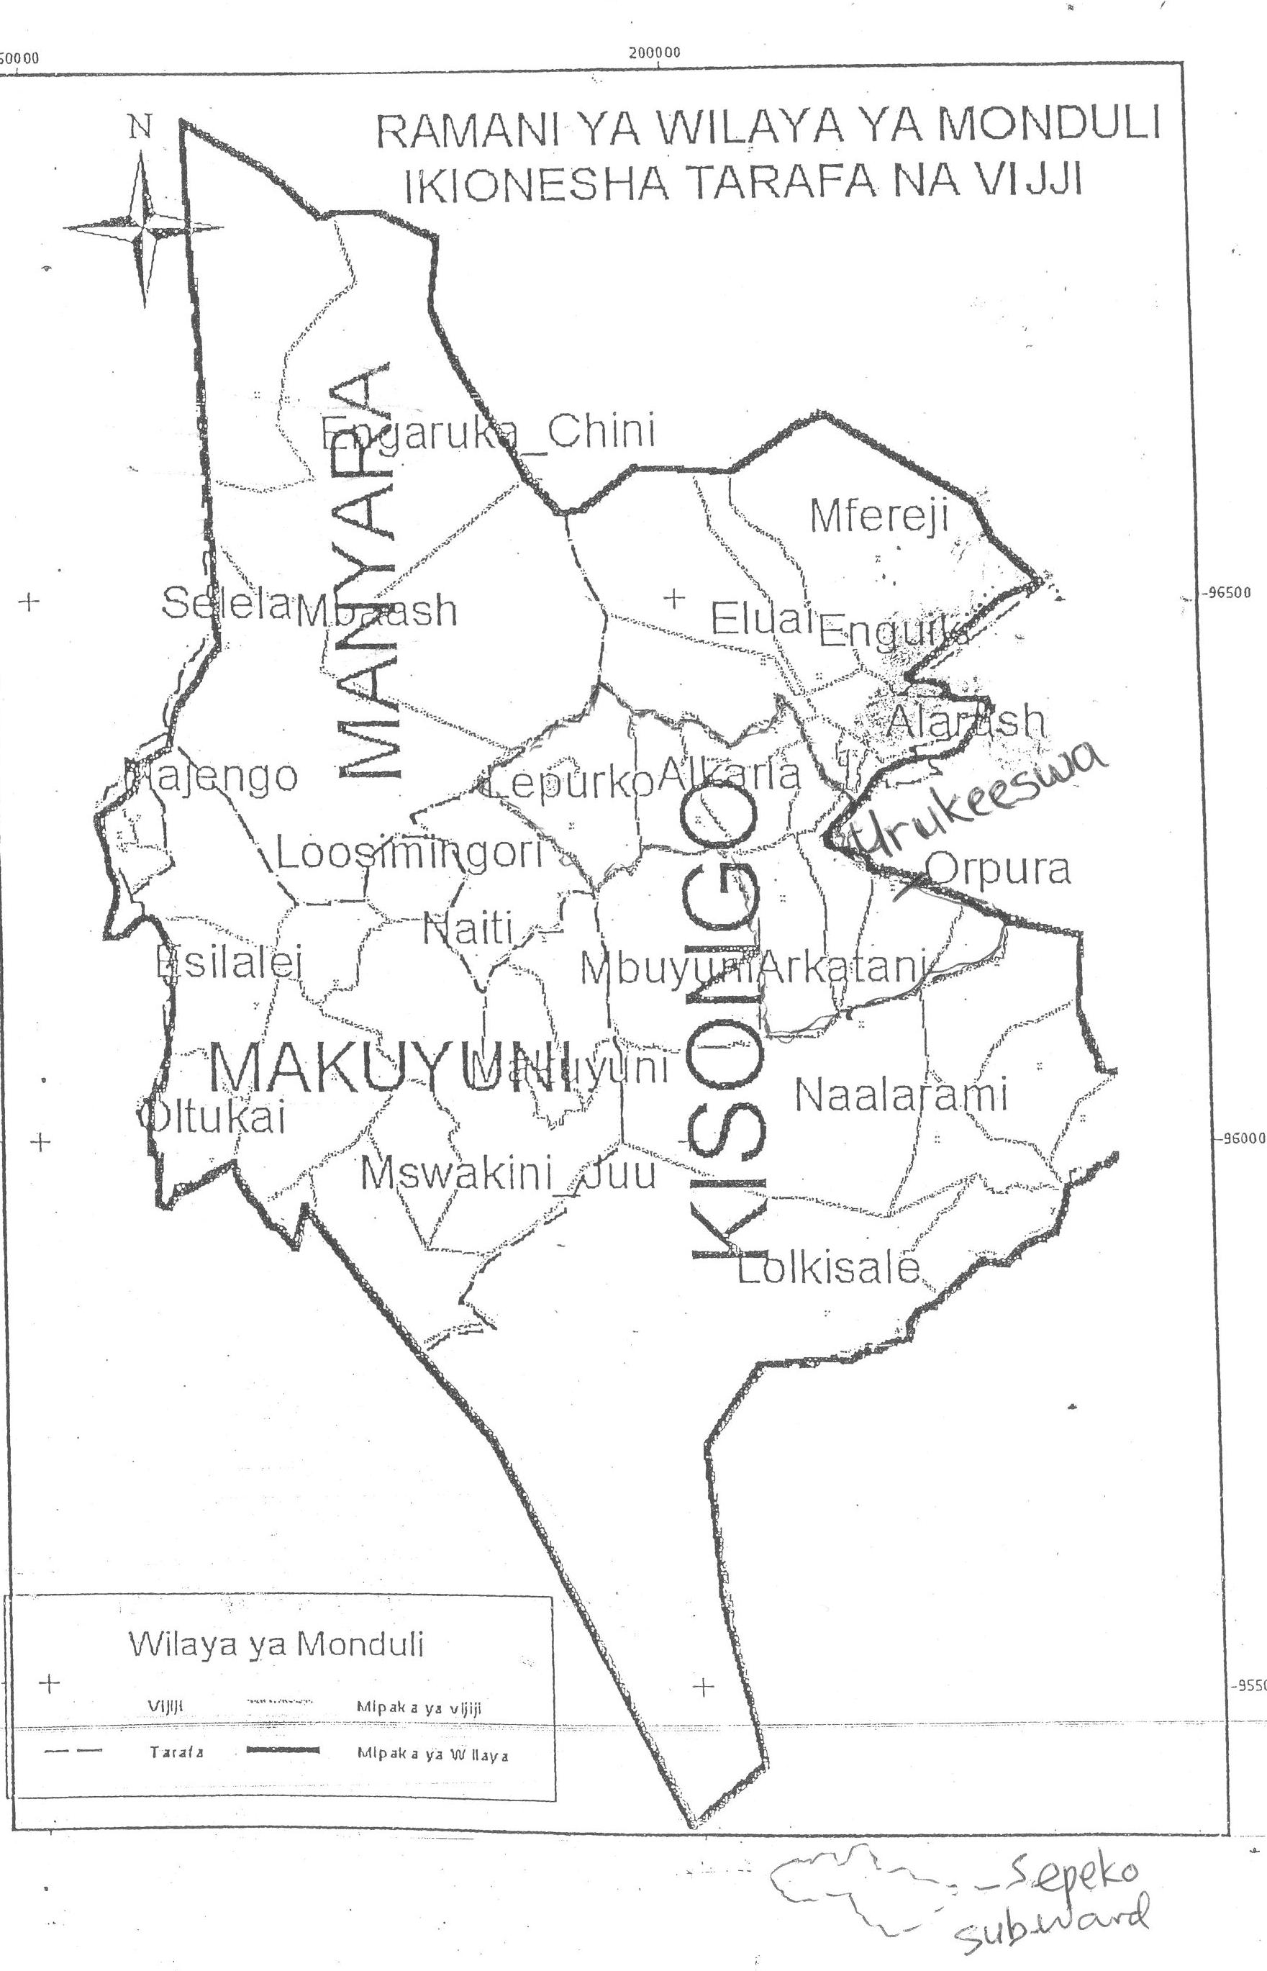 Figure 1: Map of Monduli showing Ward and Villages.
Source: Monduli District Council, 2009

The main economic activities of Urkeeswa village are livestock keeping and agriculture production. More that 90% of the population is engaged in livestock keeping and agriculture (Monduli District Council, 2009).
Table 1: Farmsize per household
 | Frequency | Percent | Valid Percent | Cumulative Percent
1 Hectare | 11 | 36.7 | 36.7 | 36.7
2 Hectares | 7 | 23.3 | 23.3 | 60.0
3 Hectares | 5 | 16.7 | 16.7 | 76.7
4 Hectares | 4 | 13.3 | 13.3 | 90.0
More than 5 hectares | 3 | 10.0 | 10.0 | 100.0
Total | 30 | 100.0 | 100.0
Source: Research Findings, 2011

The village is estimated to have 42 hectares of potential arable land but only 33 hectares are under cultivation which is about 8% of the total village land.
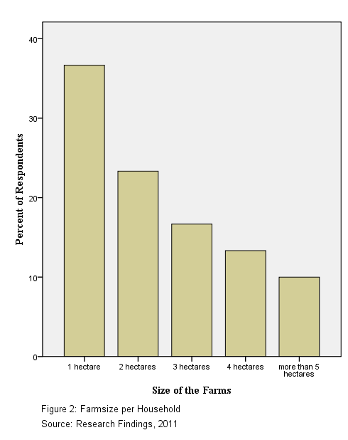
No large scale farming is practiced in this village rather; subsistence farming is the main form of farming. Major food and cash crops are maize, beans, and paddy which are the leading staple food crops. Tobacco and sunflowers are grown at s small scale.
Livestock keeping is the main predominant economic activity, which is if properly managed, could significantly contribute to the village economy.
Table 2: Livestock kept per Family Unit.
 | Frequency | Percent
Cows, goats and donkeys | 16 | 53.3
Cows only | 5 | 16.7
Goat only | 5 | 16.7
Goat and Sheep | 4 | 13.3
Total | 30 | 100.0
Source: Research findings, 2011
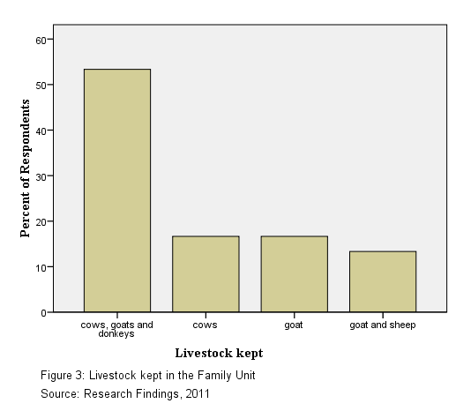
Data from the respondents’ interview showed that about 53% of the respondents family rearing cows, goat and donkeys. When asked why do they not concentrate in one type of animal keeping they said, this is according to their culture.

Cows symbolize the wealth of the family. The higher the number of cows the more wealthier the family is graded. Donkeys are more used in carrying domestic luggage and farm produces.
Table 3: Average amount of Livestock kept by the unit family
 | Frequency | Percent
1-5 Cows | 2 | 8.0
6-10 Cows | 3 | 12.0
10- 15 Cows | 4 | 16.0
16- 20 Cows | 5 | 20.0
More than 20 cows | 11 | 44.0
Total | 25 | 100.0
Source: Research finding, 2011

The leading activities for women to earn an income is selling of milk and doing casual labors in the farms of the farmers while men are more engaged in the business and rearing cattle.

Despite selling of milk being the leading activity for women to get their income, the amount of milk they get is not really reflect the labor which they employ in cow keeping.

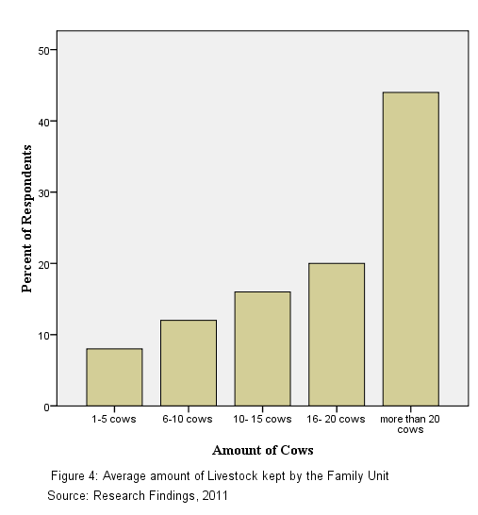
As indicated in the table below, a household can have up to five cows and yield the average of four liters of milk a day. When respondents were asked about the low yield in milk production 78% said they usually keep the local breeds which tolerate diseases and hardship of their environment but have less milk. Also they said that the milk produced is satisfactory for their family consumption.

Table 4: Average livestock kept by the Family Unit by Average Milk Production in Litres
Cross tabulation
 |  | Average milk production in litres per household family in a day |  |  |  |  |  |  |  |  |  |  |  | Total count
 |  | 2 | 4 | 5 | 6 | 7 | 8 | 9 | 10 | 12 | 15 | 20 | 22 | Total count
Amount of Livestock kept  by the Family Unit | 1-5 Cows | 1 | 1 | 0 | 0 | 0 | 0 | 0 | 0 | 0 | 0 | 0 | 0 | 2
Amount of Livestock kept  by the Family Unit | 6-10 Cows | 0 | 1 | 0 | 1 | 0 | 1 | 0 | 0 | 0 | 0 | 0 | 0 | 3
Amount of Livestock kept  by the Family Unit | 10- 15 Cows | 0 | 0 | 1 | 1 | 1 | 1 | 0 | 0 | 0 | 0 | 0 | 0 | 4
Amount of Livestock kept  by the Family Unit | 16- 20 Cows | 0 | 0 | 1 | 0 | 1 | 0 | 1 | 1 | 1 | 0 | 0 | 0 | 5
Amount of Livestock kept  by the Family Unit | More than 20 Cows | 2 | 0 | 3 | 0 | 0 | 2 | 0 | 0 | 0 | 1 | 2 | 1 | 11
Total |  | 3 | 2 | 5 | 2 | 2 | 4 | 1 | 1 | 1 | 1 | 2 | 1 | 25
Source: Research findings, 2011.

Many of the economic activities belong to men. Women might be doing their best in production but everything is appropriate to men. Women are usually own less valued properties and projects such as chicken keeping, taking casual labor in the farms of farmers, chopping of firewood and making charcoal.

According to Maasai culture, women are very much disadvantaged. Data from the interview explained that women are owners of the inferior income generating activities such as chicken keeping (in a very small scale), selling of milk in the market, fetching of charcoal and selling it to town dwellers, etc. Men work with superior income generating activities such as cow keeping farming activities, transportation of goods, etc.

Table 5: Properties owned based on gender
 |  | Frequency | Percent | Valid Percent | Cumulative Percent
Valid | chicken, making necklace | 3 | 10.0 | 10.0 | 10.0
Valid | selling charcoal, selling milk, casual labor | 2 | 6.7 | 6.7 | 16.7
Valid | casual labor in farms | 3 | 10.0 | 10.0 | 26.7
Valid | making necklaces | 3 | 10.0 | 10.0 | 36.7
Valid | selling milk, casual labor | 7 | 23.3 | 23.3 | 60.0
Valid | business, own farms and cars | 4 | 13.3 | 13.3 | 73.3
Valid | having cars and cattle | 3 | 10.0 | 10.0 | 83.3
Valid | having cattle and doing business | 5 | 16.7 | 16.7 | 100.0
Valid | Total | 30 | 100.0 | 100.0
Source: Research findings, 2011

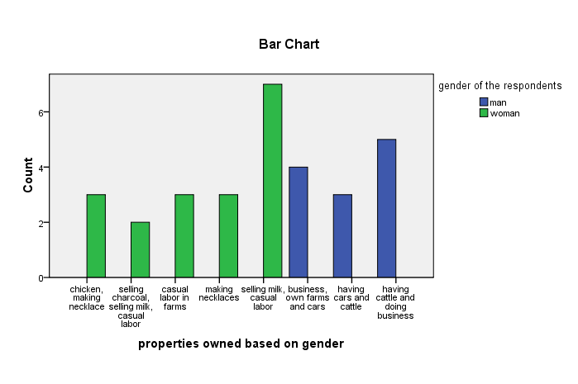
Figure 5: Properties Owned Based on Gender.
Source: Monduli District Council, 2009

Because of the nature of the Maasai people being people with shifting cultivation, it was very difficult for the government to organize the modes of school and education activities in the area. Maasai community value much on their way of life. Their culture and style of life make this community not to acquire modern way of life. Children from their childhood are oriented in livestock keeping activities and farming.

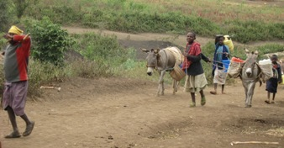 | 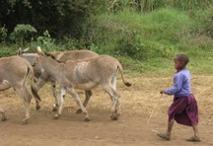 | 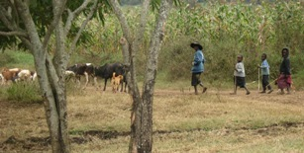
Plate 1: Maasai kids at Urkeeswa village are rearing cattle though it was a school day and time for school.
Source: Research findings, (2011)
The illiteracy level of the village is 68%; males being 36% and women are 64%. Because of low literacy level, many of Maasai people are employed in the private sectors as business people and also doing self employment as livestock keepers, and other job which are informal.

When asked why they don’t want to send children to school, 28% comment on the fact that what their children get from school is not relevant to their culture and customs. They like to stay with their children and teaching them about their traditional. 72% of respondents claimed about their culture as a shifting pastoralist to be the major reason. Knowing this problem, Municipal initiate a program of building schools to each village and by the end of 2007 whereby in the whole district there are 49 primary schools. Fee reduction and provision of lunch to primary schools enable high enrollment of pupils. The challenges which facing these schools are high dropout ratio, shortage of teachers in those schools, absence of teaching facilities and equipments such as desks. The major reason for dropout is the traditional fact that girls are involved in the early marriage and boys are forced to take care of the cattle.

Table 6: Reasons for Dropout by Sex from 2004- 2008 in Monduli District
Reason | 2003 |  |  | 2004 |  |  | 2007 |  |  | 2008
Reason | Boys | Girls | Total | Boys | Girls | Total | Boys | Girls | Total | Boys | Girls | Total
Truancy | 79 | 51 | 130 | 88 | 59 | 147 | 143 | 101 | 244 | 107 | 30 | 137
Pregnancy | - | 25 | 25 | - | 26 | 26 | - | 21 | 21 | - | 20 | 20
Death | 5 | 4 | 9 | - | 3 | 3 | 2 | 1 | 3 | 8 | 4 | 12
Other causes | 1 | 3 | 4 | 4 | 1 | 5 | 1 | 6 | 7 | 6 | 12 | 18
Total | 85 | 83 | 168 | 92 | 89 | 181 | 146 | 129 | 275 | 121 | 66 | 187
Source: Monduli District Council Planning report, 2009.
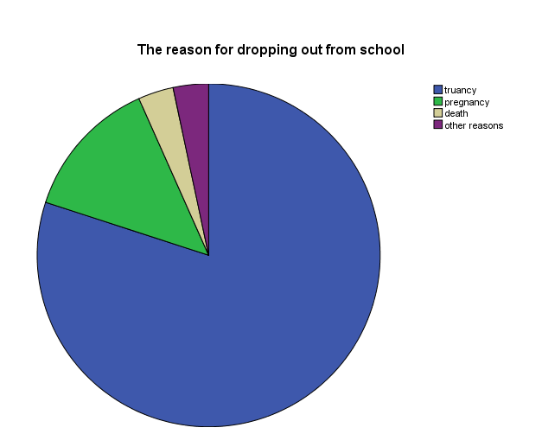
Figure 6: School Dropout Reasons
Source: Monduli District Council, 2009

1.1.1 Geographical Location
Urkeeswa village is one of the village in Sepeko sub-ward. Sepeko sub-ward is located in Kisongo ward in Monduli district. This district was established during the British colonial rule, the administrative area was named “Monduli Maasai district” which included the present Kiteto, Simanjiro, Ngorongoro, and Longido district. In 1979 the present Kiteto district was born out of the Monduli Maasai district . (then the present Simanjrio district was still part of Kiteto district). Since then the name of the district remained Monduli which included the Ngorongoro district until 1980 when Ngorongnoro stand as a solely district. In 2005 Longido district was born out of Monduli District. For that case, seven districts are now forming Arusha region. Those districts are Arusha town, Arusha rural, Meru, Longido, Karatu, Ngorongoro and Monduli districts.
Monduli district is situated between latitudes 3’00 to 4’50 south of the equator and Longitudes 36’50 to 36’45 east of Greenwich meridian. It is bordered by Arumeru District to the East, Ngorongoro and Karatu districts to the West, Mbulu and Babati districts to the South, Simanjiro district to the South East and Longido district to the North (Monduli District Council, 2009).
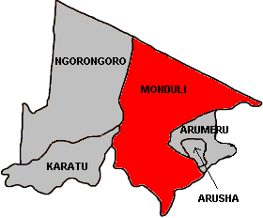
Figure 7: The map of Arusha Region with Monduli district highlighted red.
Source: Monduli District Council, 2011

The district has the total area of 6,419 sq. km of which 6,290.62 sq. km is land area, and 128,38sq.km is covered with water. Of the total land area; 3,983.85sq.km is grazing land; 876.32sq.km is area under cultivation; 1,055.47sq.km is arable land and 374.96 sq. km is under forest.

1.1.2 Demography
The population of Monduli is recorded to be 111,163 with the growth rate of 3.9% (National Census, 2002). In this case males are 54,068 while women are 57,095; sex ratio being 95 men to 100 women. The major ethnic group is the Wamasai (40%), Waarusha (20%). The rest who are non-indigenous who constitute 40% of the entire population.
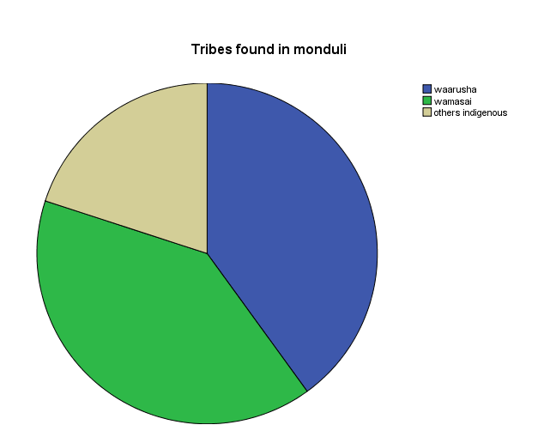
Figure 8: Tribes which are Found in Monduli District
Source: Monduli District Council, 2009

1.1.3 Economic Activities
More that 90% of the population is engaged in livestock keeping and agriculture (Monduli district council, 2009). The district is estimated to have 105,547.5 hectacres of potential arable land but only 87,632.5 hectares are under cultivation which is about 13.6%. Although large scale farming is practiced in the southern part of the district (Lolkisale), subsistence farming is the main form of farming. Major food and cash crops are maize, beans, and paddy which are the leading staple food crops. The district per capital income was estimated to be 211,630/- per annum (2002) to 500,010/- per annum
in 2010. This can be tabulated as follow:

Table 7: Monduli District economy.
Year | Per capital Income | Per capital Growth | % Growth
2002 | 211,630
2004 | 320,044 | 108,414 | 51.22
2006 | 399,594 | 79,520 | 24.84
2008 | 500,010 | 100,416 | 25.12
Source: Monduli District Council, 2009
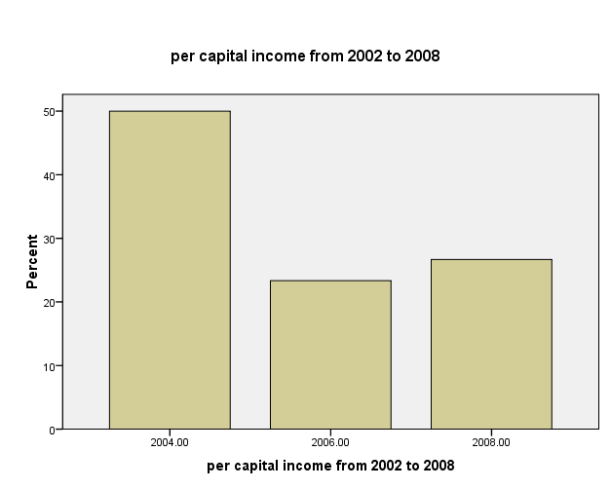
Figure 9: Per capital income of Monduli community from 2002- 2008
Source: Monduli District Council, 2009.

The graph above indicate the sharp rise of per capital income in 2002 and 2004 and also
a sharp drop in 2004 and 2006 based on the difference of the rise of per capital in those years. This was accounted by the bad weather conditions in which many livestock die for hunger and so production and sells went down. Declining heard as a results of diseases and bad weather conditions led to high mortality rates, droughts, increased cattle sales for cash (though at a very low price) which lead to a decline in cattle per capital.

1.1.4 Health facilities
At present, the district has 24 dispensaries. Two dispensaries are center in town and the rest in the villages. Some of the villages do not have any dispensary. People are travelling long distance to the nearby dispensaries to get medical services. In Monduli, each dispensary is serving an average of 5,645,625 per year.

1.2 Urkeeswa Village Community Needs Assessment
Community Need Assessment (CNA) for Urkeeswa village connotes a means to access community current situation, in order to make value based judgment regarding to the valuable concerns which are raised, resources available in the community and desired output for the community development. These including gathering community opinions about developmental services which are found in the community, community satisfaction with those services, kind of services which are needed to be present within their locality and determination in prioritizing community concern based on the situation at hand.

The CNA has been much focused to women because in Maasai community women are marginalized and discriminated. They are the victim of gender violence and they are not allowed to make decision on matters in the community. One of the major reason for this is that they don’t have economic power, which lead them to be inferior in decision making and all matters concern social issues.

1.2.1 Objectives of Community Need Assessment

1.2.1.1 General Objective
The general objective of the CNA is to enhancing women to form income generating activities and assessing their contribution to the household income and community development.

1.2.1.2 Specific Objectives:
Specific objectives of the CNA are as follows:
- To identify opportunities present in the community so as to highlights areas of potential concerns.
- To conduct trainings to five Urkeeswa women groups on how to run Income Generating Activities for them to utilize the opportunities present in their community.
- To establish two viable and sustainable generating activities by the end of 2011.

1.2.2 CNA Research Questions
- What are your opportunities present in this community?
- What are the major issues to be addressed for the development of this
community?
- What kind of the income generating activities which could help women to
improve their wellbeing and that of the community?

1.2.3 Community Needs Assessment Methodology
The quantitative and qualitative methods were used to explore both qualitative and quantitative needs in the community. Every assessment used specific methods according to the nature of the assessment.

1.2.3.1 Research Design
The research design has been considered as a "blueprint" for research, dealing with at least four problems: what questions to study, what data are relevant, what data to collect, and how to analyze the results. Claire, (1962:50) quoted by Kothari, (2004:31) define research design as the arrangement of conditions for collection and analysis of data in a manner that aims to combine relevance to the research purpose with economy in procedure.

Research design is important in order to facilitate smooth sailing of the various research operations, thereby making research as efficient as possible yielding maxima information with minimal expenditure of effort, time and money. Research design stands for advance planning of the methods to be adopted for collecting the relevant data and the techniques to be used in the analysis.

This study follow a case study designs whereby researcher examines situational conditions of women in Urkeeswa village, their participation in income generating activities and their economic contribution to community development issues through field survey, observations and structured interview questions.

Both Quantitative and Qualitative data were gathered and analyzed to explore the women situation in Urkeeswa village. Qualitative data refers to categorical data which are not expressed in terms of numbers, but rather with descriptions. The qualitative data in this study was done through observation of women and community situation in general. These include the wealth situation of women in Urkeeswa village, health condition of Urkeeswa community and the information on contribution of Maasai culture to women discrimination. Quantitative data were also collected and indicate the farm size occupied the members in Urkeeswa village, the increase of per capital income of Monduli district, average daily milk production in the Urkeeswa village, the number of students dropout from 2003- 2008 and its impact to education sector in this area. The assessment focused on four main areas namely community, economic, health and environment needs assessments.

1.2.3.2 Sampling Techniques
Sampling techniques refers to the part of statistic practices concern with the selection of a subset of individuals from within a population to yield knowledge about the whole population, especially for the purpose of making predictions based on the statistical inferences

In order to avoid high cost of conducting this research, and because of the dynamism of the population under study (Maasai community have a tendency of shifting cultivation and their settlements are scattered all over their places which could meaning more time, and other resource for conducting a research), researcher decided to do sampling to get population which will represent the entire population of the area under study. Sampling population ensure homogeneity and improve accuracy and good quality of data to be analyzed (Ader and Hand, 2008).

One hundred respondents were purposively obtained from a population of 633 women from Urkeeswa village. This was done in order to select committed respondents who will be available during project implementation because Maasai community has a tendency of shifting from one locality to another. Selected respondents assured that they will be available in their localities for the whole duration of the project without shifting to other places, and they were willing to participate in the project.

From this population, five groups of twenty women each were formed using purposive sampling based on their homogeneity which was mainly their geographical location. This facilitate easily communication between the group members because they were easily reachable by themselves when plan for any group activity. Thereafter, simple random sampling was used to select six women from each group, so ending up with 30 women to be used as respondents in the study. Purposive sampling was also used to include village leaders and organization leaders (Monduli CDTI Women Information Window) which work in the community area with women groups. In this case the Village Executive Officer (1 position) and Wards Executive officer (1 position) were included, together with the Organization officer of that locality (1 position) were added in the list of respondents and makes the total number of respondents to be 33.

1.2.3.3 Data collection Methods
Several meetings were conducted between women groups and the researcher under the WIC umbrella. There were good coordination between the researcher, WIC office and women group with the purpose of assessing women situation in their areas, analyzing women concerns and find solutions to the highlighted issues. Mrs. Sakita did a lot in mobilizing women to form groups after she had attended a train on gender based violence coordinated by WIW, CDTI Monduli Structure. She then got courage and wishes to assist other women in Maasai area to get the same training and other form of training in order to be aware of their situation and get out of vicious cycle. Apart from Mrs. Sakita, other chairpersons of the five women group were also providing a helping hand to assist the
researcher to perform the Need Assessment in their area.
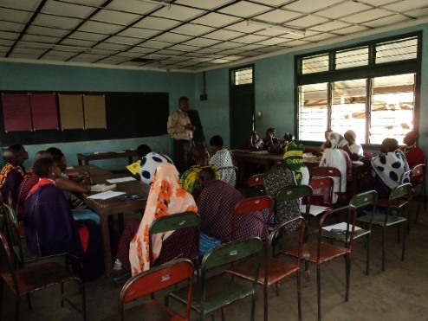 | 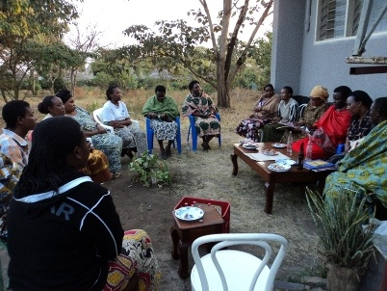 | 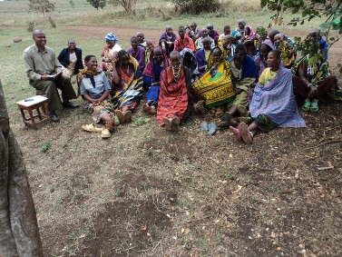
Plate 2: Some Maasai women from Urkeeswa village attend meetings on CNA.
Source: Research findings, (2011)
The Community Needs Assessment (CNA) in Urkeeswa village took place between 17th March to 17th April, 2011. Two weeks were used by the researcher to meet with the community leaders and make arrangements to identify and formulate women groups; and prepare a CNA team to work in the community. Two days were used by the CNA team to facilitate a series of group discussion sessions with the community representatives whereby researcher had meetings with them at Monduli Community Development College. Then, another five days were designated for informal households’ structured interviews which were conducted using semi structured interviews, transect walk and observations. The followed four days were used to present the findings of the CNA to the community, ranking local problems and opportunities for rural development and selecting priority projects.

17 - 31/03/2011 05/04- 06/04/2011 13- 17/04/2011
Meet with community leaders Arrange group discussion Presentations, ranking ` and Prioritization

Ma rch
MARCH APRIL

07 - 11/04/2011
Conduct structured interview, Transect walk and observations

Figure 10: Time table for CNA activities.
Source: Research findings, (2011)

The last day was also spent on detailed action planning for the selected priority projects, resulting in a community development plan. The use of O&OD techniques has made it possible to gain insight into the community situation, determine the status of existing development initiatives, know the communities’ ranking of activities in terms of priorities, and establish the needs and demands of the community in terms of technical assistance, organizational training, materials, and funds. CNA techniques have been employed to gather information on the status of natural and local conditions of prospective area of development, social economic characteristics, existing cropping pattern, existing development activities, marketing structures, institutional arrangements, rural infrastructure, environment status, development constraints and opportunities, and proposals for future development.
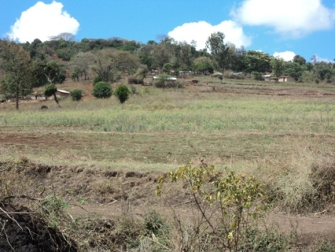 | 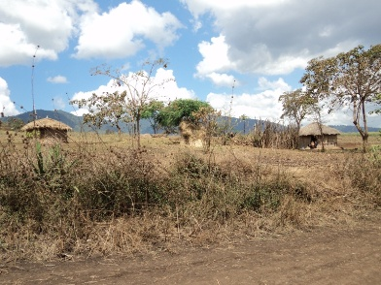
Plate 3: Photos taken by a researcher during transect walk showing a scattered households of Maasai community.
Source: Research findings, (2011).

1.2.3.3.1 Primary Data
Primary data were collected from the study area by using the following tools and techniques:
- Structured Interviews
Structured interviews are a means of collecting data for a statistical survey. In this case, the data is collected by an interviewer rather than through self-administered questionnaires. Interviewers read the questions exactly as they appear on the survey questionnaires. The choice of answers to the question is often fixed, i.e. close ended in advance. This way also provides the author to ask question depend on the response of the respondent, especially where more clarification is needed. Structured interview method was used for community members from the five women groups to have different views about their community (Appendices I and II)
- Questionnaires
Questionnaire is a research instrument consists of a series of questions and other prompts for the purpose of gathering information from the respondents. Questionnaires were designed to get information about community characteristics, economic issues, health assessment and environmental conservation issues from the Village leaders and Institution organization (Monduli CDTI Women Information Window).

- Observation
Researcher used observation to see the patterns of behavior in the community together with their life standards and conditions. Also researcher got time to visualize economy status, health and implementation of environmental conservation programs in the community.

- Transect walk
This method was used to observe the natural resources in the area and was made by women groups representing other women in the community.

1.2.3.3.2 Secondary data
Secondary data were collected through documentation. Valuable background information were collected from publish and unpublished literature. These are such as Monduli District Council Reports, books, journals, reports and news papers.

1.2.3.4 Data Analysis Methods
Data analysis is defined as a practice in which unorganized or unfinished data is ordered and organized so that utile information can be highlighted from it. It involves processing and working on data, in order to understand what all is present in the data and vice versa.
Usually data analysis methods are designed to polish and refine the data, so that the end users can reap interesting or useful information without any need of going through the entire data.

In this case, this data analysis applied descriptive statistics whereby data were analyzed. The analysis was done using different types of analyses methods such as frequency counts, descriptive statistics (mean and median), normality (frequency, histograms and normal probability plots) and find out associations of data using correlations and cross tabulations between variables.

To make it simple, the SPSS programs has been employed to treat into histograms and pie charts before researcher spoke of the data.

1.3 Community Need Assessment Findings
Urkeeswa village is about six kilometers from Monduli town. Due to patriarch system, women are marginalized and take very minor part in leadership and other administration issues of the village; neither do they own any high income generating activities.
Illiteracy is very high especially to women. More than 80% of women involved in the exercise couldn’t write and read.
Table 8: Literacy Level of the Urkeeswa village
 |  | Frequency | Percent | Valid Percent | Cumulative Percent
Valid | Able to read and write | 6 | 20.0 | 20.0 | 20.0
Valid | Unable to read and write | 24 | 80.0 | 80.0 | 100.0
Valid | Total | 30 | 100.0 | 100.0
Source: Research Findings, 2011

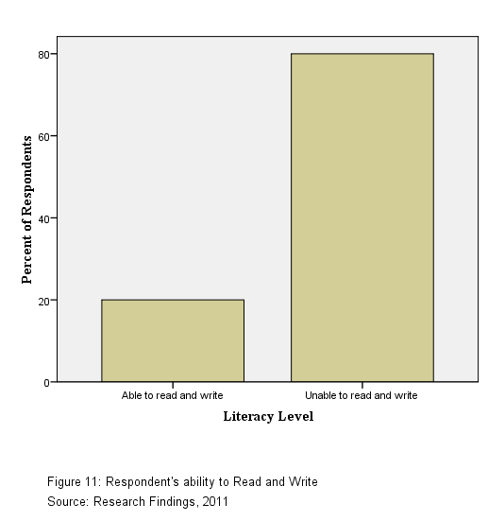
Poverty in the village is very pervasive. There is no dispensary nearby. The community depends on health service from the District hospital. The village has one primary school. The road network is poor with no plan. The major transport system is donkeys which are also used for agricultural activities. Another means of transport is motor vehicles, and taxes which are very expensive to hire in order to reach those areas. Education facilities are not sufficient as the population in the area is scattered and children used to walk long distances for primary education. There is no secondary school in the village, besides, pupils are walking over 6 kilometers to come to town for secondary school education.

For the purpose of making broader analysis, four distinguished assessment areas, namely: community in general, economic issues, health and environment issues were considered. Several tools were employed as responding to the nature of assessment.

1.3.1 Economic Assessment Findings
The assessment discovers that, women do not own strong income generating activities. Source of income for men are the sales of livestock, farm produce, skin and hides products. A number of women from the village are employed elsewhere especially during cultivation period where they till land, sow seeds, weeding and harvesting. Other are involved in making and selling of necklaces and other are selling milk.

Table 9: Source of income for women
 | Source of Income | Frequency | Percent | Valid Percent | Cumulative Percent
 | Agriculture | 18 | 60.0 | 60.0 | 60.0
 | Selling necklace | 4 | 13.3 | 13.3 | 73.3
 | Selling milk | 8 | 26.7 | 26.7 | 100.0
 | Total | 30 | 100.0 | 100.0
Source: Research findings, 2011

60% of the respondents indicated that the major source of income to women is from agricultural activities. The fact is that; women work as cheap labor in the farms of other people where they can be paid and earn the income. This is mostly happen during agricultural seasons. 26.7% of respondents showed that women depend on selling milk as their income activity. When asked why do they selling cow products while claiming that they do not owned cow, one women said, “usually women do not possess cows; what they are doing is as if they have been employed by men to work on cattle, but when a man want to sell the cow, woman will not be consulted neither knowing how money obtained has been used.” She also adds that they are allowed only to use and sell milk but not utilizing other livestock products for instance skin.

Women usually are the ones who take care of the family; so they usually bring some income to their families. Household’s income is mainly spent on buying clothes, children books, paying schools fees and buying school stuffs. After formulating the groups, women decide to contribute monthly amount which is 2000 per month, and get into the group pocket fund. This money is collected by one of them as an accountant and they used to circulate again as a loan with 10% interest to boost their capital. This is the only source of money which they have as groups project. But again, some of them fail to pay the monthly amount and lead to group misunderstanding. And this has reduced the number of group members to some of the groups. Another concern is that some people want to get more loan and the group pocket cannot offer them that amount. Maximum loan amount is fifty thousand Tanzanian shillings which is not enough to be a capital for even a medium income generating activity. Most of them use the money to pay school fees for their children or doing some domestic activities. The extra food during hard times is brought from Monduli town where there are two markets.

The wealth of the Maasai men is based on the number of cows one has. This phenomena
makes the issues of destocking to be very difficult, as Maasai can not appropriate the value of their stocks in to other development issues such as building modern houses, taking children to school, having dispensary and school nearby, and the likes. Deliberate efforts are employed by both state and non state organizations to stop this behavior. This include building schools and health facilities nearby and extension officers are passing once in a while treating their cows, but also informing them the importance of having small number of cattle, and the appropriation of their stocks into other development issues. Women posses no wealth in the Maasai community. They are actually posses non valuable assets such as chick and egg products. May be this could provide enough money if it could be well monitored and taken care of. But even in Maasai way of life, they say maasai men cannot eat ‘birds’.
Because of the poor economic value of their properties, the access to financial loan from financial institutions become very difficult or not possible at all. There is one bank in Monduli, which is National Microfinance Bank (NMB). When Loan officers go to the village to make economic assessment for collateral owned by the people, they found almost nothing. Although maasai have great number of cattle, but they can die at any time when there is diseases or heavy drought. So, if not using influential people such as member of parliament, ward executive officers or ward councilors, who used to surrender their accounts or other form of wealth materials to the bank, then it could be impossible for Maasai people to access loan from the bank.

Women group formulated by WIW office they used to contribute a certain amount of money to boost their group and also the money act as a revolving fund for their group. There are about 4 informal community based organization and two formal organizations which are really attracting new growth in the village. The cost of establishing these new
facilities are taken in cost sharing manner between community and development actors.

1.3.2 Health Assessment Findings
The district hospital is found about six kilometers from the village. The hospital is equipped with adequate human and material resources to render services to those who come to attend health services in district of Monduli. But this adequacy is for those who come to seek medication in the hospital. No health centre in the Urkeeswa village, and the hospital do not have enough facilities such as cars and moving doctors to reach each village. So patients should attend hospital. The village do not have car to move any immergence case from the village to the hospital. When asked whether women in Urkeeswa village used to attend anti natal clinic; 90% of the respondents said women in the village do not attend antenatal clinics.
Table 10: Whether women attending antenatal clinic
 |  | Frequency | Percent | Valid Percent | Cumulative Percent
 | Yes | 3 | 10.0 | 10.0 | 10.0
 | No | 27 | 90.0 | 90.0 | 100.0
 | Total | 30 | 100.0 | 100.0
Source: Research findings, 2011.

This is to say that most of the women in Urkeeswa village do not attend antenatal clinic. It can be contributed by a long distance and poor infrastructure for women to attend in the hospital. Also respondents said that Maasai women are used to the local medication and see no importance to at`tend clinic. “What they we can do is to take babies to the clinic and not the pregnancy”, one woman explain. When asked if men are accompany them to the clinic, women comment that, men can not accompany wives to attend clinic, because they feel it is not their responsibility to know the health of the children. Another issue is about Female Genital Mutilation. 56.7% of the respondents comment on Female Genital Mutilation (FGM) as the health challenge in their area.

Table 11: Common health issues in the area
 |  | Frequency | Percent | Valid Percent | Cumulative Percent
 | Zoonotic diseases | 3 | 10.0 | 10.0 | 10.0
 | FGM | 17 | 56.7 | 56.7 | 66.7
 | Malaria | 4 | 13.3 | 13.3 | 80.0
 | Dysentery | 6 | 20.0 | 20.0 | 100.0
 | Total | 30 | 100.0 | 100.0

Source: Research findings, 2011

When asked why this is so a big problem one woman comment that, “The issue of FGM has a penetration to their culture and a woman who have not undergone FGM is not accounted as a brave woman who can be given responsibility and take care of the community to pass the ties and rules from one generation to the next”.

Government, together with some NGOs which are working in the community try to educate the women society to avoid such abuse to women. For example, one NGO known as MPDI start to initiate a girl students of primary and secondary school to view FGM as an insult to women. Expectation is that the coming generation will view FGM in a different manner as compared to their parents. Also boys have to be educated on the effects of FGM because they are the one who will marry women who have not undergo FGM. Previously a woman who run away from FGM will never get a husband because she is counted as a traitor, and the betrayal of the Maasai community; hence no man will bring marriage proposal to the parent of the girl. Also she is counted as a women who bring shame to the family by running away from FGM.
The surroundings of Maasai family is not that much clean. 20% of the respondents comments on dysentery as one of health issues which facing the community. If one visit their household, there are lot of flies around, probably because they keep cattle in nearby places which 10% of the interviewed respondents said that there is a prevalence of zoonotic diseases in the village. Therefore, sanitation status of the village is very poor and it was observed that more than 90% of the households do not have permanent toilets.

1.3.3 Environment Assessments Findings
The main trees in the village are acacia spices which are mainly used for fencing the homesteads and building. Others trees are shrubs such as cactus and euphorbia which also used for live fencing. In many area of Urkeeswa, land is bare and you can easily see from a distant where the village is.

When respondents were asked about this situation they said, “We usually chop trees for charcoal making in order to sell it to the town to earn income”. There is existence of bylaws which forbid people to chop trees but still the activity is performed and the impact is now being observed because they say, they are now experiencing lesser rainfall for the past five years. Agricultural activities is carried on in some parts of the village where people are cultivating even in the slope areas which it facilitate soil erosion. Still this area seemed to be fertile because people are claimed not to use chemical fertilizers and they harvest though not too much They also apply cow dung in their farms which they take from their cowshed ‘bomas’. There are preserved areas specifically the water sources. Also there are areas demarcated for cultivation and for feeding cattle.

1.4 Community Needs Prioritization
This is used to involve people in prioritizing their needs and type of development
initiative suited to local needs. Involving community facilitate a process of democratic prioritization by the entire community, ensuring people’s involvement in their own development. Researcher also focuses on the fact that although all identified needs are important, we are bound with the limited time and resources available in addressing all the identified concerns.

We have also discovered that community concerns are multidimensional, so sometimes addressing one issue may help to solve other issues. This was performed using paired comparison technique which helps to determine which issue is to be removed or to be retained. It directly compares one issue to another and allows for the group to decide between two equally important issues. In this case community had issues which they prioritized. These include the need for having skills of reading and writing, development of income generating activities, the need to improve road infrastructures, clean and safe water supply, abandonment of the patriarch system in their community, construction of the village health centre and construction of a village primary and secondary schools. Because of scarce resources respondents were asked to narrow down their preference with the help of the ranking Matrix. This was performed by drawing the agreed symbols on a manila sheets which representing the needs of the community.
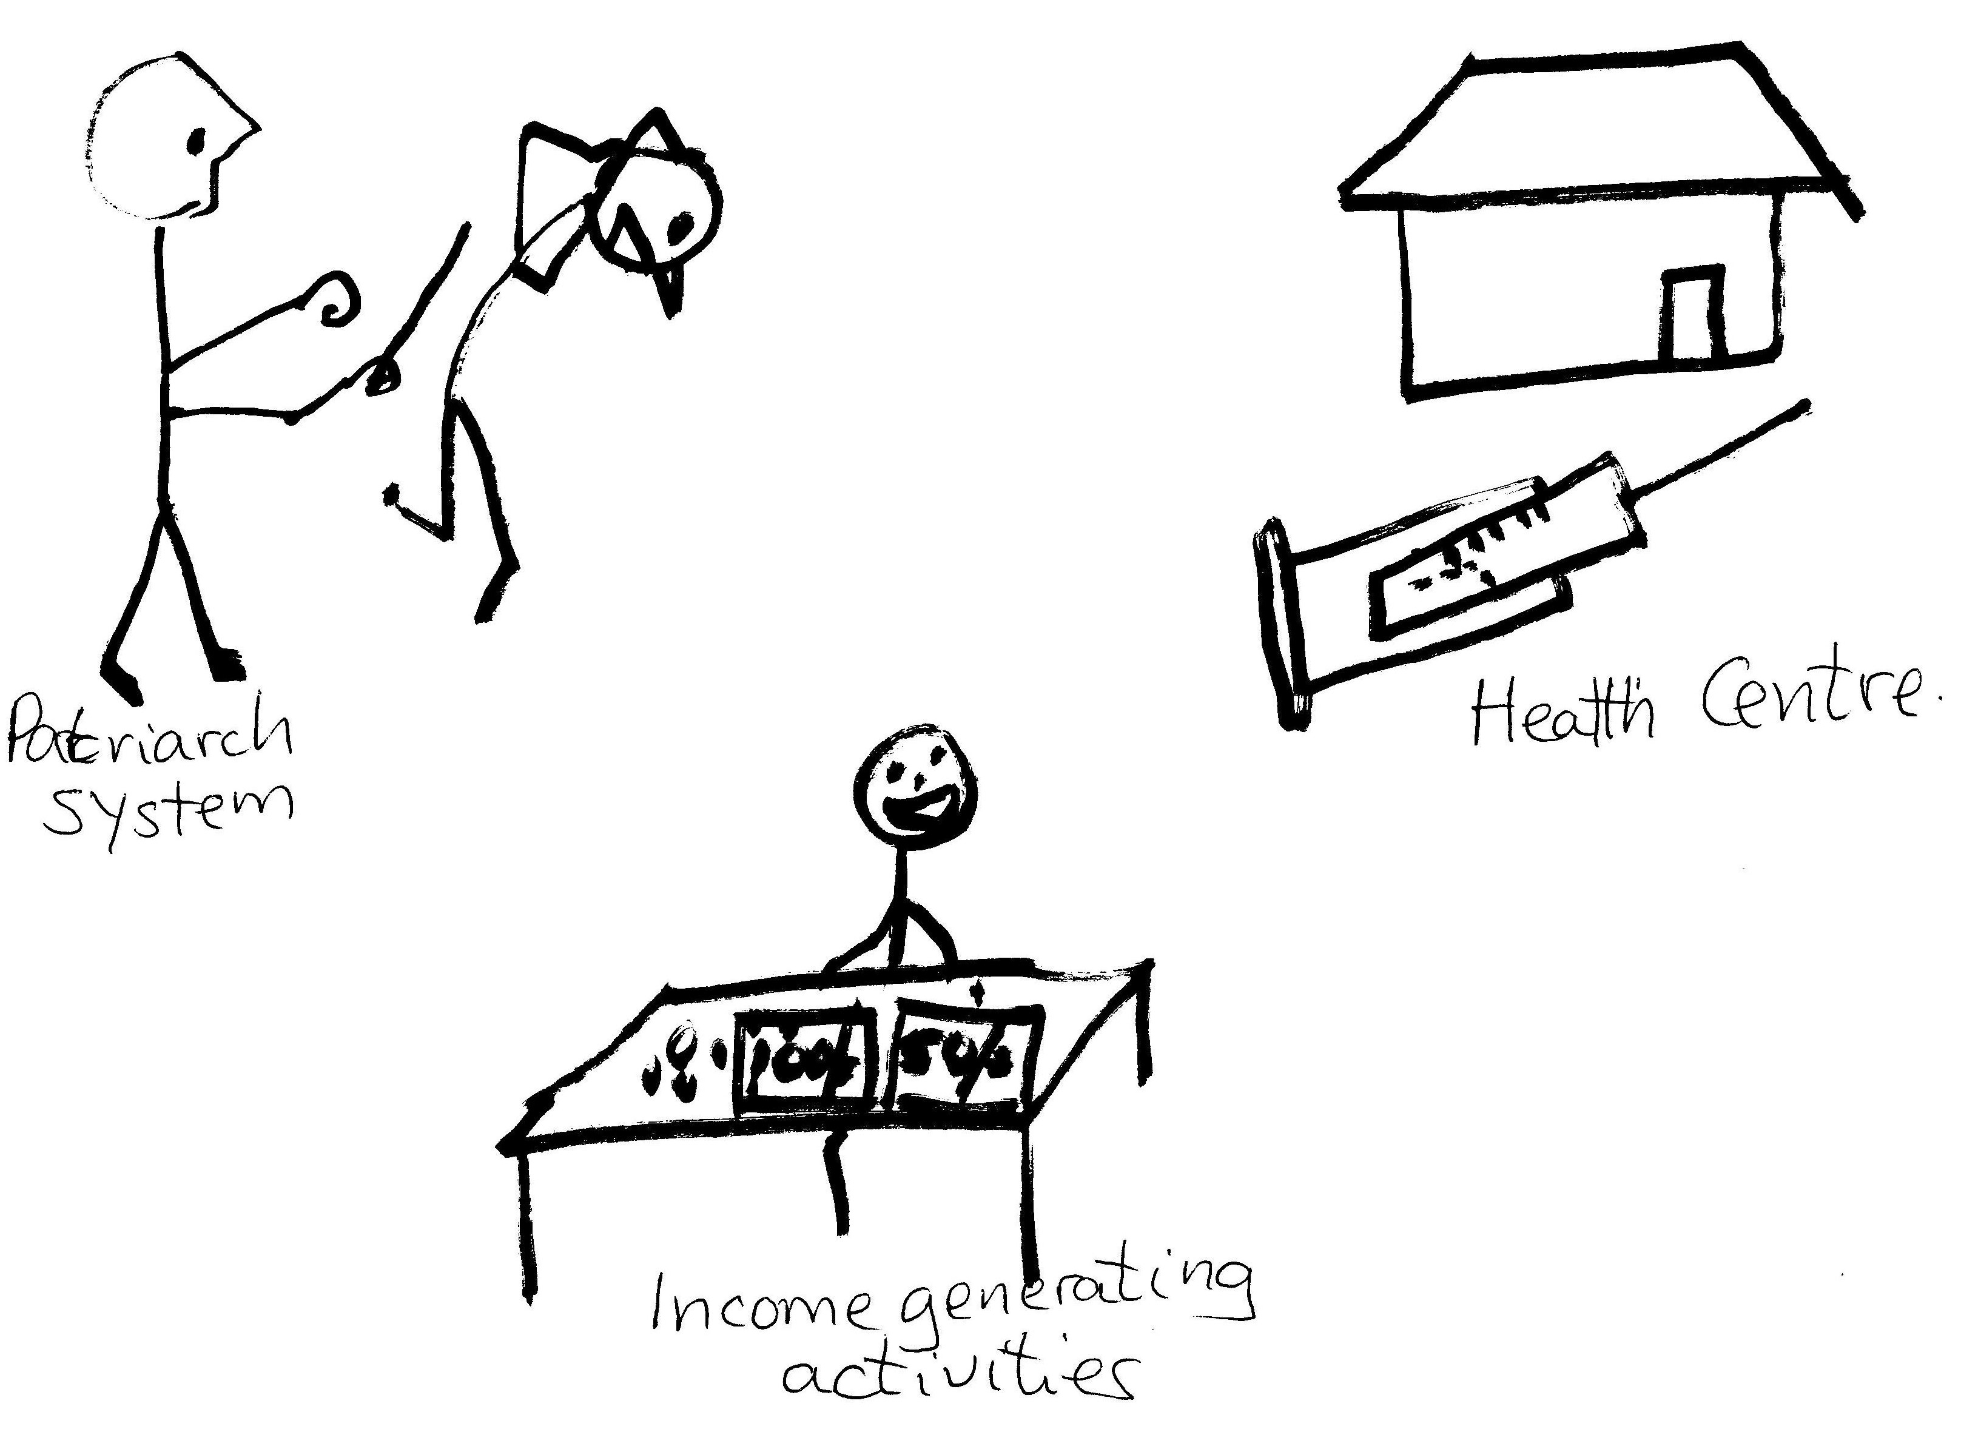
Figure 12: Symbols Representing Community Prioritized Needs
Source: Research Findings, 2011
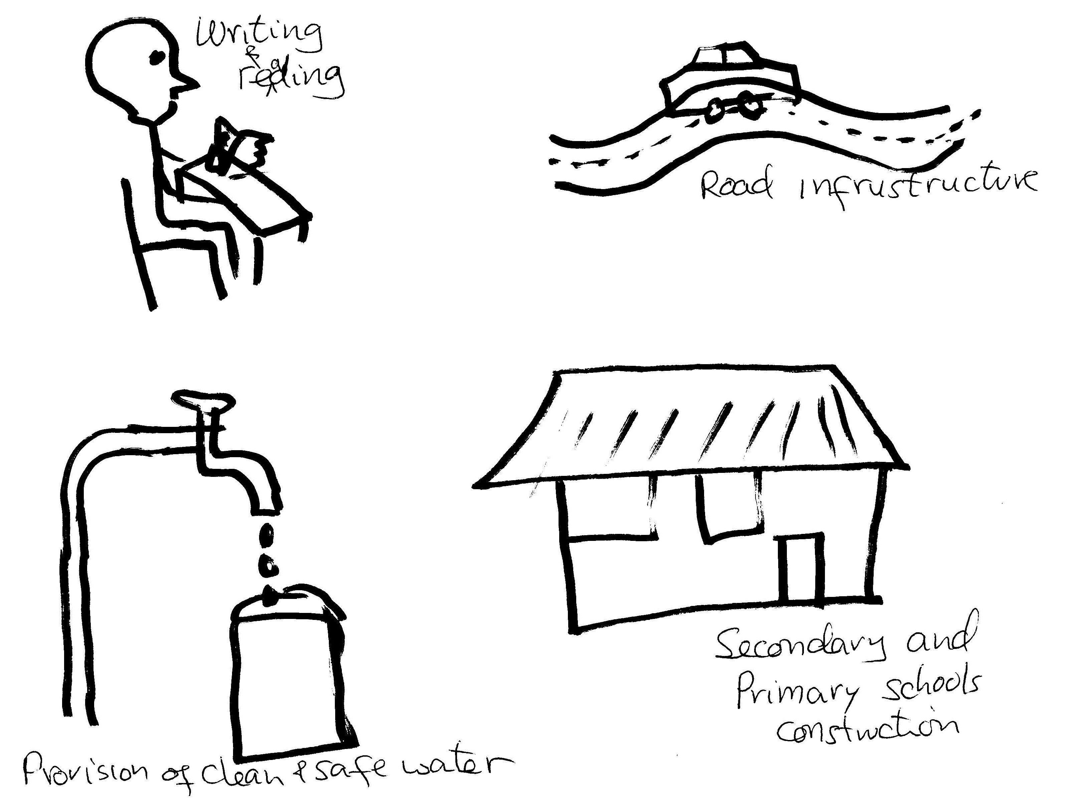
Figure 13: Symbols Representing Community Prioritized Needs
Source: Research Findings, 2011
Each respondent had to choose between the two matched symbols. Every symbol was compared in a matrix way with no repetition and the average of this exercise give rise to a summary shown below:
Table 12: Community Need Assessment ranking
ISSUES ARISED | Reading and writing skills | Income generating activities | Road infrastructure | Clean and safe water | Patriarch system | Health centre | Primary and secondary school | Total score | Ranking
Reading and write skill | Reading and writing | Income generating activities | Reading and writing skills | Clean and safe water | Reading and writing skills | Reading and writing skills | Reading and writing skills | 5 | 2
Income generating activities |  | Income generating activities | Income generating activities | Income generating activities | Patriarch system | Income generating activities | Income generating activities | 6 | 1
Road infrastructure |  |  | Road infrastructure | Clean and safe water | Patriarch system | Road infrastructure | Primary and secondary school | 2 | 5
Clean and safe water supply |  |  |  | Clean and safe water supply | Clean and safe water supply | Health centre | Primary and secondary school | 4 | 3
Patriarch system |  |  |  |  | Patriarch system | Health centre | Patriarch system | 4 | 3
Health centre |  |  |  |  |  | Health centre | Primary and secondary school | 3 | 4
School nearby |  |  |  |  |  |  | Primary and secondary school | 4 | 3
Source: Research findings, 2011.

Symbols were used because many of the respondents do not know how to read and write. So researcher opts to a technique which made all respondents to participate freely without feeling shy of not knowing how to read or write. Total scores were calculated by counting the average number of times the symbol was selected by the respondents. In this case, skill to know how to read and write counted 5 times, income generating activities counted 6 times, road infrastructure 2 times, clean and safe water supply 4 times, abolition of patriarch system 4 times and having a health center 3 times and having a school nearby 4 times. Therefore, because having income generating activities score the highest, this was the project selected to be implemented in the Urkeeswa village.

1.5 Chapter Conclusion
Community Need Assessment has many techniques to arise the real situation of the villagers, the opportunities and obstacles which they face towards development. There are lots of opportunities in this community of which if at all will be fully utilized, it will enable the community to generate richness and eradicate poverty which persist in the Urkeeswa village.

Indeed community need to strive and get to know that development which comes from their own initiatives sustained longer than the one they inherit as a gift from investors or the government. Community people have to change their mind set and strive with their own local resources to develop and run their own development programs. Anything they are doing should be productive, and they should realize profit out of it, for their own development.

Women should be empowered, especially in Maasai community. Women empowerment will bring the trickledown effect the whole community.

CHAPTER TWO

PROBLEM IDENTIFICATION

2.0 Introduction
This chapter will discuss problem facing women in Maasai community taking women in Urkeeswa village as the target area. The chapter will explain in detail the situation of women in this village and narrate the situation which needs to be changed, the extent and effects of the problem and what may happen if the problem is not addressed.

2.1 Background to Research Problem
Tanzania has signed a number of international protocols with commitments to promoting employment, best practices standards in employment, and women in employment. It also made a commitment at the fourth world Conference for women held in Beijing, China, in 1995, to address four areas of concern to women including women’s economic empowerment and poverty eradication, women’s education, training and employment.

Policies and programs to address these areas include the National Poverty eradication strategy, which seeks to ensure full participation of women in poverty eradication measures, and promote equality of opportunity for women, leading to a decent and productive life are some of so many initiatives which seems to enhance women development in the country. The question is: what is wrong with the implementation? Despite the fact that much of African economic activity is in the hands of women, especially in agriculture and informal business; still economic opportunities are often markedly different for men and women.

Women bear the brunt of domestic tasks that are often arduous, time- intensive, and
energy consuming. These include processing food crops, providing water and firewood and caring for the elderly and the sick (Amanda et al (eds), 2007:28). Although domestic duties consume time and efforts, they are not counted economically as productive work and so not included in the systems of national accounts

Gender differences persist across Maasai community in various sectors. This include education, legal status, cultural perceptions and in economic arena. Maasai community will likely to remain below its economic productivity level because of women’s unequal access to income generating activities and productive resources such as land, livestock keeping and women access to education to enhance their thinking capacity.

2.2 Problem Statement
The socio-cultural life patterns of Maasai community make women to be discriminated and unable to access economic opportunities present in their family.
Local government and other stakeholders played the role of empowering Maasai community especially women and children to form groups and initiate income generating activities. Poor managerial skills, failure to compromise with social cultural roles of women in serving their community and failure to acquire loans from the financial institutions jeopardized group sustainability.

This study explore the knowledge gap between the previous interventions in alleviate poverty to Maasai women and come up with the insights to broaden the way of enhancing women to acquire skills in group management and business skills; and so run a less task but profitable income generating activities which is beekeeping. The beekeeping project add, not only the nutritional value of its product to the family, but also as a less task but very payable income generating activity to women groups and later as an income
generating activity of the family.

2.3 Project Description
The project Title is: “Enhancing women to form income generating activities (IGA’s): A case study of Beekeeping Project in Urkeeswa village in Monduli District”

2.3.1 Targeted community
The project aimed to address five Maasai women groups in Urkeeswa village. These groups do not have a basic Income Generating Activities, apart from circulate the money which they are contributing monthly for their group to be as a loan for the group members who wish to take a loan for the returning interest of 10%.

2.3.2 Stakeholders
Apart from the Maasai women group in Urkeeswa village and other community members who are the primary stakeholders, there are other stakeholders such as:
- Local Government Authority which govern development activities of the community in Maasai area, under the Gender department. The Local government focuses on the improving people’s conditions and helps them to live a descent life. Therefore the local government is expected to provide support to the initiation of this project by registering the women groups and provide technical assistance whenever requested. Under this segment the VEO and WEO play the important part in organizing women to participate in this project for the community development.
- Arusha Beekeeping Association is the association situated in Arusha town which provide technical support and conduct training on beekeeping. It is a private organization led by Mr. Kimishua, who is an expert in beekeeping.
- Monduli Women Information Window is a project under the Ministry of Community Development, gender and children. The Organization enhance women to receive and access to information concerning development issues, health issues, awareness creation on legal issues concerning gender based violence, women and children rights. Also the window provides briefing sessions on entrepreneurships, searching scholarships for women education and link with other stakeholders who work on women development issues. It is expected the window to work hand in hand with the researcher to identify other women groups to be included in the project.
- Mtandao wa Vikundi vya Wakulima Wadogowadogo Monduli (MVIWAMO) is an NGO working with the farmers in Monduli area. This NGO is affiliated with the MVIWATA. MVIWAMO provide technical assistance and help the researcher to contact with research centers on how to run the project.
- WEDAC, Monduli SACCOS and NMB Bank are financial institutions which are expected to provide loans to women groups to run the project.

2.3.3 Project Goal
Urkeeswa village is about six kilometers from Monduli town. Due to patriarch system, women are marginalized and discriminated and given low opportunities to participate in valuable economic development activities in their community. In this case the project goal is:

“Capacity building to women groups to increase households’ income through initiation of income generating activities and awareness creation about social- economic development issues to community members in Urkeeswa village.”

2.3.4 Project Objectives
- To organize Maasai women to form and register at least 5 entrepreneurial
groups in order to combine efforts to initiate beekeeping project as an income
generating activity by the end of April, 2011.
- To conduct training to women groups on entrepreneurship, project
management techniques and beekeeping knowledge by the end of May, 2011.
- To organize community training about human rights in order to reduce
women abuse and violence in Maasai community by the end of 2011.

2.4 Host organization
The organization hosting the project is called Women Information Centre with the project titled Enhancing Women’s Access to information in Tanzania: Expansion and Support to the Women Information Centre (WIC). The collaboration partners are AIDOS, Ministry of Community Development Gender and Children (MCDGC) and UNIFEM. Sponsorship is provided by the Government of Italy (MAEE) through UNIFEM and executed by AIDOS. The project seeks to enhance women’s access to information through expansion and support to the WIC by decentralizing some information activities and women window services to 2CDTIs ( Monduli and Rungemba Community Development Training Institutes) and 2 FDCs (Bigwa and Mamtukuna Focal Development Colleges) chosen by the Ministry of Community Development Gender and Children.

2.4.1 Organization Goal
The goal of this organization is to contribute to the implementation of the Gender and Women Advancement Policy in line with the National Strategy for Growth and Poverty Reduction (MKUKUTA) and the Millennium Development Goals (MDGs) and to contribute to women’s empowerment.

2.4.2 Organization Vision
WIC has the vision to become a reputable, competent and reliable provider of professional services and consultancy in information for the Ministry and her stakeholders on gender equality, children rights and women empowerment

2.4.3 Organization Mission
The mission of the WIC is to transmit and disseminate the accumulated body of information to women and communities through documenting, counseling, repackaging, coordinating, networking, and consulting.

2.4.4 Organization Activities
- To strengthen the institutional and managerial capacity of the Ministry of
Community Development Gender and Children (MCDGC) and improve
Women Information Centre (WIC) capacity to collect, systematize, centralize,
produce and disseminate information and establishment of documentation
department.
- To expand and replicate some activities of the WIC, in particular information
activities and Women’s Information Windows (WIWs) services to 2 CDTIs
and FDCs selected.
- To research and document gender policy briefs which will be used as
evidence backed policy advocacy for the implementation of the nation gender
policy in the context of the MKUKUTA (National Strategy for Growth and
Poverty Reduction for Tanzania Mainland)

Organization Structure
Women Information Centre (WIC) has the headquarter in Dar es Salaam under the
Ministry of Community Development, Gender and Children. WIC has the Project Director, who is from the Ministry and overseas the Ministerial interest in the implementation of the project; and a Project Manager from the donor agent which is an Italian Organization working with Women Development, abbreviated as AIDOS. Then, there are Women Information Window Officer (WIWO) and Women Information Window Assistant (WIWA), who have the office in the Headquarter. There is Documentation Department which deals with collecting and storing various documents about women and development issues. There is also an Information Technology department deals with connecting the WIC to the world, bringing other information from other parts of the world through internet about women issues. Also the IT department works to facilitate information flow within the office and provide technical assistance on information technological issues.

WIC
PROJECT MANAGER
PROJECT DIRECTOR
WIWO
WIWA
COMMUNICATION UNIT
DOCUMENTATION
PRINCIPALS IN ALLOCATED CDTI/FDC
DIRECTOR OF POLICY AND PLANNING
AIDOS/UNIFEM
MCDGC
PERMANENT SECRETARY: MCDGC

WIW RUNGEMBA CDTI
WIW MAMTUKUNA FDC
WIW BIGWA FDC
WIW MONDULI CDTI
COMMUNITY MEMBERS/ WOMEN GROUPS/ WIW PARTINERS ON WOMEN ISSUES

Figure 14: Organization structure for Women Information Centre.
Source: WIC, 2011

2.4.6 The Organization SWOT Analysis
Women information Centre was established in 1997 with the cooperation help from the Italian government through AIDOS (it is an Italian Association for Women in Development) and UNIFEM (it is a United Nations Development Fund for Women).

2.4.6.1 Strength
The Women Information Centre works with full support from the donors (UNIFEM and AIDOS) and from the Ministry of Community Development Gender and Children (MCDGC). The ministry is hosting the project and its major role is to facilitate and promote the participation of its official s to the training activities, facilitate the collection of information from its offices at central and local level in order to update the Gender sensitive monitoring and evaluation system in Tanzania.

UNIFEM/ AIDOS as a donor provide managerial and technical capacity for coordinating all project activities, providing technical backstopping in gender and development, communication and documentation methodologies and tools; monitoring the progress of the project against its work plan and stated objectives and managing project finances. Therefore the WIC office to get such kind of support from the government and the donor is strength to it as it enables the office to perform its duties as required.

Establishment of the Women Information Windows (WIW) into local areas also enable the office to access the rights information about women and fulfill the mandate of address gender issues with vivid data and make the government to act on the areas where there is no gender equality. The WIC office has also a competent practitioners who have knowledge on how to work with the community. Apart from that, UNIFEM/AIDOS provide training to the practitioners to increase their competence and understand about
women issues.

2.4.6.2 Weaknesses
Despite the fact that WIC receive such a huge support from the government and the donors, perception of the community which they are saving also think of material trickle down of the support from the government or donors to women groups. WIC office do not provide material support, rather they provide information and link women to the appropriate channels in order to solve their problems. Another weakness is that WIC has establish itself in very few areas leaving many places of the country without its service.

The office are in Monduli- Arusha, Mamtukuna- Rombo, Rungemba- Iringa and Bigwa- Morogoro. With the few number of practitioners which the office has it is very difficult for them to pass through women problems even in their district. Each Window office has two staff who serves women when they come in the office or visit them in their areas. These staff also performs their daily activities in their working places, so sometimes there is a collision on their time table and plans.

2.4.6.3 Opportunities
Because women and gender issues are cross cutting issues this is an opportunity for the office to interact with good number of other partners who are working on women issues. Staff get chance to interact and share experience from local and international cases.
Presence of men as part of the officers helps the office not to look more feminine. This encourages other men also to participate and be knowledgeable with the women rights and their roles in community development. Another opportunity is that the staff get chance to work with the international agencies and so get exposed on international perspectives about women issues and so apply the skills which staff get from the International organizations and apply it to the local level.

2.4.6.4 Threat
The major threat is whether the government will allocate funds for this project after the donor pulling off. Staffs of the project are paid by the donors; also donors pay for the costs of staff training about various gender issues as per project document states. The project is not business oriented in the sense that it could earn money in order to cater for the services it offers.

2.4.7 The Author’s Role in the Project
The author’s job descriptions are to oversee the project plan and implementations. These include:
- Provide consultation services to the community members at Urkeeswa village
on group formation and coordination.
- Provide technical skills in developing constitution for the Income Generating
Activities groups
- The Author and group leaders to seek expert who will provide training on
beekeeping, management and marketability of bee products.
- Organize capacity building training sessions to women groups members in
collaboration with Monduli CDTI - Women Information Window.
- Facilitate group linking and networking with other economic development
groups to learn techniques on running the group and acquire other technical skills.
- Facilitate the documentations and replication of best practices among the
three existing groups to be used for learning by other groups.

CHAPTER THREE

LITERATURE REVIEW

3.0 Introduction
This chapter consists of Theoretical, empirical and policy reviews on income generating activities and the impact of women contribution to the economic growth of the nation when they are given opportunities; and to the other hand, the impact of women deprivation to economic opportunities on community development. Also, this chapter highlights the position of the government in assisting and the challenges it has to fulfill that role.

3.1 Theoretical literature
Around the world, 2.8 billion people which are almost half the world’s population, live on less than $ 2 a day (Narayan, 2002). Referring in Tanzania, Gemma, (2009) comments that poverty is deep and pervasive to the extent that 35.6% of households fails to meet their food and non food basic requirement while, 17.75% lives in household with total expenditure that are not sufficient to obtain enough food to met nutrition requirements. In rural areas poverty is estimated to be 57% (Ibid, 2009).

The influence of poverty on poor people’s lives is multidimensional, not simply through limited incomes and opportunities, but also through lack of education and health services, unsanitary living conditions, hunger, exhaustion, diseases, insecurity, disregard, abuse and many of related issues.

Gender disparities are also evident in formal sector employment, where men account for 71% of workers. According to data from the employment and earning survey of 2001, the ration of women to men in formal sector employment is 0.41 (URT 2004). This is high compared with other Sub Saharan African countries (0.34 in 2004). The private sector exhibits smaller ratio of women to men, at 0.39, whereas the ratio is 0.48 in public sector (Ibid, 2004). Relative employment in Government and Parastatal organizations declined in line with the government policy to reduce the civil service and to divest from parastatal organizations as part of the Stractural Adjustment Programme. The number of persons employed in the government sector declined from 3% in 2000/01 while for the parastatals, many of which were privatized, the decline was even stepper, from 2% to 0.5%. Most of the losses were at the lower cadres of employment in which women predominated (TGNP, 2007).

The majority of women and men reside and obtain their livelihoods in the rural areas. According to the Tanzania Economic Memorandum (World Bank, 2007); more than 80% of the Tanzania’s poor derive their livelihoods from agriculture. The term agriculture here covers crop production, livestock keeping, including beekeeping and small scale fishing. The contribution to GDP of the agriculture sector (at market prices) for 2001 was 29% compared to with 44.7% in the 1992 series (URT, 2009). Ideally, the structural decline of agriculture contribution to the national economy and the reduction of labor force employed in that sector results from its poor performance because of poor coordination between: agricultural input supply sector, agro- processing industries, transport and trade and the link to consumers (Ibid, 2009). This has a great impact to women and poor men as they are solely depend on agricultural.

Women’s contribution to the national economy is widely acknowledged by the government especially in agriculture, yet the status of most women and harsh realities of their lives belie their important role in the family and the national economy (TGNP, 2007).

Tanzania has made significant progress in adopting modern technology yet most women still carry water and fuel wood through head loading; their most available tool in agriculture but still women use the hand hoe; and the most common means of transport is still on foot. The main question is whether these technological adoptions, and especially in agriculture are there to favor the load of poor women and men or not.

Experience shows that the adoption of modern technology in agriculture go mostly to men where they open up big plantations and receive quality inputs supply, lessen tax for importing agro-processing industries and assurance of markets to their produces which are directly linked with the consumers within or outside the country leaving a rural farm with outdated technology but encouraged to rise agricultural production (TGNP, 2007).

The complexity of forces working against poor women in developing countries is now greater than ever. The traditional socio-cultural constraints that have long limited women's participation in the economy and their access to resources are now coupled with international issues of debt, structural adjustment programmes, declining terms of trade, and war. Women have not been part of economic policy making, nor did they own resources although they are the main economic producers. Austerity measures have curbed public spending, cutting deep into social sector programmes and causing hardship for many poor women and their children. The current lack of dynamism in many national economies has meant there are fewer economic opportunities, while innumerable barriers, such as caste and lack of education and access to land and capital, obstruct the efforts of the poor to break out of the vicious cycle.
The worldwide economic recession and the severe food crisis throughout much of sub-Saharan Africa during the 1980s have particularly intensified the burden on poor women. They now increasingly contribute to, and often assume sole responsibility for, the welfare of their families. As many men are forced by circumstances to migrate to cities, mines or abroad searching for a better life, this migration add to the burden of women responsibility who are taking care of the family to be more acute (Narayan, 2002).

The limits of a welfare-oriented response to this growing crisis are now well recognized. Alternatively, many development agencies are increasing their emphasis on assisting women to secure income through their own efforts. Such approaches are often categorized as `income-generating activities' and cover initiatives as diverse as small business promotion, cooperative undertakings, job creation schemes, sewing circles, credit and savings groups and youth training programmes.
It is sometimes argued that education and health provision, legal and political changes, and global economics all affect the abilities of people to secure an income. From this stems the confusion in the use of the term ‘income-generation’ activities. According to UNICEF, Income generating activities considered those initiatives that affect the economic aspects of people's lives through the use of economic tools such as credits and economic earning projects.

The United Nations convention on elimination of all sorts of discrimination against women explain that despite the government’s efforts to re- examine its policies and programmes for the implementation of the convention and the advancement of women, there is still a multiplicity of laws that hinders the advancement of women and the stereotyping of men’s and women’s roles continues to pervade Tanzanian society.

Participation in the informal sector is of great significance as a livelihood strategy for women and men in order to earn living for their family. However, whereas men can spend time from their homes to carry out activities such as collecting honey, making charcoal and providing services for construction, carpentry, repair, tailoring and other activities which will make them earn money; women resort to activities that can be carried out mostly at home or within the neighborhood so that they could easily be combined with their responsibilities in the domestic spheres (URT, 1992).

Women are thus involved mainly in selling of local brew, selling cooked food, making and selling crafts such as mats and baskets, processing and selling milk (in pastoral societies), dried and smoked fish in the fishing villages. The income gained are low but they do provide the much needed cash for basic needs. The harsh farming environment is one of the causes of youth (both female and male) migrating to urban areas.

In some scenarios women show a positive move despite the hardship in their environment in doing entrepreneurial activities. Women are organized into economic groups and make production and marketing of their products. Many of these groups participate in trade fairs, exhibitions and conferences to promote and marketing their products. In Mtwara for example a group of women is processing and selling properly packaged cashew nuts. This also is the case with women group from Lushoto, Tanga who are selling tea and other products in attractive packages (TGNP, 2007). Women in Makuyuni, Arusha are also engage themselves in beekeeping project where they harvest, process, pack and marketing their products despite of the multiple roles played by the women in their communities. Therefore, the impact of women development activities in the community are usually realized.

For this case of beekeeping projects, Community Based Natural Resources Management (CBNRM) focused on development of beekeeping project as an economic alternatives to destructive environmental practices (slash and burn agriculture, poaching and charcoal burning production). (Christophersen et al., 2000). The post independent period visualized the strengthening of the beekeeping sector and the introduction of beekeeping development programs and the strong inputs in technological innovations (Mpuya, 2001). For example, in 1988, an innovative, first time beekeeping policy was adopted and a formal beekeeping division was developed within the Forestry and Beekeeping division of the Ministry of Natural resources and Tourism (Ibid, 2001).

Over 90% of beekeeping in Tanzania is carried out by traditional beekeepers. Traditional beekeepers have indigenous knowledge that is used to produce high quality honey and beeswax. They represent a group of favorable stakeholders and express strong forestry conservation concerns responsible for the sustainability of their beekeeping occupation. However, participation of women and young people in beekeeping is estimated to be 5% of all beekeepers. It is important for women to participate in beekeeping project because beekeeping has proven its ability to compete with other forms of land use, generate important and direct income to the rural community, while being environmentally friendly and compatible with other complementary activities especially to women with their multidimensional roles in the community.

Rural women are also reported to respond to economic opportunities available in their local areas even if it means overworking themselves. The limited opportunities which they have are due to low productivity in rural area, limited access to capital and the need for women to be close to their homes in order to meet their obligations as the main caretakers in their households.

3.2 Empirical Literature
World Vision is implementing a Beekeeping Project to the People from Kisongo to Makuyuni for three years now since 2009. World Vision is a nonprofit organization and a faith based organization. It is working in the community in partnership with NGOs, government and other faith based organization. This organization understand the fact that over the decades, Tanzania’s economy has suffered from destabilizing shocks related to oil, food and commodity price rise, and drought. Although the country is relatively peaceful and stable politically, it is ranked among the world’s least developed nations. World Vision works in the areas where people are vulnerable to absolute poverty, example in dry areas where people are practicing under- developed agricultural practices. The aim is to identify those groups of people and expose them to developed agriculture or income generating activities. For this case, World Vision is implementing Beekeeping projects to farmers and community members from Kisongo to Makuyuni; the donor funded project. Because of the hardship these community were facing for sustaining their lives, World Vision decide to implement the beekeeping project which is now helping the community after selling their products, to cater their basic needs and perform development issues. They can now access loan and do the repayments, send pupils to school and support other family activities.

What World Vision did was to have those people sit and discuss about their situation, and come into conclusion that their community is lacking of a sustainable and viable income generating activities. World Vision suggested formation of community group of at least 20 individuals which can be manageable and make easy understanding between members of the groups. Then World Vision conduct training and now the project has initiated for the community members to implement the project, and it has shown a significant achievements as those IGA groups have started selling their products and so change their life situations.

According to the review of UNICEF 200TZN – supported Women Economic Activities
(WEA), it is clearly shows that there was a significant achievement in five years of the program implementation as of 1993. The program was involved in supporting small groups of women in income generating activities of saving and credit. The results shows that; if community members initiate and control their activities by themselves, they can achieve successful results in terms of getting income, saving and loan repayments. This is because the groups were relatively small and members manage to build mutual trust among them (UNICEF,2000).

The CIRAD-Zimbambwe’s Biodiversity Project began operative in 1996 in three wards of the Dande communal land. Many initiatives have been undertaken to assist local communities to develop land use plans and to implement beekeeping project which will improve their standard of living. The projects played a vital role in setting up the Chivaraidze community where by community were involved reserving the community forest with minimization of poaching and other environmental degradation activities.

The initiatives of ADAP, a Swiss NGO in supporting village based beekeeping in Tanzania has been supported by different favorable elements. A strong legal framework that supports both Community Based Natural resource Management and beekeeping activities, the existence of a strong collective awareness of their common interests among the beekeepers, the presence of a competitive market for bee products, a substantial support from the central government down to the village level, and the Miombo ecosystem which are highly favorable for bee products production. that covers the project areas. In the first two years of implementation, beekeeping demonstrated its ability to compete and become a leading project to depend on by the community. Apart of generating income, the beekeeping project enhance the effort of CBNRM towards environmental conservation issues.

It was estimated that honey production brings back to beekeepers about 120,000US$ in 2008 in Mpanda district. When compared with other sectors (70, 000 to 100,000 US$ from tobacco crop earnings for Inyonga division), beekeeping proves its ability to compete with the other forms of land use, while playing a considerable role in the micro-economy of the households. When stakeholders in Mpanda compares beekeeping and other land use economic activities in their district, they comment that they are time consuming (tobacco production) and environmentally destructive (charcoal production). Other extractive activities despite of being economically viable such as poaching, but it involves a lot of risky.

3.3 Policy Reviews
The government has been strive since independence in 1961, to fight against the three big development enemies which are ignorance, diseases and poverty by creating medium and long terms development plans; and resulted in a significant improvement of per capital income, access to education, health and other social services until 1970s ( URT, 2000).

Thereafter, these plans could not be suited because of the various domestic and external shocks and policy weakness. Indeed, despite of sustained efforts since the mid 1980s to address the country’s economic and social problems, one half of Tanzanians today are considered to be poor and approximately one- third of the population live in abject poverty (Ibid, 2000).

3.3.1 Gender Policy and Strategies
In 2000, the Ministry of Community Development Gender and Children (MCDGC) published revised gender policy known as “Women and Gender Development Policy”. The introduction of the word “gender” change the Ministerial name and focus from Women in Development to Gender and Development. The objectives being providing guidelines that will ensure that plans, strategies, and operations in leadership and development activities in all sectors and institutions observe gender balance. So it was a shift from only the ministry focusing on women issue to all sectors focusing on gender balancing.

Despite this change still other people, example some Members of Parliament expert the MCDGC to answer all question pertaining to women’s education, health, access to micro-credit and the like. Gender differences persist across many spheres in Tanzania including in education, health, legal status, cultural perceptions, and in the economic arena. Most of these disparities have implications for the country’s growth potentials.

3.3.2 Labor Relations Act
Despite the fact that government through the Parliamentary meetings enacted a number of laws in support of women’s economic and social well-being still there are some enormous challenges to implement and guarantee the protected rights to its citizen and especially women because they are marginalized. For example; the employment and Labor Relations Act of 1999, established that women should be treated equally with men in terms of rights to acquire, hold, use and deal with land. Also the Labor relations acts of 2004 prohibited discrimination in the workplace in the basis of gender, required employers to promote equal opportunities, introduced maternity leave and contained provisions protecting a mother’s rights to breastfeeding and to be protected from
engaging in hazardous employment.

3.3.3 The Employment Policy
The employment of men and women is guided by the Employment Policy which was passed in 1997. It defines employment as any “type of work which enables an individual to generate an income to sustain life” (Employment Policy Act,1997).
This definition excludes those activities that are carried out in the domestic sphere which do not generate income directly but which are necessary for the sustenance and reproduction of human resources. Most of these tasks are performed by women assisted by girls and in some cases boys. In this case the daily works of women in the family have to be quantified into monetary value so as to realize its impact from the household to the national economic level.

3.3.4 Tanzania Development Vision of 2025
The Tanzania Development Vision of 2025 came into being after the government realized that we need to develop ourselves by practicing self help in order to be active participants as the nation in a global development world characterized with advance technology, high productivity, modern and efficient transportation and communication infrastructure. The Development vision objectives include achieving quality and good life for all; good governance and the rule of law; and building a strong and resilient economy that can effectively withstand global competition (URT,1995).

The national development vision deploys the intent of being people centered. It consider the national development as fact in which wealth are created and distributed freely from inequalities and all forms of social and political relations which inhibits empowerment and effective democratic and popular participation of all social groups in society. The government committed to create the situation so as to foster economic transformation from a low productivity agricultural economy to a semi-industrialized one and highly productive agricultural activities which are affectively integrated and buttressed by supportive industrial and service activities in the urban and rural areas. Despite the many critical issues which have been mentioned to be part and parcel of the national vision, still gender analysis and gender inequality were over sighted.

3.3.5 National Strategy for Growth and Reduction of Poverty (NSGPR)
Tanzania completed its National Strategy for Growth and Reduction of Poverty (NSGPR, or MKUKUTA in Kiswahili) in June, 2005. The MKUKUTA calls for annual GDP growth of 6 - 8% to 2009/10. While gender is identified as a cross- cutting issue, challenges lies in the implementation, monitoring and receiving feedback together in holding the duty bearer accountable.

3.3.6 The Beekeeping Policy of 1998
The beekeeping policy enhances the contribution of the beekeeping sector to the sustainable development of Tanzania and the conservation and management of its natural resources for the benefits of present and the future generation. This policy was modeled on the 1998 Forest policy because initially it was planned the beekeeping activities to be integrated in the Forest policy and land policy. The main objectives is to make provisions for the orderly conduct of beekeeping, to improve the quality and quantity of bee products, to prevent and eradicate bee diseases and bee pests and lastly to improve revenue collection where as the bee keepers will be registered groups which are known by the local government authorities and so government collect tax from their commercial activities.

The beekeeping policy is in part with the beekeeping program which acts as an instrument designed to put the program into practices with emphasis on stakeholders’ participation in the planning, management, ownerships and sustainable utilization of bee resources for poverty eradication, improved biodiversity development and environmental conservation.

3.4 Literature review summary
In many places women are not given opportunities to show their potentiality on development activities. Sometimes the patriarchy system favors men than women and so leaves women to be people who can take no decision about her surroundings and in the community at large. In some places women have been given chances to show their potentiality and prove that they can do, sometimes better than men.

Government should review some of the policy which are gender discriminatory which suppress feminity in one way or another. There are some instruments which works for the community equality such as TAWLA, UTU MWANAMKE, CEDAW and the like, which highlights areas where policies are depriving women rights and call for the government to work upon those areas.

Our culture also plays a big role in women discrimination and so they fail to contribute to the development activities. For example, in some areas, women ownership is strictly forbidden. All resources are owned by men.

The community should be awakening through briefing sessions to discuss about the potentiality of women in community development and assist them in forming IGAs in order to sustain themselves and community at large.
In short, reducing poverty requires not only a broad-based growth and improved governance at the national level, but also support to bottom up approaches focusing on poor people and their roles and experiences in the development process. It requires the increasing of resources dedicated to this goal, together with more responsible use of those resources. Furthermore, it requires development approaches that are sustainable, so that programs and policies of today, should mean to improve people’s lives of today and never jeopardize their lives, nor those of their children tomorrow.

CHAPTER FOUR

PROJECT IMPLEMENTATION

4.0 Introduction
This chapter covers number of activities to be done in order to implement the Income Generating Activities under the established project. In this case, a list of activities was established, which focused on the project objectives. Development of implementation plan was also necessary to match resources and activities, together with responsibility based on the job description. Various trainings were conducted for capacity building which also target on provision on entrepreneurial skills to the women groups which were involved into a Beekeeping project. Contribution from various stakeholders in the initiation and implementation of the project based on their job description and the project implementation plan was also eye marked.

The observable products and output; which are indicators used to measure the achievement of the project objectives were also recorded in this chapter. Other issues like financial, material and human resources are well discussed and included in the implementation of activities in the project. Project budget was contributed by the women groups through their monthly contribution in order to buy beehive shelves. Other contribution came from the Author and Women Information Centre through its Window at Monduli CDTI.

4.1 Product and Output
The project outputs include the following:
- Imparting skills and knowledge to 5 women groups on beekeeping and
project management.
- Initiation of beekeeping project to 5 women groups
- Strengthening of women group based on group dynamics skills
- Creation of credit and serving services to women groups
- Formation of groups’ constitutions
- Registration of formulated women groups

The project focused to impart skills and knowledge to the 5 women groups in Urkeeswa village, together with the 3 community leaders on how to initiate and manage group dynamics.

Based on the type of Income Generating Activities proposed, which is beekeeping; participants were equipped with knowledge on how to supervising and monitoring their project with sustainability. Women decided to perform this project because they said it give them an ample time to accomplish other community obligation which women have in the community.

Facilitator of the Beekeeping project, Mr. Kimishua, introduced to women various kinds of beekeeping techniques where by women can opt to hang the beehives on trees or to place them where it can be easily monitored.

The advantages of hanging up the beehives on trees he mentioned to be the safety for the honey which it is produced against enemies such as theft, wild animals who are honey eaters and the likes. Therefore, placing beehives in an easily reachable place the honey become susceptible to wild animals honey eaters and thefts.

2 women groups decided that they will place their beehives in the community forests while other groups opt to place the beehives around their habitat areas.
Women were also introduced with various protective gears which will enable them avoid the bee stings. These include gloves, hats and veil (to protect head, face and neck from bee stings), special clothes and boots.

Women who opt to place their beehives in an open and easily reachable places said they will do the bee harvest exercise by themselves, while those who opt to hang in the community forest, they said they will hire someone to take care of the beehives for the starting while learning about good practices on handling beehives. Women who hang the beehives in the forest face the risk of bees and honey enemies such as wild animals which are honey eaters and human being who are the invaders.

The kinds of the beehives introduced to women groups are the modern ones which use modern skills and do not allow the damage of the honey combs; and are easily for routinely beehives inspections.

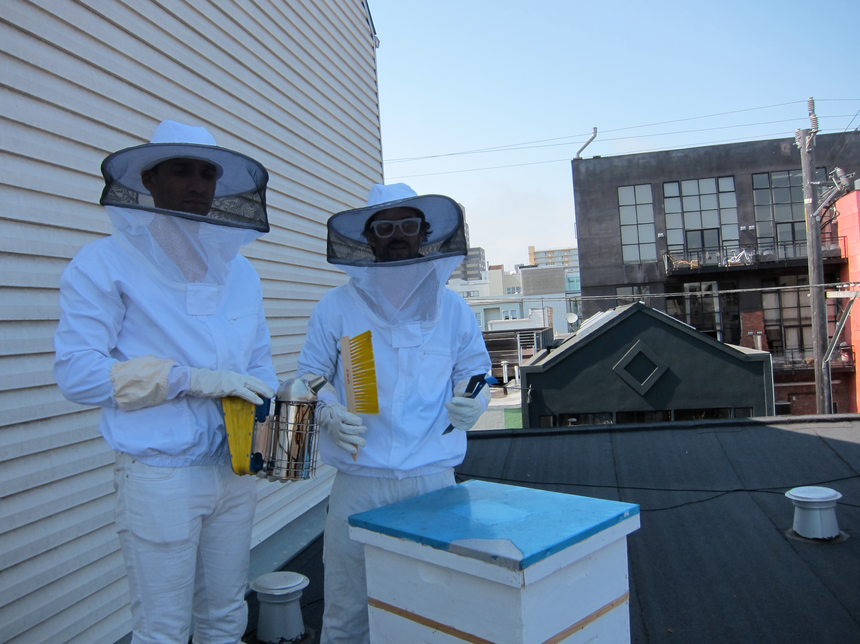
Plate 4: Protective gears used by beekeepers
Source: A picture supplied by Facilitator, Mr. Kimishua, 2011
Apart from those trainings members also were given entrepreneurial skills on business establishments, market searching for their products and skills to maintain quality of their products.

The project facilitates the initiation of beekeeping project to five formulated women groups with five box hive for each group. The target is that; at the end of two years half of the group members, in each group will possess a beekeeping project for their family. The project also focuses to facilitate the formation and registration of a local association for social advocacy and consultancy for social and economic issues among the five women groups formed. This association will have personnel who will work hand in hand with the Women Information Office to provide services to women and community in general about beekeeping.

As a result of the training conducted, women groups were strengthen with the skill which they acquired on groups dynamics and they formed those women groups based on their homogeneous interests. They form constitutions of the group which stipulate the roles of the group leaders and of the members in general. Having constitution facilitate the registration of these groups. Community leaders were also capable of formulating other two women groups and training them about group dynamics and how to manage and supervise projects; the intention being to expand the beekeeping project to their community. There were two women who had their personal business and they commented on the entrepreneurship trainings which they got that will help to facilitate the business which they owned.

Plate 5: Photos showing the impact of project implementation.
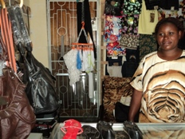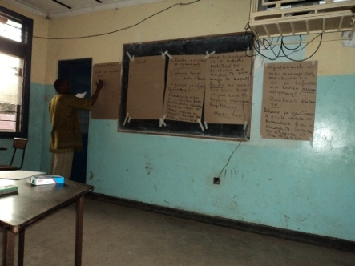 f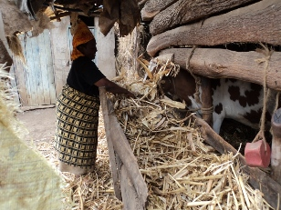
Entrepreneurial Shopkeeper. Trainings to women groups. Appropriate animal feedings.
Source: Research Findings, 2011
Women groups also develop monthly contribution to their group and form what they called saving and credit provision within members of the group. Women decided to meet two times a month to the home of one of the members where they leave a credit of fifty thousand shillings after being satisfied with the strategic plan of the utilization of the money. They also decide to supervise the utilization of that money.

The commonage in the group and sharing of social life lead women to think how they can help each other on sad and happy moments. So they establish what they called “Mfuko wa Sherehe na Maafa”, in which they provide fifty thousand shillings to the person who have such a function.

4.2 Project Planning
The project was planned in conjuction with the Women Information Centre which has the structure in the Monduli Community Development Training Institute. The project also involve the local leaders (VEO and WEO) of the Urkeeswa community and other stakeholders such as MVIWAMO, WEDAC, Religious institutions and community members to improve the household income through capacity building for the existing women groups which are participating on income generating activities within Urkeeswa village.
Below is a table showing the Implementation Plan of the project:

4.2.1 Project Implementation Plan
Table 13: Project implementation Plan
Objectives | Activities | Project Months (2011) |  |  |  |  |  |  |  | Resource  Needed | Responsible Person
Objectives | Activities | 3 | 4 | 5 | 6 | 7 | 8 | 9 | 10 | Resource  Needed | Responsible Person
- To identify opportunities which are present in the community | - Attending every after two weeks group meetings. |  |  |  |  |  |  |  |  | Travelling fee, Flip charts, Projector  Fuel for generator, Computer, Stationeries | Author,  Community members,  Group members and  Women Information Officers
 | -Meetings with community leaders
 | -Arrange group discussions with members of the community
- Awareness creation and capacity building to 5 women groups on how to run an Income Generating Activities | Conduct training on group dynamics and group management. |  |  |  |  |  |  |  |  | Travelling fee, Prepared lessons, Projector, Computer  Fuel for generator, Stationeries | Expert on group dynamics and group management,  Entrepreneurship, Project management;  Author, Community members,  Community leaders, Group members and WIW officers.
 | Conduct training on skills of entrepreneurship
 | Conduct training on project management
 | Conducting trainings on Finance management.
- Facilitate formation of viable and sustainable IGA | Conducting Need assessment to identify community needs. |  |  |  |  |  |  |  |  | Travelling fee  Prepared lessons  Projector  Computer  Fuel for generator  Stationeries | Expertise on agreed IGA,  Author,  Community members, Women Group members and  Women Information Officers, other partners.
- Facilitate formation of viable and sustainable IGA | Women groups to propose a viable IGA.
- Facilitate formation of viable and sustainable IGA | Mobilizing funds to launch the agreed IGA
- Facilitate formation of viable and sustainable IGA | Coordinate and monitor the IGA project.
Source: Research findings, 2011

4.2.2 Project Inputs
The mainly inputs utilized during the project implementation were human resources which include expertise for various fields, materials such as fuel for the generator which used to run the projector and transportation fares. All these costs are tabulated below:

4.2.2.1 Quantity and Cost for the Inputs
Table 14: Quantity and Cost for the inputs
S/n | Item | Quantity/Duration/dDistance | Cost
1 | Transportation Cost | Monduli town to Urkeeswa village:  23 visits* 20,000/- fare | 460,000/-
2 | Paying the expertise of various fields of training | 12 Training sessions * 100,000/- pay | 1,200,000/-
3 | Stationeries | -A4 reams: 5@8,000/-  -pens 1box @15,000/-  -flip charts 10 @10,000/-  -manila sheets 10@500/-  marker pen 3 boxes @10,000/- | 40,000/-  15,000/-  100,000/-  5,000/-  30,000/-
4 | Fuel for the generator | 10 liters petrol @2,000/- | 20,000/-
5 | Contingency | 100,000/- | 100,000/-
6 | Purchasing of 10 beehive shelves with bees. | 120,000*10 beehives | 1,250,000/-
 | INPUT COST |  | 3,120,000/-
Source: Research findings (2011)

4.2.3 Staffing Pattern
This project collect staff efforts from the Monduli Women Information Window, WEDAC, MVIWAMO and MPDI. Also the project makes use of the VEO and WEO for the community mobilization. Expertises from various disciplines were invited to facilitate training based on the need of the women groups.
WIW Monduli has the experts who are equipped with the skills on women, children and community issues in general. They are capable of doing community activities and power to mobilize community. They also provide consultancy to women and community in general.

Arusha beekeeping association under Mr. Kimishua is a competent organization which work with various institution together with the Institute of Wildlife. Mr. Kimishua is an expert in beekeeping with experience of more than twenty years working in government and various NGOs within and outside the country. Women groups have their own management after attending training on group dynamics and management. They have a chairperson, secretary and a treasurer for each group. Treasure is responsible for the keeping data on finances of the group. Groups were advised to store their money in the bank, instead of treasurer keeping it at home.

WIW officers coordinating and facilitate the launch of beekeeping project by linking the group with technical institutions such as the Arusha beekeeping association, WEDAC and MVIWAMO. The WIW officers also collaborate with the above institutions together with the group members to seek for the markets of the goods produced by the groups. Group leaders are collaborating well with the local and central government officers for any assistance which they need, especially during registration of the groups.

4.3 Project Implementation

4.3.1 Project implementation Report
The project was implemented in collaboration with the WIW- Monduli staff, collaborated NGOs, community leaders, women groups and community in general.

4.3.1.1 Community Mobilization and Familiarization
Community leaders help the author to get into the community. They arrange community meetings and allow the author to express the intention of meeting women, discuss with them about community challenges and opportunities which they have and not in the properly used. Because the WIW have been working in the community, it was not a difficult task to go under the umbrella of WIW and visit women.

Women were insisted to be in groups so that it will be easy to meet them. Many group members have two times meetings in every month. In these meetings is where they discuss about their success and challenges and review their development plans and suggest the way forward.

Author attended these meetings and discuss with women on how run their groups. Time was a limited factor which didn’t allow the author to go in every meeting at once. Sometimes the author got feedback from the group leaders on what was discussed in the meetings. One of the great efforts done by the author is to ensure registration of the women groups which have been formed under this project. With the good will of the District Community Development Officers, three out of the five groups were in the last stages of registration while the two other groups were completing in writing their constitution so that they can start the process of registration. The author also met with the group leaders to discuss any raised matter from the group meetings.

4.3.1.2 Capacity Building Trainings
Capacity building and awareness creation were the main activities performed during the project implementation. With was conducted by the competent personnel from the WEDAC, MVIWAMO and The Arusha Beekeeping association. Thanks for the Principal,
Monduli CDTI for providing a venue where these trainings were conducted.
Group dynamics and management was essential training in order to formulate the groups which are homogeneous in characteristics. Groups which resemble in behavior and which can agree on group plans and dynamics. Here, women got the skill on how to manage their groups focusing on their goals and objectives of forming their groups.

Focused groups were trained about entrepreneurships by the WEDAC and MVIWAMO. Trainings conducted include business establishment, how to run a business, utilizing opportunities found in your area, market search and firm management. Project management training involved WIW officers, group leaders, WEO and VEO. This was purposely for them to develop skills on managing the established project. The training include writing a project proposal, developing a strategic plan for the project, and project monitoring and evaluation techniques.

Training on Finance Management involved all stakeholders including the group members. This was purposely conducted to impart the group members and leaders the skills on how to manage the group finance from the contribution which they are making and also for the leaders to manage project finances especially on keeping records and making appropriate expenditures. All these trainings were facilitated by the Women Information Centre via the WIW office at Monduli CDTI.

4.3.1.3 Formation of viable and sustainable IGA
Procedures to formulate a viable and sustainable Income generating activity were initiated when the author was doing a Community Need assessment. Women groups propose to have a beekeeping as their project. A total number of 10 beehive shelves with bees were proposed to be bought from Arusha Beekeeping Association, where by each group will have 2 beehives. Proposal has been made to Women Information Centre in Dar es Salaam, under the Ministry of Community development Gender and Children requesting a fund to buy the beehives.

Also the author will consult other donors who work with community development issues such as World Vision, and request them to donate to this project so that it can reach more women groups. In some other places; the economically capable women groups will be advised to contribute funds and the author will facilitate consultations and linking them with facilitators and other stakeholders for them to have a viable beekeeping project. The project team which will include the author, women group leaders, VEO and WEO will coordinate and monitor these Income Generating Activities.

4.3.2 Project Implementation Ghantt Chart
S/n | Activities | Project Months (2011)
S/n | Activities | 3 | 4 | 5 | 6 | 7 | 8 | 9
1. | Attending every after two weeks group meetings.
2. | Meetings with community leaders
3. | Arrange group discussions with members of the community
4 | Conducting Need assessment to identify community needs.
5. | Conduct training on group dynamics and group management.
6. | Conduct training on skills of entrepreneurship
7. | Conduct training on project management
8. | Conducting trainings on Finance management.
9. | Women groups to propose a viable IGA.
10. | Mobilizing funds to launch the agreed IGA
11. | Coordinate and monitor the IGA project.
Table 15: The Ghantt Chart for project implementation
Source: Research findings (2011)

CHAPTER FIVE

PROJECT PARTICIPATORY MONITORING, EVALUATION AND SUSTAINABILITY

5.0 Introduction
This chapter discusses the methods applied in monitoring and evaluation of this project. It indicates how the project progress will be measured and show ways to evaluate the success of the project. Various approaches will be employed, in assessing the viability of this project. Both formative and summative evaluation has been employed to measure the performance of the project. Monitoring and evaluation were done in participatory manner including the WIW staff, WEO, VEO, other stakeholders such as WEDAC and MVIWAMO. This was done purposely to provide a wider chance for the monitoring and evaluation of the project. Also it serves as a tool for other stakeholders to learn and gain more insights on monitoring and evaluation of community project employing the MCED procedures. It will also allow the author to learn more tools, means and ways of improving the project monitoring and evaluation.

5.1 Participatory Monitoring
According to Aubel, (2004) Participatory Monitoring is the systematic recording and periodic analysis of information that has been chosen and recorded by insiders with the help of outsiders.

It is conducted regularly to access the project progress in line to planned activities and keep the project on schedule CEDPA, (1994). Therefore, monitoring is a continuous process of collecting and analyzing information in order to compare how well a project is being implemented against expected results. It aims at proving the community and other stakeholders with regular feedback and early indications of progress or lack thereof; in the achievement of intended results. It generally involves collecting and analyzing data on implementation process, strategies and results, and recommending corrective measures. The main purpose of participatory monitoring is that it provides information during the life of the project, so that adjustments and/or modifications can be made if necessary.

5.1.1 Monitoring Information System
Various mechanisms were employed in order to provide information on monitoring system. The system enable actual visualization of activities which were taking place and are accounted for the implementation of the project. Activities such as community mobilization (which lead to community meetings), formation of women groups, various trainings conducted, preparation of group constitutions and registration, searching and mobilization of donors to provide funds for the project to be implemented are used to monitor the implementation actual plan of the project.

During community meetings attendances were taken and normally leaders and participants were recording their names in ever meetings or during consultations. This was also done during trainings. There are also records of the minutes of the meetings which can also be found in the WEO office and WIW- Monduli. The Secretary of each group is also supposed to have these minutes just for references.

Each group has a constitution which guides the running of the groups’ activities. The constitution stipulate the roles, responsibilities and rights of the leaders and each group members. The Women Information Window finance the training session and they have documents on the attendance and finance transactions which were done to accomplish training activities. All these become a resourceful information monitoring system.
Follow up on the agreed activities is made by the group leaders, Women Information Office and the author. These are the ones to deliver information to the women group to remind them on the trainings or meetings to be conducted. The author and WIW make arrangement of the training prior to the schedule. These include communicating with the facilitators, arrangement of the training venue and any social services which will be provided such as food or allowances.

Training was conducted taking into consideration that participants had different ability on understanding what they were being taught. There was the average number of participants who were attending training. The plan was all women in the five formed group had to participate in the trainings, but averagely, there were an attendance of forty to sixty participants who were attending training whenever it was announced. Community social activities were among the factors which hinder the total attendance of participants to the trainings and meetings. These include the interference with economic activities such as agriculture, political meetings, community ceremonies such as weddings and burials. To solve such problem usually author and group leaders have to agree in advance the convenient time to be used for the meetings and trainings in order to take all group members on board.

The author has to comment on the community spirit of togetherness on the issues which arose in their areas. The number of people who participate in community any issues such as ceremonies is so big, as it was everyone issue. This spirit act as a challenge for the outsiders, especially researchers. Our challenge as outsiders is to find ways of tapping and unleashing the inherent creativity of people to mobilize resources, come together and solve their own problem. Also the group members show the willingness to participate, creativity, and determination to live and provide for their families even in the most
difficult circumstances.

5.1.2 Participatory Monitoring Methods Applied
Monitoring methods applied to this project ensures stakeholders participation in visualization of the project progress in all stages from design to implementation process. They ensure continuous processes of collecting and analyzing information in order to compare how well a project is being implemented against expected results. The methods applied in monitoring including PRA and Beneficiary assessment. (Appendix III)

These methods were used because of their power to mixed and match together for any one piece of participatory work and the end result bring a customized mixture of these participatory packages. PRA is one of many labels of the approaches which provide information about rural communities and rural people’s livelihoods, and with addressing social as well as physical conditions and the community level. It provides chance for the community to communicate with project staff and decision makers on their own terms. The visual techniques developed by the community members themselves during locally led analyses, is the trademark of the PRA work.

Beneficiary Assessment makes use of the verbal techniques to facilitate a dialogue with local people.

5.1.3 Participatory Monitoring Plan

Table 16: Participatory Monitoring Plan
Goal | Monitoring Objectives | Planned Activities | What was Monitored | Actual Time | Budget Allocation
Capacity building to women to increase household income. | - Whether trainings were conducted. | - Training on group dynamics, entrepreneurship, project management and finance management | - attendance to training  - trends of training  - level of trainees  - usefulness of the training  - number of training  - punctuality to training | April to June, 2011 | -facilitation: 1,200,000/-  - stationeries: 80,000/-  - fuel for generator: 20,000/-
Capacity building to women to increase household income. | - Whether 5women groups have been formed and registered | - forming of women groups  - develop their leadership and constitution  - facilitate the registration of women groups to the CD office. | - utilization of the skills and techniques of group dynamics  - group meetings minutes.  - presence of leadership and constitution  - groups consistency  - registration to be done to the women groups | March to June, 2011 | -stationeries:  60,000/-
Capacity building to women to increase household income. | - whether community needs were identified | - transect walk to the community  - conducting focus group discussion  - Conducting community survey | - data collected  - ensuring of community participation  - Number of community meetings  - community meetings minutes | March to May, 2011 | -Transport cost: 460,000/-
Capacity building to women to increase household income. | - mobilizing funds to launch the agreed IGA | - insisting on group contributions  -fund rising from the women groups and writing proposal to donors e.g. WIC | -Groups financial reports  - written proposal to donors  - beehives to be bought | June to August, 2011 | Beehive cost: 1,200,000/-
Source: Research findings, (2011)

5.2 Participatory Evaluation
Participatory Evaluation is the systematic and objective assessment of an ongoing or completed project program or policy; its design, implementation and the results obtained done by the stakeholders of the project program. Ibid, (2004)

According to CEDPA, Evaluation is the process of gathering and analyzing information to determine whether the project is carrying out its planned activities and also assessing the extent to which the project is achieving its stated objectives through the planned activities. Therefore, evaluation determines the relevance and fulfillment of the objectives, efficiency, effectiveness, impact and sustainability. It should provide information that is credible and useful, enabling incorporation of lessons learned into the decision making process of both recipients and donors.

The purpose of this evaluation was to see whether the objectives has been achieved in relation to planned activities, to find out the efficiency and effectiveness of the project; assessing its impact to community development and also analyzing its sustainability as a result of the experience and the work which has been done so far. Two types of evaluation are applied here. These are formative and summative evaluation systems.

Formative evaluation is a technique in instructional design to survey ongoing projects during their construction to implement improvements. It is also referred as an evolution conducted during the operation of a project, generally for the purpose of providing immediate feedback to the grantee about the status of project activities and so that project
revisions may be made. Summative evaluation is a method of judging the worth-fullness of the program at the end of the program activities. Generally, summative evaluation is done at the end of project intervention and is focus on the outcomes of the project.

5.2.1 Performance Indicators
CEDPHA defines indicators as the quantitative or qualitative criteria for success that enable one to measure or asses the achievement of project objectives. Loilang’akaki, (2007) on his dissertation he explained the term indicators as a specific, observable and measurable characteristics of change that shows the progress a program is making towards achieving a specified outcome. Performance indicators defines the data to be collected to measures progress and are thus an indispensable tool for decision making.

Indicators to measures the objectives of this project were designed by the stakeholders including women groups who are the project beneficiaries. These indicators were designed in such a way that they measures the input, output and the impact of the project to the community development as indicated below:

GOAL: Capacity building to women in order to increase household income
Table 17: Objectives and Indicators of the Project Goal
Objectives | Indicators
To identify opportunities which are present in the community | a) meetings are conducted  b) performing transect walk with community members  c) List of opportunities are in place
Awareness creation and capacity building to 5 women groups on how to run an Income Generating Activity | a) Training are conducted  b) Ability to apply the skills acquired  c) Allocated time to be met
Facilitate formation of viable and sustainable IGA | a) Proposed IGA in place
Source: Research findings, (2011)

5.2.2 Participatory Evaluation Methods
The participatory approach to evaluation is aimed at promoting action and community level change. It tends to overlap more with qualitative than with quantitative methods. It ensure that the perspectives and insights to all stakeholders, beneficiaries as well as project implementers are taken into consideration. Women groups themselves were responsible for collecting and analyzing the information and generating recommendations for change. In this case, methods used were again beneficiary assessment (BA) and Participatory Rural Appraisal.

Beneficiary assessment helps to gain insights into the perceptions of beneficiaries regarding the project implementations, marketability and profitability they get from the beekeeping project. beneficiaries assessment used semi-structured individuals interview and participant observation in order to collect descriptive and detailed information on individual cases.

5.2.3 Participatory Evaluation Summary
GOAL: Capacity Building to women in order to increase Household income
Table 18: Objectives and Indicators of the Project Goal
Objectives | Indicators
To identify opportunities which are present in the community | a) meetings are conducted  b) performing transect walk with community members  c) list of opportunities are in place
Awareness creation and capacity building to 5 women groups on how to run an Income Generating Activity | a) Trainings are conducted  b) Ability to apply the skills acquired  c) Allocated time to be met
Facilitate formation of viable and sustainable IGA | a) Proposed IGA in place
Source: Research findings, (2011)

5.3 Project Sustainability
Project sustainability is a major challenge in many of the projects established in the community. Large number of projects implemented at huge costs often tend to experience difficulties with sustainability as a results it discourage donors and external agencies to support other projects to local community. Several factors are responsible for poor sustainability. Some are simple, some area quite complex. Some are within the control of the project management, while other come as external threats. Sometimes poor sustainability can be tracked and taken care of at the design stage of a project, while other can be tracked and corrected during implementation, through monitoring. It is there for important that the factors that affect sustainability are well focused.

Khan, (2000) define project sustainability as the percentage of project initiated goods and services that are still being delivered and maintained after years of termination of implementation of the project; the continuation of local action stimulated by the project and generation of successor services and initiatives as a results of project built initiatives. This definition implies that sustainability concern itself with level of continuation of delivery of project goods and services, changes stimulated or caused by the project and any new initiatives caused by the project.

In another context, World Bank defines project sustainability as to be the ability of a project to maintain an acceptable level of benefits flows through its economic life. Dr. Adil Khan, who is a Senior Advisor in Monitoring and Evaluation of UNDP projects narrate the dimensions to project sustainability as follows:

- Logistic dimension, that is there should be a continued operation and maintenance of the project facilities. This will be accomplished if the project received necessary support (both budgetary and institutional) to enable the local community to maintain required level of facilities. For example, if the donors donate a machine, then the local community should be capacitated to ensure that they are able to do maintenance and administer such a facility.

- Economic dimension, that is there should be a continued flow of net benefit especially for economic sector projects. All the cost and benefits under varying conditions should be weighted properly and the project should guarantee an acceptable level of financial and economic returns. It is the factor of project viability through good supervision will results into financial and economic return.

- Community dimension, that is there should be a continued community participation into the project. Community participation is crucial for stimulating new actions as well as for the cost recovery.

- Equity dimension, that is there should be equitable sharing and distribution of project benefits on a continuous basis.

- Institutional dimension, that is there should be an administration and management support for the project operations to continue during the life time of the project.

- Environmental dimension, that is maintenance of environmental stability. The project should consider the environmental implications so that negative impacts on environment are either avoided or mitigated during the life time of the project.
The relevance of the beekeeping project established in Urkeeswa village has purposely link the project objectives and the priorities set by the government in MKUKUTA document. This project has the ability of attract required support from various parts and it has the capacity to operate in a conducive environment.

The community need assessment showed that women do not have an income generating activities which are of meaningful. Any sustainable project in Maasai community and which is based into women should have to compromise with other daily activities of women, that is should allow women to perform other domestic activities including rearing children and sick people in the family. So specific to Urkeeswa community, women are also performing such task as fetching water and firewood, which takes a lot of their time. So engaging them in a project which is time consuming will jeopardize other activities and so threaten the sustainability of the project. Beekeeping project provide women an ample time to do other activities which are of community benefits that is why it was accepted during CNA.

Under the projection of five years plan, the beekeeping project is expected to be economically viable. Currently there is a great need of the bee products in the Monduli and surrounding area. The price market of small honey bees in the market currently is 30,000/- per litre, while the biting bee honey cost half the above price per litre. Still it is expected the price to be stable for a quite long because customers will be used to the products and producers will maintain the quality of the products. Having management which is stable is also an added advantage of the women group. Later this leadership should control the price and quality of the bee product in the market. The skills these groups have attained during training is expected to be utilized in establish the project and maintaining it.

There is a natural forests within the village of which the women groups are expected to hang the beehives, after having permission from the village executive officers. Some of them can just hang the beehive in their homestead, to make a closer supervision. This project is environmentally friendly. Minor worry can be raised when these women go for extracting honey. Sometimes accidentally they can use fire which they can fail to control and bring hazards to the forest. Or sometimes people may go there for extracting honey and chopping down trees because of the access they have in the forest. But with good village management and having well equipment which women groups are supposed to purchase for the project these impacts can be taken care of. They should know they have been incorporated in the t forest management and conservation.

Implementation and monitoring strategies are SMART. Groups have been formed, CAN have been done and the trainings are conducted. Women groups have their own management and they started by monthly donation to the group fund. This will enable them to buy few bee hives while donors, especially Women Information Centre (WIC) headquarters are expected to donate other beehives for women groups as the budget indicated.

Post implementation operation and maintenance of the project will be taken care by the women group leaders under the supervision of Monduli Women Information Window, together with the author. Monduli WIW and the author will provide consultation support on how to run the project. It is expected that some of the profit obtained will be used for operation and maintenance expenses.

Although beekeeping is sound to be inferior project to Maasai men, there is a threat that men may appropriate the income generated from the women beekeeping project. To curb this situation, the WEO and VEO of Urkeeswa village are well informed about this project. Therefore, the sustainability of this project is supervised also with these government officials.
Also, trainings which will be conducted to the community based on human rights so as to reduce women abuse and violence in Maasai community, as stated in the Project objectives, will help to minimize men unnecessary control over women decision making and other women and children abuses in the Maasai community.

CHAPTER SIX

CONCLUSION AND RECOMMENDATION

6.0 Introduction
This chapter contains conclusion and recommendations for this study done in Maasai community. It gives suggestions necessary to initiate the Income Generating Activities and take control over it to ensure sustainability.

6.1 Conclusion
A growing body of evidence points the linkages between women empowerment and development effectiveness both at the society- wide level and at the grassroots levels. Women empowerment can strengthen community well being which in turn enhance growth prospects. Empowerment strategies in the establishment of community projects are supported by civil liberties and their willing to participate after visualize the importance of the project to the community. A critical aspect for an empowering approach is to reduce inequality by broadening human capabilities and improving the distribution of tangible assets such as land and access to capital. Such an approach can enhance the poverty reducing impact of growth, inducing policies and investments by enabling poor people to more effectively participate in economic markets.

Eliminating gender discrimination and empowering women are among the paramount challenges facing the world today. When women are healthy, educated and free to take the opportunities; life affords them, children thrive and countries flourish and reap a double dividend for women and children.

Reforming the law and working to strengthen the institutional machinery for implementing gender goals are important, but culture factors still strongly influence the ability of Tanzanian women to realize their potential in community development activities. Cultural norms govern prevailing attitudes and beliefs. Not only do they include the subordination of women to men, but they also have a pervasive impact on social and economic life, and on how laws and regulations operate in practice.

Interviews conducted by the author to assess the women participation on income generating activities reveals the presence of culturally based obstacles to women’s economic empowerment. The reluctance of husbands to allow their wives to engage in business activities and time constraints due to competing domestic responsibilities were the major obstacles mentioned to prevent women contribution to economic affairs. These attitudes also impacted access to finance, as well as the ability to attend training and access to business development services. As a result, women’s enterprises often remain precarious, usually tied to small- scale and informal activities that can be reconciled with their domestic obligations. This means that a substantial segment of Tanzania’s entrepreneurial potential remains underexploited. Urkeeswa community has a lot of opportunities to utilize, but the cultural obstacles which women are facing leave the community to be poor.

Women are the productive group of the community, highly engaged in agriculture, though they do not own land or any meaningful community resources. Community people have to change their mind set and acknowledge women contribution to the community development. Women should be left free to utilize the local resources in order to run development programs. Anything they are doing should be productive, and they should realize profit out of it, for community development. Women empowerment will bring the trickledown effect to the whole community.

Beekeeping project is such one of various projects which women can undertake to bring
community development. When assessing the kind of the project women could undertake, the Urkeeswa women suggest the beekeeping because it will compromise with other community obligation which they have. They also mentioned men interruption to this kind of the project is expected to be minimal because Maasai men count beekeeping as the inferior project which is valueless to them. But the fact is beekeeping earns a lot of money in the market. The substantial usage of bee products is its medicinal value. People, including Maasai men use honey to treat burnings and insect bites. As a belief, honey is also said to have a spiritual power and so applied to bring peace and harmony in the family.

The project goal was to build capacity to women groups in order to increase the households income. This was done by formulate an income generating activities which was done in a participatory manner with the entire stakeholders involved. Also awareness creation to women group about social – economic development issues was conducted. This includes the training on entrepreneur which was conducted to women groups in Urkeeswa village.

To implement this goal, some objectives were set. These include identification of opportunities which are present in the community by March 2011; awareness creation and capacity building to five women groups on how to run an income generating activities by June, 2011 and lastly facilitating formation of viable and sustainable IGA by September, 2011. Opportunities were identified and it showed that because women do not possess land, and that they have many obligations to work in the community therefore they can utilize the topography of their community which attracts the habitation of bees. This is because of the acacia trees which are plenty found in the area together with the shrubs and few thick flowering trees where by bees are seen to be wondering in most of the time. Women thought why they should tape this potential by providing good environment for the bees to utilize the hives which women groups will hang them in those trees.

Another opportunity which they have is being under the WIW office which is currently facilitates the training and still dialogue is done between the author and the WIC – Headquarters requesting them to provide funds for purchasing the 5 beehives for each women group which will initiate the project.

5 women groups have been organized and formed. Various trainings have already being conducted. These include training on group dynamics and its management, entrepreneurship trainings, beekeeping trainings, project management and finance management trainings. Because women groups make their own contributions, they are expected to facilitate the group by increase the number of the beehives per groups to be as many as they can manage. Marketability of the bee product is widely available and this ensures the sustainability of the project. Honey can be sold as raw as it is or it can be processed so as to add its market value. Currently, honey processing and refining is done at Mto wa Mbu, which is about 45 kilometres from Monduli town. As the project grow up, there will be a need for the women groups to possess such a machines so that they add value of their commodity by themselves.

Still the project wait for the donors to facilitate the availability of enough bee hives for the project to be initiated. If this will not be done on time, it will affect the project goal to be accomplished on time, and so wait until women get ability to buy the beehives.

If the project will be successful completed, author expect the life of the women and community in general to change. It is expected many other women groups to be formed and use this project as their Income Generating activities. Many people will be employed and the Bee keeping consultation office will be proposed also to be opened at Monduli district. Maasai men will also realize that beekeeping is one of the project which can be done even by them and appreciate the outcomes women are getting from the beekeeping. They will not account bee keeping as an inferior project rather as a superior one which one can earn money and be able to perform other community development activities. Beekeeping provides an ample time for the farmers to work on other activities without jeopardize other activities which a person could have been doing.

6.2 Recommendations
It is important to note that women contribution to community development issues in many societies is under exploited. Cultural factors are one of the major obstacles to women participation to community development activities. Women play a substantial role in Tanzania’s economy and are more active in agriculture, for example; which accounts for 82% of the labor force; of which women constitute 52.6% (URT, 2002).

Experience shows that if women are empowered, they can change the economy of the community faster than men because they have strong ties due to many responsibilities which they have in their communities as compared to men. When attending women in any society, one has to take care of the cultural factors as one of the obstacles which may hinder the success of the project which is targeted to women. And to be in a safe side of implementation, one should consider a project which will not jeopardize the cultural role of the women in serving their community especially children, elders and sick people, among other roles. Otherwise education has to be provided to the community in order to change their mind set and allow the utilization of women potentiality to development activities.
Another observation which was found during the community need assessment is the fact that many Maasai people do not know how to read and write. Elders have forsaken the importance of education and do not see if it is important for them to go back to school, even for the adult education classes. No initiatives which seem to establish an adult education class either. As a result of that, they even do not see the importance of education to their kids. That is why one can see children which are supposed to be in a primary school classes rearing cattle the whole day while their mate are schooling. It is important for the government and NGOs to eyesight this area and mobilize people for the adult education classes.

It has also to be appreciated that the Urkeeswa village gain skills and experience on running the bee keeping project. The techniques of applying a capacity building trainings help the women groups to acquire the required skills and so they can overcome the challenges which can arise in the cause of running the project. This is recommended to any project which is going to be established in the community that capacity building through training is very important, especially with the group dynamics and group management trainings.

Also to avoid dependence, women groups have to think on establishment of VICOBA, so as to provide loan through the contributions which they make whenever they meet. The profits which they get can partly be used to add more beehives and also serving for VICOBA. The target is for every woman to have her own beekeeping project in the household level, with numerous numbers of beehives.

REFERENCES
Adèr, H. J., Mellenbergh, G. J. and Hand, D. J. (2008). Advising on Research Methods:
A consultant's companion. Huizen, The Netherlands: Johannes van Kessel
Publishing.
Amanda, E., Blackden, M., Cutura, J., MacCulloch, F. and Seebens, H. (eds.) (2007). Gender and Economic Growth in Tanzania, The
International Bank for Reconstruction and development/ The World Bank, Washington DC.

Aubel, J. (2004). Strategic Report on Participatory Monitoring and Evaluation for
Hygiene Improvement, Office of Health, Infectious diseases and Nutrition,
Washington, DC 20523.
Bamberger, M. and Cheema, S. (1990). Case Studies of Project Sustainability,
Implications for Policy and Operations from Asian Experience. The World
Bank, Washington D.C.
Centre for Development and Population Activities (CEDPA) (1994). Project Design
for Program Managers. The CEDPA Training Manual Series Volume II, 1400 Sixteenth Street N.W., Suite 100,Washington, D.C. 20036, U.S.A.

Christophersen, K., Hagen, R. and Jambyia, G. (2000). Economic opportunities in
Wildlife Management Areas, Report prepared for the Wildlife division of the Ministry of Natural Resources and Tourism and USAID/Tanzania
Gemma, S. I. (2009). Gender Budgeting and Budget Analysis within a Gender
Perspective, REPOA, DSM.
Khan, A. M. (2000). Planning for and Monitoring of Project Sustainability: A guideline
on concepts, issues and tools on http://www.mande.co.uk/docs/khan.htm
cited on 17/07/2011.
Kothari, C. R. (2004). Research Methodology: Methods and Techniques, New Age
International, New Delhi.
Loing’akaki, L. Z. (2007). Capacity building for Increased Income at the Household
level through IGAs at Kamamma Intergrated Development Trust Fund
(KIDTF), A case study at Karangai Village in Arumeru District, Arusha
Region.
Mbilinyi, M. J. (1982). “Wife Slave and Subject of the King: The Oppression of
Women in the Shambala Kingodom”, Dar es Salaam University Press, DSM.
Ministry of Community Development Gender and Children (MCDGC), (2004).
Evaluation of Beijing Conference Conventions Implementation: A case in
Tanzania, DSM.
Monduli District Council, (2009). Economic Situation of Monduli District, Planning
Report.
Mpuya, P. (2001). Beekeeping in Zanzibar, Ministry of Natural Resources and Tourism,
Zanzibar.
Narayan, D. (ed.) (2002). Empowerment and Poverty Reduction: A source Book, The
International Bank for Reconstruction and Development, WB, NY.
National Bureau of Standards (2002). Household Budget Survey 2000/01, DSM.
Schaefer, R. T. (2006). Sociology Book. 6th ed. McGraw-Hill Co, Inc, NY.
Tanzania Gender Networking Programme (TGNP) and SARDC- WIDSAA (2007),
Beyond Inequalities: Women in Tanzania. TGNP/SARDC, Dar es Salaam and Harare.
UNICEF (2000). TNZ: The Review of UNICEF-supported Women Economic Activities
(WEA). DSM.
URT (1992). Policy on Women in Development in Tanzania, DSM.
URT (1995). The Tanzania Development Vision, 2025, DSM
URT (2000). Poverty Reduction Strategy Paper, DSM
URT (2002). Integrated Labor Force Survey 2000/2001 Analytical Report, NBS, DSM.
URT (2004). Employment and Earning Survey 2001, NBS, DSM.
URT (2009). Poverty and Human development report, DSM.
http://en.wikipedia.org/wiki/Sampling_%28statistics%29 cited on 14/06/2011.
http://www.buzzle.com/articles/data-analysis-methods.html cited on 23/03/2011.
http://www.nyu.edu/classes/bkg/methods/005847ch1.pdf cited on 14/07/2011.

APPENDICES

APPENDIX I.

Structured interview for the Project Beneficiaries:

Date: ____________ Respondent’s no. ___________
District: _______________ Division: ______________ Ward ____________
  - Age of respondent:____
  - Sex: ______
  - Marital Status: _______________
  - Occupation: __________________
  - Tribe: a) waarusha b) wamasai c) others
6. Ability to read and write?_________________________
  - Level of education: _________________
  - How long have you been living here? _____________________
  - How many children do you have?
  - What economic activities are you mostly involved with?
  - How many livestock do you have per unity family?
a ) cows ( ) b) goats ( ) c) Sheep ( ) d) donkey ( )
  - How do you spend your income?
  - What kind of the assets do you own in the family as a woman?
  - What kind of assets men own in the community?
  - Why do Maasai do not want to reduce number of their cattle and appropriate the money in other economic development activities?
  - Have you ever try to ask for a loan from any institution?
  - If YES, which institutions?
  - If NO, why have you never ask for a loan?
  - How do you sustain your group?
  - Is there any benefits?
  - If YES, explain
  - If NO benefits, explain
  - Do you have any health centre in the village?
  - Is there any issue of Female Genital mutilation in your area?
  - Are you doing any farming activities?
  - What is the size of your farm?
  - Do you use chemical fertilizer for agriculture?
  - What tools are you using for cultivation?

END.

APPENDIX II.

Structured interview for Group leaders of the Women groups

Date: ____________ Respondent’s no. ___________
District: _______________ Division: ______________ Ward ____________
- Age of respondent:____
- Sex: ______
- Marital Status: ____________________
- Occupation: ______________________
- Level of education: _________________
- How long have you been working with this project? ________
- How do you design to implementation this project?
- What will happen when project duration cease?
- What contributions given to the community in order to implement the project?
- Do you think with the above contributions, community can be left to perform the project by themselves?
- What are the sources of fund of the projects?
PROGRAM/PROJECT | SOURCE OF FUND from:
PROGRAM/PROJECT | GOVERNMENT | NGO | SELF HELP

- How do you implement the concept of Self Help in your project?
- How do you ensure Self Help idea when running project in the community?
- What challenges do you face in running this project?
END
APPENDIX III

Monitoring and Evaluation Assessment

(To all Beekeeping Project Beneficiaries)
- Do you benefit from this project?
- How much do you earn personally per year (in Tsh.) from the above project?
- Explain how your life has been changed before and after the
presence of project in your area: (materials or resources owned,
general wellbeing, wealth status, what you didn’t have and you
have it now, and vise versa…)

THE SITUATION BEFORE PROJECT SITUATION AFTER THE PROJECT
- How is your situation at present compared to previous one?
- Do you attend program meetings?
- If YES, how many times did you attend such meetings per year?
- Who dominating the discussion during the meeting?
- How can you explain about community participation in development projects?
- What is community development?
- For how long do you think this project will go on?
- What will happen to this project if donors pull off?
13. Who plan project activities?
14. How do you implement project activities?
END

http://en.wikipedia.org/wiki/Sampling_%28statistics%29
http://www.buzzle.com/articles/data-analysis-methods.html
http://www.gdrc.org/icm/wind/wind-unicef-wp.html
2000TNZ: The Review of UNICEF- supported Women Economic Activities (WEA)
http://www.wildlife-conservation.org/en/content/download/585/2824/file/igf/506/theme_i_part_i.pdf#page=147
Ibid
Ibid
http://www.mande.co.uk/docs/khan.htm

