**EFFECTS OF GAMES STRATEGY ON ENHANCING PUPIL’s PERFORMANCE IN MATHEMATICS IN WETE DITRICT ZANZIBAR**

**RAMLA ABASS FARHAN**

**A DISSERTATION SUBMITTED IN PARTIAL FULFILMENT OF THE REQUIREMENTS FOR THE DEGREE OF MASTER OF EDUCATION IN ADMINISTRATION, PLANNING AND POLICY STUDIES (MED -APPS) IN THE OPEN UNIVERSITY OF TANZANIA**

**2017**

# CERTIFICATION

The undersigned certifies that he has read and hereby recommends for accept by The Open University of Tanzania a dissertation entitled: “Effects of Games Strategy on the Pupils Performance in Mathematics”, in partial fulfillment of the requirements for the degree of master of Education in Administration, Planning and Policy Studies (MED-APPS) of The Open University of Tanzania.

……………………………………….

Dr. Michael W. Ng’umbi

(Supervisor)

…………………………………

Date

# 

# COPYRIGHT

No part of this dissertation may be reproduced, stored in any retrieval system or transmitted in any form by any means, electronic, mechanical, photocopying, recording or otherwise without the prior written permission of the author or the Open University of Tanzania on that behalf.

# DECLARATION

I, Ramla Abass Farhan**,** do hereby declare that this research is my original work and that it has not been presented and will not be presented to any other University for a similar or any other degree award.

……........................................

Signature

……........................................

Date

# DEDICATION

This work is dedicated to my son Abass, my daughters, Salma, Key, Khadija, Mchanga, Zuhura and their father, Khamis.

**ACKNOWLEDGEMENT**

I am grateful to one who has given me a better health and enabled me to conduct this research. Various individuals and institutions have helped me in the completion of this work. In particular and first of all, I would like to express my sincere gratitude to my supervisor Dr. M.W. Ng’umbi. I thank him for his constructive and scientific guidance in the whole period of doing this research from proposal up to writing the report.

My deepest appreciations go to Ms. Salma Khamis, Ms. Khadija Khamis, Ms. Mchanga Khamis and Mr. Suleiman Khamis for encouraging and giving me their full support to ensure the completion of my work. I would also like to express gratitude to my fellow workers Ms. Jamila Rashid, Ms. Fatma Shamby, Ms. Fatma Said and Personnel in Pemba Public Library for assisting me to produce this piece of work. Indeed I want to thanks all Personnel of The Open University of Tanzania and Ministry of Education and Vocational Training Zanzibar, Teachers and pupils of Mzambarauni Mixed School, for their cooperation.

I would also thank my Grand Children for their tolerance when they were missing care during my absence and my sons in law Mr. Nassor, Mr. Hamad, Mr. Haroub and Mr. Abdalla for their encouragement and support when their wives insisted me in my study. Special thanks and special way are due to all people including my family members particularly my Husband Mr. Khamis Rajab for their moral supports in the completion of the study.

# ABSTRACT

The study investigated the effects of Games Strategy on enhancing pupils’ performance in Mathematics. Poor performance in Mathematics is a worldwide problem, but in Tanzania it is a callus problem at all levels. This study was focused on exploring the effectiveness of games strategy to (i) the participation of pupils during the lessons (ii) pupils pass rate and (iii) the time consumed on teaching selected topics. The study was quasi-experimental, purposive and it was mainly quantitative; where Class 4 pupils of Mzambarauni Mixed School Wete Pemba were the sample of the study. Data were collected through observation and testing (pre-test and post-test). Almost all lessons were conducted through competitive games. The collected data were analyzed through calculating means, percentages and distribution of frequencies in order to find variance between two classes. The findings show that rate of pupils’ participation was high in experimental class than in control one, pass rate was better in class of games than in the class using traditional methods; and it was also found that, through games the selected topics were taught without much utilization of time.A researcherrecommended to Education Management System on creating friendly environment which will convincing and guiding teachers and students to use games strategy as a technique in learning and teaching Mathematics.

**Key words:** *Mathematics, pass rate, time consumption, pupils’ performance, games strategy, pupils’ participation, pre-test, post- test and test scores.*

**TABLE OF CONTENTS**

**CERTIFICATION ii**

**COPYRIGHT iii**

**DECLARATION iv**

**DEDICATION v**

**AKNOWLEDGEMENT vi**

**ABSTRACT vii**

**LIST OF TABLES xi**

**LIST OF FIGURES xii**

**LIST OF ABBREVIATIONS xiii**

**CHAPTER ONE 1**

**1.0 THE STUDY AND ITS CONTEXT 1**

1.3 Statement of the Problem 6

1.4 General Objective of the Study 7

1.5 Specific Objectives of the Study 7

1.6 Research Questions 7

1.7 Significance of the Study 7

1.8 Scope of the Study 8

4.1.9 Summary of Chapter One 9

**CHAPTER TWO 10**

**2.0 LITERATURE REVIEW 10**

2.1 Introduction 10

2.2 Theoretical Analysis on Classroom Learning 10

2.2.1 Behaviorism 10

2.2.2 Cognitive Theories 11

2.2.3 Constructivism Theories 11

2.3 Learning Theories and the Teaching and Learning of Mathematics 12

2.4 Constructivism and Mathematics Learning and Teaching 15

2.5 Empirical Studies 17

2.6 Conceptual Framework 20

2.7 Researcher’s Conceptual Framework: Games to Performance in Learning 22

2.8 Summary of Chapter Two 23

**CHAPTER THREE 24**

**3.0 RESEARCH METHODOLOGY 24**

3.1 Introduction 24

3.2 Research Approach 24

3.4 Area of the Study 25

3.5 Population 25

3.6 Sampling 26

3.7 Data Collection Instruments 26

3.8 Data Collection Method 26

3.8.1 Tests (Pre-Test and Post-Test) 26

3.9 Research Procedure 27

3.10 Data Analysis 29

3.11 Ethical Consideration 29

3.11 Validity and Reliability 29

3.14 Summary of Chapter Three 30

**CHAPTER FOUR 31**

**4.0 RESULTS 31**

4.1 Introduction 31

4.2 Participation Rate 31

4.3 P ass Rate 34

4.4 Time Consumption 42

4.5 Summary of Chapter Four 45

**CHAPTER FIVE 47**

**5.0 DISCUSSION, SUMMARY, CONCLUSION AND RECOMMENDATION 47**

5.1 Introduction 47

5.2 Discussion 47

5.2.1 Pupils’ Participation 47

5.2.2 Pass Rate 50

5.2.3 Time Consumption 53

5.2.4 The New Framework with Relation to Others 54

5.3 Summary of Research Report 55

5.4 Conclusion 56

5.5 Recommendations 57

**REFERENCES 58**

**REFERENCES 63**

**LIST OF TABLES**

Table 3.1: Mzambarauni Takao School Performance (2012-2014) 25

Table 4.1: Percentage Rate for Pupils’ Participation 31

Table 4.2: Difference between Scores 35

Table 4.3: Scores in Basic Mathematical Activities Questions Items 37

Table 4.4: Scores in Fraction Question tems 38

Table 4.5: Difference of Pass Rate between Class 4A and Class 4B 39

# LIST OF FIGURES

Figure 2.1: Framework – Games to Performance on Learning Mathematics 22

Figure 4.1: Pupils Participation Rate on Answering Questions 33

Figure 4.2: Pupils Participation Rate on Games Activities 34

Figure 4.3: Frequency Polygon - Pre Test Scores Class 4A 40

Figure 4.4: Frequency Polygon - Pre Test Scores Class 4B 40

Figure 4.5: Frequency Polygon - Post Test Scores Class 4A 41

Figure 4.6: Frequency Polygon - Post Test Scores Class 4B 41

Figure 4.7: Comparison between Two Tests of Class 4A and Class 4B 42

# LIST OF ABBREVIATIONS

CREATE Completion, Retention, and Access for Tanzanians to Education

CSEE Certificate Secondary Education Examination

EFA Education for All

KCPE Kenya Certificate Primary Examinations

NEA National Education Assessment

NECTA The National Examination Council Tanzania

OECD Organization for Economic Co-operation and Development

PISA Program for International Pupils Assessment

SACMEQ Southern and Eastern Africa Consortium for Monitoring Education Quality

TIE Tanzania Institute of Education

TMC Tanzania Mathematics Advancement Centre

USAID United State Agency for International Development

ZABEIP Zanzibar Basic Education Improvement Program

ZEC Zanzibar Examination Council

# CHAPTER ONE

# 1.0 THE STUDY AND ITS CONTEXT

**1.1 Introduction**

# The chapter is composed of introduction, background to the study (globally up to national level), Other components are research questions, significance of the study, the scope of the study and finally the limitation of the study.

**1.2 Background to the Problem**

# Mathematics in one of the core subjects in schools. According to Tuncay and Omur (2009) Mathematics influences an individual personal development and contributes to the wealth of the country. Murray (2013) stated that, the success of pupils’ achievement in Mathematics was a consequence not only for the pupils’ personal and professional lives but also for national development. Unfortunately, this generation is facing a big challenge of pupils’ poor performance on learning Mathematics. Mayer and Stanley (2009) observed that, the declining popularity of Mathematics among pupils and poor performance of pupils are not national but also a global concern for the past years. This is a global issue, but extremely experienced in African Countries. So many survey reports reveal the extent of the problem. A Gallup commissioned by Bayer Cooperation (2003) found nine in 10 Americans are concerned about the lack of Math skills for today’s pupils.

# The Commissioner of Education, Secondary Education (2012) in Tanzania, showed that for many years the performance of pupils in mathematics in all levels is below 30%. The Education for All Assessment Report, Zanzibar (2014) reveals that pupils’ performance in Form Two examinations (Zanzibar) 2010 – 2013 had a tremendous drop in Mathematics. Even at primary level the performance of pupils in Mathematics is at the poorest level.

# The above observations regarding the status of teaching and learning Mathematics calls for deliberate efforts to improve the status of the subject. Many initiatives have been taken both national and school levels to improve the teaching and learning of mathematics. It was the position of the study that most of such efforts have not been successful and hence some better child-friendly initiatives need to be devised and tested in schools. That is why this study was done to investigate the effectiveness of games in learning and teaching process for this subject.

# According to Moore (2012), the best teaching practice to improve achievement in Mathematics is incorporating the use of games in the subject. The Analysis Report of The National Examination Council Tanzania (NECTA) 2009 recommended that, candidates should develop an interest on Mathematics by providing examples related to real life situations. Another concern is Bandura’s Theory of social learning (1971 & 1977), ‘people learn from one another via observation, imitation and modeling’. That means through games the pupils develop interest and perform better because they observe, imitate, and use models effectively and efficiently.

# The study was conducted in primary classes which are the foundation level. This is due to many scholars concern. According to House of Common in England (2009), Mathematics in primary school is a good start to pave the way for success at secondary School and beyond. The intervention was experimental, purposive and mainly quantitative. The school used, runs on single session and only class four pupils were involved in the intervention. The issues of consideration in this study are the pupils’ participation during the lesson, the rate of passing marks, and the time consumed for selected topics.

# Like many other developing countries Tanzania is facing the problem of poor performance of pupils in Mathematics from primary to secondary level and beyond. According to Msonde announcement (February 2016) on the performance of candidates on Certificate Secondary Education Examination (CSEE) 2015 only 16.76% candidates passed in Mathematics. Many studies conducted and many strategies are taken to find the way of solving them. Studying poor performance of pupils in mathematics is not a new issue in this world. Since the last century, researchers and practitioners deal with this huge problem and develop their recommendations. They concern either on finding the factors which contribute to poor performance or they struggle to find the treatment of those problems.

# A Gallup survey commissioned by Buyer Corporation (2003) found nine in 10 Americans are concerned about the lack of math skills of today’s pupils (Shinn et al - 2003) The percentage of pupils in U.S class of 2009 who were highly accomplished in Math is well below that of most countries with which the U.S generally compared itself. Nowadays U.S. is a member of the Program for International Pupils Assessment (PISA), but according to Sangcap (2010), only eight percent of white pupils in the U.S. class of 2009 scored at the advanced level.

# According to the report of Mujtaba et al (2013), 24% of London’s pupils do not achieve the expected levels in Mathematics at primary levels. England planned the special National Strategy which Aims to raise performance through extensive teaching and learning resources, supported by profession program for teachers (The House of Commons report 2007). Not only that but The Filipino pupils’ poor Mathematical performance has placed the country in 36 rank out of 38 nations of worldwide (Sangap 2010), and in Mexico the performance of Mathematics in Secondary education is the lowest among the unity of Organization for Economic Co-operation and Development (OECD) (Erasmus, 2012). The Government of Ghana also tried to address the issue of poor performance in mathematics.

# According to the National Education Assessment (NEA) tests in 2009, less than 30% of primary schools children reach proficiency level in English and mathematics (Erasmus, 2013). Konami (2014) recommended that, despite the fact that over 80% of the primary children are in Public Schools in Kenya, the children do not perform well in Mathematics in Kenya Certificate Primary Examinations (KCPE). In Tanzania the different NECTA Reports from 2008 up to 2015 show that the highest failure rate (grade F) is basic Mathematics in Form IV level. Usually the pupils with credit passes (A, B, and C) are below 10% in every year. This is for Mainland and Zanzibar.

# According to Zanzibar Education Statistics 2010 – 2013, there has been very little improvement in pupil examination performance in the past ten years, with pupils performing poorly particularly in Mathematics and Sciences. Zanzibar Examination Council Report (2010-2014) also reveals that Mathematics results have the lowest result percentage in all levels; Form II, STD VII, and even STD IV. In 2013, some STD IV pupils (in Pilot Schools) did the national examination (Zanzibar wise), the results shows Mathematics subject has the lowest percentage.

# One among the strategies that is used in Tanzania is the establishment of The Center for Improving Pupils’ Achievement on Mathematics in 2007. This is Tanzania Mathematics Advancement Centre (TMC). It is especially for the improvement setting of strategies for improving pupils’ performance, which can improve the pupils’ achievement in Mathematics from Nursery to higher Schools. Tanzania Institute of Education (TIE) has also conducted several seminars for Mathematics teachers to equip them with teaching effectively syllabi; at the same time Tanzania has participated fully in certain conferences such as UNESCO 1999 and has endeavored to begin implementing the recommendation of those conferences.

# In addition to that the project of completion, Retention, and Access for Tanzanians to Education (CREATE) 2007 was conducted to improve secondary pupils performance in Mathematics, Science and English language. This project was implemented by Aga khan Foundation and supported by the American people through United State Agency for International Development (USAID). Tanzania is a member and an active participant in Southern and Eastern Africa Consortium for Monitoring Education Quality (SACMEQ). This has the aim of improving the quality in literacy and Numeracy skills at the primary level.

# Another strategy is the reform of education policies. In Zanzibar, new education policy was developed in 2006 and among the issues amended is the use of English medium for Mathematics from class five. The improvement of pupils in Mathematics from primary up to secondary level was included in Zanzibar Basic Education Improvement Program (ZABEIP) 2008 - 2013 which was funded by World Bank. The refresher courses to Mathematics teachers were conducted through this program. To ensure improvement of pupils in Mathematics, every pupil in primary and secondary schools were being provided with Mathematics textbooks by the Ministry of Education and Vocational Training in Zanzibar.

# 1.3 Statement of the Problem

According to NECTA report 2008 to 2015 and EFA Report 2014, poor performance of the pupils to Mathematics studies in Tanzania from primary level to higher levels is a callus problem. Thus, it is the concern of the researcher that the problem can cause shortage of human resources such as engineers, (civil, mechanical, electrical and so on). This entails lower performance to other subjects with high relation to Mathematics like physics, chemistry and geography. The problem causes shortage of Mathematics teachers and teachers of other subjects, and probably this problem will affect the whole system of future life of the society.

Despite the undertaken efforts to improve pupil performance in Mathematics, the subject has continued to have the worst performance (SACMEQ report 2014). It is so far obvious that many pupils do not like the subject. Making pupils like the subject may lead them having better performance; and one of such strategies is the use of games in teaching. However, the extent to which games can improve performance in Mathematics among primary school pupils is narrowly known. It was the aim of this study to use games as a strategy in teaching Mathematics and test its effectiveness.

# 1.4 General Objective of the Study

The main objective of this study was to investigate the effectiveness of the games strategy on the process of learning Mathematics in primary classes.

# 1.5 Specific Objectives of the Study

1. To examine the extent of pupils participation in Mathematics lessons through games.
2. To measure pupils’ pass rate in Mathematics by applying games strategy in learning and teaching.
3. To examine the time consumed for selected topic on learning Mathematics through games.

# 1.6 Research Questions

1. To what extent do pupils participate in learning activities through games during Mathematics lessons
2. What is the pupils pass rate in Mathematics while using games strategies?
3. Does games strategy consume more/less time than that estimated in the syllabus in learning Mathematics for selected topics?

# 1.7 Significance of the Study

The result of this study will benefit to the Government and the whole society. The information which is obtained will show the way or methods that can be used to improve pupils’ academic performance on learning mathematics. Thus, the results can be considered by the governments during educational planning and implementation of the policies especially during teaching and learning processes. It can be also used to treat the challenges on learning other subjects prior with the awareness about the importance of creating several strategies on learning and teaching process of different subjects.

Truancy and Omur (2000) argued that Mathematics is the heart of many successful careers and successful lives. Therefore, it will not be merely the reference to other researchers, but also the source of information for improving the standard of Social and National Development. Also the conduction of games as the technique of learning and teaching, can build the confidence of the pupils and ensure the use of time effectively to their power of observation and interaction that, may increase positive attitude and finally improves performance in learning Mathematics hence motivate teachers to be affiliated with this subject.

# 1.8 Scope of the Study

The study was confined on the extent that games influence the pupils’ performance of Mzambarauni Takao School in Wete District, Northern of Pemba in learning Mathematics. The pupils involved were only of class ‘Four A’ and ‘Four B’. The experimental design was used. Three months in the first term of 2016 was taken in intervention.

**1.9 Limitations of the Study**

Some limitations were experienced during the intervention of this survey.

1. Only seven of the pupils scored quarter of the total marks, (25 % and above) that means 75% of them were below 50% of the total marks. In this, the researcher realized that, many of the pupils lack reading, writing and Arithmetic skills. Some of them couldn’t write even their names.
2. During the conduction of outdoor games especially those using balls, the pupils from other classes leave their classrooms join the group.
3. Many classrooms are adjacent to each other that caused interference during the indoor games due to pupil’s noisy habit when the group wins.
4. The researcher was obliged to end the lesson before the completion of certain selected topics like Fractions (only three sub topics were covered among five). The pupils left classes before the long vacation arrived; it seems common to them.

# 4.1.9 Summary of Chapter One

The above is the discussion on how pupils’ poor performance was and being experienced in the world. The chapter shows briefly the condition on pupils’ performance in Mathematics in our generation. Although the performance is better in developed countries still they do not achieve their desired level. The coming chapter is of literature review. The chapter shows the review previous literatures of different researchers and practitioners.

**CHAPTER TWO**

# 2.0 LITERATURE REVIEW

# 2.1 Introduction

This chapter based on different perspectives of scholars and researchers studying on learning behavior and learning development in Mathematics. It is the discussion on the review of previous works including learning theories (cognitive, behaviorism and constructivism). The review is on theoretical studies, empirical studies, and conceptual framework. They are mainly concerned with poor performance or those which focused on Mathematical interventions that may promote the achievement of better performance in Mathematics.

# 2.2 Theoretical Analysis on Classroom Learning

A theory is a set of assumptions, prepositions, or accepted facts that attempts to provide a plausible or rational explanation of cause and effect relationship among a group of observed phenomenon. (Anderson, J.R.1982). The social learning theories are among the common theories of learning. These are Behaviorism, Cognitivism and Constructivism.

# 2.2.1 Behaviorism

Behaviorism is more concerned with behavior than thinking, feeling or knowing. It focuses on observable components of behavior. The psychologists who advocate on this theory believe that learning is an aspect of conditioning and will advocate a system of rewards and targets in education. Watson (1878-1958), Skinner (1904-1990), Thorndike (1874-1949), and Pavlov (1849-1936) are the originator of behaviorist approaches of learning. Pavlov determines that external stimuli have an effect to the behavior of an individual, and he believes on conditioned response. Skinner believed the habits that each of us developed resulted from our unique operant learning experience. Through reinforcement (rewarding or punishment) the change of behavior occurred. The reinforcement stimulates the learner to give his or her response. Therefore, a teacher required to use positive reinforcement for pupils to respond positively.

# 2.2.2 Cognitive Theories

The cognitive psychologists are recognizing that learning can take place in the absence of overt behavior. Tolman (1886-1959) was among the first psychologist and he noted that reinforcement was not a necessary component of learning. He was also concerned with differences in behavior that might be attributed to internal states of the organism a consideration that had been largely rejected by earlier theories. Cognitivists believe that learning is a change of knowledge, which is stored in memory. Therefore, the pupils can obtain knowledge by organization of experiences through discussion, linking concepts, analogies, observing and so on. It is the work of a teacher to guide pupils to organize their experiences.

# 2.2.3 Constructivism Theories

Husen and Waite (1989) state that constructivism is a theory of knowledge with roots in philosophy, psychology and cybernetics. According to Dropper (2002), it is the philosophy or beliefs that learner create their own knowledge based on interactions with other people. Therefore, in constructivism the learner engages himself through activities and experiences in order to achieve learning and understanding with the interactions and guidance of teachers. Piaget (1896-1980), Vygotsky (1896-1934) and Dewey are among the psychologist articulated and believed on this theory. Piaget (1896-1980) articulated that learning is transformative rather than accumulative process. Vygotsky suggested that learning environment should involve guided interactions that permit children to change their conceptions through communication.

On the other hand, Dewey contributes the idea that schools had to bring real world problems into the school’s curriculum. A learner needs a significant base of knowledge upon which can interprets ideas and creates new ones. Therefore, to apply constructivism in learning especially in primary classes the studies need brainstorming, group work, and simulations. A teacher is required to be inquisitive on finding the appropriate methods for pupils to interpret their ideas.

# 2.3 Learning Theories and the Teaching and Learning of Mathematics

Liu and Matthews (2005) looked on Vygotsky’s philosophy, Constructivism and its critics. They examined the underlying epistemological beliefs of popular constructivist theories and their criticism. They found that popular constructivist claims and critics, instead of being based on contrasting philosophical ideas are similarly grounded on the dualist separatism of the human mind and the external world. These researchers present their interpretation of Vygotsky’s historical dialectical philosophy, through discussions of learning, the role of language, and individual consciousness. They conclude that confusions about Vygostsky’s Theory often arise from concepts taken literally and from the lack of appreciation of the general philosophical orientation underpinning his work.

Johnson (2013) in his study reviewed on Mathematics interventions that may promote an increase in achievement for pupils with learning disabilities. Strategies reviewed were peer tutoring, explicit instruction, self-monitoring and technology. The review examined the theoretical framework of social constructivism. Johnson recommended that peer tutoring can be an effective strategy for increasing Mathematical achievement for pupils with learning disabilities. Second, explicit instruction can be an effective strategy of instruction for pupils with Mathematical learning disabilities.

Johnson also recommended on self-monitoring as an intervention that is easy to prepare quickly and provides pupils with strategy when a teacher may not be available to assist. Finally, he concluded that pupils with Mathematical learning disabilities can learn and achieve. Cottril (2003) discussed on theory and associated framework of understanding on how people learn and the application to teaching. He draws a distinction between learning theories and framework used for teaching. He used the theories of Piaget, Skinner, Vygotsky and Lalcoff, and Nunez, together, with theories of Mathematics learning of Steffe and Nesher (1992). He attempts the theory of behaviorism which is based on the stimulus and response model of Skinner. He also looked on constructivism where person’s knowledge is constructed by her or himself in the setting of same environment.

Cottrill drew his attention on Piaget’s theory of evolution and his stages (intra, inter-and Trans operational stages). Another theory, which Cottril discussed, is that of Vygotsky which has gained increased recognition in the Mathematics education. The theory states that, ‘The development of pupil’s intelligence results from social interaction in the world.’ He also discussed the theory of Lakoff and Nunezz (2000). It is the Theory of Embodied Mathematics. “Conceptual metaphor lays a central defining role in Mathematical ideas with cognitive unconscious”. Cottril concluded that pupils construct their knowledge just they need to be placed in situations, which allow them for the movement from one level to the next.

Lai (2011) reviewed the literature for the aim of exploring the ways in which critical thinking has been defined by researchers, to investigate how critical thinking develops, to learn how teachers can encourage the development of critical thinking skills in their pupils, and also to review best practiced in assessing critical thinking skills. It is believed that critical thinking includes the component of analyzing arguments, making inferences, evaluating and making decisions. She discussed on works of philosophy and psychologist including Lewis and Smith, (1993) and Stern Berge (1986). She reviewed the reports of different researchers, like Paul (1992), Facione (1990), Kennedy et al (1991), Willingham, (2007), Mc Peck (1990), Bailin et al (1999), Enis (1989) and so on. She summarized that educators have seen critical thinking as a desirable education outcome.

Critical thinking skills relate to other important pupil learning outcomes such as motivation, collaboration and creativity. Teacher should model critical thinking in their instruction and provide concrete examples for illustrating abstract concepts that pupils will find salient. Lai recognized that assessment task should make pupil reasoning visible by requiring pupils to provide evidence or logical arguments in support of instruments, choices, claims or assertions.

# 2.4 Constructivism and Mathematics Learning and Teaching

Husen and Waite (1989) asserted that, knowledge is not passively received but actively built up by the cognizing subject. Halpern and Doughey (2000) believed that learning is achieved through activities. The following are researches related to constructivism and Mathematics. Applefied, Huber and Moallem (2011) did the study on constructivism in theory and practice towards a better understanding.

The paper explicit some of theoretical background of constructivism and then presents a detailed example in which a traditional classroom lesson and constructivist version of the same lesson are described and analyzed. Their main aim was to examine the critical aspects of the constructivist perspective on portrait of learning and instruction to identify those essential understandings for pre service teachers to acquire. They conclude that pupils in constructivist classrooms are challenged to become more active learners to interact with their pears and always view learning as a search for meaning.

Gottler (2010) did research on Passive or Passionate Participation in Mathematics: Diagnosing and improving pupil participation in Mathematics. The purpose of the study was to investigate the reasons behind fifth grade pupils’ participation or non-participation in Mathematical discussions, and determine whether this affected their understanding of the learning material. Two methods were used, literature based teaching and an inquiry based teaching models. The scores seem to indicate a trend that pupils who participate more during Mathematical lessons perform higher on assessment related to the learning material, and pupils who participate less have lower performance scores on their assessment. In general, the pupils were observed as being more actively engaged in the inquiry base lesson than in the lecture based lessons.

McClarty et al. (2012) provided an overview of the theoretical and empirical evidence behind five keys chains about the use of digital games. In their study, they built on sound learning principles, provide more engagement for the learners, provide personalized learning opportunity, teach 21st century skills, and provide an environment for authentic and relevant assessment. In general, the research supports that the digital games can facilitate learning.

Simon (1995), in his work looked at constructing Mathematics Pedagogy from a constructivist Perspective. He suggested the model which emphasizes the importance of interplay between the teacher’s plans, and the pupils’ collective constitution of classroom activities. He asserted that teachers will need access to relevant research on children’s Mathematical thinking, innovative curriculum materialists, and ongoing professionate support to meet the demands of the role of Mathematics teachers.

Kirkland and O’Riordon (2011), the aim of their paper was to demonstrate how the application of games with post graduates; marketing pupils secures greater pupil participation and interaction. Their paper also explores the impact of games as a weekly revision on pupil progression. The analysis suggested that in a class, games do have a possible impact on pupils. The pupils who participate in the games did perform better on average in exam. In addition, pupils who participated in the games appear to be more engaged in the learning process.

Other researchers are Handal and Bobis (1989), Their research explored different instructional styles in regard to the teaching of Mathematics thematically. The finding reveals that, in general teachers opt for instructional styles that use applications of Mathematics as a justification to teach in themes rather than using the theme as the context that should overarch the development of the lesson.

Helpern and Donaghey (2000) reviewed learning theory of Classical Condition, which is associated by Pavlov and operant condition of Thorndike. They argued that learning theories are facing new challenges as people grapple with increase in the amount available information that need to be learned with rapidly changes technology that required new types of Responses to new problems and the need to continue learning throughout One’s life even into old.

# 2.5 Empirical Studies

The following are some researchers who conducted studies using empirical evidence. The information acquired by experimentation or observation. Lianghuo and Yan (2008) conducted a study on using performance Assessment in Secondary School Mathematics, an Empirical Study in a Singapore Classroom. The pupils’ academic achievements and attitudes in Mathematics were compared with a comparison class. Both qualitative and quantitative data were collected, mainly through questionnaire, survey performance task tests convectional school exams, and interviews with pupils and Teachers. The results suggest that the pupils receiving the intervention performed significantly better than their counterparts in solving convectional exam problems, and in general they also showed more positive changes in attitudes towards Mathematics learning.

Another study from Zakchariah, Komen, and George (2012), investigated the factors contributing to the pupils’ poor performance in Mathematics at Kenya Certificates of Secondary Education in Kenya, a Case study of Baringo Country, Kenya. By using Questionnaire in data collection and adopting descriptive survey research design, the findings show that factors contributing to poor performance include under staffing, inadequate teaching/learning materials, lack of motivation and poor attitudes by both teachers and pupils and retrogressive practices.

Kisakali and Kuznetsov (2015) conducted a study dealing with performance of pupils in Mathematics. The purpose of their study was to develop a factor model describing factors affecting Mathematics Performance in Tanzania’s Secondary Schools. The analysis reveals that lack of interest and triviality in studying Mathematics were the most significant factors to the performance of pupils in Mathematics. Also Tuancy and Omur (2009) conducted a study based on Identifying factors that affecting the Mathematics achievement of pupils for better instructional design. The study was conducted through collecting the opinion of Math department pupils. The results revealed that Instructional strategies and methods, teacher competency in Math education and motivation or concentration were three most influential factors that should be considered in the design decisions.

Reche et al – (2012), conducted a study to find the factors contributing to poor performance in Kenya Certificate of Primary Education Examination in Public day primary school in Mwambi division Maara District Kenya. They found several factors, which influence poor performance. Among them are the lack of motivation to teachers, inadequate prior preparations from parents and absenteeism of pupils and teachers. They recommend employing more instructional courses to head teachers, and parent’s education and rewarding of teachers. Mercy (2014) conducted the study to investigate the teacher’s perspective with regard to differentiated instruction as a teaching and learning approach in Kenya. Mercy found that teachers differentiated instruction approach was significant enough to use in the classroom, necessary for teacher’s effectiveness and improve pupil achievement.

Another study is of Umar et al (2014). They investigated the courses of poor performance in Mathematics Schools. The findings was negative attitude towards Mathematics, anxiety and fear Mathematics, in adequate qualified teachers, poor teaching methods, inadequate teaching materials and overcrowded classes. Zhao (2011) in his study of Mathematics learning performance and Mathematics learning difficulty in China aimed to standardize assessment instrument, studying the importance predictors for Mathematics learning performance in Chinese context and to identify the predictors of the study with learning problems in Mathematics.

Mbugua et-al (2012), conducted the study based on the factors that affects performance in Mathematics, social cultural facts and personal factors, and establishes the strategies that can be adopted to improve performance. The factors are under staffing, lack of motivation, poor attitudes by both teachers and pupils and retrogressive practices. Among the strategies which they found is sensitization of community. Gegbe et al (2015) did the study to investigate factors contributing pupils’ poor performance in Mathematics at West African Senior School. Certificate Examination had established the strategies that can be adopted to improve performance in Mathematics. They found that low attitude of teachers and pupils, inadequate learning Teaching Materials, lack of motivation to pupils and retrogressive. They suggest sensitization of local community to improve performance. Another researcher is Mutai (2011), who investigated attitudes towards learning and learning performance in Mathematics among pupils in Secondary Schools in BURETI District Kenya. In his study, he has found that the major problems are the lack of interest and confidence to teachers and pupils.

Mujtaba et al (2013) identified factors relate to London pupils’ aspirations to continue with Mathematics in non-compulsory education. In their research, they have found that there is still problem with the relatively low proportion of pupils, compared with other countries that continue with Mathematics in post compulsory education. One of the key reasons is that pupils do not want to continue with Mathematics because they are already disengaged from Mathematics during their compulsory education. They suggest that different types of classroom-based interventions and strategies are required.

# 2.6 Conceptual Framework

The conceptual framework represents the researcher’s synthesis of literature on how to explain a phenomenon. In other words, it is the researcher understands of how the particular variables in his study connect with each other, (Patricka 2015). The following reviews are of frame works. SRI (2010) developed a framework to help educators and researchers comprehensively understand the factors involved in improving Mathematics and the international comparison literature examining approaches to teaching and learning Mathematics in different countries. A team of researchers examined research literature. The research review concluded that, an effective strategy must include five dimensions of pupil’s school experiences. Those are intensification strategy (time spent for interventions); curriculum (curricula is considered integral to any attempt to improve Mathematics instruction), Pedagogy/Instructional approach (Pedagogical differences that seem to impact pupils’ Mathematics learning), Teacher expectations/ knowledge (Teachers’ content knowledge is a contributing factor to increase pupil learning), and also Organizational/ social climate (parental belief and support for Mathematics.

Peressini et al (2004) articulate the conceptual framework. The framework guides that guided the design, data collection, and analysis, an interpretation of finding for The Learning and Teaching Secondary Mathematics project (LTSM) through a situative lens. Mr. Hansen typically used a variety of activities research project that traces the learning trajectories of teachers from two reform based preparation programs into their early feeling careers. It focuses a situative lens on teachers’ developing knowledge and beliefs about Mathematics and Mathematics specific pedagogy, and professional identities. Through lens they have been able to trace Ms. Savants’ developing understandings of social nature and role of proof across the settings of university and high school Mathematics classes. Their observations revealed different patterns of instruction in which pupils’ actively explored important Mathematical ideas, in a group and as a whole class.

Jaffe (2006), in his study aimed to investigate the importance of Mathematical relationship Formation in world problem solving. The solving identifies ways in which Mathematical reasoning and achievement can be improved. The results supported the proposed cognitive model, suggesting that the problem solving accuracy is facilitated through mock application.

# 2.7 Researcher’s Conceptual Framework: Games to Performance in Learning

# Mathematics

As described by Patricka (2015) that conceptual framework is the researchers understanding of how the particular variables in his or her study connect with each other. In this study a framework developed according to three objectives of the study. The objectives were: (i) to examine the extent of pupils participation in Mathematics lessons through games, (ii) to measure pupils’ pass rate in Mathematics by applying games strategy in learning and teaching, and iii) to examine the time consumed for selected topic on learning Mathematics through games.

Figure 2.1: Framework – Games Strategy to Performance on Learning Mathematics

**Source:** Researcher

Therefore, the expectations of this study were that: First games as a strategy in learning and teaching Mathematics expected to activate pupil to participate in learning activities, Secondly, to stimulate pupils to increase pass rate. The strategy also as a technique of learning and teaching expected to ensure the use of time effectively. Finally, it is expected to end with enhancement of improving the performance in learning Mathematics.

# 2.8 Summary of Chapter Two

The above are the reviews of the literatures. Some of the researchers dealt with causes of poor performance and others suggest the strategies to improve performance. Many of them found that instructional methods used by teachers have problem. Teachers are not constructive, they do not interact those domains during learning sessions. That means there is low involvement of pupils during the conduction of lessons, therefore, it’s very important to prepare manageable environment and to ensure good care for pupils to learn Mathematics. The concept of this study also indicates how games as a strategy of learning and teaching Mathematics was expected to influence the pupils’ performance.

# CHAPTER THREE

# 3.0 RESEARCH METHODOLOGY

# 3.1 Introduction

This chapter of research methodology reveals the research procedures, which indicate the steps that were taken during the research process. It includes the part of the research approach, research design, area of the study, instruments which were used during the collection of data, population and sampling, data collection and data analysis. Also it indicates how a researcher was considered on ethics and quality control.

# 3.2 Research Approach

Research approach refers to the method used to collect and analyze information to increase our understanding of a topic or issue (Creswell 2012). This study employed mainly quantitative approach, quasi experimental, where tests and observation were used during the collection of data. Analysis and interpretation of results were carried on and presented.

**3.3 Research Design**

The quasi experimental design was adopted to test the effectiveness of games strategy on enhancing the performance of pupils on Mathematics. It is a controlled study in which research attempts to understand cause – and - effect relationship. The tests (Pre and Post) involved Group A which is treatment group and Group B which is control group. Quasi experimental design was selected to enable full participations of the pupils themselves and the use of actual context.

# 3.4 Area of the Study

The area of the study was Mzambarauni Takao School which is situated in rural area of Wete District, North Region of Pemba, and it is along the main road (from Madenjani to Wete). This is one out of 31 schools in this District, and it is a mixed school. It is a mixed in gender (males and females pupils), and also in levels of classes (from Pre-school to Form 1V). The school has 18 classes in 18 classrooms, with 682 pupils. This school was selected for the purpose of having enough time of intervention while they use only morning session. Another reason for this choice is that almost all of the pupils in Mzambarauni Takao School live not more than two kilometers from the school. The school is also among the moderate performer in all levels of National Exams. The following is the general performance (available) in Mathematics of Mzambarauni Takao mixed School for three years (Form II and class VII):

Table 3.1: Mzambarauni Takao School Performance (2012-2014)

|  |  |  |  |
| --- | --- | --- | --- |
|  | **POSITION** | | |
| **YEAR** | **2012** | **2013** | **2014** |
| STD VII | 10/24 | 11/25 | 8/26 |
| FORM II | 18/22 | 20/35 | 8/23 |

**Source:** EFA Assessment Report (2014)

# 3.5 Population

The target population in this study was primary pupils. This choice is deliberate according to its importance in primary school; which is a foundation level. According to Ministry of Education and Vocational Training (2014), in its Education for All (EFA) Assessment Report, the improvement in performance at the secondary level will remain elusive unless performance is first improved at primary level.

# 3.6 Sampling

The sampling of the study was purposive. Two classes of class IV Pupils of Mzambarauni Takao Mixed School was involved in the intervention. All two classes were involved in pre-test and post-test. Class A which is lower performer in pre-test was experimental group.

# 3.7 Data Collection Instruments

Seaman (1991) defined data collection instruments as devices used to collect data such as questionnaire, tests, structured interview, schedules and checklists. Abawi (2003) maintained that, data collection instruments depend on research type methods of data collection. The tools which were used in this study are the standard Mathematical test from Zanzibar Examination Council 2013 (the Pre and Post-tests), and observation during the lesson activities. A sample of test is attached (see Appendix 1). In this study names of pupils were used instead of index numbers.

# 3.8 Data Collection Method

Data were collected through quantitative approach, quasi experimental design and purposive sampling. The tools which were used during the collection of data in this research were tests (pre-test and post-test) and observation.

# 3.8.1 Tests (Pre-Test and Post-Test)

All tests in standard IV classes of Mzambarauni Mixed School were done during holidays under the supervision of the researcher and two teachers. The holidays were used to avoid interference from other classes and to have enough space for pupils to be accommodated. The pupils in class A and class B were given the instructions before entering the examination rooms. They were arranged in comfortable and acceptable sitting plan before being provided with the test papers. The tests were followed by marking and recording of marks. The results of pre-test obtained after marking for those 84 pupils are attached as shown in Appendix 2, while the scores of the post-test are shown in Appendix 6.

**3.8.2 Observation**

Firstly, observation was concerned on the participation of pupils. The average number of raising hands for pupils to answer questions was recorded to understand the extent of pupils’ participation. Another thing which was recorded to examine the extent of pupils’ participation is the average number of raising hands for pupils to participate in the games. The time taken of every lesson was considered by recording starting time and ending time of each lesson due to examine time consumed.

# 3.9 Research Procedure

The copies of test papers which composed of four printed pages were produced and packed. The copies were produced after little edition of standard IV examination paper prepared by Zanzibar Examination Council (ZEC) 2013. The paper composed of three sections (A, B, C). Ten multiple choice items in section A, ten True and False items in section B1, ten Blanks filling in section B II, and seven Comprehensive items in section C. Pupils were required to answer all questions in all sections. The researcher after obtaining the permit from the Ministry of Education and Vocational Training proceeded to inform the school management on the purpose and benefits of the study.

The study was experimental. Data were gathered through testing and observation. Class four pupils of Mzambarauni Mixed School were the sample of the study. The exercise started with pre-test which is followed by marking and recording of the results for those two classes, 4A and 4B. Forty two (42) pupils of class 4A were involved in the intervention as experimental group and the same number of pupils from class 4B of high scores was selected with the expectation these are more intelligent as control group. The pre-test was proceeding with the exercise of learning and teaching.

Oral questions, class-work and home-work were conducted according to requirements of the pupils’ understanding and lesson concerned. The conduction of almost all lessons used competition through indoor and outdoor games. Some of these games are common and some were made by a researcher. The examples of indoor and outdoor games are shown in Appendix 4. During the games activities the pupils were grouped into two or three teams, and these teams recorded their own scored points and the researcher guided them to do calculations. Then the class was under the care of the researcher in whole period of intervention for Mathematics lessons. The exercise carried almost three months for selected topics.

The topics which had been taught were Whole numbers, Basic Mathematical activities (addition, subtraction, multiplication and division), Clock and time, Decimals, Angles, Algebra, and Fractions. Those topics and their sub-topics covered by a researcher are attached, (see Appendix 3). Observation on the participation of pupils was cared. The records were kept on pupils’ participation and time consumption. Then data collected analyzed and results were presented, followed by discussion and recommendation.

# 3.10 Data Analysis

This section was inspecting, cleaning, transforming, and modeling data with the goal of discovering useful information, suggestion, conclusions, and supporting decision making. The data obtained through tests (pre- test and post- test) and observation were analyzed by calculating percentages, mean, variances, frequencies, and standard deviation to understand pupils’ participation rate, pupils’ pass rate, and the time taken during the learning activities in order to understand how long each day and each topic had been taken.

# 3.11 Ethical Consideration

The expense of human dignity and ethics were considered in this study. Research clearance letter was sought from the Ministry of education before visiting the study area. Full cooperation between the researcher, teachers and pupils was ensured during the study, the researcher was briefly explained the purpose and benefits of the study to the Society with appropriate and obedient manner to the head teacher and other staffs. The lessons were conducted in the morning sessions of the school days and two of them at the evening of one Friday and Saturday to ensure that the pupils have enough time to attend Quran classes smoothly avoiding interference of people’s beliefs.

# 3.11 Validity and Reliability

To ensure the validity the question paper used is relevant to the current curriculum, and it was prepared by legal institution (Zanzibar Examination Council). After pre-test all remaining question papers were collected and kept in restricted position until the day of doing post-test. The reliability also considered for conducting lessons simultaneously between experimental class and the control group to avoid extra time for the first group. The instruments were used effectively to the target population with great care. The test papers, which composed of short answer and comprehended question were kept in a strong shelf waiting for post-test.

# 3.14 Summary of Chapter Three

The Class 4 pupils of Mzambarauni Mixed School were used in experimental and quantitative survey to explore the effectiveness of games on their performance in learning Mathematics. The test from Zanzibar Examination Council was used with great care for pre-test and post-test to ensure reliability and validity. Besides tests, observation and questioning were used. Data were collected with high consideration of ethics and analyzed through finding percentage, mean, frequency distribution and standard deviation. The whole process was carried in school hours except those tests. The coming chapter will indicate the results of analysis.

# CHAPTER FOUR

# 4.0 RESULTS

# 4.1 Introduction

This chapter will show the results of entire process of this study. The purpose of the study was to investigate the effectiveness of games strategy on the process of learning Mathematics in primary classes. According to the objectives of this study, the chapter will firstly reveal the results which show to what extent the pupils can answer questions and participating in games activities. Secondly, it will show the mean, frequency distribution, and standard deviation of the scores for pupils of those classes and those tests. Then it will indicate the time utilized in each day of the process. The findings are shown in different figures and tables according to analysis that has been done.

# 4.2 Participation Rate

The calculations were done during analysis per day, per item and the total of both items. It is found that the percentage average of pupil raising hands for answering questions is 78.9 and percentage in games activities is 94.7. On the other hand, the total average percentage rate for both pupils’ participation and games activities is 86.8. The daily percentage rate on participation is shown in Table 4.1.

Table 4.1: Percentage Rate for Pupils’ Participation

| **Day** | **Attendance** | **Average No. of Pupils Raising Hands for** | | | |
| --- | --- | --- | --- | --- | --- |
| **Answering Questions** | | **Games Participation** | |
| **Class 4a** | **%** | **Class 4a** | **%** |
| 1 | 41 | 12 | 29.3 | 30 | 73.2 |
| 2 | 41 | 16 | 39.0 | 40 | 97.6 |
| 3 | 42 | 21 | 50.0 | 41 | 97.6 |
| 4 | 41 | 31 | 75.6 | 40 | 97.6 |
| 5 | 41 | 20 | 48.8 | 39 | 95.1 |
| 6 | 41 | 31 | 75.6 | 40 | 97.6 |
| 7 | 42 | 32 | 76.2 | 41 | 97.6 |
| 8 | 42 | 36 | 85.7 | 40 | 95.2 |
| 9 | 42 | 39 | 92.9 | 41 | 97.6 |
| 10 | 22 | 22 | 100.0 | 22 | 100.0 |
| 11 | 41 | 38 | 92.7 | 39 | 95.1 |
| 12 | 40 | 36 | 90.0 | 39 | 97.5 |
| 13 | 42 | 25 | 59.5 | 39 | 92.9 |
| 14 | 42 | 35 | 83.3 | 40 | 95.2 |
| 15 | 42 | 15 | 35.7 | 39 | 92.9 |
| 16 | 42 | 26 | 61.9 | 40 | 95.2 |
| 17 | 42 | 38 | 90.5 | 37 | 88.1 |
| 18 | 41 | 22 | 53.7 | 39 | 95.1 |
| 19 | 41 | 33 | 80.5 | 40 | 97.6 |
| 20 | 39 | 35 | 89.7 | 40 | 102.6 |
| 21 | 42 | 35 | 83.3 | 38 | 90.5 |
| 22 | 42 | 25 | 59.5 | 38 | 90.5 |
| 23 | 42 | 38 | 90.5 | 38 | 90.5 |
| 24 | 39 | 28 | 71.8 | 38 | 97.4 |
| 25 | 42 | 35 | 83.3 | 40 | 95.2 |
| 26 | 42 | 38 | 90.5 | 40 | 95.2 |
| 27 | 42 | 33 | 78.6 | 39 | 92.9 |
| 28 | 42 | 37 | 88.1 | 41 | 97.6 |
| 29 | 41 | 38 | 92.7 | 40 | 97.6 |
| 30 | 42 | 38 | 90.5 | 37 | 88.1 |
| 31 | 41 | 40 | 97.6 | 39 | 95.1 |
| 32 | 42 | 36 | 85.7 | 38 | 90.5 |
| 33 | 42 | 38 | 90.5 | 40 | 95.2 |
| 34 | 41 | 40 | 97.6 | 41 | 100.0 |
| 35 | 42 | 40 | 95.2 | 40 | 95.2 |
| 36 | 42 | 35 | 83.3 | 39 | 92.9 |
| 37 | 42 | 37 | 88.1 | 38 | 90.5 |
| 38 | 42 | 30 | 71.4 | 41 | 97.6 |
| 39 | 42 | 35 | 83.3 | 40 | 95.2 |
| 40 | 38 | 36 | 94.7 | 36 | 94.7 |
| 41 | 42 | 36 | 85.7 | 40 | 95.2 |
| 42 | 42 | 38 | 90.5 | 39 | 92.9 |
| 43 | 42 | 37 | 88.1 | 40 | 95.2 |
| 44 | 41 | 30 | 73.2 | 38 | 92.7 |
| 45 | 38 | 33 | 86.8 | 37 | 97.4 |
| 46 | 38 | 33 | 86.8 | 38 | 100.0 |
| 47 | 42 | 33 | 78.6 | 40 | 95.2 |
| 48 | 42 | 30 | 71.4 | 40 | 95.2 |
|  | **Percent** |  | **78.9** |  | **94.7** |
|  | **Average Percent** |  |  |  | **86.8283642** |

**Source**: Researchers’ Work (obtained from collection of data and data analysis)

The graphs which show the flow of participation rate are shown in Figure 4.1 and Figure 4.2. Figure 4.1 indicates the participating rate on answering questions and Figure 4.2 indicates participation in games activities. The graphs are lowered and raised gradually. It shows that, in the first days of the class lessons the pupils were silent, few of them tried to raise their hands on answering questions although they were active enough in participating games even in early days as shown in Figure 4.1 and 4.2, (See Table 4.1 also).

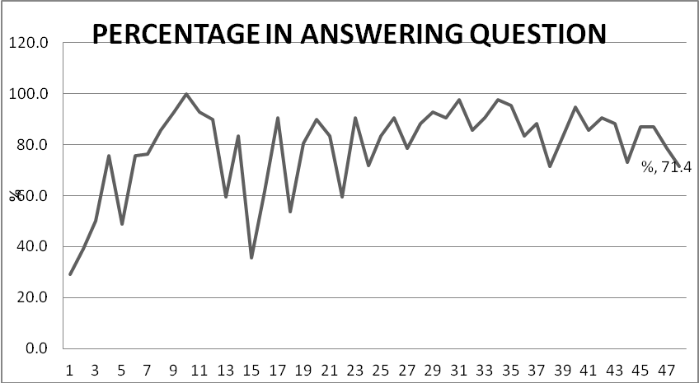

Figure 4.1: Pupils Participation Rate on Answering Questions

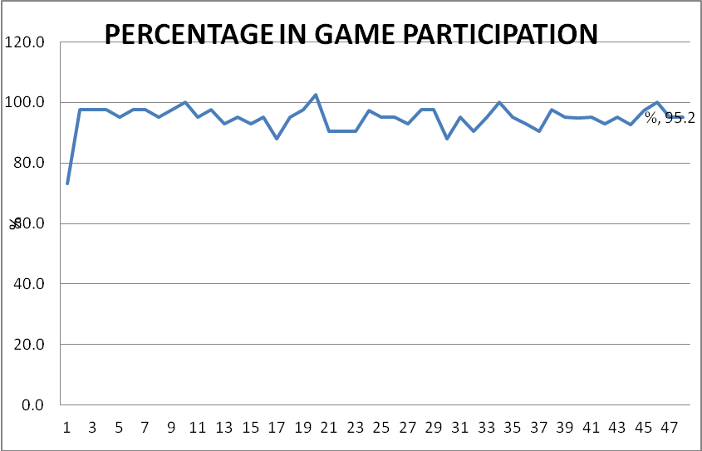

Figure 4.2: Pupils Participation Rate on Games Activities

# 4.3 Pass Rate

This section is going to show the results in mean, frequency, and standard deviation. It will also consider the difference of scores between class 4A and 4B and within the classes for pre-test and post-test. After calculations the mean in pre- test is 12.3 for class A, and 12.6 for class B. The mean of class 4B is high than that of class 4A although that is not a big difference. While the difference is big in post-test results which is 33.7 and 15 for 4A and 4B respectively as shown in Table 4.2.Overall mean also calculated for pre-test and post-test (See Table 4.2). The average mean of pretest for class 4A and 4B is 12.5; this result makes 59.5% pupils in class 4A and 61.9% of class 4B to be below the mean. (See Table 4.3). The average mean of their total scores in post - test is 25.2, which means 36.6% of class 4A pupil scores and 86.8% of class 4B scores lie below the average mean, (See Table 4.4).

The difference for each class and pupil individually between the scores of pre-test and post-test are calculated. The difference enables to show the improvement of every class and every pupil at the end of learning and teaching exercises. The positive difference of pupils total marks between pre-test and post-test is 1373 in class A and 630 in class B. Pupils’ individual marks differences between pre-test and post-test is more positive in class 4A than in class 4B as shown in Table 4.2. While the mean of Pre-test in class 4A is 12.3 and that of class 4B is 12.6 that of post-test are 33.7 and 15.0 respectively as shown in Table 4.2.

Table 4.2: Difference between Scores

|  |  |  |  |  |  |  |
| --- | --- | --- | --- | --- | --- | --- |
|  | **CLASS A** |  | | **CLASS B** |  |  |
| **Pupils' No.** | **Pre Test (%)** | **Post Test (%)** | **Difference (%)** | **Pre Test (%)** | **Post Test (%)** | **Difference (%)** |
| 1 | 2 | 25 | 23 | 6 | 7 | 1 |
| 2 | 16 | 24 | 8 | 12 | - | 0 |
| 3 | 1 | 40 | 39 | 29 | - |  |
| 4 | 14 | 26 | 12 | 3 | 13 | 10 |
| 5 | 2 | 9 | 7 | 4 | 17 | 13 |
| 6 | 9 | 22 | 13 | 15 | 23 | 8 |
| 7 | 7 | 30 | 23 | 21 | 4 | -17 |
| 8 | 6 | 9 | 3 | 11 | 22 | 11 |
| 9 | 8 | 9 | 1 | 9 | - |  |
| 10 | 5 | 53 | 48 | 4 | 18 | 14 |
| 11 | 20 | 41 | 21 | 21 | 21 | 0 |
| 12 | 23 | 46 | 23 | 15 | 12 | -3 |
| 13 | 0 |  | 0 | 6 | 22 | 16 |
| 14 | 5 | 33 | 28 | 11 | 11 | 0 |
| 15 | 5 | 29 | 24 | 9 | 25 | 16 |
| 16 | 20 | 41 | 21 | 15 | - | 0 |
| 17 | 9 | 37 | 28 | 31 | 18 | -13 |
| 18 | 12 | 57 | 45 | 39 | 54 | 15 |
| 19 | 11 | 25 | 14 | 6 | 24 | 18 |
| 20 | 21 | 78 | 57 | 22 | 29 | 7 |
| 21 | 19 | 59 | 40 | 6 | 6 | 0 |
| 22 | 21 | 29 | 8 | 6 | 12 | 6 |
| 23 | 7 | 46 | 39 | 20 | 26 | 6 |
| 24 | 4 | 37 | 33 | 14 | 11 | -3 |
| 25 | 9 | 46 | 37 | 7 | 8 | 1 |
| 26 | 12 | 22 | 10 | 10 | 35 | 25 |
| 27 | 2 | 1 | -1 | 6 | 31 | 25 |
| 28 | 35 | 78 | 43 | 27 | 13 | -14 |
| 29 | 34 | 44 | 10 | 7 | 21 | 14 |
| 30 | 29 | 48 | 19 | 15 | 15 | 0 |
| 31 | 4 | 17 | 13 | 11 | 8 | -3 |
| 32 | 22 | 39 | 17 | 14 | 12 | -2 |
| 33 | 13 | 52 | 39 | 13 | 19 | 6 |
| 34 | 12 | 26 | 14 | 10 | 21 | 11 |
| 35 | 9 | 54 | 45 | 24 | 14 | -10 |
| 36 | 18 | 31 | 13 | 6 | 2 | -4 |
| 37 | 13 | 11 | -2 | 8 | 5 | -3 |
| 38 | 8 | 25 | 17 | 9 | 4 | -5 |
| 39 | 13 | 21 | 8 | 4 | 13 | 9 |
| 40 | 10 | 10 | 0 | 5 | 4 | -1 |
| 41 | 19 | 34 | 15 | 9 | 20 | 11 |
| 42 | 7 | 19 | 12 | 11 | 10 | -1 |
| **Total** | **516** | **1383** | **867** | **531** | **630** | **164** |
| **Mean** | **12.28571429** | **33.73170732** |  | **12.64286** | **16.57895** |  |
|  |  | pretest = | 12.46428571 |  |  |  |
|  | **Average Mean** | posttest = | 25.15532734 |  |  |  |

In contrasting the scores between two classes the researcher looked also on the lowest and highest marks of each class and each test. The highest score in pre-test is 35% in class 4A and 39% in class 4B, however the lowest also is in the same class 4A which is 0%, (See Table 4.2 and 4.3). The things change in post-test, the highest score in class 4A is 78% and 54 in class 4B, where low score is 1% for all classes.

Table 4.3: Scores in Basic Mathematical Activities Questions Items



The comparison also was done for questions items of two topics fractions and mathematical activities (Multiplication, Addition, Subtraction and Division of whole numbers); the results are seen in Table 4.3 and Table 4.4. The average scores obtained for these two topics in class 4A and 4B are 10.7 and 6.9 for Mathematical Activities; 4.0 and 2.3 for Fractions respectively. The scores of mathematical activities are out of 42 and that of fractions are out of 8.0.

Table 4.4: Scores in Fraction Question Terms

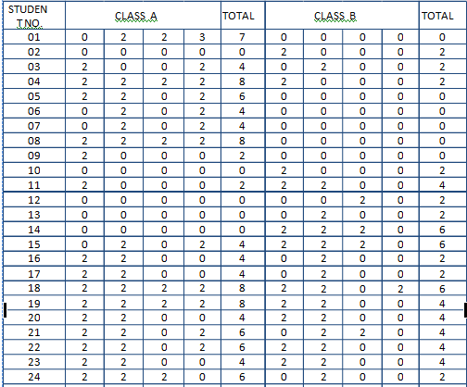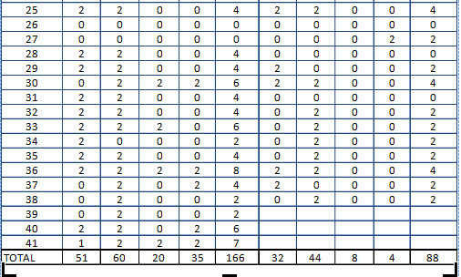

The standard deviation which is the square root variance shows the degree of dispersion in pre - test and post - test for class 4 A and 4B. The standard deviation of class 4A and 4B in pre-test are 8.4 and 8.1 respectively. The standard deviation of post- test is 17.5 for class 4A and 10.11 for class 4B.In post-test, the standard deviation of class 4A is greater than in class 4B in both tests. There is great dispersion for both score of class 4A in Pre-test and Post-test compared with class 4B. Table 4.5 indicates the results.

Table 4.5: Difference of Pass Rate between Class 4A and Class 4B

|  |  |  |  |  |
| --- | --- | --- | --- | --- |
| **ITEM** | **PRE-TEST** | | **POST-TEST** | |
| **Class 4A** | **Class 4B** | **Class 4A** | **Class 4B** |
| Total Marks | 516 | 531 | 1383 | 630 |
| Mean | 12.3 | 12.6 | 33.6 | 15.0 |
| % of pupils below the average mean | 59.5 | 61.9 | 36.6 | 86.8 |
| Lowest scores | 0 | 3 | 1 | 2 |
| Highest Scores | 35 | 39 | 78 | 54 |
| S.D | 8.4 | 8.1 | 17.5 | 8.1 |

The pre-test and post-test scores are distributed to frequency with group intervals of five as seen in Appendix 7 - 10. The frequency distribution of scores results the polygons which are skewed right but some are highly skewed. Figure 4.3 and 4.4 are of pre-test for class 4A and 4B respectively. The shapes of these figures are almost the same, they are highly positively skewed. On the other hand, the polygons of post-test scores differ in their shapes between two classes (4A and 4B). The shape of Figure 4.6 is still highly positively skewed with little changes where the shape of Figure 4.5 is nearly meets the shape of normal curve. Figure 4.5 and Figure 4.6 indicate post-test scores of class 4A and class 4B respectively.

**Figure 4.3: Frequency Polygon - Pre Test Scores Class 4A**

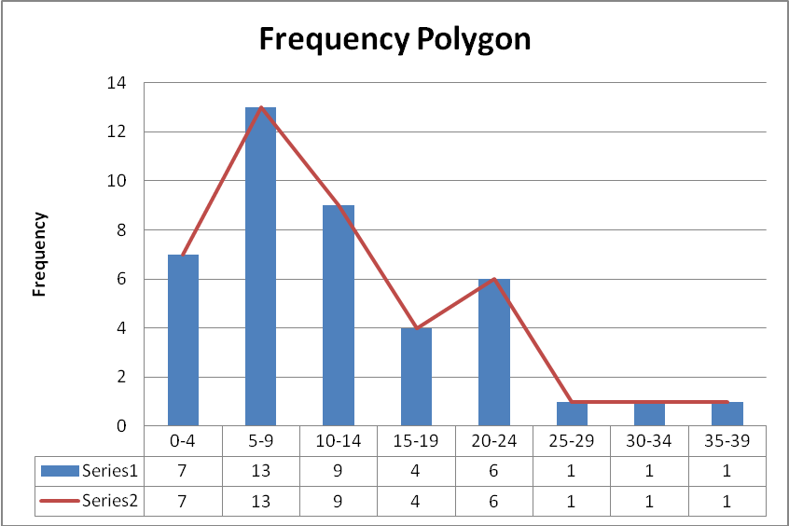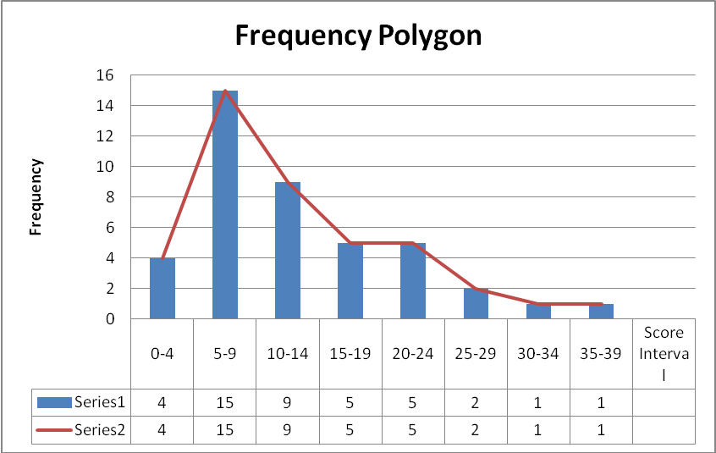

Figure 4.4: Frequency Polygon - Pre Test Scores Class 4B

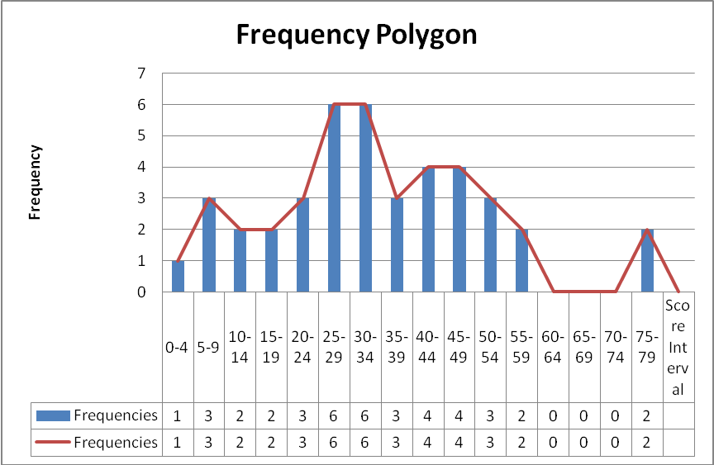

Figure 4.5: Frequency Polygon - Post Test Scores Class 4A

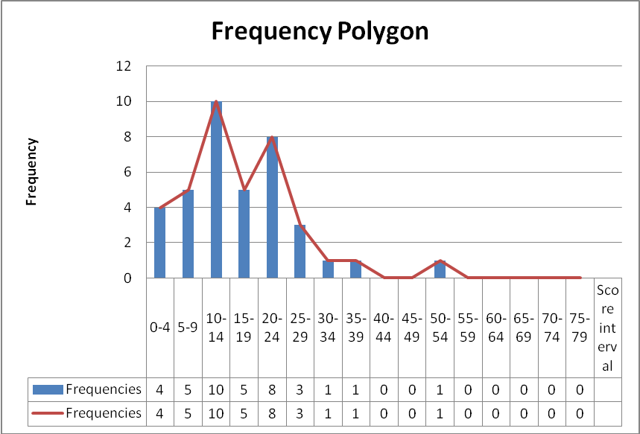

Figure 4.6: Frequency Polygon - Post Test Scores Class 4B

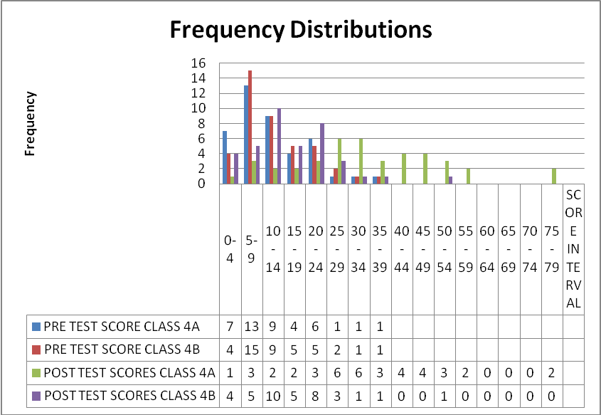

Figure 4.7: Comparison between Two Tests of Class 4A and Class 4B

# 4.4 Time Consumption

Time consuming in learning and teaching process requires planned hours as introduced in analysis. Appendix 15 shows arranged hours for each topic of class four mathematics syllabus. In this study the time utilized as recorded in Appendix 5 was analyzed to understand hours used during learning and teaching process for each day and each selected topic. The results are revealed in Table 4.7. Summary of time used for each selected topic are shown in Table 4.8.

Table 4.7: Time Consumption Topic Wise

| **S.No.** | **Topic** | **Starting Time of the Lesson** | **Closing Time of the Lesson** | **Time Used** |
| --- | --- | --- | --- | --- |
| 1 | Whole numbers | 16:45 | 17:40 | 0:55 |
| 2 | Whole numbers | 16:35 | 17:50 | 1:15 |
| 3 | Whole numbers | 7:02 | 8:03 | 1:01 |
| 4 | Whole numbers | 6:45 | 9:05 | 2:20 |
|  |  |  |  | **5:31** |
| 1 | Addition of whole numbers | 8:10 | 10:03 | 1:53 |
| 2 | Addition of whole numbers | 7:27 | 9:38 | 2:11 |
| 3 | Subtraction of whole numbers | 6:58 | 8:50 | 1:52 |
| 4 | Subtraction of whole numbers | 7:40 | 9:01 | 1:21 |
| 5 | Addition and Subtraction | 7:20 | 8:40 | 1:20 |
| 6 | Addition and subtraction | 6:50 | 9:04 | 2:14 |
| 7 | Addition and subtraction | 7:10 | 9:15 | 2:05 |
| 8 | Addition and subtraction | 7:08 | 8:30 | 1:22 |
| 9 | Multiplication | 6:51 | 7:20 | 0:29 |
| 10 | Multiplication | 7:01 | 9:05 | 2:04 |
| 11 | Multiplication | 7:09 | 9:04 | 1:55 |
| 12 | Division | 6:49 | 8:50 | 2:01 |
| 13 | Division | 7:40 | 9:16 | 1:36 |
| 14 | Division | 7:06 | 8:21 | 1:15 |
| 15 | Division | 6:48 | 9:00 | 2:12 |
|  |  |  |  | **24:50:00** |
| 1 | Clock and Time | 6:50 | 7:55 | 1:05 |
| 2 | Clock and Time | 6:50 | 8:50 | 2:00 |
| 3 | Clock and Time | 7:03 | 8:32 | 1:29 |
| 4 | Clock and Time | 6:59 | 8:45 | 1:46 |
| 5 | Clock and Time | 7:15 | 9:15 | 2:00 |
| 6 | Clock and Time | 7:20 | 9:43 | 2:23 |
| 7 | Clock and Time | 7:06 | 8:43 | 1:37 |
| 8 | Clock and Time | 7:10 | 8:30 | 1:20 |
|  |  |  |  | **13:40** |
| 1 | Geometry | 7:09 | 8:30 | 1:21 |
| 2 | Geometry | 7:30 | 9:26 | 1:56 |
| 3 | Geometry | 8:01 | 9:50 | 1:49 |
|  |  |  |  | **5:06** |
| 1 | Algebra | 7:09 | 8:55 | 1:46 |
| 2 | Algebra | 8:30 | 9:46 | 1:16 |
| 3 | Algebra | 7:05 | 8:15 | 1:10 |
|  |  |  |  | **4:12** |
| 1 | Fractions to Decimal | 7:30 | 9:40 | 2:10 |
| 2 | Fractions to Decimal | 8:01 | 9:05 | 1:04 |
| 3 | Decimal | 7:40 | 9:10 | 1:30 |
| 4 | Decimal | 7:15 | 8:26 | 1:11 |
| 5 | Decimal | 9:01 | 10:05 | 1:04 |
| 6 | Decimal | 7:05 | 8:51 | 1:46 |
|  |  |  |  | **8:45** |
| 1 | Fractions | 7:38 | 8:50 | 1:12 |
| 2 | Fractions | 7:01 | 8:35 | 1:34 |
| 3 | Fractions | 7:15 | 9:01 | 1:46 |
| 4 | Fractions | 6:43 | 8:12 | 1:29 |
| 5 | Fractions | 7:55 | 9:08 | 1:13 |
| 6 | Fractions | 6:57 | 8:06 | 1:09 |
| 7 | Fractions | 7:08 | 8:09 | 1:01 |
| 8 | Fractions | 9:01 | 10:10 | 1:09 |
| 9 | Fractions | 6:58 | 8:04 | 1:06 |
|  |  |  |  | **11:39** |

Table 4.8: Time Used for Each Selected Topic

|  |  |
| --- | --- |
| **TOPIC** | **TIME** |
| Whole numbers | 5:31 |
| Mathematics Activities | 24:50 |
| Fractions | 8:45 |
| Geometry | 5:06 |
| Clock and Time | 13:40 |
| Algebra | 4:12 |
| Decimals | 5:31 |

The analysis in contrasting the time used for certain topics between two classes was conducted too. The items concerned with fractions and mathematical activities (Multiplication, Addition, Subtraction and Division of whole numbers) were examined as listed in Table 4.9. The time used for learning and teaching exercises for two topics (Mathematical activities and fractions) were compared with the time used for same topics in class 4B as seen in table 4.4 below. Class 4A took 24:50 hours for learning basic mathematical activities and 8:45 hours for learning fractions, where class 4B used 42:40 and 14:50 hours respectively as shown in Table 4.7. The indications of average scores obtained for these two topics in both classes as calculated in analysis are shown in Table 4.3, 4.4 and 4.9.

Table 4.9: Test Items Selected for Further Analysis

|  |  |  |
| --- | --- | --- |
| **Topic** | **Mathematical Activities**  (Multiplication, Addition, Subtraction and Division). | **Fractions** |
| SECTION A | Q. NO.1NO. 5 | Q NO. 2 |
| SECTION BI | Q. NO. 1, NO. 2, NO. 3, NO. 10 | Q NO. 4, NO. 5 |
| SECTION BII | Q. NO. 4, NO. 5, NO. 6 | Q. NO. 3 |
| SECTION C | Q. NO. 5 | - |

(Q= Question)

Table 4.10: Scores for Selected Questions Items

|  |  |  |
| --- | --- | --- |
| **TOPIC** | **CLASS 4A** | **CLASS 4B** |
| Mathematical Activities | 10.7 | 6.9 |
| Fractions | 4.0 | 2.3 |

The scores of mathematical activities are out of 42 and that of fractions are out of 8.0

# 4.5 Summary of Chapter Four

The above immediate chapter reveals the results of analysis of the study. It shows that the total average participation rate of pupils (in games activities and in answering questions) during the lessons in a class of games is 86.8%. The mean of Pre-test in class 4A is 12.3 and that of class 4B is 12.6 while that of post-test are 33.7 and 15.0 respectively. Pre-test scores in frequency distribution skewed right for both classes, but in post-test class 4B is still highly skewed positively while class 4A is nearly met the shape of normal distribution. In contrasting with class 4B few hours used to conduct lessons using this strategy in class 4A than that taken in class 4B.

# CHAPTER FIVE

# 5.0 DISCUSSION, SUMMARY, CONCLUSION AND RECOMMENDATION

# 5.1 Introduction

This chapter is going to interpret the results obtained after analysis, summarize the whole report, make conclusion and suggest recommendations according to study findings and according to the culture of our society.

# 5.2 Discussion

The effectiveness’ of games on enhancing learning Mathematics was examined. That means the study examined the impact of games on learning Mathematics. The investigation was on three specific issues; the pupils’ participation rate during learning sessions, pupils pass rate and time consumption for learning activities due do selected topics. Data collected analyzed according to the demand of this study. This chapter is going to discuss the results of the study starting with the discussion on rate of pupil’s participation, and its effectiveness, the difference of pass rate between class 4A and class 4B, and the time used during the learning and teaching exercises also should be discussed.

# 5.2.1 Pupils’ Participation

The pupils’ participation on learning Mathematics increased in class of games. In addition, pupils who participated in the games appear to be more engaged in the leaning process. It is realized in this study that analysis showed the results of increasing the rate percentage of pupils’ participation accordingly. Games made pupils to become more self-confident and cooperative. They tried to share their ideas in their groups and in the whole class. This is supported by researchers like Wiersum (2012) who argued that: ‘pupils who participate in learning activities have become more self-confident and cooperative and not just passive receiver of information’.

In early days of intervention the results show very little pupils’ participation in answering questions in this study, but few days later on, they were ready to try everything in ongoing lessons. The graphs are lowered and raised gradually as seen in Figure 4.1 and Figure 4.2. Most of them raise their hands to answer questions and more than 90% try to participate in every indoor and outdoor games. Researchers like Mijtaba et al (2013), Mutai (2011), Kisakali and Kuznetsov (2015), Gegbe et al (2015), Umur et al (2014), Mbugua et al (2012) and Zakariah et al (2012) found that the major problems on pupils’ performance in learning Mathematics are lack of interest, negative attitude and lack of confidence. It had been seen that the pupils gained momentum after doing such exercise. This means that, difficulties can be eliminated by games as a method of teaching.

Kisakali and Kuznetsov (2015) in their study concluded that lack of interest and triviality in studying Mathematics is the most significant factor for poor performance on learning Mathematics. In the class in which games are used, this problem can be solved smoothly. The pupils built their confidence; they were well motivated and increased their interest in learning Mathematics as certified in the analysis of this study. Nature of children is to be affiliated with games, and accordingly they love their teachers who use this technique. The Pupils in the class in which competitive games are used are always happy and try their best to ensure they win in doing exercises.

In class of games pupils interact between themselves and their teachers, they engage themselves in order to meet their interest of winning. Games strategy shows support to the psychologists who believe on constructivism. According to Droper 2002 constructivism is the beliefs that learners create their own knowledge based on interactions with other people. Through games, the pupils increase interactions for their participation, so they performed well in different tasks. Lessons by using games were highly activator for pupils to participate in class activities and increase peer tutoring as per the recommendation of Apple field at el (2011) who concluded that pupil become more active learners when they interact with their peers.

Even pupils of special needs were benefited in this strategy. It was realized that one of class 4A pupils is a deaf. She was dormant during the first days of intervention but she changes gradually within ongoing the intervention. Johnson (2013) also recommended that peer tutoring can be an effective strategy for increasing Mathematical achievements for the pupils with learning disabilities. Competitive games in a class increase peer tutoring; they helped each other in their groups to ensure they win.

In this study, there was high interaction among the pupils in experimental class. This interaction enabled pupils to learn quickly and surely, finally their response was positive in doing tests. It can be supported by theory of Vygostsky which is recognized in learning Mathematics education. This is clearly observed that, his theory coincides with the results of this survey. One of the theory state that, the development of pupils’ intelligence results from social interaction in the world.

Games activities enable pupils to participate in learning activities; this participation enhances them to be motivated and increases their attitude. When pupils are motivated to positive attitudes at the same time critical thinking is created to promote performance in learning Mathematics. A Cottril (2016) found in his study and concluded that, through games and Mathematics activities, pupils built a sense of Mathematical values and based on that, they contrasting and modifying their thinking. Through competitive games, the lesson becomes inquiry based totally on participation in a lesson and therefore automatically they perform high on assessment. Pupils build confidence and they are in position to monitor their own programs and understanding of the subject Material.

# 5.2.2 Pass Rate

The use of games in learning increases the performance rate of pupils in Mathematics. This research proves that in using competitive games the pupils in experimental class whereby the games are used those skills can be improved. Many pupils in class 4A improved even in reading, writing and counting. Leone et al (2010) developed their strategies in their research, one of them was to use games and constructive competition to practice and review numeracy skills.

Pupils’ individual marks variance between pre-test and post-test is more positive in class A than in class B as indicated in results of the study. Scores of post-test show that pupils in class 4B were not sure of what they did, many of them scored less than in pre-test. In contrasting the scores between pre- test and post-test of both classes it shows that, class 4A only two pupils scored low marks in post-test compared with pre-test, and one pupil scored equal number in pre-test and post-test, while in class 4B, thirteen of them scored low marks in post –test than in pre-test and four pupils scored equal between two tests. It shows that more than 90% who use games obtain high marks in post-test in contrasting with pre-test, this is good result.

Pupils’ individual marks differences between pre-test and post-test is more positive in class A than in class B as shown in Table 4.2. Good result of pupils in class 4A was obtained because of high opportunity they had in observation and imitation among themselves. This is supported by the concern of Bandura in his theory of social learning. He observed that, people learn from one another via observation, imitation and modeling. That is why the class of pupils who used games in learning performed better than a class of traditional method.

Through competitive games the pupils performed higher on assessment. The analysis and results of this study indicate that in a class in which games are used pupils’ performance increased rapidly; they appear to be more engaged in the learning process. This is supported by various researchers like Kirkland and O’ Riordon (2011) as they concurred that pupils who participate in games did perform better on average in exams. On another hand, Gottle (2016) and Wiersum (2012) in their studies have viewed that, pupils who participate less in a lesson have lower performance scores on their assessment.

To use competitive games as a strategy in learning and teaching enables pupils to acquire knowledge and skills quickly. In this study, the pupils in a class of games improved in assessment, many of them who had no skills on writing, reading and arithmetic earlier perceived a lot. Carlo et al (2013) conducted a rapid review on game based learning in their research might support it. They tried to answer questions like what is game based learning, what are their impacts to learners, implication to school and so on. One of their findings is that impact of gaming can be mediated by prior experience of skills level of pupils, pupil and teacher attitude to gaming in the classroom and the type of game on experience promoted by the game.

Their study was dealing with digital games, but this study was dealing with actual games where pupils participate themselves in games activities. It can be seen from the results of this study that the strategy can provide positive changes to pupils’ performance and it proves on the difference of performance between two classes as indicated in the analysis. This research found that games strategy can be used to encourage pupils’ creativity and to be engaged themselves in learning Mathematics. Lai (2011) suggested that critical thinking relates to other important pupils’ learning outcomes such as motivation, collaboration and creativity. That was realized in this study, the pupils during games lessons seem to think critically on finding the techniques to win the game, and critical thinking promoted them to good performance.

According to Hussein (1989); knowledge is not passively received but actively built up, and the work of Helpern and Doughy (2000) who believed that learning is achieved through activities function in the class of games. Through games activities the pupils were actively built up their confidence on perceiving knowledge. At the same time they were careful in recording and calculating the scores. For example, in rope skipping each member of the group count and keep their records for their group and the scores of other group or groups, then they calculate the sum of all members scores in each group. That means the games entail the pupils to perceive the learning skills rapidly. According to Moore (2012) the best teaching practice to improve achievement in Mathematics is incorporating the use of games in the subject. This is indicated in this study that the use of games on teaching Mathematics provide the rapid change on pupils’ performance.

The standard deviation of class 4A and 4B in pre -test are 8.4 and 8.1 respectively. The standard deviation of post- test is 17.5 for class 4A and 10.7 for class 4B. In post-test, the standard deviation of class 4A is greater than in class 4B in both tests. There is great dispersion for the scores of class 4A in pre- test and post- test compared with class 4B. This means some few pupils in class 4A are most intelligent. They defeat others in a large pace. The pupils in class 4B were less dispersed in their scores for those tests. These few most intelligent pupils can be used in a class of games for peer tutoring; they were most competent in this study to guide others in a group to facilitate winning.

# 5.2.3 Time Consumption

This study provides some evidence on the effectiveness of games strategy. There was certain difference on time consuming between learning and teaching Mathematics using games strategy and using traditional means. The researcher discovered that the time taken to teach Mathematics using different strategies between two classes is nearly the same in one topic only (Whole numbers). For other topics like Mathematical activities and fractions class 4A where games strategy was used, less time consumed than class 4B, which used traditional methods. One among the strategies in five dimensions developed by SRI (2010); is intensification strategy, which described on time spent for intervention. Strength of time used should be considered to ensure benefit.

Beside the high utilization of time in class four 4B their performance is low nearly in all topics. Let us look on *mathematical activities and fractions.* The average scores for those topics class 4A have done well than class 4B.Extra benefit for theclass in which games were used was that, several concepts were realized by the pupils at a time. For example, sub topic ‘*addition of whole* *numbers*’ in a class of games can be combined with other topics like the *units of length and weight.* This indicates that, the time can be used more effectively in the class of games.

# 5.2.4 The New Framework with Relation to Others

The framework was developed by a researcher according to the objectives’ variables of the research. This meets with the expectation mentioned earlier. Games as a strategy in learning and teaching Mathematics activated pupils to *participate* in learning activities, stimulated pupils to increase *pass rate*, and also a strategy as a technique of learning and teaching ensured the use of *time* effectively. It finally ended with the enhancement of improving the *performance* of pupils in learning Mathematics.

SRI-framework (2005) supports the framework of this study. After a team of SRI researchers examined research literatures, SRI framework was developed. They concluded that an effective strategy must include five dimensions of pupil’s school experiences. Some of them are intensification strategy (time spent for interventions), and Pedagogy/Instructional approach (Pedagogical differences that seem to impact pupils’ mathematics learning). The new Frame work (Games Strategy to performance of Learning) is a pedagogical approach which makes changes on pupils’ Mathematical learning, and the time was used effectively in order to create room for pupils to learn smoothly. It is obviously coincides the earlier expectations.

The Frame work of Peressini et al (2004) for some extent supports this frame work. Their frame work guided the design, data collection, and analysis, an interpretation of finding for The Learning and Teaching Secondary Mathematics project (LTSM) through a situative lens. Through lens they developed belief about Mathematics and Mathematics specific pedagogy. Finally, their observations revealed different patterns of instruction in the classes in which students actively explored important Mathematical ideas, in groups and as whole class. In a new framework revealed that the pattern of instruction used, students were actively explored important Mathematical ideas both in groups and as a whole class and create cooperation which ended to improvement.

# 5.3 Summary of Research Report

This study was investigating the effectiveness of games strategy to pupil’s performance in Mathematics especially in primary classes. The study was experimental and purposive conducted by involving the pupils of class four of Mzambarauni mixed School. Specifically the research aimed at examining the pupils’ participation rate, measuring pupils’ pass rate, and examining time taken during the learning activities through games strategy. The data collected through pre-test, post-test and observation during lesson activities. The pupils participated fully in games competition and they were happy and comfortable in all lessons.

Mean, frequencies, standard deviation and percentages were used to analyze data. The results show that, games stimulated pupils to increase pass rate and activate pupil to participate in learning activities. Also the conduction of games as the technique of learning and teaching ensure the pupils to use time effectively to their power of observation, imitation and interaction. Besides the expected changes, the strategy motivated pupils and built their confidence to Mathematics lessons. In short there is high participation rate of the pupils in games lessons especially in doing activities. The pass rate in class of games increased more than the class using traditional methods. The time taken was almost the same as in traditional method.

# 5.4 Conclusion

Our country is facing the problem of poor performance among pupils on learning Mathematics. This research work provides the details of the results of a study on the influence of games on learning Mathematics. It focused on the pupils’ performance on participation, pass rate and lesson time duration. Games as a technique in teaching and learning have many benefits to the learning development of our children.

The results and discussion indicate that games strategy can influence pupils to participate fully in lesson activities and they are happy and comfortable in a class of games. Secondly the results show that games can accelerate the pass rate of pupils and it is a big gear to drive their thinking power and making critical decision in problem solving. The observation on the time in the lesson using games strategy concluded that, the strategy does not take too much time. Not only do games motivate pupils in offering interactive learning environment they also provide many positive features. In the class of games pupils do not get tired, they are affiliated to games, so it reduces number of truants. Still the games have large and strong part on the remedial of the performance of pupils on teaching and learning of Mathematics. A class where the games are used especially competitive games, the pupils are more active. Thus the analysis provided suggests that games strategy in learning and teaching process do have a positive impact on pupils.

# 5.5 Recommendations

The results indicate that games strategy is more effective during learning and teaching exercises than traditional methods. Good performance of pupils in learning Mathematics can be achieved if we decide to consider the use of games in the process of learning and teaching. It simplifies the work of a teacher and promotes the thinking power of pupils. The strategy is a strong stimulus in learning Mathematics and it is recommended to change of traditional classroom instructions to game based learning in Mathematics especially in primary classes to pave the way of successions. Children enjoy playing games.

Therefore, it is recommended that the education management systems should supply the roles of games in learning and teaching Mathematics to teachers. Teachers might be convinced and guided to exercise this strategy. To conduct lessons through this strategy, more spaces are required, hence it is necessary to create play grounds in our schools. It is also recommended to researchers that, there is still a room of conducting more studies in order to find appropriate management to games as a technique of teaching Mathematics in primary classes as a foundation level.

# REFERENCES

Abawi, K. (2014). Training in Sexual and Reproductive Health Research, Swiss, Geneva.

Anderson, J. R. (1987). Acquisition of Cognitive Skill, *Psychology Review.* 94*(*2), 192–210.

Applefield, J. M. (2001). Constructivism, in Theory and Practice Toward an better Understanding. *The high School journal.* 84(2): 35-53.

Bandura, A. (1971). *Social learning Theory,* New York: General Learning Press*.*

National Foundation for Educational research, (2013). *Game Based Learning Latest Evidence and Future Directions* Paris: OECD Publishing.

Chan, J. & Chang, C. (2009). Cognitive Load Theoretical Study Anxiety and Task Performance is Language learning*, International* Journal *of English* Language *Teaching,* 1(1), 24-41.

Cottril, J. (2003). *An Overviews Theory of Learning in Mathematics Education Research.* CT: Information Age Publishing.

Creswell, J. W. (2012). Educational Research: *Planning, Conducting and Evaluating Qualitative and Quantitative Research*, University of Nebraska Lincoln: USA.

Draper, R. (2002). School Mathematics Reforms, Construction, and Literacy, Instruction in there turn Oriented Math Classroom International Reading Association. Journal *of Adolescent & Adult* Literacy, 1, 45-46.

Drijvers, P. (2012). Digital Technology in Mathematics Education Why it works (or doesn’t),curriculum reform committee cTWO (2006-2012), The Utrecht University, Netherlands.

Enon, D. E. (1995). Educational Research, Statistics and Measurement.Department of Science Educational Makerere University.

Fasasi, K. M. & Yahya, A. S. ( ). *Strategies for improving The Effectiveness of Mathematics Teachers at Secondary Schools,* Department of Science and Education, Federal University of Technology, Yola Adama State.

Handal, B. & Bobis, J. (2003). Instructional Style in the Teaching of Mathematics. *International Journal of* Mathematics Teaching *and Learning,* 13(2), 47–57.

Helpern, D.F. & Donaghey (2000), *Learning Theory Constructivist Approach, Shema Theory- Historical lamom.* Brewer Shema.

House of Commons Public Account Committee, (2009). Mathematics Performance in Primary Schools Getting the Best Results 2005 – 09 Stationary Office –London, UK.

Husen, T. & T. N. Waite, P. L. (1989). *Constructivism of Education,* New York: Per Gamon Tress.

Jaffe, K. (2006). *The Importance of Mathematical Relation Formation in Math World Problem Solving an Eye Movement.* Paris: OECD Publishing

Johson, J. A. (2003). Teaching Interventions to Increase Mathematics Achievement in Elementary Pupils with Moderate to Severe Learning.North Michigan, University.

Kisakala, J. & Kuznetsov, D. (2015). Modeling Factors influencing mathematics – Learning and Performance in Tanzania Secondary Schools*. Asian Journal of Mathematics and Applications,* 1(1), 1-8.

Konami, S. B. (2014). The Extent to which Factors Contribute the Poor Performance of Primary Children on Mathematics in Republic Schools in Kenya, Kenyatta University Institute Repository.

Kormula, E. (2012). Principal Strategies for Improving the Academic Achievement of Pupils of Disadvantaged Rural Junior High Schools in Ghana. Edith Cowan University.

Leon, P., Wilson, M. & Mulcahy C. (2010). Making it Account: Strategies for Improving Mathematics Instructions for Pupils in short term facilities Washington D. C. National Education and Assistance centre for Children and Youth who are neglected, delinquent or at risk (NDTAC).

Lai, E. R. (2011). Critical Thinking. A literature reviews. Research Report (2011).

Liu, H. & Matthews, R. (2005). Vygostisky’s philosophy, constructivism and its criticisms Examined. *International Education Journal,* 6(3), 23-25.

Mbugua, Z. K. (2012). The School Based factors that Affects performance in Mathematics. *American International Journal of contemporary Research*. 2(6): 2012- 87.

Mdee, D. R. (2015). Factors Affecting Students’ Performance in National Secondary Education Examination in Temeke District Secondary School, Masters Dissertation*,* Open University of Tanzania: Dar es Salaam.

Ministry of Education and Vocational Training, (2014). *SACMEQ III* Project Report in Zanzibar*.* UN Agencies in Tanzania.

Ministry of Education and Vocational Training Zanzibar, (2014). *Education for All Assessment.* Report in Zanzibar*.* Zanzibar: Tanzania.

Mujtaba, T. (2013). What factors Affect London Pupils Aspirations continue with Mathematics Post-16? Masters thesis, TheInstitute of Education University of London.

Murray, J. (2013). Factors that influence Mathematics Achievement at the Berbice Campus, University of Guyana Berbices Campus*.*

Ndalichako, J. L. (2010). Examination Reports on the Performance of Candidate CSEE 2009- 041 – Basic Mathematics.The National Examination Council of Tanzania, Dar es Salaam.

Oso, W. Y. & Onen, D. (2005). *A General Guide to Writing Proposal and Report*. Willis Yuko: Oso & Cowen.

Patricka,R. (2015) Conceptual Framework: A Step By Step Guide on How to Make One University in Philippines.

Peresini, D. (2004). *A Conceptual Framework for Learning to Teach Secondary Mathematics.* A Situative Perspective, Kluwer: Academic Publishers.

Salad, T. U. (2014). The Causes of Poor Performance in Mathematics among Public Senior Secondary Pupil in Azare Metropolis of Bauchi State,Nigeria. Journal of Research and Method in Education.

Sang cap, P. G. A, (2010). Factors Affecting Mathematics and Problems Salving Performance. Masters thesis, Center for Educational Research and Development, University of Saint Tomas, Philippines.

Seamen M. A (1991). Satellite Humidity Measurement to Improve the Forecasting, Midlevel, Mixed Phase Clouds, Colorado State University.

Simon, M. A. (1995). Reconstructing Mathematics Pedagogy from a Constructivist Perspective. *Journal for Research in Mathematics Education,* 26(2), 114-145.

SRI, (2010). A comprehensive Frame work for Improving Mathematics in Low Performing Secondary Schools SRI International, Resta, New York.

USAID/Agakhan Foundation (2007). *Completion, Retention and Access for Tanzanian’s to Improve Education (*CREATE), Dar es Salaam, Tanzania.

**APPENDICES**

Appendix 1: Test Paper

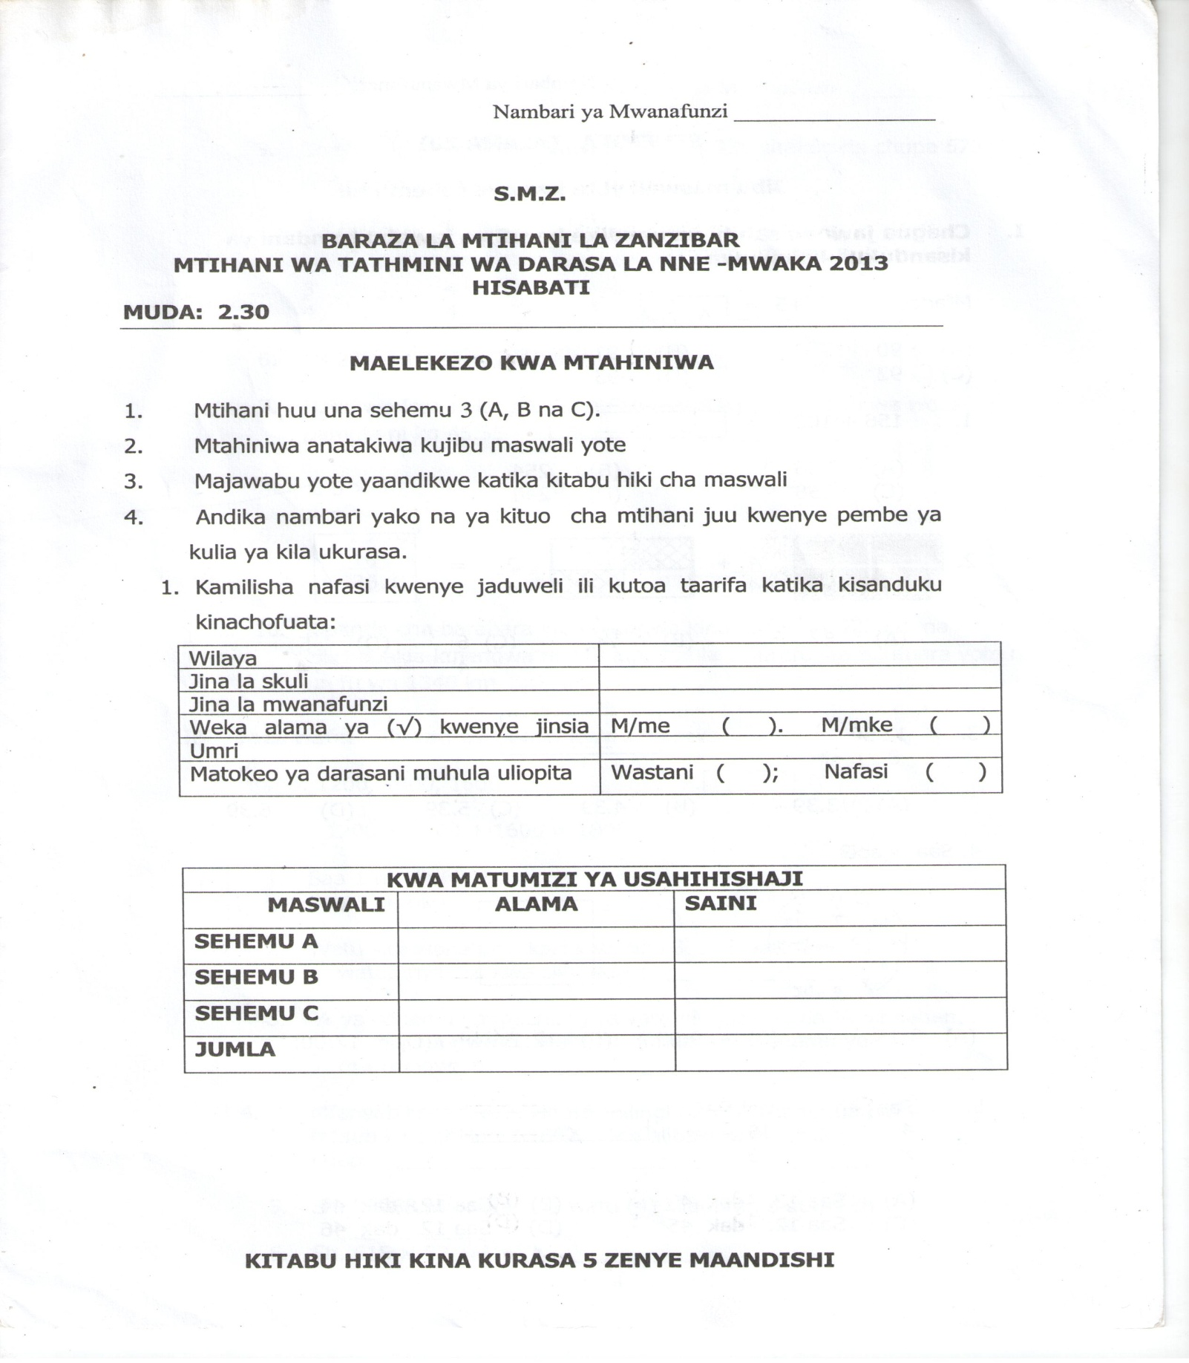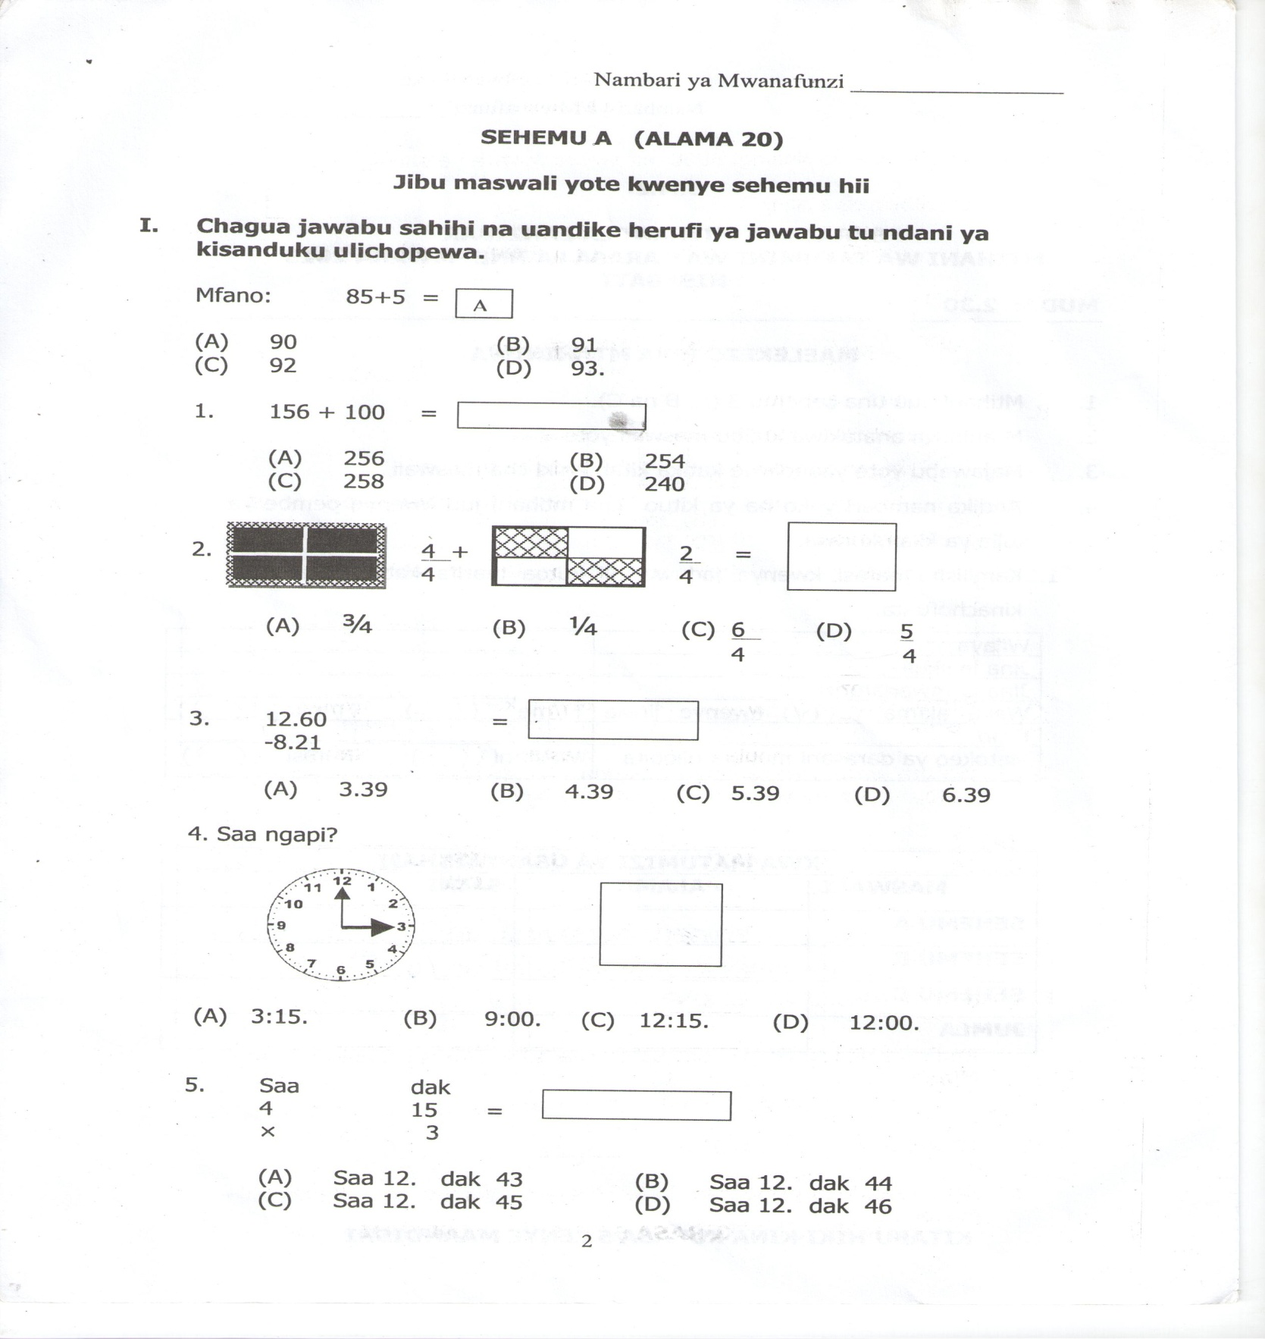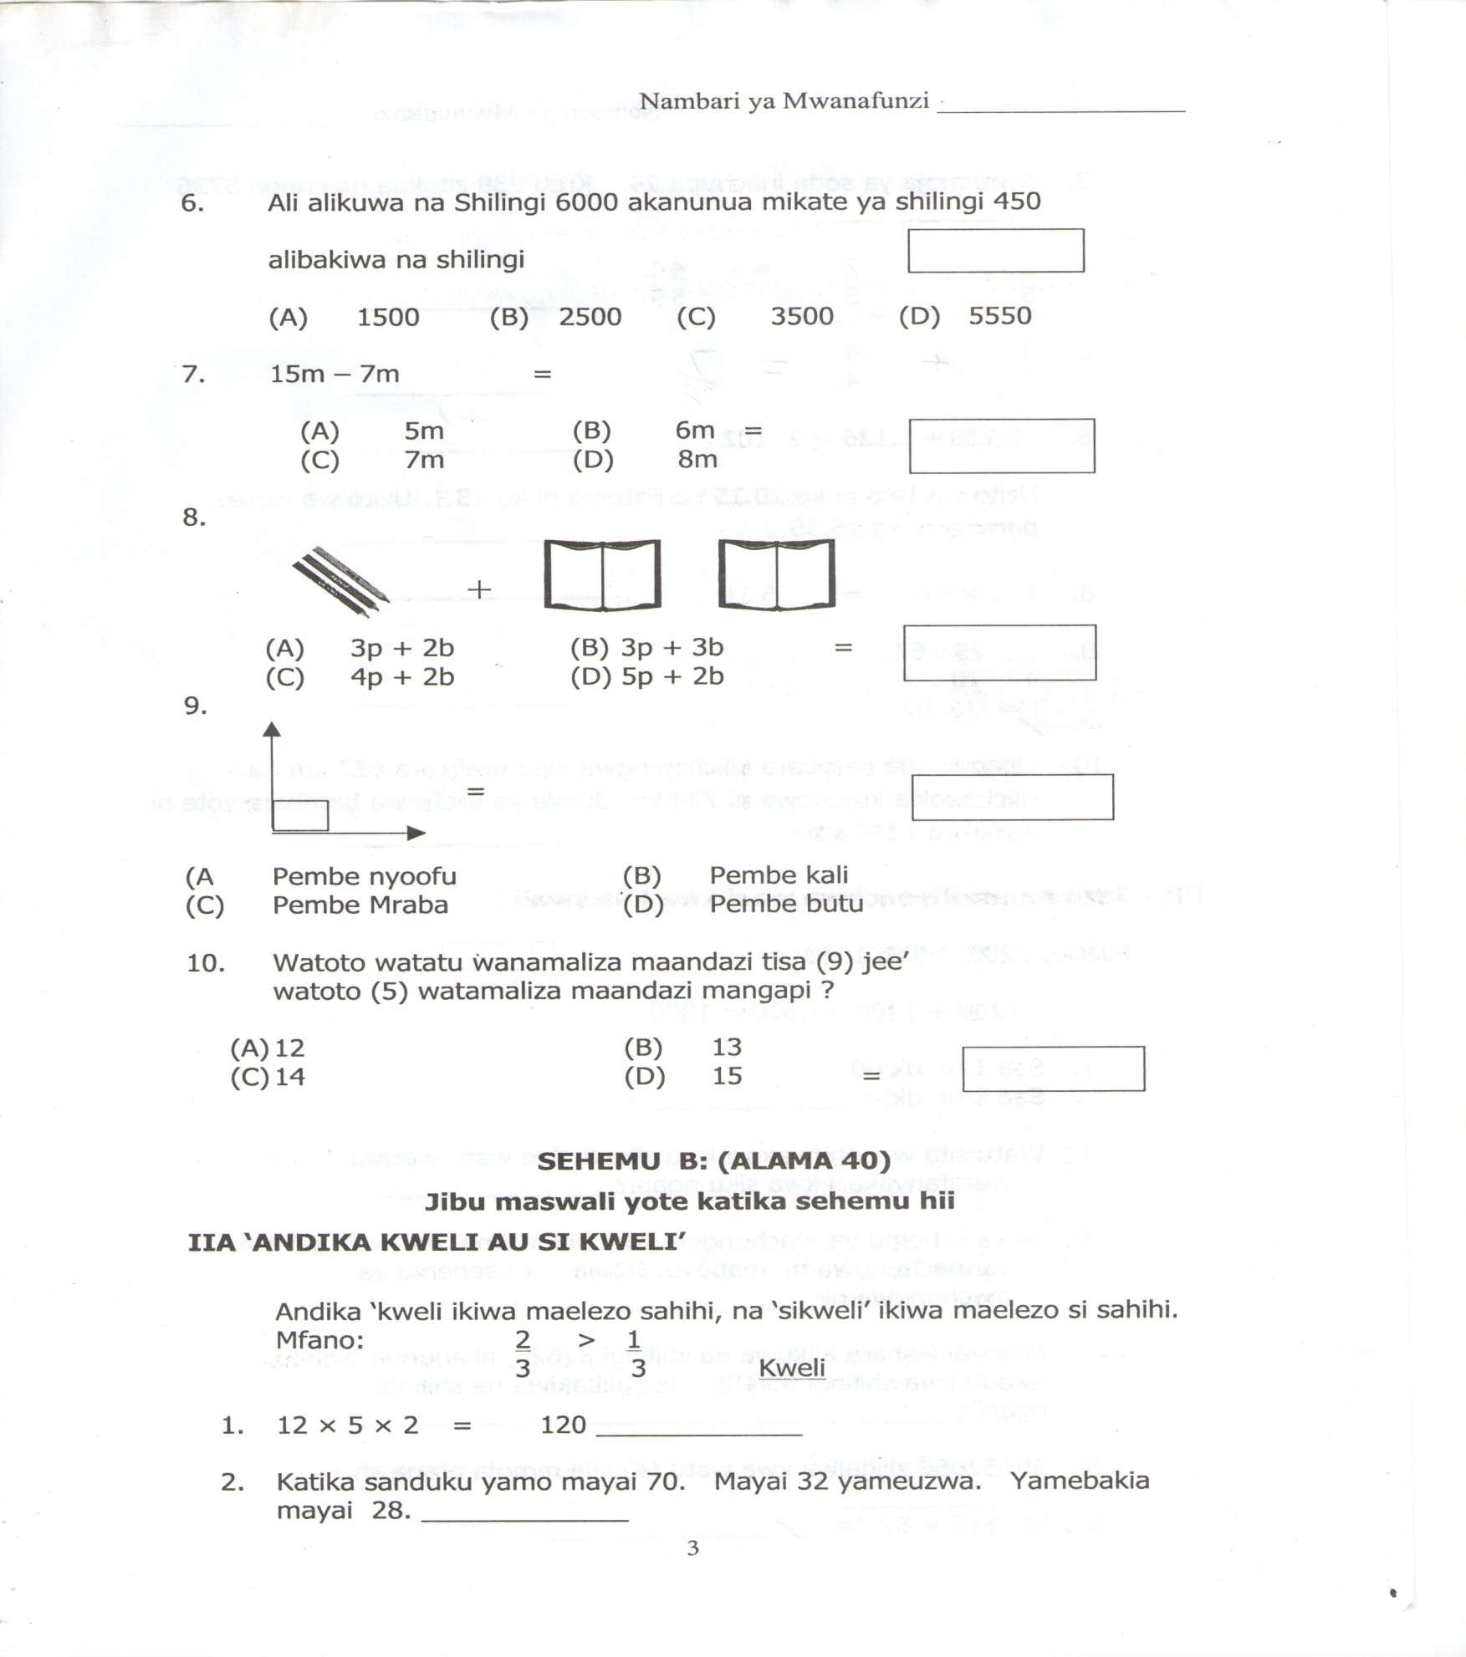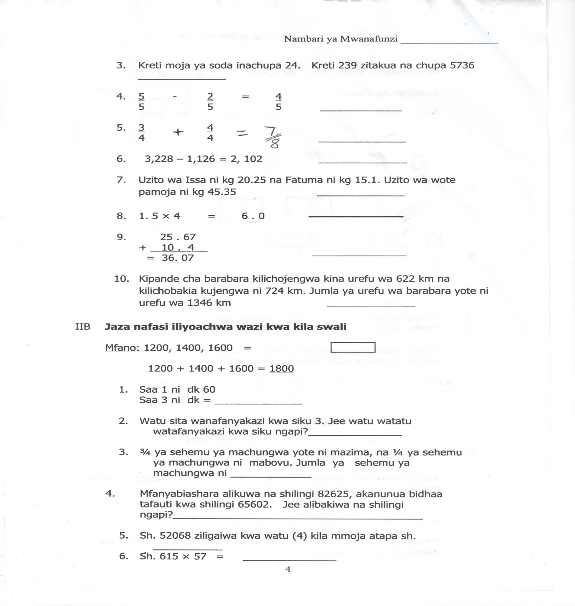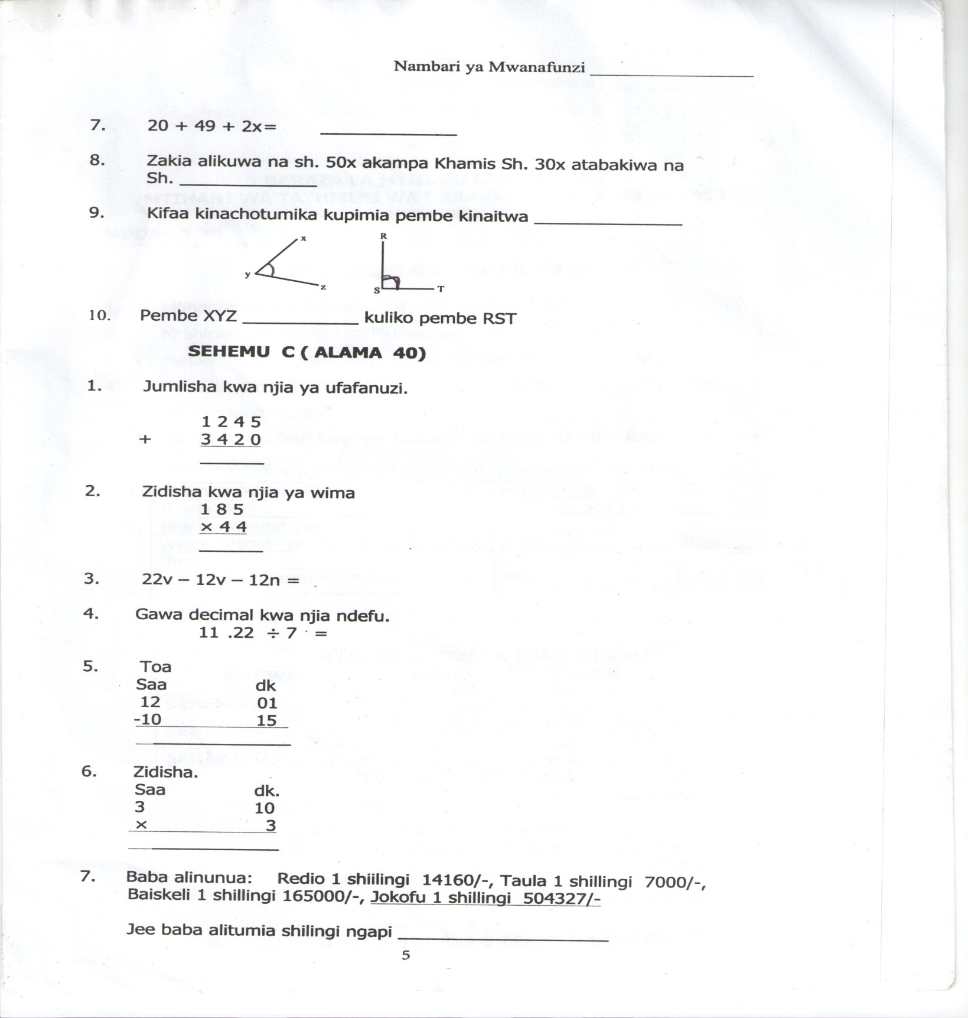

Appendix 2: Pretest Scores

| **PUPIL'S NO.** | **CLASS 4 A** | **CLASS 4 B** |
| --- | --- | --- |
| 1 | 2 | 6 |
| 2 | 16 | 12 |
| 3 | 1 | 29 |
| 4 | 14 | 3 |
| 5 | 2 | 4 |
| 6 | 9 | 15 |
| 7 | 7 | 21 |
| 8 | 6 | 11 |
| 9 | 8 | 9 |
| 10 | 5 | 4 |
| 11 | 20 | 21 |
| 12 | 23 | 15 |
| 13 | 0 | 6 |
| 14 | 5 | 11 |
| 15 | 5 | 9 |
| 16 | 20 | 15 |
| 17 | 9 | 31 |
| 18 | 12 | 39 |
| 19 | 11 | 6 |
| 20 | 21 | 22 |
| 21 | 19 | 6 |
| 22 | 21 | 6 |
| 23 | 7 | 20 |
| 24 | 4 | 14 |
| 25 | 9 | 7 |
| 26 | 12 | 10 |
| 27 | 2 | 6 |
| 28 | 35 | 27 |
| 29 | 34 | 7 |
| 30 | 29 | 15 |
| 31 | 4 | 11 |
| 32 | 22 | 14 |
| 33 | 13 | 13 |
| 34 | 12 | 10 |
| 35 | 9 | 24 |
| 36 | 18 | 6 |
| 37 | 13 | 8 |
| 38 | 8 | 9 |
| 39 | 13 | 4 |
| 40 | 10 | 5 |
| 41 | 19 | 9 |
| 42 | 7 | 11 |
|  | **516** | **531** |

**Appendix 3: Selected Topics**

|  |  |
| --- | --- |
| **TOPIC** | **SUB - TOPIC TAUGHT** |
| 1. Whole Number | Counting, reading, and writing. |
| 2. Mathematics Activities | Addition, Subtraction, Multiplication and division. |
| 3. Fraction | Comparing, Addition and Subtractions. |
| 4. Decimals | Concept, reading, Addition and Subtraction. |
| 5. Angles | Instruments used Naming, and types of angles |
| 6. Clock and Time | Reading, Addition, Subtraction and Multiplication |
| 7. Algebra | Concept, Addition and Subtraction |

Appendix 4: Teaching Competition Games

|  |  |
| --- | --- |
| **TOPIC** | **GAMES** |
| 1.Whole numbers | Rope skipping, Eye hiding, Ball bouncing |
| 2. Mathematical activities | Rope skipping, Race, Ball bouncing, shopping, shot put, discus |
| 3.Fractions | Ground Draft, Painting, stop race |
| 4.Decimals | Drafting and skipping, Potato race |
| 5.Angles | Showing and Touching, Construction, Drawing and Naming |
| 6.Clock and Time | Who is hero, Climbing and jumping |
| 7. Algebra | Shopping, Proper property, Mix. Share |

**EXAMPLES OF GAMES CONDUCTED**

**Example 1: Rope Skipping (Indoor Game)**

The teacher grouped the pupils into two teams and provided them a thick rope. They did skipping one by one in each group alternatively. The teacher guided pupils to count how many times member of the team could skip before it lost and each group kept their records. Then they made summations of their skipping numbers. Each group made its own calculations and the summation for other group.

**GROUP 1 GROUP 2**

|  |  |
| --- | --- |
| **MEMBERS** | **SCORES** |
| 1st | 21 |
| 2nd | 60 |
| 3rd | 12 |
| **TOTAL** | **93** |

|  |  |
| --- | --- |
| **MEMBERS** | **SCORES** |
| 1st | 25 |
| 2nd | 87 |
| 3rd | 30 |
| **TOTAL** | **142** |

The teacher walked around the class to guide the groups. Then the whole class discussed and finally the winner was announced.

**Example 2: Kiba (Indoor Game)**

The pupils grouped into two or three groups. The teacher hid any countable things in the form of chipping, crystals, grains or any else in his/her hand. Then she told pupils Kiba followed by the name of a thing hidden in the hand. Then pupils in a group try to mention number of things hidden followed by the name. For example:

|  |  |
| --- | --- |
| **TEACHER** | **PUPILS** |
| Kibanjugu (Kiba ground nuts) | Sitanjugu(Six ground nuts) |
| Kibanjiwe (kiba stones) | Nnenjiwe (four stones) |
| Kibanjiti (kiba Sticks) | Tanonjiti (five sticks) |

If a pupil in a group got the answer, the number was written with a letter of the substance used. Then the pupils made summations.

|  |  |  |
| --- | --- | --- |
| **GROUP A** | **GROUP B** | **GROUP C** |
| 2t + 4t + 6t = 12t | 9t + 5t + 0 = 14t | t + 10t + 2t = 13t |

‘t’ for njiti

Therefore, Group B was the winner. Sometimes these groups gave the name a food or any adjective. For example, Winner and Best,or Mango, Banana and Pineapple etc. Every pupil in a group made calculations for her/his group and for other group.

**Example 3: Potato Race (outdoor game)**

The class was grouped in two groups. Stones (which were used instead of actual potatoes) were arranged in a line and boxes/buckets were kept in the starting of each row. Members of the group one by one from each group picked stones and put in the box one by one, after certain seconds stop .Then those who were out of the game for that time counted stones in the box, then recorded for their teams.

**Example 4: Short put and Discus. (Outdoor games)**

Wood equipment for discussion and shot-put of their size were made by the researcher. The pupils in a group threw short put or discus and then measured length, calculated scores for all pupils by adding to find the winner group and the difference of scores between winners and losers were calculated.

**Example 5: Construction (outdoor game)**

The pupils in their groups were required to build their house using sticks. Then they showed and named the angles observed in the building. A winner was for the group in which the pupil named and showed more types of angles in their construction.

Appendix 5: Pupils’ Participation and Time Consumption

|  |  |  |  |  |  |
| --- | --- | --- | --- | --- | --- |
| S/N | Topic | **Avarage No. of Raising Hands for** | | **Time Consumed** | |
|  |  | **Answering**  **Question** | **Games**  **Participation** | **Starting**  **Time** | **Closing**  **Time** |
|  |  |
| 1 | Whole numbers | 12 | 30 | 16:45 | 17:40 |
| 2 | Whole numbers | 16 | 41 | 16:35 | 17:50 |
| 3 | Whole numbers | 21 | 42 | 07:02 | 08:03 |
| 4 | Whole numbers | 31 | 40 | 06:45 | 09:05 |
| 5 | Addition of whole numbers | 20 | 39 | 08:10 | 10:03 |
| 6 | Addition of whole numbers | 31 | 40 | 07:27 | 09:38 |
| 7 | Subtraction of whole numbers | 32 | 41 | 06:58 | 08:50 |
| 8 | Subtraction of whole numbers | 36 | 38 | 07:40 | 09:01 |
| 9 | Addition and Subtraction | 39 | 39 | 07:20 | 08:40 |
| 10 | Addition and subtraction | 22 | 22 | 06:50 | 09:04 |
| 11 | Addition and subtraction | 38 | 38 | 07:10 | 09:15 |
| 12 | Addition and subtraction | 36 | 39 | 07:08 | 08:30 |
| 13 | Clock and Time | 25 | 39 | 06:50 | 07:55 |
| 14 | Clock and Time | 35 | 40 | 06:50 | 08:50 |
| 15 | Multiplication | 15 | 38 | 06:51 | 07:20 |
| 16 | Multiplication | 26 | 42 | 07:01 | 09:05 |
| 17 | Multiplication | 38 | 41 | 07:09 | 09:04 |
| 18 | Division | 22 | 36 | 06:49 | 08:50 |
| 19 | Division | 33 | 41 | 07:40 | 09:16 |
| 20 | Division | 35 | 38 | 06:48 | 09:00 |
| 21 | Division | 35 | 35 | 07:06 | 08:21 |
| 22 | Fractions | 25 | 38 | 07:38 | 08:50 |
| 23 | Fractions | 38 | 38 | 07:01 | 08:35 |
| 24 | Geometry | 28 | 38 | 07:09 | 08:30 |
| 25 | Geometry | 35 | 40 | 07:30 | 09:26 |
| 26 | Geometry | 38 | 40 | 08:01 | 09:50 |
| 27 | Algebra | 33 | 40 | 07:09 | 08:55 |
| 28 | Algebra | 37 | 42 | 08:30 | 09:46 |
| 29 | Algebra | 38 | 42 | 07:05 | 08:15 |
| 30 | Fractions to Decimal | 38 | 39 | 07:30 | 09:40 |
| 31 | Fractions to Decimal | 40 | 38 | 08:01 | 09:05 |
| 32 | Decimal | 36 | 38 | 07:40 | 09:10 |
| 33 | Decimal | 38 | 40 | 07:15 | 08:26 |
| 34 | Decimal | 40 | 41 | 09:01 | 10:05 |
| 35 | Decimal | 40 | 40 | 07:05 | 08:51 |
| 36 | Clock and Time | 35 | 39 | 07:03 | 08:32 |
| 37 | Clock and Time | 37 | 38 | 06:59 | 08:45 |
| 38 | Clock and Time | 30 | 41 | 07:15 | 09:15 |
| 39 | Clock and Time | 35 | 40 | 07:20 | 09:43 |
| 40 | Clock and Time | 36 | 36 | 07:06 | 08:43 |
| 41 | Clock and Time | 36 | 40 | 07:10 | 08:30 |
| 42 | Fractions | 38 | 39 | 07:15 | 09:01 |
| 43 | Fractions | 31 | 40 | 06:43 | 08:12 |
| 44 | Fractions | 30 | 38 | 07:55 | 09:08 |
| 45 | Fractions | 33 | 37 | 06:57 | 08:06 |
| 46 | Fractions | 33 | 38 | 07:08 | 08:09 |
| 47 | Fractions | 33 | 40 | 09:01 | 10:10 |
| 48 | Fractions | 30 | 40 | 06:58 | 08:04 |

**Appendix 6: Posttest Scores**

|  |  |  |
| --- | --- | --- |
| **PUPIL NO.** | **CLASS 4A %** | **CLASS 4B ( %)** |
| 1 | 25 | 7 |
| 2 | 24 | - |
| 3 | 40 | - |
| 4 | 26 | 13 |
| 5 | 9 | 17 |
| 6 | 22 | 23 |
| 7 | 30 | 4 |
| 8 | 9 | 22 |
| 9 | 9 | - |
| 10 | 53 | 18 |
| 11 | 41 | 21 |
| 12 | 46 | 12 |
| 13 | - | 22 |
| 14 | 33 | 11 |
| 15 | 29 | 25 |
| 16 | 41 | - |
| 17 | 37 | 18 |
| 18 | 57 | 54 |
| 19 | 25 | 24 |
| 20 | 78 | 29 |
| 21 | 59 | 6 |
| 22 | 29 | 12 |
| 23 | 46 | 26 |
| 24 | 37 | 11 |
| 25 | 46 | 8 |
| 26 | 22 | 35 |
| 27 | 1 | 31 |
| 28 | 78 | 13 |
| 29 | 44 | 21 |
| 30 | 48 | 15 |
| 31 | 17 | 8 |
| 32 | 39 | 12 |
| 33 | 52 | 19 |
| 34 | 26 | 21 |
| 35 | 54 | 14 |
| 36 | 31 | 2 |
| 37 | 11 | 5 |
| 38 | 25 | 4 |
| 39 | 21 | 13 |
| 40 | 10 | 4 |
| 41 | 34 | 20 |
| 42 | 19 | 10 |
| **TOTAL** | **1383** | **630** |

Appendix 7: Frequency Distribution of Pre Test Class 4A

|  |  |  |
| --- | --- | --- |
| **Item** | **X** | **F** |
| 1 | 35 | 1 |
| 2 | 34 | 1 |
| 3 | 29 | 1 |
| 4 | 23 | 1 |
| 5 | 22 | 1 |
| 6 | 21 | 2 |
| 7 | 20 | 2 |
| 8 | 19 | 2 |
| 9 | 18 | 1 |
| 10 | 16 | 1 |
| 11 | 14 | 1 |
| 12 | 13 | 3 |
| 13 | 12 | 3 |
| 14 | 11 | 1 |
| 15 | 10 | 1 |
| 16 | 9 | 4 |
| 17 | 8 | 2 |
| 18 | 7 | 3 |
| 19 | 6 | 1 |
| 20 | 5 | 3 |
| 21 | 4 | 2 |
| 22 | 2 | 3 |
| 23 | 1 | 1 |
| 24 | 0 | 1 |
|  | **Total** | **42** |

Appendix 8: Frequency Distribution of Pre Test Class 4B

|  |  |  |
| --- | --- | --- |
| **Item** | **X** | **F** |
| 1 | 39 | 1 |
| 2 | 31 | 1 |
| 3 | 29 | 1 |
| 4 | 27 | 1 |
| 5 | 24 | 1 |
| 6 | 22 | 1 |
| 7 | 21 | 2 |
| 8 | 20 | 1 |
| 9 | 15 | 4 |
| 10 | 14 | 2 |
| 11 | 13 | 1 |
| 12 | 12 | 1 |
| 13 | 11 | 4 |
| 14 | 10 | 2 |
| 15 | 9 | 4 |
| 16 | 8 | 1 |
| 17 | 7 | 2 |
| 18 | 6 | 7 |
| 19 | 5 | 1 |
| 20 | 4 | 3 |
| 21 | 3 | 1 |
|  | **Total** | **42** |

Appendix 9: Frequency Distribution of Post Test Class 4A

|  |  |  |
| --- | --- | --- |
| **Item** | **X** | **F** |
| 1 | 78 | 2 |
| 2 | 59 | 1 |
| 3 | 57 | 1 |
| 4 | 54 | 1 |
| 5 | 53 | 1 |
| 6 | 52 | 1 |
| 7 | 48 | 1 |
| 8 | 46 | 3 |
| 9 | 44 | 1 |
| 11 | 41 | 2 |
| 12 | 40 | 1 |
| 13 | 39 | 1 |
| 14 | 37 | 2 |
| 15 | 34 | 1 |
| 16 | 33 | 1 |
| 17 | 31 | 1 |
| 18 | 30 | 1 |
| 19 | 29 | 2 |
| 20 | 26 | 2 |
| 21 | 25 | 3 |
| 22 | 24 | 1 |
| 23 | 22 | 2 |
| 24 | 21 | 1 |
| 25 | 19 | 1 |
| 26 | 17 | 1 |
| 27 | 11 | 1 |
| 28 | 10 | 1 |
| 29 | 9 | 3 |
| 30 | 1 | 1 |
|  | **Total** | **41** |

Appendix:10 Frequency Distribution of Post Test Class 4B

|  |  |  |
| --- | --- | --- |
| **Item** | **X** | **F** |
| 1 | 54 | 1 |
| 2 | 35 | 1 |
| 3 | 31 | 1 |
| 4 | 29 | 1 |
| 5 | 26 | 1 |
| 6 | 25 | 1 |
| 7 | 24 | 1 |
| 8 | 23 | 1 |
| 9 | 22 | 2 |
| 10 | 21 | 3 |
| 11 | 20 | 1 |
| 12 | 19 | 1 |
| 13 | 18 | 2 |
| 14 | 17 | 1 |
| 15 | 15 | 1 |
| 16 | 14 | 1 |
| 17 | 13 | 3 |
| 18 | 12 | 3 |
| 19 | 11 | 2 |
| 20 | 10 | 1 |
| 21 | 8 | 2 |
| 22 | 7 | 1 |
| 23 | 6 | 1 |
| 24 | 5 | 1 |
| 25 | 4 | 3 |
| 26 | 2 | 1 |
|  | **Total** | **38** |

Appendix 11: Standard Deviation of Pretest Class 4A

|  |  |  |  |  |
| --- | --- | --- | --- | --- |
| Item | X | F | fX | fx² |
| 1 | 35 | 1 | 35 | 1225 |
| 2 | 34 | 1 | 34 | 1156 |
| 3 | 29 | 1 | 29 | 841 |
| 4 | 23 | 1 | 23 | 529 |
| 5 | 22 | 1 | 22 | 484 |
| 6 | 21 | 2 | 42 | 882 |
| 7 | 20 | 2 | 40 | 800 |
| 8 | 19 | 2 | 38 | 722 |
| 9 | 18 | 1 | 18 | 324 |
| 10 | 16 | 1 | 16 | 256 |
| 11 | 14 | 1 | 14 | 196 |
| 12 | 13 | 3 | 39 | 507 |
| 13 | 12 | 3 | 36 | 432 |
| 14 | 11 | 1 | 11 | 121 |
| 15 | 10 | 1 | 10 | 100 |
| 16 | 9 | 4 | 36 | 324 |
| 17 | 8 | 2 | 16 | 128 |
| 18 | 7 | 3 | 21 | 147 |
| 19 | 6 | 1 | 6 | 36 |
| 20 | 5 | 3 | 15 | 75 |
| 21 | 4 | 2 | 8 | 32 |
| 22 | 2 | 3 | 6 | 12 |
| 23 | 1 | 1 | 1 | 1 |
| 24 | 0 | 1 | 0 | 0 |
|  |  | 42 | 516 | 9330 |

|  |  |  |  |  |
| --- | --- | --- | --- | --- |
|  |  | Mean = | 12.3 |  |
|  |  |  |  |  |
|  | SD = | √∑fx²-(fx)² |  |  |
|  |  | |  | | --- | | N N | |  |  |
|  |  |  |  |  |
|  | SD | = | 8.4382511 |  |
|  |  |  |  |  |

Appendix 12: Standard Deviation of Pre - Test Class 4B

|  |  |  |  |  |
| --- | --- | --- | --- | --- |
| **Item** | **X** | **F** | **Fx** | **fX²** |
| 1 | 39 | 1 | 39 | 1521 |
| 2 | 31 | 1 | 31 | 961 |
| 3 | 29 | 1 | 29 | 841 |
| 4 | 27 | 1 | 27 | 729 |
| 5 | 24 | 1 | 24 | 576 |
| 6 | 22 | 1 | 22 | 484 |
| 7 | 21 | 2 | 42 | 882 |
| 8 | 20 | 1 | 20 | 400 |
| 9 | 15 | 4 | 60 | 900 |
| 10 | 14 | 2 | 28 | 392 |
| 11 | 13 | 1 | 13 | 169 |
| 12 | 12 | 1 | 12 | 144 |
| 13 | 11 | 4 | 44 | 484 |
| 14 | 10 | 2 | 20 | 200 |
| 15 | 9 | 4 | 36 | 324 |
| 16 | 8 | 1 | 8 | 64 |
| 17 | 7 | 2 | 14 | 98 |
| 18 | 6 | 7 | 42 | 252 |
| 19 | 5 | 1 | 5 | 25 |
| 20 | 4 | 3 | 12 | 48 |
| 21 | 3 | 1 | 3 | 9 |
|  |  | 42 | 531 | 9503 |

|  |  |  |  |  |  |
| --- | --- | --- | --- | --- | --- |
|  |  |  |  | |  |
|  | SD = | √∑fx²-(fx)² | | √66.4 | | |  |
|  |  | N N | |  | | |  |
|  |  |  | |  | | |  |
|  | SD | = | | 8.149850798 | | |  |
|  |  |  |  | |  | | |

Appendix 13: Standard Deviation of Post Test Class 4A

|  |  |  |  |  |
| --- | --- | --- | --- | --- |
| Item | X | F | Fx | fX² |
| 1 | 78 | 2 | 156 | 12168 |
| 2 | 59 | 1 | 59 | 3481 |
| 3 | 57 | 1 | 57 | 3249 |
| 4 | 54 | 1 | 54 | 2916 |
| 5 | 53 | 1 | 53 | 2809 |
| 6 | 52 | 1 | 52 | 2704 |
| 7 | 48 | 1 | 48 | 2304 |
| 8 | 46 | 3 | 138 | 6348 |
| 9 | 44 | 1 | 44 | 1936 |
| 11 | 41 | 2 | 82 | 3362 |
| 12 | 40 | 1 | 40 | 1600 |
| 13 | 39 | 1 | 39 | 1521 |
| 14 | 37 | 2 | 74 | 2738 |
| 15 | 34 | 1 | 34 | 1156 |
| 16 | 33 | 1 | 33 | 1089 |
| 17 | 31 | 1 | 31 | 961 |
| 18 | 30 | 1 | 30 | 900 |
| 19 | 29 | 2 | 58 | 1682 |
| 20 | 26 | 2 | 52 | 1352 |
| 21 | 25 | 3 | 75 | 1875 |
| 22 | 24 | 1 | 24 | 576 |
| 23 | 22 | 2 | 44 | 968 |
| 24 | 21 | 1 | 21 | 441 |
| 25 | 19 | 1 | 19 | 361 |
| 26 | 17 | 1 | 17 | 289 |
| 27 | 11 | 1 | 11 | 121 |
| 28 | 10 | 1 | 10 | 100 |
| 29 | 9 | 3 | 27 | 243 |
| 30 | 1 | 1 | 1 | 1 |
|  | 990 | 41 | 1383 | 59251 |

|  |  |  |  |  |
| --- | --- | --- | --- | --- |
|  | SD = | √∑fx²-(fx)² | √307.32 |  |
|  |  | N N | |  |
|  |  |  |  |  |
|  | SD | = | 17.53 |  |
|  |  |  |  |  |
|  |  |  |  |  |

Appendix 14: Standard Deviation of Post Test Class 4B

|  |  |  |  |  |
| --- | --- | --- | --- | --- |
| Item | X | F | Fx | fX² |
| 1 | 54 | 1 | 54 | 2916 |
| 2 | 35 | 1 | 35 | 1225 |
| 3 | 31 | 1 | 31 | 961 |
| 4 | 29 | 1 | 29 | 841 |
| 5 | 26 | 1 | 26 | 676 |
| 6 | 25 | 1 | 25 | 625 |
| 7 | 24 | 1 | 24 | 576 |
| 8 | 23 |  | 23 | 529 |
| 9 | 22 | 2 | 44 | 968 |
| 10 | 21 | 3 | 63 | 1323 |
| 11 | 20 | 1 | 20 | 400 |
| 12 | 19 | 1 | 19 | 361 |
| 13 | 18 | 2 | 36 | 648 |
| 14 | 17 | 1 | 17 | 289 |
| 15 | 15 | 1 | 15 | 225 |
| 16 | 14 | 1 | 14 | 196 |
| 17 | 13 | 3 | 39 | 507 |
| 18 | 12 | 3 | 36 | 432 |
| 19 | 11 | 2 | 22 | 242 |
| 20 | 10 | 1 | 10 | 100 |
| 21 | 8 | 2 | 16 | 128 |
| 22 | 7 | 1 | 7 | 49 |
| 23 | 6 | 1 | 6 | 36 |
| 24 | 5 | 1 | 5 | 25 |
| 25 | 4 | 3 | 12 | 48 |
| 26 | 2 | 1 | 2 | 4 |
|  |  | 38 | 630 | 14330 |

|  |  |  |  |  |
| --- | --- | --- | --- | --- |
|  | SD = | √∑fx²-(fx)² | 102.24 |  |
|  |  | N N |  |  |
|  |  |  |  |  |
|  | SD | = | 10.11 |  |
|  |  |  |  |  |

Appendix 15: The Topics and their Planned Time in Class 4 Syllabus

|  |  |  |
| --- | --- | --- |
| **TOPIC** | **SUB-TOPIC** | **TIME (Hrs)** |
| Whole numbers | Counting | 8:00 |
| Reading of numbers | 8:00 |
| Writing of numbers | 8:40 |
| Mathematics Activities | Addition | 8:40 |
| Subtraction | 8:40 |
| Multiplication | 10:40 |
| Division | 10:40 |
| Fractions | Comparing fractions | 8:00 |
| Addition | 4:00 |
| Subtraction | 4:00 |
| Multiplication | 6:40 |
| Division | 5:20 |
| Decimals | Concept of decimals | 4:40 |
| Reading decimals | 8:40 |
| Addition and subtraction | 8:40 |
| Angles | Revision on concept of LS, types of LS, and naming of angles | - |
| Instruments to draw angles. | 7:20 |
| Clock and Time | Reading Addition, Subtraction and Multiplication. | 17:20 |
| Algebra | Concept | 6:00 |
| Addition and subtraction | 10:40 |