THE ROLE OF VILLAGE MUSEUM IN THE DEVELOPMENT OF TOURISM IN DAR ES SALAAM CITY, TANZANIA

MBARUKU MOHAMED SINONI

A DISSERTATION SUBMITTED IN PARTIAL FULFILLMENT OF THE REQUIREMENTS FOR THE DEGREE OF MASTER OF TOURISM PLANNING AND MANAGEMENT OF THE OPEN UNIVERSITY OF TANZANIA
2017

CERTIFICATION
The undersigned certify that he has read and hereby recommends for the acceptance by the Open University of Tanzania, a dissertation titled, “The Role of Village Museum in the Development of Tourism in Dar es Salaam City, Tanzania” in partial fulfillment of the requirements for the Degree of Master of Tourism Planning and Management of the Open University of Tanzania.

…………………………………
Dr. Emmanuel Patroba Mhache
(Supervisor)

…………………………………
Date

COPYRIGHT
No part of this dissertation may be reproduced, stored in any retrieval system or transmitted in any form by any means, electronic, mechanical, photocopying, recording or otherwise without prior written permission of the author or the Open University of Tanzania in that behalf.

DECLARATION
I, Mbaruku Mohamed Sinoni, do hereby declare that this dissertation is my own original work, and that it has not been submitted for a similar degree in any other University.

………………………
Signature

………………………
Date

DEDICATION
This dissertation is dedicated to my beloved children Shazmah and Salim and to my lovely wife Sophia Medadus. I also dedicate this dissertation to my lovely parents Mr. Salim Sinon and Mrs. Halima Sinon whose patience and support inspired this undertaking. They were there for me financially, physically and psychologically throughout this exercise.

ACKNOWLEDGEMENTS
This dissertation would not have been possible without assistance and support obtained from different people and organizations that their efforts made this study possible. I would like to extend my sincere gratitude to my family for sponsoring my studies. I am sincerely grateful to my supervisor Dr. Emmanuel Patroba Mhache for his unwavering support, academic advice, constructive criticisms and directions during the proposal writing, data collection, analysis and development of this dissertation. He has been more than just a supervisor to make this work successful.

Special thanks go to my lecturers, Dr. Shogo Mlozi, Mr. Michael Parrick and Ms. Veronica Nyerere for their teaching, moral and material support during my coursework and in the writing of this dissertation. I also thanks other members of staff in the Department of Tourism and Hospitality, and the Open University of Tanzania at large. I am also indebted to my colleagues mate for their academic assistance as well as social, financial and technical support they offered me. I thank you all from the bottom of my heart.

It is difficult to thank each person individually, but for those who helped me in one way or another, and their names are not mentioned here please forgive me but I thank you all in deed. Despite the immense support and help I got, I take personal responsibility for all errors and shortcomings in this dissertation.

ABSTRACT
The study focuses on the role of Village Museum in the development of tourism in Dar es Salaam city and Tanzania at large. The main objective of this study was to examine the role played by the Village Museum in the development of tourism in Dar es Salaam. The study had four specific objectives which were to identify tourism attractions available in the Village Museum, to examine the contribution of Village Museum in the development of tourism in Dar es Salaam City, to assess challenges facing Village Museum in the development of tourism in Dar es Salaam City and to evaluate strategies and measures to address challenges facing Village museum in the development of tourism in Tanzania. The study is very important as it adds reference or readings to tourism and hospitality, it also advice on policy and decision making. In this study three theories were used which were Travel Motivation Theory, Vroom’s Expectancy Theory and Invitational Theory. In this study data were collected using questionnaires, interviews, focus group discussion and documentary literature review. Deliberate sampling techniques were used to identify and locate the potential sample in the study area. The collected data was analyzed and processed using SPSS and Microsoft Excel. Information collected was presented in tables, figures and narratives. The study revealed that Village Museum is an important get-way as it portrays what is in the country side and convince tourists to visit and contribute to income, forex and employment. Village Museum is an important cultural attraction with immense contribution to the development of tourism in Dar es Salaam and the country at large. Despite its contribution this attraction face natural and cultural challenges which if well managed it will assure the prosperity of Village Museum. The study recommends promotion of Village Museum using different media like radio, televisions, magazines, internet, in trade fair and others. Keywords: Museum, Makumbusho Village, Tourism, Development, Dar es Salaam.

TABLE OF CONTENT
CERTIFICATION ii
COPYRIGHT iii
DECLARATION iv
DEDICATION v
ACKNOWLEDGEMENTS vi
ABSTRACT vii
TABLE OF CONTENT viii
LIST OF TABLE xiii
LIST OF FIGURE xiv
LIST OF PLATES xv
CHAPTER ONE 1
1.0 INTRODUCTION AND PROBLEM SETTING 1
1.1 Introduction 1
1.2 Background of the Study 1
1.3 Statement of the Problem 8
1.4 Objective of the Study 9
1.4.1 General Objective 9
1.4.2 Specific objectives 10
1.4.3 Research Questions 10
1.4.4 Significance of the Study 10
CHAPTER TWO……………………………………………………………………10
2.0 LITERATURE REVIEW 12
2.1 Introduction 12
2.2 Definition of Key Terms 12
2.2.1 Tourism 12
2.2.3 Cultural Heritage 13
2.3 Theoretical Literature Review 15
2.3.1 Travel Motivation Theory 15
2.3.2 Vroom’s Expectancy Theory 16
2.3.3 Invitational Theory 17
2.4.1 Museums: An overview 18
2.4.2 Tourism Development in Tanzania 24
2.4.3 Tourism Attractions 29
2.4.4 Tourism development strategies in Tanzania 32
2.4.5 Conceptual framework 35
2.4.6 Research Gap 36
CHAPTER THREE 38
3.0 THE STUDY AREA AND RESEARCH METHODOLOGY 38
3.1 Introduction 38
3.2 The Study Area 38
3.3 Research Design 39
3.4 Sampling Procedure and Sample Size 40
3.5 Sources of Data 40
3.5.1 Primary Data 40
3.5.2 Secondary Data 40
3.6 Methods of Data Collection 41
3.6.1 Questionnaires 41
3.6.2 Focus Group Discussions 41
3.6.3 Key Informant Interviews 41
3.6.4 Documentary Literature Review 42
3.7 Data Analysis, Interpretation and Presentation 42
3.8 Validity and Reliability of the Research Instruments 42
3.9 Ethical Consideration 43
CHAPTER FOUR 44
4.0 PRESENTATION OF THE FINDINGS AND DISCUSSION 44
4.1 Introduction 44
4.2 Socio-Demographic Characteristics of the Respondents 44
4.2.1 Age of the Respondents 44
4.2.2 Gender of Respondents 45
4.2.3 Education Level of Respondents 46
4.2.4 Marital Status 47
4.3 Tourism Attractions in the Village Museum 48
4.3.1 Traditional Houses 49
4.3.2 Natural Trees 50
4.3.3 Artistic Work 52
4.3.4 Curio Shop in the Village Museum 54
4.3.5 Traditional Garden 55
4.3.6 Traditional Dances 56
4.4 Contribution of Village Museum in the Development of Tourism 57
4.4.1 Employment Creation 58
4.4.2 Stimulate Development of Tourism Products 59
4.4.3 Contribution of Village Museum in Cultural Promotion 59
4.4.4 Preserve the Cultural Attractions 60
4.4.5 Village Museum Promote Cultural Tourism 61
4.4.6 Development of Other Sectors 61
4.4.7 Creation of Markets for Local Products 62
4.5 Challenges facing Village Museum in the Development of Tourism 62
4.5.1 Insufficient Fund 63
4.5.2 Conservation/preservation challenges 65
4.5.3 Unreliable Climatic Condition 66
4.5.4 Inadequate promotion 66
4.5.5 Shortage of Staff and Professionals 67
4.5.6 Spoils and Destruction by the Tourists 68
4.6 Measures to Address Challenges facing Village Museum in Development of Tourism 69
4.6.1 Raising the Level of Public Awareness 69
4.6.2 Improvement of the Exhibitions and Plan for New Ones 71
4.6.3 Conduct Outreach Programs 71
4.6.4 Adoption and Enforce of Tourism Policy 72
4.7 Discussion of the Findings 73
4.7.1 The Contribution of Village Museum in the Development of Tourism in Dar es Salaam City 74
4.7.2 Tourism Attractions in the Village Museum 76
4.7.3 Challenges facing Village Museum in Development of Tourism 76

CHAPTER FIVE 78
5.0 SUMMARY, CONCLUSION AND RECOMMENDATIONS 78
5.1 Introduction 78
5.2 Summary 78
5.3 Conclusion 79
5.4 Recommendations 80
REFERENCES 81
APPENDICES 85

LIST OF TABLE

Table 2.1 : Classification of Cultural Heritage 14
Table 4.1 : Age of the Respondents 45
Table 4.2 : Gender of respondents 45
Table 4.3 : Educational level of the respondents 47
Table 4.4 : Marital status of the respondents 47
Table 4.5 : Contribution of Village Museum in Tourism Development 58

LIST OF FIGURE
Figure 2.1 : The Tourists Routes to Tanzania. 28
Figure 2.2 : Museums and it impacts on tourism in Tanzania. 36
Figure 4.1 : Tourism attractions found at the Village Museum 48
Figure 4.2 : Challenges Facing Village Museum 63

LIST OF PLATES
Plate 4.1 : Chagga compound with Isale and big mango tree at the back 50
Plate 4.2 : Big mangoes and coconut trees provide natural shade. 52
Plate 4.3 : Figurine Sculptor at the Village Museum 53
Plate 4.4 : A woman at the curio shop selling different tourism items. 55
Plate 4.5 : A woman attending garden at the Village Museum 56
Plate 4.6 : Makua Traditional Dancer Performing at the Village Museum 57

CHAPTER ONE

1.0 INTRODUCTION AND PROBLEM SETTING

1.1 Introduction
Tourism industry is one of the fastest growing industries in the world (Gocldner, 1992). Tourism is becoming increasingly important as a result of immense benefits derived from the industry (Okpoko, 2006). Tourism connotes the mobilization of people’s cultural and natural resources especially those aspects which made people unique from other people via what distinguishes Africans from non-Africans (Andah, 1990). Tourism industry has been grown very fast in sub-Sahara African countries including Tanzania which showed the increase of number of tourists from 5,300 in 1947 (Ouma, 1970; Vojislar, 1972) to 867,994 in 2011 (URT, 2012). This chapter provides the background information that introduces the study, presents background to the problem and statement of the problem which clarify the needs to undertake this study. However, objectives, research questions, significance of undertaking this study as well as the limitations and delimitations of the study are provided.

1.2 Background of the Study
Tourism industry in Tanzania emphasizes both nature tourism and cultural tourism. The essential core of culture consists of traditions, historically derived and selected ideas and their attached values. Cultural systems may, on the one hand, be considered as products of action, and on the other hand as conditioning elements for further action (Kroeber and Kluckhohn, 1952). Museum is a building housing with collection of objects for inspection, study and enjoyment. The word museum was derived from the Greek word “museion”. In its original sense, it was applied to the sanctuary dedicated to the muses of Greek mythology (Okita, 1985). According to Abun (1987), the muses were believed to be nine virginal daughters of Zeus and Mnemosyne who were charged with the responsibility to protect and encourage art and science, poetry, music, dance and history of the people of Greece. The daughters of Zeus were also reported to be good dancers and singers. In this way they helped man to forget their sorrows and anxiety.

Thus museum is associated with a place man’s mind rest and for everyday affairs as well as a sense of inspiration (Okita, 1985; Taylor, 1947). It become the custom to establish shrines in their honour in shady grooves often high on the mountain tops, where the spirits of the nine learned maidens of mythology might inspire the artist to their highest endeavors. Special cults and altars adorned with images were dedicated to them; these become the gathering places for the lovers of art (Rowman and Little Field, 2008). Museum normally houses a core collection of important selected objects in its field. For example, archaeology museums specialize in the display of archaeological artifacts. Arts museums are known as an art gallery is a place for exhibitions of art, usually in the form of art objects from the visual arts primarily paintings, illustrations and sculpture (MacGregor, 2001). Museum ensures the utilization of tourism potentials (cultural and natural attractions) not only to satisfy the wants of present people but also considering the future generations. It encourages the development of cultural and rural tourism to sustain local cultures and traditions. Museum enable utilization and make use of resources and the environment in a sustainable way and aim to generate local economy by providing opportunities for employment and economic development (Wall, 1997).
Museums could be used for tourism activities if the resources or cultural materials housed in them are advertized through exhibitions and are well conserved for future generation. This should be done considering not only the need of the present tourists and visitors, but the future generations to come and see the past culture (ibid). The History of Assembling Museum collections in Tanzania can be traced back to the year 1900 during the German colonial period as they collected artifacts while constructing the central railway line. Various stone artifacts collection were stored in a house called Kulturgebaude, which was in German Language Literally meaning the house of culture, It was reported in Njombe in 1976 that the Geographer Hans Meyer who was the first Germany to climb Mount Kilimanjaro in 1889, contributed 20,000.00 shillings towards construction of Kulturgebaude. However, the building was bombed during the 1st world war in 1914.

During the British colonial period, there were new initiatives to establish a museum in Dar es Salaam. Sir Harold MacMichael the then Governor of Tanganyika Territory was the first to conceive the idea of a Museum in Dar es Salaam (Gillman, 1972). The governor convinced the willing helpers to contribute for that construction of the museum. The contributors responded positively, leading to museum objects being collected from various regions in Tanganyika and sent to Dar es Salaam where they were stored in the Sayyid Baraghash building (Gillman, 1972). After the death of King George, V. in 1936, an appeal was made for raising funds for a suitable memory. Communities responded with the contribution of 5,000.00 pounds to which the government added an equal sum. It was therefore decided that a museum building in Dar es Salaam would suit the purpose.

After Independence in 1961, the museum was renamed as the National Museum of Tanzania. Main exhibits by then were Archaeology, Ethnography, History and Natural Sciences. Later on the Education Department was added. Another museum buillt to cater for historical, archaeological/palaeontological exhibitions, laboratory, dark room, storage galleries and offices was constructed in front of the old building in 1964. Further developments took place at Kijitonyama in Dar es Salaam where the Village Museum was established as an extension of the Department of Ethnography in 1966. In Arusha two museums were established in 1977 and 1987: the Arusha Declaration Museum and the Natural History Museum respectively. Later on in 1999 the National Museum of Tanzania was entrusted with the development of the Mwl. Julius K. Nyerere Museum in Butiama, Mara Region, the birth and burial place of the father of the Nation, Mwl. Julius K. Nyerere.

The village museum is an open air museum established and opened to the public in July 1966. The museum mission is to facilitate the people of Tanzania understand each other better. Since the museum was established this mission has been fulfilled by preserving vernacular architecture, promoting crafts, arts, traditional dances and by establishing the programme of ethnic days. Kijiji cha Makumbusho sometimes known as Village Museum is located at the outskirts of Dar es Salaam City, on the road to Mwenge and Bagamoyo. It presented traditional huts from 23 different Tanzanian ethnic groups. There are also examples of traditional cultivations, and traditional dance shows held daily in the afternoon. Village Museum in Dar es Salaam, where people can discover the fascinating culture and traditions of Tanzania’s many different ethnic groups. The museum is 9 km north of city Centre (Samp, 1996). The entrance fee to the Village Museum is 1500 and 500 Tshs for Tanzanian adults and students, respectively.

The Ethnic Days Program established in 1994 was conceived to address the key problem of ethnicity which many African countries are now experiencing. The aim of the programme is to maintain unity among ethnic groups in a given country Tanzania, for instance has more than 120 ethnic groups. This large number of ethnic groups is a hotbed for potential conflict between groups with different cultural values. This programme of ethnic days is organized in such a way that one ethnic group is selected to present some aspects of its culture to other communities (Msemwa, 1996). Before the presentation is made, some members from the ethnic group together with the museum management make sure that their traditional house on exhibition is fully furnished with traditional objects. Along with the furnished traditional house, traditional dishes and drinks prepared in the museum premises and traditional dances are presented to the public. Also members of the ethnic group seizes the opportunity to explain their history and culture, this is often followed by the public discussing the presentation. From these discussions much is learnt.

During the Wangoni Day held December 8-10 1995 one person asked the presenter why many Wangoni have animal names? The presenter and other learned friends could not provide a convincing answer. But, among the audience present, two old men expressed the following view: The noted that for a “real Ngoni” a person name is power, wealth and is inheritable. As such they went on to say, it is only for subjects of the Wangoni or slaves who could be given animal names in order to differentiate them from their masters, the “real Ngoni”. According to Mpangala (1995), the so called “real Ngoni” trace their roots to Swaziland. Their ancestors settled in the now Southern Tanzania in the mid 19th century AD. These constitute about 15% of the Wangoni of Tanzania we know today. The rest are from local ethnic groups who were defeated and made subjects of the “real Ngoni”.

Here then come anthropological concepts very important in the planning and organizing an Ethnic Day. The relevant concepts are “tribe” and ethnic group”. The above examples of the Wangoni reveal that more often masters impose on the subjects’ structure that safeguards their interests. This may have nothing to do with the culture of the majority of the people as such, but rather is to establish an unequal relationship between masters and subjects. Therefore, when we talk about the Wangoni we should understand to mean community formed by an amalgamation of different ethnic groups. These include the Ngoni (conquerors who trace their roots from Swaziland) and the local Wapangwa, Wandendeule, Wahindi, etc, - the subjects. The Wangoni of today is rather a political identity which anthropologists often term as a “tribe”. A tribe as a political identity is formed by one or more ethnic groups under the rule of a chief. To the contrary an ethnic group is a people with shared customs and traditions (Msemwa, 1996).

Even within a single ethnic group with a chief as its leader you can still experience similar problems of unequal political power among the different sections of the group. However, there was a one case where a Zaramo man under the pressure of his parents could not marry a woman of his choice simply because she was a descendant of slave parents. These historical facts may be continued to affect even the pattern in which some members of parliaments are elected. People may be willing to elect a person they know least that one whom they know his ancestors or parents owned slave or belonged to a ruling clan. A further research in this line is needed. These are just two real examples which in the official circles are rarely discussed or accepted that they exist among our communities. Slavery for instance, has always been presented as a phenomenon primarily conducted by actors coming outside Africa. But, live examples show even some local people owned slaves as the above case has shown. Much has been written on factors which led humans to enslave fellow human beings. Among them include industrialization in Europe and famine, indeed,, in the course of planning the Ethnic Days we get to learn the history of the various communities and their perceptions of other communities (Msemwa, 1996).

In general this place (the Museum) is intended for anyone who would like to become better acquainted with Tanzania ways of life. This can be achieved within an hour without spending much money and time of travel. Museum is place where visitors observe how geographical conditions have influenced the construction of dwellings, enjoy and study about the environment and also instill the pride of culture, symbolic and economic expression. It is clear that the museum purpose is essentially humanistic through the interpretation of its collections, to educate visitors by explaining the interaction of human beings and with the environment (Collins and Zipporah W.1981). However, museum has been an important educational centre for people to learn and study about Tanzania culture. Allen in 1981 pointed out that, museum are already caught in the movement toward adult education and are bound to get more deeply involved. The extent museum contribute to promotes tourism and its role in tourism and national development need to be explored because museums and museum collections still remain the storage of artifacts which could be used for tourism attractions and sustainable tourism development (Alagoa, 1988; Andah, 1990). It is therefore that, tourism is a treasure house of the human race as it stores the memories of the people, their cultural dreams and hopes (Bureaw, 1975).

1.3 Statement of the Problem
Dar es Salaam city has recorded a significant growth and development since independence and has become the economic and commercial hub of the country. The region contributes high revenue to the government, employment and encouraged many developers to invest in the region. A region is also blessed to have best museums in the country.Village Museum in Dar es Salaam is the biggest outlet of cultural and traditional location in Tanzania (Samp,1996). A museum is a cultural institution, which has to do with collection, presentation and display natural and cultural objects. It is therefore, a treasure house of the human race as it stores the memories of the people, their cultural dreams and hopes (Bureaw, 1975). It is through this collection and exhibition of materials that creates links between the peoples’ past, present and future. Museum is an avenue by which future generations have an opportunity of seeing and appreciate the relics of the past and bring in tourism.

It is argued that all tourism activities contain some element of culture, ranging from visits to specific cultural sites such as museums, art galleries, or cathedrals, to experiencing the atmosphere of the city nightlife (Steyn, 2007). Previously, cultural tourism largely represent culture whereas today many new meanings of cultural and heritage tourism exist and cover tangible as well as intangible aspects of culture (Richards, 2001). The general mandate of most museums is to educate their visitors about the history, cultural and natural heritage of a city, region or a country or about a chosen subject of special interest, while also preserving these elements for future generations.

One of the earliest leading thinkers on presentation of living history was Darwin Kelsey (Hwes, 1988) who set up a living history representing the life of a typical family of an old history in Sturbridge Village in Eastern Massachusetts. In this village, interpreters costumed in their traditional clothing highlighted various aspects household and typical farm tasks. This concept was thought to represent models depicting the preservation of the relationship between crops and livestock holdings. In most cases museum have a unique roles to play in preservation of man’s cultural heritage and his environment (De Souza, 1991). With the review of different studies, museum is a collection of different culture of different tribes, ethnics, communities and societies (ibid). Thus, the information on how village museum contributed to the development of tourism is vital not only for Dar es Salaam city but also for the nation as a whole. Therefore, this study aimed at assessing and exploring the contribution of Village Museum to the development of tourism in Dar es Salaam City in particular and in Tanzania at large.

1.4 Objective of the Study

1.4.1 General Objective
The main objective of this study is to explore the role of Village Museum in the development of tourism in Dar es Salaam City.

1.4.2 Specific objectives
- To identify tourism attractions available in the village Museum in Dar es Salaam City.
- To examine the contribution of village Museum in the development of tourism in Dar es Salaam City
- To assess challenges facing village Museum in the development of tourism in Dar es Salaam City.
- To evaluate strategies and measures to address challenges facing village museum in the development of tourism in Tanzania.

1.4.3 Research Questions
- What are the tourism attractions available in the village Museum?
- What is the contribution of village Museum in the development of tourism in Dar es Salaam City?
- What are the challenges facing village museum in the development of tourism in Dar es Salaam City?
- What are the strategies used to address challenges facing village Museum in the development of cultural tourism in Tanzania?

1.4.4 Significance of the Study
The significance of this study is driven by the role of museum in the development of cultural tourism in Tanzania. The findings of this study shall contribute in strengthening the linkages between museums and promoting tourism in the country. The findings of this study are of significance to the academicians whose keen interest is to search for new body of knowledge about the role of culture in the tourism development. This study is useful to authorities concerned with management of tourisms in Tanzania such as the Ministry of Natural Resource and Tourism. This study is of advantage to my career as it broadened my knowledge towards identifying and understanding the role of culture and traditions of different Tanzanian ethnic groups to national development as well as enables me to be awarded a Master of Tourism Management and Planning from the Open University of Tanzania. However, the findings of this study will attract other researchers to conduct studies on museums and tourism, and use this dissertation as a reference.
CHAPTER TWO

2.0 LITERATURE REVIEW

2.1 Introduction
This chapter presents definition of key terms, theoretical and empirical literature review on what has been written about museums and tourism. The chapter focuses on studies and practices linking museum and tourism development. The objective of literature review was to identify research gaps that this study want to bridge in terms of knowledge regarding the potential role of museums in promoting tourism in Tanzania. The chapter also presents conceptual framework guiding this study.

2.2 Definition of Key Terms

2.2.1 Tourism
Tourism is defined as the set of activities persons travelling to and staying in places outside their usual environment for not more than one consecutive year and whose main purpose of travel is other than an activity remunerated from within the place visited (Smith, 1995). According to Mathieson and Wall (1982) tourism is the temporary movement of people to area of destinations outside their normal places of work and residence. However, according to Macintosh and Goeldner (1986) tourism is the sum of the phenomena and relations arising from the interaction of tourists, business suppliers, host governments and host communities in the process of attracting and hosting these tourists and other visitors. Defining tourism is a complex phenomenon and difficult to reach consensus. Since it is impossible to cover the complete series of approaches to tourism this research adopt the model developed by Leiper (1979) viewed tourism as a multidisciplinary consisting of all firms, organizations and facilities which intends to serve the specific needs of the tourists.

2.2.2 Cultural Tourism
Cultural tourism refers to the consumption of culture (Richards, 1996). It is the tourism which involves visiting and watching cultural heritage attractions which represent the tribes, traditions, taboos or culture as well as sites with cultural traits.

2.2.3 Cultural Heritage
The material culture contained with or associated and otherwise carries the cultural values of the particular community are referred as cultural heritage. In fact these are tangible and intangible aspects of culture that we value at present and fear for its future (Table 2.1). According to Frey and Pommerehne (1989) cultural heritage resources possess various values as attached to particular community. Option value is the (imaginary) satisfaction someone experiences of heritage. Existence value amounts to the value contained in the enjoyment of the mere existence of a heritage resource-not of enjoyment of its presence or actual use of it. They further point out that bequest value is the value that future generations derive from a heritage resource, and the prestige value is portrays the prestige that a community or person derives from having a particular heritage resources. Finally, the education value captures all benefits that heritage generates in terms of education.

Table 2.1 : Classification of Cultural Heritage

TANGIBLE HERITAGE | Built Heritage  - Monuments: buildings, sculptures, inscription, cave dwellings,  - Listed buildings: buildings in-use  - Groups of buildings: city centers
Immovable
Movable | Artifacts  - Artifacts  - Paintings  - Sculptures  - Objects  - Collections  Media  - Audiovisual media  - Books  - Plays  - Scores  Consumer and industrial goods
INTANGIBLE HERITAGE | - Art expressions;  - music, dance, literature, theater  - Martial arts  - Language  - Living cultures  - (Oral) traditions  - Narratives  - Revolutions  - Networks  - Folklore
Source: Mason, 998

Museum
Museum is a place where cultural materials are kept. In most cases museums deals with movable (both tangible and intangible heritage) heritage resources. Museums role is to look after the word’s cultural property (a significant component in defining cultural identity nationally and internationally) and interpret it to the public (Lewis, 2004). The presence of museum is commonly understood to indicate the presence of something valuable and relevant to be shared with the public with main role of protecting cultural heritage and attract more tourists (Pekarik, 2003). Museums look after the world’s cultural property and interpret it to the public. Objects displayed and stored in museums provide the primary evidence in variety of subjects including archaeology and natural sciences and as such provide an immense contribution to knowledge. There are diverse museum types depending on various aspects including the specificity of the collections they contain. But three main categories identified; History Museums, Science Museums and Art Museums.

Village Museum represent an open air museum which historically first emerged in Sweden in 1872 with the aim of preserving the traditional folk-life of Sweden. Later on it was extended to collecting and re-construction of traditional buildings in Skansen where the first open air museum was opened. Thereafter the idea spread to other parts of the world including Africa (Lewis, 2004). Village Museum in Tanzania is the only Open air Museum in the country and it preserves the original architecture and cultures of Tanzanian ethnic groups. Its location in the city of Dar es Salaam serves as unique and important cultural attraction and stimulus to cultural tourism and tourism in general.

2.3 Theoretical Literature Review
This section focused on different theories related to this study. It focused on Travel Motivation Theory, Vroom’s Expectancy Theory and Invitation Theory.

2.3.1 Travel Motivation Theory
According to Mansfield (1992), the Travel Motivation Theory of Gary presents two motives on why people go to natural settings. The first motive is having a wish to travel to an undiscovered place, which is called wanderlust in Gray’s theory. The second motive is about a place which can provide the traveler with specific facilities that do not exist in his or her own place of residence. It is common to take a traveler or a tourist as a potential market segment for travel and tourism marketing (Smith, 1989 as cited in Theobald, 1996). The motives for travel are recreation, pleasure, new experiences, cultural interest and shopping. Museum is a place where historical items and culture are kept. People visiting museums can be motivated to visit the area where those historical items or culture originated. Traditional houses erected at the Village Museum despite of its cultural significance offers an excitement to the visitors because of its authentic architectural designs and forms. As such it increases the visitor’s motives to travel all over the world to Tanzania and Dar es Salaam in particular.

2.3.2 Vroom’s Expectancy Theory
Vroom Expectancy Theory (1964) states that there is a positive correlation between efforts and performance. Favorable or good performance results leads to desired rewards. Reward is an appreciation of performing well. An individual usually will decide to behave or act in a certain way because he is motivated to do so with expectancy result of the selected behavior which depends on the outcome (Vroom, 1964). Thus, tourists and other people can be motivated to visit different tribes in the Tanzania after observing the ethnographic collections kept in the museum.

Moreover, the Expectancy Theory of motivation provides an explanation the ways an individual can choose one behavior over others. A person is motivated to opt for certain behavior because he believes that her or his decision will lead to her needed desire outcome. The theory proposes that, work motivation depends upon the perceived association between performance and outcomes. It advocates the need for organizations to relate rewards directly to performance and ensure that the rewards provided are the rewards deserved and wanted by the recipients. The theory is about the mental process regarding the choice or choosing. It is about explaining the process an individual undergoes (Vroom, 1964). In relation to teaching, Brophy and Good (1987) provided a comprehensive model of how teacher expectations could influence children’s achievements. The model posits that tourists’ expectations can be met by visiting the real area. For example, tourists visit Village Museum and see the Maasai boma (house) and the way Maasai dress. The tourist will be eager to visit the area Maasai live and experience the real situation. Thus, Village Museum can motivate people to visit the interior after visiting museum.

2.3.3 Invitational Theory
Invitational Theory advocates personal and professional practices that transform and energize the people to visit places for leisure, The theory extends positive message to one self and others (Sifuni, 2013). It inform the people what is available somewhere. Museums tell the tourists what is available in different tribes across the country and hence stimulates their intention to travel and observe the cultural life ways of the communities. The traditionalist behaviorists argue that, behavior is caused by stimulus response, reinforcement and reward. The theory operates within the four fundamental assumptions which are trust, respect, optimism and intention (Sifuni, 2013). The four characteristics provide consistent stance by which people create and maintain environments that encourage the optimal development and empowerment individuals.

This study revealed the correspondence of the three theories to the existence and persistence of the Village Museum as a tourist attraction in a sense that as a cultural attraction Village Museum demonstrates cultures and architecture of Tanzania ethnic groups. Traditional houses in this Museum has being superimposed to the urban environment which creates an enthusiasm to majority of people to visit and wonder to these structures which are far different to the city structures. This wonder lust does not ends in Dar es Salaam only but also Village Museum represent the whole country under one roof which means once a visitor tours around this Museum learns and get the general picture of how Tanzanian ethnic groups lives. Some tourists go beyond by travelling to the actual places to learn more as well as research on the evolution of culture. Village Museum caters for the cultural needs of the urban community and earns their trust because it offers what they expect. As stated in ICOM codes of ethics once a Museum earn the public trust it creates the room for mutual relationship with the public it serves so the Village Museum has being an important cultural arena attraction local and international visitors.

2.4 Empirical Literature Review

This section focused on different empirical literature review related to this study. It focuses on museums an overview, tourism development in Tanzania, tourism attractions and tourism development strategies in Tanzania.

2.4.1 Museums: An overview
Most museums in Africa were established during the colonial period. During the colonial era museums was prepared to collect and preserve historical items dominated by western countries. However, during colonial periods, ethnographic and historical objects were collected to show exotic and uncivilized aspects of African cultures. Exhibits in Africa museums were presented as other cultures as opposed to self culture which was western. For example, in 1997, the National Museum of Ethnology in Osaka, Japan organized an exhibition titled images of other cultures depicting Western and Japan view points. Some views on this subject were documented in the Museum’s Anthropological Newsletter (Kayombo, 1997; Pieterse, 1997).

It should be noted that, museum information across national boundaries is very scanty, in many cases un– available. The problem is compounded by the compartmentalization of the continent into language regimes, namely English, French and Portuguese, not forgetting Arabic, Swahili and Afrikaans. Although in the World context museums are a subject of a long history. In Africa they are a relatively new phenomenon, having their origin in the arrival of Europeans. The first modern museum was opened in Cape Town, South Africa in 1825. This was followed by the Cairo museum in Egypt in 1851.

In the earlier years, museum development in Africa was slow. From the 1950s, however as a result of increased political consciousness, museums were accepted as important institutions which preserved and made available to the masses the achievements of the past as an inspiration for the future (Carcasson, 1963). African leaders provided funds for the establishment of museums. There were other reasons for increased interest in museums. UNESCO (1993) put it as follows. In part this is a response to the changes taking place which underline the necessity for the accumulation of objects and of information concerning their use before they completely disappear, due to growing pride in their own traditions and the rise of national cultures.

Further support for museum was given by UNESCO which sent experts to local authorities to advice in planning of new museums, provided fellowship for training museum staff and donated equipment to museums. It also supported the museum Training Centre at Jos, Nigeria by providing teachers. The combined interest by Government leaders and support of UNESCO had profound implications on museum development in Africa. Many museums were established. Of this development, sir Evelyn Hone the Governor of Northern Rhodesia (now Zambia),writing as president of the museum Board of Trustees pointed out in his 1963 annual report.

There is a great resurgence of interest in the cultural and scientific heritage of each country, and respect governments are providing capital to develop their museums as shop windows of the nation. In Southern Rhodesia (now Zimbambwe) there new modern museums were build and their scientific staff engaged in presenting a most impressive biology of the country. In Tanganyika (Now Tanzania), a great program of development took paces which, in the space of recent decades have managed to make their National Museum a focal point of interest in East Africa. It is imperative that northern Rhodesia does not lag behind.

Soon after attaining political independence African Governments defined other priorities. They set to providing education, health services and road networks, museums were relegated to low priority status. Consequently, by early 1980s museum provision in Africa was still very low, and has remained so since. In relation to other regions of the World, Africa registered in 1982 only 2.2% of the total world museums as opposed to 52.9% for Europe (ICOM, 1982). Other general features of the museum services in Africa include inadequate funding, small pool of adequately trained and experienced personnel and lack of appropriate storage and documentation facilities. It should be said that museums as multi – disciplinary institutions carry out research in various fields of natural history and social sciences and provide formal and informal educational services. This is a source of confusion to many museums, unaccustomed people.

Majority of African governments are not united in defining the function of a museum provided by the International Council of Museums (ICOM) in which museum is regarded as nonprofit institution working to serve the public. “An effective museum service requires the confidence of the public it serves. As such to be effective a museum should create the public awareness on the role and purpose of its establishment and the manner in which it is being managed. The museums adhere to the minimum standard of ethics set by the International Council of Museums (ICOM). These codes of ethics are universally accepted but they are switched to meet the local requirements as well as special requirements of local museum. In managing the museum among other things there should be: written constitution, strategic plan and open to the public and especially the one with special needs. Other important aspects mentioned includes, principals governing the institution, security, funding and skilled personnel (Lewis, 2004).

This is seen in the different Ministries having responsibility for museums. In one country museums may fall under one Ministry, in another country, they are assigned to a different Ministry and in yet another country a different Ministry may have portfolio for museums. Even in one country museums may be assigned to one Ministry at one time and to a different at another time. In Zanzibar, for example, since 1966, museums have belonged to the following different ministries: Education; Co-operatives; Youth and Social Development; Office of Vice president; National Guidance and Culture; Land and Natural Resources, information, Broadcasting and Tourism; and now Tourism. The small number of trained personnel in African museums has inevitably limited the range of specialist research fields which museums can competently handle. The most commonly covered fields in social sciences are ethnography, history, archaeology and art, while in the natural sciences we have ornithology, entomology and mammalogy, unexplored or very little covered are such areas as traditional architecture, technology, performing arts, science museums and Open Air Museums are very few.

It is clear from various studies that museums have not been accessible to all members of society. They have tended to cater for certain categories of the community the educated and affluent. Thus they have remained elitist and foreigners’ institutions. For several decades, museum professionals have recognized these shortcomings and have made initiatives to address them. In the late 1950splans were mooted to create a museum Association for Topical Africa (MATA).in 1978, the organization of museums, monuments and sites of Africa (OMMSA) was formed in Nairobi. Other organizations were created and ICOM organized national committees in many African countries. In South Africa the strong museum fraternity consolidated the South Africa museum Association (SAMA) which was created in1936. In west Africa, the West African museum program (WAMP) was established and in Southern Africa the SADC Association of museums and monuments (SADCAMM) was created in Livingstone in 1988. In 1991 the museum Association of Namibia (MAN) was formed in Swakopmund. At the international level the Swedish Africa museum programme (SAMP) was established to facilitate cooperation between African and Swedish museums. SAMP has provided positive, mutual benefit to co-operating museums; it has helped these museums organize staff exchanges, creation of exchanges, creation of exhibitions and planning and execution of research projects.

Another positive initiative is creation of the AFRICOM program in 1993 and later renewed in 2000. The programme stems from the ICOM sponsored encounters on the theme: what museum for Africa: Heritage in the future? Which were held in 1991 in Lome, Togo where over 90 delegates from forty African countries participated. Europe and North America engaged in the widest exchange of ideas and experiences ever attempted in the history of museums in Africa. For decades AFRICOM have stands to implement ICOM’s activities with the aim of fulfilling the following objectives:

  - Promote the development of museums and related institutions in Africa within a context of overall human development.
  - Promote the development of professions and skills.
  - Strengthen the cooperation and collaboration between museums and museum professionals in Africa.
  - Promote the participation of all sectors of society in promoting the protection and the importance of cultural heritage and natural heritage (many Africans are not connected and do not like museums because they do not feel represented by them)
  - Fight against illegal trafficking of African cultural heritage.

In light of the need for training in exhibition development and the need to make African museums more dynamic AFRICOM conducts workshop on Training in Exhibition Development in which Museum directors, heads of public programming, curators, researchers, designers, directors of education and tourist guides are included. Throughout the workshop the participants discussed fundamental aspects of exhibition development such as: planning of the exhibition project, research for the collection, content and development of the storyline, evaluation of the public, support for education and rising of awareness, production and design techniques and other support activities. Relevant concerns and questions are also exchanged for each museum and their specific programs (ICOM – South- South Dialogue of Museum Meeting in Brazil, 2013).

2.4.2 Tourism Development in Tanzania
Tourism has become a popular global leisure activity. There has been an up-trend in tourism over the last few decades and it is estimated that every year there is an increase of international tourist arrivals worldwide. Tourism is important, and in some cases, vital for the economic growth of many countries. This industry has direct effects on the social, cultural, educational, and economic sectors of national societies and on their international relations. It brings in large amounts of income in payment for goods and services especially in destinations where most of tourist activities takes place. It also creates opportunities for employment in other sectors particularly those associated with tourism. Tanzania has many tourist attractions making it be among the best destinations. As elaborated in Tanzania’s Tourism Policy and Strategies and Wildlife resources covering 12 National parks, 31 Game reserves, 38 Game controlled areas, a Conservation area and Marine parks are considered among the finest in the world and have been widely known for many years. Cultural heritage resources range from archaeological, historical and rock painting sites, some of which have been designated to World Heritage Sites. At Olduvai Gorge traces of earliest man are found while along the Indian Ocean are the remains of settlements. Both tangible and intangible cultures are abundant in sites and museums across the country.

International tourism is largely concentrated in the Northern Wildlife Area, encompassing Lake Manyara, the Serengeti, the Ngorongoro Conservation Area and Mt. Kilimanjaro. These internationally known attractions are the industry’s ‘honey pots’ and have constituted the backbone of Tanzania tourism for many years. Tourism makes an important contribution to the economy, accounting for nearly ten percent (10%) of national output (Gross Domestic Product-GDP) and representing some forty percent (40%) of total foreign exchange earnings from the export of goods and services. The industry provides employment to about twenty seven thousand individuals (CHL Consulting Group, 2002).

Currently, Tanzania receives about five hundred thousand local and international tourists annually. In recent decades trends indicates that Africans nationals resident abroad accounted for approximately forty and half percent (40.5%) of total arrivals in 2001, followed by Europeans thirty percent (30 %) and Americans nine percent (9 %). Statistical records from Tanzania National Parks indicate that Europeans account for two-thirds of total visits and Americans a further thirty percent (30%). The length of stay of the tourists depends on the purpose of visit. Although there are no reliable published figures on the length of stay, the preliminary results of the pilot international visitor exit survey conducted few years back by CHL Consulting Group indicate that about fifty percent ( 50%) of holiday makers spend between four and seven days and just over one third spend between eight and twenty eight days. The overall average length of stay is about ten days.

In contrast to cultural heritage sites conducted surveys revealed that the main tour operators from the major source markets in Europe and the United States gives an indication of where the vacation or leisure tourist visits in Tanzania. Serengeti, Ngorongoro and Lake Manyara were mostly featured while Selous Game Reserve featured very strongly and Ruaha was featured in fifteen percent (15%) of the tour operators’ programmes. However, places such as the Gombe National Park, Mahale, and Katavi were only featured by one or two tour operators (CHL Consulting Group, 2002). This survey indicates clearly that cultural attractions and none the less Village Museum is out of site as well as of mind in majority of tourists and tour operators perhaps because of low publicity. Most of tourists tend to visit these sites as their second thought.

However, the comment from various local and international visitors and tourism analyst is that the Northern Wildlife Area is the area that has reached its maximum support and is now becoming oversaturated. As such it is very crucial to open new areas and new tourism products to expand the sector. Apart from the northern part, Tanzania has a wealth of natural, cultural and man-made attractions in all parts of the country which are still terra-incognita from the standpoint of tourism development. Although the tourist attractions are plenty yet not all areas can be developed and made accessible because of problems of inadequate access, poor infrastructure and lack of utilities (ibid). Most of cultural attractions including Village Museum offer a unique place with exceptional environment, ecology, flora and fauna and other marvelous attractions including intangible aspects of culture and folklore but it has not received much attention probably because of poor development of tourism product development (social and physical infrastructure).

The tourists routes to the country is evident that forty to fifty percent of holiday visitors comes via Kenya with the balance more or less equally divided between Dar-es-Salaam and Kilimanjaro (Figure 2.1). This is a significant change from the past years when it was estimated that sixty percent of holiday visitors come via Nairobi. The improvement in tourism product precisely, the direct air uplifts to Kilimanjaro and to Dar-es-Salaam by British Airways (BA), Dutch Airline (KLM), and Turkish Airlines has attributed to this changes. This is reflected in the European tour operator survey findings, where 3/5 of respondents indicate that Tanzania is now sold as a stand-alone destination, with the balance indicating that Tanzania is sold as an add-on to a Kenya program (CHL Consulting Group, 2002).

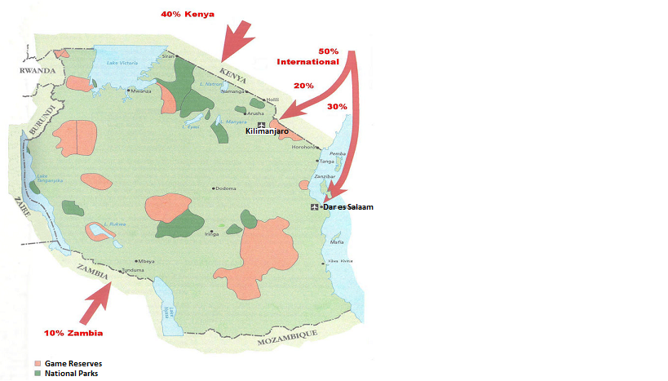
Figure 2.1 : The Tourists Routes to Tanzania.
Source: CHL Consulting Group, 2002

A joint research done by the Ministry of Natural Resources and Tourism (MNRT) in collaboration with Bank of Tanzania (BOT), National Bureau of Statistics (NBS) and Zanzibar Commission for Tourism (ZCT) revealed an increase of International tourists by 24% and revenue by 8.2% from 2013 to 2014 respectively. Number of tourists visiting Tanzania, has increased to 1,140,156 in 2014 as compared by 1,095,885 recorded in year 2013. Likewise revenue collected from the tourism business has increased from 1,853.3USD in 2013 to 2,006.3USD in 2014. Furthermore research shows that 54.1% of tourists spend an average of eight to 28 days in which visitors from German, Holland, Italy, France and Spain spent more time than those from other countries including Zimbabwe. Average tourist expenditure per night dropped from 284 USD recorded in 2013 to 221 USD in 2014. Overall statistics indicates that 43.5% of tourist visited natural attractions precisely National Parks and Game Reserves (www.mnrt.go.tz accessed 29April 29, 2016, 14:37).

Tanzania government has developed a National Tourism Policy which is a guide towards development of tourism sector in the country. The objective of the policy is to assist on efforts to promote the economy and improve the livelihood of the people. Basically, tourism policy provides strategies necessary to ensure sustainable tourism development in the country. Other efforts include encouragement of the private sector to participate in the development of tourism through encouraging investments by providing the incentives. The significance of tourism to Tanzanian National economy is vital. With the accomplishment of tourism master plan in 2002 expectations of cultural tourism growth are higher. Tourism Master Plan (TMP) strategy and actions has directed much effort in preservation and cultural heritage sites which includes one hundred and sixteen gazzeted sites according to Antiquities list and more than eight museums across the country (MNRT – Antiquities Division, 2011).

2.4.3 Tourism Attractions
Many studies have suggested that a substantial percentage of tourists seek cultural experiences such as visiting cultural attractions and participating in diverse cultural activities (Sofield and Li, 1998), (Silberberg, 1995) and (Richards, 1996). The World Tourism Organization suggests that more than 40% of all international tourists are cultural tourists (Richards, 1996). The Travel Industry Association of America has estimated that two-thirds of U.S. adults visit a cultural or heritage site or attraction when they travel (Silberberg, 1995). Based on these explanations, it has been argued that cultural tourists represent a new type of mass tourist who seeks meaningful travel experiences (McKercher and Du Cros, 2003).

There is little doubt that culture is an important part of the tourism product and is one of the factors that can improve the competitiveness of a tourism destination. An examination of the forces shaping the cultural product will help identify the reasons why cultural tourism is critical at destinations. Cultural tourism covers all aspects of travel where visitors can learn about another area’s history and way of life. Thus, cultural factors in the context of tourism include the entertainment, food, drink, hospitality, architecture, and manufactured and hand-crafted products of a destination, and all other characteristics of a destination’s way of life (McIntosh and Goeldner, 1990).

Richards (1996) focused on the marketing and development of European cultural tourism. He chose several attributes related to cultural/heritage destinations in order to analyze European cultural tourism. Especially, through analyzing these attributes, this article indicated a rapid increase in both the production and consumption of heritage attractions. Philipp (1993) studied black-white racial differences in the perceived attractiveness of cultural/heritage tourism. The article surveyed a Southern metropolitan area and chose various attributes. The research found that white tourists were more interested in cultural/heritage destinations than black tourists.

In addition to the research discussed above, many other researchers have studied cultural/heritage destination attributes. For example, Sofield and Li (1998) studied the cultural tourism of China by selecting history, culture, traditional festivals, historical events, beautiful scenic heritage, historical sites, architecture, folk arts (music, dancing, craft work) and folk culture villages as the attributes of significance. Janiskee (1996) emphasized the importance of events through several attributes such as festivals, historic houses, traditional ceremonies, music, dancing, craftwork, food, and the direct experience of traditional life events, beautiful scenic heritage, historical sites, architecture, folk arts (music, dancing, craft work) and folk culture villages as the attributes of significance. Janiskee (1996) emphasized the importance of events through several attributes such as festivals, historic houses, traditional ceremonies, music, dancing, craftwork, food, and the direct experience of traditional life.

Pierce (1996), viewed tourists destinations from five broad sectors namely attractions, transport, accommodations supporting facilities and infrastructures. He explains that attractions encourage tourists to visit the location, the transport services enable them to do so, the accommodation and supporting facilities alike (eg. shops, banks, hotels) cater for the tourist’s well-being during their stay and the infrastructure assures the essential functioning of all the above sectors. One challenge in this approach to defining tourism is, of course, the fact that many enterprises which produce commodities for tourists also save non-tourists (Nelson, 1993).For example more restaurant meals are consumed by local residents than tourists. Local attractions such as culture and architecture found at the Village Museum draw local residents as well as international tourists.

2.4.4 Tourism development strategies in Tanzania
Tanzania developed an Integrated Tourism Master Plan in 2002, which outlines strategies and programmes for the tourism sector. The primary focus of this plan is to obtain sustainable benefits for Tanzanians by generating additional economic activity from available resources. Six primary areas addressed by the Integrated Tourism Master Plan are the following: Creating greater awareness of Tanzania in the tourism source markets, expanding tourism products, securing a more competitive position, maximizing the necessary service skills, establishing the necessary structures and controls to underpin tourism development. The neo-liberal policies introduced in Tanzania in the 1980s created economic, political and ideological conditions for promotion of private economic activities in all sectors, including tourism. From a previously ambivalent stance on the role of tourism in development, the country came out with a comprehensive tourism policy which more or less accorded with these new changes in 1991 (MNRT-Tourism Division,1999).

The Tanganyika National Tourist Board Act 1962 repealed with the introduction of the Tanzania Tourist Board Act 1992. This new Act established the Tanzania Tourist Board (TTB), whose function became that of promotion and development of all aspects of the tourist industry, for example, advertising and publicizing Tanzania as a tourist destination, encouraging and developing amenities that would enhance the attractiveness of the country, undertaking research; fostering an understanding of the importance and economic benefit of tourism to the country; and collecting and disseminating tourism information. The government of Tanzania produced a Tourism Development Master Plan with the assistance of foreign private consultants and representatives of tour agents in 1996. The National Tourism Policy was revised in 1999, followed by the setting up of the Tourism Confederation of Tanzania (TCT) to represent the interests of the private sector.2 The Plan set out incentives and special benefits to companies based in neighboring countries and especially Kenya, and to overseas operators by providing tax holidays and exemptions and creating conditions for vertical integration of tourist activities under foreign control (United Republic of Tanzania, 2000). It also provided additional incentives to foreign companies that could mobilize large investment packages and establish a dominant position in the industry. Besides promotion of private investments, the policy provided a framework for environmental conservation (including the so-called participatory conservation methods) and consumer protection.

Being one of the economic activities covered under the World Trade Organization's (WTO) General Agreement on Trade in Services (GATS), donor agencies (such as the European Union-EU) and International Financial Institutions (IFIs-including the World Bank and the International Monetary Fund-IMF) anxiously provided technical and financial support to help develop and promote the sector. For the donor countries and IFIs, tourism had an important role to play as a powerful force in integrating countries such as Tanzania in the global economy; since any country that prioritized tourism as one of its major 'development' sectors had to accept and be willing to meet the expectations, needs and interests of tourists, multinational and transnational (Foster, 1994). Henceforth, from policies that previously promoted agriculture and industry as the basis of social and economic development in the 1960s and 1970s, with agriculture being viewed as the "backbone", tourism was being promoted as one of the major engines of economic growth. Tourism, it was claimed, had become an industry that could offer an alternative to traditional export commodities (coffee, tea, cashew nut. cotton, sisal and cloves) this is well explained in Milena Ivanovic, Cultural Tourism (1994).

According to the policy papers, tourism had become one of the options to diversify the economy and supplement a declining agricultural sector; create jobs in both rural and urban areas and offer entrepreneurial opportunities for small and medium enterprises as well as community cooperatives. In promoting it, the country could earn the badly needed foreign exchange and the government could increase its tax revenues (Tanzania, United Republic of 2002). It was claimed that tourism is sector with significant linkages to other sectors such as agriculture, fishing, retailing and arts and crafts and that it had economic spin-offs into other sectors such as communication, education, energy, construction and the general development of the infrastructure thereby benefiting the economy as a whole.

In the process this could lead to enhanced living standards, economic well-being and human, social and cultural development. Overall, the sector was elevated to an important position in policies geared towards "poverty alleviation" among women, youths, "indigenous people" and the poor in general. After all, donor countries such as Britain, Netherlands and Scandinavian ones had developed "Pro-Poor Tourism" strategies as an integral part of their foreign aid policies, Britain, for example, had set aside funds under its Tourism Challenge Fund for International Development (TCFID) to match grants for projects to develop business and employment opportunities in developing countries and strengthen positive social and cultural effects.

A Wildlife Policy of 1998 aimed at clarifying land-use issues for communities as far as tourism purposes were concerned. The 1998 Policy adopted strategies that aimed at integrating rural development with wildlife conservation by establishing Wildlife Management Areas (WMAs) on village lands as a means to effect Community-Based Conservation (CBC); promote legal use of wildlife and its products; introduce measures that would bring equitable sharing of revenue from tourist hunting to the rural communities; and, compel license dealers in wildlife based products to employ workers from areas where wildlife activities are conducted.

2.4.5 Conceptual framework
Museum is a place used to store historical items for present and future generation to view and get to know what was in other places or in the country side. Museum is like a show-room where people observe what is available somewhere or in the country side. With museum, tourists increased which then lead to increase in income, improved livelihood of people engaging in tourism activities starting from the museum, taking care of the tourists, guiding them and transporting them to the interior to view what they have seen or told while visiting the museum. For Museum to be productive must be marketed, promoted and regulated or controlled by policy, regulation, laws and by-laws as the result lead to increase of income, provide employment and increase number of tourists. thus, from museum government gets tax, revenue and foreign exchange; in turn the revenue obtained can improve the museum.

Museum
- Traditional houses,
- Traditional foods,
dances
- Artistic Work
- Curio Shops
- Garden
- Natural Tree

-Marketing
-Promotion
-Policy, Laws, by-laws, regulation
Increasing tourists
Employment
Revenue
Forex, income

Figure 2.2 : Museums and it impacts on tourism in Tanzania.
Source: Researchers’ work

2.4.6 Research Gap
From the literature review, the researcher has observed that while a considerable work has been done on tourism and cultural tourism in particular and there is few publications on museums and its role to tourism development. Many studies have suggested that a substantial percentage of tourists seek cultural experiences such as visiting cultural attractions and participating in diverse cultural activities (Sofield and Li, 1998; Silberberg, 1995; and Richards, 1996). The World Tourism Organization suggests that more than 40% of all international tourists are interested with cultural tourists (Richards, 1996). The Travel Industry Association of America has estimated that two-thirds of U.S. adults visit a cultural or heritage site or attraction when they travel (Silberberg, 1995). Based on these explanations, it has been argued that cultural tourists represent a new type of mass tourist who seeks meaningful travel experiences (McKercher and Du Cros, 2003). Philipp (1993) studied black-white racial differences in the perceived attractiveness of cultural/heritage tourism. The article surveyed a southern metropolitan area and chose various attributes. The research found that white tourists were more interested in cultural/heritage destinations than black tourists. In Tanzania no specific study has been conducted to ascertain the role of village Museum in the development of tourism. However, this study is designed to fill this research gap.

CHAPTER THREE

3.0 THE STUDY AREA AND RESEARCH METHODOLOGY

3.1 Introduction
This chapter presents the study area and research methodology used in this study, This chapter presents the study area, research design, target population, sampling techniques and sample size. The chapter also covers sources of data, data collection techniques, data analysis and, validity and reliability and, finally ethical consideration is provided.

3.2 The Study Area
This study was carried out at Makumbusho Village in Kijitonyama area in Dar es Salaam City. The reason for selecting Makumbusho Village is that, this is the area where the village museum is located. Dar es Salaam city is located between Latitudes 6’.36⁰ degrees and 7’0 degrees to the South of the Equator and Longitudes 39.0 and 33.33 to the east of Greenwich. It is bordered by the Indian Ocean on the East and Bagamoyo District at north, Kibaha to the west, Kisarawe to the southwest and Mkuranga to the south. All these are districts of the Coast region.

Based on the 2012 Population and Housing Census, Dar es Salaam Region had 4,364,541 inhabitants, of whom 2,125,786 were males and the rest were females. Of the five Municipalities, Kinondoni had the highest population with a total of 1,775,049 inhabitants, followed by Temeke with 1,368,881 and Ilala with 1,220,611 inhabitants (URT, 2012). The City was originally dominated by Zaramo and a few other tribes especially Ndengereko and Kwere. However, due to urbanization many people of different ethnicity and origins have immigrated to the city in big numbers.

The City experiences a modified type of equatorial climate. It is generally hot and humid throughout the year with an average temperature of 29ºC. The hottest season is from October to March during which temperatures can raise up to 35ºC. It is relatively cool between May and August, with temperature around 25ºC. There are two main rain seasons; a short rain season from October to December and a long rain season between March and May. The average rainfall is 1000mm (lowest 800mm and highest 1300mm). Humidity is around 96% in the mornings and 67% in the afternoons. The climate is also influenced by the southwesterly monsoon winds from April to October and northwesterly monsoon winds between November and March. The City is divided into three ecological zones, namely the upland zone comprising the hilly areas to the west and north of the City, the middle plateau, and the low lands including Msimbazi valley, Jangwani, Mtoni, Africana and Ununio areas. The main natural vegetation includes coastal shrubs, Miombo woodland, coastal swamps and mangrove tree. These data are collected from Tanzania Meteorological Agency.

3.3 Research Design
Research design is the conceptual structure within which research is conducted. It constitutes the blue print for the collection, measurement and analysis of data. This study used case study research design because the study selected only one area for the study which is Makumbusho Village. Two approaches were used for collection of data which were quantitative and qualitative techniques.

3.4 Sampling Procedure and Sample Size
Sampling procedure refers to the procedures of selecting sample from the population. In this study two methods of sampling techniques were used, purposive sampling and simple random sampling. Purposive sampling method was used to identify experienced or key informants like directors and specialists of the National Museum, Village Museum in particular, TTB Officials, Government Officials Antiquities ,Department officials and selected individuals around the study area due to the fact that they have ric information and experience about Museums. Another sampling technique used in this study was the simple random sampling where by all heads of the households from the study areas have an equal chance of being chosen. A sampling unit in this study was heads of the households in Makumbusho, Kijitonyama Area. The total of 60 respondents was used.

3.5 Sources of Data
In this study both secondary and primary data were collected.

3.5.1 Primary Data
Primary data refers to the collection of first hand information from the field. Primary data were collected using both closed and open ended questionnaires to acquire information from the study area. Administering questionnaires, focus group discussions, direct observation and informal interviews were used to capture information from the local community members.

3.5.2 Secondary Data
Secondary data refers to the data or information collected from the literature. Thus, secondary data was obtained from both published and unpublished literature. Secondary data were collected from books, journals, and various reports obtained within and outside the study area. Secondary information supplemented the primary data. The literature review was done at the Village Museum and the Open University of Tanzania Main Library.

3.6 Methods of Data Collection

3.6.1 Questionnaires
A number of structured questionnaires were administrated to the selected heads of the households. The questionnaires were structured in such a way that they address the general and specific objectives. The information on museums helped to access the extent to which museum resources contributed to tourism development in Dar es Salaam City and Tanzania at large. People were asked about the role of museum on the development of tourism in Tanzania.

3.6.2 Focus Group Discussions
Focus group discussions were held between moderator and the selected groups of people found around the village Museum. The groups comprised about 5 to 8 members with mixture of men and women. Respondents provided their views related to the village museum for tourism development. The way people access village museum and challenges they face in the village museum was discussed.

3.6.3 Key Informant Interviews
Checklists were used to guide discussion with key informants. Key informants are individual who are accessible and willing to talk and has a great depth of knowledge about issues in question. Among others the key informants included street leaders, NGOs and government officials whereby informants were 5 staff members from Antiquities, 3 staff members from the Village Museum and 2 leaders at the Village Museum.

3.6.4 Documentary Literature Review
Documentary literature review was used to collect secondary data or second hand information. The researcher employed documentary sources of data so as to have a thorough understanding of the past, present and predict the future trends on the role of museums. Documentary sources of data included review of previous researches, books, journals and clients comment books available in the museums. Documentary literature review was done at the OUT Main Library and use on internet.

3.7 Data Analysis, Interpretation and Presentation
The information or data collected were analyzed by using both qualitative and quantitative approaches. The information collected using questionnaires were coded and entered in a computer and analyzed using the Statistical Package for Social Science (SPSS) and Ms Excel programs. The results were then summarized in figures, tables, charts and graphs. The qualitative information were collected through interviews, focus group discussions and observations from different respondents and analyzed using content analysis. Data collected were presented in narratives.

3.8 Validity and Reliability of the Research Instruments
Validity refers to ensuring research instruments measures what is intended to measure. To ensure validity of the data, triangulation methods was used in data collection. This means that different methods of sampling and data collection methods were used. The use of triangulation helps to demonstrate validity and open up new perspective about the topic under investigation. The researcher also looked for copyright of published documents relating to the data to help validation.

The reliability of a data collection instrument relates to the consistency of research instrument (Bryman and Cramer, 2001). Reliability refers to the extent to which data collection technique or techniques yield consistent the required findings. Data collection instruments such as questionnaire, direct observation and interview were employed by the researcher to ensure that the source of data is well assessed. Survey data from large and well known organizations will be deemed reliable and trustworthy.

3.9 Ethical Consideration
Ethical standards were observed during the operation of this study. The research requested the research clearance letter from the Directorate of Postgraduate Studies of the Open University of Tanzania. The letter enabled the researcher to obtain a permit letter to conduct study in the Makumbusho Village Museum. Respondents were assured of security and confidentiality of the information the provided that were intended for study only.

CHAPTER FOUR

4.0 PRESENTATION OF THE FINDINGS AND DISCUSSION

4.1 Introduction
Data presented in this chapter were organized in relation to specific objective. The data were the results of questions designed and asked during the interviews and questionnaires, administered in the Village Museum. Both interviews and questionnaires were designed with specific focus on assessing the role of village museum to the development of tourism in Dar es Salaam city and in Tanzania. Uniform set of questions were supplied to respondents with aim of assessing their understanding of the subject matter of the research based on age structure of the respondents, gender, educational level and marital status.

4.2 Socio-Demographic Characteristics of the Respondents
Total number of sixty respondents were interviewed and supplied with questionnaires. The information presented in this section focus on age, gender, educational level and marital status of the sample.

4.2.1 Age of the Respondents
The respondents were grouped into three arbitrary age groups. The first group comprised of respondents aged 12-20 years which had 29 (48%) respondents, the second age group was 21-39 with 16 (27%) respondents and the last group involved those aged 40 years and above whom were 15 (25%) (Table 4.1). The aim of age in this study was to understand the age of respondents which could help determine the ability of elderly to argue on issues related to tourism attractions and tourism in general. Also researcher was eager to collect information from different age groups within the community about cultural tourism development in the Village Museum.

Table 4.1 : Age of the Respondents
Age of the respondents | Responses | Percentages
12 - 20 | 29 | 48
21 - 39 | 16 | 27
40+ | 15 | 25
Total | 60 | 100
Source: Field survey, 2015

4.2.2 Gender of Respondents
In this study both male and female were interviewed. The researcher was curious to investigate the purpose of visitation between men and women on the notion that majority of people visits tourist attractions. Of 60 respondents interviewed thirty three (55%) were women and twenty seven (45%) were men (Table 4.2). It was noted that, majority of women visits the curio shops to purchase cultural decorations unlike men who majority visits the exhibitions.

Table 4.2 : Gender of respondents
Sex of the respondents | Responses | Percentages
Male | 33 | 55
Female | 27 | 45
Total | 60 | 100
Source: Field survey, 2016

4.2.3 Education Level of Respondents
Education have a big impact to the public on the basis that those with exposure to education could stand a better chance to understand and respond to research questions unlike the one with limited education access. From the collected data, 23(38%) of respondents were secondary school students (Table 4.3). Thus, this group found to visit Village Museum to fulfill their education demands especially mandatory projects on culture assigned by their teachers. Primary school children counts to nineteen (32%) had partial understanding to the questions and sometimes researcher spent extra time trying to answer questions in a simple language (Swahili). Unlike secondary students, this group visits Village Museum as part of school tours organized by their teachers or schools while some accompany their parents in other activities and ends up to the exhibitions. About sixteen (27%) of the respondents were university students.

These scholars found to have various reasons to visit Village Museum. Parents were found to take their children to the Makumbusho Museum to educate them about cultural life and make them differentiate urban life they know and the rural life. Unlike other groups in this category respondent with university education seems to understand research questions and responded very well. Respondents with informal education were 2 (3%) with low understanding to the most of questions. This group was interesting as it had a wider understanding of informal cultural aspects including origin and characteristics of ethnic groups. Respondents with informal education seem to visit Village Museum to cater for their wonder lust.

Table 4.3 : Educational level of the respondents
Education | Responses | Percentages
No formal education | 2 | 3
Primary education | 19 | 32
Secondary education | 23 | 38
University Education | 16 | 27
Total | 60 | 100
Source: Field survey, 2015

4.2.4 Marital Status
Research revealed that out of sixty respondents 40 respondents (67%) were single while eighteen (30%) were married couples. This perhaps is an indication and proof that most adults visits the Museum to accompany the youngsters and direct them to museum attractions while on the other hand it shows that majority of museum visitors are single youngsters who still need to learn and enjoy their puberty life. Separated and widow counted to 1 (2%) and their low visit is an indication of their loneliness and lack of company to visit Museum and enjoy the atmosphere (Table 4.4).

Table 4.4 : Marital status of the respondents
Marital status | Respondents | Percentages
Single | 40 | 67
Married | 18 | 30
Separated | 1 | 1
Widow/widowed | 1 | 2
Total | 60 | 100
Source: Field survey, 2015.

4.3 Tourism Attractions in the Village Museum
Tourism attractions available in the Village Museum were assessed (Figure 4.1). The respondents were asked, what is tourism attractions found at the Village Museum? Majority of the respondents were able to identify cultural attractions as presented in Figure 4.1. Tourism attractions mentioned by the respondents include traditional houses, natural trees, and artistic works and curio shops. Other attractions identified include traditional garden, traditional food and traditional dances.

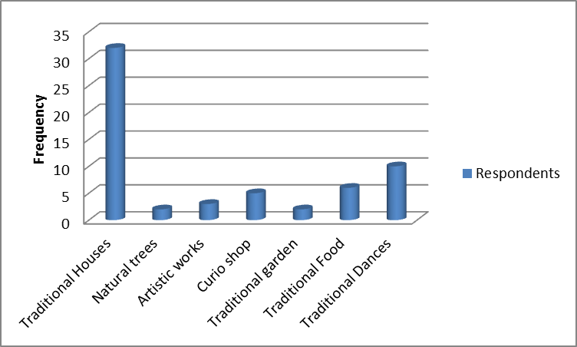

Figure 4.1 : Tourism attractions found at the Village Museum
Source: Field survey, 2016

The results revealed that traditional houses are considered as the prime tourist attraction by thirty two (54%) respondents while a traditional dance seems to be enjoyed by ten (17%) respondents. These two attractions are the most enjoyed and noticeable attraction and in fact the icon of the Village Museum. Visitors complained on the closure of the traditional restaurant which initially used to offer traditional food and drinks. Despite of complains yet six respondents (10%) vote for traditional food and urged for its revival. Out of sixty respondents only five (8%) were interested in curio shop while three respondents (5%) opted for sculpturing and fine art works performed by the artists at the Village Museum. Traditional garden and natural forest found at the Village Museum received three and two responses (3%) respectively. These results act as a good indicator to identify the interest and frequency of the tourists at the Village Museum.

4.3.1 Traditional Houses
Village Museum consists of thirty traditional houses representing twenty three ethnic groups from sixteen regions of Tanzania. According to the information given by the respondents as well as Museum curator, the houses represent majority of ethnic groups found in the country. Being of three types namely tembe, msonge (Plate 4.1) and banda these houses serves as the main tourist attraction at the Village Museum (Appendix 1). The typical feature of Tembe houses are roofed by mud roof and poles and stick walls plastered with mud as well. Inverted “V” – shaped thatched roof is a common feature of banda house which just like tembe it is rectangle in shape. Msonge houses are round in shape made of poles and sticks with their roof thatched with elephant grass. Msonge is either full suit (all made of grasses) or half suit (mud wall and thatched roof). The typical feature of Traditional houses at the Village Museum has a lot to tell about the history, architecture technology, division of labor and general social life of Tanzania ethnic groups. The information attached to traditional houses is what attracts tourists most. Authenticity of traditional houses is amazing and it discloses the richness of Tanzania in terms of natural resources. Each house is constructed with materials available in specific area of origin and this gives the houses unique features including forms and size. Inside the houses traditional objects elaborates different activities done by Tanzania ethnic groups. Traditional houses built together in a piece of one hector land is what has being named collectively as a Village and “it carries a message that despite of having more than 120 ethnic groups each with its own culture we all leaves as neighbors in one big Village called Tanzania” (Wilbard Lema, 2016).

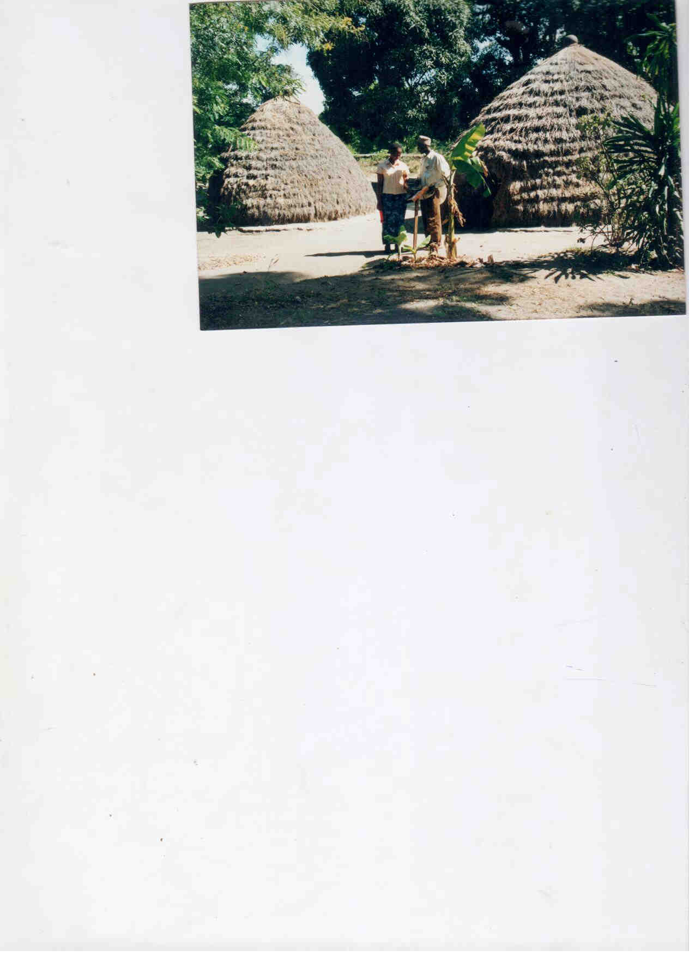
Plate 4.1 : Chagga compound with Isale and big mango tree at the back

4.3.2 Natural Trees
Natural shade from natural trees was mentioned as the most comforting atmosphere which is rare to find in the city of Dar Salaam (Plate 4.2). Traditional houses are surrounded with natural vegetation depicting the actual environment of particular groups. Likewise, trees have great stories about social life or life style of majority of Tanzanian ethnic groups. Some trees have medicinal value while others have social and economic value. “Sale/Isale” (Dracaena mannii) for instance is much respected plant among the Chagga. This plant is used as the boundary marker in farms and plots. Dracaena mannii has social value as reconciliation plant while medicinally the warm root of “sale” is effective cure of toothache.

Mkole (Grewia bicolor) tree is indigenous to Africa, and it is found in many parts of Tanzania. It is one of the indigenous multipurpose trees and produces hard and durable timber, used for building materials and domestic uses such as making spoons, walking sticks, clubs, arrows, bows and tool handles. Socially “mkole” is well respected tree among the Zaramo, Kwere and Doe ethnic groups as it is used as initiation ceremonial arena in women initiation ceremony called “mkole”. Village Museum has rare species of trees including African Blackwood (Dalbergia Melanoxylon) and Iron wood (senna siamea) which are hard types of woods used for decorations especially carving and timber production.

These are endangered species which most tourists admires when visiting Village Museum. Fruit trees including oranges, baobab, marula, tamarind and mango trees attract visitors because of their existence and unique stories they carry including their size and age. A mango and baobab tree for example has the age of more than 50 years. Despite the existence of trees around the exhibition area, Village Museum has traditional forest endowed with species of butterflies, birds and small animals which forms a favourable atmosphere to enjoy fresh air. The forest is used to reflect the actual village life with availability of firewood and other forest products such as honey.

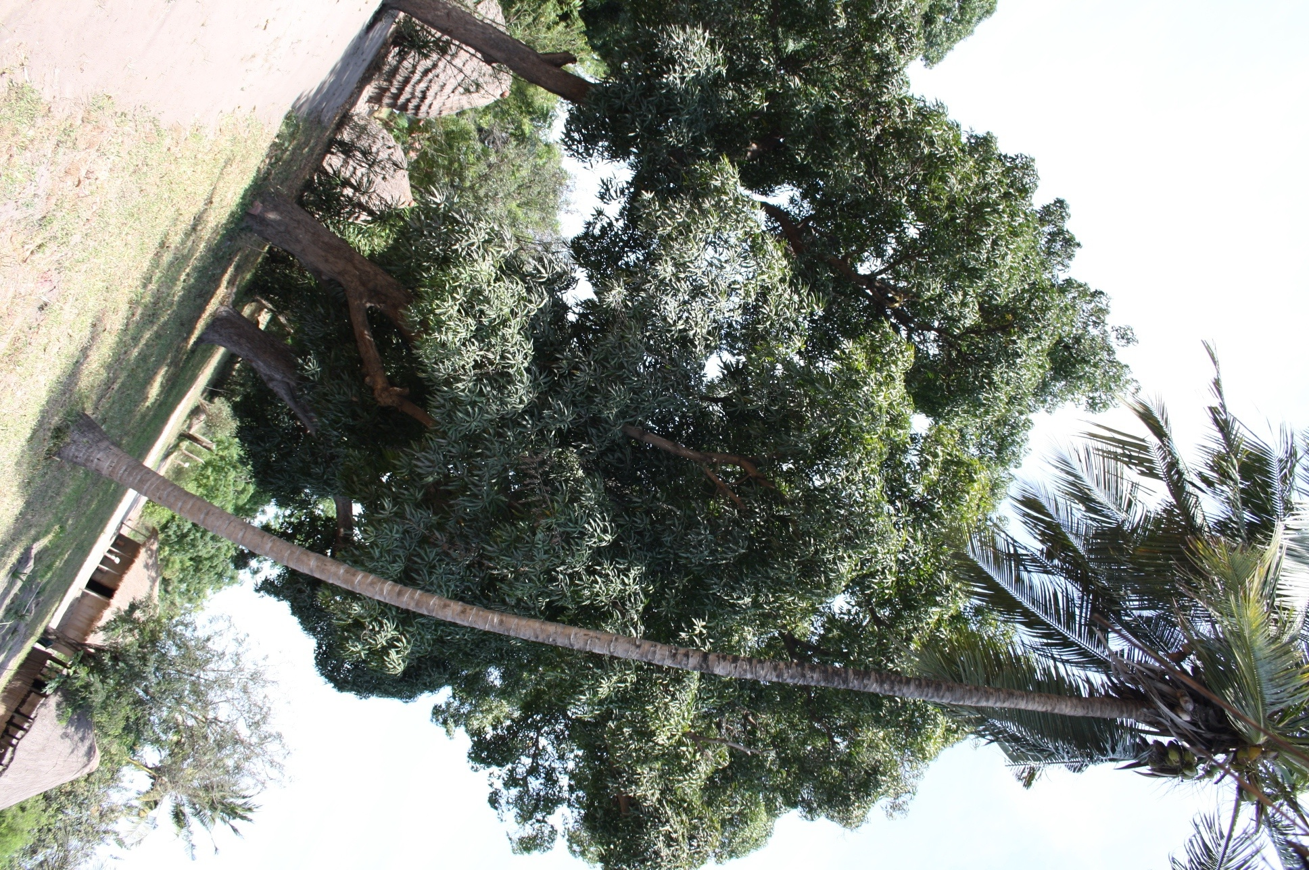
Plate 4.2 : Big mangoes and coconut trees provide natural shade.
Source: Field photo, 2016

4.3.3 Artistic Work
Artwork is a an illustrative work prepared for reproduction that may consist of drawings, hand lettering, paintings, sculpture, photographs or anything that is not typeset. Artwork (Plate 4.3) at the Village Museum complements the exhibits found in the sense that most of the artists produce artworks which portrays rural activities performed by indigenous ethnic groups. Despite of other attractions found at the Village Museum like traditional houses there are special visitors who are mainly interested in artworks especially sculptors and figurines made of clay. These are unique products that are only found at the Village Museum unlike Makonde carvings which are abundant. The figurines depict various social economic activities done by the indigenous and have being the most art work admires by the tourists. As noted from the collected data, three (5%) of the respondents were interested in artistic works. It was noted that Village Museum figurines are so unique unlike Makonde carvings. Clay used in figurines are rare as the artists prefer paintings and carvings. Despite its significance, the respondents noted that there was insufficient advertisement and promotion of artwork.
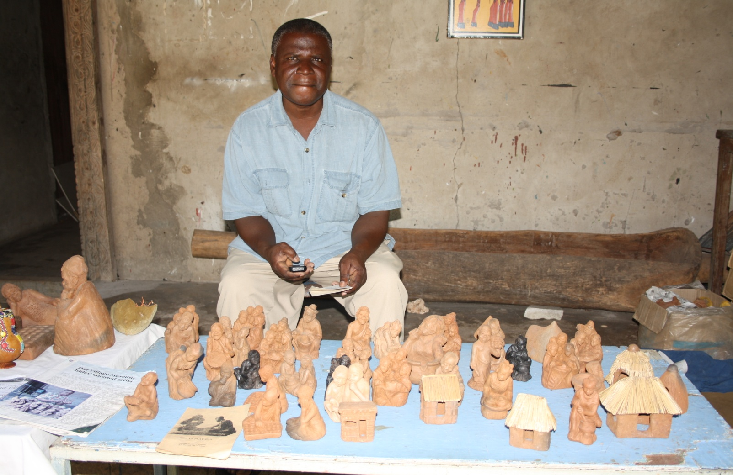
Plate 4.3 : Figurine Sculptor at the Village Museum
Source: Field survey, 2016

Paintings are another art work that attracts tourists at the Village Museum. Artists specialized in fine art and tingatinga exhibits and sell their pieces of work to the tourists. Number of tourists visiting Makumbusho Village for this purpose has being increasing every year and has contributed stimulated the development of tourist activities at the Village Museum. Though in low seasons artists suffers the drop of the tourists the situation is well paying during the higher seasons commencing from August. Artwork is two ways traffic as it attracts visitors to the Village Museum and at the same time its existence depends on Village Museum. Three respondents (5%) who found interested in artistic works pointed out that Village Museum paintings despite of being attractive they lack the element of representing rural activities which are the actual objective of the establishment of the Village Museum. According to them there should be a joint work of the artists to produce a Village museum brand souvenirs.

4.3.4 Curio Shop in the Village Museum
Village Museum conforms to the codes of ethics provided by the International Council of Museums (ICOM) and among the provisions is to integrate local community in museum activities by enabling them to benefit by the existence of the tourist attraction. Unlike other curio shops in Dar es Salaam, women were given a space to display and sell their artworks (Plate 4.4). Curio shop is a collection of local art crafts for sell to visitors. Women here are not necessarily artists but the museum has provided them a place to earn income and by doing so they are promoting tourism and indigenous culture through the collections they sell. Existence of these women as it was noted forms a known market where tourists have directed their attention. Unlike other curio shops where the artists sell their products in a well covered room or hut, situation at the Village Museum is different as said by Mwanaidi, “we perform our activities under tents, the situation become worse during rain seasons as these tents leaks”. The women interviewed mentioned that, “the closure of the Village Museum restaurant has tremendously affected the customer flow and hence reduced their sale/income”. Rukia is an artist who sells beadworks and traditional clothes and according to her, “there should be enough space for artists to produce, display and sell their produce to cater the visitors’ needs”.

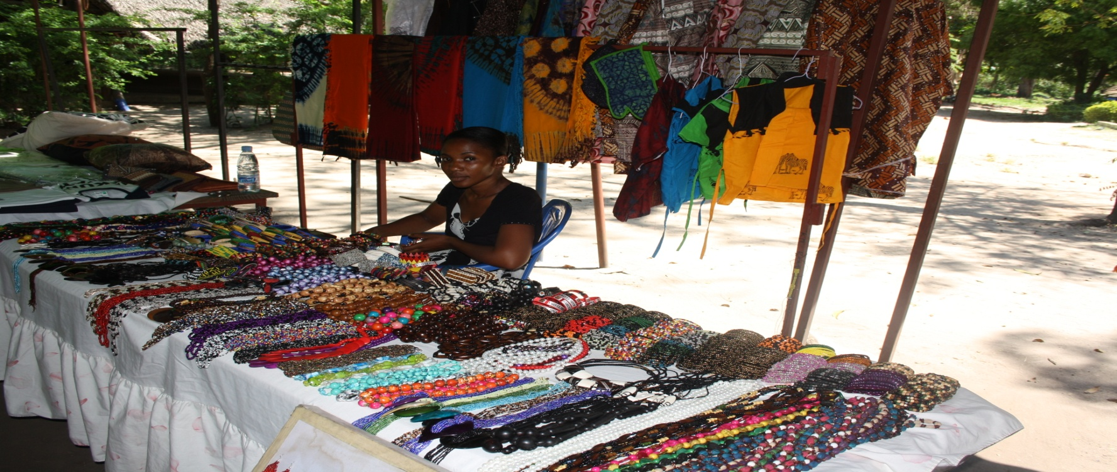
Plate 4.4 : A woman at the curio shop selling different tourism items.
Source: Field survey, 2016

4.3.5 Traditional Garden
There is a traditional garden in the Village Museum. Traditional garden (Plate 4.5) at the Village Museum offers quality, unique, rare and safe vegetables and traditional medicines to the community of Dar es Salaam. Compared to green markets available in the city with less safety guarantee, community has placed their total trust in this garden which uses drilled water and organic manure. Vegetables in this garden are planted from the traditional seeds and seedlings transported from rural ares in Tanzania. Most of the respondents about 72.5% mentioned traditional garden based on the fact that its location is within the exhibition area and such a customer must pass the exhibitions to reach the garden. As such his garden attracts tourists and at the same time creates the awareness to tourist on the existence of other tourist attractions including traditional houses.
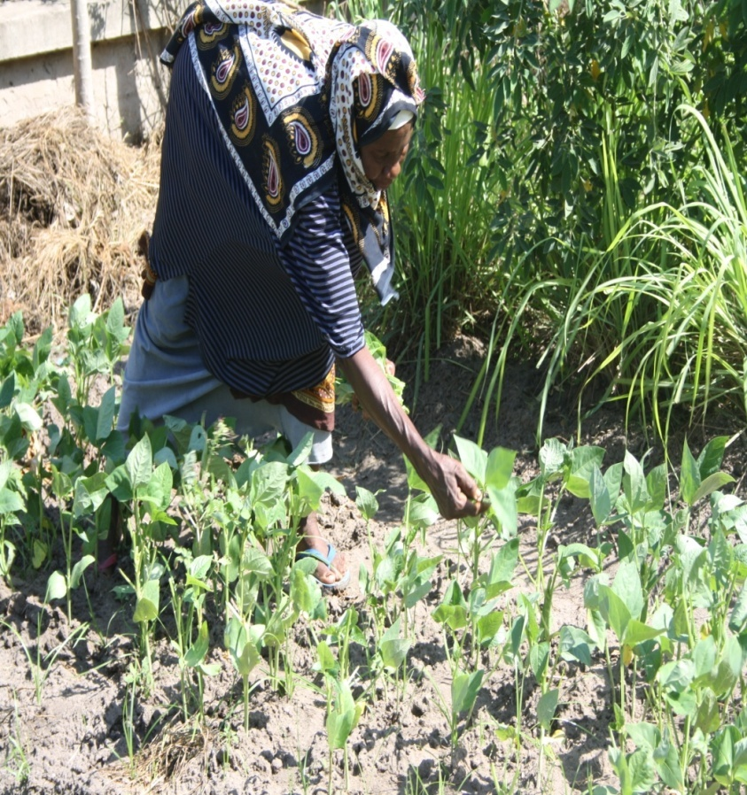
Plate 4.5 : A woman attending garden at the Village Museum
Source: Field survey, 2016

4.3.6 Traditional Dances
Tanzania is endowed with more than 120 ethnic groups each with its own cultural life style such as traditional dances in particular. Unlike other African countries where ethnicity has being the source of conflicts, in Tanzania ethnicity creates peace, love, harmony and stability. Traditional ngoma (Plate 4.6) is a recreational means developed by ethnic groups to express their cultural feelings. Indigenous people compose songs, sang and danced different ngomas in different occasions including farming and harvesting seasons as well as ceremonies and funerals. These songs and dances branded people as they participated in communal activities under the spirit of unity. Harvesting season noted to have more ngomas and ceremonies as it was a cheerful time where people had assurance of food and surplus. Tourists use their ample time to visit Village Museum to listen, dance, learn and document traditional dances. It was noted that three ethnic groups of Makua, Makonde and Gogo performs at the Village Museum every week while other ethnic groups are invited every year through the National Cultural Day Festival.
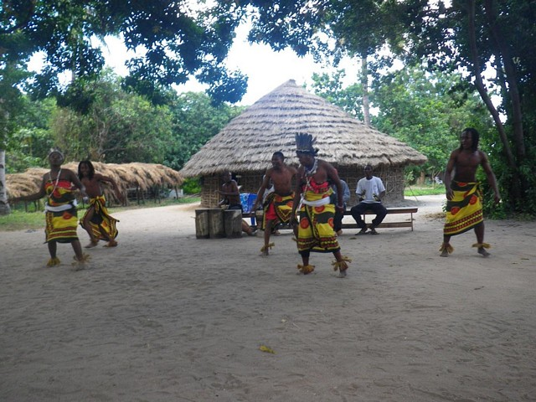
Plate 4.6 : Makua Traditional Dancer Performing at the Village Museum
Source: Field survey, 2016

4.4 Contribution of Village Museum in the Development of Tourism
The second objective of this study was to investigate the contribution of Village Museum in the development of tourism in Dar es Salaam in particular and Tanzania at large. The researcher was curious to get the opinions from the respondents on the roles played by tourism attractions in the development of tourism in the country. As noted by Richards (2009), culture and tourism are the two of the major growth industries of the 20th century, and towards the end of the century. The combination of these two sectors into ’cultural tourism’ has become one of the most desirable development options for countries and regions.

Data from the field correlates with this statement as Village Museum found to have immense contribution to the community, tourism industry and the country at large. Thus, 60 people interviewed had different opinions to the question asked on what are the role played by village museum in the development of tourism in Dar es Salaam? About 33% of respondents had the view that, Village Museum promote culture, 27% mentioned employment while 17% respondents disclosed that Village Museum promotes the development of cultural tourism (Table 4.4). In the same manner 6% of the respondents vote for the stimulation of tourism product while 5% respondents pointed out that Village Museum contributes in the promotion of local arts and crafts. It was observed at the Village Museum by 5% of the respondents that, curio shops increase market for local produced products. Existence of Village Museum attracts visitors who directly or indirectly consume the products and services from other sectors. To support these, 7% of the respondents declared Village Museum to have an impact in the development of other sectors.

Table 4.5 : Contribution of Village Museum in Tourism Development
Contribution of village museum | Respondents | Percentages
Provision of employment | 16 | 27
Promotion of culture | 20 | 33
Stimulate development of tourism product | 4 | 6
Preserve the cultural attractions | 3 | 5
Promote the development of cultural tourism | 10 | 17
Promote development of other sectors | 4 | 7
Creates markets for local products | 3 | 5
Total | 60 | 100
Source: Field Survey, 2016

4.4.1 Employment Creation
Cultural tourism contributes to provision of employment (Table 4.4). Cultural tourism is employment creation as visitors increase, the number of people to serve them should also increase in the Village Museum. This helps keep people in Dar es Salaam and act as a positive catalyst for regional development. It was said by 16 (27%) of respondents that Village Museum provides employment. Formal and informal employment is enhanced within and around the attraction as it was observed that thirty two individuals work at the Village Museum. Likewise other businesses including restaurant opened to serve the visitors and provides number of business opportunities as well.

4.4.2 Stimulate Development of Tourism Products
Village Museum provides better infrastructure and living environment for tourists and for the host community. As cultural tourism attraction center, Village Museum gives the region and country an identity, it gets known to others. It was said by 4 (6%) of respondents that Village Museum stimulate development of tourim products. Positive for the economic and social development is that cultural tourism generates new ideas and a wish to cooperate among the local population. This was revealed by the existence of the National Cultural Day conducted at the Village Museum which since its establishment in 1994 Tanzanian ethnic groups reaching 26 in number has organized and demonstrated their culture thus making the attraction facilitate, cultural harmony and understanding among people. Likewise existence of traditional houses of different ethnic groups is a best expression of the life ways of Tanzanians thus visitors imprint the impression in their experience and brand the environment better for tourism.

4.4.3 Contribution of Village Museum in Cultural Promotion
Cultural tourism helps to establish and strengthen an identity. This is an essential element in preserving and enhancing national and local pride and spirit. Culture and heritage features are essential in building a country’s image, thus cultural tourism is a key instrument in developing a positive image of a country internationally. Village Museum exhibits the culture and life ways of Tanzania ethnic groups under one roof. Data recovered from 20 (33%) respondents and through physical observation noted that existence of Village Museum offers a great message to the visitors about Tanzanian cultural practices and hence promotes culture and cultural tolerance. As noted by the Museum curator, “the houses conserved at the Village Museum stand as a symbol of Tanzania’s identity as they represents the cultures of Tanzanian ethnic groups”. Through the Village Museum collections, it is easy to understand the Tanzanian culture and architecture. Coexistence of houses from different groups under one roof is an expression of National unity and a strong message to visitors that despite of having more than 120 ethnic groups still there is no ethnicity in Tanzania.

4.4.4 Preserve the Cultural Attractions
Cultural tourism helps to preserve the cultural attractions. Majority of respondents (17%) pointed out that tourism makes an important contribution to culture and historical heritage by providing means for keeping the traditions in the museum. The protection at the Village Museum attracts and increase visitors’ appreciation of this important cultural tourist attraction. As noted in the Baltic Cultural Tourism Policy under the National Commission for UNESCO (2003), visitors’ interest in the cultural heritage attraction can be the key in attracting political support for the management and protection of particular attraction. More circulation of visitors triggers the well management of attractions at the Village Museum including research of culture and tradition of Tanzanian ethnic groups and the restoration of traditional houses and other related facilities while seeking for balance between protection and the use of heritage in a sustainable manner. About 3 (5%) of respondents commented that well physical and social-economic infrastructure at the Village Museum attracts and meets the needs of tourists.

4.4.5 Village Museum Promote Cultural Tourism
Unlike the previous decades, changes in tourism sector indicated that, visitors are more strongly interested to cultural tourism activities than earlier (Mason, 1998). Increased tourist’s interest to cultural tourism calls the attention of destination regions like Dar es Salaam to meet this emerging curiosity. The existence of cultural attractions is vital to attract more tourists. As this was mentioned by ten (17%) of respondents this research insists that Village Museum serves as the best attraction in town simply because its location in the city is so unique and calls the attention of many tourists with different cultural interests. It is obvious that existence of this Museum has awaken other cultural attractions including the tingatinga center, Mwenge carving area in Dar es Salaam as well Maasai Boma in Arusha. As a result of this attraction there is an immense increase of cultural tourism in Dar es Salaam and Tanzania in general.

4.4.6 Development of Other Sectors
Tourism sector support other sectors like industry and agriculture sectors. As revealed by the four (7%) of the respondent there is a mutual correlation between tourism and other sectors in such a way that they are inter related. As mentioned in Vroom’s Expectancy Theory, Village Museum as an attraction needs to manage itself to meet the visitors satisfaction, visitors are interested to visit the Village Museum if all their needs are met. The improvement of social and physical infrastructure to and from the Village Museum has being developed so well. Likewise social infrastructure including hotels and restaurants around the attraction are constructed to accommodate the growing number of visitors. Presence of cultural activities at the Village Museum has motivated the growth of other sectors including the ministry of culture and youth as well as economic sector through the collected revenue.

4.4.7 Creation of Markets for Local Products
Cultural tourism brings extra income to cultural products and is thus a very important supporting factor for culture itself. As it was mentioned by three (5%) respondents and observed at the Village Museum; traditional dances, arts and craft products have being promoted. It was noted that through the cultural festivals visitors and community members get a chance to brand, produce and sell their cultural goods to meet the demand and hence increase their income and expand the market for their products. The same corresponds to the demand created by the rising educational levels, the aging population, the increasing economic role of women, the increase in city tours and the general search for cultural services at the Village Museum.

4.5 Challenges facing Village Museum in the Development of Tourism
As noted previously, cultural tourism growth has been contributing positively to tourism and development of Dar es Salaam and Tanzania in general. It provides significant amount of foreign exchange needed in financing economic development. Tourism related industries such as rural handicrafts and other services are basically the important sources of non-agricultural employment and income especially in communities surrounding the attractions. In many cases the government uses tourism as a reason for attracting foreign direct investment, and an easy way to modernize its basic infrastructure. Despite the significances it has, cultural tourism and tourism industry in Tanzanian is at infant stage and faces a lot of challenges. This study has identified six challenges as presented in Figure 4.2. The challenges identified include insufficient fund, conservation/preservation challenges, climatic condition, and inadequate promotion, shortage of staff and shortage of professional staff.

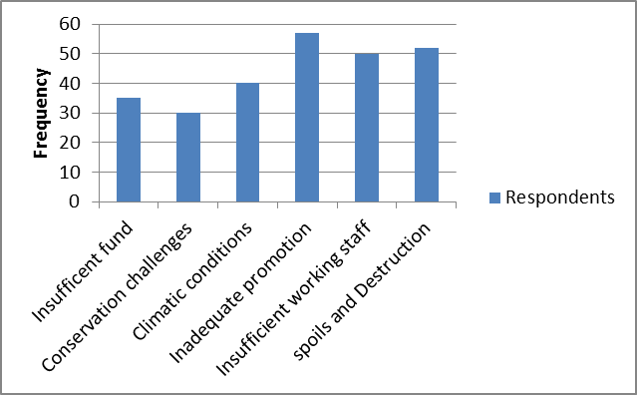
Figure 4.2 : Challenges Facing Village Museum
Source: Field survey, 2016

4.5.1 Insufficient Fund
The Government of Tanzania recognized the significance of culture when the Ministry of Culture was formed in 1964. As noted by researchers there has not been a serious thought given in funding the research on culture/cultural heritage resources neither the priority set. As noted by Yadon, et al., (1996), cultural attraction has not given a recognition it deserves while compared to other natural attractions. The funding and promotion of cultural attractions Village Museum in particular has received little promotion as well as funding. Perhaps this might be attributed by the lack of political will and the negligence of Museum activities. This is evident in 2010- 2016 Museum Strategic Plan in which since its establishment museum has not find a permanent ministry to perform its activities. Between 1962 and 1998 the National Museum of Tanzania as an institution had been relocated in eleven different ministries as follows: Ministry of National Culture and Youth (1962 1964), President’s Officer (1964-19670), Ministry of Local Government (1967-1968), Ministry of Education (1968-1974), Ministry of National Culture and Youth (1974-1980), Ministry of Information and Culture (1984-1985), Ministry of Social Development, Culture, Youth and Sports (1985-1988), Ministry of Works, Culture and Social Welfare (1988-1990), Ministry of Education and Culture (1990-1998) and Ministry of Natural Resources and Tourism (1998 to present). This not only limits the activities of Museum but also affects allocation of government subsidies as Museum considered less significant. For the past year 2014/2015 only forty percent of the budget was provided by the government to run museum activities.

As it is disclosed above Village Museum and Museum in general has been in tourism sector for the last eighteen (18) years. Museum has being under the ministry of Natural Resources and Tourism. As the name of Ministry demonstrates much attention has been to natural attractions and tourism at the expense of cultural attractions museum in particular. Information from the respondents revealed that thirty five (21%) mentioned insufficient fund as among the drawbacks for the Museum to prosper and meet tourist satisfactions (Figure 4.2).

4.5.2 Conservation/preservation challenges
Village museum is a unique and faces its own challenges. Most of open air museums were constructed to the foreign environment with more complications compared to the original place of particular structures. Study done by Louise in USA discovered that majority of historic buildings were aging constant to the march time as well as deteriorate as a result of destructing agents. Louise’s research found and proposed out that the building features that need the most attention include roofs, doorways, windowsills, interior and exterior walls (Louise, 2008). Unlike community living houses traditional houses at the Open air Museums Village Museum in particular are reconstructed and preserved to last longer. The museum concept of preservation is opposite to a normal construction as it involves more professional physical and chemical preservation techniques. This comes as an alternative means to make the houses last longer. Data recovered from this study from thirty respondents (18%) including Museum staffs disclose that most of tembe and banda houses at the Village Museum are thatched with elephant grasses and their roofs normally last for five to twelve months when well preserved. As a fact that the houses are superimposed to a coastal tropical climate, thus conservation is a challenge caused by both natural and cultural agents. During the data collection, it was observed that three houses were totally closed because of deterioration. As curator noted once a roof is deteriorated the alternative is to reconstruct new roof and that only happens if the construction materials which are seasonal are in place. As noted maintenance of houses at the museum becomes more challenging because of different material content and age ranges (Louise, 2008).

4.5.3 Unreliable Climatic Condition
Traditional houses are constructed using local materials which are not resistance to environmental hazards like heavy rains, tremors and the like. For instance there has been a consistence of deaths caused by collapse of tembe houses in central Tanzania every year caused by heavy rains. Likewise strong winds have been a cause of roof destruction to majority of traditional houses. Various researches have proved that climate affects the traditional architecture especially when the materials applied in construction lacks durability or whenever construction procedures are ignored (Louise, 2008). Tropical climate of Dar es Salaam poses a major threat to the traditional houses at the Village Museum as majority of houses were imposed to this climate from their original climatic zones. For instance tembe houses are constructed in semi-arid areas with little rains and as such once are introduced in coastal heavy rains receiving areas their survival remains at stake. As noted by Mwakyusa (2006) in his research on traditional and contemporary building styles used in Tanzania tropical climate offers a favorable breading of insects such as termites, millipedes and bores. This study observed that all houses at the Village Museum were infested with pests especially termites and millipedes. Likewise ethnographic enquires revealed that out of sixty respondents 40 (24%) mentioned climatic condition as among the challenges threatening the survival of Village Museum traditional houses.

4.5.4 Inadequate promotion
Promotion of tourism has been one of the global phenomena. As it is noted in many countries including Zimbabwe and Rwanda for example, there have been purposive measures to promote cultural tourism by among other things improving the attractions, participating private investors and trains local community as tour guides. The situation in Tanzania is different where according to MNRT (2002), the country has a variety of historical and archaeological assets which form part of cultural tourism including Stone Town in Zanzibar, Bagamoyo, Kilwa and the island of Kilwa Kisiwani, Olduvai Gorge, Isimila (near Iringa) and Tarangire. What is regarded as cultural attractions here is only historical and archaeological sites at the expenses of contemporary cultures which in other countries are the key to cultural tourism. Never the less TTB (2006) argued that, besides recent efforts and measures to advertise and sell Tanzania as a tourist destination, the policy has not achieved much in attracting more tourists or in giving incentives for activities relating to tourism for it to flourish. As it was noted from this research visitors experiences and pulled to something more embracing and participatory including cultural festivals such as Sauti za Busara Festival in Zanzibar. Fifty seven (34.2%) of the respondents pointed out that contemporary cultural heritage in Tanzania is not given proper attention.

4.5.5 Shortage of Staff and Professionals
According to Cooper et al. (1998), the challenges facing tourism industry would only be met successfully by a well-educated, well trained, motivated, energetic, multilingual and entrepreneurial workforce who understand the nature of tourism and have a professional training. A high quality of professional human resources in tourism will allow enterprises to gain a competitive edge and deliver added value with their service. Unlike what is presented by Cooper et al. (1998), Village Museum have very few number of professional museum staff. Out of thirty two total staffs found at the Village Museum there was only one (1) museum curator, one (1) technician, ten (10) unskilled hall attendants, eight (8) untrained security guards, one (1) educated officer, two (2) laborers and other eight (8) supporting staffs. In this list there is absolutely no front office desk and tour guide personnel. Likewise, museum lacks exhibition and program officer. As noted by fifty two (31.2%) respondents operation of tourist services under this condition is almost impossible as the key elements/workers are lacking. Thus shortage of staff and professionals is a threat in promotion of tourism in the Village Museum.

4.5.6 Spoils and Destruction by the Tourists
It is generally noted that together with its positive contributions to the economy, tourism could also be the cause of many negative effects such as public health, pressure on attraction resources requirement and environmental degradation. The past experiences showed that, there is environmental impact in many tourist spots such as beaches, National Parks, Game reserves, archaeological and historical sites as well as heritage sites across the country. Village Museum is not exempted from these threats and destructions. It was observed that high number of visitors especially school children has being a major problem at the Village Museum given the fact that museum lacks tour guides. Maximum number of visitors as noted by the Curator should not exceed five visitors but this study found groups of fifty students scrambling to get into one traditional house. This does not only spoil the fabric of the houses but it has been a major cause of the loss, destruction and displacement of artifacts. As noted by APEC (2006) the influx of large number of tourists into one small tourist spot raises concern by the concept of carrying capacity. Inevitably, many adverse impacts have continuously reduced the degree of attractiveness.

4.6 Measures to Address Challenges facing Village Museum in Development of Tourism
About forty eight (28.8%) of the respondents pointed out that it is impossible to overcome all challenges facing Village Museum but some actions might be taken to minimize the impacts and magnitude of the challenges. However, some measures have been instituted to minimize the challenges facing the museum as it was disclosed by the museum curator and technicians as well as other respondents. Nevertheless, respondents put forward multiple options on the subject matter.

4.6.1 Raising the Level of Public Awareness
This study found that there is a growing habit among the indigenous Tanzanian that, museums are meant for foreigners which has led majority of people feel neglected from museum services. According to Tanzania Cultural Policy of 1997 museum belongs to the local community and as such there must be efforts to engage community in museum activities. As noted by Lema (2013) museum professionals must involve the public in planning the exhibitions as part of their collections. Exhibitions must target indigenous and not merely the foreigners as protection and promotion of cultural heritage are a civil responsibility and shall be supervised by the government in that notion. Involvement of the local community in exhibition is very important because it helps in conservation of cultural heritage resources especially in the Tanzania though Village Museum.

For the promotion of community awareness this study proposes 7Rs of social concept proposed by Randy Mason (1998) which are: Research: the initial starting point of cultural heritage preservation could be the effort of the government, academics, and other stakeholders to gather information on various community cultures. Recognize: the member of the community as well as other stakeholders should be able to identify the nature of culture. Effort in this part covers the attempt to recognize old and existing set of tangible and intangible cultures that play a role in the community event. Respect: After the recognition of culture, the next important sustaining factor would be to really respect the nature of this cultural element including willingness to acknowledge the fact of cultural diversity. Regulate: Facing with threat from changes of the community socioeconomic pressure, the culture might need legal protection in the form of rules and regulations that aim at prevention of an intentional or unintentional damage on the culture itself. Revitalize: Some of the culture might need higher support from the community to recall and recognize by the way of bringing to attention by reconsideration and practice. Reserve: The next individual and group effort should center on the act of reservation, preserving the existing culture and protecting from attack as well as abrupt change of culture. Reward: Community effort should also include the promotion public relation and recognize the successful cases already implemented”.

Likewise, Village Museum should seek and establish a group of friends of museum to promote museum activities locally and internationally. This study suggests that festivals and events are an important element of the cultural tourism package as they offer the tourist additional reasons to visit a place over and above the regular cultural product offered. As a result they can be the key factor in the tourist’s decision to choose one destination over another. Cultural festivals at the Village Museum must be improved to cater the curiosity of the local and international visitors and timed consistently.

4.6.2 Improvement of the Exhibitions and Plan for New Ones
At its 23rd general conference which took place in Brazil in 2013 ICOM, participants from Latin America, Africa and Caribbean jointly discussed issues affecting their museums and hence reduced the number of visitors. In this conference it was noted that most of collections in African Museums are stagnant and attracts less and less visitors. As such there is a need to change African exhibitions as most collections in Africa Museums have been there since the colonial times. The situation at the Village Museum despite its uniqueness in the city of Dar es Salaam is frustrating, it is not given its due importance. As it was observed and through the conversation with visitors, traditional houses which are main attraction are boring and they lack “waooh” factor. Some visitors fail to describe the attraction as either a museum or a village. It is therefore propagated that management of this attraction make extra efforts using the available resources to improve the houses and cater the visitor’s curiosity. More fascinating cultural items like Maasai Ngoma, traditional foods and weekly festivals might be of extra pulling factor to raise number of visitors.

4.6.3 Conduct Outreach Programs
It has being established that the youth of today are the nation of tomorrow. Museums acts as a link to cultural heritage, by educating the young generation about culture and as such creating a firm base and strong roots that will provide a secure future for them. This study found out that outreach at the Village Museum is redundant focusing mainly to few primary schools and the results show no effective response. Unlike Village Museum other countries of East Africa, Rwanda in particular have advanced their outreach programs intensively. The Institute of National Museums of Rwanda lunched “Museum in Schools” with the mission of educating, preserving and promoting the Rwandan culture, aiming at conserving the Rwandan culture among the youths (http://museum.gov.rw).

Museum in schools helps to develop students understanding of culture and Museums in Rwanda in which students are educated about the history of Rwanda and its people through workshops, conferences dialogues and discussions related to museums, cultural tourism promotion and cultural values in general. By so doing Rwanda will have a young generation that cherishes, conserves and promoted their heritage. Village Museum therefore must change the contents, extent and frequency of its outreach programs for better if better output is desired.

4.6.4 Adoption and Enforce of Tourism Policy
Tanzania’s first National Tourism Policy was adopted in 1991 to provide the overall objectives and strategies necessary to ensure sustainable tourism development in the country. Following the changes on the political, economic and social faces within the country, the policy was reviewed in 1999 to cope with the dynamism of the tourism industry. The push of these changes has been towards stimulating efforts to expand the private sector, in accordance with disengagement of the government from the sole ownership and operation of tourist facilities. The Policy encourages the development of sustainable and quality tourism that is culturally and socially acceptable, ecologically friendly, environmentally sustainable and economically viable which will ultimately leads enhance promotion of the economy and livelihood of the people, essentially poverty alleviation nevertheless nurturing the natural and cultural attractions. According to URT (2002) implementation of the policy is done via the Integrated Tourism Master Plan with five primary areas:
- Creating greater awareness of Tanzania in the tourism source markets.
- Expanding tourism products
- Securing a more competitive position
- Maximizing the necessary service skills, and
- Establishing the necessary structures and controls to underpin tourism development.

The findings showed that 57 (34.2%) of respondents were of the opinion that tourism the important of the Village Museum have not received much attention perhaps due to the lack of public awareness and lack of government support. As Tourism policy states it is time to open the doors for private sector to boast the management and promotion of tourism activities in the country. As noted by Museum professionals at the Village Museum it is much easier to meet the visitor’s expectation when these two sectors are integrated.

4.7 Discussion of the Findings
There are many factors which make an area attractive. Some places might be fully endowed with historic features. Others might have beautiful beaches and interesting minorities’ way of life. Tanzania is awarded with immense cultural and natural attractions. According to Mapunda and Msemwa (2005), cultural heritage resources of Tanzania dated from Plio-Pleistocene epoch about four million years ago up to present. Among the earliest sites include Laetoli dated 3.5 million years ago with evidence for habitual bipedalism, Olduvai George with artifacts and faunal remains of both human and non-human primates and Isimila endowed with Acheulean artifacts ever found in Africa. The oldest rock art sites, dating between forty and fifty thousand years ago are found in central Tanzania. Along the mainland coast including the islands of Zanzibar and Pemba are stone architectural monuments, some of which dates back to 1000 years ago. One of the most valuable assets seems to be “culture” and community value which has placed the country in the world map and have attracted many visitors to Tanzania. Village Museum as a representative of cultural life ways of Tanzania has experienced number of visitors eager to learn about cultural wealth of the country.

4.7.1 The Contribution of Village Museum in the Development of Tourism in Dar es Salaam City
As research results indicates public is much aware of the roles played by this tourist attraction. Since its establishment Village Museum has been an ideal cultural attraction in the city of Dar es Salaam and Tanzania in general. Number of visitors comes purposely to learn culture and traditional architecture of Tanzanian ethnic groups has increased in recent years and this proves the significance of this attraction in development of tourism. Majority of respondents reveal that Village Museum is a proper reunion arena and a cultural bridge that connects the urban population with their indigenous through various cultural programs including the Cultural Festivals. Participatory approach done by the Museum professionals to engage the visitors and community to various Museum activities has not only been an attraction but also educative and entertaining act which cater both cultural and tourism demands.

Village Museum preserves and displays the traditional architecture within the city of Dar es Salaam where development in modern science and technology has overshadowed the indigenous traditional life ways and as such the pace of culture change is at alarming rate. In the recent past Tanzania has witnessed a rapid change from traditional life style to modern ones. This trend affects not only the social life but also the traditional technology and traditional building technology in particular. In this case traditional house types are demolished to give room for modern architectural styles. These changes pose a threat to the indigenous architecture. It was observed in this research that Village Museum stands as prime and unique cultural attraction where visitors can explore the original architecture of Tanzanians. This gives this attraction a credit as the only cultural attraction of this kind in Dar es Salaam and thus its contribution in tourism development is so immense. Likewise traditional houses at the Village Museum represent the original housing style of specific ethnic groups. These houses are no longer found in contemporary Tanzania as most of them have either being destroyed or modified in favor of modern structures. These transformations express the cultural change among the particular groups and Village Museum stands as a best reference and comparative basis of urban and rural life.

Traditional crafts and art work is well presented at the Village Museum in which local artists are given a room demonstrate their talents and ideas through piece of artworks that creates higher tourist demands. Observed artworks include paintings, sculptures, clothes, carvings, weavings and sewing products portraying diverse and unique cultures of ethnic groups found in Tanzania. The existence of Village Museum therefore provides the ground to promote and develop market for locally produced products. As such the income of the surrounding communities has improved and this gives people ability and capacity to engage in tourism activities as well as promotion of other sectors including transport and accommodation. Observation to the attraction revealed the existence of curio shops with variety of cultural and natural products and according to the participants these activities attract other business including traditional restaurant at the Village Museum.

4.7.2 Tourism Attractions in the Village Museum
Basing on the response from respondents on a given topic, an overall assessment indicated that the public has an understanding of tourist attractions found at the Village Museum as revealed by sixty (100%) of the respondents involved in this study. Traditional houses found in the Village Museum are the most notable and icon of the Village Museum and as such public refers to it as a village (Kijiji) and not necessarily a museum. There is a rising curiosity from the visitors which triggered the eagerness of the majority to experience the Tanzanian rural life but the question posed is does village museum serves the visitors curiosity? It was found out that unlike what visitors expect traditional houses resembles museum exhibition halls with captions sometimes with directives of ‘don’t touch”. There is no interaction between the visitors and collections and this turn down the expectations of majority. Some visitors disclose that most of exhibitions lack an ‘exciting’ factor and as such draws less attention to the visitors.

4.7.3 Challenges facing Village Museum in Development of Tourism
The key informants from the Village Museum disclose the rate of destruction done to traditional houses by the public intentionally and unintentionally is a major challenge to the Village, this is caused by low level of awareness. The major reason given was that majority of local visitors precisely students visit Village Museum by chance and not by choice. Students for instance visit museum to fulfill school obligations. Likewise number of parents brings their children to the museum to release pressure and have free time to perform non tourism activities including meetings. This increases the chance of destruction to this tourist attraction. There is a need of involving the local residents in various tourism / cultural activities that take place in this attraction. Seminars and publications should be provided to the public to complement contemporary school education and informal education acquired through oral traditions. It was clear that most of core functions of the museum were not performed as required simply because of insufficient funds from the government. Despite being non-profit institution Museum must serves its visitors to cater the needs and earn their trust.

CHAPTER FIVE

5.0 SUMMARY, CONCLUSION AND RECOMMENDATIONS

5.1 Introduction
This chapter presents summary, conclusion and recommendations on various measures that should be taken to address challenges facing the Village Museum in Dar es Salaam and Tanzania in general.

5.2 Summary
This study focuses on the role of village museum in the development of tourism in Dar es Salaam City. The main objective of this study was to assess the role of village museum in the development of tourism. The study was conducted in Dar es Salaam where 60 people were interviewed. Unlike other economic sectors for decades tourism has been considered as the fastest growing sector across the world. In Sub Saharan Africa including Tanzania tourism growth has been experiencing increasing number of tourists in the last four decades. Among the causative motivation for development of tourism in the general shift from traditional to more enhanced practices which advocates sustainable tourism. Despite of these changes still much efforts has been directed to natural attractions which include wild animals, mountains, water bodies and natural vegetation at the expense of cultural attractions. Tanzania is a multicultural country with massive cultural attractions. Museum being the custodian of cultural movable objects has been a vital institution to visit; to learn and for entertained. Village Museum among other Museums has being the prime cultural attraction in Dar es Salaam with countless contribution to the development of tourism in this city and country in general. This research revealed that despite of traditional buildings Village Museum consists of number of other cultural attractions which attract tourists to visit the museum including curio shop, local foods and traditional ngoma. Responding to interviews and questionnaires, respondents noted that despite its role in development of tourism Village Museum experiences natural and cultural challenges which if properly managed there would be a tremendous improvement in development of cultural tourism in Dar es Salaam.

5.3 Conclusion
Conservation of cultural resources normally contributes not only the survival of heritage assets but also in economic growth through tourism activities. On that basis this research examined the role played by the Village Museum in the development of tourism in Dar es Salaam with objectives of examining the contribution of Village Museum in the development of tourism in Dar es Salaam, examining the distribution of tourists in tourist attractions found at the Village Museum, assess challenges facing Village Museum in the development of tourism in Dar es Salaam city and evaluate strategies and measures to address the challenges facing village museum in the development of cultural tourism in Tanzania. In the overall analysis research results indicate that the level of public awareness to cultural attractions found at the Village Museum is high. Likewise respondents of this research demonstrated on the roles played by the Village Museum in development of tourism in Dar es Salaam City. It is expectations of this research that shortcomings disclosed by this research will be addressed for the successful development of tourism attractions and ultimately development of tourism in general. It is the expectation of this study that the proposed suggestions will be used to solve the existing problems if not to eradicate them all. Village museum should be managed and preserved for future generation.

5.4 Recommendations
Improvement and promotion of cultural attractions in Tanzania is necessary as they will attract more customers and tourists. It was observed that most of tourist attractions at the Village Museum were not in good shape and hence the tourists’ expectations are not met. However, this study recommends for intensive promotion of cultural and natural attractions found in the Village Museum.

Second, this study recommends more outreach programs which will attract and increase the number of local visitors in tourist attractions. in doing this, more education on cultural preservation and inheritance is required.

Third, Village Museum should incur costs to invest on durable materials which are resistant to climatic influence and insects. It is recommended where possible to apply aesthetic materials which will not affect the form and design of the house. Pesticides and other environmental friendly chemicals must also be applied to control the pests.

Lastly, there must be creativeness in planning and promoting tourisms attractions found in the Village Museum. Village Museum should organize exhibitions to show their activities and attractions found in the museum.

REFERENCES
Abun, M. S. (1987). The Roles of Museum in Tourism development in Nigeria in Nigerian Tourism, Vol. 1. No. 2. Ibadan: University of Port Harcourt.
Alagoa E.J. (1988). History, Culture and Tourism Proceedings of the 7th Conference of Archaeological Association of Nigeria, August 1998. Ibadan: University of Port Harcourt.
Andah, B. W. (1990). Tourism as Cultural Resources Introductory Comments (Ed). Cultural Resource Management: An African Dimension. Ibadan: Wisdom Publishers Limited.
Okita, S. I. & Afigbo, A. E. (1985). A temple of Forum: The Quest for an African museum: Museum and National Building. Owerri: New African Publishing Co. Ltd.
Apostolakis, A. & Jaffry, S. (2005). Stated Preferences for Two Creative Heritage Attractions in Annals of Tourism Research, 32 (4), 985-1005. Crete, Greece: Pergamon.
Bryman, A. & Cramer, D. (2001). Quantitative Data Analysis with SPSS for Window: A guide for Social Scientists. Release 10, New York: Routledge.
Carcasson, R. H. (1963). The Corydon Museum, Nairobi and the Role of Natural History Museum in Tropic Africa, Museum 16 (3) pp 182 – 5. Lausanne Switzerland: United Nations Educational, Scientific and Cultural Organization (UNESCO).
Cleare, H. C. (1989). Archaelogical Heritage Management in Modern World. London: Unwin Hymen.
Cooper, C. Fletcher, J. Gilbert, D. Shepherd, R. and Wan will, S. (1998) Tourism Principles and Practice. New York: Longman.
De Souza, A. R. (1992). Museums and the School – Age Public: the experience of the Porto- Novo Museum. Proceedings of the Workshop “what Museum for Africa”? Heritage in Future. Porto Novo, Benin: United Nations Educational, Scientific and Cultural Organization (UNESCO).
Gocldner, e. (1992) .Travel trends in the United States and Canada. Business Research Division. University of Colorado: Boulder.
Hwes, E. L. (1987). Living History and its Challenges for Museology, Proceedings of the Symposium “Musicology and Museum” September, 1987 study series 12:pgs. 134 – 137. Helsinki, Espoo: International Committee for Museology (COFOM).
Hettne, B. (1993). Ethnicity and Development: An Elusive Relationship in Contemporary South Asia. Bangladesh: Routledge.
Hone, E. (1963). The Ro Des – Living Stone Museum An. Rep. PP 4 -7. Lusaka. Ghana, Togo Nov. 18 -23 1991. Pgs 345 – 350. Benin: International Council of Museums (ICOM).
ICOM. (1982): Museums: An Investment for Development, PP 65 – 86. Paris: UCINM.
Illiffe, J. A. (1979). Modern History of Tanganyika, pp 318-320. London: Cambridge University Press.
Konare, A. O. (1993). AFRICOM Programme, PP 1 – 2. Paris: International Council of Museums (ICOM).
Kotler, N.and Philip, K. (1998). Museum Strategy and Marketing. Designing Missions. Building Audiences. Generating Revenue and Resources. San Francisco: Smithsonian Institution.
Kroeber, A. L. (1948). Anthropology: Race, Language, Culture, Psychology, Prehistory Vol 1. London: Harcourt, Brace.
Kroeber, A. L. (1953). Anthropology Toda: An Encyclopedic Inventory. New York: University of Chicago Press.
Kroeber, A. L. and Kluckhohn, C. (1952). Culture: A critical Review of Concepts and Definitions in Papers Peabody Museum of Harvard Vol. XLVII, no 1. Cambridge, Massachusetts USA: Harvard University Printing Office.
Li,Yiping. (2003). Heritage Tourism: The Contradictions between Conservation and Change. Tourism and Hospitality Research, 4(3), 247-261. Istanbul: Emerald Group Publishing.
MacGregor, A. (2001).The Origins of Museums: The Cabinet of Curiosities in Sixteenth and Seventeenth century Europe, 2nd edition, London: House of Stratus.
MNRT. (1999). The National Tourism Policy: Dar es Salaam: Ministry of Natural Resources and Tourism.
Msemwa, P. (1996). Documentary Dances and Rituals at the Village Museum, CIDOC Newsletter Volume:7: 28 -31. Paris: ICOM’s International Committee for Documentation.
MNRT. (2002). Tourism in Tanzania: Investment for Growth and Diversification. Washington: World Bank Group Multilateral Investment Guarantee Agency.
Collins, Zipporah W. (1981). Museums, Adults and Humanities: A Guide for Education Programming. Washington D.C: American Association of Museums.
Nyerere, J. K. (1964). Democracy and the Party System. Dar es Salaam: Tanganyika Standard Limited.
Okpoko, P. U., Ed.(2006). Issues in Tourism Planning and Development in Fundamentals of Museum practice pg 343. Nsukka, Enugu: Afro-Orbis Publications Ltd.
Randall, M. (1998). Economics and Heritage Conservation: Concepts, Values and Agendas for Research in Randy Mason, ed., Economics and Heritage Conservation, Proceeding of a Meeting Organized by the Getty Conservation Institute, December 1998. Los Angeles: Getty Center.
Rogers, T.(1982). Nature, Culture and Identity in French Rural Tourism, French historical studies. Durham: DUKE University Press.
Stanley, N. (1998). Being ourselves for you: The global display of cultures, Material culture series. London: Middlesex University Press.
Suherman, A. (2001). Tourism village: A conceptual approach (Case of Indonesia). Paper presented at the Cultural heritage, man and tourism seminar, Hanoi, Vietnam: Asia Europe Foundation.
Taylor. E.B. (1970). The Essence of Education (ed) The Concept of Education. London: Routledge and Keyan Paul.
TTB. (2006), The Medium Term Strategic Plan 2006/7-2010/11. Dar es Salaam: Tanzania Tourist Board.
URT. (2002). Integrated Tourism Master Plan for Tanzania: Strategy and Actions. Dar es Salaam: URT.
UNESCO. (1963). Museum Vol. 16 (13) pg.122. Paris: United Nations Educational, Scientific and Cultural Organization (UNESCO).
URT. (2001). The Economic survey 2000 in The United Republic of Tanzania pg 216. Dar- es-Salaam: The Planning Commission.
Wall, G. (1997). Tourism Development Growth: The Challenge of Sustainability. London: Routledge.

APPENDICES
APPENDIX 1: LIST OF TRADITIONAL HOUSES FOUND AT THE VILLAGE MUSEUM
NO | ETHNIC GROUP | HOUSE TYPE | NUMBER OF HOUSES
1 | Hehe | Tembe | 1
2 | Fipa | Msonge | 2
3 | Gogo | Tembe | 2
4 | Ngoni | Msonge | 3
5 | Pimbwe | Banda | 1
6 | Zaramo | Banda | 2
7 | Mwera | Banda | 1
8 | Ha | Msonge | 1
9 | Iraqw | Tembe & Msonge | 2
10 | Kwere | Banda | 3
11 | Makua | Msonge | 2
12 | Yao | Banda | 1
13 | Chagga | Msonge | 2
14 | Masai | Tembe | 1
15 | Swahili | Banda | 1
16 | Bena | Banda | 2
17 | Nyakyusa | Banda &Msonge | 2
18 | Nyambo | Msonge | 1
19 | Haya | Msonge | 1
20 | Sukuma | Msonge | 1
21 | Zanaki | Msonge | 1
22 | Sambaa | Msonge | 1

APPENDIX 2

QUESTIONNAIRE FOR HOUSEHOLD AT VILLAGE MUSEUM
.
A: LOCATION
- Ward ________________________ 2. District _________________
B: RESPONDENT’S BACKGROUND
- Sex of the respondent
- Male ________________________ 2. Female _________________

- Age group (i) 18 – 35 Yrs [ ] (ii) 36 – 55 yrs [ ]
(ii) 55yrs Above [ ]
Sex (i) Male [ ] (ii) Female [ ]

- Level of Education
- Non Formal Education _________ 2. Primary Education ____________
- Secondary Education ________ 4.Post Secondary Education ________

- Place of Origin
- Born outside the district but within the region
- Born outside the region
C. Identify tourism attractions available in village museum.

- What are the tourism attractions available in village museum?
.........................................................................................................................
..........................................................................................................................
...........................................................................................................................
...........................................................................................................................

D. Identify the contribution of village museum in Tourism development in Dar Es Salaam City.
- (i) Do you think village museum has any contribution to you?
- YES B. NO
(ii) If the answer is “YES” above, state the contribution
............................................................................................................................................................................................................................................................................................................................................................................................................................................................................................................................................................................................................................................

(iii) If “ NO” in 8 (i) above Explain Why?
............................................................................................................................................................................................................................................................................................................................................................................................................................................................................................................................................................................................................................................
E. Examining the challenges facing Village museum development in Kijitonyama.

- What are challenges facing village Museum development in Kijitonyama
.......................................................................................................................................................................................................................................................................................................................................................................................................................................................................................................................................................................................................................................
F. Examining the strategies to be adopted for the development of cultural tourism in Tanzania

- What do you think should be the strategic to develop cultural tourism in Tanzania
.......................................................................................................................................................................................................................................................................................................................................................................................................................................................................................................................................................................................................................................

- (i) Do you think the strategies which are currently adopted are sufficient?
- YES B. NO
If the answer in “NO” Above state what needs to be improved and how?
............................................................................................................................................................................................................................................................................................................................................................................................................................................................................................................................................................................................................................................

THANKS FOR YOUR PATIENCE AND PARTICIPATION

APPENDIX 3: CHECKLIST FOR KEY INFORMANTS

- Preliminary information
Name of respondent .....................................................
Age group (i) 18 – 35 Yrs [ ] (ii) 36 – 55 yrs [ ]
(ii) 55yrs Above [ ]
Sex (i) Male [ ] (ii) Female [ ]
Job title ....................................................................................................
Name of institution ......................................................................type of institution................................................ Ward ......................................... Village / Street .................................... Year Established ...........................

- Identifying the tourism attractions available in village Museum.
- (i) What are the main tourism attractions available in village museum?
.........................................................................................................................................................................................................................................................................................................................................................................................................................................................................................................................................................................................................

- What are the tourism activities that are conducted in village museum?
.........................................................................................................................................................................................................................................................................................................................................................................................................................................................................................................................................................................................................

- (i) Are these attractions fully utilized?
- YES B. NO
- If the answer is “NO” Above state what can be done.
.........................................................................................................................................................................................................................................................................................................................................................................................................................................................................................................................................................................................................

- (i) Do you think authorities concerned have done enough to promote these attractions?
- YES B. NO
- If the answer is “NO” Above explain why ?
................................................................................................................................................................................................................................................................................................................................................................................................................................................................................................................................................................................
- Identifying the contribution of village museum to the tourism development in Dar Es Salaam

- (i) Do you think village museum has any contribution to the tourism development in Dar Es Salaam?
- YES B. NO
- If the answer is “YES” Above explain how?
................................................................................................................................................................................................................................................................................................................................................................................................................................................................................................................................................................................
- Examining the challenges facing the village museum development in Kijitonyama

- What are challenges facing village museum development in Kijitonyama
.........................................................................................................................................................................................................................................................................................................................................................................................................................................................................................................................................................................................................
E. Examining the strategies to be adopted for the development of cultural tourism in Tanzania

- What do you think needs to be done to improve the cultural tourism in Tanzania?
.........................................................................................................................................................................................................................................................................................................................................................................................................................................................................................................................................................................................................

- Which strategies do you think can be adopted?
.........................................................................................................................................................................................................................................................................................................................................................................................................................................................................................................................................................................................................

THANK YOU FOR YOUR ATTENTION.

APPENDIX 4: QUESTION GUIDE FOR FOCUS GROUP DISCUSSION

- Location
- Ward .....................................
- District...................................
- What is the main historical background of the village museum?
..............................................................................................................................................................................................................................................................................................................................................................................................................................................................................................................................................................................................................

- (i) What are the main tribal composition of the village museum?
..............................................................................................................................................................................................................................................................................................................................................................................................................................................................................................................................................................................................................

(ii) How does the member benefit from the village museum?
................................................................................................................................................................................................................................................................................................................................................................................................................................................................................................................................................................................

- Identifying the tourism attractions available in village museum.
- What are the tourism attractions available in village museum?
............................................................................................................................................................................................................................................................................................................................................................................................................................................................................................................................................................................................................................................

- (i) Does the attractions benefits the Dar Es Salaam local communities?
- YES B. NO
- If the answer is “YES” Above state how?
............................................................................................................................................................................................................................................................................................................................................................................................................................................................................................................................................................................................................................................

- If the answer is “NO” above explain why?
............................................................................................................................................................................................................................................................................................................................................................................................................................................................................................................................................................................................................................................

C. Identifying the contribution of village Museums to the tourism development in Dar Es Salaam.
- What is the contribution of village museum to the tourism development in Dar Es Salaam?
..............................................................................................................................................................................................................................................................................................................................................................................................................................................................................................................................................................................................................

D. Examining the challenges facing village museum in Kijitonyama
- What are the challenges facing village museum in kijitonyama.
..............................................................................................................................................................................................................................................................................................................................................................................................................................................................................................................................................................................................................

Examining the strategies to be adopted for the development of cultural tourism in Tanzania.

- Which strategies need to be adopted to improve cultural tourism in Tanzania
..............................................................................................................................................................................................................................................................................................................................................................................................................................................................................................................................................................................................................

THANK YOU FOR YOUR ATTENTION

