ASSESSMENT OF HUMAN-WILDLIFE CONFLICTS IN WILDLIFE MANAGEMENT AREAS; A CASE OF BURUNGE WMA IN BABATI DISTRICT

TABEA L. MOLLEL

A DISSERTATION SUBMITED IN PARTIAL FULFILMENT OF THE REQUIREMENT FOR THE DEGREE OF MASTER OF ARTS IN NATURAL RESOURCES ASSESSMENT AND MANAGEMENT OF THE OPEN UNIVERSITY OF TANZANIA
2017

CERTIFICATION
The undersigned certifies that she has read and hereby recommends for acceptance by the Open University of Tanzania a dissertation entitled; “Assessment of human-wildlife conflicts in wildlife management areas a case of Burunge WMA” in the partial fulfillment of the requirement for the Master’s of Arts in Natural Resources Assessment and Management at The Open University of Tanzania.

........................................................
Dr. Anna Wawa

...................................................
Date

COPYRIGHT
No part of this dissertation may be reproduced, stored in any retrieval system, or transmitted in any form by any means, electronic, mechanical, photocopying, recording or otherwise without prior written permission of the author or the Open University of Tanzania in that behalf.

DECLARATION
I, Tabea L. Mollel, do here by declare that this dissertation is my own original work and that it has not been presented to any other university for similar or any other degree award.

……………………………..……
Signature

……………………….…….
Date

DEDICATION
I dedicate my dissertation work to my family and my friends. A special feeling of gratitude to my loving parent Mrs. Juliana Mollel, for her words of encouragement and push for studies insist. Lastly I would like to dedicate this work to my daughter Joan, who never left my side in a very special way.

ACKNOWLEDGEMENTS
I would like to acknowledge different authors and all respondents whose ideas provided the basic ground towards accomplishment of this dissertation on the Assessment of Human - Wildlife conflicts in Burunge Wildlife Management Area. I dedicate this project to God Almighty my creator, my strong pillar, my source of inspiration, wisdom, knowledge and understanding. He has been the source of my strength throughout this program and on His wings only have I soared.

I wish to humbly acknowledge with sincere gratitude to my supervisor Dr. Anna Wawa for her advice and guidance during the writing of this report. It is her persistent constructive criticisms that brought hope and confidence in me, even at the most depressing moments. She was truly a source of inspiration. Her support has certainly made studying at with an enhancing and developmental experience.

I wish to extend my sincere thanks to my employee, DED Arusha DC, who have been supportive to my career goals and who worked actively to provide me with the protected academic time to pursue those goals and lastly my friends who helped me in one way or another at different stages of my studies. Their assistance and contributions are highly acknowledged.

ABSTRACT
The purpose of this study was to assess the Human-Wildlife conflict (HWC) at Burunge Wildlife Management Area (WMA) in Babati district. Specifically the study aim to examine source of human- wildlife conflict in Burunge WMA, indicators of human - wildlife conflict in Burunge WMA and mitigation measures used by local people to reduce human- wildlife conflict. Human-wildlife conflict, is a growing problem in today‘s crowded world, and can have significant impacts on both human and wildlife populations. Human-Wildlife conflict occurs when there is close interaction between wild animals and human beings, resulting to injuries, death, predation, and even human threats. In this study, both primary and secondary data were collected from the respondents where by manageable sample size of 80 respondents was used. Questionnaire, interview and observation methods were used to obtain information from respondents. SPSS, content analysis and Excel was used to analyze data generated for this study both qualitative and quantitative data. The findings revealed that human population growth contributes a lot in competition of resources between human and wildlife which cause human-wildlife conflict. Also blockage of wildlife migratory corridors was another source of human-wildlife conflict. Indicators of HWC identified in the study area were; crop raiding, livestock predation, human injury and killing. In mitigating HWC local people use different traditional methods depends on type of animal to minimize HWC such as; using fire around field boundaries or at elephant entry points to fields, guarding and use of chili as a buffer crop.

TABLE OFCONTENTS
CERTIFICATION ii
COPYRIGHT iii
DECLARATION iv
DEDICATION v
ACKNOWLEDGEMENTS vi
ABSTRACT vii
TABLE OFCONTENTS viii
LIST OF TABLES xii
LIST OF FIGURES xiii
LIST OF ABBREVIATIONS xiv
CHAPTER ONE 1
1.0 INTRODUCTION 1
1.0 Chapter Overview 1
1.1 Background of the Research Problem 1
1.2 Statement of Research Problem 4
1.3 Objectives of the Study 4
1.3.1 General Objective 4
1.3.2 Specific Objectives 5
1.3.3 Research Question 5
1.4 Significance of the Study 5
1.5 Organization of the Work 6
CHAPTER TWO 7
2.1 Introduction 7
2.2 Definition of Key Terms 7
2.2.1 Wildlife Management Area 7
2.2.2 Wildlife Corridor 7
2.2.3 Competition Over Resources 7
2.3 Human-Wildlife Conflict 8
2.3.1 Overview of the HWC 8
2.3.2 Empirical Literature Review 10
2.3.3 Wildlife Conservation in Tanzania 12
2.4 Indicators of HWC 12
2.5 Sources of Human Wildlife Conflict 14
2.6 Mitigations Measures Towards Human-Wildlife Conflict 15
2.7 Theoretical Literature Review 16
2.7.1 Value Belief Norm Theory 16
2.8 Conceptual Framework 17
2.9 Research Gap 18
CHAPTER THREE 20
3.0 RESEARCH METHODOLOGY 20
3.1 Introduction 20
3.1 Research Design 20
3.2 Description of the Study Area 20
3.2.1 Climate 21
3.2.2 Vegetation 22
3.2.3 Animal Species 22
3.3 Selection Criteria of the Study Area 22
3.4 Targeted Population 24
3.5 Sampling Procedure 24
3.5.1 Purposive Sampling 24
3.5.2 Random Sampling Techniques 25
3.6 Sample Size 25
3.7 Sources of Data 26
3.7.1 Secondary Data 26
3.7.2 Primary Data 27
3.8 Data Collection Tools 27
3.8.1 Questionnaires 27
3.8.2 Interviews 28
3.8.3 Observations 28
3.8.4 Documentary Literature Review 29
3.9 Data analysis, Interpretation and Presentation 29
3.10 Reliability and Validity 30
CHAPTER FOUR 31
4.0 FINDINGS AND DISCUSSION 31
4.1 Chapter Overview 31
4.2 Socio-Demographic Characteristics of Respondents 31
4.2.1 Gender of Respondents 31
4.2.2 Age of Respondents 32
4.2.3 Education Level of Respondents 33
4.2.4 Economic Activities 34
4.3 Sources of Human-Wildlife Conflict in Burunge WMA 35
4.3.1 Wild Animals’ Visitation to Respondent’s Residence 36
4.4 Indicators of Human Wildlife Conflict in Burunge WMA. 37
4.5 Mitigation Measures Adopted by the Local People to Reduce Human Wildlife Conflict 42
4.6 Summary of Findings 45
CHAPTER FIVE 47
5.0 CONCLUSION AND RECOMMENDATIONS 47
5.1 Introduction 47
5.2 Conclusion 47
5.3 Recommendations 48
5.4 Suggestion for Further Studies 48
REFERENCES 50
APPENDICES 58

LIST OF TABLES
Table 3.1: Sample Size 26
Table 4.1: Distribution of Respondent by Age 32
Table 4.2 Distribution of Respondents by Education Level 33
Table 4.3: Source of Human Wildlife Conflict in the Study Area 35
Table 4.4: Mitigation Measures Adopted by the Local People to Reduce HWC 43

LIST OF FIGURES
Figure 2.1: Conceptual Framework 17
Figure 3.1: A Map of Burunge WMA 23
Figure 4.1: Distribution of Respondent by Gender 31
Figure 4.2: Main Economic Activities 34
Figure 4.3: Wild Animals’ Visitation to Respondent’s Residence 37
Figure 4.4: Indicators of Human Wildlife Conflict 38
Figure 4.5: Maize Farm Raided by Elephants in Vilima Vitatu Village 39
Figure 4.6: Zebra Killed by Farmers after invading Villager’s Crops in Ngolei Village 39
Figure 4.7: Wild Dog Killed by Villagers in Vilima Vitatu after Attacking Livestock 41
Figure 4.8: Village Chairman Injured by Hyena 41
Figure 4.9: Hyena Killed by the Villagers in Ngolei Village After Attacked a Person 42
Figure 4.10: Watching Tower in Burunge WMA 43
Figure 4.11: Torch Distributed by Burunge WMA Management to Some of the Village Leader for Scaring Wild Animal during the Night Time 44

LIST OF ABBREVIATIONS
AWF African Wildlife Foundation
CBNRM Community Based Natural Resource Management
FAO Food and Agriculture Organization of the United Nations
HWC Human-Wildlife Conflict
IUCN International Union for Conservation of Nature
SPSS Statistical Package for Social Sciences
SRS Simple random sampling
TANAPA Tanzania National Parks
TNRF Tanzania Natural Resource Forums
USAID United States Agency for International Development
URT United republic of Tanzania
VETA Vocation education and training authority
WMA Wildlife Management Area
WWF World Wildlife Fund

CHAPTER ONE

1.0 INTRODUCTION

Chapter Overview

This chapter presents background information of the study, statement of the problem, objectives of the study, and research questions together with the significance of the study.

1.1 Background of the Research Problem
Human-wildlife conflict has been existed for long time as human have existed and people shared the same resources and habitat with wild animals. The first record shows the first hominids fell prey to the animals which they shared their habitats. For instance, forensic evidence has shown the taught skull, the most famous hominid fossil discovered in south Africa in 1924, come from a child killed by an eagle two million years ago (Berger, 2006).

Over the past decades, biodiversity conservation has received increasing attention which has contributed to the increase of protected area coverage. About 193 nations have signed up to the United Nations Convention on Biological Diversity (CBD 2011), and the Convention on International Trade in Endangered Species of wild flora and fauna (CITES) has helped to improve conservation status of species ranging from crocodiles to orchids (Vincent et al. , 2013). Despite this increased profile and the implementation of a variety of conservation measures and interventions, global biodiversity continues to decline. This is particularly true on islands where limited resources can exacerbate the effects of human overpopulation, related consumption patterns and development pressures (Butchart et al., 2010).
Human-wildlife conflict occurs when the needs and behavior of wildlife impact negatively affects the goals of humans or when the goals of humans negatively impact the needs of wildlife. These conflicts may result when wildlife damage crops, injure or kill domestic animals, threaten or kill people. The conflict also occurs when a person or community seeks to kill the animal, or when a person retaliates against the authorities that are in charge of conserving wildlife and its habitat (IUCN, 2003).

According to IUCN, (2003) Protected areas are increasingly becoming islands of habitat surrounded by seas of cultivation and development; humans increasingly compete for space, resources, and places to call home. Although ecosystem-based approaches (including the development of corridors between protected areas) offer improved long-term protection for many species from a biological perspective, they also involve extensive regional opportunities for interaction and conflict between local people and wildlife.

In 1998 Wildlife Policy was adopted and revised in 2007 to effect community-based conservation, the policy provides the framework for the establishment of a new category of protected area; ‘Wildlife Management Areas’ (WMA). The policy aims at involving local communities and other stakeholders in taking joint responsibility for the sustainable management of wildlife and other natural resources. In order to support the implementation of the policy, the Government developed and approved the Wildlife Conservation (Wildlife Management Areas) Regulations in 2002. Subsequently the Government completed and approved the Guidelines for Designation and Management of Wildlife Management Areas in December 2002. The Guidelines were intended to serve as practical tools for the establishment and management of Wildlife Management Areas (WMAs) in the pilot districts of Tanzania. Lake Burunge Game Controlled Area was selected as one of the pilot WMAs in 2002. The Wildlife Conservation Act of 2009 also supports devolution of management of wildlife resource to local communities.

Human-wildlife conflict in wildlife protected areas is not new in Tanzania (Kweka, 2010), human-wildlife conflicts were already a serious problem in the country during the 1920’s prompting the establishment of a wildlife control department to tackle the issue (Wildlife Conservation Society, 2009). However, the increasing migration of people into wildlife ranges has greatly exacerbated human-wildlife conflicts in recent times, and the topic is receiving far more attention in the press and is becoming increasingly politicized locally (Distefano, 2010) Human-wildlife conflict in Burunge can be aggravated by habitat destruction and encroachment caused by various human activities whereby villagers who are living in areas adjacent to the WMA illegally extend their areas for settlement, livestock grazing and cultivation into restricted WMA areas. These activities interfere ecosystem services hence conflict with wildlife over scarce resources. Due to this conflict within the study area, there is a need for this kind of study to be conducted.

Most of the population in Tanzania is directly surviving on subsistence agriculture and the use of natural resources. About 80% of the Tanzanian population is practicing subsistence agriculture in Burunge WMA, and there is an intense competition for available land between livestock, wildlife and for crop cultivation. Conflicts with wild animals are common and local people risk having their crops raided and their livestock killed. As a result the community faces hunger, which drives them to conduct illegal off take of natural resource, such as wild meats.

1.2 Statement of Research Problem
Human wildlife conflict is one of the main threats to the continued survival of many wildlife species. According to Mwale (2000) and Sindiga (1995) human encroachment on agricultural lands since the 1970s and the 1980s has shifted to rangelands which coincidentally are the prime wildlife ecosystems this has creating problem such as competition for resources, human wildlife conflicts, blockage of wildlife migratory corridor, habitat fragmentation and negative perception towards conservation.

In areas around Burunge WMA specifically in Vilima vitatu, Olasiti and Ngolei villages have been experience HWC more in recent years. The most reported cases were livestock predation, crop damage, Wildlife killing, human injuries and killings. The most destruction case reported was caused by elephants, lions, leopard, baboons, zebra, buffalo and other wildlife animals. If the mitigations to conflicts are not adequate, local people support for conservation declines. This study was therefore undertaken to explore site specific baseline information on the indicators and sources of HWC, examine the sources of the conflicts, and the myriad of mitigation measures used in Burunge WMA that can be useful to the HWC body of knowledge.

1.3 Objectives of the Study

1.3.1 General Objective
The main objective of this study was to assess human-wildlife conflict in Burunge wildlife management areas.

1.3.2 Specific Objectives
- To examine the indicators of Human Wildlife Conflict at Burunge WMA
- To examine the sources of HWC in Burunge WMA
- To evaluate the mitigation measures adopted by the local people to reduce human wildlife conflict in the study area.

1.3.3 Research Question
- What are the indicators of human wildlife conflict in Burunge WMA?
- What are the sources of human wildlife conflict at Burunge WMA?
- What are the mitigation measures adopted to reduce HWC?

1.4 Significance of the Study
The study area is of very important ecologically, economically and socially. It is very important to carry out this study in Burunge so as to give the baseline information on extent of HWC, sources, indicators and to know different mitigation measures that can be used to reduce wildlife conflicts. In this study conservation and development objectives should be kept parallel for species’ wellbeing and peoples’ livelihoods and this is through integrated management strategies such as law enforcement and benefit haring scheme.

The outcomes of this study will be useful for the management and formulation of different by- laws which will assist in the guiding and protection of resources and to harmonize the situation that the local communities they will be as part and parcel of the resource so as to be able to protect in the Burunge WMA and the adjacent protected. This study is important to various stakeholders. The finding will help Wildlife department (WD) through the Ministry of Natural Resources and Tourism and local communities on the understanding on the factors contributing to human wildlife conflict, forms of human wildlife conflict so as to develop good methods of mitigating the human wildlife conflict. Apart from that the finding from this study will help to review the policies governing land planning/uses, natural resources and human settlement

This study will also be a source of references materials for future resources on other related topic. It expected that communities living adjacent protected areas will use the finding to keep them informed on the conflict between them and wildlife thus findings ways of co-existing with wildlife hence reducing or eliminating the conflict.

1.5 Organization of the Work
This study organized in five chapters. Chapter one consist of the introduction, statement of problem and objective of the study. Chapter two consists of definition of key terms, literature review which elaborates the theoretical and empirical concepts used during this study. Chapter three consists of description of study area and methodologies used to conduct this study. Chapter four consist f presentation of data and discussion of the finding while chapter five include conclusion and recommendation of the study.

CHAPTER TWO
2.0 LITERATURE REVIEW

2.1 Introduction
This chapetr consists of definition of key terms, theoretical literature review, empirical literature review, conceptual framework and research gap.

2.2 Definition of Key Terms

2.2.1 Wildlife Management Area
Wildlife Management Areas (WMAs) are the area established to enhancing conservation and poverty alleviation through cooperative sustainable utilization of natural resources. According to Stolla, (2005) this is the village land set aside for the conservation of wildlife with the purpose of enabling local communities in the participation of protection and utilization of wildlife resources.

2.2.2 Wildlife Corridor
Wildlife corridor refers to an area utilized by animals for movement between suitable patches of habitat, often between protected areas like national parks. Wildlife corridors help reduces wildlife movement through human habitations (Mduma et al., 2010).

2.2.3 Competition Over Resources
In this context is a situation where wildlife and people compete or struggle for a particular resources for instance land, water, pasture due to its scarcity.

2.3 Human-Wildlife Conflict
Human-Wildlife Conflict is defined as any interaction between humans and wildlife that results in negative impacts social, economic or cultural life, on the conservation of wildlife populations, or on the environment (WWF, 2005). Human–wildlife conflict is increasing across Africa (Waithaka, 1993; Hoare, 1995; Barnes, 1996). As human populations and demands for land increase throughout the continent, human–wildlife conflict will continue to increase and less land will likely be available for parks and protected areas.

The nature of HWC occur mostly in the Buffer Zone area and corridors due to an increase human in population and different activities that are taking place in and around the conserved areas (Shrestha and Paudyal, 2007). The studies around the world show that HWC is more intense in the developing countries where livestock holdings and agriculture activities are the main important part of their livelihoods. In these regions, competition between local communities and wild animals, for the use of natural resources, is particularly intense and direct because of the rapid human population growth and the expansion of areas for cultivation (Distefano, 2010).

2.3.1 Overview of the HWC
Human wildlife conflict is fast becoming a critical threat to the survival of many globally wildlife species, particularly to the large, rare mammals species and to other endangered species. The numerous cases from different countries all over the world demonstrate the severity of human – wildlife conflict (HWC) and suggest that depth analysis is essential to understand the problem and support of the conservation prospects to the wildlife species both threatened and potentially endangered species. According to the World Conservation Union (World Park Congress 2003), human - wildlife conflict occurs when wildlife requirements overlap with those of human population, creating cost for the local communities and wild animals as the communities do lost their lives, crops and properties and on the other hand the wild animal do killed and loss their habitat too. Direct contact with wildlife occurs in both urban and rural areas, but it is generally more common inside and around protected areas, where wildlife population density is higher and animals often stray into adjacent cultivated field.

Human-wildlife conflict also undermines human welfare, health and safety and has economic and social costs. Nuisance encounter with small animals, exposure to zoonotic diseases, physical injury or even death caused by larger predator attacks which have high financial cost for individual and society in form of medical treatment (Ministry of Water, Land and Air protection, British Colombia, 2003). Human can be economically affected through destruction and damage to property and infrastructure such as agriculture crops, water installation, livestock predation, transmission of domestic animal diseases, such as foot and mouth diseases. Negative social impact includes missed school and work for those who are living closer to the protected area.

Demographic and social changes place more people in direct contact with wildlife as human populations grow, settlements expand into and around protected areas (IUCN, World Park Congress, 2003) as well as in urban and sub-urban areas .In Africa human population growth has lead to encroachment into wildlife habitats, contraction of species into marginal lands (habitats), patches and direct competition with local communities (Siex et al., 1999)

Human wildlife conflicts occur in many areas and not only in Africa. Nowadays there is no corner in the world where HWC does not exist in one form or another. In America Bears raid dustbins in the national parks and even at the edge of tows in the northern USA waking up residents and creating disorders in the streets. In the USA too, deer collisions with automobiles injure an average of 29,000 people annually and cause more than US$ 1 billion in damages (USDA, 2004)

Seasonal changes is another cause of HWC because it is very difficult to control seasonal pattern of the year, changes in rainfall are directly correlated with predation intensity in many protected area. In Tsavo National Park, (Patterson et al 2004) quantified a positive association between monthly rainfall and attack, demonstrating it that, in this region lions are more likely to attack livestock during rainy season. During drought periods animals that preferred grasses spend most of their time near a limited number of water sources and thus they are easily found and killed.

2.3.2 Empirical Literature Review
Many wild species face increasing competition with people for space and resources as a result, conflicts between wildlife and people increases. This is particularly true especially to the large mammals that require a large home range and foliage. A good example is the African elephant, buffalo and some of the carnivores who normal moves out of the protected areas searching for pasture (food) and water (Sitati et.al. 2003). The conflicts can be particularly controversial when the resources concerned have economic value and the wildlife involved is legally protected. The frequency of conflicts has grown in recent decades, because of the exponential increase in human populations because of expansion of different human activities (Grahamet. Al.2004). However, worldwide HWC is a serious challenge to conservation due to human population increase and development increases with the limited resources (FAO 2007).

Damages by wildlife can have catastrophic economic consequences for vulnerable households. Major consequences for HWC include crop loss, property damage, livestock toll, harassment to the people, sometime even death. The consequences of the human-wildlife conflict are more serious in the tropics and in developing countries where by the local community who are leaving adjacent to the protected area majority of them are very poor (FAO 2009, Treves 2007). The opening of new area for farming and area for settlement is another causes for which leads to human wildlife conflict this is because majority of these area where used by wildlife as refuges areas and path areas, this generates a greater traffic of pedestrians, increasing the risk of contact with wild animals. Other activities organized around the new settlements such as the daily collection of wild fruit, and fuel wood, fishing, and poaching further expose the inhabitants to encounters with wildlife (Fergusson, 2002).

According to IUCN and World park congress (2003), growth of human population and social changes place people in direct contact with wildlife since growth of population lead to expansion of settlements into and around protected areas in Urban and sub-urban areas. In State British Colombia in Canada conflict are not restricted to natural areas or rural areas but occur in urban conglomerates. Few years ago human population growth is correlated proportionally with number encounters and serious incidents with cougar (puma concolor) grizzly bears (ursus arctor) and black bears (ursus maritimus) (Ministry of water and land, British Colombia, 2003) Apart from that, growth of human population in developing countries lead to encroachment into wildlife habitats, constriction of species into marginal habitat patches and competition with local communities (Siex et al 1999)

2.3.3 Wildlife Conservation in Tanzania
The history of wildlife conservation in Tanzania goes back to 1891 when colonial laws controlled the use and management of wildlife resources. Due to this top-down approach to conservation, integration of wildlife conservation into rural development was not a priority. Therefore, much of the wildlife (especially outside protected areas) became increasingly scarce (Shemwetta, et al, 2000). In response to this rapid loss of wildlife, the government, through the National Parks Authority and Wildlife Division, began to emphasize collaboration with local communities as part of a protected areas management strategy. By 1995, the Wildlife Sector Review Task Force [WSRTF] had suggested the creation of village-based WMAs in order to lay the basis for sustainable management and utilization of wildlife resources at the grass-roots level (WSRTF, 1995). Thus, Burunge WMA was created to cater for the same purpose.

2.4 Indicators of HWC
Human death and injuries are among the indicators of HWC, although less common than crop damage but are most severe manifestation of HWC and are universally regarded as intolerable. The assessment of the scale of human death caused by wildlife species in Africa at the end of seventies conclude that hippopotamus caused more death than any other large animals in Africa (Clark, 1977). In a study conducted by Baldus (2005) in Jukumu Wildlife Management Area which is an area of about 500 km² formed by 22 Villages located in the northern buffer zone of Selous Game Reserve in 1999-February 2004 crocodiles killed a minimum of 28 people and injured 57 people. According to WWF (2007) more than 200 people were killed by elephants alone over the last seven years in Kokum conservation area in Kenya. In the densely populated region of Namibia, a population of 5000 elephants which is a single largest free ranging populations of elephants were responsible fortwice as much aggression as a lion in 90’s and attacked over larger area, O’Connell-Rodwell et al., (2000)

According to Parker et al. (2007) a wide variety of vertebrates come into conflicts with farmers in Africa. Vertebrates such as Birds, elephants, primates, buffaloes, antelopes, rodents, bush pigs and hippopotamus were most reported in crop raiding. Elephants identified as biggest threats to African farmers since in most cases inflict the greatest damage to subsistence agriculture. Another indicator of HWC is killing of domestic animals by wildlife. The number and type of domestic animals killed by wildlife varies depend on species, time of year (seasonal) and availability of natural prey.

According to Patterson et al. (2004) large carnivores are the principal culprits. In his study, he analyzed attacks on livestock over four years on two neighboring arid land ranches joining Tsavo East National Park, Kenya. A total of 312 attacks claiming 433 head of stock were examined. Lions were more responsible for 85.9% of the attacks while hyena and cheetahs almost took small sheep and goats. However other smaller carnivore species are responsible for livestock depredation.

2.5 Sources of Human Wildlife Conflict
Human - wildlife conflict refers to interaction between wild animals and people and resultant negative impact on people or their resources, or wild animals or their habitat. Human -Wildlife Conflict (HWC) occurs when wildlife requirement extend beyond with those of human populations, and that creating costs residents and wild animals, Human- wildlife conflict has been in existence for as long as humans have existed and wild animals and people have shared same landscapes and resources Lamarque (2008).The main sources of human –wildlife conflict worldwide are the competition between growing human populations and wildlife for the same living spaces and resources. The transformation of forests, savannah and other ecosystems into agrarian areas or urban agglomerates as a consequence of the increasing demand for land, food production, energy and raw materials, has led to a dramatic decrease in wildlife habitats.

Many studies span diverse contexts and landscapes where loss of livelihood such as crop or livestock is the main sources of human- wildlife conflicts. In Virunga protected area habitat destruction, human population growth and interaction of human and wildlife are source of conflict. The interaction with local people is source of stress, can result transmission of diseases, and can lead to direct physical attacks, disability and even death (Woodford et. al., 2002). Many cases if wildlife habituated to areas outside protected area, and directly coexisting with human population and sanctuaries surrounded by settlements while the interaction takes place on the margins. If the main source of income for the communities is livestock or agriculture, the chance of conflict if the high.

2.6 Mitigations Measures towards Human-Wildlife Conflict
The socio economic impacts of HWC can be minimized through different methods; physical barriers to prevent the dangerous animals into the human settlements; electricity fencing, though dangerous but has been reported to be one of the most effective preventive measure for saving the farmer’s crop, property and life around the corridors and protected areas (Sukumar, 1994). Devoted efforts are being taken to ameliorate the impacts of human-wildlife conflicts. Numerous mitigation methods have been used including lethal and non-lethal methods (Alexander et al.,2010).

However, the use of poison methods seems unsustainable by conservationists in view of the fact that they not only involve killing, but also reduce the quality of wildlife habitats (Osei-Owusu and Barker, 2008). A report on by WWF (2008) prove that in Namibia different methods both traditional and modern were employed at a field level to keep wildlife away from humans and human property, with varying levels of success. The major methods were artificial barriers (electric fences, protection of water points, chill pepper fences, chill bombs), alternative water points for elephants, elephant trip alarms and improved livestock husbandry (WWF 2008). A package of different techniques should be designed specifically in order to meet the needs of the local community existing situation as one technique alone will not be sufficient (WWF 2008).

2.7 Theoretical Literature Review
The theoretical literature review helps to establish what theories already exist, the relationships between them; to what degree the existing theories have been investigated. Often this form is used to help establish a lack of appropriate theories or reveal that current theories are inadequate for explaining new or emerging research problems. Value belief norm theory (2000) was used in this study.

2.7.1 Value Belief Norm Theory
Stern (2000) state that value belief norm theory (VBN) explains how environmental-friendly behavior can be adopted based on personal norms, values and perceptions. For people to act in an environmental-friendly way, they need to be informed of the problem and understand the threats involved (to humans, other species or the biosphere). They also need to feel that their behavior can affect the situation and remedy the problem or threat. The environmental-friendly behavior could in the case of this study be interpreted as a more positive perception towards wildlife and towards their conservation. For wildlife to be prioritized for protection they must first be valued by indigenous adjacent to the protected area. Information and knowledge about the value of wildlife such as their contribution to tourist attractions and the consequences of their possible extinction are therefore important factors.

This theory relates to this study, since it touches the aspect of human, wildlife and their behaviors. This study examines the human wildlife conflict which involves local people adjacent to protected areas and their interactions with wildlife that seem to invade local livelihoods. It is imperative to have thorough understanding of the underlying factors of people’s perception and intentions towards value of wildlife.

2.8 Conceptual Framework
Human - Wildlife Conflict is a growing problem in many protected areas with effects on both human and wildlife populations. It occurs due to close interaction between human beings and wild animals resulting to injuries, death, predation and crop raid. Human being tends to react back even killing or injure the same animals due to lack of compensation and proper frame work to mitigate the conflict. The main sources of HWC are competition of resources and increase of population of both human and wildlife in the area. In this study resources water, Fodder, Land, wildlife and human population are referred as independent variables. Consequences of human wildlife conflict such as Injuries, crop destruction, livestock predation and death refereed as dependent variables while government policy on land, wildlife, compensation and bylaws refereed as moderating variables for human wildlife conflict. (Figure 2.1)

Independent Variables Dependent variable
HWC Indicators
- Injuries
- Crop destruction
- Predation
- Death

Resources Competition
- Water
- Fodder
- Land/ human activities
- Wildlife

Population
- increase
- Migration

Government policy
- Land policy
- Compensation policy
- Wildlife policy
- By-laws

Moderating Variables

Figure 2.1: Conceptual Framework
Source: Modified from the Value Belief Norm Theory
Extension of anthropogenic activities which is not planned such as cultivation and livestock keeping cause encroachment hence increased human wildlife conflict. Government policy on wildlife, land, compensation, human and habitat played an important role either to increase or decrease of human wildlife conflict. The increase of population of human and wildlife increase the competition of resources which cause conflict between human and wildlife in the study area.

2.9 Research Gap
Several studies about human wildlife conflict have been done; Philip et.al (2005) study on bearing cost of human-wildlife conflict. Mwale (2000) and Sindiga (1995) shows human encroachment on biodiversity depository sites in search of agricultural land has since 1970’s and 1980’s shifted to low potential rangelands which coincidentally are prime wildlife ecosystem hence creating problems like competition of resources, habitat fragmentation, blocking of wildlife migratory corridors and negative perception towards conservation. According to Amelia Dickman in her study about determinants of conflict between human and wildlife particularly large carnivore found the driving factors are political marginalization, intolerant pastoralists with their history of land alienation for conservation and insecurity of land tenure.

Also the study by Kaswamila, (1998) on social economic benefit contribution by Burunge WMA, has the potential for increase in local community livelihood through improving contracts between investors and WMA; capacity building in enterprise management, bee keeping, resource inventory and monitoring, village game scout training, and improvement of tourism facilities.
Despite many studies conducted on human wildlife conflict, few of these studies have considered various mitigation measures used by local community. This has resulted in the failure of many conservation programs, through this study will assess mitigation measures used for reducing human wildlife conflict and in the management of WMA.

CHAPTER THREE

3.0 RESEARCH METHODOLOGY

3.1 Introduction
This chapter presents the research methodology used in this study. Specifically, this chapter presents research design, the study area and study population. It further presents sampling procedure and sample size, data collection methods, data analysis and presentation, validity and reliability of collected data.

3.1 Research Design
The research design incorporate the way data were collected, measured and analyzed (Kothari, 2009). A case study design was used in this study. The case study design is the study design which concerned is with describing the characteristics of a particular individual, or of a group (Kothari 2004). A case study design was selected on the basis that it provides an opportunity for specific aspects to be studied in depth within a limited time. Secondly, a case study gives a fair and accurate account of the case in which a way that readers allowed to penetrate the superficial record and check the researcher’s interpretations by examining evidence on which the case study is built. Apart from that case study design provides suggestion for intelligent interpretation of other similar case (Kothari, 2004) Basing on that case study design helped researcher to get accurate information according to the current situation in the study area which includes source and indicators of HWC.

3.2 Description of the Study Area
Burunge WMA is located adjacent to Tarangire National Park in north eastern Tanzania covering about 280 km²; officially gazette on 22nd July 2006. The WMA comprises 10 member villages, all of which lie between Tarangire National Park to the south and east, and Lake Manyara to the north. The WMA is located in an important migratory corridor between Tarangire and Lake Manyara National Parks and the adjacent Manyara Ranch which is under African Wildlife Foundation (AWF) management. Burunge wildlife management area is among the pilot area which has proved to be a successfully WMA in Tanzania.

In Burunge, main ethnic groups in the four villages are the pastoral Maasai and the agro-pastoral Mbugwe. The WMA hosts Lake Burunge, an important area for water birds such as greater and lesser flamingo and a range of ducks and shorebirds, and particularly for mammal species such as elephant, buffalo, zebra and wildebeest, which regularly move between the two areas of Lake Manyara and Tarangire National Parks (Madulu et al. 2007).

3.2.1 Climate
Burunge WMA is in a semi-arid with average annual precipitation of 750 mm/annum. The rainfall in the study area is bi-modal with short rains occurring between November to December followed by a dry spell and by a longer period of rain from March to May. The short rains are very unreliable which normally show a high spatial variation. The long rains are more reliable both in distribution and total amount. Rain averages to about 650 mm per annum, but sometimes do vary widely from year to year (TANAPA, 2001). Mean maximum temperature is 27 ̊C and minimum temperature 16 ̊C. The extreme minimum is 4 ̊C in July and the highest maximum 40 ̊C in January. Humidity in October falls to 35 %, indicating very dry conditions.

3.2.2 Vegetation
Burunge WMA provides habitat for a large diversity of flora and fauna, covered with mixed woodland, bush land and grassland vegetation types, such as Acacia tortilis , Acacia commiphora woodlands, Combretum - Dalbergia woodlands, Acacia drepanolobium woodlands, deep gully vegetation, and rocky hill vegetation. Baobab trees dominate much of the WMA landscape and are as much a trademark of Burunge WMA due to its curiosity to tourists and provide an important habitat for a host of mammals, insects, and birds. All these vegetation elements combine to create unique and impressionable scenery.

3.2.3 Animal Species
The animals such as elephants, buffaloes, zebras and wild beests, regularly move between Burunge WMA, Tarangire and Lake Manyara National Parks. According to TAWIRI (2009), animal census shows that the large herds of elephants and buffalo are seen in the lake Burunge during the dry season due to shortage of water inside the park, many of which are also present during the wet season. Although these mammals migrate in and out of the WMA on a cyclical basis with the seasons, the WMA has deserved reputation of being a place where elephants and buffalo can always be seen.

3.3 Selection Criteria of the Study Area
Burunge WMA was picked based on the several criteria such as coverage of ethnic diversity, richness in wildlife (game), and existence of human-wildlife conflicts within this area. The three villages of, Olasiti, Vilima vitatu and Ngolei were picked as a study site based on the criteria of being within the wildlife migratory corridor, frequently interaction between human and wildlife as a result of conflict of interest and also the area is potential for human-wildlife conflicts. The study area was found in between two protected areas which are Lake Manyara National Park and Tarangire National Park as shown in Figure 3.1.

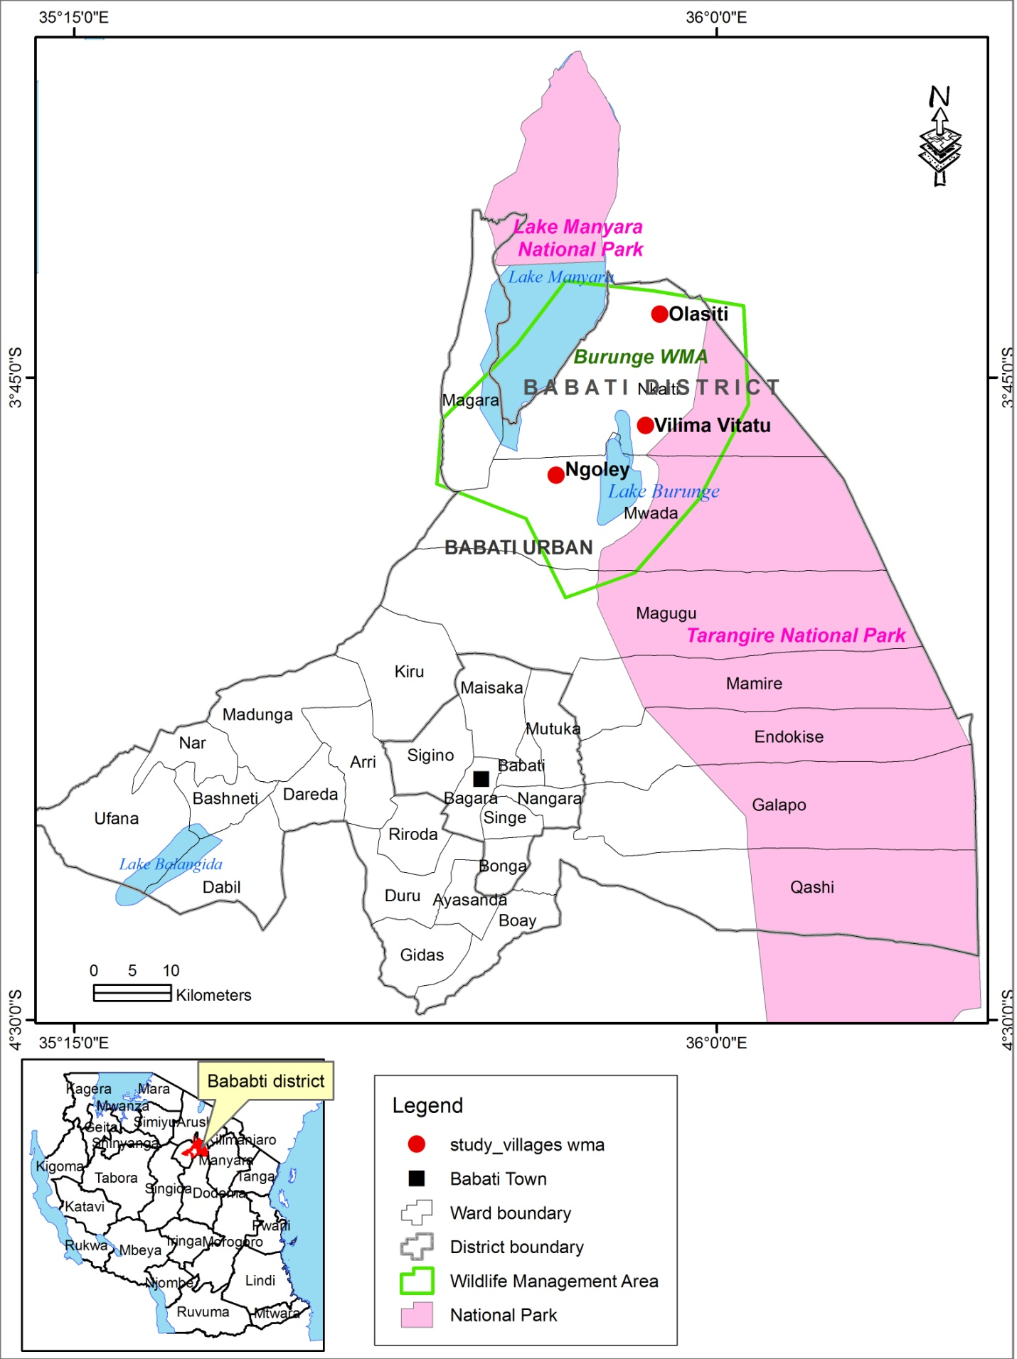

Figure 3.1: A Map of Burunge WMA
Source: Researcher, 2017

3.4 Targeted Population
According to Cooper and Schindler (2003) a population is the total collection of elements about which a researcher wishes to make some inferences. Mc Daniel and Gates (1996) explain that the population is the total group of people from whom a researcher needs to obtain information. The target population for this study was all households found in Burunge wildlife management area, conservationist of Tarangire National Park and Burunge WMA authority. Burunge WMA made by Vilimavitatu, Ngolei, Magara, Maweni, Manyara, Sangaiwe Olasiti, Kakoi, Minjingu and Mbuyuni villages.

3.5 Sampling Procedure
The sampling procedures used in this study were purposive sampling and randomly sampling procedure.

3.5.1 Purposive Sampling
Purposive sampling refers to a judgment, selective or subjective sampling (Kothari, 2004). It is a non-probability sampling method characterized by a deliberate effort to gain representative samples by including groups or typical areas in a sample. According to Kamuzora (2008) purposive sampling defined as the judgmental sampling where the researcher chooses only that element that he/she believes will be able to deliver the required data. The researcher relied on this method to select three villages which are Olasiti, Vilima vitatu, and Ngolei since they are very close to wildlife habitat. Apart from that, basing on WMA report, selected villages have high frequency of reported cases of human-wildlife conflict compare to other villages in Burunge WMA. Also purposive sampling was used to select 2 respondents from Tarangire National Park (Ecologist park and outreach program officer) and 3 respondents from Burunge WMA authority (Ecologist). Researcher selected these respondents purposively since they are aware about human-wildlife conflict, conservation, study area and surrounding community.

3.5.2 Random Sampling Techniques
In this study simple random sampling (SRS) technique was used to obtain respondents from the population in the study area. This technique was applied due to the fact that household are many and every individual has an equal chance to participate in this study. During this study researcher selected 75 respondents from 3 villages

3.6 Sample Size
The sample size refers to the number of items to be selected from the universe to constitute a sample which fulfills the requirements of efficiency, representative ness, reliability and flexibility (Kothari 2004). According to Gay and Diehl (1992) the number of respondents acceptable for a study depends upon the type of research involved, descriptive, correlation or experimental. For descriptive research the sample should be 10% of population. But if the population is small then 20% may be required. In correlation research at least 30 subjects are required to establish a relationship. For experimental research, 30 subjects per group are often cited as the minimum. Referred to Moser and Kalton (1993), in order to acquire the sample size which is required for homogenous population to provide enough and accurate data which is representative it should not be less than 5%.

Table 3.1: Sample Size
Village | Population | Sample
Vilima vitatu | 808 | 48
Olasiti | 335 | 20
Ngolei | 208 | 12
Total | 1351 | 80
Source: Field survey, 2017

Since the household population in each village were large and vary, researcher decided to use percentage in order to avoid bias and obtain representative sample size in each village. Researcher used 5% to calculate sample size from targeted population of 1351 people, whereby 75 respondents was sampled from households in three villages; Olasiti, Vilima vitatu, and Ngolei found in Burunge WMA. The selection of sample size was based on present population of each village and sampled (Table 3.1).

3.7 Sources of Data
In this study both primary and secondary data was collected. Primary data is the data collected afresh or for the first time, and thus happen to be original in character while secondary data refer to the data which have already been collected and analyzed by someone (Kothari 2009).

3.7.1 Secondary Data
Secondary data was obtained from documents such as books, theses, papers, journals, magazines, Wildlife reports, articles, pamphlets, electronic sources and unpublished literature. These data helped researcher to get information from other people who did the same or related studies.

3.7.2 Primary Data
Primary data was collected through interviews, questionnaires and observation. The data collected enable the researcher to get information from respondents about the human wildlife conflict in Burunge WMA. Primary data collected includes causes of human wildlife conflict, to identify indicators of human wildlife conflict in Burunge WMA and the mitigation measured used to reduce human wildlife conflict.

3.8 Data Collection Tools
In collecting data questionnaire, interview, observation and documentary review was used to obtain information from respondents.

3.8.1 Questionnaires
Questionnaires were used in obtaining information from household/respondents in the study area. In this study both open-ended and closed-ended questionnaires were used to enable the researcher to get sufficient data and information about the human wildlife conflict in Burunge WMA. To ensure that the entire questionnaires distributed were filled appropriately, the questionnaires were administered to the household respondents where by the researcher read and interpret questions to the simple and more understandable language without changing the meaning. For those who did not know how to read and write researcher assist them to fill questionnaires after being read and interpreted questions to them.

Questionnaire technique was used due to the fact that it is cheap and collects large information from large number of people in a short period of time and in relatively cost effective way. However, there are respondents who know to read and write preferred to fill their questionnaires for their own time. Most of them fill questionnaires correctly and return although few of them disappear and failed to return questionnaires which are a weakness of using questionnaire method in collecting data.

3.8.2 Interviews
This technique was used to collect information from WMA authority and Tarangire National Park management. The interview guide (Appendix II) was used to collect data which involves presentation of oral verb responses. Researcher decided to choose this approach because enable the researcher to get detailed information from the respondents. Interview technique increases the knowledge of both the interviewer and the interviewee. This method of data collection has an advantages since it help researcher to get in depth information, few error and more explanation about the problem in a short time. But this method has disadvantages since some interviewee fear to provide correct answers and hide some truth while avoid giving information in depth fearing for their security.

3.8.3 Observations
In this study observation technique was also used in order to supplement information collected through other data collection methods. The researcher use observations regarding the human wildlife conflicts where some of the indicators of HWC (Figures 4.4, 4.5, 4.6 and 4.7) and mitigation measures adopted to reduce HWC were direct observed ( Figure 4.9 and 4.10.) Through observations the researcher has got an opportunity to make personal judgments regarding the situation in the study area. This technique was important since researcher does not rely on people’s willingness to provide information

3.8.4 Documentary Literature Review
In this research documentary literature review was used where various literatures worldwide and local were reviewed. Different books, journals, government reports, magazines, newspaper, research papers, electronic, media and internet were also reviewed. The review was conducted in order to help researcher to get view and information from different authors about the human wildlife conflict.

3.9 Data analysis, Interpretation and Presentation
Qualitative data was analyzed using content analysis. Content analysis means analyzing the information collected through interviews in order to identify the main themes that emerge from respondents (Kumar, 2005). Content analysis is the one of the classical procedure for analyzing textual material range media products to interview data on this essential feature is the use of categories which are often derived from theoretical models (Flick, 2006). In this study content analysis was used to analyze data collected through interview, observation and open ended questionnaire.

Quantitative data are data which are in the form of numbers. This was analyzed using descriptive statistics where by simple statistical analysis such as comparisons and percentages were used to analyze data. Statistical Package for Social Science (SPSS) was applied to analyze the coded information of the questionnaire in this study. For analyzing the quantitative data, Welman and Kruger (2001) as well as Blaikie (2003) identify the descriptive statistic analysis, which is concerned with the description and or summarization of the data obtained for a group or individual unity of analysis. The data collected from this study was presented by using pie charts, tables and graphs.

3.10 Reliability and Validity
Reliability refers to the extent to which data collection technique or techniques was yield consistent findings. In other words, similar observations would be made or conclusion reached by other researcher or where there is transparency made from the raw data to ensures reliability (Saunders et al. 2007). Validity refer to the extent to which data collection method or methods accurately measure what they were intended to measure or the extent to which research findings are really about what they profess to be about (Saunders et al., 2007).

The study used various research tools to collect information to enhance the validity and reliability. Questionnaires as instruments were used to collect information from household; both open and closed ended questions were used. The researcher guided and assist respondents to fill questionnaires where there is any difficult especially for those who need more explanation and clarification about questionnaire. Interview guides was used to collect information from WMA authority and management of Tarangire national park. Face-to-face interview through interview guides was appropriate as it enabled the researcher to obtain the in-depth detailed information.

CHAPTER FOUR

4.0 FINDINGS AND DISCUSSION

4.1 Chapter Overview
The chapter presents findings obtained from respondents through questionnaire and interview, observation and documentary review. Chapter started with socio-demographic characteristics, presentation of collected data, analysis, and discussion.

4.2 Socio-Demographic Characteristics of Respondents
The parameters which were examined in this study were age, gender, education level and economic activities of respondents. These variables help to provide a profile of the sample surveyed.

4.2.1 Gender of Respondents
In order to have good representations of gender, sex of the respondents was taken into consideration. About 58 (65%) of the respondents were male and the remaining 28 (35%) were females. This is due to many African cultures where males are regarded as the heads of household.
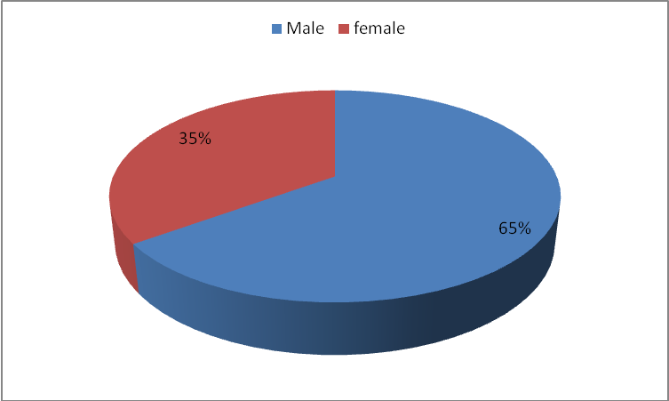

Figure 4.1: Distribution of Respondent by Gender
Source: Field survey, 2017
In this study both male and female were given a chance to participate. The study revealed that male face problem of human wildlife conflict than female since male engaged in economic activities such as grazing livestock, cultivation and security than female.

4.2.2 Age of Respondents
The age of respondents was categorized into five groups (Table 4.1) which started from the age of 18 years to 60 years and above. The grouping of age was based on consideration that economically active group in Tanzania is from the age of 15 years to 64 years (URT 1991). The investigation of respondent’s age was important due to diverse implications each group had and social setting which may subsequently have regarding to perception on human-wildlife conflict.

Table 4.1: Distribution of Respondent by Age
Age category | Respondents | Percentage
18-30 | 7 | 9
31-40 | 24 | 30
41-50 | 35 | 44
51-60 | 9 | 11
Above 60 | 5 | 6
Total | 80 | 100
Source: Field survey, 2017

The results in Table 4.1 show that, 44% of the total respondents were aged 41 to 50 years old while the minority 6% had the age above 60 years. The findings imply that the majority of the respondents are in the middle age group (41 to 50 years) which fall within the economically active and productive group. According to Basnayake and Gunaratne (2002), the age of a person usually is a factor that can explain the level of production and efficiency. In the study area, this age group own farms and engaged in crop cultivation while others engage in livestock keeping and are most suffered the consequences of human wildlife conflict.

4.2.3 Education Level of Respondents
Education is perceived as among the factors that influence an individual’s perception of an intervention before making decision to take part. According to Basnayake and Gunaratne, (2002) education is always regarded and valued as a means of liberation from ignorance. Thus, understanding the educational levels of the respondents under the study was an important factor in assessing their skills and knowledge for judging about different matters. The results in Table (4.2) revealed that, the majority; 61% of respondents had attained primary education, 26% of respondent had no formal education, 5% had attained technical education from VETA and from other vocation training institutes and colleges. 8% of total respondents attained secondary education while no respondent attained university education.

Table 4.2 Distribution of Respondents by Education Level
Education Level | Frequency/Respondents | Percentage
No formal education | 21 | 26
Primary education | 49 | 61
Secondary education | 6 | 8
Collage/Technical education | 4 | 5
Total | 80 | 100
Source: Field survey, 2017

Despite the fact that there are few respondents who cannot read or write especially elders but most of them understood the situation of human-wildlife conflict in the study area. Most respondents were able to provide correct answers about source of HWC, Indicators of HWC and Mitigation they use to minimize HWC. The study revealed that respondents with no formal education and primary education face wildlife conflict than those had secondary and collage education level. This is because in the study areas most respondents with no formal education and primary level of education engage in farming while farmers are most suffer the consequences of HWC.

4.2.4 Economic Activities
The main economic activity in the area is agriculture as the majority; 61 are involved in crop cultivation and livestock keeping (Figure 4.2). Business is another economic activity 10 where people buy agricultural products and transport to the market. There are few respondent employed 6 in public and private sector such as Minjingu phosphate Company LTD and other investors in the study area. According to respondents, local people who engage in agriculture are more suffered from HWC.

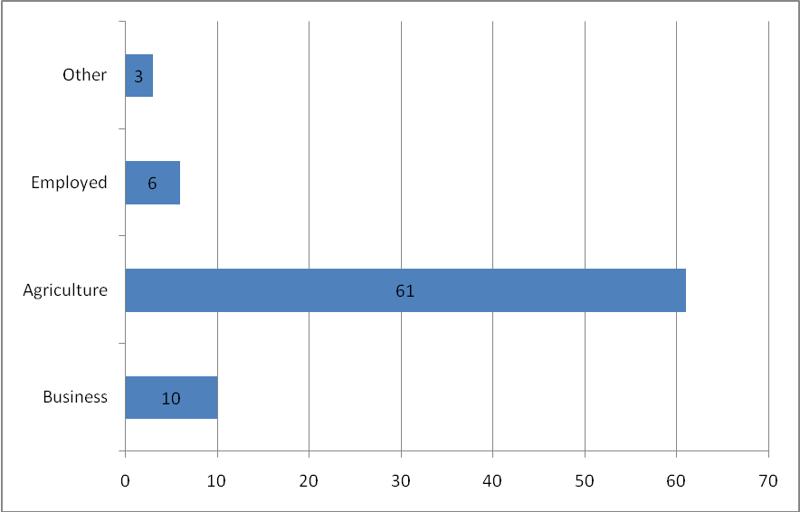

Figure 4.2: Main Economic Activities
Source: Field survey, 2017
Agriculturalists are most faced with human-wildlife conflict in the study area due to crop raiding and livestock predation. Crops such as pumpkins, maize and pigeon pees which are cultivated in the study attract wildlife such as elephants, buffalo, zebra, wildebeest, baboons and other wild animals. Apart from that livestock kept in the study area such as cows, got, and sheep predated by wild animals such as lions, leopards, cheater, and hyena hence increase of HWC.

4.3 Sources of Human-Wildlife Conflict in Burunge WMA
Most respondents (51%) agree that competition over resources are the main sources of human-wildlife conflict in Burunge WMA, 28% mention human encroachment to protected area and migratory corridor, 15% pointed out increase of population as a main sources of HWC while 6% said there are other sources/reasons apart from those mentioned. (Table 4.3)

Table 4.3: Source of Human Wildlife Conflict in the Study Area
Source | Frequency/Respondents | Percentage
Competition over resources as factor influencing HWC | 41 | 51
Human encroachment on wildlife corridor and dispersal area | 22 | 28
Increase of human population in the area | 12 | 15
Others (Lack of compensation towards wildlife damages, poaching) | 5 | 6
Total | 80 | 100
Source: Field survey, 2017

Competition over resources such as land, water and pasture between human and wildlife was mention as a main source of human wildlife conflict in Burunge WMA. Demands of resources such as land for agriculture, grazing land for livestock keeping and settlement increase everyday in the study area hence increase competition of land resource between human and wildlife as reported by Burunge WMA authority.

The study also revealed that the increase of human population in Burunge WMA contributes a lot in competition of resources between human beings and wildlife hence leading to conflict. During interviews the park ecologist of Tarangire National Park (TNP,) had this to say;
“Increased population has led to blockage of wildlife migratory corridor since Burunge WMA is a wildlife migratory corridor which join Tarangire National Park and Lake Manyara National Park.’’

Encroachment into wildlife corridor and in protected area is a factor that 28% of the respondents agree to have lead to human wildlife conflict. Apart from that increase of population in the study area led to increase of poaching. One interviewee had this to say;
“Poachers also easily escape without being caught due to high population and differentiating who is a poacher and who is not is a challenge”

This claim was supported by other respondents interviewed in the study area. Despite the fact that population increased block wildlife migratory corridor, also increase illegal activities such as poaching. During household survey and key informant interviews few respondents (6%) pointed out that there are other source of human-wildlife conflict such as crop raiding, lack of clear compensation towards wildlife damages; livestock predation, human injury or killed by wild animals.

4.3.1 Wild Animals’ Visitation to Respondent’s Residence
During this study, the researcher asked the question of whether wild animals go to people’s residence, since it could be the reasons as to why conflict between humans and wildlife exist in Burunge wildlife management area.

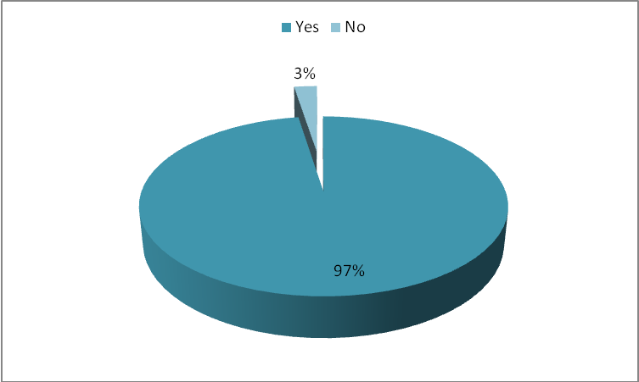

Figure 4.3: Wild Animals’ Visitation to Respondent’s Residence
Source: Field survey, 2017

The study findings Figure 4.3 show that most of the respondents 97% agree that wild animals have been visiting their residents. This is due to competition of resources and human encroachment of wildlife areas which led to blockage of wildlife migratory corridors. Apart from that this implied that there is no proper measure to protect wildlife to visit human residences which bring conflict. This is in one line with the work of Musimbi (2013) conducted on factors influencing human wildlife conflict in communities living around Nakuru National Park where by 99% of respondents agreed wild animals have been visiting their residence.

4.4 Indicators of Human Wildlife Conflict in Burunge WMA.
Figure 4.4 below shows the indicators that verify human wildlife conflict existed in the study area. The respondents rated the indicators and the results show ratings.
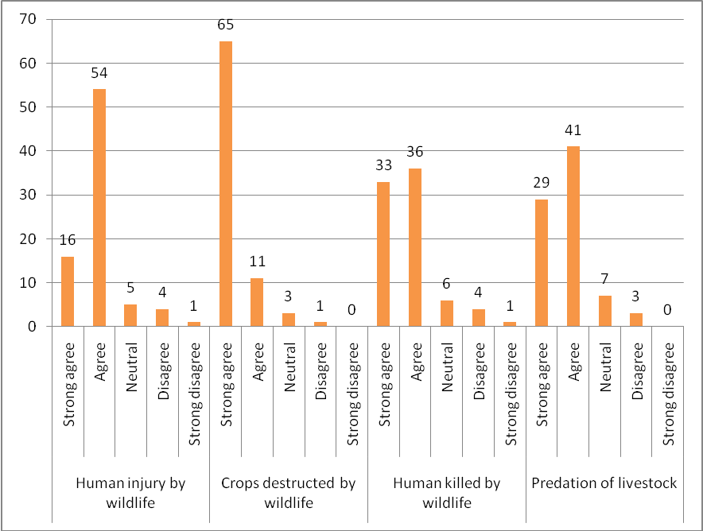

Figure 4.4: Indicators of Human Wildlife Conflict

The finding in Figure 4.4 reveals that (76) 95% of respondents agree that wild animals have destroyed crops in their residence. From the findings, crop destruction is the most experienced indicator of conflict between human and wildlife in the study area which shows that farmers are the most affected in terms of HWC. Another most rated conflict between humans and wildlife is wild animals killing livestock in residential area with (69) 87% of total respondents supporting. According to the findings, Human Injury by wildlife was another indicator of presence of human wildlife conflict whereby (70) 88% of the respondents supporting while killing of people by wildlife being ranked the least.

During interview with key informants, respondents reported that during the dry season large groups of wildlife especially herbivores migrate to local people’s residence during night to look for water and pasture whereby wildlife raiding farmer’s crops. One of local leader insisted that migration of herbivores from protected area to people’s farms is a source of hunger in Ngolei and Vilima vitatu Village. This is also supported by Parker et. al .,(2007) who revealed that wide variety of vertebrates pests such as birds, primates, hippopotamus, elephants, rodents, antelopes, bush pigs and buffalo come into conflict with farmers in Africa due to crop raiding which cause human-wildlife conflict. Apart from that, by using direct observation method and transect walk in the study area researcher observe wildlife raiding farmers crops, some of wildlife were killed by farmers in their residence see (Figures 4.5 and 4.6)
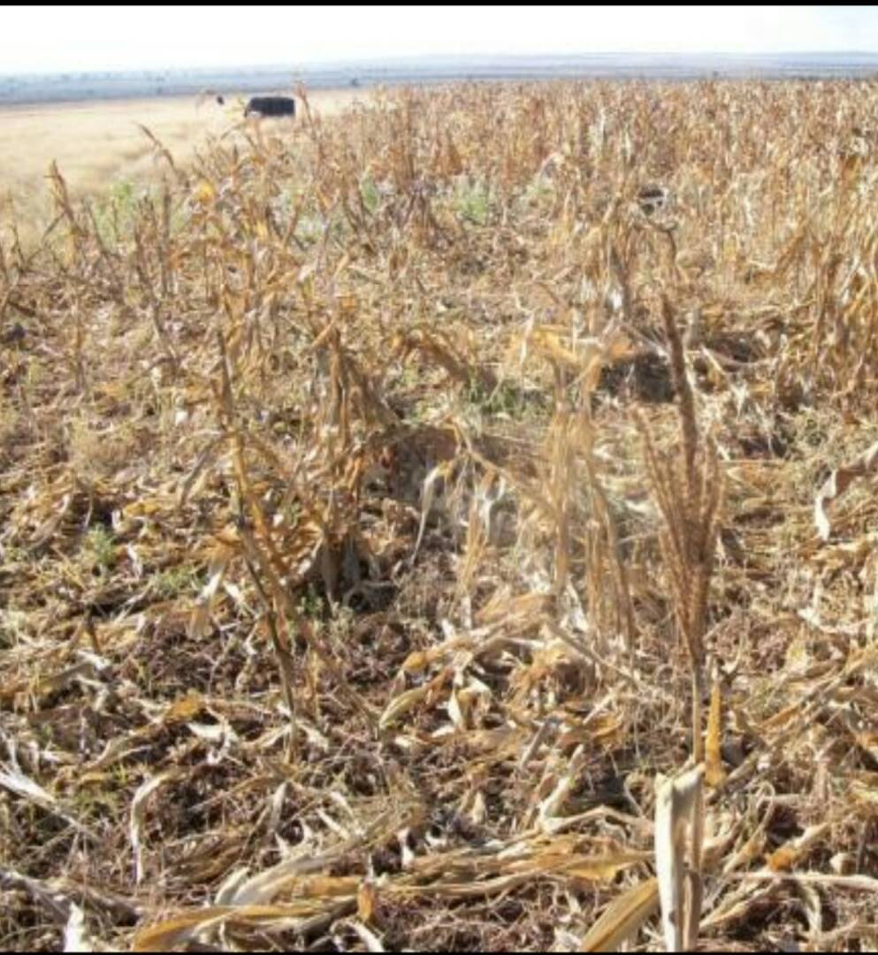

Figure 4.5: Maize Farm Raided by Elephants in Vilima Vitatu Village
Source: Field survey, 2017

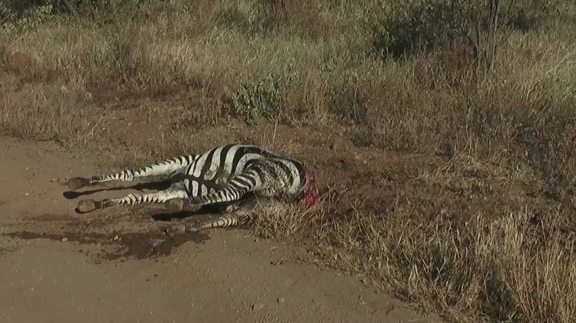

Figure 4.6: Zebra Killed by Farmers after invading Villager’s Crops in Ngolei Village
Source: Field survey, 2017
As the finding of this study shows, most people suffered consequences of human-wildlife conflict due to evidence of crop raiding, human injuries, human death and predation of livestock by wild animals. The most affected people were farmers (95%) due to crop raiding which is very dangerous since agricultural sector employ many people and most contributed sector of economy in Tanzania for many years. Third (2005) in his study found that changing patterns of agricultural land use in parts of Africa led to increase conflict between farmers and conservationist due to crop raiding.

Predation of livestock by wild animals was also common in the study area as reported by respondents. During interview with Park ecologist from LMNP and TNP complained that there are some anthropogenic activities conducted in the study area result into HWC. One of the examples given out was some of livestock keepers graze livestock in Wildlife migratory corridors, buffer zones and in or near protected areas which cause livestock predation. This agreed by other scholars like Kagiri, (2000) who pointed out that most natural wildlife buffer zones have led to competition for food, feed, water, habitat and space for both humans and wildlife hence resulting conflict for survival.

Also reported that, migration of herbivores influence migration of carnivores too since herbivores are the main food for carnivores. When large numbers of herbivores migrate from one area lead to decrease of food for carnivores hence carnivores started to predate livestock outside the protected areas. (See Fig.4.7)

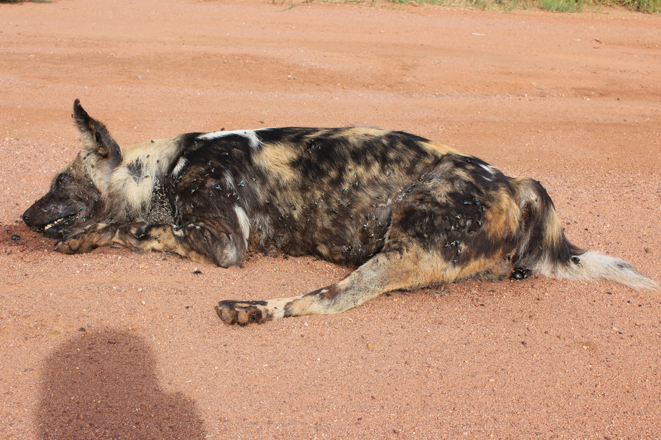

Figure 4.7: Wild Dog Killed by Villagers in Vilima Vitatu after attacking Livestock
Source: Field survey, 2017

Human injury and death caused by wildlife was also reported in the study area. During Key informants interview respondents reported the presence of injured peoples in the village. One of the injured people was chairman of Ngolei village Figure 4.7. During the interview with the injured Village chairman he said;
“It was evening in that day, at home trying to count my livestock as one of my everyday duty after being grazed. Without expecting I faced the hyena about a distance of four meters from where I was standing … I shouted loudly so as to get assistance from neighbors. Neighbors arrived though I was already attacked badly by that hyena. Am still getting treatment and next week I will be back to KCMC hospital where I was admitted. I thank God my health improving every day compared to that time” (See Fig.4.8)
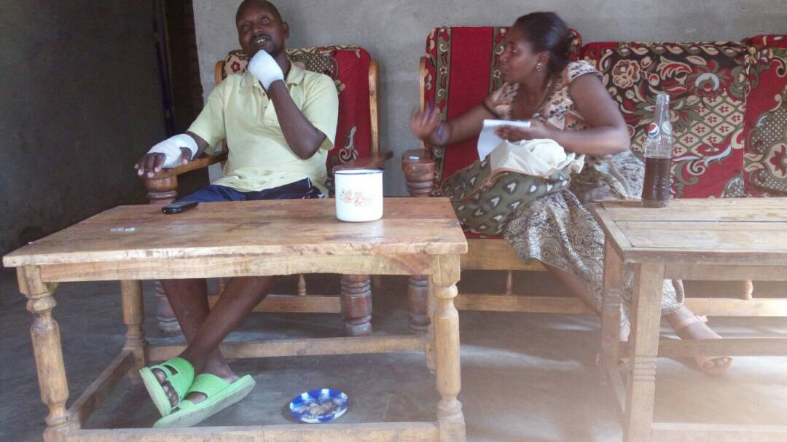

Figure 4.8: Village Chairman Injured by Hyena
Source: Field survey, 2017
Other key informants report presence of other injured people in the study area and others who were killed by dangerous animal. One of the most attacked people by the wildlife were students, farmers and alcohol drinkers as reported by one of the key informants during interview;
“There are students who walk long distance to school, there are farmers who guard their crops during night and alcohol drinkers who came back to their home late during night…. All these were most injured or killed by wildlife”(See Fig .4.9).

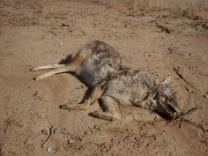

Figure 4.9: Hyena Killed by the Villagers in Ngolei Village After Attacked a Person
Source: Field survey, 2017

4.5 Mitigation Measures Adopted by the Local People to Reduce Human Wildlife Conflict
In solving problem of HWC local people adopted different measures so as to mitigate the problem as shown in Table 4.4.

Table4.4: Mitigation Measures Adopted by the Local People to Reduce HWC
Mitigation | Respondents | Percentage
Watch towers | 33 | 41
Disturbing noises | 25 | 31
Fire | 16 | 20
Others (Chili, modern livestock houses, torch) | 6 | 8
Total | 80 | 100
Source: Field survey, 2017

The majority of respondents (41%) who are farmers said that they had built temporary watch towers during the ripening of crops to help watch over wildlife that are trying to approach farms in order to raid them. (See Fig 4.10) Disturbing noises is also another mitigation method reported by respondents where by instruments such as siren and drums used to chase away wildlife such as elephants, buffalo, wildebeest and zebra where by local people clapping hands and whistling. Respondents from Honey Guide foundation a non-governmental organization narrated to the researcher on different mitigation measures that the NGO disseminated to study areas farmers in order to be able to mitigate the problem of HWC together with the support they gave the village’s farmer.
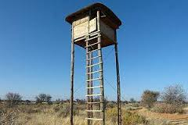

Figure 4.10: Watching Tower in Burunge WMA
Source: Field survey, 2017
However, few respondents (8%) reported to use other mitigation measures such as fire, torches and chili (See Fig.4.11). According to respondents wildlife especially elephant avoid feeding or passing in chili farms due to its tastes and smell which disturb them. Fire was another method reported by respondents where local people prepare fire at the entry points from the protected areas to the local residence area and to the farms entry point.
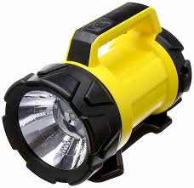

Figure 4.11: Torch Distributed by Burunge WMA Management to Some of the Village Leader for Scaring Wild Animal during the Night Time
Source: Burunge WMA Office

During the interview with key informants local leaders reported that they collaborate with different stakeholders in mitigating HWC. Example, local leaders (VEO and village Chairmen) in collaboration with Honey guide foundation (NGO) introduced the Burunge farmers to chill bricks techniques of mitigating HWC. Apart from that the NGO offers its vehicles to help the farmers to chase the wildlife inside the local residence through siren and horn as reported by village executive officer in Vilima vitatu Village. Lastly Honey guide foundation (NGO) train the farmers on mitigation measures for HWC by using awareness films made from the village`s own surroundings as reported by Village Chairman in Ngolei village. In case of livestock predation local people started to construct modern livestock houses so as to protect them from predators such as hyena, leopard, cheater, lion and other dangerous carnivores as reported in Olasiti village by VEO.

Despite different mitigation measures used by the local people to reduce human wildlife conflict in Burunge WMA, the result shows that most of these measures are not effective. This is due to presence highly reported cases associated with HWC, negative perception towards wildlife conservation and direct visible indicators of HWC. The study revealed that most of measures used to mitigate HWC are poor and aim to mitigate some wildlife such as elephants. It is difficult to mitigate HWC associated with common problem wildlife such as birds, monkey and hyena by poor mitigation such as those used by local people in the study area.

4.6 Summary of Findings
The main sources of human wildlife conflict in the study area include; increase of population associated with increased human activities, blockage of migratory corridor and resource competition. Apart from sources of HWC there are indicators of HWC identified which are crops raiding by herbivores, livestock predation by carnivores, human injury and killing. Killing was identified to both human and wildlife in Burunge WMA .However this study examined the mitigation measures used by local people in reducing human wildlife conflict where by different mitigation were identified such as building watching tower, use of fire at the entry points, disturbing noises, security torches and chill. The mitigation measures used by local people in the study area are poor and target few wildlife hence increase of human wildlife conflict.

CHAPTER FIVE

5.0 CONCLUSION AND RECOMMENDATIONS

5.1 Introduction
This chapter provides the conclusion and recommendations of this study about human-wildlife conflict.

5.2 Conclusion
This study attempted to assess human-wildlife conflicts at Burunge WMA in north eastern Tanzania. Human - wildlife conflict has increased in Burunge WMA especially in Vilima vitatu, Ngolei and Olasiti villages. The increase cases of conflict have been so common that it has called for the need to find an amicable solution to the problem. The resulting consequences from the HWC are equally devastating. The study findings have revealed that indeed, the situation is more serious than it may appear on the face of itself. From the study, it is important to note that various factors have directly or indirectly contributed to the HWC.

However, it is important to note that most of the conflicts have been reported in areas where the human settlement is so close to protected area creating a possibility of people and animals interactions. The main sources of human wildlife conflict in the study area include; increase of population associated with increased human activities, blockage of migratory corridor and resource competition. Apart from sources of HWC there are indicators of HWC identified which are crops raiding by herbivores, livestock predation by carnivores, human injury and killing. Killing was identified to both human and wildlife in Burunge WMA. However this study examined the mitigation measures used by local people in reducing human wildlife conflict where by different mitigation were identified such as building watching tower, use of fire at the entry points and use of disturbing noises.

5.3 Recommendations
Based on the major findings of this study, the following recommendations will help to minimize human-wildlife conflict in Burunge WMA.
- Different stakeholders such as MNRT, WD, TAWIRI, Conservation NGO’s and Local people should sit together to find the proper mitigation towards HWC instead excluding themselves and leaving it to local community only
- Farmers being the most affected in terms of crop raiding, the government through MNRT should come up with an alternative way of livelihood that suits the farmers living around protected areas, especially initiating programs such as creation for community conservancies that can assist farmers to accrue revenue.
- MNRT should involve indigenous people living adjacent protected areas in planning and implementation so as to minimize conflicts.
- Provision of community Education program should be put as a priority so as to enhance conservation.

5.4 Suggestion for Further Studies
The study identified many gaps hence the following should be taken in order to fill those gaps for further research;
- The effectiveness of mitigation measures used to minimize human wildlife conflict in Burunge Wildlife Management Area
- The attitude of local people towards wildlife conservation in Burunge Wildlife Management Area
- Role of technology in minimizing problem of human-wildlife conflict in Burunge Wildlife Management Area

REFERENCES
Amanda, C. J., Vincent, Y., Mitcheson, S. L. and Lieberman, S. (2013). The role of CITES in the conservation of marine fishes. Columbia: John Wiley and Sons Ltd.
Babati District Council, (2004). A Proposal for Joint LAMP-AWF Community Based Conservation Activities in Babati. Babati District Council, Manyara, Tanzania.
Barlow, A.. (2009). The Sundarbans Tiger: Adaptation, population status and conflict management. Unpublished Doctor of philosophy thesis, University of Minnesota, USA.
Barnes, R. F. W. (1996). The conflict between humans and elephants in the central African forests. California: Wiley and Sons Ltd.
Bhatta, S. (2003). Elephant – human conflict in Nepal Terai Protected Area with particular emphasis on western Terai Arc landscape, Nepal. Report to WWF Nepal Program, Kathmandu, Nepal India.
Blaikie, N. (2003). Analyzing Quantitative Data, University of science, Paperback: SAGE Publication LTD.
Butchart, S. H, Walpole, B, Collen, A. and Davidson, F. (2010). Global Biodiversity: Indicators of recent Declines. Annual Report.
Butchart, S. H, Walpole, B. Bruno, K. Davidson, F. (2012). Protecting important sites for biodiversity contributes to meeting global conservation targets. Climatic Change, 82(1), 61-76.
Cooper, D. R. and Schindler, P. S (2003). Research Designs and Methods. Training manual, University of Pretoria, South Africa.
Cooper, F. G. (1998). Tourism: Principles and Practices, New York: Wesley Longman Ltd.
Dickman, J. A. (2010). Complexities of conflict: the importance of considering social factors for effectively resolving human–wildlife conflict, University of Oxford, UK.
Distefano, E. (2010). Human-Wildlife Conflict Worldwide: Collection of Case Studies, Analysis of Management Strategies and Good Practices. FAO, Rome.
Ehrlich, P. R. and Pringle, R. M., (2008). Colloquium paper: where does biodiversity go from here? paper no. 105, Stanford University, CA FAO, Roma, Italy.
Fergusson, R. A. (2002). Living with a wild predator: managing human/crocodile conflict in Africa. A proposal for an IUCN Crocodile Specialist group, Newsletter, 21(4), 17-21.
Food and Agriculture Organization (2007). Nature and Fauna Human-Wildlife Conflicts Annual report, FAO, Roma, Italy.
Food and Agriculture Organization (2009). Human -wildlife conflict in Africa. Annual report, FAO, Roma, Italy.
Gay, L. R., Diel P. L. (1992). Research Methods for Business and Management, New York: MacMillan Publishing Company.
Gore, M. L., Knuth, B. A., Curtis, P. D., and hanahan, J. E. S. (2006). Stakeholder perceptions of risk associated with human-black bear conflicts in New York: Wildlife society Bulletin.
Graham, K., Andrew, P. Beckerman, Simon, T, (2004). Human–predator–prey conflicts: ecological correlates, prey losses and patterns of management. Centre for Conservation Science, University of Sterling, UK.
Hennink, M., (2007). International focus group research, a handbook for the health and social sciences, Cambridge: Cambridge University Press.
Hoare, R. (1995). Options for the control of elephants in conflict with people. Pachyderm 19:54-63.
International Union Conservation for Nature, (2003). World Parks Congress press release. IUCN: New York.
International Union Conservation for Nature, (2003). World Parks Congress press release. IUCN: New York.
IUCN, (2003). World parks congress press release. Retrieved on September 17th 2017, from; IUCN http:// www.iucn.org.
Jones, B. (2004). CBNRM, poverty reduction and sustainable livelihoods: Developing criteria for evaluating the contribution of CBNRM to poverty reduction and alleviation in southern Africa. CASS/PLASS occasional paper series no. 7. pp 47.
Kamuzola, F. (2008). Research Methods for business and social studies and social studies. Mzumbe Book project. Morogoro: Mzumbe.
Kideghesho, J., Shemwetta, D. (2005). Human-Wildlife Conflicts in Tanzania, What research and extension could offer to conflict resolution. Proceedings of the 1st University Wide Scientific Conference, 5t h – 7th April, 2000.
Kilpatrick, A. M., Gillin, C. M. & Daszak, P. (2009). Wildlife livestock conflict. Journal of Applied Ecology, 46(1), 476-485.
Kothari, C. R (2004). Research Methodology Methods and Techniques. New Delhi: New Age International (P) LTD.
Kothari, C. R. (2003). Research Methodology: Methods and Techniques, New Delhi: New Age International (P) Limited.
Kruger, S. J. and Welman, C. (2001). Research Methods for the Business and Administrative Science, Oxford: Oxford University press.
Kweka, D. (2010). Establishing Wildlife Management Areas: Impacts of Community Based Natural Resources Management on Biodiversity and Communities in Tanzania.
Lamarque, F. (2008). Human-Wildlife Conflict in Africa. An Overview of Causes, Consequences and Management Strategies. Forestry paper 157, FAO, Italy.
Madulu, N. F., Yanda, P.Z., Maganga, F. P., Mung’ong’o, C. and Mwakaje, A. (2007). Assessment and valuation of Wildlife Management Areas, Report prepared for the Wildlife Division in Tanzania, Dar es Salaam, Tanzania.
Magenda, O.M and Mugenda, A.G (1999). Research Methods, Quantitative and Qualitative Approaches. Nairobi: African Centre for Technology Studies Press.
Mishra, C., Allen, P., McCarthy, T., Madhusudan M. Bayarjargal, A. and Prins, H. (2003). The role of incentives program in conserving the snow Leopard, Department of environmental science, Wageningen University, Netherlands.
Moser, C. and Graham, K. (2003). Survey Methods in Social Investigation, Ashgate publishing group, Aldershot England. UK.
Newmark, W. D, Manyanza, D. N, Gamassa, D. M. (1994). The conflict between wildlife and local people living adjacent to protected areas in Tanzania. Conservation Biology journal. 68(1), 35-41.
Newmark, W. D., Leonard, N. L, Sariko, H. I, & Gamassa, D. M. (1993). Conservation attitudes of local people living adjacent to five protected areas in Tanzania, 63(2), Conservation Biology journal, 172-183.
Ngirwa, C. A. (2006). Human Resources in African Work Organization. 1st Ed., Institute of Social Work. Dar es Salaam, Tanzania.
Nyhus P. and Tilson R. (2004). Agro forestry elephant and tiger balancing conservation theory and practice in human dominated landscape of Southeast Asia. Cambridge: Cambridge University press.
Nyhus, P., Osofsky, S., Ferraro, P., Madden, F., Fitcher, H. (2005). Bearing the Costs of Human-wildlife Conflict: The Challenges of Compensation Schemes. Cambridge: Conservation Biology Series, Cambridge University press.
Osei-Owusu, Y., Bakker, L. (2008). Human-Wildlife Conflict Elephant Technical Manual. Forestry Dept, FAO: Italy.
Parker, G., Osborn, F. and Niskanen, L. (2007). Human elephant mitigation: Approaches in Africa, Training course for community based approaches in Africa Development Trust, Zambia and IUCN/SSC AF: Nairobi, Kenya.
Patterson, Bruce, D, Samuel M, Edwin, Roland W, (1999). Livestock predation by lions (Panthera leo) and other carnivores on ranches neighboring Tsavo National Park, Kenya. Elserver Ltd. Nairobi, Kenya.
Petterson, B. D., Kisiki S. M., Selempo, E. and Kays, R. W. (2004). Livestock Predation by lion and other Carnivores on ranches neighboring Tsavo National Parks Kenya, Nairobi.
Pimentel, D., Zuniga, R. and Morrison, D. (2005). Update on the environmental and economic costs associated with alien-invasive species. USDA National Wildlife Research Center Symposium University of Nebraska- Lincoln, NY.
Rigg, R., Findo, S., Wechseilberger, M. and Gorman, M. L. (2011). Mitigating carnivore–livestock conflict in Europe, Oxford: Oxford University press.
Saunders, M., Lewis. P, and Thornhill, A. (2007). A Crucial Discussion of Research Methods and approaches 5th Ed, England: Pearson Education LTD,
Shemwetta, D. and Kideghesho, J. R. (2000). Human-Wildlife Conflicts in Tanzania: What Research and extension could offer to conflict resolution. Unpublished Masters thesis, Sokoine University of Agriculture, Morogoro Tanzania.
Shrestha, D. B, Paudyal, A. (2007). When Mega Vertebrates Makes Ranch their home Issues, Kathmandu, Royal Institute of Management Nepal. pp 39
Shrestha, R. K. and Alavalapati, J. R. R. (2006). Linking Conservation and Development, Environment, Development and Sustainability, International weekly Journal, 8(1), 69-84
Siex, K. and Struhsaker, T. (1999). Columbus monkey and Coconut. Perceived human- wildlife conflicts in Zanzibar, Tanzania, Journal of Applied Ecology, 36(2), 34-41.
Sindiga, I. (1995). Wildlife based tourism in Kenya: Land use conflicts and government compensation policies overprotected areas .Journal of Tourism studies, 6(2), 23-30.
Sitati, N. W., Walpole, M. J., Smith, R. J. and Leader-Williams, N. (2003). Predicting spatial aspects of human–elephant conflict. Journal of Applied Ecology. 40(4), 12-20.
Stern, P. C. (2000). Towards a coherent theory of environmentally significant behavior. Journal of Social Issues, 56(1), 407-424.
Sukumar, R. (1994). Wildlife-Human Conflict in India, an ecological and social perspective, New Delhi: Oxford University Press.
Tanzania Wildlife Research Institute, (2009). Tanzania Elephant Management plan workshop Report. TAWIRI: Dar es Salaam.
Thomas, H., WhiteJr, A., Jhonson, C. & Toby, B. (2011). Human Perceptions Regarding Endangered Species Conservation, A case study of Saona Dominica Republic. Dominican Republic, Washington DC.
Treves, A. (2007). Balancing the Needs of People and Wildlife, When Wildlife Damage Crops and Prey on Livestock, University of Wisconsin, Cambridge: Cambridge University Press.
Treves, A., Robert, B. Wallace, L. and Naughton, T. (2005). Evaluating lethal control in the management of human–wildlife conflict, Cambridge: Cambridge University press.
Tsi, E. A, Ajaga, N., & Wiegleb, G. (2008). The willingness to pay for the conservation of wildlife animals University of Daschang, Cameroon.
United Republic of Tanzania, (2003). The National Tourism Policy. Ministry of Natural Resources and Tourism. Dar es Salaam, Tanzania.
Waithaka, J. (1993). Wildlife Conservation, The elephant menace. Cambridge: Cambridge University Press.
Wildlife Sector Review in Tanzania, (1995). Assessment of the Current Situation. Annual Report, Institute of Resource Assessment. Ministry of Tourism Wildlife Division, WSART: Dar es Salaam, Tanzania.
World Wildlife Fund (2006). ACT SHEET: Human-animal conflict. World Wide Fund for Nature. WWF: Geneva.
World Wildlife Fund, (2005). Human Wildlife Conflict Manual-Wildlife Management Series, WWF: Geneva.
World Wildlife Fund, (2007). Assessment and Evaluation of the Wildlife Management Areas in Tanzania, Report, World Wide Fund for Nature, Ministry of Natural Resource and Tourism. Dar es Salaam, Tanzania.

APPENDICES

Appendix I, Questionnaires for household

PERSONAL INFORMATION
- Age:
- 18-30 ( )
- 31-40 ( )
- 41-50 ( )
- 51-60 ( )
- Above 60 years old ( )
- Sex:
- Male ( )
- Female ( )
- Education:
  - No formal education ( )
  - Primary education ( )
  - Secondary education ( )
  - College / technical education ( )
  - University education ( )
- Are you a resident of this village?
⁯ Yes
⁯ No
- What are the main sources of your income? (Preferences)
1. | Employed ( )
2. | Agriculture ( )
3. | Industrial ( )
4. | Business ( ).
5. | Others ( )

B. HUMAN-WILDLIFE INTERACTIONS
1. Have you ever encountered with the wild animals in your area or village?
⁯ Yes
⁯ No
2. How often do they visit?
Daily ……………….Once a week ………..Twice a week………..Any time ……
3. Which time of the day?
During day time…………….At night ………………………Any time………………
4. What season of the year? ………………………….……………………………
5. What kind of the problems do the wild animals create?
Crop Damage ………….
Human harassment (Injured and Killed)………..
Livestock depredation …………
Damage properties ………….
Others (Specify)……………….
6. If they damage crops, what types of crops do they destroyed in your farm and mostly preferred?
S.N. | Wild animal | Season | Crop loss/Damage in a year
 |  |  | Type of crop | Damage (In Rs)
1.
2.
3.

7. If wild animals prey on your livestock, what types (species) of animals do mostly prey on your livestock? …………………………………………………..
8. Which livestock is attacked or killed by wild animals?
……………………………………………………..
9. How do you control them?
………………………………………
10. How do they control the wild animals to minimize damage to their crops?
…………………………………………………………………
11. Is there any Game officer in your village?
Yes
No
12. If yes, what is his / their role or duties?
……………………………………………….
13. What is your opinion on the presence or absence of Game officers at your village? ………………………………………………
14. The table below lists some of the damages might have incurred caused by wild animals. Please indicate your level of agreement of the damage that occur in your area by ticking
S/N | HWC indicator | Strong agree | Agree | Neutral | Disagree | Strong disagree
i | Dangerous wild animals have attacked and injured people in my residence
ii | Wild animals have destroyed crops in my community
iii | Some of my community members have been killed by wild animals
iv | Dangerous wild animals have killed livestock in my residential area

C. ACCESS TO NATURAL RESOURCES
1. What are your major sources of cooking energy?
A. Gas
B. Electricity
C. Firewood
D. Others
2. If is a fire wood, where do you collect?
………………………………………………..
3. What is the status of the forests that you used for collecting forest products?
Dense ………………... Thin……………………..… Same as before ………………
4. Where do you get poles and grass for construction purposes?
…………………………………………………………
5. Where do you feed your livestock?
……………………………………………
7. Where do you get water for domestic use? ………………………………………
8. Where do you get water for watering your livestock?
……………………………………………………….
9. What are the benefits brought or caused by the existence of tourism industry in your area or village? …………………………………………………………..

D. PERCEPTION TOWARD WILDLIFE
- Have you notice any wild animal killed with local people?
- If yes, name the species and number (how much?)
- What is the reason do you think?
- Was anybody in your family harassed/killed by wild animals?
- When that incidence has happened?
This Year .......Last year............Two years ago .............Three years ago.........
Others specify …………………….
- Have you complained or report about the wild animals killing?
Yes
No
7. If yes, where did you complain ……………................................
8. Your complaint properly heard and reciprocated?
Yes
No
9. Have you received any compensation of your crop or domestic animal loss?
- If your answer is "yes” who provided you the compensation?
………………………………………………………………
B. Are you satisfied with the compensation? Yes……..No….. .. Please explain.
10. In your opinion, who should provide the compensation?
………………………………………………………..
11. In your observation, do you think that the incident of human wildlife conflict is?
A. Increasing B. Decreasing C. Same as before
12. In your opinion, why the wild animals are coming out more frequently from the WMA than before?
13. Do you get any benefits from WMA?
Yes …. No…….
14. If yes which are those benefits?
……………………………………….
15. In your opinion do you think the WMA should still exist?
Yes
No
- If yes why?
- If no why?

E. MITIGATIONS MEASURES
- What are your suggestions to control or mitigate wildlife impacts in your village areas?
…………………………………………………………
- Do you chase or repel wild animals approaching your house or farm land?
Yes….. No…..
- If yes which method are frequently used.
A ……………………… B……………………….. C. ………………………
- Could you suggest how this problem of human- wildlife can be solved?
- Do you think Human-Wildlife conflict will increase in the near future?
Yes
No
- What are your suggestion for the Burunge WMA Management?

APPENDIX II: INTERVIEW GUIDE FOR WMA AND TARANGIRE AUTHORITY
- What are the situations of the Human-Wildlife conflict your area?
- What are the main causes of the HWC in Burunge WMA?
- What are the solutions for the reduction of the human-wildlife conflict?
- Does the government have any new kinds of techniques under consideration for the future to mitigate HWC in Burunge WMA?
- How should WMA conservation and natural resource management fulfill the necessity of local community?

