**ASSESSMENT OF HUMAN- ELEPHANTCONFLICT IN VILIMA VITATU VILLAGE IN BABATI DISTRICT: MANYARA REGION**

**IDDA PETER MALLYA**

**A DISSERTATION SUBMITED IN PARTIAL FULLFILMENT OF THE REQUIREMENT FOR THE DEGREE OF MASTER OF ARTS IN NATURAL RESOURCES ASSESMENT AND MANAGEMENT OF THE OPEN UNIVERSITY OF TANZANIA**

**2017**

**CERTIFICATION**

The undersigned certifies that she has read and hereby recommends for acceptance by the open University of Tanzania, a dissertation entitled: Assessment of human-elephant conflicts in Vilima Vitatu village in Babati district: North Eastern Tanzania, in the partial fulfillment of the requirement for the Masters of Arts in Natural Resources Assessment and Management at the Open University of Tanzania.



………………………………….

Dr. Susan Rugano Gwalema

Supervisor

17th November, 2017

………………………….

Date

**COPYRIGHT**

No part of this dissertation may be reproduced, stored in any retrieval system, or transmitted in any form by any means, electronic, mechanical, photocopying, recording or otherwise without prior written permission of the author or the Open University of Tanzania in that behalf.

**DECLARATION**

I,Idda Peter Mallya, do hereby declare that this dissertation is my own original work and that it has not been presented and will not be presented to any other university for a similar or any other degree award.

………………….………………

Signature

…………………………….

Date

**DEDICATION**

I dedicate this work to my beloved mother Bertha Mallya whose love beyond words keeps me going.

**ACKNOWLODGEMENT**

I exalt the name of JESUS CHRIST above everything in heaven and on earth that deserves exaltation for his bounty blessings. He is the essence of my success in my academic and all other areas of my life. I would like to acknowledge different authors and all respondents whose ideas provided the basic ground towards accomplishing this dissertation on the assessment of human – elephant conflicts.

Special thanks to my supervisor Dr. Susan Rugano Gwalema, who took her precious time to supervise me closely and constantly throughout from the development of research proposal to the completion of this dissertation. To my lecturers Professor Deus Ngaruko, Dr. Anna Wawa, Dr. Cosmas Haule, Dr. Emanuel Patroba Mhache, Dr. Jummanne Kalwan, and Dr John Msindai. Since it is not possible to mention everyone, I wish to extend my sincere thanks to all my colleagues on the Master’s degree of Natural Resource assessment and management. To my friends who helped me in oneway or another at different stages of my studies. Your assistance and contributions are highly acknowledged.

Also I would like to express my gratitude to my leaders at workDr Abdu A. Hayghaimo, Dr. Michael Madege and Dr. Obed Malangu. To my other leaders at work in different levels in the Ministry of agricultural livestock and fisheries. Thanks my sister Christine Kessy for your prayer, moral and financial support, my beloved nephew Daniel Mallya for forsaking the time that we could enjoy together so that I could study. Lastly I extend my appreciations to my brothers Fortunate and Patrick Mallya.

**ABSTRACT**

The study assessed the problem of Human-Elephant Conflicts in Vilima Vitatu village in Manyara region Tanzania. The study aimed at Determining the causes of human-elephant conflicts in Vilima Vitatu village,Examining the most common human-elephant conflicts occurring in Vilima Vitatu village, exploring the attitudes of local community at Villima Vitatu village towards the problem of elephants and evaluating the measures taken by local communities to mitigate existing human- elephant conflicts in Vilima Vitatu village. In this study both secondary and primary data were collected from a sample of 135 respondents who were selected randomly and purposively. Content analysis, Excel and SPSS were applied in data analysis generated for this study which involved both qualitative and quantitative data. The study revealed that the increase of human population and expanding agriculture activities has increased the potential for conflicts between elephants and human beings in Vilima Vitatu village. The majority of respondents had a negative attitude towards elephants. Elephants bring out the supreme fear to the local people because of their potential to damage large ranges of crops, property and cause injury and loss of life. HEC extremely affected the life standards of farming communities particularly by damaging crops, thereby leading to food insecurity in households. Consequently, farmers kill elephants or turn a blind eye to poaching when they reflect on the damage they have caused. In mitigating HEC, local people use different traditional methods to minimize them. These include: using fire around field margins or at animal access points to fields, disturbance, and guarding and use of chili as a buffer crop. The study suggested that, land use planning and law enforcement are necessary in resolving the HEC.

**TABLE OF CONTENTS**

**CERTIFICATION** ii

**COPYRIGHT** iii

**DECLARATION** iv

**DEDICATION** v

**ACKNOWLODGEMENT** vi

**ABSTRACT** vii

**TABLE OF CONTENTS** viii

**LIST OF TABLES** xiii

**LIST OF FIGURES** xiv

**LIST OF ABBREVIATIONS** xv

**CHAPTER ONE** 1

**1.0 INTRODUCTION** 1

1.1 Introduction 1

1.2 Background of the Research problem 1

1.3 Statement of the Research Problem 3

1.4 Objectives 5

1.4.1 General Objective 5

1.4.2 Specific Objectives 5

1.5 Research Questions 5

1.6 Significance of the Study 6

1.7 Organization of the Study 6

**CHAPTER TWO** 8

**2.0 LITERATURE REVIEW** 8

2.1 Introduction 8

2.2 Definition of Key Terms 8

2.2.1 Conflicts 8

2.2.2 Protected Areas 8

2.2.3 Human Wildlife Conflicts 8

2.2.4 Human- Elephant Conflict 8

2.2.5 National Park 9

2.2.6 Problematic Elephant 9

2.2.7 Wildlife Corridor 9

2.2.8 Wildlife Management Area 9

2.3 Theoretical Literature Review 9

2.3.1 Theory of Planned Behavior 9

2.3.2 Value-Belief-Norm Theory 11

2.4 Empirical Literature Review 13

2.4.1 Most Common HEC in Areas facing HEC 13

2.4.2 Causes of Human – Elephant Conflicts (HEC) 15

2.4.3 Mitigation Measures 20

2.4.4 Traditional Deterrents 21

2.4.5 Conventional Deterrents 23

2.4.6 Attitude of Farmers Towards The Problematic Elephants 29

2.5 Conceptual Framework of the Study 29

2.6 Research Gap 31

**CHAPTER THREE** 33

**3.0 RESEARCH METHODOLOGY AND THE STUDY AREA** 33

3.1 Introduction 33

3.2 The Study Area 33

3.3 Research Design 35

3.4 Target Population 35

3.5 Sampling Procedures and Sample Size 36

3.5.1 Sampling Procedure 36

3.5.2 Sample Size 37

3.6 Sources of Data 37

3.6.1 Primary Data 38

3.6.2 Secondary Data 38

3.7 Data Collection Methods 38

3.7.1 Questionnaires Method 38

3.7.2 Observation Method 39

3.7.3 Interview Method 39

3.7.4 Documentary Review 40

3.8 Data Analysis, Interpretation and Presentation 40

3.9 Validity and Reliability 41

**CHAPTER FOUR 42**

**4.0 DATA PRESENTATION AND DISCUSSION OF FINDINGS 42**

4.1 Introduction 42

4.2 Socio-Demographics of Respondents 42

4.2.1 Gender of the Respondents 42

4.2.2 Age of Respondents 43

4.2.3 Education Level of the Respondents 44

4.3 Economic Activities Carried Out In the Study Area 45

4.3.1 Crop cultivation in Vilima Vitatu village 45

4.5 Causes of Human-Elephant Conflict 48

4.6 Methods Used by local Community and TNP to Overcome the Challenge of Human-Elephant Conflict in Vilima Vitatu Village 50

4.6.1 Measures Taken by Local community to Mitigate HEC 50

4.6.2 Measures taken by Tarangire National Park to Mitigate HEC 52

4.7 Attitude of Local People Towards Elephants In Vilima Vitatu Village 53

4.8 Discussion of the Findings 53

4.8.1 Common Human-Elephant Conflicts 53

4.8.2 Causes of Human-Elephant Conflict 54

4.8.3 Methods Used by local Community and TNP to Overcome the Challenge of Human-Elephant Conflict in Vilima Vitatu Village 54

4.8.4 Attitude of Local People Towards Elephants in Vilima Vitatu Village 55

**CHAPTER FIVE** 56

**5.0CONCLUSION AND RECOMMENDETIONS** 56

5.1 Introduction 56

5.2 Conclusion 56

5.3 Recommendations 57

5.3.1 Recommendations for the Practice 57

5.3.2 Recommendations for Policy Maker 58

5.3.3 Recommendations for Further Research 58

**REFERENCE** 59

**APPENDICES** 70

**LIST OF TABLES**

Table 3.1: Sample Size 37

Table 4.1: Distribution of Respondents by Education Level 44

Table 4.2: Crops Cultivated in Vilima vitatu village 46

**LIST OF FIGURES**

Figure 2.1: Theory of Planned Behavior 10

Figure 2.2: Conceptual Framework for Human-Elephant Conflicts, Causes and Consequence’s 30

Figure 3.1: The Map to Show the Study Area 34

Figure 4.1: Distribution of Respondents by Gender 42

Figure 4.2: Distribution of Respondents by Age 43

Figure 4.3: Distribution of Respondents by Economic Activities 45

Figure 4.4: Pigeon Peas Farm Affected by Elephants in VilimaVitatu Village 47

Figure 4.5: Presence of Human- Elephant Conflict in the Study Area 48

Figure 4.6: Elephant Dung with Pigeon Peas 49

**LIST OF ABBREVIATIONS**

AWF African Wildlife Fund

CAA`s Conservation Authority Areas

HEC Human Elephant Conflict

IUCN International Union Conservation for Nature

NGO Non-Governmental Organization

PA Protected Areas

TANAPA Tanzania National Parks

TAWIRI Tanzania Wildlife Research Institute

TNP Tarangire National Park

TTB Tanzania Tourist Board

URT United Republic of Tanzania

WMA Wildlife Management Area

WWF World Wildlife Fund

**CHAPTER ONE**

**1.0 INTRODUCTION**

* 1. **Introduction**

This chapter introduces the background of the study,statement of the problem,objectives of the study, research questions andfinally significance of the study.

**1.2 Background of the Research problem**

Desai and Riddle, (2015) state that human-elephant conflict (HEC) is a complicated interaction between humans and elephants, and it represents a harmful impact on both species. Such impacts can be portrayed in the form of crop raiding, property destruction, and sometimes it encompasses killing and injury to people (Desai and Riddle, 2015). So far human – elephant conflict and specifically crop raiding, is a recurrent conservation problem that appears to be increasing wherever elephant range overlaps with human habitat and cultivation areas (Walpole *et al.,* 2004). Conflicts with farmers are considered to pose a grave threat to elephants in both Africa and Asia. Not only that, but also human-wildlife conflicts (HWC) in general are getting unberable (World Wildlife Fund, 2013).

Hossen (2013) described that, there are only two elephant species worldwide, the first is the African Elephant (*Loxodontaafricana)* and the other one is the Asian elephant (*Elephasmaximus*). There are two subspecies of the African elephant known as: the savanna (or bush) elephant *(Loxodonta africana africana*) and the forest elephant (*Loxodonta africana cyclotis*) (WWF, 2014). According to Mayberry, (2015) African savanna elephants allocate eighteen to twenty hours of their day to foraging and during this moment, they consume considerable quantities of food, ranging from one-hundred-and-fifty to four-hundred-and fifty kilograms of food depending on their body weight. According to the author they also consume up to one-hundred-and-sixty liters of water per single day.

Hossen, (2013) stated that,While in Asia the elephant population is decreasing considerably, in some African countries such as Zimbabwe, Tanzania, South Africa and Botswana the elephant populations are increasing. Tanzania is estimated to have 150,000 elephants, which means Tanzania has more elephants than any other country in Africa (Graham and Litoroh, 2009). It has been apparent that when people and wildlife have to compete for the same space and resources, as is often the case with agricultural practices, conflicts will inevitably arise causing disharmony on both parts involved (Sitati and Walpole, 2006; Jackson *et al.,* 2008; Dunham *et al.,* 2010; Granados *et al.,* 2012; Hoare, 2012). In less developed countries where most people still earn their livelihood from subsistence agricultural, and where the population growth rates are above the global average; these reserved areas which are homes to wildlife such as elephants are placed under a growing human pressure (Johansson, 2008).

A number of articles have proven that human-elephant conflicts are becoming a more frequent problem (Sitati and Walpole, 2006; Jackson *et al*., 2008; Graham *et al*., 2010; Harich, 2013). Eighty percent of the African elephant’s range lies outside protected areas, which makes overlap with human activities inevitable (Granados, 2012). With the growing human population, human-wildlife encounters, and thereby the risk of conflicts, are expected to increase (Jackson, 2008; Barua, 2013).

According to World Wildlife Fun (2014),as a result of human-elephant conflicts many problems occur such as; crop-raiding, destruction to village infrastructure, homesand injury to/or death of livestock and seldomly people.A number of elephants are shot as a result of retaliatory killing by farmers and sometimes by the authorities. For example in Sri Lanka around 150 elephant deaths are found every year due to HEC (Perera, 2009). Due topoaching, habitat loss and (HEC) the population of Asian elephant has declined from 100.000 to between 35.000 and 50.000 in the same period, while the African elephant has dropped from around 3.5to 2 million to between 470,000 and 690,000 in the last 100 years (WWF, 2014).

Walpole *et al*., (2004) narrates that, in Tanzania, west of the Serengeti National Park and related game reserves , crop raiding by elephants reached epidemic magnitudes in early 2004. Walpole and co-workers (2004), further narrates that three people were killed in Bunda District, to the west of Serengeti District, in the particular case the wildlife division had to gun down the elephant. Tarangire Manyara ecosystem located in north eastern Tanzania is intensely populated with elephants. The study area is in this ecosystemwhichdepends on agriculture as one of its major economic activities;cultivating crops that are potentiallyattractive to elephants. This fact illustrates that the villagersare bound to face conflicts with elephants. This study assessed (HEC) in Vilima Vitatuvillage in Manyara regionTanzania.

**1.3 Statement of the Research Problem**

Normally people and elephants are meant to live amicably if it was not for human activities done near protected areas such as building of settlements, infrastructures and agriculture to mention but a few. This situation brings about humans and elephants in closer proximity than they should have been thus, provoking hostility. The proximity of humans and elephants therefore, causes them to compete for resources such as land, food, and water, virtually in all places they come into contact with each other.

The problem of Human – Elephant conflicts is not a local or regional issue, it is diversified worldwide particularly in Asia and Africa adversely affecting people who live within the elephant range. The aspect of Human – Elephant Conflicts has been documented by a number of researchers for instance (Hedges and Gunaryadi, 2008; Graham*et al.,* 2009; Kikoti, Griffin and Pamphil, 2010; Harich, 2013, Linnea, 2014, Desai and Ridlle, 2015; Munuo, 2016), to mention a few. Literature has made it clear that whenever human and elephant interests for natural resources overlap, conflicts between them are likely to occur, which often end up with injury or loss of human life, loss of property and or death of elephants. Tarangire National park is known for its largest population of African elephants (*Loxodantaafricana*). Since Babati is adjacent to Tarangire National Park, the problem of human-elephant conflicts is highly relevant in the district.

For instance, in 2006 up to 2008 crop raiding occurred in 3 villages adjacent to Tarangire National Park (TNP), namely; Naitolia, Lolkisale and Lobor so it in the Tarangire Manyara ecosystem north eastern TNP. Although measures have been taken to mitigate human-elephant conflict (HEC), the problem still persists for several reasons. These include, limited resources, technical solutions that are inefficient in determining elephants, lack of commitment and cooperation from affected farmers, and the socio - economic cost of living with wildlife.

The study area is in the Tarangire- Manyara ecosystem which is famous for its big number of elephants. Besides, the study area is practicing agriculture as one of its main economic activities within the area. Hence, the great possibility of the presence of HEC since it is cultivating some of the crops to which elephants are attracted to. This study therefore, will assess the problem of HEC in the study area.

**1.4 Objectives**

**1.4.1 General Objective**

The general objective of this study was to asses human-elephant conflict at Vilima Vitatu village in Manyara region.

* + 1. **Specific Objectives**

1. To examine the most common human–elephant conflicts occurring in Vilima Vitatu village.
2. To examine the causes of human – lephant conflicts in Vilima Vitatu village.
3. To explore the attitudes of local community at Villima Vitatu village towards the problematicelephants.
4. To evaluate measures taken by local communities to mitigate existing human- elephant conflicts in Vilima Vitatu village.

**1.5 Research Questions**

1. What are the most common human–elephant conflicts occurring in Vilima Vitatu village?
2. What are the causes of human-elephant conflicts in Vilima Vitatu village?
3. What are the attitudes of local community at Villima Vitatu village towards the problematic elephants?
4. What are the measures taken by the local community at Villima Vitatu village to mitigate existing human - elephant conflicts in Vilima Vitatu village?

**1.6 Significance of the Study**

It is absolutely important to conduct this research study at this point in time since in Tarangire Manyara ecosystem, the number of elephants is increasing rapidly especially due to the decrease in elephant poaching following the introduction of the Convention in International Trade in Endangered species (CITES) of wild flora and fauna. Also the human population growth is increasing pressure significantly within and around protected areas within the ecosystem due to settlement building, livestock keeping and agricultural activities. Hence, HECs are likely to increase unless effective, efficient and immediate measures are taken to resolve the problem.

In addition, this study will contribute significantly to better understanding of how endemic the problem of human – elephant conflict is, and why it has persisted despite the employment of various mitigation measures. Moreover, this study has suggested workable mitigation measures for human-elephant conflicts to the local community and Tanzania National Park authority, which are necessary for both humans and elephants. Furthermore, through this study, policies concerning wildlife and their habitats can be reviewed and be amended.

**1.7 Organization of the Study**

This research paper is made up of five chapters. Chapter one introduces background of the study, statement of the problem, objectives of the study, research questions and significance of the study. Chapter two consists of definition of key terms, theoretical literature review, empirical literature review, conceptual framework and research gap. Chapter three in cooperates the study area, research design, target population and sample size. It also introduces sampling techniques, data collection methods, data analysis techniques also validity and reliability. Chapter four begins with socio- demographic characteristics of respondents which includes, age, economic activities, education level and gender. It consists of data presentation and discussion of the findings. Chapter five bares the conclusion and recommendations of the research study.

**CHAPTER TWO**

**2.0 LITERATURE REVIEW**

**2.1 Introduction**

This part of the research dissertation consists of definition of key terms, theoretical literature review, impirical literature review,conceptual framework and research gap.

**2.2 Definition of Key Terms**

**2.2.1 Conflicts**

According to Fisher, (1990) a conflict can be defined as an incompatibility of goals or values between two or more parties in a relationship combine with attempts to control each other and antagonistic feelings toward each other.

**2.2.2 Protected Areas**

Protected areas (PA) are where certain land and resource use are restricted. Activities like burning, removing, cutting or injuring tree shrubs, saplings or seedlings as well as cattle grazing are prohibited. (Stolla, 2005)

**2.2.3 Human Wildlife Conflicts**

These refer to interactions between humans and wildlife that negatively impact social, economic or cultural life of humans, the environments, or wildlife conservation (WWF, 2005).

**2.2.4 Human- Elephant Conflict**

This refers to interactions between humans and elephants resulting in negative impacts on either species. The impacts can include damage to crops, injuryto/orkill of domestic animals, threat to/or kill of people and retaliatory chasing or killing of elephants. The conflicts can also results in people retaliating against authorities in charge of wildlife and habitat conservation. (Madden, 2004)

**2.2.5 National Park**

A large natural area set aside for the protection of the ecosystems and species within them. It also provides recreational, scientific, educational and visitor opportunities. (IUCN, 2014b).

**2.2.6 Problematic Elephant**

This is an individual elephant which habitual targets and harms people or their property irrespective of the humans’ use of protection or preventive methods. (WWF, 2005)

**2.2.7 Wildlife Corridor**

Refers to an area utilized by animals for movement between suitable patches of habitat, often between protected areas like national parks. This can help to reduce elephant’s movement through human habitations. (Mduma*et al.,* 2010).

**2.2.8 Wildlife Management Area**

This is a village land set aside for the conservation of wildlife with the purpose of enabling local communities in the participation of protection and utilization of wildlife resources (Stolla, 2005).

**2.3 Theoretical Literature Review**

**2.3.1 Theory of Planned Behavior**

The Theory of planned Behavior (TPB) is a model that explains and predicts human behavior in various contexts (Ajzen, 1991). People’s intentions are fundamental in this theory, since the stronger intention a person has, the more likely it is for the behavior to be adopted (Ajzen, 1991). According to the theory, how other people behave can influence our choice of actions in different circumstances. Thus the “behavioral achievement depends jointly on motivation (intention) and ability (behavioral control)” (Ajzen, 1991). According to (Downs and Hausenblas, 2005), attitudes, subjective norms and perceived behavioral control are independent variables that can determine people’s intentions and consequently predict their behavior (Figure 1.1).

The attitudes can for instance include thoughts about the behavior as being beneficial for the individual or not. The subjective norm can include social pressure from the general public to either adopt the behavior or not. Lastly, the perceived behavioral control is based on personal experiences and anticipated barriers and it includes the opinions of the behavior as being easy or difficult to adopt. Beliefs in one’s ability to adopt a behavior can make one more likely to succeed to do so, therefore self-confidence can be of great importance in facilitating the adoption of a behavior (Ajzen, 1991).



**Figure 2.1: Theory of Planned Behavior**

**Source:** Adopted from: Ajzen (1991)

Theory of Planned Behavior is criticized by different scholars. Fishbin *et al.* (2010) argued that the theory of planned Behavior does not assume that behavior is rational. They admit that individuals may hold irrational, unreasonable, untrue or any other types of beliefs. Further they argue that people may change from intentions to behavior in ways that are irrational.

The application of planned behavior theory in this study is that, TPB can be used for examining and explaining farmer’s attitudes toward elephants and the various factors influencing them. People who perceive positively of elephants together with their conservation, will also understand that other people would expect them to preserve elephants and would also believe that they are able to help preservation of elephants or at least refrain from harming them; thus intentions and possibly the formation of a behavior beneficial to elephants can be established and the killing of problematic elephants would be the last resort after every other mitigation measure has failed.

**2.3.2 Value-Belief-Norm Theory**

Value-Belief-Norm (VBN) theory describes how environmental-friendly behavior can be adopted based on personal norms, values and attitudes. For people to act in an environmental-friendly way, they need to be informed of the problem and understand the threats posed to humans, other species or the biosphere. They should also feel that their behavior can affect the situation and remedy the problem or threat. Restrictions such as laws, regulations or lack of resources can limit or hinder action (Stern *et al.*, 1999). As far as this study is concerned the environmental-friendly behavior could be interpreted as a more positive attitude towards elephants as well as their conservation. For elephants to be prioritized for protection they must first be valued by villagers in Tanzania.

Information and knowledge about the value of elephants such as their contribution to tourist’s attractions and the consequences of their possible extinction are therefore important factors. Both theories relate to this research, since they both touch the aspect of attitudes and behavior. Since this study examines the HEC`s which involves farmers adjacent to protected areas and their attitudes toward elephants that seem to invade farmers livelihoods, it is imperative to have thorough understanding of the underlying factors of people’s attitudes and interaction towards valuable natural resources such as elephants.

Value belief-norm theory is criticized by different authors. Steven *et al.,* (1999) explains that pro-environmental behavior is a function of value, beliefs and norms. Again Steven (2000) argue that pro-environmental personal norms or other feelings of obligation to perform given pro-environmental behavior are the direct predictor of the behavior. In turn these norms are affected by three types of personal values relating to environmental concern: biospheric values, altruistic values and egoistic values. According to Dietz *et al.,* (2005) biospheric values refer to unselfish concern directed towards ecosystem or other species beyond the benefits to humans and altruistic values refer to unselfish concern directed towards other humans.

The application of value belief-norm theory (VBT) to this study can be shown when environmental-friendly behavior is adopted based on personal norms, values and attitudes. And this adaptation must also benefits both local communities and National parks. This will enable sustainability of environmental-friendly behavior.

**2.4 Empirical Literature Review**

**2.4.1 Most Common HEC in Areas facing HEC**

Most common type of human wildlife conflict (HWC) seems to be crop raiding by wild animals, especially large mammals and birds outside their refuge; although in extreme situations injuries and fatalities are caused to humans and livestock (Monney, *et al*., 2010). Increasing human populations and expanding agriculture have increased the potential for conflict between humans and elephants in many regions (Parker *et al.,* 2007). According to parker and co-workers, this is due to the fact that elephants have been forced into smaller areas and their traditional migration routes have been cut off and as a result, they compete directly with humans for land that is becoming progressively scarce.

For instance in India each year, nearly 400 people and 100 elephants are killed in conflict-related instances and nearly 500,000 familiars are affected by crop damage (MOEF, 2010). In Africa, a survey that was carried outin Botswana indicated a high proportion of respondents who reported on elephant crop damages as the major sources of conflicts (Gillinghamand Lee, 2003). Likewisea survey carried in Mozambique and Tanzania concluded that the commonest human –elephant conflict problems were crop‐raiding, loss of human life and human injuries, contribution to poverty through loss of livelihoods, food insecurity and interference with day to day activities such as going to school and fetching water just to mention but a few (Graham and Litoroh, 2009).

The northern subpopulation in Tarangire National Park has been closely studied since 1993 and exhibits one of the highest growth rates ever recorded in an African elephant population (Foley and Faust, 2010). It is obvious that, this huge number of elephants needs a substantial area for food and habitat. The aspect of human -wildlife conflict in the Tarangire-Manyara ecosystem is a common phenomenon and it is mostly due to crop raiding and livestock depredation caused by wildlife (Pittiglio, 2008). According to Pittiglio (2008), studies carried out in and around this ecosystem, have shown that elephants are the major cause of crop raiding, followed by zebra, wildebeest and warthog.

The peak period of crop damage is between June and September which coincides with the maturation of crops as well as the dry period where there is a shortage of and water for wildlife. According to Warner (2008), elephants are more likely to raid along boundaries rather than going deep into farming areas because the risk of detection is lowest in areas that serve as a buffer between protected areas and areas cleared for cultivation. Unlike primate crop raiders (Hill, 2000), elephants are widely perceived as major threats to rural lives and livelihoods and inspire great animosity and fear among people who live in elephant range because they cause terrible, localized and seasonal damage to crop farms (De Boer and Ntumi, 2001; Parker and Osborn, 2001).

Due to the fact that elephants can cause food insecurity, their conservation is of serious concern outside of protected areas where 63% of the elephant range occurs (Blanc *et al*., 2007). Over the past decades, human population growth, immigration and land transformation from natural habitats to cultivated areas have strongly increased around protected areas in many parts of Africa, (Codipietro, 2002). This has undeniably intensified HEC.

**2.4.2 Causes of Human – Elephant Conflicts (HEC)**

HWC arise when wildlife and human requirements overlap with consequential costs to humans and/or the wild animals (Osei-Owusu and Bakker, 2008). HEC adversely affects the people who live in land around elephant’s habitat on one hand, while on another hand it affects elephants and undermines efforts to conserve the species (Desai and Riddle, 2015). HEC occurs because people live and practice agriculture in or near elephant habitats, and elephants raid crops that are grown by these people (Desai and Riddle, 2015).According to the authors, by removing one of the components (people/crops or elephants) from this equation HEC can be stopped.

In Asia for instance HEC takes the form of crop raiding and property damage, and also involves manslaughter and injury to people (Desai and Riddle 2015). In all 13 Asian Elephant Range States, HEC have been experienced and loss of human life due to elephants and on the other side elephants deaths due to retaliatory killing by people have been reported by most range States (Desai and Riddle, 2015).

Equally in Africa, Human –Elephant Conflicts (HEC) remains pervasive throughout the range of the African Elephant (Walpole and Linkie, 2008; Lamarque, 2009). Where the costs of co-existing with elephants to affected communities outweigh the benefits, elephants are often killed or displaced into over more secluded refuges (Dublin and Hoare, 2004; Sitati *et al.,*2007).With nearly 70% of the African elephant range outside of protected areas (Blanc *et al.,* 2007) and increasing human settlements in many of these unprotected areas (Newmark, 2008), elephant home ranges and dispersal areas are increasingly fragmented and human-elephant conflicts are on increase( Sitati *et al.,* 2003; Lee and Graham 2006; Cushman *et al.,* 2010).

The impacts of these conflicts are either direct or indirect (Graham *et al.,* (2010). Baruaand co-workers (2013) brought up the subject of indirect or hidden impacts of human-wildlife conflicts, such as recourses(time and money) spent on preventive measures like guarding fields at night or buying deterrents to scare elephants off their land. For instance in India, Elephant Project is a project dedicated to the conservation of elephants in the country. India spends nearly 60 to 70% of its budget directly or indirectly on HEC mitigation (Desai and Riddle, 2015). The hidden impacts can also include disruption of food security and livelihoods through livestock or crop loss, with health and nutrition effects as a result, diminished psychological wellbeing from injuryor death in the family and opportunity and transaction costs from pursuing compensation (Bhagwat and Jadhav (2013). It is therefore vital to acknowledge and minimize the hidden impacts of human-wildlife conflicts (Barua, Bhagwat and Jadhav, 2013).

Dunham *et al.,* (2010) state that wildlife attacks on humans are much rarer than those on crops or domestic animals. They, however, determine that the mortality rate for people attacked by elephants are high (84%) in their study. Usually crop raiding in India many increase when other food sources other depleted (Femando *et al.,* 2005). According to (Pittiglio, 2008), although livestock depredation occurs less frequently than crop damage, it has the considerable impact on the livelihood of the local communities. On the other hand, severe relations to culprit elephants most invariably result into unsustainable wildlife conservation (Walpole *et al.*, 2004).

In Rombo District in Tanzania, the annual damage cost of crops from elephants damages in 2008 was Shilling 718 million (317,643 US $) (Liganga, 2010). According to many agriculturists, the major causes of crop damages in Tanzania are elephants (Karimi, 2011). In south-eastern Tanzania, HEC assessment was carried out around villages in Rufiji, Kilwa and Liwale districts bordering the Selous Game Reserve (Malima *et al*., 2004). According malima and co-workers, many types of crops were reported to be damaged by elephants in 973 separate incidences recorded.

A number of factors contribute in in influencing the magnitude, spatial and temporal trends of HEC as explained subsequently; firstly being the aspect of soil fertility. An analysis of rainfall and soil fertility in Kenya and Zimbabwe for instance concluded that elephants and humans both preferred fertile water areas’ and that competition for land between the two species was inevitable (Parker *et al.,* 2007). Farmers in search of fertile soils are sometimes forced by circumstances to plant crops in dispersed patterns far from villages, which increase the area of interface between humans and elephants, thereby accelerating human elephant conflict.

Another factor is that, human settlement and farms around many protected areas increase their isolation and pose barriers to traditional wildlife migration routes; Tanzania is not an exception (Newmark, 2008; Hofer *et al.,* 2004). Usually movement corridors were recommended for linking protected areas and reducing human-elephant conflicts; in Zimbabwe (Osborn and Parker 2003), Kenya (Douglas-Hamilton*et al.,*2005) and Tanzania (Hofer*et al.,* 2004) as an option for reducing elephant densities in over-abundant elephant populations (Balfour *et al.,* 2007; van Aarde and Jackson, 2007). Elephant movement is suggested to be non-random (Loarie *et al*., 2009), with animals creating a cognitive map of their home range and the distribution of available resources within that range (Von Gerhardt-Weber, 2011).Therefore blocking those corridors provoke human elephant conflicts because by doing so the interface between humans and elephants is increased.

Moreover when the Convention on the International Trade in Endangered Species of Wild. Flora and Fauna (CITES) took effect in 1989, African elephant populations had a chance to rebound as poaching pressure declined (meaning an increase in number of elephants in protected areas) and action was taken to implement better management strategies (Warner, 2008). Tanzania has a large elephant population that has grown beyond the carrying capacity of the places where they live (Graham and Litoroh, 2009).That resulted in some elephants losing fear to people and because of that elephant crop raiding continued.

Furthermore, changes in land tenure, with a trend towards privatization, has discouraged traditional farming strategies based on joint properties thus focusing the impacts of crop loss on individuals rather than communities. Also in many places, farmers have abandoned communal hunting, planning and guarding activities that once reduced crop loss to wildlife including elephants as they decided to migrate to cities in search of employment (Warner, 2008). As a result of this, the habit of elephants to raid crops persisted because threats towards them decreased. Another factor is the availability of artificially maintained water sources that may attract elephants during drought periods; other rural areas have had greater interaction with elephants because they have altered the environment artificially with maintained water sources that attract elephants during the times of drought (Warner, 2008).

Also logging brings elephants in closer proximity to humans because elephants forage on the secondary vegetation that moves in after the disturbance (Warner, 2008). It is also fact that there has also been human migration as rural residents move to more urban areas in search of employment. When they abandon their fields, they leave a configuration of farmland scattered with early successional forests that attract elephants (Warner, 2008).This has therefore encouraged elephants to keep on raiding crops. The increasing migration of people into elephant range has greatly aggravated in recent times, and the topic is receiving far more attention in the press and is becoming progressively politicized locally (Hoare, 2007). With the press spreading the issue, the knowledge of HEC in our society becomes well known.

Another aspect is insufficiency of or poor application of crop protection measures which results in crop raiding and therefore HEC. Barriers such as electric fences can be effective to limit HEC, but only if there is inadequate training about providing proper maintenances as well as combining the barrier with other protection measures such as guarding (Desai and Riddle, 2015). According to Graham and Litoroh (2009), there are limited opportunities to derive benefits from wildlife outside of parks. That fact hence lessens opportunities for local people to develop positive attitudes towards elephants.

To conclude drivers of HEC are many. Immediate causes include loss of wildlife habitat and disruption of migratory routes due to deforestation, expansion of agriculture and human encroachment into protected areas (Sukumar, 2006). These drivers are underpinned by distal causes including large-scale development projects and poor environmental governance in elephant-beating states (Barua, 2010).

**2.4.3 Mitigation Measures**

Studies conducted in Sri Lanka concerning HEC, revealed that there are a couple of main mitigation measures which can be applied to curb HEC and crop raiding. there are: i) crop guarding, ii) chasing elephants away from the vicinity of crop fields and villages, iii) driving elephants away, and iv)translocations well as electric fencing (Liyanage, 2012). Some traditional deterrent methods for HEC used in south Africa are the same as the ones used in Tanzania and some are different from those used in Tanzania as they are clarified below; there are passive methods (buffer zones, string fences, alarm systems, grease and hot pepper oil) and active methods (fires, pepper dung, noise makers) (Liyanage, 2012).

In Tanzania, farmers still use traditional elephant deterrent methods to drive them away. They have divided the methods in to two groups, passive deterrent methods (electric or barbed wire fences, trenches, warning systems, and buffer zones) and active deterrents methods (people driving the elephants away with loud noises like gunshots or banging on pots, burning dung mixed with chili peppers, throwing stones, or night-guarding) (Liyanage, 2012). Tanzania is also using other traditional strategies to mitigate the HEC, such as using spotlight and fire to scare the elephants, spreading chili oil around crop fields and even sometimes killing the offending animals (Liganga, 2010). Liganga (2010) states that, elephants easily get used to most strategies used by humans and learn quickly how to avoid them and therefore continue raiding crops.

The management of HEC has been researched and documented throughout Asia and Africa (Parker and Osborn, 2006) and a number of mitigation measures to reduce the conflicts particularly elephant crop damages are employed; some of which have been well tested and are described subsequently.

**2.4.4 Traditional Deterrents**

‘Traditional deterrents are those that have been generated by rural communities living alongside elephants keeping areas. They are usually made of low-tech materials that are widely available in rural locations (Parker *et al.,* 2007). According to Parker and co-workers, they include a range of noisemakers, such as beating drums and tins, ‘cracking’ whips and yelling and whistling to scare elephants away. Farmers may also use catapults, or throw rocks, burning sticks and occasionally spears at crop-raiding elephants. Sometimes fires may be lit on the boundaries of fields or burning sticks may be carried by the farmers. Plastic and rubber may also be burnt to create a noxious smoke, and fires may be left burning all right even if the farmers are not present in the fields.

Crop guarding is not strictly a deterrent method, crop guards’ sleep on watchtowers with some means of alerting the community to crop-raiding elephants such as whistles in case they occur. In Asia farmers individually or collectively scare away elephants depending on the courage the farmers have to face elephants, especially herds of females elephants with young ones (Fernando *et al.,*2008).

Walpole *et al* (2004), state that, in Ikorongo Serengeti Tanzania, there did not appear to be any real effort at guarding or pro-active defense of farms. Although some fields are near to family compounds, and others had small huts adjacent to them for guards to sleep in, there did not appear to be any active patrolling. Indeed, guard huts adjacent to remoter fields had been abandoned due to fear of elephants, thus encouraging crop raiding to continue.

There is a means of noise making by use of whip-cracking to imitate gunfire as used in most African and Asia countries (Nyhus *et al.,* 2000), while bamboos burnt (causing them to ‘explode’) by communities around the Dzanga-Sangha Reserve in the Central African Republic showed a deterrent measure. Moreover, beating drums or making loud noise of any sort is one of the most common tactics to scare elephants away from crop fields. For example, farmers around the Maputo Elephant Reserve in Mozambique used noise made by drumming on tins to frighten off elephants (Nyhus *et al.,* 2000).

Fires around fields boundaries or at elephants entry points to fields, serve as short-term deterrent because most wild animals avoid fire, but are unsustainable in a long run since that might end up to large tracks of forest being cut down or fire breaks. Other materials can be burnt to increase the deterrents effect of fire. In the Democratic Republic of Congo, chili seeds have been incorporated to fires, while in Zimbabwe ‘blocks’ of elephants dung mixed with ground chilies were used to irritate elephants when they inhale smoke from crop fields (Hoare, 2001). In Mozambique and the Republic of Tanzania share elephant range and it has been reported that pilot areas with Non-Governmental Organizations-backed projects that have made local, multiple and low-tech HEC mitigation approaches such as the chill package combined with some village land-use planning, have already considerably reduced HEC (AfESG, 2010).

**2.4.5 Conventional Deterrents**

There are various conventional approaches to HEC mitigations which have been commonly applied for wildlife management across Africa (Parker *et al.,* 2007).There is a disturbance shooting which is the firing of gun shots over the heads of crop-raiding elephants. Since the method is normally carried out by wildlife authority game scouts responding to the problem from a central location, it is therefore constrained by transport and logistical problems. Slow response is considered the greatest problem, with scouts arriving at the scene of crop damage long after the elephants have moved on (Parker *et al.,* 2007). An example in Serengeti district, the most common approach to crop raiding is for villages to request assistance from either Tanzania National Parks (TANAPA) or Grummet Reserves.

TANAPA usually sends a vehicle, if available, with a driver who is authorized to use a gun loaded with blank ammunition. Rangers are seldom sent since their field allowances are high (TSH 25,000per person per day). The driver together with a group of residents guard farms overnight, chasing elephants with the vehicle, using its horn and firing blanks to scare them away. Since this method only temporarily displaces the elephants a short distance, it is usually necessarily for the vehicle to remain in places for 2-3 days to keep displacing them when they return (Walpole *et al.,* 2004).

Driving elephants away from crop fields by use of aircrafts, vehicles or people is a method involving use of massive disturbance such as people, vehicles and or helicopters to drive elephants away from a conflict zone. As an example an effort was made in 2003 to move some 300 elephants from one of the open areas back in to Grummet game reserve, where vehicles and helicopter were used, coupled with the firing of blank ammunition, to persuade the elephants to move away from crops. The success of that exercise was short lived because such exercise can only be conducted during the day, whereas elephants raid crops almost exclusively at night (Walpole, 2014).

Killing problematic elephants have been used as a quick-fix solution to human elephant conflicts where the wildlife personnel by the use of firearms kill a susceptible elephant to please the affected communities. Usually the number of problems elephants shot does not always reflect the severity of human elephant conflict but in country, human elephant conflict is sometimes used as an excuse for illegal killings (Malima *et al.,* 2005).

The fact is removal of the animals from the ‘problems component (Hoare, 2001) does not reduce the number of raiders, because other recruits in the ‘occasional raider’ subpopulation (Chiyo *et al.,* 2011a) merely replace them. Killing or use of lethal control as HEC mitigation is a highly controversial and emotive issue, morally and culturally which is in tolerable in most Asian countries (Perera, 2009). In Tanzania, the official policy is to use lethal control as a last resort (Graham and Litoroh, 2009). According to Graham and Litoroh (2009), approximately 100 elephants are shot every year on control in southern Tanzania.

There is translocation method which involves removal of the ‘problematic’ animal(s) to an area where there will be reduced contact with people and their crops. The disadvantages of translocations are that: i) it is expensive, ii) needs skilled personnel and the potential distortion of population structure and iii) there are welfare concerns for the elephants being moved. It is also an unsustainable solution when considering the places to relocate problematic elephants and inappropriate when the conflict involves migratory elephants. However, its major benefits is that it has non-fatal effects to elephants when properly executed (Hoare, 2000).

Repellent methods are also used which involve the use of specific repellents for elephants, both factory and auditory. Elephants have special receptors located within their respiratory track which detect irritant substances during breathing (Hoare, 2001). The use of irritants in chilies (Capsicum sp) has been the focus of many researchers as olfactory elephants repellents (Osborn and Parker, 2002; Paterson, 2007).

Playing recorded vocals has also proven to be one of the possible mitigation measures. Various studies of elephant communication have demonstrated possibilities for manipulating elephants’ behavior with playbacks of their own vocalizations. There are a number of calls that could be used to attract or repel elephants, such as low frequency distress calls emitted during culling (Parker *et al.,* 2007). The problems with using elephant vocalizations as a repellent are: firstly most of them are of very low frequency and hence require expensive equipment to record and playback; secondly a range of recording would possibly have to be used to avoid habituation; and lastly there is a potential to disrupt normal communication and social systems. At present this field is experimental and the effectiveness of such deterrents is largely speculative (Parker *et al.,* 2007).

Trenches and moats as physical barriers have been used in different areas in Asia and Africa with some success. In Sumatra, trenches of 2 m wide and 3 m deep were observed to be effective to prevent elephant entry in Way Kambas National Park, Sumatra (Nyhus*et al.,* 2007) while a similar method reinforced with stone walls appeared to be effective in the Aberdares Mountain, Kenya. The main drawbacks of physical barriers as the large investment required for construction, their vulnerability to soil erosion and regular maintenance costs. Also sometimes, elephants learn to kick the sides of the trenches in order to make crossing points. However, it has been proven in civil society initiatives that thorough maintenance of physical barriers will definitely reduce crop raiding elephants and also improves people’s livelihoods (Sankaran and Madhusudan, 2010).

An electrified fence is another physical barrier perceived to be the best solution to human-elephant conflicts. These fences come in a variety of designs and have been used to protect small farms, enclose entire wildlife reserves, or deflect animals away from specific areas (Parker *et al.,* 2007). However, elephants are intelligent enough seeking out the weak points of fences. They can overcome most modifications in time, meaning that a fence's effectiveness can not only rely on design, construction and voltage. The materials, installation and maintenance costs usually make electric fencing impractical for applications in poorer developing countries (such as Tanzania) unless funded by international aid agencies (Parker *et al.,* 2007).

Walpole *et al.* (2004), states that, none of the farms visited in Serengeti district during the assessment were not fenced in any way. Many fields appeared to have been established somewhat randomly in the bush, at some distance from other fields and with no protection whatever. In some other areas, fields were clustered farming blocks, but most were unfenced. Some used sisal as a form of hedge or boundary marker, but this was actively targeted and eaten by elephants.

Noise from African honeybees *(Epismeliffera)* is known to be deterrent to African elephants where upon hearing sound from disturbed honeybees, African elephants produced alarm calls and make all members in the group to runaway from the source of that sound (Munuo, 2016). Regardless of the presence of some limitations, beehive fences hold to be one of the most effective mitigation methods of crop depredation caused by African elephants (Munuo, 2016).

For a person whose properties have been destroyed by elephants, the first reaction is a request for compensation. This is especially true when the animals are legally or effectively owned by the state (Hoare, 2001). However, Tanzania does not offer compensation for crop losses to wildlife (Walpole *et al.,* 2004). Compensation has been tried in some African countries such as Kenya and Zimbabwe. But the systems appeared to have a number of weaknesses as summarized by Hoare (2001): There has been failure to decrease the level of the problem (by not tackling the root cause).

Also there has immediate increase in claims, indirectly suggesting both corruption through bogus or exaggerated claims and carelessness of farmers’ crop-guarding efforts. Another diagnosis was complaints of unreasonably low payments and or the inability to cover all claims. Moreover there has been unequal disbursement (example only to some people), creating social disputes and resentment. Furthermore, bureaucracy through cumbersome, expensive and slow administration, brought about by the need to train assessors, huge areas to be covered and the verification needed for fraud prevention. Failure to quantify some socio-economic and opportunity costs for people affected by the threat of elephants was also diagnosed lastly but with lack of apparent end point.

There are biological methods that hold promise for mitigating Human-Elephant conflict which include psychological, pharmacological and immunological methods for modifying the reproduction and/or behavior of elephants (Perera, 2009). According to the author, these could have applications in situations where elephant populations need to be reduced or maintained without further increase, or for controlling aggressive behavior and musth in adult males. Trials are under way in Asia (Sri Lanka) and Africa (South Africa). Two officers from TAWIRI said that, a new mitigation measures to overcome HEC known as “Drones” has been introduced in Tanzania recently and is on trials in areas adjacent to Tarangire National Park.

A drone as modern HEC migration techniques is an airplane device with plane like appearance but no pilot in it. It is flown over an area with crops about to be raided by elephants in order to scare them away. It is therefore, controlled remotely from the ground. Nadu (2014) argues that, the choice of intervention should not only depend on effectiveness but also sustainably.

**2.4.6 Attitude of Farmers Towards The Problematic Elephants**

Local peoples` attitudes towards elephants can differ depending on the kind of land use practice people attend to Gadd (2005) found that people practicing agriculture tended to be less tolerant towards elephants than people practicing pastoralism; This means that, land conversion to agriculture could threaten survival of elephants both through habitats loss and through reduced tolerance among people who shift to farming. Gadd (2005) also discovered that people, who live in communities get indirect benefits from wildlife through tourism, often, overlooked the connection between wildlife and tourism or aid.

In contradiction the villagers in the study conducted by Kikoti*, et al.,* (2005) did not think that elephant numbers should be reduced (although they were causing trouble) mainly because of the belief that they attracted tourists. The aspect of increased access to media and information via newspapers, TV, and to social media via the internet has created a greater awareness about better standards of living and peoples’ rights to a better life (Desai and Riddle, 2015). This leads to increased social and economic aspirations making people less tolerant of loses brought about by elephants.

**2.5 Conceptual Framework of the Study**

Elephant’s crop raiding habits is among the most leading forms of human elephant conflict (HEC) in most African countries Tanzania inclusive. The underlying causes, impacts and the consequences are summarized in the conceptual framework in Figure 2.1. Effects of severe drought from climatic changes, elephant migration patterns and elephant feeding habits are independent variables. Dependent variables are habitat loss, elephant conservation, human elephant conflict, food insecurity, and poverty, community resilience to shock, increased human population and activities. HEC is a result of the expansion of human populations near to/or into protected areas coupled with fragmentation and loss of elephant habitat. Other root causes of HEC include the establishment of protected areas that are inadequate in size for elephants’ needs resulting in elephants occupying areas outside protected areas for survival.

Resilience to shock

Human-elephant conflict

Habitat loss

Poverty

Elephant conservation

(Elephants in protected areas)

Impacts (social, economic)

Food In security

Effects of severe drought from climatic change

Elephant’s migration patterns

Increased human population

Elephants feeding habits

Human activities

**Figure 2.2: Conceptual Framework for Human-Elephant Conflicts, Causes and Consequence’s**

**Source:** Author’s creation 2017.

Also human activities such as agriculture adjacent to conservation areas with cultivation of crops that attract elephants provoke the conflict. An elephant’s food preferences and migration patens coupled with human activities can influence its habitat thus leading to human elephants conflicts. Elephant crop raiding results into food shortages which impacts and social welfare of the community leading to poverty. The extent of shock caused by poverty to the community will determine if the affected community will favor the elephant conservation or retaliate.

**2.6 Research Gap**

A number of researches concerning human-elephant conflicts have been documented by different researchers worldwide. For instance Hossen (2013) researched on records of levels of human and elephant conflict in Bangladesh Asia, during the year 1972 up to 2012. Also Monney *et al.,* 2015 did an assesment on crop raiding situation by elephants *loxodonta africana*in farmsaround Kakum protected area in Ghana. Similarly a HEC study done by (May berry, 2015) in Botswana explored the diverse ways in which conflicts with elephants impacted the perceived well-being of humans living in Greater khumaga. In Tanzania a study done by (Munuo, 2016) assessed distribution patterns of human-elephant conflicts (HEC) in areas adjacent to Rungwa Game Reserve (RGR).

According to Empirical literature review, wherever HEC studies have been done worldwide as well as in Tanzania, local communities were usually living and practicing agriculture in areas of close proximity to PAs. Despite the fact that Vilima Vitatu Village is situated adjacent to a PA known as Tarangire National Park which is endowed with a considerable number of elephants and the villagers are cultivating crops that are attractive to elephants, there are no studies so far that have been carried out to illustrate the problem of HEC in this area. This therefore provides a research gape that calls for the need to assess the HEC in Vilima Vitatu village in Babati district, northern Tanzania.

**CHAPTER THREE**

**3.0 RESEARCH METHODOLOGY AND THE STUDY AREA**

**3.1 Introduction**

This chapter introduces the study area, research design, target population and sample size. It also introduces sampling procedures (techniques), data collection methods and data analysis techniques.

**3.2 The Study Area**

Vilima Vitatu village is located in northern Tanzania within the Maasai steppes ecosystem complex. It lies between latitudes 03035` 38” and 030 48` 02” south; longitudes 350 48` 21” and 350 59` 25” (Gamassa, 1997). It is situated in Babati district Manyara region with temperatures ranging between 250 C – 250C Wiley, 2000). It covers an area of 19,800 hectors. It is bordered by Tarangire and Lake Manyara National Parks in the eastern and Western parts respectively. A large part of the village land as per observation is a wildlife corridor joining Tarangire and Lake Manyara. The corridor is used by animals as a route to Lake Manyara during the dry season when water dries up in Tarangire (Baha and Chachage, 2007).

Vilima Vitatu village is one of the villages which make up the Burunge wildlife management area. The entire Vilima Vitatu village has a population of 2,200. Most of them are farmers, traders and livestock keepers including the nomadic pastoralists as reported by “The Arusha Times Newspaper2008.The main ethnic groups in the village are the pastoral Maasai and the agro-pastoral Mbugwe. Vilima Vitatu village has been chosen purposively as a study area because a large part of the village land is a wildlife corridor joining Tarangire and Lake Manyara National Parks where there is a considerable number of elephants and hence the potentiality of HEC. Figure 3.1 depicts the location of Vilima Vitatu village.

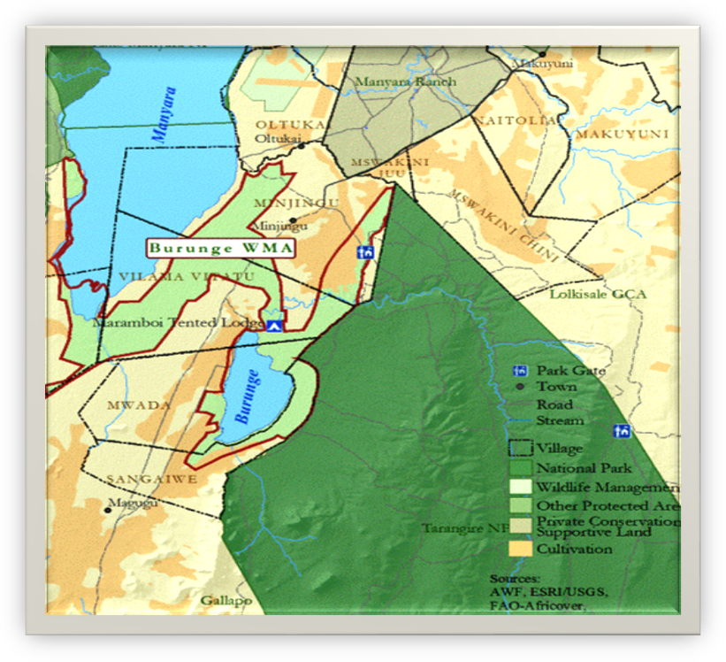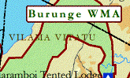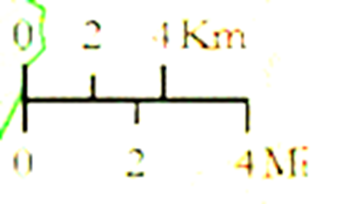

**Figure 3.1:** **The Map to Show the Study Area**

**Source:** Sulle *et al.,* (2011)

The study area is in a semi-arid land with average annual precipitation of 750mm per annum (Kaswamila, 2006). The rainfall pattern is bimodal, with short rains between May and June and long rains between November and January. The period between June and October is normally a dry seasons in the village. The climate zones observed are tropical with an average temperature ranging between 17-27°C (Khan, 2014). Agriculture and livestock keeping are the major economic activities in the study area being practiced by 94% of the village population. Other activities include fishing, tourism and related business such souvenirs, mat weaving and other small business. Crops growing in the area are mainly sorghum, maize, cotton, simsim and groundnuts (Babati District council, 2004).

**3.3 Research Design**

A research design is the arrangement of conditions for collection and analysis of data in a manner that aims to combine relevance to the research purpose with economy in procedure (Kothari, 2004). According to Kothari (2004), it is the conceptual structure within which research is conducted; it constitutes the blue print for the collection, measurement and analysis of data. The research design was descriptive one which employed both qualitative and quantitative methods. With semi-structured interviews the researcher could be more flexible and be able to adapt to the situation together with different respondents, thereby raising the validity of the study (Teorell and Svensson, 2007).

**3.4 Target Population**

According to Cooper and Schindler (2003), a population is the total collection of the elements about which a researcher wishes to make some inferences. Mc Daniel and Gates (1996) explain that the population is the total group of people from whom a researcher needs to obtain information. According to National census of the year 2012 the population number of local communities was 918.Also number of TNP officials were 19 and civil society leaders were 30.Therefore, target population in the study area were967.The sample selection was based on the knowledge of the village history together with the knowledge of the problem of HEC.

**3.5 Sampling Procedures and Sample Size**

**3.5.1 Sampling Procedure**

Both purposive and simple random sampling techniques were used.

**3.5.1.1 Purposive Sampling**

According to Kamuzora (2008), purposive sampling is defined as judgmental sampling where the researcher chooses only elements that he or she believes will be able to deliver the required data. Purposive sampling was used by the researcher to interview different selected respondents such as key respondents in order to know cases, types as well as causes HEC together with mitigation measures that havebeen applied before. In this study purposive sampling technique was used to select village leaders, TNP authority and civil society

**3.5.1.2 Simple Random Sampling**

In this study simple random sampling (SRS) technique was used to obtain respondents from the local community. This technique was applied due to the fact that local people were many and every individual has an equal chance to give views about the human elephant conflict. In this study simple random technique was used to select heads of households. In order to avoid bias, the researcher prepared pieces of papers written YES and NO. Pieces of paper written YES were equal to the number of respondent required, and then she asked the heads of households to pick one piece of paper each. Those who picked pieces of paper written YES were included in the sample size.

**3.5.2 Sample Size**

Cohen (2000) defines a sample size as a strategic and purposive category of respondents who provide information for the study. According to Bryman (2004), the rationally for sampling is to measure these elements and draw conclusion concerning the population. Patton (2002) argues that the sample size depends on what one wants, the purpose of the inquiry, what is at stake, what will be useful, what will have credibility and what can be done with available time and resources. Alreck and Settle (1995) states that it is necessary to sample more than 10% of the total population. Therefore this study used 14% of total population to get sample size. The sample size of this study was 14% * 967 which is equal to 135 (Table 3.1)

**Table 3.1: Sample Size**

|  |  |  |
| --- | --- | --- |
| **Respondents** | **Population** | **Sample size** |
| Heads of house holds | 901 | 126 |
| Village leaders | 17 | 2 |
| Civil society leaders | 30 | 4 |
| TNP authority (Park rangers, Officers.) | 19 | 3 |
| TOTAL | 967 | 135 |

**Source**: Researcher’s computation, 2017

**3.6 Sources of Data**

Data inquired from respondents were cases of HEC, common HEC, causes of HEC, mitigation measures taken to curb the problem to HEC and attitudes of farmers’ towards elephants. This research used two major types of data that is primary and secondary data.

**3.6.1 Primary Data**

Primary data is the first hand informationobtained directly from the respondents or the surveyed area. This is the information gertherd directly from the experimental study or respondents using research instruments. The information was obtained by measuring the variables of interest (Mbogo*et al*., 2012). In primary, interview, observation and questionnaires methods of data collection were used.

**3.6.2 Secondary Data**

Secondary data refer to the data which has been collected and analyzed by someone else (Kothari, 2004). In this study documentation were employed in collecting secondary data both from published and unpublished documents such as journals, books, articles from the Internet, and manuscripts. Documentary literature review helped the researcher to obtain information about the HEC through understanding the past and presents situation in order to predict the future situation.

**3.7 Data Collection Methods**

**3.7.1 Questionnaires Method**

Questionnaire is a set of printed typed questions, which data either be printed or mailed to the respondents who then answer the questions at their time and then mail them back to the researcher or collected at the specified location. The forms of questions are either open or closed ended. Kothari, (2004) comments that this type of instrument is free from bias, inexpensive; provide respondents’ adequate time to understand the questions, respond, and collect many data, which needs little interpretation comparing to other data instruments.

Since some respondents were scattered, the researcher used questionnaires for data collection. This allowed coverage of a wider geographical area and more respondents than was the case with interview. Also since this method guarantees anonymity of the respondents, it assured high rate of respondents when dealing with such sensitive issues like income of a respondent. The researcher used questionnaires (refer appendix I) to ask heads of house hold questions related to Human-Elephant Conflict. A translator was used wherever necessary. And data collected through this method was quantitative.

**3.7.2 Observation Method**

Observation is a method for providing information about the actual behavior (Mbogo, *et al.,*2012). It is suitable where the researcher needs to gather evidences by seeing because she will gain access to life situation in her/his study area. In this study, while carrying out observation by using a checklist, (refer appendix II) the researcher observed her respondents as well as other aspects concerning HEC such as fields raided by elephants and people or animals injured by elephants. Photographs were taken for evidences. This supplemented other data collection tools that were questionnaire and interview as people were not always willing to write their true views on a questionnaire or tell a stranger what they really think at an interview session. This data collection method provided the researcher with detailed and context-related information. Qualitative data was obtained from this method.

**3.7.3 Interview Method**

This is the method of data collection that involves oral questions of respondents either individually or in a group whereby answers to the questions posed during an interview can be recorded by writing them down on a piece of paper or by use of a computer immediately after the interview or during the interview or by tape –recording the respondents or by combination of both. The interviews can be classified as unstructured, semi-structured or structured (Castro, 2006). Respondents for interview were selected purposively which included village elders, TNP authority and civil society leaders. The numbers of interviewers were 9 and data obtained from this method was qualitative. In this study the researcher prepared interview guide for the local leaders (refer appendix III) and asked them question related to HEC. Also the researcher asked the Park officials and civil society leaders (refer appendix IV) questions concerning Human-Elephant Conflicts.

**3.7.4 Documentary Review**

Kothari (2004) defined secondary data as data that is available in documents. In this study the researcher obtained secondary data from TAWIRI reports, TANAPA reports, TTB reports and from previous dissertations related to human-elephant conflict.

**3.8 Data Analysis, Interpretation and Presentation**

Since the researcher collected both qualitative and quantitative data, the statistical package for IBM Social Sciences (SPSS) was used to analyze qualitative data by analyzing coded information resulting from questionnaires of this study. Content analysis was applied to qualitative data where necessary. Whenever necessary, Microsoft Excel was used to analyze collected quantitative data. Descriptive statistics which included numbers, tables, and charts, wereused to present data.

**3.9 Validity and Reliability**

To ensure reliability the researcher was applied primary data collection methods like questionnaires, interview and observation. In other words, similar observations made or conclusion reached by other researchers or where there is transparency in how sense was made from the raw data ensures reliability (Saunders *et al*. 2007).To ensure validity of the data, triangulation of methods was used in sampling and effective data collection. The use of triangulation such as use of different samples and methods of data collection increases the validity of the study (Cooper and Schindler, 2003).

**CHAPTER FOUR**

**4.0 DATA PRESENTATION AND DISCUSSION OF FINDINGS**

**4.1 Introduction**

This chapter presents the findings obtained through interview, questionnaire, observation and documentary review from different categories of respondents. The chapter begins with socio- demographic characteristics of respondents basing on age, economic activities, education level and gender. The chapter goes further to present attitude of local people towards elephants and sources of human elephant conflicts in Vilima Vitatu Village in Babati district.

**4.2 Socio-Demographics of Respondents**

The parameters which were examined in this study were gender, age, education level and economic activities. These variables helped to provide a profile of the sample surveyed.

**4.2.1 Gender of the Respondents**

The gender categorization was done based on household heads. This implied that there were more male heads of household than females as depicted in Figure 4.1

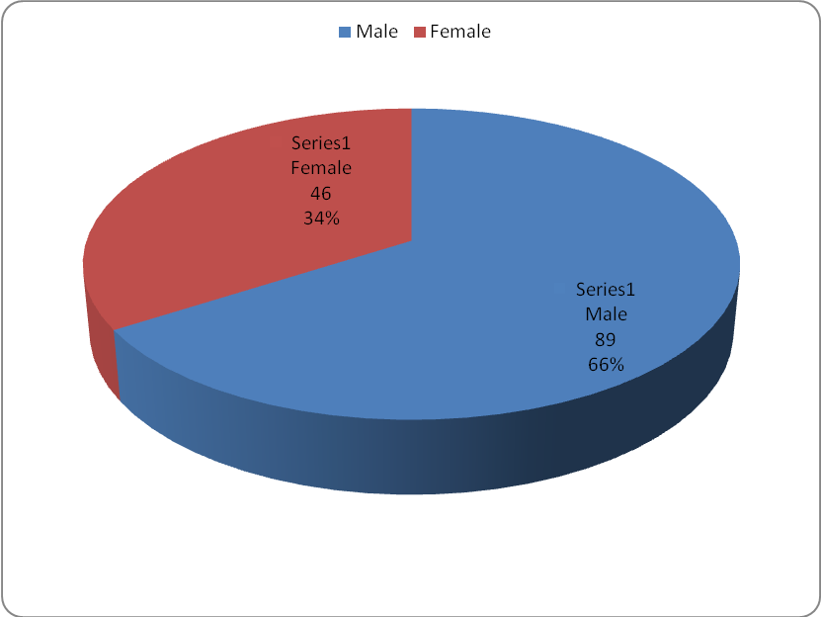

**Figure 4.1: Distribution of Respondents by Gender**

**Source:** Field survey, 2017.

**4.2.2 Age of Respondents**

It was important to investigate the age of the respondents because of the diverse implications each age group has on the human elephant conflicts. Therefore, the age of respondents was categorized into four groups; the grouping was from the age of 18 years to 50 years and above. This grouping was based on the consideration that the economically active and productive group in Tanzania is from the age of 15 years old to 64 years (URT 1991). Figure 4.2 shows the distribution of respondents by age.

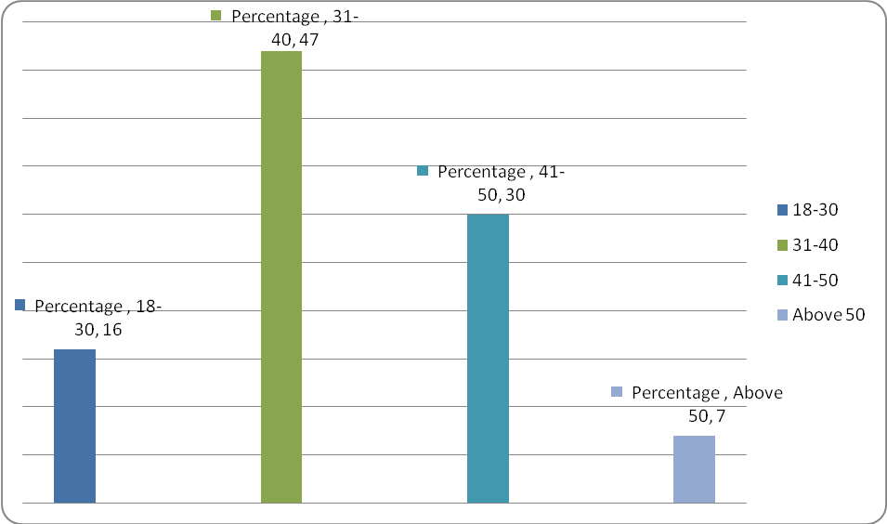

**Figure 4.2:** **Distribution of Respondents by Age**

**Source:** Field survey, 2017.

These results show that, more than three quarters (77%) of the respondents were adults age 31 years and above. According to Basnayake and Gunaratne (2002), the age of a personal usually is a factor that can explain the level of production and efficiency. The results indicate that most of the respondents were in the productive age, thus susceptible to human-elephant conflicts.

**4.2.3 Education Level of the Respondents**

Education is always regarded and valued as a means of liberation from ignorance (Basnayake and Gunaratne, 2002). It is perceived as among the factors that influence an individual’s perception of an intervention before making decision to take part. Thus, understanding the education levels of the respondents in this study was an important factor in assessing their skills and knowledge for making judgment about various matters.

The results revealed that, the majority of respondents had attained primary education; a few had no formal education (Table 4.1). This implies that there were respondents who were not able to read and write. Only 18% of the respondents had secondary and technical college education (Table 4.1). Although education level in Vilima Vitatu village was low, the respondents managed to understand the questions in this survey properly. Once asked, they were able to provide relevant answers and they understood well the situation of HEC in Vilima Vitatu village. This was due to informal education and experience they had regarding the HEC situation in their area.

**Table 4.1: Distribution of Respondents by Education Level**

|  |  |  |  |  |
| --- | --- | --- | --- | --- |
| Education |  | Respondents |  | Percentage |
| No formal education |  | 42 |  | 31 |
| Primary education |  | 69 |  | 51 |
| Secondary education |  | 11 |  | 8 |
| Collage/Technical education |  | 13 |  | 10 |
| University education |  | 0 |  | 0 |
| **Total** |  | **135** |  | **100** |

**Source:** Field survey, 2017

**4.3 Economic Activities Carried Out In the Study Area**

About 31.9% (43) of total population in VilimaVitatu village were immigrants. They migrated to live in VilimaVitatu village in order to be able to conduct a variety of economic activities. The main economic activities are crop cultivation, livestock keeping and business as shown in Figure 4.3.

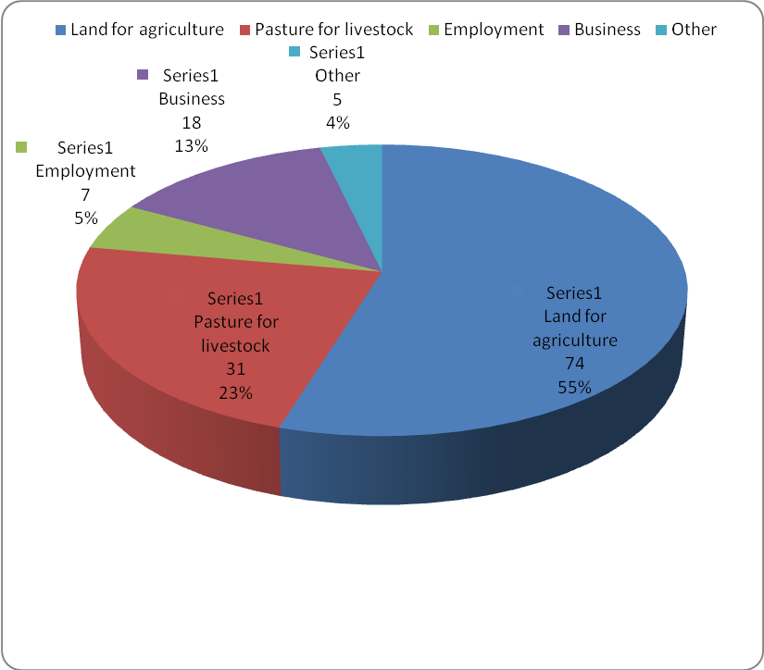

**Figure 4.3:** **Distribution of Respondents by Economic Activities**

**Source:** Field survey, 2017.

Agriculture was the main economic activity of the study area and since most of the crops grown there were attractive to elephants, the huge part of economic outputs was vulnerable to elephants crop raiding. Thus agricultural zone is where HEC occurred and therefore most of the local community’s livelihoods were at stake.

**4.3.1 Crop cultivation in Vilima Vitatu village**

Due to soil fertility in the study area, different crops were cultivated such as maize, legumes, millet and pigeon peas as shown in Table 4.2.

**Table 4.2:** **Crops Cultivated in Vilima vitatu village**

|  |  |  |  |  |  |
| --- | --- | --- | --- | --- | --- |
|  | **Crop** |  | **Response** |  | **Percentage** |
|  | Maize |  | 39 |  | 53 |
|  | Legumes |  | 18 |  | 24 |
|  | Millet |  | 3 |  | 4 |
|  | Pigeons peas |  | 9 |  | 12 |
|  | Other crops |  | 5 |  | 7 |
|  | **Total** |  | **74** |  | **100** |

**Source:** Field survey, 2017

Maize was the main crop cultivated in the study area as confirmed by a half of the respondents, while millet was grown by the minority. Other cultivated crops were such as pumpkins, water melons, vegetables, sun flower and other horticultural crops. Pumpkins and water melons are very attractive to elephants.

**4.4 Common Human-Elephant Conflicts**

Human-elephant conflict can be ‘direct’ or ‘indirect’ according to its impact upon people. Direct human elephant conflicts upon the physical and economic wellbeing of rural communities by causing damage to crops, livestock and property, as well as human injury and death. Indirect human elephant conflict causes broad and indirect social impacts upon people, for example through the effort required to protect crops and property, the disturbance of normal activities such as walking at night, and the fear of injury or death. Such indirect costs form a major component of the conflict perceived by local people

Crop damage appeared to be the most prevalent form of conflict in the study area. When elephants damage food and cash crops, they affect rural farmer’s livelihoods. Elephants in large groups can destroy large areas of crops in a single night. When elephants target a certain food crop such as maize, they also damage other crops. Crop damage not only affects a farmer’s ability to feed his or her family, but also reduces cash income and has repercussions for health, education and ultimately, development. Figure 4.4 illustrates the kind of damage that elephants can cause.

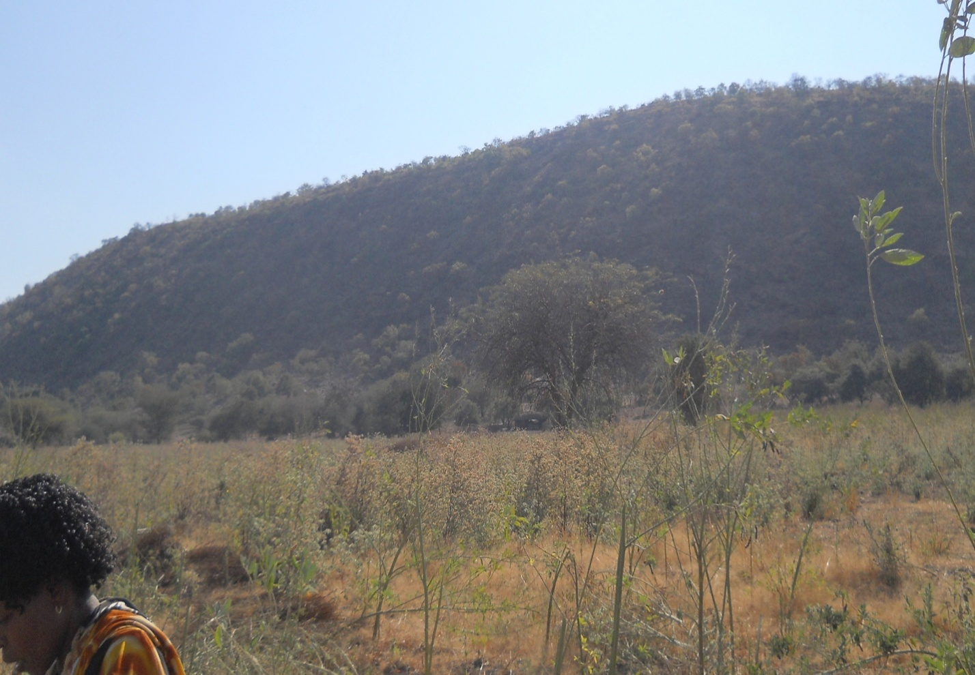

**Figure 4.4: Pigeon Peas Farm Affected by Elephants in VilimaVitatu Village**

**Source:** Field survey, 2017.

Almost all local people in Vilima Vitatu were aware of the presence of human- elephant conflict in their area. In this study 96% (129) of total respondents confirmed about the existence of human elephants conflicts in Vilima Vitatu village while only 4% (6) said there is no human- elephant conflict (Figure 4.5). Most of the respondents especially farmers showed negative attitude towards elephants. Farmers were more affected by elephants due to crop raiding without compensation. Apart from crop raiding respondents reported about people being killed and damage of water infrastructures. Some people killed elephants in retaliation a factor which aggravated human -elephant conflict.

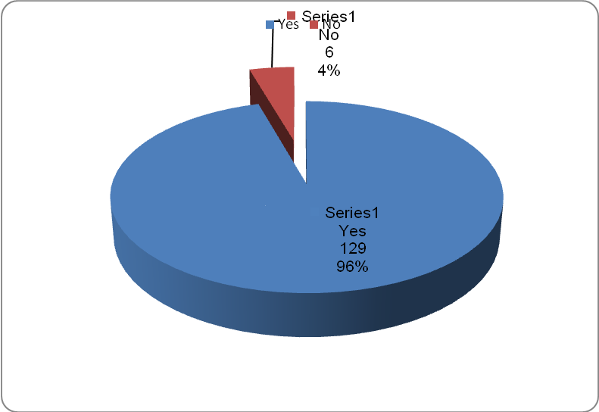

**Figure 4.5: Presence of Human- Elephant Conflict in the Study Area**

**Source:** Field survey, 2017

Sources of permanent water such as Lake Burunge in Vilima Vitatu village were the interface for conflict, being a resource of water for both humans and elephants. Crop damage has been observed around water points. Elephants are highly water-dependent and where water is limited the potential for conflict is high. Crop damage at water points/sources are incidental since elephants coming to drink water many discover crops there and raid them opportunistically.

**4.5 Causes of Human-Elephant Conflict**

During interview with National park officials, one of the respondents said that “*the source of human elephant conflict was wildlife (elephants) corridor blockage due to human population increase in Vilima Vitatu village”*. Other causes of human elephant conflict mentioned by park officials were farm yards established close or along the wildlife corridor, settlement and or farm close to protected areas. On the other hand, a local leader said that, “*the main causes of human elephant conflict in Vilima Vitatu village was cultivation of crops in the area since elephants prefer to feed on certain kinds of crops such as pumpkins, water melons and maize which are very attractive to elephants”*. Also, elephants invaded the village land especially during nights looking for water and forage and sometimes destroyed water infrastructures.

Ecologically, elephants have a natural preference for derivatives of plants from the *Gramineae* family, which includes maize. Such food crops are attractive to wild animals because the selective breeding of wild plants over centuries has reduced naturally-occurring defense chemicals, spines and thorns, as well as fibrous tissues, making them more palatable. Maizeripens uniformly and presents a super-rich patch of food and is consequently highly vulnerable to predation. Figure 4.6 illustrates some elephant`s dung with Pigeon peas.

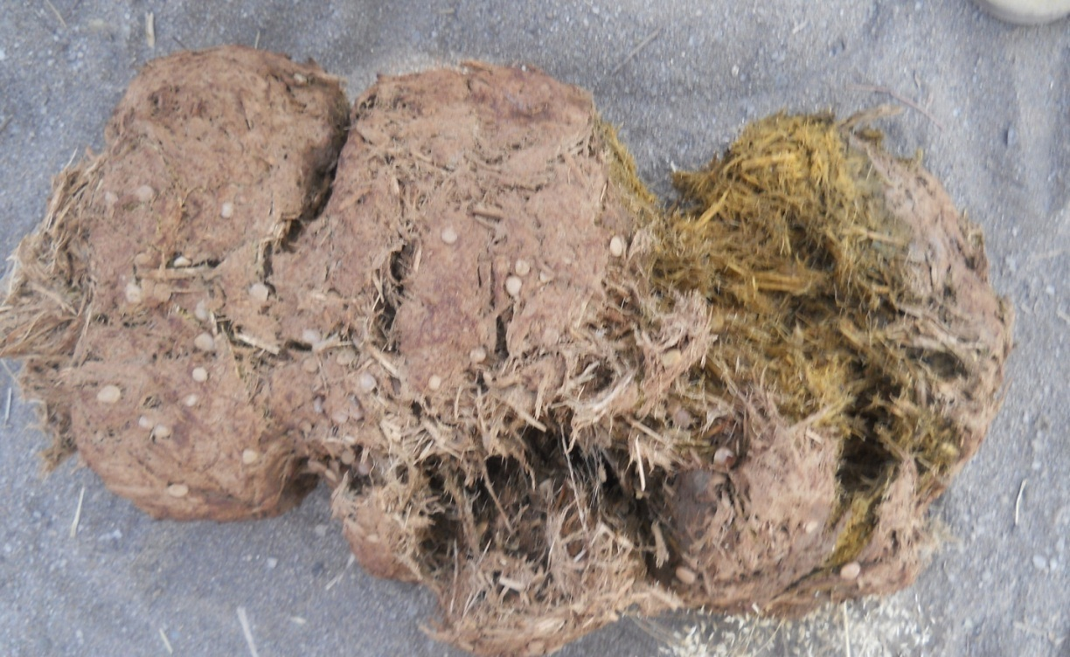

**Figure 4.6:** **Elephant Dung with Pigeon Peas**

**Source:** Field survey, 2017.

**4.6 Methods Used by local Community and TNP to Overcome the Challenge of Human-Elephant Conflict in Vilima Vitatu Village**

**4.6.1 Measures Taken by Local community to Mitigate HEC**

Fire has been used to counteract the problem of HEC in Vilima Vitatu but it has been proven to be unsuccessful in a long run because elephants have learnt quickly to avoid areas with fire and have paved their ways to raid crops. The majority of respondents who are farmers said that they had built temporary watch towers during the ripening of crops to help watch over elephants that were trying to approach farms in order to raid them. Immediately after the crops have been harvested the watch towers were dismantled to prevent them from becoming snakes hideouts.

Disturbance methods used to chase away elephants were such as clapping hands, whistling, “Kombeo” and “Mjeledi”. “Kombeo” is a rope made up from palm trees leaves that is used tothrow stones at elephants in order to chase them away before they can raid crops. “ Mjeledi” is also a rope made from palm tree leaves that has a stick as a handle to help hit that rope on the ground and produce an explosive sound that will scare away elephants trying to raid crops.

Apart from local community`s own efforts to mitigate HEC, there is a project of HEC mitigation founded by TAWIRI known as “Tembopilipili” which also has been disseminated to some Morogoro croppers living adjacent to Mikumi National Park who formerly faced the problem of HEC. The purpose of this project was to create a friendly environment between croppers and elephants. This project started with the suburb of Kakoye where water melons were grown. Some farmers were trained on building temporary chill fences bearing pieces of clothes that have been soaked in chill around farms as repellants to crop raiding elephants because elephants repel to chill. Equipment used for the preparation of the fences was chill powder, dirty car engine oil, sisal ropes, cotton-textured bed sheets and poles. Farmers had to incur expenses for poles only since other equipment were supplied by TAWIRI. However, after harvesting season was almost over, the fences were removed in order to avoid elephants from habituating to the mitigation measure.

Respondents from honey Guide foundation; a non-governmental organization narrated to the researcher on different mitigation measures that the NGO disseminated to Vilima Vitatu farmers in order to be able to mitigate the problem of HEC together with the support they gave to the village farmers. The farmers were provided with the tool kit that included torches, air horns also known as bull horn, chili bomb or chili cloud and eight short Roman candle. Honey guide foundation also introduced to Vilima Vitatu farmers the chill bricks techniques of mitigating HEC. Furthermore, the NGO offered its vehicles to help the farmers to chase away the elephants by disturbance method. Lastly, they trained the farmers on mitigation measures for HEC by using awareness films made from the village’s own surroundings.

Powerful torches were also used to scare elephants away. A single torch has the capacity to cover 800 meters ahead and scare away a herd of elephants about to raid a farm. Torches like these were provided to farmers who were trained on how to use them effectively. According to the respondents, the torches have 95% effectiveness on counteracting the problem of HEC. Bull horns were also used to produce a noise that disturbed elephants and chased them away from farms before they could raid crops. Chili bomb also known as chili cloud consisting of chill powder, gravel and silver cracker kept in condoms were used as repellent explosives. When elephants were noticed on their way to farms to raid crops, the condoms were burst to release not only the irritant chili but the explosive sound that disturbed and chased away the elephants about to raid farms.

Chili bricks are made of chili powder and wet cow dung which after mixing them together, the mixture is allowed to dry up in a solid container. The dry chill bricks were then burnt on the ground exactly on paths that were used by elephants to get into farms and raid crops. The eight colours Roman candle producing fire, works like an explosive. It was used as a last resort technique within the kit after the torch, air horn and chill cloud techniques had failed to chase elephants away from farms. The technique was meant to deal with aggressive elephants such as mother elephants, female elephants that are on heat, elephants that have suffered a disadvantage of a broken tusk(s) and or elephants that have been injured. According to the respondents, the effectiveness of this mitigation method was almost 100%.

**4.6.2 Measures taken by Tarangire National Park to Mitigate HEC**

Tarangire National Park as other National Parks in Tanzania spends some of its money to the neighboring communities in order to win significant support on conserving and protecting the park’s resources for sustainability of conservation. In line with National Policies for National Parks in Tanzania (1964), TNP management ensures that neighboring communities receive benefits from the Park to help counter the costs they incur, and increase community support for the continued conservation of the park. The Policies for National Parks in Tanzania states that, ‘TANAPA will seek ways to share the benefits of conservation with neighboring communities in ways that are sustainable and promote sound development’ (TANAPA, 1994).

**4.7 Attitude of Local People Towards Elephants In Vilima Vitatu Village**

Despite the fact that TNP spends some money to the neighboring community, local people in Vilima Vitatu had a negative attitude towards conservation. This is due to the fact that TNP share benefits with local people indirectly through supporting local projects such as construction of Mdori primary school, hospital and water projects in the village. As such, people do not see the benefits as narrated by one interviewee: ``*I have lived in this village for more than 30 years; I have not seen any benefit of elephant’s conservation except destruction of our crops and killing of our relatives.* This verifies that local people had a negative attitude towards elephant’s conservation and thus not expected to cooperate in the conservation of elephants.

**4.8 Discussion of the Findings**

**4.8.1 Common Human-Elephant Conflicts**

The findings of the study show that Human-elephant conflict can be ‘direct’ or ‘indirect’ according to its impact upon people. Crop damage seemed to be the most prevalent form of conflict in Vilima Vitatu village, especially when large groups’ of elephants raid farms and they affect rural farmer’s livelihoods. The findings are in the line with (Røskaft *et al*., 2012) who concludes that Conflicts happens directly when elephants damage crops, infrastructure, properties water systems, attack people and cause injures or loss of life. Indirectly, people along the conflicts zones spend much time guarding their fields from crop raiding elephants, field with insecurity in conducting daily activities such as planting of cash crops, children walking to and from school, as well as collection of firewood. Hence, such a conflict affects social economic development of the particular communities.

**4.8.2 Causes of Human-Elephant Conflict**

The findings of the study show thatthe main causes of human elephant conflict in Vilima Vitatu village was cultivation of crops in the areas near protected areas since elephants prefer to feed on certain kinds of crops such as pumpkins, water melons and maize which are very attractive to elephants. The findings also comply with the study done by Linnea.O (2014) who observed that, both humans and elephants require large areas of land and the spatial overlap is therefore the cause of the human-elephants conflicts. The elephants need space to be able to migrate long distances in their search for food and water and humans need land to cultivate to feed a fast-growing population.

**4.8.3 Methods Used by local Community and TNP to Overcome the Challenge of Human-Elephant Conflict in Vilima Vitatu Village**

The results show that different types of mitigation measures such as fire, use of powerful torches, trenches and fences to mention a few, have been used to counteract the problem of HEC in Vilima Vitatu village. The study done by Munuo (2016) revealed that, the traditional methods applied by the locals are of simple technology and affordable. Noise makings techniques involve hitting objects such as tins, drums, yelling, and sometimes whistling to deter problem elephants from the fields.

**4.8.4 Attitude of Local People Towards Elephants in Vilima Vitatu Village**

The findings show that local people had a negative attitude towards elephant’s conservation and thus not expected to cooperate in the conservation of elephants. Similar results were observed by Linnea, O. (2014) who commented that in Indonesia dozens of elephants are poisoned in oil palm plantations and in Kenya 50 to 120problem elephants are shot by wildlife authorities each year.

**CHAPTER FIVE**

**5.0CONCLUSION AND RECOMMENDETIONS**

**5.1 Introduction**

This chapter provides conclusion and recommendations of this particular study.

**5.2 Conclusion**

This study has attempted to assess human-elephant conflicts at Vilima Vitatu village in north eastern Tanzania.The specific objectives of this study were to determine the main causes of the human-elephantconflict, to examine the most common HEC, to explorethe attitudes of local community towards elephant and to evaluate mitigation measure taken by local community towards human elephant conflict. A sample size of 135 selected from the study area by using both purposive and simple randoum sampling. Questionnaires, interview, observation and documentary review were used to collect data. The study revealed that human- elephant conflict had increased due to the increase of population in the area which led to blockage of wildlife/elephant corridor.

Apart from that, human elephant conflict increased due to agricultural activities conducted in Vilima Vitatu village. Some of the crops that were cultivated in the study area such as pumkins, maize and water melons were very attractive to elephants. Also the change of climatic conditions caused the change of elephants behaviour, whereby during dry season, elephants fed outside the park especially in areas where crops were cultivated through irrigation. This is due to the fact that during dry season, there is no enough pasture in the Park. Increasing human populations and expanding agriculture have increased the potential for conflict between humans and elephants in Vilima Vitatu village. Whenever elephant’s habitat has been compressed into ever-smaller areas and their traditional migration routes have been cut off, it has led to humans and elephants competing directly for land that is becoming increasingly scarce.

Apart from that HEC creates anger towards elephants from the communities who live with them because they can ruin people’s livelihoods. Such anger undermines support for elephant conservation, and has led to farmers killing elephants or turning a blind eye to poaching in relation for the damage they have caused. Consequently, HEC casts an ominous shadow over the future of elephant conservation outside protected areas. HEC seriously affects the livelihoods of rural farming communities. To mitigate the impact of crop damage upon rural livelihoods, there is a need to apply a combination of various mitigation measures and also to diversify rural incomes.

**5.3 Recommendations**

Based on the results, findings and conclusions, the following are the recommendations.

**5.3.1 Recommendations for the Practice**

Encourage the use of combine HEC mitigation techniques because it will prevent habituation of elephants to a single or a few mitigation measures. The aspect of land use planning should consider the effective control of resource use between local people living adjacent PAs together with elephants and wildlife in general. Therefore, buffer zones and wildlife dispersal areas for large animals like elephants should be taken into consideration during planning to avoid or minimize the conflicts that might arise between local communities and elephants or other wildlife.

The TNP authority should educate the local community of Vilima Vitatu village about the benefits that the park is trying to share with them through outreach so that they can be able to appreciate and therefore, participate fully in elephant conservation instead of focusing only on how destructive elephants can be.

**5.3.2 Recommendations for Policy Maker**

The government of Tanzania through the Ministry of Natural Resources and Tourism should put emphasis on outreach programme which may greatly facilitate wildlife conservation. This finally will reduce Human-Elephant conflicts.

**5.3.3 Recommendations for Further Research**

Other studies should be conducted in other areas such Conservation Authority Areas (CAA`s) for comparison purposes. The study will provide more evidence on how to mitigate Human-Elephant conflict.

**REFERENCE**

Ajzen, I., (1991). The theory of planned behavior. *Organizational behavior and human decision processes*, 50(2), 179-211.

Alreck, P. L. and Settle, R. B. (1995). *The Survey Research Handbook*. (2nd). Chicago: University of Chicago Press.

Balfour, D., Dublin, H. T., Fennessy, J., Gibson, D., Niskanen, I. and Whyte, I. J. (2007). Review of opinions for managing the impacts of locally over abundant African elephants. IUCN. Gland, Switzerland. Available at:

Barua, M. (2010).Representations of human- Elephant Conflicts in India and International Media. *Science Communication,* 32(1), 55-75.

Barua, M., Bhagwat, S. and Jadhav, S. (2013). The hidden of human-elephant conflicts: health impacts, opportunity and transaction costs. *Biological Conservations,* 157(1), 309-316.

Basnayake, B. M. J. K. and Gunaratne, L. H. P. (2002). Estimation of Technical Efficiency and its Determinants in the Tea Small Holding Sector in the Mid Country Wet Zone of Sri Lanka. *Sri Lankan Journal of Agricultural Economics,* 4(1), 137-150*.*

Behram, K. M. (2014). High Seroprrevalence of echinococossis, Schistosmiasis and toxoplasmosis among the populations in Babati and Monduli districts Tanzania. *Parasites and Vectors, 2*(7), 505-510.

Blanc, J. (2007). An update from the African elephant database, African elephants status report, IUCN. Retrieved on 16th June 2017 from; https://portals.iucn.org/library/efiles/ documents/SSC-OP-033.pdf.

Bryman, A. (2004). *Social research methods*, Oxford: Oxford University press.

Chiyo, P. I., Archie, E. A., Hollister-Smith, J. A. (2011a). Association patterns of African elephants in all-male groups: the role of age and genetic relatedness. *Animal Behaviour,* 81, 1093–1099.

Chiyo, P. I., Moss, C. J., Archie, E. A., Hollister-Smith, J. A., Alberts, S. C., (2011b). Using molecular and observational techniques to estimate the number and raiding patterns crop-raidings elephants. *Journal of applied Ecology*, 48, 788–796.

Cohen, P. (2000). *Research Methods for Business*, 3rd ed. New York: John Willey and Sons.

Cooper, D. R. and Schindler, P. S., (2003). *Business Research Methods*. Boston: McGraw-Hill Education.

Cushman, S. A., Chase, M.J. and Griffin, C. (2010). Mapping Landscape resistance toidentify corridors and barriers for elephant’s movement in southern Africa. In S.A. USFWS: Pictorial.

De Boer, W. F. and Ntumi, C. P., (2001). Elephant crop damage and electric fence construction in the Maputo Elephant Reserve, Mozambique: *Pa-chyderm*. 30, 57-64.

Desai, A. and Riddle, H., (2015). Human-elephant conflicts in Asia. Retrieved on 20th March, 2017, from; https:/www.fws.gov/international/pdf/Human-elephant conflicts-in-Asia-June2015.pdf.

Douglas-Hamilton, I., Krink, T. and Volrath, F., (2005). Movement and corridors of African elephant in relation to protected areas. *Naturwissenschaften,* 92(4), 158-163.

Downs, D. and Hausenblas, H. (2005). Elicitation studies and the theory of planned behavior: as systematic review of exercise belief. *Psychology of sports and Exercise,* 6(1), 1-31.

Dulbin, H. T. and Hoare, R. E., (2004). Searching for solutions: the evolution of an integrated approach to understanding and mitigating human–elephant conflict in Africa. Human Dimensions of Wildlife, 9(1), 271-278.

Dunham, K. M., Ghiurghi, A., Cumbi, R. and Urbano, F., (2010). Human-Wildlife conflicts in Mozambique: A national perspective, with emphasizes on wildlife attacks on humans. *Oryx,* 44(2), 185–193.

Fernando, P., Kumar, M., Williams, A., Wikramanayake, E., Aziz, T. and Sing, S., (2008). Review of human – elephant conflict mitigation measures practiced in south Asia. WWF: South Asia.

Fisher, R. J. (1990). *The* *social Psychology of Intergroup and International Conflict Resolution.* New York: Springer-Verlag.

Foley, C. A. H., Faust, L. J., (2010). Rapid population growth in an elephant *loxodonta africana* population recovering from poaching in Tarangire National Park, Tanzania. *Oryx,* 44, 205– 212.

Gadd, M., (2005). Conservation outside of parks: Attitudes of local people inLaikipia, Kenya. *Environmental Conservation*, 32(1), 1-14.

Gamassa, D.M., (1993)*.* Marginalization of Maasai pastoralists in Northern Tanzania. retrieved on 30th June, 2017 from; http://dlc.dlib.indiana/edu/dlc/ bitstream/handle/10535/5447/Marginalization_of_Maasai_Pastorali.pdf?sequence=1.

Gillingham, S., Lee, P. (2003). A study of local perception of wildlife crop damage conflict in an area bordering the Selous Game reserve, Tanzania*. Orxy,* 37(3), 316-325.

Graham, M. and Litoroh, M., (2009). Human-elephant mitigation Meeting Sharing Lessons and experience from across East Africa. Retrieved on 29th June, 2017 from; http://www.geog.cam.ac.uk/research/projects/heccapacity/ Workshop2009.pdf

Graham, M. D. Douglas-Hamilton, L., Adams, W.M. and Lee, P.C., (2009). The movements of African elephant in a human- dominated land-usemosaic*. Animal Conservation*, 12, 445-455.

Graham, M., Noter, B., Adams, W. M., Lee, P. C. and Ochieng, T. N. (2010). Paterns of crop- raiding by elephants, Loxodonta Africana, in Laikipia, Kenya and the management of human- elephant conflict. *Systematics and Biodiversity*, 8(4), 435-455.

Granados, A., Weladgi, R.B. and Loomis, M.R., (2012). Movement and occurrence of two elephants herds in a human –dominated land scape, the Benoue Wildlife Conservation Area*,* Cameroon .*Tropical conservation science*, 5(2), 150-162.

Graneheim, U. H. and Lundman B. (2004). Qualitative content analysis in nursing research: concepts, procedures and measures to achieve trustworthiness*. Nurse Education Today*, 24(1), 105-112.

Harich, F. K., Treydte, A. C., Sauerborn, J., Owusu, E. H., (2013). People and wildlife*: Conflicts arising around the Bia Conservation* Journal for Nature Conservation, 21(5), 342–349.

Hill, C. M., (2000). Conflict of interests between people and baboons. *International Journal of primatology*, 21(2), 299–315.

Hoare, R. (2012). Lessons from 15 years of human-elephants conflicts mitigation: management consideration involving biological, physical and governance issues in Africa. *Pachyderm*, 51, 60-74.

Hoare, R. E. (2011). Management implications of new research on problem elephants. *Pachyderm* 30, 44-48.

Hoare, R. E., (2000). A review of compensation schemes for agricultural and other damage caused by elephants. IUCN Report. Human-elephant conflicts Task force. Retrieved on 20th May, 2017 from; https://cmsdata.iucn.org/ downloads/heccomreview.pdf.

Hoare, R. E., (2007). Vertically integrated human-elephant conflicts management system in Tanzania: background and next steps. IUCN African Elephants Specialist Group, Nairobi Kenya. Retrieved on 20th May, 2017 from; https://www.iucn.org/sites/dev/files/import/downloads/heccstzvertint.pdf.

Hofer, H., Hildebrandt, T. B., Gortz, F., East, M. L., Mpanduji, D. G., Hahn, R, Siege, L. and Baldas, R. D. (2004). Distribution and movements of elephants and other wildlife in the Selous- Niassa Wildlife Corridor, Tanzania. Retrieved on 20th May, 2017 from; http://library.wur.nl/WebQuery/ clc/1726981.

Hossen, A. (2013). Human-elephants conflicts in Bangladesh; causes and intensity of fatalities. Retrieved on 20th May, 2017 from; http://www.diva-portal.org/smash/get/diva2:640176/FULLTEXT01.pdf.

Jackson, T. P., Mosojane, S., Fereira, S. M. and Van-Aarde, R. J., (2008). Solutions for elephant Loxodonta African cop-raidingin northen Botswana: Moving away from symptomatic approaches. *Oryx*, 42(1), 83-91.

Johanson, T. (2008). Beasts on Fields. Human-wildlife conflicts in Nature – Culture Borderlands. Retrieved on 19th May, 2017 from; https://helda.helsinki.fi/bitstream/handle/10138/21165/beastson.pdf.

Kamuzola, F., (2008). *Research methods for business and social studies*, Paperback: Sage publications.

Karimi, R.R., (2011). An assessment of perceived crop damage in a Tanzania village impacted by human elephant conflict, URL: Michigan State University.

Kaswamila, A. L., (2006). Evaluation for rural land –Use plans in protected Area Bio- Networks in Northeastern Tanzania. PhD Thesis, University of Greenwith, UK.

Katharina E. M., (2011). Elephants movement and human-elephants conflicts in a trans frontier conservation area. Stellenbosch: University of Stellenbosch.

Kikoti, A. P., Grinfin, C. R., Pamphil, L., (2010). Elephant use and conflict leads to Tanzania`s first wildlife conservation corridor. *Pachyderm*, 48, 57-66.

Lee, P. C. and graham, M. D. (2006). African elephants and human – elephants-interactions: implications for conservation. *International zoo Year book,* 40(1), 9-19.

Liganga L., (2010). The Human Elephant Conflict, URL. Available at: http://allafrica.com/stories/201004290382.html [accessed July 12, 2016].

Madden, F. (2004). Creating coexistence between human and wildilife: global perspectives on local efforts to address human–wildlife conflicts. *Human Dimensions of wildlife*, *9*(4), 247-257.

Madhusudan, M. D., Sarakan, P. (2010). Seeing the Elephants in the room: Human-elephants conflicts and the ETF Report economic *and Political weakly,* 45(49), 29-31.

Malima, C., Hoare, R. E., and Blanc, J. J., (2005). Systematic recoding of human – elephant conflicts: a case study in south-eastern Tanzania. *Pachyderm,* 38(38), 29-38.

Mayberry, A. (2015). Human Dimensions of Human –Elephant Conflicts in Botswana: Exploring Visible and Hidden Well- Being Impacts. Retrieved on 19th May, 2017 from; [https://atrium.lib.uoguelph.ca/xmlui/handle/10214 /9397](https://atrium.lib.uoguelph.ca/xmlui/handle/10214/9397).

Mbogo, S., Kitula, M., Gimbi, A., Ngaruko, D., Massomo, S., Kisoza. J., Ngatuni. P. and Swai, M. H., (2012). *Research Methodology*, Dar es Salaam: The Open University of Tanzania.

Mduma, S. R., Lobora, A. L., Foley, C., and Jones, T., (2010). Tanzania Elephant management plan 2010-2015. Arusha, Tanzania.

Monney, K. A., Dakwa, K. B. and Wiafe, E. D., (2010). Assessment of crop raiding situation by elephants (Loxodontaafricanacyclotis) in farms around Kakum conservation area, Ghana. Retrieved on 20th April, 2017 from; http://www.academicjournals.org/journal/IJBC/article-abstract/DBD7158164 83.

Munuo, W., (2016). Distribution Patterns of Hum Adjacent an –Elephant conflicts Areasto Rungwa Game Reserve, Tanzania. Retrieved on 20th April, 2017 from; https://brage.bibsys.no/xmlui/bitstream/handle/11250/2390460/12568 _FULLTEXT.pdf?sequence=1&isAllowd=y.

Nadu, T., (2014). Assessment of Human-elephants conflicts and mitigation measures to resolve the conflict in Dharmapuri Forests division, Dharmapuri, India available Retrieved on 22nd April, 2017 from; http://www.teriuniversity.ac.in/mct/pdf/new/assignment/V_Thirunavukarasu%20_Dharamapuri_division.pdf.

Newyork, W. D., (2008). Isolation of African protected areas. *Frontiers in ecology and the environment*, 6, 321-328.

Nyhus, P. J. and Tilson, R. (2000). Crop- raiding elephants and conservation implication at Way Kambas National Park, Sumatra, Indonesia. *Oryx*, 34, 262-274.

Olson, L., (2014). Human – elephant conflict: A qualitativestudy of farmers’ attitudes towards elephants in Babati, Tanzania. 28th August, 2016 from; http://www.diva-portal.org/smash/record.jsf?pid=diva2%3A725475&dswid =7952.

Osborn, F. V. and Parker, G. E. (2002). A community-based system to reduce crop damage by elephant in the communal lands of Zimbabwe. Retrieved on 20th April, 2017 from; https://cmsdata.iucn.org/downloads/heccombaptmen.pdf.

Osborn, F. V. and Parker, G. E., (2003). Towards an intergrated approach for reducing the conflict between elephants and people: a review of current research. *Oryx,* 37(1), 80-84.

Osei- Owusu, Y. and Barker, L. (2008). Human-elephants conflicts. FAO Elephant technical Manual. Retrieved on 21st May, 2017 from; [http://www4.fao.org/cgi-bin/faobib.exe?rec_id=581800&database=faobib& search_type=link&table=mona&backpath=/faobib/mona&lang=eng& format _name=EFMON](http://www4.fao.org/cgi-bin/faobib.exe?rec_id=581800&database=faobib&search_type=link&table=mona&back%20path=/faobib/mona&lang=eng&format_name=EFMON).

Parker, G. E. and Osborn, F. V. (2006). Investigating the potential for chili Capsicum to reduce human-wildlife conflict in Zimbabwe. *Oryx,* 40(03), 343–346.

Parker, G., Osborn, F., Hoare, R. and Niskane, L., (2007). Human-elephant conflict Mitigation. A training causefor Community – based approaches in Africa. Percipients manual elephant paper development Trust, Livingstone, Zambia. Retrieved on 13th April, 2017 from; [https://brage.bibsys.no/xmlui/bitstream/ handle/11250/2358846/10560_FULL TEXT.pdf](https://brage.bibsys.no/xmlui/bitstream/handle/11250/2358846/10560_FULL%20TEXT.pdf).

Parker, G.E., (2006). The Costs and Benefits of elephants*:* Communities and Campfire Programme in Zimbabwe. PhD Thesis, University of Kent, UK.

Paterson, A. (2007). Wandering about South Africa’s new protected Areas Regime. *SA Public Law,* 22 (1), 1-33.

Perera, O. B. M. A., (2009). The Human elephant conflicts: A Review of currency status and mitigations Methods, Faculty of Veternary Medicine and Animal science, University of Peradeniya, Peradenia, Sri Lanka.

Pittiglio, C., (2008). Novel forms of livestock and wildlife integration adjacent protected areas in Africa (GCP/URT/124/WBG). Human-Wildlife Conflict (HWC) monitoring activity. HWC: Arusha.

Sitati, N. W. and Walpole, M. J., (2006). Assessing farm-based measures for mitigating human- elephant’s conflicts in Transmara District, Kenya. *Oryx,* 40(03), 279 – 286.

Sitati, N. W. and Walpole, M. J., Smith, R. J., Leader- Williams, N., (2003). Predicting special aspects of human- elephants. *Journal of Applied Ecology,* 40(4), 667–677.

Stern, P. C., Dietz, T., Abel, T., Guagnano, G. A. and Kalof, L., (1999). A Value-belief theory of support for social movements: The case of environmentalism. *Human ecology review,* 6(2), 81-91.

Stolla, F. (2005). Wildlife management area: A Legal Analysis, Natural Research Forum. Arusha, Tanzania.

Sukumar, R., (2006). A brief review of the status, distribution and biological of wild Asian elephants Ellephas769maximus.*International Zoo Yearbook*, 40, 1-8.

Sulle, E., Lekaita, E., Nelson, F., (2011). Wildlife management area in northern Tanzania. Available at: http://www.ucl.ac.uk/pima/docs/reference/13_ promince_to_ perfomance.pdf.

Tim, C., Gardena, T. A., Stoner, C., Fitzherbat, E., and Davenport, T. R. B. (2009). Assessing the effectiveness of protected areas: paradoxes call for pluralism in evaluating conservation performance. *Diversity and Distributions,* 15(1), 178-182.

Valeria, G., Preatoni, D., Martinoli, A. Wauters, L. A. and Tosi, G. (2006). Space and habitat use of the African elephant in the Tarangire–Manyara ecosystem, Tanzania, *Implication Conservation. Mammalian Biology*, 71(2), 99-114.

Van-Aarde, R. J. and Jackson, T. P. (2007). Megaparks formeta populations: addressing the causes of locally high elephant numbers in southern Africa. *Biological conservation*, 134, 289-297.

Walpole, M. and Linkie, M. (2007). Mitigating Human elephant conflict: Case studies from Africa and Asia. Fauna and Flora international, Cambridge, UK.

Walpole, M. J. (2004). Community scouts promote conservation and livelihood security in the Mara Ecosystem, Kenya. *Sustainable Development international*, 10, 119-121.

Warner, Z., (2008). Examining human elephants conflicts southern Africa: *Causes and Options for coexistence.* Unpublished Master`s Dissertation, University of Pennsylvania, Philadelphia.

**APPENDICES**

**Appendix 1: Research clearance letter**

**THE OPEN UNIVERSITY OF TANZANIA**

***DIRECTORATE OF RESEARCH, PUBLICATIONS AND POSTGRADUATE***

***STUDIES***

**To Whom It May Concern**



**14th June, 2017**

**RE: RESEARCH CLEARANCE**

This is to certify that **Miss Idda Peter Mallya**has been granted permission to conduct research on “**Assessment of Human – Elephant conflict in Vilima Vitatu Village in Babati District; NorthernTanzania.”** This permission allows her to conduct research in Babati District ManyaraRegion in connection with his research. This is in accordance with the Government circular letterRef. No. MPEC/R/10/1 dated 4th July, 1980; the Vice Chancellor was empowered to issue research clearance to the staff and students of the University on behalf of the Government and the Tanzania Commission for Science and Technology, a successor organization toUTAFITI.

This permission is granted for the period between **15thJune** to **14th September, 2017.**

We thank you in advance for your cooperation and facilitation of this research activity.

Yours sincerely,

***Prof. HosseaRwegoshora***

**For: VICE CHANCELLOR**

**THE OPEN UNIVERSITY OF TANZANIA**

P.O. Box 23409,Dar es Salaam, Tanzania

**APPENDIX 2: QUESTIONNAIRES FOR HEADS OF HOUSE HOLDS**

**Introductions**

My name is **Idda Peter Mallya**a student from the Open University of Tanzania conducting

A study on the **assessment of Human – Elephant Conflicts at Vilima Vitatu Village in Babati District in north eastern Tanzania.** You are kindly requested to fill inas much informationas you can. The information you will provide is strictly confidential and yourparticipation in thisstudy is voluntary.

**PART A: PERSONAL PARTICULARS**

1. Please answer the following questions by putting a tick mark (√) in the space provided to indicate choice of your answer.

(i) Age

a. Between 18-30 ( )

b. Between 31-40 ( )

c. Between41-50 ( )

d. Above 50 ( )

(ii)Sex

(1) Male ( ) (2) Female ( )

(iii)Level of education:

No formal education { }

Primary education { }

Secondary education { }

College / technical education { }

University education ( )

(iv)Are you a native to this area ( ) or A migrant from a different place ( )

(v) If you are a migrant what motivated you to come and live in this place?

Land for agriculture ( )

Pasture for livestock ( )

Marriage ( )

Employment ( )

Income generating activities ( )

Education for children ( )

Other (specify)……………………………………………………

(vi) How long have you been staying in Vilima Vitatu village?

Less than a year ( )

Five years ( )

Ten years ( )

More than ten years ( )

Other….. (Specify)

(vii) What are the main economic activities in your family?

Crop cultivation ( )

Livestock keeping ( )

Business ( )

Other ( ) Specify ………………………………………………………

(viii) What type of crops do you usually grow?

Maize ( )

Sorghum ( )

Millet ( )

A mixture of (a) and (b) ( )

A mixture of (a) and (c) ( )

A mixture of (b) and (c) ( )

A mixture of (a), (b) and (c) ( )

Other…(specify)

(ix). Have your house hold suffered crop raiding?

Yes( ) if yes explain…………………………………………………………………..

No( )

**PART B: COMMON HUMAN ELEPHANT CONFLICTS**

1. Are there any Human Elephant Conflicts in your area?

None ( )

Yes ( )

2. What is the common Human Elephant Conflictin your area?

Crop raiding ( )

Wildlife corridor blocking ( )

People killed ( )

Damaged water sources ( )

Elephant killing ( )

Other ( )(Specify)…………………………………………………………………

**PART C: CAUSES OF HUMAN ELEPHANT CONFLICTS**

1. What are the possible reasons/conditions that influence elephants to attack people, livestock and or damage crops and or water sources?

Elephants looking for water in the village land ( )

Settlement along / close to wildlife/elephant corridor ( )

Farm yard close or along the elephant corridor ( )

Settlement and/ or farms close to protected areas ( )

Elephants prefer to feed a certain kind of crop(s) ( )

Others(specify)……………………………………………………………

2. Where do you fetch water for domestic use?

Natural springs, rivers, dams or basins in the public land ( )

Natural springs, rivers, dam, or basins ( )

Piped water ( )

Shallow wells ( )

Other sources (Specify)……………………………………….

3. Do you share the same water sources with elephants? 1. Yes ( ). 2. No ( ). 3. Sometimes ( ).

4. What kind of injury or death has ever occurred in the past ten years as a result of Human Elephant Conflicts?

People ( )

Livestock ( )

Both ( )

None ( )

6. How many elephants have been killed in order to secure the villagers lives or their properties in the past ten years?

Less than 5

More than 5

None

7. Mark the type of human- elephant conflict occurring frequently in your area

Attacks on people ( )

Attacks on livestock ( )

Crop-raiding ( )

Elephant killing ( )

Blockageof wildlife corridor ( )

Did elephants cause any harm and or death to people?

A handicapped person caused by an elephant( )

A person injured by an elephant ( )

A valid report of a person/ people injured or killed by an elephant(s) (Stated by Government authority) ( )

**PART D: MITIGATION MEASURES TAKEN BY LOCAL COMMUNITY AGAINST HUMAN ELEPHANT CONFLICTS**

1. How do you usually overcome the challenge of human elephant conflict in your area? (Briefly)

a. Traditionally

Fire ( )

Disturbance ( )

Guarding ( )

Use of chili ( as a buffer crop, chilly blocks) ( )

Beehives ( )

Conventionally ( )

Fences ( )

Consolation scheme ( )

Translocation ( )

Killing a problem elephant ( )

Scaring away (By means of drones( ), vehicles( ), aircraft( ), shooting ( ) ,other( )

Other (Specify) ……………………………………………………………………

2. Do you usually overcome the problem (s)

Individually ( )

As a community ( )

3. What mitigation measure (s) works best for the problem of human – wildlife conflict and how?

…………………………………………………………………………………………

4. What are the other mitigation measures that you think will be effective when applied?

Translocation of problem elephants ( )

Eviction of people from the conflict zone ( )

Others (specify)………………………………………………………………………..

5. In your opinion are human- elephant conflicts

Increasing( )

Decreasing ( )

Constant ( )

6. What kinds of support if any do you get to overcome the problem of human –elephant conflict apart from the community itself?

Governmental ( ) (Specify the name of the organization)………………………………………………………………………

Non- governmental ( ) (Specify the name of the non-organization)………………………………………………………………………

None ( )

**PART E: ATTITUDES OF LOCAL COMMUNITY TOWARDS HUMAN ELEPHANT CONFLICTS**

1. Are there any advantages of living adjacent to Tarangire National Park?

None

Yes (If yes please mention them briefly)…………….........................................

2. Are there any disadvantages of living adjacent to Tarangire National Park?

None ( )

Yes ( ) (If yes Please state them briefly)……………………………………………

3. How do you perceive of elephants?

Valuable…..specify ( )

Destructive……specify ( )

Non valuable…….specify ( )

Valuable but destructive…….specify

4. Do you like sharing the same environment with elephants?

Yes ( ) if yes why?

No ( )

5. Is there any importance of conserving elephant and other wildlife?

Yes ( ) if yes why?

No ( )

6. What benefits do you normally get from elephant and wildlife conservation in general?

a. Meat ( )

b. Social services (hospitals, schools, water) through tourism ( )

c. Other ( ) Specify

7. Upon HEC incidents, where do you report?

Village leaders ( )

Ward leaders ( )

District Game Officer ( )

Wildlife authority (Management of Tarangire National Park, Ant poaching Units) ( )

Others ( ) (Specify)…………………………………………………………………..

What can you say about the response of the relevant authorities after they receive the reports of HEC cases?

Prompt ( )

None prompt ( )

Other ( ) (Specify)………………………………………………………..

**Thank you for your Cooperation.**

**APPENDIX3**: **DIRECT OBSERVATION CHECKLIST**

This guide is for helping the researcher to observe the human – elephant conflict evidences at Vilima Vitatu Village in Babati District in north eastern Tanzania**.**

**Important issues to observe:**

1. If there is any proof of crop raiding on the farm such as:-

* Elephant foot prints in the farm
* Elephant dung in the farm
* Crops damaged

2. Common human elephant conflict by checking if there is crop raid and infrastructure damaged.

3 Causes of human – elephant conflict

4Any mitigation measures carried out in the village by the local community and Tarangire National Park.

5. Attitudes of local community.

.

**APPENDIX 4: INTERVIEW GUIDE FOR LOCAL LEADERS**

My name is **Idda Peter Mallya**a student from the Open University of Tanzania conducting a study on the **assessment of Human – Elephant Conflicts at Vilima Vitatu Village in Babati District in north eastern Tanzania.** You are kindly requested to fill in as much information as you can. The information you will provide is strictly confidential and your participation in this study is voluntary.

1. Are there any advantages of living adjacent to Tarangire National Park?

2. What are the disadvantages of living adjacent to Tarangire National Park?

3. Are there any human elephant conflicts in your area?

4. What are the most common human –elephant conflict in Vilima Vitatu Village?

5. What are the causes of human –elephant conflict in Vilima Vitatu Village?

6. What are the attitudes of local communities at Vilima Vitatu Village towards problematic elephants?

7. What are the mitigation measures taken by the local communities at Vilima Vitatu Village to mitigate existence of human –elephant conflict?

8. Upon human elephant conflicts incidents, where do you report?

9. What can you say about the response of the relevant authorities after they receive the reports of HEC cases?

**APPENDIX 5: INTERVIEW GUIDE FOR PARK OFFICIALS AND CIVIL SOCIETY**

My name is **Idda Peter Mallya**a student from the Open University of Tanzania conducting

A study on the **assessment of Human – Elephant Conflicts at Vilima Vitatu Village in Babati District in north eastern Tanzania.** You are kindly requested to fill in as much information as you can. The information you will provide is strictly confidential and your participation in this study is voluntary.

1. Are there HEC in Vilima Vitatu village?

2. How does the park compensate the farmers in Vilima Vitatu village for crops that have been damaged by elephants?

3. How does the park carry out outreach programs in helping the local community in Vilima Vitatu village?

4. What does the park do to help the farmers in Vilima Vitatu village on the issue of HEC mitigation measures?

5. What are the most common human –elephant conflict in Vilima Vitatu Village?

6 What are the causes of human –elephant conflict in Vilima Vitatu Village?

7. What are the attitudes of local communities at Vilima Vitatu Village towards problematic elephants?

8. What are the mitigation measures taken by Tarangire National Park at Vilima Vitatu Village to mitigate existence of human –elephant conflict?