IMPROVING LIVELIHOODS OF KUVM THROUGH A CAR WASH PROJECT AT BUSWELU CENTRE, ILEMELA DISTRICT

DWASSI DANIEL MASSUNGA

A PROJECT SUBMITTED IN PARTIAL FULFILLMENT OF THE
REQUIREMENTS FOR THE DEGREEE OF MASTER OF ARTS IN COMMUNITY ECONOMIC DEVELOPMENT OF THE OPEN UNIVERSITY OF TANZANIA
2017

CERTIFICATION
The undersigned certifies that he has read and here by recommends this project for acceptance by the Open University of Tanzania a project titled; “Improving Livelihoods of Kuvm through a Car Wash Project at Buswelu Centre, Ilemela District” in partial fulfillment of the requirements for the degree of Master in Community Economic Development (MCED).

……………………………………
Dr. Leonard Fweja
(Supervisor)

…………………..…..……...
Date

COPYRIGHT
No part of this dissertation may be reproduced, stored in any retrieval system, or transmitted in any form by any means, electronic, mechanical, photocopying, recording or otherwise without the written permission of the Director of Postgraduate Studies on behalf of both the author and the Open University of Tanzania.

DECLARATION
I Massunga, Daniel Dwassi, do hereby declare that this CED project report is my own Original work and that it has not been presented and will not be presented to any other university for Similar or any other degree award.

....................................................
Signature

……………………….......
Date

DEDICATION
This work is dedicated to my wife Mary Nyabuho Massunga and my children Isaac, Deborah and David Dwassi Daniel Massunga for the love and humility they have shown to me throughout the time I have been doing this tough work, surrey, they missed my company and a special farther love during all the period of this dissertation.

ACKNOWLEDGEMENTS
First and foremost, I thank God who gave me life and strength to do and accomplish this work to this far. In fact without the grace of God to give me life and good health I could not have time to do this task of writing this project report. In a special way, I thank Dr. Leonard Fweja my supervisor for helping to reach this stage. Real his encouragement and motivation throughout the writing of this project report and he will not be forgotten as you read this thesis. This work would be impossible if not of your sincere and tolerant heart you have shown me, may God bless you abundantly. Also I would like sincerely to appreciate the entire administration of OUT for their fatherly love have shown me, may God bless them so much.

In particularly, I am also thankful to all instructors of the Community Economic Development Program who taught and instructed me in the years 2013 to 2016, on how to study and use the skills of this course Surely, I got the knowledge I expected too. I pray God to bless them all. I am also indebted to my wife, Mary N. Massunga and my children Isaack, Deborah and David for being patient with me and encouraging me to make my dream reality. They have been and they will always be my source of success and I love them all. Lastly, I cannot ignore some contributions rendered by different friends and relatives of mine may feel happy to receive my heartfelt appreciations.

ABSTRACT
A dissertation on establishment of CAR WASH for Youth income improvement is a result of the needs assessment conducted in Buswelu centre-Ilemela District. Assessment indicated that low income is a core problem of Youths living in urban centre’s including vulnerable Youths and orphan in Buswelu. Participatory methods particularly focus group discussion was used to set project goal and objectives with beneficiaries fully participation. Implementation was conducted following the assessment which indicated what initiatives to undertake to achieve the intended goals. Through survey researcher identified three appropriate strategies namely, the establishment of Car wash, capacity building for Car wash members on micro-enterprise development and to empower project committee on supervision skills and exercise sustainable development activities. Target group were mobilized to contribute {solicit} money for raising fund for establishment of car wash. The response was that 08 youths {Male} and 04 youths {Females} joined the Car wash project named as Kikundi chaUmoja wa vijan maendeleo youth group and it is now continuing with its/Car wash operations clearly. The problem of Vulnerable Youths age including KUVM youth group in Tanzania is not new. It has been in existence since independence. In response to the rapid increase number of the street youth, the government through the Ministry of Youth and Social Welfare, MEVT and NGOs has been implementing different measures, including provision of moral and material support like small loans and places of conducting their small business, establishment of Youth centres and formulation of different policies for Youth rights protection aiming at solve the problem.

TABLE OF CONTENTS
CERTIFICATION ii
COPYRIGHT iii
DECLARATION iv
DEDICATION v
ACKNOWLEDGEMENTS vi
ABSTRACT vii
TABLE OF CONTENTS viii
LIST OF TABLES xiv
LIST OF FIGURES xv
LIST OF ABBREVIATIONS xvi
CHAPTER ONE 1
1.0 PARTICIPATORY NEEDS ASSESSMENT 1
1.1 Background Information 1
1.2 Community Profile 1
1.2.1 Geographical Location 1
1.2.2 Population 2
1.2.3 Ethnicity 3
1.2.4 Cultural Factors 3
1.2.5 Administrative Structure 3
1.2.6 Economic Activities 4
1.3 Community Needs Assessment 7
1.3.1 CNA Overall Objective 8
1.3.2 CNA Questions 9
1.3.3 Research Methodology 9
1.3.3.1 Research Design 9
1.3.3.2 Study Population 9
1.3.3.3 Sampling Techniques 10
1.3.3.4 Data Collection Methods 10
1.3.3.5 Data Analysis Methods 11
1.4 CNA Findings 12
1.4.1 Age of Respondents 12
1.4.2 Level of Education 13
1.4.3 Marital Status 13
1.4.4 Number of Dependants 14
1.4.5 Problems Facing Buswelu Centre Youth 14
1.4.6 Lack of Entrepreneur Skills 15
1.4.7 Suggested Measures 16
1.4.8 Findings from Key Informants 16
1.4.9 Identified Problems 17
1.4.10 Available Resources in the Community 18
1.4.11 Suggested Solutions 18
1.5 Community Needs Priotization 19
1.6 Chapter Conclusion 20
CHAPTER TWO 21
2.0 PROBLEM IDENTIFICATION 21
2.1 Background to Research Problem 21
2.2 Problem Statement 21
2.3 Project Description 22
2.3.1 Target Community 23
2.3.2 Stakeholders 23
2.3.3 Project Goal 23
2.3.3.1 General Objectives 23
2.3.3.2 Specific Objectives 24
2.4 Host organization CBO/Profile 24
2.4.1 Vision of Buswelu SDA Church 24
2.4.2 Mission of Buswelu SDA Church 24
2.4.3 Buswelu SDA Church organization Structure 25
2.4.4 Buswelu SDA Church SWOT Analysis 26
2.4.5 Sources of Funds for the Group 26
2.4.6 The Role of CED Student’s In the Project 26
2.4.7 Role of Buswelu SDA Church as Host organization 27
CHAPTER THREE 28
3.0 LITERATURE REVIEW 28
3.1 Introduction 28
3.2 Theoretical Literature 29
3.2.1 Definition and Concept of Youth 29
3.2.2 The Theory of Poverty 30
3.2.3 The Concept of Poverty 30
3.2.4 The concept of Youth Unemployment 32
3.2.5 Youths’ Empowerment 33
3.2.6 Role of Entrepreneurship and SMEs 35
3.2.7 Car Wash in Relation to Youths Employment 36
3.2.8 A Good Location of Car Wash 38
3.2.9 A Good Type of Car Wash Machines 39
3.2.10 Challenges of Car Wash Business 40
3.2.12 How to Use a Manual Car Wash 45
3.2.12.1 Some Disadvantages of Using Hand Car Washes 46
3.3 Empirical Literature 47
3.3.1 The Concept of Car Wash 47
3.3.2 Role of Car Wash Services in Income Generation 47
3.3.3 Car Washes in MDCS’ and How Can Reduce Poverty 49
3.3.4 Contribution of Entrepreneurship on Economic Growth and Development 50
3.3.5 Problems that Hinder Youths Empowerment 51
3.4 Policy Review 53
3.5 Literature Review Summary 58
CHAPTER FOUR 62
4.0 PROJECT IMPLEMENTATION 62
4.1 Introduction 62
4.2 Products and Outputs 63
4.2.1 Project Products 63
4.2.2 Project Output 63
4.3 Project Planning 63
4.3.1 Implementation Plan 64
4.3.2 Inputs 66
4.3.3 Project Logical Framework for a Car Wash Services 66
4.3.4 Staffing Pattern 69
4.3.5 Project Budget 70
4.4 Actual Implementation 75
4.4.1 Project Implementation Gantt Chart 76
CHAPTER FIVE 78
5.0 PROJECT PARTICIPATORY MONITORING, EVALUATION AND SUSTAINABILITY 78
5.1 Introduction 78
5.2 Participatory Monitoring 78
5.2.1 Monitoring Information System 80
5.2.2 Participatory Monitoring Methods 81
5.2.2.1 Document Analysis 81
5.2.2.2 Observation 81
5.2.3 Participatory Monitoring Plan 82
5.2.4 Participatory Evaluation 85
5.2.5 Performance Indicators 86
5.2.6 Participatory Evaluation Methods 88
5.2.6.1 Meeting 89
5.2.6.2 Interview 90
5.2.6.3 Focused Group Discussion 90
5.2.3 Project Evaluation Summary 91
5.3 Project Sustainability 92
5.3.1 Institutional Sustainability 92
5.3.2 Financial Sustainability 92
5.3.3 Political Sustainability 93
CHAPTER SIX 95
6.0 CONCLUSION AND RECOMMENDATION 95
6.1 Conclusion 95
6.2 Recommendations 97
REFERENCES 99
APPENDICES 106

LIST OF TABLES
Table 1.1: Education Centers in the Ward 6
Table 1.2: Sample Size Composition 11
Table 1.3: Age of Respondent 13
Table 1.4: Level of Education 14
Table 1.5: Marital Status 14
Table1.6: Number of Dependants 15
Table1.7: Problem Facing Urban Youth 16
Table 1.8: Do You Have any Entrepreneurship Skills 16
Table 1.9: Suggested Measures 17
Table 1.10: The Findings from the Key Informants 18
Table 1.11: Problems Encountered Within the Community 19
Table 1.12: Priotization of Needs Through Pair Wise Ranking 20
Table 2.1: Stakeholders Analysis 24
Table 2.2: SWOT Analysis 27
Table 4.1: Project Implementation Plan 67
Table 4.2: Project Inputs 68
Table 4.3: Logical Framework Matrix 69
Table 4.4: Staffing Plan and Training Needs 71
Table 5.1: Participatory Monitoring Plan 86
Table 5.2: Performance Indicators 91

LIST OF FIGURES
Figure 1.1: Location of Ilemela District 3
Figure 1.2: Community Sensitization Meeting With the Chair Person 8
Figure 2.1: Buswelu SDA Church Organization Structure 26
Figure 3.1: Simply Sprays on Your Vehicle and Then Wipes it off with a Micro fiber Towel 45
Figure 4.1: Church Members Solicit Fund for KUVM Youth 73
Figure 4.2: Community Sensitization Meeting With the Chair Person Speaking 74
Figure 4.3: KUVM Members with CED Student During The Formation of Group 74
Figure 4.4: Youths During Entrepreneurship Training 76
Figure 4.5: Fastest and Most Effective Pressure Washer Car Wash 77
Figure 4.6: Car Wash Group Working/making bricks for Car wash 77
Figure 5.1: Facilitators, CED Student and KUVM Members Getting Lunch after Entrepreneurship Seminar 85
Figure 5.2: Community Members after Fund Raising 90
Figure 5.3: KUVM Youth Washing Cars 90

LIST OF ABBREVIATIONS
AIDS Acquired Immunodeficiency Syndrome
AMO Adventist Men Organization
ATAPE Adventist Tanzania Professionals and Entrepreurship
CED Community Economic Development
CNA Community Needs Assessment
CRDB Cooperative Rural Development Bank
FGD Focus Group Discussion
FIFO First In First Out
HIV Human Immunodeficiency Virus
ICPD International Conference on Population and Development
IFAD International fund for Agriculture development
ILO International labor Organization
LDCs Least Developed Countries
MDG Millennium Development Goals
MIS Monitoring Information System
M & E Monitoring and Evaluation
MDC Most Developed Countries
MOV Means of Verification
O & OD Opportunity and Obstacles to Development
OUT Open University of Tanzania
OVIs Objectively Verifiable Indicators
PRA Participatory Rural Appraisal
SDA Seventh-Day Adventist Church
SELF Small Entrepreneurs Loan Facility
SPSS Statistical Package for Social Scientist
TANESCO Tanzania Electric Supply Company
UNIFEM United Nations Development Fund for Women
URT United Republic of Tanzania
KUVM Kikund cha Umoja wa Vijana Maendeleo
VBA Village Business Areas
WEO Ward Executive Officer
VEO Village Executive Officer
YDF Youth Development Fund

CHAPTER ONE

1.0 PARTICIPATORY NEEDS ASSESSMENT
  - Background Information
The Participatory need assessment (PNA) is a method for determining from the community’s of actual needs aspects. The (PNA) also supported by Kasaija and Nsabagani (2008) who argue that PNA acknowledges the fact that people know their area more than outsiders and finally ready to identify and discuss the problems in their community. The aim of conducting participatory needs assessment for the present study was to collect information about the car wash situation in Buswelu centre, which would assist in identifying the problems the Community is facing and formulate a possible project to address the main problem based on their ranking. The car wash plays a major role in sustaining the livelihood of the majority of Youth in the community members within the study area; hence, car wash was very important for the current study to have focus on it.

1.2 Community Profile

1.2.1 Geographical Location

Buswelu centre is situated near to the District headquarter of Ilemela. Buswelu Ward is among of 19 wards in Ilemela municipal. Buswelu centre is located at Southern part of Ilemela District headquarters it lies between 01°22' to 02°13' Longitudes, East of Greenwich and 01°10' to 01°21' Latitudes South of the Equator about 1/2 Km and 23.5 Kms from Mwanza Town. The centre lies within semi arid zone which is characterized by bimodal and unreliable rainfall between 750-1200mm per annual which extending from September to May, also an altitudes of about 1000-1400 meters above sea level. Buswelu Ward include: Ten cells, hamlet, Village Council, village executive officer and Ward executive officer who is a district council employee. Figure 1.1 shows the Geographical location of Ilemela district where Buswelu is situated.

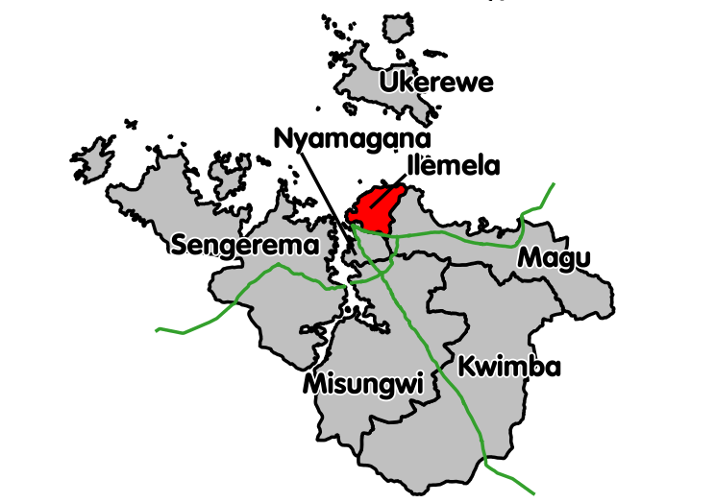Figure 1.1: Location of Ilemela District

KEY
Other Districts
Ilemela Municipal where Buswelu is located.

1.2.2 Population
The Buswelu ward has 4,286 households, the ward population was 21,877 people whereby 10,383 are males and 11,494 are females (National census 2012). However, the Youth (15-34YRS) population is characterized with about 1,606 in total, whereby 675 Males and 931 Females. These Youths are coming within / out of 14 different Local Governments in Buswelu ward. However, the researcher dealt with the Youth at Buswelu centre.

1.2.3 Ethnicity
The ward as well as the centre comprises Youths of Sukuma tribe as the majority who account almost over 85%. Other tribe include: Jitta, Haya, Waha, Wakerwe, Luo and others in minority like Zanaki, Wakwaya, Waluli and many of others. For the case of religious, the community of the ward is dominated with Christians, Muslims and few are Pagans (local believes). Youth at Buswelu centre are also included in these ethnicity groups. The majority as named above respectively. Most of them are Christians followed by Muslims and the rest are Pagans in minimal number.

1.2.4 Cultural Factors
Buswelu Ward community is dominated by Wasukuma tribe, followed by Wajita and wakerewe. The main language of the community is Kiswahili language is mostly used because majority of them are familiar of it. The second language is the native ones, which are mostly used in homes.

1.2.5 Administrative Structure
Buswelu Ward falls under Ilemela municipal in Mwanza city which has 19 Wards. The Buswelu centre is in Buswelu ward and has 2 Streets i.e. Street A and Street B this is according to 2016 reports.

1.2.6 Economic Activities
1.2.6.1 Agriculture
According to Ward Agricultural officer (2016) report, Individual Small-scale farmers cultivate an average of 1.3 - 2.2 hectares per year. Food crops grown include rice, cassava, maize, sweet potatoes, sorghum, Millet, banana and beans. Rice is the major cash crop as well a steppe food, where sweet potatoes, maize, groundnuts and cassava are also cultivated as cash crops in some areas of the Buswelu Ward. Horticulture crops like onions, carrot, egg plant, tomatoes productions to a large extent is geared toward domestic as well as consumption. In the recent years production of both food and cash crop has been increasing due to; high demand and the growing centre of Buswelu which is the head quarter of Ilemela municipal. Also it has few areas useful for irrigation system in the ward. The challenge is lack of agricultural inputs and implements, small scale farming and insufficient of pests and insecticides and lack of knowledge.

1.2.6.2 Livestock Keeping
Although people in the Ward are keeping livestock they do face some problems facing the livestock sector include; lack of enough area for rearing as the area is located in town, poor livestock husbandry, Diseases control, water shortage and high cost of veterinary drugs. The livestock kept most of the time attacked by various diseases such as Newcastle, Kideri for Poultry.

1.2.6.3 Fishing
Fishing is another economic activity, which is taking place in Buswelu Ward because is bordered to the Lake Victoria. It is observed that, within the ward many young people are engaged in small-scale fishing in Lake Victoria. Some fish catches are sold to restaurants and hotels based in Buswelu centre and the rest are for domestic consumption. Fishing sector is experiencing the following problems; illegal fishing, high prices of fishing gears and lack of Community knowledge on modern fishing methods.

1.2.6.4 Trade
In Buswelu Ward, most of the commercial activities are small and medium shops which are carried out in the center all seasons, and also in various villages commonly known as “Viosk” which forms the Village Business Areas (VBA). However, a number of shops are located in the surroundings of the VBA and other small shops also found distributed in different village places mostly selling the daily need commodities of the respective residents.

1.2.6.5 Social Services
1.2.6.5.1 Education
The Buswelu Ward has primary schools and Secondary schools owned by the Government and private one and other institutions as summarized in table 1.2providing education services in the Ward.

Table 1.1: Education centers in the Ward
 | Primary Schools | Secondary Schools | Training Centers
Owned by Government | 04 | 03 | 02
Private | 02 | 02 | ----
Total | 06 | 05 | 02
Source: survey 2016
1.2.6.5.2 Health
The ward has 1 dispensary namely Buswelu Dispensary owned by the government, 2 laboratories for primary diagnoses 5 small pharmacies which are private owned.

1.2.6.5.3 Water
There are several water sources which deliver water services to Buswelu ward community. These sources include Lake Victoria, Mwanza Urban Water Supply Authority (MWAUWASA), 7 bore holes owned by both Government and private and several traditional shallow wells within the ward.

1.2.6.5.4. Infrastructures

The ward is good in networking’s systems with other places such as; town, all places in Mwanza town through good roads. Motor transports are very convenient to support socio-economic growth of the ward members. The Buswelu centre transport used is rough road which connects Buswelu centre to tarmac road (Mwanza- Musoma) as well as Mwanza town and rough road to Airport.

1.2.6.5.5 Communication Services
The Buswelu ward is an urban with more Communication lines/ telephone which is dominated by the presence of, AIRTEL, TIGO, VODACOM and HALOTEL The centre is also connected with permanent power from the TANESCO Company which is durable. In short, the community is good in networking’s systems for communication with all places in Mwanza and other areas which support socio-economic growth as well as social issues.

1.3 Community Needs Assessment
Community Needs Assessments (CNA) was done in Buswelu Ward in Ilemela District. The CNA was carried out in order to collect information about the car wash situation in the area that would assist in identifying the problems the community is facing and formulate a project to address the main problem based on their ranking. The CNA involved Youth who are the sufferer of economic crises as urban area is concerned. The CAN adopted a participatory approach in which survey method and group discussions were used. This led the researcher at Buswelu centre to assess the need of the community particularly Urban Youths and to identify the availability of resources which can be beneficial to Youth and be utilized.
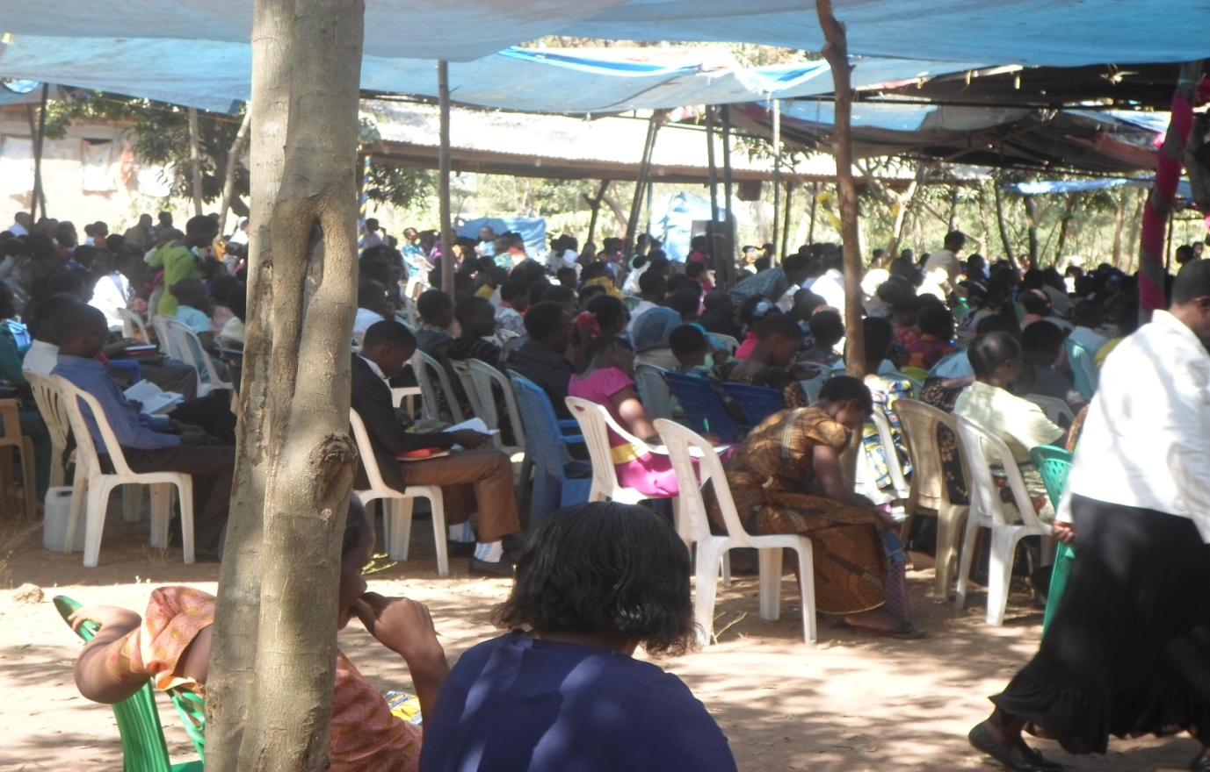

Figure 1.2: Community Sensitization Meeting With the Chair Person

However, Whang-Ramos, Seekins and Bradford (1987) and Suarez, Balcazar and Keys (1999) contends that, this can be done simply by the indigenous/residents interacting to pose their opinions about the development off services within the community, how they satisfy with the services, and what particular services are needed. Their opinions and suggestions can be used in building an agenda aims at community change that can build the capacity of community –based organizations that are designed to provide services and development opportunities to residents. Community Needs Assessment was conducted basing on this principle of Participatory approach

1.3.1 CNA Overall objective
The overall objective for conducting community needs assessment (CAN) was to collect information about the youth community at Buswelu center that would assist Youth in Identifying the socio economic needs and the main problem the community is facing and suggest ways and formulate a project to address the main problem based on their ranking.

1.3.1.1 Specific Objectives
- To identify the problems facing social economic needs of youth within the area.
- To establish the priorities of the identified problems and needs of youth within the community.
- To identify the type of assets available within the community and among community members.
- To identify suitable interventions for improving socio- economic status of Youth for identified problems.

1.3.2 CNA Questions
1. What are the problems facing Youth/community members involved within the area?
2. What is the most problem of socio- economic status of youth at Buswelu centre?
3. What is the type of assets available within the Youths and among community members?
4. What are the suitable interventions for the identified problems?

1.3.3 Research Methodology

1.3.3.1 Research Design
According to Oso and Onen (2008), contends that a research design defined as the overall plan or strategy for conducting the research. In this study the cross – sectional design was used, in which simple random sampling and purposive sampling were used to select a representative sample to collect information. The design is considered to save time and resources and is eventually used for determination of relationship between variables (Bailey, 1998). Both quantitative and qualitative data were obtained through this design. The main emphasis was on the discovery of ideas and viewes. The process of conducting CNA involved three methods namely; survey, interview and observation methods.

1.3.3.2 Study Population
This study will be conducted in Buswelu Ward particularly at Buswelu centre about 526 youths and 57 key informants /staff ward. Buswelu ward is one of the 19 wards in Ilemela Municipal in Mwanza city. It has many jobless youths at Buswelu centre. It is therefore, considered appropriate for providing a focal point for the study of improving livelihoods of KUVM through a car wash project at Buswelu centre.

1.3.3.3 Sampling Techniques
The sampling techniques which were used to get the required sample size included Simple Random Sampling (SRS) and Purposive sampling. The SRS method was used to choose 12 respondents who are Car washers while Purposive sampling was used to obtain 62 youths from Buswelu centre , two streets (A & B) in the study area, also purposive sampling used to get 10 key informants from community leaders. Table 1.2 shows the sample size composition.

Table 1.2: Sample Size Composition
Category of Respondents | Number of Respondents
Street A | 31
Street B | 31
Car washers | 12
Key informants | 10
Total | 84

Source: Surveyed data, 2016

1.3.3.4 Data Collection Methods
Data collection method based only on primary, data collected during the survey process. Primary data were collected from the community through questionnaire, semi-structured interview and observations

1.3.3.4.1 Interview (key informants)
An interview is among the techniques of data collection in which information is obtained in a face to face situation. The interview conducted to gather primary data from 10 key informants. This was done for individual respondent separately using a semi structured questions this helps to guide the interview process, to get challenges facing youths ‘and sustainable solutions.
1.3.3.4.2 Observations
The survey engaged at the target group and observes physically what was going on without direct doing or participating on the business. This method helped the researcher to understand the situation and context of the youths are engaging in business operations as far as the problem of socio-economic is concerned.

1.3.3.4.3 Questionnaires
Self – administered questionnaires (structured) were distributed to 84 respondents. For the illiterate respondents, the researcher assisted them. The questionnaire technique for gathering data is widely used in most of research studies. The questionnaire was used in this to determine opinions and attitudes of the respondents on problems facing youth’s members who involved in socio-economic issues. In this study the open-ended questions were included in the questionnaire to enable the respondent to state her/his case freely and allowed to give reasons as well.

1.3.3.5 Data Analysis Methods

Data were exported from the program Microsoft word to Statistical Package for social scientist (SPSS) windows version 16.0, which offered statistical tools applied to social sciences programs Pair ways ranking tool. After processing, scaling and indexing of the necessary and relevant variables to perform subsequent statistical analysis for drawing inferences. The descriptive analysis was done to get frequencies and percentages. The analyzed data were presented by using tables and qualitative data were thematically analyzed to make meaningful interpretation.

1.4 CNA Findings

This section presents findings of the CNA where tables and figures illustrate the findings. Information’s were presented in tables and figures illustrate the findings. Section 1.4.1 discusses the demographic issues of the respondents so as to get the first hand information of the respondent. Also, the assessment was made on getting to know problems facing urban youth, level of livelihood, economic activities do urban youth engaged, income earning per month, as well as measures undertaken to intervene the problem (section 1.4.2 suggested solutions.)

1.4.1 Age of Respondents
The findings show that 74 respondents are of the age group of 18 - 29 years equivalents to 83.4%, which is an active group for car wash services and business operations. The age group distribution pattern shows the dominance of the active manpower and the potential of the society in economic productivity. The age of respondents involved during the study/data collection. The age group 18 – 30 which is the target of the researcher covers 83.4%. This group experience different socio economic activities and faces a lot of challenges in the community. This comes from the fact that, youth under this age are at the position of having many responsibilities and duties in their lives.

Table 1.3: Age of Respondent
 |  | Frequency | Percent | Valid Percent | Cumulative Percent
Valid | 18-23 years | 35 | 41.7 | 41.7 | 41.7
Valid | 24-29 years | 35 | 41.7 | 41.7 | 83.4
Valid | 30 and above | 14 | 16.7 | 16.7 | 100.0
Valid | Total | 84 | 100.0 | 100.0
Source: researcher, 2017

1.4.2. Level of Education
Table 1.4 shows that, among 84 respondents in the study area, 50.0 % proved to access primary education, 25.0% not attain any education level while 17.9% of the respondents have secondary education, and 7.1% attend adult education. Generally the results show that most of respondents (75.0%) received at least basic education which will facilitate the adoption of entrepreneurial skills and the implementation of new technologies when applied and if they are skilled.

Table 1.4: Level of Education
 |  | Frequency | Percent | Valid Percent | Cumulative Percent
Valid | Not attended school | 21 | 25.0 | 25.0 | 25.0
Valid | Adult education | 6 | 7.1 | 7.1 | 32.1
Valid | primary education | 42 | 50.0 | 50.0 | 82.1
Valid | Secondary education | 15 | 17.9 | 17.9 | 100.0
Valid | Total | 84 | 100.0 | 100.0
Source: researcher, 2017

1.4.3 Marital Status
Table1. 5 show marital status of respondents within the study area. The findings show that most of respondents by 84.5% were single and 15.5% of the respondents were married. Most of the respondents were single, this indicates that probably they fear to marry because of cost of living. Although there few married, they face even more challenges than single one. This means that urban youth do face the same socio – economic challenges no matter which status they have.

Table 1.5: Marital Status
 |  | Frequency | Percent | Valid Percent | Cumulative Percent
Valid | Single | 71 | 84.5 | 84.5 | 84.5
Valid | Married | 13 | 15.5 | 15.5 | 100.0
Valid | Total | 84 | 100.0 | 100.0
Source: researcher, 2017

1.4.4 Number of Dependants
The table 1.6 shows the respondent’s number of dependants from the study area. The data shows that 50.0% of respondents do have 2 dependants, followed by 39.3% have 1 dependants, which imply that apart from their personal life, urban youth have to take care of their families despite the fact that they are facing a lot of challenges within the community. They play many roles such as domestic, economic and social roles in order to make sure that they engage fully for their lives, their families and community in general.

Table1.6: Number of Dependants
 |  | Frequency | Percent | Valid Percent | Cumulative Percent
Valid | 1 | 33 | 39.3 | 39.3 | 39.3
Valid | 2 | 42 | 50.0 | 50.0 | 89.3
Valid | 3 | 6 | 7.1 | 7.1 | 96.4
Valid | 4 and above | 3 | 3.6 | 3.6 | 100.0
Valid | Total | 84 | 100.0 | 100.0
Source: researcher, 2017

1.4.5 Problems Facing Buswelu Centre Youth
Table 1.7 shows that, despite many challenges facing urban youth in Buswelu centre, income poverty seems to be the main problem facing the them as it displays 38.1% followed by Lack of capital by 28.6%, Lack of entrepreneurial skills by 15.5%, lack of improved technology by 9.5% and lack of special area for their petty business by 8.3%. Income poverty among youth in urban areas is still the challenging issue e.g. the majority of youth are engaged in small scale business in informal sector but. face problem in their struggle for economic and social make up.

Table1.7: Problem Facing Urban Youth
 |  | Frequency | Percent | Valid Percent | Cumulative Percent | Rank
Valid | Lack of entrepreneur skills | 13 | 15.5 | 15.5 | 15.5 | 3
Valid | Lack of special area for their petty business | 7 | 8.3 | 8.3 | 23.8 | 5
Valid | Lack of capital | 24 | 28.6 | 28.6 | 52.4 | 2
Valid | Income poverty | 32 | 38.1 | 38.1 | 90.5 | 1
Valid | Lack of improved technology | 8 | 9.5 | 9.5 | 100.0 | 4
Valid | Total | 84 | 100.0 | 100.0
Source: researcher, 2017

1.4.6 Lack of Entrepreneur Skills
Table 1.8 shows that 86.9% of all respondents don’t have any entrepreneurship skills and only 13.1% at least are knowledgeable. This reveals that, most youth in Buswelu centre who are engaged in different petty business and other IGAs have no entrepreneurship skills this needs the specific objective no.2 to be considered. During the interview and focused group discussion respondents suggested that, youth should be provided with entrepreneurship training of their business including car wash. Through the entrepreneurial training youth will be able to generate business idea, carry out a market research, and develop a business plan, set up the business and managing & monitoring the business initiated.

Table 1.8: Do You Have any Entrepreneurship Skills
 |  | Frequency | Percent | Valid Percent | Cumulative Percent
Valid | Yes | 11 | 13.1 | 13.1 | 13.1
Valid | No | 73 | 86.9 | 86.9 | 100.0
Valid | Total | 84 | 100.0 | 100.0
Source: researcher, 2017

1.4.7 Suggested Measures
Table 1.9 shows that 42.9% of respondents suggested car wash as the most need in improving their livelihood. 22.6% needed vegetable garden, 17.9 soap making project, 11.9% need saloon project and 4.8% need entrepreneurship skills. Through the focus group discussion with urban youth, the researcher used time to ask the respondents to identify the possible opportunities having which can improve the livelihood of urban youths in Buswelu centre.

Most of them suggested/opted the establishment of car wash and its’ services as an income generating activity (IGA) according to their domicile. Car wash- services is very marketable for urban youth as it cost less capital to establish but also the availability of many cars all the time in Ilemela municipal, this proves the presence of market all the time. This exercise and evidence helped the researcher to know what is supposed to be done & emphasized when planning the suggested project.

Table 1.9: Suggested Measures
 |  | Frequency | Percent | Valid Percent | Cumulative Percent | Ranking order
Valid | Establishment of vegetable garden | 19 | 22.6 | 22.6 | 22.6 | 2
Valid | Establishment of carwash | 36 | 42.9 | 42.9 | 65.5 | 1
Valid | Establishment of saloon | 10 | 11.9 | 11.9 | 77.4 | 4
Valid | Soap making skills | 15 | 17.9 | 17.9 | 95.2 | 3
Valid | Entrepreneurship skills | 4 | 4.8 | 4.8 | 100.0 | 5
Valid | Total | 84 | 100.0 | 100.0
Source: researcher, 2017

1.4.8 Findings from Key Informants
Key informants involved were 10, include: WEO; VEO; Local leader, Hamlet leader religious leaders, parents on their interview had identified the problems and challenges facing the community and suggested measures to overcome. Key informants identified the major problem is lack of car wash knowledge and skills of handling it. They said that “urban youth in Buswelu centre do depend much on petty business including selling scrappers though others do engage in collar jobs, begging, as well as vendors/ machinga.

Table 1.10: The Findings from the Key Informants
Key informants | Female | Male | Total
WEO/ VEO | 00 | 02 | 02
Local leader/ Hamlet leader | 01 | 01 | 02
Religious leaders/parents | 03 | 03 | 06
Total | 04 | 06 | 10
Source: researcher, 2017

When asked, what are the suitable measures for improving the livelihood status of urban youth? They proposed that, “youth should be supported with income generating activities (IGAs) like car wash-services simply because the market for it is available all the time within their local area”. With this notion they said that “though youth will be supported with income generating activities that should collaborate with entrepreneurship training”. The training could help them to run their project well. This study help the researcher to understand what was to be emphasized more during project planning, as it was revealed that the priority was establishment of car wash project for intervention.

1.4.9 Identified Problems
Participatory results on Community Needs Assessment with a particular focus on problems identification (Table 1.11) revealed five common major problems namely;, Lack of entrepreneur skills, Lack of special area for their petty business, Lack of capital, Income poverty and Lack of improved technology.

Table 1.11: Problems Encountered Within the Community
Problem | Score | % scored | Rank
Inadequate capital for business operations | 1 | 6.7 | 5.5
Lack of capital/income poverty | 5 | 33.3 | 1
Lack of capacity in establishment of cooperative society | 3 | 20.0 | 2.5
Lack of modern car wash | 3 | 20.0 | 2.5
Lack of entrepreneurship skills | 2 | 13.3 | 4
Lack of book keeping skills to members of the group | 1 | 6.7 | 5.5
TOTAL | 15 | 100
Source: survey 2016

1.4.10 Available Resources in the Community
Based on the survey results the notable available resources of the community include Land, lake, steams, human resources, township location, bicycles, motor cycles, cars, tracks and water taps. These resources can be utilized for economic progress to the study area.

1.4.11 Suggested Solutions
Following the availability of resources also the participatory approach was involved to local people in identifying their problems and the way in solving them. It was thus important to get their views on the possible remedies of the existing problems as far as the hand car wash and Pressure pump is concerned. Five possible solutions were suggested by the local community as outlined below.
1. Establishment of vegetable garden
2. Establishment of carwash
3. Establishment of saloon
4. Soap making skills
5. Entrepreneurship skills

1.5 Community Needs Priotization
According to the results of pair wise ranking, the lack of knowledge and skills of establishment of Car wash, handling and quality control becomes a most priority area of the community need Table 1.12: shows the Pair wise ranking exercise which involved members of the group and the exercise was done successfully because each member participated fully and freely by asking, arguing and making decision according to her/his wishes.

Table 1.12: Priotization of Needs through Pair Wise Ranking
Need | Establishment of vegetable garden | Establishment of carwash | Establishment of saloon | Soap making skills | .Entrepreneurship skills | Score | Ranking
Establishment of vegetable garden |  | Establishment of carwash | Establishment of vegetable garden | Establishment of vegetable garden | Entrepreneurship skills | 2 | 3
Establishment of carwash |  |  | Establishment of carwash | Establishment of carwash | Establishment of carwash | 4 | 1
Establishment of saloon |  |  |  | Soap making skills | Entrepreneurship skills | 0 | 5
Soap making skills |  |  |  |  | Entrepreneurship skill | 1 | 4
Entrepreneurship skills |  |  |  |  |  | 3 | 2
Source: Survey, 2016
Members of the group were supposed to list as many as possible problems which hinders their socio-economic development/income poverty and which business can help them and finally members of the group come up with five main needs. Frequently the exercise was pausing for waiting consensus of the audience on comparative of five areas. Therefore priority need of the community concluded to be capacity building on effective way of establishment of car wash, handling and quality control in business.

1.6 Chapter Conclusion
This chapter on participatory needs assessment has presented the community profile of Buswelu centre where the Community Needs Assessment (CNA) was done. The CNA used a participatory approach in undertaking the study. The sample from the target population was both randomly and purposively selected from among community members and got involved in the identification of the problem as far as the car wash project is concerned. The CNA based on the pair wise ranking indicated that lack of knowledge of establishment of Car wash which is the most pressing need that requires immediate attention. Thus the anticipated project will focus on addressing issues related to car wash handling and quality control as well as car wash day- to-day business in the area

CHAPTER TWO

2.0 PROBLEM IDENTIFICATION

2.1 Background to Research Problem
The most identified problem facing the KUVM CBO was income poverty. However, several problems were included and priotized to determine the most pressing problem in their business which were inadequate capital for business operations, lack of capacity in establishment of cooperative society, lack of modern car wash, tools and equipments for business operations, inadequate knowledge and skills on car wash handling and quality control and car wash marketing, lack of entrepreneurship and cooperative skills, lack of book keeping skills to members of the group. Based on the participatory findings of the CNA the most need to overcome the income poverty was establishment of car wash, which is the focus of the proposed project towards addressing this problem.

2.2 Problem Statement
The most problem of Youths in Tanzania is income poverty caused by unemployment. It has existed since independence. The Most vulnerable youth also are lacking education and lack of entrepreneurship skills. The Government and NGOs are helping youths for moral and material support. These supports are vanishing with time due to severe household income poverty, effects of globalization, change of technology, socio-economic changes and income poverty among of youths themselves means low ability to acquire their basic needs due to low income which is not enough to sustain life in town. Also failure to use resources available to produce goods and services is another challenge. However, the proposed project establishment of car wash will be the solution.

Car washes are the highly pressing need to address the problem in modern world especially in urban areas. The business is good for youth since it needs energetic and strong people like youths. The increase of cars, tracks, motorcycles, tractors and bicycles, in the urban centers these put the project in place to be highly demanded. It is also the right source of income to overcome the income poverty of youths who have no formal employment in the urban areas. In fact, the head quarter of Ilemela Municipal is situated at Buswelu centre where the project is situated, this gives chance for the place to have more cars hence, offer more opportunity for car wash business to have many clients.

Due to above resources and opportunity, the current study came up with the detailed study which unveils the opportunities for viable and reliable economic activity with the focus of contributing in sustainable economic development. In view of this situation the current study focuses and came out with Hand and Pressure washer Car wash project for KUVM as a way forward to solve the problem. This is done by impact of skills of car wash and handling practices among youths who are involved in car wash operation/group, marketing and controlling within the community.

2.3 Project Description

The title of the project is “Improving livelihoods of KUVM through establishing a car wash project at Buswelu centre in Ilemela District”. The project was undertaken in Buswelu Ward, in Mwanza Region and the owners of the project are Kikundi cha Umoja wa Vijana Maendeleo (KUVM).

2.3.1Target Community
The targeted community in the project is the urban youths in Buswelu centre (Street A&B) as well as the entire community.

2.3.2 Stakeholders
Different stakeholders have contributed in the implementation and success of the project. The main stakeholder is the Ilemela District Council includes: Trade Officer; WEO & VEO; Youth development officer, Buswelu SDA Church. The stakeholders of the project everyone was assessed depending on what stakeholder can contribute strengths, weaknesses, threats, experience and stakeholder’s needs. See Table 2.1.

Table 2.1: Stakeholders Analysis
S/N | Stakeholder | Role | Expectations
1 | Ilemela municipal Council | - Financial support through YDF  - Facilitate group registration  - Advisor of the project | The fund is released at a reasonable time for the implementation of the project.
2 | Urban youth | Initiate, manage and operate the project.  Owners of the project | Ensure sustainability of the project  Improve standard of living from car wash services.
3 | Buswelu centre community | Consumers of car wash products | Clients improve live of their cars

Source: researcher, 2017

2.3.3 Project Goal
The goal of this project is to improve the livelihood of Urban Youths through income generating projects in Buswelu Centre.

2.3.3.1General Objectives
To empower urban youth’s economically in Buswelu centre, by provision of knowledge and skills of car wash handling and quality control to car wash operators, by establishment of hand and pressure washer car wash project by June, 2016.

2.3.3.2 Specific Objectives
- To conduct training to 12 youths on car wash by January, 2016
- To conduct training on entrepreneurship to 12 youths in Buswelu by February, 2016.
- To establish car wash project at Buswelu centre by May 2016.
- To establish a reliable market of Car wash services rendered by KUVM members by June, 2016.

2.4 Host organization CBO/Profile
The host organization is Buswelu SDA Church. The Church is in Buswelu centre, in Ilemela District. The Church led by the church Elder who is the Chair person of the church. The group is working under the leadership of the Church assisted by VEO & WEO offices. However, for management of the project, the group has its own leaders, among of them are; chair person, Secretary and the treasury selected by all members through voting.

2.4.1 Vision of Buswelu SDA Church
Assume the responsibility of offering the current and future needs of the community with high quality of life and human value.

2.4.2 Mission of Buswelu SDA Church
Buswelu SDA Church offer services, for all people in the society with all respect regardless of their race or gender.

2.4.3 Buswelu SDA Church organization Structure
ANNUAL GENERAL CHURCH MEETING
GENERAL CHURCH BOARD MEETING

STEERING COMMITTEE

GENERAL SECRATARY

CHURCH LEADERS

___________________________________________________________________
ENTERPRENUISHIP UNIT

DISCIPLENE COMMETTEE

FINANCE & ADMINISTRATIVE UNIT

HEALTH UNIT

LOANS UNIT

MONITORING & EVALUATION UNIT

STRATEGIC PLAN OFFICER

YOUTTH DEPARTMENT UNIT

ALL CHURCH MEMBERS

Figure 2.1: Buswelu SDA Church Organization Structure

2.4.4 Buswelu SDA Church SWOT Analysis

Table 2.2: SWOT Analysis
Strengths | Weakness
- 1.The organization has good leadership and cooperative  - Community for progress issues  - 2.The committed & Volunteered personnel  - 3. Has experienced and hard working staff.  - 4. Positive relationship with other churches as well as local go government leaders | - 1.Solely dependency on donors  - 2,Shortage of working capital  - 3.Lack of materials/ facilities  - 4.Parents not allow youths to join groups
Opportunities | Threats
- 1.Positive participation of Youths in advocacy of work  - 2.The readiness of Government officials helping Youths’ CBOs  - 3. The group has good relationship with surrounding community, customers, Ward and Ilemela Council’s leaders | 1..Delay in Financial release from the Donors  2. Youths not soliciting their subscription fees on time.

Source: researcher, 2017

2.4.5 Sources of Funds for the Group

The group has different sources of funds which include:
a) SDA Church organization
b) AMO- Adventist Men Organization aid.

c) Membership & subscription fee T.shs 50,000/=
d) Earning from Car wash business
e) Aid or grants from donors/NGO

f) The organized funds rising from well- wishers.

2.4.6The Role of CED Student’s In the Project
1. To discuss with the CBO leaders to invite expert on Carwash.
2. To sensitize Buswelu community members on the importance of Car wash.
3. Helping the group on advertisement in connection with the mass media and magazines
4. Collaborate with Buswelu SDA Church and other stakeholders for monitoring/ evaluation the project.

2.4.7 Role of Buswelu SDA Church as Host organization
- To create the conducive environment for the project
- To ensure the sustainability of the project
- To provide technical knowhow to the project
- To assist administrative activities during the project life
- To make sure that progress report is provided wherever is required

CHAPTER THREE

3.0 LITERATURE REVIEW

3. 1 Introduction
This chapter discuss theoretical, empirical and policy review literature. According to Ngaiza et al 2003, literature review is a procedure that guides writers to access both published and unpublished source of information in respect to study. Theoretical literature refers to citations of other studies from books, professional journals, reports, etc which had been made in relation to the research topic. Empirical literature describes how similar projects (in local, national or international) are doing and how others have approached to embark on the similar projects.

Narrative information, which provides empirical literature, were found and cited in books, articles, web sites, reports etc. Policy literature refers regional and national and international policies designed to provide a framework to the entire project. This is the area, which study and review how the current policies provide clear guidelines or promote community economic development initiatives in the area of project intervention. ‘A critical summary and assessment of the range of existing materials dealing with knowledge and understanding in a given field … Its purpose to locate the research project, to form its context or background, and to provide insights into previous work’ (Blaxter et al., 1996: 110).

Future more, (Burton, 2000: 137). Argued that, the literature review therefore involves a detailed search through a range of resources such as books, journals, the Internet and electronic journals, abstracts and microfiche. Kumar argues that a literature review has three functions. First, the literature review clarifies and focuses the research question. It helps the researcher understand the subject area more fully and identify the different theoretical approaches that have previously been applied. The literature review therefore enables the researcher to conceptualize the research question and point to gaps in existing social research into the chosen area of study. Second, the literature review may improve the researcher’s methodology

3.2 Theoretical Literature

3.2.1 Definition and Concept of Youth
The various definitions have been given by different scholars about youths. The first one is according to Oxford Advanced Learner’s Dictionary (2001), “A Youth is the time of life when a person is young, especially the time before a child becomes an adult” (2001). According to Shaidi Joyce (2006), a youth in Tanzania is defined as a person between the ages of 15-35 years. The total population of Tanzania is 34 million. 33 % of the total population is Youth, and 68 % of the active labour force is young people. The core problem facing youth in Tanzania is unemployment. This problem is characterized by lack of job opportunities in urban areas, and underutilization of the majority of the national labour force in both rural and urban areas.

This has been the main challenge for developing countries Tanzania is included. This situation has led to the increase of jobless (vulnerable) youth most in urban areas. The youth aged between 15 and 34 years are more vulnerable to unemployment. This also proved that the most vulnerable youth group are in urban areas, the group is suffering mostly economically. The result they engage themselves in bad behaviours like thief’s, robbing (Panya road in Dar- es-Salaam, Teleza in Kigoma and more others), begging, scooping others property, immorality issues (sexual business) and being subject to get HIV/ AIDS To rescue the situation of a vulnerable youth a co operate effort is needed (ibid).

3.2.2 The Theory of Poverty
Sometimes poverty can be caused by Corruption of the country as reported by (ACG, 2006), the link between corruption and development is clear. Various studies involving different countries have shown that the more corrupt a government, the more underdeveloped the country becomes. (UNDP 2004) Poverty becomes more rampant, social services are reduced and investments in infrastructure and social services are diminished. Corruption fosters an anti-democratic environment characterized by uncertainty, unpredictability, declining moral values and disrespect for authority. Corruption embodies, not just a governance deficit, but also an amputation of human rights, resulting to poverty and threatening human security. Corruption is a governance issue because it involves society thru its political, economic and social. When these formal and informal institutions break down, laws and policies that ensure accountability and transparency of the government become harder to implement.

3.2.3The Concept of Poverty
Poverty has been the global concern for enormous years. Each country in the world is striving to get rid of poverty to her people. Poverty can be defined as a state of deprivation and prohibitive of decent life by failure to meet basic needs (URT, 2003). Poverty can be classified into absolute poverty and relative poverty. Absolute poverty is the inability of a person to attain minimum specified standards of living based on nutrition and other none food basic necessities. Relative poverty refers to the level of wellbeing which is judged to be poor or well-off based on comparing people who are of the same society or community (URT, 2005; URT, 2007).

Poverty which resulted for unemployment has existed for a long time to urban areas, whereby majorities are engaging in small business. However, poverty is classified into two main different forms, these are; income poverty and none income poverty. Income poverty has said to be exacerbating any other categories of poverty (URT, 2006). also this is justified by the (T.H.D.R, 1999/2000). In Tanzania, which in 1999 ranked 156 out of 174 countries in the Human Development Index (HDI), In Tanzania: 51% of the population live on less than $1 a day; About half or 42% of these live in absolute poverty on less than $0.75 cents a day; 81% of the labour force is rural; the majority of the urban workforce is underemployed and minimally skilled, the good number of this group is vulnerable one. (THDR, 2000).

To establishment of car wash is the only way forward to address the problem. Tanzania has engaged itself into effective Participatory approach in its different planning process to involve youths on fighting against poverty reduction. The youth’s participation in development planning as well as policy making has been the contemporary approach to ensure that youths participate in struggling pulling out from abject poverty as envisaged by the National Development Vision 2025 (URT, 2000). Striving to pool out of poverty has resulted into different strategies. MKUKUTA II has an intention of halving abject poverty by 2015. Tanzania also has adopted the Millennium Goals which aim to reduce absolute poverty by 2015 (URT, 2006).
Therefore, fighting for poverty alleviation is a crucial issue which needs many techniques of curbing it. Poverty for a long time has said to be a major phenomenon whereby majorities of Youth are engaging in hand to mouth economy. For this reason small business for youth organized groups through diversification is the only possible means to carter the problem. However, Tanzania has engaged herself into different and effective Participatory approach in its planning process to involve local communities on fighting the enemy against poverty alleviation. Community participation in development planning has been the contemporary approach to ensure that the community participate in struggling pulling out from abject poverty by the National Development Vision 2025 (URT, 2000).

3.2.4 The concept of Youth Unemployment
Tanzania, together with many other Sub-Saharan countries (Guarcello and others 2005), suffers from a severe youth unemployment and inactivity problem in urban areas (Mjema 1997). Despite of sustained growth in the second half of the last decade, during the 1990s labor market outcomes have further deteriorated (Government of Tanzania 2003). Although unemployment is by no means a problem unique to youths in Sub-Saharan Africa, the problem there is compounded by disappointing education outcomes that make the prospects of youths appear rather dim and by the circumstance that work is often the only asset for a large part of the population while no publicly provided insurance mechanism against the risk of unemployment is in place. (Mancorda and Kondylis, 2006).

The number of Youth who complete different levels of education, from primacy, secondary and high learning institutions are entering the labour force annually is about 700,000 but only 40,000 get employment into formal sector, about 660,000. The incidence of unemployment among the youth is relatively high. The youth constitute 60 % of all people who are unemployed. According to labour Force Survey 2001 unemployment rate for the whole country is 12.9%. Almost half of the unemployed live in urban areas. For example 46.5% of active people in Dar es Salaam are unemployed, unemployment for the other urban areas is 25.5 %, and for rural areas is 8.4%. Unemployment for people aged 18-34 was 8.6% in the rural areas and 41.4% in the urban areas. The youth aged between 15 and 34 years are more vulnerable to unemployment (Shaidi Joyce, 2006)

3.2.5 Youths’ Empowerment
By definition empowerment is a process of change by which individual or group with little or no power gain the power and ability to make choices that affect their lives. Empowerment is about changes, choice and power (Stanley K. and Jaya K.1993). The structure of power who has it, its sources, how it is exercised, directly affects the choice that people are able to make in their lives. Empowerment goes beyond participation. It implies enabling people to understand the reality of their environment, reflect on the factors shaping that environment, and take steps to effect change to improve the situation

Furthermore, empowerment is the process of obtaining basic opportunities for marginalized/Vulnerable people, either directly by those people, or through the help of non-marginalized others who share their own experience and access to these opportunities. It also includes actively thwarting attempts to deny those opportunities. Empowerment also includes encouraging, and developing the skills for, self-sufficiency, with a focus on eliminating the future need for charity or welfare in the individuals of the group (wiki). It is not easy to reduce poverty. It involves many different people at different levels in society working on different problems in different places. We need to work together so that we do not waste time, effort and money through lack of communication and getting in each other’s way. This means that we need an agreed set of structures and procedures.

Many people are already gathering valuable information about poverty but they do not always use this information as well as they could. A lot of the work is informal and does not cover national priorities. It is not always based on a good understanding between the people who gather the information, and the people who will eventually use it. This means that there is plenty of room for improvement in how we gather information and how we use it for systematic and evidence-based planning {URT August, 2002).
Youths aged between 15 and 34 typically lack access to financial capital and have more limited opportunities to gain high education, knowledge, and skills that can lead to self economic stability. Vulnerable youth often lack social support either from home or the community; social norms can create barriers to their economic advancement. Economic empowerment can be a critical level for change in youths’ lives style, helping them to gain financial independence, establish good saving habits, and improve their future prospects for participation in the labour force. It can also provide youth with more mobility, promote their confidence, strengthen their social competent, and improve their economic outcomes. (Dunning et al, 2013).

3.2.6 Role of Entrepreneurship and SMEs
The Global Entrepreneurship Monitor research project found that young people (ages 18–34) were the most likely to become active as entrepreneurs. A third of successful entrepreneurs came from that age group (Leibbrandt and Mlatsheni 2004). However, the word entrepreneurship is the act of being an entrepreneur which was derived from the French word which means to undertake. The earliest usage of the term was recorded in 17th century.

According to Economics the Science of Cost (1993), Microfinance institutions are financial intermediaries formed to serve the needs of special group of people. Microfinance and Micro-credit are mostly used to finance small scale enterprises. Microfinance in general includes Micro credit, Micro-savings, Micro-insurance and payment services. Micro-credit is extension of medium and small loans to micro-entrepreneurs who lack collateral and do not qualify for traditional bank loans. In fact, in developing countries Micro-credit enables very poor people to engage in self-employment projects those which will generate income.

According to BRI of Indonesia and BancoSol of Bolivia are good examples of successful micro-finance institutions that follow best practices when delivering their services to low income people. This also added by (Massawe 1999) that the most important distinction found among SMEs is between survivalist activities, craft and microenterprises, small enterprises and medium-sized enterprises: Survivalists are unskilled workers who perform, almost exclusively, informal trading activities income generated from these businesses usually falls far short of even a minimum standard, with little capital invested, virtually no skills training in the particular field and only limited opportunities for growth into a viable business. The youth can initiate a large percentage of these businesses. The KUVM is falling in this type of business.

The 1991 National Informal Sector Survey revealed that micro-enterprises employed about 20% of the total labor force. The 1996 NIGP -ESRF study on micro and small enterprises confirmed that there is high concentration in petty trade and commerce and that the informal sector and youths are important actors among SMEs. Youths are increasingly starting business enterprises, mostly in the urban areas, with the objective of raising income. Concerning the formal SME sector, the national industrial statistics only keep record of those firms employing more than 10 people, leaving unrecorded a large group of small companies (Ibid).

3.2.7 Car Wash in Relation to Youths Employment
Car wash is a good business to both young and adult people. This employment depends on the treatments of customers, the way they should be treated, especially if you haven’t trained the employees they can chase away the customers. Youths can be helped to change the works of selling petty business to permanent work. It is possible to wash a car with no soap or small piece of soap. The bottom line is that you can employ unskilled personnel to do the work. Also it cannot spend a lot of time at a car wash. After a time, business will be well enough to be able to hire a professional manager who can take over the skilled duties. This can be done for certain types of car washes most likely self-service and, to a lesser extent, in-bay automatic washes, but for a full-service or exterior-conveyor wash, you’re going to have to hire employees and responsibilities that go along with them.
In fact, aside from the initial investment in equipment and commercial space, employees will probably be one of the biggest costs the car wash can incur while running the car wash business. But before you start looking elsewhere for that great business opportunity, consider this: Many people have made a lot of money washing cars and they are using youths. The car wash is a service that is always in demand and that most consumers are certainly willing to pay for. The business is profitable and payable one.

The creation of self employment for urban youths including Buswelu centre youths is significance to the Tanzania economic because the project is relay with National Strategy for Growth and Reduction of Poverty II, 2015 Millennium Development Goal and National Youth Development Policy 2007. However, the economic empowerment to urban youths has been seen taken carefully in the world. Different policies, stakeholders, treaties and development partners have put much effort on making sure that urban youths are empowered economically despite there are number of different small informal economies scales are engaged. Urban youths are key agents for economic development; they are energetic and play a big role towards achievement of transformational economic, environmental, psychological and social changes required for sustainable development.

Youth are limited access to credit, health care; income poverty and education are among of many challenges youth they face. These are further catalyzed by the global change of technology, unemployment, economic crises and climate changes. Empowering them is essential, not only for individual well-being, dependants/families and urban communities, but also for overall economic productivity (FAO, 2011). Tanzania National Census 2002 shows that the Tanzania population is 34 million. 33% of the total population is youth, and 68 percent of the active force is young people. The Youth aged between 15 and 34 years are more vulnerable to unemployment. The sectors is characterized by poor technological used by the youth and not any added value to poverty eradication.

Despite unemployment being largely an urban phenomenon in Tanzania, labor market outcomes of rural youths are not much rosier. Although rural children transition at very early ages into work most end up in low productivity jobs on the household farm. This is possibly a major reason behind increasing migration from the countryside to urban areas (U.S. Census Bureau 1995), even in the face of poor and deteriorating urban labor market prospects. Urbanization reflects wider demographic trends: between 1957 and 2002 population grew fourfold, and this trend is not expected to end any time soon, casting serious doubts on the possibility that the youth joblessness problem will disappear in the meantime. (Y.L.M.T.S.W.T, 2006).

3.2.8 A Good Location of Car Wash
The more professional car wash service in the urban areas, need to have higher standards. One of the most important aspects of starting this business is location. You need a convenient location that has some space mostly around residential areas. Your target market includes individual car owner and leasers, car dealerships, and local businesses. Some of the best locations include within a restaurant, nyama choma joints and pubs where you can wash your customers’ cars as they eat or entertain themselves. Having the right location can make or break your business. A successful location should be near a shopping centre, in a high traffic, residential area, be easily and visible accessible from the road, allow for expansions and business growth, and have enough space for cars to line up. However, among of many others, the following factors should also be considered:-
- Your sign is visible to drivers for at least 40 seconds. Ideally, traffic should travel past at no more than 40 miles per hour (64 km/hr) so drivers have time to see your signage and make that split-second decision to have their cars washed.
- Choose a venue large enough to accommodate the bays, pump rooms, vacuum and drying areas, and the office.
- Check your city's zoning regulations to be sure you are allowed to open a car wash at your chosen location. If you need a special permit, obtain it before you buy or lease your venue.
- It is helpful to work with a real estate agent, city planner, lawyer, and/or an accountant to get the best deal on a location.

3.2.9 A Good Type of Car Wash Machines
The factors to consider in making your decision or choice of a good car wash may include: The amount of capital you have at your disposal; the amount of time you want to spend running the business, Location of the area. Considering a good car wash; amount of money you’re hoping to make, the type of car wash that’s going to require the biggest investment from you, both in terms of time and money. Therefore, choosing a good type of car wash machines is very important issue. However, there are really four distinct types of car washes that you might choose to operate according to their efficiency:-
1. A full-service wash. That’s also the type that tends to generate the most revenue. But unless you have around $1 million (or more) to invest upfront, it’s probably not the best choice. 2. An exterior-conveyor car wash is the next highest in terms of start up costs. 3. An in-bay automatic car wash. 4. A self-service car wash. However, each type of car wash has its advantages in terms of time and capital investment vs. profit potential. If your goal is simply to make extra money to supplement another income, consider sticking to a car wash with a few self-service bays at least initially.

The four types of car wash will you operate (exterior-conveyor, full-service, in-bay automatic or self-service), a good car wash will depend on the more services you provide, the more money you’re going to make. A full-service car wash, which frequently “up sells” customers, has a higher profit potential than a self service car wash. Also depend on the location support. For example, if your full-service car wash is in an area filled with high-income professionals driving sports cars, it’s probably going to do better than if it’s located in a low-income neighborhood or an economically depressed town.

3.2.10 Challenges of Car Wash Business
Employees sometimes will not treat customers the way they should be treated, especially if you haven’t trained them well. This can be the most challenge. After all, it’s pretty much impossible to wash a car with no soap and clients cannot be satisfied. The bottom line is that you’ll have to incur more money for imparting skills and knowledge for operators. Otherwise you will spend a lot of time at your car wash, until you hire a professional and skilled people to run the business. Another challenge is changes in weather affect the profitability of this business. Sometimes, people are content to let their cars stay dirty for long especially if the season is wet and muddy making make people reluctant to pay for a car wash. These cycles can affect the business severely interns of income.

Provision of the best quality of wash and trustworthy can be challenge to operators. Customers today demand better services from the car wash operators. Also customers today are better educated Smart and time minder. If you take longer than 18 minutes to wash someone’s car, chances are you won’t see them again. Not only do you have to provide a great wash, but you’re also going to have to do it quicker than ever before to succeed. The Changing Attitudes of Customers People today have less and less time to spend on errands like getting their car washed. One of the main challenges of today’s car wash owner isn’t just providing customers with clean cars it’s providing customers with clean cars in as short a time as possible. Also you and your employees must be trustworthy to attract car owners who might be worried about losing valuables in their cars.

3.2.10.1 A Car Wash is a Seasonal Business
The ins and outs car wash business depends on the working weekend days. If you drive by your local car wash on a weekend days, Saturday and Sunday morning, you’ll see many cars waiting in line for a wash. But drive by that same car wash on other days you may see few cars in line, according to the International Carwash Association. Car Wash Chapter 1 1.3 Thursday afternoon, and you’ll be lucky if you see one or two cars waiting. You might even see that the shop is closed for the day. Variables such as the time of the week as well as the weather affect how profitable car wash businesses can be on any given day, or for any given week, month or season.

Sometimes, people are content to let their cars stay dirty for “one more day.” Or, if the season is particularly wet, snowy or some other factor that would make people reluctant to pay good money for a car that’s likely to be filthy again in a few days, months can pass where business is down sometimes severely so. If this happens it is expensive to run the car wash business. You might not ever see a human being doing any work at all though even most automatic conveyor washes do employ at least a few workers to complete the drying process by hand. In truth though, this is not a business that you can put on autopilot. And, depending on the type of equipment you buy, they might break down much more than you think.

The more you can combine the services they need, the more likely customers will be to pick your car wash over another. According to a survey published in Auto Laundry News, almost half (46 percent) of car wash owners say that having a gas station nearby that offers a free wash with a gas purchase has hurt their business. While that’s significant, the fact that the free wash doesn’t take even more business away may be due to the fact that washing cars is a side business for these gas stations, and they tend not to do as good a job as a dedicated car wash.

3.2.10.2 A Quality Car Washes Services to Clients
Car washes business can be payable if you choose to offer multiple services to your customers to enhance your business, don’t forget that your primary business is offering a quality car wash. People are buying more expensive vehicles, and they’re keeping them longer and want to maintain them in good condition. In short, the following are things to consider before car wash business to start. Every entrepreneurial involves risk, and you will have to research your local market diligently and assess your chances for success. You will also need to evaluate whether a car wash is the right type of business for you. Also you will enjoy the tasks that come along with it—fixing machinery, keeping supplies on hand, meeting and dealing with customers, resolving conflicts and crises.

But unless you’re constantly striving to take steps to make your business even better, you run the risk of having your business become stale. No one would want the economy as a whole to just remain where it is right now and not grow, and it’s the same thing with your car wash. If you make $100,000 in your first year, you have to maximize the next year such as to make $125,000. Each type of car wash has its advantages in terms of time and capital investment vs. profit potential. If your goal is simply to make extra money to supplement another income, consider sticking to a car wash with a few self-service bays at least initially. If this new business is intended to be your life’s pursuit and your primary income, you’re probably going to need a full-service or exterior Types of Car Washes in the United States Exterior-Conveyor/Full-Service 20% In-Bay Automatic 40% Self-Service 40% Conveyor car wash to make that happen. Accessed on 23rd March, 2016. Benefits of Using an Auto Car Wash, Posted on Autos.com Editor in Car Maintenance on October 7, 2013.

3.2.11 Car Wash and Environmental Issues
Using an auto car wash service is a good way to be environmentally conscious and help to protect the resale value of your car. Automatic car washes save water, reduce ground water pollution, preserve your car’s paint and finish, and help to retain the resale value of your vehicle. Environmental Reasons to Use an Auto Car Wash Washing your vehicle at home can easily use 150 gallons of water, where a touch less or brushless auto car wash will use approximately 35 gallons. The soaps and detergents used to wash the vehicle, along with the grunge that comes off it, can sink into the ground and pollute the local ground water supply. Auto car washes reclaim the water used for washing. The water is cleaned and treated before being reused for subsequent car washes. Accessed on 24th March, 2016.Autos.com Editor in Car Maintenance Posted on October 7, 2013.

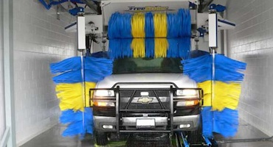

Figure 3.1: Simply Sprays on Your Vehicle and Then Wipes it off with a Micro fiber Towel

There are not a ton of car wash tools that actually save water, but there are methods to conserve water while keeping your car clean. As far as products go, there is a waterless car wash spray that can be used on a moderately dirty car. It is not always necessary to give your car a full wash, so a using a spray can save water. Simply spray on your vehicle and then wipe it off with a microfiber towel. This type of spray gets good ratings from both experts and consumers. As odd as it sounds, using a car wash actually uses less water than doing it at home. It is also more environmentally friendly, because all of the waste-water is sent directly to a water treatment facility.

3.2.12 How to Use a Manual Car Wash
A manual car wash or a self service car wash is a coin operated system that enables you to wash your car. This system has an open bay, a coin operated dial, a pressure sprayer, a timer and an area to vacuum the interiors of your car.
- Since manual car washes are coin operated, it’s important you carry a lot of coins with you. Besides coins, you should also carry nonabrasive towels.
- Also familiarize yourself with the dial. The dial will list the stages of the wash such as pre-soak, soap, wash, foam brush, rinse and wax.
- When you are ready, put coins in the coin slot and turn the dial to the stage you want to start from.
- To pre–soak, wait for the water to start flowing and use the spray to wash the dirt off your car and off the car mats against the wall.
- Subsequently, soap your car with the high pressure soap spray. You should start from the top of the vehicle and go downwards. It’s also best to complete work on one side before moving over to the other side. You should remember to spray each wheel particularly inside the wheel wells.
- Activate the foam brush and use the brush to wash the car. You should try to wipe the soap suds with a rag as the brush moves.
- Once the car has been washed, turn the knob to activate the high pressure rinse system and start rinsing the soap off the car’s surface. Once again, it’s best to start from the top and work downwards.
- Since your car is wet, it might be a good idea not to wax it, but to drive it out of the car wash bay area. You can then start drying your car using the towels you have brought with you. Like the rinsing and washing, start drying your vehicle from the top. The wheels should be dried as well.
- To finish off, go to an area of the car wash where there are facilities to vacuum and clean the interiors of the car.

By using a manual car wash, you can be assured of a clean car that looks its best. Car washes are popular, as washing your car at home involves a lot of hard work. Whereas manual car washes offer the convenience of automatic car washes at a fraction of the cost.

3.2.12.1 Some Disadvantages of Using Hand Car Washes

Washing Your Vehicle By Hand (Scrubbing With Sponges And Brushes) Actually Produces Tiny Scratches In The Paint. This Is Caused By Fine Particles Of Dirt, Sand And Silt That Become Trapped In Your Brush Or Sponge. By Car Washing At Home, You Are Actually Degrading The Finish.
- The Scratches Produced By Washing With Brushes And Sponges Can Be As Deep As 10% Of The Thickness Of The Paint. Auto Brushless Or Touch Less Car Washes Use A High Pressure Spray Of Water To Remove The Dirt Off The Surface Before It Is Washed, And The Materials Used To Clean The Surface Of The Vehicle Are Continually Being Rinsed To Prevent Any Accumulation Of Grit.
- Weekly Cleaning Helps The Finish Last Longer, Because Dirt Traps Moisture Against The Vehicle’s Finish And Promotes Rust. Cleaning A Car’s Finish Weekly In An Auto Touchless Or Brushless Car Wash Environment Can Eliminate The Corrosive Actions That Dirt, Salt And Pollution Can Create, Which Will Help Keep Your Car Looking Good And help keep the resale value up.

3.3 Empirical Literature

3.3.1 The Concept of Car Wash
A car wash (also written as "carwash") or auto wash is a facility used to clean the exterior and, in some cases, the interior of motor vehicles. No matter what happens, it is likely that as long as there are cars, there will always be a need for car washes. Fun Fact The world’s first car wash opened in 1914 in Detroit. It was called “The Automated Laundry.” Stat Fact According to recent data derived from a variety of industry sources; there are approximately 90,000 car washes in the United States. In 2013, there were approximately 113,000 car washes in the United States. As long as there are cars on the road, there will be a need for car wash businesses. Depending on factors, such as location and weather, a car wash can be a lucrative business for a budding entrepreneur. www.eynacarwash.com Accessed on 11/03/2016

3.3.2 Role of Car Wash Services in Income Generation
There is a parallel increase, as the number of cars on the road continues to increase the need for car wash businesses should also increase, according to the International Carwash Association website (ICAW). A car wash can also be a good business for someone who enjoys working with his hands and enjoys working with the public. Anyone can make money running a car wash!” you might have thought. Many people think a car wash is a great business opportunity because they see it as a business that doesn’t require a great deal of hands-on work but that still produces a great return on your investment.

A car wash can be a good business for an entrepreneur with little previous business experience. According to the International Carwash Association, 37% of car wash owners have owned their business for less than five years in USA. According to a survey in Auto Laundry News, profits can range from $55,000 to $100,000 per year for a self-service car wash; also can range $500,000 to $900,000 for a full-service business. The trend in this business is offering extra services. For example, you can sell car spare parts and lubricants alongside other motor vehicle accessories. You can also set up a shop selling snacks and drinks as well as the more usual air fresheners and key chains. This is a business that can be combined along with others. For instance it works very well with a petrol station, entertainment joints, among others. Also you can offer carpet cleaning services. (International Carwash Association www.eynacarwash.com) accessed on 13/03/2016

Starting a car wash is one of the easiest and low cost types of business. This is a business venture that can be started with just a bucket, soap and washing cloth at the bank of a river. However if you desire a more professional service in the urban areas, you’ll have to have higher standards. One of the most important aspects of starting this business is location. You need a convenient location that has some space mostly around residential areas. For those with large capital can invest in an automatic car washing machine. This type consisting of a machine that literally “rolls over” a stationary car parked in a washing bay. Waxing: you can also offer waxing services mostly targeting the top of the range vehicles (ibid).

Finally, a nation's development should be people-centred, based on sustainable and shared growth and be free from abject poverty. For Tanzania, this development means that the creation of wealth and its distribution in society must be equitable and free from inequalities and all forms of social and political relations which inhibit empowerment and effective democratic and popular participation of social groups (men and women, boys and girls, the young and old in society by the year 2025, such that economic activities will not be identifiable by gender, race. law, politics, employment, education or culture and will have been reformed.(URT,2010).

3.3.3 Car Washes in MDCS’ and How Can Reduce Poverty
In most developed countries in different areas will demand different types of car washes. While an affluent neighborhood may have a greater market for full-service car washes, a moderate- to low-income area might have greater market demand for in-bay automatic or self service car washes. In short, you must match your services with the demands of the neighborhood in which you’ll do business. Beyond these basics, there are the factors that determine the success of any business—how successful you are at marketing and selling your services, keeping costs under control, hiring quality employees and so on. Here are some general guidelines for the profit potential of the four types of car washes we’ve mentioned:
- Full-service car wash: $500,000 to $900,000 per year
- Exterior-conveyor car wash: $125,000 to $500,000 per year
- In-bay automatic car wash (a “3 and 1” combination of self-service and in bay automatic wash bays, discussed in Chapter 4): $75,000 to $125,000 per year
- Self-service car wash (assuming a four-bay, self-service facility): $55,000 to $100,000 per year Now that you know the basics of the car wash industry, it’s time to move on to the nitty-gritty of running and building your business.

For those with large capital can invest in an automatic car washing machine. Therefore, this is profitable business to MDCS’. http://www.entrepreneur.com/ downloads/guides/1076_Car_Wash_08_ch1.pdf

3.3.4 Contribution of entrepreneurship on economic growth and development
Reinforcement on promotion of small enterprises including small industries development put in place under the Small Enterprise Policy which intends to prioritize small business in the county plans (Shaidi 2006). The purchase of Pressure washer car wash machine project which is planned to be used at Buswelu centre, this will be the modern car wash for income generating activities (IGA) revised Youth Policy of Tanzania of 2007 under the youth development. The project is also in hand to hand with Millennium Development Goals (MDG) 2015, the MKUKUTA II under the section of poverty reduction. MKUKUTA II builds on the predecessor Strategy (MKUKUTA I), it is more oriented towards growth, and give better productivity, with greater alignment of the interventions towards wealth creation as way out of poverty (URT, 2010:2)
It also in line with the Tanzania five years Development plan (2011/12-2015/16) as well as the Nation Development vision 2025, focusing on poverty reduction through SMEs involvement. However, with the basic issues in the development Vision are elaborated, which focus on increasing production and market availability for the products. These objectives are mainly deal with economic issues, and also increasing involvement of the people in working for their own development. The thrust of these objectives is to attain a sustainable development of the people with high quality livelihood. Therefore, the car wash project is hereby as a driving force towards successful of poverty reduction goals and creates self employment through those strategies. VISION 2025.

3.3.5 Problems that Hinder Youths Empowerment
According to (URT,2007), and the Integrated Labor Force Survey (2001), Young people who constitute about 65 per cent of the total labor force, and require economic enfranchisement and equitable access to resources that provide a solid economic and material base for their development. One of the key resources is land. Young people have limited access to land ownership. Customary practices discriminate young ones to own and even to inherit land. There is limitation on equity of resource allocation and capital accessibility for youth development, which affect their effective participation in economic activities.

On the other hand, the major challenges facing youth are the same viewed by Simon Amenya et al; (2009) Young people are provoked to start their own business with small capital, this is due to the chance of finding jobs in the current labour market is very limited, however, lacking of support on sustainability governed by other factors such as, availability of investment capital, risk absorption capacity, and lack of know how in terms of financial management, enterprises development and market accessibility (Juma .A 2007). The ineffectiveness of enforcing regulations with respect to registering, monitoring and coordination of labour migration poses a serious challenge for Tanzania to provide employment opportunities for its youths.

According to (Ngowi et al., 2014) Access to finance for youths is very challenging in the context of accessing the available funds for initial capital, particularly in banks. Youths entrepreneurs (aged 15-24) do face more challenges most of the time compared to mature people. Some of the challenges are as follows and more others: Required to have formal business with license and address, Required to have good, business plan, Required to have collateral, most also fixed asset, Required to have business transactions documentations such as sales, sales revenues, profit and loss, Required to have good referee, Required to pay for loan fees, Need to get approval of male members of the family (family head) before accessing a loan to financial institutions.

According to (Jonathan, 2014) attests that “Despite of the increased role that youths are playing in the growth and development of the nation’s economy it is depicted that development programs totally not involved to the need of this special group”. In Tanzania the government and other stakeholders has taken tremendous efforts to empower youths and other vulnerable groups, but they are still facing major challenges in accessing employment opportunities in many sectors. The other challenges are on how to facilitate access to information and technology to the majority of youths especially those in the urban setting (URT, 2005).

The United Nations, since its inception, has continuously called for the increased participation of youth. Historically, youth participation has been very limited. However, recently it has gained momentum and they are now seen and heard at various levels of the UN. Youth from all parts of the world participate not actively in all relevant levels of decision making processes because this affects their lives today and has implications for their lives today and in futures. Moreover, they should establish mechanisms that permit youth access to information and provide them with the opportunity to present their perspectives on government decisions for their destiny, (UN 2002).

The major problem faced by many youths today is lack of enough capital to run their business. The income poverty has said to be the urban phenomenon whereby majority of people are concentrated on small business by using little capital and poor transport. Household’s consumption reports have been mainly used in establishing poverty status by matching it with the established poverty lines in the particular time. Expenditure pattern tend to be more stable than income and commonly used as the best indicators of income poverty. The term income poverty has been used throughout since it is in more common usage than the more technically correct consumption poverty (URT, 2005).

3.4 Policy Review
The Ministry of Labor and Youth Development (MoL) is in charge of implementing the National Employment Policy, sanctioned by cabinet in April 1997. This policy revisits the state of wage employment in Government, parastatals, and the private sector and self -employment in agriculture and the informal sector. The National Employment Promotion Service Act was passed by Parliament in 03/1999. Special attention was given to the employment implications of micro and small enterprise development. Tanzania Youth Policy, the National Youth Development Policy (2007) defines a youth as 'a boy or girl who is in transition from childhood to adulthood'. The policy adopts the definition of youth as declared by the United Nations, which defines a youth as a person aged between 15 to 24 years. The analysis of youth employment is based on this age group. Some policies of its different kinds have been formulated for dealing with the purposes of addressing youth’s empowerment. Some of them are as follows;-

Youth’s Development Policy (2007) mainly focuses on economic empowerment of youths and eradication of poverty and hunger as one of its four main areas of focus by the government of Tanzania through the National response of Micro-Finance Policy, as regards the MDGs for Action. The policy has enabled mainstreaming of youth concerns in the other Government Policies like the National Health Policy, the Education and Training Policy, the Labor Development Policy and Youth Development Policy included. Contemporarily, every efforts took place in Tanzania should focus on the National Development Vision of 2025.

The policy envisages alleviating poverty for all Tanzanian by 2025. Minority of Tanzanian still residing in urban areas (25%) in which its major economic activity is small enterprises. To realize the National Development Vision deliberate and conscious efforts should focus on Youths development. The envisioned status of Tanzanians is substantially developed one with a high quality livelihood. Under this vision, by 2025 abject poverty will be a thing of the past.

In addition, Tanzania Development Vision 2025, one of the strategies is Poverty Eradication Strategy, MKUKUTA which was accompanied with some policies and national strategies: The National Employment Policy; The Youth Development Policy; The Local Government Reform Agenda; National Population Policy; Small Enterprise Policy and MKURUBITA for Tanzania Zanzibar. The Youth Development policy and the Nationals Employment Policy are currently under review to take into consideration the globalization and National Vision 2025 Poverty Reduction Strategy is in place.

The National Youth Development policy of 2007 focuses on youth development issues which include; economic empowerment, environment, employment promotion, youth participation, H1V and AIDS, gender, arts and culture, sports, adolescent reproductive health and family life issues. Youth Development is a crosscutting issue, which requires multi-sectoral approach for effective implementation. The National Youth Development Policy will therefore depend on successful mainstreaming of the youth development issues in Ministries' policies and other stakeholders development programs.

However, different policies identify strategies to address the problems of youth unemployment. According to the Millennium Development Goals (MDGs) which are eight international development goals that were established following the Millennium Summit of the United Nations in 2000, one of them is to eradicate extreme poverty and hunger, following the adoption of the United Nations Millennium Declaration. All 189 United Nations member states at the time (there are 193 currently) and at least 23 international organizations committed to help achieve the Millennium Development Goals by 2015, the Youths who are majority in LDCs Tanzania included.

Furthermore, Tanzania as a country has signed various rules that protect and fight youth’s rights, such as the right of education. Right of protection, Avoid of hard works and more others. Also other efforts are being made to assist Youth to acquire good standards of life from their activities they are doing. They are obliged to access internal and external markets like Street vendors Complex in Dar-es-salaam. Various credit facilities targeting youths have been initiated. Some of them are the Youths’ Development Fund (YDF), which is supported by the government administered by the local councils. The fund provides credit to Youths for total of 114 Local Councils of mainland Tanzania. There are also other Funds, established by different stakeholders, which are geared for vulnerable youths. These include; promotion of urban initiative and development enterprise.

The National Micro-Finance Policy (2000) provides guidelines to achieve gender equity in accessing financial services in order to empower women economically. It directs that special efforts be made to incorporate mechanisms that would make the services accessible to both women and men. The Policy also gives flexibility in regulating micro-finance institutions including specialized and non-specialized banks, urban community banks, like Bank of Africa (BOA), Exim Bank, Equity Bank, SACCOS, NGO’s and other private owned financial institutions. Those few institutions provide credit to youths provided are in groups also terms and conditions that can be adhered by youths. Although the policy has been able to explain various things it has it’s complications for implementation.

The National Youth Development policy (2007) reveals that, young people have limited equitable access to resources that provide a solid economic and material base for their development; however the issue is more critical to young ones they are not allowed to inherit land. The policy directs a promotion of equitable access to land and other resource allocations. Emphasis shall be put on rural youth and gender equity, Nevertheless there is limitation on equity of resource allocation and capital accessibility for youth development, which affect their effective participation in economic activities. The policy directs that there shall be an affirmative action by the ministries of concern to allocate funds which will enhance satisfactory direction with a view of having sustainable funds, to support youth with specific focus on their income generating activities. Also there shall be mechanism to promote the establishment of youth friendly credit support services and empower youth on credit.

According to (URT, 2007), and the Integrated Labor Force Survey (2001), Young people also lack skills on marketing and production of quality products. The Policy Statement states that “There shall be a promotion of equitable access to land and other resource allocations. Emphasis shall be put on Small and Medium Enterprise Policy, but this is not practical to youth in urban areas. This was proved by the leader of youth Mr. Jumanne at Ilemela District who said ‘there is no land even a small one which has been located by the local council for youth’’ (April, 2016).

3.5 Literature Review Summary
Street youths are amongst the most vulnerable of vulnerable youths believing that life on street is better than life at home. In reality, they face hardships and risk, and at last they end up in stress or depression, the main cause is economic instability. Adilisha (2008), for years now, Mwanza city has been faced with a problem of street youths. These youths roam the street of Ilemela town (Buswelu centre included) and encounter many problems in each day for their survival. Some of difficulties in life (lack of basic needs) lead the youths to run away from the home environment because of their hardship life they face. According to UNICEF, the number of street youths who have vulnerable life had increased from 100 million in 1989 to 150 million in 2000 Worldwide (UNICEF 2002).

Today every country in the world, especially those in the south, is said to be experiencing and witnessing a rapid increase in the number of street youth as well as the negative environment in which they live. One of the African countries which have witnessed a tremendous increase in unsupervised youths either living alone or working alone in urban streets, is Tanzania. This social problem is especially acute in big cities, like Dar es Salaam, Arusha, Mbeya and Mwanza whereby, the rate of urban population growth has been exploding. The rapid population growth has been associated with an increase in the number of youths living alone on urban streets or spending most of their lives on the streets for their survival caused by lack of employment.

The number of most vulnerable youths has been increasing in Tanzania daily. It was estimated that the total number of vulnerable youths increased by 28% from 749, 203 in 2007 to 1,044,096 in 2010. Also by the end of 2009, more than 700,000 youths had been identified as ‘most vulnerable’ following a criteria and identification process implemented by communities (UNICEF, 2009).Data from the Tanzania HIV/AIDS Malaria Indicator Survey (THMIS) of 2007/08 estimated that orphan hood has increased from 11% to 17.6% of all Youths.

Most Vulnerable Youths are more common in areas (town setting) and highly deprived areas. The reason for the increase is due to increase in HIV/ AIDS, economic instability hence, poverty in the society. In response to this the researcher decided to establish a project which will enable the Vulnerable Youths at Buswelu centre to be empowered economically, instead of being beggars’ in streets and self dependent, through this they will increase their income which will help them to curb income poverty hence Vulnerable Youths problem solved.

The government of Tanzania has engaged in several efforts to deal with the issue of Vulnerable Youths such as signing some polices the Social Security Policy of Youths 2007 by developing and implementing a national strategy for social security (Poverty Reduction Strategy) and Protection for Vulnerable Youth groups (VPO, 2005). Some of these policies include: The Education and Training Policy (2014); Technical Education and Training Policy (1996); National Youth Development Policy (2007); National Employment Policy (2008); National Small and Medium Enterprises (SME) Policy; and the National Sustainable Industrial Development Policy (1996).Tanzania has continued to work towards: Raising awareness to the public on youths rights violations, especially unemployed Youths.
Other efforts include loans from financial credits when they form groups. The vulnerable youths National Casted Plan of Action of 2007-2010 (Phase I) and 2013-2017 (Phase II). Despite of all these important efforts taken by the Tanzania government to cater the issues of Vulnerable Youths’ problem, in fact various programs have been implemented by the government at different levels, minimizing the problem of unemployment of Vulnerable Youths’ within the Town communities, still the problem exist as it was also at Buswelu centre.

The programs were faced by many challenges like lack of land occupancy, lack of capital to start the project among of many others in its implementation and thus their impacts have not been realized. The most vulnerable youth programs also have been reported to have little evidence of their impact, poor participation of youths in the identified process, uncoordinated, lack of monitoring and evaluation of the services delivered to vulnerable intervention mainly focused on social protection and only few deals with preventive and promotion of social protection. Socially welfare youth were also affected, for example, in 2009, implementation of the National

Action Plan on Care Services, Training and Protection for Vulnerable Youths continued, whereby vulnerable youths were identified in 85 councils compared to 81 councils in 2008. A total of 746,183 Youths were identified up to 2009, of which 388,015 or 51.9 percent were boys and 358,168 were girls. A total of 39 people with disabilities completed vocational and entrepreneurship training program in government colleges in 2009 compared to 305 people in 2008. (URT, 2009). This shows that the group is much ignored in the community.
Those data reveals/ proves that less effort has been put in the issue of Unemployed youth. All the above literatures reviewed; do acknowledge that the Youths has been left away, ignored and segregated by the government, stakeholders, well-wishers and communities hence it needs co operative efforts to support this special group. Initiatives should first emanate from the community and then to the local government, town council, government without forgetting the stakeholders.

CHAPTER FOUR

4.0 PROJECT IMPLEMENTATION

4.1 Introduction
Implementation plan is a plan design that indicates the table of activities, resources required to implement the project and responsible persons who will execute the activities. Also the implementation plan shows the sequence of activities and time that will be implemented. The purpose of the project is to improve quality of life of Buswelu ward community members especially youths. The overall objective of the project is to provide knowledge and skills of hand and pressure washer car wash its operation and maintenance for owners and users/ clients by the end of June, 2016. Project implementation was participatory in nature involving target group, stakeholders as well as a researcher. The implementation of the project begun in January 2016.The project planning involved CNA and situational analysis of the (KUVM) to identify capacity building gaps hence prepare an implementation plan to address the gaps which were identified.

The chapter documents the project plan through a logical frame work analysis, the actual implementation that took place and the project Gantt chart. Therefore this chapter represents the actual work done in implementing the project and describes what was supposed to be done according to the plan, what have been done and report what was accomplished. Future more, the chapter describes in detail the project, which was to be implemented, it shows planning schedule and activities that had to be implemented. It itemizes expected and actual products and outputs and staffing pattern.

4.2 Products and Outputs
During the preparation of the implementation plan a list of output indicators describing project activities were also developed according to specific objectives. Such list of indicators was important in the process of measuring the desired success.

4.2.1 Project Products
The major product among of many others is livelihood improvement of (KUVM) members at Buswelu centre. However, products expected are as follows;
- Creation of employment to KUVM.
- Increased income to primary stakeholders.
- Improved life standard of KUVM.
- Improved cleanliness to many cars.

4.2.2 Project Output
The project is expected to accomplish the following outputs by the end of 2016. This includes;
a) Primary stakeholders skilled in both hand pressure car washing services.
b) Car ash owners skilled in business and handling.

C) Primary stakeholders self employed as car washers
c) Car wash owners and community equipped with knowledge of the importance of car wash storage and handling.
d) Good networking between car washers and consumers of car washing services

4.3 Project Planning
Project planning is a discipline for stating how to complete a project within a certain timeframe, usually with defined stages, and with designated resources. In this section shows project implementation plan, inputs needed to accomplish activities, the staffing pattern of the KUVM and project budget which will enable the project to be implemented. Not only have that but also logical framework and budgeting parted of planning process. Project planning generally consists of; identifying deliverables and creating the work breakdown structure, identifying the activities needed to complete those deliverables and networking issues and the activities in their logical sequence, estimating the resource required, time and cost for activities under taken.

4.3.1 Implementation Plan
The participatory planning of the project was done by the MCED student in collaboration with KUVM members and different stakeholders in the community to provide their views on how the project was supposed to be implemented; a work plan shows a number of activities to be conducted within the located time also available resource, and the person responsible for each project objective. The project work plan was participatory in nature and the approach prepared by involving different stakeholders, and others people were consulted to provide their views on how the project was supposed to be implemented.

In short the project implementers were (KUVM) members, NGO members, VEO, WEO, and District leaders and others developmental institutions. The CED student was collaborating with all project implementers in planning, implementation, monitoring and giving advice to the right direction on how the project should take off. Table: 4.1testifying the implementations plan.

Table 4.1: Project Implementation Plan
Objective | Activities | Resource/  Input | Responsible  Persons | Time  Frame
To conduct training on 12 car washing project by April, 2016 | To conduct training on;  - Effective car washing  - Car wash overhead  - Proper detergents for car washing  - Car wash chemical management | -Transport  -Funds  -Stationeries  -Training  materials  - Experts costs | CED  Students,  Trainers  ATAPE  NEMC | April -  June,  2016
To conduct training on entrepreneurs skills for 12 KUVM members by May, 2016 | To conduct training on;  -Car washing requirements, e.g. Brushes, soaps  -Steps in car washing,  -Handling of the car washing machines,  -Precautions to be taken when washing,  -How to operate the machine. | Transport  -Funds  -Stationeries  -Training  materials  -Experts/NEMC costs | CED  Students,  Trainers,  ATAPE  NEMC | May-  June,  2016
To establish car wash project by May, 2016 | -electrification of the site  -installation of car washing equipment  -acquiring a license  -procure the necessary consumables  -Environmental issues/ ( NEMC  -Construction of Car wash site  -Building /set-up the car wash house  -purchasing Pressure washer pump  -sewage system  -water installation | Transport  -Funds  -Stationeries  -Training  materials  -Experts/NEMC costs | CED  Students,  Trainers,  ATAPE  NEMC | May-June,2016
To establish reliable market of car washing of KUVM by June, 2016 | To conduct train on  - Preparation of marketing tools such as brochures, radio adverts etc  - Identifying potential customers  - Distributing brochures and paying for the adverts to reach potential customers  -Sensitize them on the benefits of regular car washing | Transport  -Funds  -Stationeries  -Training  Materials  Trader officer  -Experts/NEMC costs | ATAPE, WCD Officer ,SIDO Business officer and VEO | May-June,2016
Source: Survey, 2016

4.3.2 Inputs
The inputs of project implementation involve various things, such as materials resources, financial, time and human, were employed to meet the expected planned goals. Human resources were experts from Ilemela LGA, field officer from Buswelu SDA Church and KUVM chairperson from Buswelu centre. The inputs required for accomplishing the above planed objectives and activities are shown in Table 4.2.

Table 4.2: Project Inputs
Inputs | Cost ( Tshs)
Trainers cost | 80,000
Training costs | 903,000
Training venue | 100,000
Training materials/manual | 130,000
Purchasing &Transport of Pumps for car wash from one place to site | 1,300,000
Car wash construction & materials purchase | 2,795,600
Total input ( costs) | 5,178,600

Source: Survey, 2016

4.3.3 Project Logical Framework for a Car Wash Services
Logical framework is a management tool for effective planning and implementation of developmental projects. It provides clear, concise and systematic information about a project through a framework. We know about various components of a project such as goal, objectives, activities, results and indicators concerned. The Logical framework helps in connecting all these components in one framework, presenting the clear relationship between these components and leading to the achievements of the expected results. It is also widely known as Goal Oriented Project Planning/ Objectives Oriented Project Planning. Logical framework for Car wash services project were tools for concisely describing the results of project design process, as it gives a summary in a standard form as follows:-
- What the project is going to perform & achieve
- What activities will be involved in the project
- What are resources or inputs (human, technical, infrastructural) are needed
- What are predictions/ potential problems could affect / hinder the success of the project to take off
- How the progress and success of the project will be measured and verified

The details on activities, inputs (resources) and outputs are described in the project logical framework (Table 4.3).

Table 4.3: Logical Framework Matrix
Summary of Objectives and Activities | Objectively Verifiable Indicators (OVI) | Means/Source of Verification (MOV) | Assumptions
Goal: To train target group proper ways of car wash business, handling and Maintenance. | Car wash handling, Maintenances and quality  Services | - CBO reports  - Observation | -Successful  implementation of the car wash  Project business.
1. To conduct training on car wash to 12 youths in Buswelu by February, 2016. | (i) 12 members of CBO group trained on Car wash services  (ii)Skills on effective car wash handling.  (iii) Skills on car wash overheads  (iv) Skills on proper detergent use for car washing  (v) Skills on car wash chemical management | -Survey/ Observations  - CBO reports & trainers reports | - Youths are willingly to form group.  - Fund available.  - Target group attended  Training.  - Active participation of  target group
2. To establish car wash project at Buswelu centre by May 2016. | (i)Most number of participants attended & participated in training  (ii) The high income of car wash.  (iii)Number of car wash services materials constructed  (iv)Number of some car wash material purchased | -Trainers/ CBO report  - Observations  - Interview | -Target members are willing to attend training  -Availability of training materials  -KUVM members are willing to participate
3. To establish a reliable market of Car wash services rendered by KUVM members by June 2016. | (i)More services offered and sold at the market by KUVM  -High quality services of car wash |  | -Availability of Customers,  - willingness to buy /get the services  -Good services offered
Expected outputs  1. Effective use of Car wash, handling and quality services.  2.Good and genuine machines.  3.Increased quality of washing.  4.Innovative,initiative attitudes | 1. High income to target group  2. Increased sales turnover  3. Customer care improved.  4. High quality of Car wash services offered to customers. | 1. Interview with group members.  2. Interview with customers.  3. CBO financial report  4. Observation and interview with customers  5.improved sewage systems  And water recycling. | - Training objectives achieved.  - Qualified staff employed.  - Brushes & soaps facilities  Purchased
Activities  1. To train the target group on Pressure pumps car wash.  2. To train target group on better handling & running of car wash.  3. To train the target group on methods of improved way of car wash services.  4. To conduct training on entrepreneurship & marketing skills in relation to car wash business.  4. To train target group on the basic  principles and practice of entrepreneurship | Inputs  1. Training venue  2.Trainers/facilitators  3.Transport  4. Stationery  5. Food and Refreshment  6. Training materials  7. Accommodations  8. Training manual  9. Funds  10. Facilitators cost | 1. Cash Sale receipts.  2. Receipt voucher.  3. Delivery Note  4. ledger | - Availability of financial resources to pay trainers/ facilitators.  - Positive participation in  Training of target group.  - Availability of resources to  Cater training costs.
Source: Survey, 2016.

4.3.4 Staffing Pattern
The project has five voluntary staff being a program coordinator, program accountant officer, Technical officer, M&E officer, and field officer .Ilemela Municipal offered the land as project site. The project implementation was getting high support from community development department, cooperative and Trade and market department and Human resource department.

Table 4.4: Staffing Plan and Training Needs
No | Position | Duties /Supervisory Roles |  | Training needs
1 | Chair person | - To ensure the Management Committee functions properly  - To ensure the project/ group is managed effectively  - To provide supervision to the project  - To represent the group as public relations  - To call special meetings of the group where appropriate  - To review and sign minutes of group meetings/KUVM  - To act as Chairperson for meetings of shareholders | - Skills of leadership  - Job descriptions
2 | Vice Chair Person | - To assist the chair person  - To serve as chair person in the absence of the chair person  - To take the important role in monitoring the implementation of the project strategies | - Job descriptions.
3 | Secretary | - Ensuring meetings are effectively organized and minute  - Maintaining effective records and administration  - Upholding the legal requirements of governing documents  - Communication and correspondence issues | - Responsibility of the secretary.  - Accountability  - Recording & Keeping
4 | Vice Secretary | - Directly assist the Secretary in all matters pertaining the group issues | - Job descriptions.  - Responsibility
5 | Treasure | - To maintain an overview of the project financial status for all transactions and  - To ensure that proper financial records and procedures are maintained | - Financial skills.  - Accountability  - Book keeping  - Business management
Source: Survey, 2016
Also the project has more support from the municipal council office of youth’s development department and the office of land department and CED Student for technical knows how. For effective and smooth running of the organization, no salaries are provided by the group to the leaders, each member of the staff adhered his or her responsibilities and duties as described in Table 4.4.

4.3.5. Project Budget
A project Budget is the total amount of authorized financial resources allocated for the particular purpose(s) of the project for a specific period of time. It is the primary financial document that constitutes the necessary funds for implementing the project and producing the deliverables. The budget planned for the Car wash project was T. Shs 5,178,600.

Table 4.5: Project budget
Activity | Budget (T.shs)
Identification of training needs | 35,000
Preparation of training materials/ manual | 130,000
Identification of training resources (Human and financial resources) | 40,000
Identification of training venue/hiring | 100,0000
Acquiring required training resources | 45,000
Meeting with target group leaders to discuss and agree the training schedule | 55,000
Trainers costs | 80,000
Purchasing materials and Construction of Car wash site | 2,795.600
Conducting training on maintenances, Car wash installation & handling. Keeping records & running car wash business. | 325,000
Conducting training on installing system of Car wash business. | 85,000
Purchasing facilities of car wash business. | 1,300,000
Conducting training on the concept of marketing and  Entrepreneurship skills. | 120,000
.Designing/ Disseminate of advertisement through posters and local Radio PM & E | 68,000
Total budget | 5,178,600
Source: Survey, 2016
Ilemela municipal council contributed a total of Tshs 2,661,800/= as photocopying and training venue cost and some building materials while T.Shs 1,876,800/= was contributed by Buswelu SDA Church, T.shs 12,000/= WEO office T. Shs 1,000,000/= solicited from well-wishers and T.shs 520,000/= contributed by KUVM. However the fund obtained were expected to be enough for the completion and implementation of the planned project activities as per work plan as stipulated in Table 4.5.

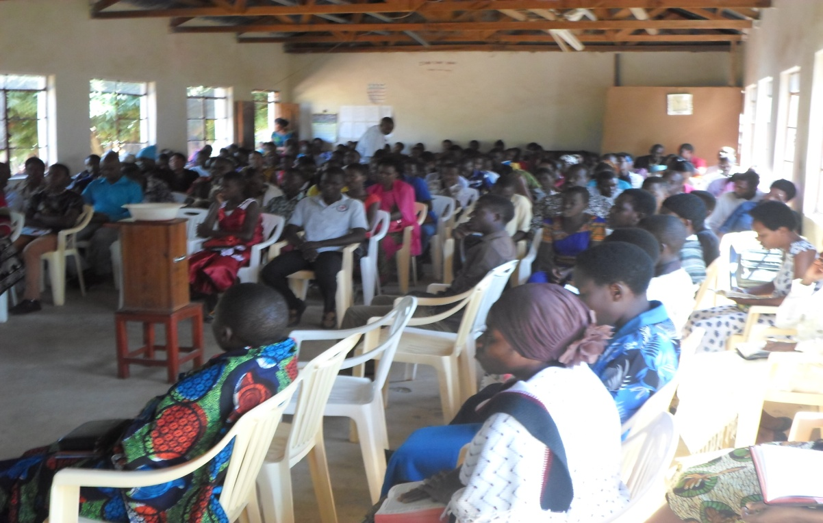

Figure 4.1: Church Members Solicit Fund for KUVM Youth

The Buswelu centre meetings were organized for sensitization of the community members about the project and mobilization of Kikundi cha Umoja wa Vijana Maendeleo (KUVM) to establish the Car wash services project. The program/activity was done by the CED student who was in charge/ researcher for this project. Figure 4.2 below community awareness.
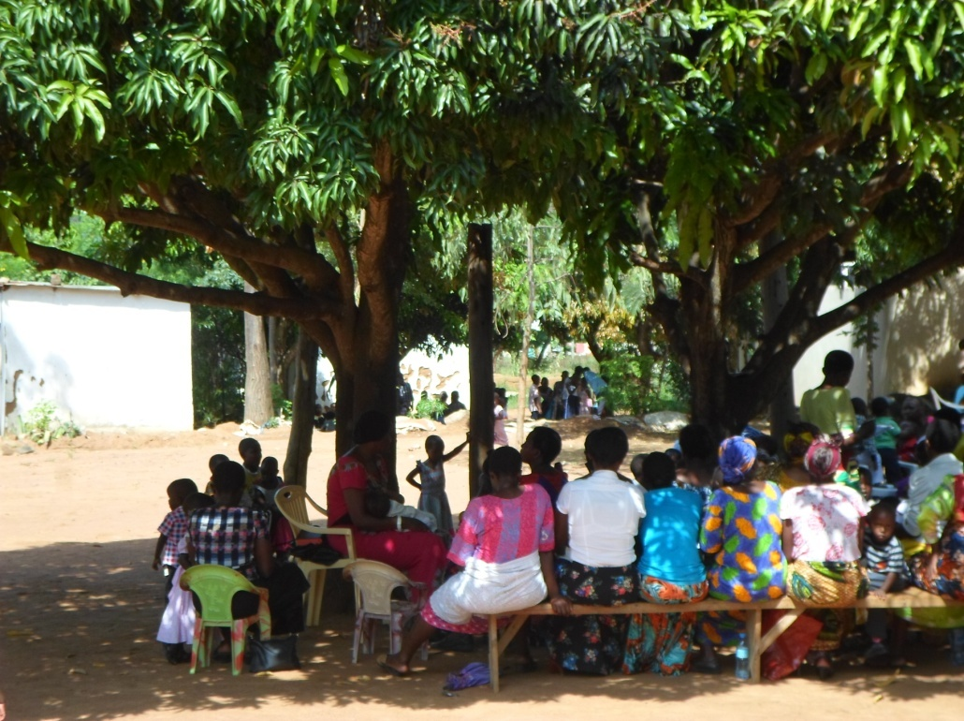

Figure 4.2: Community Sensitization Meeting With the Chair Person Speaking
Source: Survey, 2016

Formation of a group of 12 urban youths was organized and formed a group which will be the key in dealing with the project. CED student was there to assist the urban youths to form entire group. See the members of Kikundi cha Umoja wa Vijana Maendeleo{KUVM}.
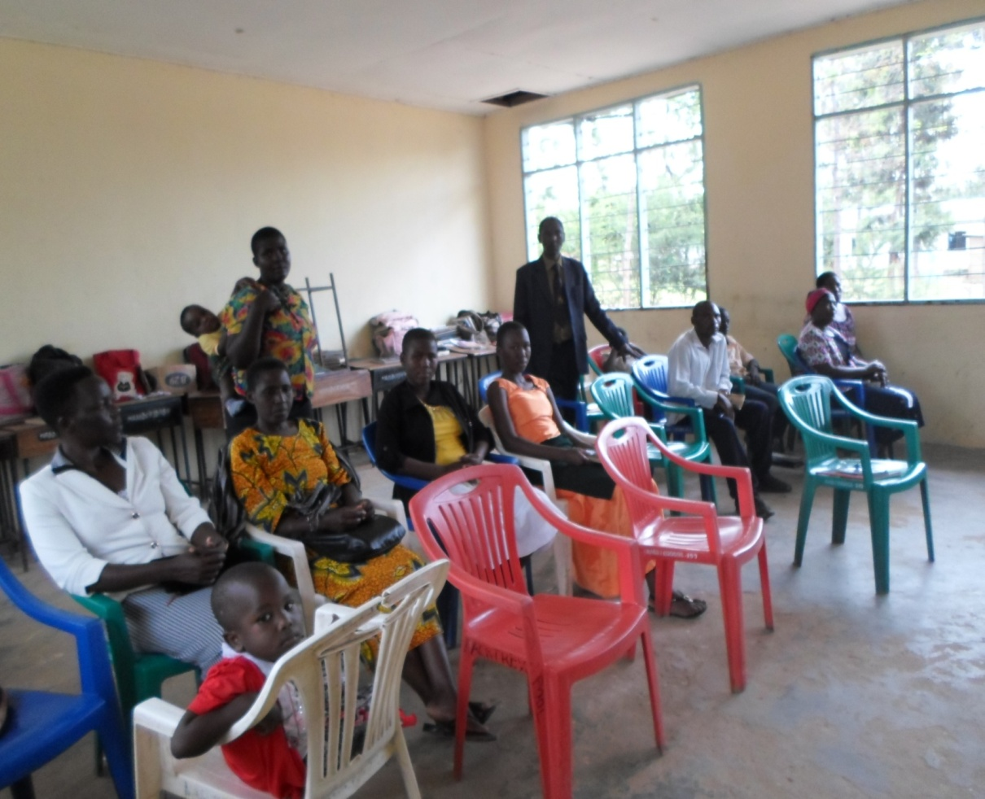

Figure 4.3: KUVM Members with CED Student During The Formation of Group
Source: survey, 2016
Formalization and selection of leaders, after the group being reformed, members decided to run it officially by the name (KUVM) members and they have opened up the bank account. The CED student assisted the group to reform a group constitution and connect them to District Council. Training manuals were prepared to be used for training. These manuals were entrepreneurship education training manual and Car wash services training manuals. The CED student monitored the activity which was done by the community development officer and Trade District officer. Community development officer prepared Entrepreneurship Education Training Manual and Trade Officer prepared Car wash services Training Manual. In fact two manuals were prepared for catering the intervention of car wash services in urban areas.

Conduct training, this was the 03 days training of which the CBO Group was trained on entrepreneurship skills and how to run the car wash services. The members were imparted skills on how to run the Car wash services project as well to be good entrepreneurs. Some topics and sub-topics of their kind were taught including how to develop a business plan, set up the business and managing it and carrying out a market research. In short all the above make the sustainability of the project.
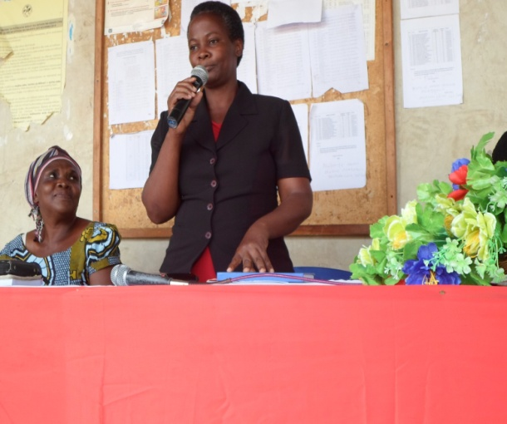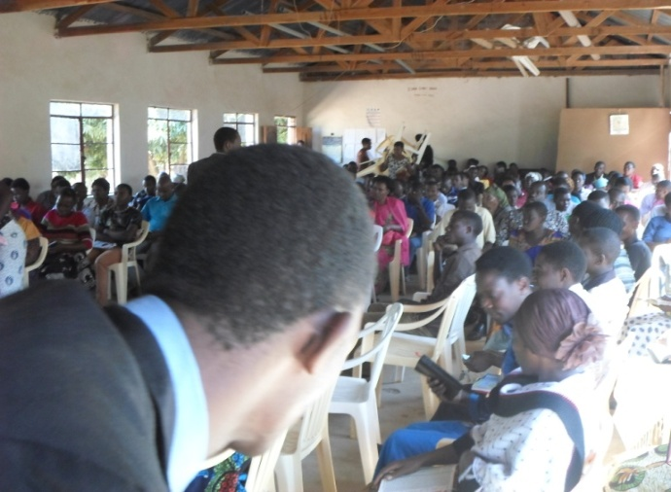

Figure 4.4: Youths During Entrepreneurship Training (Group discussion)
Source: survey, 2016
The Construction of car wash site, two technicians was hired to construct one site for Car wash services. The site was ready to be used for Car wash services purposes. To purchase two Pressure Washer Car wash were purchased ready to start the business of Car wash services. There are various ways to reach your clients and market your business. Word-of-mouth is the fastest and most effective, although you can also place classified pumps according to your power purchase. These 2 pumps below are some of among 08 types of pressure washer car wash. They use both diesel and petrol fuels. Each one cost of T.shs 600,000/= and 400,000/= respectively. This added the business value and Services:
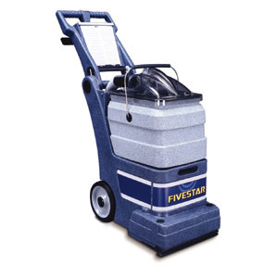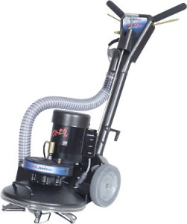

Figure 4.5: Fastest and Most Effective Pressure Washer Car Wash

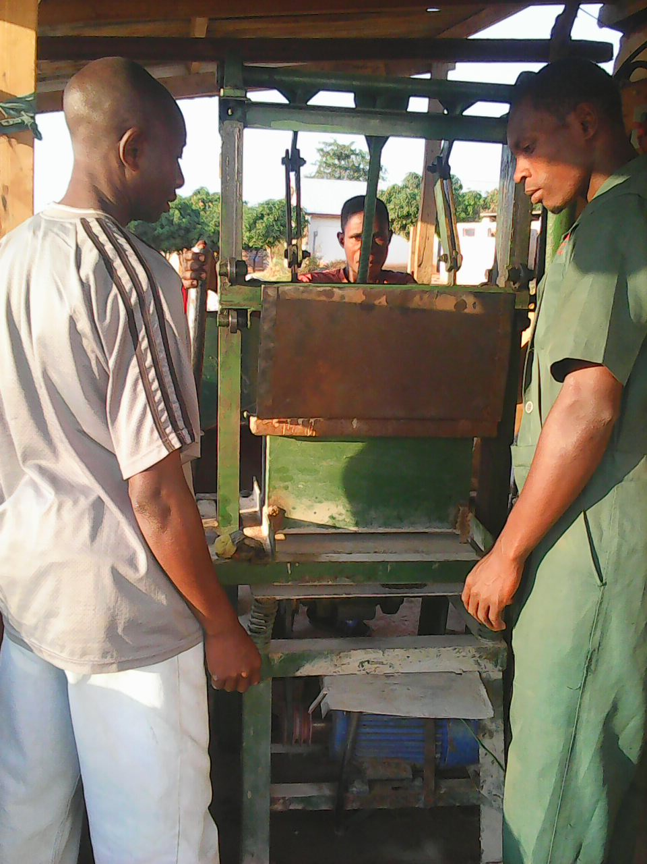

Figure 4.6: Car Wash Group Working/making bricks for Car wash
Source: survey, 2016
Running the car wash services, installing of water systems roller and some connecters were needed and were purchased; the group is guarding the site and using it properly. They have divided themselves in four groups of which each group consists of three people. The division makes them to rotate two times per week for offering services to clients. Each group worked for one day per week. Fig 4.6 shows the details.

Designing of advertisement, the adverts were designed and produced in order to disseminate the information to the community. These adverts were in form of posters. Disseminate advertisement through posters. Posters were distributed within the community and also those who are outside the community they were informed through phones. So the market was found through these means of communication. The members are in the position of having market for offering Car wash services. The checklist for monitoring and evaluation were prepared to monitor the activity. This enabled to see if the project was implemented as planned.

4.4 Actual Implementation
The actual implementation is the Process whereby “project inputs are turned to project outputs”. Also, this is putting in action the activities of the project, putting into practice what was proposed in the project document in short is a transforming the project proposal into the actual project, and administration of the project purposes. Car wash services project applied as the involvement approach, whereby KUVM are the first beneficiaries’ who implemented the project. However, other stakeholders provided the financial resources, including Ilemela municipal council, CED student and technical personnel assistance. The actual implementation also it shows whether the activities implemented as scheduled or planned, objective, output, activities, resources, timeframe, actual implementation and remarks are shown.

4.4.1 Project Implementation Gantt Chart
Gantt chart is a technique in which the activities of the project are drawn as a horizontal bar, the length of which is proportional to the time duration of the activities (Namwata, M.L.2010). During project implementation process Gantt chart method facilitated stakeholders to visualize easier what was taking place showing the primary dependency relationship among activities and the actual time spent from January to June 2016. It also depicted activity progress which obtained towards the completion of each step of activity as summarized in Table 4.6.

Table 4.6: Project Implementation Gantt Chart
Activities | Implementation period |  |  |  |  |  |  |  |  |  |  |  |  |  |  |  |  |  |  | Resource needed |  | Responsible person
Activities | Year 2015 |  |  |  |  |  | Year 2016 |  |  |  |  |  |  |  |  |  |  |  |  |  |  | Responsible person
Activities | O | N |  | D |  |  | J |  | F |  | M |  | A | M |  | J |  |  | J
Identification of the Community |  |  |  |  |  |  |  |  |  |  |  |  |  |  |  |  |  |  |  | Stationery |  | CED student
Writing a letter requesting to conduct CNA |  |  |  |  |  |  |  |  |  |  |  |  |  |  |  |  |  |  |  | Stationery |  | CED student
Conducting CAN |  |  |  |  |  |  |  |  |  |  |  |  |  |  |  |  |  |  |  | Funds Stationery Fuel |  | CED student Community Member
Identification of problem |  |  |  |  |  |  |  |  |  |  |  |  |  |  |  |  |  |  |  | Funds Stationery |  | CED student Community Member
Project formulation |  |  |  |  |  |  |  |  |  |  |  |  |  |  |  |  |  |  |  | Stationery |  | CED student Community Members
Writing CNA report |  |  |  |  |  |  |  |  |  |  |  |  |  |  |  |  |  |  |  | Stationery, Funds |  | CED student
Identification of training needs |  |  |  |  |  |  |  |  |  |  |  |  |  |  |  |  |  |  |  | Funds Stationery |  | CED student and target group
Identification of training resources |  |  |  |  |  |  |  |  |  |  |  |  |  |  |  |  |  |  |  | Funds, Stationery |  | Facilitator CBO leaders
Mobilization of financial resource |  |  |  |  |  |  |  |  |  |  |  |  |  |  |  |  |  |  |  | Funds Stationer |  | -CED student  CBO leaders
Preparation of training materials/ manual |  |  |  |  |  |  |  |  |  |  |  |  |  |  |  |  |  |  |  | Funds, Stationery |  | CED student  Trainers
Identification of training venue |  |  |  |  |  |  |  |  |  |  |  |  |  |  |  |  |  |  |  | Stationery, Funds |  | CED student
Acquiring required training resources |  |  |  |  |  |  |  |  |  |  |  |  |  |  |  |  |  |  |  | Funds |  | CED student
Meeting with CBO leaders to compromise and confirm training schedule |  |  |  |  |  |  |  |  |  |  |  |  |  |  |  |  |  |  |  | Funds, Stationery |  | CED student Trainers CBO leaders
Conducting training on Car wash project |  |  |  |  |  |  |  |  |  |  |  |  |  |  |  |  |  |  |  | Funds, Training materials |  | CED student  Trainers
Conducting training on better ways of car wash operation & maintenances |  |  |  |  |  |  |  |  |  |  |  |  |  |  |  |  |  |  |  | Funds, Training materials |  | CED student Trainers
Conducting training on methods of improved way of running car wash |  |  |  |  |  |  |  |  |  |  |  |  |  |  |  |  |  |  |  | Funds, Training materials |  | Trainers  CED student
Conducting training on the concept of marketing and entrepreneurship. |  |  |  |  |  |  |  |  |  |  |  |  |  |  |  |  |  |  |  | Funds, Training materials |  | Trainers  CED student
Conducting training on simple Book keeping |  |  |  |  |  |  |  |  |  |  |  |  |  |  |  |  |  |  |  | Funds, Training materials |  | Trainers  CED student
Conducting Monitoring and Evaluation |  |  |  |  |  |  |  |  |  |  |  |  |  |  |  |  |  |  |  | Funds, Training materials |  | CBO leaders  CED student
Writing project report |  |  |  |  |  |  |  |  |  |  |  |  |  |  |  |  |  |  |  | Funds, Training materials |  | CED student
Source: Survey, 2016

CHAPTER FIVE

5.0 PROJECT PARTICIPATORY MONITORING, EVALUATION AND SUSTAINABILITY

5.1 Introduction
Any successful project benefits to the end recipients are entirely built on participatory monitoring, evaluation and sustainability. The chapter explains more about the project participatory monitoring, evaluation and sustainability. Participatory monitoring and evaluation is crucial in any project. To determine whether the project is operating within the stipulated limits and within the resources available, monitoring of the activities is required. At the same time to determine whether the activities will lead to the expected objectives, a periodical, midterm evaluation is required and at the end of the project evaluation is required to determine whether the expected objectives and outcomes are complied/ achieved.

PM&E can, therefore, provide more comprehensive information on efficiency, relevance, sustainability, impact, clearness and effectiveness of work in progress/ project. However, the chapter is divided into the following parts: monitoring information system; participatory monitoring methods, participatory monitoring plan, participatory evaluation plan, performance indicator, participatory evaluation methods, project evaluation summary and project sustainability.

5.2 Participatory Monitoring
This refers to systematic recording and periodic analysis of information which has been chosen and recorded by both insiders with the help of outsiders. Therefore, participatory monitoring is a system that involves the community to monitor the programme activities. The objectives of participatory monitoring was to analyze current situation, identify problems and find solutions, discover trends and patterns, ensure project activities on timeframe, measure progress towards objectives and formulate the future goals and objectives and make decisions about human, material resources and financial.

The aims of Participatory Monitoring was to supervise the implementation of planned activities such as sensitization/awareness, meeting to Buswelu centre community members, training on entrepreneurship skill, financial management, governance and leadership, establishing of Car wash services, empowering and advocacy meeting. However, various technique and methods were employed to collect information, process and analysis to verify the progress of the planned activities. Participatory monitoring also used various participatory methods and includes various stakeholders such as municipal leaders, ward leaders, local government leaders, and NGOS members themselves. Participatory monitoring was the continuous assessment of the progress of the project towards achieving the desired goal and objectives. Monitoring basically included the project activities implementation, project output and project outcome or impact. Monitoring as per project implementation plan involved the whole process of routine data gathering and giving feedback about the progress of the project to stakeholders.

Another aim of Participatory Monitoring was to build a spirit of ownership of the project to the target group and to bring the attention of the project implementers to any relevant changes to project implementation. It was conducted to measure the progress and evaluate the project success and get a clear picture of project activities such as sensitization meeting to KUVM members and Buswelu centre community members, training on entrepreneurship skills, financial management, managerial skills, record management, HIV/AIDS and leadership to KUVM members. It was planned to be undertaken throughout of the entire period of the project implementation, to ensure effectiveness of the project activities, to establish indicators and to maintain the standards of the aimed project. It also intends to get information for future evaluation process.

5.2.1 Monitoring Information System
Monitoring information system is a monitoring tool designed to collect and analysis the project information regarding the planned activities which assists the implementers of that project to assess their performance during the implementation process. For creation employment for the youth project the monitoring information system designed to create data sheet which can record the related information against planned activities within the timeframe. The necessary information include number of training and sensitization meeting required and actual implementation, records of participants who attended that project activities, information on project materials received from different stakeholders.

Monitoring will also include the amount of loan taken by the target group, loan repayment and type of business ventures established by youth group. The process of recording will be done weekly bases because the youth group met twice per monthly and the youth management are the responsible of writing monthly report and present it to general meeting and CED student will help the group. For improving life standards through business in improving livelihoods of KUVM youths members through a car wash project at Buswelu centre in Ilemela.

5.2.2 Participatory Monitoring Methods
The participatory monitoring methods used to engage community in the monitoring of the project. The project employed participatory methods and techniques to ensure that all internal implementers were fully participated in project activities. The PRA and techniques employed to collect information like observation and documentation analysis for secondary data, these methods are explained below.

5.2.2.1. Document Analysis
This method was used to collect data from some documents sources at the Centre and municipal level. The documents used were training report conducted, sensitization and advocacy meeting conducted. Minutes for weekly and monthly meetings from the target group who meet in an every week to discuss their achievements, challenges and agreements on how to overcome such challenges and the way forward were also used. Other information’s documented were loan and loan repayment forms. Furthermore, CED students hand book were used as a guiding tool towards this exercise task.

5.2.2.2 Observation
Through observation, internal implementers observed the progressive of activities if it had implemented as planned. These included type of training, business ventures and meeting carried out, number of participants attended such training and meeting, number of KUVM members who joined the groups, and the loan taken from the Bank if deemed so, and amount of profit raised by the targeted group (KUVM).

5.2.3 Participatory Monitoring Plan
Jain S. P. & Polman W (2003) asserts that “Participatory community monitoring and evaluation are extremely important for learning about the achievement/ deviation from the original concerns and problems faced by local development projects/ programs being implemented, so that corrective measures can be taken in time”. The main purpose of Monitoring is to provide information during the life of the project, so that adjustments and/ or modifications can be made if necessary. Monitoring is the process of routine gathering of information on all aspects of the projects.
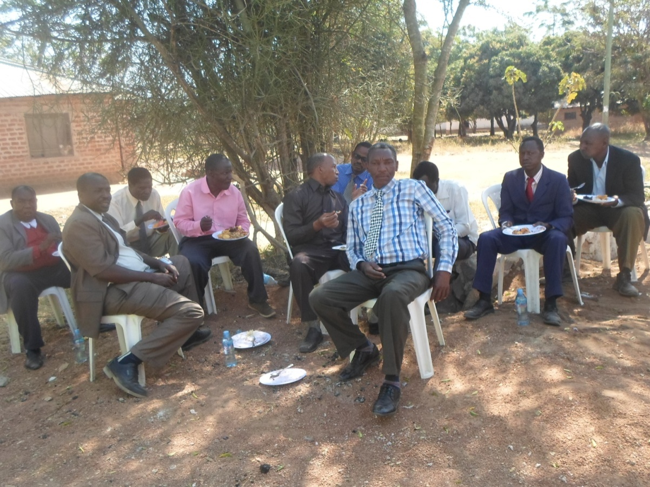

Figure 5.1: Facilitators, CED Student and KUVM Members Getting Lunch after Entrepreneurship Seminar
Source: survey, 2016

The project has participatory monitoring plan that includes monitoring methods, activities to be monitored, indicators of progress, responsible person and time frame. All these helped stakeholders to collect information needed to analyze the current situation, identify the problem and find solution, keep the project activities on schedule hence smooth achieving of intended objectives. A participatory monitoring plan for the project is as shown in the Table 5.1.

Table 5.1: Participatory Monitoring Plan
Work plan Activities | Monitoring  Objective | Objective verifiable indicators | Importance of monitoring | How gathering monitoring information | Responsible person | Time frame
Identification of training needs | - To know training needs of the target group | -Conducted trainings -Target groups attended trainings | -Know the gap and train what is real needed by the target group | -Training needs assessment report | CED student  CBO members | Jan 2016
Identification of resources ( Human and financial resources) | - To know and get right trainers and funds for training | - Acquired resources  -Conduct training  Opening account. | - To have valuable resources for implementation of the project. | -Human and finance resource report | - CED student, -CBO members - CBO leaders | Jan,2016
Preparation of training materials/ Training Manual | - To get training manual for guide training. | - Developed training manual | - Having a tool of training | Training report and Manual | - CED student | Jan-Feb.2016
Identification of training venue | - To have venue for training | - Acquire venue for training | - To avoid inconveniences | -Visiting training venue | - CED student - CBO members – Leaders | March-April,  2016
Acquiring required training resources | - To acquire training materials | - Acquired training materials | To be well organized before starting trainings | -Training resources report | - CED student | April,  2016
Meeting with target group leaders to compromise and confirm training schedule | - Acquitting group leaders and members the intention of trainings | - Conducting group leaders meeting | To make training move smoothly and as planned | -Visiting the CBO leaders -CBO leaders meeting | CED student –Trainers | April,  2016
Conducting training on Car wash project | - To provide knowledge and skills to the target group | -Number of participants attended trainings | Target group acquire knowledge and skills | Training report -Relevance of training materials | -CED student  -Trainers | April,  2016
Conducting training on better ways of car wash operation & maintenances | - To provide knowledge and skills to the target group | - Number of participants attended trainings | Target group acquire knowledge and skills | -Training report -Relevance of training materials | -CED student –Trainers | April,  2016
Conducting training on methods of improved way of car wash handling and quality control | - To provide knowledge and skills to the target group | - Number of participants attended trainings | Target group acquire knowledge and skills | -Training report - Relevance of training materials | -CED student –Trainers | April-May.  2016
Conducting training on the concept of marketing and entrepreneurship | - To provide knowledge and skills to the target group | - Number of participants attended trainings | Target group acquire knowledge and skills | -Training report - Relevance of training materials | -CED student –Trainers | May,  2016
Training on simple Book keeping | - To provide knowledge and skills to the target group | - Number of participants attended trainings | Target group acquire knowledge and skills | - Training report - Relevance of training materials | -CED student –Trainers | June,  2016
Source: survey, 2016

5.2.4 Participatory Evaluation
According to Zikoski A. & Luluquisen M. (Aoril, 2002) “Participatory evaluation is a partnership approach to evaluation in which stakeholders actively engage in developing the evaluation and all phases of its implementations”. Also TACAIDS, (2004) define participatory evaluation as a process that advocates for involvement and participation of community members and other stakeholders in designing and execution of the evaluation process. Participatory Evaluation uses data and records during the process of monitoring and other information such as focus group discussion and user survey to review performance and identify ways to make improvement better. Therefore, monitoring and evaluation are complementary project management functions which ensure that the project is running on the right way/ direction.

This aimed at enhancing the best practices of the project. Evaluation was carried out as a continuous activity with the participation of all project stakeholders and most important beneficiaries. Negotiation leads to agreement on how progress would be measured and the findings acted upon, they decided to undertaken the midterm evaluation after six month and one year after ending of the project. The evaluation was carried out by project management committee from village representing the targeted group and some officials from the District and NGO themselves.

Participatory evaluation involves the assessment of change through processes that involve many people/ groups, each of which is affected by the impacts being assessed. Negotiation leads to agreement on how progress should be measured and the findings acted upon. Before the implementation of creation employment for youth project the all implementers discussed and agreed on how to implement the project by setting the project objectives, goals and activities. They decided to undertake the mid-term evaluation after six month and one year after ending of the project.

5.2.5 Performance Indicators
From the Wikipedia, the free encyclopedia, (accessed on 24th May, 2016); “A performance indicator or key performance indicator (KIP) is an industry jargon for a type of performance measurement. KIPs are commonly used by an organization to evaluate its success or the success of a particular activity in which it is engaged”. Indicators are signs or variables that show the extent of change that resulted from projects. Indicators help to measure what actually happened in terms of quantity, quality and timelines against what was planned. They measure progress in achieving outputs and outcomes.

The process of identification and indicators was participatory approach, all stakeholders and project management were involved and agreed on quantitative and qualitative as an indicator for creation employment for youth project, these measures based on project objective and overall goal. The input indicators described the means by which the projects are implemented, such as the number of hours of training and the amount of money spent. In turn the output measure the extent to which the project is delivering what it is intended to be delivered.
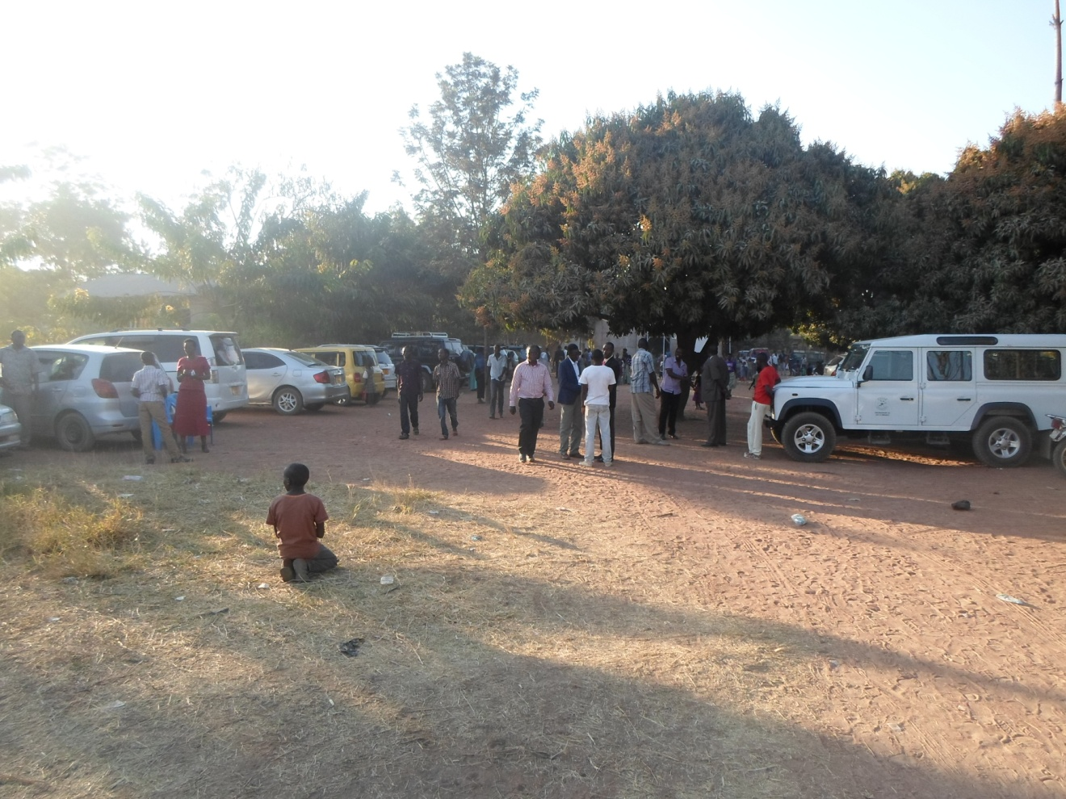

Figure 5.2: Community Members after Fund Raising
However, the impact indicators measure the actual change to KUVM members. In general the youth in Buswelu centre are expected to employee themselves by establishing income generating activities (IGA)/ business venture hence create self employment and reduced unemployment as well as poverty and achieve their basic needs.
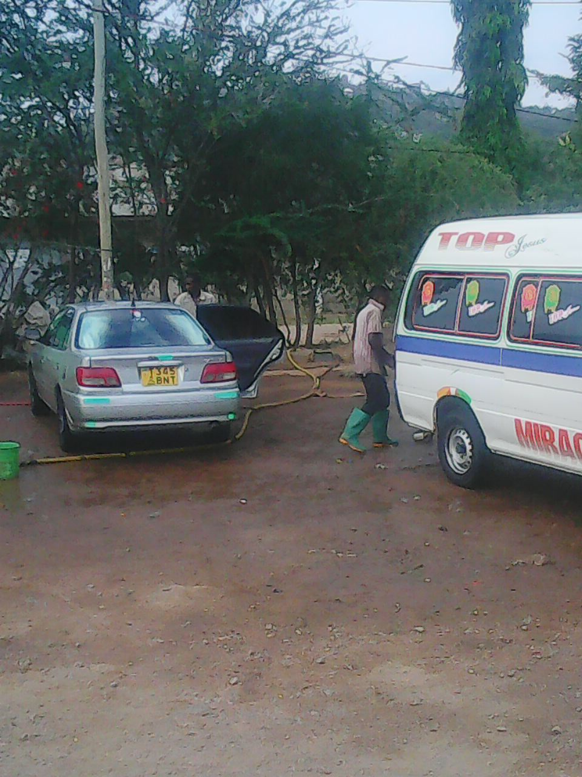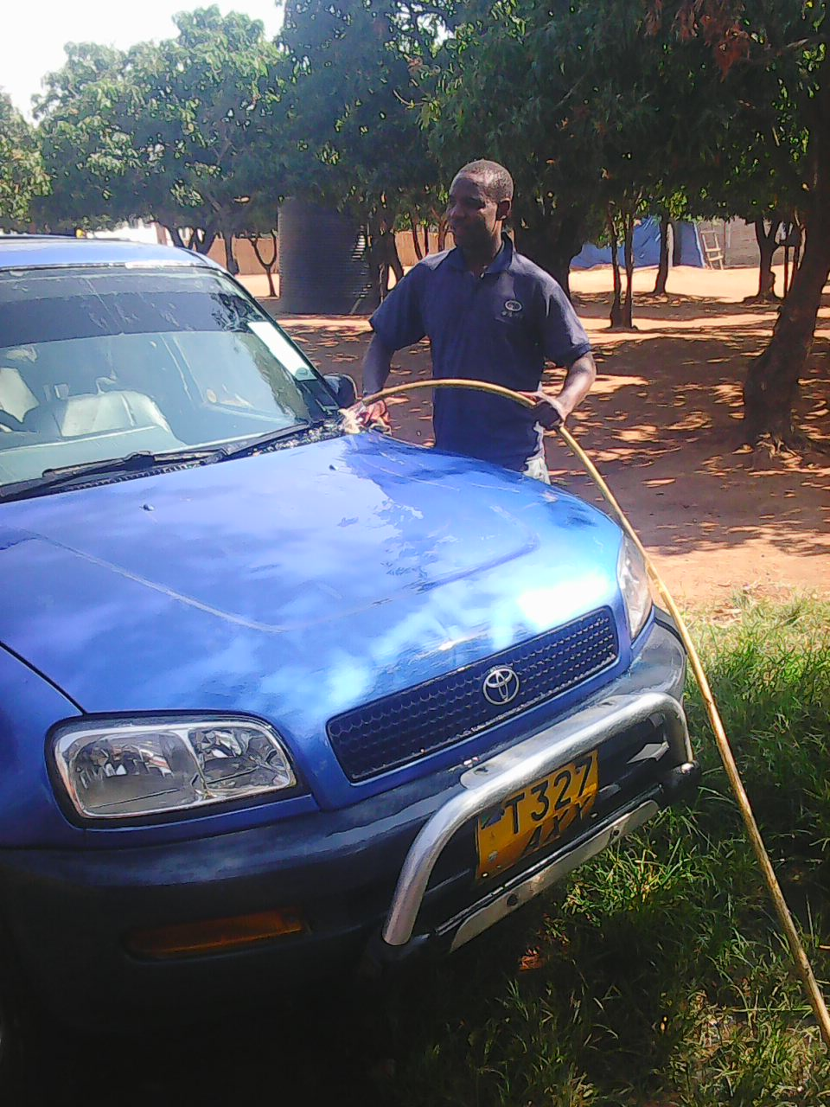

Figure 5.3: KUVM Youth Washing Cars

The project goal and project objectives performance indicators were summarized in Table 5.2.

Table 5.2: Performance Indicators
Objective | Output | Activity | Resources Needed | Performance Indicator
To conduct training on car wash and entrepreneurship to the group of 12 youth in Buswelu by February 2016 | 12 youth at Buswelu centre trained on car wash and entrepreneurship skills | Preparation of training manual  Conduct training | Printing and photocopying  Stationeries  Facilitators  Transport (fuel)  Refreshment  Communication | Number of training manual developed  Number of days for training  Number of participants trained
To establish car wash project at Buswelu by May 2016 | One car wash services project established | Construction of car wash site/ house  To purchase of pressure pumps  Car wash in operation | Construction Materials  Technicians  Transport (fuel)  2pumps  Purchase water pipes  Water storage/ systems | Number of pumps purchased  Number of pipes purchased  Number of taps in place
To establish a reliable market for car wash services produced by the KUVM by June 2016 | Stable market for car wash established by the youth group | Designing of advertisement  Disseminate advertisement  Conduct midterm M & E of project implementation | Stationeries  Posters  Air time | Number of advertisement designed  Number of posters and airtime made  Number of days for monitoring and evaluation
Source: survey, 2016

5.2.6 Participatory Evaluation Methods
The methods which are used to undertake Participatory Evaluation are almost the same as those used in Participatory Monitoring, Briefly, participatory evaluation can be explained as a partnership approach which stakeholders, “actively engaged in developing the evaluation of all phases of its implementation. Those who have the most at stake in the program – partners, program beneficiaries, funders and key decision markers- play active roles”.(Ibid Zioski) Participation occurs throughout the evaluation process including: identification of relevant questions; planning the evaluation design; selecting appropriate measures and data collection methods; gathering and undertaking data analysis.

The participatory evaluation employed and assesses the progress in work plan, implementation of planned activities, achievement of objectives, effectiveness of project and impact of project. It also evaluates the project sustainability. For the case of creation employment for the youth the key informants used for youth management, LGA officials (WEO and VEO), project officers while focus group discussion used for youth group (target beneficiaries to collect data and information at the same time as observation used to verify collected data and information related to project to see if the intended objectives and activities are collaborated. In the participatory evaluation side the following results were detected.

5.2.6.1 Meeting
During the advocacy meeting, when discussing about ‘‘Role of entrepreneurship in Tanzania economy’’ participants discuss and shows evidence, some people in Buswelu centre community who engaged in small generating activities especially Youths, such as selling of second hand iron (scrappers), street vendors and hawkers (Machinga) among of many others of this type, normally can afford or not to meet their basic needs such as getting food, shelter and some time can support their family compared to those who do not engaged in any kind of generating activities finally become frustrated and even commits suicide themselves or run away his/her family premises. From that discussion it observed that entrepreneurship as a crucial element for the informal sectors. Capacity building to KUVM members has a clear mind to project intervention; it gives the implementer skills and knowledge in running out their project profitable oriented.

5.2.6.2 Interview
Evaluation team interviewed some of community members to learn more about the implementation and project success. This took place immediately after ending the evaluation meeting and it aimed to collect some information during the meeting. About 87.2% of the interviewees concurred that the project has brought some changes among community members. This was proved by the community itself when it involves more in caring and supporting KUVM members. The purpose of establishment of car wash project was to enable them to increase their household income. The project has undergone a participatory evaluation. The internal and external stakeholders gave their own views concerning the project performance.

5.2.6.3 Focused Group Discussion
The Focus group discussion (FGD) was used for target group (target beneficiaries) to collect data and relevant information through observation method which was used to verify the collected data and information related to project to prove whether the intended objectives and activities are achieved. For example objective 4 which intended to establish the feasible market for Car wash services to serve and support to 5 local government community leaders and 12 KUVM committee members’ on improvement livelihood through car wash projects have shown the positive outcome. The Municipal council will include youths in its budget from own source to support KUVM for the financial year 2016/17.

5.2.3 Project Evaluation Summary
Table shows the project evaluation summary based on the project goal, objectives, performance indicators, expected outcomes and actual outcome. Based on the project goal, objectives and activities planned have been met with exception of terminal and annual evaluation that will be done after six months of project implementation. Generally the evaluation shows that there are strong commitments of various stakeholders from the planning stage to the implementation stage/ activities. This proves that the project is very important to both beneficiaries and community based. This is also in the Table 5.3.

Table 5.3: Project Evaluation Summary
Objective | Output | Activity | Performance Indicator | Expected outcome | Actual Outcome
To conduct training on car wash and entrepreneurship to the group of 12 youth in Buswelu centre by February 2016 | 12 youth at Buswelu centre trained on car wash and entrepreneurship skills | Preparation of training manual  Conduct training | Number of training manual developed  Number of days for training  Number of participants trained | 12 group members acquired skills on car wash services and entrepreneurship | KUVM trained on car wash services and entrepreneurship skills.
To establish car wash project at Buswelu centre by May 2016 | One car wash project established | Construction of car wash house  To purchase pressure pumps  Storage of water systems | Pumps purchased  And stored at the site | Viable economic activity established | Car wash project established
To establish a reliable market for car wash services produced by the youth group by June 2016 | Stable market for car wash services established by the youth group | Designing of advertisement  Disseminate advertisement  Conduct midterm M & E of project implementation | Number of advertisement designed  Number of posters and airtime made  Number of days for monitoring and evaluation | Availability of market/ clients | Reliable market established/ many cars

Source: Survey, 2016

5. 3 Project Sustainability
The project sustainability refers to the capacity of a project to maintain or keep on functioning, supported by its own resources (human, material, and financial), even external sources of funding have ended. The implementers (KUVM members) are responsible for planning to make the project sustainable on institutional, financial as well as political.

5.3.1 Institutional Sustainability
The capacity building was given to youth through entrepreneurship training which helps in strengthening the implementation of their income generating activities established by managing properly their business/ income generating activity. This will result to create self employment for the Buswelu centre youth by applying knowledge and establish business centers. In fact, every member of youth will understand and resume his/ her responsibilities patterning to leadership and good governance, training provided to them during the implementation stage of the project, this knowledge/ experience will be a good contribution to work hard and produce more.

5.3.2 Financial Sustainability
The improving livelihoods of KUVM youths group through a car wash project at Buswelu centre in Ilemela Municipal will sustain even after the phase out of project, firstly the car wash services for the youth has started and registered, this will be easy for them to access loans from bank like CRDB, and other credit financial systems to maintain financial stability for car wash. Secondly, Every beneficiary contributed TZS 50,000/= as entry fees and involves in supervision in rotation bases/ weekly, this gives the assurance to know the money issues, thirdly, each member is able to borrow the money after two months as a loan and repay in four months (allowed to loan up to TZS 100,000/= ). Because one of the aim of the project allow youth to access loan at reasonable interest rate and establish small income generating activities (selling snacks, oil, aerated drinks). Fourthly, the pressure pump car wash are used is first and wash more cars in a short time. This also will attract many clients, hence generate more income and sustain the project.

The idea of establishing the project catches the attention of youth ministry and agreed the national call of self employment. This income generating activities managed by them (KUVM) members will be sustainable because, the site of Car wash project for the youth in Buswelu centre is surrounded by many cars, motor cycles and bicycles, this will help the project beneficiaries to establish good system of market and serve more clients within and outside the centre (Ilemela Municipal Headquarter) this will increase the capital. Also the members putting on written the mechanism of ensuring there is no any defaulters by constructing a constitution which is leading the institution. For those who will pay a loan repayment late will be required to pay loan plus interest as well as penalty of five percentage of the total loan taken. Also within the constitution each group the member is subject to leadership jus after every two years.

5.3.3 Political Sustainability
The establishment of a car wash project at Buswelu centre in Ilemela for improving livelihoods of KUVM youths group, is significance to the Tanzania economic because the project is relay with National Strategy for Growth and Reduction of Poverty II, Millennium Development Goal, National Youth Development Policy 2007, due to these, the leaders from grass root to district council/ municipal council level are in support of the project. The political leaders have shown their interest in this project; especially youths project. Also the project has been supported by different stakeholders (NGOs) who created a bridge to local government, community members and youths in general.

In 2009, a total of 3,755 NGOs were registered compared to 2,893 NGOs in 2008. Similarly, during the period under review, 816 NGOs were registered and received certificates of approval, equivalent to an increase of 22 percent. All of these NGOs are there to support Projects including youths projects (KUVM). Therefore, these make the project to be politically sustainable (URT, 2009).

CHAPTER SIX

6.0 CONCLUSION AND RECOMMENDATION

6.1 Conclusion
Income poverty among of many youths is the most critical problem which led to the set up of this project. Thus this project focused on addressing issues related to establishment of car wash, quality control and car wash marketing. The lack of car wash not only leads to income poverty of the Youths, but also attributes to high rate of poverty. This problem as existed to the CBO, regardless of more cars to be washed. However, the management of car wash a connection to NEMC laws should be well addressed by the high authority to CBO members.

Project intervention was mainly addressing to fight against income poverty situation of the CBO. So the project had four specific objectives, which are;
1. To conduct training to 12 youths on car wash by January, 2016
2. To conduct training on entrepreneurship to 12 youths in Buswelu by February, 2016.
3. To establish car wash project at Buswelu centre by May 2016.
4. To establish a reliable market of Car wash services rendered by KUVM members by June 2016.

The project is expected to achieve and accomplish the objectives by the following outputs by the end of 2016. This includes;
a) Primary stakeholders skilled in both hand pressure car washing services.
b) Car ash owners skilled in business and handling.

C) Primary stakeholders self employed as car washers
c) Car wash owners and community equipped with knowledge of the importance of car wash storage and handling.
d) Good networking between car washers and consumers of car washing services
e) Training of12 youths of Car wash handling, Maintenances and quality Services
1. High income to target group
2. Increased sales turnover
3. Customer care improved.
4. High quality of Car wash services offered to customers.

It is very important to note that, more progress has been achieved on the project objectives. To a large extent the activities planned have been accomplished in the right time as scheduled. Significant income is yet to be realized since they have not served many cars /clients as the product of the project initiated as also the time is too short to realize the maximum profit.

It is also important to note that, the services like lubricants, aerated drinks, shoe polish and snacks are adding value to business. These available resources, which may help the KUVM members in developing their skills and creating sustainable income with less inputs and get more output. The project is growing well this will be an answer for economic empowerment to urban youth (KUVM) in Buswelu centre, in turn improve livelihood of their lives.

The researcher had only 6 months to work with the CBO and the established project was limited to time due to the fact that the period set by the University for Project Implementation was not enough. Also the project had fund constraints where 80% of Funds to implement the project were mobilized from SDA Church, ATAPE, different Donors of the CBO and well wishers.

6.2 Recommendations
Considered on experience from the implementation of creation of employment for the urban youth was proved, that the participatory community needs assessment (PCNA) is very crucial in planning of any development project. Therefore, it creates carries with the feelings of ownership, and builds a strong accountability for the intervention in the community; also forms trustiness among youth’s and ensures that the intervention will have more credibility in all sector of the community. I would rather suggest and recommended, to use participatory rural appraisal when someone is interested to ascertain creation employment for the youth project because it gives a room for the local people and other stakeholders to plan together (participatory approach) on proper ways.

From existing literature review challenges and suggestion on creating youth employment the government should work hard together with other stakeholders including NGOs and other well-wishers to improve the living standard life of youth in urban areas. Furthermore, KUVM members and their families in Buswelu centre are disturbed by a social problem, in order to minimize this, the following are recommended. KUVM members problems should be tackled collectively by home and community itself, churches, private sectors and some stakeholders, NGOs, the existing community structure should be firmly enough to meet KUVM members’ basic needs.
The establishment of KUVM car wash services (Pressure washer car wash) to support KUVM (Unemployed youth) at every centre in urban/ town setting should be encouraged and supported as one of important stage for the employment problem facing youth by either providing them land/ special areas for their business or giving them soft loans for their small generating income activities, and make sure that no youth is left out without being supported. Lastly but not least, the findings obtained in this study should be the initial stage and act as base for policy/ decision makers to put emphasis on the community participation at all levels in fighting income poverty against KUVM members as well as youth unemployment problems.

Despite the fact that different policies such as the Social Security Policy of 2003 by developing and implementing a national strategy for social security and Protection for Vulnerable groups (VPO, 2005), Youth Development Policy 2007 and Vulnerable Youth National Data Management System that has been undertaken by the government of Tanzania to address the issue of Vulnerable Youth, some policies are on paper and if practiced are for few. This implies that there is a need to have other significant policies that provide guideline and education to stakeholders on criteria that influence proper identification of vulnerable children; create a sense of accountability and ownership to support KUVM. Since the study have proved its significance toward solving KUVM problem in the society, one may decide to carry out an investigation on the role of KUVM members registration as CBOs towards addressing KUVM problem as purposive sensitization to group members is highly needed.

REFERENCES
Africa: Monitoring progress towards the UN Declaration of Commitment on HIV/AIDS (2005), UK: World Vision.

Amin, E. (2005). Social Science Research Concept, Methodology and Analysis, Uganda: Makerere University Printer.
Carol, T. F. (1990). “Performance indicator”, BERA Dialogues (2). October 13–15, Somerset West, South Africa.
CEDPA, (1994). Project Design for Program Managers. Washington DC. URL retrieved 2004 November from the World Wide Web: (Free) http://www.cedpa.org/publications/pdf/projdesign.html.
Cole, A. H. (1959). Business enterprise in its social setting, Cambridge: Harvard University Press.
Freeman, A. M. (2002), What Might We Do About It?', Journal of Economic Perspectives,10(1), 1-8.
Freeman, R. B. and Lindauer, D. (1999). 'Why not Africa?', NBER working papers, w6942, February 1999.
Helgesson, L. (2006). Getting Ready for Life: Life Strategies of Town Youth in Mozambique and Ibadan, Department of Economics, Ibadan, Nigeria.
Heymann, J. Sherr, L. and Kidman, R., (2004). Protecting child hood in the AIDS Pandemic: finding solution that work. United state of America: Oxford University of press.
Jain, S. P. & Palman, W. (2003). The Panchayati Raj model in India: A handbook for Trainers on Participatory Local Development: Training module on participatory community monitoring and evaluation, Bangkok: FAO.
Juma, A. (2007). Promoting Livelihood Opportunities, for Rural Youth: Some Lessons.
Jupp, V. (2006). Sage Dictionary of Social Research Methods, New Delhi: SAGE Publications.
Kasaija, J. and Nsabagani, X. (2008). Community HIV counseling and testing a Handbook, retrieved on 30th March, 2017 from; Retrieved from:http://www.worlded.org/docs/Publications/.
Kiria, J. (2006). youth development in Tanzania. retrieved on 30th March, 2017 from; www.infoyouth.or.tz.
Leibbrandt, M., and C. Mlatsheni. (2004). “Youth in Sub-Saharan Labor Markets.” Paper presented at African development and poverty reduction: The macro-micro linkage forum, October 13-15, Somerset West, South Africa.
Mancorda and Kondylis, (2006). Youth in the labuor Makert and the Transtion From School to Work in Tanzania, retrieved on 20th March, 2017 from; https://books.google.co.tz/books?isbn=0857240005.
Mwanza City Profile, (2008). Retrieved on 26th October, 2017 from; mwacity@thenet.co.tz or mwacity-dir@thenet.co.tz.
Mwanza’s per capita income (2013). The Citizen Daily, Dar es Salaam, Tanzania. Retrieved on 21st April, 2017 from; http://mwanzanewsblog.blogspot.com /2013/01/mwanzas-per-capita-income-up.html.
NBS, (2003). 2002 Population and Housing Census, Volume II. Age and Sex Distribution, Dar es Salaam, Tanzania.
NBS, (2007). Analytical Report for Integrated Labour force Survey (ILFS) 2006, Analytical Report. Dar es Salaam: National Bureau of Statistics. Dar es Salaam, Tanzania.
Ngaiza, M. K., Lyimo, F. and Mniachi, A. (2003). A test manual for research methodology training, University of Dar es Salaam, Tanzania.
O’Higgins, N. (2003), 'Trends in the Youth Labour Market in Developing and Transition Countries', World bank, Social Protection Discussion Paper Series, n. 321, October 2003.
Oso and Onen (2008). A general Guide To Writing Research Proposal and Research Report, Makerere: Makerere University Press.
Project Design for program managers, (1994). Conducting a workshop on planning community-Based Projects: the CEDPA training manual series, II. U.S.A: Washington D. C. (PP 46-64).
RAWG, URT, (2008). Views of the People 2007, Tanzanians give Their Opinions on: Growth and Reduction of Income Poverty, Their Quality of Life and Social Well-being, and Governance and Accountability. Dar es Salaam, Tanzania.
Research on Poverty Alleviation, (2007). Children and Vulnerability in Tanzania: a brief synthesis'. Special Paper 07.25, Tanzania: Dar es Salaam press.
Saunders, M. (2009). Research Methods for Business Students, 5th ed, England: Pearson Education Limited.
Simon, G. (2011). The Effects of Unemployment among Youth in the Society of South Africans, Pictorial, South Africa. Britain: Oxford University Press.
United Nation, (2005). Youth and violent conflict: society and development in crisis? A strategic review with a special focus on West Africa. New York: UNDP Bureau for Crisis Prevention and Recovery.
United Nations, (2007). World Development Report: WHO. Retrieved on 15th March, 2017 from; http://www.unodc.org/pdf/research/Cr_and_Vio_Car_ E.pdf.
United Nations, (2007). A Joint Report by the United Nations Office, retrieved on 27th February, 2017 from; http://www.unodc.org/pdf/research/Cr_and_Vio_ Car_E.pdf.
United Nations, (2008). The Millennium Development Goals Report,, New York, USA.
URT, (1999). “Tanzania small and medium scale enterprise policy proposals” Prepared by: Calcopietro, C. M., Washington, DC, and Massawe D., Dar es Salaam, Tanzania.
URT, (2000). “Tanzania Development Vision, Planning Commision”, Dar es Salaam: Government Printers.
URT, (2002). Tanzania put in place a Small and Medium Enterprise Development. Policy, Dar es Salaam: UNIDO.
URT, (2005). Country report on implementation of the Beijing platform for action and the outcome document of the twenty-third special session of the general assembly- Beijing +10, Tanzania. Dar es Salaam, Tanzania.
URT, (2005). National Strategies for Growth and Reduction of Poverty: ministry of Finance and Economic affairs. Tanzania, Dar es Salaam: Dar es Salaam University press.
URT, (2005). Poverty and Human Development Report, Research and analysis, Dar es Salaam: Mkuki na Nyota Publishers.
URT, (2005). Summary of the National Strategy for Growth and Reduction of Poverty, Vice Presidents office 11Pp, Dar es Salaam, Tanzania.
URT, (2006). “Millenium Development Goals progress Report”, Ministry of Planning, Dar es Salaam, Tanzania..
URT, (2007). National Youth Development Policy, Ministry of Labour, Employment and Youth Development United Nation, Dar es Salaam, Tanzania.
URT, (2007). “National quality standards of care for service provision to most vulnerable Children”. Tanzania: Dar es Salaam press.
URT, (2007). “National Youth Development policy December”, Dar es Salaam, Tanzania.
URT, (2007). “Poverty and Human Development Report, Research and analysis”, Dar es Salaam, Tanzania.
URT, (2008). “Millennium Development Goal Report”, Midi-way Evaluation 2000-2008 PP44, Dar es Salaam, Tanzania.
URT, (2008). The national coasted plan of action for Most Vulnerable Children: Ministry of Health and Social Welfare, Dar es Salaam: University of Dar-es-salaam press.
URT, (2009). “Poverty and Human Development Report, Research and Analysis working group”, MKUKUTA Monitoring System. Ministry of Finance and Economic affairs.pp13, Dar es Salaam, Tanzania.
URT, (2009). The Economic Survey, Produced by: The Ministry of Finance and Economic Affairs, Dar es Salaam, Tanzania.
URT, (2009). “National Guideline for Quality Improvement for the Most Vulnerable Children: ministry of Health and Social Welfare”. Dar es Salaam: Dar es Salaam press.
URT, (2010). Millennium Development Goals, ministry of Ministry of Finance and Economic. Dar es Salaam, Tanzania.
URT, (2010). National Strategy for Growth and Reduction of Poverty II, Ministry of Finance and Economic Affairs, Dar es Salaam, Tanzania.
URT, (2011). “Tanzania Country Report on the Millennium Development Goals 2010”. Dar es Salaam, Tanzania.
URT, (2011). Tanzania Five Years Development Plan, President’s Offices Planning Commission, Unleashing Tanzania’s latent growth potentials, Dar es Salaam Pp 1-11. Dar es Salaam, Tanzania.
URT, (2013). “Mwanza’s per capita income up From the Citizen Daily”, Dar es Salaam. Retrieved on 20th March, 2017 from; http://mwanzanewsblog.blogspot.com/2013/01/mwanzas-per-capita-income-up.html.
VETA, (2014). Addressing Youth Unemployment through TVET: Policy Perspective in Tanzania; retrieved on 21st March, 2017 from; http://www.veta.go.tz/assets/uploads/b7cd9-Final-Paper-on--Addressing-youth-unemployment-through-TVET--Policy-perspective-in-Tanzania-(2)-1.pdf.
Wilson, C. (1993): Economics the Science of Cost. Benefits and Choice Working Papers, w3875, October 199. Economics Working Paper No. 85.
World Vision, (2005). More than words? Action for Orphans and Vulnerable, retrieved on 20th March, June, 2017 from; www.eynacarwash.com.
Zioski, A. & Luluquisen, M. (2002). Participatory evaluation: Community based public health- Policy Practice for Participatory Evaluation, retrieved on 23rd May, 2017 from; http/depts..Washingtong.edu/pdf files/Evaluation.pdf.

APPENDICES
Appendix 1: Structured questionnaire for vulnerable youth in urban areas.
Topic: Improving livelihood of youth’s in Buswelu centre.
Instructions
Dear Respondent,
I salute you in the name of God.
My name is Mr. Massunga, Dwassi Daniel. I’m from Open University of Tanzania I would like to invite you to this good exercise of answering some questions about y urban youths. The information you give in this questionnaire will be useful for developing a tool that will help you to address the needs of your community. Your participation in this survey is completely voluntary and your answers will be
kept confidential

General information: Tick (√) the correct answers where applicable
1. What is your age?
- 18-23yrs
- 24-29yrs
(c) 30 and above
2. The level of education
- Not attended school
- Adult education
- Primary education
- Secondary education
3. Marital status
- Single
- Married
4. The number of dependants
- 1
- 2
- 3
- 4 and above
5. What are the main problems facing Urban Youths?
- Lack of entrepreneur skills
- Lack of special area for their petty business
- Lack of capital
- Income poverty
- Lack of improved technology

6. Do you have any entrepreneurship skills?
- Yes...........
- No............

7. What should be done to improve the livelihood of the urban Youths in Buselu centre?
- .........................................................................................
- .........................................................................................
- ..........................................................................................
- ..........................................................................................
- ..........................................................................................

THANK YOU FOR GOOD COOPERATION AND GOD BLESS YOU.

Appendix 2: QUESTIONS USED IN INTERVIEW/Key informants to identify the socio-economic status of youth.
1. What are the sources of your household income?
2. What is the level of livelihood of urban youth?
- What are the existing income generating activities (IGAs)?
- What are the main Problems facing urban youth?
5. How many jobless youths in your street?
6. How do Youths have their daily needs?
7. Did you have any plan for youth to help them economically? YES / NO.
8 How many families are solely dependants on youth?
9. What is the economic status of youths is it increasing/ decreasing and why?

THANK YOU FOR YOUR CO-OPERATION

Appendix 3: The KUVM Constitution
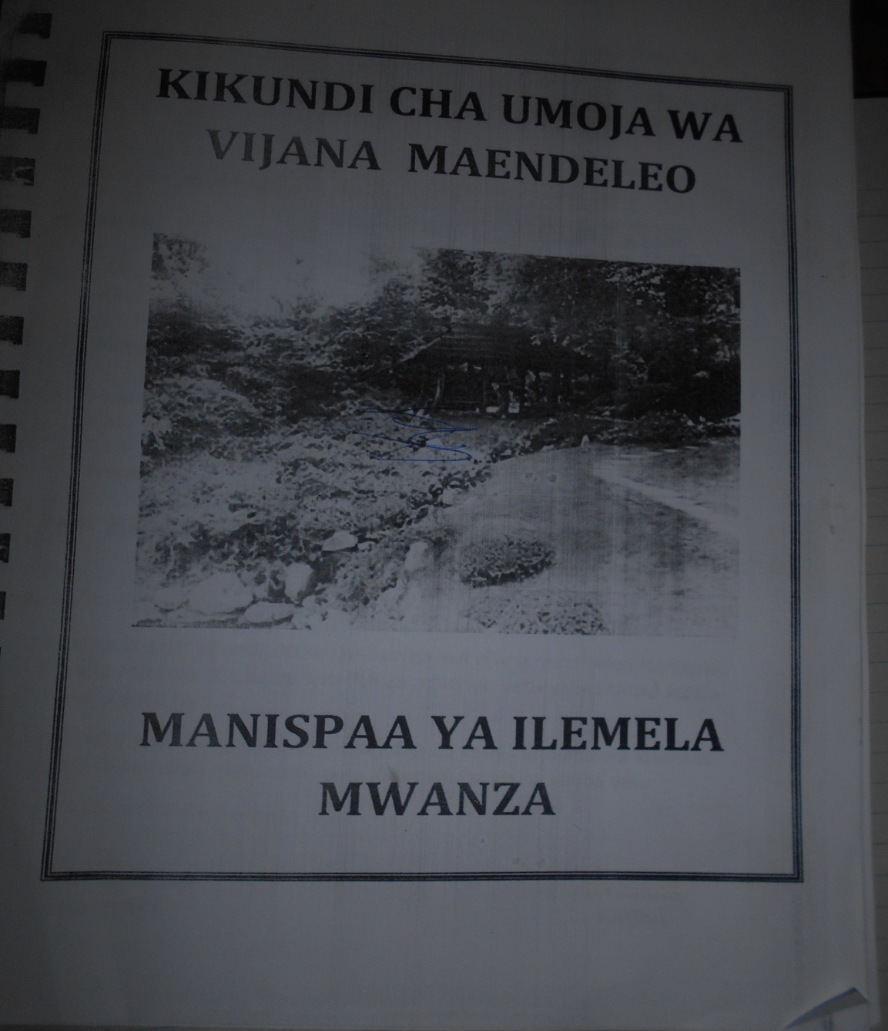

Appendix 4: KUVM Organization chart /leadership
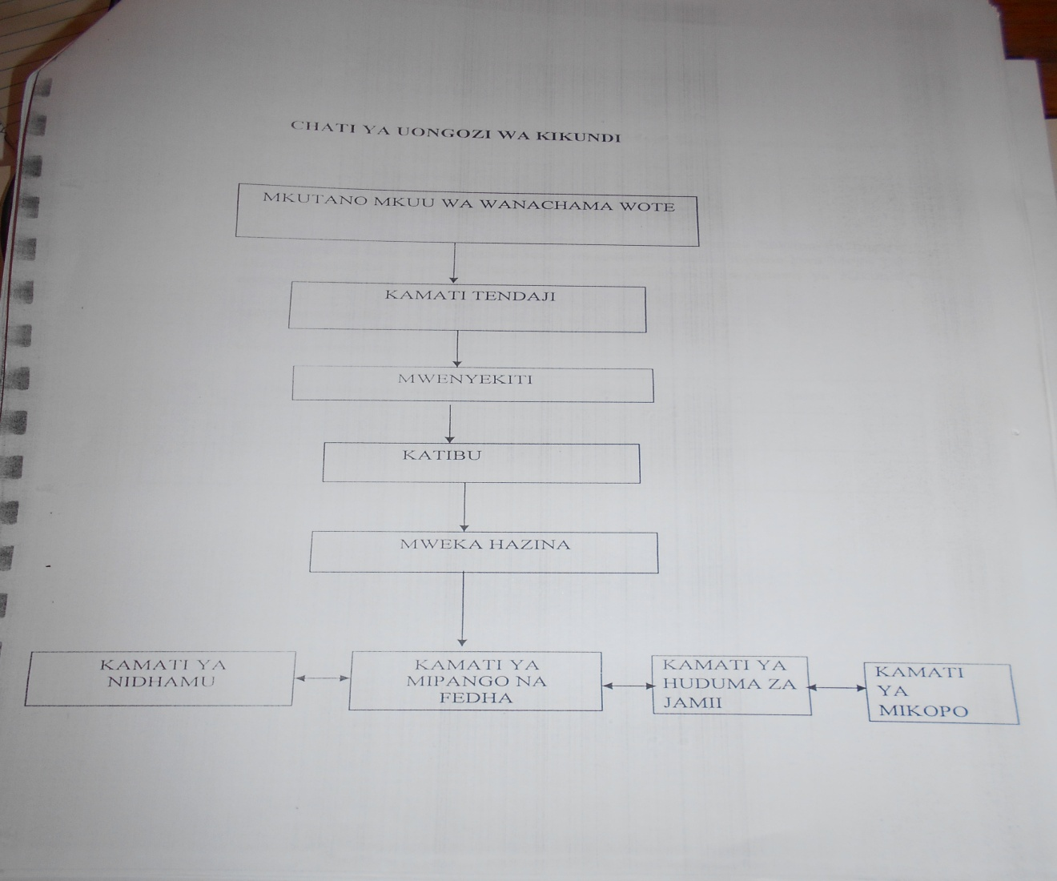

Appendix 5: KUVM Registration


Appendix 6: Barua ya Utambulisho kuhusu Kufanya Utafiti.


