AN ANALYSIS OF HUMAN RESOURCE PLANNING AND ITS EFFECT ON POLICE FORCE EFFECTIVENESS: THE CASE OF SONGEA MUNICIPAL POLICE

REMIGIOR CHOROHA

A DISSERTATION SUBMITTED IN A PARTIAL FULFILLMENT OF REQUIREMENTS FOR THE DEGREE OF MASTER OF HUMAN RESOURCE MANAGEMENT OF THE OPEN UNIVERSITY OF TANZANIA
2017

CERTIFICATION
The undersigned certifies that he has read and here by recommends for acceptance by Open University Of Tanzania a dissertation entitled “An Analysis of Human Resource Planning and its Effect on Police Force Effectiveness the Case of Songea Municipal Police” in a partial fulfillment of the requirements for the award of degree of Masters of Human Resource Management (MHRM).

……………………………….
Dr. Damas K. Mbogoro
(Supervisor)

………………………………..
Date

COPYRIGHT
No part of this Dissertation may be reproduced, stored in any retrieval system, or transmitted in any form by any means, electronic, photocopying, recording or otherwise without prior written permission of the author or of the Open University of Tanzania in that behalf.

DECLARATION
I, Remigior Choroha, do hereby declare that this dissertation is my own original work and that it has not been presented and will not be presented to any other university for a similar or any other degree award.

………………………….……….
Signature

…………………..…………
Date

DEDICATION
To Almighty God who gave me energy and strength to complete my studies, I dedicate this dissertation to my Parents Athanas Alberto Choroha and Lucia Cosmas and my Wife Neema Mulokozi and to my supervisor Dr. Damas K. Mbogoro and Dr. Janeth Isanzu for you have been a crucial part for my academic achievements. You are blessing are eternally cherish and I will continue living your ways.

ACKNOWLEDGEMENTS
I would like to extend my gratitude and appreciations to the Almighty God for granting his grace and mercy by giving me good health during the entire period of my study. I express my deepest and sense of gratitude of all those who helped me in bringing out this dissertation.

The first person I want to thank is my supervisor Dr. Damasi K. Mbogoro, Dr. Janeth for their guidance and supervision. Where by the supervisors have winded my knowledge and perspectives in research and helped me see that there was more on Human Resource Planning and its effect on the effectiveness of the SMP. I enjoyed our frequent discussions over the subject matter and I have benefited from them. My thanks should also go to the Open University Of Tanzania-Ruvuma Centre which is under Director Dr. Frank Julius and his managements in general and the Staffs in particular for their efforts in enlightening my academic life.

I thank also my employer the Ruvuma Police Commander ACP Zuberi Mwombeji for his support in terms of the time he granted to me during the study as well as material wise during the time of research. I further extend my sincerely appreciation to the Officer Commanding of District of Songea Municipal SSP Kenneth Mgani for honoring my request and permitting me to collect research data from his esteemed organization. Also to Officer Commanding Station of Songea ASP Paul Mashimbi for his support by allowing the employees to give full support during the research. I gratefully acknowledge and thank all the participants who took their time schedules to fill all the questionnaires and also to discuss the matter of Human Resource Planning with me in their departments. The hospitality that they accorded me during the research went far beyond my expectations.

To my Family, I extend my sincerely thanks to my father Mr. Athanas Alberto Choroha, mother Lucia Cosmas, my beloved wife Neema Mulokozi for their love by being humble to allow me to study and prepare this report and understanding me through difficult patches during the research.

Lastly in a special way I extend my deep appreciation to my colleagues who have helped me in preparing my dissertation report who have provided a friendly and favorable environment during my study.

ABSTRACT
The study was to examine the effectiveness of Human Resource Planning (HRP) and its effect on Songea Municipal Police (SMP), where the study which have the research design, research population, sample and sampling procedure and data gathering instruments. And then dealt with also to find out whether there are policies and practices are done in the SMP and also establish whether the Human Resource Planning practices and procedures which are within the Songea Municipal Police are functioning effectively and also to find out the challenges of provision of framework to guide the implementation of Human Resource Planning that are in Songea Municipal Police. The findings of the study found that most of officers employed at Songea Municipal Police do not have a wide knowledge of Human Resource Planning and also found that Human Resource Planning is not well practiced by the administration officers. The study concludes that with the organization being more active in recruiting and retaining employees will help the SMP effective in making sure that all the departments at the SMP are functioning well to make the citizens enjoy the service provided and also to the employees to be well treated and frequently trained, promoted and appreciated when the job is well performed. And the recommendations for Songea Municipal Police towards an effective Human Resource Planning for organization to perform and meet their goals.

TABLE OF CONTENTS
CERTIFICATION ii
COPYRIGHT iii
DECLARATION iv
DEDICATION v
ABSTRACT viii
TABLE OF CONTENTS ix
LIST OF TABLES xiii
LIST OF FIGURES xv
LIST OF ABBREVIATIONS xvi
CHAPTER ONE 1
1.0 INTRODUCTION 1
1.1 Background to the Study 1
1.2 Statement of the Problem 3
1.3 Objective of the Study 4
1.4 Questions 4
1.5 Significance of the Study 5
1.6 Brief Methodology 5
1.7 Scope and Limitation of the Study 5
1.8 Organization of the Study 6
CHAPTER TWO 7
2.0 LITERATURE REVIEW 7
2.1 Introduction 7
2.2 Human Resource Planning 7
2.3 Operational Definitions of Keywords in Working Title 8
2.4 Importance of Human Resource Planning 10
2.5 Steps in Human Resource Planning 13
2.6 Benefits of Human Resource Planning 18
2.7 Tools and Techniques in Human Resource Planning 19
2.8 Conceptual Framework at SMP 19
2.11 Aims of Human Resource Planning 25
2.12 Human Resource Planning and Manpower Planning 27
2.14 Process of Human Resource Planning 28
2.15 The Organization Context of Human Resource Planning 30
2.16 Conclusion 30
CHAPTER THREE 32
3.0 METHODOLOGY 32
3.1 Introduction 32
3.2 Research Design 32
3.2.1 Research Population 33
3.2.2 Sample and Sampling Procedure 34
3.3 Data Gathering Instruments 35
3.3.1 Questionnaire 35
3.3.2 Interview 36
3.4 Method of Data Analysis 37
3.5 Brief Description of the SMP 38
3.6 Data Analysis Plan and Presentation 41
3.7 Validity and Reliability of the Research 41
3.7.1 Peer review 41
3.7.2 Pilot Study 41
3.8 Ethical Consideration 41
CHAPTER FOUR 43
4.0 FINDINGS, RESULTS AND DISCUSSION 43
4.1 Introduction 43
4.2 Characteristics of the Respondents 43
4.2.1 The Number of the Employees at SMP 43
4.2.2 Age of the Respondents 44
4.2.3 Sex of the Respondents 45
4.2.4 Rank of the Respondents 45
4.2.5 Education of the Respondents 46
4.2.6 Marital Status of the Respondents 46
4.2.7 Distribution of the Respondents by Departments 47
4.2.8 Working experience at SMP of Respondents 48
4.3 Human Resource Policies and Practices 49
4.3.1 Human Resource Planning at SMP 49
4.3.2 Human Resource Practices at SMP 50
4.3.3 Human Resource Planning Cycle begin 50
4.3.4 Human Resource Planning effect at SMP 51
4.4 Effectiveness of Human Resource Policies and Practices 51
4.4.1 Defaulters 51
4.4.2 Human Resource Departments involved in Planning at SMP 52
4.4.3 Role of OCS at SMP 52
4.4.4 Human Resource Department Responsible for Planning 53
4.4.5 Officer Responsible for Management at SMP 54
4.4.6 Whether this Role has been well played over the last 10 Years 54
4.4.7 Rating of Practices Over the Last 10 Years at SMP 55
4.5 Constraints and Challenges at SMP 55
4.5.1 Observation of Constraints and Challenges at Human Resource Planning Department 55
4.5.2 Constraints and Challenges at SMP 56
4.5.3 Challenges Hindering the Human Resource Planning at SMP 56
4.5.4 Management of the Challenges at SMP 57
4.5.5 Seriousness of the Impact of Constraints and Challenges at the Department 58
4.6 Conclusion 58
CHAPTER FIVE 59
5.0 SUMMARY, CONCLUSION AND RECOMMENDATIONS 59
5.1 Summary 59
5.2 Conclusion 60
5.3 Recommendations 60
5.4 Recommendations for Further Research 61
REFERENCES 63
APPENDICES 65

LIST OF TABLES
Table 4.1 Number of employees at SMP 45
Table 4.2 Age of the Respondents 45
Table 4.3: Sex of the Respondents 46
Table 4.4 Rank of the Respondents 46
Table 4.5 Education Level of the Respondents 47
Table 4.6 Marital Status of the Respondents 48
Table 4.7: Distribution of Respondents by Departments 48
Table 4.8 Working experience at SMP of respondents 49
Table 4.9 Human Resource Planning 50
Table 4.10: Human Resource Practices 51
Table 4.11: Human Resource Planning Cycle 51
Table 4.12: Human Resource Planning Effect 52
Table 4.13: Defaulters 53
Table 4.14 Human resource Department involved in Planning 53
Table 4.15: Role of OCS 54
Table 4.16: Department responsible for Planning Process 54
Table 4.17: Officer responsible for Management 55
Table 4.18 Whether roles has been well played over the last 10 Years 55
Table 4.19 Rating of Practices over last 10 Years 56
Table 4.20 Observation of Constraints and Challenges 57
Table 4.21: Constraints and Challenges 57
Table 4.22 Challenges Hindering the Human Resource Planning 58
Table 4.23: Management of the Challenges 58
Table 4.24 Seriousness of the Impact of Constraints and Challenges 59

LIST OF FIGURES
Figure 2.1 Conceptual Framework 20
Figure 2.2: Process of Human Resource Planning 29

LIST OF ABBREVIATIONS
A/INSP Assistance Inspector of Police
ACP Assistance Commissioner of Police
ASP Assistance Superintendent of Police
CP Commissioner of Police
CPL Corporal
DCP Deputy Commissioner of Police
HR Human Resource
HRM Human Resource Management
HRP Human Resource Planning
IGP Inspector General Of Police
INSP Inspector of Police
OC-CID Officer Commanding of Criminal Investigation Department
OCD Officer Commanding District
OC-FFU Officer Commanding of Field Force Unit
OCS Officer Commanding Station
OUT Open University of Tanzania
PC Police Constable
RCO Regional Criminal Officer
RPC Regional Police Commissioner
RTO Regional Traffic Officer
S/SGT Station Sergeant
SACP Senior Assistance Commissioner of Police
SGT Sergeant
SMP Songea Municipal Police
SP Superintendent of Police
SSP Senior Superintendent of Police
TPF Tanzania Police Force

CHAPTER ONE

1.0 INTRODUCTION

1.1 Background to the Study
Human resources have been considered as the crucial assets in any organization or any company. The human resource planning use management functions to plan, organize, direct and control other resources in the organization/company to ensure that the targeted objectives are met. When we talk of other resources we mean financial resources, physical resources like buildings, chairs and others of the same nature. Another resources which are planned, directed, organized and controlled by human resources is what we call time. Time is another resource because is used or organized by human resource to meet other organization objectives.

Human resources are organized arguably the most valuable assets of any organization and obviously constitute the largest corporate investment (Roslender et al, 2009). Employs’ skills and competencies have significance bearing on organizations’ productivity, profitability and continued survival (International Labour Conference, 2008). Therefore, in order to achieve a corporate goals and remain in business there is a need to asses employees job performance and device strategies in an effective manner.

Although people’s understanding of Human Resource Planning (HRP) differs, the general objective shall be how to use scarce talents in an effective way in the interest of work and the organization. Human Resource Planning may be seen in its entirety as an effort to anticipate the future of the organization and to provide personnel to fulfill that organization’s and to satisfy customer’s demands.
According to Bulla and Scott (1994,p.66) as, the process of ensuring that human resource requirements of an organization are identified and plans are made for satisfying those requirements. This view suggests several specific, interrelated activities that together constitute HRP which include personnel inventory, human resource process, action plan, control and evaluation. Human Resource Planning is also the personnel process that attempts to provide adequate HR to achieve future organizational objectives. It includes forecasting future needs for employees of various types, comparing these needs with the present workforce and determining the numbers and types of employees to be recruited or phased out of the organization’s employment.“Human resource planning is the system of matching the supply of people, internally (existing employees) and externally (those to be hired and searched for) with over a given time frame”

Watters cited in Byres & Rue, (1991). Human resource planning has two objectives; the optimum utilization of currently employed human resources and providing future HR needs in the areas of skills and numbers (Harvey & Bowin, 1996). HRP will enhance the process of decision making, encourage open discussion, bringing the right people together around the right questions, resolving conflicts among strong technical professionals, and managing emotional ups and downs of employees of the organization.

Schein (1976,p.3) noted that, the more complex organizations become, the more they will be vulnerable to human error. They will not necessarily employ more people, but they will employ more sophisticated highly trained people both in managerial and in individual contributor, staff roles.

1.2 Statement of the Problem
Human resource has been considered or described by many human resource writers as the most valuable resource of an organization. Despite the complex nature of human beings, which is their personality, character and the ability to achieve goals, people differ in all other aspects. People are in constant demand, but, cannot be easily replaced by technology or moved around like finance. Again, the Human Resource Planning is underpinned by Government’s priorities to provide tangible improvements in services to citizens and to build strong, interconnected and sustainable communities. A systematic approach to human resource planning is needed to ensure that the public service is made up of the right people, in the right place, at the right time to deliver high quality, value for money services in partnership with communities, all the time.

Like many other parts of the world, organizations in Tanzania of which Songea Municipal Police is no exception, are facing looming challenges in attracting and retaining skilled and valuable employees to meet changing service delivery needs. Together with rapid advances in communication technology, these factors are already having a profound effect on what and how services are provided, to whom, and at what cost. This has made the need for effective planning of the organization’s most valuable asset.

The Songea Municipal Police have qualified employees who have skills, knowledge, and talents that are required by the organization to achieve the goals but due to poor planning of the SMP then these employees are not working to the required areas since they only work due to the roster which is planned weekly. The issue of Human Resource Planning raises series of questions. For instance, how effective have Human Resource Planning policies and practices in the Songea Municipal Police? How do they address human capital challenges that hamper the execution of service delivery initiatives and interventions at the Songea Municipal Police? How effective is the Human Resource Planning practices and procedures at the Songea Municipal Police? It is against this background, that this researcher seeks to analyze the Human Resource Planning and its effect on the Songea Municipal Police.

1.3 Objective of the Study
The main objectives of the study were to examine the effectiveness of Human Resource Planning and its effect on the Songea Municipal Police. The specific objectives of the study were:
- To find out whether there are HRP policies and practices in the Songea Municipal Police
- To establish whether the Human Resource Planning practices and procedures within Songea Municipal Police are functioning effectively.
- To find out the challenges of the provision of a framework to guide the implementation of HRP in the Songea Municipal Police.

1.4 Questions
- How effective is Human Resource Planning (HRP) policies and practices Songea Municipal Police?
- How effective is Human Resource Planning practices and procedures within Songea Municipal Police and are functioning effectively?
- What challenges are hindering the implementation of HRP in the Songea Municipal Police?

1.5 Significance of the Study
The research will be valuable reference material for students, organizations and other interested persons who may want to undertake a similar study. Recommendations made by the study shall enable organization to have more insights on the need to shift from poor planning to more systematic and scientific based planning of their human resources. Finally, it shall enable Songea Municipal Police to appreciate the effectiveness of Human Resource Planning on the Police Force.

1.6 Brief Methodology
The researcher used descriptive research design that focus on in-depth description of the Human Resource Planning practices and procedures, roles and responsibilities of key units in HRP processes at the concerned Department. The staffing of the Songea Municipal Police, constitute the population for the study. A representative sample size were determined and selected from the population for the study. Both primary and secondary data were collected and analyzed. Primary data was collected basically from the interviews with selected respondents. Secondary data were collected from both published and unpublished reports of the department, books, and journals among other studies done on the subject matter. The study also shall use both qualitative and quantitative data for the analysis.

1.7 Scope and Limitation of the Study
The scope of the study is limited to Songea Municipal Police. Where the headquarters of the Police Forces has the mandate for the centralized human resource planning in the entire establishment, despite the fact that the headquarters of police forces has decentralized units at regional and district levels across the country. It is anticipated that a couple of factors may limit the credibility for future use of this work and render it less appropriate in making general conclusions.

The study focusing on only one public sector organization may not provide adequate and representative facts and empirical evidence applicable to all public sector organizations in Tanzania. The study may not cover all aspects and dimensions of Human Resource Planning and therefore, may not be able to provide comprehensive empirical facts and evidence of HRP in organizations. Using the head office of the Songea Municipal Police may leave vital HRP perspectives and other empirical facts and evidence from the Regional and District units of the Police Forces.

1.8 Organization of the Study
The study was organized into five chapters. Chapter one deals with the introduction, which outlines the background to the study, statement of the problem, objectives of the study, research questions, significance of the study, methodology to be used, scope and limitations of the study and the organization of the study. Chapter two present the review of various work related to the topic and discussions of concepts on the subject matter, from both published and unpublished sources, while chapter three contained the methodology in details. It also provided a brief background of the study area, Songea Municipal Police. Chapter four focuses on the analysis, discussion and presentation of data collected for the study and finally, chapter five present a summary of the study, draw conclusions and recommendations for the study area that will be created by the researcher

CHAPTER TWO

2.0 LITERATURE REVIEW

2.1 Introduction
This chapter reviews the literatures relating to the research topic. While Human Resources Planning (HRP) is the subject area of this particular research project, the scope of this literature review is expanded to include other related topics relevant in addressing the research questions. Often business time-frames are too short to encourage good strategic planning. The best companies take the time and do it well. Human Resources Planning (HRP) is one of the most impactful aspects of business planning. Management literature is packed full of reasons why HRP is crucial to business success. Without it, there is little chance of the business having the right people at the right place at the right time doing the right work.

2.2 Human Resource Planning
According to Gould, 1984, p.31 HRP is defined as, “the strategically driven human resource function will be devoted to finding ways to help the organization gain important advantages over its competitors”. Those advantages are often described in terms of the capacity that a business has with which to pursue its objectives. “The capacity of an organization to achieve its strategic objectives is influenced by human resources in three fundamental ways: cost economics; capacity to operate effectively; capacity to undertake new enterprises and change operations” (Biles and Holmberg, 1980, p.64).

Mullins (1996) acknowledges that “in recent years increasingly more attention has given to the important of planning human resources as well as other economic resources such as capital, materials, machinery and equipment”. Bulla and Scott (1994,p.66) has shown that, Human Resource Planning (HRP) as “the process for ensuring that the human resources requirements of an organization are identified and plans are made for satisfying those requirements”. Human resource planning basically refers to the planning of all the various activities carried out by the human resource department or even planning how the activities of the human resource department can be executed. Some of these human resource activities are recruitment, selection, motivation, coaching, career development, empowering, and evaluations among others.

According to Mondy et al (1996) HRP is defined as a systematic analysis of HR needs in order to ensure that correct numbers of employees with the necessary skills are available when they are required. When the researcher prepare our planning programme, Practitioners should bear in mind that their staff members have their objective they need to achieve. This is the reason why employees seek employment. Neglecting these needs shall result in poor performance, motivation, creativity that may lead to unnecessary poor performance and even industrial actions to be underproductive according to all what they needed to achieve in their goals.

2.3 Operational Definitions of Keywords in Working Title
The application of concepts in the research is human resource, planning and organization. Human Resource: are those inherent and special traits as skills, creative abilities, experience, talents, energy, knowledge competence, belief etc. that a person possesses which are needed and put to use by a person or a group of people to achieve set goals and objectives (Stewart, 1994).
Planning – is the process managers use to identify and select appropriate goals and courses of action of an organization. The resultant plans that come out of planning process details the goals of the organization and specifies how they are intended to be attained. Like people, organizations can not have it all done, so in a scale of preference, they need to determine their pro-rates and concentrate their time, energy, and other resource to release their aims (Stewart, 1994).

Organization - According to Stewart (1994) “organizations are set up to achieve purposes that individuals want to achieve on their own organization they provide a means of working with others to achieve the goal like to determine by whoever is in the best position to influence them… A key characteristic of an organization is their complexity”. Individuals in an organization, depend on each other’s effort through interactions which enable them work to words the realization of a common goal. Laid down structures however fashion out how they relate to others. It can also be defined as a group of people identified with shared interest or purpose, example a business or a school.

Human Resource Planning: is defined as a rational approach to the effective recruitment, retention, and deployment of people within an organization including, when necessary, arrangements for dismissing staff. It is therefore concerned with the flow of people through and sometimes out of the organization. It is however not a mere numbers game but rather concerned with the optimum deployment of peoples knowledge, skill creative abilities, etc. and hence qualitative and quantitative.

Human Resource Planning (HRP)
The success of a business is directly linked to the performance of those who work for that business. Underachievement can be a result of workplace failures and inefficiency. Human Resource planning is a critical component of organizational planning that ensures that the right resources are available at the right time to achieve organizational goals, vision, and strategy. Human Resource plans affect many elements of Human Resource, including recruitment, selection, training, development, organizational structure, and compensation. In short, Human Resource Planning is the basic function of Human Resource Management.

It’s also defined by Beach:- Human Resource Planning ” is the process of determining and assuming that the organization will have an adequate number of qualified persons available at the proper lines, performing jobs which meet the needs of the enterprise and which provide satisfaction for the individuals involved”. Human resource planning has been defined by Denis and Griffin(2nd Edition) as “the process of forecasting the supply and demand for human resources within an organization and developing action plans for aligning the two”.

2.4 Importance of Human Resource Planning
Nyamupachari (2012) conducted a research suggesting a number of important of Human Resource Planning and these are as follows: Planning is not as easy as one might think because it requires a concerted effort to come out with a program that would easy your work. Commencing is complicated, but once you start and finish it you have a smile because everything moves smoothly. Planning is a process that has to be commenced from somewhere and completed for a purpose. It involves gathering information that would enable managers and supervisors make sound decisions. The information obtained shall also be utilized to make better actions for achieving the objectives of the Organization. HR Planning involves gathering of information, making objectives, and making decisions to enable the organization achieve its objectives. Surprisingly, this aspect of HR is one of the most neglected in the HR field. When HR Planning is applied properly in the field of HR Management, it would assist to address the following questions: How many staff should the organization have? What type of employees as far as skills and abilities does the Company have? How should the organization best utilize the available resources? How can the Company keep its employees?

HR planning makes the organization move and succeed in the 21st Century that we are in. Human Resources Practitioners who prepare the HR Planning programme would assist the organization to manage its staff strategically. The programme does not only assist the organization, but it will also facilitate the career planning of the employees and assist them to achieve their objectives as well. This augment motivation and the organization would become a good place to work. HR Planning forms an important part of Management information system.

HR have an enormous task keeping pace with the all the changes and ensuring that the right people are available to the organization at the right time. It is changes to the composition of the workforce that force managers to pay attention to HR planning. The changes in composition of workforce not only influence the appointment of staff, but also the methods of selection, training, compensation and motivation (Nyamupachari (n.d 2012). Also professor Pradeesh. N.M (2011) added some other importance of the human resource planning in his handbooks which are as follows:
Human Resource Planning is considered as the way by which management can overcome problems relating to Human Resource by identifying the future requirements of Human Resource of an organization and the estimates of Human Resource supply. Organization can ensure the smooth functioning through placing the right individual at the right time at the right job. Human Resource Planning is important as it helps to determine future personnel needs. Surplus or deficiency in manpower strength is the result of the absence of an effective planning mechanism working in an organization. The following are the significances of Human Resource Management:
- Forcing Top Management to involve in HRM
Systematic HRP forces top management of an organization to participate actively in total HRM functions ,an area that has been neglected by most of the companies until recently. If there is active involvement of top management in the preparation of human resources plans.
- Coping with Change
Human Resource Planning enables an enterprise to cope with changes in competitive Human Resource market place , technology and government regulations. Such Changes generate changes in job content, skill demands and number and type of personnel.
- Providing base for developing talents
Jobs are becoming highly intellectual all over the world and individuals are getting vastly professionalized. The Human Resource manager must use his Skill to attract and retain qualified personnel within the organization.
- Protection of weaker section of society
In employment sector sufficient representation need to be given to physically handicap and backward class citizen. A well conceived personnel planning Programme would protect the interests of such groups.
- Resistance to change
There is chance of increasing resistance among employees to change. There is also a growing emphasis on self evolution of loyalty and dedication to the organization. A sound Human Resource management can predict the possible resistance from employees and to develop suitable strategies for Human Resource development.

2.5 Steps in Human Resource Planning
In his writing Professor Pradeesh.N.M (2011) added the following as the steps in human resource planning:
    - Analysis of Organizational Plans and Objectives
Human Resource planning is a part of overall plan of a business organization. Plans
relating to technology, production, marketing, finance, expansion and diversification give an idea about the volume of future work activity. Each plan can further be analyzed into sub-plans and detailed programmes. It is also important to decide the time horizon for which Human Resource plans are to be prepared. The future organization structure and job design should be made clear and changes in the organization structure should be examined so as to anticipate its Human Resource requirements in future.
    - Forecasting Demand for Human Resources
Human Resource planning starts with the estimation of the number and type of Human Resource required at different levels and in different departments. The main steps involved in Human Resource Planning process are:
- to determine and to identify present and prospective needs of Human Resource,
- to discover and recruit the required number of persons.
- to select the right number and type from the available people.
- to hire and place in the positions for which they are qualified,
- to provide information to the selected people about the nature of work assigned to them,
- to Promote or to transfer as per the needs and the performance of employees,
- to demote if the employees are disinterested or their performance is not up to the mark,
- to terminate if they are not needed or their performance is below standard and shows no hopes of improvement.

It is the most crucial area of Human Resource Development. Human Resource Development manager must give attention to place the right individual to the right job Human Resources, recruitment, selection ,Training and Placement of employees. This calls for the adoption of a systematic procedure to complete recruitment and selection.

    - Forecasting Supply of Human Resources
One of the important functions of Human Resources planning is to deal with allocation of persons to different departments depending upon the work-load and requirements of the departments in future. While allocating Human Resource to different departments, care should be taken to consider appointments based on promotions and transfers. Allocation of Human Resource should be so planned that available manpower is put to full use.

    - Estimating Manpower Gaps
Net Human Resource requirements gaps can be identified by comparing demand and supply forecasts. Such a comparison will reveal either deficit or surplus of Human Resources in future. Deficits suggest the number of persons to be recruited from outside whereas surplus implies redundant to be redeployed or terminated. Similarly, gaps may occur in terms of knowledge, skills and aptitudes. Employees deficient in qualifications can be trained whereas employees with higher skills may be given more challenging jobs as a part of job enrichment.

    - Matching Demand and Supply
It is one of the objectives of Human Resource planning to assess the demand for and supply of Human Resources and match both to know shortages and surpluses on both the side in kind and in number. This will enable the Human Resource department to know overstaffing or understaffing. Once the manpower gaps are identified, plans are prepared to bridge these gaps. Plans to meet the surplus manpower may be redeployment in other departments and retrenchment in consultation, with the trade unions. People may be persuaded to quit to voluntarily retire. Deficit can be met through Human Resource planning ,recruitment, selection, transfer, promotion, and training plans. Realistic plans for the procurement and development of manpower should be made after considering the macro and micro environment which affect the manpower objectives of the organization. And also according to Nyamupachari (n.d 2012) Human Resource Planning have the following steps, and are as follows:

    - Forecasting
HR Planning requires that we gather data on the Organizational goals objectives. One should understand where the Organization wants to go and how it wants to get to that point. The needs of the employees are derived from the corporate objectives of the Organization. They stern from shorter and medium term objectives and their conversion into action budgets. Therefore, the HR Plan should have a mechanism to express planned Company strategies into planned results and budgets so that these can be converted in terms of numbers and skills required.

    - Inventory
After knowing what human resources are required in the Organization, the next step is to take stock of the current employees in the Organization. The HR inventory should not only relate to data concerning numbers, ages, and locations, but also an analysis of individuals and skills. Skills inventory provides valid information on professional and technical skills and other qualifications provided in the firm. It reveals what skills are immediately available when compared to the forecasted HR requirements.

    - Audit
We do not live in a static World and our HR resources can be transformed dramatically. HR inventory calls for collection of data, the HR audit requires systematic examination and analysis of this data. The Audit looks at what had occurred in the past and at present in terms of labour turn over, age and sex groupings, training costs and absence. Based on this information, one can then be able to predict what will happen to HR in the future in the Organization.

    - HR Resource Plan
Here we look at career Planning and HR plans. People are the greatest assets in any Organization. The Organization is at liberty to develop its staff at full pace in the way ideally suited to their individual capacities. The main reason is that the Organization’s objectives should be aligned as near as possible, or matched, in order to give optimum scope for the developing of the potential of its employees. Therefore, career planning may also be referred to as HR Planning or succession planning. The questions that should concern us are: Are we making use of the available talent we have in the Organization, and have we made enough provision for the future? Are employees satisfied with our care of their growth in terms of advancing their career? Assignment of individuals to plan future posts enable the administration to ensure that these individuals may be suitably prepared in advance.

    - Actioning of Plan
There are three fundamentals necessary for this first step. Know where you are going. There must be acceptance and backing from top management for the planning. There must be knowledge of the available resources (i.e) financial, physical and human (Management and technical). Once in action, the HR Plans become corporate plans. Having been made and concurred with top management, the plans become a part of the company’s long-range plan. Failure to achieve the HR Plans due to cost, or lack of knowledge, may result in serious constraints on the long-range plan.

    - Monitoring and Control
This shall be the last stage of HR planning in the Organization. Once the programme has been accepted and implementation launched, it has to be controlled. HR department has to make a follow up to see what is happening in terms of the available resources. The idea is to make sure that we make use of all the available talents that are at our disposal failure of which we continue to struggle to get to the top (Nyamupachari (n.d 2012).

2.6 Benefits of Human Resource Planning
From the institute of Employment Studies, Reilly (1996,p.312) conducted a research suggesting a number of reasons why organizations choose to engage in HRP. These reasons include the following: Planning for substantive reason; that is, to have a practical effect by optimizing the use of resource and/ or making them more flexible, acquiring and nurturing skills that take time to develop, identifying potential problems and minimizing the chances of making a bad decision. Planning because of the process benefit which involves understanding the present in order to confront the future, challenging assumptions, liberating thinking, making explicit decisions which can later be challenged, standing back and providing an overview, and ensuring that long term thinking is not driven out by short term focus. Planning for organizational reasons which involves communicating plans so as to obtain support/adherence to them, linking HR plans to business plans so as to influence them, regaining corporate control over operating units, and coordinating and integrating organizations decision making and action (Reilly, 1996,p.312).

2.7 Tools and Techniques in Human Resource Planning
Many tools are available to assist in the HRP process. Byers and Rue (1984), in their book Human Resource Management state the following as the tools of Human Resource Planning. The skills inventory is one of the frequently used Human Resource Planning tool, a skills inventory consolidates information about the organizations human resources. It provides basic information on all employees, including in its simplest form, a list of names, certain characteristics, and skill of employees.

The second useful tool is succession planning which identifies specific people to fill key positions throughout the organization. Under an optimal succession planning system, individuals are initially identified as candidates to move up after being nominated by management. Their performance appraisal data are reviewed, potentials are assessed, development program are formulated, and career paths are mapped out. The third tool is commitment planning, a systematic approach to HRP designed to get managers and their subordinates thinking about and involved in HRP (Byers and Rue, 1984).

2.8 Conceptual Framework at SMP
As explained by Ndunguru (2007), conceptual framework refers to an assembled set of research, concepts, cum variables together with their logical relationships often presented in form of diagrams, charts, graphs, pictograph, flow charts, organ gram or mathematical equations. Figure 2.1 indicates how the human resource planning if placed well in the Songea Municipal Police can bring about the effectiveness of the Police Force. With these variables when are placed and done accordingly then the SMP can increase its performance and also its effectiveness in making sure that the customers are satisfied from their provider of service. Reilly (1996) consider the circumstances in which Human Resourcing can be used.

Intermediate variables
Dependant variables
Independent Variables

Commanding
Age

Sex
Training
Marital Status

Effectiveness
Good planning
Education level

position

Job placement
experience

Figure 2.1 Conceptual Framework
Source: Researcher (2017)
Determining the Numbers to be Employed at a New Location: Songea Municipal Police over-do the size of their workforce it will carry surplus or under-utilized staff. Alternatively, if the opposite misjudgment is made, staff may be overstretched, making it hard or impossible to meet production or service deadlines at the quality level expected. So the questions asked were; How can output improve your understanding the interrelation between productivity, work organization and technological development? What does this mean for staff numbers? What techniques can be used to establish workforce requirements? Have more flexible work arrangements been considered? How are the staffs you need to be recruited? The principles can be applied to any exercise to define workforce requirements, whether it be a business start-up, a relocation, or the opening of new office (Reilly, 1996).

Retaining Your Highly Skilled Staff: Issues about retention may not have been to the fore in recent years, but all it needs is for Songea Municipal Police to lose key staff to realize that an understanding of the pattern of resignation is needed. Thus SMP should, monitor the extent of resignation, discover the reasons for it establish what it is costing the organization and Compare loss rates with other similar organizations. Without this understanding, management may be unaware of how many good quality staff is being lost. This will cost the organization directly through the bill for separation, recruitment and induction, but also through a loss of long-term capability. Having understood the nature and extent of resignation steps can be taken to rectify the situation. These may be relatively cheap and simple solutions once the reasons for the departure of employees have been identified. But it will depend on whether the problem is peculiar Songea Municipal Police, and whether it is concentrated in particular groups (eg by age, gender, grade or skill).

Managing an Effective Downsizing Programme: This is an all too common issue for managers. How is the workforce to be cut painlessly, while at the same time protecting the long-term interests of the organization? A question made all the harder by the time pressures management is under, both because of business necessities and employee anxieties. HRP helps by considering the sort of workforce envisaged at the end of the exercise, the pros and cons of the different routes to get there, how the nature and extent of wastage will change during the run-down, the utility of retraining, redeployment and transfers and what the appropriate recruitment levels might be.

Such an analysis can be presented to senior managers so that the cost benefit of various methods of reduction can be assessed, and the time taken to meet targets established. If instead, the Managing Director announces on day one that there will be no compulsory redundancies and voluntary severance is open to all staff, the danger is that an unbalanced workforce will result, reflecting the take-up of the severance offer. It is often difficult and expensive to replace lost quality and experience (Reilly, 1996).

Where will the Next Generation of Managers come from?: Many senior managers are troubled by this issue. They have seen traditional career paths disappear. They have had to bring in senior staff from elsewhere. But they recognize that while this may have dealt with a short-term skills shortage, it has not solved the longer term question of managerial supply: what sort, how many and where will they come from? To address these questions you need to understand the following the present career system (including patterns of promotion and movement, of recruitment and wastage), the characteristics of those who currently occupy senior positions, the organization’s future supply of talent.

This then can be compared with future requirements, in number and type. These will of course be affected by internal structural changes and external business or political changes. Comparing your current supply to this revised demand will show surpluses and shortages which will allow you to take corrective action such as: recruiting to meet a shortage of those with senior management potential, allowing faster promotion to fill immediate gaps, developing cross functional transfers for high fliers, hiring on fixed-term contracts to meet short-term skills/experience deficits and reducing staff numbers to remove blockages or forthcoming surpluses (Reilly, 1996).

Thus appropriate recruitment, deployment and severance policies can be pursued to meet business needs. Otherwise processes are likely to be haphazard and inconsistent. The wrong sort of staff’s are engaged at the wrong time on the wrong contract. It is expensive and embarrassing to put such matters right. According to Reilly (1996), After the War, there were social and political agitations in London which led to the 1948 Christiansburg riots and the subsequent appointment of the will adopt Human Resource Planning systems for the following reasons they are responsive to change, where assumptions can easily be modified, recognize organizational fluidity around skills, allow flexibility in supply to be included, are simple to understand and use, and is not too time demanding. To operate such systems effectively Songea Municipal Police need appropriate demand models, good monitoring and corrective action processes and Comprehensive data about current employees and the external labor market.

How Human Resource Planning Performs Effectively to Organization Plan: According to Byers and Rue, (1984) human resource planning involves applying the basic planning process to human resource needs of the organization. To be effective, any human resource plan must be derived from the long term and operation plans of the organization. In essence, the success of the human resource planning depends largely on how closely the human resource department can integrate effective people planning with organization’s business planning process ((Walker, 1990, p.229). Unfortunately, human resource planning is often tied to over-all corporate planning. Strategic business planning seeks to identify various factors critical to the success of the organization can become better positioned and equipped to compete in the industry. To accomplish it the planning should provide a clear statement of organization’s mission and commitment from staff members to mission, an explicit of assumption and a plan of action in the light of available resources, including trained and talented people (Miller, 1989, p.127)

Need for Human Resource Planning: Factors which give rise to the need for human resource planning in almost all organization include seven, mentioned by Bowey (1974). The opening or closure of a section, department or site, Organizational growth or contraction, the imminent retirement of a large proportion of labour force, the introduction of new production methods or technology, the redesigning of large number of jobs, the re-organization of department of section and the need for large number of employees with scarce or unused skills.

Human resource planning therefore assures the organization of qualified candidate got vacancies that may occur in key positions. It gives the organization an orderly procedure for planning transfer and promotions. It also gives a picture of the internal resources available to the organization and it leaves the organization with the information needed to develop talents which are available that shall make more achievement with the appropriate training to the employees so a to make be more efficient to their daily routine.

2.11 Aims of Human Resource Planning
Human resource planning interprets which plans in terms of people requirements. But it may
- influence the business strategy by drawing attention to ways in which people could be developed and deployed more effectively to further the achievement of business goals as well as focusing on any problems that might have to be resolved to ensure that the people required will be available and will be capable of making the necessary contribution. As Quinn Mills (1983) indicates, human resource planning is: a decision-making process that combines three important activities:
  - identifying and acquiring the right number of people with the proper skills,
  - motivating them to achieve high performance, and
  - creating interactive links between business objectives and people-planning activities.
Human resource planning aims to ensure that the organization has the number of people with the right skills needed to meet forecast requirements. Research conducted by the Institute for Employment Studies (Reilly, 1999) established that there are a number of reasons why organizations choose to engage in some form of human resource planning. These fall into the following three groups.

Reasons for engaging in Human Resource Planning;
- Planning for substantive reasons, that is, to have a practical effect by optimizing the use of resources and or making them more flexible, acquiring and nurturing skills that take time to develop, identifying potential problems and minimizing the chances of making a bad decision.
- Planning because of the process benefits, which involves understanding the present in order to confront the future, challenging assumptions and liberating thinking, making explicit decisions that can later be challenged, standing back and providing an overview and ensuring that long-term thinking is not driven out by short-term focus.
- Planning for organizational reasons, which involves communicating plans so as to obtain support or adherence to them, linking HR plans to business plans so as to influence them, (re)gaining corporate control over operating units, and coordinating and integrating organizational decision making and actions.

Farnham (2006) explained that human resource planning is important because it encourages employers to develop clear and explicit links between their business and HR plans and to integrate the two more effectively. It allows for better control over staffing costs and numbers employed, and it enables employers to make more informed judgments about the skills and attitude mix in organizations. Human resource planning also provides a profile of current staff in terms of age, sex, disability, etc so as to move towards being an equal opportunity organization. But he commented that organizations give little time to it because of lack of resources and skills, the time and effort required and the absence of relevant data to do so.

Michael (2006) mentions that, the aims of human resource planning in any organization will largely depend on its context but in general terms, the typical might be to attract and retain the number of people required with the appropriate skills, expertise and competencies, develop a well trained and flexible workforce, thus contributing to the organization’s ability to adapt to an uncertain and changing environment, reduce dependence on external recruitment when key skills are in short supply by formulating retention, as well s employee development strategies and improve the utilization of people by introducing more flexible systems of work (Michael, 2006).

2.12 Human Resource Planning and Manpower Planning
Human resource planning is indeed concerned with broader issues about the employment of people than the traditional quantitative approaches of manpower planning. Such approaches, as Liff (2000) comments, derive from a rational top-down view of planning in which well tested quantitative techniques are applied to long term assessments of supply and demand.

Pitfall in Human Resource Planning: Sadly, human resource planning has not often been successful; Byars and Rue (2004,p.124) have mentioned the following as obstacles to proper execution of human resource planning, and are as follows; sponsorship of top management - for human resource planning to be viable in the long run, it must have the full support of at least one influential senior executive. Such high-ranking support can ensure the necessary resources, visibility, and cooperation necessary for the success of the human resource planning programs, size of initial effort.

Many human resource planning programs fail because of an over complicated initial effort, successful human resource planning programs start slowly and gradually expand as they meet with success, coordination with the other management and HR functions - human resource planning must be coordinated with the other management and HR functions, unfortunately human resource planning specialists become absorbed in their own functions and fail to interact with others, integration with organizational plan.

Human resource plans must be derived from organization’s plans. The key here is to develop good communication channels between the organization planners and the HR planners and non involvement of operation managers - human resource planning is not strictly an HR department function. Successful human resource planning requires a coordinated effort on the part of the operating managers and HR personnel (Byars and Rue, 2004).

2.14 Process of Human Resource Planning
Human resource planning process deals with the activities involve in it. The structure and explanation below give an overview of what goes into planning process.
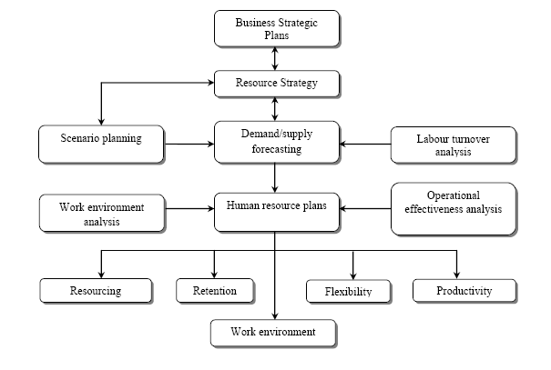

Figure 2.2: Process of Human Resource Planning
Source: Michael Armstrong (2006)

Business Strategic Plans - defining future activity levels and initiatives demanding new skills.
Resource Strategy - planning to achieve competitive advantage by developing intellectual capital-employing more capable people than rivals, ensuring that they develop organization specific knowledge and skills, and taking steps to become an employer of choice.
Scenario Planning - assessing in broad terms where the organization is going in its environment and the implications for human resource requirements.
Demand/ Supply Forecasting - estimating the future demand for people (number and skills), and assessing the number of people likely to be available from within and outside the organization.
Labor Turnover Analysis - analyzing actual labor turnover figures and trends as an input to supply forecasts.

2.15 The Organization Context of Human Resource Planning
Michael (2006) has shown that “the human resource takes place within the context of the organization. The extent to which it is used, and the approach adopted, will be contingent on the extent to which management recognizes that success depends on forecasting future people requirement and implementing plan to satisfy those requirements. The approach will also be affected by the degree to which it is possible to make accurate forecasts. Organizations operating in turbulent environments in future activity levels are difficult to predict may relay on short term measure to recruit and keep people. However, even these businesses may benefit from those aspects of human resource planning that are concerned with policies for attracting and retaining key staff.

2.16 Conclusion
For an organization to get the right number of people to do a particular task, human resource must be forecast. Forecasting require that an organization determines the number of future workers, with specialized skills and ability needed over period of time. Availability forecasting is to determine the number of needed employees for the organization is able to hire. Human resource planning is crucial in organizations in the sense that, it makes the organization aware of what course of action to take, and also to be proactive in recruiting and retaining employees. Through human resource planning organizations can determine, if there will be the right supply of talent in order to increase their recruiting efforts and act quickly to secure skilled and talented employees.

To better compete in the global market, organization will need to create and implement corporate strategies to promote itself as a “preferred employer” – investing in progressive HR policies and programs with the goal of building a high-performing organization of engaged people, and fostering and creating a work environment where people want to work, not where they have to work. Human resource planning contributes to organization success in the sense that, it ensures that an organization always have a concept of the job market and how it is related to its failure. A company that refuses to engage in human resource in order to be proactive may find itself with a number of unfilled positions. I would like to conclude that, human resource planning needs a continual process to help organizations to achieve its goals, though some jobs are still in demand during downturn, securing people with highly desirable skills will always be a challenge.

CHAPTER THREE

3.0 METHODOLOGY

3.1 Introduction
This chapter devoted to methodology of the study which contains the research design, research population, case study organization, sample and sampling procedure, data gathering instruments and method of data analysis.

3.2 Research Design
The design which was used for this study is a descriptive survey, thus data were systematically collected at a point in time, analyzed and presented to give a clear picture of Human Resource Planning practices at the Songea Municipal Police. A descriptive research was used in that it is basically designed to find out the existing situation of a particular phenomenon of concern. In other words, a descriptive research is the research which deals with the relationship among non-manipulated variables. In descriptive research, the events or conditions either already exist or have occurred and the researcher mainly selects the relevant variables for an analysis for their relationships (Best and James, 1993). This type of research was a systematic attempt to collect information from members of an identifiable population particularly, employees of Songea Municipal Police.

The rationale for using the descriptive survey is that it helps in telling what the situation is in a systematic manner, it involves collection of accurate data for the purpose of determining the current nature of the subject of study thus impact of Human Resource Planning on Songea Municipal Police, it also involves formulation and testing or research questions by describing the situation and using local methods for inductive deductive reasoning to arrive at the organizations. The descriptive survey follows specific procedures and makes possible interpretation of data collected. Here, research questions are raised and answered in a descriptive way. Any other person therefore can follow the same procedure and come out with the same results. The descriptive survey minimizes personality values; beliefs and predisposition of the researcher since there are laid down procedures to follow. The descriptive survey also provides the researcher with instruments which are easier for the collection of data for the study (Best and James, 1993).

3.2.1 Research Population
Martins, Loubser and Van Wyk (1996) stated that the population is the aggregate of elements from which the sample is drawn. Aaker, Kumar and Day (1998) concur, but add that it is important to determine the target population. In the case of this study, the target population for this study is the employees of Songea Municipal police. The employees of Songea Municipal Police shall be are used because of Human Resource Planning affects them directly.

The study population was a group of individuals in a study. The study aimed at getting information from workers of SPM, hence the targeted population were the workers of SONGEA MUNICIPAL POLICE consisting of Administration department, Criminal investigation department, Resources department, Operational department, Community Policing department, Intelligence department and Traffic department. Also three sections namely Tanzania Police Force Gender Desk, Accounts has been included in the study. The following are the names of OCDS who have been administering at Songea Municipal Police:
- SP. Dau 1987
- SP. Mwanjabiki 1992-1993
- SSP. Mushi 1993-1994
- ASP. Masanja 1994-1995
- SP. Sangu 1995-1997
- SSP. Kasseta 1997-1998
- SP. Jonath 1998-1999
- SSP. R. Shomary 1999-2001
- SSP. S. tarimo 2001-2002
- SP. B.M. mfundo 2002-2005
- SSP. J. Lesilwa 2005-2008
- SSP. Ponera 2008-2009
- SP. C.A. Milinga 2009
- ASP. M.R.N. Joshua 2009-2010
- SSP. R.M. Mihunga 2010-2012
- ASP. L.M. Nico 2012
- SP. A.R.F. Kasoro 2012-2014
- SSP. K.P. Mgani 2014-…..

3.2.2 Sample and Sampling Procedure
Martins et al. (1996) stated that sampling involves defining the population, identifying the sample, selecting the sampling method and sample size. As was explained above the applicable target populations in this research study were the employees of Songea Municipal Police. Various sampling methods exist, such as probability sampling which includes random sampling, systematic sampling, stratified sampling etc, and non probability sampling which also includes purposive, convenience sampling and many more.

The sample methods were used include the systematic sampling and purposive sampling techniques. The systematic random technique were used to determine and select respondents from the sample frame for the study. The purposive sampling technique was also used to determine and select key officials of the department with managerial responsibility for Human Resource Planning and management in the Department. The staffing of the Police Headquarters (PHQ), constitute the population for the study. The population is expected to be 400 ( Songea Municipal Police, 2016). To obtain the required sample size representative of the employees, a table developed by Krejcie & Morgan (1970) was used. From the table, a population of expected 400 shall give a sample size of and a population gives a sample size of 59. Therefore, the sample size for this study is 59.

3.3 Data Gathering Instruments
The main research tool or technique used for collecting the primary data was questionnaire and interview.

3.3.1 Questionnaire
According to Yin (1994), questionnaires are the most appropriate method for case study. For the purpose of this study questionnaires were used because it helped to collect data from large number of respondents in different locations. Also, because of the social climate it is opened enough to allow full and honest answers. There is also standardized data from identical questions without need have face to face interaction. Apart from these, it saves time and other resources.

Apart from these advantages, the survey questionnaire also enables one to collect standardized information in respect of the same variables for everyone in the sample selected (Parfitt 1997; cited in Zahari, 2007). This makes the questionnaire an indispensable tool in gathering primary data about people, their behaviour, attitudes, opinions and awareness of specific issues. Based on the above reasons questionnaires were used to collect primary data. Carefully crafted but wide-ranging questionnaires aimed at eliciting right responses were constructed for the employees of Songea Municipal Police.

In the questionnaires, the researcher used multiple choice questions with single answers, multiple-choice questions with multiple answers, rankings and Likert scaled questions. The appearance and layout of the questionnaire are very important factors and essential in ensuring that relevant data is collected. Martins, et al. (1996) feel that there should be sufficient space to record answers the questionnaires should not appear overly long, as this may put off both the respondents and discourage them from being totally committed to complete the questionnaires clear and understandable to encourage the respondents to answer them. Most of the questionnaires was multiple choice questions with simple answers like (a-d)

3.3.2 Interview
The researcher also conducted interviews with key officials of the department, head office SMP with managerial responsibility for Human Resource Planning and management in the Department. Interviews have been used in this work because they represent a valuable and rich source of information in doing a case study. The interviews have been done in an open, lively but focused manner with the intention of acquiring relevant information to enrich the findings of the study.

The researcher realized that a lot of information could be derived from interviews that are conducted in an open and focused way. Deliberate and purposive sampling techniques have also been employed to identify some interviewees because of the nature of the study. The researcher acquired a wealth of information from all these people which sheds more light on the intricacies surrounding Human Resource Planning in the Songea Municipal Police. I acknowledge that getting quick access to these people who are more or less the resource persons were not easy due to their duties and their daily routine they are facing here and there can cause the real meaning of getting the pure result.

3.4 Method of Data Analysis
The kind of analysis for this study was that of descriptive statistics which made use of numbers, tables, charts, and graphs used to describe, organize, summarize, and present raw data. All questionnaires completed during the research process were subjected to the editing process to ensure that the data collection procedure was performed properly and to eliminate questionnaires that did not comply with the criteria. Each completed questionnaire was inspected to determine whether it was usable and Microsoft Excel Spread Sheet was used to process the data for the analysis. Tables and statistical diagrams like bar charts, pie charts and line graphs also aided in the data presentation.

3.5 Brief Description of the SMP
Songea Municipal Police is the institution that is there to make security of citizens and their properties outfit of the Government both home and abroad. It was established by the British Colonial Government as a small unit during the Second World War (1939-1945) to provide information on the progress of the war. Its favored tools were its publication – the Empire at War, later Gold Coast Bulletin, and the Mobile Cinema Vans. The Department shall adapt itself to the changing conditions of Tanzania’ socio-economic and political life, since its inception. It has now shed all the functions that could be usefully performed by others, while concentrating mainly on government, public relations, citizens and properties for both Tanzania and abroad.

The area of study shall be Songea Municipal Police (SMP), which is the part of the Tanzania Police Force under the Ministry of Home Affairs. The TPF is led by an Inspector General of Police Ernest John Mangu. Also the TPF has got eight commissions; Administration and Resource Management Commission, Operations and Training Commission, Criminal Investigation Commission, Dar Es Salaam special Police Zone Commission, Zanzibar Police Commission, Community Policing Commission, Intelligence Commission and Traffic Commission.

The following is the short background of the TPF: In 1885 the German came to Tanganyika to colonize, they formed a group of people who worked as Police. In 1916 during the First World War, thirty one (31) police officers arrived from South Africa with rifles to do police works. In 25th August 1919 The United Kingdom Government announced through Magazines that Tanganyika Police Force was now established and the Headquarter was in Lushoto District under the leadership of Major S.T.Davis.

In 1921 another group of inspectors from Europe came to Tanganyika to start police school in Morogoro region. The first police station was opened in 1925 at Lupa Tingatinga goldmines in Chunya. Where in 1930 the Police Headquarters was shifted to Dar es salaam and the Field Force Unit was established in 1949. In December 1961 Tanganyika got her Independence from there the Police Force was started to change to reform its direction from that used by colonialists to citizens of Tanganyika.

In 1962 for the first time police commissioner rank which was covered by the Whiteman Mr. M.S.Wilson CP was taken by the African Mr.Elangwa Shahidi-CP. On 26th April 1964 Tanganyika and Zanzibar united to become Tanzania that is where Mr. Elangwa Shahidi was promoted to become Inspector General of Police (IGP). The Police Force was established by the law of Police Force and Auxiliary Service Act Cap 322, which covers an Act on how to serve for the organization, displine, powers and duties of the Police Force, a Police reserve and Auxiliary Police Force and for the related matters.

Also this Act is assisted by the Police General Orders (PGO) together with the Police Force Service Regulation 1995. Also was established by the United Republic of Tanzania constitutional Act chapter 9 section 147 subsection (i) to (iv) and section 148 (i) to(iii). The following are the IGPs who led the TPF since its origin after independence
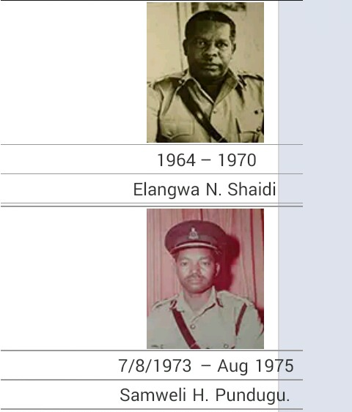 | 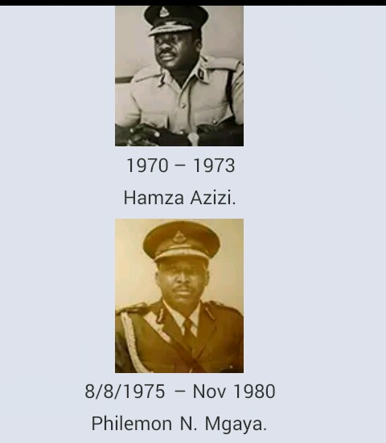
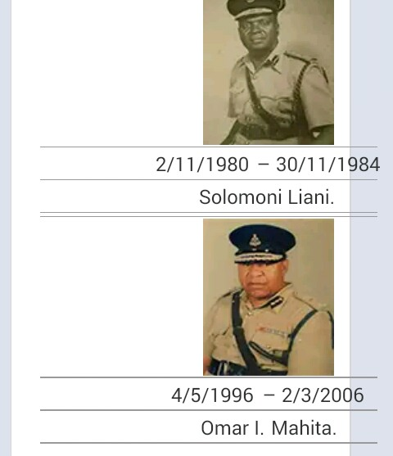 | 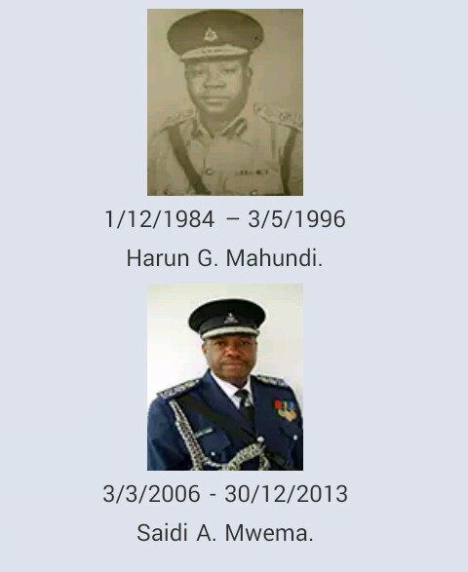
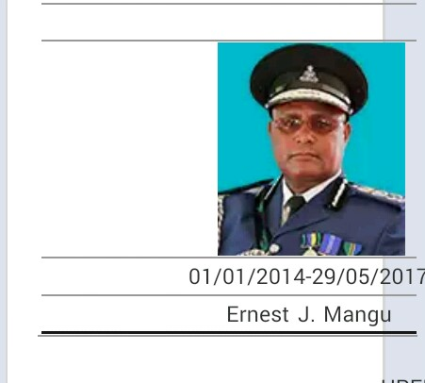 | 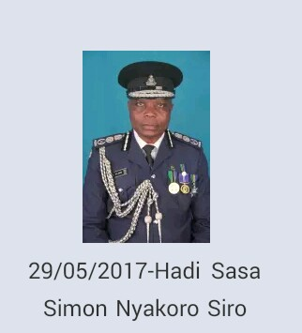
Source: www.policeforce.go.tz

3.6 Data Analysis Plan and Presentation
Data analysis is a body of methods that help to describe facts, detect patterns, develop explanations, and test hypothesis (Levine, 1997). In analyzing data both quantitative and qualitative approaches have been employed in order to get necessary information at the same time minimizing the risk of behavioral and emotional biasness. The presentation of findings shall be in form of tables, figures, diagrams and pie charts for easier interpretation and understanding.

3.7 Validity and Reliability of the Research
Researcher insured the validity and reliability of the findings where the researcher employed peer review and pilot study.

3.7.1 Peer review
The researcher discussed the instruments with colleagues before consulting the supervisor for the further advice. The comments from both the supervisor and the colleagues helped the researcher to improve the data collection instruments so that they yield the expected outcomes.

3.7.2 Pilot Study
The questionnaires were tried out in one of the selected police stations in Songea in order to identify the weakness and strengths. Therefore the researcher had an opportunity to improve the appropriateness of the tools for data collection.

3.8 Ethical Consideration
In conducting and evaluating the findings the researcher was obliged to protect respondents from any harm, be it social, psychological or physical which would cause their participation in giving data. Therefore adhered to the following issues: A letter of an introduction which is given by the OUT-RUVUMA centre to allow the researcher to go to the field for the data collection method. The same applied the RPC-RUVUMA who has provided an introduction letter to OCD of Songea and then the letter given by OCD of Songea to introduce the researcher to other departments under him.

After an introduction and explanation on the significance of the study, the respondents shall be told of their voluntary nature of participating in the study.
The researcher ensured the confidentiality of the information. Then researcher assured the respondents that the information they provided was for the purpose of the study and the issue of confidentiality was observed. Neither Police Station nor individual participants were identified by names in the researcher’s report instead letters or words were used for the purpose of hiding the identity.

CHAPTER FOUR

4.0 FINDINGS, RESULTS AND DISCUSSION

4.1 Introduction
This chapter puts forward an analysis of the data collected, the findings of the research, discusses and provides the interpretation of the findings. The data was collected parallel with the research objectives and questions provided in chapter one. An analysis is based on the data collected from Songea Municipal Police. The data collected are analyzed in the context of the methodology which is represented in chapter three. For this reason, questionnaires were administered to fifty members of the Songea Municipal Police as well as interviews with the human resource manager and other divisions involved in the human resource planning to solicit further information and detailed explanation.

4.2 Characteristics of the Respondents
The researcher was interested in finding the number of the employees at SMP, the age of the respondents, sex of the respondents, rank of the respondents, education of the respondents, marital status, distribution of the respondents by departments and working experience at SMP of the respondents.

4.2.1 The Number of the Employees at SMP
The interest of the researcher was to know the number of the employees who are employed at the Songea Municipal Police where the TPF has divided into two groups which are officers and ranks and files. The officers include A/INSP, INSP, ASP, SP, SSP, ACP, SACP, DCP, CP and IGP while the Ranks and Files include PC, CPL, SGT, S/SGT and RSM and the table below describe them.

Table 4.1 Number of employees at SMP
Structure SMP | Number | Percentage
OFFICERS | 08 | 3
RANK & FILE | 272 | 97
TOTAL | 280 | 100
Source: Research Data 2017

Table 4.1 shows that 97% of the employees employed at the SMP are of ranks and files while only 3% of the employees are of Officers.

4.2.2 Age of the Respondents
The researcher was interested in knowing the age of the respondents who participated in answering the questionnaires which were provided to the respondents. The table 4.2 shows their age.

Table 4.2 Age of the Respondents
Age | Frequency | Percentage %
18-25 | 10 | 20
26-45 | 30 | 60
46-50 | 6 | 12
51-60 | 4 | 8
Total | 50 | 100
Source: Research Data 2017

Table 4.2 above shows that majority of the employees employed at the SMP are of age 26-45 which is 60% of the respondents, 20% of the respondents are between 18-25, 12% of the respondents is between 46-50 and 8% between 51-60 and researcher found that the most of the respondents at 26-45 because the age of retirement is at 50 and compulsory retirement is 55.

4.2.3 Sex of the Respondents
The researcher was interested in the sex of the respondents to know the number of the employees who answered the questionnaires. The results are shown on the table 4.3

Table 4.3: Sex of the Respondents
Sex | Frequency | Percentage %
Male | 35 | 70
Female | 15 | 30
Total | 50 | 100
Source: Research Data 2017

Table 4.3 indicates that 70% of the respondents were males while 30% of the respondents were females. The number of the employees employed in TPF are males mostly and this makes the majority employed at SMP to be male too.

4.2.4 Rank of the Respondents
The researcher wanted to know about the rank of the respondents involved in the interviews. The results are as shown in the table 4.4

Table 4.4 Rank of the Respondents
Ranks | Frequency | Percentage %
Officers | 09 | 18
Ranks and Files | 41 | 82
Total | 50 | 100
Source: Research Data 2017

Table 4.4 describes the rank of the respondents where 82% were in the group of Ranks and Files and 18% are in the group of the officers who are in different departments at SMP.

4.2.5 Education of the Respondents
The researcher was also interested to know the education level of the respondents who were provided the questionnaires and the table below shows the level of the education of the participants.

Table 4.5 Education Level of the Respondents
Education level | Male | Percentage % | Female | Percentage % | Total | Percentage %
Ordinary Secondary Education | 16 | 32 | 6 | 12 | 22 | 44
Advanced Secondary Education | 7 | 14 | 2 | 4 | 9 | 18
Certificate | 1 | 2 | 3 | 6 | 4 | 8
Diploma | 2 | 4 | 0 | 0 | 2 | 4
Advance Diploma/Degree | 8 | 16 | 4 | 8 | 12 | 24
Postgraduate Diploma/Degree | 1 | 2 | 0 | 0 | 1 | 2
PHD | 0 |  | 0 | 0 | 0 | 0
Total | 35 | 70 | 15 | 30 | 50 | 100
Source: Research Data 2017

Table 4.5 shows that 44% of the respondents have the Ordinary secondary Education, 24% of the respondents have Advanced diploma/degree, 18% of the respondents have Advanced Secondary Education, 8% of the respondent have Certificate, with Diploma are 4% and 2% of the respondents have Postgraduate/Masters degree. The questionnaires were answered by all respondents successfully.

4.2.6 Marital Status of the Respondents
The marital status of the respondents is an important to be known and this made the researcher to be interested in marital status of the respondents who were provided the questionnaires and those involved in the interviews as shown in the table 4.6

Table 4.6 Marital Status of the Respondents
Marital | Frequency | Percentage%
Single | 18 | 26
Married | 32 | 64
Total | 50 | 100
Source: Research Data 2017

Table 4.6 shows that 64% of the respondents who answered the questionnaires are married and 26% of the respondents are single. So this shows that the large number of the employees in the SMP are married which is good for the administration system for many of her employees are more focused to perform their duties since many of the activities are done in helping different ages but mostly of married customers with marriage problems and many others. Knowing these problems the SMP started the department which deals with such problems known as “Dawati la Jinsia na Watoto” which has helped to control all such problems with the help of these officers who are married since they are in the same situations.

4.2.7 Distribution of the Respondents by Departments
The questionnaires were distributed to departments which are at SMP where the researcher was interested to know the different problems which they are facing on their duties and the table below illustrates that.

The Table 4.7 shows that all the questionnaires that were distributed at the SMP departments were 100% collected from the respondents which shows that there were good interaction between the researcher and the respondents.

Table 4.7: Distribution of Respondents by Departments
Department | Distribution of  Questionnaires | Collected  Questionnaires | Percentage %
Officer Commanding of District (Administration OCD) | 7 | 7 | 100
Officer Commanding of Station(Human Resource OCS) | 13 | 13 | 100
Officer Commanding of Criminal Investigation (Criminal investigation OC-CID) | 10 | 10 | 100
Community Policing | 6 | 6 | 100
Operations department | 4 | 4 | 100
Intelligence department | 3 | 3 | 100
Traffic department | 7 | 7 | 100
Total | 50 | 50 | 100
Source: Research Data 2017.

4.2.8 Working experience at SMP of Respondents

Table 4.8 Working experience at SMP of respondents
Years | Male | Female | Frequency | Percentage %
0-5 | 12 | 04 | 16 | 32
6-20 | 15 | 05 | 20 | 40
21 and above | 11 | 03 | 14 | 28
Total | 38 | 12 | 50 | 100
Source: Research Data 2017

In order to know better the SMP the researcher wanted to be sure of the working experience of the respondents so as to have clear data which will be provided to the researcher. The table 4.8 describe the experience of respondents involved. Table 4.8 above shows that 40% of the respondents had work experience at SMP of 5-20 years, and 32% of the respondents had 0-5 years and 32% had 21 and above years of experience in working at SMP. This is good for the respondents for the majority have experienced enough.

4.3 Human Resource Policies and Practices
The policies and practices which the researcher intended to discuss include the following; human Resource Planning at SMP, Human Resource Practices at the SMP, Human Resource Planning Cycle, Human Resource Planning cycle begin and Human Resource Planning effect in order to understand it more on how the SMP policies and practices are done.

4.3.1 Human Resource Planning at SMP
The researcher interested to know on how human resource planning at the SMP is practiced the respondent were provided the questionnaires to clarify on this and below is the table to describe.

Table 4.9 Human Resource Planning
Practices | Frequency | Percentage%
Training | 33 | 66
Motivation | 8 | 16
Promotion | 6 | 12
Recruitment | 3 | 6
Total | 50 | 100
Source: Research Data 2017

The Table 4.9 describe on how the human resource planning is done at SMP where 66% of the respondents said training, 16% of the respondents on motivation, 12% of the respondents said on promotion and 6% of the respondents said on recruitment.

4.3.2 Human Resource Practices at SMP
Practices at SMP was also interested by the researcher to get to know on how are carried out and how they help to shape the respondents in their duties. More description on the table 4.10

Table 4.10: Human Resource Practices
Practices | Frequency | Percentage %
Daily | 19 | 38
Monthly | 21 | 42
Yearly | 7 | 14
3 Years | 3 | 6
Total | 50 | 100
Source: Research Data 2017

Table 4.10 shows that the respondents who answered the questionnaires said that 42% was daily, 38% said monthly, 14% said yearly and 6% said after 3 years.

4.3.3 Human Resource Planning Cycle begin
The researcher wanted to know about the cycle of human resource planning where it begins at SMP so by using his respondents will rectify on the beginning of the cycle of human resource planning at SMP as shown to the table 4.11. The Table 4.11 above shows that the respondents answered the question and the majority said 70% was planning, 20% of the respondents said was evaluation, 6% said was development/design and 4% of the respondent said implementation.

Table 4.11: Human Resource Planning Cycle
Begin | Frequency | Percentage %
Planning | 35 | 70
Development/design | 3 | 6
Implementation | 2 | 4
Evaluation | 10 | 20
Total | 50 | 100
Source: Research Data 2017

4.3.4 Human Resource Planning effect at SMP
Researcher was interested in knowing the effect of human resource planning at SMP all is to make sure that there are good performance of employee and employees as shown to the table 4.12

Table 4.12: Human Resource Planning Effect
Effect | Frequency | Percentage %
Shortage of employee | 28 | 56
Unskilled employee | 18 | 36
Regular promotion | 4 | 8
Total | 50 | 100
Source: Research Data 2017

The Table 4.12 above illustrates that the question which was answered by the respondents said that 56% said was shortage of employee, 36% said was unskilled employee and 8% said was regular promotion.

4.4 Effectiveness of Human Resource Policies and Practices
The policies and practices at the SMP involves of defaulters, human resource unit involved in planning, the role of OCS, human resource department responsible for planning, the role played by the departments, the officer responsible for management, whether this role has been well played over last 10 years, rating of practices over last 10 years.

4.4.1 Defaulters
The researcher was interested in knowing whether defaulters can help to bring about effectiveness at SMP and the respondents were asked on this as the table below states.

Table 4.13: Defaulters
Defaulters | Frequency | Percentage %
Yes | 07 | 14
No | 43 | 86
Total | 50 | 100
Source: Research Data 2017

The above Table 4.13 shows that 86% of respondents said no and 14% of respondents said yes, majority here said that defaulters does not contribute to the effectiveness at SMP they just make the employees to work underperformance.

4.4.2 Human Resource Departments involved in Planning at SMP

Table 4.14 Human Resource Department involved in Planning
Department | Frequency | Percentage %
OCD | 5 | 10
OCS | 35 | 70
OC-CID | 7 | 14
OC-OPERATION | 3 | 6
Total | 50 | 100
Source: Research Data 2017
The interest of the researcher wanted to know how the units at SMP were involved in planning and the policies and practices can bring about the effectiveness at SMP as shown to the table 4.11 The illustration of the Table 4.14 indicates that when the respondents asked about to answer this question then 70% of respondents said was OCS, 14% said was OC-CID, 10% said was OCD and 6% said was OC-OPERATION.

4.4.3 Role of OCS at SMP
The respondents were asked about the role of OCS at SMP which was the interest of the researcher to know how OCS plays his roles as the table below illustrates.

Table 4.15: Role of OCS
Department | Frequency | Percentage %
Planning | 25 | 50
Counseling | 10 | 20
Administration | 5 | 10
Coaching | 10 | 20
Total | 50 | 100
Source: Research Data 2017

From the Table 4.15 above indicates that 50% of respondents who answered said planning, 20% of respondents each said counseling and coaching and 10% of respondents said was administration.

4.4.4 Human Resource Department Responsible for Planning
The researcher was interested in understanding which department at SMP was responsible for planning processes as shown to the table 4.16

Table 4.16: Department responsible for Planning Process
Process | Frequency | Percentage %
Training and Development | 11 | 22
Recruitment and Promotion | 39 | 78
Total | 50 | 100
Source: Research Data 2017

Table 4.16 shows that 78% of respondents which is the majority of the respondents said was recruitment and promotion and 22% of respondents said was training and development.

4.4.5 Officer Responsible for Management at SMP
In his findings the researcher wanted to know the officer who has the responsible of management at SMP so the respondents were provided the questionnaires to clarify the researcher as shown to the table 4.17

Table 4.17: Officer Responsible for Management
Official | Frequency | Percentage %
OCD | 43 | 86
OCS | 5 | 10
OC-CID | 2 | 4
Total | 50 | 100
Source: Research Data 2017

The illustration of the Table 4.17 shows that the majority of respondents which was 86% said was OCD, 10% said was OCS and 4% of respondents said was OC-CID. OCD is responsible for under the SMP all the departments were under OCD.

4.4.6 Whether this Role has been well played over the last 10 Years
The researcher also was interested whether this role of OCD of management has been played well over the last 10 years. The respondents were asked by the researcher to make this more understood as shown below to the table.

Table 4.18 Whether Roles Has Been Well Played Over the Last 10 Years
Opinion | Frequency | Percentage %
Yes | 38 | 76
No | 12 | 24
Total | 50 | 100
Source: Research Data 2017

Table 4.18 indicates that for the question answered by the respondents, 76% of respondents said yes and 24% of respondents said no.

4.4.7 Rating of Practices Over the Last 10 Years at SMP
The researcher wanted to know about the rate of practices how are done and been practiced over the last 10 years. For the researcher was important to know if all these practice were well practiced as table 4.19 below shows.

Table 4.19 Rating of Practices over last 10 Years
Satisfaction | Frequency | Percentage %
Satisfied | 9 | 18
Somehow satisfied | 15 | 30
Not satisfied | 26 | 52
Total | 50 | 100
Source: Research Data 2017

As shown to the Table 4.19 describes that 52% of the respondents were not satisfied, 30% said that they were somehow and 18% said that were satisfied which implies that over the last 10 years the administration had not done good job.

4.5 Constraints and Challenges at SMP
The researcher in this wanted to know the constraints and challenges involved at SMP administration which were observation of constraints and challenges at human resource planning departments, challenges hindering the human resource planning, management of the challenges and impact of constraints and challenges at the departments.

4.5.1 Observation of Constraints and Challenges at Human Resource Planning Department
The researcher wanted to know more on how the respondents observe the constraints and challenges at SMP as shown to the table 4.20

Table 4.20 Observation of Constraints and Challenges
Challenges | Frequency | Percentage %
Yes | 50 | 100
No | 0 | 0
Total | 50 | 100
Source: Research Data 2017

The Table 4.20 above indicates that whether they observe or experience any constraints and challenges as the majority of the respondents supported by saying yes which is 100% of the respondents that there are many problem facing the SMP.

4.5.2 Constraints and Challenges at SMP
The researcher wanted to know the constraints and challenges that SMP is facing as responded by the respondents as shown in the table 4.21

Table 4.21: Constraints and Challenges
Challenges and Constraints | Frequency | Percentage %
Change of leaders | 12 | 24
Poor management | 10 | 20
Record keeping | 28 | 56
Total | 50 | 100
Source: Research Data 2017

Table 4.21 indicates that 56% of the respondents said that it was record keeping, 24% of the respondents said that it was change of leaders while 20% of the respondents said that it was poor management.

4.5.3 Challenges Hindering the Human Resource Planning at SMP
Researcher was interested to know the challenges that hinder the SMP administration and the respondents gave their responses on these challenges as shown in the table 4.22

Table 4.22 Challenges Hindering the Human Resource Planning
Challenges | Frequency | Percentage %
Poor planning | 33 | 66
Motivation | 12 | 24
Promotion | 5 | 10
Total | 50 | 100
Source: Research Data 2017

Table 4.22 above shows that 66% of the respondents said was poor planning, 24% said that it was inadequate motivation and 10% said that it was lack of promotion.

4.5.4 Management of the Challenges at SMP
The researcher was interested in knowing how are these challenges managed by the administration at SMP as table 4.23 describes.

Table 4.23: Management of the Challenges
Cope with and Manage | Frequency | Percentage %
Training | 16 | 32
Promotion | 8 | 16
Coaching and Counseling | 26 | 52
Total | 50 | 100
Source: Researcher Data 2017

Table 4.23 indicates that 52% of the respondents who answered the question said that challenges were managed by coaching and counseling, 32% of the respondents said that was managed by training and 16% said that was managed promotion.

4.5.5 Seriousness of the Impact of Constraints and Challenges at the Department
The other question in which the researcher interested in was by the researcher was the seriousness of the impacts of constraints and challenges which are facing the employees at SMP in the different departments. Table 4.24 below has responses

Table 4.24 Seriousness of the Impact of Constraints and Challenges
Constraints and Challenges | Frequency | Percent %
Yes | 50 | 100
No | 0 | 0
Total | 50 | 100
Source: Research Data 2017

Table 4.24 shows that 100% of the respondents which is the majority saw the Seriousness of the impact of constraints and challenges causes all the problems the SMP is facing.

4.6 Conclusion
In his findings the researcher found that there were many challenges and difficulties that the employees at the SMP are facing, and due to these changes so the effectiveness of the SMP in giving service to the citizens always the performance will be down, and so the SMP and TPF should take major steps to solve all these challenges to make sure that the SMP is able to meet the goals and make sure that citizens are safe all the time and their properties.

CHAPTER FIVE

5.0 SUMMARY, CONCLUSION AND RECOMMENDATIONS

5.1 Summary
The study set to analyze Human Resource Planning practiced at Songea Municipal Police (SMP). The study tried to answer the following questions: How effective are Human Resource Planning (HRP) policies and practices at the SMP? How effective are HRP practices and procedures within the SMP and are they functioning effectively and what are the challenges hindering the implementation of human resource planning in the SMP?

For these reasons, questionnaires were administered to fifty employees of the Songea Municipal Police as well as interviews were conducted with the human resource manager (OCS) and other divisions involved in the human resource planning to solicit further information and detailed explanation. Both secondary and primary sources of data were used, with the secondary sources that involved were data that was collected from documents such as annual reports from SMP, brochures on the profile of organization, operations and policy manuals of the organization. These documents were produced for specific purposes and have the advantage of being authentic, sincere and objective because they are documented policy statements for the organization.

Primary data is the basic material from which the study is obtained. First-hand full investigation was undertaken through the administration of questionnaires and interviews guides. The methods were used to supplement the data collected from the secondary sources. The research ended with the conclusions and recommendations that will help the SPM to improve on their Human Resource Planning practices.

5.2 Conclusion
The study examined the extent to which Human Resource Planning is practiced at Songea Municipal Police .It also sought to examine the relationship between Human Resource Planning and strategic planning of Songea Municipal Police and the importance of Human Resource Planning concept at Songea Municipal Police. Furthermore, the study touched on the response for Human Resource Planning, how it is carried out, Officials responsible for Human Resource Planning as well as the challenges of the Songea Municipal’s Police practices. The results of the study reveal that most of the SMP employees do not have in-depth knowledge on Human Resource Planning, thus it is not well practiced by the senior officers. It also reveals that Human Resource Planning can not align the organization plan with Human Resource Planning. The study ends with a recommendation for Songea Municipal Police towards the improvement of Human Resource Planning Practices.

5.3 Recommendations
The human resource department (OCS) should develop and implement a comprehensive career development training programme for the employees. This would make them proactive and resilient, and effectively propagate government policies. For the development of the organization when the department of the HR plays its role then the goals will be achieved as planned. The mentality of every employee should be changed through seminars and workshops to empower them. Proper logistics should be provided as well as adequate budgetary allocation for the human resource department, to overcome improper keeping of records of employees and excess employees. By keeping the records of the employees will make the department to remember how number of the employees needed by the SMP and how should be deployed to their works according to the field one is trained for.

The human resource department should be structured to take its rightful place in the scheme of affair, so that they can educate the employees more, giving them promotion according to their Police General Orders (PGO), on job training and motivations, and on their practices and how they plan for the human resource practices like recruitment, promotion, evaluation among others. The department itself should have a human resource plans so that no matter what changes occur in management, the plans can still be followed. These plans should be periodically reviewed in order to adjust to the dynamic environment. This would overcome the issues of excess employees which leads to increase cost of labour and also constant changing of administration in the organization.

Lastly, everyone should be self disciplined including management so as to execute both the organization and human resource plans. The department should know that for human resource planning to be effective it should be aligned with the organizational plan. And discipline for all the department should be clear to make all the departments to play their part in making sure that the implementation of all the procedures and practices of the human resource planning are well organized and do focus on the development of the SMP.

5.4 Recommendations for Further Research
A tracer study needs to be carried out to develop a deeper understanding of the human resource planning and its effect on police force effectiveness, all is to bring out about the effectiveness of the Police Force in making sure that their working performance is good. The existence of awareness of strategies, policilies, procedures and practices of the SMP for them to be implemented well. This study has been done in urban district, another study needs to find out awareness of the effectiveness of SMP for the use of human resource planning for the development of both SMP and employees.

REFERENCES
Aaker, K., and Day (1998). Research methods for political science: quantitative and qualitative approaches. 2nd Edition, London: The Croswell Press.
Best, O. & James, W. (1993). Fundamentals of social research methods: an African perspective. 3rd ed., Lansdown: Juta Education.
Biles, G. E. and Holmberg, S. R. (1980). Strategic Human Resource Planning. New Jersey: Thomas Horton and Daughters.
Bowey, A. M. (1974). A Guide to Manpower Planning. MacMillan, London.
Bryman, A. (2004). Social Research Methods (2nd Edition). Oxford, Oxford University Press.
Bulla, D. N. (1994). Manpower requirements forecasting: a case example, in Human. Human Resource Planning Society, New York.
Burack, E. H. (1985) “Linking Corporate Business and Human Resource Planning: Strategic Issues and Concerns,” Human Resource Planning, 8(3), 133-145.
Byars, L. L. and Rue, L. W. (2004). Human Resource Management, 7th ed. New York: McGraw Hill.
Byars, L. L., & Rue, L. W. (1991). Human resource management. USA: Von Hoffman Press.
Byars, L. L. and Rue, L. W. (1984). Human Resource Management. Irwin McGraw-Hill, New York.
Gould, R. (1984). “Gaining a Competitive Edge Through Human Resource Strategies,” Human Resource Planning, 7(1), 31-38.
Harvey, D., & Bowin, R. B. (1996). Human resource management: An experiential approach. New Jersey: Prentice Hall.
Information Services Department, (2012). Annual Performance Report, 2011. Accra: Assembly Press.
Krejcie, R. V., & Morgan, D. W. (1970), “Determining Sample Size for Research Activities”, Educational and Psychological Measurement.
Martins, J. H. (1996). Data analysis: processing and basic analysis, Pretoria: University of South Africa Press.
Michael, A. (2006). Human Resource Management Practice. Cambridge University Press.
Miller, E. C. (1989). “Strategic Planning Pays off”, Personnel Journal. 29(2), 1-12.
Parfitt, J. (1997). Questionnaire design and sampling. In Flowerdew, R. & Martin, D. (eds) Methods in Human Geography - a guide for students doing a research project, Essex: Longman.
Pradeesh, N. M. (2011). Steps in Human Resource Planning, Cincinnati: South-Western Publishing Co.
Reilly, P. (1996). Institute for Employment Studies, Human Resource Planning. Report 312, Institute for Employment Studies.
Schein, E. A. (1976). Increasing Organizational Effectiveness Through Better Human Resource Planning and Development, MIT. Resource Management Journal, 33, 239-260.
Walker, J. W. (1990). Human Resource Planning. 2nd Edition, Thousands Oakl: stage Publications.

APPENDICES

Appendix 1: Questionnaire

I am Remigior Choroha, the MHRM student at The Open University Of Tanzania Ruvuma Center. This study is been conducted as a part for the requirements for the award of the degree of the Masters of Human Resource Management under the faculty of Business Management. The research type is “An Analysis of Human Resource Planning and its Effect on Police Force Effectiveness, The Case Study of Songea Municipal Police”. In your hands are the questionnaires. Where the information you provide will therefore be used for academic purposes only and will be treated with confidentiality. Please answer the questions that are stated below:-

QUESTIONNAIRE
A. PERSONAL INFORMATION
1. Sex
a. Male () b. Female ()
2. Age Group
a. 18 – 25 Years ()
b. 26 – 45 Years ()
c. 46-50 Years ()
d. 51-60 Years ()
3. Marital Status
a. Single () b. Married ()
4. Educational Level
- Secondary ()
- Diploma()
- Degree ()
d. Technical()

5. Departments
a. Administration ()
b. Human resource. ()
c. Criminal Investigation ()
d. Community Policing ()
e .Operation ()
f .Intelligence()
g. Traffic ()

6. Years in SMP
a. 1 – 5 years ()
b. 6-10 years ()
c. 11-15 years ()
d. 16-20 years ()
e. 21 and above ()

B. HUMAN RESOURCE PLANNING PRACTICES AND PROCEDURES
7. What are the human resource planning practices in your organization?
a. Promotion ()
b. Counseling ()
c. Coaching ()
d. Dismissing ()
8. How are these practices carried out in SMP?
a. Monthly ()
b. Yearly ()
c. Every 3years ()
d. Daily ()
9. What are the elements of the human resources planning cycle in your department?
a. Planning/Implementation
b. Coaching
c. Counseling
10. When does the human resource planning cycle begin?
a. Planning ()
b. Design/Development ()
c. Implementation ()
d. Evaluation ()
11. What is the effect of human resource planning in your department?
a. Shortage of Staff ()
b. Regular Promotion ()
c. Unskillful Staff ()

C. KEY UNITS INVOLVED IN HUMAN RESOURCE PLANNING
12. Which Division has principal responsibility for human resource planning in the department?
a. Administration OCD ()
b. Human resource OCS. ()
c. Criminal Investigation OC-CID ()
d. Community Policing ()
e .Operation ()
f .Intelligence ()
g. Traffic ()
13. What role does the OCS is responsible for human resource planning play?
a. Plan for HR Practices ()
b. Advertisement ()
c. Operations ()
d. Administration()
14. Which section in the human resource department is SMP responsible for planning?
a. Recruitment &Promotion ()
b. Human Resource ()
c. Public Relations ()
d. Operations ()
e. Community policing ()
f. Investigation ()
15. What role does these section play in the human resource planning?
a. Administration ()
b. Promotion ()
c. Plan for HR Practices ()
16. Which officer is responsible for the management of the human resource planning process?
a. OCD []
b. OCS []
c. OC-CID []
d. OC-TRAFFIC []

D. ROLE OF HUMAN RESOURCE PLANNING IN TANZANIA POLICE FORCE
17. What is the main role of human resource planning in the department?
a. Plan for HR Practices []
b. Administration []
c. I.T and operations []
d. Advertisement []
18. In your opinion, do you think that this role has been well played over the last 10 years?
a. Yes
b. No
c. Can‟t tell
19. Give reasons for your answers
................................................................................................................................................................................................................................................................................
20. Are you satisfied with the manner human resource planning has been practiced in the department over the last 10 years?
a. Yes ()
b. No ()
21. Give reasons for your answer
................................................................................................................................................................................................................................................................................
22. How you rate your satisfaction with the human resource planning practices over the last 10 years?
a. Very satisfied
b. Satisfied
c. Fairly Satisfied
d. somehow satisfied
e. Not satisfied
23. Give reasons for your rating?
..............................................................................................................................
..............................................................................................................................
..............................................................................................................................
E. Main Constraints and Challenges that Hinder Human Resource Planning Processes
24. Do you observe or experience any challenges hindering human resource planning in the department?
a. Yes ()
b. No. ()
Give your reasons
………………………………………………………………………………………………………………………………………………………………………………………………………………………………………………………………………………
25. If yes, what are these constraints and challenges?
a. Frequent Change of Leaders
b. Good management
c. keeping of records

26. How do these challenges affect or hinder human resource planning in the department?
a. Poor Planning ()
b. Enough ()
c. High Motivation ()
d. Regular Promotion ()
27. How does the department cope with and manage these constraints and challenges?
a. Training/Promotion
b. Sharing money to staff
c. Counseling
28. Do you think that these constraints and challenges impact on human resource planning in the department?
a. Yes ()
b. No ()
29. Give reasons for your answer
.............................................................................................................................
..............................................................................................................................
.............................................................................................................................
30. How do you rate the impact of these constraints and challenges on human resource planning in the department?
a. Very high
b. High
c. Fair
d. Low
e. Very low
31. Give reasons for your answer
..............................................................................................................................
..............................................................................................................................
F. RECOMMENDATIONS TO IMPROVE HUMAN RESOURCE PLANNING
32. What recommendations would you make to address the constraints and challenges hindering human resource planning in the department?
..............................................................................................................................
..............................................................................................................................
33. What recommendations would you make to improve human resource planning generally, in the department?
.............................................................................................................................. ............................................................................................................................
34. Do you have any other comments on human resource planning in Tanzania Police Forces generally?
.....................................................................................................................................................................................................................................................

APPENDIX 2: INTERVIEW GUIDE

1. What are the challenges in the human resource planning process in Songea Police Municipal
……………………………………………………………………….
……………………………………………………………………….
……………………………………………………………………….
2. What challenges does the human resource section face in the implementation of the plan?
……………………………………………………………………………
……………………………………………………………………………
……………………………………………………………………………
……………………………………………………………………………
3. What are the effects of human resource planning on the employees?
…………………………………………………………………………………
…………………………………………………………………………………
…………………………………………………………………………………
…………………………………………………………………………………
4. What recommendations would you make to address the challenges in question 1 and 2?
…………………………………………………………………………
……………………………………………………………………………

APPENDIX 3: LETTERS

An Introduction letter from the University
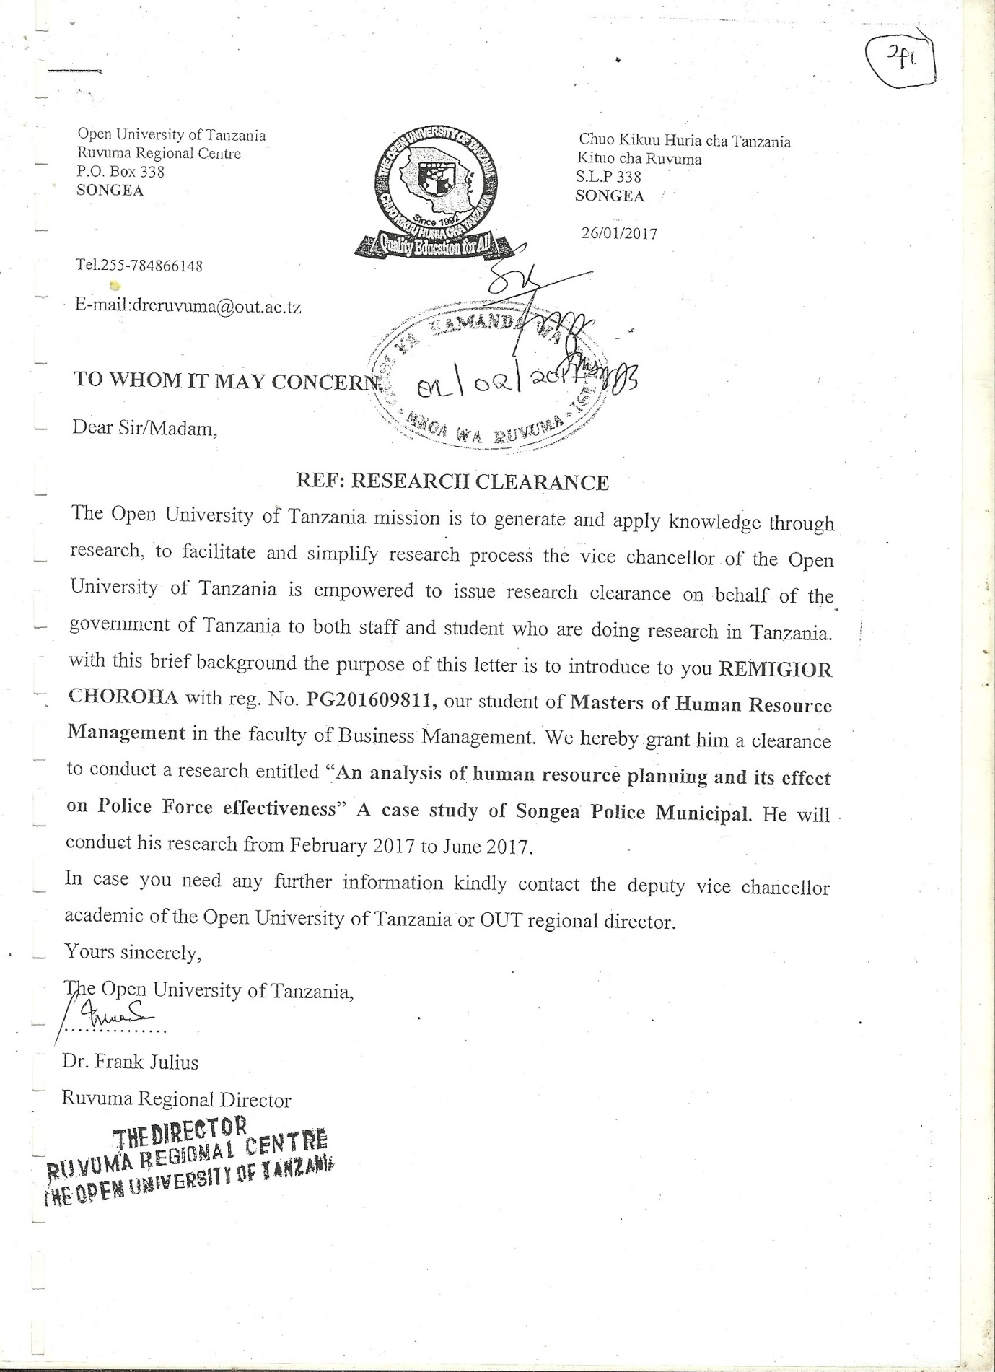

An Introduction letter from RPC’s Office
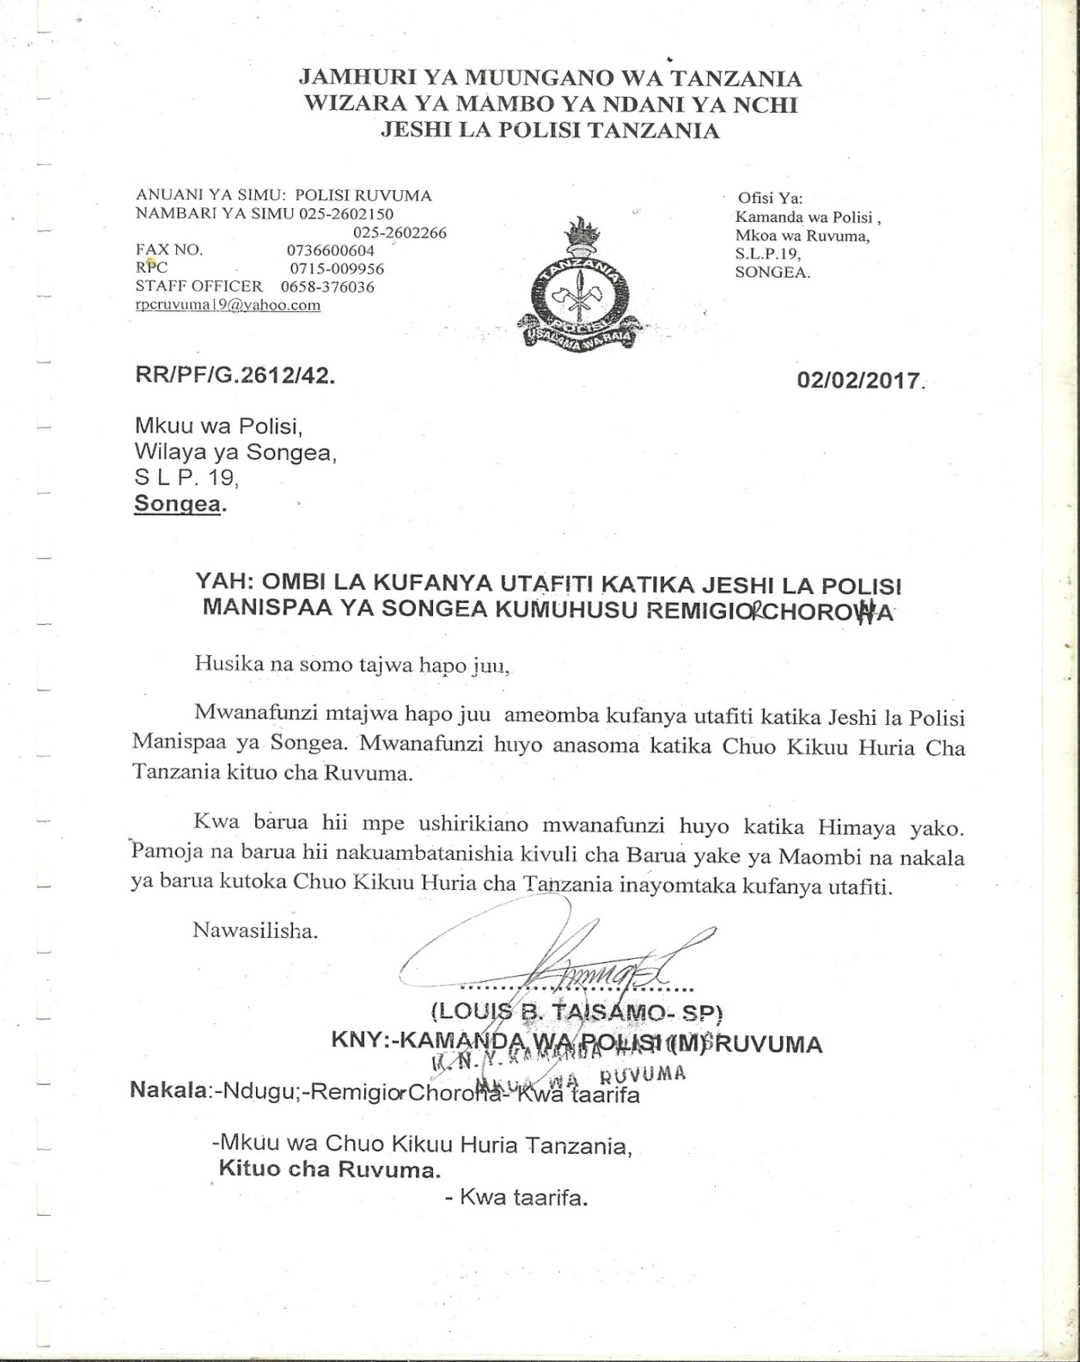

An Introduction letter from OCD’s Office


