THE INFLUENCE OF CORPORATE SOCIAL RESPONSIBILITY
ON EMPLOYEES PERCEPTION AT COCA COLA KWANZA (T) LIMITED

JUDITH GEORGE

DISSERTATION REPORT SUBMITTED IN PARTIAL FULLFILMENT OF THE REQUIREMENT FOR THE AWARD OF MASTERS OF PROJECT MANAGEMENT OF OPEN UNIVERSITY OF TANZANIA
2017

CERTIFICATION
The undersigned certifies that she has read and hereby recommends for examination a dissertation titled, “The influence of corporate social responsibility on employees perception at Coca Cola Kwanza (T) Limited” in partial fulfillment of the requirements for the award of the degree of Master of Project Management of The Open University of Tanzania.

……………………………………
Dr. Salvio Macha
(Supervisor)

………………………………
Date

COPYRIGHT
No part of this dissertation may be reproduced; stored in any retrieval system: or transmitted in any form by means; electronic, mechanical, photocopying, recording, or otherwise without prior written permission of the author or the Open University of Tanzania on that behalf.

DECLARATION
I, Judith George, do hereby declare that this dissertation is my original work and that it has not been presented and will not be presented to any other University for similar or any other degree award.

……………………………………
Signature

………………………..……...
Date

DEDICATION
This research is dedicated to my beloved Daddy George Massawe and Mother Blandina Shoo whose commitment to education is beyond doubt and my loving young sister Anna who has been unwavering in her support towards completion.

ACKNOWLEDGEMENT
I am very grateful and genuinely thankful to all who helped me during my education journey, my research as well as production of this dissertation. I would like to appreciate the support from my classmates and more specifically my discussion group mates who contributed in many ways to my studies.

In a special way, I am sincerely grateful to my supervisor Dr. Salvio Macha who carried me through the first phase of my research and his tremendous guidance was invaluable in ensuring that this journey comes to a triumphant end. Importantly, I wish to acknowledge the contribution of the respondents from Coca Cola Kwanza (T) Ltd, am in no doubt that without them this dissertation could not be possible. All I can say now is thank you.

ABSTRACT
This study discusses the influence of corporate social responsibility on employee’s perception at CCK. The study had three specific objectives namely; to determine the initiatives played by CCK towards the development of society, to examine the communities’ expectations on CCK’s CSR programs and to find out how CCK CSR programs are perceived by the employees. Data collection instruments were questionnaires, personal interviews, and documentary sources. Data collected were analyzed using Statistical Package for Social Sciences (SPSS) mainly descriptive statistics (Frequencies & Statistical means). Data collected through documentary review and personal interview were analysed using content analysis. The study used a sample of 38 respondents from different departments at CCK. The findings showed that there is no agreement between public expectations and perceptions on CSR initiatives at CCK. Furthermore the findings revealed that employees of CCK have shown dissatisfaction level on the following aspects environmental protection (29%), health protection (19%), fair pricing (10%) and satisfactory employee compensation (8%). Conclusively the researcher argues that CSR initiatives are negatively perceived by employees. There is a need to involve employees in planning for CSR initiatives.

TABLE OF CONTENTS
CERTIFICATION ii
COPYRIGHT iii
DECLARATION iv
DEDICATION v
ACKNOWLEDGEMENT vi
ABSTRACT vii
TABLE OF CONTENTS viii
LIST OF TABLES xiii
LIST OF ACRONYMS xv
CHAPTER ONE 1
1.0 INTRODUCTION 1
1.1 Introduction 1
1.2 Background Information to the Problem 1
1.3 Statement of the Problem 3
1.4 Objective of the Study 4
1.4.1 General Objective 4
1.4.2 Specific Objectives 4
1.5 Research Question 4
1.6 Significance of the Study 5
1.7 Scope of the Study 5
CHAPTER TWO 6
2.0 LITERATURE REVIEW 6
2.1 Introduction 6
2.2 Theoretical Literature Review 6
2.2.1 Definition of Corporate Social Responsibility 6
2.3 History of Corporate Social Responsibility 7
2.3.1 Worldwide Perception 7
2.3.2 Tanzanian Perception 7
2.4 Theories Underpinning Corporate Social Responsibility 8
2.4.1 Stewardship Theory 8
2.4.2 Milton Friedman Theory 8
2.5 Elements of CSR 9
2.5.1 Drivers of CSR 10
2.5.2 Approaches to CSR 10
2.5.2.1 Voluntary and Regulatory Approaches 10
2.5.3 Categories of Responsibilities in CSR 10
2.5.3.1 Responsibilities to Employees 10
2.5.3.2 CSR Responsibilities to Customers 11
2.5.3.3 Responsibility to the National Economy 11
2.5.4 Benefits of CSR to Organizations 11
2.5.4.1 CSR Enhances Competitiveness 12
2.5.4.2 CSR Enhances Brand Image 12
2.5.4.3 CSR Enhances Public Relations 12
2.5.4.4 CSR is a Promotional Tool 13
2.6 Empirical Literature Review 13
2.7 Research Gap 19
2.8 Conceptual Framework 20
CHAPTER THREE 22
3.0 RESEARCH METHODOLOGY 22
3.1 Introduction 22
3.2 Research Design 22
3.3 Area of Study 22
3.4 Study Population 22
3.5 Sample Size and Sampling Procedure 23
3.5.1 Sample Size 23
3.5.2 Sampling Techniques 24
3.5.3 Simple Random Sampling 24
3.5.2 Purposive Sampling 24
3.5.3 Stratified Sampling Technique 25
3.6 Research Instruments 25
3.6.2 Self-Administered Questionnaire 25
3.6.3 Interview Guide 26
3.6.4 Secondary Data Collection 27
3.7 Data Analysis Methods 27
3.8 Ethical Issue 27
3.8.2 Reliability and Validity data 28
CHAPTER FOUR 29
4.0 RESULTS PRESENTATION AND DISCUSSION OF THE FINDINGS 29
4.1 Introduction 29
4.2 Overview of the Coca Cola Company 29
4.3 Corporate Social Responsibility and Employees Perception of Coca Cola Kwanza 30
4.4 Characteristics of Respondents 32
4.4.1 Sex of Respondents 32
4.4.2 Educational Background of Respondents 33
4.4.3 Initiatives Played by CCK Towards Improving Society’s Welfare 35
4.5 Determination of Employees’ Expectations on CCK’s CSR Programs 36
4.5.1 Health Promotion 37
4.5.2 Environmental Protection 38
4.5.3 Interest in Improving Social Life 41
4.5.4 Attention to Consumers’ Safety 42
4.5.5 Satisfactory Compensation to Employees 44
4.5.6 Fair Pricing 46
4.5.7 CCK Efforts to Reduce Unemployment 47
4.5.8 Employees’ Perception on CSR Initiatives 48
4.5.9 Health Promotion 48
4.5.10 CCK and Unemployment 50
4.5.11 Fair Pricing 50
4.5.12 Satisfactory Compensation to Employees 52
4.5.13 Attention to Employees 53
4.5.14 CCK and Economic Development 54
4.6 Conclusion to Chapter Four 55
4.7 Discussion of the Findings 56
CHAPTER FIVE 58
5.0 CONCLUSION AND RECOMMENDATION 58
5.1 Introduction 58
5.2 Summary of Findings 58
5.2.1 Initiatives Played by CCK Towards the Society 58
5.2.2 Employees’ Expectations on CCK CSR Initiatives 59
5.2.3 Employees’ Perception on CSR Initiatives 60
5.2 Conclusion 60
5.3 Recommendations 62
5.4 Area for Further Study 63
5.5 Contribution to Knowledge 63
5.5.1 To the Researcher 63
5.5.2 To the Other Researcher Student 64
REFERENCES 65
APPENDICES 68

LIST OF TABLES
Table 3.1: Distribution of Sample 24
Table 4.1: Sex of Respondents 32
Table 4.2: Education Level of Respondents 34
Table 4.3: Corporate Social Responsibilities at CCK 35
Table 4.4: Employees’ Expectations on Health Promotion 37
Table 4.5: Employees’ Expectations on Environmental Protection 39
Table 4.6: Employees Expectations on Improved Social Life 41
Table 4.7: Employees Expectations on Safety 43
Table 4.8: Employees Expectations on Satisfactory 45
Table 4.9: Employees’ Respondents on Pricing 46
Table 4.10: Employees Perception on Health Programs 49
Table 4.11: Employees Perception on Pricing 51
Table 4.12: Employee Perception on Satisfactory Compensation 52
Table 4.13: Employees Perception on Safety 54
Table 4.14: Employees’ Satisfaction on CSR Initiatives 56

LIST OF FIGURES
Figure 2.1: A Conceptual Model for CSR 20
Figure 4.1: Gender of the Respondent 33
Figure 4.2: Education level of the Respondent 34
Figure 4.3: Expect CCK to Protect the Health of the Customers 38
Figure 4.4: Expect CCK not to Pollute the Environment With Their Operations 40
Figure 4.5: Expect CCK to Build an Interest in Improving Social Life 42
Figure 4.6: Expect CCK to Pay Attention to Consumer Safety 43
Figure 4.7: Expect CCK to Recompense Satisfactory Their Employees 45
Figure 4.8: Employees Expectations on Pricing 47
Figure 4.9: Employees Perception on Health Protection 49
Figure 4.10: Employees Perception on Pricing 51
Figure 4.11: Employees Perception on Satisfactory Compensation 53
Figure 4.12: Employees Perception on Safety 54

LIST OF ACRONYMS
CCK Coca Cola Kwanza
CSR Corporate Social Responsibility
REPOA Report on Poverty Alleviation
TCCC The Coca Cola Company
NGDP National Gross Domestic Product

CHAPTER ONE

1.0 INTRODUCTION

1.1 Introduction
This study aims to assess the influence of Corporate Social Responsibility (CSR) activities in the private sector in Tanzania by focusing on Coca Cola (ltd) as a case study. Specifically, the study aims to identify areas in which Coca Cola’s CSR activities are focused, to identify beneficiaries of Coca cola’s CSR activities and the effectiveness of Coca cola’s CSR activities in achieving set objectives.

Background Information to the Problem
The concept of CSR is not very new and even it is not very old either. The concept of CSR has changed over time. Once, the business was conducted only for protecting the interest of owners. About one hundred years ago, the purpose of the management of the business was to maximize profit and managers paid very little attention to social responsibility. This form of business changed during the first quarter of nineteen century (Hargreaves, 2005).

This change brought the separation of the management from the ownership. Under this system, the management started working to earn profit for owners as well as to pay attention to the expectations of the society. This was the era of trade unions recognition, the rise of consumerism and awareness for human rights which made business organization get concerned for quality of life (Sullivan, 2002). According to Sullivan (2002), the recognition of CSR came to be known by the business organizations in the past few decades whereby society has developed the attitude that all corporations should react to the all effects or problems created by them or from the consequences of their business operations. This concept supported that corporations are to be proactive and committed to respond to the social problems or simply socially responsive.

Traditional Corporation is a business organization for single group with a clear cut single purpose of conducting business for profit. This traditional view states only the legal social responsibility and leaving the public interest (p, 79). The history of private companies in Tanzania dates back before independence which operated during colonial times and after independence too. Things changed in 1967 after the Arusha Declaration when the government nationalized majority of private businesses, which was the beginning of the end for the private sector in Tanzania (Nyasingo, 2007). During the late 1980s, Tanzania underwent Structural Adjustment Programmes (SAPs), which among other things, involved privatization of public companies, which signaled for the re-birth of the private sector in Tanzania. Thereafter more private companies were established (Nyasingo, 2007).

Coca cola Kwanza (T) Limited was established to offer soft drinks services. Coca cola’s CSR activities are handled by the public affairs and communication department, which is a department within the company that offers donations to various groups and individuals in the society as part of the company’s social responsibility activities (Kaiza, 2015). CSR activities of Coca Cola Kwanza are directed towards sponsorship of events, learning institutions, donations to entrepreneurs, women empowerment and water projects. The objective of these activities is to improve the overall welfare of individuals and communities in the country.

Statement of the Problem
Organizations use CSR as tool of developing a favorable corporate image among members of the communities in which they operate. CSR activities help organizations to build good reputation and maintain good relations with members of the community that can be used as a social capital and contribute to future profitability of the company (Szeles, 2001). Coca Cola is among local companies which have engaged themselves in various CSR activities which are aimed to boost the company’s image among members of the general public.

Coca Cola’s CSR activities are handled by the specific department within the company that offers donations to various groups and individuals in the society as part of CSR initiatives (John Kaiza, 2015). Corporate social responsibility activities of Coca Cola Kwanza (T) Ltd are directed towards sponsorship of events, learning institutions, donations to entrepreneurs, women empowerment and water projects. The objective of these activities is to improve the overall welfare of individuals, communities and the country as a whole (John Kaiza, 2015).

However, there are suspicious that CSR activities conducted by Public affairs and communication department have less impact on public perceptions on Coca Cola’s products and services. On the company side it was expected the CSR initiatives to boost sales and create a pool of committed employees while externally creating a pool of potential customers with positive thinking about the organization (Kaiza, 2015). Moreover (Kaiza, 2015) argues that most CSR initiatives are externally focused. They have concentrated much on contributing to communities’ socio-economic development with less emphasis on employees and their families to improve quality of life. It is the researcher’s expectations that CSR initiatives are directed to external and internal environment and should result into increased employee productivity, loyalty and development of competitive advantage.

Therefore since no study has been conducted on the influence of CSR on public perception of soft drinks companies and their products, this study will examine how CSR programs are identified and implemented. It will also explore the communities’ expectations on CSR and determines challenges that face CSR initiatives and finally recommend on how to improve Coca Cola’s CSR initiatives.

Objective of the Study

General Objective
The main objective of this study is to determine the perception of the employees on Corporate Social Responsibility (CSR).

Specific Objectives
The study was guided by the following specific objectives
- To identify the initiatives played by Coca Cola towards the development of society
- To examine the communities’ expectations on Coca cola’s CSR programs
- To find out how Coca Cola’s CSR programs are perceived by the community

Research Question
The study will be guided by the following research questions;
- What are CSR initiatives implemented by Coca Cola Kwanza (T) Ltd to the community?
- What are the communities’ expectations on CSR initiatives of Coca Cola Kwanza (T) Ltd?
- What the communities’ perception on CSR initiatives?

Significance of the Study
The findings of the study will help Coca Cola Kwanza (T) Ltd and other private companies and the general public to become aware of the areas in which Coca Cola’s CSR activities are focused, that are the beneficiaries of such CSR activities and the effectiveness of Coca Cola’s CSR activities in solving social problems, and suggest measures to be taken to improve their effectiveness. In addition, the findings will enable Coca Cola Kwanza (T) Ltd and other private companies to come up with new and more effective ideas of implementing CSR activities, focus on key areas of people’s lives that need immediate attention, identify beneficiaries who are in genuine need of assistance and serve as a stimulant and stepping stone for future researchers.

Scope of the Study
The study will cover the activities related to Coca Cola Kwanza (T) Ltd corporate social responsibilities within Dar es Salaam region. Specifically this study will cover the following scope: Literature review, development of data collection instruments, data collection, data entry and analysis, data interpretations, draft report, presentation of draft report and production of final report.

CHAPTER TWO

2.0 LITERATURE REVIEW

2.1 Introduction
This chapter provides a summary of theoretical and empirical literature reviewed by the researcher during the study. It covers the theory underpinning the CSR, concepts of the CSR, empirical studies done by others on CSR, literature gap and conceptual framework of the CSR.

2.2 Theoretical Literature Review

2.2.1 Definition of Corporate Social Responsibility
There are number of definitions of CSR as given by various sources. CSR is what an organization does to contribute to the social, economic, political or educational development of the community where it is located, but which it is not compelled to do by any law (Ademosu, 2008). The social responsibility of business encompasses the economic, legal, ethical, and discretionary expectations that society has of organizations at a given point in time (Archie, 2009) CSR is a means of analyzing the inter-dependent relationships that exist between businesses and economic systems, and the communities within which they are based.

A key indicator to determine the true worth and value of modern organizations is their ability to give back to the society part of their income through some mutually beneficial initiatives (Nkanbra and Okorite, 2007); these initiatives are encapsulated in the concept of CSR. CSR is a means of discussing the extent of any obligations a business has to its immediate society; a way of proposing policy ideas on how those obligations can be met (Nkanbra and Okorite, 2007).

2.3 History of Corporate Social Responsibility

2.3.1 Worldwide Perception
The needs and desires of society could best be met by the unfettered interaction of individuals and organizations in the marketplace (Friedman, 2006). This notion was coupled with greater concern of the needs of the community which later changed due to Industrial Revolution. Industrial revolution resulted into individuals accumulating more wealth for the expense of others. This concept was cemented by the philosophy of Charles Darwin “Social Darwinism” in nineteen century who believed on survival for the fittest. Individuals believed in and practiced a philosophy that came to be called "Social Darwinism".

Noyer, (2003), this type of philosophy justified strategies and did not allow for much concern about the community, or the larger society. The social Darwinism could not survive longer since human being is social being. Organizational performance depends on individual motivation and commitment. Therefore between 1900 and 1960 the business world began to accept additional responsibilities other than making a profit and obeying the law.

2.3.2 Tanzanian Perception
For a number of years, the concept of corporate social responsibility was strange to many organisations, as the overriding emphasis was profit and nothing else. As at the time in question, company’s management never bordered about the customer or the environment within which business is being operated, and that created a lot of problems for the various institutions (Nyasingo, 2007). This has been so due to the fact that customers had little or no option, as the number of companies were relatively small. Moreover, the literacy level and consciousness of the company customers was quite low and so many things were taken for granted. Indeed times have changed a great deal and awareness about companies corporate social responsibility has continued to grow steadily ever since (Nyasingo, 2007).

2.4 Theories Underpinning Corporate Social Responsibility

Stewardship Theory
The Stewardship Theory basically follows religious teaching. The theory asserts that wealthier individuals and business entities recognizes themselves as steward or care taker of the community wealthy. They just hold the properties in trust for the whole society. The principle requires the business to use the wealthy it posses in the only use that the society deem appropriate and legitimate (Carnegie, 1900). This theory originated from communal mode of production or command economy where the government is controlling major resources of production of land, capital, labour, entrepreneurship and technology. The advent of free market economy where companies are after profit maximization very few organisations are considered with communities’ welfare, since CSR is treated as a cost centre that consumes part of the profit. In practice CSR initiatives should be treated as an investment because they are the ones to create a pool of potential customers and motivates internal customers (employees).

Milton Friedman Theory
In his views, Milton Friedman believes that business organizations have one and only one social responsibility to use its resources and engage in activities designed to increase profit. He further argues that business organization needs to ensure it maximizes its wealth creation objective by using all its energy and resources as long as it operates within the required norms and do not break the laws of the day (Friedman, 1983).

In the legal sense therefore, the corporation has no special moral or social obligations. The basis of Friedman’s argument is an unguarded acceptance of the values of hard core free market economic system. Such values include individual free choice and rights, especially the right to own property and to a free use of that private good (Friedman, 1983). A business's social responsibility lies in making profit has shown a controversial point of view in modern business. Some people believe in Friedman's ideas while others do not. Is it possible that Friedman can be both right and wrong? In business, there are different situations that require different perspectives and methods of approach. Where organisations are working in a competitive environment where customers are free to choose the organisation to trade with the role of CSR cannot be underestimated. On the other hand employees are loyal to their organisation where the organisation has CSR programs that look after their social economic needs.

Elements of CSR
CSR has four elements namely; social obstruction, social obligation, social response and social contribution which are mentioned above. It is usual that making goods and services available to make profit is the minimum degree of social responsibility followed by legally compelled obligations. These two parts are generally performed by every business organization (Khan, 2000). According to Khan (2000), the elements of the social responsibility include investment in community outreach, employee’s relation, creation and maintenance of employment, environmental stewardship and financial performance. According to this, CSR should take into consideration three main areas. These are society, the economy of a country and the environment. a corporation which is socially responsible should perform its activities in such a way as to cover these three areas.

Drivers of CSR
Under the banner of CSR, many companies have taken voluntary steps to improve their responsiveness to the concerns of the communities in which they operate by incorporating CSR into their business models and adopted codes of conduct regarding CSR practices. These companies spend considerable sums on philanthropic efforts, such as building schools and hospitals (Graddfland, 2002).

Approaches to CSR

Voluntary and Regulatory Approaches
To define CSR is that whether it engages the approach of voluntary initiatives or whether it is simply seen as compliance to regulation in the different areas covering to the society & to the environment. According to the Friedman, CSR relates to obeying the law and generating as much money as possible for the shareholders (Milton Friedman, 1962). A voluntary approach will be productive to the organization since it will be concerned to the needs of society hence affecting communities’ perception.

Categories of Responsibilities in CSR

Responsibilities to Employees
Employees are the members of the society, so to be responsible to the employee is the responsibility to the society. An organization’s first responsibility is to provide jobs to employee, keeping people employed and letting them have time to enjoy the fruits of their labor is the finest thing business can do for society. Enron is a company which violated this responsibility (Gitman, 2005).

CSR Responsibilities to Customers
All the efforts of an organization go to its customers. A central theme of today’s business is that a business must satisfy its customers to be successful. A firm must deliver what it promises (Gitman, 2005). It must also be honest and forthright with its clients. If the customers are unsatisfied then the fundamental theme of the business will fall in vain. So corporations should not run after only profit, it should also satisfy its customers.

Responsibility to the National Economy
Economic responsibility is the bed rock of all responsibilities and the foundation of all CSR, which if not achieved other responsibility will not be attained. This responsibility emphasizes the reason for business establishment. According to Carroll (2009), a business first responsibility is to an economic institution, that is, it should be an institution whose orientation is to identify customers’ needs and provide these needs with a view of making profit (p, 42).

Benefits of CSR to Organizations
Well managed CSR supports the business objectives of the particular corporation. It helps to build relationship with key stake holders whose opinion will be most valuable when times are very hard. There are many reasons of corporate social responsibility to be essential. In a word, it can be said that to perform CSR activities or to be concerned about CSR is the reality of the present time. Actually it is the demand of situation (Skinner and Ivancevich, 1992).

There are some external and internal reasons behind this. There is a direct correlation between the economic result and company image of CSR policy. A socially responsible firm makes deliberate, regular efforts to increase its positive impacts on society while reducing its negative impacts. In the past, operation of business was limited to a certain area or to a group of customers (Skinner and Ivancevich, 1992).

CSR Enhances Competitiveness
This is the most influential factor to form CSR policy or to involve in CSR activities. Environmentalism creates some special challenges for global marketers (Kotler and Armstrong 2006). Now an organization faces a hypercompetitive market where it is very tough to operate. Many forces make the market hypercompetitive. So to get competitive advantage or to be differentiated, it (CSR) is very useful and effective tool (Kotler and Armstrong 2006)

CSR Enhances Brand Image
Corporate social responsibility plays a vital role to build customer loyalty based on distinguished ethical values. So CSR program makes the organization different from competitors. Brand image helps in increasing sales which contributes to profit (Sullivan, 2002).

CSR Enhances Public Relations
CSR plays a significant role in building and maintaining public relation. Corporations are increasingly becoming motivated to be socially responsible because their stakeholders expect that corporations understand and address social and community issues that are relevant to them. CSR activities help them to have good relationship with public. This certainly increases the social image and status of the organization (Weihrich and Koontz, 1994).

CSR is a Promotional Tool
Business firms run their promotional activities through different ways. Some of them are more effective for their own benefits while other ways benefit at some extent to the society. CSR is the only way which benefits the business firm and the society. CSR acts as a very effective tool to run promotional activities. CSR activities are published through annual report and different media which make the organization well known as compared to the competitors it faces (Paula, 2009).

Empirical Literature Review
If a company socially responsible, it means, that all its units are also operating responsibly. In order to sustain harmony between the CSR-strategies of the units, it is better to develop a single CSR strategy which is company’s operating strategy as well. A well-planned CSR strategy influences consumers and the society in general to have a positive and favorable outlook on the company (Westlund, 2008). In order for a company to build a favorable image, it is not enough to act responsibility, it is also important to communicate the responsibility, what the company feels for society. As part of CSR activity, management has to share openly the company’s social actions with both employees and customers. The company and employees should also dedicate time and energy implementing projects that benefit the community (Hundes, 2008).
According to a study conducted by (Green 2007) in South Africa, 84% of consumers have better opinion about a brand which they can link to some kind of social involvement, and 74% of them think that they would prefer to buy socially responsible product. 66% of customers said they would change brand if they found out that the company they buy products from does not have a good reputation (p, 87).

According to Lawrence (2002), the greater the CSR association perceived by consumers, the more positively a company is evaluated by consumers, and the greater the company’s identity attractiveness for consumers; the more likely consumers are to be loyal to the company’s products, and thus the greater the likelihood of the company realizing profits from it’s business operations. CSR can be an asset that provides all these needs for the employees. Socially responsible companies have better abilities to attract, motivate and keep the best employees. CSR is also a good asset of group-building. For instance, Vodacom frequently sends out its employees to collect garbage from the street, visit orphanages, paint school classrooms or visit patients in hospitals (Lawrence, 2002).

These are the problems that private companies have been addressing through their CSR activities. A study conducted by REPOA (2008) in Tanzania found out that CSR is favorably perceived by the society. 89% of respondents who were asked to give their opinions on how they perceive the role played by CSR in the society replied that CSR is perceived to play a positive role by the society (p, 23). Corporations have become increasingly supportive of social causes through Public Private Partnerships (PPP) initiatives which aim at contributing to the development of the nation by giving back to the society. The study by REPOA (2008) identified creating a positive perception among members of the society as one of the motives for companies to continuously support social causes. The research further elaborated how Corporate Social Responsibility has become another way of reminding their customers to keep buying their products and services.

Another study conducted by Kamau (2009) revealed that Kenyan companies spend a large percentage of CSR budget on causes which are not directly beneficial to the welfare of the society especially those in need of urgent help. Data collected during the study showed that sports and entertainment are allocated majority of the budget for CSR at 69% compared to what is allocated for education projects. The research results show that 71% of the amount is targeted for youths aged 19-39 years, compared to 18% of the total amount which is targeted towards people aged 0-18 years and 11% of budget allocated towards older people aged 40 years or above. This shows that the youth are the major beneficiaries of CSR support from Kenyan companies (Kamau, 2009).

Also data shows that companies’ CSR support is directed to sports and entertainment (65%), education (24%) and health care (11%). Compared to the needs of the society, especially vulnerable members of the society, these data shows that there is a mis-match in allocation of resources as much CSR effort by companies is directed towards entertaining instead of solving problems of the society (Kamau, 2009). Furthermore, an analytical comparison of the data collected on the needs of the society showed that areas of priority which Kenyan companies directs CSR activities show that there is a mis-match between what the society needs and what companies focus their CSR activities on, and this contributes to reducing the impact and effectiveness of CSR activities (Kamau, 2009). In his study, Marcus (2008) analyzed the findings of 13 most significant studies available on this subject. Marcus found out that a definite correlation exists between higher profits and more responsible corporate behavior. Seven of the studies revealed a positive relationship between financial performance and social responsibility, while only 2 showed the opposite.

The study also found that ethical behavior pays and in most cases, irresponsible or unethical behavior is costly. Much evidence indicates that a wrong decision by a company can have extreme impacts on the bottom line as well as the ability of that company to markets its products and services in future. The fact ethical behavior creates fatter profits is proven not only by surveys but also by countless (Marcus, 2008). Luo and Bhattacharya (2006) conducted a study on impact of CSR on stakeholders’ attitudes towards businesses and found a negative relationship with performance because of the cost involved to invest in Corporate Social Responsibility. The study also found that Corporate Social Responsibility practices on stakeholder’s attitudes and behaviors towards an organization, though it remains poorly developed (p, 22).

In survey conducted by the conference board, executives reported that volunteer programs improved employee productivity and morale, fostered teamwork and built skills. Another survey indicates that 84% of managers believed that achieving a responsible image in the community is important for employee morale (Business Ethics, 1997). Moving on the same track a study conducted by Cropanzano et al. (2001) demonstrates that employee attitudes and behaviors are heavily influenced by fairness of organizational actions towards them. Redington (2005) with the help of twelve case studies, while underlining the HR professionals’ key role in managing the changes required for CSR activities to succeed, stated that employees are the most neglected though most important stakeholder of the organization for conducting CSR activities and having a good reputation socially implies that a company’s behavior is acceptable.

Rupp et al. (2006) accentuated that CSR plays a role about fostering positive social relationships between organizations and communities. They highlighted that employees will turn to CSR to assess the extent to which their organization values such relationships and so high levels of CSR can meet employees’ need for belongingness with the organization and the society. A survey conducted by Sirota Survey Intelligence (2007) affirmed that employees who are satisfied with their organization’s commitment to social and environmental responsibilities are likely to be more positive, more engaged and more productive than those working for less responsible employers and when employees are positive about their organizations’ CSR commitment, their engagement rises to 86 per cent (p, 73).

On the other hand, when employees are negative about their employer’s CSR activities, only 37 per cent are highly engaged. Similarly, Murray (2008) on the basis of survey stated that more than one-third of respondents pointed that working for a caring and responsible employer was more important than the salary they earned and nearly half would turn away from an employer that lacked good CSR policies. However Fenwick and Bierema (2008) has pointed that HR department, which has the potential to play a significant role in developing CSR activities within the organization, found to be marginally involved or interested in CSR. Mehta (2003), in a survey, found that of management workforce have been less likely to be involved in developing and implementing a policy on business responsibility towards society.

There are large variations conducted by companies and businesses in the understanding of CSR in the head office and the local plant or sales office of an organization (Young, 2006). The perceptions of workers and management also differ about whether an organization is complying with such regulations as related to labor or working conditions (Mehta, 2003). Agarwal (2007) stated that with the adoption of HR policies, such as, periodic review of employee performance, adequate training for the workforce and career advancement norms for its personnel, creating motivation, and commitment in the workforce the organization can reap the full business benefits and become successful to the great satisfaction of all its stakeholders.

Emphasizing upon such dimensions Krishnan and Balachandran (2004) pointed out the role of HRM in incorporating responsible practices within an organization. It is due to the lack of involvement of employees and failure to embed the socially responsible values into the organizational culture that many CSR initiatives inevitably fail and they just become an exercise in public relations.

The above verdicts of different researchers at different points of time entail that no doubt they have underscored the role of employee involvement through HR in various socially responsible initiatives of organization. But they have paid little attention on this aspect that how the internalization of CSR culture can happen with the initiatives of HR department of organization.

Masoud and Lauwo (2006) conducted a study aimed at understanding stakeholder view of CSR in state owned and privatized forms in Tanzania specification they wanted to test under formulated by Carroll in 1991 and 1995 on the ranking of CSR components and philanthropic the importance and community carrel pyramid model which ranks the CSR components in priority. The study posed questions as to where the results can differ if studies were done in a developing countries like Tanzania for both state and private firms while relationship between stakeholder wondered and salient and the components of CSR was found to be signification between employee private as well as more state owned forms conferment that shareholders are more concerned (Masoud and Lauwo, 2006).

Research Gap
From the literature reviewed above, the researcher concludes that more studies have been conducted on the influence of CSR initiatives on the public perception to involved companies abroad but few studies have been conducted on the influence of CSR activities in Tanzania. In regard with Coca Cola Kwanza (T) Ltd nothing has been documented on the perception of the public on CSR initiatives. Moreover studies have clearly indicated the importance of CSR but have not shown how companies involve themselves in CSR initiatives. There are differing assumptions on the role of CSR and how they are implemented. Some say Coca Cola CSRs have no impact on the livelihood of the community and others say CSRs initiatives are centered to external customers (community) with less emphasis to internal customers (employees) affairs. As a result, there is a knowledge gap that needs to be addressed, and that is the main objective of this study.

Conceptual Framework
A conceptual framework is an analytical tool with several variations and contexts. It is used to make conceptual distinctions and organize ideas. Strong conceptual frameworks capture something real and do this in a way that is easy to remember and apply. Conceptual frameworks (theoretical frameworks) are a type of intermediate theory that attempt to connect to all aspects of inquiry (e.g., problem definition, purpose, literature review, methodology, data collection and analysis). Conceptual frameworks can act like maps that give coherence to empirical inquiry. Because conceptual frameworks are potentially so close to empirical inquiry, they take different forms depending upon the research question or problem. The conceptual framework has been clearly indicated using the Figure 2.1.

Independent variable Dependent Variable

LEVELS OF CSR INVOLVEMENT
- Community needs
- Business Partners
- Investors interests
- Employees needs
- Clients needs

PUBLIC PERCEPTION
- Health protection
- Environmental protection
- Improved social life,
- Sustainability of projects
- Satisfactory recompensation
- Fair pricing
- Reduced unemployment rare

Figure 2.1: A Conceptual Model for CSR

Source: Developed by Researcher, Judith George, (2015)
In this study the conceptual framework highlights the relationship between Corporate Social Responsibilities Initiatives and Public perception of Coca Cola Kwanza (T) Ltd.

CHAPTER THREE

3.0 RESEARCH METHODOLOGY

3.1 Introduction
This section describes how the research methods were employed. The chapter provides explanations on the following areas: Area where the study was conducted, research design and research approaches to be employed during the study, population, sample and sampling procedures, data collection methods and how data collected were analyzed.

3.2 Research Design
A research design is a plan of action for collecting data, organizing and analyzing it with the objective of combining the relevance of the research with the economy in procedure (Kothari, 1997 and Bailey, 1994). For the purpose of this study.

3.3 Area of Study
The research was conducted in Coca Cola Kwanza (T), Dar es Salaam. The choice of the area was influenced by availability of data and shortage of financial resources.

3.4 Study Population
The sum total of the units of analysis is called the population or universe (Bailey, 1987:81). A large population cannot be studied in its entirety for reasons of size, time, cost or inaccessibility (Ahuja, 2001:157). In the same way, the researcher used the sample in this research due to the constraints of time and other resources. The population for this study included all 800 employees working for Coca Cola Kwanza (T). The selection of these people was based on the fact that they had some experience and practice in one way or another in CSR.

3.5 Sample Size and Sampling Procedure

3.5.1 Sample Size
The study expected to employ 89 respondents from respective population available. The sample was obtained using Kothari’s (2007) formula as indicated below.
n = N
1 + N (e) ²
Where by
n = Sample size
N = Targeted population
e = Level of confidence i.e. 10%
n = 800
- + 800 (0.1)²
n = 800
9
n = 89

However the response rate dropped to 38 respondents. This was due to a number of employees being pre-occupied by a number of undertakings hence delaying to feel the questionnaire. As an alternative to questionnaire the researcher tried to request for personal interview with employees and that also was not possible to ordinary employees, while other employees went further by asking money to feel the questionnaire.

Table 3.1: Distribution of Sample
S/N | Departments/Sections |  | Population | Sample size
1 | Distribution/Logistics Department: | Procurement | 36 | 4
 |  | Stores | 55 | 2
 |  | Distribution | 109 | 9
2 | Accounts Department |  | 21 | 2
 | Public Affairs and Communication |  | 3 | 3
3 | Administration | Chief Executive Officer | 01 | 01
 |  | Human Resource | 6 | 3
4 | Marketing |  | 400 | 10
5 | Production |  | 169 | 4
 | Total |  | 800 | 38
Source: Developed by the Researcher, 2015

3.5.2 Sampling Techniques
A simple random sampling, stratified sampling, and purposive sampling techniques were used to select the sample size among the respondents and stakeholders.

3.5.3 Simple Random Sampling
Simple random sampling is a probability whereby all members in the population have equal chance of being selected to form a sample. In this case probability selection of the study was made where by each staff had an equal chance of being selected to form a sample. Using simple random sampling made the researcher to select the sample at random from the sampling frame without replacement (Krishimaswami, 2002:148-152). Employees in the study were selected using simple random sampling technique.

Purposive Sampling
This is where the researcher targets a group of people believed to be typical or average or a group of people specially picked for some unique purpose. The researcher never knows if the sample is representative of the population, and this method is largely limited to exploratory research. (Babbie, 1992). Ndunguru (2004) and Kothari (2000) argue that purposive sampling is considered as representatives of the population for the case study research. Thus the study purposely selected Heads of Departments who are directly involved in CSR at Coca Cola Kwanza. Heads of departments were selected purposively because, by virtue of their positions in their respective organizations/institutions, had right information being sought about CSR initiatives.

Stratified Sampling Technique
Stratified sampling is the process of getting sample by dividing the population into a series of relevant strata means that the sample is likely to be representative as the researcher can ensure that each of the strata is represented proportionally within the sample (Saunders et.al 2012). The strata that were included in this sample are; Procurement, Stores, Distribution, Accounts and Finance Department, Administration, Human Resource, Marketing and production and operations department.

Research Instruments
In collecting relevant data the researcher used relevant instruments and methods for data collection such as:-

Self-Administered Questionnaire
Questionnaire is the systematic design questions for the purpose of collecting data from a respondent. Is a set of questions that are usually sent to the respondents to answer at their own convenient time and returned back the field questionnaire to the researcher (Mugenda, 1999). Randomly sampling was applied to obtain the information from respondents. A structured questionnaire (Appendix 1) was used to collect data relevant to the study. To ensure reliability and validity of data the questionnaire was pretested before the actual study took place. Kidder (1981) argues that the use of questionnaire is of advantage because of economy, limiting interviewer’s bias and the possibility of anonymity. The respondents of questionnaire were selected randomly from the population of employees. Every member of the sample was given a questionnaire to be filled with exception of Managerial cadre.

Interview Guide
An interview is a scheduled set of questions administered through oral or verbal communication in face to face relationship between the interviewer and interviewee (Devie 1997). For the purpose of collecting well-detailed information unstructured interview schedule was used. This is because an interview was essential for understanding data obtained through quantitative methods (Kothari,2002) also Leedy (1994:196) argues that face to face interviews have the advantage of enabling the researcher to establish rapport with the participants and gain their cooperation.

The research technique involved verbal questioning in collecting data and was administered through person to person contact. By the use of the said instrument of data collection, information from key informants (such as the officials from the company) was sought. In order to avoid some inconveniences the researcher made an appointment to each client in advance. The respondents of interview were selected purposive for Head of departments, because they are the key players in CSR.

Secondary Data Collection
Documents refer to an official paper or a book that gives information about something or that can be used as evidence or proof of something (Oxford Advanced Learners Dictionary, 2000:390). Company reports were used in order to obtain secondary data; Secondary data were collected through documentary review including minutes and newspapers.

Data Analysis Methods
Data analysis consists examining, categorizing, tabulating, testing or otherwise combining both quantitative and qualitative data to address the initial propositions of the study (Yin, 2003). Descriptive statistical methods were employed in this study. Frequency distribution tables, graphs and charts were prepared to summarize the data. For categorical variables cross - tabulations were prepared. Simple indices such as mean and standard deviation were used. The analysis was done by the use of Statistical Package for Social Sciences (SPSS) software. SPSS was used to analyze closed ended questions whereby for open ended questions Content analysis was used.

Ethical Issue
The study was conducted in accordance with the ethics requirements and the rights of individuals as stipulated in the Constitution of the United Republic of Tanzania. Under no circumstances the researcher entertained the intrusion of respondents without requesting the prior approval from them.

Reliability and Validity data
Reliability defined as the extent to which results are consistent overtime ((Saunders, Lewis & Thornhill, 2012). Reliability has to do with accuracy and precision of measurement procedures. The reliability of data was measured by making sure that respondents taken are the ones knowledgeable with Corporate Social Responsibility. In order to ensure data reliability the study used the Cronbach`s an alpha test was 0.05 to examine the data for reliability. Reliability coefficients quantify the consistency among the multiple measurement on a scale from 0 to 1, in which 0 represent errors and 1 represent error free Webb NM (2006).

Validity implies applicability and usefulness of the data obtained through such reliable design and all the way to conclusive findings (Kothari, 2007). Pilot study was done to test whether the tools are truly measuring what they intended to measure (Kothari 2007). Reliability of the tool was made by piloting the questionnaires before a comprehensive exercise of data collection to see if the tool can give consistent response from different respondents.

CHAPTER FOUR

4.0 RESULTS PRESENTATION AND DISCUSSION OF THE FINDINGS

4.1 Introduction
This Chapter analyses and presents the research findings about centralized the influence of Corporate Social Responsibility of employees’ perception of Coca Cola Kwanza (T). The study had three specific objectives namely; to determine the initiatives played by Coca Cola Kwanza towards the development of society, to examine the communities’ expectations on Coca Cola Kwanza CSR programs and to find out how Coca Cola Kwanza CSR programs are perceived by the community.

4.2 Overview of the Coca Cola Company
The Coca-Cola Company (TCCC) is the largest beverage company in the world, serving 1.7 billion consumers a day in more than 200 countries. The production and distribution of Coca-Cola follows a franchising model in which TCCC provides a syrup concentrate to its bottling partners who then manufacture package, distribute, and sell products for local consumption. Boasting the world’s largest distribution system, the TCCC system is renowned for its ability to make Coca-Cola products available in even the most remote locations.

TCCC established its first bottling plant in Tanzania in 1952. Currently, TCCC has three Tanzanian bottling partners [Coca-Cola Kwanza (CCK), Nyanza Bottling Co. Ltd., and Bonite Bottlers Limited], among which Coca-Cola Kwanza have played an instrumental role as TCCC’s local partners in the current supply chain initiative. "Whatever has to do with improvement of the Tanzania community it also touches improvement of, and welfare of our company." - Manager, Coca-Cola Kwanza
TCCC served as the lead investor and private sector champion of the project. The true value of the Coca-Cola contribution came from leveraging their convening power and sharing the core business expertise that has resulted in one of the farthest reaching supply chains in the world. As a show of its commitment to the partnership, two members of TCCC’s International Government Relations and Public Affairs team dedicated a proportion of their time to assist in moving the project forward, including engaging the local bottling system. In addition to many in-kind contributions, TCCC contributed more than $350,000 to the project and secured participation from Yale’s Global Health Leadership Institute to lead an analysis of key learning’s from the partnership experience.

4.3 Corporate Social Responsibility and Employees Perception of Coca Cola Kwanza
Corporate Social Responsibility is concerned with what is-or should be the relationship between global corporations, governments and individual citizens. More locally it is concerned with the relationship between corporation and the local society in which it resides and operates. In other words it is the relationship between a corporation and its stakeholders (Crowther & Aras, 2010).

Coca Cola Kwanza (CCK) is considering itself as a social entity that provides support to stakeholders on voluntary basis. CCK stakeholders include both internal and external. Internal stakeholders comprise of employees, managers and board of trustees while external stakeholders include suppliers, government and social and economic groups and individual citizens. CCK is aware that their operations have an effect not just to itself but also upon the external environment within which it operates. In recognition of the impact of its operation to external environment it has established some initiatives as its responsiveness to stakeholders. To mention some include; CCK do sponsor Copa Coca Cola football competition for the whole country and other social events in Tanzania.

By sponsoring football clubs the Company believes in gaining a share of heart in the society hence brand positioning of the company. CCK hopes by engaging in corporate social responsibility helps to build and sustaining the two teams. CCK accomplishes this by providing kits for teams, match gear, casual and training. On top of this, CCK uses their resource to support football clubs to build the brand loyalty. CCK Public Affairs and Communication Manager is the one who deals with social responsibility. According to Public Relations and Communication Manager of CCK, the company has been involving itself in contribution to disasters, supporting needy people in the community, creating awareness to public on social issues, supporting sporting activities, and education support to bright school children. If you compare the figure in the income statement and the expenses they incur on supporting the community are of so minimal.

The aim of this study was to know whether there is any correlation between corporate social responsibility initiatives and public perception of the Company in offering CSR. To arrive at conclusion the study had three specific objectives namely; determination of the initiatives played by CCK towards the development of society, determination of employees’ expectations on CCK’s CSR programs and finding out how CCK’s CSR programs are perceived by the community. The discussions of the said specific objectives have been indicated under here below.

Characteristics of Respondents

Sex of Respondents
Gender sensitive is a global issue under discussion in every working environment today. From the questionnaire distributed to employees it was revealed that 89% of employees were male and 11% were female. If we examine the results critically we find that CCK is gender insensitive. This might be due to nature of tasks of CCK and communities’ perception on alcoholic drinks.

Most of jobs require night shifts that make it difficult for women to accommodate the situation since they are expected to take of their families especially in the late hours in the evening. Moreover the researcher was interested in knowing the sex of respondents for the sake of understanding if there are any statistical significance difference in expectations and perception between male respondents and female respondents. The table 4.1 below shows the sex of respondents as appeared from the field.

Table 4.1: Sex of Respondents
Sex of Respondents | Frequency | Percent
Male | 34 | 89
Female | 4 | 11
Total | 38 | 100
Source: researcher, 2017

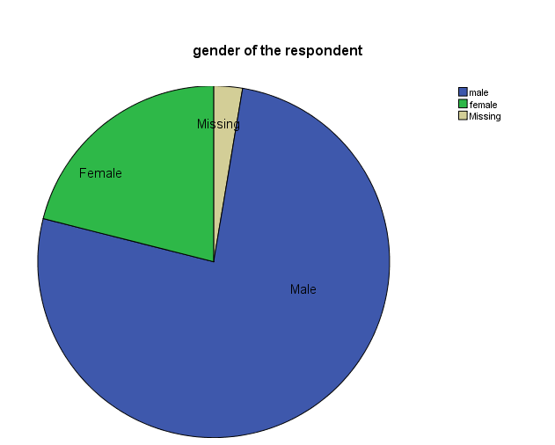

Figure 4.1: Gender of the Respondent
Source: researcher, 2017

Based on the findings it is clearly indicated that the organisation (CCK) is composed of many men as compared to women. As the results has shown only (4) 11% were female respondents, (34) 89% were male. This type of sample is likely to affect the results to large extent since female respondents have different expectations as compared to male respondents. Moreover the research has revealed that the mean expectations on CSR initiatives to improve employees’ welfare for women were found to be 3.9 while that of male was 3.2. The mean perception of female respondents on CSR initiatives was 2.4 while that of male was 3.0. Therefore the level of satisfaction is higher to men than that of women. This might be caused by the specific needs that women do address as opposed to those of men.

Educational Background of Respondents
Good performance of any working environment requires proper and possibly relevant credentials in the field. The researcher wanted to find out the level of education of the personnel recruited for the post they undertake. It was also necessary for the study to determine the educational levels of the respondents as that could determine what whether there are any significant difference in expectations and perception between those with high education and those with medium and low education. The findings revealed that the organization had employees of different educational qualifications. The distribution of respondents based on education was as follows; certificate level were 4 making 11% diploma level were 5 making 13%, 29 making 76% had bachelor degree . Table 4.2 below presents the data of educational background of respondents:

Table 4.2: Education Level of Respondents
Education level | Frequency | Percent
Certificate | 4 | 11
Diploma | 5 | 13
Degree | 29 | 76
Total | 38 | 100
Source: researcher, 2017

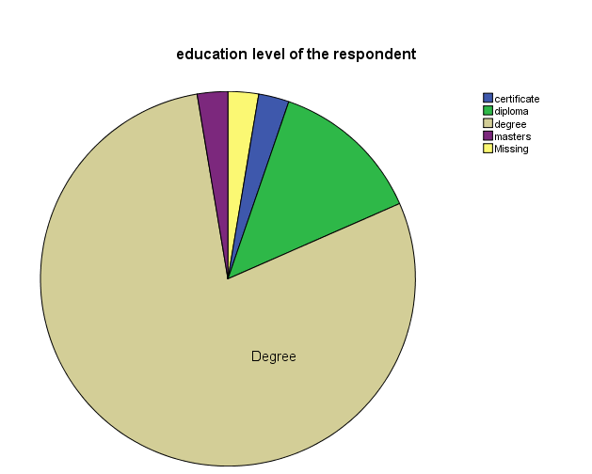

Figure 4.2: Education level of the Respondent
Source: researcher, 2017
The distribution above indicate that the organisation is characterized by majority with bachelor degree (29), followed by diploma holders (5) and (4) certificate holders (table 4.2). Since the majority of respondents are bachelor degree holders it is obvious that the responses were almost similar among respondents.

Initiatives Played by CCK Towards Improving Society’s Welfare
In order to know corporate social responsibility initiatives, the researcher created open ended question administered to employees and interviews were administered to employees of different departments. The initiatives have been presented according to the score it received from respondents. The results in Table 4.3 show how employees and Head of Departments identified some CSR initiatives at CCK. The frequencies and percentages for each initiative identified are given. These have been multiple response questions hence each item is scored independently at 100%.

Table 4.3: Corporate Social Responsibilities at CCK
Variable | Responses | Frequency | Percentage %
CSR initiatives identified by employees | Contribution to disasters | 35 | 92
 | Sports and games | 38 | 100
 | Supporting people in needy | 37 | 97
 | Education Support | 26 | 68
 | Employees welfare | 18 | 47
 | Total Number of Respondents | 38
Source: Research Findings, 2015

The above findings reveal the CSR initiatives are ranked by employees. The results show that all 38 employees (100%) do agree that CCK is very active in supporting sports and games, 37 (97%) of employees agree to the fact that CCK supports people in needy, 35 (92%) say CCK contributes to disaster mitigation, 26 (68%) say CCK supports education and 18 (47%) agree that CCK improves employees welfare.
The findings reveal that employees consider sports and games to receive high priority followed by supporting people in needy, disaster mitigation, education support and lastly were employees’ welfare. When one observes critically on the employees responses she/he will note that employees are not satisfied on the way the company deals with employees’ welfare. For sustainability of CSR initiatives, the involvement of all stakeholders mentioned earlier is of paramount important. If employees will perceive as neglected in the whole program then, they will be bad ambassadors hence distortion of the company’s public image.

Moreover the company was observed to sponsor football clubs with less emphasis on other games like netball, basketball, volleyball and other related games. This has led a community to believe that CCK CSR initiatives are a bit biased to football clubs. The community is in expectations of seeing CCK sponsoring all kinds of sports.

Determination of Employees’ Expectations on CCK’s CSR Programs
Employees have expectations for their careers and the organisation for which they work. Engaged, committed, high-performing teams are created by matching organization expectations and opportunities with employee skills, talents, and expectations. To match employee needs with organisation expectations, one must uncover the different motivations, strengths, and preferences of each employee. By conducting confidential, individual employee work expectations assessments, one can gauge where to begin individually, and collectively as an organization.

These assessments will identify a clear starting point that will provide a springboard to decision-making at CCK for the various CSR programs. To know employees’ expectations the researcher composed a number of variables to be ranked by employees by showing their true perception on how an aspect is important. The following aspects were measured; health protection, environmental protection, interest in improving social life, attention to consumer safety, satisfactory recommendation, fair pricing, honest to customers, reduce unemployment and contribution to economic development of the country. The results for the mentioned aspects are presented below.

Health Promotion
Health promotion is the process of enabling people to increase control over their health and its determinants, and thereby improve their health". The primary means of health promotion occur through developing healthy public policy that addresses the prerequisites of health such as income, housing, food security, employment, and quality working conditions (WHO, 2005). CCK advocates itself to be a champion in health promotion to Tanzanian community. This being the case the researcher developed a question to be ranked by employees on how CCK is expected to associate itself in health promotion and the following were the outcomes; 98% of respondents thought to be very import or important. This implies that employees are expecting CCK to promote health by 97.4% thus leaving 2.6% of respondents who were indifferent that is to say they neither disagreed nor agreed.

Table 4.4: Employees’ Expectations on Health Promotion
Responses | Frequency | Percent
neither disagree nor agree | 1 | 2.6
Agree | 9 | 23.7
strongly agree | 28 | 73.7
Total | 38 | 100.0
Source: researcher, 2017
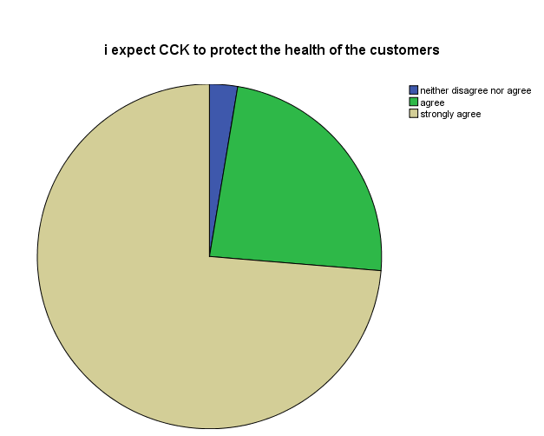

Figure 4.3: Expect CCK to Protect the Health of the Customers

Moreover the findings have revealed a mean different in expectations between male and female respondents. Female respondents have shown higher expectations on health promotion (mean of 3.7) as compared to male who have shown a mean of 3.6. Comparing the two means we find the difference of 0.1 which is greater than the significance level (α= 0.05). Therefore the difference is statistically significant. This implies that women are more vulnerable to health and hygienic problems due to their biological make-up thus demand more health care than men.

Environmental Protection
Coca cola Kwanza has been observed to involve itself in water management programs. Moreover Coca Cola Kwanza believes that water is a public good of very high value in all its competing uses, and requires that careful conservation and sustainable utilization be ensured. Deliberate efforts are, therefore, needed towards protection and sustaining the resource and to ensure that it is used efficiently and effectively for the benefit of the present and future generation. Moreover Coca Cola Kwanza believes that a company that implements an environmental management system is able to meet the requirements from the environmental law maintain good community relations and enhanced public image, as well as fostering development through the sharing of environmental solutions.

CCK has set itself as a role model for a company that puts environmental concerns on top of its agenda. This indicates that the Company is keen enough on aspect of environmental protection. A good example on how CCK involves itself in Wami-Ruvu and Pangani basin management which is very crucial for the life of Tanzania. However when the researcher asked how employees assign the importance of environmental protection the following were the outcomes; 55% of respondents either agreed or strongly agreed (see table 4.4), 37% neither disagree nor agree and 8% strongly disagreed. Based on these findings it is clearly indicated that employees are not much concerned with environmental protection. For them much consideration on environmental protection does not motivate them much to perform their duties.

Table 4.5: Employees’ Expectations on Environmental Protection
Responses | Frequency | Percent
Strongly disagree | 3 | 7.9
Neither disagree nor agree | 14 | 36.8
Agree | 11 | 28.9
Strongly agree | 10 | 26.3
Total | 38 | 100.0
Source: researcher, 2017

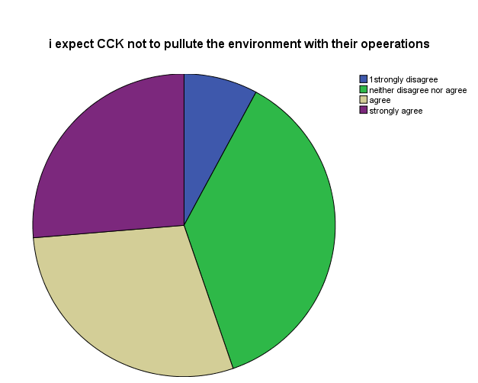

Figure 4.4: Expect CCK not to Pollute the Environment With Their Operations

When looking differences among respondents it was revealed that female respondents had higher expectations than male. The statistical mean of female respondents was 2.9 while that of male was observed to be 2.7 thus making a mean difference of 0.2 which is greater than significant level. This difference is statistically significant. This calls to the fact that women are more responsive to environmental protection than men and when droughts arise women are more vulnerable than men.

On the other hand the researcher was interested to know whether there are statistical differences in expectations between respondents with different levels of education. Again this revealed that people with higher education have higher expectations than those with low level of education. The results indicate that respondents with certificate level of education have a mean of 2.0, diploma 3.0, Bachelor Degree 2.7 and Master Degree had a mean of 4.0. This indicates that the more you learn the more you expect things to look better.

Interest in Improving Social Life
According to Kaiza (2015) CCK is very responsive to improved community life. This is cemented by his speech of July 22, 2014 to journalist that 70% of CCK CSR initiatives are directed to improved social life with a special concern to water projects. He further insisted that CCK has started a project of support to education, support to people in needy. Again the researcher wanted to know whether this was a community need or it was a wish of CCK to offer that assistance. When respondents were asked on this the following were the outcomes; 82% of respondents either agree or strongly agree to the fact that CCK should build an interest to improved social life, while 16% neither agree or disagree to the fact that CCK should build an interest to improved social life of the community. The results can be further depicted by the Table 4.5.

Table 4.6: Employees Expectations on Improved Social Life
Responses | Frequency | Percent | Valid Percent
neither disagree nor agree | 6 | 15.8 | 15.8
Agree | 2 | 5.3 | 5.3
strongly agree | 29 | 76.3 | 76.3
Missing System | 1 | 2.6 | 2.6
Total | 38 | 100.0 | 100.0
Source: researcher, 2017

To add the findings revealed male respondents have higher expectations than female respondents (statistical mean of 5.1 and 3.3 respectively). It was also observed that respondents with certificate, bachelor degree and master degree level of education had higher expectations than diploma holders. The reasons for such differences in expectations are still unknown thus calling for further research on why such differences exist.
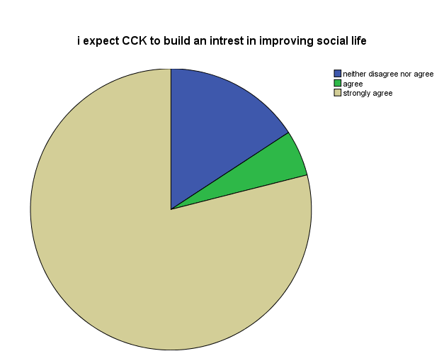

Figure 4.5: Expect CCK to Build an Interest in Improving Social Life

Attention to Consumers’ Safety
The Coca Cola Kwanza (CCK) is claimed to be very concerned to work hard to improve its working environment for its employee and customers and as a result it scoops an international award for its safety, health and environmental risk management at workplace organized yearly by a South African firm (Kaiza, 2014). Kaiza (2015), has further been quoted saying that CCK is continuing to work hard to improve the working environment for its employees and customers. He added saying the year 2012 the company won the occupational health award sponsored by the government of Tanzania.

This statement touched the researcher to the extent of knowing what employees expected of these CSR initiatives played by the company. The responses to the question were as follows; 97% of respondents either agree or strongly agreed (see table 4.6) to the fact that CCK should pay attention to employees and consumers safety, 3% neither agreed nor disagreed to the fact.

Table 4.7: Employees Expectations on Safety
Responses | Frequency | Percent
neither disagree nor agree | 1 | 2.6
Agree | 8 | 21.1
strongly agree | 29 | 76.3
Total | 38 | 100.0
Source: researcher, 2017

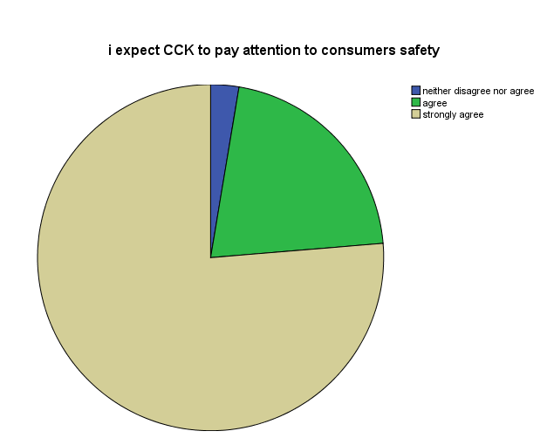

Figure 4.6: Expect CCK to Pay Attention to Consumer Safety

When the researcher analyzed to detect the differences among groups of respondents it was revealed that male respondents had higher expectations than female respondents (mean of 3.7) while female respondents had a statistical mean of 3.6. These means were compared to know whether the difference is statistically significant. Since the significance level was 0.05 the difference (0.1) was greater than the significant level hence the differences were significant.

Moreover there is growing concern among consumers, public health professionals and government agencies about the health problems associated with obesity. In addition, some researchers, health advocates and dietary guidelines are suggesting that consumption of sugar-sweetened beverages, including those sweetened with HFCS or other nutritive sweeteners, is a primary cause of increased obesity rates and are encouraging consumers to reduce or eliminate consumption of such products.

Increasing public concern about obesity; possible new or increased taxes on sugar-sweetened beverages by government entities to reduce consumption or to raise revenue; additional governmental regulations concerning the marketing, labeling, packaging or sale of sugar-sweetened beverages; and negative publicity resulting from actual or threatened legal actions against CCK or other companies in beverage industry relating to the marketing, labeling or sale of sugar-sweetened beverages may reduce demand for or increase the cost of CCK sugar-sweetened beverages, which could adversely affect CCK profitability.

In response to this response community consciousness on health related issues it has been observed that CCK is keen in reducing amount of sugar to its products. The community has witnessed the invention of new product by the name of Coke Zero which is sugar less and it is widely accepted among Tanzanians who seem to be affected by obesity.

Satisfactory Compensation to Employees
In this study satisfactory compensation refers to wages, salaries, overtime payments, bonuses, commissions and any other financial rewards paid to employees in return for the work they perform for their employers. Sometimes it is referred to as pay. When the researcher asked employees on whether satisfactory compensation could be a major aspect of CSR the following were the responses. 79% of respondents strongly agreed, 18% agreed and 3% strongly disagreed. These results can be further depicted using Table 4.7 and Figure 4.7.

Table 4.8: Employees Expectations on Satisfactory
Responses | Frequency | Percent
strongly disagree | 1 | 3.0
Agree | 7 | 18.0
strongly agree | 30 | 79.0
Total | 38 | 100.0
Source: researcher, 2017

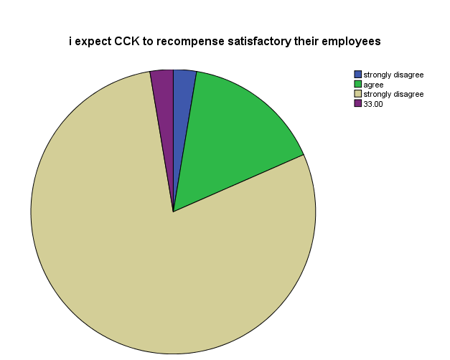

Figure 4.7: Expect CCK to Recompense Satisfactory Their Employees

Based on findings it was also observed differences in expectations among categories of respondents. Female respondents showed higher expectation on this aspect (mean of 7.4) while male respondents showed a mean of 3.8. The difference among male and female is very significant since it is above the significance level. Apart from the fact that female respondents had higher expectations than male, it was further revealed that respondents with diploma level of education had higher expectations (mean 9.0) than other categories like certificate (mean 4.0) and bachelor degree (mean 3.8).

Fair Pricing
The annual report (2014) of CCK’s marketing manager indicates that CCK is currently trading at a deep discount compared to its competitor PEPSI at 57%. The marketing manager was further quoted saying that without CCK discounting their products the current price of one bottle of Coke of 350mils could range between Tshs. 700 and Tshs. 1000. When the researcher asked respondents to rate whether fair pricing is part of CSR the following were the results; 3% respondents strongly agreed, 49% agreed, 43% neither agreed nor disagreed and 5% strongly disagreed. Based on these findings it is clearly indicated that pricing CCK’s products is not much considered as part of CSR initiatives (see Table 4.8).

Table 4.9: Employees’ Respondents on Pricing
Responses | Frequency | Percent | Valid Percent
strongly disagree | 2 | 5.3 | 5.4
neither disagree nor agree | 16 | 42.1 | 43.2
Agree | 18 | 47.4 | 48.6
strongly agree | 1 | 2.6 | 2.7
Total | 37 | 97.4 | 100.0
Missing System | 1 | 2.6
Total | 38 | 100.0
Source: researcher, 2017

It was the researcher’s interest to know if there are differences in expectations on whether price is an important aspect among male and female. After computation of data it was revealed that male respondents had higher expectation of 2.5 mean while female respondents had lower expectations of 2.2. This makes a difference of 0.3 which is very significant when compared to the set significant level of 0.05. This proves the allegation that male drink more than women. Men seem to be expecting CCK not to overprice their products since they major consumers of the product compared to women. This might be the reason to why male respondents had higher expectations as compared to female.

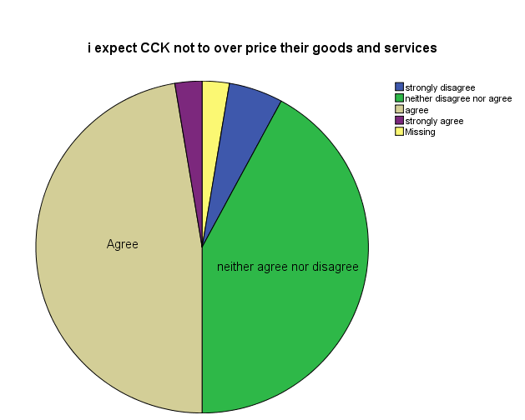

Figure 4.8: Employees Expectations on Pricing

CCK Efforts to Reduce Unemployment
Unemployment is the percentage of the civilian labour force that is without jobs but that is actively looking for work (Miller, 1995). Unemployment can reduce living standards, disrupt families and take from an individual his or her feeling of self respect. As a result maintaining a low unemployment rate is one of the major goals in stabilizing the economy. It was the researcher’s expectations to see that among CCK’s CSR initiatives is reducing unemployment rate in Tanzania. When the researcher asked respondents on whether reduction of unemployment rate was their major concern, all respondents (100%) agreed to the fact that CCK CSR initiatives should consider it as a critical aspect.
This has been so due to the fact that all respondents were employees of CCK. Therefore the results indicate that employees appreciate the fact that CCK has offered them with employment opportunities.

Employees’ Perception on CSR Initiatives
Perception is the process by which people translate sensory impressions into a coherent and unified view of the world around them. Although perception is necessarily based on incomplete and unverified (or unreliable) information, perception is equated with reality for most practical purposes and guides human behavior in general. To know employees’ perception the researcher used the same criteria used in measuring employees’ expectations. These are Health promotion, CCK and unemployment, Fair pricing, satisfactory compensation to employees, Attention to consumers’ safety, Interest in improving social life and Environmental protection. The findings on these aspects are presented.

Health Promotion
The government of Tanzania enacted a National Health Policy in 2003 catering the following specific objectives; Access to quality primary health care for all, access to quality reproductive health service for all individuals of appropriate ages, reduction in infant and maternal mortality rates by three quarters of current levels, universal access to clean and safe water, and improved life expectancy. In line with the National Health Policy, CCK has established a number of projects including water projects, distribution of mosquito nets in secondary schools, construction of improved latrines in schools. Since these programs are designed by the management the researcher thought of asking employees to give their true feeling on how health programs are offered by CCK. The following were the results. 79% either agreed or strongly agreed to the fact that CCK is fully engaged in health protection, 18.4% neither agreed nor disagreed while 2.6% strongly disagreed to the fact. If we compare with what employees expected on health promotion it is clearly revealed that the perception is less by (79-98= -19) 19%.

Table 4.10: Employees Perception on Health Programs
Response | Frequency | Percent
strongly disagree | 1 | 2.6
neither disagree nor agree | 7 | 18.4
Agree | 15 | 39.5
strongly disagree | 15 | 39.5
Total | 38 | 100.0
Source: researcher, 2017

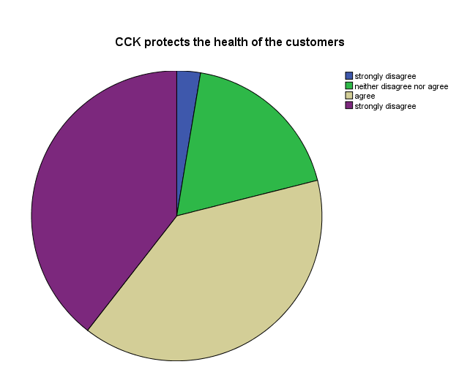

Figure 4.9: Employees Perception on Health Protection

Moreover it was further revealed that there were differences in perception between male and female respondents. Male respondents view CCK doing far better in Health protection (Mean of 3.2) while female respondents perceive CCK to do less in health matters (mean of 2.9). The mean difference among male and female is 0.3 which is statistically significant when compared to significance level of 0.05. These results reveal that women needs more care in health related issues than men. Therefore the organisation is required to put more efforts on hygienic issues to women working environment.

CCK and Unemployment
CCK is advocating being a company that provides employment opportunities on merit basis. For Dar es Salaam office alone it has more than 800 employees leaving other zonal offices. Provision of employment opportunities to the community is treated as one of the initiatives of CSR. When the researcher asked respondents whether CCK offers employment opportunities on merit basis, 100% of respondents were in agreement to the fact. This implies that employees are satisfied with recruitment and selection procedures at CCK and employees consider it as part of Corporate Social Responsibility. When compared to employees expectations it was observed that the difference was (100-100) 0, meaning that employees are satisfied with this aspect. In addition to direct employment In addition, CCK contracts out all noncore activities to private companies, thereby creating employment.

Fair Pricing
When the researcher asked respondents to show their true feelings on how they perceive the pricing strategies at CCK the following were the results; 58% of respondents neither agreed nor disagreed (table 4.10) and 42% either agreed or strongly agreed. It should be noted that Price can be set to maximize profitability for each unit sold or from the market overall. It can be used to defend an existing market from new entrants, to increase market share within a market or to enter a new market. Businesses may benefit from lowering or raising prices, depending on the needs and behaviors of customers and clients in the particular market. Finding the right pricing strategy is an important element in running a successful business. CCK products price have been raising from time to time thus affecting employees’ perception on pricing strategies. This has been evidenced by the results indicated above where 58% of respondents did not agree that CCK uses pricing strategies as part of CSR initiatives.

Responses | Frequency | Percent
neither disagree nor agree | 22 | 57.9
Agree | 11 | 28.9
strongly agree | 5 | 13.2
Total | 38 | 100.0

Table 4.11: Employees Perception on Pricing
Source: researcher, 2017

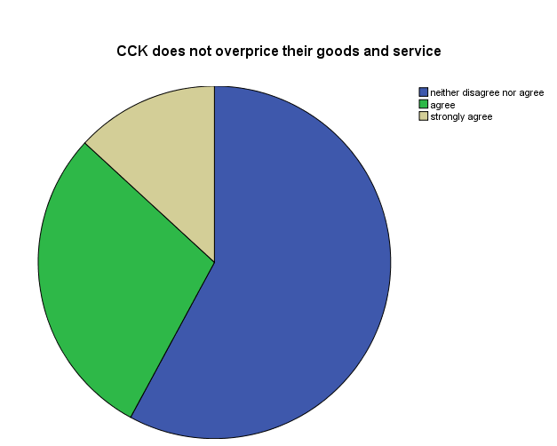

Figure 4.10: Employees Perception on Pricing

While male respondents had a mean of 2.5 female respondents had a mean of 2.6. This indicates a mean difference of 0.1 which is greater than alpha level of 0.05. The differences can be explained by looking at consumer behavior. It has been experiential that female are price sensitive than male. This being the case it is very easy for them to detect the difference in any price change since they are the budget holders in most of the families. However when compared to expectations the difference is not significant. Employees saw pricing strategy as important by 52% and they have perceived the same by 42%. The difference is not big, hence researcher argues that this aspect is not much important to influence the public perception of the company.

Satisfactory Compensation to Employees
In modern working environment it is no wonder to see vacancy announcement that states that “Attractive package will be offered to successful candidate”. This implies that people are moving from one organization to another looking for better paying jobs. Therefore good remuneration is treated as a CSR initiative. When the research asked respondents to show their true feelings on satisfactory compensation, they responded as follows; 71% of respondents agreed while 29% neither agreed nor disagreed.

Table 4.12: Employee Perception on Satisfactory Compensation
Responses | Frequency | Percent
Neither disagree nor agree | 11 | 28.9
Agree | 1 | 2.6
strongly agree | 26 | 68.4
Total | 38 | 100.0
Source: researcher, 2017
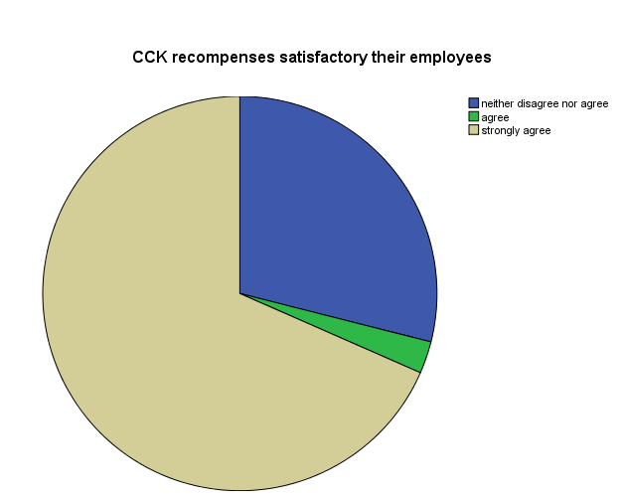

Figure 4.11: Employees Perception on Satisfactory Compensation

When the researcher analysed data among categories (male and female) it was revealed that male felt far better (mean of 3.4) as compared to women with mean of 3.2. Comparing the mean we get the mean difference of 0.2 which is greater than the alpha level of 0.05, thus the difference is statistically significant. From these findings it seems men are well compensated than women. This might be due to the fact that men do offer extra working hours thus demanding overtime pay than women who immediately rush to attend their families after the normal working hours.

Attention to Employees
The Occupation Health and Safety Act (2003) of Tanzania section 24-50 provide instructions on safety issues. In line with this the CCK claims to adhere to National provisions including the provisions of OSHA, 2003. When the researcher asked respondents on the extent to which CCK adheres to these provisions as part of CSR initiatives, 55.3 % agreed (See table 4.12) that CCK pays attention to employees/consumers safety while 44.7% strongly agreed to the fact. This implies CCK is very keen in ensuring that employees are safe.

Table 4.13: Employees Perception on Safety
Responses | Frequency | Percent
Agree | 21 | 55.3
strongly agree | 17 | 44.7
Total | 38 | 100.0
Source: researcher, 2017

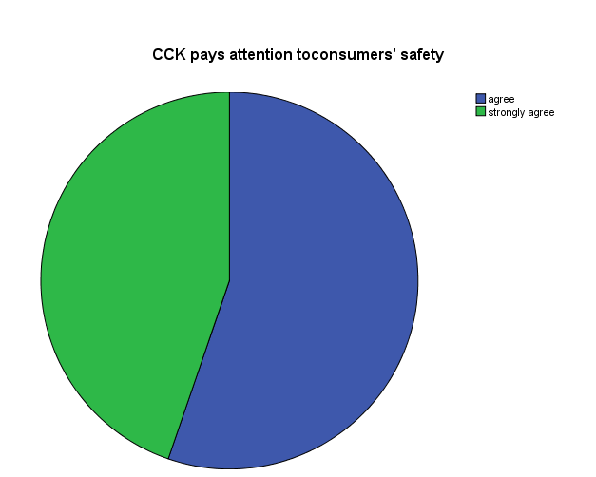

Figure 4.12: Employees Perception on Safety

CCK and Economic Development
Michael Todaro (1995) defines economic development as an increase in living standards, improvement in self-esteem needs and freedom from oppression as well as a greater choice. The most accurate method of measuring development is the Human Development Index which takes into account the literacy rates & life expectancy which affects productivity and could lead to Economic Growth. It also leads to the creation of more opportunities in the sectors of education, healthcare, employment and the conservation of the environment. It implies an increase in the per capita income of every citizen. Economic growth is the expansion of the economy to produce more goods, jobs and wealth. The researcher was interested in knowing the perception on whether CCK improves economic development 100% of respondents agreed to the fact. This implies that CCK attracts qualified employees, improved social life and contributes to National Gross Domestic Product (NGDP) through payment of taxes. This makes employees to see it as the organisation of their choice.

Conclusion to Chapter Four
Findings suggest that, employees had their expectations on CSR at CCK. The most critical aspects that was sought to be very important included:- reduction of unemployment rate (100%) health promotion (98%), employees and consumers safety (97%), improving social and economic life (82%), satisfactory compensation (79%), environmental protection (55%) and fair pricing (52%). Moreover employees perception on the same aspects were as follows; reduction of unemployment rate (100%) and Health promotion (79%), Employees and consumers safety (100%), improving social and economic life (100%), satisfactory compensation (71%), environmental protection (26%) and fair pricing (42%).

Based on the findings above we can merge expectations and perceptions to detect whether employees are satisfied on not, hence knowing how the organization is perceived and what aspects needs more attention. To know the level of satisfaction the researcher used Parasuraman (2008) principle, that states as follows;
Satisfaction = Perception – Expectation
Where the result is 0 or positive then employees are satisfied while negative results indicate dissatisfaction level.

Table 4.14: Employees’ Satisfaction on CSR Initiatives
S/N | Item | Perception | Expectation | Satisfaction
1 | Reduction of unemployment rate | 100% | 100% | 0
2 | Health promotion | 79% | 98% | -19
3 | Employees and consumers safety | 100% | 100% | 0
4 | Improving social and economic life | 100% | 100% | 0
5 | Satisfactory compensation | 71% | 79% | -8
6 | Environmental protection | 26% | 55% | -29
7 | Fair pricing | 42% | 52% | -10
Source: Research Findings, 2015

The Table (4.13) above indicates that employees are satisfied with three aspects of Reduction of unemployment rate, Employees and consumers safety and Improving social and economic life. Employees perception on these aspects were equal to employees expectations hence satisfaction. Moreover aspects of environmental protection and fair pricing are not considered as much important to influence the public perception.

Discussion of the Findings
When this study is compared to Westland (2008), it is evident that CSR at Coca cola cannot be sustained since employees consider themselves as neglected. Employees of Coca Cola see CSR as a tool to satisfy external customers and not internal customers (employees). This is contrary to what Westland (2008) argues that a well planned CSR must have a positive and favorable outlook on the company. CSR needs to be communicated to both internal and external customers that employees dedicate time and energy to these initiatives.
Moreover the study at hand reveals that CSR initiatives seem to concentrate on promotion side while leaving aside the community welfare. This again is contrary to Green (2007) who emphasizes on consumers involvement while planning for CSR. The current study indicates that consumers are not involved in planning for CSR initiatives. This is evidenced through employees’ response where they argued not to be consulted in planning for CSR. On the other hand the community is just given a project of which the company things can bring value to their business.

Based on the findings on table 4.13 it is clearly indicated that employees had higher expectations than what they perceived. The findings show that employees are not satisfied with the way the company promotes consumers’ health (-19%), environmental protection (-29%), satisfactory competition (-8%), and fair pricing (-10%). This means that CCK needs to work more on promoting health of consumers. This trend can be seen where a big number of people currently are avoiding consumption of Coca Cola products for the reasons that they are made of materials that considered as hazardous to their health. The study findings are contrary to Green (2007) who argues that for a long term survival of a business CSR must look after the people and the community as well as the environment.

CCK needs to reconcile and align demands, needs, interests and values of employees, customers, suppliers, communities, shareholders, the environment and the society at large. CCK’s track record in terms of CSR accounting will be effective when appropriate CSR measures are included in its internal as well as supply chain activates.

CHAPTER FIVE

5.0 CONCLUSION AND RECOMMENDATION

5.1 Introduction
This chapter presents conclusion and recommendations based on study findings, analysis and discussion. The study had three specific objectives namely; to determine the initiatives played by CCK towards the development of society, to examine the communities’ expectations on CCK’s CSR programs and to find out how CCK CSR programs are perceived by the employees. The chapter is concluded by brief summary and recommendations.

5.2 Summary of Findings
The primary purpose of the study was to examine if there is any correlation between corporate social responsibility initiatives and employees perception of the company in offering CSR. Various statistical techniques used to analyze data derived from objectives of study. Research questions and interview guide were answered. The study findings show that employees are not satisfied the way company promotes consumers health 19%, environmental protection 29%, satisfactory competition 8% and fair pricing 10%. On the other hand, the findings revealed that 89% of employees respondents were male and in addition, 76% of employees respondents had bachelor degree.

The following are the summary of the research findings from the research objectives;

5.2.1 Initiatives Played by CCK Towards the Society
The research findings have revealed the CSR initiatives that receive more emphasis include; Water Programs, Sports and games, Rural Health Care, Environmental protection and Employees welfare. The above findings were obtained using questionnaire where respondents mentioned the initiatives and the initiatives were analysed using content analysis. When these aspects were ranked by respondents in priorities the following were the outcomes; Sports and games (95.5%), health promotion (93.2%), water programs (68.2%), environmental protection (61.4%) and employees welfare (54.5%).

5.2.2 Employees’ Expectations on CCK CSR Initiatives
To get employees expectations the researcher administered a questionnaire with aspects to be measured. Data were analysed using statistical package for social sciences (SPSS) specifically frequency distribution. Employees ranked the following according to what they thought they were important; Reduction of unemployment rate (100%), Health promotion (98%), Employees and consumers safety (100%), Improving social and economic life (100%), satisfactory compensation (79%), Environmental protection (55%), and Fair pricing (52%).

It should be noted that employees have their expectations on how the company should behave. They believe that if the company would prioritize the ranked initiatives the way they expect the company should avoid some long term potential loss. If CCK needs to accomplish its goals it has to adhere to customers, employees, consumers and suppliers expectations.

Managers need to behave as a socially responsible managers and how to solve problems related to the community. In Tanzania there are some laws that enforce companies to be socially responsive. However to be socially responsive one must be more than simply law abiding who has to be capable of acting and being held accountable for decisions and actions. It is important to note that CSR initiatives and managerial behavior should be directed to stakeholders’ expectations. It is important to note that even if CSR programs are not stipulated in writing, they are social contract between a company, society, employees, government, consumers and suppliers. Moreover the findings revealed that CCK was observed to perform well in aspects of provision of employment opportunities (100%), employees’ welfare (100%) and employees and consumers welfare (100%). Other aspects were negatively perceived (that is to say employees were not satisfied with them).

5.2.3 Employees’ Perception on CSR Initiatives
To know employees perception the researcher administered a questionnaire to employees and data were analysed using Statistical Package for Social Sciences (SPSS). Aspects that have been identified to receive more emphasis include; Reduction of unemployment rate, Employees and consumers safety and improving social and economic life. Employees are satisfied with this and are ranked 100% excellent. However employees were not satisfied with satisfactory compensation (8%), Environmental protection (29%), Fair pricing (10%) and Health promotion (19%).

Conclusion
The main objective of this study was to determine the perception of the employees on Corporate Social Responsibility of the Coca cola Kwanza Company. Specifically the study identify the initiatives played by Coca cola Kwanza towards the development of society, examine the communities` expectations on Coca cola`s CSR programs and to find out how Coca cola`s CSR programs are perceived by the community. Primary data for the study was obtained through structured questionnaires to explain the main objective.

Data were analyzed using various statistical techniques: Statistical Package for Social Sciences (SPSS) was used to analyze closed ended questions and content analysis was used for open ended questions. The study findings revealed that two dimensions of the levels of Corporate Social Responsibility have positive and significant effect on employees` perception in the Coca cola Kwanza. Furthermore, the findings revealed that gender and education level of the respondents have impact on employees CSR involvement level.

When CSR is done correctly, CCK has enormous potential to affect change in their communities and the environment by investing in CSR initiatives. Research findings point out that CSR matters to employees’ job performance and public perception of the company. If employees perceive the company positively they will advocate the same to the public hence good reputation of the company to the community. The Company’s management need to be aware of what pay-offs they can expect to get from an investment in CSR, and it should be noted that a participative style in CSR investment is needed if sustainability is required. Managers who stay aware of CSR and the implications for their organizations will be able to make the most informed decisions.

In this study the researcher attempted to answer a question of how CSR initiatives at CCK are perceived by the employees. The study has determined aspects that receive more attention and those that do not. Conclusions have been given basing on these three specific objectives.

Recommendations
It is an undeniable fact that in recent times many organizations have come to the realization of the importance of CSR in influencing the public perception. In order to reap the full benefits of CSR initiatives CCK should ensure that the following are instituted at the work place.

Identification of stakeholders: CCK must identify its stakeholders and describe its relationship with each individual group.

Engagement of stakeholders: CCK must demonstrate inclusive engagement of stakeholders on issues of significant concern to them. The organization should demonstrate that an appropriate approach has been used to enable stakeholders to express their views and opinions.

Evaluation of stakeholders’ expectations: The organization shall evaluate the expectations of its stakeholders. The evaluation shall cover the aspects of the ‘Triple Bottom Line’ – economic, environmental and social. Records of the evaluation of stakeholders’ expectations should be maintained.

Evaluation of the impacts of the organization: The organization shall evaluate social and environmental impacts of its activities, products and services that the organization can control and influence. Records of that evaluation shall be maintained and shall include, but not necessarily be restricted to, the following areas: financial health, corporate governance and business ethics, workplace health and safety, human rights issues, individual supply chains and the overall supply web, business partners and communications.

Area for Further Study
The researcher recommends the future researchers to commit their efforts towards the following areas;
- The effect of CSR initiatives on employees performance
- The impact of CSR initiatives on employees turnover
- The impact of CSR on public perception of the company- non- employees perspectives

Contribution to Knowledge
The findings and analysis of this study show that CSR initiatives are well perceived by employees at CCK, although there are some discrepancies in perception among stakeholders (Managers and ordinary employees). There is a need to harmonize the situation. More than that the study has contributed that effective CSR initiatives should be backed up by identification of stakeholders and their expectations in terms of economic, social and legal aspects. As far as research study is concerned, the contribution of knowledge will be to the following area:

To the Researcher
Through research study made at CCK the researcher has widened her knowledge following the findings obtained due to ability of revealing the challenges and the solutions in relevant study. In that SSSS the researcher has accumulated a lot of knowledge and will be able to carry out another related study more efficiently in broader area of study.

To the Other Researcher Student
This research report will help other Project Management professionals and other managers who will be undertaking the related study to acquire knowledge and making deeper investigation on the study by making sure that they are covering the gaps not covered by the researcher hence bringing new insight.

REFERENCES
Boyd, D. (2003), Unnatural Law: Rethinking Canadian Environmental Law and Policy. Vancouver: UBC Press.
Carrol A S (2009). Managing Corporate Social Responsibility, Journal of Management Studies, 43(1), 47-73.
Churchill, G. A. (2006). Basic Marketing Research, 3rd Edition, Orlando Florida the Dryden Delhi, India.
Doh, J. (2006). Corporate Social Responsibility in Europe and the United States: An Institutional-Stakeholder Perspective’, Journal of Management Studies, 43(1), 47-73.
Economist Intelligences Unit, (2005). The Importance of Corporate Responsibility. Retrieved June 23, 2013 from www.economist.com.
Freidman, M. (1962). The social responsibility of business to increase profits”. New York times magazines, sep. 30.
Gitman, J. L. (2008), The Future of Corporate Social Responsibility, 5th Edition, 88-90, Gabriola Island: new society publishers.
Graafland, J. (2002). Benchmarking of Corporate Social Responsibility: Methodological Problems and Robustness’, Journal of Business Ethics, 53(1-2), 137-139.
Green, A. (2007). Corporate Social Responsibility in Developing Countries, Macmillan Press Ltd., London.
Hargreaves, B. (2005). Policy for Responsibility, McGraw-Hill Publishers, London.
Honders, H. (2008). Partnership for Corporate Social Responsibility’, Management Decisions, 46(1), 152-167.
Kotler, P. & Armstrong, G. (2006). Principles of Marketing, New York, Kogan Page.
Kamau, P. E. (2009). Making Corporate Social Responsibility (CSR) Work: How Kenyan Companies Practice CSR, Business and Society Review, 111(2), 137- 163.
Kothari, C. R. (2006). Research Methodology: Methods and Techniques, 7th Edition, New York Prentice Hall.
Lawrence, A. (2002). The Drivers of CSR Engagement, Journal of Corporate Citizenship, 6 (Summer 2002), 71-85.
Marin, L. & Ruiz, S. (2009). The Role of Identity Salience in the Effects of Corporate Social Responsibility on Consumer Behaviour’, Journal of Business Ethics, 84(1), 65-78.
May, S. M. (2009). Implementing CSR Through Partnerships, Journal of Business Ethics, 85(1), 413-429.
Newell, P. (2005). Citizenship, Accountability and Community: Limits of the CSR Agenda’, International Affairs (Royal Institute for International Affairs 1944, 81(3), 541-557.
Rahbek, E. (2006). Modeling CSR: How Managers Understand the Responsibilities of Business towards Society.
Saunders, M. K. (2012). Research Methods for Business Students, 6th Ed., UK, Pearson.
Skinner, S. J. & Ivancevich, J. M. (2004). The Impact of Corporate Social Responsibility on Business Performance. McGraw-Hill Publishers, London
Sullivan, R. (2002). Corporate Citizenship: Defining and Implementing Human Rights Norms. Journal of Corporate Citizenship, 7 (2002), 79-91.
Szeles, P. (2001). The Power of the Reputation and Image, Journal of Corporate Management Strategies, 23(2), 12-44.
TCC, (2009). Annual Report, Weihrich, H. and Koontz, H. (1994). CSR: A Global Perspective”, Journal of Corporate Social Responsibility, 2(2), 223-224.
Westlund, R. (2008). Corporate Social Responsibility, Institutional Investor- International, 33(3) 1-4.
White, A. L. (2009). Confessions of a CSR Champion’, Stanford Social Innovation Review, 7(1), 31-33.
Woodman, J. M. & Kverndal, D. (1976). Towards Social Responsibility, Report of the Study Group on Social Responsibilities of Business, Delhi.

APPENDICES

Appendix 1: Questionnaire
My name is Judith George; I am currently in the process of writing my dissertation for the completion of a Master Degree in Project Management of the Open University of Tanzania. My research topic based on “The Influence of Corporate Social Responsibility on Employees Perception of the Company at Coca Cola Kwanza (T) Limited”. Your assistance in filling and returning the questionnaire is greatly valued. The responses are completely anonymous and confidential and are for academic purposes only.

SECTION A: RESPONDENT’S PROFILE
Please tick in the boxes provided.

Personal data
1. Gender or the respondents
a) Male
b) Female
2. Respondents level of education
a) Certificate
b) Diploma
c) Degree
d) Masters
3. Occupation………………………………
4. Department……………………………….
SECTION B: Relationship between corporate social responsibility initiatives on employee’s perception of the company at Coca Cola Kwanza (T) Ltd
Employees Expectations
Give a score to each Expectation out of 4 points
The following set statements relate to your expectations about your organization. For each statement, please show the extent to which you expect your company to show on each statement.
DIRECTIONS: Indicate your true expectations by choosing a score from ‘1’ strongly disagree to ‘4’ strongly agree.
Scale: (1 = strongly disagree, 2= neither disagree nor agree, 3 = Agree, 4 = strongly agree).
S/N | Question/Item | Ranking
 |  | 1 | 2 | 3 | 4
1 | I expect Coca Cola to protect the health of the customers
2 | I expect Coca Cola not to pollute the environment with their operations
3 | I expect Coca Cola to build an interest in improving social life
4 | I expect Coca Cola to pay attention to consumers’ safety
5 | I expect Coca Cola to recompense satisfactory their employees
6 | I expect Coca Cola to look after the safety of employees
8 | I expect Coca Cola not to gain outrage profits at the expense of customers
9 | I expect Coca Cola not to overprice their goods or services
10 | I expect Coca Cola not to delude the consumers
11 | I expect Coca Cola reduce unemployment in the country
12 | I expect Coca Cola to contribute to the prosperity of the community
13 | I expect Coca Cola to contribute to the economic development of the country
Employees Perceptions
Give a score to each Perception out of 4 points
The following set statements relate to your feelings about Coca cola (T) Ltd. For each statement, please show the extent to which you believe Coca cola has the feature described by the statement.

DIRECTIONS: Indicate your true feeling about the actual experience (perception) by choosing a score from ‘1’ Strongly disagree to ‘4’ strongly agree..
Scale: (1 = strongly disagree, 2= neither disagree nor agree, 3 = Agree, 4 = strongly agree).

S/N | Question/Item | Ranking
 |  | 1 | 2 | 3 | 4
1 | Coca Cola protects the health of the customers
2 | Coca Cola do not pollute the environment with their operations
3 | Coca Cola builds an interest in improving social life
4 | Coca Cola pays attention to consumers’ safety
5 | Coca Cola recompenses satisfactory their employees
6 | Coca Cola looks after the safety of employees
7 | Coca Cola builds an interest in improving citizens’ quality of life
8 | Coca Cola does not gain outrage profits at the expense of customers
9 | Coca Cola does not overprice their goods or services
10 | Coca Cola does not delude the consumers
11 | Coca Cola reduces unemployment in the country
12 | Coca Cola contributes to the prosperity of the community
13 | Coca Cola contributes to the economic development of the country

What other CSR initiatives do you consider as most critical to influence employees perception at Coca Cola Kwanza (T) Ltd?
a)……………………………………………
b)……………………………………………
c)……………………………………………
d)……………………………………………...
e)……………………………………………….
What are the Challenges faced by Coca Cola Kwanza (T) Ltd in implementing CSR?
a)……………………………………………
b)……………………………………………
c)……………………………………………
d)……………………………………………...
e)……………………………………………….

Thank you for your Cooperation

