THE CAUSALITY EFFECTS OF MACROECONOMIC FACTORS ON ECONOMIC GROWTH IN TANZANIA

VICENT STANSLAUS

A DISSERTATION SUBMITTED IN PARTIAL FULFILLMENT OF THE
REQUIREMENTS FOR THE AWARD OF THE DEGREE OF MASTERS OF SCIENCE IN ECONOMICS OF THE OPEN UNIVERSITY OF TANZANIA
2017

CERTIFICATION
The undersigned certifies that, he has read and hereby recommends for acceptance by Open University of Tanzania a Dissertation entitled: “The causality effects of macroeconomic factors on economic growth in Tanzania “in partial fulfillment of the requirements for the Degree of Master of Science in Economics of Open University of Tanzania.

.................................................
Dr. R. Gwahula
(Supervisor)

……................................
Date

COPYRIGHT
No part of this dissertation may be reproduced, stored in any retrieval system or transmitted in any form by means; electronic, mechanical, photocopying, recording, or otherwise without prior written permission of the author or The Open University of Tanzania on that behalf.

DECLARATION
I, Vicent Stanslaus, do hereby declare that this dissertation is my own original work, and it has not been presented and will not be presented to any other university for similar or any degree award.

..............................................
Signature

.......................................
Date

DEDICATION
To God Almighty and to my grandmother Annamalia Nyakato.

ACKNOWLEDGEMENT
This dissertation report could not be completed without the help of many people. It is exceedingly difficult to mention all those who helped me in one direction or another, only to name the few, I would like first to extend my sincere thanks and admiration to my supervisor Dr. R. Gwahula for his academic guidance, critical review of my report drafts, encouragement and advice in whole period of research. May God bless him abundantly.

Special thanks to my family, Dativa Raphael (wife), Innocent M. Vicent (son) and Victoria K. Vicent (daughter). I wish also to extend my sincere thanks to my uncle and sponsor Gratian Mushumbusi.

Lastly, I would like to express my sincere gratitude to all academic and non academic staffs at the Open University of Tanzania and to my friends and colleagues in class for their support during the course and report writing.

ABSTRACT
This study assessed the causal effects of macroeconomic factors of economic growth in Tanzania. The factors under study included GDP, inflation, money supply (M3) and government expenditure. The study was motivated by the Granger-causality method which unlike other methods on similar studies underscores the importance of multiple causations of economic variables over and above normal relationships modeling; it combines the four macro-economic variables in a multiple vausation modeling through Vector Auto Regressive (VAR) models. The study used STATA software to analyse the data. It also used VAR, Unit root test, OLS, multivariate cointegration test and the Granger causality test. The main findings of the study reveal that inflation rate has a significant effect on the economic growth in Tanzania. This effect was shown to be negative, thus inflation has ill effects on the economic growth. Money supply has a significant effect on economic growth, this effect was shown to be declining, and as money supply declined so did economic growth decline. Government expenditures decline leads to economic growth increase. The effect is inversely proportional. This finding was as well statistically significant. The study was also able to statistically measure and establishes that inflation rate; money supply, government expenditure and economic growth granger cause each other as indicated in the analysis. All the results were statistically significant. The government through its financial and economic policy planning organs such as the central bank using monetary and fiscal policies need to take into account the effects and causes of each of these variables.

TABLE OF CONTENTS
CERTIFICATION ii
COPYRIGHT iii
DECLARATION iv
DEDICATION v
ACKNOWLEDGEMENT vi
ABSTRACT vii
TABLE OF CONTENTS viii
LIST OF TABLES xii
LIST OF FIGURES xiii
LIST OF ABREVIATIONS xiv
CHAPTER ONE 1
1.0 INTRODUCTION 1
1.1 Chapter Overview 1
1.2 Background to the Study 1
1.3 Statement of the Problem 4
1.4 Research Objectives 5
1.4.1 General Research Objectives 5
1.4.2 Specific Objectives 5
1.5 Research Hypothesis 6
1.6 Significance of the Study 6
1.7 The Scope of the Study 6
1.8 Organization of the Study 7
CHAPTER TWO 8
2.0 LITERATURE REVIEW 8
2.1 Chapter Overview 8
2.2 Conceptual Definitions 8
2.3 Theoretical Literature Review 10
2.3.1 Classical Growth Theory 10
2.3.2 The Neoclassical Growth Theory 10
2.3.3 Keynesian Theory 11
2.3.4 Monetarism Theory 12
2.4 Empirical Literature Review 12
2.5 Research Gap 17
2.6 Conceptual Framework 17
CHAPTER THREE 19
3.0 RESEARCH DESIGN AND METHODOLOGY 19
3.1 Chapter Overview 19
3.2 Research Paradigm 19
3.3 Research Design 19
3.4 Study Area 20
3.5 Research Population 20
3.6 Types and Sources of Data 20
3.7 Data Analysis and Model Specification 21
3.7.1 Model Specification 21
3.8 Nature of Data 23
3.9 Variables and Measurement Procedures 23
CHAPTER FOUR 25
4.0 FINDINGS, ANALYSIS AND DISCUSSION 25
4.1 Chapter Overview 25
4.2 Data 25
4. 2.1 The Source of Data 25
4. 2.2 Description of Data 25
4.3 Modeling 25
4.3.1 Vector Autoregression (VAR) 25
4.3.2 Transformation of Data 26
4.3.3 VAR Lag Order Selection 34
4.3.4 Models Selection 35
4.3.5 Estimation for the Model 36
4.4 Impulse Response Function 41
4.5 Testing Procedures 45
4.5.1 Granger Causality Test 45
4.5.2 Multivariate Cointegration Test 46
4.6 Interpretations of Results 47
4.6.1 Research Hypothesis 47
4.6.2 Discussion of Findings 48
CHAPTER FIVE 53
5.0 CONCLUSIONS AND POLICY RECOMMENDATIONS 53
5.1 Conclusions 53
5.2 Policy Recommendations 54
5.3 Areas for Future Research 54
REFERENCES 55
APPENDICES 59

LIST OF TABLES
Table 4.1: ADF-Test for GDP 28
Table 4.2: ADF-Test for GEXP 29
Table 4.3: ADF-Test for INF 31
Table 4.4: ADF-Test for M3 33
Table 4.5: Order Selection 34
Table 4.6 VAR summary 36
Table 4.7: Models and Equations Summary Statistics 37
Table 4.8: VAR Outputs 37
Table 4.9: VAR Outputs 38
Table 4.10: VAR Outputs 39
Table 4.11: VAR Outputs 40
Table 4.12: Granger- Causality Test 45
Table 4.13: ADF-Cointegration Test 46

LIST OF FIGURES
Figure 2.1: Conceptual Framework 18
Figure 4.1: Gross Domestic Product 27
Figure 4.2: Government Expenditure 29
Figure 4.3: Inflation Rate 30
Figure 4.4: Money Supply 32
Figure 4.5: Transformed Variables 33
Figure 4.6: GDP Impulse-Response 41
Figure 4.7: GEXP Impulse-Response 42
Figure 4.8: INF Impulse-Response 43
Figure 4.9: M3 Impulse-Response 44

LIST OF ABREVIATIONS
ADF Augumented Dicker Fuller
GDP Gross Domestic Product
VAR Vector Autoregressive
OLS Ordinary Least Square
BOT Bank of Tanzania
NBS National Bureau of Statistics
CPI Consumer Price Index
AD-AS Aggregate Demand and Aggregate Supply
FDI Foreign Direct Investment
IMF International Monetary Fund
MOF Ministry of Finance
GEXP Government Expenditure

CHAPTER ONE

1.0 INTRODUCTION

Chapter Overview
This is an introductory chapter. It presented the background to the problem, statement of the problem, objective of the study, research questions, relevance and the organization of the study

Background to the Study
Economic growth refers to the quantitative increase in the Gross domestic product, or gross national product of a country. The formula formula for GDP comprises of consumption expenditure, investment expenditure, government expenditure, and the net factor income from abroad, that is the difference between export and import (Mbulawa, 2015). Therefore GDP=C+I+G+(X- M).Several factors may affect this relationship. Such factors may include inflation rate, interest rate, government expenditure, and or money supply. The discussion on the key drivers of economic growth had been ongoing and it is still far from over. Several researches on economic growth had been undertaken in both theoretical and applied work. The primary objective of macroeconomic policy among others is to ensure economic stability and growth (Mbulawa, 2015).

Also the argument on what fundamentally determines economic growth is also rising. Different authors have figured out different macroeconomic determinants of economic growth. The neoclassical economists for example, focused on the growth model by Solow which assigns importance to investment and the theory of endogenous growth which assigns importance on human capital and innovation. Noting Ghosh and Phillips (1998) who hypothesizes that high inflation positively affects the economic growth note that the relationship between inflation and economic growth remains inconclusive, several empirical studies confirm the existence of either a positive or negative relationship between these two macroeconomic variables.

Mubarik (2005) found that low and stable inflation promotes economic growth and vice versa. Shitundu and Luvanda, (2000) concluded that inflation has been harmful to economic growth in Tanzania. Fischer (1993) institute a significant negative association between rising prices and economic growth. Written reports on growth have suffered from model uncertainty as theory fails to present a proper empirical model. Also, there is no vigorous conclusion on whether the determinants have negative or positive effects on economic growth.

Inflation and Economic Growth: In recent years concern has been raised over the issue of price stability. For example, inflation in Zimbabwe has been termed the number one enemy until the adoption of multicurrency and recently the use of foreign currency. The relationship between rising prices and economic growth has been investigated by different students and results had been too diverse. According to Barro (2013) the adverse effects of inflation on growth in the short term are small but inflation has severe effects on the standards of living.

According to Kasidi and Mwakademela (2013), inflation has a negative impact on growth and there is no long run relationship with growth. Bruno and Easterly (1998) likewise found that growth comes down sharply during periods of high inflation but it does encourage growth when it is at lower tiers. The findings imply that high inflation has negative effects on economic growth. However, this depends on a given threshold level. It causes a negative effect on growth after reaching a certain threshold level, Ayyoub et al (2011).

On the other hand Pollin and Zhu (2005) contradicts with previous studies as they indicate that there is a positive relationship between rising prices and economic growth. Jha and Dang (2011) observed that when the rate of inflation exceeds the 10 % level, it has a negative effect on economic growth in developing economies but no effect on growth for developed nations.

Money Supply and Economic Growth: The existing empirical researches indicate both a positive and negative relationship between money supply and economic growth. Money supply through the monetary policies is used to control inflation hence stabilize the economy. Some of the empirical research on money supply and economic growth include, Amin, (2011) who studied the Quantity Theory of Money and its Applicability in the case of Bangladesh. The results indicated that money supply may lead to inflation and its adverse effects on growth.

Chimobi and Uche, (2010) examined the relationship between Output, Money and Inflation in Nigeria. Their finding indicates that money supply granger causes output. They indicate that monetary instability can destabilize the economic system.
On the other hand Tabi and Ondoa, (2011) investigated the relationship between economic growth, inflation and money in circulation in Cameroon for the period starting from 1960 to 2007. They found that growth in money supply stimulates growth and that growth causes inflation. Besides, the results indicated that an increase in money supply does not necessarily increase inflation. Studies in Tanzania have been inconsistent; some indicating a positive relationship between money supply and economic growth while others showing a negative relationship (Ailkaeli, 2007; Odhiambo, 2012)

Government Expenditure and Economic Growth: Government expenditure refers to the process where the government of a country injects money into the economic system through either consumption or investment. The government may also spend on development and non developmental projects. An increase in government spending is anticipated to take in positive effects on economic growth. However, this will depend on a specific sector of the economy. For example, some studies have revealed that expenditure on education and defense has a negative effect on growth while on health, communication and transport has a positive relationship (Antwi et al, 2013; Kweka and Morrissey, 2000).

Other studies have revealed that expenditure on consumption has a positive effect on economic growth while increased productive expenditure (physical investment) appears to have a negative impact on growth. Even the growth theories are inconsistent, for example the Keynesian growth theory suggest that public expenditure lead to economic growth while government consumption have a negative effect on economic growth (Kweka and Morrissey, 2000).

Statement of the Problem
The main objective of macroeconomic factors is to ensure economic growth. Different factors ranging from endogenous to exogenous may affect economic growth. The factors or variables which determine economic growth include consumption expenditure, investment expenditure, government expenditure, and the net factor income from abroad. These factors are affected by exogenous factors which include, among others inflation and money supply. Inflation rate for example has reduced to 5% and the economy is reportedly to be growing at 7%. It is clear that both theoretical and empirical findings have identified mixed factors which affect economic growth, but the directions and magnitude of the effects are evidently mixed and contradictory. Also, studies are inconsistent on whether what macroeconomic factors affect economic growth positively or negatively.

Research Objectives
The research objectives include the general objective and the specific objectives.

1.4.1. General Research Objectives
The general objective of the study was to find out the effects of macroeconomic factors on economic growth in Tanzania.

1.4.2 Specific Objectives
In order to achieve the main objective, the following specific objectives guided the study.
- To assess the effects of inflation rates on economic growth in Tanzania
- To find out the effects of money supply on economic growth in Tanzania
- To find out the effects of government expenditure on economic growth in Tanzania

Research Hypothesis
- Ho: Inflation rate does not affect economic growth in Tanzania.
- Ho: Money supply does not affect economic growth in Tanzania.
- Ho: Government expenditure does not affect economic growth in Tanzania.

Significance of the Study
The study is focused on the macroeconomic variables that may or may not lead to economic growth. The study will add to the body of knowledge especially on whether these factor lead to economic growth or not. The study will therefore be beneficial to policy makers especially on how to control inflation rates, money supply and interest rate. The study will establish the granger causality among the variable hence indicating a direction of causality among them. Students, both undergraduates and postgraduate together with other researchers will benefit from the applied method hence be able to apply the same in their study. Also the study will enrich both their empirical literature review and theoretical literature review.
Finally, the study will propose future research thereby providing avenue for researchers to conduct research.

The Scope of the Study
The study intended to find out the effects of macroeconomic factor on economic growth in Tanzania. The factors under study included inflation rate, money supply and government expenditure. Also the study found out the causality effect of inflation, money supply government expenditure and economic growth. The study was conducted in Tanzania and the secondary data were obtained from Tanzania National Bureau of Statistics (NBS) and the Bank of Tanzania (BOT).

1.8 Organization of the Study
The study is organized into five chapters, chapter two covers the literature review which is the review of previous studies, chapter three covers the methodology for carrying out the study, chapter four gives the analysis and discussion of findings and chapter five covers the conclusion and recommendations.

CHAPTER TWO

2.0 LITERATURE REVIEW

2.1 Chapter Overview
This chapter presents the literature done by different authors concerning the research topic. It starts by providing the definition of the main concepts used in this study, followed by theoretical literature review and empirical literature. The theoretical literature review part provides theories underlying this study while the empirical literature review provides related studies done both in the word and in Tanzania. Finally the conceptual framework is indicated at the end of this section.

2.2 Conceptual Definitions
This section provides the definitions of key terms used in the study. The terms are;

2.2.1 Inflation Rates
Inflation rates (CPI) as defined by some scholars refer to too much money chasing few goods and services in the economy. One of the effects for this circumstance is the increase in price levels; therefore in this study inflation rate is defined as a persistent increase in the price of goods and services. Evidence from a large and growing empirical literature strongly suggests that there have been changes in inflation and output dynamics all over the world, (Barnett A, Mumtaz H and Theodoridis K, 2012). Also when calculating inflation using CPI a price index is usually given a value of unity, or 100, in some reference period and the values of the index for other periods of time are intended to show the average proportionate or percentage change in prices from this price reference period, Denbel F. S et al, (2016).
2.2.2 Money Supply
Money supply refers to the injection of money in an economy. In economics, money supply or money stock is the total amount of monetary assets available in an economy at a specific period of time. There are several ways to define "money", but standard measures usually include currency in circulation and demand deposits (depositors' easily accessed assets on the books of financial institutions). Also the definition will depend on whether it is narrow money or broad money (M1, M2 and M3). In this study M3 has been chosen as a measure of money supply in US Dollar Millions. The M3 consists of coins and bank notes in circulation outside the banking sector plus the deposits of the non-bank private sector with banks or in some countries with closely related financial institutions. The measurement selection was based to various studies such as the study of Duasa (2007).

2.2.3 Government Expenditure (GEXP)
Government consumption expenditure consists of two major main components; expenditure on final goods and services and expenditure on wage and salaries accruals (Cavallo, 2005). This study used to measure the government expenditure by the government final consumption expenditure in goods and services in US Dollar at current prices and current exchange rates in Millions as adopted from the study of Kibet (2014).

2.2.4 Gross Domestic Product (GDP)
This refers to the market value of all the final goods and services produced by both nationals and non nationals living within the geographical boundary of a country. This also includes net export. The formula for GDP=C+I+G+X-M
Where C is the consumption expenditure, is the investment expenditure, G is the government expenditure and X-M is the net export. Government consumption expenditure consists of two major main components; expenditure on final goods and services and expenditure on wage and salaries accruals (Cavallo, 2005). This study used to measure the government expenditure by the government final consumption expenditure in goods and services in US Dollar at current prices and current exchange rates in Millions as adopted from the study of Kibet (2014).

2.3 Theoretical Literature Review
This part presents the theories underlying this study. The theories to be discussed include:

2.3.1 Classical Growth Theory
The Classical economist championed by the works of Adam Smith, David Ricardo, and Karl Marx among others as cited in Sindano (2014). They considered a supply side driven growth model. Supply is specified as a function of land, labor, and capital. As a result, output growth is driven by population growth, investment growth, and land growth, as well as the increase in the overall productivity. Smith assumed a self-reinforcing growth (increasing return to scale) and that savings creates investment, hence growth, therefore, he saw income distribution as being one of the most important determinants of how fast (or slow) a nation should grow.

2.3.2 The Neoclassical Growth Theory
The theory was introduced by Ramsey (1928) but it was Solow (1956) who put forth its most popular model. Assuming exogenous technological change, constant returns to scale, substitutability between capital and labour and diminishing marginal productivity of capital, the neoclassical growth models have made three important stances. The fist stance is that increase in the capital-to-labour ratio which is investment and savings ratio is the key source of economic growth. The second stance is that economies will eventually reach a state at which no new increase in capital will create economic growth, also referred to as steady state, unless there are technological improvements to enable production with fewer resources.

Thirdly, for the same amount of capital available, the less advanced economies would grow faster than the more advanced ones until steady state is reached, and as such economic convergence is to be achieved. The endogenous growth theories pioneered by Romer (1986, 1990) and Lucas (1988) argue in contrary to the neoclassical and indicate that the introduction of new accumulation of factors, such as knowledge and innovation will induce self-sustained economic growth, leading to divergent growth patterns1, Pavleas vanitidis P. P. &, Petrakos, G, (2009), also Mamo, (2012) and Sindano (2014). Therefore to accumulate the desired wealth, people save more by switching to assets, increasing their price, thus driving down the real interest rate. Greater savings means greater capital accumulation and thus faster output growth (Mamo, 2012).

2.3.3 Keynesian Theory
This is another theory linking inflation, interest rate, money supply and economic growth. Keynesian theory provided the AD-AS framework which is a more comprehensive model for linking inflation to growth. The theory also states that money supply increases affect inflation through interest rate movements (Yabu1 and Kessy, 2015). Sindano (2014) Keynesians attributed inflation more to demand pressures within an economy. This affect model of AD=AS inflation initially tend to positively affect economic growth but eventually turns negative.

2.3.4 Monetarism Theory
Milton Friedman is the founder of the monetary theory. The theory tends to concentrate on the importance of (domestic or international) money supply and on policies to control money supply growth. The monetarist argue argue that money is a close substitute for real assets (houses, land, etc.) and financial assets (bank deposits, treasury bills, bonds, etc.) and that any extra cash balances realized from increased money supply will be spent on those assets rather than held as idle money balances. This situation will give rise to excess demand for assets, which will cause prices to rise, thereby ultimately leading to increased inflation (Mamo, 2012; Yabu1 and Kessy, 2015).

2.4 Empirical Literature Review
This part presents the different studies related to the topic under study. These studies are derived both from the world and from Tanzania. Mbulawa S, (2015) conducted a study on Macroeconomic Determinants of Economic Growth in Zimbabwe. The study used a Vector error correction approach and the finding of the study indicated that inflation and openness had a significant negative and positive impact on economic growth respectively. Inflation converges to long run equilibrium with growth and causal relationships were found among other variables in the short term. Another study was carried out by Denbel et al (2016). The study was conducted to find out the relationship between inflation, money supply and economic growth in Ethiopia. The study used Cointergration and causality analysis, as well as Johansen co integration test. The key findings of the study revealed that inflation is a monetary phenomenon in Ethiopia and inflation is negatively and significantly affected by economic growth. This means that economic growth affect inflation and not inflation affecting economic growth.

Hossain (2012) conducted a study in Bangladesh which aimed at finding out the long run relationship between inflation and economic growth over the period starting from 1978 to 2010. A stationarity test was carried out using the Augmented Dickey-Fuller (ADF) and Phillip-Perron (PP) tests and The result of the Co-integration test showed that for the periods, 1978-2010, there was no co-integrating relationship between inflation and economic growth for Bangladeshi data. The author made further efforts to check the causality relationship that exists between the two variables by employing the VAR-Granger causality at two different lag periods and results showed the same at different lags.

Also Kari et al (2015) conducted a study in Bangladesh to find out the Impact of key Macroeconomic factors on Economic Growth. The study used VAR Co-integration Analysis and the findings suggested that market capitalization, foreign direct investment and real interest rate have impact on economic growth in the long run, but in short run it does not have any predictable behavior. Mbulawa (2015) also conducted a study in Botswana to find out the Effects of Macroeconomic Variables on Economic Growth. The study used Vector error correction model and Vector Autoregression techniques and the findings revealed that Foreign Direct Investment (FDI) and inflation had a positive effect on economic growth but the key drivers of economic growth was its previous performance and FDI flows explaining 89% and 8% of variations respectively.

Yabu et al (2015) investigated the appropriate threshold level of for economic growth: evidence from the three founding EAC countries. The study used the non-linear quadratic model and regression. The finding of the study showed that the average rate of inflation beyond 8.46 percent has negative and significant impact on economic growth. For individual countries, findings from the Seemingly Unrelated Regression (SUR), which treats each country separately, showed that the optimal levels of inflation for Kenya, Tanzania and Uganda are 6.77 percent, 8.80 percent and 8.41 percent, respectively, beyond which inflation starts exerting cost on economic growth.

Carter et al (2013) did a study on Government Expenditure and Economic Growth in a Small Open Economy. The study used Dynamic Ordinary Least Squares and the Unrestricted Error Correction Model and the findings revealed that total government spending produces a drag on economic growth, particularly in the short-run.Another study was conducted by Olulu et al (2014) on Government Expenditures and Economic Growth: The Nigerian Experience. The study used ordinary least square (OLS), Augmented Dickey Fuller (ADF) and the findings indicated that there is an inverse relationship between government expenditures on health and economic growth; while government expenditure on education sector, is seen to be insufficient to cater for the expending sector in Nigeria. The study also discovered that government expenditure in Nigeria could increase foreign and local investments.
Agalega and Antwi (2013) did their study on the Impact of Macroeconomic Variables on Gross Domestic Product: Empirical Evidence from Ghana. The study used multiple linear regressions to the method of analysis. It was found out that there exists a fairly strong and positive correlation between GDP, Interest rate and Inflation, but Inflation and Interest rate could only explain movement in GDP by only 44 percent. The study further established that, there existed positive relationship between inflation and GDP and a negative relationship between interest rate and GDP.

Taiwo (2011), conducted a study on Government Expenditure and Economic Development: Empirical Evidence from Nigeria. The study used Ordinary Least Square (OLS) technique and Durbin Watson unit root test as the method for data analysis and the findings indicated the absence of serial correlation and that all variables incorporated in the model were non-stationary at their levels. In an attempt to establish long-run relationship between public expenditure and economic growth, the result reveals that the variables are co integrated at 5% and 10% critical level. The findings show that there is a positive relationship between real GDP as against the recurrent and capital expenditure.

Olorunfemi and Adeleke (2013) studied Money Supply and Inflation in Nigeria: Implications for National Development. The study used Vector Auto Regressive (VAR) model and causality test. The findings revealed that money supply and exchange rate were stationary at the level while oil revenue and interest rate were stationary at the first difference. Results from the causality test indicated that there exists a unidirectional causality between money supply and inflation rate as well as interest rate and inflation rate. The causality test indicated that it runs from money supply to inflation, from the interest rate to inflation and from interest rate to money supply.

Ume et al, (2016) conducted a study in Nigeria which aimed at Modelling the Long Run Relationship between Inflation and Economic Growth Using the Engel and Granger Approach for the data staring From Nigeria 1985 To 2013. The findings revealed evidence in favour of cointegration between inflation and economic growth. Likewise, estimates from the error correction model provide evidence to show that the proxy for inflation and GDP series converge to a long-run equilibrium at a reasonably fast rate. The result points to the fact that the moderate inflation in the system can accelerate economic growth. Kapunda and Topera (2013) conducted a study on public expenditure composition and economic growth in Tanzania: Socio-economic Policy Implications. The study used Ordinary Least Square method using 1965-2010 data. The findings of the study indicated that the factors which contribute positively and significantly to economic growth are capital expenditure and terms of trade.

Kasidi F & Mwakanemela K, (2013) did a study on the impact of inflation on economic growth, a case study of Tanzania. The study used Correlation coefficient and co-integration technique Coefficient of elasticity. The results suggest that inflation has a negative impact on economic growth. The study also revealed that there was no co-integration between inflation and economic growth during the period of study. No long-run relationship between inflation and economic growth in Tanzania.
Equally Odhiambo, (2012) analyzed the short-run and long-run causal relationship between Economic growth, investment and inflation in Tanzania. He used the ARDL-bounds testing approach to analyse the data. The findings of the study indicate the unidirectional causal flow from inflation to economic growth without any feedback response.

2.5 Research Gap
Based on the literature review in this section, it is evident that most studies have been based mono and bivariate time series analysis of econometric variables, such as studying inflation only over time or comparing the mutual effects of inflation and GDP over time and on each other. This current study underscores the importance of studying macroeconomic variables within a multivariate setting where more than one or two variables are considered conjointly to assess the combinatorial causations of these variables, in a more realistic setting of interacting variables. The method employed is not new to these types of study, but what is a knowledge gap in this context, to the best of my knowledge and review done so far, is the kind of variable combinations that is involved within the Tanzanian economic context, where the study sought to unveil the Granger causality of gross domestic product, government expenditures, inflation rate and money supply in the Tanzania economy.

2.6 Conceptual Framework
Conceptual framework is a set of coherent ideas or concepts organized in a manner that makes them easy to communicate to others (Msabila & Nalaila, 2013). In a conceptual framework, there are two types of variables, independent variables and dependent variable. In this study independent variables are inflation measure as CPI, money supply measured as M3 and government expenditure. The dependent variable is economic growth measured as GDP.

INFLATION RATES (CPI)

ECONOMIC GROWTH

MONEY SUPPLY (M3)

GOVERNMENT EXPENDITURE

Figure 2.1: Conceptual Framework
Source: Own developed model, variables derived from both empirical and theoretical literature review, 2016.

CHAPTER THREE

3.0 RESEARCH DESIGN AND METHODOLOGY

3.1 Chapter Overview
This chapter describes the design and methodology used in the study. The following sections include; the research design, research paradigm (philosophy), types and sources of data, data collection methods, time framework, Research model and data processing and analysis.

3.2 Research Paradigm
The study used a positivism research design. According to Saunders et al; (2012) positivism is the philosophy of science where information are derived from logical and mathematical treatment and reports of sensory experience. This study used the quantitative method in gathering and analyzing the obtained data. The quantitative method is the best in collecting and analyzing exploratory data. A quantitative research design combines the theoretical consideration with empirical observation and focuses on analysis of numerical data. Aduda et al (2012), Garcia and Liu, (1994) also applied the related design. A deduction approach was used and the collected data were used to test theories related to macroeconomic factors and economic growth. This approach combines different steps such as theory, hypothesis, data collection, findings and then hypothesis confirmed or rejected and lastly the revision of theory.

3.3 Research Design
Research design is a plan which show how the problem of investigation would be solved (Ngechu, 2009). It is a process of meticulous selection of methods to be used to answer research questions and solve the research problem. Punch, (2002) consider research design as a basic plan for a piece of empirical research. According to Saunders et al (2012), this strategy makes use of administrative records and documents as the principle source of data. Data were obtained from Bank of Tanzania (BOT), National Bureau of Statistics (NBS), International Monetary Fund (IMF), the World Bank, and Ministry of Finance (MOF)-Tanzania.

3.4 Study Area
The study was carried out in Tanzania since it intended to find out the effects of macroeconomic factors on economic growth in Tanzania. The study gathered the data from the Bank of Tanzania (BOT), National Bureau of Statistics (NBS), International Monetary Fund (IMF), the World Bank, and Ministry of Finance (MOF)-Tanzania.

3.5 Research Population
The population from which the data were drawn includes Bank of Tanzania (BOT), National Bureau of Statistics (NBS), International Monetary Fund (IMF), the World Bank, and Ministry of Finance. (MOF)-Tanzania.

3.6 Types and Sources of Data
The study used secondary data, annual series covering a period of 41 years from 1970 to 2011. Basing on non-probability sampling, the data were obtained from Bank of Tanzania (BOT), National Bureau of Statistics (NBS), International Monetary Fund (IMF), the World Bank, and Ministry of Finance (MOF)-Tanzania. The main objective was to find out the effect of macroeconomic factors on economic growth in Tanzania.

3.7 Data Analysis and Model Specification
Data were analysed using STATA software. VAR analysis will be used to test the hypothesis and the relationship between the dependent and independent variables. The Granger Causality was used to check the causal relationship among the variables.

3.7.1 Model Specification
Following existing studies on the effects of macroeconomic factors on economic growth (e.g. Mbulawa, 2015; Denbel et al., 2016) and several others the study employed the Granger cau sality test and the VAR model. The Granger causality test is a statistical hypothesis test for determining whether one time series is useful in forecasting another. A time series X is said to Granger-cause Y if it can be shown, usually through a series of t-tests and F-tests on lagged values of X (and with lagged values of Y also included), that those X values provide statistically significant information about future values of Y.
Granger defined the causality relationship based on two principles:
- The cause happens prior to its effect.
- The cause has unique information about the future values of its effect.
Given these two assumptions about causality, Granger proposed to test the following hypothesis for identification of a causal effect of X on Y:
……. (1)
where refers to probability, A is an arbitrary non-empty set, and I(t)and I_{-X}(t) respectively denote the information available as of time t in the entire universe, and that in the modified universe in which X is excluded. If the above hypothesis is accepted, we say that X Granger-causes Y. The multiple linear regression models in this study is used to study the relationship between a dependent variable and one or more independent variables. The generic form of the linear regression model is
y = f (x1, x2, . . . , xK) + ε
= x1β1 + x2β2 + ・・ ・+xKβK + ε

Where y is the dependent or explained variable and x1, . . . , xK are the independent or explanatory variables. One’s theory will specify f (x1, x2, . . . , xK). This function is commonly called the population regression equation of y on x1, . . . , xK. In this setting, y is the regress and and xk, k=1, . . . , K, are the regressors or covariates. The underlying theory will specify the dependent and independent variables in the model.
The model was formulated in the following form;
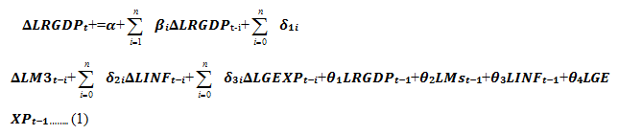
Where,
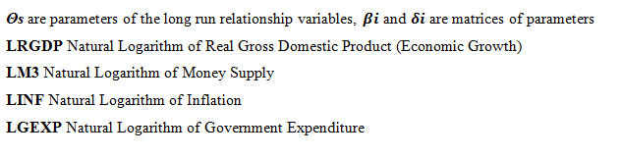

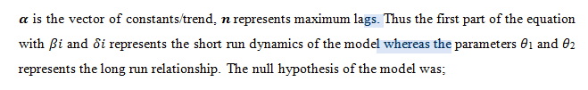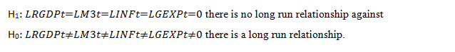

3.8 Nature of Data
The study primarily used secondary data. The data runs for a total of 42 years. It starts from 1970 and end in 2011. The data is of a time series nature. The data in its raw state, as it is normally the case, was non-stationary, therefore data transformation was necessary to make it analyzable through econometric models. Differencing and log transformation were some of the techniques that were used to make the data stationary. The data was mainly sourced from the Bank of Tanzania (BOT) and complemented by other sources including National Bureau of Statistics (NBS), International Monetary Fund (IMF), the World Bank, and Ministry of Finance. (MOF)-Tanzania.

3.9 Variables and Measurement Procedures
There are four data series used in the study; namely Gross Domestic Product, which used aggregate values (GDP) which was differenced twice to make it stationary, Government Expenditures, which are aggregate expenditures done by the government (GEXP) which was differenced twice to make it stationary, Inflation rate, the percentage change in prices (INF) which was differenced once to make it stationary and Money Supply, in which money three was used (M3). This was differenced thrice to make it stationary. The set of graphs summarizes the transformed series or variables which are namely “d2_gdp” for GDP, “d2_gexp” for GEXP, “d_inf” for INF and “d3_m3” for M3 which are respective coding from GDP, GEXP, INF and M3.

CHAPTER FOUR

4.0 FINDINGS, ANALYSIS AND DISCUSSION

4.1 Chapter Overview
This chapter presents the findings of the study. It also analyses and discusses the findings of the study. The findings are analyzed and discussed in the context of the objectives and hypothesis of the study stated in chapter one.

4.2 Data

4. 2.1 The Source of Data
The data was sourced from the Bank of Tanzania (BOT). This is the main sources for economic and financial data for the country. The BOT collects such data on a periodic regular way, for economic and financial planning purposes of the country. Other sources included National Bureau of Statistics (NBS), International Monetary Fund (IMF), the World Bank, and Ministry of Finance. (MOF)-Tanzania.

4. 2.2 Description of Data
The data runs for a total of 42 years. It starts from 1970 and end in 2011. The data is of a time series nature. There are four series namely Gross Domestic Product (GDP), Government Expenditures (GEXP), Inflation rate (INF) and Money Supply (M3).

4.3 Modeling

4.3.1 Vector Autoregression (VAR)
Vector Autoregression (VAR) is an econometric model used to capture the evolution and the interdependencies between multiple time series, generalizing the univariate Autoregressive (AR) Models. All the variables in a VAR are treated symmetrically by including for each variable an equation explaining its evolution based on its own lags and the lags of all the other variables in the model.

4.3.2 Transformation of Data
All econometric models require that data be from stationary series. These series are normally not stationary. Determining the stationary of a time series is a key step before embarking on any analysis. The statistical properties of most estimators in time series rely on the data being (weakly) stationary. Loosely speaking, a weakly stationary process is characterized by a time-invariant mean, variance, and autocovariance. In most observed series, however, the presence of a trend component results in the series being non-stationary. Furthermore, the trend can be either deterministic or stochastic, depending on which appropriate transformations must be applied to obtain a stationary series.

Unit Root Tests/ Stationarithy Test
It is argued that, the majority of economic and financial series contain a single unit root, although some are stationary and consumer prices have been argued to have 2 unit roots. In the process we use the ADF tests to assess:
H0: Series contains a unit root (not stationary)
H1: Series is stationary

Gross Domestic Product (GDP)
The variable Gross Domestic Product (GDP) was assessed for stationarity and found to be non-stationarity. Two methods were used, the ADF test was applied and the graphical method was employed. The first graph on the left indicated that the series was non-stationary. The variable was transformed by first differencing (middle graph) but could not be stationary. So the next transformation was done, which involved a second differencing (graph on the right).
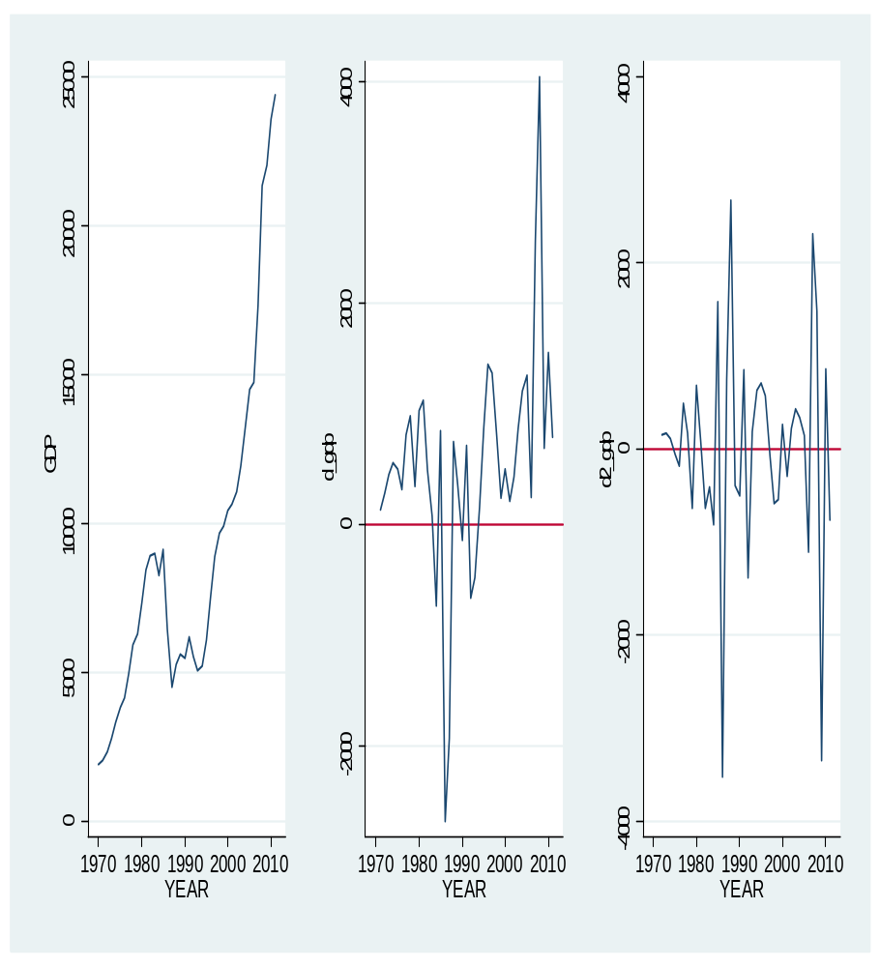

Figure 4.1: Gross Domestic Product
Source: Data Analysis (2017)

When the last transformed series (d2_gdp) was tested for stationarity (ADF test) (Table 4.1) it was found to be stationary at 0.0091 level of statistically significance.

Table 4.1: ADF-Test for GDP
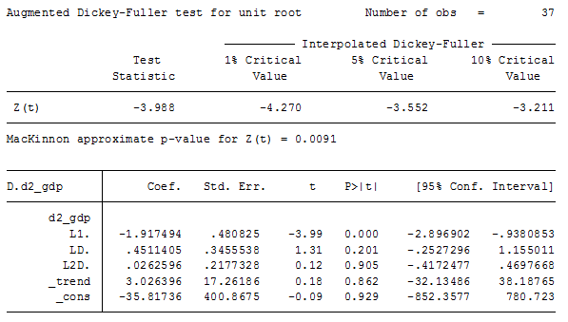
Source: Data Analysis (2017)

Government Expenditure (GEXP)
The variable Government expenditure (GEXP) was assessed for stationarity and found to be non-stationarity. As previously, two methods were used to assess it, the ADF test was applied and the graphical method was employed. The first graph on the left indicated the series was non-stationary. The variable was transformed by first differencing (middle graph) but could not be stationary. So the next transformation was done, which involved a second differencing (graph on the right). The last graph indicated that the series was stationary.
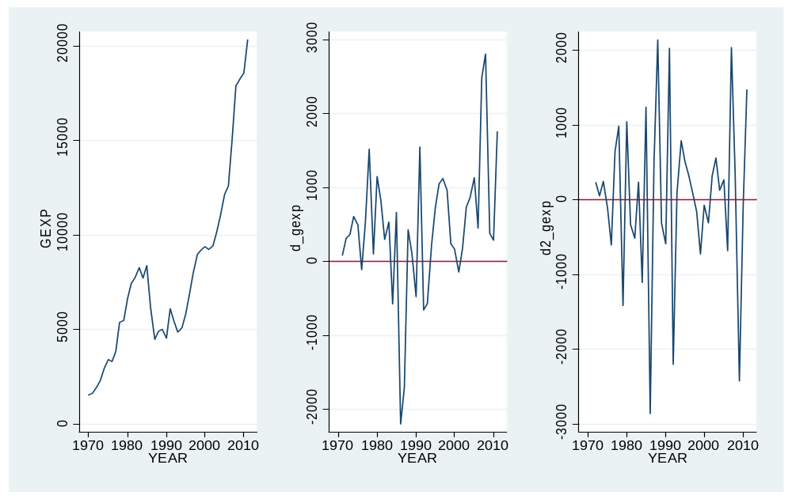

Figure 4.2: Government Expenditure
Source: Data analysis (2017).

When the last transformed series (d2_gexp) was tested for stationarity (ADF test) (Table 4.2) it was found to be stationary at 0.0009 level of statistically significance.

Table 4.2: ADF-Test for GEXP
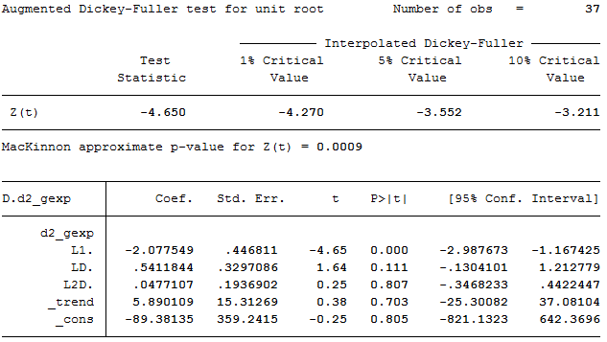
Source: Data Analysis (2017)
Inflation (INF)
The variable inflation rate (INF) was examined for stationarity and it was non-stationarity. As before, two methods were used to assess it, the ADF test was applied and the graphical method was employed. The first graph on the left indicated the series was non-stationary. The variable was transformed by first differencing (graph on the right) and the graph indicated that the series was stationary.
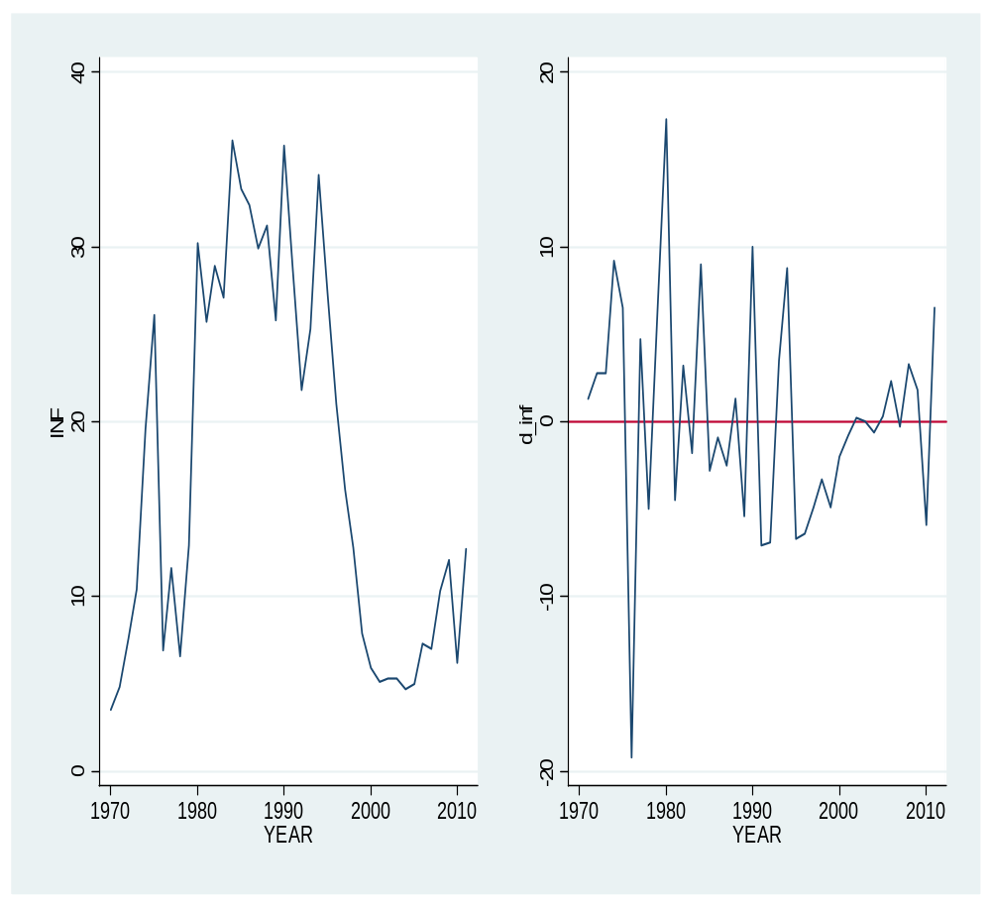

Figure 4.3: Inflation Rate
Source: Data analysis (2017).

When the last transformed series (d_inf) was tested for stationarity (ADF test) (Table 4.3) it was found to be stationary at 0.0065 level of statistically significance.

Table 4.3: ADF-Test for INF
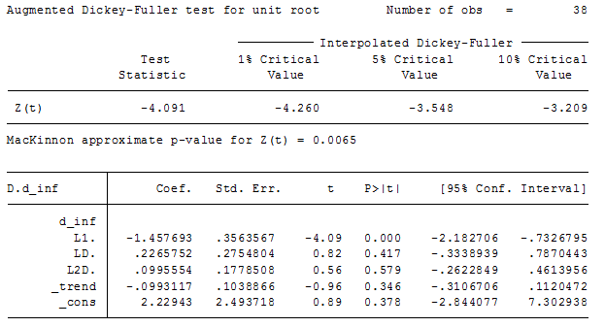
Source: Data analysis (2017).

Money Supply (M3)
Money supply was assessed for stationarity. It was found to be non-stationary. The graph on the top left corner indicated that series behavior. The graph on the top right was at the first transformation through first differencing. The graph at the lower left was the second transformation and then the graph at the lower right was the third transformation through third differencing which was able to make the series stationary.
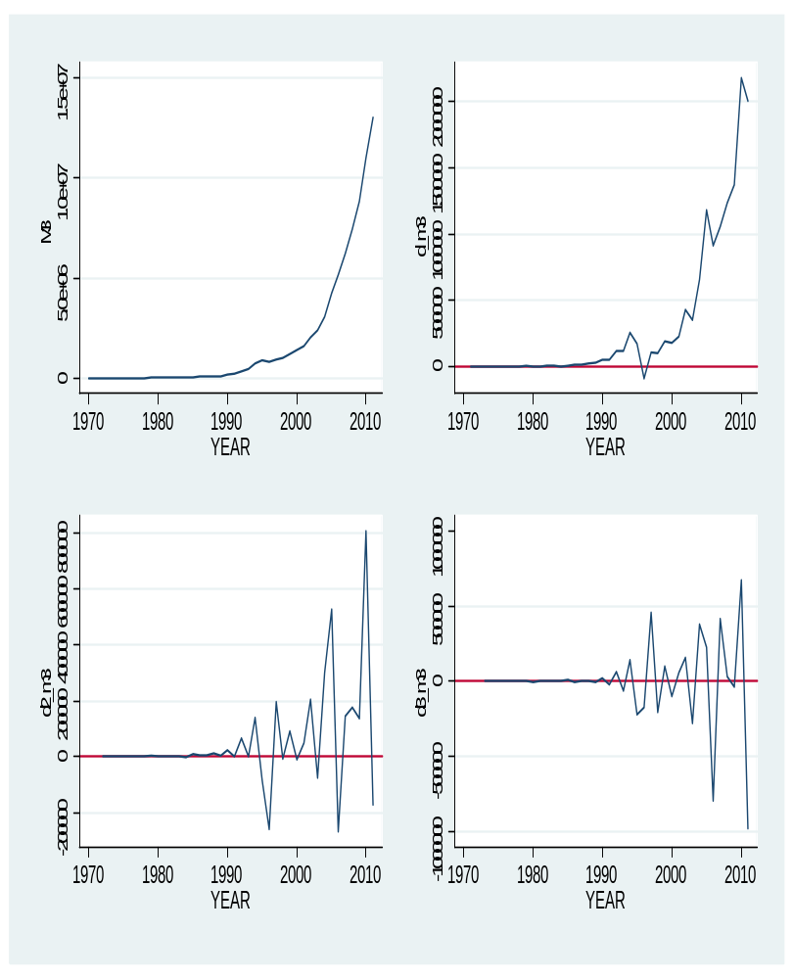

Figure 4.4: Money Supply
Source: Data Analysis (2017).

The ADF test (table 4.3) indicated that the series was stationary at third transformation. The test was significant at 0.0002. Thus it was able to use this series for further analysis as were the other three mentioned above.

Table 4.4: ADF-Test for M3
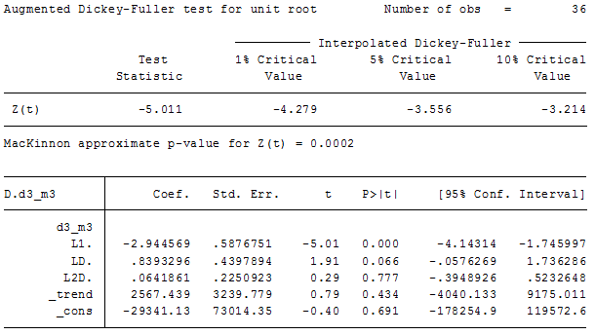
Source: Data Analysis (2017).

This set of graphs summarizes the transformed series or variables which are namely “d2_gdp” for GDP, “d2_gexp” for GEXP, “d_inf” for INF and “d3_m3” for M3. These are respective transformed series for Gross Domestic Product, Government Expenditure, Inflation rate and Money Supply.
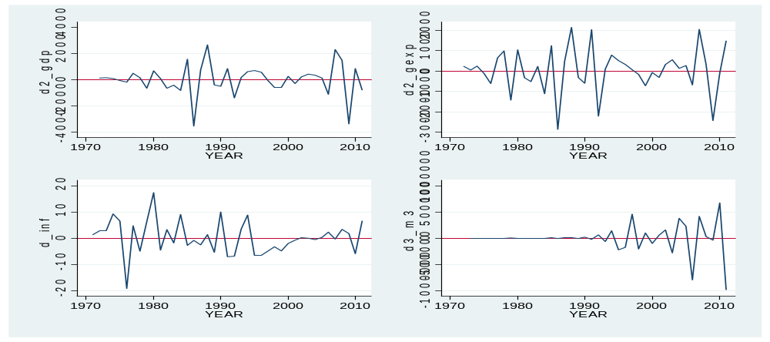

Figure 4.5: Transformed Variables

4.3.3 VAR Lag Order Selection
The analysis employed a STATA special command to help select the orders, VAR (P). Too many lags could increase the error in the forecasts; too few could leave out relevant information. Experience, knowledge and theory are usually the best way to determine the number of lags needed. There are, however, information criterion procedures to help one come up with a proper number. Three commonly used are: Schwarz's Bayesian Information Criterion (SBIC), the Akaike's Information Criterion (AIC), and the Hannan and Quinn Information Criterion (HQIC). All these are reported by the command ‘varsoc’ in Stata. The selection criteria requires that we select the number of order which have the lowest AIC/BIC in this case referring to the table below, the number of order/ lags are supposed to be 8 as indicated by lines with stars (-180.659). But based on FPE we select 7 lags. The later criterion was taken due to data limitations.

Table 4.5: Order Selection 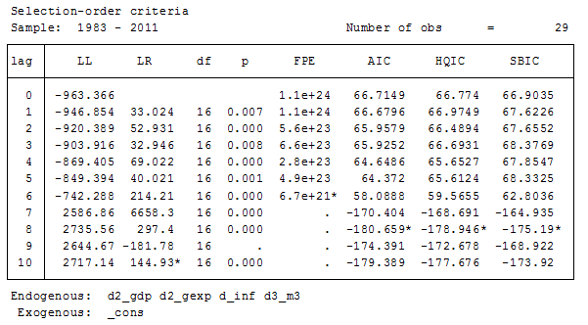
Source: Data Analysis (2017).

4.3.4 Models Selection
VAR-Models themselves do not allow us to make statements about causal relationships. This holds especially when VAR-Models are only approximately adjusted to an unknown time series process, while a causal interpretation requires an underlying economic model. However, VAR-Models allow interpretations about the dynamic relationship between the indicated variables.

VAR is one of the most commonly used models for applied macro econometric analysis and forecasting in central banks. Our analysis adopted an unrestricted VAR includes all variables in each equation. Note that a restricted VAR might include some variables in one equation, other variables in another equation. Sims argued that the conventional models were restricted VARs, and the restrictions had no substantive justification. Based on incomplete and/or non‐rigorous theory or intuition Sims argued that economists should instead use unrestricted models, e.g. VARs. He proposed a set of tools for use and evaluation of VARs in practice. In my case each equation was estimated by Ordinary Least Squares (OLS). The VAR model can be represented as follows through a system of equations:

Where; y, x, v and w are variable series for GDP, GEXP, INF and M3 respectively. While; a, b, c, and d are respective coefficients for the variables. And u and e are constants and error terms respectively. The variables are lagged for a total of p periods.

4.3.5 Estimation for the Model
The models demanded that we select 8 lags, but we were limited by the data so we have to select only seven (7) lags. After running VAR the following were the results: the model summary is presented first below which indicated that the model fitted our data well because the AIC and other related statistics were small.

Table 4.6: VAR summary
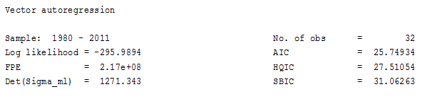

Source: Data Analysis (2017).

The table 4.7 summarizes statistics for each model. The GDP, GEXP and M3 models had the greatest explanatory power. The r-squared were well above 95% which indicated that these models factors were powerful in explaining these series.

Table 4.7: Models and Equations Summary Statistics

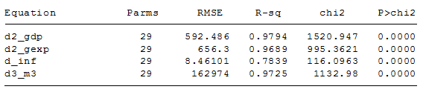

Source: Data Analysis (2017).

Table 4.8: VAR Outputs

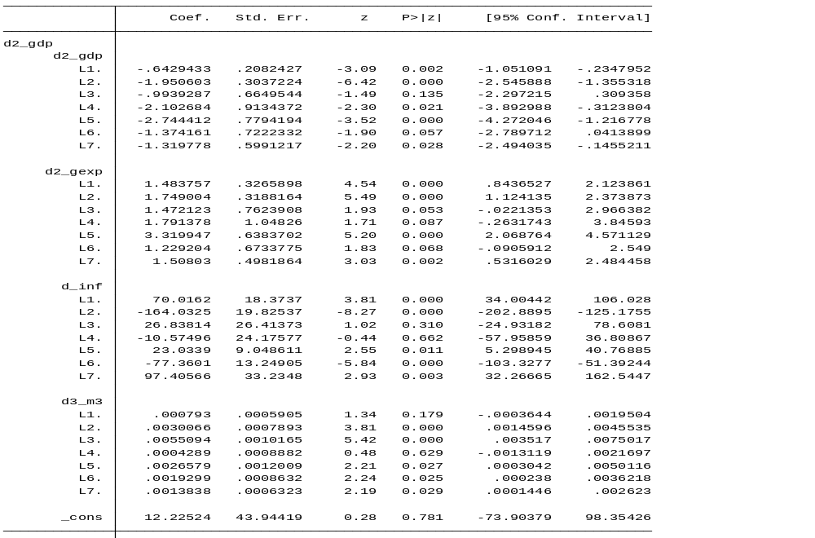

Source: Data Analysis (2017)

The analysis indicated that most of the coefficients in the models were statistically significant. GDP lags have a negative effect on GDP. Prior years GDP causes a decline in future years GDP. GEXP is positively related to GDP all lags indicated the same effects. On the other hand inflation rates had mixed effects indicating a cyclical effect over time on GDP. M3 was positively influencing GDP but the magnitude of effect was very small. (Refer to table 4.8 below).

GDP showed a negative effect on GEXP indicating that declines in GDP contributes to an in increase in GEXP. However, GEXP lags has a positive effect on GEXP. The effects of INF and M3 were mixed. The effects sometimes were positive or negative as indicated in table 4.9.

Table 4.9: VAR Outputs

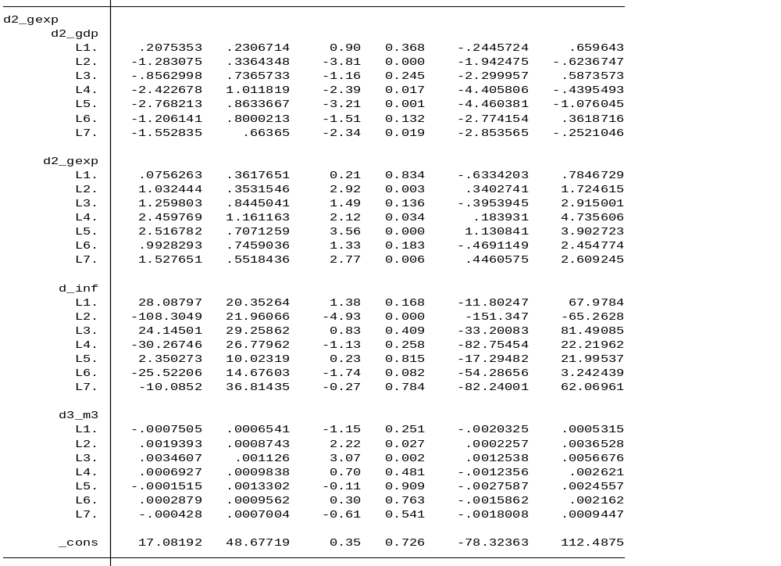

GDP has a negative relationship with INF. GEXP was mostly positively related to INF. INF lags and M3 had mixed relationship on INF. Most of these results were statistically significant. (Please refer table 4.10).

Table 4.10: VAR Outputs
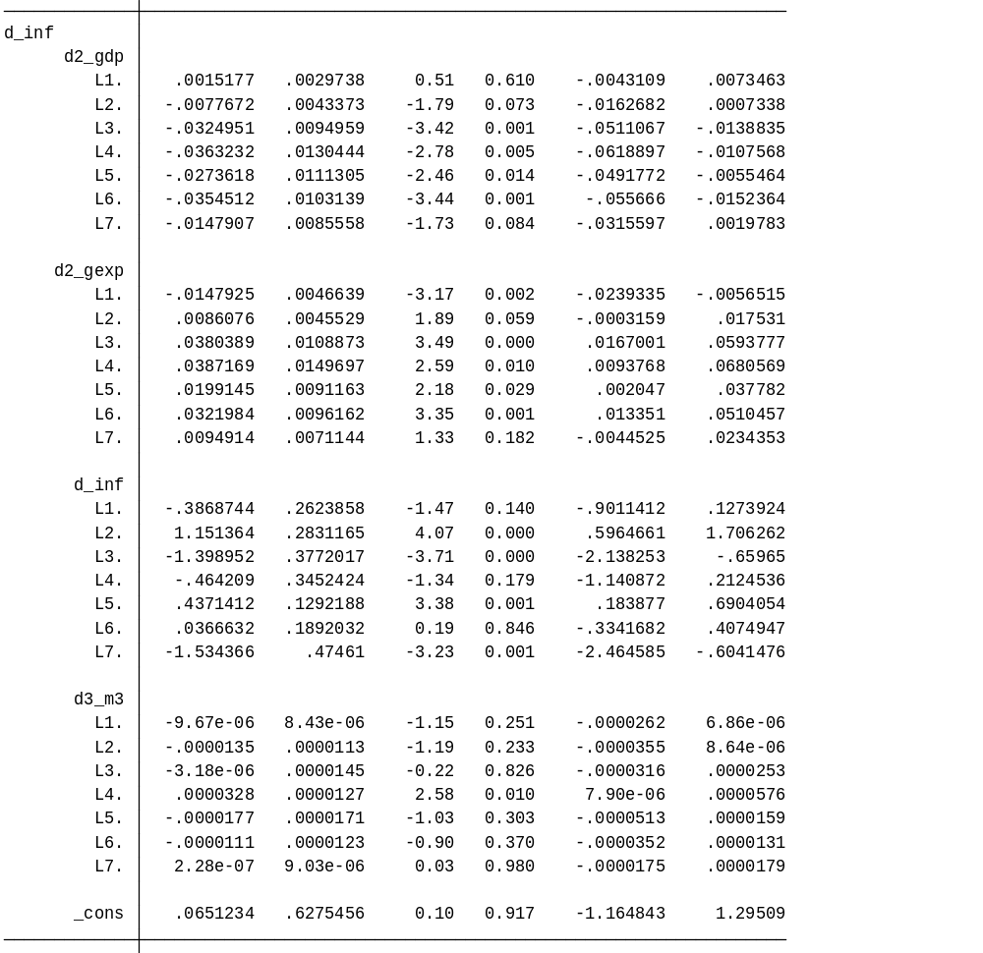
GDP was positively related to M3. GEXP was negatively related to M3. INF and M3 lags had mixed relationship with M3. Most of these results were statistically significant (please refer table 4.11).

Table 4.11: VAR Outputs
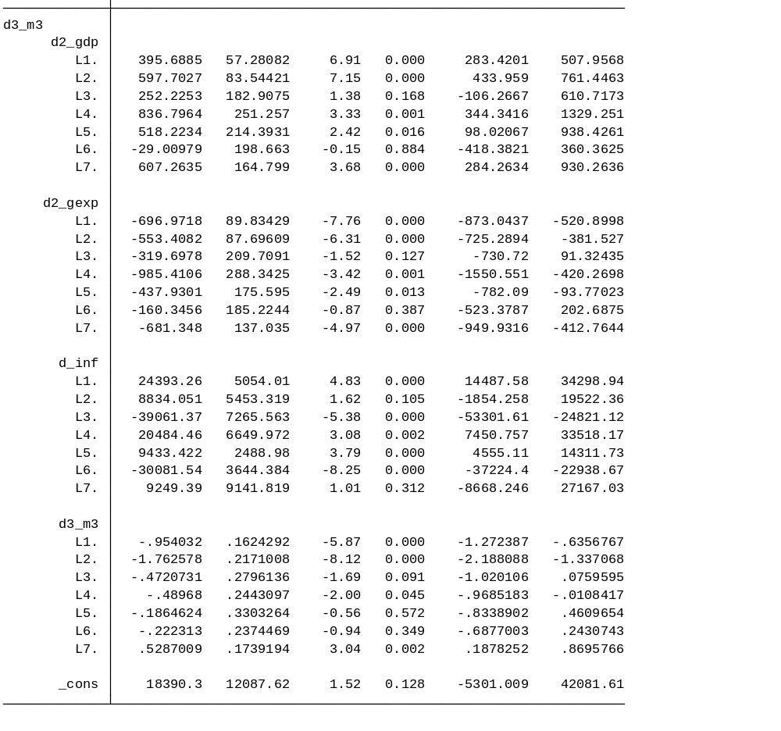

4.4. Impulse Response Function
It is normally noted that it is difficult to interpret the large number of coefficients in the VAR model. The main tools for interpretation are normally the “Impulse responses functions”. The impulse responses are the time path of in this case GDP, GEXP, INF and M3 in response to shocks emanating from the error terms. They are functions of the VAR estimated coefficients. Generally speaking in k-variable system there are k² impulse response functions. Thus with 4-variables we have 16 response functions as indicated below through graphs. “Impulse variable” means the sources of the shock. “Response variable” means the variable being affected. For instance from the graphs: upper left is the impact of GDP shocks on time-path of GDP, upper right is the impact of GDP shocks on the time path of GEXP.
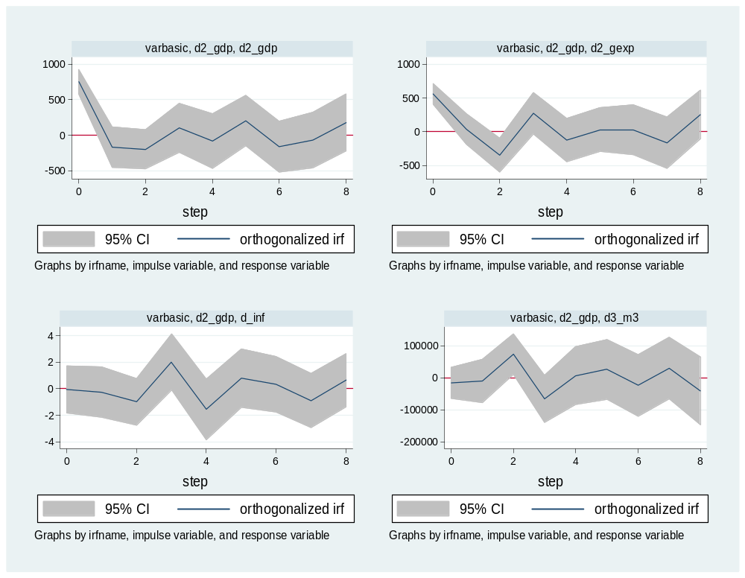

Figure 4.6: GDP Impulse-Response
Source: Data Analysis (2017).

The graphs above indicate the shocks from GDP on itself and other variables: GEXP, INF and M3. The analysis indicated that the responses are similar for INF and GEXP, that is whenever GDP is negative INF and GEXP are also negative. Declines in GDP leads to declines in INF and GEXP. However, M3 presents a reversed response pattern, when GDP is positive M3 is negative. Generally the shocks produce a modulated response on all four variables without peaks and troughs.

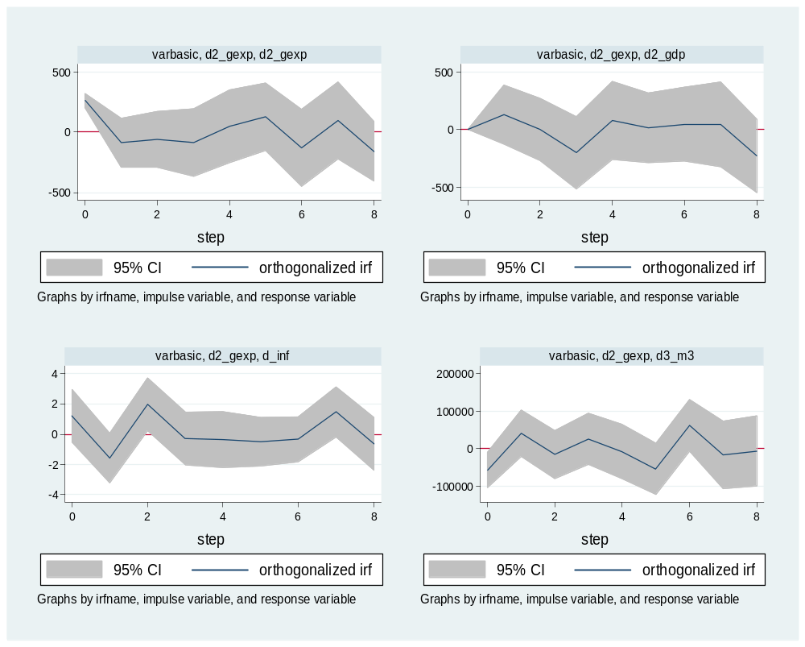

Figure 4.7: GEXP Impulse-Response
Source: Data Analysis (2017).

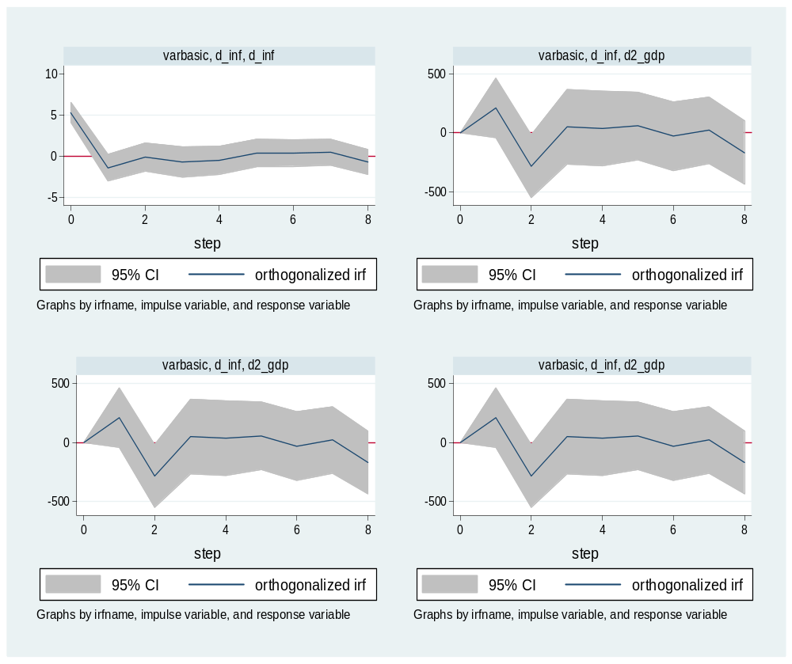
The variable GEXP, when taken as the impulse variable indicated some differentiated effects on the response variables, namely GDP, INF, M3 and on GEXP itself. For inflation and GDP the effect at step 4 to 6 is almost nonexistent as indicated by the flat lines at those segments. However, M3 indicated a reversed pattern, when GEXP is positive M3 is negative and vice versa. The decline in GEXP leads to a decline in INF but a rise in M3 and GDP.

Figure 4.8: INF Impulse-Response
Source: Data Analysis (2017).

The shocks of INF on INF are almost zero for the most part on its time-path. The first two steps in the time path of the variables and the last step are the only ones that seem to vary. The INF shock is pronounced at the beginning of each series. The effect on the response variables is the same for all four variables, indicating that INF has a uniform effect/shock on these variables. As indicated by the pattern of the sock from INF, as INF declines (negative) all the other three response variables, namely GDP, GEXP and M3 are rising (positive).

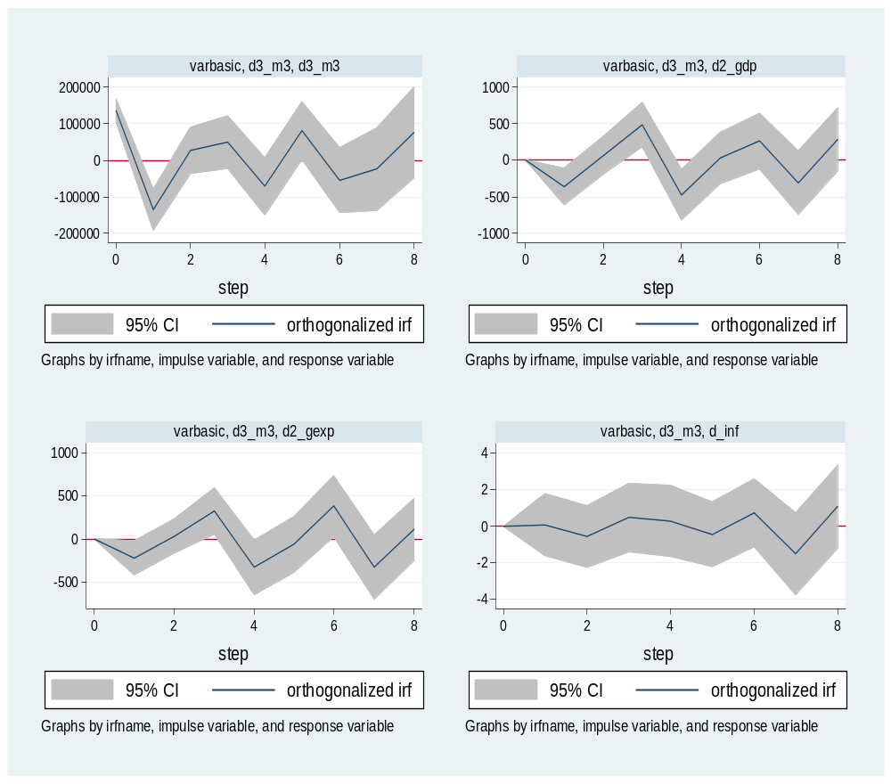

Figure 4.9: M3 Impulse-Response
Source: Data analysis (2017).

The pattern for M3 is interesting, when M3 is negative GDP and GEXP are also negative. These shocks seem to be cyclical over time paths of these variables, they are never stable they keep on rising and falling. However, the shocks in M3 do not have pronounced effect on INF. INF seems to stable and flat over a long time path and then fluctuates.

4.5. Testing Procedures

4.5.1 Granger Causality Test
In time series analysis, sometimes, we would like to know whether changes in a variable will have an impact on changes on other variables. Granger causality test is a technique for determining whether one time series is useful in forecasting another. It can determine whether there is causality relationship between variables.

Table 4.12: Granger- Causality Test
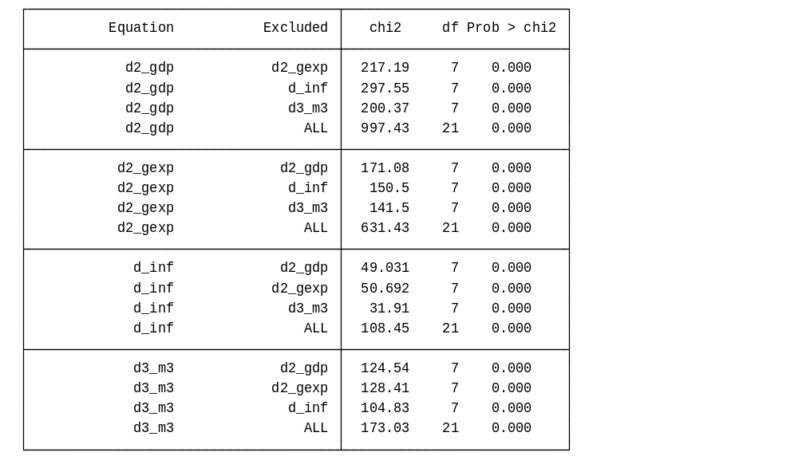
Source: Data Analysis (2017)

The analysis indicated that GDP was granger causing GEXP, INF and M3. Similarly, GEXP was granger causing GDP, INF and M3. Also, INF was granger causing GDP, GEXP and M3. Lastly, it also indicated that M3 was granger causing GDP, INF and GEXP. This indicated that as each variable changed it has an effect on other variables. These results are important and crucial because of their statistical significance. (Refer table above).

4.5.2 Multivariate Cointegration Test

The order of integration of the variables, it is noted that all the variables used have to be of the same order of integration. We have the following cases: All the variables are I(0) (stationary): one is in the standard case, that is VAR in level. If two or more series are themselves non-stationary, but a linear combination of them is stationary, then the series are said to be cointegrated. In many time series, integrated processes are considered together and they form equilibrium relationships.

Table 4.13: ADF-Cointegration Test
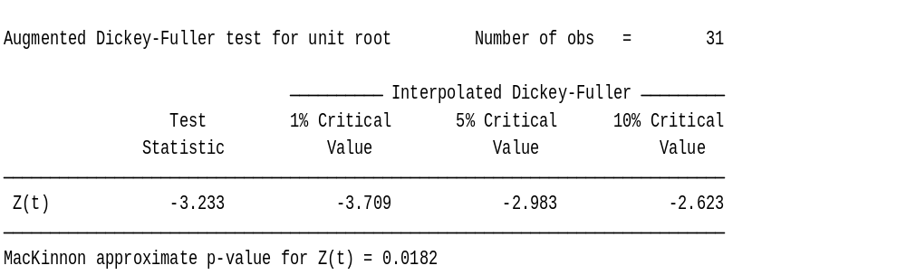
Source: Data analysis (2017).

Before the vector error correction model (VECM) can be formed and used, there first has to be evidence of cointegration, given that cointegration implies a significant error correction term, cointegration can be viewed as an indirect test of long-run causality. It is possible to have evidence of long-run causality, Cointegration refers to the fact that two or more series share a stochastic trend (Stock & Watson). Engle and Granger (1987) suggested a two step process to test for cointegration (an OLS regression and a unit root test), the EG-ADF test. Based on this suggestion this study’s test indicated that multiple integration of the four variables does exist. (Refer to table 4.10).

Rejecting the null hypothesis of non-stationarity concludes “cointegration relationship” does exist. Thus, our four variables, namely: GDP, GEXP, INFL and M3 are integrated of order zero, I(0). Based on the ADF test we are able to establish that the four series are integrated because the test was statistically significant (0.0182).

4.6 Interpretations of Results
The following were the hypotheses that were put forward to test causation on the variables as postulated in the null forms: based on the granger causality tests the following interpretation and inferences were made:

4.6.1 Research Hypothesis
a) Ho: Inflation rate does not affect economic growth in Tanzania.
The null hypothesis was rejected and the alternative hypothesis adopted thus, inflation rate does affect economic growth.
b) Ho: Money supply does not affect economic growth in Tanzania.
The null hypothesis was rejected and the alternative hypothesis adopted thus, money supply does affect economic growth in Tanzania
c) Ho: government expenditure does not affect economic growth in Tanzania.
The null hypothesis was rejected and the alternative hypothesis adopted thus, government expenditure does affect economic growth in Tanzania.
d) Ho: There is no Granger causality of inflation rates, money supply, government expenditure and economic growth in Tanzania.

The null hypothesis was rejected and the alternative hypothesis was adopted that, inflation rate, money supply, government expenditure and economic growth do granger cause each others.

4.6.2 Discussion of Findings

The analysis indicated that most of the coefficients in the models were statistically significant. GDP showed a negative effect on GEXP indicating that declines in GDP contributes to an in increase in GEXP. However, GEXP lags have a positive effect on GEXP. The effects of INF andM3 were mixed. The effects sometimes were positive or negative as indicated in table 4.9 bellow. GDP has a negative relationship with INF. GEXP was mostly positively related to INF. INF lags and M3 had mixed relationship on INF. Most of these results were statistically significant. (Please refer table 4.10 below). GDP was positively related to M3. GEXP was negatively related to M3. INF and M3 lags had mixed relationship with M3. Most of these results were statistically significant (please refer table 4.11 above).

The analysis indicated that the responses are similar for INF and GEXP, that is whenever GDP is negative INF and GEXP are also negative. Declines in GDP leads to declines in INF and GEXP. However, M3 presents a reversed response pattern, when GDP is positive M3 is negative. Generally the shocks produce a modulated response on all four variables without peaks and troughs. The variable GEXP, when taken as the impulse variable indicated some differentiated effects on the response variables, namely GDP, INF, M3 and on GEXP itself. For inflation and GDP the effect at step 4 to 6 is almost nonexistent as indicated by the flat lines at those segments. However, M3 indicated a reversed pattern, when GEXP is positive M3 is negative and vice versa. The decline in GEXP leads to a decline in INF but a rise in M3 and GDP.

The shocks of INF on INF are almost zero for the most part on its time-path. The first two steps in the time path of the variables and the last step are the only ones that seem to vary. The INF shock is pronounced at the beginning of each series. The effect on the response variables is the same for all four variables, indicating that INF has a uniform effect/shock on these variables. As indicated by the pattern of the sock from INF, as INF declines (negative) all the other three response variables, namely GDP, GEXP and M3 are rising (positive).

The pattern for M3 is interesting, when M3 is negative GDP and GEXP are also negative. These shocks seem to be cyclical over time paths of these variables, they are never stable they keep on rising and falling. However, the shocks in M3 do not have pronounced effect on INF. INF seems to be stable and flat over a long time path and then fluctuates.

The current study indicated that inflation rates had mixed effects indicating a cyclical effect over time on GDP. These results are comparable to many other mixed results from different contexts. Madhukar and Nagarjuna (2011) confirms our findings where he found that inflation had a positive impact on the economic growth. Noting Ghosh and Phillips (1998) who hypothesizes that high inflation positively affects the economic growth note that relationship between inflation and economic growth remains inconclusive, several empirical studies confirm the existence of either a positive or negative relationship between these two macroeconomic variables. Mubarik (2005) found that low and stable inflation promotes economic growth and vice versa. Shitundu and Luvanda, (2000) concluded that inflation has been harmful to economic growth in Tanzania. Fischer (1993) found a significant negative association between inflation and economic growth.

On the other hand out results indicated that, GDP caused GDP over time, compared to Umaru and Zubairu, (2012), their results suggested that all the variables in the unit root model were stationary and the results of causality revealed that GDP caused inflation and not inflation causing GDP. The results also revealed that inflation possessed a positive impact on economic growth through encouraging productivity and output level. Mallik and Chowdhury, (2001) found two results: First, the relationship between inflation and economic growth is positive and statistically significant for Bangladesh, Pakistan, India and Sri Lanka.

Ghosh and Phillips, (1998) maintain that while there is no doubt about the fact that high inflation is bad for growth, there is less agreement about the effect of moderate inflation, they found a statistically and economically significant inverse relationship between inflation and economic growth which holds robustly at all but the least inflation rates. Quartey, (2010) using the Johansen co-integration methodology, he found that there is a negative impact of inflation on growth. Barro, (1995) results suggested that an increase in average inflation of 10 percent per annum reduces the growth rate of real GDP by 0.2 to 0.3 percent per annum. Hasanov, (2010) indicated that there was non-linear relationship between inflation and economic growth in the Azerbaijani economy

Kasidi and Mwankanemela (2013) results showed that there was negative relationship between inflation and economic growth in Tanzanian economy. The results implied that as the general level of prices increases, the GDP decreases. This means that an increase in the general price level (inflation rate) by 1% results in a decrease of GDP by 18.305%. This could imply that an increase in the general price level was harmful to economic growth. The results in the current study, when compared to Shitundu and Luvanda (2000) findings who used the Least Trimmed Squares (LTS) method, which detects regression outliers and produces robust regression, to examine the impact of inflation on economic growth in Tanzania. The empirical results obtained suggest that inflation has been harmful to economic growth in Tanzania. Thus it is worth noting that the combined evidence point to the fact that inflation is detrimental to the Tanzania economy and has had controversial effects on GDP.

Rashid and Sara (2010) contend that many studies show that government expenditure is positively related with economic growth, but due to high expenditure most of the developing countries are facing the problem of fiscal deficit. Zafar and Mustafa (1998) found increase in government expenditures is negatively correlated with the economic growth. On the other hand, Barro (1996) in another study found that the growth rate is enhanced by lower inflation, lower government consumption. Other related studies indicate the mixed, contrasting and comparable results, for instances; Metin (1991) analyzes the empirical relationship between inflation and budget deficit for Turkish economy through multivariate co integration analysis. He found that the scaled increase in government expenditure significantly effects the inflation in Turkey. Catao and Terrones (2003) examined the relationship between fiscal deficit and inflation. A strong positive relationship between fiscal deficit and inflation among high-inflation and developing country group were studied. Soloman and Wet (2004) examined the effect of budget deficit on inflation in Tanzania and found hat economy experienced a high inflation rate accompanied by high fiscal deficit.

The current study indicated that GEXP is positively related to GDP all lags indicated the same effects. These results are comparable to the results of Benneth (2007) who showed that government expenditures are the important in increasing GDP. Jamshaid, (2010) examined the relationship between economic growth and government expenditure, both at bivariate (aggregate) and multivariate (disaggregate) systems and concluded that economic growth causes government expenditure at bivariate level and also supported that increase in GDP causes growth in government expenditure.

Compared to these comparable studies the current study results indicated that GDP was granger causing GEXP, INF and M3. Similarly, GEXP was granger causing GDP, INF and M3. Also, INF was granger causing GDP, GEXP and M3. Lastly, it also indicated that M3 was granger causing GDP, INF and GEXP. This indicated that as each variable changed it has an effect on other variables. These results are important and crucial because of their statistical significance.

CHAPTER FIVE

5.0 CONCLUSIONS AND POLICY RECOMMENDATIONS

5.1 Conclusions

The conclusions are drawn based on the research objectives which are accordingly listed below: The general objective of the study was to find out the effects of macroeconomic factors on economic growth in Tanzania. In order to achieve the main objective, the following specific objectives guided the study and these are the results summaries in terms of how the objectives were attained or failed to be attained:
- To assess the effects of inflation rates on economic growth in Tanzania
The study found that inflation rate has a significant effect on the economic growth in Tanzania. This effect was shown to be negative, thus inflation has ill effects on the economic growth.
- To find out the effects of money supply on economic growth in Tanzania.
Money supply has a significant effect on economic growth, this effect was shown to be declining, as money supply declined so did economic growth decline.
- To find out the effects of government expenditure on economic growth in Tanzania
The study found that government expenditure decline leads to economic growth increase. The effect is inversely proportional. This finding was as well statistically significant.
- To find out the Granger causality of inflation rates, money supply, government expenditure and economic growth in Tanzania.
The study was able to statistically measure and establishes that inflation rate, money supply, government expenditure and economic growth granger cause each other as indicated in the analysis. All the results were statistically significant.

5.2 Policy Recommendations
The government through its financial and economic policy planning organs such as the central bank need to take into account the effects and causation of each of these variables namely: inflation rate, government expenditure, money supply and economic growth on each other for a proper planning of the economy. Inflation rates seem to have uniform impacts on the rest of the variables. Thus, its effects need to be monitored for and regulated to avoid the effects it might cause to the economy particularly economic growth.There should be a plan to reduce government expenditures. The results indicated that as government expenditure declined economic growth increased. Critical policy issues need to be addressed to take into account of this effect.

5.3 Areas for Future Research
Studies need to analyze government expenditure by analyzing their categories separately to assess independent effects on economic growth the effects of money supply and inflation on other aspects and variables of the economy such as investments and interest rates need to be studied.

REFERENCES
Ali, A. Saifullah, K. & Binti, K. (2015). The Impact of key Macroeconomic factors on Economic Growth of Bangladesh: A VAR Co-integration Analysis, International Journal of Management Excellence, 6(1), 1-8.
Antwi, S. & Agalega, E. (2013). The Impact of Macroeconomic Variables on Gross Domestic Product: Empirical Evidence from Ghana. African Journal of Business Management, 4(3), 312-319.
Antwi, S. E., Mills, A., & Zhao, X. (2013). The impact of macroeconomic factors on economic growth in Ghana. A cointegration Analysis. International Journal of Academic Research in Accounting, Finance and Management Science, 3(1), 35-45.
Ayyoub, M., Chaudhry, I. S. and Imran, F. (2011). Does inflation matter for sectoral Growth in Pakistan? An empirical analysis, Test statistic: F(2, 41) = 0.0175086, Pakistan.
Bank of Tanzania, (Annual Report). Various Issues, Dar es Salaam, Tanzania.
Barro, R. (1990). Government Spending in a Simple Model of Endogenous Growth, Journal of Political Economy. 98(1), 103-125.
Barro, R. (1995). Inflation and economic growth: NBER Working Paper, 53(26), 166-176.
Barro, R. J. (1995), "Inflation and Economic Growth", National Bureau of Economic Research, (NBER) Working Paper No. 5326 (October).
Barro, R. J. (2013). Inflation and economic growth, Annals of economics and finance, 14(1), 85-109.
Carter, J, Craigwell, R. & Lowe, S. (2013). Government Expenditure and Economic Growth in a Small Open Economy: A Disaggregated Approach. JEL Classification No: E62, E210, H50.
Catao, L. Terrones, M. (2003). Fiscal deficits and Inflation, IMF working paper series, wp/03/65.
Denbel, F. S, Ayen Y. W. and Regasa, T. A (2016). The Relationship between Inflation, Money Supply and Economic Growth in Ethiopia: Co integration and Causality Analysis.
Dickey, D. A. and Fuller, W. A. (1981). "Likelihood Ratio Statistics for Autoregressive Time Series with a Unit Root", Econometrica, 49(1), 1057-1072. Economics, 70: 65–94.
Fischer, S. (1993). The Role of Macroeconomic Factors in Growth. Journal of Monetary Economics, 47(5), 485-512.
Ghosh, A. and Phillips, S. (1998). Warning: Inflation May Be Harmful to Your Growth, IMF Staff Papers, 45(4), 672-710.
Hasanov, F. (2010). Relationship between Inflation and Economic Growth in Azerbaijani Economy. Is there any Threshold Effect? Asian Journal of Business and Management Sciences, 1(1), 6-7.
Hossain, E, (2012). Inflation and economic growth in Bangladesh, Journal of Arts, Science & Commerce, 4(2), 12-18.
Isfahani, R. D., Sameti, M. & Haghighi, H. K. (2012). The Effect of Macroeconomic Instability on Economic Growth in Iran. Research in Applied Economics, 4(3), 1-8.
Kapunda, S. M. and Topera, J. S. (2013). Public expenditure composition and economic growth in Tanzania: Socio-economic Policy Implications. Dar es Salaam, Tanzania.
Kasidi, F. & Mwakanemela, K. (2013). Impact of inflation on economic growth: a case study of Tanzania. Asian Journal of Empirical Research, 3 (4), 363-380.
Kasidi, F. and Mwakanemela, K. (2013). Impact of inflation on economic growth: A case study of Tanzania, Asian Journal of empirical research, 3(4), 363-380.
Kweka, J. P. and Morrissey, O. (2000). Government Spending and Economic Growth in Tanzania, 1965-1996. Dar es Salaam, Tanzania.
Madhukar, S. and Nagarjuna, B. (2011). Inflation and Growth Rates in India and China: A Perspective of Transition Economies, International Conference on Economics and Finance Research, 4(97), 489-490.
Mallik, G. and Chowdhury, A. (2001). Inflation and Economic Growth: Evidence from Four South Asian Countries, Asian Pacific Development Journal, 8(1), 123-135.
Mubarik, A. (2005). Inflation and Growth. An Estimate of the Threshold Level of Inflation in Pakistan. SBP- Research Bulletin, 1(1), 35-43.
Odhiambo, N. M (2012). Inflation Dynamics and Economic Growth in Tanzania: A Multivariate Time Series Model. The Journal of Applied Business Research, 28(3), 55-61.
Olorunfemi, S. & Adeleke, P. (2013). Money Supply and Inflation in Nigeria: Implications for National Development. Modern Economy, 4(3), 161-170.
Olulu R. M, & Erhieyovwe, E. K. (2014). Government Expenditures and Economic Growth: The Nigerian Experience. Mediterranean Journal of Social Sciences, 5(10), 33-42.
Quartey, P. (2010). Price Stability and the Growth Maximizing rate of inflation for Ghana, Business and Economic Journal, 1(1), 180-194.
Saunders, N. K. M. and Lewis, P. (2012). Research Methods for Business Students, Paperback: PM Publishing Management.
Shitundu, L. and Luvanda, G. (2000). The Effect of Inflation on Economic Growth in Tanzania, African Journal of Finance and Management, 9(1), 70-77.
Solomon, M., Wet, A., (2004). The Effect of a Budget Deficit on Inflation: The Case of Tanzania, SAJEMS NS, 7(1), 33-38.
Taiwo, M. & Abayomi, T. (2011). Government Expenditure and Economic Development: Empirical Evidence from Nigeria. European Journal of Business and Management, 3(9), 12-19.
Umaru, A. and Zubairu, J. (2012). The Effect of Inflation on the Growth and Development of the Nigerian Economy: An Empirical Analysis, International Journal of Business and Social Science, 3(10), 187-188.
Ume, K. E., Okechukwu, C. O., Raph, O. M. & Izuchukwu, O. (2016). Modeling the Long Run Relationship between Inflation and Economic Growth Using the Engel and Granger Approach (Evidence From Nigeria 1985 To 2013). IOSR Journal of Humanities and Social Science (IOSR-JHSS), 21( 4), 1-12.
Yabu, N. & Kessy, N. J. (2015). Appropriate threshold level of for economic growth: evidence from the three founding EAC countries. Applied Economics and Finance, 2(3), 44-48.

APPENDICES

APPENDIX 1: Tables and graphs

Gross domestic product (GDP)
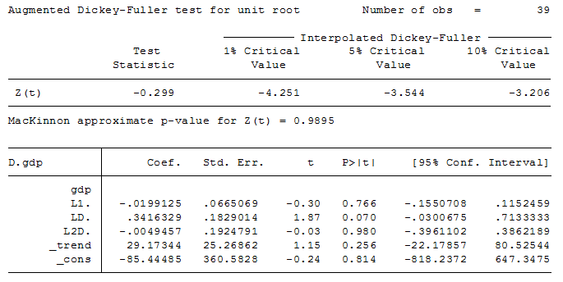
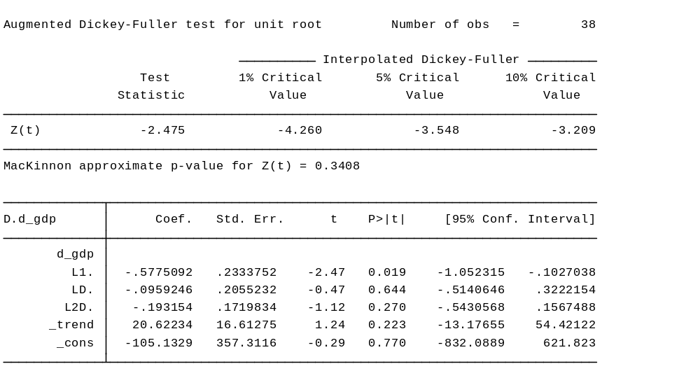
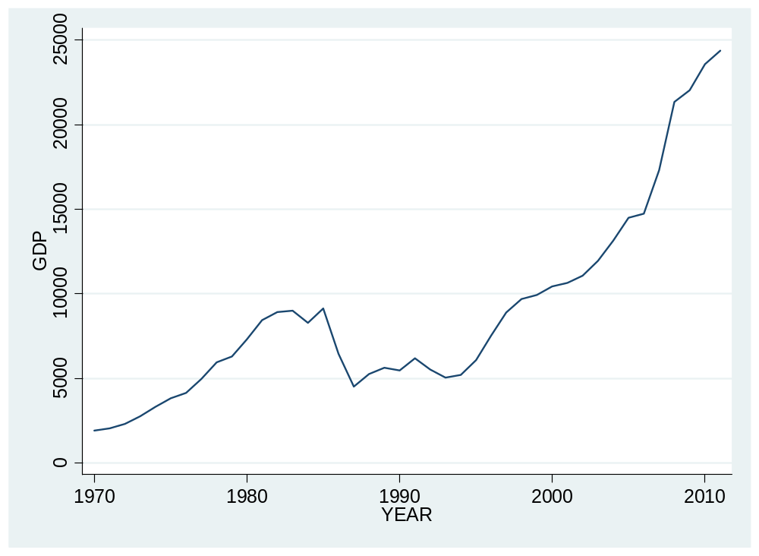
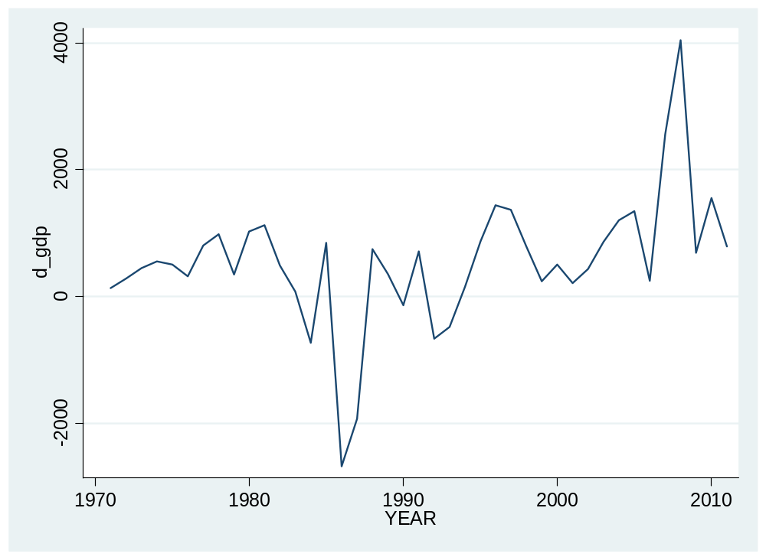
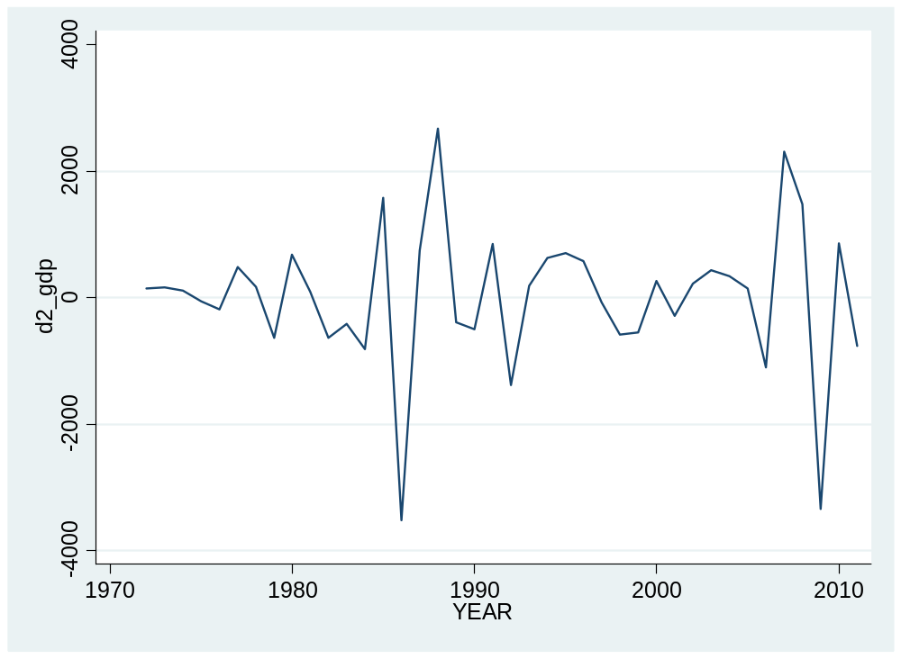

Government expenditure (GEXP)
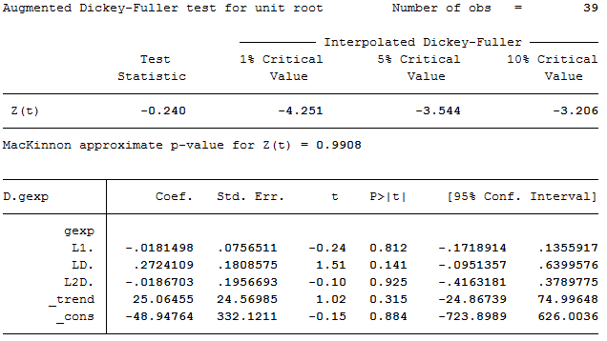
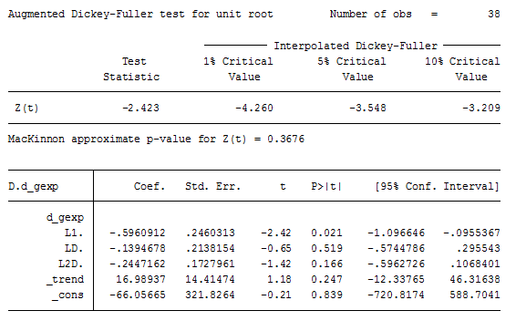
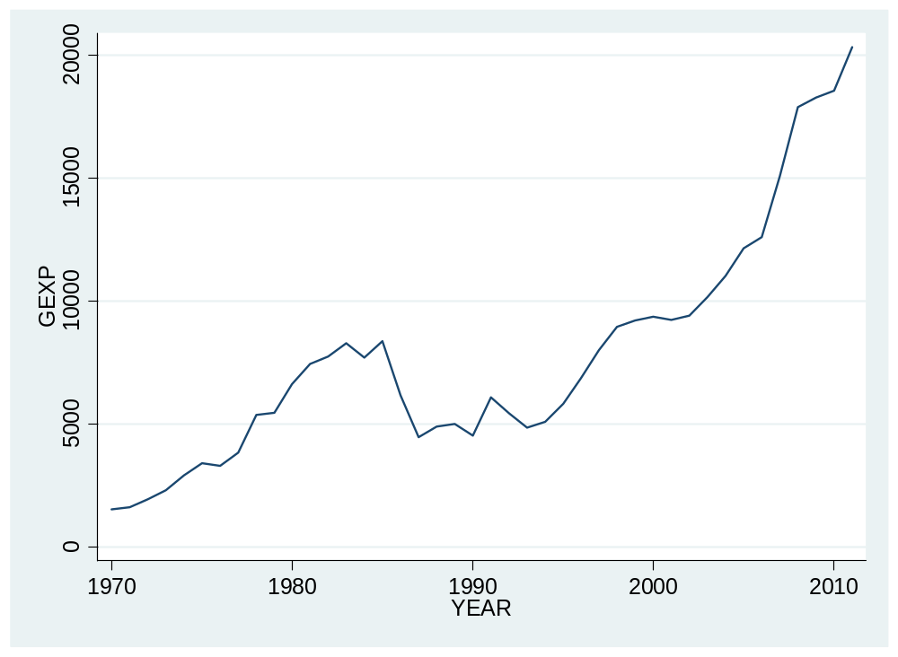

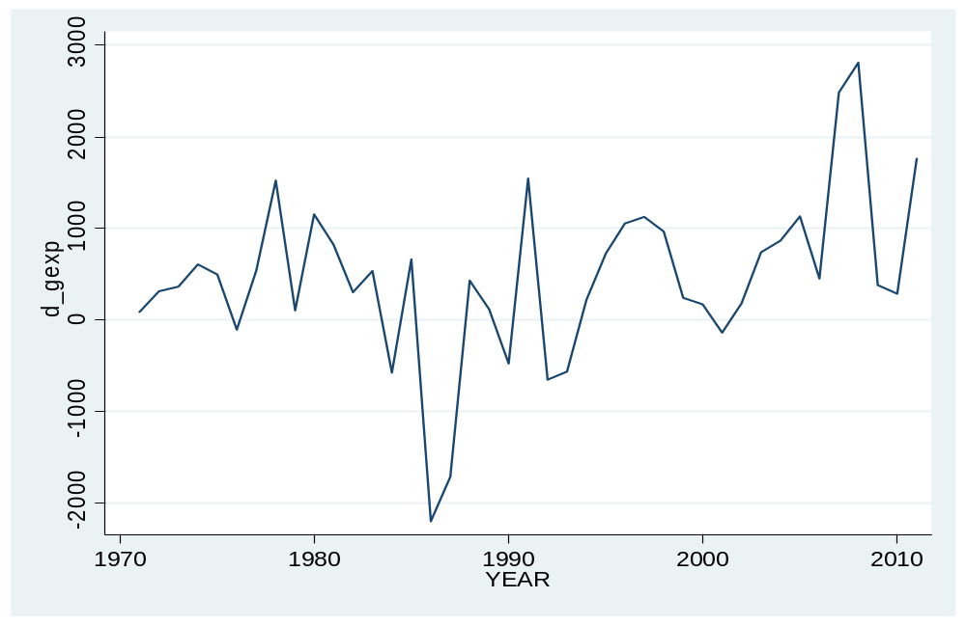

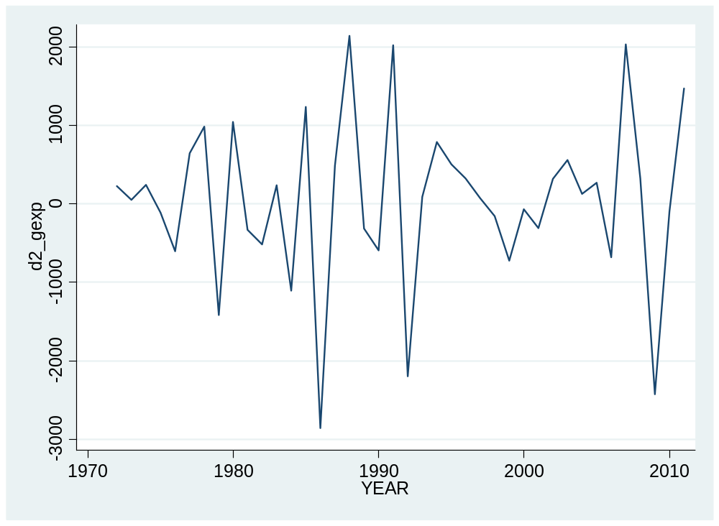

Inflation (INF)
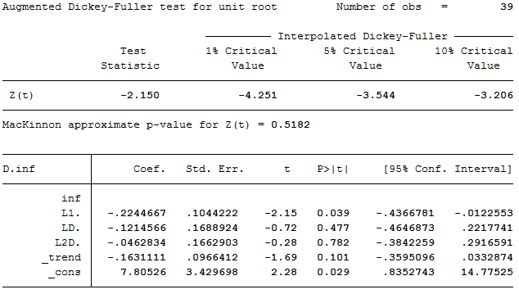
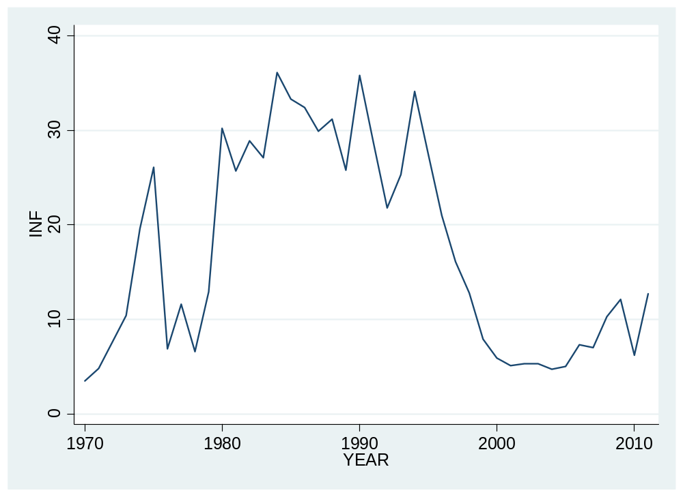
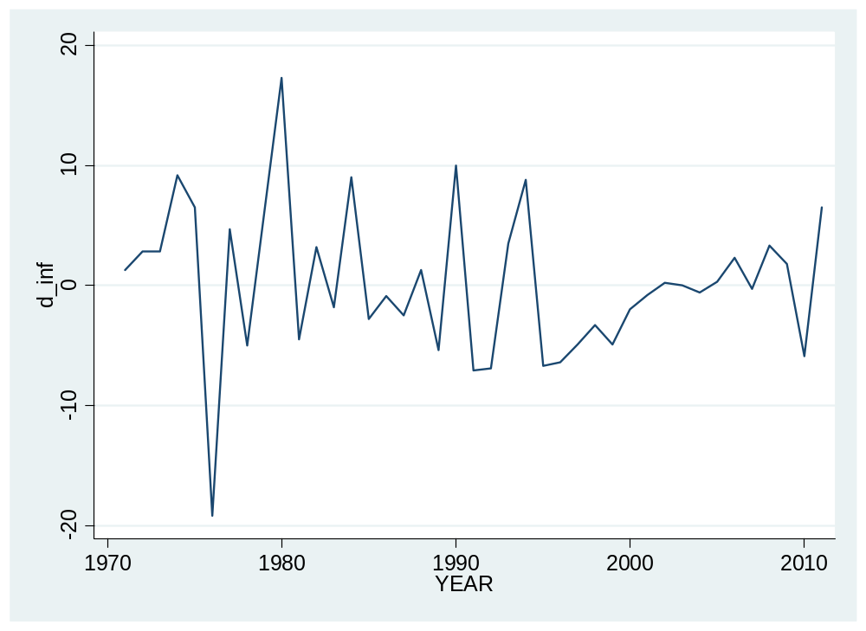

Money three (M3)
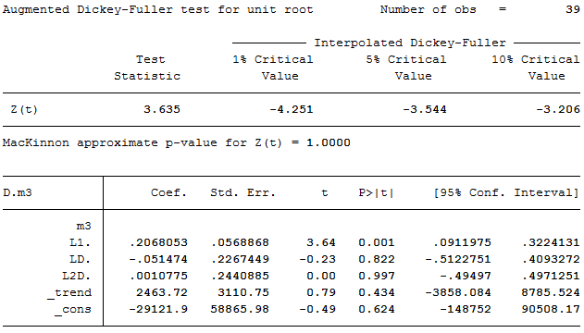
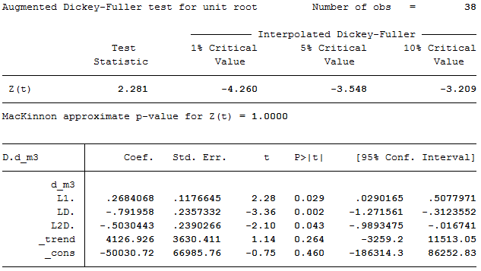
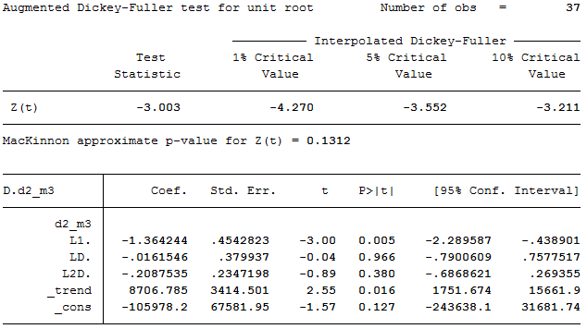
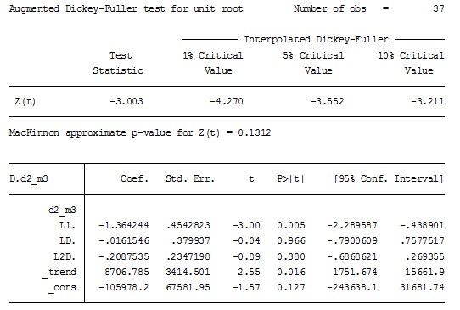
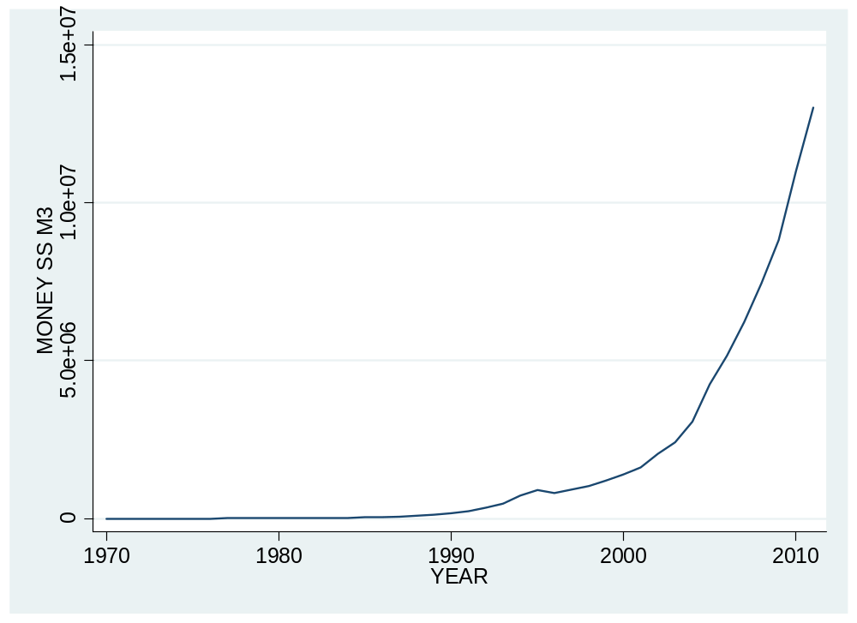

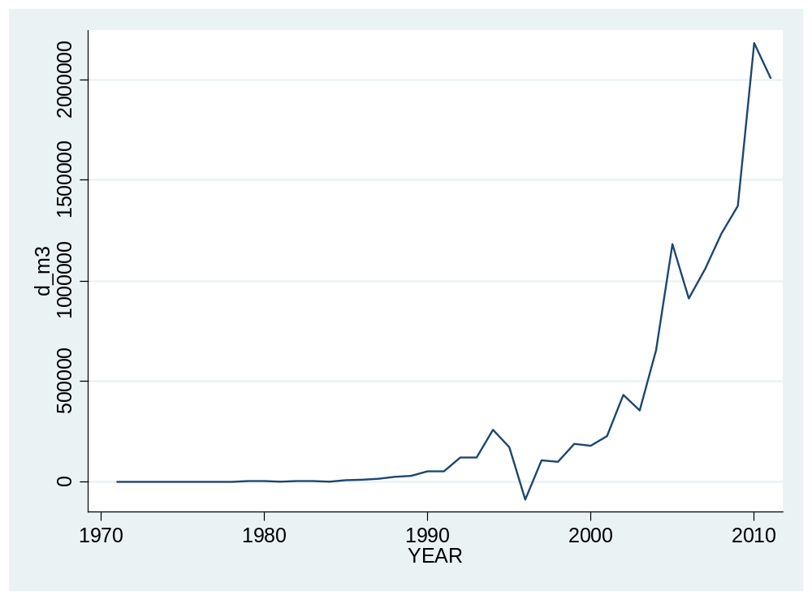

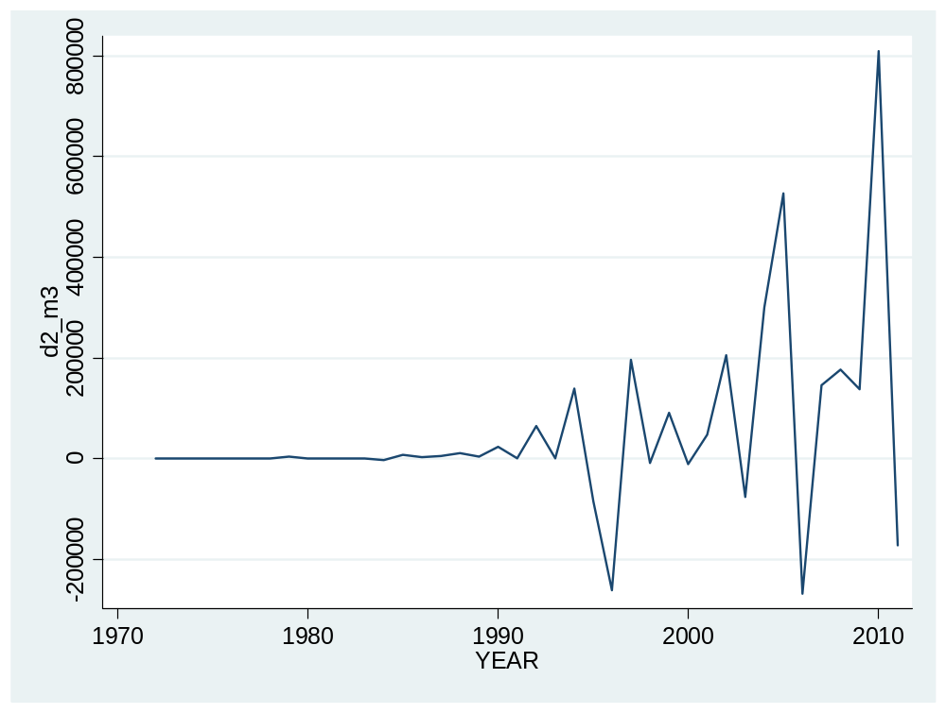
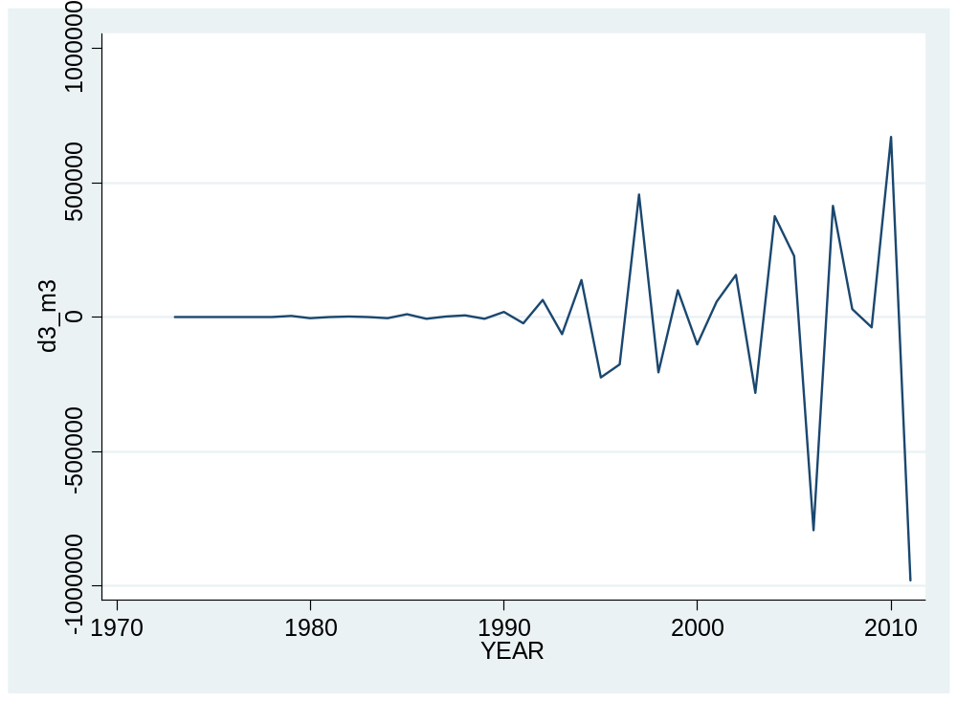

APPENDIX II: Data sets
year | gdp | Gexp | inf | m3 | d2_gdp | d2_gexp | d_inf | d3_m3
1970 | 1905.6 | 1534.4 | 3.5 | 2219.6
1971 | 2038.8 | 1623.6 | 4.8 | 2624.4 |  |  | 1.3
1972 | 2320.9 | 1939.6 | 7.6 | 3089.7 | 148.8998 | 226.8 | 2.8
1973 | 2769.6 | 2305 | 10.4 | 3653 | 166.6003 | 49.40002 | 2.8 | 37.49976
1974 | 3326.4 | 2913.5 | 19.6 | 4462 | 108.0996 | 243.1 | 9.200001 | 147.7
1975 | 3829.4 | 3410.3 | 26.1 | 5552.7 | -53.7998 | -111.7 | 6.5 | 36.00024
1976 | 4147.3 | 3302.8 | 6.9 | 6946.8 | -185.1001 | -604.3 | -19.2 | 21.69922
1977 | 4954.7 | 3841.1 | 11.6 | 8346.7 | 489.5005 | 645.8 | 4.7 | -297.5986
1978 | 5934.4 | 5362.5 | 6.6 | 9396.3 | 172.2993 | 983.0999 | -5 | -356.1016
1979 | 6282.3 | 5468.8 | 12.9 | 13806.6 | -631.7998 | -1415.1 | 6.3 | 3711.001
1980 | 7310.5 | 6619.8 | 30.2 | 17519.8 | 680.3003 | 1044.7 | 17.3 | -4057.799
1981 | 8433.3 | 7440.2 | 25.7 | 20694.7 | 94.59961 | -330.5996 | -4.5 | 158.7959
1982 | 8924 | 7742.5 | 28.9 | 24728.6 | -632.0996 | -518.1006 | 3.199999 | 1397.305
1983 | 9002.5 | 8278.7 | 27.1 | 29127.4 | -412.2002 | 233.9004 | -1.799999 | -494.1016
1984 | 8269.9 | 7706.9 | 36.1 | 30218.1 | -811.0996 | -1108 | 8.999998 | -3673.002
1985 | 9119.6 | 8371.3 | 33.3 | 38971 | 1582.299 | 1236.2 | -2.799999 | 10970.3
1986 | 6442.4 | 6175.4 | 32.4 | 50353.4 | -3526.899 | -2860.3 | -0.8999977 | -5032.703
1987 | 4514.3 | 4467.1 | 29.9 | 66442.9 | 749.0996 | 487.6001 | -2.500002 | 2077.604
1988 | 5261 | 4897.9 | 31.2 | 92987.7 | 2674.8 | 2139.1 | 1.300001 | 5748.203
1989 | 5619 | 5014.7 | 25.8 | 123800 | -388.7002 | -313.9995 | -5.400002 | -6187.711
1990 | 5479.8 | 4538.7 | 35.8 | 178062 | -497.2002 | -592.8003 | 10 | 19181.7
1991 | 6193.6 | 6085.2 | 28.7 | 232900 | 853.0005 | 2022.5 | -7.099998 | -22872.7
1992 | 5528.2 | 5431.5 | 21.8 | 352272 | -1379.2 | -2200.2 | -6.900002 | 63957.32
1993 | 5052 | 4866.2 | 25.3 | 472018 | 189.1997 | 88.40039 | 3.5 | -64160.95
1994 | 5209.8 | 5088.8 | 34.1 | 731094 | 634 | 787.8994 | 8.799999 | 138958.7
1995 | 6076.2 | 5817.8 | 27.4 | 905124 | 708.6006 | 506.4004 | -6.699999 | -224378.4
1996 | 7519.5 | 6870.9 | 21 | 818063 | 576.8994 | 324.1001 | -6.4 | -176044.5
1997 | 8889.6 | 7996.3 | 16.1 | 927069 | -73.2002 | 72.2998 | -4.9 | 457158.5
1998 | 9678.6 | 8962.7 | 12.8 | 1.00E+06 | -581.0996 | -158.9995 | -3.3 | -205157.3
1999 | 9920.7 | 9204.9 | 7.9 | 1.20E+06 | -546.8994 | -724.2002 | -4.9 | 99816.44
2000 | 10423.8 | 9375.7 | 5.9 | 1.40E+06 | 260.999 | -71.40039 | -2 | -101306.7
2001 | 10637.3 | 9236.4 | 5.1 | 1.60E+06 | -289.5996 | -310.0996 | -0.8000002 | 57813.19
2002 | 11070.4 | 9417.5 | 5.3 | 2.10E+06 | 219.6006 | 320.3994 | 0.2000003 | 157592.6
2003 | 11935.2 | 10154.6 | 5.3 | 2.40E+06 | 431.6992 | 556 | 0 | -281105.3
2004 | 13141.9 | 11018.8 | 4.7 | 3.10E+06 | 341.9004 | 127.1006 | -0.6000004 | 376070.5
2005 | 14491.7 | 12150.8 | 5 | 4.30E+06 | 143.0996 | 267.7998 | 0.3000002 | 226727.5
2006 | 14738.6 | 12601.7 | 7.3 | 5.20E+06 | -1102.9 | -681.0996 | 2.3 | -794937.3
2007 | 17298.8 | 15087.1 | 7 | 6.20E+06 | 2313.302 | 2034.499 | -0.3000002 | 413821.5
2008 | 21340.4 | 17895.9 | 10.3 | 7.50E+06 | 1481.398 | 323.4014 | 3.3 | 30655
2009 | 22034.1 | 18278.2 | 12.1 | 8.80E+06 | -3347.9 | -2426.502 | 1.8 | -38831
2010 | 23586.8 | 18564.8 | 6.2 | 1.10E+07 | 859.002 | -95.69727 | -5.900001 | 671749.5
2011 | 24377.5 | 20322.6 | 12.7 | 1.30E+07 | -762.002 | 1471.197 | 6.5 | -981636

APPENDIX III: STATA commands
//Setup
tsset year
tsline gdp, name(gd, replace)
dfuller gdp , lags(2) trend regress
generate d_gdp=d.gdp //transformation of variable
tsline d_gdp, name(d_gdp, replace)yline(0)
dfuller d_gdp , lags(2) trend regress
generate d2_gdp=d2.gdp //transformation of variable
dfuller d2_gdp, lags(2) trend regress
tsline d2_gdp, name(gdp, replace) yline(0)
graph combine gd d_gdp gdp, cols(3)
//..............
tsline gexp, name(gex1, replace)
dfuller gexp , lags(2) trend regress
generate d_gexp=d.gexp
tsline d_gexp, name(gex2, replace) yline(0)
dfuller d_gexp , lags(2) trend regress
generate d2_gexp=d2.gexp
dfuller d2_gexp , lags(2) trend regress
tsline d2_gexp, name(gexp, replace) yline(0)
graph combine gex1 gex2 gexp, cols(3)
//....................
dfuller inf , lags(2) trend regress
tsline inf, name(infl1, replace)
generate d_inf=d.inf
dfuller d_inf , lags(2) trend regress
tsline d_inf, name(infl, replace) yline(0)
graph combine infl1 infl, cols(2)
//.............
dfuller m3, lags(2) trend regress
tsline m3, name(mon1, replace)
generate d_m3=d.m3
dfuller d_m3, lags(2) trend regress
tsline d_m3, name(mon2, replace) yline(0)
gen d2_m3=d2.m3
dfuller d2_m3, lags(2) trend regress
tsline d2_m3, name(mon3, replace) yline(0)
gen d3_m3=d3.m3
dfuller d3_m3, lags(2) trend regress
tsline d3_m3, name(m3, replace) yline(0)
graph combine mon1 mon2 mon3 m3, cols(2)
//......................
// lags selection and VAR model
// lags selection
varsoc d2_gdp d2_gexp d_inf d3_m3, maxlag(10)
//Fit a VAR model
var d2_gdp d2_gexp d_inf d3_m3 if year >=1973, lags(1/7) // 7 lags were optimal
//Store estimation results in basic
estimates store vicent
//Perform pairwise Granger causality tests on the VAR model
vargranger, estimates(vicent)
esttab d2_gdp d2_gexp d_inf d3_m3 using vicent.rtf, beta(%8.3f) p compress mtitles
esttab L.d2_gdp L.d2_gexp L.d_inf L.d3_m3 using vicent.rtf, beta(%8.3f) p compress mtitles
varbasic d2_gdp d2_gexp d_inf d3_m3 if year>=1973, lags(1/3) //interpretation tool
irf graph oirf, impulse(d2_gdp) response(d2_gdp) yline(0) name(aa, replace) //interpretation tools for each pair ect
irf graph oirf, impulse(d2_gdp) response(d2_gexp) yline(0) name(bb, replace)
irf graph oirf, impulse(d2_gdp) response(d_inf) yline(0) name(ff, replace)
irf graph oirf, impulse( d2_gdp) response(d3_m3) yline(0) name(ii, replace)
graph combine aa bb ff ii, cols(2)
irf graph oirf, impulse(d2_gexp ) response(d2_gexp) yline(0) name(a, replace)
irf graph oirf, impulse( d2_gexp) response(d2_gdp) yline(0) name(b, replace)
irf graph oirf, impulse( d2_gexp) response(d_inf) yline(0) name(f, replace)
irf graph oirf, impulse( d2_gexp) response(d3_m3) yline(0) name(i, replace)
graph combine a b f i, cols(2)
irf graph oirf, impulse(d_inf) response(d_inf) yline(0) name(j, replace)
irf graph oirf, impulse(d_inf) response(d2_gdp) yline(0) name(k, replace)
irf graph oirf, impulse(d_inf) response(d2_gdp) yline(0) name(p, replace)
irf graph oirf, impulse(d_inf) response(d2_gdp) yline(0) name (q, replace)
graph combine j k p q, cols(2)
irf graph oirf, impulse(d3_m3) response(d3_m3) yline(0)name(w, replace)
irf graph oirf, impulse(d3_m3) response(d2_gdp) yline(0) name(x, replace)
irf graph oirf, impulse(d3_m3) response(d2_gexp) yline(0) name(r, replace)
irf graph oirf, impulse(d3_m3) response(d_inf) yline(0) name(t, replace)
graph combine w x r t, cols(2)
//cointegration tests
regress d2_gdp d2_gexp d_inf d3_m3
predict e, resid
dfuller e, lags(7)

