THE EFFECTS OF CHILD MALTREATMENT ON THEIR ACADEMIC PERFORMANCE AS PROXY FOR HUMAN RESOURCE POTENTIAL IN TANZANIA

TINDE BAHUNDE

A DISSERTATION SUBMITTED IN PARTIAL FULLFILLMENT OF THE REQUIREMENT FOR THE DEGREE OF MASTER OF HUMAN RESOURCE MANAGEMENT OF THE OPEN UNIVERSITY OF TANZANIA
2017

CERTIFICATION
The undersigned certifies that he has read and hereby recommends for acceptance by The Open University of Tanzania a dissertation titled “The effects of child maltreatment on their academic performance as proxy for human resource potential in Tanzania” in partial fulfillment of the requirements for the degree of Master of Human Resource Management of The Open University of Tanzania.

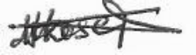
…………………………….
Dr. Joseph Magali
(Supervisor)

20/8/2017
……………………………..
Date

COPYRIGHT
No part of this dissertation may be reproduced, stored in any retrieved system, or transmitted in any form by any means, electronic, mechanical, photocopying, recording or otherwise without prior written permission of the author or The Open University of Tanzania in that behalf.

DECLARATION
I, Tinde Bahunde, do hereby declare that this dissertation is my own original work and that it has not been submitted for any award in any other University for a similar or any other degree award.

…………….…………………
Signature

……………..……………
Date

DEDICATION
This dissertation is sincerely dedicated to my family especially my loving husband Wilson E. Nkhambaku, my daughter Linda and my two sons Ethan and Jeremy for always supporting me in my study.

ACKNOWLEDGEMENTS
The completion of this dissertation would not have been possible without the help, valuable advices and encouragement from many organizations and individuals. I would like to express my sincere gratitude and appreciation to all of them who participated in the achievement of the completion of this dissertation. I am extending my heartfelt gratitude’s and thanks to my Almighty God who gave me good health as well as this opportunities and confidence to study this programme and to manage to complete this level of education.

I express my deepest gratitude to my supervisor, Dr. Joseph Magali, for providing me with dedicated supervision, invaluable guidance, consistent encouragement and support throughout my whole Master research journey. He has always been a great source of motivation and encouragement for me during demanding times. He is not only my respected supervisor for inspiring me in carrying out quality research, but also a good friend and a big brother for offering me generous help without limits.

To my Loving husband for providing me with needs for completion of this dissertation and always being there to encourage me and support me, without his support and encouragement, I would not have been able to reach my aim of completing my studies. I would also like to express my deep appreciation to Staff of The Open University of Tanzania, for encouraging and supporting me to undertake my master research, for always trusting my capability in conducting research, and for guiding me as a student with wisdom and valuable experience. I also extend my gratitude to my fellow students for encouragement and friendship they rendered to me throughout this period of my studies.
I thank all the government officials, teachers, parents, youths and children who have provided me with the necessary information needed in completing my study. They have been a great part of this dissertation for providing me with vital data used to reach to my conclusions.

ABSTRACT
The aim of this study was to assess the effects of child maltreatment on their academic performance as proxy for human resource potential in Tanzania. Specifically this study was done (i) to determine the effects of child physical abuse to their academic performance, (ii) to determine the effects of child discrimination to their academic performance , and (iii) to determine the effects of child neglect to their academic performance and iv) To determine the effects of child labor to their academic performance. Both case study design and survey design was used in a total sample size of 210 respondents. Case study helped in obtaining in-depth understanding of child maltreatment phenomenal and its effects in Academic performance of children for strengthening the survey phase. Survey was used for testing hypothesis and in model development. Stratified sampling technique was used to ensure representativeness of the sample from Arumeru district thereafter simple random sampling was used to draw a sample of 210 for survey. Purposive sampling technique was used to ensure that the required data is obtained from the 210 respondents in ten wards of Arumeru District. The findings using descriptive statistics and structural equation modeling (SEM) revealed that child maltreatment factors i.e physical child abuse, child discrimination, child neglect and child labor strongly affect the children’s academic performance and human resource management potential. This study recommended that much effort should be put in educating the community about child maltreatment so as to eradicate or at least minimize cases of child maltreatment within the communities in Arumeru district.

TABLE OF CONTENTS
CERTIFICATION ii
COPYRIGHT iii
DECLARATION iv
DEDICATION v
ACKNOWLEDGEMENTS vi
ABSTRACT viii
TABLE OF CONTENTS ix
LIST OF TABLES xiv
LIST OF FIGURES xv
LIST OF ABBREVIATIONS AND ACRONYMS xvi
CHAPTER ONE 1
1.0 INTRODUCTION 1
1.1 Background of the Problem 1
1.2 Statement of the Problem 4
1.3. Objectives of the Study 5
1.3.1 The General Objective 5
1.3.2 Specific Objectives 5
1.4 Research Questions 6
1.4.1 General research questions 6
1.4.2 Specific Research Questions 6
1.5 Significance of the Study 6
1.6 Organization of the Dissertation 7
CHAPTER TWO 8
2.0 LITERATURE REVIEW 8
2.1 Overview 8
2.2 Conceptual Definition 8
2.2.1 Child Maltreatment 8
2.2.2 Academic Performance Potential 9
2.3 Critical Theoretical Review 9
2.3.1 Family System Theory 9
2.3.2 Attachment theory 10
2.4 Empirical Analysis of Relevant Studies 11
2.4.1 General studies on child maltreatment 11
2.4.2 Studies in America on Child Maltreatment 12
2.4.3 Studies in Europe on Child Maltreatment 13
2.4.4 Studies in Asia on Child Maltreatment 14
2.4.5 Studies in Australia on child maltreatment 14
2.4.6 Studies in African Countries on Child Maltreatment 15
2.4.3 Empirical Studies in Tanzania on Child Maltreatment 16
2.5 Research Gap Identified 18
2.6 Conceptual Framework 18
2.7 Theoretical Framework 19
2.8 Summary 19
CHAPTER THREE 20
3.0 RESEARCH METHODOLOGY 20
3.1 Overview 20
3.2 Research Design 20
3.2.1 Population of the Study 22
3.2.2 Area of the Study 22
3.3 Sampling Design and Procedures 23
3.3.1 The Sampling Technique 23
3.3.2 Sample Size 24
3.3.3 Sampling Frame 24
3.4 Data Collection Techniques and Instrumentation 25
3.4.1 Secondary Data Collection 25
3.4.2 Questionnaire Survey 26
3.4.3 Pre-Testing of the Questionnaire 26
3.4.4 Administration of Questionnaires 27
3.4.5 Interviews 27
3.5 Data Processing and Analysis 28
3.5.1 Descriptive Analysis 28
3.5.2 Multivariate Data Analysis 28
3.6 Expected Results of the Study 29
3.6.1 Variable and Measurement 29
3.6.2 Data Validity and Reliability 32
3.6.3 Research Ethics Consideration 36
3.6.4 Research Limitation 36
CHAPTER FOUR 37
4.0 FINDINGS OF THE STUDY 37
4.1 Overview 37
4.2 Descriptive Analysis 37
4.2.1 Respondents Sample Distribution 37
4.3 Findings from Case Studies 39
4.3.1 Introduction 39
4.3.2 Summary of the Case Studies on Effects of Child Maltreatment to Their Academic Performance Potential 40
4.3.3 Pattern Matching and Cross-Case Synthesis 43
4.4 Finding from Survey on Specific Objectives 46
4.4.1 Model Formulation and Validation 46
4.4.2 Analysis of the Basic Structural Model of the Effects of Child Maltreatment to Their Academic Performance Potential 61
CHAPTER FIVE 75
5.0 DISCUSSION OF THE FINDINGS 75
5.1 Overview 75
5.2 Effects of Child Physical Abuse to Their Academic Performance Potential 75
5.2.1 Authorities response (PA6) 77
5.2.2 Policies (PA7) 79
5.2.3 Community Intervention (PA8) 81
5.3 Effects of Child Discrimination to Their Academic Performance Potential 83
5.3.1 Attachment and Family Organization (CD2) 85
5.3. 2 Authorities response (CD6) 86
5.3.3 Community Intervention (CD8) 88
5.4 Effects of Child Neglect to Their Academic Performance Potential 89
5.5 Effects of Child Labor to Their Academic Performance Potential 90
5.6 A Review of the Study Hypotheses 91
5.7 Effects of Child Maltreatments on Their Human Resource Management Potential 93
CHAPTER SIX 95
6.0 CONCLUSION AND RECOMMENDATIONS 95
6.1 Overview 95
6.2 Summary of Findings 95
6.3 The Study Conclusion 95
6.4 Study Implications 96
6.4.1 Theoretical Implications 96
6.4.2 Attachment Theory 96
6.4.3 Family System Theory 97
6.4.2 Implication to Policy Makers 98
6.4.3 Implications for Researchers 99
6.5 Limitations and Recommendation for Future Research 100
6.6 Recommendations 100
6.7 Areas for Further Study 102
REFERENCES 103
APPENDICES 109

LIST OF TABLES
Table 3.1: Sample Size in Stratification 25
Table 4.1: Respondents Distribution by Gender 38
Table 4.2: Respondents Education Level 38
Table 4.3: Respondents by Age Group 39
Table 4.4: Selected Exploratory Factor Analysis Output of Dropped Items 49
Table 4.5: Definitions of Construct and Their Dimensions of Retained Factor 50
Table 4.6: Model Regression Weight and Standardized Regression Weights 61
Table 4.8: Child Physical Abuse Basic Model Un-standardized and Standardized Regression Weights 65
Table 4.10: Structural Model Regression Weight and Standardized Regression Weight 68
Table 4.11: Child Neglect Descriptive Statistics 70
Table 4.12: Basic Model Un-standardized and Standardized Regression Weights 71
Table 4.13: Descriptive Statistics 73
Table 4.14: Basic Model Un-Standardized and Standardized Regression Weights 73

LIST OF FIGURES
Figure 2.1: Conceptual Framework Illustrating Relationship Between Child Maltreatment and Academic Performance Potential 18
Figure 3.1: Illustrating Structural Model of the Study 31
Figure 3.2: Illustrating the Measurement Model of the Study 31
Figure 4.1: Model Summary of Factors Extracted From All Cases 45
Figure 4.2: Child Physical Abuse Measurement Model 54
Figure 4.3: Child Discrimination Measurement Model 55
Figure 4.4 Child Neglect Measurement Model 56
Figure 4.5 Child Labor Measurement Model 57
Figure 4.6 Effects on Academic Performance Potential Measurement Model 58
Figure 4.7: Baseline Measurement Model 60
Figure 4.8: The Basic Structural Model 62
Figure 5.1: Authority Responses to Child Physical Abuse 78
Figure 5.2: Policies on Child Physical Abuse 79
Figure 5.3: Showing Community Interventions to Child Physical Abuse 82
Figure 5.4: showing Attachment Patterns and Family Organization, Child Discrimination 85
Figure 5.5: Authority Responses to Child Discrimination 87
Figure 5.6: Showing Community Interventions to Child Discrimination 88

LIST OF ABBREVIATIONS AND ACRONYMS
ACPF African Child Policy Forum
ACRWC African Charter on Rights and Welfare of Children
ASB Anti Social Behavior
AVE Average Variance Extracted
CCI Child Care Institute
CEDAW Convention on the Elimination of all forms of Discrimination Against Women
CPS Child Protection Services
CRC Convention on the Rights of Children
CRIN Child Rights International Network
HRW Human Rights Watch
ILFS International Labor Force Survey
LCA Law of a Child Act
MKUKUTA Mpango wa Kudhibiti Umaskini na Kukuza Uchumi Tanzania
MOHSW Ministry of Health and Social Welfare
MVC Most Vulnerable Children
NBS National Bureau of Statistics.
NCPA National Costed Plan
NSCAW National Survey of Child and Adolescent Well being
PHC Population and Housing Census
PEPFAR Presidents’ Emergency Plan Foe Aids Relief
REPOA Research on Poverty Alleviation.
SEM Structural Equation Modeling
SPSS Statistical Package for Social Sciences
TCRF Tanzania Child Rights Forum
UNECEF United Nations Children Fund
URT United Republic of Tanzania
USA United States of America
VAC Violence Against Children
VETA Vocational Education and Training Authority
WHO World health Organization

CHAPTER ONE

1.0 INTRODUCTION

1.1 Background of the Problem
Child maltreatment has been happening in many parts of the world, the history can be traced back to the beginning of time. “Prior to 1875, many children went without protection, although there was never a time when children were completely bereft of assistance. Criminal prosecution has long been used to punish egregious abuse. In 1809 for example a New York shopkeeper was convicted for spastically assaulting his slave and her three years old daughter” (Meyers, 2010:3). Studies have shown that parents maltreated as children are likely to maltreat their own children.

Child maltreatment is not simply a theoretical concept; it is a real-life phenomenon that needs to be understood within its societal context. The study on child maltreatment has grown exponentially in years since the identification of “battered child syndrome” (Kempe et al, 1962). This problem is big and seen in many parts of the world. The family system theory and attachment theory reveals that, problems of child maltreatment are viewed as the consequences of dysfunctional relationships among family members as well as attachment patterns within families. Child maltreatment is not just due to aggressive behavior but also it reflects relationships that are shifting within a period of time.

Studies in the 1950s revealed that young children hospitalized without their parents respond first by crying for them, then by showing signs of despair, and finally by emotionally detaching from the parents and acting indifferent to their absence. This detachment is hard to repair and highly detrimental to a child's development-most children who feel they cannot rely on their parents grow up to become more emotionally insecure and less self-assured than their peers (Newton et al. 2008). Early environment is very important in development of social behaviors, child maltreatment has received much attention due to the key influence of child -care giver interactions on child’s attachment, effect regulation and peer relationships (Cicchetti and lynch, 1995, Maughan and Cicchetti, 2002). The use of harsh or overly coercive physical discipline has been linked to an increased risk of anti social behaviors (ASB), particularly aggression in numerous studies (Burnette et al, 2012).

The stress and frustration of living in poverty may combine with attitudes towards the use of corporal punishment to increase the risk of physical violence, for instance, researches have shown that unemployment can lead to family stress and child abuse. There is accumulated evidence through various studies that show that maltreated children often experience disrupted growth and development, adverse effects have been identified in maltreated children’s well being and these effects accumulate over time. As they grow older, children who have been abused and neglected are more likely to perform poorly in school, to commit crimes and to experience emotional problems; sexual problems and alcohol/substance abuse (Diana, 1998).

The United States of America, Department of Health and Human Services shows that there are almost 1,000,000 reports of abuse each year. The study reveals that child maltreatment is a pervasive social problem with victims of abuse comprising a significant number of all psychiatric admissions in America. According to European report on preventing child maltreatment by World Health Organization (WHO, 2013), the report outlines the high burden of maltreatment , it’s causes and effects as well as cost of prevention programs. The report reveals that maltreated children are at increased risk of becoming victims or perpetrators of violence in later life and may have poorer education attainment and employment prospects.

Many countries in sub-Saharan Africa are experiencing an increased rural-urban migration with people seeking employment opportunities and better living conditions. This migration not only increased the spread of HIV from the urban to rural populations, but also predisposed girls aged 10-19 years to have sex with adults (Karim et al, 1992). Connections to the extended family and village elders have weakened. In many settings, cultural taboos make open discussions on sexual matters difficult (Ecker, 1994). To date, empirical reports suggest that maltreatment such as physical and sexual abuse, child neglect, and child labors is prevalent in multiple settings, including homes, institutions, streets, or places of worship in developing countries (Akmatov, 2011and Owolabi, 2012).

Research has shown the extensive use of corporal punishment in schools in poor countries (Anderson and Payne, 1994 as cited by Hecker et al 2014). For example in a UNICEF report on the use of corporal punishment against children in 35 middle and low income countries, six of the 10 countries in which corporal punishment was found to be very common are in Sub-Saharan Africa ( UNICEF, 2010 as cited by Hecker, et al 2014 ). In Tanzania where 47% of the population is children under 14 years, Country records show shocking levels of child maltreatment (UNICEF/VAC report, 2011). Tanzanian children commonly face sexual, physical and emotional abuse in their everyday lives.
Nearly three out of ten girls surveyed reported experiencing at least one incident of sexual violence, while approximately one-quarter of girls and nearly three out of every 10 boys reported experiencing emotional violence. Localized data on violence against children in specific areas throughout Tanzania indicate that sexual violence is a serious concern (Lalor and McElvaney, 2010; McCrann, et al, 2006; Stoltenborgh, et al, 2011; Larsen, et al, 2008; WHO, 2005; Wubs et al, 2009). History shows that children had been involved in child labor in mines and flower plantations in 1990’s, denying them education and a promising future. Children have been maltreated in many ways, for example, the names given to those working in various areas like in Buzwagi mines they call them “manyani”(Monkeys) and in Mirerani mines they refer them as “manyoka” (Snakes).

1.2. Statement of the Problem
According to National policy guideline (2011), three quarters of children experience some form of physical violence by relative, teacher or other authority figure by the time they are 18 years old. According to the ministry of health and social welfare, nearly 30% of female and 14% males ages 13-24 in Tanzania reported experiencing at least one incident of sexual violence before the age of 18 (National policy guideline, 2011).

Police report data shows a total of 2,571 children have been raped in the past seven months from January to July, 2016. In Dar es Salaam 435 children, in Mbeya 177, in Morogoro 160 while in Kilimanjaro and Arusha a total of 164 children. These are only the reported cases where by 1,203 cases are still under investigation, 822 are at the courts and 234 have already been given judgment.
According to the reports in Arumeru district, a total of 47 children in Arusha district council and a total of 43 children in Meru district council have been maltreated in various ways between the year 2004 to 2017 and these are the cases that have been reported to the police station, whereby some of the children had experienced multiple types of abuse. Data shows that 20 children had experienced physical abuse, 10 had been neglected at a very tender age, 1 was discriminated and 9 were involved in child labor and this may probably influence the academic performance potential. Therefore, this study assessed the effects of child maltreatment to their potentials focusing on academic performance.

1.3. Objectives of the Study

1.3.1. The General Objective
The study intended to determine the effects of child maltreatment to their academic performance potentials.

1.3.2. Specific Objectives
- To determine the effects of child physical abuse to their academic performance potential.
- To determine the effects of child discrimination to their academic performance potential.
- To determine the effects of child neglect to their academic performance potential.
- To determine the effects of child labor to their academic performance potential.

1.4 Research Questions
In the light of the objectives of the study, we attempt to answer the following questions:

1.4.1 General research questions
What are the effects of child maltreatment to their academic performance potential?

1.4.2 Specific Research Questions
- What are the effects of child physical abuse to their academic performance potential?
- What are the effects of child discrimination to their academic performance potential?
- What are the effects of child neglect to their academic performance potential?
- What are the effects of child labor to their academic performance potential?

1.5 Significance of the Study
This study intends to add the knowledge that will contribute to the reduction of the events of maltreatment among Tanzanian children and provide for additional means of intervention to help the affected children to get over the problem and improve their academic performance. The data obtained in this study can be used by the local government authorities in Arumeru District in dealing with child maltreatment, policy makers, academicians and children stake holders in the efforts to eradicate the problem within the society. The findings of the study will also add to the scanty literature available on issues of child maltreatment in Arumeru District and Tanzania at large.

1.6 Organization of the Dissertation
After seeing the background of the problem and other details in chapter one, chapter two of this dissertation contains literature review where there is definition of key concepts, critical theoretical review of other similar studies as well as some theories developed explaining the phenomenon. Empirical analysis of relevant studies, the research gap is identified; conceptual framework of the study as well as theoretical framework, and the summary are also in chapter two of this dissertation. Chapter three contains research methodologies while chapter four presents the results and discussion and chapter five presents the conclusion and recommendations.

CHAPTER TWO

2.0 LITERATURE REVIEW

2.1 Overview
This chapter gives a review of related literature, aiming at identifying the knowledge gaps that this research sought to bridge.

2.2 Conceptual Definition

2.2.1 Child Maltreatment
This study adopts the definition of a child by the United Nations Convention of the rights of the child and the United Republic of Tanzania Constitution and child development policy that a child is one below 18 years of age. In 1999 the, WHO consultation on child abuse provided the following definition, “child abuse or maltreatment constitutes all forms of physical and /or emotional ill-treatment, sexual abuse, neglect or negligent treatment or commercial or other exploitation, resulting in actual or potential harm to the child’s health, survival, development or dignity in the context of a relationship of responsibility, trust or power” (Mahram et al., 2013).

Physical child abuse is the acts of commission by a caregiver that cause physical harm or potential for harm to a child. Using a child for sexual gratification or satisfaction is sexual abuse while failure to provide an appropriate and supportive environment and acts that have adverse effect on emotional health and development of child can be referred as emotional child abuse, for example, ridicule, rejection, intimidation, and discrimination. Child neglect is the failure of a care giver to provide for the development of a child in education, health, nutrition, emotional development and safe living conditions.

2.2.2 Academic Performance Potential
Academic performance potential is the factors influencing excellence in education or predictions of success (Abulaban et al., 2015). Students’ improvement has always been one of the main goals of education. Many studies have been conducted to identify factors affecting the student’s achievement positively or negatively whereby among the factors revealed were lifestyle, learning environment, attitude and motivation. Potential is the possibility of something happening, of someone to do something in the future. These are the abilities that can be developed. Brain development is modified by the quality of environment, early cognitive and socio-emotional development are strong determinants of school progress (Stupp et al., 2007).

2.3 Critical Theoretical Review
The study on child maltreatment has grown exponentially in years since the identification of “battered child syndrome” (Kempe et al., 1962). This problem is big and seen in many parts of the world; hence influenced the development of various theories. This study focused on two of the theories on child maltreatment;

2.3.1 Family System Theory
A family is more than a social organization; it is a social institution, because it includes all the beliefs and practices of and about all of the families on a particular society and geopolitical context, the way it is connected with other families and other social institutions (Klein and White, 1996). The family system channels and defines patterns of interpersonal relationships that in turn shape the course of children’s early development. Each person in a system enacts roles that reflect expectations and norms regarding appropriate ways to relate to and interact with other members of a family (Smith and Tamis-Lemonda, 2013).

2.3.2 Attachment theory
Studies in the 1950s revealed that young children hospitalized without their parents respond first by crying for them, then by showing signs of despair, and finally by emotionally detaching from the parents and acting indifferent to their absence. This detachment is hard to repair and highly detrimental to a child's development-most children who feel they cannot rely on their parents grow up to become more emotionally insecure and less self-assured than their peers (Newton et al., 2008).

This study also used Attachment theory in describing the tendency of individuals to form strong emotional bond with a primary caregiver who functions as a source of security and safety. In attachment theory an attachment is a tie based on the need for safety, security and protection, this need is paramount in infancy and childhood, where the developing individual is immature and vulnerable (Prior and Glaser, 2006). The type of bond that develops between child and caregiver affects the child’s later relationships; there is a clear relation between early attachment experiences and the patterns affectionate bonds one makes throughout their life time. Securely attached children also tend to become more resilient and competent adults. In contrast, those who do not experience a secure attachment with their caregivers may have difficulty getting along with others and be unable to develop a sense of confidence or trust in others (Hong et al., 2012).

2.4 Empirical Analysis of Relevant Studies

2.4.1 General studies on child maltreatment
Early environment is very important in development of social behaviors; child maltreatment has received much attention due to the key influence of child - care giver interactions on child’s attachment, effect regulations and peer relationships (Cicchetti and lynch, 1995, Maughan and Cicchetti, 2002). The use of harsh or overly coercive physical discipline has been linked to an increased risk of anti social behaviors (ASB), particularly aggression in numerous studies (Burnette et al., 2012).

The stress and frustration of living in poverty may combine with attitudes towards the use of corporal punishment to increase the risk of physical violence, for instance, researches have shown that unemployment can lead to family stress and child abuse. There is accumulated evidence through various studies that show that maltreated children often experience disrupted growth and development, adverse effects have been identified in maltreated children’s well being and these effects accumulate over time. To reverse these adverse effects, it requires timely identification of the maltreatment and appropriate intervention. As they grow older, children who have been abused and neglected are more likely to perform poorly in school, to commit crimes and to experience emotional problems; sexual problems and alcohol/ substance abuse (Diana, 1998).

Child abuse and neglect can have a multitude of long-term effects on physical health. The USA National Survey of Child and Adolescent Well-being (NSCAW) researchers, using comparative analysis in their study, found that, at some point during the 3 years following a maltreatment investigation, 28 percent of children had a chronic health condition (ACF/OPRE, 2007). Several studies have documented the correlation between child abuse and future juvenile delinquency.

Weller and Fisher (2012) examined maltreated children’s decision making in two contexts: potential gains and potential losses. The study used inferential data analysis method to compare low and middle income groups. Maltreated and non-maltreated children showed impairments for both domains; these differences were especially prominent in the loss domain. Moreover, maltreated children also took excessive risks and were insensitive to changes in expected values, particularly in outcomes with risky options. Response latency analyses revealed that maltreated children were slower to make decision.

2.4.2 Studies in America on Child Maltreatment
The United States of America, Department of Health and Human Services shows that there are almost 1,000,000 reports of abuse each year (SPCC, 2017). The study reveals that child maltreatment is a pervasive social problem with victims of abuse comprising a significant number of all psychiatric admissions in America. In the article The Good Father by Ransaw (2014) which studied nine African American fathers who attempted to be good and help their children in school, this article used an adaptive qualitative version of the quantitative method of data analysis of fathers’ involvement scale which based on engagement, accessibility and responsibility, the study utilized qualitative interview and the findings revealed that this influenced the children positively. President Obama reported by NRP said, “We need to realize that what makes you a man is not the ability to have a child but the courage to raise one” (Martin, 2009). Studies show that boys with an engaged father have fewer behavioral problems during their school years and more socially advantaged than those with fathers who neglect them (Aldous and Milling,2002). Also daughters with involved fathers are more likely to have higher academic achievement than the neglected ones (Leman and Sorensen, 2000). Furthermore, fathers’ involvement has a protective effect against criminality for children (Coley and Mediros, 2007).

2.4.3 Studies in Europe on Child Maltreatment
According to European report on preventing child maltreatment by World Health Organization (WHO, 2013), the report outlines the high burden of maltreatment , it’s causes and effects as well as cost of prevention programs. The report reveals that maltreated children are at increased risk of becoming victims or perpetrators of violence in later life and may have poorer education attainment and employment prospects. The adversity may affect people throughout the life with high societal costs (WHO, 2013).

Report further asset that maltreatment may cause stress that affects children’s brain development, especially in the early years and also into adolescence which can lead to cognitive impairment and development of health risk behaviors, harming mental and physical health. Almost a quarter of the burden of mental disorders especially in association with other adverse or negative experiences in childhood is due to maltreatment. The report was based on a routine information on children aged 0-14, parents and other family members and peers age 15-19 from 32 European countries. It used statistical measurements (ratio analysis) to measure.

2.4.4 Studies in Asia on Child Maltreatment
In his article the burden of child maltreatment in china, Fang (2014) used multiple regression analysis to do the estimation of health and economic burdens of child maltreatment by using the 2010 global burden of disease estimates to calculate disability adjusted life years (DALYs) lost as a result of child maltreatment. The findings were that many maltreated children suffer substantial psychological distress and might adopt behavior that increases the risk of chronic disease.

In a systematic review of data from East Asia and pacific regions, Fay et al., 2010 used a comparative search of 16 data bases and articles from last ten years (2000 – 2010) to study the consequences of maltreatment on children lives. Using comparative data analysis the study reveals that children experiencing maltreatment are at increased risk of experiencing mental health disorders, physical health problems, high risk sexual behaviors and increased exposure to future violence including IPV as adults. It reveals that the more severe the abuse the stronger the association with poor outcomes in adulthood.

2.4.5 Studies in Australia on child maltreatment
Najman et al., 2005 in their article sexual abuse in childhood and sexual dysfunction in adulthood, by using ratio analysis between men and women, they examined self reported adults sexual functioning in individuals reporting a high history of childhood sexual abuse (CSA) in a representative of Australian population. Samples of 1793 people aged 18-59 years were randomly selected from states and territories of Australia. Respondents were interviewed and the study revealed that there is a significant association between CSA and sexual dysfunction which leads to stress and depression, also women are likely to experience maltreatment and sexual abuse than men. Stress and depression is always a stumbling block to academic development.

2.4.6 Studies in African Countries on Child Maltreatment
Crombach and Bamboye (2015) assessed integration violence in Burundi as an example to explore the association between childhood maltreatment, IPV, and perceived partner intimidation. This study used correlation data analysis method. A sample of 282 men and women in Bujumbura were interviewed. Findings were that child maltreatment was strong predictors for perpetration of violence against children. The study, hidden effects of child maltreatment in war region, conducted in Northern Uganda by Kani et al., 2014 assessed both war trauma and child maltreatment trauma. A comparative data analysis was used to study two generations in severely war affected regions in northern Uganda, they revealed the relationship between both trauma types, but child maltreatment accounted for post traumatic stress disorder (PTSD) symptoms. They concluded that even in war, the impact of child maltreatment on psychological disorder surpasses the damage of war trauma.

Many countries in sub-Saharan Africa are experiencing an increased rural-urban migration with people seeking employment opportunities and better living conditions. This migration not only increased the spread of HIV from the urban to rural populations, but also predisposed girls aged 10-19 years to have sex with adults (Karim et al., 1992). Connections to the extended family and village elders have weakened. In many settings, cultural taboos make open discussions on sexual matters difficult (Ecker, 1994). To date, empirical reports suggest that maltreatment such as physical and sexual abuse, child neglect, and child labors is prevalent in multiple settings, including homes, institutions, streets, or places of worship in developing countries (Akmatov, 2011and Owolabi, 2012;).

Research has shown the extensive use of corporal punishment in schools in resource-poor countries (Anderson and Payne, 1994, as cited by Hecker et al., 2014). For example in a UNICEF report on the use of corporal punishment against children in 35 middle and low income countries, six of the 10 countries in which corporal punishment was found to be very common are in Sub-Saharan Africa ( UNICEF, 2010 ). In these countries more than 80% of the children reported frequent use of corporal punishment at home. In a study conducted in Nigeria, Ani and Grantham-McGregor (1998) described high levels of corporal punishment both at home and in school.

2.4.3 Empirical Studies in Tanzania on Child Maltreatment
In Tanzania where 47% of the population is children under 14 years, Country records show shocking levels of child maltreatment (UNICEF/VAC report, 2011). Tanzanian children commonly face sexual, physical and emotional abuse in their everyday lives. Nearly three out of ten girls surveyed reported experiencing at least one incident of sexual violence, while approximately one-quarter of girls and nearly three out of every 10 boys reported experiencing emotional violence. Localized data on violence against children in specific areas throughout Tanzania indicate that sexual violence is a serious concern (Lalor and McElvaney, 2010).
In their study Olsson (2016) explored the causes of leaving home, and views and experiences among children and youth in the Kagera region in Tanzania, who have lived on the streets or been domestic workers. Two phased mixed method of data analysis was used. The analysis process was conducted in parallel and later triangulated in the discussion of the results (Bryman, 2006). The children who had left home showed strong agency and competency but lived in vulnerable conditions, especially young children living on the streets.

The prominent cause started with how one or both parents died or left home and thereby forced the child to move in with a relative, often a grandmother or uncle. When a parent remarried, the child gained a step-parent, which made life harder in the new setting. The child was often beaten and mistreated by their caregivers. Sometimes, caregivers abused alcohol and became aggressive when drunk. Many stories included various types of mistreatment by a stepmother. Other types of child maltreatment that has been studies is corporal punishment to children in schools and at homes, this is used as a corrective measure for behavioral problems of children.

Corporal punishment has remained common practice not only in many homes, but is also regularly practiced in schools, particularly in low-income countries, as a measure to maintain discipline (Hecker et al., 2014). In their study by Hecker et al., 2014 also revealed that nearly all children had experienced corporal punishment at some point during their lifetime both in family and school contexts, half of the respondents reported having experienced corporal punishment within the year 2013 from a family member.

2.5 Research Gap Identified
Though a number of studies have been done on child maltreatment, some aspects were not clearly explained or not at all. In the study by Lalor (2004) revealed that in Tanzania and Kenya, little empirical data exist on child sexual abuse in Tanzania. Olson (2016) noted that Orphan hood and maltreatment drive children to leave home in Kagera region. To the best of our knowledge none of study was done in Arumeru district to assess the effects of child maltreatment on their academic performance potential. Therefore, this study was done to fulfill the gap.

2.6 Conceptual Framework
Child maltreatment is not simply a theoretical concept; it is a real-life phenomenon that needs to be understood within its societal context. The conceptual framework is a simplified systematic conceptual structure of interrelated elements in a systematic form such as narrative statements or mathematical equation. It describes relationships between and among concepts and variables (Swami, 2009).
Dependent Variable Independent Variable
Child physical abuse
Children academic performance potential.
Child discrimination eg. Disabled children.

Child neglect
Child labor.

Figure 2.1: Conceptual Framework Illustrating Relationship Between Child Maltreatment and Academic Performance Potential
Source: Developed by the Researcher Based on Empirical Literature (2017)

2.7 Theoretical Framework
This current study goes deep into the family system theory so as to identify problems as the consequences of dysfunctional relationships among family members because various studies show that the way the family is organized can lead to child maltreatment as well as stop the event from happening. Attachment theory will be observed in assessing the emotional bonds of children with their caregivers who function as a source of security and safety.

2.8 Summary
This chapter has presented the related work to this study and the research gap. The following chapter presents the research methodology which will be used in collecting and analyzing data for the study.

CHAPTER THREE

3.0 RESEARCH METHODOLOGY

3.1 Overview
This chapter describes research strategies used in the study, population researched and the area of the research. Sampling design and procedures used are explained as well as variables and measurement procedures are described. Furthermore, methods of data collection, data processing and analysis, as well as expected results of the study, variables and measurements, hypothesis model of the study, data validity and reliability, research ethical consideration and research limitations.

3.2 Research Design
Kothari (2004) defines a research design as an arrangement of condition for collecting and analysis of data in a manner that aims to combine relevance to the research purpose with economy in procedure. In the same line, Aker et al., 2002 as cited in Adam and Kamuzora (2008) defined a research design as a detailed blue print used to guide towards its objectives. Similarly, it is a conceptual structure with which research is conducted; it constitutes the blue print for the collection, measurement and analysis of data (Kothari, 2004).

The current study used a case study design. A case study is an in depth comprehensive study of a person, a social group, a process, a situation, a programme, a community, an institution or any other social unit (Swami,2009). According to Swami (2009) the case studies are flexible with respect to data collection methods, since all methods of collecting data can be used. A particular strength of Case studies is its ability to cover both a contemporary phenomenon and its context. This characteristic also creates difficulty once the context has been incorporated into a study, the number of variables of interest will inevitably be an order of magnitude greater than the number of data points. This means that few statistics will be relevant for data analysis (Yin, 1981).

Case study approach seeks to understand the problem being investigated. It provides an opportunity to ask penetrating questions and capture the richness of behavior. The weakness is that conclusion drawn may be specific to a particular place and may not be generalized (Smith, 1990). Case studies has the opportunity to achieve high levels of construct validity or the ability to measure in a case the indicators that best represent the theoretical concept we intend to measure (Bennet et al., 2003). Statistical research is not only useful preceded by case study research to identify relevant variables, it is often followed by case study work that focuses on deviant cases and further refines concepts (Collier, 1998). Case studies can use process tracing to examine in detail the observable implication of hypothesized casual (unobservable entities) mechanisms in individual cases (Bennet, 1999).

A final advantage of case studies is their ability to accommodate complex causal relations such as equi-finality, complex interactions effects, and path dependency (Ragin 1987 as cited by Bennet, 1999). One of the common critiques of case study research is that they are prone to selection bias (Geddes, 1990). Such biases can occur when the researcher selects cases that represent a truncated sample along the dependent variables of the relevant universe of cases (Collier and Mahoney, 1996, as cited by Bennet, 1999). While this is the most dangerous kind of selection bias, it is also usually easy to identify and avoid (Bennet, 1999).
More objective criticism comes from social sciences; it identifies four corresponding problems of case study research, lack of controllability, deductibility, repeatability and generalizability (Lee, 1989). Lee goes on to defend case study method suggesting that those problems are neither endemic nor insurmountable; they none the less remain relative to other research methods. Considering the nature of this study, it was an appropriate approach to be used in order to understand phenomena and its effects on children’s academic performance potential.

3.2.1 Population of the Study
According to Kombo and Tromp (2004) population is total number of people or group or organization who could be included in a study. These are the people from which samples are taken for measurement. On the other hand Adam and Kamuzola (2008) argue that the population is the totality of object under investigation. This study targeted primary/ secondary school students and children from orphanages aged between 13 – 17 years, youth from student centers and secondary schools ages 18-22 years, government officials, parents/guardians and teachers from 10 wards in Arumeru district.

3.2.2 Area of the Study
The study was conducted in Arumeru District which is one of the six districts in Arusha region. Arumeru district has two District Councils which has a total of 53 wards with the population of about 591,342 people (PHC, 2012) of which studies show that half of the population is children less than 18 years. The study was conducted in 10 wards selected randomly. This district is characterized with numerous orphanages, children centers and child labor in plantations and mines, so that made it easier to obtain the data pertinent to the study.

3.3 Sampling Design and Procedures

3.3.1 The Sampling Technique
Sampling is a process of selecting a number of individuals or objectives from a population such that the selected group contains elements representatives of the characteristics found in the entire group (Oroth and Kombo, 2002). A sample is a small group drawn from the population in which a researcher is interested in gaining and drawing conclusion about the universe (Kothari, 1992). The study employed purposive sampling which entails deliberate selection of cases on the basis of specific qualities (Ibid). The goal of using purposive sampling was to select individuals who are likely to be information rich with respect to researcher’s purposes (Gall et al., 2005). Hence the researcher used purposive sampling so as to enable her to assess the effects of child maltreatment to their academic performance potential by focusing on those who have experienced maltreatment or have adequate information on the study.

In a list of 210 respondents from 10 wards of the Arumeru district, stratified random sampling was applied to ensure that all locations are represented. Stratified sampling technique involves partitioning of the population into groups called strata and then drawing a sample independently from each stratum (Kothari, 2004). The main objective of stratified sampling is to provide a sample which is more representative, easy to administer and led to more reliable results (ibid).

3.3.2 Sample Size
A sample is the exact number of items selected from a population (Adam and Kamuzora, 2008). It is recommended to use large sample size to be able to generalize the findings. The larger the sample size, the lower the likely error in generalizing to the population. Using Structural equation modeling the sample size can depend on estimation technique. When the sample size exceeds 400, the maximum likelihood estimation (MLE) technique tends to be very sensitive to any small variation in the data (Tanka and Huba, 1984). Given this limitation, recommended sample size for SEM ranges from 150 – 400 respondents, hence this study used the estimated sample size of 210 respondents distributed equally in each of the 10 wards where data will be collected from. This sample size meets SEM requirement of sample size.

3.3.3 Sampling Frame
Kothari (2004) define sample frame as a complete list of all objects or elements in the population from which researcher’s sample will be drawn from it. In this study sampling frame was children, youth, parents/guardians, teachers and Government officials as district education officer, community development officer, social welfare officer and Ward executive officers. The researcher used these individuals since they are the ones who were able to provide rich information about the topic.

This study was conducted in 10 wards of Arumeru district as shown in the table below:

Table 3.1: Sample Size in Stratification
Ward | Children  13-17 yrs | Youth  18-22yrs | Teachers | Government official | Parents | Total
Ngaramtoni | 10 | 5 | 2 | 2 | 2 | 21
Sekei | 10 | 5 | 2 | 2 | 2 | 21
Sokon II | 10 | 5 | 2 | 2 | 2 | 21
Kisongo | 10 | 5 | 2 | 2 | 2 | 21
Kiranyi | 10 | 5 | 2 | 2 | 2 | 21
Maji ya chai | 10 | 5 | 2 | 2 | 2 | 21
Kikatiti | 10 | 5 | 2 | 2 | 2 | 21
Mbuguni | 10 | 5 | 2 | 2 | 2 | 21
Usariver | 10 | 5 | 2 | 2 | 2 | 21
Nkoanrua | 10 | 5 | 2 | 2 | 2 | 21
Total | 100 | 50 | 20 | 20 | 20 | 210
Source: Developed by the researcher

3.4 Data Collection Techniques and Instrumentation
In research, the term data collection refers to gathering specific information aimed at proving or refuting some facts (Kombo and Tromp, 2006). This study employed three data collection techniques which are literature review, questionnaire and interview in assessing the effects of child maltreatment to their potential in academic performance. These techniques and instruments of data collection are the right ones which will enable the researcher to obtain rich information about the topic from the respondents. The study used multiple methods because no single method will be adequate in itself in collecting valid and reliable data on a particular problem. Bogan and Biklen (1992) argued that exclusive reliance one method might bias or distort the researcher’s picture of particular reality.

3.4.1 Secondary Data Collection
Review of published and unpublished literature which is more relevant to the research problem was being undertaken. Borg and Gall (1989) argues that, often the insights gained through the review of literature will save as much time in conducting the research as the review it’s required. Literature review also helped the researcher to identify other people’s works in the same field and increase the breadth of knowledge of a researcher’s area of study (ibid).

3.4.2 Questionnaire Survey
A questionnaire is a structured technique for primary data collection; it is generally a series of written questions for respondents to provide the answers (Gay, 1981). Structured questionnaire attached at appendix I was used in this study to collect quantitative data for hypothesis testing and model validation. As argued by Kothari (2004) that structured questionnaire is mostly used to capture measurable data for statistical testing of the hypothesis of the study. In this study the specific objectives of this study are to test the hypothesis which is developed to assess the effects of child physical abuse, child discrimination, child neglect and child labor to their academic performance potential. Within this context, a questionnaire was suitable in survey situations of this study as it offer a standardized system of question to collect measurable and factual data to classify a specific group of people and their circumstances in statistical characterization(Goretti,2008). Hence questionnaire was used in this study during the main quantitative survey due to its ability to capture data that were suitable for statistics analysis.

3.4.3 Pre-Testing of the Questionnaire
Before the questionnaires being used, they were pre-tested in order to test if the instrument will elicit responses required to achieve the objectives of this study. Also pre-testing assessed if the questions are clear, answerable, specific and relevant to the study (Punch, 2000). Some ambiguous questions were removed and others were re-phrased. 17 respondents (5 children, 5 youth, 3 parents, 2 teachers and 2 government officials) were used to pre-test the questionnaires and the time for pre-testing was about 20 minutes per respondents which was done by the researcher.

3.4.4 Administration of Questionnaires
The researcher visited schools, student centers, government offices and households and administer the questionnaires personally so as to have the opportunity to establish rapport and explain the purpose of the study as well as to clarify the meaning of the items that may not be clear. Questionnaires were administered mainly to the youth, children and teachers.

3.4.5 Interviews
According to Kvale (1996) interviews are interchange of views between two or more people on a topic of mutual interest, sees the centrality of human interaction for knowledge production, and emphasizes the social situations of research data. Interviews are ways for participants to get involved and talk about their views and the interviewees are able to discuss their perception and interpretation in regards to a given situation. Interview is not simply concerned with collecting data about life: it is part of life itself; its human embeddedness is inescapable (Cohen et al., 2000). Wenden (1982) considers that the general interview guide approach is useful as it allows for depth probing while permitting the interviewer to keep the interview within parameters traced out by the aim of the study. Semi-structured interview attached in Appendix II was used to collect data from the government officials and parents/guardians within the study district so as to obtain deeper information.

3.5 Data Processing and Analysis
Data analysis refers to the computation of certain measures along with searching for patterns of relationship that exist among data groups (Kothari, 2004). Mutai (2000) provides that analysis of data is the process of interpreting the survey data. This study used quantitative approach in data analysis which is not only useful but also may be considered indispensable in most type of research (Best and Khan, 2006). After collecting data, the returned questionnaires were coded and entered in SPSS version 24 and analyzed using both inferential and descriptive analysis.

3.5.1 Descriptive Analysis
Descriptive analysis was done by using frequencies and percentages. Leach et al (2005) argues that the use of frequency and percentages is considered useful for profiling the characteristics of the phenomena. The analysis was done to profile and gain an understanding of various characteristics of the population under investigation which includes age, gender experience etc. This helped to provide a clear picture of the population sample in general which facilitated discussion on findings.

3.5.2 Multivariate Data Analysis
Hypothesis testing and examination of significant effect of predictor variable was done using structural equation modeling (SEM). SEM has the ability of incorporating observed variables (measured) and latent constructs (unobserved) while traditional technique analyses only measured variables (Hoper et al., 2008). In this study the hypothesis used four latent constructs which were measured by number of indicators in the model.
Having observed and unobserved variables in conceptual framework of this study, SEM is suitable for analyzing data. SEM supports the use of a collection of measured variables that can represent latent theoretical constructs more realistically than a single variable (Oke et al., 2012). Also SEM is suitable in this study because it allows making use of several indicator variables per construct simultaneously which leads to more valid conclusions at the construct level (Byrne, 2010). Hox and Bechger (2012) argue that the requirement in sample size appears vague and the in appropriation of the results should be handled with care. This means it requires an appropriate sample size so as to produce reliable and stable estimates. In this study an appropriate sample size was selected to produce reliable and stable results.

3.6 Expected Results of the Study
The researcher’s expectations of this study was that the findings would answer the research questions as well as contribute in the knowledge on child maltreatment and its effects on human resource potential and identify the means of reducing the problem in the society.

3.6.1 Variable and Measurement
This study used Structural Equation Modeling, the data were tabulated, frequencies and responses were calculated as percentages. The approach used by parents/care givers, teachers and social workers to develop children/youth potentials was analyzed. Moreover, Path Analysis model was used where there are texts, quotations, frequencies, figures and tables. Measure of central tendency and dispersion such as mean, standard deviation and variances was used by the researcher to analyze data. The path analysis model used two types of variables which are independent variables and dependent variables. Independent variable is the outcome or response of dependent variable while dependent variable is what a researcher measures to establish an association with an independent variables. The study tested the influence of independent variables which are child physical abuse, discrimination, child neglect and child labor were measured by its level of influencing the development of children potential in academic performance which was the dependant variable.

According to Bechger (1987) path analysis equation is written as follows:
Y= β10 X1+ β11 X2+ β12 X3+ β13 X4 +ε

Hypothesis model of the study:
Null H1a: Child physical abuse has a negative effect on the children academic performance potential.
Alternative H1b: Child physical abuse does not have negative effect on the children academic performance potential.
Null H2a: Child discrimination has a negative effect on the children academic performance potential.
Alternative H2b: Child discrimination does not have a negative effect on the children academic performance potential.
Null H3a: Child neglect has a negative effect on the children academic performance potential.
Alternative H3b: Child neglect does not have a negative effect on the children academic performance potential.
Null H4a: Child labor has a negative effect on the children academic performance potential.
Alternative H4b: Child labor does not have a negative effect on the children academic performance potential.
CPA= child physical abuse
CHD=child discrimination
CHN=child neglect
CHL=child labour
AP=academic performance

CPA
CHD
AP
CHN

CHL

Figure 3.1: Illustrating Structural Model of the Study

X1
β10
X2
Y
β11
β12
ε
X3
β13
X4

Figure 3.2: Illustrating the Measurement Model of the Study

Where Y = dependent variable whereby;
1. = high educational performance and self confidence.
2. = lower educational performance and self confidence.
β = direct effect
ε =Error term and the independent variables are described below:
x1 = child physical abuse
x2 = child discrimination
x3 = child neglect
x4 = child labor

3.6.2 Data Validity and Reliability
Data validity: Welman and Kruger (2001) describe validity as a mechanism that ensures that the process implemented to collect data has collected the intended data successfully. Validity refers to the extent to which an empirical measure adequately reflects the real meaning of the subject under investigation (Babbie, 2005). To ensure that the data collected are valid, this study took the following steps;

An extensive literature review, interview and questionnaire surveys were conducted (Finn et al., 2000). Interview guidelines were generated in conjunction to the fieldwork so as to ensure that interview focus on the topic and the purpose of the study was explained clearly to the respondents and issues of concern were resolved fully. The study used experts from the field as well as conduct pre-testing of the questionnaires to ensure the validity of data obtained. Respondents were assured of anonymity and confidentiality to encourage frankness during interviews. According to Greener (2008) a test is said to be valid if it measures what it claims to measure. Validity means determination of whether a measurement instrument actually measures what it is supposed to measure. Sobh and Perry (2008) described different types of validity namely content validity, construct validity and criterion validity.
Content validity
Content validity considers whether or not the item on a given test accurately reflects the theoretical domain of the latent construct it claims to measure (Morse, 2002). In this study a case study approach was used to ensure that the items on a given test accurately reflect the theoretical domain of the latent construct. Experts in the field were used as a sample population to enable the researcher to strengthen the data collection instruments by assessing the coverage in theoretical domain.
Construct validity
Construct validity is defined as the extent to which a measure behaves the way that the construct it purports to measure should behave with regard established measures of other constructs (Mello and Collins, 2001). Construct validity was observed by observing convergent, discriminant and nomological testing validity (Cohen, 1976).
Convergent validity is concerned with whether a test is similar to those to which it should theoretically be similar (ibid). To ensure convergent validity, Falk and Miller (1982) recommended a loading in measurement model to be at least 0.55 which explains at least 30% of the variance in the variable.
Discriminant validity is the extent to which a given scale can be distinguished from other scales which are measuring different concepts or traits. Discriminate validity was assessed by comparing the AVE (average variance extracted) of each individual construct with the shared variances between this individual construct and all of the other constructs. A higher AVE than shared variance for an individual construct suggests discriminate validity is achieved (Fornell and Larcker, 1981).
Lastly, nomological validity was tested by relating measurements to a theoretical model that leads to further deductions, interpretations, and tests (Spiro and Weitz, 1990). To assess nomological valididy should have all standardized coefficients have significant values greater than 0.2.

Criterion validity: This is also called instrumental validity. Criterion related validity is based upon the premise that processes and instruments used in a study are valid if they parallel similar to those used by previous, validated research. Criterion- related validity. This type of validity provides evidence about how well scores on the new measure correlate with other measures of the same construct or very similar underlying constructs that theoretically should be related. It is crucial that these criterion measures are valid themselves (Kimberlin and Winterstein, 2008).This validity measure can be pursued in one of two contexts: predictive validity or concurrent validity. Concurrent validity uses an already existing and well-accepted measure against which the new measure can be compared. In order to ensure concurrent validity, in this study the data collection instrument was drawn and developed by considering strong validated literature and expert panels.

Data reliability: Babbie (2005) describes reliability as a condition in which the same results can be achieved whenever the same technique is repeated to do the same study. According to Ellis and Levy (2009) reliability is the degree to which measures are free from error and therefore yield consistent results. On the other hand, Golafshani (2003) also pointed out that, reliability is the extent to which results are consistent over time and an accurate representation of the total population under study is referred to as reliability and if the results of a study can be reproduced under a similar methodology, then the research instrument is considered to be reliable.
Ultimately, Kirk and Miller (1986) cited in Golafshani (2003) has identified three types of reliability referred in quantitative research, which relate to: (1) the degree to which a measurement, given repeatedly, remains the same (2) the stability of a measurement over time; and (3) the similarity of measurements within a given time period. Because reliability is consistency of measurement over time or stability of measurement over a variety of conditions, In order to measure repeatability, or stability-over-time, Scholar Zikmund (2003) have suggested the use of test-retest method which advocate that, the same scale or measure is administered to the same respondents at two separate points in time.

However, test-retest procedures may not be useful when participants may be able to recall their previous responses and simply repeat them upon retesting (Drost, 2011). For instance, when the interval between the first and second test is too short, respondents might remember what was on the first test and their answers on the second test could be affected by memory. Alternatively, when the interval between the two tests is too long, maturation happens (Drost, 2011). Base on the above argument, in this study to insure the repeatability of the data collection instrument, the researcher conducted exploratory study and pilot study before the main survey in order to insure that the instrument capture the context variable and use the language which is clear to the targeted respondents so as to increase the suitability of data collection instruments.

On the other hand, the researcher used composite reliability to assess the internal consistency of the variables. Internal consistency measures the degree within the instrument and questions on how well a set of items measures a particular behavior or characteristic within the test. Internal consistency is also known as scale homogeneity, in other words, the ability of items in a scale to measure the same construct or trait. In the analysis a p-values above 0.5 are considered significant while the coefficients that range from 0.6 and above are considered more acceptable in scientific research although lower p-values can be used as well and accepted (Tabachnick and Fidell, 1996; Hair et al., 2003).

3.6.3. Research Ethics Consideration
Kumar (1999) stipulates that ethical principle in the conduct of research includes acquiring research clearance and the informed consent of the participants as maintaining confidentiality. In this study, during administration of questionnaires, interview and documentary review, the researcher assured the respondents that privacy, confidentiality and anonymity will be guaranteed. Also assurance was given to respondents that name(s) and places they live will not be revealed in this study.

3.6.4. Research Limitation
Financial inadequacy and time limited coverage of the study area and the sample size.

CHAPTER FOUR

4.0 FINDINGS OF THE STUDY

4.1. Overview
This chapter presents the findings of the study. It starts by presenting the data analysis on characteristics of the sample, respondent’s ages, level of education and other descriptive statistics forming the fundamental description of the sample and area under study. Second it presents findings from case study. The aim of the case study was to do in-depth analysis of the effects of child maltreatment to their academic performance potential. In so doing the case study supplemented the survey results and it has helped to build the insights as well as supporting the final analysis of survey results. Finally, this chapter presents the analysis from survey by performing confirmatory factor analysis and thereafter by testing the hypotheses developed under study.

4.2 Descriptive Analysis
Descriptive analysis helps to understand the nature and characteristics of the respondents and of the area used in the process of data collection. The descriptive analysis covers the background information of respondents and other variables that gives the general picture of data analysis.

4.2.1 Respondents Sample Distribution
Respondents’ distributions are important part in research because they provide a major picture of the percent of respondents which participated in the research. Hence, it helps to describe the proportional and representation of each unique characteristic of the group of respondents which could affect the outcome of the research. By considering such needs, in this study respondent gender, age and education level were profiled in this section as described below.

4.2.1.1 Respondents’ Distribution by Gender
In this study the gender of the respondents consisted of both male and female who were children, youth, parents, teachers and government officials in Arumeru District as presented in Table 4.1. Among the 210 respondents, 42% were male, and 57.5 % were female. Despite the fact that female respondents were slightly higher than male respondents, the proportional of the percent above indicated at least equal proportional of representation of gender in the process of data collection which helped to capture data which address each group of gender.

Table 4.1: Respondents Distribution by Gender
Gender | Frequency | Percent
Male | 85 | 42.7%
Female | 114 | 57.3%
Total | 199 | 100%
Source: Field Data (2017)

4.2.1.2 Respondents’ Distribution by Education Level
Table 4.2 shows the respondents’ distribution by level of education. The researcher found that it was necessary to include various categories of respondents with different education levels so as to capture diverse views and experiences from the respondents regarding the objectives of the study.

Table 4.2: Respondents Education Level
Education | Frequency | Percentage
Primary | 81 | 40.7%
Secondary | 85 | 42.7%
Non degree | 13 | 6.5%
Bachelor’s degree | 16 | 8.1%
Post graduate | 4 | 2%
Total | 199 | 100%
Source: Field data (2017)

4.2.1.3 Respondents’ Distribution by Age
In this study, it was considered that each age plays a big role in understanding the phenomenon. Table 4.3 below shows the distribution of respondents’ based on their ages. These findings indicate that at least each group was contacted in the research hence findings cover data from each group.

Table 4.3: Respondents by Age Group
Group | Frequency | percentage
Children | 100 | 50.3%
Youth | 48 | 24.1%
Other | 51 | 25.6%
Total | 199 | 100%
Source: Field data (2017)

4.3 Findings from Case Studies

4.3.1 Introduction
The main aim of the case study approach was to do an in-depth investigation of the effects of child maltreatment to their academic performance potential. In so doing, the case studies complemented the survey results. This strengthened the conclusions on effects of child maltreatment to their academic performance potential. The case studies involved 3 youths under 22 years and 2 young adults above 22 years.The cases were selected based on their possibility of getting adequate information, which is in congruence with Yin’s (2003) case selection criteria. Data were collected through semi-structured interviews with the parents and government officials.

In this study, pattern matching and cross-case synthesis were used out of the five techniques of case analysis (Yin, 2003). First, the cases were analyzed individually through a case pattern matching matrix. Then patterns were related to effects of child maltreatment to their academic performance potential. The case study subjects were asked questions about effects of child maltreatment to their academic performance potential. This was followed by cross-case synthesis to analyze the cases and draw conclusions. The following section summarizes the analysis of the case study. It presents a summary of five cases followed by discussion and conclusions on the case studies using IBM SPSS 24 software.

4.3.2 Summary of the Case Studies on Effects of Child Maltreatment to Their Academic Performance Potential
Respondent no. 003: Respondent no.003 is a young boy of 17 years who dropped out of school due to physical abuse and discrimination. He tells that his father’s frequent beatings made him not being able to concentrate in his studies and he even hated school this caused him to always be the last student in almost all exams he did which was also a reason for him to be discriminated by his peers. “I remember one day I asked some of my classmates to help me with the home work but most of them rejected to help me.

One of them agreed to help me so we stayed at school doing the home work, then I went home a bit late. My father did not even ask me the reason for being late he mercilessly beat me, since that day I decided to stop going to school and spent most of my time on the street and at the market selling shopping bags to people in the market where I am experiencing both physical abuse and discrimination. This young boy he did not see the importance of education and hence decided to drop out of school and this paved way for child labor. He says only if He had parents who encouraged him instead of punishing him always he would be far in his studies and if he would not have been discriminated by his peers.

Respondent no. 106: A young girl of 22 years who has experienced physical abuse by her mother throughout her life tells her story on how difficult it was for her to concentrate in her studies and even studying at home. “ I lived with my mother all my life before I decided to get married, my mother was always bringing different men to our house and because we had a single room, she always told me to go find a place to sleep, and if I ask why should I go, I would get beaten up so hard. So I would always sleep outside the door of our house, I did not know where to go at the time of the punished me in a way that I would never forget, so I was afraid to tell anyone again. This caused me to always be tired at school because of the little sleep and this made me to perform poor in my studies. When I completed my class seven despite I failed, I had a sponsorship under compassion international, and I was taken to proceed with secondary school education. However, where I completed my form four and I failed again and hence I decided to be married.”

Respondent no. 110: A young man of 22 years who works as a motorcycle rider says, “I have never been able to perform well in my studies throughout my primary and secondary school because of physical abuse and neglect”. This is a maasai boy who was raised by his aunt, the sister to his father. In the maasai culture, when a woman is not able to have children, then a relative who has children gives one of her children to her at a new child birth. This is what happened to this boy, he was given for adoption to his aunt who could not have children. They lived happily in his early years of childhood until he was four years when God gave his aunt her own child then the things changed, his aunt started maltreating him so badly. This created a huge psychological trauma to this boy that made him always panic when he sees a teacher holding a stick in his/her hands. He said, “for me seeing a teacher holding a stick would mean I am going to be beaten again, if you see my body, I have marks all over my body till today due to the beatings which I used to receive from my aunt despite I did not know why she hated me so much. Therefore, I was worried that if a teachers holds a stick in the class he/she would beat me without justifiable reasons.

Respondent no. 111: This is a girl who experienced child discrimination due to her health condition. She says that, she was raped by her step father when she was six years; his step father continued doing it to her every time her mother was not at home. However, she was afraid of telling her mother until she started getting sick most of the time then her mother took her to the hospital where the doctors realized the problem of abuse together with the infection for the child. When they went home the step father had already ran away. Due to her sickness, other children at school started discriminating her and she had no one to study with or even help her. This created inferiority complex and frustrations. She said “I have always been the last one or close to the last in all my studies.

Respondent no. 194: This is a ward educational officer, according to his reports; it shows that there are a few reported cases of child maltreatment although many children are being maltreated. He says, “Children who are maltreated are always poor performers in their studies, a few who get help improve as long as the help is available. Children centers provide a lot of help to these children who are maltreated although they cannot reach all of them, there is a need for more efforts to help the children and stop maltreatment”. “I have tried to be a friend for some of the children who are maltreated so as to help them and I have realized that they afraid to say who maltreats them; though some can tell about the maltreatment, it is difficult to help them improve their studies because at school they feel inferior to others and at home no one cares for their studies, parents are too busy to follow up their children’s studies” .

Child maltreatment happens every day in our communities, it has become part of everyday events, says the ward educational officer, and it is difficult to stop it since these things occur within families and kept confidential within families. He added that, though there are good child protection policies, the government cannot solve all of them, since the family members do not report these events,” he argues.

4.3.3 Pattern Matching and Cross-Case Synthesis
Children while young depend solely on their parents or guardians to guide them through life. Early environment is very important in development of social behaviors; child maltreatment has received much attention due to the key influence of child-care giver interactions on child’s attachment, effect regulation and peer relationships (Maughan and Cicchetti, 2002). There are things which can contribute to ones achievement or failure in life. Children are brought up in families or other places like orphanages, the life they live there can have a positive or negative effect in various parts of their lives, and this includes their potential for academic performance. The following section discusses the patterns which are related to the effects of child maltreatment to their academic performance potential.
Effects of child physical abuse to their academic performance potential: In almost all cases, child physical abuse appears to be common and plays a great role to the poor performance of children in academic issues. For example in the case of respondent no. 110, became psychologically traumatized because of physical abuse that was occurring often to him. Since most of teachers especially in public schools are used to walk around with a stick, it made this respondent live a tough life at home as well as at school. His ability to grasp what the teachers teach was interrupted by the occurrence of physical abuse, leading to the negative effects to his potential of academic performance.

Effects of child discrimination to their academic performance potential: Child discrimination occurs in cases like physical disability or other types of disabilities or sickness like HIV and the like. In this study we see an example of respondent number 111 who was infected leading to her being sick most of the time and all friends started discriminating her due to the kind of sickness she had. This had a great effect in the respondent’s academic performance since the respondent felt neglected and rejected always she did not have the passion for studying hard. Respondent number 003 was discriminated due to his poor performance in the class and this increased the problem leading to his dropping out of school.

Effects of child neglect to their academic performance potential
Many parents and guardians neglect their children in various ways knowingly and sometimes unknowingly. Respondent number 106 experienced child neglect by the mother who cared much of her own pleasure than taking care of her child. The child was left to sleep outside the house many times and this contributed to her poor performance in studies. Also respondent number 110 experienced neglect by both his aunt and biological mother leading to his poor performance in studies.

Effects of child labor to their academic performance potential: In families sometimes child labor is seen as part of teaching a child, though in other families it exceeds the normal house chores, causing children to lack time to study and rest denying them the opportunity of developing their potential in academic matters. Respondent number 003 dropped out of school and started to sell plastic bags in the market places while he is still bellow 18.

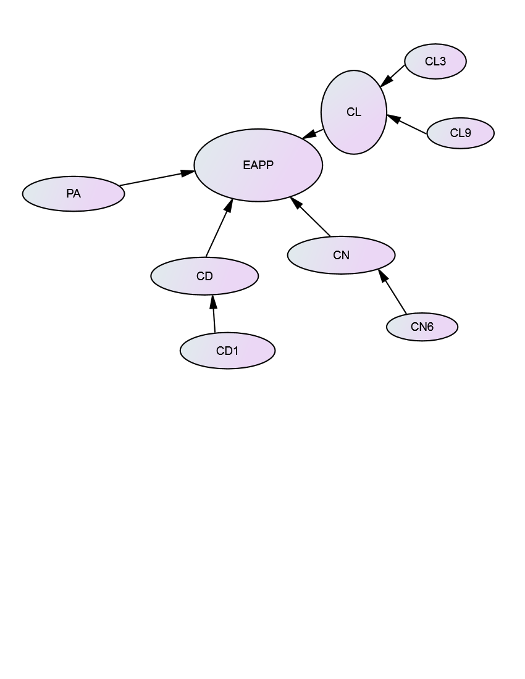

Figure 4.1: Model Summary of Factors Extracted From All Cases

EAPP= Effects to Academic Performance Potential
PA= Physical child abuse
CD= Child discrimination
CD1= Discrimination frequency
CN= Child neglect
CN6= Authority response to child neglect
CL= Child labor
CL3= Child labor Abuser
CL9= Activist response to child labor

4.4 Finding from Survey on Specific Objectives

4.4.1 Model Formulation and Validation
The aim of this part is to check if the proposed factor structures are indeed consistent with the actual data. This is because at the conceptual framework development, the researcher had developed the conceptual framework without data; therefore, it is not clear if the constructs are aligned with their underlined measure. Given this context, the researcher used factor analysis of both exploratory factor analysis and confirmatory factor analysis to ensure that the construct are aligned with their indicators variables as described below.

Exploratory factor analysis: Exploratory factor analysis is used in order to ensure that constructs are aligned with their indicator variables. This is because at the start of any study, the researcher mixed the hypothesized, empirical and theoretical measures of a construct from different setting without data. Babyak and Green (2010) advocate that, in a situation where there is incongruence between the researcher, theory and data, a poor model fit will always result. As such, researchers utilize exploratory factor analysis to identify a set of unobserved factors that reconstruct the complexity of the observed data in an essential form (Henson and Roberts, 2006). Matsunaga (2010) looks at EFA as a tool intended to help generate a new theory by exploring latent factors that best accounts for the variations and interrelationships of the manifest variable. It is used to estimate the unknown structure of the data.

In this study, the researcher built the conceptual framework by integrating construct and indicator variables from different theories, empirical literature and expertise view without data. To help to harmonize the data with the researcher’s hypotheses, empirical and theoretical dimensions of constructs, exploratory factor analysis was used to provide a diagnostic tool to evaluate whether the collected data are in line with the theoretically expected pattern, or structure of the target construct and thereby to determine if the measures used have indeed measured what they are purported to measure.

Exploratory factor analysis procedure and output: The researcher performed exploratory factor analysis by conducting principal component factor analysis with varimax rotation to assess the underlying structure for the thirty nine (39) items of the effects of child maltreatment to their academic performance potential survey questionnaire basing on the theoretical framework. In selecting factors to retain, fifteen components were extracted namely eigen values, scree test (i.e., scree plot), component theoretical assumption and factors that have more than one items as recommended by Yong and Pearce (2013) , that the use of a combination of criteria will help to offsite the weakness of using one criteria.
According to this situation fifteen factors were extracted base on those four criteria which they explain 66.04% of the cumulative variance. The fifteen factor had Eigen values >1 which has meet Kaiser’s criterion which suggests retaining all factors that are above the Eigen value of 1 (Kaiser, 1960). Using a scree test (see graph 1 at appendix II) all factors above the break/cut off point on scree graph was retained and those below the break/cut off point were dropped as recommended by Cattell (1978). Furthermore, fifteen components were produced and all produced factor were aligned with theoretical Framework. Finally, all retained factors had more than one items/indicator.

Though the fifteen factors have met the criteria and now they are qualified to be retained, rotation failed to converge in 25 iterations, it required more, and so further analysis of indicator variables was done in order to see if this indicator really fit to their underlying factor. In order to assess the suitability of each indicator variables to their underlying structure, the following criteria recommended by Yong and Pearce (2013) were adopted for retaining/dropping an item/indicator as follows; all items loaded into their associated factors were retained and those loaded into more than one factors were dropped. Then, if more than two items loaded in one factor, all items were retained and if less than three items loaded in one factor were all dropped.

The researcher retained all items with KMO p-value greater than 0.5 and those with less than 0.5 were dropped. The fourth step done was, all items with loading ranging from 0.4 to 0.8 were retained and those with loading less than 0.4 or above 0.8 were dropped as suggested by Yong and Pearce (2013), for the criteria to be adopted for either to retaining the items or dropping the items in order to improve the model. As far as this study, Table 4.4 presents a selected output of SPSS of items which was dropped in other way those poor fitted the data as elaborated below as follows:

Table 4.4: Selected Exploratory Factor Analysis Output of Dropped Items
Factor | Item Removed
PA: Child physical abuse | PA1: Frequency of abuse PA2: Attachment &Family organization, PA3: Abuser  PA5: Where reported
CD: Child discrimination | CD1: Frequency of abuse; CD4:Place of abuse CD5: Where reported  CD9: Activist intervention
CN: Child neglect | CN1: Abuse frequency CN3: Place of abuse CN4: Parental follow up CN5: Where reported  CN6: Authorities response
CL: Child labor | CL2: Attachment &Family organization CL4:parental follow up CL8: Community intervention; CL9: Activist intervention
Source: researcher, 2017

Child physical abuse (PA), PA1; PA2; PA3 and PA5 was eliminated from the analysis because it had weak loadings and hence affected its fitting, it was eliminated because it was loading weakly with value less than 0.4. Child discrimination (CD), CD1; CD3; CD4; CD5 and CD9 were eliminated from the analysis because they had weak loadings on theoretical model and hence affected its fitting. Child neglect (CN), CN1; CN3; CN4; CN5 and CN6 was eliminated because it had weak loadings on their theoretical model and hence affected its fitting, it had the value of 0.1. Child labor (CL); CL2; CL4; CL8 and CL9 were eliminated because they had weak loadings on theoretical model and hence affected its fitting. For example CL2 had value of 0.3.hence failed to support theoretical assumption. Given this perspective, those items that did not fit well with the factor solution were dropped from the analysis as described above in Table 4.4 and those fitted very well were retained as described below in Table 4.5.

Table 4.5: Definitions of Construct and Their Dimensions of Retained Factor
Key Note
PA: Child physical abuse | PA4: Place of abuse PA6: Authorities response PA7: Policies PA8: Community intervention PA9: Activist intervention
CD: Child discrimination | CD2: Attachment &Family organization, CD3: Abuser  CD4: Place of abuse CD6: Authorities response  CD7: Policies CD8: Community intervention
CN: Child neglect | CN2: Attachment &Family organization, CD5: Where reported  CN6: Authorities response CN7: Policies  CN8: Community intervention CN9: Activist intervention
CL: Child labor | CL1: Frequency of abuse CL3: Abuser; CL5: Reported; CL6: Authorities response CL7: Policies;
EAPP: Effects on academic performance potential | EAPP1: Child physical abuse effects EAPP2: Child Discrimination effects EAPP3: Child Neglect effects EAPP4: Child Labor effects
Source: researcher, 2017
After establishing the study framework from the exploratory factor analysis, the following step is to conduct confirmatory factor analysis as described in detail below:

Confirmatory factor analysis: By using EFA, the researcher intended to discover whether the original variables are organized in a particular way reflecting latent variables. In this study, confirmatory factor analysis was used to analyze theoretical constructs through assessing the loadings of the measures, error variances and covariance (Hooper et al., 2008). The researcher wanted to confirm and harmonize a belief about how the original variables are organized in a particular way using CFA. To carry out confirmatory factor analysis measurement model was developed to test for specification error and correlation between the latent variables (Yong and Pearce, 2013). In this section, measurement models of different variables as used in the conceptual framework are presented and thereafter the measurement models for the composite structure or variables are also presented.

Model fitness evaluation in confirmatory factor analysis: Schermelleh-Engel et al., 2003 recommended the following criteria to guide the model refinement process to achieve a better fit: Standardized regression weights (S.R.W) values should be above 0.5 and Modification indexes (MI) that reveal high covariance between measurement errors accompanied by high regression weights between these errors’ construct and cross loading items are candidate for deletion.

Measurement model for child physical abuse: IBM Amos 24 was run to test for child physical abuse (PA) measurement model fitness which comprised five dimensions namely PA4, PA6, PA7, PA8 and PA9. The researcher conducted the initial CFA run, the model fit index produced the following indices: CMID/DF=6.292, CFI= 0.137 and Chi Square=31.460. In reference to model fit, the researchers used numerous goodness-of-fit indicators such as Normed Fit Index (NFI), Non-Normed Fit Index (NNFI, also known as TLI), Incremental Fit Index (IFI), Comparative Fit Index (CFI), and Root Mean Square Error of Approximation (RMSEA) to assess a model. At the first run of CFA, NFI=0.311, TLI=-1.589, IFI=0.349, and RMSEA= 0.162 which indicate poor fit and there was a need for further improvement or model refinement in order to achieve a model fit. According to Hu & Bentler, 1999; Mac-Callum et al., 1996 the wellness of different indices with different samples sizes, types of data, and ranges of acceptable scores are the major factors to decide whether a good fit exists.

In general, TLI, CFI, and RMSEA for one-time analyses are preferred (Schreiber et al., 2006). The relative chi-square CMIN/DF, also called normal chi-square or chi-square to df ratio, this is the chi-square fit index divided by degrees of freedom. It refers to an attempt to make model chi-square less dependent on sample size. Relative chi-square should be in the 2:1 or 3:1 range for an acceptable model (Carmines and McIver, 1981). Ullman (2001) argues that 2 or less reflects good fit. Kline (1998) argues that 3 or less is acceptable. While other researchers insist relative chi-square should be 2 or less. Less than 1.0 is poor model fit. Value below 2 is preferred but between 2 and 5 is considered acceptable (Paswan, 2009).

However, Garson (2011) have discussed four ways in which the chi-square test may be misleading. Because of these reasons, many researchers who use SEM believe that with a reasonable sample size (ex., > 200), other fit tests (ex., NNFI, CFI, RMSEA) also should be considered to avoid of blindly acceptance or modify the model. Since GFI and AGFI tests can yield meaningless negative values, they are not any more preferred indices of goodness-of-fit and no more reported (Ibid). Incremental Fit Index (IFI) also should be equal to or greater than 0.90 to accept the model. IFI is relatively independent of sample size and is favored by some researchers for that reason. Hu and Bentler (1999) have suggested TLI >= 0.95 as the cutoff for a good model fit and this is widely accepted. Relative Fit Index (RFI), also known as RHO1, is not guaranteed to vary from 0 to 1. However, RFI close to 1 indicates a good fit (Hu and Bentler, 1999).

The model refinement process was done so as to improve the model, the researcher scanned AMOS output to see the items for deletion. The criteria used for this process was items that demonstrate high covariance plus high regression weight in the modification indexes (M.I) should be candidate for deletion ( Hoe, 2008), Further, those items with standardized regression weights (S.R.W) values less than 0.5, are also candidate for deletion (Ibid). AMOS was run two times and the following four item was deleted PA8 because it having high value of standardized regression weight, covariance and regression weight at the modification index compared to other items in a model hence resulting in an inadequate fit in the model.

After the deletion of those items, a re-run of CFA using IBM Amos 24 resulted in the following model fit indexes: CMIN/df = 1.195; NFI =.860;CFI=940; TLI = .90; IFI= .970 and RMSEA = .031.
All items retained had a standardized regression weights (S.R.W) values cut of 0.45 or greater, hence falling within the acceptance framework which means that the selected observed variable used fit the model relating to the physical child abuse in the study.

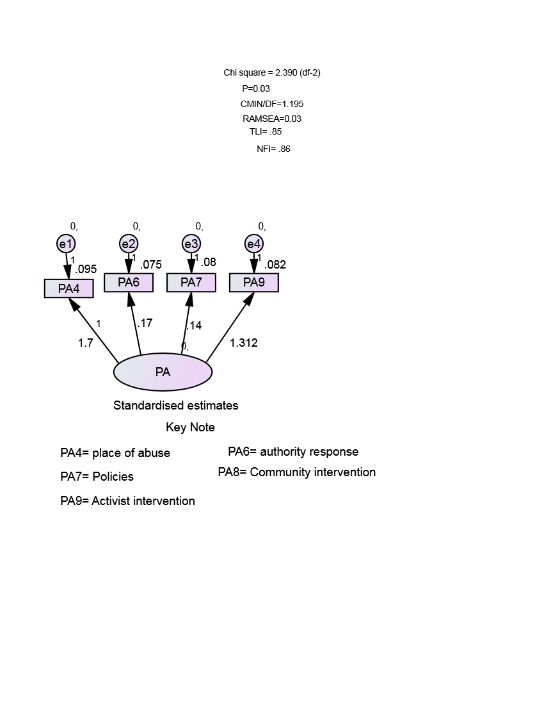

Figure 4.2: Child Physical Abuse Measurement Model

Measurement model for child discrimination (CD): Initially the model was specified with the following observed variable namely CD2; CD3; CD4; CD6; CD7 and CD8 to form Child Discrimination (CD) measurement model. After initial specification of the model, a maximum likelihood estimate was run for the working file using IBM AMOS 24 which produced the following indices: CMIN/DF= .491, which indicate an inadequate model fit as suggested by Paswan (2009) that value below 2 is preferred but between 2 and 5 is considered acceptable. The researcher dropped one item (CD7) from exploratory factor analysis because it had standardized regression weights (S.R.W) values less than 0.5. After the deletion of that items, a re-run of CFA using IBM Amos 24 resulted in the following model fit indexes: CMIN/df = 1.806; NFI =.870;CFI=1.000; TLI = 1.328; IFI= 1.061 and RMSEA = .021. All items retained had a standardized regression weights (S.R.W) values cut of 0.45 or greater, hence falling within the acceptance framework which means that the selected observed variable used fit the model relating to the child discrimination in the study.
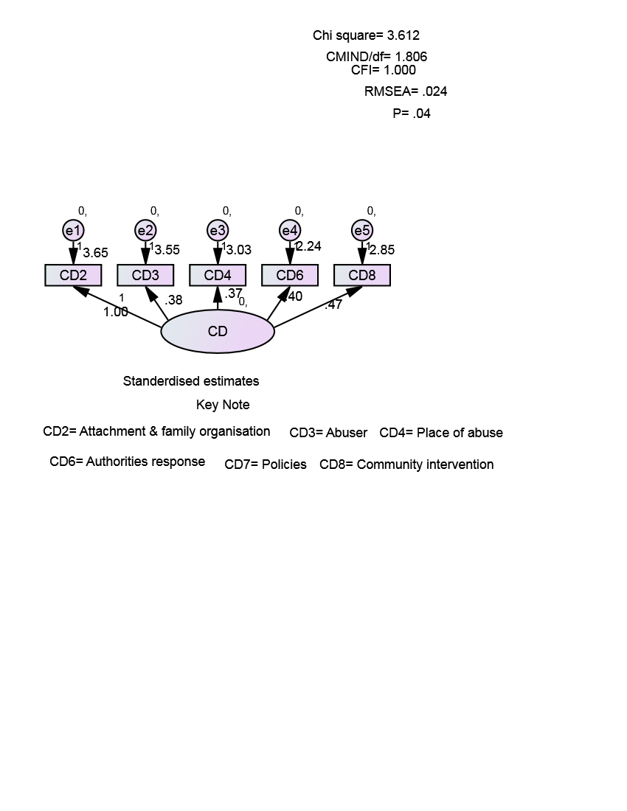

Figure 4.3: Child Discrimination Measurement Model

Measurement model for child neglect (CN): CFI was run using IBM Amos 24 to test and confirm for Child neglect (CN) measurement model base on the following observed variable namely CN2; CN5; CN6; CN7; CN8 and CN9.The model output as illustrated in figure indicating that the model fit well based on Hoe (2008). Commonly applied fit indices which require a model to achieve the following minimum requirement CFI (>0.90 indicates good fit), RMSEA (<0.08 indicates acceptable fit), and commonly used χ2 statistic (χ2/ df ratio of 3 or less) in order to be considered fit. As presented in the model fit in figure 4.5 with CMIN/DF= 2.382, TLI =.951; NFI=932 CFI = .992; and RMSEA = .011 which indicated a good model fit.
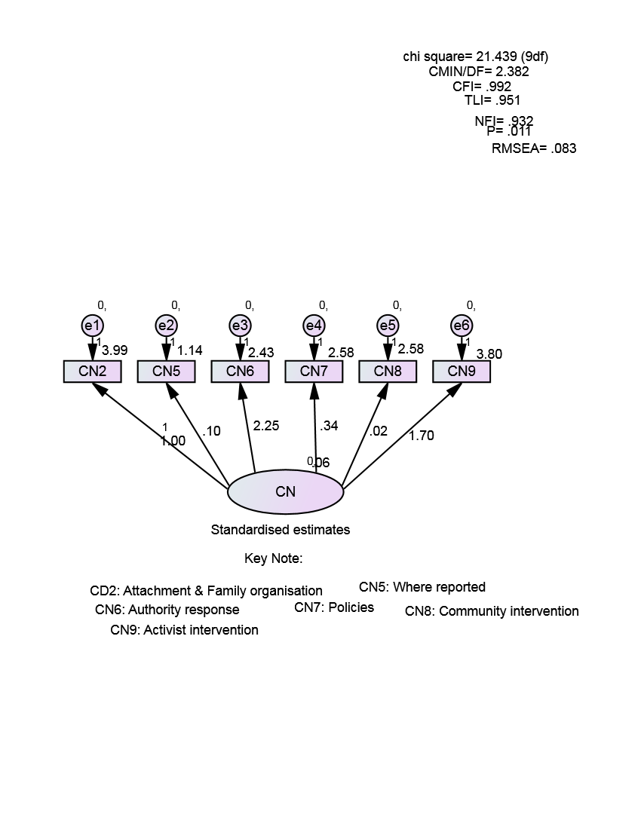

Figure 4.4 Child Neglect Measurement Model

Measurement model for child labor (CL): Initially the model was specified with the following observed variable namely CL1; CL3; CL5; CL6 and CL7 to form Child Labor (CL) measurement model. After initial specification of the model, a maximum likelihood estimate was run for the working file using IBM AMOS 24 which produced the following indices: CMIN/DF= 1.977, which indicates an adequate model fit as suggested by Paswan (2009). Also other fit indexes: NFI =.922; CFI=.97; TLI = .92 and RMSEA = .020. All items retained had a standardized regression weights (S.R.W) values cut of 0.45 or greater, hence falling within the acceptance framework which means that the selected observed variable used fit the model relating to the child labor in the study.

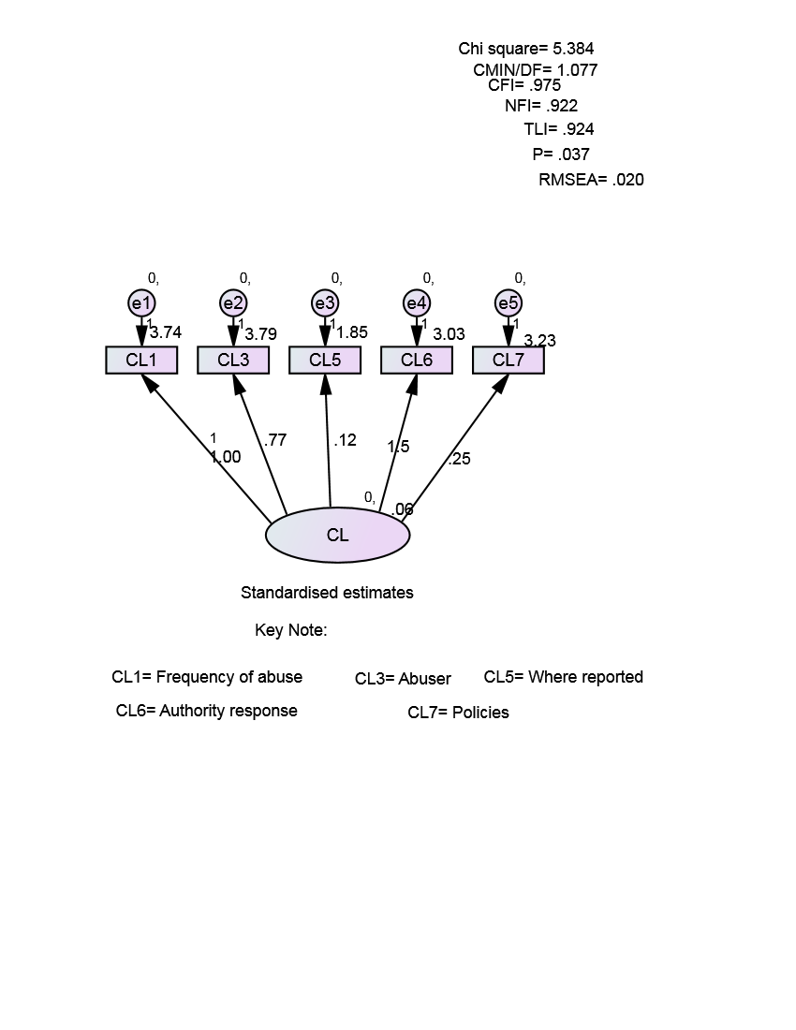

Figure 4.5 Child Labor Measurement Model

Measurement model for effects on academic performance potential (EAPP): CFI was run using IBM Amos 24 to test and confirm for effects on academic performance potential (EAPP) measurement model base on the following observed variable namely EAPP1; EAPP2; EAPP3 and EAPP4.The model output as illustrated in figure indicating that the model fit well based on Hoe (2008) commonly applied fit indices which require a model to achieve the following minimum requirement CFI (>0.90 indicates good fit), RMSEA (<0.08 indicates acceptable fit), and commonly used χ2 statistic (χ2/ df ratio of 3 or less) in order to be considered fit. As presented in the model fit in figure 4.5 with CMIN/DF= 1.890, TLI =.898; NFI= .90; CFI = .85; and RMSEA = .011 which indicated a good model fit.
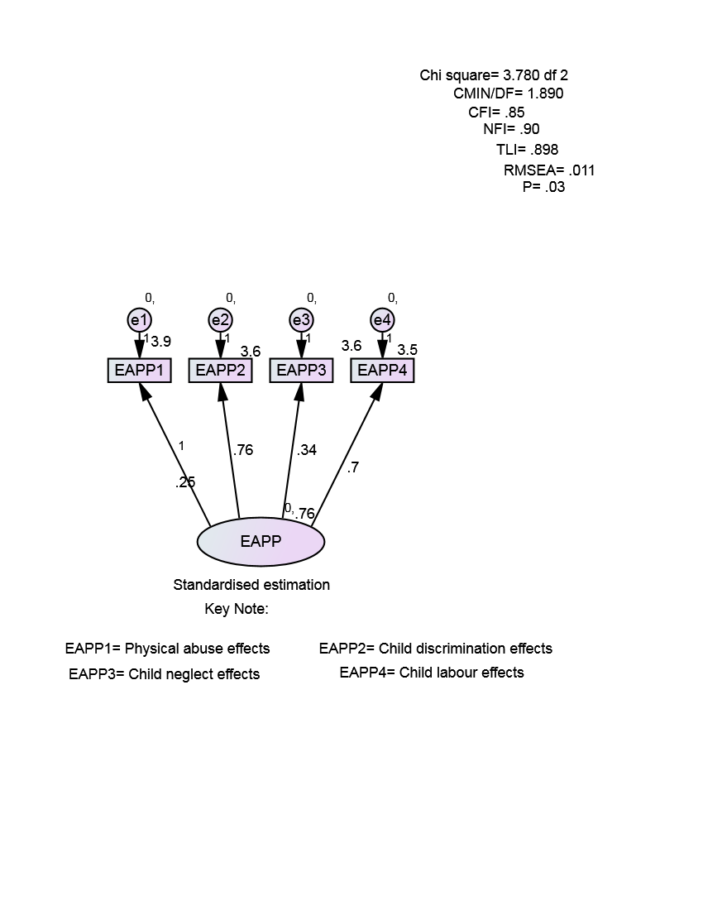

Figure 4.6 Effects on Academic Performance Potential Measurement Model

Measurement model for baseline model: In order to reach a baseline measurement model that fits both components, the five individual measurement models which were developed earlier were combined and CFA was run with maximum likelihood estimate in IBM Amos 24 to determine its fitness. After initial run, the results showed a bad model fit with CMIN/DF= 5.180, CFI=0.288, NFI=0.248, TLI= .378 and RMSEA=0.179. According to Hoe (2008) the recommendation of the required model should achieve the following minimum requirements CFI (>0.90 indicates good fit), RMSEA (<0.08 indicates acceptable fit), and commonly used χ2 statistic (χ2/ df ratio of 3 or less) in order to be considered fit. So as to improve the model, the researcher removed some items that were affecting the significance of the model’s fitness as recommended by Hooper, et al. (2008) to remove the items that demonstrate high covariance plus high regression weight in the modification indexes (M.I), those items standardized regression weights (S.R.W) values less than 0.5 and cross loadings items.

The following items were removed: PA4; CD3; CD4; CN2; CN5; CN7 and CL1. At this point, elimination was made at item level and items that were removed not only were weakened the model but were also indicating weak statistical power. After removing those items in the model, re-running the model indicated adequate fit results with CMIN/DF= 2.040, NFI=0.91, TLI=0.96, CFI=0.85, P= .000 and RMSEA= 0.077.On the other hand the observed variables with significant probabilities have positive standardized regression weights greater than 0.50 and standardized path coefficients between measured variables and factors in the models show that all path coefficients between measured (manifest) variables and latent (un-observed) variables in the model are significant( p < 0.05).

These results indicate that most of the factor loadings explaining the measurement model are adequate and thus reflects a very good reliability of the research constructs. As recommended by Hox and Bechger (2014) factors loading lower than 0.5 are not significant while Bentler and Yuan (2000) indicated that a negative regression weight on the other hand presents doubtful measurement models. In our case, the researcher has achieved the above good results; hence the model achieved an adequate measurement model as illustrated in figure 4.7 below. The retained items were used in the final analysis in the structural model.

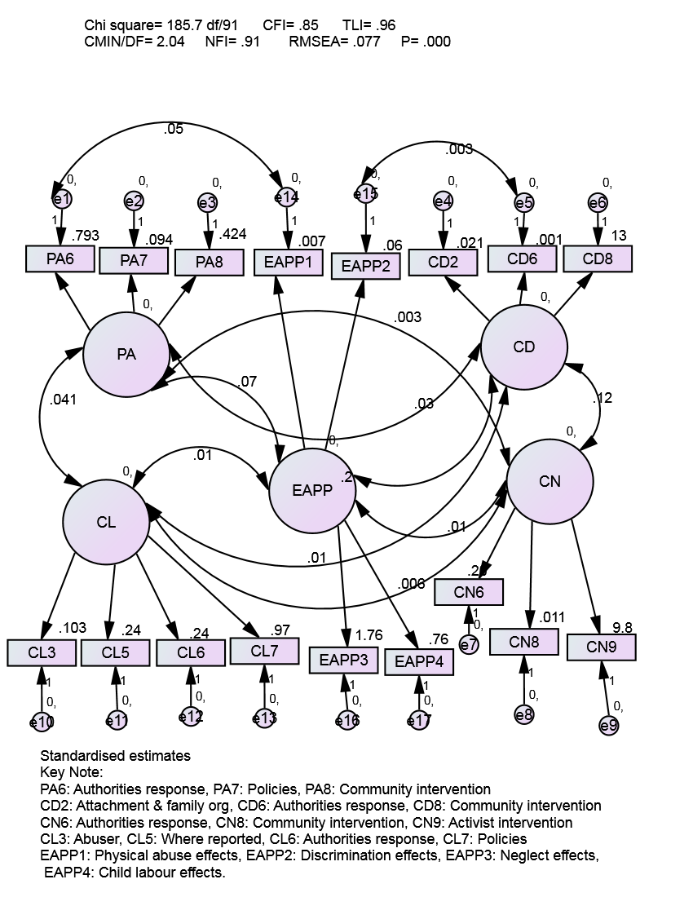

Figure 4.7: Baseline Measurement Model

Based on the summary of the findings presented in Table 4.13, the standardized coefficient of at least 0.2 for all relation is achieved with the critical values(C.R) >1.96 using significance level of p < 0.05 indicating that there is positive and strong significant relationship between the observed and unobserved variable of the model. The results thus confirm a strong positive relationship between observed variable and unobserved variable. Hence they provide a very strong framework that can be used in future for further analysis of relationship.

Table 4.6: Model Regression Weight and Standardized Regression Weights
 | PATH |  | Estimate | S.E. | C.R. | P | Label | Standardized regression weigh Estimate
PA8 | <--- | PA | 1.000 |  |  |  |  | .424
PA7 | <--- | PA | .221 | .101 | 1.948 | *** | par_1 | .594
PA6 | <--- | PA | 1.744 | .110 | 2.455 | *** | par_2 | .793
CD8 | <--- | CD | 1.000 |  |  |  |  | .911
CD6 | <--- | CD | .500 | .000 | 2.110 | *** | par_3 | .401
CD2 | <--- | CD | .502 | .007 | 2.251 | *** | par_4 | .521
CN9 | <--- | CN | 1.000 |  |  |  |  | .761
CN8 | <--- | CN | .601 | .003 | 3.363 | *** | par_5 | .411
CN6 | <--- | CN | .402 | .005 | 5.369 | *** | par_6 | .520
CL7 | <--- | CL | 1.000 |  |  |  |  | .966
CL6 | <--- | CL | .297 | .053 | 2.842 | *** | par_7 | .242
CL5 | <--- | CL | .857 | .162 | 1.969 | *** | par_8 | .235
CL3 | <--- | CL | .565 | .129 | 5.721 | *** | par_9 | .303
EAPP3 | <--- | EAPP | 1.000 |  |  |  |  | .759
EAPP2 | <--- | EAPP | .701 | .003 | 8.338 | *** | par_10 | .406
EAPP1 | <--- | EAPP | .800 | .001 | 6.342 | *** | par_11 | .507
Source: researcher, 2017

After establishing the model fit, all hypothesis of the relationship between observed variables have agreed with unobserved variable. The researcher moved to a structural model in order to be able to test for the hypothesis of the study between the dependent and independent variables as explained in the next section.

4.4.2 Analysis of the Basic Structural Model of the Effects of Child Maltreatment to Their Academic Performance Potential
The basic structural model of the study which hypothesized the relationship between child physical abuse; child discrimination; child neglect and child labor on academic performance potential was analyzed. The results of the analysis using AMOS version 24 are diagrammed in the figure 4.7 shows the goodness of fit indices based on five indices namely CMIN/DF, CFI, NFI, TLI and RMSEA are presented in figure 4.7 and elaborated below.

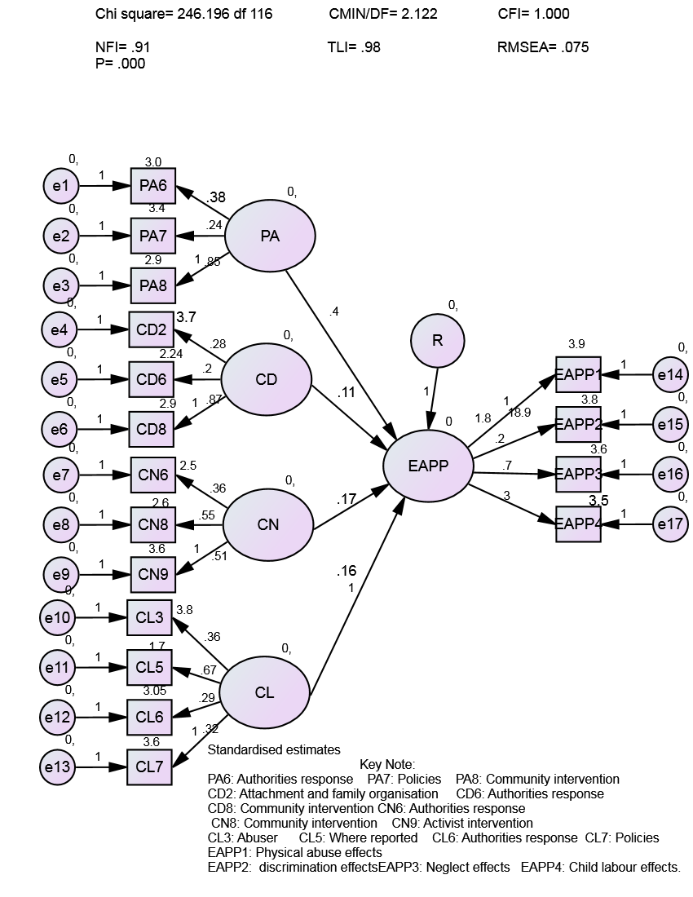

Figure 4.8: The Basic Structural Model

The findings for model fit in the basic structural Model figure 4.7 are elaborated as follows: The ratio of the χ 2, to the degree of freedom-CMIN/DF also referred to as normed chi-square value has produced a value of 2.122 , which has range to the suggested cut of point values < 2 or < 3 as suggested by Schermelleh-Engel et al., 2003. The CFI=1.000, NFI =0.91 and TLI= .98 obtained fall under the acceptable range since values close to 1 and generally values above 0.9 indicate a good fit as suggested by Schermelleh-Engel et al., 2003. RMSEA value of 0= indicate perfect fit, < 0.05 = indicate close fit, 0.05 to 0.08 indicate fair fit and 0.08 to 0.1 a mediocre fit, > 0.1 =poor fit. In reference to these criteria RMSEA values of 0.075 which was produced in the analysis indicate that the model fits well in the data. Having established a model fit which indicate a good fit using the indices, as suggested by Hoe (2008) path coefficient and hypothesis testing were evaluated as explained in the following section using this model.

The Basic Path Model Coefficients and Hypothesis Testing: The researcher used structural model to test the hypothesized relationships. The hypothesized relationships are examined against various coefficients and scores obtained from the analysis, where as in this research the hypotheses were tested based on the direction, strength and the level of significance of the path coefficients. A standardized paths coefficient, critical value (C.R) and significant level (p) was used in this study in the testing and evaluation of strength and the level of significance of the hypotheses. Testing hypotheses at each run was done for comparison purposes.

The Effects of child physical abuse to their academic performance potential as proxy for Human Resource potential: The first postulated relationship of this study hypothesized a strong negative significant relationship between child physical abuse and academic performance potential as stated below.
H1: Child physical abuse (PA) has a negative effect on their academic performance potential.
For testing this hypothesis, the researcher first run multivariate regression analysis which yielded results of adjusted r square value of 0.18 in the model summary table and 0.04 significance level in the ANOVA table. Also the researcher ran a reliability analysis which produced Crobanch alpha value of 0.437. It is recommended by Nunnally (1978) that a minimum level of 0 .7. Cronbach alpha values are dependent on the number of items in the scale. When there are a small number of items in the scale (fewer than 10), Cronbach alpha values can be quite small. In this situation it may be better to calculate and report the mean inter-item correlation for the items. Optimal mean inter-item correlation values range from .2 to .4 (Briggs & Cheek 1986). The researcher ran a descriptive statistic analysis to profile the influence of each attribute of child physical abuse on predicting the children’s potential for academic performance as shown in Table 4.7.

Table 4.7: Child Physical abuse Descriptive Statistics
Variable | N | Minimum | Maximum | Mean | Std. Deviation
Authorities response | 199 | 1.00 | 5.00 | 2.9950 | 1.05647
Policies | 199 | 1.00 | 5.00 | 3.5226 | 1.12288
Community intervention | 199 | 1.00 | 5.00 | 2.9095 | 1.13345
Valid N (listwise) | 199
Source: researcher, 2017

Table 4.7 Indicates the results of the analysis among the three attribute of child physical abuse in the table above, policies had high impact on affecting children academic performance potential with the mean of 3.52 followed by Authorities response with mean of 2.995, and community intervention with mean of 2.909. Ndekwa (2016) argues that the greater the mean the high the impact or the more the mean value close to five the more the impact. These findings have collaborated with findings from case studies.
For example Respondent 110 says, “for me seeing a teacher holding a stick would mean I am going to be beaten again, if you see my body, I have marks all over till today due to the beatings, I used to receive from my aunt, I did not know why she hated me so much, I never understood the teacher if she/he was teaching while holding or even keeping a stick in the classroom, all I would think of is the stick and not what the teacher is teaching”. This means that policies need to be rectified to be more suitable it solve the problem of child maltreatment and the authorities should intervene more often and create more strict policies on how to treat and behave in front of the children; also the community should assist the authorities to ensure that child physical abuse is reduced or erased. Further, analysis was done using SEM so as to determine the significant effects of child physical abuse to their academic performance potential as illustrated below in Table 4.8.

Table 4.8: Child Physical Abuse Basic Model Un-standardized and Standardized Regression Weights
PATH |  |  | Estimate | S.E. | C.R. | P | Label | Standardised Estimate | Results
EAPP1 | <--- | PA | 1.000 |  | 5.432 | .027 |  | .917 | Supported
PA6 | <--- | PA | .301 | .007 | 3.093 | *** | par_2 | .267 | Supported
PA7 | <--- | PA | .201 | .014 | 2.063 | *** | par_3 | .199 | Supported
PA8 | <--- | PA | .201 | .010 | 2.053 | *** | par_4 | .199 | Supported
Source: researcher, 2017

The path leading from PA to EAPP1 in Table 4.8 is used to examine the relationship child physical abuse and academic performance potential. A positive path coefficient (γ = .917) using standardized estimate results in Table 4.8 above indicates that child physical abuse negatively affects children’s academic performance potential. Chin (1998) and Hoe (2008) argued that a standardized paths coefficient (γ ) should be at least 0.2 in order to be considered significant and meaningful for discussion.Thus, the result in a current study shows a strong negative relationship between child physical abuse and academic performance potential.

The researcher conducted further analysis by using critical ratio and p-value to determining the significant effects of child physical abuse to their academic performance potential. In this study findings yielded a critical value of (C.R =5.432 which is >1.96) and significance level of p=0.027, as argued by Hox and Bechger (2014) that a relationship which has yield a critical ration greater than 1.96 and p-value less than 0.05 is considered significant. This means that the hypothesis H1a which state that child physical abuse has negative effects on children’s academic performance potential is confirmed while the hypothesis H1b is rejected.

These results agree with other findings by other researchers as Davries et al., 2014 which showed a strong negative effect of child physical abuse on their academic performance, they surveyed 3706 students and 577 school staff members; 93.3% (SE 1.0%) of boys and 94.2% (SE 1.6%) of girls attending primary school reported lifetime experience of physical abuse from a school staff member and this was associated with increased odds of poor mental health and double the odds of poor educational performance, their study showed that despite a ban on corporal punishment in Ugandan schools since 1997, the use of violence against students is widespread and associated with poor mental health and educational performance.

The Effects of child discrimination to their academic performance potential: The study also hypothesized a negative effect of child discrimination to their academic performance potential as stated below.
H2a: Child Discrimination (CD) has negative effect to their academic performance potential.

While testing the above hypothesis, the researcher run multivariate regression analysis which yielded results of adjusted r square value of 0.2 in the model summary table and 0.048 significance level in the ANOVA table. The reliability analysis was conducted and yielded crobanch alpha value of 0.217. Nunnally (1978) argues that a minimum level of 0 .7. Cronbach alpha values are dependent on the number of items in the scale. When there are a small number of items in the scale (fewer than 10), Cronbach alpha values can be quite small. In this situation it may be better to calculate and report the mean inter-item correlation for the items. The researcher conducted descriptive statistic analysis to profile the influence of each attributes of child discrimination on their academic performance potential as shown in table 4.9.

Table 4.9 Child Discrimination Descriptive Statistics
 | N | Minimum | Maximum | Mean | Std. Deviation
Attachment & family organization | 199 | 1.00 | 5.00 | 3.6482 | 1.10412
Authority response | 199 | 1.00 | 5.00 | 2.2412 | 1.01609
Community intervention | 199 | 1.00 | 5.00 | 2.8492 | 1.00874
Valid N (listwise) | 199
Source: researcher, 2017

In Table 4.9 above the results of the analysis are shown. Among the three attributes of child discrimination showed in Table 4.9, attachment and family organization had slight high impact than the other four attributes of effects of child discrimination to their academic performance potential by yielding a high mean value of 3.648 compared to the rest which had the mean value of 2.241 and 2.285 respectively. The greater the mean the high the impact or the more the mean value close to five the more the impact (Ndekwa, 2016). These results collaborate with the findings from the case study. For example in the case of respondent number 111who was discriminated by her peers due to her health status, she says “I have always been the last one or close to the last in all my studies results”. Because of discrimination this respondent felt inferior to others and did could not perform well in her studies and the potential of her performing well was crashed. Further analysis was done using SEM in order to determine the effects of child discrimination on academic performance potential as shown in the Table 4.10.

Table 4.10: Structural Model Regression Weight and Standardized Regression Weight
PATH |  | Estimate | S.E. | C.R. | P | Label | Standardized Estimate | Results
CD8 | <---CD | 1.000 |  |  |  |  | .319 | Supported
CD6 | <---CD | .868 | .136 | 10.990 | *** | par_1 | .675 | Supported
CD2 | <---CD | -2.097 | 1.081 | -1.941 | *** | par_4 | -.612 | Not supported
EAPP2 | <---CD | .324 | .158 | 5.738 | .047 | par_5 | .278 | Supported
Source: researcher, 2017

This hypothesis is examined using the path leading from CD to EAPP which form a relationship between child discrimination (CD) and Academic performance potential (EAPP2) as illustrated in Table 4.10 above. Results of the standardized path coefficients (γ ) in Table 4.10 above have yield a standardized regression weights of .278 which indicate a significant negative relationship between child discrimination and academic performance potential as postulated by Chin (1998) that a standardized paths coefficient (γ ) should be at least 0.2 in order to be considered significant and meaningful for discussion. This means that child discrimination has significant negative effects on children’s academic performance potential. Also all other attributes discrimination showed a positive standardized paths coefficient which is considered to be significant and meaningfully for discussion as illustrated in Table 4.10.

Further analysis of the effects of child discrimination to their academic performance potential using critical ration values in Table 4.10 above indicated that the analysis has yield a critical ration of 1.738 and p=0.047 in Table 4.10. As argued by Hox and Bechger (2014) that a relationship which has yield a critical ration greater than 1.96 and p-value less than 0.05 is considered significant. Basing on the findings in the current study was found to be significant. Hence, hypothesis H2a was accepted and H2b was rejected.

The Effects of child neglect to their academic performance potential: The first postulated relationship of this study hypothesized a strong negative significant relationship between child physical abuse and academic performance potential as stated below.
H1: Child Neglect (CN) has a negative effect on their academic performance potential.

For testing this hypothesis, the researcher run multivariate regression analysis which yielded results of adjusted r square value of 0.64 in the model summary table and 0.01 significance level in the ANOVA table. Furthermore, the researcher ran a reliability analysis which produced a Crobanch alpha value of 0.814. Nunnally (1978) argues that a minimum level of 0 .7. Cronbach alpha values are dependent on the number of items in the scale. When there are a small number of items in the scale (fewer than 10), Cronbach alpha values can be quite small. In this situation it may be better to calculate and report the mean inter-item correlation for the items. A descriptive statistic analysis to profile the influence of each attribute of child neglect on predicting the children’s potential for academic performance was done as shown in Table 4.11.

Table 4.11: Child Neglect Descriptive Statistics
 | N | Minimum | Maximum | Mean | Std. Deviation
Authority response | 199 | 1.00 | 5.00 | 2.4824 | 1.00425
Community intervention | 199 | 1.00 | 5.00 | 2.5628 | 1.07065
Activist intervention | 199 | 1.00 | 5.00 | 3.6030 | 1.10928
Valid N (listwise) | 199
Source: researcher, 2017

Table 4.11 Indicates the results of the analysis among the three attribute of child neglect in the table above, activist intervention had high impact on affecting children academic performance potential with the mean of 3.603 followed by community intervention with mean of 2.563 and then authority response with mean value of 2.482. Ndekwa (2016) argues that the greater the mean the high the impact or the more the mean value close to five the more the impact. This means that children are mostly neglected due to insufficient intervention of the activist and the community within the communities. Further analysis was done using SEM so as to determine the significant effects of Child Neglect to their academic performance potential as illustrated below in Table 4.12.

Table 4.12: Basic Model Un-standardized and Standardized Regression Weights
 | PATH | Estimate | S.E. | C.R. | P | Label | Standardized Estimates | Results
EAPP3 | <---CN | 7.700 | .078 | 1.998 | .057 |  | 9.609 | Supported
CN9 | <---CN | .020 | .001 | -.370 | *** | par_1 | -.105 | Not supported
CN8 | <---CN | -.002 | .005 | -.427 | *** | par_2 | -.023 | Not supported
CN6 | <---CN | .020 | .001 | .320 | *** | par_4 | .003 | Not supported
Source: researcher, 2017

This hypothesis is examined using the path leading from CN to EAPP3 which form a relationship between Child Neglect (CN) and Academic performance potential (EAPP) as illustrated in Table 4.12 above. Results of the standardized path coefficients (γ) in Table 4.12 above have yield a standardized regression weights of 9.609 which indicate a strong significant relationship between child neglect and children academic performance potential. Chin (1998) has postulated that a standardized paths coefficient (γ) should be at least 0.2 in order to be considered significant and meaningful for discussion.

In our case, the standardized paths coefficient of other attributes of child neglect which are all below the recommended value to be considered for meaningful discussion means that these attributes of child neglect are not significantly associated with academic performance potential to be considered significant and meaningfully for discussion as illustrated in table 4.12 above so the effect of child neglect to their academic performance potential will be discussed without its attributes.
Further analysis of the significant effects of child neglect to their academic performance potential using critical ratio values in Table 4.18 above indicated that the analysis has yield a critical ration of 1.998 and p =0.057 in Table 4.12. As argued by Hox and Bechger (2014) that a relationship which has yield a critical ration greater than 1.96 and p-value less than 0.05 is considered significant. Base on the findings in the current study the effects of child neglect to their academic performance potential was found significant although it’s attributes were found to be non significant due to all the other attributes yielding insignificant results. Hence, hypothesis H3b was rejected and the Hypothesis H3a was accepted.

The Effects of child labor to their academic performance potential: The first postulated relationship of this study hypothesized a strong negative significant relationship between child labor and academic performance potential as stated below.
H4a: Child Labor (CL) has a negative effect on their academic performance potential.

For testing this hypothesis, the researcher run multivariate regression analysis which yielded results of adjusted r square value of 0.703 in the model summary table and 0.051 significance level in the ANOVA table. Further, the researcher conducted a reliability analysis which yielded Crobanch Alpha value of 0.811. Nunnally (1978) argues that a minimum level of 0 .7. Cronbach alpha values are dependent on the number of items in the scale. The researcher ran a descriptive statistic analysis to profile the influence of each attribute of child labor on predicting the children’s potential for academic performance as shown in Table 4.13.

Table 4.13: Descriptive Statistics
 | N | Minimum | Maximum | Mean | Std. Deviation
Abuser | 196 | 1.00 | 5.00 | 3.7908 | 1.45782
Where reported | 199 | 1.00 | 3.00 | 1.6784 | .60893
Authority response | 189 | 1.00 | 5.00 | 3.0423 | 1.11961
Policies | 176 | 1.00 | 5.00 | 3.2330 | .94249
Valid N (listwise) | 163
Source: researcher, 2017

Table 4.13 Indicates the results of the analysis among the four attribute of child labor in the table above, abuser had high impact on affecting children academic performance potential with the mean of 3.791 followed by policies with mean of 3.233 and the rest have values of 3.042 and 1.678. Further analysis was done using SEM so as to determine the significant effects of Child Labor to their academic performance potential as illustrated below in Table 4.14.

Table 4.14: Basic Model Un-standardized and Standardized Regression Weights
 | PATH | Estimate | S.E. | C.R. | P | Label | Standardized Estimate | Results
CL7 | <---CL | 1.000 |  |  |  |  | .554 | supported
CL6 | <---CL | .931 | .124 | 2.196 | *** | par_1 | .434 | supported
CL5 | <---CL | .315 | .161 | 1.951 | *** | par_2 | .270 | supported
CL3 | <---CL | .445 | .131 | 1.346 | *** | par_3 | .159 | supported
EAPP4 | <---CL | .228 | .148 | 1.982 | .051 | par_5 | .202 | supported
Source: researcher, 2017

The path leading from CL to EAPP1 in table 4.14 is used to examine the relationship between child labor and academic performance potential. A positive path coefficient (γ = .202) using standardized estimate results in table 4.14 above indicates that child labor negatively affects children’s academic performance potential. Chin (1998) and Hoe (2008) argued that a standardized paths coefficient (γ) should be at least 0.2 in order to be considered significant and meaningful for discussion. Thus, the result in a current study shows a strong negative relationship between child labor and academic performance potential.

The researcher conducted further analysis by using critical ratio and p-value to determining the significant effects of child labor to their academic performance potential. In this study findings yielded a critical value of (C.R =1.98 which is >1.96) and significance level of p=0.051, as argued by Hox and Bechger (2014) that a relationship which has yield a critical ration greater than 1.96 and p value less than 0.05 is considered significant. This means that the hypothesis H1a which state that child labor has negative effects on children’s academic performance potential is confirmed while the hypothesis H1b is rejected.

CHAPTER FIVE

5.0 DISCUSSION OF THE FINDINGS

5.1 Overview
Chapter five discusses the main findings of the study. The discussion will base on the findings from both survey and case study. The main objectives of this chapter is to recapitulate the information generated in the results while comparing and contrasting the current findings with what has been found out in previous related studies. This will help to reflect on the findings about the nature and effects of child maltreatment to their academic performance potential and examine points of departure from literature, the study objectives, hypotheses, conceptual and theoretical framework of the study.

5.2 Effects of Child Physical Abuse to Their Academic Performance Potential
The study considered if child physical abuse could have significant effects on children’s academic performance potential. This explains the fact that growing body of evidence indicates that adverse childhood experiences can lead to grave, diverse, and long-term negative outcomes for children (WHO, 2002 & 2006). Children who are maltreated often experience significant mental and physical suffering, and sometimes death (Christoffel et al., 1992, p. 1033). Child maltreatment relates to long-term outcomes such as violent behavior, depression, smoking, obesity, high-risk sexual behavior, teen pregnancy, and substance abuse (World Health Organization, 2002, 2006).

In her study Gershoff (2002) conducted Meta-analyses representing research on more than 36,000 individuals and 88 studies on the topic, their study confirmed that spanking and other forms of Corporal Punishment are related to increased aggressive and delinquent behavior in children, poorer parent/child relationships, worse child mental health, increased adult aggression and criminal behavior, decreased adult mental health, and increased risk of abusing one’s own spouse or child as an adult. A recent review of the literature documented that exposure to severe and frequent physical violence increased the risk of maladaptation across many domains such as social and emotional (Haselschwerdt, 2014).

As it has been acknowledged in Tanzania National Policy guideline for the health sector prevention and response to gender based violence (GBV) September 2011 that the national survey on violence against children (VAC) in Tanzania and the findings show that Tanzanian children often suffer from abuse, and in many cases, multiple types of abuse including emotional, physical, and sexual violence. The study found that children were the most vulnerable to abuse in the home and school settings the two places where Tanzanian children spend the majority of their time as they mature into young adults. Three quarters of children experience some form of physical violence by a relative, teacher, or other authority figure by the time they are 18 years old (MHSW, 2011).

Based on that background, in the current study it was hypothesized that Child physical abuse has negative effects on the children’s academic performance potential. The empirical result in chapter four of this study support this hypothesis by yielding standardized coefficient estimate (γ) of .203, critical ration (C.R) of 2.280 and significant p-value of 0.023. These all present a positive and significant effect of child physical abuse to their potential in academic performance. These findings support the findings from case study. For example, in a case study of respondent number 110 who experienced physical abuse during childhood and this resulted to his in ability to concentrate in the classroom any time the teacher enters the class with a stick held on hand, He says, “for me seeing a teacher holding a stick would mean I am going to be beaten again.

In the current study of Arumeru district, the research models identified Authority response (PA6), Policies (PA7) and Community intervention (PA8) to explain the effects of child physical abuse to their academic performance potential. These three attributes of child physical abuse implies that the effects caused by child physical abuse on the children’s academic performance potential are strongly influenced by these three attributes. These findings are supported by survey findings from case study For example, in case of respondent number 110, in this case it appears that the child experienced physical abuse both at home and school which are the places where children spends most of their time, hence always being under psychological trauma can never pave way for a child’s potential to excel leading to poor performance. Though there are policies that do not allow corporal punishment to children, there are still practices of physical abuse at homes and in schools and the authorities rarely intervene. Most of community members who should be concerned with child welfare do not intervene in cases of child physical abuse. More explanations are under the following sub section.

5.2. 1 Authorities response (PA6)
The study investigated whether or not the Authorities response in child physical abuse influences the effects on children academic performance potential. The results in the current study have yielded a standardized path coefficient (γ) of .267, critical ration (C.R) of 3.093 and significant value (p) of 0.00. The results indicate that authorities’ response is significantly related to effects of child abuse to the children academic performance potential. The researcher aimed at ascertaining the contribution of authorities’ response to the effects of child physical abuse to their academic performance potential. The study reveals that the authorities’ response in child physical abuse is not satisfactory, it shows that more than 42% of respondents disagree that the authorities’ responds to child physical abuse as shown in the pie chart below:
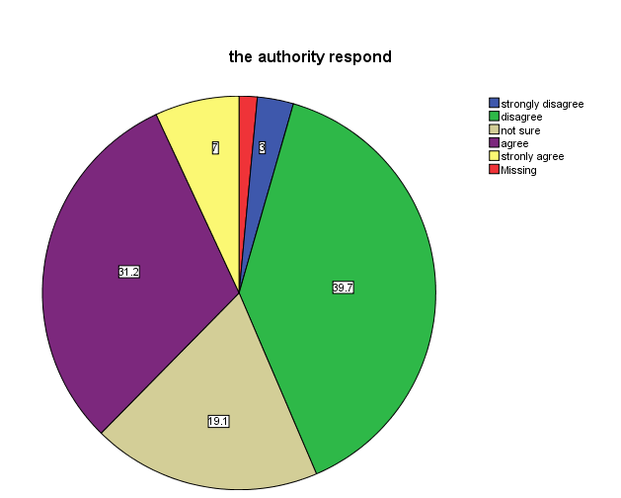

Figure 5.1: Authority Responses to Child Physical Abuse

This concurs with the study conducted by Kahemele (2014); after analyzing how the concept and form of child protection and context of child abuses developed; this paper establishes the presence of rampant physical abuse of children in Tanzanian society and a continuous high level of silence on this matter. Kahemele (2014) argues that corporal punishment in Tanzania not only is generally acceptable in the society, it exists legally. Although the law seems to be provide guidance that can protect children vulnerable to violence through the execution of corporal punishment, this form of punishment increases a potential for excessive violence in particular, because at the execution level it is not easy to ensure adherence to policy guidelines. According to Kahemele (2014) Tanzanian society widely believes in disciplining a child and considers the use of corporal punishment for this purpose. This hinders the chance for the authorities to intervene because very few people report the cases of child physical abuse to the authorities.

5.2. 2 Policies (PA7)
The current study investigated whether or not the policies about child physical abuse influences the effects on children academic performance potential. The results in the current study have yielded a standardized path coefficient (γ) of .199, critical ration (C.R) of 2.063 and significant value (p) of 0.00.
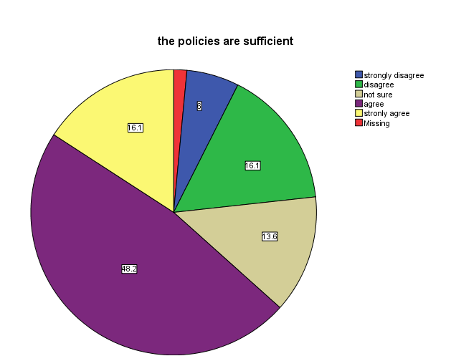

Figure 5.2: Policies on Child Physical Abuse
The results indicate that policies are significantly related to effects of child abuse to the children academic performance potential. The researcher aimed at ascertaining the contribution of policies to the effects of child physical abuse to their academic performance potential. The study shows that 22% of respondents disagree that the policies on child physical abuse are sufficient and 13% are not sure as shown in the pie chart below:

Provisions against violence and abuse in the Penal Codes and other laws are not interpreted as prohibiting corporal punishment in childrearing. In mainland Tanzania, the Law of the Child Act (2009) states that parents should protect children from all forms of violence (article 9), includes beatings which cause harm in the definition of child abuse (article 3) and prohibits "torture, or other cruel, inhuman punishment or degrading treatment" (article 13). However, it allows for "justifiable" correction (article 13) and does not exclude all forms of corporal punishment from such correction.

In Zanzibar, article 14 of the Children's Act (2011) states that "no child shall be subjected to violence, torture, or other cruel, inhuman or degrading punishment or treatment or any cultural or traditional practice which dehumanizes or is injurious to his physical and mental wellbeing" but it also states that "parents may discipline their children in such a manner which shall not amount to injury to the child's physical and mental wellbeing": this is not interpreted as prohibiting all corporal punishment in childrearing" (Global Initiative to End All Corporal Punishment of Children, 2012 p.2).
Caning in Tanzania schools is still legal and a common form of punishing students for misbehaving, failure to complete assignments or underperformance (Kahemele, 2014). Corporal punishment is lawful in schools in mainland Tanzania under the National Corporal Punishment Regulations (1979) pursuant to article 60 of the National Education Act (1978), which authorizes the minister to make regulations "to provide for and control the administration of corporal punishment in schools". The Law of the Child Act does not does not repeal this provision or prohibit corporal punishment in schools.

Government guidelines in 2000 reduced the number of strokes from six to four and stated that only the heads of schools are allowed to administer the punishment, with penalties for teachers who flout these regulations. In Zanzibar, the Ministry of Education has adopted a policy against corporal punishment in schools, but it remains lawful under the 1982 Education Act. The Zanzibar Children's Act does not explicitly prohibit corporal punishment in schools. In rejecting the recommendations to prohibit corporal punishment made during the UPR in 2011, the Government asserted that "corporal punishment does not apply in the education system" but that caning is administered in schools and is "a legitimate and acceptable form of punishment (not intended to) be violent, abusive or degrading.

5.2. 3 Community Intervention (PA8)
This study investigated whether or not the community intervention to child physical abuse influences the effects on children academic performance potential. The results in the study have yielded a standardized path coefficient (γ) of .199, critical ration (C.R) of 2.053 and significant value (p) of 0.00. The results indicate that community intervention is significantly related to effects of child abuse to the children academic performance potential. The researcher aimed at ascertaining the contribution of community intervention to the effects of child physical abuse to their academic performance potential. The study shows that more than 40% of respondents disagree that the community intervenes in child physical abuse as shown in Figure 5.3.
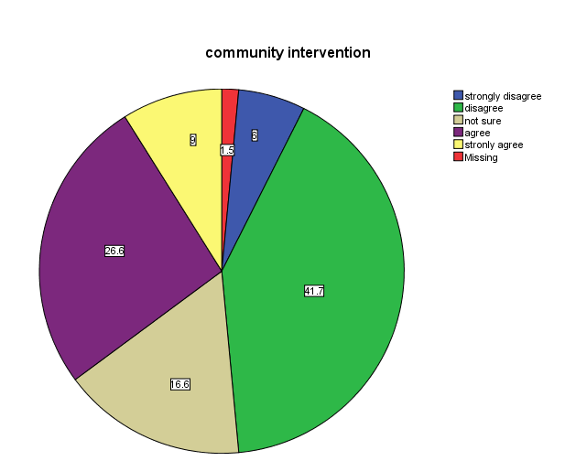

Figure 5.3: Showing Community Interventions to Child Physical Abuse

Child physical abuse is a community concern. Each community has a legal and moral obligation to promote the safety and well-being of children, which includes responding effectively to child maltreatment. At the National and local levels, various professionals assume various roles and responsibilities such as prevention, identification, and reporting of child maltreatment as well as intervention, assessment, and treatment of child maltreatment. Child protective services (CPS) agencies, along with law enforcement, play a central role in receiving and investigating reports of child physical abuse.
With the increasing events of domestic violence and child maltreatment in our communities, CPS should working more closely with those providing services related to child maltreatment. It is important to note that various child activists are mandated to report suspected child maltreatment to CPS or law enforcement, such as health care workers and school personnel. According to this study of Arumeru District, the percentage of community intervention seems to be low and this does not help much to solve the problem of child physical abuse. In addition, community-based agency staff, extended family members, and concerned citizens also need to play important roles in keeping children safe.

5.3 Effects of Child Discrimination to Their Academic Performance Potential
The study considered if child discrimination could have significant effects on children’s academic performance potential. This explains the fact that growing body of evidence indicates that adverse childhood experiences can lead to grave, diverse, and long-term negative outcomes for children (WHO, 2002, 2006). Child maltreatment relates to long-term outcomes such as violent behavior, depression, smoking, obesity, high-risk sexual behavior, teen pregnancy, and substance abuse (World Health Organization, 2002, 2006).

The study found that children are most vulnerable to abuse in the home and school settings the two places where Tanzanian children spend the majority of their time as they mature into young adults. Based on that back ground, in the current study in Arumeru district it was hypothesized that Child discrimination has negative effects on the children’s academic performance potential. The empirical result in chapter four of this study support this hypothesis by yielding standardized coefficient estimate (γ) of .278, critical ration (C.R) of 5.738 and significant p-value of 0.047. These all present a positive and significant effect of child discrimination to their potential in academic performance. These findings support the findings from case study. For example, in a case study of respondent number 111 who experienced discrimination during childhood due to her health condition and this resulted to his in ability to concentrate in the classroom which resulted to her inability to perform well in her studies.

In the current study of Arumeru District, the research models identified Attachment and family organization (CD2), Authority response (CD6) and community intervention (CD8) to explain the effects of child discrimination to their academic performance potential. These three attributes of child discrimination implies that the effects caused by child discrimination on the children’s academic performance potential are strongly influenced by these three attributes. These findings are supported by survey findings from case study For example, in case of respondent number 111, in this case it appears that the child experienced discrimination both at home and school which are the places where children spends most of their time, hence always being under psychological trauma can never pave way for a child’s potential to excel leading to poor performance.

Though there are policies that do not allow discrimination to children, there are still practices of discrimination at homes and in schools and the authorities rarely intervene, children are discriminated due to their health conditions, their gender especially the girls in many societies, also due to disabilities and race. The study by Adair (2015) reveals that there is evidence that the way children are treated during early schooling affects their behavior and academic performance, children who receive negative messages about themselves in school may be less likely to achieve academic success and graduate from school, more explanations about the attributes of child discrimination are under the following sub section:

5.3.1 Attachment and Family Organization (CD2)
The study investigated if the attachment patterns and family organization of child discrimination influences the effects on children academic performance potential or not. The results in the current study have yielded a standardized path coefficient (γ) of .192, critical ration (C.R) of 9.587 and significant value (p) of 0.00. The results indicate that attachment and family organization is significantly related to effects of child abuse to the children academic performance potential.

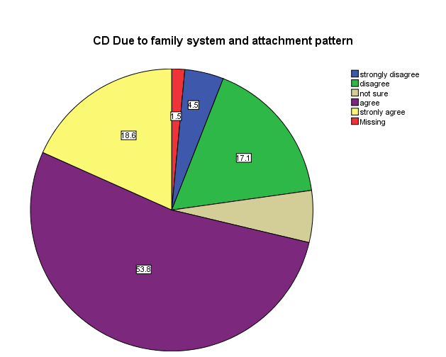

Figure 5.4: showing Attachment Patterns and Family Organization, Child Discrimination
The researcher aimed at ascertaining the contribution of attachment patterns and family organization to the effects of child discrimination to their academic performance potential. The study shows that the children experience this kind of abuse in the places they spend most of their time, at school and their homes as shown in Figure 5.4. The Figure shows that more than 80% percent of child discrimination occurs either at homes or schools. This kind of hypothesis was established by previous studies which found that the children are mostly maltreated in their surroundings. For example the study by Mohamed (2015) found that 61% of abused children were abused either at school or at their homes. All the above studies confirm that child physical abuse occurs in the areas where children spend most of their time at. This makes it difficult for the children to be able to perform well in their studies due to the lack of ability to concentrate well given the situation is not accommodating for them to do so.

5.3.2 Authorities Response (CD6)
The study investigated whether or not the Authorities response in child Discrimination influences the effects on children academic performance potential. The results in the current study have yielded a standardized path coefficient (γ) of .675, critical ration (C.R) of 10.990 and significant value (p) of 0.00. The results indicate that authorities’ response is significantly related to effects of child discrimination to the children academic performance potential. The researcher aimed at ascertaining the contribution of authorities’ response to the effects of child discrimination to their academic performance potential. The study shows that the authorities’ response in child discrimination is not satisfactory, this may be because most of discrimination cases are not reported to authorities, it shows that more than 68% of respondents disagree that the authorities’ responds to child discrimination as shown in the Figure 5.5.

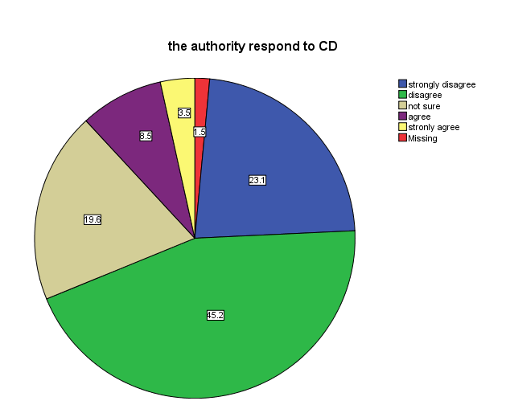

Figure 5.5: Authority Responses to Child Discrimination

Tanzania has made significant progress in the harmonization of children’s laws in the last few years. This is evident by the enactment of the Law of the Child Act of 2009 applicable in Tanzania Mainland and the Children’s Act of 2011, applicable in Zanzibar. These two statutes bring Tanzania closer to fully domesticating its obligations under international law that are relevant for children’s rights. The Acts have four general principles in implementing their obligations under international law that are relevant for children’s rights in Tanzania, one of these principles is that of non-discrimination: The principle of non-discrimination and equality has been domesticated in Tanzania. This is entrenched in the Constitution. The Constitution of the United Republic of Tanzania (1977) and the Constitution of Zanzibar (1984) prohibit discrimination of any kind in Articles 13(5) and (6) and Article 12(4) and (5), respectively. The authorities are obliged to ensure that child discrimination is not practiced in any part of the country. This shows that the authorities’ response is low because the community practicing discrimination does not report these cases as required and this makes it difficult for the authorities to respond to the problem.

5.3.3 Community Intervention (CD8)
This study investigated whether or not the Community intervention to child discrimination influences the effects on children academic performance potential. The results in the study have yielded a standardized path coefficient (γ) of .319, critical ration (C.R) greater than 1.96 and significant value (p) of 0.00. The results indicate that community intervention is significantly related to effects of child discrimination to the children academic performance potential. The researcher aimed at ascertaining the contribution of community intervention to the effects of child discrimination to their academic performance potential. The study shows that less than 40% of respondents agree that the community intervenes in child discrimination as shown in the Figure 5.6.
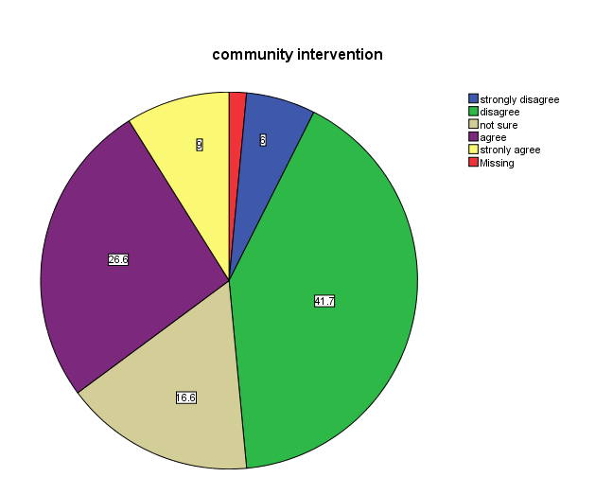

Figure 5.6: Showing Community Interventions to Child Discrimination
Child discrimination is a community concern. Every community has a legal and moral obligation to promote the well-being of children, which includes responding effectively to child discrimination. At the State and local levels, professionals assume various roles and responsibilities ranging from prevention, identification, and reporting of child discrimination to intervention, assessment, and treatment. Child protective services (CPS) agencies, along with law enforcement, play a central role in receiving and investigating reports of child discrimination. The community should working more closely with those providing services related to child discrimination.

It is important to note that the community is required to report suspected child discrimination to CPS or law enforcement, such as health care workers and school personnel. According to this study of Arumeru District, the percentage of community intervention seems to be low and this does not help much to solve the problem of child discrimination. In addition, community-based agency staff, clergy, extended family members, and concerned citizens also need to play important roles in making sure that children are treated equally regardless of their status, color or gender.

5.4 Effects of Child Neglect to Their Academic Performance Potential
The study considered if child neglect could have significant effects on children’s academic performance potential. Based on that back ground, in the current study it was hypothesized that Child neglect has negative effects on the children’s academic performance potential. The empirical result in chapter four of this study support this hypothesis by yielding standardized coefficient estimate (γ) of 9.609, critical ration (C.R) of 1.998 and significant p-value of 0.057. These all present positive and significant effects of child neglect to their potential in academic performance. These findings support the findings from case study. For example, in a case study of respondent number 110 who experienced neglect during childhood and this resulted to his in ability to perform well in his studies.

In the current study of Arumeru district, the research models did not identify any attribute of child neglect to be significant for discussion in explaining the effects of child neglect to their academic performance potential. This explains the fact that growing body of evidence indicates that adverse childhood experiences can lead to grave, diverse, and long-term negative outcomes for children (WHO, 2002, 2006). Children who are maltreated often experience significant mental and physical suffering, and sometimes death (Christoffel et al., 1992, p. 1033). Child maltreatment relates to long-term outcomes such as violent behavior, depression, smoking, obesity, high-risk sexual behavior, teen pregnancy, and substance abuse (WHO, 2002, 2006).

5.5 Effects of Child Labor to Their Academic Performance Potential
The study considered if child labor could have significant effects on children’s academic performance potential. In Tanzania study findings show that Tanzanian children often suffer from abuse, and in many cases, multiple types of abuse including emotional, physical, and sexual violence. Based on that back ground, in the current study it was hypothesized that Child Labor has negative effects on the children’s academic performance potential. The empirical result in chapter four of this study support this hypothesis by yielding standardized coefficient estimate (γ) of .202, critical ration (C.R) of 1.982 and significant p-value of 0.051. These all present a positive and significant effect of child labor to their potential in academic performance.

In the current study of Arumeru district, the research models identified abuser (CL3), where reported (CL5), Authority response (CL6) and Policies (CL7) to explain the effects of child labor to their academic performance potential. These four attributes of child labor implies that the effects caused by child labor on the children’s academic performance potential are strongly influenced by these four attributes. These findings are supported by findings from other studies (Gunnarsson et al., 2004 and Heady, 2003), that child labor is still pervasive.

5.6 A Review of the Study Hypotheses
This study provides conclusion by revisiting the major assumptions of the study. Previously, we hypothesized that child physical abuse has a negative effect on children’s academic performance potential. The effects of child physical abuse were measured using authorities response, policies and community intervention as identified in the basic structural model in figure 4.8. The study findings support this relationship as it was found to be positive and significant. This implies that child physical abuse has strong negative effects on the children’s’ academic performance potential. Therefore, the attributes of child physical abuse which are authorities’ response, policies and community intervention had significant contribution to the effects of child physical abuse in their academic performance potential.

The study hypothesized that child discrimination has a negative effect on children’s academic performance potential. The effects of child discrimination were measured using attachment patterns and family organization, authorities’ response and community intervention as identified in the basic structural model in figure 4.8. The study findings support this relationship as it was found to be positive and significant. This implies that child discrimination has strong negative effects on the children’s academic performance potential. Therefore, the attributes of child discrimination which are attachment patterns and family organization, authorities’ response and community intervention had significant contribution to the effects of child discrimination in their academic performance potential.

This study hypothesized that child neglect has a negative effect on children’s academic performance potential. The study findings found that there is a negative and significant effects of child neglect to children’s’ academic performance potential. This implies that child physical abuse has strong negative effects on the children’s’ academic performance potential.
Child physical abuse
Authorities’ response
Policies
Community intervention

Child Discrimination
Attachment & family org Authorities’ response Community intervention

Children academic performance potential

Child Neglect
Authorities’ response*** Community intervention***
Activist intervention***

Child Labor
Abuser
Where reported
Authorities’ response
Policies

Figure 5.11: Hypothetical Model of the Study

= Significant relationship
***= Insignificant relationship
= Significant relationship
V The study also hypothesized that child labor has a negative effect on children’s academic performance potential. The effects of child labor were measured using abuser, where reported, authorities’ response and policies as identified in the basic structural model in figure 4.8. The study findings support this relationship as it was found to be positive and significant. This implies that child labor has strong negative effects on the children’s’ academic performance potential. Therefore, the attributes of child labor which are abuser, where reported, authorities’ response and policies had significant contribution to the effects of child labor in their academic performance potential.

5.7 Effects of Child Maltreatments on Their Human Resource Management Potential
A child is like an empty vessel that can be filled with anything; the ones who fill up this empty vessel are the caregivers and the people who surround these children. As parents, caregivers and community members, we play a great role in creating a safe environment for the children to grow and enable them become successful in their future lives. Child maltreatment destroys the children potentials in education. As they grow older, children who have been abused and neglected are more likely to perform poorly in school, to commit crimes and to experience emotional problems; sexual problems and alcohol/substance abuse (Diana, 1998).

According to the reports in Arumeru district, by the social welfare officer, maltreated children are psychologically traumatized and this affects their academic performance and some of them drop out of school. Knowledge is an asset; Human Resource management is not just about hiring and firing, it also involve developing employees potentials to ensure that they become more valuable in an organization, this requires people with the right kind of knowledge as well as the right kind of behavior and attitude so as to be able to facilitate developing their potential within an organization.

Pitfall in children’s potentials in education can affect their Human Resource Management potential because they will produce whatever has been planted in them during childhood. For an adult who has experienced maltreatment in childhood, it becomes very difficult to manage him/her as well as their potential development. Child maltreatment in our communities affects children’s access to high quality education and safe/supportive learning atmosphere. Every year thousands of children are subjected to child maltreatment which aside from destroying their academic potentials, they often result to difficulty in managing their Human Resource Potential. This is because children who have been subjected to child maltreatment they have probability of becoming not good human resource managers.

CHAPTER SIX

6.0 CONCLUSION AND RECOMMENDATIONS

6.1 Overview
This chapter provides conclusion, implications, limitations and recommendations for further study.

6.2 Summary of Findings
The practice of child maltreatment is a violation of child rights. This study focused on four types of child maltreatment namely; physical child abuse, child discrimination, child neglect and child labor. Those types are common within the Arumeru district communities. Child maltreatment is increasing as days go by. A number of factors contribute to this situation. This is including some of the people who are responsible to protect child rights such as the police, parents, teachers and other community members become perpetrators of child maltreatment. The practice of child maltreatment has immediate and long term consequences on those children. This is includes failure to achieve their academic performance potential. This situation suggests that child maltreatment has now reached an alarming stage which warrants immediate attention and actions of eradicating or at least minimizing it. The children of today will become adults in the future and will take responsibilities and functions of society. We as elders have the responsibility to protect them and ensure that they reach their maximum potential in all aspects of life.

6.3 The Study Conclusion
The findings using descriptive statistics and structural equation modeling (SEM) revealed that child maltreatment factors i.e physical child abuse, child discrimination, child neglect and child labor strongly affect the children’s academic performance and hence human resource management potential.

6.4 Study Implications
This section presents the theoretical implications, implications for policy makers and implications for researchers drawn from the findings. Theoretical implications highlight the contributions of the study to the literature on child maltreatment and policy implications include recommendations for addressing policy issues relating to the development and improvement of child rights.

6.4.1 Theoretical Implications
Focusing on child maltreatment (PA,CD,CN & CL), this study has theoretically developed and empirically evaluated an integrated research framework incorporating factors from attachment pattern theory and family organization theory, for assessing the effects of child maltreatment to their academic performance and human resource potential in Arumeru district with reference to other studies conducted using one or both of these theories (Brainstein, et al. 2013, Olema, et al. 2014 and Bamboye et al., 2015 ).

6.4.2 Attachment Theory
It is a belief of Attachment theorists that humans develop behaviors as a result of how their caregivers nurture them. Masten & Coatsworth (1998) used attachment pattern theory to study the development of competence in favorable and unfavorable environments and revealed that those living in favorable environments become more competent than their counter parts. The results of the current study suggested that children’s’ academic performance potential is linked to the attachment patterns within their communities, most children who live with their parents and caregivers and experience maltreatment within and outside their homes grow up to become more emotionally insecure and less self-assured than their peers. Securely attached children also tend to become more resilient and competent adults. In contrast, those who do not experience a secure attachment with their caregivers may have difficulty getting along with others and be unable to develop a sense of confidence or trust in others (Hong at al., 2012).

These Attachment Connection shows that paying attention to the emotional needs of every child can help them grow up secure, happy, and confident. This perspective helps us to gain a more holistic picture of the effects of child maltreatment to their academic performance and human resource potential through observation of child physical abuse, child discrimination, child neglect and child labor with their attributes in this study. Researchers can now use our model which is already evidenced to provide a useful framework for studying child maltreatment and its effects in academic performance potential to children. This is a significant contribution to the academic literature.

6.4.3 Family System Theory
This theory is similar to ecological theory; they both focus on the entire family unit when assessing the needs and service approach for responding to child maltreatment. Family systems theory focuses the family and identifies problems as the consequences of dysfunctional relationships among family members. The current study most of acts of child maltreatment within communities is due to dysfunctional relationships within families. Very few of the acts of child maltreatment is reported, the people who observe these evil acts just decide to keep quiet about it. For example, in cases where the father is the perpetrator, there is a great possibility that the mother’s or other family members will not intervene and this contributes to repetition of child maltreatment.

This perspective helps us to gain a more holistic picture of the effects of child maltreatment to their academic performance potential through observation of child physical abuse, child discrimination, child neglect and child labor with their attributes in relation to the family systems within our communities. Researchers can now use our model to study child maltreatment and its effects in academic performance and human resource potential for children using this framework. This is a significant contribution to the academic literature.

6.4.2 Implication to Policy Makers
The study finds and concludes that the child maltreatment has greatly affected the children’s’ potential in academic performance; there is a need for the authorities to provide more education on the rights of children within our communities as well as regulating some of the policies and legislations. The Child Development Policy (2008) highlights the need to protect children living in difficult circumstances, such as orphans, children with disabilities, street children, children affected by natural disasters, children who cannot fend for themselves such as adolescent mothers. It also states that it shall provide directions on upbringing of children in difficult circumstances and therefore propose measures to promote protection of children living in difficult circumstances.
Education and Training Policy (1995) addresses issues of right to education, basically enrollment. The policy recognizes the need to re examine issues of access and equity. Education for all is stated to be a human right. The implementation of this policy has been a great challenge for Tanzania. Reports on progress of MKUKUTA implementation reflect the fact that equitable access to quality education has been a challenge although since the beginning of this year primary and secondary (up to form four) education has become free, there are some contributions that some families still cannot afford.

The Education Act and Policy do not provide for protection against corporal punishment in schools although the Ministry of Education and Vocational Training has issued guidelines that provide for a limited number of strokes for a child who is believed to have committed a wrong (National education corporal punishment regulation act of 1979). This type of punishment is believed to be one of the push factors for high dropout rates and low attendance rates in school (Guga, 2009). Little progress has been made in completely prohibiting corporal punishment and incidence of physical punishment within the home and the school environment are increasing (Nkwame, 2012).

6.4.3 Implications for Researchers
This study has advanced the methodological context of the prior studies, so it provides a guideline for researchers interested in studying the effects of child maltreatment in relation to their academic performance potential. In particular, the philosophical, data collection instrument, validity and reliability, selection of variables and sampling procedure should also enlighten researchers on the best methodology of obtaining data from the community setting in a local context.

6.5 Limitations and Recommendation for Future Research
There are a number of limitations of this study. Firstly the study findings more specific the identification of factors and their dimensions of this study was done using factor analysis which limit the use of dependent and independent variable with categorical variables. Future study for assessing the effects of child maltreatment to their academic performance potential is proposed to use other method such as correspondent analysis that could accommodate the use of dependent and independent categorical variables in the development of conceptual framework. On the other hand, this study adopted SEM which limits the use of dependent variables with interval scale. As argued by Myoung (2009) when a dependent variable is categorical, the ordinary least squares (OLS) method can no longer produce the best linear unbiased estimator, hence the nonlinearity of categorical dependent variable models makes it difficult to fit the models and interpret their results. This means that this study was limited only to dependent variable with interval scale.

6.6 Recommendations
The study recommends the following interventions in the efforts of stopping child maltreatment as per the findings of this study, since most of the cases of child maltreatment are not reported to the authorities, there is a need for the authorities to follow up closely these events within the communities as well as intervening without waiting for the members of the community to report them. It is recommended that it is important for the Government or the police to create conducive environments that will enable the children know their rights and trust the police so as to be able to report events of child maltreatment to the police. Conducive environments include the police to execute their duties according to the Police code of conduct or rules and regulations which guide duties of the police. This involves the police to protect rights of children and avoid exposing children to any form of maltreatment and not receiving bribery from anyone who are involved in child maltreatment. After doing all these, the establishment of free hot line (telephone number) through which all cases of child maltreatment can be reported.

Moreover, there is a need for Arumeru district to establish and facilitate special groups of people who will be living within these communities (each village/street) which should be dealing with matters related to child maltreatment and report all the cases whenever they happen. The groups should operate under the supervision of Village Executive Officer (VEO) who will be under the supervision of the Ward Executive Officer (WEO). Duties of the groups should include collecting incidents or allegations of child maltreatment and other information related to child maltreatment within a ward.

It is also recommended that NGOs dealing with children, the Government through departments of Development and Welfare in Arumeru district and Village Executive Officers should work together to educate the community members about effects child maltreatment. The education program can be done through seminars and meetings with the community members. Also songs can be used to deliver the message to the community. The Government, NGOs, international organizations such as UNICEF and religious institutions should provide education to the public at large in order to change negative altitudes of some people who are perpetrators of child maltreatment. The use of mass media including televisions, radios and newspapers can also be useful in spreading the knowledge of child maltreatment its effects and child rights.

Also, religious institutions can advocate for the eradication of child maltreatment within families. Therefore, with this positive perception the Public can feel child maltreatment is a violation of child rights and that it is their responsibility to fight against this act.

6.7 Areas for Further Study
Areas in which further research may be conducted include community participation in the prevention of child maltreatment. The study should focus on how the community members can contribute in stopping the acts of child maltreatment within their communities. It is important to research on this area since the community members are the perpetrators of child maltreatment and they are also the ones who hide most of these cases.

REFERENCES
Ahmed, S., Guga, E. & John, B. (1999). Children in Need of Special Protection Measures: A Tanzania Study. UNICEF 395. Dar es Salaam, Tanzania.
Allan, J., Annegreet, G., Catherin, M., Hans, E., Leif, A., Sherry, B. & Sylvia, K. (2009). Dating violence among school students in Tanzania and South Africa: Prevalence and socio-demographic variations. SJPH Publication, 37(2), 75-86.
Althea, L., Charmine, M., Gittens, B., Kimberly, A., Laaptiste, C. & Theodere, L. (2005). The cost of sexual abuse and domestic violence: An economic perspective with implication for Trinidad and Tobago, West Indies University, Caribbean.
American SPCC, (2017). Statistics & Facts about Child Abuse in the U.S. Retrieved on 21st March, 2017 from: http://americanspcc.org/child-abuse-statistics/.
Amy, W., Lauri, A. & Madeline, R. (2006). Divided we fall: Childrens’ friendship and peer victimization, University of Arkansas. Sage publication, 23(5), 721-740.
Analee, T. & Deborah, T. (2012). The consequences of child maltreatment on children lives. Sage journals, 13(4), 209-233.
Andrew, G. & Melanie, O. (2007). The predictors of parental use of corporal punishment. National council on family relations, 56(1), 80-91.
Bechger, M. & Joop, H. (1987). Introduction to structural Equation Modeling. Family science review, 11(1), 354-373.
Bennett, A. (1999). Case Study Methods: Design, Use, and Comparative Advantages Retrieved on 30th April, 2017 from http://citeseerx.ist.psu.edu/viewdoc/ download?doi=10.1.1.666.9718&rep=rep1&type=pdf.
Bethea, L. (1999). Primary prevention of child abuse. University of south Carolina. 59(6), 1577-1585.
Bezerra. G. (2009). The Impact of Child Labor and School Quality on Academic Achievement in Brazil. Universidade de Sao Paulo. Report No. 4062.
Boyes, M., Cluver, L., Menick, F & Mhlongo, E. (2015). Risk and protective sexual abuse of children and adolescents in Africa: A review and implications for practice. Sage publication, 16(1), 81-107.
Bragg, H. (2003). Child protection in families experiencing domestic violence. Research, Department of Health and Human Services, Children's Bureau. Washington, DC: U.S.
Braitsteinb, P. (2013). Maltreatment experiences and associated factors prior to admission to residential care: A sample of institutionalized children and youth in western Kenya. Child Abuse Neglect. 37(10), 778–787.
Burnette, M., Lax, R. Oshri, A, Ragbeer, S. & Richards, D. (2012). Pathways from harsh parenting to adolescent antisocial behavior: A multi-domain test of gender moderation. Development and Psychopathology, 24(1), 857–870.
Byrne, B. M. (2010). Structural Equation Modeling with AMOS: Basic Concepts, Applications, and Programming, 2nd Ed., New York: Taylor and Francis Group.
Claudia, C. David, K. Frank., N. Regina, S. & Verena, E. (2014). The hidden effects of child maltreatment in a war region: Correlates of psychopathology in two generations living in Northern Uganda, ISTSS publication, 27(1), 1-7.
Cluver, L., Gardner, F., Hutchings, J., Kelly, J., Lachman, J. & Ward, C. (2016). Process evaluation of a parenting program for low income families in South Africa. Sage publication, 71(2), 1-15.
Cohen, L., Manion, L. & Marrison, K. (2000) Research Methods in Education: British Journal of Education, 48(4), 446-446.
CRIN, (2009). Global report on laws protecting children from age discrimination. Global Report on Status Offences, London: CRIN, 2009.
Dante, C. & Sheree, L. (2013). A developmental psychopathology perspective on child maltreatment. HHS publication, 18(3), 135-139.
Deborah, A. & Xiangming, F. (2014). The burden of child maltreatment in china: a systematic review. Sage Journals, 93, 176-185.
Denis, C. & Joan, K. (2001). Effects of early stress on brain structure. Development and Psychopathology, 13(1), 451-471.
Diana, J. (1998). The Extent and Consequences of Child Maltreatment: The Future of Children. Princeton University, 8(1), 39-53.
Drost, E. (2011). Validity and Reliability: Social Science Research, Research and Perspective, 38(1), 105-123.
Elbert, T., Hecker, T., Hermanau, K. & Isele, D. (2014). Corporal punishment and children's externalizing problems: A cross-sectional study of Tanzanian primary school aged children. Child abuse neglect, 38(5), 884-92.
Frankenberg, S., Holmqvist, R. & Rubenson, B. (2010). The care of corporal punishment: Conceptions of early childhood discipline strategies among parents and grandparents in poor and urban area in Tanzania. Sage publication, 17(4), 455-469.
Gay, J. (1981). A Conceptual Framework of Bonding: Journal of Obstetric, Gynecologic, & Neonatal Nursing, 10(1), 440–444.
Gershoff , E. (2002). Corporal punishment by parents and associated child behaviors and experiences: a meta-analytic and theoretical review. Psychol Bull, 128(4), 539-79.
Hong, Y. R., & Park, J. S. (2012). Impact of attachment, temperament and parenting on human development. Korean Journal of Pediatrics, 55(12), 449–454.
Jeanette, O. (2016). Orphanhood and mistreatment drive children to leave home: A study from early AIDS affected Kagera region, Tanzania. Sage publication, 1-15.
Jen, J., John, J. & Jonathan, B. (2006). Child maltreatment in United States. American academy, 3(1), 40-45.
Jonathan, E. (2015). The terror of being destroyed. Penn state University press, 3(2), 259-283.

Kahemele, J. (2014). The Sanctioned Emotional, Physical and Sexual Abuse of Children in Tanzania. Medline journal, 80(4), 443-50.
Karen, M. & Robert, P. (2004). The classroom assessment saving system. The University of Chicago press, 104(5), 409-426.
Karen, M., Devries, Jennifer, C., Child., Allen, E., Walakira, E., & Parkes, J. (2014). School violence, mental health and educational performance in Uganda. American of Academy of Pediatrics, 113(1), 1-9.
Kimberlin, C. & Weinterstein, G. (2008). Validity and reliability of measurement instruments used in research. American Society of Health Pharmacists, 65(1), 2279–2284.
Kimberly, B. Kimberly, E. & Michelle. S. (2011). Act against violence parents raising safe kids program: Effects on maltreatment related parenting behaviors and beliefs. American psychological association, 32(1), 55-74.
Kombo, D. & Tromp, D. (2006). Proposal and thesis writing: An introduction. Nairobi: Paulines Publication Africa.
Kothari, C. R. (2004). Research methodology: Methods and techniques, (2nd Ed.). New Delhi: New Age International (P) Ltd.
Lalor, K. (2004). Child sexual abuse in sub-Saharan Africa: a literature review. Child Abuse Neglect, 28(4), 439-60.
Lalor, K. (2004). Child sexual abuse in Tanzania and Kenya. Dublin institute of technology, Child Abuse and Neglect, the International Journal, 28(8), 833-844.
Lewis, P., Saunders, K. & Thornhill, A. (2012). Research Methods for Business student, (6th Ed). England: Pearson’s educational limited.
Mahram, M., Hosseinkhani, Z., Nedjat, S., & Aflatouni, A. (2013). Epidemiologic Evaluation of Child Abuse and Neglect in School-Aged Children of Qazvin Province, Iran. Iranian Journal of Pediatrics, 23(2), 159–164.
Nchahaga. G., (2002). Investigating the Worst forms of Child Labor No. 13: Children Working in Commercial Agriculture – Tea: A Rapid Assessment. ILO-IPEC, Geneva.
Newton, R. & Schore, A. (2008). The Attachment Connection: Parenting a Secure & Confident Child Using the Science of Attachment Theory, Oakland, CA: New Harbinger.
Prior, V. and Glaser, D. (2006). Understanding Attachment and Attachment Disorders: Theory, Evidence and Practice. London: Jessica Kingsley publishers.
Ross, A. (2014). Stress and child development. Princeton university, 24(1), 41-59.
Rutter, M., & Sroufe, L. A. (2000). Developmental psychopathology: concepts and challenges. Development and Psychopathology, 12(1), 265–296.
Shawwa, L., Abulaban, A., Merdad, A., Baghlaf, S., Algerthami, A. & Balkhoyo. (2015). Factors potentially influencing academic performance among medical students. Sage journals, 6(1), 65-75.
TCRF, (2013), Tanzania child rights status report. Retrieved on 30th May, 2017 from: http://www.childrightsforum.org/document.php?c=Child%20Rights%20 Instruments%20And%20Reports.
Theodore, R. (2014). The Good father. Indiana university press, 2(2), 1-25.
Trickett, P., & McBride-Chang, C. (1995). The developmental impact of different forms of child abuse and neglect. Developmental Review, 15(1), 311–337.
URT, (2017). Global Initiative to End all Corporal Punishment of Children, Corporal punishment of children, Dar es Salaam, Tanzania.
Weller, J. & Fisher, P. (2013) Decision-Making Deficits among Maltreated Children. Sage journals, 18(3), 184-194.
WHO, (1999). Convention on the Rights of a Child. Retrieved on 30th May, 2017 from: https:/www.Who.Int/Violence.
Wolfe, D. & Jaffe, P. (1991). Child abuse and family violence as determinants of child psychopathology. Canadian Journal of Behavioural Science, 23(1), 282–299.

APPENDICES

Appendix I

Table 1: Total Variance Explained
Component | Initial Eigenvalues |  |  | Extraction Sums of Squared Loadings
Component | Total | % of Variance | Cumulative % | Total | % of Variance | Cumulative %
1 | 3.235 | 8.295 | 8.295 | 3.235 | 8.295 | 8.295
2 | 2.562 | 6.570 | 14.865 | 2.562 | 6.570 | 14.865
3 | 2.157 | 5.530 | 20.395 | 2.157 | 5.530 | 20.395
4 | 2.078 | 5.328 | 25.724 | 2.078 | 5.328 | 25.724
5 | 1.916 | 4.912 | 30.636 | 1.916 | 4.912 | 30.636
6 | 1.759 | 4.510 | 35.145 | 1.759 | 4.510 | 35.145
7 | 1.622 | 4.158 | 39.303 | 1.622 | 4.158 | 39.303
8 | 1.601 | 4.104 | 43.407 | 1.601 | 4.104 | 43.407
9 | 1.481 | 3.796 | 47.204 | 1.481 | 3.796 | 47.204
10 | 1.382 | 3.545 | 50.749 | 1.382 | 3.545 | 50.749
11 | 1.291 | 3.310 | 54.058 | 1.291 | 3.310 | 54.058
12 | 1.244 | 3.190 | 57.248 | 1.244 | 3.190 | 57.248
13 | 1.174 | 3.011 | 60.259 | 1.174 | 3.011 | 60.259
14 | 1.140 | 2.924 | 63.183 | 1.140 | 2.924 | 63.183
15 | 1.114 | 2.858 | 66.040 | 1.114 | 2.858 | 66.040
16 | .999 | 2.562 | 68.602
17 | .936 | 2.400 | 71.002
18 | .892 | 2.286 | 73.289
19 | .869 | 2.228 | 75.517
20 | .821 | 2.105 | 77.622
21 | .779 | 1.998 | 79.620
22 | .727 | 1.864 | 81.484
23 | .689 | 1.767 | 83.252
24 | .681 | 1.746 | 84.998
25 | .628 | 1.609 | 86.607
26 | .582 | 1.492 | 88.099
27 | .548 | 1.405 | 89.504
28 | .524 | 1.345 | 90.849
29 | .472 | 1.210 | 92.059
30 | .421 | 1.080 | 93.139
31 | .408 | 1.045 | 94.184
32 | .387 | .991 | 95.175
33 | .369 | .946 | 96.122
34 | .299 | .766 | 96.888
35 | .295 | .756 | 97.644
36 | .254 | .651 | 98.296
37 | .243 | .622 | 98.918
38 | .216 | .553 | 99.471
39 | .206 | .529 | 100.000
Extraction Method: Principal Component Analysis.

Appendix II: Graph 1: Scree Plot
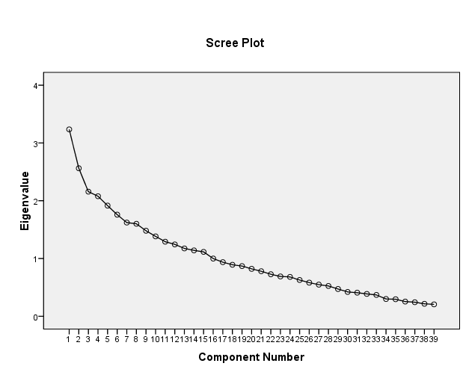

Appendix III

Unreported data analysis
Pa1= Disagree= 2.5%
Agree= 60.4%
Pa2= Disagree=20.1%
Agree= 58.9%
Pa3= Parents=12.4%
Caregivers=18.8%
Other=78.8%
Pa4= Home= 9.9%
School= 6.4%
Other=85.7%
Pa5= Not At All=55.4%
Within A Family= 37.1
Police= 5.9%

Pa9= Disagree= 50%
Agree= 32.7%

Cd1= Disagree= 9.5%
Agree= 79.7%

Cd3= Parents= 2.5%
Caregivers= 5.9%
Other= 91.6%
Cd4= Home=4%
School= 54%
Other=42%
Cd5= Not At All=82.2%
Within A Family= 16.3%
Cd7= Disagree= 62.4%
Agree= 4.5%

Cd9= Disagree= 23.1%
Agree= 12.4%
Cn1= Disagree= 12.4%
Agree= 80.2%
Cn2= Disagree= 6.5%
Agree= 76.7%

Cn3= Parents= 61.4
Caregivers=27.2%
Other= 11.4
Cn4= Disagree= 71.3%
Agree= 8.9%
Cn5= Not Al All= 90.1%
Within A Family= 3.5%
To The Police= 5%

Cn7= Disagree= 61.3%
Agree= 21.7%
Cl1= Disagree= 19.6%
Agree= 68.8%

Cl2= Disagree= 7%
Agree= 84.7%

Cl4= Disagree= 53.4%
Agree=33.6%
Cl8= Disagree=30.5%
Agree=50.5%
Cl9= Disagree= 19.7%
Agree= 59.4%

Appendix IV: Introduction letter
113


