ASSESSMENT OF THE IMPACT OF ECONOMIC ACTIVITIES ON DEFORESTATION: A CASE OF BAHI DISTRICT, DODOMA, TANZANIA

ROBERT BOSS ROGGIE

A DISSERTATION SUBMITTED IN PARTIAL FULFILMENT OF THE REQUIREMENTS FOR THE DEGREE OF MASTER OF ARTS IN NATURAL RESOURCES ASSESSMENT AND MANAGEMENT OF THE OPEN UNIVERSITY OF TANZANIA
2017

CERTIFICATION
The undersigned certifies that he has read and hereby recommends for acceptance by the Open University of Tanzania this dissertation entitled: Assessment of the Impact of economic Factors on Deforestation: a Case of Bahi District, Tanzania, in partial fulfillment of the requirements for the Master of Natural Resources Assessment and Management of the Open University of Tanzania.

……………………………………………
Dr. Reguli Mushy
(Supervisor)

…………………………………
Date

COPYRIGHT
This dissertation is copyright material protected under the Berne Convention, the Copyright Act of 1999 and other international and national enactments, in that behalf, on intellectual property. It may not be reproduced by any means, in full or in part, except for short extracts in fair dealings, for research or private study, critical scholarly review or discourse with an acknowledgement, without the written permission of the Director of Postgraduate Studies, on behalf of both the author and the Open University of Tanzania

.

DECLARATION
I, Robert Boss Roggie, declare that this dissertation is my own original work and that it has not been presented and will not be presented to any other university for a similar or any other degree award.

--------------------------------------------
Signature

--------------------------------
Date

DEDICATION
This thesis is dedicated to the Almighty God, to Him be all the Glory and Honour for by his Mercy and Grace, I have been able to accomplish this work. Also to my parent and sisters who saw the importance of educating their young brother. May God bless you all

ACKNOWLEDGMENTS
The completion of this work has been possible through support and contributions of many individuals, organizations and institutions. It has been not easy to mention everybody here by name, but I sincerely wish to express my gratitude to them all.

I would like to extend my grateful thanks to my parents for providing funding for my research and giving me a good chance to study at Open University of Tanzania. I express special thanks to Dr. Mushy, for giving technical advice, sharing knowledge, and leading me from beginning to the end of my study.

I express my heartfelt thanks to Erick Ngwegwe, Evans J.Evans for such a lovely and wonderful constructive criticism during the presentation of my research proposal, data collection, data analysis, and eventually the writing of the final research report. I am thankful to Mr. Masanja Miss Anna Maria, Mr. Kanyugi, village executive officers in Bahi, Lamaiti and Goima villages who made me welcome in their respective areas.

MAY THE ALMIGHTY GOD ABUNDANTLY BLESS YOU ALL

ABSTRACT
This study was undertaken to assess the Impact of economic activities on Deforestation in Bahi District. Specifically this study aimed at identification of economic activities for deforestation through examine challenges which hinder afforestation and the mitigation measures. Study employed a case study design, a sample size of 188 respondents covered three wards; Bahi, Lamaiti and Goima were selected to represent the whole population of Bahi district were purposively selected as they surround forest reserves. The Respondents were local communities, local government leaders and forest officials. The study adopted both qualitative and quantitative approaches of data collection and analysis. SPSS and content analysis were used for data collection where information was summarized in frequencies, percentages, narratives and presented in the tables and figures. This study has revealed the Economic activities accelerates deforestation are charcoal production and firewood demand, rapid population growth, improper agriculture practice and unemployment. Challenges which hinder effective afforestation area; little community participation in afforestation activities, lack of enough education to the community on how to protect forest, lack of clear forest laws, possible mitigation measures are provision of enough education about environment, improve security & law enforcement, afforestation& reforestation and controlling of cutting down of tree. Suitable recommendations are Improve market for farming output, Provision of enough education about environment, provide alternative sources of energy cheap and affordable, Afforestation and reforestation, Integration of other stakeholder who are affected by forest exploitation such as water and Involvement of community from early stage in order to own the project of reforestation
TABLE OF CONTENTS
CERTIFICATION ii
COPYRIGHT iii
DECLARATION iv
DEDICATION v
ACKNOWLEDGMENTS vi
ABSTRACT vii
LIST OF TABLES xiii
LIST OF FIGURES xv
LIST OF ACRONOMYS xvi
CHAPTER ONE 1
1.0 INTRODUCTION 1
1.1 Background of the Study 1
1.2 Statement of the Problem 3
1.3 Objective of the study 4
1.3.1 General Objective 4
1.3.2 Specific Objectives 4
1.3.3 Research Questions 5
1.4 Significance of the Study 5
1.5 Conceptual Framework 5
CHAPTER TWO 7
2.0 LITERATURE REVIEW 7
2.1 Introduction 7
2.2 Definition of Deforestation 7
2.3 Theoretical Review 8
2.3.1 Environmental Kuznets Curve (EKC) 8
2.3.2 Theory of Planned Behavior 10
2.4 Deforestation Overview 13
2.4.1 Global Trends of Deforestation 13
2.4.2 Deforestation Situation in Africa 14
2.4.3 Deforestation in Tanzania 14
2.4.4 Causes of Deforestation in Tanzania 15
2.4.5 Economic Activities Cause Deforestation in Tanzania 16
2.5 Measures Taken to Address Deforestation 19
2.6 Empirical Literature Review 20
2.6.4 Economic Factors For Deforestation 20
2.6.5 Factors Which Hinder Effective Forestation 21
2.6.6 Mitigation Measures Towards Deforestation 23
2.7 Knowledge Gap 24
CHAPTER THREE 26
3.0 RESEARCH METHODOLODY 26
3.1 Chapter Overview 26
3.2 Study Area Description 26
3.2.1 Climate 27
3.2.2 Relief 27
3.2.3 Vegetation 28
3.2.4 Population 28
3.2.5 Socio-economic Activities 29
3.2.6 Livestock Keeping 29
3.2.7 Water Supply and Sanitation 30
3.3 Research Design 30
3.3.1 Sampling Techniques and Sample Size 30
3.4 Data Collection 32
3.4.1 Tools and Methods 32
3.5 Validity and Reliability 34
3.6 Data Analysis Plan 35
CHAPTER FOUR 37
4.0 FINDINGS AND DISCUSSIONS 37
4.1 Introduction 37
4.2 Demographic Characteristics of Respondents 37
4.2.1 Gender and Marital Status of Respondents 37
4.2.2 Age and Education Level of Respondents 38
4.2.3 Occupation of Respondents 39
4.3 Deforestation in Bahi 40
4.3.1 Extent of Deforestation in Bahi 40
4.3.2 Causes of Deforestation in Bahi District 41
4.3.3 Economic Impacts of Deforestation to the Community and Environment 42
4.4 Challenges Hindering Effective Reforestation in Bahi District 43
4.4.1 Existing Forest Conservation Activities in the Area 43
4.4.1 What Should Be Done to Improve Forestation Activities in the Area 44
4.5 Mitigation Measure and Suggestion towards Deforestation 44
4.5.1 Suggested Measure to Solve Problem of Deforestation 44
4.5.2 Participation in Activity that Help to Eradicate Deforestation 46
4.5.3 Recommendations Measure Should be Taken by the Community After the Problem Emerges 46
4.5.4 Mitigation Measures to be Done by the Government 47
CHAPTER FIVE 49
5.0 CONCLUSIONS AND RECOMMENDATIONS 49
5.1 Introduction 49
5.2 Conclusions 49
5.3 Recommendations 51
5.4 Area For Further Studies 52
REFERENCES 53
APPENDICES 59

LIST OF TABLES
Table 3.1: The distribution of Respondents 32
Table 4.1: Distribution of Respondents Based on Gender and Marital Status 38
Table 4.2: Age and Education Level of Respondents 38
Table 4.3: Occupations of the Respondents 40
Table 4.4: Extent of deforestation 41
Table 4.5: Existing Forestation Activities In The Area 44
Table 4.6: Measures to Solve Problem of Deforestation 46
Table 4.7: What Measure Will Community Take after the Problem Emerges Soon 48
Table 4.8: What Mitigation Measures Dhould be Done by the Government 48

LIST OF FIGURES
Figure 2.1: EKC for Deforestation: a) An Inverted U-shaped; b) U-shaped; and c) N-shaped 9
Figure 2.2: Theory of Planned Behavior 11
Figure 3.1: Map of Bahi District 26
Figure 4.1: Extent of Deforestation in Bahi District 40
Figure 4.2: Causes of Deforestation in Bahi District 43
Figure 4.3: Economic Impact of Deforestation to the Community and Environment 44
Figure 4.4: Recommended Measures to Improve Reforestation 45
Figure 4.5: Participation in Any Activity That Help to Eradicate Deforestation 47

LIST OF ACRONOMYS
BAENET Bahi District Environment Network
DONET Dodoma Environment Network
EMA Environment Management Act
FAO Food and Agriculture Organization
IPCC Intergovernmental Panel on Climatic Change
MKUKUTA Mkakati wa Kukuza Uchumi na Kupunguza Umaskini Tanzania
MLNRT Ministry of Land, Natural Resources and Tourism
MTNRE Ministry of Tourism Natural Resources and Environment
NAP National Action Programme
NEMC National Environment Management Council
NEP National Environmental Policy
PEI Poverty Environmental Issues
PTM Program ya Taifa ya Misitu

CHAPTER ONE

1.0 INTRODUCTION

Background of the Study
Tanzania, like other third world countries, is facing the problem of deforestation. The country is flourished with forests and woodlands which play big roles to the development of the country. Deforestation is the direct human-induced conversion of forested land to non-forested land (UNFCCC, 2001). FAO (2001) defines deforestation as the conversion of forest land to another land use or the long term reduction of the below the minimum 10 percent threshold. Deforestation implies the long-term or permanent loss of forest cover and implies transformation into another land use. Such a loss can only be caused and maintained by continued human-induced or natural perturbation. Globally, around 13 million hectares of forests were converted to other uses or lost through natural causes each year between 2000 and 2010 as compared to around 16 million hectares per year during the 1990s (FRA, 2010).

Forests play a critical role in enhancing the quality of life, guaranteeing the existence of other species and the functioning of the planet’s natural systems. They support the poor in reducing their vulnerability to economic and environmental shocks. The livelihoods of about 1.6 billion people, over 25% of the world population living in extreme poverty are sustained by forests (FAO, 2014).

Deforestation rates in Tanzania are quite high; between 1990 and 2005 an estimated 412,000 ha per annum were cleared, equivalent to about 1.1% of the total forest area (Blomley et al., 2009). Government estimate quote a rate of deforestation of 300,000 hecters to 400,000 per annum. Ministry of lands, Natural Resources and Tourism, MLNRT, 1989). The main direct causes of deforestation are clearing for agriculture, overgrazing, wildfires, charcoal making, persistent reliance on wood fuel for energy, over-exploitation of wood resources and lack of land use planning (Blomley et al., 2008). Reliance on wood fuel and charcoal for energy supply have been identified as a key driver behind national rates of deforestation and degradation, and it presents a real challenge, as almost all domestic (rural and urban) energy consumption are derived from these sources (Miles et al., 2009).

Deforestation in Tanzania is a widespread problem. In Eastern Usambara for example, the Amani forest has been reduced by about 50% while in western Usambara an estimated average of about 7,000 hectors of forest has been cleared annually between 1960 and 1980 (Temu, 1984). The rate of forest loss is increasing, at an average of 0.6% per year after 1975, to an average loss of 3.8% per year currently (The Arc Journal, 2009).The forest cover in the Eastern Usambara has been much reduced due to agriculture expansion, population increase and commercial logging (Binggeli, 2006). In Shinyanga region, about 1.9 million hectors of forest is estimated to have been lost between 1900 and 1984 (Mnzava, 1988).

The factors that cause deforestation are expansion and clearance for small scale and commercial agriculture, felling for domestic and agricultural fuel wood, charcoal, building poles, and exports, indiscriminate bush clearing and bush fires for various reasons and overgrazing (Reed, 1999).
Following the over increasing effects of deforestation in Bahi district the community decided to take action which was being facilitated by members of the Dodoma Environment Network (DONET, 2010). They decided to form four wards Environment network. The members of these networks had to identify the environmental problems predominant in their wards and develop the means of resolving those environmental problems; the establishment and management of tree nurseries. The next step was tree planting around homesteads and the establishment of forest in reserved area of each village.( ibid).

Statement of the Problem
Rural environmental problems are normally considered as a problem that requires long-term solutions which most African nations can barely afford. Among those problems is a deforestation issue which is more critical problem as it directly linked with safety and environment. In recent years, deforestation found to be increasing in those rural areas which are found near urban areas (Kideghesho, 2015).

Bahi district is among areas which are most seriously affected by deforestation (URT, 1999). Bahi district has 2819 hectares of land covered with both natural and exotic forests, many of which are being harvested annually with little replanted (Damas et al., 2010). The natural forest reserves of Dangiyo, Goima, Lamaiti and Chenene are found to be depleted as majority of residents exploit forest resources for economic activities such as charcoal production, agriculture expansion and overgrazing, these forest reserves are found on village and general land with no properly defined management regime; (where deforestation and degradation is the most severe) (ibid; URT, 2012), also there is a large natural forest known as Mtungutu found in Bahi district, which is one of the largest forests in Dodoma region. It consists of various tree species that endures semi-arid climatic condition. Due to inadequate knowledge of potentials of forest, the forest has been excessively exploited for firewood collection, timber harvest, and collection of natural medicine, firing of the forest for agriculture expansion has reduced a large area of Mtungutu forest (Herieth, 2011). Despite efforts made to combat deforestation by government, other NGO such as DONET and project such as HADO still the deforestation is found to be increasing as there is a little knowledge on causes of deforestation in the area (DONET, 2010), this study therefore, is intended to assess impact of economic activities on deforestation. The study focuses on rural Tanzania, particularly; Bahi districts in Dodoma Region where deforestation rate is tend to increase at alarming rate.

Objective of the Study

General Objective
The overall objective of this study was to assess impact of economic activities on deforestation in Bahi district.

Specific objectives
- To identify economic activities for deforestation
- To examine mitigation measure towards deforestation.
- To examine challenges which hinder effective reforestation in Bahi district

Research Questions
- What are the economic activities for deforestation?
- What are the mitigation measures towards deforestation?
- What are the challenges that hinder effectiveness forestation in Bahi district?

Significance of the Study
The findings of this study will address and provide information on a practical way on how economic activities accelerated deforestation in Bahi district. The knowledge found would be useful to policy makers, planners, administrators and other stakeholders in the forest sector, in improving ways to reduce the problem of deforestation. The findings would also contribute to and stimulate other studies as one of the ways to get more information about deforestation in semi arid areas.

Conceptual Framework
All activities for which forest clearing is required are taken to be the causes of deforestation. These include activities such as forest clearing for agriculture, fuel wood harvesting, logging, and others (Allen and Barnes, 1985). Hence, the use for which land is employed (agriculture, habitation, ranching) or the process of resource extraction from the forest (fuel wood harvesting logging) are the causes for which forest is cleared.

Infrastructure development and new economic opportunities such as road construction represents the most harmful aspect of forestry activities. Poverty causing forest resources to be in high demand as poor people depend much on forest resources to survive. India is a poor country contains 63.73 Hecate of forest cover (FSI, 1999), and losing 150 000 ha of forest per annum. (Pachauri, 2001). thus poverty accelerate deforestation.

Impact of deforestation on environment are Loss of Biodiversity, Loss of Soil Fertility, Increase of Carbon dioxide concentration and Emergence of flood, deforestation are harmful to the environment as it reduce productive capacity of the place and increase poverty level mitigation measures toward deforestation; Improvement of people’s economy, Development of alternative source of energy, Improvement of government policies and laws Extension of education.

ECONOMIC ACTIVITIES

Population pressure
Agriculture Expansion
Charcoal Production
Lumbering
Mining activates

DEFORESTATION

Impacts of Deforestation on environment
Mitigation measures

Loss of Biodiversity
Loss of Soil Fertility
Increase of Carbon dioxide concentration
Emergence of flood
Improvement of people’s economy
Development of alternative source of energy
Improvement of government policies and laws
Extension of education

Figure 4.1: Relation Between Economic Activities and Deforestation
Source; researcher survey, 2016

CHAPTER TWO

LITERATURE REVIEW

Introduction
This chapter reviews published and unpublished literature related to the study objectives. The framework that guided this study has been discussed. The study will also cover definitions of key-terms, theoretical literature review and empirical literature review. Finally conceptual framework and research gap is given.

Definition of Deforestation
Deforestation is the conversion of forest to an alternative permanent non-forested land use such as agriculture, grazing or urban development (van Kooten and Bulte, 2000). Deforestation is primarily a concern for the developing countries of the tropics (Myers, 1994) as it is shrinking areas of the tropical forests (Barraclough and Ghimire, 2000) causing loss of biodiversity and enhancing the greenhouse effect.

Forest degradation occurs when the ecosystem functions of the forest are degraded but where the area remains forested rather cleared (Anon, 2010). It is clear that deforestation results a when forest is replaced by another land uses including different types of shifting and permanent agriculture as well as non-agriculture use such as mining and settlements. That deterioration can be temporary or permanent such disturbances have been termed by Grainger (1993) as “degradation”.

From this perspective, deforestation then would represent one extreme of degradation which is easy to monitor by satellite sensor in comparison with selective logging.

Theoretical Review

Environmental Kuznets Curve (EKC)
It’s originally adopted from economics field proposed by Kuznets (1955) who correlates between income and equality (the Kuznets Curve), environmental economists have developed EKC to investigate income effect on environmental degradation. An initial effort in examining EKC application is done by Grossman & Krueger (1991) who investigates the environmental impacts of trade liberalization (NAFTA).

Afterwards, EKC has been applied in forestry sector, known as the EKC for deforestation, hypothesizing the similar notion of EKC. Theoretically, the concept of the ECK for deforestation was discussed by López (1994). As economic or income growth rising, deforestation will be declined when the stock effects of forest resource on agricultural production are internalized.

According to this concept, deforestation is a function of income or economic growth forming an inverted U-shaped curve (Figure 2.1.a). In the early phase of development when level of income or GDP growth is relatively low, increasing income per capita will accelerate deforestation rate until a certain turning point. During this early stage, deforestation is probably one of negative consequences of development. Then, as income rising, the rate of deforestation will decline. Increasing income would incentivize people to improve their forest resources and environmental quality.
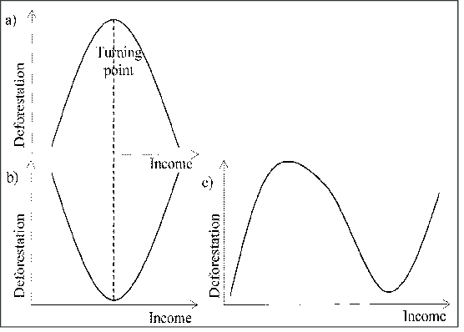

Figure 2.1: EKC for deforestation: a) An inverted U-shaped; b) U-shaped; and c) N-shaped
Source: a) Culas (2012); b) Miah et al. (2011).

Since EKC for deforestation has been theoretically conceptualized, many empirical studies have been carried out at various levels. Before 1990s, there is one study (Allen & Barnes, 1985) relating to economic growth and deforestation. However, their approach is a linear model by utilizing FAO data 1968-1978 found that GDP per capita is insignificantly correlated with total change of forests. Some empirical studies of EKC for deforestation are well-acknowledged, such as (Antle & Heidebrink, 1995; Bhattarai & Hammig, 2001; Culas, 2007; Stern et al., 1996).

Recently, EKC for deforestation still motivates many researches. A cross-country study by Ceddia et al. (2013) using FAO data 1970-2006 found the significance of income effect on deforestation. A time-series single country analysis by Esmaeili & Nasrnia (2014) reveals the existence of an inverted U-shaped curve with the turning point USD 24,555/capita for the case of Iran.
A criticizing article is discussed by Mills (2013) arguing that the existence of EKC for deforestation should be credited to the developed countries in which their imports drive deforestation in poorer countries. However, the author posits that the curve is still useful to see the progress of the conservation program in the developed countries. Finally, another interesting result from one of empirical studies found that deforestation have taken place at an earlier stage of development than heavy industrialization (Panayotou, 1993). This conclusion is drawn from the fact that the turning point of deforestation is relatively much less than other pollutants.

EKC for deforestation is about the link between development and environment. Based on this theory, there is trade-off between economy and environment during the development stage. In this context, seeking the win-win solution (Munasinghe, 1999) is the main motivation of the EKC study. It is so crucial for developing countries to take lessons learned from developed countries experiencing some environmental damages during their early development phases. Such studies could encourage developing countries in restructuring their development programs towards a more sustainable development path without sacrificing economic goals. In sum, the EKC ”… could help the developing countries to avoid higher amount of per capita income for the turning points, and thereby reduce the environmental degradation in the development path …” (Culas, 2007).

Theory of Planned Behavior
The Theory of Planned Behavior was proposed by Ajzen (1985). The theory consists of three conceptual determinants of deforestation, these include the attitude towards deforestation, economic factors termed as subjective norm which refers to the perceived social pressure on either to use or not to use forest resources and facilitation conditions such as demand for forest resources (Figure 2.1). Not much is known on how economic factors motives deforestation in Bahi district.
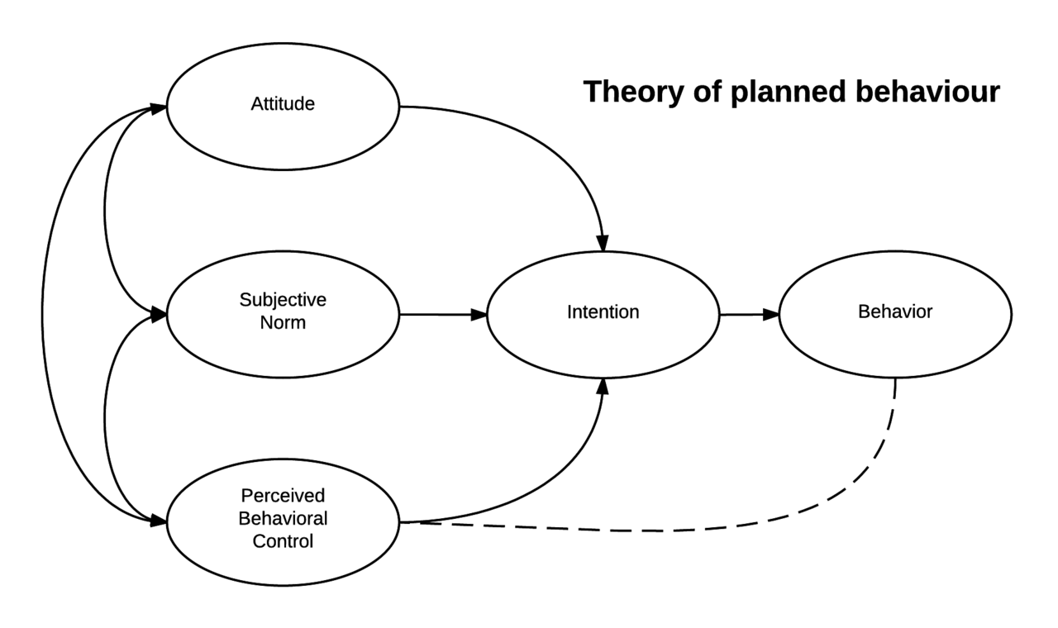

Figure 2.2: Theory of Planned Behavior
Sources: Ajzen, 1985

The theory argues that a person’s behavioral intention depends on the person’s attitude towards the behavior, the subjective norms, and on the perceived behavioral control. An attitude is defined as ‘‘a person’s favorable or unfavorable evaluation of the behavior’’ and is formed by the beliefs about the likely outcomes of the behavior (salient beliefs) and the evaluations of these outcomes (Fishbein and Ajzen, 1975).
A belief represents the information a person has about an object and thus links the object to an attribute; the term is not used to refer to cultural or religious beliefs in this paper. The subjective norm is the perceived social pressure to perform or not to perform the behaviour and is constructed by beliefs about the perceived expectations of others to carry out the behavior (normative beliefs) and the motivation to comply with these expectations.

Perceived behavioral control reflects the extent to which the individual feels he or she is able to actually carry out the behaviour, which is based on beliefs about factors that may facilitate or impede performance of the behaviour (control beliefs) and the perceived power of these factors (Ajzen 1991). Together, the attitude toward the behaviour, the subjective norms, and the perception of behavioural control lead to the formation of a behavioural intention, which in turn leads to the performance of the behaviour (Ajzen 1991).

The theory of planned behavior has received widespread support as a model to predict intentions and behaviour in a range of fields (Armitage and Conner 2001) and has been used to successfully understand the attitudes, intentions and behaviour in relation to forest management (Tesfaye et al., 2012).

Bahi district is among the poorest district in Tanzania. It has experienced high levels of poverty, food insecurity and environmental degradation. The district has the annual deforestation rate of SONR2 0.015 and still believed to be among the highest in the region. Several studies have reported increased deforestation rate (Swaiet al., 2012, Damas, 2013; DONET 2010). However, not much is known about the actual contribution of economic activities towards deforestation and forest degradation in Bahi district. This study adopted the Environmental Kuznets Curve (EKC) for deforestation theory: as this theory helps to elaborate how economic activities do affect forest and examines the potential measure to combat deforestation in the area.

Deforestation Overview

Global Trends of Deforestation
Global deforestation sharply accelerated around 1852 (Wilson, 2002). It has been estimated that about half of the Earth's mature forests between 7.5 million and 8 million km² (2.9 million to 3 million sq mi) of the original 15 million to 16 million km² (5.8 million to 6.2 million sq mi) that until 1947 covered the planet have now been destroyed (Ron Nielsen, 2006). The total area remaining as tropical rainforest is even smaller now, as rainforests are being removed at a rate of 100,000 to 200,000 km² per year, with approximately the same area being greatly disturbed (Skole and Tucker, 1993; Katzman and Cale, 1990); some say, several times as much (Pimm et al, 2001). Sponsel, Bailey and Headland (1996) estimate the deforestation rate at 142,000 km² annually.

The highest rate of deforestation is occurring in Southeast Asia, followed by Brazilian Amazon, Indonesia and Zaire (Laurance, 2001; Skole and Tucker, 1993). The Amazon has lost about 14% of its rainforest, while 40% has been damaged by fragmentation. In the countries of Benin, Ivory Coast, Ghana, Nigeria, and Togo in Africa; western Ecuador, El Salvador, Atlantic Brazil, and Haiti in the Neotropics, the rainforests are virtually gone.

The rate of deforestation are complex because future demand is unknown, future human population size is unknown, and the remaining forest is in more remote areas and in terrain difficult for logging. Environmental groups are putting political pressure on governments to save rainforests, which may mitigate some of the pressures facilitating rainforest destruction.

Deforestation Situation in Africa
Africa is suffering deforestation at twice the world rate, according to the United Nations Environment Programme (The Independent, 2008) Some sources claim that deforestation has already wiped out roughly 90% of West Africa's original forests (Steve Nix, 2016) Deforestation is accelerating in Central Africa (Mongabay, 2009). According to FAO, Africa lost the highest percentage of tropical forests of any continent during the 1980s, 1990s, and early 2000s (Mongabay, 2006).

According to the figures from FAO (1997), only 22.8% of West Africa's moist forests remain, much of this degraded (Mongabay, 2009). Nigeria has lost 81% of its old-growth forests in just 15 years from 1990 to 2005 (Mongabay, 2010). Massive deforestation threatens food security in some African countries (Raphael, 2010). One factor contributing to the continent's high rates of deforestation is the dependence of 90% of its population on wood as fuel for heating and cooking (Agyei, 2009).

Deforestation in Tanzania
Several studies have established that the forestry sector in Tanzania, which is approximately 34.6 million ha of forests and woodland habitats (UN-REDD, 2009; Zahabu,2008 and Blomley et al., 2008); are currently facing alarming deforestation promoted by the human demand for biomass and income generation activities. It is estimated that Tanzania lost an average of 412,200 ha of forests per annum in the 1990s and early 2000s; this amounts to a destruction of 14.9% of its forest cover (or 37.4% including woodlands) in the period 1990-2005 alone (UN-REDD, 2009). Over 17, 3 million hectares, a third of total forested land, are on village and general land with no properly defined management regime; and this is where deforestation and degradation is the most severe (URT, 2012). Overall, the alarming rate of deforestation in Tanzania has received global and local policy attention.

Bahi district is facing environmental degradation due to deforestation, Land fertility has declined substantially and area under natural forest is almost non-existence (GEF, 2014). The traditional forest reserves of Dangiyo, Goima, Lamaiti, and Chenene are found to deplete due to increase demand of charcoal and new area for agriculture activities (Damas, 2010). The rate of deforestation in Bahi is high and it became hard to control deforestation in the area as these forest are not found in the official forest reserves (ibid).

The Bahi District commissioner of 2013, Ms Betty Mkwasa said..
“The forests that are in danger are Goima, Lamaiti and Makanda. These forests have been invaded by farmers, some of whom cut down trees for charcoal and firewood while some are keeping livestock in forest. We should not wait until the district turns into desert for authorities to act”… ( Habel, 2013).

Causes of Deforestation in Tanzania
It is difficult to say exactly what constitute “deforestation” in a country with vast natural grassland like Tanzania, and the following below are the main reason for deforestation in Tanzania.

Economic Activities Cause Deforestation in Tanzania

Urbanization and Deforestation
Urbanization, is the process of transforming natural landscapes (such as wetlands and forests) to build environments (Antrop, 2000). The UN-HABITAT’s report on the State of the World’s Cities indicated that half of the world’s population was already living in cities. Tanzania, one of the African countries, is experiencing rapid rate of urbanization, mainly due to high rates of rural–urban migration. The country’s urban population grew almost 17 times, from 6.4% in 1967 to 29.6% in 2012 (UN-HABITAT, 2008). The urban population has been increasing at a rate of 9.3% per annum for the period from 1978 to 2002. The proportion of the national population living in urban areas increased from 25% in 2002 to over 30% in 2012 (URT, 2014).

The urbanization and population growth have implications on forests and woodlands. More lands are cleared in order to provide space for administrative offices, social services, settlements and infrastructures. The effects of urbanization are also felt in areas away from the urban areas. Building materials and furniture (timber) are obtained from rural areas. Furthermore, urbanization creates high demand for fuel wood, especially charcoal (URT, 2009), estimated the amount of charcoal consumed in Dar es Salaam to be 1904 tonnes per day or 694,960 tonnes per year (Msuya et al.,2011).

The Increase Demand in Fuel Wood
The increasing demand for fuel and scarcity of alternative sources of energy is also a major factor. Urban growth has created a great demand for charcoal resulting in a loss of some 575,000ha annually through fuel wood extraction (Kulindwa and Shechambo, 1995). Fuel wood supply to Dar- es- Salaam city alone had been depleting forests in the surrounding areas at a rate of 75,000ha per annum (Hagman, 1984).

Consequently, to day charcoal is brought to a distances of up to 200km inland (MTNRE, 1994a, Misana and Minyaki, 1993) piles of charcoal bags a waiting collection are a common sight along major roads leading to the city of Dar es salaam. The gradual disappearance of wood land in circular areas around towns has also been observed in Dodoma (Allen, 1985).

Mining Activities
Mining is causing deforestation by felling trees and land stripping in preparation for mining. This is evident in the small scale gold mining areas in Kahama and Geita district and in Morogoro Region where there is intensive mining of ruby (NEMC, 2000).

And a Dodoma region during the early 28th century is attributed to this. More recently the influx of refugees from neighboring Rwanda and Burundi has had devastating effect on some of the forested areas in Kagera, Kigoma, Rwanda and Tabora regions about 4000 hecters of forests have been cleared in Kagera, Kigoma and Rukwa regions (MTNRE, 1994).

Infrastructure Improvement And New Economic Opportunities
The past three decades have seen Tanzania investing in developing and improving
infrastructures in view of allowing accessibility to different parts of the country. Currently, virtually all parts of the country, previously regarded as remote areas, are easily accessible through good roads. The total classified road network in Tanzania Mainland is estimated to be 87,524 km (NBS, 2015). While, on one hand, the improvement of the road network is a credit to the government and important entry point towards social and economic development, it has undesirable consequences on the other hand. These efforts, apart from improving people’s living standards, can lead to serious environmental and socio-economic tradeoffs such as a surge in uncontrolled logging and timber trade activities. Areas with intact forests and high-quality timber trees have been subjected to heavy logging to satisfy market demands within and outside the country. For example, forest inventories conducted in 2005 rated most forests in southern Tanzania as “degraded” or “heavily degraded”. The main reason was cited as the completion of the Mkapa Bridge in early 2000s (Miya, 2015)

The factors that cause deforestation are many and include expansion and clearance for small scale and commercial agriculture, feeling for domestic and agricultural fuel wood charcoal building poles and exports indiscriminate bush clearing and bush fires for various reasons and overgrazing (Read, 1996, Ministry of Tourism Natural Resources and Environment (MTNRE, 1994 a, MLNRT, 1989a, Misana and Nyaki, 1993). Regions most affected are coastal area Mbeya, Dodoma, Singida, Shinyanga, Tabora, Kigoma, and Tanga. The expansion of agriculture has often taken the form of shifting cultivation. This has a market impact in the tobacco growing areas of Tabora, Urambo, Iringa, Chunya and Songea district (Misana and Nyaki, 1993).

Measures Taken to Address Deforestation
Main international organizations including the United Nations and the World Bank have begun to develop programs aimed at curbing deforestation. The blanket term Reducing Emissions from Deforestation and Forest Degradation (REDD) describes these sorts of programs, which use direct monetary or other incentives to encourage developing countries to limit and/or roll back deforestation. Funding has been an issue, but at the UN Framework Convention on Climate Change (UNFCCC) Conference of the Parties-15 (COP-15) in Copenhagen in December 2009, an accord was reached with a collective commitment by developed countries for new and additional resources, including forestry and investments through international institutions, that will approach USD 30 billion for the period 2010–2012 (UNFCC, 2009). Significant work is underway on tools for use in monitoring developing country adherence to their agreed REDDS targets. These tools, which rely on remote forest monitoring using satellite imagery and other data sources, include the Center for Global Development's FORMA (Forest Monitoring for Action) initiative. (Forest Monitoring for Action ,2009) .Methodological guidance for forest monitoring was also emphasized at COP-15 (UNFCC, 2009 )The environmental organization Avoided Deforestation Partners leads the campaign for development of REDD through funding from the U.S. government. (Climate Progress ,2010) In 2014, the Food and Agriculture Organization of the United Nations and partners launched Open-Foris a set of open-source software tools that assist countries in gathering, producing and disseminating information on the state of forest resources, (FAO, 2014). The tools support the inventory lifecycle, from needs assessment, design, planning, field data collection and management, estimation analysis, and dissemination. Remote sensing image processing tools are included, as well as tools for international reporting for Reducing emissions from deforestation and forest degradation (REDD) and FAO's Global Forest Resource Assessments.

In evaluating implications of overall emissions reductions, countries of greatest concern are those categorized as High Forest Cover with High Rates of Deforestation (HFHD) and Low Forest Cover with High Rates of Deforestation (LFHD). Afghanistan, Benin, Botswana, Burma, Burundi, Cameroon, Chad, Ecuador, El Salvador, Ethiopia, Ghana, Guatemala, Guinea, Haiti, Honduras, Indonesia, Liberia, Malawi, Mali, Mauritania, Mongolia, Namibia, Nepal, Nicaragua, Niger, Nigeria, Pakistan, Paraguay, Philippines, Senegal, Sierra Leone, Sri Lanka, Sudan, Togo, Uganda, United Republic of Tanzania, Zimbabwe are listed as having Low Forest Cover with High Rates of Deforestation (LFHD). Brazil, Cambodia, Democratic Peoples of Korea, Equatorial Guinea, Malaysia, Solomon Islands, Timor-Leste, Venezuela, Zambia are listed as High Forest Cover with High Rates of Deforestation (HFHD) (Angelsen, 2009).

Empirical Literature Review

Economic Factors For Deforestation
The forests of Africa are the most depleted of all the tropical regions with only 30 per cent of the historical stands still remaining (Chidumayo and Kwibisa 2003). Socio-economic factors are contributing to alter or deplete the forest cover and affect forest structure and species composition (Schwartz and Caro 2003). The intensity of disturbances also varies within a given landscape in terms of land use, accessibility, topography and the type of vegetation present. The increase in dominance of small woody trees in harvested Miombo woodlands suggests that the woodlands may degrade to shrub lands due to anthropogenic pressures (Luoga 2000).

In Tanzania population growth is undoubtedly one of the most critical socio-economic factors that could alter the pattern of forest resource use. Seventy five million people inhabit areas covered or formerly covered by Miombo woodland, with an additional 25 million urban dwellers relying on Miombo wood or charcoal as a source of energy (Campbell et al. 1996). Luoga et al. (2000) found that in Eastern Tanzania, apart from using Miombo woodlands for farming, local people had eleven types of uses for the trees, including charcoal, firewood, poles, timber, medicine, withies, food, ropes (fibre), live fences, carving and rituals.

Deforestation in the Congo is partly caused by the increase in demand for land from local subsistence activities by poor farmers and villagers who rely on forest lands for the increasing scale of agricultural activities. The timber industry is a major employer in Congo, thousands of workers rely on logging companies for basic healthcare and other services. This causes heavy deforestation to the Congo Basin at a very fast pace.

Factors Which Hinder Effective Forestation
Forestation is the establishment of forest growth on areas that either had forest or lacked it. (Nyland, 2002). Reforestation and afforestation are categories of forestation. Many governments and non-governmental organizations directly engage in programs of afforestation to create forests, increase carbon capture and carbon sequestration, and help to anthropogenic ally improve biodiversity.

Rural communities in many parts of the tropics are dependent of forests for their livelihoods and for environmental services. Forest resources in the tropics have declined rapidly over the past century and therefore many developing countries in the tropics have reforestation programs. Although reforestation is a long-term process with long-term benefits, existing evaluations of the success of these programs tends to focus on short-term establishment success indicators (Hai, 2011).

Reforestation can help reverse some of the more severe impacts of forest loss and degradation on rural communities in the tropics by providing secure access for local people to a range of forest products, including fuel wood and non-timber forest products; improved hydrological regulation and nutrient cycling; providing more diverse and better connected habitats, thus supporting more biological diversity; and options to increase the resilience and adaptability of existing agricultural systems (Maginnis and Jackson, 2002).

Ensuring long-term success is one of the greatest challenges facing many reforestation initiatives in developing countries. However, most evaluations of reforestation success have been narrowly focused on reaching planting area targets. Few evaluations have measured the environmental or socio-economic success of reforestation projects. In addition, little is known about what influences the success of reforestation projects and in what situations reforestation projects succeed or fail. More holistic, integrated approaches to assessing reforestation success are needed.
Knowing the objectives of reforestation is important for assessing success (Aronson et al., 1993; Brown and Lugo, 1994; Hobbs and Harris, 2001). To evaluate previous reforestation actions, both initial and current reforestation objectives need to be considered because objectives defined when the project was conceived may not necessarily match current environmental and social demands. Reforestation objectives are fundamentally valued based (Davis and Slobodkin, 2004) and have traditionally been focused on wood production, erosion prevention and water flow management. In recent decades, the objectives have shifted towards socio-economic benefits, ecosystems goods and services, recreation and wildlife conservation (Vallauri et al., 2002).

Mitigation Measures Towards Deforestation
Increasing the area of forest plantations by using vacant or unused lands and Planting trees outside forest areas will reduce pressure on forests for timber, fodder and fuel wood demands. Moreover the deforested areas need to be reforested. As of now much of the world’s tropical forest are state owned but community participation in forest ownership and management needs to be encouraged with restrictions on extraction and conversion (Chomitz et al., 2007). Land reform is essential in order to address the problem deforestation. However an enduring shift in favour of the peasants is also needed for such reforms to endure (Colchester and Lohmann, 1993). Moreover the rights of indigenous forest dwellers and others who depend on intact forests must be upheld. Therefore, the recognition of traditional laws of the indigenous peoples as indigenous rights will address the conflicts between customary and statutory laws and regulations related to forest ownership and natural resource use while ensuring conservation of forest resources by the indigenous communities. Central to this is the right to ‘Prior Informed Consent’, ensuring the indigenous communities to know what they are agreeing to. A means must be found to reconcile conservation and development by involving local/indigenous populations more closely in the decision-making process and by taking the interactions between ‘societies’ and forest resource more fully into account (Chakravarty et al., 2008).

Strong and stable government is essential to slow down the rate of deforestation. FAO (2010) considered that half of the current tropical deforestation could be stopped if the governments of deforesting countries were determined to do so (Anon., 2010). Environmental NGO’s contribution towards conservation management has been enormous. They are better equipped to bypass corruption and they are very effective at getting to the people at the frontier who are in most need.

Knowledge Gap
Various efforts have been done to combat deforestation in Tanzania and few studies have explored factors for deforestation (Blomley et al., 2008, Milledge et al., 2007). The governments and NGO’s from different regions are in struggle to and some have already developed comprehensive environmental laws, that can support the management of resources as to resist against the mismanagement of forest resources, despite of these efforts still the problem of deforestation continue in many parts of Tanzania, as there are few knowledge on what cause deforestation, and the rate of forest change increased by 11.0% to 12.10% per annum (Mongabay, 2010). Furthermore this study aims at establishing impact of economic activities on deforestation in Bahi district, things which have not featured in previous studies.

CHAPTER THREE

RESEARCH METHODOLODY

Chapter Overview
This chapter presents information on the profile of the study area including its location and major characteristics of the study districts. The chapter further provides the explanation on how the study was conducted including sampling procedures, data types and their sources, data collection techniques and the methods used for processing and analyzing data.

Study Area Description
This study was carried out in Bahi district, Dodoma region, Tanzania. Bahi district is among the seven districts that make up Dodoma region. It extends between latitude 5° and 8° south and between longitude 35° and 37° east.
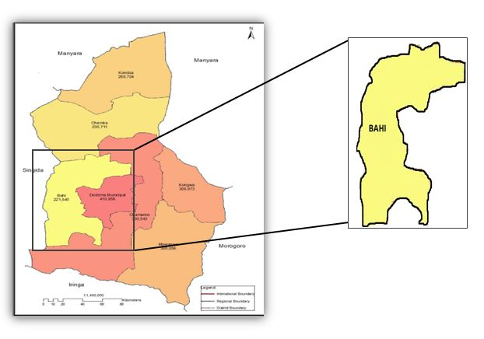

Figure 3.1: Map of Bahi District
Source; (NBST, 2016)
The district covers an area of 5948 square kilometers and bordered to Kondoa district to the North, Manyoni district to the West, Dodoma municipal to the South-west and Chamwino district to the East. Administratively the district is divided into four divisions, 20 wards, 56 villages and 49254 households (PMORALG, 2015). According to the 2012 Tanzania National Census a population of Bahi district was about 221,645 residents. The area of study was deliberately chosen by researcher due to the fact that, the area is currently experiences persistence deforestation

Climate
Bahi district has a dry savannah type of climate which is characterized by a long dry season lasting between April to early December and a short single wet season occurring during the remaining months. The average rainfall is 500-800mm annually. Rainfall is not only relatively low but also unpredictable in frequency and amount. It is this unreliable rainfall which has imposed erosion risk in traditional agriculture and which represents a serious constraint on efforts to improve crop yields (Bahi District Profile, 2014).

Relief
Bahi district is mostly a flatland with gentle slope hills and low lands in some places. In the eastern part of the district there is Bahi lowland area with swampy characteristics which makes it suitable for paddy farming. The Southern zone of the district with undulating hills is the most populated area of the district, used for cultivation of sorghum, millet, groundnuts and maize as food crops and tomatoes, onions and vines for cash. The main river in the district is Bubu river which flows from the north to south-east and drain its water into Bahi swamps. Like most natural rivers, dams, and swamps in the district, Bubu river is a seasonal one (Bahi District Profile, 2014).

Vegetation
The characteristic vegetation of Bahi district is bush or thicket type which is wide spread throughout the area. The district is also endowed with forestry resources; it is estimated that the area of 2819 hectares is covered with natural forests and 175 hectares covered with exotic forests and 2644 hectares are forest reserves which are Dangiyo, Goima, Lamaiti and Mutungutu (Bahi District Profile,2014) . Tree planting efforts in the district have been initiated by Non-Governmental Organizations like World Vision Tanzania, Dodoma Environmental Network (DONET) and Dodoma Biogas Project (MIGESADO). A good number of people in the district depend on trading forest products for their livelihood. A significant proportion of charcoal and firewood supply to Dodoma municipality is from the district. The trend of forest products harvesting has been increasing and there is no sign of having the trend declining which implies that pressure on forests is increasing (ibid).

Population
Bahi district was established on July 2007. In 2012, the district had a population of 221,645 where males were 105,975 and female 115, 670 with a population growth rate of 1.6 and population density of 39.35km² (NBS, 2013). The rise in population put pressure in available forest resources as which increase demand and exploitation rate, most of the time local people end up selling charcoal, fire wood and agriculture expansion so as to support their families. With increase in population the resource trends per capital tend to decrease.

Socio-economic activities
The major economic activities in the district are subsistence farming contributing 41.0% and livestock keeping contributing 47.5% which altogether contribute to 88.5% to the district GDP. Majority of households in Bahi are still poor with average income being estimated at Tshs 427,489 per year (Bahi District Profile, 2014). Its economy is entirely dependent on farming, managed by smallholder farmers. Farming is characterized by low productivity resulting from low rainfall, high evapo-transpiration and low moisture holding surface soil. Apart from farming, livestock also have great potential of contributing significantly to the district economy (Bahi District Profile, 2014).

Livestock Keeping
According to 2006 livestock census the district has 236,115 livestock, 189,841 cattle, 39,470 goats and 7,604 sheep. Constraints limiting livestock development include overgrazing and lack of pasture management, pasture and water are very scarce particularly during dry season resulting into poor conditions of animals. Facilities for disease prevention and control are extremely inadequate. An inadequate support service has led to prevalence of diseases like Contagious Bovilie Pleurophenmonia (CBPP), East coast fever, foot and mouth diseases. More than 95% of cattle in the district are indigenous which have been developed over long period of time, and adopted a local condition (Bahi District Profile, 2008).

3.2.7 Water Supply and Sanitation
Due to poor climatic conditions and absence of reliable rainfall, permanent water sources like rivers and springs have been affected. Bahi district is characterized by seasonal rivers and swamps/wetlands. Furthermore, construction of boreholes, shallow wells, rain water harvesting structures and wind mills have minimized the perpetual chronic water shortage for both animals and domestic use. The district has 133 water supply schemes capable of providing clean and safe water to 66% of people in the district. (Bahi District Profile, 2012).

Research Design
This study employed a case study design. Welligton (2000) argues that case study design allows the researcher to investigate research questions in depth for a short time. The rationales of using this research design was firstly aimed to obtain complete and accurate information of the studies, secondly have contributed in providing protection against bias and maximize reliability, thirdly showed the concern for the economical completion of the research study (Kothari, 2004).

Sampling Techniques and Sample Size

Sampling Techniques
According to Meshack & Sheuya (2011) sampling is the process of drawing a sample from a larger population. Therefore sampling is a process of getting the number of elements about which one would wish to make inferences. Random sampling was used in this study, in order to be able to draw valid inferences from a sample in relation to its respective population. A simple random sampling is a way of selecting subjects in which every element in the population has an equal chance of being chosen (Meshack & 11 Sheuya, 2011). Therefore, the researcher selected the samples from the sample frame using random numbers and Sampling frame constituted of three wards, namely, Bahi, Lamaiti and Goima, which was purposively selected as there are surrounding forest reserves.. The sample frame of household heads in the study area was obtained in the Village office during preliminary study.

Sample size
The total number of households in the three selected wards, amounted to 4,140 households (NBS, 2012). Due to time and financial constraints it will be impossible to go through every household. The sample size of the study was 188 was selected based on confidence level 95%, Confidence interval 5 (Research advisors, 2006).
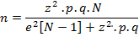

N=4140 Z=2.005(confidence level of 95.5%)
P=0.02 q=1-0.02
e=0.02 (since the estimate should be within 2% of true value)
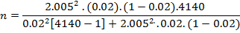
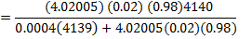
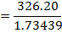
= 188
Apart from the household sample of 188 other respondents were 8 public officers who are forest officer, land officer, three ward executive officers and three ward chairpersons from three wards of selected Bahi district, 9 ward council. The representative sample from each study ward is shown in Table3.1

Table 3.1: The distribution of Respondents
Ward | Village | Total number  of Households | Proportional Representative Sample (PRS) of Households | Number of Households Sampled
Bahi | Bahisokoni village | 2313 | 2313/4140x188 | 105
Goima | Goima | 705 | 705/4140x188 | 33
Lamaiti | Lamaiti | 1122 | 1122/4140x188 | 50
Total |  | 4140 | X | 188
Source: Researcher survey, 2016

Data collection

Tools and Methods
These are ways and techniques of collecting data such as interview, observation, questionnaire and documentation methods where the researcher choose to collect data from the respondents (Kothari, 2004).

Primary Data
These are data collected afresh and for the first time. The data obtained from the community members, local leaders and officers of a particular ward through questioners and interview.

Questionnaire Method
Hans (2002) defines a questionnaire as a list of written questions put forward to a person for them to answer. Emphasize that a questionnaire has ability to collect large amount of information in a reasonable time. The instrument is chosen because the target population is considerable literate.

Questionnaires was administered to the 188 head of households, the study use both closed ended and opened ended questionnaires. The study use this method because it is easy to collect a lot of information required at a short time, also it ensure there is no bias on the side of researcher and respondents. The questionnaires were distributed to respondents who know to read and write down the reply and those who don’t know how to read and write the research assist them. The respondents answered the questions on their own.

Observation Method
The study adopt observation method to observe how economic motives deforestation. The main advantage of this method is that subjective bias is eliminated, the information obtained under this method relates to what is currently happening; it is not complicated by either the past behaviour or future intentions or attitudes (Kothari, 2004). Through this method researcher observed a lot stumps in the area, charcoal production sells, fire wood and charcoal selling taking place around villages’ forest reserve.

Interview Method
17 interviews were carried out, the main issue addressed was how economic activities cause deforestation, ways to combat deforestation and what hinder those ways to combat deforestation.
The study used structure interview which involved setting a pre-determined question. The advantages of this method was able to get more information with more detail about deforestation also it will be more flexible that the researcher can be flexible to change the question according to the level of people in terms of language and education of respondents (Kothari, 2004). In-depth interviews was administered to WEOs, VEOs, 8 ward council members, land and forest officer from Bahi district. The form of interview guide was structured and unstructured in order the respondents to be able to freely express themselves in length and provide in-depth data about the problem under investigation.

Secondary Data
These are data which are already collected. In order to get the data the researcher obtained data from different sources as internet, various publications of the central, state are local governments, various publications of foreign governments, technical and trade journals, books, magazines and newspapers, reports and publications of various associations connected with business and industry, health, other sectors.

Validity and Reliability
Validity is based on determining whether the findings are accurate from the standpoint of the researcher, the participant or the readers of an account (Creswell & Miller, 2000). Validity will be determined through seek other relevant evidence that confirms the answers we have found with our measuring tool. What is relevant, evidence often depends upon the nature of the research problem and the judgment of the researcher. Reliability has to do with the accuracy and precision of a measurement procedure. Reliable measuring instrument does contribute to validity, but a reliable instrument need not be a valid instrument.

A pilot test was carried out at single village of Bahi Sokoni to test validity and reliability of the question covered in the interview and questionnaire, as it important to try research tools in order to check that all the details are right. The research questions was tested to relate respondents including VEO of Bahi Sokoni, Bahi Sokoni villagers and member of ward council found in Bahi Sokoni village. To validate the study, the researcher use triangulation method, by using interview, documentary review and questionnaire as Patton et al., (2002) insist use of more than one method in collection of data to validate the study.

Data Analysis Plan
The term analysis refers to the computation of certain measures along with searching for patterns of relationship that exist among data-groups (Ayub, 2013). Thus, “in the process of analysis, relationships or differences supporting or conflicting with original or new hypotheses should be subjected to statistical tests of significance to determine with what validity data can be said to indicate any conclusions” (Kothari, 2004). Selltiz et al. (1967),opine that analysis of data in a general way involves a number of closely related operations which are performed with the purpose of summarizing the collected data and organizing these in such a manner that they answer the research question(s) (Ackoff, 1961).

The qualitative data was analysed thematically, using the content analysis procedure. Content analysis procedure is a systematic procedure designed to examine and analysed the recorded information also is the most important analyses which involves ordering (Ngaruko, 2012). Quantitative data were collected by questionnaires and encoded, entered into the SPSS version 20 computer software and then analysed. The data were presented in descriptive statistics in terms of percentages and frequencies and presented in form of tables and figures. The analysis of the data provided insight into various issues that relate to the objectives of the study.

CHAPTER FOUR

FINDINGS AND DISCUSSIONS

Introduction
This chapter presents the findings of the study and discussions of the results.it involves the presentation, discussion and reporting of the data whereas tables, figures and charts were deployed in the presentation of the data and both qualitative and quantitative data presentation methods were deployed to make the study more understandable and the analysis more easily.

Demographic Characteristics of Respondents
This section presents demographic characteristics of respondents in terms of age, gender, marital status, occupation and education level of Bahi people. This information is important to know, as it provides the forest officer, land officer and other government officials with current information of local people surrounding the forest areas.

Gender and Marital Status of Respondents
The findings from Table 4.1 indicate that 67.3% of households in the study area are male headed as compared to 32.7% female headed households. This has implication on decision making system; the decision on the impact of economic factors towards deforestation greatly rests on the head of household. Most of the head of households in Bahi district are males and few are female. In the study area males have access and ownership of different households resources compared females who have very little/no ownership and access to household resources).Moreover, large numbers of respondents are married 88.9% respondents followed by those who were not married (single) about 5.3%.

Table 4.1: Distribution of Respondents Based on Gender and Marital Status
Variable | Description | Percentage %
Variable | Description | Bahi (N=95) | Lamaiti (N=47) | Goima (N=29) | Total (N=171)
Sex of Respondents | Male | 69.5 | 59.6 | 72.4 | 67.3
Sex of Respondents | Female | 30.25 | 40.4 | 27.6 | 32.7
Sex of Respondents | Total | 100 | 100 | 100 | 100
Marital Status of Respondents | Married | 90.5 | 93.6 | 75.9 | 88.9
Marital Status of Respondents | Single | 3.2 | 4.3 | 13.8 | 5.3
Marital Status of Respondents | Widow | 4.4 | 2.1 | 3.4 | 3.5
Marital Status of Respondents | Widower | 2.1 | 0 | 6.9 | 2.3
Marital Status of Respondents | Total | 100 | 100 | 100 | 100
Source: Field Survey, 2016

Age and Education Level of Respondents
Based on age groups, most of the respondents (38%) were between the age of 30 to 40 years and these are the active working group of the population, the possible explanation for the findings is that there are few employment opportunities which create problem of job scarcity.

Table 4.2: Age and Education Level of Respondents
Variable | Description | Percentage %
Variable | Description | Bahi (N=95) | Lamaiti (N=47) | Goima (N=29) | Total (N=171)
Age of Respondents | Between 20-30 years | 30.5 | 29.8 | 41.4 | 32.2
Age of Respondents | Between 30-40 years | 41.1 | 34 | 34.5 | 38
Age of Respondents | Between 40-50 years | 20 | 25.5 | 24.1 | 22.2
Age of Respondents | Between 50-60 years | 8.4 | 10.6 | 0 | 7.6
Age of Respondents | Total | 100 | 100 | 100 | 100
Education Level of Respondents | College education | 1.1 | 2.1 | 0 | 1.2
Education Level of Respondents | Secondary education | 14.7 | 8.5 | 13.8 | 12.9
Education Level of Respondents | Primary education | 63.2 | 46.8 | 65.5 | 59.1
Education Level of Respondents | Non Formal Education | 21.1 | 42.6 | 20.7 | 26.9
Education Level of Respondents | Total | 100 | 100 | 100 | 100.0
Source: Field Survey, 2016
The results further indicate that a majority of respondents were in the economically active age, that is, 20 – 60 which are active engaged in deforestation exploitation for their income generation. (Table 4.2).

Quarter of Tanzanian adults has no formal education, and 29 percent can neither read nor write. In rural areas, 30 percent of the population has no education, hence a significant rise of deforestation as they have little knowledge efficient user of forest resources (Tanzania, 2002).The study identified that majority (59.1%) of respondents were literate since they had formal education (primary education). Also this was supported by the Village Executive Officer in Goima village, who had this to say;
“There is low educational awareness as most of the villagers are not devoted into educating their children thus majority end up in charcoal production and others become tomato-growers”.

Occupation of Respondents
The Table 4.3 below shows 52.6% of the respondents are farmers and 31% do livestock keeping and crop farming, while 14% are Petty traders based on charcoal production and selling of domestic goods in the villages.

Furthermore, the results from interviews, questionnaires and observation show that the majority of the resident depend on natural resources for their survival. This accelerate deforestation, as the main direct causes of deforestation are clearing for agriculture, overgrazing, wildfires, charcoal making, persistent reliance on wood fuel for energy, over-exploitation of wood resources and lack of land use planning

Table 4.3: Occupations of the Respondents
Variable | Description | Percentage %
Variable | Description | Bahi (N=95) | Lamaiti (N=47) | Goima (N=29) | Total (N=171)
Main Economic Activity | Livestock keeping | 3.2 | 0 | 0 | 1.8
Main Economic Activity | Farming | 55.8 | 46.8 | 51.7 | 52.6
Main Economic Activity | Petty trade | 16.8 | 12.8 | 10.3 | 14.6
Main Economic Activity | Livestock keeping & Farming | 24.2 | 40.4 | 37.9 | 31
Main Economic Activity | Total | 100 | 100 | 100 | 100
Source: Field Survey, 2016

Deforestation in Bahi

Extent of Deforestation in Bahi
The results in table 4.4 below shows that majority of respondents (99.1%) are aware on extent of deforestation on their area which is high (Table 4.4). The possible explanation of these findings is that majority of these respondents have been able to saw the trend of deforestation since they are originated in the area. This was supported by explanation from the Village Executive Officer in Bahi sokoni village, who had this to say:
“In the previous times there were dense forest from police station downwards as it was not safe to pass through in nights/evening hours due to its darkness and it was a place where robbers hide at bahi “

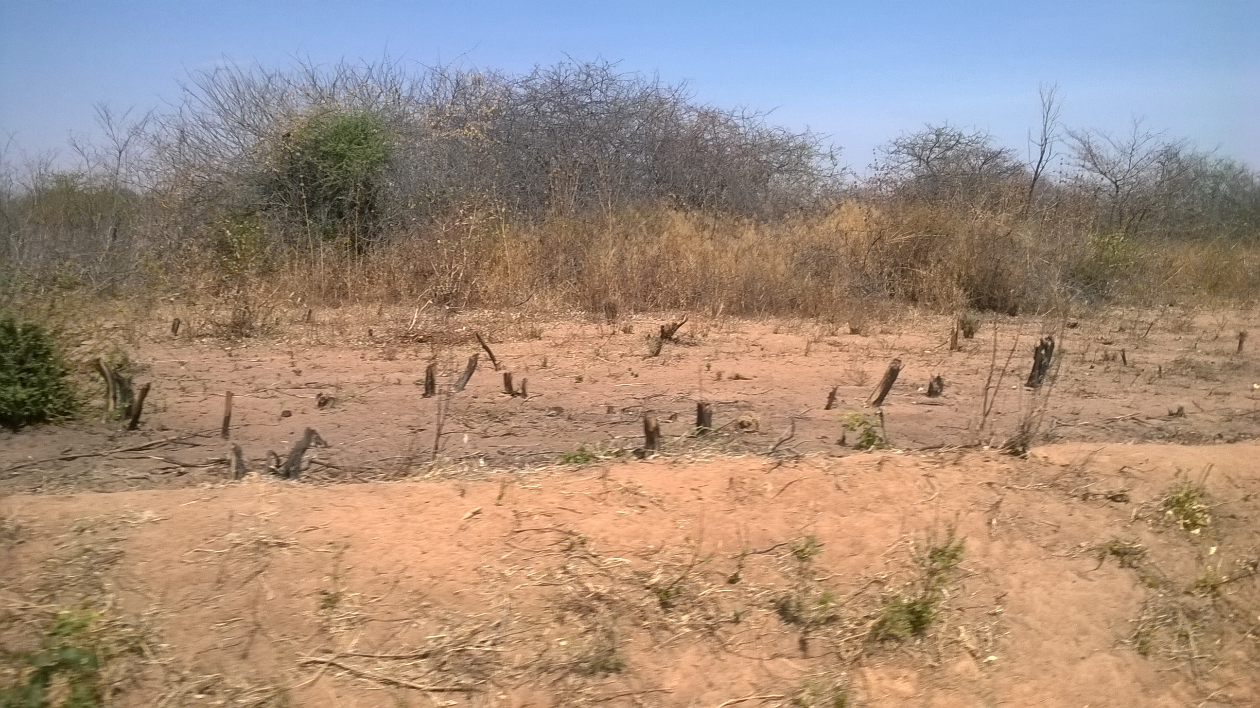Figure 4.1: Extent of Deforestation in Bahi District
Source: Researcher Field Data, 2016
Figure 4.1 shows extent of deforestation to the environment in Bahi, as a large area of land is left open after cutting down of tress for charcoal production.

Table 4.4: Extent of Deforestation
Variable | Description | Frequency | Percentage (%)
The extent of deforestation | High | 170 | 99.1
The extent of deforestation | Low | 1 | 0.9
The extent of deforestation | Moderate | 0 | 0
Source: Researcher field Data 2016

Causes of Deforestation in Bahi district
The results in figure 4.2 shows that about 29.5% of respondents identified charcoal making and selling as a main cause of deforestation while 21.6% of respondents associated deforestation to poor farming methods. About 17.8% of respondents identified rapid population increases as causes of deforestation also about 12.0% of respondents have considered the construction of new settlement as the cause of deforestation; about 11.5% of respondent’s identify improper livestock keeping cause deforestation. About 4.4% of respondents have identified that unemployment and illiteracy also cause deforestation and lastly about 3.1% of respondents have considered lumbering as one of the causes the deforestation. The possible explanation for the finding is that most of these causes have been influenced by the need to generate income. The implication of the findings to the study is that majority of respondents are aware of the causes of deforestation. Scarcity of fuel wood caused by deforestation has also been a major problem to the majority of people, who are poor as they cannot afford other sources. African women have been forced to walk farther for fuel wood, reducing the amount of time they would spend on other productive activities (World Bank, 1992). One key informant had this to say:
“Demand of charcoal and firewood has been increasing here at Bahi, which accelerate deforestation, also the increase of immigrants especially the Sukuma has led to cutting down of trees to allow agricultural, pastoralism as well as clearing areas for residence”.

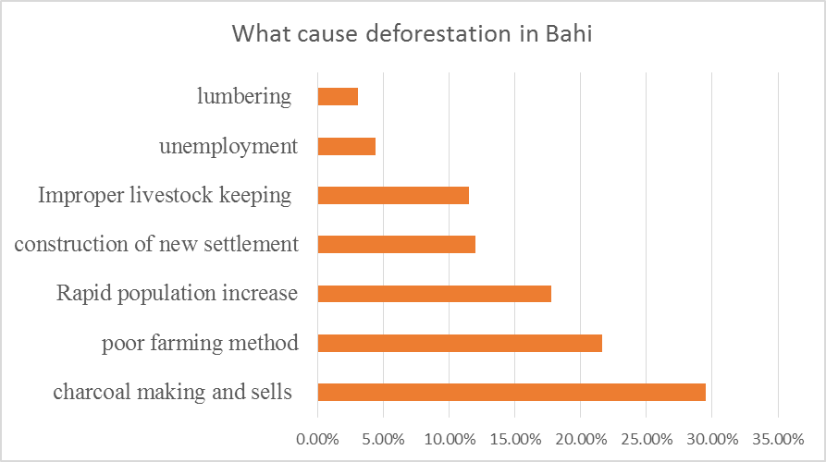 Figure 4.2: Causes of Deforestation in Bahi District
Source Researcher field Data 2016

Economic Impacts of Deforestation to the Community and Environment
The result in Figure 4.3 shows that 37.7% low farming output, 29.4% poor health livestock. Also about 21.3% increase of poverty and about 7.7% of loss of soil fertility as the economic impacts of deforestation, most these respondents have been able to experience the economic impact of deforestation since they are living to that area more than 20 years. This is implies that depletion of forest resources in Tanzania is of great concern for environment and development. As it affecting not only the economy of the country but also the health of the people
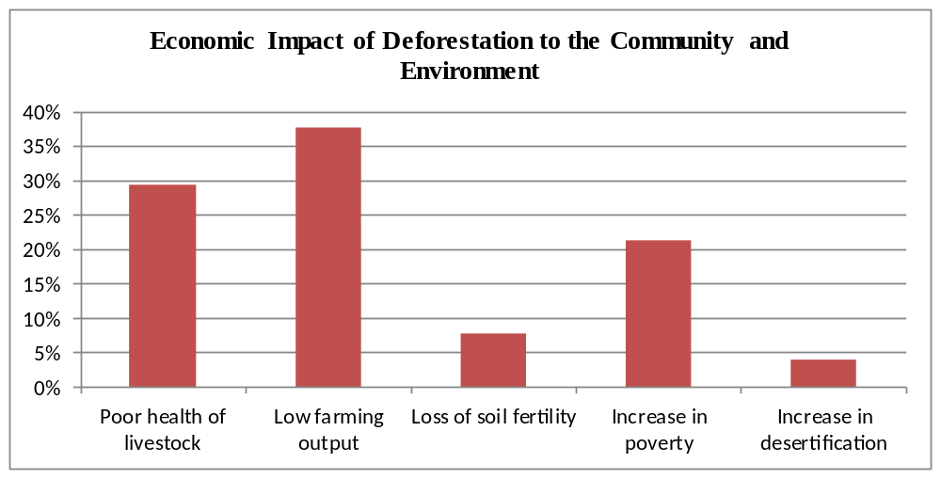

Figure 4.3: Economic Impact of Deforestation to the Community and Environment
Source: Researcher field Data 2016

Challenges Hindering Effective Reforestation in Bahi District

4.4.1 Existing Forest Conservation Activities in the Area
The table 4.5 below shows existing forest conservation activities which are known by respondent whereby; Afforestation and Reforestation 68%, not allowed feed livestock to forest areas 12% and not allowed to cut down trees 33%, this implies three existing forestation activities are the one known by many. There is need for more education about forest conservation to majority of community member.

Table 4.5: Existing Forestation Activities In The Area
Variable | Description | Frequency |  | Percentage (%)
What are the existing forestation activities in the area | Afforestation and Reforestation  Not allowed to feed livestock to forest areas |  | 68  12 | 60.2  10.6
What are the existing forestation activities in the area | Not allowed to cut down trees |  | 33 | 29.2
What are the existing forestation activities in the area | Total |  | 113 | 100.0
Source: Researcher field Data 2016

What Should Be Done to Improve Forestation Activities in the Area
35.8% of respondents suggest provision of enough education about environment, 35.8% of respondents suggest planting of trees and taking care of them, also about 27.2% of the respondents suggest to improve security around forest areas and about 1.2 of respondents suggest availability of alternative source of energy. However, in order to maintain the momentum achieved, more enforcement, education and financial resources for sustainable forest development are needed. Education is the key to changing the mind sets of various actors of sustainable development, people in government, private sector, business and the public ( URT,2012)
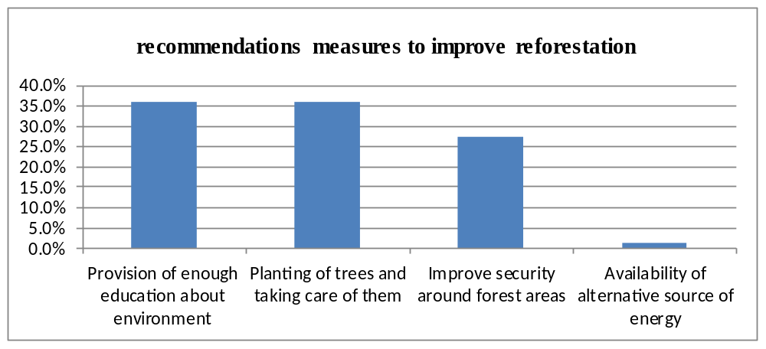

Figure 4.4: Recommended Measures to Improve Reforestation
Source: Researcher field Data 2016

Mitigation Measure and Suggestion towards Deforestation

Suggested measure to solve Problem of Deforestation
The results in Table 4.6 below shows that about 49.5% of the respondents suggest afforestation and reforestation as to overcome the problem of deforestation. Also 21.0% of respondents suggested logging controlled, 15.4% of respondents consider the improvement of security and laws enforcement as measure towards deforestation, 7.9% of respondents suggested that provision of education about environment should be provided as environmental assistance. Lastly 6.1% of respondents considered no pasturing of livestock around forest area.

The possible explanation of the findings is that stakeholder will be able to understand what exactly measures to this problem of deforestation after encourage individual and community participation toward the solving existing problem, the implication of these findings to the study is that deforestation can be solved when there is great interaction between stakeholder, government and community so as participation can lead to the various solution towards deforestation. Individual and stakeholder initially programmes dealt with extension in relation to conservation - awareness raising, agro forestry and conservation. At present, however, the project activities have been expanded to include afforestation, strengthening extension, range management, bee-keeping and land-use planning. Afforestation activities have concentrated on establishment of nurseries, tree planting, agro forestry and soil conservation.

Table 4.6: Measures to Solve Problem of Deforestation
Variable | Description | Frequency | Percentage (%)
Measure Will You Take to Solve Problem of Deforestation | Provision of enough education about environment  Improve security & law enforcement  Afforestation& reforestation  Controlling of cutting down of tree  No pasturing of livestock in forest areas  Total | 17  33  106  45  13  214 | 7.9  15.4  49.5  21.0  6.1  100.0
Source: Researcher Field Data 2016

Participation in Activity that Help to Eradicate Deforestation
73.7% of respondents have not participated in any activity that help to eradicate deforestation and 26.3% of respondents have participated in any activity that help to eradicate deforestation, the possible explanation for the finding is that many of respondents were not able to understand the attributes of participating in those activity, which are very potential on the solving problem of deforestation. The implication of these findings to the study is that the respondents are not willing to participate on activities that will help eradicate deforestation so as to keep on preserve deforestation activities to occur as they are not aware of it important
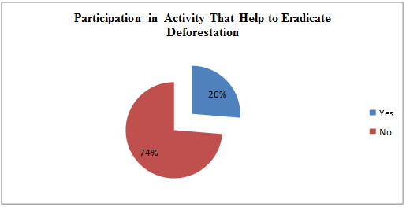

Figure 4.5: Participation in Any Activity That Help to Eradicate Deforestation
Source: Researcher field Data 2016

Recommendations Measure Should be Taken by the Community After the Problem Emerges
The results in Table 4.7 below shows that about 49.8% of respondents suggest that practice of good farming should be given priority to the community so as to overcome the problem of deforestation, also 44.0% of respondents suggested that community should practice afforestation and reforestation, capture all people who are practices deforestation, provision of education and to enforce forest laws. Lastly about 6.2% of respondents consider the provision of education to be the priority measure towards deforestation. The possible explanation of the findings is that community understands different means towards solving problem of deforestation but they lack support on solving the problem, the implication of these findings to the study is that there is the problem of implementation towards all the solution to the problem hence led to the problem continue to grow.

Table 4.7: What Measure Will Community Take after the Problem Emerges Soon
Variable | Description | Frequency | Percentage (%)
What Measure Will Community Take After the Problem Emerges Soon | Practice good farming | 112 | 49.8
 | Afforestation & reforestation | 99 | 44.0
 | Provision of Education | 14 | 6.2
 | Total | 225 | 100.0
Source: Researcher field Data 2016

Mitigation Measures to be Done by the Government
The results in table 4.8 shows that about 23.2% of respondents suggest that government should give priority to the improve market for farming output so as to overcome the problem of deforestation, also 28.2% of respondents suggested that government should provide enough education on environment. 29.7% of respondents consider the improve security and fine to be the priority measure towards deforestation, 3.8% of respondents suggested that government should provide alternative sources of energy cheap and affordable. Also 7.8% of respondents considered the provision of cheap tools for farming as only way government should deal with deforestation. Also 7.1% of respondents considered the afforestation and reforestation as only way government should deal with deforestation. The possible explanation of the findings is that majority of respondents understands the role that government play towards providing the solution to the problem, the implication of these findings to the study is that in order to overcome the problem the government should must make there is good implementation of those laws and by-laws as well as good monitoring of forest resources towards community involvement. Observation shows that deforestation in Tanzania is driven primary by public policies that stimulate agro- expansion, commercial logging for short term profit and massive land alienation hence when these public policies must be reviewed so as to overcome the problem (Barraclough and Ghimire, 1994). One of the forest officer say;
“The forest status is at stake as there is a high rate of forest distraction, in the meantime there is an ongoing operation conducted by central government in collaboration with the local government to combat the situation by dealing with the charcoal makers and sellers and subject them to fine, otherwise in five years’ time forest in Bahi will disappear”.

Table 4.8: What Mitigation Measures Dhould be Done by the Government
Variable | Description | Frequency | Percentage (%)
What Mitigation Measures should be done by the Government | To improve market for farming output | 79 | 23.2
What Mitigation Measures should be done by the Government | Provision of enough education about environment | 98 | 28.8
What Mitigation Measures should be done by the Government | Improve security and fine | 101 | 29.7
What Mitigation Measures should be done by the Government | To provide alternative sources of energy cheap and affordable | 13 | 3.8
What Mitigation Measures should be done by the Government | Cheap tools for farming | 25 | 7.8
What Mitigation Measures should be done by the Government | Afforestation and reforestation | 24 | 7.1
What Mitigation Measures should be done by the Government | Total | 340 | 100.0
Source: Researcher field Data 2016

CHAPTER FIVE

CONCLUSIONS AND RECOMMENDATIONS

Introduction
This chapter has comprised of main conclusion, recommendations for the improvements of studied topic and conclusion as proposed by the researcher. However, the chapter has significantly shown appropriate rational approaches to be taken to provide possible solution to the economic impacts of deforestation in Bahi district.

Conclusions
The main objective of this study was to assess the impact of economic factors on deforestation. The study was conducted in Bahi Districts in Dodoma region where deforestation is persistent. The study employed a multi-stage sampling procedure involving purposive selection of the study villages which are near to forest reserve areas at capturing how economic factor influence deforestation, mitigation measure, awareness and attitude of people towards deforestation .The study adopted both qualitative and quantitative approaches for collection and analysis of data related to impact of economic factors on deforestation.

The study findings reveal that there is diminishing forest resources due to economic factor. Fuel wood in the form of firewood and charcoal is the major source of energy for domestic use to a greater part of the sample population. The demand for fuel wood solution was highly expressed by respondents in villages which were most affected by deforestation indicated by long distances from homestead to firewood sources and increasing time consumed for firewood collection.

The study was guided by three specific objectives; the first objective was to identify economic factors for deforestation. Findings through descriptive analysis have shown that all factors as per conceptual framework have relationships with economic factors towards deforestation and that the perceptions on the major economic factors for deforestation are Charcoal making and sell, improper farming method, poor livestock keeping, lumbering and population increase. All these factors had increase deforestation in Bahi district and also discouraged potential to minimize deforestation.

The second objective of the study was to examine challenges which hinder effective afforestation in Bahi district. From the findings of the study the majority of the respondents acknowledged that they had at least tried to combat deforestation. However, from descriptive analysis on the respondents’ knowledge toward effective afforestation it was revealed that a majority of them had no or little knowledge of it. Even ward & villager official claimed to have little knowledge on operations of afforestation as well as on emerging obstacles. A majority of people in the study area were aware that there was something known as afforestation & reforestation but they did not have its details or even practise it.

The third specific objective was to examine mitigation measure towards deforestation. The mitigation strategy used by TANAPA, DONET and other forest officer to disseminate deforestation was advertisement through the word of mouth. Findings revealed that the strategy was negatively perceived as being selective and inefficient because it resulted into only few people being informed of the deforestation while the greater part of the sample population was not informed. Another weakness noted was that information dissemination was not continuous were held during the establishment of the DONET project in the study area, after which there were no more campaigns conducted. In addition there was insufficient training and inadequate technical services resulted to abandonment of planted trees.

Recommendations
In view of the major findings and conclusions drawn from the findings, the following recommendations are made for actions to be taken in order to solve the problem of deforestation for rural populations.
- To improve market for farming output Provision of enough education about environment
- Improve security and fine
- To provide alternative sources of energy cheap and affordable
- Cheap tools for farming
- Afforestation and reforestation
- Integration of other stakeholder who are affected by forest exploitation such as water.
- Involvement of community from early stage in order to own the project of reforestation

Area For Further Studies
This study was limited to deforestation situation in Bahi district of Dodoma region adding to earlier studies by Evans (2013). Since deforestation exists throughout the country, similar studies could be carried to other parts of the country to come up with comprehensive and professional recommendation and way forward for forest conservation and development in Tanzania.

REFERENCES
Ackoff, R. L. (1961). The Design of Social Research, Chicago: Chicago University Press.
Agyei, Y., (2009). Deforestation in Sub-Saharan Africa. African Technology Forum, 8(1), 1-4. Retrieved on 31st May, 2016 from web.mit.edu/africantech/www/articles/Deforestation.htm.
Ajzen, I. (1985). From Intentions to Actions: A Theory of Planned Behavior, in Kuhl, J. and Beckmann, J. (eds.). Action - Control: From Cognition to Behavior. Heidelberg: Springer.
Allen, J. C., & Barnes, D. F. (1985). The causes of deforestation in developing countries, Annals of the Association of American Geographers, 75(2), 163-184. Retrieved on 1st September, 2016 from onlinelibrary.wiley.com/doi/10.1111/j.1467-8306.1985.tb00079.x/abstract
Angelsen, A., Tron H., Mohammad S., N., (2009). Reducing Emissions from Deforestation and Forest Degradation (REDD): An Options Assessment Report, Meridian Institute for the Government of Norway. Retrieved on 11th November, 2016 from http://www.redd-oar.org/.
Antle, J. M. & Heidebrink, G. (1995), Environment and Development: Theory and International Evidence, Economic Development and Cultural Change, 43(3), 603-625. Retrievedon on 30th December, 2016 from https://econpapers.repec.org/RePEc:ucp:ecdecc:v:43:y:1995:i:3:p:603-25.
Antrop, M. (2000). Changing patterns in the urbanized countryside of Western Europe. Landscape Ecology. 15, 257–270. Retrieved on 7th August, 2016 from https://doi.org/10.1023/A:1008151109252.
Ayub, V. O. (2013). The Secrets of Hidden Knowledge: How Understanding Things in the Physical Realm Nurtures. London: Life Abbot Press
Bahi District Commissioner’s Office (2014). Bahi District Profile. Dar es Salaam: Government Printer.
Barraclough, S. and Ghimire, K. B. (2000). Agricultural Expansion and Tropical Deforestation. New Jersey: John Wiley & Sons Ltd.
Bhattarai, M., & Hammig, M. (2001). Institutions and the Environmental Kuznets Curve for deforestation: A crosscountry analysis for Latin America, Africa and Asia, World Development, 29(6), 995-1010. Retrieved on 25th February, 2016 from https://projects.ncsu.edu/project/amazonia/BhattaraiHammig.pdf.
Blomley, T., Pflienger, K., Isango, J., Zahabu, E., Ahrends, A. & Burgess, N. (2008). Seeingthe Wood for the Trees: An Assessment of the Impact of Participatory Forest Management on Forest Condition in Tanzania, Oryx, Fauna & Flora International, Vol. 42(3): 380–391. Retrieved on 21st September, 2016 from oi:10.1017/S0030605308071433.
Colchester, M. And Lohmann, L. (1993). The Struggle for land and the fate of forest. London: Zed Books.
Chomitz, K., Buys, P., De Luca, G., Thomas, T. and Wertz-K, S. (.2004). Policy Research Report. Washington, DC: World Bank.
Creswell, J. W. & Miller, D. (2000). Determining validity in qualitative inquiry. Theory into Practice Journal, 39(3), 124-130. Retrieved on 11th May, 2017 from http://www.tandfonline.com/doi/abs/10.1207/s15430421tip3903_2.
Culas, R. J. (2007), Deforestation and the environmental Kuznets curve: An institutional perspective. Ecological Economics, 61(3), 429-437. Retrieved from https://econpapers.repec.org/RePEc:eee:ecolec:v:61:y:2007:i:2-3:p:429-437 on 13th March, 2017.
Damas, K. & Augustino, M. (2010). Economical and Ecological Research of Bahi Swamp Final Report. Retrieved on 29th March, 2017 from www.wise-uranium.org/pdf/BahiSwamp.pdf.
ESRF, (2013). Annual Report. Retrieved on 5th April, 2017 from www.esrftz.org/pubdetails.php?id=233.
FAO, (2013). Sustainable Forest Management in a Changing Climate. FAO‐Finland Forestry Programme -Tanzania. A Fire Baseline for Tanzania. Retrieved from www.fao.org/forestry/39605-016494740dc4dd315b0b298b573b083b.pdf on 1st January, 2017.
Green, C. P. (1992). The environment and population growth, Decade for action. Population Reports. Series M: Special Topics. 10, 1-31. Retrieved from https://www.popline.org/node/321663 on 15th May, 2017.
Grossman, G. M., & Krueger, A. B. (1991). Environmental Impacts of a North American Free Trade Agreement. Cambridge: Cambridge University Press.
Hamilliton, A. C, & Bensted, R. (2000). Forest conservation in eastern usambara maountain in Tanzania. Nairobi: Man Graphics Ltd.
Hans, R. (2002). Theory and practice in social research, (3rd edition). New delhi: Surjeet Publications.
Kalapula, E. S., (1989). An Economic Assessment of Smallholder Tobacco Village Project in Tabora Region, M.A dissertation, University of Dar es Salaam, Tanzania.
Kikula, I. S. (1986). The influence of fire on the composition of Miombo Woodland of SW Tanzania, OIKOS Journal, 46(3), 317-324. Retrieved on 26th November, 2016 from https://www.jstor.org/stable/3565829.
Kothari, C. R., (2004). Research Methodology, Methods and Techniques. New Delhi: Welesy Eastern.
Kulindwa, K. and Shechambo, F. (1995). The impact of Rural Energy use on the Environment during the Economic Reforms Period (1981-1992), UTAFITI(New Series), 2(1&2), 110-131.
Kuznets, S. (1955). Economic growth and income inequality. American Economic Review, 45, 1-28. Retrieved on 16th July, 2017 from www.sciepub.com/reference/46496.
López, R. (1994). The environment as a factor of production: The effects of economic growth and trade liberalization, Journal of Environmental Economics and Management, 27(2), 163-184. Retrieved from https://econpapers.repec.org/RePEc:eee:jeeman:v:27:y:1994:i:2:p:163-184 on 18th August, 2017.
Michael, T. L. (1992). Deforestation of the Amazon: A Brazilian Perspective. GeoJournal 26 (3): 311-22. Retrirvrd on 17th July, 2017 from http://www.jstor.org/stable/41145398.
Mills Busa, J. H. (2013), Dynamite in the EKC tunnel? Inconsistencies in resource stock analysis under the environmental Kuznets curve hypothesis, Ecological Economics, 94(2013), 116-126. Retrieved on 10th November, 2016 from http://docslide.com.br › Documents.
Msuya, N., Masanja, E., Temu, A. K. (2011). Environmental burden of charcoal production and use in Dar es Salaam. Journal of Environmental Protection, 2011(2), 1364-1369. Retrieved on 14th April, 2016 from https://file.scirp.org/pdf/JEP20111000004_80996665.pdf.
Myers, N. (1994). Tropical deforestation: Rates and Patterns. Chicago: UCL Press
NBS, (2013). The 2011/12 National Household Budget Survey. Dar es Salaam: Government Printer.
Pachauri, E. and Batra R. K. (2001). Directions, Innovations and Strategies for Harnessing Action for Sustainable Development. New Delh: Multiplexus.
Panayotou, T. (1993), Empirical tests and policy analysis of environmental degradation at different stages of economic development. Working Papers, International Labor Office, Geneva. Retrieved on 16th June, 2016 from https://pdfs.semanticscholar.org/ca05/b529871726c3f7fb974bd76fa1229335e6de.pdf.
Patricia R. M. 2015 Reversal Of Fortune: Deforestation Of Amazon Rainforest Increased By 28% Over Past Year international business times
Rai, S. N. and Chakrabarti, S. K. (1996). Demand and Supply of Fuelwood, Timber and Fodder in India. Indian Forester, 127. 263-279. Retrieved on 11th July, 2017 from https://www.researchgate.net/publication/.
Ron, N. (2006). The Little Green Handbook: Seven Trends Shaping the Future of Our Planet. New York: Picador.
Sheila, N. (2008). The Final Energy, a study of energy trends, prospects, assets and liabilities in different political systems and regions, (2nd edition). London: Pluto Press.
Spracken, D., Yaron, G., Singh, T., Righelato, R. (2008). The Root of the Matter: Carbon Sequestration in Forests and Peatlands. London: Policy Exchange Publisher.
Sullivan, A. and Steven, M. S. (2003). Economics: Principles in Action. New Jersey: Pearson Prentice Hall.
UN-HABITAT, (2008). State of World’s Cities 2008/2009 Report. Retieved on 14th April, 2017 from https://unhabitat.org/year/2008/.
URT, (2014). Fifth National Report on the Implementation of the Convention on Biological Diversity. Dar es Salaam: Government Printer.
URT, (2012). National Strategy for Reduced Emissions from Deforestation and Forest Degradation (REDD+). . Dar es Salaam: Government Printer.
URT, (2012). National Report for the United Nations Conference on Sustainable Development. Dar es Salaam: Government Printer.
URT, (2012). National Strategy for Reduced Emissions from Deforestation and Forest Degradation (REDD+). Division of Environment, Office of the Vice-President. Dar es Salaam: Government Printer.
WWF-World Wild Life Foundation (2006) Report for a living planet. Global foot
Zhai, D. L, Xu, J. C, Dai, Z. C., Cannon, C.H, 2013. Increasing tree cover while losing diverse natural forests in tropical Hainan, China. Regional Environmental Change.

APPENDICES
Appendix I: Questionnaire for the households on the assessment of the impact of economic factors on deforestation
Question ID_______________Date______________Region____________________ District_____________ Ward_______________
A. Personal Particulars
- Name of Respondent __________________________
- Age ___________________________
- Sex ___________________________ (1) Male (2) Female
- Marital status: (1) Married (2) Single (3) Divorced (4) Widow (5) Widower
- Education Level: (1) University Level (2) College Level (3) Advance Secondary Level (4) Ordinary Secondary Level (5) Primary School Level (6) No formal Education
- Main Occupation: (1) Livestock keeping (2) Farming (3) Businessman/woman (4) Both 1 and 2 (5) Others (specify) _______________________
B. To identify economic factors for deforestation.
- Do you understand the meaning of forest? (1) Yes (2) No
- Is there any forest found in your area or community? (1) Yes (2) No
- If yes, name them………
- What is the situation of the forest in your area or community? (1) Good (2) Bad
- i. Do you understand the meaning of deforestation? (1) Yes (2) No
ii . Tick the correct answer Deforestation includes: (1) Cutting down of trees and burning of bushes (2) Keeping large number of animals (3) Demand for timber production and charcoal (4) Poor agriculture practices and ideology (5) Both of above answer are correct
- Are there any signs of deforestation in your local area? Yes/ no
If yes mention them………
- In your area is there any case of deforestation? (1) Yes (2) No
- At what rate and extant of deforestation is in your area or community? (1) High (2) Low (3) Moderate
- What causes deforestation in Bahi district? (Mention any 5 causes)
i)
ii)
iii)
iv)
v)
- Mention five economic activities which causes deforestation
i)
ii)
iii)
iv)
v)
- Mention five social impacts of deforestation towards community.

- Mention five economic impacts of deforestation to the community and environment.
I)
ii)
iii)
iv)
v)
C. Challenges which hinder effective forestation in Bahi district
- How is the effectiveness of the existing forestation activities in Bahi district
- Excellent B)Good C)Poor
- What are the existing forestation activities in the area ?( Mention any 5)
- What should be done to reduce or eradicate to improve forestation
D. Examine the mitigation measure and suggestion towards deforestation.
  - Are you aware on the forest conservation? (1) Yes (2) No
I) If yes, what is it? ___________________________________________
  - What measures will you take to solve the problem of deforestation? (Mention any 5)
  - Did you participate in any activity(s) that help in eradicate deforestation? (1) Yes (2) No
If yes, mention activity(s): ______________________________________
  - What measures will community take after the problem emerges soon? (Mention any 5)
  - What are mitigation measures should be done by government to solve the problem of deforestation? (Mention any 5)

APPENDICES II
Interview guide to key informants
- What are economic activities that influence deforestation? (Mention any 5)
- The rate of deforestation in your area or community? (1) High (2) Low(3) Moderate
- How is the trend of deforestation before, during and after five year to come will be? (1) Increase (2) The same (3) Decrease
- How is the effectiveness of the existing forestation activities in Bahi district
  - Excellent B)Good C)Poor
- What are the existing forestation activities in the area ?( Mention any 5)
- What are the challenges toward effectiveness of forestation?
  - Which one hinder more and why
- What should be done to reduce or eradicate those challenges
- Are the communities aware about forest conservation? (1) Yes (2) No
- Is there any forest conservation practices take place around your area? (1) Yes (2) No
- Have you ever joined to any forest conservation training? (1) Yes (2) No
- What are mitigation measures should be done by community to solve the problem of deforestation? (Mention any 5)
- What are mitigation measures should be done by government to solve the problem of deforestation? (Mention any 5)

