EMPIRICAL ANALYSIS ON PRODUCTIVITY OF CONTAINER TERMINAL IN TANZANIA: A CASE OF DAR ES SALAAM PORT GENERAL CARGO CONTAINER TERMINAL

LUCAS PASTORY MWISILA

A THESIS SUBMITTED IN FULFILLMENT OF THE REQUIREMENTS FOR THE DEGREE OF DOCTOR OF PHILOSOPHY OF THE OPEN UNIVERSITY OF TANZANIA
2018

CERTIFICATION
The undersigned certifies that he has read and hereby recommends for acceptance by The Open University of Tanzania a thesis entitled; “Empirical Analysis on Productivity of Container Terminal in Tanzanian: A case of Dar es Salaam Port General Cargo Container Terminal” in fulfilment of the requirements for the degree of Doctor of Philosophy of the Open University of Tanzania.

…..…….............................................
Prof. Deus D. Ngaruko
(Supervisor)

…..……......................................
Date

COPYRIGHT
No part of this thesis may be reproduced, stored in any retrieval system, or transmitted in any form by any means, electronic, mechanical, photocopying, recording, or otherwise without prior written permission of the author or the Open University of Tanzania in that behalf.

DECLARATION
I, Lucas Pastory Mwisila, do hereby declare that this thesis is my own original work and that it has never been presented and will not be presented to any other University for a similar or any other degree award.

…..……............................................
Lucas Pastory Mwisila

…..…….........................................
Date

DEDICATION
This thesis is dedicated to my parents Mr. Pastory Mwisila and Ms. Tereza Samwel for their endless prayer; my wife Naanjela John, my lovely daughter Tereza and all family Members of Mwisila Clan for their support and encouragements geared to completion of this thesis.

ACKNOWLEDGEMENTS
I thank God for being merciful in all situations that I underwent to the point when this thesis was successfully done.

This work from preliminary to conclusion was made possible and successful by the assistance, advice, critique, comments and encouragements from my supervisor Prof. D. D. Ngaruko. Other important challenges and constructive comments were from Dr. L. J. A. Kisoza, Mr. T. Lyanga, Dr. C. Awinia and Dr. A. Kishe who potentially enhanced my ability to accomplish this PhD Study. Heartily, I should convey my thanks to DMI and FASS academicians for being helpful in my study and tolerance for any inconvenience caused throughout the time of my studies.

ABSTRACT
This thesis presents an empirical analysis on productivity of Dar es Salaam Port General Cargo Container Terminal (DSM Port GCCT). The study examined productivity of DSM Port GCCT; determined DSM Port GCCT productivity model; and analysed future trend of the container traffic. The quantitative research method was used and numerical data were collected, analysed and discussed. The major findings in this study were that; DSM Port GCCT is productive due to increase in container terminal throughput (CTP) and container moves per hour (CMPH). DSM port GCCT productivity model has explanatory (predictors) variables that are jointly significant. The predictors have neither long-run nor short-run relationships because they are weak to stimulate the respondent variable. The weaknesses include the controversy that tonnage (TN1) and container ships (CS1) are decreasing while the container terminal throughput (CTP1) is increasing. On the other hand, the port is faced with congestion and delay despite the fact that, the increase in container moves per hour (CMPH1) increased CTP1. The scenario implies that the increase in CMPH1 does not reduce ship turnaround time. Also the increase in dwell time (DT1) makes containers stay longer at the port before being cleared. Furthermore, the container traffic forecast shows that the container terminal throughput will increase, hence terminal developments and fast container handling automations are required. It is recommended that, review of policies on tariffs, terminal operations, productivity factors, trade, financing and transport operations; and further study on productivity of the quay, yard, gate and cost effective areas be carried out.

TABLE OF CONTENTS
CERTIFICATION ii
COPYRIGHT iii
DECLARATION iv
DEDICATION v
ACKNOWLEDGEMENTS vi
ABSTRACT vii
TABLE OF CONTENTS viii
LIST OF TABLES xii
LIST OF FIGURES xiv
LIST OF ABBREVIATIONS AND ACRONYMS xv
CHAPTER ONE 1
1.0 INTRODUCTION 1
1.1 General introduction 1
1.2 Background of the Problem 3
1.3 Statement of the Problem 6
1.4 Delimitation of Research 7
1.5 Justification and Rationale of Study 7
1.6 Relevance of the Research 8
1.7 Research Objectives 9
1.7.1 General Objective 9
1.7.2 Specific Objectives 9
1.8 Research Hypotheses 9
1.9 Limitation of Research 9
1.9 Thesis Organisation 10
CHAPTER TWO 11
2.0 LITERATURE REVIEW 11
2.1 Overview 11
2.2 Conceptual Definitions 11
2.2.1 Port 11
2.2.2 Productivity 12
2.2.3 Containerization 12
2.3 Establishment of DSM Port 13
2.4 Theoretical Review 14
2.5 Empirical review 19
2.5.1 Global container business 19
2.5.2 Container Terminal Productivity 21
2.5.3 Productivity Factors for Global Container Terminal 24
2.5.4 Effects of Containerization on Global Container Terminal Productivity 25
2.5.5 Container Business in Eastern and Southern Africa 27
2.5.6 Container Business between Dar es Salaam port and Mombasa Port 27
2.5.7 Container Business at Dar es Salaam Port 28
2.5.8 Container Business at DSM Port General Cargo Container Terminal 29
2.6 Policy Review 30
2.7 Research Gap 32
2.8 Conceptual Framework 33
2.9 Theoretical Framework 35
2.10 Specific Hypotheses 36
2.11 Summary 37
CHAPTER THREE 39
3.0 RESEARCH METHODOLOGY 39
3.1 Chapter Overview 39
3.2 Research Design 39
3.3 Research Paradigm 39
3.4 Research Strategy 40
3.5 Research Approach 40
3.6 Area of Research 40
3.7 Sampling Design and Procedures 41
3.8 Variables and Measurement Procedures 42
3.9 Methods of Data Collection 43
3.10 Data Processing and Analysis 43
3.10.1 Examining Productivity of DSM Port GCCT 44
3.10.2 Developing DSM Port GCCT Productivity Model 45
3.10.3 Analysis of Future Prospect of DSM Port GCCT Container Traffic 61
3.11 Triangulation in Quantitative Research 62
3.12 Validity and Reliability 62
3.13 Ethics 63
3.14 Summary 64
CHAPTER FOUR 65
4.0 RESULTS AND DISCUSSION 65
4.1 Chapter Overview 65
4.2 Productivity of DSM Port GCCT 65
4.2.1 Container Terminal Throughput (CTP) at DSM Port GCCT 65
4.2.2 Container Moves per Hour (CMPH) at DSM Port GCCT 66
4.2.3 Dwell Time (DT) at DSM Port GCCT 67
4.3 DSM Port GCCT Productivity Model 68
4.3.1 Test for Fitness and Goodness of the Model 73
4.3.2 Causality analysis of DSM Port GCCT Productivity Model Predictors 79
4.3.2.1 Causality Analysis Relationships 79
4.3.2.2 Causality Analysis of Factors Affecting DSM Port GCCT Productivity 80
4.4 The Future Prospects of DSM Port GCCT Container Traffic 86
4.5 Summary 88
CHAPTER FIVE 90
5.0 CONCLUSIONS AND RECOMMENDATIONS 90
5.1 Chapter Overview 90
5.2 Conclusions 90
5.3 Recommendations 95
REFERENCES 97
APPENDICES 107

LIST OF TABLES
Table 2.1: Container throughput at DSM port 29
Table 3.1: Benchmarked Productivity Factors 44
Table 3.2: Stata Results for Variables Approximately Normally Distributed 45
Table 3.3: DSM Port GCCT average benchmarked productivity factors 47
Table 3.4: Stata Results for Variables Approximately Normally Distributed 48
Table 3.5: Syntax for Common Data Transformations 51
Table 3.6: Box-Cox Transformation Stata Output 54
Table 3.7: Transformed Variable CTP1and Residual (e) 54
Table 3.8: Regression Model Output for Transformed Variables 55
Table 3.9: VIF Stata Output for Transformed Explanatory Variables 56
Table 3.10: Lags Selection Order Criteria 57
Table 3.11: Cointegration analysis by Augmented Dickey-Fuller 58
Table 3.12: Cointegration Analysis by Trace and Max Statistics 60
Table 3.13: Regression Output for Forecasting Equation 62
Table 4.1: Container Throughput (CTP) 66
Table 4.2: Container Moves per Hour (CMPH) 66
Table 4.3: Dwell Time (DT) 67
Table 4.4: Correlation Matrix – Pairwise Correlation 69
Table 4. 5: Regression Model Output for Six Correlated Predictors 70
Table 4.6: VIF Stata Output for Six Correlated Predictors 71
Table 4.7: Regression Model Output for Five Correlated Predictors 71
Table 4. 8: VIF Stata Output for Five Correlated Predictors 72
Table 4.9: Regression Model Output for Four Correlated Predictors 72
Table 4.10: VIF Stata Output for Four Correlated Predictors 73
Table 4.11: Normality Tests 74
Table 4.12: Normality Tests 75
Table 4.13: Heteroscedasticity Tests 76
Table 4.14: Autocorrelation Tests 76
Table 4.15: Test for White Noise 77
Table 4.16: Causality of GCCT Productivity Model 79
Table 4.17: Test for Short-Run Causality 80
Table 4.18: Regression Model Output of Transformed Variables 81
Table 4.19: Generation of Containerships’ and Draft from pre 1970 – 2012/20 87

LIST OF FIGURES
Figure 1.1: DSM Port Throughput (TEU) from 2005 - 2014 4
Figure 2.1: Closed Loop Control System 14
Figure 2.2: Container Terminal System with Four Main Sub systems 15
Figure 2.3: Containership Capacity from 1968 to 2018 20
Figure 2.4: Throughput at DSM Port GCCT from 2011 - 2015 30
Figure 2.5: Conceptual Container Terminal Productivity Model 34
Figure 3.1: DSM Container Terminal Layout (GCCT and TICTS) 41
Figure 3.2: Scatter Plots with Fitted Lines 48
Figure 4.1: Normal Distribution of Residuals 74
Figure 4.2: Cumulative Periodogram White-Noise 78
Figure 4.3: Residuals Plots 78
Figure 4.4: Throughput Forecasts (TEU) from 2016 - 2023 86

LIST OF ABBREVIATIONS AND ACRONYMS
AIC Akaike’s Information Criterion
ADF Augmented Dickey-Fuller
AIC Akaike’s Information Criterion
BoC Berth Occupancy
BU Berth Utilisation
CCTT Capital Costs per Tonnage in TEU
CSLC Centre for the Study of Living Standards
CLCS Closed Loop Control System
CMPH Container Moves per Hour
CMPH.LD Container Moves per Hour - Lagged Difference
CSM Container System Model
CTP Container Terminal Throughput
CTP.LD Container Terminal Throughput - Lagged Difference
CU Crane Utilisation
DSM port Dar es Salaam port
DT Dwell Time
FEU Forty-foot Equivalent Unit
FPE Final Prediction Error
GU Gate Utilisation
GCCT General Cargo Container Terminal
GDP Gross Domestic Product
HQIC Hannan and Quinn Information Criterion
HMC Harbour Mobile Cranes
HTT Horizontal Transport Time
H₀ Null Hypothesis
ICT Information Communication Technology
LCTT Labour Cost per Tonnage in TEU
LD Lagged difference
LCL Less Container Load
LR Likelihood Ratio
Ltd Limited
LL Log Likelihood
MFP Multi Factor Productivity
NTP National Transport Policy
NS Number of Ships
OLCS Open Loop Control System
OECD Organisation for Economic Cooperation and Development
OCTT Operational Cost per Tonnage in TEU
PMAESA Port Management Association of Eastern South Africa
RTT Revenue per Tonnage in TEU
RMT Review of Maritime Transport
SFP Single Factor Productivity
SBIC Schwarz’s Bayesian Information Criterion
SSGC Ship to Shore Gantry Cranes
STT Ship Turnaround Time
SU Storage Utilisation
SUMATRA Surface and Marine Transport Regulatory Authority
TICTS Tanzania International Container Terminal Services
TPA Tanzania Port Authority
TRC Tanzania Railways Corporation
TAZARA Tanzania Zambia Railways
TQE TEU across Quay Edge
TGS TEU Ground Slots
TTT Truck Turnaround Time
TEU Twenty-foot Equivalent Unit
ULCS Ultra Large Container Ship
UNCTAD United Nations Conference on Trade and Development
USD United States Dollars
VIF Variance Inflation Factor
VARM Vector Auto-Regression Model
VECM Vector Error Correction Model

CHAPTER ONE

1.0 INTRODUCTION

1.1 General introduction
Economics is based on how to manage the scarce resources. According to Krugman (1997) an organisation providing services such as container terminal is intentionally accountable for the input of resources used against the output (services) delivered. Wang, Song and Cullinane (2003) stipulated that, the container terminal requires inputs resources such as labour, land, quay length, terminal area, number of gantry cranes, number of yard gantry cranes and number of straddle carrier in order to be in position to provide the required services to respective ship size and capacity.

Container terminal have been continuously restructured by building new ones, employing modern handling equipment and ICT facilities. Similarly, the container terminal supports the development of hinterland connectivity, infrastructures for intermodal, empower human resources with relevant skills, cooperate with private sector in investing and operating ports so as cope with new generations of ships in order to remain competitive in business.

Globally, the marine ports in which some of the terminals or whole port is dedicated for handling containers are under-pressure of the containerization processes which jeopardises productivity. According to Bernhofen et al (2014) the 1950s was the era when shipping business seemed unprofitable and Maclean thought of having integrated transport system where cargo could be moved door to door from producer to customer. Maclean thought came into effect when he purchased Ideal –X Vessel (a World War II tanker-ship) and redesigned to make it capable of accommodating 58 containers.

The vessel made its first voyage in 1956 from port Newark to port Houston. That time handling of containers at ports were done by cranes designed for other purpose. Three years later in 1959 cranes designed purposely for handling containers were made available and by average productivity gains in terms of tonnage handled per hour was forty times more than the longshore gang. The penetration of the container aided with technological changes in transport modes and port operations has made containerization to be among the drivers of the 20th century economic globalization.

Since the invention of container (metal box) business in 1956 several changes have been observed in the container business in terms of containership growth, increase in container throughput and standardization of containers. The commonly standardized container sizes are known as Twenty-foot Equivalent Unit (TEU) and Forty-foot Equivalent Unit (FEU) (Stopford, 2009). According to UNCTAD (2015) in the year 2014 established that the World’s largest terminal operator handled 65.4 million TEUs. Productivity in terms of Container Moves per Hour (CMPH) for the world’s top ten when measured showed that, APM terminals at Yokohama was the most efficient container terminals and performed 180 CMPH.

In the Sub-Saharan region, the container business was projected to grow. The growth facilitated by container ships with draft equal to or more than 14.5m which are expected to move for the South - South trade route where few ports in Africa such as South Africa and Egypt are likely to benefit. Furthermore, UNCTAD (2015) reported that in year 2013 the most efficient country was South Africa with average throughput of 4, 694,500 TEUs and the tenth was Namibia with throughput of 124,815 TEUs. Tanzania was among the top ten in the 7th position with throughput of 526,321TEU (UNCTAD, 2012).

1.2 Background of the Problem
Tanzania is a maritime country; with 1,424 km coastline. The coastline comprises common ports including; DSM port, Tanga port, Mtwara port and other small ports like Kilwa, Lindi and Mafia. DSM port is the second largest after Mombasa port in East Africa. The port is the gateway as it handles cargo from Tanzania and neighbouring countries. The port has a Quay length of 2.6 km with a total of 11 berths. Berths 1 to 7 are operated by Tanzania Port Authority (TPA) and handle break-bulk cargo, dry bulk cargo, Roro and containerized cargo at what is known as General Cargo Container Terminal (GCCT). Likewise berths 8,9,10 and 11 are dedicated for container handling and are operated under concession by the Tanzania International Container Terminal Services (TICTS) Ltd. DSM port facilitates trade at micro and macro levels of economy.

At macro level the port facilitated the movement of containers as a gate way to countries which are landlocked and at the same time linking them to international markets. Likewise, at micro level the employees and community benefit in terms of salaries and revenues respectively for the services provided by the port. Dar es Salaam port is accessible 24 hours a day and can accommodate ships of maximum length of 234 metres and draft of 10.5 metres independent from tidal. DSM port also provides other services such as handling of oil, passengers and fishing boats (TPA, 2007).
The container terminal at DSM port was designed with capacity of 250,000 TEU. However, as shown in Figure 1.1 the capacity was surpassed in the year 2005 due to increasing container traffic. The container handled during the year 2005 reached 258,389TEU and containerized cargo was 59% implying that more cargoes were being carried in containers (TPA, 2007). According to TPA (2013), during the year 2012/2013 annual container throughput was 399,961TEU indicating the continuous growth of container traffic. On the other hand DSM Port GCCT for the period from 2010 to 2014 increased the container moves per hour. The increase was from 8.5 moves per hour in 2010 to 16.6 moves per hour in 2014 (TPA, 2015a; TPA, 2015b).

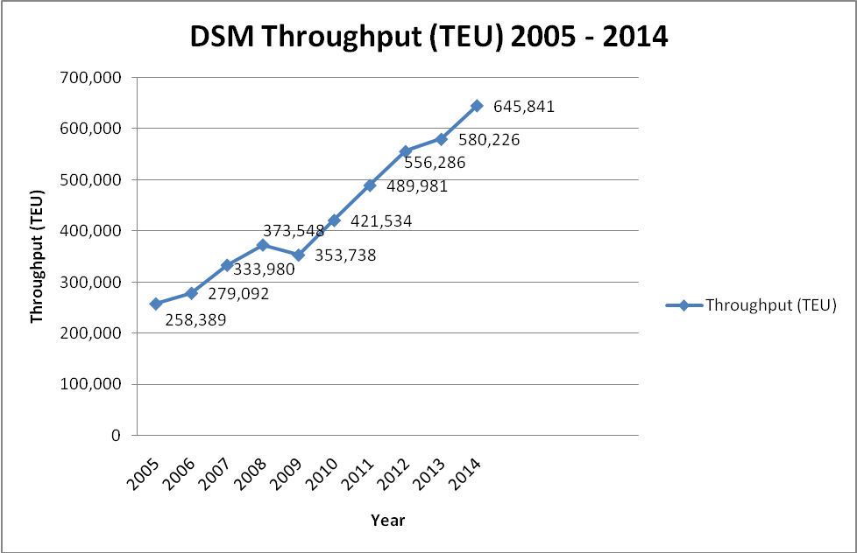
Figure 1.1: DSM Port Throughput (TEU) from 2005 - 2014
Source: PMAESA (2011), MRT (2015) and TPA (2015)

The number of moves per hour indicates growth in container traffic per annum; the growth in container traffic at DSM Port GCCT was substantial when mathematically interpolated monthly. Due to inadequacy information on DSM Port GCCT productivity; information which were used in calculations were berth length 555metres, peak factor 1.3, TEU factor, 1.4 and Ground Slot 1200 TEUs. The researcher conducted this study in order to have more indicative productivity factors affecting the port and hence bridging knowledge gap on port productivity.

Productivity at DSM port is being hampered by long waiting time where in average the ship take 10 days to wait for services. Other measures such as Dwell time for import and export was 10 days and 6 days respectively while container moves per hour (CMPH) was by average 13 CMPH The inadequacy in productivity was caused by delays in the operation process at anchorage, berthing, loading, unloading, custom clearance and exiting the port. The inadequacy lead to prices increase of goods as a result volume of imports and exports decreased.

When price of intermediary goods are higher for local producer it implies higher price for finished products. When price of local and imported finished goods are higher, the purchasing power of consumers is reduced resulting in decrease in consumption levels and welfare. The decrease in consumption reduces demand of goods and supply of tonnage (ships) hence revenue and profits from port operators, local producers and the Nation (GDP) are reduced. Tanzania is losing a lump sum of about USD 157 billion per year which is equivalent to 3 percent of annual public revenue. Similarly, consumption by Tanzanian household could have saved 8.5% of total expenditure or USD 147 per year if the port could be productive. The value of merchandise passing at the port of DSM was USD 15 billion which was equivalent to 60% of Tanzania’s GDP in 2012 (World Bank, 2013).

TPA (2011, 2012, and 2013) reports pointed out four different types of productivity factors published annually. The productivity factors include container moves per hour (CMPH), Ship turnaround time (STT), dwell time (DT) and berth occupancy (BoC). Among the four productivity factors three which are STT, DT and BoC were generalized and only MPH was separately discussed for GCCT and TICTS. Handlings of inbound and outbound containers at the port of DSM were not smooth due to reportedly traffic build-up (congestion) and inadequacy container distributions across modes of transport. For example, cargoes moved to the hinterland from the port of DSM; only 9.1% were transported by railway of which 5.8% were transported by Tanzania Railways Corporation (TRC) and 3.3% by Tanzania Zambia Railways (TAZARA). On the other hand the road sector carried about 90.6% of cargoes (TPA, 2007).

It was found in literature review that DSM container terminal is faced with delay at anchorage, berthing, unloading, loading, and customs clearances. Similarly, the port is having inadequacy in terms handling facilities, space and channel limitations in terms of draft. This study exhausted as much as possible the various productivity measures benchmarked from the literature review and developed the container terminal productivity regression model that conforms to Tanzanian conditions. The productivity model is developed for the purpose of bridging the gap that was found by the researcher as very little was known in regard of the effects of containerization on GCCT productivity. The findings will also, help to improve container terminal productivity and broaden the understanding to port mangers, community and other stakeholders.

1.3 Statement of the Problem
The General Cargo Container Terminal (GCCT) at DSM port is operated publically by TPA. Container ships have grown larger in terms of size and capacity on the other hand the operations of container terminal had been slower in container handling to match the capacities carried by these ships. Shipping companies, shippers and the public desire that DSM Port GCCT is productive for the benefits of the nation and shippers. The DSM Port GCCT is under pressure of container traffic resulting into port congestion and delays.

TPA reports on productivity factors for the container terminal were aggregated. The information found by researcher from literature review was inadequate to describe the Productivity of DSM Port GCCT, effects of productivity factors on entire container terminal and its prospective trend. The problems were that the port was faced with delay, congestion and loss of revenue; however, very little was known about productivity of DSM Port GCCT. One of the reasons could be that there was no well designed and tested terminal productivity model conforming to Tanzanian ports.

1.4 Delimitation of Research
This study was delimited to the Dar es Salaam Port General Cargo Container Terminal (DSM Port GCCT) only, the time frames for data collection was from the year 2011 to year 2015 because the data before 2011 was not easily accessible.

1.5 Justification and Rationale of Study
Productivity at DSM container terminal has been presented by several authors as it was found from literature review. Reports from Tanzania Ports Authority (TPA, 2011, 2012 and 2015) provided information in aggregate on productivity factors such as container moves per hour (CMPH), ship turnaround time (STT) and dwell time (DT). Similarly, SUMATRA (2009) in the process to improve productivity provided productivity benchmarks for factors such as CMPH = 25 TEU, STT = 3 days, BoC = 60% and container throughput (CTP) 17,500 TEU.

However, the World Bank (2013) reported that CMPH and DT were the bottlenecks facing DSM port; the report went further by pointing out that DSM port was not productive resulting in loss of revenue due to congestion and delay. Therefore, this study was justified because the researcher needed information on DSM Port GCCT productivity, productivity factors and their respective effects but was inadequate. The researcher used the benchmarks from SUMATRA, to examine productivity of DSM Port GCCT and developed DSM Port GCCT productivity model which was analysed in order to have an insight on causality relationship, effects of model predicator, and future throughput trend. Also, suggested ways to improve productivity of container terminals in Tanzania.

1.6 Relevance of the Research
This study is relevant and provides an insight and adds knowledge through literature on DSM Port GCCT productivity model, causality, effects of predictors on the model and throughput trend. The awareness will help port managers to seek and keep detailed container information, evaluate port productivity, improving and develop container terminal ports prudently. Similarly, other Stakeholders in container business would inquiry right information if need be because of this awareness.

1.7 Research Objectives

1.7.1 General Objective
This was an empirical analysis on productivity of container terminal in Tanzania; the case study of Dar es Salaam port general cargo container terminal (DSM Port GCCT).

1.7.2 Specific Objectives
The proposed study has the following specific objectives:-
- To examine productivity of DSM Port GCCT
- To develop DSM Port GCCT productivity model
- To analyse the future prospects of DSM Port GCCT container traffic

1.8 Research Hypotheses
The respectively hypothetical statements for the specific objectives are:-
- H₀₁: The mean CTP, CMPH, STT, BoC and DT from collected data are not greater than hypothesised CTP = 1,700TEU, CMPH = 25TEU, STT = 3 days, BoC = 60% and DT = 6 days.
- H02: There is no significant relationship between the respondent variable CTP and the jointly explanatory variables TN, CS, STT, CMPH, CU, TQE, BoC, BU, TGS, SU and DT.
- H03: CTP forecast trend influences positively DSM Port GCCT operations at the quay yard and gate.

1.9 Limitation of Research
The Review of literature identified the quay, yard, gate and cost effective as the potential areas contributing to container terminal productivity. The researcher relied on quantitative secondary data and only productivity factors from the quay and yard were benchmarked. The gate and cost effective areas were eliminated due to inaccessibility of data. Nevertheless, the researcher carried on the study as the quay and yard were crucial areas in the analysis of the container terminal productivity. All kind of perception information related to productivity of container terminal and the study presentation based on secondary data drawbacks thought were eliminated by collecting information from various sources followed by data checking, comparing accuracy and relevance.

1.9 Thesis Organisation
This thesis comprises five Chapters. Chapter one explains the background of the problems, statement of the problem, research objectives, research hypotheses, relevance of the research, delimitation of research and limitation of research. Chapter two reviewed the literature related to containerization, theories, container business and productivity factors globally and locally. Furthermore, hypotheses were developed and the summary was provided. Chapter three discussed the research methodology in terms of research strategy, populations, area of research, sampling design and procedures, variable and measurement procedures, methods of data collection, data analysis, validity, reliability, ethics and summary. Chapter four presented the finding, discussed the results and summarized the findings of this study. Chapter five provided the conclusion and recommendation.

CHAPTER TWO

2.0 LITERATURE REVIEW

2.1 Overview
This chapter reviewed the existing literature from which productivity and containerization were defined. The review also, helped to have a broader and thoroughly understanding of the DSM port, container terminal, productivity, containerization, theories, container business and research gap.

2.2 Conceptual Definitions

2.2.1 Port
A port according to UNCTAD (1975) represents ‘a collection of physical facilities and services designed to serve as an interchange point between land and sea transport’. Esmer (2008) defines a sea port as ‘a terminal as area within which ship are loaded and or unloaded with cargo and includes the usual places where ships wait for their turn or are ordered or obliged to wait for their turn no matter the distance from the area’. The definition of port from UNCTAD (1975) and Esmer (2008) was internalized by the researcher who provided the following definition:-

A port is an interface comprised of terminals formed of infrastructures and superstructures intending for serving cargo and passenger ships. The cargoes include general cargo, containers, liquid bulk and dry bulk. The infrastructure is mainly the quay connecting the water and land while the superstructure are for cargo and or container handling, the yards are for temporary storage of imports and exports, the buildings for offices’ facilitations and warehouse for storage of parcels. Therefore, the container terminal is a dedicated node for handling import and export containers.

2.2.2 Productivity
Krugman (1997) defined productivity as the ratio between output volume and volume of input; OECD (2001) defines productivity as a ratio of volume of output to a volume of input; while Kumar and Suresh (2008) defines productivity as the quantitative relationship between what is produced and resources used to produce them. It can be expressed as the ratio of output over input.

The definitions of productivity provided by Krugman and OECD are similar and meaningful; the researcher adopted the definition of productivity ‘as a ratio of volume of output to a volume of input’. In determining productivity three key issues were considered, these were firstly, input variables and output variables with their respective unit measures identified and secondly, productivity factors benchmarked from literature review. Because prosperity of an entity depends on its own rate of productivity growth; any economic activity such as the container business needs to measure its productivity to justify the use of input resources which could be allocated to other economic activities and for improvement purposes.

2.2.3 Containerization
According to UNCTAD (1991) containerization is simply carrying cargo in a box of standard dimensions known as the ‘container’. The commonly container sizes are known as Twenty -foot Equivalent Unit (TEU) and Forty-foot Equivalent Unit (FEU). The FEU is twice in size as much as the TEU. The definition of containerization provided by UNCTAD (1991) was meaningful; the researcher adopted the definition of containerization as ‘a box of standard dimensions used for carrying cargoes. Shipping of cargoes by containers have reduced to a great extend the transport costs and transport time. The containerization resulted in standardizing operations at ports because they are automated mechanically by machines when loading or unloading on ships, trucks and rail.

According to Prabhu and Rendell (2014) envisage that shipping of cargo through containers have been made easy, fast, secure, efficient and smoothly moved across different modes of transport from factory to truck, rail, ship, barge to final destination and vice versa for both finished goods and raw material. Likewise, planning, handling, safety, security and reverse logistics have become reliable than shipping loose cargo. The use of containers has posed several challenges in terms of space, repositioning, stacking, Un-employment and financing as the container terminal by nature is capital intensive. However, the benefits of using the containers are enamours in terms of government revenue, and consumptions of multiple goods. So managers should prudently venture on container business.

2.3 Establishment of DSM Port
DSM Port is the major port along that coastline, the origin of DSM port is sighted back as early as 1860s when the Harbour of Dar es Salaam was dominated by Arabs until 1880s when Sultan of Zanzibar was compelled to lease to Germany East Africa Company the collections of customs dues at Dar es salaam and Pangani. However the arrival of the Officer of the German Company on a Warship at Dar es Salaam on 25th May, 1887 was regarded by the Arabs and Some African as Intrusion and there was resistance in several places including Dar es salaam. The resistance so called ‘Arab revolt’ or ‘Bushiri uprising’ was neutralized by the German Government by gunfire power.
In January 1891 Dar es Salaam was made the capital of German East Africa centre, during the year the entrance channel was buoyed and the Light house was built in 1894. Other developments of DSM port as per printed British map in 1916 showed three sheds and a jet where heavy goods and material and fuel were unloaded respectively. Material and fuel were loaded for the construction of rail started in 1905. Until the year 1968 total tonnage at the port of Dar es Salaam was 2,143 tonnes, no single container delivery was registered at DSM port despite the fact of container existence in 1956 (Mascarenhas, 1970).

2.4 Theoretical Review
According to UNCTAD (1976) stipulated the importance of having a control system from which the actual output can be measured and compared with the desired output of an operation or a process. Two control systems have been discussed in regard of gang productivity as an indicator. Firstly, the ‘Open Loop Control System (OLCS)’, this system has no feedback loop and secondly, the Closed Loop Control System (CLCS), this system has feedback loop.

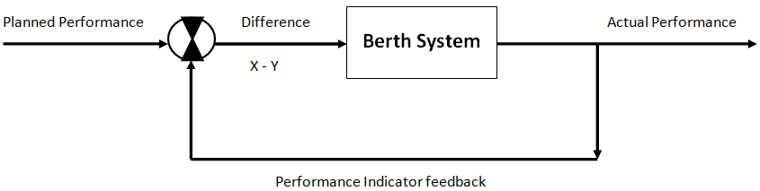Figure 2.1: Closed Loop Control System
Source: UNCTAD (1976)

In OLCS the management becomes aware when productivity is very poor and there are a lot of complaints from customers while in CLCS (Figure 2.1) shows, the management timely identify the area holding down productivity and takes steps to improve. CLCS provides performance indicator feedback from which the planned performance can compare to actual performance. Furthermore, Henesey (2004) on the Container System Model (CSM) in Figure 2.2 shows that, the container terminal system has four sub systems whose functions affect the performances of each other. The sub-systems included the ship-to-shore movement, transfers, storage and delivery -receipts. The sub systems involve allocating berth to ships, pilotage, unloading and loading (import and export) of containers, moving containers to yard, transhipment and the inbound and outbound containers through the gate.
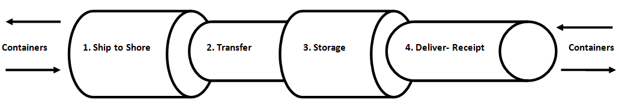
Figure 2.2: Container Terminal System with Four Main Sub systems
Source: Henesey (2004)

Rankine (2003) and Esmer (2008) said that the container terminal has four main areas including the quay, yard, gate and cost effective. The Quay is concerned with schedules of arriving ships, allocations of wharf space, cranes and other resources necessary to serve the ship. The quay productivity depends very much on length of berth, number of ships, size of ships, percentage cargo exchange, transhipment, speed of operations, personnel and type of facilities and equipment used. Secondly, the yard is the busiest stage in the terminal; it is concerned with loading and unloading of container to and from the ship to yard, shuffling of containers, redistributions of containers to other blocks, loading onto second vessel and inter-terminal haulage. The yard productivity depends very much on area of yard, personnel, stacking techniques, advanced logistics systems, modern facilities and equipment.

The gate deals with receiving and delivering of containers. At the yard the freight forwarders take delivery of inbound containers through the gate and bring in outbound to be loaded onto ships. Thirdly, the gate productivity depends very much on number of gates, personnel and advanced logistics systems. Lastly, the cost effective depends on factors of productions such as land, capital, labour, entrepreneurship and technology as necessary inputs used to provide the required services of handling containers. In carrying out calculations for the monthly numeric value for the benchmarked productivity factors at DSM Port GCCT; the following information such as the General Cargo Container Terminal berth length 555metres, peak factor 1.3, TEU factor 1.4 and Ground Slot 1200 TEUs were used. Similarly the mathematical equations 1 to 10 for the respective productivity factors were used.

- Ship Turnaround Time (STT)
Radmilović and Jovanović (2006) describe that Ship Turnaround time is the average time the unit (ship) spends in the system. The single waiting line model is modified to suite the container terminal system by adding the average berthing time and average un-berthing time is given by the equation 1:-
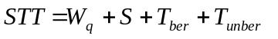 (1)

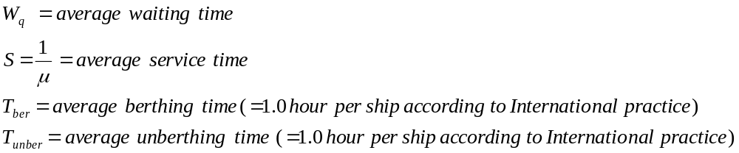
- Container Moves per Hour (CMPH)
Container moves per hour (Radmilović and Jovanović, 2006) is given by the equation 2:-
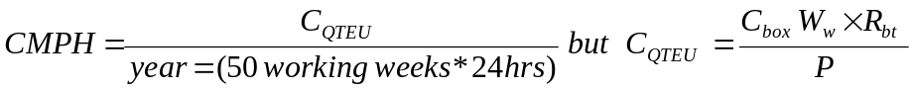 (2)
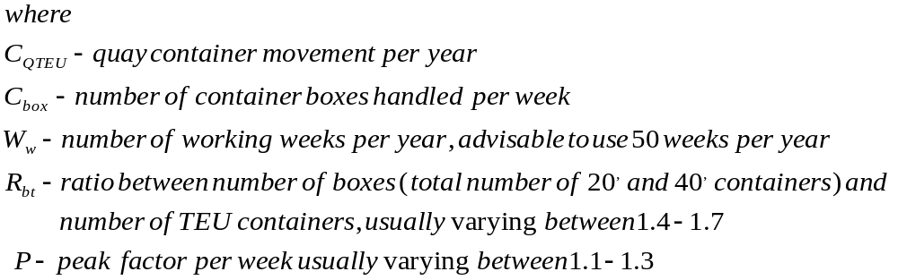
Container moves per hour (Ligteringen, 2009) is given by the equation 3:-
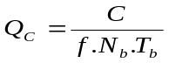 Where
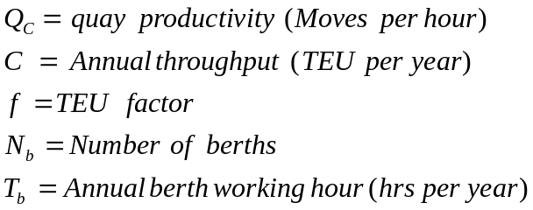 (3)
- Crane Utilisation (CU)
Crane utilisation (Tioga, 2012) is given by the equation 4:-
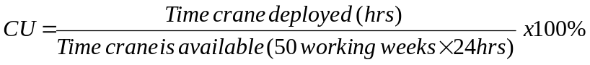 (4)
- TEUs across Quay Edge (TQE)
TEU across quay edge (Rankine, 2003) is given by the equation 5:-
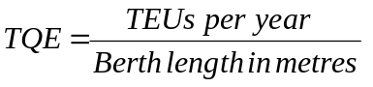 (5)
- Berth Occupancy Rate (BoC)
Berth occupancy rate (Radmilović and Jovanović, 2006) is given by the equation 6:-
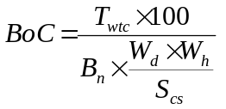 (6)
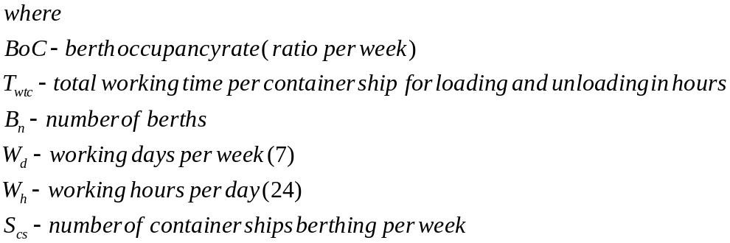
- Berth Utilisation (BU)
BU = Berth utilisation (Esmer, 2009) is given by the equation 7:-
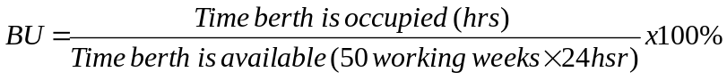
(7)
- TEU Ground Slots (TGS)
TEU per yard area (Rankine, 2003; Esmer, 2009; SUMATRA, 2009 & Tioga, 2012) is given by the equation 8:-
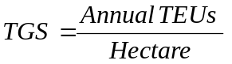 (8)
- Storage Utilisation (SU)
Storage utilisation (Esmer, 2009) is given by the equation 9:-
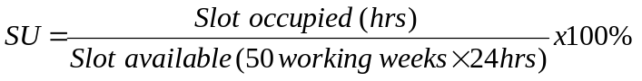 (9)
- Dwell Time (DT)
Dwell time (Rankine, 2003 &Esmer, 2009) is given by the equation 10:-
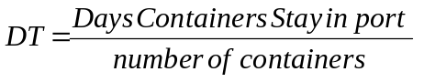 (10)

2.5 Empirical review

2.5.1 Global container business
Starting from the pre-1970 period, ships from first generation had a draft of 9 metres and average capacity of about 1,700TEUs (Appendix 1). Furthermore, from the year 2012 to date modern Ultra Large Container Ship (ULCS) capable of handling a maximum of 14,000 TEUs to 22,000 TEUs and draft of > 16m have been deployed (UNCTAD, 2011). According to UNCTAD (2011) five ships of capacity 12,800 TEUs are to be upgraded to 16,000TEUs and twenty ships with capacity of 18, 000 TEUs are in book of order.

The major container terminals that exist today can handle ships carrying a maximum capacity of 18,000 TEUs to 22,000 TEUs; above this capacity a major restructuring on the quay-wall, channel (draft) and superstructure are required in order to accommodate these ships. Similarly, according to World Maritime News (2017) bigger container ships as shown in Figure 2.3 have been deployed. The ships include Marco pollo (CMA CGM) with capacity of 16000+TEU deployed in 2012, Maersk Mc-Kinney Møller with capacity 18,270TEU deployed in 2013 and CSCL Globe/MSC Oscar with capacity 19,000+TEU deployed in 2014/15. Either in 2018 the container business expects to embrace containership with capacity of 22,000TEU.

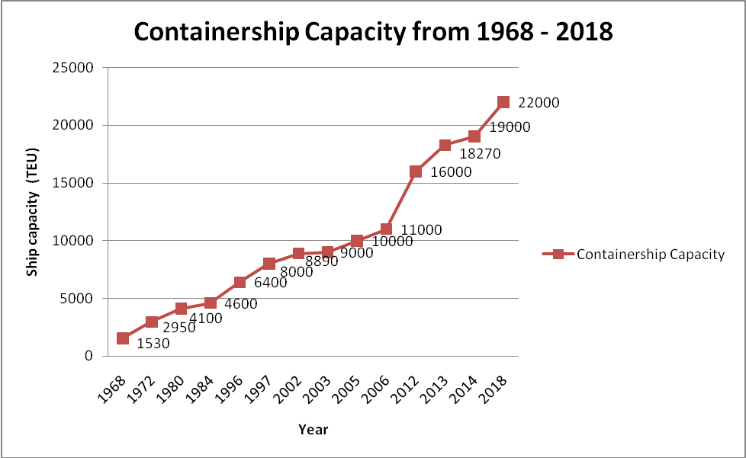
Figure 2.3: Containership Capacity from 1968 to 2018
Source: World Maritime News- Figure made by Author

These large ships known as Ultra large/ Very Large are expected to dominate the East – West trade route where draft is more than 18m replacing the existing ships of lower capacity. The replaced ships are expected to move for the South - South trade route where few ports in Africa (i.e. South Africa and Egypt) with draft equal to or more than 14.5m are likely to benefit. The effects of these ships are felt by all maritime players and the whole supply chain (UNCTAD, 2012). UNCTAD (2014, 2015) reported that the global containerization grew by 4.6 percent in 2013 and by 5.3 in 2014 to make the total volume of 160 million TEUs and 171 Million TEUs respectively.

2.5.2 Container Terminal Productivity
Productivity is greatly stressed in this study because is a controllable variable of economy which has a multiplying effect to other economic variables. ‘The importance of productivity comes from the fact that, an organisation providing services is intentionally accountable of the input resources used against the output (services) delivered (Krugman, 1997). According JOC Group (2014) higher productivity at the container terminal are something ports should strive for; these doesn’t mean only productivity factors such as ship turnaround time (STT) calculated at the berth but through the port to respective supply chain networks for both the inbound and outbound containers in order to improve the entire flow of trade.

Productivity can be increased or improved when more goods and services are produced by either adding more inputs or some factors in utilisation of resources for production of goods and services, have been well managed to raise output with less or same level of inputs. Measuring productivity depends very much on the nature of an organisation and the number of inputs used to produce goods and services expected. When a single input is used then the single factor productivity (SFP) can be measured and when more than one input are used the multi-factor productivity (MFP) can be measured (Pritchard, 2002). The quality and quantity of inputs intended to produce certain goods or services would result in production of quantity and qualities outputs required. The change in productivity could be an outcome of capacity utilisation, advancement in technology, economy of scale and efficiency in operation and management.

The prosperity of any organisation depends on its own rate of productivity growth. The contribution of productivity to economic growth and competitiveness are substantial and very useful for comparisons and country performance assessments globally. An organisation striving for prosperity emphasises on productivity as an important element of success. The Macro-economic and Micro-economic studies on productivity help the organisation and the respective stakeholders to use productivity factors as indicators and tool for accountability on input resources consumed to produce goods and or services.

In Macro-economics productivity helps to trace the effect of technological change, assess the productive capacity and compare productivity across international markets for decision making (i.e. policy making, drivers of growth and forecasting). On the other hand Micro-economic productivity helps to identify drivers of productivity growth, technical efficiency and reallocation of resources. Similarly, it can help in providing information on other characteristics of a firm such as size, location, competition, managerial practices, research and development and input/output mix (Mai and Warmke, 2012).

The Organisation for Economic Co-operation and Development -OECD (2001) provides indicators to trace changes in firstly technology; where change can be in terms of new technological techniques in designing and quality of goods and or services and intermediary inputs. Secondly, Efficiency; where change can be in terms of new techniques employed in profit or services maximisations using new technology. Thirdly, real cost saving; where change can be in terms of new techniques used in reducing costs in production or services delivery. Fourthly, benchmarked production processes; where productivity of the factory to factory processes can be compared to identify inefficiencies.

Fifthly, living standards; where change or development of living standards can be in terms of per capita income directly varying with labour productivity. For single input factors such as labour a single productivity factors was used and where there were more input factors such as labour, capital and intermediary inputs (energy, material and services) then multifactor productivity measure was used. Tanzania being among the maritime players and in supply chain network has felt the effect of containerization, the deployment and shifting of ships from one route to another route created centres for hub and spoke. The container terminal in Tanzanian requires to strive to remain in business by ensuring productivity in all aspects. CSLC (1998) stipulates that productivity should be that accumulate capital, human capital development and the technological development enhanced by research and development.

2.5.3 Productivity Factors for Global Container Terminal
Tioga (2012), SUMATRA (2009) and Rankine (2003) provided some indicative factors for assessing productivity of the container terminal. The factors include; ship turnaround time, Crane moves per hour, TEUs per hour, berth utilization/occupancy, TEUs per gate hour, dwell time and yard density. UNCTAD (1976) provides a summary of financial and operational indicators to be used in general cargo terminal. The financial indicators include Tonnage worked, Berth occupancy revenue per ton of cargo, Cargo handling revenue per ton of cargo, Labour expenditure per ton of cargo and Capital equipment expenditure per ton of cargo. The operation indicators include: Arrival rate, waiting time, Service time, Turn-around time, Tonnage per ship, Fraction of time berthed ships worked, Number of gangs employed per ship per shift, Tons per ship-hour in port, Tons per ship hour at berth, Tons per gang–hour and Fraction of time gangs idle.

The indicators are conventional and can be used to measure container terminal productivity. The indicators are very essential in assessing productivities of the container terminal in general and of the individual activities related to operations of the container terminal. They provide picture of the output (actual) which can be compared against what were planned. The output information is important for decision making therefore the indicators should be precise and not ambiguous.

Likewise, Esmer (2008) provided seven different core productivity factors to be used in monitoring productivity. However there can be more than the identified core productivity depending on the nature and depth of the desired outcome. The seven core productivities are ship productivity, equipment productivity, quay productivity, terminal area productivity, labour productivity, crane productivity and cost effective ((Appendix 3).

Esmer (2008) citing Bichou and Gray (2004) provided two categories of port performance indicators as suggested by UNCTAD (1999); that the macro performance indicators quantify aggregate port impacts on economic activities while the micro performance indicators evaluates input/output ratio measurements of port operations. The concept of macro and micro performance provide opportunity for the whole economic activities to be dealt and studied collectively and or individually and results be provided individually or as an aggregate about the efficiency use of resources which can be quantified by means of measuring productivity of the container terminal. Furthermore, according to UNCTAD (2015) in 2014 (Appendix 1), the APM terminals Yokohama in Japan was the most efficient container terminals and performed 180 CMPH followed by Tianjin Port Pacific International which performed 144 CMPH while the tenth in position were Yantian International and Nansha Phase 1 which performed 117 CMPH each.

2.5.4 Effects of Containerization on Global Container Terminal Productivity
Tomlinson (2009) pointed out that containerization has changed the transportation pattern which in turn affected the whole socio-economy arena. The effects are obvious; ports are subjected to intensive capital and human development in order to have enough capacity in terms of handling facilities, navigable channel and skilled labour. The massive handling and automation of containers resulted into reduction of port spaces, labourers and warehouses because containers are their own stores. Other effects occurred at the shipyard where gigantic ships were built, integration of transport modes, growth in shipping company, emerges of new markets, more access to markets and availability of varieties of commodities. Furthermore, the effects is the mismatch of demand and supply may result into surplus or shortage because of the imbalance in trade which leads to congestion, delays, idleness (infrastructures/superstructures), costs related to extra burning of fuel, wages and inventory (Jugović, Hess and Jugović, 2010).

Demand of cargoes from shippers, supply of transport services (container ships), container terminal productivity and the availability of input resources are driving forces in shipping of containers which require prudent decision and strategic approach to reduce the shipping costs and delays across the whole supply chain-network. According to UNCTAD (2012 and 2015) the World container trade grew by 7.1% and world container port throughput estimated to increase by 5.9% during the year 2011. On the other hand the amount of cargo increased from 1464 tons in 2012 to 1631 tons in 2014.

According to John (2009), the effects of shipping containers have resulted in reallocation of industries because of lack of space in cities. For example at ports, the containers demanded technological change, more space, modern infrastructures, equipment, facilities and hinterland connectivity. Therefore, some port functions were reallocated to less developed locations and or develop new ports because of limited space and congestions in cities surrounding the port. Similarly the container being a standardized unit has reduced costs related to insurance, inventory, transport and other related shipping logistics.

2.5.5 Container Business in Eastern and Southern Africa
Containerization growth in the Sub-Saharan was projected to increase due to reasons based on market expansions as large proportions of region’s population join the middle class, infrastructure improvement and increase of foreign investment to catch Africa’s markets (UNCTAD, 2014). Tanzania being economically viable to potential investors, growth in population, improved living standards and having surrounded by some countries not open to sea expect to reap from the spill over of containerization business. PMAESA (2011) report revealed that container throughput has been increasing in all ports operating in the area of its administrations since 2005 to 2009.

Either during the year 2009 the most efficient container terminal was Durban with average throughput of 2,395,175 TEUs or the tenth was Beira with throughput of 92,236 TEUs. Dar es Salaam port being the area of study in 2009 was among the top ten in the 6th position with throughput of 353,738TEUs and the near port Mombasa was in third position with throughput of 618,816TEU (Appendix 4). Moreover, according to MRT (2015) in year 2013 the most efficient country was South Africa with average throughput of 4, 694,500 TEUs and the tenth was Namibia with throughput of 124,815 TEUs. Tanzania was among the top ten in the 7th position with throughput of 526,321TEU (Appendix 5).

2.5.6 Container Business between Dar es Salaam port and Mombasa Port
DSM port is not alone in the container business; it has nearby competitors such as Mombasa port, Beira port and Maputo port and Durban Port. Despite of its geographical advantages, DSM port is the second in terms of container throughput when compared to Mombasa port. Congestion, delay and hinterland connectivity waive the geographical advantages Tanzania has against Mombasa and other near ports. For the past eight years between 2005 and 2012 inclusively, throughput between DSM port and Mombasa port have been increasing.

Throughput in 2005 was 258,389 TEUs for DSM port and 436,671 TEUs for Mombasa port. Throughput have been increasing throughout the period, in 2012 it has reached 556,286 TEUs for DSM port and 903,463 TEUs for Mombasa port. Throughout the period the market share has been to the average of 37 percent and 63 percent for DSM port and Mombasa port respectively as shown in Appendix 6 (PMAESA, 2011 and MRT 2015). It is obvious that DSM port is running after Mombasa port, DSM port is challenged to run before and after Mombasa port in order to justify its geographical advantages it has over the Eastern and Southern African ports by focussing on productivity of its container terminals and prudent investments.

2.5.7 Container Business at Dar es Salaam Port
The container business at Dar Es Salam port has been growing; according to TPA (2015a, b) reports only five productivity factors, including firstly, container terminal throughput (CTP) which was increased from 487,813 TEU in 2011 to 645,841 TEU in 2014; Secondly, container moves per hour (MPH) which was increased from 17 MPH in 2011 to 22 MPH in 2014; Thirdly, ship turnaround time (STT) which was reduced from 6.8 days in 2011 to 3.6 days in 2014; fourthly, dwell time (DT) which was reduced from 11.5 days in 2011 to 9.9 days in 2014 and fifthly, berth occupancy (BoC) which was reduced from 83 % in 2011 to 75 % in 2014. There had been up and downs for STT, BoC and DT as shown in Table 2.1. In order to improve productivity of container terminal SUMATRA (2009) provided benchmarks which were CMPH = 25; STT= 3; BoC = 60% and DT = 6. Taking CMPH as an average per hour then the average monthly throughput (25*50*7*24/12) = 17,500TEU. It goes without saying that some improvements have been made and container traffic at DSM port has substantially increased.

Table 2.1: Container Throughput at DSM Port
Year | Throughput | Number of Vessel | Ship Turnaround Time | Moves Per Hour | Dwell Time | Berth Occupancy
2011 | 487,813 | 477 | 6.8 | 17 | 11.5 | 83
2012 | 581,146 | 357 | 8.5 | 16 | 9.5 | 89
2013 | 580,226 | 427 | 3.5 | 21 | 9.3 | 73
2014 | 645,841 | 492 | 3.6 | 22 | 9.9 | 75
Source: TPA (2015a, b)

2.5.8 Container Business at DSM Port General Cargo Container Terminal
Throughput has been by average increasing, as shown in Figure 2.4, throughput increased from 240,792TEU in 2011 to 368,967 in 2015; however, there was a fall in 2013 and sharp increase in 2014, The reason could be from imbalance in trade, market replenishment and loss of market due to congestion and delays. Likewise, the container moves per hour at DSM Port GCCT for the period from 2010 to 2014 has been increasing.

The container moves per hour increased from 8.5 CMPH in 2010 to 16.6 CMPH in 2014 (TPA, 2015a, b). Lu and Park (2013) found the terminal cranes and yard tractor to be the critical productivity factors of container terminal; therefore the increase in CMPH indicates either an increase in container automation resulted from employing more modern equipment and else work extra time and or growth in container traffic per annum. This is a potential growth and researcher wanted to have an understanding of DSM Port GCCT productivity and more indicative productivity factors with their relevant effects on productivity of container terminal. The researcher focused on the quay and yard areas because of constraints such as time, finance and unavailability of data for the gate and cost effectiveness.

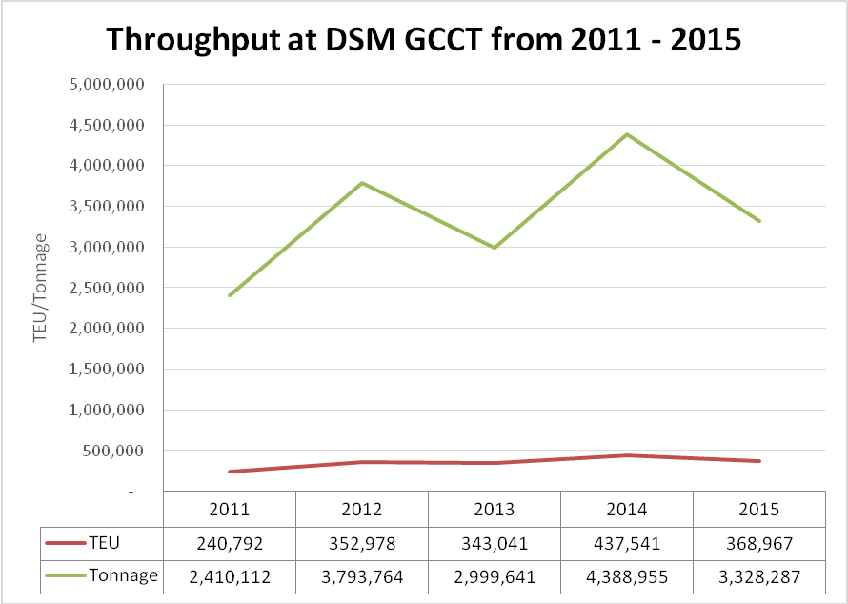
Figure 2.4: Throughput at DSM Port GCCT from 2011 - 2015
Source: TPA – DSM Port GCCT

2.6 Policy Review
Stopford (2009) stipulates that the change in European economy in 1960s was triggered by change in trade policies. Trade was facilitated by opening of borders, production for export, multinational cooperation, efficient shipping and agreement policy on tariffs and trade. International trade and shipping is risk and volatile for that matter there should be strategic choice and flexible policies in regard on shipping markets and cycles in regard of costs, financing and transport operations.
According to UNCTAD (2016), pointed that ‘supporting the maritime sector is no longer a policy choice’, ‘Port and shipping business is the key enabler of countries foreign trade’. Policy makers need to be strategic, keen and careful to identify potential subsector in maritime requiring to be developed. The subsectors should be that add value to national economy and stimulate growth of other sectors. The port and shipping business generates income and employment; the port and shipping business providing handling services, easing mobility, connecting markets and ensuring reliable supply of consumers’ wants.

International trade and pattern is greatly influenced by Government policies and interventions. Policy on expansion port market services on hinterland to facilitate international trade and transit of cargo from neighbouring countries; policy on competitive markets in terminal operations, pricing and intermodal transport ensuring fair business and connectivity and policy on productivity ensuring that terminal facilities, equipment, human resource, information and technology are efficiently used to avoid delay and uncertainty.

The National Transport Policy (2003) reported that, transport sector in Tanzania, experiences hindrance in its operation which makes the sector to be characterized by high costs, low quality service, inadequate infrastructure, regulation and other dissenting ministerial/institutional arrangements. The high cost is stipulated in Review in Maritime Transport (2011) that, transport costs are very high in Africa as compared to the rest of the world. It is estimated that shipping of goods to last destination in Africa is 10.6 per cent of total shipping cost while in developed countries is 6.4 per cent of the total shipping cost. The consequences for difference in transport costs are greatly associated with improper managing of container traffic at ports, handling equipment, communication facilities, space usage and the multimodal transport. The commonly means of transport associated in container shipping are identified as ships, trucks, rail-wagons and barges. Containers loaded or unloaded at DSM port are shipped to other ports through waterways and to the hinterlands through roadways and railways.

Mankiw (2004) discussed the issue of trade said ‘trade can make everyone better off; Tanzania stands in a better position in international trade if can strategically and prudently finance and invest in maritime subsector with comparative advantage. National transport policy should provide the balance for all players taking part in shipping business and environment protections. DSM Port GCCT as key player in shipping provides services in container handling form which generates income and employment. There should be flexible polices in pricing (vessel size, types of cargo and time spent at berth), replacement and maintenance of facilities, equipment, financing, employees, safety and security and terminal leasing which ensures a win-win business among all parties.

2.7 Research Gap
Several studies on productivity of the container terminal have been done globally and locally. TPA (2011) indicated that container traffic has been increasing and the port is experiencing inadequacy capacity to accommodate the container traffic. The increase in container traffic in turn raises ship turnaround time, dwell time and delay for both the inbound and outbound container flow. These impediments caused some shipments from nearby countries like Zambia to go to Durban. For example in 2006 shipment of cargo from Zambia through Durban was 624,000 tons exceeded 559,000 tons from Zambia to Dar es Salaam (Haralambides et al, 2011).

The World Bank (2013) report pointed out that, if DSM port could be productive; Tanzania and its neighbouring countries could have gained 2.6 billion (TZS) while Tanzania alone could gain1.8 billion (TZS). From the review of this study, DSM container terminal is faced with delay at anchorage, berthing, loading, unloading and customs clearances. Similarly, the port is having inadequacy in terms of handling facilities and limitation on size of container ship. The researcher did not find adequate information on productivity of DSM Port GCCT and there was no model for DSM Port GCCT productivity. For that matter very little is known about productivity of DSM Port GCCT, causal relationships of variables, effects of model predictors and trend of container traffic could be established.

The study therefore needs to exhaust as much as possible on various productivity factors benchmarked from the literature review, develop a container terminal productivity model that conforms to Tanzanian conditions. The productivity model is likely to increase container terminal productivity and broaden the understanding of port mangers, community and other stakeholders.

2.8 Conceptual Framework
The Conceptual framework for DSM Port GCCT productivity was developed by amalgamating the theories from Henesey (2004) on the Container System Model and from UNCTAD (1976) on Closed Loop Control System (CLCS) found from theoretical review. The researcher internalized the two theoretical models CLCS by UNCTAD (1976) and CSM by Henesey (2004). The two theoretical models were found to have no adequate information on key areas of the container terminal and their respective productivity factors and effects. Therefore, the amalgamation of theories were necessary in order to come up with a modified Schematic Container Terminal Productivity Model (CTPM) to include firstly, the quay which allocate berth to ships, pilotage, transhipments, unloading and loading (import and export) of containers.

Secondly, the yard which allocate containers to yards, transhipments and customs clearance. Thirdly, the gate does the checking and exit/entry, and Fourthly, the cost effective which deal with finance issues. The model has four areas; three being physical and one being operational. The physical areas include quay productivity, yard productivity and gate productivity and the fourth is cost effective as shown in Figure 2.5. The container processes (containerization) across quay, yard, gate and cost effective accounts to GCCT productivity.
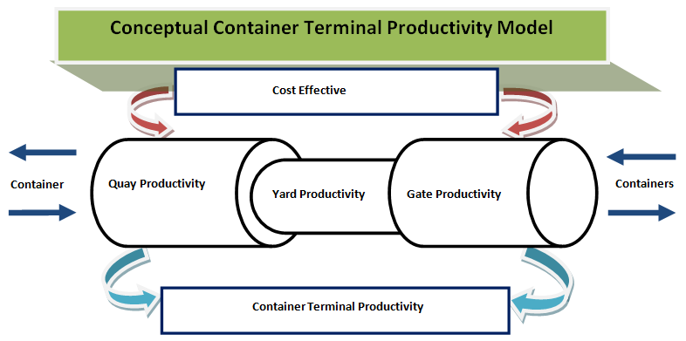
Figure 2.5: Conceptual Container Terminal Productivity Model
Source: Modified by Author

2.9 Theoretical Framework
Creswell (2009) citing Kerlinger (1979) provided a definition of theory as “an interrelated set of constructs (variables), definitions, and propositions that represents a systematic view of phenomena by specifying relations among variables, with purpose of explaining natural phenomena”. The theoretical model by UNCTAD (1976) and Henesey (2004) stipulated the importance of having benchmarks productivity which can be compared to actual productivity from which analysis can be made and decision made.

According to Rankine (2003) and Esmer (2008), the container terminal has four main area which contribute to productivity of the container terminal; the areas include the quay, yard, gate and cost effective. The benchmarked productivity factors from the four areas include Terminal Throughput (CTP), Number of Ships (NS), Ship Turnaround Time (STT), Container Moves per Hour (CMPH), Crane Utilisation (CU), TEU across Quay Edge (TQE), Berth Occupancy (BoC), Berth Utilisation (BU), TEU Ground Slots (TGS), Storage Utilisation (SU), Dwell Time (DT), Horizontal Transport Time (HTT), Truck Turnaround Time (TTT), Gate Utilisation (GU), Labour Cost per Tonnage in TEU (LCTT), Operational Cost per Tonnage in TEU (OCTT), Capital Cots per Tonnage in TEU (CCTT) and Revenue per Tonnage in TEU (RTT). The identified productivity factors have been locally and globally reported depending on purpose and interest of stakeholders (UNCTAD 2015, TPA, 2015, Tioga, 2012, PMAESA, 2011 SUMATRA, 2009).

However, this study on productivity of DSM Port GCCT considered productivity factors from yard and gate because of the availability of data. Therefore, the dependent (respondent) variable was the Container terminal throughput (CTP) and the explanatory variables were Container Ships (CS), Tonnage (TN), Ship Turnaround Time (STT), and Container Moves per Hour (CMPH), Crane Utilisation (CU), TEU across Quay Edge (TQE), Berth Occupancy (BoC), Berth Utilisation (BU), TEU Ground Slots (TGS), Storage Utilisation (SU) and Dwell Time (DT).

2.10 Specific Hypotheses
According to Kumar (2005), hypotheses are prediction of what the researcher expects the results to show. This was an empirical analysis on productivity of the DSM Port General Cargo Container Terminal (DSM Port GCCT) was for containers handled for the past five years. Data were collected, analysed and conclusion made. The explanatory variables were the benchmarked productivity factors and the responded variable was the container terminal throughput; in this study the three specific objectives with their respective developed hypotheses comprises the respondent variables and explanatory variables are as follows:-
- To examine productivity of DSM Port GCCT
Container throughput at DSM Port GCCT increased. SUMATRA (2009) set productivity standards for DSM port. These were CTP = 1,700TEU, CMPH = 25TEU, STT = 3 days, BoC = 60% and DT = 6 days. The researcher’s assumption is that productivity has increased and is greater that the set standards. The hypothesis for this assumption is:-
H₀₁: The mean CTP, CMPH, STT, BoC and DT from collected data are not greater than hypothesised CTP = 1,700TEU, CMPH = 25TEU, STT = 3 days, BoC = 60% and DT = 6 days.
- To develop DSM Port GCCT productivity model.
H02: There is no significant relationship between the respondent variable CTP and the jointly explanatory variables TN, CS, STT, CMPH, CU, TQE, BoC, BU, TGS, SU and DT.
- To analyse future prospects of DSM Port GCCT container traffic.
H03: CTP forecast trend influences positively DSM Port GCCT operations at the quay yard and gate.

2.11 Summary
It was found from literature review that containerization has changed the transportation pattern. Container business was found growing both globally and locally. Bigger ships have been built requiring more depth, use of electronic automation software to easy the scheduling, payments, scanning, security, safety, navigations and space management. This study was guided by modified Schematic container terminal productivity model focusing on quay and yard areas. The benchmarked productivity factors were Container Ships (CS), Tonnage (TN), Ship Turnaround Time (STT), Container Moves per Hour (CMPH), Crane Utilisation (CU), TEU across Quay Edge (TQE), Berth Occupancy (BoC), Berth Utilisation (BU), TEU Ground Slots (TGS), Storage Utilisation (SU) and Dwell Time (DT. It was revealed from the literature review that Tanzania could have gained more if its ports would be productive.

DSM container terminal is faced with delay at anchorage, berthing, loading, unloading and customs clearances. Similarly, the port has inadequate handling facilities and draft limitation on size of container ship. The researcher did not find adequate information from which DSM Port GCCT productivity and causality could be based. One of the reasons could be the absence of a productivity model from which the explanatory and respondent variables are expressed. For that matter very little is known about the productivity of DSM Port GCCT, causal relationships, factors affecting DSM Port GCCT productivity and trend of container traffic. The study therefore, exhausted as much as possible the various productivity factors benchmarked from the literature review and developed DSM Port GCCT productivity model that conforms to Tanzanian container terminal conditions. The productivity model is likely to increase container terminal productivity and broaden the understanding to port mangers, community and other stakeholders.

CHAPTER THREE

3.0 RESEARCH METHODOLOGY

3.1 Chapter Overview
This chapter discussed the research methodology in terms of research design, study paradigm, research strategy, research methods, population, area of research, sampling design and procedures, variable and measurement procedures, methods of data collection, data processing and analysis, Triangulation, validity, reliability and ethics.

3.2 Research Design
The research design for this study is a ‘case study’ which emanated from the research problem and objective. The research case study design was justified on grounds that; the study was specifically on productivity of container terminal. The study aimed at analysing productivity of DSM Port GCCT. The research design provided a direction from which the relevant numerical data were collected, analysed, interpreted, presented and reported with minimum expenditure of efforts, time and money. This was an exploratory research study intended to discover ideas and insights. The research design in case of this exploratory research study had opportunity to survey relevant literatures which were used in developing the hypotheses, data collections and analysis (Kothari, 2004). The data were obtained from secondary sources at DSM Port GCCT which was study area.

3.3 Research Paradigm
This study employed a deductive approach from which the general understanding of productivity of container terminal in Tanzania were inferred based on the case study at DSM Port GCCT. According to Keller (2007), inferential statistics is a body of methods from which conclusions or inferences on characteristics of the population can be drawn based on sample data. The Researcher used Using Quantitative research method and the historical numerical data were collected from the quay and yard in regard of the benchmarked productivity factors from literature review. This empirical study on productivity of of DSM Port GCCT was analysed in regard of the hypotheses developed from the specific objectives. Saleemi (2011) said that hypothesis testing techniques enable to decide on value of population parameter basing on sample data. The hypotheses developed were tested, analysed, discussed and confirmed at 0.05 alpha levels.

3.4 Research Strategy
This is a case study of DSM Port GCCT, the terminal was purposely selected and its productivity was analysed using the data collected from quay and yard in regard of the specific objectives and their respective developed hypotheses. The results were analysed, tested and confirmed by the researcher (Kothari, 2004).

3.5 Research Approach
The research method used in this study was quantitative research method. The dependent and independent variables were numerically presented. According to Kothari (2004), when the concept is capable of being presented as a number or being coded then quantitative research method must be employed.

3.6 Area of Research
Tanzania has several ports in the mainland and Zanzibar which provide container handling services. Among these ports the major port is Dar es Salaam, the port was selected as a study area due to its wider connectivity and growth of container throughputs. DSM port has several terminals for handling containers, general cargo, dry bulk and liquid bulk. The port provides services to local and international customers and contributes to the economic development of Tanzania and that of the neighbouring countries. The port as shown in Figure 3.1 is located in the Vicinity of the City of Dar Es salaam in the mainland.
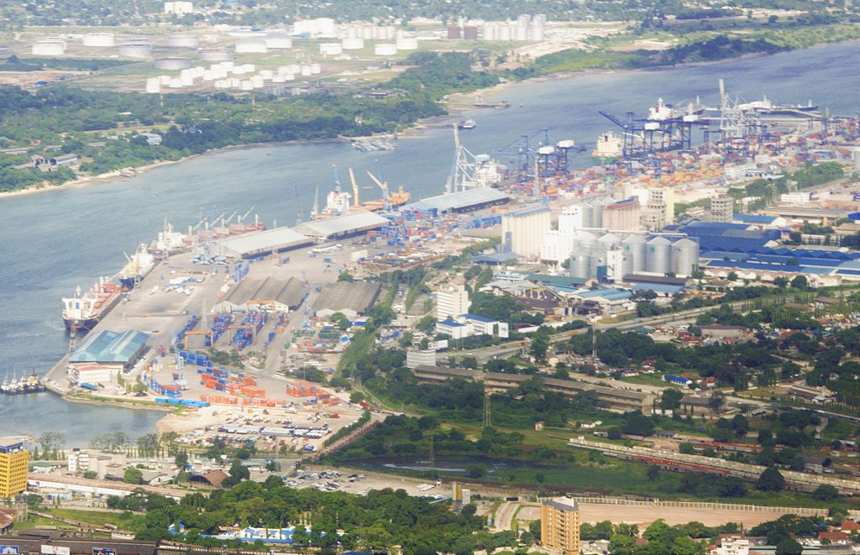
Figure 3.1: DSM Container Terminal Layout (GCCT and TICTS)
Sources: https://en.wikipedia.org/wiki/port_of_Dar_es_Salaam

3.7 Sampling Design and Procedures
It was the researcher’s desires to explore and have information on productivity of DSM port. DSM Port GCCT was selected using purposive sampling because of availability of data, potential growth of container throughput and competitiveness to TICTS. DSM Port GCCT was launched for the purpose of reducing or alleviating container congestions after TICTS saturation. The operations of DSM Port GCCT would in aggregate reduce STT, increase CMPH and hence curb the problems of delays at DSM port. However, the port of Dar es salaam was facing challenge of the increase in ship turnaround time and dwell time (TPA, 2013). The data required for this research were mainly quantitative and were randomly sourced from secondary sources in relation to container traffic at GCCT. The data were used to examine productivity of DSM Port GCCT, develop productivity model and analyse its future prospects.

3.8 Variables and Measurement Procedures
The study looked into the relationship between the dependent and independent variables of DSM Port GCCT productivity. The respondent variable is the DSM Port GCCT productivity represented by monthly container terminal throughput (CTP) measured in TEU. On the other hand the explanatory variable is the container terminal processes represented by the benchmarked productivity factors including Tonnage (TN) measured in Ton, Container Ships (CS) measured in unit number, Ship Turnaround Time (STT) measured in days, Container Moves per Hour (CMPH) measured in TEU moves per hour, Crane Utilisation (CU) measured in TEU per year per crane, TEU across Quay Edge (TQE) measured in TEU per metre per year , Berth Occupancy (BoC) measured in percentage, Berth Utilisation (BU) measured in unit, TEU Ground Slots (TGS) measured in annual TEU per hectare, Storage Utilisation (SU) measured in unit and Dwell Time (DT) measured in days.

3.9 Methods of Data Collection
The methods of collecting data were selected depending on the hypotheses addressed, type of sample and desire of the researcher to have information in depth. Rogelberg (2007) stipulates the importance of understanding the depth and breadth of the problem being addressed before embarking in the process of gathering data. The researcher surveyed and sorted secondary data in relevance of research study context. The data collection methods, limitations, delimitation, time, reliability and validity of information collected from the study were systematically geared to this research study.

The secondary data came from documentaries such as books, articles, pamphlets, journal, magazines, newsletter and internet. The quantitative data collected at DSM Port GCCT container terminal were from the two strata namely as quay and yard. The past years data for DSM Port GCCT were difficult to obtain, therefore, the 60 months data from the recent five years taken from 2011 to 2015 were collected. Each month had 12 inputs which in total amounted to 720 data entries.

3.10 Data Processing and Analysis
This study benchmarked productivity factors summarized in Table 3.1. The factors include Container Ships (CS), Tonnage (TN), Ship Turnaround Time (STT), and Container Moves per Hour (CMPH), Crane Utilisation (CU), TEU across Quay Edge (TQE), Berth Occupancy (BoC), Berth Utilisation (BU), TEU Ground Slots (TGS), Storage Utilisation (SU), Dwell Time (DT) and DSM Port GCCT productivity is measured in terms of container throughput (CTP).
Table 3.1: Benchmarked Productivity Factors
No | Productivity Areas | Benchmarked Productivity factors | Indicative units
1 | Quay Productivity | Ship Turnaround Time (STT) | days /total time the ship takes in the container terminal system
1 | Quay Productivity | Container Movers per Hour (CMPH) | Number of container Moved / Hour
1 | Quay Productivity | Crane Utilisation (CU) | TEU/Year per crane
1 | Quay Productivity | Quay Edge Utilisation (QEU) | TEU/metre per year
1 | Quay Productivity | Berth Occupancy (BoC) | % level berth is occupied
1 | Quay Productivity | Berth Utilisation (BU) | Time berth occupied per time berth is available
2 | Yard Productivity | TEU Ground Storage (TGS) | Annual TEU/hectare
2 | Yard Productivity | Storage Utilisation (SU) | Time slot is occupied per time slot is available
2 | Yard Productivity | Dwell Time (DT) | Days container stays in terminal per total containers
Source: Summarised from Tioga, 2012; Esmer, 2009; Rankine, 2003 and UNCTAD, 1976

This study has three specific objectives whose respective null hypotheses are H_{01,} H₀₂ and H₀₃. The analysis for H_{01,} H₀₂ and H₀₃ were guided by the rule that when p-value is less than 0.05 the null hypothesis H_{0:} is rejected because of lack of enough evidence. Else, alternative hypothesis is favoured (Mardiana, 2015; Schopohl, 2014; Brooks, 2008 and Kothari, 2004). The analysis on how each hypothesis was tested and confirmed under each objective is described below as follows:-

3.10.1 Examining Productivity of DSM Port GCCT
Theoretical Statement 1: The assumption from hypothesis is H₀₁: The mean CTP, CMPH, STT, BoC and DT from collected data are not greater than CTP = 1,700TEU, CMPH = 25TEU, STT = 3 days, BoC = 60% and DT = 6 days found in literature review. The normality test for the variables was done and the results for upper tail test from a one-sample test in Stata were discussed and confirmed at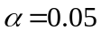.
Normality test: The productivity factors CTP, CMPH, STT BoC and DT from the collected data were tested for normality. The null hypothesis is “variables are normally distributed”. The results from Table 3.2 show that CTP, CMPH and DT are normally distributed because their respective p-values are higher than 0.05; therefore, the null hypothesis cannot be rejected. Else, STT and BoC have p-value less than 0.005 therefore the null hypothesis is rejected; variables STT and BoC were not taken in a one-sample test because they are not normally distributed.

Table 3.2: Stata Results for Variables Approximately Normally Distributed
Variables | Shapiro- W test for Normal Data | Skewness/Kurtosis test for Normality
Variables | Prob>z | Prob>Chi(2)
CTP | 0.74563 | 0.8557
STT* | 0.00000 | 0.0001
CMPH | 0.76201 | 0.8188
BoC* | 0.00008 | 0.0082
DT | 0.99726 | 0.8545
Source: Stata output

Examination of the Hypotheses by One Sample T-Test: The variables CTP, CMPH and DT were found normally distributed. The assumption is their mean are not greater than CTP = 17500, CMPH = 25TEU and DT = 6. The respective hypotheses are as written below: -
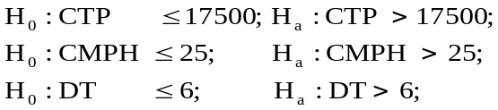

3.10.2 Developing DSM Port GCCT Productivity Model
Theoretical Statement 2: The assumption from hypothesis is H₀₂: There is no significant relationship between the respondent variable CTP and the jointly explanatory variables TN, CS, STT, CMPH, CU, TQE, BoC, BU, TGS, SU and DT being variables of DSM Port GCCT productivity model. The formulated multiple regression equation for DSM Port GCCT productivity model was:-
The model was analysed using p-value of the F-statistic for the model representing all variables jointly and r² value. According to Schopohl (2014) and Brooks (2008) the null hypothesis H₀₂ is rejected when the p-value is less than 0.05 and the argument would be made in favour of the alternative hypothesis. The model was jointly significant and other statistical tests for multicollinearity, model fit and causality relationship were carried out as explained in the procedures below:-

The productivity model for DSM Port GCCT was developed essentially for analysing the significant relationship between the respondent variable and the explanatory variables. In order to develop a desirable model, the following steps such as correlation test, test for multicollinearity, test for fitness and goodness, significance and causality analysis were performed.

Correlation test: Correlation test was carried out using Pearson’s correlation analysis performed in Stata-software by a Graphical User Interface (GUI). The GUI is known as ‘pairwise correlation’ the tests were between variables CTP and TN, CTP and CS, CTP and STT, CTP and CMPH, CTP and CU, CTP and TQE, CTP and BoC, CTP and BU, CTP and TGS, CTP and SU, and CTP and DT. The results from Stata provide the likelihood that the relationship could have occurred by chance (p-value) and the Pearson correlation value ‘r’. The categories of ‘r’ according to Evans (1996) are stipulated below as:-
- 0.00 – 0.19 “very weak”
- 0.20 – 0.39 “weak”
- 0.40 – 0.59 “moderate”
- 0.60 – 0.79 “strong”
- 0.80 – 1.0 “very strong”

In order to use Pearson’s correlation analysis the four statistical conditions must be met. The conditions are variables are continuous (interval or ratio), approximately normally distributed, linearly related and no significant outliers. Results from Table 3.3 show the variables in this study are continuous because they are measured monthly (interval).

Table 3. 3: DSM Port GCCT average benchmarked productivity factors
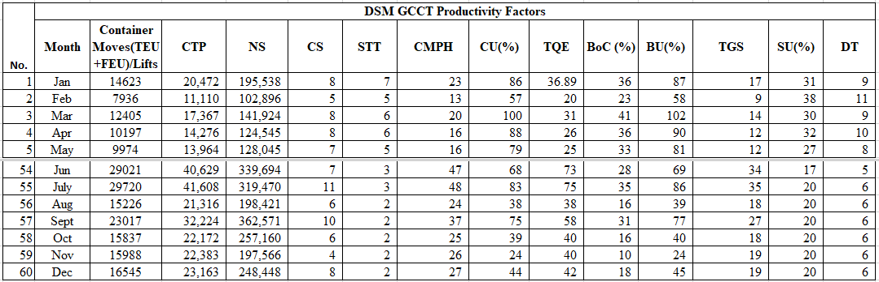Source: TPA – GCCT (Monthly Data 2011 - 2015)

Similarly, all variables except the variables STT, CU, BoC, BU and TGS indicated with * in Table 3.4 are approximately normally distributed because have p-value higher than 0.005 favouring the null hypothesis for normality.
Table 3.4: Stata Results for Variables Approximately Normally Distributed
Variables | Shapiro-Francia W test for Normal Data | Skewness/Kurtosis test for Normality | Jarque-Bera test for Normality
Variables | Prob>z | Prob>Chi(2) | Prob>Chi(2)
CTP | 0.85051 | 0.8557 | 0.7823
TN | 0.85113 | 0.9527 | 0.9082
CS | 0.83001 | 0.6489 | 0.6552
STT* | 0.00001 | 0.0001 | 0.0000
CMPH | 0.87938 | 0.8188 | 0.7593
CU* | 0.00025 | 0.0088 | 0.0029
TQE | 0.90026 | 0.8507 | 0.7788
BoC* | 0.00027 | 0.0082 | 0.0026
BU* | 0.00031 | 0.0099 | 0.0036
TGS* | 0.00001 | - | -
SU | 0.71469 | 0.6637 | 0.7433
DT | 0.99386 | 0.8545 | 0.8773
Source: Stata output

Furthermore, results in Figure 3.2 show scatter plots with fitted lines have no significant outliers and are linearly related. The lines with down slopes indicate negative relations and those with upwards slopes indicate positive relations (Adkins and Carter Hill, 2011).

CTP vs TN CTP vs CS CTP vs STT CTP vs CMPH
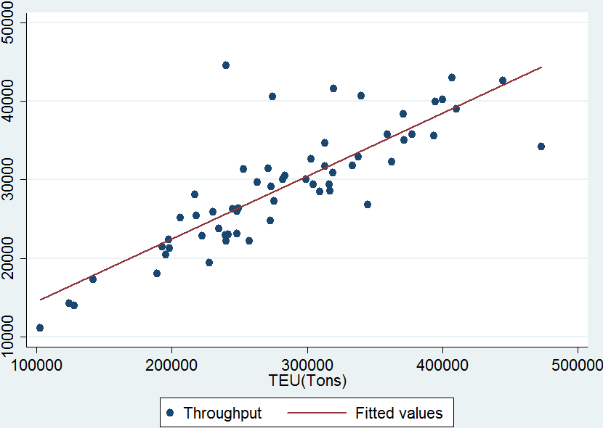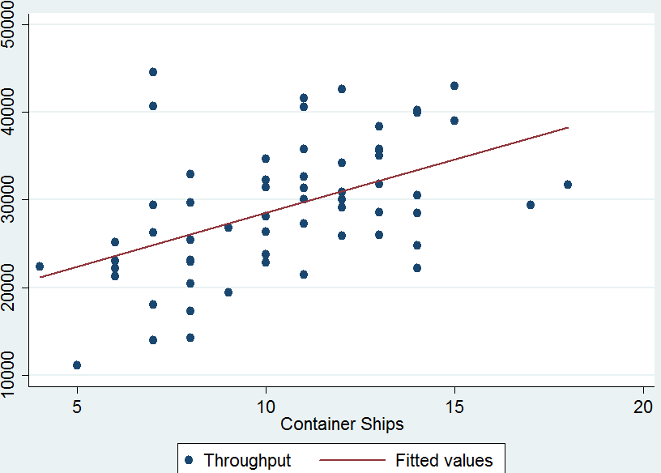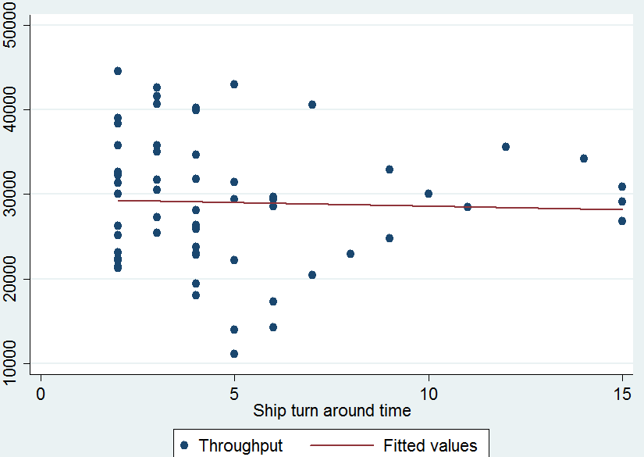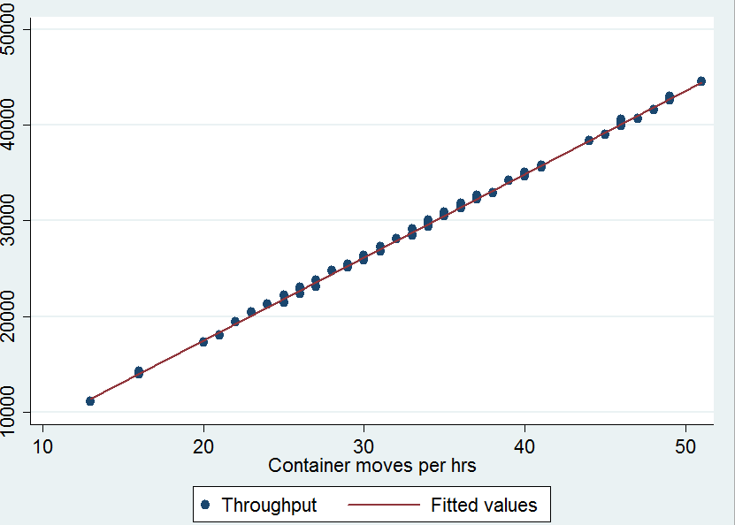
CTP vs CU CTP vs TQE CTP vs BoC CTP vs BU
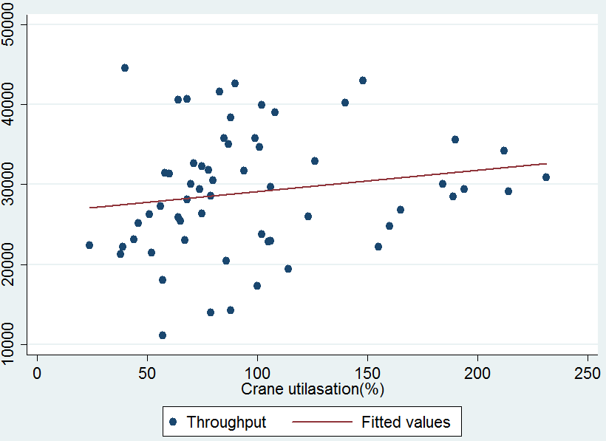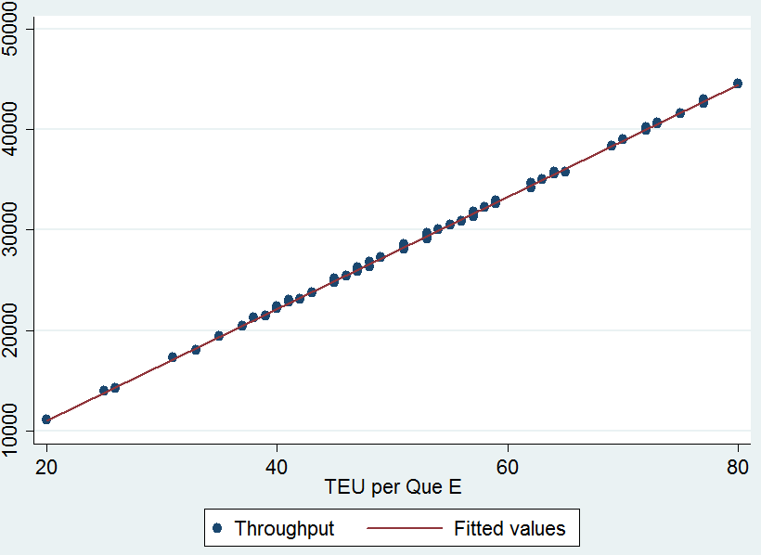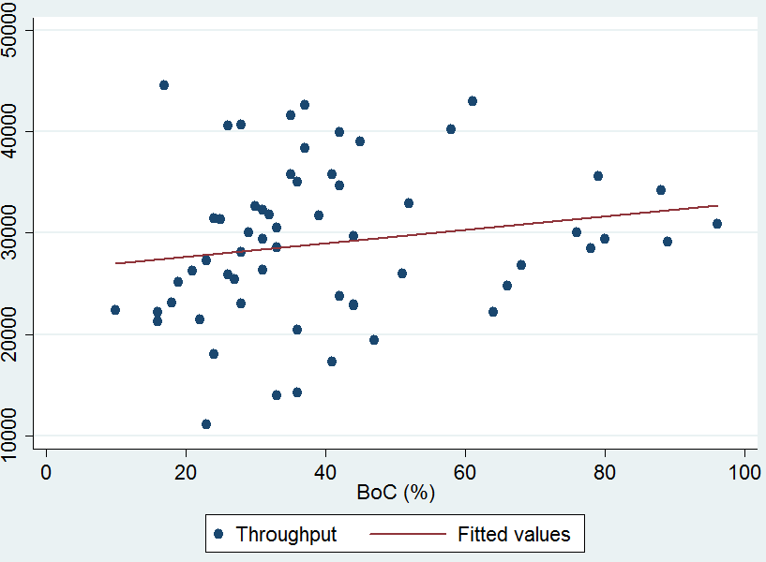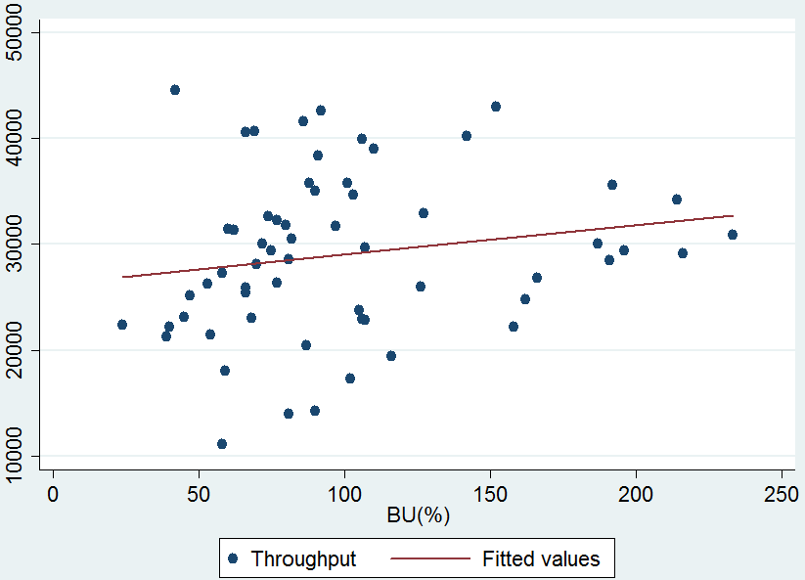
CTP vs TGS CTP vs SU CTP vs DT
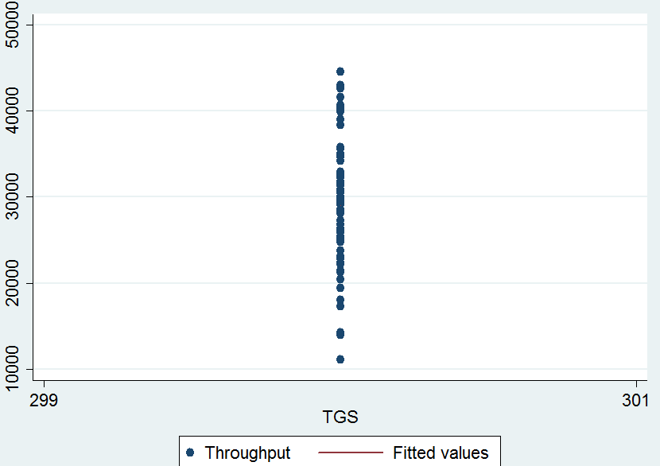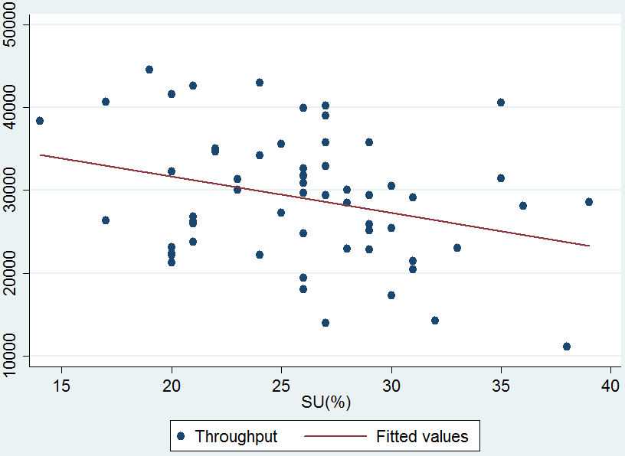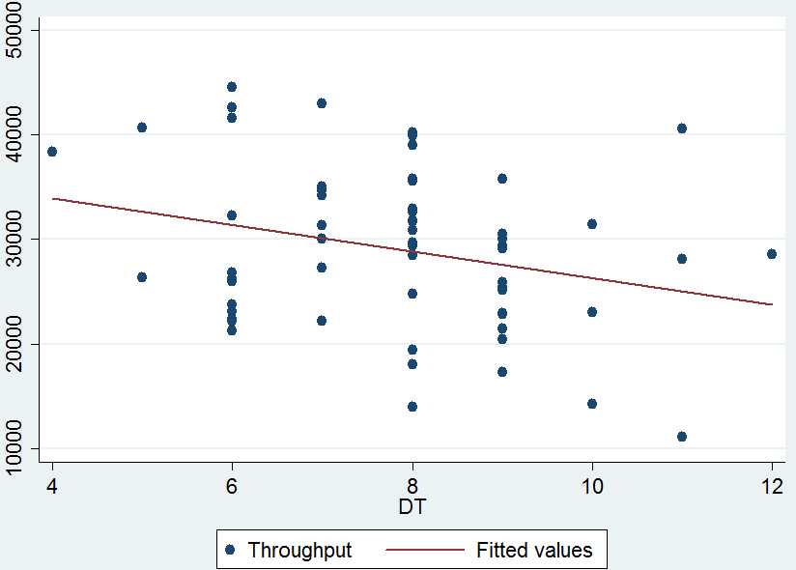
Figure 3.2: Scatter Plots with Fitted Lines
Source: Stata output
It was found from the analysis that the variables STT, CU, BoC, BU and TGS were not normally distributed and were eliminated in the correlation test. Therefore correlation test was carried out for variables TN, CS, CMPH, TQE, SU, DT and CTP using pairwise correlations GUI.

Test for multicollinearity: The variable TN, CS, CMPH, TQE, SU, DT were correlated to CTP. The variables were presented in regression model of the type 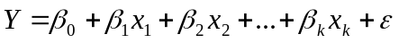 and the equation become.
(12)
Where:
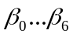 : Coefficient terms
TN : Tonnage
CS : Container ships
CMPH : Container moves per hour
TQE : TEU across quay edge
SU : Storage utilisation
DT : Dwell time
: Error term (assumed to be normally distributed, independent, random and
identical

If the model is jointly significant and r² value is very high while the p-values for most of the individual variables in the model are insignificant then multicollinearity exists. In dealing with multiple regression models, it is possible for the predictor variables to depend on each other; this phenomenon is known as multicollinearity. Multicollinearity is detected by using the inspection correlations coefficient and tolerance or Variance Inflation Factor (VIF) in Stata. Multicollinearity is dealt by treating one variable step by step through elimination until a desirable VIF is reached. According to Allison (2012), argued that the regression model with VIF more than 2.5 tends to be of more concern. For example a VIF of 1.8 implies that the variance of a particular coefficient is 80 percent larger than it would if the predictor was completely not collinear with other predictors.

Therefore for the purpose of this study, where a regression model was found to have multicollinearity; VIF equal to and or less than 2.5 (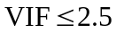) was desirable. The model for this study was found to be jointly significant and VIF test showed that the model has multicollinearity. Therefore, the variables with high VIF were removed from the regression model step by step while regressing the remaining variables and checking for the desirable. The step by step elimination of explanatory variables was employed in order to avoid throwing away the variables which due to multicollinearity might have been inflated.

Test for fitness and goodness of model: In examining the fitness and goodness of GCCT productivity model two different approaches were used. The first approach was the diagnostic checking and the second was the white noise test. The productivity model is:-
(13)
In the First approach; diagnostic checking, there were three conditions:-
H_{031a}: Residuals are normally distributed.
H_{031b}: Residuals are homoscedasticity
H_{031c}: Residuals are not serial correlated

In the second approach; White Noise Test, there were three conditions:-
H_{032a}: Residuals are white noise (meaning that residuals are homoscedasticity, no serial correlation and mean is zero)
H_{032b}: Residuals are random and independent
H_{032c}: Residuals are stationary.

The theory for both approaches is; the null hypothesis H_{0:} is rejected when the p-value is less than 0.05 and the argument would be made in favour of the alternative hypothesis.

Transformation of variables: The residuals for the model Equation 13 was not normally distributed and the variables CTP, TN, CS, CMPH and DT were transformed to make the non-normal variables normal in order to satisfy the statistical assumptions conditions.
Table 3.5: Syntax for Common Data Transformations
SKEWNESS |  | STATA COMPUTE | SPSS COMPUTE* | SAS COMPUTE*
Positive Skewness | Moderate positive skewness | gen NEWX = sqrt(X) | NEWX = SQRT(X) | NEWX = SQRT(X)
Positive Skewness | Substantial positive skewness | gen NEWX = log(X) | NEWX = LG10(X) | NEWX = LG10(X)
Positive Skewness | Substantial positive skewness with zero | gen NEWX = log(X+C) | NEWX = LG10(X+C) | NEWX = LG10(X+C)
Positive Skewness | Severe positive skewness | gen NEWX = 1/X | NEWX = 1/X | NEWX = 1/X
Positive Skewness | Severe positive skewness (L-shaped)with zero | gen NEWX =1/(X+C) | NEWX = 1/(X+C) | NEWX = 1/(X+C)
Negative Skewness | Moderate negative skewness | gen NEWX = sqrt(K-X) | NEWX = SQRT(K-X) | NEWX = SQRT(K-X)
Negative Skewness | Substantial negative skewness | gen NEWX = log(K-X) | NEWX = LG10(K-X) | NEWX = LG10(K-X)
Negative Skewness | Severe negative skewness (J-shaped)with zero | gen NEWX = 1/(K-X) | NEWX = 1/(K-X) | NEWX = 1/(K-X)
Source: Roberts (2008) and Modified by Author to add Stata Syntax
C = a constant added to each score so that the smallest score is 1
K = a constant from which each score is subtracted so that the smallest score is 1: usually equal to the largest score +1.
* Also may be done through SPSS and SAS
Transformation changes the shape of a distribution or relations. In this study the residuals were not normally distributed implying that were skewed to the right. According to Hosmer and Lemeshow (2011), transformation changes the shapes of the distribution and hence achieving normality of observations. Roberts (2008) describes transformation as applying a non-linear such as log, square-root and or reciprocal functions to raw data. A good transformation is the one that which what transformed becomes approximately symmetric or normally distributed. The syntax for common types of data transformations are provided in Table 3.5.

Another transformation technique is the Box-Cox transformation, this technique provides a wide range of opportunities where data can be transformed into normality, homoscedasticity and or constant variances. The Box-Cox Transformation incorporates families of transformation powers such as natural logarithmic functions, inverse functions and n^{th}-root functions such as square and cube (Osborne, 2010). Similarly, Viélez et al (2015) pointed out that Box-Cox Transformation is a fundamental tool which gives a single transformation parameter 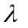 aiming at reducing anomalies and ensure linear model assumptions are met.

Transformation of data can result into abnormal behaviour from the origin. For example in the process of normalisation, the model can change from homoscedasticity to heteroscedasticity; for that matter, the transformed data should be checked to ensure that all linear model fit assumptions are not violated (Osborn, 2010 and Viélez et al, 2015). When the proper is applied in transformation, the transformed data, analysis and conclusion will be plausible meaningful.
The Box-Cox (1964) defined the Box-Cox transformation as
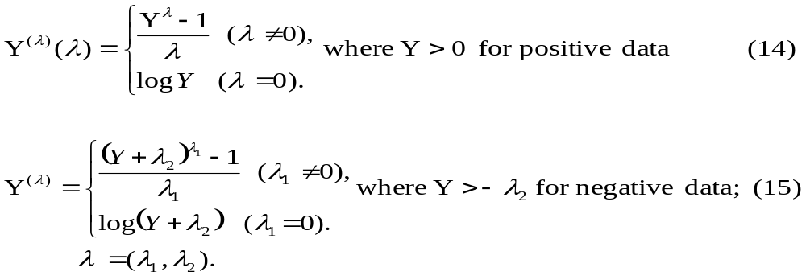
For the purpose of this study the Box-Cox transformation was used because of its robustness to calculate the parameter from which the data greatly expects to normalize when transformed. The quantitative variables in this study are positive then, the Box-Cox transformation equation is 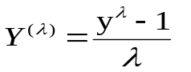 (16)
where 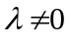 and is obtained though Box-Cox GUI in Stata
The lambda model uses the parameter to transform the dependent variables and independent variables (Stata Manual 13, 2017) the result is equation 17
(17)
The transformed DSM Port GCCT productivity model becomes

(18)
If 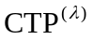= CTP1, 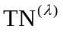= TN1, 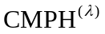= CMPH1 and 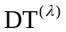= DT1
The equation now is (19)
The dependent variables CTP and independent variables TN, CS, CMPH and DT were processed in Stata through Box-Cox transformation Graphical User Interface (GUI). The results in Table 3.6 show that = 1.207322 which is significantly related to CTP.

Table 3.6: Box-Cox Transformation Stata Output
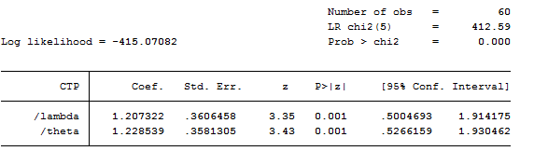

Therefore, the transformed variable, were carried out in Stata and the results are as shown in Table 3.7.
Table 3.7: Transformed Variable CTP1and Residual (e)
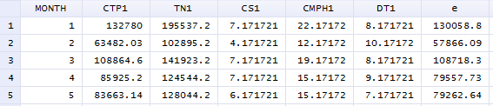
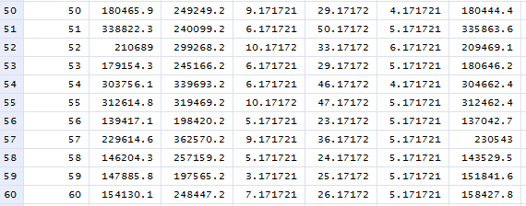
Source: TPA – DSM Port GCCT (Monthly Data 2011 - 2015) transformed by Author
Significance of DSM Port GCCT productivity model: The model Equation 19 was regressed in Stata. Results in Table 3.8 show Prob > F = 0.0000 which mean that F-value of the regression model is significant at 0.05 level. So there is some evidence to reject the null hypothesis which says ‘no significant relationship’. The argument is made in favour of the alternative hypothesis; therefore the explanatory variables are jointly significant to determine the container terminal productivity. On the other hand, the coefficient of determination r² = 99.97 percent is very high implying that the model has some explanatory power. However, most of t-values with their respective p-value higher than 0.05 are not significant despite of having very high r²; and only the t-values for CMPH and TQE are statistically significant. Else, some of the coefficients of the explanatory variables such as TN, CS, TQE, SU and DT seem to be inflated. These inconsistencies suggest that some of the explanatory variables depend on each other and multicollinearity exists.

Table 3.8: Regression Model Output for Transformed Variables
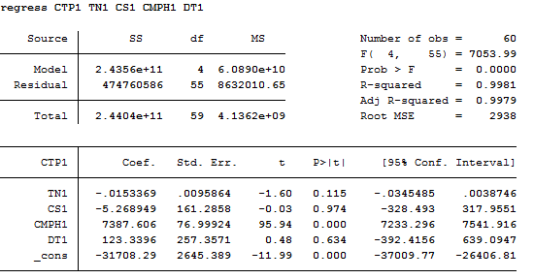
Sources: Stata output
Results from Table 3.9 shows the explanatory variables with VIF = 2.50 which was desirable. Hence the level of multicollinearity at VIF = 2.50 was that which was acceptable in this study and the further analysis was carried on this model
. (20)

Table 3. 9: VIF Stata Output for Transformed Explanatory Variables
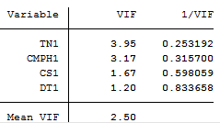
Sources: Stata output

The dependent variable CTP1 and the independent variables TN1, CS1, CMPH1 and DT1 were regressed, the model fit was re-examined and results discussed.

Causality: In this study causality implies analysis on causal relationship and factors affecting DSM Port GCCT productivity. The causal relationships analysed the long-run and short-run relationship between the respondent variable (CTP1) and its respective explanatory (predictor) variables (TN1, CS1, CMPH1 and DT1). The analysis used the lag selection criteria and cointegration. On the other hand, the factors affecting DSM Port GCCT productivity was done by analysing the coefficients of the model predictors against the respondent variables.

- Lags selection criteria
The process started by Firstly, selecting the number of lags, the lags was chosen using lag selection criteria. The three commonly criteria are Akaike’s Information Criterion (AIC), Hannan and Quinn Information Criterion (HQIC) and Schwarz’s Bayesian Information Criterion (SBIC). Other criteria include Log Likelihood (LL), Likelihood Ratio (LR) and Final Prediction Error (FPE). When a lag has more star (*) that lag is selected to be the lag number of the model. According to Sukati (2013) on the concept of lags said that too many lags could increase error in forecast and too few lags could leave out relevant information.

The lags with more criteria indicated by a star (*) becomes the number of lag(s) for the model. As shown in Table 3.10 the criteria Final Prediction Error (FPE), Akaike’s Information Criterion (AIC) and Hannan and Quinn Information Criterion (HQIC) satisfied the criteria for lag selection. Therefore the model has 1 lag. However, in this study and for this model the author will use a maximum of 2 lags. The choice of 2 lags incorporates the risk of having few and many lags depicted in the theory.

Table 3.10: Lags Selection Order Criteria
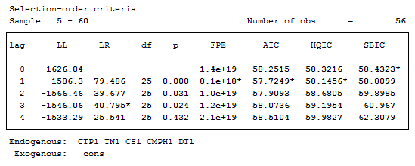
Sources: Stata Output

- Cointegration analysis by ADF test for unit root
The test for variables cointegration was done using Augmented Dickey-Fuller (ADF) test for unit root and Trace Statistic and Max Statistics over 5% Critical Values. The ADF test for unit root has hypothesis H₀: there is unit root. The unit root meant that variables were not cointegrated. In the ADF test for unit root the MacKinnon approximate P-value for Z(t) if less than 0.05 cannot reject the null hypothesis. On the other hand the absolute values for Test Statistic and 5% Critical Value were considered, the hypothesis was H₀: there is no cointegration; when Test Statistic is less than 5% Critical Value then can reject the null hypothesis in favour of the alternative hypothesis.

The P-value of the Augmented Dickey-Fuller (ADF) test for unit root in Table 3.11 was 0.0124 which is less than 0.05. So there is enough evidence to reject the null hypothesis (there is a unit root). Therefore No unit root, no trend and variables are cointegrated. Likewise, the absolute Test Statistics 3.359 is more than the 5% Critical Value 2.924 hence the H₀: no cointegration can be rejected in favour of the alternative hypothesis. Therefore variables are cointegrated.

Table 3. 11: Cointegration analysis by Augmented Dickey-Fuller
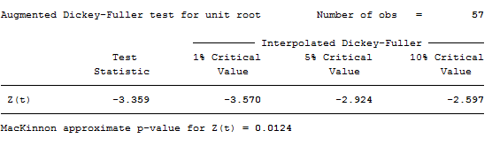
Sources: Stata Output
Cointegration analysis by Trace and Max Statistics over 5% critical values
Furthermore, the Trace Statistic and Max Statistics over 5% critical values were used, the hypothesis H₀: there is no cointegration. The rule here was when trace statistics and max statistics are more than their respective 5% critical value the null hypothesis can be rejected. In this test only the absolute values are considered. The maximum ranks 0, 1, 2, 3, 4… represent the null hypothesis to be analysed. For the rank 0 the hypothesis was H₀: no cointegration, while for ranks 1, 2, 3, 4… represented the alternative hypothesis considered after rejecting the null hypothesis H₀: no cointegration. The ranks 1, 2, 3, represented the number of cointegration 1, 2, 3, 4… available in the model. According to Hossain and Abedin (2016), cointegration signifies the existence of a causal relationship between variables without specifying the direction of causality.

The rule here is when trace statistics and max statistics are greater than 5% critical value the null hypothesis can be rejected. In this test only the absolute values are considered. The maximum ranks (0, 1,2,3,4 and 5) in Table 3.12 represent the null hypothesis to be analysed. For the rank 0, H₀: no cointegration; the respective trace statistics 77.4119 percent is greater than 5% critical values 68.52 percent and max statistics 28.3079 percent is less than 5% critical values 33.46 percent. So the null hypothesis can be rejected, the variables are not cointegrated.

Once the rank 0 is rejected the processes proceeds to the next rank which is rank 1; for rank 1 H₀: one cointegration; the respective trace statistics 49.1040 percent is greater than 5% critical values 47.21 percent and max statistics 20.3602 percent is less than 5% critical values 27.07 percent. So the null hypothesis can be rejected, the variables are not cointegrated. Once the rank 1 is rejected the processes proceeds to the next rank which is rank 2; for rank 2 H₀: two cointegration; The respective trace statistics 28.7438 percent and max statistics 13.5932 percent are less than 5% critical values 29.68 percent and 20.9 percent respectively. So the null hypothesis cannot be rejected, the variables are cointegrated and there are two cointegration. Likewise, Rank 2 in trace statistic column is automatically marked.

Table 3.12: Cointegration Analysis by Trace and Max Statistics
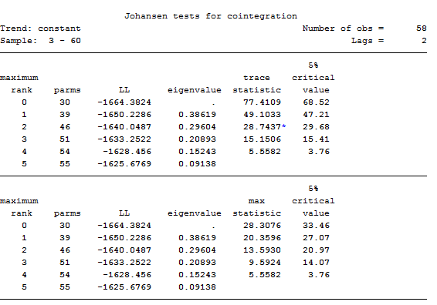
Sources: Stata Output

Therefore, Vector Error Correlation Model (VECM) was used If variables were not cointegrated Vector Auto-Regression Model (VARM) would be used. VECM stipulates that CE1-L1 also known as the vector error coefficient for the dependent variable CTP must be negative and significant for the model to have long-run causality running from the explanatory variables to respondent variable. Secondly, the coefficients of the lagged difference for the explanatory variables with respective zeros as null hypotheses; if their respective P-values are less than 0.05 the null hypothesis can be rejected and hence variables are not zeros, significant and have short-run causality running for the respective explanatory variables to respondent variable.

3.10.3 Analysis of Future Prospect of DSM Port GCCT Container Traffic
Theoretical Statement 3: The assumption from hypothesis is H₀₃: CTP forecast trend influences positively DSM Port GCCT operations at the quay, yard, gate and hinterlands. The forecasting equation was by regressing CTP as a respondent variable and time as an explanatory variable. The regression equation was tested at.

Results from Table 3.13 shows that the regression equation has Prob>F= 0.000 and
p-value = 0.000 which are less that 0.05; therefore the equation is significant and time has effect on throughput. The forecasting equation is where 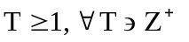the equation provides monthly forecast and were annually reported and presented in chapter four.

Table 3. 13: Regression Output for Forecasting Equation
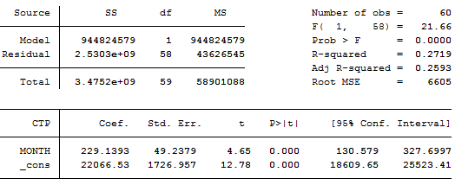
Sources: Stata Output

3.11 Triangulation in Quantitative Research
Triangulation provides opportunity for researcher to gather data from using various methods for sourcing data. In this study various sources of data were consulted, compared and recalculated, the sources include TPA reports, PMAESA reports and UNCTAD reports. Normally, secondary data has its drawbacks in terms of quality, accuracy, reliability and range. However, the richness in information from various sources eliminated the drawback.

3.12 Validity and Reliability
During the study and analysis process, the researcher ensured consistence of information and interpretation of the findings through proper selection of the sample, the measuring techniques and identification of benchmarks productivity factors. According to Garbarino and Holland (2009); validity refers to questions which determines which data is to be gathered and how is to be gathered. So if it is quantitative, is the result replicable? Are the measurement accurate and what is being measured is that which was intended to be measured? And if it is qualitative, are the research instruments and information gathered precise, credible and transferable.
The validity and reliability of the study matter was ensured by adapting a Conceptual Container Terminal Model (CTPM) from which the respondent and explanatory variables were identified and the respective data collected, analysed and discussed. The data were collected from the quay and yard. Data analysis and discussion started by firstly, examining productivity of DSM Port GCCT; assumption was that mean of CTP, STT, CMPH, DT and BoC from collected data were greater than the hypothesised mean for CTP, STT, CMPH, DT and BoC from industry. The assumption was tested and confirmed at 0.05 alpha levels. Secondly, DSM Port GCCT productivity model was developed, various statistical test including correlation test, VIF test and fitness and good model test.

The residuals of variables in the model after VIF test was not normally distributed for that matter the variables were transformed. The fitness and goodness model test was repeated and the transformed model satisfied the statistical conditions that residuals are normally distributed, homoscedasticity, not serially correlated and white noise test. The discussion on causality relationship and effects of coefficient of predictor for DSM Port GCCT productivity was done. Thirdly, the trend analysis of forecasted monthly throughput was done and summarised in years followed by the discussion. Therefore from the researcher’s point of view, what was measured was what were intended. All the assumption were statistically tested and confirmed, Moreover the whole process of collecting information, analysing, interpreting and writing the report were precise and consistent.

3.13 Ethics
The researcher purposely and cautiously ensured confidentiality and protection of the information obtained. Great assurance was made that no pieces of information received were misused and wrongly misplaced. The analysis of data and findings were fairly dealt to avoid biasness. Furthermore, the ethical matters related to academic excellence and professionalism were adhered.

3.14 Summary
This was a case study where GCCT was purposely selected for study. The research design provided a direction from which the relevant secondary quantitative data from quay and yard areas were collected. The respondent variable is the DSM port GCCT productivity represented by monthly container terminal throughput (CTP) measured in TEU. On the other hand the explanatory variable is the container terminal processes represented by the benchmarked productivity factors including Tonnage (TN) measured in Ton, Container Ships (CS) measured in unit number, Ship Turnaround Time (STT) measured in days, Container Moves per Hour (CMPH) measured in TEU moves per hour, Crane Utilisation (CU) measured in TEU per year per crane, TEU across Quay Edge (TQE) measured in TEU per metre per year , Berth Occupancy (BoC) measured in percentage, Berth Utilisation (BU) measured in unit, TEU Ground Slots (TGS) measured in annual TEU per hectare, Storage Utilisation (SU) measured in unit and Dwell Time (DT) measured in days.

The quantitative data collected at DSM Port GCCT container terminal covered 60 months from 2011 to 2015. The researcher used the econometric software-Stata to produce output and having guided by reviewed theories, analysed and discussed the finding of the study.

CHAPTER FOUR

4.0 RESULTS AND DISCUSSION

4.1 Chapter Overview
This chapter presents the research results and discussion of the empirical analysis on productivity of the container terminal in Tanzania. The DSM Port General Cargo Container Terminal (DSM Port GCCT) was a study sample purposively selected as a case study. The sources of data were mainly secondary and only the quantitative data were collected from the quay and yard areas. This study has three specific objectives from which the respective hypotheses were developed. The results from an econometric software-Stata at 95% confidence intervals (α = 0.05) and excel software on productivity of DSM Port GCCT, causality relationships, effects of model predictor variables and future trend of container traffic were analysed and discussed.

4.2 Productivity of DSM Port GCCT

4.2.1 Container Terminal Throughput (CTP) at DSM Port GCCT
Result in Table 4.1 shows a one-sample t-test with p-value = 0.0000 which is less than 0.05; this means that there is some evidence to reject the null hypothesis which says Ho: CTP = 17500TEU. The argument is made in favour of the alternative hypothesis that the mean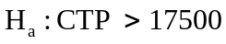. CTP from collected data is 29055.3TEU so there is enough evidence to confirm that it is greater than the hypothesised (17500TEU) and at 95% confidence interval lies between 27072.7 and 31037.87. Therefore, CTP = 29055.3TEU is the monthly average throughput and the increase implies that DSM Port GCCT is Productive.

Table 4.1: Container Throughput (CTP)
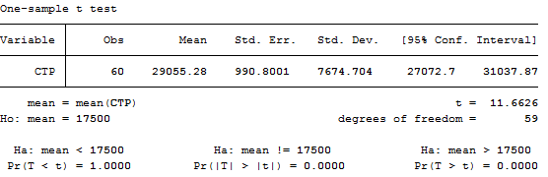
Sources: Stata output

4.2.2 Container Moves per Hour (CMPH) at DSM Port GCCT
Result in Table 4.2 shows a one-sample t-test with p-value = 0.0000 which is less than 0.05; this means that there is some evidence to reject the null hypothesis which says Ho: CMPH = 25TEU. The argument is made in favour of the alternative hypothesis that the mean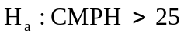. CMPH from collected data is = 33.27TEU so there is enough evidence to confirm that it is greater than hypothesised (25) and at 95% confidence interval lies between 30.98 and 35.55. Therefore, CMPH = 33.27TEU is the monthly average container moves per hour and the increase implies that DSM Port GCCT is Productive.

Table 4.2: Container Moves per Hour (CMPH)
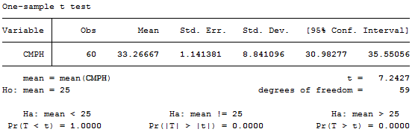
Sources: Stata output

4.2.3 Dwell Time (DT) at DSM Port GCCT
Result in Table 4.3 shows a one-sample t-test with p-value = 0.0000 which is less than 0.05; this means that there is some evidence to reject the null hypothesis which says Ho: DT = 6days. The argument is made in favour of the alternative hypothesis that the mean 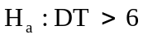days. DT from collected data is 7.83 days so there is enough evidence to confirm that it is greater than hypothesised (6) and at 95% confidence interval lies between 7.41 and 8.25. Therefore, DT = 7.883 days is the average days the container stays at the port (import and export). The number of days the container stays at the port has slightly increased and implies that container stays longer at the port before being cleared. One of the reasons could be increase of container throughput; however, container stay at the port (dwell time) should be minimum as it jeopardise the terminal spaces from which new arrivals both import and export would temporarily be kept.

Table 4.3: Dwell Time (DT)
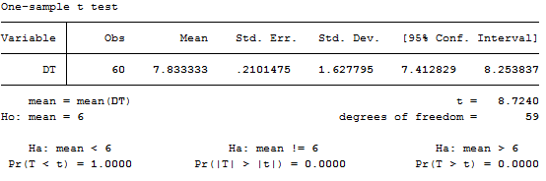
Sources: Stata output

According to Keller (2007) and Anderson et al (2010) when the null hypothesis or alternative hypothesis at alpha level (0.05) is significant and the mean of variable lies at 95% confidence interval; then, the mean of the variable is significant and valid. Having statistical evidence information facts in regard of a matter, then strategic decision can be made. Therefore, CTP, CMPH and DT being greater than those hypothesised, imply that throughput at DSM Port GCCT has been increasing. However, the extent that DSM Port GCCT is productive in terms of CTP, CMPH and DT is not desirable because the port is congested, as a result the government losses revenue and port market share declines (World Bank, 2013 and TPA 2015).

4.3 DSM Port GCCT Productivity Model
Correlation of variables: Results from Table 4.4 shows, the p-values and Pearson coefficient r from which the explanatory variables related to CTP were identified.
- The variables CTP and TN have p-values = 0.0000 and r = 0.8268. The p-value is lower than 0.05 implying that the variables are significantly related. Likewise, the r-value indicates that the variables are positively and very strongly related;
- The variables CTP and CS have p-values = 0.0001 and r = 0.4857. The p-value is lower than 0.05 implying that the variables are significantly related. Likewise, the r-value indicates that the variables are positively and moderately related;
- The variables CTP and CMPH have p-values = 0.0000 and r = 0.9995. The p-value is lower than 0.05 implying that the variables are significantly related. Likewise, the r-value indicates that the variables are positively and very strongly related;
- The variables CTP and TQE have p-values = 0.0000 and r = 0.9998. The p-value is lower than 0.05 implying that the variables are significantly related. Likewise, the r-value indicates that the variables are positively and very strongly related;
- The variables CTP and SU have p-values = 0.0209 and r = -0.2976. The p-value is less than 0.05 implying that the variables are significantly related. Likewise, the r-value indicates that the variables are negatively and weakly related;
- The variables CTP and DT have p-values = 0.0363 and r = -0.2709. The p-value is less than 0.05 implying that the variables are significantly related. Likewise, the r-value indicates that the variables are negatively and weakly related;

Table 4.4: Correlation Matrix – Pairwise Correlation
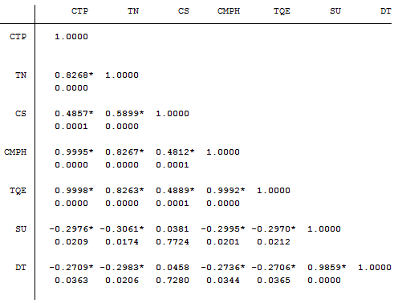
Sources: Stata output

Therefore, the productivity factors TN, CMPH, TQE, SU and DT are correlated to CTP. According Udovičić et al (2007) asserts that correlation is mainly for examining the relationship between two variables and not the cause; however, it forms the base for causal analysis. Therefore, the productivity factors TN, CMPH, TQE, SU and DT and CTP were used in developing the DSM Port GCCT productivity model.

Testing multicollinearity: The model was regressed in Stata. Results in Table 4.5 shows the regress output Prob > F = 0.0000 which mean that F-value of the regression model is significant at 0.05 level. So there is some evidence to reject the null hypothesis which says ‘no significant relationship’. The argument is made in favour of the alternative hypothesis; therefore the explanatory variables are jointly significant to determine the container terminal productivity. On the other hand, the coefficient of determination r² = 99.97 percent is very high implying that the model has some explanatory power. However, most of t-values with their respective p-value higher than 0.05 are not significant despite of having very high r²; and only the t-values for CMPH and TQE are statistically significant. Else, some of the coefficients of the explanatory variables such as TN, CS, TQE, SU and DT seem to be inflated. These inconsistencies suggest that some of the explanatory variables depend on each other and multicollinearity exists.

Table 4. 5: Regression Model Output for Six Correlated Predictors
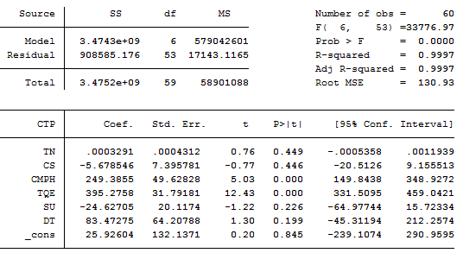
Sources: Stata output
The test for multicollinearity was done by calculating VIF using Stata software, the results in Table 4.6 shows the average VIF value equal to 234.42; this value is greater than what is desirable 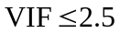(Allison, 2012). High VIF value implies that the variances of the coefficients are quite larger than what would be if the predictors were completely not collinear. The variable TQE with high VIF = 662.65 was removed from the model.

Table 4.6: VIF Stata Output for Six Correlated Predictors
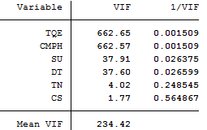
Sources: Stata output

The variable TQE was eliminated from the regression model and the remaining variables were regressed. The results in Table 4.7 were used to calculate VIF as shown in Table 14.8.

Table 4.7: Regression Model Output for Five Correlated Predictors
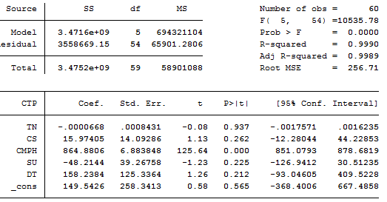
Sources: Stata output
The results in Table 14.8 shows the regression model with explanatory variables whose average VIF = 16.77 which is higher than what is desirable. Therefore, the variable SU was eliminated from the model.

Table 4. 8: VIF Stata Output for Five Correlated Predictors
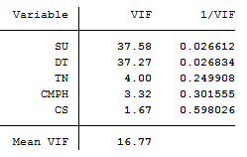
Sources: Stata output

The variable SU was eliminated from the regression model and the remaining variables were regressed. The results in Table 4.9 were used to calculate VIF as shown in Table 4.10.

Table 4.9: Regression Model Output for Four Correlated Predictors
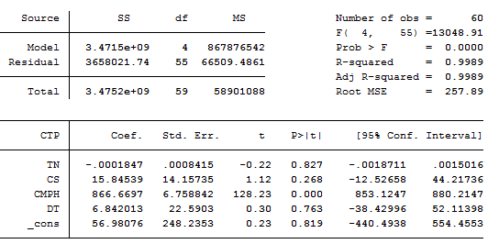
Sources: Stata output
Results from Table 4.10 shows the explanatory variables with VIF = 2.50 which was desirable. Hence the level of multicollinearity at VIF = 2.50 was that which was acceptable in this study and the further analysis was carried on this model
.

Table 4.10: VIF Stata Output for Four Correlated Predictors

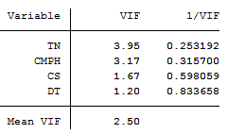
Sources: Stata output

4.3.1 Test for Fitness and Goodness of the Model
The model at was tested for fitness and goodness. The two approaches known as diagnostic checking and white noise test were used to examine the fitness and goodness of the model. The residuals from this model were used in the two approaches.

Diagnostic Checking: In the diagnostic checking approach, a good regression model must satisfy three conditions. The conditions are residual should be normally distributed, homoscedasticity and no serial correlation. The hypotheses for the respective conditions are:-
H_{031a}: Residuals are normally distributed.
As shown in Table 4.11 the p-values for Skewness/Kurtosis (0.0006) and Shapiro-Wilk-W (0.00802) tests for normality were less than 0.05 which implies that; there is some evidence to reject the null hypothesis which says ‘residuals are normally distributed’. Therefore the argument is made in favour of the alternative hypothesis that residuals are not normally distributed. Hence, one of the conditions for good model is not met.

Table 4.11: Normality Tests
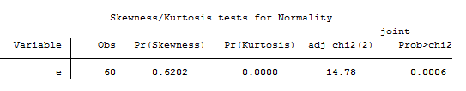
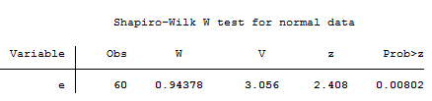
Sources: Stata Output

It is observed in Figure 4.1 that the residual are flatter from left near the mean zero indicating that the residuals are not normally distributed.
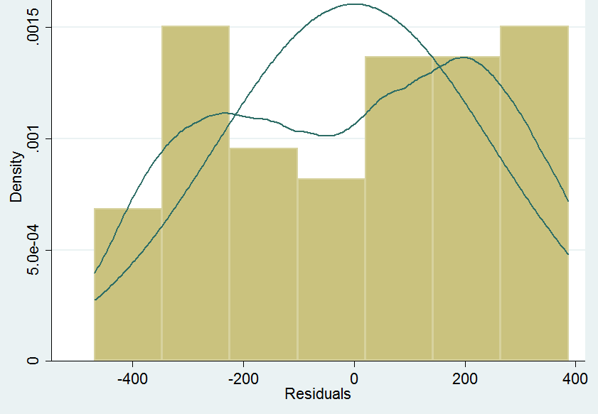
Figure 4. 1: Normal Distribution of Residuals
Sources: Stata output
- Test for Fitness and Goodness of the Model After Transformation
The transformation process is shown in the data analysis. After the transformation the model becomes . The test for fitness and goodness model is as shown below:-

H_{031a}: Residuals are normally distributed.
As shown in Table 4.12 the p-values for Skewness/Kurtosis (0.4971) and Shapiro-Wilk-W (0.10226) tests for normality were greater than 0.05 which implies that; there is no evidence to reject the null hypothesis that ‘residuals are normally distributed’. Residuals are normally distributed; therefore one of the conditions for good model is met.

Table 4.12: Normality Tests
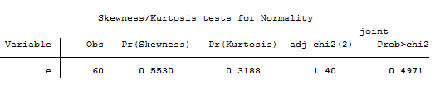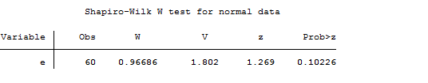
Sources: Stata Output

H_{031b}: Residuals are homoscedasticity
As shown in Table 4.13, the p-values for Breusch (0.2010) test for heteroscedasticity is greater than 0.05 which implies that; there is no enough evidence to reject the null hypothesis which says ‘residuals are homoscedasticity’. In other words residual were not heteroscedasticity, therefore residual were homoscedasticity (constant variation). In this test, residuals are homoscedasticity; therefore one of the conditions for good model is met.

Table 4.13: Heteroscedasticity Tests

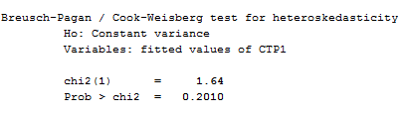
Sources: Stata Output

H_{031c}: Residuals are not serial correlated
As shown in Table 4.14 the p-values for Durbin’s alternative (0.3355) and Breusch-Godfrey (0.3141) tests for autocorrelation are greater than 0.05 which implies that; there are no enough evidence to reject the null hypothesis which says ‘residuals have no serial correlation’. In other words residual are not autocorrelated. In this test, residuals are not serial correlated; therefore one of the conditions for good model is met.
Table 4.14: Autocorrelation Tests
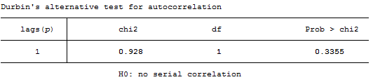
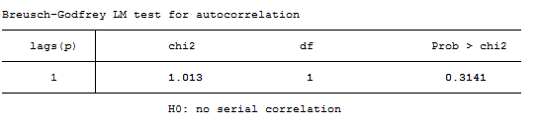
Sources: Stata Output
White Noise Test: In the White noise test approach, a good regression model must satisfy three conditions. These conditions of the residual variables are residual is white noise (i.e. residuals are homoscedasticity, no serial correlation and mean is zero), residuals are random and independent, and residuals are stationary. The respective hypotheses are:-

H_{032a}: Residuals are white noise
As shown in Table 4.15 the p-values for Portmanteau test for white noise (0.0628) is greater than 0.05 which implies that; there is no evidence to reject the null hypothesis which says ‘residuals are white noise’. Likewise, the p-values are more than 0.05 thus residuals are white noise meaning that residuals are not correlated, not heteroscedasticity, residuals are randomly distributed and they are stationary. Therefore a condition for white noise for good model is met.

Table 4.15: Test for White Noise
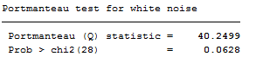
Sources: Stata Output

H_{032b}: Residuals are random and independent
As shown in Figure 4.1, for cumulative periodogram White-Noise the residuals variables independent and random plotted and they are within the boundaries hence stationary. Likewise, this test suffices the test for H₀: residuals are white Noise because P-value (0.7937) for Bartlett’s (B) statistics is greater than 0.05 therefore cannot reject the null hypothesis. Therefore conditions for random, independent and white noise for good model are met.

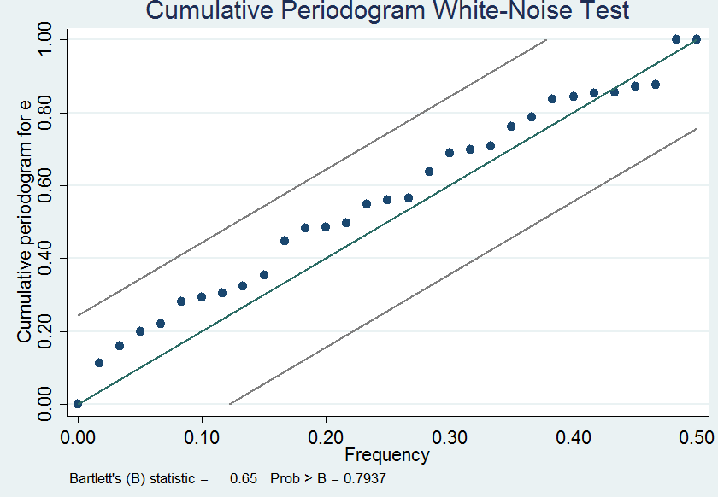
Figure 4.2: Cumulative Periodogram White-Noise
Sources: Stata Output
H_{032c}: Residuals are stationary

As shown in Figure 4.2, the plot of residual variables are upsides and downs, mean is zero and plots has no trend as such they are stationary. Therefore one of the conditions for good model is met.
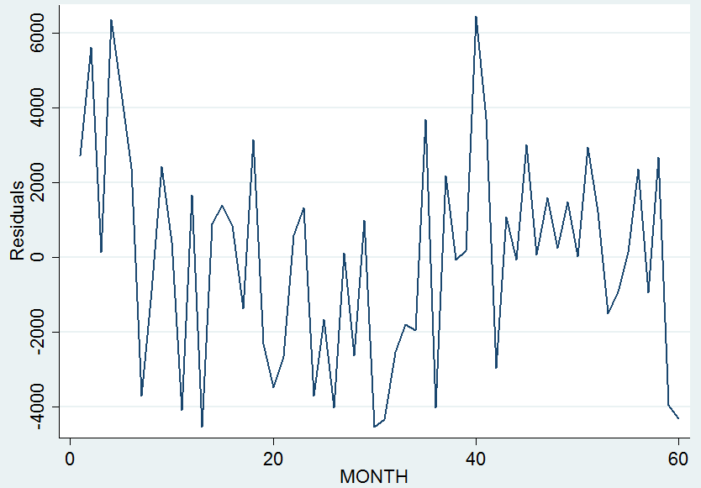
Figure 4.3: Residuals Plots
Sources: Stata output

Therefore, fitness and goodness test satisfies all the statistical conditions. This model was subjected to causality analysis and effects of model predictors.

4.3.2 Causality analysis of DSM Port GCCT productivity model predictors

4.3.2.1 Causality Analysis Relationships
It has been observed that the variables are cointegrated, and there are two cointegration. Therefore VECM was used to analyse whether the relationship among variables are significant and have long-run and or short-run relationships. Results in Table 4.17 shows P>(t) = 0.963 for CEI-L1; which is higher than 0.05, so cannot reject the null hypothesis that coefficient (0.77895) for CEI-L1 is zero meaning that zero is inclusive in the 95% confidence intervals (-3.257952 and 3.413742). Therefore, there is no long-run relationship between the explanatory variables (TN1, CS1, CMPH1 and DT1) and the respondent variable (CTP1).

Table 4.16: Causality of GCCT Productivity Model
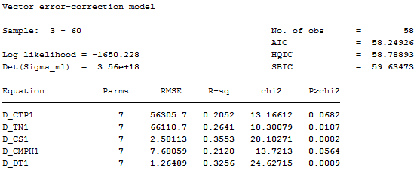
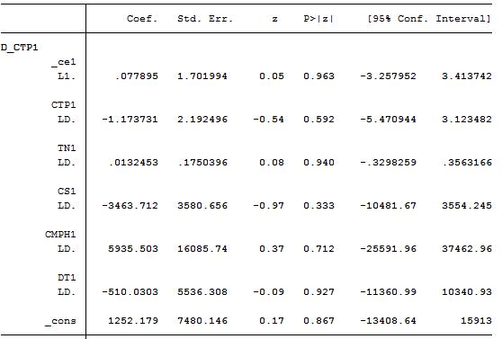
Sources: Stata Output

The short-run causality for the coefficient of lagged difference in Table 4.18 indicate that the P-values for TN (0.9397), CS (0.3334), STT (0.7121) and DT (0.9266) were higher than 0.05, so, cannot reject the null hypothesis that variables are zeros. Therefore, there is no short-run relationship between the explanatory variables (TN1, CS1, CMPH1 and DT1) and the respondent variable (CTP1).

Table 4.17: Test for Short-Run Causality

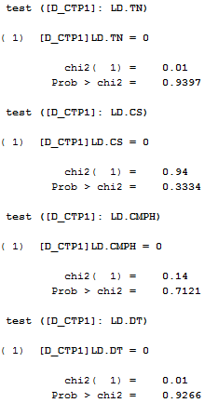

Sources: Stata Output

4.3.2.2 Causality Analysis of Factors Affecting DSM Port GCCT Productivity
Results from Table 4.16 are from DSM GCCT productivity model presented as
(21)
The dependent variable CTP1 is DSM Port GCCT productivity measured in TEU; the explanatory variable TN1 is cargo measured in tonne; the explanatory variable CS1 is the container ships measured in number; the explanatory variable CMPH1 is the container moves per hour, measured in TEU per hour and the explanatory variable DT1 is the time the container stays at port and is measured in days. The respective coefficients (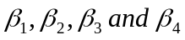) are multipliers showing the individual effects on respondent variable. Similarly, 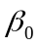is the constant from which the dependent variable CTP1 is predicted when the independent variables are equal to zero. Furthermore, the positive and negative signs on coefficients indicate the directions of the effect. The positive and negative signs explain the extent the dependent variable CTP1 increases or decreases respectively when the independent variable increases by one unit while holding other independent variables constant (PUL Web, 2007).

Table 4.18: Regression Model Output of Transformed Variables
Sources: Stata output

The DSM Port GCCT productivity model has Prob> F = 0.0000 which is less than 0.05, so there is some evidence to reject the null hypothesis which says ‘r² is zero’. The argument is made in favour of alternative hypothesis that r² is not zero; therefore the model has some explanatory power and significant. On the other hand, the coefficient of determination r² = .9981 implying that 99.81 percent is explained by TN, CS, CMPH and DT and only 0.19 percent is not explained (error).

The equation for DSM Port GCCT productivity model is
The effects of productivity factors (predictors) for DSM Port GCCT productivity model are expressed by the coefficients of the respective predictors discussed below as follows:-

Tonnage (TN1); the P>(t) = 0.115 is higher than 0.05, so cannot reject the null hypothesis that coefficient is zero meaning that zero is inclusive in the 95% confidence intervals (-0.345485 and 0.0038746); when the coefficient is zero implies that the coefficient has no effect on CTP. However, it shows from the model that when TN goes up by one tonne, CTP1 decrease by 0.0153369TEU. This is contrary because by increasing tonnage the expectation is that throughput CTP1 would increase slightly due to exchangeability between Twenty-foot Equivalent Unit (TEU) and Forty-foot Equivalent Unit (FEU). The inverse proportionality between CTP1 and TN1 is contrary to the perspective of the container business (MRT, 2015; TPA, 2015 and PMAESA, 2011). Furthermore, further study should be carried out to investigate the phenomenon.
Container ship (CS1); the P>(t) = 0.974 is higher than 0.05, so cannot reject the null hypothesis that coefficient is zero meaning that zero is inclusive in the 95% confidence intervals (-328.493 and 317.9551). When the coefficient is zero implies that the coefficient has no effect on CTP1. However, it shows from the model that when CS1 increases by one ship, CTP1 decrease by 5.268949TEU. This is contrary because by increasing number of ships, the expectation is that throughput CTP1 would increase regardless of the exchangeability between Twenty-foot Equivalent Unit (TEU) and Forty-foot Equivalent Unit (FEU). It was found in literature review that ships have been growing large and large so one of the reason could be the phasing out from smaller ships to larger ones (MRT, 2015); replacement of smaller vessels with bigger ones reduces the number of ship and not throughput. Therefore, further study should be carried out to investigate the phenomenon.

Container moves per hour (CMPH); the P>(t) = 0.000 is less than 0.05, so there is some evidence to reject null hypothesis that coefficient is not zero meaning that coefficient is different from zero because zero is not inclusive in the 95% confidence intervals (7233.296 and 7541.916). When the coefficient is different from zero implies that the coefficient has effect on CTP1. Furthermore, it was revealed from the model that, when CMPH1 goes up by one container move per hour, CTP1 increases by 7387.606 TEU. The effect of CMPH1 to dependent variable CTP is enormous. It is obvious that more moves can be performed prior to increase of CTP1. According to Djellal and Gallouj (2008) it is important to know how CMPH is measured, types of resources required, how resources are measured and what CMPH level is optimal.
Findings by UNCTAD (2015) signify that, ships have grown bigger; the bigger ships carry massive of container at the same time require shorter STT. For GCCT to accommodate these gigantic container ships must have infrastructures and superstructures in order to move container faster as desirable by Port Managers across the quay, yard and gate. According to Smith (2012) high automation of CMPH can be managed by accommodating several approaches such as transhipments at the waterside and landside, increase yard storage density and sufficient number of gates.

If CMPH is not well managed may result into ships taking many hours at the port which would firstly, dissatisfy shipping line due to wastage of time (delays) and surcharges. Secondly, dissatisfy agents in using port services because of surcharges. Thirdly, lose market share by which because of because of the surcharges spill-over effect to goods from which consumers’ wellbeing could be enjoyed when the port could be productive. Lastly, lose Government earnings hence little or no profit because the port is unproductive.

Dwell time (DT); the P>(t) = 0.634 is higher than 0.05, so cannot reject the null hypothesis that coefficient is zero meaning that zero is inclusive in the 95% confidence intervals (-392.4156 and 639.0947). When the coefficient is zero implies that the coefficient has no effect on CTP1. However, it shows from the model that when DT1 goes up by one day, CTP1 increases by 123.3396TEU. This is contrary because by increasing dwell time of container for one day does not increase throughput CTP1. But the opposite is true that when CTP increase likely DT will slightly increase but dwell time is supposed to be kept down as it hampers operation of the port for both import and export reducing port space. So increase or decrease in dwell time (DT) does not result in increasing of DSM Port GCCT throughput CTP rather reduces port flexibility in its operations hence proper management and care as per benchmarks in regard of container dwell time (SUMATRA, 2009 and Rankine, 2003).

The constant (); the P>(t) = 0.000 is less than 0.05, so there is some evidence to reject the null hypothesis that coefficient is zero meaning that the coefficient is different from zero and is not inclusive in the 95% confidence intervals (-37009.77 and -26406.81). When the coefficient is different from zero it implies that the coefficient has effect on CTP1. The effect are obvious when there are no cargo (TN = 0), no container ship (CS = 0), no container handled per hour (CMPH = 0) and no or less than one day for container stay at the port (DT = 0); therefore, CTP1 measured in TEU will severely decrease by 31708.29TEU being average TEU per month. These will reduce government revenue.

In the general as per F>statistics, jointly factors TN1, CS1, CMPH1 and DT1 are crucial for DSM Port GCCT productivity Model, despite the fact that the model predictors have no long-run and short-run causality to respondent variable. According to Elmakki et al (2017) pointed that, absence of causal relationship is due to weak or inability of the explanatory variable to stimulate the respondent variable. Therefore, the coefficients of the key productivity factors in the DSM Port GCCT productivity model provide highlights on strategic issues requiring improvement. The issues are in terms of number ships and capacity, tonnage handled at port, the moves performed per hour and the number of days the container stay at the port. The factors if not well managed will lead to increasing ship turnaround time, to limited space, inflexibility and loss of potential customer and revenue (PRSA, 2016; TPA, 2015; World Bank. 2013; Tioga, 2012 and SUMATRA, 2009).

4.4 The Future Prospects of DSM Port GCCT Container Traffic
Results in Figure 4.4 show forecasted container traffic (CTP) with trend, linear with positive slope. Considering a year with 50 weeks, 7 days, 24 hours a day and the forecasted throughput of 514, 584TEU, DSM Port GCCT will be required to perform at least 60 moves per hour (CMPH). Almawsheki and Shah (2015) stipulated on the importance of container data and forecasting, urged the terminal managers to keep detailed container information including the exogenous factors and use correct demand forecasts in planning and terminal developments. The automation of containers depends on the number of gantry cranes, their capacity and reinforced quay wall to accommodate them. It is obvious that more moves should be performed prior to increase of CTP. Furthermore; the terminal must have robust logistics and supply chain and connectivity to hinterlands (Flitsch, 2012).
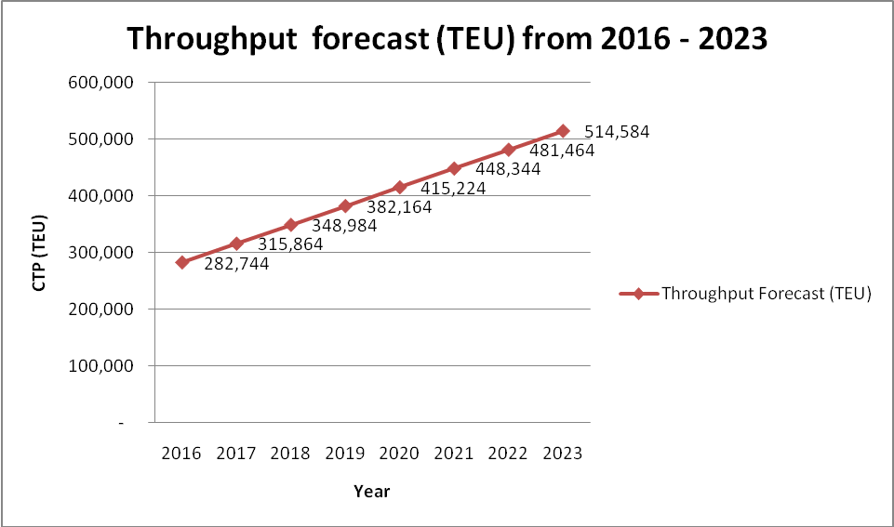
Figure 4.4: Throughput Forecasts (TEU) from 2016 - 2023
Source: Forecast Made by Author
According to World Maritime News (2017) the container ship growth in terms of size and capacity has been enormous. Container ship of capacity 19000TEU was deployed in 2014 and the container business expects to employ the ship of 22000 TEU in 2018. The DSM port has a draft of 12metres; according to Table 4.19 the port can accommodate the container ship with average capacity of 3000 TEU. These container ships need to be loaded and unloaded efficiently for that matter the port needs to be productive. According to Loke et al (2014) port productivity of the container terminal is affected by vessels calls in terms of number, size and capacity. For that matter, DSM port must have sufficient draft to accommodate large container ships. Similarly it has to have adequate equipment and facilities to perform adequate container moves per hour which is the rate of loading and unloading of containers per hour. CMPH may results in congestion and increase ship turnaround time (STT).

Table 4.19: Generation of Containerships’ and Draft from pre 1970 – 2012/20

Year | Draft(m) | TEU
Pre 1970 | <9 | 1700
1970 - 1980 | 10 | 2300
1985 | 11.6-12.8 | 3220
1986-2000 | 12.8-14 | 4848
2000-2005 | 14.5 | 8600+
2005-2012 | 15 | 9600+
2012-2020 | >16 | 14000+
Source: http://www.virginiaplaces.org/transportation/shiptransport.html.

Container business like other seaborne businesses is cyclical and patterned causing variability in supply of container ships versus the available cargo. The phenomena is that one side of the port can have more container to be unloaded resulting to congestion and or few container to be loaded so ships will have to sail half loaded while on another side of port there can be few container to be unloaded resulting idleness and or more to be loaded so ships will have to sail full loaded. Due to other economic shocks resulting from the variables such as fuel price, shipping market cycles and other speculations influencing supply of container ships and demand for cargo; it is possible for the port to be idle for quite some time.

4.5 Summary
The results and discussion of the analysis for the three objectives with their respective hypotheses are:-

Objective1: In examining productivity of DSM Port GCCT one-sample was used. It was found that the mean for CTP = 29055.3TEU, CMPH = 33.27TEU, DT = 7.53 days from data collected were greater than CTP = 17500TEU, CMPH = 25TEU and DT = 6days being hypothesised. The mean for CTP, CMPH and DT from collected data are greater than hypothesised mean for CTP, CMPH and DT. Therefore, increase for the individual respective productivity factors is substantial and for that matter DSM Port GCCT is productive.

Objective2: In developing DSM Port GCCT productivity model, the respondent variable CTP was correlated to the explanatory variables TN, CS, CMPH, TQE, SU and DT. The model was found to have multicollinearity with VIF = 234.42 which was reduced to a desirable VIF = 2.50. The process removed the variables TQE and SU from the model. The model became. This model did not satisfy conditions for fitness and goodness because residuals were not normally distributed. However, the variables were transformed and the model satisfied the statistical conditions for fitness and goodness. The transformation model equation is:-
, the predictor TN1, CS1 CMPH1 and DT1 found to have neither long-run nor short-run relationships to the respondent variable CTP1. The absence of long-run and short-run relationships were due to lower stimuli of the predictors on the respondent variable. DSM Port GCCT productivity model is jointly significant and has strong explanatory power; therefore, reasons for lower stimuli of predictors to the respondent variable are expressed as effects of factors (predictors) using their respective coefficients from the model.

Objective3, in analysing the future prospects of DSM Port GCCT container traffic, throughput of DSM Port GCCT was forecasted from 2016 to 2023. Trend of the forecasted data shows a potential increase of containers measured in TEU. It is obvious that more moves should be performed prior to increase of CTP. Managers at the container terminal should keep detailed container information including the exogenous factors and use correct demand forecasts in planning and terminal developments.

CHAPTER FIVE

5.0 CONCLUSIONS AND RECOMMENDATIONS

5.1 Chapter Overview
This was a descriptive empirical analysis on productivity of container terminal in Tanzania; a case study of Dar es Salaam Port General Cargo Container Terminal (DSM Port GCCT). The study examined productivity of DSM Port GCCT, developed the model and analysed throughput forecasted trend. Likewise the study had three objectives from which the three hypotheses were developed. The study collected monthly quantitative secondary data for 60 months for the consecutive five years from 2011 to 2015. The hypotheses were tested and confirmed at 0.05 alpha levels.

5.2 Conclusions
The summaries of the findings for the three objectives are explained below as follows:-

The first objective examined the productivity of DSM Port GCCT; the assumption was that DSM Port GCCT is moderately productive because the mean of collected data are greater than the hypothesised mean. It was found that the individual mean from collected data were CTP = 29055.3 TEU, CMPH = 33.27 TEU, DT = 7.53 days. These individual respective mean were greater than hypothesised mean CTP = 17500 TEU, CMPH = 25 TEU and DT = 6 days. The mean from collected data are greater than those benchmarked, the reasons were due to increased use of containers for the indigenous and the neighbouring countries. The increase of container throughput CTP requires that the container moves per hour (CMPH) be increased in order to ensure that ship turnaround time is quite short. On the other hand, the increase in dwell time (DT) increased the average number of days the containers stay at the port demanding more terminal spaces which reduces terminal flexibility in handling new arrivals of import and export containers. However, the extent of productivity at DSM port is not what is desirable due to congestion and delays resulting to loss of market shares, revenues and shortage of spaces.

The second objective developed DSM Port GCCT productivity model; the model was found after having satisfied the correlation test and. When the model was tested for fitness and goodness the residuals were found to be not normally distributed. The variable from the model were transformed and after variables transformation the model became.

The Vector Error Correlation Method (VECM) was used in analysing the existence of long-run and or short-run relationship. It was found that there were neither long-run relationships nor short-run relationships between the explanatory variables (TN1, CS1, CMPH1 and DT1) and the respondent variable CTP1. The absence of causality relationship is due to weak or inability of the explanatory variable to stimulate the respondent variable. The inabilities were interpreted by analysing the coefficient of the DSM Port GCCT model predictors. The productivity model for DSM Port GCCT has Prob > F = 0.0000 and coefficient of determination r² = .9981 which implies that the model is jointly significant and has explanatory power that 99.81 percent is explained by TN1, CS1, CMPH1 and DT1 and only 0.19 percent is not explained (error). The equation for DSM Port GCCT productivity model is given by:-
The predictor TN1 has no effect on CTP because the coefficient is zero at 95% confidence intervals (-0.345485 and 0.0038746). So when TN1 goes up by one tonne, CTP1 decreases by 0.0153369 TEU. This is contrary to expectation because by increasing tonnage, the expectation is that throughput CTP1 would increase slightly due to exchangeability between Twenty-foot Equivalent Unit (TEU) and Forty-foot Equivalent Unit (FEU). The inverse proportionality between CTP1 and TN1 is contrary to the perspective of the container business. (why is this contradiction).

The predictor CS1 has no effect on CTP1 because the coefficient is zero at 95% confidence intervals (-328.493 and 317.9551). So when CS1 increases by one ship, CTP1 decreases by 5.268949 TEU. This is contrary because by increasing number of ships, the expectation is that throughput CTP1 would increase regardless of the exchangeability between Twenty-foot Equivalent Unit (TEU) and Forty-foot Equivalent Unit (FEU). It was found in literature review that ships have been growing larger and larger so one of the reasons could be the phasing out from smaller ships to larger ones. The replacement of smaller vessel with bigger one reduces the number of ships and not throughput.

The predictor CMPH1 has effect on CTP because the coefficient is not zero at 95% confidence intervals (7233.296 and 7541.916). So when CMPH1 goes up by one container move per hour, CTP1 increases by 7387.606 TEU. The effect of CMPH1 to dependent variable CTP is substantial; bigger ships carry massive number of container at the same time require shorter STT which can be minimised by increasing the number of container moves per hour (CMPH1). For DSM Port GCCT to accommodate these gigantic container ships must have infrastructures and superstructures in order to move container faster as desirable by port Managers across the quay, yard and gate.

High automation of CMPH can be managed by accommodating several approaches such as transhipments at the waterside and landside, increase yard storage density and sufficient number of gates. If CMPH is not well managed may result into ships taking long hours at the port which results into firstly, dissatisfaction of shipping line due to wastage of time (delays) and surcharges. Secondly, dissatisfactions of agents in using port services because of surcharges. Thirdly, loss of market shares because of the surcharges spill-over effect to goods from which consumers’ wellbeing could be maximised when the port could be productive. Lastly, the Government earns low revenues and hence little or no profit because the port is unproductive. Therefore it is important to do timely analysis of CMPH, the required resources and the optimal CMPH level as benchmarked by the industry or stakeholders in container business.

The predictor DT1 hypothetically has no effect on CTP1 because the coefficient is zero at 95% confidence intervals (-392.4156 and 639.0947). So when DT1 goes up by one day, CTP1 increases by 123.3396 TEU. This is contrary because by increasing dwell time of container for one day does not increase throughput CTP1. But the opposite is true that when CTP1 increase, DT1 will slightly increase, however, dwell time is supposed to be kept down as it hampers operation of the port for both import and export reducing port space. So dwell time (DT1) does not increase container terminal throughput (CTP1) rather reduces port flexibility in its operations and can result into port being unproductive. Hence proper management and care as per benchmarks in regard of container dwell time is necessary.

Moreover, the constant 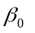= 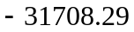 has effect on CTP1 because the coefficient is not zero at 95% confidence intervals (-37009.77 and -26406.81). So when there is no cargo (TN = 0), no container ship (CS = 0), no container handled per hour (CMPH = 0) and no container stay at the port (DT = 0), CTP1 measured in TEU will severely decrease by 31708.29TEU being average TEU per month. These will reduce government revenue.

Generally as per F>statistics, the jointly productivity factors TN1, CS1, CMPH1 and DT1 are crucial for DSM Port GCCT productivity Model, despite the fact that the model predictors have no long-run and short-run relationships to the respondent variable CTP1. The absence of long-run and short-run relationships is due to weak or inability of the predictor variable to stimulate the respondent variable. The weakness and inability of the predictor variable are reflected firstly; from the controversy that TN1 and CS1 predictors are decreasing while respondent variable CTP is increasing. The increase in TN1 and CS1 are expected to directly increase CTP but for this case is contrary.

However, because ships have grown bigger, the call of bigger ships at DSM port could cause a slight decrease in CS1 while increasing CTP, but this is not the case to DSM port due to draft limitations. Secondly, it is the fact that the CMPH1 and DT1 predictors are increasing directly proportion to increase in CTP1 while the port is congested and succumbed with delays. The increase in CMPH1 is substantial but not desirable to reduce ship turnaround time and the increase in DT1 makes container stay longer at the port before cleared for export or imports. Nevertheless, all the coefficients of the key productivity factors provide highlights on strategic issues requiring improvement. The issues are in terms of number ships calling at DSM port and their respective capacity, tonnage handled at port, the moves performed per hour and the number of days the container stay at the port. The factors if not well managed will lead to increasing ship turnaround time, to limited space, inflexibility and loss of potential customer and revenue.

The third objective analysed the future prospects of DSM Port GCCT container traffic. It was found that container traffic in terms throughput forecasts is linear with positive trend. The trend shows growth in throughput, the trend should go hand by hand with future planning, terminal developments and automation of containers which depend on the number of gantry cranes, their capacity, reinforced quay wall and sufficient number of gates. It is obvious that more moves should be performed prior to increase of CTP1.

5.3 Recommendations
In order to improve productivity of the container terminal in Tanzania, the researcher recommends to:-
- Carry out further studies to incorporate all productivity factors in the container terminal model and evaluate productivity timely for improvement.
- Timely test and review the productivity model or develop new model to suit the container terminal needs, technological changes, demand and supply in container business.
- Examine the best standard methods of correcting, keeping and tabulating data of container processes.
- Review and or put in place policies on strategic issues such as expansion of port market to the hinterlands, tariffs, terminal operation, productivity, trade, financing and transport operations.

REFERENCES
Adkins, L.C. and Carter Hill, R. (2011). Using Stata: For Principles of Economics. 4th Edition, NewYork: John Wiley & Sons, Inc.
Allison, P. (2012). Statistical Horizon: When can you Safely Ignore Multicollinearity. Retrieved on 01/10/2016, from; [http://statisticalhorizons. com/multicollinearity].
Almawsheki, E.S. and Shah, M.Z. (2015). Technical Efficiency Analysis of container terminal in the Middle Eastern Region. Asian Journal of Shipping and Logistics. 31(4), 477-486.
Anderson, D. R., Sweeney D. J. and Williams, A. T (2012). Essentials of Statistics for Business and Economics, 6th edition, New York: South–Western Cengage Learning.
Anderson, D. R., Sweeney D. J., Williams, A. T., Camm, J. D. and Martin, K. (2012). An Introduction to Management Science: Quantitative Approaches to Decision Making. 13th revised edition, pp. 502 – 541, USA: South –Western Cengage Learning.
Anderson, S., Ilea, D. and Shi, L. (2005). Productivity Measurement in the Public Sector. New York: New York City Agency.
Bernhofen, D. M., El-Sahli, Z. and Kneller, R. (2014). Estimating the Effects of the Container Revolution on World Trade. Retrieved on 15/12/2015, from; www.american.ed/cas/economics/news/upload/bernhofen-paper.pdf.
Box, G. E. P. and Cox, D. R. (1964). An analysis of Transformations, Journal of the Royal Statistical Society, 26(2), 211-252.
Branch, A. E. (2009). Maritime Economics: Management and Marketing, 3rd Edition, New York.: Routledge Tayrol & Francis Croup.
Brooks, C. (2008). Introductory, Econometrics for Finance. 3rd edition, 669pp, The ICMA Centre, Cambridge University Press.
Bryman . A. (2008). Social Research Methods. 3rd edition, Oxford: Oxford University Press.
Centre for the Study of Living Standards, (1998). Productivity: Key to Economic Success, Report prepared by the Centre for the Study of Living Standards for. The Atlantic Canada.
Chopra S., Meindl P. and Kalra D. (2008). Supply Chain Management – Strategic, Planning and Operation, 3rd edition, New Delhi: Prentice-Hall of India Pvt Ltd.
Cothari, C. R. (2004). Research Methodology; Methods and Techniques. 2nd revised edition, New Age International (P) Limited Publisher. New Delhi. 401pp
Creswell, J. W. (2009). Research Design, ‘Qualitative, Quantitative, and Mixed Approaches’, 3rd edition, London: Sage Publications.
Djellal, F. and Gallouj, Faïz. (2008). Measuring and improving productivity in Services Issues. Strategies and Challenges. pp261, Northampton, MA, USA.
Elmakki, A., Bakari, S. and Mabrouki, M. (2017). The Nexus between Industrial
Esmer, S. (2008), Performance measurements of container terminal operations. Dokuz Eylul University (DEU) J GSSS, 10(1), 238–256.
Exports and Economic Growth in Tunisia: Empirical Analysis. Retrieved on 15/6/2017, from; https://mpra.ubub.uni-muenchen.de/79360.
Flitsch, V. (2012). Efficiency Measurement of Container Ports- a new Opportunity for Hinterlands Integration. Journal of Research in Logistics and Production, 2(2), 163-173.
Garbarino, S. and Holland, J. (2009). Quantitative and Qualitative Methods in Important in impact Evaluation and Measuring Results, Issues Paper, DFID/OPM/GSDRC. Retrieved on 11/3/2012, from; www.gsdrc.org.
Golafshani, N. (2003) Understanding Reliability and Validity in Qualitative Research. Qualitative Report, 8(4), 597-607.
Gupta, P. K. and Hira, D. S. (2011). Operations Research. New Delhi: S.Chand and Company LTD.
Haralambides, H., Veldmanb S. Van Drunenb E. And Liu M. (2011). Determinants of a Region Port-Centric Logistics Hub; the case of East Africa. Maritime Economics & Logistics, 13(1), 78-97.
Henesey, L. E. (2004). Enhancing Container Terminal Performance: a multi Agent System Approach. Doctoral thesis, Blekinge Institute of Technology, Karlskorona, Sweden.
Hosmer, D. W. and Lemeshow, S. (2011). Applied Logistics Regression, 2nd Edition, New York: Wiley Interscience Publication.
Hossain, S. and Abedin, T. (2016). Multivariate Dynamic Co-integration and Causality Analysis between Inflation and its Determinants. Journal of Economics and Behavioral Studies. 8(5), 240-250.
JOC Group, (2014). Port Productivity; Berth Productivity: The Trends, Outlook and Market Forces Impacting Ship Turnaround Time. JOC Group. Inc. retrieved on 20/5/2016, from; www.joc.com/port_productivity.
John, T. (2009). History and Impact of intermodal Shipping Container. Pratt Institute, For LIS 654-05/Carrie Bickner.
Jugović, A., Hess, S. and Jugović, T.P. (2010). Traffic Demand Forecasting for Port Services. Journal on Traffic and Transportation. 23(1), 59-69.
Keller, G. (2007). Statistics for Management and Economics. 8th Edition. South-Western College Pub.
Krugman, P. (1997). The Age of Diminished Expectation. U.S. Economic Policy in 1990s. 3rd Edition, London: The MIT Press.
Kumar, R. (2005). Research Methodology: A Astep by Step Guide for Beginers. 2nd edition. New Delhi: Sage Publications.
Kumar, S. A and Suresh, N. (2008). Production and Operations Management, 2nd Edition. pp284, New Delhi: New Age International (P) Limited.
Ligteringen H. (2009). Port and Terminal Readers, Delft University of technology, retrieved on 13/7/2012, from; [http://docslide.us/documents/designing-a-container-terminal-yard.html.
Loke, K., Othman, M,R., Saharuddin, A.M. and Fadzil, M.N. (2014). Analysis of Variables of Vessel Calls in Container Terminal. Open Journal of Marine Science, 4, 279-285.
Lu, B. and Park, N. Y. (2013). Sensitivity Analysis for Identifying the Critical Productivity factor of the Container Terminal. Journal of Mechanical Engineering. 59(9), 536-546.
Mai, B. and Warmke, N. (2012). Comparing Approaches to Compiling Macro and Micro Productivity Measure Using Statistics New Zealand Data. [www.stats.govt.NZ]. Site visited on 14/4/2014.
Mai,B. and Warmke, N (2012). Comparing Approaches to Compiling Macro and Micro Productivity Measures Using Statistics New Zealand data. Wellington, New Zealand.
Mardiana, A. (2015). Effect Ownership Accountant Public Office, and Financial Distress to the Public Company Financial Fraudulent Reporting in Indonesia. Journal of Economics and Behavioral Studies, 7(2), 109-115.
Mark, (2005). Qualitative Research Methods: A Data Collector’s Field Guide by Family Health International. Research Triangle Park, North Carolina 27709 USA. Retrieved on 12/2/2013, from; http://www.fhi.org.
Mascarenhas, A.C. (1970). The port of Dar es Salaam. Notes and Records, 71, 85-118
McConvile J. (2009). Economics of Maritime Transport “Theory and Practice” 1st Edition, London: Withersby & Co. Ltd.
National Transport Policy, (2003). Ministry of Communication and Transport of the United Republic of Tanzania, Dar es Salaam, Tanzania.
Niyimbanira, F., Rangaza, K., Shimwe- Niyimbanira, R. and Kuyel, S.S. (2015). The Determinants of Interest Rate Spreads in South Africa: A Cointegration Approach. Journal of Economics and Behavioral Studies. 7(2), 101-108.
Oke, S. A. (2004). A productivity Measurement Model for Higher Educational Institutions, South African Journal of Industrial Engineering, 15(2), 91-106.
Organisation for Economic Co-operation and Development, (2001). Measuring Productivity. Measurement of Aggregate and Industry – Level Productivity growth. OECD Manual. Retrieved on 2/5/2016, from; www.sourceOECD.org.
Osborne, J. W. (2010). Improving your data Transformation: Applying the Box-Cox Transformation. A Practical Assessment, Research and Evaluation. 15(12), 1-9.
Port Management Association of Eastern South Africa (2011). Study on Development of Port Statistics and Performance Indicators in PMESA Ports. Final Report, pp. 1 – 141, Trade Mark Southern Africa.
Ports Regulatory of South Africa, (2016). Benchmarking report: SA Port Terminal (2015/2016). Durban South Africa.
Prabhu, Nagi. and Rendell, James. (2014). Smart Containerization; A Unique technology that Manages Security, performance, Compliance and Support Characteristics of any Device, Application, Content or Email while Preserving the Quality of the Mobile User Experience. Retrieved on 20/12/2015, from; www.ca.com/content/dam/ca/us/files/solutions-brief/ smart-containerization.pdf.
Princeton University Library, (2007). Data and Statistical Services. Retrieved on 20/6/2017, from; http://dss.princeton.ed/online_help/analysis/interpreting_ regression.htm.
Pritchard, A. (2002). Measuring Productivity Change in the Provision of Public Services. Economic Trends No. 582, 1 Drummond Gate, London SW1V@QQ.
Radmilović, Z. and Jovanović, S. (2006). Berth Occupancy at Container Terminals: Comparison of Analytical and Emperical Results. Promet-Traffic and Transportation. 18(2), 99 – 103.
Rankine, G. (2003). Benchmarking Containership Terminal Performance, Container Port Conference Rotterdam, February, 2003.
Research Report 11: Truck Drayage Productivity Guide. pp. 1 – 97, The Tioga Group Inc. Philadelfia.
Roberts, S. (2008). Nutrition, Transform your data. Statistics column. Clinical Nutrition Experimental. Nutrition, 24, 492–494.
Rodrigue, J. P., Comtois, C. and Slack B. (2006). The geography of transport system. New York: Routledge, Taylor and Francis Group.
Rogelberg, S. G. (2007). Handbook of Research Methods in Industrial and Organisational Psychology. New York: Blackwell Publishing Ltd.
Saleemi, N. A. (2011). Business Mathematics and Statistics Simplified. 4th Edition. Saleemi Publication LTD.
Schopohl, L. (2014). Stata Guide to Accompany Introductory Econometrics for Finance. Cambridge University Press © Chris Brooks (2014).175pp.
Smith, D. (2012). Container Port Capacity and Utilization Metric – Diagnosing the MARINE Transportation System. Transportation System. 1 (1), 1-24.
Stopford, M. (2009). Maritime Economics, 3rd edition, New York: Routledge.
Sukati, M. A. (2013). Cointegration Analysis of Oil Prices and Consumer Price Index in South Africa using Stata Software. Paper No. 49797. retrieved on 10/5/2014, from; http://mpra.ub.uni-muenchen.de/49797/MPRA.
Surface and Marine Transport Regulatory Authority (2009). Report on Port Performance Indicators and Benchmarks. 53pp.
Tanzania Planning Commission, (1995). Tanzania Development Vision 2025, retrieved on 13/7/2013, from; http://www.mof.go.tz/mofdocs/overreach/ vision2025.pdf.
Tanzania Port Authority, (2011). To Lead Regional Trade and Logistics Services to Excellency.
Tanzania Ports Authority (2012). Annual Report and Accounts.
Tanzania Ports Authority (2013). Annual Report and Accounts.
Tanzania Ports Authority (2015a). Quick Facts about Dar es Salaam Port; The Hub of East African Trade.
Tanzania Ports Authority (2015b). Dar es Salaam Port Hand Book.
Tanzania Ports Authority, (2007). Brief on Dar es Salaam Port - the Hub of East African Trade and Routes, Dar es Salaam, Tanzania.
Tanzania Ports Authority, (2009). Annual Report and Accounts. Dar es Salaam, Tanzania.
Tanzania Ports Authority, (2011). Corporate Strategic Plan 2011/12 – 2015/16.
The Conference Board (2009) Productivity, Employment, and Growth in the World’s Economies. Productivity brief.
The Tioga Group Inc. (2011). National Cooperative Freight Research Programme
Tomlinson, J. (2009). History and Impact of Intermodal Shipping Centre. Pratt Institute. 9pp.
Tucker, I.B. (2013). Macroeconomy and Fiscal Policy. In: Survey of Economics. pp 227-390. South Western, USA.
Udovičić, M., Bažadarić, K., Bilić-Zulle, L. and Petrovečki, M. (2007). What we need to know when calculating the coefficient of correlation?. Biochemia Medica. 17(1), 10-15.
United Nations Conference on Trade and Development (1975). Port pricing. TD/B/C.4/110/Rev,1. Report by the Secretariat United Nations, New York and Geneva.
United Nations Conference on Trade and Development (1976). Port Performance Indicators UNCTAD. TD/B/C.4/131/Supp.1/Rev.1. 27pp.
United Nations Conference on Trade and Development (1991). Handbook on the Management and Operation of Dry port. UNCTAD/RDP/LDC/7. Report by the Secretariat United Nations, New York and Geneva.
United Nations Conference on Trade and Development (2003). African ports: Reforms and the Role of the Private Sectors. Report by the Secretariat of UNCTAD. UNCTAD/SDTE/TLB/5.
United Nations Conference on Trade and Development (2007). Improving Transit Transport in East Africa: Challenges and Opportunities. Report by the Secretariat United Nations, New York and Geneva.
United Nations Conference on Trade and Development (2011). Review of Maritime Transport. Report by the Secretariat United Nations, New York and Geneva.
United Nations Conference on Trade and Development (2012). Review of Maritime Transport. Report by the Secretariat United Nations, New York and Geneva.
United Nations Conference on Trade and Development (2014). Review of Maritime Transport. Report by the Secretariat United Nations, New York and Geneva.
United Nations Conference on Trade and Development (2015). Review of Maritime Transport. Report by the Secretariat United Nations, New York and Geneva.
United Nations Conference on Trade and Development (2016). Review of Maritime Transport. Report by the Secretariat United Nations, New York and Geneva.
United Republic of Tanzania (2009). Hali ya Uchumi wa Taifa katika Mwaka 2008 (The 2008 Economic Situation Report - 2009). Ministry of Finance and Economy, Dar es Salaam,Tanzania.
Utouh, H.M.L. (2007), Selected Topics in Microeconomics. Published by The Department of Research and Publications P.O.Box 84 Mzumbe University.
Viélez, J. I., Correa, J. C. and Marmolejo-Ramos, F. (2015). A new Approach to the Box-Cox Transformation. Frontiers in Applied Mathematics and Statistics. 1(12), 1-10.
Wang, T. F., Song, D-W and Cullinane, K. (2003). Container Port Production Efficiency: A Comparative Study of DEA and FDH Approaches. Journal of the Eastern Asia Society for Transportation Studies, 5, 698-710.
William, R. (2015). Multicollinearity, http://www3.nd.ed/~rwilliam/Last revised January 2015.
World Bank, (2013). Tanzania Economic Update. Opening the Gate; how the port of Dar es Salaam can transform Tanzania. The World Bank Africa Region Poverty Reduction and Economic Management, Dar es Salaam, Tanzania.

APPENDICES

Appendix 1: Top Global Terminals' berth Productivity, 2014 - CMPH
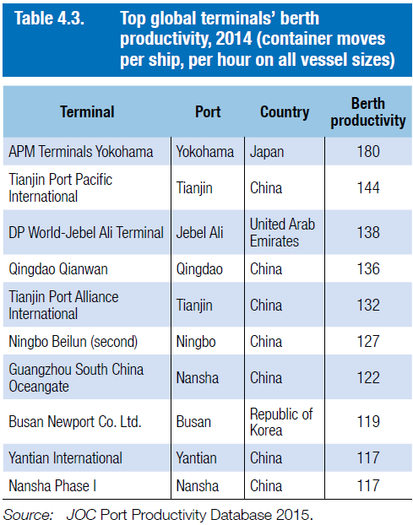

Appendix 2: Generation of Container Ships
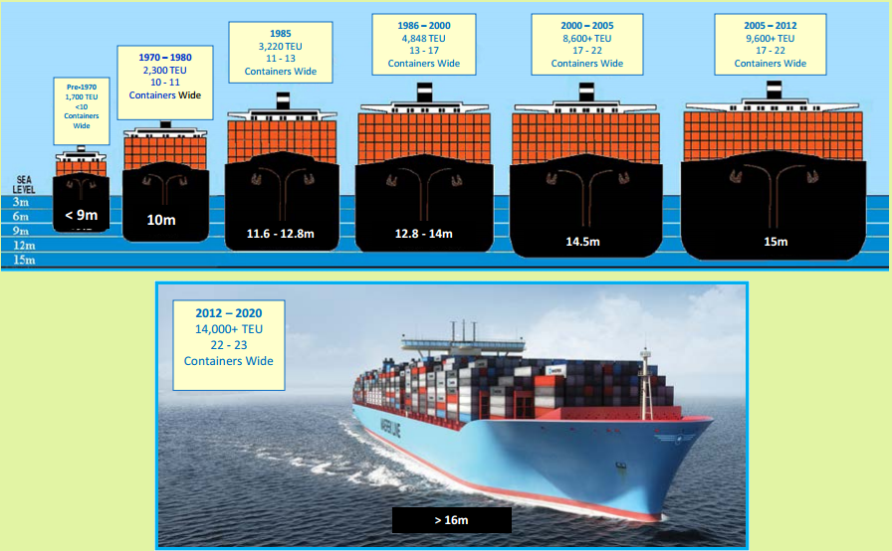
Source: http://www.virginiaplaces.org/transportation/shiptransport.html

Appendix 3: Summarized Indicative Productivity factors
Esmer (2009) | Rankine (2003) | SUMATRA (2009) | UNCTAD (1976) | Tioga (2012)
Ship Productivity:-  ship turnaround time – hrs/ship | Vessel turnaround time – hrs/ship | Ship turnaround time – hrs/ship  (3 days (waiting time <1, berthing time, service time ~1 and deberthing time) | Waiting time – hrs/ship  Berthing time – hrs/ship  Service time – hrs/ship  Ship turnaround time – hrs/ship | Vessel turnaround time – hrs/ship
Equipment productivity:-  Machine per hour  Equipment utilisation =  time deployed/ time available | Moves per crane – TEUs/hrs  (20 to 25 moves per hour  Modern port ~115,000TEU pa) | Moves per crane – TEUs/hrs (25mph) | Moves per crane – TEUs/hrs | Moves per crane – TEUs/hrs  Vessel calls per crane/hrs  Crane utilisation =  Time used/time available
Quay productivity:  Berth occupancy rate (%)  Berth utilisation =  Time berth occupied/ Time available | Berth productivity :-  TEU/m of berth length  Standard 1000TEU per metre pa  EU 850TEU per metre pa  USA 550TEU per metre pa  China 1,500TEU per metre pa  Berth occupancy rate (60% to 80%) | Berth occupancy rate (60%) | Berth occupancy rate (%) | Annual TEU / berth length
Terminal area productivity:-  Annual TEUs/Acre  Storage utilisation =  Slots occupied/slots available  Gate utilisation  Dwell time (days) | Yard productivity -TEUs/hectare (20,000TEU per hectare pa  Large terminal + 50%)  Dwell time (3days or 4days  Practice 5days and 7 days )  Truck turnaround time (25 to 30 minutes from entry to exit  Reduce to 10 to 15 minutes)  Mean stack height  Trucks per gate per operating hour | TEUs/hectare  Dwell time (Import 7 days  Export 4 days) | - | Annual TEUs/hectare
Crane productivity  Moves per crane – TEUs/hrs | - | - | - | -
Labour productivity:-  TEUs per man hour | TEUs/employee/year per terminal/berth/yard  Trucks per gate labour hour | - | TEUs per man hour | TEUs per man hour  Crane moves per man hour
Cost effective productivity:-  Cost /TEUs | Loss/damage per 1000TEUs  Equipment availability = available /required | Expenditure /TEUs | Berth occupancy revenue/TEUS  Labour expenditure /TEUS  Capital equipment cost/TEUs | -
Source: Tioga (2012), SUMATRA (2009), Esmer (2009), Rankine (2003) and UNCTAD (1976)

Appendix 4: Region’s Top Ten Ports Container Throughput
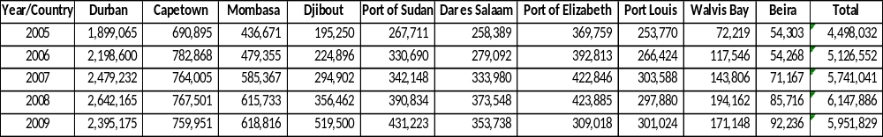
Source: PMAESA (2011)

Appendix 5: Region’s Top Ten Countries Container Throughput
Source: MRT (2015)

Appendix 6: DSM and Mombasa Market Share from 2005 to 2012
YEAR | DSM | MOMBASA | TOTAL | SHARE - TZ | SHARE - KN
2005 | 258,389 | 436,671 | 695,060 | 37 | 63
2006 | 279,092 | 479,355 | 758,447 | 37 | 63
2007 | 333,980 | 585,367 | 919,347 | 36 | 64
2008 | 373,548 | 615,733 | 989,281 | 38 | 62
2009 | 353,738 | 618,816 | 972,554 | 36 | 64
2010 | 421,534 | 695,600 | 1,117,134 | 38 | 62
2011 | 489,981 | 770,804 | 1,260,785 | 39 | 61
2012 | 556,286 | 903,463 | 1,459,749 | 38 | 62
Average percentage |  |  |  | 37 | 63
Source: PMAESA (2011) and MRT (2015)

