IMPROVEMENT OF YOUTH INCOME THROUGH POULTRY KEEPING AT ORKKESUMET HAMLET IN SIMANJIRO DISTRICT

LONYAMAL NDUUNI

A PROJECT REPORT SUBMITTED IN PARTIAL FULFILMENT FOR THE REQUIREMENTS FOR THE DEGREE OF MASTER IN COMMUNITY ECONOMIC DEVELOPMENT IN THE OPEN UNIVERSITY OF TANZANIA
2017

CERTIFICATION
The undersigned certifies that she has read and hereby recommends for acceptance by Open University of Tanzania (OUT) a project titled; “Improvement of Youth income through poultry keeping at Orkesumet Hamlet in Simajiro District in Manyara Region”, in partial fulfillment of the requirements for the degree of Master of Community Economic Development of the Open University of Tanzania.

………………………………………….
Dr. Harrieth G. Mtae
(Supervisor)

.......................................
Date

COPYRIGHT
No part of this dissertation may be reproduced, stored in any retrieval system or transmitted in any form by any means, electronic, mechanical, photocopying, recording or otherwise without prior written authorization of the author or the Open University of Tanzania in that behalf.

DECLARATION
I, Lonyamal Nduuni, do hereby declare that this CED project report is my own original work and that it has not and won’t be presented to any other University for similar or any other degree award.

...…………………………….………..
Signature

................................................
Date

DEDICATION
I am grateful before God to dedicate this work to my beloved wife Nakaji Melayeki Mollel; as she extended her love, support, encouragement and unquenchable tolerance throughout the duration of my absence for studying. She really took care of our family successfully. May the fountainless blessings of God keep on embracing her!

ACKNOWLEDGEMENT
I am grateful before God to extend my thanks to my daughters (Nossim and Esupat Lonyamal) for their decent cooperation. Special thanks to MCED Coordinator and my Supervisor (Dr Harrieth) for her tireless efforts, patience, encouragement and continuous suggestions and comments throughout the whole long run duration of two years until these moments of happiness.

My sincere gratitudes are as well forwarded to my Lecturors; Proffesor Deus Ngaruko, Dr. Shungu, Dr. Mutasa and Dr. Malya for their moral help and assistance academically. My Employer (Yefred Myenzi - DED SMJ) deserves unutterable thanks for financial support, permission and encouragement. Finally, I would like to acknowledge the support, participation, encouragement and immeasurable cooperation from my fellow MCED students (Rehema, Selina, Godson, Mgaya, Vedastus, Urio, Mponji, Dora, Madanganya and Joseph). This list is not exhaustive but enough as representatives.

ABSTRACT

Improvement of youth income through poultry keeping at Orkesumet Hamlet in Simanjiro District emerged to be a solution to their income need. Youth in this community face a challenge of unreliable source of income, there are various sources like crop production, dairy and beef cattle farming, carpentry, masonry and food vending, but this homogeneous group can’t afford any of these. These youth are those who have or may not have even completed class seven, who are not married, looking for employment and still depending to their parents or guardians for a daily bread. This group of Youth and the other of low income earners Women can only afford poultry farming due to its low running costs, little seed capital and high demand of chicken in restaurants and in households. Poultry keeping has been picked during community need assessment. During discussion session ranking of needs by the aid of pair wise ranking matrix resulted into four priority needs for implementation. In combating this problem the following interventions were identified; poultry farming, crops production, fish farming, establishment of vegetable garden and establishing food vending business. Hamlet Chairperson, student and the target group representative (leader) visited identified places where food remains could be collected freely to reduce feeding costs. Identified places were Simanjiro Secondary School, Rozana and Bhalingas Restaurants. Clean buckets are placed in collection places and picked every evening. A startup capital was raised by the members whereby everyone started with two hens (10,000/= each), two from the Hamlet chairperson (16,000/=), one from OUT student (8,000/=) and two cocks from Town Executive Officer (20,000/=). Another stakeholder brought a duck (10,000).

TABLE OF CONTENTS
CERTIFICATION ii
COPYRIGHT iii
DECLARATION iv
DEDICATION v
ACKNOWLEDGEMENT vi
ABSTRACT vii
TABLE OF CONTENTS viii
LIST OF FIGURES xiv
LIST OF ABBREVIATIONS xiv
CHAPTER ONE 1
1.0 PARTICIPATORY NEEDS ASSESSMENT 1
1.1 Introduction 1
1.1.1 Community Profile 3
1.1.2 Administration Structure 3
1.1.3 Economic Activities 3
1.2 Community Needs Assessment 4
1.2.1 CNA Objectives 5
1.2.1.1 General Objective 5
1.2.1 Specific Objectives 5
1.2.2 Research Questions 5
1.2.3 CNA Research Methodology 6
1.2.3.1 Research Design 6
1.2.3.2 Sampling Techniques 6
1.2.3.3 Data Collection Methods 7
1.2.3.3.1 Structured Questionnaires 7
1.2.3.3.2 Focus Group Discussion 8
1.2.3.4 Data Analysis Methods 8
1.3 Community Needs Assessment Findings 9
1.3.1 Description of the Demographic Characteristics of Orkesumet Hamlet Community 9
1.3.1.1 Description of Marital Status of the Orkesumet Hamlet Community 9
1.3.1.2 Dependence Status 9
1.3.2 To Identify Challenges facing Orkesumet Hamlet Community 11
1.3.3 Identification of Income Generating Activities to Youth in Orkesumet Hamlet 11
1.3.3.1 Various Income Generating Activities in Orkesumet Hamlet 11
1.3.3.2 Poultry Farming as the Source of Income to Orkesumet Hamlet Youth 12
1.3.4 Coming up with the Project which will Alleviate the Identified Need 13
1.3.4 Identification of Different Ways of Raising Funds for Project Implementation in Orkesumet Hamlet 13
1.4 Community Needs Prioritization 14
1.5 Conclusion 16
CHAPTER TWO 18
2.0 PROBLEM IDENTIFICATION 18
2.1 Background of Research Problem 18
2.2 Problem Statement 19
2.3 Project Description 20
2.3.1 Target Community 21
2.3.2 Stakeholders 21
2.3.3 Project Goal 22
2.3.4 Project Objectives 22
2.4 Host Organization/CBO Profile 22
2.4.6 Host Organization Roles in the Project 24
2.4.7 Students Role in the Project 25
CHAPTER THREE 26
3.0 LITERATURE REVIEW 26
3.1 Introduction 26
3.2 Importance of Poultry farming in Tanzania and in Orkesumet Hamlet 26
3.3 Poultry Rearing Systems 28
3.3.1 Free Range Poultry rearing System 29
3.3.2 Backyard Poultry Rearing System 29
3.3.3 Intensive and Semi Intensive Systems 29
3.4 Challenges Facing Poultry Farming 31
3.5 Policy Review 32
3.5.1 Poultry Farming Policies in Tanzania 33
3.5.2 Policy Statements 33
3.6 Literature Review Summary 34
CHAPTER FOUR 36
4.0 PROJECT IMPLEMENTATION 36
4.1 Introduction 36
4.2 Project Outputs 36
4.2.1 Project Activities 37
4.2.2 Project Implementation Plan 38
4.2.1.1 Project Logical Framework 40
4.2.2 Project Inputs 42
4.2.3 Staffing Pattern 42
4.2.4 Project Budget 43
4.2.5 Project Implementation Report 44
4.2.7 Project Implementation Gantt chart 47
CHAPTER FIVE 52
5.0 PROJECT PARTICIPATORY MONITORING, EVALUATION AND SUSTAINABILITY 52
5.1 Introduction 52
5.2 Participatory Monitoring 52
5.2.1 Monitoring Information System 53
5.2.2 Participatory Monitoring Methods 54
5.2.2.1 Observation 55
5.2.2. 2 Documentation Method 55
5.3 Participatory Evaluation 55
5.2.1 Performance Indicators 55
5.2.2 Participatory Evaluation Methods 56
5.2.2.1 Participatory Rural Appraisal 56
5.2.3 Project Evaluation Summary 56
5.4 Project Sustainability 58
5.4.1 Financial Sustainability 58
5.3.2 Human Resource Sustainability 59
CHAPTER SIX 60
6.0 CONCLUSION AND RECOMMENDATIONS 60
6.1 Introduction 60
6.2 Conclusion 61
6.3 Recommendations 62
REFFERENCES 66
APPENDICES 68

LIST OF TABLES
Table 2.1: SWOC Analysis 24
Table 4.1: Planned Project Activities 37
Table 4.2: Project Implementation Plan 39
Table 4.3: Project Logical Framework 40
Table 4.4: Project Inputs 42
Table 4.5: Staffing Parten 42
Table 4.6: Project Budget 43
Table 4.7: Project Implementation Gantt Chart 48
Table 4.8: Project Actual Implementation 49
Table 5.1: Project Evaluation Summary 57

LIST OF FIGURES
Figure 1.1: Discussion on Needs Prioritization Using Pair Wise Ranking Matrix 17
Figure 2.1: Organisation Structure 23
Figure 3.1: Poultry Meat Photograph 27
Figure 3.2: Eggs Photograph 28
Figure 3.3: Chicks Photograph 28
Figure 3.4: Free Range Poultry Rearing System Photo 29
Figure 3.5: Layers Photograph 30
Figure 3.6: Intensive System of Rearing Birds 30
Figure 4.1: DC, DED, TEO and Orkesumet Hamlet Leaders in a Public Meeting 46
Figure 4.2: Group Member Collecting Building Materials for Poultry Shed Construction 47
Figure 4.3: Poultry Farmers Surveying the Land to See an Appropriate Place for Poultry Shed Construction 47
Figure 4.4: Poultry Shed under Construction 50
Figure 4.5: Four Hens bought, Purchasing Exercise is on Progress 50
Figure 4.6: Two of the Five bought Hens have started Laying Eggs 51
Figure 4.7: Collected Eggs 51
Figure 4.8: Chicken Scavenging Outside their Shelter 52

LIST OF ABBREVIATIONS
CED Community Economic Development
CNA Community Needs Assessment
DED District Executive Director
FDI Foreign Direct Investment
MCED Masters of Community Economic development
OUT Open University of Tanzania
OVI Objectively Verifiable Indicator
PRA Participatory Rural Appraisal
SMJ Simanjiro District Council
STD Standard
TASAF Tanzania Social Action Fund
TEO Township Executive Officer
TSH Tanzania Shillings
VO Veterinary Officer

CHAPTER ONE

1.0 PARTICIPATORY NEEDS ASSESSMENT

1.1 Introduction
Involvement of Orkesumet Community during need assessment played a great role as focused group of youth contributed much in this exercise. Snow balling technique aided and has posed affordable cost in collection of the required information. Indeed, it was a participatory tool. The researcher managed to get three youth who helped to search and succeeded to get thirty more youth facing the same need of improving income.

This group of youth was that who have or may not have even completed class seven, who are not married, looking for employment and still depending to their parents or guardians for a daily bread. It was interesting because the first three boys enjoyed the matter to the extent that they worked hard to get the rest thirty. Enjoyment to them was like a turbulent flow of water along a thirsty throat. Sources of income to Youth in Orkesumet Hamlet are challenging due to rainfall scarcity, lack of seed capital, lack of loan collaterals and business illiteracy. As a result youth found poultry keeping to be manageable in comparison to the other sources of income worthwhile to be invested.

War against poverty is fought by people. Awareness creation on the available opportunities for individual development and collectively to National development vests on vision focused leaders. Tanzania possesses a lot of profitable opportunities to invest. For instance, in Simanjiro though draught seasons characterized a large part but still, the land is arable. Livestock husbandry is another opportunity. It only needs a normal level of technology that seeks innovation and creativity in every ones locality. For example, keeping a small manageable flock requires little creativity of preserving crop’s straws collected during their plenty periods of rainy seasons to overcome scarcity of pastures during draught seasons. In doing this fattening of cattle business is worthy to invest in and it purifies life into the other good face of it.

Orkesumet Hamlet has got profitable opportunities upon creativity and innovation. Only awareness and sensitization to the community that they should not wait and wave to others who thought and brought in practical what they thought. Poultry farming amount to one of the available opportunities to the low income earners group, especially children, women and youth. Hotels and restaurants demand chicken daily for different meals from morning to night. The researcher once witnessed drivers at midnight who arrived in Orkesumet town looking for “ugali chicken”, “chips kuku,” twenty chicken were swallowed within an hour. Why can’t this be an opportunity?

Hedaru, Arusha City, Moshi Town/City are potential markets. Poultry are reared at an affordable cost that’s why this group has embarked into it. Thus, if such a business is approached intentionally for profit making rather than for subsistence, it will become a very good project. Hard working of focused vision person must get a way through towards income improvement. But this group of youth is the most vulnerable and unlucky; they are still too young enough to put their visions into the practical world. Education and assistance saved the purpose and fruits are evident. A startup capital has been raised by the members whereby everyone contributed two hens (10,000/=), two from the Hamlet chairperson (16,000/=) and one from OUT student (8,000/=) and two cocks from Town Executive Officer (20,000), making a total of five hens and two cocks.

1.1.1 Community Profile
Orkesumet Hamlet is in Orkesumet Town. The Town is the second in Simanjiro District in Manyara Region. The other one is Mirerani neaby Arusha City. The town accommodates two Wards namely Orkesumet and Endonyongijape. Orkesumet Ward has six Hamlets (Mitaa) namely Bomani, Njiro, Madukani,Mukumbi, Jitegemee and Narosoit. Endonyongijape Ward has three villages; Orkirung’urung’, Irkujit and Endonyongijape.

1.1.2 Administration Structure
Orkesumet Hamlet is among the six Hamlets in Orkesumet Ward within Orkesumet Town. Its leader is the Hamlet Chairperson. Orkesumet Town is one of the two towns in Simanjiro District, the other one is Mirerani Town. The District is in Manyara Region. Mirerani is famous as the only place where Tanzanite gemstones are mined in the World.

1.1.3 Economic Activities
Main activities include Pastoralism and cultivation (both large and small scale). Other activities are animal farming (poultry, piggery), carpentry, masonry, mechanics and welding. Business is among economic activities that employs whole seller, retails, brokerage and food vending. Agricultural activities employs almost 96% of the people in this Town. Plantations together with small scale farmers deal with cultivation in areas allocated during land Management Programme in which animal grazing areas are separated from agricultural activities areas. Crops raised are maize, different varieties of beans, sorghum and few engage in sunflower cultivation. Animals reared includes cows, goats, sheep, pigs, poultry and donkeys.

Poultry keeping is exercised by the low income earners group (women, children and youth). Most of them rear dual purpose chicken. Prices vary from 3,000 to 20,000 per hen/cock depending on physical size appearance. Thus investing into poultry reveals a potential income for livelihood and poverty reduction towards eradication.
Long seasons of draught discourage low earners who are risk averse. They do not like to lose since they don’t have any other alternative contrary to risk takers who own portfolios. Poultry keeping assures production upon proper management of diseases. Thus through veterinary experts training, poultry keeping improves income to this group of youth rather than crop production and dairy cattle farming which are vulnerable to scarce rain.

1.2 Community Needs Assessment
The researcher dealt with identification of available assets and other investable opportunities in the Hamlet Community. Community needs assessment in Orkesumet Hamlet started from March to June 2017. The assessment aimed at collecting information of the youth Community regarding its strength weaknesses, opportunities and challenges. These informations helped revealing the need of the targeted group of unmarried, unemployed and unskilled group of youth. They were found healthy and strong enough and able to do any project if there were any person who was ready to support them financially. Training on project and business management was another area of their concern. Other stakeholders were interested and ready to provide tangible items such as pieces of used iron sheets, timber and even live birds as part of startup capital to the youth. Table 7 shows SWOC analysis.

1.2.1 CNA Objectives
Objective of the CNA was to find out the challenges that the community is facing and resources which are available in the community and later on to come up with the project which will improve their livelihood. There were general and specific objectives as they have been explained bellow.

1.2.1.1 General Objective

Improving youth income at Orkesumet Hamlet in Simanjiro District Council through poultry keeping.

1.2.1 Specific Objectives
- To describe the demographic characteristics of Orkesumet Hamlet Community
- To identify challenges facing Orkesumet Hamlet Community
- To identify income generating activities to youth in Orkesumet Hamlet.
- To come up with the project which will alleviate the identified need
- To identify different ways of raising funds for project implementation.

1.2.2 Research Questions
- What are the demographic characteristics of Orkesumet Hamlet Community?
- Can you rank the listed challenges facing Orkesumet Community?
- Can you rank the available sources of income in Orkesumet Hamlet?
- Which of the following projects will suit your position in alleviating income poverty?
- What are the available different ways of raising funds for project implementation in Orkesumet Hamlet?

1.2.3 CNA Research Methodology
Community needs Assessment is an exercise performed participatorily with the target community aiming at identifying assets it owns. In this, the researcher employed research design, sampling techniques and gathered information analysis methods. Descriptive research design, non sampling, snow balling and structured questionnaires were the tools applied in attaining the goal. This research has been conducted in Orkesumet Hamlet in Simanjiro District.

1.2.3.1 Research Design
Descriptive research design was found by the researcher to be useful. The targeted community of youth had their uniqueness. Time in gathering information was another consideration. The researcher managed to collect information by picking few respondents who helped to find more youth of the same characteristics.

1.2.3.2 Sampling Techniques
The researcher used non probability sampling technique. The sample was of thirty youth who were unmarried, unemployed, who completed standard seven and still dependant to their parents. Thus, this sample frame was picked suiting timeframe. Geographical area has been narrowed as from Manyara Region, Simanjiro District Council to Orkesumet Hamlet. Further narrowing lead to a unique youth girls and boys group in Orkesumet Hamlet. Samples were picked from three different Wards within and nearby the Town namely; Orkesumet, Endonyongijape and Laangai)

Snow Ball sampling technique was worthy to be used. This followed from the fact that our focused group of youth was scattered all over the geographical location. The researcher managed to talk to a few number of three who understood the lesson and enjoyed it enough and extended full participation. Lucky enough the youth know each other to the extent that they communicated, shared and organized a meeting in correlation with their local community leaders. Likewise snow balling was effective in distribution of questionnaires as well as its collection.

1.2.3.3 Data Collection Methods
In this part the researcher employed two ways of gathering information pertaining to this community of youth. Structured questionnaires and focus group discussion were the data collection methods used just as seen here under.

1.2.3.3.1 Structured Questionnaires
Structured Questionnaire data collection method was found successful through snow balling technique. The researcher distributed structured questionnaires to three youth who distributed to thirty other youth. Within two days all answers were collected with an affordable low cost which matured and cleared thereof. This technique eased collection of data since members of the target group found their fellows wherever they were. Within the target geographical area the three identified youth were a stepping stone towards searching for the others. The researcher started with, three to five number of the target group and it satisfied the demand to the target.

1.2.3.3.2 Focus Group Discussion
Focus group discussion was a discussion that involved a community of youth in Orkesumet Hamlet. As per CED philosophy, these youth had many features in common namely; youth who were still dependant to their parents or guardians, with no reliable employment and eagerly seeking employment. Other unique features has been explained bellow. It has been used during prioritization of needs, youth met together in presence of CED student, then, conducted a discussion on which intervention to be implemented first, second, third and fourth out of the available list. The list comprised dairy cattle farming, crop production, fish farming, vegetable gardening, poultry keeping and food vending business. During the discussion, poultry keeping became of the first priority followed by food vending business.

This method sticked on that group of youth with the following characteristics: Boys and girls who completed class seven, even those youth who were unlucky to join primary school. Girls and boys, who can at least read, write and speak Kiswahili language fluently. Youth who are not employed, have no reliable self employment, seeking for employment and who are still dependant to their parents/guardians for a daily bread. Focus Group Discussion has been useful during need prioritization in which all respondents participated in discussing and finally ranking the needs as which one becomes the first and the last.

1.2.3.4 Data Analysis Methods
Descriptive analysis and Frequency tables were used as data analysis methods. These were found effective, efficient and economical.

1.3 Community Needs Assessment Findings
This section was all about the findings on the community’s assets, needs and problems a researcher have come out with. The researcher used snow balling and structured questionnaires to collect information that lead to facts on Orkesumet Hamlet Youth need. The community was found to be in need of improving income that would release them from dependency. Various interventions were discussed whereby pair wise ranking matrix aided to come up with poultry keeping.

1.3.1 Description of the Demographic Characteristics of Orkesumet Hamlet Community

1.3.1.1 Description of Marital Status of the Orkesumet Hamlet Community

Married youth weighed 6.7% while unmarried were 93.3%. These results indicated that many of them are single (not married). Refer table 1.1. This group is eagerly looking for employment to support their livelihood before they embark into marriage. Marriage demand responsibilities for children upbringing and other various couple’s requirements.

Table 1.1: Marital Status
Marital status | Frequency | Percentage (%) | Valid percent | Cumulative percent
Married | 2 | 6.7 | 6.7 | 6.7
Single | 28 | 93.3 | 93.3 | 100.00
Number of respondents | 30
Source: Research Data 2017

1.3.1.2 Dependence Status
Dependence comes from inability of a person to manage oneself for basic needs such as food, shelter and clothing. Other indicators incorporate; health, education and social contributions in the community. A person who is unable to manage all these for himself/herself need to have somewhere else to secure. Securing from somewhere else is dependency. Orkesumet Hamlet youth depend on either parents, guardians, self employment or their employees to support their livelihood. Table 1.2 below shows that 66.7 % of the youth depends on their parents, 26.7% depends on their guardians. Employed youth weighed 6.7% (few boys are employed in farm works and others in unreliable daily casual works). No self employment. The cause of this was found to be the aforementioned challenges of seed capital, prolonged draught seasons and lack of creativity and business skills.

Table 1.2: Dependence Status
Dependence status | Frequency | Percentage (%) | Valid percent | Cumulative percent
Parents | 20 | 66.7 | 66.7 | 66.7
Guardians | 8 | 26.7 | 26.7 | 93.4
Employed | 2 | 6.7 | 6.7 | 100.1
Self employment | 0 | 0 | 0 | 100.1
Number of respondents | 30
Source: Research Data 2017

1.3.1.3 Level of Education
Results in table 1.3 shows that most of the youth have completed standard seven as that category weighed 66.7%, below standard seven followed by 16.7%. Form two dropouts had 13.3% while form four weighed 3.3 %. This indicated that these youth can speak, read and write in Kiswahili language (Tanzania National Language). It is also growing into International language anyway.

Table 1.3: Level of Education
Level of Education | frequency | Percentage (%) | Valid percent | Cumulative percent
Below STD seven | 5 | 16.7 | 16.7 | 16.7
STD seven | 20 | 66.7 | 66.7 | 83.4
Form two dropout | 4 | 13.3 | 13.3 | 96.7
Form four | 1 | 3.3 | 3.3 | 100.00
Number of respondents | 30
Source: Research Data 2017

1.3.2 To Identify Challenges facing Orkesumet Hamlet Community
Challenge is a new or difficult task that tests somebody’s ability and skills (Hornby, 2010). This community faced a number of challenges. the challenges were well discussed turning them into opportunities. Ranking indicated that income improvement lead by 33.3% followed by lack of seed capital. See the table 1.4.

Table 1.4: Challenges facing Orkesumet Hamlet Community
Challennges | Frequency | Percentage (%) | Valid percent | Cumulative percent
Lack of seed capital | 8 | 26.7 | 26.7 | 26.7
Income improvement | 10 | 33.3 | 33.3 | 60.0
Unreliable rainfall | 5 | 16.7 | 16.7 | 76.7
Lack of education | 7 | 23.3 | 23.3 | 100.0
Number of respondents | 30
Source: Research Data 2017

1.3.3 Identification of Income Generating Activities to Youth in Orkesumet Hamlet

1.3.3.1 Various Income Generating Activities in Orkesumet Hamlet
Orkesumet Hamlet has various income generating activities namely crop production, poultry farming, food vending and dairy cattle farming. Ranking of these sources based on capability of the youth following challenges facing them. Such challenges comprise lack of seed capital, long periods of draught leading to scarcity of pastures and unreliable rainfall that makes crop production unreliable.

Due to those reasons poultry keeping was ranked number one (53.3%), followed by food vending (26.7%), dairy cattle farming being the third (13.3) and crop production ranked the last 6.7% due to long periods of draught, unreliable rainfall, high costs of crop production of which this unique group cannot afford. According to their ranking, they didn’t dare to make crop production one of their choices of income generating activities. Refer table 1.5.

Table 1.5: Income Generating Activities
Sources of income | Frequency | Percentage (%) | Valid percent | Cumulative percent
Crop production | 2 | 6.7 | 6.7 | 6.7
Poultry keeping | 16 | 53.3 | 53.3 | 60.0
Food vending | 8 | 26.7 | 26.7 | 86.7
Dairy cattle farming | 4 | 13.3 | 13.3 | 100.0
Number of respondents | 30
Source: Research Data 2017

1.3.3.2 Poultry Keeping as the Source of Income to Orkesumet Hamlet Youth
Poultry keeping ranked number one since the Hamlet community found it to be draught resistant. They need little seed capital of 5,000 a hen (they don’t need to secure a loan), simple to manage, and little feeding costs. The group opted to start raising dual purpose poultry type found to be tolerant to diseases; they can stay outdoors for feeding in a fenced safe area. The group was lucky as well to get food remains from Simanjiro Secondary school for feeding (refer their letter of request in appendix A). Lack of adequate feeding facilities was among challenges of raising poultry, however, through thinking and creativity, the challenge was turned into an opportunity after getting the food remains from the Secondary School. The youth are now enjoying the investment.

1.3.4 Coming up with the Project which will Alleviate the Identified Need
The identified need of the Orkesumet Youth Community was income improvement. This need aims at alleviating icome poverty in this community. Table 1.6 shows the chosen intervention that aided in alleviating this need. Poultry keeping ranked number one by 53.3% followed by Food vending which weighed 26.7%

Table 1.6: Project for Identified Need Alleviation
Project | Frequency | Percentage | Valid percent | Cumulative percent
Food Vending | 8 | 26.7 | 26.7 | 26.7
Crop Production | 2 | 6.7 | 6.7 | 33.4
Poultry Keeping | 16 | 53.3 | 53.7 | 87.1
Fish Farming | 4 | 13.3 | 13.3 | 100.4
Number of respondents | 30
Source: Research Data 2017

1.3.4 Identification of Different Ways of Raising Funds for Project Implementation in Orkesumet Hamlet

Different ways of raising funds for project implementation in Orkesumet Hamlet. Contributions from primary beneficiaries of the project ranked number one as the source of funding the project (60%). The second source was contributions from Hamlet leaders and other stakeholders (26.7%) whereas bank loan and DEDs Office (through Youth Funds) has equal weights of 6.7% each. Refer table 1.7.

Tanzania has a policy of supporting Youth and Women through Women and Youth Funds in Local Government Authorities. But these funds are too beauractical thus it may cause delay or non implementation of projects. Bearing that in mind it is worthwhile to ignore and think of other reliable sources for project implementation. Upon any period of such funds release, the beneficiaries will be thankful as well.

Table 1.7: Identified Different Ways of raising Funds for Project Implementation
Sources of Funds | Frequency | Percentage (%) | Valid percent | Cumulative percent
Primary beneficiaries contributions | 18 | 60 | 60 | 60
Bank loan | 2 | 6.7 | 6.7 | 66.7
DEDs Office (Youth Funds) | 2 | 6.7 | 6.7 | 73.4
Contributions from leaders and other stakeholders | 8 | 26.7 | 26.7 | 100.1
Number of respondents | 30
Source: Research Data 2017

1.4 Community Needs Prioritization
Community needs prioritization comes from the economists who postulated that needs are unlimited but resources are scarce. Due to this scarcity of resources, there must be wisdom in selecting a need to act on first followed by another, upon availability of the required resources for implementation. It was found also that, Pair wise ranking matrix to be a useful tool in ranking. Community needs prioritization was carried by the aid of Pair wise ranking matrix. It was conducted in the focus group discussion where the targeted group of youth met in presence of CED student in a meeting. A table of needs was drawn, then the youth picked one need after another and voted by raising hands of acceptance. Thereafter ranking took place in which the one that had many votes ranked number one and has been taken for implementation, this was poultry farming.

Table 1.8: Pair Wise Ranking of Community Needs
NEEDS | Crops production | Dairy cattle farming | Poultry keeping | Establishment of vegetable garden | Establishing food vending business | Fish farming | Scores | Ranking
Crops production |  | Dairy cattle farming | Poultry keeping | Establishment of vegetable garden | Establishing food vending business | Fish farming | 0 | 6
Dairy cattle farming |  |  | Poultry keeping | Establishment of vegetable garden | Establishing food vending business | Fish farming | 1 | 5
Poultry keeping |  |  |  | Poultry keeping | Poultry keeping | Poultry keeping | 5 | 1
Establishment of vegetable garden |  |  |  |  | Establishment of vegetable garden | Establishing food vending business | 3 | 3
Establishing food vending business |  |  |  |  |  | Establishing food vending business | 4 | 2
Fish farming |  |  |  |  |  |  | 2 | 4
Source: Research Data 2017

Needs prioritization results revealed that, the first need of Orkesumet Hamlet Community was Poultry keeping as it ranked number one after scoring five points, whereas the last one appeared to be crops production which ranked number six out of the six needs. Refer Table 1.8. Other needs were Food vending business establishment, fish farming and establishment of vegetable garden. Due to the challenges facing youth; lack of seed capital, lack of business skills and long periods of draught, poultry keeping was found implementable. The table 1.8 shows leveling of needs. Pair wise ranking matrix has been employed as a ranking tool. The ranked needs included:
- Crops production
- Dairy cattle farming
- Poultry keeping
- Establishment of vegetable garden
- Fish farming
- Establishing food vending business

1.5 Conclusion
This community managed to air out and discussed several ways of tackling unreliable income problem to youth. These constituted dairy cattle farming, poultry keeping, crop production, fish farming, establishment of vegetable garden and establishing food vending business. Poultry keeping weighed the highest percentage of sixty of all. Thus it deserved to be their solution starting point. A hindering challenge to the other mentioned interventions were unreliable rainfall for both crops production and dairy cattle where pastures are yearly scarce. Likewise long periods of draught do not allow dependent youth to deal with crop production and cattle rearing.

Therefore, by the aid of pair wise ranking matrix the community selected poultry keeping as their first project to be implement towards improvement of their income. However, other stakeholders are urged to pick up the rest and turn it into the world of implementation for youth income improvement.

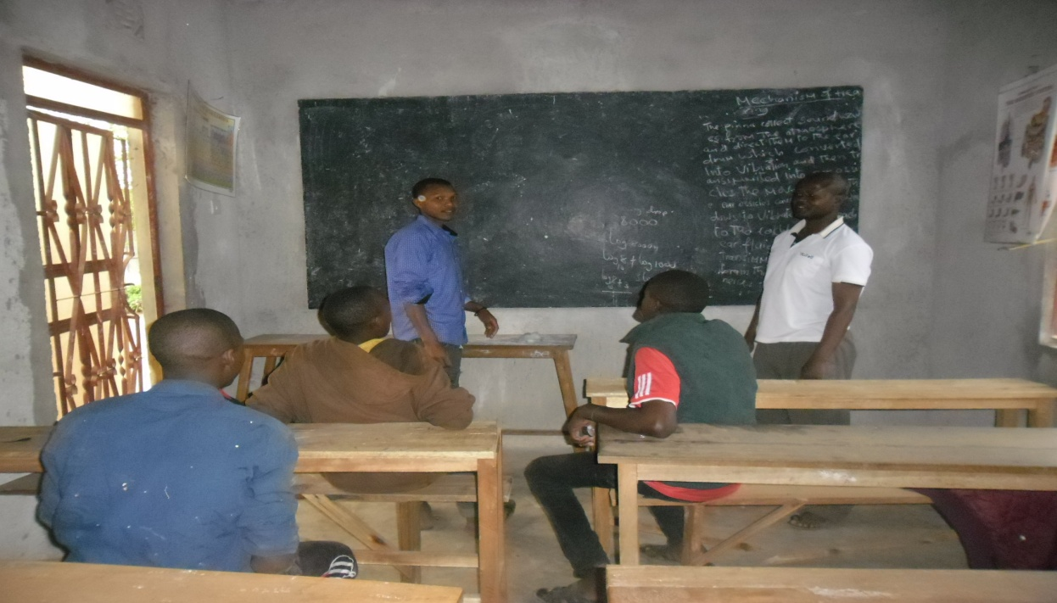

Figure 1.1: Discussion on Needs Prioritization Using Pair Wise Ranking Matrix

CHAPTER TWO

2.0 PROBLEM IDENTIFICATION

2.1 Background of Research Problem
Main challenges facing this community were identified to be unreliable source of income, unreliable rainfall though the land is arable and fertile and business illiteracy. Lack of collaterals as a security to a bank loan in seeking a seed capital marginalizes this group dumping it into lack of income. This community cannot afford three meals a day on their own, instead they get assurance of subsistence from their parents or guardians.

Lack of education amount to another indication of depth of the income problem to this community. As per the Tanzanian Constitution, Primary education is a basic need which is a child’s Constitutional right. But the families from which this group of youth belongs, can’t afford other associated Primary education costs to their children. Costs like school uniform vests on parents, costs like school fees are born by the nation (free primary school to all children to ordinary level).

Orkesumet Hamlet community strives hard in agricultural activities where they raise maize grains, varieties of beans and sunflower. They are struggling to get a reliable source of income but yet the afore mentioned challenges are insatiable killers of their efforts. Solutions to these problems have been discussed and ranked thereafter as which one should be implemented first and the last. By the use of pair wise ranking matrix poultry farming was ranked number one followed by food vending business, dairy cattle farming and finally crop production. Community participation through focused group discussion lead to the choice of Poultry keeping. Training brought the community to the position of understanding different diseases and how to prevent and cure them in case of any disease outbreak. Investing into poultry keeping appeared profitable since they can contribute a large part of the seed capital themselves. In the discussion, other stakeholders were impressed and decided to contribute. In lowering operational costs the Hamlet chairperson and the group leader managed to get remnants of food from Simanjiro Secondary School.

2.2 Problem Statement
Lack of a reliable source of income persisted for a long time without solution to youth in Orkesumet Hamlet. They toiled for years finding out what to do but ended having no solution. They tried various ways like casual civil works without any success. Much of these construction works are occasional with low income as well. They thought of selling used clothes (commonly known as mitumba in Tanzania) but they missed capital. Various projects have been conducted in Simanjiro District Council. One of the projects was Poultry Farming for Orphans in Lemkuna Village (TASAF and SMJ, 2012). This project aimed at supporting Children who lost their parents. Orphans were facing a number of needs including schooling, food, clothing and health requirements. Hence the Village introduced the matter to TASAF and SMJ which finally materialized to the mentioned intervention.

Welding was another project targeted to youth who were technicians skilled in welding and smelting in Orkesumet Ward (TASAF and SMJ, 2012). This group of youth faced a challenge of having no capital. On the other hand Orkesumet Hamlet Youth Community had a need but did not know how to seek a help in solving their problems or meeting their needs. Likewise, there were no researches done specifically for this unique group. The researcher recognized this during a discussion on need prioritization. The Community found itself lucky by having such a discussion that dealt with their needs and finally an intervention was found.

2.3 Project Description
Youth income improvement through poultry keeping at Orkesumet Hamlet in Simajiro District aims at reducing income poverty. Income generating opportunities demand creativity skills and seed capital of which, this community cannot afford. Investing into cattle rearing, crop production and fish farming requires extra miles of brainstorming and paper works for finance. Draught and lack of pastures caused Cattle keeping to amounts to a dream to this group of youth who depends on their parents and guardians for a daily bread.

On the other hand, poultry keeping accommodates all of this groups’ weaknesses and awarding them a chance to invest in. Meat, eggs and manure promises harvests within a period of not more than five months from the starting point of rearing. Manure is collected within a week, eggs within a month whereas slaughtering requires not more than three months after hatching. What a favorable business to the group? In this project pests and feeding are the main challenges but way through has been set in advance. Buckets have been placed in Simanjiro Secondary School for food remains collection as one of the feeding challenge solution.

Vaccination will rescue the chickens against pests while fencing protects predation. Reared varieties of “Kishingo and Sukuma” are tolerant to diseases and it is considered as another tackling measure thought to be in place. The project is draught free and demands little capital that does not demand any business plan to be submitted to whomever for finance. It only requires the group members a hen or Tsh 5,000 per hen.

2.3.1 Target Community
Improvement of Youth income through Poultry Keeping aims at intervening a long period need of the Orkesumet Hamlet Community of youth. The youth are grateful upon implementation of this project that appears to change their historical financial background of lacking reliable income to an improved one. They promised full participation, day and night. Target Community includes primary, secondary and tertiary beneficiaries of the project. But in this scenario the target community are the primary beneficiaries who are the Youth found vulnerable to lack of reliable employment. This is a group of Youth who have completed standard seven, who can read, speak and write in Kiswahili language. A group of unmarried and who are still dependent to their parents and guardians for a daily bread. Secondary and tertiary part of the stakeholders accommodates Hamlet leaders, TEO, DED, DAICO, Student, HM and Teachers though the list is not exhaustive.

2.3.2 Stakeholders
This is the Part of the Community that has an influence to the project life. They are categorized into primary, secondary and tertiary beneficiaries. All people touched by the project positively or negatively deserve a worthwhile consideration, “Always turn a negative situation into a positive situation” (Michael Jordan). Meaning that if any of the stakeholders pose a negative attitude, then, the negative is creatively turned into an opportunity to invest. Gratefully the following are the Poultry Farming stakeholders: Simanjiro DC, DED, Orkesumet TEO, Okesumet Hamlet Leaders, MCED student, Orkesumet Hamlet Community, Simanjiro DAICO.

2.3.3 Project Goal
The sole goal of this project focused on improvement of Youth income towards reduction of income poverty through poultry keeping. It seeks securing the youth against inability of meeting their basic needs namely food, shelter and clothing. These Youth dwells in a semi desert area where livestock keeping demand a draught resistant variety of livestock. Poultry keeping tackles such a climatically challenging life calamity to this group who are in the most vulnerable marginalized part of the society.

2.3.4 Project Objectives
Poultry Keeping aims at fulfilling the following objectives towards Youth income improvement at Orkesumet Hamlet in Simanjiro District:
- Training of 30 Orkesumet Hamlet Community youths on Poultry keeping by September 2017
- Hiring land and construction of chickens shed by August 2017
- Procurement of 18 chicks/chickens by September 2017

2.4 Host Organization/CBO Profile
Host Organization is Orkesumet Township Council. It is among the Local Government Authorities of Tanzania. LGA begins at Hamlet level as the lowest one coming up to Village level, Township/District, Regional and Ministerial level (The Ministry of Local Government Authorities). Orkesumet Township as a Government Organ implements visions and missions of the Nation at it level.

2.4.1 Vision
Township Council to provide efficient and quality social economic services to the Community

2.4.2 Mission
Orkesumet Township Council to become the provider of the highest quality of socio – economic services to the Community for their livelihood improvement.

2.4.3 Activities
Orkesumet Township Council deals with ensuring security of the citizens and safety of their possessions in its locality. This level is also the superviser of the Government projects taking place within its boundaries. It has a responsibility of seeing as whether the projects are rendered revealing all the qualities set in advance complying to efficiency, effectiveness and economy (Value for Money).

2.4.4 Orkesumet Township Council Organizationa Structure
Orkesumet Township Council

Township Chairperson

Township Executive Officer

Township Council Committees

Figure 2.1: Organizationa Structure
2.4.5 SWOC Analysis
SWOC (Strenth, Weakness, Opportunities and Challenges) aimed at analyzing the Orkesumet Communitof Youth on what do they have in hand and the challenges they face. This analysis places its importance in all areas especially in appropriate project to be undertaken. Strength involved the readiness of the youth community and their physical ability to work in day and night with stakeholders supporting them for any project promising to improve their income.

Table 2.1: SWOC Analysis
 | Strength | Weakness | Opportunities | Challenges
1 | Presence of land for farming | Hired, not owned by the community | The land is in a big area that allows free range. Presence of restaurants for consumption | Long periods of draught
2 | Human resource | Lack of business skills | Readiness to take responsibilities in project management | The area has poor infrastructures namely roads, no electricity, no water.
3 | Presence of veterinary Officer in Orkesumet Town | Occupied by Governments responsibilities | Available within the area for any advice for poultry management and treatment
4 | Simanjiro Secondary School | Food supplements are expensive an not available in sufficiency all the time | Availability of food remains in the school | School closure in June and December

2.4.6 Host Organization Roles in the Project
Orkesumet Township Council has a role of ensuring security and existence of the project. It is an active stakeholder of all projects within its locality. In this it encourages youth to find different ways of employing themselves, poultry keeping being a vivid example to be imitated. In addition it also need to do the following:
- To participate in the poultry keeping training
- To participate in brainstorming and discussion on finding different sources of financing the project
- Assisting the Youth group and CED student in consulting the School HM for food remains.
- Participate in contractual processes for land hiring.

2.4.7 Students Role in the Project
MCED student has a role of ensuring that all the projects activities are put into implementations, these included
- Training on poultry keeping to be conducted as per the plan
- Land hiring and construction of poultry shed is implemented
- To ensures that Poultry are procured as it was planned
- To consult Veterinary Officers for training on poultry keeping
- Consulting different stakeholders like TEO,DED, Hamlet leaders to contribute a seed capital for the project
- Consulting Simanjiro Secondary School Administration for food remains to feed poultry as a means of reducing operational costs.

CHAPTER THREE

3.0 LITERATURE REVIEW

3.1 Introduction

This chapter deals with literature review, works done and written by different writers on poultry farming. Interest focused much on improvement of youth livelihood which finally and collectively turns into poverty reduction tool. “Despite the steady economic growth registered, poverty is still prevalent in the country, the rate of illiteracy is the highest and youth employment is tending towards the extreme” (Prof. Issa Shivji - 2010)

Poultry keeping deals with rearing domesticated birds like chickens, ducks, turkeys and geese. Worldwide, the main purpose of keeping poultry aims for food (meat and eggs). ‘Rearing chicken is the kind of business anyone can undertake. What matters most is the farmer’s capability when it comes to the systems and bird types to rear’ (Christine Katende) Now days birds are Not only for food purpose but also for business purpose for income improvement of households and for ornamental purpose too. Family poultry is rarely the sole means of livelihood for the family but is one of a number of integrated and complementary farming activities contributing to the overall well-being of the household (Sonaiya and Swan, 2004).

3.2 Importance of Poultry Keeping in Tanzania and in Orkesumet Hamlet
Poultry Keeping has other advantages apart from the direct income it generates through selling meat and eggs. These comprise manure which improves soil fertility for more crops production. Importance of poultry includes soil aeration and natural fertilizer ( Grandy Chacha, 2012). Poultry are harvested within a short period in comparison to cattle or crops production that appears to be too involving. It’s advisable health wise to use protein from white meat (chicken) rather than red meat. Gout (Arthritis) is a side effect that affects excess red meat consumption. Chicken consumption is the best alternative as a source of protein just as beef which as well solve the problem of gout.

Poultry products are many, few mentioned as per literature review included meat, eggs, chicks and farm yard manure. Fresh eggs, natural fertilizer and organic pest control marked another impotance (Jessi Bloom,2012). Photos bellow shows some of the products namely meat, chicks and eggs. Refer Figure 3.1, 3.2, and 3.3.Figure 3.1 shows parts of slaughtered chicken ready for preparations of different meals like soup, fried meat and roast to mention just few.
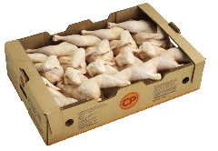

Figure 3.1: Poultry Meat Photograph

Figure 3.1 photos taken from other researchers works showing poultry products. Eggs are popular for preparation of a meal commonly known as chicken chips mostly in urban areas and other food staffs upon addition of value to eggs. Figure 3.2 bellow is a photograph of eggs.
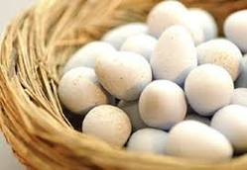

Figure 3.2: Eggs Photograph

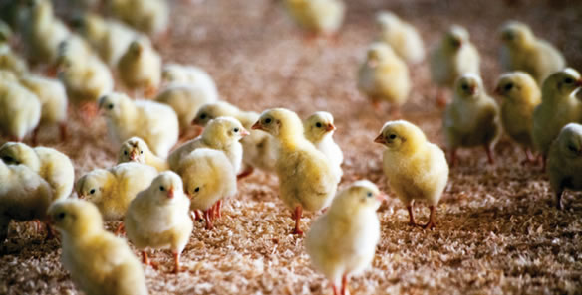

Figure 3.3: Chicks Photograph

Chicks are other poultry products. Apart from eggs and meat chicks are produced for commercial purposes.

3.3 Poultry Rearing Systems
Poultry birds can either be farmed on free range or confined. These can either be reared on a commercial or domestic basis (Dr John Baptist Kasule).

3.3.1 Free Range Poultry rearing System
Free range poultry rearing system has been adopted so long it allows the chickens to move around and even supplement themselves with some of important nutritional elements like iron. They are confined indoors during the whole night to rescue them from predators. On broad day hours they are allowed outdoors under great care against predators like eagles, snakes and even theft.
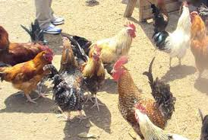

Figure 3.4: Free Range Poultry Rearing System Photo

3.3.2 Backyard Poultry Rearing System
Back yard poultry rearing is another system in which birds are kept at the back of house. The birds are allowed to scavenge, given additional feeding and water. Fencing is done to rescue them from predators. Bird housing is construed in the back yard. Example of birds reared in this system is the dual purpose same as the free rang system.

3.3.3 Intensive and Semi Intensive Systems
Semi intensive system of rearing poultry was another system found during literature review. In this the birds are confined in rooms, given a time outdoors during day hours but they spend much of their time indoors. Types of birds reared in this system include layers and broilers. Literature review revealed another system called Intensive system in which poultry are confined indoors day and night. Their shelter appears as seen in figure 3.5 and 3.6.

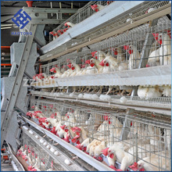

Figure 3.5: Layers Photograph

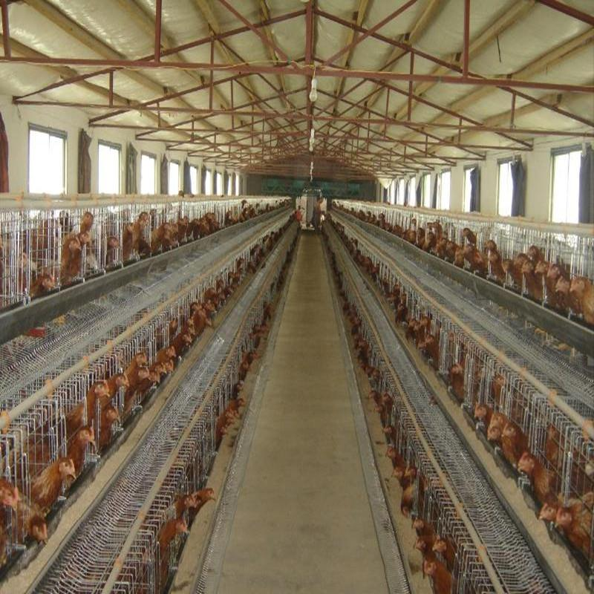

Figure 3.6: Intensive System of Rearing Birds

3.4 Challenges Facing Poultry Keeping
Challenges facing poultry Keeping in Tanzania comprises poor health control, poor health and inadequate feeding, lack of adequate capacity to control diseases that attack poultry (like Newcastle, diarrhea), lack of marketing skills, lack of organization among producers and poor nutrition and husbandry management (URT). Lack of hatcheries and breeding farms is another hindrance. Orkesumet hamlet faces the same challenges. Besides discussing the principles and processes involved in maintenance of poultry house, grading and packaging of eggs and dressed poultry, and even marketing, the emphasis has been on the factors affecting the quality of eggs and chicken meat (Morley Allan Jull, 2013)

Poultry farmers in Orkesumet do not have places for hatcheries and breeding. Breeding farms are very important to poultry farmers, they learn or aquire an improved breed of their desire. In the current situation farmers picks a variety by considering draught resistance, a variety that can scavenge for food. Way through could be establishment of harcheries and breeding farms.

Diseases like diarrhea and Newcastle are hindering challenges especially to this group of youth who have no reliable source of seed capital. Way through were discussed to be close monitoring with consultation to expert for immediate notification. Upon identification then, available experts will advise what next. Vaccination was another advise from VO and it is found useful since the purchased few were vaccinated. Another way was found to be “avoidance of overcrowding” (Grandy Chacha, 2017). The poultry farmers at Orkesumet were given a large area enough to avoid overcrowding.
Marketing was noted as another challenge that required skills. However, the District Commissioner promised to advertize their products such as eggs and chicken for slaughtering in public meeting. Another way through, considered as long plan is the rural industrialization aimed to absorb rural farm products. The youth planned as well to walk through the available restaurants and other food venders and advertize their products. This exercise started from September 2017. Besides discussing the principles and processes involved in all these areas, the emphasis has been on the factors affecting the quality of eggs and chicken meat (Grady Chacha, 2012)

Some opportunities can sometimes be harnessed from challenges. For instance; in Orkesumet Hamlet, Youth have got a way through for inadequate feeding challenge by utilizing properly the food left over’s from Simanjiro Secondary School to feed their chickens. They placed a collection basket in the school where they daily collect and feed their birds for cost lowering. They only need little money to supplement for nutritional requirements. Thus they have obtained a reliable source of feeding their flock a sufficient period of brainstorming on solving such a challenge. Hence the challenge is converted into an opportunity and a starting point of investment. “Always turn a negative situation into a positive situation” (Michael Jordan).

3.5 Policy Review
The researcher reviewed rules, strategies and plans in place regarding income improvement to youth Community. In Tanzania, the following policies and strategies were reviewed: Sustainable Industrial Development Policy (SIDP 1996 – 2020). This emphasizes on employment creation just like Tanzania Mini Tiger Plan ( 2020) on FDI. National Strategy for Growth and Poverty Reduction 2005 that focused on increasing finance accessibility and improving investment environment.

3.5.1 Poultry Farming Policies in Tanzania
Tanzania Development Vision (TDV, 2025) incorporates all sectors development strategies towards making the country’s economy a semi-industrial economy. Implementation of which involves various issues like infrastructures like roads, railways, airways, marine transport and electricity. Improvement of such structures ease accessibility of farm produces.

Sustainable Industrial Development Policy (STDP – 1996 – 2020) makes market availability for various farm produces. In doing so, poultry farming will be promoted. Products such as meat, eggs, and feathers will get reliable market accessibility. Tanzania is now striving and encouraging citizens to focus their minds into industries establishment. It started developing special economic zones to accelerate economic growth. The zones are for exportation of various products. Reference is made from Tanzania Mini Tiger Plan 2020. It is all about adoption of the Asian economic Model – creating employment through attracting FDI and promoting exportation.

3.5.2 Policy Statements
- The Government will support and strengthen technical support services and use of appropriate technologies in poultry production.
- The Government will promote inventorisation, characterisation, evaluation and selection of the indigenous poultry breeds.
- In collaboration with other stakeholders the Government will promote improvement of genetic potential in the traditional flock in order to increase livestock productivity.
- Efforts will be undertaken to promote investment in poultry production, processing and marketing.
- (v) The Government will encourage establishment of quality breeding farms and hatchery facilities.
- The Government will sensitize, encourage and promote establishment of poultry producers and traders associations. (URT, 2006)

3.6 Literature Review Summary
Literature review chapter included going through researches and works of different writers. Meaning of poultry keeping, importance of rearing different birds like chicken, ducks and geese were obtained from literature reviewed. Various poultry rearing systems such as back yard, free range, intensive and semi-intensive which are evident through their photographs, were taken from other researchers work. Policies were reviewed from Tanzania Poultry farming policies which were accommodated in the Tanzania vision 2025. This aimed at alleviating poverty same as the goal of the Orkesumet Youth Community of income improvement for livelihood. Different poultry products named above as meat, chicks, natural fertilizer and biological pests control (Jessi Bloom, 2012) enlighten the path for this research.

Participatory Community needs assessment revealed characteristics of the Orkesumet Youth. it is marginalized group wich deserved financial inclusion. However, a problem arose as who was to voice out the need of the group. The researcher received full participation since the group was eager and ready to work very hard for their livelihood and income poverty alleviation. Challenges were sorted out where needs were discussed and finally came up with an intervention to alleviate the income improvement need.

Tanzania vision 2025 in its implementation touched all sectors; health, education, water, infrastructures and also human resource. The country implements all these towards a sem- industrial economy. Adoption of the Tanzania mini tiger plan 2020 aims at improving employment environment. Railways and roads infrastructures are evident, collectively making poverty alleviation. Poultry keeping found in Agricultural sector has its plans and policy country wise. Orkesumet Youth Community started enjoying implementation where more deliverables like land, shelter and laid eggs increased morale and hard working to the group members.

CHAPTER FOUR

4.0 PROJECT IMPLEMENTATION

4.1 Introduction

This chapter deals with putting into practical all the plans. Plans are guidelines set in advance that aids as a road map towards laying down step by step what is required to meet the goal. Thus implementation is to bring the plans into existence and tangibles. For example poultry keeping constitutes various plans like hiring land, procuring chickens, training poultry keepers and construction of chickens shed. Once the training is done, the land is hired and the chickens are procured then, the plans are fulfilled the assets are tangible and hence part of implementation as per plans.

At this part, carefulness is crucial as per its importance. Any lapse here promises death of the project. Projects are implemented in phases and each phase is a project by itself, that all participants, beneficiaries, Host Organization, CED Student and other stakeholders need not to allow loopholes for any inconveniency. Each phase of putting down plans into practical, demand close supervision and monitoring ensuring the targeted results meeting objectives and finally the goal.

4.2 Project Outputs

Project outputs are expectations to be borne by accurate performance of set activities. These could be in the form of a report in case of services rendered or a tangible product in terms of goods. They are project deliverables. Tangibles in poultry farming project comprised live birds, bird’s shelter, land for the project and different reports like monitoring and evaluation reports and sales report. Poultry Keeping comprised the following outputs:

Training of 30 on poultry keeping to Poultry farmers by July 2017

Availability of contract documents for hired land by July 2017

One Chicken shed with a capacity of hundred chicken constructed by September 2017

Eighteen dual purpose chickens procured by September 2017

4.2.1 Project Activities
Poultry Keeping comprised various planned activities which were successfully implemented to tackle the Orkesumet community need of improving youth income. Planed activities included training to poultry farmers in Orkesumet Hamlet by July August 2017, Hiring of land and construction of chicken by August 2017 and Procurement of Chickens by September 2017. Table 8 below shows the planned activities.

Table 4.1: Planned Project Activities
Objectives | Output | Activities
1. To conduct training to Poultry farmers in Orkesumet Hamlet community by July 2017 | 1.1 Conducted Training on poultry keeping | 1.1.1budget preparation for training
 | 1.1 Conducted Training on poultry keeping | - 1.1.2 Organizing the training
 | 1.2 Thirty members attended the training | 1.2.1 Inviting veterinary Officer for training
 | 1.2 Thirty members attended the training | 1.2.2Conducting the training
2. Hiring Land and Construction of Poultry Shed by August 2017 | 2.1 Contract documents/hired land | 2.1.1 Consulting a lawyer
 | 2.1 Contract documents/hired land | 2.1.2 Contract documents preparation
 | 2.2 Poultry shed | 2.2.1budget preparation
 | 2.2 Poultry shed | 2.2.2Procurement of building materials
3. Procurement of Poultry by September 2017 | 3.1Collected monies (Tsh 200,000 ) | 3.1.1 Budget Preparation
3. Procurement of Poultry by September 2017 | 3.1Collected monies (Tsh 200,000 ) | 3.1.2 Building Poultry shed
3. Procurement of Poultry by September 2017 | 3.2 Bought Eighteen dual purpose chickens | 3.2. 1Buying Poultry feeds and vaccines
3. Procurement of Poultry by September 2017 | 3.2 Bought Eighteen dual purpose chickens | 3.2.2 Buying Poultry
3. Procurement of Poultry by September 2017 | 3.3Participatory M & E Report | 3.3.1Preparation of M&E Plan
3. Procurement of Poultry by September 2017 | 3.3Participatory M & E Report | 3.3.2 Appointing M&E Team
3. Procurement of Poultry by September 2017 | 3.3Participatory M & E Report | 3.3.3 Conducting M&E
Source: researcher, 2017

4.2.2 Project Implementation Plan
A schedule of all activities of the project has been prepared and it’s in place as road map for every participant to pick his/her portion. A project is categorized into phases to ease performance and provide a room for close supervision and monitoring. Monitoring is done at each stage of performance for rectification of deviations. Objectives, outputs, resources required time being inclusive, responsible persons and activities to be done have been planned properly as they are evident in table 9 below.

Participatory monitoring and evaluation at this implementation juncture calls for all key players as well as the other stakeholders to ensure meeting of the goal. Orkesumet Hamlet leader, CED student, Group leader, Poultry Keeping members, DAICO, Veterinary Officer, TEO, DED and other stakeholders have a great contribution to this project progress. Everyone devoted time and resources for the project take off.

Table 4.2: Project Implementation Plan
Objectives | Output | Activities | Implementation Month |  |  |  |  |  | Resources needed | Responsible person
Objectives | Output | Activities | July | Aug | Sept | Oct | Nov | Dec |  | Responsible person
1. To conduct training to Poultry farmers in Orkesumet Hamlet community by July 2017 | 1.1 Conducted Training on poultry keeping | 1.1.1budget preparation for training |  |  |  |  |  |  | Monies, stationery, | Township Council
 | 1.1 Conducted Training on poultry keeping | 1.1.2 Organizing the training |  |  |  |  |  |  |  | Township Council
 | 1.2 Thirty members attended the training | 1.2.1 Inviting veterinary Officer for training |  |  |  |  |  |  | Stationeries, monies | Township Council and group leader
 | 1.2 Thirty members attended the training | 1.2.2Conducting the training |  |  |  |  |  |  | Monies,stationeries | Training Officer
2. Hiring Land and Construction of Poultry Shed by August 2017 | 2.1 Contract documents/hired land | 2.1.1 Consulting a lawyer |  |  |  |  |  |  | Monies | Township Council
 | 2.1 Contract documents/hired land | 2.1.2 Contract documents preparation |  |  |  |  |  |  | Stationeries | Lawyer, Township Council
 | 2.2 Poultry shed | 2.2.1budget preparation |  |  |  |  |  |  | Stationeries | Township Council and group leader
 | 2.2 Poultry shed | 2.2.2Procurement of building materials |  |  |  |  |  |  | Monies | Township Council and group leader and Technicians
3. Procurement of Poultry by September 2017 | 3.1Collected monies (Tsh 200,000 ) | 3.1.1 Budget Preparation |  |  |  |  |  |  | Stationeries, Monies | Verterinary Officer, Hamlet leader and group leader
3. Procurement of Poultry by September 2017 | 3.1Collected monies (Tsh 200,000 ) | 3.1.2 Building Poultry shed |  |  |  |  |  |  | Monies | Tchnician and group leader
3. Procurement of Poultry by September 2017 | 3.2 Bought Eighteen dual purpose chickens | 3.2. 1Buying Poultry feeds and vaccines |  |  |  |  |  |  | Monies | HVO,Grou leader, Township Council
3. Procurement of Poultry by September 2017 | 3.2 Bought Eighteen dual purpose chickens | 3.2.2 Buying Poultry |  |  |  |  |  |  | Monies | HVO,Grou leader, Township Council
3. Procurement of Poultry by September 2017 | 3.3Participatory M & E Report | 3.3.1Preparation of M&E Plan |  |  |  |  |  |  | Time | Orkesumet Hamlet, Verterinary Officer
3. Procurement of Poultry by September 2017 | 3.3Participatory M & E Report | 3.3.2 Apointing M&E Team |  |  |  |  |  |  | Stationeries | Orkesumet Township Council Vertirinary Officer
3. Procurement of Poultry by September 2017 | 3.3Participatory M & E Report | 3.3.3 Conducting M&E |  |  |  |  |  |  | Human, M&E Plan, Monies | Orkesumet Hamlet, Verterinary Officer
Source: researcher, 2017

4.2.1.1 Project Logical Framework
Logical framework is a matrix summarizing and connecting a projects’ goal, objectives, outputs, inputs, activities, finance and time together.

Table 4.3: Project Logical Framework
Hierarchy of Objectives | Objectively Verifiable Indicators (OVIs) | Means of verification (MOV) | Assumptions
Goal(impact)Income Improvement to poultry farmers towards reduction of income poverty. | Poultry farmers Youth Income status | Survey reports, observations and sales reports | Openness in information sharing among farmers and other stakeholders
Objective 1: To conduct training to poultry farmers in Orkesumet Hamlet community by July 2017

Output 1.1 Training on poultry keeping conducted | 30 Poultry keepers trained on poultry farming practice | Participants attendance list
Activities
1.1.1 budget preparation for training | Prepared budget |  | Availability of the budget
1.1.2 Organizing the training | Organized training | Training report | Training report is accessible
Output 1.2 Thirty members attended the training | Knowledge and skills trained | Training report
Activities
1.2.1 Inviting veterinary Officer for training | Received letter of acceptance | Progressive report | Readiness of the exprt tto impart knowledge and skills
1.2.2Conducting the training | Acquired knowledge and skills | Participants attendance list
Objective 2: Hiring Land and Construction of Chickens Shed by August 2017

Output 2.1 Contract documents/hired land | Hired land | Procurement report | Accessibility of reports are unlimited
Activities
2.1.1 Consulting a lawyer | Stamped and Signed contract documents | Contract document | Freedom of all parties to enter into contractual terms
2.1.2 Contract documents preparation | Prepared documents | Project report | Accessibility of reports are unlimited
Output 2.2 Poultry shed | Built shed | Project report | Accessibility of reports are unlimited
Activities
2.2.1budget preparation | Prepared budget | Project report | Accessibility of reports are unlimited
2.2.2Procurement of building materials | Procured Building materials | Procurement report | Accessibility of reports are unlimited
Objective 3: Procurement of poultry by September 2017
Output 3.1: Collected monies (Tsh 200,000 ) | Collected monies | Financial report | Accessibility of reports are unlimited
Activities
3.1.1Budget Preparation | Prepared budget | Project report | Accessibility of reports are unlimited
3.1.2 Building Poultry shed | Built shed | Project progress report | Accessibility of reports are unlimited
Output 3.2: Bought Eighteen dual purpose Poultry | Bought poultry | Procurement report | Accessibility of reports are unlimited
Activities
3.2. 1Buying Poultry feeds and vaccines | Bought feeds and vaccines | Procurement report | Accessibility of reports are unlimited
3.2.2 Buying Poultry | Bought Poultry | Project procurement report | Accessibility of reports are unlimited
Output 3.3 Participatory M & E Report
Activities
3.3.1Preparation of M&E Plan | Prepared M&E plan | M&E report | Accessibility of reports are unlimited
3.3.2 Appointing M&E Team | 4 M&E Team members appointed | Appointment meeting minutes | Safe custody of minutes
3.3.3 Conducting M&E | Conducted M&E | M&E report | Accessibility of reports are unlimited

4.2.2 Project Inputs

Project inputs constitute human resource, financial resources, equipments, stationeries, machineries and live birds. Poultry Farming at Orkesumet Hamlet planned to possess the following inputs:

Table 4.4: Project Inputs
Input | Quantity/Amount | Unit cost (in Tsh) | Total Cost (in Tsh)
Financial | 549,500
Live birds | 18 | 8,000 | 144,000
Poultry feeds | 30 kilograms | 1000 | 30,000
Vaccines and other antibiotics | 300 milliliters | 10,000 per bottle | 10,000
Iron sheets | 9 pieces | 18,000 | 162,000
Timber | 9 pieces | 7,000 | 63,000
Rims | 4 | 12,000 | 48,000
Wire mesh | 5 meters | 4,000 | 20,000
Flip charts | 10 pieces | 2000 | 20,000
Marker pens | 10 pieces | 1500 | 15,000
Note books | 30 | 1500 | 30,000
Pens | 30 | 200 | 6,000
Soft drinks | 6 crates | 15000 | 90,000
Snacks | 50 | 1000 | 50,000
Human resource | 1 | 30,000 | 30,000

4.2.3 Staffing Pattern

The overall manager of the project is Orkesumet Hamlet under supervision of the Youth Group leadership that owns it. The group appointed their project Secretary as well the Treasurer. The parten is Seen in table 4.5. All know their roles as from the training day.

Table 4.5: Staffing Parten
Project Staff | Staff Role
Project Manager | Manages all the affairs of the project
Project Secretary | Ensures smooth implementation of all activities of the project and records keeping
Project Treasurer | The custodian of monies, financial documents, other equipments and tools of the project

4.2.4 Project Budget

Host Organization, Group leader, Secretary and the Project Treasurer managed to collect Tsh 549,500. Give explanation as project seed capital. Its breakdown is seen in Table 4.6.

Table 4.6: Project Budget
Objective | Output | Activities | Resources | Quantity | Unit price | Total
Objective 1: To conduct training to poultry farmers in Orkesumet Hamlet community by July 2017 | 1.1 Training on poultry keeping conducted | 1.1.1 budget preparation for training | Time
 | 1.1 Training on poultry keeping conducted | 1.1.1 budget preparation for training | Rim | 1 | 12,000 | 12,000
 | 1.1 Training on poultry keeping conducted | 1.1.2 Organizing the training | Time
 | 1.2 Thirty members attended the training | 1.2.1 Inviting veterinary Officer for training | Person | 2 days ½ Per diem | 30,000 | 60,000
 | 1.2 Thirty members attended the training | 1.2.2Conducting the training | Flip charts | 10pices | 2,000 | 20,000
 | 1.2 Thirty members attended the training | 1.2.2Conducting the training | marker pens | 3 | 1500 | 4,500
 | 1.2 Thirty members attended the training | 1.2.2Conducting the training | notebooks | 20 | 1000 | 20,000
 | 1.2 Thirty members attended the training | 1.2.2Conducting the training | pens | 20 | 200 | 4,000
 | 1.2 Thirty members attended the training | 1.2.2Conducting the training | Soft drinks | 6 crates | 15,000 | 60,000
 | 1.2 Thirty members attended the training | 1.2.2Conducting the training | Snacks/bites |  | 50,000 | 50,000
Objective 2. Hiring Land and Construction of Chickens Shed by August 2017 | 2.1Contract documents/hired land | 2.1.1 Consulting a lawyer | Funds, | lumpsum | 20,000 | 20,000
 |  | 2.1.2 Contract documents preparation | Rim | 1 | 12,000 | 12,000
 |  | 2.1.2 Contract documents preparation | Funds |  | 10,000 | 10,000
 | 2.2Poultry shed | 2.2.1Budget preparation | Time
 | 2.2Poultry shed | 2.2.2Procurement of building materials | Timber | 9 pieces | 7,000 | 63,000
 | 2.2Poultry shed | 2.2.2Procurement of building materials | Iron sheets | 9 pieces | 18,000 | 162,000
 | 2.2Poultry shed | 2.2.2Procurement of building materials | Wire mesh | 5metres | 4000 | 20,000
Objective 3: Procurement of poultry by September 2017 | 3.1Collected monies (Tsh 200,000 ) | 3.1.1Budget Preparation | Time
Objective 3: Procurement of poultry by September 2017 | 3.1Collected monies (Tsh 200,000 ) | 3.1.2 Building Poultry shed | Technician | lumpsum | 50,000 | 50,000
Objective 3: Procurement of poultry by September 2017 | 3.2 Bought Eighteen dual purpose chickens | 3.2. 1Buying Poultry feeds and vaccines | Poultry feeds | 1bag | 30,000 | 30,000
Objective 3: Procurement of poultry by September 2017 | 3.2 Bought Eighteen dual purpose chickens | 3.2. 1Buying Poultry feeds and vaccines | vaccines | 1 bottle | 10,000 | 10,000
Objective 3: Procurement of poultry by September 2017 | 3.2 Bought Eighteen dual purpose chickens | 3.2.2 Buying Poultry | Chickens | 18 | 8,000 | 144,000
Objective 3: Procurement of poultry by September 2017 | 3.2 Bought Eighteen dual purpose chickens | 3.2.2 Buying Poultry | Ducks | 3 | 10,000 | 30,000
Objective 3: Procurement of poultry by September 2017 | 3.3 Participatory M & E Report | 3.3.1Preparation of M&E Plan | Rim | 1 | 12,000 | 12,000
Objective 3: Procurement of poultry by September 2017 | 3.3 Participatory M & E Report | 3.3.2 Appointing M&E Team | Time
Objective 3: Procurement of poultry by September 2017 | 3.3 Participatory M & E Report | 3.3.3 Conducting M&E | Time,
Objective 3: Procurement of poultry by September 2017 | 3.3 Participatory M & E Report | 3.3.3 Conducting M&E | Rim | 1 | 12,000 | 12,000
 |  |  | Grand total |  |  | 549,500
Source: researcher, 2017

4.2.5 Project Implementation Report

Implementation started in July whereby poultry farmers were trained on good poultry farming practices. The training covered many knowledge areas like resistant varieties to draught and diseases such as ducks and “Kishingo” type of chickens. Veterinary Officer also answered participants’ questions especially on the importance of supplementary feeding on top of free range scavenging. Implementation took and still taking place step by step as per the project cycle categories. Orkesumet Township Council facilitated the training for two days continuously.

Monitoring that involved the M&E team, were working in collaboration with the Host organization and CED Student. Deviations were noted and rectified that none of them had a negative impact to the project. Some of the deviations noted were the number of the training participants that dropped from thirty to twenty. The team had a task of making budget adjustment for proper usage of scarce resources. Refreshments were reduced coping with the existed number of participants. Likewise other inputs like stationeries such as notebooks and pens reduction was made. These deviations are seen in table 4.6.

CED Student played a big role in practical pre-evaluation in collaboration with M&E team where some activities have been changed into another parten to ease its implementation. The student learnt and enjoyed the spirit of the local project members working together as a team. This spirit helped smooth performance of the scheduled activities on time with efficiency. Mid and annual project evaluations will be done as per plan. Monitoring and evaluation are taken all the time within the project life cycle for rectification deviations to accommodate occurring changes.

Land has been hired outside of Orkesumet Hamlet. The project members proposed that place because it is big enough to accommodate all varieties of poultry and all systems of rearing. It’s also conducive for free range system where poultry are outdoors throughout day hours and indoors at night only. Thus it allows a wide area for scavenging. Supplementary feeding takes place early in the morning and at evening hours. This area is also too close to the place where two members of the farmers group dwells. Then it was found good for guarding and safety all the time, day and night.

Poultry shed is under construction. Building of the shed started in phases according to inflows of funds and other non monetary items. For instance four, pieces of used iron sheets and timbers sufficient to start the construction have been utilized in the first phase of the shed building. Likewise, purchases of chickens have been started from August 2017, by the time being, five chicken and four ducks have been brought. These birds have been brought by interested stakeholders who promised to support the youth. Beneficiaries decided to work in phases following the way they received any support and their group entry contributions. The ducks were contributions from stakeholders who drawn interest of supporting the youth (TEO and the land owner). Promises from Hamlet Leader, CED student, VO, will materialize within September 2017. Three members have brought in five chickens as Group entry contributions.

Figure 4.1: shows DC, DED, TEO and Orkesumet Hamlet Leaders in a public meeting. In this meeting TEO was given a chance to introduce Poultry Farmers Youth Group to citizens as a way of advertizing their business and invite other youth to join.

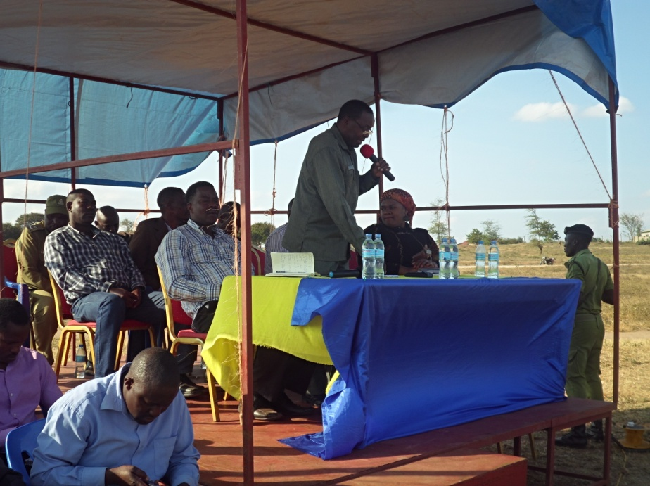 | 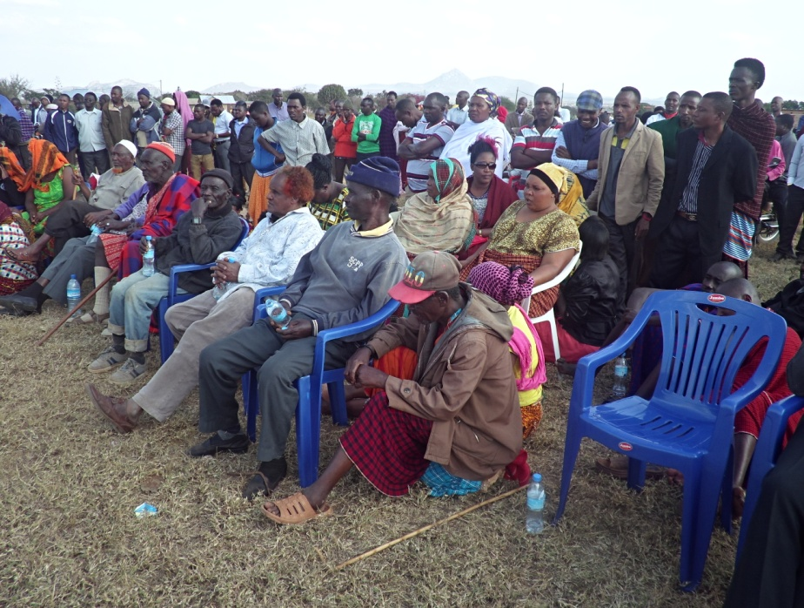

Figure 4.1: DC, DED, TEO and Orkesumet Hamlet Leaders in a Public Meeting

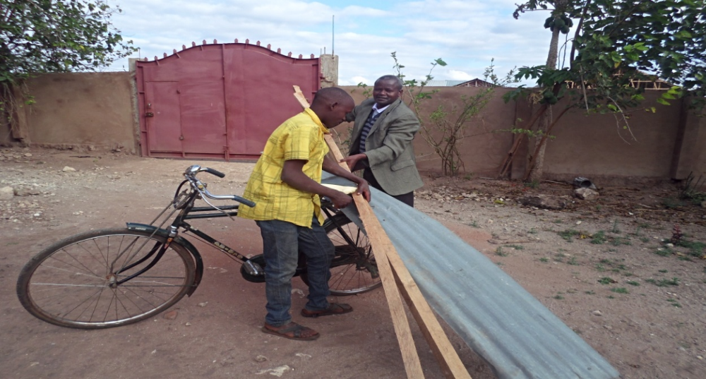

Figure 4.2: Group Member Collecting Building Materials for Poultry Shed Construction
Figure 4.2 indicates participatory observation of activities implementation. This was a poultry farmer group leader collecting timbers and iron sheets. These materials were provided by stakeholders who have drawn interest of supporting the youth.

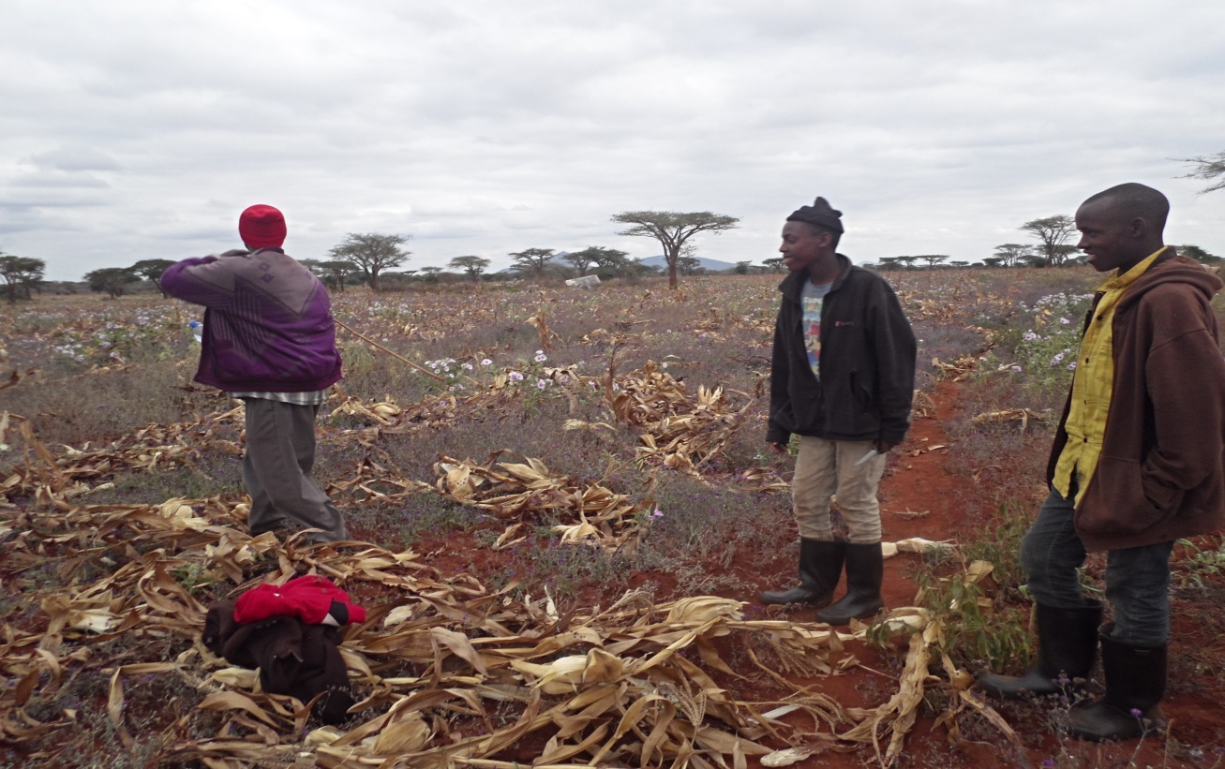

Figure 4.3: Poultry Farmers Surveying the Land to See an Appropriate Place for Poultry Shed Construction

4.2.7 Project Implementation Gantt chart

This is a table showing objectives, output, activities and period of implantation. It has all activities scheduled. Date of performing each activity is shown on this table. This helps during monitoring and evaluation. However, a hindrance on activities implementation was found to be delayed support from interested stakeholders, especially funds for construction of the shed. Also purchases of birds. But the chart stayed as a good point of reference in implementation of the planned activities as seen in Table 4.7.

Table 4.7: Project Implementation Gantt Chart
Objectives | Output | Activities | Implementation Month
Objectives | Output | Activities | Jul | Aug | Sept | Oct | Nov | Dec
1. To conduct training to poultry farmers in Orkesumet Hamlet community by July 2017 | 1.1 Training on poultry keeping conducted | 1.1.1budget preparation for training
 | 1.1 Training on poultry keeping conducted | 1.1.2 Organizing the training
 | 1.2 Thirty members attended the training | 1.2.1 Inviting veterinary Officer for training
 | 1.2 Thirty members attended the training | 1.2.2Conducting the training
2. Hiring Land and Construction of Chickens Shed by August 2017 | 2.1 Contract documents/hired land | 2.1.1 Consulting a lawyer
 | 2.1 Contract documents/hired land | 2.1.2 Contract documents preparation
 | 2.2 Poultry shed | 2.2.1budget preparation
 | 2.2 Poultry shed | 2.2.2Procurement of building materials
3. Procurement of poultry by September 2017 | 3.1Collected monies (Tsh 400,000 ) | 3.1.1 Budget Preparation
3. Procurement of poultry by September 2017 | 3.1Collected monies (Tsh 400,000 ) | 3.1.2 Building Poultry shed
3. Procurement of poultry by September 2017 | 3.2 Bought Eighteen dual purpose chickens | 3.2. 1Buying Poultry feeds and vaccines
3. Procurement of poultry by September 2017 | 3.2 Bought Eighteen dual purpose chickens | 3.2.2 Buying Poultry
3. Procurement of poultry by September 2017 | 3.3Participatory M & E Report | 3.3.1Preparation of M&E Plan
3. Procurement of poultry by September 2017 | 3.3Participatory M & E Report | 3.3.2 Appointing M&E Team
3. Procurement of poultry by September 2017 | 3.3Participatory M & E Report | 3.3.3 Conducting M&E

Project Actual Implementation

This sub section is a table showing actual project implementation. It also indicates reasons for non implemented part of the planned activities. Table 4.8 shows objecyives, output, activities, implementation status ad reasons for not implementing arranged in columnar form.

Table 4.8: Project Actual Implementation
Objectives | Output | Activities | Implementation status | Reasons for not implementing/deletion
1. To conduct training to Poultry farmers in Orkesumet Hamlet community by July 2017 | 1.1 Conducted Training on poultry keeping | 1.1.1budget preparation for training | A budget of Tsh was prepared
 | 1.1 Conducted Training on poultry keeping | - 1.1.2 Organizing the training | - Training organized successfully
 | 1.2 Thirty members attended the training | 1.2.1 Inviting veterinary Officer for training | Veterinary Officer invited
 | 1.2 Thirty members attended the training | 1.2.2Conducting the training | 20 Poultry farmers were trained instead of the planned thirty. | Other youth embarked into casual works in maize and beans plantations.
2. Hiring Land and Construction of Poultry Shed by August 2017 | 2.1 Contract documents/hired land | 2.1.1 Consulting a lawyer | Lawyer consulted
 | 2.1 Contract documents/hired land | 2.1.2 Contract documents preparation | Contract documents prepared
 | 2.2 Poultry shed | 2.2.1budget preparation | Tsh .. budget prepared
 | 2.2 Poultry shed | 2.2.2Procurement of building materials | Building materials procured except cement | Cement for concrete will be bought in September
3.Procurement of poultry by September 2017 | 3.1Collected monies (Tsh 400,000 ) | 3.1.1 Budget Preparation | Tsh 110,0 budget prepared
3.Procurement of poultry by September 2017 | 3.1Collected monies (Tsh 400,000 ) | 3.1.2 Building Poultry shed | Poultry are bought
3.Procurement of poultry by September 2017 | 3.2 Bought Eighteen dual purpose Poultry | 3.2. 1Buying Poultry feeds and vaccines | Feeds are bought except vaccines | Postponed until hatching in November since the bought poultry were vaccinated.
3.Procurement of poultry by September 2017 | 3.2 Bought Eighteen dual purpose Poultry | 3.2.2 Buying Poultry | bought
3.Procurement of poultry by September 2017 | 3.3Participatory M & E Report | 3.3.1Preparation of M&E Plan | M&E Plan prepared
3.Procurement of poultry by September 2017 | 3.3Participatory M & E Report | 3.3.2 Appointing M&E Team | M&E Team is appointed and working
3.Procurement of poultry by September 2017 | 3.3Participatory M & E Report | 3.3.3 Conducting M&E | M&E carrying on

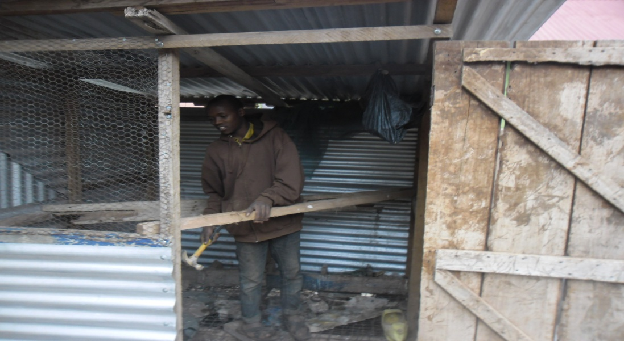

Figure 4.4: Poultry Shed under Construction

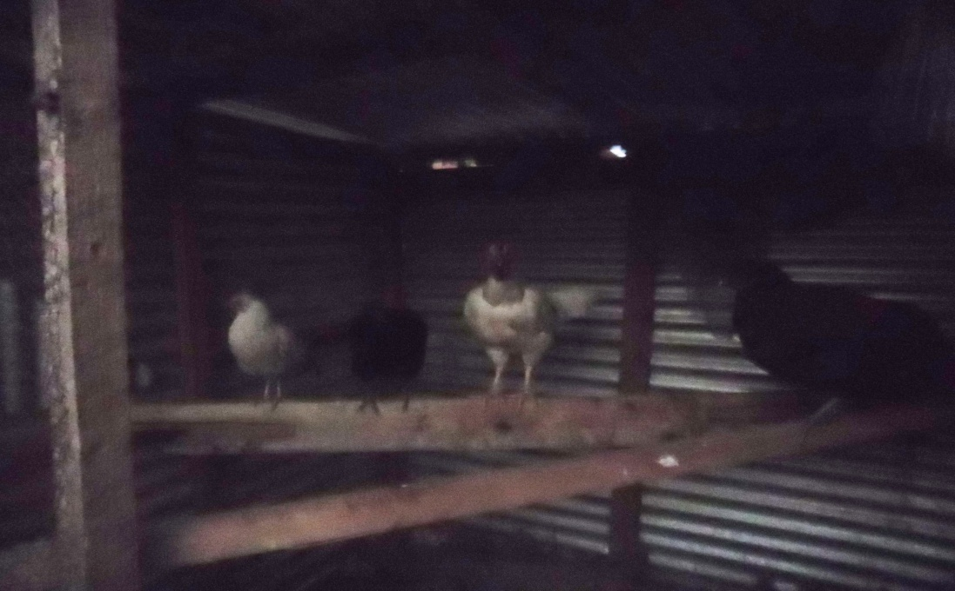

Figure 4.5: Four Hens bought, Purchasing Exercise is on Progress

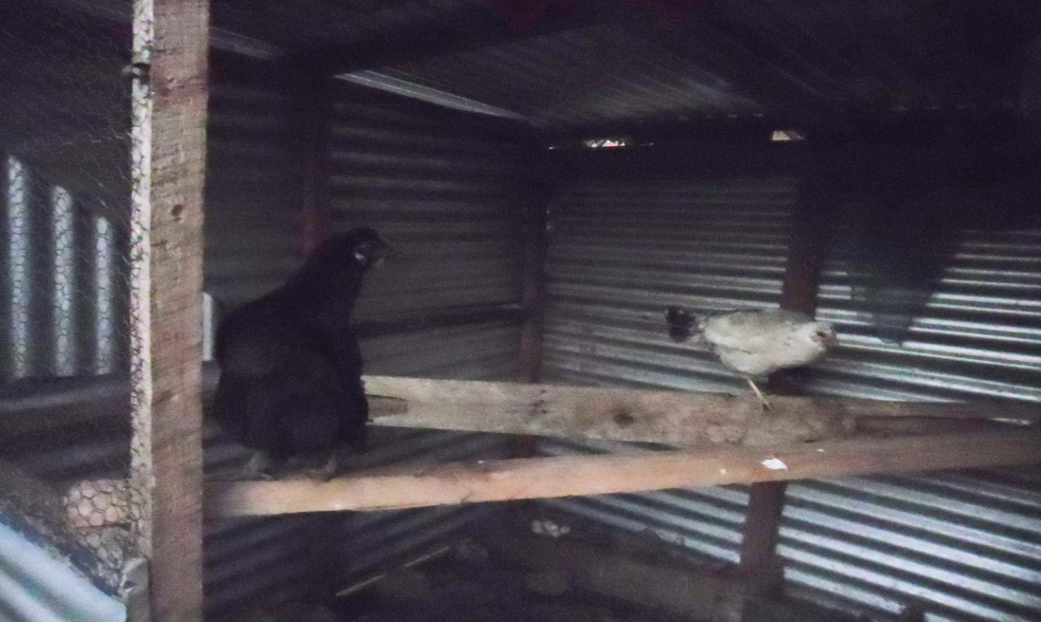

Figure 4.6: Two of the Five bought Hens have started Laying Eggs

Figure 4.7 shows eggs laid by a hen, a tray for eggs collection will be bought along the project course, and first priority was to increase birds through hatching. Thus the eggs are kept for local natural incubation using hens themselves.

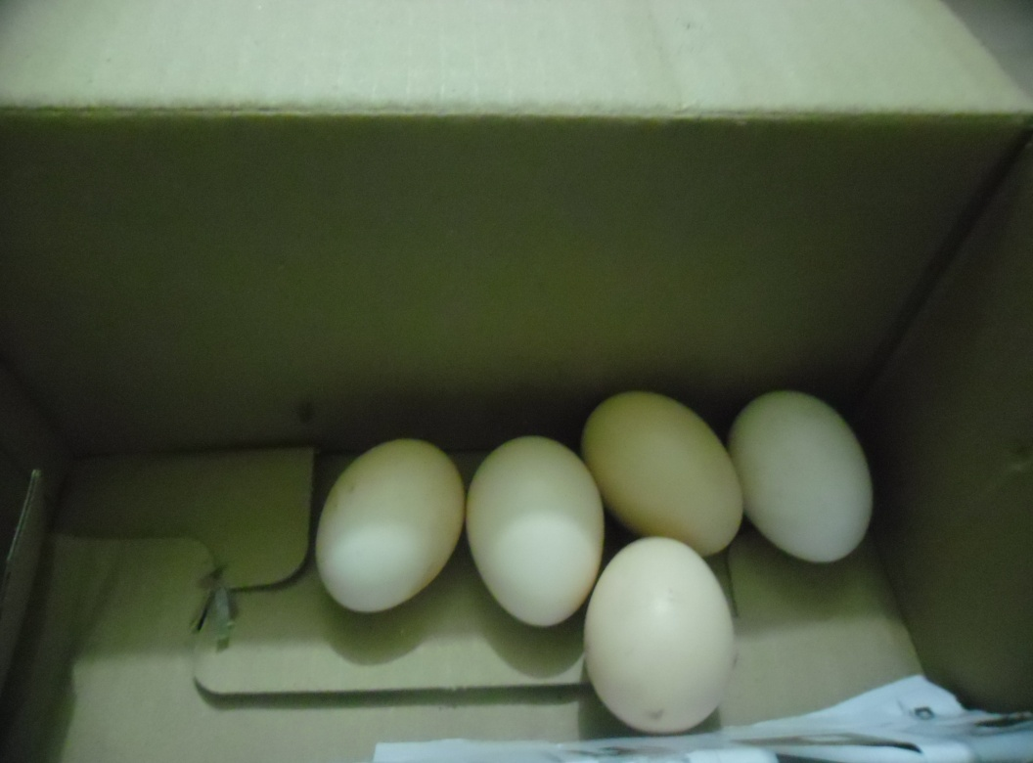

Figure 4.7: Collected Eggs

Figure 4.8, shows four birds out of eight scavenging within locally fenced area, others ran outside of the fence, the cock and the black hen are seen moving towards outside the fence too.

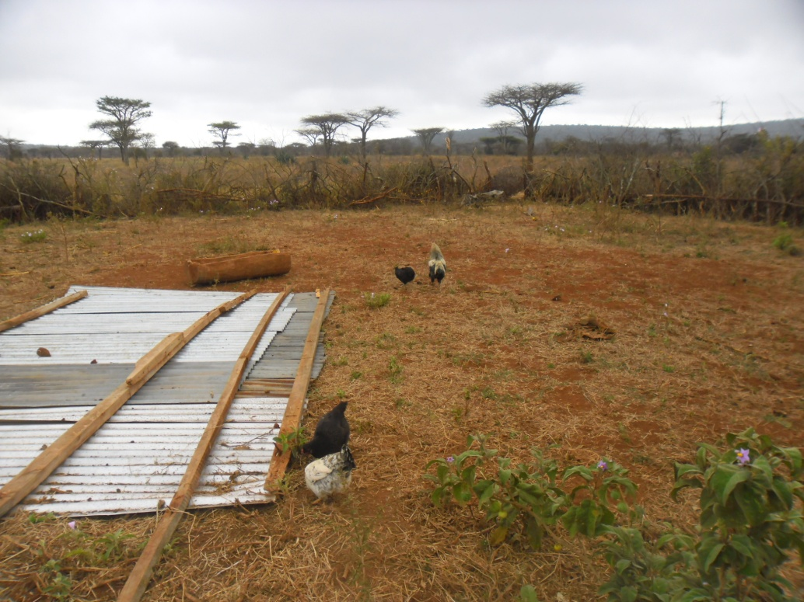

Figure 4.8: Chicken Scavenging Outside their Shelter

CHAPTER FIVE

5.0 PROJECT PARTICIPATORY MONITORING, EVALUATION AND SUSTAINABILITY

5.1 Introduction

Monitoring is the process making close observation of activities being performed against plans. Data collected during this close supervision of activities in progress useful to managers who analyses them for problems identification. Project owners find solutions for the identified problems before they become a hindrance. Solutions are found making sure that performance of activities match with the set plans towards the goal. Monitoring system is always in touch before the commencing of the project. It is a responsibility of the M&E Team but also other stakeholders in a participatory manner.

Poultry Keeping group of Youth monitored their works continuously under supervision of M&E Team. The project manager is responsible for all of the tasks of the project. They all manage each activity under operation for identification any deviation. CED Student enjoyed this teamwork spirit especially exercised in local areas of Orkesumet. Hence he concluded it to be a real practical participatory monitoring and evaluation. This phenomenon is exercised throughout the life cycle of the project as the analysis of such collected information by the participants helped to reshape deviations of activities into the right channel to the desired goal.

5.2 Participatory Monitoring

Participatory monitoring is the process whereby all project participants engage in performing all activities. If a member of the group had no knowledgeable enough, he gained experience from others, CED Student, VO, TEO and other stakeholders. Participatory monitoring was evident in Poultry farming as from the planning of project exercise to its implementation. Activities like collection of building materials such as timber, iron sheets, wire mesh were transported by the group members using their parents and guardians bicycles and motorbikes. This saved a lot of transportation costs.

Building of the poultry shed was done by the group members under supervision of the Civil Technician and VO. Refer Figure 2 above. Other participatory duties were surveying for the required resistant poultry variety, this was done by the youth under guidance and supervision of VO and CED Student. They succeeded to purchase ducks and chickens. Actually, it was a very interesting and tireless job. Activities went smoothly, timely with efficiency. It was also economical since quality of the required commodities were secured at a lower cost. This was just because every activity was performed in a teamwork manner lowering labor charges and time with extra care.

5.2.1 Monitoring Information System

Poultry Keeping have got varieties of information as from its idea development to its implementation. Key players in distribution of information included all project participants such as Owners, TEO, CED student, potential customers and OV in a participatory manner. There were sufficient collected information that aided its progress, but also more are being collected to date for further development. The gathered information were tools for participatory monitoring and evaluations. Those included human resource, funds, building materials, live birds, reports, time, obstacles and challenges.

Mentioned information above are not exhaustive. These endure to the end of the projects life cycle. Project sustainability will call for more or the same depending on the demand, situation and challenges being faced. Corrective measures call for quick attention at any stage if anything that alters the predetermined objectives and activities implementation. This was approached upon delivery of appropriate information to the project supervisors and owners. Through observation and sharing of experience these information channeled activities to its track where objectives were efficiently realized.

Postponed procurement of poultry vaccines is a good example as one group member disclosed vaccinated bought chicken and ducks. Likewise presence food remains at Simanjiro Secondary school was result information brought in during a brainstorming time in a discussion. Finally operational costs were trimmed down enough making the remaining costs bearable. The Project Secretary and his Treasurer were given a responsibility of receiving, recording, keeping and distributing the information timely for stern measures. Project supervisor, CED Student as well as the Group leader visits the custody of these information frequently as a monitoring mechanism.

5.2.2 Participatory Monitoring Methods

Some participatory monitoring methods employed by Host Organization, Poultry Farmers Community, VO, TEO, CED Student and the Hamlet leader in participatory manner included the following:

5.2.2.1 Observation

Observation is defined as the act of watching something carefully for period of time, especially to learn something (A S. Hornby - 2010). Performance of activities were openly done such that everybody was keen enough, watching expected outcomes. Carriage of timbers, iron sheets, cement, procured poultry using bicycles and motorbikes by the beneficiaries and other stakeholders like VO, Researcher were obvious to any observer. Every participant was able to observe and forward information to supervisors for any deviation seeking corrective measures in time.

5.2.2. 2 Documentation Method

Custodian of financial documents was the project Treasurer whereas other administrative documents were kept by the Project Secretary. Project Manager is he overseer of all project affairs, thus he has access to all documents to satisfy himself as whether they are kept according to the required standards. CED Student used to advice the document custodians on how to prepare, record and keep in a safe place for further use. Financial books of account like cashbook, sales books purchases books were prepared and put in use by the aid of the researcher. A project report preparation gathers its information from various documents kept by different participants. They cooperatively put together.

5.3 Participatory Evaluation

This part involved all participants for supply of all relevant information in due time for analysis and corrective measures that promise goal achievement.

5.2.1 Performance Indicators

These indicators were exhaustively discussed in the Project Log frame. Objectively Verifiable Indicators (OVIs) for the Project goal was stated whereas each objective and activity had its own OVI as well.

5.2.2 Participatory Evaluation Methods

The following methods were used to evaluate implementation of activities, objectives and finally to reveal the targeted goal:

5.2.2.1 Participatory Rural Appraisal

During the exercise of community assessment the community was cooperative to the extent of extending forward existing problems to their community. Problems can always be turned into opportunities upon proper identification through creativity and innovation. This technique helped much to determine and see the fulfillment of goal and objectives demand. Activities performance as they appear in the plan are set in a check list then through observation done by all implementers are evaluated. Discussions among participants on realizing the objectives took place. Information gathered was evaluated to see whether implementation is still towards the expected outcomes. Analysis results showing deviations were instantly corrected.

5.2.3 Project Evaluation Summary
This part dealt with finding as whether project goal and its objectives set in advance have been reached. Performance indicators were used to determine and see the outcomes upon occurrence of the indicator. Expected outcomes are compared with actual outcomes reaching to the conclusion that the goal and the objectives have been realized.

Table 5.1: Project Evaluation Summary
Objectives | Output | Activities | Performance indicators | Expected outcomes | Actual outcomes
1. To conduct training to Poultry farmers in Orkesumet Hamlet community by July 2017 | 1.1 Conducted Training on poultry keeping | 1.1.1budget preparation for training | Prepared budget | Prepared budget | A budget of Tsh 130,500 prepared
 | 1.1 Conducted Training on poultry keeping | 1.1.2 Organizing the training | 30 participants training organized | 30 participants training organized | 20participants acquired poultry farming skills
 | 1.2 Thirty members attended the training | 1.2.1 Inviting veterinary Officer for training | Received acceptance letter | Veterinary Officer invited | Trained 20 poultry farmers
 | 1.2 Thirty members attended the training | 1.2.2Conducting the training | Trained 30 poultry farmers | 30 poultry farmers trained | 20 poultry farmers trained
2. Hiring Land and Construction of Poultry Shed by August 2017 | 2.1 Contract documents/hired land | 2.1.1 Consulting a lawyer | Consultation fees receipt | Consulted lawyer | Lawyer has been consulted
 | 2.1 Contract documents/hired land | 2.1.2 Contract documents preparation | Prepared contract documents | Prepared contract documents | Documents are prepared
 | 2.2 Poultry shed | 2.2.1budget preparation | Tsh295,000 budget prepared | Tsh.295,000 budget prepared | Tsh.295,000 budget prepared
 | 2.2 Poultry shed | 2.2.2Procurement of building materials | Procured building materials | Procured materials | Procured materials
3.Procurement of poultry by September 2017 | 3.1Collected monies (Tsh 400,000 ) | 3.1.1 Budget Preparation | Tsh400,000 budget prepared | Tsh400,000 budget prepared | Tsh400,000 budget prepared
3.Procurement of poultry by September 2017 | 3.1Collected monies (Tsh 400,000 ) | 3.1.2 Building Poultry shed | Built shed | Built shed | Built shed
3.Procurement of poultry by September 2017 | 3.2 Bought Eighteen dual purpose chickens  3.3Participatory M & E Report | 3.2. 1Buying Poultry feeds and vaccines | Bought feeds and vaccines | Poultry and vaccines bought | Poultry feeds bought except vaccines
3.Procurement of poultry by September 2017 |  | 3.2.2 Buying Poultry | Bought poultry | Poultry bought | Bought poultry
3.Procurement of poultry by September 2017 |  | 3.3.1Preparation of M&E Plan | Prepared M&E Plan | Prepared M&E Plan | M&Eplan available
3.Procurement of poultry by September 2017 |  | 3.3.2 Appointing M&E Team | Appointed team | A team of members | A Team of 4 members appointed
3.Procurement of poultry by September 2017 |  | 3.3.3 Conducting M&E | M&E report | Activities performed efficiently | M&E performed and Continuing

5.4 Project Sustainability

Project sustainaibility means making the project to continue for a long time. Making it deliver what it has been sought of for a long period. For the poultry farming project, it is expected to solve the Orkesumet Youth community income need for a long period enough to change their life through an improved income. Thus efforts, brain storming and skills are employed here for existence of this intervention to meet the purpose for a long period of time.

5.4.1 Financial Sustainability
Chickens consumption rate increases day to day due to quality poultry white meat. Its demand escalates following healthy advice of reducing consumption of red meat; beaf, goat, sheep and others. As a result all earnings will be reinvested for project growth, building an ability of running on its own. This exercise will take place as from the grace period of having supports from the stakeholders; TEO’s Office, DAICO, DED and other who showed interest and supported us.

Project treasurer, Secretary, CED, TEO and Poultry Farmers Group Leader have planned to sell eggs chicks and grown up poultry to be sold every month and utilized to fulfill project sustainability plan. An egg is sold at Tsh 300/=, live hen at Tsh 10,000/=, a cock at Tsh 15,000/=, a duck at Tsh 15,000/=. Another Poultry Keeping sustainability plan in place a vegetable gardening that makes use of the manure as a byproduct from the very project. Very soon in the year 2018, Simanjiro District Council, is going to supply water from Ruvu river which is within the Pangani River Basin. This water project is a solution to the long periods of draught. Thus it’s an opportunity to entrepreneurs. Varieties of marketable vegetables which are diseases resistant like pumpkins of which it’s edible as from their leaves to fruits are in the plan. Pumpkins need little water and plenty of manure especially our farm yard one.

5.3.2 Human Resource Sustainability
Entry fee to the group was set to be five poultry per person. Youth who have joined are three with eight birds. The three members have planned to mobilize other youth working in plantations on casual basis to join them. The three will as well seek advice and training on how to add value on their products, they will start by making chips, in this more youth will be attracted to join the group leading to more capital and project growth too.

CHAPTER SIX

6.0 CONCLUSION AND RECOMMENDATIONS

6.1 Introduction
This chapter provides conclusion and recommendations drawn by the researcher as a result of the idea development of the project, planning, initiation, implementation to the end. It gives a summary of all project phases. Participatory Performed activities under participatory monitoring and evaluation eventually lead to predetermined outcomes as per planed objectives and goal. Recommendations from the researcher will be a good starting point to other researchers and any other stakeholder interested with youth income improvement. Likewise to the owners, it is an eye opener for participatory supervision of projects.

Poultry Keeping had its stated goal which was described by well planed objectives and activities. The objectives of which participatory monitored implementation, revealed improvement of Youth income at Orkesumet Hamlet were; To conduct training to Poultry farmers in Orkesumet Hamlet community by July 2017, Hiring Land and Construction of Poultry Shed by August 2017 and Procurement of poultry by September 2017. Each objective had two output whereas each output possessed two activities.

All these were as well a result of Participatory Community Need Assessment. The Community, Orkesumet Township Council, CED Student, Orkesumet Hamlet Leader and the Youth cooperatively discussed and came up with several needs. Some were poultry farming, fish farming, crop production and cattle farming. Through Pair wise ranking Matrix, finally Poultry Keeping ranked number one weighing 66.667% of all.

6.2 Conclusion
Youth Income improvement is a battle which demands tireless efforts against income poverty. Financial exclusion weakened these efforts as banks used to inquire business plan and collaterals for extension of loans to this pour group. However Micro financing rescued the situation to some extent evident from VICOBA, FINCA, NMB included this marginalized group, especially women and youth into their loan plans. The situation in this Homogenous group of Youth at Orkesumet Hamlet, found themselves unable to secure such a loan, they even didn’t think on how to get and make use of the such loan for income improvement. CED Student with the introduction of CED philosophy became an eye opener and helpful.

Participatory Community Need Assessment findings revealed presence of various income generating activities at Orkesumet Hamlet. Identified sources comprised crop production, poultry keeping, food vending, fish farming and dairy cattle farming. It was also noted that there challenges hindering practical implementation of some of the opportunities. Those obstacles were lack of seed capital, long periods of draught leading to scarcity of pastures and unreliable rainfall that makes crop production unreliable.

Due to those reasons poultry keeping was ranked number one (53.33%), followed by food vending (26.67%), dairy cattle farming being the third (13.33) and crop production ranked the last 6.67% due to long periods of draught, unreliable rainfall, high costs of crop production of which this unique group cannot afford. All phases of TASAF, with their goal of helping poor households didn’t succeed to meet this group of youth. This group is thirsty to education, health, shelter, food and clothing. Their parents strive enough to get food, making education a vocabulary as few of this group cannot read neither in Kiswahili nor English. Thus CED philosophy that makes use of Participatory CNA became of a very crucial help for this marginalized group of the society. Hence they are now enjoying the fruits CED philosophy that enabled to dig out their problem and the solution altogether.

Various literatures wrote on a growing demand of poultry keeping. “Interactions with the poultry farmers in the municipality revealed that, poultry and its products provide some acceptable form of protein to humans to combat mal-nutrition, create employment and also give income to these farmers” (John Eden Butler, 20015). In Orkesumet Hamlet and likewise in our country poultry importance fall under the same as in Wa Ghana but unmentioned ones that exists in Tanzania are; poultry farming is friendly to environment as well as soil fertility improvement (URT).

6.3 Recommendations
Improvement of Youth income through Poultry Keeping forms a participatory war against poverty fort by our country. This has been mentioned in the Tanzania Vision 2025 of making Tanzania a semi-industrialized economy. Products from poultry farming yield raw materials for rural industries dealing with processing and packaging of chicken meat “.Efforts will be undertaken to promote investment in poultry production, processing and marketing”( URT – 2006). Orkesumet Hamlet has started investing poultry as implementation to one of our country’s’ policy towards rural industrialization.
The researcher recommends that, other researchers may pick this community’s need from the ranked matrix for their further income improvement. Such other interventions seeking implementation comprises; crops production, dairy cattle farming, fish farming, establishment of vegetable garden and establishing food vending business. Even the Host Organization or other Private sectors may perpetuate this graceful exercise of improving our youths’ income. Not only for flourishment of our youth but also for economic growth of our entire country

The only fortunate changes were the land for the project which was obtained through a farmer who volunteered a big place ample for free ranging system instead of procuring as per the plan in Objective three. The land has locally fenced area that required a fence wire for predators’ prevention. Project members agreed thankfully because two of the beneficiaries are within the shamba for casual works of cows care and grazing. Thus they found the place to be beneficial for poultry security and close care throughout twenty four hours. Refer the famer’s letter in Appendix C.

Through participatory monitoring and evaluation throughout the project life cycle all objectives were successful and efficiently met. No changes of objectives. Prompt corrections on deviations occurred. Owners became good observers, performers and informers of such deviations in time that led to quick actions that brought the activities into the right tack before becoming worse. A good example was security of poultry at the time when the beneficiaries succeed to obtain a casual temporary work. The solution became to be a transfer of the location of the project to a place where two of the beneficiaries work for twenty four hours.
Poultry keepers Youth started enjoying the project through sales of eggs and chicken. Their Treasurer keeps all documents pertaining to income earned therefrom. Potential markets are found within the Town; restaurants, local food vendors (Mama Lishe), households and neighboring Towns like Mirerani and Arusha City. However marketing challenges are unavoidable, the farmers were advised to focus on value addition as a solution to rivals who may reduce their market share. Establishment of food vending could solve the same through preparing chicken meals for selling such as chips, fried eggs and other foodstuffs.

Literature revealed scarcity of hatcheries to poultry farmers on improved varieties, but this could be solved through establishment of rural industries where all stakeholders could be sensitized to invest in. The Government through Agricultural and Livestock Sectors can make this. District Livestock Officer in collaboration with his/her staff can plan on how to render seminars to youth in order to incorporate them into self employment through poultry farming. It requires little capital and also little operational and management costs through Participatory CNA, monitoring and evaluation.

Project sustainability strategies have been set in place whereby the owners and other stakeholders need to proceed investing into birds farming. This group of Youth, TEO, CED Student, Hamlet leader planned together and wanted the group to set aside part of the earnings for reinvestment. Such monies will be used to buy more poultry for project growth. Furthermore they have thought of establishing pumpkins garden. Pumpkins make use of little water but plenty of farm yard manure which will become plenty from the poultry as well.
Government on the hand is advised by the researcher to do something to Youth through the already laid Youth and Women Fund available in Local Authority Government. This Fund requires Districts to contribute 10% to Youth and Women Development Projects from its Own Sources yearly (URT). Inasmuch, I would like to advise also that, may the Government employ the use of CED Philosophy in all aspects of these funds project implementation!

Although financial inclusion is trying to focus on marginalized group, women and youth being inclusive, there is a problem in its implementation yet. For instance TASAF projects implementation faced a lot of shortcomings in all phases. From researchers observation, this was caused by lack of; Participatory community need assessment, participatory monitoring and evaluation. Allowing CED philosophy to take charge then, CED experts will provide education ought to be and thereafter samples for implementation countywide will take implementation route. Poultry Keeping has started a good sample for adoption in Orkesumet Hamlet. Youth, the beneficiaries feel the project as a real solution to their income improvement and they are managing it themselves just as they were the ones who thought and brought it into implementation.

REFFERENCES
Hornby, A. S. (2010). Oxford Advanced Learners Dictionary of current English, 7th Edition, London: Oxford University Press.
Acharya, R. M. & Kumar, A. (1984). Performance of local birds in South Asia. Indian poultry industry yearbook. Indian Journal of Poultry Science, 35(1), 312-314.
Chacha, G. (2017). Common mistakes every poultry farmer must avoid. Retrieved on 12th June, 2017 from: http://news24-d50.kxcdn.com/media/uploads/ froala_editor/images/poultry.jpg- vifaranga.
Butler, J. E. (2016). The gross income and net income for eggs production, African Journal of Poultry Farming, 4(1), 103-112.
Olawoye, J. E. & Domenico, D. C. (1990). Socio-cultural factors related to livestock production in southern Nigeria. Paper presented at the National conference on Nigerian livestock industry and prospects for the 1990s, 19-22, November, 1990, Kaduna, Nigeria.
Sonaiya E. B. and S. Swan, E. J. (2004). Small Scale Poultry Production, Department of Animal Science Obafemi Awolowo University Ile-Ife, Nigeria.
TASAF and SMJ (2012). Poultry Farming for Orphans in Lemkuna Village. TASAF Projects report – Simanjiro. Arusha, Tanzania.
TASAF and SMJ (2012). Welding Project for Orkesumet Youth. TASAF Projects report – Simanjiro. Arusha, Tanzania.
URT, (1999). National Development Vision 2025, Planning Commission. Dar es Salaam, Tanzania.
URT, (2011). Tanzania Five Years Development Plan, President’s Offices Planning Commission, Unleashing Tanzania’s latent growth potentials. Dar es Salaam, Tanzania.

APPENDICES
Appendix A: Orkesumet Hamlet Community Need Assessment Questionnaires
- Description of the demographic characteristics of Orkesumet Hamlet Community
Fill the table bellow on your marital status by putting a tick (ѵ) in the relevant place
Marital status | Put a tick (ѵ) in the relevant place of your marital status
Married
Single

Put a tick (ѵ) at the appropriate place of your dependence status
Dependence status | Put a tick (ѵ ) at the place where your dependence status fall
Parents
Guardians
Employed
Self employment

Put a tick (ѵ) at the row showing your level of education
Level of Education | Put a tick (ѵ) at the row of appropriate level of education
Below STD seven
STD seven
Form two dropout
Form four

- Can you rank the listed challenges facing Orkesumet Youth Community? Rank by putting a tick (ѵ ) at the appropriate row of your choice
Challenges | Put a tick (ѵ) in the row of your choice
Lack of seed capital
Income improve
Unreliable rainfal
Lack of education

- Rank the following sources of income found in Orkesumet Hamlet by putting a tick(ѵ) in the appropriate column and row of your choice (1- Very important, 2- Important , 3- Somehow important, 4- Not important
Sources of income | Ranks
Sources of income | 1 | 2 | 3 | 4
Crop production
Poultry farming
Food vending
Dairy cattle farming

- Rank the following different ways of raising funds for project implementation by putting a tick (ѵ) in the appropriate column and row of your choice showing which one is number 1, number 2, number 3 and number 4

Differenet ways of raising funds for project implementation | Ranks
Differenet ways of raising funds for project implementation | Number 1 | Number 2 | Number 3 | Number 4
Primary beneficiaries contributions
Bank loan
DEDs Office (Youth Funds)
Contributions from leaders and other stakeholders
- Which of the following projects will suit your position in alleviating income poverty? Rank by putting a tick at the appropriate row of your choice.
Project | Put a tick of ranking in the appropriate row of your choice
Project | 1 | 2 | 3 | 4
Crop production
Fish farming
Poultry farming
Dairy cattle farming

APPENDIX B: APPLICATION LETTER TO THE HOST ORGANIZATION

20.06.2017
AFISA MTENDAJI WA MJI
MJI WA ORKESUMET
S.L.P 9596
ORKESUMET - SIMANJIRO

YAH: OMBI LA KUFANYA UTAFITI KATIKA MJI WAKO WA ORKESUMET
Husika na kichwa cha habari hapo juu.

Mimi ni mwanafunzi ninayesoma Shahada ya Uzamili katika Chuo Kikuu Huria Tanzania. Ninaomba kufanya utafiti katika Mji wako wa Orkesumet. Utafiti huo utakuwa shirikishi kwa wadau wote, Ofisi yako ikiwemo, katika upatikanaji wa ufumbuzi wa masuala yatakayobainika.
Asante.

LONYAMAL NDUUNI
MWANAFUNZI

APPENDIX C: RESPONSE LETTER FROM THE HOST ORGANIZATION
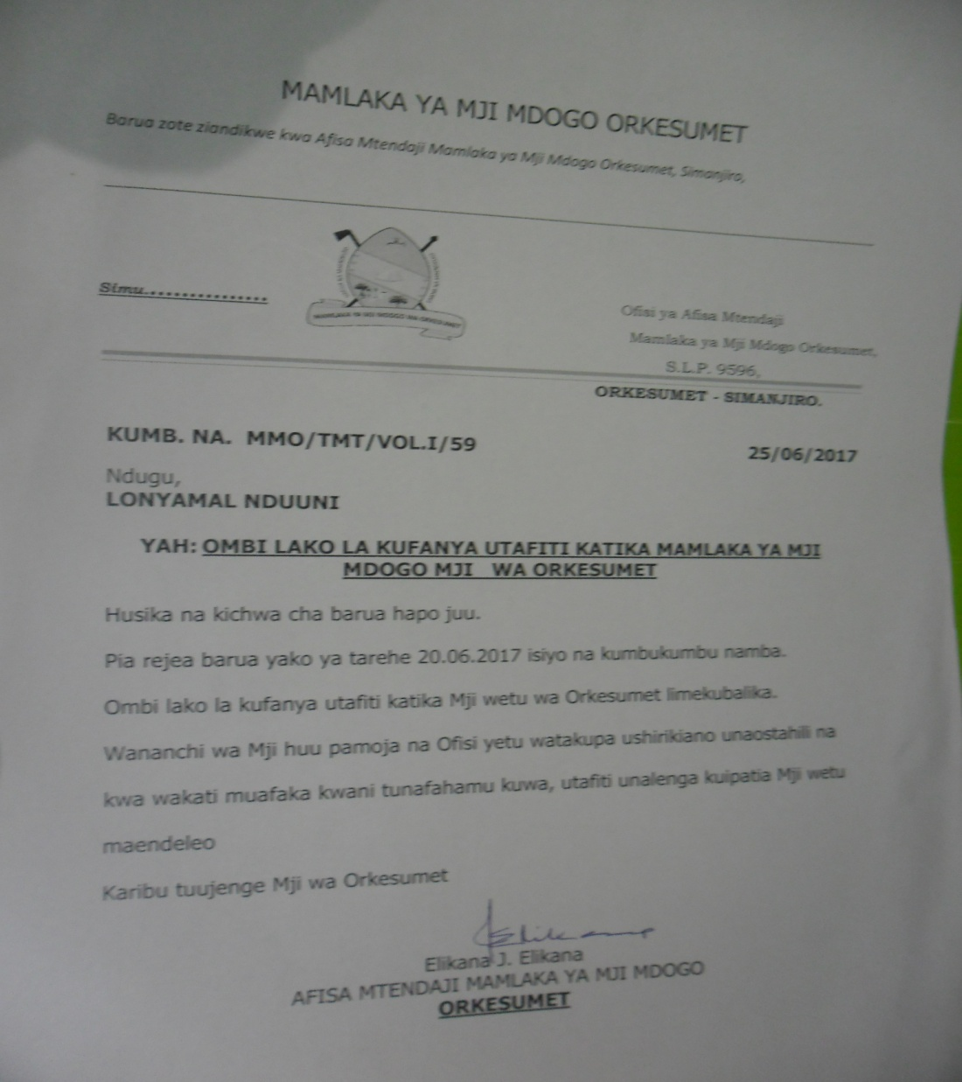

APPENDIX D: Food Remains request letter to Simanjiro Secondary School HM

28.07.2017
MKUU WA SHULE YA SEKONDARI SIMANJIRO
S.L.P 9515
ORKESUMET – SIMANJIRO
YAH: OMBI LA KUPEWA MABAKI YA CHAKULA SHULENI KWA AJILI YA KULISHIA KUKU
Husika na kichwa cha barua hapo juu.
Sisi ni vijana tulioko katika Mji wa Orkesumet, Uongozi wa Mji umetupatia mafunzo ya siku mbili juu ya ufugaji wa kuku. Tulihudhuria vijana ishirini kuanzia katika mafunzo.
Baada ya mafunzo, tulikubaliana kuchanga kuku watano kila mmoja wetu kama kiingilio na kianzio cha mradi. Hadi sasa tuko vijana watatu na kianzio cha kuku kumi na bata watatu.
Tunauomba Uongozi wa shule utuunge mkono kwa kutupatia mabaki (makombo) ya chakula cha Wanafunzi shuleni hapo itusaidie kupunguza gharama za kuwalisha kuku zetu.
Tunatanguliza shukurani kwa kutupa ushirikiano.
Salimu Omari
Katibu
Kikundi cha Vijana Wafugaji wa kuku
Mji wa Orkesumet Simanjiro
APPENDIX E: Photo of a letter from a Family that volunteered a land to the Poultry Farmers
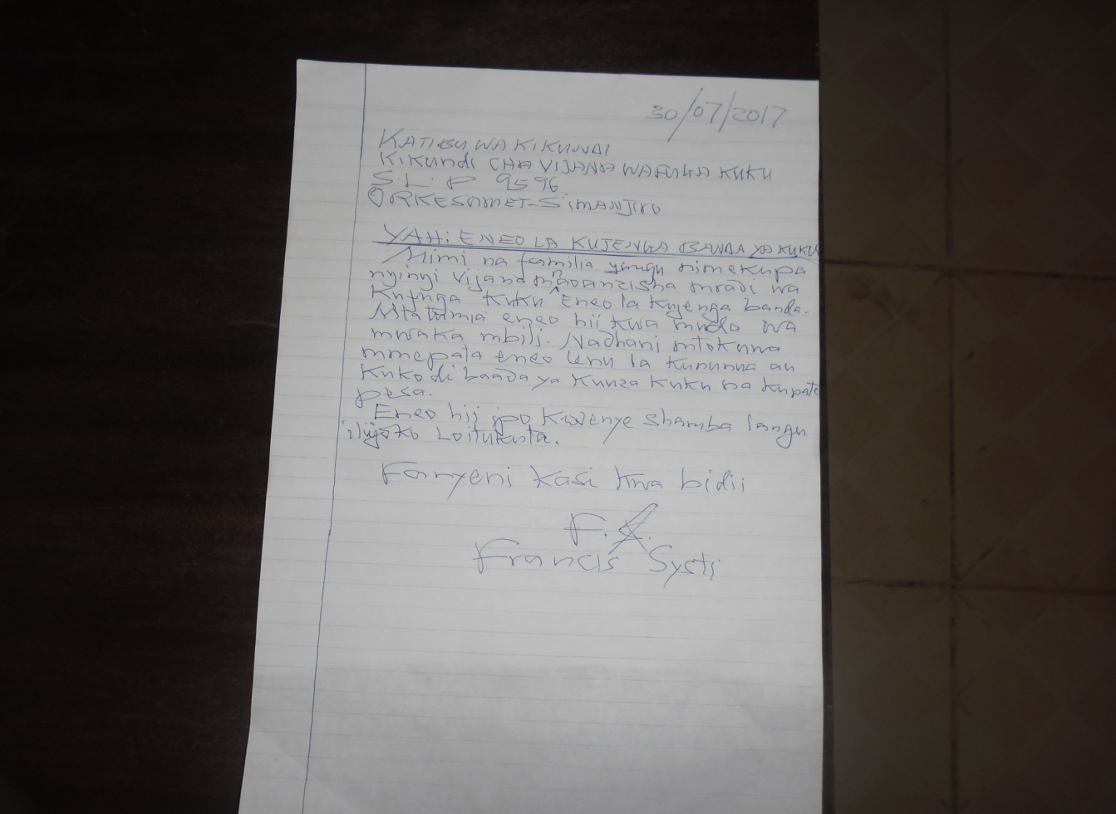

APPENDIX F: Shukurani kwa mdau aliyetupa eneo la kujengea banda la kuku kwa muda.
01.08.2017
FAMILIA YA FRANCIS SYSTI
S.L.P 9515
ORKESUMET –SIMANJIRO
YAH: SHUKURANI KWA KUTUPA ENEO LA KUFUGIA KUKU
Husika na kichwa cha barua hapo juu.
Sisi Vijana Wafugaji wa kuku Orkesumet, tunaishukuru familia yako kwa kutupa eneo la kufugia kuku. Umetuokolea fedha nyingi sana ikiwa ni pamoja na kufanikisha utekelezaji wa lengo letu la kuanzisha mradi huu kwa wakati.
Salimu Omari
Katibu
Kikundi cha Vijana Wafugaji wa kuku
Mji wa Orkesumet Simanjiro

