INITIATING VSLAs FOR YOUTH ECONOMIC EMPOWERMENT IN BUGESERA DISTRICT, EASTERN RWANDA

ETIENNE NIYITULINDA

A PROJECT REPORT SUBMITTED IN PARTIAL FULFILLMENT OF THE REQUIREMENTS FOR THE DEGREEE OF MASTER IN COMMUNITY ECONOMIC DEVELOPMENT OF THE OPEN UNIVERSITY OF TANZANIA
2018

CERTIFICATION
The undersigned certifies that I have read and hereby recommend for the acceptance of the Open University of Tanzania (OUT) a project report entitled, “Initiating VSLAsfor Youth Economic Empowerment in Bugesera District, Eastern Rwanda”in partial fulfillment of the requirements for the degree of masters of Community Economic Development of the Open University of Tanzania.

…………………………………….
Dr. Felician Mutasa
(Supervisor)

………………………………..
Date

COPYRIGHT
No part of this thesis may be reproduced, stored in any retrieval system, or transmitted in any form by any means, electronic, mechanical, photocopying, recording or otherwise without prior written permission of the author or the Open University of Tanzania in that behalf.

DECLARATION
The piece of work entitled “Initiating VSLAs for Youth Economic Empowerment in Bugesera District, Eastern Rwanda”, is my own work, except wherever acknowledged. Errors ifany are the responsibility of my own. This work has not been submitted to any other university for any academic award.

……………………………………..
Etienne Niyiturinda

………………………………
Date

DEDICATION
This work is devoted to my respected parents Andre Kwibuka and Marthe Mukanyangezi and my beloved wife Mrs. Janviere Nyirabagirishya for their love, care and encouragement.

ACKNOWLEDGEMENT
Firstly, I would like to thank God for giving me the opportunity to study this course and carry out this study. I would like to express my warm gratitude to my esteemed supervisor Dr. Felician MUTASA for his incessant guidance, advice and support since the proposal preparation to report finalization. His productive comments, untiring help, guidance and practical ideas stirred me to achieve this project successfully.

I also like to express my sincere thanks to the staff of Bugesera District, especially the Executive Secretary of Mareba Sector for harmonizing the environment during my entire field work and providing the needed data related to my project. I would also like to thank my friends and colleagues for their exceptional company during my two years stay in the campus.

Last but not the least; I am very appreciative to my wife Janviere Nyirabagilishya for her determination, love and support. Profound love and respect goes to my brothers and sisters and other family members who always inspire me to build my educational career.

ABSTRACT
The study was carried out in Mareba Sector of Bugesera District, Eastern Rwanda with the aim of initiating VSLAs for youth economic empowerment. Community needs assessment took one month and Focused Group Discussion method was used to ensure community and other stakeholders’ participation. Primary and secondary data were gathered and helped to realize the specific objectives and answer the three research questions. The CNA findings and the needs pair wise ranking as well as the reviewed literatures revealed that effective entrepreneurship and business development is considered as one of the key strategies for creation of off-farm jobs and initiating VSLAs for youth was found to undoubtedly boost their economic empowerment in a sustainable perspective. The implementation of project was carried out following five objectives including VSLAs starting up, VSALs groups formation, starting saving and loans disbursement, entrepreneurship skills development and linking successful VSLAs groups to formal Financial Institutions. Initially, 157 shares were purchased at 39,250RWF, saving and social fund contribution included. One share was purchased at 200 RWF for saving and 50 RWF for social fund. After training members on VSLAs scheme, they started to apply for loans so as to start investing in agriculture, bee keeping, MTN and TIGO cash, petty business, etc. Up to the end of November 2016, at the midway evaluation a total of 1,884 shares were purchased at 471000 RWF, saving and social fund contribution included and a total of 132,000 RWF of loans were requested and provided. At all stages of the project, institutional, financial as well as political sustainability was ensured so that this project would maintain functioning, supported by its own resources, even when the external sources of funding have ended.

TABLE OF CONTENTS
CERTIFICATION ii
COPYRIGHT iii
DECLARATION iv
ACKNOWLEDGEMENT vi
ABSTRACT vii
TABLE OF CONTENTS viii
LIST OF TABLES xiv
LIST OF FIGURES xv
LIST OF ABBREVIATIONS & ACRONYMS xvii
CHAPTER ONE 1
1.0 PARTICIPATORY NEEDS ASSESSMENT 1
1.1 Background Information 1
1.2 Community Profile 3
1.2.1 Location 3
1.2.2 Social Situation 4
1.2.2.1 Population 4
1.2.2.2 Health 4
1.2.2.3 Education 4
1.2.2.4 Social Protection Sector 5
1.2.3 Economic Analysis 5
1.2.3.1 Agricultural Sector 5
1.2.3.2 Tourism 5
1.2.3.3 Trade and Industry 6
1.2.3.4 Water and Sanitation 6
1.3 Community Needs Assessment 6
1.3.1 Research Objectives 7
1.3.1.1 Overall Objective 7
1.3.1.2 Specific Objectives 8
1.3.2 Research Questions 8
1.3.3 Research Methodology 8
1.3.3.1 Research Design 8
1.3.3.2 Sampling Techniques 9
1.3.3.3 Data Collection Methods 10
1.3.3.3.1 Primary Data 10
1.3.3.3.2 Secondary Data 10
1.3.3.4 Data Analysis Methods 11
1.4 Community Needs Assessment Findings 11
1.4.1 Social-Demographics Findings 11
1.4.1.1 Sex of Respondents 12
1.4.1.2 Age Ranges of Respondent’s 12
1.4.1.3 Educational Level 13
1.4.1.4 Income Generating Activities 14
1.4.1.5 Annual Income of Respondents 15
1.4.1.6 Income vs Needs 15
1.4.2 Current Situation of Saving and Loaning habit 16
1.4.2.1 Per Annum Saving 16
1.4.2.2 Preconditions to Saving and Loaning Projects Development 17
1.4.2.3 Current Situation of Existing VSLAs 18
1.4.2.4 NGOs and CBOs Operating in Youth Economic Empowerment 19
1.4.2.4 Needed Interventions by the Community 20
1.4.2.4 Respondents' Awareness Level on VSLAs 21
1.4.2.4 Perceived Keys VSLAs Promotion Strategies 22
1.4.3 Strengths, Constraints and Opportunities 23
1.4.3.1 Strengths 24
1.4.3.1 Constraints 25
1.4.3.1 Opportunities 25
1.4.4 Plan Rwanda and VSLAs development 26
1.4.4.1 Impact of Plan Rwanda on VSLAs Development 26
1.4.4.2 Plan Rwanda’s Interventions 27
1.4.4.3 Challenges Overcoming Suggestions 28
1.3.5 Findings from Key Informants 28
1.5 Community Needs Prioritization 28
1.6 Conclusion 31
CHAPTER TWO 33
2.0 PROBLEM IDENTIFICATION 33
2.1 Background to Research Problem 33
2.2 Problem Statement 34
2.3 Project Description 35
2.3.1 Target Community 38
2.3.2 Stake Holders 38
2.3.3 Project Goal 39
2.3.4 Project Objectives 40
2.4 Host Organization 40
2.4.1 Organization Structure 41
2.4.2 Plan’s Mission Statement 41
2.4.3 Plan’s Values Statement 41
2.4.4 Plan’s Administration 42
2.4.5 Plan’s Objectives 42
2.4.7 Plan’s Implemented Activities 43
CHAPTER THREE 44
3.0 LITERATURE REVIEW 44
3.1 Introduction 44
3.2 Theoretical Literature 44
3.2.1 Concepts Definition 45
3.2.1.1 Community Economic Empowerment 45
3.2.1.2 Youth 45
3.2.1.3 Youth Empowerment Programs 45
3.2.1.4 Microfinance Institutions 46
3.2.1.5 Villages Saving and Loans Associations 46
3.2.2 Overview of Rwandan Youth Sector 46
3.2.2.1 Economic Problems Affecting Youth 47
3.2.3 Youth Economic Empowerment 50
3.2.3.1 International Best Practice 50
3.2.3.2 Youth Economic Empowerment in Rwanda 53
3.2.4 VSLAs as Youth Economic Empowerment Tool 54
3.2.4.1 Rationale of VSLAs 55
3.2.4.2 VSLAs Methodologies 57
3.2.4.3 Strengths and Weakness of VSLAs 63
3.3 Empirical Literature Review 64
3.4 Policy Review 68
3.4.1 Rwanda National Youth Policies (2006 and 2015) 68
3.4.2 Youth Sector Strategic Plan (YSSP) 2013-2018 70
3.4.3 Rwanda National Youth Council 71
3.4.4 Rwanda Cooperatives Promotion Policy 71
3.5 Literature Review Summary 72
CHAPTER FOUR 74
4.0 PROJECT IMPLEMENTATION 74
4.1 Introduction 74
4.2 Project Products and Output 74
4.3 Project Planning 75
4.3.1 Implementation Plan 76
4.3.2 Inputs 83
4.3.3 Project Budget 84
4.4 Project Implementation 85
4.4.1 Project Implementation Report 85
4.4.2 Project Implementation Gantt chart 93
CHAPTER FIVE 95
5.0 PROJECT PARTICIPATORY MONITORING, EVALUATION AND 95
SUSTAINABILITY 95
5.1 Introduction 95
5.2 Participatory Monitoring 95
5.2.1 Monitoring Information System 96
5.2.2 Participatory Monitoring Methods 97
5.3 Participatory Evaluation 102
5.3.1 Performance Indicators 103
5.3.2 Participatory Evaluation Methods 107
5.3.3 Project Evaluation Summary 110
5.4 Project Sustainability 113
5.4.1 Institutional Sustainability 114
5.4.2 Financial Sustainability 114
5.4.3 Political Sustainability 115
CHAPTER SIX 117
6.0 CONCLUSION AND RECOMMENDATIONS 117
6.1 Introduction 117
6.2 Conclusion 117
6.3 Recommendations 121
REFERENCES 125
APPENDICES 128

LIST OF TABLES
Table 1.1: Sample Distribution (N = 64) 9
Table 1.2: Pair Wise Ranking 30
Table 2.1: Analysis of Stakeholders Involved in the Project 39
Table 4.1: Projects Products and Outputs 75
Table 4.2: Project Implementation Plan 77
Table 4.3: Project Logical Framework 78
Table 4.4: Duties and Responsibilities of VSLA Staff 84
Table 4.5: Project Budget 86
Table 4.6: Project Implementation Gantt chart 93
Table 5.1: Participatory Monitoring Plan 99
Table 5.2: Project Performance Indicators 105
Table 5.3: Project Evaluation Summary 111

LIST OF FIGURES
Figure 1.1: Geographical Location of the Project 3
Figure 1.2: Gender Distribution among Respondents 12
Figure 1.3: Age Ranges among Respondents 12
Figure 1.4: Education Level of Respondents 13
Figure 1.5: Income Generating Activities of Respondents 14
Figure 1.6: Respondents Annual Income in Rwandan Francs 15
Figure 1.7: Actual Income and Needs Meeting 15
Figure 1.8: Current Situation of Saving Among Respondents 16
Figure 1.9: Preconditions to Saving and Loaning Projects Development 17
Figure 1.10: Actual Situation of Existing VSLAs 18
Figure 1.11: CBOs Operating in Youth Economic Empowerment 19
Figure 1.12: Most Needed Interventions by the Community 20
Figure 1.13: Respondents' Awareness Level on VSLAs 21
Figure 1.14: Perceived Keys VSLAs Development Strategies 22
Figure 1.15: Perceived Strengths to VSLAs Development 24
Figure 1.16: Perceived Constraints to VSLAs Development 25
Figure 1.17: Perceived Opportunities to VSLAs Development 25
Figure 1.18: Perceived Impact of Plan Rwanda on VSLAs Development 26
Figure 1.19: Intervention Community Would like Plan to Provide 27
Figure 1.20: Suggestions for VSLAs Projects Development 28
Figure 4.1: CED Student Etienne Niyiturinda (With Badge) With a Group of Youth During One of The Mobilization Meeting On Saving Spirit Development 88
Figure 4.2: Jyambere Rubyiruko VSLA group during one of the weekly saving session 89
Figure 4.3: VSLA Members in one of the Income Generating Activities (Agriculture) 91

LIST OF ABBREVIATIONS & ACRONYMS
ASCA Accumulating Savings and Credit Association
CBO Community Based Organization
CAN Community Needs Assessment
CED Community Economic Development
CLASSE Community, Learning and Action for Saving Stimulation and Enhancement
EDPRS Economic Development and Poverty Reduction Strategy
EICV Integrated Household Living Conditions Survey
FSAP Financial Sector Assessment Program
GoR Government of Rwanda
ICRW International Center for Research on Women
INADES Institut Africain pour le développement économique et social, (African Institute for Economic and Social Development)
MCED Master in Community Economic Development
MFIs Microfinance Institutions
MINECOFIN Ministry of Finance and Economic Planning
MINIYOUTH Ministry of Youth
MINISPOC Ministry of Sports and Culture
MINICOM Ministry of Trade and Industry
MGLSD Ministry of Gender, Labour and Social Development
MYICT Ministry of Youth and Information and Communication Technology
NEEDS National Economic Empowerment and Development Strategy
NEP National Employment Program
NICI Information and Communications Infrastructure
NISR National Institute of Statistics of Rwanda
NYC (Rwanda) National Youth Council
PIP Project Implementation Plan
PMIS Project Management Information Systems
PRA Participatory Rural Appraisal
RCA Rwanda Cooperatives Agengy
RNFS Rural Non-farm Sector strategy
SACCO Savings and Credit Co-operative
SME Small and Medium Enterprises
VSLA Village Saving and Loan Association
YEPs Youth empowerment programs
YSSP Youth Sector Strategic Plan

CHAPTER ONE

1.0 PARTICIPATORY NEEDS ASSESSMENT

1.1 Background Information
Assessing a community’s strengths, weaknesses, needs, and assets is an essential first step in planning an effective project. By taking time to learn about the community, you can discover the most relevant opportunities for projects and maximize the ability to make a meaningful impact (Evanston, 2008). This community assessment was carried out in the study area to get a better understanding of the dynamics of a community and help both the MCED student and the beneficiaries make important decisions about service priorities. An effective assessment revealed things not know before and helpedin building valuable relationships and is expected to encourage community members to actively participate in making lasting improvements. It wasa critical first step in creating trust, community ownership, and sustainability, the key drivers of an effective Youth Economic Empowerment in Rwanda.

Rwanda’s Youth are a major asset of the Country and key drivers for sustainable development, if empowered and well-motivated. For purposes of harmonization with the Child Policy and other existing regulations, the 2015 revised National Youth Policy defined Youth as persons aged between 16-30 years, principally to create better opportunities such that more efforts are concentrated on the cohort of young people who have lesser opportunities and yet more challenges in terms of betterment of their livelihoods and Socio-Economic Development in general (GoR, 2015). According to the EICV3, the rates of poverty are high for this segment of the population. Out of 57% of the general population living below poverty line, 38.5% are young people with 19.6% of them living in absolute poverty (NISR, 2012).

The unfortunate aspect here is that this sector is characterized by activities of extremely low productivity, low earnings and involves precarious conditions which can be considered as vulnerable employment. The Country has implemented a series of programs derived from the National Youth Policy since 2006. Most of these programs mainly focused on Youth participation, mobilization and social welfare and Villages Saving and Loan Associations (VSLAs) were found to be among the most effective projects for Youth economic Empowerment (GoR, 2015).

The basic principle of the Village Savings and Loan (VSL) system is that members of a self-selected group voluntarily form a VSLA and save money, through purchasing shares. The primary purpose of a VSLA is to provide simple savings and loan facilities, in a community that does not have access to formal financial services. Associations are autonomous and self-managing (Hugh Allen, 2007). This is fundamental because a VSLA’s goal is institutional and financial independence and the researcher managed to initiate VSLAs for youth selected among beneficiaries of Plan International Rwanda, a Community Based Organization (CBO) operating in Mareba Sector of Bugesera District, Eastern Rwanda.

For a successful assessment, various methods to gather data and information from the community were used and included mainly structured questionnaire but also interview, focus group discussions, individual key-informants and existing previous research reports.

1.2 Community Profile

1.2.1 Location
Mareba Sector is on the 15 Sectors composing Bugesera District, located in the south Eastern plains of Rwanda notably in the south west of the Eastern Province. It borders with the Republic of Burundi in the South, Ngoma district to the East, Kigali city and Rwamagana district to the North. The district is sandwiched between Rivers Nyabarongo and Akanyaru which converge at the southern part to form Akagera River. The estimate terrain elevation above sea level is 1438 meters. The area is bounded between -2.2315of Latitude and 30.1127of Longitude (Bugesera, 2013).
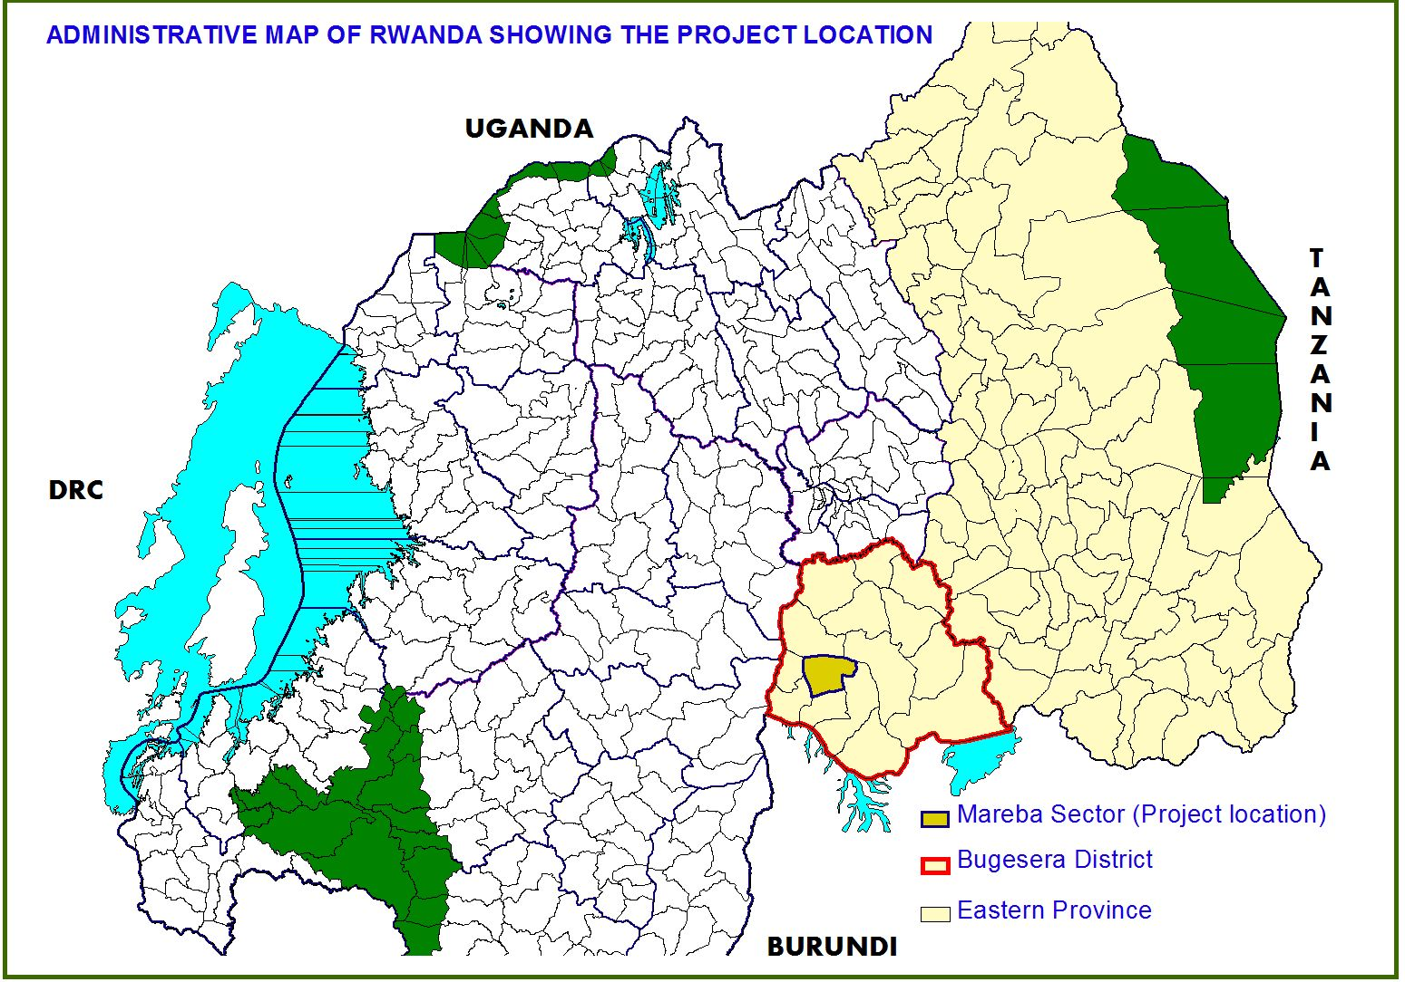

Figure 1.1: Geographical location of the project
Source: Own design with Arcview 3.2a

1.2.2 Social Situation

1.2.2.1 Population
The population of Bugesera district is estimated at 13.9% of the whole Eastern Province population, and at 3.4% of the total population of Rwanda (General population census 2012) and 48.4% are below poverty line where 28.3% are poor and 20.1% are extremely poor. Its population Average Annual Growth Rate is 3.1%, with a population density of 282 people per km²(Bugesera, 2013).

1.2.2.2 Health
Bugesera District has various types of health care services. These services are defined to help citizens to access health services in clear and good conditions, the formal ones are set up from the sector to District level. On sector level all fifteen sector have health centers constructed by the government and development partners. All district residents are mobilized to subscribe to health insurance services available in each health center (Bugesera, 2013).

1.2.2.3 Education
In the education sector, over the last 5 years, the adult literacy rate was increased from 35.9% to 72.9% (increase of 37%). 13 schools of Nine Years Basic Education (9YBE) and 16 schools of Twelve Years Basic Education were constructed and equipped with scholastic materials. Youth who have never attended school represent 12.4% of the total youth resident population at national level; it represents 13.8% of the total youth resident population in the Eastern province and 13.6% of the total resident population of Bugesera district (Bugesera, 2013).

1.2.2.4 Social Protection Sector
In last five years, the percentage of people below poverty line has been reduced from 66% to 48.4%, meaning a reduction of 17.6%. The percentage of the population in extreme poverty is 28.3%. The District uses different approaches initiated by the Government like One cow per family (Girinka) program, Ubudehe program, Vision 2020 Umurenge program (VUP), and other social assistance schemes meant for genocide survivors and demobilized soldiers, implemented by FARG and RDRC. This has improved the life of District’s citizens and reduced poverty (Bugesera, 2013).

1.2.3 Economic Analysis
In Bugesera district, the majority of youth aged currently employed are self-employed (71.8%), followed by employees (18.4%) and contributing family workers (6.1%) (NISR, 2012).

1.2.3.1 Agricultural Sector
The district is at the 17th position in the country to have a percentage of Households involved in agriculture and livestock activities. Crop farming and livestock rearing are the district’s economy’s backbones where by 77.8% of the population depend on agriculture against 72% for national average and 72.3% of the HH of the district have less than 1ha of land to be cultivated (Bugesera, 2013).

1.2.3.2 Tourism
Bugesera is one of the Districts with unique tourist assets and potentials. Its natural endowments are not developed to foster a vibrant and competitive industry. Currently the sector depends on bird tracking as the major touristic activity. However it has lots of potentials based on 9 lakes, rivers, geographical set up and culture (Bugesera, 2013).

1.2.3.3 Trade and Industry
Bugesera District is an area favorable for trading due to its borders. It has opportunity to improve on trade. It borders Burundi where there are booming economic activities. Bugesera has got at least 7 trading centers (Nyamata, Ruhuha, Gashora, Nyabagendwa, Batima, Kabukuba, and Nemba border) and at least one small trading center in each Sector. It has got different modern markets built in those trading center. This is an opportunity for small and medium enterprises development. Currently trade is developing, although the private sector is still very small and hence, its employability is still low. Moreover, the District has potential for industrialization given its low relief and many pipeline projects such as the regional airport expected to be completed by 2017, the industrial zone to be constructed and the future railway line project which will start in 2018.(Bugesera, 2013).

1.2.3.4 Water and Sanitation
In both urban and rural areas, the main sources of water supply used is improved source of water (85.7% in urban compared to 64% in rural).The most used types of toilet are private pit latrine (74.1% in urban and 88.1% in rural) and shared pit latrine (21.6% in urban and 8.3% in rural) (Bugesera, 2013).

1.3 Community Needs Assessment
Assessing Mareba Sector community’s strengths, weaknesses, needs and assets of youth was an essential first step in planning an effective VSLAs project. By taking time to learn about the community, most relevant opportunities for projects were discovered and the ability to make a meaningful impact was maximized. This community need assessment (CNA) helped to get a better understanding of the dynamics of Mareba Sector youth community and helped both the MCED Student and the beneficiaries to make important decisions about service priorities. Even if actively involved in the community, an assessment revealed additional strengths and opportunities for empowerment. Effectively doing this assessment revealed things we did not know before and helped in building valuable relationships while encouraging community members to actively participate in making lasting improvements. It was a critical first step in creating trust, community ownership, and sustainability.

1.3.1 Research Objectives
The overall objective of conducting CNA was to gather information from community so as to identify needs, constraints and opportunities within youth in Mareba Community. It attempted to get a better understanding of the dynamics of Mareba Sector youth community and helped both the MCED Student and the beneficiaries to make important decisions about intervention priorities. The findings from the assessment enabled the researcher to prioritize the identified community needs through pair wise which in the final analysis led to the formulation and design of the project specifically to address the identified priority.

1.3.1.1 Overall Objective
The overall objective was to initiate VSLAs for youth economic empowerment in Mareba Sector of Bugesera District, Eastern Rwanda.

1.3.1.2 Specific Objectives
The specific objectives were:
- To identify the economic development problems facing youth in the community;
- To evaluate the current situation of saving and loans tendency among youth;
- To identify intervention and strategies required to increase the number of VSLAs;
- To identify the major problems hindering youth VSLAs projects development, effectiveness and sustainability in Mareba Community.

1.3.2 Research Questions
The research questions and the question in the questionnaire were set to fulfill the envisaged target of increasing the youth’s income, poverty reduction which in turn will contribute the livelihood of the community in question.
- What are the economic development problems facing youth in the community?
- What is the current situation of saving and loans tendency among youth?
- Which intervention and strategies are required to increase the number of youth VSLAs?
- What are the major problems hindering youth VSLAs projects development, effectiveness and sustainability in Mareba Community?

1.3.3 Research Methodology

1.3.3.1 Research Design
Descriptive survey research was applied in conducting this CNA. Surveys are a popular method for collecting information and opinions (Evanston, 2008). In the context of a community assessment, a survey has been an effective way to assess the community’s perceived strengths, weaknesses, needs, and existing assets. Surveys targeted the Youth specific segments of Mareba community.

1.3.3.2 Sampling Techniques
The sample consisted in selection of individual belonging in Youth specific segments among the beneficiaries of Plan International Rwanda, a Non-Government Organization (NGO) operating in Mareba Sector of Bugesera District, Eastern Rwanda. Basing on Rwanda National Youth Policy (GoR, 2015), all individuals aged between 16 and 30 years old were considered. Fifty nine (59) youth were identified among all Plan International Rwanda’s beneficiaries and considering the fact that the number was below 100, all of them were selected (Suskie, 1996). In addition, proposed key informants were selected and these included 2 Plan International Rwanda representatives, 2 Local leader and 1 youth and Microfinance experts. Keys informants accepted to fill the entire questionnaire in addition to their specific check list.

Table 1.1: Sample Distribution (N = 64)
Number of Respondents | Sample Size | Percent
Youth | 59 | 92
Plan Rwanda representatives | 2 | 3
Local leader | 2 | 3
Youth and microfinance Expert | 1 | 2
TOTAL | 64 | 100
Source: researcher, 2017

1.3.3.3 Data Collection Methods
The data required for this CNA to answer the research questions were collected from both primary and secondary sources.

1.3.3.3.1 Primary Data
A combination of methods was employed in collection of primary data including focused group discussion, questionnaire survey and in depth interviews with key informants. The questionnaire was translated into Kinyarwanda to make sure all respondents understand what was being asked. The respondents filled in the questionnaire individually, but were gathered in a group, in order to save time for data collection.

In addition, explanation was given to those that need clarification concerning the questionnaire. Interviews were conducted in Kinyarwanda, with answers immediately verbally translated into English. Though making attempt to ensure accuracy of information provided, all data were subject to the truthfulness of respondents as well as their knowledge of the data provided. A focus group discussion was held with community members after the fulfillment of the questionnaire to reveal unexpected information.

1.3.3.3.2 Secondary Data
A detailed theorical and empirical literature study was undertaken in order to get information on Community need assessment, Rwandan Youth Sub-Sector, the role played by VSLAs in Youth Economic Empowerment and existing Youth Empowerment policies. Data was retrieved from District and national reports, maps, internet as well as published and unpublished documents of other organizations. Information was also obtained from published and unpublished books, journals, newsletters, thesis/dissertations, periodicals and articles.

1.3.3.4 Data Analysis Methods
The data was coded, categorized and entered in computer to be analyzed using SPSS 16.0. Calculations were made of total and average frequencies. In addition, the frequencies were converted into percentages enabling the analysis and the interpretation of results.

1.4 Community Needs Assessment Findings
A total of 64 distributed copies of the questionnaires were filled and given back to the researcher making the survey response rate 100%. Following are the findings from the questionnaire, mainly based on the set of objectives and in conformity with the research questions. Bar charts were used to present the findings and all results are presented in term of Percentages. Tables with detailed information have been appended.

1.4.1 Social-Demographics Findings
In a community based survey research, socio-demographic need to be assessed by qualitative questionnaire and measurements. Most of community needs are associated with various socio-demographic variables like, age group, gender, education occupation and income. This section presents the socio-demographic related findings.

1.4.1.1 Sex of Respondents
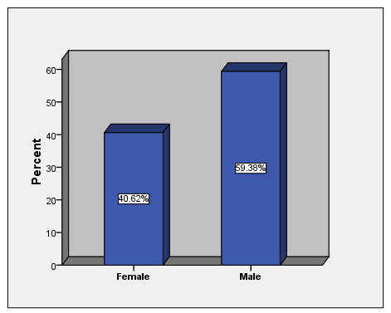
Figure 1.2: Gender Distribution among Respondents
Source: researcher data

The Figure 1.2 shows the respondents by sex. In order to get the information from both male and female the researcher managed to get good response from the community whereas out of 64respondents, 26 (40.62%) were female and 38 (59.38%) were male. This reveals that more males participated, reflecting the well-known and existing gender imbalance. However, the percentage of female exceeded 30% required by Rwanda nation gender policy. Views where then obtained from difference sex avoiding biasness.

1.4.1.2 Age Ranges of Respondent’s
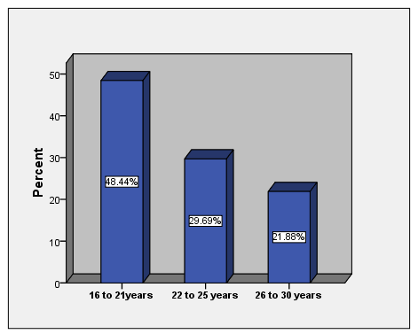
Figure 1.3: Age Ranges among Respondents
Source: researcher data
Coming to age, only individuals falling in Youth segment of Plan Rwanda’s beneficiaries in Mareba Sector were surveyed. Most of the respondents were under 21 years old as indicated in Figure 2 above. The majority range (31 respondents) was between 16 – 21 years of age with 48.44% followed by the 22 – 25 range with 19 respondents (29, 69%).

1.4.1.3 Educational Level
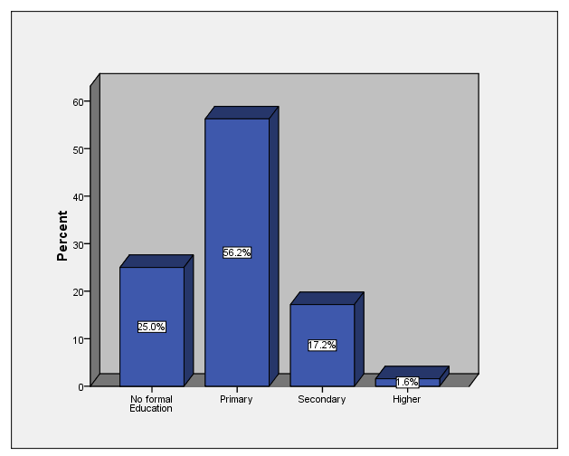
Figure 1.4: Education Level of Respondents

More often than not there are clear differences in opinion between respondents with a different educational level. Respondents were asked about their highest level of education completed’ and the finding in Figure 4 indicate that the majority (56.2%) have completed the Primary level of study followed by 25% of respondents who have no formal education.

Only 17.2% of respondents had completed secondary level and only 1.6% had higher education and these included particularly the key informants. The information was gathered so as to understand the capacity of youth living in Mareba community to participate in initiated VSLAs projects.

1.4.1.4 Income Generating Activities
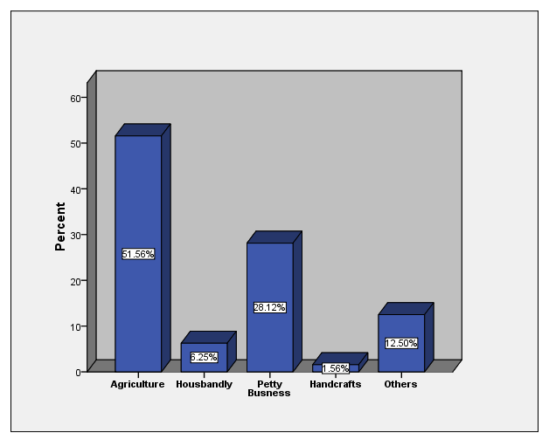
Figure 1.5: Income Generating Activities of Respondents

Ensuring the income of youth is an essential precondition for the elimination of poverty andthe upholding of human rights, in particular at the individual level, as it helps to build a base for social change. When different dimensions of the livelihood issue are considered, the incidence of income is the most important.

Findings in Figure5 suggest that majority (51.56%) of Youth in Mareba community are working in agriculture followed18.12% of respondents who are running various petty businesses. These findings are in line with the analysis by the National Institute of Statistics of Rwanda indicating that 61% of the employed youth are self-employed and 67% of them are primarily into Agriculture (NISR, 2012).

1.4.1.5 Annual Income of Respondents
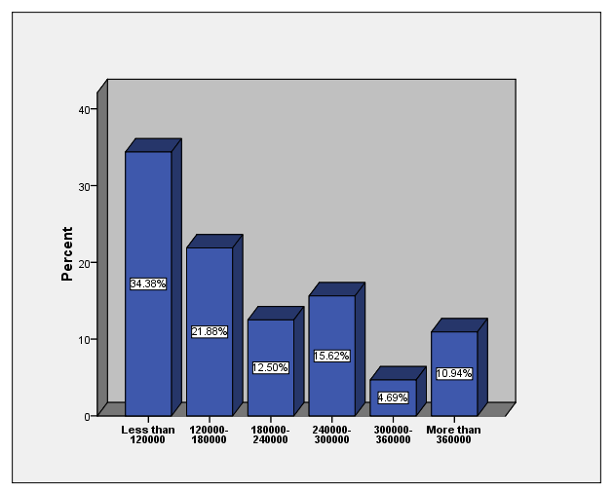
Figure 1.6: Respondents Annual Income in Rwandan Francs
Source: researcher data

As far as income is concerned, the study reveals that majority of respondents (34.38%) gain less than 120000 Rwf per annum (10000 Rwf per month). Only 10.94%of the residents are above 360000 Rwf per annum (30000 per month). These findings suggest that there is lack of viable income generating opportunities and through this assessment, effective VSLAs projects will be the affordable and practical alternatives.

1.4.1.6. Income vs Needs
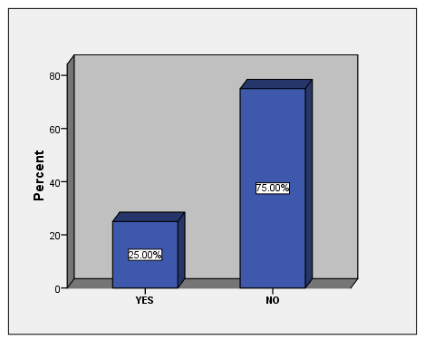
Figure 1.7: Actual Income and Needs Meeting
Source: researcher data
The findings in Figure 1.7 indicate as many as 75% of respondents are not meeting their everyday socio-economical needs given their actual income. According to the Government of Rwanda, The unfortunate aspect is that youth sector is characterized by activities of extremely low productivity, low earnings and involves precarious conditions which can be considered as vulnerable employment (GoR, 2015). Poverty is generally understood as a brief experience when income falls below family survival needs or the poverty line. These findings imply that there is an urgent need to find other income sources other than agriculture.

1.4.2 Current Situation of Saving and Loaning habit

1.4.2.1 Per Annum Saving
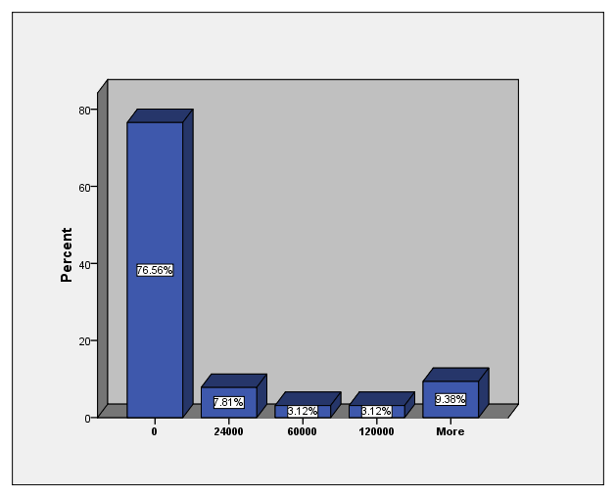
Figure 1.8: Current Situation of Saving Among Respondents
Source: researcher data

This assessment revealed that the majority of youth in Mareba community are not meeting their everyday socio-economical needs given their actual income (Figure 7). This constraint directly influence the saving practice and as many as 76.56%of respondents do not save no money at all along the year as shown by the finding in Figure 1.8. Only 9.38% were able to save more than 120,000 Rwf per annum (10,000 per month). Various evidences reveal that the financial services provided to the youth has been instrumental and effective in increasing the access to and control over the productive resources to the youth and ultimately supporting in their endeavors towards social and economic empowerment(Sida, 2014). These finding stress the urgency of initiating saving projects in youth of Mareba community.

1.4.2.2 Preconditions to Saving and Loaning Projects Development
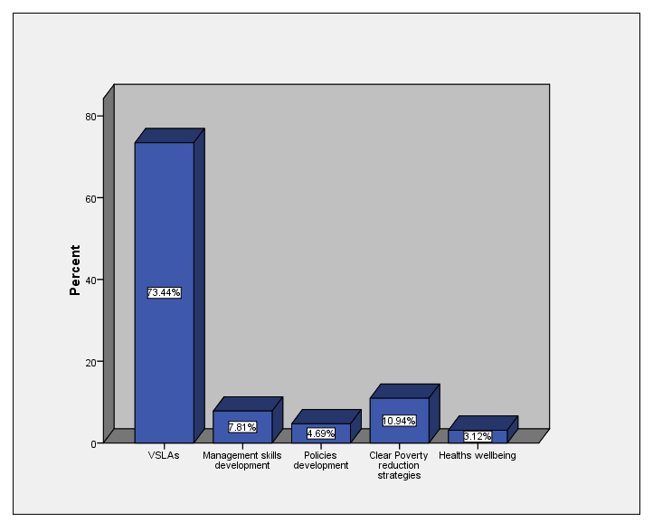
Figure 1.9: Preconditions to Saving and Loaning Projects Development
Source: researcher data

VSLAs projects were identified as the most effective way of promoting saving and loaning by the youth of Mareba community with 73.44 of percentage. In Africa it is becoming clear that while many banks and microfinance institutions (MFIs) provide valuable services to the poor, they are most successful in economically dynamic urban areas, where borrowing requirements are high and the costs of reaching clients is low. Most of the people who live in rural areas and in urban slums (and particularly the very poor) receive no services at all. Thus, there is still a very large gap between the needs of the poor for financial services and the ability of banks and MFIs to provide these services. Moreover, the gap cannot be filled by these types of institutions because, in most cases, they will never be able to cover their costs (Hugh Allen, 2007).

The implication of these findings is that there is a need of alternative models that are able to provide the rural poor and the urban very poor with savings services as well as insurance and credit that can be delivered cost-effectively. Evidences prove that VSLAs provide not only a secure place to save and the opportunity to borrow in modest amounts but also a convenient access to saving services because of the easy understanding and transparency in its operations (Hugh Allen, 2007). VSLAs are also inexpensive to set up and as they are locally managed.

1.4.2.3 Current Situation of Existing VSLAs
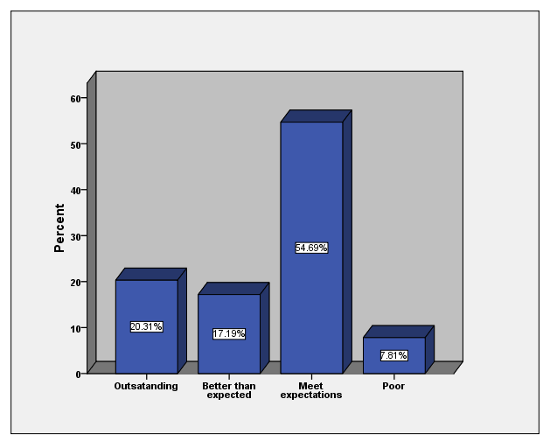
Figure 1.10: Actual Situation of Existing VSLAs
Source: researcher data

While assessing the needs of youth in Mareba community, it was found and confirmed by hundred percent of respondents that they were some already initiated VSLAs, most of which were run by women and adults associations. This information was expected to help the researcher to initiate the most effective VSLAs and respondents were asked to evaluate those existing ones. As presented in Figure 9, the majority of already established VSLAs (64.69%) were categorized as meeting expectations implying that there is a need of improvement.

1.4.2.4 NGOs and CBOs Operating in Youth Economic Empowerment
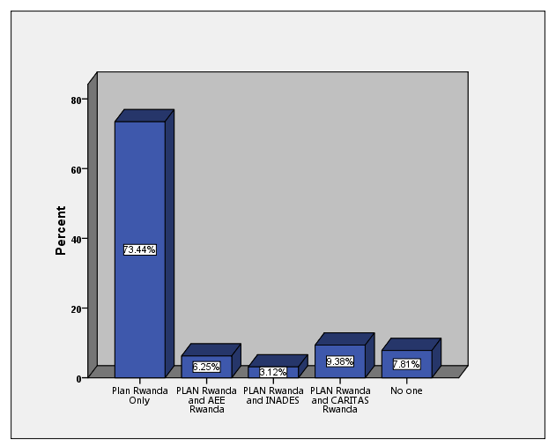
Figure 1.11: CBOs Operating in Youth Economic Empowerment

Poor performance of government in meeting the socioeconomic quests of citizens has been identified as one of the reasons behind the proliferation of community based organizations (CBOs) in the new millennium (Abegunde, 2009). As there are many CBOs aiming to economically empower the youth in Bugesera District, this assessment sought important to know by which ones respondents are economically supported. The findings (Figure 11) revealed that except the key informants, in addition to Plan Rwanda, some youth were economically supported by other CBOs including CARITAS Rwanda, AEE Rwanda and INADES. Except the key informants, all respondents were selected among beneficiaries of Plan International Rwanda.

1.4.2.4 Needed Interventions by the Community
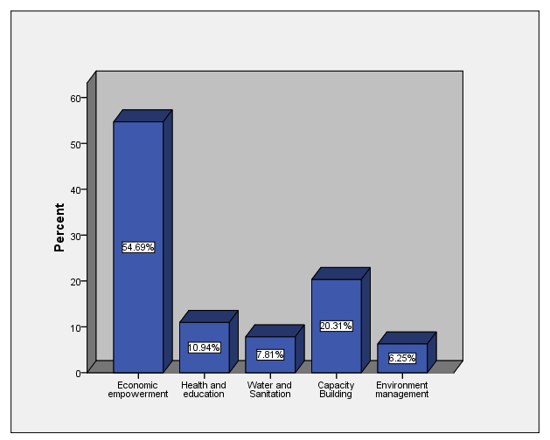
Figure 1.12: Most Needed Interventions by the Community
Source: researcher data

As setting, the community is primarily defined geographically and is the location in which interventions are implemented. Various interventions are employed to empower youth in Bugesera District, but as shown by the finding in Figure 12,economic empowerment was found to be the most needed (54.69%) followed by capacity building (20.31). Others are health and education, environment and water and sanitation. Or these strategies involve individuals, families, social networks, organizations, and public policy.

The community-based interventions engage community input through advisory committees or community coalitions that assist in tailoring interventions to specific target groups or to adapt programs to community characteristics. However, the focus of this community-based project is primarily on changing individuals’ behaviours as a method for increasing the youth’s participation and effectives VSLAs will be with no doubt, a key driver of economic empowerment. Ensuring all young people, including the most marginalised and disadvantaged, can unlock their potential through access to decent work will drive progress towards sustainable, inclusive development.

The critical issues here are to improve the quantity and quality of youth enterprises and contribute towards reducing poverty and unemployment among the youth. It also seeks to economically support young people in order to unleash their potential to create economic wealth, sustainable decent employment, increase their savings and investment levels, and develop their human resource capacities, entrepreneurship and technical knowledge.

1.4.2.4 Respondents' Awareness Level on VSLAs
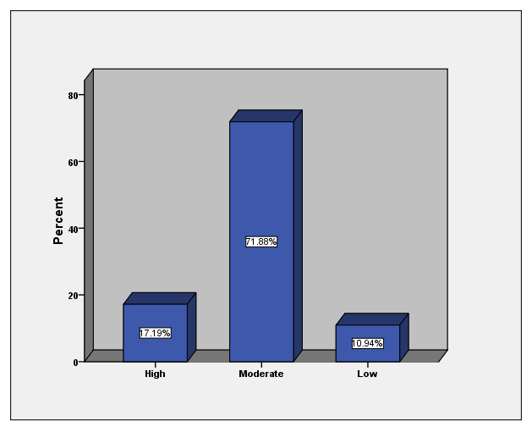
Figure 1.13: Respondents' Awareness Level on VSLAs
Source: researcher data

The findings in Figure 13 suggest that youth are not aware enough about the contribution of VSLAs to economic empowerment. Only 17.19% of respondents are aware enough about the benefits and the operating principles of VSLAs.Raising public awareness is not the same as telling the public what to do; it is explaining issues and disseminating knowledge to people so that they can make their own decisions. Community awareness rising is crucial for the success of the project because in order to work together, the youth needs to have a common understanding of what VSLA is, and how it contributes to their economic empowerment in the community.

1.4.2.4 Perceived Keys VSLAs Promotion Strategies
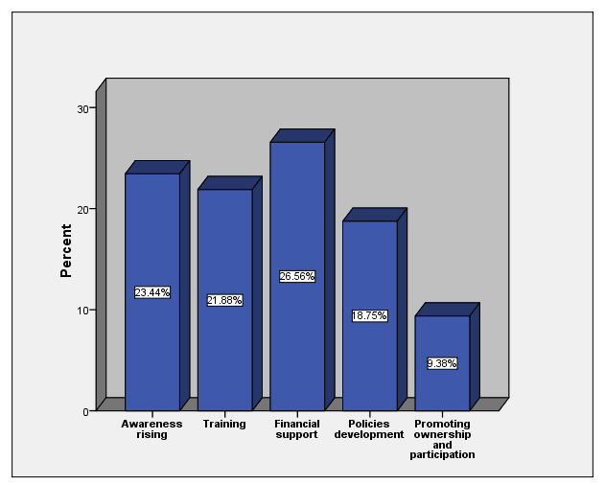
Figure 1.14: Perceived Keys VSLAs Development Strategies

This assessment revealed a number of issues concerning the establishment and running of an effective VSLA in Mareba community. Concerns include of insufficient or lack of capital, inexistence of saving and loaning habit and lack of awareness just to mention few of them. Given the situation, this assessment deemed crucial to find what respondent believe they can be the strategies of upholding VSLAs projects in their community and as shown by the finding in Figure 14, Financial Support was fond to be the most frequent (26.56%) followed by awareness rising (23.44%). Others are training, policies development and promotion of ownership and participation.
VSLAs to be based in Mareba community, will becomplementary to MFIs, tending to serve the youth whose income is irregular and less reliable and who may not be full-time business people. Their principal need is for services that help them manage their household cash-flow and provide useful lump sums for life-cycle events, which may or may not include income generation. Youth are more likely to be economically vulnerable and, for the most part, they live in rural areas that are served only intermittently by local markets, at the periphery of the national economy.

1.4.3 Strengths, Constraints and Opportunities
Effective entrepreneurship and business development is considered as one of the key strategies for creation of off-farm jobs. However, Youth are facing challenges in their struggles to penetrate the sector. According to Rwanda SME Survey 2013, 31.3% of Youth face challenges related to access to finance mainly due to lack of collateral. On the other hand, 27.8% face challenges related to procedures and lack of managerial experience to run their enterprises and thus questioning profitability. Other challenges involved, on one hand, include high interest rates in order to access loans and on the other hand poor or non-bankable business plans.

Lack of competitiveness, innovation, access and use of information technology are still challenges that need critical attention(GoR, 2015).It is critical that efforts towards Youth Economic empowerment are addressed using a multisectoral approach at all levels of governance and involvement of all key players including private sector.
Out of 608 Youth who were randomly selected during consultations with stakeholders, 41% ranked issues associated to economic empowerment (included lack of capital, unemployment, lack of entrepreneurship skills, lack of employable skills, inadequate training and inadequate access to economic opportunities) as their number one priority while 50% and 43%ranked the same as second and third respectively(GoR, 2015). For a proper needs prioritization, this assessment, using questionnaire, judged crucial to analyze the situation of Mareba community in terms of strengths, constraints and opportunities in relation to VSLAs projects success.

1.4.3.1 Strengths
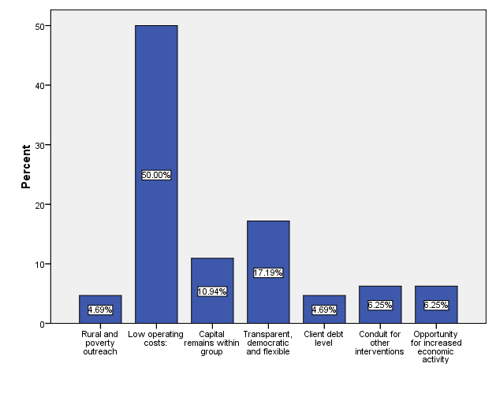
Figure 1.15: Perceived Strengths to VSLAs Development
Source: researcher data

From the Figure 1.15, the majority of respondents (60.0%) believe that the strengths of VSLAs relay on their low operational cost, while 17.19% of respondents would have adopted VSLAs because of transparency, democracy and flexibility. Other but not many mentioned the rural and poverty outreach, the fact that capital remains within group, opportunity for increased economic activity, client debt level and the fact that VSLAs may be the conduit for other interventions. These factors should be taken in to consideration by the community themselves in collaboration with other stakeholders so as to establish effective VSLAs.

1.4.3.1 Constraints
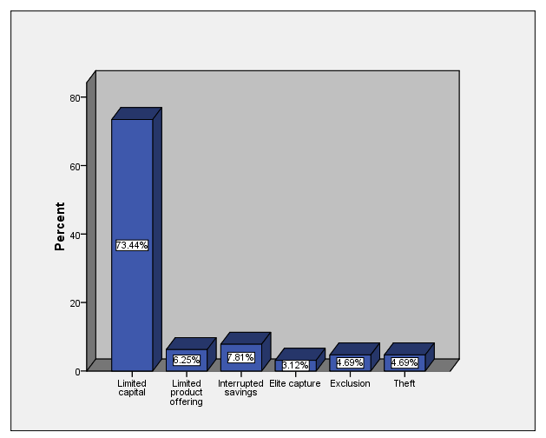
Figure 1.16: Perceived Constraints to VSLAs Development

The Figure 1.16 presents the constraints to VSLAs projects in Mareba Youth community as pointed out by respondents. Not surprisingly, the limited capital toped up the list with 73.44 of percentage. Interrupted savings (7.81%) and limited products offering (6.25) were also frequent. Respondent were also worried about exclusion, theft and elite capture.

1.4.3.1 Opportunities
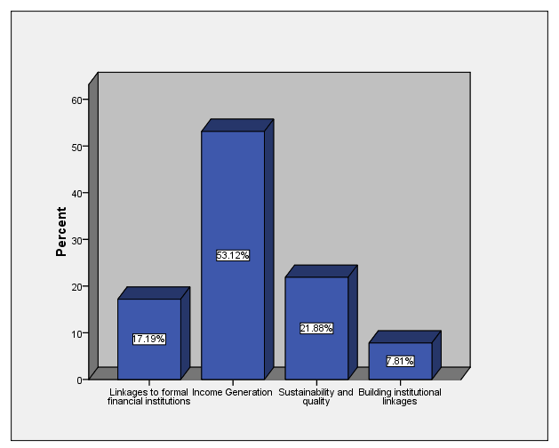
Figure 1.17: Perceived Opportunities to VSLAs Development
Source: researcher data

The Figure 1.17 presents the opportunities in relation to VSLAs projects in Mareba Youth community as pointed out by respondents. The income generation was the most frequent with 53.44 of percentage followed by sustainability and quality (21.88%). Linkages to formal financial institutions (17.17 %) and Building institutional linkages (7.81%) were also frequent mentioned.

1.4.4 Plan Rwanda and VSLAs development

1.4.4.1 Impact of Plan Rwanda on VSLAs Development
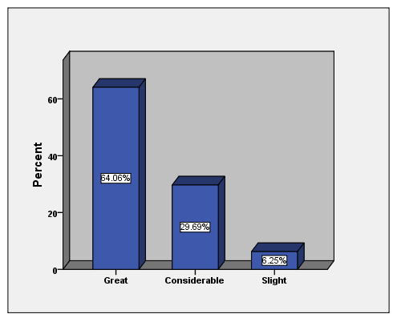
Figure 1.18: Perceived Impact of Plan Rwanda on VSLAs Development
Source: researcher data

The findings in Figure 18 suggest Plan Rwanda is perceived to have a great impact on VSLAs projects throughout its youth economic empowerment in the community. Only 6.25% of respondents perceived the impact as slight. These findings raise the confidence in choosing Plan Rwanda and the hosting CBO.

1.4.4.2 Plan Rwanda’s Interventions
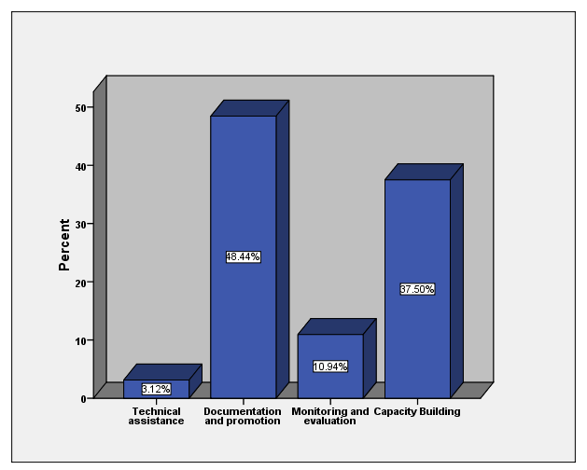
Figure 1.19: Intervention Community Would like Plan to Provide
Source: researcher data

The findings in Figure 1.19 indicate that most of the respondents (48.44%) would like Plan Rwanda to assist them in terms of documentation and promotion. However capacity building (37.5%), monitoring and evaluation (10.94%), and technical assistance (3.12%) were also pointed up as interventions the community would like the NGO/CBOto provide.

The Figure 1.20 presents the suggestions by which by the community believe they will make VSLAs projects more effective and sustainable in Mareba Youth community. Accessibility and affordability of financial services was the most frequent with 67.19 of percentage followed by saving mobilization (10.94%). Promotion of ICT in everyday activities (17.17 %), capacity building (7.81%) and development of an appropriate policy, legal and regulatory framework (4.69%) were also mentioned.

1.4.4.3 Challenges Overcoming Suggestions
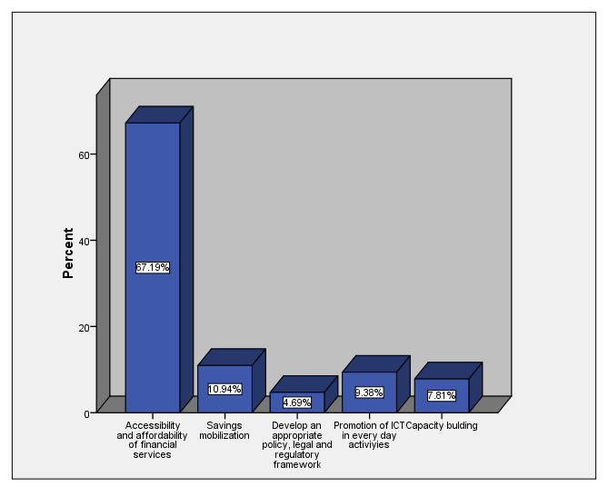
Figure 1.20: Suggestions for VSLAs Projects Development
Source: researcher data

1.3.5 Findings from Key Informants
The key informants were glad with the notion of establishment effective and sustainability VSLAs for youth. A total of 5 key informants participated in semi structured interviews. The interviewees were people interested in youth economic empowerment and these included two staff members of Plan Rwanda, two local leaders and one community economic empowerment expert. They have all stressed the importance of establishing effective and sustainable VSLAs for youth in Mareba Sector and capacity building, monitoring and evaluation, technical assistance, accessibility and affordability, awareness rising, clear policies development and promotion of youth ownership were perceived to the keys drivers of well-functioning VSLAs.

1.5 Community Needs Prioritization
A community needs assessment conducted in Mareba community was meant to bring to light issues in the community that need to be addressed and it revealed a number of needs particularly among youth. However, it’s unlikely that all the issues can be dealt with at the same time. The researcher have to make choices about what’s most important and timely to deal with that his eventual action plan will effectively target the real needs of the youth. Pair wise ranking technique was used to prioritize the identified needs throughout group discussion method.

Prioritization is a key step in a community economic empowerment process that served as a natural transition from focusing on the findings of the community need assessment to developing effective VSALs projects. Prioritization helped youth focus on key issues in order to maximize impact and use their resources as efficiently as possible. The community needs assessment identified five priorities to focus on within Mareba community. Economic empowerment was ranked the first followed by education and health and capacity building. Water and sanitation and environment management have all get the same and last score.

Table 1.2: Pair Wise Ranking
 | Economic empowerment | Health and education | Capacity building | Water and Sanitation | Environment management | Score | Rank
Economic empowerment |  | Economic empowerment | Economic empowerment | Economic empowerment | Economic empowerment | 4 | 1
Health and education |  |  | Health and education | Water and Sanitation | Health and education | 2 | 3
Capacity building |  |  |  | Capacity building | Capacity building | 2 | 2
Water and Sanitation |  |  |  |  | Environment management | 1 | 3
Environment management |  |  |  |  |  | 1 | 3
Source: researcher, 2017

1.6 Conclusion
Community needs assessment took one month while Plan Rwanda was still conducting its community based interventions. Focused Group Discussionmethod was used to ensure community and other stakeholders’ participation in identifying resources and real needs of the youth. The researcher collected baseline data from District officials and Sector officers which helped in designing questionnaire. Primary and secondary data were gathered and helped to realize the specific objectives and answer the three research questions.Various interventions are employed to empower youth in Bugesera District, but as shown by the finding in Figure 1.12 and the needs pair wise ranking, economic empowerment was found to be the most needed.

The community-based interventions engage community input through advisory committees or community coalitions that assist in development interventions to specific target groups or to adapt programs to community characteristics. However, the focus of this community-based project is primarily on changing individuals’ behaviours as a method for increasing the youth’s participation and effectives VSLAs will be with no doubt, a key driver of economic empowerment for Mareba Youth community. Ensuring all young people, including the most marginalised and disadvantaged, can unlock their potential through access to decent work will drive progress towards sustainable, inclusive development.

The critical issues here are to improve the quantity and quality of youth enterprises and contribute towards reducing poverty and unemployment among the youth. It also seeks to economically support young people in order to unleash their potential to create economic wealth, sustainable decent employment, increase their savings and investment levels, and develop their human resource capacities, entrepreneurship and technical knowledge.

CHAPTER TWO

2.0 PROBLEM IDENTIFICATION

2.1 Background to Research Problem
While many banks and MFIs provide valuable services to the poor in the developing world, they are most successful in economically dynamic urban areas, where investment opportunities abound; the borrowing requirements of small-scale enterprises are high; income streams are regular and diverse and the cost of reaching clients is low. But 30 years since the start of the microfinance revolution, people who live in many rural areas and urban slums, and in particular those who are very poor, have a difficult time gaining access to useful microfinance products. Unsurprisingly, this is the case in the study area, particularly in youth.

Rwanda’s Youth are a major asset of the Country and key drivers for sustainable development, if empowered and well-motivated. According to the EICV3, the rates of poverty are high for this segment of the population. Out of 57% of the general population living below poverty line, 38.5% are young people with 19.6% of them living in absolute poverty (NISR, 2012). The unfortunate aspect here is that this sector is characterized by activities of extremely low productivity, low earnings and involves precarious conditions which can be considered as vulnerable employment.

The Country has implemented a series of programs derived from the National Youth Policy since 2006 focusing on Youth participation, mobilization and social welfare. The CNA findings suggest there is lack of viable income generating opportunities and through this assessment, effective VSLAs projects were found to be an affordable and practical alternative. Unfortunately, the findings in Figure 7 indicate as many as 75% of youth in Mareba Sector are not meeting their everyday socio-economical needs given their actual income.

Not meeting every day needs directly influence the saving practice and as many as 76.56% of respondents do not save no money at all along the year as shown by the finding in Figure 8. These finding stress the urgency of initiating VSLAs projects in youth of Mareba community. Evidences prove that VSLAs provide not only a secure place to save and the opportunity to borrow in modest amounts but also a convenient access to saving services because of the easy understanding and transparency in its operations (Hugh Allen, 2007).

However, the CNA revealed a number of issues concerning the establishment and running of an effective VSLA in Mareba community. Concerns included of insufficient or lack of capital, inexistence of saving and loaning habit and lack of awareness just to mention few of them. VSLAs to be based in Mareba community, will be complementary to MFIs, tending to serve the youth whose income is irregular and less reliable and who may not be full-time business people. Their principal need is for services that help them manage their household cash-flow and provide useful lump sums for life-cycle events, which may or may not include income generation. Youth are more likely to be economically vulnerable and, for the most part, they live in rural areas that are served only intermittently by local markets, at the periphery of the national economy.

2.2 Problem Statement
Rwanda’s Youth are a major asset of the Country and key drivers for sustainable development, if empowered and well-motivated but57% of the general population
living below poverty line, 38.5% are young people with 19.6% of them living in absolute poverty (NISR, 2012). The unfortunate aspect here is that this sector is characterized by activities of extremely low productivity, low earnings and involves precarious conditions which can be considered as vulnerable employment. The Country has implemented a series of youth empowerment programs and these included VSLAs projects which were undertaken by the government its self and different partners in different parts of the country in order to increase income generation but most of established VSLAs are run by adult women and men’s associations with very low youth participation.

The VSLA methodology first developed by CARE International in Niger was introduced and adapted to the Rwandan context in 1999. This approach was first piloted through the Rural Livelihood Diversification project in the former province of Gikongoro and 15 years later, the project had spread in other parts of the country with the aim of economically empowering the rural poor people who had no possibility to access financial services form other MFIs. The main problem is that many challenges are hindering the already established VSLAs and youth was the most of time excluded because of the lack or limited capital.Youth are also perceived to be ‘high risk’ for many formal institutions and thus barred from the start from entering the market. By initiating VSLAs for youth economic empowerment in Mareba Sector of Bugesera District, Eastern Rwanda; this project will contribute to address these challenges.

2.3 Project Description
This project consisted in initiating VSLAs for youth economic empowerment in Mareba Sector of Bugesera District, Eastern Rwanda. The basic principle was that members of a self-selected youth group will voluntarily form a VSLA and save money, through purchasing shares. The savings were invested in a loan fund from which members can borrow, repaying with a service charge added. Initiated VSLAs operate as a form of accumulating savings and credit association (ASCA), a generic term that describes this type of small-scale community-managed financial institution.
The primary purpose was to provide simple savings and loan facilities, for youth that do not have access to formal financial services. Loans are also provide a form of self-insurance to members, supplemented by a social fund which provides small but important grants to members in distress. Associations are autonomous and self-managing and all transactions are carried out at meetings in front of all the members of the Association, to ensure transparency and accountability.

The cycle of savings and lending are time bound (12 months from June 2016 to May 2017). At the end of an agreed period (the ‘cycle’), the accumulated savings and service charge earnings are shared out amongst the membership in proportion to the amount that each member has saved throughout the cycle. A cycle won’t last for more than one year prior to share-out. All members have got an individual passbook to permit varying rates of savings and to track member loan liabilities, but there is no association record-keeping ledger.

The Association social fund and the loan fund are recorded at each meeting. VSLAs are made up of 20 members striking a balance between being big enough to create a useful pool of capital and small enough to keep meetings manageable. Associations meet at regular intervals, on a weekly basis during the first cycle. In future cycles, once VSLAs are independent, meetings may reduce in frequency.

Associations are comprised of a General Assembly and a Management Committee. Members of the Management Committee were elected by the General Assembly. Each member of the General Assembly had one vote. The Management Committee consists of five people: a Chairperson, Record-keeper, Box keeper and two Money-counters. The Management Committee must be re-elected at the start of each cycle. Each Association developed a written constitution that is signed by every member, first to provide a framework for governance, dispute resolution and disciplinary action and secondly to specify the conditions for share purchase/ savings, access to benefits payable from the social fund.

All members of the Association save through Share-purchase. This is the core activity of the VSLA and regularity in saving is the key to mutual confidence and success. Between 1 and 5 shares are purchased at each meeting but the value of a share was set by the Association. It was set at a level (200Rwf weekly) that allows the poorest members reliably and regularly to buy at least one share per meeting. Additionally, 50Rwf is deposited per each share purchased for social fund contribution. However at the start of a new cycle, and with the agreement of all members of the Association, the value of a share may be increased or decreased.

Loans are made every month and all members of the Association have the same right to borrow from the loan fund, which is comprised of the members’ share purchase money, loan service charges and fines. The loan given is returned back with 10% of interest within 3 months. After this period 5% of penalties per month are added if the member is unable to return back timely the loan given. Priorto VSALs initiation youth were trained and provided in establishing and running VSLAs.

2.3.1 Target Community
This project consisted in initiating VSLAs for youth economic empowerment in Mareba Sector of Bugesera District, Eastern Rwanda. The primary purpose was to provide simple savings and loan facilities, for youth that do not have access to formal financial services. Youth aged between 16 and 30 according to National Youth Policy (GoR, 2015) were chosen and selected for this project among Plan Rwanda beneficiaries. Youth were targeted because, there are not enough but many other interventions aiming to empower other segments (children and women particularly) of the population in Mareba Sector. VSLAs are made up of 20 members striking a balance between being big enough to create a useful pool of capital and small enough to keep meetings manageable.

2.3.2 Stake Holders
The implementing stakeholders in this particular project included: Non-Government Organization (Plan Rwanda), Local government such as National Youth council representatives, Leadership of Mareba Sector/Executive Secretary of Sector, Cooperative officers, Ministry of Youth and ICTas well as parents and security organs. The stakeholders contributed in one way to another to the success of the project as shown below on the Table 2.3.

Table 2.3: Analysis of Stakeholders Involved in the Project
Stakeholder | Roles of the stakeholder | Concerns | Expectations | Assumptions
Plan Rwanda | Key project implementer | Youth economic empowerment | Awareness rising, Capacity building, technical and financial assistance | Increased awareness and developed saving and loaning skills
Sector Youth Coordinator | Provide advisory and extension services to project including monitoring and backstopping | Youth economic empowerment | Youth empowerment policies development, implementation, monitoring and evaluation | Economically empowered youth
Sector Cooperative Officer | Production of fertilizers, funds provider, Market, provision of technical expertise, and disease surveillance in case of outbreak | Youth Cooperatives and enterprise promotion | Technical and legal assistance in Association and cooperatives initiation and sustainability | Effectiveness and sustainability of initiated VSLAs
Local Leaders | Providing required authorizations and assistance | Administration | Administrative assistance | Officially recognized VSLAs
VSLAs members | Projects owners | Ownership and participation | Income generation, decreased unemployment | Economically empowered youth
MCED Student | Provide technical assistance through training and advisory services | Achievement of outputs, specific objectives and overall project goal | Awareness rising, Capacity building and skills development | Economically empowered youth

Source: researcher, 2017

2.3.3 Project Goal
The Project Goal was to initiate VSLAs for youth economic empowerment in Mareba Sector of Bugesera District, Eastern Rwanda.This community-based project engaged community input through stakeholders that assist in economic empowerment interventions specifically toyouth target groups in other to adapt VSLAs to youth characteristics and behaviours. The focus of this youth-based projectwas primarily on changing individuals’ behaviours as a method for increasing the participation. Effectives VSLAs are with no doubt, a key driver of Youth economic empowerment. Ensuring all young people, including the most marginalised and disadvantaged, and unlocked their potential through access to decent work driving progress towards sustainable and inclusive development.

2.3.4 Project Objectives
The project expected to achieve the following objectives:
- To undertake the startup of VSLAs for potential members by June 2016
- To initiate the VSLA formation and management for self-selected youth groups by June 2016
- To support to the saving and loan process for formed VSLAs by September 2016
- To provide the Business Development Skills to VSLAs members by November 2016
- To link VSLAs groups to formal financial institutions by May 2017

2.4 Host Organization
The name of the organization hosting the project is Plan International Rwanda. Plan International was founded over 70 years ago and is an international humanitarian, child-centered development organization without religious, political and government affiliation. Plan’s main objective is to improve the quality of life of children, their families as well as their communities through community participation. Its program interventions are focused on child poverty alleviation in the domains of education, health and nutrition, water and sanitation, household economic security and child protection. Plan International works in 50 developing countries across Africa, Asia and the Americas, with nearly 38,000 communities each year, covering a population of 28,200,000 children. Plan’s vision is of a world in which all children realize their full potential in societies that respect people's rights and dignity. Plan International Rwanda opened in January 2007 and is currently working in the Eastern and Southern Provinces of Rwanda in the districts of Gatsibo, Kayonza, Rwamagana, Bugesera, Nyaruguru and in all districts hosting refugee camps. The country office is at Kagugu, Kigali.

2.4.1 Organization Structure
Plan International is a global federation that is active in over 70 countries around the world. The global organization comprises 21 fundraising offices, which are separate legal entities known as National Organizations, and Plan International, Inc, which runs the field operations, principally through branch offices. Plan International’s headquarters in the UK is run through Plan Limited, Plan International Inc’s subsidiary.

2.4.2 Plan’s Mission Statement
To reach as many children as possible, particularly those who are marginalized or excluded, with high-quality programs that deliver long-lasting benefits.

2.4.3 Plan’s Values Statement
Plan’s strategy focuses on 4 key areas that will have the biggest impact in driving it towards its goal. These are: Tackling exclusion consisting in reaching the most marginalized groups to work towards rights for every child; Improving program quality aiming to make sure the impact of their programs is measured to ensure the greatest possible impact; Expanding successful programs for adapting and replicating successful projects locally, regionally and globally and finally Extending the influence by using their influence and expertise to collaborate with others and influence at global level.

2.4.4 Plan’s Administration
The Members’ Assembly is Plan International’s highest decision-making body and is made up of delegates representing all full member National Organizations. Delegates from the National Organizations attend Members’ Assembly meetings twice a year, and all are volunteers. Regional Offices co-ordinate and support the work of each Country Office within its region, providing leadership and technical expertise. Plan International conducts program work in four regions: East and Southern Africa, Asia, West Africa and the Americas. Each Regional Office is led by a Regional Director, who reports to International Headquarters. Program Units are the operation units that manage and implement programs on the ground. They work directly with children and communities, and also work closely with partner organizations. The Program Units are run by a Program Unit Manager, who is personally accountable to the Country Director.

2.4.5 Plan’s Objectives
Plan aims to achieve lasting improvements in the quality of life of deprived children in developing countries, through a process that unites people across cultures and adds meaning and value to their lives, by:
- Enabling deprived children, their families and their communities to meet their basic needs and to increase their ability to participate in and benefit from their societies;
- Building relationships to increase understanding and unity among peoples of different cultures and countries and promoting the rights and interests of the world's children;
- Child protection and ending all forms of violence against children and children’s right to sexual and reproductive health are two of Plan’s eight impact areas.

2.4.7 Plan’s Implemented Activities
Plan International believes that ensuring all young people, including the most marginalized and disadvantaged, can unlock their potential through access to decent work will drive progress towards sustainable, inclusive development. Plan International is committed to tackling this global problem, with over 40 of our Country Offices implementing youth economic empowerment projects, 11 of which are funded by the European Commission and €47 million are invested in the right to economic security; 1,274,811 people engaged in savings groups; 76,352 people trained in vocational and business skills (Plan International, 2016).

CHAPTER THREE

3.0 LITERATURE REVIEW

3.1 Introduction
Governments, funders, and community based organizations increasingly demand that young people be involved in the processes that affect their lives and communities. Youth empowerment programs (YEPs) are designed to build on the assets of young people through a focus on active participation, mastery experiences, and positive connections in order to improve developmental outcomes and positive transitions to adulthood.

Today, most community development practitioners are increasingly concerned about the impact of project interventions to measure whether or not they have achieved their goals. In the fight for youth inclusion in economic development, youth empowerment has emerged as one of the leading subjects for debates. This Chapter consists in theoretical and empirical review of youth empowerment interventions and the impact of savings and loans associations (VSLAs) as a means of youth economic empowerment will be highlighted.

3.2 Theoretical Literature
The purpose of this form is to examine the corpus of theory that has accumulated in regard to youth economic empowerment, Youth and VSLA concepts, theory and phenomena. The theoretical literature review helps to establish what theories already exist, the relationships between them, to what degree the existing theories have been investigated, and to reveal the gap. This review will help establish a lack of appropriate theories or reveal that current theories are inadequate for explaining new or emerging research problems. The unit of analysis will focus on a theoretical concepts framework.

3.2.1 Concepts Definition

3.2.1.1 Community Economic Empowerment
While there is no “official” definition of economic empowerment, in this review it consists of giving a group of people the means to be in control of their own economic destiny. It consists of helping people improve their economic status while, at the same time, gaining more control over that status. Economic empowerment is meant to give people the means to improve themselves economically, not just food or money to fulfill their immediate needs (ICRW, 2015).

3.2.1.2 Youth
For purposes of harmonization with the Child Policy and other existing regulations, the revised Rwanda National Youth Policy defined Youth as persons aged between 16-30 years. This principle was to create better opportunities such that more efforts are concentrated on the cohort of young people who have lesser opportunities and yet more challenges in terms of betterment of their livelihoods and Socio-Economic Development in general.

3.2.1.3 Youth Empowerment Programs
This review defines youth empowerment programs (YEPs) as interventions that regularly involve young people as partners and participants in the decision-making processes that determine program design, planning, and/or implementation. With the support of caring adults, YEPs engage young people in program leadership as a characteristic of their involvement in safe, positive, and structured activities.Youth empowerment involves a collective, democratic, and pro-social process of engagement, which implies group interaction (Montgomery, 2011).

3.2.1.4 Microfinance Institutions
A microfinance institution is an organization that offers financial services to low income populations. Almost all give loans to their members, and many offer insurance, deposit and other services, (Joanna L, 2006)

3.2.1.5 Villages Saving and Loans Associations
VSLAs are self-managed groups that do not receive any external capital and provide people with a safe place to save their money, access small loans, and obtain emergency insurance. The approach is characterized by a focus on savings, asset building, and the provision of credit proportionate to the needs and repayment capacities of the borrowers. Groups are low-cost, simple to manage and can be seen as a first step for people to reach a more formal and wider array of financial services (Hugh Allen, 2007).

3.2.2 Overview of Rwandan Youth Sector
Certainly, for the Rwandan economy to flourish and to achieve its objective of becoming a middle-income country by 2020, Youth fraction has to be given special attention. Within this context, the Government of Rwanda, (GoR) established Ministry of Youth (MINIYOUTH) to ensure that the needs of Rwanda’s youth are planned and streamlined into government development plans. MINIYOUTH has undergone major structural changes such as separation from Ministry of Sports and Culture (MINISPOC) as well as a recent merger within the Ministry of ICT to become Ministry of Youth and Information and Communication Technology (MYICT) (MINECOFIN, 2016).

3.2.2.1 Economic Problems Affecting Youth
Rwanda’s economy has registered stable and progressive improvement in the recent years. The average annual GDP growth was 8.2 from 2000 to 2012. In the period 2005-2010, more than a million people were lifted out of poverty, with reducing poverty levels from 56% to 44%. According to the recent statistics of 2012 the GDP was USD 644 increasing from USD 593 in 2011. However, this has not been fully translated into improved standards of living for the vast majority of Rwandans especially Youth. According to the NISR, the rates of poverty are high for this segment of the population (NISR, 2012).

Out of 57% of the general population living below poverty line, 38.5% are young people with 19.6% of them living in absolute poverty. It is vital to note that 60% of the young population aged between 14 and 35 are employed, 4.1 % unemployed and 37% are inactive. 75% of the economically inactive are students and 16% are looking after families/homes (GoR, 2015). The overall labor force participation rate among the young population of the same age is 63%. Further analysis indicates that 61% of the employed youth are self-employed and 67% of them are primarily into Agriculture. The unfortunate aspect here is that this sector is characterized by activities of extremely low productivity, low earnings and involves precarious conditions which can be considered as vulnerable employment. In general unemployment rate is highest among young women (4.9 %) as compared to young men (3.2%). The highest unemployment rate is observed among young active women living in urban areas (13%) (GoR, 2015).

Effective entrepreneurship and business development is considered as one of the key strategies for creation of off-farm jobs. However, Youth are facing challenges in their struggles to penetrate the sector. According to Rwanda Small and Medium Enterprises Survey 2013, 31.3% of Youth face challenges related to access to finance mainly due to lack of collateral. On the other hand, 27.8% face challenges related to procedures and lack of managerial experience to run their enterprises and thus questioning profitability (MINICOM, 2010).

Other challenges involved, on one hand, include high interest rates in order to access loans and on the other hand poor or non-bankable business plans. Lack of competitiveness, innovation, access and use of information technology are still challenges that need critical attention. The vast majority (around 77%) of the working-age population (16+) estimated at about 5 million people are on farm and informal sector workers, majority are engaged in activities of extremely low productivity and thus qualifying them to be underemployed (GoR, 2015).

In fact, currently informal employment in Rwanda serves as a bulwark against open unemployment and destitution, and as such constitutes a sponge for sucking up the largest number of new entrants on the labor market. The employment challenge should mainly emphasize on productivity enhancement in the informal economy and the creation of stable jobs for vulnerable workers in the labor force, while aiming at providing a return to their labor sufficient for raising living standards and lifting them out of poverty (MINECOFIN, 2016).

It is critical that efforts towards Youth Economic empowerment are addressed using a multisectoral approach at all levels of governance and involvement of all key players including private sector. Out of 608 Youth who were randomly selected during consultations with stakeholders, 41% ranked issues associated to economic empowerment (included lack of capital, unemployment, lack of entrepreneurship skills, lack of employable skills, inadequate training and inadequate access to economic opportunities) as their number one priority while 50% and 43% ranked the same as second and third respectively(GoR, 2015).

In Rwanda unemployment is overwhelmingly an urban phenomenon, as most Youth in rural areas are employed in the agriculture Sector that accounts for 90% of the labor force. The majority of the Youth do not have the required competencies to be absorbed on the labor market. They often lack access to labor market services and their ability to secure decent and productive work is often undermined. For those who have basic skills, the preference for experienced and skilled manpower by employers further erodes their opportunities to access the labor market (GoR, 2015).

In brief, the major causes of problems in regard to access to market include but are not limited to limited access to information and opportunities; low level of employable skills; inadequate access to resources like land and capital; negative attitude towards blue color jobs; insufficient support services such as internship, apprenticeship and industrial attachment schemes, coaching, role modeling and mentorship and increased number of Youth joining the labor market and yet low corresponding levels of job creation.

3.2.3 Youth Economic Empowerment
Governments, funders, and charity organizations increasingly demand that young people be involved in the processes that affect their lives and communities. Youth empowerment programs are designed to build on the assets of young people through a focus on active participation, mastery experiences, and positive connections in order to improve developmental outcomes and positive transitions to adulthood. Proponents of Youth empowerment programs suggest that they may constitute an effective, theory-based approach to youth development (Montgomery, 2011).

3.2.3.1 International Best Practice
As a developing country, India has a lot of similarities with South Rwanda in terms of level of development and economic challenges facing the youth of these countries. Among other things, India is referred to because of the interventions that it has put in place to address such challenges. On the policy front and in prioritizing youth development and economic empowerment, the Indian government created the Ministry of Youth Affairs (USAID, 2007).

The Youth Ministry has developed the National Youth Policy (2003-2008) that shapes youth economic development and specifies programs in this regard. The thrust of the Policy centers on Youth Empowerment in different economic sectors. Embedded with the policy, is the Rural Non-farm Sector strategy (RNFS) that focuses on the rural and tribal youth, out-of-school youth, and youth with disabilities. The policy also outlines effective coordination mechanisms for the implementation of policies and programs of the various Ministries and Agencies. The National Youth Policy has identified RNFS has proved to be effective in increasing the rate of growth in the past ten years in states like Punjab, Haryana and Gujarat wherein RFNS is seen to have contributed significantly to their economic development and relatively lower poverty levels(NPYC, 2016).

Uganda, a neighboring country to Rwanda with many similarities in youth economic empowerment challenges has prioritized youth economic development which has made it rank number 2 in the world in terms of the 2005 Global Entrepreneurship Monitor Report. This responsibility of promoting youth economic empowerment is the mandate of the Ugandan Ministry of Gender, Labor and Social Development. This Ministry is responsible for youth affairs and spearheads the overall policy implementation, monitoring, evaluation and review, in addition to mobilizing resources necessary for the implementation of programs. The Ministry developed the National Youth Policy to promote youth economic development.

The policy contains an action plan with specified actions, timeframes and budget allocations. It also defines the target groups (youth), and strategies aimed at mainstreaming youth economically in the country. The National Youth Policy also guides, harmonizes, complements and enhances the actions and roles of all the stakeholders with respect to youth economic development (MGLSD, 2016).The Ugandan government has introduced a Youth Enterprise Scheme, a non financial instrument, aimed at providing business development support services for the aspirant young entrepreneurs and already operating businesses owned by the youth.
These business development support services include business skills training, enterprise and entrepreneurship development and mentorship for the youth. In addition to the provision of non-financial support program, the government also provides financial support in the form loans to young entrepreneurs and tertiary students through a program called Micro Credit Financial Institution. In this area of finance, the long term objective is to establish the Youth Trust Bank providing various financial products that will meet the financial business needs of young people (MGLSD, 2016).

In order to ensure the effective mainstreaming of the youth in the policy and legislative arena and the economy at large, the government has put in place the National Youth Council, tasked to monitor, review and report progress on youth economic empowerment and development. It also plays the role of lobby and advocacy for the implementation of the National Youth Policy (MGLSD, 2016). In Nigeria, the government recognized that in order to effectively empower young people (between the ages of 18 to 35); there was a need to formulate The National Policy on Youth Development20. Nigeria developed the National Economic Empowerment and Development Strategy 2 (NEEDS 2) aimed at transforming its economy and growing small businesses in the country. Youth have been mainstreamed into this strategy through the Youth Position Paper(TakingITGlobal, 2016).

The Youth Position Paper articulates the following policy recommendations worth noting and some can be useful to Rwanda. Under the aspect Youth Economic Empowerment, the following policy prescriptions are proposed: reserve30% quota in the economy and policy development processes; engage youth as professionals and not as recipients of agendas; review all sector policies to accommodate the interests of young people and entrepreneurs; establish special funding skills to enable access to funding for young entrepreneurs; interests charges on sector scheme loans for young people should be reduced and subsidized, introduction of business and entrepreneurship education programs in secondary schools and tertiary institutions; and existing financial schemes should be tailored to support young entrepreneurs (TakingITGlobal, 2016).

3.2.3.2 Youth Economic Empowerment in Rwanda
The Vision of Rwandan Youth Strategic Plan (MINECOFIN, 2016) is to promote a generation of Youth with the right values of Patriotism, Self-reliance, Dignity and Socio-Economically empowered to compete globally for transforming the Country. The strategy focuses on enabling Rwanda’s youth to realize their potential and rights through an integrated approach addressing the challenges they face such as economic poverty and unemployment. This will be done through focusing on new job creation, creating off-farm jobs, improving the work relevance of education, linking SMEs to large farms and leveraging ICT to raise productivity in public and private sectors. As far responsibility is concerned, the National Youth Policy seeks to instill the culture of responsibility among Youth (GoR, 2015).

The policy will therefore provide for favorable programs that aim at creating a generation of Young people who are fully responsible for public and personal actions. This will be achieved through a comprehensive and multi-sectoral response with the aim of integrating the youth and working with them for their empowerment and participation in the entire Nation development process.

The youth policy aims at ensuring that youth participation is ensured and thus Youth issues are reflected in all sectors of development. In their Youth Economic Empowerment Programs, the Government itself and its diverse partners, Youth Economic Empowerment Program, the focus is put in increasing opportunities for youth to acquire skills and experience in income-generating activities by promoting access to financial services for youth; promoting the culture of Savings through the Village Loans and Savings Associations; Training youth on income generating activities and fostering sense of entrepreneurship and environmental awareness among youth.

3.2.4 VSLAs as Youth Economic Empowerment Tool
Community-managed savings-led approaches to financial services for the poor have a long and successful history, particularly in India where there are over two million self-help groups (SHGs), serving 30 million members. More recently, community-managed approaches have proliferated in remote, rural regions in Africa and Asia. One such approach, Village Savings and Loan Associations (VSLAs), has been pioneered by CARE and has been successfully adapted by other agencies including Plan, Oxfam, Catholic Relief Services and the Aga Khan Foundation, reaching approximately two million very poor people in 22 countries (Hugh Allen, 2007).

VSLAs are self-managed groups that do not receive any external capital and provide people with a safe place to save their money, access small loans, and obtain emergency insurance. The approach is characterized by a focus on savings, asset building, and the provision of credit proportionate to the needs and repayment capacities of the borrowers. Groups are low-cost, simple to manage and can be seen as a first step for people to reach a more formal and wider array of financial services (Hugh Allen, 2007).

3.2.4.1 Rationale of VSLAs
While many banks and MFIs provide valuable services to the poor in the developing world, they are most successful in economically dynamic urban areas, where investment opportunities abound; the borrowing requirements of small-scale enterprises are high; income streams are regular and diverse and the cost of reaching clients is low. But 30 years since the start of the microfinance revolution, people who live in many rural areas and urban slums, and in particular those who are very poor, have a difficult time gaining access to useful microfinance products. Surprisingly, this is often the case in countries with a well-developed microfinance sector, a fact that is becoming increasingly evident as the industry matures (Spadacini, 2010).

Even large-scale microfinance Institutions (MFIs) that are licensed to mobilize savings struggle to provide products that suit the small capital requirements and irregular incomes of their poorest clients, many of whom may borrow from informal sources to support their repayment obligations. They face a high risk of indebtedness if investments or income sources fail them and, to reduce their risk exposure, may only save the minimum necessary to access loans (Spadacini, 2010). Thus, MFIs are best configured to serve growth-oriented entrepreneurs, whose income is diverse and reliable; who work full-time in their businesses and who need access to large pools of capital to satisfy their demand for loans. People of this type are usually economically secure and for the most part live in densely populated areas, served by active markets that are deeply integrated into the national economy (Spadacini, 2010).

Village Savings and Loan Associations (VSLAs), based in the community, are complementary to MFIs, tending to serve the very poor whose income is irregular and less reliable and who may not be full-time business people. Their principal need is for services that help them manage their household cash-flow and provide useful lump sums for life-cycle events – which may or may not include income generation. These people are more likely to be economically vulnerable and, for the most part, they live in rural areas that are served only intermittently by local markets, at the periphery of the national economy (Hugh Allen, 2007).

The two approaches are not an either-or proposition. MFIs intermediate large pools of capital and focus on credit to finance growth investments. Usually the savers and borrowers do not know each other and may be drawn from an extensive geographical area. To cover its expenses, the MFI will try to lower unit costs for the delivery of services, minimizing the number of small loans and the expensive administration of a large number of small deposits and withdrawals: over time its average loan size will tend to get bigger. VSLAs, on the other hand, provide people, no matter how remote or poor, with a means to intermediate small amounts of local capital on flexible terms and to transact frequently at very low risk and negligible cost (Hugh Allen, 2007).
Members of VSLAs can still be MFI clients and vice versa; choosing different services to satisfy different needs. It is not necessary that the one should try to emulate the other because, if a VSLA does so, it will likely abandon its original membership base. Creating federations of VSLAs and creating linkages to MFIs and banks, is an area of growing interest in the microfinance community, especially in the light of Indian experience, where Self Help Groups provide more than 40 million people with community-managed access to savings and loan facilities, often augmented by capital supplied by banks and MFIs (Joanna L, 2006). While regarding these linkages as useful (and inevitable), we suggest a cautious approach, on terms that favor the VSLA and reduce the risks of over-borrowing, indebtedness and loss of autonomy. Creating such linkages needs to be based on demand and not just an ideological enthusiasm to deepen financial markets (Joanna L, 2006).

3.2.4.2 VSLAs Methodologies
CARE International launched the Village Savings and Loans (VSL) methodology in 1991 in the villages of southern Niger, in West Africa. In the early 1990s, women in this part of the world had little prospect of improving their lives. Nearly everyone in these villages struggled to survive on subsistence farming. Initial funding for the project came from far away thanks to a nation-wide fundraiser event by a network of women’s organizations in Norway who wanted to raise money for women in developing countries (Spadacini, 2010).

When Niger women started to organize into groups, they called themselves Mata Masu Dubara, which, in Hausa language, means “Women on the Move.” Since then, the VSL experiment has taken on a life of its own. It has become a model for self-sustaining, village level microfinance that has been gaining momentum through a growing number of similar programs throughout sub-Saharan Africa and in Asia as well. Since 1991, CARE has launched VSL programs in 21 countries, for an estimated total of more than 54,000 VSL groups on the continent, serving more than 1 million members, the majority of whom are women (CARE, 2009).

Experience has demonstrated that it is women in VSL groups who are the first to reap the benefits of this approach. As VSL members, women receive training, benefit from group solidarity, earn their own income and invest in what matters most to them: their families. The result is enhanced self-esteem, greater participation in public life, better nutrition, health and education for children, and new dynamics in their relationships with men. The model has now spread and been adapted around the world. Other development agencies are carrying out similar projects across the subcontinent (CARE, 2009).

The basic principle of the Village Savings and Loan (VSL) system is that members of a self-selected group voluntarily form a VSLA and save money, through purchasing shares. The savings are invested in a loan fund from which members can borrow, repaying with a service charge added. VSLAs are a form of accumulating savings and credit association (ASCA), a generic term that describes this type of small-scale community-managed financial institution (CARE, 2009). The primary purpose of a VSLA is to provide simple savings and loan facilities, in a community that does not have access to formal financial services. Loans can also provide a form of self-insurance to members, supplemented by a social fund which provides small but important grants to members in distress. Associations are autonomous and self-managing. This is fundamental because a VSLA’s goal is institutional and financial independence. Promoting institutions should never seek to manage a VSLA’s affairs on behalf of its members. All transactions are carried out at meetings in front of all the members of the Association, to ensure transparency and accountability (Hugh Allen, 2007).

To ensure that transactions do not take place outside the regular meetings, a lockable cash box is used, to prevent unauthorized cash movement and the risk that records might be tampered with. The cycle of savings and lending is time bound. At the end of an agreed period (the ‘cycle’), the accumulated savings and service charge earnings are shared out amongst the membership in proportion to the amount that each member has saved throughout the cycle. This is critical for resolving outstanding issues; for transparency and for maintaining the confidence of the members (Hugh Allen, 2007).

A cycle must not last for more than one year prior to share-out. All members have an individual passbook. This is necessary to permit varying rates of savings and to track member loan liabilities, but there is no Association record-keeping ledger. The Association social fund and the loan fund are recorded, mainly through memorization, at each meeting (Hugh Allen, 2007). VSLAs are made up of 10 - 25 members. This strikes a balance between being big enough to create a useful pool of capital and small enough to keep meetings manageable. The members are self-selected, usually from amongst the adult population. Membership is open both to women and to men, but at least three of the five Committee members elected are normally female in the case of mixed Associations. Members who hold public office should not be eligible for Committee positions (Hugh Allen, 2007).

Associations meet at regular intervals, weekly, fortnightly or every four weeks during the first cycle, as the members agree. In future cycles, once VSLAs are independent, meetings may reduce in frequency Associations are comprised of a General Assembly and a Management Committee. Members of the Management Committee are elected by the General Assembly. Each member of the General Assembly has one vote. The Management Committee consists of five people: a Chairperson, Record-keeper, Box keeper and two Money-counters. The Management Committee must be re-elected at the start of each cycle (Hugh Allen, 2007).

Each Association develops a written constitution that is signed by every member. A Constitution performs two functions: first to provide a framework for governance, dispute resolution and disciplinary action and secondly to specify the conditions for share purchase/ savings, access to benefits payable from the social fund. Each member of the General Assembly may be assigned one or more rules to remember, on which they are likely to be questioned at meetings. This has the effect that after some months everyone knows the regulations by heart. Associations agree on the length of the operating cycle and this is recorded in the constitution (Hugh Allen, 2007).

A cycle should not be less than nine months, or longer than a year. All members of the Association save through Share-purchase. This is the core activity of the VSLA and regularity in saving is the key to mutual confidence and success. Between 1 and 5 shares can be purchased at each meeting. The value of a share is set by the Association. It is set at a level that allows the poorest members reliably and regularly to buy at least one share per meeting. However it should not be set so low that five shares will not satisfy the savings objectives of the majority (Hugh Allen, 2007).

At the start of a new cycle, and with the agreement of all members of the Association, the value of a share can be increased or decreased. An Association may allow a member who is experiencing financial difficulties to stop saving (buying shares), but only for a limited period. At certain times of the year it may be hard to save, or there may be no time to attend meetings. While it is important to ensure financial discipline and regular share-purchase, it is a reality that rural incomes are unstable and variable. Even if an Association has suspended share purchase/ savings, loans must continue to be repaid and can continue to be disbursed (CARE, 2009). Associations may provide a daily savings service to members through use of a slot-savings system. This system is optional. It makes savings easier because it allows the regular deposit of small amounts. This enables members to meet the minimum share-purchase/savings requirements. Loans are made every four weeks. All members of the Association have the same right to borrow from the loan fund, which is comprised of the members’ share purchase money, loan service charges and fines (Hugh Allen, 2007).

The Association sets the length of the loan repayment term, which should never be more than six months and, during the first cycle, no longer than 12 weeks. The size of a loan available to a member may not be more than three times the total value of all the shares they have bought. This ensures a fair distribution of capital and prevents the risk that any one member will be overwhelmed by too much credit. The Association decides the percentage rate of the service charge for loans, and notes it in the constitution. Service charges on loans are due at four-week intervals. The service charge is applied to the balance of the loan every four weeks until fully repaid. It must be paid when due, regardless of whether or not the member repays loan principal (Hugh Allen, 2007).

Loan principal repayments are made at four-week intervals. The period of loan repayment is agreed when the loan is taken, but the borrower may repay early, to avoid further service charges if (s) he wishes. When a borrower pays part of the balance due, the remaining balance is treated as a new loan, with the service charge percentage applied to the new amount and due at the end of the next four-week period. The Association does not fine borrowers for late loan repayment. This aggravates any underlying economic crisis the household may be facing. The embarrassment of being late is sufficient penalty. Associations may wish to create a social fund. Associations agree on a regular, equal contribution by all the members to this fund. This provides small grants for specific purposes such as emergency assistance; funeral expenses and educational costs for orphans. The fund is not intended to grow, but is set at a level that covers the minimum insurance needs of the Association’s members (Hugh Allen, 2007).

Anyone needing a grant from the social fund makes the request publicly to the General Assembly. Approval rests with the General Assembly and may be immediately disbursed. The social fund is kept separate from the loan fund, and is not included in the end of cycle share-out. When the operating cycle comes to an end, the Association shares out the total value of its financial assets amongst the members (except for the social fund). As the end of the cycle approaches, no new loans are issued and all outstanding loans are repaid. This is mingled with any money remaining on hand and is shared out amongst the members in proportion to the number of each person’s shares (Hugh Allen, 2007).

After the share-out, members who do not want to stay in the Association may leave and new members may be invited to join. At the end of the share-out meeting, members who plan to continue to the next cycle may consider making a lump-sum starting contribution to the loan fund in order to initiate lending activities with a useful amount of money on hand. If they decide to do this, all members should agree to contribute the same amount at the first meeting of the next cycle, which should take place immediately. The amount of the contribution on this one occasion is not limited to the normal five-share ceiling (CARE, 2009). Once the start-up shares are stamped into all passbooks, deposit shares will be bought as normal, subject to the normal five-share ceiling. When a new cycle begins, members can agree to change the value of the standard share. The price of a share cannot be changed during the cycle (CARE, 2009).

3.2.4.3 Strengths and Weakness of VSLAs
Strengths | Weaknesses
- Ability to deliver appropriate financial services in remote areas.  - The methodology is adaptable to local conditions and needs and is transferable in almost any environment.  - VS&LA can serve non-literate people as well as literate people.  - It does not need an expert and expensive staff to implement.  - VS&LA have operating expenses close to zero, so that they can afford to make extremely small loans  - The system of transactions is quick, simple and transparent and ensure high returns on savings  - Cultivates financial management culture  The action audit allows participants to acquire useful lump sums of capital at a predictable time | - Loan amount is small especially at the beginning of the cycle  - Loan period is usually short and limits long term investment  - Loan funds are not always available at appropriate times

3.3 Empirical Literature Review
Rwanda is one of the poorest countries in the world and is still recovering from one of the worst humanitarian catastrophes in the history of humankind, the 1994 genocide and the extended periods of ethnic violence prior to and following the genocide. Its productive and institutional capacity has been severely damaged and almost no one has escaped the trauma. Beyond the genocide and a history of conflict, there are a number of factors contributing to widespread poverty in Rwanda. The country is small (26,338 square kilometers), land-locked in Central Africa, with a population of over 10.5 million people. It has a very high population density of 328 inhabitants per square kilometer (Spadacini, 2010).

In the last decade Rwanda has followed an economic liberalization program, privatized the financial sector, encouraged market determined prices of financial services, encouraged entry of international players and enhanced market competition. However, in spite of these reforms, Rwandan authorities recognized that the financial sector’s ability to play its role of mobilizing savings, conducting effective intermediation, and financing its ambitious economic reform agenda would be difficult to achieve.

The Rwandan Government invited the World Bank/IMF Financial Sector Assessment Program (FSAP) to carry out a diagnostic of the Rwandan financial sector and make recommendations for further reform. In 2005 a report was produced that identified a number of weaknesses in the financial sector and paved the way for the financial sector reform process in 2006 (MINECOFIN, 2016). The “Rwandan Vision 2020” statement which articulates the Rwandan Government’s commitment to “transform Rwanda into a middle income country as well as an economic trade and communications hub by the year 2020” set the stage for the financial sector reform process in Rwanda and the Rwandan Financial Sector Development Program (FSDP), which constitutes the Rwandan Government’s response to the report recommendations, was launched in 2006. Despite a relatively high penetration rate compared to other African countries, only 21% of the active population has access to formal financial services (CARE, 2009). Microcredit institutions are concentrated in urban areas, offering loans that range anywhere from 50,000 to 500,000 FRW (US$60-US$600) with monthly interest rates between 2-3% (Spadacini, 2010).

The VSL methodology first developed by CARE in Niger was introduced and adapted to the Rwandan context in 1999. The methodology itself became known as CLASSEINTAMBWE. CLASSE stands for Community, Learning and Action for Saving Stimulation and Enhancement, while Intambwe is a Kinyarwanda word term that figuratively means ‘Step by Step’. This approach was first piloted through the Rural Livelihood Diversification project in the former province of Gikongoro. Like in Niger, the methodology consists of organizing vulnerable individuals into Voluntary Savings and Loans groups not larger than 30 people, in order to strengthen their livelihoods security. The usual target is rural and poor people who do not qualify for accessing the formal financial system. Close to sixty-seven percent of the group members are often illiterate, living under the poverty line and the majority of them are women (Spadacini, 2010).

The main obstacles encountered by poor people when attempting to access financial services are related to the fact that they do not possess property or capital to be given as a guarantee to the micro-finance institutions. Poor people are also perceived to be ‘high risk’ for many formal institutions and thus barred from the start from entering the market. The CLASSE-Intambwe methodology in Rwanda is implemented in five phases. A VSL Field Officer guide, produced by CARE, sets out the basic VSL principles, which focus on savings based financial services, self-management, simplicity and transparency of operations, flexibility in loan amounts and terms and conditions for lending, low group management cost and retention of group earnings within the group or in the community (Spadacini, 2010).

Phase 1 is the start up phase and it entails identification and selection of group participants. This is usually done with the assistance and support of the local authorities that invite community members for a sensitization meeting on the VSL methodology itself. Phase 2 focuses on supporting newly established groups and training two representatives on the VSL methodology. The criteria for selecting these representatives include the ability to read and write, the capacity to facilitate change, and the trust they elicit from other group members. It is during this phase that group members develop their internal regulations and elect their management committee (Sida, 2014).

During Phase 3 the trainers facilitate learning about the savings and loans methodology. After at least three months of savings and loans activities, the groups are encouraged to form their networks or intergroupments with other groups. (Spadacini, 2010). During Phase 4, three day training on Selection, Planning and Management of income generating activities is provided to the trained representatives. The objective of this training is to improve group member’s investments before the group is linked to the bank. The Voluntary Savings and Loans approach is much more than a way to become financially independent. It is about changing the mentality of the people, encouraging them to become self-sufficient and to think for themselves. The impact is especially visible on women. Those who are in these groups are more outspoken about community issues and bring their concerns to the local authorities (Spadacini, 2010).

Phase 5 is usually after eight months of intensive training and is when groups graduate and the eligible ones are formally linked to the bank. CARE Rwanda’s CLASSE-Intambwe model is different from the original model developed in Niger in that Savings and Loans groups are linked together through federations, called Intergroupments (IG)(Spadacini, 2010).

In the past, these federations were in turn linked to external loan funds (provided by CARE) held at the Banque Populaire, a network of credit unions located across the country. This is one of the most innovative features of the VSL model in Rwanda. Recently, the Banque Populaire has become a commercial bank therefore CARE will explore new partnerships with microfinance institutions over the coming years. These structures consist of 25 to 30 Savings and Loans groups that create value by effectively linking demand for loans with the credit supply (Spadacini, 2010).

“CARE Rwanda realized that the majority of members of CLASSE-Intambwe wanted larger loans than their internal loan fund could provide,” explains Glycerie Niyibizi, Economic Security and Development Program Manager for CARE International in Rwanda. “The link to external credit was provided to open new economic opportunities within and beyond the farming sector. In target districts, CARE deposited a credit fund with the Banque Populaires,” (Spadacini, 2010). In the past, CARE provided a Credit Fund of up to 100 million Rwf (approximately US$ 200,000) per IG structure for loan disbursement to its Voluntary Savings and Loans group members. Groups applied for loans as soon as one year after they had begun their weekly savings. Rather then apply directly to the bank, groups submit their business plans to the IG, which reviews it and determines if it is a solid and viable proposal (Spadacini, 2010).

The Voluntary Savings and Loans group can decide whether the loan from the bank is used for a group income activity, which is most common, or for individual income generating activities by one or several members. Regardless, all group members are responsible for repaying the loan through a group solidarity mechanism. As a VSL association, the most popular investment sectors have been corn, sunflower, animal husbandry, pineapple, basket weaving, tree tomatoes and the commercialization of bananas. As of August 2008, on a total of 4484 trained VSL groups, 3959 are operational, 1575 are linked to a bank and 673 got a credit from it. The average credit amount given to a group is around US$ 576. The total credit value is US$ 381,531 and the outstanding amount is currently US$ 64,812. The repayment rate on the credit from the bank is 93% (Spadacini, 2010).

3.4 Policy Review

3.4.1 Rwanda National Youth Policies (2006 and 2015)
The 2015 Policy is a revised version of the 2006 National Youth Policy. It was undertaken by the Ministry of Youth and ICT so as to update and renew the direction of the Youth Sector in relation to a number of guidelines and orientation that have since emerged in the Sector. The revision also takes into consideration the Post-2015 global agenda context as enshrined into the Sustainable Development Goals (SDGs) (GoR, 2015).

The 2015 youth policy is aligned to the Rwanda Vision 2020, the National Employment Program (NEP) as well as the National Information and Communications Infrastructure (NICI) Plan amongst other national development plans and macro-economic policies. The Policy is also aligned to the Economic Development and Poverty Reduction Strategy (EDPRS2), especially on its two pillars, which are economic transformation and productivity and youth employment (GoR, 2015). The policy clearly establishes a comprehensive and targeted youth programming through economic empowerment with strong emphasis on mainstreaming job-based budgeting in all sectors. It envisages the decentralization of youth structures and a strong mobilization mechanism up to the village level. It also defines clear mechanism of establishing a strong synergy between Youth and ICT (GoR, 2015).

The policy brought to light the conditions affecting Youth such as Poverty, Productivity, Employment and Economic Empowerment and according to the policy empowering Youth through employment and productivity for economic development requires a holistic set of interventions. It may include availing opportunities, required skills on the labor market, creating an enabling environment to boost creativity and innovation. Youth shall be mobilized youth towards successful implementation of National Employment Program, changing attitude towards work, and creating environment-enabling access to resources and services (GoR, 2015).

Rwanda opted for a “green economy” approach for economic transformation. Development of smart cities and villages will require skilled human resources. The green growth will create more opportunities for youth not only by promoting job creation but also living in an environmentally friendly region. In addition to that, green technology will be stimulated to serve as a catalyst of job creation through green construction, green urbanization, green industries and modern mining. Much effort will be put on increasing awareness about environment protection and climate change among youth (GoR, 2015).

3.4.2 Youth Sector Strategic Plan (YSSP) 2013-2018
It is upon Vision 2020, the former UN MDGs, the 7YGP, and EDPRS II that the YSSP 2013-2018 anchors itself. The attainment of YSSP which mission is to mobilize, build capacity, advocate for youth initiatives that lead to economic/social development as well as a productive and patriotic young generation requires greater efforts from all Rwandans (MINECOFIN, 2016).

The strategy is premised on a strong political will as well as key partnerships with various stakeholders such as NGOs and the private sector among others. In this YSSP, Youth Economic Empowerment is expected from the focus on enabling Rwanda’s youth to realize their potential and rights through an integrated approach addressing the challenges they face such as economic poverty and unemployment. This will be done through focusing on new job creation, creating off-farm jobs, improving the work relevance of education, linking SMEs to large farms and leveraging ICT to raise productivity in public and private sectors. The Youth Sector will place emphasis on implementation (MINECOFIN, 2016).

3.4.3 Rwanda National Youth Council
The National Youth Council (NYC) is an organ responsible for coordinating, advocating, designing and implementing youth friendly programs under the guidance of the Ministry having Youth in its attribution. It is established by both Rwandan Constitution of 04/06/2003 as amended to date in its article no.188 and by law No.05/2006 of 05/02/2006 modifying and complementing law no 24/2003 of 14/08/2003 establishing the functioning and organization of the National Youth Council. Since its establishment in 2003, The National Youth Council actively involves in socio economic development and transformation of Rwandan youth. It has nurtured productive and national developmental activities among youth by equipping youth with skills and by supporting them to be able start, run and improve their productivity (MIFOTRA, 2011).

3.4.4 Rwanda Cooperatives Promotion Policy
The policy highlights the importance of cooperatives, reviews their past and present, and scans through the constraints and opportunities they reflect in the national development. Further the document lays out policy, strategies and action plan aimed at orienting and ensuring that cooperatives become a viable tool for social-economic development in Rwanda (RCA, 2013).

The Government of Rwanda views cooperatives as a potential vehicle through which the cooperatives members could create employment and expand access to income-generating activities, develop their business potential, including entrepreneurial and managerial capacities through education and training; increase savings and investment, and improve social well-being with special emphasis on gender equality, housing, education, health care and community development. Considering the fact that cooperatives are found in various fields, they will help in promoting the agricultural sector, mobilization of savings and provision of credit, marketing of handicrafts, housing and constructions and artisans (RCA, 2013).

3.5 Literature Review Summary
For Rwandan’s poorest and most marginalized households, few financial institutions exist to serve them, and they generally have inappropriate products and services. To address the issue of financial inclusion and reach poorer clients, CARE began promoting a savings-led microfinance model, called Village Savings and Loans Associations (VSLAs). Now more than ever before, VSLAs were seen as an important, and often necessary, rung on the ladder of financial inclusion. However, VSLAs initiated by CARE centered on women and youth fraction was almost completely excluded because youth have for longtime perceived to be ‘high risk’ for many formal institutions and thus barred from the start from entering the market in spite many economic challenges facing them.

Certainly, for the Rwandan economy to flourish and to achieve its objective of becoming a middle-income country by 2020, Youth fraction has to be given special attention. Rwanda’s economy has registered stable and progressive improvement in the recent years but, this has not been fully translated into improved standards of living for the vast majority of Rwandans especially Youth. According to the NISR, the rates of poverty are high for this segment of the population (NISR, 2012). Reviewed literatures revealed that effective entrepreneurship and business development is considered as one of the key strategies for creation of off-farm jobs and initiating VSLAs for youth where there on access to other financial institutions will undoubtedly boost their economic empowerment in a sustainable perspective.

CHAPTER FOUR

4.0 PROJECT IMPLEMENTATION

4.1 Introduction
The project implementation chapter involves a schedule of activities which indicates time frame within which the activity carried out over the project implementation period. It is necessary that implementation be well planned and be carried out according to the plans, schedules and other parameters as set out during preparation and appraisal. Community needs assessment took one month and as shown by the finding in and the needs pair wise ranking, the main problem was that many challenges are hindering the already established VSLAs and youth was the most of time excluded because of the lack or limited capital.The findings from the assessment enabled the researcher to prioritize the identified community needs through pair wise which in the final analysis led to the formulation and design of the project specifically to address the identified priority.

In this respect, project tangible outputs of this project are stated; a logical framework of implementation plan is established; the quantities and costs of each input are shown; staff and budget are determined; actual implementation stepwise is described; detailed descriptions for each project activity are reported and a time management chart showing time management of the entire projectis produced.

4.2 Project Products and Output
The execution/implementation phase ensures that the project management plan’s deliverables are executed accordingly. This phase involves proper allocation, co-ordination and management of human resources and any other resources such as material and budgets. Products and out puts of the project were set based on the project objectives as detailed in the Table 4.1:

Table 4.1: Projects Products and Outputs
Objectives | Products and outputs
To facilitate the start up | - Meeting with community leaders and members  - Identification of potential VSL members  - Capacity assessment of members  - Socio-economic profiling of the group members  - Self selection and formation of VSLAs
To initiate the VSLA formation and management | - Training of VSLAs Members  - First share-purchase/savings
To support to the saving and loan process | - Training of member on VSLAs scheme  - First loan disbursement  - First loan repayment
To provide the Business Development Skills | - Training on Business Development Skills  - Initiating income generating activities  - Development and maturity Supervision  - Share-out of savings
To link VSLAs groups to formal financial institutions | - Facilitates members to enter in to agreement with formal financial institutions for bigger loans
Source: researcher, 2017

4.3 Project Planning
Project planning relates to the use of schedules such as Gantt charts to plan and subsequently report progress within the project environment and it is used to organize different areas of this project, including project plans, workloads and the management of teams and individuals. This planning was done before the project actually started. Therefore the duration of the tasks was often estimated through a weighted average of optimistic, normal, and pessimistic cases.
The necessary resources were estimated and costs for each activity were allocated to each resource, giving the total project cost. At that stage, the project schedule was optimized to achieve the appropriate balance between resource usage and project duration to comply with the project objectives. Progress is measured against the baseline schedule throughout the life of the project.

4.3.1 Implementation Plan
The Project Implementation Plan (PIP) is a representation of the project in a structured format. The project Implementation Plan was prepared participatory by involving different stakeholders to provide their views on how the project was supposed to be implemented. This a work plan shows a numbers of activities to be undertaken within the time frame, agreed resources are disbursed or procured and indicating responsible person for each objective. The participatory monitoring has been conducted to ensure the planned activities were conducted as planned, to avoid repetition to some activities and ensure minimal running costs.

Table 4.2: Project Implementation Plan
Objective | Outcomes | Activity | Timeline |  |  |  |  |  |  |  |  |  |  |  | Resource needed | Responsible  Person
 |  |  | 2016 |  |  |  |  |  |  | 2017
 |  |  | 6 | 7 | 8 | 9 | 10 | 11 | 12 | 1 | 2 | 3 | 4 | 5
1.To initiate the project (startup) | - Potential VSL members are identified | 1.1.1.Meeting with community leaders and youth  1.1.2. Conduct a capacity assessment of members  1.1.3. Conduct a socio-economic profiling of member  1.1.4. Self-selection of members and group formation | x  x  x  x |  |  |  |  |  |  |  |  |  |  |  | Human resources, transport, communication, stationery and time | CED student, Youth Clubs, BO/NGO, community members  &other stakeholders
2.To initiate the VSLA formation and management | 2.1. Three VSLA groups are created  2.2. A 3 days training of 59 youth is conducted  2.3 Shares are purchased and first savings are done | 2.1.1. Election of General Assembly and the Management Committee  2.1.2.Development of the VSLAs written constitution  2.2.1.Planning and budgeting of training  2.2.2. Conduct training  2.3.1.Shares purchasing  2.3.2. Weekly saving | x  x  x  x  x  x  x  x |  |  |  |  |  |  |  |  |  |  |  | Human resources, transport, communication, stationery and time | CED student,  Sector Youth Coordinator and  Cooperative promotion officers
3.To support to the saving and loan process | 3.1 A 3 days training on VSLAs scheme  of 59 youth is conducted  3.2.First loan are disbursed | 3.1.1 Planning and budgeting of training  3.1.2. Conduct training  3.2.1. Conduct a meeting on loan disbursement  3.2.2. Disbursement of first loans |  |  | x  x  x | x |  |  |  |  |  |  |  |  | human resources, transport, stationery and time | Plan Rwanda, CED student,  Sector Youth Coordinator and  Cooperative promotion officers
To provide the Business Development Skills | 4.1.Training on Business Development Skills is conducted  4.2.A semesterly evaluation is conducted  4.3.Income generating activities are initiated  4.4.First cycle savings are shared-out | 4.1.1. Planning and budgeting of training  4.1.2. Conduct training  4.2.1. Conduct a semesterly evaluation  4.3.1.Mobilization on income generating activities  4.3.2.Identifing the income generating activities  4.3.3.Initiating small investments in identified activities  4.4.1.Sharing out the savings from the first cycle |  |  |  |  | x  x | x | x | x | x |  |  | x | Human and Financial resources, transport, communication, stationery and time | CBO, CED student and Sector  Cooperative promotion officers
To link VSLA groups to formal financial institutions | 5.1.Facilitates members to enter in to agreement with formal financial institutions for bigger loans  5.2.Anannual evaluation is conducted | 5.1.1. Starting of the second saving/loaning cycle  5.1.2. Meeting local MFIs and Banks representatives  5.1.3.Linking VSALs groups to MFIs and Banks  5.2.1. Conduct an annual evaluation |  |  |  |  |  |  |  |  |  |  |  | x  x  x | Human resources, transport, communication, stationery and time | Plan Rwanda, CED student,  Sector Youth Coordinator and  Cooperative promotion officers
Source: researcher, 2017

Table 4.3: Project Logical Framework
Intervention Logic | Objectively verifiable indicators (OVI) | Means of verification | Assumptions/risks
Goal:  To initiate VSLAs for youth economic empowerment in Mareba Sector of Bugesera District, Eastern Rwanda | Youth are economically empowered | Reports, records and household survey data. | Positive political will and poverty reduction strategies facilitated in startup
Objective 1: To initiate the project (startup)
- Outcome 1.1:Potential VSL members are identified | 100 potential members are identified  59 youth are self-selected | List of identified potential members is available  List of self-Selected youth is available | Lack of Awareness on VSLAs by community member affect the project
- Outcome 1.1:Potential VSL members are identified | 100 potential members are identified  59 youth are self-selected | List of identified potential members is available  List of self-Selected youth is available | Lack of Awareness on VSLAs by community member affect the project
- Outcome 1.1:Potential VSL members are identified | 100 potential members are identified  59 youth are self-selected | List of identified potential members is available  List of self-Selected youth is available | Lack of Awareness on VSLAs by community member affect the project
Objective 2: To initiate the VSLA formation and management
Outcome 2.1: VSLAs groups are formed  Outcome 2.2: A 3 days training of 59 youth is conducted  Outcome 2.2: Shares are purchased and first savings are done | 3 VSLAs Groups are formed.  A 3 days training of 59 youth is conducted  157 shares are purchased | Survey (Cultivated plot) | Positive behaviors and mindset influence the success
Activities:
2.1.1. Election of General Assembly and the Management Committee | A General Assembly and a Management Committee are elected for each of the 3 formed VSLAs | List of Assembly and committee members | Good VSLAs governance is crucial for VSLAs development
2.1.2. Development of the VSLAs written constitution | A VSLAs constitution is participatory written for each of the three formed VSLAs | Constitutions are available | Participation and involvement of community member is an advantage
2.2.1: Planning and budgeting of training | A concept note for the training is prepared | A concept note for the training is available | Capacity building is imperative for the success of the project
2.2.2: Conduct training | 59 VSLAs members received the training | Attendance list is available | Capacity building is imperative for the success of the project
2.2.1: Shares purchasing | 157 shares were purchased | Books and reports | Shares purchasing enable member to save more
2.2.2: Starting of weekly saving | 200 Rwf per share and 50 Rwaf for social fund are saved on a weekly basis | Pass Books and reports | Positive political will and poverty reduction strategies influence the success
Objective 3: To strengthen the saving and loan process
Outcome 3.1. A 1 days training on VSLAs scheme of 59 youth is conducted  Outcome 3.2. First loan are disbursed  Outcome 3.3. Loan repayment conditions and length are set | 59 youth were trained on VSLAs scheme  19 members applied for loan  Loan repayment terms are highlighted in the constitution | Attendance list  Records and reports  Constitution | VSLAs are key drivers for community economic empowerment
Activities:
3.1.1. Planning and budgeting of training | A concept note for the training is prepared | A concept note for the training is available | Capacity building is imperative for the success of the project
3.1.2. Conduct training | 59 VSLAs members received the training | Pictures and Attendance list are available | Capacity building is imperative for the success of the project
3.2.1. Conduct a meeting on loan disbursement | One meeting was conducted | Pictures and Attendance list are available | Awareness and preparedness are fundamental for VSLAs success
3.2.2. Disbursement of first loans | 19 members applied for loan and their applications were approved | Pass book, records and reports | VSLAs are key drivers for community economic empowerment
Objective 4: To provide the Business Development Skills
Outcome  4.1.Training on Business Development Skills is conducted  Outcome  4.2. Income generating activities are initiated  Outcome 4.3.First cycle savings are shared-out | 58 members received training on business development skills  38 members are involved in diverse income generating activities  Earned saving are shared out | Pictures and attendance lists are available  Record, reports and pictures  Pass book, records and reports | Capacity building is imperative for the success of the project
Activities:
4.1.1. Planning and budgeting of training | A concept note for the training is prepared | A concept note for the training is available | Capacity building is imperative for the success of the project
4.1.2 Conduct training | 59 VSLAs members received the training | Attendance list and Pictures are available | Capacity building is imperative for the success of the project
4.2.1 Conduct a semesterly evaluation | Existing evaluation sheets with evaluation findings | Evaluation sheets, Records and reports | A midterm evaluation allows to look back and see what went wrong and undertake the required corrective measures
4.3.1.Mobilization on income generating activities | 300 community members including 59 VSLAs members were mobilized | Pictures and reports | Awareness and preparedness are fundamental for VSLAs success
4.3.2 Identifying the income generating activities | Identified activities include Agriculture, Petty business, livestock, bee keeping among others | Records and reports | VSLAs and income generating activities are interconnected and complementary
4.3.3.Initiating small investments in identified activities | 38 members are involved in diverse income generating activities | Testimonies, Records and reports | VSLAs and income generating activities are interconnected and complementary
4.4.1.Sharing out the savings from the first cycle | Members shared their earnings for the first saving cycle according to their shares | Pass books, Testimonies, Records and reports | VSLAs are key drivers for community economic empowerment
Objective 5: To link VSLA groups to formal financial institutions
Outcome 5.1.VSLAs embers are facilitated to enter in to agreement with formal financial institutions for bigger loans | 25 youth are facilitated to get bigger loans from local MFIs and Banks | Pass books, Testimonies, Records and reports | VSLAs enable rural community members to develop a culture of working with Banks
Activities:
Outcome 5.1.1. Starting of the second saving/loaning cycle | Five VSLAs groups start for the second cycles | Pass books, Records and reports | VSLAs are key drivers for community economic empowerment
Outcome 5.1.2. Meeting local MFIs and Banks representatives | Five meetings were held with MFIs and Banks representatives | Pictures and attendance list | VSLAs enable rural community members to develop a culture of working with Banks
Outcome 5.1.3.Linking VSALs groups to MFIs and Banks | 25 youth are facilitated to get bigger loans from local MFIs and Banks | Pass books, Testimonies, Records and reports | VSLAs enable rural community members to develop a culture of working with Banks
Outcome 5.2.1. Conduct an annual evaluation | Existing evaluation sheets with evaluation findings | Evaluation sheets, Records and reports | An effective evaluation of the first saving cycle will help for improvement for future saving cycles
Source: researcher, 2017

4.3.2 Inputs
The project implementation involved various inputs such as financial resources, human resources and materials resources employed to meet the projected goal. Human resources were Mareba Sector Youth coordinator, Mareba Sector Cooperative Promotion Officer, Staff from Plan Rwanda and other development partners in collaboration with local leaders. Financial resources were principally provided by Plan Rwanda and were usedin facilitating training (capacity building), mobilization and advocacy meetings, communication, transport and stationeries.

Staffing Pattern: The project runs under the Management Committee elected by the general assembly that comprises all VSLAs members. The Project management Committee is led by the Chairperson, a Secretary, treasurer and Money Counter. Staff Pattern is shown on the Table 7.

Table 4.4: Duties and Responsibilities of VSLA Staff
No | Position | Duties
1 | The General Assembly
 | All members of the Association | - Setting the rules and regulations of the Association in a written Constitution  - Election of the management committee
2 | The management committee
 | VSLA Chair person | - To call and conduct the meetings to order, announce the agenda and lead discussions  - To represent the Association to outsiders and non-members.  - To facilitate discussion of issues raised by the General Assembly and to ensure that everyone’s views are listened to  - To facilitate conflicts resolution
 | VSLA Secretary | - Ensures that all financial transactions take place in front of the Association members,  - Records all transactions,  - Makes all Member Share Passbook entries and signs when loan repayment is completed  - Provides a summary of the financial state of Association affairs at every meeting  - Takes the minutes of the meeting, if required
 | VSLA Treasurer | - Keeps Association records, Member Share Passbooks and money safely at home in the cash box/pouch  - Produces the cash box/pouch containing Association records, Member Share Passbooks and surplus cash at every meeting  - Enters the share contribution stamps in the Member Share Passbooks
 | VS&LA Money Counter | - Verify all movements of money both in and out of the cash-box/pouch  - Count the money during each cash-box/pouch operation  - Inform the Secretary of each transaction so as to facilitate record-keeping  - Assist the Secretary in resolving any discrepancies between the Association’s records and the cash-box/pouch.

Source: Researcher, 2017

4.3.3 Project Budget
The cost of implementation is approximated at 1,309,500 RWF as outlined in Table 4.5 of the budget below. Inputs needed for fulfilling the objectives include stationeries, venue, refreshment, training manual/materials and cash for facilitating transport and transportation activities. All required funds are provided by Plan International Rwanda NGO and MCED student. Human resources didn’t cost anything as all tasks such as mobilization and training were realized by Plan Rwanda Staff and MCED student and many of other required tasks were voluntary and participatory carried out by the community members and other stakeholders.

4.4 Project Implementation

4.4.1 Project Implementation Report
In order to achieve project objectives, it was the responsibility of CED student, target group and other stakeholder to ensure that project activities are efficiently implemented. The project implementation involved many stakeholders; mainly volunteers were working participatory following the sequential order of activities that resulted into project objectives achievement. The implementation of the project was launched on 1st June, 2016and the 1st saving cycle is expected to end at 31thMay 2017. The implementation was carried out following five objectives including VSLAs starting up, VSALs groups formation, starting saving and loans disbursement, entrepreneurship skills development and linking successful VSLAs groups.

Mobilizing the target group on the importance of developing saving spirit was the first project activity to be conducted. The meeting was organized by CED student in collaboration with Mareba Sector officials in early June. The target group was mobilized to save weekly whatever little they have and all accepted the idea.

Table 4.5: Project Budget
Objective | Outcomes | Activity | Resource needed | Unity price/Rwf | Total RWF
1.To initiate the project (startup) | 1.1.Potential VSL members are identified | 1.1.1.Meeting with community leaders and youth | Transport for CED Student | 10,000 | 10,000
 |  | 1.1.2. Conduct a capacity assessment of members | Transport for CED Student | 10,000 | 10,000
 |  |  | Stationeries | 5,000 | 5,000
 |  | 1.1.3. Conduct a socio-economic profiling of member | Transport for CED Student | 10,000 | 10,000
 |  |  | Stationeries | 5,000 | 5,000
 |  | 1.1.4. Self-selection of potential members and group formation | Transport for CED Student | 10,000 | 10,000
Subtotal 1 |  | 50,000
2.To initiate the VSLA formation and management | 2.1 Three VSLA groups are created | 2.1.1 .Election of General Assembly and the Management Committee | Transport for CED Student | 10,000 | 10,000
 |  | 2.1.2.Development of the VSLAs written constitution | Stationeries | 5,000 | 5,000
2.2. A 3 days training of 59 youth is conducted | 2.2.1Planning and budgeting of training | Stationeries | 5,000 | 5,000
 | 2.2.2. Conduct training | Transport for 59 Trainees | 5,000 | 295,000
 |  | Transport for 3 Facilitators | 10,000 | 30,000
 |  |  | Stationeries | 5,000 | 5,000
 |  |  | Communication for 3 Facilitators s | 5,000 | 15,000
 | 2.3 Shares are purchased and first savings are done | 2.3.1.Shares purchasing  2.3.2. Weekly saving | Passbooks | 1500 | 4,500
 |  |  | Cash boxes | 10,000 | 30,000
Subtotal 2 | 379,500
3.To support to the saving and loan process | 3.1 A 3 days training on VSLAs scheme of 59 youth is conducted | 3.1.1 Planning and budgeting of training | Stationeries | 5,000 | 5,000
 |  | 3.1.2. Conduct training | Transport for 59 Trainees | 5,000 | 295,000
 |  |  | Transport for 3 Facilitators | 10,000 | 30,000
 |  |  | Stationeries | 5,000 | 5,000
 |  |  | Communication for 3 Facilitators s | 5,000 | 15,000
 | 3.2.First loan are disbursed | 3.2.1. Conduct on loan disbursement | Transport for CED Student | 10,000 | 10,000
 |  | 3.2.2. Disbursement of first loans | - | 0 | 0
Subtotal 3 |  |  |  |  | 360,000
To provide the Business Development Skills | 4.1.Training on Business Development Skills is conducted | 4.1.1. Planning and budgeting of training | Stationeries | 5,000 | 5,000
 |  | 4.1.2. Conduct training | Transport for 59 Trainees | 5,000 | 295,000
 |  |  | Transport for 3 Facilitators | 10,000 | 30,000
 |  |  | Stationeries | 5,000 | 5,000
 |  |  | Communication for 3 Facilitators s | 5,000 | 15,000
 | 4.2. A semesterly evaluation is conducted | 4.2.1. Conduct a semesterly evaluation | Transport for 1CED Student | 10,000 | 10,000
 | 4.3.Income generating activities are initiated | 4.3.1.Mobilization on income generating activities | Transport for 1CED Student, 2 staff from Plan and | 10,000 | 30,000
Source: researcher, 2017

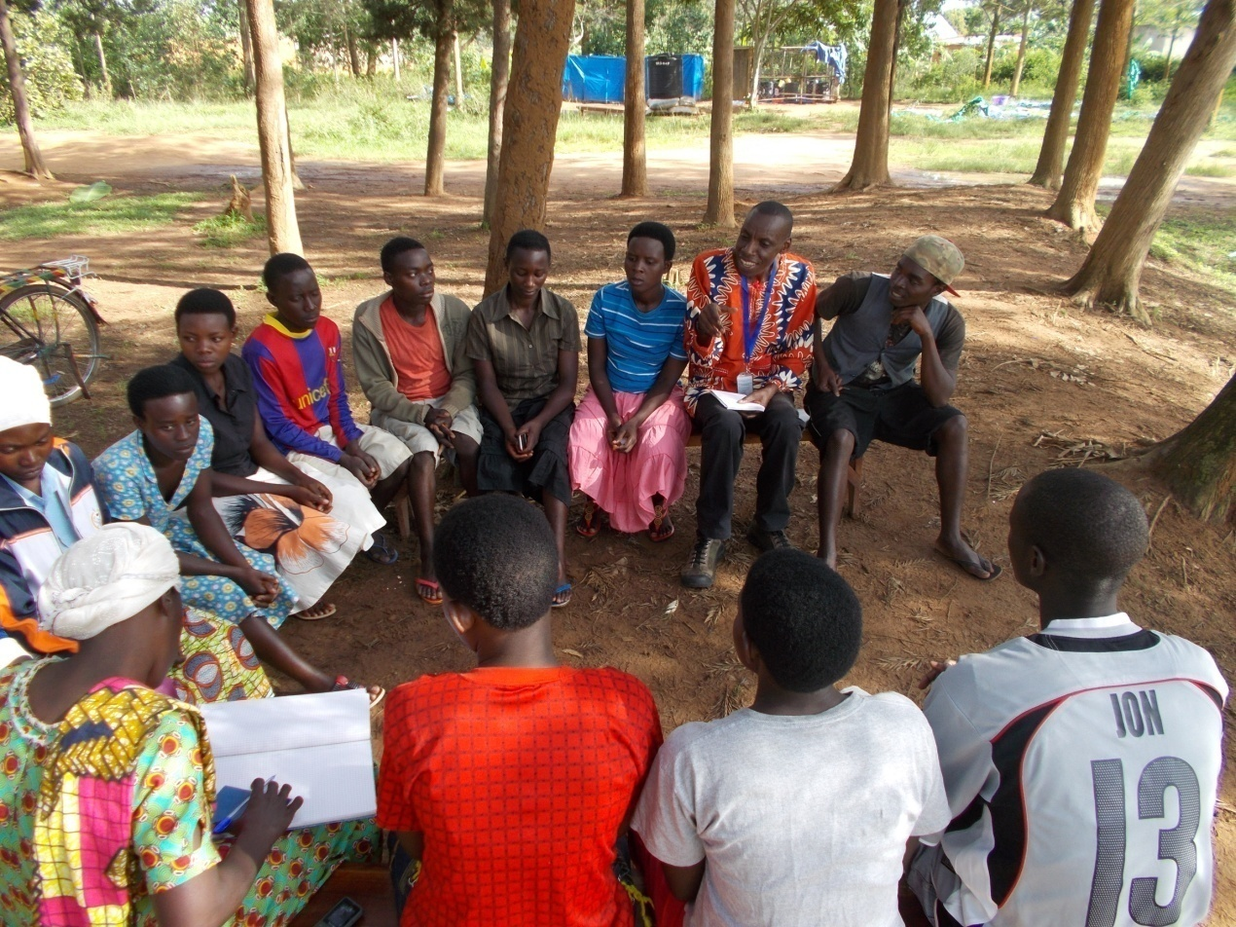
Figure 4.1: CED Student Etienne Niyiturinda (With Badge) With a Group of Youth During One of The Mobilization Meeting On Saving Spirit Development

After target group mobilization on developing serving spirit and its advantages, the self selected members formed 3 VSLAs groups with 20 members in both Tuzamurane and Twitezimbere groups whereas the 3rd group (Jyambere Rubyiruko) comprised 19 members. Next to VSLAs formation, it was necessary for the groups in coordination with CED student to develop constitution which guides the operation of the VSLAs. It stipulates amount of shares that every member is ought to contribute weekly and other important guidelines on how the loans would be disbursed and repaid.

In order for the project activities to take place smoothly, it was necessary for the VSLAs members to elect their leaders and the project runs under the Management Committee elected by the general assembly that comprises all VSLAs members. The Project management Committee is led by the Chairperson, a Secretary, a Treasurer and Money Counter. Each member was registered and given a passbook where the shares and contributions for social services specifically education and health are recorded. Every VSLA member is supposed to weekly contribute 250 RWF, (200RWF as share and 50RWFas social services contribution) and they all agreed to meet on every Friday morning for VSLAs activities. Associations agreed on a regular, equal contribution by all the members to social fund. This provides small grants for specific purposes such as emergency assistance; funeral expenses and educational costs for orphans. The fund was not intended to grow, but was set at a level that covers the minimum insurance needs of the VSLAs’ members.

Initially, 157 shares were purchased at 39250 RWF, saving and social fund contribution included. One share was purchased at 200 RWF for saving and 50 RWF for social fund. After training members on VSLAs scheme, they started to apply for loans so as to start investing in agriculture, bee keeping, MTN and TIGO cash, petty business, etc. Up to the end of November 2016, at the midway evaluation a total of 1,884 shares were purchased at 471000RWF, saving and social fund contribution included and a total of 132,000 RWF of loans were requested and provided. Thus the three first objectives were successfully achieved.
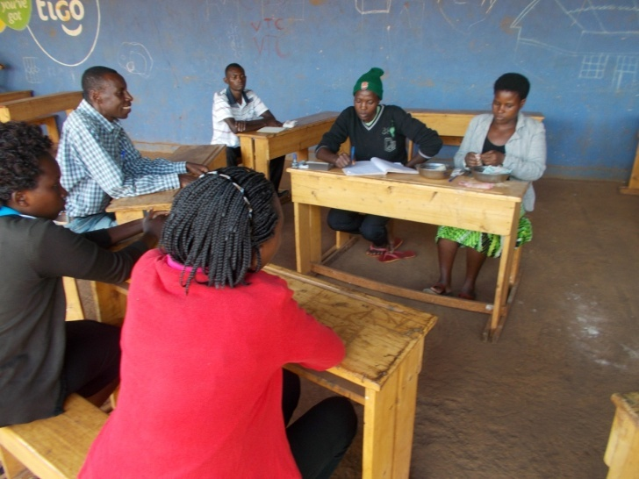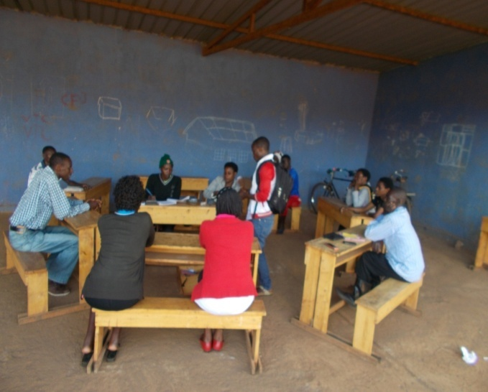
Figure 4.2: Jyambere Rubyiruko VSLA group during one of the weekly saving session
In order to develop the culture of working with financial institutions and the safety of the saved money, each of the tree VSLA group opened a current account in Mareba SACCO. The chair person was pointed as principal signatory and the two others were elected from the general assembly. Once the shares and social services contributions are collected, they are directly taken to Mareba SACCO by the treasurer not later than 6h00 PM. The bank slip is then presented at the next saving meeting and a bank statement is requested each month.

For the group recognition at Sector level, it was necessary to ensure that the groups are registered. To accomplish this task the VSLAs management committees in collaboration with CED student wrote a letter which was attached with copies of VSLAs constitutions to the Sector Cooperative Promotion Officer who is ought to register all socio-economic groups in the Sector. The tree formed VSLA groups have been successfully registered; this therefore implies that objective number 1 and 2 of the project are achieved. Initiating VSLAs for youth economic empowerment focuses at ensuring that the target group access soft loans that will serve as capital to business initiatives, based on this fact, one of project objective was facilitate the saving and loaning process and to build capacity of VSLAs members on income generating activities development. These objectives were achieved through different project activities namely; meetings, mobilization and trainings.

The train manual on entrepreneurship skills and income generating activities was developed by CED student in collaboration with other project stakeholders. It focuses on business skills such as starting up, scale up and reach up, identifying and investing in local income generating activities. These skills will help members to invest in diverse profitable activities after accessing soft loan from their saving group. Training was successfully conducted as 100% of VSLAs members attended the training and therefore being equipped with entrepreneurship skills. CED student in collaboration with experts from Plan Rwanda and Mareba Sector conducted the training.

After training VSLAs members started to apply for loans so as to start investing in agriculture, bee keeping, MTN and TIGO cash, petty business, etc. Up to the end of December 2016 a total of 90,000 RWF loans were requested and provided. The interest rate is 5% for the loan and 2% for loan insurance for loans taken in consideration of three times the shares deposited and the interest rate of 15% for the loans taken out of normal procedures i.e. amount of loan requested exceed three times shares deposited according to the VSLAs constitutions. Every FridayVSLAs members meet to buy shares and loans are offered to those members who are ready to take loan for improving their income generating activities. Usually loans count three times shares a member has saved.
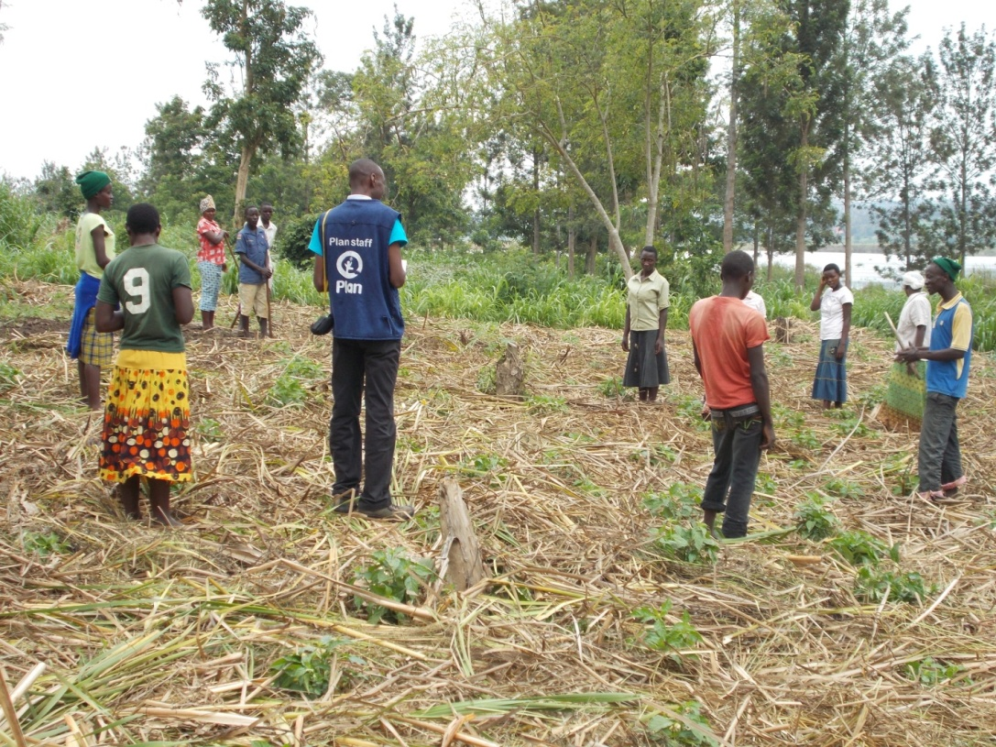
Figure 4.3: VSLA Members in one of the Income Generating Activities (Agriculture)
In order to ensure sustainability of the project even after project period (12 months) the last objective was to make sure that the project beneficiaries are empowered with the culture of working with formal financial institutions to get bigger loans and invest in more income generating activities. The objective has activities such as encourage many more members to join VSLAs and start the second saving cycle, meeting and mobilizing the financial institution to work with VSLAs group and then link the successful VSLAs to MFIs and Banks. As the entrepreneurship culture is developed VSLAs members are expected to work with formal financial institutions and apply for bigger loans for investing in more income generating activities and the fifth and golden objective of the project is expected to be achieved not later than May 2017.

4.4.2 Project Implementation Gantt chart
Table 4.6: Project Implementation Gantt Chart
Objective | Outcomes | Activity | Timeline: June 2016 to May 2017
 |  |  | 2016 |  |  |  |  |  |  | 2017
 |  |  | Jun | Jul | Aug | Sept | Oct | Nov | Dec | Jan | Feb | Mar | Apr | May
1.To initiate the project (startup) | - Potential VSL members are identified | 1.1.1.Meeting with community leaders and youth
 |  | 1.1.2. Conduct a capacity assessment of members
 |  | 1.1.3. Conduct a socio-economic profiling of member
 |  | 1.1.4. Self-selection of members and group formation
2.To initiate the VSLA formation and management | 2.1. Three VSLA groups are created | 2.1.1 .Election of General Assembly and the Management Committee
 |  | 2.1.2.Development of the VSLAs written constitution
 | 2.2. A 3 days training of 59 youth is conducted | 2.2.1.Planning and budgeting of training
 |  | 2.2.2. Conduct training
 | 2.3 Shares are purchased and first savings are done | 2.3.1.Shares purchasing
 |  | 2.3.2. First Weekly saving
3.To support to the saving and loan process | 3.1 A 3 days training on VSLAs scheme of 59 youth is conducted | 3.1.1 Planning and budgeting of training
 |  | 3.1.2. Conduct training
 | 3.2.First loan are disbursed | 3.2.1. Conduct a meeting on loan disbursement
 |  | 3.2.2. Disbursement of first loans
To provide the Business Development Skills | 4.1.Training on Business Development Skills is conducted | 4.1.1. Planning and budgeting of training
 |  | 4.1.2. Conduct training
 | 4.2.A midway evaluation is done | 4.2.1.Conducting a midway evaluation
 | 4.2.Income generating activities are initiated | 4.2.1.Mobilization on income generating activities
 |  | 4.2.2.Identifing the income generating activities
 |  | 4.2.3.Initiating small investments in identified activities
 | 4.3.First cycle savings are shared-out | 4.3.1.Sharing out the savings from the first cycle
To link VSLA groups to formal financial institutions | 5.1.Facilitates members to enter in to agreement with formal financial institutions for bigger loans | 5.1.1. Starting of the second saving/loaning cycle
 |  | 5.1.2. Meeting local MFIs and Banks representatives
 |  | 5.1.3.Linking VSALs groups to MFIs and Banks
 | 5.2.Annual evaluation | 5.2.1.Conduct and anannual evaluation
Source: researcher, 2017

CHAPTER FIVE

5.0 PROJECT PARTICIPATORY MONITORING, EVALUATION AND

SUSTAINABILITY

5.1 Introduction
This chapter covers participatory monitoring, participatory evaluation and project sustainability. To determine whether the project is operating within the stipulated limits and within the resources available, monitoring of the activities is required. Participatory monitoring as the first part of this chapter is crucial to the success of the project as it analyze the present situation, identify problems and find solutions, discover trends and patterns, keep project activities on schedule, measure progress towards objectives, formulate/revise future goals and objectives and make decisions about human, financial, and material resources. Participatory Monitoring and Evaluation provide more comprehensive information on efficiency, relevance, sustainability, impact and effectiveness of work in progress. By learning from mistakes and route, it can lead to timely corrective action.

On the other hand, participatory evaluation analyzes information to determine whether the project is realizing its planned activities and the extent to which the project is achieving its stated objectives through these activities, to find out how successful the project is, to find out how well things are being done and to learn from experience so future activities can be improved.

5.2 Participatory Monitoring
Participatory monitoring (also known as collaborative monitoring, community-based monitoring, locally based monitoring or volunteer monitoring) is the regular collection of measurements aiming at providing managers and major stakeholders with regular feedback and early indications of progress or lack thereof in the achievement of intended results. It involves collecting and analyzing data on implementation processes, strategies and results, and recommending corrective measures. Various technique and methods were employed to collect information, process and analysis to verify the progress of the planned activities. The aims of Participatory Monitoring was to supervise the implementation of planned activities such as sensitization meeting, training on VSLAs, identification of local income generating activities and micro-investments initiation as well as linking successful VSLAs to formal financial institutions.

5.2.1 Monitoring Information System
To ensure the success of VSLAs project a Project Management Information Systems (PMIS) is fundamental to assist project managers and stakeholders in the management and undertaking of the project activities. The PMIS was expected to help the project managers in performing their tasks in a more professional manner thus increasing the success rate of the project. PMIS helped therefore in the achievement of the project success while respecting the projects constraints and meeting the project objectives. Monitoring information system was based on the weekly recorded information relating to activities that were arranged in a specified period of time. It includes community members’ participation in the exercise, such as mobilizing target group on the importance of developing a saving spirit.

Weekly records showing number of shares bought in every week is then easily traced and therefore giving monitoring information on the project implementation. Prepared documents such as pass books and VSLAs constitutions also provide information for participatory monitoring as monitoring team can see and ready the documents. For the case of registration process, a letter written to the Sector Cooperatives promotion Officer who is responsible for registering socio-economic groups provides good information for the monitoring process.

Other monitoring information systems include thereports and attendance lists of participants in conducted meetings and trainings. Loans are monitored using loan application forms used by VSLAs members. These forms indicate the reason of loan, the type of income generating activities in which the loans are invested. In monitoring utilization of funds, the bought items and their respective receipts such as pass books, cash box, bank slips and bank statements are used. These items can be seen easily and therefore ensures the monitoring team that they were bought as stipulated in the project budget.

5.2.2 Participatory Monitoring Methods
There are a wide variety of tools and methods used for participatory monitoring. The Participatory Rural Appraisal (PRA) is mainly used in this project and it involves Diagram (Map and Transect), Priority matrix, Seasonal calendar, Venn diagram, time trend, observation, seasonal calendars and record review. Participatory rural appraisal (PRA) is a set of participatory and largely visual techniques for assessing group and community resources, identifying and prioritizing problems and appraising strategies for solving them. Diagram (Map and Transect) provides alternative database, depicts differing local perception of local problems/needs, builds rapport with locals, and supports maps of local resources/needs. With Priority matrix, the entire community is involved in prioritizing needs and development initiatives. Venn diagram helps to identify marginalized individuals and groups within the community.

Different tools used in PRA, intent to encourage participation, make it easier for youth to express their views and help to organize information in a way that makes it more useful and more accessible to the management committee when trying to analyze a given situation. They are intended to give a sense of what information can be obtained by using different tools and how diverse issues can be looked at from multiple angles. PRA is presented in highly visual form, usually out in the open and on the ground, using pictures, symbols and locally available materials.

Alongside with PRA techniques, project management committee was given a monitoring sheet for information collection. Collection of information exercise was conducted on weekly basis when VSLAs members meet to buy shares and any other activity regarding to the project progress. During weekly meetings, observation was used to assess the way VSLAs members buy their share and social fund contributions. The passbooks were exactingly filled and the record review was used to see how many shares were previously purchased. This technique also was used to assess the disputes management and the commitment as well as the active or passive individuals’ participation in implementing the project activities.

Time trend tool was used to assess time as an important element in any activity. Here, VSLAs members were asked as to whether every activity was implemented according to the plan and if there is need to reverse the implementation plan. During
the discussions every member was given a chance to assess how time used in project operations and hence responses were recorded for further analysis.

5.2.3 Participatory Monitoring Plan
Table 5.1 indicates participatory plan as agreed by the team involved in the project operations:

Table 5.1: Participatory Monitoring Plan
Objective | Outcomes | Activity | Indicators | Data source | Method/Tools | Responsible person | Time Frame
1.To initiate the project (startup) | - Potential VSL members are identified | 1.1.1.Meeting with community leaders and youth | Attendance list and Pictures | Weekly reports and secretary minutes. | Priority matrix and seasonal calendar | CED Student, Sector Youth coordinator and CBO | June 2016
 |  | 1.1.2. Conduct a capacity assessment of members | Assessment findings | Reports | Venn diagram and observation | CED Student and Sector Youth coordinator | June 2016
 |  | 1.1.3. Conduct a socio-economic profiling of member | Profiling results/findings | Reports | Venn diagram and observation | CED Student and Sector Youth coordinator | June 2016
 |  | 1.1.4. Self-selection of members and group formation | List of VSLAs members | Reports | Venn diagram and Observation | CED Student, and community members | June 2016
2.To initiate the VSLA formation and management | 2.1. Three VSLA groups are created | 2.1.1 .Election of General Assembly and Management Committee | Existing committee | Reports | Venn diagram, Observation and report review | CED Student, and community members | June 2016
 |  | 2.1.2.Development of the VSLAs written constitution | Written constitution | Written constitution | Priority matrix , Observation and record review | Project Committee and CED student | June 2016
 | 2.2. A 3 days training of 59 youth is conducted | 2.2.1.Planning and budgeting of training | Training Concept Note | Training Concept Note | Record review | VSLA management Committee, CBO and CED student | June 2016
 |  | 2.2.2. Conduct training | Training attendance list | Training report and attendance list | Record review | Sector Cooperative Promotion Officer and CED student | June 2016
 | 2.3 Shares are purchased and first savings are done | 2.3.1.Shares purchasing | Pass books | Weekly records | Observation and Record review | VSLA management Committee and CED student | July 2016
 |  | 2.3.2. Weekly saving | Pass books and bank slips | Weekly records | Observation and Record review | VSLA management Committee and CED student | July 2016
3.To support to the saving and loan process | 3.1 A 3 days training on VSLAs scheme of 59 youth is conducted | 3.1.1 Planning and budgeting of training | Training Concept Note | Training Concept Note | Record review | VSLA management Committee and CED student | August 2016
 |  | 3.1.2. Conduct training | Training attendance list | Training report and attendance list | Record review | Sector Cooperative Promotion Officer and CED student | August 2016
 | 3.2.First loan are disbursed | 3.2.1. Conduct a meeting on loan disbursement | Attendance list and pictures | Weekly reports and secretary minutes. | Record review | VSLA management Committee | August 2016
 |  | 3.2.2. Disbursement of first loans | Pass books and bank slips | Weekly records | Observation and Record review | VSLA management Committee | September 2016
4.To provide the Business Development Skills | 4.1.Training on Business Development Skills is conducted | 4.1.1. Planning and budgeting of training | Training Concept Note | Training Concept Note | Record review | VSLA management Committee and CED student | October 2016
 |  | 4.1.2. Conduct training | Training attendance list | Training report and attendance list | Record review | Sector Cooperative Promotion Officer, CBO and CED student | October 2016
 | 4.2. A semesterly evaluation is conducted | 4.2. Conduct a semesterly evaluation | Existing evaluation sheets with evaluation findings | Evaluation sheets, Records and reports | Record review | Sector Cooperative Promotion Officer, CBO and CED student | November 2016
 | 4.2.Income generating activities are initiated | 4.2.1.Mobilization on income generating activities | Report and Pictures | Mobilization report | Priority matrix | CBO and CED student | December 2016
 |  | 4.2.2.Identifing the income generating activities | Report | Reports | Priority matrix and Venn diagram | VSLA management Committee, CBIO and CED student | January 2017
 |  | 4.2.3.Initiating small investments in identified activities | Report and Pictures | Reports | Seasonal calendar and time trend | VSLA management Committee, CBIO and CED student | February 2017
 | 4.3.First cycle savings are shared-out | 4.3.1.Sharing out the savings from the first cycle | Pass books and bank slips | Weekly records | Observation and Record review | VSLA management Committee | May 2017
5.To link VSLA groups to formal financial institutions | 5.1.Facilitates members to enter in to agreement with formal financial institutions for bigger loans | 5.1.1. Starting of the second saving/loaning cycle | Pass books and bank slips | Weekly records | Observation and Record review | VSLA management Committee, CBIO and CED student | May 2017
 |  | 5.1.2. Meeting local MFIs and Banks representatives | Attendance list and pictures | Weekly reports and meeting minutes. | Diagram (Map and transect) and records review | VSLA management Committee, CBIO and CED student | May 2017
 |  | 5.1.3.Linking VSALs groups to MFIs and Banks | Attendance list and pictures | Weekly reports and meeting minutes | Diagram (Map and transect) and records review | VSLA management Committee, CBIO and CED student | May 2017
 | 5.2.Annual evaluation | 5.2.1.Conduct and a Annual evaluation | Evaluation sheets and findings | Weekly records and reports | Observation and Record review | CED student and VSLA management Committee | May 2017
Source: researcher, 2017
This Participatory Monitoring Plan shows in details how all stakeholders including local beneficiaries are involved in measuring, recording, collecting, processing and communicating information to assist CED Student and other stakeholders in decision-making while implementing the projects. For each set project objective and according activities, the monitoring indicators are given away so that all stakeholders can use them to in supervising the implementation of planned activities such as sensitization meeting, training on VSLAs, identification of local income generating activities and micro-investments initiation as well as linking successful VSLAs to formal financial institutions.

For each activity to be carried out data sources are presented and the method used to implement the objective are listed. Priority matrix, seasonal calendar tools were mainly used for carrying out the Participatory Rural Appraisal as the main methodology used in developing stakeholders’ understanding of the rural reality for the planning and development of project; and the feeling of a greater degree of ownership and responsibility in the beneficiaries for better results and social acceptance of the project. For the project to succeed, all tasks and responsibilities need to be effectively assigned and in this respect as well as to facilitate better monitoring, for each objective and according activities, a clear responsibilities/tasks repartition was done and shown in participatory monitoring plan.

5.3 Participatory Evaluation
Participatory evaluation assists in adjusting and red fining objectives, reorganizing projects arrangements or re-allocating resources as necessary. Involving stakeholders in project evaluation is one of the learning objectives of participatory management.
Apart from project’s impact on the life of the youth, it is also worthwhile to evaluate attitudinal changes in the local community about their role and sense of responsibility, if people have gained confidence in their ability to undertake new activities and lessons about people’s capacity, extent of participation and community responsibilities. It provides an opportunity to the project implementation committee to assess deficiencies in the project design, if objectives and implementation plan were realistic, if local funding was adequate and whether project actually owned by the target group.

Evaluation was conducted in November2016 (mid way) and Annual evaluation is planned to be conducted in May 2017. Mid evaluation involved The CED student, Mareba Sector Cooperatives Promotion Officers, VSLA Management Committee and Plan Rwanda representative. Evaluation were based to assess the extent to which the project objectives were realized, to assess the extent to which people’s expectations were fulfilled and Suggest ways for improvement.

5.3.1 Performance Indicators
Performance indicators are measures of project impacts, outcomes, outputs, and inputs that are monitored during project implementation to assess progress toward project objectives. They are also used later to evaluate a project's success. Indicators organize information in a way that clarifies the relationships between a project's impacts, outcomes, outputs, and inputs and help to identify problems along the way that can impede the achievement of project objectives.

Performance indicators are based on the objectives of the projects butthe set of performance indicators are also based on an underlying logical framework that links project objectives with project components and their respective inputs, activities, and outputs at different implementation stages. The framework is objective-driven, since any action under a project is aimed at achieving its objectives. Given the project's development objectives, the best mixes of outputs to achieve these objectives and components that will yield these outputs are derived. The logical framework is a participatory planning tool whose power depends on how well it incorporates the full range of views of intended beneficiaries and other stakeholders.

For VSLAs projects, from the first shares purchasing to saving sharing out, incorporating performance measurement into the design forces greater consideration of the critical assumptions that underlie that program's relationships and causal paths. Thus performance indicators help clarify the objectives and logic of the program.

The input indicators describe the means by which projectsis implemented, such as the number of trainees, the amount of money spent, though for output measure the extent to which the project is delivering what it is intended to deliver, while impact indicators measure actual change to youth group. Project goal and project objectives performance indicators were developed as shown in Table 5.2.

Table 6.2: Project Performance Indicators
Objective | Outcomes | Activity | Resource needed | Performance indicators
1.To initiate the project (startup) | - Potential VSL members are identified | 1.1.1.Meeting with community leaders and youth | Transportfor CED Student | Number of members attended
 |  | 1.1.2. Conduct a capacity assessment of members | Transport for CED Student | Capacity assessment findings
 |  |  | Stationeries | Receipts and list of stationeries purchased
 |  | 1.1.3. Conduct a socio-economic profiling of member | Transport for CED Student | Profiling findings
 |  |  | Stationeries | Receipts and list of stationeries purchased
 |  | 1.1.4. Self-selection of members and group formation | Transport for CED Student | Number of self-selected members
2.To initiate the VSLA formation and management | 2.1. Three VSLA groups are created | 2.1.1 .Election of General Assembly and the Management Committee | Transport for CED Student | Functioning elected Assembly and committee
 |  | 2.1.2.Development of the VSLAs written constitution | Stationeries | Existence of Constitution, Receipts and list of stationeries purchased
 | 2.2. A 3 days training of 59 youth is conducted | 2.2.1.Planning and budgeting of training | Stationeries | Training concept note
 |  | 2.2.2. Conduct training | Transport for 59 Trainees | Training attendance list, Signed transport pay list
 |  |  | Transport for 3 Facilitators | Signed transport pay list
 |  |  | Stationeries | Receipts and list of stationeries purchased
 |  |  | Communication for 3 Facilitators s | Signed communication pay list
 | 2.3 Shares are purchased and first savings are done | 2.3.1.Shares purchasing | Passbooks | Number of shares purchased
 |  | 2.3.2. Weekly saving | Cash boxes | Amount of money saved
3.To support to the saving and loan process | 3.1 A 3 days training on VSLAs scheme  of 59 youth is conducted | 3.1.1 Planning and budgeting of training | Stationeries | Training concept note
 |  | 3.1.2. Conduct training | Transport for 59 Trainees | Training attendance list, Signed transport pay list
 |  |  | Transport for 3 Facilitators | Signed transport pay list
 |  |  | Stationeries | Receipts and list of stationeries purchased
 |  |  | Communication for 3 Facilitators s | Signed communication pay list
 | 3.2.First loan are disbursed | 3.2.1. Conduct a meeting on loan disbursement | Transport for CED Student | Meeting attendance list
 |  | 3.2.2. Disbursement of first loans | Passbooks and constitution | Filled loan application forms
4.To provide the Business Development Skills | 4.1.Training on Business Development Skills is conducted | 4.1.1. Planning and budgeting of training | Stationeries | Training concept note
 |  | 4.1.2. Conduct training | Transport for 59 Trainees | Training attendance list, Signed transport pay list
 |  |  | Transport for 3 Facilitators | Signed transport pay list
 |  |  | Stationeries | Receipts and list of stationeries purchased
 |  |  | Communication for 3 Facilitators | Signed communication pay list
 | 4.2.A midway evaluation is done | 4.2.1.Conducting a midway evaluation | Transport for 1CED student | Evaluation sheets and findings
 | 4.3.Income generating activities are initiated | 4.3.1.Mobilization on income generating activities | Transport for 1CED Student, 1 staff from Plan | Number of members attended
 |  | 4.3.2.Identifing the income generating activities | Transport for 1CED Student | List of identified activities
 |  | 4.3.3.Initiating small investments in identified activities | Transport for 1CED Student, 2 staff from Plan | Number of running investment
 | 4.4.First cycle savings are shared-out | 4.4.1.Sharing out the savings from the first cycle | Passbooks | Bank slips and statement and Passbooks
5.To link VSLA groups to formal financial institutions | 5.1.Facilitates members to enter in to agreement with formal financial institutions for bigger loans | 5.1.1. Starting of the second saving/loaning cycle | Transport for 1CED Student, 2 staff from Plan | Number new shares purchased
 |  | 5.1.2. Meeting local MFIs and Banks representatives | Transport for 1CED Student, 2 staff from Plan | Number of participant and Meeting minutes
 |  | 5.1.3.Linking VSALs groups to MFIs and Banks | Transport for 1CED Student, 2 staff from Plan | Number of members applied for loans
 | 5.2.Annual evaluation | 5.2.1.Conduct and an annual evaluation | Transport for 1CED Student | Existing evaluation findings
Source: researcher, 2017

5.3.2 Participatory Evaluation Methods
As for participatory monitoring, the Participatory Rural Appraisal (PRA) methodology was mainly used in this project and it involves Diagram (Map and Transect), Priority matrix, Seasonal calendar, Venn diagram, time trend, observation, seasonal calendars and record review. Participatory rural appraisal (PRA) is a set of participatory and largely visual techniques for assessing group and community resources, identifying and prioritizing problems and appraising strategies for solving them.

Diagram (Map and Transect) provides alternative database, depicts differing local perception of local problems/needs, builds rapport with locals,and supports maps of local resources/needs. With Priority matrix, the entire community is involved in prioritizing needs and development initiatives while as Venn diagram helps to identify marginalized individuals and groups within the community. This participatory evaluation is reflective and action-oriented. It is empowering because it claims the right for Mareba community to control and own the process of making evaluation decisions and implementing them.

Participating in an evaluation from start to finish is to give stakeholders a sense of ownership over the results. Recognizing local talents and expertise builds confidence and pride in the community, and among participants. This participatory evaluation was conducted to promote participant learning and is an opportunity to introduce and strengthen evaluation skills.

Active participation by stakeholders is to result in new knowledge and a better understanding of their environment. This, in turn, enables groups to identify action steps and advocate for policy changes. Participatory evaluation builds teams and participant commitment through collaborative inquiry. Inviting a broad range of stakeholders to participate and lead different parts of the process is to develop and celebrate local leadership skills. It will lead to stronger, more organized VSLAs groups, strengthening the community’s resources and networks. Finally, this participatory evaluation is not just interested in findings; it is focused on creating a learning process. It creates a knowledge base among Mareba Sector people and organizations, which can be applied to other programs and projects. The techniques and skills acquired will lead to self-sustained action.

5.3.3 Project Evaluation Summary
Table shows the project evaluation summary based on the project goal, objectives, performance indicators, expected outcomes and actual outcome. Based on the project goal, objectives and activities planned are being met with exception of annual evaluation that will be done after twelve months of project implementation. Generally the evaluation shows that there are strong commitments of various stakeholders from the planning stage to the implementation activities. This implies that the project is the important to beneficiaries and community at large.

Table 7.3: Project Evaluation Summary
Objective | Output | Activity | Performance indicators | Expected Outcome | Actual outcome
1.To initiate the project (startup) | - Potential VSL members are identified | 1.1.1.Meeting with community leaders and youth | Number of members attended | Positive response | Five community leaders and 200 youth attended the meeting
 |  | 1.1.2. Conduct a capacity assessment of members | Capacity assessment findings | Knowledge about the capacity to run a VSLA | Community members’ capacity to run a VSLA is known
 |  | 1.1.3. Conduct a socio-economic profiling of member | Profiling findings | Knowledge about the socio-economic status of potential VSLA members | The socio-economic status of potential VSLA members is known
 |  | 1.1.4. Self-selection of members and group formation | Number of self-selected members | Potential VSLA members re self-selected | 100 potential VSLA members are self-selected, 59 are selected
2.To initiate the VSLA formation and management | 2.1. Three VSLA groups are created | 2.1.1. Creation of three VSLAs groups | Number of VSLAs created | Three VSLA groups start operations | 59 members are selected and formed three groups
 |  | 2.1.2 .Election of General Assembly and the Management Committee | Functioning elected Assembly and committee | General Assembly is elected and it elects in turn a management committee | General Assembly and committee are operational
 |  | 2.1.3.Development of the VSLAs written constitution | Existence of Constitution, Receipts and list of stationeries purchased | Improved efficiency in proper project management | - Constitution is developed.
 | 2.2. A 3 days training of 59 youth is conducted | 2.2.1.Planning and budgeting of training | Training concept note | Training is well prepared | A training concept note is developed
 |  | 2.2.2. Conduct training | Training attendance list, Signed transport pay list | Participants gained skills and experience | 59 VSLAs members were trained
 | 2.3 Shares are purchased and first savings are done | 2.3.1.Shares purchasing | Number of shares purchased | First shares are purchased | 157 shares were purchased
 |  | 2.3.2. Weekly saving | Amount of money saved | First savings are done | 157,000 Rwf are saved
3.To support to the saving and loan process | 3.1 A training on VSLAs scheme is  conducted | 3.1.1 Planning and budgeting of training | Training concept note | Training is well prepared | A training concept note is developed
 |  | 3.1.2. Conduct training | Training attendance list | Participants gained skills and experience | A 3 days training of 59 youth is conducted
 | 3.2.First loan are disbursed | 3.2.1. Conduct a meeting on loan disbursement | Meeting attendance list | Positive response | 59 (100%) members attended the meeting
 |  | 3.2.2. Disbursement of first loans | Filled loan application forms | First loan applications are done | 19 members applied for loan and their applications were approved
4.To provide the Business Development Skills | 4.1.Training on Business Development Skills is conducted | 4.1.1. Planning and budgeting of training | Training concept note | Training is well prepared | A training concept note is developed
 |  | 4.1.2. Conduct training | Training attendance list, Signed transport pay list | Participants gained skills and experience | A 3 days training of 59 youth is conducted
 | 4.2.A midway evaluation is done | 4.2.1.Conducting a midway evaluation | Evaluation sheets | A midway evaluation is conducted | A midway evaluation was successfullyconducted
 | 4.3.Income generating activities are initiated | 4.3.1.Mobilization on income generating activities | Number of members attended | Positive response | 300 community members are mobilized
 |  | 4.3.2.Identifing the income generating activities | List of identified activities | Local income generating activities are identified | Identified activities include Agriculture and Petty business among others
 |  | 4.3.3.Initiating small investments in identified activities | Number of running investment | VSLAs member invested in identified activities | 38 members invested in diverse income generating activities
 | 4.4.First cycle savings are shared-out | 4.4.1.Sharing out the savings from the first cycle | Bank slips and statement and Passbooks | Members shared their earnings for the first saving cycle | Still saving, waiting for sharing out in May 2017
5.To link VSLA groups to formal financial institutions | 5.1.Facilitates members to enter in to agreement with formal financial institutions for bigger loans | 5.1.1. Starting of the second saving/loaning cycle | Number of new shares purchased | The second saving cycle started | The first saving cycle is still underway
 |  | 5.1.2. Meeting local MFIs and Banks representatives | Number of participant and Meeting minutes | Positive response | Five meetings will be held in November 2016 with MFIs and Banks representatives
Source: researcher, 2017

5.4 Project Sustainability
Sustainability is the ability of a project to maintain its operations, services and benefits during its projected life time. Even if this project is seen as worth sustaining today, may not be so in future. This section shows how this project will maintain functioning, supported by its own resources (human, material, and financial), even external sources of funding have ended. The implementers are responsible for planning to make project sustainable even after the project phasing out. This developed plan focuses on institutional sustainability, financial sustainability as well as political sustainability.

5.4.1 Institutional Sustainability
Capacity building given to youth on entrepreneurship helps in strengthening the implementation of their income generating activities established by managing properly their capital accumulated throughout the saving as well as through loans application. This will result to create employment for the Mareba youth by applying knowledge and establish business ventures. Accountability will be strengthened due to leadership and good governance training provided to them throughout the implementation stage of the project.

5.4.2 Financial Sustainability
The VSLAs project is designed to ensure sustainability because the VSLAS remains in the communities. Even after CED student and Plan Rwanda involvement ends, as more and more people express interest in joining VSLAs, the project’s work continues as they form new groups and train them. All VSLAs are expected to be self-managed and sustainable once they master the VSLA methodology. In addition CED student expects some locally based partner organizations to continue their contacts with the VSLAs as they work on other programs. CED Student is seeking ways to make the VSLAs known to other organizations working in these areas so that they can serve as links to other interventions.

In Mareba Sector, CED Student will help establish clusters, or networks, of VSLAs managed by cluster committees. These structures will work together to discuss issues concerning VSLAs as well as communities. They will provide support to groups as well as to VSLAs so that both have a way to resolve issues. The idea of initiating the VSLAs project is capturing the attention of many more CBOs and they are expected to continue providing financial and technical assistance needed for ensuring the sustainability of project.

When members reach at a certain level where they require bigger loans which associations cannot accommodate, then this indicates that they have entered in to huge investments. At this stage, CED Student and other stakeholders facilitates them to enter in to agreement with formal financial institutions which have the capacity to support such types of investments. This is the beauty of this project because once members start investing in income generating activities and working with formal financial institutional, they become economically empowered in a sustainable way.

5.4.3 Political Sustainability
Initiating VSLAs for youth is line with the 2015 youth policy which is in turn aligned to the Rwanda Vision 2020, the National Employment Program (NEP) as well as the National Information and Communications Infrastructure (NICI) Plan amongst other national development plans and macro-economic policies. This project is also aligned to the Economic Development and Poverty Reduction Strategy (EDPRS2), especially on its two pillars, which are economic transformation and productivity and youth employment. This project clearly establishes a comprehensive and targeted youth economic empowerment with strong emphasis on saving culture in Mareba Sector. It envisages the linkage of youth projects with formal financial institutions.

The Government of Rwanda views VSLAs and cooperatives as a potential vehicle through which the cooperatives members could create employment and expand access to income-generating activities, develop their business potential, including entrepreneurial and managerial capacities through education and training; increase savings and investment, and improve social well-being with special emphasis on gender equality, housing, education, health care and community development. Considering the fact that the target of this project is youth who make a high percentage of Rwandan population, they will help in promoting the agricultural sector, mobilization of savings and provision of credit, marketing of handicrafts, housing and constructions and artisan and become economically empowered in a sustainable way.

CHAPTER SIX

6.0 CONCLUSION AND RECOMMENDATIONS

6.1 Introduction
This chapter provides a sum up of the initiation of VSLAs project for youth economic empowerment in Mareba Sector of Bugesera District. It looks atthe whole process conducted starting with needs assessment to project implementation. The chapter comprises Community Needs Assessment, Problem Identification, Literature Review, Project Implementation, Participatory Monitoring, Evaluation and Sustainability of the Project. Conversely, the chapter draws out the conclusion which will assist researcher, duty bearers and other development actors in the youth development issues to access to the necessary information about the project and makes the improvements of the project for its sustainability.

6.2 Conclusion
Community needs assessment took one month while Plan Rwanda was still conducting its community based interventions. Focused Group Discussion method was used to ensure community and other stakeholders’ participation in identifying resources and real needs of the youth. Primary and secondary data were gathered and helped to realize the specific objectives and answer the three research questions. The critical issues as shown by the CNA finding and the needs pair wise ranking were to improve the quantity and quality of youth investments and contribute towards reducing poverty and unemployment among the youth and effectives VSLAs were undoubtedly found to be a key driver to address the problem and lead to economic empowerment for Mareba Youth community.
VSLAs to be based in Mareba community were to be complementary to MFIs, tending to serve the youth whose income is irregular and less reliable and who may not be full-time business people. The basic principle was that members of a self-selected youth group will voluntarily form a VSLA and save money, through purchasing shares. The savings were invested in a loan fund from which members can borrow, repaying with a service charge added.

The stakeholders in this particular project included Non-Government Organization (Plan Rwanda), Local government such as National Youth council representatives, Cooperative officers, Ministry of Youth and ICT as well as parents and security guards. The stakeholders contributed in one way to another to another to the success of the project. After the community needs were assessed and prioritized, stakeholders to address the identified problem and implement the VSLAs project also acknowledged. However, for the success of the project, a detailed literature review was done and consisted in theoretical and empirical review of youth empowerment interventions and the impact of savings and loans associations (VSLAs) as a means of youth economic empowerment.

Reviewed literatures revealed that effective entrepreneurship and business development is considered as one of the key strategies for creation of off-farm jobs and initiating VSLAs for youth where there on access to other financial institutions will undoubtedly boost their economic empowerment in a sustainable perspective. All available literatures reviewed in this project have proven that today, most community development practitioners are increasingly concerned about the impact of project interventions to measure whether or not they have achieved their goals.In the fight for youth inclusion in economic development, youth empowerment has emerged as one of the leading subjects for debates.

In order to achieve project objectives, it was the responsibility of CED student, target group and other stakeholder to ensure that project activities are efficiently implemented. The implementation of the project was launched on 1st June, 2016 and the 1st saving cycle is expected to end at 31stMay 2017. The implementation was carried out following five objectives including VSLAs starting up, VSALs groups formation, starting saving and loans disbursement, entrepreneurship skills development and linking successful VSLAs groups.

Initially, 157 shares were purchased at 39250RWF, saving and social fund contribution included. One share was purchased at 200 RWF for saving and 50 RWF for social fund.After training members on VSLAs scheme, they started to apply for loans so as to start investing in agriculture, bee keeping, MTN and TIGO cash, petty business, etc. Up to the end of November 2016, at the midway evaluation a total of 1,884 shares were purchased at 471000RWF, saving and social fund contribution included and a total of132,000 RWF of loans were requested and provided. Thus the three first objectives were successfully achieved.

The fourth objective that consists in equipping VSLAs members in entrepreneurship skills so that they can invest in different income generating activities is partially achieved as some the training are scheduled in February, 2017. In order to ensure sustainability of the project even after project period (12 months) the fifth and last objective was to make sure that the project beneficiaries are empowered with the culture of working with formal financial institutions to get bigger loans and invest in more income generating activities. The fifth objective had activities such as encourage many more members to join VSLAs and start the second saving cycle, meeting and mobilizing the financial institution to work with VSLAs group and then link the successful VSLAs to MFIs and Banks.

As the entrepreneurship culture was developed VSLAs members are expected to work with formal financial institutions and apply for bigger loans for investing in more income generating activities and the fifth and golden objective of the project is expected to be achieved not later than May 2017.While Participatory monitoring and Evaluation, the Participatory Rural Appraisal (PRA) was mainly used in this project and it involved Diagram (Map and Transect), Priority matrix, Seasonal calendar, Venn diagram, time trend, observation, seasonal calendars and record review.

The Participatory Monitoring Plan showed in details how all stakeholders including local beneficiaries are involved in measuring, recording, collecting, processing and communicating information to assist CED Student and other stakeholders in decision-making while implementing the projects. For each set project objective and according activities, the monitoring indicators were given away so that all stakeholders can use them to in supervising the implementation of planned activities. Based on the project goal, objectives and activities planned were met with exception of those planned in 2017 such as annual evaluation that will be done after 12 months of project implementation.

Generally the midway evaluation showed that there are strong commitments of various stakeholders from the planning stage to the implementation activities. At all stages of the project, institutional, financial as well as political sustainability was ensured so that this project would maintain functioning, supported by its own resources, even when the external sources of funding have ended. As VSLAs members are reaching a certain level of maturity and accountability, CED Student and other stakeholders facilitates them to enter in to agreement with formal financial institutions which have the capacity to support such types of investments.

Initiating VSLAs for youth is line with the Economic Development and Poverty Reduction Strategy (EDPRS2), the 2015 youth policy which is in turn aligned to the Rwanda Vision 2020, the National Employment Program (NEP) as well as the National Information and Communications Infrastructure (NICI) Plan amongst other national development plans and macro-economic policies.

The Government of Rwanda views VSLAs and cooperatives as a potential vehicle through which the cooperatives members could create employment and expand access to income-generating activities and develop their business potential. In terms of impact, this project will considerably improve lives of VSLA members. It has after all targeted the most vulnerable and the most excluded community group and it will undoubtedly improve their lives when it comes to investing in local income generating activities leading to education, health, family assets, shelter and clothing and then become economically empowered in a sustainable way.

6.3 Recommendations
The CNA findings as well as the reviewed literatures revealed that effective entrepreneurship and business development is considered as one of the key strategies for creation of off-farm jobs and initiating VSLAs for youth where there on access to other financial institutions was found to undoubtedly boost the youth’s economic empowerment in a sustainable perspective. All available literatures reviewed in this project have proven that in the fight for youth inclusion in economic development, youth empowerment has emerged as one of the leading subjects for debates.

Referring to this project, it was concluded that effective VSLAs projects were affordable and practical alternative as they were found to a key driver for rural youth economic empowerment. Unfortunately, the findings in Figure 7 indicate as many as 75% of youth in Mareba Sector are not meeting their everyday socio-economical needs given their actual income. Not meeting every day needs directly influence the saving practice and as many as 76.56% of respondents do not save no money at all along the year as shown by the CNA findings.

The findings proved that VSLAs provide not only a secure place to save and the opportunity to borrow in modest amounts but also a convenient access to saving services because of the easy understanding and transparency in its operations. However, the CNA revealed and insufficient or lack of capital, inexistence of saving and loaning habit and lack of awareness just to mention few of them the following recommendation has been formulated and addressed to all actors in youth empowerment especially through VSLAs:

Improved and Inclusive Targeting: VSLAs projects should be developed and reinforced intending to reach the poorest of the poor, the most destitute and vulnerable people in the communities. This should be done with the help of local authorities and community members. Participatory methods should be used to increase awareness and provide further information about the VSL groups, criteria to join, expectations and level of commitment required.

Investing in Village Agents: Village agents are members of the target community and are trained to promote the establishment of VSLAs and should be used in designing and implementing successful VSLAs projects. Village agents are trained and supervised by field officers from an implementing institution organization or individuals.

Introducing Different Implementation Models: In order to ensure program quality, build greater local capacity, scale up VSL activities and spread this methodology as widely as possible in Rwanda, all actors should do direct implementation of the project as well as implementation through four local partners and community members to make their projects as participatory as possible.

Strengthening Linkages to Formal Financial Institutions: All players in VSLAs projects should establish significant mechanisms for linking members of savings-led groups to formal financial services.

Promote Learning and Knowledge Management: All players in VSLAs projects especially those for designed for youth should provide important tools, models, and lessons on providing access to financial services to youth communities in rural areas. The main activities being to include monitoring and evaluation using appropriate Management Information System adapted to VSLA programs, impact assessment, documenting and sharing learning, including an analysis and a comparison of the existing different implementation models.

In future, if these recommendations are considered and followed by all players in VSLAs projects, they will considerably improve lives of VSLA members. They will after all target the most vulnerable and the most excluded community group and they will undoubtedly improve their lives when it comes to investing in local income generating activities leading to education, health, family assets, shelter and clothing and then become economically empowered in a sustainable way.

REFERENCES
Abegunde, A. A. (2009). The role of community based organisations in economic development in Nigeria: The case of Oshogbo, Osun state, Nigeria. International NGO Journal, 4(5), 236-252.
Bugesera, D. O. (2013). Bugesera District Development Plan 2013-2018. Bugesrea: Bugesera District.
CARE, (2009). Bringing Financial Services to Africa’s Poor. Geneva: Care Internation.
Evanston, I. R. (2008). Community Assessment Tools: A Companion Piece to Communities in Action — A Guide to Eﬀective Service Projects, retrieved on 20th May, 2017 from; www.rotary.org/RIdocuments/en_pdf/605c_en.pdf. Illinois.
GoR, G. O. (2015, September). Rwanda National Youth Policy. Kigali, Rwanda.
Hugh, A. M. S. (2007). Village Savings and Loan Associations: A Practical Guide. California: Practical Action.
ICRW, I. C. (2015). Economic Empowerment. Washington DC.
Joanna, L. V. W. (2006). Transforming Microfinance Institutions: Providing Full Financial Services to the Poor. Washington DC: World Bank.
MGLSD, U. (2016). Uganda National Yout Policy. Retrieved August 15, 2016, from; http://www.mglsd.go.ug/policies/Uganda%20National%20 Youth% 20Policy.%202001.pdf.
MIFOTRA, (2011). NYC Service charter the National Youth Council copy, retrieved June 17, 2016, from; http://www.mifotra.gov.rw/fileadmin/user_ upload/chaters/NYC_Service_charter__the_National_Youth_Council_copy.pdf.
MINECOFIN, (2016). Youth Sector Strategic Plan 2013-2018. Ministry of Finance and Economic Planning, Retrieved on July 13th 2016, from; http://www.minecofin.gov.rw/fileadmin/templates/documents/sector_strategic_plan/Youth_Sub_Sector_SSP.pdf.
MINICOM, (2010). Small and Medium Enterprises (SMEs) Development, Ministry of Trade and Industry, retrieved on August 05, 2016, from; http://www.minicom.gov.rw/fileadmin/minicom_publications/policies/SME_Devt_policy_V180610.pdf.
Montgomery, P. A. (2011). Youth empowerment programs for improving self-efficacy and self-esteem of adolescents. Oslo, Norway: The Campbell Collaboration.
NISR, (2012). Fourth Population and Housing Census, Kigali: NISR.
NPYC, N. W. (2016). National Youth Economic Empowerment Strategy, retrieved on August 12, 2016, from; http://www.nwpyc.org.za/index.php: http://www.nwpyc.org.za/index2.php?option=com_docman&task=doc_view&gid=29&Itemid=2.
Plan Internation, (2016). About plan-international, Retrieved on August 15, 2016, from; https://plan-international.org/organisation.
Plan International, (2016). Plan International, Worldwide Annual review 2015. London: Plan Intenational.
RCA, (2013). Rwanda’s National Cooperatives Promotion Policy, Rwanda Cooperative Agency, Retrieved on June 17, 2016, from; http://www.rca.gov.rw/IMG/pdf/POLICY_DOCUMENT__FINAL__March_2006.pdf.
Sida, A. (2014). The role of microfanance institutions in improving livelihood: In case of Oromia Credit and Saving Share Company in Agaro Town, Jimma Zone. Addis Ababa: GRIN Verlag.
Spadacini, B. (2010). Empowering Rwandan Communities, Kigali: Noel Creative Media Ltd.
Suskie, L. (1996). Questionnaire Survey Research, 2nd edition. Washington DC: Assn for International Research.
TakingITGlobal, (2016). Youth Position Paper NEEDS II, retrieved on June 11th 2016, from; http://www.tigweb.org: http://www.tigweb.org/action-tools/.../youth%20position%20paper%20NEEDS%20II.pdf.
USAID, (2007). India National youth policy, retrieved July 16, 2016, from; http://www.youth-policy.com/Policies/IndiaNATIONALYOUTHPOLICY 2003. pdf

APPENDICES
APPNDINX 1: STRUCTURED QUESTIONNAIRE FOR YOUTH
- SOCIO-DEMOGRAPHIC CHARACTERISTICS
Names …………………………………………….
- Age …………….................
- 16 – 21 ( )
- 21 – 25 ( )
- 26 – 30 ( )
- Sex
- Male ( )
- Female ( )
- Marital Status
- Single ( )
- Married ( )
- Separated ( )
4.0 What is your highest level of education?
- No formal education ( )
- Primary School ( )
- Secondary School ( )
- Higher Learning ( )
5.0 What are your sources of day to day income?
- Agriculture ( )
- Husbandly ( )
- Petty business ( )
- Handcraft ( )
- Others ( )
6.0 What is your annual income in Rwanda Francs?
- Less than 120,000 ( )
- 120,000 –180,000 ( )
- 180,000 –240,000 ( )
- 240,000 –300,000 ( )
- More than 300,000 ( )
- Is your annual income meeting your daily requirement?
- Yes ( )
- No ( )
- How much do you save from your annual income?
- 0 ( )
- 24,000 ( )
- 60,000 ( )
- 120,000 ( )
- More ( )

- CURRENT SITUATION OF SAVING AND LOANING

9.0 What do you need to boost up your saving practice?
- VSLAs ( )
- Management skills development ( )
- Policies development ( )
- Clear Poverty reduction strategies ( )
- Health wellbeing ( )
- Environmental wellbeing ( )
9.1 Which NGOs/CBOs are economically supporting you?
- Plan only ( )
- Plan and AEE ( )
- Plan and INADES ( )
- Plan and CARITAS ( )
- No one ( )
9.2 Which interventions would you like your supporting NGO/CBO to provide?
- Economic empowerment ( )
- Health and Education ( )
- Water and sanitation ( )
- Capacity building ( )
- Environment management ( )
9.3 Are there the already established VSLAs in your community?
- YES ( )
- NO ( )
9.4 If “YES” in 7.3, what the current situation of the established VSLAs?
- Outstanding ( )
- Better than expected ( )
- Meet expectations ( )
- Poor ( )
- Very poor ( )
9.5 Are you a member of any established VSLA?
- YES ( )
- NO ( )
9.6 How would you qualify your awareness about VSLA and its operating principles?

- High ( )
- Moderate ( )
- Low ( )
9.7 What do you thing can be VSLAs promoting strategies?

- Awareness rising ( )
- Training ( )
- Financial support ( )
- Policies development ( )
- Promoting ownership and participation ( )

C. Strengths, Constraints and Opportunities analysis
10.0 What do you think are the strengths to VSLAs development?
- Rural and poverty outreach ( )
- Low operating cost ( )
- Capital remain within community ( )
- Transparent, democratic and flexible ( )
- Client debt level ( )
- Transparency, democracy and flexibility ( )
- Conduit for other intervention ( )
- Increased Economic activity ( )
10.1 What do you think are the constraints to VSLAs development?
- Limited capital ( )
- Limited product offering ( )
- Interrupted savings ( )
- Elite capture ( )
- Exclusion ( )
- Theft ( )
10.2 What do you think are the opportunities to VSLAs development?
- Linkages to formal financial institutions ( )
- Income generation ( )
- Sustainability and quality ( )
- Building institutional linkages ( )
D. Plan Rwanda’s interventions
11.0 How would you qualify the impact of Plan on VSLAs development?
- Great ( )
- Considerable ( )
- Slight ( )
11.1 Which of Plan’s interventions do you need the most?
- Technical assistance ( )
- Documentation and promotion ( )
- Monitoring and evaluation ( )
- Capacity building ( )
11.2 What do you suggest for VSLAs development, effectiveness and sustainability?
- Accessibility and affordability of financial services ( )
- Saving mobilization ( )
- Develop an appropriate policy, legal and regulatory framework( )
- Promotion of ICT in everyday activities ( )
- Capacity Building ( )

THANKS FOR YOUR COOPERATION

APPENDIX II: CHECKLIST FOR FOCUS GROUP DISCUSSION AND KEY INFORMANTS
Place, Date and participants of Group
……………………………………………………………………………………………………………………………………………………………………………………
Name and Function of Key Informant
…………………………………………………………………………………………
  - What are economic development problems facing youth in your community?
…………………………………………………………………………………………
…………………………………………………………………………………………
  - Which interventionswould you like the government and its partners to provide in your community?
…………………………………………………………………………………………………………………………………………………………………………
  - What do you suggest for VSLAs development, effectiveness and sustainability?
……………………………………………………………………………………………………………………………………………………………………
THANKS FOR YOUR COOPERATION

