THE EFFECTIVENESS OF MICROFINANCE INSTITUTIONS IN PROVIDING CREDIT TO THE POOR RURAL SOCIETY: THE CASE OF UNGUJA SOUTH REGION

ALI AME ALI

A DISSERTATION SUBMITTED IN PARTIAL FULFILLMENT OF THE REQUIREMENT FOR THE DEGREE OF MASTER OF BUSINESS ADMINISTRATION IN FINANCE OF THE OPEN UNIVERSITY OF TANZANIA
2017

CERTIFICATION
The undersigned certifies that he has read and hereby recommends for the acceptance of the dissertation titled “An assessment of Microfinance Institutions in providing credit to poor households and small enterprises. A case of Unguja South Region” in partial fulfillment of the requirement of the degree of Master of Business Administration in Finance of the Open University of Tanzania.

……………………………………………

Dr. Raphael Gwahula
(Supervisor)

…………………………………

Date

COPYRIGHT
No part of this dissertation may be reproduced , stored in any retrieved system, or transmitted in any form by means, electronic, mechanical, photocopying , recording or otherwise without prior written permission of the author or the Open University of Tanzania in that behalf.

DECLARATION
I, Ali Ame Ali, do hereby declare that except the references to other people’s work which have been duly acknowledged this work to the result of my own research and that it has not been presented in part or in whole for the award of any degree in the Open University of Tanzania and elsewhere for a similar or any other educational or non educational award.

………………………………….

Signature

………………………….

Date

DEDICATION
This dissertation is dedicated to my late father Ame Ali and late mother Asha Omar Ali who some forty years ago took me to school. I believe that they fulfilled their parental responsibility of educating us. I am also indebted to my wives Fatma and Mafunda for the moral support given to me. Likewise to my lovely children as an inspiration for them.

ACKNOWLEDGEMENT
First and foremost my sincere gratitude and thanks to the Almighty God for seeing me through my university education and who supplied the strength, capability to accomplish this work. Without Him I would have probably tried but perhaps in vain. May his name be praised. I take this opportunity to express my appreciation to the office of the second vice president (Zanzibar), District, and Regional office (Unguja-South) and the office of Statistics (Urban West) for their valuable contribution to this report.

I wish to express my profound gratitude to my supervisor, Dr. Gwahula Raphael for his valuable comments and criticism. He has been a source of inspiration and my mentor, and helped me to complete this work successfully. I wish to express my profound gratitude to Mr. Ali Amour for his valuable work of language editing of this report. I would have never completed my University programme without the incredible amount of help and support received from my wives, Fatma M. Juma and Mafunda S. Ali and my children for their patience and encouragement.

ABSTRACT
The implementation of financial reform and the subsequent privatization of the government owned financial institutions have made things worse to the majority of the rural poor households and small enterprises. The government focuses to strength banking system in low risk urban based clients in order to improve their portifolio performance rather than reach out smaller clients located in rural areas. The main objective of the study was to assess the effectiveness of microfinance institutions in providing crerdit to the low income rural society, to determine the constraints of MFIs in Tanzania, to assess how these small income earners have access to loan and also to assess whether the conditions and procedures of loans and credit granting set by the MFIs favour the rural poor house holds and small enterprises. The purpose of using both methods is to be able to examine further into the data set to understand its meaning and to use another method to verify findings from other methods. This study used descriptive and cross-sectional design. The purpose of descriptive design was to observe, describe, and document aspect of situation, naturally as they occur in a given population. The findings of the study revealed that most of the rural poor house holds and small enterprises are not accessible the financial services. Some conditions such as high interest rates, securities of the loans and other procedures such as formalities, lack of training have made them not benefited by loans. The researcher recommended that the government to establish rural financial services, government to have the awareness programs on MF services to poor rural house holds and small enterprises, interest rates should also be reduced and rural properties such as houses should have ownership deeds.

TABLE OF CONTENTS
CERTIFICATION ii
COPYRIGHT iii
DECLARATION iv
DEDICATION v
ACKNOWLEDGEMENT vi
ABSTRACT vii
TABLE OF CONTENTS viii
LIST OF TABLES xiii
LIST OF FIGURES xv
1.2 Background of the Study 1
1.2 Statement Of Research Problem 3
1.4 General Objective 5
1.4.1 pecific Objectives 5
1.5 Research Questions 5
1.6 Significances of the Study 5
1.7 Organization of Research 6
CHAPTER TWO 8
2.0 LITERATURE REVIEW 8
2.1 Chapter Overview 8
2.2 Conceptual Definition 8
2.3 Theoretical Literature 10
2.3.1 Social Capital Theory 10
2.3.2 Joint Liability Theory 12
2.3.3 Present – Biased Theory 13
2.3.4 General Investments and Saving Theory 13
2.3.5 The Role of MFIs 16
2.3.6 Successes and Challenges of Microfinance 17
2.3.7 Entrepreneurial Skills Theory 20
2.3.8 Empirical Studies Outside Tanzania 24
2.3.9 Empirical Review in Tanzania 27
2.4 Research Gaps identified by the Study 30
2.4.1 Conceptual Framework 31
2.4.2 Discussion of the Conceptual Framework 31
CHAPTER THREE 33
3.0 RESEARCH METHODOLOGY 33
3.1 Chapter Overview 33
3.2 Research Approach 33
3.3 Research Paradigms 33
3.4 Research Design 34
3.5 Study Area 34
3.6 Demographic Data 35
3.7 Population Sampling Techniques 36
3.7.1 Sample Size 36
3.8 Data Collection Tools 37
3.8.1 Questionnaires 38
3.8.2 Interviews 38
3.8.3 Documentary Reviews 38
3.8.4 Organization of the Field Survey 39
3.9 Data Analysis 39
3.10 Definition and Measurement of Variable 40
3.11 Summary and Conclusion 40
CHAPTER FOUR 41
4.0 PRESENTATION AND FINDINGS 41
4.1 Chapter Overview 41
4.2 Validity and Reliability Analysis 41
4.3 Socio-Economic Data 43
4.3.1 Gender Distribution of Sample Rural Households 43
4.4 Age Distribution of the Sample Population 44
4.5 Type of Family and Family size of the Population 45
4.6 Educational Information 46
4.7 Households’ Major Economic Activities 49
4.8 Households’ Participation in Microfinance 50
4.9 Constraints of the Microfinance Industry in Tanzania: Overview 51
4.10 Detailed Assessment for Constraints to Access to Rural Finance 54
4.11 Summary 72
4.12 Major Sources of Finance those Rural Households are Access to: An Assessment 74
4.12.1 Sources of Loan at Different Level of Education 76
4.12.2 Sources of Loan at different Households’ Occupations 80
4.12.3 Utilization of Loan and Credit in Rural Areas 81
4.13 Summary 84
4.14 An Assessment for Perception of Rural Households towards Microfinance Services 85
4.15 Awareness of Rural Households in MFIs Services 85
4.16 Perception of Rural Households Regarding the Role of MFIs Services 86
4.17 Households’ Perceptions at Different Level of Education 88
4.2.8 Households’ Perception on Variety of Microfinance Services 92
4.2.9 Perception of Rural Households on Effectiveness of MFIs in Rural Areas 93
4.3 Summary 95
CHAPTER FIVE 96
5.0 DISCUSION OF FINDINGS/RESULTS 96
5.1 Chapter Overview 96
5.2 To Determine the Constraints to the Development of MFIs in Tanzania 96
5.3 Assessment on how Poor Household and Small Enterprises have Access to MFIs 97
5.4 Assessment whether the Conditions and Procedures of Loans and Credit Granting Set by MFIs Favor the Poor Rural Households and Small Enterprises 97
CHAPTER SIX 99
6.0 SUMMARY, CONCLUSION AND RECOMMENDATIONS 99
6.1 Summary 99
6.2 Conclusion 101
6.3 Recommendations 104
6.4 Area for Further Studies 105
6.5 The Profile of the Study Areas 106
6.5.1 The Geographical Location and Administrative Division 106
6.5.2 Demographic Data 106
6.6 Study Population 107
6.7 Sample Size and Sampling Techniques 107
REFERENCES 109
APPENDIX 113

LIST OF TABLES
Table 2.1: Empirical Study Summary 28
Table 3.1: Demographic Data 35
Table 3.2: Respondents Distribution 37
Table 3.3: Measurement of Variables 40
Table 4.1: Reliability Analysis 42
Table 4.2: Gender Distribution 43
Table 4.3: Age Distribution of the Sample Rural Households 44
Table 4.4: Family Data 45
Table 4.5: Distribution for Educational Data 47
Table 4.6: Distribution of Households’ Economic Activities 49
Table 4.7: Households’ Participation in Microfinance 50
Table 4.8: Challenges Face the Microfinance Industry 52
Table 4.9: Distribution of Interest Rates on Informal Loans 55
Table 4.10: Distribution of Interest Rates on Formal Loans 57
Table 4.11: Loan Associated Transaction Cost 58
Table 4.12: Households Received Non Financial Services 59
Table 4.13: Non Financial Services received by Households 60
Table 4.14: Distribution of number of MFIs in Unguja 61
Table 4.15: Loan Requirements Set by Some MFIs 62
Table: 4.15: Estimated Values of Households Immovable Properties 63
Table 4.16: Rural Household’s Occupation 65
Table 4.17: Rural Households hold Bank Account and their form of Education 66
Table 4.18: Distribution of Rural Households who Keep Business Records 67
Table 4.19: Distribution of Rural Registered Business 68
Table 4.20: Ceiling of Unsecured Loan of the Bank 70
Table 4.21: Ceiling of Fixed Assets 71
Table 4.22: Rural Households’ Sources of Finance 74
Table 4.25: Forms of Loans at Different Households’ Occupations 81
Table 4.26: Utilization of Loan and Credit in Rural Areas 82
Table 4.27: Distribution of Microfinance Stories Read/Heard by Rural Households 85
Table 4.28: Households Opinions on Microfinance Services 87
Table 4.23: Distribution of Rural Households Accessing the Formal Form of Finance 75
Table 4.24 Sources of loan at different level of education 76
Table 4.29: Households’ Perceptions at Different Level of Education 88
Table 4.30: Rural Households’ Perception on Various Financial Services 92
Table 4.31: Households’ Views on the Effectiveness of MFIs 94
Table 6.1: Selected Population Data for Unguja South Region 107

LIST OF FIGURES
Figure 2.1: Conceptual Framework 32
Figure 4.1: Age Distribution of the Sample Rural Households 44
Figure 4.2: Graphical Presentation of Educational Data 48
Figure 4.3: Graphical Presentation of Households with Formal Education 48
Figure 4.4: Distribution of Households’ Economic Activities 49
Figure 4.5: Households’ Participation in Microfinance 51
Figure 4.6: Distribution of Interest Rates on Informal Loans 56
Figure 4.7: Distribution of Interest Rates on Formal Loan 57
Figure 4.8: Estimated Values of Households Immovable Properties 63
Figure 4.9: Rural Households’ Sources of Finance 74
Figure 4.10: Sources of Formal Loan at Different Level of Education 77
Figure 4.11: Sources of Informal Loan at different Level of Education 78
Figure 4.12: Uneducated Households with Form of Loans 78
Figure 4.13: Households with Primary Level Education with various Forms of Loans 79
Figure 4.14: Households with above Primary Level with various Forms of Loans 79
Figure 4.15: Rural Households’ Opinions on Microfinance Services 87
Figure 4.16: Perception of Uneducated Rural Households 91
Figure 4.17: Perception of Rural Households with Primary Education 91
Figure 4.18: Perception of Rural Households with Above Primary Level Education 91
Figure 4.19: Rural households’ perception on various financial services 92
Figure 4.20: Households’ Views on the MFIs’ Effectiveness 94

CHAPTER ONE
1.0 INTRODUCTION
  - Chapter overview
The history of microfinancing can be traced back as long to the middle of the 1800s then the theorist Lysander Spooner was writing over the benefits from small credit to entreneurs and farmers as a way getting the people out of poverty. But it was the end of World War 11 with the Marshall plan the concept had a big impact. The today use of the expresion microfinancing has its roots in the 1970s when organisations, such as Grameen Bank of Bangladesh with the microfinance peoneer, Mohammad Yunus, where starting and shaping the modern industry of microfinancing.

The economics peoneer professor Mohammad Yunus and the founder of Grameen Bank were awarded the Nobel Prize 2006 by the Norwegian Nobel Committee 2006 for his efforts. Another pioneer in this sector is Akhtar Hameed Khan. At that time a new wave of microfinance initiatives introduced many new innovations into the sector. Many pioneering enterprises began experimenting with loaning to the underserved people. The main reasons why microfinance is dated to the 1970s is that the programs could show that people can be relied on to repay their loans and that it’s possible to provide financial services to poor people through market based enterprises without subsidy. Sharebank was the first microfinance and community development bank founded 1974 in Chicago.

1.2. Background of the Study
Formal credit and savings institutions for the poor have also been around for decades, providing customers who were traditionally neglected by commercial banks a way to obtain financial services through cooperatives and development finance institutions. One of the earlier and long-lived micro credit organizations providing small loans to rural poor with no collateral was the Irish Loan Fund system, initiated in the early 1700s by the author and nationalist Jonathan Swift. Swift’s idea began slowly but by the 1840s had become a widespread institution of about 300 funds all over Ireland (Hollins and Sweetman, 1976). Their principal purposes were making small loans with interest for short periods.

The rise of Microfinance as an important policy goal is due to the fact that access to financial services can induce a positive difference in the lives of the poor households. From the field, the evidence comes in the form of rapid take-up of financial services when they are made available to poor households and the very high rates of repayment that the poor exhibit in order to maintain access. The results of the Financial Diaries Project; summarized in the recent book “Portfolios of the Poor”, by Collins, Morduch, Rutherford, and Ruthven (2009); show how dependent the poor are on various financial instruments, both informal and formal, to manage what little money they have on a day to day basis.

Tanzania’s financial sector and the microfinance industry in particular, are relatively young. In the recent years, the financial sector as a whole has undergone major changes from the originally state-owned and -controlled system to a liberalized financial sector. Principal elements of reform included liberalization of interest rates, restructuring of state-owned financial institutions, strengthening the BOT’s role in regulating and supervising financial institutions, and allowing entry of local and private banks into the market. However, despite the progress, Tanzania’s financial sector remains relatively small, and access to financial services remained stunted for the majority of Tanzanians especially to rural households (Triodos-Facet 2007).

During 2000 the government of Tanzania developed the National Microfinance Policy in line with the overall financial reforms initiated in 1991 where by the policy aims at enabling low-income earners through their SMEs to access financial services. Microfinance Institutions (MFIs) have become alternative sources for financing SMEs in place of Formal Financial Institutions (FFIs) (URT, 2000, Severine & Urio, 2006). Although there is financial sector reforms and implementation of National microfinance policy of May, 2000 there still a gap towards the achievement of the microfinance service to poor rural households, this is due to the fact that most of MFIs operate their business in urban areas while leaving the poor rural households and enterprises in the deep darkness of lacking the financial services.

So after revealing this situation the government of Tanzania has developed” The second-generation Financial Sector Reform Action Plan approved by Cabinet (2006 – 2011,with $22 million funding from WB and DFID) whereby among other things aims to review the current National Microfinance Policy to the Financial inclusion policy and develop the rural financial services strategy to ensure the financial services are accessible to the poor rural households and enterprises (Triodos Facet,2007,BOT,2010).

  - Statement Of Research Problem
The theoretical and empirical literature shows that many studies have been conducted to determine the effectiveness of MFIs in providing loans to poor rural house holds and small ernterprises in Tanzania, both in rural and urban areas. The literature has demontrated that most of the scholars analysed the effeciency of microfinance institutions in providing loans to the low income earners. Despite those efforts done by the scholars to address the problem of financial services in Tanzania, particularly in rural areas, the credit delivery has been still a problem.

Whereas the government realizes the financial needs for poor rural people, there remain financial gaps in many places. The implementation of financial reforms and the subsequent privatization of government owned financial institutions have made things worse for the majority of the rural households and entrepreneurs. While banking systems are being strengthened through better supervision, they have so far tended to focus their efforts on low risk urban based clients in order to improve their portfolio performance rather than reach out smaller clients located in rural areas.

Although Micro-finance Institutions (MFIs) such as banking institutions, SACCOS and NGOs are speedly emarging to provide financial services at grassroots level but still their outreach and sustainability is still limited and the conditions and procedures for their services not favour the poor and low income households and enterprises particularly those who live in rural areas.The most MFIs are weak, have limited coverage, poor organizational structures and some are donor driven. It is therefore ,logically to attempt the research to investigate if the effectiveness of MFIs in term of outreach, sustainability and quality of their services is as stipulated in the National Micro Finance Policy (NMFP) of May, 2000 that is, covering poor rural households and enterprises and if their conditions and procedures favour the target groups (poor and low income earners).

1.4 General Objective
The main objective of the study was to assess the effectiveness of Micro finance institutions in providing credit to rural households and small enterprises in Zanzibar.

1.4.1 pecific Objectives
The study centered on the following specific aspects:-
- To determine the constraints to the development of the MFIs in Tanzania (particularly rural areas).
- To assess how poor households and small enterprises have access to loans.
- To assess wheather the conditions and procedure of loans and credit granting set by MFIs favour the poor rural households and enterprises.

1.5 Research Questions
- What are the constraints to the development of the micro finance institutions (MFIs) in Tanzania (particularly in rural areas)?
- To what extent do poor house holds and small enterprises have access to loans from microfinance institutions?
- Do conditions and procedures of loans and credit granting set by Micro finance Institutions favour the poor households and small enterprises?

1.6 Significances of the Study
Research writig is one among the rquirements of The Opn Univrsity of Tanzania. Therefore,completion of this study effectively and efficiently l allow me to graduate my Masters degree. This study provides benefits to MFIs, policy makers, MSEs and the community at large. The study explored and recommended potential areas that MFIs need to put more efforts when delivering their services. On the other hand, policy maker also benefit in the sense that, the findings provided informed suggestions on how policy can be improved. With improved and easy to implement policies, more rural MSEs and the rural community at large are able to access and benefit from the services of MFIs.

Moreover, the study enables MFIs to realize the core obstacles which make the poor households fear to apply loans from them and the measures that should be taken to solve such a problem. And also this study stimulates people to have awareness of applying loans, repaying loans and how easy they can overcome those obstacles of getting loans from MFIs. When completed, this study aims to promote awareness to poor rural households and MSEs to understand that they have the right to apply loans from MFIs, the interest rates they supposed to pay and how repayment of this loan are made.

1.7 Organization of Research
Research organization mostly examines all what have been contained in the chapters of the research. Chapter number one which is Introduction of this report covers the Statement of research, General objective of the research, Specific objectives, Research questions, Significance of the report and Research organization. Chapter two of this report which is Literature review covers Conceptual definition of effectiveness of microfinance, Theoretical analysis, Empirical study, Research gap, and Conceptual frame work of the report. Chapter three which is Research methodology covers Research philosophy, Research design, Study area, Sampling procedure, Sampling design, Data collection tools, Focus discussion, Documentary review, etc Chapter four covers Data findings, presentation and analysis. And chapter five almost covers Summary, Conclusion and Recommendations.

CHAPTER TWO

2.0 LITERATURE REVIEW

2.1 Chapter Overview
This chapter provides the exactly information which shows how the study matches with other researchers and academicians have done. The literature review is on the effectiveness of MFIs in providing credits to poor households and small enterprises with the guidance of the research objectives.

2.2 Conceptual Definition
Effectiveness refers to the extent to which an activity fulfils its intended purpose of function (Harvey, 2004). It means that if MFIs are capable of providing loans the ability of poor household and small enterprises can be enhanced so that the standard of living and business enterprises will also be improved, for example outputs/products will be obtained. In order for the effectiveness to be accomplished, certain aspects should be involved. Such aspects are as mentioned below:

Reliability; an organization to be able to accurately work towards achieving its services in time and with accordance with promises made to its clients.

Responsiveness; the willingness and tendency of services providers to assist clients and satisfy their needs, immediately reply to their inquiries and solve their problems as quickly as possible (Parasuraman et al. 1988).

Competence; Acquiring required information and sufficient skills to enable employee to perform their tasks properly (Parasuraman et al. 1988).
Accessibility; Granting easy accessibility to service with regards to location and through services provided via the internet, the telephone or any other means of communication. (Parasuraman et al. 1988).

Courtesy;
Providing good treatment to client respectfully and in a friendly polite manner, taking into account their feelings and responding to their phone calls gently. (Parasuraman et al. 1988).

Communication; this occurs when a customer listen to the client in a gentle manner and transmit information by facilitating external communication with people. (Parasuraman et al. 1988).

Credibility; it can be achieved through entire confidence and self-assurance in the service provider as well as honesty and straight forwardness. (Parasuraman et al. 1988).

Security; the service is free from risks and hazard, defects or doubts so that it provides bodily safety, financial security as well as privacy. (Parasuraman et al. 1988).

Understanding/ Knowing the Customer;
This can be accomplished attainable through identify the customer’s needs and understanding their individual problems.

Tangibility; this includes physical aspects with service such as devices and equipment, human being, physical facilities like buildings and nice decoration facilities.

The above mentioned ten dimensions have been integrated into only five ones. Researchers agreed on the fact that these dimensions are appropriate once which facilitate and reveal the beneficiaries’ expectations and perception. This model is called ‘SERVQUAL’. These compound words consist of the two words ‘Service’ and ‘Quality’. These dimensions include experience of group members and training courses provided by microfinance institutions. It is also expected that the productivity of households and enterprises to increase if there is a healthy workforce, which in turn, is a product of a sufficient and stable consumption bundle.

2.3 Theoretical Literature

2.3.1 Social Capital Theory
The concept of social capital existed ever since small communities formed and humans interacted with the expectation of reciprocation and trust. However, the term in its present form and associated meanings was popularized amongst other by Bourdieu, Coleman and Putnam.There are many possible representations of social capital. Broadly, social capital can be seen in terms of five dimensions: first, network-lateral associations that vary in density and size, and occur among both individuals and groups, second, reciprocity – expectation that in short or long run , kindness and services will be returned.

Thirdly, trust- willingness to take initiatives (or risk) in a social context based on assumption that others will respond as expected , fourth, social norms – the unwritten shared values that direct behavior and interaction, and fifth, personal and collective efficacy-the active and willing engagement of citizens within participative community. These five dimensions manifest themselves in various combinations and shape the interaction amongst the members of a group, organization, community, society or simply network and can be studied through various perspectives.

Social capital is a broad term that encompasses the norms and networks facilitating collective actions for mutual benefits (Woolcock, 1998). This broad definition of the term makes it susceptible to multiple inter presentations and usage which span multiple theoretical traditional. At one end social capital can be seen as a notion that is based on the premise that social relations have potential to facilitate the accrual of economic benefits to the individuals and on the other end social capital can be seen to reside in the relations and not in the individual. Social capital is a context dependent and takes many different interrelated forms, including obligations (within a group), trust, intergenerational closure, norms, and sanctions with underlying assumptions that the relationships between individual are durable and subjectivity felt. An example of social capital could be the voluntary participation of members over a lunch break to discuss social /organizational aspects which benefits all the participants. Another important aspect of social capital theory is of economic growth in which economic actors interact and organize themselves to generate growth and development (Nyangena, Sterner, 2008).

In development policy, social capital is viewed as a productive asset which can be strategically mobilized by individuals and groups for particular ends (Wong 2003, World Bank 2001). Social capital is a valuable asset, but like all kinds of capital it can be misused. The ways in which Social capital affects economic growth in broader terms can be summarized as building trust in institutions and people, which facilitates cooperative decision making and action (Nyangena , Sterner , 2008 ). It is from this perspective that microfinance institutions work and act for the benefit of all members.

Social capital is heterogeneous , existing in many different forms and the incentive s to invest are equally diverse , but , since every investment has some impact upon the market valuation of output across all stages of production , investments are necessarily interdependent ( Hayek, 1941 ). Investment delivers consumption goods across a wide range of near and distant future periods. He points to the narrower confines for a coherent configuration of capital goods than for consumption goods. According to him, capital investment creates economic resources out of non- economic resources and from the released potential of the latter , further opportunities to enhance productive capacity may arise.

However, Knight (1936) criticized Hayek (1941) pointing out that difficulty and complexity arise because the relation between capital and interest take different forms and especially because of the danger of circular reasoning. On the one hand, capital is usually and properly defined as ‘income ‘capitalized at some ‘rate of return’. But the interest rate is usually thought of as the ratio between the net annual yield and a quantity of capital.

2.3.2 Joint Liability Theory
Early theoretical work on microfinance focused on joint liability, where a small group of borrowers are held jointly liable for one another’s repayments, as the key to high loan recovery rates. But while joint liability remains a feature in the majority of microfinance loan contracts, it is no longer the sole focus. Several factors have expanded into or converted their portfolios to individual liability loans, although the evidence on the effects of these changes remains inconclusive. There has also been a growing recognition of the potential costs of joint liability (Banerjee, Besley and Guinnane, 1994, Besley and Coati, Fisher 2009).

2.3.3 Present – Biased Theory
Fisher and Ghatak (2009) proposed an alternative theory based on present – biased, quasi hyperbolic preferences in order to capture the belief of many microfinance practitioners that clients benefit from the fiscal discipline required by a frequent repayment schedule. Their work is motivated by a pervasive sense among practitioners that frequent repayment is critical to achieving high repayment rates.

2.3 .4 General Investments and Saving Theory
General investment theory by Keynes (1936) postulate that savings depends on income. The members saving in SACCOs depend on the income they generate from productive activities. High income includes high savings which again induces more investments through intermediation (Keynes, 1936). Savings increases when the individual’s marginal propensity to consumption is small. This represents a trade –off between the two variables whereby increasing savings implies increasing investments, income and employment.

According to Keynes ( 1936) the saving propensity of families may be linked to one, or a combination, of the following elements: build up a reserve against unforeseen contingencies, provide for an anticipated future relation between the income and the needs of the individual or his family education, or the maintenance of dependents, enjoy interest and appreciation, i.e because a large real consumption at a later date is preferred to a smaller immediate consumption, enjoy a gradually increasing expenditure, since it gratifies a common instinct to look forward to a gradually improving standard. These motives might be called the motives of precaution, foresight, calculation, improvement, independence; enterprise, pride and avarice: and we could also draw up a corresponding list of motives to consumption such as enjoyment, short-sightedness, generosity, miscalculation, ostentation and extravagance (Keynes, 1936).

Harrod- Domar Model of saving by Harrod (1939) states that household savings comes from current income. Firms invest these savings resulting into creation of capital goods and production of output. The ultimate result is increase in income and therefore reduction of poverty (Harrod, 1946). The theory indicates that savings have a strong impact in poverty reduction if channeled towards production of capital goods. Major critiques of the theory are on the assumption that saving rate and capital –output ratio variables are exogenous ( Harrod, 1946). The people close to subsistence cannot save much which means as income rises there is more room for saving but the very rich have less need for savings ( Domar, 1939 ).

The Life-Cycle Model which was developed Franco Modigliani (1950) indicates that pattern of consumption is much smoother than the income pattern and saving from permanent increase in income is less than from a temporary increase in income. The vicious Cycle of poverty by Nurkse (1953) demonstrates that a society is poor because it is poor. Low level of savings means that low investment, while the low levels of consumption means not enough market to induce investment –that is, even if the capital for investment were available. The theory emphasized the importance of savings to realize a balanced investment to break the vicious cycle of poverty. Savings are needed by people to protect their incomes and to serve as an alternative to the assumption of debt (Akanji, 2005). Savings contributes a positive relation with the income of the households (Akanji, 2005). If the income increases the savings also increases and vice versa.

Saving guarantees borrowing by some credit unions because they encourage financial discipline among borrowers and provides funds for on- lending which substantially increase the depth of outreach of micro finance (Lashley, 2004). The mobilization of saving is the most obvious and important function of the SACCOs (Levine, 1997). Saving mobilization enables the poor to draw down accumulated savings to start microenterprises, which eventually generates more employment, higher incomes and thereby reducing poverty (DFID, 2004).

Likewise, Jalilian and Kirkpatrick (2007) demonstrated that the increased access to financial services by the poor will increase their income growth, thus having a direct impact on poverty reduction. The above mentioned theories helped to guide this thesis to increase understanding for some aspects. When small groups of poor rural households and small enterprises meet, they manage to discuss matters benefit for them. Example of the benefits are communication between them, exchanging of views about expectations, willingness of expectations, sharing value discussions, to have joint liability, to have disciplined repayment schedules, and also to a capacity of saving funds.

2.3.5 The Role of MFIs
The role of financial institution is crucial since the focus is mainly on the poor who are often lack the financial services. In the wake of the intense global concern to lift people out of exclusion, the need for recognition of the pivotal role that MFIs play in reaching out to low- income earners and poor who make the bulk of the world’s population must be placed on national agenda if the goal of financially including people is to be achieved. According to the Rangarajan (2008), access to finance by the poor and vulnerable groups is a prerequisite for poverty reduction and social cohesion.

It is an essential part of efforts to promote inclusive growth as providing access to finance is a form of empowerment of vulnerable groups. He referred to financial inclusion as the delivery of financial services at affordable cost to vast sections of disadvantaged and low- income groups. These services credits, savings, insurance, payments and remittance facilities. Financial inclusion also has as its objective the extension of the scope of activities of the organized financial system (formal banking system) to embrace within its domain people with low incomes. Accordingly, microfinance institution (MFIs) can play a significant role in facilitating inclusion since they are uniquely positioned in reaching out to the rural poor.

Many MFIs operate in limited geographical areas, have greater understanding of issues specific to the poor, enjoy greater acceptability amongst the rural poor and have flexibility in their operations which provides a level of comfort to their customers at the lower income brackets ( Rangaranjan, 2008) . Microfinance is also a powerful tool for achieving higher levels of financial inclusion in developing economies thereby facilitating efficiency and equity benefits. Microfinance also provides opportunities and attracts private capital flows. Regional networks of microfinance service providers can provide useful entry points for action in key economies (Conroy, 2008).

2.3.6 Successes and Challenges of Microfinance
Fisher and Ghatak (2010) reviewed theoretical and empirical studies of microfinance. The objective was to highlight the main points of divergence between theoretical and empirical studies and their inter connections. The analysis revealed that theories were developed but that there have been no empirical studies done to prove the issues or points contained in the theories. The study also identified issues of conflicting theories for the purpose of harmonizing the conflicting views and resolves debates and offer insights on how future research can bridge the gap(s) between theoretical and empirical works. Practitioners are pioneers whose works will ultimately give researchers basic materials to enable them think about what is likely to work or not whether those works were successes or failures.

The study identified the following as gaps between theoretical, empirical and microfinance practitioners. Hulme and Mosley ( 1996 ) in a comprehensive study on the use of microfinance to combat poverty, argue that well- designed programmes can improve the incomes of the poor and move them out of poverty. They further state that ‘’there is clear evidence that the impact of a loan on a borrower’s income is related to the level of income’ as those with higher incomes have a greater range of investment opportunities. They indicated that credit schemes are more likely to benefit ‘middle and upper poor’. They also revealed that credit when MFIs such as the Grameen Bank and BRAC provided credit to very poor households they were able to raise their incomes and their assets.

Mayoux ( 2001 ) further states that while microfinance has much potential, the main effect on poverty have been the significant contribution credit has made by increasing incomes of the better – off poor including women. Hulme and Mosley (1996) show that when loans associated with increase in assets, borrowers are encouraged to invest in low-risk income generating activities and very poor are encouraged to save, vulnerability of the very poor is reduced and their poverty situation improves as well. Johnson and Rogaly (1997) also refer to examples of savings and credit schemes that were able to meet the needs of the very poor. They stated that microfinance specialists are beginning to view improvements in economic security, rather than income promotion, as the first step in poverty reduction as this reduces beneficiaries’ overall vulnerability.

However, from the examination of the role of MFIs development, specifically in relation to alleviating poverty, there remain some levels of misunderstandings. The challenge facing MFIs today that are affecting their impact on poverty alleviation were seen to be an over-emphasis on financial sustainability over social objectives, and a failure of many MFIs to work with the poorest in society ( Morduch, 2004). The impact of microfinance on poverty alleviation has been keenly debated and remains an unresolved issue. It is generally accepted that it is not a silver bullet and has not lived up, in general, to expectation ( Hulme and Mosley, 1996 ).
Despite the apparent success and popularity of microfinance, no clear evidence yet exists that microfinance programmes have positive impacts (Armendariz de Aghion and Morduch 2005, 2010) on its targets especially the poor. Four major reviews were conducted to examine the impacts of microfinance on financial inclusion and poverty reduction ((Sebstad, Chen (1996), Gale and Foster 1996, Goldberg 2005, Odell 2010, Orso 2011)). The reviews conducted that, in the midst of the anecdotes and other inspiring stories ((Todd, 1996)) purported to show that microfinance can make a real difference in the lives of those served , rigorous quantitative evidence on the nature, magnitude and balance of microfinance impact is still scarce and inconclusive ((Armendariz de Aghion and Morduch 2005, 2010)).

Overall, it is widely acknowledged that no well-known study robustly shows any strong impacts of microfinance (Armendariz de Aghion and Morduch 2005). Because of the growth of the microfinance industry and the attention the sector has received from policy makers, donors and private investors in recent years, existing microfinance impact evaluations need to be re- investigated, the robustness of claims that microfinance successfully alleviates poverty and empowers women must be scrutinized more carefully.

Bateman (2011) also in his study of microfinance claims that supporters of microfinance now accept their failure and have therefore resulted to sedulously deploy other goals with satisfaction. They want to use the achievement of these goals to justify the high level of attention and funding received in the past by the famous Grameen Bank of Bangladesh and the microfinance in general. And chief among them is financial inclusion which is the provision of bank accounts for the poor. This criticism seems to be an unending bad news for microfinance. He also asserts that there is now deeper fear among practitioners that microfinance might be failing to meet its goals of helping poor economies and societies. Instead of helping them, it is instead destroying them.

The critics claim that in the face of the criticism , the microfinance industry has now embark on a form of goal rotation as means of getting more supports to the industry. Bateman further stated that some analysts out of desperation do claim that jobs created within the MFIs are some of the positive achievement of microfinance. He concluded that microfinance is in the state of confusion. This argument has heightens the ante whether microfinance is a good development policy or not and that evidence s are accumulating in the most saturated countries, regions and localities like India, Bangladesh and Mexico that the poor are now trapped in poverty. This is not because of the ubiquity of microfinance but microfinance itself (Bateman, 2011).

He concluded that microfinance is a mixed blessing acknowledging that some analysts point out some of the benefits for the poor such as the escape from poverty with a loan that lead to a successful micro enterprise and that the poor also value microfinance as a source of loan offered at lower interest rates than the traditional money lenders. He also admitted that these benefits are not dismissed lightly but that they do not represent the whole picture of microfinance activities raising the question as to whether the benefits outweighs the cost.

2.3.7 Entrepreneurial Skills Theory
Schumpeter (1950) in his theory of entrepreneurship state that new business comes from entrepreneurs. He described the entrepreneur as combining resources in new ways. In this vein it was defined that entrepreneurship is the creation of new business, and by new it means businesses that do not exactly duplicate existing businesses but have some element of novelty (Schumpeter, 1950). He did not automatically equate entrepreneurship with the creation of new organizations or ventures, although the concern was the conditions impeding internal entrepreneurship. If entrepreneurial activity is seen as motivated by the chance for gain, its frequency, locus, and organizational context should be determined by the availability of entrepreneurial insights, by the potential returns to entrepreneurship, and by the entrepreneur’s ability to attract the requisite resources.

That entrepreneurial innovation need not he technical should go without saying (Drucker, 1985). Drucker reminds us that innovation does not have to be technical, does not indeed have to be a ‘thing’ altogether. Few technical innovations can complete in terms of impact with such social innovations as the newspaper or insurance. Schon (1967) stated that entrepreneurs without authority cannot take the necessary leaps, their justifications before the fact always turn out to be inadequate.

Coon (2004) demonstrates that some of the characteristics or behaviors associated with entrepreneurs are that they tend to be more opportunity driven, demonstrate high level of creativity and innovation, and show high level of management skills and business know-how. They have also been found to be optimistic, emotionally resilient and have mental energy, they are hard workers, show intense commitment and perseverance, thrive on competitive desire to excel and win, tend to be dissatisfied with the status quo and desire improvement, entrepreneurs are also transformational in nature, who are lifelong learners and use failure as a tool and springboard (Coon, 2004). They also believe that they can personally make a difference, are individuals of integrity and above all visionary.

Entrepreneurs do not cause change but exploit the opportunities that change creates (Drucker, 1985). ‘This defines entrepreneur and entrepreneurship; the entrepreneur always searches for change, responds to it, and exploits it as an opportunity’. What is apparent in Drucker’s opportunity construct is that entrepreneurs have an eye more for possibilities created by change than the problems. Stevenson ( 1990 ) extends Drucker’s opportunity- based construct to include resourcefulness. This is based on research to determine the differences between entrepreneurial management and administrative.

Monetary effects by SACCO s and other circumstances promote each time a wave of new application of capital over a whole range of investors. However, the theory does not satisfy some of the environment for instance in Tanzania we lack the base of true entrepreneurs since the business community is dominated by the petty traders such as’ Machinga’ business vendors who cannot qualify as the entrepreneurs or regarded as the driving force for economic development. This theory is very useful in this study in that it will help to understand the extend entrepreneurial skills is developed and has been creative in development aspects.

Basic theories of human capital states that skills enable an individual to think of not only the years of schooling but also of varieties of other characteristics as part of human capital investment. The investor’s wise choice of investments undertakings and focus on goal depends upon the innovation of that person (Schumpeter, 1950). Human capital is directly useful in the production process more explicitly, human capital increases productivity of workers in all tasks. McClelland (1961) defined entrepreneurial skills as an attempt at new business or new venture creation, such as self-employment, a new business organization, or the expansion of an existing business, by an individual, teams of individuals, or established businesses. He noted that entrepreneurs creates new business ideas and then assume the risks associated with developing those ideas.

According to Chigunta ( 2002 ) entrepreneurship is the process of being aware of the self employment career option, develop ideas , take and manage risks, learn the process and take the initiative in developing and owning a business. He further concluded that, besides finance, entrepreneurs need to know how to develop a business plan, business management, financial management, time management, stress management, improving sales, managing and reducing costs, debt recovery techniques, stock control techniques, marketing and recruitment.

Schoof (2006) argue that, there is a lack of on-the –job training focusing on technical aspects of starting up business, project formulation, start-up administration, procedural details, forms, duration. Mwangi and Wanjau (2013) conducted a study on Credit and employment growth among Small enterprises in Kenya and argued that increase in provision of relevant entrepreneurship education would lead to increase in growth of entrepreneurial skills. Entrepreneurial skills are made up of goal orientation and financial skills. They complement to capital and in increasing the productivities of the borrowers. Borrowers with such skills are likely to make wise investments compared to those borrowers without them.

2.3.8 Empirical Studies Outside Tanzania
Amin et al (2003) used a unique panel dataset from northern Bangladesh with monthly consumption and income data for 229 household before they received loans. They found that while microcredit is successful in reaching the poor, it is less successful in reaching the vulnerable, especially the group most prone to destitution (the vulnerable poor). Coleman (1999) also finds little evidence of an impact on the programme participants. The results, Coleman further explains, are consistent with Adam and Von Pischke’s assertion that’’ debt is not an effective tool for helping most poor people enhance their economic condition’’ and that the poor are poor because of reasons other than lack of access to credit.

According to Mosley (1999), microfinance makes a considerable contribution to the reduction of poverty through its impact on income and also has a positive impact on asset level. But the mechanism through which poverty reduction works varies between institutions. Generally, institutions that give, on average, smaller loans reduce poverty much more by lifting borrowers above the poverty line, whilst institutions giving larger loans reduce it much more by expanding the demand for labour amongst poor people.

Mosley and Hulme (1998) found evidence of a trade-off between reaching the very poor and having substantial impact on household income. They found that programmes that targeted higher-income households (those near the poverty level) had a greater impact on household income. Those below the poverty line were not helped much and the very poorest were somewhat negatively affected. The poorest tended to be more averse to risk-taking. They also used their loans for working capital or to maintain consumption levels rather than for fixed capital or improved technology. Since, microcredit programmes typically require loan repayment on a weekly basis, some critics argue that repayment comes from selling assets rather than from profits of micro-enterprises.

Fatchamps (1997) noted that with insufficient funds, farmers and fishers cannot invest in new equipment and machinery, and it becomes difficult to reach out to new markets and products. He further contends that without financial assistance, small farmers and artisanal fishermen cannot cope with temporary cash flow problems, and are thus slowed down in their desire to innovate and expand. The general perception is that access to external finance is critical for poor entrepreneurs, who may never have funds proportional to their ambitions.

Pitt and Khandker (1998) reasoned that given the small loan size and the type of activities undertaken by micro-entrepreneurs, it is unlikely that capital intensity has increased. Given that the labour and the capital intensity of rural non-farm production are unchanged, increased microfinance implies that employment can be expected to rise. However, if increases income as a result of microfinance programmes results in a decrease in labour supply (income effect), it can negatively affect labour supply of particular type, for example male labour supply. As a result employment may decline, given the demand for labour. Therefore, the net impact cannot be determined a priority.

Microcredit programmes seem to reduce wage-employment and income, but raise self-employment and corresponding income for programme-participating households. One might expect that a reduction of employment in the wage market might increase wages, but this may not happen because the wage-employment gap may be filled by previously unemployed or underemployed wage workers. Mosley (2001), in his research on microfinance and Poverty in Bolivia, assessed the impact of microfinance on poverty, through small sample surveys of four microfinance institutions.

Two urban and two rural, using a range of poverty concepts such as income, assets holdings and diversity, and different measures of vulnerability. All the institutions studied had on average, positive impacts on income and asset levels, with income impacts correlating negatively with income on account of poor households choosing to invest in low-risk and low-return assets. The studies revealed also that in comparison with other anti-poverty measures, microfinance appears to be successfully and relatively cheap at reducing the poverty of those close to the poverty line.

However, it was revealed to be ineffective, by comparison with labour-market and infrastructural measures, in reducing extreme poverty. Nichols (2004) used a case study approach to investigate the impact of microfinance upon the lives of the poor in the rural China and found that the participation of poor in MFI program had led to positive impact in their life. Their income have increased, spending on educational and health have increased hence improved their standard of living and also women have benefited out of this program. There were visible sign of higher wealth level within the village.
The studies show that MFIs are the medium of poor households and small enterprises. Grameen bank with the microfinance pioneer Muhammad Yunus, now serves over 7 million Bangladeshi women, has inspired the world, it has proved difficult to replicate this success. FICA, the Foundation for International Community Assistance, was formed in Latin America in the 1987 with the idea to run a saving –and-loans club run by the poor women clients with initial help from outsiders. In South Africa, MFIs used to describe the supply of financial services to low-income employees, which is closer to the retail finance model prevalent in mainstream banking. South Sudan has a program known as Financial Sudan Limited (FSL) which specially designed as microfinance lenders in the country.

2.3.9 Empirical Review in Tanzania
In Tanzania several studies has been done on microfinance institutions service, one of the researcher who have done research on MFIs is Kuzilwa and Mushi (1997), examined the role of credit in generating entrepreneurial activities. He used qualitative case studies with a sample survey of business that gained access to credit from a Tanzania government financial source. The findings reveal that the output of enterprises increased following the access to the credit. It was further observed that those enterprises, whose owners received business training and advice, performed better than those who did not receive training. He recommended that an environment should be created where informal and quasi-informal financial institutions can continue to be easily accessed by micro and small businesses.

In study conducted by Kessy & Urio (2006) on contribution of MFIs on poverty reduction in Tanzania, the researchers covered four regions of Tanzania which are Dar es Salaam, Zanzibar, Arusha, and Mwanza. Primary and secondary data were collected, primary data were collected from 352 MSE’s through questionnaires, and interviews were also conducted. PRIDE (T) Ltd which is a microfinance institutions were used as a case study so as to get the insight of MFI operations. The study findings pointed out that to large extent MFI operations in Tanzania has brought positive changes in the standard of living of the people who access their services, clients of MFI complained about high interest rate charged, the weekly meeting was pointed out as barrier as the time spent in weekly meeting could be used to other productive activities. The study recommended MFI to lower its interest rate, increase grace period and provide proper training to MSEs.

Table 2.1: Empirical Study Summary
Variable | Method | Country | Findings/Objectives | Author
 | Unique panel dataset | Bangladesh | While microcredit is successful in reaching the poor, it is less successful in reaching the vulnerable especially the group most prone to destitution (the vulnerable poor). | Amin et al  (2003)
 | Study case | China | To investigate the impact of  Microfinance upon the lives of the poor in the country and found that the participation of poor in MF program had led to positive impact in their life. | Nicolas  (2004)
 |  | Bangladesh | To examine the effectiveness  of MFIs. He found that over 7 million Bangladesh women were served by MF services. | Yunus  (2008)
 | Qualitative case study | Tanzania | With a sample survey of business that gained access to credit from a Tanzania government financial services. Their findings revealed out that output of enterprises increased following the access to the credits. It was further observed that those enterprises, whose owners received business training and advice, performed better than those who did not receive training. | Kuzilwa and  Mushi (1997)
 | Questionnaires  And Interviews | Tanzania | The contribution of  MFIs in poverty reduction in the country and to a large extent has brought positive changes in the standard of living of the people who access the MF services. They further observed that the clients of MFoIs suffer from the high interest charged by these institutions. Also the weekly meetings were found to be the barrier as time spent in weekly meeting could be used to other productive activities. | Kessy and  Urio (2006)
 |  | Thailand | Majority of MF customers were satisfied with the services rendered by the institutions. | Kaboski and Townsend (2005)
 |  | Kenya | Found that most of the participants in MFIs were poor people who reported to be a monthly income of less than ten thousand Kenya shillings. | Fred
 | Descriptive and Qualitative, quantitative method | Pakistan | About 67% increase in permanent jncome which spent in servicing education and health is contributed by loans. Using the similar findings in Pakistan, Mahmoud founded that 62 % of the women who get loans for starting new ventures had their income increased and created self employment compared to 38% of those who spent in other ventures. | Sunia (2013)  Mahmoud(2011)
 | Descriptive method | Nigeria | The effect of saving is seen in increased income and self employment | Hossain (2012)
 | Descriptive Analysis  Method | Nigeria  Somalia | 65% percent of youth interviewed indicated that lack of financial skills is the reason for high poverty | Akonyi and  Ilemona (2013)
 | Qualitative and Quantitative | Ghana | The impact of financial and non-financial service provision by MFIs at the enterprise level is positive in many respects: wage earning employees becoming, micro entrepreneurs, increased asset creation and savings, enterprises size and higher employment generation, both the qualitative and quantitative assessment show that the provision of loans by MFIs has assisted customers to keep them going even in the most challenging periods, as well as contribute to providing continued employment to customers and their families, and to increase the number of employees in their businesses, either on temporary or permanent basis. | Ghamfin (2006)
 | Qualitative and Quantitative method | Tanzania | The contribution of MFIs on entrepreneurship development and found that, there is an increase in the number of employees and amount of working capital of entrepreneurs alter using the services of MFIs. | Kushoka (2013)
Financial skills | Descriptive analysis method | Nigeria  Somalia | 65% of the youths interviewed indicated that lack of financial skills is the reason for high poverty rate in Nigeria. Similarly results were observed in the study by Boitumilo (1995) who noted that financial skills are essential for enhanced productivity through efficient utilization of loans and savings. However, contradictory findings were illustrated in Somalia by Ali (2013) who found that there was a weak correlation between entrepreneurship skills and poverty reduction. The correlation was 0.195. | Akonyi and Ilemona (2013)  Boitumilo (1995)  Ali (2013)
Source: Field work.

2.4. Research Gaps identified by the Study
The theoretical and empirical literature review shows that many studies have been conducted to determine the effectiveness of Microfinance Institutions in providing credits to poor households and small enterprises in Tanzania both in rural and urban areas. The literature has demonstrated that most of the scholars analyzed the efficiency ( Magali , 2013 ). The effectiveness of MFIs were analyzed using logistic regression model. In general there is a high recognition that Mf contributes to poor households and small enterprises. However, despite all those efforts, credits provision remains a big challenge. The studies conducted based on credit delivery approaches and increasing accessibility to loans. Other important variables like loans, goal orientation and financial skills are not researched and a lot remains to be desired in Tanzania. Specifically, the objective of the study was to assess the effectiveness of MFIs in providing credits to poor households and small enterprises including the relationships between investment and credit providing.

2.4.1 Conceptual Framework
The conceptual framework quoted from literature review sheds the light for the methodology of this study. The conceptual framework developed has two parts: one part encompasses loan size and continuous assistance , training of utilization of loan, and relationship with management, which is independent variables and the other part comprised of dependent variables, such as output, increased self- esteem, net profit, food security, self- efficacy, control over saving and greater role in decision making.

2.4.2 Discussion of the Conceptual Framework

Independent variables; It is a variable that can be controlled and changed. In this study the independent variables were as follows:

Credit; it comprises of loans sizes and continuous assistance which contributed to the poor households and small enterprises to have more access to loan which is adequate and to have continuous reliable assistance from management. When this done efficiently and effectively, the groups are empowered economically and socially.

Training; Poor households and small enterprises need training on how to use the loan, including how to make investment appraisal which is viable. When training is given properly, the groups are empowered socially and economically. But in order for the groups to do well they need relationship with the management.

Relationship; in order for the groups to operate their activities successful, they need enough relationship with management. When this done properly, all social and economic issues can be improved.
Independent Variables Dependent Variables

Credit providing:
-Increased Income
-Improved social services
-Increased self esteem
-Net profit
-Food security
-Improve standard of
-Self employment

Households and Small enterprises
Credit:
.Loan size and continuous assistance
.Training of utilization of loan and

Training and utilization of loan

Relationship with management

Figure 2.1: Conceptual Framework

Dependent variables; A dependent variable is a variable that can be measured in the experiment. The change in dependent variable depends to the changes in independent variables. In this study the, the dependent variables were increased income, improved social services, increased social esteem, net profit, improved standard of living and food security.

CHAPTER THREE

3.0 RESEARCH METHODOLOGY

3.1 Chapter Overview
This chapter of this study examined research philosophy, justification of sampling size, research design, study area, population sampling techniques, sample size, data collection, interview, data analysis, questionnaires, documentary review, data accuracy and reliability, summary and conclusion, definition and measurements of variables

3.2 Research Approach
According to Johnson and Christensen (2005), research approach is a perspective that is based on the set of shared assumptions, values, concepts and practices. The researcher was used mixed method (a combination of both qualitative and quantitative research design). The purpose of using both methods is to be able to examine further into the dataset to understand its meaning and to use one method to verify findings from other method (Creswell & Plano Clark, 2007; Morse, 1991; Onwuegbuzie & Leech, 2005).

3.3 Research Paradigms
“Pradigms is away examining social phenomena from which particular understandings of these phenomena can be gained and explanations attempted” (Sanders et al 2007). Positivism philosophy is based upon the highly structured methodology to enable generalization and quantifiable observations and evaluate the result with the help of statistical methods. Positivism philosophy is commonly used in natural science and it is a critical and objective base method. It is an approach that includes the various philosophy of natural science such as philosophy of unchanging, universal law and the view of everything that occurs in the nature (Sanders 2003).

With the help of positivism philosophy, researcher can collect all the facts and figures that are associated with the research issue through general sources. According to Sunders (2003), in this research philosophy the role of researcher is very important for the study. He stated that in positivism philosophy the researcher plays role of an objective analyst to evaluate the collected data and produces an appropriate result in order to achieve research aims and objectives

3.4 Research Design
According to Claire (1962), research design is the arrangement of conditions for collection and analysis of data in a manner that aims to combine relevance to research purpose with economy in procedure. In fact, research design is the conceptual structure within which research is conducted. This study used a descriptive and cross-sectional design. The purpose of descriptive design was to observe, describe and document aspects of situations, naturally as they occur in a given population. Cross-sectional design was conducted in this study to examine what currently exists and fundamentally is characterized by the fact that all data are collected at one particular time/session.

3.5 Study Area
Due to financial resource limitation, this study was conducted in Unguja- South Region. The selection of the study area is attributed by fact that the area is occupied by poor rural Unguja South region lies on southern part of Unguja Island bordering Zanzibar Town and west region in West and surrounded with Indian Ocean in the rest of the boarders ( i.e east, west and south of the region).

3.6 Demographic Data
Administratively Zanzibar South is divided into two districts, South and Central districts; Where South district has the population of 37,642 people(17,230 male, 20,412 female) and Central district has the population of 58,584 people (19,342 male,39,246 female) according to the population and Housing Census of 2012 (URT, 2013). South district is composed by 18 villages, namely, Makunduchi, Mtende, Kimkazi Dimbani, Kizimkazi Mkunguni, Paje, Jambiani, Michamvi, Pete, Koani, Dongwe, Bwejuu, Kitogani, Muungoni, Muyuni A, Muyuni B, Muyuni C, Kibuteni, Jozani, Mtangamle, Ukongoroni, and Charawe, while Central district composed of 25 villages namely, Chwaka, Uroa, Marumbi, Nyamanzi, Ndijani, Mchanganishamba, Ndagaa, Dunga, Bambi, Uzini, Binguni, Ungujaukuu, Tunguu, Uzi, Bungi, Kibele, Umbuji, Jendele, Ufufuma, Pongwe, Mwera, Cheju, Pagali, Kiboje, Kikungwi,

Table 3.1: Demographic Data
District | Population Number |  |  | Households Average Size
 | Male | Female | Total | Number | Average Size
South District | 17,230 | 20,412 | 37,642 | 12,547 | 3.0
Central District | 19,342 | 39,246 | 58,588 | 22,038 | 4..8
Total | 36,572 | 59,658 | 96,230 | 34,585 | 2.78
Source : (URT, 2013)

3.7 Population Sampling Techniques
The researcher used probability to get sample of the study’s respondents whereby under probability sampling, the simple random was used to obtain 200 samples of poor households and small enterprises at Unguja South Region The multiple linear regression (MLR) has increased the question of how large a sample is required to produce the reliable results. Having any statistical analysis that is computed using simple data the size of the sample (n) in large part determines the value of the statistical results of a multiple regression analysis (Gross 1973, p17). In this study the population of the study used was 400 respondents (N).

3.7.1 Sample Size
Kothari (2004) defined a sample as a collection of some parts of the population on the basis of which judgement is made, small sample for convenient data collection and large enough to be a true representative of the population from which it has been selected. This refers to the number of items to be collected from the universe to constitute a sample. The sample should be optimum rather than being excessively large or too small. In order to avoid biased respondents, the researcher gave equal chances by using random sampling technique to obtain sample size. The sample size used in the study was 200.

Data collection may be done on the entire population but this study covered a total of 400 households and small enterprises. Specifically, the coverage will include 100 households who have access and use microfinance services and 200 households who do not use micro financing services (Control Group). The study is stratified in nature whereby sample involves a distribution of 10 female manager and 10 male manager of MFIs, 80 other female business women. With regard to the sample size the researcher applied simplified formula provided by Yamane (1967) as cited by Yilme Mulukeni to determine the minimum required sample size at 95% confidence level, degree of variability = 0.5 and level of precision (e) = 0.05.

N = N /1+Ne^2 , whereas
n = Sample size
N = Total number of study population
e = The level of precision
n = 400/ 1+400 x 0.05^2
n = 400/ 2
n = 200

Table 3.2: Respondents Distribution
S/N | Respondents Category | Expected Number | Period
1. | Women seaweed farmers in South Region who have no access to loan | 200 | 2013-December
2. | Women seaweed farmers in South who have received loans from PRIDE (T). | 100 | 2013-December
3. | Other Business women in Area. | 80 | 2013-December
4. | Financial Institutions staff | 20 | 2013-December
 | TOTAL | 400
Source: researcher, 2017

3.8 Data Collection Tools
The study involved both questionnaire and interview where primary data collected from the field, text books and other literature (i.e periodicals, reports, newspapers, monographs, journals, internet etc), will be used to compile secondary data, other sources include published information relating to poor households, small enterprises and MFIs relations in credit provision.

3.8.1 Questionnaires
The decision of choosing this method will be influenced by the need of maintaining uniformity in questions asked and collecting more information. Structural questionnaires in this study will be adopted to administer close and open ended questions in obtaining quantitative and qualitative data.

3.8.2 Interviews
Interview method adopted basing on its advantages that it allows verbal ways of delivering and receiving information and is used to fill the gaps of unclear findings which need more perspective (Cohen et al, 2007&Patton, 2002)

3.8.3 Documentary Reviews
The study also used secondary data especially for data relating to the assessment of loan terms and conditions of MFIs and challenges face the MFIs in Tanzania. The written and unwritten documentary sources and survey were used to collect the secondary data, such sources are Organisations' communications such as Organizations’ websites, published reports, Journals, Newspapers, publications, books, Census of Population, newsletters, Organisations’ surveys, poverty related surveys, academics’ surveys and research report.

Most of these data and information were obtained from the office of regional commissioners, office of district commissioners, Regional development committee, District Development Committee, Financial institutions, SACCOS, Government Programme and institutions dealing with Microfinance, Bank of Tanzania, People Bank of Zanzibar, Commercial Bank ,Various Government Ministries (Ministry of State (Presidents Office), Regional Administration, Local Government and Special Departments (MRALGSD)-,Ministry of Livestock and Fisheries, Ministry of Agriculture and natural resources, women empowerment and cooperative related ministries).Other sources of secondary data were the Ministry of Finance, Zanzibar Main Library, Zanzibar Institute of Financial Administrations (ZIFA), Office of BOT and PBZ and Office of Zanzibar National Chamber of Commerce, Industry and Agriculture (ZNCCA).

3.8.4 Organization of the Field Survey
Before commencement of the field survey, the researcher had the series of consultative meetings with co-supervisors to share the study framework and methodologies. This followed by mapping the study areas and selection of sample frame. The researcher exercised the pre-survey to the villages to ensure that the questions and checklists well understood by both enumerators and respondents in real survey.

3.9 Data Analysis
Data collected was analyzed, with respect to the specific objectives using descriptive statistic method. Quantitative data was analyzed using Microsoft excel software. Likewise, frequency distribution tables were used to analyze and present data for interpretation. The analysis was focused on target clients of MFIs, comparison of types of financial services offered, sources of funding available to MFIs, product designs, especially credit services and savings in order to determine the overall capability of MFIs in reaching out in meeting the financial needs of the population of Tanzania. The findings were summarized to determine the extent to which financial inclusion strategies had been adopted by MFIs. Moreover, the reliability of the data collected was tested by Microsoft excel using the Cronbach’s alpha.

3.10 Definition and Measurement of Variable

Table 3.3: Measurement of Variables
Type of variable | Name of variable | Definition of variable measurement
Dependent Variable | Credit provision | Output. Increase in life standard, Net profit, Food security, Control over saving and income generation from business, Greater role in decision making, Self esteem, Increase in income
Independent Variable | Accessibility  Training  Utilization of loan | How easy people reach financial institutions to get loan  Percentage of beneficiaries received training in financial skills before borrowing  Empowering household in improving standard of living,  Starting investments, Paying educational fees, etc
Source: Field data

3.11 Summary and Conclusion
Credit providing is dependent variable which depends on variable factoring which is loan size and training and utilization of loan.

CHAPTER FOUR

4.0 PRESENTATION AND FINDINGS

4.1 Chapter Overview
This chapter comprises of presentation and analysis of findings/results. Mainly it focuses on presenting and analyzing data using descriptive statistics, regression analysis and correlation between variables. Results were presented and analyzed as tested according to the specific objectives which were as follows:-
- To determine the constraints/challenges to the development of MFIs in Tanzania
- To assess how poor rural households and small enterprises have access to loans
- To assess whether the conditions and procedures of loan set by MFIs favor the poor households and small enterprises

4.2 Validity and Reliability Analysis
The terms validity and reliability are closely related. Maxwell (1996) defined validity as correctness or credibility of a description, explanation, interpretation, account or conclusion. In the same line, Ott and Larson (2000) stated that, validity refers to whether the variables ‘measure what they are intended to measure’. There are three types of validity test, namely, criterion, content, and construct validity. On the other hand, the term reliability refers to the degree to which the same results could be obtained in repeated attempts of the same test (Ballinger’s, 2000).

In this study the researcher tested the validity using close-ended questionnaires. One problem with the split-half method is that the reliability estimate obtained using any random split of the items is likely to differ from that obtained using another. One solution to this problem is to compute the Spearman-Brown corrected split-half reliability coefficient for every one of the possible split-halves and then find the mean of those coefficients. This is the motivation for Cronbach’s alpha. Cronbach’s alpha is superior to Kuder and Richardson Formula 20 since it can be used with continuous and non-dichotomous data. In particular, it can be used for testing with partial credit and for questionnaires using a Likert scale.

Definition 1: Given variable x₁, x_{k} and x₀ = 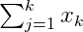 and Cronbach’s alpha is defined to be
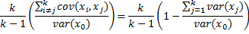
Property 1: Let x_{j} = t_{j} + e_{j} where each e_{j} is independent of t_{j} and all the e_{j} are independent of each other. Also let x₀ = 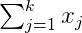 and t₀ = 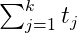. Then the reliability of x₀ ≥ α where α is Cronbach’s alpha.

Table 4.1: Reliability Analysis
Question | Cronbach’s | No of item | No of respond.
Challenges/Constraints to the development of MFIs in Tanzania | 0.812 | 80 | 5
How poor rural households and small Enterprises have access to loans | 0.945 |  | 3
Conditions and procedures of MFIs favor the loan beneficiaries | 0.956 | 80 | 6
The goal of borrowing from MFIs | 0.7 | 80 | 5
Training given by MFIs to loan users | 0.851 | 80 | 5

Source: researcher, 2017
The analysis presented by Table 4.1 indicates that the reliability coefficients of conditions and procedures of MFIs favor the beneficiaries and how poor rural households and small enterprises are excellent, while the reliability coefficients challenges to the development of MFIs, training given by MFIs to loan users are good but the goal of borrowing from MFIs is acceptable.

4.3 Socio-Economic Data

4.3.1 Gender Distribution of Sample Rural Households
The questionnaires used to collect data include the demographic data such as gender and age of the respondents. From the sample population size of four hundred (400), three hundred and fifty (350) were individual rural households and fifty (50) were other stakeholders including staffs from financial institutions, political leaders, official of MFIs, Local Government workers and microfinance practitioners.

Table 4.2: Gender Distribution
Gender Frequency Percentage
Female 163 46.6%
Male 187 53.4%
Total 350 100%

Sources: compiled from field data

From the Table 4.2, total numbers of 163 respondents representing 46.6% of the total sample population were female while the total numbers of 187 respondents representing 53.4% of the total sample population were male. So we can clearly observe that there is a greater number of male participants than female this may be due to the stratified simple random sampling techniques used in this study. Hence this data gathered from questionnaire forms of rural households only and exclude other stakeholders.

4.4 Age Distribution of the Sample Population

Table 4.3: Age Distribution of the Sample Rural Households
Age Frequency Percentage
Below 25 36 10.3%
25-30 99 19.1%
35-40 72 20.6%
40-45 48 13.7%
45-above 28 8%
Total 350 100%
Mean age 34 Mode 27.5

Sources: Field data

As far as age is concern, the sample populations were categorized in to the following age group below 24 ages, 25-30, 30-35, 35-40, 40-45, above 45 years. The age distribution of the sample population is illustrated in the Table 4.3 and graphical presented in the graph of the Table 4.3.

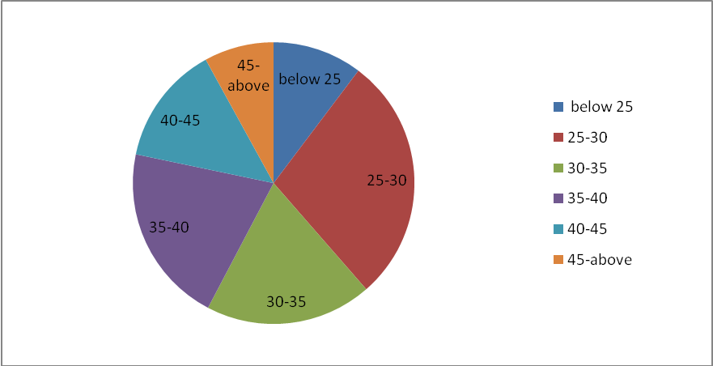

Figure 4.1: Age Distribution of the Sample Rural Households

Sources: Field data
From the Table 4.3 and Figure 4.1, we clearly observe that out of three hundred and fifty (350) respondents, thirty six (36) respondents representing 10.3% of the total sample population were aged below 25 years, Ninety nine (99) respondents representing 28.3% were aged between 25 to 30 years, Sixty Seven (67) respondents representing 19.1% were aged between 30 to 35 years, Seventy two (72) respondents representing 20.6% were aged between 35 to 40 years, Forty Eight (48) respondents representing 13.7% were aged between 40 to 45 years and Twenty Eight (28) respondents representing 8.0% were aged above 45 years.

4.5 Type of Family and Family size of the Population
As far as family size is concern, the sample populations were categorized in to the following age group below 5 members, 5-10, and 10-15 and above 15 members. In another hand the type of family were classified into nuclear family i.e. the family made up of two parents and their children, Extended family i.e. the family made up of two parents, their children and other relatives and finally single parent family i.e. the family made up of one parent and his/her children. The family types and size distribution of the sample population is illustrated in the Table 4.4.

Table 4.4: Family Data
Family size Frequency Percentage Type of Family Frequency Percentage
Below 5 60 17.2% Nuclear 113 32.3%
5-10 145 41.1% Extended 204 58.3%
10-15 102 29.1% Single Parent 33 9.4%
Above 15 43 12.3% Total 350 100%
Total 350 100%
Mean Size 9 Modes 6
Source: Field data
From the Table 4.4; it is clearly shown that most of the rural families are of extended families in nature i.e. the family is comprised of two parents, their children and other relatives such as grandmother ,uncles etc. the number of extended families are two hundred and four (204) representing 58.3% of the sample population, it is followed by nuclear family that are one hundred and thirteen (113) representing 32,3% of the sample population and finally the single parent families that are thirty three (33) representing 32,3% of the sample population.

In another hand the family size of the most of the rural families lie between 5-10 members, this is due to the fact that birth rate in the rural areas is high as compared to the urban areas, one hundred and forty five (145) of the respondents representing 41.4% of the sample population have family size comprising of 5-10 members, this is followed by the family size ranging between 10-15 members represented by the 29.1%, 17.2% of the respondents live in the family of below 5 members while 12.3% 17.2% of the respondents live in the family of above 15 members. The mean family size of the rural family is nine (9) members and mode is 6 family members.

4.6 Educational Information
In order to gather education related data, the sample population was categorized into those with formal education, informal, both formal and informal and those who have nor forma nor informal education. Furthermore those respondents who possess formal education were categorized into primary level. Secondary, Diploma, Degree and Post graduate. The Table 4.5 shows frequency distribution of these data and graphically presented in Figure 4.1.

Table 4.5: Distribution for Educational Data

Frequency distribution for form of education Distribution of households’ formal education
____________________________________________________________________
Education Frequency Percentage Level of formal Frequency %
Formal 60 17.1% Primary 91 42.7%
Informal 137 39.1% Secondary 66 30.9%
Formal& informal 153 43.7% Diploma 29 13.6%
Total 350 100% Degree 21 9.9%
Postgraduate 6 2.8%
Total 213 100%
Source: Field data

From the Table 4.5 & Figure 4.2 and 4.3, it is clearly shown that most of the rural households have informal education than formal education; this is presented by the 29.1% of respondents who possess informal education only as compared by 17.1% of respondents who possess the formal education only and followed by 10% of the respondents who have no formal nor informal education. One hundred and fifty three (153) respondents possess both formal and informal education while sixty (60) possess formal education only, hence this make the total respondents possess the formal education be two hundred and thirteen (213).
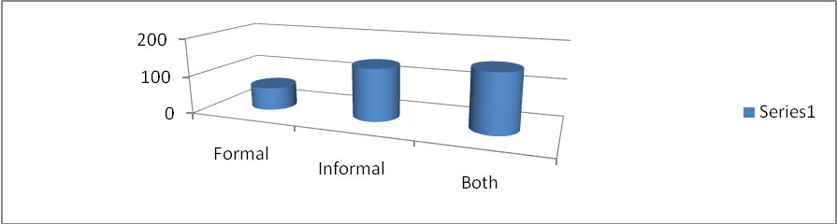

Figure 4.2: Graphical Presentation of Educational Data

Sources: Field data

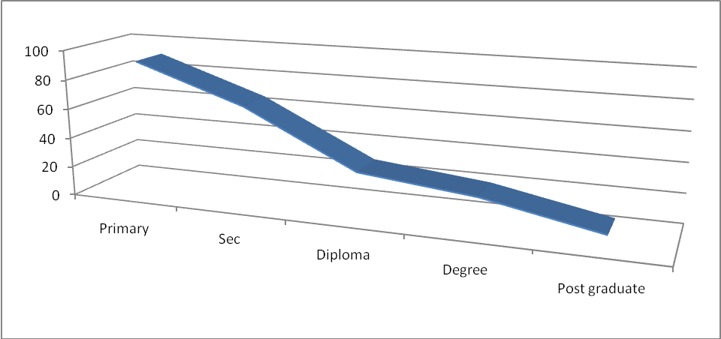

Figure 4.3: Graphical Presentation of Households with Formal Education

Sources: Field data

The number of rural households who have formal education has decreasing trends from primary education to high level education, this is clearly shown in the table above whereby 42.7% of the respondents with formal education have primary level followed by 30.9% of the respondents possess the secondary education, respondents possess diploma level education is 13.6% followed by Degree and Postgraduate level who occupy 9.9% and 2.8% respectively.

4.7 Households’ Major Economic Activities
The major households’ economic activities are categorized into farmers, Pastoralist, Fishermen, Trader, official employee and other. The Table 4.6 shows the frequency distribution of these data.

Table 4.6: Distribution of Households’ Economic Activities
____________________________________________________________________
Occupation Frequency Percentage Forms of farming Frequency %
____________________________________________________________________
Farmers 152 43.4% Subsistence 94 61.8%
Pastoralist 84 24% Commercial 30 19.7%
Fishermen 31 8.9% Both 28 18.4%
Trader 39 11.1% Total 152 100%
Official employee 29 8.3%
Other occupation 15 4.3%
Total 350 100%

Sources: Field data

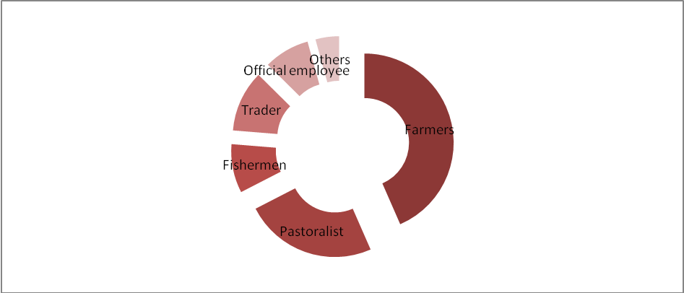

Figure 4.4: Distribution of Households’ Economic Activities

Sources: Field data
From the Table 4.6 and Figure 4.4, total respondents of one hundred and fifty two (152) representing 43.4% of the sample population are farmers followed by eighty four (84) representing 24%, thirty nine (39) respondents representing 11.1% of the sample population are traders followed by fishermen, official employee and other occupation who are representing 8.9%, 8.3% and 4.3% respectively. Most of the rural households are famers due to the fact large area in the rural is of agricultural land as compared by urban land that is largely built-up area, also most of them are uneducated in such a way that they unable to work in official institution also many economic activities are in urban areas than in rural areas so this it become difficult for rural households to engage in business occupation.

4.8 Households’ Participation in Microfinance
From the Table 4.7 and Figure 4.4 ,only 95 households representing 27.1% are the participants in the microfinance industry and the remaining households of about 72.9% are not participate in the microfinance industry .

Table 4.7: Households’ Participation in Microfinance
____________________________________________________________________
Participation Frequency Percentage Participants Frequency %
____________________________________________________________________
Participants 95 27.1% SACCOS 30 28.6%
Non participants 255 72.9% Bank 49 46.7%
Total 350 100% FinNGOs 26 24.8%
Other NGOs - -
Total 105 100%
____________________________________________________________________

Source: Field data

Out of 95 households who are microfinance participants, 49 households representing 46.7% of the microfinance participants are the bank account holders and the remaining are members of SACCOS and member of other FinNGOs who are thirty (30) and twenty six (26) represented by 28.6% and 24.8% respectively. The total number of household microfinance participants exceeds ninety five (95) as some households participate in more than one MFI.

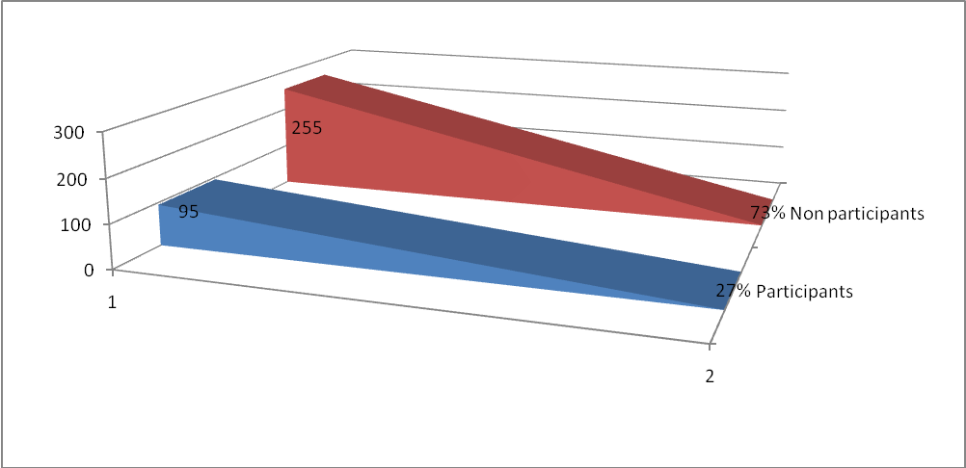

Figure 4.5: Households’ Participation in Microfinance

Sources: field data

4.9 Constraints of the Microfinance Industry in Tanzania: Overview
Despite the speedy progress of the microfinance sector in Tanzania, the sector still face a some challenges that hinder its effectiveness in providing loans in Tanzania. In order to find out the constraints/challenges facing the microfinance sector, the respondents were required to express their opinions on what challenges face the microfinance sector in Tanzania in such a way that it cannot meet effectively the demand of financial services especially to poor rural households in Tanzania. The respondents were required to select the possible challenges or to specify other challenges that they perceive to face the microfinance sector in Tanzania, the possible challenges face the microfinance sector in Tanzania set in questionnaires were loan repayment, Qualification criteria for loan disbursement, inadequate capital of MFIs, poor support from the MFIs, few MFIs that meet need, Poor regulation and supervision of MFIs in Tanzania and others. Table 4.8 shows the frequency distribution of the data.

Table 4.8: Challenges Face the Microfinance Industry
____________________________________________________________________
Challenges Frequency Percentage
____________________________________________________________________
Loan repayment 88 19%
Loan disbursement 96 20.7%
Inadequate MFIs capital 60 13%
Poor support from MFIs 77 16.6%
Few MFIs in area 79 17.1%
Poor regulation and supervision of MFIs 40 8.6%
Other 23 5%
Total 463 100%
______________________________________________________________________________________________________

Source: Field data for individual Households questionnaires

From the Table 4.8, we can see that the total number of respondents is four hundred and Sixty three (463) above the sample size this is due to the fact that some respondents perceive more than one challenge face the Microfinance Industry in Tanzania and choose more than one answer in this question. A total of 96 respondents representing 20.7% of total respondents state that the principal challenge face the Microfinance Industry in Tanzania is the Qualification criteria set by MFIs for the one to be disbursed for the loans.
The respondents explained that most of rural households not qualify for the loan disbursement due to poor record keeping of their business, not able to prepare the business plan for their intended investment/expansion that need to be financed by the loan, most of them have no collateral and so forth. Eighty eight (88) respondents representing the 19% state that the principal challenge face the Microfinance Industry in Tanzania is the clients’ unwillingness/dishonest or inability to repay the loan within the stipulated time ,hence this affects the liquidity of the MFIs and thus slow the disbursement of the loans to other customers, the respondents explained that the loan recovery problem is contributed by high interest rate, customers’ defaults and loss for the business in which the loan was taken.

Sixty (60) respondents representing 13% state that the principal challenge face the Microfinance Industry in Tanzania is inadequate capital of MFIs to disburse the loan and meet the existing demand of the loans and credit. Seventy Seven (77) respondents representing 16.6% state that the principal challenge face Microfinance Industry in Tanzania is poor support of MFIs to their clients such as lack of entrepreneurial skills including business record keeping, marketing skills, business proposal writing and lack of monitoring and evaluation to loan/credit beneficiaries.

Seventy Nine (79) representing 17.1% state that the principal challenge faces the Microfinance Industry in Tanzania is small number of MFIs in the rural areas that can not meet the growing demand of finance services in the rural area, this is followed by forty (40) and twenty three (23) respondents representing 8.6% and 5% state that the principal challenge faces the Microfinance Industry is poor regulation and supervision of MFIs and other challenges respectively

4.10 Detailed Assessment for Constraints to Access to Rural Finance

A: Challenge to Loan repayment i.e. cost of borrowing;
The cost of borrowing that made up of transaction cost and interest rate that are charged to the borrower is too high to support the rural SMEs, whereas the landing rate of MFIs lie between 20% to 30% while the deposit interest rates in below 5% per annum and the annual inflation rate is 8.3% in May, 2013 that make the real interest rate on deposit become below 2% per annum which enough to discourage saving among the rural households and limit the potential borrowers to enjoy the loan (Faustine K.Bee,2007,National Bureau of Statistic.

In order to get overviews of interest rate charged in various forms loans, the respondents were asked to identify/estimate the interest rate charged on their loans undertakings in the last three years. Table 4.9 summarizes the data. From the Table 4.9 and figure 4.5, it is clearly shown that majority of the rural households get informal loan with free interest rate largely from their relatives or friends, personal saving and Rotating Saving and Credit Association (ROSCA) this is due to the rural communities cultures and religious believes that foster the habits of helping each other when one is shortage of fund or need fund for investment or other purpose.

Always there is no written agreement in these loans and rarely associated with collateral whereby the borrower receive the loan and promise to pay it the determined future time. Forty two (42) form respondents received loans from the relatives/family of which 36 respondents charged free interest rate and 6 respondents charged the interest rate of 0%-10%,thirty respondents received loan from merchants of which 11 respondents,15 respondents and 4 respondents charged interest rate of 1%-10%,11%-20% and 21%-30% respectively, three respondents received loan from their employee of which two respondents and one respondents charged the interest rate of 11%-20% and 21%-30% respectively, twenty eight and forty five respondents received fund from the ROSCA and personal saving with free interest rate and the remaining thirty eight respondents received their loans from other informal sources of which seven, nineteen, eleven and one respondents charged the interest rates range 0%,1%-10%,11%-20% and 21%-30% respectively. The mean interest rate is 4.03% and the interest rate with highest frequency i.e. mode is 0%.
.

Table 4.9: Distribution of Interest Rates on Informal Loans
_____________________________________________________________________________________________________

Interest rate
Sources Frequency 0% 0% -10% 11% -20% 21% -30% Above 30%
____________________________________________________________________
Relatives/Friend 42 36 6
Merchants 30 11 15 4
Employer 3 2 1
ROSCA 28 28
Personal saving 45 45
Others 38 7 19 11 1
Total 186 116 36 28 6
Mean interest rate 4.03%
Mode 0%
__________________________________________________________________

Sources: Field data

From the Table 4.10 and Figure 4.7, it is clearly shown that majority of the rural households who get formal loan are charged high interest rate. Nineteen (19) respondents out of the twenty six (26) respondents who received loan from SACCOS charged interest rate lie between 21%-30% followed by seven (7) respondents charged the interest rate lie between 11%-20%, twenty two (22) respondents received loan from FinNGOs whereby eighteen (18) of them charged the interest rate between 21%-30% and the remaining four (4) respondents charged the interest rate lie between 11%-20%, twelve (12) respondents out of the twenty one (21) respondents who received loan from Bank charged interest rate lie between 11%-20% and the remaining nine (9) respondents charged the interest rate lie between 21%-30%,the mean interest rate is 20.3% and the interest rate with high frequency rate i.e. Mode is 23.8%.

Generally the majority of the respondents received the loan from the various formal sources were charged the interest rates between 21%-30%, this is clearly presented in the Figure 4.6.

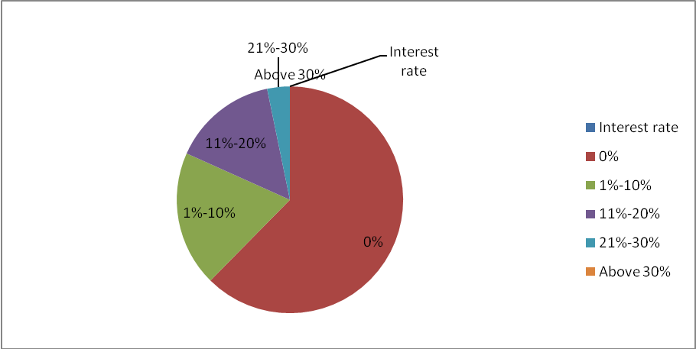

Figure 4.6: Distribution of Interest Rates on Informal Loans

Sources:field data

Table 4.10: Distribution of Interest Rates on Formal Loans
____________________________________________________________________

Interest rate
Sources Frequency 0% 0% -10% 11% -20% 21% -30% Above 30%
____________________________________________________________________
SACCOS 26 7 19
Government Program 6 4 2
FinNGOs 22 4 18
Bank 21 12 9
Other -
Total 75 4 2 23 46
Percentage 100% 5.3% 2.7% 30.1% 61.3%

Mean interest rate: 20.3%

Mode 23.8%
____________________________________________________________________

Sources: Compiled from field data

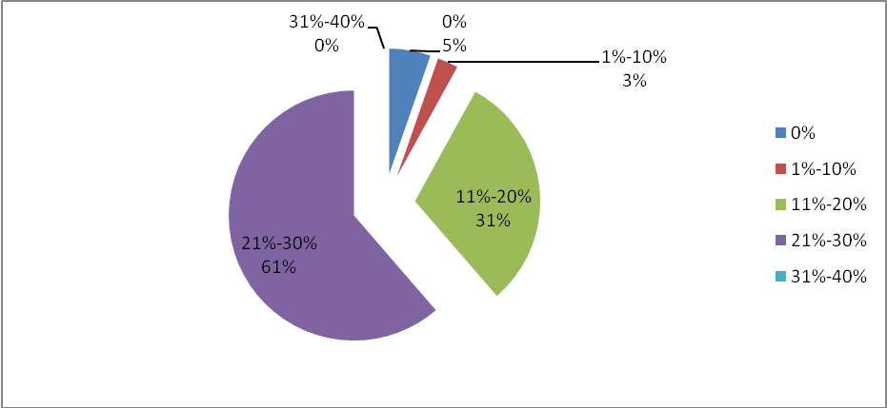 Figure 4.7: Distribution of Interest Rates on Formal Loan
Sources: Field data
Despite of the high interest rate charged to loan borrowers but is still there is another cost associated with the loan which is still high as well; these are referred to the transaction cost that may be explicit or implicit cost. In addition ,the borrower incur other loan associated cost such as application fees, services fees, ledger fees, cost of photograph for passport size, time spent on loan processing, collateral ,business registration, business proposal, Audited accounts, minimum non withdrawal balance, travel time and cost of searching the referee. Table 4.11 illustrates the transaction cost charged by four MFIs namely, NMB, TPB, Berclays Bank and PRIDE Tanzania.

Table 4.11: Loan Associated Transaction Cost
S/n | Types | Forms of cost | Cost bearer
1 | Loan requirements | - Collateral  - Business registration  - Business records  - Audited accounts  - Minimum non-withdrawal balance  - Minimum deposit balance | Borrower
2 |  | - Services charges and Travel cost  - Application fees  - Cost of photographs  - Time spent of loan processing  - Searching for referee  - Searching for other members to form a group  - Time spent on attending weekly meetings. | Borrower
Sources: Modified from Faustino K. Bee, 2007 in table 7.18

B: Poor Support from MFIs;

The evidence from the field gathered data show that most of the MFIs offer only financial services and only few of them offer non financial services which are supporting services to the borrower in ensuring that they use the loan in profitable investment and building capacity in the business management such services are advisory services, business training such as project write up, business proposals, costing and price determination techniques, business record keeping, marketing, etc and monitoring and evaluation services.

Out of three hundred and fifty (350) surveyed rural households only fifty three (53) respondents representing 12.3% received non-financial services ,from which only thirty two (32) representing 9.1% of the total respondent received non-financial services from MFIs followed by fifteen (15) representing 4.3% received non-financial services especially business training while they are at school and the remaining six respondents representing 1.7% received non-financial services from the government program.

Table 4.12: Households Received Non Financial Services
____________________________________________________________________
Institution frequency percentage%
____________________________________________________________________
MFIs 32 60.4%
School 15 28.3%
Government Program 6 11.3%
Total 53 100%
____________________________________________________________________

Source: Field data

Out of the thirty two (32) respondents who received non-financial services from MFIs seventeen (17) respondents received the advisory services only , twelve (12) respondents received the business train only and only three (3) respondents received the monitoring and evaluation services only while five (5) respondents received more than one financial services. Table 4.13 and 4.14 illustrates these finding.

Table 4.13: Non Financial Services received by Households
____________________________________________________________________
Non Financial services Frequency Percentage
____________________________________________________________________
Advisory services only 17 45.9%
Business training only 12 32.4%
Monitoring and evaluation services 3 8.2%
More than one services 5 13.5%
Total 38 100%
____________________________________________________________________

Source: Field data

General the data show that level of non financial services offered by MFIs is unsatisfactory as many MFIs specialized only with financial services such as landing and saving services while ignoring the non financial services that support the loan borrowers in utilizing the loan profitably which will deteriorates the loan repayment and slow the offering of the loan to other households which depend on the loan repayment.

C: Limited number of MFIs in Rural Areas;
Seventy seven (77) respondents from the Individual households’ questionnaires state that the principal challenge of Microfinance Industry is the limited number of MFIs in the rural areas that limit the supply of financial services to meet the demand of the financial services in the rural areas. According the survey done to the five banks which operate their business in Unguja show all five banks have 10 branches in Town West region of Unguja which is urban region and have thirteen ATMs which located in various areas of Town West region of Unguja whereby there is no single branch or ATM in any of the Unguja South Region and Unguja North Region which are rural regions. Hence these data justify that rural finance is limited with small number of MFIs operating their business in the rural areas as compared to the urban areas. Table 4.14 illustrates these arguments.

Table 4.14: Distribution of number of MFIs in Unguja
_____________________________________________________________________________________________________
Rural Town
MFIs Number Number
____________________________________________________________________
SACCOS Data not available to date
Bank branches Nil 10
FinNGOs Data not available to date
ATM Nil 13
Community Village Banks Nil -
Sources:http://www.barclays.com,http://www.crdbbank.com,www.pbltd.com, http://www.postalbank.co.tz/atm-network, http://www.nmbtz.com

D: Loan Requirements;

In order for one to access the loan from the MFIs must meet the loan requirements set the MFIs ,MFIs set various requirements for various kinds of loans where by some of them seem to be difficult for rural households to meet hence this limit them to access the loan from MFIs such loan requirements seem to limit the rural households in accessing the loan are employment guarantee, MFIs’ customer proper business records ,secured collateral and business registration Table 4.15 illustrate the loan requirements set by some MFIs.

Table 4.15: Loan Requirements Set by Some MFIs
Name of MFIs | Type of Loan | Loan requirements
Barclays Bank Tanzania | Unsecured personal loans | - loans for private purposes granted to NBC customers who have shown a constant regular stream of income for a period defined by the bank  - Minimum loan is TZS 1,000,000 and maximum is TZS 20,000,000  - Maximum repayment period is 48 months  - Credit life insurance is a compulsory  - Applicants must have banked with NBC for at least 12 months.
Barclays Bank Tanzania | Overdraft | - These are loans granted in local currency or USD for various purposes depending on the nature of the business.  - Repayment is deducted on monthly basis from borrowers and period of payment is between 12 and 60 months  - Secured collaterals as stipulated in NBC’s Credit Policy
National Microfinance Bank (NMB) | Micro and Small Enterprises (MSE) Loans | - Applicant must be at least 18 years of age  - Business must have a steady cash flow.  - Applicant must have proper recording system and also shows the capability of operating business profitably  - The borrower must have business license/permit from local authorities in his or her own name  - Applicant must open or have a business or personal account with NMB
People Bank of Zanzibar (PBZ) | Personal loan | - Personal loans to salaried employees in both government and private sectors
PRIDE Tanzania | Ajira Loan Product | - The product is targeting employees in the government and other reputable organizations.  - Employers guarantee their employees.  - Less than a week processing time  - Loan sizes range from Tshs 100,000 to TShs. 15Million or 15 times gross salary etc.
Sources: Respective MFIs websites visited on 15th June, 2016

According to the data collected from questionnaires revealed that the major challenges face the Microfinance industry in rural areas is the loan requirements including assets for loan security as most of the rural households lack the ownership of valuable asset that qualify for collateral especially in long term development loan, researcher intended to explore the capacity of rural households to own the properties such as land or buildings that they can use as collateral to access the long term loan, In collaboration with researcher the households required to estimate value of the immovable properties they own. The result is summarized in the Table 4.15.

Table: 4.15: Estimated Values of Households Immovable Properties
____________________________________________________________________
Estimated Value Frequency %
____________________________________________________________________
Below 3,000,000/- 136 41.9%
Up to 6,000,000/- 149 45.8%
Up to 9,000,000/ 28 8.6%
Above 9,000,000/- 12 3.7%
Total 325 100%
Mean TSH 3,669,230/- Mode TSHS 3,291,045/=
____________________________________________________________________

Source: Field Data
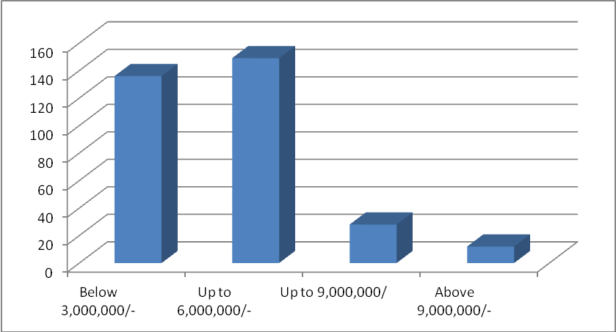

Figure: 4.8: Estimated Values of Households Immovable Properties

Sources: field data

From the Table 4.15 and Figure 4.8 it is clearly revealed that only twelve (12) respondents representing 3.7% of the sample households own the immovable properties that has estimated value of the above Tanzania Shillings Nine Millions (10,000,000/-),this is to say that they can access the loan of the equivalent amount, twenty eight (28) respondents representing 8.6% own the immovable properties that has estimated value of the above six millions and below nine millions, one hundred and forty nine (149) respondents representing 45.8% own the immovable properties that has estimated value of the above three millions and below six millions and the remaining one hundred and thirty six (136) respondents representing 41.9%.

Own the immovable properties that has estimated value of the below three millions. From the above data more than eighty six percentage (86%) of the households own the immovable properties have the estimated value of below Tanzania Shillings six millions (6,000,000/-) ,The mean value of the rural households owned immovable properties is Tsh 3,669,230/-, the modal value is Tsh 3,291,045/- .So from this evidence we can clearly state that majority of the rural households not own the high valuable immovable properties that they can use as security for the long term development loan which normally become huge loan as compared to short term loan, this is due to the fact that most of the rural house are made up of local building materials as seen in the Picture 1 above.

Another form of security is used in the loan disbursement is the employment guarantee, this security fever only official employee where their employment act as guarantee for them to access loan from MFIs, the fact is that most of the rural households are self employee so they can not access these kinds of loan as they don’t meet this requirements. Table 4.16 illustrates the distribution of rural households occupations.

Table 4.16: Rural Household’s Occupation
Distribution of household’s occupation Distribution of self employee
Occupation Frequency % Occupation Frequency %
____________________________________________________________________
Official employee 53 15.1% Farmers 142 44.7%
Self employee 318 84.9% Pastoralists 82 25.8%
Total 371 100% Fishermen 43 13.5%
Mode 318 Traders 51 16%
Others
Total 318
Mode 142
Sources: Field Data

From the Table 4.16, it is clearly shown that fifty three (53) representing 15.1% of the total households are official employee thus they can access the loan that need employment Guarantee while the remaining majority of the rural households are self employee who are not eligible for the loan that need employment guarantee such loan are ajira loan product of the Pride Tanzania, unsecured Premier Life loan of the Barclays Bank and personal loans of PBz, as shown in the Table 11.3 three hundred and eighteen (318) households representing 84.9% of the total households are self employees into various economic sectors, out of which one hundred and forty two (142) representing 44.7% are farmers ,eighty two (82) representing 25.8% are pastoralist and the remaining are forty three (43) and fifty one (51) representing 13.5% and 16% are fishermen and traders respectively.

In order to access the loan from the bank, most banks offer loan to their customers who hold the accounts in their banks, in another hand most of the rural households are not aware with bank services in such a way that most of them prefer to save their small money at their home instead of saving at bank, the researcher intended to explore the degree of rural households’ responsiveness to saving services offered by the bank. Table 4.17 illustrates the rural households holding the bank account.

From the Table 4.17, only fifty one (51) households representing 14.6% of the total sample households hold the bank account while two hundred and ninety nine (299) representing 85.4% of the total sample households do not hold the bank account. Generally we can say that 85.4% of the rural households have no bank account so they are non potential loan customers of the most commercial bank as they don’t meet the loan requirements of having the bank, in another hand only 14.6% of the of the total sample households have the bank account so they are potential to the loan offered by the most of the commercial bank.

Table 4.17: Rural Households hold Bank Account and their form of Education
____________________________________________________________________
Account holding Frequency % A/C Holders Frequency %
____________________________________________________________________
A/C holders 51 14.6% Formal 36 70.6%
Non A/C holders 299 85.4% Informal 15 29.4%
Total 350 100% Total 51 100%
____________________________________________________________________
Source: Field data

Another loan requirements set by the MFIs in loan disbursement especially in the short and medium loans is the proper business records that that shows business cash flow, statement of comprehensive income and statement of financial position. Most of the rural MSEs fail to keep proper records of their business as they have no knowledge of accounting and other perceive to be time wasting. Table 4.18 illustrates distribution of rural households/MSEs who keep business records.

Table 4.18: Distribution of Rural Households who Keep Business Records
Record keeping Frequency %
____________________________________________________________________
Keep records 33 9.4%
Don’t keep records 317 90.6%
Total 350 100%
____________________________________________________________________

Sources: field data

From the Table 4.18, only thirty three (33) households representing 9.4% of the total households keep the business records even in unscientific system but at least they are able to indicate their annual business profit and financial position of their business, they can at least meet the loan requirements of having the proper business records, the remaining three hundred and seventeen (317) representing 90.6% they do not keep the records to their business so they are ineligible for the loan that require the proper records of the business of which the loan is applied for.

Another requirements for business loan disbursement is the registration of the business that accompanied by the certificate of registration, business licenses, TIN and VAT registration, Most of the rural households did not register their business in such away they fail to access for loan as they do not have the legal documents of the business in which the loan is applied for. Table 4.19 illustrates the distribution of rural households registered business.

Table 4.19: Distribution of Rural Registered Business
____________________________________________________________________
Business registration frequency % Registered Frequency %
___________________________________________________________________
Registered 57 16.3% Farmers 2 3.5%
Unregistered 293 83.7% Pastoralists 0 0%
Total 350 Fisherman 10 17.5%
Traders 45 79%
Other occupation 0 0%
Total 57 100%

Sources: Field data

From the Table 4.19 fifty seven (57) households representing 16.3% of the total households under research registered their business of which forty five (45) representing 79% of the registered business are traders followed by Fishermen and Farmers who are ten (10) and two (2) representing 17.5% and 3.5% respectively while no pastoralist who registered his/her business. In another hand two hundred and Ninety three (293) representing 83.7% did not registered their business. Generally most of the rural households deals with livestock keeping business did not register their business and few farmers and fishermen register their business while majority of the traders especially single unit shops that are alongside the roads make their business registered, this is due to the fact that most of the traders are harassed by the Municipal Council officers when they are met with no business licenses from relevant Government Authority.

In general term we say that more than 83.7% of the rural households did not register their business in such a way that they have no legal documents of their business such as business licences, so they are ineligible for some loan disbursement as they did not meet some of the loan requirements set by the MFIs. In addition, there is additional cost incurred in the loan application process such cost are services fees, travel cost .cost of photograph etc.

D: Poor regulation and supervision of MFIs;
“Promotion and expansion of rural financial services is facilitated by appropriate microeconomic policy environment, legal and regulatory framework in place” (Faustine K. Bee, 2007). According to the responses of microfinance stakeholders and rural households in individual questionnaires supplied to them revealed that one of the major challenge faces the microfinance industry in Tanzania is the weak regulatory and legal framework of Microfinance industry in the country. The regulatory and legal framework of Microfinance industry in Tanzania is well presented in the chapter Two of this report, through the responses of the Microfinance stakeholders in individual questionnaires who required to provide their comments on the currents regulatory and legal framework of Microfinance industry in Tanzania and through the review of the various reports and publication the researchers revealed the following major weakness underlying the regulatory and legal framework of Microfinance industry in Tanzania:-

Ceiling on unsecured loans by licensed banks: the Bank of Tanzania (BOT) through its The Banking and Financial Institutions Act of 2006 and its regulation of 2008 require the licensed banks to offer unsecured loan to single borrower not exceeding 5% of the bank capital, Most of the Microfinance Practitioners argue that this ceiling is very low in such a way that it limit the capacity of the bank to offer unsecured loans and limit the supply of loan financial services especially to the bank deals with rural finance such as community Village Banks and rural unit banks which their capital is too low. Table 4.19 illustrates the limit of unsecured loan by the banks.

From the Table 4.20, the amount of unsecured loan offered by the bank to the single borrower is limited, most of the MFIs operating in rural areas such as are Regional Unit Commercial Bank and rural unit bank have less amount of unsecured loan that they can offer to their clients which range between Tsh. 2.5 Millions to Tsh 10 Million as compared to most of commercial banks and MFCs that centralize mostly in the urban areas and having less branches in the rural areas, this make the chance of urban households to access large amount of unsecured loan to be higher than rural households.

Table 4.20: Ceiling of Unsecured Loan of the Bank
Type of Bank | Maximum required Capital | Ceiling of unsecured loan to single Borrower
Regional Unit Commercial Bank | Tsh 200Millions | Tsh 10 Millions
Rural Unit Bank | Tsh 50 Millions | Tsh 2.5 Millions
Non-Bank Financial Institution | Tsh 100Millions | Tsh 5 Millions
Micro Finance Company | Tsh 800 Millions | Tsh 40 Millions
Financial Cooperative | Tsh 800 Millions | Tsh 40 Millions
Commercial Bank | Tsh 5 billions | Tsh 250 Millions
Source: Compiled from Capital Adequacy Regulations, 2001-Tanzania and Banking and Financial Institutions regulation of 2008

Ceiling on Fixed Assets; the Bank of Tanzania (BOT) through its regulation of Banking and Financial Institutions of 2008 impose the ceiling of the capital expenditure such as ATM Machines, furniture, electronic equipments and construction of office buildings made by the bank up to 10% of the capital of the bank, Most of the Microfinance stakeholders argue that this ceiling is very low in such a way that it limit the efficiency and outreach of the bank especially those deals with rural finance such as community Village Banks and rural unit banks which their capital is too low. Table 4.21 illustrates the ceiling of fixed assets.

Table 4.21: Ceiling of Fixed Assets
Type of Bank | Maximum required Capital | Ceiling of Capital expenditure
Regional Unit Commercial Bank | Tshs 200Millions | Tshs. 20 Millions
Rural Unit Bank | Tshs 50 Millions | Tshs. 5 Millions
Non-Bank Financial Institution | Tshs 100Millions | Tshs. 10 Millions
Micro Finance Company | Tshs 800 Millions | Tshs. 80 Millions
Financial Cooperative | Tshs 800 Millions | Tshs 80 Millions
Commercial Bank | Tshs 5 billions | Tshs 500 Millions
Source: Compiled from Capital Adequacy Regulations, 2001-Tanzania and Banking and Financial Institutions regulation of 2008

Outreach of the MFIs depend on their level of capital expenditure of such as construction of new office branches and ATM and efficiency of the MFIs depend on effective working equipments such as computer, communication equipments, servers etc that are categorized as fixed assets, the MFIs outreach and efficiency is limited by ceiling of fixed assets expenses imposed by the BOT whereby ceiling of fixed assets expenses of rural specialized banks such as community Village Bank, Regional Unit Commercial Bank and rural unit bank is too low that range between Tsh 5 millions to Tsh 20 Millions as per Table 4.21, this amount is lower than the other bank with large capital and mostly operate their business in the large cities urban areas.

Bureaucracy of judiciary system: Most of the microfinance stakeholders including banks staffs complain on judiciary system of Tanzania that take too long time to make judgment on the cases brought to them by MFIs concerning on forfeiture of default customers’ properties, hence this increase the fear of MFIs on loan repayment rates and may result in interest rate increase and slow down the issue of loan to others.

Other microfinance constraints associated with policy environment, legal and regulatory framework in Tanzania are:-
- Impact of taxes on the cost of commercial and financial transactions
- Inadequacy and lack of qualified staffs of regulatory and supervisory Authorities such as BOT, Ministry of Finance, Ministry deals with cooperative both in Tanzania Mainland and Zanzibar in supervising the MFIs such as Community Village Bank, SACCOs etc.
- Institutional constraints of such as property rights and registries and presence of functioning credit bureau that provides information to both borrowers and Lenders.

4.11 Summary
According to the opinions of many respondents the microfinance industry still faces a number of challenges such as conditions and terms of loan, inadequate capital of MFIs, poor support from the MFIs, few MFIs that meet need and poor regulation and supervision of MFIs. Most of the rural households who received the loan from formal sources were charged the interest rate between 21%-30% which relatively large for growth of rural small enterprises while most of the rural households who received the informal loans charged free interest rate and few of them charged interest rate of below 10%.,other cost charged to borrowers are application fees, services fees, ledger fees, cost of photograph for passport size, time spent on loan processing, collateral ,business registration, business proposal, Audited accounts, minimum non withdrawal balance, travel time and cost of searching the referee.

Most of the MFIs offer only financial services and only few of them offer non financial services which are supporting services to the borrower in ensuring that they use the loan in profitable investment and building capacity in the business management such services are advisory services, business training such as project write up, business proposals, costing and price determination techniques, business record keeping, marketing, and monitoring and evaluation services.

The supply of rural finance is still limited as there is limited number of MFIs in rural areas as compared to the urban areas, most of the banks operate in urban areas and only few FinNGOs and SACCOS operate their business in the rural areas which can not meet rural finance demand. Criteria of loan disbursement still limiting factors for rural households’ access to finance because most of them can not meet those criteria, such as criteria are business registration as most of them do not register their business, lack of proper business records, not holding account in the bank, official employment where employment act as guarantee, ownership of collateral properties such as house, motor vehicle etc.

Other microfinance constraints are associated with policy environment, legal and regulatory framework in Tanzania, such constraints are Bureaucracy of judiciary system that prolong the among other things the MFIs related cases, low ceiling on unsecured loans by licensed banks imposed by BOT, low ceiling on Fixed Assets, Impact of taxes on the cost of commercial and financial transactions, Inadequacy and lack of qualified staffs of MFIs regulatory and supervisory Authorities.

4.12 Major Sources of Finance those Rural Households are Access to: An Assessment
One of the specific objectives of the research was to assess the major sources of finance that rural households are access to, the individual households were requested to select the sources of finance in the set of various sources given in the individual questionnaires form. Detailed distribution of the rural households’ sources of finance is summarized in the Table 4.22.

Table 4.22: Rural Households’ Sources of Finance
____________________________________________________________________
Form of Finance Frequency %
____________________________________________________________________
Formal 98 26.6%
Informal 270 73.4%
Total 368 100%
____________________________________________________________________

Sources: field data

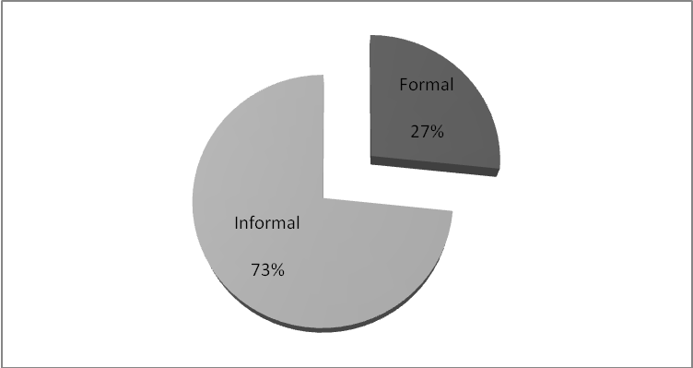

Figure 4.9: Rural Households’ Sources of Finance

Sources: Field data

From the Table 4.22 and Figure 4.7, ninety eight (98) households representing 26.6% of the surveyed rural households access the finance through formal sources of finance such as Commercial banks, SACCOs, FinNGOs and Government agency/Program while majority of rural households who are two hundred and seventy (270) representing 73.4% of total households are access to informal sources of finance such as relatives/friends and personal saving, the total households exceed three hundred and fifty (350) because eighteen (18) households shared both formal and informal sources of finance. Table 4.23 illustrates distribution of rural households with formal and informal sources of finance.

From the Table 4.23, out of ninety eight (98) households who access the formal sources of finance, twenty eight (28) households representing 28.6% access their finance from SACCOs followed by twenty three (23) households representing 23.5% access their finance from FinNGOs, the remaining are twenty one (21) households representing 21.4% and fourteen (14) representing 14.3% access their finance from commercial bank and Government Agency/Program respectively.

Table 4.23: Distribution of Rural Households Accessing the Formal Form of Finance
____________________________________________________________________
Formal Sources of Finance Informal Sources of Finance
Sources of Finance Frequency % Sources of Finance Frequency %
____________________________________________________________________
Commercial Bank 21.4% Personal saving 173 61.1%
Community Village Bank - 0% Relatives/friends 54 19.1%
FinNGOs 26 26.5% Others 56 19.8%
Government Agency/Program 8 8.2%
Total 283 100%
SACCOs 28 28.6%
Other Specify 4 4.1%
Total 98 100%
____________________________________________________________________

Sources: field data

In another hand out of two hundred and seventy (270) households who access the informal sources of finance, one hundred and seventy three (173) households representing 61.1% access their finance through their personal saving while one hundred and ten (110) representing 38.9% access their finance from relatives and friends, total number of households access the informal sources of finance exceed two hundred and seventy (270) because thirteen (13) households shared both sources relative/friends and personal saving.

4.12.1 Sources of Loan at Different Level of Education

Table 4.24 Sources of loan at different level of education
Form of education  Sources of finance | None |  | Primary |  | Above Primary |  | Total
 | No | % | No | % | No | % | No | %
Formal | 19 | 5.5% | 21. | 6.0% | 40 | 11.4 | 80 | 22.9%
Informal | 116 | 33.1% | 63 | 18% | 73 | 20.9% | 252 | 72%
Both | 2 | 0.6% | 7 | 2% | 9 | 2.5% | 18 | 5.1%
Total | 137 | 39.2% | 91 | 26% | 122 | 34.9% | 350 | 100%
Sources: Compiled from field data

From the Table 4.24 and Figure 4.9 and 4.2, eighty (80) households representing 22.9% access the formal sources of loan, out of which forty (40) households representing 11.4% have the education of above primary level while twenty one (21) households representing 6.0% and nineteen (19) households representing 5.5% have the primary education and informal education, this analysis justify that there is positive relationship between level of formal education and accessing formal sources of loan ,this may be due to the awareness of the educated people towards the microfinance industry or because they have greater chance of meeting the loan requirements than uneducated ,this requirements are such as employment guarantee and being the bank account holder.

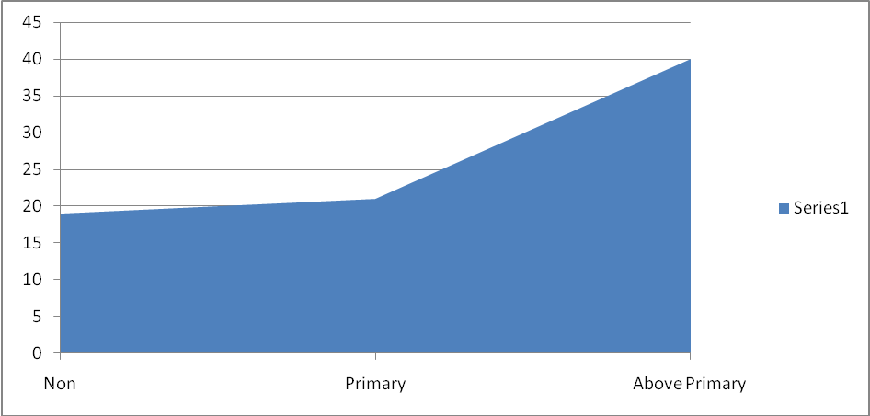

Figure 4.10: Sources of Formal Loan at Different Level of Education

In another hand, two hundred and fifty two (252) households representing 72% access the informal sources of loan, out of which one hundred and sixteen (116) households representing 33.1% are uneducated or have informal education followed by the sixty three (63) representing 18% and seventy three (73) households representing 20.9% have the primary level and above primary level respectively.
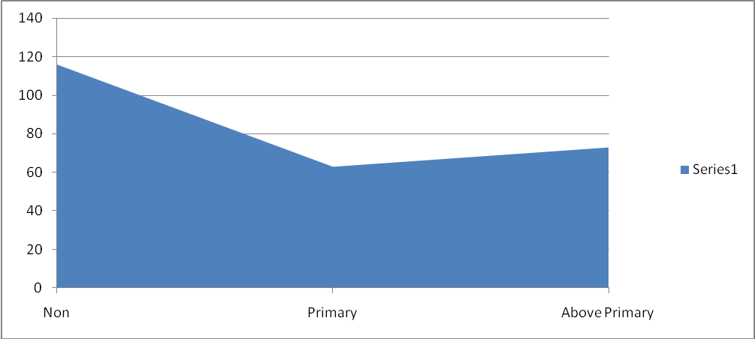

Figure 4.11: Sources of Informal Loan at Different Level of Education

Sources: Constructed from Table 4.24

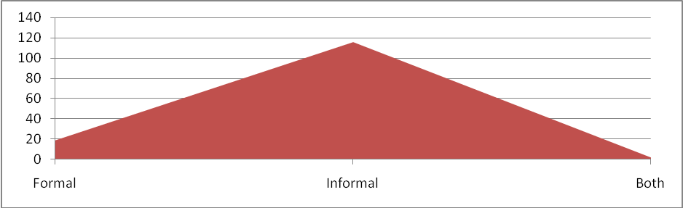

Figure 4.12: Uneducated Households with Form of Loans

Sources: Constructed from Table 4.24
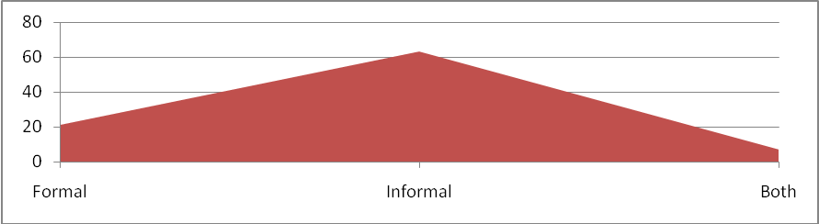

Figure 4.13: Households with Primary Level Education with various Forms of Loans

Sources: Constructed from Table 4.24

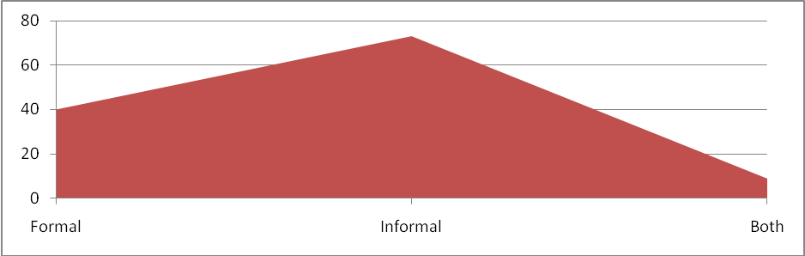

Figure 4.14: Households with above Primary Level with various Forms of Loans

Sources: Constructed from Table 4.24

Furthermore the households shared both formal and informal education are eighteen (18) households representing 5.1% of the total households that made up of nine (9) households representing 2.5% who possess above primary education level and seven (7) households representing 2% and two (2) households representing 0.6% have primary education and above primary level respectively. So in general term we can say that the higher the educational level they have the larger chance of accessing forma sources of loan and opposite is true. Figure 4.12, 4.13 and 4.14 graphically present forms of loans for uneducated households, primary leavers and who have above primary education respectively.

4.12.2 Sources of Loan at different Households’ Occupations
Out of eighty (80) households representing 22.9% of the total households who accessed the formal sources of loan, fifty one (51) households representing 14.6% of the total households engaging in the agriculture i.e. farmers and pastoralist, thirteen (13) households representing 3.7% are traders followed by the official employee and in other occupations who are nine (9) and seven (7) representing 2.6% and 2% respectively.

In another hand, out of two hundred and fifty two (252) households representing 72% of the total households who accessed the informal sources of loan, one hundred and seventy seven (177) representing 50.6% are engaging in the agriculture while twenty three (23) representing 6.6% are the traders followed by the official employee and in other occupations who are eighteen (18) and thirty four (34) representing 5.1% and 9.7% respectively. Furthermore, out of eighteen (18) households representing 5.1% of the total households who accessed the both formal and informal sources of loan, eight (8) households representing 2.3% are engaging in the agriculture while three (3) households representing 0.9% are the traders followed by the official employee and those in other occupations who are two (2) and five (5) representing 0.6% and 1.4% respectively. The Table 4.25 summarizes the above analysis.

Table 4.25: Forms of Loans at Different Households’ Occupations
Occupation  Sources of finance | Agriculture | Business |  | Official employee | Other occupation |  | Total
 | No | % | No | % | No | % | No | % | No | %
Formal | 51 | 14.6 | 13. | 3.7 | 9 | 2.6 | 7 | 2 | 80 | 22.9%
Informal | 177 | 50.6 | 23 | 6.6 | 18 | 5.1 | 34 | 9.7 | 252 | 72%
Both | 8 | 2.3 | 3 | 0.9 | 2 | 0.6 | 5 | 1.4 | 18 | 5.1%
Total | 236 | 67.5 | 39 | 11.1 | 29 | 8.3 | 46 | 13.1 | 350 | 100%

Sources: Compiled from field data

4.12.3 Utilization of Loan and Credit in Rural Areas
In analyzing the sources of loan the researcher also intended to explore how these funds were used, the respondents were asked to select one or more among the five elements in the set of expenditures provided in the questionnaires forms, the provided expenditure were first element was the basic needs i.e. food, shelter and clothing, the second element was about other consumption namely school fees, medical care and transport, third element was the investment expenditure, the forth element was entertainment/festival and final element was about social expenditure. The results were summarized in Table 4.6.

Table 4.26: Utilization of Loan and Credit in Rural Areas
Uses of Loans  Sources of finance | Consumption |  |  |  | Investment |  |  |  |  |  | Social Expenditure |  | Entertainment/ Festival |  | Total
 | Basic | School fees ,health and others  es Others | Total | % | Agriculture | Trade | Fishing | Others | Total | % | Community development | % | Entertainment | % | No | %
Formal | 21 | 10 | 31 | 8.9 | 19 | 11 | 4 | 9 | 43 | 12.3 | 1 | 0.3 | 5 | 1.4 | 80 | 22.9
Informal | 113 | 84 | 197 | 56.3 | 17 | 9 | 5 | 6 | 37 | 10.6 | 9 | 2.6 | 9 | 2.6 | 252 | 72
Both | 6 | 4 | 10 | 2.9 | 3 | 1 | - | 1 | 5 | 1.4 | 1 | 0.2 | 2 | 0.6 | 18 | 5.1
Total | 142 | 96 | 238 | 68 | 41 | 26 | 7 | 11 | 85 | 24.3 | 11 | 3.1 | 16 | 4.6 | 350 | 100
Sources: Compiled from the field data

From the Table 4.26, out of eighty (80) households representing 22.9% of the total households who accessed the formal sources of loan, forty three (43) households representing 12.3% injected their loan in the investment projects led by the agricultural investment, trade and others, thirty one (31) households representing 8.9% spent the loan on households’ consumption especially in the basic needs such as food, clothing, and shelter, while five (5) households representing 1.4% and one (1) households representing 0.3% spent their loan in entertainment/festivals i.e. religious ceremonies, traditional, social ceremonies etc. and social expenditure i.e. education, infrastructure etc. respectively. Generally, we conclude that most of the rural households receive the fund from the formal sources of fund spend the funds in the investment rather than consumption, social expenses and entertainment/festivals, this may be due to the fear of households on consequences of not repay the loan such as interest increase and forfeiture of the households’ properties if they were pledged as security in the loan.

In another hand, out of two hundred and fifty two (252) households representing 72% of the total households who accessed the informal sources of loan, one hundred and ninety seven (197) households representing 56.3% spent their loan in the consumption expenditure, thirty seven (37) households representing 10.6% injected the loan on investment project particularly in agricultural activities, trade and others, while nine (9) households representing 2.6% and nine (9) households representing 2.6% spent their loan in social expenditure i.e. education, infrastructure etc. and entertainment/festivals respectively.

So the above analysis, we can conclude that most of the rural households who receive loan from informal sources spend the loan in the households’ consumption such as foods, shelters, clothing, health etc, this may be due to the fact that most of the informal loan are like a grants issued to support among the family members, relatives or friends that usually bear no interest and always the receivers have less fear of repayment as compared to the formal loans.

Furthermore, out of eighteen (18) households representing 5.1% of the total households who accessed the both informal and formal sources of loan, ten (10) households representing 2.9% spent their loan in the consumption expenditure, five (5) households representing 1.4% injected the loan on investment project particularly in agricultural activities, trade and others, while one (1) households representing 0.2% and two (2) households representing 0.6% spent their loan in social expenditure i.e. education, infrastructure etc. and entertainment/festivals respectively.

4.13 Summary
Most of the rural households especially who are uneducated use the informal sources of loans such as Personal savings, support from relatives or family members and others to finance their consumptions, investment, social expenditure and entertainment and festivals. Few rural households who access the formal sources of loan from formal MFIs are mostly educated with at least above primary education, the types of MFIs that rural households are access to be SACCOs, FinNGOs, commercial banks and government programs.

Most of the rural households who received loan from the formal sources spent the funds in the investment rather than consumption, social expenses and entertainment/festivals, this may be due to the fear of households on consequences of not repay the loan such as interest increase and forfeiture of the households’ properties if they were pledged as security in the loan while majority of the rural households who received loan from informal sources spent the loan in the households’ consumption such as foods, shelters, clothing, health etc, this may be due to the fact that most of the informal loans are like a grants issued to support the family members, usually bear no interest and always the receivers have less fear of repayment as compared to the formal loans.

4.14 An Assessment for Perception of Rural Households towards Microfinance Services
One of the specific objectives of the research was to explore the perception of rural households towards the microfinance services, the research intended to explore the perception in term of understanding/awareness of the position of MFIs as a of poverty reduction tool and performance of MFIs in their areas.

4.15 Awareness of Rural Households in MFIs Services
In order to measure the understanding or awareness of the rural households in microfinance services, the respondents were required to identify the number of stories/articles of microfinance services they have read or heard in the last six months, the result is summarized in the Table 4.27.

Table 4.27: Distribution of Microfinance Stories Read/Heard by Rural Households

No of stories/articles Frequency %
None 303 86.6%
1 - 5 47 13.4%
6 - 10 0 0%
11 - 15 0 0%
16 -20 0 0%
Above 20 0 0%
Total 350 100%
Mode 0
Mean 0.403
____________________________________________________________________

Source: field data
From the Table 4.27, only forty seven (47) households forms 13.45% of the total households have read or heard at least one story/article about microfinance services for the past five years while majority of them totaling three hundred and three (303) representing 86.4% have ever read or hear any story or article about microfinance services, the mode number of stories/articles read or heard by the rural households for the past six months is zero and mean number of stories or articles read or heard by the rural households for the past six months was 0.403.

This justify that most of the rural households are not aware to microfinance services this is due to the fact that most of the rural households have no tendency of reading not only professional journals of such as microfinance industry but even other readings such as newspaper, lack of those journals in public or private centers, lack of awareness programs in microfinance industry in public television and radio which most of the rural households are access to and lack of awareness programs in microfinance industry conducted by the MFIs in rural areas.

4.16 Perception of Rural Households Regarding the Role of MFIs Services
Also in realizing the rural households’ awareness on microfinance services they were asked to guess or provide their opinions on the contribution of microfinance services in poverty reduction process, the result is summaries in the table 4.28 and graphically presented in the Figure 4.15.

Table 4.28: Households Opinions on Microfinance Services
____________________________________________________________________
Opinions/Guesses Frequency %
____________________________________________________________________
Very Low 53 15.1%
Low 78 22.3%
Moderate 81 23.1%
High 49 14%
Very High 38 10.9%
Undecided 51 14.6%
Total 350 100%
____________________________________________________________________

Sources: Compiled from field data

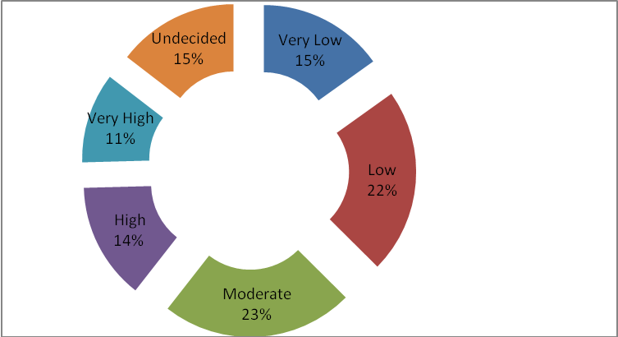

Figure 4.15: Rural Households’ Opinions on Microfinance Services

Sources: Constructed from field data

From the Table 4.28 and Figure 4.15, eighty one (81) households forms 23.1% of the total households perceive the contribution of microfinance services to poverty reduction process as a moderate while seventy eight (78) households representing 22.3% perceive the contribution of microfinance services to poverty reduction process as a low and fifty three (53) households representing 15.1% the contribution of microfinance services to poverty reduction process as very low, this is followed by the forty nine (49), thirty nine (39) and fifty one (51) households representing 14%,10.9% and 14% perceive the contribution of microfinance services to poverty reduction process as a high, very high and undecided respectively. These data justify that most of the rural households have low perception on the chance of microfinance sector in their poverty reduction strategies.

4.17 Households’ Perceptions at Different Level of Education
In measuring the perceptions of rural households on the chance of microfinance services have toward poverty alleviation process, various perceptions or opinions were realized as summarized in the Table 4.29 and discussion above, further more the researcher intended to explore the relationship between households’ perceptions on microfinance industry and their level of education, Table 4.29 illustrate the result.

Table 4.29: Households’ Perceptions at Different Level of Education
Form of education  Perception on MFIs | None |  | Primary |  | Above Primary |  | Total
 | No | % | No | % | No | % | No | %
Very low | 30 | 8.6% | 16 | 4.6% | 7 | 2% | 53 | 15.1
Low | 43 | 12.3% | 24 | 6.9% | 11 | 3.1% | 78 | 22.3%
Moderate | 22 | 6.3% | 27 | 7.7% | 32 | 9.1% | 81 | 23.1%
High | 9 | 2.6% | 11 | 3.1% | 29 | 8.3% | 49 | 14%
Very high | 7 | 2% | 6 | 1.7% | 25 | 7.2% | 38 | 10.9%
Undecided | 26 | 7.4% | 7 | 2% | 18 | 5.2% | 51 | 14.6%
Total | 137 | 39.2% | 91 | 26% | 122 | 34.9% | 350 | 100%
Sources: Compiled from field data
From the Table 4.29, out of fifty three (53) households representing 15.1% of total households who have very low perception on contribution of microfinance services in poverty reduction, thirty (30) households representing 8.6% of total households lack formal education followed by sixteen (16) households and seven (7) households representing 4.6% and 2% of total households who have primary level education and above primary level respectively.

Out of seventy eight (78) households representing 22.3% of total households who have low perception on contribution of microfinance services in poverty reduction, forty three (43) households representing 12.3% lack formal education followed by twenty four (24) households and eleven (11) households representing 6.9% and 11% of total households who have primary education and those with above primary level education respectively, out of eighty one (81) households representing 23.1% who moderate perception on contribution of microfinance services in poverty reduction, thirty two (32) households representing 9.1% of total households are educated in above primary level followed by twenty seven (27) households representing 7.7% whose households have primary level education and twenty two (22) households representing 6.3% of total and those who are not educated at all.

Out of forty nine (49) households representing 14% of total households who have high perception on contribution of microfinance services in poverty reduction, twenty nine (29) households representing 8.3% of total households have above primary level education, eleven (11) households representing 3.1% of total households have primary level education followed by nine (9) households representing 2.6% of total households have no formal education at all, out of thirty eight (38) households representing 10.9% of total households who have very high perception on contribution of microfinance services in poverty reduction, twenty five (25) households representing 7.2% of total households have above primary level education followed by seven (7) households representing 2% of total households have no formal education.

Six (6) households representing 1.7% of total households have primary level education, out of fifty one (51) households representing 14.6% of total households who failed to comment on the contribution of microfinance services in poverty reduction, twenty six (26) households representing 7.4% of total households have no formal education followed by eighteen (18) households representing 5.2% of total households have above primary level education and seven (7) households representing 2% of total households have primary level education.

From the above discussion and presentation we can generally conclude that there is positive relationship between level of education and right perception of microfinance services in poverty reduction process as majority of educated rural households have between moderate and very high perception of microfinance services in poverty reduction process while majority of uneducated rural households have between very low and moderate perception on microfinance services in poverty reduction process while many others uneducated households can even not judge the position of microfinance services in the poverty reduction process. The Figure 4.16, 4.17 and 4.18 graphically present the perception of uneducated households, primary leavers and who have above primary education respectively.
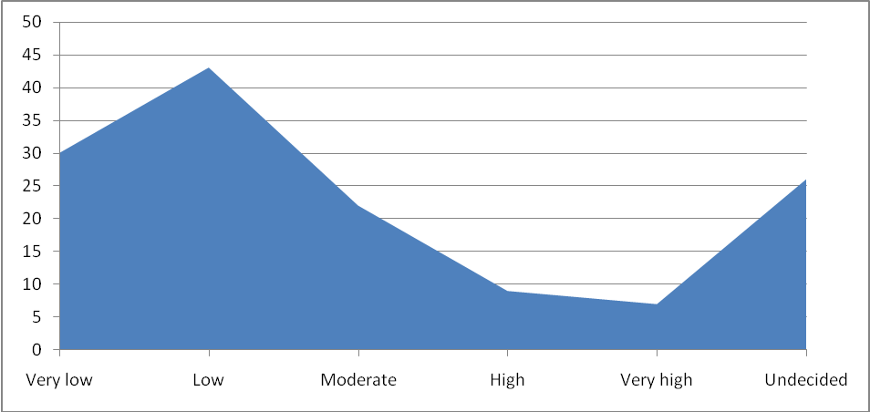

Figure 4.16: Perception of Uneducated Rural Households

Sources: constructed from Table 4.29

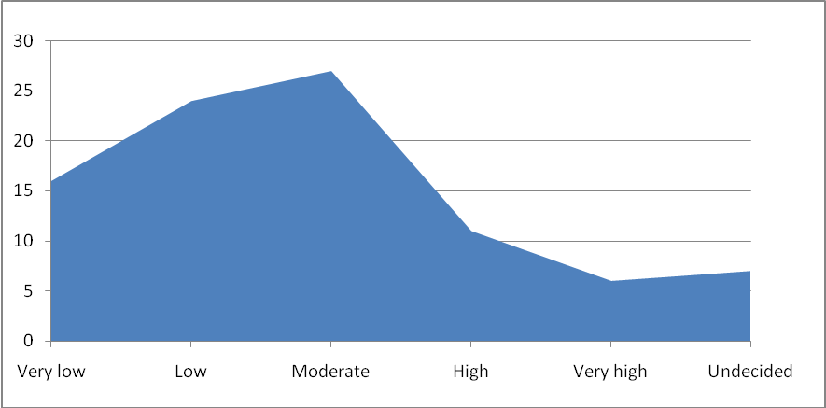

Figure 4.17: Perception of Rural Households with Primary Education

Sources: constructed from Table 4.29

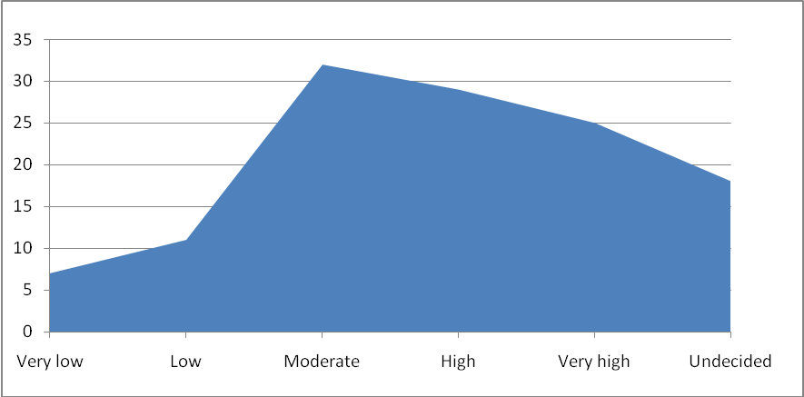

Figure 4.18: Perception of rural households with above primary level education

Sources: constructed from Table 4.29

4.2.8 Households’ Perception on Variety of Microfinance Services
Another question asked to rural households in the questionnaire forms was to identify the best financial services that expect to get or demand from the MFIs that interest them, the respondents were required to select among the provided financial related services such as loan, saving, insurance, pension services, business training and other financial related services. The result is summaries in the Table 4.30 and graphically presented in the Figure 4.19.

Table 4.30: Rural Households’ Perception on Various Financial Services
Types of financial services Frequency %
Loan/credit provision 350 66.5%
Saving 41 11.7%
Insurance 19 5.4%
Pension 5 1.4%
Business training 11 3.1%
Other services 0 0%
Total 526 100%

Sources: Compiled from field data

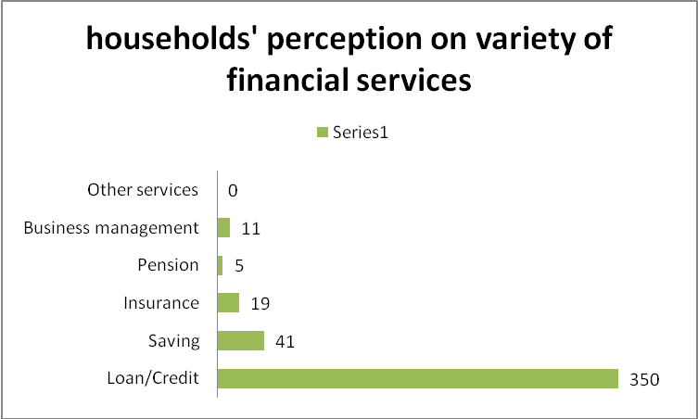

Figure 4.19: Rural households’ perception on various financial services

Sources: Constructed from field data
From the Table 4.30 and Figure 4.19, all households totaling three hundred and fifty (350) households are aware with and demand loan and credit services from the MFIs, forty one (41) households representing 11.7% of total households are aware with and demand saving services from the MFIs while nineteen (19) households representing 5.4% are aware with and demand the insurance services followed by eleven (11) and five (5) households representing 3.1% and 1.4% of total households are aware with and demand the business training services and pension services respectively.

The total number of rural households exceeds the three hundred and fifty (350) because some of them shared the more than one financial service. From these data we can conclude that most of the rural households are aware with only loan and credit services while they are not aware and have bad perception on variety of financial services offered by MFIs such as saving, insurance, pension, business trainings services and other services which are crucial to livelihood improvement of rural poor households.

4.2.9 Perception of Rural Households on Effectiveness of MFIs in Rural Areas
In another hand the researcher wanted to assess the perception of the rural households on the effectiveness of the MFIs to poor rural households, the respondents were required rank the degree of effectiveness of MFIs activities in the rural areas, the respondents were to choose among the very good, excellent, excellent, encouraging and bad, the Table 4.31 and figure 4.20 illustrate the rural households’ views on the effectiveness of MFIs in rural areas.
From Table 4.31 and Figure 4.20, ninety (90) households forms 25.7% of the total households fails to provide their views on the performance of the MFIs in rural areas, this may be due to the fact that most of the rural households are not aware with microfinance industry and they are not close to the services of MFIs, seventy eight (78) households representing 22.3% of the total households state that the performance of MFIs is encouraging, while seventy one (71) households representing 20.3 of the total households rank the effectiveness of MFIs in rural areas as good.

Table 4.31: Households’ Views on the Effectiveness of MFIs
Views Frequency %
Good 71 20.3%
Very good 51 14.6%
Excellent 42 12%
Encouraging 78 22.3
Bad 18 5.1%
Undecided 90 25.7%

Total 350 100%

Sources: Compiled from field data

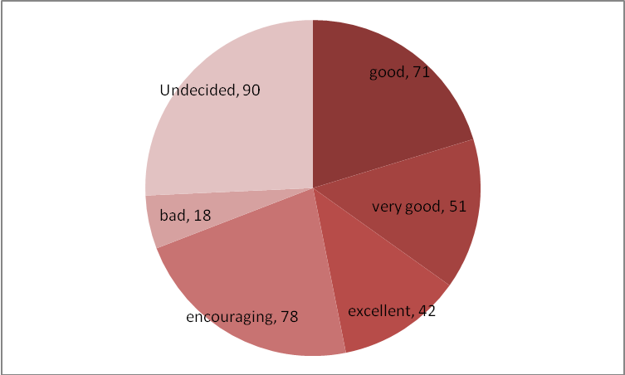

Figure 4.20: Households’ Views on the MFIs’ Effectiveness

Sources: Constructed from field data.
More over fifty one (51) households representing 14.6% of the total households state that the effectiveness of MFIs on rural areas is very good followed by those who rank the effectiveness of MFIs to be encouraging and bad presented by forty two (42) and eighteen (18) households representing 12% and 5.1% of the total households respectively. From the above discussion, the effectiveness of MFIs to poor rural households over the years has been encouraging.

4.3 Summary
Most of the rural households have no good perception on the role of microfinance services in their day to day activities, this is due to the fact that most of the rural households have no tendency of reading not only professional journals of such as microfinance industry but even other readings such as newspaper, lack of those journals in public or private centers, lack of awareness programs in microfinance industry in public television and radio which most of the rural households are access to and lack of awareness programs in microfinance industry conducted by the MFIs in rural areas. Only few rural households have high perception of microfinance services which most of them are educated with at least above primary education.

Most of the rural households are aware with only loan and credit services among the many other financial and related services offered by MFIs such as saving, insurance, pension, business trainings services and other services which are crucial to livelihood improvement of rural poor households and according to the views of many rural households the performance of MFIs to poor rural households over the years seems to be encouraging.

CHAPTER FIVE

5.0 DISCUSION OF FINDINGS/RESULTS

5.1 Chapter Overview
Descriptive statistics was used to analyze data whereby tables and charts were used to present data. Results of the research showed the following in the operational activities of microfinance institutions (MFIs) in Tanzania. MFIs targeted clients from diverse financial backgrounds such as traders, farmers, hawkers and beneficiaries of government credit programs. This section presents the discussion based on findings as well as what other scholars have pointed out in literature review. This discussion of findings was done based on specific objectives as follows:-

5.2 To Determine the Constraints to the Development of MFIs in Tanzania
The first objective was to determine the constraints in Tanzania particularly in rural areas. The variables tested in this area were loans and savings. Majority of the respondents agreed that microfinance services in the form of savings and loans helps the rural poor households and small enterprises to improve their standard of living, increase income and creation of employment opportunities. This finding is in agreement with the study done in Nairobi count.

Fred found that most of the participants are poor people who reported to be a monthly income of less than ten thousand Kenya shillings. However, the findings by Rangarajani (2008) pointed out that , access to finance by the poor and vulnerable groups is a prerequisite for poverty reduction and social cohesion. Moreover, Hulme and Mosley (1996) also pointed out that MFIs such as the Grameen Bank and BRAC provided credit to very poor households as they were able to raise their income and assets. This study showed that majority of poor rural households and small enterprises had no access to loan because most of rural areas were lack of financial institutions compared to urban areas. Also people who are living in rural areas are lack of financial training and advice and also they lack of trust and confidence in MFIs.

5.3 Assessment on how Poor Household and Small Enterprises have Access to MFIs
The specific objective was to assess whether poor households and small enterprises have access to loans. This finding showed that only 27% of the participants have access to loan while 73% were outreached compared to the situation in Bangladesh where Yunus (2008) found that 7 million women were served by MFIs. However, the finding by Akwasi (2013) in Ghana, showed that only few enterprises had accessed loans from MFIs due to high interest rate , ignorance of the existence of MFIs as well as lack of trust and confidence in MFIs. In Tanzania, Kuzilwa and Mushi (1997), pointed out that business owners received training and advise, performed well than those who did not receive training.

5.4 Assessment whether the Conditions and Procedures of Loans and Credit Granting Set by MFIs Favor the Poor Rural Households and Small Enterprises
The specific objective was to assess if the conditions and procedures of loans and credit granting set by MFIs favor the poor households and small enterprises. This study found that the conditions and procedures adopted by MFIs were difficulty to be complied with by rural poor households and small enterprises. Some obstacles such as high interest rates which were difficulty for the groups to comply with.
The cost of borrowing that made up of transaction cost and interest rate that are charged to the borrower is too high to support the rural SMEs, whereas the landing rate of MFIs lie between 20% to 30% while the deposit interest rates in below 5% per annum and the annual inflation rate is 8.3% in May,2013 that make the real interest rate on deposit become below 2% per annum which enough to discourage saving among the rural households and limit the potential borrowers to enjoy the loan (Faustine K.Bee,2007,National Bureau of Statistics. Walday ( 2010 ) , argued that the different products provided by the MFIs to their clients have significant impact on the performance of the institutions as it affect the number of clients of the institutions.

CHAPTER SIX

6.0 SUMMARY, CONCLUSION AND RECOMMENDATIONS

6.1 Summary
According to the opinions of many respondents the microfinance industry still faces a number of challenges such as conditions and terms of loan, inadequate capital of MFIs, poor support from the MFIs, few MFIs that meet need and poor regulation and supervision of MFIs. Most of the rural households who received the loan from formal sources were charged the interest rate between 21%-30% which relatively large for growth of rural small enterprises while most of the rural households who received the informal loans charged free interest rate and few of them charged interest rate of below 10%.,other cost charged to borrowers are application fees, services fees, ledger fees, cost of photograph for passport size, time spent on loan processing, collateral ,business registration, business proposal, Audited accounts, minimum non withdrawal balance, travel time and cost of searching the referee.

Most of the MFIs offer only financial services and only few of them offer non financial services which are supporting services to the borrower in ensuring that they use the loan in profitable investment and building capacity in the business management such services are advisory services, business training such as project write up, business proposals, costing and price determination techniques, business record keeping, marketing, and monitoring and evaluation services.

Most of the rural households especially who are uneducated use the informal sources of loans such as Personal savings, support from relatives or family members and others to finance their consumptions, investment, social expenditure and entertainment and festivals. Few rural households who access the formal sources of loan from formal MFIs are mostly educated with at least above primary education, the types of MFIs that rural households are access to SACCOs, FinNGOs, commercial banks and government programs.

Most of the rural households who received loan from the formal sources spent the funds in the investment rather than consumption, social expenses and entertainment/festivals, this may be due to the fear of households on consequences of not repay the loan such as interest increase and forfeiture of the households’ properties if they were pledged as security in the loan while majority of the rural households who received loan from informal sources spent the loan in the households’ consumption such as foods, shelters, clothing, health etc, this may be due to the fact that most of the informal loans are like a grants issued to support the family members, usually bear no interest and always the receivers have less fear of repayment as compared to the formal loans.

Most of the rural households have no good perception on the role of microfinance services in their day to day poverty elimination activities, this is due to the fact that most of the rural households have no tendency of reading not only professional journals of such as microfinance industry but even other readings such as newspaper, lack of those journals in public or private centers, lack of awareness programs in microfinance industry in public television and radio which most of the rural households are access to and lack of awareness programs in microfinance industry conducted by the MFIs in rural areas. Only few rural households have high perception of microfinance service in poverty reduction of which most of them are educated with at least above primary education. Most of the rural households are aware with only loan and credit services among the many other financial and related services offered by MFIs such as saving, insurance, pension, business trainings services and other services which are crucial to livelihood improvement of rural poor households and according to the views of many rural households the performance of MFIs to poor rural households over the years seems to be encouraging.

6.2 Conclusion
Most researchers of microfinance industry approved that there is a direct relationship between access of financial services and livelihood improvement of the poor and for large extent MFIs operation in Tanzania has brought about positive changes in the standard of living of people who access their services (Severine S. A.Kessy and Fratern M. Urio, 2006, Prof. Samuel Wangwe and Moorine Lwakatare, 2004, Mkwawa, Edmund Pancras ,2005).

Despite this achievements of MFIs in Tanzania it is still most of the rural households are not accessible to these services due to limited number of MFIs operating in rural regions, unfriendly loan requirements to the rural people including high interest rate and high valuable securities and poor regulatory and supervisory framework of MFIs of such as bureaucracy of judiciary system that prolong the among other things the MFIs related cases, low ceiling on unsecured loans by licensed banks imposed by BOT, low ceiling on Fixed Assets, Impact of taxes on the cost of commercial and financial transactions and inadequacy and lack of qualified staffs of MFIs regulatory and supervisory Authorities. The finding reveals that most of the rural households are not aware with role of microfinance services, variety of financial and related services such as insurance, pension, saving and business training in their day to day poverty elimination activities, this is due to the fact that most of the rural households have no tendency of reading not only professional journals of such as microfinance industry but even other readings such as newspaper.

Moreover, lack of those journals in public or private centers, lack of awareness programs in microfinance industry in public television and radio which most of the rural households are access to and lack of awareness programs in microfinance industry conducted by the MFIs in rural areas. Only few rural households have high perception of microfinance service in poverty reduction of which most of them are educated with at least above primary education. According to the views of many rural households the performance of MFIs to poor rural households over the years seems to be encouraging.

Also finding reveals that most of the rural households especially who are uneducated use the informal sources of loans such as Personal savings, support from relatives or family members Saving group, Rotating Saving and Credit Association (ROSCA),merchants and others whereby the large proportion of these loans are spent in consumption, social expenses and entertainment/festivals rather than investment. Only few rural households access the formal sources of loan from formal MFIs who are mostly educated with at least above primary education, whereby the large proportion of these loans are spent in investment rather than consumption, social expenses and entertainment/festivals, The types of MFIs that rural households are access to are SACCOs, FinNGOs, commercial banks and government programs.
The group lending approach adopted by some MFIs from Grameen Bank model operating in Bangladesh is seem to be more favorable and helpful to poor rural households as it ignore some of the pre loan conditions that limit the most of the poor rural households to access the other forms of loans offered by MFIs, such waived pre loan conditions are collateral items such as house, motor vehicle etc as most of the rural households have no acceptable valuable collateral items instead group guarantee is used, other waived pre-loan condition is the employment guarantee as most of the rural households are not official employee.

In another hand there is still some limitation in this forms of lending to poor rural households such as excessive transportation cost for rural client to attend the regular meeting in MFIs offices in urban areas , the loan size is too low for investment or business expansion purpose that generally not exceed Tsh 5Mill/-, also the loan repayment period is too short and do not allow the grace period of loan repayment, large number of loan repayment installments include interest, Loan Insurance Fund (LIF) and part of the principle of the loan slow the business growth of the rural small enterprises,

High cost of borrowing include high interest rate that normally become above 20% per annum, registration fees, minimum compulsory savings and the loan application fee, weekly repayment of Loan slow the business growth of the rural small enterprises and long loan processing time especially for new client. Most of the loan offered by MFIs not associated monitoring and evaluation of loan injected clients’ business and building capacity of the clients in managing their business such as business record keeping, marketing skills and other entrepreneurial skills.
In another hand the individual landing offered by the MFIs is relatively large to meet the need of long term investment but still this form of loan limit most of the rural households to access to as necessitate the client to be official employee of the government or other reputable organization while most of them are not official employee, need of eligible collateral items, proper business records and business registration.

6.3 Recommendations
The below recommendations are presented in order to improve the performance of MFIs in rural areas in Tanzania:-
- The government in collaboration of other MFIs stakeholders should establish the rural finance policy and strategies to improve the performance of MFIs in rural regions due to the fact the current National Microfinance Policy of 2000 is implemented and achieved mostly in the urban areas.
- The government should have the awareness programs on Microfinance services to poor rural households so as to improve perception of rural households in microfinance and their participation in Microfinance industry.
- The interest rate on loan offered by MFIs should be lowered to reasonable rate by keeping in mind that most of the SMEs generate low rate of return, so the high interest rate affect the profitability of SMEs and approve the stunted growth, the MFIs should set interest rate to cover only their operational cost and inflation rate and reduce the rate of risky in the interest rate.
- Security in rural areas is still challenging, apart from most of the rural properties such as houses are less valuable but also they are not accompanied by the ownership deeds because they are not formal registered. So there is need to innovatively search for alternative ways of securing the loans without necessitate the physical collateral.
- Short term loans are not needful for the investment purpose instead long term development loans are needed.
- The government and MFIs should emphasize the business training to the poor rural households so as to enable the uses of loan/credit successfully such required trainings are Bookkeeping ,marketing, entrepreneurship, insurance and risk management, business planning etc.

6.4 Area for Further Studies
The research has brought to for the effectiveness of microfinance services to poor rural households in Tanzania. To enhance development of Microfinance industry in Tanzania more of such research should be conducted to various rural regions countrywide to bring to public domain the role of microfinance in poverty reduction, the challenges and the way forward. Furthermore the population size should be increased to cover most of the rural clients since larger samples are more representative of the population than a smaller sample.

The cost of borrowing including interest cost have been observed to be a serious problem, there is a need to conduct a study to determine cost of borrowing that would meet the operating expenses of MFIs and at the same time facilitate the growth their clients’ business. There is a need to conduct a comparative study between MFIs operations in rural areas and MFIs operating in urban areas. This would delineate the rural-urban structure of MFIs operations.

6.5 The Profile of the Study Areas

6.5.1 The Geographical Location and Administrative Division
Zanzibar South is one of the thirty regions of Tanzania. Located on the island of Unguja- Zanzibar, Makunduchi serves as the region's capital. As the system of local government is not considered as Union matter and is thus regulated by entirely separate Zanzibar legislation – different from Mainland Tanzania. So Zanzibar South region is established under Article 128 contained in Chapter 12, Section 2 of the 1984 Constitution of Zanzibar; and Act number 1 of 1998 – The Regional Administration Authority Act of Zanzibar. Unguja South region lies on southern part of Unguja Island bordering Zanzibar Town and west region in West and surrounded with Indian Ocean in the rest of the boarders ( i.e east, west and south of the region).

6.5.2 Demographic Data
Administratively Zanzibar South is divided into two districts, South and Central districts; Where South district has the population of 37,642 people(17,230 male, 20,412 female) and Central district has the population of 58,584 people (19,342 male,39,246 female) according to the population and Housing Census of 2012 (URT, 2013). South district is composed by 18 villages, namely, Makunduchi, Mtende, Kimkazi Dimbani, Kizimkazi Mkunguni, Paje, Jambiani, Michamvi, Pete, Koani, Dongwe, Bwejuu, Kitogani, Muungoni, Muyuni A, Muyuni B, Muyuni C, Kibuteni, Jozani, Mtangamle, Ukongoroni, and Charawe, while Central district composed of 25 villages namely, Chwaka, Uroa, Marumbi, Nyamanzi, Ndijani, Mchanganishamba, Ndagaa, Dunga, Bambi, Uzini, Binguni, Ungujaukuu, Tunguu, Uzi, Bungi, Kibele, Umbuji, Jendele, Ufufuma, Pongwe, Mwera, Cheju, Pagali, Kiboje, Kikungwi.

Table 6.1 Selected Population Data for Unguja South Region
District | Population Number |  |  | Households Average Size
 | Male | Female | Total | Number | Average Size
South District | 17,230 | 20,412 | 37,642 | 12,547 | 3.0
Central District | 19,342 | 39,246 | 58,588 | 22,038 | 4..8
Total | 36,572 | 59,658 | 96,230 | 34,585 | 2.78
Source: (URT, 2013)

6.6 Study Population
The population is the totality of the subjects under investigation while sample is a part of the population whereby Sample size is the exact number of items selected from a population. A sampling techniques are the ways of choosing sample which can either be probability sampling where every number in the population have equal chance of being selected to form a sample and non-probability sampling which is biased sampling where no guarantee that every element in the population has a chance of being selected to form a sample (Jamal Adam and Faustin Kamuzora, 2008). According to the population and Housing census of 2012 (URT,2013) the total population of Unguja South Region is 96,230 people for the purpose of this study the target population is the number of households in selected villages of Unguja South region whereby 350 households were selected to form a sample of this study.

6.7 Sample Size and Sampling Techniques
In order to present the various agro-ecological zone of the region and ensuring the inclusive presentation of population in both two districts of the region, the stratified sampling technique was used to divide the population into two strata namely South and Central, then a random sample drawn from each of the strata. The study covered 8 villages out of 18 villages in South district and 7 villages out of 25 villages in Central district that were randomly selected in each district, this will make a total of 15 villages as research sample in the whole region.

The selection was necessary as it is not possible to cover the whole region. From these 15 villages a sample of 190 households in South and 160 households in Central again randomly selected in each district to make a research sample of 350 households in the whole region, the sample consist of farmers, livestock keepers, businessman and rural employees and member of cooperative societies. The selection of respondents was done with help of Village leadership and was guided by the attributes such as age, gender, education, occupation, household’s size and they were drawn from the villages as follow:-
- Makunduchi, Mtende, Kizimkazi, Paje, Jambiani, Pete, Bwejuu, Michamvi, for South district
- Chwaka, Uroa, Marumbi, Ndagaa, Dunga, Uzini, Ungujaukuu, for Central district.

Apart from individual households the study also involved 50 interviewee from financial institutions, leaders, official of MFIs, Local Government workers and other relevant people and institutions again randomly selected to present all key stakeholders in Microfinance industry.

REFERENCES
Aleke, P. (1999). “Marketing in a networked economy”, Journal of marketing (special issue).
Banerjee, A. Esther D. Glennerster, R. and Kinnan, C. (2009). The miracle of microfinance? Evidence from a randomized evaluation.” Cambridge: MIT Poverty Action Lab.
Bank of Tanzania (2009) Report: Financial Market in Tanzania http//www.bot.tz.org/Financial Market/ Financial _Market in Tanzaia.htm.

Brown, G. J. (2001). Literature. Journal of Entrepreneurial Finance and Business Ventures, 9(1), 1-26.
Burns, N. and Grove, K. (1993), Nursing Research, Research, Methodology, 2nd edition, Hardcover: Sanders.
Cohen, M. (2001). “Making Microfinance More client-led,” Journal of International Development, 35(10), 1721-1738.
Collins, D., Morduch, J., Rutherford, S., and Ruthven, O. (2009). Portfolios of the Poor: How the World's Poor Live on $2 a Day, New York: Princeton University Press.
Cooper, D. R. & Schindler, P. S. (2006). Business Research Methods , 9th Edition, New Delhi: Tata McGraw Hill.
Fischer, G. & Ghatak, M. (2010). Spanning the Chasm, Uniting Theory and Empirics in Microfinance Research. London: London School of Economics and Political.
Frederic S. M. & Stanley, G. E. (2006). Financial Markets and Institutions. Kansas: Pearson Education.
Galbraith, J. K. (1975). Money: Whence it came, where it went. Boston: Houghton Miffllin.
Herwegen, J. (1997). The New World of Micro enterprise Finance: Building Health Institutions for the Poor. Colorado: Kumarian Press.
IFAD, (2009). Rural financial support program, retrieved on 20th March, 2017 from: [www.rfsp.org/00about.htm].
IOB evaluation/NR 296, (2004). “An evaluation of Dutch aid to two district rural development programmes in Tanzania”, visited 30th January, 2017 from: (www.euforic.org/iob).
Jayasheela, D. P. T. and Hans, V. B. (2009). Financial Inclusion and Microfinance in India: An Overview.
Karlan, D. and Zinman, J. (2009). Expanding Credit Access: Using randomized supply decisions to estimate the impacts, Review of Financial Studies, 23 (1), 433–464.
Kessy, A. S. & Urio, F. M. (2006). Research paper on “Contribution of Microfinance Institutions to Poverty Reduction in Tanzania” published by REPOA in 2006.
Khandker, S. (1998). Fighting Poverty with Microcredit. The International Bank of Reconstruction and Development (The World Bank) Washington D.C.
Mkwawa, E. P. (2005) “The impact of microfinance activities in Dar Es Salaam: a case of Dar Es Salaam Community Bank Limited and Pride Tanzania in Dar es Salaam, Tanzania.
Ogama, B. N. (2006). Survey of Potential Saving – Led Microfinance Institutions – A Case Study of Makueni District, Kenya.
Robinson, M. S. (2001). The Microfinance Revolution, The World Bank and Open Society Institute, New York, USA.
Roodman, D. (2011). "Due Diligence: An Impertinent Inquiry Into Microfinance." Center for Global Development, 2011.
Rubambey, G. (2001). “Tanzania National Micro Finance Policy”, A Paper Presented at the 5th Annual International Conference on entrepreneurship and Small Business Development (ICAESB), White Sand Hotel, Dar es Salaam, Tanzania.
Rweyemamu, D. C. Kimaro, M. P. and Urassa, O. M. (2003). “Assessing Micro-Finance Services in Agricultural Sector Development: A Case Study of Semi-Formal Financial Institutions in Tanzania” Economic and Social Research Foundation. 4(1), 1-46.
Sulaiman, M. & Matin, I. (2002). How beneficial has Microfinance been for the Poorest? Research paper, Finance for the Poor Volume 1.
URT, (1999). National Poverty Eradication Strategy, Vice-President’s Office, Dar es Salaam, Tanzania.

URT, (2000). “National Micro Finance Policy”, Dar es Salaam, Tanzania.
URT, (2000). “Poverty Reduction Strategy Paper (PRSP)” Printed by Government Printer, Dar es salaam, Tanzania.
Yaron J., Benjamin, M. P. & Piprek, L. (1997). Rural Finance: issues, design, and Best practice. ESSD Studies and monograph series 14 Washington DC: World Bank.
Yaron, J. (1992). How to assess performance of Development Finance Institutions in Microfinance for the Poor edited by hartmut Schneider. Paris. OECD.
Yunus, M. (1999) Banker to the Poor, Micro-Lending and the Battle against World Poverty, Public Affairs, New York.
Zaman, H. (2000). Assessing the Poverty and Vulnerability Impact of Micro-Credit in Bangladesh: A case study of BRAC. World Bank.

APPENDIX
Appendix I: Questionnaires for Microfinance Beneficiaries

THE OPEN UNIVERSITY OF TANZANIA

Introduction
The study is conducted by Ali, Ali Ame, a student of Open University of Tanzania in the Faculty of Business Management. The study will result in to a dissertation report, which is a partial fulfillment for the award of a Masters of Business Administration Degree of Open University of Tanzania. This study is about the effectiveness of Microfinance Institutions in providing credits to rural poor households and small enterprises. The survey thus is to avail background information about Microfinance services and the effectiveness in providing credits to rural poor households and small enterprises.

The purpose of the survey is therefore to gather data from different households in Unguja South Region. You have been selected because you are a stakeholder of Microfinance services and beneficiary. Iam requesting you to give me the requested information to accomplish this study. The data collected shall be treated with utmost confidentiality and anonymity.

Thank you for your cooperation

Section A: Background information of the Respondent

- Gender

- Male

- Female

2. Age (Years)

  - 18 – 25
  - 26 – 40
  - Above 40

- Marital Status

  - Married
  - Not married
  - Widow

- Level of education

  - None
  - Primary
  - Secondary
  - University

Section B: MFIs challenges / constraints

- The challenges / constraints faced by Microfinance Institutions ( in each area tick only one item among the items ranked 1, 2, 3, 4, and 5 )

MFIs Loans  Utilization Areas | Strongly  Agree  1 | Agree  2 | Not sure  3 | Disagree  4 | Strongly disagree  5
Capital financing
Law and lagislation
Loan repayment
Loan disbursement
Poor support

6. The MFIs loans accessed by contributed to improve standard of living and enhance small enterprises for the last eight years from 2007 to 2014 ( for every item in a row , put only one tick labeled 1, 2, 3, 4, and 5 ).

Impact of MFIs loans to poor house holds and small enterprises | Strongly agree | Agree | Not sure | Disagree | Strongly disagree
 | 1 | 2 | 3 | 4 | 5
Increase of income
Improved social services
Self employment

Section C: Savings

7 . Saving mobilization by MFIs have contributed to improve households standard of living and enterprises activities for nearly eight years from 2007 to 2014 (for every item in a row, put only one tick labeled 1, 2, 3, 4, and 5 ).

Impact of MFIs on improving household standard of living and small enterprises. | Strongly Agree | Agree | Not sure | Disagree | Strongly disagree
 | 1 | 2 | 3 | 4 | 5
Increase of income
Improved social services
Self employment

Section D: Goal orientation

8. Did you receive any training from MFIs before borrowing ?

- Yes
- No

9. The goals of borrowing from MFIs includes the following : ( for every item in a row , put only one tick labeled 1, 2, 3, 4, and 5 ).

Goal orientation | Strongly Agree | Agree | Not sure | Disagree | Strongly disagree
 | 1 | 2 | 3 | 4 | 5
I want to use microfinance to improve my standard of living
I want to make effort to acquire new venture skills
I want to improve the education condition by by undertaking business activities
I want to work for long hours to increase my income
I want to become self employed by undertaking business activities
Other if any ( Mention)

10. Did you use the loans obtained to finance the goals of borrowing ?

- Yes
- No

11. If the answer is no, can you say why ?

- Inadequate capital
- Lack of skills
- Lack of time

Section D: Financing skills

12. As a result of MFIs training before borrowing. I have acquired financial skills in the following areas (for every item in a row, put only one tick labeled 1, 2, 3, 4, and 5).

Financial skills | Strongly agree | Agree | Not sure | Dis agree | Strongly disagree
 | 1 | 2 | 3 | 4 | 5
I know how to record separately my properties and those of the business
I know how to prepare business plan to present to MFIs leaders
I know how to prepare budget for various activities of my business
I know how to prepare profit and loss statement of my business
I know how to record balance sheet of my business

13. Financial skills help the borrowers to make wise investment activities which contribute to improve standard of living and enterprises. What can you say ? ( put only one tick in the item ranked 1, 2, 3, 4, and 5 ).

Strongly agree | Agree | Not sure | Dis agree | Strongly disagree
1 | 2 | 3 | 4 | 5

14. What is the amount o savings that you have in your account with MFIs for the year 2014 ?
Amount of savings | TZS…………………………………………..
15. What is the amount of loans that you received during the year 2014 ?

Amount of loan received | TZS……………………………………………

16. MFIs services have brought positive impact in improving standard of living and enterprises . Can give your perception pertaining to this statement basing on the services you accessed with the real life that you are experiencing now ( put a tick in only one item ranked in numbers, 1, 2, 3, 4, and 5 ).

Strongly agree | Agree | Not sure | Disagree | Strongly disagree
1 | 2 | 3 | 4 | 5

Rural stand for Unguja North regions and Unguja South Region
5PB branches,2 Barclays branches,1 branches @ for NMB,CRDB and TPB
3 Barclays ATMs, 4 PB ATMs,4 for NMB,1 for TPB,1 for CRDB,

