**DETERMINANTS OF EFFECTIVENESS MONITORING AND EVALUATION SYSTEM IN NGOs: A CASE STUDY OF KINONDONI MUNICIPALLY DAR ES SALAM REGION**

**JOHN GILBERT BUSILIE**

**A DISSERTATION SUBMITTED IN PARTIAL FULFILMENT OF THE REQUIREMENTS FOR THE DEGREE OF MASTER OF ARTS IN MONITORING AND EVALUATION ATOPEN UNIVERSITY OF TANZANIA**

**2017**

**CERTIFICATION**

The undersigned certify that he has read and hereby recommends for the acceptance by the Open University of Tanzania a dissertation entitled: “Determinants Of Effectiveness Of Monitoring And Evaluation System At Ngos A Case Study Kinondoni Municipally Dar As Salaam Region”, in partial fulfillment of the requirements for the Degree of Master of Arts in Monitoring and Evaluations at Open University of Tanzania.

……………………………..…….

Dr. Felician Mutasa

(Supervisor)

………………………………..

Signature

**COPYRIGHT**

This dissertation is a copyright of the Open University of Tanzania (OUT). It may not be reproduced by any means in full or private study, critical scholarly review or discourse with the acknowledgement, without the written permission of the author or the Open University of Tanzania in that behalf

**DECLARATION**

I, John Gilbert Busilie,do herebydeclare that this research report is my own work. It has not been submitted for Bachelor degree or any other similar award in any higher learning institution.

……………………………………..

Signature

………………………………….

Date

**DEDICATION**

I sincerely dedicate my research to my father and mother for their nice cooperation and assistance during my research. I also dedicate my research work to my fellow students since primary school up the level I am now.

**ACKNOWLEDGEMENTS**

I acknowledge all those persons who in one way or the other assisted me to complete this study. I am grateful to Drelician Mutasa for this guidance and supervision throughout the whole thesis writing process. I sincerely appreciate my father, Dr. Gilbert John, My mother Odes Gilbert , My beloved sister Juliana and my brother Willy John, lastly I wish to thank my friends Remedies Binamungu, Dunia, and Salumu for their care and encouragement thought my study period.

A above all, I give Glory back to God the almighty for the good health and strength to carry out all the required tasks of the study.

# 

# ABSTRACT

NGOs recently are in the pressure for improve M&E system from different stakeholder which are more interested in transparency and accountability. Moreover, they are going auxiliary than effectiveness, efficiency, relevance, sustainability, relevance and impact of certain intervention. Despite with that crucial pressure but M&E system in NGOs they not convene robust monitoring and evaluation system which satisfy demand of internal and external stakeholders. This study focused at the determinants of effectiveness of monitoring and evaluation system in NGOs within Kinondoni Municipality. The study used non- probability sampling method, information gathered from M&E Directors, officers and project Managers. The sample involved 30 NGOs. Analysis was done by using Statistical package for social science research (SPSS) to get descriptive results. Findings presented by using tables and charts. Finding designated that. Implementations of Monitoring and evaluation system in national NGOs are not easy due to scarcity of resources. M&E staffs are not competent enough that has led to poor selections of M&E tools. Role of management 80% majority of national NGOs management had good responsibilities toward M&E system. In International NGOs financial resource, role of management, M&E staffs are effective which strength M&E system was but they faced shortage of native M&E specialists. The study concludes that M&E system at sampled national NGOs are infective compared to sampled international NGOs which has effective M&E system. Study recommend that management should using M&E information the both aspects, NGOs should allocate enough budgets for M&E system, NGOs should provide capacity building for M&E staff for purpose of handle M&E system effectively.

TABLE OF CONTENTS

CERTIFICATION ii

COPYRIGHT iii

DECLARATION iv

DEDICATION v

ACKNOWLEDGEMENTS vi

ABSTRACT vii

TABLE OF CONTENTS viii

LIST OF TABLES xi

LIST OF FIGURES xii

LIST OF ABBREVIATION xiv

CHAPTER ONE 1

1.0 BACKGROUND TO THE STUDY 1

1.1 Background of the Study 1

1.2 Statement of the Problems 4

1.3 Research Objectives 6

1.3.1 General Research Objective 6

1.3.2 Specific Research Objective 6

1.4 Specific Research Questions 7

1.5 Relevance of the Research 7

CHAPTER TWO 8

2.0 LITERATURE REVIEW 8

2.1 Introduction 8

2.2. Definition of Key Concept 8

2.2.1 Non Government Organization (Ngos) 8

2.2.2 Monitoring 9

2.2.3 Evaluation 9

2.2.4 Monitoring and Evaluation System 11

2.3 Theoretical Literature Review 12

2.3.1 Theory of Change 12

2.3.2 Theory of Logical Model 15

2.3.3 Logical Frame Work Approaches 18

2.4 Empirical Literature Review 23

2.5 Research Gap 29

2.6 Conceptual Framework 29

CHAPTER THREE 32

3.0 RESEARCH METHODOLOGY 32

3.1 Introductions 32

3.2 Research Design 33

3.3 Study Area 33

3.4 The Target Population 34

3.5 Sampling Strategy 34

3.6 Sampling Technique 34

3.7 Data Collection Methods 35

3.7.1 Primary Data Collection 35

3.8 Data Analysis and Techniques 36

3.8.1 Data Processing and Analysis 36

3.8.2 Analysis of Quantitative Data 36

CHAPTER FOUR 37

4.0 RESULT AND DISCUSSION OF FINDINGS 37

4.1 Introduction 37

4.2 Demographic Information 37

4.2.1 Gender Distribution 37

4.2.2 Level of Educations 38

4.2.3 Experience on Monitoring and Evaluation System 39

4.2.4 Age of Respondents 39

4.3 Effectiveness of Monitoring and Evaluation System 40

4.4 Review of Monitoring and Evaluation System in NGOs 41

4.5 Challenges Countenancing Monitoring and Evaluation System 41

4.6 Factors Affecting Monitoring and Evaluation System 42

4.7 Effectiveness of Financial Resource Toward Monitoring and Evaluation System 43

4.8 Measurement Taken 44

4.9 Competency of M&E Staff to Handle Monitoring and evaluation System in Organizations 45

4.10 Measurement Been Taken 46

4.11 Management Responsibility toward Effectiveness of Monitoring and Evaluation System 47

4.12 Uses of Monitoring and Evaluation Information to Organization Managements 47

4.13 Usefully of Monitoring and Evaluation Information to the Organization Managements 48

4.14 Recommendations for Improving Monitoring and Evaluation System in NGOs 49

CHAPTER FIVE 50

5.0 CONCLUSION AND RECOMMENDATION 50

5.1 Conclusion 50

5.2 Recommendations 51

5.3 Recommendation for Further Research 52

REFERENCE 53

APPENDICES 58

LIST OF TABLES

Table 4.1 Challenges Countenancing Monitoring and Evaluation system 41

Table 4.2 Competency Of M&E Staff To Handle Monitoring and E Valuation System 45

Table 4.3 Management responsibility toward effectiveness of M&E system 47

Table 4.4 Recommendation for improving M&Eystem 49

# LIST OF FIGURES

Figure 2.1: Theory of Change Diagram 13

Figure 2.2: Logical Model Diagram 16

Figure 2.3: Difference between Theory of Change and Logical Framework 22

Figure 2.4: The Identified Independent Variables and the Existing Relationship Between Them and The Dependent Variable 31

Figure 4.1: Gender Distribution 38

Figure 4.2: Level of Education 38

Figure 4.3: Experience on Monitoring and Evaluation System 39

Figure 4.4: Age of Respondents 39

Figure 4.5: Effectiveness of Monitoring and Evaluation System 40

Figure 4.6: Reviews of Monitoring and Evaluation System 41

Figure 4.7: Factors Affecting Monitoring And Evaluation System ion 2017 42

Figure 4.8: Effectiveness of Financial Resource toward Monitoring and Evaluation System 43

Figure 4.11: Uses of Monitoring and Evaluation Information to

Organization Managements 47

Figure 4.12: Usefully of M&E Information to the Organization Management 48

Figure 4.9: Measurement Taken 44

**LIST OF ABBREVIATION**

ADBAfrica Development Bank

APRAnnual Project Report

EIRR Economic Internal Rate

HIPC Highly Indebted Poor country

IFADInternational Fund for Agricultural Development

IFRCInternational federation for Red Cross

ILOInternational Labor Organization

IMFInternational Monetary Fund

LFA Logical framework Approach

M&E Monitoring and evaluation

MDG Millennium Development Goals

MES Monitoring and evaluation system

NGO National Government Organization

SPSS Statistical Package for Social Sciences

Toc Theory of Change

UN United Nation

UNICEF United National children Fund

UNDP United National Development Program

URT United republic Tanzania

**CHAPTER ONE**

# 1.0 BACKGROUND TO THE STUDY

**1.1 Background of the Study**

The practice of developing monitoring and evaluation advanced in the post-World War II period was revealed as donor agencies began to recognize M&E as an essential management tool and “began to emerge both at country level and in the UN system in the early 1950s. Since then, it has evolved slowly and unevenly” UN Taskforce, 1984:Toscano (2013).

Part of the 1950's and all through the 1960's was a moderate time of nation level concentrate on M&E where the United Nations advanced working of national improvement arranging capacities. Building limit in M&E was imagined to expand responsibility for advancement process for the administrations and nationals in the nations where improvement programs were being actualized. Intrigue and exercises in creating M&E fluctuated significantly amid the 1970s. Program observing and assessment, "for example, regarding advancement tasks or specialized help exercises – were restricted in idea and degree. They were concerned more with dispensing and conveyance of physical sources of info and yields than with the idea of effect on recipients. As of late, in any case, this has been evolving (Toscano, 2013).

Development Evaluation in the 1970's and 1980's, turned into a full-fledged profession in numerous OECD nations and many observing and assessment methodologies, techniques and guidelines were made IPDET Handbook Module 1, (2007, p.30) wasn't until the 1990's that improvement assessment 'extended and coordinated' into proficient relationship with measures for the assessment of global projects Hogan, (2007, p.6).Now there are proficient assessment associations, for example, the American Evaluation Association, assessment organizations, for example, The Evaluators' Institute at George Washington University, and numerous online e learning courses(Toscano, 2013).

Auriacombe (2009). Report that The United States (US) is regarded as the motherland of the field in terms of its trends, number of authors and their academic and professional influence, degree of professionalization, focus of academic programmers, legislation and institutionalization of M&E, development of models and approaches for M&E, M&E capacity building initiatives, M&E standards and guiding principles, number and attendees of evaluation conferences and workshops, publications and their impact factor, guides and evaluation handbooks. The American Evaluation Association (AEA) for example remains the most dominant evaluation society in the world with membership that has grown from just over 3000 members in 2001 to approximately 7000 by mid-2015. The association has members from every state in the US and in more than 60 foreign countries.

In Africa, the oldest Monitoring and Evaluation Association was established in 1997 in Ghana, while the African monitoring and Evaluation association was itself established in 1999 with the day period of Intense professional associations reported between 2000 and 2004. Domestic and global Forces played a role in this growth. Bymugisha et.al (2015). According to Martens, *et*.*al* (2000); Basheka, et.al (2015) proclaim that the emergence of many new regional and national organizations illustrated the growing worldwide recognition of the importance of monitoring and evaluation. Before 1995 there existed only five regional and/or national Monitoring and Evaluation organizations in the world but by 2000 there were Volume 8 number 3 September 2015 more than 30 - a 500% increase in a 5-year period. Much of this growth was occurring in developing countries, particularly in Africa.

Malefetsane, *et*.*al* (2014:5) Report that in Africa, evaluation has been on the increase a trend predicted to Continue especially with political recognition of the utility of monitoring and evaluation to good governance. De Kool, et.al (2004) conceded that the rise to New Public Management (NPM) which was constructed around key philosophies that emphasized outputs and outcomes. Ronette. *at*.*al* (2010) Report that in 2005, the South African Cabinet approved recommendations from the President’s Office on “an implementation plan to develop a monitoring and evaluation (M&E) System.” The system was to include functions such as monitoring, evaluation, early Warning, data verification, data collection, analysis, and reporting. The role of M&E in the policy cycle of planning, implementation, and monitoring was established. A conceptual anchor for the system was the establishment of a set of national indicators. The implementation plan included dates for phased implementation of the system.

In Tanzania. (TanEa) Tanzania evaluation Association was established in 2005 and formally registered in January 2009. The association was a result of a series of inspirational conferences on M&E and development organized by the African Evaluation Association (AfrEA) in 2002, 2004 and 2006. In June 2006, a national conference which brought together about 35 M and E experts from the public, private and civil society sector in Tanzania was held in Dar as Salaam. It was during this conference, a Steering Committee (now Technical Advisory Committee) of TanEA was formed drawing members from FCS, TRACE, PO PSM, REPOA, AMICA Tanzania, KIM Consult, UNICEF and Kimara Peer Educators. By and large, this committee played a greater role to making this association. TanEA has a broad mandate of serving its members both in urban and rural areas in an efficient manner. The major role is that of creating conducive working environment for the M and E practitioners to excel in the provision of services to its clients. The mandate of TanEA is derived from its constitution and the prevailing social context in Tanzania. (TanEA, 2005 transparency and accountability, created a demand for M&E in Africa).

Tanzania prime minister's office regional administration and local government has integrate (LGDG) System and M&E system. (URT 2014) Report that Monitoring and Evaluation system is an effective system for enhance the quality of planning and management of the community initiating projects. Monitoring was assisted Local Government Authority (LGAs) to determine whether the projects are progressing in schedule while evaluation was assisted to assess to what extent to which the intended objectives of the Local Government Council Development Grant( LGDG) system are achieved an effective M &E system was a part of the LGDG System

# 1.2 Statement of the Problems

Monitoring and Evaluation (M&E) system an integral part of any programme or project in the non- governmental organization environment. Continuous monitoring and regular evaluation of the process, outcomes, and impact are essential. Informed decision making is seriously compromised when decisions are not based on monitoring information. Buckmaster, *etal*.( 1999)

M&E systems also build knowledge capital by enabling governments and organizations to develop a knowledge base of the types of policies, programs, and projects that are successful and more generally, what works, what doesn't, and why. Results-based M&E systems also help promote greater transparency and accountability, and may have beneficial spillover effects in other parts of a government or organization. In short, there is tremendous power in measuring performance. Ray C. Rist, *et*.*al* (2004) while on the other hand monitoring and evaluations system improve not only the quality of the services delivered (through transparency and accountability), but also the attraction of other funding and donors. Beamon at el (2008).

Ray C. Rist, *at*.*al* (2004) Report that many developing countries have made progress toward instituting M&E system. Despite the growing emphasis on national M/E systems, the focus of M&E system in most developing countries continues to be narrow, the data are underutilized, and the contribution to project management and national development planning is limited. Joseph Valadezate (1994) Innovative in illegal Empowerment. (2015) Report that regardless of the fact that Tanzania Women Lawyers Association (TAWLA) has been implementing many project since 1990 there is no effective documented monitoring and evaluation system in tracking the information of the implemented projects. Also, the M&E unit is still in its early stages of development with limited staffing that is only one M&E personnel that is M&E Officer. These have resulted in incomplete tools for data collection, false data and late reporting and even fail to report. Rist. *et. al (*2004)) conclude that instituting results-based M&E systems has been challenging for developing countries.

From that scrutiny indicate that monitoring and evaluation system has grown considerably in recent years, different stakeholders (NGOs, Donors, Government) have come under mounting pressure to formulate robust monitoring and evaluation system. Regardless with those pressures but M&E system in developing countries are not effectively. (Rist.*et .al* (2004), Innovative in illegal Empowerment (2015) which are call for intervention. This researcher decided to look at the existing M&E system used by different NGOs working within Kinondoni Municipally in scrutiny factors affecting the effectiveness of M&E system as well as recommend on how to adopt a result-based M&E system that is more effective and efficient for NGOs.

**1.3 Research Objectives**

# 1.3.1 General Research Objective

General objective of this research is to find out factors that affect effectiveness of monitoring and evaluation system in non-government organizations at Kinondoni municipality.

# 

# 1.3.2 Specific Research Objective

1. To examine how financial resource affect effectiveness of M&E system
2. To assess how M&E staff affect effectiveness of M&E system
3. To examine how the role of management affect effectiveness of M &E system

# 1.4 Specific Research Questions

1. How does financial resource affecting monitoring and evaluation system?
2. How does M&E staff affecting monitoring and evaluation system?
3. What are the M&E roles of management affecting monitoring and evaluation system?

# 1.5 Relevance of the Research

This study was particular help the NGOs agencies and project manager to improve knowledge of M&E system in the aspect of financial resource towards effectiveness of M&E system at national and international NGOs. It was keep in knowledge the essences of role of management toward effectiveness of M&E system and it was recommend how to deal with aspects which was shows infectiveness results toward M&E system furthermore the study was shows how level of competency toward M&E system and recommend how to deal with incompetency M&E staff. The study was show comparison in the three aspects of M&E system between national and international NGOs and how to empower the NGOs which facing critical challenges in among of the three aspects.

The study is therefore beneficial to NGOs, donor agencies, project managers and monitoring and evaluation managers who are involved in the designing and implementation of effective M&E systems. This study was also contributed to the body of knowledge since it can be used as a reference material by researchers. The study was also identify areas related to M&E field that was require more research, hence a basis of further research.

# CHAPTER TWO

# 2.0 LITERATURE REVIEW

**2.1 Introduction**

This chapter provides literature review. The chapter has the following sub section; Definition of key term, Theoretical review, research gaps and conceptual framework

# 2.2. Definition of Key Concept

**2.2.1 Non Government Organization (Ngos)**

According to (URT 2011) National Policy on Non-Governmental Organizations. Define non-government organization has a voluntary grouping of individuals or organizations which is autonomous and not-for-profit sharing; organized locally at the grassroots level, nationally or internationally for the purpose of enhancing the legitimate economic, social and /or cultural development or lobbying or advocacy on issues of public interest or interest of a group of individuals or organizations.

According to URT (2011) it reveals the characteristics of Non-government organizations which are; Organization this means an established or permanent institution. This is demonstrated by a degree of organizational structure i.e. regular meetings and rules of procedures. Self-governing. Non- Governmental Organizations have their own internal procedures of governance but nonetheless operate within the laws of society as a whole. NGOs are not-for-profit sharing organizations. Profit and/ or benefits accrued are not for personal or private gain by members or leaders. On Political NGOs are organizations that do not seek political power or campaign for any political party. Objective This requires that the organizations are not self-servicing aim to improve the circumstances and prospects of a particular group or act on concerns and issues which are detrimental to the wellbeing, circumstances or prospects of people or society as a whole. Founders NGOs can be formed either by individuals or organizations.

**2.2.2 Monitoring**

According to IFRC (2011). Define monitoring is the routine collection and analysis of information to track progress against set plans and check compliance to establish standard .It helps identify trends and patterns adapt strategies and inform decisions for project /program me management. UNDP (2002). Define monitoring as a continuing function that aims primarily to provide the management and main stakeholders of an ongoing intervention with early indications of progress, or lack thereof, in the achievement of results. An ongoing intervention might be a project, program me or other kind of support to an outcome.

Monitoring it focus mainly on the following criteria are finance, personnel and materials available on time and in the right quantities and quality?. Are activities being implemented on schedule and within budget? Are activities leading to the expected outputs? How do beneficiaries feel about the work? Are outputs leading to achievement of the outcomes what is causing delays or unexpected results? Is there anything happening that should lead managements to modify the operations implementation plan? IFRC (2011).

**2.2.3 Evaluation**

According to UNDP (2002) Define Evaluation is a selective exercise that attempts to systematically and objectively assesses progress towards and the achievement of an outcome. Evaluation is not a one-time event, but an exercise involving assessments of differing scope and depth carried out at several points in time in response to evolving needs for evaluative knowledge and learning during the effort to achieve an outcome. Evaluation it focuses mainly on the following criteria. Relevance, effectiveness, efficiency, sustainability, impact.

According to ADB (2006). Relevance criterion addresses three main questions: (I) the extent to which the proposed outcome of the project is consistent with the country’s development priorities and ADB’s country and sector strategies, both at appraisal and at evaluation; (ii) the extent to which the work used to justify project intervention was satisfactory and based on a sound problem-tree analysis, including consideration of the main constraints to the achievement of results; and (iii)the extent to which the design and the financing instrument selected were an appropriate response to the identified development problem. Relevance were the operation’s objectives consistent with beneficiaries’ needs IFRC (2011).

According to ADB (2002) Efficiency is a measure of how well the project used resources in achieving the outcome. It is measured in economic terms, because it examines whether the project was an efficient use of resources for the country and/or society (not merely for the operating entity). Two main questions are addressed: (I) to what extent has the project achieved, or is expected to achieve, an EIRR (economic internal rate of return) higher than the opportunity cost of capital; and (ii) have the economic benefits been achieved at least cost? Efficiency it focused mainly in the following criteria stocks of items available on time and in the right quantities and quality Activities implemented on schedule and within budget? Outputs delivered economically IFRC (2011).

Effectiveness criterion looks at whether the outcome of the project as defined in the design and monitoring framework was achieved or is expected to be achieved. And it mostly focused what went right, what went wrong, and the outcome ADB (2002). Sustainability. The sustainability criterion looks at the probability that the human, institutional, financial and natural resources are sufficient to maintain the outcome achieved over the economic lifetime of the project and that any risks need to be or can be managed. ADB (2002).

Impact it is long-term outcome of the project and mainly focused on what changes did the project bring about? Was there any UN planned or unintended changes IFRC (2011?). Rest *et al*(2004) Demonstrate monitoring and evaluation system as the all the indicators, tools and processes that you will use to measure if a program has been implemented according to the plan (monitoring) and is having the desired result (evaluation). Monitoring and evaluation system are comprise Formulate outcomes and goals Select outcome indicators to monitor. Gather baseline information on the current condition. Set specific targets to reach and dates for reaching them. Regularly collect data to assess whether the targets are being met. Analyze and report the results.

**2.2.4 Monitoring and Evaluation System**

Samuel J. *et*.*al* (2001) Define monitoring and evaluation system as an action plan that identifies what is being done, when, and the planned level of resource usage for each task and sub task in the project. Setting up monitoring and evaluation system is an important management tool because it helps in providing insights in achievement and lessons learned on what works and what does not.

**2.3 Theoretical Literature Review**

**2.3.1 Theory of Change**

Isabel Vogel (2012; 9) He review found that there is no single definition of what theory of change is and no set methodology. People work with theory of change flexibly, according to their needs. Rick Davies, a well-known evaluation specialist, defines a theory of change simply as: The description of a sequence of events that is expected to lead to a particular desired outcome. Rogers (2014), Another well-known evaluation expert puts it like this every program me is packed with beliefs, assumptions and hypotheses about how change happens about the way humans work, or organizations, or political systems, or eco-systems. Theory of change is about articulating these many underlying assumptions about how change will happen in a program me.’

Weiss, C. (1995).Described a ToC as “a theory of how and why an initiative works. More fully articulated, this can be understood as a way to describe the set of assumptions that explain both the mini-steps that lead to a long term goal and the connections between these activities and the outcomes of an intervention or program me.Danielle. *et* ,*al*( 2012)report that ToC has been called a number of other things: “a roadmap, a blueprint, an engine of change, a theory of action and more..

Rogers , P. (2014) report that Theory of change explain how activities undertaken to produce series of results which contribute achievement of final intended impacts and it can be developed for any level of projects, event, program, policy, or within an organization. Not only that but also Rodgers (2014) explain that theory of change can be developed for an intervention where objectives and activities can be identified and tightly planned beforehand, or that changes and adapts in response to emerging issues and to decisions made by partners and other stakeholders.

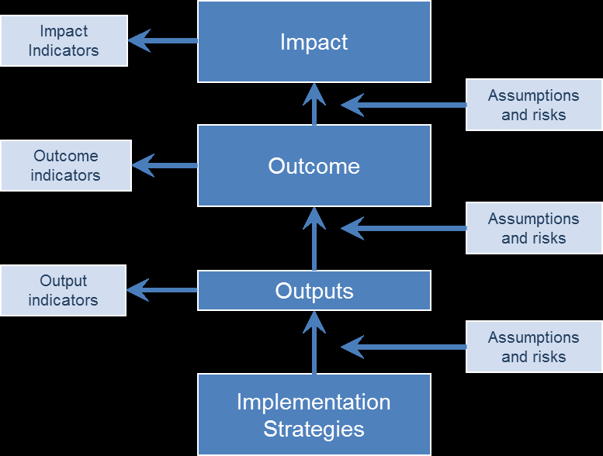

Figure 2.1: Theory of Change Diagram

**Source:** United Nations Children’s Fund, (2014)

Results chain is one of the things included in theory of change. The result chain shows series of boxes of outputs, outcomes and impacts, other times it is used to refer to specific types of representations – especially those that provide more detail about different levels of change, different actors and different causal pathways. The representation narrates the contextual factors that help or prevent change and the assumptions on which it is built. Conditions which are necessary for it to work but which are not under the control of implementers Rogers, P. (2014).

Anderson *et*. *Al*. (2004) Report that theory of change link outcome and activities to explain how and why the desired change is expected to come about theories of change may start with a program but best when starting with a goal before deciding what programmatic approaches are needed. Rogers (2014) elaborate more that theory of change also requires justification at each steps you have to articulate the hypothesis about why something will cause something else. Rogers *at. el*. (2014) it is important to ensure that theory of change represents what project/program intend to achieve and how satisfaction will be used. Therefore development of theory of change is more than filling in boxes since theory of change explains how change is understood to come about, rather than simply linking activities to expected results with an arrow Rogers, P. (2014).

Ideally, a theory of change explains Anderson *et*. *al*, (2004) report that Theories of Change require identifying indicators and also can be used during implementation to identify which indicators must be monitored, and to explain to staff, funders and partners how the program or policy works. Rogers *et*,*al* (2014) In an impact evaluation, a theory of change is useful for identifying the data that need to be collected and how they should be analyzed. It can also provide a framework for reporting Rogers, P. (2014).

Rogers, P. (2014) explain that a theory of change should begin with a good situation analysis involves identifying the problem that the intervention seeks to address, causes and consequences of this problem and the opportunities, Rogers.*at.al*( 2014) elaborate more that the next stage is to clarify which aspects of the problem the intervention will address and to make explicit the outcomes and impacts that it seeks to produce. When there is agreement about the current situation and the desired situation that the intervention is intended to contribute to producing Rogers. *at*, *al* (2014). The next step is to develop a theory about how to get from the current situation to the desired situation this should be in two parts – a theory about how this change will come about (e.g., deterrence) and a theory about how the intervention will trigger this change Rogers. *at*, *al.*( 2014 ).

Rogers. *at*,*al*( 2014 ) report development of a theory of change should ideally draw upon a combination of information and processes. Rogers. *at*, *al.* ( 2014 ) a theory of change can be used with any research design that aims to infer causality for experimental and quasi-experimental designs, Randomized Controlled Trials, and Quasi-experimental Design and Methods, it can identify important contextual variables that should be addressed when comparing treatment and comparison or control groups. A theory of change can use a range of qualitative and quantitative data, and provide support for triangulating the data arising from a mixed methods evaluation Rogers, P. (2014).

# 2.3.2 Theory of Logical Model

The Logic Model process is a tool that has been used for more than 20 years by program managers and evaluators to describe the effectiveness of their programs. The model describes logical linkages among program resources, activities, outputs, audiences, and short-, intermediate-, and long-term outcomes related to a specific problem or situation. Once a program has been described in terms of the logic model, critical measures of performance can be identified Paul F, McCauley (2014; 1-4).

Logic models are narrative or graphical depictions of processes in real life that communicate the underlying assumptions upon which an activity is expected to lead to a specific result. Logic models illustrate a sequence of cause-and-effect relationships—a systems approach to communicate the path toward a desired result. Paul F,McCauley (2014; 1-4)

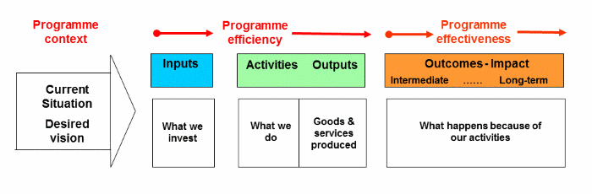

Figure 2.2: Logical Model Diagram

Adopted with modification from Will-Allen (2+016).

The elements of accountability are auxiliary described in the context of the logic model, below.

**Situation:** Paul F. McCauley (2014; 1-4) the situation statement provides an opportunity to communicate the relevance of the project. Paul F. McCauley (2014; 1-4) characteristics that illustrate the relevance to others include statement of the problem, a description of who is affected by the problem, who else is interested in the problem? The situation statement establishes a baseline for comparison at the close of a program. A description of the problem and its symptoms provides a way to determine whether change has occurred. Describing who is affected by the problem allows assessment of who has benefited. Identifying other stakeholders and programs builds a platform to measure our overall contribution, including increased awareness and activity, or reduced concern and cost Paul F. McCauley (2014; 1-4).

**Inputs.** Inputs include those things that we invest in a program or that we bring to bear on a program, such as knowledge, skills, or expertisePaul F. McCauley (2014). Describing the inputs needed for a program provides an opportunity to communicate the quality of the program. Inputs that communicate to others that the program is of high quality include human resources, such as time invested by faculty, staff, volunteers, partners, and local people Paul F. McCauley (2014).

**Activities:** what the program me does with the resources; the processes, tools, events, technology and actions that are an intentional part of the program implementation. These interventions are used to bring about intended changes or results Paul F. McCauley (2014).

Outputs.Paul F. McCauley(2014) report thatoutputs are those things that we do (providing products, goods, and services to program customers) and the people we reach (informed consumers, knowledgeable decision makers). Describing our outputs allows us to establish linkages between the problem (situation) and the impact of the program (intended outcomes).Paul F. McCauley(2014) Outputs that help link what we do with program impact include teaching events such as workshops, field days, tours, short courses .The people we reach also are outputs of the program and need to be the center of our model. They constitute a bridge between the problem and the impactPaul F. M.C.Cowley (2014; 1-4).

**Outcomes:** Program outcomes can be short-term, intermediate-term, or long-term. Outcomes answer the question “What happened as a result of the program?” and are useful to communicate Paul F. McCauley (2014). The impacts of our investment, Outcome can include Short-term outcomes, Intermediate-term outcomes include changes that follow the short-term outcomes and Long-term outcomes follow intermediate-term outcomes when changed behaviors result in changed conditions Paul F. McCauley (2014).

Theory of change and logical model are related theory but they differ Anderson et.al (2004) Report that Logical models graphically illustrate program components and creating one helps stakeholders clearly identify outcomes, inputs and activities. Theories of change link outcomes and activities to explain how and why the desired change is expected to come about. Logic Models require identifying program components, so you can see at a glance if outcomes are out of sync with inputs and activities, but they don’t show WHY activities are expected to produce outcomes Theories of Change also require justifications at each step – you have to articulate the hypothesis about why something will *cause* something else. Logic Models don’t always identify indicators (evidence to measure whether outcomes are met or not) Theories of Change require identifying indicators.

# 2.3.3 Logical Frame Work Approaches

Over the past few decades LFA has come to play a central role in planning, managing and monitoring development interventions. Its origins lie in a US military planning approach, which USAID adopted for development projects sometime in the late 1960s. In the 1980s it was used by several international development organizations (e.g. UNDP, ILO) and also taken on board by several European development organizations. In the late 1980s it was introduced as a planning and management tool for European development aid. And by the end of the 1990s it had become the standard approach required by many donors and directorates of the European Commission Nobuko Fujita (2010)

The Logical Framework Approach (LFA) is an analytical process and set of tools used to support objectives-oriented project planning and management. It provides a set of interlocking concepts which are used as part of an iterative process to aid structured and systematic analysis of a project or program idea Milaca Delevan (2011). logical framework(log frame) is a tool that has the power to communicate the essential elements projects clearly and succinctly thought the project cycle .it is used to develop the overall design of a project cycle .it is used to develop the overall design of a project, to improve project implementation monitoring and to strengthen periodic project evaluation .in essence the log frame is a causes and effect model of project intervention to create desired impacts for the beneficiaries World Banks( 2001)

Logical framework approaches it focuses on the delivery of activities and outputs, and on the achievement of intended effects through intended routes. It is useful to distinguish the Logical Framework (log frame) – the matrix which summarizes the main elements of an intervention and connects them to each other – from the Logical Framework Approach(LFA) – the process by which these elements are formulated: Although there are variations in terminology and structure, the Logical Framework as a matrix has a reasonably standard form which integrates two types of logic: Vertical logic as a hierarchy of objectives – activities deliver outputs, which contribute to outcomes, which help bring about the overall goal; Horizontal logic showing how progress against each objective can be assessed (indicators and means of verification) and the external factors (assumptions and risks) which might affect the achievement of objectives Nobuko Fujita (2010).

The Logical Framework Approach is concerned with the procedures of problem analysis, the development of objectives and indicators, and the identification of risks and assumptions, which feed into the matrix. In general, this process should be a participatory one, involving key stakeholders in order to reach consensus on an intervention, which is then summarized in a logical framework Nobuko Fujita (2010). The LFA is composed of two stages used in project identification and formulation: Analysis stage and planning stage these two phases are carried out progressively during the identification and formulation of the projects to ensure the quality of design and therefore its implementation as well as its ex-post evaluation Nobuko Fujita (2010).

Analysis phase it includes Stakeholder analysis - identifying & characterizing potential major stakeholders; assessing their capacity Problem analysis - or “Problem Tree”. It consists of identifying key problems, constraints & opportunities; determining cause & effect relationships Objective analysis – or “Solutions Tree”. It consists in developing solutions from the identified problems; identifying means to end relationships. Strategy analysis – identifying different strategies to achieve solutions; selecting most appropriate. Milaca Delevan, (2011)

Planning phase it include Developing Logical Framework matrix – defining project structure, testing its internal logic & risks, formulating measurable indicators of success Activity scheduling – determining the sequence and dependency of activities; estimating their duration, and assigning responsibility Resource scheduling – or “Budgeting”. From the activity schedule, developing input schedules and a budget. Milaca Delevan, (2011).

Logical framework approach can be used in various phase of project cycle management. Milaca Delevan, (2011) Elaborate that Logical Framework Approach (LFA) is used at various phases of the Project Cycle Management It is to note however that LFA does not apply rigorously to projects of all types and sizes in the same way and it may be relevant to distinguish between the following types of projects Large projects, where the use of considerable resources for planning and design is justified and the use of LFA is a must. Experimental projects where the use of LFA is necessary regardless of size. Program consisting of several projects, where LFA should be used both on the program itself as well as the individual projects. Small projects, where fewer resources are available for planning, design and the use of LFA. Non-projects (event-projects) e.g. financial support, seminars, etc., where it does not make sense to use LFA.

Logical framework it facing some challenges (Nobuko Fujita 2010) report that. “Logic-fewer frames”: When the use of log frames is imposed by donors, they are often invented after a project has been prepared. Thus only an illusion of logic is provided because the log frame format is used to accommodate a pre-existing design, rather than to help create a logical design in an appropriate format. lack-frame”: The log frame is frequently too simple and omits vital aspects of a project, as not everything of importance can be captured in one table. Many users have underestimated that a “frame” includes some things and leaves others out, and that a “frame-work” is to “frame” (help) the required work, not substitute for it. “lock-frame”: after an LFA has been prepared, it tends to be fixed and not up-dated, thus blocking learning and adaptation. Therefore oversimplified plans (matrices) become treated as blueprints that dictate outcome, and as a control tool to ensure that the required outcome is achieved. Logical framework approach and theory of change are related but differ. Pirosika. B. Bullen (2016) explain A Logical Framework is like zooming in on the specific pathway that your program deals with and creating a neat, orderly structure for it. This makes it easier for you and the donor to monitor program implementation

# 

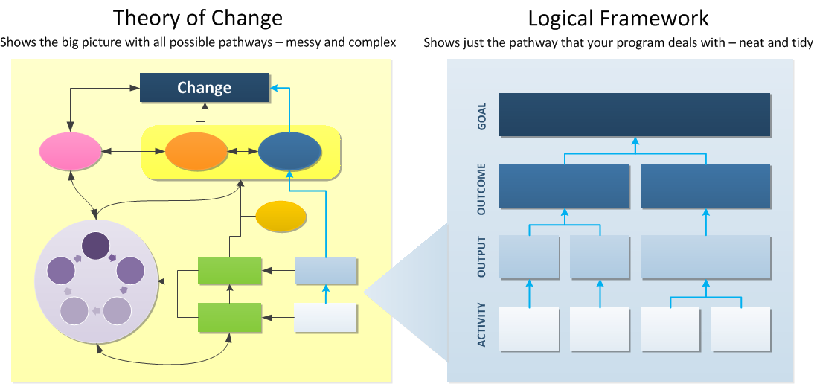

Figure 2.3: Difference between Theory of Change and Logical Framework

**Source:** from Persia B .Bullpen (2016).

# 2.4 Empirical Literature Review

The study of Elizabeth W. Wahhabi (2009) on study of determinants influencing the effectiveness of M&E systems in NGO’s within Nairobi County, Kenya. The sample of this research was selected using stratified random sampling method. Elizabeth W. Wahhabi (2009) the primary data was collected from the project managers or the M&E staff from each NGO. The findings demonstrated that there are challenges in the use of the M&E frameworks, which was chiefly ascribed to the devices and procedures utilized this is because of the trouble in their relevance. The part of administration in the operations of the M&E framework, despite the fact that named as satisfactory and provoke, likewise influences the viability of the M&E framework.

A decent number of the respondents had gone to preparing in the M&E frameworks and named it as complete and applicable since it added to the adequacy of the M&E framework and also to the ability of the staff. The M&E preparing was likewise observed to be an imperative donor towards enlistment of neighborhood M&E specialists notwithstanding expanding the quality and amount of the M&E human asset. The specialized aptitude of the group despite the fact that named as one of the slightest calculate adding to troubles utilizing M&E frameworks, it decides the echelon of achievement of the M&E framework (Wahhabi, 2009).

Muzinda mark (2007) on the study of M&E practice and challenges of Gaborone based local NGOs implementing HIV/AIDs project in Botswana. Data for research was collected using the descriptive survey method where a questionnaire was distributed to M&E officer and project a officials of the NGOs. The study also revealed that the M & E activities of the local NGOs fell short of the best practices. Most of the best activities were erratically done and others were not done at all. Planning for M&E was improperly done and inconsistently by respondents. Employing the M&E process was not effectively conducted by the respondents. The study also identified quite a number of challenges the NGOs faced in carrying out M&E of the projects they faced. These challenges made it tough for the NGOs to effectively monitor and evaluate the projects they implemented. The most significant ones included; insufficient finances, shortage of expertise, stringent and multi-donor reporting requirements, inadequate baseline data. The research indicate that, all in all the projects implemented by the local Non Government Organizations were not effectively monitored and evaluated.

The study by Koffi-Tessio (2002) On Efficacy and Efficiency of Monitoring-Evaluation Systems (MES) for Projects Financed by the Bank Group that was done in Burkina Faso, Mauritania, Kenya, Rwanda and Mozambique, through desk review and interviews, for projects approved between 1987 and 2000.Koffi-Tessio (2002) findings results indicate that M&E systems are not meeting their standard requirements as decision making tool instead their activities are viewed a scheming by a bureaucratic management, poor acquisition of the appropriate M&E systems by NGOs is also attributed to the organizations over emphasis on the physical infrastructure (for instance computer equipment’s, working capital etc.) rather than methodological and conceptual training.

Wegayehu Huluka Tulema (2014) on the study of M&E practices and challenges of local NGOs executing education projects in Addis Ababa. Research used simple random sampling technique for acquisition of quantitative data and to substantiate quantitative data six local NGO directors included using availability sampling technique. The data were analyzed using SPSS and interpreted in percentage, mean and standard deviations. The findings of this study revealed that: a large majority of subjects (63 %) confirmhave challenges such as limited finance, insufficient baseline data, and shortage of expertise to monitor and evaluate projects effectively, They take up method such as initiated participatory M&E, allocated enough budget for M&E and abstain from working in areas located far away from their head offices to reduced challenge. This study in general shows local Non government organizational (NGOs) were not effective in conducting M&E though anticipated outcomes of their projects articulated clearly mainly due to ineffectiveness planning for M&E.

Mthethwa, R .M. at al. (2016) On the Challenges in implementing monitoring and evaluation (M&E)The case study of the Mfolozi Municipality .Research employed secondary data from different documents such as the Mfolozi municipality’s IDP and annual reports. The research was examining, because the main objective of the study was to study and to gain a better understanding of the problem that arise in conducting M&E particularly in the Mfolozi municipality. Furthermore, descriptive research was employed toexplain the problems in implementing an monitoring and evaluation system. The findings of this research that their shortage of financial resource and insufficiently skills contribute to the ineffectiveness of monitoring and evaluation.

Jose lee S. Kasule (2016) on study of factors affecting the application of Results Based M &Esystem by Nurture Africa. The research study used a mixed method to collect data from 40 sampled respondents. These included surveys, key informative interviews and document review of M&E tools. Out of38 respondents, most (37%) disagreed that Nurture Africa management provides capacity building for staff in M&E. There was however a significant number of respondents (31.5%) who agreed that management provided capacity building for staff in M&E. The majority of the respondents (52.6%) disagreed and 10.5% strongly disagreed that Nurture Africa management allocated sufficient funds for M&E activities.

The highest percentage (60.5%) of the respondents interviewed disagreed that Nurture Africa staff possessed M&E skills and experience. Close to37 (36.8%) of the respondents interviewed, disagreed that Nurture Africa conducted a baseline for every project, while 26.3% agreed and 21.1% strongly agreed that Nurture Africa always conducted baseline studies. Only 15.8% percent of the participants were not sure whether Nurture Africa conducts baseline studies. It was concluded that management support, organizational capacity as well as utilization of baseline information affected the capacity of Nurture Africa staff to report project outcomes and impact.

Donna LouiseLoveridge, (2011) On the study about development of M&E capacity in the public sectors of developing countries. The objectives of the research are to expand our sympathetic of how capacity in monitoring and evaluation enlarge in the complex public sector developing country contexts. The premise is that discover the assumptions and propositions underpinning how public sector capacity is estimated to develop are instrumental to this understanding. The research takings through an in-depth case study of the Government of Tanzania, using a ‘theories of change’ approach that examines the interrelationship between context, mechanisms and outcomes. The theories of change approach intended to carry surface these three elements to highlight how change is expected to occur, whether the theories espoused are similar to those that are in use, and whether they are partial, confused or contradictory.

Theories of change that appeared through the assess of Government of Tanzania monitoring and evaluation capacity development efforts, this research revealed that there has been problem consideration of context and mechanisms while preferred outcomes are articulated more clearly. This situation has indicated insufficient recognition of the problem to initiating M&E to a complex developing country, partial learning, ineffective capacity development strategies being used and unrealistic expectation about how to improve success.

Recommendation of the study is that there is a significant required to modify the existing approach to improve monitoring and evaluation capacity development in the Government of Tanzania if the preferred outcomes to be realized . The optional approach requires much critical evaluative thinking and theorizing about change processes, commitment to evaluation for learning and openness about the complexities and uncertainties of international development.

Kayaga (2015) On the study of role of M&E in improving sustainability in water projects a case study of water projects in Bagamoyo District, Pwani Region. The study was conducted in Bagamoyo District in Pwani Region, whereas five (5) wards and six (6) villages were studied, those wards includes Zinga, Kiromo, Fukayosi, Dunda and Kiwangwa. The study had the following specific objectives, firstly to determine the current M&E practices applied in water projects, to determine challenges faced by water projects in implementing monitoring and evaluation activities and to find out the anticipated best approaches to be employed in improving M&E practices applied in water projects.

A total of 100 respondents were drawn from different levels which included the officials in District water department, who are the project implementers, Village government members including water committee’s members and local communities who are the water users and the project beneficiaries. Both Quantitative data obtained through prepared questionnaires and Qualitative data from Interviews done with villagers, district officials and village government members were used, together with documentary evidences. Findings of this study showed that, the most applied M&E practices in water projects is Field visit and meeting. Other practices are APR, LFA and PRA, which are not effectively applied. It also revealed that, most of established water projects lack sustainability, and the major reason among others is ineffective M&E systems.

The findings indicate that, water projects faces different problems in conducting monitoring and evaluation activities including inadequate budgetary allocation in M&E activities, shortage of technical M&E staffs, Low central government support, poor t reports and lower community participations information systems, It also indicated the lack of an independent monitoring and evaluation unit in the District water department and the use of unskilled M & E staffs.

# 2.5 Research Gap

From the literature review done and review studies that have been done it show that a lot of effort has been discuss challenges facing NGOs to implement monitoring and evaluation system Wegayehu Huluka Tulema (2014), R .M. Mthethwa .at ,al (2016), Joseylee S. Kasule (2016) etc. Despite with those literature review mostly of studies has conducted at Kenya, Botswana and Ethiopia furthermore Tanzania have little studies conducted on monitoring and evaluation (Nathaniel kayaga (2015), Loveridge, D. L. (2011) The studies was concentrated on role and development of M&E capacity in the public sectors of developing countries but has regret determinates factors such financial resource, human resource, role of management on how affect effectiveness of monitoring and evaluation system in NGOs. This research will going to cover the gaps about determinants of effectiveness monitoring and evaluation system in national and international NGOs especially at kinondoni municipality in Dar es salaam Region.

# 2.6 Conceptual Framework

Conceptual framework is a diagram that illustrates the interaction among relevant factors that may influence the winning accomplishment of goals and objectives. It helps determine which factors will catalyst and how each of these factors might relate to and impact the Outcomes. (Ending Violence against Women and Girls Programming Essentials 2, 2013, Wachamba E. Wanjiru (2009). Kusek at, al (2009) Report that People who are skilled, role of management, and budget motivate for and maintain a functional M&E system. This research looks at the determinants factors which are financial resources, Role of management, M&E staff on how influencing effectiveness of M&E systems in NGO’s. The study was strived to show how combinations of the independent variables contribute to the effectiveness of an M&E system.

M&E system cannot function without skilled people who effectively execute the M&E tasks for which they are responsible Kusek at, al (2009).M&E staff can have positive or negative effects on the monitoring and evaluation system when have adequate skills in M&E can agitate robust M&E system in the organization. Skilled staff can lead into good selection of different tools which strength M&E system. An effective M&E system requires capable people to support it. (IFRC, 2011). Jody ZallKusek finalized on the Book of Making Monitoring and Evaluation Systems Work; A Capacity Development Toolkit that *“No skilled people, no M&E system.* Kusek*at*, *al* (2009).

management have responsible for making sure there is sufficient and appropriate personnel with the right level of resources and other support needed to implement good quality M&E system (IFRC 2002) The management plays a big role in budget allocation. Being the key decision makers in a project, they contribute significantly in deciding what should be given a priority in the budget. It calls for their commitment to the implementation of Monitoring and evaluation systems (IFAD 2002, Abala at.al 2016). Most managers show little or no interest at all in the implementation of active Monitoring and evaluation systems World Bank,( 2000).M&E system are not crucial when management are not used information from monitoring and evaluation.

Financial resource is among of the factors which agitate M&E system to be vigorous. Financial resource cans weak or vigor M&E system. A general rule of thumb is that the M&E budget should not be as small as to compromise the accuracy and credibility of results, IFRC (2011) however most projects in Africa and other developing countries have suffered a great deal due to lack of budget to implement Monitoring and evaluation systems IFAD, (2002).

Effective M&E systems can help identify promising programs or practices. They can also identify unintended, but perhaps useful, project, program and policy results. M&E systems can help managers identify program weaknesses and take action to correct them. M&E can be used to diminish fear within organizations and governments and to foster an open atmosphere in which people learn from mistakes, make improvements, and develop skills along the way. Kusek, *atal* (2009) this study was strive to show how combinations of the independent variables contribute to the effectiveness or ineffectiveness of M&E system. (Dependent variable)

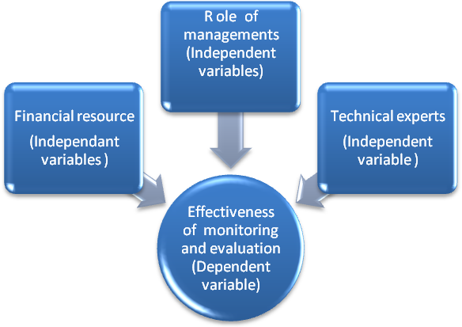

Figure 2.4: The Identified Independent Variables and the Existing Relationship Between Them And The Dependent Variable

# CHAPTER THREE

# 3.0 RESEARCH METHODOLOGY

**3.1 Introductions**

This sections present the research methodology showing research design, are of the study, population sample, sampling techniques, data collection and analysis techniques used in data collection, analysis and interpretation during the study. Research design it was used triangulation methods which are contain qualitative and quantitative approaches in order to have genuine findings.

Qualitative approach is one in which the inquirer often makes knowledge claims based primarily on constructivist perspectives (i.e., the multiple meanings of individual experiences meanings socially and historically constructed, with an intent of developing a theory or pattern) or advocacy/participatory perspectives (i.e., political, issue-oriented, collaborative, or change oriented) or both. It also uses strategies of inquiry such as narratives, phenomenologies, ethnographies, grounded theory studies, or case studies. The researcher collects open-ended, emerging data with the primary intent of developing themes from the data. John W. Creswell (.1998).

A quantitative approach is one in which the investigatory primarily uses postpositive claims for developing knowledge (i.e., cause and effect thinking, reduction to specific variables and hypotheses and questions, use of measurement and observation, and the test of theories), employs strategies of inquiry such as experiments and surveys, and collect data on predetermined instruments that yield statistics data. John W. Creswell (1998).

Mixed methods approach or triangulation methods approaches is one in which the researcher tends to base knowledge claims on pragmatic grounds (e.g., consequence-oriented, problem-centered, and pluralistic). It employs strategies of inquiry that involve collecting data either simultaneously or sequentially to best understand research problem. The data collection also involves gathering both numeric information (e.g., on instruments) as well as text information (e.g., on interviews) so that the final database represents both quantitative and qualitative information. John W. Creswell (1998).

# 3.2 Research Design

Research design can be defines as the conceptual structure within which research conducted. it further clarification that, a research design implement an order by arranging steps of activities to find answer of research questions of the study. There many types of research design include exploratory , descriptive, experimental design (kothar 2004, Malinda 2017)

# 3.3 Study Area

Kinondoni municipality is among of five municipalities in Dar es salaam Tanzania the area of kinondoni is 531 km² the latest list of Non-Government Organization are 250 which included local and international NGOs am interested to select kinondoni municipally because is among of municipally which have large populations of active national and international Non-Government Organizations. For that view has been able to had genuine findings. Exploratory, descriptive design was used and research techniques for data collection. In order to meet required research criteria different procedures was been taken include formulation of questionnaires tools, selection of sample survey for data collection furthermore data analyzing and discussion of the results.

# 3.4 The Target Population

Kothari (2004) define population as total collection of elements and sample as a part of such population that is selected according to some rules and statistics. The population of this research was 250 NGOs operated within kinondoni municipally at Dar es Salaam .National Bureau Database, (2013). The target population was 30 NGOs registered and operated within kinondoni municipality that had monitoring and evaluations system but are non-performing.

# 3.5 Sampling Strategy

This is the process of selecting a sufficient number of elements from a population Raval, (2009). It was superior techniques and process that was used to select a sample. The Sample of this research was picked used non probability sampling the methods of convenience sampling, where 30 NGOs within Kinondoni municipally was been selected by employed non probability sampling and among of criteria used to be legible must has monitoring and evaluation system and then researcher was picked 15 local NGOs and 15 international NGOs by using Quota sampling the respondents for the target population was monitoring and evaluation managers, monitoring and evaluation staff and project staff. This is because they are accountable of various aspect of the project and operations of NGOs, including M & E system.

# 3.6 Sampling Technique

Kothari (2004). Explicate that non probability sampling the organizers of the enquiry purposively choose the particular units of the universe for constituting a sample on the basis that the small mass that they so select out of huge one will be typical or representative of the whole”. Non probability (purposefully) sampling was employed. and among of criteria used in order NGOs to be legible must have monitoring and evaluation system and located at kinondoni municipally Which means 30 NGOs was been selected by using non probability sampling and then convenience and Quota sampling was used to employed 15 local NGOs and 15 international NGOs.

# 3.7 Data Collection Methods

The study was used triangulation method that includes (qualitative method and quantitative methods) with validity and reliability of data, sampling procedures and data analysis techniques as discussed below.

**3.7.1 Primary Data Collection**

Primary information in this study was gathered through the following techniques:

Data collection through questionnaire. Questionnaire is one of the methods used in primary data collection in study according to Kothari (2004) explain that questionnaire is considered the heart of survey. Questionnaire tools which include closed and opened questions was distributed to M&E Managers, M & E officer and projects officer from sampled National and International NGOs located at Kinondoni district who were expected has detailed information about M & E system in there NGOs for purpose to dig up rigorous findings.

# 3.8 Data Analysis and Techniques

# 3.8.1 Data Processing and Analysis

The primary data collected from questionnaires was analyzed by using regression analysis techniques with the help of Software Package for Statistical Science (SPSS).The methods is chosen because it is suitable to measure the relationships more easily. The tool was employed for data analysis.

# 3.8.2 Analysis of Quantitative Data

Data from questionnaire were processed and analyzed by using Statistical Package for Social Sciences (SPSS) which is the most widely used computer software in social science research. SPSS is chosen because is user friendly and widely accessible. The first task after collecting all the questionnaires was to make sure that they are filled in appropriately, and to prepare codes for each question asked. Each individual questionnaire numbered for easy identification to avoid some errors or missing data on a particular case. Data entered into SPSS and then processed. The process involves running frequencies for each survey and, if there are some mistakes, typing the appropriate number on the SPSS editor. The next step was to analyze the data through available measures in SPSS; which include the use of descriptive statistics and cross table analysis for purpose of comparing the results of national NGOs and international NGOs and results was articulated by graphs, percentage and table.

# CHAPTER FOUR

# 4.0 RESULT AND DISCUSSION OF FINDINGS

# 4.1. Introduction

This chapter is a presentation of the research findings acquired from national and international NGOs located at Kinondoni Municipally. This section contain background information, presentation of findings and analysis based on general objectives and specific objectives were descriptive analysis have been applied. Research questionnaires was distributed to 15 National NGOs were all was positively responses to fill those questions moreover 15 questionnaires was distributed to 15 international NGOs where by 14 was have positively responses and only one NGOs have negative response.

**4.2 Demographic Information**

The study required to find out the demographic information of the respondents which included Gender, level of education, Experience on monitoring and evaluation system.

**4.2.1 Gender Distribution**

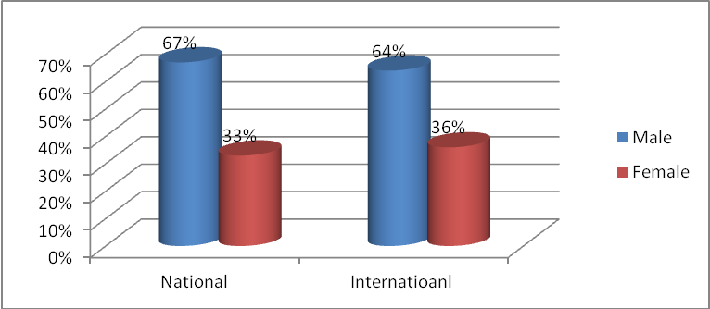

**Figure 4.1: Gender Distribution**

**Source:** researcher, 2017

Gender distribution of the respondents was required for purpose of understand gender participation in monitoring and evaluation system in both national and international NGOs. Finding indicate that majority of the respondents were male (67%) while female respondent were (33%) at national NGOs compare to the international NGOs majority of the respondents were (64%) and female were (36%) .This designate that female has lower participation in monitoring and evaluation system amongst sampled national and international NGOs

**4.2.2 Level of Educations**

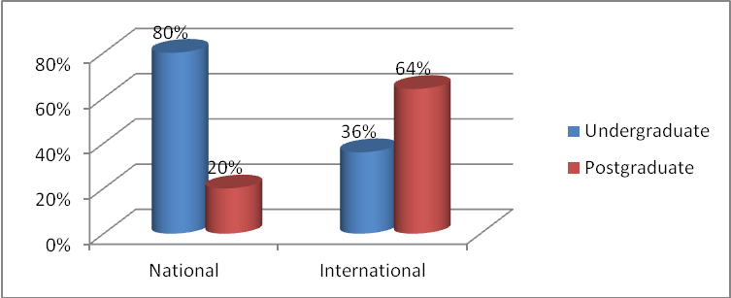

Figure 4.1: Level of Education

**Source:** researcher, 2017

The study above indicate that 80% at national NGOs they had first degree( undergraduate) and only 20% had postgraduate while at international NGOs 64% they had postgraduate and 36% are undergraduate .This indicate sampled respondent are more knowledgeable to provide are valid information about monitoring and evaluation system.

**4.2.3 Experience on Monitoring and Evaluation System**

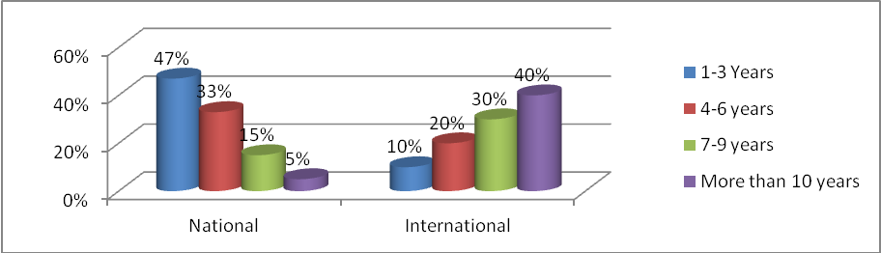

Figure 4.2: Experience on Monitoring and Evaluation System

Source: Field Data Collection 2017

Based on the findings majority (47%) of the sampled respondent at national NGOs had experience on monitoring and evaluation system between 1 to 3 years followed by (33%) who had experience between 4 to 6 years while (15%) had experience between 7 to 9 years and only (5%) had experience more than 10 years. while sampled respondent at International NGOs ( 40%) had experience on M&E system more than 10 years followed by (30%) had an experience between 7 -9 years while (20%) had experience between 4-6 years and only (10% ) had experience between 1-3 years. This implies sampled respondent from International NGOs had more experience rather than National NGOs which agitate ineffectiveness of monitoring and evaluation system at National NGOs

**4.2.4 Age of Respondents**

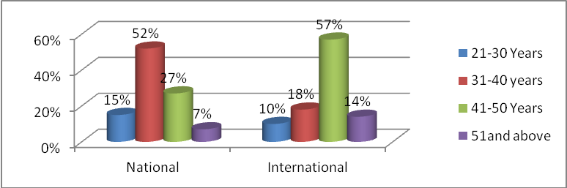

Figure 4.3: Age of Respondents

Source: Field Data Collection 2017

Majority of sampled respondent from national NGOs (52%) indicate that their age range between 31-40 followed by 27% who indicate their age range between 41-50 years, 15% their age range between 21-30 years and only 7% their age are 51 and above. While at international NGOs 57% of samples respondent their age range between 41-50 years followed by 18% who their age range between 31-40 years while 14% their age range between 41-50 years and only 10% range between 21-30 years. This implies that both at national and international NGOs have lower involvement of the age range between 21 -30 years.

**4.3 Effectiveness of Monitoring and Evaluation System**

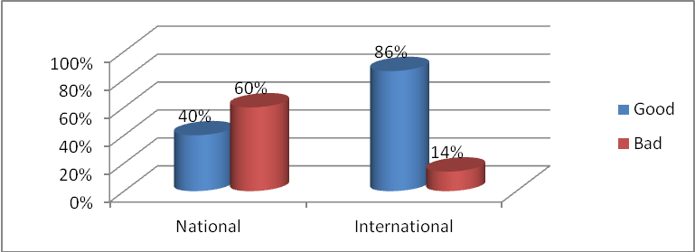

Figure 4.4: Effectiveness of Monitoring and Evaluation System

Source: Data Field Collection 2017

Results of study designate that (60%) sampled respondent from national NGOs has rate effectiveness of M&E system was in dire condition while 40% had rate effectiveness of M&E system are in good conditions. While 86% sampled respondent from international NGOs rate effectiveness of M&E system are in good conditions and only 14% had rate effectiveness of M&E system are in terrible condition, This implies that sampled international NGOs had good effectiveness of M&E system compared to sampled national NGOs.

**4.4 Review of Monitoring and Evaluation System in NGOs**

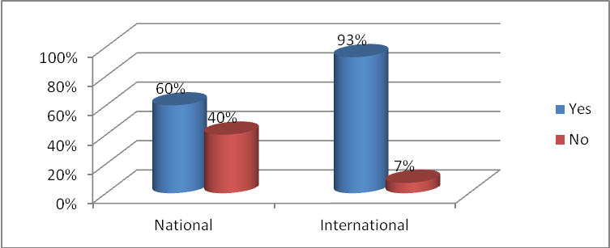

Figure 4.5: Reviews of Monitoring and Evaluation System

Source: Data Collection 2017

Revision of M&E system was essential for purpose of track relevance of monitoring and evaluation system for intention of determines effectiveness of M&E system. Findings indicate that (60%) sampled national NGOs M&E system was reviewed followed by (40%) was not reviewed. While (93%) sampled international NGOs M&E system was reviewed and only (7%) international NGOs was not reviewed. This indicate that majority of international NGOs M&E system are complies with internal system and donor requirement than national NGOs.

**4.5 Challenges Countenancing Monitoring and Evaluation System**

Table 4.1: Challenges Countenancing Monitoring and Evaluation system

|  |  |  |  |  |  |
| --- | --- | --- | --- | --- | --- |
|  | |  | Yes | No | Total |
|  | National NGOs | Frequency | 15 | 0 | 15 |
| Percentage | 100.0% | .0% | 100.0% |
|  |  |  |  |
|  | International NGOs | Frequency | 12 | 2 | 14 |
| Percentage | 85.7% | 14.3% | 100.0% |
|  |  |  |  |

**Source:** Data field collection 2017

Results of study indicate that 100% of sampled respondents from national NGOs was faced different challenges when operated monitoring and evaluation system while 87% sampled respondents from International NGOs was faced some of challenges when operated M & E system and only 14% are operated smoothly without challenges. This indicate majority of sampled NGOs faced different challenges when was operated M&E systems

**4.6 Factors Affecting Monitoring and Evaluation System**

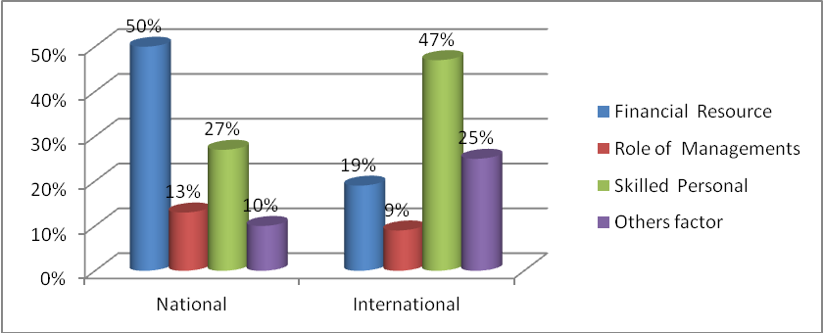

Figure 4.6: Factors Affecting Monitoring And Evaluation System. Source Field Data Collection 2017

Study findings designate that 50% majority of sampled respondents from national NGOs had faced shortage of financial resource to support M & E system followed by 27% employed skilled M&E personal while 13% there faced challenges of accountability of managements and only 10% faced other challenges while 47% majority of sampled respondents from International NGOs their faced challenges of employed M&E specialist due to shortage of M&E specialists at Tanzania. According to the one of respondents elaborate that “NGOs it has capacity to employed specialist of M&E but it difficult to get native specialist due to most of university did not provide program of monitoring and evaluation a lot of university provide short course of monitoring and evaluation which are incapable to personal to operate M&E system effectively and enforced most of NGOs to employed foreigner M&E specialist which a very expensive”. Followed by 25% there had other challenges which are out of financial, role of management, skilled personal, followed by 19% there had financial problem which affect effectiveness of Monitoring and Evaluation system and only 9% there had poor responsibility of management toward effectiveness of M&E system this implies that majority of national NGOs had faced financial problems. IFRC (2011; 75) Report that industry standard is that between 3 and 10 per cent of a project/programmer’s budget be allocated to M&E. International NGOs majority had faced challenges of employed native M&E staff

**4.7 Effectiveness of Financial Resource Toward Monitoring and Evaluation System**

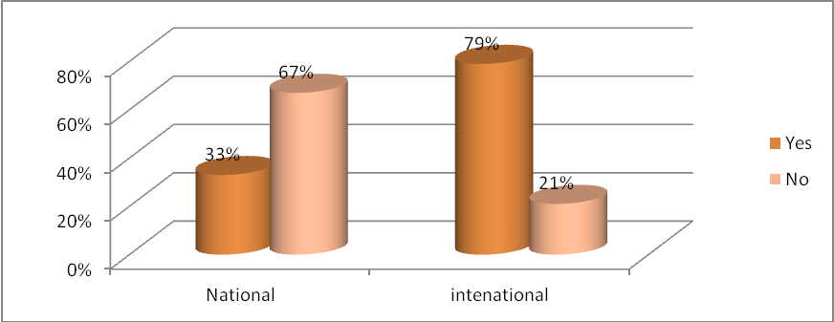

Figure 4.7: Effectiveness of Financial Resource toward Monitoring and Evaluation System

Source: Field data collection 2017

Results from study indicate that 67% majority of sampled respondent from national NGOs has ineffectiveness financial resource which was affected monitoring and evaluations system and only 33% had good effectiveness’ financial resource which was optimistic force for monitoring and evaluation system while 79% sampled respondent international NGOs their had adequate financial resource toward monitoring and evaluation and according to among of respondents explain that “their locate 10% of total project budgets for monitoring and evaluation activities” This indicate financial resource it strength M&E system while 21% had inadequate financial resource. This indicate that majority of sampled national NGOs there had financial resource infectiveness toward monitoring and evaluation rather than sampled international NGOs.

Majority of sampled respondents from National NGOs had elaborated that due to scarcity of financial resource was unable to formulate good and relevance tools for tracking project progress.

**4.8 Measurement Taken**



Figure 4.8: Measurement Taken

Source: Data field Collection 2017

Results from findings indicate that 73% of sampled respondents of national NGOs there had explained was been taken different measure to solve scarcity of financial resource toward M&E system and among of respondent had explained that in our NGO was restructuring their policy to inject 10% of total budgets for M & E activities while 27% was not taken any measure of financial resource toward M & E system and sampled international NGOs was taken measure and only 14% had not taken measure.

**4.9 Competency of M&E Staff to Handle Monitoring and evaluation System in Organizations**

Table 4.2: Competency of M & E Staff to Handle Monitoring and Evaluation System Source Field Data Collection 2017

|  | |  | Competency of staff handling Monitoring and Evaluation System at NGOS | |  |
| --- | --- | --- | --- | --- | --- |
|  |  | competent | Incompetents | Total |
| Categories of Non-Governmental Organizations (NGOs) | National | Frequency  Percentage | 4 | 11 | 15 |
| 27% | 73.3% | 100.0% |
|  |  |  |
| International | Frequency  Percentage | 8  57% | 6  43% | 14  100.0% |

Source: Data field Collection 2017

Results from the study indicate that 73% of sampled respondents at national NGOs their faced are problem of employed M&E specialists due scarcity of competent M&E specialist its required a lot of financial resource to retain them regard as majority of national NGOs their faced inadequate fund for M&E system and only 27% had incompetent M & E staff while 57% sampled respondents from international NGOs there had competent M & E specialists while 43% had incompetent M&E Staff this implies that majority of sampled respondents from national and international their faced challenges of employed native competent M&E Specialists due to precipitate of monitoring and evaluation fled at Tanzania for that facts it affect monitoring and evaluation system for that reason majority of staff who performed M&E activities are not capable to formulate and use different tools for tracking project progress.

**4.10 Measurement Been Taken**

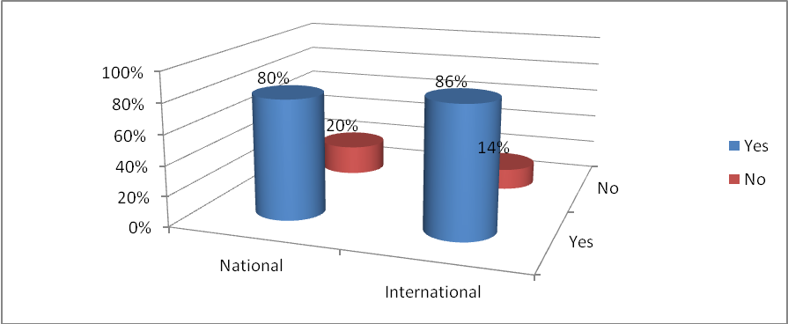

Figure 4.9: Measurement Taken Source; Field Data Collection 2017

Source: Data field Collection 2017

Findings indicate 80% majority of sampled respondent from international NGOs there had taken different measurement to tackle challenge of incompetent staff among of respondent had explicated that “was formulate capacity building program and it was made joint training with international NGOs that had more skilled in monitoring and evaluation. while 20% had not taken any measurement to solve this challenges of incompetent M&E staff for sampled respondent at international NGOs majority of 86% there had taken measurement and among of solutions taken is to enroll incompetent staff to different short course of M&E.

**4.11 Management Responsibility toward Effectiveness of Monitoring and Evaluation System**

Table 4.3: Management Responsibility Toward Effectiveness of M & E System

|  | | | Managements Responsibility towards effectiveness of Monitoring and Evaluation system | |  |
| --- | --- | --- | --- | --- | --- |
| Effectiveness | Ineffectiveness | Total |
| Categories of NGOs | National | Frequency | 12 | 3 | 15 |
| Percentage | 80.0% | 20% | 100.0% |
| International | Frequency | 11 | 3 | 14 |
| Percentage | 97% | 3% | 100.0% |

# 

**Source:** Field data collections 2017

Findings indicate that sampled respondents from national NGOs majority of 80% their had effectiveness management toward monitoring and evaluation system followed by 20% their had infectiveness management toward monitoring and evaluation system while 97% sampled respondent international NGOs there had management effectiveness toward monitoring and evaluation system this implies that management of national and international NGOs had worth monitoring and evaluation at different projects performed by organizations.

**4.12 Uses of Monitoring and Evaluation Information to Organization Managements**

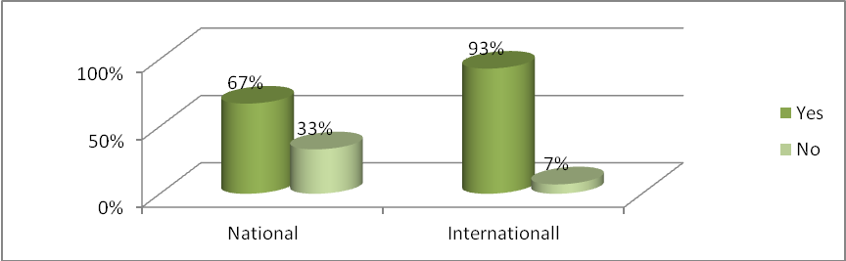

Figure 4. 10 Uses of Monitoring and Evaluation Information to Organization Managements

Source: Field Data Collection 2017

Results from findings designate that 67% of sampled respondents from national NGOs management utilized M & E information followed by 33% had unutilized M&E information while 93% of sampled respondents from international NGOs management had used M & E information and only 7% did not used M & E information’s

**4.13 Usefully of Monitoring and Evaluation Information to the Organization Managements**

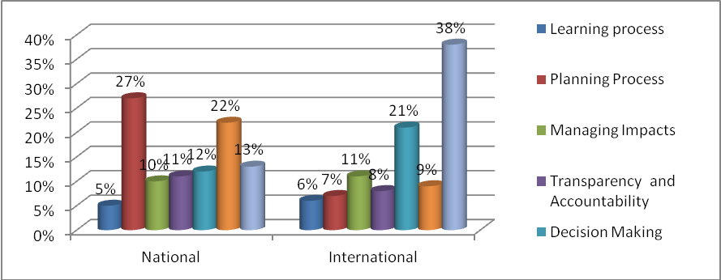

Figure 4.11: Usefully of M&E Information to the Organization Management

Source: Field data collections 2017

Results of findings designate that 27% sampled respondent from national NGOs had used M&E information for planning process. Followed by 22% their used for project improvements while 13% are used both criteria’s t together and 12% used for decision making while 11% used for managing impacts and only 5% used for learning process while 38% samples respondent from international NGOs used M&E information in both criteria together while 21% used for decision making and 11% for managing impacts followed by 9% for project improvement while 8% for transparency and accountability also 7% for planning process and only 6% for learning process. This implies that majority of national and international NGOs

**4.14 Recommendations for Improving Monitoring and Evaluation System in NGOs**

Table 4.4: Recommendation for Improving M&E system

|  |  |  |  |  |  |  |  |
| --- | --- | --- | --- | --- | --- | --- | --- |
|  | | | Enough budgets | Capacity building of M&E Staff | Regular review of M&E system | Team working | Total |
| Categories of Non Government Organizations (NGOs) | National | Frequency | 6 | 5 | 1 | 3 | 15 |
|  | Percentage | 40.0% | 33% | 7% | 20.0% | 100.0% |
| International | Frequency | 2 | 7 | 3 | 2 | 14 |
|  | Percentage | 14% | 50% | 22% | 14% | 100.0% |

Source: Field Data Collection 2017

Recommendations for improve monitoring and evaluation system in NGOs was inserted for purpose of verdict factors that determine effectiveness of monitoring and evaluation system which are financial resource, role of management, M&E staff. Findings indicate that 40% of sampled respondent from national NGOs their recommend that to increase financial resource toward monitoring and evaluations activities followed by 33% recommend to had capacity building program about M&E to project staff while 20% recommended to had team working for purpose of sharing skills and knowledge and only 7% advocate to review M& E system in order to be relevance with internal and donor s obligation while 50% of sampled respondent international NGOs had suggest capacity building in M & E to staff followed by 22% recommend to had regular review of monitoring and evaluation system while 14% advice to have enough budgets and 14% advice to have team working for purpose of skills and knowledge sharing among the staff.

# CHAPTER FIVE

# 5.0 CONCLUSION AND RECOMMENDATION

This chapter include conclusion of the study, recommendations and finally provide suggestion for further study.

# 5.1 Conclusion

Financial resource, role of management and M & E staffs is among of the factors which determine effectiveness of monitoring and evaluation system this reveal that if these factors are vigorous enough it can strengthen monitoring and evaluations system and when are feeble can affecting monitoring and evaluation system in NGOs

Financial resource, monitoring and evaluations staff at national NGOs has affected monitoring and evaluations system. Inadequate financial resource it lead some of sampled national NGOs to incapable operating M&E system due to scarcity of resource it was unable to covered regular field visiting and also software application which can simplify data storage. M&E staffs are not competent enough which has led to poor selections of M & E tools for role of management at majority of national NGOs management had good responsibilities toward M & E system and had used information from monitoring and evaluations to making decision, for learning process, managing impacts.

Project improvements, transparency and accountability but management had some few knowledge about usefully of monitoring and evaluation information most used in one aspect and regret other aspects according to At international NGOs financial resource, role of management, skilled monitoring and evaluation are effective which was strength M&E system. But was challenges of getting native M & E specialists enforce to employed foreignness specialists which are much cost fully. M&E system at sampled national NGOs are infective compared to sampled international NGOs which has effective M&E system it required some efforts to tackle those challenges brave M&E system at sampled national NGOs.

# 5.2 Recommendations

Based on the findings and conclusion made this study provide initial directions for purpose of overcoming different challenges which has been exposed in M & E system into aspect of financial resource ,role of management M & E staff. Their needed for allocate enough budgets for monitoring and evaluation system especially at national NGOs that will agitate to financing different issue which can strengthen monitoring and evaluation such as recruitment external consultants of M&E, Cabinet implementation units in Australian (2013;3) report that Successful monitoring, review and evaluation activities require adequate financial resourcing. Resources to establish a methodology for Collecting and maintaining data, conducting the reviews of monitoring and evaluation system and engaging stakeholders will need to be addressed in the monitoring and evaluation system.

According to the findings of this research there needed to develop training curricula for M&E staff and to conduct training workshops this will agitate to the orientation of local M&E staff and also to improve quality and quantity of the local experts furthermore this training should be focused on M & E tools, methods, approach and concept .That will enable national and international to employed local experts rather than to employed foreign experts who expensive. The study suggest that the management of national NGOs and international NGOs should be based on M&E information for project or program decision making and therefore at national NGOs should use M&E information not only in one aspect but on the both aspects. The study therefore recommends that the management should be innovative and interconnect with financial resource, role of management and M&E staff capacity building program.

**5.3 Recommendation for Further Research**

The researcher has examine three factors which are financial resource, role of management, M&E staff as the amongst of factors which determine evaluation system at national and international NGOs but has other factors which are crucial but are not included in this research for further researcher can take as the advantage to examine other factors which are determine effectiveness of monitoring and evaluation system in NGOs

**REFERENCE**

Abalang, J. A. (2016). Assessment of Performance of Monitoring and Evaluation Systems at Caritas Torit, in South Sudan.

Auriacombe, C. J. (2009). *Section A: Methodology Class UJ Internal Handbook for Honours Students, 2005–2009*. Johannesburg: University of Johannesburg.

Beamon, B. M., &Balcik, B. (2008). Performance measurement in humanitarian relief chains. *International Journal of Public Sector Management, 21*(1), 4–25.

Buckmaster, N. (1999). Associations between outcome measurements, accountability and learning for non-profit organizations. *International Journal of Public Sector Management,* 12(2), 186–197.

Byamugisha, A. & Basheka, B. (2015). Public budgeting in African Nations, *Evaluating the budget*, 21(4), 442-464.

Cabinet Implementation Unit within the Department of the Prime Minister and Cabinet (2013). Cabinet Implementation Unit Toolkit Monitoring, review and evaluation, Departments of the Prime Minister and Cabinet. Australian Government.

Clark, H. (2009). *Handbook on planning, monitoring and evaluating for development results*, New York: UNDP.

Gladys, L., Acevedo, K., R. and LyciaLima, H. H. (2010). Challenges in Monitoring and Evaluation: An Opportunity to Institutionalize M & E Systems the International Bank for Reconstruction and Development.

Gray, R., &Bebbington, J. (2006). NGOs, civil society and accountability: making the people accountable for capital. *Accounting, Auditing & Accountability Journal, 19*(3), 319–348.

Heléne, C. and Andrea, A. A. (2004). *Theories of Change and Logic Models*, Georgia: American Evaluation Association Atlanta.

Henderson, K. M. (1997). Alternatives to imposed administrative reform: The NGOs. *International Journal of Public Sector Management, 10*(5), 353–363.

Hogan, R. L. (2007). The historical development of program evaluation: Exploring the past and present. *Online Journal of Workforce Education and Development,* 2(4), 34-56.

IFAD, (2002). Local Initiative Support Project Evaluation Report No.34*,* Office of the Evaluation Studies. Rome, Italy.

IFRC, (2011). *IFRC Handbook for Project/Program for Monitoring and Evaluation* *(M & E).* In I. S. Planning and Evaluation (PED) Department, *Project/Program for Monitoring and Evaluation (M & E) Guiltiness.* International Federation of Red Cross and Red Crescent Societies (IFRC). Geneva, Swiss.

Independent Evaluation Group and Carleton University, (2007). Module 1: Introduction to development evaluation. (Pp.9-30) International Program for Development Evaluation raining (IPDET) Handbook, The World Bank Group.

Indrakumaran, A. (2011*).* The role of monitoring and evaluating in promoting good governance in south Africa, A case study of the department of social development, Published by university of Witwatersrand, South Africa.

Innovative in Illegal Empowerment (NAMATI) (2015). *Monitoring and Evaluation System for the Tanzania Women Lawyers Association (TAWLA),* Dar es Salaam: NAMATI.

Jody, Z. (2004). *Ten steps to Results -Based Monitoring and Evaluation System*, a Handbook for Development Practionnaire. NW Washington: World Bank.

Joseylee, S. K. (2016). *Factors Affecting Application of Results Based Monitoring and Evaluation System by Nurture Africa*, Makerere: Technology and Management University (UTAMU).

Kaplan, R. S. (2001). Strategic performance measurement and management in nonprofit organizations. *Nonprofit management and Leadership,* 11(3), 353–370.

Kothari, C. R. (2004). *Research methodology method and techniques*, New Delhi: New age international (P) limited publishers.

Loveridge, D. L. (2011). Theories of change: monitoring and evaluation capacity development in the government of Tanzania. Doctorate, Centre of Program Evaluation, Melbourne Graduate School of Education, the University of Melbourne.

Mebrahtu, E. (2002). Perceptions and practices of monitoring and evaluation: International NGO experiences in Ethiopia. *Development in Practice, 12*(3/4), 501–517.

Mthethwa, R. M. & Jili, N. N. (2016). Challenges in implementing monitoring and evaluation (M&E), the case of the Mfolozi Municipality; *African Journal of Public Affairs,* 8(3), 20-46.

Mutinda, V. (2011*).* Planning on monitoring andevaluation, Innovative Development & Policy Studies, 3(3), 12-27.

Muzinda, M. (2007). Monitoring and evaluations practice and challenges of Gaborone based local NGOs, implementing HIV/AIDS project in Botswana.

Nathaniel, S. (2015). The role of monitoring and evaluation in improving sustainability in water projects: a case study of water projects in Bagamoyo district, Pwani Region. Unpublished thesis, Open University of Tanzania. Dar es Salaam, Tanzania.

Olive, (1998). *Project planning for development*. Durban: Olive Publications.

Paul, F. M. (1996). The Logic Model for Program Planning and Evaluation, PhD thesis, University of Washington, CD.

Regional Administration and Local Government (2014); Local Government Development Grant (LGDG) system and monitoring& evaluation framework (M&E) Published by the United Republic of Tanzania Prime Minister Office

Rogers, P. (2014). Theory of Change, Methodological Briefs: Impact Evaluation 2, UNICEF Office of Research, Florence.

Ronette. E, (2010). Implementing a Government-wide Monitoring and Evaluation System in South Africa published by The World Bank Washington, DC.

Samuel, J., Mantel, Jr., Jack, M., Margaret M. (2001). Core Concepts of Project Management. River Street, Hoboken-USA: Johnwiley & sons Inc.

Toscano, S. (2013). "Exploring the History and Challenges of Monitoring and Evaluation in International Nongovernmental Organizations: Complemented by Intern Experience at Save the Children USA. Retrieved September 13, 2017, from [http://digitalcollections.sit.edu/cgi/viewcontent.cgi?article=3650 &context=capstones](http://digitalcollections.sit.edu/cgi/viewcontent.cgi?article=3650&context=capstones)

Training (IPDET) Handbook, the World Bank Group.

United Nations Children’s Fund, Supplementary Program Note on the Theory of Change, Peer Review Group meeting, 11 March 2014, UNICEF, New York.

United Nations Development Program Evaluation, (2002). Handbook on Monitoring and Evaluating for Results, New York: UNDP

Valadez, J. & Bamberger, M. (1994). *Monitoring and Evaluating Social Programs in Developing Countries;* a Handbook for Policymakers, Managers, and Researchers, N. W. Washington: The International Bank for Reconstruction and Development.

Weiss, C. (1995). *Nothing as Practical as Good Theory: Exploring Theory-Based Evaluation for Comprehensive Community Initiatives for Children and Families*, in Connell, J, Kubisch, A, Schorr, L, and Weiss, C. (Eds.) ‘New Approaches to Evaluating Community Initiatives’. Washington, DC: Aspen Institute.

World Bank, (2001). A logical framework approach to project cycle management, handbook, N. W. Washington: World Bank.

World Bank, (2002). Monitoring & Evaluation: some tools, methods and approaches. The World Bank, Washington, D.C

# 

**APPENDICES**

# APPENDIX i: INTERNATIONAL NGOS QUESTIONNAIRE

**DETERMINANTS EFFECTIVENESS OF MONITORING AND EVALUATION SYSTEM IN NONGOVERNMENT ORGANIZATIONS THE CASE STUDY OF KINONDONI MUNICIPALILY DAR ES SALAAM**

1. **INTRODUCTIONS**

This questionnaire is meant to collect information on determinants of effective M&E systems in NGOs within kinondoni Municipality Dar es Salaam, Tanzania.

The information obtained through this questionnaire will be kept with privacy and used for academic purpose only. Kindly take a moment to answer all the questions as perfectly as possible.

**2. BACKGROUND INFORMATIONS**

1. Name of the Non-Government Organization (NGOs)

…………………………………………………………………………………………

2. Category of the Non-governmental organizations? Nation ( ) International ( )

3. Respondent position level………………………………………………………

4. Gender Male ( ) Female ( )

5. Level of educations Diploma ( ), Undergraduate ( ), Postgraduate ( ) other ( )

6. What is your experience on monitoring and evaluation system in NGOs?

Less than 1 year ( ), 1-3years ( ), 3-6 years ( ), 6-9 years ( ) More than 9 years ( )

7. Age of respondents

Below 20 years, ( ) 20-30 years ( ), 30-40 years, ( ) 40-50 years ( ) above 50 years ( )

**SECTIONS THREE:** Determinants of effectiveness of monitoring and evaluations system

1. How would you rate effectiveness of monitoring and evaluation system in your organizations? excellent ( ) good ( ) bad ( ) I don’t know ( )
2. Elaborate more according to the answer given on first question ………………………………………………………………………………………………………………………………………………………………………………………………………………………………………………………
3. Did monitoring and evaluation system in your organization be reviewed?

Yes ( ), No ( )

1. Did you face any challenges when using monitoring and evaluation system in your organizations? Yes ( ) No ( )
2. If yes, rate this factors according to the weight of challenge affect monitoring and evaluation system in your NGOs

|  |  |  |  |
| --- | --- | --- | --- |
| Factors affecting monitoring and evaluation system | Tick where appropriateness | | |
| 1 | 2 | 3 |
| Financial resource |  |  |  |
| Role of managements |  |  |  |
| Skilled personal |  |  |  |

Interpretation 1 means (HIGH) 2 means (MEDIUM), 3 means (LOW)

1. How do you rate financial resource toward effectiveness of monitoring and evaluation system in your NGOs?

Very effectiveness ( ), effectiveness ( ) infectiveness ( ) very infectiveness ( )

7. If its infectiveness or very infectiveness what measure was been taken? ……………………………………………………..……………………………………………………………………………………………………………………………………………………………………………………………………………………………………………………………………………………………………………………………………………………………………………………………………………

8. What is the competency of staff handling M&E system in your organizations?

Very competent ( ), competent ( ) incompetent ( ) very incompetent ( )

9. Ifit’s incompetent or vey incompetent what measure was been taken?

……………………………………………………………………………………………………………………………………………………………………………………………………………………………………………………………………………………………………………………………………………………………………………………………………………………………………………………………………………………………………………………………………………………………………………………………………………………………………………………………………………………………………………………………………………………

10. How would you rate the responsibility of management towards the effectiveness of the M&E system?

Very effectiveness ( ) effectiveness ( ) infectiveness ( ) very infectiveness ( )

11. did monitoring and evaluation information used with organizations management?

Yes ( ), No ( )

12. How would you rate usefully of monitoring and evaluations information to the organization managements?

|  |  |  |  |  |  |  |
| --- | --- | --- | --- | --- | --- | --- |
| Function of monitoring and evaluation information | Tick according to the priority of uses | | | | | |
| 1 | 2 | 3 | 4 | 5 | 6 |
| For learning process |  |  |  |  |  |  |
| For planning process |  |  |  |  |  |  |
| For managing impacts |  |  |  |  |  |  |
| For transparency and accountability |  |  |  |  |  |  |
| For decision making |  |  |  |  |  |  |
| Project improvements |  |  |  |  |  |  |

13. What recommendations would you give to assist improve M&E systems used in

Projects by NGO sector?

…………………………………………………………………………………………………………………………………………………………………………………………………………………………………………………………………………………………………………………………………………………………………………………………………………………………………………………………………………………

**APPENDIX 11: NATIONAL NGOS QUESTIONNAIRE**

**DETERMINANTS EFFECTIVENESS OF MONITORING AND EVALUATION SYSTEM IN NONGOVERNMENT ORGANIZATIONS THE CASE STUDY OF KINONDONI MUNICIPALILY DAR ES SALAAM**

1. **INTRODUCTIONS**

This questionnaire is meant to collect information on determinants of effective M&E

systems in NGOs within KinondoniMunicipality Dar es salaam, Tanzania.

The information obtained through this questionnaire will be kept with privacy and used for academic purpose only. Kindly take a moment to answer all the questions as perfectly as possible.

**2. BACKGROUND INFORMATIONS**

1. Name of the Non-Government Organization (NGOs)

………………………………………………………………………………………………………………………………………………………………………………..

2. Category of the Non-governmental organizations? Nation ( ) International ( )

3. Respondent position level………………………………………………………

4. Gender Male ( ) Female ( )

5. Level of educations Diploma ( ), Undergraduate ( ), Postgraduate ( ) other ( )

6. What is your experience on monitoring and evaluation system in NGOs?

Less than 1 year ( ), 1-3years ( ), 3-6 years ( ), 6-9 years ( ) More than 9 years ( )

7. Age of respondents

Below 20 years, ( ) 20-30 years ( ), 30-40 years, ( ) 40-50 years ( ) above 50 years ( )

**SECTIONS THREE;** Determinants of effectiveness of monitoring and evaluations system

1. How would you rate effectiveness of monitoring and evaluation system in your organizations? excellent ( ) good ( ) bad ( ) I don’t know ( )
2. Elaborate more according to the answer given on first question……………………………………………………………………………………………………………………………………………………………………………………………………………………………………………………………………………………………………………………………………………
3. Did monitoring and evaluation system in your organization be reviewed?

Yes ( ), No ( )

1. Did you face any challenges when using monitoring and evaluation system in your organizations? Yes ( ) No ( )
2. If yes, rate this factors according to the weight of challenge affect monitoring and evaluation system in your NGOs

|  |  |  |  |
| --- | --- | --- | --- |
| Factors affecting monitoring and evaluation system | Tick where appropriateness | | |
| 1 | 2 | 3 |
| Financial resource |  |  |  |
| Role of managements |  |  |  |
| Skilled personal |  |  |  |

Interpretation 1 means (HIGH) 2 means (MEDIUM), 3 means (LOW)

1. How do you rate financial resource toward effectiveness of monitoring and evaluation system in your NGOs?

Very effectiveness ( ), effectiveness ( ) infectiveness ( ) very infectiveness ( )

7. If its infectiveness or very infectiveness what measure was been taken? ……………………………………………………..…………………………………………………………………………………………………………………………………………………………………………………………………………………………………………………………………………………………………………………

8. What is the competency of staff handling M&E system in your organizations?

Very competent ( ), competent ( ) incompetent ( ) very incompetent ( )

9. Ifit’s incompetent or vey incompetent what measure was been taken?

………………………………………………………………………………………………………………………………………………………………………………………………………………………………………………………………………………

10. How would you rate the responsibility of management towards the effectiveness of the M&E system?

Very effectiveness ( ) effectiveness ( ) infectiveness ( ) very infectiveness ( )

11. did monitoring and evaluation information used with organizations management?

Yes ( ), No ( )

12. How would you rate usefully of monitoring and evaluations information to the organization managements ?

|  |  |  |  |  |  |  |
| --- | --- | --- | --- | --- | --- | --- |
| Function of monitoring and evaluation information | Tick according to the priority of uses | | | | | |
| 1 | 2 | 3 | 4 | 5 | 6 |
| For learning process |  |  |  |  |  |  |
| For planning process |  |  |  |  |  |  |
| For managing impacts |  |  |  |  |  |  |
| For transparency and accountability |  |  |  |  |  |  |
| For decision making |  |  |  |  |  |  |
| Project improvements |  |  |  |  |  |  |

13. What recommendations would you give to assist improve M&E systems used in

Projects by NGO sector?

……………………………………………………………………………………………………………………………………………………………………………………

……………………………………………………………………………………………………………………………………………………………………………………