INCOME GENERATION THROUGH VEGETABLE GARDENING FOR NAURA SECONDARY SCHOOL FORM FOUR BUSINESS STUDENTS IN LEMARA WARD, ARUSHA DISTRICT

DANIEL URIOH

A PROJECT REPOR SUBMITTED IN PARTIAL FULFILMENT OF THE REQUIREMENTS FOR THE DEGREE OF MASTER IN COMMUNITY ECONOMIC DEVELOPMEMT OF THE OPEN UNIVERSTY OF TANZANIA
2017

CERTIFICATION
The undersigned specify that I have read and hereby recommend for the acceptance by the Open University of Tanzania (OUT) a project entitled, “Income Generation Through Vegetable Gardening For Naura Secondary School Form Four Business Students In Lemara Ward, Arusha District’ in partial fulfillment for the requirements for the degree of Masters in Community Economic Development of the Open University of Tanzania.

......................................................
Dr. H. G. Mtae
(Supervisor)

.................................................
Date

COPYRIGHT
No part of this dissertation may be reproduced, stored in any retrieval system or transmitted in any form by means, electronic, mechanical, photocopying, recording or otherwise without prior permission of the author or The open University of Tanzania in that behalf.

DECLARATION
I, Daniel Urioh, do hereby declare that this dissertation is my own original work and that it has not been presented and will not be presented to any other University for a similar or any other degree award.

…………………………………
Signature

…………………………………
Date

DEDICATION
This work is dedicated to my family, my wife, Upendo Michael, who encouraged and supported me to undergo the programme, to our beloved Sons; Desmond Daniel and Denil Daniel for their patience, integrity and obedience during my study period. Also my relative representatives, beloved brother Gadiel Wangael, my sister Tumaini Wangael and my father Wangael Yusto. Others include my beloved late mother Eliakunda Wangael and my son Derick Daniel.

ACKNOWLEDGEMENTS
I wish to express my sincere thanks to allmight God, Naura Secondary School, Elimu Afrika Organisation, Naura Secondary School Teachers and Students, Project incharge and community members who cooperated with me tirelessly from the beginning of the project. I would like to thank my Project Supervisor Dr Harieth G. Mtae whose tireless support, supervision, guidance and facilitation made this project report to come the way it looks. Special thanks should also go to the following faculty members who taught us various subjects during the coursework sessions, Prof. Deus D. Ngaruko, Dr. Mallya, Dr. Hamidu Shungu, Dr. Harieth G. Mtae and Dr. Felician Mutasa.

I would also like to express my sincere thanks and appreciations to class group members, John Joseph, Fullegence Mponji, Selina Ngurumwa, Godson Olendayai, Mohammed Besta and Emmanuel Akyoo for their moral and material support. I would like to express my thanks to the Research respondents, Focus Group Discussion, Naura Secondary School leadership, Teachers, Students, Mr. Godrich Zakaria, Mr Jesse Kaimukilwa and the entire Naura Secondary School community for their extension and advisory services to the project. However this type of research and project undertaking has involved the efforts of many people who are to be on an infinite list thus it behaves me to mention just few as above and I sincerely thank them for their cooperation and assistance in various aspects pertaining to the successful completion of the project report and the course in general.

ABSTRACT
This study focus on income generating project for Naura Secondary school form four business class in Lemara ward Arusha district, with the aim of introducing and apply entrepreneurship skills for students and encourage then to creating their own income, manage it and invest it while they still young. As the idea chosen by the students is Vegetable production within the school area, that become the project, located in Naura Secondary school. Community need assessment was conducted to help the students identifying their major need and deciding what kind of project will be sufficient to that need. The research also identified that other important community needs are access to capital, of income generating activity and capacity building for form four business class students. The focus group discussion conducted revealed that the need of substitute income generating activity is the priority number one since some students have the other sources of income. The implementation of this project aimed at achieving the objectives of training 50 students on entrepreneurship skills and vegetable production techniques, after getting the skills students they will be able to produce more than 5,000 grams of vegetables each month and sell it to the community, surely the project generate income. When the monitoring and evaluation was conducted, it was revealed that all these objectives are achievable given the good organization of the students whereby their cooperative is supervised by themselves and the business class teacher. Activities were being carried as planned and on good track. Also the Monitoring and Evaluation activities have proven that project enjoys institutional, financial political sustainability, and developmental sustainability

TABLE OF CONTENTS
CERTIFICATION ii
COPYRIGHT iii
DECLARATION iv
DEDICATION v
ACKNOWLEDGEMENTS vi
ABSTRACT vii
TABLE OF CONTENTS viii
LIST OF TABLES xiii
CHAPTER ONE 1
1.0 PARTICIPATORY NEEDS ASSESSMENT 1
1.1 Background Information 1
1.2 Community Profile 2
1.2.2 Social Economic Activities 3
1.2.3 Socio - Economic Infrastructure 3
1.3 Community Needs Assessment (CNA) 4
1.3.1 CNA Objectives 4
1.3.2 Research Questions 5
1.3.3 CNA Methodology 5
1.3.3.1 Research Design 5
1.3.3.2 Sampling Techniques 6
1.2.3.3 Data Collection Methods 6
1.3.3.3.1 Interviews 6
1.3.3.3.2 Questionnaire 7
1.4 CNA Findings 8
1.4.1 Socioeconomic Characteristics of Form Four Business Studies Class 8
1.4.1.1 Age of Respondent 8
1.4.1.2 Gender of Respondent 9
1.4.1.3 Income Generating Activities 9
1.4.1.4 Feedback from Community 10
1.4.1.5 Previous and Current Entrepreneurship Activity 10
1.4.1.6 Income Level 11
1.4.1.7 Community Need 12
1.4.1.8 Substitute Economic Activity 12
1.5 Community Need Priotisation 13
1.5 Conclusion 13
CHAPTER TWO 15
2.0 PROBLEM IDENTIFICATION 15
2.1 Background to Research Problem 15
2.2 Problem Statement 17
2.3 Project Description 19
2.3.1 Target Community 19
2.3.2 Stakeholders 19
2.3.3 Project Goals 20
2.3.4 Project Objectives 20
2.3.4.1 Specific Objectives 20
2.4 Host Organization Profile 21
2.4.1 Vision of Naura Secondary School 21
2.4.2 Mission of Naura Secondary School 21
2.4.3 SWOT Analysis of the CBO 21
CHAPTER THREE 23
3.0 LITERATURE REVIEW 23
3.1 Chapter Overview 23
3.2 Theoretical Literature 23
3.2.1 Definitions of Key Terms 23
3.2.1.1 Vegetable 23
3.2.1.2 Vegetable Production 24
3.2.1.3 Income Generation 24
3.3 Empirical Literature 24
3.3.1 Relationship Between School And Vegetable Garden 24
3.3.2 Benefits of School Gardens 28
3.4 Policy Review 29
3.4.1 Work-Oriented Education 29
3.4.2 Features of Work-Oriented Education 30
3.4.3 Overview of Work-Oriented Education and Practical Education Curriculum 32
3.4.4 Tanzanian Independence, President Julius Nyerere, and the Educational System 33
3.4.5 The Education for Self-Reliance Document and Policy 36
3.6 Literature Review Summary 40
CHAPTER FOUR 41
4.0 PROJECT IMPLEMENTATION 41
4.1 Chapter Overview 41
4.1 Product and Outputs 41
4.2 Project Planning 42
4.2.1 Project Implementations 43
4.2.2 Project Logical Framework 45
4.2.3 Inputs 47
4.2.4 Staffing Patterns 47
4.2.5 Project Budget 48
4.3 Project Implementation 51
4.3.1 Project Implementation Report 51
4.3.2 Project Implementation Gantt Chart 55
CHAPTER FIVE 56
5.0 PROJECT PARTICIPATORY MONITORING, EVALUATION AND SUSTAINABILITY 56
5.1 Introduction 56
5.2 Participatory Monitoring 57
5.2.1 Monitoring Information System 57
5.2.2 Participatory Monitoring Methods Involving the Community 58
5.2.2.1 Conversational Interview 58
5.2.2.2 Focus Group Discussion 58
5.2.2.3 Observation 58
5.2.3 Participatory Monitoring Plan 59
5.3 Participatory Evaluation 60
5.3.1 Performance Indicators 60
5.3.2 Participatory Evaluation Methods 62
5.3.3 Project Evaluation Summary 62
5.4 Project Sustainability 63
5.4.1 Institutional Sustainability 64
5.4.2 Financial Sustainability 64
5.4.3 Political Sustainability 64
CHAPTER SIX 65
6.0 CONCLUSION AND RECOMMENDATION 65
6.1 Introduction 65
6.2 Conclusion 65
6.3 Recommendation 68
REFERENCES 70
APPENDICES 70

LIST OF TABLES
Table 1.1: Age of Respondent 8
Table 1.2: Gender of Respondent 9
Table 1.3: Income Generating Activities 9
Table 1.4: Feedback from Community 10
Table 1.5: Previous and Current Entrepreneurship Activity 11
Table 1.6: Income Level 11
Table 1.7: Community Need 12
Table 1.8: Substitute Economic Activity 13
Table 1.9: Pair Wise Matrix 13
Table 2.1: Roles and Expectations of various Stakeholders 20
Table 2.2: SWOT Analysis 21
Table 4.1: Project Output and Activities 42
Table 4.2: Project Implementations Plan 44
Table 4.3: Project logical framework 45
Table 4.4: Inputs 47
Table 4.5: Staffing Patterns 48
Table 4.6: Project Budget 49
Table 4.7: Project Implementation Report 52
Table 4.8: Project Implementation Gantt Chart 55
Table 5.1: Participatory Monitoring Plan 59
Table 5.2: Performance Indicators 61
Table 5.3: Project Evaluation Summary 63

LIST OF FIGURES
Figure 1.1: Naura Secondary School Form Four Business Class during the Short Training On How to Fill the Research Questionnaires 7
Figure 4.1: CED Student and Some Students Soon After Finishing Planning of the Project 43
Figure 4.2: Some Students on the Field, Soon After Finishing Planning of the Project 43
Figure 4.3: CED Student and Form Four Business Class Students during the Entrepreneurship Training 53
Figure 4.4: Form Four Business Class Students with the Facilitator During Vegetable Production Training 53
Figure 4.5: Students Checking Nursery Vegetables 54
Figure 4.6: Nursery Vegetable 54

CHAPTER ONE

PARTICIPATORY NEEDS ASSESSMENT

1.1 Background Information
The focus of this study is to create an income generating project for Form four Naura Secondary school business students with the aim of helping students especially in business classes to create social business ideas, nurture them and create income from it. A lot of families spend about their lifetime to create dependents members of the family especially their kids while are in their studies. Most of families they belief that students job is learning only, it’s a curse to mix school and income generating activities.

As the time goes by everything changes, system change, time change, employment status change too. It’s better now to implement/ install entrepreneurship spirit to youth especially in schools, so that they can create their own business ideas, nurtures them and creates income from them. This will help youth students to create their own income legally use it legally and invest it legally and will be helpful for the government to reduce dependence ratio, unemployment and poverty. Most of the youth after finishing form four education they just stay at home waiting for the results and going tuition never trying something to create income that is because the system and culture created them to think as consumers and not producer which obviously affect our economy and development at all.

This project aim to break this bad habit of laziness creatively, it’s time for youth to create income wisely and use it wisely. This project will introduce something new to the community that influence creation of own opportunities, community can recreate lives the way they want it to be, make any amount of money they way they want since they have power, resources and the youth who are always ready and committed to see the positive results. Also the manifestation of this project will ensure not only income for students but a perfect diet for society that surround the school, and as project going on will provide advanced knowledge on how to brand products, how to market it and how to sell it, so this project will create students financial independent. As employment becomes a great tragedy in our community and Africa in general, vegetable gardens project for Form four Naura Secondary school business students aims to generate employment opportunities, part time and full time, and from that will generate income through the implementation of the project.

Therefore CNA was conducted to help the students identify their major need and come up with the project on how to fulfill the need. The community needs assessment was conducted by using a participatory approach to make sure that, the project is implemented, owned and sustained by the school community. Very briefly, Participatory needs assessment (PNA) it’s a way of asking group or community members what they see as the most important needs of that group or community. The results from the research guide future action. Generally, the needs that are rated most important are the ones that get addressed. Participatory needs assessment helps to build capacity of the community by developing knowledge and skills on tackling their needs identified to improve the quality of life.

1.2 Community Profile
Lemara ward is situated in Arusha city. Naura Secondary School is the government day secondary schools in Arusha City District situated in Korongoni Street, which offers science, arts and business subjects from form one to form four. Naura secondary school has 37 Teachers, 9 males and 28 females. Naura secondary school located about 10 Km from Arusha City headquarters. Naura Secondary School population is 595 students. According to the 2017 statistics extracted from the updated student’s registration book, 259 boys and 336 girls.

1.2.2 Social Economic Activities
In Lemara ward the main social economic activities includes livestock keeping, retail businesses, informal and formal employment. Around Lemara there is a waste disposal pool under Arusha urban water, whereby they practice water recycling. Recycling project influence most of Lemara citizens involved in vegetable gardens, due to availability of land and nutrients in water from the project. Lemara ward is among the biggest producer of vegetable in Arusha. As vegetables being the most common product in Lemara vegetable demand grow every single day, from the industries, companies, organizations, small venders and households. Vegetable garden in Lemara ward is the surest income generating activity and this is among the reasons students with the help of researcher see the vegetable garden opportunity.

1.2.3 Socio - Economic Infrastructure
Lemara ward socio-economic infrastructures are water, transport and Communication, health and education infrastructure, these characters makes Lemara ward so unique in terms of productions. In lemara there is the number of industries which is employ a big number of Arusha citizens. Lemara ward has 3 primary schools, 3 secondary schools, in Lemara ward there is an institutions one of them is VETA Hotel and Tourism Training Institute (VHTTI) whereby as they practice hotel in professional way. Lemara ward has FBO’s such as Baptist church, Lutheran church, Catholic Church and Mosques and a lot of NGO’s.

Community Needs Assessment (CNA)
Community needs assessment in Lemara ward was conducted by the researcher with the support of community members; WEO, community development officer and the Naura Head master by surveying, to enable the students identify their needs and prepared interventions to overcome the needs. Also it aimed at describe the important need of the community which will identify the available resources so as to implement a project that will be an income generating. This was done based on the appropriate use of research design, data collection methods in order to obtain relevant data. Hopeful the research findings will make a positive feedback to community, Naura secondary school and other stakeholders who are interested in helping the community. The findings can be used by Syllabus makers, policy makers and decision makers for social education development planning purpose other parts of Tanzania in order to influence, entrepreneurship skills, financial IQ to secondary schools community reducing dependency and hence poverty eradication.

1.3.1 CNA Objectives
The overall objective of Community Needs Assessment was to collect information from Naura secondary school form four business students in Lemara ward which will be used to implement a project aiming at improving students’ lives financially and skillful through establishment of a relevant project. As for the overall objectives, specific objectives of community needs assessment stated as follows:
- To assess the general characteristics of Form four Naura Secondary school business students.
- To identify important need for Form four Naura Secondary school business students
- To identify relevant project that will satisfy the need.

1.3.2 Research Questions
- What are the general characteristics of Form four Naura Secondary school business students?
- What is the most important need for Form four Naura Secondary school business students?
- Which relevant project will satisfy their need?

1.3.3 CNA Methodology
The researcher used methods which helped collection of data in a quickest way and also consider the condition and situation of respondents during conduct CNA. The methodologies described under this section are research design, sampling techniques and data collection method. After the collection of the data, data were analyzed by using software known as Statistical Package for social science (SPSS).

1.3.3.1 Research Design
This part is all about a detailed outline of how an investigation will take place, how data is to be collected, what instruments will be employed, how the instruments will be used and the intended means for analyzing data collected as chooses by the researcher. Research design always ensures that the evidence obtained enables researcher to effectively address the research problem logically and as unambiguously as possible. During the conducting of this project sampling method, Interview and questionnaires were used.

1.3.3.2 Sampling Techniques
Sampling is a shortcut method for investigating a whole population or procedures in which a sample is selected from an individual or a group of people or things for research purpose. In sampling, the population is divided into a number of parts called sampling units. Because there is not enough time, money, energy, and equipment, access to suitable sites to measure the whole school or every single form four business class, randomly sampling strategy is adopted to obtain fifty (50) representatives to represent the whole class, where by the researcher choose randomly fifty students from form Naura Secondary school four business class to represent others in this project.

1.2.3.3 Data Collection Methods
During conducting CNA the researcher uses and applied different method of collecting data which are questionnaire and interview.

1.3.3.3.1 Interviews
An interview “consists of asking questions orally in order to get needed information according to Acktouf (1988). During the collection of data semi-structured interview has been used most. Semi-structured interviews consist of several key questions that help to define the areas to be explored, but also allows the interviewer or interviewee to diverge in order to pursue an idea or response in more detail. Dealing with this kind of population Semi structured interview helps most to get the right information. This method helps Form four business class to find out what kind of project will be simple and applicable inside the school and which will not interfere school timetable, with the help of business teacher they came up with the idea of vegetable gardens.

1.3.3.3.2 Questionnaire
Questionnaires is a predefined series of questions used to collect information from individuals, is the common tool in collection of data. During the collection of data structured questionnaires was used. Structures questionnaire is the type of questionnaire where by the respondents are given a list of predetermined responses from which to choose their answer. This type of questionnaire mostly involves close ended questions. 50 Questionnaires were distributed to form four business class filled and returned to researcher.
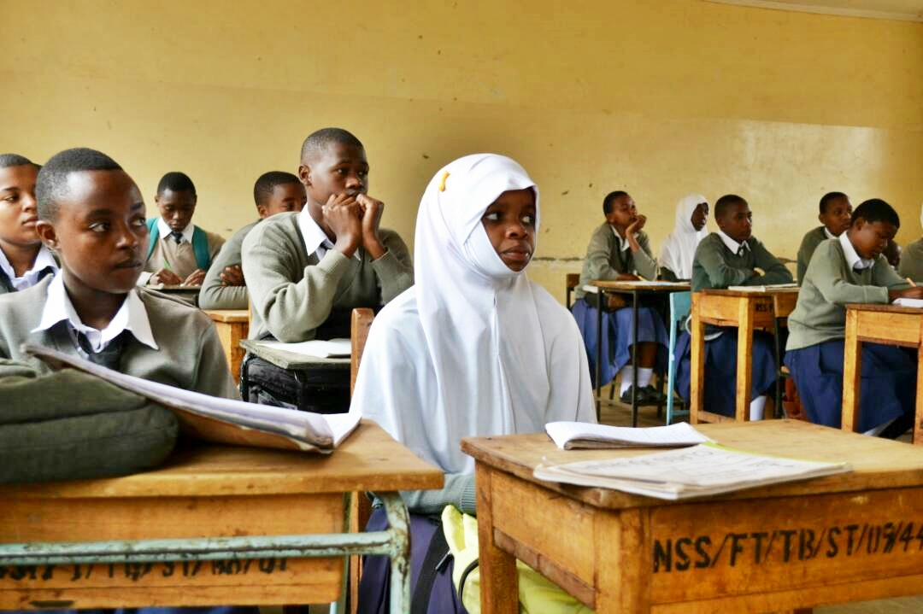

Figure 1.1: Naura Secondary School Form Four Business Class during the Short Training On How to Fill the Research Questionnaires

1.4 CNA Findings

1.4.1 Socioeconomic Characteristics of Form Four Business Studies Class
Business studies in secondary schools aiming to help student which most of them are youth to have the ability of creating business ideas, and make sure that ideas turn into reality within and outside the given specific society using available resources. It is all about using scarcity resources. The challenge is our curriculums focus only on employment (white collar jobs), creating students to think as employer not employee, not to create something that he/she will employ other people. This part elaborates characters and socioeconomic activities of Form four business class students as finding from the research, these socioeconomic results shows the day to day rituals of their social and economic life. Basically from how they create their own opportunities, how they create income and how they distribute it. Relationship of age, income and responsibility in their personal life are as follows;

1.4.1.1 Age of Respondent
Age between 15 – 20 years seems dominated in this class, which also according to our secondary education curriculum is the rightful age to finish ordinary secondary level education. Also this age is the perfect age for the patents and community at all to invest positively in their kids mentally, physically and spiritually, inside and outside of the school system in order to help them make their own decisions and commit themselves to get the results.

Table 1.1: Age of Respondent
 |  | Frequency | Percent | Valid Percent | Cumulative Percent
 | Below 15 | 2 | 4.0 | 4.0 | 4.0
 | Between 15 – 20 | 48 | 96.0 | 96.0 | 100.0
 | Total | 50 | 100.0 | 100.0

1.4.1.2 Gender of Respondent

The implementation of any successful project will depend most on gender ratio and gender balance, as the findings shows that female gender take over the Male gender. This helps most on reduce excuse during the implementation of the project. This gender result will help also in developing good teamwork which is the best foundation to self-employment. The finding also shows how parents send girls to school now days, which is the best milestone to the future development of our Nation.

Table 1.2: Gender of Respondent
 | Frequency | Percent | Valid Percent | Cumulative Percent
Male | 21 | 42.0 | 42.0 | 42.0
Female | 29 | 58.0 | 58.0 | 100.0
Total | 50 | 100.0 | 100.0
Source: researcher, 2017

1.4.1.3: Income Generating Activities
These business class students once in a while in their lives they have been involved themselves in different social economic activities, family business or any other small businesses. This is the good sign especially in this generation where there is a huge unemployment problem all over the world, this will help youth student to develop business skills which will develop and grow inside them slowly.

Table 1.3: Income Generating Activities
 |  | Frequency | Percent | Valid Percent | Cumulative Percent
 | Yes | 37 | 74.0 | 74.0 | 74.0
 | No | 13 | 26.0 | 26.0 | 100.0
 | Total | 50 | 100.0 | 100.0
Source: researcher, 2017

1.4.1.4: Feedback from Community

According to our findings the feedback from parents and community about their children involving themselves in different income generating activities is good, 56% students claim to get positive results from their family members and community at large. As the northern part of Tanzania respected for entrepreneurship spirit and respect anyone who put effort in generating income especially in early, also because of the unemployment problems all over the world parents start let their children involved in different economic activities, all in all is the good sign to let youth involved in different income generating activities legally and couch them to master it.

Table 1.4: Feedback from Community
 | Frequency | Percent | Valid Percent | Cumulative Percent
Good | 28 | 56.0 | 56.0 | 56.0
Normal | 18 | 36.0 | 36.0 | 92.0
Bad | 4 | 8.0 | 8.0 | 100.0
Total | 50 | 100.0 | 100.0
Source: researcher, 2017

1.4.1.5 Previous and Current Entrepreneurship Activity
Findings shows that about eighty percent (80%) of business class once in a while they have involved themselves in different income generating activities such as, Bites and soft drinks, livestock keeping, selling milk and vegetable gardens. Probably this must be family business to support the family economy due to most of these students are from the of middle class and low income earners family. Only twenty percent (20%) of the business class students have never tried any income generating social economic activities. Vegetable garden takes more percentage forty six percent (46%) indicating that this economic activity is common around Lemara ward.

Table 1.5: Previous and Current Entrepreneurship Activity
 | Frequency | Percent | Valid Percent | Cumulative Percent
Bites & soft drinks | 9 | 18.0 | 18.0 | 18.0
Livestock | 8 | 16.0 | 16.0 | 34.0
Vegetable garden | 23 | 46.0 | 46.0 | 80.0
Nothing | 10 | 20.0 | 20.0 | 100.0
Total | 50 | 100.0 | 100.0
Source: researcher, 2017

1.4.1.6 Income Level

Seventy six percent (76%) of business class students earn below fifty thousand Tanzania shillings (50,000) from their socioeconomic activities, They claim that that amount of money helps them cover small costs like fares, and some other small school demands like exercise books, pens, pencil etc. This gave them sense of responsibilities to them and they help parents in some cases. Only eighteen percent (18%) of students earn between fifty and one hundred thousand from their economic activities. Six percent according to our finding they earn above One hundred thousand Tanzania shillings (100,000).

Table 1.6: Income Level
 | Frequency | Percent | Valid Percent | Cumulative Percent
Below 50,000 | 38 | 76.0 | 76.0 | 76.0
50,000 - 100,000 | 9 | 18.0 | 18.0 | 94.0
Above 100,000 | 3 | 6.0 | 6.0 | 100.0
Total | 50 | 100.0 | 100.0
Source: researcher, 2017

1.4.1.7 Community Need

Sixty two percent (62%) of the students they need capital to improve and expand their economic business so that to earn more income from it. Because most of the income generating activities they are involved are family business they have no say about how to improve and expand it, so if they can find another way of getting capital or other legal ways to expand their income they will apply it accordingly.

Table 1.7: Community Need
 | Frequency | Percent | Valid Percent | Cumulative Percent
Capital | 31 | 62.0 | 62.0 | 62.0
Income generation | 11 | 22.0 | 22.0 | 84.0
Training | 8 | 16.0 | 16.0 | 100.0
Total | 50 | 100.0 | 100.0
Source: researcher, 2017

1.4.1.8 Substitute Economic Activity
Due to reason that they are students, they have to pay serious attention in their studies and there is no way to get capital from parents or school board, they come across with the solution which is to invest some of their time after or before classes in vegetable gardens which will be inside the school area. Vegetable garden will be easy for them to access it, to work together with low supervision because they have to attend school every week day, also this project will be very helpful reduce absentees and school dropout in school. Vegetable garden project inside the school area will help to generate income together as business studies class, the income generated from vegetable garden will be distributed equally to business class students. This will be solution to the community need which is capital.

Table 1.8: Substitute Economic Activity
 | Frequency | Percent | Valid Percent | Cumulative Percent
Vegetable garden | 35 | 70.0 | 70.0 | 70.0
Selling milk | 8 | 16.0 | 16.0 | 86.0
Bites & soft drinks | 7 | 14.0 | 14.0 | 100.0
Total | 50 | 100.0 | 100.0
Source: researcher, 2017

1.5 Community Need Priotisation
Several community needs were mentioned and prioritized so as to come up with one most important need which once it will be implemented through a project majority of respondents will benefit from the need. Therefore different choices of needs were put into the discussion during conduct CNA and the students come up with the need which is foremost need. Pair wise ranking technique was used to prioritize the identified need so as to get a project to be implemented.

Table 1.9: Pair Wise Matrix
 | Income  Generating | Access To  Capital | Training | Score | Rank
Income  Generating |  | Access To  Capital | Income  Generating | 3 | 1st
Access To  Capital | Income  Generating |  | Training | 2 | 2nd
Training | Income  Generating | Access To  Capital |  | 1 | 3rd
Source: researcher, 2017

1.5 Conclusion
The need assessment conducted in Naura secondary school form four business studies students has used participatory assessment which is vital method of involving the community to list down their own need, challenges and available opportunities to overcome the needs. Different methods were used to assist the students to identify main need and suggested measure to address the existing need. The needs assessment carry out using a survey which was accompanied by structured Questionnaire and interview which come up with the major need as training, access to capital and income generation activity.

Therefore after analysis of the data and the assessment of three major needs identified during survey, it has been seen that the first priority need for Form four Naura Secondary school business students is to organize an income generating activity which will help them generate income to satisfy their need.

CHAPTER TWO

2.0 PROBLEM IDENTIFICATION

2.1 Background to Research Problem
Since independence, the government has sought to combat poverty, ignorance, and hunger. To achieve this, various strategies have been launched including state intervention to reduce economic and social inequalities in resource distribution and control. Furthermore, mass mobilization has been undertaken using catch-phrases, such as: "Freedom and Work" (Uhuru na Kazi) to extol the virtues of work as a basis of development and self-dignity as well as a strategy to enhance employment opportunities; "Politics is Agriculture" (Siasa ni Kilimo) to increase rural incomes and ensure food security and to improve small holder agriculture through better farm management practices and the use of improved technologies; "Life is Health" (Mtu ni Afya) to increase mass awareness of the importance of health care and to catalyze community action towards the provision of health care services; "Universal Primary Education" (UPE) to promote primary education and functional literacy in the adult population; and "Modern Houses" (Nyumba Bora za Kisasa) to promote adequate and decent housing for all.

Tanzania is experiencing significant out-migration of young people from low productivity agriculture to urban informal service sectors, where productivity is just as low. Unemployment is high and growing rapidly, especially in the urban areas and among youth. The official unemployment rate is 12% and is highest in the cities, reaching 32% in Dar es Salaam (2006). In addition, one-third of those employed are so-called "working poor": technically employed, but whose income is less than the basic needs poverty line of USD 0.96 per day. They often work either in farming or in the urban informal service sector in low-productivity, part-time jobs. An estimated 700,000 new young job-seekers enter the labour market each year, but only a fraction of them have a realistic possibility of obtaining a stable job that can give them the possibility to provide for a family. The flow from countryside to city of rural-urban migration will continue in years ahead, and Dar es Salaam is already one of the fastest growing cities in Africa.

Employment is an important avenue of earning income among the population. Employment opportunities have been limited in the recent past due to the slow growth of the economy, and the freezing of new recruitment in the public sector. However, employment opportunities in the informal sector have increased in the recent past. A survey of the city of Dar es Salaam undertaken in 1995 indicates that this sector provides employment to about 65% of the city's labour force.

The garden can serve as a source of artistic inspiration and as a means of creative expression. Now consider how a gardener and a student can be one. A garden and the knowledge gained by gardening can be incorporated, integrated, and used to its fullest academic, experiential, and social potentials, not only outdoors, but also inside a high school classroom. This means that gardens can be tailored to meet the educational needs of different students and adapted to fit different high school curricula.

Gardens are very flexible in their form and function, and as such can be shaped by the style and goals of individual teachers. Since methods of planning, planting, and maintaining of a garden are unique to the particular garden and gardeners, the gardening experience itself is a fundamentally unique learning process. While developing and caring for a garden requires hard work and is by no means an easy task, the benefits to teachers and students are outstanding and well worth the commitment. The school garden serves as a foundation from which valuable lessons about the environment are learned. In doing so, it fosters and strengthens a community. The communal, environmental, and social discoveries made in growing a vegetable garden provide academic and personal challenges for high school students. We want to plant seeds in people's minds about how a garden can work for students, teachers, their school, and their community.

2.2 Problem Statement
Tanzania is one of the least developed countries and the unemployment level is very high, at 11% in 2006, though the country is endowed with rich natural resource base. Unfortunately, the education system in Tanzania has failed to deliberately develop values, attitudes, knowledge and skills that enable students and graduates to see and realize the potentials around them. Because of the importance of entrepreneurship to the growth and prosperity of the country, mainstreaming entrepreneurship in the education and training system has been emphasized by both the National Higher Education Policy and the Small and Medium Enterprise Development Policy.

The aim of this mainstreaming is to promote “a culture that is entrepreneurial”, emphasize “individual entrepreneurial initiatives”, encourage the education system “to create job creators” and respond to the changing world of science and technology and the corresponding ever-changing needs of people. There are numerous reasons for the contemporary interest in entrepreneurship and the creation of entrepreneurs. Entrepreneurship is a key driver of our economy. It is argued that perhaps the main importance of entrepreneurship education is becoming a component of new economic strategies for fostering job creation.

The outcome of entrepreneurship education is a new generation of entrepreneurs who create jobs not only for themselves but also for others. However, the benefits of entrepreneurship education are not limited to boosting start-ups, innovative ventures and new jobs. Entrepreneurship is a competence for all, helping young people to be more creative and self-confident in whatever they undertake. In fact, entrepreneurial mindsets, knowledge and abilities will be of benefit to young people in all walks of life and in a variety of jobs.

Children learn best by doing. Doing requires motivation, curiosity, freedom to experiment and explore, and an opportunity to put basic skills to practical application. Learning from direct experience is fundamental in school gardens, as students are involved in the activity hands-on. To foster the types of learning desired, teachers will need to act more as facilitators of learning and students will need to become more active doers and thinkers in the classroom rather than simply passive recipients of information.

The main objective of this study is to build strong income generation foundation through encouraging education and entrepreneurship. Students will learn how to be creative, how to utilize scarcity resources, the value of money, how to create money, how to use it wisely, how to invest it to create a sustainable live environment and community in general.

2.3 Project Description
Title of this research is “income generation through establishment of vegetable garden for form four business students in Naura Sec School. The project is allocated at school, Lemara ward, Arusha City. The location is appropriate for the project to take place because it is easily reachable by beneficiaries and it is very ideal for its accessibility to potential market points such as market vendors, Health and education centers around school and supermarkets.

2.3.1 Target Community
The project target Naura Secondary school business class students, this community will monitor and evaluate the project. The second target is the school in general. The third beneficiary is the local population and community members.

2.3.2 Stakeholders
Stakeholders are those duty bearers in development who are influenced by and expert an influence on those things that place in the project direct or indirectly. These stakeholders may be inside or outside an organization which sponsor a project, or have an interest or a gain upon a successful completion of a project, may have a positive or negative influence in the project completion. The community with collaboration with the researcher identified key stakeholders who played a great role on make a project succeeds. The stakeholders are Lemara Form four business class students, Local government, Naura Secondary school as the host CBO and CED student. The below table shows the summary of every stakeholder and their role and expectations in the project:

Table 2.10: Roles and Expectations of various Stakeholders
Name of stakeholder | Role | Expectations
Form four business class students | Project initiators | Generating income through vegetable production.
Local Government | Mobilize other school and the community to start the project like this. | Challenge other school and the community through innovation
CED student | Carry a study on how vegetable production can improve student’s life through income generation | Implement project for Naura Secondary form four business class students.
CBO- Naura Sec School | Supervision of the project | Make project sustainable
Source: researcher, 2017

2.3.3 Project Goals
The foremost goal of the project is to create an income generation activity which will help form four business class students to improve their lives through establishment of vegetable production. The establishment of vegetable for form four students will help to improve the community’s life by reducing the dependence ration in families.

2.3.4 Project Objectives
The objective of this research is income generation through establishment of vegetable garden for school form four business students in Naura Sec School at Lemara ward.

2.3.4.1 Specific Objectives
- To train 50 Form four business class students on entrepreneurship skills by June 2017.
- To train 50 Form four business class students on vegetable production by June 2017.
- To harvest 5000 grams of vegetable by August 2017.

2.4 Host Organization Profile
Naura Secondary school is the official host CBO of this project. The CBO will Support, monitor and implement the project. Mobilize the beneficiaries to work on make a project sustainable;

2.4.1 Vision of Naura Secondary School
The vision of Naura secondary school is to prepare students in order to be useful members in our society.

2.4.2 Mission of Naura Secondary School
The mission of Naura secondary school is to provide relevant and appropriate education to the community to make them manage their life and the environment better.

2.4.3 SWOT Analysis of the CBO

Table 112: SWOT Analysis
STRENGTH  - Committed and active business students class.  - Ample land for vegetables farming  - Water availability  - Presence of school guardsmen | WEAKNESS  - Treasurer is not employed.  - Lack of enough safety fence around the school.  - Some students a lazy they don't perform their duties.  - Prevalence of vegetables disease
OPPORTUNITIES  - Students trained on how to run the project.  - Presence of training person/institutions.  - Presence of the students in the school that provide chase for selling.  - Students has vegetables growing experience | THREAT  - Willingness of taking care of the garden.  - Different levels of students understanding.  - Lack of reliable markets.  - Students sometimes uses to be out of the school during holiday
Source: researcher, 2017
Role of CED Student in the Project
- To create and coordinate the project study
- Coordinate capacity building for project participants
- To coordinate the project activities
- To conduct monitoring and evaluation of the project.

Role of host CBO
- To assist CED student on land acquisition.
- To assist CED student on project implementation.
- To provide resources needed for training.
- To organize and host stakeholder’s meetings
- To make the project sustainable and make follow up.

CHAPTER THREE

LITERATURE REVIEW

3.1 Chapter Overview
This chapter is all about different authors and projects which have been done on vegetable and vegetable productions. In this chapter there different subsections which are theoretical literature which explain aspects related to vegetable production, empirical literature which assess previous project or research work studies done same or close related to vegetable production also this chapter will discuss the relationship between agriculture (garden) and education policies.

3.2 Theoretical Literature
Under this section the researcher will define the key concept i.e. vegetable, vegetable production and income generation.

3.2.1 Definitions of Key Terms

3.2.1.1 Vegetable
in this chapter is limited to plant parts, usually eaten fresh or processed in any way (cooked, steamed, dried, marinated, etc.) and that are not used as conventional fruit, nut, root/tuber crop, pulse or staple, but as an accompaniment of the main dish or alone as a snack mainly for their micronutrient benefits. This can be simplified to any plant part that is consumed usually fresh or after minimal processing to facilitate consumption of the main dish, as well as for its micronutrients. Vegetables are consumed for their freshness and for their being good sources of micronutrients (especially vitamins A and C), some minerals and roughage (Maundu. C.1999).

3.2.1.2 Vegetable Production
This term including the potential impact of vegetable production for alleviating poverty, the effects of food production standards on stakeholders, an assessment of markets and marketing potential for various crops and advanced economic approaches to production. Vegetable production in Tanzania has had growing importance as a complement to diets and consumption practices as well as for sale in the domestic and export market (Solomon et al., 2014).

3.2.1.3 Income Generation
Income generation simply means gaining or increasing income (Weinberger and Swai, 2006). The term used by economists to explain the intricacies of a nation’s economy. However, it is now quite widely used to cover a range of productive activities by people in the community. Income generation does not always mean the immediate getting of money, although in the end we use money to place a measurable value on the goods and services people produce. An example of income generation which does not lead to getting money would be a situation where a productive person produces enough food to feed himself or herself and the family.

3.3 Empirical Literature
This section study similar project income generation project implemented for the purpose of creates income for students. Also it shows how different countries used vegetable production to raise community income.

3.3.1 Relationship Between School And Vegetable Garden
Schools and gardens became affiliated during the first decade of the twentieth century as educational reformers and philosophers began to stress the correlation between learning and personal, active experience. They were conceived as a means of "bringing boys and girls into closer relationship with their environment," but educators recognized that "the development of strong-bodied, efficient, and contented citizens is the real purpose and the main result of this work". This type of experiential learning developed momentum across the country; in 1910 there were approximately 80,000 school gardens maintained in the United States. Gardens, and in the larger context, nature, have long been a component of what educational progressives have associated with "real life" or "hands-on" learning.

In the mid1800s, Francis Wayland, former president of Brown University and educational reformer, advocated the active acquisition of knowledge through experimentation in the physical world. In The Pursuit of Knowledge Under Difficulties, he discussed how, rather than simply using principles to disprove theories, great thinkers learned directly from the natural world, or as he refers to it, "the book of Nature": "Newton pursued it [the book of Nature] as a volume altogether worthy of being studied for its own sake".

Another advocate of experiential learning, John Dewey, believed in creating a community within the school where a child's individuality could be continually cultivated in the social context. Freedom is power, power to frame purposes, to judge wisely, to evaluate desires by the consequences which will result from acting upon them, power to select and order means to carry chosen ends into operation. As a leading educational reformer and philosopher in the early 1900s, Dewey sought to educate through "social occupations" learning fundamental principles and skills through practical efforts. He found it essential to connect academic subjects with students' own experiences. In creating opportunities for students to have such experiences, Dewey encouraged teachers and students to get out into nature, to touch it and to feel it at his University of Chicago Laboratory School, students maintained a garden. As Herbert Kliebard noted, at the Dewey School "reading, writing and arithmetic were things that occurred naturally in the course of building a clubhouse, or cooking, or raising a pair of sheep"

Through gardens, high school students deal directly with the abstract scientific equations, mathematical calculations, and problem-solving that are taught in the classroom. They also utilize various forms of writing, such as descriptive, persuasive, and analytical styles. Students are able to see, touch, and analyze the processes that created and support the theories they read about in textbooks. The subject matter is brought closer to the students as they keep working with and learning from it. While "no one set of teaching strategies will work best for all students at all times" (Armstrong 65), gardens present a variety of ways that students can demonstrate their ability, effort, and knowledge.

Coinciding with Howard Gardner's theory of Multiple Intelligences, gardens incorporate the opportunity for high school students to solve problems and create products in "context-rich and naturalistic settings", while using their linguistic, logical-mathematical, spatial, bodily-kinesthetic, and interpersonal intelligences. This is experiential learning in its essence; real life experiences, gardens draw together skills from many different disciplines. In addressing the educational needs of a student, Dr. George Wood, principal of Federal Hocking High School, says: "...math, science, English, social studies, blend into one another, which is, after all, the way the world really works to assume that teaching [students] a fragmented curriculum will lead them to a unified sense of place and person is unrealistic". Parallel to this is Potter's assertion that "curriculum design in schools should recognize that education addresses the whole child as well...there is not a math child, a reading child, or a science child, but rather one person absorbing all the subject areas into one brain which attempts to organize the input into some meaningful pattern". Gardens connect different disciplines and learning methods.

Environmental education should "illuminate the essential idea that all cultures have a relationship with the natural world which they and all others can draw upon for understanding and inspiration". Since high school gardens are located near or at the schools, they encourage students to experience and learn from nature within a familiar setting. They help students realize that their community is also part of the environment, thus fostering connections between the two.

The work that goes into a high school garden teaches lessons with applications outside the classroom as well. Karneal Thomas, a landscape architect who helped students design Harlem's Success Garden, cites "values of hard work, discipline, being prompt, following directions, and making decisions" as the "basic practices of living" are reinforced through gardening. High school gardens can provide students with "lessons in business integrity and moral courage, and at the same time show children how they may, in one way, at least, earn an honest living". In addition to the development of personal and interpersonal skills, gardens also promote a sense of community and can contribute to the improvement of the area in which they are located. As students learn that a healthy garden takes thought and care, they can translate that knowledge into improving their surroundings.

Cooperation is certainly necessary for a successful garden, and the value of teamwork has been noted by many educational reformers. Ted Sizer, Professor of Educational Studies at Brown University and founder of the Coalition of Essential Schools, stresses the importance of providing opportunities for students to gain these skills. The real world demands collaboration, the collective solving of problems learning to get along, to function effectively in a group, is essential the act of sharing ideas, of having to put one's own views clearly to others, of finding defensible compromises and conclusions, is in itself educative.

3.3.2 Benefits of School Gardens
Experience and research have shown numerous benefits of school gardens and natural landscaping as follows:-
- Students learn focus and patience, cooperation, teamwork and social skills.
- Students gain self-confidence and a sense of "capableness" along with new skills and knowledge in food growing soon to be vital for the 21st century.
- Garden based teaching addresses different learning styles and intelligences, our non-readers can blossom in the garden.
- Achievement scores improve because learning is more relevant and hands-on.
- Students become more fit and healthy as they spend more time active in the outdoors and start choosing healthy foods over junk food.
- The schoolyard is diversified and beautified.

"Information alone can never become knowledge, and knowledge never becomes wisdom without some kind of rooting in the good soil of experience” - James Raffan

3.4 Policy Review
The history of Tanzania’s educational system is a complex one, and has been driven by many goals, ideologies, intentions, and motives. Yet, understanding the changes and recognizing the similarities across all of the fluctuations and shifts in education in Tanzania can reveal important implications for current and future educational policies. Work-oriented education remains an important component of the current Tanzanian educational policy despite a shift in the 1995 Education and Training Policy (ETP).This shift saw policies move away from vocational education to a more general education policy, and it was accompanied by a change in policy emphasis from rural-oriented vocational education to technology education.

3.4.1 Work-Oriented Education
Work-oriented education is concerned with the ways in which basic educational institutions prepare students to function and transition into the world of work after ending formal education. Work-oriented education is adopted with the intention of creating an educational system that effectively prepares students for productive work within their environment (Hoppers, 1996). Thus, the nature of work-oriented education causes it to be theoretically related to practical education, in the sense that a “practical” education is “one which develops skills which may be applied in the everyday world, especially in the world of work” (Rowell & Prophet, 1990).

In independent Tanzania, work-oriented education has been used as a primary method for integrating practical education with the general education curriculum. The ultimate goal of this approach is to encourage a greater balance between theory and practice in basic education, in order to effectively and appropriately prepare students for work within the Tanzanian environment. Work-oriented education both is affected by and attempts to affect issues surrounding the topics of educational perspective and rural education (Hoppers, 1996). Educational perspective refers to the dichotomy between general education and vocational education in educational theory. This dichotomy has important implications for rural education and the shape of the work-oriented approach and its programs.

3.4.2 Features of Work-Oriented Education
A defining feature of work-oriented education is its tendency to identify and shape itself around the specific context of the “world of work” for which students are being prepared (at least within the majority of models of work orientation). Through this, work-oriented education attempts to address some the common problems facing workforces in many developing countries, such as educated unemployment, limited modern sector jobs, rural-urban migration, and manpower imbalances (Middleton, 1993).

Since work-oriented education attempts to shape itself around specific work environment for which it is preparing students, the features of any particular work-oriented program is heavily related to the socio-economic situation of a country and schools. In many developing countries, like Tanzania, this has led to a strong emphasis on traditional rural work environments, particularly agriculture and other manual labor occupations, within work-oriented education (D. Komba, 1996). However this association that has developed between work-oriented education and agricultural and rural-oriented vocational training is not necessarily a defining feature of the broader concept of work-oriented education. In fact, particularly recently, the focus of many work-oriented education programs is upon technological or scientific education, many of which are geared toward the industrial or modern sector jobs (Hoppers, 1996).

The above discussion intends to emphasize that the work-oriented education does not promote a specific focus of work orientation, such as agricultural education, despite strong associations that may be formed between the two in certain countries. Rather, work-oriented education is intended to be much broader in its scope of preparing students for work within their own environment, whatever that may be; the focus is provided by the specific environment of the educational system and students. This does mean that the nature of the environment and specific situation can and does affect which of the work-oriented programs and foci an educational system is likely to adopt.

There are also a couple of concerns and issues surrounding work-oriented education that need to be noted. First, it is important to consider the demands of a work-oriented education and its objectives upon an educational system and whether these demands are realistic or fair. There are a number of concerns about the ability of schools to affect wider societal objectives, which are outside of the realm of the academic western educational model (Hoppers, 1996). Increasingly schools have taken on a wider role and responsibility for societal transformation, but it is not known to what extent schools can actually achieve objectives beyond their traditional academic ones. This issue relates particularly to the ability of schools to form or change attitudes, particularly deep-rooted ones, which is often a goal within work-oriented education programs (D. Komba, 1996).
Work-oriented education is based upon the assumption that educational systems and schools are in fact able to effectively prepare students for work and achieve objectives related to productive skills, changing relationships between schools and communities, and the transformation of mind-sets. Therefore it is tremendously important to consider the extent of schools’ ability in relationship to achieving work-oriented objectives.

A second issue relates to concerns about inbuilt inequalities in the work-oriented education model, especially across the rich-poor and urban-rural divides, which are often congruent with one another. Work-oriented and vocational education is far more likely to be available to economically disadvantaged and rural students than any other population because of their perceived needs and the nature of the rural labor occupations and markets (Evans, 1981). This is done with the intention that these students will be able to improve both their communities and individual standards of living with their training, often with the larger goal being rural development. Yet a work-oriented approach has the potential to increase the already severe stratification between educational and professional opportunities for students in urban and rural areas.

3.4.3 Overview of Work-Oriented Education and Practical Education Curriculum
Work-oriented education includes the specific objectives, approaches, and programs that an educational system uses to strengthen the connection between schooling and the world of work through the integration of certain knowledge and skills learning targeted to preparing students for productive work within their environment. Practical education curriculum is often a critical component of this. Within work-oriented education, the term “practical education” utilizes a broad definition of a “practical” curriculum, such as Rowell and Prophet’s (1990) description: one which develops skills which may be applied in the everyday world, especially the world of work. The focus is on the application of that learned in school and ‘practical’ denotes ‘utilitarian’. Thus practical skills include specific manual skills and mental skills.

It is common for a practical curriculum to emphasize the “development of manual or digital dexterity in subjects such as home economics, agriculture, or woodwork” over those of more generalizable practical skills and knowledge, particularly in older programs (Rowell and Prophet, 1990). However the important thing is that a practical education curriculum is most basically characterized by an “activity-oriented” approach. This includes both manual “hands-on” as well as mental activities for developing practical knowledge and skills, either within or outside of the regular classroom environment (Rowell & Prophet, 1990).

3.4.4 Tanzanian Independence, President Julius Nyerere, and the Educational System
After independence in 1961, educational reforms began almost immediately and initially made definitive moves away from the prior colonial education policies. With the introduction of the 1962 Education Ordinance by the Ministry of Education, a strong focus was placed on education as a solution the manpower problem within Tanzania, characterized by a national shortage of highly trained and specialized personnel to fulfill the top technical and specialized professions in Tanzania.

Education was viewed as critical in meeting these manpower and personnel needs and also in establishing Tanzania as an independent and industrial country that was “self- reliant” in that positions at the government and professional levels would be filled by Tanzanian citizens, rather than foreigners. Therefore, the new Education Ordinance encouraged all primary schools to extend the length of their programs to eight years and also emphasized the importance of increasing the availability of secondary education to students (Dolan, 1970).

This approach was in many respects opposite of the colonial educational policies, which instead emphasized the need for a limited education for the majority of students with more targeted programs to provide very basic skills in a shorter period of schooling. General ‘academic’ education was considered as both unnecessary and undesirable for the majority of African students, who should instead stay in their local communities to utilize the training and skills they had acquired through the vocational school programs. The independent government’s deliberate shift away from British colonial education policy was in part driven by the demands of Tanzanian students and parents, who recognized education as a path to social and economic advancement.

Parents and students learned to resent the colonial policies that forced vocational training and manual labor on students as part of school curriculum in rural areas while providing a traditional general education to white and Indian students (Dolan, 1970). As part of the call for educational equality that included the racial and religious integration of the previously segregated educational system in 1962, students and parents also demanded equality within the curriculum and access to economic advancement through education (D. Komba & Temu, 1996).

However, the move toward a more general education approach for the wider population was short-lived, as the new government began to focus on the importance of vocationalized education in the context of rural development and the philosophy of Ujamaa. In 1967, President Julius Nyerere delivered the Arusha Declaration and announced along with it his new educational policy titled ‘Education for Self-Reliance’ (ESR). Ujamaa, or “African Socialism” was the broad economic, political, and social reform that was introduced by Nyerere as an attempt to return Tanzania to its traditional past, which involved a history of natural socialism and an emphasis on egalitarian societies. The goal of Ujamaa was to develop a classless system based on equality and a socialist mixed economy, with a focus on rural development and national achievement (Nyerere, 1968).

Education for Self-Reliance (ESR) fit within the Ujamaa policy as a key instrument in building the new Tanzania envisioned within the Arusha Declaration, as schools were given the mission to prepare students to become exemplary and “self-reliant” citizens of the new society. To Nyerere, education was a “method of preparing citizens for service to other citizens in order that all the citizens together might engage in the task of building a self-reliant Tanzania,” and should not be viewed as a route to improvement of an individual’s life, but rather in the context of the entire country’s improvement (Dolan, 1970). However, this view of education for societal or community benefit was in direct conflict with previous attitudes toward education as an opportunity for individual advancement and economic gain. This focus on national and rural development and vocationalized education was therefore end of the short-lived shift toward a more general education approach after independence.

One of the key theoretical adjustments in the new policy was the shift from an emphasis on supplying manpower needs at the higher tiers of the economy, such as professional or government positions, to an emphasis on rural development and skill training at the lower levels of society. This shift was in line with the philosophy of Ujamaa, and was an attempt to implement an economic strategy of bottom-driven rural development in contrast to top-led industrial development.

3.4.5 The Education for Self-Reliance Document and Policy
President Julius Nyerere’s ESR policy was based upon the perceived inappropriateness of a western model of education that was imported by colonists along with a foreign curriculum. Along this line of thought, because Africa’s history, culture, and position differs from that of the western countries, so too do the goals and needs of the educational system. ESR was a part of the broader Ujamaa reforms that attempted to address these inadequacies and failures of the colonial educational system that was still in use in independent Tanzania.

As such, the new policy was to teach students the values of equality and respect, the importance sharing of resources, and a belief in the philosophy of hard work by every citizen without exploitation; all ideals that Nyerere felt the colonial educational system lacked. Rather than simply being inadequate for Tanzania, Nyerere saw the colonial education model as a system that was introduced with the intent to inculcate colonial values and force cultural change.

The ESR policy was intended to redress these problems through the reorganization of the educational system, mainly by changing curriculum content, adjusting the entry age of school children, and the decentralization of educational institutions. However, in order for the new reforms to be successful, perceptions and attitudes would also need to be adjusted, not just administrative changes (Nyerere, 1968). The ultimate goal of ESR was for Tanzania and its citizens to achieve “self-reliance” or freedom from dependence on outside resources. In the context of the state, this meant a strong self-sustaining economy and political system that was free from dependence on foreign aid or the influence of other governments. For the individual students, self-reliance meant an ability to sustain one’s own living without relying on employers or the state in other words, ability for entrepreneurship.

Education was viewed as having an important role in the achievement of self-reliance at both the state and individual level by inculcating students with the ideals, values, and skills necessary to be both good citizens and good entrepreneurs. ESR was primarily focused on rural agriculture and development, both because of the influence of the Ujamaa philosophy and also because Nyerere believed that rural development must first lead industrial development.

Because of the predominantly undeveloped and rural population in Tanzania, ‘self-reliance’ and its goal of fostering entrepreneurship became synonymous with agricultural employment and farming, along with a few other crafts and trades deemed appropriate for rural life. As a result, it was decided that the education received by students should prepare them for this type of agricultural work and life in a rural community.

Thus the main policy thrust of ESR was to develop a curriculum that would include so-called ‘practical’ education elements that would prepare students for work through vocational education and skill acquisition through participatory productive work by the students, primarily in agriculture (Nyerere, 1968). Vocational education within the educational system came to include agriculture, crafts, post-primary technical centers, pre-vocational secondary schools, and technical colleges. Within primary and secondary schools, vocational education came to be primarily identified with vaguely-defined ‘Self-Reliance Projects’ which were generally extracurricular and included agricultural work, often on school ‘farms’, as well as other productive activities such as crafts, shop-keeping, and livestock (D. Komba & Temu, 1996).

According to ESR, self-reliance would be fostered through the development of these so-called practical skills, as well as critical thinking skills, which would enable students to become successful entrepreneurs in agriculture and other rural occupations in their home communities. ESR also heavily emphasized an education that would teach students cooperation and the necessity of contributing to the collective good of society, rather than focusing on individual advancement. It was intended that students would exit the educational system with the values and attitudes necessary to make Ujamaa successful, as well as instill within students an awareness of the duties and responsibilities of Tanzanian citizenship (Nyerere, 1968).
In order to achieve these numerous and diverse goals, ESR policy called for a primary school education that would be comprehensive and self-complete at seven years of schooling, providing students with the skills necessary to live and work in their local environments. Additionally, the age of entry into primary school was increased to seven years, so that students would be closer to maturity at the time of graduation from primary school and would be able to use the skills and knowledge learned sooner.

ESR’s primary school reform was a response to the reality that the majority of students in the educational system would not continue on to secondary or higher education, and therefore the primary education that they received must be comprehensive and sufficient by itself (Nyerere, 1968). This changed the educational system to one that included seven years of primary schooling, four years at the secondary level, two years of advanced secondary education, and between three to five years of tertiary or university education (D. Komba & Temu, 1996).

ESR also called for the reduced role of examinations within the educational system. Stemming from the western model, examinations were the only recognized tool of evaluation for students in Tanzania and were the sole determinants in the passing or failing of students as well. A final feature of the ESR-reformed school was its intended design as a ‘self-reliant’ community within itself. This was seen as achieving several goals of ESR and Ujamaa simultaneously.
- Productive work would teach students self-reliant skills and be a core component of practical work in schools.
- Productive work would further integrate the school with its community and teach students values about responsibility and contributing to their communities.
- Productive work would produce both food and income for schools as well reduce outside labor and upkeep costs associated with running a school, which would lessen the financial contributions of both the surrounding community and the government.

“What is done in classes is not integrated with what goes on outside of classes”. In many ways, the problems and failures of ESR, as well as the strength of the philosophical rationales and values behind it, had a huge impact upon the changes that took place in the educational system and the eventual formation of the new policy in 1995. In 1990, a National Task Force on Education was appointed to evaluate and review the educational system. The recommendations of this Task Force were used to prepare the Ministry of Education and Culture 1995 Education and Training Policy (ETP) document, which remains in use today.

3.6 Literature Review Summary
History shows us that gardens have been successful tools for cultivating academic, personal, and interpersonal skills in schools. Educational philosophers, reformers, and teachers have long advocated the experiential learning undertaken in school gardens. Starting and maintaining a successful secondary school garden takes time, energy, and funding. However, there are resources available to overcome these obstacles. Moreover, there is an undeniably significant amount of growth in educational, environmental, and communal learning that stems from secondary school gardens. They are an underutilized resource whose implementation benefits all who are involved.

CHAPTER FOUR

4.0 PROJECT IMPLEMENTATION

4.1 Chapter Overview
This chapter is all about the implementation of the whole project. The implementation started with the CNA conducted in Naura Secondary School (Form Four business class students) Lemara ward, Arusha District to identify the need of Naura Secondary School (Form Four business class students) and implement the idea to fulfill the need which is Income generating through vegetable production. This chapter will concentrate on the project outputs, objectives, resources required and the time frame necessary to accomplish the project. The participants for implementation of the project include MCED student, Naura secondary school, Local government, and Naura Secondary School Form Four business class students as the owner of the project.

Product and Outputs
Community Needs Assessment (CNA) conducted in the first chapter was to gather information to be used in the implementation of a project aiming to challenge and improve the financial and entrepreneur lives of Form four business class students through vegetable production. By linking the overall objectives and the objectives of the project as defined in the second chapter, we can define the outputs of the implementation of this project as follows:
- Objective 1: To train 50 students on entrepreneurship skills by June 2017
- Output 1: 50 students acquire entrepreneurship training
- Output 2: 50 students having 1 week to generate entrepreneur Idea
- Objective 2: To train 50 students on vegetable production by June 2017.
- Output 1: 50 students acquire Training on vegetable production
- Output 2: 50 students having 2 weeks field on vegetable production.
- Objective 3: To produce 5000 grams of vegetable by august 2017
- Output 1: Vegetable production
- Output 2: Vegetable ready for sale by august 2017

4.2 Project Planning
Planning is very important element to achieve the project. This planning part is based on use of schedules to plan and subsequently report progress within the project environment, identifying deliverables and creating the work breakdown structure, identifying the activities needed to complete those deliverables and networking the activities in their logical sequence, estimating the resource requirements for the activities, estimating time and cost for activities, developing the schedule and developing the budget;

Table 4.12: Project Output and Activities
Objectives | Output | Activities
Objective 1: To train 50 students entrepreneurship skills by June 2017 | Output 1: 50 students acquire entrepreneurship training | Activity 1: Purchasing of products and equipment for training
 |  | Activity 2: Theoretical and practical entrepreneurship training
 | Output 2: 50 students having 1 week to generate entrepreneur Idea | Activity 1: Leadership and teamwork training
 |  | Activity 2: Idea generation and selection process
Objective 2: To train 50 students on vegetable production by June 2017. | Output 1: 50 students acquire Training on vegetable production | Activity 1: Identification of vegetables types and character.
 |  | Activity 2: Workshop on vegetable production
 | Output 2: 50 students having 2 weeks field on vegetable production. | Activity 1: Land preparations
 |  | Activity 2: Trial field seedling
Objective 3: To produce 5000 grams of vegetable by august 2017 | Output 1: Vegetable production | Activity 1: Nursery installation
 |  | Activity 2: Field preparation and seedling
 | Output 2: Vegetable ready for sale by august 2017 | Activity 1: Marketing and order taking
 |  | Activity 2: selling vegetable

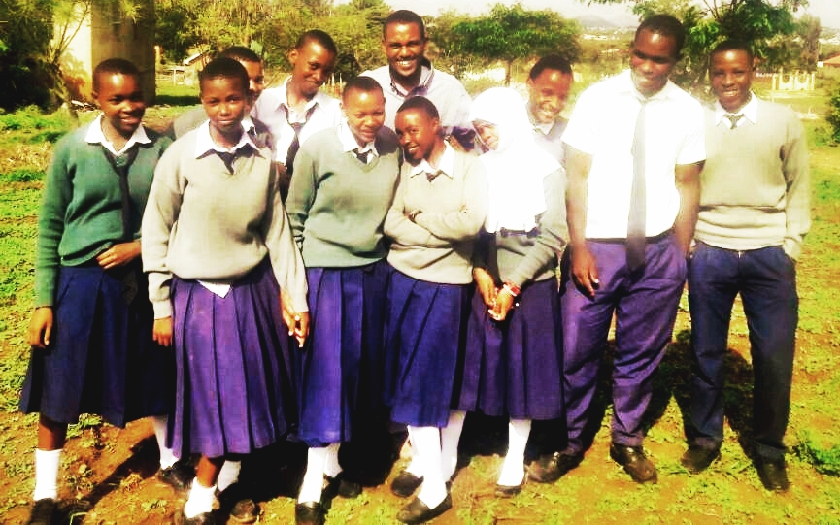

Figure 4.1: CED Student and Some Students Soon After Finishing Planning of the Project

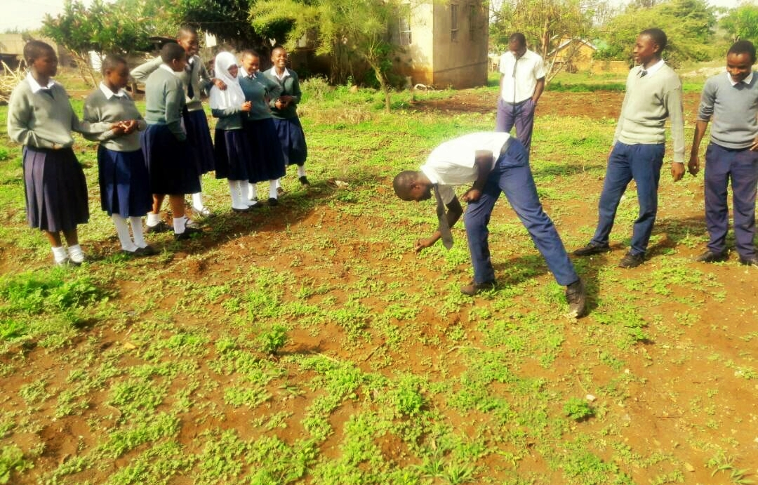

Figure 4.2: Some Students on the Field, (Where The Project Will Take Place) Soon After Finishing Planning of the Project

4.2.1 Project Implementations

This part will elaborate in details objectives of the project and its outputs, all activities according to the need of the output and objectives. This section also will explain and show the timeframe required to perform activities, needed resources and responsible personnel.

Table 13: Project Implementations Plan
Objectives | Output | Activities | Project Month |  |  |  |  |  |  |  |  |  |  |  | Resources  Needed | Responsible  Person
 |  |  | J | F | M | A | M | J | J | A | S | O | N | D
Objective 1: To train 50 students entrepreneurship skills by June 2017 | Output 1: 50 students acquire entrepreneurship training | Activity 1: Purchasing of products and equipment for training |  |  |  |  |  | X |  |  |  |  |  |  | Human resource  Financial resource | Students and  CED Student
 |  | Activity 2: Theoretical and practical entrepreneurship training |  |  |  |  |  | X |  |  |  |  |  |  | Human resource  Stationery  Venue | Students and  CED Student  Facilitator
 | Output 2: 50 students having 1 week to generate entrepreneur Idea. | Activity 1: Leadership and teamwork training. |  |  |  |  |  | X |  |  |  |  |  |  | Human resource  Stationery  Venue | Students and  CED Student  Facilitator
 |  | Activity 2: Idea generation and selection process |  |  |  |  |  | X |  |  |  |  |  |  | Human resource  Stationery  Venue | Students and  CED Student  Facilitator
Objective 2: To train 50 students on vegetable production by June 2017. | Output 1: 50 students acquire Training on vegetable production. | Activity 1: Identification of vegetables types and character. |  |  |  |  |  | X |  |  |  |  |  |  | Human resource  Stationery  Venue | Students and  CED Student  Facilitator
 |  | Activity 2: Workshop on vegetable production |  |  |  |  |  | X |  |  |  |  |  |  | Human resource  Stationery  Venue | Students and  CED Student  Facilitator
 | Output 2: 50 students having 2 weeks field on vegetable production. | Activity 1: Land preparations |  |  |  |  |  | X | X |  |  |  |  |  | Human resource  Tools. | Students and  CED Student
 |  | Activity 2: Trial field seedling |  |  |  |  |  | X | X |  |  |  |  |  | Human resource  Tools. | Students and  CED Student
Objective 3: To produce 5000 grams of vegetable by august 2017. | Output 1: Vegetable production | Activity 1: Nursery installation |  |  |  |  |  |  | X | X |  |  |  |  | Human resource  Tools. | Students and  CED Student
 |  | Activity 2: Field preparation and seedling |  |  |  |  |  |  | X | X |  |  |  |  | Human resource  Tools. | Students and  CED Student
 | Output 2: Vegetable ready for sale by august 2017. | Activity 1: Marketing and order taking |  |  |  |  |  |  |  | X |  |  |  |  | Human resource | Students and  CED Student
 |  | Activity 2: selling vegetable |  |  |  |  |  |  |  | X |  |  |  |  | Human resource | Students and  CED Student

4.2.2 Project Logical Framework

The plan is illustrated in the next Logical Frame table indicating other details which interventions, objectives to be achieved, indicators for verification of achievements, means of verification, and assumptions.

Table 14.3: Project logical framework
Hierarchy of objectives | Objective verifiable indicators (OVIs) | Means of verifications (MOV) | Assumptions
Goal  Income generation through establishment of vegetable garden for Naura secondary school form four business students in Lemara ward. | To produce 5000 grams of vegetable by august 2017. | Vegetable production | Successful growth, harvest and selling of Vegetable
Objective 1: To train 50 students entrepreneurship skills by June 2017
Output 1.1: 50 students acquire entrepreneurship training | entrepreneurship Skills acquired | entrepreneurship Skills training | Students are ready for the training
Activities
1.1.1: Purchasing of products and equipment for training | Purchasing of required equipment | Purchasing | Fund available
1.1.2: Theoretical and practical entrepreneurship training | entrepreneurship Skills acquired | entrepreneurship Skills training | Successfully sessions
Output 1.2: 50 students having 1 week to generate entrepreneur Idea. | To get the best Idea | The idea | Successfully sessions
Activities
1.2.1 Leadership and teamwork training. | Leadership & teamwork Skills acquired | Leadership & teamwork Skills training | Successfully sessions
1.2.2 Idea generation and selection process | To get the best Idea | The idea | One successful idea
Objective 2 To train 50 students on vegetable production by June 2017.
Output 2:1: 50 students acquire Training on vegetable production. | 50 students informed and aware of the training. | Training timetable and list of student’s names are known. | 50 students will be available and committed to the training.
Activities
2.1.1 Identification of vegetables types and vegetable character. | To understand vegetable character and its growth. | Training on identification vegetable characters. | Successful training on vegetable characters.
2.1.2: Workshop on vegetable production | To understand vegetable growth. | Training on identification vegetable characters. | Successful training on vegetable characters.
Output 2.2: 50 students having 2 weeks field on vegetable production. | 50 student’s informed and aware of two week field on vegetable production. | Field timetable and list of student’s names are known. | 50 students will be available and committed to the 2 weeks field.
Activities
2.2.1: Land preparations | Land cleaning | seedbed | friendly Weather
2.2.2: Trial field seedling | Practice seedling | Vegetable Seedling | successfully vegetable growth
Objective 3: To produce 5000 grams of vegetable by august 2017.
Output 3.1: Vegetable production | Production of healthy vegetable | Harvest 5000 grams of vegetable | Land suitability for production
Activities
3.1.1: Nursery installation | Produce 500 plants | Nurturing the nursery for one week | friendly Weather
3.1.2: Field preparation and seedling | Seedbed settings | Seeds ready for seeding | The weather is suitable for the seedling
Output 3.2: Vegetable ready for sale by august 2017. | Successful vegetable harvesting | Packaging | Successful vegetable harvesting
Activities
3.2.1: Marketing and order taking | Produce 500 plants | Nurturing the nursery for one week | friendly Weather
3.2.2: selling vegetable | Seedbed settings | Seeds ready for seeding | The weather is suitable for the seedling

4.2.3 Inputs
The fulfillment of the project goal depends on the availability of human and material resources. Human resources were Form four business class students of Naura secondary school, MCED student and entrepreneur agricultural expert from Elimu Africa Organization Arusha. The financial resource was a key section to the implementation of the project. It helped in training, purchase of equipment for the project and other expenses of the project such, transport, consultancy and marketing.

Table 15: Inputs
Inputs needed | Quantity | Units price | total
Human resource  Stationary:  Flip chart  Marker pen  Projector (rent)  Note books | 50  10  3 box  1  50 | 4,000  5,000  20,000  200 | 40,000  15,000  20,000  10,000
Facilitator  Equipment:  Seeds  Manure  Rack  Bucket  Hoes  Fork Hoe | 4  6 kg  5 bags  4  6  4  4 | 20,000  5,000  3,000  4,000  5,000  7,000  7,000 | 80,000  30,000  15,000  12,000  30,000  28,000  28,000
Source: researcher, 2017

4.2.4 Staffing Patterns
The project has four staffs, the chairperson, the secretary, the treasurer and the marketing Personnel. These staffs selected during the idea generation process as the current project managers working with the remaining students.

Table 16: Staffing Patterns
Staff | Duties
Chairperson | Manage project activities
Secretary | Coordinate project activities
Treasurer | Manage project money
Marketing | Promote project products
Source: researcher, 2017

The remaining group of Students works together with their leaders on the field to make sure the project become successful.

4.2.5 Project Budget
In order to achieve the project objectives, different resources will be involved such as Stationeries facilities, facilitator fee etc. The budget of this project was prepared after project implementation plan which indicated activities, time frame, resources/inputs and responsible people. The cost of the inputs and activities are provided in the next table:

Table 17: Project Budget
OBJECTIVES | OUTPUT | ACTIVITIES | RESOURCES NEEDED | QUANTITY | UNIT PRICE | TOTAL
Objective 1: To train 50 students entrepreneurship skills by June 2017 | Output 1: 50 students acquire entrepreneurship training | Activity 1: Purchasing of products and equipment | Flip chart  Marker pen  Projector (rent)  Note books  Facilitator  TOTAL | 2  1box  1  50  1 | 4,000  5,000  20,000  200  20,000 | 8,000  5,000  20,000  10,000  20,000  63,000
 |  | Activity 2: Theoretical and practical | Projector (rent)  Facilitator  Piggy Bank  Record Book  TOTAL | 1  1  1  1 | 20,000  20,000  5,000  1,500 | 20,000  20,000  5,000  1,500  26,500
 | Output 2: 50 students having 1 week to generate entrepreneur Idea | Activity 1: Leadership and teamwork training | Flip chart  Marker pen  Projector (rent)  Note books  Facilitator  TOTAL | 2  1box  1  50  1 | 4,000  5,000  20,000  200  20,000 | 8,000  5,000  20,000  10,000  20,000  63,000
 |  | Activity 2: Idea generation and selection process | Flip chart  Stick notes  Projector (rent)  Note books  Facilitator  TOTAL | 2  10  1  50  1 | 4,000  10,000  20,000  200  20,000 | 8,000  100,000  20,000  10,000  20,000  158,000
Objective 2: To train 50 students on vegetable production by June 2017. | Output 1: 50 students acquire Training on vegetable production. | Activity 1: Identification of vegetables types and character. | Flip chart  Marker pen  Projector (rent)  Note books  Facilitator  TOTAL | 2  1box  1  50  1 | 4,000  5,000  20,000  200  20,000 | 8,000  5,000  20,000  10,000  20,000  63,000
 |  | Activity 2: Workshop on vegetable production | Flip chart  Stick notes  Projector (rent)  Note books  Facilitator  TOTAL | 2  10  1  50  1 | 4,000  10,000  20,000  200  20,000 | 8,000  100,000  20,000  10,000  20,000  158,000
 | Output 2: 50 students having 2 weeks field on vegetable production. | Activity 1: Land preparations | Manure  Rack  Hoes  Fork Hoe  TOTAL | 2bags  4  2  2 | 3,000  4,000  7,000  7,000 | 6,000  16,000  14,000  14,000  50,000
 |  | Activity 2: Trial field seedling | Seeds  Manure  Rack  Bucket  Hoes  Fork Hoe  TOTAL | 1kg  1bags  4  6  2  2 | 5,000  3,000  4,000  5,000  7,000  7,000 | 5,000  3,000  16,000  30,000  14,000  14,000  82,000
Objective 3: To produce 5000 grams of vegetable by august 2017. | Output 1: Vegetable production | Activity 1: Nursery installation | Seeds  Rack  Bucket  Hoes  Fork Hoe  TOTAL | 5kg  4  6  2  2 | 5,000  4,000  5,000  7,000  7,000 | 25,000  16,000  30,000  14,000  14,000  99,000
 |  | Activity 2: Field preparation and seedling | Manure  Rack  Bucket  Hoes  Fork Hoe  TOTAL | 2bags  4  6  2  2 | 3,000  4,000  5,000  7,000  7,000 | 6,000  16,000  30,000  14,000  14,000  80,000
 | Output 2: Vegetable ready for sale by august 2017. | Activity 1: Marketing and order taking | Transport  TOTAL | 5 | 1,000 | 50,000  50,000
 |  | Activity 2: selling vegetable | Vegetable trays  TOTAL | 10 | 8,000 | 80,000  80,000
TOTAL |  |  |  |  |  | 972,500

4.3 Project Implementation
All activities carried out from the beginning of the project presented in this section. The project implementation is divided into two major subsections which are project implementation report and project implementation Gantt chart.

4.3.1 Project Implementation Report
The project began with the aim of introduce and implement entrepreneurship skills for students while they still in school so as to prepare them facing the reality after finishing their education and go back to their community, With the help of Lemara Local government and the administration of Naura secondary school. The MCED student has carried out a survey and a Focus Group with the Naura secondary school form four business students to find out a project which could contribute to Generate Income.

The implementation of the project commenced in June, 2017 as it can be noticed in the project plan which shows the numbers of the activities to be done. The implementation started with conducting of CNA to Naura secondary school form four business students by CED student explaining the importance of the CED project to the community.

Table 18: Project Implementation Report
PLANS |  |  | ACCOMPLISHMENTS
Objectives | Output | Activities | Activities | Means of verification | Comments
Objective 1: To train 50 students entrepreneurship skills by June 2017 | Output 1: 50 students acquire entrepreneurship training | 1.1.1 Purchasing of products and equipment for training | Purchasing  Training | entrepreneurship Skills training  Purchasing | Activity carried out by Students, facilitator and CED student
 |  | 1.1.2 Theoretical and practical
 | Output 2: 50 students having 1 week to generate entrepreneur Idea. | 1.2.1 Leadership and teamwork training. | Training | The idea | Activity carried out by Students, facilitator and CED student
 |  | 1.2.2 Idea generation and selection process
Objective 2: To train 50 students on vegetable production by June 2017. | Output 1: 50 students acquire Training on vegetable production. | 2.1.1 Identification of vegetables types and character. | Training | Training on identification vegetable character. | Activity carried out by Students, facilitator and CED student
 |  | 2.1.2 Workshop on vegetable production
 | Output 2: 50 students having 2 weeks field on vegetable production. | 2.2.1 Land preparations | Practical workshop | Seedbed settings  Vegetable Seedling | Activity carried out by Students, facilitator and CED student
 |  | 2.2.2 Trial field seedling
Objective 3: To produce 5000 grams of vegetable by august 2017. | Output 1: Vegetable production | 3.1.1 Nursery installation | Seedling and nurturing | Nurturing the nursery for one week | Activity carried out by Students and CED student
 |  | 3.1.2 Field preparation and seedling
 | Output 2: Vegetable ready for sale by august 2017. | 3.2.1 Marketing and order taking | Marketing and promotion | Means of marketing Preparation | Activity carried out by Students and CED student
 |  | 3.2.2 : Selling vegetable | Packaging and order delivery | Order note | Activity carried out by Students and CED student

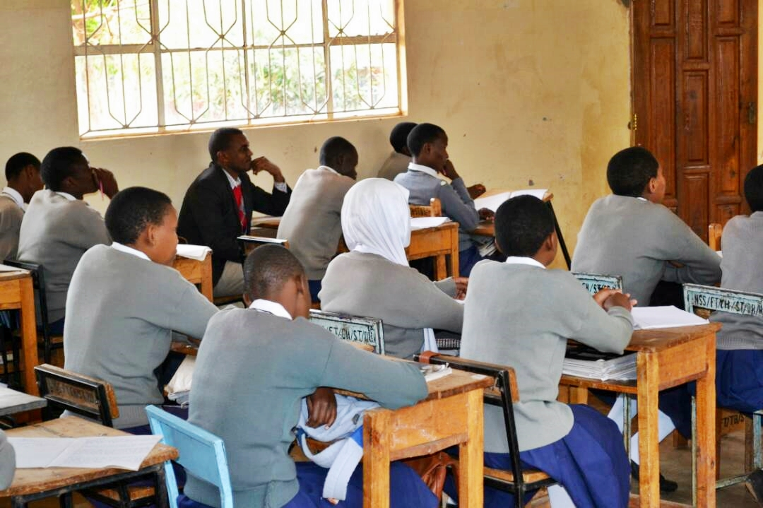

Figure 2.3: CED Student and Form Four Business Class Students during the Entrepreneurship Training
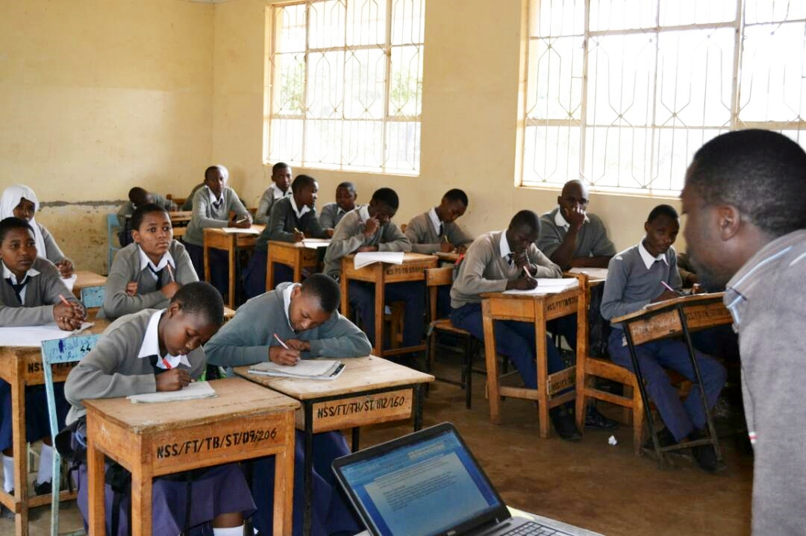

Figure 4.4: Form Four Business Class Students with the Facilitator During Vegetable Production Training

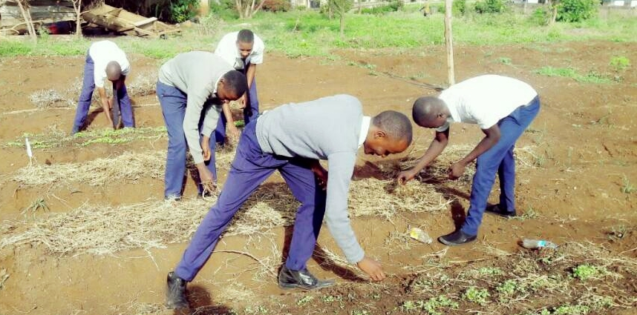

Figure 4.5: Students Checking Nursery Vegetables
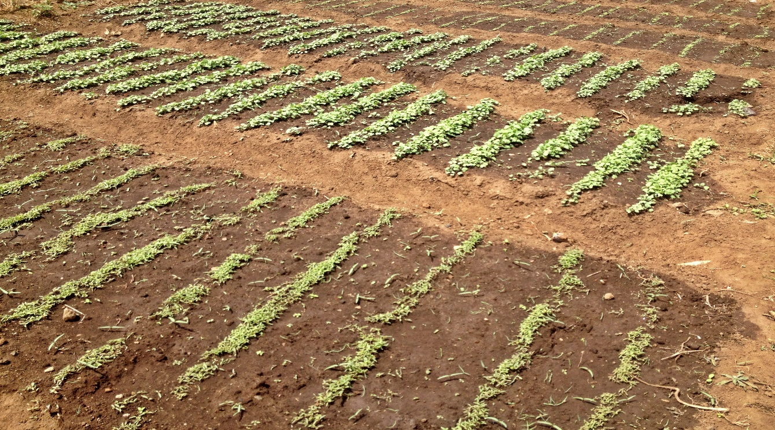

Figure 4.6: Nursery Vegetable

4.3.2 Project Implementation Gantt Chart

Table 19: Project Implementation Gantt Chart
Objectives | Output | Activities | Project Month
 |  |  | J | F | M | A | M | J | J | A | S | O | N | D
Objective 1: To train 50 students entrepreneurship skills by June 2017 | Output 1: 50 students acquire entrepreneurship training | Activity 1: Purchasing of products and equipment for training |  |  |  |  |  | X
 |  | Activity 2: Theoretical and practical entrepreneurship training |  |  |  |  |  | X
 | Output 2: 50 students having 1 week to generate entrepreneur Idea. | Activity 1: Leadership and teamwork training. |  |  |  |  |  | X
 |  | Activity 2: Idea generation and selection process |  |  |  |  |  | X
Objective 2: To train 50 students on vegetable production by June 2017. | Output 1: 50 students acquire Training on vegetable production. | Activity 1: Identification of vegetables types and character. |  |  |  |  |  | X
 |  | Activity 2: Workshop on vegetable production |  |  |  |  |  | X
 | Output 2: 50 students having 2 weeks field on vegetable production. | Activity 1: Land preparations |  |  |  |  |  | X | X
 |  | Activity 2: Trial field seedling |  |  |  |  |  | X | X
Objective 3: To produce 5000 grams of vegetable by august 2017. | Output 1: Vegetable production | Activity 1: Nursery installation |  |  |  |  |  |  | X | X
 |  | Activity 2: Field preparation and seedling |  |  |  |  |  |  | X | X
 | Output 2: Vegetable ready for sale by august 2017. | Activity 1: Marketing and order taking |  |  |  |  |  |  |  | X
 |  | Activity 2: selling vegetable |  |  |  |  |  |  |  | X

CHAPTER FIVE

5.0 PROJECT PARTICIPATORY MONITORING, EVALUATION AND SUSTAINABILITY

5.1 Introduction
Monitoring and Evaluation is the assessing of all activities carried out as planned and if the project objectives are being achieved. According to Rietbergen-McCracken (1998), “the monitoring concerns the follow up of the execution of the planned activities, while the evaluation is concerned with the achievement of the objectives and many evaluations can be undertaken at certain times, such as at project mid-term or at completion. In participatory monitoring and evaluation work, the distinction between monitoring and evaluation can often become blurred, as participatory assessments and feedback mechanisms are built-in to project design as a regular component of the work, rather than one-time events”.

In community development projects, participatory monitoring and evaluation is to be used whereby the community is responsible for collecting, analyzing and generating recommendations for change. This project of generating income through vegetable production, the MCED Student will play the role of a facilitator in participatory Monitoring and evaluation in order to assess objectively the quality of the process the outputs of the vegetable production project. This chapter is divided into three subsections which are project participatory monitoring which provides information about the life of the project, Evaluation which shows how the project will be successful and lastly sustainability which gives the overview of its life span even if the stakeholder withdraw. Project monitoring and evaluation determines whether the intended objectives and activities have been attained and the project is progressing. So the project implementers will be able to see the effectiveness of the project at large.

5.2 Participatory Monitoring
The main purpose of participatory monitoring is to provide information during the life of the project, so that adjustments or changes can be made if necessary. Therefore participatory monitoring has been used as ongoing process to monitor all activities carried out by the community during establishment of the project.

5.2.1 Monitoring Information System
This is a system which allows users to capture data, process and disseminate information in a systematic way. This enables the researcher to measure trends of various indicators based on the data collected in the field. This section explain a system which was considered to gather and report information on project activities to enable the researcher/supervisor to plan, monitor, evaluate and report the operations and performance of the project. Therefore MIS in this project was used as essential tool of reporting information about inputs, outputs, and impacts of the project. The kind of information which will be gathered for monitoring purposes will concern the amount of money used, space used for vegetable production and site, number of vegetable produced, number of vegetable sold, amount of income, number of project participants and the income generated from the project.

5.2.2 Participatory Monitoring Methods Involving the Community
As done for the CNA, The participatory methods are to be used for the monitoring. For the Vegetable production project, the Beneficiary Assessment (BA) was used to assess the benefit found by the students in the project chosen by them. This BA was supported by conversational interviews, observation and Focus Group Discussion conducted by MCED Student helped by the Lemara Ward local government.

5.2.2.1Conversational Interview
This interview conducted individually with the researcher in order for the project beneficiaries to reveal their thought, feelings and beliefs about the project individually.

5.2.2.2. Focus Group Discussion
This technique is used to interview and discuss with the target in group on how to conduct and implement the project in order to reach project goals. This technique helps the researcher to get needed information from the project participants and to improve the health of the project.

5.2.2.3 Observation
The researcher observes the day to day activities carried out by the beneficiaries. All activities had responsible persons and financial resource was allocated accordingly. The activities included organizing, collaborating and communicating with different stakeholders. The observation helps the CED student to monitor day to day project activities.

5.2.3 Participatory Monitoring Plan
The monitoring of activities aims at assessing achievements against set goals and objectives. The comparison between the plans and actualisations are based on the schedule summarised in the Table 20.

Table 20: Participatory Monitoring Plan
Objectives | Output | Activities | Output Indicators | Data Source | Methods | Person Responsible | Time Frame
Objective 1: : To train 50 students entrepreneurship skills by June 2017 | Output 1: 50 students acquire entrepreneurship training | Activity 1: Purchasing of products and equipment for training  Activity 2: Theoretical and practical entrepreneurship training | Training  Purchasing | Training report | Group discussion  presentation | Students, CED student and facilitator | June 2017
 | Output 2: 50 students having 1 week to generate entrepreneur Idea | Activity 1: : Leadership and teamwork training  Activity 2: Idea generation and selection process | Training | Training Activity report | Group discussion  presentation | Students, CED student and facilitator | June 2017
Objective 2: To train 50 students on vegetable production by June 2017. | Output 1:50 students acquire Training on vegetable production | Activity 1 Identification of vegetables types and character.  Activity 2: Workshop on vegetable production | Training | Activity report | Group discussion  presentation | Students, CED student and facilitator | June 2017
 | Output 2: 50 students having 2 weeks field on vegetable production. | Activity 1: Land preparations  Activity 2: Trial field seedling | Field practical | Activity report | Field activity | Students, CED student and facilitator | June 2017
Objective 3: To produce 5000 grams of vegetable by august 2017 | Output 1 Vegetable production | Activity 1: Nursery installation  Activity 2: Field preparation and seedling | Production | Activity report | Field activity | Students and CED student. | July 2017
 | Output 2: Vegetable ready for sale by august 2017 | Activity 1: : Marketing and order taking  Activity 2: selling vegetable | Marketing  Packaging  sales | Activity report | Door to door marketing | Students and CED student. | August 2017

5.3 Participatory Evaluation

“Evaluation” is concerned by the achievement of the objectives while “participatory evaluation” involves the beneficiaries and other stakeholders to assess not only the progress in work plan and the effectiveness of project but also the establishment of systems, the implementation of planned activities, the impact, and even the efficiency/cost-effectiveness of project. The participatory evaluation can be made periodically in mid and at the end of the project.

5.3.1 Performance Indicators
Indicator is a sign that shows the condition or existence of something resulted from project. Indicators help to determine what happened in terms of quantity, quality and timelines against what planned. This project describes three types of indicators which are input indicators, output indicators, and impact indicators. These indicators are used to measure or evaluate the achievement of project objectives.
- Input indicators describe the means by which project are implemented, such as the number of hours of training, the amount of money spent and the amount of resources used.
- Output indicators describe the extent to which the project is delivered and what is intended to be delivered and activities to be carried out such as the number of community workers trained, the number of customers served and the number of students involved in the project.
- Impact indicators measure actual change of students involved in the project such as number student with increased monthly income.

The Table 21 shows how different indicators used to assess the achievement of vegetable production project objectives:

Table 21: Performance Indicators
Objectives | Output | Activities | Resources Needed | Performance Indicators
Objective 1: To train 50 students entrepreneurship skills by June 2017 | Output 1: 50 students acquire entrepreneurship training | Activity 1: Purchasing of products and equipment for training  Activity 2: Theoretical and practical entrepreneurship training | Human resource  Financial resource  Venue | Training sessions attendance
 | Output 2: 50 students having 1 week to generate entrepreneur Idea | Activity 1: Leadership and teamwork training  Activity 2: Idea generation and selection process | Human resource  Stationery  Venue | Training sessions attendance
Objective 2: To train 50 students on vegetable production by June 2017. | Output 1:50 students acquire Training on vegetable production | Activity 1: Identification of vegetables types and character.  Activity 2: Workshop on vegetable production | Human resource  Stationery  Venue | Training sessions attendance
 | Output 2: 50 students having 2 weeks field on vegetable production. | Activity 1: Land preparations  Activity 2: Trial field seedling | Human resource  Stationery  Venue  Tools. | Production process
Objective 3: To produce 5000 grams of vegetable by august 2017 | Output 1: Vegetable production | Activity 1: Nursery installation  Activity 2: Field preparation and seedling | Human resource  Tools. | Production process
 | Output 2: Vegetable ready for sale by august 2017 | Activity 1: Marketing and order taking  Activity 2: selling vegetable | Human resource | Marketing  sales

5.3.2 Participatory Evaluation Methods
There different methods of engaging the community to evaluate the project objectives, this methods includes action plan, self-assessment methods, PRA, BA etc. Method used in this project is BA. Beneficiaries Assessment (BA) is a qualitative research tool used to improve the impact of development operation by gaining the views of intended beneficiaries regarding a planned or ongoing intervention. The method will help to understant how the beneficiaries perceive the project chosen by themselves and implemented by them for their benefit. In this process, the role of MCED Students is to facilitate the evaluation by using interviews and FGD.

5.3.3 Project Evaluation Summary
The Table below shows the project evaluation summary which consist of the following project goal, objectives, performance indicators for each goal, expected outcomes and actual outcome. Generally the evaluation shows that there are strong commitments of various stakeholders from the planning stage to the implementation activities. This proves that the project will be sustainable and hence benefit all beneficiaries and community at large.

Table 22: Project Evaluation Summary
Objectives | Output | Activities | Performance Indicators | Expected Outcomes | Actual Outcomes
Objective 1: To train 50 students entrepreneurship skills by June 2017 | Output 1: 50 students acquire entrepreneurship training | Activity 1: Purchasing of products and equipment for training  Activity 2: Theoretical and practical entrepreneurship training | Training sessions attendance | Positive training attendance | Successful training attendance
 | Output 2: 50 students having 1 week to generate entrepreneur Idea | Activity 1: : Leadership and teamwork training  Activity 2: Idea generation and selection process | Training sessions attendance | Positive training attendance | Successful training attendance
Objective 2: To train 50 students on vegetable production by June 2017. | Output 1: 50 students acquire Training on vegetable production | Activity 1: Identification of vegetables types and character.  Activity 2: Workshop on vegetable production | Training sessions attendance | Positive training attendance | Successful training attendance
 | Output 2: 50 students having 2 weeks field on vegetable production. | Activity 1: Land preparations  Activity 2: Trial field seedling | Production process | Field practice attendance | Successful field practice
Objective 3: To produce 5000 grams of vegetable by august 2017 | Output 1: Vegetable production | Activity 1: Nursery installation  Activity 2: Field preparation and seedling | Production process | Vegetable production | Vegetable production
 | Output 2: Vegetable ready for sale by august 2017 | Activity 1: Marketing and order taking  Activity 2: selling vegetable | Marketing  sales | Vegetable ready for sale | Vegetable ready for sale

Project Sustainability
Is the ability of project to maintain its operations, services and benefits during its projected life time even when the external support has stopped. So during implementation phase the target group should think on a sustainable plan which will help the project to continue even if different stakeholders withdraw from the project and make sure their able to establish another project resulted from the existing
one. Three aspects are to be considered in the plan; Institutional sustainability, financial sustainability and political sustainability.

Institutional Sustainability
The institution which is responsible for implementation of the vegetable production is Naura Secondary school Form four business study students, so it will make sure that the project is sustainable, by assist the project management team since they have all knowledge about the establishment of the project.

Financial Sustainability
Vegetable production project as an income generation will definitely make profit to project beneficiaries. Lemara ward as the one of the best vegetable producers in Arusha district, surrounded by different social economic infrastructure and customers, ensures market to sell the vegetable hence the project will make profit which will ensure its financial sustainability.

Political Sustainability
This project relay on the National Strategy for Growth and Reduction of Poverty II, Millennium Development Goal. The government and the local government aim to promote entrepreneurship studies and skills from the secondary level so that to generate other employment and reduce the unemployment rate in the Country, due to this reasons the leaders from ward level to district level support the project. The support showing by the local government during CNA it proves that the project will be politically sustainable.

CHAPTER SIX

6.0 CONCLUSION AND RECOMMENDATION

6.1 Introduction
This chapter comprise of all information presented on previous chapters in summary, Also it summarizes the all project work and recommend on ways to make other people interested with community to establish other CED project in order to alleviate community dependency. This chapter also will examine all process conducted, from project identification to project implementation. Discussion will base from Community Needs Assessment, Problem Identification, Literature Review, Project Implementation, Participatory Monitoring and Evaluation to Sustainability of the Project. Conversely, the chapter draws out the conclusion which will assist researcher, duty holder and other economic development actors in youth development issues obtain the vital information about the project and make the improvements of the project and create new project.

6.2 Conclusion
Tanzania is one of the least developed countries and the unemployment level is very high, at 11% in 2006, though the country is endowed with rich natural resource base. Unfortunately, the education system in Tanzania has failed to deliberately develop values, attitudes, knowledge and skills that enable students and graduates to see and realize the potentials around them. Because of the importance of entrepreneurship to the growth and prosperity of the country, mainstreaming entrepreneurship in the education and training system will be the key to personal and community development.
The aim of this mainstreaming is to promote “a culture that is entrepreneurial”, emphasize “individual entrepreneurial initiatives”, encourage the education system “to create job creators” and respond to the changing world of science and technology and the corresponding ever-changing needs of people. There are numerous reasons for the contemporary interest in entrepreneurship and the creation of entrepreneurs. The garden can serve as a source of artistic inspiration and as a means of creative expression. Garden and the knowledge gained by gardening can be incorporated, integrated, and used to its fullest academic, experiential, and social potentials, not only outdoors, but also inside a high school classroom. This means that gardens can be tailored to meet the educational needs of different students and adapted to fit different high school curricula.

Gardens are very flexible in their form and function and as such can be shaped by the style and goals of individual teachers. Since methods of planning, planting, and maintaining of a garden are unique to the particular garden and gardeners, the gardening experience itself is a fundamentally unique learning process. While developing and caring for a garden requires hard work and is by no means an easy task, the benefits to teachers and students are outstanding and well worth the commitment.

Entrepreneurship is a key driver of our economy. It is argued that perhaps the main importance of entrepreneurship education is becoming a component of new economic strategies for fostering job creation. The outcome of entrepreneurship education is a new generation of entrepreneurs who create jobs not only for themselves but also for others. However, the benefits of entrepreneurship education are not limited to boosting start-ups, innovative ventures and new jobs. Entrepreneurship is a competence for all, helping young people to be more creative and self-confident in whatever they undertake. In fact, entrepreneurial mindsets, knowledge and abilities will be of benefit to young people in all walks of life and in a variety of jobs.

Vegetables are significant component of agricultural farming systems in Africa and have recently become a stronger focus for research institutions, development organizations and policy makers. As well as generating income for producers, vegetable production for domestic and export markets can generate employment opportunities in processing and trade, making it an important driver of growth. The garden-based learning experience for students shows evidence of a progressive overall increase in academic success and a reduction of idleness and dependence. Furthermore other beneﬁts are provided to the community a higher number of students graduating with greater knowledge and skills, who can contribute more in the community development future. To students, at the end they have the ability to create job opportunities or possibilities of going on to higher degrees of academic or professional training. Since attitudes have been modiﬁed, participants show are more sociable, and can work better in groups, with higher levels of self-esteem and a lower sense of failure.

School gardens are a wonderful way to use the schoolyard as a classroom, reconnect students with the natural world and the true source of their food, and teach them valuable gardening and agriculture concepts and skills that integrate with several subjects, such as math, science, art, health and physical education, and social studies, as well as several educational goals, including personal and social responsibility.

6.3 Recommendation
The real world demands collaboration, the collective solving of problems learning to get along, to function effectively in a group, is essential the act of sharing ideas, of having to put one's own views clearly to others, as is in itself educative. This practice will build strong relationship foundation which really needed to make the Nation strong as Mwalimu Nyerere preached back in the days. Education for Self-Reliance (ESR) as a key instrument in building the new Tanzania envisioned within the Arusha Declaration, as schools invest on the preparing students to become exemplary and “self-reliant” citizens of the new society.

The methods used in conducting CAN has helped to identify the project suitable for students and selected by themselves. This gave hope that the project will be implemented and managed planned well. It is for this reason that recommended using participatory methods like Beneficiary Assessment (BA) as used in this research because they ensure ownership and involvement of the community in handling their projects. Naura secondary school Form four business class students should not have identified that there is simple project that can be executed for the reduction of unemployment and income generation. It is only after the community has expressed its feelings, needs and concerns that the vegetable production project has been identified as responding to their problems.

Based on the implementation of vegetable production Naura secondary school Form four business class students in Lemara ward, it has proven that participatory community need assessment is a vital planning for any community economic project because it helps the community to identify their need and find the project to satisfy the need. From this project, it is recommended to local authorities to conduct a CNA in other secondary school and training institution in order to identify their needs and problems. Many other simple projects may be identified for the benefit of the youth, students and the whole community.

REFERENCES
Abukutsa - Onyango, M. O. (2003). Researching African Indigenous Fruits and Vegetables – Why? Department of Horticulture, Jomo Kenyatta University of Agriculture & Technology, Nairobi, Kenya.
Armstrong, A. (1987). Master plans for Dar es Salaam: Tanzania, Habitat International. The Shaping of an African City', Habitat International, 11(2): 133–145.
Armstrong, A. (1990). Multiple Intelligences. VA: Association for Supervision and Curriculum Development. Educational Leadership, 48(2), 66-70.
Atukunda, G. (1998). An analysis of the impacts of IDRC funded research projects on urban agriculture in Uganda. Makerere Institute of Social Research. University of Kampala. Kampala, Uganda.
AVRDC, (1992). Vegetable Production Training Manual, Asian Vegetable Research and Development Centre. Taiwan, Shanhua.
ESRF, (2014). Tanzania Human Development report: Economic Transformation for Human Development. Dar es Salaam, Tanzania.
Kilpatrick, V. (1940). The School Garden: A Laboratory of Nature. New York.
Lupala, A. (2002). Peri-Urban Land Management in the Rapidly Growing Cities: The Case of Dar es Salaam, SPRING Research Series no 32. Dortmund, Germany.
Magigi, W. (2008). Improving Urban Land Governance with Emphasis on Integrating Agriculture Based Livelihoods in Spatial Land Use Planning Practices in Tanzania, PhD thesis, Freiburg University. Germany.
Shackleton, C. M., Pasquini, M. and Drescher, A. W. (2009). African indigenous vegetables in urban agriculture. London: Earthscan.

APPENDICES

Structured questionnaire

SECTION A: INTRODUCTION
(Round the correct answer)
- Age of respondent
- Below 15
- 15 - 20
- Above 20
- Gender of respondent
- Male
- Female

SECTION B
- As a student, have you ever involved yourself in any income generating activities?
- Yes
- No
- What feedback did you get from your family/ community members?
- Good
- Normal
- Bad
- Which of the following economic activities have you ever do or try?
- Bites and soft drinks
- Selling milk
- Livestock
- Vegetable garden
- Nothing.
- What was/is your Income level per month it Tshs?
- Below 50,000
- 50,000 – 100,000
- Above 100,000
- What do you think is the most important need in your current or expected economic activity?
- Capital
- Substitute Income generation activities
- Training
- Which of the following economic activities will help you generate income comfortable?
- Vegetable garden
- Selling groundnuts
- Selling Milk
- Bites and soft drinks.

