IMPROVING LIVELIHOODS OF THE ELDERS THROUGH SALT EXTRACTION PROJECT IN MCHINGA 1 VILLAGE LINDI DISTRICT COUNCIL

AIDAN PETER MAKWITA

A PROJECT REPORT SUBMITTED IN PARTIAL FULFILMENT OF THE REQUIREMENT FOR THE DEGREE OF MASTER OF COMMUNITY ECONOMIC DEVELOPMENT OF THE OPEN UNIVERSITY OF TANZANIA
2017

CERTIFICATION
The undersigned certifies that she has read and hereby recommends for acceptance by The Open University of Tanzania (OUT) a project report entitled; “Improving Livelihood of Elders through Salt Extraction Project in Mchinga 1 Village in Lindi District”, in partial fulfilment for the award of Masters in Community Economic Development degree of The Open University of Tanzania.

......................................................
Dr. Harrieth G. Mtae

..................................................
Date

COPYRIGHT
No part of this report/dissertation may be reproduced, stored in any retrieval system, or transmitted in any form by any means, electronic, mechanical, photocopying, recording or otherwise without prior written permission of the author or The Open University of Tanzania in that behalf.

DECLARATION
I, Aidan Peter Makwita, certify that this dissertation/thesis is my own original work, and that it has not been presented to any other institution and will not be presented to any other institution other than The Open University of Tanzania.

....................................................
Signature

....................................................
Date

DEDICATION
This work is dedicated to my lovely junior nieces Maria Angrus Mkwela, Monica Angrus Mkwela and my lovely granddaughter Rose Joackim. I wish to tell them that education is a long way process and so they shouldn’t be satisfied with the little education that they possess. They should set their minds towards to covering the long journey of education.

ACKNOWLEDGEMENTS
I am indebted to the All Mighty God for giving me the potential, courage and determination to complete my studies and this dissertation in particular. This report wouldn’t have taken this shape without the countless hours of discussion and unwavering commitments of my supervisor, Dr. Harrieth G. Mtae, a lecturer at The Open University of Tanzania. Her comments and guidance greatly enriched this study. I wish to thank her for the support, assistance and the professional inputs provided before and during the writing of this report.

My sincere and grateful thanks are also extended to Community Economic Development coordinators as well as other staff of The Open University of Tanzania for their moral and material support during the writing of this report. Much gratitude’s are extended to my colleagues at The Open University of Tanzania, with whom we pursued the Masters of Community Economic Development Programme for their encouragement and support given during the whole duration of the study. I wish to express my thanks to my family members for their support, tolerance, endurance and encouragement during the course of my study. Many thanks go to staff members who spent their time, skills and experience in providing resourcefully advice for successfully completion of my study.

Finally, my deepest appreciations go to all stakeholders (Mchinga 1 village government, Ward development committee, Elders, Mchinga Division Officer and officers at Lindi district council) who in one way or another participated during the whole period of project implementation. It is not possible to mention all of them but I owe them a debt of gratitude. May God bless you all.
ABSTRACT
Community Needs Assessment was conducted in Mchinga 1 village early in 2017. During the needs assessment exercise, methodologies such as research design, sample design, data collection methods and tools, data analysis and interpretation processes were used to generate necessary inputs needed for the study. Findings from the community needs assessment came up with five general needs which required community interventions and natural resources and income generating activity were the leading needs. Furthermore, levelling of needs was conducted and come up with critical community needs in which salt extraction business was finally identified as the most feasible income generating business for improving the livelihoods of the elders. Four objectives for the project were identified to be implemented so as to replicate livelihood of the elders including; Identifying fifteen direct project beneficiaries’ members group for salt extracting business, excavate three sea water catchments to generate salt concentrations, conduct three days’ entrepreneurial skills to fifteen direct project beneficiaries ‘and form one managerial structure of the fifteen direct project beneficiaries’ and communicate roles and responsibilities of each members group and plan for benefit sharing. The study realizes that the communities can best use of their local land and forest resources as sustainable sources of income if there is good planning and implementation in a means that poverty is eradicated. Therefore, the study recommends that deliberate efforts should be taken in involving all stakeholders in implementing of community economic development projects to ensure sustainability and reduced poverty that is threatening the nation.

TABLE OF CONTENTS
CERTIFICATION ii
COPYRIGHT iii
DECLARATION iv
DEDICATION v
ACKNOWLEDGEMENTS vi
TABLE OF CONTENTS viii
LIST OF FIGURES xiii
LIST OF ABBREVIATIONS xvi
CHAPTER ONE 1
1.0 PARTICIPATORY NEEDS ASSESSMENT 1
1.1 Background Information 1
1.2 Community Profile 2
1.2.1 Locations 2
1.2.2 Population 3
1.2.3 Climate 3
1.2.4 Administratively 4
1.2.5 Ethnic Groups 4
1.2.6 Social Economic Activities 4
1.2.7 Social Services 5
1.2.8 Environment 7
1.3 Community Needs Assessment 7
1.3.1 Objectives of Community Needs Assessment 8
1.3.2 Community Needs Assessment Research 8
1.3.3 Community Needs Assessment Methodology 9
1.3.3.1 Research Design 9
1.3.3.2 Sampling Techniques 10
1.3.3.3 Data Collection Methods 13
1.3.3.4 Data Analysis Methods 15
1.3.3.5 Limitations of the Study 16
1.3.3.6 Delimitations of the Study 16
1.4 Community Needs Assessment Findings 17
1.4.1 Demographic Characteristics of Respondents 17
1.4.1.1 Sex 18
1.4.1.2 Age 18
1.4.1.4 Education Level 20
1.4.1.5 Values of Ordinary People in Mchinga 1 Village 20
1.4.1.6 Available Natural Resources in the Village 21
1.4.1.7 Available Customers for the Local Businesses in the Village 22
1.4.1.8 Individual Monthly Income in Mchinga1 Village 22
1.4.1.9 Challenges Villager/Elders Group face in Mchinga 1 Village 23
1.4.1.10 Result on Environmental Friendly Activity can be carried out to Counterpart Challenges Mchinga 1 Elders Face 24
1.4.1.11 Required trainings on Economic Activities in the Village in 1.3.1.7 25
1.4.2 Findings from Qualitative Data Analysis 26
1.5 Community needs Prioritization/Levelling 29
1.6 Chapter Summary 30
CHAPTER TWO 31
2.0 PROBLEM IDENTIFICATIONS 31
2.1 Background to the Research Problem 31
2.2 Problem Statement 32
2.3 Project Description 33
2.3.1 Target Community 34
2.3.2 Project Stakeholders 35
2.3.3 Project Goals in CED Terms 36
2.3.4 Project Objectives 37
2.3.4.1 General Objective 37
2.3.4.2 Specific Objectives 37
2.4 Host Organizations 38
2.4.1 Vision 38
2.4.2 Mission 38
2.4.3 Mchinga 1 Village Activities 38
2.4.4. Organization Structure 39
2.4.5 SWOT Analysis 39
2.4.5 Role of the Community Economic Development Student in the Project 40
2.4.6 Role of the Host Organization 41
CHAPTER THREE 42
3.0 LITERATURE REVIEW 42
3.1 Introduction 42
3.2 Theoretical Literature Review 42
3.2.1 Status of Salt Water Production Globally 44
3.2.2 Challenges of Salor Salt Production in Tanzania 47
3.3 Empirical Literature 49
3.4 Policy Review 52
3.5 Literature Review Summary 56
CHAPTER FOUR 57
4.0 PROJECT IMPLEMENTATION 57
4.1 Introduction 57
4.2 Products and Outputs 58
4.3 Project Planning 60
4.3.1 Project Implementation Plan 60
4.3.1.1 Project Logical Framework 63
4.3.2 Project Inputs 65
4.3.3 Staffing Pattern 67
4.3.4 Project Budget 68
4.3.4 Project Implementation 68
4.4.1 Actual Project Implementation Report 77
4.4.2 Project Implementation 79
CHAPTER FIVE 80
5.0 PROJECT PARTICIPATORY MONITORING, EVALUATION AND SUSTAINABILITY 80
5.1 Introduction 80
5.2 Participatory Monitoring 81
5.2.1 Monitoring Information System (MIS) 81
5.2.2 Participatory Monitoring Methods 83
5.3 Participatory Evaluation 86
5.3.1 Performance Indicators 86
5.3.2 Participatory Evaluation Methods 89
5.4 Project Sustainability 92
5.4.1 Institutional Sustainability 92
5.4.2 Financial Sustainability 93
5.4.3 Political Sustainability 93
CHAPTER SIX 95
6.0 CONCLUSION AND RECOMMENDATIONS 95
6.1 Introduction 95
6.2 Conclusion 95
6.3 Recommendations 99
6.3.1 Recommendation regarding Community Needs Assessment 99
6.3.2 Recommendation on Literature 100
6.3.3 Recommendation on Project Implementation 100
6.3.4 Recommendation on Sustainability 101
6.3.5 Recommendations on Policy 101
REFERENCES 102
APPENDICES 105

LIST OF TABLES
Table 1.1: Respondent’s Categorization 12
Table 1.2: Responses on Values that Ordinary People in Mchinga 1 Village 21
Table 1.3: Response on some of the Main Natural Resources that are Available in Mchinga 1 Village 22
Table 1.4: Customers in Mchinga 1 Interested in buying Local Products in the Village 23
Table 1.5: Responses on the Main Challenges Villagers face in Mchinga 1 Village 24
Table 1.6: Responses on Environmental Friendly Activity to be carried out to Counterpart Challenges Mchinga 1 Villagers/Elders group Face 25
Table 1.7: Response on any training that can Facilitate the Way of Working or Goal Achievement to a Dedicated Social – Economic Activity in 1.3.1.7 26
Table 1.8: Prioritization and Levelling of Needs 30
Table 2.1: Expected Stakeholders, Role and Expected End-Result 37
Table 2.2: SWOT Analysis of the Mchinga 1 Village 41
Table 3.1: Type and Amount of Salt Produced Worldwide 46
Table 4.1: Project Objectives, Outputs And Activities 60
Table 4.2: Project Implementation Plan 62
Table 4.3: Project Logical Framework for the Salt Extraction Business among Elders in Mchinga 1 Village 64
Table 4.4: Project Inputs 67
Table 4.5: Project Budget of the Salt Extraction Business in Mchinga 1 Village, 2017 71
Table 4.6: Definite Project Implementation Report 79
Table 4.7: Project Implementation Ghantt Chart 81
Table 5.1: Project Monitoring Information System for Salt Extraction Business 84
Table 5.2: Participatory Monitoring Plan 86
Table 5.3: Project Performance Indicators 89
Table 5.4: Project Evaluation Summary 92

LIST OF FIGURES
Figure 1.1: A Map of Mchinga1Village Illustrating Location and Boundaries 2
Figure 1.1: Age of the Respondents 19
Figure 1.2: Marital Status of the Respondents 20
Figure 1.3: Level of Education attained among Respondents 21
Figure 1.4: Responses on Individuals Amount of Income that Respondents are Earning in Mchinga1 Village Per Month 24
Figure 1.5: Response on Available Services that are so Satisfactory to the Villagers in Mchinga 1village Currently 27
Figure 1.6: Economical, Environmental And Topographical Characteristics of the Mchinga 1 village 28
Figure 2.1: Arrangements of the Village Structure as Sourced from CNA Study 40
Figure 4.1: Mchinga 1 Villagers at a Meeting Sharing Details of the Project 74
Figure 4.2: Meeting to Screen Applicants for the Project and Design Project Development Plan at Mchinga Ward Meeting Venue 75
Figure 4.3: Progress Pans Construction Work Located at Mchinga 1 Coast Stretch 75
Fugure 4.4: Ongoing Pans Digging Work Around Mchinga 1 Viilage 76
Figure 4.5: Ongoing Water Crystallization To Form Salt In Some Pans Begin 76
Figure 4.6: Entrepreneurial Training to the Elders in Ward Meeting Venue by the Researcher 77
Figure 4.7: Election of Leaders And Sharing Rules And Responsibilities of the Individual Member Groups Facilitated By The Researcher 77

LIST OF ABBREVIATIONS
BC Before Christ
CED Community Economic Development
CAN Community Need Assessment
DED District Executive Director
DRC Democratic Republic of Congo
EIS Evaluation Information System
FIFO First In First Out
GDP Gloss domestic Product
IDD Iodine Deficiency Disorders
IFRC International Federation of Red Cross and Red Crescent Societies
Kms Kilometres
MCED Masters of Community Economic Development
MDS Minimum Data Set
MEO Mtaa Executive Officer
MIS Monitoring Information System
NEEP Nation Economic Empowerment Policy
NSGRP National Strategy for Growth and Reduction of Poverty
PRA Participatory Rural Appraisal
SARAR Self-esteem, Associative strengths, Resourcefulness, Action planning, Responsibility
SME Small and Medium enterprises
SPSS Statistical Package of Social Science
SWOT Strength, Weakness, Opportunity, Threats
TDHS Tanzania Demographic and Health Survey
TFNC Tanzania Food and Nutrition Centre
UN United Nation
UNICEF United Nations International Children’s Emergency Fund
USD United State Dollar
VAT Value Added Tax
VEO Village Executive officer
WADC Ward Development Committee
WAO Ward Agriculture officer,
WCDO Ward Community development officer
WEO Ward Executive Officer
WHO World Health organization
WNRO Ward Natural resource officer

CHAPTER ONE
- 1.0 PARTICIPATORY NEEDS ASSESSMENT

1.1 Background Information
Community Needs Assessment was conducted at Mchinga 1village situated in Mchinga ward in Lindi district in March 2017. This Community Needs Assessment purposely aimed at exploring a major social- economic challenge faced by elders group in the village and in return suggested salt extraction business as income generation project as an enabling activity. Salt production in Tanzania has been the historical business in the area and has been produced from solar pans along the Tanzanian coastal strip and from brine springs at Uvinza for centuries.

Records shows that in 1926 Tanzania received 342,000Tshs after selling 3,000tons of solar salt, fourth after diamonds, gold and mica, and in 1959 the country increased salt yields to 30,000tons worth 5 million Tshs coming fifth after diamonds, gold, lead and copper. National Economic Empowerment Policy (2004) calls for effective utilization of land resources to enhance participation of Tanzanian citizens in economic ventures and access to finance. To this regard, the NEEP 2004 attracted the researcher to collaborate with the targeted community to initiate the activity that will use natural land to bring social-economic development of the elders in Mchinga 1 village compared to other mostly used activities like bee keeping, agriculture, health, funding and education projects.

With this challenge at hand, observation, wealth ranking and questionnaires was deployed as mean of data collection and the process incorporated recipients’ groups, village leaders and other project stakeholders to generate information that was meaningful. Inclusion of the elders group, village leaders and other project stakeholders in the whole process was a priority so as to increase ownership and sustainable actions at the end. The study used various methodologies by carefully selecting the study population, determining exact study design, appropriate sampling techniques, tangible research questionnaires, reasonable sample size, appropriate data collection and data analysis and lastly good presentation to smoothen the process and obtain fruitful findings.

1.2 Community Profile

1.2.1 Locations
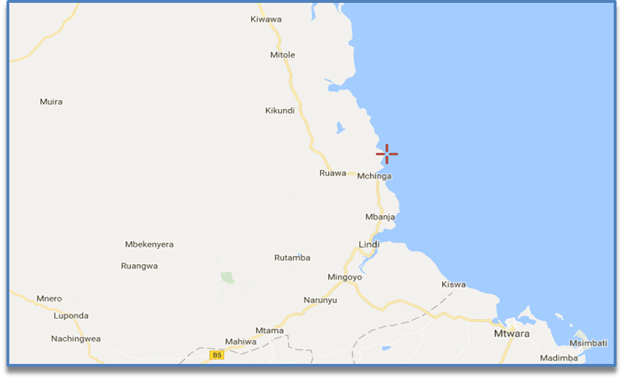

Figure 1.1: A Map of Mchinga1Village Illustrating Location and Boundaries
Source: Google Map (April 20, 2017: 11:40)

Mchinga Village is located in Lindi District - just 32kms from Lindi town. The village lies between latitude 100 -110 South of equator and longitude 180-390 East of Greenwich. The village share borders with the Indian Ocean to the east and Kilangara village in the north. The village shares borders with MtoMkavu Village in South while there is Rondo forest reserve in Western side. The village has an area of 43 square kms, out of these 22 square kms - which is equal to 84% of the total village land suitable for agriculture and only 11.8 Sq. kms is under cultivation. The village is occupied with vegetation Savannah type characterized by different dominant grasses, trees and bushes.

1.2.2 Population
The village has 187 households with a total population of 2766 out of whom 1309 are males and 1457 are females. People live in scattered houses except the houses located along the main road whereby buildings are close to each other. The average village household size is 3.7 people. At present the village population growth rate is about 0.6%. The village population density is about 28 people per square kilometre.

1.2.3 Climate
The village lies between 200 - 900 meters above sea level and occupied with savannah type vegetation characterized by different dominant grasses, trees and bushes. The village receives annual rainfall rate of between 800 – 1,000mm and has only one rainy season which normally falls between the months of November to April. Rainfall increases with altitude, hence the lowlands are relatively drier compared to the highlands. Day time temperature ranges from 25⁰ to 31⁰C and relative humidity ranges from 71% to 86%. The main rain season lasts for roughly 120 days between March and June every year. The rains are usually heavy and spread throughout. This is also the main crop planting season for all crops, especially for seasonal crops such as maize. The short rain season lasts for about 60 days between October and December each year. The rains are not evenly distributed and they are not very reliable.

1.2.4 Administratively
The village is headed by the village chairperson who was democratically elected during local government elections in 2014 and is assisted by five hamlet chairpersons and twenty-seven (27) village council members. The village has one Village Executive Officer who is employed by the Lindi district council. The Village Executive Officer and village security committee is responsible for security matters in the village. The village has security personnel well known as Mgambo (community security guards) who supports the committee and the Village Executive Officer in day to day enforcement and maintenance of security in the village.

1.2.5 Ethnic Groups
Mchinga village is inhabited by three main tribes namely Mwera, Makonde, Makua plus other additional, small group of Ngindo and Matumbi.

1.2.6 Social Economic Activities
There is several incomes earning activities taking place in Mchinga village. Two main economic activities are agriculture and fishing. The commercial crops in the village are cashew nuts, sesame and coconuts. The prices for cash crops have been very low in current years resulting into decreasing of productivity in the area. Types of food crops are maize, cassava, rice and sorghum. The challenges faced by famers include poor farming methods -specifically use of hand hoes, lack of fertilizers, usage of traditional seeds and shortage of farming supplements such as fertilizers all of which result in low productivity. A few people keep livestock, but this is done at a very minimal level. Majority of households keep chicken, compared to few numbers of people who keep cows, goats and sheep. To this regard, availability of meat and milk becomes a challenge in the village. Men and women participate equally in most activities, except for fishing which is done by men only.

Fishing is another major economic activity in the village. Majority of the customers come from outside village to buy both dried and fried. Fishing activities are mostly dominated by traditional fishing gear and simple tools. Bee keeping is done at a minimal level. However, charcoal is another outstanding alternative source of energy and income for the majority as well. There are few private owned salt extraction pans employing a number of people producing salt that is sold locally and in other part of the country. Further, petty businesses like food vending and kiosks are practised among women selling food stuffs to passengers and pedestrians along the Lindi – Dar es salaam main road. There are money transferring/ changing business activities including TigoPesa, M-pesa and Airtel Money.

1.2.7 Social Services
1.2.7.1 Education
Mchinga village has one primary school that enrols pupils from the village and nearby villages. There is also one ward secondary school that receives students from the village and nearby wards.
1.2.7.2 Transportation
Mainly road and water are transportation systems available in the village. There is availability of buses and cars from Lindi to Mchinga and Mchinga to other areas of the country any time of a day and throughout the year. For someone seeking transport in moving within the village, there is availability of local transportation of motorcycle well known as bodaboda. Through marine transportations, there are availability of private owned dhows and boats transporting people from one village/district to another including trips to Kilwa and Mafia.

1.2.7.3 Markets
A market is also available in the village. Most of the commodities sold there are agricultural based products including, tomatoes, vegetables, crops, cereals, fish, coconuts, salt, industrial products, etc.

1.2.7.4 Communications and Financial Services
Telephone services are available in the village provided by various companies including Vodacom, Tigo, Airtel and Halotel. These companies provide good financial services like mobile money transactions and transfer. The only nearby place where you can access bank services is in Lindi town where there are National Microfinance Bank, CRDB, Tanzania Postal Bank, and National Microfinance Bank.

1.2.7.5 Health and Water Services
Health serves are provided by the health centre located in the village and has good laboratory facilities. For complicated cases, patients are referred to Sokoine regional hospital of located 32kms at Lindi town. Water is available as there are five (5) wells that provide water to the people all year around.

1.2.8 Environment
In Mchinga 1 village, waste is not well disposed and majority of villagers use pit latrines instead of modern ones that use flashing water. The village is surrounded by a dense forest in the west which is under the Ministry of Natural Resources and Tourism and no social economic activities that are allowed to be conducted in the forest. Areas around people’s habitats are surrounded by mango and coconuts trees and some of the areas are reserved as open spaces. In the east, there is a long coastal strip along the Indian ocean that is potential for salt extraction business.

1.3 Community Needs Assessment
Aparna, Mindy, &Yolanda ( ), have explained the goal for Community Need Assessment as identifying the assets of the community to determine potential concerns that it faces. A straightforward way to estimate the needs of the community is to simply ask residents their opinions about the development of services within the community, their satisfaction with services, and what services are needed. Their opinions can be used in building an agenda aimed at community change that can build the capacity of community – based organization that are designed to provide its residents services and development opportunities.

To this regard, Community Need Assessment was conducted in Mchinga village whereby the researcher incorporated 18 respondents - both male and female including elders, key village leaders and other selected project stakeholders who were systematically selected. The needs assessment exercise aimed at revealing the level of social-economic challenges the elders were facing that impacted their welfare and revealed that salt extraction for income generation as being a priority need that could stimulate people`s social economic well-being.

    - Objectives of Community Needs Assessment
1.3.1.1 Overall Objective
To collect data that aimed at identifying social economic threat, disclose community priority needs and suggest possible intervention for improving livelihood status of the elders group in Mchinga 1 village, Lindi district.

1.3.1.2 Specific Objectives
- To identify the sources of income of Mchinga1 elder’s community.
- To identify main social-economic challenges facing elders that inhibit their welfare.
- To identify available resources for improving livelihoods of Mchinga 1 village elders.
- To determine elders group`s priority needs that could stimulate their social economic welfare.
- To ascertain social-economic interventions for the elder’s welfare.

    - Community Needs Assessment Research/Questions
- What are major social economic activities that are undertaken by the Mchinga1 communities?
- What are most critical challenges that elders in Mchinga 1Village facing?
- Which resources are in place that can be utilized to improve livelihood of the elders in Mchinga 1?
- What are the likely social economic priority that can be undertaken to address the needs that elders are facing?
- Is there any specific activity can be taken to facilitate social economic welfare of the elders?

1.3.3 Community Needs Assessment Methodology
Bobbie (2007) described methodology as the philosophy or the general principle which will guide the research. It is the overall approach to studying your topic and includes issues you need to think about such as the constraints, dilemmas and ethical choices within your research. So, this community needs assessment involved methodologies such as research design, sample design, data collection methods and tools, data analysis and interpretation processes.

      - Research Design
The research design refers to the overall strategy that someone chooses to integrate the different components of the study in a comprehensible and logical way, thereby, ensuring him/her effectively address the research problem; it constitutes the blueprint for the collection, measurement, and analysis of data. This study used descriptive research design that consisted of both quantitative and qualitative approaches in collecting data in the field. Quantitative believe that social world is made by fact that can be studied like the natural world. So, the researcher employed questionnaire and desk document review so as to avoid subjectivity.
The approach secures objective data, data that refracts external facts about social reality. So, quantitative method is good because it is impartial, reliable data that operates outside of the researcher influence. The researcher preferred to use stratified sampling, in which case population contain different strata that appears in different proportions within a population as units of study. Data is presented in summaries, charts and tables. Another approach which guided this study is qualitative method that believes that the social world varies from the natural world. Sociological subject matters are in free will that makes social life unpredictable, therefore it is impossible to study in any rigid or structural way. The researcher applied qualitative approach to get live information that reveal subjective experience of study area. Unstructured interview was included to get in depth and meaningful data. Resource mapping was applied, that involved majority participation in providing economic and social status of the village population bearing on the situation.

      - Sampling Techniques
Bobbie (2007) described two types of sampling - namely, probability sampling or non-probability sampling. This study used both probability sampling and non-probability sampling.

Probability Sampling: Probability sampling is based on the concept that every member of the sample has a known or unknown likelihood of being selected. In probability sampling, systematic sampling was opted for and it involved selecting one person in every nine persons. So, in this study elders (both male and female at Mchinga) were assigned numbers (while at their respective homes) from one up to one-hundred then, a researcher picked one person in each interval of nine counting until the total number reached. Therefore, systematic sampling is good because it minimizes sampling errors although it is time consuming.

Non-Probability Sampling: Non-probability sampling refers to any sampling procedure that does not give specified values to the selection, and thus probabilities of selection of some members of the target population are unknown. In non-probability, purposive sampling was used and it involved using own researcher judgment or intuition to identify sample units that considered to be representative of the study population. Four kinds of village leadership (Chairperson, VEO and two MEOs) were purposely chosen to represent the study population of village leaders.

Again, four village development stakeholders (Division officer, WEO, Ward Natural Recourse officer and Ward Community Development officer) were directly chosen as well to represent study populations project stakeholders. Purposive sampling technique was good because it served a time and financial resource of the study and in the other side the technique is not good as it can motivate subjectivity as the researcher may decide to select respondents of his/her interests.

Study Population: The study involved the population of the village -- mostly elders - both male and female, at Mchinga Village. Currently, there is no official definition of the elderly or the old globally. WHO unveiled the Minimum Data Set (MDS) Project collaborators agreed at the 2000 Harare Workshop to use the chronological age of 60 years as a guide for the working definition of "old"; however, this definition was revisited during this meeting. Many felt this definition was not taking into account the real situation of older persons in developing countries, specifically in sub-Saharan Africa. Hence, upon further deliberation and discussion during the 2001 Dar es Salaam Minimum Data Set (MDS) meeting, the working definition of "older" or "old" for the purposes of their project was changed to the age of 50 years. Therefore, according to researcher and for the purpose of this project "older" or "old" will mean people with 50 years of an age for both male and female.

Sample Population: According to Lindi district profile (2013), Mchinga1 village have a total of 100 people who are categorised as the elders based on retired age of 55 years old and above. To this regard, this study will have sample populations of 100 village elders.

Drawing a Sample Size: As Mugenda and Mugenda (2003) suggest, if entire population is somehow big then at least 10% of the sample population are good representation of the population. Therefore, 10% of the 100 elders in Mchinga 1 village can be good representation of the population and can be calculated as follows.
= 10 Respondents Plus 8 respondents selected through purposely/judgmental samplingin 1.3.3.2 above.

Table 1.1: Respondent’s Categorization
Stakeholder title | Area | Female | Male | Total
Elders | Mchinga village | 5 | 5 | 10
Village Government officers | Mchinga village | 2 | 2 | 4
Project Stakeholders | Anywhere around Lindi district council | 2 | 2 | 4
Total |  | 9 | 9 | 18
Source: Field Data (2017)

1.3.3.3 Data Collection Methods
Both Secondary and Primary data methods were collected by the researcher.

Secondary Data: Secondary data are readily made data from other researchers or writers for the study. It included reading similar project reports of the village to get clear insight of various project issues. Secondary data are convenient and costless although they can be outdated or exaggerated. To this regard, desk review conducted in this study included reading project reports such as Aga Khan animal (cow and goat) keeping report (2015/2016) of the village.

Primary Data: Primary data are the original data collected by the researcher. Primary data are always accurate and fresh although they are more expensive and consume a lot of time in collecting. The following tools used for Primary data collection during this study.

Questionnaire: Questionnaire is the tool of data collection whereby questions about the phenomena are written and given to the respondents to obtain his/her expression for survey purpose or other means. In this study, questionnaire involved disseminating structured questionnaire that were in a form of printed close-ended questions to each identified respondent`s home. Before letting the respondents answer the questions, the invigilator took through the respondent in all question so as to ensure uniformity answers. Thereafter, a copy of questionnaire is given to the respondents request him/her to answer the questions therein before the invigilator pass back to collect those filled copies. Some of the respondent did not know how to read and write. The invigilator assisted them in reading and recording the replies on the paper. One merit of using questionnaire tool is that it is free from bias of the interviewer. Demerits of using this tool is that, it is slowest and other questionnaires may be lost in the process of sending or receiving back.

Observation: This involves observing people and things around study area. The study involved observing validity and reliability of the information referring to people and their environments. It involved researcher’s observation on people, their culture and available opportunities/wealth around the village as a one-way data collection. Resource mapping was applied that involved systematically walk along the defined areas of the village together with the local people so as to identify social-economic potentials by looking, asking, listening and jotting potential areas for certain activities. Observation is good because it has no bias and it tells what is currently happening. Its demerit is that the tool is too expensive and can interfere with what observed and what is hidden.

Interview: Interview is the verbal conversation between two people with the objective of collecting relevant information for the purpose of getting study justifications. There are two types namely unstructured (non - directive) and structured (directive). An unstructured interview or non-directive interview is an interview in which questions are imposed without any set format but in which the interviewer may have some key questions formulated to ask in advance.

An unstructured interview allows more questions based on the interviewee's responses and proceeding during the session opposite to structured interview which offers a set amount of standardized questions only. Therefore, the researcher used interview in this study to probe study information’s from the key informant (Mchinga Division officer). Interview is a good tool to use for data collection as it gives a researcher fresh information from the source. On the negative side, the tool is not so good to use as the interviewee can provide information that is of his/her interest.

      - Data Analysis Methods
Data Processing: Data processing involves classification and summarization of data in order to provide accurate answers both qualitatively and quantitatively. In this study data process incurred the following procedures.

Data Editing: Consisted of checking and correcting errors and omission of irrelevancies of responses. Data editing is divided into two. Field data editing that dealt with checking and/or inspecting whether the respondents answered all questions before leaving the site. Also, home data editing that dealt with checking accuracy (neglecting wrong answers and take correct answer to analysis), and uniformity, that involve checking pattern and consistence of answers.

Classification: Classification means grouping responses into main categories of responses to bring out essential pattern. This study had exhaustive classification that included all responses, also exclusive responses, in the sense that each response have only one category and classification in terms of number of categories that should not be neither too many nor too few depending on statistical data.

Coding: Coding means assigning numerals to a category or responses. Therefore, this study used coding to identify item of variables or observation.
Ranking and/or Scoring: After cording data, each category or responses was assigned its recorded max/degree of disparities so as to make them informative ready for tabulation. From tabulation, again raw data processed and presented in the statistical table. Data collected through questionnaires, vivid statistics was applied using the Statistical Package for Social Scientists (SPSS) to generate frequency tables that was presented for interpretations. Statistical Package for Social Scientists (SPSS) was bought from genuine dealer to ensure validity and reliability check of your instruments.

1.3.3.5 Limitations of the Study
In any human action prevention of hindrances is required to maximise success. Limitations that faced this study were:
- Time: This Researcher was an employee at the time of developing this report and so was unable to balance responsibilities. The researcher spent much time on employment responsibilities than the time spent on study responsibilities hence probability to elongate time for report completion.
- Rainy season: is another limitation that affected this study. The study was carried out during the rainy season and besides, it was a crop cultivation period hence limited the availability of respondents as they were busy doing agricultural activities.

1.3.3.6 Delimitations of the Study
- As of time, extra hours were utilized for data collection. Moreover, an assistant from the village was employed to disseminate, receive back and follow-up unanswered questionnaires.
- As of duration, questionnaires were disseminated and collected during in the evenings when respondents were tired coming back from their farms instead of morning/afternoon.

1.4 Community Needs Assessment Findings
Below are the CNA findings for the study that was conducted in Mchinga 1 village basing on methods and type of data collection. The findings are presented in to two categories thus quantitatively and qualitatively. In quantitative, charts and tables were used to express demographic characteristics of the respondents and other research related findings to get detailed understanding of the study population as it was extracted from questionnaires feedback. In qualitative, pictures are presented to display various village characteristics that can be of potentials for long term social economic gain of the elders. Tools such as resource mapping, unstructured interview and observation are being used to capture the qualitative findings.

In analysing demographic data and project questions, the researcher started by presenting detailed discussions before winding-up with the elaborative charts or tables. In general, the researcher succeeded in involving projected number of respondents for 100% and so good to say that majority of these respondents were those directly beneficiaries of the project hence good representation especially on identifying challenges and exploring possible solution.

1.4.1 Demographic Characteristics of Respondents
It is preliminary part of my findings and contains feedback of the personal/respondent’s information such as age, sex, education and marital status so as to reflect nature of the community. Charts were used to express demographic characteristics of the respondents and other research related findings to get detailed understanding of the study population as it was extracted from questionnaires.

1.4.1.1 Sex
Findings in chart 1 below illustrate that there was equal balance between men and women respondents by 50% of the sample. From a researcher perspective, this indicates that the ideas that came in this report are explored by both men and women and so describes real life of both and favour gender balance.

1.4.1.2 Age
Again, the findings in chart 2 below show that research respondents of the age of 60 years and above constituted 39% of the respondents, followed by respondents aged 41- 60 of which constituted of 33%; then respondents of those aged between 21 and 40 constituted 28%. This indicates that most of the ideas and recommendations in this project were initiated by people aged of 60 years and above, followed by people with an interval age of 41-60 years and lastly people with an interval age of 21-40 years. Through the findings, there is the possibility of coming up with good community needs as respondents of that age group had have more life experience. Moreover, the project was expected to involve families in its implementation as in normal circumstances, people of an age of 40 and above lives with several dependents.

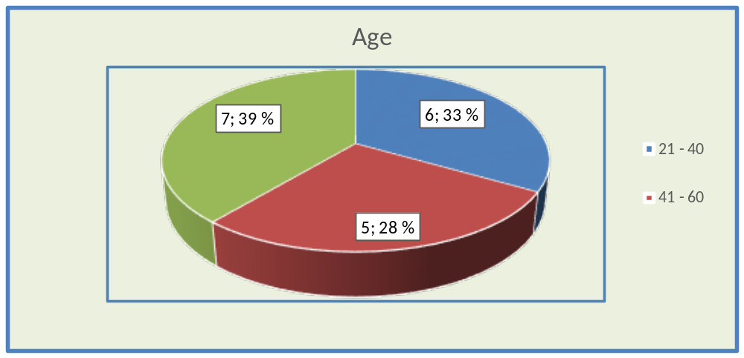

Figure 1.1: Age of the Respondents

1.4.1.3 Marital Status
Questionnaires in chart number 3 below demonstrates that married respondents constitute of 78% of overall research respondents followed by not married responded for 11% and again widower respondents for another 11%. As majority of respondents indicates to be married, it gives an impression to the researcher that there might be a possibility of establishing a project that can involve families or households.
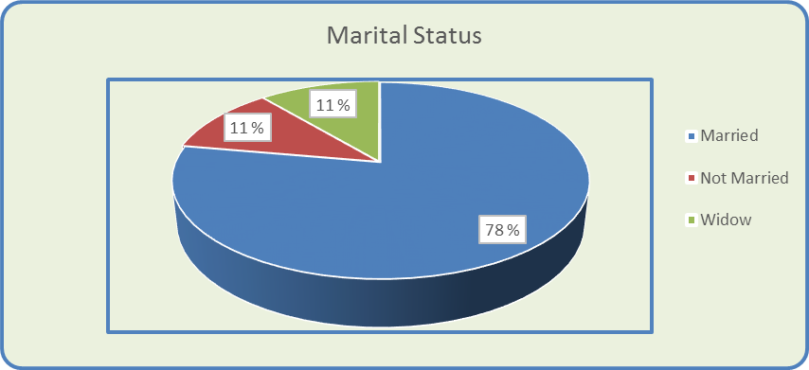

Figure 1.2: Marital Status of the Respondents

1.4.1.4 Education Level
Feedback in chart 4 above on level of education among respondents articulates that 44% of the respondents were uneducated as 28% of respondents had primary education level. Moreover, there were 11% respondents who had secondary education s and another 11% of had technical education and 6% were university graduates. The findings alarmed the researcher as most of the project ideas and recommendations were provided by the uneducated with primary and secondary education - hence need of more training to elders during project implementations.

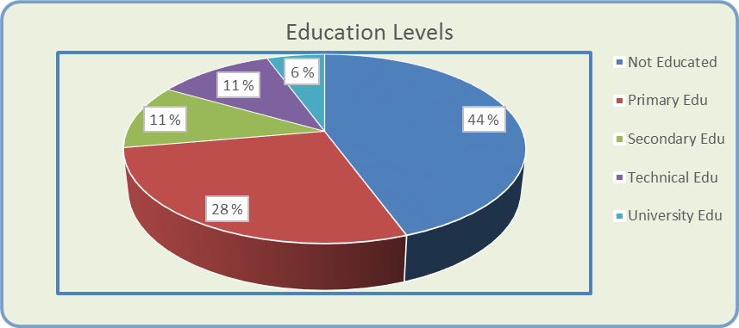

Figure 1.3: Level of Education Attained among Respondents

1.4.1.5 Values of Ordinary People in Mchinga 1 Village
Table 1 indicates that 56% the people at some extent do appreciate to work as a team followed by probability of being trust worthy 33% and lastly hardworking 11%. This implies that there is possibility of success for the interventions that are likely to be realised team-wise than individual-wise. Further, the findings show that people will possibly work harder in cases where individual commitment is needed to fulfil the programme tasks or meeting deadlines and what is interesting is that people are trust worth meaning that there might be enough security of project resources for program sustainability.

Table 1.2: Responses on Values that Ordinary People in Mchinga 1 Village
Category | Frequency | Percent | Valid Percent
Teamwork | 10 | 56 | 56
Trust worth | 6 | 33 | 33
Hardworking | 2 | 11 | 11
Total | 18 | 100 | 100
Source: Field Data (2017)

1.4.1.6. Available Natural Resources in the Village
The findings indicate that the main natural resources available within the village is the ocean, (56%), land for agriculture (22%), followed by undeveloped land for livestock (17%) and transportation infrastructure (5%). The findings give a clear picture on which natural resources that can be utilised effectively within the village for social economic gains of the elders. Table number 2 illustrates available natural resources in the village by percentage.

Table 1.3: Response on some of the Main Natural Resources that are Available in Mchinga 1 Village
Category | Frequency | Percent | Valid Percent
Ocean | 10 | 56 | 56
Undeveloped land for livestock | 3 | 17 | 17
Transportation Infrastructures | 1 | 5 | 5
Plenty of land for agriculture | 4 | 22 | 22
Total | 18 | 100 | 100
Source: Field Data (2017)

1.4.1.7. Available Customers for the Local Businesses in the Village
The basis of asking this question was to understand potential customers suppose the researcher come up with activity that was business oriented. Answers from the survey showed that 39% of customers of the local businesses in a village are bus or car passengers, followed by 28% of customers from the remote areas who normally come in Mchinga village to buy various products. Another group of customers are ordinary Mchinga villagers who constituting for 22% and finally 11% of customers are pedestrians and neighbouring villagers. The survey indicated that there is enough market for businesses that are available around the village and other business that can be initiated. Table 1.4 illustrates availability of customers in the village.

Table 1.4: Customers in Mchinga 1 Interested in buying Local Products in the Village
Category | Frequency | Percent | Valid Percent
Bus or car passengers and owners | 7 | 39 | 39
Pedestrians and neighbouring Villagers | 2 | 11 | 11
Ordinary Villagers | 4 | 22 | 22
People from remote aimed to come and buy products | 5 | 28 | 28
Total | 18 | 100 | 100

Source: researcher, 2017

1.4.1.8. Individual Monthly Income in Mchinga1 Village
The survey found out that 67% of the respondents earned 1tshs -70,000Tshs per month, followed by 28% of respondents who earned 71,000 tshs – 360,000Tshs and additionally 5% of respondents who earned 361,000tshs and above per month. This shows that there is income problem among majorities in the village and so undernourishment of families socially and economically. Therefore, promoting income generating should be given priority when planning social economic interventions in the village. Figure 1.4 shows respondent’s incomes per month.
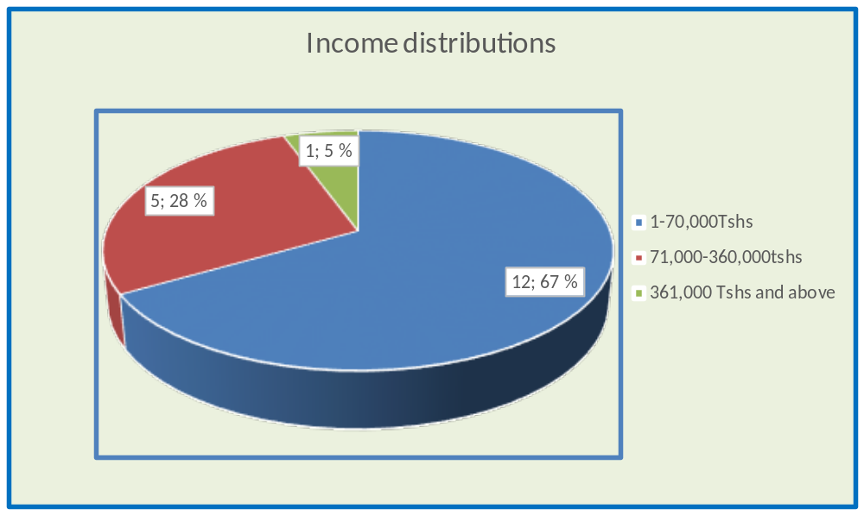

Figure 1.4: Responses on Individuals Amount of Income that Respondents are Earning in Mchinga1 Village Per Month

1.4.1.9. Challenges Villager/Elders Group face in Mchinga 1 Village
Survey (Table 1.5) concluded that the main challenges villagers facing ware lack of sustainable income for 50% of the respondents. Lack of safe and clean water covers 17% of responses equal to responses on lack of health and education services. Environmental destruction indicates 11% responses followed by insufficient financial services which testified 5%. Findings in this question correspond with the findings in (1.3.1.5) above that reported the majority earned income between 1tshs -70,000tshs per month. Therefore, promoting income generating should be given priority when planning social economic interventions for elders livelihoods improvement in Mchinga 1 village.

Table 1.5: Responses on the Main Challenges Villagers face in Mchinga 1 Village
Category | Frequency | Percent | Valid Percent
Lack of sustainable income | 9 | 50 | 50
Lack of safe and clean water | 3 | 17 | 17
Lack of health and education services | 3 | 17 | 17
Insufficiency of financial services | 1 | 5 | 5
Environmental destruction | 2 | 11 | 11
Total | 18 | 100 | 100
Source: Field Data (2017)

1.4.1.10 Result on Environmental Friendly Activity can be carried out to Counterpart Challenges Mchinga 1 Elders Face
Table 1.6 shows that 44% of the respondents support natural resources activity for income generation activities. Access for funds constitutes 17% of the responses - equal to percentages of responses supporting bee keeping. Moreover, livestock keeping and farming activity accounts for 11% of the total responses parallel to education for employment. Nevertheless, interventions on economic earnings are now clearly noted as a key social economic issue that need to be addressed in planning well-being of the elders group in the village as it was appeared in (1.3.1.5) & (1.3.1.6) above.

Table 1.6: Responses on Environmental Friendly Activity to be carried out to Counterpart Challenges Mchinga 1 Villagers/Elders group Face
Category | Frequency | Percent | Valid Percent
Natural resources activity for economic earning | 8 | 44 | 44
Livestock keeping and farming activity | 2 | 11 | 11
Access to fund | 3 | 17 | 17
Honey bee keeping | 3 | 17 | 17
Education for employment | 2 | 11 | 11
Total | 18 | 100 | 100
Source: Field Data (2017)

1.4.1.11 Required trainings on Economic Activities in the Village in 1.3.1.7 above
Table 1.7 shows that 72% of respondents prefer impartation of entrepreneurial skills followed by 17% of respondents who prefer environmental protection skills and 11% of respondents preferred good agriculture and livestock practice. Research result here gives an indication to the researcher that entrepreneurial training is needed for successfully attainment of the project or programme. Results here correlate with those in Chart 4 on level of education the respondents have were by 83 % reported to be uneducated hence need of training to project beneficiaries.

Table 1.7: Response on any Training that can Facilitate the Way of Working or Goal Achievement to a Dedicated Social – Economic Activity in 1.3.1.7
Category | Frequency | Percent | Valid Percent
Entrepreneurial skills | 13 | 72 | 72
Good agriculture and livestock practice | 2 | 11 | 11
Environmental protection skills | 3 | 17 | 17
Total | 18 | 100 | 100

Source: Field Data (2017)

1.4.1.12. Satisfactory Service to the Villagers in Mchinga 1 Village
The reason for imposing this question was to understand the type of immediate services that can be available to facilitate successful project implementations. Chart number 6 specifies that managerial service was mentioned as one of immediate services available for 72% of the respondents followed by availability of technical services for 22% and lastly immediately available service was fund for 6%. The findings imply that much consideration should be kept on introducing activities that require less financial support due to less availability but more considerations on project that need technical and managerial services.

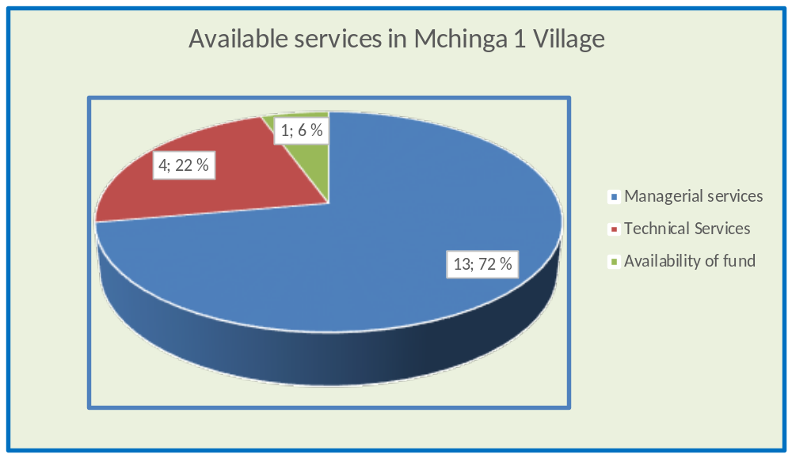

Figure 1.5: Response on Available Services that are so Satisfactory to the Villagers in Mchinga 1village Currently

1.4.2 Findings from Qualitative Data Analysis
As regards qualitative data analysis, the researcher presented pictures - to display various village characteristics potentials for long term social economic investment for the elders. Tools such as resource mapping, unstructured interview and observation were used to capture the qualitative findings. Figure 1.6 illustrates economical, environmental and topographical characteristics of the Mchinga 1 village.
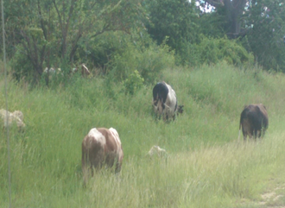 | 
 |  | 
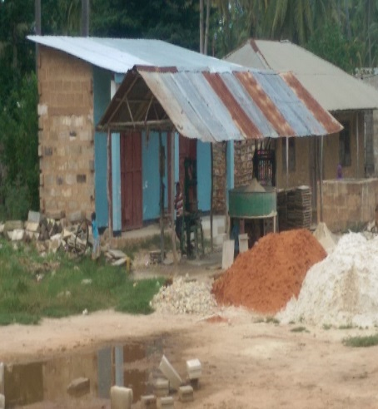 |  |  | 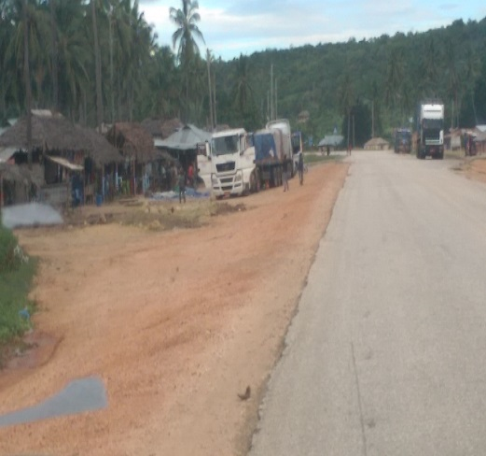

Figure 1.6: Economical, Environmental And Topographical Characteristics of the Mchinga 1 village

The researcher - in collaborations with other village members, conducted resource mapping exercise around the village to determine social economic potential of possible activities that can facilitate welfare of the elderly persons in the village. Before going around, the researcher interviewed the Mchinga Division officer to find her views on best social economic activities that can be executed to best fit welfare of the elders in the village.

The Division officer responded thus: `in my four-year working here I experienced people prefers readymade/convenience money than vice versa. So, I would have suggested the activity that might allow people to work first and earn money in return. I witnessed several fully sponsored projects such as bricks making one, long-term cash crops planting (coconut and cashew), poultry keeping and latest, free animal (cow and goats) program but of these listed projects perished because people sold all the scheme assert/resources to have cash money in hand`. Furthermore, Aga Khan reports available in the village expresses that there was animal keeping (goats and cows) project year 2015/2016.

Throughout resource mapping exercise, the team noted that the village was surrounded by dense forest that can be used for bee keeping but the forest is a reserved land with limited human social economic activities. There is good land for animal pasture such as cow and enough land that can be used for seasonal or long term crops production like maize and coconut. There is good road infrastructure connecting southern regions of Mtwara and Lindi to business city of Dar es salaam; hence making it easier for market access and product transportation. In the eastern part of the village, there is wide area of beaches and coastal stretches that can be used for salt extractions. From these observations and keeping into consideration the Division officer`s comments and additional results in chart 1.3.1.9 (poor availability of fund in the area), the researcher feels that salt extraction and selling for livelihood improvement of the Elders is the best project idea to be implemented.

1.5 Community needs Prioritization/Levelling

Table 1.8: Prioritization and Levelling of Needs
 |  | A | B | C | D | E | Total Row | Row %
A | Salt Extraction activity |  | 8 | 8 | 1 | 8 | 25 | 43
B | Animal keeping Activity | 0.1 |  | 4 | 0.2 | 4 | 8.3 | 15
C | Revolving or Rotating fund | 0.2 | 0.1 |  | 4 | 0.2 | 12.4 | 22
D | Honey bee keeping | 1 | 4 | 0.2 |  | 1 | 6.2 | 11
E | Technical education for employment | 0.2 | 0.1 | 4 | 1 |  | 5.3 | 9
 | Total |  |  |  |  |  | 57.2 | 100
Source: Field Data (2017)
Key:
Score | Meaning
8 | Row is much more important than column
4 | Row is more important than column
1 | Row and column are equally important
0.2 | Row is less important than column
0.1 | Row is much less important than column

1.6 Chapter Summary
Community Needs Assessment was carried out in Mchinga 1 Village in March 2017 focusing on identifying important social-economic challenges elders were facing as regards their welfare, in order determine which challenges were to be given priority so as to stimulate their social economic welfare and ascertain social-economic activities interventions. Two methods of data collection were employed - primary (at large level) and secondary (at an insignificant level) data collected. Yet, tools such as structured questionnaires were employed to capture quantitative findings which were presented in charts and tables to express demographic characteristics and/or detailed understanding of the study population.

Again, tools such as resource mapping, unstructured interview and observation were used to capture the qualitative findings which were presented in pictures and spoken words. The whole process of identifying the economic activity was of participatory so as to ensure that project owners are involved for remarkable goal/activity achievement and sustainability.

Finally, both quantitative and qualitative findings showed that major issues facing the community was availability of sustainable income and that could be achieved through the establishment of salt extraction activity. Pans for salt extraction requires less and/or indirect financial capital of the ordinary villages (as per Division Officer`s advice). More technical and managerial assistance is more required than financial (as per table number 6). This type of the project is more likely to sustainable for long time hence ensuring long term economic gain for the elders.

CHAPTER TWO

2.0 PROBLEM IDENTIFICATIONS

2.1. Background to the Research Problem
Identification of income problem threatening elders in Mchinga 1 Village was done through participatory needs assessment. Moreover, the conducted needs assessment task came up with the clear picture that salt extraction and selling was the overarching solution to counter the mentioned problem. The process of identifying community needs in Mchinga 1 village was participatory and involved different social groups like elders, village government leaders and community development stakeholders. The researcher believes that inclusiveness generated positive ideas for project validity and reliability and minimization of biases.

As regards emerging problems facing the elders in the village, the research disclosed many competing options like bee keeping, access to funds, livestock keeping and farming activities and education for employment. Nevertheless, interventions on economic earning were noted as being a key social economic issue to be addressed. Furthermore, community need levelling came-up with competing results as well including animal keeping activity, availability of revolving or rotating funds, bee keeping and technical education for employment. However, salt extraction and selling become a priority.

Resource mapping exercise conducted by the researcher in the village discovered the village to have a dense forest that can be used for honey bee keeping b therein. There is good land for pasture and cultivation of seasonal or long term crops like maize and coconut. There is good road structure connecting regions of Mtwara and Lindi to business city of Dar es salaam hence good environment for market and product transportation. In the East part of the village, there is long beach stretch and wetland that can be used for salt extractions hence streamlines the team that salt extraction and selling for livelihood improvement of the elders can be the best idea to be acted upon.

Moreover, the study disclosed various challenges associated with the needs. Challenges such as impartation of entrepreneurial skills to the project recipients are of critical importance to be considered so as to facilitate goal/project achievement. Finally, the study recognized potential opportunities within the community related to the identified needs. Potentials such as availability of excellent managerial and technical services will generate positive project implementation and sustainability. In additional, noted ordinary peoples culture like team work, hard work and trustworthiness added value to the project achievement and sustainability.

2.2. Problem Statement
Elders in Mchinga 1 Village noted to be facing critical income poverty. Lack of sustainable income was ranked as number one by the community members who revealed this during the process of participatory needs assessments which indicated that 67% of the people live within Tshs 1 to Tshs 70 per month. Income poverty of the elders in Mchinga affect their purchasing power - hence inability to accommodate individual’s basic needs like health, food, water, clothes, light and transportation. Being aware of the income problem the villagers were facing, in the year 2014/2015 Aga Khan Lindi introduced a project termed `Ufugajiwa Wanyama kwa Kipato Endelevu` meaning “animal keeping for sustainable income aimed at counterpartying poverty income issues’. The Aga Khan animal project was based on the approach that someone interested and registered earlier to join for the project was the one got animals.

Animal keepers were linked to ward veterinary officer in case animals needed treatment and no extra training like entrepreneurial skills were given. As of now, all animals have been sold by keepers and the project has been closed. The current study bridges the gap between what was done previously by incorporating the community themselves in identifying the need lather than introducing ready decided project. By doing so, elders will enjoying their decision that they have made in identifying the project, implementing and then managing it. Entrepreneurial skills will newly be introduced to beneficiaries so as to smoothen the project implementation and management process for goal achievement. Therefore, livelihoods of the elders in Mchinga 1 village can be improved through salt extraction and selling as it is specific and practical solution among other solutions.

2.3 Project Description
This project is called “Improving livelihood of the Elders through salt extraction project in Mchinga 1 Village Lindi District Council”. The village project is located along the Dar es salaam main road just 35 kms from Lindi town. The village characterized with a dense forest, fertile land for animal pasture, and cultivation and long coast land which is good for salt farming. The project will be implemented by the well-motivated elders and they will be technically assisted by well experienced WEO, Ward Agriculture officer, Ward Natural resource officer, ward Community development officer and other village leaders.

The project involved identifying small coast strip in the Mchinga 1 village and then digging-off salt pans. Sea water was trapped in the pans and then allowed to crystallise to form salt to be iodinated before being sold to the customers. Funds were secured to buy inputs like sulphate bags, hoes and spades to accommodate whole activities. Beneficiaries were trained on entrepreneurial skills to make them better managers of their business sustainably. Group leaders supported by project committee were selected to manage day to day operations of the business. Moreover, rules, responsibilities and benefit sharing guidelines were formulated to ensure equal participation and gains among members group.

2.3.1. Target Community
First and key target community of this project was the Elder of the Mchinga 1 village who ware the mostly affected by the unavailability of the sustainable income for their livelihood. Need assessment results above indicated that entrepreneurial training, recipients commitment, availability of good management and technical know-how ware the prerequisites for this project success. The second target community of this project was the families and relatives whom live with elders. Since elders has capacity to generate income then availability of basic need within the families ware of positive.

Elders families/relatives managed to sustain themselves on food, health, shelter, transport, water, light and clothes and hence minimized dependency. Third target communities are the Mchinga 1 villagers and local government at whole. The village has the place to buy fresh salt from the source cheaply instead of searching such services at some remote villages with extra cost and beside this was the first salt project to be initiated in the village and so acted as a learning platform to other entrepreneurs whom would like to do the similar business. Through this project, burden from the village government, ordinary villagers and some relatives to serve the elders was minimized as elders become independency financially. The fourth and final target communities ware the pedestrians, nearby villagers and car passengers whom potentially be interested on buying salt from the elders and so minimize time and financial resources to search such products at the remote villages .So, there was project social multiplayer effect in end.

2.3.2 Project Stakeholders
Project Management Institute (2013) define stakeholder as an individual, group, or organization, who may affect, be affected by, or perceive itself to be affected by a decision, activity, or outcome of a project. To this regard, realization of this project will positively be influenced by the contributions of list of stakeholders not limited to Mchinga Village Council, Elders, Project committee, WEO& Ward councillor, Ward Community Development officer, Ward Natural Resource officer, Ward Agriculture officer, Mchinga division officer and Lindi district Council. Table 7 provides a list of stakeholders involved, expected responsibilities of each stakeholder and the overarching intended results at end.

Table 2.1: Expected Stakeholders, Role and Expected End-Result
Stakeholder | Responsibility of the stakeholder | Expected result
Mchinga Village council | - Allocate village land for salt farming  - Support identification of elder groups members for the project  - Support local resources mobilization for the work and ware house for salt storage | - Smoothen implementation of the project  - Availability of salt in the village  - Increased income of the project members  - Increased income of the village
Elders | - Digging pans for sea water catchments  - Harvesting salt, Storing and selling salts  - Project monitoring and evaluations | - Salt produced  - Increased income  - Sustainability of the project
Project committee | - Advisory work to the project leaders | - Sustainability of the project
WEO& Ward councillor | - Provide venue, financial and managerial services | - Continuous salt production
Ward Community Development officer | - Provision of technical services  - Assist project Monitoring and evaluation | - Increased community participation  - Score project sustainability
Ward Natural Resource officer | - Allocate village land for salt farming  - Provision of technical services | - Score Project sustainability  - Continuous salt production
Ward Agriculture officer | - Provision of technical services | - Continuous salt production
Mchinga division officer | - Provision of managerial services | - Continuous salt production
Lindi district Council | - Provision of financial services and iodine | - Continuous salt production
Source: Researcher (2017)

2.3.3. Project Goals in CED Terms
The overall goal of this project is to improve livelihood of the elders facing a critical problem of income poverty through sustainable income generating measures. Report from needs assessments conducted in Mchina 1 village indicated unavailability of basic need within the families. To that regard, this project will facilitate with Elders promising income to sustain basic needs like food, health, shelter, transport, water, light and clothes and hence minimized dependency. In principal, fifteen elders were identified and form a single group to constitute direct project beneficiaries’ members. The direct project beneficiaries’ members were given small area along coastal strip by the village to create pans (with a technical assistance from experienced Ward Natural Resource officer and Agricultural officer) for salt water catchment that would later generate salt concentrations for selling.

Additionally, the direct project beneficiaries’ members would be trained on entrepreneurial skills to impart their minds with business attitude. In a short and long run, the project will be assisted by the full-time government available, technical and managerial human resources including Village leaders, WADC and division officer. The direct project beneficiaries’ members’ structure would be formed to ensure there was equal benefit (equal income sharing), fair financial management, good conflict resolutions and reasonable project management for sustainability.

2.3.4 Project Objectives

2.3.4.1. General Objective
Supportable income earning for the elders through salt extraction business Mchinga 1 village Lindi district by July 2017 remained the overall objective of the Improving livelihood of the Elders through salt extraction business in Mchinga 1 Village Lindi District Council.

2.3.4.2 Specific Objectives
- To identify fifteen direct project beneficiaries’ members group for salt extracting business by April 2017
- To excavate three sea water catchments to generate salt concentrations for income generation by May 2017
- To conduct three days’ entrepreneurial skills to fifteen direct project beneficiaries’ members group by May 2017
- To form one managerial structure of the fifteen direct project beneficiaries’ and communicate roles and responsibilities of each members group and plan for benefit sharing by May 2017

2.4 Host Organizations
Mchinga 1 village council was the host organization of the study. The village council consisted of chairperson, VEO, Mtaa chairperson`s, MEOs and 25 village council members. Therefore, the village government was composed of elected members and non-elected members. List of elected leaders comprised of village chairperson and the Mtaa chairperson and list of direct government employed comprises of VEOs and MEOs. All village leaders were under discretion of the village general assemble.

2.4.1 Vision
To utilize available natural resources and opportunities for sustainable development of the entire community at Mchinga 1 village.

2.4.2 Mission
Work as a team of villagers and leaders in ensuring transformation of village natural resources into social economic opportunities and services for community welfare.

2.4.3 Mchinga 1 Village Activities
The following are day to day organization activities
- Maintaining peace and security of the village members
- Planning for and protect village resources like forest resources, water, ocean
- Planning and Assist availability of social services to the people like school, water, hospitals
- Encouraging environmental protection and conservation activities
- Fighting for village natural disasters - whenever when it exists, like hunger, flood and draught

2.4.4. Organization Structure
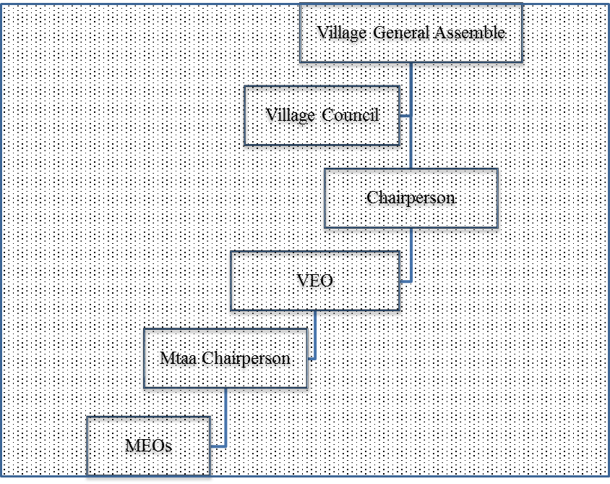

Figure 2.1: Arrangements of the Village Structure as Sourced from CNA Study
Source: Village government reports available in VEO office

2.4.5 SWOT Analysis
Table 2.2 outlines the Strengths, Weaknesses, Opportunities and Threats of the host community as it was extracted from study summaries.

Table 2.2: SWOT Analysis of the Mchinga 1 Village
Strength | Weakness | Opportunity | Threats
- Availability of free land for salt farming  - Availability of good management and trained personnel  - Committed and active beneficiaries  - Acceptability of the project by the community | - Lack of some potential member for the project like an accountant  - Politics in the project as other elected leaders coming from different parties  - This is new project in the area so not well known challenges | - Presence of experienced technicians in the village  - Enough market for the products  - Low competition of the similar project  - Availability of transportation infrastructure  - This project does not require a lot of finance to complete | - Low purchasing power of the ordinary people  - Great care needed when selecting the area to construct salt pans to avoid environmental degradation  - Political leaders have no salaries hence likely to lack commitment during project follow-up

2.4.5 Role of the Community Economic Development Student in the Project
- Facilitate identification of fifteen direct project beneficiary group members for salt extracting and selling
- Facilitate identification of the environmental friendly area that can be best for digging pans for sea water catchment for salt concentration
- Coordinate and conduct training on entrepreneurial skills to the direct project beneficiaries
- Facilitate formation of beneficiaries’ organization structure that will assist day to day project operations
- Facilitate coordination of beneficiaries, government leaders, other stakeholders and community in successful implementation of the project
- Facilitate monitoring and evaluation of the project
    - Role of the Host Organization
- Attend all preliminary meetings
- Attend the work of identifying fifteen direct project beneficiaries’ members group for salt extracting and selling
- Spot environmental friendly area that can be best for digging pans for sea water catchment to concentrate salt
- Participate formation of direct project beneficiaries’ members group organization structure to manage day to day project operations
- Participate in implementation of the project
- Collaboration with the MCED students to meet different stakeholders who could potentially fund the project whenever financial resources needed
- Ensure security of the project assets
- Attend during procurement of the project asserts
- Participate project monitoring and evaluations

CHAPTER THREE

3.0 LITERATURE REVIEW

3.1 Introduction
In this chapter the researcher reviews various literatures from different authors who wrote about salt extraction business for income generation in different perspectives so as to have detailed understanding of the salt industry. Tanzanian policies that govern salt industry are also discussed to replicate the business guidance and outcome as well. A study gained relevance information by reviewing different books, journals, reports and policies of the United Republic of Tanzania on salt extraction and selling for livelihood improvement.

Literature review is divided into four parts - theoretical literature, empirical literature, policy reviews and the literature review summary. In theoretical part, stress is put on aspects related to project definition and description of core concept. In the empirical part, the researcher reviews previous projects/researches closely related to salt extraction business inside and outside locality/community with special interest on possible outcomes, experiences and lessons learnt. Another part of the literature review involved analysing available policies that describe the project and at the last part of the chapter gives a general summary of the literature reviewed.

3.2 Theoretical Literature Review
At the moment, there is no United Nations standard numerical criterion, but the UN agreed cut off is 60+ years to refer to the older population. As far back as 1875, in Britain, the Friendly Societies Act, enacted the definition of old age as, "any age after 50", yet pension schemes mostly used age 60 or 65 years for eligibility. The challenge to define Elder remain transition in livelihood (social class differences or functional ability related to the workforce, but more often current political and economic situation) became the basis for the definition of old age which occurred between the ages of 45 and 55 years for women and between the ages of 55 and 75 years for men (Thane, 1978)

WHO unveiled the Minimum Data Set (MDS) Project collaborators agreed at the 2000 Harare workshop to use the chronological age of 60 years as a guide for the working definition of "old"; however, this definition was revisited during this meeting. Many felt this definition was not taking into account the real situation of older persons in developing countries, specifically in sub-Saharan Africa. Hence, upon further deliberation and discussion during the 2001 Dar es Salaam Minimum Data Set (MDS) Meeting, the working definition of "older" or "old" for the purposes of their project was changed to the age of 50 years. Therefore, for the purpose of this project "older" or "old" will mean people with 50 years of an age for both male and female.

Again, WHO report on Elder Abuse Infographic disclosed health problem, loneliness, poverty, loss of hope, dignity and trust are among problem facing old persons and suggested social connection, financial capabilities and health insurance measures for the elder’s wellbeing. In this regard, WHO’s report reflect Mchinga 1 Village elders and hereby this researcher was convinced to initiate salt extraction and selling project to facilitate livelihoods of the elders in the village. According to Jeremy (2011) salt extraction business is the long term business (also known salt trading route). From the Bronze Age (in the 2nd millennium BC) fixed seasonal routes appeared within salt-rich provinces to supply salt to those starved. For example, that of Via Salaria, an ancient Roman road in Italy, eventually ran from Rome to Castrum Truentinum on the Adriatic coast. In Africa, Ethiopia blocks of salt called Amoleh, which were rich in salt pans of the Afar along Lake Afrera managed to make and carry out salt by camel to Atsbi and Ficho in the highlands to other areas of the Ethiopia, as far south as the Kingdom of Kaffa.

Jeremy (2011) said that, sea water contains 3.5% evaporates of which salt contains 77.8% of sodium chloride. The remainder is known as bittern as it includes the bitter tasting, aperient and deliquescent sulphates of magnesium 11% and sodium 11% as well as about 11% magnesium chloride. Producing marketable salt relays on the tiny crystallization of salt-water creating the maximum quantity of salt without being polluted by bittern salts. As seawater is evaporated, very small amounts of calcium carbonate are precipitated followed by some calcium sulphate and again followed by the crystallization of sodium chloride (actual salt).

3.2.1 Status of Salt Water Production Globally
Currently, about 240 million tons of salt are produced worldwide per annum. More than one third of the total salt is produced by solar evaporation of sea water or inland brines. Another third is obtained by mining of rock salt deposits from both underground and on the surface. The balance is obtained as brines, mainly by solution mining. Table 3.1 demonstrates the type of salt and amount that is produced worldwide (Vladimir,2009). In purity in India and China reach 99 - 99.5% sodium chloride (NaCl) but solar salt produced in Australia and Mexico is 99.7 – 99.8% pure and anticipate that vacuum salt is usually 99.8 - 99.95% pure. Globally, there are three main leading uses of salt. The chemical industry is the major salt consumer of approximating 60% of the total production. This sector uses salt as low materials in making certain properties like chlorine, caustic soda and soda ash needed for petroleum refining, petrochemistry, organic synthesis and glass production. The second main user of salt is mankind itself. People normally use about 30% of the total salt produced to support their physiological functions and eating habits. And lastly, a portion of 10% of world salt is needed for road de-icing, water treatment, production of cooling brines and many other smaller applications (Janne, 2008). Accessing quality of salt that produced through salt water, reports below shows types of salt produced.

Table 3.1: Type and Amount of Salt Produced Worldwide
Sn No. | Type of salt | World production  tons per year (tpy
1 | Solar salt | 80,000,000)
2 | Rock salt | 60,000,000
3 | Brines | 70,000,000
Source: Vladimir,2009

As regards world availability of salt facilities, Kasedde., Kirabira, Bäbler,Tilliander, and Jonsson ( ) posed that two thirds of the world countries possess salt producing facilities, ranging from traditional solar evaporation in salt pans to advanced multi-stage evaporation in salt refineries. Almost 100 countries harvest a certain amount of salt mainly on a small scale. The Chinese salt industry is the largest world producer of salt and in the year 2011, its production accounted for about 22.2 percent of the world’s total production followed by the United States of America for 16.7 percent and followed by other major producers like India, Australia, Mexico, Germany and Canada. Taking USA, salt production statistic in 2002 indicate that 29 companies operated 66 salt-producing plants in 15 cities of USA of these 9 companies and 15 plants produced more than 1 million tons each and accounted for 90% total USA production (Dennis, 2002).

Kasedde., Kirabira., Bäbler., Tilliander., and Jonsson. ( ) described three overarching methods of salt production worldwide including underground mining/rock salt mining the process that deals with mining of the underground deposits of salt through drilling and blasting whereby accumulation of solid rock salt is harvested. Solar evaporations is the second method that produced salt and it involves extraction of salt from oceans and saline water bodies by evaporation of water in solar ponds leaving salt crystals which are then harvested using mechanical means.

Solar energy and wind energy are used as evaporation agents to produce salt. The third method of salt production is solution mining whereby refined salt is produced through mining of the underground rock salt solution deposit. The underground rock salt solution is pumped out and left for couple of hours to allow evaporation from the brine using mechanical means such as steam-powered multiple effect or electric powered vapor compression appliance. In the process, thick slurry of brine and salt crystals is formed.

However, various reports disclosed impurities in all types of salts such as solar salt evaporation, rock salt and solution salt. Calcium sulphate is normal impurity of salt. In rock salt, calcium sulphate is found as anhydrite, hemihydrite or polyhalite. Availability of Gypsum always limits quality of both in sea salt and in lake salt. Magnesium is always present in the sea salt. In lake salts, magnesium sulphate is typically supported by sodium sulphate (Vladimir, 2009). In this regard, simple salt washing will remove some of the impurities. But the more you wash, the more you lose quantities of salt. In developed countries, a high mechanical way - known as the Hydrosalsalt upgrading process, is developed to hydro-extraction of impurities from salt.

3.2.2 Challenges of Solar Salt Production in Tanzania
Paul (1990) argues that salt production in Tanzania has been a historical business and has been produced from solar pans along the Tanzanian coast and from brine springs at Uvinza for centuries. In 1926 Tanzania received 342,000Tshs after selling 3,000tons of solar salt, fourth after diamonds, gold and mica, and in 1959 the country increased salt yields to 30,000tons worth 5 Million Tshs, fifth after diamonds, gold, lead and copper. To facilitate development of salt production in the country, Nyanza Salt Mines Limited was established at Uvinza in Kigoma District with the operation based on the exploitation of underground brines. Again, in 1987 a new plant was constructed - known as IDECO SRL (Italy), mainly for refining salt. In addition, a technical team formed by the Commissioner for Mines via a team of experts to visit the villagers to empower small-scale salt famers working at solar production at Bagamoyo, Dar es Salaam, Lindi and Mtwara.

In Tanzania, main use of solar salt is for human consumption, as a vital component in diets, particularly when iodized. Other uses of lower grade, non-iodized salt, include livestock feed, use in food preservation and in industry Nordic Development Fund (2014). The ways in which salt is made varies by geographic region and depend on availability of local resources and quantity desired by the producer and local population. In Zanzibar, it was anticipated to have 105 hectares of salt pans and Pemba alone constitutes producing approximately 2,000 tons of salt per annum UNICEF (2013).

Salt industry is not formalized in most of area in Tanzania and to this regard does not contribute significantly to the national GDP Nordic Development Fund (2014). Despite that, solar evaporation is the most widely used method (40%) and the one that is the least capital-intensive there are others salt concentrations methods include thermal evaporation, vacuum evaporation and foothills salt collection. In Pemba, small scale salt -holders produced 28.8 tons per hector per year whereas a large-scale, commercial salt works at full efficiency in Bagamoyo produces at least 100 tons per hector per year. Zanzibar’s total solar salt production is likely to be in range of 2,000-3,000 tons per year, compared to an annual production estimated for coastal Tanzania at between 1.0-1.5 million tons (Wolchok, 2006).

Salt prices in Tanzania vary depending on whether salt is iodised and the quality. A small-scale salt producer on Pemba retails was sold in 50Kg bags at equivalent to USD 17 per ton (Wolchok, 2006), whereas large-scale producers on the mainland of Tanzania expect to receive closer to the world price solar salt, between USD 50-60 per tons. Trends in the sector recommend that there has been an increase in production of salt recently - especially Pemba in Zanzibar, due to fact that availability of suitable land is not an issue. In general, the Tanzania salt produced by solar is of low quality hence not suitable for export.

3.3 Empirical Literature
Wolchok (2006) says that salt extraction business is increasingly produced in Zanzibar -also worldwide, due to fact that the business requires land only (which is not an issue) to sustain. Shaba (2011) disclosed that in Tanzania main land has four main centres for salt production. The areas include Nyanza salt works located west and south-west of the country which supplies salt to Kigoma, Rukwa, Kagera, Rwanda, Burundi and Democratic Republic of Congo (DRC). Other centre ware in Bagamoyo and Dar es Salaam which supplied salt to Coast Region, Dar es Salaam, Morogoro, Dodoma, Singida, Tabora, Shinyanga Mwaza Iringa, Mbeya and Ruvuma. Mtwara and Lindi also produce salt for the coastline and across countries like Mozambique and Malawi. Finally, Tanga region also produces salt that is sold to Tanga, Kilimanjaro, Arusha and Musoma regions. In general, there is a good market for solar salt and there is an increasingly demand.

In 1970s, it was discovered that most of the salt that was produced through solar was lacking iodine, an essential component of the thyroid hormones, thyroxine and triiodothyronine. Inability to have enough iodine in salt produced locally brought about above mention hormonal problems hence affecting parts of human body like muscles, heart, liver, kidney, and brain development resulting into diseases known as Iodine Deficiency Disorders (IDD). The costs of Iodine Deficiency Disorders include brain hindrance and insufficient performance of the nervous system, goitre diseases and increased childhood death rates (Nordic Development Fund, 2014).

It is recommended that a human being should consume a total of 140 micrograms to prevent Iodine Deficiency Disorders syndrome and most of it can be obtained by eating enough fish, sea vegetables and other sea foods. Efforts to combat IDD started in the 1950s, whereby the Tanzania Food and Nutrition Centre (TFNC) was formed. The first survey conducted by this organization was to determine occurrence of goiter and in 1970s it came-up with the findings that 41% of the population was at risk and about 25% (equivalent to 5.6 million people at the time) were already affected from iodine deficiency. From that finding, the government came up with the idea that, every salt producer had to treat his/her salt with certain amount of iodine. According to Nordic Development Fund (2014) one kilogram of potassium iodine costs approximately US$ 44, enough for around 19 tons. Iodine easily available in the market.

Various initiatives have been attempted to ensuring that local salt users get commodities that of quality for human consumption. The Government of Zanzibar in cooperation with UNICEF supplied free iodine and spraying equipment to Pemba salt producers with the aiming for universal salt iodination on the island. The Tanzania Demographic and Health Survey (TDHS) 2004/05 also recorded a high production of iodinated salt 74%. However, the report disclosed the insufficiency of iodinated salt in couple of regions like Zanzibar, Mtwara and Lindi whereby majority of households consumed lower percentages of iodinated salt than other parts of the country.

To this regard, greater monitoring of salt iodination is required to ensure that the project produces iodinated salt to secure health of the users and general customers. Shaba (2011) has confirmed that iodine is now available in Lindi District in cost sharing arrangement with local government. It also costs nothing to producers to make arrangements with World Health Organization (WHO) and the Ministry of Health in Dar es Salaam to get enough stock of the iodine that is available for free.
Great concern among salt producers in Zanzibar remains taxes and levies which increase operation costs. Producers are required to pay VAT (18%) on each amount of salt that is supposed to be sold and hence affecting the consumer. The opposite is the case in Lindi District where salt buyers are obliged to payment Tanzania shillings 1,000 per tonnage of a salt sold as a fee payable to the authorities and if in case producer him/herself makes transportation of salt to seek external market then he/she has obligation to also pay a fee before transportation.

Nordic Development Fund (2014) identified other problems salt producers encounter in Zanzibar including rise of sea levels that endangers salt infrastructure, human activities also in salt pans limit daily function of the farms. Farmers have limited financial means and lack access to technical assistance; hence minimizing quality of salt produced. Employment in the salt sector is based on a core staff to run the salt works and additional personnel recruited during the harvesting period. UNICEF (2007), reported that there are several hundred-people employed in the salt sector along Zanzibar’s coasts.

Abdala., Charles., Anthony., Chripinus., and Elvis, (2015) noted that salt production using solar salt pans are common in Lindi municipality along villages of Machole, Mtange, Tulieni and Ngongo. Local salt industries around the mangrove forests areas are legally owned and managed by individuals and different groups. This activity offers important incomes to local communities living adjacent to the coastal areas; yet it has negative impact on the growth and stocking of mangrove forest due to clear-felling of mangrove forest for salt pan farms thus reducing number of mangrove species. To respond to environmental degradation issue, the project ensured the selected area was an open area that did not compromise with mangrove species and beside the group will plant new mangrove tree around the salt pans to boost the nature of the sea.

3.4 Policy Review
Tanzania Development Vision 2025 aims at guiding Tanzanian’s development efforts into the 21st Century and achieve a certain level of development by the year 2025. The objective of this Development Vision is to awaken, co-ordinate and direct the people's efforts, minds and country national resources towards those core sectors that will enable citizens attain development goals and survive for the expected intensive economic competition ahead of the country. One of the pillars of the vision is competence and competitiveness whereby development actors are encouraged to effectively harness domestic resources in order to attain competitiveness in diverse economic activities. Competence and competitiveness, as driving forces, will be realized through sound effective utilization of domestic resources, higher productivity and strengthening of the capacity to effectively anticipate and respond to external changes.

Developmental mindset and empowering culture is another pillar of 2025 Tanzania development vision and the priority is being given to education and continuous learning, the effective transformation of the mindset and culture to promote attitudes of self-development, community development, confidence and commitment to face development challenges and exploit every opportunity for the improvement of the quality of livelihood. The effective ownership of the development agenda coupled with the spirit of self-reliance, at all societal levels, are major driving forces for the realization of the Vision.

Tanzanians should learn to appreciate and honour hard work, creativity, professionalism and entrepreneurship and strive to develop a culture of saving and investment. This vision recognized utilization of domestic resources and entrepreneurship spirit for quality livelihoods of the population as per this project (salt extraction business) and so in return by 2025, Tanzania is expected to have elders with a high quality of life and competitive economy capable of producing sustainable growth and shared benefits.

Tanzanian Small and Medium Enterprise Development (SME) Policy (2003), reorganizes entrepreneurship development as an essential instrument in poverty alleviation and as a source of employment in the country. SMEs and other informal sector are of key importance in accessing financial services, promoting self-employment, improving quality of labour through apprenticeship, entrepreneurship programs and vocational training, enhancing life skills and entrepreneurship trainings for rural population and increasing access to rural finance services to subsistence farmers and ordinary villagers.

SMEs Policy (2003) describe the Economic Reform Programmes that are practiced by the Tanzanian Government as essentially based on the assumption that Tanzania is loyal to free market economy whereby the private sector will take the lead in creating incomes, employment and economic growth. The State will be a producer of public goods, play a regulatory role and create conducive environment for the private sector to take the lead in driving economic growth. It is estimated that about 700,000 graduates will be available per annum in Tanzania and sadly enough that public sector employs only about 40,000 graduates leaving about 660,000 jobless. Informal Sector Survey (1991) showed a number of microenterprises working informally to be more than 1.7 million employing 3 million persons - about 20% of the Tanzanian labour force. This reflects how SMEs - like the salt extraction business, is very crucial in taking the lead in creating incomes, employment and economic growth for the country.

The National Economic Empowerment Policy (2004) was initiated to ensure involvement of local Tanzanian in the country’s economic development. Lack of opportunities among Tanzanian to participate effectively in their economy was among the concerns for the policy. Some of the strategies developed by the policy to ensure enough attendance of ordinary citizens in their economy included encouragement of strong cooperation, cooperatives and good common voice in pursuing common goals and overcoming problems in the sectors of the country’s economy in localities.

This is only achievable through formation of small scale productive associations, groups and cooperatives unions. Another interesting strategy of the policy is a good land use. NEE Policy (2004) claims that land has not been utilized effectively in enhancing the participation of Tanzanian citizens in economic ventures hence calling for effective use of land to enable citizen of Tanzania access of finance as per salt extraction business.
Both Tanzania Forest Policy 1998 and National Strategy for Growth and Reduction of Poverty (NSGRP) 2005 was committed to ensuring that development activities today do not adversely affect the development needs of future generations. Emphasis is on sustainable use of the country’s natural resources and avoiding harmful effects on the natural environment and on people’s livelihoods. It is advocates for people-cantered development and the prerequisites are to enhancing life-skills and entrepreneurship training for rural population, strengthening cooperatives and other farmers’ organizations and furthermore promoting off-farm activities and value-addition arrangements to primary agricultural, fishing, forest, wildlife and livestock products through agro-processing SMEs and cooperatives as per this project.

The Mineral Policy of Tanzania 2009 recognizes salt as one of the minerals available in Tanzania. The mineral sector contributed for about 2.7% of the country Gross Domestic Product (GDP) in 2009. Despite of the contribution that mineral sector has in the country, still lots of challenges are encountered in the sector such as slow development of small scale mining. So, one of the major policy objectives is to support and promote development of small scale mining so as to increase its contribution to the national economy.

Through this policy, the government in collaboration with other stakeholders is keen to supporting small scale mining through provision of allowance services, preservation of the environment in areas of operations, creation of instruments for accessing capital and establishing programs to upgrade small scale mining into organized and modernized mining. Therefore, the Elders and their leaders will regularly meet with the government around whenever it is deemed necessary so as to replicate collaboration in managing environmental risks and seek other supports as per the Mineral Policy of Tanzania 2009.

3.5 Literature Review Summary
As it has been indicated above that salt extraction especially solar salt extraction business is a global business and it stimulates social, economic, technology and cultural aspect of human development. The main challenges facing this kind of business remain environmental - such as degradation of mangrove forests for the pans that are built in areas along coastal stretches. To this regard, environmental consideration needs to be prioritized in choosing/planning location for this project. Areas that are not surrounded by mangrove forests, less human activities such as fish landing sites, reclamation areas and non-habitant’s areas will be of priority in selecting proper location for the project pans.

CHAPTER FOUR

4.0 PROJECT IMPLEMENTATION

4.1 Introduction
In the first chapter of this report, main focus was on identifying the sources of income of Mchinga1 community, identifying leading social-economic challenges elders were facing that impacted their welfare in the village, availability of resources for improving livelihoods, determining priority needs that will stimulate social economic welfare and ascertaining social-economic interventions for the elder’s welfare.

Chapter two was basically based the identifying needs (salt extraction business) in different angles such as its background, magnitude and stakeholder’s arrangement with potential to counter or resolve the problem. In chapter literature review displayed different pictures that the need (salt extraction business) has as was presented by other researchers in similar studies so as to give out deep understanding of the problem.

This chapter provides a synopsis on how identified community needs realistically executed to achieve social economic welfare of the elders. Chapter four consisted of products and outputs, project planning (including project implementations, inputs, staffing patterns and budgets), project implementations (that is Project Implementation Report and ghantt chart). Therefore, proper implementation of the project elements plus good utilization of available resources will lead to good realization of project goals at final stages.

4.2 Products and Outputs
The project is committed to utilize limited inputs of the local community so as to accomplish outputs necessary for attainment of the project objective/goals. Outputs refer to the first level/immediately result of the project when inputs are used. Each specific objective of the project has one output with certain activities at the end. To this regard, there were four expected outputs for this project thus;
- One group of fifteen direct project beneficiaries’ elders/members for salt extracting business formed,
- Area for digging salt pans is identified and pans are constructed,
- 15 elders for salt extracting business are trained on entrepreneurial skills and
- One organ for the direct project beneficiaries formed and roles and responsibilities of each member group shared.

In output number one under specific objective one, human resource were required to successfully accomplishment of it. The selection criteria of the elders, communication among elders about the project and establishment of action plan for project take-off were the best fit activities. Output number two under specific objective number two required both human and financial resources. Technical support from well experienced team of ward Natural resource and Agriculture officers, village government leaders and Elders were needed to support the outputs.

Financial requirement was of critical importance in ensuring that produced salt was iodinated to upgrade its quality. Activities such as identification of area to construct salt pans, digging of pans, harvesting and salt iodination were planned in this output.
Outputs number three under specific objective number three required both financial and human resources. Skilled manpower was required to facilitate training on entrepreneurial education to the beneficiaries. Funds were also needed to accommodate stationeries during the training. The fourth output under specific objective number four targeted at forming structure to smoothen day to day operation of the group. Human resource was only an asset needed to accomplish this output with certain activities be group election and sharing roles and responsibility among members. Through implementation of the aforesaid outputs above was expected that elders would earn income for their livelihoods’ improvement. Table 4.1 illustrates planned outputs and activities.

Table 4.1: Project Objectives, Outputs And Activities
Objectives | Outputs | Activities
- To identify fifteen direct project beneficiary group members for salt extracting business by April 2017 | - One group of fifteen elders direct project beneficiaries’ members for salt extracting business formed | - Preparation of selection criteria
 |  | - Inter – elder communication about the project and joining criteria
 |  | - Screening applicants and develop action plan for the project
- To excavate three sea water catchments to generate salt concentrations for business by May 2017 | - Area for digging salt pans is identified and pans are constructed | - Identify area for salt pans digging with the support of Ward Natural resource officer, Agriculture officer and village government
 |  | - Digging the pans
 |  | - Harvesting and salt iodination
- To conduct three days’ entrepreneurial skills workshop to fifteen direct project beneficiaries’ members group by May 2017 | - Fifteen elders for salt extraction business are trained on entrepreneurial skills | - Press order at ward meeting venue
 |  | - Develop entrepreneurial training manual
 |  | - Collect training stationaries
 |  | - Conduct training
- To form one managerial structure of the fifteen direct project beneficiaries’ and communicate roles and responsibilities of each members group and plan for benefit sharing by May 2017 | - One organ for the direct project beneficiaries formed and roles and responsibilities of each member group shared | - Conduct election of the Chairperson, secretary, treasurer and conflict handler
 |  | - Develop and share job descriptions among member groups
 |  | - Reporting
Source: researcher, 2017

4.3. Project Planning
For realization of this project, planning is crucial knowing that resources such as money, human and time were required to accomplish activities, outputs and general objectives/goals of the project. Clear division of labour among project stakeholders is of key to accomplish project activities timely with available resources. Moreover, the project was limited with financial resources hence needed proper planning and good use of available funds. Finally, the project covered both academic perspective and community gain.

4.3.1 Project Implementation Plan
Project Implementation Plan is a researcher’s tool with information regarding project management of specific package measures (activities, time frame, responsible personnel and resources plan) designed to assist execution and monitor implementation effectively.

Table 4.2: Project Implementation Plan
Objectives | Outputs | Activities | Resources | Responsible Person | Month
 |  |  |  |  | 4 | 5 | 6 | 7 | 8 | 9
- To identify fifteen direct project beneficiaries for salt extracting business by April 2017 | - One group of fifteen elders direct project beneficiaries’ members for salt extracting business formed | - Preparation of selection criteria | Personnel, Stationaries | CED student, Village leaders & Elders
 |  | - Inter – elder’s communication about the project and joining criteria | Personnel & Fund | CED student, Village leaders & Elders
 |  | - Screening applicants and develop action plan for the project | Personnel, Stationaries | CED student, Village leaders & Elders
- To excavate three sea water catchments to generate salt concentrations for business by May 2017 | - Area for digging salt pans is identified and pans are constructed | - Recognize area for salt pans digging with the support of Ward Natural resource officer, Agriculture officer and village government | Personnel | Village leaders, WADS & Elders
 |  | - Digging the pans | Human, fund & local gear | Elders, CED student, WADC, & DED
 |  | - Harvesting and salt iodination | Human & fund | Elders, Village leaders, WADC & DED
- To conduct three days’ entrepreneurial skills to fifteen direct project beneficiaries’ members group by May 2017 | - Fifteen elders for salt extracting business are trained on entrepreneurial skills | - Press order at ward meeting venue | Human & venue | Elders, CED student, WADC
 |  | - Develop entrepreneurial training manual | Human | CED student,
 |  | - Collect training stationaries | Human & fund | Elders
 |  | - Conduct training | Human, stationaries & venue | Elders, CED student &WADC
- To form one managerial structure of the fifteen direct project beneficiaries’ and communicate roles and responsibilities of each members group and plan for benefit sharing by May 2017 | - One organ for the direct project beneficiaries formed and roles and responsibilities of each member group shared | - Conduct election of the Chairperson, secretary, treasurer and conflict handler | Human, stationaries & venue | Elders, Village leaders, WADC & DED
 |  | - Develop and share both job descriptions among member groups and benefit sharing formalities | Human, stationaries & venue | Elders, Village leaders, WADC & DED
 |  | - Project Reporting | Human & stationary | Elders, CED student & stakeholders
Source: researcher, 2017

4.3.1.1 Project Logical Framework

Table 4.3: Project Logical Framework for the Salt Extraction Business among Elders in Mchinga 1 Village
Hierarchy of Objectives | Objectively Verifiable Indicators  (OVIs) | Means of Verification (MOVs) | Assumptions
Goal: Improving livelihood of the Elders through salt extraction business in Mchinga 1 village | Increased revenues and better living  standards of salt business Elders | Records of the beneficiary’s incomes before and after the project | Availability of correct information from the beneficiaries
Objective1: To identify fifteen direct project beneficiaries’ members group for salt extracting business by April 2017
Output 1.1 One group of fifteen elders direct project beneficiaries’ members for salt extracting business formed | Available number of elders for the salt extraction business | Project records | There are criteria that favours Elders to join the group and willingness of elders to join
Activities
1.1.1 Preparation of selection criteria | Criteria are in place | Project records | Activeness of the project stakeholders
1.1.2Inter – elder’s communication about the project and joining criteria | Number of follow-up communication | Project Records | Activeness of the project stakeholders
1.1.3 Screening applicants and develop action plan for the project | List of total applicants and action plan document | Progress/implementation report | Active participation of the project stakeholders
Objective 2: To excavate three sea water catchments to generate salt concentrations for business by May 2017
Output 2.1 Area for digging salt pans is identified and pans are constructed | Project meeting records | Visit pans in a project area | Timely mobilization of resources
Activities
2.1.1 Recognize area for salt pans digging with the support of Ward Natural Resource officer, Agriculture officer and village government. | List of dedicated site available to project stakeholders | Project implementation records | Participation of all project stakeholders
2.1.2 Digging the pans | Three pans are constructed | Visiting project site | Committed project people
2.1.3 Harvesting and salt iodination | Salt harvested and iodination gears collected | Visiting the site and warehouse a place salt stored | Conducive weather condition
Objective 3: To conduct three days’ entrepreneurial skills to fifteen direct project beneficiaries’ members group by May 2017
3.1.1 15 elders for salt extracting business are trained on entrepreneurial skills | List of trained personnel and governing manual | Project progress report | Committed facilitator and trainees
Activities
3.1.1 Press order at ward meeting venue | Venue use timetable | Ward venue records | Good cooperation from WEO
3.1.2 Develop entrepreneurial training manual | Governing manual available | Project progress report | Committed facilitator
3.1.3 Collect training stationaries | Pens, rim of paper, mark pen, flip charts are collected | Project progress report | Timely available of resources
3.1.4 Conduct training | 15 Elders and other interested personnel attended the training. | Training Reports | Readiness of  Elders and others to attend  training
Objective 4: To form one managerial structure of the fifteen direct project beneficiaries’ and communicate roles and responsibilities of each members group and plan for benefit sharing by May 2017
Output 4.1 One organ for the direct project beneficiaries formed and roles and responsibilities of each member group shared | List of selected leaders and their roles and responsibilities | Selection Records | There will be free and fair election
Activities
4.1.1 Conduct election of the Chairperson, secretary, treasurer and conflict handler | List of selected personnel | Election records | Free and fair election
4.1.1 Develop and share both job descriptions among member groups and benefit sharing formalities | Job descriptions and benefit sharing frameworks documents developed | Project implementation reports | Participation and alignments among the stakeholders on who should do what
4.1.1 Project Reporting | Monitoring and evaluation reports | Project implementation reports | Good involvement of all project stakeholders

The above Logical Framework is as a planning tool consisting of a matrix which provides an overview of a project’s goal, objectives, activities and anticipated results. It provides a structure to help specify the components of a project and its activities and for relating them to one another. It also identifies the measures by which the project’s anticipated results will be monitored. Hierarchical, the matrix consists of activities (the main tasks that need to be completed for the output to be achieved), outputs (observable, measurable change, and tangible products/services to be delivered by the intervention, which serve to achieve the objectives), objectives (a localized result that the intervention seeks to achieve in support of the goal) and general goal (broader issue that the project seeks to contribute).

Horizontally, there are main columns for Narrative Summary (describing the events), Objective Verifiable Indicators (a quantitative or qualitative measurement which provides a reliable way to measure changes connected to an intervention), Sources of verification (Describes the information sources necessary for data compilation that would allow the calculation of indicators) and Assumption (external factors which may positively or negatively influence the events/activities)

4.3.2 Project Inputs
Inputs are resources needed to be in the project. Therefore, various inputs in terms of human or financial resources were spent to accomplish the set activities, outputs, objectives and goal of this project. In other words, both in put in terms of tangible materials and in-kind are imperative of this project realizations. Most of the activities observed to use similar inputs. In nutshell, important inputs in this project are human resource, stationaries, followed by meeting/storage venue and lastly working gears as Table 4.4 displays.

Table 4.4: Project Inputs
Objectives | Outputs | Activities | Needed inputs
- To identify fifteen direct project beneficiaries’ members group for salt extracting business by April 2017 | - One group of fifteen elders direct project beneficiaries’ members for salt extracting business formed | - Preparation of selection criteria | 1.1.1.1 Facilitator
 |  | - Preparation of selection criteria | 1.1.1.2 note book 1pc
 |  | - Preparation of selection criteria | 1.1.1.3 pen 2 pcs
 |  | - Inter – elder’s communication about the project and joining criteria | 1.1.2.1 Facilitator
 |  | - Screening applicants and develop action plan for the project | 1.1.3.1 Facilitator
 |  |  | 1.1.3.2 Venue
 |  |  | 1.1.3.3 flip chart 1 pc
 |  |  | 1.1.3.4 Mark pen 3pcs
- To excavate three sea water catchments to generate salt concentrations for business by May 2017 | - Area for digging salt pans is identified and pans are constructed | - Recognize area for salt pans digging with the support of Ward Natural resource officer, Agriculture officer and village government | 2.1.1.1 Facilitator
 |  |  | 2.1.1.2 Rope bundle 5pc
 |  |  | 2.1.1.3 Ruler 1 pc
 |  |  | 2.1.1.4 Marking poles 15pcs
 |  | - Digging the pans | 2.1.2.1 Facilitator
 |  | - Digging the pans | 2.1.2.2 wheel barrow 1pc
 |  | - Digging the pans | 2.1.2.3 hoes 20 pcs
 |  | - Digging the pans | 2.1.2.4 spade 15 pcs
 |  | - Harvesting and salt iodination | 2.1.3.1 Facilitator
 |  | - Harvesting and salt iodination | 2.1.3.2 wheel barrow
 |  | - Harvesting and salt iodination | 2.1.3.3. Spade 15 pcs
 |  | - Harvesting and salt iodination | 2.1.3.4 Spraying cane 1 pc
 |  | - Harvesting and salt iodination | 2.1.3.5 Iodine solution 1kg
 |  | - Harvesting and salt iodination | 2.1.3.6 storage bags
 |  | - Harvesting and salt iodination | 2.1.3.7 storage venue
- To conduct three days’ entrepreneurial skills to fifteen direct project beneficiaries’ members group by May 2017 | - 15 elders for salt extracting business are trained on entrepreneurial skills | - Press order at ward meeting venue | 3.1.1.1 Personnel
 |  | - Develop entrepreneurial training manual | 3.1.2.1 Personnel
 |  | - Collect training stationaries | 3.1.3.1 Personnel
 |  | - Conduct training | 3.1.4.1 Facilitator
 |  | - Conduct training | 3.1.4.2 rim of paper 1pc
 |  | - Conduct training | 3.1.4.3 Flip chart 2pc
 |  | - Conduct training | 3.1.4.4 pens 20pcs
 |  | - Conduct training | 3.1.4.5 Mark pen 5pcs
- To form one managerial structure of the fifteen direct project beneficiaries’ and communicate roles and responsibilities of each members group and plan for benefit sharing by May 2017 | - One organ for the direct project beneficiaries formed and roles and responsibilities of each member group shared | - Conduct election of the Chairperson, secretary, treasurer and conflict handler | 4.1.1.1 Facilitator
 |  |  | 4.1.1.2 Venue
 |  |  | 4.1.1.3 flip chart 1 pc
 |  |  | 4.1.1.4 Mark pen 1 pc
 |  | - Develop and share job descriptions among member groups | 4.1.2.1 Facilitator
 |  | - Develop and share job descriptions among member groups | 4.1.2.2 Venue
 |  | - Develop and share job descriptions among member groups | 4.1.2.3 flip chart 1 pc
 |  | - Develop and share job descriptions among member groups | 4.1.2.4 Mark pen 1 pc
 |  | - Project Reporting | 4.1.3.1 Facilitator
 |  | - Project Reporting | 4.1.3.2 Rim of paper 1pc
 |  | - Project Reporting | 4.1.3.3 pens 20 pcs
Source: researcher, 2017

4.3.3 Staffing Pattern
There were selected leaders to manage day to day operation of the group. The selected leaders formed overall group beneficiaries and included group chairperson (main representative of the elders and oversee day to day progress of the group), secretary (work on documentation of all issues of the group), treasurer (keep money with proper financial records) and conflict handler (investigate and manage all group disputes).

There were group committee which included nine members and other project stakeholders to provide advisory services of the project sustainably. For a purpose of security of a project asserts, Village Executive Officer and village security committee ware responsible for security matters in the village. The village has security personnel well known as Mgambo (community security guards) who supports the committee and manage day to day enforcement and maintenance of security in the village.

4.3.4 Project Budget
Human, financial, time and any other types of resources were of key in successfully accomplishment of a project. Therefore, both in kind contribution and finance contributions complemented this project. Total budget of the project was 1,400,000 Tshs. As we saw above in project inputs table 4.5, most of the activities depended on personnel in its implementation and besides the nature of personnel used was of volunteerism plus government paid or employed staffs hence minimized use of fund during the mobilization of project work forces.

4.3.4 Project Implementation
Implementation of this project was based on four areas. The first area was about identification of Elders who could join as beneficiaries. Criteria to govern entire process of acquiring elders was developed by the project stakeholders and this was a good step to minimize complains of the non-selected members. About 72 elders applied for the group memberships but unfortunately only 15 were selected. The main screening criteria were:
- The oldest persons
- Persons who lacked life supporting resources like land
- Persons lacking cash crops (coconut trees or cashews)
- Person lacking supporting relatives
- Other criteria based on number of dependents person has and
- Persons with disability and those lacking network

This stage depended much on Village government comments to know individual’s preferences that match him/her with selection criteria.

Table 4.5: Project Budget of the Salt Extraction Business in Mchinga 1 Village, 2017
Objectives | Outputs | Activities | Needed inputs | Quantity | Unit | Unit Cost | Total 1 (Tshs) | Sub-total | Grand total
1 To identify fifteen direct project beneficiaries’ members group for salt extracting business by April 2017 | 1.1 One group of fifteen elders direct project beneficiaries’ members for salt extracting business formed | 1.1.1 Preparation of selection criteria | 1.1.1.1 Facilitator | 1 | 1 day | 0 | 0
 |  | 1.1.1 Preparation of selection criteria | 1.1.1.2 note book | 1 pc | 0 | 1000 | 1000
 |  | 1.1.1 Preparation of selection criteria | 1.1.1.3 pen | 2pcs | 0 | 300 | 600
 |  | 1.1.2 Inter – elder’s communication about the project and joining criteria | 1.1.2.1 Facilitator | 1 | 1 day | 0 | 0
 |  | 1.1.3 Screening applicants and develop action plan for the project | 1.1.3.1 Facilitator | 1 | 1day | 0 | 0
 |  |  | 1.1.3.2 Venue | 1 | 1 day | 0 | 0
 |  |  | 1.1.3.3 flip chart | 1pc | 0 | 6000 | 6000
 |  |  | 1.1.3.4 Mark pen | 3pcs | 0 | 600 | 1800 | 9400
2 To excavate three sea water catchments to generate salt concentrations for business by May 2017 | 2.1 Area for digging salt pans is identified and pans are constructed | 2.1.1. Recognize area for salt pans digging with the support of Ward Natural resource officer, Agriculture officer and village government | 2.1.1.1 Facilitator | 1 | 1 day | 0 | 0
 |  |  | 2.1.1.2 Rope bundle | 5pc | 0 | 5000 | 25000
 |  |  | 2.1.1.3 Ruler | 5 pc | 0 | 1000 | 5000
 |  |  | 2.1.1.4 Marking poles | 15pcs | 0 | 0 | 0
 |  | 2.1.2 Digging the pans | 2.1.2.1 Facilitator | 1 | 5 days | 0 | 0
 |  | 2.1.2 Digging the pans | 2.1.2.2 wheel barrow | 7pcs | 0 | 70000 | 490000
 |  | 2.1.2 Digging the pans | 2.1.2.3 hoes | 20 pcs | 0 | 0 | 0
 |  | 2.1.2 Digging the pans | 2.1.2.4 spade | 15 pcs | 0 | 3800 | 57000
 |  | 2.1.2 Harvesting and salt iodination | 2.1.3.1 Facilitator | 1 | 2 days | 0 | 0
 |  | 2.1.2 Harvesting and salt iodination | 2.1.3.2 wheel barrow | 7pcs | 0 | 0 | 0
 |  | 2.1.2 Harvesting and salt iodination | 2.1.3.3. Spade | 15 pcs | 0 | 0 | 0
 |  | 2.1.2 Harvesting and salt iodination | 2.1.3.4 Spraying cane | 1 pc | 0 | 116,0000 | 116,000
 |  | 2.1.2 Harvesting and salt iodination | 2.1.3.5 Iodine solution | 1kg | 0 | 0 | 0
 |  | 2.1.2 Harvesting and salt iodination | 2.1.3.6 storage bags | 500pcs | 0 | 500 | 250000
 |  | 2.1.2 Harvesting and salt iodination | 2.1.3.7 storage venue | 0 | 0 | 0 | 0 | 943000
3 To conduct three days’ entrepreneurial skills to fifteen direct project beneficiaries’ members group by May 2017 | 3.1 15 elders for salt extracting business are trained on entrepreneurial skills | 3.1.1 Press order at ward meeting venue | 3.1.1.1 Personnel | 1 | 1day | 0 | 0
 |  | 3.1.2 Develop entrepreneurial training manual | 3.1.2.1 Personnel | 1 | 7 days | 0 | 0
 |  | 3.1.3 Collect training stationaries | 3.1.3.1 Personnel | 1 | 1 day | 0 | 0
 |  | 3.1.4 Conduct training | 3.1.4.1 Facilitator | 1 | 0 | 0 | 0
 |  | 3.1.4 Conduct training | 3.1.4.2 rim of paper | 1pc | 0 | 14000 | 14000
 |  | 3.1.4 Conduct training | 3.1.4.3 Flip chart | 2pc | 0 | 6000 | 12000
 |  | 3.1.4 Conduct training | 3.1.4.4 pens | 20pcs | 0 | 300 | 6000
 |  | 3.1.4 Conduct training | 3.1.4.5 Mark pen | 5pcs | 0 | 600 | 3000 | 35000
4 To form one managerial structure of the fifteen direct project beneficiaries’ and communicate roles and responsibilities of each members group and plan for benefit sharing by May 2017 | 4.1 One organ for the direct project beneficiaries formed and roles and responsibilities of each member group shared | 4.1.1 Conduct election of the Chairperson, secretary, treasurer and conflict handler | 4.1.1.1 Facilitator | 1 | 1 day | 0 | 0
 |  |  | 4.1.1.2 Venue | 1 | 1 day | 0 | 0
 |  |  | 4.1.1.3 flip chart | 1 pc | 0 | 6000 | 6000
 |  |  | 4.1.1.4 Mark pen | 1 pc | 0 | 600 | 600
 |  | 4.1.2 Project Reporting | 4.1.3.1 Facilitator | 1 | 1 day | 0 | 0
 |  | 4.1.2 Project Reporting | 4.1.3.2 Rim of paper | 1pc | 0 | 0 | 0
 |  | 4.1.2 Project Reporting | 4.1.3.3 pens | 20 pcs | 0 | 300 | 6000 | 12600 | 1000000

The second area was about identifying areas for pan construction. This was not too difficult a stage as the village surrounded by wide range of coastal stretch. Main consideration was on selecting an area with less mangrove vegetation covers. Total of three main pans were constructed for salt crystallization. Commitment, skills and experience in similar business from the Ward Natural resource officer, Agriculture officer and village government was of key in this stage. So far salt deposits and harvest started and iodine solution ready obtained from the district executive director’s office. The third project area involved entrepreneurial training delivery to the beneficiaries. This was a three-day training and was facilitated by the researcher. It was vital part of the project so as to ensure transformation of the beneficiary’s attitude into business focus.

The fourth and last area of the project was based on empowering the elders through formation of a decision-making structure. Democratic election was conducted to obtain the chairperson, secretary, treasurer and conflict handler for the group. Moreover, a committee of 9 people comprising of project stakeholders was formed to provide group advisory services. During the process, roles, responsibility and benefit sharing guidelines was developed and shared to all so as to bring about group uniformity and alignments.

Best Deliverables for the Project Successfulness;
- Commitment of the researcher
- Commitment of DED office, WADC, Village government and Elders/beneficiaries
- Free Village warehouse
- Free ward meeting Venue
- Availability of free project working gears like hoes
- Availability of free and open village land for pans construction
- Free facilitators
- Free training manuals
- Free iodine solution and cost shared spraying machine

In general, existence of the project came up as the recommendation from the Community Needs Assessment that was conducted in Mchinga 1 Village early this year (2017) Practical implementation of the project started in early April, 2017. The project budget was of 1,400,000Tshs spent on equipment’s and stationaries during training work 1,000,000Tsha being actual fund meanwhile 400,000ths being in-kind contributions. Planned activities were all done accordingly except for the activity 4.1.2 project reporting (Monitoring & Evaluation), that is either ongoing or done partially during the entrepreneurial training. The following photos illustrate parts of the project that has been ready implemented as it was taken in the field.

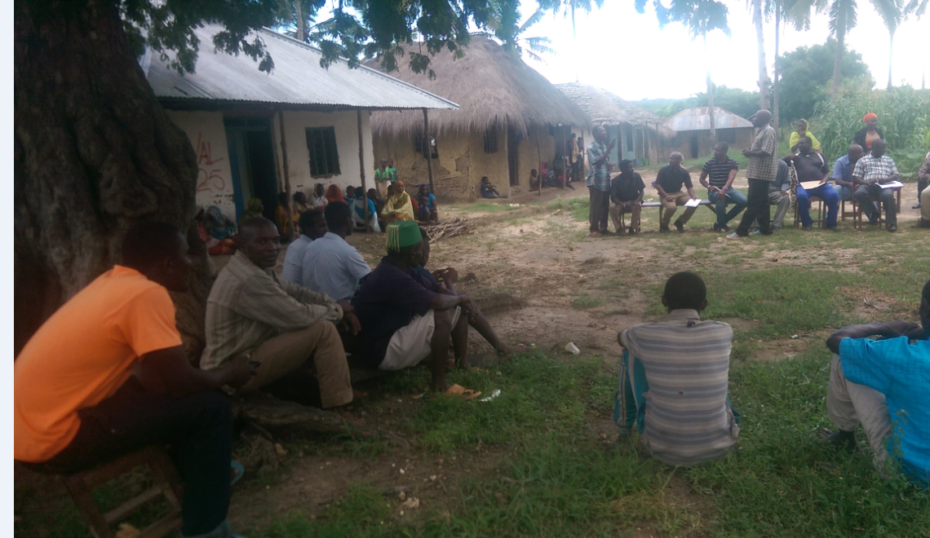 Figure 4.1: Mchinga 1 Villagers at a Meeting Sharing Details of the Project
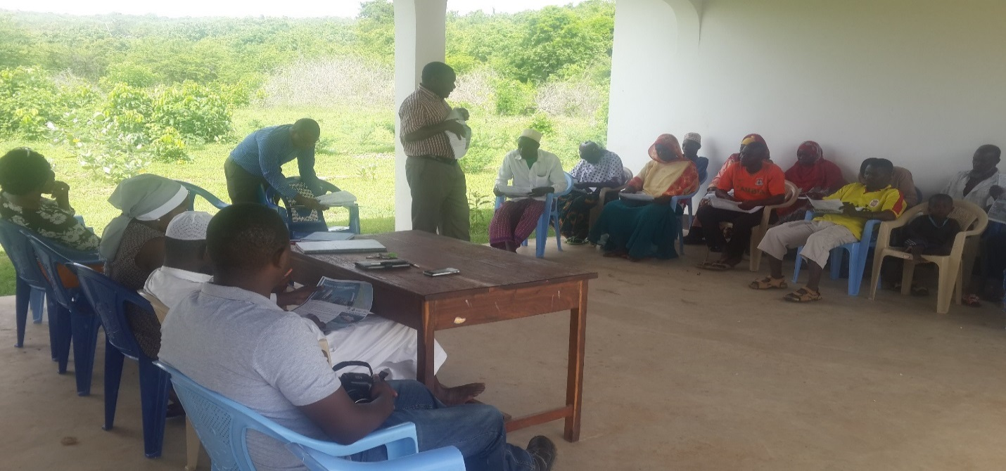

Figure 4.2: Meeting to Screen Applicants for the Project and Design Project Development Plan at Mchinga Ward Meeting Venue

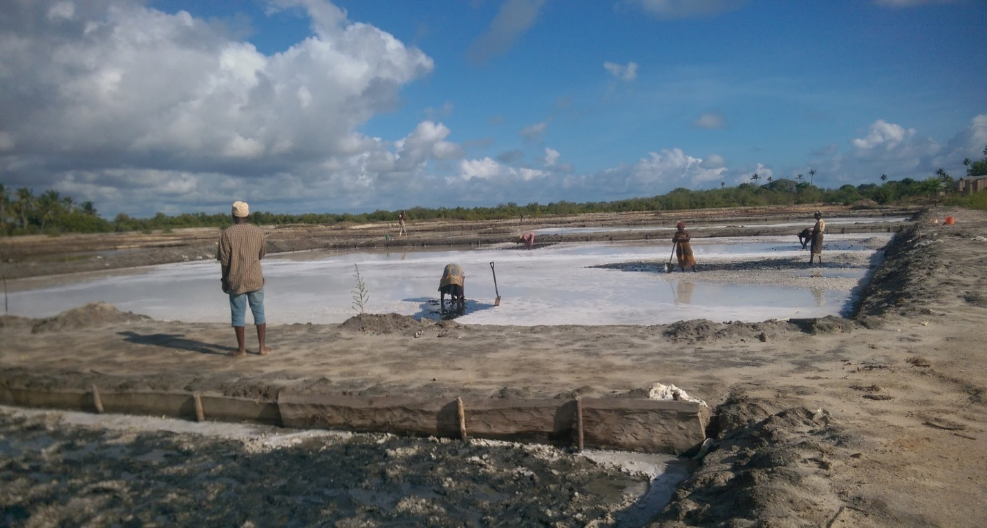

Figure 4.3: Progress Pans Construction Work Located at Mchinga 1 Coast Stretch
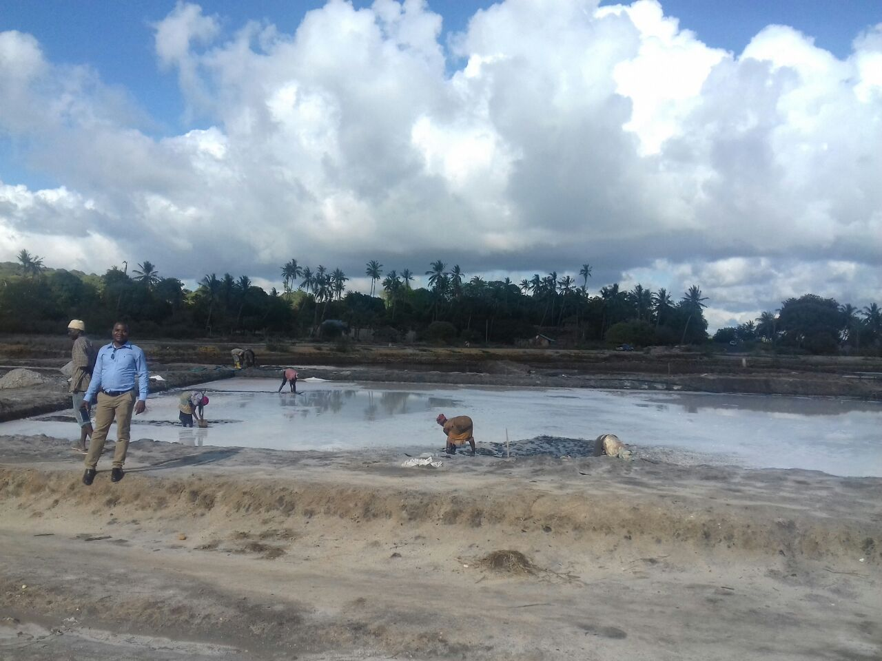

Fugure 4.4: Ongoing Pans Digging Work Around Mchinga 1 Viilage

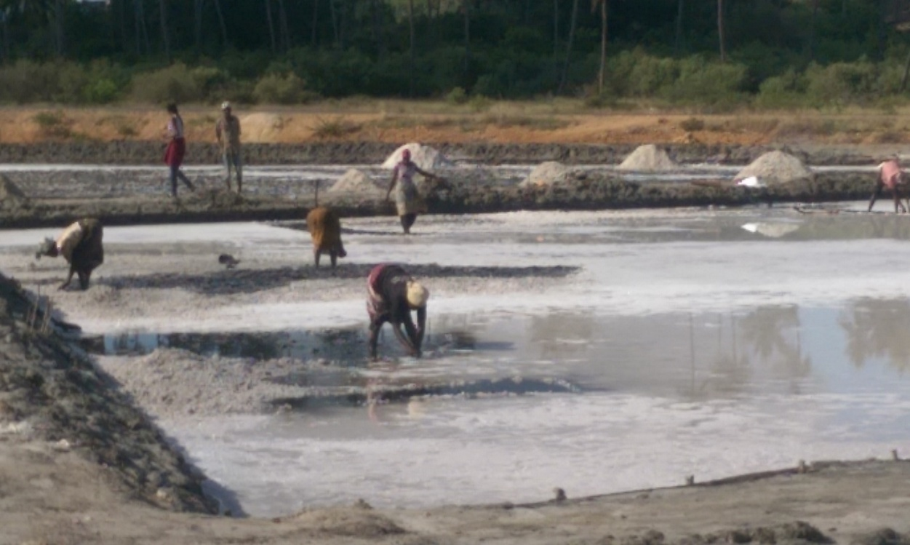

Figure 4.5: Ongoing water crystallization to form salt in some pans begin. There are certain constrains like rainy and clouds limiting accuracy of the process
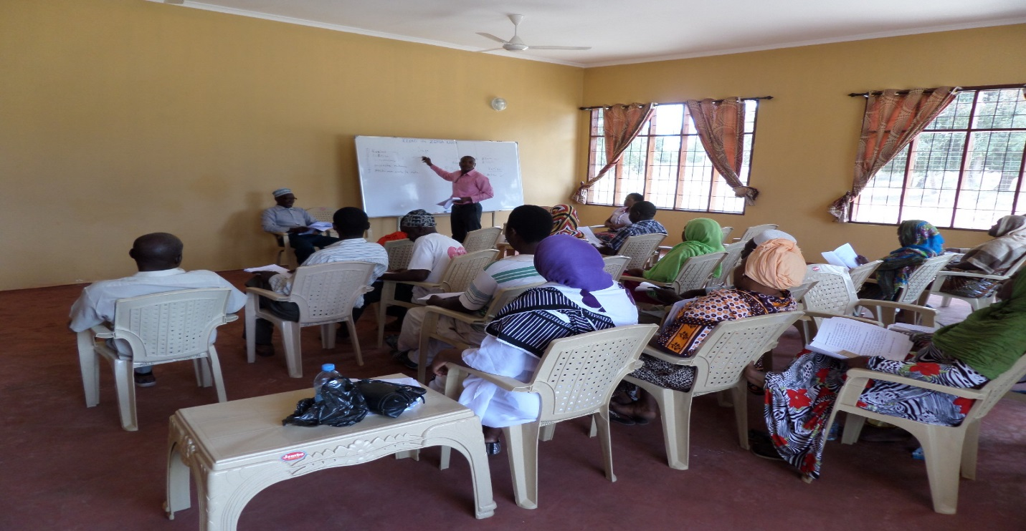

Figure 4.6: Entrepreneurial Training to the Elders in Ward Meeting Venue by the Researcher

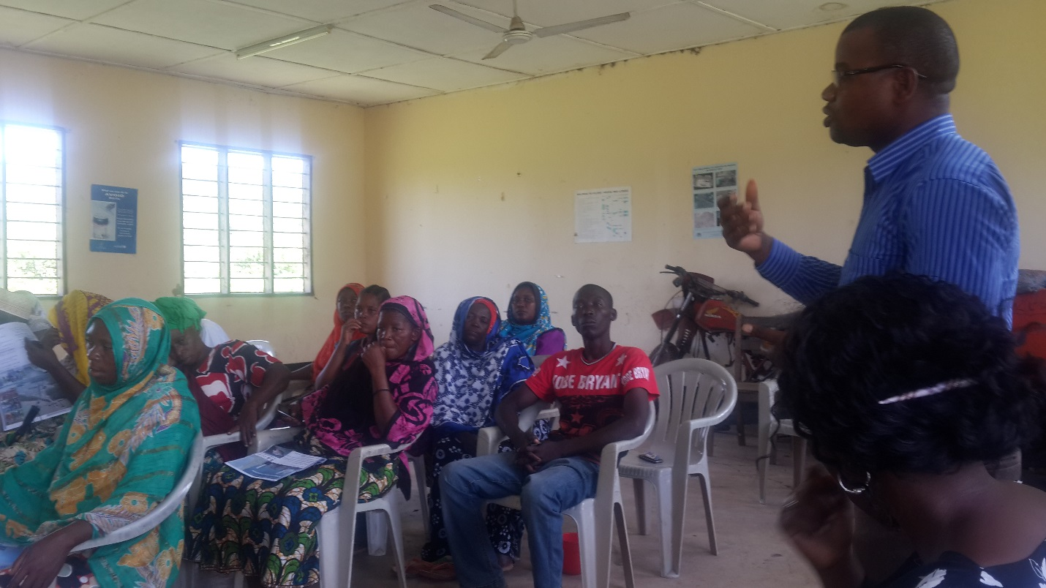

Figure 4.7: Election of Leaders And Sharing Rules And Responsibilities Of The Individual Member Groups Facilitated By The Researcher

4.4.1 Actual Project Implementation Report
The project Improving livelihood of the Elders through salt extraction project in Mchinga 1 Village Lindi District was implemented successfully. Twelve activities of the project were:
- Completed including preparation of selection criteria
- Inter – elder’s communication about the project and joining criteria
- Screening applicants and developing action plan for the project
- Recognize area for salt pans digging with the support of ward natural resource officer
- Agriculture officer and village government
- Digging the pans
- Harvesting and salt iodination
- Press order at ward meeting venue
- Develop entrepreneurial training manual
- Collect training stationaries
- Conduct training
- Conduct election of the chairperson, secretary, treasurer and conflict handler and develop and share job descriptions among member groups.

Table 4.6: Definite Project Implementation Report
Objectives | Outputs | Activities | Definite implementation summary
- To identify fifteen direct project beneficiaries’ members group for salt extracting business by April 2017 | - One group of fifteen elders direct project beneficiaries’ members for salt extracting business formed | - Preparation of selection criteria | Selection criteria were formed in early April 2017 and village meeting were held to inform people about the project and selection prerequisites.
 |  | - Inter – elder’s communication about the project and joining criteria
 |  | - Screening applicants and develop action plan for the project | About 72 candidates applied for the project memberships and only 15 members were selected. Action plan for the project developed
- To excavate three sea water catchments to generate salt concentrations for business by May 2017 | - Area for digging salt pans is identified and pans are constructed | - Recognize area for salt pans digging with the support of Ward Natural resource officer, Agriculture officer and village government | Area for the pans total of one hectare marked with poles surrounded with ropes identified by early April 2017 ready for digging
 |  | - Digging the pans | Three pans ready constructed by mid of April with the supportive water tunnels. Salt harvest ready started in minimal levels due torain season. Salt iodination also commenced in a small amount that harvested.
 |  | 2.1.3 Harvesting and salt iodination
- To conduct three days’ entrepreneurial skills to fifteen direct project beneficiaries’ members group by May 2017 | - 15 elders for salt extracting business are trained on entrepreneurial skills | - Press order at ward meeting venue | Order for the meeting was pressed early on May 2017 and the training manual ready developed by the researcher .
 |  | - Develop entrepreneurial training manual
 |  | - Collect training stationaries | Entrepreneurial education especially on business management was conducted early May 2017 to 15 elders
 |  | - Conduct training
- To form one managerial structure of the fifteen direct project beneficiaries’ and communicate roles and responsibilities of each members group and plan for benefit sharing by May 2017 | - One organ for the direct project beneficiaries formed and roles and responsibilities of each member group shared | - Conduct election of the Chairperson, secretary, treasurer and conflict handler | Election ready conducted mid of May 2017. During the process roles and responsibilities of each members group and benefit sharing module were agreed
 |  | - Develop and share job descriptions among member groups
 |  | 4.1.3. Reporting | Some feedback - like after training evaluation report was conducted. General project monitoring and evaluation report will be gradual produced.

4.4.2 Project Implementation

Table 4.7: Project Implementation Ghantt Chart
Objectives | Outputs | Activities | Apr |  |  |  | Ma |  |  |  | Jun | Jul | Aug | Sep
Objectives | Outputs | Activities | W1 | W2 | W3 | W4 | W1 | W2 | W3 | W4
- To identify fifteen direct project beneficiaries’ members group for salt extracting business by April 2017 | - One group of fifteen elders direct project beneficiaries’ members for salt extracting business formed | - Preparation of selection criteria
 |  | - Inter – elder’s communication about the project and joining criteria
 |  | - Screening applicants and develop action plan for the project
- To excavate three sea water catchments to generate salt concentrations for business by May 2017 | - Area for digging salt pans is identified and pans are constructed | - Recognize area for salt pans digging with the support of Ward Natural resource officer, Agriculture officer and village government
 |  | - Digging the pans
 |  | - Harvesting and salt iodination
- To conduct three days’ entrepreneurial skills to fifteen direct project beneficiaries’ members group by May 2017 | - 15 elders for salt extracting business are trained on entrepreneurial skills | - Press order at ward meeting venue
 |  | - Develop entrepreneurial training manual
 |  | - Collect training stationaries
 |  | - Conduct training
- To form one managerial structure of the fifteen direct project beneficiaries’ and communicate roles and responsibilities of each members group and plan for benefit sharing by May 2017 | - One organ for the direct project beneficiaries formed and roles and responsibilities of each member group shared | - Conduct election of the Chairperson, secretary, treasurer and conflict handler
 |  | - Develop and share both job descriptions among member groups and benefit sharing formalities
 |  | - Project Reporting

CHAPTER FIVE

5.0 PROJECT PARTICIPATORY MONITORING, EVALUATION AND

SUSTAINABILITY

5.1 Introduction
In a nutshell, this Chapter consists of seven items, namely - monitoring information system, participatory monitoring methods, participatory monitoring plan, participatory evaluation plan, performance indicator, participatory evaluation methods, project evaluation summary and project sustainability. We have seen how the community needs were identified in chapter one, arrangement of the community needs in chapter two, different aspects of the community needs as presented by other writers in chapter three, and implementation planning in chapter four. This chapter describes how narrated community needs in previous chapters were monitored and evaluated to ensure that allocated resources like time, fund and personnel were effectively utilized for the sustainable livelihood improvement of the elders in Mchinga 1 village.

The International Federation of Red Cross and Red Crescent Societies (IFRC) ( ) has defined monitoring as the routine collection and analysis of information to track progress against set plans and check compliance to established standards. In this project monitoring helped in identifying trends and patterns, adapting strategies and informing decisions for project/programme management. Further, (IFRC) defined evaluation as an assessment, systematic and objective as possible, of an ongoing or completed project, programme or policy, its design, implementation and results. In this regard evaluation is herein used to determine the relevance and fulfilment of objectives, developmental efficiency, effectiveness, impact and sustainability and so provide information that is credible and useful, enabling the incorporation of lessons learned into the decision-making process of both recipients and other project stakeholders.

5.2 Participatory Monitoring
A researcher defines Participatory monitoring as the process of collecting, processing and sharing project data to assist participants in decision making and learning. The main drive is to provide all stakeholders with information to find out whether group objectives, outputs and activities are achieved or not. Participatory monitoring requires equal involvement and responsibility, active participation of local stakeholders, shared authority and agreed process among those concerned in which data going to be collected, analysed and shared. Therefore, in this project, participatory monitoring aimed at monitoring implementation of all activities including formation of beneficiaries group for salt extraction business, construction of pans, salt harvesting and iodination, impartation of entrepreneurial skills and formed structure to assist group welfare and equal shared benefits.

5.2.1 Monitoring Information System (MIS)
Monitoring Information System (MIS)
Monitoring Information System (MIS) is the skeleton or framework that provides basics for testing success of the project and so giving information’s for project monitoring and controlling. It is both guiding skeleton for the progress of the project and increase project success rate. It gives project stakeholders accurate and relevant information within the required time frame and helps to speed up decision making process among other actions to make sure that the project is aligned within planned time, budget and objectives. MIS usually compares information that is needed and its significance to the project and execution. The information that is collected must help project team to plan, organize and control the project. Therefore, MIS of this project stressed on monitoring and controlling project planned time, budget and objectives.

Table 5.1: Project Monitoring Information System (MIS) for Salt Extraction Business
Categories of information | What to Monitor | What Records to Keep | Who collects data | Who uses data | How to use information | What decisions can be made
- Work plan activities | Activity timing, fund and personnel | Weekly and monthly work plans | Secretary | Project Selected leaders and formed committee | Guarantee time, fund and personnel for activities | Resize fund and personnel as per activity
- Cost and expenditure | Allocated fund and its balance | Receipts and recording books | Treasurer | All project stakeholder and donors | Certify that there is compliance in using fund | Balance less versus high fund need per activity
- Staff and supervision | Number of staffs, qualification, position | Roles and responsibilities and their capabilities | Chairperson, secretary, treasurer, conflict handler, | Group members, committee and project stakeholder | Sort internal grievances and assess group deliveries | Re-election in case there is insignificance delivery, training
- Other inputs | Records of project inputs bought | Project tools register and Receipts | Secretary and treasurer | Group members, committee and project stakeholder | Monitor project inputs. Minimize over spend on similar inputs | Suspend buying inputs that are ready bought in other activities
- Results | Training delivered, salt harvested and sold | Number of trainees, tonnage of salt harvested and sold | Secretary and researcher | Group members, committee and project stakeholder | Monitor achievements of project objectives | Increase training or scale up some activities for project win-up
Source: Research Findings (2017)

5.2.2 Participatory Monitoring Methods
Self-esteem, associative strengths, resourcefulness, action planning, responsibility (SARAR) is the participatory monitoring method used in this project and mainly based on fostering and strengthening the (SARAR) attributes to the stakeholders. The process encouraged development of ordinary project beneficiary’s capacity for self-direction and management and this pushed-up the quality of inclusiveness among all of stakeholders. Project monitoring is a continuous process aimed at giving all project practitioners feedback based on what was planned against what is achieved and disclose any gap for further mitigation. In nutshell, it involved on collecting and processing data based on project implementation timing, inputs and objectives and suggest alternative measures to overcome as demonstrated in Table 5.1 Monitoring Information System above.

During the training session, formative assessment was conducted. Formative assessment is a tool used to test whether the mode of training, content materials, venue and trainer were helpful to the trainees. So, simple questionnaires were developed and shared to the trainees letting them to respond. The answers gave insight to the facilitator about trainee’s capability, quality of materials delivered and channel of communication in order to make responsive changes in future teaching and learning.

Table 5.2: Participatory Monitoring Plan
Objectives | Outputs | Activities | Indicators | Data source | Methods/ tools | Responsible | Timing
- To identify fifteen direct project beneficiaries’ members group for salt extracting business by April 2017 | - One group of fifteen elders direct project beneficiaries’ members for salt extracting business formed | - Preparation of selection criteria | Plan document | Project report | Reading reports | Selected leaders | April 2017
 |  | - Inter – elder communication about the project and joining criteria | Number of meeting | Project report | Interview | Project members | April 2017
 |  | - Screening applicants and develop action plan for the project | Lists of previous applicants | Progress reports | Reading reports | Secretary | April 2017
- To excavate three sea water catchments to generate salt concentrations for business by May 2017 | - Area for digging salt pans is identified and pans are constructed | - Recognize area for salt pans digging with the support of Ward Natural resource officer, Agriculture officer and village government | List of pans | Project reports | Interview, observation | Secretary, Project members, committee | April 2017
 |  | - Digging the pans | List of pans | Project reports | Interview, observation | Secretary, Project members and committee | April 2017
 |  | - Harvesting and salt iodination | Tonnage of salt harvested | Project reports | Interview, observation | Secretary, Project members and committee | April 2017
- To conduct three days’ entrepreneurial skills to fifteen direct project beneficiaries’ members group by May 2017 | - 15 elders for salt extracting business are trained on entrepreneurial skills | - Press order at ward meeting venue | Ward reports | Ward office | Reading, interview | Committee | May 2017
 |  | - Develop entrepreneurial training manual | Training manual | Project report | Interview, observation | Researcher , secretary | May 2017
 |  | - Collect training stationaries | List of stationaries | Project report | Reading | Secretary | May 2017
 |  | - Conduct training | Number of members trained | Project report | Interview, observation | Researcher , secretary | May 2017
- To form one managerial structure of the fifteen direct project beneficiaries’ and communicate roles and responsibilities of each members group and plan for benefit sharing by May 2017 | - One organ for the direct project beneficiaries formed and roles and responsibilities of each member group shared | - Conduct election of the Chairperson, secretary, treasurer and conflict handler | Names of selected members | Project report | Interview, observation | Secretary, Project members and committee | May 2017
 |  | - Develop job descriptions among member groups and project benefit sharing | Available job and benefit sharing document | Project report | Interview, observation | Secretary, Project members and committee | May 2017
 |  | - Reporting | Copies of reports | Project progress | Interview, observation | Secretary, Project members and committee | June to an end

5.3 Participatory Evaluation
Participatory evaluation is partnerships (internal and external) approach to evaluations in which stakeholders are actively engaged in developing evaluation in all phases of its execution. Throughout participation covers question identifications, coping evaluation model, data collection methods, collecting and analysing. Brad ( ) defined participatory evaluation as applied systematic inquiry for the purpose of making judgement about the merit and worth of programs or supporting program decision making. To this regard, participatory evaluation - comprising researcher, beneficiaries, committee and other stakeholders, will be carried out to provide lessons from the implemented part and so as to replicate future decision making.

5.3.1 Performance Indicators
Performance indicators are alarms demonstrating achievement of what is planned in the project including achievement of objectives or activities. Achievement can be in a form of good utilization of project inputs and or achievement of planned activities or objectives. Performance indicator can be both qualitative (direct observable by own eyes) and quantitative (statistical records of implemented certain activities). Therefore, performance indicators in this project might not be limited to number of trainings delivered, list of trainees attending training, list of inputs collected, constructed pans, amount of salt harvested, list of group leaders selected, list of committee members selected and list of elders selected. Detailed project performance indicators per each activity are herein outlined in Table 5.3.

Table 5.3: Project Performance Indicators
Objectives | Outputs | Activities | Needed inputs | Performance Indicator
- To identify fifteen direct project beneficiaries’ members group for salt extracting business by April 2017 | - One group of fifteen elders direct project beneficiaries’ members for salt extracting business formed | - Preparation of selection criteria | 1.1.1.1 Facilitator | Number of plans
 |  | - Preparation of selection criteria | 1.1.1.2 note book 1pc | Number of plans
 |  | - Preparation of selection criteria | 1.1.1.3 pen 2 pcs | Number of plans
 |  | - Inter – elder’s communication about the project and joining criteria | 1.1.2.1 Facilitator | Number of meeting
 |  | - Screening applicants and develop action plan for the project | 1.1.3.1 Facilitator | List of inputs available
 |  |  | 1.1.3.2 Venue | List of inputs available
 |  |  | 1.1.3.3 flip chart 1 pc | List of inputs available
 |  |  | 1.1.3.4 Mark pen 3pcs | List of inputs available
- To excavate three sea water catchments to generate salt concentrations for business by May 2017 | - Area for digging salt pans is identified and pans are constructed | - Recognize area for salt pans digging with the support of Ward Natural resource officer, Agriculture officer and village government | 2.1.1.1 Facilitator | List of inputs available
 |  |  | 2.1.1.2 Rope bundle 5pc | List of inputs available
 |  |  | 2.1.1.3 Ruler 1 pc | List of inputs available
 |  |  | 2.1.1.4 Marking poles 15pcs | List of inputs available
 |  | - Digging the pans | 2.1.2.1 Facilitator | Constructed pans available
 |  | - Digging the pans | 2.1.2.2 wheel below 1pc | Constructed pans available
 |  | - Digging the pans | 2.1.2.3 hoes 20 pcs | Constructed pans available
 |  | - Digging the pans | 2.1.2.4 spade 15 pcs | Constructed pans available
 |  | - Harvesting and salt iodination | 2.1.3.1 Facilitator | List of inputs are in place and available of tonnage of salt in ward warehouse
 |  | - Harvesting and salt iodination | 2.1.3.2 wheel below
 |  | - Harvesting and salt iodination | 2.1.3.3. Spade 15 pcs
 |  | - Harvesting and salt iodination | 2.1.3.4 Spraying cane 1 pc
 |  | - Harvesting and salt iodination | 2.1.3.5 Iodine solution 1kg
 |  | - Harvesting and salt iodination | 2.1.3.6 storage bags
 |  | - Harvesting and salt iodination | 2.1.3.7 storage venue
- To conduct three days’ entrepreneurial skills to fifteen direct project beneficiaries’ members group by May 2017 | - 15 elders for salt extracting business are trained on entrepreneurial skills | - Press order at ward meeting venue | 3.1.1.1 Personnel | List of inputs in place
 |  | - Develop entrepreneurial training manual | 3.1.2.1 Personnel | List of inputs in place
 |  | - Collect training stationaries | 3.1.3.1 Personnel | List of inputs in place
 |  | - Conduct training | 3.1.4.1 Facilitator | Number of elders trained
 |  | - Conduct training | 3.1.4.2 rim of paper 1pc | Number of elders trained
 |  | - Conduct training | 3.1.4.3 Flip chart 2pc | Number of elders trained
 |  | - Conduct training | 3.1.4.4 pens 20pcs | Number of elders trained
 |  | - Conduct training | 3.1.4.5 Mark pen 5pcs | Number of elders trained
- To form one managerial structure of the fifteen direct project beneficiaries’ and communicate roles and responsibilities of each members group and plan for benefit sharing by May 2017 | - One organ for the direct project beneficiaries formed and roles and responsibilities of each member group shared | - Conduct election of the Chairperson, secretary, treasurer, conflict handler and committee | 4.1.1.1 Facilitator | List of selected leaders and assisting committee available
 |  |  | 4.1.1.2 Venue | List of selected leaders and assisting committee available
 |  |  | 4.1.1.3 flip chart 1 pc | List of selected leaders and assisting committee available
 |  |  | 4.1.1.4 Mark pen 1 pc | List of selected leaders and assisting committee available
 |  | - Develop and share job descriptions among member groups | 4.1.2.1 Facilitator | Job description and benefit sharing guidelines available
 |  | - Develop and share job descriptions among member groups | 4.1.2.2 Venue | Job description and benefit sharing guidelines available
 |  | - Develop and share job descriptions among member groups | 4.1.2.3 flip chart 1 pc | Job description and benefit sharing guidelines available
 |  | - Develop and share job descriptions among member groups | 4.1.2.4 Mark pen 1 pc | Job description and benefit sharing guidelines available
 |  | - Project Reporting | 4.1.3.1 Facilitator | Reports available in project stakeholder’s offices
 |  | - Project Reporting | 4.1.3.2 Rim of paper 1pc | Reports available in project stakeholder’s offices
 |  | - Project Reporting | 4.1.3.3 pens 20 pcs | Reports available in project stakeholder’s offices

5.3.2 Participatory Evaluation Methods
Participatory Rural Appraisal (PRA) was the evaluation method used in this project. The appraisal involved incorporation of rural people’s knowledge and opinions in planning and management of development programmes and projects. The tools escalated to enable locals to formulate their situation so in turn managed to plan, act, monitor and evaluate their actions. In this project, evaluation incorporated diverse stakeholders including researcher, elders/beneficiaries, selected leaders, committees, Village government, WADC, Division and District council leaders and ordinary villagers. Basically, techniques such as interview to key project personnel, observations and documentations were dedicated to testify applicability of the project planning and resource allocations. Formative questionnaires were shared during training to evaluate compatible of the materials to the trainees.

The salt project leaders opted structured interview techniques so as to get feedback of the project from the researcher, elders/beneficiaries, selected leaders, committee, Village government, WADC, Division and District council leaders and ordinary villagers. Structured interview questions focused on probing effective inputs utilization, activities implementation timing and escalation of project plan whether correspond with intended objectives/goals. Observation was the second technique opted for in PRA and it mainly focused on assessing project details such as stock of equipment bought, constructed pans, amount of salt harvested and storage area.

In addition, documentation techniques covered by regular meeting minutes were shared to track progress of the project. The group secretary is responsible for taking note of all meetings and at the end were shared with stakeholders on achievements,
challenges, solutions and learning for further improvements. Treasurer was responsible for keeping all financial records for ease of tracking.

Table 5.4: Project Evaluation Summary
Objectives | Outputs | Activities | Performance Indicator | Expected outcomes | Actual  outcomes | Reccomendations
- To identify fifteen direct project beneficiaries’ members group for salt extracting business by April 2017 | - One group of fifteen elders direct project beneficiaries’ members for salt extracting business formed | - Preparation of selection criteria | Number of plans | One selection plan made | One plan document made | Implemented successful
 |  | - Inter – elder’s communication about the project and joining criteria | Number of meeting | Personal meetings among elders | One village assemble meeting done | Village assemble saved time than personal meetings
 |  | - Screening applicants and develop action plan for the project | List of inputs available | 72 applicants applied | 15 applicants selected | Implemented successful
- To excavate three sea water catchments to generate salt concentrations for business by May 2017 | - Area for digging salt pans is identified and pans are constructed | - Recognize area for salt pans digging with the support of Ward Natural resource officer, Agriculture officer and village government | List of inputs available | Three area dedicated | One area selected | Environments issues was determinants of the selected area
 |  | - Digging the pans | Constructed pans available | Three major pans constructed | Three major pans constructed | Completed successfully
 |  | - Harvesting and salt iodination | List of inputs are in place and available of tonnage of salt in ward warehouse | 10 tons of salt harvested per month | 2 tons of salt accumulate | Still these are new pans to generate more salts besides this is rainy and clouds seasons hence limited crystallization
- To conduct three days’ entrepreneurial skills to fifteen direct project beneficiaries’ members group by May 2017 | - 15 elders for salt extracting business are trained on entrepreneurial skills | - Press order at ward meeting venue | List of inputs in place | Venue, training manual and stationaries reserved | 1 day Venue, training manual and stationaries collected | Free venue and volunteerism facilitated the activity
 |  | - Develop entrepreneurial training manual
 |  | - Collect training stationaries
 |  | - Conduct training | Number of elders trained | 15 elders trained on entrepreneurial | 22 participants attended the training | Completed successfully
- To form one managerial structure of the fifteen direct project beneficiaries’ and communicate roles and responsibilities of each members group and plan for benefit sharing by May 2017 | - One organ for the direct project beneficiaries formed and roles and responsibilities of each member group shared | - Conduct election of the Chairperson, secretary, treasurer, conflict handler and committee | List of selected leaders and assisting committee available | 4 leaders and 9 committee members selected | 4 leaders and 9 committee selected | Other committee members are not part of beneficiary’s member groups
 |  | - Develop and share job descriptions among member groups | Job description and benefit sharing guidelines available | 1 governing to be document formed | 1 governing document formed
 |  | - Project Reporting | Reports available in project stakeholder’s offices | 1 inputs list, 1 finance report, formative summary developed | Inputs, finance, formative summary made | Ongoing activity to whole project life

5.4 Project Sustainability
In general, project sustainability refers to continued existence of the project even after preliminary funding and institutional arrangements are finalized. This is a common and an important part in any project as it reveals to what extent the project is going to survive or end after mobilized initial resources have been consumed. For some donor funded project, it is difficult to be supported if the project document doesn’t demonstrate sustainability of the initiative. As regards this project, its sustainability encompassed three aspects, namely; institutional, financial and political aspects.

5.4.1 Institutional Sustainability
Training remained a good foundation of institutional sustainability. Training on entrepreneurial skills transformed beneficiary’s mindset into business oriented attitude. Furthermore, facilitation on pans construction know-how conducted by Ward Natural resource officer, Community development officer and Agriculture officer generated possible experience on pans scale-up. Community Needs Assessment report in Table 1 in Chapter one of this report illustrates ordinary people/beneficiaries had teamwork and trust worth tendency necessary for fulfilment of the programme tasks or meeting deadlines and security of project resources for institution sustainability. Again, community Needs Assessment report on Chart 6 demonstrates that villagers had enough managerial and technical assistance from government employees. So, to have managerial and technical assistance from the government employees was good for project implementation and general sustainability.

5.4.2 Financial Sustainability
By nature, salt extraction business is an income generating project whereby salt have been harvested and sold to the market for profit gaining and group financial sustainability. Up to date, total of two tonnage of salt worth of 120 USD already harvest. Ready a group treasurer elected to keep financial records and books. Group bank account already opened to hold day to day group finance. Benefit sharing guidelines also were established to ensure every group member earned equal benefit for livelihood improvements. Monthly direct project expenses were set aside before the balance was divided to all elders/beneficiaries.

5.4.3 Political Sustainability
Since the initiation of the project, there was much support from the government. The village government supported the project in a range of services like freely allocating coast stretch area for salt pans, security of resources and warehouses to store salt and associated project materials. Ward government played vital role in ensuring project take-off specifically on technical know-how on pans preparation and management and ultimately on providing free meeting venue platforms for planning and managing day to day operation of the project. Enough support was obtained from District Executive Officer especially on provision of free iodine solution and cost-shared spraying cans. This government support was assertive towards the project political sustainability.

Moreover, there were selected leaders - chairperson, secretary, treasurer and conflict handler to manage day to day operations of the group sustainably. Selected leaders met regularly to discuss project challenges, achievements and plan for future project prosperity. A committee of nine project stakeholders was also formed to provide advisory and technical support to the selected leaders and general project beneficiaries on best project practice in line with Tanzania’s Aged peoples policy, Tanzania Development Vision 2025, The National Economic Empowerment Policy and Tanzanian Small and Medium Enterprise Development (SME) Policy (2003).

CHAPTER SIX

6.0 CONCLUSION AND RECOMMENDATIONS

6.1 Introduction
This chapter is divided into two sections - conclusion and recommendation. The conclusion part covers a summary of previous chapters such as Community need Assessment, problem identifications, literature review, project implementation, monitoring, evaluation and sustainability. Recommendations part covers researcher`s suggestions from observations during the whole process of project identification through implementation. It is my believe that below noted suggestions will be of important to other researchers, decision makers and planers in designing or doing similar or close related salt extraction project.

6.2 Conclusion
Community Needs Assessment was conducted in Mchinga 1 village in March 2017 with the aim of identifying the sources of income of Mchinga1 elder community, and also identified leading social-economic challenges the elders were facing against their welfare, identified available resources for improving their livelihoods determined elders their priority needs that could help to stimulate their social economic welfare and ascertained social-economic interventions for the elder`s welfare. Tools such as questionnaires, observations schedules and key informant interviews were conducted to generate data for analysis so as to come up with the community needs in Mchinga 1 village.

Community Needs Assessment disclosed that 67 % of the respondents lived within Tshs 1 to Tshs 70,000 per month as shown in Chart 5. Low income was noted to be a problem in the village that increases level of poverty. Responses on type of environmental friendly activities that can combat income problem elders facing showed that, utilization of natural resources can be one mean of economic activity of the elders. Both key informant interviews and resource mapping exercises suggested that income generation activities through natural resource utilization could be the best alternative as a mean of alleviating the elder’s income needs because the village is surrounded by wide stretches of coast areas viable for salt extraction. Choice of the project (salt extraction business) was justified through participatory community needs prioritizations shown in Table 7.

Vital target community of this project is elder community of the Mchinga 1 village who were mostly affected by the unavailability of the sustainable income for their livelihood. The second target communities of this project were the families and relatives who lived with the elders. Since the elders had the capacity to generate income then availability of basic needs within the families would be good. Elders families/relatives could manage to sustain themselves on food, health, shelter, transport, water, light and clothes and hence minimize dependency.

The third target for the whole community of the Mchinga 1 village and local government: The village would have the place to buy fresh salt from the source cheaply instead of searching such services at some remote villages with extra cost and beside this was the first salt project to be initiated in the village and so act as a learning platform to other entrepreneurs whom would like to do the similar business. The fourth and final target communities were the pedestrians, nearby villagers and car passengers who could potentially be interested on buying salt from the elders and so minimize time and financial resources to search such products at the remote villages. To sum-up, the project had multiplayer effect to diverse social groups.

Literature review indicated that salt extraction business in Tanzania has a long history as has been practiced for centuries. In 1926 Tanzania received 342,000Tshs after selling 3,000tons of solar salt, fourth after diamonds, gold and mica, and in 1959 the country increased salt yields to 30,000tons worth 5 million Tshs, fifth after diamonds, gold, lead and copper hence applicability of the business to the elders. There were some challenges in 1960s like production of un-iodinated salt which led to brain hindrance and insufficiency performance of nervous system, goitre diseases and increased childhood death rates among users but such challenge currently sorted. Environmental problem was another focal challenge associated with the business whereby mangrove destruction had been observed in similar projects during pans construction. Therefore, during the planning phase for this project, the environmental issue was of great consideration.

In general, feedback from literature review indicated that salt extraction is as good business as it requires less direct financial investment. Once pans are constructed, salt can be harvested for a long time, and only solar energy is needed to facilitate crystallization and inclusive human assistance in harvesting and storage. To date, salt remains a global business with high demand it is used in industries, farming and human consumptions.

Four objectives were identified for implementation towards needs accomplishment for improvements of livelihoods of the elders. List of embedded project objectives led to identifying fifteen direct project beneficiary members groups for salt extracting business by April 2017 namely: excavation of three sea water catchments to generate salt concentrations for the business by May 2017, conduct three days’ entrepreneurial skills to fifteen direct project beneficiary members groups by May 2017 and form one managerial structure of the fifteen direct project beneficiaries’ and communicate roles and responsibilities of each members group and plan for benefit sharing by May 2017.

Together with the above objectives, four outputs manifested to reinforcing project applicability including one group of fifteen elders direct project beneficiaries for the formed salt extraction business, area for digging salt pans identified and pans constructed, 15 elders for salt extracting business trained on entrepreneurial skills and one organ for the direct project beneficiaries formed and roles and responsibilities of each member group shared. As successful achievement of the project depended much on commitment, skills and experience of every stakeholder, SARAR (Self-esteem, associative strengths, resourcefulness, action planning, and responsibility) is the participatory monitoring method used in this project and mainly based on fostering and strengthening the (SARAR) attributes to the stakeholders.

Participatory Rural Appraisal was selected as the evaluation method of the project. Summary of project evaluation indicated successful implemented of the objectives number one, two, three and four. Another activity of the project such as (project reporting) is an on-going activity and will be implemented time by time. In general, 98% of the project activities were implemented successfully. Involvement of beneficiaries in project planning and implementation acted as key for timely implementation. The commitment of both the elders and other project stakeholders (researcher, Village government, WADC and district council) was of vital importance in reaching the project objectives. Monitoring guidelines, evaluation frameworks and sustainability prerequisites are in place to assist long term project survival.

6.3 Recommendations
As a researcher in implementing the project titled: `Improving the livelihoods of the Elders in Mchinga 1 Village in Lindi District through salt extraction project` by considering the local experience, knowledge and skills gained during the identifying and implementing phase of the project and the team that was involved, I wish to make the following recommendations follows:

6.3.1 Recommendation Regarding Community Needs Assessment
Community need assessment is a good approach in identifying community development projects as it directly involves project beneficiaries. The approach favours project achievement and sustainability as it covers the phases - peoples’ decision making, participation, and implementation. Feedback on previous project developed in the village indicated that little achievement as noted and sometimes the whole project was abandonment by ordinary people notwithstanding enough resources directed to the project by donors or the government. In this regard, Community Needs Assessment is vital and can be capitalized as a leading tool in identifying, planning and implementing other social projects for desired economic development.

6.3.2 Recommendation on Literature
In Zanzibar, great concern among salt producers centres on government taxes and levies which increase production costs. Producers are required to pay VAT (18%) on each amount of salt sold. Improvement of small and medium business remains a constrained in situations like this - where tax and levies are high. National SME Policy 2003 favours apprenticeship, entrepreneurship programs and vocational training, enhancing life skills and entrepreneurship trainings for rural population and increasing access to rural finance services to subsistence farmers and ordinary villagers. Therefore, the government should remove or minimize direct taxes and levies to community-based enterprises so as encourage development of informal sectors.

6.3.3 Recommendation on Project Implementation
There is need to have entrepreneurial training in all aspects of community projects. Entrepreneurial training not only empowers beneficiaries on proper management of the business but also gives energies relative for business achievement while portraying the picture of what is going to be achieved by the beneficiaries. For this and other similar projects, more training is needed as most of the beneficiaries might be uneducated (on level of education among respondents) which revealed that 44% of the respondents were uneducated at all tailed by 28% of respondents who had only primary education level. Moreover, there were 11% of respondents who had secondary education level and another 11% had technical education and finally 6% were university graduates.

6.3.4 Recommendation on Sustainability
From my experience, in project nourishing - like the one salt extraction business, keeping consideration of the political hotness of the area, politics do play a part in ensuring that ruling or opposition party in the area uses project achievement as the winning agenda in seeking popularity from the community. I would recommend to the project leaders not to work for any political party in this project and if it happen one political party want to support a group, a supporter/party need to do so in a good faith and not for political gain.

6.3.5 Recommendations on Policy
The National Economic Empowerment Policy 2004 emphasises on effective utilization of land in enhancing the participation of Tanzanian citizens in economic ventures. This is a good idea keeping in mind that Tanzania as a country has enough of land that can be used sustainably to generate sources of income for the ordinary people. I therefore recommendation that the local district councils, wards and villages governments should reserve in their localities potential land for social economic development of the ordinary people. My advice to the local government authorities is to consider environmental conservation when planning development projects in such a way that current developments plans shouldn’t conflict with our natural forests resources.

REFERENCES
Abdala, S., Charles, K., Anthony, K., Chripinus, R., and Elvis, J. (2015). Effects of salt making on growth and stocking of mangrove forests of south western Indian Ocean coast in Tanzania. Mediterranean Journal of Biosciences, 1(1), 27-31.
Aparna, S., Mindy, L. &Yolanda, S. (2000). “A Community Need Assessment Guide: A Brief Guide on How to Conduct a Need Assessment”. Centre for urban Research and learning and the department of Psychology, Loyola University. Chicago, US.
Best, S. (2000:9). Active Sociology: As and A level. England: Peason Education Ltd.
Catherine, D. (2002). “Practical Research Methods: A user-friendly guide to mastering research techniques and projects”. By How to Books Ltd, 3 Newtec Place, Magdalen Road, Oxford OX4 1RE, United Kingdom.
Dennis, S. K. (2002). Salt. US geological data survey. International data coordinator, Department of the Interior, England, UK.
Jack, R. M., and Samuel, K. M. ( ). A Managerial Approach. Monitoring and Information System. 8th Ed., Washington: John Wiley & Sons.
Joanne, K. H. (2008). Salt Production in South Australia. Geological survey branch, PIRSA. MESA Journal 50
Kasedde, H., Kirabira, J., Bäbler, M., Tilliander. A., and Jonsson, S. ( ). “A State of the Art Paper on Improving Salt Extraction from Lake Katwe Raw Materials in Uganda”. Department of Materials Science and Engineering, Royal Institute of Technology KTH, Brinellvägen 23, SE-100 44 Stockholm, Sweden.
Kothari, C. (2004). Research Methodology: Methods and techniques. 2nd Ed., New Delhi: New Age International (P) Ltd.
Lindi District Council, Socio Economic Profile, 621, 293. Mtwara, Tanzania.
Mugenda, O. and Mugenda, A. (2003). Research Methods: Quantitative and qualitative Approaches. Nairobi: African Centre for Technology Studies.
Nordic Development Fund, (2014). “Coastal Profile for Zanzibar”, Thematic Volume I Including Threats Prioritization. Investment Prioritization for Resilient Livelihoods and Ecosystems in Coastal Zones of Tanzania. Zanzibar, Tanzania.
Paul, B. (2008). “Participatory Monitoring”. CBD/IADB Civil Society Organization Dialogue. Buddys International Hotel Providence, East Bank Demarara Guyana, Novemver 18-20-2008.
Paul, J. (1990). INR Open Report No 119. Institute of mining research University of Zimbabwe, Harare, Zimbabwe.
Rodolfo, S. (2004). Project Management Information System, Implementatin and managing a DME project Information System, 14(5), 1- 20.
Shaba, K. Z., (2011). Entrepreneurship Development in Lindi Municipal: The Case of Salt Works and Fishery Sub Sectors. Unpublished masters dissertation, the Open University of Tanzania, Dar es Salaam, Tanzania.
Snoall R., R. and Mshindo H, B. (2002). Concise English – Swahili: Kamusi ya Kiingereza – Kiswahili Dictionary, Revised Edition. Oxford University Press.
Society of International Development, (2009). The extractive Resources Industry in Tanzania. Status and challenges of the Mining sector. Cape Town: Heinrich boll Stiftung, East & Horn of Africa.
The United Republic of Tanzania, (2004). The National Economic Empowerment Policy, The Prime Minister’s Office. Dodoma, Tanzania.
The United Republic of Tanzania, (2005). National Strategy for Growth and Reduction of Poverty (NSGRP), Vice President’s Office, Dar es Salaam, Tanzania.
URT, (2009). Ministry of Energy and Minerals, Mineral Policy of Tanzania, Dodoma, Tanzania.
Vladimir, M. S. (2006). Environmental balance of salt production speaks in favour of solar saltworks. Salt Partners Ltd., Carl Spitteler Str. 102 CH-8053 Zurich, Switzerland.
WHO, (2002). Health statistics and information systems: Proposed working definition of an older person in Africa for the MDS Project.
WHO, (2016). Elder Abuse: The Health Sector Role in Prevention and Response. Communicate Health. WHO/NMH/NVI/16.5.

APPENDICES
APPENDIX 1: Community Needs Assessment Questionnaire
Community Need Assessment QNS (Please select or fill the correct answers below (Tafadhari chagua au jaza majawabu sahihi hapa chini)
A: None research Questions (Maswali yasiyo yakiutafiti)
- Sex (Jinsi)
  - Male (Mme)
  - Female (Mke)
- Your age (Umri wako)
- 14 – 20
- 21 – 40
- 41 – 60
- 61 and above (61 Na kuendelea)
- Your marital status (Hali yako ya Ndoa)
- Married (Umeoa/Umeolewa)
- Not Married (Ujaoa/Ujaolewa)
- Divorced (Umetarakiana)
- Separated (Umetengana)
- Widow (Mjane)
- Level of education attained (Kiwango cha elimu uliyonayo)
- Primary education (Una elimu ya shule ya Msingi)
- Ordinary Secondary education (una elimu ya shule ya sekondari)
- Advanced secondary education (una elimu ya kidato cha sita)
- Technical education (Una elimu ya ufundi)
- University education (Una elimu ya chuo kikuu)
- I don’t know (Sijui)

B: Research questions (Maswali yahusuyo utafiti)
- What values do your ordinary village members has? Select two (Taja desturi mbili ambazo wanakijiji wanazo kati ya hizi hapa chini)
- Teamwork (umoja/mshikamano)
- Trust worse (uaminifu)
- Hardworking (wachapa kazi)
- Development oriented (wapenda maendeleo)
- Not hard working (Sio wachapakazi)
- Individualist (wabinafsi)
- Not trust worse (Sio waaminifu)
- What are some of the main natural resources available in your village? select one (Taja rasilimali asilia mojawapo inayopatikana zaidi hapa kijijini)
- Ocean (Bahari)
- Undeveloped land for agriculture and livestock keeping (ardhi ya kilimo na ufugaji)
- Rivers (Mito)
- Historic sites (Maeneo ya kihistoria)
- Transportation infrastructures (Miundombinu ya usafirishaji)
- Forest reserve (Hifadhi ya Msitu)
- Different type of minerals (Aina tofauti za madini)
- Plenty of land for agriculture (Ardhi ya kutosha kwa kilimo)
- In case your businessperson, mention two customers of your businesses (Kama wewe ni mfanyabiashara, taja wateja wako wakuuu wawili wa biashara yako)
- Bus or car passengers and owners, (abiria na wamiliki wa magari)
- Pedestrians and neighbouring villagers (watembea kwa miguu na vijiji majirani pia)
- Ordinary villagers (wanakijiji wenzako)
- People from far intended to come and buy product (watu kutoka mbali waliokusudia kuja kununua)
- Select average amount of income are you earning per month in Tshs (chagua wastani wa kiwango cha fedha unazopata kwa mwezi kwa fedha za Kitanzania)
- From tshs 1 - tshs 70,000 (Kuanzia shilingi za kitanzania 1 - 70,000)
- From tshs 71,000 - tshs 360,000 (Kuanzaia shilingi za kitanzania 71,000 – 360,000)
- From tshs 361,000 and above (Kuanzia shilingi za kitanzania 361,000 na kuendelea)
- What are the main challenges villagers facing in this village? Please list three of them (Unafikiri wanakijiji wanasumbuliwa na changamoto zipi hapa kijijini, tafadhari orodhesha tatu tu)
- Lack of sustainable income (Ukosefu wa chanzo endelevu cha kipato)
- Lack of safe and clean water (Ukosefu wa maji safi na salama)
- Lack of health and education services (Okosefu wa huduma za afya na elimu)
- Environmental destruction (Uharibifu wa mazingira)
- Lack of financial services (ukosefu wa huduma za fedha)
- Lack of transport services (ukosefu wa huduma za usafiri)
- Lack of security (ukosefu wa usalama)
- Suggest one type of environmental friendly activity can be carried out to counterpart challenges (mentioned in question number 11 above) ordinary villagers facing in the village (Tafadhali pendekeza shughuli moja ambayo unaiona itaondoa changamoto zinazowakabiri wanakijiji (swali namba 11 hapo juu)
- Natural Resources activity for income generation (Maliasili kwa shughuri za kujiingizia kipato)
- Livestock and farming activities (Shughuli za ufugaji wa wanyama na kilimo pia)
- Vegetable production (uzalishaji wa mboga)
- Best health services delivery (utoaji wa huduma bora za afya)
- Improved produce market accessibility (upatikanaji wa masoko wa bidhaa zetu)
- Improved provision of extension services (upatikanaji wa huduma bora za kilimo)
- Access to fund (Upatikanaji wa fedha)
- Increased land ownership (Umilikaji wa ardi)
- Nursery tree planting and sell (upandaji wa miti na uuzaji)
- Environment conservations education (elimu ya utunzaji wa mazingira)
- Honey Bee keeping (ufugaji wa nyuki wa asali)
- Financial services delivery (utoaji wa huduma za fedha)
- Education for employment (elimu kwa ajili ya ajira)
- Suggest any training that can facilitate the way of working or goal achievement for activity to be initiated in question 12 above. (Pendekeza aina yoyote ya mafunzo unayoona yanayoweza kuongeza ufanisi wa kazi au kufikia malengo kwa shughuli unayopendekeza kuanzishwa katika swali namba 12 hapo juu)
- Entrepreneurial skills (elimu ya ujasiriamali)
- Good agriculture and livestock practices (Kilimo na ufugaji bora)
- Environmental protection skills (elimu ya utunzaji wa mazingira)
- Health education (elimu ya afya)
- Please select one of services below that you feel are so satisfactory in the village currently. (Tafadhari chagua huduma mojawapo kati ya hizi tajwa hapo chini ambayo unaona inaridhisha sana hapa kijijini)
- Availability of fund (Upatikanaji wa fedha)
- Managerial services (Huduma za utawala)
- Technical services (Huduma za kiutaalam)

APPENDIX 2: Entrepreneurial Training Manual

MAFUNZO YA UJASILIAMARI YALIYOENDESHWA KWA WAZEE WANAOJIHUSISHA NA BIASHARA YA UVUNAJI WA CHUMVI KIJIJI CHA MCHINGA 1 LINDI VIJIJINI MAY 2017 UKUMBI WA KATA

MADA YA KWANZA: JINSI YA KUANZISHA BIASHARA, WAZO LA BIASHARA

Biashara huanza na wazo linalotokana na ndoto au shauku. Mathalani vijana wengi wanapenda kuwa na vitu vya thamani kama magari ambavyo kwa mshahara hawawezi kuvipata. Kama una ndoto ya kuwa na vitu vya thamani sharti ufikirie kuanzisha biashara ili kuongeza mapato. Wazo la biashara huzaa ubunifu ambao hufanya biashara unayotaka itokee.

Ukiwa na wazo la biashara basi tafuta taarifa zitakazokuwezesha kufanya maamuzi sahihi. Ni vizuri wazo liwe ndani ya kitu unachokipenda na unakiweza. Baadhi ya taarifa muhimu ambazo unapaswa kuzitafuta ni:

je biashara unayoifikiria inahitajika? Uhitaji wa huduma/bidhaa unagusa kundi gani la watu?

Kundi hilo linaguswa kwa kiasi gani?

Gharama za kuanzisha biashara?

Je mahitaji ya wateja yatatatulika?

Na je walengwa wana uwezo wa kulipia?

Taarifa hizi unaweza kuzipata kwa kuuliza wanaofanya biashara kama hiyo, kuangalia hali halisi, kusoma maandiko, kupata ushauri wa kitaalam, na vyanzo vingine.

Mbinu nyingine ambazo unaweza kuzitumia kupata wazo la zuri la biashara ni kwa kujiunga vilabu au vikundi vya kimaendeleo, kuhudhuria semina na mikutano.

MTAJI WA KUANZIA BIASHARA
Kuanza biashara kunahitaji mtaji kulingana na aina na kiwango cha biashara unachotaka kuanzia. Mtaji huo utatumika katika mambo mengi yakiwemo kuanzisha biashara yenyewe, kulipia pango na usajili. Hata hivyo mtaji hutoka katika vyanzo vingi lakini chanzo muhimu ni akiba binafsi au kukopa kutoka kwa ndugu au familia au mkopo. Hata hivyo inashauriwa usitumie mkopo wa benki kuanzishia biashara bali tumia mkopo kuendeleza biashara. Hivyo basi ni vizuri kwa anayetaka kuingia kwenye ujasiriamali kuanza kujiwekea akiba. Njia ni nyingi mno za kupata mtaji.
ENEO LA BIASHARA
Baada ya kuhusu wazo lako la biashara sasa ni wakati wa kutafuta eneo la biashara ambalo lazima liwe ni rahisi kumwelekeza mtu, linafikika kiurahisi, kuna mwingiliano wa watu, na kuwa na uwezekano wa kubandika bango la biashara yako.

KUANDIKISHA BIASHARA

Kabla ya kuanza biashara, sharti isajiliwe kwa mujibu wa sheria za nchi.
Jina laBiashara Biashara sharti iwe na jina na inaweza kuandikishwa kama ya mtu mmoja, kampuni, ushirika au ubia.Kama biashara yako itakuwa ya mtu mmoja (sole proprietorship) itakupasa kufuata utaratibu huu:-
(1)Chagua jina la biashara (2) Andika barua kwa Mkurugenzi wa BRELA ukiomba kuangaliziwa jina ulilochagua kama halijasajili na mwingine (kwa sasa unaweza kuangalia mwenyewe kutoka tovuti: www.brela-tz.org), (3) Baada ya jina kupita jaza fomu nambari 2 na 3 ambazo unaweza kuzipata toka tovuti ya BRELA (4) Lipia ada ya usajili ya Sh. 6,000/= (5) wasilisha fomu na baada ya siku chache utapatiwa hati ya usajili.

Kama unataka kusajili kampuni yenye ukomo (Limited Liability) itakulazimu kuzingatia yafuatayo:-

(1)Kampuni lazima iwe na watu si chini ya 2 na wasizidi 50 (2) hakikisha jina la kampuni utakalopendekeza liwe halijawahi kutumika katika tovuti ya BRELA: www.brela-tz.org (3) Andaa hati ya makubaliano (MEMARTs) (4) Jaza fomu nambari 14a na 14b (5)hakikisha MEMARTs na fomu 14b zimesainiwa na wakili au mwanasheria (6)Lipia gharama za usajili kulingana na mtaji unaoanza nao, (7) wasilisha maombi yako na hati ya usajili itatolewa baada ya muda mfupi.
JISAJILI KAMA MLIPA KODI (TIN NUMBER)

Mfanyabiashara pia anapaswa kujisajili mamlaka ya kodi – TRA. Ili kujisajili unapaswa kuzingatia yafuatayo: (1) uwe na hati ya usajili (2) uthibitisho wa eneo la biashara.
LESENI YA BIASHARA

Biashara zote lazima ziwe na leseni na vibali maalum ambazo hutolewa na ofisi za biashara za halmashauri ya Manispaa au Wilaya ya eneo la biashara yako. biashara yako.
ZIJUE TARATIBU ZA KUANZISHA BIASHARA
Napenda kutumia fursa hii kuwashawishi baadhi ya watu wanaofikiria kuanzisha biashara. Bila shaka endapo msomaji anafanya biashara atakuwa amepata mambo matatu ambayo yatakusaidia kurekebisha mahali ambako ulikosea.
Je, ni njia zipi unapaswa kupitia ili kuwa mjasiriamali? Hili ni swali gumu sana kwa sababu majibu yanatofautiana
Kama hujawahi kufikiria kuwa mjasiriamali na inatokea bahati mbaya unatafuta kazi, lakini hujapata na ukaamua kuanzisha biashara utakuwa katika wakati mgumu kupata mafanikio. Lakini kwa mtu mwingine ambaye amekuwa akifikiria kuwa mjasiriamali, hakika ukianza biashara utakuwa katika nafasi nzuri ya kufanikiwa. Zifuatazo ni mbinu za kuwa mjasiriamali bora:

1. Elimu: Pata taarifa mbalimbali za ujasiriamali fahamu faida na changamoto. Pia fahamu tabia za wajasiriamali waliofanikiwa ujenge taswira ya mjasiriamali wa namna gani utakuwa. Mathalani kama bado uko shule au chuo hudhuria vipindi vingi vya elimu ya ujasiriamali. Kama hauko shule, tafuta namna yoyote upate elimu mfano elimu ya watu wazima, makongamano, warsha, midahalo, mafunzo, kuangalia televisheni na sikiliza redio. Angalizo: jipangie muda maalumu ili usitumie muda mwingi kujifunza na kuchelewa kuanza biashara. Suala la elimu linaendelea hata baada ya kuanzisha biashara.

2. Jenga ndoto kubwa: Katika hatua nyingine ili kuwa mjasiriamali bora, weka mikakati ya kwamba unataka kuwa mjasiriamali wa aina gani. Fikiria miaka mitano, kumi mpaka 20 itakuaje. Pia fikiria namna gani utaiendesha biashara ya ndoto yako. Katika hatua hii usisumbuke kufikiria namna ya kupata fedha ya kuanzisha biashara. Kama utaanza kuwa na wasiwasi wapi utapata fedha, pia hutaweza kuanza biashara. Katika hatua hii, wasiliana na watu mbalimbali wenye biashara, waulize walianzaje. Pia fikiria mambo makubwa. Usiwaze kufanya vitu vidogo ambavyo kila mtu anaweza kufanya.
3. Mipango: Baada ya kujenga ndoto yako, andika mipango mbalimbali jinsi ya kuanzisha biashara. Mipango hii sio mchanganuo wa biashara bali andika mambo mbalimbali unayojifunza kutoka kwa wajasiriamali wenzako na tunza vizuri taarifa hizo. Kama umenunua gazeti na kuona habari njema kwako chana kipande na tunza, inapendeza ukiwa na faili au hata bahasha fulani hivi tunza vipande vya karatasi unazoandika mambo yako siku moja utaifungua na utagundua una taarifa nyingi za kukusaidia kuanzisha biashara.

4. Fedha: Vyanzo vya fedha ni akiba kwa mjasiriamali. Kama umeajiriwa kopa kwa ajili ya biashara, pia pokea msaada kutoka kwa wazazi, ndugu jamaa au rafiki. Wakati mwingine unaweza kutafuta wawekezaji kama biashara ni kubwa. Kwa msaada zaidi tembelea ‘smallbusinessfinancing.com’.

5. Maandalizi: Baada ya hatua hizo fanya maandalizi, fanya mchanganuo kujua wateja wako ni nani, wanapenda nini, uwezo wao wa kununua. Jipange namna gani taarifa zitawafikia endapo utaanzisha biashara. Biashara ni matangazo. Pia kama utahitaji wafanyakazi, ni muda mwafaka kuchanganua utaanza na wangapi kwa nafasi zipi. Fikiria zaidi mahitaji ya biashara unayotarajia kuanzisha kwa mfano leseni, vibali na eneo la biashara.
6. Anzisha biashara: Baada ya mipango na maandalizi kukamalika unashauriwa kuanzisha biashara. Tangaza biashara yako, fanya tafrija fupi, karibisha familia, jamaa na marafiki ili wajue biashara yako. Katika tafrija hiyo unaweza kupata wateja au mtandao wa biashara yako. Unaweza kuanzia hapo.

7. Fanya marekebisho ya mipango: Wahenga walisema mipango sio matumizi kwa kuwa inawezekana kabisa uliyoyapanga kabla ya kuanza biashara, yakawa tofauti.
MADA YA PILI:

HATUA 26 ZA KUFUATA KATIKA KUANZISHA BIASHARA NDOGONDOGO
  - Hatua ya kuamua kuingia katika biashara
Kuamua kuingia katika biashara ni majumuisho ya utayari wa kisaikolojia, kiakili, kiuchumi na kukabiliana na hatari au vitisho vyote vitakavyojitokeza kwenye biashara
  - Hatua ya kuchanganua uwezo na udhaifu wako
Maeneo manne ni muhimu yapatiwe taarifa halisi na kuchukua hatua ili uweze kumudu kufanya biashara husika
 | Mazingira wezeshi | Mazingira pingamizi
Mazingira ya Ndani | Uwezo  Uwezo wako katika kuendesha biashara mfano: utaalam, vitendea kazi, kiwanja nk. | Udhaifu  Udhaifu wako katika kuendesha biashara mfano: ukosefu wa utaalam, vitendea kazi, kiwanja nk.
Mazingira ya Nje | Fursa  Kuwepo kwa sera nzuri, katiba nzuri, hali ya hewa nzuri, mwitikio wa jamii nk | Vitisho  Kutokuwepo kwa sera nzuri, katiba nzuri, hali ya hewa nzuri, mwitikio mbaya wa jamii nk

  - Hatua ya kupata mafunzo
Baada ya kujua udhaifu wako, pata mafunzo Mfano:- Ya kupata ufundi au kubadili mitizamo Kupata utaalam wa kiufundi katika biashara husika
  - Hatua ya kupeleleza mazingira utakayofanya biasha ili kujua:
i) Fursa nzuri zilizopo
ii) Vitisho au hatari zitakazoikabili biashara yako (vihatarishi vya biashara husika kama vile sera mbovu, barabara mbovu, hali ya hewa mbovu nk)
  - Hatua ya kuchagua biashara gani ufanye,
i) Kutengeneza bidhaa (Manufacturing), ii) Kuuza bidhaa (Trading); iii) Kutoa huduma (Service). Kutengeneza bidhaa (Manufacturing), Kutengeneza bidhaa ni kutumia rasilimali watu na malighafi ili kutengeneza bidhaa ya kuuza kwa mlaji au mchuuzi. Bidhaa ni kama vyakula, vyombo, nk
Kuuza bidhaa (Trading), Kuchuuza bidhaa zilizotengenezwa hapo juu no. A(a)
Kutoa huduma (Service), Kutumia ujuzi wako au wa wengine katika kuwahudumia watu na shida zao kwa malipo. Mfano kufundisha, kutibu, kusafirisha, kutumbuiza nk
  - Hatua ya utafiti wa soko (Market Survey), i) Ukubwa wa soko ii) Mgawanyo wa soko iii Aina ya soko/masoko iv) NK
  - Kuamua aina ya mfumo wa biashara utakayofanya: Fuatilia maelezo ya kila mfumo ukitilia maanani faida na hasara za kila mfumo. Unaweza pia kumtumia mshauri wa masuala ya biashara kukushauri kulingana na mazingira yako utakayofanyia biashara.
    - Mtu mmoja (sole proprietor), Faida yake, Kuanzisha ni rahisi, Maamuzi hupitishwa kwa haraka kwa hiyo hakuna urasimu
Hasara yake, Biashara ikipata shida mmiliki anahusika na hasara kama vile ya ufilisi nk
    - Ushirika (>watu wawili) (partnership)
Faida yake
Kuanzisha ni rahisi
Maamuzi hupitishwa kwa haraka kwa hiyo hakuna urasimu
Hasara yake, Biashara ikipata shida wamiliki wanahusika na hasara kama vile ya ufilisi nk, Mikataba inayoingiwa na mmoja wa washirika huwabana na wengine wasiohusika
iii) Kampuni ya umma au mashirika ya umma (public companies) (zaidi ya watu wawili bila kikomo)

Faida yake
Utambulisho wa kisheria
Ukomo wa ufilisi upo kwenye kampuni husika na sio wenye hisa
Ni rahisi kuvutia mitaji mikubwa kupitia masoko ya hisa

Hasara yake
Haina usiri hivyo ni hatari kwani washindani wa biashara husika wanaweza kutumia taarifa hizo kujipanga
Muda na rasilimali muda kupotea kwa shughuli za kihasibu na kazi za makaratasi
iv) Kampuni ya binafsi yenye ukomo wa hisa (private companies limited by shares) (watu wawili hadi 50)

Faida yake
Utambulisho wa kisheria
Ukomo wa ufilisi upo kwenye kampuni husika na sio wenye hisa
Kazi za makaratasi ni chache ukilinganisha na makampuni ya umma
Mlolongo wa taratibu za kisheria ni chache ukilinganisha na makampuni ya umma

Hasara yake
Gharama katika kuanzisha tofauti na biashara binafsi
Huruhusiwi kuuza hisa katika masoko ya hisa
Kampuni li lazima angalau iwe na wakurugenzi, katibu na mhasibu
Ni lazima ifanyiwe ukaguzi wa mahesabu kila mwaka
v) Kampuni ya binafsi yenye ukomo wa udhamini (private companies limited by guarantees) (watu wawili hadi 50)

Faida yake
Utambulisho wa kisheria
Ukomo wa ufilisi upo kwenye kampuni husika na sio wenye hisa
Kazi za makaratasi ni chache ukilinganisha na makampuni ya umma
Mlolongo wa taratibu za kisheria ni chache ukilinganisha na makampuni ya umma

Hasara yake
Gharama katika kuanzisha tofauti na biashara binafsi
Huruhusiwi kuuza hisa katika masoko ya hisa
Kampuni li lazima angalau iwe na wakurugenzi, katibu na mhasibu
Ni lazima ifanyiwe ukaguzi wa mahesabu kila mwaka
vi) Jumuiya (association)

Faida yake
Utambulisho wa kisheria
Inavutia wahisani
Ni ya watu wachache waliokubaliana
Hasara yake
Ukiritimba katika kupitisha maamuzi
Ugomvi wa mara kwa mara
Haina kinga kwa waazilishi
vii) Vyama vya ushirika
Faida yake
Utambulisho wa kisheria
Inavutia wahisani
Ni ya watu wachache waliokubaliana
Hasara yake
Ukiritimba katika kupitisha maamuzi
Ugomvi wa mara kwa mara
Haina kinga kwa waazilishi
viii) Mashirika yasiyo ya kiserikali

Faida yake
Utambulisho wa kisheria
Inavutia wahisani
Ni ya watu wachache waliokubaliana

Hasara yake
Ukiritimba katika kupitisha maamuzi
Ugomvi wa mara kwa mara
Haina kinga kwa waazilishi
  - Ukishachagua mfumo mzuri wa biashara yako, unatakiwa kuanza mchakato wa kuisajili katika mamlaka ya usajili wa makampuni inayoitwa BRELA ambayo ofisi zake zipo Jengo la shirika –Dar es salaam

  - Hatua ya kuchagua sehemu ya biashara
Kama ni sheli itabidi iwekwe kando ya barabara yenye magari mengi

  - Hatua ya kuchagua technolojia
i) Teknolojia itasaidia kujua
a) Aina ya watumishi
b) Aina ya vitendea kazi mashine /mitambo
Mfano kilimo cha maksai na kukamua kwa mashine
ii) Teknolojia nzuri ni lazima iwe na sifa zifuatazo
a) Ni rahisi kutumiwa
b) Iwe rahisi kupata msaada kama mafundi nk
c) Iwe inaendana na tamaduni husika
d) Iwe ni rafiki wa watu na mazingira
e) Iwe na gharama ndogo za uendeshaji
f) Inaendelezeka
  - Hatua ya kununua mashine na vifaa
Mashine na mitambo mingine itategemea sana uchaguzi wa teknolojia hapo juu
Mashine zote na mitambo ni lazima kuzingatia yaliyotajwa hapo juu
  - Hatua ya usajili wa biashara
Hii hufanywa mara nyingi kwenye manispaa husika. Leseni kwa wafanya biashara ndogondogo ni bure (biashara ndogondogo ni ile ambayo mauzo yake hayazidi Shs 20 milioni kwa mwaka)

  - Hatua ya kuandika Mchanganuo wa Biashara (Business Plan)
  - Baada ya kufanya hayo yote sasa ni wakati mzuri wa kuandika mchanganuo wa biashara yako
  - Mchanganuo wa biashara ni maelezo ya kina ambayo inaonyesha biashara yako ilikotoka, inakokwenda, hali ya masoko, sekta, kifedha na uongozi wa biahara yako. Ni taarifa muhimu ya kuwavutia wawekezaji na watoa mikopo kama mabenki

Mambo muhimu ya kujua katika kuandika Mchanganuo wa Biashara
- Muhtasari wa biashara yako
- Historia na maelezo ya biashara yako
- Maelezo ya bidhaa au huduma ya biashara yako
- Mchanganuo wa masoko
    - Ukubwa wa soko
    - Mgawanyo wa soko
    - Aina ya soko/masoko
    - Mchanganuo wa ushindani
      - Watoa huduma au wauza bidhaa kama yako
      - Udhaifu wao
      - Uwezo wao
      - Mkakati wa utekelezaji
        - Uongozi na usimamizi wa kazi
        - Uchambuzi wa madhaifu, nguvu, fursa na hatari zinazokabili biashara yako
        - Mkakati wa Uzalishaji
        - Mkakati wa kuuza
Mpango wa fedha
- Uchambuzi wa mahitaji ya mtaji
- Wapi utatoa mtaji
- Matumizi ya mtaji
- Makisio ya Mauzo
- Uchambuzi wa kurudisha gharama (break even analysis)
- Makisio ya faida au hasara
- Makisio ya mzunguko wa fedha katika biashara yako (cashflow)
- Makisio ya oanisho la mali na madeni ya biashara yako (balance sheet)
- Ulinganifu wa sehemu mbalimbali za biashara (business ratios) Viambatanisho
i. Lesseni
ii. Cheti cha ulipaji kodi
iii. Cheti cha usajili
iv. Taarifa mbalimbali za biashara yako ambazo hazikupata nafasi ndani ya mchanganuo huu
  - Hatua ya kupanga juu ya pesa.
Kutafuta mikopo kwa kufuata utaratibu wa taasisi za fedha husika
Taasisi nyingi huhitaji yafuatayo
- Dhamana ya mkopo
- Uzoefu wa biashara husika
- Mchanganuo wa biashara
- Maombi ya mkopo

  - Hatua ya ufahamu wa kiufundi.
Hii ifanywe ili mwenye biashara apate ufahamu wa kiufundi juu ya biashara yake hasa kutoka kwa taasisi husika au mshauri wa biashara (consultant).

  - Hatua ya kujua vyanzo vya nishati:
Kama ni umeme hakikisha iko sawa na umeme utakidhi matakwa ya biashara.
Kama ni mafuta uhakikishe mafuta inapatikana na bei haitaadhiri bei ya bidhaa

  - Hatua ya kuweka vifaa: (Machines installation)
Wataalam husika wafanye hii kazi

  - Hatua ya kuajiri wafanyakazi
Wafanyakazi wako wengi mtaani, lakini kumpata mtu atakayekidhi matakwa ya biashara yako kwa maana ya ubora na kufikia lengo la uzalishaji inahitaji usambazaji wa taarifa kwa upana zaidi na kwa maeneo maalum ambayo unategemea wafanyakazi watoke. Mfano vyuoni, makanisani nk. Unashauriwa pia kutumia marafiki na ndugu wa karibu ili upate mfanyakazi ambaye ni bora zaidi

  - Hatua ya kujua upatikanaji wa malighafi
Malighafi bila ubishi ni kiungo muhimu kwa biashara yeyote inayohusisha bidhaa. Vyanzo vya kupata malighafi ni muhimu ijulikane na iwe ya uhakika.
  - Hatua ya uzalishaji mali
i) Uzalishaji wa majaribio, Kuuza kwa majaribio kutoa huduma kwa majaribio muda – miezi 2-6
ii) Kuanza biashara rasmi
  - Hatua ya kuhakikisha bidhaa yako hainakiliki
i) Kutunza siri ya unavyozalisha au kutoa huduma tofauti na wengine
ii) Tunza vizuri siri zingine za biashara yako
  - Usalama wa biashara yako
i) Epuka majengo ambayo ni rahisi kuwaka moto, kubomolewa na wezi, wizi katika pesa za mauzo, utapeli wa bidhaa katika kununua na kuuza nk.
  - Hatua ya kuuza (Selling)
- Kufikia wateja (fikiria utamfikiaje mteja wako wa kwanza – maelezo zaidi yatakuwepo katika mchanganuo wa biashara)
- Kusambasa huduma/bidhaa
- Kuweka bei
- Kutangazia biashara
- Promosheni nk.
  - Hatua ya Utafiti wa soko (Market Research)
- Hii ifanywe kila mara ili kujua kama wateja wamebadilika au bado Ili kujua kama wanapenda huduma/bidhaa zako au la.
- Kujua biashara yako imekamata asilimia gani katika soko
- Kupata maoni ya wateja ili kuboresha biashara/huduma/bidhaa Namna ya kufanya utafiti
i) Utafiti wa kuendelea
Kila mteja anaponunua bidhaa, ajaze fomu maalum ya maoni. Mfano ya jinsi alivyohudumiwa, bei ya bidhaa, usindikaji, ubora nk
ii) Utafiti maalum
Huu ufanywe wakati wa kutoa vivutiuo maalum au promosheni maalum.
Mteja wa promosheni ajaze fomu maalum ya maoni. Mfano ya jinsi alivyohudumiwa, bei ya bidhaa, usindikaji, ubora nk

  - Hatua ya kusimamia na kuthibiti biashara:
Hii ni kuhakikisha kuwa biashara inakwenda kama ilivyobuniwa /pangwa.
  - Hatua ya kutathmini biashara.
Hii ni kujua kama biashara imekwenda kama ilivyobuniwa /pangwa.
Mambo ya kuangalia
    - Mapato na matumizi
    - Bajeti iliyiopita
    - Matokeo ya utaifit/wa soko
  - Hatua ya kufanya maboresho/mabadiliko
Unaweza kumuajiri au kumtumia mtaalam wa sekta hiyo kufanya taadhmini ya biashara yako.
Fanya sawa sawa na matokeo ya tathmini/utafiti
MADA YA TATU: NAMNA YA KUKUZA NA KUENDELEZA BIASHARA
BIASHARA yoyote si majaribio, hakikisha umeibuni vizuri ili iwe endelevu na yenye kukuletea faida. Kutambua vizuri soko la bidhaa au huduma yako. Unaweza kujua nani ni wateja wako (soko) kwa kuangalia;
Uhitaji - angalia uhitaji walionao watu katika eneo fulani kisha tafuta biashara ambayo itaweza kuondoa au kupunguza uhitaji huo. Mfano, Watu waliona huduma ya Babu wa loliondo inachukua muda mrefu hali watu wanahitaji chakula na kulala, hivyo biashara ya chakula na malazi ikaanzishwa.
Mapenzi ya kuwa na kitu Fulani – Watu hutokea wakapenda kitu fulani kwa sababu mbalimbali. Mfano kutokana na foleni za Dar es salaam watu wengi wamekuwa wakitumia gharama kubwa kwa mafuta ya gari. Hivyo watu wengi wanapenda kutumia magari madogo kwa kuwa yanatumia mafuta kidogo, na biashara ya magari hayo ina fursa ya kuongezeka na kukua zaidi.
Uwezo wa kununua – hakikisha watu unaotaka kuwauzia wana uwezo wa kununua kwa maana ya kwamba utarudisha gharama zako na faida.Mapungufu ya bidhaa zingine – Hakikisha unauza bidhaa zenye ubora zaidi kuliko washindani wako ili ujijengee uhalali kwenye soko na wateja watakuamini na utawapata wengi.
Jinsi ya kudumu na wateja, Uza kile anakithamini mteja na si chochote kilichopo - hakikisha unauza bidhaa waipendayo wateja na si chochote tu. Jitahidi kuwa na suppliers kutoka sehemu mbalimbali. Hii itasaidia kama leo hana bidhaa fulani basi unaweza kuipata kwa mwingine na si kuwaletea wateja chochote kwa kisingizio kuwa ndio kilichopo tu.
Mbinu zingine ni pamoja na kuchagua kundi la wateja watakaonunua kwa faida na uwe karibu nao, jitahidi kufanya utafiti wa soko, kuwa msikivu kwa maoni ya wateja wako na siku zote weka hazina ya uaminifu.
Jinsi ya kujijengea jina kibiashara
Biashara yako itakuwa endelevu iwapo jina lake ni imara. Zifuatazo ni kanuni za kujijengea jina kibiashara; kutoa huduma bora na si bora huduma, kutoa ahadi timilifu na za kweli kwa wateja, chagua aina fulani tu ya wateja ambao unajua utawahudumia vema kwa kuwa si rahisi kuhudumia kila mtu vema, toa huduma zako kwa ufanisi mkubwa, acha na blah…. blah…, fanya biashara ambayo si rahisi mtu mwingine kuiga kirahisi, ambatana na mteja na achana na wasio walengwa, jitangaze.
Njia za kutangaza biashara kwa gharama nafuu
Kutangaza biashara ni muhimu sana vinginezo itakuozea, kutangaza biashara ni gharama sana ila kuna baadhi ya njia za kutangaza kwa gharama nafuu nazo ni kama ifuatavyo;
Kutoa motisha kwa wateja na kuwabembeleza wakuletee wateja wapya, weka matangazo kwenye nguzo, majumba au mbao ambapo watu wengine wameweka, onyesha kwa vitendo jinsi ya kutumia bidhaa unayouza, zungumza kuhusu bidhaa zako katika mkusanyiko wa watu,fadhili timu katika eneo la karibu na biashara, fadhili mashindano mbalimbali, andika makala katika magazeti juu ya biashara yako.
Mbinu nyingine ni kama utumiaji wa simu kwa kuwaandikia ujumbe mfupi wateja wako kuhusu bidhaa mpya, tumia barua pepe (e-mail) tovuti, blogu, facebook, twita.
Mchanganuo wa biashara
Ili biashara iwe endelevu ni lazima iwe na dira, mipango na mikakati inayotekelezeka ambayo huwekwa katika mchangunuo wa biashara. Mchanganuo huu utakuonesha namna biashara yako ilipotoka, ilipo na inapokwenda kwa kipindi ulichojipangia mfano miaka 3 hadi 5. Aidha, mchanganuo utakuwezesha kupanga mikakati na mbinu za kuendeleza biashara. Na hatimaye itakuwezesha kuongeza mtaji kwa kupata mkopo kutoka benki au taasisi ya fedha.
Kuandaa mchanganuo unaotekelezeka ni vyema kuwaona watalaamu wanaotoa huduma hizo mathalani unaweza kuwapata kwenye mtandano mfano google (wataalam wa business plan Tanzania) na vitabu mfano National Business Directory.
Mbinu nyingine zinazoweza kukusaidia kukuza biashara yako ni pamoja na;
- Hakikisha unafanya ukaguzi wa mahesabu yako walau mara moja kila mwaka (external audit)
- Hakikisha unakuwa na mtandao wa watalaam mbalimbali mfano, mambo ya biashara, wanasheria, watalaam wa kodi, wahasibu,bima na wengine wengi kulingana na aina ya biashara yako
- Daima timiza matakwa ya kisheria, mfano, kulipa kodi kwa wakati, kama unawafanyakazi peleka michango yao ya penseni kwa wakati na kuhakikisha vibali na leseni ya biashara iko ndani ya muda wake.
- Jenga utamaduni wa kujifunza mambo mapya yahusuyo biashara yako kwa kuhudhuria kozi fupi, mikutano, semina, n.k.
- jitahidi kujifunza kompyuta, namna ya kutumia huduma kwenye simu yako ya mkononi. - Jitahidi kuhudhuria maonesha mbalimbali ya biashara.
- Pata taarifa mbalimbali, “taarifa ni nguvu/mamlaka” (information is power). Taarifa zitakuwezesha kujua hali halisi ya soko na mambo mengi yanayokuzunguka. Na pia utakuwa na uwezo mzuri wa kufanya maamuzi sahihi.
- Wakati wote kopa kwa malengo maalum, na hakikisha mkopo wote umekwenda kwenye shughuli uliokusudia na si kuhamisha matumizi.

Appendix 3: Training Evaluation Form
Kichwa cha habari cha Mradi………………………………….
Tarehe ya Mafunzo: ……………………………………
Aina ya mafunzo: ………………………………….
Ukumbi: …………………………………

Tafadhali usiandike jina lako. Tiki jibu lililo sahihi chini ya kolamu za majawabu hapo chini.
 | Ushauri | Vizuri sana | Vizuri | Mbaya
i | Madhari ya ukumbi
ii | Mada zilizofundishwa
iii | Uvaaji wa mwezeshaji
iv | Muda uliotumika wakati wa kufundisha
v | Uwepo wa vifundishio
vi | Ushirikishwaji kutoka kwa mfundishaji

- Tafadhali tuambie kama matarajio yako yamefikiwa katika mafunzo haya. Tiki jawabu lililo sahihi hapa chini
Ndiyo ( ) Hapana ( ) Sijui ( )
- Tafadhali shauri nini kifanyike ili kuboresha mafunzo kama haya hapo siku za usoni
…………………………………………………………………………………………………………………………………….

