THE CONTRIBUTION OF TEACHERS’ RESOURCE CENTRES ON IMPROVING ACADEMIC PERFORMANCE OF COMMUNITY SECONDARY SCHOOLS IN KISARAWE DISTRICT

ZAITUNI RASHIDI

A DISSERTATION SUBMITTED IN PARTIAL FULFILLMENT OF THE REQUIREMENTS FOR THE DEGREE OF MASTER EDUCATION IN ADMINISTRATION, PLANNING AND POLICY STUDIES OF THE OPEN UNIVERSITY OF TANZANIA
2016

CERTIFICATION

The undersigned certifies that she has read and hereby recommends for acceptance by the Open University of Tanzania, a dissertation entitled: “The Contribution of Teachers Resource Centre on Improving Academic Performance of Community Secondary Schools in Kisarawe District:” in partial fulfillment of the requirements for the degree of Master of Education in Administration, Planning and Policy Studies of the Open University of Tanzania.

............................................
Dr. Coletha C. Ngirwa
(Supervisor)

............................................
Date

COPYRIGHT

No part of this dissertation may be reproduced, stored in any retrieval system or transmitted in any form by any means electronic, mechanical, photocopying, recoding or otherwise without prior written permission of the author or the Open University of Tanzania in that behalf.

DECLARATION

I, Zaituni Rashidi, do hereby declare that this dissertation is my own original work and that it has not been presented and will not be presented to any other University for a similar or any other degree award.

............................................
Signature

............................................
Date

DEDICATION

This study is dedicated to my lovely family and especially to my late farther Mr. Rashid Mzee for allowing God to use him to bring me into existence (R.I.P).

ACKNOWLEGMENT

Nothing purchased can come close to the renewed sense of gratitude for having family and friends; therefore, I wish to acknowledge the contribution of the following people for the successful completion of this research dissertation. My first appreciation goes to the Almighty God who has been the brain behind undertaking this dissertation for His unending showers of blessing, protection, provision and care upon my soul since the beginning of my life to this present moment. Secondly, I sincerely acknowledge my able supervisor Dr. Coletha Ngirwa whose professional guidance helped me to bring this research work to laudable conclusion. My profound gratitude also goes to my tutor of Research Methods in Education, Prof. Omari I. Mchoro who has been the major back-bone behind my academic success in terms of tutoring and advice in the process of preparing this study. Thirdly, I, also recognize the understanding and support of head of my school Mr. Petro P. Mahimbo and the staff of Pugu station secondary school for their understanding during the period of preparing my dissertation, may the Lord bless you and your family. I appreciate the effort of my fellow students Veronica D. Mwaisaka and Frola G. Rugeiyamu who contributed greatly towards the success of this dissertation report, may the Lord uphold you and bless you. I also thank my young sister Zakia Rashidi and my lovely mother Sarah Daudi, I love you.

Finally, I sincerely express my gratitude to my husband Deogratius B. Liganga and our lovely babies Maureen and Maurice D. Liganga for their wishes, contribution and support towards the success of this study. I pray that all your good desire shall be granted onto you and continue enjoying life in the God’s name.

ABSTRACT
The purpose of this study was to assess the contribution of TRCs to improving academic performance of community secondary schools in Kisarawe district. The study was guided by four research tasks namely: to examine the contribution of TRCs to improving school’s academic performance; to examine the types of academic support provided by TRCs to secondary school teachers; to assess the challenges facing TRCs in Kisarawe district and to establish the strategies that would improve TRCs for promotion of academic performance of community secondary schools. The study was conducted in Coast Region in Kisarawe District. The sample comprised of 72 respondents including secondary school teachers, head teachers, Ward Educational Coordinator, TRC coordinator and DEO of Kisarawe district. Questionnaire, interview and documentary review were used as basic instruments of data collection. The findings showed that secondary school teachers in Kisarawe District were unaware of the use of TRCs in teaching and their contribution to general students’ academic performance. Moreover, the findings revealed that the academic support provided by TRCs favored primary school teachers more than secondary school teachers. The findings also revealed various challenges facing TRCs such as lack of a clear policy on motivation of teachers, inadequate financial resource and support at district and national levels; teacher awareness, inadequate office space, and insufficient teaching and learning materials such as textbooks. The findings also revealed that there is a need for the establishment of TRCs with enough and relevant books in every ward, which would be used by secondary school teachers. Additionally, the government should provide financial support to TRCs and support the conduct of seminars and workshop for teachers.
TABLE OF CONTENTS

CERTIFICATION ii
COPYRIGHT iii
DECLARATION iv
DEDICATION v
ACKNOWLEGMENT vi
ABSTRACT vii
LIST OF TABLES xii
LIST OF FIGURES xiii
LIST OF APPENDICES xiv
LIST OF ABBREVIATIONS xv
CHAPTER ONE 1
INTRODUCTION 1
1.1 Background to the Study 1
1.2 The Statement of the Problem 7
1.3 Purpose of the Study 8
1.4 Research Objective 8
1.5 Research Questions 9
1.6 Scope of the Study 9
1.7 Significance of the Study 10
1.8 Limitation of the Study 11
1.9 Delimitation of the Study 12
1.10 Definition of Key Terms 12
1.10.1 Community Secondary School 12
1.10.2 Performance 12
1.10.3 Student Academic Performance 13
1.10.4 Teacher Resource Centre 13
1.11 Summary of Key Issues 14
CHAPTER TWO 15
REVIEW OF RELATED LITERATURE 15
2.1 Introduction 15
2.2 Theoretical Review 15
2.2.1 Human Capital Theory 15
2.3 Conceptual Framework 16
2.4 Empirical Literature 17
2.4.1 Studies Related to Teacher Resource Centers 17
2.4.2 Effectiveness of Teachers' Resource Centers 19
2.5 Factors that Affect the Use of TRCs 20
2.5.1 Motivation 20
2.5.2 Teacher Resource Centre Management 21
2.5.3 Number of Schools to be Served by Teacher Resource Centres 22
2.5.4 Teacher Resources Centers’ Infrastructure 22
2.5.5 Teachers Negative Attitude/ Perception toward Teacher Resource Centers 23
2.5.6 Funding for Teacher Resource Centre 23
2.6 Strategies to Improve Student Performance 24
2.7 Research Gap 25
2.8 Summary of Key Issues 26
CHAPTER THREE 27
RESEARCH METHODOLOGY 27
3.1 Introduction 27
3.3 Research Approaches 28
3.5 Study Population 29
3.6 Sample and Sampling procedures 30
3.6.1 Sample of the Study 30
3.6.2 Sampling Procedures 31
3.6.2.1 Purposive Sampling Technique 31
3.6.2.2 Random Sampling Techniques 31
3.7 Instruments of Data collection 31
3.7.1 Questionnaires 32
3.7.2 Interview Guides 32
3.7.3 Documentary Review 33
3.8 Validity and Reliability of Data Collection Instrument 33
3.8.1 Validity of Data Collection Instrument 33
3.8.2 Reliability 34
3.9 Data Analysis and Processing 34
3.10 Ethical Issues to be Considered 35
3.11 Summary of the Key Issues 36
CHAPTER FOUR 37
DATA PRESENTATION, ANALYSIS AND DISCUSSION 37
4.1 Introduction 37
4.2.1 Distribution of the Respondents’ Education Level 39
4.3 The Contribution of Teachers’ Resource Centers on Improving School Academic Performance 40
4.4 Types of Academic Support Provided by Teacher Resource Centers to Secondary School Teachers 47
4.5 Challenges facing Teacher Resource Centres in Kisarawe District 52
4.6 Strategies that would Improve Teaches Resource Centers for
Promotion of Academic Performance 54
4.7 Summary of Key Issues 58
CHAPTER FIVE 60
SUMMARY, CONCLUSIONS AND RECOMMENDATIONS 60
5.1 Introduction 60
5.2 Summary of the Research Findings 60
5.3 Conclusions 62
5.4 Recommendations 63
5.4.1 Recommendations for Administrative Action 63
5.4.2 Recommendations for Further Research 64
REFERENCES 65
APPENDICES 72

LIST OF TABLES

Table 1.1: Performance Trends of Community Secondary Schools in Kisarawe District 4
Table 3.1: Composition of the Sample 30
Table 4.1: Distribution of the Respondents by Age 38

LIST OF FIGURES

Figure 2.1: Represents the Conceptual Framework of this Study on the Contribution of TRCs on Students’ Academic Performance 16
Figure 4.1: Gender of Respondents 38
Figure 4.2: Education Levels of Respondents 39
Figure 4.3: Participation of Teachers in Teacher Resource Centre Activities 40
Figure 4.4: Relationships between Teacher Resource Centre and Students’ Academic Performance 43
Figure 4.5: Relevant Books to Students in Teacher Resource Centres 44
Figure 4.6: Motivation to Participate in Teacher Resource Centre Activities 46
Figure 4.7: Teacher Resource Centre Seminars and Workshops 48
Figure 4.8: The use of Teacher Resource Centre in Developing Teaching Professions 49
Figure 4.9: The use of Teacher Resource Centres in Exchanging Ideas
on Teachers’ Teaching and Expertise 50
Figure 4.10: Supports from the Government to TRCs 53
Figure 4.11: Materials in Teacher Resource Centres 53
Figure 4.12: Teacher Awareness on TRC and its Practice 55
Figure 4.13: Provision of Enough Books and other Teaching Material in TRCs 56
Figure 4.14: Support from the Government to TRCs 57

LIST OF APPENDICES

Appendix 1: Interview Guide for District Educational Officer 73
Appendix 2: Interview Guide for TRC Coordinator of Kisarawe District 76
Appendix 3: Questionnaires for Ward Education Coordinator 79
Appendix 4: Interview Guide for Head Teachers 82
Appendix 5: Questionnaire for Secondary School Teachers 85
Appendix 6: Documentary Review Checklist 88

LIST OF ABBREVIATIONS

BESO Basic Education Strategic Objective
BEST Basic Education Statistics in Tanzania
BRN Big Result Now
CSE Certificate of Secondary Education
DEO District Education Officer
DSEO District Secondary Education Officer
EFA Education for All
ESDP Education Sector Development Program
MED-APPS Masters of Education in Administration, Planning and Policy Studies
MoEVT Ministry of Education and Vocational Training
SES Socioeconomic Status
SWAP Sector- Wide Approach
TETP Tanzania Education and Training Policy
TRC Teachers Resource Centers

CHAPTER ONE

INTRODUCTION

1.1 Background to the Study
Education is the process of initiating and preparing man through training in his environment, in order to play active roles in society. It provides desirable and worthwhile broad and in depth modes of thought, skills, attitudes and understanding needed for the full development of human thinking and actions. Education makes man aware of his own condition and that of his society; it is embodied within its science and technology (Tanzania Education and Training Policy, 1995).

Following the TETP (1995) report the Education Sector Development Programme (ESDP) was initiated in 1997 as a strategy towards a Sector Wide Approach (SWAP) to educational development. The main goal of SWAP was to achieve the long-term human development, to reduce poverty and to redress the problems of fragmented interventions through projects, so as to promote collaboration and partnership among all Stakeholders using pooled human, financial and material resources.

Secondary education occupies a pivotal role in the development of the economy and the education system itself. Experience shows that, the majority of the people in both the private and public sectors are expected to be secondary education leavers. The primary education system relies on teachers who are the product of secondary education system. Candidates of higher and tertiary education training are the products of the Secondary education system. This is the essence of being pivotal or the lynch pin.
During the third phase, Tanzanian government under the president Benjamin William Mkapa introduced the implementation of the Tanzania Education Policy, which went together with the campaign of increasing the number of students’ enrollment from primary school to secondary school. The government, as one of the main education stakeholders in the country introduced ward secondary schools, whereas, every ward is supposed to establish a secondary school. This led to the increasing number of student who was enrolling from primary school into secondary school education in the country.

However, when all these transformations are taking place, the factors that affect the academic performance of these ward secondary schools are still not yet studied. It is this situation, which created interest to the researcher to develop this kind of research inquiry. For the case of this study, the focus has been on the TRCs and how they can improve Performance of community secondary schools in Kisarawe district. Teachers’ Resource Centers (TRCs) were first established in Britain between the late 1950s and early 1960s as a way to help teachers develop as professionals and improve teaching and learning process (Knamiller, Jain, Khatete,

Welford & Wiegand, 1999), in the late 1960s and early 1970s a major wave of educational reform in Asia and Latin America brought TRCs and school clustering to the forefront as innovative strategies towards improving teaching and learning. After this period of reform, school clusters and TRCs continued to operate in some countries (Giordano, 2008). Over time, TRCs have come to be regarded as a very effective way of supporting professional development of teachers and providing opportunity to access organized educational resources (Knamiller et al., 1999). For instance, Giordano (2008) maintains that TRCs are used for delivery of professional development activities such as in-service training and to support teachers instructionally.

Following the World Declaration of Education for All (EFA) at the Jomtien Conference in 1990, educational ministries and donor organizations made a new commitment to improve the provision and quality education (Giordano, 2008). Since then, the TRCs strategy has grown to be a common feature of educational reforms and improvement programmes throughout the developing world, particularly in Asia and Africa (Mac Neil, 2004 as cited in Giordano, 2008, p. 25).

In Tanzania, the first TRC was established at Kleruu Teachers’ College in 1972 with financial support from Government of Denmark. In 1986 the Ministry of Education and Culture issued a directive to establish TRCs in every region and district (Qvist & Omar, 1996). By the year 1999, for example, a total of 283 TRCs had been established in Tanzania Mainland and 9 in Zanzibar (Binde, 1999).

It is through teachers’ professional development provided at the TRCs that will enhance the quality of teaching that students receive in the classrooms. The poor academic performance of form four national examinations of the students in Kisarawe district has been a concern of education stakeholders in the district. Kisarawe is one of the 6 district assemblies in the Coast Region of Tanzania. This district has about 83 primary schools and 22 secondary schools. Among the secondary schools, 14 are community secondary schools.
Table 1.1: Performance Trends of Community Secondary Schools in Kisarawe District
 | Name of School | Year | Position-Region | Position-Nation
1. | CHANZIGE S. 1396 | 2011  2012  2013  2014 | 42/91  52/114  27/105  31/60 | 2476/3108  2411/3396  1259/3256  966/2322
2. | CHOLE S. 1149 | 2011  2012  2013  2014 | 83/91  66/114  95/105  42/84 | 3023/3108  2741/3396  3226/3256  1005/2097
3. | GONGONI S. 2692 | 2011  2012  2013  2014 | 84/91  89/114  75/105  45/60 | 3059/3108  3172/3396  3026/3256  1639/2322
4. | JANGUO S. 1387 | 2011  2012  2013  2014 | 39/91  86/114  98/105  47/84 | 2436/3108  3123/3396  3231/3256  1170/2097
5. | KIBUTA S. 2691 | 2011  2012  2013  2014 | 90/91  88/114  92/105  37/84 | 3099/3108  3170/3396  3172/3256  1776/2097
6. | KIMANI S. 5096 | 2011  2012  2013  2014 | -  -  57/105  29/60 | -  -  2684/3256  853/2322
7. | KURUI S. 4974 | 2011  2012  2013  2014 | -  -  -  33/84 | -  -  -  848/2097
8. | MAKURUNGE S. 3465 | 2011  2012  2013  2014 | 45/91  68/114  73/105  55/84 | 2517/3108  2846/3396  2949/3256  1271/2097
9. | MANEROMANGO S. 0543 | 2011  2012  2013  2014 | 91/91  107/114  85/105  57/84 | 3100/3108  3355/3396  3090/3256  1316/2097
10. | MASAKI S. 2866 | 2011  2012  2013  2014 | 87/91  108/114  69/105  50/84 | 3085/3108  3358/3396  2882/3256  1211/2097
11. | MFURU S. 2689 | 2011  2012  2013  2014 | 86/91  112/114  89/105  30/84 | 3081/3108  3385/3396  3125/3256  773/2097
12. | MSIMBU S. 2690 | 2011  2012  2013  2014 | 55/91  58/114  87/105  59/60 | 2674/3108  2490/3396  3120/3256  2233/2322
13. | MZENGA S. 1123 | 2011  2012  2013  2014 | 71/91  85/114  62/105  56/84 | 2891/3108  3116/3396  2782/3256  1281/2097
Source: The Office of District Secondary Education Officer (DSEO)
In year 2013 the district has been performing poorly when compared to other districts such as Kilimanjaro and Dar-es-Salaam in Certificate of Secondary Education (CSE) in Tanzania. The general performance of community secondary schools in Kisarawe district for about four years has been consistently worse, Table 1.1 hereunder.

Looking at Table 1.1, the schools were lagging behind others in academic performance in Tanzania. For example, in 2012 Mzenga Secondary School was among least performing schools in Tanzania as it was the 3116th out of 3396 nation wise. In 2013, Msimbu Secondary School was the 3120th out of 3256 while Mfuru secondary school, consistently for three years, was last (i.e., ranked 3018/3018) school in 2011, was the 3385/3396 in 2012 and was ranked 3125/3256 in 2013.

The situation described above in the table indicates a great problem. Since, the introduction of BIG RESULT NOW (BRN) in Tanzania with the view of improving the quality of the education system, there has been little or no academic improvement in Kisarawe district. Through the BRN programme the Tanzania Government seeks to ensure that all students perform well with the fundamental knowledge and skills that will enable them to be full stakeholders in and beneficiaries of development. Several factors have generally been identified as causes of poor academic performance. Agyeman (1993) reported that a teacher who does not have both the academic and the professional teacher qualification would undoubtedly have a negative influence on the teaching and learning of his or her subject. However, Agyemang (1993) further stated that a teacher who is academically and professionally qualified, but works under unfavorable conditions of service would be less dedicated to his work and thus be less productive than a teacher who is unqualified but works under favorable conditions of service. Neagley & Evans (1970) were of the view that effective supervision of instruction can improve the quality of teaching and learning in the classroom. Etsey, Amedahe & Edjah (2004) in a study of 60 schools from peri-urban (29 schools) and rural (31 schools) areas in Ghana found that academic performance was better in private schools than public schools because of more effective supervision of work. Another factor is motivation; a highly motivated person puts in the maximum effort in his or her job. Several factors produce motivation and job satisfaction. Young (1988) examined the job satisfaction of California public school teacher in the USA and found that one of the overall job predictors was the salary.

Butler (1987) has also found homework to be a correlate of academic performance. He stated that homework bore a positive relationship with learning outcomes when it is relevant to learning objectives, assigned regularly in reasonable amounts, well explained, feedback to students. The presence of all or some of the factors identified above may have resulted in the poor academic performance of students in rural areas at Coast Region in Kisarawe district schools.

However, evidence of the availability of these factors as well as other factors need to be obtained. For instance, in what ways TRCs affect students’ learning and their academic performance in schools? Can TRCs also be among important factors that enhance improved academic performance in Community secondary schools? The pathetic situation in Kisarawe has alarmed the researcher to seek on the contribution of TRCs on improving academic performance in Kisarawe.

1.2 The Statement of the Problem
A good number of achievements have been registered as a result of TRCs. Shamdoe the Coordinator of Tinder TRC was quoted saying:
“We have around ten teachers who have joined universities. Amongst them, one is proceeding with a master’s degree. They are a product of this centre. Our centre is very often used by teachers who are preparing themselves for Qualifying Test, Form 4 and 6 National Examination and those hold weekend seminar.’’

Through TRCs, teachers improve students’ learning by effective use of training (Qvist & Omar, 1996). TRCs provide textbooks and supplementary materials for teachers and students’ reading. They have assisted teachers in preparing their lessons through that way improving their teaching. Through meetings held at TRCs, teachers have been able to exchange experiences and expertise of teaching difficult subjects.

Through that way the academic and professional standards have improved as well as pupils’ performance. TRCs promote continuous inquiry and improvement embedded in the daily life of schools. Moreover, TRCs enable teachers to develop further experts in subject contents, teaching strategies, uses of technologies, and other essential elements in teaching to high standards. Although TRCs have been considered the back bone point of teachers’ professional development, they have some challenges too. Very often when the coordinator is not available for some reasons like leave or attending other official duties then the TRCs are closed.

This applies to weekends whereby TRCs are closed. That denies some readers (who are mostly teachers) with an opportunity to use the TRCs. An ideal time for TRCs users is in the evening after their official work hours. That contravenes with the coordinator’s timetable as it is the time she/he should be closing the TRCs and going home. There has been low additional support from the government especially in the library reading materials.

To the largest extent the available materials are donor supported and are outdated. The number of TRCs users is still very low. The TRCs catchment area is still too wide. Sometimes it becomes difficult for some interested readers to travel as far as 7 kms to the nearest TRCs.

Therefore, this was what has made the researcher to conduct this study to examine the contribution of TRCs on improving academic performance of community secondary schools in Kisarawe district. It specifically, seeks to understand if TRCs have any academic support to teachers on their teaching endeavors and to look the measures to improve TRCs for the promotion of secondary schools academic performance.

1.3 Purpose of the Study
This study intends to examine the contribution of TRCs on improving academic performance in community secondary schools in Kisarawe district.

1.4 Research Objective
The general objective of this study was to examine the contribution of TRCs on improving academic performance of community secondary schools in Kisarawe district.
Specifically the study sought to:
- Examine the contribution of TRCs to improving school’s academic performance.
- Examine the types of academic support provided by TRCs to secondary school teachers.
- Assess challenges facing TRCs in Kisarawe district.
- Suggest strategies that would improve TRCs for promotion of academic performance of community secondary schools.

1.5 Research Questions
- To what extent do TRCs improve school’s academic performance?
- What type of support is provided by TRCs to secondary school teachers?
- What are the challenges facing TRCs in Kisarawe district?
- What are the strategies that would improve TRCs for promotion of academic performance of community secondary schools?

1.6 Scope of the Study
The study was carried out in Coast Region in Kisarawe district among 6 government community secondary schools from Mzenga, Chole, Janguo, Maneromango, Chanzige, Mfuru, Msimbu, Kibutu, Kimani, Makurunge, Masaki, Kurunzenga, Vikumburu and Gongoni secondary school.

Due to the nature of study and research design (descriptive design) and the use of questionnaire soliciting the desired information, individuals that will be surveyed (sample size) where identified and also, the means on which the survey will be conducted and to summarizing the data that provides the designed descriptive information.

The sample size taken were involved in a technical to control statistical disclosure where as when ever data are transferred to other person should have in a sense of confidentiality as to the original pledge to influence generalizability findings. Punctuality was one of the limitations observed to meet the research time for the findings within a time frame work as influenced with the friendliness carried up behavior to the persons within my sample size while soliciting information.

The use of clear and simple language in questionnaire construction were also to be considered as well as various ways of probing that getting aware of some individuals tendency to provide false answers and that why is very important to acknowledge that psychological factors such as fear or low self –esteem that can induce incorrect response. As long as during my research the Great care were to be taken to design study that minimizes this effects.

1.7 Significance of the Study
This study was very significant in three ways:
Theoretically, this study extends the existing theory on human capital theory by explaining the ways teachers would develop knowledge and skills through reading, interacting and exchanging experiances with other teachers, and getting various materials found in TRCs. TRCs would encourage teachers to develop professionally. Policy wise, this research provides information that may assist planners and administrators in the MoEVT, to enhance education planning and development through TRCs. The information could draw attention of the MoEVT on assisting teachers’ professional development through effective use of TRCs.

Practically, the study suggests that the government invests in TRCs as a part of enhancing academic performance in community secondary school. Moreover, teachers should be motivated in the use of TRCs as the real centers of empowering teachers’ skills for better health, knowlegde and professional development, important for development of academic performance in community secondary schools. The study finding hence, comment on the increase of number of TRCs so as to enable those who want to use them to benefit from the TRCs. The central and local governments should consider TRCs as one very significant space for teachers’ academic and professional growth. this calls for the increased staffing and budget allocations for TRCs.

1.8 Limitation of the Study
In attempt to carry out the study, the researcher encountered several limitations. The interview with D.E.O required the researcher first to meet her to arrange for appointment date and time as she had a lot of duties to attend. This has been done by a researcher.

Furthermore, some head teachers and teachers were not around during the date of collection of the questionnaire. This situation made the researcher to arrange for another meeting day when they could be around. Some few respondents misplaced their responses something that made the researcher to provide them with another questionnaire. Despite all these limitations, the researcher finally managed to gather all the required data.

1.9 Delimitation of the Study
In spite of the fact that performance in academic can be caused by different factors like social, economic, political as well as cultural factors, this study was only based on human factors, which involve Kisarawe district in only few schools, thus the findings from such small sample may not be generalized to all community secondary schools at rural areas in Tanzania

1.10 Definition of Key Terms

1.10.1 Community Secondary School
Community schools are those schools which are built and owned by members of a given community (Gohamwende, 1997). These schools are built within the geographical areas in the respective community. Since community schools are built by members of the community, they purposely save the members of the community. The study used the word community secondary schools to refer to those schools which are built around the society. Also, those schools are built by the people who participate in building the school through contributions and manpower like making bricks, carrying sand, etc.

1.10.2 Performance
Performance is the ability to do something that can be good or bad, high or low or average. Performance can be measured through internal or external examinations done by students (Hornby, 2000). The study used the word performance to refer to the scores, scored or performed by students after doing form four national examination for particular years.

1.10.3 Student Academic Performance
According to Ellie William (2001) when people hear the term “academic performance” they often think of a person’s GPA. However, several factors indicate a student’s academic success. While some may not graduate top of their class, they may hold leadership positions in several student groups or score high on standardized tests such as the SAT or ACT. In this study the term ‘academic performance refers to the results students get after doing form four national examination.

1.10.4 Teacher Resource Centre
This term indicates a place where teachers meet and where resources for teaching and learning are held. From a process point of view, TRCs are essentially strategies to provide professional services to teachers to enable them to perform effectively in their classrooms (DANIDA, 1996).

Teacher resource centers were established with the support of the central or local government, owners and managers of public and private schools. A teacher resource centre is usually adequately supplied with equipment, materials, technologies and other resources for education improvement and serves as places where retired, experienced, practicing and new teachers can meet to share and exchange professional experiences.

In this study, TRC is considered as the centre that can serve as convenient places where government and other promoters of education can make inputs for the enhancement of teachers and the teaching profession, and provide teachers professional in-service training.

1.11 Summary of Key Issues
This chapter has provided background information related to this study in general. Specifically, the chapter dealt with background to the study problem, statement of the problem, purpose of the study, objective of the study, research questions, and significance of the study, operational terms, and theoretical review of the study. The next chapter review related literature relevant to this study.

CHAPTER TWO

REVIEW OF RELATED LITERATURE

2.1 Introduction
This chapter contains theoretical review and empirical review on Teacher Resource Centers, challenges facing secondary school students and strategies to improve academic performance. Also the chapter provides a research gap.

2.2 Theoretical Review
A research work always takes the advantages of the information and the knowledge that had been accumulated in the past as a result of constant research endeavor by mankind. According to Koul (2009), research can never be undertaken in the isolation of the work that has already been done on the problems related to the study proposed by any researcher. Every researcher reviewed the related literature from the different resources that include research journals, articles, books, magazines, encyclopedias, dissertations, abstracts, international year books, theses and most important in the present era the internet access. In this study, theoretical literature on Teacher Resource Centre and Academic Performance will be reviewed.

2.2.1 Human Capital Theory
This theory holds major assumptions that as one of important factors for a national economic growth in the modern economy. Therefore, there is evidence on the non monetary benefits of education. More educated individuals have better knowledge and better status, even after controlling for such variables as family income (Grossman, 1976; Kenkel, 1990).
Evidence on the benefits of education is reinforced by a large literature on comparisons of international economic performance. A number of studies, notably including Barro (1991) & Mankiw, Romer & Weil (1992) conclude that growth in human capital is a centrally important contributor to economic growth. Mankiw, Romer & Weil (1992) used the fraction of the working age population attending secondary school as a measure of human capital investment at any point in time.

In this study, Human Capital theory was used to derive assumptions that; when human are well trained he or she will bring positive results and improve performance in his or her area respectively. A teacher who is involved in some in- service training has possibilities of improving student’s academic performance as well.

2.3 Conceptual Framework
Teacher Resource Centre
Available Resources and infrastructure.
Available Training Programmes

Improved Academic Performance
Students’ Learning Improved

Teaching Processes Improved
Effective utilization of teaching and learning resources
Teachers’ Teaching Processes Improved

Figure 2.1: Represents the Conceptual Framework of this Study on the Contribution of TRCs on Students’ Academic Performance
Source: Researcher Field Study (2016)
Conceptual framework is a basic structure that consists of certain abstract blocks which represent the observational results. It is the experiential and analytical aspect of processor system being conceived (Enon, 1998). A conceptual framework is a research tool intended to assist a researcher to develop awareness and understanding of the situation under scrutiny and to communicate it (Kombo et al., 2006). This study uses conceptual framework that connects all aspects of empirical inquiry linking to the problem definition, purpose, literature review, methodology, data collection and analysis in three aspects such as input, process and out puts.

The major variables of this study are Teacher Resource Centre’s and secondary school academic performance. The variables were grounded from human capital theory. This study holds major assumptions that TRCs enhance teaching processes and effective use of teaching and learning resources by teachers. This would eventually improve students’ learning processes which is an important predictor of high school academic performance.

2.4 Empirical Literature

2.4.1 Studies Related to Teacher Resource Centers
Teacher resource centers began in Britain in the 1960s. Over time, they came to be regarded as a very successful way of supporting professional development for teachers and of providing access to a range of educational resources. However, the effectiveness of the teachers’ resource centers as a strategy, in terms of its impact on schools, was never properly assessed in Britain. Towards the end of the 1980s, with the advent of a National Curriculum and the need for rapid and efficient retraining of all teachers, effectiveness became much more relevant and teacher resource centers began to decline. The teacher resource centre as a model has influenced teacher development in other countries around the world. In the early 1970s, teacher resource centers were enthusiastically sold abroad as an effective way of responding to teachers' needs and of ensuring professional growth (Kahn, 1982; Gough, 1989).

A disparity appears to exist between what teachers' centers are felt to do best and what teachers actually get out of them. This was true in Britain where, on one hand teachers' centre wardens and bodies such as the Schools Council emphasized the value of teachers engaging in local level curriculum development at the teachers' centre, while on the other hand teachers were more interested in attending practical courses and having access to a wide range of resources. Reviews of centers in Britain show that there was actually very little systematic curriculum development and that only small group of teachers and head teachers engaged in such activities. It was concluded that material production and curriculum development were very difficult tasks for teachers to achieve in limited sessions at a teachers' centre (Weindling et al., 1983).

Dove (1977) felt two decades ago that training centers should be set up and named as such, rather than taking the teachers' centre model with all its associated ideas, hopes and promises, and then using it for other purposes. She warned that countries were ‘in danger of advocating the setting up of teachers' centers and only then deciding on their purpose’. Avalos (1985) suggests that such training can stop at the stage of raised consciousness only, and may not provide enough content, methods and direction to help teachers deal with "the effects of poor material conditions of teaching, of pupil learning difficulties and of an often miserable wage structure".
Furthermore, even if involvement in training at the teachers' centre does bring about individual changes in teachers, Haddad (1985) believes that this does not necessarily mean that teachers will be able to use their new skills or knowledge in a system based on different assumptions or be able to transfer them to a regular school setting. According to Oliveira & Farrell (1993: 14) this view is supported by evidence from Lockheed, Fornacier & Bianchi (1989), who found that teachers who begin displaying behaviors in their schools that they learned in training institutions eventually switch to the prevailing behaviors of their colleagues.

2.4.2 Effectiveness of Teachers' Resource Centers
Hoppers (1996: 2) claims that professional support services for teachers have come to be seen as indispensable for an education system that wishes to maintain or promote quality, improve relevance, and increase efficiency in the use of resources. However, as in the UK, there has been a general lack of reliable evidence to either support or deny the effectiveness of the various approaches to post experience training of teachers. Andrews et al (1990: 64) point to a sizeable literature on the topic of in-service training in developing countries. They suggest, however, that these studies are not very helpful in terms of evaluating the effectiveness of particular strategies because they are 'mainly anecdotal and authorized by the involved practitioners or do not present credible evaluations of the projects evaluated.' Farrell (1993: 180) found that studies mainly looked at particular aspects of training rather than at making a comprehensive evaluation of the training process.

Greenland (1984) found that although half of the sixty in-service activities which they looked at had some form of evaluation, the 'dominant mode' was the end of course written questionnaire or question and answer session. He doubts the usefulness of this method considering how difficult it is to design questionnaires and that the expertise in designing them is often lacking. He also points out that teachers are not used to responding in this medium. He implies that for proper information about the impact of in service sessions, there need to be follow up visits to the Schools. Any discussion of the evaluation and impact of in-service work or of teachers' centre as a strategy, inevitably points to the many difficulties inherent in such studies. Schwarz (1985) points out that it is risky to assume that the effectiveness of an in-service training programme will be revealed by gains in student performance because a number of factors are an incompatible curriculum, inadequate materials or facilities; resistance to change on the part of the principals can preclude impact on student achievement. Greenland (1983: 8), too, states that studies of the effectiveness of teachers are fraught with difficulties, not least the holding constant of countless intervening variables so that we can be sure that the training activity and the teachers’ subsequent performance in the classroom are causally.

2.5 Factors that Affect the Use of TRCs
TRCs development can be affected by various factors.

2.5.1 Motivation
Teachers join the teaching force for the purpose of fighting against ignorance, which is one of the nations’ enemies. Teachers have got their needs, values and aspiration and react to a situation around them. They become pleased when they get enough of what they basically need including to get exposure, opportunity to get new knowledge, good working condition, and recognition and respect. Together with this noble objective, teachers are expected further education and entertainment (Imelda, 2008). TRCs are institutions used for teachers’ motivation. Teachers felt so pleased to receive TRC invitation because they believe that they are going to get support and directions on their teaching difficulties. By attending to TRC seminars and workshop, teachers feel motivated.

On other hand when teachers are not receiving invitation or when the invitation is not fairly accorded, teachers who are not promoted get demoralized (Dale, 1984). Teacher centers not only ensure that teachers are and remain competent, but they also allow assuring that they stay motivated throughout. As we all know that to teach is very complex and it demands intellectual work that cannot be accomplished without the adequate preparation.

2.5.2 Teacher Resource Centre Management
Management is the process, which is undertaken through coordinated effort and activities of people to achieve a desirable result. Sherlker (1984) as quoted in Kiwia (1995) defines management as guidance, leadership and control of people towards some common objectives. Gupta (1990) as cited in Galabawa (2001) define management as the process by which managers create, direct, maintain and operate purposive organization through systematic coordinated, cooperated human effort. TRCs management on its part provided support to the teacher on a daily basis through advice, supervision, monitoring and evaluation of the teaching and learning activities. The effectiveness of TRCs largely depends upon the availability of resources and effective management (Abimbade, 1999).

2.5.3 Number of Schools to be Served by Teacher Resource Centres
The number of schools required to be served by a TRC should be fewer in order for the TRC to be effective. This is to ensure that teachers of the schools have access and opportunity to participate well in learning and interaction at their TRC. The experience shows that the TRCs that serve small number of schools do well in providing services to teachers (Armstrong, 2008). In this study, we also assumed that in a case where TRCs are serving fewer schools would be more effective and thus would indirectly affect positively schools academic performance.

2.5.4 Teacher Resources Centers’ Infrastructure
TRCs infrastructure and other quality dimensions such as the quality of school building may be related to presence of adequate instructional materials and text books, working conditions for students and teachers and ability of teachers to undertake certain instructional approaches (Miskel & Dowd, 1998). A study conducted in India, with the sample of 59 schools found that of these only 49 had buildings and of these, 25 had toilets, 20 had electricity, 10 had libraries and other 4 had televisions (Lieberman, 1995).

In this case, the quality of the learning environment was strongly correlated with pupils’ achievement. Therefore the quality of facilities may have direct effect to the attendance and to the use of TRC. Resource centre therefore should provide enough information, regarding location, organization, material and resources person outside the institution, which will enhance and promote learning since TRCs are the institutions where teachers meet and exchange their experiences, expertise and acquire skills through in-service training and have access to resources (Bakari, 2008).
Moreover TRCs are defined as meeting points for teachers for the purpose of facilitating school development (Mliwa, 2009). A Resources Centre for the 21st century should have space for various types of activities. It can be a place for the production of instructional materials, reprographic unity, recording studio, computer terminals, and photographic darkroom.

2.5.5 Teachers Negative Attitude/ Perception toward Teacher Resource Centers
This factor can make TRCs less utilized by teachers. Teachers’ awareness and attitude to TRCs can have some influence to the teachers’ attendance. This is because some teachers are not aware of TRCs and their contribution to the development of the teaching hence poor attendance. TRCs may be wrongly perceived by teachers. Some of them may consider TRCs as a center for seminars only or a place where they can get money or tip to support their lives. They may not know the role of TRCs, especially when the publicity and knowledge is not clearly delivered from the beginning.

2.5.6 Funding for Teacher Resource Centre
The teachers’ centers need finance to implement their plans. The better the financial position the TRCs have, the more effective the services. In Britain TRCs received regular and reliable funding from the local education authority. The funding and consequently the direction of the teachers’ centers had changed in the last ten years. Where donor funding had been discontinued as a project, even where this had only been for a short time, the functioning of the teachers’ centers had been affected (Fairhurst, 1999). In Kenya, donor funding for the TRCs had stopped in 1992, and the teachers’ centers were found to be functioning at fairly low level of activity. The TRC tutor was still paid by the government, but the levy from head teachers was not always forthcoming and only 60% of eligible schools participated in the programme. Where financial support was lacking or only half hearted, the tutor was found to be struggling to maintain a useful level of service.

In Tanzania TRCs are financed by teachers themselves through annual membership contributions. Teachers and students of the schools served by the nearby TRC are responsible to run the center. TRCs’ management committees that are formed by head teachers plan the activities to be implemented throughout the year. No government budget is directed to TRCs except paying salary to TRCs workers. The most important feature of TRCs is to their ability to run themselves without depending too much on the government budget.

TRCs need administrative, communication and transport costs, which are high, while school contribution, are limited. Teachers develop a resistance to the contribution system because they have to finance their own transport to cluster meeting and workshops. Negative attitudes develop as a result of this burden in comparison to invitation procedures where only very few teachers get the chance. Although the TRCs are supposed to be assisted with logistics and equipments, this does not happen due to financial constraints (John, 2001).

2.6 Strategies to Improve Student Performance
The majority of teachers are not conversant with the concepts and requirements of a competence based curriculum, which is being implemented in schools. There is therefore a need, as a matter of urgency:
To devise a mechanism through which teachers could be given proper orientation on the concept, philosophy, and requirements of a competence based curriculum for teachers to be competent, conversant, and committed in their profession, they need, among other things, continuous professional development opportunities, which should be provided on a regular basis. The MoEVT and other relevant stakeholders should devise sustainable mechanisms for providing professional development opportunities for teachers, regularly, and sustainably.
- TIE and NECTA should provide enough time and training to implementers whenever changes are made in curricula and examinations formats before students sit for examinations under the new curriculum to enable them internalize the changes. Frequent changes of the curriculum without adequate preparation in terms of the teaching and learning materials also negatively affect students’ performance as well as teaching and learning processes. Frequent changes in the type of books, which students are supposed to read as well as frequent changes in examination formats, also affect students.
- Professional development for secondary school teachers should be a process to enable teachers to share practical experiences and for individual teachers development. The MOEVT should establish TRCs in each ward and equip them. Collaboration among education stakeholders should be strengthened in pursuance of quality education.

2.7 Research Gap
Most studies that have been conducted in Tanzania focused on assessing the use of TRCs on public schools and promote teachers professional development rather than examining the extent to which TRCs can serve to improve students’ academic performance. There are few studies which have examined the extent to which TRCs can improve academic performance to students. Therefore the findings of this study fill that gap by examining the contribution of TRCs on improving academic performance of community secondary schools in Kisarawe district.

2.8 Summary of Key Issues
The chapter in depth has provided theoretical review, empirical review which is human capital theory. Also the chapter has provided the related variable of the study as it has been discussed by other researchers. The discussed variables are teacher resource centre, academic performance, also the chapter discussed the contribution of TRCs on improving school’s academic performance, and together the chapter suggests some strategies which can improve academic performance of secondary students. The study that has been done on TRCs by different authors were observed and discussed. Lastly the existing knowledge gap was shown. The next chapter presents the research methodology employed to generate data for the study.

CHAPTER THREE

RESEARCH METHODOLOGY

3.1 Introduction
This chapter describes the processes that were used to conduct this study on the contribution of TRCs in improving academic performance of community secondary schools in Kisarawe District. Specifically, this chapter explains about research design and approaches, location of the study area, study population unity of inquiry (targeted group), sample size, sampling procedures, data analysis procedures and ethical consideration.

3.2 Research Design
Research design is the conceptual structure within which the research was conducted. It is a detailed strategy or plan for achieving research objectives (Orodho, 2003). This study employed descriptive research design.

Descriptive research guided the processes of data collection and analyses of the research problem. This involves gathering data that describe events and then organizes, tabulates, depicts, and describes the data collection (Glass & Hopkins, 1984). It often uses visual aids such as tables and charts to aid the reader in understanding the data distribution. Because the human mind cannot extract the full import of a large mass of raw data, descriptive statistics are very important in reducing the data to manageable form. When in depth, narrative descriptions of small numbers of cases are involved, the research uses description as a tool to organize data into patterns that emerge during analysis.

3.3 Research Approaches
This study employed mixed research approaches namely, the qualitative approach and quantitative approach. This is due to the nature of this study where we aim to test the possible influence of TRCs in improving students’ academic performance in Kisarawe district. Moreover, we wanted to examine how TRCs can bring good performance to the students of community secondary schools in Kisarawe district through teachers competencies gained through TRCs.

Qualitative approach enables the researcher to collect information from the respondents in their natural setting (Yin, 2009). The researcher went physically to the study area and collect information directly from the respondents. The approach seeks to describe and analyze the culture and behavior of human and their groups from the point of view of those being studied. In this approach flexibility is needed to allow the discovery of unexpected and an in-depth investigation of TRCs in improving academic performance of community secondary schools in Kisarawe District.

3.4 Location of the Study
The area of study was Kisarawe District, one of the districts in Coast region in Tanzania. Other districts in the region include Mkuranga, Bagamoyo, Mafia, Kibaha and Rufiji. The district borders Kibaha District to the west, Temeke district to the north, Mkuranga District to the east and reserved forest to the south. Kisarawe District was purposefully selected on the criteria that it has community secondary schools whose performance is poor than other district. It is this reason that we aimed to investigate if the TRCs can be used to improve the academic performance in such schools.
The study used 72 respondents as a total sample, 10 teachers form each school, and 4 heads of schools from selected schools among those 6 schools, 6 ward education coordinators, 1 TRC’s coordinator and D.E.O of Kisarawe. Its population is approximated to 101,598 people with an average of 3.9% households covering areas of 3535 sq kms. (2012 census) and comprises of 15 wards managed under 4 administrative divisions namely Mzenga, Chole, Sungwi and Maneromango (DEO) Kisarawe. This area was selected because it has community secondary schools which have enrolled students whose academic performance was poor.

3.5 Study Population
A population is the entire set of observation or measurements under study. It is a full set of cases from which a sample is taken (Sounders et al., 2000). This study used questionnaire, interview guide and documentary review to collect data from 06 community secondary schools in Kisarawe district. The study population included teachers, head of schools, TRCs coordinator, ward education officers and district educational officer (DEO).

Teachers were involved in this study because they are the main target of the study as we would like to see how they will use TRCs to improve academic performance, basing on the fact that they are the ones who facilitate students’ academic performance development through their participation in TRCs. Moreover head of schools were involved as administrators and supervisors of educational matters in their schools while TRCs coordinator was believed to be the organizer of these TRCs and is supposed to make sure that the TRCs work in the sense that it brings positive effect to both teachers and students. Again ward education coordinators were involved in this study just because they are the people who coordinate and supervise the education process in their ward. District educational officer (DEO) was involved just because she is the one who coordinates, supervises, plans and controls the schools in her district.

Kothari (2004) states that: “a decision has to be taken concerning a sampling unit before selecting sample”. This study employed 10 teachers from each of the 6 schools that made a total of 60 teachers, 4 heads of schools from respected selective schools, 6 ward education coordinators, 1 TRC coordinator and 1 district education officer (DEO). Therefore, total respondents in this study were 72. This sample size was selected with the assumption that it would provide good representation of the population because this study would not be able to access every member of the population in the study areas.

3.6 Sample and Sampling procedures

3.6.1 Sample of the Study
The sample of this study comprises 10 teachers from 6 schools making a total of 60 teachers, 4 head of schools from respected selective schools, 6 ward education coordinator, 1 TRCs coordinator and 1 district education officer (DEO).

Table 3.1: Composition of the Sample
S/N | DESRIPTION | NUMBER OF PEOPLE
1 | DEO | 1
2 | TRCs Coordinator | 1
3 | Ward education coordinators | 6
4 | Head of schools | 4
5 | Teachers | 60
 | Total | 72
Source: Research field study (2016)

3.6.2 Sampling Procedures
Onwuegbuzie & Collins (2007), define sampling designs as representing the framework within which the sampling occurs, comprising the number and types of sampling schemes and the sample size; this is a process used in statistical analysis in which a predetermined number of observations will be taken from a larger population. The methodology used to sample from a larger population depended on the type of analysis being performed. For the purpose of gathering accurate data that are free from bias, purposive and random sampling techniques were employed.

3.6.2.1 Purposive Sampling Technique
Purposive sampling technique was used to select 4 Heads of schools, and 1 TRCs coordinator, 6 Ward Education Coordinators and 1 District Education Officer. The respondents was selected because of the managerial positions and that they would provide relevant information on the contribution of TRCs in improving academic performance of community secondary schools in Kisarawe District than other respondents.

3.6.2.2 Random Sampling Techniques
Random sampling techniques were used to select 60 teachers’ respondents from 06 selected schools. Specifically, 10 teachers were randomly selected from each school basing on their willingness to participate in the study, randomly from their teaching classes, experience and their education level.

3.7 Instruments of Data collection
Data collection is the process of gathering information to serve or prove some facts (Kombo et al., 2006). It is a process of collecting information from different sources such as from the fields, newspapers, journals and etc. (Kothari, 2003). Research instruments are the tools used to collect data from the field (Kothari, 2003). This study employed three methods of data collection namely, questionnaires, interview guides and documentary review.

3.7.1 Questionnaires
Questionnaires consist of a number of questions printed or typed in a definite order on a form or set of forms (Kothari, 2004). A questionnaire is usually sent to a person with a request to answer the question and return the questionnaire. This study used two sets of questionnaires.

The first one was for 60 teachers, which intended to collect data about TRCs and its contribution on improving academic performance of community secondary schools in Kisarawe District. The other questionnaire was used for 6 ward educational coordinators to gather more information on how they involve teachers in TRCs and strategies that would improve TRCs for promoting academic performance of community secondary schools.

3.7.2 Interview Guides
This tool uses a written list of questions or topic that need to be covered by the respondents (Kombo et al., 2006). Interview is another instrument, which was used to gather data for this study. This tool was employ to collect information on types of academic support provided by TRCs to teachers from 1 TRCs coordinator, again the instrument was used to 4 head of schools and other interview guide was used to 1 DEO to collect information about challenges facing TRCs in Kisarawe District.

3.7.3 Documentary Review
Documentary review is defined as a process of reading various extracts found in officers or places dealing or associated with the issue relating to what the research is investigating (Miles, 1996). Data obtained through this technique was taken as secondary data. Documentary research was used as a technique of enriching information obtained from the interviews and questionnaires. However, Best and Khan (1992) cautioned that when using documentary sources, one must bear in mind that what is appearing in print are not necessarily trustworthy. This method was used to gather data on students’ academic performance for different years from 2011 up to 2014, number of TRCs available in Kisarawe District and availability of teaching and learning materials.

3.8 Validity and Reliability of Data Collection Instrument

3.8.1 Validity of Data Collection Instrument
According to Best & Khan (2006), validity means correctness; accuracy and appropriateness of the data collection instrument such that it can collect data that correspond to research objectives. Validity also, refers to the degree to which evidence and theory support the interpretation of scores detailed by the research proposal (Best & Khan, 2006).

With the focus on relevance, coverage of items relative to research task questions, the instruments were sent to the research supervisor as part of research proposal for suggestions and advice; the supervisor made improvements accordingly. To ensure the validity of the instruments, the researcher used different data collection instruments including interview, questionnaire and documentary review to complement each other in the case of any default, as Denscombe (1998) argues that there is no single research instrument which is adequate itself in collecting valid and reliable data on a particular problem.

3.8.2 Reliability
According to Best & Khan (2006), & Punch (2004), reliability means consistency and stability of the tool of data collection such as questionnaire. Reliability of a measure indicates the extent to which the measure is without bias and hence offers consistent measurement across time and across the various items in the instrument (Sekaran, 1999). In this study questionnaires were administered at Pugu station secondary school and the results were discussed with the fellow master’s students and supervisor whereby amendments were made before the instruments were used to collect data for this study.

3.9 Data Analysis and Processing
Data processing involves editing, coding, classification and tabulation of collected raw data so as to make them ready for analysis (Kothari, 2003). Also gathered data was examined, categorized, tabulated, by using SPSS programme to see if they may assimilate evidence in order to obtain answers to the research questions. This study gained two kinds of data. The data gained through qualitative approach and the data gained through quantitative approach. Thus, the analyses were also of two kinds.

The data gained through qualitative research approach, interviews and documentary review were analyzed through qualitative data analysis technique. This method use logical statement to analyze the data collected from interview and documentary review during the study. Information was recorded, dated, transcribed and labeled based on the objectives of the study. Then the data were grouped under specific themes. The themes were further discussed in line with objectives of the study. Inappropriate data were discarded and whenever unclear information was found, the research re-visited the field for data clarifications and confirmation. Thus, data classification, tabulation and computation were used to enhance analysis and interpretation.

The data gained through quantitative research approach, questionnaires were analyzed through Statistical Package for Social Science (SPSS). Also editing, coding, transcription was performed. The findings were presented in bar chart to show responses to specific objectives and research questions; the findings were presented in the form of actual frequencies, and percentages of responses. The method was preferred by the researcher in order to meet the objective of the study. The possible inferences were also made basing on the major focus of the study on the possible influence of TRCs in enhancing students’ academic performance.

3.10 Ethical Issues to be Considered
Ethical consideration is very important in research especially the research whose subjects are people or animals (Kothari 2004). It was the researcher’s responsibilities to ensure that the participants were physically and psychologically protected from any discomfort or danger that may rise due to the research procedures (Gay, 2002). Before the interview process, the researcher was assured the respondents on their confidentiality on whatever response to be given. To prove the safety and confidentiality, the researcher ensured that no name of any respondent will be used in the data collection instruments so as to make the respondents respond freely and also to ensure their security.

Moreover to ensure the research ethics, official permission from the Open University of Tanzania was asked to conduct the study at Kisarawe, the researcher asked permission from Kisarawe district so as to collect data about TRCs in that district and ask permission from Heads of schools particular.

3.11 Summary of the Key Issues
This chapter has dealt with the methodology of this study, which was employed in obtaining and dealing with the collection of data. The instruments, which were used to obtain data in this study include documentary review, questionnaires and interview guides also explain how the data was analyzed.

CHAPTER FOUR

DATA PRESENTATION, ANALYSIS AND DISCUSSION

4.1 Introduction
This chapter dealt extensively with the analysis and interpretation of the study information gathered from the field. The data collected were represented in form of tabulations, bar chart and percentages. The researcher used questionnaire, interview and documentary review in gathering information which was divided into teachers, head of schools, ward education officers, TRC coordinator and D.E.O. The main objective of the study was to examine the contribution of TRC’s in improving school academic performance in Kisarawe District, Tanzania. In this chapter, data is presented and analyzed under four sections, namely.
  - The contribution of TRCs in improving schools’ academic performance.
  - Types of academic support provided by TRCs to secondary school teachers.
  - Challenges facing TRCs in Kisarawe District.
  - Strategies that would improve TRCs for promotion of academic performance.

4.2 Respondents Personal Information
This section presented respondents’ personal information which includes age, gender and education level. A total of seventy two (72) respondents which involve sixty (60) teachers, four head of schools (4), six (6) ward educational officers, one (1) TRC coordinator and one (1) D.E.O constituted the respondents of this study who dully completed their questionnaire while others were interviewed.
Table 4.1: Distribution of the Respondents by Age
 |  | Frequency | Valid Parcent
Valid | 25-35 years | 22 | 30.6
Valid | 35-45 years | 40 | 55.6
Valid | 45-65 years | 10 | 13.8
Valid | Total | 72 | 100.0
Source: Field survey (2016)

Information presented on Table 4.1 indicates large number of the respondents (40) representing 55.6% who were within age bracket of 35-45 years, followed by the age bracket of 25-35 years with a total number of 22 respondents equals to 30.6%. Moreover, the age bracket of 45-65 years had only 10 respondents and 13.8% respectively. The implication of the above table shows that most of the respondents were within age bracket of 35-45 years which implies that most of the respondents of the study were younger.
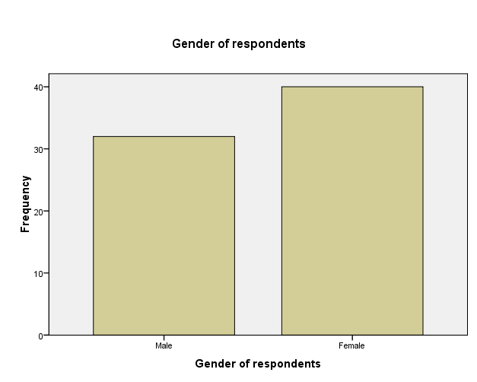
Figure 4.1: Gender of Respondents
Source: Field Survey (2016)
The Figure 4.1 indicates that 32 representing 44.4% of the respondents were male while 40 representing 55.6% were female. This shows that they both have almost equal representation of the responses. The above figure clearly indicates that there are more female than male respondents. The implication of the above figure is that the sample of this study in Kisarawe District involved more females that males.

4.2.1 Distribution of the Respondents’ Education Level
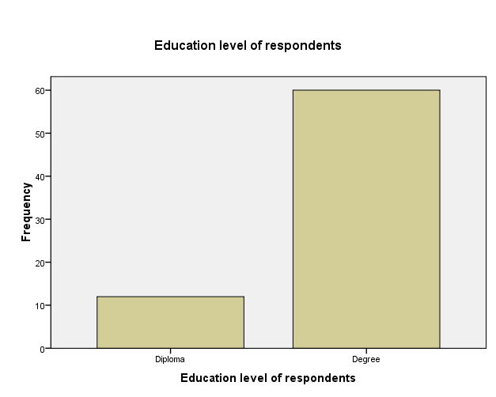
Figure 4.2: Education Levels of Respondents
Source: Field Survey (2016)

Regarding the level of education, the majority (60 respondents=83%) had the degree academic qualification. Others (12 respondents=16.7) had diploma qualification. According to the Tanzania Education Policy (1995), secondary school teachers should hold either diploma or University degree to teach in ordinary level secondary school. This implies that secondary school teacher should be qualified teachers. According to Duncan (2010), education is important in the development process. It helps society address the social and ethical questions raised by new development policies and project, ensuring that conservation of long-term interests is given priority over short-term gains.

4.3 The Contribution of Teachers’ Resource Centers on Improving School Academic Performance
The first objective of this study was to examine the contribution of TRCs on improving school academic performance. The objective was intended to examine how TRCs can be used to improve school academic performance. Interview and questionnaires were used to obtain information from 72 respondents. The questionnaire was set using Likert scale of 4 points from (1) Strongly Disagree, (2) Disagree (3) Neutral (4) Agree (5) Strongly Agree. Moreover, the questionnaire comprised of 3 items. The first item asked: As a teacher do you participate in TRCs activities? The following were the results on whether teachers participate in TRCs activities.
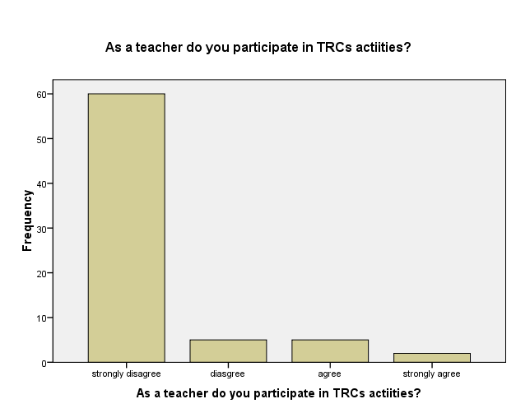
Figure 4.3: Participation of Teachers in Teacher Resource Centre Activities
Source: Field Survey (2016)
The findings explain the idea that in order to improve academic performance of secondary schools, it is important for teachers to be broadly aware of the existence and activities of the TRCs. It was therefore important for the researcher to find out on the participation of teachers in TRC activities. The results revealed that about 60 (83.3%) respondents marked “Strongly Disagree”, 5 (6.9%) marked “Disagree” while only 5 (6.9%) marked “Agree” and only 2 which is (2.9%) marked “Strongly Agree”. This was not a surprise since there seem little efforts made in sensitizing and motivating teachers on the importance of using TRCs in improving their teaching endeavors. This finding explains what Wallace et al. (1982) argued that teachers need to be exposed regularly to new methodologies and approaches of teaching with the ever changing environment. The teaching effectiveness of a very serving teacher will therefore need to be developed through planned and known schedules of invitation and in-service training programmes of secondary school teachers.

Figure 4.3 indicates that teachers had never participated in TRC activities. This situation implies that teachers were limited in terms of the new knowledge and skills that were always found in TRCs. And thus, the findings would mean that teachers miss the important backup such as new technologies and knowledge provided by TRCs, which is necessary for teachers’ performance in their day- to-day teaching responsibilities. Felix and Lloyd (1976) observed that training is intended to increase a person’s ability in particular kind of work. Also, it was argued by Johnson (1976) that training solves a variety of manpower problems which affect productivity, whereby with training one expects good result such as improved quality of work, high morale, developed new skills, knowledge, understanding and attitude.
The findings gained through interview reveal that secondary school teachers are not aware about the use of TRCs as most of them did not even know what TRC means and what it does. Some heads of schools admit that they are aware about the TRCs but neither they nor their teachers have been involved in TRCs activities.
A school head commented: “TRCs is a good thing but nowadays teachers are not participating due to lack of knowledge and awareness”.

Furthermore, the results concur with Hawley and Valli (1999) in their study on Basic Education Strategic Objective (BESO) in Ethiopia. The researcher found that the teachers get 2 days of professional development every 10 years. They reported that great majority of teachers, particularly female and male teachers with little seniority had never participated in a single day in in-service professional development. This situation deprives them the chance to develop their skills since teachers benefit from multiple opportunities to learn (Hawley & Valli, 1999) therefore contrary to the fact that the TRCs were introduced so as to develop the teachers’ competencies in teaching content and methodologies and exposure. The sending item in questionnaire under the first objective aimed to learn whether teachers were aware of the contribution of TRCs in enhancing secondary schools academic performance. The findings were as follows:

The TRC is seen as a mechanism that would improve students’ academic performance. Therefore I also sought to find out the view and perception of respondents on their expectation of the TRC. They had varied opinions which made my findings interesting. It is important to note that a significant number of respondents strongly disagreed. Other opinions from the rest of the respondents agreed that there is a relationship between the TRC and students’ academic performance. This number includes six Ward Education Coordinators.

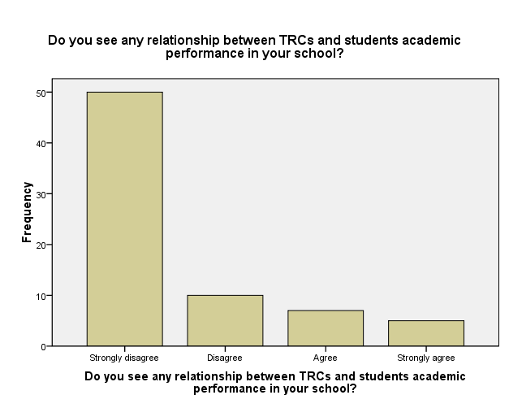
Figure 4.4: Relationships between Teacher Resource Centre and Students’ Academic Performance
Source: Field survey (2016)

In all cases, the proportion of well-trained teacher is by far most important detriment of student achievement as is highly significant in all equations for both subject areas in all years and at all grade levels. Also the finding contrasted with the study by Kasiisa & Tamale (2013) conducted in Uganda, which revealed that teacher’s quality in terms of qualification is a universal remedy for attainment of sustainable goals and objectives. The study also shows a positive significant relationship between teachers’ training and students’ academic performance in Eastern Uganda.
Another area of investigation based on knowing if there are enough books relevant to students. When asked about the availability of books that are relevant to students, the Kisarawe TRC coordinator commented that there was a shortage of books in the TRC library and very few found was outdated. According to this statement, it shows that teachers were not interested to go to TRC library due to lack of useful and relevant books, which would have helped them in solving their problems.

The findings gained through interview reveal that if TRCs were well used, they would have positive relationship with academic performance because TRCs would bring new knowledge to teachers using such knowledge and skills to improve students’ academic performance.
A school head commented: “if the centre was effectively utilized and teachers participated in TRCs activities, the performance of students would increase”.

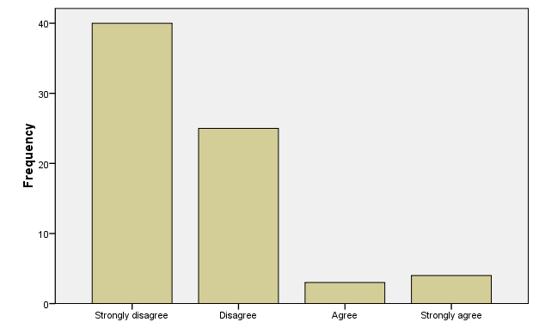
Figure 4.5: Relevant Books to Students in Teacher Resource Centres
Source: Field Survey (2016)
The result showed that 40 (55.6%) respondents strongly disagree, 25 (34.6%) respondents disagree while 3 (4.2%) respondents agree and other 4 (5.6%) strongly agree. A TRC coordinator said that there is a shortage of books and that those few available are outdated, hence a proof that the government was not giving support to TRCs. The TRC coordinator told me that they would like to see teachers interact with different books, which are relevant to students.
“If we would have enough and relevant books, it will be easy for teachers to use them when they prepare their lessons”.

Another ward education coordinator noted that:
“We did not really use TRCs as it was planned. The government support was very important for the TRCs to work effectively”.

From the data above it is obvious that TRCs do not have enough and relevant books to students. But again secondary teachers did not go to TRC searching for books so as to develop their knowledge in order to improve students’ academic performance.
These results are not in line with Miskel & Dowd’s (1998) findings which show that TRCs should be well equipped with library facilities so as to prepare teachers to increase their teaching ability through references found in their respective TRC library. They argued that the presence of adequate and useful instructional materials and text books bring better knowledge and working conditions for teachers as well as better learning environment to students.

Lack of enough books that are relevant to students implies that there is stagnation in terms of knowledge and skills of teachers who do not have a tendency of making reference. Their teaching and working conditions, according to Miskel & Dowd (1998), will be of low standard and that the whole process of better learning and development of education in the country will also be affected. The findings gained through interview reveal that though teachers are not aware of the TRCs, there is also a problem of books and relevant materials in TRCs due to lack of support from the government.

A school head commented:
“If we had enough and relevant books in TRCs it would be easy for teachers to use them when they prepare their lessons”. The government support was very important for these TRCs to work effectively”.

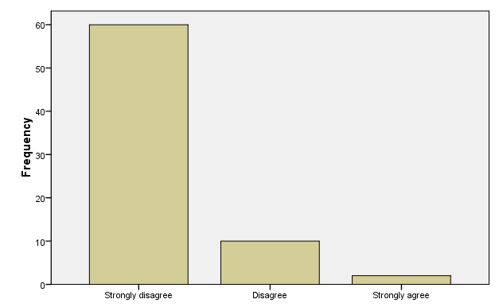
Figure 4.6: Motivation to Participate in Teacher Resource Centre Activities
Source: Field survey (2016)

As mention above, motivation to teachers on the use of TRCs was done only to primary school teachers in Kisarawe District. However, the importance of TRCs is for all teachers (secondary school teachers inclusive) and their respective schools. Ngirwa (2006) defines work motivation as the willingness to work. Therefore, when teachers are sensitized and motivated to use TRCs, they will willingly participate in TRCs activities. From the findings below, 60 respondents (83.3%) strongly disagreed on the issue of motivation to secondary teachers regarding their participation in TRC activities, 10 (13.9%) respondents also disagree while only 2 (2.8%) of all respondents strongly agreed that motivation is made to make teachers to participate in TRC activities.

According to Herzberg’s (1995) theory, it is suggested that people should be used in such a way that they get achievement, interest and responsibility so that they grow and advance in their work. This has an implication on the study since the organization needs to motivate teachers to participate in TRC activities appropriately. However, some respondents went far saying that even though motivation was widespread to all secondary teachers, yet they think it was not satisfactory especially with the challenge of distance as most of TRCs were in town and were few compared to the number of existing teachers who need that service.

4.4 Types of Academic Support Provided by Teacher Resource Centers to Secondary School Teachers
The second objective aimed to examine types of academic support provided by TRCs to secondary school teachers. The first question asked was: Do TRCs conduct seminars and workshops for teachers? The answers given to this question were grouped as shown in the bar Figure 4.7. The researcher also wanted to know the extent to which secondary school teachers attended TRCs for seminars and workshops. When almost all respondents were asked whether the TRCs conduct seminars and workshops for teachers, they marked ‘Strongly Disagree’. Their opinions varied on why they did not go to seminars and workshops conducted by TRC. Some respondents said the TRC is special for primary school teachers. They believed that TRCs are especially for primary school teachers only. Finding below indicates that TRC did not conduct seminars and workshops for teachers. Gay & Airian (2002) advocate that training is intended to increase a person’s ability in particular kind of work.

They further argued that training solves a variety of manpower problems which affect productivity; with training, one expects good result such as improved quality of work, high morale, developed new skills, knowledge, understanding and attitude. It helps to reduce waste, accidents, turnover, lateness, absenteeism and other overhead costs, implementing new policies and ensuring survival and growth of the school. Another item also focused on finding out whether TRCs conduct seminars and workshops for teachers. The findings were as follows hereunder.
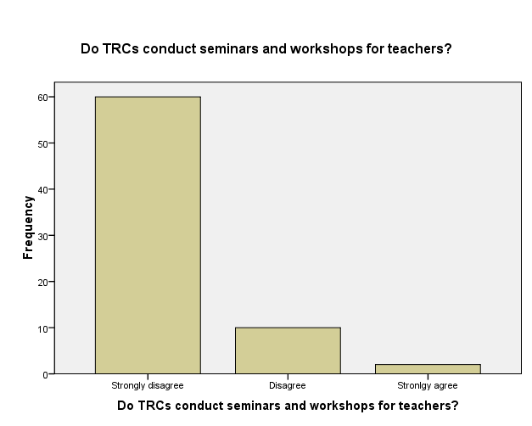
Figure 4.7: Teacher Resource Centre Seminars and Workshops
Source: Field survey (2016)
This implies that TRCs intentionally want to implement their plans by providing seminars and workshops to as many teachers as possible but there was inadequate finance to facilitate their programmes. This trend deprives teachers of the opportunity to receive in-service training from their employer. Under this situation then there is a possibility of teachers to wait for a long time without attending seminars and workshops from their respective TRCs. The findings gained through interview supported this that TRCs did not conduct seminars for teachers just because the government refuses to provide aids to facilitate TRCs activities and those TRCs were distant from schools.
A TRC coordinator said:
“Even though the TRC will conduct seminars and workshops for teachers, it was not enough because those TRCs were built in the big towns and not in the small villages, and they were normally only one day events”.

Another item also focused on finding out whether teachers develop professionally through effective use of TRCs. The findings were as follows hereunder.

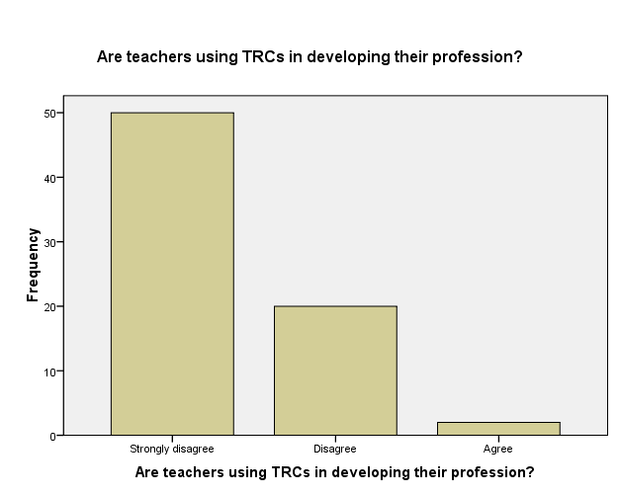
Figure 4.8: The use of Teacher Resource Centre in Developing Teaching Professions
Source: Field survey (2016)
The TRCs’ main objective was to develop teaching profession. Interestingly however, 50 (69.4%) respondents strongly disagreed and 20 (27.8%) respondents disagreed with that objective of TRC. Other 2 (2.8%) respondents agreed saying that TRC indeed develop teaching profession through in-service training.

This situation shows that TRCs are wrongly translated by secondary school teachers as they consider the TRCs as special for primary school teachers. It seems that secondary school teachers have not been told about the aims of having teachers’ centers. The publicity on the role and functions of TRCs are still needed as TRCs are not there for primary school teachers only. The findings shows that teachers do not use TRCs in developing their knowledge accordingly as Mliwa (2009) argues that, the advice provided in the TRCs enable teachers to be in good position to get support, guidance and information on both academic and professional aspects in one hand, and on the other hand keep them up-to-date to new curriculum changes, new teaching and learning materials and new methodologies.
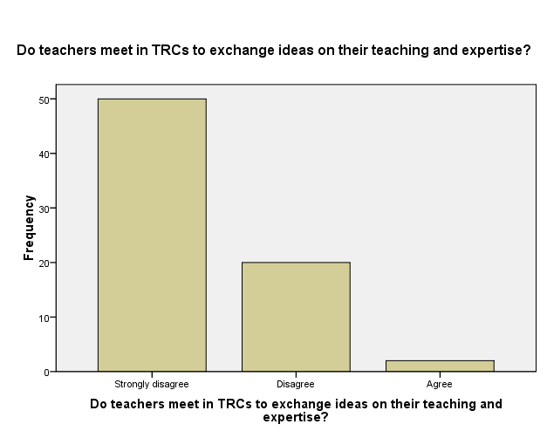
Figure 4.9: The use of Teacher Resource Centres in Exchanging Ideas on Teachers’ Teaching and Expertise
Source: Field Survey (2016)
Respondents in this category believe that teaching is a natural process that takes a lot of time to be achieved. Another item also focused on finding out whether teachers meet in TRCs and exchange ideas about their teaching experience and experts. The findings were as follows hereunder.

This was one of the items of the questionnaire of this study. In this question, the researcher wanted to know the extent to which teachers meet in TRCs and exchange ideas about their teaching and expertise. The data obtained through interview with the D.E.O of Kisarawe, TRC coordinator and head of schools, and through questionnaire administered to teachers and Ward educational coordinator generally revealed that TRCs were not meeting to exchange teachers’ experience and expertise since they did not meet at all but rather gave a chance to primary schools teachers to use the centers.
For example, the DEO said: “We are not participating in TRC activities as the centers are mostly used by primary school teachers”

Teachers have no enough knowledge about TRCs. It seemed that the use of TRCs is not recognized as strategic places to develop their profession. Teachers were further asked whether they had ever met in TRCs to exchange ideas about their teaching experience and expertise.

The results were as shown in the Figure 4.9. From the data collected from those responding to this, 50 (69.4%) respondents strongly disagreed; other 20 (27.8%) respondents disagreed while only 2 (2.8%) respondents agreed. The general findings indicate that the secondary school teachers from Kisarawe District were not meeting in TRCs for the exchange of ideas. This could have implications on their professional development, teaching capabilities and effectiveness which significantly affect the academic performance of the schools.

4.5 Challenges facing Teacher Resource Centres in Kisarawe District
In this area of investigation, the researcher wanted to know challenges facing TRCs in Kisarawe District. To achieve this objective the researcher asked three questions. The first question was: Does the government provide support to TRC? The study found out that 60 respondents, who were equal to 83.3%, disagreed, 10 (13.9%) respondents disagreed while 2 (2.8%) of them agreed.

The TRCs need finance to exercise their day-to-day plans. The better the financial position of the TRCs, the more effective the service will be. TRCs have their plans that need financial resources to be practiced. There seems to be no government budget set for TRCs for running their respective activities. The first item aimed to learn whether the Tanzanian government does provide support to TCRs. The findings were as presented in Figure 4.10.

The data indicate that the dominant problem that hindered teachers’ participation in TRCs activities was lack of support from the government. The TRCs use some local NGOs to encourage them to use the premises for various training purposes in order to get income to run their activities. The TRC coordinator, when asked if there is any support from the government to run TRCs activities, said: “For more than ten years now government has been stopped to support TRCs though the workers from the centers are still paid by the government.”
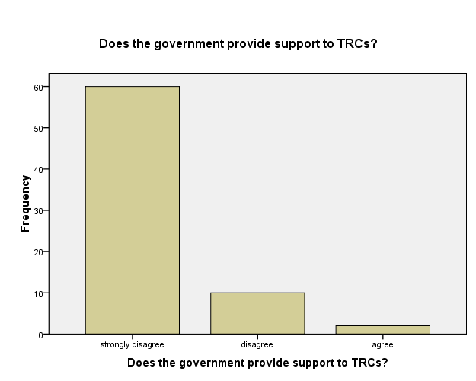
Figure 4.10: Supports from the Government to TRCs
Source: Field survey (2016)

There also seems to be no government budget given to TRCs for running their academic activities. Responding to the question on the challenges facing TRCs in Kisarawe District, the Coordinator mentioned lack of budgetary support from the government as one of the challenges.
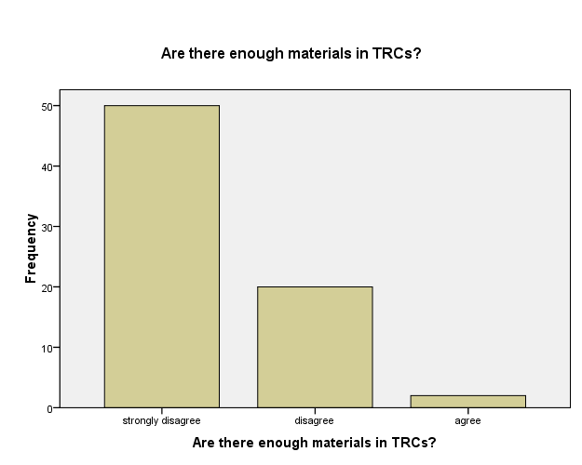
Figure 4.11: Materials in Teacher Resource Centres
Source: Field survey (2016)
On whether there are enough materials importantly for teachers’ professional development, the findings were as presented in Figure 4.11. The findings revealed that materials such as books, computers from the TRC library were very poor. The chart above shows that there is no enough material in TRCs.

The study observed that among the challenges that led to the decline in the use of the TRCs then was the unavailability of text books of various subject in Kisarawe TRCs. Considering that teachers are required to make references every day in order to make teaching and learning effective, without making references, the teachers will not be up to date and therefore neither teaching and learning nor teaching professional development will be effective.

4.6 Strategies that would Improve Teaches Resource Centers for Promotion of Academic Performance
In this area the study sought to suggest strategies, which should be taken to improve the use of TRCs by teachers. To achieve this, the respondents were asked three questions. The following were the responses delivered by D.E.O, TRCs coordinator, Ward Educational Coordinators, heads of schools and secondary school teachers. The first questions asked whether sensitizing teachers would improve the usage of TRCs and its effect on students’ academic performance of secondary schools.

This was the leading challenge as the study found out that 52 respondents who were equal to 72.2% were not aware of the TRCs and its practice. Some of them considered the TRCs as special for primary school teachers only. They did not recognize that they are supposed to participate in TRC activities. When heads of schools were asked, they said that awareness should be made to enable secondary school teachers to use the centers effectively. Therefore this challenge made teachers not to participate in TRC.

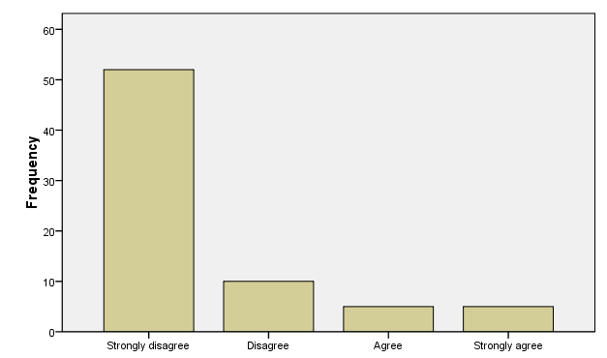
Figure 4.12: Teacher Awareness on TRC and its Practice
Source: Field survey (2016)

Findings gained through interview reveal that if there is awareness for teachers to participate in TRCs they could participate and develop their knowledge and skills. Teachers are interested in developing their professions but they lack that opportunity.
A school head commented: “Teachers need to be aware about TRCs because most of them did not know what TRCs mean and their activities”

Respondents to this question agreed to the statement as above chart depicts. 60 (83.3%) respondents agreed, 9 (12.5%) respondents strongly agreed while 2 (2.8%) respondents strongly disagreed and 1 (1.4%) respondent disagreed.
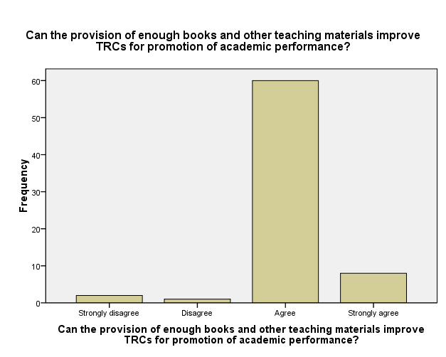
Figure 4.13: Provision of Enough Books and other Teaching Material in TRCs
Source: Field survey (2016)

The findings gained through interview reveal that when these centers are well equipped with relevant books and other teaching materials could help to promote students academic performance because they will enable teachers to use the materials for reference as well as to develop their knowledge in their areas of specialization.
A school head commented:
“TRCs should equipped relevant books and other leading materials to allow teachers to interact with different source of materials when they prepare their subject”.

The computer training could attract and enhance teachers to use the centers effectively. Another item aimed to find out the extent to which government support would enhance the performance of TRCs. The findings were as presented hereunder.
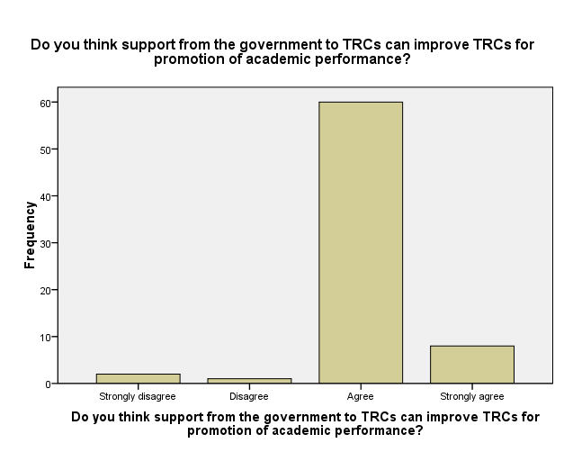

Figure 4.14: Support from the Government to TRCs
Source: Field survey (2016)

In the context of Kisarawe, the Ministry of Education and Vocational Training seems responsible for providing policy and financial support for Teachers’ Professional Development. TRCs are responsible for providing training, ensuring policy implementation, conducting education research and providing relevant literature and materials to support teachers’ endeavors in schools.

TRCs staff receive salaries from MoEVT, but they have to mobilize funds for their operational programmes. It was learned in the field that there seems to be no budget received from the Ministry of Education and Vocational Training to support the TRCs activities. It is argued that the Government and particularly the MoEVT should budget for the TRCs’ activities.
The findings gained through interview reveal that there is no any government support to TRCs; this hinders the centers from running their daily activities. When talking to TRCs coordinator, he insisted on having government support in a belief that it could help the centers to run their activities.

A TRCs coordinator commented:
“Government should support the centers financially and materially to allow teachers to utilize the resources available so as to develop students’ academic performance”.

4.7 Summary of Key Issues
On the whole, the findings show that, despite the existence of the Kisarawe TRCs and the fact that they operate and implement their day-to-day programmes, secondary school teachers are not motivated to use TRCs and thus not served by the TRCs. In this case, the professional development plans through TRCs can take very long time to be implemented. The study revealed that lack of awareness can be among the major reasons for teachers not to attend and use TRCs. The responses revealed that there were many challenges that hinder teachers in participating in TRCs activities.

The researcher found that the leading challenges were lack of awareness, lack of government support and lack of reading materials. Moreover, the research found that the Ministry of Education and Vocational Training direct no budget to TRCs which to some extent would have led to TRCs failure to enhance their duties and activities that seem important for teachers and students learning. Finally the study findings suggest the strategies to enhance the use of TRCs for the secondary school teachers of Kisarawe District. These are: making teachers aware of the importance of using TRCs; government should support TRCs activities; provision of relevant books and other teaching materials and lastly to build TRCs at least in every ward to solve the problem of the distance.

CHAPTER FIVE

SUMMARY, CONCLUSIONS AND RECOMMENDATIONS

5.1 Introduction
Chapter five summarizes the research findings and provides the conclusion and recommendations on the contribution of TRCs on improving school academic performance. The conclusions and recommendations are consistent with research questions and objectives advanced in the study.

5.2 Summary of the Research Findings
The objective of this study was to examine the contribution of TRCs on improving academic performance of community secondary schools in Kisarawe District. This study involved a sample of 72 respondents selected using purposive and random sampling techniques. The study was informed by a survey research design whereby interviews, questionnaires and documentary review were used in data collection and analyses. Both qualitative and quantitative data analysis approaches were used. The study was designed to address the following research objectives:
- To examine the contribution of TRCs on improving schools’ academic performance.
- To examine the types of academic support provided by TRCs to secondary school teachers.
- To assess the challenges facing TRCs in Kisarawe district.
- To suggest strategies that would improve TRCs for promotion of academic performance of community secondary schools.
The findings showed that secondary schools teachers in Kisarawe District were unaware of the use of TRCs in teaching and their contribution to general students’ academic performance. Some heads of schools were aware about TRCs though they did not practice it. Inadequate use of TRCs to secondary school teachers was contributed by the government’s lack of policy both at District and National levels.

The study findings also showed that there were six TRCs in the Kisarawe District but they were all effectively used by primary school teachers and not by secondary school teachers. On the types of academic support provided by TRCs to secondary school teachers, the findings revealed that there is no any support or budget from the government to run TRCs activities though their workers are still paid by the MoEVT.
(c) The use of TRCs among secondary school teachers was hindered by lack of a clear policy on motivation to teachers, inadequate financial resources and support at district and national levels; teacher awareness, inadequate office space, insufficient teaching and learning materials such as textbooks. The existing TRCs also have no electricity which could enable teachers to interact with new technology of using ICT. The TRCs also were found to have out dated buildings.

The findings also showed that teachers could not access TRCs service under the guarantee of the employer. There was insufficient budgetary allocation for the teaching profession development through TRCs at Kisarawe District.
There were various suggestions / strategies that could be employed to enhance the contribution of TRCs on improving school academic performance. Some of these involved;
  - Establishment of TRCs with enough and relevant books in every ward which would be used among secondary school teachers.
  - Government should provide financial support to TRCs and conduct seminars and workshop for teachers.
  - Employer should conduct frequent visits and meetings to discuss challenges and difficulties faced by TRCs workers.
  - Establishing and implementing a clear policy for use of TRCs by secondary school teachers.
  - Teachers should be motivated and educated on the use of TRCs and their contribution on academic performance.

5.3 Conclusions
Based on the research findings, it was concluded that:
  - There were no enough TRCs in Kisarawe district and that the existing very few TRCs are not used by secondary school teachers to develop them professionally and hence to improve secondary schools academic performance.
  - The use of TRCs by secondary school teachers was hindered by lack of a clear policy on motivation of teachers, inadequate financial resource and support at district and national levels; teacher awareness, inadequate office space, and insufficient teaching and learning materials such as textbooks.
  - There was a relationship between TRCs and students academic performance whereby in Kisarawe district where TRCs were used, teachers attended in-service training and developed their teaching profession contributing to an improvement in school academic performance.
  - There is a need to equip TRCs with enough and relevant books, to ensure the Government financial support, and establishing a clear policy on the mandatory use of TRCs by teachers of all education institutions.

5.4 Recommendations

5.4.1 Recommendations for Administrative Action
Based on the research findings the following recommendations are made.
- The Central Government or Local Authorities (Councils) should establish facilities such TRCs in every Ward which would be used by primary and secondary school teachers. This would enhance the teaching and learning processes and promote academic performance of primary and secondary schools in Kisarawe District.
- The central government and local authorities should take deliberate efforts to formulate a clear policy to guide, regulate and implement the use of TRCs by secondary schools teachers.
- The employers should conduct frequent visits in order to meet with TRCs coordinators to discuss their problems and find solutions to the problems. This would provide a forum for TRCs coordinators to express their concerns and problems in the presence of their employers.
- In order to enhance motivation on the effective use of TRCs by secondary school teachers, it is recommended that there should be time to time seminars and workshops on the importance use of TRCs activities.

5.4.2 Recommendations for Further Research
Since this study limited itself to the use of TRCs on improving community secondary school academic performance in Kisarawe district, it is recommended that a similar study be conducted to examine the possible use of TRCs by teachers in private secondary schools in Tanzania.

Secondly, it recommended that a study should be conducted to look into the use of TRCs to promote students performance in public Primary Schools. This would help to provide a wider and general picture on how TRCs can influence school academic performance also in public secondary schools in Tanzania.

REFERENCES
Abimbade, A. (1999). Principle and Practice of Educational Technology. Ibadan; International Publisher Ltd.
Agyemang, D. K. (1993). Sociology of Education for African Students. Accra Black Mask Ltd. And Teacher Development Branch.
Andrews, J., Housego, I. E. & Thomas, D.C. (1990). Effective in-service programs in developing countries: A study of expert opinion, in V.D. Rust and P. Dalin (eds) Teachers and Teaching in the Developing World. London: Garland Publishing Inc.
Ankrah-Dove, L. (1977). Teachers Groups and Centers in Developing Countries: Report of Workshop helps jointly by the British Council and the Development of Education in Developing countries: University of London, school of Education.
Armstrong, E. G. (2008). School Clusters and Teacher Resource Centers. International Institute for Educational Planning, Paris: UNESCO.
Ary, D. Jacobs, L.C. & Socense, C. (2010). Introduction to Research in Education. Wadsworth. U.S.A.
Avalos, B. (1993). Teacher training in Developing Countries: Lessons from research, in L.P. Farrell & J. B. Oliveira (Eds) Teachers in Developing Countries: Improving Effectiveness and Managing Costs. Washington DC; World Bank, Economic Development Institute Seminar Series.
Bakari, F, K. (2008). Leading and Managing Teacher Professional Development through Combination of Models; Some Implication for Zanzibar Teacher Centers, School of Education, Flinders University, South Australia.
Barro, R. (1991). 'Economic growth in a cross-section of countries', Quarterly Journal of Economics 56(1), 407-43.
Becker. G. (1994). Human Capital: A Theoretical and Empirical Analysis with Special Reference to Education. Chicago: The University of Chicago Press.
Best, J. W. & Khan, J. V (2006). Research in Education. (10th Ed). Baston: Pearson. Education Inc.
Best, J .W & Khan, J .V. (1992). Research in education. Boston: Allyn and Bacon.
Binde, A. L. (1999). Teachers’ resource centers. Baseline study in Tanzania. Dar es Salaam.
Blaug, M. (1987). “Declining subsidies in tertiary education: An economic analysis”. In M. Blaug, The Economics of Education and the Education of an Economist: New York University Press.
Butler, R. (1987). Task Involving and ego involving properties of evaluation: Effects of different feedback conditions on motivational perceptions, interest, and performance. Journal of Educational Psychology. 2(1), 135-162.
Dale, E. (1984). Management: Theory and Practice. Singapore: McGraw-Hill Books.
DANIDA and Ministry of Education and Culture, Tanzania, (1996). Teachers Resource Centers: Regional Workshop on Teachers Resource Centers, Arusha, Tanzania June 3–7, 1996 – A Sharing of Experiences. The Workshop Report. Dar es Salaam, Tanzania.
Denscombe, M. (1998). Educational research for small social research projects. Beckham; Open University Press.
Enon, J. C. (1998). Education research statistic and measurement. Nairobi: Department of psychology school of education.
Etsey, Y. K. A. Amedahe, F. K. & Edjah. K. (2005). Do private primary schools perform better than public school in Ghana? Unpublished paper. Department of Education Foundations, University of Cape Coast, Cape Coast.
Fairhurtst, G. (1999). The Effectiveness of Teacher Resource Center Strategy. London. Department for International Development.
Farrell, L. P. (1993). International lessons for school effectiveness: The view from the developing world, in L.P. Farrell and L.B. Oliveira (Eds) Teachers in Developing Countries: Improving Effectiveness and Managing Cost. Washington DC: World Bank, Economic Development Institute Seminar Series.
Felix, A. N. & Lloyd, G. N. (1976). The New Public Personnel Administrarion. Hasea Illinois: Peacock Publishers.
Galabawa, J. C. (2001). Perspectives in Educational Management and Administration. Dar-es-salaam; H.R. Consult.
Gay, L. & Airian, P. (2002). Educational Research. Competencies for Analysis Application. Upper Saddle River: Merrill Prentice Hall.
Giordano, E. A. (2008). School clusters and teacher resource centers. Paris: United Nations.
Glass, G. V, & Hopkins, K. D. C. (1984). Statistical methods in education and psychology. Englewood Cliffs; N.J; Prentice Hall.
Gohamwende, J. M. (1977). Education Psychologie. New Delhi: Publisher higher and further edition pity LTD South Africa.
Greenland, J. & Bude, U. (Eds) (1984). West African Approaches to INSET for Primary School Teachers. German Foundation for International Development/Bonn: Deutsche Stiftung fur Internationale Entwicklung (DSE).
Greenland, J. (1983a). The inset Africa project: an interim report, in U. Bude and J. Greenland (Eds) In-service Education and Training of Primary School Teachers in Anglophone Africa. Baden-Baden; Deutsche Stiftung fur International Entwicklung (DSE).
Greenland, J. (1984). Inset policy and provision in Africa in the early 1980s: Where do we go from here?, in U. Bude and J. Greenland (eds) West African Approaches to INSET for Primary School Teachers. German Foundation for International Development/Bonn: Deutsche Stiftung fur International Entwicklung (DSE).
Greenland, J. (Ed) (1983b). The In-Service Training of Primary School Teachers in English - Speaking Africa, London: Macmillan Press.
Grossman, M. (1976). 'The correlation between health and schooling', in Terleckyj, Nelson (ed.). Household Production and Consumption, New York: Columbia University Press.
Gupta, R. (1990). The Process of Management. Basely: V. K. Publication House.
Haddad, W. (1985). Teacher training: A review of World Bank experience, EDT Discussion Paper 21, World Bank, Population and Human Resources Department, Washington DC, USA,
Hawley, W.D & Valli, L. (1999). The Essential of Effective Professional Development. A new consensus in Darling Hammond, L. And Sykes, G (Eds). Teaching as the Francisco, Canada. Jossey- Bass.e Learning Profession. A handbook of and Practice San. New York University Press.
Herzberg, F. (1995). Work and Nature of man. London: Sapless press.
Hoppers, W. (1996). Teachers' Centers and Resource Work in Southern African Education: An Investigation into Decentralization and Educational Reform, paper presented at NASEDEC Conference, October 1996, Harare, Zimbabwe.
Hornby, A. S. (2000). Oxford Advanced Learners Dictionary 6th Edition. New York: Oxford University press.
John, M. (2001). A Review of Cluster School in Namibia. Report for the Ministry of Basic Education Sport and Culture, Namibia.
Johnson, R. B. (1976). Organization and Management of Training. New York: McGraw-Hill.
Kahn, H. (1982). Teachers’ centers – A Commonwealth perspective. British Journal of In-Service Education.25(2), 107-128.
Kasiisa, F. & Tamale, M, B. (2013). Department of Humanities and Language Education Makerere University- Uganda. International Journal of Innovative Education Research.1(7), 107-128.
Kenkel,D. (1990). VALUING health for policy. An economic approach. Chicago: New Age International
Kiwia, S. F. (1995). Management Issues in Primary Education Sector. Papers in Education. 16, pp 93-103. Performance Report. Nairobi, Kenya.
Kombo, D.S. & Tromp L.A. (2006). Proposal and Thesis Writing an Introduction. Nairobi: Pauline Publications Africa.
Kothari, C. R.(2004). Research Methodology: Methods and Techniques, New Delhi: New Age International.
Kothari, C. R. (2003). Research Methodology. Methods and Techniques (2nd Ed). New Delhi: New Age International Limited.
Koul, L (2009). Methodology of educational research. Noida, India; Vikash.
Lieberman, A. (1995). Practice support teacher development: Transforming conception of professional learning. Phi delta kappan, 76,591-596; London: Macmillan Press.
Lockhead, M. E, Verspoor, A. M. (1991). Improving Primary Education in Developing Countries. London: World bank/Oxford University Press.
Mankiw, N. G., Romer, D. & Weil, D. N. (1992), 'A contribution to the empirics of economic growth'. Quarterly Journal of Economics 107(4), 407-37.
Miles, M. B. (1996). Qualitative Data Analysis .Thousand Oaks, CA: Sage Publication Inc.
Miskel, G. & Dowd, K. (1998). Test Score, Dropout Rate, and Transfer Rates as Alternative indicators of High School Performance: Journal American Education Research, 42(1), 3 – 42.
Mliwa, K. (2009). Effectiveness of Teachers Resource Centers in Professional Development: Unpublished M.Ed Diseertation, Dodoma. Tanzania.
Bungco, N. G. I. (2008). The Effect of Decentralization by Devolution (D by D) Policy on Primary School Teachers. Management and Professional Support in Tanzania Mainland, Dar-es-Salaam; University of Dar es salaam.
Neagley, R. I., & Evans, N. D. (1970). Handbook for effective supervision of Instructions. Englewood Cliffs; NY: Prentice-Hall Inc.
Oliveira. J. & Farrell, L. P. (1993). Teacher costs and teacher effectiveness in Developing Countries. In L.P. Farrell and L.B. Oliveira (Eds) Teachers in Developing Countries: Improving Effectiveness and Managing Costs. Washington DC: World Bank, Economic Development Institute Seminar Series.
Onwuegbuzie, A. J., & Collins, K. M. T. (2007). A typology of mixed methods sampling designs in social science research. The Qualitative Report, 12(2), 281-316. Retrieved August 31, 2007, from http:// www.nova. edu/sss s/QR/ QR12-2/onwuegbuzie2.pdf.
Orodho, A. J. & Kombo, D. K. (2002). Research Methods. Nairobi; Kenyatta University, Institute of open learning. Performance Report. Nairobi. Kenya.
Orodho, A. J. (2003). Essentials of Educational and Social Sciences Research Method. Nairobi: Publishing House Pvt. Ltd.
Punch, K. F. (2004). Introduction to Social Research Quantitative and Qualitative Approaches. London; SAGE Publications.
Qvist, K. & Omar, B. (1996). Teachers’ resource centers: Regional workshop on TRCs. Dar es Salaam; Ministry
Schwrz, P. A. (1995). Education of the Pakistan primary project: a methodological case Study in B. Searle (Ed) Evaluation in World Bank Education projects: Lessons from three case studies.
Sherleker, A. A. (1984). Modern Business Organization and Management: a system Based Contigency, Approach to the Organization and Management of Business. Bombay; Girgan Himalaya Publishing House.
Sounders et al (2000). Research Methods for Business Educations. New York; Pearson Education Limited.
The United Republic of Tanzania (1995). “The Education and Training Policy”. Dar-es-salaam; The Ministry of Education and Culture.
Wallace, M. (1980). Administering Human Resources. New York; Random House.
Weindling, D., Reid, M. I. & Davis, P. (1983). Teachers' centers: A focus for In-Service education? Schools Council Working Paper 74, London; Methuen Educational, UK.
Williams, J. D. (1996). Learning divides: Ten policy equations about the performance and equity of school and Schooling system. Montreal; Canada UNESCO Institute for statistics.
Yin, R. K. (2009). Case study research: design and methods. (4th ed). Thousand Oaks, A: Sage Publications Inc.
Young, A. W. (1988). Human Cognitive Neuropsychology. Hove, UK: Erlbaum Associates Publishers.

APPENDICES

Appendix 1: Interview Guide for District Educational Officer (D.E.O)

My name is Zaituni Rashidi. I am a student from the Open University of Tanzania. I am conducting a study about “The contribution of TRCs on improving academic performance of community secondary schools in Kisarawe District”. The aim of my study is to enhance .academic performance of community secondary schools in Kisarawe district. I request you to respond to questions that you will be given. However, your responses will be taken highly confidential and that your name will not be mentioned or appear in any part of this study.

A. Personal Information
1. Age
25----35 Years
35------45 Years
45------65 Years

2. Gender Male ( ), Female ( )

3. Education level
What is your education level (Tick appropriately)
Certificate
Diploma
Degree
B. THE CONTRIBUTION OF TEACHERS’ RESOURCE CENTRES ON IMPROVING SCHOOL ACADEMIC PERFORMANCE
I. The contribution of TRCs on improving schools’ academic performance.
1. Do teachers participate in TRCs activities?
2. Do you see any relationship between the TRCs and students academic performance?
3. Are there enough books in TRCs relevant to students?
4. Are teachers in your school motivated to participate in TRCs activities?
II. Types of academic support provided by TRCs to secondary school teacher.
1. Do TRCs conduct seminars and workshops for teachers?
2. Are teachers using TRCs in developing their profession?
3. Do teachers meet in TRCs to exchange aides on their teaching and expertise?
III. Challenges facing TRCs in Kisarawe District.
1. Does the government provide support to TRCs?
2. Are there enough materials in TRCs?
3. Are teachers aware on what TRCs are and its practice?
IV. Strategies that would improve TRCs for promotion of academic performance.
1. Can the Provisions of enough books and other teaching materials improve TRCs for promotion of academic performance?
2. Do you think support from the government to TRCs can improve TRCs for promotion of academic performance?
3. Can teacher’s awareness of on the use of TRCs improve academic performance?
4. Do you have additional strategies that would improve TRCs for promotion of academic performance of community secondary schools? Please explain.

Thank you for your cooperation
Appendix 2: Interview Guide for TRC Coordinator of Kisarawe District

My name is Zaituni Rashidi. I am a student from the Open University of Tanzania. I am conducting a study about: “The contribution of TRCs on improving academic performance of community secondary schools in Kisarawe District”. The aim of my study is to enhance .academic performance of community secondary schools in Kisarawe district. I request you to respond to questions that you will be given. However, your responses will be taken highly confidential and that your name will not be mentioned or appear in any part of this study.
A. Personal Information
1. Age
25----35 Years
35------45 Years
45------65 Years

2. Gender Male ( ), Female ( )

3. Education level
What is your education level (Tick appropriately)
Certificate
Diploma
Degree

B. THE CONTRIBUTION OF TEACHERS’ RESOURCE CENTRES ON IMPROVING SCHOOL ACADEMIC PERFORMANCE
I. The contribution of TRCs on improving schools’ academic performance.
1. Do teachers participate in TRCs activities?
2. Do you see any relationship between the TRCs and students academic performance?
3. Are there enough books in TRCs relevant to students?
4. Are teachers in your school motivated to participate in TRCs activities?

II. Types of academic support provided by TRCs to secondary school teacher.
1. Do TRCs conduct seminars and workshops for teachers?
2. Are teachers using TRCs in developing their profession?
3. Do teachers meet in TRCs to exchange aides on their teaching and expertise?

III. Challenges facing TRCs in Kisarawe District.
1. Does the government provide support to TRCs?
2. Are there enough materials in TRCs?
3. Are teachers aware on what TRCs are and its practice?

IV. Strategies that would improve TRCs for promotion of academic performance.
1. Can the Provisions of enough books and other teaching materials improve TRCs for promotion of academic performance?
2. Do you think support from the government to TRCs can improve TRCs for promotion of academic performance?
3. Can teacher’s awareness of on the use of TRCs improve academic performance?
4. Do you have additional strategies that would improve TRCs for promotion of academic performance of community secondary schools? Please explain.

Thank you for your cooperation

Appendix 3: Questionnaires for Ward Education Coordinator (WEC)

My name is Zaituni Rashidi. I am a student from the Open University of Tanzania. I am conducting a study about “The contribution of TRCs on improving academic performance of community secondary schools in Kisarawe District”. The aim of my study is to enhance .academic performance of community secondary schools in Kisarawe district. I request you to respond to questions that you will be given. However, your responses will be taken highly confidential and that your name will not be mentioned or appear in any part of this study.

- Personal Information
Put a tick;
1. Age
25----35 Years
35------45 Years
45------65 Years
2. Gender Male ( ), Female ( )
3. Education level
What is your education level (Tick appropriately)
Certificate
Diploma
Degree

SECTION B; THE CONTRIBUTION OF TEACHERS’ RESOURCE CENTRES ON IMPROVING SCHOOL ACADEMIC PERFORMANCE
Please indicate whether you agree or disagree with the following statements
Strongly Disagree = 1, Disagree = 2, Neutral =3, Agree =4, Strongly Agree =5.
S/N | ITEM | Strongly  Disagree | Disagree | Neutral | Agree | Strongly Agree
I. | The contribution of TRCs on improving schools’ academic performance | * | * | * | * | *
2. | Do teachers participate in TRCs activities? | 1 | 2 | 3 | 4 | 5
3. | Do you see any relationship between TRCs and students academic performance in your school? | 1 | 2 | 3 | 4 | 5
4. | Are there enough books in TRCs relevant to students? | 1 | 2 | 3 | 4 | 5
5. | Are teachers in your school motivated to participate in TRCs activities? | 1 | 2 | 3 | 4 | 5
II. | Types of academic support provided by TRCs to Secondary School teachers | * | * | * | * | *
1. | Do TRCs conduct seminars and workshops for teachers? | 1 | 2 | 3 | 4 | 5
2. | Are teachers using TRCs in developing their profession? | 1 | 2 | 3 | 4 | 5
3. | Do teachers meet in TRCs to exchange aides on their teaching and expertise? | 1 | 2 | 3 | 4 | 5
III. | Challenges facing TRCs in Kisarawe District | * | * | * | * | *
1. | Does the government provide support to TRCs? | 1 | 2 | 3 | 4 | 5
2. | Are there enough materials in TRCs? | 1 | 2 | 3 | 4 | 5
3. | Are teachers aware on what TRCs are and its practice? | 1 | 2 | 3 | 4 | 5
IV | Strategies that would improve TRCs for promotion of academic performance
1. | Can the provisions of enough books and other teaching materials improve TRCs for promotion of academic performance? | 1 | 2 | 3 | 4 | 5
2. | Do you think support from the government to TRCs can improve TRCs for promotion of academic performance? | 1 | 2 | 3 | 4 | 5
3. | Can teachers awareness of on the use of TRCs improve academic performance? | 1 | 2 | 3 | 4 | 5

2. Do you have additional strategies that would improve TRCs for promotion of academic performance of community secondary schools? Please explain
…………………………………………………………………………………………

Thank you for your cooperation
Appendix 4: Interview Guide for Head Teachers

My name is Zaituni Rashidi. I am a student from the Open University of Tanzania. I am conducting a study about “The contribution of TRCs on improving academic performance of community secondary schools in Kisarawe District”. The aim of my study is to enhance, academic performance of community secondary schools in Kisarawe district. I request you to respond to questions that you will be given. However, your responses will be taken highly confidential and that your name will not be mentioned or appear in any part of this study.
- Personal Information
Put a tick
1. Age
25----35 Years
35------45 Years
45------65 Years

2. Gender Male ( ), Female ( )
3. Education level
What is your education level (Tick appropriately)

Certificate
Diploma
Degree
SECTION B: THE CONTRIBUTION OF TEACHERS’ RESOURCE CENTRES ON IMPROVING SCHOOL ACADEMIC PERFORMANCE
Name of school………………………………………………………..
I. The contribution of TRCs on improving schools’ academic performance.
1. Do teachers participate in TRCs activities?
2. Do you see any relationship between the TRCs and students academic performance?
3. Are there enough books in TRCs relevant to students?
4. Are teachers in your school motivated to participate in TRCs activities?

II. Types of academic support provided by TRCs to secondary school teacher
1. Do TRCs conduct seminars and workshops for teachers?
2. Are teachers using TRCs in developing their profession?
3. Do teachers meet in TRCs to exchange aides on their teaching and expertise?

III. Challenges facing TRCs in Kisarawe District
1. Does the government provide support to TRCs?
2. Are there enough materials in TRCs?
3. Are teachers aware on what TRCs are and its practice?

IV. Strategies that would improve TRCs for promotion of academic performance
1. Can the Provisions of enough books and other teaching materials improve TRCs for promotion of academic performance?
2. Do you think support from the government to TRCs can improve TRCs for promotion of academic performance?
3. Can teacher’s awareness of on the use of TRCs improve academic performance?
4. Do you have additional strategies that would improve TRCs for promotion of academic performance of community secondary schools? Please explain

Thank you for your cooperation

Appendix 5: Questionnaire for Secondary School Teachers

My name is Zaituni Rashidi. I am a student from the Open University of Tanzania. I am conducting a study about “The contribution of TRCs on improving academic performance of community secondary schools in Kisarawe District”. The aim of my study is to enhance .academic performance of community secondary schools in Kisarawe district. I request you to respond to questions that you will be given. However, your responses will be taken highly confidential and that your name will not be mentioned or appear in any part of this study.
- Personal Information
Put a tick;
1. Age
25----35 Years
35------45 Years
45------65 Years

2. Gender Male ( ), Female ( )
3. Education level
What is your education level (Tick appropriately)
Certificate
Diploma
Degree

SECTION B; THE CONTRIBUTION OF TEACHERS’ RESOURCE CENTRES ON IMPROVING SCHOOL ACADEMIC PERFORMANCE
Name of school................................................................................................
Please indicate whether you agree or disagree with the following statements
Strongly Disagree = 1, Disagree = 2, Neutral =3, Agree =4, Strongly Agree =5.
S/N | ITEM | Strongly  Disagree | Disagree | Neutral | Agree | Strongly Agree
I. | The contribution of TRCs on improving schools’ academic performance | * | * | * | * | *
1 | Do teachers participate in TRCs activities? | 1 | 2 | 3 | 4 | 5
2 | Do you see any relationship between TRCs and students academic performance in your school? | 1 | 2 | 3 | 4 | 5
3 | Are there enough books in TRCs relevant to students? | 1 | 2 | 3 | 4 | 5
4 | Are teachers in your school motivated to participate in TRCs activities? | 1 | 2 | 3 | 4 | 5
II. | Types of academic support provided by TRCs to Secondary School teachers | * | * | * | * | *
1 | Do TRCs conduct seminars and workshops for teachers? | 1 | 2 | 3 | 4 | 5
2 | Are teachers using TRCs in developing their profession? | 1 | 2 | 3 | 4 | 5
3 | Do teachers meet in TRCs to exchange aides on their teaching and expertise? | 1 | 2 | 3 | 4 | 5
III. | Challenges facing TRCs in Kisarawe District | * | * | * | * | *
1 | Does the government provide support to TRCs? | 1 | 2 | 3 | 4 | 5
2 | Are there enough materials in TRCs? | 1 | 2 | 3 | 4 | 5
3 | Are teachers aware on what TRCs are and its practice? | 1 | 2 | 3 | 4 | 5
IV. | Strategies that would improve TRCs for promotion of academic performance
1. | Can the provisions of enough books and other teaching materials improve TRCs for promotion of academic performance? | 1 | 2 | 3 | 4 | 5
2. | Do you think support from the government to TRCs can improve TRCs for promotion of academic performance? | 1 | 2 | 3 | 4 | 5
3. | Can teachers awareness of on the use of TRCs improve academic performance? | 1 | 2 | 3 | 4 | 5

2. Do you have additional strategies that would improve TRCs for promotion of academic performance of community secondary schools? Please explain
…………………………………………………………………………………………

Thank you for your cooperation

Appendix 6: Documentary Review Checklist

Form four national examination results from 2011 up to 2014
Number of TRC available in Kisarawe District
Availability of books and other leading material in TRCs

