THE IMPACT OF MIGRATION OF PEOPLE ON NATURAL RESOURCES IN RUVUMA RIVER VALLEY, RUVUMA REGION

JAMES LUBERE

A DISSERTATION SUBMITTED IN PARTIAL FULFILMENT OF THE REQUIREMENTS FOR THE AWARD OF THE MASTERS OF ARTS IN NATURAL RESOURCES ASSESSMENT AND MANAGEMENT OF THE OPEN UNIVERSITY OF TANZANIA
2016

CERTIFICATION
The undersigned certifies that he has read and hereby recommend for acceptance by the Open University of Tanzania a dissertation titled: “The Impact of Migration of People on Natural Resources in Ruvuma River Valley, in Ruvuma Region” in fulfillment of the requirements for the Degree of Masters of Arts in Natural Resources Assessment and Management of the Open University of Tanzania.

………………………………………..
Dr. Emmanuel Patroba Mhache
(Supervisor)

…………………………………
Date

COPYRIGHT
No part of this dissertation may be reproduced, stored in any retrieval system, or transmitted in any form or by any means, electronic, mechanical, photocopying, recorded or otherwise without permission of the author or the Open University of Tanzania in that behalf.

DECLARATION
I, James Lubere, declare that, this dissertation is my own work for the degree of Master of Arts in Natural Resources Assessment and Management of the Open University of Tanzania. It has not and it will not be presented to any other University or Institution for a similar or any other degree award.

:……………………………….
Signature

………………………………
Date

DEDICATION
This dissertation is dedicated to the Almighty God, my creator and savior the Lord Jesus Christ. Secondly, it is dedicated to my precious family, my wife Elizabeth Konga and my children Jerome, Edson, Jesca and Eliya as they are special gift from God. Finally, I dedicate this dissertation to my parents, sister and brothers May God consecrates them always.

ACKNOWLEDGEMENT
I would like to extend my special thanks to the Almighty God for being with me throughout the period of my studies at the Open University of Tanzania. I would also like to express my sincere gratitude to my supervisor Dr. Emmanuel Patroba Mhache for his suggestions and inspiration throughout the writing of this dissertation. The accomplishment of this work would not have been possible without his invaluable guidance.

I am also greatly indebted to Mr. P. Y. Chausi, Mr. P. J. Rugwaguza, Mr. B. S. Bahame, Mr. Sinkara and Mr. Chiwinga for their support and for providing ideas throughout my academic life at the Open University of Tanzania. Very special thanks go to my Pastor and Church Members for their contribution and prayers throughout the time of accomplishing this dissertation. Others who may not be forgotten for their great contribution of this production to mention a few are; Mr. January John, Mr. Amos Lubere and Mr. Julius Franck.

To all I say thanks very much.

ABSTRACT
This study focused on the impact of migration of people on natural resources in Ruvuma River Valley. The study assesses the causes and effects of migration on natural resources and suggested measures to avoid the environmental degradation. The increasing of population leads to high demand of natural resources in the study area. The study confirmed that there are significant association between migration of people and natural resources degradation. Migration is associated with the habit of setting bush fire, deforestation, the practice of mono culture for a long time which caused soil exhaustion, cultivating on the river banks causing erosion and the use of non-appropriated mesh net for fishing causing the decrease of fishes. 97% of the Ruvuma River valley habitants confirm that the natural resource available is forest and green pastures, 95% said fertile land, 89% said rivers and ponds, 67% talked about fishes. In this study 66 respondents were used. Data collection methods used in the study comprised review of secondary data, administering of questionnaires, focus group discussions and direct observation. Ms Excel and SPSS were used for data analysis. The study revealed that migration had caused the deforestation, soil exhaustion because of monoculture practice and bush fire practice. Also, the decrease of the quantity of fish in the river, the shifting cultivation to the river banks as well as soil erosion. The suggested solutions to the effects of migration on natural resource were: to avoid deforestation, to improve the level of awareness of people on the effects of migration on natural resources and the enforcement of laws and regulations on natural resources management.
TABLE OF CONTENTS
CERTIFICATION ii
COPYRIGHT iii
DECLARATION iv
DEDICATION v
ACKNOWLEDGEMENT vi
ABSTRACT vii
LIST OF TABLES xii
LIST OF FIGURES AND PLATES xiii
LIST OF PLATES xiv
ABBREVIATIONS xv
CHAPTER ONE 1
1.0 INTRODUCTION 1
1.1 Introduction 1
1.2 Background to the Research Problem 1
1.3 Statement of the Problem 3
1.4 Objectives of the Study 5
1.4.1 General Objective 5
1.4.2 Specific Objectives 5
1.5 Research Questions 5
1.6 Significance of the Study 6
1.7 Limitations and Delimitations 6
CHAPTER TWO 7
2.0 LITERATURE REVIEW 7
2.1 Introduction 7
2.2 Definition of Concepts 7
2.2.1 Natural Resources 7
2.2.2 Migration 8
2.3 Theoretical Literature Review 9
2.3.1 Malthusian Theory of Population of 1798 9
2.3.2 Ester Boserup’s Theory of Population (1965) 12
2.3.3 Carrying Capacity and Macro Models 15
2.4 Empirical Literature Review 17
2.4.1 Poverty and the Environment in Malaysia 17
2.4.2 Migration and its Implications on Natural Resource Management and Agriculture 19
2.4.3 Migration of People and Deforestation in Ecuador 21
2.4.4 The Environmental Factor in Migration Dynamics in Africa 22
2.4.5 Population Migration and Water Conflicts in Pangani River Basin in Tanzania 26
2.4.6 The Role of Traditional Irrigation Practice on the Rufiji Basin in Tanzania 28
2.4.7 Policy Implications in Tunisia and the Maghreb 30
2.4.8 Government Policy Implications 30
2.5 Research Gap 31
2.6 Conceptual Framework 32
CHAPTER THREE 35
3.0 RESEARCH METHODOLOGY 35
3.1 Introduction 35
3.2 The Study Area 35
3.3 Research Design 37
3.4 Target Population 38
3.5 Sampling Techniques and Sample Size 38
3.6 Sources of Data 41
3.7 Data Collection Methods 41
3.7.1 Administration of Questionnaires 41
3.7.2 Interviews 42
3.7.3 Focus Group Discussions 42
3.7.4 Direct Observation 43
3.7.5 Documentary Literature Review 44
3.8 Data Analysis, Interpretation and Presentation 44
3.9 Validity and Reliability 45
3.10 Ethical Considerations 47
CHAPTER FOUR 48
4.0 RESEARCH FINDINGS AND DISCUSSION 48
4.1 Introduction 48
4.2 Characteristics of the Respondents 48
4.2.1 Age of the Respondents 49
4.2.2 Marital Status of the Respondents 50
4.2.3 Gender of the Respondents 50
4.2.4 Education Level of the Respondents 52
4.2.5 Occupation of the Respondents 52
4.3 Migration and Natural Resources 53
4.4 Reasons for Migration to Ruvuma River Valley 55
4.5 Natural Resources in the Ruvuma River Valley 61
4.6 Impacts of Migration of People on Ruvuma River Valley 65
4.7 Measures to Control the Impacts of Migration 68
4.8 Discussion of the Findings 78
4.8.1 Relationship between Migration and Natural Resources 78
4.8.2 Migration and the Degradation of Natural Resources 79
4.8.3 Migration and Natural Resources Conflicts 80
4.8.4 Reasons for Migration of People in Ruvuma River Valley 81
CHAPTER FIVE 84
5.0 SUMMARY, CONCLUSION AND RECOMMENDATIONS 84
5.1 Introduction 84
5.2 Summary of Findings 84
5.3 Conclusion 91
5.4 Recommendations 92
REFERENCES 95
APPENDICES 100

LIST OF TABLES
Table 4.1: Age of the Respondents 66
Table 4.2: Marital Status of the Respondents 66
Table 4.3: Gender of the Respondents 51
Table 4.4: Education Level of the Respondents 69
Table 4.5: Occupation of the Respondents 69
Table 4.6: Respondents Aware On the Migration to the Ruvuma River Valley 70
Table 4.7: Level of knowledge about migration to the Ruvuma River Valley 71
Table 4.8: Measures taken to control effects of Migration on Natural Resources 88
Table 4.9: Organizations Contributing On Avoidance of Impacts of Migration on Natural Resources 89
Table 4.10: Methods of Raising Awareness on the Effects of Migration in Ruvuma River Valley 90
Table 4.11: Organizations Responsible For Educating the Populations 91

LIST OF FIGURES
Figure 2.1: Impact of Migration of People on Natural Resources in Ruvuma River
Valley 48
Figure 3.1: The Map of Songea Rural District Showing the Study Area at Nakawale and Magwamila Villages 52
Figure 4.1: Reasons for Migration of People to Ruvuma River Valley 72
Figure 4.3: Natural Resources lead to Migration 77
Figure 4.4: Natural Resources found in Ruvuma River Valley 78
Figure 4.5: Resources which attract people to Ruvuma River Valley 64
Figure 4.6: Effects of Migration on Natural Resources in the Ruvuma River Valley 84
Figure 4.7: Solutions to the Effects of Migration on Natural Resources 92

LIST OF PLATES
Plate 4.1: Burnt Forest in the Study Area in 2015 83
Plate 4.2: Clearing of Land for Farming Activities in the Study Area in 2015 83
Plate 4.3: Fishermen in the Ruvuma River Valley Carried the Fishing Nets Going To Conduct Their Fishing Activities in the Study Area 87
Plate 4.4: Fishing Canoe and the Fishing Nets in the River Prepared For Fishing Activities 87

ABBREVIATIONS
DALDO District Agricultural Livestock Development Officer
FAO Food and Agricultural Organization
GCM Global Climate Mode
ITV Independent Television
IUCN International Union for the Conservation of Nature
JICA Japan International Cooperation Agency
NGOs Non-Governmental Organizations
PRA Participatory Rural Appraisal
SPSS Statistical Package for Social Sciences
SWC South Western Commissions
UN United Nations
VCP Village Chair Person
VEO Village Executive Officer
WEO Ward Executive Officer

CHAPTER ONE

1.0 INTRODUCTION

Introduction
This chapter covers the background to the problem, statement of the problem and the objectives of the study. It further presents the research questions, significance of the study, limitation and delimitation of the study.

Background to the Research Problem
The study findings by Yanda and Madulu (2003), Kivelia (1997) and Mbonile (1990, 2000) highlights the importance of natural resources to Tanzania’s economy and to local livelihoods. Natural resources include water, land, soils, forests, minerals and wetlands, to list some. The natural resources in Tanzania improved livelihood of people through poverty reduction. However, over eighty percent of people in Tanzania depend on agriculture which is outsourced from land resource for their daily needs (Yanda and Madulu, 2003). Natural resources play a great role on raising the national income contributing to the economic growth of the nation, through agriculture, tourism, mining, forestry and fisheries.

The study conducted in Karatu and Monduli districts by Yanda and Madulu (2003) further identified the importance of natural resources on poverty alleviation. It showed that, the major economic activities conducted in the area include agriculture and livestock keeping. These needs have attracted many people to move into river valleys. Mbonile (2003) conducted a research on land use change and the impacts of that change on the slopes of Mountain Kilimanjaro. His research revealed that there was population migration to the slopes of Mountain Kilimanjaro mainly for farming activities, especially for coffee production. The introduction of coffee production as a cash crop has slightly alleviated the problems such as land degradation and water pollution which have caused the super population pressure migration (Kivelia, 1997; Mbonile, 2000).

The population migration pressure showed a complex relationship between man and land. It was largely associated with the imbalance between population and the land resources. The scarcity of the land and other natural resources compelled the people on the slopes of Mountain Kilimanjaro to migrate to other places where the natural resources were available. One of the impacts of farming activities on the slopes of Mountain Kilimanjaro was severe land degradation in the sense that land has been cultivated for several decades using fertilizers, improper farming methods on the slopes of the Mountain for a long time. Irrigation activities for a long period have exhausted soil through salinization, pollution of streams nearby the farms through run-off and the use of chemicals to spray the crops against the insects that destroyed the crops (Mbonile, 1999; 2000). The population growth of Tanzania which is estimated to be about 49 million people (Tanzania National Bureau of Statistics, 2012), has exerted pressure on the available natural resources leading to the depletion of the resources in different parts of Tanzania because of over-exploitation.

The increase of population has influenced the growth of other sectors like trade, infrastructure, industry, and construction activities affecting the sustainability of natural resources. It was reported, for example, in 2014 on ITV media that, illegal migration of people into protected land in Meru District, damaged the sources of water. The human activities such as industries, charcoal marking, agriculture, mining and animal grazing conducted by the people who migrate into river valleys cause environmental destruction (Kaswamila and Tenge, 1997). Despite of the fore mentioned studies done on migration of people on natural resources in different parts of the country, there is no study have been conducted to ascertain the impact of migration of people on natural resources in Ruvuma River Valley. This is the gap this study ought to fill.

Statement of the Problem
The study findings by Yanda and Madulu (2003), Kivelia (1997) and Mbonile (1990, 2000) highlighted the importance of natural resources to Tanzania’s economy and to local livelihoods. Natural resources include water, land, soils, forests, minerals and wetlands. These natural resources improved livelihood of the people through providing income, food, fertile land and contributed to poverty reduction. However, over eighty percent of people in Tanzania depend on agriculture which is outsourced from land resource for their daily needs (Yanda and Madulu, 2003). The study conducted in Karatu and Monduli districts by Yanda and Madulu (2003) identified the importance of natural resources. It showed that, the major economic activities conducted in the area include agriculture and livestock keeping. These needs have attracted many people to move into the river valleys.

Mbonile (2003) conducted a research on land use change and the impacts of that change on the slopes of Mountain Kilimanjaro. His research revealed that there was population migration to the slopes of Mountain Kilimanjaro mainly for farming activities, especially for coffee production. The introduction of coffee production as a cash crop has slightly alleviated the problems such as land degradation and water pollution which have caused the super population pressure migration (Kivelia, 1997; Mbonile, 2000). The population migration pressure showed a complex relationship between man and land. It was largely associated with the imbalance between population and the land resources. The scarcity of the land and other natural resources compelled the people on the slopes of Mountain Kilimanjaro to migrate to other places where the natural resources were available.

One of the impacts of farming activities on the slopes of Mountain Kilimanjaro was severe land degradation in the sense that land has been cultivated for several decades using fertilizers and improper farming methods. Irrigation activities for a long period have exhausted soil through salinization, pollution of streams nearby the farms through run-off and the use of chemicals to spray the crops against the insects that destroyed the crops (Mbonile, 1999; 2000).

The population in Tanzania is about 45 million people plus (Tanzania Statistical Bureau, 2012). This number has exerted pressure on the available natural resources leading to the depletion of the resources in different parts of Tanzania because of over-exploitation. The increase of population has influenced the growth of other sectors like trade, infrastructure, industry, and construction activities affecting the sustainability of natural resources. It was reported, for example, in 2014 on ITV media reports, on illegal migration of people into protected land in Meru District, damaged the sources of water. The human activities such as industries, charcoal marking, agriculture, mining and animal grazing conducted by the people who migrate into river valleys cause environmental destruction (Kaswamila and Tenge, 1997). Despite of the fore mentioned studies done on migration of people on natural resources in different part of the country, little has been conducted to ascertain the impact of migration of people on natural resources in Ruvuma River Valley. This study aimed at filling this research gap.

Objectives of the Study

General Objective
The main objective of this study was to examine the impact of migration on natural resources exploitation in Tanzania.

Specific Objectives
- To assess the factors influencing the migration of people into Ruvuma River Valley.
- To assess the effects of migration on natural resources in Ruvuma River Valley.
- To evaluate measures used to control the impact of migration of people on natural resources in the study area.

Research Questions
- What are the factors influencing migration of people from different places towards the Ruvuma River Valley?
- What are the effects of migration of people on natural resources in Ruvuma River Valley?
- What are the measures taken to control the effects of migration of people on the natural resources in the study area?

Significance of the Study
This study provided information which would help to mitigate the impacts of land degradation in the Ruvuma River Valley. The study has widen the understanding of how migration increase impacts on natural resources, particularly land, forests and water in Ruvuma River Valley and other valleys. In addition, this study is a source of information for other researchers interested to research on issues related to population, migrations, land use and natural resources management. Also, this study is disseminating the information to the authority concerned to establish more implementable national and internal policies on migration and resources.

Limitations and Delimitations
Due to time limitation and limited financial resource, it was not easy to reach all places in the Ruvuma River Valley and interview all people in the area. In order to solve this problem of finance the researcher borrowed money from family members which facilitated the study to take place. The geographical set up of the area of study was complicated with physical landscapes which made it difficult to reach all the places. However, the transportation means of using the motor cycle to cross the complicated physical landscapes was used.

CHAPTER TWO

LITERATURE REVIEW

Introduction
According to Tromp (2006), literature review is an account of what has been published related to the research problem. Literature review is essential in research since it gives the researcher insights into what is already done in the selected field, identifying its merits and demerits. It also sharpens and deepens the theoretical foundation of the research and helps the researcher to identify research gaps to be filled. This chapter has covered the conceptualization of key terms such as natural resources and migration. Theories reviewed in this chapter include Malthusian Theory, Boserup Theory, Carrying Capacity and Macro-Models. The assumptions, criticisms and the relevance of these theories were stated. However, empirical literature review was done followed by conceptual framework and research gap.

Definition of Concepts

Natural Resources
Natural resources refer to natural occurring materials and features needed and utilized by mankind in order to sustain and increase socio-economic welfare (Weiss, 1962). Natural resources can be found within the environment and may exist as a separate entity such as fresh water and air, as well as living organisms such as a fish, animals and plants. They may also exist in alternate forms which must be processed to obtain the resources such as metal ores, oil, and most forms of energy (Waugh, 2000). Natural resources are categorized into renewable and non-renewable resources. Renewable resource is the resources which can be renewed in a short period of time which include land, forest, water and climate. Another type of renewable resource is renewable energy resources which include solar, geothermal and wind power. A non-renewable resource is a resource which does not renew in a short period of time.

The non-renewable resources include fossil fuels such as oil, gas and mineral, to list some. Earth minerals and metal ores, fossil fuels and groundwater in certain aquifers are all non-renewable resources (Brundtland and Harlem, 2013).

Migration
Migration is the permanent change of area of residence entailing a change in the social and economic activities (Waugh, 2000). Migrations fall into several broad categories. First, internal and international migration may be distinguished. Within any country there are movements of individuals and families from one area to another like from rural areas to the cities, and this is distinct from movements from one country to another. Second, migration may be voluntary or forced.

Most voluntary migration, whether internal or external, is undertaken in search of better economic opportunities or housing. Forced migrations usually involve people who have been expelled by governments during war or other political upheavals or who have been forcibly transported as slaves or prisoners. Intermediate between these two categories are the voluntary migrations of refugees fleeing war, famine, or natural disasters (Michael et al. 2015).

Theoretical Literature Review
There are significant theories on the impact of migration of people on natural resources. Among these theories includes Malthus Theory of Population Growth, Esther Boserup’s Theory of Population Growth on relationship between human population and food production, and Higgins et al. (1982) on Carrying Capacity and Macro Models Theory. The Ester’s Population Theory, Carrying Capacity and Macro Models were adopted to make the investigation on the study area based on the objectives of the research. This was because Ester’s Population Theory explains the relationship between agriculture and population growth of which was one of the components of this study on investigating the impacts of migration on the natural resources. Also, the Carrying Capacity and Macro Models were important to be included in this study due to its relationship between population and sustainable development, if it could be extended to include other basic needs besides food, for example, access to water as well as access to factors other than the natural distribution of resources such as social, cultural and political constraints.

Malthusian Theory of Population of 1798
Thomas Malthus in 1798 wrote an essay outlining his response to the problem of population growth, a theory on how and why the size of the population would change. Malthus thought that if the human population continued to grow, food production would not be able to keep up with the demand and there would not be enough food to feed the people. He warned that there would be a terrible famine that would kill many people. Malthus reasoned that this disastrous outcome could only be avoided if the population stopped growing. He described two types of checks which could stop population growth. He further said that a negative check that would cause a drop in the birth rate increased the use of contraceptives. A positive check that would increase the death rate was disease or war. This is what Malthus thought would save people from large-scale starvation.

However, Malthus theory has been criticized by the United Nations that population has not stopped growing. Since Malthus’s lifetime the number of humans on the planet has continued to increase. In 2011 the population reached seven billion (United Nations, 2011). Malthus’s theory was based on the assumptions that the population would grow exponentially (1, 2, 4, 8, 16, and 32) whereas, food production would grow arithmetically (1, 2, 3, 4, 5), much more slowly. Human beings have great potentialities to produce children. In agriculture, the law of diminishing returns operates; also human beings will need food to eat as well as passion between sexes is necessary and unavoidable.

Engels (1844) criticized the Malthusian catastrophe because Malthus failed to see that surplus population was connected to surplus wealth, surplus capital, and surplus landed property. Population is large where the overall productive power is large. Engels states that the calculation that Malthus made with the differences in population and productive power is incorrect because Malthus did not take into consideration a third element which is science.

Ester Boserup (1965) stated that, the economics of agrarian change under population pressure, determines the agricultural methods, rather than agricultural methods determining population. The major point of her observation was that innovation was the mother of invention. Another scholar Simon (1994) challenged the Malthusian catastrophe, citing the existence of new knowledge and educated people to take advantage of it and economic freedom which was the ability of the world to increase production when there was a profitable opportunity to do so.

The economist Henry George in (2001) argued that Malthus did not provide any evidence of a natural tendency for a population to overwhelm its ability to provide for itself. George wrote that even the main body of Malthus' work refuted this theory; that examples given show social causes for misery, such as ignorance and greed, bad government, unjust laws, or war, rather than insufficient food production. Thomas Malthus did not allow for the development of irrigation systems that have allowed for increased yields. The green revolution wide spread introduction of high yield crop varieties, pesticides and fertilizers. The slowdowns in population growth, as countries develop economically and progress to the latter stages of the Demographic Transition Model.

Scientific progress is as unlimited and at least as rapid as that of population. On the other hand, Joseph (2003) argued that science has diminishing marginal returns and scientific progress is becoming more difficult. Malthus’ theory on population growth has proved to be correct and has grown to a staggering 6.8 billion people in 2010. There have also been many local famines within regions, natural disasters, water shortages to check local population growth. Indeed, some of the poorest countries in the world can still export food to raise foreign earnings and gain investment.
The office of statistics of United Kingdom in (2010) noted that Malthusian view still revealed that catastrophe was imminent. This was because population continues to rise rapidly and many of the farming practices were heavily dependent on unsustainable substances such as crude equipments. In addition, there might be less famine deaths but hundreds of millions of people survive on very basic diets leading them to be malnourished rather than undernourished. So, the population size and density has a negative impact on their lives. FAO says that more than 800 million people are chronically malnourished. UN said that by 2050, 4.5 billion people will be living in areas that cannot provide enough water for basic needs.

Ester Boserup’s Theory of Population (1965)
Ester Boserup (1910–1999) was an economist who specialized in the economics and development of agriculture. She developed the theory of the relationship between human population growth and food production. Boserup challenged Malthus’s conclusion through “The conditions of agricultural growth (1965) and the economics of agrarian change under population pressure” (1965) that the size of the human population is limited by the amount of food it can produce. She suggested that food production can and will increase to match the needs of the population.

Boserup drew the knowledge of farming in the developing world where populations were growing quickly. Boserup observed that the threat of starvation and the challenge of feeding more mouths motivate people to improve their farming methods and invent new technologies in order to produce more food. This change was described as agricultural intensification, for example, a farmer who has four fields to produce food for his family might grow crops in three of the fields, leave the fourth field empty as the ground is dry and his crop will not grow there. However, if the farmer has two more children, the pressure to produce more food may drive him to build irrigation canals to bring water to the fourth field or to buy a different type of seed that would grow in drier ground. Boserup’s theory seemed to provide a model for continuous population growth, as modern environmentalists, scientists and politicians debated the future of the world’s climate and resources. Boserup’s observation was significant in this study.

The model assumed the conditions of agricultural growth and the agrarian change under population pressure. The amount of land available was fixed, and did not make allowances for other responses to increased population growth such as trade, migration of people and conquest. The environment has a limit that restricts population. It has limits which could be changed using technologies. Population growth was the trigger for innovation to allow food supply to increase. There have been a number of cases in which the model did not seem to apply. Increased agricultural intensification did not require more work or putting more work into intensified agriculture; it did not increase crop yields. Davis and Christian (1999) criticized Boserup’s model into a recasting of the model that seen applicable only under certain circumstances where increased labor was both necessary and sufficient to raise production. When this was the case, one option for coping with increased population pressure was what they term Boserupian intensification, which was basically the process. Boserup described a situation in which people worked harder and got higher total yields but lower yields per unit of work on a fixed amount of land.

There were other options, including migration of people and trade for dealing with population growth in this context. In other contexts, where Boserupian intensification was not an option because of ecological conditions, those other options comprise the whole set of possible responses. In other conditions, such as arid environments, where the weather was very unpredictable, intensification through increased labor does not work to increase yields reliably. So, the population pressures become a very big problem that was addressed through other solutions (David and Christian, 1999).

The increasing intensity of shifting cultivation in developing countries, moved from slash and burn practices on using irrigation in rural areas with higher population densities. Also the green revolution that widened spread introduction of high yielding varieties and pesticides. Increased production allowed more people to be fed. Boserup noted that overpopulation could lead to unsuitable farming practices which degraded the land.

David and Christian (1999) pointed out that, in a condition where intensification was possible without hard work because of new technology or innovative techniques, population pressure ended up not being much of a problem. A good example was the raised-field agriculture in the Andes and rice paddies in East Asia. It seemed that many of the problems of having a finite land area and possible food shortages have been overcome by technology. The industrialisation of farming, the green revolution, Genetic Modified crops, improved farming methods, and land reform have all massively increased food production (David and Christian 1999).

Carrying Capacity and Macro Models
The concept of carrying capacity as defined by Higgins et al. (1982) presumes that there were critical levels of population that any given land area could support. This level or carrying capacity was determined by soil and climatic conditions and technological inputs for example, fertilizers and irrigation. The concept of carrying capacity has also formed the basis for numerous macro-model studies that have aimed to predict limits to population growth.

In 1970s, Meadows et al. (1972) developed the world macro model to estimate global carrying capacities and limits to population growth. For each country, the potential population capable of being supported was calculated based on the aggregate country-specific caloric requirements of the population, climatic variability, soil productivity, rainfall and natural erosion, which depended on the slope. Calculations were carried out separately using low, intermediate and high technology input assumptions. There were three levels which were pointed out: hand labor, lack of fertilizers and pesticides and the current crop mixture. The second were hand tool and draught labor, some fertilizers and pesticides and the current mixture of crops plus some calorie productive crops. Third were fully mechanized labor, optimum fertilizer and pesticide use, and only the most calorie-productive crops. Present and projected irrigated and rain fed land was also taken into account at each input level. The results indicated that by the year 2000, the majority (64) of the countries considered would be unable to meet their food needs under low-input assumptions which were thought to be most realistic.

The concept of carrying capacity also underlies several recent simulation and modeling exercises that examined population and environment relationships in developing countries (Arcia et al. 1991). The current population and land use trends were projected into the future for six ecological zones which were shore, mangroves, lowlands, low hills, steep hills and mountains through three different scenarios such as maximum development, maximum conservation and a compromise between the two. Results indicated that steep hills and mountain zones would be subjected to the greatest environmental degradation in the future and that the compromise scenario was best. The suggestions given were to direct settlement away from highland zones and to seek a balance between conservation and development.

The concept of carrying capacity have pointed out that it did not adequately account for the potential impact of technological change. The aspirations for higher standards of living possibilities for and effects of international trade and institutional, social, economic and political constraints on land use and production was forthcoming. Boserup (1965), in emphasizing the impact of technological change, also offered an implicit criticism of carrying capacity. In a recent attempt to calculate carrying capacities it had effectively taken into account variations in institutional and socio-economic factors. Hogan and Burian (1993) have carried out a review of existing concepts of carrying capacity. They concluded that the concept represented was an important tool for considering the relationship between population and sustainable development. If it could be extended to include other basic needs besides food that should be met.

In this study, the study applied Ester’s population theory and carrying capacity and macro models had been applied to make the investigation on the study area based on the objectives of the research. This was because the Ester’s population theory explained the relationship between agriculture and population growth. The study has used carrying capacity and macro models which were considering the relationship between population and sustainable development if it could be extended to include other basic needs besides food, other needs that should be met.

Empirical Literature Review
Empirical literature review comprised previous studies that relate or show with one`s study`s hypothesis and variables. Empirical literature review can also include systematic identification, location and analysis of documents containing information related to a research problem under investigation (Anthony, 2011). Different empirical literatures have shown that there was a relationship between migration of people and the environment in different places where the studies were conducted. Natural resources played a central role in rural well-being in many regions across the globe, few researches have explored the relationship between migrants well-being and natural resource availability (Barbieri and Carr, 2005; Massey et al. 2010).

Poverty and the Environment in Malaysia
Arild et al. (1995) found that traditional uses of the environment have often maintained a sound balance between people’s short-term needs and the maintenance of the ecosystem’s long-term health, and thereby its ability to satisfy the people’s long-term needs. However, as briefly discussed in the introductory chapter, there is some controversy regarding how to explain this: was it the outcome simply of low demand due to low population densities, limited access to markets, and the lack of means to overexploit the environment? Or, was it the result of moral systems and institutions, which have evolved to ensure a sustainable management of the resources?

This balance interrupted in several ways. In some cases, population growth has increased the pressure on resources (population-driven degradation). New market opportunities (better access, price increased, or market integration of the local economy) led to overexploitation of certain resources (market-driven degradation). Yet another possibility was when local communities lost control over the resources (conflict-driven degradation). In situations with low population densities and no external users, it was less important who has the property rights. If resources were abundant, the value of establishing and enforcing property rights (individually or collectively) was small. This was evidenced in Ekoko’s article of Bakas in the Congo rain forest. In effect, they were so few in number that they could not overuse their environment. Still, it was evident that they felt that they own the forest and did not want to harm it. The main response to the question “why do you oppose the idea of clearing the forest?”, was “because it was our life”. If no outsiders would come to their residential areas, Bakas would unlikely start destroying their livelihood. The risk for environmental degradation was not coming from the Bakas, but from the outside world.

Migration and its Implications on Natural Resource Management and Agriculture
The study by Deshingkar (2012) probed the causal links between migration, remittances and resilience to environmental change. Three case studies have been chosen, Western Mexico, the Central Plateau of Burkina Faso and Eastern India. There were satellite imagery showed recent regeneration of vegetative cover and where there was evidence of high rates of migration. The findings were analyzed through a framework that drew on concepts of ecological anthropology. The new economics of labor theories and livelihood analyzed migration drivers and impacts. The three regions covered showed that there was diversity in migration patterns and impacts even within a region. Broad categories such as international migrants were not homogeneous but were in fact composed of individuals with diverse characteristics and households with diverse endowments. There have been the implications for the way in which migration impacts on agriculture and resilience to environmental shocks and stresses.

The evidence from Mexico indicated that households with certain characteristics and endowments such as ejido land, receiving substantial remittances, possessing business acumen and belonging to a household that has already met its consumption needs. All improved the chances of intensification of agriculture. In Burkina Faso, migration was positively associated with soil and water conservation in only one study. It was possible that this have occurred due to their ability to access external support under SWC programs. Other studies showed a positive correlation between high return migration to Europe and capital investment in agriculture. Whereas migration within the region did not generate earnings that were sufficient to enable rural households to move out of low return and labor intensive agriculture. Finally, in the case of Jharkhand, only those farmers with larger plots of land were able to invest remittances in agriculture. Soil and water conservation appear to have been negatively impacted by migration.

However, case studies provide insights into factors at the household level, and even the level of the individual, as well as the broader context in shaping decisions to invest labor and capital in agriculture. They also indicated agricultural intensification through capital investments may improve the resilience of poor households to economic and environmental shocks but this does not necessarily mean an improvement in ecological resilience of the system. Given these processes, what were the implications for a future world with increased climate variability and possibly higher levels of migration? What would increased migration mean for improving resilience through investment in agriculture?

A great deal of uncertainty remains in predictions of rainfall, storms and other processes based on GCM models, for example in the Sahel (Caminade et al. 2009) and South Asia (Wang et al. 2010). In the face of such uncertainty, migration led to a number of outcomes including intensification and disintensification. Experience from other parts of the world has shown that remittances were not invested in agriculture if policy conditions were not conducive, as was seen in the case of Albania (Miluka et al. 2010). Early introduction of policies to introduce appropriate technologies and backup has improved the chances of remittances being invested in agriculture and natural resources. For poorer households where migration was a coping strategy, more stresses coming from slow onset climate impacts could mean a greater reliance on migration to cope with and adapt to change. Ultimately, policymakers needed to heed the advice given by the recent foresight report on migration and environmental change which was to view migration as a form of adaptation to environmental change. Also the effective way to build long-term resilience (Foresight, 2011)

Migration of People and Deforestation in Ecuador
The research done in Ecuador in South America focused on migration of people and deforestation (Bilsborrow, 1999). This was due to drug production and insecurity in its Andean neighbors’ Amazon regions and the resulting paucity of road construction. In Ecuador, the migration of people to northern Amazon provinces and the subsequent deforestation by agricultural colonists began in the early 1970s with the construction of roads by petroleum companies to lay oil pipelines (Pichón, 1997). Those roads facilitated an influx of migrant colonists, 75 percent of which originated in the highlands and 83 percent in rural areas (Pichón, 1997; Pichón and Bilsborrow, 1999). At the same time, deforestation in Ecuador mainly in the Amazon proceeded at a rate of 1.8 percent per year, the highest among the seven Amazon Basin countries (FAO, 1997).

The overall estimated rate of deforestation in Latin America was 1.2 percent per year in 1995-2000; this remains the highest rate (FAO, 2001). The data obtained to date from specialized household surveys in 1990 and 1999 permitted detailed analysis of the factors responsible for changes in land clearing and land use by migrant households in the Amazon region. These analyses facilitated the development of better demographic, agricultural, environmental, and socioeconomic policies for that region (Bilsborrow et al. 1984; 1997).

The Environmental Factor in Migration Dynamics in Africa
Jonsson (2010) found that while most contemporary case studies concluded that there was no linear stimulus-response relationship between drought and migration, the push factor and types of studies tended to present rather simplistic models to explain migration dynamics. These studies often attempted to provide clear answers to certain hypotheses regarding the causality between environmental change and migration (which was translated into policy recommendations). Hein de Haas (2001) conducted a research on migration of people and agricultural transformations in the oases of Morocco and Tunisia. The research focused on the impact of migration of people and the concomitant socio-economic and political changes on agriculture and natural resource exploitation. The study aimed to assess the ecological consequences of current changes in land and water management of oases of Morocco and Tunisia. Within each oasis, a household survey was conducted.

The survey was set up so that migrant households as well as non-migrant households were included, the latter serving as a control group to assess the impacts of migration of people in the oasis. Semi-structured interviews were conducted with peasants on land and water management on the agricultural plot. An evaluation of the bio-physical environment of research oases was implemented to assess the quality and quantity of land and water resources available and to detect possible signs of degradation. In the arid zones of the Maghreb, population settlements and agriculture have traditionally been concentrated in areas where water availability is relatively reliable. Over many centuries, the inhabitants of these regions developed sophisticated techniques to capture surface water or to extract groundwater.

Also, these techniques were used to exploit these water resources for irrigated agriculture. In this way, oases were defined as agricultural areas in arid environments where agriculture is normally not possible without irrigation. Oases were important agricultural production centers in generally unproductive environments. Depending on the specific natural environment in which they are located, the water sources were used, and the irrigation techniques were employed in the agricultural production. Three traditional oasis types were identified: river, groundwater and spring oases. The maintenance of intricate irrigation systems has traditionally demanded high labor of oasis agriculture. The second layer consists of smaller fruit trees bearing figs, almonds, inputs while the scarceness of natural resources, high population pressure, and the need for diversification and risk-spreading has also often meant the cultivation of two or even three vegetation layers. The upper layer was generally that of the date palm - itself the very symbol and pillar olives, and pomegranates. The third and lowest layer consists of annual crops such as cereals: barley, wheat, and sorghum, alfalfa the main fodder crop and different vegetables. As a result, patterns of land-tenure inheritance and high population densities, plots tend to be very small.

Traditional oasis systems were dependent on a symbiosis between animal husbandry and tillage. Animal husbandry was one of the principal elements of traditional oasis agriculture which was highly dependent on the utilization of manure for the maintenance of soil fertility (Tisserand, 1990). In exchange, the oasis system produces fodder to feed the animals. In addition to maintaining soil fertility, animals also play an important role in transport, water extraction and ploughing. Touristic use has resulted in falling water tables (Zaimeche, 1992; Kassah, 1999; Bennadji et al. 1998 and Côté, 1998).

It was an urgent question whether current agricultural developments are ecologically sustainable and how future water crises can be prevented. If the anarchic boom in water pumping remains uncontrolled, the increasing stress on water resources, in the end, lead to a resource crisis. In several water-scarce, peripherally located oases with generally poor populations, peasants have tended to partially withdraw from agriculture, leading in some cases to the breakdown of traditional irrigation systems, sand encroachment, and erosion and increasing problems of soil salinity due to a lack of irrigation (Bencherifa, 1993).

The research confirmed that land degradation in such circumstances was by no means inevitable. It was, in fact, soil salinity which seemed to be the most immediate threat to oasis agriculture, especially in the oases where there was an intensification of agriculture and which were more water demanding. If salts were not leached out of the system, soil salinity builds up. Soil salinity is variable, and its degree depends essentially on the following factors which included: soil management and tillage, no-tilled and poorly tilled plots that presented a clear surface salinity. Irrigation water, where irrigation water was saline, there was a continuous input of salts by irrigation and drainage and the depth of the water table. Soil salinity and soil sodicity seemed rised due to increasing irrigation and the lack of drainage in some oasis.

Pumping through various mechanisms led to the deterioration of the chemical quality of water. In combination with changed irrigation methods, lack of drainage and water logging problems, caused land degradation via sodification and salinization (Côté, 1998; Fassi, 1992; Skouri, 1990). Shallow water tables were the main causes of salinity and to lower the water table was essential to desalinize the soil as efficient drainage reduced salt concentration.

Consequently, this problem could be avoided or solved through proper land and water management. The intensification of agriculture puts increasing stress on water resources and this may threaten the long-term sustainability of oasis agriculture. In the oases, the growing need for irrigation water led to an increasing scarcity of water resources and increased costs for water extraction.

In general, the digging of new wells took place in a chaotic way. It was a process which operated in a power vacuum as it was not or only partly controlled by the state or the traditional village institutions. The risk of the over-exploitation of water resources was apparent and possed a potential environmental threat. In many areas throughout the Maghreb, excessive pumping of water for agricultural and urban-industrial or touristic use has resulted in falling water tables (Zaimeche, 1992, Kassah, 1999), Bennadji et al. 1998, Côté, 1998).

Population Migration and Water Conflicts in Pangani River Basin in Tanzania
Mbonile (2005) conducted a research on Population Migration, and Water Conflicts on the Pangani River Basin Tanzania. The researcher selected about 10 percent of the households in every village such as, Ngirei, Mbuguni, Mamba, Ndanda, Materuni, Mamsera, Msaranga and Kisangara in the study area with the help of village leaders, and administered a structured questionnaire to the heads of households. The literature has indicated that there was migration of people towards the Pangani river basin. The population of both rural and urban areas of the Pangani River basin currently increased to3.7 million inhabitants. I

n the first half of the 21st century, the population was predicted to double every 20 years in rural areas and every 10 years in urban Areas (University of Dar es Salaam and United Nations, 1993). Ninety percent of the population lives in the highlands, leading to a population density of up to 300 people per square kilometer, compared to 65 people per square kilometer in the lowlands (IUCN, 2003).

This rapid population growth and high population density could generate conflicts over natural resources as scarcity grows (Mbonile, 1999). The population at the middle altitudes 2,500-3,000 meters above sea level traditionally migrated to the higher altitudes 3,500-4,000 meters, to grow perennial food crops such as bananas and cash crops like coffee (Kimambo, 1996). More recently, as the population has grown and land in the highlands has deteriorated, people from the core middle altitudes, instead occupied marginal agricultural land in the basin lowlands, which had previously been dominated by pastoralists (Maro, 1975); (Maddox et al. 1996); (Mbonile, 1999).

In addition, migrants moved from the highlands to more remote lowlands, escaping from drought and famine or seeking more space for settlement (Gould, 1992). Most migrants from outside the basin come from neighboring parts of the country. New developments within the basin such as the Lower Moshi irrigation scheme, new towns, and Tanzanite mines, have attracted migrants from more distant regions.

The development of Kilimanjaro International Airport and the increasing urbanization of regional headquarters like Arusha and Moshi, have attracted in-migrants seeking access to water, schools, and health services. Water consumption in urban areas has grown more than 500 times since the first installations were built in the 1950s and the number of connections has increased more than 300 times (JICA, 1988); Kironde and Ngware (2000). Large-scale migrant farmers from other parts of the country were motivated by the cultivation of new cash crops. The cash crops, like soybeans and flowers, took over large tracts in the lowlands. The cultivation of marginal land areas, previously reserved for pastoralists, extends to interior districts.

This was generating new frontiers for land and water conflicts. Some pastoralists have been forced to change their social and economic activities. For example, young Maasai have migrated in large numbers to major urban centers in the country for employment (Kweka, 1999); (Mbonile, 2001).
The migration of people towards the Pangani river basin has caused several impacts. These impacts included land degradation due to increasing number of livestock in the basin. This has risen dramatically over the last 20 years as low-land pastures far from the river is degraded due to heavy use and drought. There are great numbers of cattle at the Nyumba ya Mungu hydroelectric dam due to their great consumption of water and land degradation from overgrazing. The great amounts of livestock and cultivation in the lowlands have accelerated land degradation. Serious competition between livestock, population, and wildlife has far exceeded the basin’s carrying capacity, leading to a great deterioration of biomass, which endangers the entire ecosystem. Fires and deforestation were observed including the Rural-Urban Competition as the people migrate to urban areas.

The demand for water in towns, such as Arusha and Moshi, rapidly increased for both domestic and industrial activities. Moreover, some large rivers have been dammed in order to supply water for these towns. This process reduced the flow of water downstream and causing some of the rivers to dry up completely during the dry season. In addition, these urban centers generated solid and liquid wastes that polluted the major sources of water (Kalwani, 2001).

The Role of Traditional Irrigation Practice on the Rufiji Basin in Tanzania
Majule and Mwalyosi (2003) conducted a research in the Rufiji river basin in Tanzania on the role of traditional irrigation practice (Vinyungu). Vinyungu was a traditional irrigation method that has become more important to the peoples’ livelihood as it maximized the harvest when a mixture of field crops and vegetables were grown together by using irrigation practice using water from various water sources in the river basin. The research was based on the socio-economic and environmental implications of the traditional farming practice which was not clearly known.

Data were collected through review of various reports, published papers and relevant government documents related to vinyungu farming practices. Various offices were visited in Iringa to acquire major documents. Discussions with key informants were also held with different people including the District Agricultural Livestock Development Officer (DALDO) for Iringa District. Primary data were collected in the field, household and at individual farmer levels. This was achieved through administration of structured questionnaire and Participatory Research Assessment (PRA).

A 1-2 hour Participatory Rural Appraisal (PRA) meeting was conducted in each of the selected villages involving a maximum of 20 people of both gender and mixed age. PRA discussions were guided by few leading and exploratory questions. A semi-structured questionnaire was used to gather specific detailed data/information of interest from households. For interview, 10% of total households who practice Vinyungu farming in the village were identified and interviewed. In each of the village, 10% of the total number of households engaged in vinyungu farming was randomly selected for interview.

Policy Implications in Tunisia and the Maghreb
In Tunisia, the state has pursued a specific policy to rehabilitate the oases that were suffering from water shortages. Through solving the problems of water shortages, the state policy aimed at establishing central drillings, modernizing and increasing efficiency of irrigation and drainage systems. Also, the policy was re-organizing the ancient oases and promoting the cultivation of crops for the export market. The Algerian and Tunisian states have actively promoted the creation of new agricultural areas outside the traditional oases (Kassah, 1998).

Government Policy Implications
The Government’s Water Rights Policy intensified the basin’s water shortages. The water right policy by the state was discouraging some potential migrants from moving to villages that were paying for the water. Therefore, the population was concentrating in a few villages without water rights. Also, many of the water rights which were allocated during the pre-independence period allowed very high withdrawal rates. This was because the water rights were issued when the population was very low. Since these water rights still exist, they have been a major source of water conflict (Huggins, 2000). Conflict resolution and policy implications mechanisms in the Pangani basin must be designed to suit the type of water conflict they seek to address. For example, resolving the conflict between the community and conservationists required protecting forests on the Meru, Kilimanjaro, and Pare mountain ranges from deforestation to ensure a sustainable supply of water. Conservationists should increase community participation and share the benefits of tourism and forest products with local communities.
In addition, local communities must be trained in the best ways to conserve land and increase crop yields. When yields were poor, people exploited the forests as a survival strategy. Sustainable water management regimes have existed in the Pangani basin since the pre-colonial period. It was when the management of water was an integral part of the customary laws and behavioral norms of each tribe or community. These customary laws, most of which were still respected by a wide spectrum of the basin’s people, ensured that ownership of water resources was vested in the local community or clan rather than a household or individual. Community authorities distributed water after evaluating the demands of an individual or different water uses. For example, among the Maasai in the basin, any person could draw water from any point in the river for domestic use. But only clan members assigned that particular point could use it to water their cattle. This type of regulation ensured that there was no congestion of livestock at one point, thus avoiding land degradation and loss of water through evaporation.

Research Gap
The literatures reviewed indicated that various scholars have done researches pertaining to the impacts of migration of people on natural resources in different areas including river valleys. The research by Mbonile (2005) on the Pangani River Basin based on the population migration and water resources conflicts while Majule and Mwalyosi (2003) conducted a research in the Rufiji River Basin in Tanzania on the role of traditional irrigation practice (Vinyungu) which was a traditional cultural irrigation method that was becoming more important to peoples’ livelihood as it maximized harvests.
In Ruvuma, the research which was conducted by Hoeggel et al. (2012) based on the settlement of livestock herders who were forced to move from Ihefu basin in Mbeya Region in 2006/2007 by the government. The livestock keepers were made to go to Lindi but they were compelled to settle in Songea rural district due to the East Coast Fever that attacked many of their herds. The livestock keepers were grazing their herds in the Ruvuma river basin where there was the plenty of natural resources such as water and good pastures. Also, Mwambene et al. (2014) conducted a study revealing the occupation in parts of Ruvuma River Valley by the pastoralists in 2008. Of all the reviewed studies no study has focused on the impacts of people’s migration on natural resources in the Ruvuma River Valley. This is the research gap which this study is geared to fill.

Conceptual Framework
Conceptual framework is a set of broad ideas and principles taken from relevant field of inquiry and used to guide subsequent presentation (Raichel and Ramey, 1987). On the other hand, Guba and Lincoln (1989) say that the conceptual framework refers to research tools intended to assist a researcher to develop awareness and understanding of the situation under scrutiny and to communicate. In addition, conceptual framework has potential usefulness as a tool to assist a researcher to make the meaning of the research phenomenon.

Many parts of the country have been experiencing the impacts of human activities. These impacts were soil erosion, water pollution, and destruction of river banks. Also there were deforestation, shifting agriculture, soil exhaustion, bush fires and overfishing (Figure 2.1). Soil erosion resulted from bad agricultural methods used in the production process. Water pollution was due to the use of artificial fertilizers and pesticides as the mechanism of increasing the production and sprays for controlling pests and diseases in the farms. Deforestation was a result of obtaining fuel woods, charcoal making, and land clearance for farming activities and for construction activities.
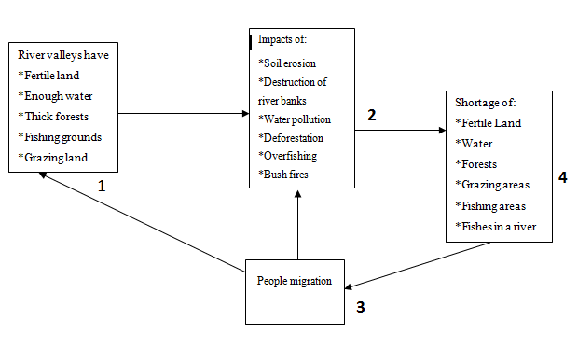

Figure 2.1: Impact of Migration of People on Natural Resources in Ruvuma River Valley
Source: Adopted and modified from Waugh, 2000.

Some people were using prohibited nets for fishing activities that catch the premature fishes at the same time destruction of breeding grounds for fish. Also, the practice of keeping large numbers of livestock in small areas results into land degradation. Bush fires were common in the farms by farmers. The practice of growing one crop for a long period of time has been noted to exhaust the land. These impacts result into the shortage of land for farming activities, absence of fish or little fish in the rivers compared to the demands. Grazing areas and water become a problem; forests were diminished and sometimes were reduced in size.

In turn, the migration of people took place at a particular place where those effects were prevailing towards the places such as in the river valleys. In the river valleys there were different kinds of natural resources, like fertile lands for farming activities, enough water for irrigation and livestock and enough pastures for feeding livestock. Also in the river valleys there were thick forests which provided the shade in the catchment areas and the rivers provided room for fishing activities. However, the migration of animals like cattle in large groups from one place to another caused soil erosion. Also when large numbers of livestock were grazed in a small place, destroyed the vegetation of the place, especially the young trees.

The study has independent and dependent variables. Independent variables were those variables the investigator has chosen to study in order to assess their possible effect(s) on one or more other variables. The independent variables in the study include, migration of people searching for natural resources such as (fertile land, forests, water in the river valley and grazing land for livestock). The dependent or outcome variable depended on what the independent variable did to it (Fraenkel and Wallen, 2000). The dependent variable in the study was the impact of migration of people on the natural resources in the Ruvuma river valley.

CHAPTER THREE

RESEARCH METHODOLOGY

Introduction
This chapter focused on the study area and research methodology. Its sections included the research area, research design, the target population, sampling and sampling techniques. It further highlighted the sources of data, various instruments and methods used in data collection, data analysis, presentation and interpretation. Other issues presented in this chapter were ethical issues, reliability and validity of research instruments.

The Study Area
This study was conducted in Ruvuma Region in Ruvuma River Valley which passes through Songea Municipality and Songea Rural District. The Ruvuma River starts at the bottom of the Matogoro hills and drained towards the west side of the Matogoro hills where at some few kilometers, it entered the Namtumbo District. Ruvuma region was situated in the southern part of the country. The region extends between latitudes 900 35' to 1100 45' South of Equator and longitudes 3400 35' to 3800 10' Meridian, Ruvuma Region borders the Republic of Mozambique in the South, Lake Nyasa and Mtwara Region in the West and Iringa Region in the North-North East. The lowlands in the eastern part of the region are 3000 meters above sea-level while the Northern and Western parts of Lukumburu and Matengo mountains rise to the level of 2,000 meters above sea level.

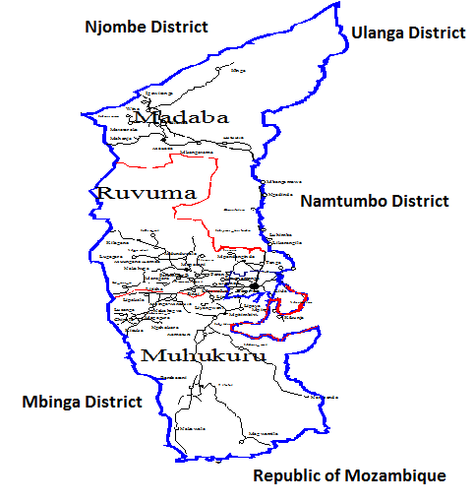

Figure 3.1: The Map of Songea Rural District Showing the Study Area at Nakawale and Magwamila Villages

The Ruvuma River originated from the springs of the Matogoro hills, accumulating water at the bottom of the hills to form the tributaries that collectively form the river at some far distance from the root of the hills. The River drained its water into the Indian Ocean in Mtwara Region approximately 670 km from its source to the ocean. The study focused on exploring information on the impacts of migration of people on natural resources in Ruvuma River Valley. The rationale for selecting Ruvuma River Valley as the study area was that no research has been conducted to highlight the impacts of migration of people on natural resources in Ruvuma River Valley.

Research Design
A research design is a strategic framework for action with the objective to be a link between the research questions and the execution or implementation of the research, in such a way that the internal and external reliability of the research results can be improved (Blanche and Durrheim, 1999). This study employed the descriptive research design. A case study research design is a description of the state of affairs as it exists (Kombo and Tromp, 2006). It is a procedure for systematically collecting information from people in the field by obtaining their responses to questions using the questionnaire, Focus Group Discussion, interviews and observation as instruments for data collection (Phillips, 1985). This method can be used when collecting information about people’s attitudes, opinions, habits or any of the variety of education or social issues (Orodho and Kombo, 2002). The aim of the descriptive research design is to obtain information from widely scattered respondents, which could be analyzed, patterns extracted from it and comparisons made (Bell, 1993).

Case research design was chosen because the study tried to establish the causal relationship between two variables (Saunders et al. 2007). The variables examined were migration of people in search of natural resources and the impacts of migration in the Ruvuma river valley. Case study approach had assisted the researcher to study the impacts of migration of people in order to relate it with the migration of people on natural resources such as fertile land for agriculture, water for irrigation and livestock in the Ruvuma River valley. The descriptive approach therefore was found useful for this study.

Target Population
Population refers to the entire group of individuals to which studies are interested in obtaining the information for the study in order to generalize the conclusions (Julius, 1998). Statistically, population was the entire aggregation of items from which samples can be drawn. The targeted population for this study was villagers in the Nakawale village in Muhukulu ward and Magwamila village in Lilahi ward. However, the study targeted farmers, fishermen and pastoralists who were living along the Ruvuma River Valley.

Sampling Techniques and Sample Size
Sampling refers to techniques used to get samples for the study. Sampling is a branch of applied mathematics concerned with the collection and interpretation of quantitative data and the use of probability theory to estimate population parameters (Charles, 1995). While selecting a sample size, researchers are advised to put into consideration three important aspects; the availability of population, methods of sampling to be used, and the financial resources available for the facilitation to the specific study (Charles, 1995). This study combined both purposive and random sampling as the techniques of getting samples for the study. Purposive sampling was used in identifying village chairpersons, ward executive officers and village executive officers from the study villages. These leaders provided detailed information concerning the impact of migration of people on the natural resources in the study area. The focus on the leaders was made because it was expected that they possessed reliable data that were to be used in the study.

Random sampling technique is a selection technique that provided each population an equal chance of being included in the sample (White, 2003). Random sampling was used to get sample from farmers, fishermen and the pastoralists. One hundred and fifty nine farmers (159), nine (09) pastoralists and thirty one (31) fishermen were randomly selected. The following ways were used to get the samples with esteem to the respondents. In Nakawale village 75 farmers were selected to be involved in the study. In order to get 75, the researcher wrote 150 pieces of papers and numbering them from 1- 150. Thereafter, a researcher allowed the respondents to pick a piece of a paper written a number.

Finally, the researcher could decide who will be involved either those with even numbers or those with prime numbers provided that the study got 75 respondents to be involved in the study.

In order to get 15 fishermen from the population, the same method was used whereby, 30 pieces of papers numbered from 1- 30 were prepared. The respondents were allowed to pick a piece of a paper written a number. The researcher could decide who had to participate in the study. The choices were either that have picked the prime numbers or odd numbers provided that the picked pieces of papers with written numbers resulted into 15 the targeted samples. There were no pastoralists at Nakawale village in the Ruvuma river valley but most of them concentrated at Magwamila village.

In Magwamila village, 84 farmers were obtained by preparing 168 pieces of papers. Thereafter, the farmers were allowed to pick the pieces of papers written numbers. Every farmer was allowed to pick one piece of a paper. Then the researcher could decide who will be involved in the study. The selections were either those who had picked odd numbers or even numbers in which when counted results into 84 farmers. Nine pastoralists were obtained by preparing 18 pieces of papers. The farmers were allowed to pick the pieces of papers written numbers. Every pastoralist was allowed to pick one piece of a paper and then the researcher could decide who would be involved in the study.

The choice was either those who had picked odd numbers or even numbers in which when counted results into 09 pastoralists. Also, sixteen fishermen were obtained by preparing 32 pieces of papers. Then the fishermen were allowed to pick the pieces of papers written numbers. Every fisherman was allowed to pick one piece of a paper from box. The decision was either those who have picked odd numbers or even numbers in which when counted results into sixteen pastoralists.

Sources of Data
Data are the facts and figures collected for records or any statistical investigation (Adams and White, 2007). There are two main sources of information normally used for research purposes, which are primary and secondary sources of data. Primary data are those data in which are needed to conduct a new survey for gathering information at different levels with regard to the inquiry. Secondary data are those which are made available or have been collected for other research purposes (Khan and Robert, 2007). Primary data were obtained through questionnaires, interviews, direct observation and focus group discussions. Respondents for this study were selected among the community members in selected villages. Secondary data were obtained from books, official documents, journals and other publications that are relevant to this study.

Data Collection Methods
Different methods and instruments were used in the collection of data. These included administration of questionnaire, interview, observation, documentary literature review and focus group discussion. Digital camera was used for pictures during the observation.

Administration of Questionnaires
A questionnaire refers to a set of questions for gathering information from individuals (Taylor and Powell, 1998). The questionnaires (Appendix 1) were given to the sampled respondents to fill them. Enough time was given for the respondents to fill in the questionnaires. The information collected from questionnaires included the impacts of migration of people on natural resources in the Ruvuma River Valley.

Interviews
Interview is a method of data collection that involves two or more people exchanging information through a series of questions and answers (Kristin, 2002). The questions are designed by the researcher to elicit information from interview participant(s) on a specific topic or set of topics (Kristin, 2002). The researcher prepared a list of questions or interview guide (Appendix 2) that was used during the interviews. Interview was used for officials like village chairmen, village elders, village executive officers and resources officers who were knowledgeable about the migration in the Ruvuma River Valley.

Focus Group Discussions
A focus group discussion is a form of group interviewing in which a small group usually not less than five members and should not exceed eight people (Krueger, 2011). This group of people is usually led by a moderator (interviewer) in a loosely structured discussion of various topics of interest. The course of the discussion is usually planned in advance and most moderators rely on an outline or moderator’s guide. The main focus of discussion is to ensure that all topics of interest are covered (Morgan, 1997).

In this study a small group of people was made from five to eight people from farmers, fishermen and the pastoralists. The discussions were conducted over various topics of interests and the researcher guided them to ensure that all the topics of interests, basing on the research objectives, were covered. The Focus Group Discussion in the study area at Nakawale and Magwamila were as follows: At Nakawale village there were two groups, first group was farmers and second group was fishermen. The three groups were formed in Magwamila village first group was farmers and second group was fishermen and other was pastoralists. The groups were characterized by village leaders, religious leaders, village elders, herbals, farmers, fishermen and pastoralists. Also, village executive officers, forest officers and resource officers were included. The researcher avoided gender bias by balancing the ratio of respondents as males and females.

Direct Observation
Marshall and Rossman (2015) defined observation as the systematic description of events, behaviors, and artifacts in the social setting chosen for the study. Observations (Appendix 3) enable the researcher to describe existing situations using the five senses taking some photographs shown really situation of the study area. Michael Patton (2010) stated that, direct observation provides insight of activities which may go unreported by participants. This gives the researcher direct experience of the phenomenon being studied. It also creates an opportunity for researcher to see and hear what is happening in a social setting rather than focusing solely on narrative descriptions of the participants.

The study has also used observation technique in order to supplement information collected through other data collection methods. Observation checklist (Appendix 3) was used in observing issues, things which has informed the research objectives. In the field the study observed that soil erosion is caused by farming activities and livestock keeping in the Ruvuma River Valley in the study area. It was also observed that, the state of river banks and the state of forest deforestation, as well as fishing activities in the Ruvuma River Valley. Through observations the researcher had an opportunity to make personal judgment regarding the situation on the ground. The researcher used the camera and took photographs in the study area that was used to show the real situation in the study area.

Documentary Literature Review
Documentary literature review involves the review of texts, books and other documents (Scott, 2006). The documentary literature review includes government publications, books, newspapers, certificates, census reports, novels, films, video and paintings. Photographs, visual and pictorial sources, papers, electronics or other `hard copy' form are also reviewed. Documentary literature review has used to collect secondary data. The researcher employed documentary sources of data so as to have a thorough understanding of the past, present and predict the future trends of impact of migration of people in the Ruvuma river valley across the study area. Documentary sources of data included: various national policies, migration of people, guidelines of environmental issues, and other documents such as government publications, newspapers, certificates and census publications.

Data Analysis, Interpretation and Presentation
Data analysis is the process of systematically applying statistical or logical techniques to describe and illustrate, condense and recap, and evaluate data (Shamoo and Resnik, 2003). Data analysis started with individual responses which were purposively sorted and grouped coherently with the research objectives and research questions. The data collected were reduced into small parts easy to manage and interpret. In this research both qualitative and quantitative approaches were used in data analysis.

Responses from the questionnaires were coded, summarized and analyzed using the IBM Statistical Package for Social Sciences (SPSS) version 16.0. Data were entered into the SPSS spread sheet following the developed codes or format. The SPSS program was appropriate since it has features that accommodated the categorical variables; and which performed all the statistical tests and the classification analysis required in this study making it compatible to the data and problem in questions. It was a more user friendly program. After data entry was completed, data were cleaned and verified prior to analysis. Descriptive analysis was conducted basing on the data from primary and secondary sources. The analysis involved computation of frequencies (numbers and percentages) of the distributions. Qualitative data obtained through interviews were analyzed by using content analysis method.

Validity and Reliability
Validity means research instruments accurately measure what they were intended to measure or the extent to which research findings are really about what they profess to be about it. This judgement, in general, depends on whether the measuring instrument leads to inferences that are meaningful and useful (Finchilescu, 2002). To ensure validity of the data, questionnaire, observation, interview and focus group discussion methods of data collection were used in order to ensure effective data collection. The use of qualitative approach helped to demonstrate validity and open up new perspectives about the topic under investigation.

Saunders et al. ( 2007) defined validity as the extent to which data collection method or methods accurately measure what they were intended to measure or the extent to which research findings are really about what they profess to be about. The data collection methods for survey data was easier to assess where clear explanation of techniques used and response rate as well as the questionnaire used indicated a degree of validity. The process by which the data was selected, collected, or recorded was also deemed valid.

Reliability refers to how consistent a research procedure or instrument is. It is the degree of consistency demonstrated in a study (Julius, 1998). The researcher used different instruments to measure what is supported to ensure reliability. The study used questionnaire, interview and observation and focus group discussion to a sample selected to test the reliability. In other words, similar observations would be made or conclusions reached by other researcher or where there is transparency in how sense was made from the raw data ensure reliability (Saunders et al, 2007). Secondary data collected through a survey, from other researchers, with a high response rate were more reliable to utilize than the one with a low response rate. With data collection instruments, the researcher ensured that the authority or reputation of the source of data was well assessed. The method by which the data were collected and to find out the precision needed by the primary user.

Ethical Considerations
The ethical issues were adhered to during the research process. The intention of the study was made clear to the respondents to avoid ambiguities. Accurately, yet comprehensive information was provided to the respondents in order to make them clear about all aspects, objectives and outcomes of the research. Mutual approval form, permission letter and other written consent, if needed dually signed by the researcher and the respondent. It was made sure to secure and protect the information gathered from respondent to avoid any harmful consequences for them. The confidentiality of the participants was protected to the highest extent acceptable by the law. In order to overcome potential ethical issues in writing the research regarding the use of verbal communication, suppressing, falsifying or other counterfeit practices, the complete particulars were released so that the readers determined by themselves the trustworthiness of the study.

CHAPTER FOUR

RESEARCH FINDINGS AND DISCUSSION

Introduction

This chapter examined data collected from the field on the impacts of migration of people on the natural resources in Ruvuma River Valley. This chapter includes the characteristics of respondents, descriptive analysis of focus group discussion, questionnaires, interviews and data collected using observation in the study area.

Characteristics of the Respondents
The movement of people into the Ruvuma River Valley has been taking place for a long time as indicated in several studies (Hoeggel et al. 2012); (Mwambene et al. 2014). Population in the study area has been increasing as the time went on. Nakawale village in 1988, the population was 452 people whereby 228 were males and females were 224. In 2002 the population reached 590 people whereby 300 were males and females were 290. In 2012 the population rose to 980 in which males were 500 and females were 480. Magwamila village has recently mushroomed, in 1990. It had a total population of 552 people, whereby 282 were males and 270 were females. In 2012 the population was 1,108 people whereby 560 were males and 548 females (Songea Rural Statistics Bureau, 2014).

Most of the people found in the study area were the Yao and Ngoni and few ones were the Ndendeule and the Sukuma as well as the Barabaig who were the pastoralists. The Yao, Ngoni and Ndendeule were farmers; others were doing business, teachers and nurses. Sukuma and Barabaig were the pastoralists grazing their animals in the study area. The farmers were conducting their farming activities in the Ruvuma river valley. The crops grown were. The farming systems in the study area included both annual food crops and cash crops. The main food crops included cassava (Manihot esculenta), rice (Oryza sativa), maize (Zea mays), sweet potatoes (Ipomoeat batatas), groundnuts (Arachis hypogaea), cowpeas (Vigna sinensis), pigeon peas (Cajanus cajan) and beans (Phaseolus vulgaris). Also, Cassava, finger millet (Eleusine coracana) and sorghum (Sorghum bicolor) were the preferred food for a long period of time as the staple food in the study villages of Magwamila and Nakawale in Songea Rural District. Cashew nuts production was made a main cash crop in the study area.

Other perennial crops in the study area included citrus fruits and mangoes. Currently, the pastoralists had been grazing their animals in the study area and their number had been increasing as it was observed in the study area. The pastoralists were staying with their families in the grazing areas in the study area.

Age of the Respondents
Table 4.1 presents the age of respondents which range from 18 to 95 years. About 26% of the respondents were aged between 18-28 years old, 35% were between 29-39 years, 23% were of the age between 40-50 years and 5% between 51-61 years, 8% between 62-72 years, 2% between 73-83 years and 5% were aged between 84-95 years.

Table 4.1: Age of the Respondents
Age |  | Respondents |  | Percentage
18 - 28 |  | 17 |  | 25
29 - 39 |  | 23 |  | 34
40 - 50 |  | 15 |  | 22
51 - 61 |  | 3 |  | 4
62 - 72 |  | 5 |  | 7
73 - 83 |  | 1 |  | 1
84 - 95 |  | 5 |  | 7
Total |  | 66 |  | 100
Source: Field data, 2015

Marital Status of the Respondents
Table 4.2 shows that 90.9% of respondents were married, 6.1% divorced and 3% were single. The findings indicated that different respondents in relation to the marital status were married, divorced and single were among the migrants in the Ruvuma River Valley.

Table 4.2: Marital Status of the Respondents
 | Marital Status |  | Respondents |  | Percentages
 | Single |  | 02 |  | 3.0
 | Married |  | 50 |  | 90.9
 | Divorced |  | 04 |  | 6.1
 | Total |  | 66 |  | 100.0
Source: Field data, 2015

Gender of the Respondents
In this study 59.1% of respondents were males and 40.9% of respondents were females (Table 4.3). The number of females did not match with the number of males as presented in Table 4.3, because the targeted population found in the study area was the one which was used in the study. The number of females found in the study by the time the data was collected was low compared to males. Some respondents reported that they had married and their wives went to visit their relatives in the neighboring wards because during the dry seasons most of the farmers do have a rest. This situation made the study to decide to work with the available respondents despite of number of males overweighed the number of females.

Table 4.3: Gender of the Respondents
S/n | Gender | Respondents | Percent
1 | Female | 27 | 40.9
2 | Male | 39 | 59.1
 | Total | 66 | 100.0
Source: Field data, 2015

The respondents reported that males were migrating at a long distances than females. For example lumbers were covering long distances to search for big trees in the forests so as to get timbers. Pastoralists did not migrate with their families and the possibility of living with them in the forests was difficult because of harshness conditions in the grazing grounds. The researcher witnessed three women among eight men in the grazing grounds. Farmers in the study area were males and females but the number of males was big. This symbolized that as far as shifting cultivation was concerned the females were not managing to migrate more often with children as males used to do. Slash and burn was managed by males especially cutting trees and tall grasses.

The respondents said that only males were conducting their fishing activities than females who could not be able to conduct fishing activities. They could be able to assist fishermen to sell the fish in the neighboring villages or within the villages as the fish mongers. Through this situation males were seen migrating more than females in compared to the nature of activities and where the natural resources were obtained. Hunters were farmers and fishermen so they planned what to do in the following day depending on the requirement of the family. They used to make a camp of one-two weeks and they travelled a long distance to search wild animals for food. This activity was done by males as the respondents reported.

Education Level of the Respondents
The findings revealed that many of the respondents were primary school leavers. Since their level of education was low, it was found that many of them were engaged in shifting agriculture as the way of earning their daily bread. Table 4.4 shows that 68% of respondents had primary education, 17% had reached secondary school level and 15% have never been to school.

Table 4.4: Education Level of the Respondents
S/n | Education level | Respondents | Percent
1 | Never gone to school | 10 | 15.1
2 | Primary | 45 | 68.2
3 | Secondary | 11 | 16.7
 | Total | 66 | 100.0
Source: Field data, 2015

Occupation of the Respondents
Occupation of the respondents was seen as an important aspect for this study. It was established by the study findings that many of the respondents practiced agricultural activities such as farming and livestock keeping. This occupation was seen as the driving force behind people`s migration. This was because, people required large areas for practicing these activities. Table 4.5 indicates the occupations of the respondents as per study, 82% of respondents practiced agriculture only, 15% fishing and 3% were public sector workers.

Table 4.5: Occupation of the Respondents
S/n. | Occupations | Respondents | Percent
1 | Agriculture | 54 | 81.8
2 | Fishing | 10 | 15.2
3 | Public sector workers | 03 | 03.0
 | Total | 66 | 100.0
Source: Field data, 2015

Migration and Natural Resources
Table 4.6 shows that 89.4% of the respondents were aware of migration movement of people in the Ruvuma River Valley and its determinants. This meant that people in the Ruvuma River Valley have been migrating from different areas in search of fertile land, plenty of water for domestic use, fishing and agricultural activities, forests and pastures for grazing animals. The valley was not their original place of residence and this was well expressed by the old generation of respondents when compared to the new generation of respondents. About 10.6% of the respondents acknowledged that they are not aware about the migration of people in the Ruvuma River Valley. This was because; these are people who were born there and thought that the river valley was their mother land. The migrants were not aware that people who were in the Ruvuma River Valley were the migrants in the past years. That was why some respondents replied that they were not aware on the migration movement of people in the Ruvuma River Valley.

Table 4.6: Respondents Aware On the Migration to the Ruvuma River Valley
S/no | Responses | Respondents | Percent
1 | No | 7 | 10.6
2 | Yes | 59 | 89.4
 | Total | 66 | 100.0
Source: Field data, 2015

The respondents were asked about their understanding obout migration (Table 4.7) to the Ruvuma river valley. About 30.3% of Ruvuma river valley inhabitants who responded to the survey attested a good understanding of migration phenomenon and its effects as well. This meant that; they knew much about the migration of people in the Ruvuma River Valley. They had a great knowledge on what attracted them to the river valley and what forced them to migrate to the Ruvuma river valley. About 36.4% of respondents said that, they understanding little about migration of people to the Ruvuma River valley. This meant that some respondents had a normal level of knowledge of migration of people in the river valley. That people were there just because of availability of fertile land, water, forests and others in compared to the rest of respondents who replied at other levels of understanding of migration movement of people in the river valley.

Table 4.7: Level of knowledge about migration to the Ruvuma River Valley
S/no | Knowledge about migration | Respondents | Percent
1 | I don’t know much | 22 | 33.3
2 | I know much | 20 | 30.3
3 | Normal level of knowledge | 24 | 36.4
 | Total | 66 | 100.0
Source: Field data, 2015
About 33.3% of respondents affirmed that they did not know much about migration and its consequences on natural resources in Ruvuma River Valley. This was the group of respondents who had a little knowledge on the migration of people in the Ruvuma river valley. These respondents were among of new generation who thought that Ruvuma river valley was their mother land. But at a distance used to hear from their grandfathers and grandmothers that they came from different areas and the migration phenomenon was not clearly explained to the new generation of respondents to know where they came from and why. Also, these respondents had a little experience on the migration of people in the river valley.

Reasons for Migration to Ruvuma River Valley
Several reasons were given for migration to Ruvuma River Valley (Figure 4.1). The majority of the respondents of about (98%) were migrated to the Ruvuma River Valley seeking for fertile lands and availability of water streams was about (85%) of respondents. Other reasons were opportunity for agricultural business (83%), availability of forests for keeping cattle and raising bees for honey (79%) and availability of fishes (67%). Moreover, (61%) migrated to Ruvuma River Valley because of availability of wood for building and charcoal supported and 36% for safety drinking water. However, (97%) of the respondents explained that, the natural resources found in the river valley was the reason of migration of people into the Ruvuma river valley, while (3%) of the respondents said aridity in their area of origin was the reason for migration. The wetlands in the river valley helped them to practice agricultural activities throughout the year.
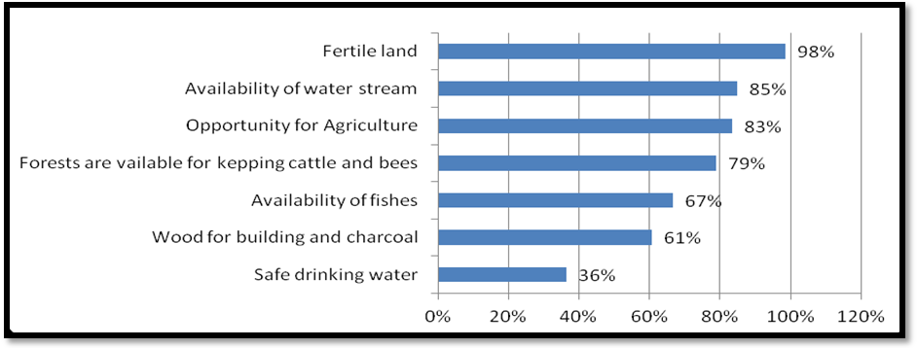

Figure 4.1: Reasons for Migration of People to Ruvuma River Valley
Source: Field data, 2015

Figure 4.2 presents the determinants of migration of people to the Ruvuma River Valley. The determinants of migration of people in the study area were natural resources (97%), drought (12%), inundation (12%), starvation (12%), social responsibilities (11%) and job opportunities (3%). The natural resources in the study area were known as the wealth supplied by nature and available for human use. Natural resources in the Ruvuma River Valley are forests, soil fertility, water, fish, wildlife, timber, natural pastures, mineral deposits and natural scenery.

These natural resources were available in large quantity in the river valley that attracted people at (97%), and made them to migrate from their original areas to the river valley. In the original areas these natural resources were exhausted because of overexploitation when compared to the destination areas.
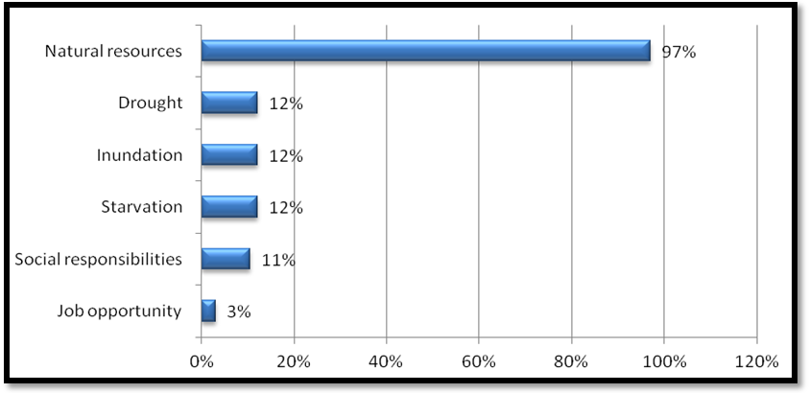 Figure 4.2: Determinants of Migration
Source: Field data, 2015

Drought was known to the respondents as the prolonged, continuous period of dry weather which meant a long period of time when there was little or no rain which constituted 12% of respondents`. This situation forced people in their original areas to move in search of palatable areas where there were alternative means of survival. The Ruvuma River Valley was a place in which people migrated and settled therein for their survival. Because, the valley had enough water throughout the year for domestic use, agriculture and for animals and also the river valley had a lot of forests that provided shed and regulated climate and provided the other basic needs like, fuel wood, timber and trees for construction of houses, medicine and fruits as well as wildlife. Fertile land pastures for livestock.

Inundation was defined by the respondents as specifically to a flood of water, like when a river bank was at risk of inundation after several days of heavy rain. About 12% of the respondents explained that in the original areas the inundation was a common phenomenon. This caused the deaths of people and destruction of their property. The solution to this phenomenon was to move to the free areas from the areas that are used to flood more often during the heavy rains. Along the Ruvuma River Valley was the good place for settling and conducting their social and economic activities.

Starvation was explained by the respondents as the state of suffering and death caused by having no food to eat or having nothing that you need which had (12%) of respondents. The respondents explained that due to the occurrence of drought and inundation, people suffered a lot and others died in the original areas before they had decided to migrate to the Ruvuma River Valley. Drought caused the crops to dry before flowering like maize and floods covered the all areas where people were living. This led people to lack food when their planted crops dried out and during the floods their properties and crops like sweet potatoes, cassava and maize were destroyed and lost. The old people, children and their mothers were the ones who were subjected to the catastrophe when broke out. These difficult conditions brought about the hardships which led people to move from these areas as sometimes were regarded as the misfortunes. The respondents acknowledged that starvation was worse in the original places and forced people to migrate to Ruvuma River Valley.

Social responsibilities referred as the people and organizations behaved ethically and with sensitivity toward social, cultural, economic and environmental issues. Striving for social responsibility helped individuals, organizations and governments to have a positive impact on development, business and society with a positive contribution to bottom line results. The social responsibility had 11% of respondents supporting it. In the destination areas there were the other activities conducted such as small business, health services, schools and religious matters. The respondents who were involved in the study explained that some social activities forced them to migrate from different areas to the study areas where these socio-economic activities were available. Also, respondents reported that other people were still migrating from different areas where there were no such services to the study areas following the social and economic services.

Job opportunities: An opportunity was referred as a situation in which it was possible for respondents to do something that they wanted to do. Job opportunities were jobs that were possible for respondents to pursue in their field or line of work. Job opportunities offered a variety to a respondent looking for a new position in the study areas. Respondents of about 3% who were involved in the study reported that job opportunities were very few and were only to some teachers who were teaching at primary schools, ward, village executive officers and nurses at health centres. These respondents were there in the study areas as the employed ones.

The majority of the respondents, (94%) were convinced that there was a relationship between migration and natural resources. The respondents reported that migrants in the study area were following the available natural resources such as fertile lands, forests, water and ponds in the river valley, pastures for livestock, fish and wild animals for meat. So those natural resources were reasons for the migrants to move. The respondents added that in areas where those natural resources were scarce the migrants were not interested to go therein. Whereas, 6% of respondents thought that there was no such a relationship. The respondents who were dealing with other activities other than agriculture, pastorals, lumbering, fishing and the alike did not know exactly the existing relationship between natural resources and migration. That was why they replied no relationship between migration and natural resources. The respondents who knew well their presence in the river valley reported that it was only the availability of natural resources that made them to be therein. Because most of the migrants were farmers, fishermen, pastoralists and others were lumbers. The different activities conducted were determined by the availability of certain type of natural resource in the Ruvuma River Valley.

All respondents, (100%) confirmed that the availability of fertile land for agriculture activities was the main factor for migration of people to the Ruvuma River Valley (Figure 4.3). About 95% said that the availability of abundant streams of water was also influencing migration while 91% said that fishing activity was another factor for migration. However, 89% said that the availability of forest for charcoal, firewood and wood for construction was also associated with migration, where 83% confirmed that the possibility of keeping bees for honey was also a factor for migration of people to Ruvuma River Valley.

Moreover, 61% and 24% of the respondents suggested that the availability of green pasture and good environment for human activities, respectively, contributed to migration of people to Ruvuma River Valley.
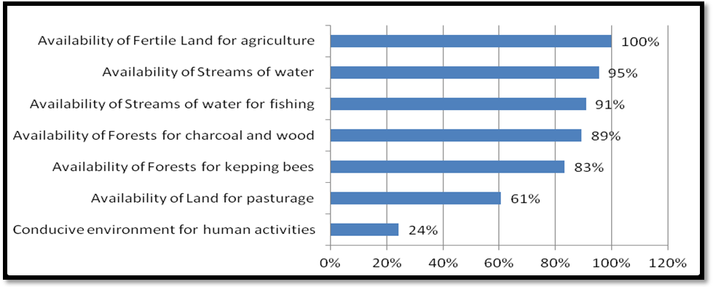

Figure 4.3: Natural Resources lead to Migration
Source: Field data, 2015

Natural Resources in the Ruvuma River Valley
Figure 4.4 presents the natural resources found in Ruvuma River Valley. The majority of respondents (97%) mentioned forest. This was because at that particular time the migrants were establishing their settlements as the first human being to live there in the Ruvuma River Valley. The respondents witnessed that no body was living there by the time they were approaching therein. Forests covered the whole river valley and in the dry land because no body was there cutting the trees for a certain purpose. The forests were used as the source of medicine through tree leaves, roots and barks. Some trees provided wild fruits that were consumed. Trees were used for house construction that was why migrants decided to settle around the river valley. Forests conserved water sources, provided shed and regulated the climate through influencing the rainfall. Also, forests offered fuel wood as the source of energy. The big trees were used to make wooden canoes as it was observed in the field of study in the Ruvuma river valley. These canoes assissted much fishermen in fishing activities in Ruvuma river. Also, trees were used to make fenses surrounding the houses and making fires outside the houses to keep away the predators like lions and hippoppotumus.
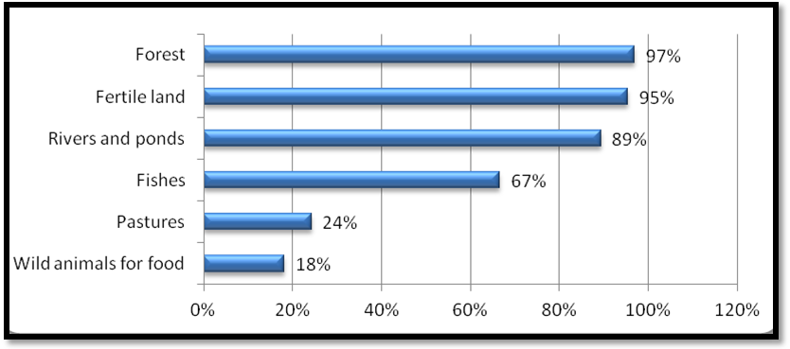

Figure 4.4: Natural Resources found in Ruvuma River Valley
Source: Field data, 2015

However, 95% of respondents mentioned fertile land as another resource in the valley. The Ruvuma River valley had been flooding seasonally for a long period of time. This phenomenon caused the river valley to be fertile for a long period of time. The availability of fertile lands in the Ruvuma river valley facilitated the migrants to move from different areas to come and dominate the river valley for different activities. The fertile land was used for farming activities where different crops such as maize, yarms, banana plantains, finger millet,sorghum, cassava and sweet popatoes were grown. Other crops grown there were sugarcane, tobacco and cashewnuts and groundnuts. The found fertile soil in the Ruvuma river valley made the agricultural activities to be easy because there was no need of additional of fertilizers in the dominated farms in the river valley. About 89% of respondents reported that there were river and ponds. In the Ruvuma river valley there were many great ponds that contained varieties of fish. In the Ruvuma river fishing activities were taking place and its ponds. The ponds were less risky in compared to the main river where crocodiles and hippoppotumus were their home and untill furthernotes. Ponds were sources of water and maintained the ecology of river valley.

About 67% of respondents said that fishes were other natural resources found in the Ruvuma river valley. Fishermen took advantages of catching fish in the river and its ponds. Varieties of fish were found in the Ruvuma river and were caught easily. Different methods were used to fish such as hooks, migono, leaves of trees, roots and processes bark of trees though other methods were illegal methods used especially in the ponds to get fish. However, 24% of respondents said green pastures which was used to feed the domestic animals. These pastures were plenty as it was reported by the respondents. Because in the Ruvuma river valley land in most cases was wet and fertile which not only facilitated by the floods but also the decayed vegetation in the surroundings.

Also, 18% of respondents said that the natural resources found there was wild animals. Some wild animals were and still be hunted for getting meat as food. The antelopes, hare and other edible animals were hunted and when killed the meat was eaten and other sold so as to get the income by the hunters in the Ruvuma river valley. Because of availability of pastures and water sources it became easy for hunters to make traps in the targetted areas and caught them easily. Some hunters had fire arms that used to shoot wild animals. These natural resources found in the Ruvuma river valley made people to specialize on the different activities so as to utilize them effectively.
Figure 4.5 presents resources which attracted people to the Ruvuma river valley. The respondents reported that the availability of forests in the river valley attracted people for about 100%. People have been using forests found in the river valley for lumbering for commercial and construction purposes. Also trees had been used for construction of houses, hunting, and medicine collection. Furthermore, forests have been used for regulating the climate in the place and bee keeping as pointed out by 83% of the respondents. Fertile land has been another source of attraction of people in the Ruvuma river valley. The data obtained in the field revealed that 100% of the respondents involved in the study agreed that fertile land in the river valley attracted people to migrate to Ruvuma River Valley. The fertile land was mainly for agricultural activities where different crops had been grown in the river valley. The crops grown were maize, sweet potatoes, sugarcane, tobacco and banana plantains as well as vegetables.
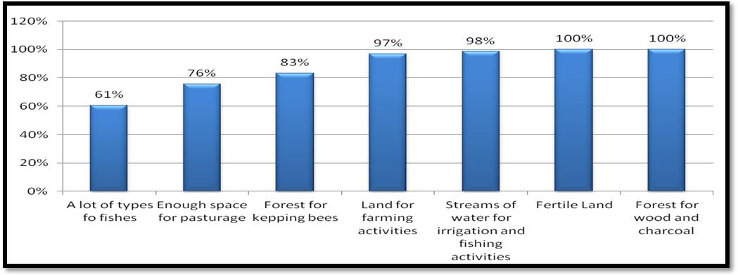 Figure 4.5: Resources which attract people to Ruvuma River Valley
Source: Field data, 2015
Availability of water in the river valley was the source of people’s attraction. Water has been used for irrigating the crops in the dry seasons. Water has been used for washing, drinking and cooking. Water for grazing animals was another source of attraction. People to some extent agreed that water accounted for 98% of the migration in Ruvuma river valley. In the Ruvuma river valley there were the different varieties of fish. This attracted people to migrate to Ruvuma river valley for fishing activities. Among the respondents there were the fishermen who used to catch fish in the river. They had been using the different methods to catch fish such as; hooks, “migono” and mesh nets by using the simple canoes. This constituted about 61% of attraction of people in the Ruvuma river valley. In addition to that, in the valley there was enough space with less competition on the land for grazing. The fishing activities accounted for 76% of the migration in the river valley.

Impacts of Migration of People on Ruvuma River Valley
Figure 4.6 shows that 94% of respondents believed that the deforestation in the Ruvuma River Valley was due to migration; 91% thought that migration has caused soil exhaustion because of mono-culture practice, and 91% said that migration has contributed to bush fire practice. The indiscriminate cutting down of forests was exacerbated by farming activities and uncontrollable bush fires in the study area as presented in Plates 4.1 and 4.2. Also, 86% talked about the decrease of the quantity of fishes in the river as an effect of migration. Shifting cultivation practices along the river banks was another effect of migration according to 67% of respondents. However, 59% of respondents pointed out that soil erosion was another effect of migration, 50% of the people interviewed commented that, migration leads to the destruction of the river banks. Moreover, 26% said that there was the destruction of young plants by animals and 18% were convinced that migration caused land conflict.
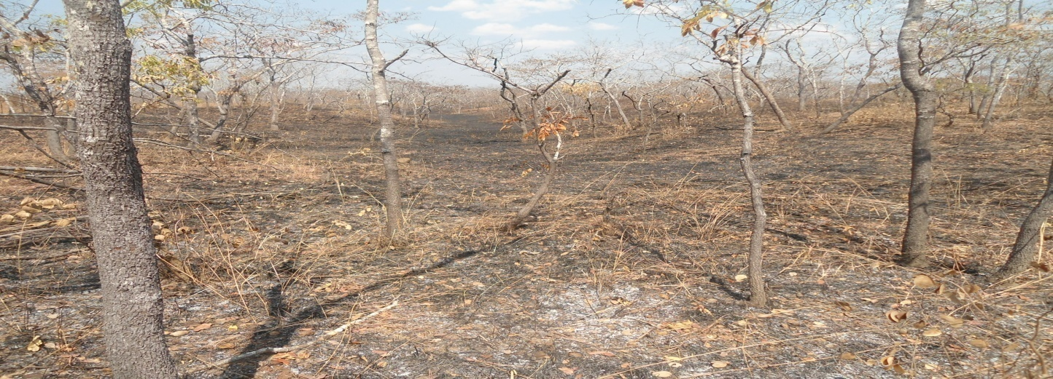

Plate 4.1: Burnt Forest in the Study Area in 2015
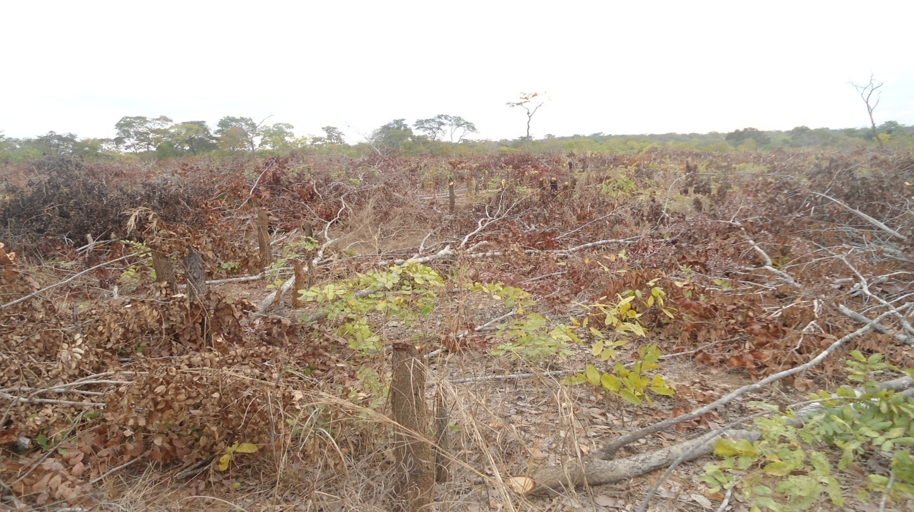

Plate 4.2: Clearing of Land for Farming Activities in the Study Area in 2015

Land conflict is one of the impacts of migration in the Ruvuma River Valley. Land conflict was reported by the respondents that, migrants have farms of different crops like maize, sweet potatoes, and tobacco, sugarcane and banana plantains. The pastoralists had been grazing their animals close to the farms. Sometimes the animals had been eating and destroying the planted crops. When the farmers had been complaining for compensation the pastoralists had not been ready to pay for compensation to the farmers. The respondents explained that some migrants especially pastoralists had been stealing the domesticated animals found in the Ruvuma river valley that belonged to the migrants like goats, sheep and cattle. Also, respondents added that some farmers had the habit of stealing the animals that belonged to the pastoralists. There was no clear boundary for pastoralists and farmers to conduct their activities freely in the Ruvuma river valley. This led the pastoralists and farmers to interrupt and contradict each other over land use as a result all these circumstances raised the land conflicts in the study area as it was noted.
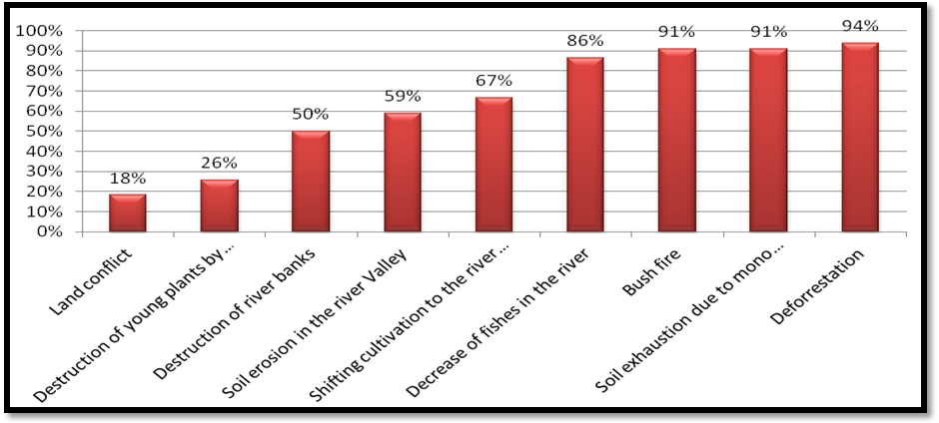

Figure 4.6: Effects of Migration on Natural Resources in the Ruvuma River Valley
Source: Field data, 2015.
Information from government officials made it clear that, pollution of water streams caused the decrease of the type and quantity of fish due to mining activities. The miners used mercury to get gold and minerals leaving harmful chemical substances and unsolved compounds in the river streams, hence destroying the breeding places for fish. Also, government officials confirmed that there was a local committee responsible for dealing with natural resources protection and management but it was not functioning. Hence, they advised the village government to re-establish that committee which used to deal with natural resources management. Specifically in Nakawale village, the government officials pointed out that the reasons for migration of people to the Ruvuma river valley were villagization policy and marriages where women followed their husbands.

Measures to Control the Impacts of Migration
There are several measures in place to control the impact of migration of people in the Ruvuma River Valley (Table 4.9). About 93% of respondents reported that there were little measures done by the local community, village leaders and the local government. These organizations had been there and performing their roles but the only problem was the facilities to enable them to fulfil their responsibilities. For example, in the study area people were found sparsely distributed. This needed the transportation means to monitor the peoples` activities by the organization concerned especially the local government. With the absence of these facilities it had been difficult for the local government authority to perform their roles. The area was so big with sparsely population that made the monitoring of environment to be difficult hence resulted the monitoring activities of environment to be achieved at low level.
The local communities, local government and the village leaders were the ones in the study area to be answerable at all in all issues concerning the environment surrounding them. There were the committees that were responsible for environmental protection. About 3% respondents in the study area reported that the committees were responsible to make sure that the surrounding environment had to be protected. This was done by educating people that when one cut a tree had to replant another one in the same place as soon as possible. Bylaws, regulations and rules were to compel any one to abide on them. The bylaws and regulations and rules wanted that anyone who wanted to cut a tree had to consult the village authority so as to be given the permission to carry on regardless the tree had been belonging to you or it was the common property.

Also, the common properties were strictly prohibited to anyone to utilize without prior permission of the authority was concerned. Despite of all these initiatives, the success was less and less that was why only 3% of respondents agreed on the environmental protection.

Avoiding illegal fishing was another measure that had 2% of respondents was very crucial in which the authority concerned that was village government strictly prohibited the illegal fishing of using poisons of processed leaves, roots and bark of trees in the ponds and in the river. Also the use of prohibited nets (Plate 4.3 and 4.4) by the government of ½ inch and 1inch had decreased the number of fish in the fishing grounds. The fishermen were educated on the disadvantages of illegal fishing and advantages of sustainable fishing. The alternative means of sustainable fishing by the fishermen was to avoid using the processed products of trees and prohibited nets for fishing. In addition they were encouraged to use the proposed fishing nets of about 2, 3, 4, 5 inches.
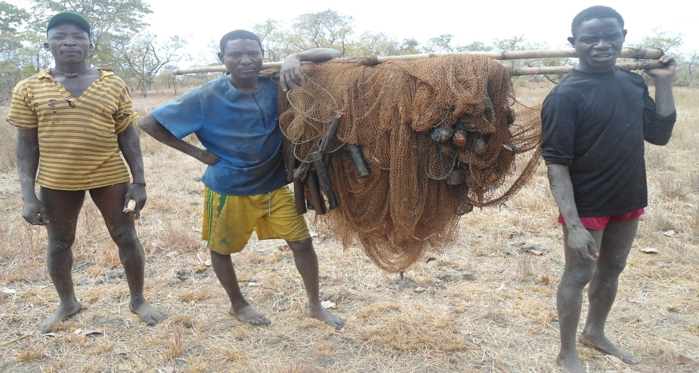

Plate 4.3: Fishermen in the Ruvuma River Valley Carried the Fishing Nets Going To Conduct Their Fishing Activities in the Study Area
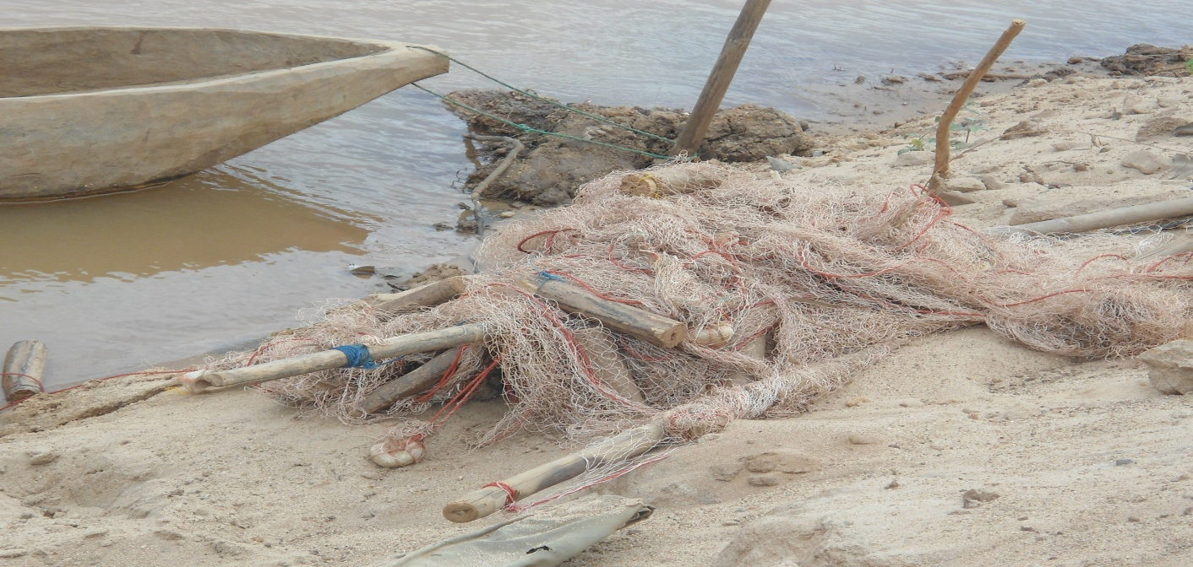

Plate 4.4: Fishing Canoe and the Fishing Nets in the River Prepared For Fishing Activities
Photo by Lubere, 2015
Avoid deforestation and bush fire had 2% of respondents` support. This has shown that the responsible organs were not responsible at a required level. Supervision was weak indeed, people in the study area used to cut trees anyhow and set fire in the bushes and uncontrolled fire in the farms that sometimes spread to the unintended places. Measures had been taken to stop indiscriminate deforestation because of shifting agriculture. Bush fires by the farmers and hunters had been stopped but this had been difficult to control. There were some migrants as it was reported by the respondents that they set fire to catch small animals finally the fire spread to the bushes and destroy many young generation of trees. However, the local government had enforced bylaws, rules and regulations to be observed by every member of the community and ensured that they were followed. Legal step measures were issued to be taken against those who would deny the orders from the local government in the study area.

Table 4.8: Measures taken to control effects of Migration on Natural Resources
Measure to avoid consequences of migration | Respondents | Percentage
Little was being done | 62 | 93
Protection of the environment | 2 | 3
Avoid illegal fishing | 1 | 2
Avoid deforestation and bush fire | 1 | 2
Total | 66 | 100
Source: Field data, 2015

Table 4.9 shows that there were no NGOs in the Ruvuma River Valley dealing specifically with migration issues and environment protection as it was reported by 93% of respondents (Table 4.10). However, 3% of respondents thought that local communities could start acting for environment protection, whereas, 2% suggested that the local government might address the cases of migration and natural resources protection in the Ruvuma river valley.

Table 4.9: Organizations Contributing On Avoidance of Impacts of Migration on Natural Resources
Organizations acting | Respondents | Percentage
There was no NGOs acting in Ruvuma river valley | 62 | 93
Local communities | 2 | 3
Village leaders | 1 | 2
Central government | 1 | 2
Total | 66 | 100
Source: Field data, 2015

Table 4.10 presents the measures of raising awareness on natural resources protection and management in the Ruvuma River Valley. One way of raising awareness was through provision of education to the people on conducting their activities and utilize the natural resources in a sustainable way. Farmers had been encouraged to stop shifting cultivation, to use the modern methods of cultivation and avoid monoculture. Also, leaders had been trying to enforce bylaws, regulations and rules to the people in the study area to follow them. Fishermen as well had been emphasized to use the proper fishing nets in order to continue conducting their fishing activities. Because as they had been using the improper methods of fishing the fish in the fishing grounds had been decreasing time to time. The village leaders and executive ward officers had been emphasizing the community to protect the environment in the surrounding by explaining the importance of forests in the study area. Some of the importance was that, forests regulate the climate of an area, forests provide shed and good air in the surrounding, forests acted as the wind breaker, forests protect the water sources and forests provide timber and a home of wildlife.

Table 4.10: Methods of Raising Awareness on the Effects of Migration in Ruvuma River Valley
Measure for raising awareness | Frequencies | Percentage
Little is being done | 62 | 93
Community discussion | 3 | 5
Public campaigns | 1 | 2
Total | 66 | 100
Source: Field data, 2015

Only 5% of respondents said that sometimes they had community discussions. This was done in the public meeting which was organized by the ward executive officers, village executive officers and heads of the households. To enable these community discussions to succeed different strategies were employed in order to make ends meet. Different matters concerning migration of people on natural resources had been raised and the effects that were even worse and difficult to reverse to the destroyed natural resources. One of the worst events which had been discussed was the use of poisons in fishing activities. Some varieties of fish were scarce currently in compared to the past and others were completely extinct.

Some varieties of trees had extinct because lumbering even the premature one simply because those varieties their products were valued that other species. All those mentioned above were discussed in details so as to mitigate the problems in the near future.
However, 2% of respondents talked about public campaign had some influence in conjunction with community discussions. These campaigns had slight difference with discussions. The respondents reported that different cards, posters, songs and presentations and demonstrations were displayed aiming at educating the community to be aware on the effects of migration on natural resources. The embodied information in the songs, posters, cards and presentations by the different actors who were farmers, pastoralists and the fishermen reflected the meaning to the public campaign. Through these public campaigns people understood well importance of natural resources management and protection.

Table 4.11 indicated that the organizations responsible for educating the population on the effects of migration of people in the Ruvuma River Valley. About 84.8% of respondents in the collected data indicated no NGOs responsible for educating the people on the effects of migration on the environment. About 13.6% of the respondents surveyed indicated that local organizations were responsible to educate the people on the effects of migration of people in the river valley. However, 1.5% of people indicated that, the local government provided education to the people on the effects of migration of people on the natural resources in Ruvuma River Valley.

Table 4.11: Organizations Responsible For Educating the Populations
Organizations | Respondents | Percentages
Local government | 1 | 1.6
Local organizations | 9 | 13.6
No NGOs educating communities | 56 | 84.8
Total | 66 | 100.0
Source: Field data, 2015
The respondents suggested several solutions for the effects of migration on natural resources in the study area (Figure 4.7). The first solution which was supported by 100% of the respondents was to avoid deforestation. The same 100% commented that increase in the level of awareness on the effects of migration of people on the natural resources would also reduce the impacts on natural resources in the study area. However, 95% of people indicated that education should be provided to the people so as to avoid the harmful effects caused by migration in Ruvuma River Valley.
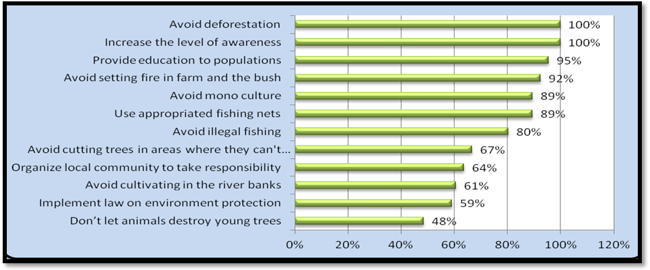

Figure 4.7: Solutions to the Effects of Migration on Natural Resources
Source: Field Data, 2015

Moreover, 92% of respondents revealed that setting of unmonitored fires on farms and shifting agriculture caused the spread of fires to unintended places. So this was seen as a bad practice that might be avoided by all means. Mono-culture was found to be a bad method of agriculture which was suggested by 89% of the respondents in the study area, as it caused loss of soil infertility. Fishermen in the Ruvuma river valley have been using illegal methods of catching fish like poisons, small mesh nets of a half inch and one inches which lead to fish even the small fishes (sardines). 89% of respondents in the study area suggested the use of appropriate mesh nets of about 2, 3, 4, 5 inches. People in the Ruvuma River Valley practised indiscriminate cutting of trees. These activities were; opening up the new farms, shifting agriculture, expansion of farms, constructional of houses and paddocks by the pastoralists. 67% of respondents suggested that indiscriminate cutting of trees on a large scale without replacing them must be avoided in the river valley. In the area of study, there were local community organizations which dealt with the environment in general. The study discovered that, those organizations were not fulfilling their responsibilities. Thus, 64% of respondents suggested that the local community organizations had to fulfil their responsibilities for protecting and managing the environment.

People who conducted several activities in the Ruvuma river valley especially agriculture destroyed the river banks. This practice caused soil erosion in the river valley. Thus, 61% of the respondents suggested that, farmers should at least leave six to ten metres from the river banks. This could have saved the crops to survive during wet seasons and avoid the soil erosion in the river valley. Therefore, 59% of the respondents pointed out that the enforcement of laws could be the solution to the problem. This could promote the efficient and effective utilization of natural resources in Ruvuma River Valley.

During the focus group discussion with farmers, farmers suggested that education should be provided to the society on environmental issues. The village government had to enforce the laws and regulations so as to control the destruction of natural resources in Ruvuma River Valley. Songea Rural Government Authority has to send the agricultural extension officers, bee keeping officers and fishermen officers so as to provide the education on how to utilize the natural resource in the Ruvuma river valley. The government has to demarcate the areas for farmers and pastoralists so as to avoid the conflicts over land use. The studies have to continue to take place in the areas so as to identify more effects of human activities on the natural resources in the Ruvuma river valley.

Farmers should be advised to practise good methods of agriculture such as crop rotation that fertilize the soil unlike the mono-culture. People had to leave at least 6 to10 meters from the river bank so as to avoid the soil erosion and destruction of banks. Moreover, people had to leave the farm at last for two years if a famer has more than 1 hector for soil fertility restoration. Finally, there should be the group of people in the village government which would be dealing with the action of controlling the use of the natural resources available in the environment.

However, the focus group discussion with pastoralists suggested that people who had habits of stealing animals should stop so as to avoid conflicts between farmers and pastoralists. They pointed out that the clear boundary between farmers and pastoralist could help to avoid the conflicts over land use, veterinary officers have to visit the pastoralists more often so as to vaccinate the animals, hence to protect them from the outbreak of diseases such as East Coast Fever, Rift Valley Fever, Foot and Mouth Disease, Bluetongue Virus and Spores of the anthrax bacterium, (Bacillus anthracis). Also, one of the respondents pointed out that the clear markets for selling the animals at least twice a year like auction could help the pastoralists to get other needs like medicine for vaccination and treatment as well as food and clothes. Another focus group discussion with fishermen suggested that fishermen should stop using prohibited nets and poison to catch fish, miners have to be informed about the pollution of the river by mining activities, education on the importance of sustainable utilization of natural resources must be given to the society.

Discussion of the Findings

Relationship between Migration and Natural Resources
The study revealed that there is a relationship between migration of people and the natural resources. The majority of the respondents about 94% agreed that there was the relationship between the migration of people and its impacts on the natural resources found in the study area. This finding was confirmed by Barbieri and Carr (2005) and Massey et al. (2010) who attested that there was a relationship between migration of people and the environment in different places where these kinds of studies were conducted. They pointed out that natural resources play a central role in rural well-being in many regions across the globe and few researches have explored the relationship between migrants’ well-being and natural resource availability.

Other reasons show the relationship between natural resources and migration of people include availability of fertile land for agriculture, availability of water in the Ruvuma River Valley for irrigation, domestic purposes and fishing activities; availability of forests for charcoal, fuel wood, medicinal plants, animals for hunting, wild fruits, trees for house construction and bee keeping. All these reasons trigger migration of people to Ruvuma River Valley. Also, the availability of grazing pastures was another point which was supported by the respondents as a reason for migration. Furthermore, the pastoralists fed their animals in the wetlands of Ruvuma river valley thereby destroying the environment.

Migration and the Degradation of Natural Resources
This study discovered that migration leads to deforestation. Deforestation occurred because of agricultural activities, construction activities, lumbering, cutting of trees for fuel wood and charcoal making. Soil exhaustion due to monoculture was also reported. Bush fires had been the common practice of the migrant farmers and hunters in the river valley. The decrease of fish in the river was noted as another effect of migration in the Ruvuma river valley. Shifting cultivation in the river valley was revealed as the consequence of migration of people in the study area.

Amongst other negative effects of migration on natural resources in the Ruvuma River Valley were: soil erosion and destruction of river banks, grazing of animals in the Ruvuma River Valley, the destruction of young trees by animals and human activities and land conflicts between farmers and pastoralists. The research done in Ecuador focusing on migration of people and deforestation by Bilsborrow (1999) stated that deforestation was due to drug production, insecurity in its Andean neighbors’ Amazon regions and the resulting paucity of road construction. In Ecuador, the migration of people to northern Amazon provinces and the subsequent deforestation by agricultural colonists began in the early 1970s with the construction of roads by petroleum companies to lay oil pipelines (Pichón, 1997). Those roads facilitated an influx of migrant colonists, 75% of which originated in the highlands and 83 percent in rural areas (Pichón, 1997; Pichón and Bilsborrow, 1999). At the same time, deforestation in Ecuador mainly in the Amazon proceeded at a rate of 1.8 percent per year, the highest among the seven Amazon Basin countries (FAO, 1997).

The overall estimated rate of deforestation in Latin America due to migration is 1.2 percent per year in 1995-2000; this remained the highest rate (FAO, 2001). The data obtained to date from specialized household surveys in 1990 and 1999 permitted detailed analysis of the factors responsible for changes in land clearing and land use by migrant households in the Amazon region. These analyses facilitate the development of better demographic, agricultural, environmental, and socioeconomic policies for that region (Bilsborrow et al. 1984; 1997).

Migration and Natural Resources Conflicts
The respondents explained that, the natural resources found in the river valley, the aridity and the need of surviving attracted migrants. The study has shown that the resources which attracted people to the Ruvuma River Valley were: availability of forests in the river valley, fertile land, streams of water and different varieties of fish. The findings of this study were similar to the findings of Mbonile (2005) who conducted a research on Population Migration, and Water Conflicts on the Pangani River Basin Tanzania, where migrants moved from the highlands to more remote lowlands, escaping from drought and famine, seeking more space for settlement. He found that the rapid population growth and high population density could generate conflicts over natural resources as scarcity grows (Mbonile, 1999).
The study also indicated that the level of attraction by natural resources in the Ruvuma River Valley was very high. As Mbonile’s (1999) study depicts migration that generated some land conflicts. Like in Burkina Faso, according to Deshingkar (2012) a study on Environmental risk, resilience and migration: implications for natural resource management and agriculture. Migration was direct related with soil and water conservation, farmers with larger plots of land was able to invest remittances in agriculture. Soil and water conservation appear to have been depressingly impacted by migration.

The measures that have to be taken so as to avoid the effects of migration on natural resources were; improvement of people’s level of awareness on the effects of migration on Natural resources and creating communities’ group discussion on natural resources management. For the sound management of natural resources in the Ruvuma River Valley, the study suggested the following solutions: To avoid deforestation, to increase the level of awareness on the effects of migration and to provide education to the populations. Farmers should also change some farming practice like fire in the farm or in the bush, monoculture method for long time span, shifting agriculture, cultivating on river banks and down cutting trees without replacement. Fishermen in the Ruvuma river valley must avoid the use of illegal methods of catching fish like poisons, mesh nets of a half inch or one inch.

Reasons for Migration of People in Ruvuma River Valley
Unlike Gunvor (2010) on “the environmental factor in migration dynamics” who stated that while most contemporary case studies concluded that there was no linear stimulus-response relationship between drought and migration, the push factor type of studies tended to present rather simplistic models to explain migration dynamics; this study has confirmed a relationship between migration of people and natural resources in the Ruvuma river valley. Migration was related with the habit of setting bush fire, deforestation (meaning cutting trees without replacement), the practice of monoculture for a long time span which caused soil exhaustion, cultivating on the river banks, causing erosion and the use of inappropriate mesh net for fishing causing the decreasing of fishes.

This study confirmed that migrants were less informed about natural resources management. There was a direct relationship between agriculture, deforestation and bush fire among the migrants. Like, Angelsen et al. (1995) conducted the study on Poverty and the Environment and found that the traditional uses of the environment have often maintained a sound balance between people’s short-term needs and the maintenance of the ecosystem’s long-term health, and thereby its ability to satisfy the people’s long-term needs. Population growth increased the pressure on resources (population-driven degradation). New market opportunities (better access, price increases, or market integration of the local economy) led to overexploitation of certain resources (market-driven degradation). In situations with low population densities and no external users, it was less important who has the property rights.

If resources were abundant, the value of establishing and enforcing property rights (individually or collectively) was small. In areas with low population densities, shifting cultivation methods could be sustainable to obtain the needs. However, if land use intensity increases, for instance, because of in-migration or plantation projects, shifting cultivation methods add to the environmental burden. The government encouraged in-migration through resettlement program or subsidies such as granting land and/or providing irrigation water free of charge, the resource use intensity raised quickly. In addition, if the government gave logging concessions without taking into consideration the negative impact of logging on the watershed and rivers, it gave an implicit subside to unsustainable development in the area.

CHAPTER FIVE

SUMMARY, CONCLUSION AND RECOMMENDATIONS

Introduction
This chapter entails the summary, conclusion and recommendations of the study.

Summary of Findings
This study titled the impact of migration of people on natural resources in the Ruvuma River Valley was conducted with the objective of assessing the impact of migration on natural resources in the Ruvuma River Valley. The identified problem was that the increased population led to the increase in natural resources demand. Movements of migrants to the Ruvuma River Valley have been observed for a long time leading to questioning of its impact on environmental management and natural resource utilization in the area.

The sample size of the study was 66 respondents drawn from the population in Ruvuma River Valley. The sample composed of 39 males (59%) and 27 females (41%), the age varied between 18 and 95 years old. About 91% of respondents were married and 68% had only primary level of education. In the Ruvuma River Valley, 82% of the respondents practiced agriculture and 15% of respondents engaged in fishing. 89% of respondents were aware of migration movement and its consequences. 97% of respondents confirmed that the flow of migrants to the Ruvuma River valley was due to the availability of natural resources. Respondents confirmed that there was a relationship between migration and natural resources at 94% of respondents support.
All respondents, 100% confirmed that the availability of fertile land for agricultural activities was related with migration into the Ruvuma river valley whereas 95% of respondents said that the presence of streams of water was also associated with migration, 91% of respondents said that fishing activity was associated with migration, 89% of respondents said that the availability of forests for making charcoal, fire wood, hunting, wood and trees for construction of houses were related with migration, 83% of respondents confirmed that the possibility of keeping bees for honey was also related with migration. About 61% of respondents suggested that the availability of green pastures was related with migration and only 24% of respondents said that a conducive environment for human activities was related with human migration.

About 97% of the Ruvuma River valley respondents confirmed that the natural resources available there were forests, 95% of respondents said fertile land, 89% of respondents said rivers and ponds, 67% of respondents talked about fishes, 24% of respondents said green pastures and 18% of respondents said that the natural resources found there were wild animals. The respondents reported that the availability of forests in the river valley attracted people at 100%. People used forests available in the river valley for lumbering, construction and commercial purposes.

Also trees were used for construction of houses, and medicine collection. Furthermore, forests were used for regulating climate, providing fuel wood, charcoal and bee keeping which accounted for 83% of the respondents’ attraction.
Fertile land was another source of attraction of people in the Ruvuma river valley. The study findings revealed that 100% of the respondents surveyed agreed that fertile land in the river valley attracted people to migrate to Ruvuma river valley. The fertile land was mainly for agricultural activities where different crops were grown in the river valley. The crops grown were maize, cashew nuts, groundnuts, finger millet, sweet potatoes, sugarcane, tobacco and banana plantains as well as vegetables. Availability of water in the river valley was the source of people’s attraction to migrate into the area. Water was used for irrigation during the dry seasons and used for domestic purposes and for livestock. 98% of respondents agreed that water attracted them to the river valley. The availability of various types of fish in Ruvuma river valley attracted people to migrate into the area. They used the different methods such as; hooks, “migono,” mesh nets to catch fish by using the simple canoes. This constituted about 61% of respondent`s attraction in the Ruvuma river valley, people felt free to practice illegal fishing methods because of lawlessness situation in the area. In addition to that, in the valley there was the enough space with less competition on the land for grazing. The extent of attraction led to 76% of respondents’ agreement.

About 94% of respondents believed that the deforestation in the Ruvuma River Valley was due to migration, 91% of respondents thought that migration caused soil exhaustion because of monoculture practice, and 91% of respondents said that migration resulted into bush fire practice, 86% of respondents talked about the decrease of the quantity of fish in the river as an effect of migration, shifting cultivation to the river banks was another effect of migration according to 67% of respondents surveyed, 59% of respondents pointed soil erosion as another effect of migration, 50% of respondents said that migration caused the destruction of the river banks, 26% of respondents said there was destruction of young plant by animals and 18% of respondents were convinced that migration caused some land conflicts.

The respondents declared that little has been done to avoid the impacts of migration of people on natural resources. There was a weak organization in The Ruvuma River Valley dealing specifically with migration issues and environment protection. 3% of respondents though that local communities should start acting in environment protection whereas, 2% of respondents suggested that the local government was the one to address the cases of migration and natural resources protection. People’s level of awareness on natural resources protection and management was very poor which led little to be done to change the situation.

Only 5% of respondents said that sometimes they had community discussions and 2% of respondents talked about public campaign events on natural resources management and protection. 84.8% of respondents indicated that there was no non-governmental organization responsible for educating the people on the effects of migration. About 13.6% of respondents indicated that, local organizations were responsible to educate the people on the impacts of migration of people on the river valley. 1.5% of respondents indicated that there was the local government that used to provide education to the people on the effects of migration of people on the natural resources in Ruvuma river valley. However, these local organizations were weak to fulfil their responsibilities.
The suggested solutions for the effects of migration on natural resource from the field of study were to avoid deforestation increase level of awareness on the effects of migration, providing education to the people in the Ruvuma River Valley. Setting of unmonitored fires in the farms and shifting agriculture are bad habits, they must be avoided. Fishermen in the Ruvuma river valley have been using the illegal methods of catching fish like poisons, mesh nets of a half inch and one inch which was strictly prohibited by the government. Fish men should use appropriate fishing mesh nets of about 2, 3, 4 and 5 inches which was proposed by the government. The migrant’s activities in the Ruvuma river valley used to cut down trees. These activities were due to opening up the new farms, shifting agriculture, expansion of farms, constructional of houses and paddocks by the pastoralists. 67% of respondents indicated that cutting down of trees on a large scale without replacing must be avoided in the river valley.

In the areas of study, there were the local organizations which were dealing with the environment in general. The study discovered that, those organizations were not fulfilling their responsibilities well. This was because they were very weak to enforce the regulations and by-laws also lacked the support from the central government.

Thereafter, 64% of respondents suggested that the local community organizations had to fulfil their responsibilities. People who were conducting their activities in the Ruvuma river valley especially agriculture were destroying the river banks. This habit has been causing the soil erosion in the river valley. 61% of respondents suggested that farmers should at least leave six to ten metres from the river banks. This would have saved the crops to survive during wet seasons and avoid the soil erosion in the river valley. Other suggested solutions by the respondents were, implementation of bylaws and regulations that had 59% of respondents support. This could be considered when people would be utilizing the natural resources in the Ruvuma river valley.

The 100% of respondents recommended that deforestation must be avoided in the river valley by observing bylaws and regulations. Also, unmonitored fires in the farms were recommended by respondents at 91% that should be stopped. Provision of education to the local communities was recommended to take place which was supported about 89% by the respondents. The education was recommended to be done by the stakeholders, Non-governmental organizations and public sectors on the environmental issues. This could be organized by the district, ward and village resource officers.

The study conducted in the Ruvuma river valley discovered the problem of decreasing of the types and quantity of fish in the Ruvuma River. This was due to the use of inappropriate methods of fishing. These bad methods of fishing as it was reported by the respondents included the use of prohibited mesh nets, poisons of processed roots, bark and leaves of trees in the river and in the ponds. About 88% of respondents’ recommendations indicated the use of appropriate methods of fishing activities should be practiced.

The study identified the problem of monoculture in the study area. Most of the farmers in the Ruvuma river valley practiced monoculture. 85% of respondents’ recommendation was to avoid monoculture in the Ruvuma river valley. This practice was exhausting soil in the river valley which resulted to the poor yields of crops.

About 30% of the respondents suggested that bylaws and regulations should be observed by the communities around Ruvuma river valley. This meant that bylaws and rules when would be effectively implemented they would help to protect the natural resources found in the Ruvuma river valley and its surroundings. Proper management of natural resources was about 58% of respondents’ recommendations that natural resources should be managed well because some were renewable and others were non-renewable. The non-renewable ones once diminished they can extinct and others take a long time to be reversed. Also, the renewable ones when were taking a long to be in ecological system because of change of weather and bush fires.

The respondents informed that when the big trees were cut down which took a lot of decades to grow and were cut in a very short time by using chain saw. The argument was that the second growth had the different influence in weather and rate of recovery in ecological system compared to the previous primary growth. Local community organizations which had 67% of respondents’ recommendations had to fulfil their responsibilities. This was because local organizations were weak because of lack of support from the higher authorities in the district level. The study also confirmed a relationship between migration of people and natural resources in the Ruvuma river valley. This study confirmed that migrants were less informed about natural resources management and fortification. The research confirmed that the Age was related with the conservation of natural resources, meant that as people were getting older, as they were willing to conserve their natural resources. It was shown that people’s occupation was strongly related with the protection of natural resources; those who practiced agriculture were more involved in deforestation and bush fires than others and fishermen were the ones using prohibited nets for fishing. Among them were also found illegal fishermen. Some cultivators were practicing the mono culture system forever and ever in the river valley.

The level of awareness on risk of poor natural resources management was also a factor influencing the use of natural resources. The study revealed that increasing people’s awareness on the risk of migration on natural resources management and environment conservation was the solution to the problem. It was confirmed in the study that there was strong relationship between the causes of migration and the use of natural resources.

Conclusion
There was a relationship between migration of people and natural resources in the Ruvuma river valley. Migration was related with the habit of setting bush fire, deforestation, cutting trees without replacement, the practice of monoculture for a long time span which caused soil exhaustion, cultivating on the river banks, caused erosion and the use of inappropriate mesh nets for fishing caused the decreasing of fish. This study confirmed that migrants were less informed about natural resources management. There was also a relationship between agriculture, deforestation and bush fire among migrants.
The study revealed that increasing people’s awareness on the risk of migration on natural resources management and environment conservation was the solution to the problem. It was confirmed that there was a direct relationship between the causes of migration and the use of natural resources. Migrants came for fertile land, lumbering, shifting cultivation on the river banks. They also burnt trees on the river banks thereby destroying soil texture and fertility. There was also a relationship between the need of river for fishing and poor natural resources management. Migrants came because they needed river for fishing activities illegal fishing nets of about a half inch and one inch were used. The deforestation was most practiced by migrants who needed wood for construction and charcoal for both domestic and commercial uses. The proportion of migrants who practiced deforestation was higher in the Ruvuma River valley. In conclusion, from this study, it was predicted that migrants to the Ruvuma River Valley would practice deforestation, thus inducing poor natural resources management and other related risks.

Recommendations
From the analysis and interpretation of data collected in the Ruvuma River Valley on the impact of migration of people on natural resources in the Ruvuma river valley, the following recommendations were formulated:
- The deforestation must be avoided by the farmers, charcoal makers who practice indiscriminate cutting down of trees without replacing them. The unmonitored fires in the farms and the bush must be strictly avoided. Unmonitored fires in the farms results to the destruction of forests especially young trees when the fire spread to the unintended places. Thus, farmers who practice this should monitor the fire in their farms.
- Education to local population on the protection and management of natural resources must be provided by the authorized actors, NGOs, Government organs and local governments. The proper education to the people in the study area should be given on the environmental issues by the public sectors, Non-governmental organizations and the stakeholders so as to mitigate the impacts of migration of people on the natural resources available in Ruvuma River Valley.
- Fishermen must use appropriate methods and proper tools for fishing. The government concerned should conduct the seminars and discussions to the fishermen demonstrating the appropriate tools and methods of fishing activities. The proposed fishing mesh nets should be provided to the fishermen by the government or non-governmental organization so as to facilitate the fishing activities in the study area. Avoiding the practice of monoculture in the Ruvuma river valley, the agricultural extension officers should educate the people on the importance of good methods of cultivation.
- The practices of monoculture, shifting cultivation and others detrimental impacts causing soil erosion and exhaustion in the river valley must be avoided.
- Implementation of laws, by-laws and regulations on environmental management and protection should be enforced and anyone found breaching them must be fined or imprisoned. The local government should enforce by-laws and regulations and make follow up. The necessary step measures should be taken against those who ignore them.
- Local communities must fulfil their responsibility of protecting their environment and its natural resources.
- It is recommended that further studies should be conducted in the other wetlands where human activities are conducted so as to assess the negative impacts of human activities.

REFERENCES
Arcia, G., Bustamante, G. and Paquay, J. (1991). Population and the urban environment: The Costa Rican experience. Paper presented at the American public health association annual meeting. Atlanta, Georgia.
Barbieri, A. F. (2005). Farm household life cycles and land use in the Ecuadorian Amazon. Population and Environment: Ecuadorian Publishing House.
Barbieri, A. F. (2005). People, Land, and Context: Multi-scale Dimensions of Population Mobility in the Ecuadorian Amazon. PhD dissertation in City and Regional Planning: Chapel Hill, University of North Carolina.
Barbieri, A. F., Bilsborrow R. E. and Pan W. K. (2001). Farm household life cycles and land use in the Ecuadorian Amazon. Forthcoming in Population and Environment Ecuadorian Publishing House.
Bilsborrow, R. (1987). Population pressures and agricultural development in developing countries: A conceptual frame work and recent evidence. World Development: Boston Massachusetts.
Bilsborrow, R. and Delargy, P. (1990). Land use, migration and natural resources deterioration: The experience of Guatemala and the Sudan. Population and Development Review16, Sudan: Educational Series Incorporation.
Bisio, A. and Sharon, B. (Eds). (1997). The Wiley Encyclopedia of Energy and the Environment. New York: John Wiley and Sons Inc.
Blunden, J. and Alan R, (eds). (1996). Energy Resources and Environment London, United Kingdom: Hodder and Strongthon.
Boserup, E. (1965). The Conditions of Agricultural Growth: The Economics of Agrarian Change under Population Pressure: London: Allen and Unwin Publishers.
Brown, A. and Neuberger R. (Eds). (1977). Internal Migration: A Comparative Perspective: London: Academic Press.
Brundtland, B. and Harlem G. (1987). Energy: Choices for Environment and Development". Our Common Future: Report of the World Commission on Environment and Development. Oslo. Retrieved 27 March 2013.
Cannon, C. and John A. (Eds). (2008). Barron’s AP World History. Barron’s Educational Series Incorporation.
Chale, B. (2002). The African Environment and Development I (OGE 306), DSM: OUT.
Clarke, F. and Kosinski, H. (Eds). (1982). Redistribution of Population in Africa. Nairobi: Heinemann.
Clarke, F. John I. (Ed). (1975). An Advanced Geography of Africa. Amershan: Hulton Education Publications.
Clayton, D. and John A. (1973). The Ancient River Civilizations: Western man and modern world. London: Elsevier.
De-Largy, P. (1991). Population growth, natural resources use and migration in the third world: The cases of Guatemala and Sudan. New York: The population council and oxford university press.
Deshingkar, P. (2012). Environmental risk, resilience and migration: implications for natural resource management and agriculture; United Kingdom: School of Global Studies, University of Sussex.
George, H. (2001). www.encyclopedia.com. International Encyclopedia of the Social Sciences.
Gunvor. (2010). The environmental factor in migration dynamics, a review of African case studies. Guatemala: Academic Education Press.
Higgins, G. Bilsborow, R. and Jacobsen, H. (1982). Potential population supporting capacity of lands in the developing world: Rome: FAO.
Hunt, Neville, Tyrrell, Sidney (2001). Stratified Sampling: Webpage at Coventry University.
John, S. (2006). Conceptualizing the Social World. Cambridge University Press, 2011.
Joseph, A. Tainter. (2003). The collapse of complex societies: United Kingdom: Cambridge University Press.
Julian, E. and Simon, S. (1994). More people, Greater wealth, more resources, Healthier environment, Economic Affairs. London. J. Int. Econ. Affairs.
Juliana, R. and Johann, K. (2000). The Impact of Migration and Remittances to Rural Migration-Sending Households in Limpopo Province, South Africa: Educational Press.
Keita, M. (2001). International World History Project: Villanova, Pennsylvania, USA. Educational Publishers Limited.
Lucas, R. and Robert, E. (1977). Internal Migration and Economic Development: An Overview in. Brown et al. op.cit publishers.
Lyimo, G. and Kisanga, D. (2001). Physical Resources I (OGE 201) DSM: The Open University of Tanzania.
Majule, A and Mwalyosi R. (2003). The role of traditional irrigation on small scale production in Rufiji Basin, Southern High land of Tanzania: A case of Iringa Region: Dar es salaam: Institute of Resource Assessment.
Malthus, T. R. (1798). An Essay on the Principle of Population: England. J. Johnson, London.
Manongi, G. (2004). River Basin Planning and Management of Wetlands: Dar es Salaam. Educational Publishers limited.
Masija, I. and Felix, E. (2002). Irrigation wetland in Tanzania: DSM. TEMA Publishers Co. Ltd.
Master, N. (1975). Agricultural Geography and settlement Geography: East Africa. John J. and Clark op.cit, ibid publishers.
Matthew J., Taylor, M., Moran, T. and Debra, R. (2005). Land, ethnic, and gender change: Transnational migration and its effects on Guatemalan lives and landscapes, Department of Geography, University of Denver, USA: Elsevier Ltd.
Mays, Y. and Larry, W. (1996). Water Resources Handbook: New York: McGraw-Hill.
Mbonile, M. (2003). Absentee Farmers and change of land management on Mountain Kilimanjaro, Tanzania: Land use change, impacts and dynamics: LUCID working paper series no. 24. The University of Dar es Salaam.
Michael, C., Michael, J. and Adam, A. (2015). The Encyclopedia Britannica: Inc.
Paul, W. (1962). "Renewable Resources: a report to the committee on natural resources". National Academy of Science, National Research Council, Washington D.C., USA: Retrieved 2013.
Sara, C. (2003). Migration, Social capital and the environment: Indonesia Princeton University.
Shahrokh, E. M. and Dougherty, E. R. (2014). Effect of separate sampling on classification accuracy: Bioinformatics.
Shane, H. and Montoya, O. (2005). Rivers in the World History: The Indus River. Chelsea House Publishers.
Shillington, K. (1995). History of Africa: Addis Ababa. Macmillan Publishers limited
Simon, R. (1999). Environment, Technology and Development (ODS202B): DSM, OUT.
Spengler, L. and George, M. (1977). Migration and Socioeconomic Development: Today and Yesterday: Brown and E. Neuberger (eds) op cit.
Tanzania National Bureau of Statistics, (2012).
Terre, B. Erwin, G. and Angel, N. (Eds). (1999). Research in practice: Applied methods for social sciences. Cape Town: University of Cape Town Press
United Nations, (1994). Population and Environment in developing countries (ESA/P/WP.123): New York.
Waugh, D. (2000). Geography: An Integrated Approach; third edition. London: Nelson
World Resources Institute. (1992). World Resources. New York: OUP.
Yanda, P. and Madulu, N. (2003). Ntural Resources use Patterns and Poverty Alleviation Strategies in the Highlands and Lowlands of Karatu and Monduli Districts. A study on linkages and environmental implication: Research Report no. 03.3 Dar es Salaam: Tanzania. Mkuki na Nyota Publishers.

APPENDICES
APPENDIX 1: Questionnaires for Heads of Households
Introduction
I am a student of Open University of Tanzania carrying out research on “The impact of migration of people on natural resources in Ruvuma River Valley in Tanzania”. I kindly request your participation in this study and give your opinion. Provide clear and appropriate answer in the space provided. The information obtained will be treated with high confidentiality and will be used only for academic purposes.

Basic Information
- Age of respondent _______________________
- Marital status: Single [ ] Married [ ] Widow [ ] Separated [ ] Divorced [ ]
- Gender Male [ ] Female [ ]
- Level of education
University level [ ] Primary level [ ]
Diploma level [ ] Non-Formal education [ ]
Secondary level [ ]
- Occupation
Entrepreneur [ ] Civil servant [ ] Private sector employee [ ]
Other occupation: ………………………………………………………………
Are you aware of migration?
- Yes [ ]
- No [ ]
- If yes please how far are you aware on migration?
- Great extent
- Some extent
- Poor
- Explain your answer
- Please answer the following questions.
- What is migration?
- Are you born here?
- If no where have you born?
- Why have you migrated to this place?

- Please indicate your agreement on by ticking where it is appropriate on the following factors that lead to the migration where
1= strongly Agree 2= Agree 3= Disagree 4= strongly disagree 5= Neutral
S/n | Factors leading to migration of people in the study area | 1 | 2 | 3 | 4 | 5
1 | Availability of natural resources
2 | Employment opportunity
3 | Trade
4 | Infrastructure
5 | Calamities like hunger, floods, droughts, war
6 | Social services

- In your opinion, is there any relationship between the migration and natural resources?
- Yes
- No
- If yes, what are the relationships?
_________________________________________________
_________________________________________________
_________________________________________________
- Can you mention the natural resources which are found in your area?
_________________________________________________
_________________________________________________
_________________________________________________
- In your opinion, how do the above mentioned natural resources attract the migration of people in Ruvuma River Valley?
_________________________________________________
_________________________________________________
_________________________________________________
- In your opinion explain how natural resources influence the migration?

- In your opinion, what were the effects of the migration of people to the natural resources?
_________________________________________________
_________________________________________________
_________________________________________________
- What measures were taken to overcome the above mentioned effects?
_________________________________________________
_________________________________________________
_________________________________________________
- Indicate your opinion by showing your agreement to the following actors on their efforts to overcome the effects that result from migration on natural resources by ticking appropriate area.
Where 1= strongly Agree 2= Agree 3= Disagree 4= strongly disagree 5= Neutral
S/n | Organization acting to overcome the effects of migration of people on natural resources in the Ruvuma river valley | 1 | 2 |  | 3 | 4 | 5
1 | Family members
2 | Village
3 | Ward
4 | Non-governmental organization
5 | Government
6 | International organizations
7 | None of the above mentioned

- What methods are mostly used to make people aware of the effects of the migration of people on natural resources in your area?
_________________________________________________
_________________________________________________
_________________________________________________
- Are there any persons or organizations responsible for educating people on the effects of migration on the natural resources?
- Yes
- No
- Who are these? _________________________________________________
- In your opinion what should be done in order to overcome the impacts of migration of people on natural resources?
_________________________________________________
_________________________________________________
_________________________________________________

- Any other comment or advice.

APPENDIX 2: Interview Guide for Government Officials

(VCP, VEO, WEO AND NGO_{S})
The targeted respondents here were; village chair persons, village executive officers and ward executive officers of LILAHI ward at MAGWAMILA village and MUHUKURU ward at NAKAWALE village.
- Population of the village/ward/district.
- Where population found on the study area came from?
- What are the reasons for migration of people from different areas to Ruvuma River Valley?
- What are the natural resources found on Ruvuma River Valley in that particular time?
- What was the state of the natural resources found in the Ruvuma River Valley at the first time you arrived here?
- How was the state of forests, soil, fishing activities and pastorals?
- What are the impacts caused by the farming activities?
- What are the impacts of overfishing in the Ruvuma River Valley?
- What are the impacts of pastoralism in the Ruvuma River Valley?
- What are the measures being taken to control the impacts of farming, fishing and animal keeping activities in the Ruvuma River Valley?
- Which institutions are responsible for controlling the impacts of human activities in the Ruvuma River Valley?
- What is the situation today compared to the past and the future trend of natural resources exploitation in Ruvuma river valley?
- Any other comments/suggestions/advice
APPENDIX 3: Observation Guide
- To observe the extent to which soil erosion has been caused by farming activities and livestock keeping in the Ruvuma river valley in the study area.
- To observe the state of river banks.
- To observe the state of forest depletion.
- To observe the state of fishing activities, soil, animal grazing.
- Photographs will be taken in the study area showing the real situation in the Ruvuma River Valley as far as the human activities is concerned.

APPENDIX 4a: Focus Group Discussion for Farmers
- What were the former activities here?
- How was the Ruvuma River Valley?
  - What attracted people to migrate to the Ruvuma River Valley?
  - Is the migration of people continuing migrating to Ruvuma River Valley?
  - Currently, what is the condition of fertile land and forests in the Ruvuma river valley compared to the past?
  - Is there any impact of farming activities in the Ruvuma River Valley?
  - What are the impacts of farming activities in the Ruvuma River Valley?
  - What are the measures and necessary steps being taken to control farming activities in the Ruvuma River Valley?
  - What are the agencies involved in natural resources control in the Ruvuma River Valley?
  - In general what are the impacts of population increase in the Ruvuma River Valley?
  - Any other comments.

APPENDIX 4b: Focus Group Discussion for Pastoralists
- What activities have you been dealing with before being here?
- What attracted people to migrate to the Ruvuma River Valley?
- Is the migration of pastoralists continuing taking place to Ruvuma River Valley?
- What factors influence people to migrate with their animals to Ruvuma River Valley?
- In the first time how the natural resources and the condition of the natural resources were in the Ruvuma River Valley?
- What is the condition of pasture land in the Ruvuma river valley compared to the past?
- Is there any impact of land degradation caused by animal keeping in the Ruvuma river valley?
- If yes, what are the impacts of animal keeping in the Ruvuma River Valley?
- What are the necessary step measures being taken to control the impacts caused by animal keeping in the Ruvuma River Valley?
- What are the agencies involved in natural resources control in the Ruvuma River Valley?
- In general what are the impacts of population increase in the Ruvuma River Valley?
- Any other comments or suggestion?

APPENDIX 4c: Focus Group Discussion for Fishermen
- What attracted people to migrate to the Ruvuma River Valley?
- At the first time what was the state of natural resources and the condition of the natural resources found in the Ruvuma River Valley?
- Is the population of fishermen continuing increasing in the Ruvuma River Valley?
- What are the methods used to catch fish in the Ruvuma River?
- What types of fish are available in the Ruvuma River?
- What are your comments regarding availability of fish in the Ruvuma River today compared to the past?
- Is there any impact of fishing activities in the Ruvuma River?
- If yes, what are the impacts of fishing activities the Ruvuma River?
- What are the necessary step measures being taken to control illegal fishing methods?
- What are the agencies involved in natural resources control in the Ruvuma River Valley?
- In general what are the impacts of population increase in the Ruvuma River Valley?
- Any other comments?

