ENHANCING PADDY PRODUCTIVITY THROUGH IMPROVING THE IRRIGATION SCHEME: A CASE OF SERENGETI VILLAGE-BUNDA DISTRICT

ADIMIRABILIS VITUS GWANKO

A DISSERTATION SUBMITTED IN FULFILMENT OF REQUIREMENTS FOR THE AWARD OF DEGREE OF MASTER’S OF COMMUNITY ECONOMIC DEVELOPMENT (MCED) OF OPEN UNIVERSITY OF TANZANIA
2015

CERTIFICATION
The undersigned certifies that has read and hereby recommends for acceptance by the Open University of Tanzania, a dissertation entitled” Enhancing paddy productivity through improving the irrigation scheme at Serengeti village in Bunda district in fulfilment of the degree of Master’s of Community Economic Development of Open University of Tanzania

___________________
Dr. Leonard Fweja
(Signature)

___________________
Date

COPYRIGHT
This dissertation is a copyright material which is protected under the Berne Convection, the copy right Act 1999 and other International and National enactments, in the behalf on intellectual property. It may not be produced by any means, in full or in part, except for short discourse with an acknowledge, written permission of the directorate of Post Graduate studies, on behalf of both the author and the Open University of Tanzania

DECLARATION
I, Adimirabilis Vitus Gwanko, do hereby declare that the dissertation is my own original work and has not been presented and will not be presented to any academic or non academic institution to the best of my knowledge and understanding. It does not contain any materials previously published or written by other academician except where due respect and reference clearly indicated in this dissertation.

___________________
Signature

___________________
Date

DEDICATION
This work is dedicated to my lovely wife, Queen William and my Employer Bunda district director who graceful gave me permission to attend the class which is a source of attaining the knowledge I have. Also to my sons , Daniel Vitus, Aulelia Vitus, William Vitus, Grolia Vitus, Gwanko Vitus and Hallen Vitus whom they have been praying for me to perusal a masters degree.

ACKNOWLEDGEMENTS
First and foremost, I would like to express my sincere appreciation to Dr Leonard Fweja my supervisor through his academic support; I have been able to write this work, his personal commitment, advice, scholarly, guidance and dedication that made this dissertation possible are unforgettable.

Sincerely, my appreciation should go to my wife Queen William and my sons for their spiritual support throughout the study, time and moral support they have shown in my whole life of study. I convey my special thanks to Bunda District Executive Director for his permission, advice and financial support, without forgetting Irrigation officer Mr Juma Mugaya as well as my head of Department Carolyne Wanzagi and other staffs like Mariam Mbaraka Masters holder who encourages me to perusal Masters Degree.
In an exceptional way, I articulate gratitude to my fellow students of master’s degree Community Economic Development of Open University of Tanzania Miss Nasra Msuya, Miss Joyce Mtui and Mr Msakila Kabende just to mention a few for their contributions are highly celebrated. However it is not possible all those who have provided some form of support in this work it is my exceedingly desire to thank all of them and mostly respondents host CBO and all stakeholders contributed a lot in project implementation.

I would like to express my gratitude and respects to staff of Open University who were Lectures in Mwanza center, those were Dr Leonard Fweja, J J. Shengena. Dr. F Mutasa. Dr. W. Pallangyo, Dr .D. Ngaruko for their precious work during class hours on how to undertake this works practically

ABSTRACT
The CNA was conducted in in Serengeti village in Bunda district District to identify the problems and needs of paddy farmers. Considering the findings of CNA several problems facing them and the associated needs were identified. Of these expansion of irrigation scheme was conceived as the most pressing need and thus formed the basis of setting up a project entitled “Enhancing paddy productivity through improving the irrigation scheme. The objectives of this project included awareness creation to 120 farmers on the importance of expanding the infrastructure of the irrigation scheme, determining the costs for its expansion and mobilising resources and equipments from development partners. All the targeted 120 farmers attended the awareness creation training and acted as a catalyst in the implementation of the project. The budget for the project was also developed after identifying the needed equipment and facilities in its expansion which amounted to around 20M. The potential donors were also identified and Bunda district council took a lead in this contributing about 16M and the farmers themselves volunteered to work as labourers in the project, the contribution which was worth 4M. This ensured the completion of the project and the expansion of the production as planned.

TABLE OF CONTENTS
CERTIFICATION ii
COPYRIGHT iii
DECLARATION iv
DEDICATION v
ACKNOWLEDGEMENTS vi
ABSTRACT vii
TABLE OF CONTENTS viii
LIST OF TABLES xiv
LIST OF FIGURE xv
LIST OF APPENDICES xvi
ABBREVIATION xvii
CHAPTER ONE 1
1.0 PARTICIPATORY NEEDS ASSESSMENT 1
1.1 Introduction 1
1.2 Community Profile 2
1.2.1 Location 2
1.2.2 Climate 2
1.2.3 Population 2
1.2.4 Economic Activities 2
1.2.4.1 Agriculture 3
1.2.4.2 Livestock. 3
1.2.4.3 Business 3
1.2.4.4 Fishing 3
1.2.5 Social services 4
1.2.5.1 Health Services 4
1.2.5.2 Water 4
1.2.5.3 Education 4
1.4.5.4 Transportation infrastructures 4
1.3 Community Needs Assessment 5
1.3.1 Objectives 5
1.3.2 Research questions 6
1.3.3 Research Methodology 6
1.3.3.1 Research Design 6
1.3.3.2 Sampling techniques 7
1.3.3.3 Data collection methods 7
1.3.3.3.2 Interview 7
1.3.3.3.3 Focused Group Discussion 8
1.3.3.3.4 Observation 8
1.3.3.4 Data analysis methods 9
1.4 CNA Findings: 10
1.4.1 Demographic information 10
1.4.2 Problems in paddy irrigation 13
1.5 Need of the community 14
1.5.1 Lists of community needs 14
1.5.2 Suggested solutions 15
1.6 Conclusion 16
CHAPTER TWO 17
2.0 PROBLEM IDENTIFICATION 17
2.1 Background to Research Problem 17
2.2 Problem Statement 17
2.3 Project Description 18
2.3.1 Target Community 18
2.3.2 Stakeholders 18
2.3.3 The Project Goal 19
2.3.4 Project Objective 20
2.4 Serengeti Irrigation Group / CBO Profile 20
2.4.1 CBO Leadership 21
2.4.2 Vision 21
2.4.3 Mission 21
2.4.4 CBO objectives 22
2.4.5 SWOT Analysis For Serengeti Irrigation Group 24
2.4.7 The role of CED student in the project 25
2.4.8 Roles of Serengeti Irrigation group 25
CHAPTER THREE 26
3.0 LITERATURE REVIEW 26
3.1 Introduction 26
3.2 Theoretical literature 26
3.2.1 Introduction 26
3.2.2 Feature of successful irrigation scheme 27
3.2.3 Participation, Ownership and Commitment 27
3.2.4 Flexibility 29
3.2.5 Stakeholder/Beneficiary Participation 29
3.2.6 Low Cost Irrigation 30
3.2.2 Paddy irrigation 31
3.2.3 Infrastructure for irrigation scheme 32
3.2.4 Financing smallholder irrigation schemes 33
3.3 Empirical Literature 34
3.3.1 Irrigation scheme as a poverty reduction strategy 34
3.3.2 Water resources Vs Small holder irrigation schemes 35
3.4 National irrigation policy 38
3.4.1 Government strategies on irrigation Development 38
3.4.2 Characterized of Irrigation practice in Tanzania 39
3.4.4 Challenges 40
3.4.5 Measures to address challenge and constraint in irrigation development 41
3.5 Literature review summary 42
CHAPTER FOUR 43
4.0 PROJECT IMPLEMENTATION 43
4.1 Introduction 43
4.2 Products and outputs 44
4.3 Project planning 44
4.3.1 Implementation plan 44
4.3.2 Inputs 50
4.3.3 Staffing Pattern 51
4.3.4 Project Budget 51
4.4 Project Implementation. 54
4.4.1 Project Implementation Report 54
CHAPTER FIVE 58
5.0 PROJECT PARTICIPATORY MONITORING, EVALUATION AND SUSTAINABILITY 58
5.1 Introduction 58
5.2 Participatory Monitoring 58
5.2.1 Monitoring Information System 59
5.2.2 Participatory Monitoring Methods 60
5.2.2.1 Key informant interview 60
5.2.2.2 Observation 60
5.1.2.3 Documentation 61
5.3 Participatory Evaluation 64
5.3.1 Performance Indicators 64
5.4 Project Sustainability. 65
5.4.1 Institutional Sustainability. 66
5.4.2 Infrastructure Sustainability 66
5.4.3 Political Sustainability 67
CHAPTER SIX 68
6.0 CONCLUSION AND RECOMMENDATION 68
6.1 Introduction 68
6.2 Conclusions. 68
6.3 Recommendation. 69
REFERENCES 70
APPENDICES 73

LIST OF TABLES
Table 1.1 : Sex of respondents 10
Table 1.2 : Age of respondents 10
Table 1.3 : Education level of respondents 11
Table 1.4 : Individual Household income per month 12
Table 1.5 : Problems for the Irrigation scheme group 13
Table 1.6 : Lists of need 14
Table 1.7 : Solution to solve the problems of people in Serengeti village 15
Table 4.1 : Project implementation plan 46
Table 4.2 : Project Logical frame work 48
Table 4.3 : Staffing Pattern 51
Table 4.4 : Project Implementation Gant Chart 57
Table 5.1 : Participatory Monitoring Plan 62
Table 5.2 : Performance Indicator 65

LIST OF FIGURE
Figure 1.1 : Shows paddy farm owned by group members of CBO. (Photo by Vitus student of MCED- OUT 2012/13) 5
Figure 1.2 : Shows MCED student and respondent during focused group discussion from Serengeti village in Kunzugu ward (Photo by Vitus student of MCED- OUT) 8
Figure 1.3 : Shows some of the infrastructure for irrigation scheme, Ground tank and pipes given by UNDP to support CBO in irrigation (Photo by Vitus student of MCED- OUT 2012/13) 9
Figure 2.1 : Serengeti Irrigation Organization Structure 22Figure 2.2 : Organization structure for the expansion irrigation project for sustainable economy 22
Figure 4.1 : The constructed extended trench for water to irrigate the paddy farm 50
Figure 4.2 : Project Budget 53
Figure 4.3 : Awareness creation to Serengeti Community Members on Importance of expansion of the scheme, Benefits of the scheme and their responsibility 55
Figure 4.4 : Organising Fundraising Meeting 56

LIST OF APPENDICES
Appendix 1 : Structured Questionnaire for Respondent 73
Appendix 2 : Interview Guide for Focus Group Discussions with CBO 75
Appendix 3 : Interview Guide to Government Officials 76
Appendix 4 : Meeting to Community 77

ABBREVIATION
PNA Participatory Need Assessment
CNA Community Need Assessment
CBO Community Based Organization
MCED Masters of Community Economic Development
OUT The Open University of Tanzania
UNDP United National Development Project
SACCOS Saving and Credit Cooperative society
FAO Field Agriculture Officer
SWOT Strength, Weakness, Opportunity and Threats
CED Community Economic Development
JICA Japan International Cooperation Agency
UVIP Usangu Village Irrigation Project
SIIP Smallholder Irrigation Improvement Project
IFAD International food and development
MKUKUTA Mpango wa Kukuza Uchumi na Kupunguza Umasikini Tanzania
TDV Tanzania Development Vision
NIMP National Irrigation Master Plan
ASDP Agricultural Sector Development Program
MDGs Millennium Development Goals

CHAPTER ONE

PARTICIPATORY NEEDS ASSESSMENT

1.1 Introduction
Participatory needs assessment is a method of gathering information about a community’s opinions, needs, challenges, and assets used to determine which project(s) will meet the real needs of the community; it is done in collaboration with local community-based organisations.

The agriculture sector plays essential roles in the economy of many developing countries; it provides food, income and employment opportunity. In Tanzania Agriculture sector contribute much in national income. Majority of famers in Tanzania produce to scale of subsistence agriculture, crop production is very low even though agriculture contributed high employment rate compared to other sectors.

The experience shows that most of the development project has been done to solve the community problems, those projects based on health, education, engineering works and environment issues with the influence of government and non government organisation, but community income generating activities has less been dealt with.

The present PNA aims at working with farmer’s community in Serengeti village to gather information about their agriculture activities, the associated problems, their needs and how to address them.

1.2 Community Profile

1.2.1 Location
The project is in Serengeti village, Kunzugu ward in Bunda District. The village is located at the southern end of Bunda district about 25 KMs from the district Headquarters (Bunda). On the south side it is boarded by Busega district in Simiyu Region.

1.2.2 Climate
The rain fall pattern in the district differs from the midland and the low land. The midland has an average annual rainfall which range from 900mm - 1,300mm. In the lowland zone, and Serengeti village is in that zone which has an average annual rainfall ranges from 700mm to 900mm and the temperature range between 17°C- 35°.

1.2.3 Population
The village has the population of 1,886, where male is 892 and female is 994 with total number of 189 household (Planning office 2012). The major ethnic tribe is Sukuma, others are Kurya, Jita, Ikizu and Zanaki.

1.2.4 Economic Activities
Serengeti villagers are engaged in various economic activities, the major economic activities are Agriculture, fisheries, Livestock and small business. Most of people depend on livestock keeping and subsistence farming and self employed in various businesses, very few are employees in government and non-government institutions.

1.2.4.1 Agriculture
Agriculture dominates the livelihood and economic activities of the people in Serengeti village and weather condition continuous to be the major determinant of agriculture performance in the village. However, according to the 2002/03 Agriculture sample Census results, 43.8 percent of the population in the village involved in both agriculture production and livestock keeping. Major food crops are maize, sorghum, millet, cassava, sweet potatoes and groundnuts. Horticulture crops are cabbages, onions, and tomatoes. Cash crops are cotton and paddy, Nowadays the demand of horticultural crops specifically tomatoes is growing very fast hence prices of cotton is low and unstable, although production is declining due to unreliable rainfall and land degradation.

1.2.4.2 Livestock.
Livestock keeping in Serengeti village is based on cattle, sheep, goats and chickens. Most of villagers keep goats and chickens. Livestock keeping in village is small scale, done as a source of food and supplement income.

1.2.4.3 Business
The business conducted in Serengeti village is selling paddy/ rice and fish. Retail shop supply materials consumed at household level. The major customers are neighbours from Serengeti national park camp; the horticulture product transported to Lamadi and Bunda township.

1.2.4.4 Fishing
Serengeti village is situated nearby by Lake Victoria, some of people conduct fishing activities as a part of business, they sell fish to fishing industry situated in Lake Zone, also they consume as food.

1.2.5 Social services

1.2.5.1 Health Services
Villagers do receive health services from Dispensary located in Nyatwali village and district designated hospital in Bunda Township. The women during delivery they walk long distance to District hospital.

1.2.5.2 Water
Water Supply in Serengeti villages consists of rain water, shallow wells and bore holes. The water for home consumption is not a problem, because the majority afford to get such water although it is a long walking distance for some of the villagers.

1.2.5.3 Education
In Serengeti village has one primary school which is known as Serengeti primary school. The school accommodates all the pupils enrolled to school from standard one to seven.

1.4.5.4 Transportation infrastructures
Road transportation is the basic mode of transportation for goods and people within and outside the village of Serengeti. Therefore, road transport is one of the key sub-sectors that are responsible for sustainable development and poverty reduction in the village
Serengeti village is situated along the main road connecting Mwanza and Musoma, provides an entrance to Serengeti national park and which extend to Ngorongoro. Other road starts from Serengeti to Nyatwali village, thus facilitate the movements of people particularly in accessing social services such as health services at dispensary in Nyatwali village.

1.3 Community Needs Assessment
A community need assessment is a way of gathering information about a community’s opinions, needs, challenges and assets used to determine which could be used in meeting the real needs of the community. The importance of conducting CNA is to obtain data that will help to set strategies and intervention of development projects.
The present CNA was conducted in Serengeti village to gather activities carried out and identify the problems and needs of UMWAGILIAJI MAJI group (CBO) and hence set up interventions to address the critical most needs
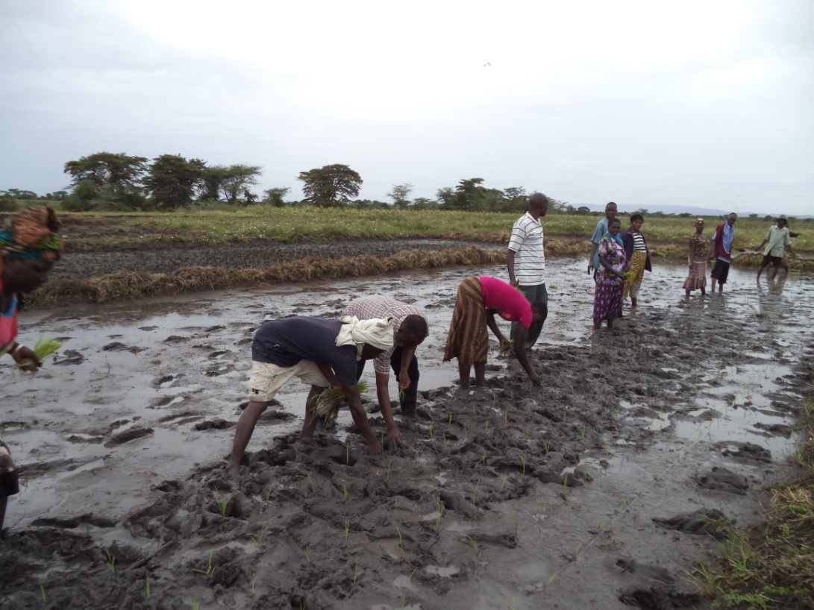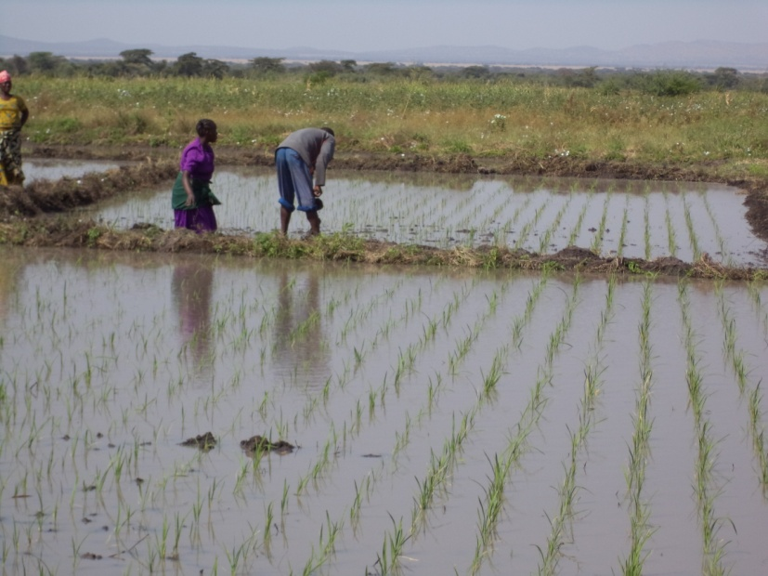
Figure 1.1 : Shows paddy farm owned by group members of CBO. (Photo by Vitus student of MCED- OUT 2012/13)

1.3.1 Objectives
The overall objective is to collect information that will provide for the identification of the most pressing need and set the base for setting a project to address it
Specifically need assessment aims to:
- To identify the problems and needs of Serengeti village paddy farmers.
- To prioritize the problems and needs of Serengeti village paddy farmers.
- To set up a project to address the most pressing need of Serengeti village paddy Farmers,

1.3.2 Research questions
- What are the problems and needs of people in Serengeti village paddy farmers?
- What are the priorities of problems and need to people in Serengeti village paddy Farmers?
- What project may be implemented to solve the problem and needs of paddy famers?

1.3.3 Research Methodology
During the selection of research method, the researcher considered the situation and conditions of subjects or respondents, time available, the quickest way to obtain data, and resources available for the study. Therefore, descriptive research design was chosen to compute data obtained from data collection methods and tools were then developed. The methods, tools and instruments had to be systematic, valid, reliable neutral and objective.

1.3.3.1 Research Design
In the present CNA, a cross-sectional survey design was used to achieve the goals of the study. Data were collected at a single point in time in order to collect a body of both qualitative and quantitative data in connection with two or more variables, which were then examined to detect patterns of association. This was important in saving time, energy, and money particularly collecting data. Typically, a cross-sectional study involved drawing a sample of elements from the population of interest. Research methodology includes research design, sampling, data collection and data analysis methods. The methods used were face to face person Interview, field visit, and door to door questionnaire and focused group discussion guided by checklist.

1.3.3.2 Sampling techniques
The study population in this case constituted of paddy farmers and some key stakeholders in virtual of their responsibilities and from which a total of 40 respondents were selected. The farmers were randomly selected while the key stakeholders (e.g. Village Executive officer and field agriculture officer from Local authority) were purposively sampled. Famers were identified from the documents obtained to Village Excecutive office and treated as the sampling frame.

1.3.3.3 Data collection methods
Methodology of data collection was used to acquire information from different levels being primary and secondary information, primary data was collected from the community through various data collection tools such as focus group discussion, interview, observation and questionnaires. While Secondary data information was collected from the literature delivered from different sources being progress reports of CBO. The time of seven days (7) were planned to be used in data collection.

1.3.3.3.1 Questionnaire
The questionnaire consisted both open and closed questions which intended to capture the biographical information of the respondents and also gather their opinion towards the problems experienced in paddy production and needs to be addressed.

1.3.3.3.2 Interview
During CNA the interview was conducted with 4 key informants who were most likely to give information concerning problems and needs facing paddy farmers and get their suggestions on how to solve them. These included government officials like village leaders and agricultural officers and extension officers.

1.3.3.3.3 Focused Group Discussion
Focused Group Discussion for 10 CBO members was organized for discussion which was guided by a question checklist which was prepared by the researcher in view of the CNA goals. The researcher was initiating the discussion through probing and providing a chance for discussion to each of the panel members. The purpose of conducting Focus group discussion was to get in-depth information of the problems facing community and also identify the needs while at the same time borrowing their experience in expected project implementation, and determine their commitments, ability to run project and finally to get opinion that assist during project planning process.
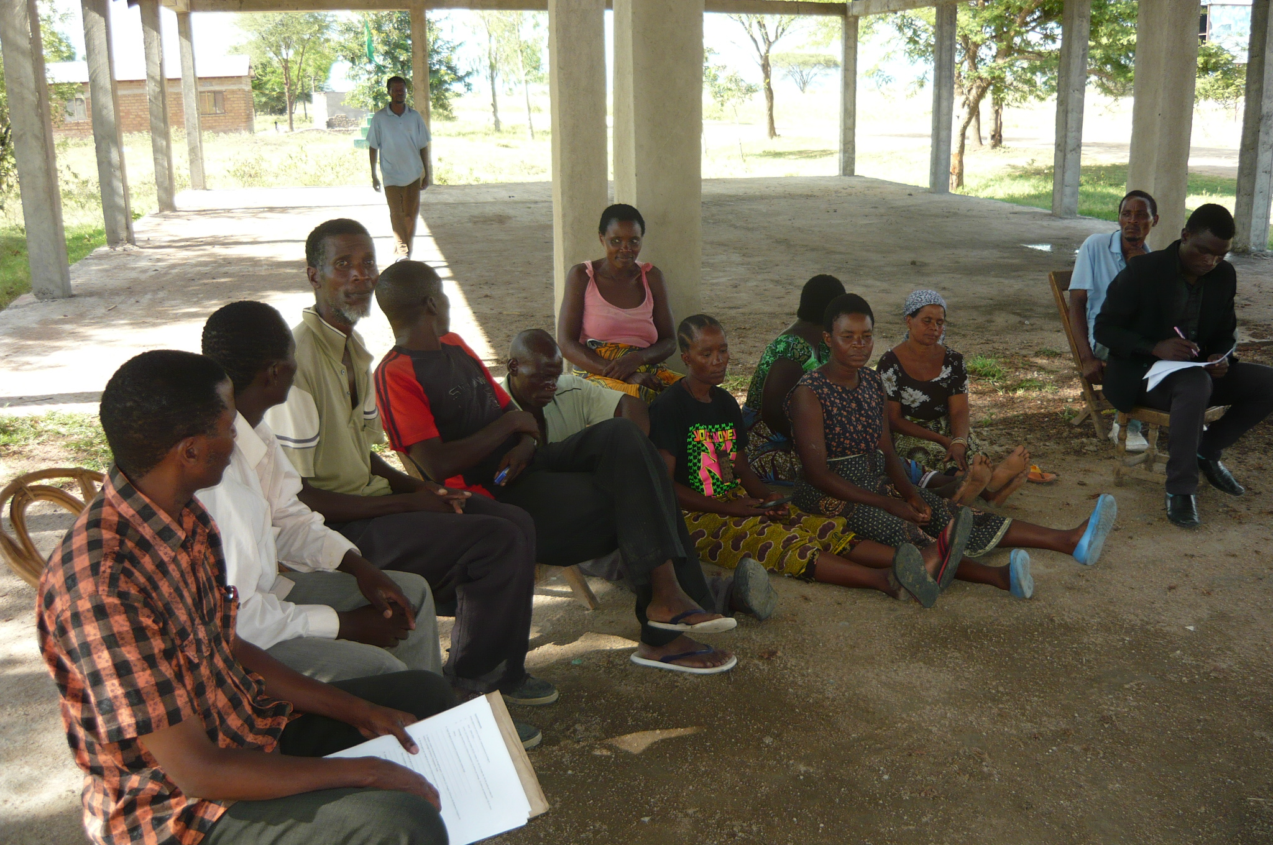
Figure 1.2 : Shows MCED student and respondent during focused group discussion from Serengeti village in Kunzugu ward (Photo by Vitus student of MCED- OUT)

1.3.3.3.4 Observation
The observation was done for the purpose of verifying the responses from the responds through physical farm visits and visual observation of the problems encountered on filed. This was important in enriching the researcher’s understanding of the real situation on ground and linking them with the responses to the different probed issues. .

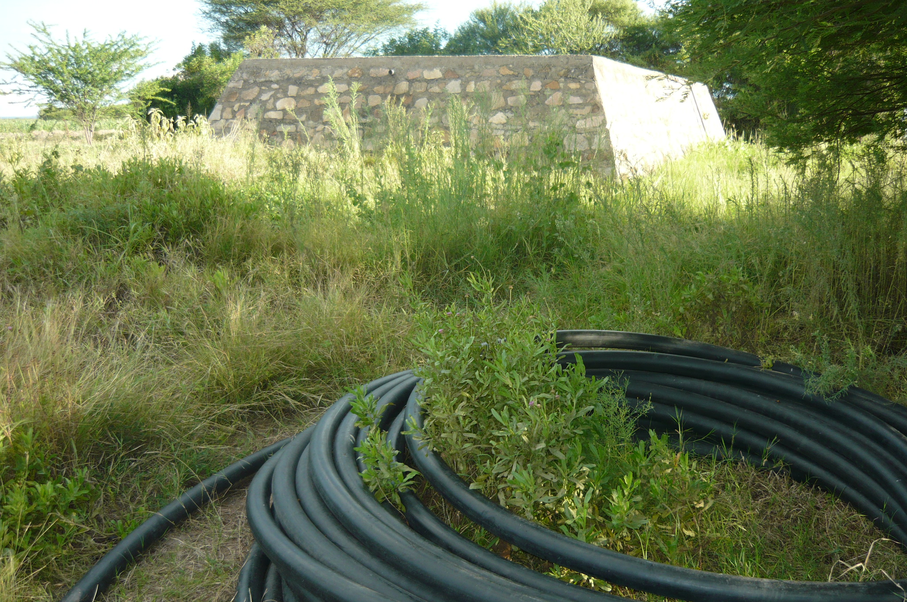
Figure 1.3 : Shows some of the infrastructure for irrigation scheme, Ground tank and pipes given by UNDP to support CBO in irrigation (Photo by Vitus student of MCED- OUT 2012/13)

1.3.3.4 Data analysis methods
Data analysis was done by using a Statistical Package for social science (SPSS vession16) and in particular using descriptive statistics. Qualitative analysis includes searching for patterns of data or events or behaviour and making interpretation of meaning. After data collection, the researcher summarized data in tabular and diagrammatic forms to reflect on the patterns, relations and converted the data into statements and conclusions which ultimately answered research objectives.

1.4 CNA Findings:

1.4.1 Demographic information

Table 1.1 : Sex of respondents

 |  | Frequency | Percent | Valid Percent | Cumulative Percent
Valid | Male | 22 | 55.0 | 55.0 | 55.0
Valid | Female | 18 | 45.0 | 45.0 | 100.0
Valid | Total | 40 | 100.0 | 100.0
Source: Study findings in Serengeti village (2013)

Result in table 1 shows the number of respondent by sex who were involved in the study. An almost equal number shows an almost involvement of either sex in agriculture activities in Serengeti village.
Table 1.2 : Age of respondents

 |  | Frequency | Percent | Valid Percent | Cumulative Percent
Valid | 15- 18 years | 2 | 5.0 | 5.0 | 5.0
Valid | 20-40 years | 14 | 35.0 | 35.0 | 40.0
Valid | 40-50 years | 22 | 55.0 | 55.0 | 95.0
Valid | above 50 years | 2 | 5.0 | 5.0 | 100.0
Valid | Total | 40 | 100.0 | 100.0
Source: Study findings in Serengeti village (2013)

Table 1.2 summarises the statistics of respondent based on age groups of respondent. The majority of respondents were of the age of 40-50 years who constituted more than half of all the responds. The second largest group was that of the respondent of age between 20-40 years, and the least were of that group of respondents aged between 15- 18 and that above 50 years with 5 percentage each. Generally the results imply the engagement of the active labour force in such economic activities in the village.

Table 1.3 : Education level of respondents

 |  | Frequency | Percent | Valid Percent | Cumulative Percent
Valid | Informal education | 9 | 22.5 | 22.5 | 22.5
Valid | Primary education | 22 | 55.0 | 55.0 | 77.5
Valid | Secondary education | 9 | 22.5 | 22.5 | 100.0
Valid | Total | 40 | 100.0 | 100.0
Source: Study findings in Serengeti village (2013)

Results in table 3 shows education level of respondent, where by 55% of respondent were of primary education level. Respondents with informal and secondary education level constituted 45% of the entire sample that is 22.5% for each group these results imply that the majority of village members are working in the informal sector in view of the current employment requirements and situation.

Table 1.4 : Individual Household income per month

 |  | Frequency | Percent | Valid Percent | Cumulative Percent
Valid | 5,000 - 50,000 | 16 | 40.0 | 40.0 | 40.0
Valid | 50,000 - 150,000 | 17 | 42.5 | 42.5 | 82.5
Valid | 150,000 - 250,000 | 5 | 12.5 | 12.5 | 95.0
Valid | more than 250,000 | 2 | 5.0 | 5.0 | 100.0
Valid | Total | 40 | 100.0 | 100.0
Source: Study findings in Serengeti village (2013)

The study reviled that 42.5 percentages of the respondents have a monthly income ranging between 50,000 to 150,000 Tanzania shillings followed by those with income between 5,000 –50,000. Very few of population members 12.5 have an income in the range of 150,000 to 250,000 and only 5 percentages have income above 250,000 per month.

And from the survey those who earning above 250,000 per month are those engaged in Agriculture activities, particularly cotton and paddy irrigation. The reason for these good earning as described by respondent is that, cotton and paddy are fetching good price in the market.

1.4.2 Problems in paddy irrigation

Table 1.5 : Problems for the Irrigation scheme group

 |  | Frequency | Percent | Valid Percent | Cumulative Percent
Valid | Income poverty | 23 | 57.5 | 57.5 | 57.5
Valid | Lack of knowledge | 5 | 12.5 | 12.5 | 70.0
Valid | Agriculture input | 1 | 2.5 | 2.5 | 72.5
Valid | Accessibility of market | 1 | 2.5 | 2.5 | 75.0
Valid | inadequate irrigation infrastructure | 10 | 25.0 | 25.0 | 100.0
Valid | Total | 40 | 100.0 | 100.0
Source: Study findings in Serengeti village (2013)

The problems identified for irrigation scheme are presented in table 1.5. Five problems were identified in which case the most pressing problems were agricultural input and market accessibility (2.5%). The second ranked problem was inadequate irrigation infrastructures, followed by lack of knowledge in agricultural activities.

According to result in table 1.6, four needs were identified by respondents. Of the four needs provision of warehousing and agriculture inputs were equality ranked at 12.5 percent, expansion irrigation scheme and financial support by 37.5 percent.
Warehousing is a place where agriculture products are stored while waiting market price to be higher for the purpose of making profit.

The expansion of irrigation scheme aims at increasing productivity and the number of famers involved in paddy irrigation. The irrigation is conducted as nonstop production, the water is available throughout the year and gives rooms for famers to cultivate and harvest has become a routine work. Increases in agricultural productivity lead to agricultural growth and help to alleviate poverty.

1.5 Need of the community

1.5.1 Lists of community needs

Table 1.6 : Lists of need

 |  | Frequency | Percent | Valid Percent | Cumulative Percent
Valid | Ware housing | 5 | 12.5 | 12.5 | 12.5
Valid | Expansion irrigation scheme | 15 | 37.5 | 37.5 | 50.0
Valid | Provision of Agriculture input | 5 | 12.5 | 12.5 | 62.5
Valid | Financial support | 15 | 37.5 | 37.5 | 100.0
Valid | Total | 40 | 100.0 | 100.0
Source: Study findings in Serengeti village (2013)
The availability of agriculture input could help people in paddy production to enhance their income and solve various socio economic problems. The respondents also explained their concerns in particular the low price they a getting for their produce during harvest season. In view of this they suggested to construct a warehousing to be used to stored their produce until the price is high to enable the famer to sell at profitable price.

On the other hand expansion of irrigation infrastructure would enable farmers to cultivate a much bigger area for paddy irrigation and also increase the number of people with access to the irrigation scheme. Availability of infrastructure for irrigation will help to solve the financial problem and people would be able to meet other household expenses and break circle of poverty.

1.5.2 Suggested solutions
Table 1.7 : Solution to solve the problems of people in Serengeti village

 |  | Frequency | Percent | Valid Percent | Cumulative Percent
Valid | Establish economic project | 23 | 57.5 | 57.5 | 57.5
Valid | Provide soft loan as capital | 14 | 35.0 | 35.0 | 92.5
Valid | Establish Income generating activities | 3 | 7.5 | 7.5 | 100.0
Valid | Total | 40 | 100.0 | 100.0
Source: Study findings in Serengeti village (2013)

The respondent had different option on possible solution to address their problems, give direction of community to have solution which in one way or another is answer for problems and needs of people in Serengeti village.

The studies revealed several suggestions from respondents which included establish economic projects, provide soft loan as capital and run income generating activities to address the problems of people in Serengeti village. Establishment of economic projects ranked higher at 57.5 whereas establishment of income generating activities were ranked least at 7.5 percent

1.6 Conclusion
This chapter dealt with participatory need assessment, it involves community in identifying their own problems and needs of the community. The finding has been used in enabling community in identify top ranking problems and needs and planning for interventions to solve their problems.

The four needs were identified by respondents to be provision of warehousing, agriculture inputs, expansion irrigation scheme and financial support. Though expansion of an irrigation scheme and financial support were found to be the most pressing needs with equal scores, in view of the fact that agricultural activity is the main economical activity it was then agreed by community members to focus on irrigation scheme. Thus expansion of the irrigation scheme was taken to be the most pressing need and thus be considered to be the focal point of intervention

CHAPTER TWO

2.0 PROBLEM IDENTIFICATION

2.1 Background to Research Problem
Several needs were identified in view of the existing problems and prioritised as indicated in chapter one. Four needs were identified and their prioritisation indicated expansion of irrigation scheme and financial support to have the same tally in priority one and provision of agricultural inputs and ware housing tallying in the second priority. However, in view of paddy as the main economic activity among the target population the respondents unanimously opted for the expansion of irrigation scheme as the most prioritizing need. The villagers were of the view that they have abundant land that suits paddy cultivation but is being underutilised. Thus improving their irrigation scheme could ensure increased productivity of paddy. Thus expansion of irrigation scheme was the base of the present project aiming at improving paddy productivity.

2.2 Problem Statement
There has been different initiatives taken by Community members in Serengeti village towards poverty alleviation but they have not been effective and the community still is poor. Though subsistence agriculture is a major source of income for the majority in the village but still a considerable number of households face food shortage year after year. This is due to the fact that the area is semi arid; it gets a little amount of rainfall per annual to sustain agriculture production. However, the existing infrastructure for paddy irrigation scheme supports few farmers and leaving out the majority of farmers. Fishing, business and Livestock keeping are other type of activities in which villagers are involved to meet their needs, but have not been successful due to a variety of challenges emanating from them.
Research conducted under UNDP (2009) in Serengeti village found out that irrigation may minimize poverty among community farmers if used to support agricultural production. Under same study UNDP supported infrastructure irrigation scheme through the Serengeti group (CBO), the community based organisation which seems to perform better in terms of production and increase household income. However, the existing infrastructure supported by UNDP is inadequate Thus the present project aimed at improving agricultural productivity and in particular paddy through improving the irrigation scheme to provide a reliable economic activity that can be undertaken and contribute to sustainable economic development

2.3 Project Description
The title of the project is “Enchasing Paddy Productivity through Improving the Irrigation Scheme”. The implementation of this project will improve and sustain paddy productivity in the village and thus ensure food security, income and nutritional status in general of the entire community.

2.3.1 Target Community
The target community include paddy farmers and all community members in Serengeti village.

2.3.2 Stakeholders
The stakeholders of this project are the paddy farmers (who are primary stakeholders), Serengeti villagers, Community Based Organization (CBO), Financial institutions such as Banks, SACCOS, Local Savings and Credit. All, those stakeholders will contribute in one way or another to the success of the project as analyzed in stakeholder’s analysis

Table 2.1 : The Roles Of Stakeholders

NA | STAKEHOLDER’S NAME | ROLE OF THE STAKEHOLDERS | EXPECTATION
1 | CBO | 1.1 Create a reliable market center  1.2 provide experience on irrigation issues | 1.1 The sustainability of the  project is ensured  1.2 The income of the CBO  and Famers are increased
2 | FAO and DCDO from Bunda district council | - Provision of technical assistant.  - Link to other stakeholders  - Capacity building in terms of Entrepreneurial operation skills.  - Promotion of paddy production thoroughly irrigation schemes  - Financial support.(Loans) | 2.1 knowledge increased  about irrigation scheme  2.2 Increased number of paddy  Famers  2.3 Accessibility of financial  support
3 | BANKS, SACCOS, LOCAL SAVINGS AND CREDIT | 4.1 To provide affordable loans.  4.2 Capacity building to the famers on  Entrepreneurial skills. | 3.1 Reliable customers  3.2 Increased income
4 | Mass media ( Local radio, ) | Promotion of paddy irrigation | 4.1 Reliable market
Source: Study findings

2.3.3 The Project Goal
The project goal is to reduce income poverty among farmers through increasing paddy productivity by expanding the irrigation scheme and embracing more farmers in paddy production project.

2.3.4 Project Objective
The project object is to improve paddy production through expansion of irrigation schemes for sustainable economic development. In order to achieve the goal the following specific objectives of the project will lead to achieving the project goal.
- Awareness creation to 120 Serengeti community members on the importance of expansion of infrastructure for paddy irrigation scheme by September 2014
- Determine the cost for the expansion of the irrigation scheme and human resources requirement by October 2014
- Mobilize resources and equipments from development partners by December 2014.

2.4 Serengeti Irrigation Group / CBO Profile
Serengeti Irrigation group is Community Based Organisation (CBO) was registered as CBO by Community development, Gender and children department in Bunda district council in 2009 with registration No 493, the CBO is found in Serengeti villages, the group has 57 members, where male are 37 and female are 20. The main objective of the group is to improve the living standard of life of group members through paddy irrigation , the project implemented by group from 2002, the group starts with horticulture activities which the result shows positive improvement, from there inwards in 2009 the group supported by UNDP in paddy irrigation.

The UNDP funded the group amount of 52 millions, the group purchase solar energy for 42 million and construction of tank which costs 10 millions. The infrastructure donated by UNDP for paddy irrigation was for land of 100 acres. The group members cultivated paddy for shifting, one after another until all members has got chance to participate in irrigation.

The operation area of the project prepared by the group was 100 acres; production obtained is range from 35- 40 bags per acre. The agriculture technical assistance from District council gave technical support the group. The group members’ life improved, some achieved to pay school fees for their children, good and improved housing and other house hold expenses were meet. The group aims to have the tank which will accommodate the 150 paddy farmers’ in the villages.

2.4.1 CBO Leadership
The CBO has the leadership of General meeting and Management team. General meeting involves all CBO members and management team comprises chairperson, secretary and treasury, the Management team is directly responsible to General meeting. The management team is organizer of every intervention implemented in the organization

2.4.2 Vision
The vision of the group is to ensure improved living standard through sustaining agriculture activity especially in paddy irrigation.

2.4.3 Mission
The mission of Serengeti Irrigation group is to create economic sustainability for a healthy society.

Figure 2.1 : Serengeti Irrigation Organization Structure

GENERAL MEETING

CHAIRPERSON

SECRETARY
TREASURY

2.4.4 CBO objectives
- To create bond among the members of CBO, to support each other in terms of human kind in case a member is faced with social problems.
- To establish income generating activity through agriculture
- To collaborate with other stakeholders in various activities concerning with community development.
Figure 2.2 : Organization structure for the expansion irrigation project for sustainable economy
MANAGEMENT TEAM

PROJECT COORDINATOR

FARM MANAGER

MARKET MANAGER
WATER RESOURCE MANAGER

STAKEHOLDERS

2.4.5 SWOT Analysis For Serengeti Irrigation Group
Table 2.2 : CBO -SWOT analysis

NO | STRENGTH | WEAKNESS | OPPORTUNITY | THREAT/CHALLENGES
1 | Strong and committed leadership | Leadership are not professional, based on experience | National Guidelines for establishment of CBOs and NGOs | Leadership has the limited time, are voted by members.
2 | Presence of CBO Constitution | Lack of organisation (CBO) policy | Professionals of Organisational policy | Changes of constitution
3 | The group has the supportive infrastructure for irrigation | No fund for repair irrigation infrastructure | Availability of other development stakeholders | Depreciation of infrastructure
4 | The group has experience on paddy irrigation scheme | The group has no professional employed staff | Technical assistance from Bunda local government authority | Much costs to have professional employed staff
5 | The group is qualified to access loan | Inadequate knowledge to write business plan to accesses loan | Presence of financial institutions | Changes of financial institution policy
Source: Study finding

2.4.7 The role of CED student in the project
The role of CED student is to make sure, plan and activities are implemented as they are planned.
- To mobilize and create awareness creation to Serengeti community members on enhancing paddy productivity through improving the irrigation scheme
- Determine the cost for the expansion of the irrigation scheme and human resources.
- To mobilize resources and equipments from development partners

2.4.8 Roles of Serengeti Irrigation group
- To find the market for paddy product
- Participate on mobilize Serengeti community members on expansion of infrastructure for paddy irrigation
- To attend the Entrepreneurship training of project management
- To purchase equipment for project to take off
- To keep records and submit reports to responsible parties

CHAPTER THREE

3.0 LITERATURE REVIEW

3.1 Introduction
This part goes over authors who wrote on issues correlated to enhancing paddy productivity through improving the paddy irrigation schemes. Report finding from various projects explain the empirical and theoretical point of view on issues of paddy irrigation. The chapter highlighted issues on related to paddy irrigation; it gives some definition and description on core concept in relation to the project. The chapter also give brief details on irrigation national policy.

The primary aim of the development of irrigation scheme is to raise rice production through increasing the secured supply of irrigated water.

3.2 Theoretical literature

3.2.1 Introduction
An irrigation scheme for paddy irrigation is done by various communities to ensure food security to the area with less rainfall. The Serengeti irrigation group (CBO) has shown initiatives to work in irrigation scheme, the group introduce irrigation scheme although infrastructure available for irrigation is not sufficient to meet the requirement of the community in Serengeti village.

Irrigation practice is one of the effective means in increasing and stabilizing food and cash crop production and productivity for curbing food shortages and increasing export of cash crop and its products. In this regard, a brief plan and implementation for the development of irrigation infrastructure is applicable. Water is a central and basic natural resource which sustains life and provides for various social and economic needs including irrigated agriculture.

3.2.2 Feature of successful irrigation scheme
The report of the World Bank's (1992) describes the factors of successful irrigation schemes. Such factors are project identification/preparation approach of the detailed project designed only to find a disparity with local capacity to implement it. Money and technical assistance has then been provided to bridge the gap. Technical assistance frequently then crowds out any local capacity, and may in effect substitute for local management rather than strengthen it, bringing no sustainable improvement.

Projects should be planned to match local capacity for implementation, which implies that planning teams should first acquire a thorough appreciation of this capacity. The planning process therefore give specific attention to an analysis of institutional capacity, and to providing a detailed program to enable the implementers to prepare themselves for carrying out the tasks expected of them.

3.2.3 Participation, Ownership and Commitment
It is recommended that countries in SSA should move from an administrative 'command and control' approach to a more participatory approach that treats water as a scarce resource (Sharma et al. 1996).

The successful irrigation schemes require participation in the planning and implementation process by all stakeholders, in order to create a sense of ownership of, and consequent commitment to, the project. This requires that the project planning process should allow time for the borrower and users to participate in, or preferably drive, the planning process, and for any potential losers to have a substantive influence on decisions that affect their future. Ownership and commitment by the users are unlikely to be achieved unless they consider that the project would meet their felt needs and they have a stake in the equity - that is, they share in or bear all of the investment costs.

Building ownership and commitment through participation has often been difficult to achieve in the past. The conventional sequence of identification/preparation, carried out against tight deadlines by external planning teams, has seldom allowed time for genuine participation (which should go beyond mere consultation), either by government staff or farmers. On implementation, government irrigation engineers, for their part, have usually seen irrigation only from engineering, rather than a farming or social, perspective. They have been reluctant to adopt participatory approaches with farmers, mainly because of a misplaced belief that farmers are unable to understand or make any contribution to technical matters, or because of concerns that participation might delay implementation or result in design changes that compromise the quality of the final product.

Undue delays in project approval and implementation are undesirable, not least for the farmers; but taking time over stakeholders' participation in planning does not necessarily mean delay. It can often pay dividends, by preparing the implementers, ensuring smooth start-up, building farmers' commitment to change, and ultimately lead to more rapid implementation and a more sustainable development impact.

Experience has shown that the ultimate scheme design almost always benefits from involving the users in the planning process. Farmers, or at least those with some experience or knowledge of irrigation, from the poorest illiterate smallholder to the richest well-educated commercial farmer, usually have practical ideas of what works and what does not, from their detailed local knowledge of weather patterns, hydrology, soils, markets, and so on. Communities often have strong preferences regarding the nature and location of development that needs to influence planning, such as aligning a canal to avoid excavation in sacred ground.

3.2.4 Flexibility
A distinct feature of successful irrigation drainage projects was the flexibility of allowing appropriate design changes during implementation. Most projects reviewed had modified their project scope in response to actual site conditions and implementation challenges. Project reformulation facilitated and improved project implementation. For instance, the Pulangi River Irrigation Project in the Philippines (2008) adopted a process approach that allowed flexibility in project implementation. Making changes in project designs during implementation that contribute to achieving good project outcomes was an important contribution made by project administration staff associated with successful projects.

3.2.5 Stakeholder/Beneficiary Participation
A sound understanding of the roles and responsibilities of farmers is a feature of successful Irrigation projects. Successful projects are characterized by the involvement of direct stakeholders and beneficiaries in all project phases, particularly O&M. This was reflected in projects in Nepal and Philippines (2008), where farmer-managed irrigation systems and farmer/water users associations took part in O&M activities. Globally, the collection of irrigation service fees is good practice to finance and sustain O&M activities. In the Philippines and Nepal cases, farmers themselves collected the fees. This resulted in better collection efficiency and minimal administrative and transaction costs for the executing agency (EA). Increasing the responsibility of farmer groups also conforms to good practice among irrigation and drainage projects. Beneficiary involvement increased the sense of ownership and responsibility among the participants. Similar patterns were evident in Indonesia and Pakistan. In general, beneficiary participation in every phase of the project cycle contributes to successful ID projects.

3.2.6 Low Cost Irrigation
Irrigation schemes, REPOA (2009) acknowledges that, Low cost irrigation has been developed on the initiative of farmers rather than governments, and has continued their existence in the same way. Traditional irrigation systems are often characterized by poor water control, and consequent low cropping intensities and yields. In many cases improved water control can be achieved at comparatively low cost, and is often easily justified by the incremental production that can be achieved as a result. Thus, given that in some countries the area under traditional irrigation far exceeds the area under formal irrigation, the scope for obtaining increased food production from these systems could be significant. The identification of opportunities for such improvements may therefore be a priority for planners. However, it noted that the most important feature of these systems is local initiative, responsibility and control; proposed improvements should avoid unintended transfer of responsibility to government.

3.2.2 Paddy irrigation
Paddy irrigation mobilized in various communities to ensure reduction of food shortage, increase economic status and also irrigation schemes function as a development ‘pole’ in rural areas, where population concentrations increased attracts additional services and infrastructure. Also, the increased incomes from production and employment mean that more families can afford schooling, health care and other community needs (IPTRID 1999).

The arguments concerning the role that agriculture can play in both economic growth and poverty reduction clearly apply to both rain fed and irrigated agriculture. It seems reasonable to argue that the potential of the irrigation sector is greater because of the greater intensity of the direct effects on productivity and incomes. In addition, technological, and infrastructural for schemes supports increase of productivity compared to rain fed areas, particularly remote and low potential areas. The irrigation sub-sector will tend to be ‘richer’ in terms of the crucial multiplier and linkage effects. According to Reardon et al. (2000) emphasize that, the potential for livelihood diversification by the poor will be greatest in areas with good infrastructure and dynamic agriculture.
JICA states that since the initiation of TANRICE training in 2007 (alongside irrigation), Kitivo's production has increased from 2.9 t/ha in 2007 to 5.1 t/ha in 2013 whilst between 2007 and 2009 Kiroko and Ilonga have both experienced an increase of 2.1 and 3.4 t/ha to 3.6 and 4.9 t/ha respectively

The National Water Policy (GoT,2003) acknowledges that irrigated agriculture provides protection against drought and it is also the most important way of ensuring the availability of food reserves. Furthermore, this type of agriculture contributes to the reduction of poverty since it can facilitate many people to cultivate high value crops such as vegetables and fruits. The policy further asserts that efforts should be made to ensure reliable supply of water in all the competing uses important for the national economy, like agriculture, one way of achieving this is by increasing water use efficiency and water productivity. In Tanzania, there have been efforts to increase efficiency of water use in the traditional irrigation schemes, which is generally presumed to be low. The RBMSIIP (2001) project and other donors have been implementing a number of interventions in the MSC aimed at improving the indigenous irrigation schemes.

3.2.3 Infrastructure for irrigation scheme
It needs a cost to build the Infrastructure for irrigation schemes. In Tanzania, Most of the improved infrastructure such as pipes and intakes were built in the 1980s onwards and were geared towards smallholder farmers. For example, Majengo, Mswiswi and Moto Mbaya intakes were built during the Usangu Village Irrigation Project (UVIP) in the mid 1980s. During early 2000s, other irrigation schemes were either developed or improved. They include Inyala A & B, Iyawaya and Imezu Mkombozi irrigation schemes. Furthermore, in 2002, two more irrigation projects (Ipatagwa I & II and Luanda Majenje), funded by the World Bank under the Smallholder Irrigation Improvement Project (SIIP) component of the River Basin Management Project were opened. Currently, Shamwengo irrigation scheme was improved the main canal. Therefore there has been an increase in the number of improved intakes in MSC, the total abstraction capacity has steadily risen, and more importantly, the ability to abstract water during the dry season has increased.

World Bank development report 1994 brought to light the multiple positive spin –offs and link between infrastructure and development. The report (1994) underscored the role of policy in improving quantity and quality of infrastructure. The similar findings of the considerable impact of the infrastructure investment on aggregate total factor productivity have been found acceptable by Aschauer (1990s), Munnel (1990a,1990b, 1992) Mitra et al.(2000) and Easterly and Rebelp (1993).

3.2.4 Financing smallholder irrigation schemes
Since the late 1990s, IFAD has been financing smallholder irrigation development in the United Republic of Tanzania. Although there were successes, there were also problems, not least of which was the traditional top-down approach prevalent at that time. However, lessons learned ‘the hard way’ is now influencing the Government towards a new participatory approach to irrigation development. This approach reflects a main characteristic of the inspiring a higher degree of ownership.

IFAD’s early experience in investing in smallholder paddy rice irrigation in semi-arid, marginal areas, drought and uncertainty still dominate the lives of poor rural people. However, some irrigation schemes did prosper. Average paddy rice yields increased from 1.8 to 2.3 tons per hectare (ha) and farm incomes grew as a result. The investment needed was modest – US$1,000- 2,000/ha – in sharp contrast with the approximately US$10,000/ha required at that time to build larger irrigation schemes. In 2000, applying these principles, FAD embarked on a six-year program with the Government, whose policy was now to support the development of smallholder irrigation schemes. The goal was participatory irrigation development in the central plateau and rehabilitation of some 12,000 ha of land, to the benefit of more than 15,000 people.

IFAD embarked on a six-year program with the Government, whose policy was now to support the development of smallholder irrigation schemes. The goal was participatory irrigation development in the central plateau and rehabilitation of some 12,000 ha of land, to the benefit of more than 15,000 people. The programme targeted the poorest farming families, particularly those headed by women. The families possessed small landholdings and few resources. Their crop yields were low and they depended on income from casual labour for up to eight months a year. Practice into results Some 42 irrigation schemes have now been completed successfully.

3.3 Empirical Literature

3.3.1 Irrigation scheme as a poverty reduction strategy
Irrigated agriculture is one mechanism in focus on modernizing production. Rwenyemamu (2009) emphasizes that the Tanzania's Poverty Reduction Strategy Paper of 2005 clearly states that irrigation is to be the key in pushing the transformation of Tanzania's agriculture for poverty alleviation and food security attainment. Further there appears to be political will in boosting rice production while protecting local farmers market through various rural initiatives.

All Africa (2013) reports the impact of irrigation in rice production in Mabogini –Moshi where small scale farmers have increased their irrigation area from 300 to 1600 hectares whilst witnessing their rice production doubled from 3 to 6t/ha in the process making the area the biggest rice producer in the country.

JICA (2013) elaborate this further by pointing to the extent of which irrigation has played in increasing rice production in Tanzania. They cite three irrigation schemes, i.e. Kitivo in Tanga, and Kiroko and Ilonga both in Morogoro. JICA states that since the initiation of TANRICE training in 2007 (alongside irrigation), Kitivo's production has increased from 2.9 t/ha in 2007 to 5.1 t/ha in 2013 whilst between 2007 and 2009 Kiroko and Ilonga have both experienced an increase of 2.1 and 3.4 t/ha to 3.6 and 4.9 t/ha respectively.

DOWN in Mabogini ward in Lower Moshi is one success story of how irrigation agriculture can change a farmer's wealth. Local farmers have increased land under irrigation from less than 300 hectares to over 1600 hectares, a development that has seen their rice production double and topping in the country.

Scoones (1996) argued that in semi-arid areas there is potentially no better way to reduce rural vulnerability and ensure the viability of people’s livelihoods than to enhance natural capital and the productive base. Protecting the system against drought requires investment in water management, and it is irrigation and the water storage provided by small dams or enhanced recharge of aquifers that can reduce the vulnerability of rural communities to periods

3.3.2 Water resources Vs Small holder irrigation schemes
The concept of paddy irrigation schemes originated from productivity of water and river basin resources management. Improving water productivity (WP), a measure of performance generally defined as the physical quantity or economic value derived from the use of a given quantity of water (Molden et al., 2003), is one important strategy towards confronting future of the people depending on agriculture. Increasing WP to obtain higher output or value of water used can play a key role in mitigating the problems of drought (Molden et al., 2001; UNDP, 2006).

Smallholder irrigation involves the diversion of water from one area into a relatively small area for the purpose of supplementing available water for crops (FAO, 2001). The techniques of diverting the water include use of gravity through canals or pipes and lifting water through the use of pumps for application in the fields through various irrigation methods (FAO, 2001) with the objective of increasing crop production. The terms smallholder, small-scale, subsistence, communal and emergent farmers have been loosely used to mean the same thing although they have different meanings.

Cornish (1998) described as farmer who practices both commercial and subsistence farming for deriving a livelihood and the family is the principal source of labour. Cornish (1998) added that the smallholder farm may also include a small section where high value crops are grown for commercial purposes, and the smallholder farmer usually earn a living from an irrigated area usually less than 5 hectares (ha). However, this may vary from one country to another.

Smallholder irrigation also includes small individual farms and groups where the farmers have taken on the responsibility for managing the distribution of water among the members of their group (FAO, 2001). In South Africa, the smallholder farm is located in the former homelands with the majority of the small farms being owned by historically disadvantaged races and groups (Denison and Manona, 2007). Rukuni (1984) showed that, in general, yields achieved on smallholder schemes are higher than rainfed dryland yields in communal areas. Meinzen-Dick et al (1993) showed that gross margins for irrigating farmers were significantly greater than for dryland farmers. They further pointed out that the effect of irrigation on increasing crop production and incomes is even more marked in the dry winter season, when dryland production is impossible because of lack of rain.

Alvord (1933) claimed that Mutema irrigation scheme in Manicaland Province of Zimbabwe had alleviated famine in the area. The same author further claimed that 28 ha under irrigation in Mutema area reduced the need for drought relief grain from government by approximately 90 to 180 tons per year. Meinzen-Dick et al (1993) reported that the greatest food deficits in Zimbabwe appear to occur in dryland areas of Natural Region V. In their study they noted that fewer irrigation schemes ran out of food during the year than dryland areas. The same study mentions that the majority (72%) of farmers with between 0.25 ha and 0.5 ha of irrigated land reported that irrigated land was their only source of livelihood.

According to Therkildsen (2011) it was agreed in the Agricultural Sector Development Programme paper that 1 million hectares of irrigation expansion land was identified for development within a 5 year period under the stewardship of local government authorities.

Concurrently, the East African Community imposed a Common External Tariff to protect local farmers from cheap imported rice (USDA 2011).

3.4 National irrigation policy
The Government has formulated various National Policies and Strategies which are strongly recognizing the importance of irrigation towards the increase in food security and the economy at both Household and National levels. These include: The Tanzania Development Vision (TDV) 2025; The National Strategy for Growth and Reduction of Poverty-NSGRP (MKUKUTA) II; The Millennium Development Goals (MDG) 2015;
The National Irrigation Policy 2010, which provides the direction for irrigation interventions to contribute effectively towards food security and poverty reduction;

The National Five Year Development Plan 2011/2012 – 2015/2016; The Agricultural Sector Development Strategy (ASDS) 2001; and The National Irrigation Master Plan (NIMP) 2002. To foster the implementation of the above National Strategies, in 2009 the Government Officially launched the KILIMO KWANZA initiatives to provide more momentum in the development initiatives of the Agricultural Sector in the Country. In other words, this initiative is stimulating the implementation of the ASDP.

Government support has been directed to improve traditional irrigation schemes by mainly improving the irrigation infrastructure and organizing the beneficiaries into formally registered entities. These schemes have permanent structures and facilities for irrigation, drainage and flood protection and have been designed with full water control and measurement to assist in water delivery and management.

3.4.1 Government strategies on irrigation Development
The Government’s strategy on irrigation development stresses on attainment of National Food Security, increased productivity and profitability in Agriculture. In this context the Government has placed priority on the following interventions when viewing irrigation development: Improvement of existing Traditional Irrigation Schemes and construction of new ones especially in the high development potential areas; Improvement of irrigation schemes based on water harvesting technology in climatically marginal Regions in the Country; Construction of small, medium and strategic large scale dams for irrigation development. Exploitation of ground water for irrigation development in areas rich in ground water; and Promotion of water saving technologies such as sprinkler, drip irrigation systems coupled with use of energy sources like wind power and solar power for pumping water for irrigation

The recent policy developed in 2009 that support the sector is “Kilimo Kwanza,” the Presidential initiative seen as a green revolution to transform Tanzania’s agriculture into a modern and commercial sector. The KILIMO KWANZA initiatives emphasizes the implementation of agricultural development initiatives particularly ASDP. Through the Tanzania Five Year Development Plan 2011/2012 – 2015/2016, the Government Targets to expand the area with developed Irrigation Infrastructure to a cumulative area of One Million Hectares by the year 2015. The targeted area for development is for all levels from Small Scale, Medium and Large Scale Irrigation Schemes to be owned and managed by either Smallholder Farmers or Commercial Medium and Large Scale Farmers.

3.4.2 Characterized of Irrigation practice in Tanzania
Practice of irrigation in Tanzania is characterized by: i) Reliance on the run–off–river water abstractions for gravity-fed irrigation schemes, hence highly susceptible to climate change effects on rivers and stream flows thus affecting the optimal availability of water resource for crop production , ii) Low irrigation water use efficiency, iii) Irrigated Agriculture dominated by smallholder farmers whose knowledge in Irrigation Water Management and capacity to afford efficient Irrigation Water use technologies is low. In some irrigation schemes water storage structures (dams) of different sizes have been built to store water or harvest rainfall runoff for irrigation to supplement other sources when in short supply to meet crop water requirement

3.4.4 Challenges
Irrigation Development is faced with some crucial constraints which the Government is committed to address so as to realize the envisaged target these constraint include: i) Inadequate investment in water storage infrastructure; ii) Low rate of investment in Irrigated Agriculture by the Private Sector; iii) Inadequate capacity of Smallholder Farmers to invest in Infrastructure for their Irrigation Systems; iv) Inadequate capacity of the Private Sector to participate in irrigation development; v) Low level of Irrigation Skills of the Farmers; vi) Low production and inefficient marketing systems to absorb the produce from irrigation farming; vii) Inadequate institutional capacity at national level with respect to planning, implementation and sustainable management of irrigation development in Tanzania.

The Irrigation Research and development in Tanzania has been constrained by problems such as shortage of Irrigation Research Scientists, inadequate funding and lack of appropriate irrigation research facilities and equipment. Research activities undertaken by research and academic institutions in the Country do not adequately address irrigation issues such that practical problems facing Irrigation Schemes and Farmers are not addressed to provide the required technological support for improvement of productivity and profitability.

3.4.5 Measures to address challenge and constraint in irrigation development
The Government is taking some measures to gradually address the constraints facing Irrigation Development in the country, these include: i) Increasing Financial Resources (Government in collaboration with the Development Partners through the ASDP) increased investment in irrigation from Tshs 8.5 Billion in 2006/2007 to Tshs 67.6 Billion by the end of financial year 2010/2011; ii) The process for establishment of the National Irrigation Commission – a semi independent institution are currently started; iii) Support is being given to Institutions of higher learning to enable them train more staff in irrigation fields; iv) On the issue of human resource, deployment of more appropriate human resource is gradually being done. Also measures for increasing collaboration with other countries through the South – South cooperation are being pursued; v) The Government is committed to establish a National Irrigation Research and Training Centre as an effort to strengthening Irrigation Research and Development in the Country; and vi) Promotion of water saving technologies, rainwater harvesting and utilization of ground water for irrigation.

The major focus and practices in irrigation development in our country especially for Smallholder Farmers has been more on the development of surface Irrigation Systems. These systems are often focused on paddy crop production with less room for diversification intensification to include other crops such as vegetables, banana, flowers, cotton, pasture, orchards and tree plantations. This situation, calls for opening cooperation with more experienced development partners in diverse Irrigation Technologies which ensure higher efficiency in irrigation water use in order to increase the pace of sustainable irrigation development with increased crop production and productivity in the country.

3.5 Literature review summary
The various studies show that Irrigation is the artificial exploitation and distribution of water at project level aiming at application of water at field level to agricultural crops in dry areas or in periods of scarce rainfall to assure or improve crop production. The Government of Tanzania is now giving higher priority to irrigation as a reliable strategy for food and cash crop production. This is reflected in reforms that have taken place including the preparation of the MKUKUTA (2005). From the literature review it has been evident that studies that were carried out in relation to paddy irrigation for economic purpose, as part of the solution to the problem, concentrated on finding out the uses of irrigation scheme and expand the schemes in order to meet the community requirement.

However, in Serengeti village the existing infrastructure for paddy irrigation scheme supports few farmers and leaving out the majority of farmers. But majority of people have not successful meet the paddy irrigation infrastructure for their economic stability to support their lives.

CHAPTER FOUR

4.0 PROJECT IMPLEMENTATION

4.1 Introduction
This chapter highlight information on how the project is designed, implementation and activities done to meet the expected objective and resource required to implement the project. It mentions responsible personnel and time frame to accomplish the project, analyses tentative budget for purchase of tools and equipment and other over costs. Various commitments of stakeholders to support the project includes Bunda local government authority, community based organisation.

Implementation of Expanding infrastructure for paddy irrigation project has planned to start operating effectively September 2014, the existing scheme is old and does not satisfy the community needs, the project proposed is to extend scheme to satisfy all paddy farmers in the village.

The infrastructure proposed is those related with aim of expanding Schemes: these are schemes whereby water is pumped from a source to tank, a well, a trench, a water reservoir and convey it to the command area under pressure. The method for irrigation at the scheme could be surface, and pipes. Various form of construction of a new diversion structure, gated canal intake, water division boxes and other farm related structures, the layout of the irrigation canals and drainage system

4.2 Products and outputs
The implementation plan of the project went hand in hand with the identification of the indicators of the products and outputs that reflect on the implementation of project activities as listed below
- Increased awareness on the importance of irrigation
- Increased and improved irrigation facilities
- Expanded irrigation scheme
- Increased area of cultivation
- Increased number of engaged farmers in using irrigation scheme

4.3 Project planning
Project planning is a continuous process which involves decision, or choice about alternative ways of using available resources with the aim of achieving particular goal at specific period of time. The project plan involved the following major steps:
- Identification of project objective
- Sequencing activities
- Identifying responsible person for carrying out the activities.
- Identifying facility equipment and service needed.
- Preparing the budget.

4.3.1 Implementation plan
To implement the project, work plan was prepared and show different activities to be carried out, the required resources, time frame and responsible person for each project objectives. The implementers of the project involved different stakeholders. The community based organisations (CBO) were full participated from the beginning of the project identification due to their knowledge, skills and experience on irrigation scheme they have.

The key activities in Project implementation are participation of community, Coordination and Monitoring and Evaluation. The implementers involved CBO members, paddy famers, Extension workers with professionals from Bunda District council and village government leaders.
Table 4.1 : Project implementation plan
Objective | Activity |  |  | Implementation period 2014 |  |  |  |  |  | Resources | Responsible Person
Objective | Activity | Apr | May | Jun | July | Aug | Oct | Nov | Dec | Resources | Responsible Person
Awareness creation to 120 Serengeti community members on the importance of expansion of infrastructure for paddy irrigation scheme by September 2014 | To conduct awareness to 120 community members on  - Importance of expansion of the scheme  - Benefits of the scheme  - Their responsibility to the scheme |  |  |  |  |  |  |  |  | Human, Fund,  Stationery and  Transport | CED Student, Comm. Dev Officer, Agric. Officer and CBO leaders
Determine the cost for the expansion of the irrigation scheme and human resources requirement by October 2014 | - To prepare project budget  - Identify the required human resources  - Recruit the desired human resource |  |  |  |  |  |  |  |  | Human, Fund,  Stationery and  Transport | CED Student, Comm. Dev Officer and Dist Planning Officer
Mobilize resources and equipments from development partners by December 2014 | - Identify potential funders |  |  |  |  |  |  |  |  | Human, Fund,  Stationery and  Transport | CED Student,  Bunda LGA and  Other stakeholders
 | - Prepare a venue for the fundraising |  |  |  |  |  |  |  |  | Venue and  Lunch | Comm. Dev Officer, Agric. Officer and CBO leaders
 | - Organise a fundraising meeting |  |  |  |  |  |  |  |  | Human, Fund,  and  Transport | CED Student, Comm. Dev Officer, Agric. Officer and CBO leaders
 | - Purchasing equipment and resource |  |  |  |  |  |  |  |  | Human,  Fund,  and  Transport | CED Student, Comm. Dev Officer, Agric. Officer and CBO leaders

In the implementation phase, the project is designed to be implemented in participatory manner; it involves participation of stakeholders such as Community Economic Development (CED) student, Professionals from Bunda local government authority (LGA) and CBO members and community farmer.

The COB contributed labour force and the old infrastructure which was been operating at previous period before undertaking the new project ready to take action on expanding irrigation scheme.

Resource for implementation contributed by different stakeholders, the previous resource supported by UNDP to CBO in Irrigation, these needs only maintenance, the material and equipment for expand the irrigation scheme purchased by money obtained through fundraising, the various stakeholders such as Bunda Local government authority, community and UNDP contributed the fund special for expansion irrigation schems. Bunda Local government authority contributes technical support through professional and put special budget to assist the completion of the project.

Table 4.2 : Project Logical frame work

OBJECTIVE | OBJECTIVELY VERIFIABLE INDICATOR (OVIs) | MEANS OF VERIFICATION ( MOVs) | ASSUMPTION
Goal: Income poverty reduced and standard of living improved to famers. | Increased income and standard of living of famers improved | Survey and auditing monthly and annual sales report. | Project implemented according to plan
Objective 1: Awareness creation to 120 Serengeti community members on the importance of expansion of infrastructure for paddy irrigation scheme by September 2014
Output 1: awareness creation to 120 community members on expansion of infrastructure for paddy irrigation scheme. | 120 community members aware on expansion of infrastructure for paddy irrigation scheme. | Meeting reports. | Awareness creation meeting conducted
Activity
To conduct awareness on  Importance of expansion of the scheme, Benefits of the scheme and their responsibility to the scheme | 120 Community sensitized on importance of the expansion of the scheme, Benefits of the scheme and their responsibility to the scheme | Meeting report | Awareness creation meeting conducted
Objective 2: Determine the cost for the expansion of the irrigation scheme and human resources requirement by October 2014
Output 2.1: The cost for expansion irrigation scheme | Budget prepared for expansion irrigation scheme | Project budget approved | Budget prepared and approved
Activities
2.1 To prepare project budget | Project budget document | Budget document | Project budget prepared
- Identify the required human resources | The human resource needed | Report | Identification of human resource done
2.3 Recruit the desired human resource | Recruit human resource | Report | Recruitment done
Objective 3: Mobilize resources and equipments from development partners by December 2014
Output 2.2: resources and equipments mobilised from development partners | Resources and equipments received | Project inventory records | Mobilization of contribution of materials and resource done
Activities
2.1.1, Identify potential funders | The founders of the project identified | Lists of potential funders | Identification of funders done
2.1.2,Prepare a venue for the fundraising | Venue for fundraising obtained | Venue for fundraising | Meeting done
2.1.3, Organise a fundraising meeting | Fundraising meeting done | Minutes of meeting | Meeting done
2.1.4 To purchase equipments and tool | Equipment and tools purchased | Inventory records | Equipment and tools purchased
Source: Study findings

4.3.2 Inputs
In project implementation, various inputs were employed such as human resource, financial and material resources. in human resource both man power and technical issues were applied, the Community member participated where manpower resource were used during excavation of the trench and rehabilitation of tank for water storage, the technical issues related with infrastructure given by expert from Bunda local government authority. Famer community participate during project implementation from the beginning of the project identification and understand their responsibility during project work. to ensure that social or economic problems are addressed and solved by collaboration of different stakeholders like district council and other development partners.

District government authority supported the project on technical assistance and agree to put costs in their budget to support irrigation scheme project, Where CBOs member contributes equipment and materials for infrastructure offered by UNDP, the project install powerful solar energy to generate electricity to pump water from the source to water storage tank to supplement the existing equipments to meet the project gaol.
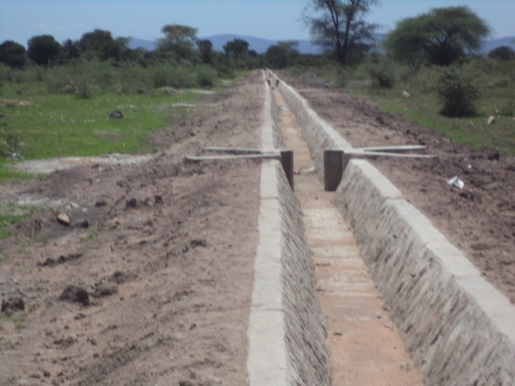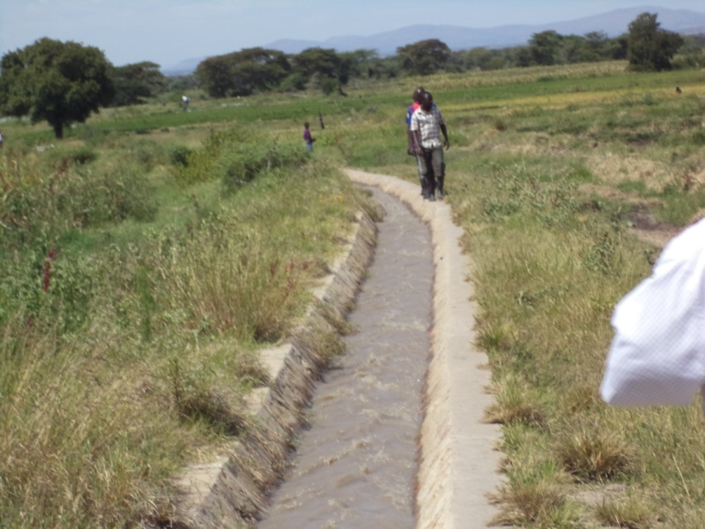
Figure 4.1 : The constructed extended trench for water to irrigate the paddy farm

4.3.3 Staffing Pattern
Table 4.3 : Staffing Pattern
NA | POSITION | TRAINING NEEDS | RESPONSIBILITY
1 | Chairperson, | Leadership training | Responsible for the overall management of project
1 | Chairperson, | Leadership training | Leading meeting and ensure meetings run effectively.
1 | Chairperson, | Leadership training | Prepare agenda for meetings (in consultation with others )
2 | Secretary | Recoding of minutes ,  Prepare of agenda | Prepare copies of the agenda of meeting
2 | Secretary | Recoding of minutes ,  Prepare of agenda | Make sure that any reports or information requested at the last meeting is available
2 | Secretary | Recoding of minutes ,  Prepare of agenda | Prepare a draft of the minutes.
2 | Secretary | Recoding of minutes ,  Prepare of agenda | Take minutes during meetings
3 | Treasury | Records of project financial statement | Keep clear, accurate records of the project financial transactions
3 | Treasury | Records of project financial statement | Present budgets, accounts and financial statements.
3 | Treasury | Records of project financial statement | Ensure that record-keeping and accounts meet the conditions of funders
3 | Treasury | Records of project financial statement | Advise on the organisation's fundraising strategy
3 | Treasury | Records of project financial statement | Prepare a budget
4 | Project Manager | Project management | To ensure that activities is done to meet goals and objectives.
4 | Project Manager | Project management | Organize tasks to be implemented according to schedule, and arrange the right roles for the right people.
4 | Project Manager | Project management | Responsible to community on issues of project
5 | Farm manager |  | To ensure that the plot of farm is given to community members according to periodic schedule.
5 | Farm manager |  | Seeking the market for product
6 | Water Manager |  | To ensure that the water is available in the scheme, ready to supply on the farm

4.3.4 Project Budget
The budget of the project was done, it was participatory, the community contribution was considered in the budget, and manpower was calculated in terms of paying piece work done by people in particular work. The other expenses considered were purchase of equipment and materials for irrigation scheme.

The total project budget was 20,695,200/= out of the total budget, 1,765,200/= was contributed by Local authority through technical advice and facilitation during awareness creation and capacity building. 5,000,000/= were donated by stakeholders and 15,945,200/= is contribution from local authority and 4,000,000/= was contribution of beneficiaries as manpower. Costing of items of project equipment and materials was done in collaboration with expert from local authority, CBO leaders and Management team. The project budget was developed as shown in the table below.

Figure 4.2 : Project Budget
Activities | Resource needed | Quantity | Unit price | Total
Conducting community need assessment (CNA),  - Community identification  - Identifying problems and the most pressing need  - Planning for an intervention i.e. setting up a project | Facilitator allowance | 3 | 20,000 | 60,000
 | Mark pen | 3 | 650 | 1950
 | Flip chart | 1 | 10,000 | 10,000
Sub total |  |  |  | 71,950
To conduct training to 120 Serengeti community members on  - Importance of expansion of the scheme  - Benefits of the scheme  - Their responsibility to the scheme | Ream paper | 1 | 10,000 | 10,000
 | Pen | 120 | 1,000 | 120,000
 | Note books | 120 | 1000 | 120,000
 | Marker pens | 5 | 650 | 3,250
 | Flip charts | 1 | 10,000 | 10,000
 | Facilitator allowance | 2 | 80,000 | 160,000
 | Lunch,Soft drinks and Snacks | 122 | 10,000 | 1,220,000
 | Venue | 1 | 50,000 | 50,000
Sub total |  |  |  | 1,693,250
To prepare project budget | Lunch allowance | 6 | 80,000 | 480,000
To prepare project budget | Stationery | Lump sum |  | 30,000
Identify the required human resources | Allowance | 3 | 20,000 | 60,000
Recruit the desired human resource | Stationery | Lump sum |  | 20,000
Sub total |  |  |  | 590,000
To identify potential funders | Stationery | Lump sum |  | 50,000
To identify potential funders | Soft drinks and Snacks | 50 | 3500 | 175,000
To identify potential funders | Venue | 1 | 100,000 | 100,000
Sub total |  |  |  | 275,000
To prepare a venue for the fundraising | Booking venue for meeting | 1 | 10,000 | 10,000
To prepare a venue for the fundraising | To hire the venue | 1 | 50,000 | 50,000
Sub total |  |  |  | 60,000
To organise a fundraising meeting | Stationery | Lump sum |  | 50,000
To organise a fundraising meeting | Soft drinks and Snacks | 50 | 3500 | 175,000
To organise a fundraising meeting | Venue | 1 | 50,000 | 50,000
Sub total |  |  |  | 225,000
Purchase equipments and tools | Solar electricity energy | 1 | 5,000,000 | 5,000,000
Purchase equipments and tools | Cement bag | 210 | 18,000 | 3,780,000
Purchase equipments and tools | Stone trips | 50 | 60,000 | 3,000,000
Purchase equipments and tools | Pipes | 30 | 200,000 | 6,000,000
Sub total |  |  |  | 17,780,000
RAND TOTAL |  |  |  | 20,695,200

4.4 Project Implementation.

4.4.1 Project Implementation Report
Project Implementation was the responsibility of target group under the management team, to ensure that the project is implemented according to the action plan, the implementation taking place from September 2014 followed by the sequence of several activities to meet the objective.

Implementation was done in participatory manner, the community member were sensitized, the MCED student, Community Development officer and Agriculture officer from Bunda local authority was the facilitator during sensitization to create awareness to community to accept the project and build a sense of ownership.

During awareness creation, Management team, CBO and paddy famers have given training on Importance of expansion of the scheme, Benefits of the scheme and their responsibility. The understanding the importance of expanding the irrigation schemes will enable the community to participate fully in project implementation and enhance sustainability of the project, they have to know the responsibility on the concerned project. Furthermore the beneficiaries has to know the benefit that will be obtained by implementing the project , they also encouraged to work in teamwork and cooperation, mobilized to use their availability resources to implement the project, to contribute the manpower and materials for project implementation.

The Potential funders of the project were identified, CED student and Bunda LGA collaborated to identify the stakeholders to fund the project, they identified were famer community, Bunda Local government authority, UNDP and richest person in the village.

Venue for conducting fundraising were obtained, the events were done where the Bunda local authority were contributed a lot, the technical assistance were given by the personnel from Bunda district council, furthermore , during the fundraising, the council contribute a total of 15,945,200/=. The community contribution were in terms of manpower were 4,000,000/= shillings, other were 5,000,000 contributed by other attended stakeholders.The equipment and material was purchased, that were solar powerful system, cement bags, stones and pipes to extend the infrastructure for irrigation scheme

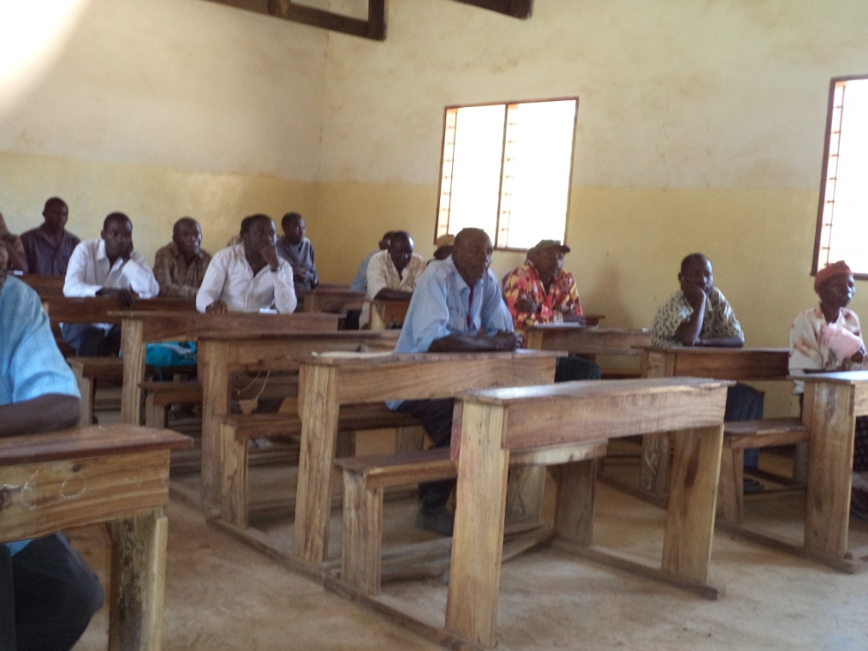
Figure 4.3 : Awareness creation to Serengeti Community Members on Importance of expansion of the scheme, Benefits of the scheme and their responsibility

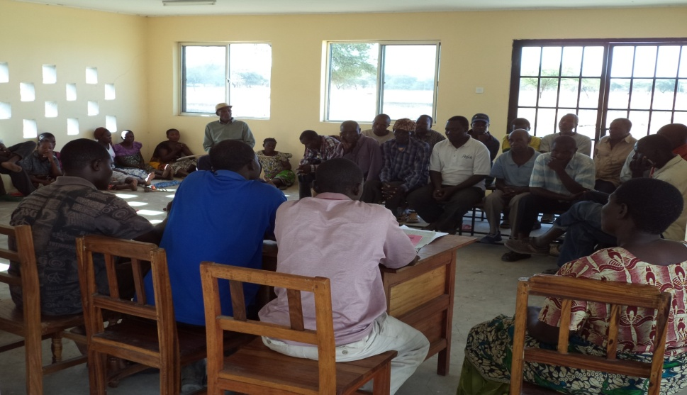
Figure 4.4 : Organising Fundraising Meeting

Table 4.4 : Project Implementation Gant Chart

Activities | Project months 2014
Activities | April | May | June | July | August | Sep | Oct | Nov | Des
Conducting Community Need Assessment (CNA),
- Community identification
- Identification problems and the most pressing need
- Planning for an intervention i.e. setting up a project
To conduct training to 120 Serengeti community members on
- Importance of expansion of the scheme
- Benefits of the scheme
- Their responsibility to the scheme
To prepare project budget
Identify the required human resources
Recruit the desired human resource
Identify potential funders
Prepare a venue for the fundraising
Organise a fundraising meeting
Purchasing equipment and resource

CHAPTER FIVE

5.0 PROJECT PARTICIPATORY MONITORING, EVALUATION AND SUSTAINABILITY

5.1 Introduction
The chapter discusses project participatory monitoring, evaluation and sustainability of the project. From the beginning of the project, during problem identification, implementation, monitoring and evaluation stages, participation was the key issues considered in implementation of the project.

The chapter explain monitoring information system, Participatory monitoring methods used to engage community in monitoring, participatory monitoring plan, participatory evaluation plan, performance indicators, participatory evaluation methods, project evaluation summary and project sustainability.

5.2 Participatory Monitoring
Monitoring is a systematic and continuous collection and analysis of data for the purpose of comparing how well a project is being implemented against expected results. Monitoring determines whether the planned activities are being implemented or not, if so, are timely and within the projected resource limits,

Participatory monitoring was done through which stakeholders shared control over implemented activities. Participation takes different forms, ranging from in sharing information on what is going on, collaboration that give stakeholders more persuade, control and monitor implementation of all activities. In this project, activities monitored were awareness to famers’ community and CBO members on the importance of the expansion of irrigation scheme, benefits and their responsibilities toward project, to prepare project budget, Identification meeting for project funders, to prepare a venue for the fundraising, Organise a fundraising meeting and purchase project materials and equipments.

5.2.1 Monitoring Information System
Monitoring was designed to monitor the implementation of all project activities that include the meeting to community member in order to get feedback to what is going on during implementation of the project, if it happened something which was negative to project it corrected before proceeding with doing mistakes.

Project information system planned to collect information on project and project activities that enable the project manager to map, monitor and evaluate operations and performance of the project. For example, enhancing paddy productivity through improving the irrigation scheme, the monitoring and information system designed to establish a data base by record information to activities that were planned in specific period of time. Information required include project facilities required and available, staff and number of paddy famers, project stakeholders, training required and actual implementation, information about fund received, equipment and material received( Inventory). Monitoring also covered utilization of fund, item purchased as authorised by relevant authority, bought items and their perspective receipts. To have these entire information help manager to plan, monitor, evaluate and have a right decision making based.

5.2.2 Participatory Monitoring Methods
Participatory monitoring methods used to engage community, CBO members and paddy famers in the monitoring of project implementation, through action plan beneficiaries were participated. Action plan was designed by the beneficiaries themselves determine how, when project activities is going to be implemented. Either self assessment method should be applied whereby assessment form should be filled by beneficiaries and there after it known what required to make collection.

The PRA techniques and principles were used to gather information which includes key informant interview, observation and documentation. The analysis done on implementation of enhancing paddy productivity through improving the irrigation scheme helped to make some improvement on daily project activities.

5.2.2.1 Key informant interview
The researcher gathered information through key informant that includes extension staff, CBO members, and district officials agreed to measure project operation. During discussion they agreed that the project management team should conduct daily fallow up for every activities conducted.

5.2.2.2 Observation
The researcher in collaboration with CBO members and paddy farmers observe all project activities implementation, as it was planned and the training work related with enhancing paddy productivity through improving the irrigation scheme.

5.1.2.3 Documentation
Documentation involves minutes of meeting conducted whereby beneficiaries got feedback on project progress. The meeting minute taken during discussion of achievements, challenges, solution and the way forward was documented. Also information about the equipment and material purchased documented in a relevant books includes payment voucher, receipt book, cashbooks, regal and journal book.
Table 5.1 : Participatory Monitoring Plan

ACTIVITY | MONITORING OBJECTIVE | INDICATORS | DATA SOURCE | METHODS/TOOLS | PERSONAL RESPONSIBLE | TIME FRAME
Conducting community need assessment (CNA) | Needs of the community is well known | List of Participants | Meeting report | Meeting | MCED student,  CBO members and Extension officer | April and May 2014
To conduct training to 120 Serengeti community members on  - Importance of expansion of the scheme  - Benefits of the scheme  Their responsibility to the scheme | 120 community members aware on importance of expansion of the scheme, Benefits of the scheme and their responsibility | List of Participants | Training repor | Training | CED Student, Comm. Dev Officer, Agric. Officer and CBO leaders | August to September 2014
To prepare project budget | Project budget approved | Project budget document | Report | Meeting | CED Student, Comm. Dev Officer and Dist Planning Officer | October 2014
Identify the required human resources | The human resource needed | List of human resource needed | Report | Meeting | Village leader and CBO leaders | October 2014
Recruit the desired human resource | Recruit human resource | Human employed | Report | Recruitment | Village leader and CBO leaders | October 2014
Identify potential funders | The founders of the project identified | Lists of potential funders | Report | Meeting | CED Student,  Bunda LGA and  Other stakeholders | October 2014
Prepare a venue for the fundraising | Venue for fundraising obtained | Venue for fundraising | Report , | Hire | Comm. Dev Officer, Agric. Officer and CBO leaders | November 2015
Organise a fundraising meeting | Fundraising meeting done | Minutes of meeting | Report , | Meeting | CED Student, Comm. Dev Officer, Agric. Officer and CBO leaders | November 2014
Purchasing equipment and resource | Equipment and tools purchased | Inventory records | Report , | Inventory | CED Student, Comm. Dev Officer, Agric. Officer and CBO leaders | December 2014

5.3 Participatory Evaluation
Evaluation is periodic assessment of the relevance, efficiency, effectiveness, impact, economic and financial viability and sustainability of a project in the context of its stated objectives.

Deepa Narayan (1993) defines participatory monitoring and evaluation that “is a process of collaborative-problem solving through the generation and use of knowledge. It is a process that leads to collective action by involving all level of stakeholders in shared decision making” From the definition the key concept is involvement of stakeholders and collective actions towards problem solving or improving the situation. That evaluation to be termed as a participatory evaluation should involve stakeholders at different levels who will work together to assess the project so as to take corrective action required.

Implementing project of enhancing paddy productivity through improving the irrigation scheme, the stakeholders greed on that project goal, objectives and activities that need to be implemented, they discussed when to conduct evaluation, how and who will be responsible. On the help of MCED student they prepare action plan agreed to evaluate a project after one year.

5.3.1 Performance Indicators
Performance indicator of enhancing paddy productivity through improving the irrigation scheme project based on project goal and objectives, input indicators measured by examine resources that were utilized in the process of project implementation. Also output indicator involves awareness conducted to community, CBO members on the importance of the irrigation scheme Benefits of the scheme and their responsibility to the scheme, while impact indicators will be measured by examining actual increased of productivity, and improvement of standard of living of famers.

Table 5.2 : Performance Indicator

Specific Objective | Performance indicator
Awareness creation to 120 Serengeti community members on the importance of expansion of infrastructure for paddy irrigation scheme by September 2014 | 120 Serengeti community members aware on the importance of expansion of infrastructure for paddy irrigation schemes
Determine the cost for the expansion of the irrigation scheme and human resources requirement by October 2014 | Approved budget,
Mobilize resources and equipments from development partners by December 2014 | Resource and equipment collected,  .Fund raising meeting

5.4 Project Sustainability.
Project sustainability is the ability of project to continue functioning, supported by its local available resources, human and material resources, even though external source of funding or support is ended. The beneficiaries agreed to use their available resources, skills and knowledge to ensure that irrigation scheme is working properly all over the time.

5.4.1 Institutional Sustainability.
The sustainability of paddy irrigation scheme for farmers in Serengeti village is likely to be sustainable because the management team of the project is within the village members. The paddy famers themselves are direct beneficiaries of the project supporting them in paddy production year to year.

Capacity building done to community on paddy irrigation scheme contributes in increase of paddy production after project objective achieved; the farmer will increase their income, make a good life to meet basic needs. The villagers who are not paddy farmer will learn from them, and sometimes they will benefit through buying rice as consumption food. Action of expansion of paddy irrigation scheme will enable the farmers increased in paddy production through awareness creation conducted before the project starts. Furthermore the participation of the community in identifying, designing, planning, implementation, monitoring and evaluation of the project is the key issue that create the sense of ownership that leads to project sustainability.

5.4.2 Infrastructure Sustainability
Infrastructure rehabilitated and constructed to support irrigation scheme in Serengeti village will be sustainable due to awareness done to community members, CBO members on the importance of the expansion of irrigation and their responsibility toward schemes. Is likely to be suitable hence the community agreed to have such expansion of irrigation scheme project which support the paddy production. Hence the community benefit, the infrastructure will be kept functioning.

5.4.3 Political Sustainability
The paddy irrigation scheme is supporting the National agriculture policy (2000), Agricultural Sector Development Programme (ASDP) 2006 and Big result now (2013), that being a case the village leader, councilors, Executive officers, District Chairperson and district Executive director is in favor of the project. Efforts done by different stakeholders, development partners to support the project has created good relationship between local government and community of Serengeti village

CHAPTER SIX

6.0 CONCLUSION AND RECOMMENDATION

6.1 Introduction
This chapter gives a summary of the enhancing paddy productivity through improving the irrigation scheme in Serengeti Village. Briefly it analyzes on the processes that were carried out from project identification up to the project implementation result. The information within the chapter includes Community Needs Assessments, Problem identification, Literature review, Project implementation, Participatory Monitoring, Evaluation and sustainability of the project. However, the chapter will carry a conclusion which will enable researchers, decision makers, policy makers and other developments partners in the agriculture sector get the necessary information about the project and come up with concrete suggestions and improvement.

6.2 Conclusions.
The enhancing paddy productivity through improving the irrigation scheme in Serengeti Village is directly supporting the Tanzania Agricultural Policy, the National Strategy for growth and Reduction of Poverty II. Community dwellers in Serengeti village with the assistance of CED student conducted CNA exercise, which showed that, community needs are provision of warehousing, agriculture inputs, expansion irrigation scheme and financial support. According to priorities the community decided to improve the paddy irrigation scheme through enhancing paddy productivity through improving the irrigation scheme.

Although policy of agriculture is focused to utilize available resources of commercialization and market oriented dairying in order to raise income of farmers and improve their standard of living, little has been done hence it seems to be more theoretical than practical. That being the case, Stakeholders involved in to support the project. The progress of the implementation project has been covered by all three objectives and six activities were implemented.

The CED student work together with community members, CBO members and other stakeholders in project identification, project planning, implementation and monitoring and evaluation of ongoing activities, the aim of CED student was to ensure that those stakeholders are capable enough to run the project in absence of CED student.

6.3 Recommendation.
Based on community needs assessment, the community should be the key in participation, transparency and sense of ownership can easily be determined as roots of project sustainability. In community need assessments, I would recommend to use Participatory Rural Appraisal (PRA) tools as it allow for joint learning between local people and outsiders (development practitioners, government officials) to plan together on appropriate interventions.

The participatory assessment should involve the representative of community residents in clusters being residents, farmers, livestock keepers, business people, and stakeholders from government, private institution and sector experts. This helps to share knowledge and experiences that minimize wastage of resource especially during the planning, designing and budgeting exercise.

REFERENCES
Alvin, C. M. and Caren, J. M. (July 2008) Best practices in irrigation and drainage Learning from successful projects, A Case Study from the 2006 Annual Evaluation Review.
Bunda District Executive Director, (2013), Bunda District Profile, Bunda District Council.
Burchinal, L. (1997), Methods for Social Researchers in Developing countries, Available in PDF and www.srmdc.net/ last accessed on October 15th 2008.
C.R Kothari (2004), Research Methodology, methods and techniques .second revision edition.
Center for Development and Population Activities (1994). Project Design for Program Managers, Washington DC.
Centre for Community Enterprise (2000). Tools and Techniques for Community Recovery and Renewal, Boston.
Creswell, J.W (2008), Research Design, Qualitative, Quantitative and Mixed Method approaches, New Delhi: Sage.
Feuerstein, Marie-Therese (1986), Partners in Evaluation: Evaluating Development and Community Programmes With Participants MacMillan Publishers Ltd. ISBN 0-333-42261-9, Distributed by Teaching Aids at Low Cost, P.O. Box 49, St. Albans, Hertfordshire, ALI 4AX, UK.
Guijt, I. (2004) 'ALPS in Action: A Review of the Shift in Action Aid towards a new Accountability, Learning and Planning System', Action Aid International.
Isinika, A. C., Gasper C. A. and James, E. D. M. (2005): From Ujamaa to Structural Adjustment Agricultural Intensification in Tanzania,The African Food Crisis: Lessons from the Asian Green Revolution .
Kaassen and Moyniham (2005), Information: Its Collection and Use throughout the project Lifecycle. Available in PDF.
Loyola University Chicago: ( September 2000), Centre for Urban research and learning and the department of psychology.
Mdemu, Makarius Victor, and Theresia Francis (2013), "Productivity of Water in Large Rice (Paddy) Irrigation Schemes in the Upper Catchment of the Great Ruaha River Basin, Tanzania.
Mrema, G. C. (1984)" Development of smallholder irrigation in Tanzania: Problems and prospects."African regional symposium on smallholder irrigation, University of Zimbabwe, Harare, Zimbabwe.
Mrema, G. C. (1984)"Development of smallholder irrigation in Tanzania: Problems and prospects." African Regional Symposium on Smallholder Irrigation, University of Zimbabwe,Harare, Zimbabwe.
Mulwa, F. (2008), Participatory Monitoring and Evaluation of Community Projects, Paulines Publication, Nairobi.
Narayan, D. (1993), Participatory Evaluation: Tools for Managing Change in Water and Sanitation.World Bank Technical Paper No. 207, Washington, DC
NSSP Working Paper No. 21( October 2011), Nigeria Strategy Support Program (NSSP).
Rwegoshera, Hosea (2006), A Guide to Social Science Research
Steyaert and Lisoir (2005), Participatory Methods Toolkit, London.
[http://www.southernalabama.edu/coe/bset/johnson/dr_johnson/2lectures.html].site visited on 24/12/2013.
[http://www.scribd.com/doc/939968/].Research-Methodology-PartI-Introduction-to-Research-Methodology, site visited on 24/12/2013.
[http://www.hmdc.harvard.edu/projects/ SPSS_Tutorial], site visited on 25 /12/2013.

APPENDICES
Dear respondent. Aim requesting you to participate in this study by filling in a questionnaire and respond to the questions. I assure you that your answer will only be used for scientific purpose in this study, thus your information will secretly be treated as strictly confidentially and will be presented in the form of statistic report.

Appendix 1 : Structured Questionnaire for Respondent

STRUCTURED QUESTIONNAIRE FOR RESPONDENT

Personnel particulars:
- Sex: (1) Male, (2) Female)
- Age : (1) under 18 years, (2) 20 – 40 years, (3) (2) 40- 50 years (4) above 50 yeas
- Level of education : (1) informal (2) primary (3) Secondary (4) Colleges and University
Economic assessment;
- Economic activities conducted in your village (1) fishing (2) Livestock (3) agriculture (4) business (5) other specify
- What you think is sustainable economic activities in your area: (1) (1) fishing (2) Livestock (3) agriculture (4) business (5) other specify
- What are the other potential economic projects in the community?
- Household income per month (1) Tsh 5,000 - 50,000 (2) 50,000 - 150,000(3) 150,000- 250,000 (4) more than 250,000
- List a community needs………………………………………………………
- What is priorities in ranking……………………………………………………….
- What challenges do you think you may face in implementing the proposed project? .....
- What are suggested solution to solve the problems in Serengeti village (1) to run economic activity (2) Provision of soft loan (3) conducting household income generating activities (4) other specify

Appendix 2 : Interview Guide for Focus Group Discussions with CBO

INTERVIEW GUIDE FOR FOCUS GROUP DISCUSSIONS WITH CBO

Name of non government organisation (NGO)………….......………………...............….
- How many members are in Serengeti irrigation group ……...................................
- Is the CBO registered ...............................................................……………….......
- What are the CBOs goals …………………………………....................................
- Who financed the CBO? ..........................................................................................
- What is income activity being undertaken by group................................................
- Is the income activity undertaken profitable? .........................................................
- What are the challenges facing your business?
- Have the CBO members received any training on business under takings or technical knowledge related to the group activities.
- How have the group members benefited?
- What kind of support has CBO received from the Government/any other development institution?
- What should be done to improve the group economic performance?

Appendix 3 : Interview Guide to Government Officials

INTERVIEW GUIDE TO GOVERNMENT OFFICIALS

- What are the other potential economic projects in the community?
- Suggest measures to improve the performance of economic activity operated by CBO
- What measures to be taken to improve the economic activity in the community
- Is the community members aware with potential economic activities supposed to be undertaken in the community, yes or no
- If the answer is no, what you think is supposed to be done..............................
- What are the opportunities to community members
- What measures do the LGA and other Stakeholders take to support the Serengeti irrigation group (CBO)

Appendix 4 : Meeting to Community

MEETING TO COMMUNITY

HALMASHAURI YA WILAYA YA BUNDA
MKOA WA MARA  Simu: +255 (0) 28 262 1055  Nukushi: +255 (0) 28 262 1264 Email:halmashauri_bunda@yahoo.com  Website: www.bunda.go.tz  Kumb. Na. HB/UK/5/423 |  | OFISI YA MKURUGENZI MTENDAJI (W)  S.L.P. 126,  BUNDA  11/04 /2014
Mtendaji wa Kijiji
Serengeri
Bunda

YAH; MWALIKO WA KIKAO CHA PAMOJA CHA WAKULIMA NA WANAKIJIJI WOTE

Kichwa cha habari pao juu, chajieleza.
Mimi ni mwanafunzi wa chuo kikuu huria (Tanzania) na mtumishi wa Idara ya Maendeleo ya Jamii wa Halmashauri ya Bunda.

Dhamira yangu ni kukutana na wakulima na wanakijiji wote kwa ujumla ili kufanya mkutano wa pamaoja ambao utatupa fursa ya kubaini tufanye nini, kutumia raslimali zinazotuzunguka ili kujiletea maendeleo endelevu katika kijiji chetu.

Basi napenda uniandalia mkutano wa pamoja ambao unafaa ufanyike tarehe 03.04.2014 .masaa ya jioni saaa 10:00 baada ya wananchi kutoka katika shughuli za uzalishaji mali. Bila kuwasahau kikundi cha kilimo cha umwagiliaji Serengeti,
Wako

Adimirabilis Vitus

