POVERTY INDICATORS AFFECTING ACADEMIC PERFORMANCE IN TANZANIA SECONDARY SCHOOLS AT NKASI DISTRICT

GEOFREY MSHANI

A DISSERTATION SUBMITTED IN PARTIAL FULFILLMENT OF THE REQUIREMENT FOR THE MASTER DEGREE OF EDUCATION IN ADMINISTRATION, PLANNING AND POLICY STUDIES (MED-APPS) OF THE OPEN UNIVERSITY OF TANZANIA
2015

CERTIFICATION

The undersigned certifies that she has read and hereby recommends for acceptance by the Open University of Tanzania (OUT) a dissertation titled; “Poverty Indicators Affecting Academic Performance in Tanzania Secondary Schools at Nkasi District” in partial fulfillment of the requirements for the Degree of Master of Education in Administration, Planning and Policy Studies of the Open University of Tanzania.

…………………………………
Dr. Elna Lyamuya.
Supervisor

………………………………
Date

COPYRIGHT

No part of this dissertation may be reproduced, stored in any retrieval system, or transmitted in any form by any means, electronically, photocopying, recording or otherwise without prior permission of the author or The Open University of Tanzania in that behalf.

DECLARATION

I, Geofrey Mshani, do hereby declare to the Senate of the Open University of Tanzania that this dissertation is my own original work, and has not been submitted for a higher degree in any other University.

…………………………………
Signature

...……………….………………
Date

ACKNOWLEDGMENTS

I wish to acknowledge all those whose contributions have made possible the accomplishment of this dissertation. First and foremost is Dr. Elna A. Lyamuya, the Director of Rukwa Regional Center, Open University of Tanzania who is also my supervisor. She has showed a fresh perspective that carried me through some very difficult points in my graduate experience. I believe that without her cooperation this research could not be a realistic. Secondly is Mr. Dennis Konga, a staff member of the Open University of Tanzania at Rukwa Regional Center for his advice, directions and his faithful heart to this work. I say may God bless him.

I also wish to extend my sincere thanks to the District Executive Director of Nkasi for his permission to collect data in his jurisdiction; He showed me assistance -needed to the accomplishment of this work. I wish to thank Mr. Njau F.M. who is currently teaching at St Theresia Secondary School in Sumbawanga. He encouraged me during the difficult times.

I also thank members of the Education Department of the Open University of Tanzania who gave me directions relating to the procedures relating to this project work. Whatever shortfalls encountered in this document are due to my own weaknesses and should not be attributed to any person acknowledged herein.

ABSTRACT

This study was about Poverty Indicators Affecting Students’ Academic Performance in Tanzania secondary schools in Nkasi District. Its purpose was to examine the manner in which poverty indicators are affecting Students’ Academic Performance in the said area. Specifically, it sought to determine the academic underperformance trend at levels, investigate socio economic factors affecting the said performance; Assess parents’ played roles and challenges faced in solving factors. The study approach was qualitative. It involved 121 respondents who were selected by purposive- random sampling. One of the findings included: that the underperformance were caused by mentioned seven factors of which they were asked to rank them in terms of their potentiality and significance. Consequently, they ranked first the English language, poverty income of parents, heavy house home chores and child labour while at school, distance from home to schools. Lack of study facilities, Lack of teachers and lack of basic needs. Poverty was confirmed as one of the socio economic factors for underperformance though not alone. The study found that some parents were playing their roles as supposed though students singled some who discouraged their children to study hard. The researcher recommended that government should intervene to rescue poverty line households to subside secondary school students. Finally, it was recommended that since this study was carried in qualitative let further study of the same be conducted using quantitative design.

TABLE OF CONTENTS

CERTIFICATION ii
COPYRIGHT iii
DECLARATION iv
ACKNOWLEDGMENTS v
ABSTRACT vi
LIST OF TABLES xii
LIST OF FIGURES xiii
LIST OF APPENDICES xiv
LIST OF ABBREVIATIONS xv
CHAPTER ONE 1
INTRODUCTION 1
1.1 Background to Statement of the Problem 1
1.2 Statements of the Problem 7
1.3 Objectives of the Study 8
1.3.1 Purpose of the Study 8
1.3.2 Specific Objectives 8
1.4 Research Questions 9
1.5 Significance of the Study 9
1.6 Limitations of the Study 9
1.7 Delimitation of the Study 10
1.9 Definition of Terms 10
1.10 Organization of the Study 11
CHAPTER TWO 12
LITERATURE REVIEW 12
2.1 Introduction 12
2.2 Concept of Poverty versus Academic Performance 12
2.2.1 Conceptualization of Poverty 12
2.2.2 Global Poverty Status 13
2.2.3 Poverty Status in Tanzania 14
2.2.4 Education as an Approach to Poverty Alleviation 14
2.3 Poverty and Academic Performance 15
2.3.1 Influence of Poverty on Educational Performance 19
2.4 Involvement of Parents and Families in Academic Performance 29
2.5 Conceptual/Theoretical Framework 30
2.6 Research Gap 33
2.7 Chapter Summary 34
CHAPTER THREE 35
RESEARCH METHODOLOGY 35
3.1 Introduction 35
3.2 Research Design 35
3.3 Research Approach 35
3.4 Study Area 36
3.4.1 Land and Administrative Area 38
3.5 Target Population 38
3.6 Sample Size and Sampling Techniques 39
3.6.1 Sample Size 39
3.6.2 Sampling Techniques 40
3.7 Research Methods 41
3.7.1 Interview 41
3.7.2 Questionnaire 42
3.7.3 Documentary Review 43
3.8 Validity and Reliability 43
3.9 Ethical Consideration 44
3.10 Data Analysis Plan 45
3.11 Chapter Summary 45
CHAPTER FOUR 46
DATA PRESENTATION, ANALYSIS, DISCUSSION AND INTERPRETATION 46
4.1 Introduction 46
4.2 Characteristics and Distribution of Respondents 46
4.2.1 Academic Performance Trend in Rukwa Region 49
4.3 Perceived Socio Economic Factors Influencing Academic Performance 51
4.4 The Role of Educational Stakeholders on Facilitating Academic
Performance in Nkasi secondary schools. 61
4.4.1 Parents’ Responsibilities in Supporting their Children for Quality
Performance 61
4.4.2 Lack of Role Models from the Family 62
4.4.3 Cultural Values, Traditions and Beliefs 62
4.5 Challenges Facing a way Forward to Solve Factors for Underperformance 64
4.5.1 Efforts for Solving the Academic Underperformance in Secondary School 64
4.5.2 Penalising Parents Hindering their Children to School Strategy 65
4.5.3 Perceived Obstacles in Accelerating Variation for Academic Performance 66
4.6 Discussion 67
4.7 Academic Performance Trend Results at Various Levels 68
4.7.1 Perceived Socio economic Factors that Affect Academic Performance Significantly 70
4.7.2 Significant Versus Potential Factors Perceived to Affect Academic Performance 70
4.7.3 Parents’ Responsibilities in Facilitating Academic Performance 75
4.7.4 Challenges Facing Efforts to Solve Factors Affecting Academic
Performance 77
CHAPTER FIVE 81
SUMMARY, CONCLUSION, AND RECOMMENDATION 81
5.1 Introduction 81
5.1.1 Determine Underperformance Scenario Trend in Secondary
Schools at Levels 81
5.1.2 Socio economic Factors and Academic Activities versus Varying Performance 83
5.1.3 Educational Stakeholders’ Roles in Facilitating Quality Performance 84
5.1.4 Challenges in Attempt to Solve the Factors for Underperformance 85
5.2 Summary 86
5.3 Recommendations 87
5.3.1 Recommendation for Actions 88
5.3.2 Recommendations for Further Studies 88
REFERENCES 89
APPENDICES 98

LIST OF TABLES

Table 1.1: Students’ Performance in Community Secondary Schools Since 2008-2010 (National Level) 3
Table 4.1: Respondent’s Distribution 47
Table 4.2 Distribution of the Students According to Sex 47
Table 4.3: Students’ National Examination Results Status of Rukwa Region
(2008-2010) 50
Table 4.4: National Students’ Performance Community Schools Status of Nkasi District (2008-2010) 50
Table 4.5: Students’ Perceived Factors for their Academic Underperformance in School 52

LIST OF FIGURES

Figure 3.1: Map of Nkasi Districts showing Administrative Boundaries 37
Figure 4.1: Eight Cohorts’ National Certificate of Secondary School Examination Results 50
Figure 4.2: Student Preparing her Lunch During Lunch Time 55
Figure 4.3: A Student walking Longer from School to Home 57
Figure 4.4: Employed Student at Construction Work to Earn Income 60
Figure 4.5: Rented Girl Students’ Sleeping Room without Electricity 61
Figure 4.6: A Male Student Studying in His Room 62

LIST OF APPENDICES

Appendix I: Questionnaire for Both Continuing and Graduate Students 98
Appendix II: Dodoso kwa Washiriki Waliomaliza na Wanaoendelea na Shule 100
Appendix III: Letter of Research Clearance 102
Appendix IV: Interview Schedule 103

LIST OF ABBREVIATIONS

CTCCHR Child Trends and Center for Child Health Research
DT Dependency Theory
EFA Education for All
ESR Education for Self Reliance
GDP Gross Domestic Product
GNP Gross National Product
HCT Human Capital Theory
HIV Human Immune Virus
NICCY Northern Ireland Commissioner for Children and Young People
PEDP Primary Education Development Plan
SEDP Secondary Education Development Plan
UN United Nations
UPE Universal Primary Education
URT United Republic of Tanzania
USA United States of America
WASCE West African School Certificate Examination
WB World Bank

CHAPTER ONE

INTRODUCTION

1.1 Background to Statement of the Problem
No country in the world has developed without providing the quality education be at primary, secondary or university levels to her citizens as echoed in the World Bank report (WB, 1990). The report adds that development comes, when the nations invest in people to improve their access to social services such as education. The concept of poverty and education in Tanzania goes back to 1960s when, the then first president of Tanganyika, criticised the colonial formal education as irrelevant since it was racial, gender biased and incapable of eradicating the three identified enemies. These enemies were ignorance, diseases and poverty (Nyerere, 1967).

In order to eradicate the three enemies of the people namely: ignorance, diseases and poverty, Nyerere decreed the philosophy of Education for Self Reliance in (ESR, 1967) that activated the education development. As a result the 1970s era, saw the free primary education provision to the majority of pupils in unison with the Universal Primary Education (UPE) programme (Galabawa and lwaitama, 2008). Nyerere’s thoughts about the potential powers of education to fight the three enemies he identified since 1960s in particular poverty, find support from worldwide studies, theories, articles, and concepts as follows.

The right to education is enshrined in the Universal Declaration of Human Right, which the 1948 United Nations General Assembly adopted and which our countries are signatories, including Tanzania. Although every child was guaranteed the free and compulsory primary education from 1976, as a result of the United Nations (UN) declaration on the Universal Primary Education (UPE), at the secondary school level things are different today under the UN declaration of Education for All (EFA) on secondary education. It is unfortunate that from 1960s, the secondary education was not a priority for the world nations, since by then it was not possible for every youth to get access to secondary education. This outlook reigned in Tanzania from early 1980s until 1999, when only minority accessed secondary school education. But the changes occurred beginning from 2000. This is a time when; Tanzania put on the implementation of the Makweta’s Task force report of 1983 proposals, among which there was a proposal on the need to expand the entire system of education holistically (URT, 2000). The government came up with the whole school development plan by 2000.

In making the poverty Reduction Strategy a reality in Tanzania, secondary education is considered as one of the major components of the strategy as per (URT, 2004). It is in the same line whereby the Tanzanian government had embarked on the expansion of the secondary school system aiming at increasing the rate of economic growth and productivity of her own people. Moreover, the secondary education has been exhibited as an essential for the improvement of the quality for primary education leavers.

Despite the desire to expand any system of education, there have always been the major challenging issues of education expansion that are four: enrolment, retention, completion and pass rates along with ensuring efficiency and quality of the given education (Galabawa and lwaitama, 2008).
It is argued that to enrol is one issue but to ensure quality is another. The experience has shown that once the enrolment grows without ensuring uniform increase of the other conditions such as: infrastructure, teachers, teaching and learning materials, quality of academic performance will tend to decline (Galabawa and Lwaitama, 2008). The infrastructure side includes: inadequate classrooms, office and houses for teachers, laboratories and practical equipments, furniture, toilets, lack of water and electricity in some of the schools, inadequate teaching and learning materials and inadequate teachers especially for science and mathematics subjects.

This leads to underperformance scenarios among learners, especially girls in science and mathematics (URT, 1996). The general underperformance at the national level is well documented as can be briefly illustrated in the results of community secondary schools at the national level from 2008-2009 in Table 1.1 as follows.

Table 1.1: Students’ Performance in Community Secondary Schools Since 2008-2010 (National Level)
Year | Percentage of students who passed
2008 | 81.35%
2009 | 67.67%
2010 | 43.01%
Source: (BEST, 2012)

Table 1.1 furnishes the condition of the community secondary schools at national level. It illustrates that the performance from 2008-2010 dropped by 38.34%, compared to performance (43.01%) of the community secondary schools in 2010. The analysis indicates that general results in 2008 stood at 81.35 percent. The next year in 2009 the general results pass rates were at 67.67 percent. The data suggest that from this data one sees the academic performance had a difference of 13.68 percent and the gap of underperformance scenario increased. 1n 2010 the examination results were 43 percent, below the average of the examination results which previously was at 54.4 percent. The extent at which poverty influences learners’ performance is well documented.

Studies done by Sutton (2007) found that children from well to do families had more positive attitude toward education hence good performance. Very few studies have been done in Tanzania to see the effect of poverty in education. It is acceptable that attainment of education at the secondary education increases the chances of success in adulthood (Hirsch, 2006). The education consequences are said to assist in reducing the number of poverty stricken families through employment and wage (Blenden and Gregg, 2004; Gregg and Machin, 2000). This is due to the fact that employment is a principal source of income in both well to do and poverty stricken families.

The findings from Dresden, et al. (2004) too, reveal that the interviewed parents had higher aspiration regarding their children’s schooling; each parent wished that his/her child would proceed to higher level of education. Furthermore, Dresden, et al. (2004) report that the family income is associated with increased levels of parental stress, depression, and poor health conditions that might adversely affect parents’ ability to nurture their children. The researcher sites an example that, in 1998, (27) percent of kindergartners lived with poverty in USA, and had a parent at risk for depression, compared to (14) percent for other kindergartners from well to do families. The same source URT (2004) source reports, that Tanzania lags behind when it is compared to Uganda and Kenya on secondary school issue by having only 9 percent of the labour force, who have attained the education beyond primary school. It is argued that the productive skilled labour force has been below what is required. This in turn acts as one of the major constraints on the increased domestic and foreign investment. Moreover, there are reports of decreasing for the formal employment in the government and parastatal sectors as well as in the private sectors. Greater anticipation is placed on the informal sector requiring secondary education to perform in a modest way (URT, 2004).

Despite the recognised value of secondary education the practical challenge facing all nations has always been expansion of enrolment without ensuring the three issues of education. The enrolment, retention, and quality academic performance need to be ensured that are achieved together for the sake of the present generation in secondary schools education (Galabawa, and Lwaitama, 2008). The researcher’s experience shows that every school vision and missions and every parent enroll children in secondary schools expecting the quality academic performance. However, the expanded enrolment has not always favoured an increase of the expected quality results at the form four national examinations in particular.

The results for so long have always been released with underperformance scenarios contrary to educational stakeholders’ expectations (Twaweza, 2013). This is despite the observed teaching and learning processes taking place in both private and public secondary schools. The contrariety in the national examinations results, leads to the researcher’s puzzle on what factors are at work accelerating the contrariety of expectations in secondary schools performance. The contrary expectations on secondary school students’ completion results have attracted the researchers’ attention to investigate what factors are at work to influence the academic performance variations. Presenting the causes for underperformance scenarios long ago Clemens and Oelke (1967) study attributed the cause of poor academic performance to the combination of personal and institutional factors.

These researchers found that the personal factors related to the individual’s intelligence, knowledge, and ability. While the institutional factors of either family, parental, or societal, the institutional influences were found out to be those of school related factors. These included: student/teacher support, teacher related factors, accommodation and living conditions as found in (Clemens and Oelke, 1967). In their findings these authors mentioned personal factors which include: problems affecting students him/her self, where by poverty as a single entity is not discussed. In the same vein for Wiseman (1973) study attributes among other issues, by examining the causes of poor academic performance among primary school students. Some of the identified factors were: intellectual abilities, poor study habits, and motivation, lack of vocational goals, low self-concept, poor family structure and anxiety.

The consequences of lacking the identified attributes were attributed to the causes of indiscipline in schools and low level of educational standards. The Daily Sketch Published study on “causes and cures of poor performance in West African School Certificate Examination WASCE (2006),” identified and categorized problems responsible for students’ poor performance. This study too attributes the problems of students of the underperformance, some to teachers, some to problems of inadequate facilities in the schools, problem traceable to students, problems caused by parents and society at large and problems of government policies and low funding of the education sector (Ajila and Olutola, 2007).

1.2 Statements of the Problem
Despite the desire to expand secondary education on issues of enrolment, retention, completion, and pass rates beginning 2005, yet the quality of students’ academic performance in Tanzania secondary schools, has increasingly declined year after year (MOEVCBEST, 1998-2012;Twaweza, 2013). This is despite the on going processes of teaching and learning in secondary schools. Whereas so many researchers have paid great attention to investigate the factors affecting academic in the secondary schools, the poverty variable has been neglected especially in peripheral rural areas such as Nkasi district in Rukwa.

Consequently, there was a knowledge gap between what was known and unknown in addressing the raised grand question of the current study, How do poverty indicators affect the students’ academic performance in Tanzania secondary schools in particular in peripheral areas of the country like Nkasi?

(Makori, 2001) argues that extra family income might also matter if parents use the money for child-centered goods like books, for quality daycare or preschool programs, for better dependent health care, or to move to a better neighborhood. Until recently, empirical studies linking poverty and income to child outcomes have done little to eliminate biases caused by the omission of unobserved family and child characteristics.
The poverty issue has been neglected as if it is less potential contributory factor in the said area. May be the negligence of such studies in the said area has been because the poverty variable is regarded as an abstract. Consequently, the evidence of informing the possibility of poverty to be affecting secondary school students’ academic achievement, has received less attention by researchers. This was why there was a need for designing a study that would address the said raised grand question. This study was about “Poverty Indicators Affecting Academic Performance in Tanzania Secondary schools at Nkasi District.”

1.3 Objectives of the Study
The current study had aims broken into the general objective as a purpose of the study and specific objectives as follows:

1.3.1 Purpose of the Study
The main objective of the study was to examine the manner how poverty indicators affect students’ academic performance among secondary schools in Tanzania, so as to come up with a way forward.

1.3.2 Specific Objectives
The study sought to attain the following specific objectives:
- Determine the students’ performance results trend at different levels.
- To investigate the mediating socio economic factors surrounding the academic activities leading to the variation of academic performance in studied secondary schools.
- To assess some educational stakeholders’ roles in facilitating students’ quality academic performance.
- To assess the faced challenges in attempt to solve the mediating factors affecting the variation of the academic performance in secondary schools.

1.4 Research Questions
- What has been the trend of variation for the academic performance nationally, regionally and division wise?
- What are the mediating socio economic factors surrounding the academic activities leading to the variation of academic performance in studied secondary schools?
- Do parents play their responsibilities to support their children toward quality performance?
- What are the obstacles and suggested solutions as a way forward?

1.5 Significance of the Study
This study was important because it would find out how poverty at district and division, and family levels influences students’ academic performance. It was hoped that after this study some of the important from the various levels would be used to rectify the current underperformance scenario.

1.6 Limitations of the Study
To some extent the study had limitations. The study studied a smaller number of research participants, as such its findings could not be generalised. The anonymity of respondents surely affected the quality of information given the nature of the study about issues of poverty. The researcher got the problem on communicative language, the researcher made interrogations with parents of the students in Kiswahili since, almost all of them could not speak Kiswahili and English. So, the questionnaire was written in Kiswahili as seen in Appendices. Latter the translations might have altered some original intended meanings. The presence of the researcher among parents might have caused some fear and that would also alter the quality of collected information.

1.7 Delimitation of the Study
The scope of this study focused only on the effects of poverty indicators on students’ academic performance in the studied secondary schools of Tanzania, particularly in Rukwa region, Nkasi district at Namanyere division. Consequently, the current study did not study the effects of poverty on academic performance in primary schools or the rest of secondary schools in the entire country of Tanzania.

1.9 Definition of Terms
In this study the following terms were operationalised in the personal context.

Poverty - a situation that may be experienced in terms of indicators of socio economic standards.
Academic performance - a school achievement as a result of being taught and having learnt.
Parents: father, mother or guardian with students who were at secondary school or completed secondary school.
Students –learners in secondary schools level.
Underperformance- a situation of declining from the maximum peak of already achieved success to the minimum peaks.
Poor performance- stands for results which is below the pass mark

1.10 Organization of the Study
This study is organized in five chapters. Chapter one dealt with the problem and its context while chapter two presents the related literature. Chapter three explains the used research methodology and chapter four deals with the presentation, analysis, discussion and interpretation of the findings. Chapter five presents the summary, conclusions, and recommendations of the study.

CHAPTER TWO

LITERATURE REVIEW

2.1 Introduction
Chapter two is a continuation of theoretical background information that began right from chapter one. As such, it is about the related reviewed literature on the perspectives about the studied problem. It presents an introduction, followed by conceptual literature on theories addressing the grand question “how do poverty indicators affect the students’ academic performance in secondary schools of Nkasi district? Likewise, the chapter consists of the reviewed global related empirical literature findings world wide with the researcher’s critiques of each study, about the poverty and performance variables. Towards the end the created knowledge and chapter summary are presented.

2.2 Concept of Poverty versus Academic Performance
The conceptual literature in this study meant the reviewed concepts besides empirical literature. This kind of literature clarifies the technical concepts that are used in certain.

2.2.1 Conceptualization of Poverty
The identification of poverty in Tanzania began right from independence, when the then president of Tanganyika declared ignorance, diseases, and poverty as enemies of the people. The president since then declared the war against such psychological enemies, the war that has been endless (Nyerere, 1964). Since then, Tanzania defined poverty as a state of deprivation and prohibitive of a decent human life (URT, 2005). The source describes poverty as result of many and mutually reinforcing factors, including lack of productive resources to generate material wealth, illiteracy, and prevalence of diseases. It is added that the factors are discriminative socio-economic and political systems, natural calamities such as drought, floods, HIV and man-made situations such as wars (URT, 1999).

The WB (2005) characterizes poverty as pronounced deprivation of the wellbeing of a person whereas one is thought to be poor if one does not have enough income or consumption. The criteria of the WB seem to be similar with those of Tanzania by also having the income criterion as a base, followed by measuring malnutrition similarly with the literacy level.

However, the WB criteria differ from Tanzanian ones by also looking the position and the capability one has in the society. It may be concluded that there is a general consensus between the WB and developing countries like Tanzania that the dominant criteria of identifying the poor are just its indicators poor lack capabilities and in most cases they may have inadequate education, income, poor health, feel powerless and lack political freedom (WB, 2005).

2.2.2 Global Poverty Status
The IFAD (1992) report estimated that more than one billion people in the world population lived below poverty line in 1992. Among these 939 million were found in rural areas of the world. In particular, Asia was pointed out to have the highest number of people living in rural areas, where the poor were estimated to be 633 million. In comparison with the Sub-Saharan Africa it had 204 million people. The Latin America and Caribbean followed by having 76 million poor people. The rest were the near East and North Africa countries (IFAD, 1992). Later on the WB (2000) reported that, between 1987 and 1998 the population in the developing countries lived on less than one dollar a day.

2.2.3 Poverty Status in Tanzania
Using the monetary indices of the Gross Domestic Product (GDP), Gross National Product (GNP), and per capita income Tanzania was reported to have poor people, who lived on less than one dollar a day. Such indices perspective situated Tanzania among the poorest countries in the World as per (URT, 2003). The reasons were due to the proportion of her population who are below the national basic needs poverty line at 35.7 percent, whereby those below the national food poverty line stands at 18.7 percent (URT, 2005). This source estimates that half of all Tanzanians are basically poor and one third of her population is reported to live in abject poverty. The other third was estimated between 15 million and 18 million adult people who are reported to live below the poverty line of 0.65 dollar a day (World Bank, 2000).

2.2.4 Education as an Approach to Poverty Alleviation
The fundamental role of education in the national development cannot be over emphasized. The investment in education is self-evident in order for any countries to achieve higher levels of economic growth and productivity in particular (WB, 2000). Tanzania is not an exceptional of the confirmed norm. It is further confirmed that, the secondary education increases chances for poverty alleviation as currently the world economies require the supply of the educated and trainable labor force with secondary education as the minimum qualifications. The URT (2004) country report asserts that the eminence of secondary education in Tanzania has been regarded as the necessary condition for economic competitiveness in the context of globalization and liberalization.

Moreover, the secondary education has been exhibited as an essential for the improvement of the quality for primary education leavers. In making the poverty Reduction Strategy a reality, secondary education is considered as one of the major components of the strategy as per (URT, 2004). It is in the same line whereby the Tanzanian government had embarked on the expansion of the secondary school system aiming at increasing the rate of economic growth and productivity for her own people. Moreover, it is confirmed that the expansion of education increases the chances of children from poor families attending secondary school and thereby ultimately improving their living conditions (URT, 2004).

The same source URT (2004) reports, that only 9 percent of the labour force has received education beyond primary school, while the productive skilled labour force has been below what is required. This in turn acts as one of the major constraints on increased domestic and foreign investment. However, there are reports of decreasing in the formal employment in the government and parastatal sectors as well as in the private sectors. Greater anticipation is placed on the informal sector requiring secondary education to perform in a modest way.

2.3 Poverty and Academic Performance
Bakare (1994) specifically talks on issues of poverty and the academic performance. For this author the underperformance means any achievement that falls below the desired standard. The author theorises that the criteria of excellence could be estimated from 20 to 100 percent depending on the subjective yardstick of the evaluator or assessor. Besides those perspectives, Aremu (2000) asserts that the poor academic performance among other things is dependent on the decision of the examinees towards failing to reach the expected standard. The interpretation of this expected or desired standard is better appreciated from the perpetual cognitive ability of the evaluator of the performance.

The evaluator or assessor can therefore give different interpretations of achievement depending on some factors. It is from the above contentions that the investigations on the factors that affect students’ performance have attracted many researchers, so that through their research findings they would come up with various suggestions. From these findings, many factors and ways forward have been pointed out, but still yet the problems of underperformance scenarios still persist at the level of secondary school. Addressing the causes for the underperformance scenarios the long ago. Clemens and Oelke (1967) attributed the causes of poor academic performance to be the combination of personal and institutional factors.

The researcher argued by then that the personal factors are broad to include: the individual’s intelligence, knowledge, and ability. Furthermore, the attributes extend to the institutional influences, family or parental and societal. The institutional influences are such as the school environment related factors student/teacher rapport, teacher related factors, accommodation and living conditions (Clemens and Oelke, 1967). In their findings these researchers singled out personal factors, which include: problems affecting an individual student him/her self, where by poverty as a single entity was not seen as a contributory factor in that study.

In the same vein Wiseman (1973) study attributed among other issues, had examined the causes of poor academic performance among primary school students. This study identified factors such as the intellectual abilities, poor study habits, and motivation, lack of vocational goals, low self-concept, poor family structure and anxiety. The study too found that the consequences of lacking the identified attributes were attributed to the causes of indiscipline in schools and low level of educational standards. Another study is that of Daily Sketch Published study on the “causes and cures of poor performance in West African School Certificate Examination WASCE (2006), which identified and categorized problems responsible for students’ poor performance.

It is added that although, the school related factors are responsible for the experiences it bears to an individual’s life during school life, yet parents and the individual’s experiences at home play tremendous roles in building the personality of the child and making the child what he/she is. In unison with previous study report, Ichado (1998) concludes that the environment in which the student comes from can greatly influence their performance at school. Based on the previous study reports, it is clear that the socio economic factors besides other factors have greater influence on an individuals’ academic performance.

Elaborating how the poverty contributes to the poor academic performance the researcher Emeke (1984) identified how the poor income families affected the primary school pupils’ outcomes performance. The study findings concluded that family income affects learners’ performance outcomes in primary schools. On top of those reported findings, Bakare (1994) studied the factors for poor performance identifying that the children who attended school either without school uniforms or with dirty ones, as well as the bare-foot or wearing slippers were psychologically affected. Secondly, the study reports that pupils who were physically unprepared to participate in the learning process, were those who attended school without having any breakfast, and stayed there for eight hours without any lunch.

Fourthly, the pupils studied in dilapidated classrooms that were poorly furnished. The researcher concluded that it is difficult for pupils to make good academic progress. Sogbetan (2000) suggests that some parents in poor households were not only poor financially but also in terms of their knowledge, awareness and interest in schooling. This affected the children’s schooling. As a result, some children were either not enrolled in school, or even if they were, were not motivated to attend school. On the whole, low human capital affected the children’s schooling in various ways:

Not only that but also Makori, (2001) Argues that extra family income might also matter if parents use the money for child-centered goods like books, for quality daycare or preschool programs, for better dependent health care, or to move to a better neighborhood. Until recently, empirical studies linking poverty and income to child outcomes have done little to eliminate biases caused by the omission of unobserved family and child characteristics.
Alexander and Entwisle (1988); McNeal (1999); Coleman (1988) contend that the early childhood, is a critical time for an intervention in the schooling of at-risk children if we expect to change their outcomes. These sources have in common suggesting that any discussion of how the social capital affects behaviors must take into account the resources within the network as well as the potential resources that can be drawn upon from outside the network. These sources are in consensus that, the family’s resources, physical, human, cultural and social capital) are necessary in enhancing children’s education. These forms of capital are the determinants of the children’s schooling behavior.

The family’s resources determine the pupils’ attitudes, perceptions, and aspirations, learning behavior, school achievement, school outcomes and school commitment. Parents’ involvement in education is widely cited as an important strategy for improving pupils’ schooling behavior outcomes, effective learning, and education quality (Hassan, 2004).

2.3.1 Influence of Poverty on Educational Performance
Research on educational production functions has provides an improved method for understanding the influence of specific inputs on student performance. The study Coleman (1966) indicated that school controlled inputs have little effect on achievement independent of the family background that has had a major impact on public attitudes and public policy toward education.

Higher performance in the private schools relative to the public schools, Murnane (1984) had generated increased interest in the importance of school controlled inputs in the education process. Coleman and Hoffer (1987) suggest that the community structure is important in explaining this differential. Greely (1982) finds that minority students (blacks and Hispanics) in Roman Catholic high schools performed better than those in public schools because of different family backgrounds, personal characteristics and superior instruction. According to Greely (1982), Catholic schools are most successful with the poor.

Datcher-Loury (1989) using data from the ETS-head presented the longitudinal study on low income black children and it found that differences in family behavior and attitudes had large and important long term effects on the academic performance. Andrews (1991) found that the school, family, and community inputs were significant in the educational process and they were considered in any attempt to improve educational performance. The racial composition, family structure, early school programs, parental education and private school enrollment were all important variables in the estimated model.

The researcher Barton (2003) elaborates that since in the US a large percentage of students, who live in poverty come from single parent households, there can be a range of sibling family, and elder-care responsibilities thrust upon them that their more affluent peers do not, in general, experience. These additional familial responsibilities influence students’ success at school. Students’ academic preparation, attendance rates, behavior, and the amount of effort they are able to put into their schoolwork are particularly susceptible to the deleterious effects of poverty. The effect poverty has on students’ preparation to achieve academically is well documented (Barton, 2003).
The study shows that the students’ perception that they were constantly being sent signals of not conforming to the norms of the school. This perception says Barton (2003) can propel students to push back, skip school, or simply withdraw from active participation. Student’s effort is also affected by poverty. Many of the circumstances of poverty cited above are said to lead to the behavioral issues which can also undermine the amount of efforts students put in their schoolwork. This set up a number of counter-productive dynamics: first there are students who pass key exams but receive low or failing grades because they have accumulated multiple zeros for not completing assignments (Barton, 2003).

The students assume that because they passed the test, they were warranted to pass the course. When they fail the course, they attribute the failure to the teacher not liking them, rather than recognizing that the course failure stems from not turning in their assignments. Students’ misunderstanding of the source of their poor course performance prevents them from reflecting on what they might need to do to improve their academic performance (Barton, 2003).

Second, because many students who have experienced the sting of course failure in earlier grades they seek to shield themselves from again experiencing the negative feelings associated with this failure by denying effort. In this way, the anticipated course failure can be attributed to the fact that students do not care or try, something that could be self-corrected in the future, rather than putting themselves in situation in which they believe they tried their hardest and still failed. Alternatively, some students act out in this situation because they would rather be viewed by their classmates as bad than dumb (Barton, 2003).
In the United States (USA) the gaps in achievement among poor and advantaged students are substantial Rowan, Cohen, Raudenbush (2004). Through multiple studies, the U.S. Department of Education in 2001 has indicated results that clearly demonstrate that student and school poverty adversely affect student achievement. The U.S. Department of Education (2001) found the key findings regarding the effects of poverty on the student achievement in a study conducted in standards three across the standard five.

It is reported that students from the survey of 71 high-poverty schools, scored below norms in all years. It is added that the tested students, who lived in poverty scored significantly worse than other students in other schools with children who came from middle income families scored significantly worse initially but closed the gap slightly as time progressed. Numerous individual studies have found similar results as follows.

On one hand, the students from low income families consistently, regardless of their ethnicity or race, scored well below the average (Bergeson, 2006). The example is sited that in one study, 43.5% of low-income students did not successfully meet any of the required subject area assessments, while only 13.2% of low-income students met all of the required subject area assessments (Bergeson, 2006). Similar studies have found comparable results (Bergeson, 2006). Poverty effects on the child increase with the duration of poverty. “Children who lived in persistently poor families scored 6 to 9 points lower on the various assessments than children, who were never poor” (Smith et al., 1997).
The extent at which poverty affects the academic performance has been confirmed with a significant effect in (Smith, 1997). This study reports that children from the very poor households, with income below 50% of the poverty line scored 7 to 12 points lower than children from near-poor households while children in the poor households, income between 50 to 100% of poverty line, scored 4 to 7 points lower (Smith et al., 1997). Through multiple studies on various age groups, middle adolescents tend to display the effects of poverty most prominently (Omary 999)). For middle adolescent students, the family economic risk and the level of neighborhood risk predicted behavior risk factors for all subgroups (Omary 1999).

In contrast, a few studies have found little correlation between family incomes and the academic achievements. The family income level was a predictor of school completion for all subgroups as well in the study of (Omary 1999). An additional study conducted by Mayer (1997) studied the test scores of siblings. It tested the testing of one sibling prior to an increase in parental income and one sibling after an increase in parental income. The study found that “changes in income between siblings had a very small and statistically insignificant effect on children’s test scores and educational attainment” (Mayer, 1997).

Demir (2009) conducted a study about factors influencing the academic achievement of the Turkish urban poor in Turkey. Its purpose was to estimate the individuals and combined effects of selected family, students and school characteristics on the academic achievement of poor, urban primary school students in the Turkish background. The researcher used the survey method in collecting the study data to achieve the purpose which was to investigate the variables related to students’ characteristics including the teaching and learning activities as well as required services that influence the academic achievement. The researcher used the sample of 719 respondents from standards six; seven and eight of primary school pupils from 23 schools near and away the city squatter settlements.

The findings of this study indicated that first, set of variables comprising students characteristics including poor at scholastic activities and support showed that largest amount of variables in academic achievement among were at work in urban poor (Demir, 2009). The second finding from this study was the specification of particular variables to include: the family background characteristics and school quality indicators which were also found to be significant related to students’ academic achievement.

Besides European study there is another related empirical study of Geoffrey & Laura (2001) from North America about the academic success among poor and minority students. Its aim was to explore the educational growth and opportunities. The researchers specifically, identified personal features that distinguished academic success, or resilient, among the third grade students from minority and low socioeconomic status. Also, the researcher analysed the competing models of school effects in Washington. Among the findings of the study suggested that the minority students from the poorer family backgrounds were exposed to the greater risks and fewer chances to resilient improved conditions than otherwise to similar low white students.
The researchers concluded that the minority students from the poorer levels of the internal local control and academic self-efficacy were those, who were found to the school environments that were less good to support the academic improvement. The study furthermore, suggested that the white families from good economic backgrounds performed better compared to those who came from the low economic backgrounds. Although the study data showed that the poorest students performed substandard in examination, but the study too showed the deference, between white of lower status quo and African pupils who came from poorer backgrounds.

The former white group despite their low status quo economically, but still yet they were better of academically compared to their African counterparts, who originated from poorer backgrounds performed poorly. This study implied that poverty and academic performance relate.

Furthermore, Bezerra, Kassouf and Kuenning (2009) carried a study about the impact of child labor and school quality on academic achievement in Brazil. Its purpose was to analyse the impact of child labour on students’ academic performance. The researchers used the Brazilian school achievement test data to achieve their research ends. The researchers too used the control for “endogeinity” of child labour instrument of variables techniques. The labour instrumental variables referred to average wage for estimating unskilled labour in the nation. One of the findings was that child labour caused a loss in students’ school achievement.

The researchers too found that adolescents who did not work had better school performance more than students who worked. The study found that for students who worked two hours a day their school performance had no statistical significance decrease. However, for students who had worked beyond two hours per day, their academic performance was decreased significantly statistically. It was generalised that the researchers’ differences in working conditions affected students’ school performance.

The issues of poverty in relation to the academic performance are not only the experience of one continent but of all continents as exhibited in the study of Das and Karuna (2013) from Asia in particular the country of India. That study was about the prevailing academic scenarios of a representative group of secondary schools in Assam secondary schools with special references to students’ performance in general subjects and mathematics performance in particular.

The researchers assessed this performance in the state of Assam as one of the representative of poor regions economically in India which also are witnessing socio-political disturbances mainly centered with the younger population. Among the findings from this study was that: the financial and managerial statuses of the schools were found to be the major factors influencing the academic performance particularly mathematics performance in the government and private schools that were better than the schools not getting government capitation grant.

Okoz, Aluede, Justina and Akpaida (2012) present their study results from West Africa reported in the published paper about the secondary school students’ perception of environmental variables influencing the academic performance in Edo state of Nigeria. Specifically, these researchers investigated the influence of three environmental variables such as: the learning environment, teachers’ method of teaching and students’ family backgrounds. The “Environmental factors in students academic performance instrument was employed in that study. A survey of 1500 students was drawn from multistage proportionate sampling technique that constituted the sample of the study. The study findings confirmed that the three variables namely: learning environments, teacher’s method of teaching and parental socio-economic status, were found out to mediate in influencing students’ academic performance significantly.

Not only that but also, Sunday (2011) conducted a study that was presented in the published paper about the relationship between the school location and the students’ academic achievement of secondary school in Ekiti state of Nigeria between 1990 and 1997. The main purpose of that study was to prove that students in urban areas had better academic achievement than their rural counterparts. The study dealt with graduate population results of the West African School Certificate Examinations (WASCE) in 50 secondary schools of both rural and urban areas in the said state.

The results from that study showed that there was a significant difference between students’ academic achievement of rural and urban secondary schools in senior school certificate examinations. Furthermore, the findings of that study confirmed that in the rural areas where poverty reigns, its most graduated students performed poorly compared to those in the improved urban areas. Findings from students' responses on the other hand, showed that while teachers' qualifications and students' environment influenced students' poor performance, teachers' method of teaching and learning materials did not.
Munda and Odebero (2014) is another empirical related study from East Africa, which was conducted at Bungoma in Kakamega County of Kenya about the influence of educational costs on students’ academic performance. Its main purpose was to investigate the relationship between the educational unit cost and students’ academic performance in secondary schools at Bungoma. The researchers involved 80 class teachers from 20 schools, who were selected randomly. The descriptive survey design was applied to collect the feedback from the study participants. The structured questionnaire method was used to collect teachers’ feedback. In analysis of the data the Pearson correlation was to measure the degree of relationship.

Among the findings from that study included: that a significant positive relationship existed between unit cost and academic performance, and that the government efforts to provide financial subsidy to education were still not adequate to cover vulnerable groups. The researchers concluded that the current funding approaches in Kenya involved the wide range of stakeholders. Conclusively, the researchers recommended that there was a need to reformulate such approaches to assist the government efforts and mitigate the deprivation that vulnerable groups endured.

The above presented studies are not the only ones about the relationship between poverty worldwide; there are others like that of (Komba, Hizza, Winledy and Jonathan, 2013). These researchers did a study, which they presented in the published paper about the factors influencing the academic performance of ward secondary schools in Moshi Tanzania. The focus of their study was on investigating the links between variables of education providers, facilitators, and learning environments and the influence they have on students’ academic performance. It also assessed whether the availability of all required facilities and infrastructures, were adequate or not so as to influence students’ performance in ward secondary schools at district level.

The study involved 100 students, 4 heads of schools, 8 teachers, 4 ward education officers, and 2 municipal or district education officers. Surveying interview method, elite interviews and document review were methods used to collect data. The data were analyzed both qualitatively and quantitatively. The study ended by giving various factors that affects performance of students in the studied study area.

Twaweza (2013) is another country study that was about the situation of Ordinary Certificate for Secondary schools Results from 2007- 2012. The purpose was to collect the public views about awareness of what was happening about the said examination results. It used the daily broadcasting surveys where the public was interviewed randomly by phones. Twaweza reported that the results in the period up to 2007 had a slight upward movement in Division I-III pass rate towards a maximum of 38 percent, but reflected by decreasing of the Division Zero (0) rate. The source cements that the Division Zero failure rate stood at 10 percent. It is concluded that in 2007, Division Zero rates shot up to the current 61 percent over a period of five years (MOEVT BEST, 1998-2012; Twaweza, 2013).

2.4 Involvement of Parents and Families in Academic Performance
It is further claimed that developing the positive relationships with parents and families of low socio-economic status and getting them involved with their children's education and school activities is a challenge. It is added that parenting is a critical process affecting many developmental outcomes for children living in poverty. Moreover, parent ability is weakened by living in poverty conditions and by the emotional and psychological stress associated with living in poverty (Kaiser and Delaney, 1996).

2.5 Conceptual/Theoretical Framework
The conceptual or theoretical models in this study referred to the mental schemas or the simplified methodological conceptual arrangement that describe the relationships between and among concepts and variables (Krishna, 2006). The framework of emerging model with emerging concepts helped to unite the collected facts and provided guidance towards collection of suitable information. This is held by the fact that without the conceptual or theoretical frameworks to bind fact together, one would be having uneven discrete segment of knowledge as confirmed in (Katani 1999, Kajembe, 1994). Many researchers base their studies on certain theories.

These theories act as guides of the particular studies. However, these theories should not be taken as the only truth; one needs to be critical to such theories so that one may have some balanced view of issues (Holmarsdottir, 2001). According to Aurbach and Silverstain (2003), theoretical framework is a set of beliefs about psychological and social process with which the researcher approaches the study (Galabawa and Lwaitama, 2008). Some of its characteristics that are suitable to the context of this study will be adopted and the researcher will add some from the studied area conceptually.
The authors elaborate that the areas with low per capital incomes tend to have low enrolment ratios. Likewise, the current study might be understood in the light of some features of the Dependency Theory (DT) which was introduced under the director of the United Nations Economic Commission for Latin America, Raul Prebisch (Ferraro, 1996). This theory was introduced through the United Nations Technical Assistance to Latin American countries. Once again the Dependency theory is related to historical era, but now has wider application (Makori, 2001). On the other hand, Madman (1996) comments that with regard to the developing countries’ politics, the dependency theory has to be defined from the colonial legacy which is to be blamed for developing countries’ economic stagnation.

Brock-Utne and Philipson (2000) have seen the dependency of developing countries as affecting people’s lives because it is concerned with the economic ways of living. The dependence of African countries is perpetuated in the continent through the use of loans and other donor support. Because of dependence on donors, in a country like Tanzania does not fully utilize its local resources for developing schools. It is therefore, assumed that Tanzania fails to achieve quality education for all because of its economic dependency. The Dependency theory was selected to inform the current study because of educational development in most third world countries which depends much on the community contributions, fees and donor support (Rodney, 1974).

The economic situation of Tanzania has not been so strong enough to run the education and other social services like healthy. In recent years Tanzania unlike the era of Nyerere from 1986, embarked on the privatisation economy and abandoned the socialism policies that underscored the Western model of capitalism. Since then it has been a dependant country on the donors’ fund contributions, cost sharing and donations from agencies (Kuleana, 2001). The trend that is backed up by westerners’ through the WB policy strings. This means that the educational development, which is seen as a tool for fighting poverty, cannot be achieved if the above mentioned contributors are not willing to support social services education (Rodney, 1974; URT, 2004).

This theory is suitable for this study because the study examined factors which contribute to school poor academic performance in secondary schools. It is the Dependency theory that explains the reasons why Tanzanian government depends much on contributions from the parents and community to develop these schools, the parents and the community at large has been failing to contribute to the schools, which remain in a bad situation of having dilapidated classrooms, houses for teachers, text books and other teaching and learning materials, (Kuleana, 2001).

This theory has been helpful in my study because in looking for factors contributing to school poor academic performance in community secondary schools, it has been found that poverty is one of the causes and provision of education to the children in the study area depends on parents’ contributions. Since parents are poor, they fail to contribute; they want their children get to married and work so that they can get something for the family. This study adopts it due to dependence of the country to donors, leading to less utilization of the local resources for developing schools and students’ performance.

Research Gap
Critically speaking the study Twaweza has a lot of strengths when compared with the current study. It is directly addressing the same issue of underperformance scenario in ordinary secondary education in the country of Tanzania. However, its focus was general moreover it was less interested with how poverty issue affects students’ performance. Several studies on what is known about the poverty relationship with the secondary school academic performance have been presented precisely on education on the concept of poverty and academic performance in secondary school in this chapter. Still yet, none addresses directly the puzzling question that has been raised in this study namely, how do poverty indicators in terms of socio-economic criteria affect secondary schools academic performance in Nkasi District? The reviewed empirical studies included: Demir (2009); Ghaemi and Yazdanpanah (2014); Geoffrey & Laura (2001); McCoy and Reynolds (1992) have been reviewed. Furthermore, Bezerra, Kassouf and Kuenning (2009); Bezerra et al. (2009); Das and Karuna (2013); Aluede, Justina and Akpaida (2012) have also been reviewed.

Also, Sunday (2011); Asikhia (2010); Munda and Odebero (2014); Nzabihimana (2010); Komba, Hizza, Winledy and Jonathan (2013); Liviga and Makacha (1998); Mnenwa and Maliti (2010); Twaweza (2013); as well as Msoka and Vuzo (2012) were revisited. There were inadequate studies that had directly addressed this question, something that leads to knowledge gap.

This was the reason why there was a need to design this study to fill in this knowledge gap about the said puzzle. The study was bout “Poverty indicators Affecting Academic Performance in Tanzania Secondary Schools at Nkasi District.”

2.7 Chapter Summary
In chapter two the introduction, followed by the conceptual literature about theories on poverty in relation to school achievement were presented, followed by theoretical framework and leading to the identification of knowledge gap. The chapter ends with chapter summary.

CHAPTER THREE

RESEARCH METHODOLOGY

3.1 Introduction
This chapter covers research design, research approach, study area, and target population. Further it presents, find sample size, technique, research methods, validity and reliability, ethical issues, analysis plan, and the chapter summary.

Research Design
Research design is the plan on how to conduct research in which how data will be collected and analysed Bogdan(1998) This study involved case where individuals respondents were interviewed on how poverty affects their academic performance. Case study was selected as it could provide in depth the experiences on how academic performance was affected by poverty in Nkasi district.

3.3 Research Approach
By research approach the researcher understands the procedure of the study in the process of investigation. In this study the researcher used qualitative paradigm. The paradigm in this study referred to the researcher’s suppositions that would be used to justify any decisions on issues of research approaches. Consequently, the logic of selecting the qualitative paradigm included: first, it was because of the nature of the current study. The researcher rationalized that while the issues of poverty could not be measured by numbers except by its indicators the academic performance could be measured quantitatively.
This is why the researcher had to borrow and triangulated the quantitative methods where necessary but not the paradigm of quantitative parse. The third reason for selecting the qualitative paradigm was the researcher’s intention of collecting in-depth explanation from the researched population. The researcher’s claims on selecting research paradigm was supported by Mertens (1998) contending that the qualitative study calls for comprehensive and elaborate description of events or people necessary to convey the complexity of the situation so as to provide the reader with sufficient information for judging the researcher’s interpretation of the phenomena. Also, Bogdan and Biklen (1998), contend that the concerns in qualitative studies are procedures and implication, not mere outcomes or products.

3.4 Study Area
By study area the researcher understands the place where the study was conducted. In this study the area of study done in Namanyere division which at Nkasi District in Rukwa Region in south west of Tanzania as illustrated in Figure 1.1. The rationales of selecting the Nkasi district where the Namanyere division is found were: first Nkasi has been among the least performing districts in Tanzania (MOECBEST, 1998- 2012).

The District was established in 1983 and lies in South West of Tanzania, between latitudes 60 58` and 80 17` South and Longitude, 30 20’ and 31 30’ East. The District is bordered by Katavi Region to the North, Sumbawanga District and Zambia to the south, Sumbawanga Municipal to the East and to the West by the Democratic Republic of Congo through Lake Tanganyika. Namanyere, the district headquarters is about 1,596 km from Dar es Salaam City (Nkasi District Profile, 2013).
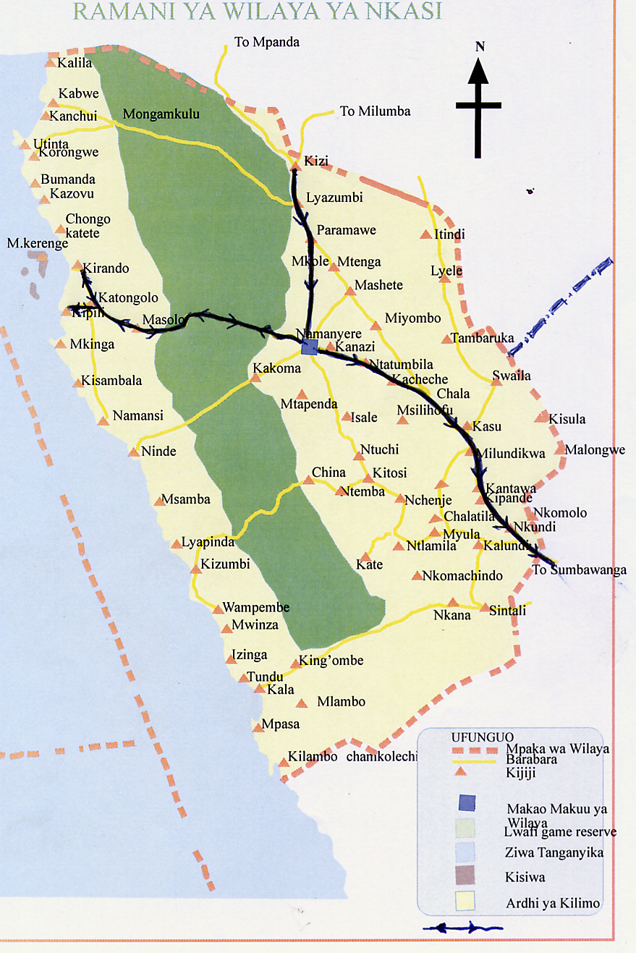
Figure 3.1: Map of Nkasi Districts showing Administrative Boundaries
Source: Nkasi District Profile (2013).

3.4.1 Land and Administrative Area
The district is administratively sub-divided into 5 divisions, which are further sub-divided into 17 Wards, 90 villages and 762 hamlets (Vitongoji) (Nkasi District Profile, 2012: Appendix 1). The district has 98 primary schools with a total of 53,977 pupils of which 26,378 are female and 27,599 are males. Moreover, the district has 19 day public secondary schools and one boarding secondary school. The council is also continuing with the construction of 4 other Schools (Nkasi District Profile, 2013).

3.5 Target Population
By target the population the researcher understands the grand total of people, who are to be included in the process of investigation of the study. In this study, the target population was all form four students and graduates found in studied secondary schools of Namanyere division, their teachers, parents, and district educational officer. The rationale of this population was to get information that will help the researcher to obtain study data that help to reach the objectives of the study.

The study is supported by Cooper (1989) and Vans (1990) who said that the target population means all those members or individuals or groups, or other elements that the researcher wants to be represented in the study. However, since it was not economically viable to reach them all; hence a sample was selected to represent the population.

3.6 Sample Size and Sampling Techniques

3.6.1 Sample Size
By research sample size the researcher understands the proportion of population selected to represent the whole population in the study. Best and Kahn (2006) argue that a sample is a small proportion of population selected for observation and analysis from the population, with similar characteristics. Researcher thought this number was adequate for this study based on the given rationales as follows: The sampled student respondents were both form four continuous and graduates were eighty (80). Among these ten students from eight schools five had graduated and five were candidates waiting the form four examinations.

This number was considered adequate because first these students were from the form four examination classes. Also, some graduates were victims of varying performance rates of the national examination results. The selected Headmasters were eight, one from each school because of their administrative roles. Form four class teachers were sixteen; two teachers were sampled from each school because of their teaching roles. Likewise, sixteen parents of which two parents represented their fellows with continuous students and graduates in the studied schools. Finally, one DEO was sampled because of his custodian role of educational issues in the entire Nkasi district.

The rationales of selecting a small sampled number were: first it was due to the nature of the current study which focused much on poverty variable a non statistical issue. Second rationale, the small number fitted the current study because of being qualitative in nature, and as Patton (1994) puts it that the adequacy number of the sampled respondents is not always an issue says. The author argues further that the purpose of qualitative study is to seek in-depth rich information. For Patton any amount of 40 respondents in the relevant study. Furthermore, Gall, Borg and Gall, (1996 (1996) adds that there is no sample size that is best; any sample can be acceptable depending on the nature of the study. The third rationale was that the researcher of the current study did not expect its findings to be generalized except to be useful in the studied schools of Nkasi.

3.6.2 Sampling Techniques
The research sampling technique in this study referred to the skill or method of collecting data in the process of investigation of the study. In this study the researcher used two sampling techniques, namely: purposive - simple random sampling in selecting research participants. Whereas the small number of the sampled respondents proven to possess rich information was selected purposively, the larger number of respondents was selected randomly, so as to save time. Patton (2003) points out that the purposive random sampling is viable.

The random sampling technique was done to select large number of accessible respondents in particular students. The procedure was done simply by writing 40 pieces of paper with (Yes) and 40 pieces of paper with (No). Then continuous students of form four in the studied classes were asked to peak papers randomly with gender balance in mind. This technique enabled the researcher to obtain an equal unbiased representation of 40 form four continuous candidate respondents and the rest student participants who were 40 graduates selected randomly. The 16 form four teachers, 16 parents, 8 headmasters and one DEO were selected purposively.

3.7 Research Methods
The research method in this study meant the ways of collecting data in the field. Manion and Marnis (2000) elaborate that the choice of the research methods depends on the purpose of the research and questions that guide investigation. In this study the researcher employed four triangulated data collection methods, as documentary primary and secondary sources, interview, observation from the qualitative approach and questionnaire from quantitative approach. The logic of selecting these methods was due to the nature of the research title, which is about the poverty non-statistical variable, versus the academic performance the statistical oriented variable. So, though the study approach was qualitative, yet the triangulation of borrowed methods from quantitative paradigm was crucial in this study as supported in (Patton, 1990).

3.7.1 Interview
In this study the interview referred to the face-to-face dialogue between two people, in this sense the researcher and respondent in the process of investigation met face-to-face. This claim finds support that interview involves the purposive oral questioning technique or discussion, that is to say, the face-to-face interaction between individuals leads to self-report (Enon, 1995). The author outlines three types of questions in interview, namely: structured, which has a fixed order of questions; semi-structured, which consists of questions that can be asked and answered flexibly without a specific order; and unstructured, which leaves more flexibility to both the interviewer and interviewees.

In this study the researcher employed the semi-structured interview. The researcher formulated the research schedule with research questions reflecting the objectives of the current study, but had chance to probe as seen in (App. 2 & 3). The rationale for selection of semi-structured interviews was because; they allowed flexibility in probing much more information from the respondents as suggested in (Denscombe, 1998). The in-depth interview was administered to the teachers, parents, ward executive officers, the District education officials and students. In supporting the method Webster (1985) argues that the interviews are common methods of collecting qualitative data. The importance of using interviews essentially lies on the fact that it gives the researcher an opportunity to enter into the other people’s world.

3.7.2 Questionnaire
In this study too, the questionnaire method was employed. By the questionnaire the researcher understands the use of written items to which the respondent individually responds in writing in the process of investigation of the study. The researcher formulated the questionnaire and distributed it to be filled by literate study participants: teachers, parents and students. The rationale for the questionnaires was to obtain the information about the varying trend of the school performance.

Also, it aimed at obtaining the opinions about the factors which contribute to the school academic performance and how it relates to poverty. Second, the extracted information from the questionnaires was used to complement the data gathered through other methods. Supporting the questionnaire method Guba and Lincolin (1994) contend that the major advantage of the questionnaire is stability of being reviewed repeatedly.

3.7.3 Documentary Review
By documentary review the researcher understands the written or stored material that researchers retrieve some information in the study. This claim finds support that any documentary written sources or recorded are prepared materials at the request of the inquirer or for the purpose of evaluation (Guba and Lincolin, 1985). In this study the researcher used some stored or written papers of information to support the field collected data. In this method two types of documentary sources primary and secondary sources of information were used. The primary data referred to directly observed or collected data from the first-hand experience. Published data and the data collected in the past or other parties meant the secondary sources. The logic of selecting documentary sources was due to the nature of the research title, which was on two variables of poverty versus the academic performance. So, the researcher retrieved some material from the official documents on the national examination results MOEVTBEST (-1998-2012) for form four. The original copies were found from the head of the schools and the District Education Officer (DEO) showing the performance of students in the studied area. Official or field data are also known as primary data with first hand information.

3.8 Validity and Reliability
In qualitative study studies issues of validity and reliability are termed as transferability, commensurability and credibility (Patton, 1990). The claim also finds support and it is exhibited that“…reliability is the degree to which an assessment tool produces stable and consistent results and validity referring to how well a test measures what it is supposed to measure… ”(Cozby, 2001). For Patton the validity and reliability is the positivists’ language for studies that aim to generalise information from the deductive studies, but not fit for inductively non-positivists whose studies with ungeneralisable purposes. The author furthers that non positivists’ credibility and the transferability echo the soundness and consistency of the study.

In the current study the credibility and soundness of the researcher’s findings were ensured through: first, the triangulation of multiple methods within the qualitative approach. Secondly, sample was obtained by mixing random and purposive strategies. Yet, the findings of this study were contextually, done as such they may be transferable in areas of the same context as Nkasi but can not be generalised nationally. Likewise, the credibility of instruments for collecting data such as the questionnaire was edited by experts like supervisors and other research fellows as authentic. The corrected questionnaire version was used to collect preliminary data from 12 respondents beside the actual participants and it proved to bring viable data (App, 2&3).

3.9 Ethical Consideration
By Ethical Consideration the researcher understood the moral measures before, during and after the study. The researcher carefully abided to human rights and national research policies especially of the Open University of Tanzania (OUT, 2008: App. 1). The researcher took the research clearance letter from the postgraduate directorate of the OUT, which permitted the researcher to proceed to the field. During the research process the researcher made sure that, respondents understood the purpose of the study and ask for their consent. Respondents were not required to write their names anywhere and they were assured of confidentiality. The need to consider an ethical issue in research project is insisted that, the research is controlled by its rules that are to be followed (Resnik, 2011).

3.10 Data Analysis Plan
In this study the qualitative techniques were mainly used to analyse the emerged field data. Furthermore, some elements of quantitative were applied in the collection of data. The collected data were classified, presented, edited, analysed, discussed, interpreted and summarized as illustrated in chapter four and five. The emerged quantitative data analysis were subjected to calculators and the excel software. These data were presented in the form of graphs and tables and percentage rates. The qualitative data were assembled, categorized, leading to the memos that latter on resulted into written excerpts of quoted information to yield quoted texts.

There were some questions formulated by the researcher on the observation while some important themes were noted throughout the research process. In this process, as the research was progressing, some questions were discarded and others were reformulated to suit the study objectives. Through the analysis of the obtained data, the researcher draw conclusion with regard to the aim of the research. Elaborating the analysis of data Lapin (1987) explains that data analysis involves the ordering of data into constituent parts in order to obtain answers for research questions.

3.11 Chapter Summary
In Chapter three the researcher presented the research design, research approach, study area, and target population. Likewise, the sample size, technique, research methods, validity issues, ethical, analysis plan, and chapter summary were presented. The next is chapter four.

CHAPTER FOUR

DATA PRESENTATION, ANALYSIS, DISCUSSION AND INTERPRETATION

4.1 Introduction
Chapter four presents the data analysis and interpretation. interpretation follows the four themes namely first Determining the students’ performance results trend at different levels, second to investigate the mediating socio economic factors surrounding the academic activities leading to the variation of academic performance in studied secondary schools. Third to assess some educational stakeholders’ roles in facilitating students’ quality academic performance. and lastly assessing the faced challenges in attempt to solve the mediating factors affecting the variation of the academic performance in secondary schools. It should be recalled that the main purpose of the study was to examine the manner in which poverty indicators affect the students’ academic performance among studied secondary schools in Tanzania.

4.2 Characteristics and Distribution of Respondents
The study involved interviewing 121 respondents, where by eight secondary school were visited and each secondary school was represented by form four students where 80 were students respondents, one head of the school from each schools and sixteen teachers from eighth secondary schools, sixteen parents, Moreover, 1 District Education Officer as were included.

Table 4.1: Respondent’s Distribution
Respondents |  | students | teachers | parents | headmasters | DEO’ | Total
 | Number | 80 | 16 | 16 | 8 | 1 | 121
Source. Author April 2014

Not only that but also gender issues were considered to the respondents. Where by both sex was put into considerations on the impact of poor academic performance in secondary school studies.

Table 4.2 Distribution of the Students According to Sex
sex | Number of student interviewed | Percentages of students interviewed
MALE | 75 | 62.0
FEMALE | 45 | 38.0
Total | 121 | 100.0
Source. Author April 2014

4.2 Presentation and Analysis
The current study sought to achieve four specific objectives: first, to determine the students’ performance results trend at different levels. It sought to address one sub question: What has been the trend of variation for the academic performance nationally, regionally and division wise? The methods that were used to collect data for this objective was field reviewed primary official documents. The results were presented and analysed as follows:

National
From the first analysed primary official document with results of the national Form Four examination, the data portrayed the trend varying results for six cohorts from 1998 to 2012. It should be borne in mind that the quality of students’ academic performance in Tanzania is measured in terms of Divisions. Whereas Division one represents the overall excellent quality performance, Division two reflects Very well, Division three Good, Division four Poor or average quality, and Division zero represents Failure best (MOEVTBEST, 1998-2012). Consequently, the trend of performance in Tanzania secondary schools is as illustrated in Figure 4.1.

80%
70%
60% |  |  |  |  | 55% |  | 61%
50% |  |  | 50% |  | 55%
50% | 47% |  | 50% |  |  |  |  | Div 1-3
40% |  |  | 38% |  | 36% |  |  | Div 4
30% |  |  |  |  | 36%
30% | 29% |  |  |  |  |  | 26% | Div 0
20% | 24%
10% |  |  | 12% |  | 10%
10% |  |  |  |  | 10% |  | 6%
0% |  |  |  |  |  |  | 6%
1998 | 2000 | 2002 | 2004 | 2006 | 2008 | 2010 | 2012
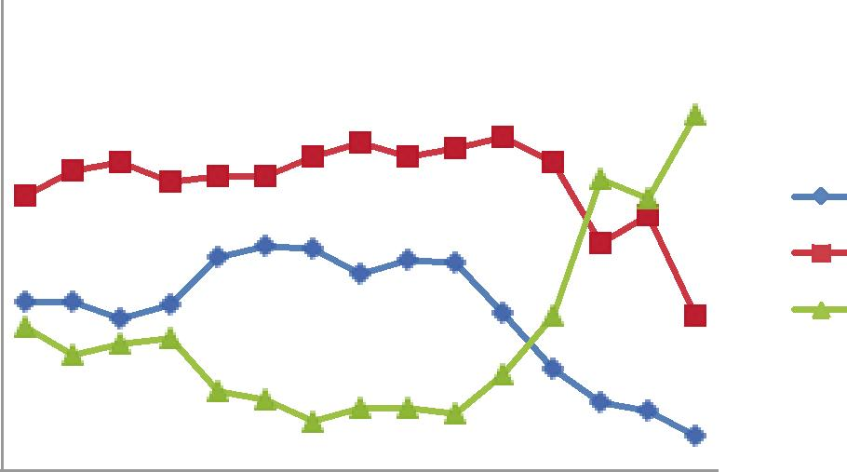
Figure 4.1: Eight Cohorts’ National Certificate of Secondary School Examination Results
Source: BEST (2013)

Figure 4.1 presents the eight cohorts examination results from 1998-2012 of students who sat for the national examination. One sees that the overall results of students put students into three major categories, those who achieved excellent quality of Division one, very good quality with Division two, and good quality with Division three their they are placed under category one. Their results trend within eight cohorts was as follows: Between cohorts from 1998-2000 their pass rates stood at 29 percent. Then it rose to 38 percent by an increase of 9 percent in cohorts of 2002-2004. In the cohorts from 2006-2008 it dropped slightly from the maximum peak by variation of 2 percent to 36 percent. In the cohorts from 2010-2012 the results for category one dropped drastically to 6 percent, with the variation of 32 percent from the maximum peak (Figure 4.1).

For graduates who passed with poor or average performance with Division four form the second category. Figure 4.1 indicates that in the cohorts from 1998-2000 the pass rate quality of these graduates who performed poorly, stood at 46 percent, and from cohorts 2002-2004 it rose by 3 percent to 50 percent. The cohort from 2006-2008 the pass rates rose by 5 percent to the peak of 55 percent. Surprisingly, it dropped drastically in the cohort 2010-2012 from the maximum pass rate to 26 percent with the variation of 29 percent (Figure 4.1). For Division Zero the field data indicated alarming failures rate nationally from 10 percent between 2006 and 2008 to 61 percent between 2010 and 2013 cohorts (MOEVTBEST, 1998-2012).

4.2.1 Academic Performance Trend in Rukwa Region
Having looked at the examination results trend nationally, the researcher proceeded to investigate the status of results in the studied area beginning with the Rukwa regional level then to proceed to the grassroots. The DEO’s office assisted to get the general trend as calculated by the district experts. The documents that were available indicated what is shown in Table 4.3.

From Table 4.3 one learns that Rukwa region in form four examination results showed that in 2008 the trend stood at 63.82 percent as it was reflected at the national level. But the results variation trend declined at 52.42 percent by 11.40 percent variation. Moreover, in 2010 the results continued to drop drastically to 44.74 percent with the variation of 19.08 percent from the maximum pass rate. The results showed that the academic performance is increasingly dropping year after year, exhibiting the existence of underperformance scenario (Table, 4.3).

Table 4.3: Students’ National Examination Results Status of Rukwa Region (2008-2010)
Year | Percentages of Students’ Passes
2008 | 63.82
2009 | 52.42
2010 | 44.74
Source: (BEST, 2013)

Table 4.4: National Students’ Performance Community Schools Status of Nkasi District (2008-2010)
Year | Students’ Passes in Percentages | Students’ Passes in Percentages
2008 | 81.35% | 72.54%
2009 | 67.67% | 63.16%
2010 | 43.01% | 38.23%

Source: (BEST, 2013)

The increasing of decline in performance is not only exhibited at the nation, region but also, at district level at Nkasi. In Table 4.4 the results at the national level are compared to students who performed the underperformed. It is shown that in 2008 students’ overall pass rate from divisions I, II, III, and IV stood at 81.35 percent; those of Nkasi were at 72.54 percent. In 2009 the national pass rates stood at 67.67 percent dropping by 13.68 percent those of Nkasi stood at 63.16 percent dropping by 9.38 percent.

In 2010 the results dropped even more at 43.01 percent with variation of 38.34 percent from the maximum pass rate, while those of Nkasi stood at 38.23 percent with variation of 34.31 percent from the maximum (Table, 4.4). As such, the regional and district students’ performance trend scenario was established as declining based on the presented and analysed data.

4.3 Perceived Socio Economic Factors Influencing Academic Performance
The second objective was to investigate the socio economic factors surrounding the academic activities to accelerate the variation of the academic performance in studied secondary schools. It had a task of investigating the factors existing in the teaching and learning environment of the studied schools. The objective had one issue of whether there were socio economic mediating factors that influence the academic activities performance. The methods that were reliable to collect data for this question were questionnaire, interview, and observations. Its results were presented and analysed as illustrated in Table 4.5.

Table 4.5 compares the responses of the form four graduates versus continuing students about the factors they thought were contributory to their academic underperformance. When inquired through questionnaire to rank the emerged factors, the students perceived heavy chores at home to contribute to the acceleration of their academic underperformance. The data indicated that majority of graduates 32 (40) percent out of 80 student respondents ranked it to be a potential and significant causative factor for the said underperformance. Similarly, majority 36(45) percent out of the same number of student respondents had similar thought about it.

Table 4.5: Students’ Perceived Factors for their Academic Underperformance in School N=80
Perceived Reasons academic performance | Graduates’ Responses  N=40 | % | Candidates’ Responses  N=40 | % | Responses=80 | Total %
Heavy house chores at home | 32 | 40 | 36 | 45 | 68 | 85
Shortage of Basic needs | 28 | 35 | 20 | 25 | 48 | 60
Distance home to school | 30 | 37.5 | 35 | 43.75 | 65 | 81.25
Shortage of teachers | 20 | 25 | 28 | 35 | 48 | 60
Family Poverty income | 32 | 40 | 38 | 47.5 | 70 | 87.5
Inadequate study facilities | 30 | 37.5 | 30 | 37.5 | 60 | 75
Language of instruction – English | 36 | 45 | 38 | 47.5 | 74 | 92.5
Source: (Field Notes, 2014)

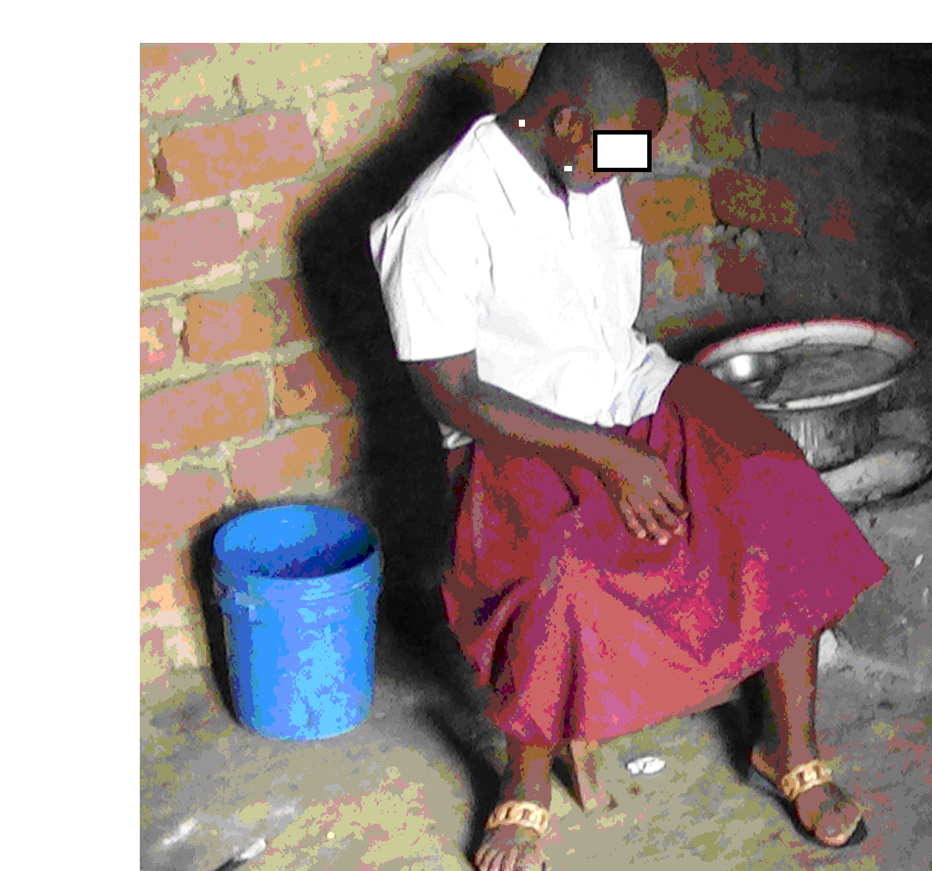
Figure 4.2: Student Preparing her Lunch During Lunch Time
Source: (Field Notes with consent of the student, 2014)
The researcher through the observation method was able to capture a student female, who during lunch time was left by guardian to prepare her food by cooking. Figure 4.2 exhibits the student respondents’ response of thinking heavy home chores as a significant contributory factor for their academic under performance.

From Figure 4.2. One may learn a lesson where by the researcher found this student in girls’ rented village rooms were visited by the researcher. The data portray a cooking female student during the lunch time, when the researcher had a chance to visit some students who were in the catchment areas of the studied schools. The act of rendering students to deal with home chores instead of concentrating to studies was interpreted by the researcher to be among time wasters for the students. The researcher probed the victim of home chores to tell for how long she has been doing home tasks during the time of school. She said;
“…to me this has been a trend since when I was young, I prepare my food during afternoon, even in the evening, I prepare the dinner for our entire family. I find it difficult, this time because I am required to study hard due to form four coming examination preparations, while I am required to serve myself often times and my family…”(Field Notes, 2014).

Besides that when the respondents were inquired whether the said shortage of basic needs contributed to accelerate their underperformance, few graduates 28(35) percent out of 80 respondents and a few 20(25) thought shortage of basic needs like clothes, food and shelter contributed little to their underperformance. This is despite the cumulative 48 (60) percent out of same number of student respondents saw it as potential factor contributing to their underperformance but not significant. Not only that but also, when inquired whether long walking distance from home to school contributed to accelerate their academic underperformance, a good number of graduates 30 (37.5) percent out of same respondents perceived it a s a potential factor. Likewise, a good number of continuing students 35(43.75) percent out of the same respondents viewed the walking distance to school to be potential but insignificant factor. Through observation method the researcher pursued the student who was distant from the studied schools as exhibited in Figure 4.3.

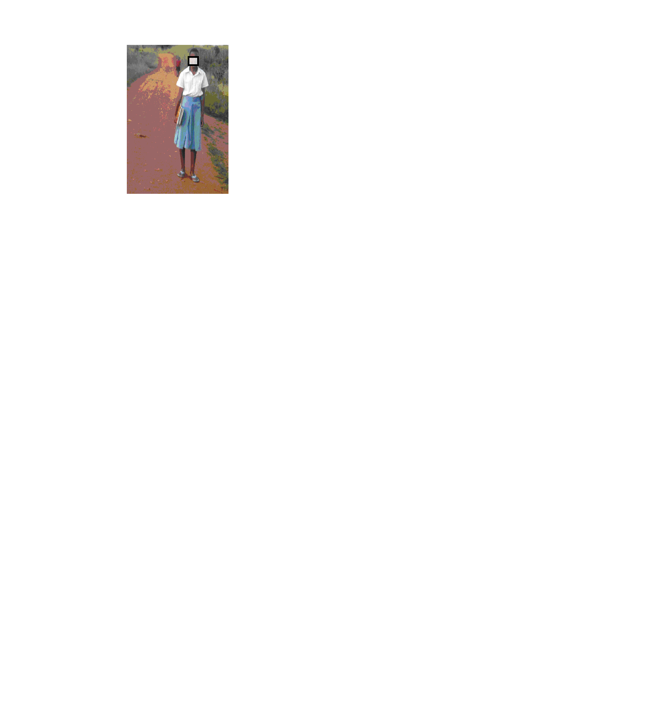
Figure 4.3: A Student walking Longer from School to Home

Source: (Field Notes with consent of the student, 2014)

From Figure 4.3 one learns a lesson that despite the lady having no standard shoes, except sleepers, she was observed walking from her Nkasi secondary school to her home Nfili village which is 15 kilometers away about three hours walk. The researcher was interested to know the endurance of this lady, for all these years walking such a long distance to school. When asked how she manages to do so the lady had the following words to say:
“…my parents do not have money to rent houses for me and even if they rent a house they cannot afford to provide food to eat. That is why I am walking 15 kilometers because I passed and like the school…” (Field Notes, 2014).

On top of that when inquired whether shortage of teachers contributed to accelerate their academic underperformance a few graduates 20(25) out of same respondents viewed it to be insignificant contributory factor. Similarly, few continuing students 28(35) percent perceived it to be potential factor but insignificant to their underperformance.

As if that was not enough, when inquired whether family poverty income contributed to accelerate their academic underperformance a good number of graduates 32 (40) percent out of the same respondents rated it highly. In the same vain a good number 38(47.5) of continuing students out of the same respondents attributed the same poverty income as a significant contributory factor for their underperformance. Cumulatively, the majority 70(87.5) percentage out of 80 student respondents saw the family poverty income as a significant factor for their academic underperformance (Table, 4.3).

Not only that but also, when the researcher proceeded to inquire whether inadequate learning facilities at schools such as study materials or libraries, electricity contributed to the academic underperformance, a good number of graduates 30(37.5) percent still yet, perceived it to be significant contributory factor. In the same vain similar amount of continuing 30(37.5) percent saw similar inadequate facilities the next significant contributory factor for their academic underperformance. Cumulatively, the majority of student respondents saw inadequate of learning facilities among significant factors accelerating the academic underperformance in the studied schools (Table, 4.4). Through interview one male continuing student had the following words to say;
“…Community secondary schools are not conducive for us because there are no enough books and enough teachers to teach us. Sometimes a week can pass without seeing a teacher in the class. This discourages us to stay at school that is why some of us decide to stay at home or find activities to keep them busy surely the possibility to perform poorly in our school is high….” (Field Notes, 2014).

It was learnt through dialogue with interviewees when probed where they get assistance for buying meals in the rented houses. Whether it was parents who supported them to pay for rents or otherwise, the researcher inquired. One of the male continuing students had the following words to say;
“…As for me my parents work hard to pay a school fee, but cannot afford to pay for me other needs. I used to walk longer distances; I decided better to find manual works normally after school hours. I learnt that my fellows did so and completed form four, so I thought why not me? There are construction works, where foremen need cheap labour here at Namanyere. On Saturdays and Sundays, I am able to collect more than 50,000 per month. With this cash, I am self reliant, and I am able to send some extra cash to my parents, and the remaining support me for rent and contributing food with my friends…”(Field Notes, 2014).

The researcher probed the interviewee about the effects felt because of being a double dealer, a student and the worker at the same time. The respondents replied saying; “…at the beginning it was very difficult to work and go to the class on Monday. But as I got used, I manage even during the week days evening I spend three hours or four and feel normal to study in the evening…”
The observation method was conducted, the interviewer took the researcher to the place, where they worked on Saturdays and I was able to capture the following photo to cement claims in interviews as seen in Picture 4.3.
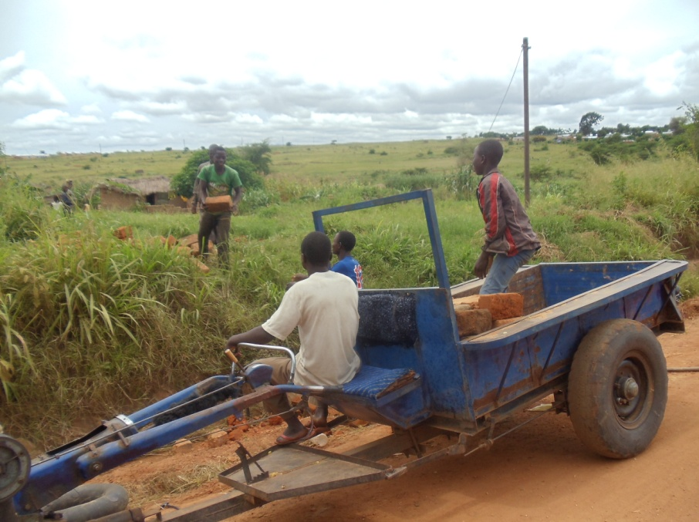
Figure 4.4: Employed Student at Construction Work to Earn Income
Source: (Field Notes with consent of the candidate students, 2014)

From Figure 4.4 one learns a lesson that the fellows are at work collecting burned building bricks. Among these fellows the researcher captured the student who had called me to show me where he worked. It was not evident from girls’ responses to tell what sources of income they get their cash to pay for unsecured rented rooms.

Through observation method, the researcher observed students, who were renting houses in village homes because of lacking electricity facility and hostels. This situation was observed by the researcher one of the evenings when he visited six wards of which only two wards had electricity, while the rest had no such facility. The time the researcher visited students were supposed to be in preps had they been in boarding schools. Figure 4.5 exhibits the sleeping room for girl students without electricity as follows.
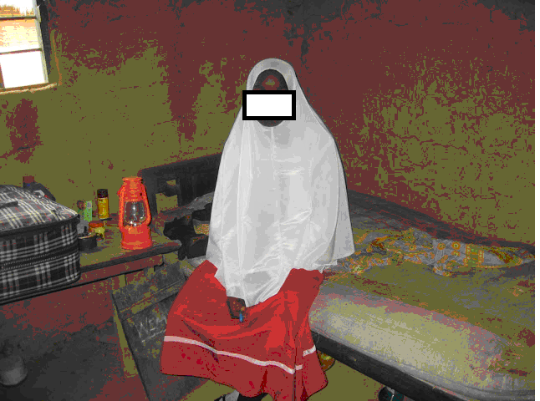

Figure 4.5: Rented Girl Students’ Sleeping Room without Electricity
Source: (Field Notes with consent of the student, 2014)

From Figure 4.5 one learns the lesson that exhibits students’ response that truly, their studied schools in the rural areas are lacking some essential facilities. In particular, the researcher witnessed ladies being in their hired rooms. The observed lantern tells an observer that not only was used to lighten the rooms, but also it was a sign that it was also used for studying during the night.

The researcher continued to observe students’ socio economicfactors surrounding rented male students’ learning sleeping rooms. The researcher managed to capture the room of one of the male students, who was so busy studying during the day as illustrated in Figure 4.6.

In Figure 4.6 one learns a lesson that students’ learning environments for both males’ and females’ areas, are not conducive to promise quality academic performance, as the observed exhibit indicates (Figure 4.6).
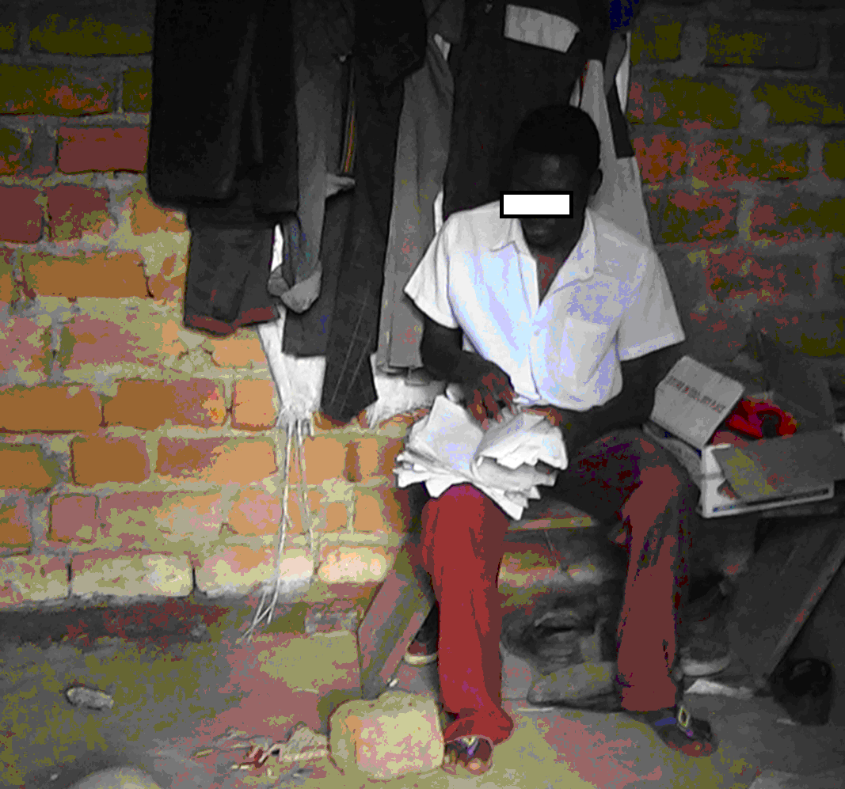
Figure 4.6: A Male Student Studying in His Room
Source: (Field Data with consent of the student, 2014)

Last but not least, the other emerged issue was English language of instruction. When the researcher proceeded to inquire whether the English language of instruction was also a contributory factor, a good number of graduates 36(45) percentage out of the same student respondents perceived it as problematic. They too attached the greater significant to it as the contributory factor for the academic underperformance. The similar significance to the language factor was seen by a good number 38(47.5) of continuing students. Cumulatively, the greatest number of student respondents 74(92.5) viewed English instruction of all contributory factors for students’ academic performance (Table, 4.3).

When the researcher proceeded to inquire about the contributory factors for the academic underperformance, through interview the headmaster respondent from one of the visited school had the following words to say;
“…my school is lacking a lot of books in varying subjects for teachers’ guides and students’ texts as well as references. But this is the duty of the government to make sure that schools have all the required resources. My role is to supervise the entire school…” (Field data, 2014).

The words of the headmaster confirmed students’ claims about inadequate study facilities at one of the studied schools. When probed to add, the official visitors interrupted and the head master could not add anymore. Still yet, one may learn the lesson from the headmaster’s response that the inadequacies of study materials were the problem in the studied schools.

The researcher did not end up with one source of information but also one of the parents with a child in form four at Namanyere secondary school was interviewed. When asked about the observation the researcher observed of some of the rented houses by students, and its reasons, one of the male parent respondent had the following words to say:
“...Mmh! Although some members of the community have built hostels for our children to stay, the experience shows that majority of parents have failed to afford the expenses. I insist that we cannot afford to pay these expenses for our children. I like my child to go there but I have no money and two sacks of maize to take there for paying a hostel. This is why my child is among those who join together to pay 1,500/- per month, it is cheapest, per year 18,000/- this is ten times the hostel’s expenses…” (Field Notes, 2014).

The researcher pursued other schools leadership at the community level. Responding to the same question on the affordability of Hostels for the sake of children of Namanyere, one of the female parent, who also was the school board chairperson said, “…Most of the parents cannot afford to pay hostel expenses. Therefore, it seems as if we have done nothing. What I see is that these hostels are not expensive but parents have failed to pay due to lower income….” When probed how much new hostels cost per month and per year, the chair person said;
“…Tshs. 30,000/- per month and per year 360,000/-. The parents are opting unsafe village hired houses, where they only 3000 per month 180,000 annually, spite knowing that no adequate study facilities, even monitoring. The challenge for sure is a free market competition…” (Field Notes, 2014).

4.4 The Role of Educational Stakeholders on Facilitating Academic Performance in Nkasi secondary schools.
The third objective was to examine some educational stakeholders’ roles in facilitating students’ quality academic performance.

4.4.1 Parents’ Responsibilities in Supporting their Children for Quality Performance
The raised sub question in this objective asked, do parents play their responsibilities to support their children towards quality performance? The method used to collect information was interviews. The findings from these methods were presented as follows. One of the responses that emerged from some respondents about the cause of academic underperformance was less encouragement from parents. During interview with one of the parent ward education officers (WEO) said,
“…parents do not bother to encourage their children to study hard. The students at the level of secondary schools are still children, so unless they are reminded they may tend to forget to learn as required unfortunately, some parents do discourage students to attend school so that they can help them on family activities such as caring for children at home, as a result this leads to poor attendance at school ending fail. …”
The researcher had to inquire from students too about their perceptions on parents’ played responsibilities towards their quality performance. Interview with one of the students in one of the studied schools said;
“…my parents are the source of my poor performance at school. My father is a good example for this because sometimes he tells me not to come to school, so that we can go to the farm. My father has never realised the importance of education more than farming. My farther too cites the example of the teachers who are poor despite teaching others; instead they have opened big farms in villages as he does. So he doesn’t see why bother with education…?”

The words of WEO got support from the headmaster, who saw parents being responsible for their children’s academic underperformance. ‘...Parents tend to let the load of their children to the teachers. They rationalise that once the school fees is paid it is over, the work remains for the teacher to rare students...’

4.4.2 Lack of Role Models from the Family
The historical background of the family is one of the socioeconomic factors at work. Through interview with one female parent respondent she said; “…If I am not educated it is difficult for me to convince my children or the rest to study hard...” Also, through interview with one of the continuous students respondent said;
“…I have my sisters and my brothers who are married, and they have never attended secondary education, my parents also have never been to primary school, this makes me not to feel lonely in studies and one day I feel that I can leave the school and continue with other businesses at home like farming because all my family members are attaching value to farming and marriage. I ask God to help me so that my efforts of enduring the four years are not lost...” (Field Notes, 2014).

4.4.3 Cultural Values, Traditions and Beliefs
Some aspects of culture and beliefs are also part of the socio-economic issues that are at work to allow or hinder the development of students in their studies. From documentary primary source, Bude (1991) defines culture as a way people react in a given environment in order to survive; it is the man made part of the social and natural environment and is the result of accumulated innovations for survival. Education is a part of culture.

In this study tradition, culture, and some beliefs in the studied emerged from respondents’ responses as one of the factors that contribute to the school underperformance in studied secondary schools at Namanyere. It was learnt that some of the parents want their children to get circumcised and latter be married as source of dowry income and the increase of the clan. Thus, parents force their children to poor academic performance of school so that they can be married. Through interviews with some of the parents, teachers and ward executive officers it was revealed that tradition, cultures and beliefs were potential factors for students’ academic underperforming especially girls. These claims were exhibited through interview with one of the male parent respondent had the following words to say;
“… I was sick I decided to stop my child (girl) from studies so that she could take care of me because my wife died one year ago. I found that it was better to stop this girl because she would get married one day. So there is no importance for educating her. I make sure that this boy gets education because he can help me later. Girls bring wealth in the family by getting married, that is the advantage of a girl child, but boys must get education...” (Field Notes, 2014).

Also, one of the headmaster respondents in one school said; “…There are many girls who left school because their parents want them to get married. If we try to follow them their parents threaten us. It becomes difficult for us to continue making follow up….”(Field Notes, 2014). Likewise, the traditions reflect the truth of cattle keepers’ values.

4.5 Challenges Facing a way Forward to Solve Factors for Underperformance
The fourth objective was to examine the faced challenges in attempt to solve the mediating factors affecting the variation of the academic performance in secondary schools.

4.5.1 Efforts for Solving the Academic Underperformance in Secondary School
The raised questions under objective four asked, what are respondents’ suggested solutions as a way forward for the obvious academic underperformance scenario? The methods used in the collection of data for this question was interview. One of the emerged suggestions for strategy to be used to solve the problem of school underperformance in secondary schools was to educate parents on the importance of education for their children as one of the form four teacher respondents proposed:
“...Every year in our school we conduct a meeting with parents to tell them the progress of the school in terms of infrastructure and performance. We tell them the importance of bringing their children to school and that they have to insist their children to come to school daily, although some parents are rigid. Also, every term we have a school ‘Baraza’ where we tell students the importance of engaging in schooling rather than other businesses like drug abuse and sexual practices. This has helped us to some extent to reduce the problem of underperformance in our school...” “…There is a lot of efforts taken to educate parents and the community at large on the importance of education for the life of their children but the message penetrates gradually and changes come slowly…”(Field Notes, 2014).

Also, the headmaster respondent of one of the studied schools was asked to propose a way forward along with giving out the experienced challenges in doing as he was echoed saying;
“…Education is given to parents on the importance to invest in education and its returns, though it takes longer time to their children to complete schools, but some of them are rigid since they are ignorant and they do not know the importance of education for their children...” (Field Notes, 2014).
Looking at these proposals one learns the two lessons. That given education is crucial parents are made to meet often time to talk about the problems of their children performance. Secondly, parents are involved in running schools through meetings and are advised to invest in education.

4.5.2 Penalising Parents Hindering their Children to School Strategy
Another method used to reduce the problem of underperforming students in school is fining parents. This can be evidenced from an interview made with one of the WEO respondent revealing;
“...I try my level best to make sure that all parents who do not send their children to school, are being arrested and fined, although some of the parents run away when they find that they are to be arrested. The reason is the ignorance they have; they do not know the importance of education to their children” (Field Notes, 2014).

Also, one of the headmasters in one of the studied schools was probed on the measures taken and a way forward, the head master began saying;
“…In the first place I am transparent to parents, who hinder their girl children to complete their cohorts to form four. So, parents know my position. But secondly, with the help of school boards we have a forum for parents’ day where we inform them about the school development. Thirdly, with local authority, we take culprits before the law any male, who temper with hindering girls to get their education…” (Field Notes, 2014).

When asked about building of hostels one of the headmaster respondents said;
“…..There are built hostels that have been put in place to help students who live far away from school and also to help students to get the opportunities for further studies after class because there is no electricity in their homes, since here we use solar power it becomes easier for them, but most of the parents do not want to pay for hostels and they are supposed to pay thirty thousand, two sacks of maize and 20 kilos of beans per year. According to me this is not expensive...”Also, we put alternative for those who have cash, they give some agreed bags of maize and beans per year, parents currently are two bags…’(Field Notes, 2014).
Although the government and other education stakeholders have tied their level best to build hostels but parents see it as expensive.

One parent WEO revealed that; “…there are students who get assistance from the government and we encourage individuals who support poor students and orphans to come directly to school administration...” Through documents the researcher witnessed some names of different students who got assistance from different people. The very education officer respondent said;
“…We give assistance to poor students and orphans so that they can get their right to education. We announce to different people who can help poor students. The government also provides some funds to help poor students. As you have seen in my documents, I have a list of names of people who give support to poor students and orphans. This is the step ahead in education…”(Field Notes, 2014).

These findings are supported by Munda and Odebero (2014) at Bungoma in Kakamega County of Kenya found that a significant positive relationship exists between unit cost and academic performance, and that the government efforts to provide financial subsidy to education were still not adequate to cover vulnerable groups.

4.5.3 Perceived Obstacles in Accelerating Variation for Academic Performance
The second question under objective four asked, what are the perceived obstacles in attempt to solve the mediating factors accelerating the variation of the academic performance in secondary school? The methods used in the collection of data for this sub question was interview; the findings were presented as follows. Responses from one of the educational officer respondents from DEO’s office gave her perception on he thought were obstacles to solve factors that accelerate underperformance scenario;
“…We are trying to help poor students the neediest, who passed but who cannot pay school fees and other contributions although not all, since their too poor, they fail to pay. These hostels have been built to help students, and their costs are very low. But some parents fail to pay boarding costs because their sources of income are likely to be poor. They let their children who live very far away from school leave and stay at home. Poverty is really a big challenge in solving the problem of school in our community…”

On the other hand, the responses from the other headmasters revealed:
“…From these responses one learns that the hostels that were built to solve the problem of distance students but it seems they are expensive, this is why may be students are found renting village houses. The act of parents to boycott the given price is seen as a greater challenging the problem facing students who come from far…”

Next is part two of chapter four on discussion of the above presented and analysed data.

4.6 Discussion
The discussion is a continuation of each emerged issue from presentation and analysis of data under chapter four. The discussion was guided by objectives which began from chapter one and these were: first to investigate the mediating socio economic factors surrounding the academic activities leading to the variation of academic performance in studied secondary schools. Second, was to assess the perceived socio-economic aspects revealing the poverty indicators in affecting students’ academic performance studied secondary schools at Nkasi. The third was to assess some educational stakeholders’ roles in facilitating students’ quality academic performance. The fourth was to assess the faced challenges in attempt to solve the mediating factors affecting the variation of the academic performance in secondary schools. The discussion proceeded as follows.

4.7 Academic Performance Trend Results at Various Levels
Objective one was to determine the students’ performance results trend at different levels. It had two issues, whether the trend of performance variation for form four exhibited a reality or illusions on the existing of the underperformance scenario nationally, regionally, district and division wise. Second issue was whether the studied community was aware and bothering with the varying trend decline of examination performance?

(i) Determining Performance Trend Results Variation at Levels
The primary official document data found in the field, informed that results of the national examinations for form four were increasingly deteriorating in quality at secondary schools in Tanzania as from 1998-2012. Consequently, it was confirmed as an existing reality not an illusion nationally, and it was even reflected in its grassroots levels at region, district, and division wise. The field data suggested that both studied respondents especially students who were continuous and graduates, parents, likewise teachers of the responsible class so did the administrators school heads, WEOs and DEO were all aware with issue of underperformance scenario trend within their catchment area of studied secondary schools.

The official documentary data from the field, also suggested that the phenomenon was a reality nationally even at grassroots secondary schools. Category two were those with average or poor quality The evidence revealed that there is the highest alarming rate of the Division Zero, whose unbreakable national record remains at 61 percent as it was confirmed in official primary document in (MOVTBEST, 1998-2012). From the review of the said primary documents the researcher realised that the Ministry of Education Vocation Training (MOEVT) uses the criterion of divisions to classify the quality of candidates. The researcher identified three major categories: The excellent quality with Division one, very good quality with Division two, and good quality with Division three were under category one. with Division four, and the third category was that of the poorest quality with Division Zero. It was discovered from the first category that their pass rate was with deteriorating trend of performance. This claim was exhibited with evidence whereby divisions one, two and three from 1998-2000 their pass rate stood at 29 percent. Thereafter, their pass rate rose to 38 percent by an increase of 9 percent in cohorts of 2002-2004. In the cohorts from 2006-2008 it dropped slightly from the maximum peak by variation of 2 percent to 36 percent (Figure 4.1). The claims of the current study findings resemble with findings of (Twaweza, 2013).

Its findings observed the same reviewed (MOEVTBEST, 1998-2012). Twaweza reported that the results in the period up to 2007 had a slight upward movement in Division I-III pass rate towards a maximum of 38 percent, but reflected by decreasing of the Division Zero (0) rate. The source cements that the Division Zero failure rate stood at 10 percent. It is concluded that in 2007, Division Zero rates shot up to the current 61 percent over a period of five years (MOEVT BEST, 1998-2012; Twaweza, 2013). It has to be borne in mind that the focus of the current study was in Nkasi district at Namanyere Division.
The researcher found the same trend reflected in the studied schools, when the regional and district same results were compared in line with the national level (Table 4.1; 4.2). Generally, an increase in the academic underperformance scenario trend was confirmed as a reality in the studied area of Nkasi district in particular Namanyere Division schools.

4.7.1 Perceived Socio economic Factors that Affect Academic Performance Significantly
The second objective was to investigate socio economic factors mediating to affect performance. It had a task of investigating existing factors surrounding the teaching and learning environment to influence the academic performance. The objective had one issue whether there existed socio economic factors affecting the students’ academic performance in the studied area. Various studied candidates and the graduates alike had enumerated various factors during the dialogue from which the researcher made a list of random factors as illustrated in (Table, 4.3). These were: language of instruction, family poverty income, heavy house chores at home, distance from home to school, shortage of basic needs, inadequate study facilities and in adequate teachers.

4.7.2 Significant Versus Potential Factors Perceived to Affect Academic Performance
The student respondents both continuous and graduates were asked through questionnaire to rank, what they thought was potential and significant contributory factor for their academic underperformance in the environment of the studied schools.
(i) English Language of Instruction
Contrary to the researcher’s assumptions, the greatest number 74 out of 80 student respondents (92.5) ranked the English language of instruction to be of all the contributory factors for students’ academic performance (Table, 4.4). The students’ thoughts confirm the findings of several researchers of Msoka and Vuzo (2012); Kangas (2000); Roycampbel and Qorro (2001) who found the English language as a crisis making the achievement of the quality education in Tanzania to be a myth. The researchers cautioned that the use of a foreign language in education hinders learning.

(ii) Family Poverty Income
In line with the researcher’s assumptions, the family poverty income was ranked the second potential and significant contributory factor by 70 out of 80 respondents (87.5) percent The argument here is that from the researcher’s observations some places of Namanyere are in remote areas from the town centre, where there are no well-established decent social services like roads, safety water, and electricity. The researcher basing on student respondents’ identification of poverty income as the second factor interpreted such a situation as being one of the causes of the academic underperformance for the majority students.

The poverty income was also associated with child labour which the researcher observed in Figure 4.6 for employed student at construction work to earn income. The current study findings too tally with several findings of in England, where Egan (2012); and Estyn (2010) exhibit that living in poverty, has a major impact upon levels of educational achievement in Wales.
Likewise, the current findings were similar to the study findings of Bezerra, Kassouf and Kuenning (2009), which carried a study about the impact of the child labor and school quality on the academic achievement in Brazil. The study found that for students who worked two hours a day their school performance had no statistical significance decrease. However, for students who had worked beyond two hours per day, their academic performance was decreased significantly statistically. It was generalised that the researchers’ differences in working conditions affected students’ school performance.

(iii) Heavy House Home Chores
Heavy house chores at home was ranked the third factor, whereby 68 out of the same number of respondents (85) percent as potential and significant contributory factor for their academic underperformance. The act of rendering students to deal with home chores instead of concentrating with studies was interpreted by the researcher to be among time wasters for the students in particular girls (Field Notes, 2014). The findings of the current study seem to be with similar findings of Bezerra, Kassouf and Kuenning, who carried a study about the impact of the child labor and school quality on the academic achievement in Brazil. The study found that for students who worked two hours a day their school performance had no statistical significance decrease (Bezerra, Kassouf and Kuenning, 2009).

However, for students who had worked beyond two hours per day, their academic performance was decreased significantly statistically. It was generalised that the researchers’ differences in working conditions affected students’ school performance.
(iv) Distance Home to School
Distance home to school was ranked the fourth factor whereby 65 out of the same number of respondents (81.25) percent as potential and significant contributory factor for their academic underperformance. As life proceeds the researcher’s experience has taught that a human being has been innovating to solve problems including those that are relate to mobility. Evidence of this claim indicates bicycles, motorcycles, vehicles, airplanes, canoes and ships are solvent of mobility. In the studied area no interviewed student singled a bicycle as an instrument to solve distances. Not even buses to help them sometimes.

This observation was related to income poverty the studied area. This also was interpreted as an obstacle delaying the development of the quality performance in studied area as per (Field notes, 2014). These findings were supported by Sunday (2011) who conducted a study that was presented in the published paper about the relationship between the school location and the students’ academic achievement of secondary school in Ekiti state of Nigeria between 1990 and 1997.

The main purpose of that study was to prove that students in urban areas had better academic achievement than their rural counterparts. The results from that study showed that there was a significant difference between students’ academic achievement of rural and urban secondary schools in senior school certificate examinations. Furthermore, the findings of that study confirmed that in the rural areas where poverty reigns, its most graduated students performed poorly compared to those in the improved urban areas (Sunday, 2011).
(v) Inadequate Study Facilities
Inadequate study facilities at school as a factor was rated the fifth by 60 out of the same number of respondents (75) percent as potential and significant contributory factor for their academic underperformance. Facilities in this study meant issues related to the availability of adequate and quality infrastructures, study materials, libraries, hostels, and so on. The fact that the student respondents identified it as a factor is a felt need. The administration of some schools confirmed students’ claims on inadequacy of learning facilities.

The current study findings are in way similar with findings of Clemens and Oelke (1967) study, which attributed the cause of academic underperformance to the combination of not only to the personal but also to the institutional factors. While the personal factors related to student/teacher rapport, teacher related factors, accommodation and living conditions, institutional factors of either family, parental, or societal, influences were found out to be those of school related factors.

(vi) Shortage of teachers
The two factors ‘shortage of basic needs’ factor was rated by a few 48 out of 80 student respondents (60) percent in the same manner the ‘shortage of teachers’ 48(60), were equally ranked less significant although potential contributory factor for their academic underperformance. Cumulative respondent number and the percentage equaled to the responses on the basic needs (Table, 4.4). To the researcher, the equal ranking of these factors implied that teachers as well as basic needs in the studied area were adequate. No complaint was heard about the availability of teachers in the studied schools.

4.7.3 Parents’ Responsibilities in Facilitating Academic Performance
Observation data under Figures (4.2 and 4.4) exhibit that some parents fulfill their responsibilities, however the data suggest also that some parent are irresponsible pushing home cores especially girls to heavy house chores instead of assisting them to get more time for studies. The third objective was to assess parents’ fulfillment of their responsibilities in facilitating their children towards quality performance. It had two issues: whether parents played their responsibilities to support their children toward quality performance or otherwise? Second whether there are existing cultural values in place to promote or demote students’ academic performance.

(i) Lack of the Role Models from the Family
Some continuing student respondents mentioned the absence of the role models in the historical background of families on education to imitate. One of the student felt discouragement from her sisters and brothers because all were married and they were farmers. As such, no one is interested with schooling at home. This was interpreted by the researcher that the role models in the families in everyday lives motivate others to do the similar thing moreover in a better way. As such, one of the less felt contributors to underperformance originates from students’ families’ background (Field Notes, 2014).

The current study findings are in way reflected in the study of Omari and Millanzi who through their study exhibited that “….lack of a person whose success could attribute to schooling students are not motivated to continue with schooling. It is added that, majority of the rural poor households have a mother or father without education at all, this makes children lack modeling” (Omari, 1999; Millanzi, 2005).
(ii) Cultural Values, Traditions and Beliefs
The studied schools catchment area in Namanyere division was found by the researcher to be surrounded with several cultural values of some farmers and cattle keepers. Some belief aspects are also part of the socio-economic issues that were at work to allow or hinder the development of students in their studies. From documentary primary source, Bude (1991) defines culture as a way people react in a given environment in order to survive; it is the man made part of the social and natural environment and is the result of accumulated innovations for survival. Education is a part of culture. In this study tradition, culture, and some beliefs in the studied emerged from respondents’ responses as one of the factors that were perceived to contribute to the school underperformance in studied secondary schools at Namanyere.

It was learnt that some of the parents want their children to get circumcised and latter be married as source of dowry income and to extend the clan (Field Notes, 2014). From these responses the researcher interpreted with the learnt lesson that, since there are cultural values of cattle keepers and farmers surely student girls might be involving themselves early in dating with betrothals. The researcher interpreted that with the rented village homes, girl students might be falling prey of glutton males. Likewise, the traditions reflect the truth of cattle keepers.

The findings of the current study are similar to the findings in Kwesiga (2002), who conducted a survey study with the aim of investigating the extent to which society (through marriage) influence women’s education. The result showed that the reproductive role of women was the greatest barrier; the study also found that women’s education was not beneficial to the family. Likewise, the study by Mbilinyi, Mbughuni, Meena, and Olekambaine, (1991 (1990) and Gordon (1995), support the current study findings by informing that, economically troubled families give priorities to invest their limited resources in the education of boys rather than girls. It is added that, traditionally, girls eventually married and went to live with the families of their husbands, thus transferring their knowledge, prestige and income to the families they were married.

4.7.4 Challenges Facing Efforts to Solve Factors Affecting Academic Performance
The fourth objective was to examine the faced challenges in attempt to solve the mediating factors affecting the variation of the academic performance in secondary schools. It had a task of examining the perceived obstacles in attempt to solve the mediating factors accelerating the variation of the academic performance in secondary schools. Two issues were in this objective whether respondents face challenges in trying to solve the emerged socio economic problems that surround the teaching and learning activities. Second issue was whether respondents had suggestions from their understanding for a way forward for solving the problem of school underperformance scenario in the studied secondary schools as per (Field, Notes, 2014).

Looking at respondents raised views and their proposals one learns the two lessons. First, the researcher met mixed up community of both farmers and pastoralists each having own beliefs and traditions. It was realised that there were progressing efforts in trying to solve the socio economic identified problems. The most pressing perceived problem was cultural within the school context and that was English. Unfortunately, no measures were heard about this response from students by administrators. Poverty income of parents was second perceived problem for the said underperformance.

- Parents’ Meetings Strategy
First, the community at large seemed to have in place some strategies which were much concerned to solve the poverty income indicators for instance, the long distance from school to students’ home, problem of meals, electricity, and monitoring of students learning behaviours holistically. The administrators thought that once hostels problem is solved then, the rest problems would be solved as well. Given obvious importance of education parents are made to meet often times to talk about the problems of their children’s academic performance. Thirdly, it was found that parents were involved in running schools through meetings and were advised to invest in education (Field Notes, 2014).

The meeting strategy was interpreted by the researcher as an attempt to involve the community to solve problems surrounding their schools. Second, the responses from the administrators of education, to insist on education as an investment to parents, was interpreted by the researcher as a measure to develop people of the studied Division through education. The current findings from the current study tally with Nkoma (1979) who found that in any given school area depended on the degree to which that area is developed and people’s general level of education that can translate educational spill avers.
(ii) Penalties to Parents who do not Send their Children to School
Another used technique by school boards in reducing the problem of students’ underperforming in school is sanctioning the parents by fining some amount of money as a punishment through existing bylaws (Field Notes, 2014) as per one of the Ward Education Officer respondents revealed. Another headmaster in one of the schools was probed about the measures taken as a way forward. The head master began saying; we are encouraging some investors to build hostels and rent them to the customers, since majority of students come from as far as 15 to 20 kilometres. Despite the government and other education stakeholders to attempt their level best to build hostels, but parents see these hostels as expensive and opt to rent cheaper rooms in the villages (Field Notes, 2014).

The current findings are similar to the study in Kenya about parents’ alert to the unit cost of education (Munda and Odebero, 2014). It was learnt from one parent Educational Officer who revealed some more information that there are students who get assistance from the government and that they encourage individuals, who support poor students and orphans to come directly to school administration...” Through primary school documents the researcher witnessed some names of different students who got assistance from different people (Field Notes, 2014).

(iii) Perceived Obstacles Accelerating Variation for Academic Performance
Findings on the perceived obstacles in attempt to solve the mediating factors accelerating the variation of the academic performance in secondary school were collected through interviews. From the interview responses one learns a lesson that the lower source of incomes for parents which was confirmed variously, not only by students but also by the studied school authorities were interpreted that the owners of the said hostels are hiring them on the basis of profit, the move that is boycotted by the majority of parents….” (Field Notes, 2014).

The current study observation findings tally with the study at Bungoma in Kakamega County of Kenya about the influence of educational costs on students’ academic performance. Among the findings from that study included: that a significant positive relationship exists between unit cost and academic performance, and that the government efforts to provide financial subsidy to education were still not adequate to cover vulnerable groups (Munda and Odebero, 2014).

CHAPTER FIVE

SUMMARY, CONCLUSION, AND RECOMMENDATION

5.1 Introduction
In this chapter find the summary of the findings based on the study objectives, tasks and sub research questions that addressed the major grand question as the puzzle for this study. Also, find the recommendations and the proposed further studies.

It was the purpose of the current study to address the major grand research question that was raised right from the first chapter, how do poverty indicators mediate to affect the students’ academic performance in the studied rural secondary schools of Nkasi district at Namanyere Division? In the current study eight community secondary schools were purposively involved for the study. A total of 121 respondents: teachers, parents, and headmasters, as well as the DEO were involved. The study was of qualitative paradigm in which the researcher triangulated methods from both approaches for data collection. These included interviews, questionnaires, observation, and documentary review. The current study had four main objectives:

5.1.1 Determine Underperformance Scenario Trend in Secondary Schools at Levels
The first objective was to determine whether the underperformance varying scenario trend in Tanzania secondary schools in particular peripheral regions like Rukwa was a reality or an illusion. It had two issues first whether the declining trend of form four results was also reflected at grassroots levels or it just ends at the national level.
The findings on this objective were sought through primary official documents which among other things the field data revealed that the ordinary secondary school students’ academic performance quality in Tanzania was measured under the criterion of Divisions. The field data suggested that the performance was mainly in three major categories: Division one represented an Excellent quality, Division two represented a Very good quality and Division three represented a Good quality academic performance. This category was considered as better performance, whose highest pass rate reached a peak record of 38 percent nationally in cohorts between 1998 and 2013.

The data too suggested that the trend of first category began to decline drastically from 38 to 6 percent between 2010 and 2013 nationally and the same trend is reflected at grassroots levels. Likewise, the data suggested that the second major category of the quality on the performance was that of Division four representing an average or the poor quality for the academic performance. Much more, the field data suggested that this category of the poor performance continued to increase from 46 percent by 2008 to 55 percent by 2013. The same documentary method of primary official scripts indicated the data of the third major category for the Division “Zero” representing the poorest or failure quality of the said academic performance.

The field data indicated further that this category increased speedy from 10 percent to outstanding record peak of 61 percent between 2010 and 2013 cohorts. All these variations in underperformance trend were also reflected at the grassroots levels in particular at the studied region, district, and Division. From these data the underperformance scenario trend was determined as reality and not an illusion at the said levels reflecting the national standing at the peak of 61 percent.

5.1.2 Socio economic Factors and Academic Activities versus Varying Performance
The second objective was to investigate the existing mediating socio economic factors surrounding the academic activities leading to the variation of academic performance in the studied secondary schools. It had a task of investigating the existing factors in teaching and learning environment that influence the academic performance variation. It had one issue of searching whether there existed the perceived factors for students’ academic underperformance in the studied schools.

From questionnaires the findings indicated the most rated factors for the underperformance by student respondents to be: first most significant and potential of all perceived factors was English. This current study finding confirmed several previous studies revealed the problem of persistence of using the foreign language to teach, as illusion in achieving quality education to the recipients. The next second perceived significant and potential factor was poverty income, which was also rated by the majority as the contributory factor.

The third perceived as the third significant and potential contributory factor was heavy home chores followed by the fourth distance from home to school; and fifth was in adequate learning study facilities. The lack of teachers and basic needs were rated by minority student respondents as potential contributory factors but not significant for students’ academic underperformance. As such, poverty as one of the most significant factors of underperformance was confirmed by student respondent in the current study.

5.1.3 Educational Stakeholders’ Roles in Facilitating Quality Performance
The third objective was to assess some educational stakeholders’ roles in facilitating students’ quality academic performance. It had a task of assessing parents’, teachers’, and head masters’/mistresses’ fulfilled responsibilities in enabling students to achieve quality academic performance. Under the third objective there were three issues:

Parents’ Played Responsibilities to Support Quality Performance
The issue here was whether the parents played their responsibilities to support their children toward quality performance. Through interviews and observation methods the students’ perspectives on their parents on one hand revealed both practices for some parents are responsible assisting their roles in supporting their children at school.

But on the other hand, some students pointed out some parents, who discouraged their children from pursuing studies as required citing teachers who are educators are poor like any other and are investing in farming. Yet, most of students sympathized with their parents’ of poverty income as the reason for not assisting them adequately. The sympathy went as far as some students to assume their parents roles by being employed temporarily to earn the living and the excess to assist their parents.

On the second issue was whether students’ family backgrounds had educational role models to motivate their efforts. The interviews data suggested that some of students had no role models who had ever shown the educational successes at the home steady. Students reported that they look like strange among their parents and relatives whose talk is always focused on agricultural and cattle issues. The findings of the current study were confirmed by previous study on similar issue of lack of the role to imitate in the given family.

On third issue was whether in the studied are there existed some cultural values that promoted or demoted students’ academic performance. The current study findings on this issue of cultural values indicated that they existed. These values were observed among pastoralists’ and farmers’ children at schools, but were also confirmed through follow up of parents in their homes. Some interviewed parents WEOs, who were part of the school board revealed that the dowry and circumcision sometimes hindered girl child to complete their school cohorts to form four level in Nkasi studied schools.

5.1.4 Challenges in Attempt to Solve the Factors for Underperformance
The fourth objective was, to assess the faced challenges in attempt to solve the mediating factors affecting the variation of the academic performance in secondary schools. It had the role of assessing the perceived obstacles in attempt to solve the mediating factors accelerating the variation of the academic performance in secondary schools.

Perceived obstacles in solving factors accelerating underperformance
The first, question under objective four what are the perceived obstacles in attempt to solve the mediating factors accelerating the variation of the academic performance in secondary school? The findings of the perceived obstacles found that one of the challenges to solve the problem of distance from schools, it was found out majority of parents boycotted the built hostels. This was revealed by encountering good number of students hiring village unsafe rooms, where facilities like electricity was available. As such, to convince businessmen to reduce price is still a challenges as perceived by respondents.

Suggested Solutions as a Way Forward
The second question asked, what are the suggested solutions as a way forward? The current study findings too found out that educational stakeholders in the area had existing measures of ensuring that students adhere to concentrate on their studies to perform. The study revealed that administrators were making sure they involve the members of the community at large. Such strategies included parents’ day meeting with teachers to talk about school progress for their children performance.

This was interpreted by researcher that participatory methods are welcome. The community too had hostels to solve the problem of distance for some students despite the high price for renting. Finally, the bylaws are used to sanction parents who hinder their children to participate fully.

5.2 Summary
Generally, the underperformance trend scenario was reflected as real in grassroots at region, district even at Division of Namanyere in particular based on the national outstanding peak of failures at pass rate of 61 percent. People were aware of this trend being informed by some reliable and unreliable ones. Among the perceived factors the leading were: English language, followed by poverty income, heavy house chores, distance from home to school, inadequate study facilities were seen as potential and significant contributory factor for underperformance.

The other two factors: inadequate teachers basic needs were rated lowly as potential but not significant contributory factor. Generally, one may infer that while poverty income factor was identified affecting significantly the students’ academic underperformance in the studied schools, yet it cannot be taken as the only factor but there others as they emerged from respondents’ perspectives.

5.3 Recommendations
Since the findings have shown that majority of students who had completed form four secondary education among the eight studied schools under performed in the studied schools it is hereby recommended that:
- Let there be a thorough research on the progress of the remaining number of students who have completed form four in secondary school, and if possible let the government fund this kind of studies all over the country so as to come up wit more way to lessen the low identified socio-economic indicators.

- There is a need for the government authorities (local and central government authorities) through participatory planning and implementation of secondary schools development programmers in order to have a sustainable and bright future of existing ward secondary school instead of adding more and more secondary schools. On the basis of the research findings, this study recommends the following:

5.3.1 Recommendation for Actions
It is recommended that the local government authority and the central government of Tanzania should make sure that the Local leaders and some staff from the central government should sensitize parents and students on the importance of education for their own lives, their families and the nation at large. And as far as the research is concerned and that poverty have being identified to be the leading factor for poor academic performance, the researcher advises government to announce for free secondary education, this will help poor students to attend studies peaceful eventually will make them perform well in their examination.

Lastly, the government and policy makers should make sure that accommodation, transportation, feeding, and clothing to those families living below the poverty level is improved. Furthermore we will be complaining that academic performance is dropping day to day unless these advices have been put into consideration.

5.3.2 Recommendations for Further Studies
- Although the study has achieved its objectives, it has not concentrated on the kind of assistance given to those students who under perform while their parents are not poor. So further studies should be done to find out what causes rich family students to under perform in their examination.

- The current study was done qualitatively let the same study be conducted quantitatively.

REFERENCES

Aremu, S., and Oluwole, B. (2000). The Development and Validation and Academic Performance. Ibadan: University of Ibadan.
Ajila, K. and Olutola, B. (2007). The Effects of Family Structure and Parenthood on The Academic Performance of Nigerian University Students. Ibadan: University of Ibadan,
Entwisle, D. A., Olson, L. (2001). Educational Evaluation and Policy Analysis. N.J: American Educational Research Association.
Achoka, J. S .K. (2007). “Review in Search of remedy to secondary school dropout pandemic in Kenya: role of the principal.” Educational Research and Review vol. 2 (7), pp 236-244.
Asikhia, O. A. (2010). “Students and teachers' perception of the causes of poor academic performance in Ogun state secondary schools in Nigeria.” In European Journal of Social Sciences, March, 2010, Vol. 13 (2), pp.1-.229.
Barton D, E (2003). “Parsing the Achievement Gap: Baselines for Tracking Progress.” Policy Information Report, Retrieved from: http://www.ets.org/ Media/ on 20.3.2014.
Bezerra, E. M .G and Kassouf, A. L. and Kuenning, M. A. (2009). “The impact of child labor and school quality on academic achievement in Brazil.” In IZA Discussion Paper.
Best, J. and Kahn, J. (2006). Research in Education. 8th Ed. New Delhi: Prentince Hall
BEST (2013). Basic education statistics in Tanzania: National data (2006-2012). Dar es salaam: Ministry of Education press.
BEST (2007). Basic Education Statistics in Tanzania: Regional Data. Dar es Salaam: Ministry of Education press.
BEST (2006). Basic Education Statistics in Tanzania: Regional Data. Dar es salaam: Ministry of Education press.
BEST (2005). Basic Education Statistics: Regional Data. Dar es salaam: Ministry of Education Press.
Bunto, T. N. (2002). “Patterns and cause of school in Arusha and Arumeru Secondary schools.” Unpublished M.A. Dissertation of University of Dare es Salaam.
Brocke, B. and Pilipson, R.(2000). Whose education for all? The Colonization of the African Mind. New York: Falmers press.
Cohen, L. Manion, L. and Marnison, K. (2000). Research Methods in Education in Education. London: Routledge Falmer.
Chikoko, B., and Mhiloyi, K. (1995). Introduction to Educational Research Methods. Harare; Centre for Distance Education.
Clemens, E., and Oelke, D. (1967). Effect of Family Parenthood on Academic Performance in Nigeria. Ekopma: Edo state Nigeria.

Chinyoka, K., and Naidu, N. (2014). “Influence of home based factors on the academic performance of girl learners from poverty stricken families: A case of Zimbabwe.” In Mediterranean Journal of Social Sciences, Vol. 5(6), pp.1 241.
Carlo, F., Dyson, A., Gunter,H., Hall, D., Campbell,A., and Framey, C. (1994). “Effects of early intervention on intellectul and academic achievement: A follow-up study of children from low- Income families.”
Coleman, J. S., and Hoffer, T. (1987). Public and Private High Schools: The impact of Communities New York: Basic Books.
Denscombe, M. D. (1998). The Research Guide. Philadephia: open University press.
Doorlag, D. and Lewis, R. (1999). Teaching Special Student in General (5th Ed.). New York: Macmillan Publishers.
Das, N. R and Baruah, D. K. (2013). Secondary School Education in Assam (India) with Special Reference to Mathematics. Gauhati and Barbhag: India Publishing House.
Demir, C. E. (2009). “Factors influencing the academic achievement of the Turkish urban poor.” In International Journal of Educational Development, vol. 29 (1) pp. 17-29.
Driessen, G; Smit, F and Sleegers, P, (2004). “Parental Involvement and Educational Achievement.” British Educational Research Journal.
Egan, D. (2012b). Communities, families and schools together: a route to reducing the impact of poverty on educational achievement in schools across Wales.” Unpublished report.
Estyn (2010). Tackling child poverty and disadvantage in schools. Cardiff.
Enon, J. C. (1998). Educational Research, statistics and measurement (2nd Ed.) Makerere: Makerere Universty Press
Ferraro, V. (1996). Dependency Theory: An Introduction. South Hadley: Mount Holyoke College.
Geoffrey, B., and Laura, R.T. (2001). “Academic success among poor and minority student: An analysis of competing models of school effects.” In ERICK pp.1-36.
Ferguson, H. (2007). “The impact of poverty on educational outcomes for children.” In pediatrics and Child Health, October, 12(8), at www. pulsus.com, visited on 19-3-2015.
Ghaemi, F. and Yazdanpanah, M. (2014). “The relationship between socio-economic status and the achievement in English language classrooms.” In European Journal of English Language and Literature Studies. March, Vol. 2 (1), pp.49-57.
Galabawa, C. J., and Lwaitama, F. (2008). Community secondary schools: How long is their journey to quality education? Dar es Salaam: University of Dar es Saalam.
Galabawa J., Senkoro, F., and Lwaitama, A. (2000). The Quality of Education Issues and Experience. Dar es Salaam: University of Dar es Salaam.
Goretti, H., (2007). The Impact of Poverty on Young Children Experience of School, First Published 2007. NJ: Joseph Rowntree Foundation.
Gall, M; Borg, W. and Gall, J. (1996). Educational Research: An Introduction. (6th Ed.). New York: Longman.
Guba, E. G.; and Lincolin, Y.S. (1985). Naturalistic Inquiry. Beverly Hills: CA: Sage.
Hinga, T. M. (1995). The Role of Religious Networks in Female Education in Kenya. Nairobi: Academy science Publishers.
Hunt, J, (2008). Dropping out from school: A Cross Country Review of Literature. research monograph. Brighton: university of Sussex.
Huebler, F. (2008). Beyond Gender: Measuring Disparity in South Asia using an Education Parity Index. Kathmandu: UNICEF ROSA/UNGEI.
Hastings, A., Flint, J., McKenzie, C., and Mills, C. (2005). Cleaning up Neighborhoods: Environmental Problems and Service Provision in Deprived Neighbourhoods. Bristol: The Policy Press.
Hirsch, D. (2006). What will it Take to end Child Poverty? NJ: Joseph rowntre Foundation.
IFAD (1992). International Fund Agricultural Development. London: Oxford University press.
Jordan, A. (2006). In-School/Classroom Strategies to Support Learning Diversity. Background Research Paper for a National Dialogue on Students at Risk. Toronto: The Learning Partnership.
Kajembe, G. C. (1994). Indigenous management systems as a base for community forestry Tanzania: A case study of Dodoma Urban and Lushoto Districts. Tropical Resource Management Paper. No.6, Wageningen Agricultural University.
Kayunze, K. A; Mashindano, O; and Maro, F. (1998). Poverty Mobility in Tanzania with Government. Mkuki and Nyota Publishers.
Kisusu, R. W. (2003). “Adoption and impact of dairy and Irrigated Rice Technologies in Poverty Alleviation in Dodoma, Tanzania.” Unpublished Dissertation for Award of Ph.D Degree at Sokoine University of Agriculture. pp. 1 – 59.
Kohen, D., Hertzman, C. and Gunn, J. (1999). Neighborhood Affluence And School Readiness. Education Quarterly Review Statistics. Canada: Catalogue no. 81-003.
Kothari, C. (2004). Research methodology: Methods and technique. New Delhi: New Age International.
Kuleana (2001). Country Situational Report. Mkuki & Nyota Publishers.
Lapin, L. (1987). Statistics for Modern Business Decisions. Harcourt Brace Jovanovich, Inc.
Ludwig, J., Ladd, T., and Duncan, G. (2001). Urban poverty and educational outcomes Brookings-Wharton papers on urban affairs. Princeton: Brookings Institution.
Makori, G. (2001). The use of English as a Medium of Instruction in Kenya Secondary Schools: Thesis for the Masters of Philosophy in International and Comparative Education. Oslo: University of Oslo.
Madman, M. (1996). Citizens and Subject: Contemporary Africa and the Legacy of the Late Colonialism. New Jersey: Princeton University Press.
Malekela, G., and Ndeki, A. S. (2001). “Access and equity in basic education in Tanzania.” In Papers in Education and Development. No. 21, pp. 96-110.
Mayer, S. E. (1997). The "True" Effect of Income. In what Money can't Buy: Family Income and Children's Life Chances. Cambridge, MA:Harvard University Press.
Mbilinyi, M., Mbughuni, P., Meena, R. and Olekambaine, P. (1991). Education in Tanzania with a Gender Perspective. Dar es Salaam: SIDA.
McCoy, A. R, and Reynolds, J. (1999). “Grade retention and school performance: An extended investigation.” In Journal of School Psychology. Vol. 37 (3), Autumn, pp. 273-298.
Meen, G., Gibb, K., Goody, J., McGrath, T. and Mackinnon, J. (2005). Economic Segregation in England: Causes, Consequences and Policy. Bristol: The Policy Press.
Millanzi, J. E. (2005). “Patterns and causes of dropout in community secondary schools in Lindi Rural District. ” Unpublished M.A Dissertation of the University of Dar es Salaam.
Molteno, M., Ogaghoh, K., Cain, E. and Crumpton, B. (Eds.) (1999). Towards Responsive Schools: Supporting Better Schooling for Disadvantaged Children. London: Rotledge.
Msoka, P., and Vuzo, M. (2012). “Language as hurdle in delivering secondary distance education.” In Jipe. Vol. 4, pp. 107-117.
Nkasi District Profile, (2013), the Free Encyclopedia. Retrieve, April 20, 2015, from http://en.wikipedia.org/w/index.php?title=Nkasi_District profile
Nzabihimana. (2010). “The nature of schools and academic performance of pupils in primary schools in Gasabo district Kigali city” Unpublished Masters Thesis of Kigali University.
Nyerere, J. K. (1967). Education for Self-Reliance. Dar es Salaam: Oxford Press. Publishers.
Nyerere, J. K. (1967). The Arusha Declaration. Dar es Salaam: KIUTA.
Smith, R. (2001). Enrolment and Expansion Technical Working Group on Non-Formal Education for out of School Children and Youth. Oslo: Oslo University College.
Omari, I. M. (1999). The Relationship Between Education and Income in Poverty. Dar es Salaam: Oxford Publishers.
Patton, M. Q. (1990). Qualitative Evaluation and Research Methods. (2nd Ed.). N.J: Newbury Park.
Okoz, P., Aluede, O., and Justina, E, and Akpaida, A. (2012). “Secondary school students’ perception of environmental variables influencing academic performance in Edo state of Nigeria.” In Bangladesh e-Journal of Sociology. Volume, 9(2) pp. 47-52.
Phillips, D., and Adams, G. (2001). Childcare and Our Youngest Children. Future of Children. London: Sage.
Rowan, B., Cohen, D.K, Raudenbush S.W. (2004). “Improving educational outcome of Students in poverty through multidisciplinary research and development.” In Dillman (1994). How to Conduct your Own Survey. John Wiley. & Sons, Inc.
Twaweza (2013). Form Four Examination Results, Citizens Report on the Learning Crisis in Tanzania, Sauti ya Wananchi, Brief no.2 pp 1-12bbosaaaaaaa
UNESCO (2008). Regional Overview: South and West Asia. Report Prepared for the Education for all Global Monitoring Report. Paris: UNESCO.
URT (2005 a). The National Strategy for Growth and Reduction of Poverty (NSGRP), Dar es Salaam. Govt. Press.
URT (2005 b). Tanzania Poverty and Human Development Report. Dar es Salaam: Mkuki and Nyota Publishers
URT (1998-2012). Basic Education Statistics in Tanzania National Data from 1998-2012.Dar es Salaam: MOEVT.
URT (2005 a). The National Strategy for Growth and Reduction of Poverty. Dar es Salaam: Govt. Press.
URT (2004). Education sector Development programme. By moevt, Dar es salaam
URT (1995). Educational and Training Policy. Dar es salaam: MOEC.
Wiseman, P (1973). The Impact of Family Structure on University Academic Performance. Iloni: University press.
Wedgwood, R. (2006). Education and Poverty Reduction in Tanzania. Dar es salaam: Hakielimu
World Bank (1990). World Development Report on Poverty Report. How Poverty Looks 25 Years Later. NJ: Oxford university press.
World Bank, (2002). “Joint Donor Staff Training Activity Partnership for Poverty Reduction. The elimination of the user fees for Primary Education in Tanzania: A case study on the Political Economy of Pro-poor Policies.’ Module1, p. 5.
World Bank (2004). Education sector status report (Tanzania), Dar es Salaam: World Bank.
World Bank, (2000). Education Sector Development Programme Project Appraisal document. Dar es Salaam: Africa Regional Office (NSGRP).

APPENDICES

Appendix I: Questionnaire for Both Continuing and Graduate Students

Dear respondent this study is about Poverty Indicators Affecting Students’ Academic Performance in Tanzania secondary schools at Nkasi District.” It addresses the grand research question how do poverty indicators mediate to affect the students’ academic performance in the studied rural secondary schools of Namanyere Division? Its main purpose was to examine the manner how poverty indicators affect students’ academic performance among secondary schools in Tanzania, so as to come up with a way forward(All responses will be kept confidential).

- Please indicate by putting (V) your status where appropriate
- A continuous student.................( )
- A graduate student.....................( )
- Parent.........................................( )
- Teacher.......................................( )
- Head Master/mistress.................( )
- DEO............................................( )
- Any other................................... ( )

2. In our interview some factors for students’ underperformance in form four examinations? Please would you rank the following according to their priority? Put descending numbers 1-7 which one you perceive to be the first, second...
Lack of study facilities.........
Lack of teachers.................
Lack of basic needs as food, clothes.........
Poverty income.........................................
Heavy house chores at home/child labour......
Long distance from home to school.............
English language..............................

3. Are you aware that form four results currently are declining from quality passes to poor quality passes?...YES/NO/NOTSURE...............................? If Yes or No why do you think this trend is happening in your schools at Namanyere? Give two reasons or more.............................................................................................................
4. Through which source of communication do you always know Form four examination results among the following? Put (V) where appropriate.
(i) Internet cafes.................. (ii) News papers (iii) Government press release
iv) Hearsays (v) Else.........
- Why do you rely on the source you have chosen…………………………………..?
- How poverty indicators affects academic performance of students in secondary school Tanzania in Namanyere Division…………………………………………..

THANK YOU FOR VOLUNTEERING

Appendix II: Dodoso kwa Washiriki Waliomaliza na Wanaoendelea na Shule

Ndugu washiriki, utafiti huu unahusu Viashiria vya umasikini vinavyoathiri matokeo ya wanafunzi katika shule za sekondari Tanzania, Eneo la utafiti ni wilaya ya Nkasi tarafa ya Namanyere. Swali linalotawala utafiti ni jinsi gani viashiria vya umasikini vinaathiri matokeo ya wanafunzi wa shule za sekondari katika tarafa ya Namanyere?, Lengo la utafiti ni kupata sababu zinazofanya matokeo wa wanafunzi kuwa mabaya na baadaye kupendekeza njia za kumaliza tatizo hili. (majibu yote yatakuwa siri)

- Tafadhari weka alama (V) pale panapotakiwa
  - mwanafunzi anaeendelea…………….….....( )
  - mwanafunzi aliyehitimu…………………...( )
  - mzazi……………………………………….( )
  - mwalimu......................................................( )
  - mkuu wa shule.............................................( )
  - Afisa Elimu..................................................( )
  - wengineo...................................................... ( )

- Je unaoufaham kuwa matokeo ya wanafunzi yamekuwa yakiporomoka mwaka hadi mwaka?... jibu ndiyo/ hapana/ sijui ……………….................
- kama ndiyo/hapana unadhani kwanini hali hii inatokea katika wilaya ya Nkasi?
Naomba sababu mbili au zaidi
..................................................................................................................................................................................................................................................................................................................................................................................................

- Ni vyanzo gani vya mawasiliano vinakusaidia kupata taarifa ya matokeo ya kidato cha nne?. Weka alama (v) panapotakiwa.
- maduka ya mitandao ya kompyuta..................
- magazeti …………………………..………..
- matangazo ya serikali……..……………
- iv) ulisikia mitaani ………..……………
- (v)mengineyo..........................................

- Kwanini ulichagua njia hii kupata taarifa?
...................................................................................................................................................................................................................................................................................................................................................................................................

- unadhani viashiria gani vya umasikini vinachangia matokeo ya wanafunzi kuwa mabaya. Taja viwili au zaidi…………………………………………

NASHUKURU KWA USHIRIKIANO WAKO

Appendix III: Letter of Research Clearance


Appendix IV: Interview Schedule

- What has been the trend of variation for the academic performance nationally, regionally and division wise?

- Is the studied community aware and bothering with the varying trend decline of examination performance?

- What are the mediating socio economicfactors surrounding the academic activities leading to the variation of academic performance in studied secondary schools?

Tarehe ya mwisho ya majibu: 30 April 2014

