ANALYSIS OF OCCUPATIONAL HEALTH AND SAFETY IN CONSTRUCTION INDUSTRY IN TANZANIA: CASE STUDY CONSTRUCTION PROJECT SITES IN DAR ES SALAAM, KINONDONI DISTRICT

JAMES MARK MBILINYI

A DISSERTATION SUBMITTED IN PARTIAL FULFILMENT OF THE
REQUIREMENTS FOR THE DEGREE OF MASTERS IN PROJECT MANAGEMENT OF THE OPEN UNIVERSITY OF TANZANIA
2015

CERTIFICATION

The undersigned certifies that he has read and hereby recommends for acceptance by the Open University of Tanzania the dissertation entitled “Analysis of Occupational Health and Safety in Construction Industry in Tanzania and found it to be in form acceptable for submission. I hereby recommend it be accepted for partial fulfillment of the requirements for Masters degree in Project Management of The Open University of Tanzania Dar es Salaam.

………………………………
Dr. Salum Mohamed
Supervisor

…………………………..
Date

COPYRIGHT

No part of this dissertation may be reproduced, stored in any retrieval system or Transmitted in any form by any means, electronic, mechanical, photocopying, recording or otherwise without prior written permission of the author or The Open University of Tanzania.

DECLARATION

I James Mark Mbilinyi, do hereby declare that this is my own work and that it has not been submitted anywhere for any academic award. Sources of information used here have been duly acknowledged.

……………………………..…..
Signed

…………………………………….
Date

DEDICATION

This work is dedicated to my dearly beloved parents, Mr. and Mrs. Mark Mbilinyi, my fiancée Perpetua, my sisters Christina, Margreth, Yuster and my brother Augustino and Erasmo. I also dedicate this work to my late sister Ritha and late fr. Alphonce Mapunda for their moral and spiritual support until I reach this stage.

ABSTRACT

Construction practitioners’ world – wide are increasingly becoming aware that they cannot concentrate primarily on the technical aspects of the industry alone and ignoring the workers and others who may be adversely affected by construction activities. In most developing countries, including Tanzania, safety consideration in the construction project delivery is not given a high priority. The current approach is that safety interventions occur in response to specific, often major accidents or injury. The main objective of this research is to scrutinize why road and building construction industries in Tanzania have paid little attention to the issues of health and safety in construction sites. Data was obtained from different literatures and fields. Secondary data collected from different sources including publication on health and safety, academic journals, books, official documents and reports from Government Ministries, Agencies, NGO’s and development partners. Conclusively people pay little attention to the things concerning health and safety issues in construction building sites. The absence of clear national health and safety policy to safeguard all issues regarding the welfare of the construction workers in the country is a challenge. The fact is construction industry is still suffering on how health and safety would be safely practiced in construction sites. So, we need to make a clear policy concerning health and safety in general with regards to the construction industry. Also training on health and safety to all stakeholders should be taken into account as well as introduction of safety gears to the workers on the field of construction building sites.

AKNOWLEDGEMENTs

In undertaking this task, many individuals and institutions have helped me in different ways. Indeed, I benefited a lot in terms of knowledge, material and moral support, without which this dissertation would not be completed. I very much acknowledge such support and thank all who closely assisted me. Although it is very difficult to mention everyone, a few individuals and institutions are worth mentioning briefly as follows:

First, I very much acknowledge the role played by my supervisor Dr. Salum Mohamed. Despite his tight schedule at the Open University, family and many other national and international obligations, Dr. Salum worked tirelessly in reading, correcting, advising and making necessary corrections to meet requirements of this dissertation. From criticisms he provided me constructive feedback, encouragement, as well as skillfully showing me the path to producing a professional work.

Many thanks to all lecturers of the Open University of Tanzania University, whom in many ways have enhanced my ability in presenting issues. Colleagues from my MPM class mate have been most helpful in expounding my thinking through their tangible and constructive criticisms in discussions. Special thanks to Festo Mboya, Elibahati, Denis Green, Annastazia, Rechel as well as ESRF staff members; madam Vivian Kazi, Manyama, Songole and James Kashindi.

Finally, I wish to express my gratitude to my Family (Mbilinyi family), friends and all who participate in one way or another.
May God Bless you All.

TABLE OF CONTENTS

CERTIFICATION ii
COPYRIGHT iii
DECLARATION iv
DEDICATION v
ABSTRACT vi
AKNOWLEDGEMENTs vii
TABLE OF CONTENTS viii
LIST OF TABLEs xiii
LIST OF FIGURES xiv
CHAPTER ONE 1
1.0 INTRODUCTION 1
1.3 Research Objectives 4
1.3.1 General Objective 4
1.3.2. Specific Objectives 4
1.4 Research Questions 4
1.4.1 General Research Question 4
1.4.2. Specific Research Questions 4
1.5 The Significance of the Study 5
1.6 Scope of the Study 6
1.7 Organization of the Study 6
CHAPTER TWO 8
2.0 LITERATURE REVIEW 8
2.1 Introduction 8
2.2 Conceptual Definitions 8
2.1.1 Occupational Health Safety 8
2.3 Theoretical Literature Review 9
2.3.1 Theory of Safety 11
2.3.2 Globalization and Occupational Health and Safety 12
2.3.3 Promotional Framework for Osh Convention 12
2.3.4 National Policy Frameworks 13
2.3.5 Occupational Health and Safety Management Systems 13
2.3.6 National Occupational Health and Safety Systems 13
2.3.7 Work Hours and Occupational Health and Safety 14
2.3.7.1 Daily Working Hours 15
2.3.7.2 Health, well-being and Satisfaction 15
2.3.8 Occupational Health & Safety Challenges in Construction Sites in Tanzania 17
2.3.9 Occupational Health and Safety in Construction Sites 20
2.3.10 Occupational Health and Safety Programs 21
2.3.11 Statutory Requirements Governing OHS in Construction Sites in Tanzania 22
2.3.11.1 The Contractors Registration Act No. 17 Of 1997 22
2.3.11.2 The Contractors Registration by-laws 1999 22
2.3.11.3 The Factories Ordinance Cap 297 (1950) 23
2.3.11.4 The Factories (Building Operations and Works of Engineering 23
2.3.11.5 Security of Employment Act 24
2.3.11.6 The Workmen’s Compensation Ordinance 24
2.3.12 Injury and Diseases Reporting in Tanzania 25
2.3.13 Statutory Requirement to Report Injury and Disease in Tanzania 26
2.4 Empirical Literature Review 26
2.4.1 Empirical Literature Review World Wide 27
2.4.2 Empirical Literature Review in Africa 28
2.4.3 Empirical Literature Review in Tanzania 30
2.5 Research Gap Identified 31
2.6 Conceptual Frame Work 32
2.7 Theoretical Framework 33
CHAPTER THREE 34
3.0 RESEARCH METHODOLOGY 34
3.1 Introduction 34
3.2 Research Design 34
3.3 Area of the Study 34
3.4 Survey Population 35
3.5 Sampling Design and Sample Size 35
3.5.1 Sampling Design 36
3.5.2 Sample Size 36
3.6 Variables and Measurement Procedures 37
3.7 Methods of Data Collection 38
3.8 Data Collection Tools 38
3.9 Reliability and Validity of Data 40
3.9.1 Reliability of Data 40
3.9.2 Validity of Data 41
3.10 Data Processing and Analysis 41
CHAPTER FOUR 42
4.0 DATA PRESENTATION, ANALYSIS OF THE RESULTS 42
4.1 Introduction 42
4.2 Profile of the Respondents 42
Table 4.1: Profile of the Study Respondents 43
4.2.1 Health and Safety Mechanisms and Policies Guiding Construction 43
4.2.2 Provision of Trainings on Health and Safety to Staff by Construction 45
4.2.3 Role of Government in Ensuring Of Occupational Health and Safety . 46
4.2.3.1 Capacity Building. 46
4.2.3.2 Policies and Guidelines Enforcement 47
4.2.4 Commitments of Stakeholders towards Achievement of Health 48
4.2.4.1 Provision of Safety Gears 48
4.2.4.2 Employment of Health and safety Personnel 50
4.2.4.3 Allocation of Budget for Health and Safety 51
4.3 Analysis of Result 52
4.3.1 The Presence of Health and Safety Mechanisms and Policies 53
4.3.2 To Deduce if Tanzania Construction Industry conduct Training 55
4.3.3 Identify the Role of Government in ensuring of Occupational Health 57
4.2.4 To Determine Commitment of Stakeholders towards Achievement 60
4.4 Discussion of the Findings 61
CHAPTER FIVE 64
5.0 SUMMARY, CONCLUSION AND RECOMMANDATIONS 64
5.1 Introduction 64
5.2 Summary of the Main Finding 64
5.2.1 The Presence of Health and Safety Mechanisms and Policies 64
5.2.2 To Deduce if Tanzania Construction Industry Conduct Training 65
5.2.3 Identify the Role of Government in Ensuring of Occupational 66
5.3 Implications of the Findings 68
5.5 Recommendations 71
5.5.1 Recommendations for Training 71
5.5.2 Recommendation for the Stakeholders 71
5.5.3 Recommendations for Policy Implication 72
5.6 Limitation of the Study 72
5.7 Suggested area for the Further Studies 73
REFERENCES 74
APPENDICES 78

LIST OF TABLEs

Table 3.1 Shows the Sample Distribution in Construction Sites 37
Table 4.1: Profile of the Study Respondents 43
Table 4.2: Health and safety personnel of the respondent personnel 50
Table 4.3: Respondent of Supervisors Interview on Number of Trained Employees 56

LIST OF FIGURES

Figure 2.1: Construction Personal Protective Equipment, Adopted From Mwombeki, F.K, 2005. 21
Figure 2.2; Conceptual Framework 32
Figure 4.1; The Respondent Of Supervisor About First Aid Kit Issue 45
Figure 4.2: Percentage of Respondents who have been trained on Health and Safety at Working Place 46
Figure 4.3; Respondents Answer of Training Attendance per Year 47
Figure 4.4; Respondents Answer on Osha visitations for training and inspection 48
Figure 4.5; Respondents answers on the use of safety gears 49
Figure 4.6; Column Graph, Protective Gears Provided by Construction Companies to Workers Error: Reference source not found
Figure 4.7; Respondents Perceptions on Efforts Taken By Their Employers to Ensure Workers Health and Safety in Working Places. 52
Figure 4.8; Show Workers Exposed to Risk of Falling because there is no Mechanism to Protect Them 55
Figure 4.9; Workers working with full Protection 57
Figure 4.10; Workers working without full set of PPE at Kinondoni District Site Tanzania 59

LIST OF ABBREVIATION
BOQ Bill of Quantities
CRB Contractors Registration Board
COPAs Condition of Particular Application
ESIA Environmental and Social Impact Assessment
GOT- Government of Tanzania
HS- Health and Safety
HSMP Health and Safety Management Plan
ILO International Labour Organization
NGOs Non Governmental Organization
OHS Occupational Health and Safety
OSHA Occupational Health and Safety Authority
PPE Personal Protective Equipment
PSRP Public Service Reform Programme
OSH Occupational Safety and Health
TANROADS Tanzania National Road Agency
UK United Kingdom
USA United State of America

CHAPTER ONE

1.0 INTRODUCTION

1.1Background to the Study
Construction industry plays a significant role in economic development. However, the construction industry is known for its dangerous physical working conditions and high accident risks. It is one of the most hazardous occupational settings worldwide as work in construction is very harsh and has among the 3D occupations: dirty, difficult and dangerous.

Occupational Health and Safety is concerned with health and safety in relation to work, working environment, working tools, machines, working stations and the workers. Its key functions include the assessment, prevention and control of hazards in the working environment, accidents, occupational diseases, injuries and any other related damages attributable to the work place. Whenever any person carries out any duty the first thing they think of is success in completing the undertaking. This success includes completing the work without hurting or injuring oneself. If any tools are involved, it further includes also not damaging the working tools. As such one can easily conclude that the issue of safety is inherently an important part of the working conditions for every human being. The concept of working safely without being hampered by occupational diseases, accidents and injuries is what brought about the notion of ‘Occupational Health and Safety’ (OHS) (URT, OSHA Act, 2003). The occupational safety and health authority has been entrusted to ensure that all working places in country comply with safety and health in workplaces. In this world, in order to improve productivity, among other things, health and safety of all workers need to be considered of high priority. In order to achieve this, a joint effort between the Government, private sectors, Employers, Employees and the general public is needed. Since independence in 1961, occupational health and safety standards in Tanzania were provided for by the Factories Ordinance Cap 297 of 1950. The government through the Public Service Reform Programme (PSRP) established Occupational Safety and Health Authority under the Executive Agency Act No. 30 of 1997. Occupational Safety and Health Agency was officially launched on 31st August, 2001. It has been set up with the aim of improving the health and wellbeing of workers, and of workplaces. This will be achieved by promoting occupational safety and health (OSH) practices in order to prevent occupational injuries and diseases, and ultimately achieve better productivity.

The Tanzania working population is exposed to several new stress factors as a consequence of globalization including the fast growing of construction and industrial sectors. In addition to the well-known traditional hazards, new problems of information technology, nanotechnology and manufactured nonmaterial, biological risks and biotechnology, chemical risks, new organization of work and psychological stress are encountered by workers, managers and the experts. All these problems require new strategies; new approaches and new competencies. OSHA can help by developing different approaches for ensuring prevention or minimization of such occupational hazards. In most developing countries, including Tanzania, safety consideration in the construction project delivery is not given a priority or concentration. The current approach is that safety interventions occur in response to specific, often major accidents or injury. The reactive management approach used for safety management is contrary to the proactive management approach used in other aspects such as quality, productivity and the like (Lema, et al 2006).The problem developed from day to day in Africa countries such as Tanzania, this research will be concentrated on some analysis concerning occupational health and safety in building projects in Tanzania, case study Dar es Salaam specifically Kinondoni District.

1.2 Statement of the Research Problem
Day after day in Tanzania there are occurrences of either accidents or diseases in working environment. The study tried to figure out how, why and read different books and journals and decide to do a research concerning that occupational health and safety in project construction cities. In every 15 seconds, a worker dies from a work-related accident or disease. In every 15 seconds, 160 workers have a work-related accident and in every day, 6,300 people die as a result of occupational accidents or work-related diseases–more than 2.3 million deaths per year. In general, 317 million accidents occur on the job annually; many of these resulting in extended absences from work (ILO, 2012).

The human cost of this daily adversity is vast and the economic burden of poor occupational safety and health practices is estimated at 4 per cent of global Gross Domestic Product each year (ILO, 2012). This research analyzed why construction industry in Tanzania seems to pay little attention to health and safety issues at work sites taking into consideration that the industry is the second highest in accident or injury rate in the country. It should be noted that this industry is one of the most hazardous occupational setting worldwide.

1.3 Research Objectives

1.3.1 General Objective
The general objective of the study was to analyze if building construction industries in Tanzania are paying devotion to the issues of health and safety in the construction sites.

1.3.2. Specific Objectives
The research will be focused on the following specific objectives;
- To analyze whether there are health and safety mechanisms and policies in the construction industry in Tanzania
- To deduce if Tanzania construction industry conduct training to make their people aware of issues concerning occupational health and safety.
- To identify the role of government in ensuring of occupational health and safety provisions in the construction industry.
- To determine commitment of stakeholders towards achievement of health and safety measures.

1.4 Research Questions

1.4.1 General Research Question
To what extent Tanzania construction industry pay attention to the health and safety issues at construction sites?

1.4.2. Specific Research Questions
1. What are the mechanisms and policies governing health and safety issues in construction industry?
2. How does the construction industry in Tanzania deal with health and safety issues in work places?
3. What is the role of the government to ensure health and safety provisions in the construction contracts?
4. What is the perception of workers towards occupational workplace health and safety in organizational performance?

1.5 The Significance of the Study
This research is vital for policy makers, academicians, health and safety practitioners, project management practitioners and other stakeholders who are continuously preaching the issue of safety in construction sites to be given more priority during design through execution of the any construction project. Project successfully should be measured based on how the project concerned observed the issue of health and safety in a way that the number of accidents are minimized or minimal hence awareness and practice of safe work procedures being part of the project management commitment.

The research expected to be used as a corner stone towards compliance on the execution of construction projects in the country. The findings highlight the current situation on adherence of health and safety clauses in construction contracts. The research has also suggested procedures and regulations to be followed during the entire projects execution. Further, the research would be used as an important document in workshops, seminars and trainings organized by the ministry of works and other construction projects practitioners.

1.6 Scope of the Study
The study took place in Dar es Salaam region, Kinondoni district to the chosen building constrictions sites as a sample space. Also the study went further to the Board of contractors and OSHA office so that to get the certain relevant information. The title of the study says ‘analysis of occupational health and safety in construction industry in Tanzania.’ Case study Dar es Salaam region, Kinondoni district in several building contraction sites as a sample space. The study searched both primary and secondary data in concerning place by the use of observation, questionnaires and interview. Data presentation and analysis of data took place to give the genuine answer as well as recommendation. The study wanted to analyze if building construction industries in Tanzania paying devotion to the issues of health and safety in the construction sites.

1.7 Organization of the Study
Based on the main objective of this research and according to Open University of Tanzania, this research organized as follows: Chapter one is an introductory party which consist of background information, statement of the problem, research objectives, and research questions with sub parties, the relevance of the study and scope of the study. Chapter two will present literature review, which is divided into various parts. First part is about conceptual definitions, also discussion on the theoretical literature review, followed with empirical findings related to the current study, research gap identified, theoretical framework and lastly summary of chapter two. Chapter three is all about research methodology that will be used in this research such as research design, area of the research, sample size, sampling design and procedures, variable measurement procedure, method of data collection, study’s population, expected result of the study, chapter four where data presentation will be done and covers the statutory requirements of health and safety in construction industry as propounded by different organizations and individual citizens and chapter five which will specifically looking at the analysis of result as well as discussion and finally summary, conclusion, recommendation and further study.

CHAPTER TWO

2.0 LITERATURE REVIEW

2.1 Introduction
This chapter presented the main conceptual of the terms/definitions, theoretical analysis, empirical analysis, research gap identified, conceptual framework. Policies, laws and acts of Tanzania concerning with occupational health safety will be applied or used and summarization of the chapter three. It divided into subsections as presented hereunder.

2.2 Conceptual Definitions

2.1.1 Occupational Health Safety
As defined by the World Health Organization (WHO) occupational health deals with all aspects of health and safety in the workplace and has a strong focus on primary prevention of hazards. Health has been defined as a state of complete physical, mental and social well-being and not merely the absence of disease or infirmity. Occupational health is a multidisciplinary field of healthcare concerned with enabling an individual to undertake their occupation, in the way that causes least harm to their health. Health has been defined as it contrasts, for example, with the promotion of health and safety at work, which is concerned with preventing harm from any incidental hazards, arising in the workplace.

Since 1950, the International Labour Organization (ILO) and the World Health Organization (WHO) have shared a common definition of occupational health. It was adopted by the Joint ILO/WHO Committee on Occupational Health at its first session in 1950 and revised at its twelfth session in 1995.
The main focus in occupational health is on three different objectives: (i) the maintenance and promotion of workers’ health and working capacity; (ii) the improvement of working environment and work to become conducive to safety and health and (iii) development of work organizations and working cultures in a direction which supports health and safety at work and in doing so also promotes a positive social climate and smooth operation and may enhance productivity of the undertakings. The concept of working culture is intended in this context to mean a reflection of the essential value systems adopted by the undertaking concerned. Such a culture is reflected in practice in the managerial systems, personnel policy, principles for participation, training policies and quality management of the undertaking (Fanning, F. 2003).

2.3 Theoretical Literature Review
Different countries take different approaches to ensuring occupational safety and health, areas of OSH need and focus also varies between countries Similar to the findings of the ENHSPO survey conducted in Australia, the Institute of Occupational Medicine found that in the UK, there is a need to put a greater emphasis on work-related illness (Anonymous. 2008). In contrast, in Australia and the USA a major responsibility of the OHS professional is to keep company directors and managers aware of the issues that they face in regards to Occupational Health and Safety principles and legislation. However, in some other areas of Europe, it is precisely this which has been lacking: Nearly half of senior managers and company directors do not have an up-to-date understanding of their health and safety-related duties and responsibilities (Paton, 2008). The ILO estimates that 337 million accidents occur on the job annually, while the number of people suffering from work-related diseases is close to 2 million. These mistakes amount to approximately 2.3 million deaths each year, with 650,000 of them due to hazardous substances–double the number of a few years ago. The economic burden of poor OSH practices is staggering. Roughly 1.25 trillion US dollars is siphoned off annually by costs such as lost working time, workers’ compensation, the interruption of production, and medical expenses. Beyond the economic issues, we have a moral obligation: the human costs are far beyond unacceptable. Although work should not be a dangerous undertaking, in reality it kills more people than wars do.

Why is this, when there is an unprecedented volume of research and knowledge about risk management, and large numbers of legal instruments, technical standards, guidelines, training manuals, and practical information available? A closer look at the statistics shows that, although industrialized countries have seen steady decreases in the numbers of occupational accidents and diseases, this is not the case in countries currently experiencing rapid industrialization or those too poor to maintain effective national OSH systems, including proper enforcement of legislation.

In developing countries, standards and practices are often far below acceptable levels and the rate of accidents has been increasing rather than decreasing. Rapid globalization has led to technological change and competitive pressures in the scramble for capital that often induce employers in these regions to regard occupational safety and health as an afterthought. The potential for institutions with the capacity to act on a worldwide level to mobilize the forces of globalization for positive change must be realized to reverse these trends (Alli, 2001).

2.3.1 Theory of Safety
While a well-designed schedule featuring long shifts should not lead to chronic sleep deprivation, so long as the job is not too demanding, there may be problems of acute fatigue at certain points within the shift cycle. A meta-analysis of occupational injury and accident data collated from three previously published studies of national accident statistics identified a substantial increase in risk in the last three hours of a 12-hour shift, after correcting for exposure (Folkard and Tucker, 2003). Risk in the twelfth hour on shift was more than double the average hourly risk during the first eight hours. Longer shifts (particularly those of 12.5 hours or longer) have also been linked to an increased risk of drowsiness at the wheel and driving accidents/ near–misses on the journey home from work (Scott et al., 2007).

The problem with the above theory is that they do not explicitly distinguish between the effects of extending shift length while keeping weekly work hours constant (i.e. compression of the work week) and the effects of extending the length of the work week (i.e. working more hours per week). Hence it is unclear whether increased risk towards the end of an extended shift is the result of a single shift being worked, or whether the trends partly reflect accumulated fatigue that result from having limited time off during the week. In this regard, an epidemiological study of medical worker injuries reported that while working more than 60 hours per week was associated with increased risk, working 12 or more hours per day was not (Dembe, Delbos and Erickson, 2009). Conversely, other studies in medical settings have reported increases in risk associated with both extended shifts (durations of 12.5 hours or longer) and longer weekly work hours (Rogers et al., 2004; Scott et al., 2006). However, in these studies it was unclear whether the two effects were entirely independent of one another, as the researchers did not explicitly control for the number of hours worked per week when comparing longer and shorter shifts.

2.3.2 Globalization and Occupational Health and Safety
The repercussions of globalization have been perceived as the greatest force for change in the world of work, and consequently in the scope of occupational safety and health, in both positive and negative ways. Liberalization of world trade, rapid technological progress, significant developments in transport and communication, shifting patterns of employment, changes in work organization practices, the different employment patterns of men and women, and the size, structure and life cycles of enterprises and of new technologies can all generate new types and patterns of hazards, exposures and risks. Demographic changes and population movements and the consequent pressures on the global environment can also affect safety and health in the world of work (Alli, 2001).

2.3.3 Promotional Framework for Osh Convention
A recent development in the field of OSH is the adoption of the Promotional Framework for Occupational Safety and Health Convention (No. 187) and it’s accompanying Recommendation (No. 197) by the International Labour Conference in 2006. The purpose of this Convention is the integration of the ILO’s fundamental strategies to better OSH. The content of the Convention, promotional rather than prescriptive, highlights the two strategies: the development and maintenance of a preventive safety and health culture, and the application at the national level of a systems management approach to occupational safety and health (Alli, 2001).

2.3.4 National Policy Frameworks
Another development presented in the book of ‘‘Fundamental Principles of Occupational Health and Safety’’, focus of national policy frameworks that countries design and implement to prevent occupational accidents and diseases. In the past, many of these frameworks were hampered by fragmented ideals and organization and could not keep up with shifting demands of the world of work, therefore having little impact. The traditional strategies and methods for prevention and control needs radical updating to respond effectively to the fast and continuous changes in the workplace. In addition, there is a perpetual need to train new generations of workers as they replace retiring ones. Mechanisms and strategies must therefore be developed to always keep occupational safety and health at the forefront of national and enterprise priorities. Convention No. 187’s focus on not only the development but also the maintenance of OSH culture addresses this need (Alli, 2001).

2.3.5 Occupational Health and Safety Management Systems
The book of Fundamental Principles of Occupational Health and Safety expands on the OSH management systems which help companies accept and administer the culture of health and safety as their prime responsibility. The new edition offers samples of how a comprehensive evaluation system would include baseline evaluations, auditing, self-inspection and self-correction, incident investigation, medical surveillance and management review activities (Alli, 2001).

2.3.6 National Occupational Health and Safety Systems
In recent years, governments, enterprises and international organizations have all been giving greater attention to the need to adopt systematic models for managing OSH. A major aim of the ILO Global Strategy on OSH is the development of national OSH policies, systems, programmes, and profiles through a management systems approach. OSH is a complex subject, involving a large number of specific disciplines and a wide range of workplace and environmental hazards. National OSH systems need somehow to capture these complexities if they are to function coherently and effectively. While national policies will vary greatly based on regional cultures, customs, and political situations, they should all operate within the relatively broad framework set out in the new Promotional Framework for Occupational Safety and Health Convention, 2006 (No.187) and in accordance with the Occupational Safety and Health Conve ntion,1981 (No. 155) (Alli, 2001).

2.3.7 Work Hours and Occupational Health and Safety
The longer people work during the day, the more likely they will begin to experience fatigue at some point during that duty period. In most cases, these feelings of fatigue will persist, and likely increase, until work is ended. A long work day means that the window of opportunity for rest and recovery before returning to work the next day is reduced.

Thus, if another duty period is scheduled for the next day, the individual will return to work less rested than if the previous work day had been shorter. If this same pattern of long work periods and inadequate recovery is repeated day after day, throughout the week, and perhaps also from one week to the next, the result is likely to be a substantial accumulation of fatigue and associated problems (e.g. impaired well-being). Thus long work duty periods are particularly problematic when there is inadequate opportunity for regular rest and recovery between duty periods.
This highlights the need to consider the length of an individual duty period in the light of the accumulated number of hours that are worked during the week. There is an important distinction to be drawn between working several long duty periods in a week (e.g. working 5 or more days per week with overtime), such that the overall weekly hours are high and rest opportunities are limited, and compressing the normal weekly work hours into fewer longer duty periods (i.e. extending daily working hours).

The two issues are therefore considered separately below, beginning with the latter. It would tempting to assume that, as a corollary of the above, short weekly working hours (i.e.<30 hours per week) will be associated with lower levels of fatigue and hence generally benign impacts on health and safety. In practice, while the evidence base is very limited in this regard, research findings suggest that this may not always be the case (Alli, 2001).

2.3.7.1 Daily Working Hours
Compressing the work week into fewer longer shifts (e.g. 12-hour instead of 8-hour shifts) tends to be popular with workers, who appreciate the extended periods of time off and the reduced number of commutes. However, longer shifts require the work effort to be sustained over an extended period without substantial rest. This could, in theory, result in fatigue accumulating to unsafe levels towards the end of the shift.

2.3.7.2 Health, well-being and Satisfaction
The lack of a clear and consistent association between compressed work weeks and sleep problems is paralleled by a lack of evidence linking them with negative physical and psychological health outcomes. Indeed, some studies have reported positive changes in health outcomes associated with longer shifts. However, in many cases the comparisons between longer and shorter shift durations were confounded by other variations in other schedule characteristics (e.g. speed of shift rotation, shift change-over times). It seems likely that the relatively benign effects of compressed work weeks on health are contingent upon well-designed schedules that involve rapidly rotating shifts. Negative health outcomes are most likely to be associated with extended shifts in combination with either high work demands (e.g. Iskra-Golec et al., 1996) or regular overtime (e.g. Caruso, Lusk and Gillespie, 2004). Such schedules are likely to maximize the mismatch between need and opportunity for recovery.

A further caveat to the apparently benign impact of extended shifts is that because employees often tend to prefer working fewer longer shifts each week, this may bias the reporting of health problems in favour of such working time arrangements. In this vein, it is interesting to note that two studies whose methodologies were less likely to alert respondents to the comparative nature of the research (Martenset al., 1999; Yamada et al., 2001) both found that compressed work weeks had a negative impact on health. Positive attitudes towards compressed work weeks may explain why such schedules have been linked to improved rates of staff turnover, while the majority of studies find that absenteeism rates are unaffected (Tucker, 2006).
There is some evidence from studies of nurses of an association between extended shifts and incidence of musculoskeletal disorders (Lipscomb et al., 2002; Trinkoff et al, 2006). Trinkoff et al. reported that, with the exception of back disorders, the associations were largely explained by physical demands.

2.3.8 Occupational Health & Safety Challenges in Construction Sites in Tanzania
In construction industry, there are standards, conventions and directives, but none is meticulously adhered to as experienced daily by contractors, employers and even clients. This situation leads to occupational diseases and accidents, injuries, damage, loss of money, time and materials (URT, CRB, 2001).

The statistics available in Tanzania show that accidents from construction industry rank high and hundreds of millions of Tanzanian shillings are spent annually for compensation and treatment of occupational related accidents and diseases. Safe construction techniques and good form of work organization reduce/eliminate accident risks, enabling speedy construction completion and better return (URT, CRB, 2001).

It is from this line of thought; the Contractors Registration Board (CRB) was established by the act of Parliament No.17 of 1997 as amended in 2008. The Board is a Regulatory body charged with responsibility for registration, regulation and development of Contractors have consistently argued for genuine and fundamental revolution in construction industry to improve safety and health. Such an improvement is possible only if everybody from drafting, study and organization of work right up to the execution of the construction project is fully aware of the importance of safety and health at work (URT, CRB, 2001).

Construction buyers are rapidly discovering the economic value to them of hiring contractors with good safety records. This, in turn, has motivated many construction chief executives to establish a goal of ‘zero accidents’ as a cornerstone of their companies’ culture. A goal of zero accidents then becomes the focus for continuous efforts to improve all aspects of construction safety management within the firm (Raymond, et al, 1993). The construction industry business in Tanzania like in other countries cannot be tackled effectively without harnessing of the Occupational Health and Safety (OHS), to safeguard the health of the workers and the entire community. Unfortunately in this Industry, assessment on the impacts of such developments to the workers, surrounding environment and the community are rarely considered (Mwombeki, 2005). Outdated Labour legislations should be reviewed to cater for the current needs and realities in the construction Industry.

Law enforcement from the relevant Government Institutions both at central and local level including provision of Personal Protective Equipment (PPE) Programs in construction sites should be strengthened. The paper concentrates on the status of safety and health for the workers at construction sites, efforts so far being done by the Government Institutions in shaping construction industry and challenges to be faced to meet the required standards. It is expected that this will open a fruitful discussion to a way forward (Mwombeki, 2005). Naturally, the effect of construct ion on Safety, Occupational Health and the surrounding environment would vary from particular operations starting with extraction of building materials from quarries and methods by which the extraction is occurring, transportation, preparation of building materials at site and construction of works processes (Mwombeki, 2005). In the Civil and building construction works which involve excavation, and/or demolition, concrete work, painting, roofing, operation of machines, plant and equipment, use of hand tools and many other operations call for attention from relevant authorities, regulatory bodies, societies, scientists, professionals and businessmen to establish safety and health management programs and laws governing construction works activities (Mwombeki, 2005). Unfortunately, there have been little efforts put into practice to ensure safety and health of workers and the entire community. Inspection of the construction sites for the past five years and Base line study carried by the Contractors Registration Board (CRB) on conditions of Safety and Health in Tanzania revealed that amongst other short falls noted, the situation, provision and use of safety gear during construction works was appalling (Mwombeki, 2005).

Further, key players that include clients, consultants and contractors ignore inclusion of safety provision during inception stage through tendering, in which all elements connected to safety measures are disregarded on the grounds of cutting cost (Mwombeki, 2005). In the process of carrying out its regulatory functions, the Board has learnt that majority of local and few foreign contractors are not taking the issue Health and Safety and provision of PPEs seriously. For instance, inspection of construction sites by CRB during year 2001 and 2002 revealed that, out of 83 sites inspected year 2001, 54 (66%) did not provide safety gear, while out of 308 sites inspected year 2002,193 (63 %) sites did not provide safety gear to the workers. Either, the 3% range between the two years shows that despite the Board’s efforts to enforce the provision and use of PPE, the problem is still serious. The snag is, even in some cases where contractors provide safety gear especially the helmets, not all workers do use them (Mwombeki, 2005). Not only that, the study conducted by CRB in collaboration with OSHA in 2001 revealed that at least about 50% of the company directors interviewed have knowledge of PPE in construction, while site supervisors, skilled, semi and unskilled workers have little knowledge and consider PPE issue less important. This situation creates vacuum for the company directors to disregard the safety issue to workers all together, whereby in some cases it has gone sour to the extent of not putting in place measures to prevent accidents, or reporting to relevant authorities in case of occurrence of fatal accidents(Mwombeki, 2005). It should be realized that implementation of safety and occupational health in construction works is not only for compliance purposes. Provision of H&S policies/programs such as workers welfare arrangements, clear and agreeable compensation plans, good working tools, conducive working environment and use of safety gear, has positive result in the productivity for the company, hence increase profit. Long-term indicators have it that, lack of H& policies and programs not only will affect the company dividend but the worker, family and the community (Mwombeki, 2005)

2.3.9 Occupational Health and Safety in Construction Sites
Occupational Health is the promotion and maintenance of the higher degree of physical, mental and social well-being of workers in all occupations. At the construction workplaces the workers are exposed to hazards of occupational diseases and injuries and the adverse effects of excessively long hours of work. Machines, plants and other sophisticated construction equipment posse danger to the operators, who in most cases do not have prior skills for operating such machines or plants (Mwombeki, 2005). Occupational health services should be concerning with the preventive measures laid down to guide the employers the workers and their representatives on the requirements for a safe healthy working environment. A worker should be assigned duties in relation to his physical and mental health and skills. Further, employers should have complete control over their employees and therefore ensure adherence to safety practices. The company must comply with all provisions of safety and health regulations that pertain to the construction works itself (Mwombeki, 2005).
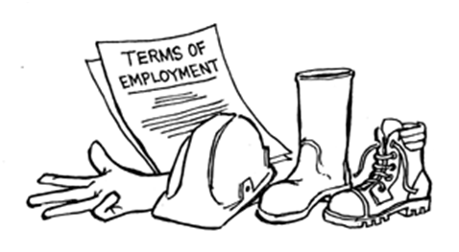

Figure 2.1: Construction Personal Protective Equipment, Adopted From Mwombeki, F. K, 2005.

2.3.10 Occupational Health and Safety Programs
Safety program on a project is set by the prime contractor’s project manager who maps out a program of safety measures commensurate with the size of the project and the conditions and hazards peculiar to it. Programs for construction safety include:
- Adequate first aid facilities and trained personnel and Safety committee comprising of key personnel –supervisors, safety personnel and company doctor
- Disaster control programs, which should be maintained by the in-charge who is qualified personnel.
- Crew leaders who hold brief meetings with workers under their supervisor at least once a week to discuss the safety operation of their crew and workers, and specific problems (held after the safety committee meeting)
- Safety instructions given to all new workers as part their introduction
- Special mass safety meetings called by the project engineer (all workers attend this meeting)
- Safety devices designed to prevent injury and accidents during building and road construction works.
- Management and supervisors visit the workers and inspect the works and participate in the safety programs periodically.
Evaluation and review of programs as required by changing conditions to address new problems that may arise (Mwombeki, 2005)

2.3.11 Statutory Requirements Governing OHS in Construction Sites in Tanzania
There are several statutory requirements governing Safety & Occupational Health in Tanzania, which are implemented by various bodies as follows: -

2.3.11.1 The Contractors Registration Act No. 17 Of 1997
Section 4 (m) of the Contractors Registration Act empowers the Board to ensure that all construction sites are hoarded and labour laws occupational health and safety regulations in the construction industry are adhered to.

2.3.11.2 The Contractors Registration by-laws 1999
These By -laws administered by Contractors Registration Board govern the conduct of contractors as follows:-
- By law 14 (I): every contractor is required to maintain and provide to every person at site appropriate PPE’s
- Section 20 (3) a Contractor shall maintain at every construction site register in which all accidents and causes there from are recorded and such accidents shall include all major and minor injuries sustained on the construction site.
- Section 20 (4) Noncompliance of the provision of paragraph (3), shall be punishable by fine of 0.1% of the contract sum or one hundred thousand shillings, whichever is higher; table 2
- Section 20 (9) All Building construction sites shall be hoarded and failure to do so constitutes an offence punishable by fine equal to 0.5% of the contract sum or two hundred thousand shillings, whichever is higher.
- Section 20 (11): every contractor shall provide every person on site with the appropriate PPE’s and failure to do so shall constitute an offence punishable by a fine of twenty thousand shillings per person.
- Section 20 (12): every contractor shall ensure that there is fire-fighting equipment and hygienic facilities on site and failure to do so shall constitute an offence punishable by a fine of fifty thousand shillings.

2.3.11.3 The Factories Ordinance Cap 297 (1950)
The Factories Ordinance, 1950, which makes provisions for the safety, health and welfare of persons at work in factories and other places of work; and for matte incidental thereto and connected therewith. This instrument is now outdated and the process of repealing it is ready. It will come out as Occupational Health and Safety Act with a broader scope of application in order to provide protection to more workers and address more hazards (Mwombeki, 2005).

2.3.11.4 The Factories (Building Operations and Works of Engineering Construction) Rules 1985
The Factories Ordinance is the main legislation making provision for safety, health and welfare of person employed in factories and other places and for matters incidental to, and connected with it. The Ordinance was enacted after the government recognized the need to provide safe working conditions for workers in the construction industry. These rules give safety provision on: Excavation, shafts & tunnels, Cofferdams and caissons, Operations and works on/or adjacent to water, Road works, scaffolding and other, Lifting operations, Demolition (Mwombeki, 2005).

2.3.11.5 Security of Employment Act
Security of Employment Act, 1964, makes provisions to restrict the powers of employers to dismiss employee summarily or otherwise in payment of additional compensation on the occasion of termination of employment except in specific circumstances to amend the law relating to employment and severance allowance and for matters connected therewith and incidental hereto. In the ongoing reform of labour laws, this legislation is also going to be reviewed in order to match with the labour market changes happening today(Mwombeki, 2005).

2.3.11.6 The Workmen’s Compensation Ordinance
Workmen’s Compensation Ordinance, 1949 makes provisions for compensation or benefits due to injuries or diseases or death arising in the course of employment. This instrument is also one of the outdated labour laws, which are currently under reform. The updating of this piece of legislation has a vital role to play in the workplace accident mitigation (Mwombeki, 2005). The updated legislation is expected to make provision for a compensation system that encourage prevention of accidents as opposed to the current situation where compensation is cheaper than prevention, and as a result most employers do not bother to prevent accidents (Mwombeki, 2005). The social security system in Tanzania is also fragmented in that there are several institutions that provide social security in the country. As a result of that, compensation system is also not functioning well. The repeal of Workmen’s Compensation Ordinance is intended to address a number of shortfalls in the current legislation (Mwombeki, 2005).

2.3.12 Injury and Diseases Reporting in Tanzania
Collection of data on injuries and diseases is inadequate in most countries. In some of the countries where there is an adequate data collection system, most of the data is not fully comparable from one country to the next because of variations in definitions, recording and notification systems. The motivation to report injuries and diseases varies according to the types of incentives provided in the compensation and social security systems (African Newsletter on Occupational Health and Safety, Vol, 20, No 3, 2010).

Severe injuries and diseases, such as fatalities, poisoning, acute inhalation of respiratory toxic substances and dermatitis among others are frequently recorded by workers’ compensation systems or social security system. Countries where workers’ compensation is the source of injury and disease data normally encounter several limitations, such as lack of standardization in the eligibility requirements for reporting, lack of standard case definitions, disincentives to workers and employers to file claims, inadequate numbers of physicians to recognize chronic occupational diseases with long latency periods and the usual gap (several years) between initial filling and resolution of a claim(African Newsletter on Occupational Health and Safety, Vol, 20, No 3, 2010).

2.3.13 Statutory Requirement to Report Injury and Disease in Tanzania
In Tanzania, reporting of injuries and diseases is required under some pieces of legislation administered by different government enforcing authorities. The legislation currently requiring reporting of injuries and diseases is the Workmen’s Compensation Ordinance of 1949 Cap 263 and its amendments and the Notification of Accidents and Occupational Disease Ordinance of 1953 Cap 330. In other words, all occupational injuries must be reported under the Accidents and Occupational Diseases Notification Ordinance, and employees must be insured against occupational injuries under the Workmen’s Compensation Ordinance (African Newsletter on Occupational Health and Safety, Vol, 20, No 3, 2010).

According to the Occupational Health and Safety Act No 5 of 2003 and its regulations, administered by the Chief Inspector of Occupational Safety and Health Authority, reporting of injuries and diseases is also required. Although all of the legislation has been announced in the official gazette, with the exception of the Workers’ Compensation Act, only the Workmen’s’ Compensation Ordinance is functioning to some degree. To a large extent, workers make an important contribution here; they are motivated to report injuries and diseases so that they can be compensated (African Newsletter on Occupational Health and Safety, Vol, 20, No 3,).

2.4 Empirical Literature Review
The empirical literature review on occupational health and safety in building construction sites based on global level, continent level as well as national level. Here the study sighted how different people from those basement mentioned above say about occupational health and safety in construction industry.

2.4.1 Empirical Literature Review World Wide
Dowling, (2011) wrote several articles concerning Global Workplace Health and Safety Compliance. He went further and tried to see if there are occupational health and safety on various working place. He wrote; General health/safety standards imposed across worldwide operations, such as a global code of conduct safety provision, a set of company “cardinal safety rules,” or a manifesto on health/safety principles like Sony’s “Global Policy on Occupational Safety and Health. He narrated well the failure to meet occupational health and safety with regards to the labour law worldwide.

Honda's approach to occupational health and safety "No safety, no production": as a company that holds respect for the individual as one of the basic tenets of its philosophy, Honda considers the mental and physical health of associates to be one of its most important responsibilities, alongside workplace and traffic safety. Besides making these views explicit in our basic policy on occupational health and safety, Honda engages in initiatives designed to ensure that its workplaces are among the safest and most comfortable in the industry. http://world.honda.com/CSR/ employee/safety/. A recently released study by the Global Construction Perspective and Oxford Economics (Global Construction 2025) forecasts an increase of 70% in the volume of outputs from the industry by 2025. In developing countries the report shows that regardless increase of the increase in revenue in construction industry, they have paid a great attention in occupation health and safety. Developing counties such as Scandinavian countries apart from being a prominent source of pollution, construction Work is characterized by the entire spectrum of health and safety, hazards, namely physical, mechanical, ergonomic, biological, and chemical hazards. But in reality they try their best level to make sure health and safety are obtained. Another global survey by KPMG International in Europe (2012), which involved face–to-face interviews with 165 executives from construction industries, similarly showed an increase in great care of occupational health and safety which they think is the myth in increase in revenue of up to 5% in 2012/13, as reported by more than half of the respondents. Major drivers are the increased demand for better health and safety, good health and safety policy as well as its implementation and stakeholders’ awareness in occupational health and safety.

Neale and Waters (2012) tried to explain factors to improve health and safety regarding United Kingdom 40 years of transition in occupation health and safety. The construction company obviously had taken OSH very seriously nowadays compared to 40 years ago by providing good barriers between the site and the public, safety fencing on all floors, and fans to catch falling debris. The construction company had adopted the principle of ‘zero incidents’ and generally this is what they achieved. The fact is 40 years ago they faced so many problems concerning health and safety but they undergo transition period by inducing deliberate policy plan and implement it.

2.4.2 Empirical Literature Review in Africa
Ncube (2014) Executive Consultant Senior Specialist for Occupational Safety, Occupational Health and Environmental Management Group CEO of Centre for Business Excellence Zimbabwe do some investigation on ‘Organizational requirements for the implementation of effective Occupational Safety and Health Management Systems” in Africa newsletter 2014. He concluded that in his investigation; the lack of a systematic approach to occupational safety and health management has contributed to the ineffective implementation of the required operational programmes and activities. Safety and Health Culture Transformation in organizations is an essential prerequisite for the adoption of the modern approach to Occupational Safety and Health Management Systems. Loewenson (2014) after doing their research concerning the successes and shortcomings of a regional programme in occupational health: an evaluation of Work and Health in Southern Africa. They come with a good strategy of external and internal evaluations Programme that had to a reasonable extent achieved the main objective of its first phase, and that its intervention approach was highly relevant in relation to existing problems in the area of occupational health and as a possible future contribution to the reduction of poverty in the region.

Capacity and networking had been strengthened, especially among the resource centers involved. A substantial amount of information had been collected, which needed to be systematized and utilized in order to be able to raise awareness. Neale and Waters (2012) In their book “Safety and health in construction in developing countries” he described Ten factors to improve occupational safety and health in construction projects which are; Developing a national culture of safety, International agreements influence national policies and national laws, Funding agencies must insist on good OSH through their contracts, Comparative studies of the OSH environment and practices, A comprehensive, generalized model on the business case for OSH should be developed, OSH has to be managed actively, Workers should be more directly involved in planning and implementing safe and decent work, OSH personal protective clothing and equipment (PPCE) must be developed to suit the diversity of cultures and physiques of both men and women workers, The technology to improve OSH, including better control and warning systems, communication devices and better (safer) machines, should be further developed and Effective education and training in OSH is required globally; it should be designed in such a way as to measurably enhance attitudes, skills and knowledge. Mosanawe, from BOTSWANA wrote article in Africa Newsletter on Occupational Health and Safety 2013; concerning Construction safety and occupational safety and health in Botswana. After seeing the accident statistics he observed that there are Inadequate regulations to Building Operation and Works of Engineering Construction Regulations lack some of the fundamental clauses that could go a long way in improving safety on construction sites.

2.4.3 Empirical Literature Review in Tanzania
Most of the study conducted by prominent figure that are competent such as Mbuya (2001) to investigate the status of Occupational Health and Safety in the Tanzanian roads construction industry, determined that there are a number of factors contribute to the slow pace of safety improvement in this industry. These factors are outdated OH& S regulations, lack of sufficient staff to enforce health and safety regulations, poor planning, organization and management of safety in the construction industry, lack of sufficient manpower to conduct safety training, high rate of unemployment, employing incompetent personnel, lack of research in OH&S, unethical practices and finance/budgetary constraints. Also Kitumbo, et al (2001) ratify to investigate construction industry in Tanzania, concluded that there is no compliance of the implementation of health and safety in construction industry in Tanzania. He suggests the way forward for the improvement of occupational health and safety in construction industry based on educating the stakeholders in the concerning sector.

Another prominent figure called Ofori, (1990) concluded that the construction industry; Aspects of its Economics and Management, concluded that some improvement should be done in order to enforce health and safety compliance in construction industry. CRB (2001) tried to elaborate on Baseline Study on Safety conditions in construction sites in Tanzania, in this study, three sets of questionnaires for directors of construction firms, site managers and workers in the construction sites together with a checklist to assess compliance with health and safety requirements were used as tools for collection of study data.

The study sample, which was randomly selected, consisted of 63 construction sites in the cities of Dar es Salaam and Mwanza and municipalities of Arusha and Mbeya. The findings of the study were poor or little knowledge of legislation, lack of knowledge of health and safety risks in construction sites, no provision for health and safety in the Bill of Quantities, lack or inadequate provision of personal protective equipment, unreported accident rate in construction sites, unsafe scaffolds and ladders, safety of people not in contractor’s employment, lack of measures to protect persons working at height, poor housekeeping, inadequate provision of welfare facilities and lack of health and safety policy in construction industry. The study concluded that health and safety construction industry in Tanzania pose high risks to workers in the industry.

2.5 Research Gap Identified
From the theoretical and empirical literature review that has been elaborated above, it can be argued that various studies have been conducted on occupational health and safety in construction industry in Tanzania, African as well as world wide but such studies were done most out of Construction project sites in Dar es Salaam, Kinondoni District, few studies that were done in related topic were not exhaustive; hence more still needed to be done so as to gain wide understanding of the occupational health and safety in construction industry in Tanzania especially Kinondoni District. So the study think there is a great need of doing some analysis due to the fact that there are a lot of challenges in construction industry in Tanzania especially in addressed place.

2.6 Conceptual Frame Work

Occupational of health and safety
Factors for occupation health and safety
-Government policy
-management system
-training and awareness of health and safety
- Financial stability
-commitment of stakeholders

Figure 2.2: Conceptual Framework

From the figure 3, relationship between independent variables, dependent variable was drawn. Above figure clearly shows that engagement or improvement of occupational health and safety as dependent variables enhanced by commitment of stakeholders, financial stability, and training and awareness of people about health and safety as independent variable. Not only that but its performance depends on the management of occupation of health and safely is also influenced by number of factors particularly Government policies and regulation, commitment of stakeholders and as well as infrastructure.

2.7 Theoretical Framework
Theoretical framework for research paper provides a handy model for conducting research and analyzing research results. These frameworks act as a sort of lens through which the study interpret research data and report on that data. The casual effect relationships between independent variables, intermediate variables and dependent variable were drawn.

The Improvement of occupational health and safety depend upon the influence of the particular variables such as government policy where by government should have good policy which are easily implemented, management system which are considerate to occupational health and safety issues to their workers, Efficiency that is all about the ability to avoid wasting of materials either effort or money or time, financial ability since implementation of health and safety policy need fund, and training where by stakeholders are being taught so that they can be aware of occupational health and safety. But the performance depends on the management of occupation of health and safely is also influenced by number of factors particularly Government policies, and regulation as well as infrastructure and management system.

CHAPTER THREE

3.0 RESEARCH METHODOLOGY

3.1 Introduction
This chapter provides research methodology. It covers the research strategies, survey population, sampling design and procedure, variable and measurement procedures, method of data collection data processing analysis. Research methodology refers to a systematic way applied to solve the research problem (Kothari, 1990).

3.2 Research Design
Orodho (2003) defines it as the scheme, outline or plan that it is used to generate answers to research problems. A research design can be regarded as an arrangement of conditions for the collection and analysis of data in a manner that aims to combine relevance with the research purpose. It constitutes the blueprint for the collection, measurement and analysis of data (Kothari, 2003). Due to nature of the question raised, the research adopted a case study based on primary and secondary data whereby it adopts a qualitative method. It is a qualitative method simply because the nature of the study revolves around social issues that demand an examination of the connection between health and safety provisions in construction contracts in projects.

3.3 Area of the Study
According to Denzin and Lincoln (1994), a researcher needs to select a specific area for the study, since only specific locations and not all areas are ideal and suitable to test particular theories. This research used secondary data focusing on selected ongoing building construction sites in Tanzania. The area study of the research is Dar es Salaam region specifically Kinondoni District. The researcher preferred the place due to the reason that there are various projects building taking place. The researcher preferred to use organization especially NGO’s such as International Labor Organization (ILO) and Economic and social Research Foundation, due to the reason that it was easy for a researcher to collect data.

3.4 Survey Population
Population is the group of individual who have one or more common characteristics that are of interest to the researcher (Adam & Kamuzora, 2008). The specification of the population to which the enquiry will be addressed affects decisions that researchers must make both about sampling and resources (Kothari, 2004).The expected populations to be surveyed are workers in building project cheap labours and skilled labours as well as constructors and project managers. All of them interviewed because they are persons who are direct affected by occupational health and safety. Research will find the construction sites and to the offices such as Board of Contractors office and OSHA office. It identified that, by using their characteristics such as wearing style, communication style and location for those who are found in the offices.

3.5 Sampling Design and Sample Size
Kothari (2004) defines a sample as a subset of a population that is used to represent the entire group as a whole. When doing research, it is often impractical to survey every member of a particular population because the sheer number of people is simply too large. In order to make inferences about characteristics of a population, researchers use d a sample.

3.5.1 Sampling Design
According to Krishnaswami and Ranganatham, (2007), sampling design is made of two elements which is Sampling method which refers to the rules and procedures by which some elements of the population are included in the sample. Some common sampling methods are simple random sampling, stratified sampling, and cluster sampling and another element is Estimator which refers to the process of calculating sample statistics. The study used sampling method based on simple random sampling. Simple random sampling refers to a sampling method that has the following properties; the population consists of N objects, the sample consists of n objects an all possible samples of n objects are equally likely to occur. An important benefit of simple random sampling is that it allows researchers to use statistical methods to analyze sample results. The study used simple random sampling to stakeholders of the building construction industry such as constructors, foremen, builders, cheap labour or day workers and others who are direct affected by concerning industry.

3.5.2 Sample Size
According to Krishnaswami and Ranganatham, (2007), a sample is an empirical field of study that requires collection of first-hand information or data pertaining to the unit of the study from the field. The total sample size was 150 persons. Due to the limited resources, researcher will interview 120 labours from field (construction project sites) and 5 people from other place such as OSHA office, 10 people from ministry of construction 5 peoples from CRB and the 10 other people surrounding the building industry who are directly or indirectly affected by the projects. Literary researcher chose both sex and tries to get the right information as much as it can.

Table 3.1 Shows the Sample Distribution in Construction Sites
S/N | Respondents from  Construction sites | Frequencies (N) | Percentage (%) | Sampling design | Data collection tools
 | Victoria | 10 | 8.33 | Simple random | Questionnaire
 | Morocco | 10 | 8.33 | Simple random | Questionnaire
 | Sinza | 15 | 12.5 | Simple random | Questionnaire
 | Osteybay | 10 | 8.33 | Simple random | Questionnaire
 | Masaki | 10 | 8.33 | Simple random | Questionnaire
 | Magomeni | 10 | 8.33 | Simple random | Questionnaire
 | Mikocheni | 10 | 8.33 | Simple random | Questionnaire
 | Msasani | 15 | 12.5 | Simple random | Questionnaire
 | Total | 90 | 100
Respondents from
other place
 | Ministry of Work | 10 | 8.33 | Snow bar sampling | Interview
 | OSHA | 5 | 4.16 | Snow bar sampling | Interview
 | CRB | 5 | 4.16 | Snow bar sampling | Interview
 | Other stakeholders | 10 | 8.33 | Simple random sampling | Questionnaire
 | Total | 30 | 100
 | Total sample size | 120 | 100

3.6 Variables and Measurement Procedures
In this section researcher preferred to get first-hand information from the people direct concerned with construction project that is all about constructors, workers and project managers as well as the society people surrounding the area. Researcher obtained information by using observation, interview method as well as questionnaire; also used the second data information from various books, journals and papers. Researcher used structured and unstructured questionnaire to distribute to the key informants and other respondents such as managers and Constructors since they are aware with it.

3.7 Methods of Data Collection
Method of collecting data varies according to type of research conducting. Due to time limitation, the research used secondary data obtained from different literatures (Bell, 2005). Secondary data includes official statements, documents and reports from recognized institutions, Government Departments, agencies and NGOs like the International Labor organization (ILO), partners such as World Bank, African Development Bank, Millennium Development Goal, Millennium Challenge Corporation and also collected from Economic and Social Research Foundation(ESRF), Ministry of Works, Ministry of Finance, Contractors Registration Board and International Labor Organization–Country Office in Dar es Salaam while tertiary data include books, academic journals, publication on health and safety and all documents which offer an effectiveness of health and safety provision in the construction industry (Aniekwe, 2008).

3.8 Data Collection Tools
The data collection tools need to be strong enough to support what the evaluations find during research. This study used Data collection tools involving secondary participation require no direct contact to gather information(web based survey), in personal contact observations are used when there is face to face contact with the participants(interview, questioner, direct observation) and Case Studies and Content Analysis(literature review and content analysis). An interview is a conversation between two or more people where questions are asked by the interviewer to elicit facts or statements from the interviewee. (Wikipedia free encyclopedia) Interviews are a standard part of qualitative research. The study used interview as one among data collection tool to the selected sample and here standardized, open-ended interview The same open-ended questions are asked to all interviewees; this approach facilitates faster interviews that can be more easily analyzed and compared.

A questionnaire is simply a ‘tool’ for collecting and recording information about a particular issue of interest. It is mainly made up of a list of questions, but should also include clear instructions and space for answers or administrative details. Oppenheim, (1992). In this study the Questionnaires should have a definite purpose that is related to the objectives of the research, and it needs to be clear from the outset how the findings will be used. Respondents also need to be made aware of the purpose of the research wherever possible, and should be told how and when they received feedback on the findings.

Observation is a systematic data collection approach. Researchers use all of their senses to examine people in natural settings or naturally occurring situations. Savage (2000)In this study prolonged engagement in a setting or social situation clearly expressed, self-conscious notations of how observing is done, methodical and tactical improvisation in order to develop a full understanding of the setting of interest, imparting attention in ways that is in some sense 'standardized' and recording one's observations done.

3.9 Reliability and Validity of Data
Reliability is the degree to which an assessment tool produces stable and consistent results while Validity refers to how well a test measures. The study made sure the data is reliable and valid. Winter (2000) Reliability and validity depend on the skills of the researcher.

3.9.1 Reliability of Data
The study ensured the reliability through totally transparent, systematic approach to data collection from study sources. Also by documenting clearly the flow and processing of the data so that to make sure who ever test it regarding principal could get the same answer. The study insured to be reliable also using draw the data using the prescribed approach and having some kind of focus group with a sample of clinician/researcher, who can reach a consensus on when whether the data for the study represents what it is supposed to.

This relates to whether research results can be applied to a wider group than those who took part in a study. In other words, would similar results be obtained if another group containing different respondents or a different set of data points were used? For example, if 120 person out of 2,000-person in this study participate in a research study focusing on health and safety in construction site, is the information obtained from these 120 people sufficient to conclude how the entire people feels about health and safety in construction site? What if the same study was done again with 40 different salespeople, would the responses be similar?

3.9.2 Validity of Data
In this study Questions concerning reliability and validity are associated with how reliable and valid the researcher's data collection and analysis are. The study use research methods that ensure that the data recording is accurate and the interpretations of data are empirical and logical is important to increasing reliability and validity in qualitative studies. With data gathering represents several concepts that to the non-researcher may be quite complex. But basically validity boils down to whether the research is really measuring what it claims to be measuring.

3.10 Data Processing and Analysis
Before data to be analyzed the process for editing and coding of data used to make the data agreeable for analysis. Quantitative data collected using questionnaire by using Statistical Package for Social Science (SPSS) Mbogoet (.2012). In view of this, descriptive analysis used. Qualitative data obtained by using interviews; and literature review.

CHAPTER FOUR

4.0 DATA PRESENTATION, ANALYSIS OF THE RESULTS and discussion of the findings

4.1 Introduction
This chapter analyses the empirical data in an attempt to make analysis of occupational health and safety in building construction sites project in Dar es Salaam region, Kinondoni district. It covers the statutory requirements of health and safety in construction industry as propounded by different organizations which deal with projects of building constructions.

4.2 Profile of the Respondents
The survey was conducted with 120 people working in construction sites.80% were male and at least 58% have primary school education level. Majority of the respondents were, 82% and 60% were builders and work in residential building construction projects.

In addition, in depth interviews were conducted with three supervisors in construction sites; Site Engineers and Project Coordinator. They gave required support and they were so cooperative although in some circumstances their answers hung and they don't want to reveal some information. Here observation take a great chance and the study here wanted to see if there are some requirements such as certificates from OSHA, seeing first aid kits, seeing the person who is responsible for the issue pertaining health and safety in a considerable working area and company as whole. here the first hand information were founded and surely were raw data.

Table 4.1: Profile of the Study Respondents
Respondent |  | Frequency(N) | Percentage( %)
Sex of respondent | Male | 96 | 80%
Sex of respondent | Female | 24 | 20%
Education level | Incomplete primary education | 0 | 0%
Education level | Primary school education | 70 | 58%
Education level | Secondary school education | 30 | 25%
Education level | College education | 0 | 0%
What is your role? | Builder | 98 | 82%
What is your role? | Driver | 22 | 18%
Nature of the construction | Residential building | 72 | 60%
Nature of the construction | Commercial building | 48 | 40%

4.2.1 Health and Safety Mechanisms and Policies Guiding Construction Industry in Tanzania
Supervisors in responding the interview guide question all declare there is no clear policy governing health and safety in construction industry. So 100% of supervisors declare such a thing and even OSHA officers as well as CRB.
In this section respondents explained various health and safety mechanisms which they use in construction industry. Most of them based on the following things;
Site organization; Everything you need to know about organizing a safe and healthy construction site.
Slips, trips and falls; Assess, eliminate and control the risks of slips, trips and falls on construction sites.
Work at height; The hierarchy of controls for working at height, from working at ground level, using towers, scaffolds, platforms and ladders and, as a last resort, fall restraints and safety netting.
Structural stability; Assess the risks and prevent unintentional structural collapse during alterations, demolition and dismantling; and the measures you need to take to prevent accidents in excavations.
Cranes; All lifting operations involving lifting equipment must be properly planned by a competent person; appropriately supervised; and carried out in a safe manner.
Electricity; Work safely with power supplies and electrical equipment; map overhead power lines and underground cables to prevent accidental contact with machinery.
Fire; Identify the risks of fire; control combustible materials and ignition sources; and make it clear exactly what to do if fire does break out.
Mobile plant and vehicles; Assess the risks, establish competence to operate and control access to telehandlers, excavators, mobile work platforms, dumpers and road vehicles.
Demolition; All demolition, dismantling and structural alteration should be carefully planned and carried out by competent practitioners.

Since there no clear policy in the issue concerning health and safety Occupational Safety and Health Authority in Tanzania (OSHA) Act 2003, require the Employer to provide a health and safety session in any construction sites. In this study it is found that 102 people out of 120 which is equal to 85% has got a knowledge on first aid kit and they have it in their field area. Also 18 people out of 120 have not got knowledge about first aid kit and they even don't have it in field area.
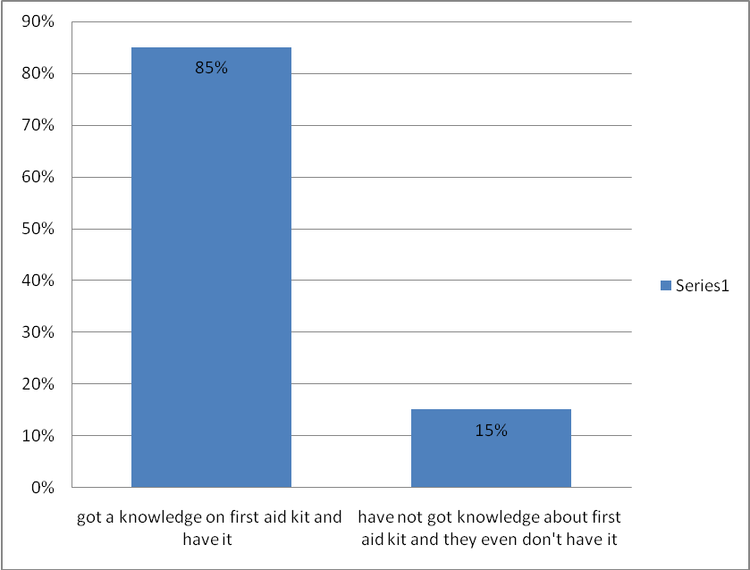

Figure 4.1: The Respondent of Supervisor about First Aid Kit Issue

4.2.2 Provision of Trainings on Health and Safety to Staff by Construction Company
Interview with field supervisors at construction sites indicates that construction companies provide trainings to their staff on health and safety. Construction companies use both internal personnel and outsourced experts from OSHA to train their staff. However proportion of staff trained varies between the companies. Company A has 140 workers and all have been trained at least once while company B has trained 40 workers out of 60. Responses from the workers also indicate that not all workers have been trained on health and safety. Out of 120 respondents, only 80 respondents (67%) reported that they have been trained.
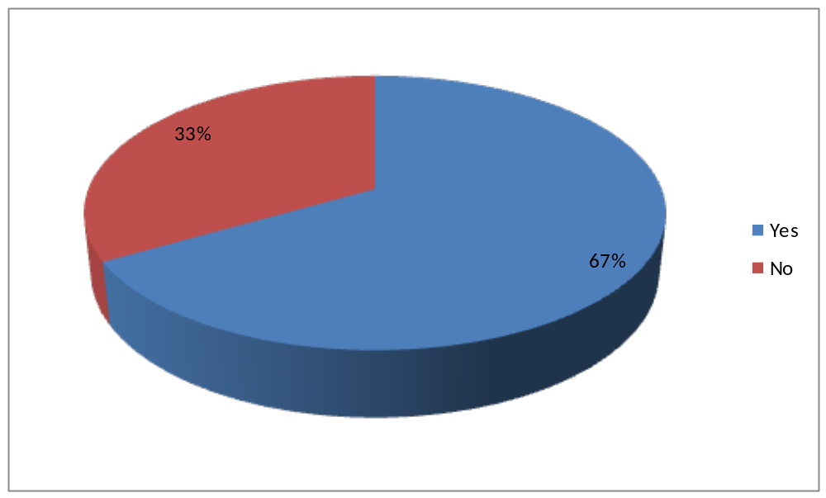

Figure 4.2: Percentage of Respondents who have been trained on Health and Safety at Working Place

4.2.3 Role of Government in Ensuring Of Occupational Health and Safety Provisions in the Construction Industry
To assess role of the government in occupational health and safety provisions in the construction industry, site supervisors at construction sites were asked number of questions that aimed to determine support they receive from the government. Findings indicate that the government support construction industry in Kinondoni district main areas:

4.2.3.1 Capacity Building
All site supervisors acknowledged that they have attended one or more trainings organized by one of the government agency that is responsible for health and safety in working place, OSHA. But other workers said they do not attend it even single time. Among 120 respondents 80 who have been trained; 50 respondents said they have undergo training once which is equal to 41.7%, 20 respondents said they have undergo the training two times per year which is equal to 16.7% and 10 respondents have undergo training more than two which is 8.3% . There were 40 respondents who have not attend any training concerning health and safety in construction sites which is equal to 33.3%.
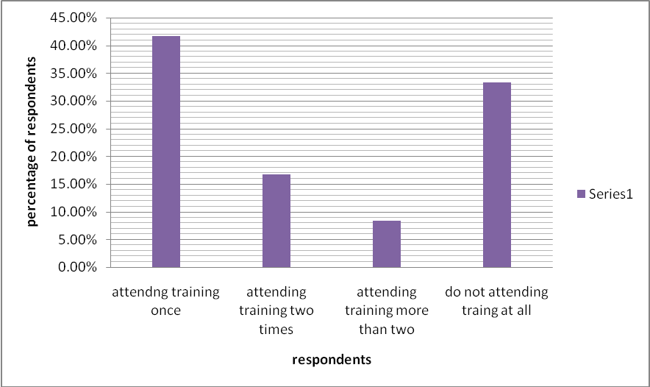

Figure 4.3: Respondents Answer of Training Attendance per Year

In addition, OSHA provides training materials to companies that would like to provide trainings to their workers by using internal personnel.

4.2.3.2 Policies and Guidelines Enforcement
Supervisors reported that they are visited by technical persons from OSHA who comes to assess their application of laws and policies governing construction industries. Nine among ten sites supervisor reveal that OSHA officers come to do unexpected inspection. And one supervisor said his company never visited by OSHA for two years now. Also OSHA people when visited by this study maker said they have the timetable to go and teach as well as make unexpected inspection. Research finding show 90% of the building company have been inspected and follow all procedure from registering themselves to OSHA. One company was no idea about inspection done by OSHA which is equal to 10%. In appendices of this report there are application form of permanent registration for work place and application form for OSH courses. The figure below show the company which is visited and not visited by OSHA for inspection purposes.
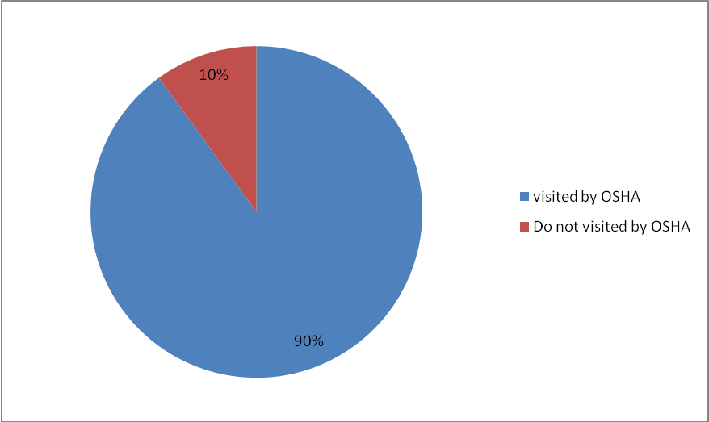

Figure 4.4: Respondents Answer on OSHA visitations for training and inspection

4.2.4 Commitments of Stakeholders towards Achievement of Health and Safety Measures
Construction companies visited show that they are committed to ensure health and safety of their works. Interview with workers and site supervisors indicated that, construction companies employ the following strategies;

4.2.4.1 Provision of Safety Gears
In this study 90 respondents which is equal to 75% of the respondents reported that they have access to number of safety gears that they use during working hours to protect them from accidents and injuries. The remaining 25% of the respondents do not use safety gears and others even not afraid of such a situation of working without those safety gears.
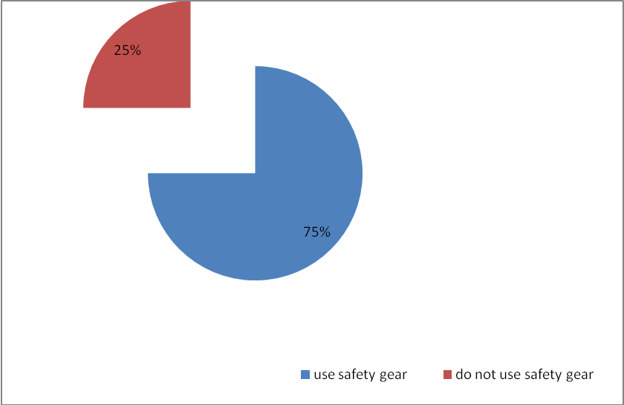

Figure 4.5: Respondents Answers on the use of Safety Gears

Most mentioned safety gears mentioned include gum boots(79%), helmets (70%) and gloves (65%).Nerveless, availability of belts is the least mentioned (23%)
Table 4.2 Protective Gears Provided By Construction Companies to Workers
Types of safety gears | Number of workers | Percentage of workers who use protective gears
Boots | 95 | 79%
Helments | 84 | 70%
Gloves | 78 | 65%
Overalls | 72 | 60%
Dusks masks | 70 | 58%
Belts | 27 | 23%
Visibility clothing | 98 | 82%
Eye protection | 50 | 42%

The suitability of the personal protective equipment that is selected must take into account the characteristics of the individual who is to wear the equipment and be effective at ensuring the risks are adequately controlled. Hygiene considerations must also be taken into account and, where necessary, equipment provided for individual use. Also the companies have first aid kits in sites and they have established linkages with nearby health facilities where their staff will be taken for further care in case of serious injuries. Apart from those the companies have stores for those equipments to be stored and protected from deterioration and be fit for the use.

4.2.4.2 Employment of Health and safety Personnel
Supervisors interviewed and mentioned that their companies have designed personnel who are responsible for ensuring working environment is safe for their workers. Although roles of the personnel in the two companies differ, their responsibilities are similar. Company A has Capacity Building Officer, company B has Risk Analyst.

Table 4.3: Health and Safety Personnel of the Respondent Personnel
Name of company | Number of health and safety personnel | Name Of Department
Company A | 3 | Insurance and risk management
Company B | 4 | Health and safety
Company C | 2 | Human resources
Company D | 1 | Risk management
Company E | 6 | Risk management and mitigation
Company F | 3 | Health assurance
Company G | 5 | Health support
Company H | 1 | Human relations
Company I | 3 | Health and safety
Company J | 1 | Human resources and health assurance

4.2.4.3 Allocation of Budget for Health and Safety
Four of the five company site supervisors mentioned that their company has special funds for health and safety of their workers. The funds are used for buying safety gears, covering training cost and medical bills for their workers who get injured. Despite the commitments by the construction companies to ensure health and safety of their workers, satisfaction of workers is low.

Respondents were asked four questions about their perceptions on initiatives taken by their employers pertaining and occupational health and safety at work place. They were required to rate the statements in three (3) likely scales of where 1-dissatisfied,2-neutral and 3-satisfeied. Overall mean score of the respondents satisfaction is 2.12. However, high satisfaction was expressed in availability of quality protective gears (mean=2.6) and availability of adequate protective gears (mean=2.4) while more dissatisfaction was mentioned on seriousness shown by employers on issues pertaining to workers health and safety (mean=1.6)
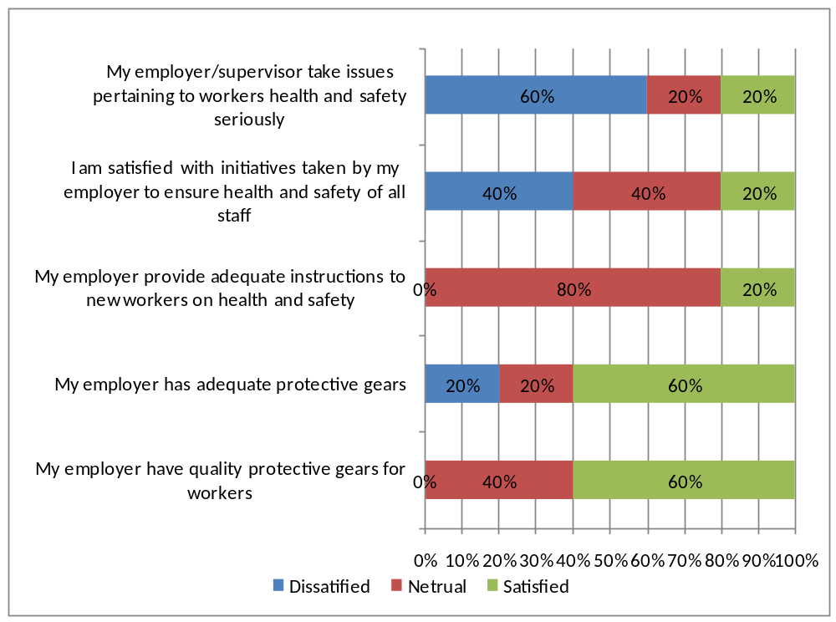

Figure 4.6: Respondents Perceptions on Efforts taken by their Employers to Ensure Workers Health and Safety in Working Places

4.3 Analysis of Result
The analysis of result focus on addressing the four major research objectives, which are: 1) to analyze whether there are health and safety mechanisms and policies in the construction industry in Tanzania. 2) To deduce if Tanzania construction industry conduct training to make their people aware of issues concerning occupational health and safety. 3) To identify the role of government in ensuring of occupational health and safety provisions in the construction industry. 4) To determine commitment of stakeholders towards achievement of health and safety measures. Thereafter, the focus is on analyzing the result in the order of the research objectives as indicated above. The usefulness of this chapter lies in the fact that it provides answers to the research questions formulated. In Tanzania developmental projects especially building construction projects is purely financed or funded by different people either individual clients or donors. Some of the projects are funded by the Government of Tanzania and in some cases, the projects is funded by multilateral donors in collaboration with the Government. The overall result show that many of the construction projects, indicates the sense of noncompliance of health and safety, notable case of noncompliance includes no control of access to the camp which made many people from outside to be present on the site without any permission, no separation of activities between space for work.

Rest and eating areas, no space provided for workshop on the camp and thus all work was done in the open yard like assembling of metal support frames laid on the ground unattended they may create health hazard that may lead to severe bodily harm or worse, in case someone tripped and fell on the exposed metal, either a day worker, a visitor or a night intruder, given that the camp is not closed and there is no security on site, no signage and no demarcation of areas, including several open trenches and holes without warning signs or security tapes, most Construction workers had incomplete or no Personal Protective Equipment (PPE) and no evidence of training on safe work procedures to workers. This in case of large project.

4.3.1 The Presence of Health and Safety Mechanisms and Policies in the Construction Industry in Tanzania
In responding the first objective of this research, the result shows that there is clearly understanding of health and safety issues in construction industry in Kinondoni district. A certain company which is doing a building project at Morocco street, 99% of their workers respond that they do morning meeting every Monday morning and discuss as well as taught many things concerning health and safety. Through evidence of site specific Health and Safety Management Plan (HSMP) for upgrading of Morocco apartment and shops building project nearby Osteybay police station, result revealed that there are health and safety mechanisms in construction sites whereby construction workers normally trained on identification of hazards and risks associated with construction works (GOT 2010). Supervisors in responding the interview guide question all declare there is no clear policy governing health and safety in construction industry. So 100% of supervisors declare such a thing and even OSHA officers as well as CRB.

This shows that Tanzania government have pay little attention in the issue concerning occupational health and safety in construction industry. The mechanism deployed in construction sites in Tanzania includes provision of personal protective equipments (PPEs) as a major means of protecting workers from injuries and potential risks at sites. 75% of the respondents reported that they have access to number of safety gears that they use during working hours to protect them from accidents and injuries It is through the result learnt that this mechanism seems to be a final resort with regard to risk control. Result also shows that this mechanism does not fully provide protection for workers from risks during construction work or sites despite the fact that to some extent it would help if more emphasis would be put in place to enforce the mechanisms. With regard to policies, result shows that many construction projects have its own health and safety guidelines rather than policies on construction sites which enforcing the use of protective gears. It has been learnt that there is no clear national policy which governing health and safety in construction industry. All 10 supervisors from construction company, OSHA officer, CRB officer and workers of ministry of labour reveal that. In addition, the research realize that every company or site normally developing its own guideline to suit its need for a particular project life span and comply with tendering procedures which requires every company to have its health and safety guideline. All the organizations involved in a construction project should have a written and agreed occupational health and safety policy. The policy should be written specifically by and for the organization, formulated with the participation of employees and their representatives, adopted positively at all levels especially by senior management, clearly stated and effectively communicated to all and continually reviewed and up-dated.
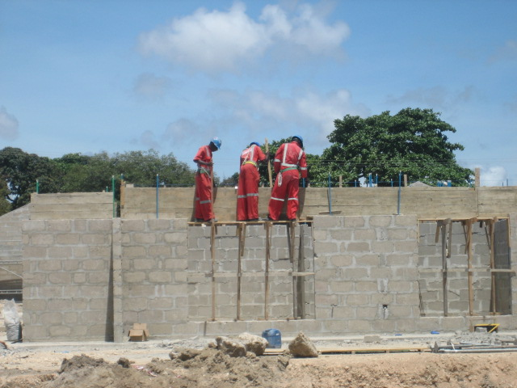

Figure 4.7: Show Workers Exposed to Risk of Falling because there is no Mechanism to Protect them

4.3.2 To Deduce if Tanzania Construction Industry conduct Training to make their People aware of issues concerning Occupational Health and Safety
This section seeks to deduce how Tanzania’s construction industry conducts training to make their people aware of issues concerning occupational health and safety. This is to partly answer our second research objectives. The study show that Interview with field supervisors at construction sites indicates that construction companies provide trainings to their staff on health and safety. Construction companies use both internal personnel and outsourced experts from OSHA to train their staff. However proportion of staff trained varies between the companies. Example A consulting engineering has 140 workers and all have been trained at least once while company B Construction Company has trained 40 workers out of 60. The table bellow show the number of training for ten company which the study interviewed.

Table 4.4: Respondent of Supervisors Interview on Number of Trained Employees
Name of company | Number of employees | Number of trained employees | % of employees trained
Company A | 140 | 80 | 57
Company B | 60 | 40 | 67
Company C | 113 | 84 | 74
Company D | 78 | 67 | 86
Company E | 204 | 120 | 59
Company F | 153 | 130 | 84
Company G | 87 | 60 | 69
Company H | 72 | 50 | 69
Company I | 86 | 50 | 58
Company J | 48 | 20 | 42
Summation | 1041 | 701 | 665
Average | 104.1 | 70.1 | 66.5

Responses from the workers also indicate that not all workers have been trained on health and safety .Out of 120 respondents, only 80 respondents (67%) reported that they have been trained before starting work. This is so dangerous as a study opinion all workers should be trained because those who do not attend even if they are small in numbers but they may cause damage and accident even to those who attend hence high risk for both of them. The four reviewed construction contracts under GOT financing do not cover health and safety provision simply because there is no clear national policy which the government could use to enforce every contractor to comply with the available policy. In the absence of the national policy of occupational health and safety, it would be very difficult for the contractors to make sure that health and safety is part of construction work. Through evidence of few cited construction contracts, it is also very difficult for government to monitor compliance of health and safety simply because health and safety is not a contractual issue (GOT 2010).
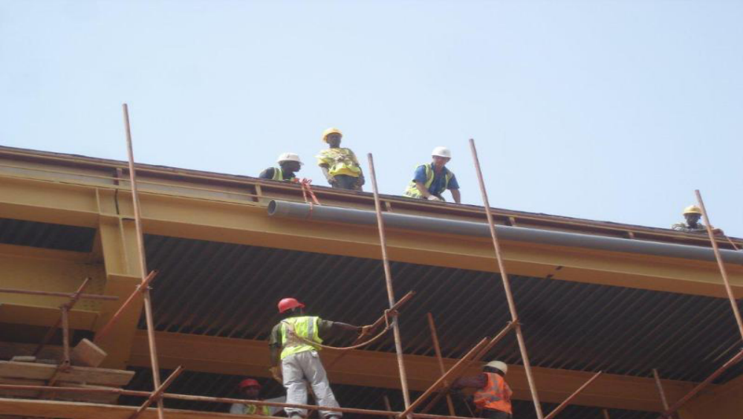

Figure 4.8; Workers Working with full Protection

4.3.3 Identify the Role of Government in ensuring of Occupational Health and Safety Provisions in the Construction Industry
Based on the third objective of the research, the result shows that the government established occupational safety and health authority (OSHA) to deal with supervision and monitoring of occupational health and safety in construction industry in Tanzania. 100% site supervisors acknowledged that they have attended one or more trainings organized by one of the government organ that is responsible for health and safety in working place, OSHA. Also 67% of the field workers reveal that they undergo training. Through the occupational health and safety Act 2003, OSHA is the main legislation governing occupational health and safety practice in Tanzania. The most important features of the OSHA Act, 2003 are introduction of health and safety representatives and committees of workers at construction sites, employers are legally responsible for providing health and safety training to workers including information on hazards inherent in the work, OSHA has power to compound offences and preparation of health and safety policy and code of practice (GOT, 2003).

Capacity building since site supervisors acknowledged that they have attended one or more trainings organized by one of the government agency that is responsible for health and safety in working place, OSHA. But other workers said they do not attend it even single time. Among 120 respondents 80 who have been trained; 50 respondents said they have undergo training once which is equal to 41.7%, 20 respondents said they have undergo the training two times per year which is equal to 16.7% and 10 respondents have undergo training more than two which is 8.3% . There were 40 respondents who have not attend any training concerning health and safety in construction sites which is equal to 33.3%. This still a challenge since those 33.3% who do not undergo training can harm the people in the field of construction sites.

Policies and guidelines enforcement since supervisors reported that they are visited by technical persons from OSHA who comes to assess their application of laws and governing construction industries. It is kind of inspection and inspectors from government agency OSHA do it to the construction company and bring a report for the action to be taken either awards or punishment. Nine among ten sites supervisor reveal that OSHA officers come to do unexpected inspection. And one supervisor said his company never visited by OSHA for two years now. Also OSHA people when visited by this study maker said they have the timetable to go and teach as well as make unexpected inspection. Research finding show 90% of the building company have been inspected and follow all procedure from registering themselves to OSHA. One company was no idea about inspection done by OSHA which is equal to 10%. In appendices of this report there are application form of permanent registration for work place and application form for OSH courses. The table bellow show the company which is visited and not visited by OSHA for inspection purposes.
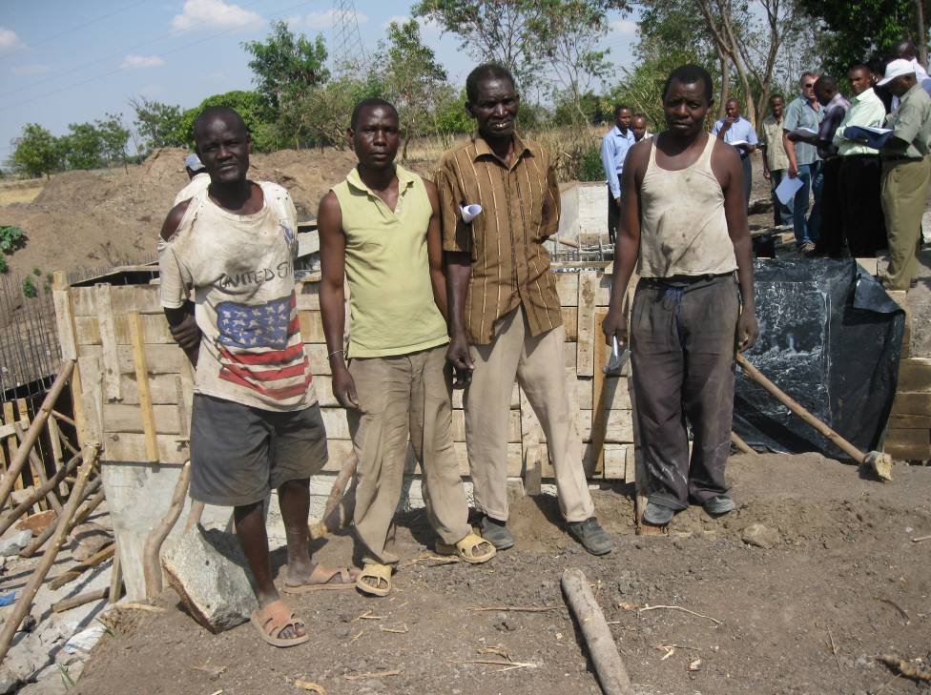

Figure 4.9: Workers working without full set of PPE at Kinondoni District Site Tanzania

4.2.4 To Determine Commitment of Stakeholders towards Achievement of Health and Safety Measures
This is the forth objective of the study, the finding of this study shows that the stakeholder are committed towards achievement of health and safety measures. Example, nine among ten supervisors from building company show their health and safety plan and budget. And among of them one company even employs Consultancy Company which deals with the issue concerning health and safety in their working environment. One supervisor reveals that there are no any plan and known budget concerning health and safety although they give safety gears and trains their workers occasional. Nine of the ten company site supervisors mentioned that their company has special funds for health and safety of their workers. The funds are used for buying safety gears, covering training cost and medical bills for their workers who get injured.

Despite the commitments by the construction companies to ensure health and safety of their workers, satisfaction of workers is low. Respondents were asked four questions about their perceptions on initiatives taken by their employers pertaining and occupational health and safety at work place. They were not fully satisfied by the initiative taken by stakeholders which means there are some problems somewhere which is all about being profit monger instead of looking the health and safety of their workers. The study also detect there is no any policy which enforcing all stakeholders to take full control of health and safety issues to its workers as part and parcel of successful completion of the project. It is through this study that, it is high time now for the government authorities to make sure that health and safety policy should be in place so that it would help construction industry to be safe and if possible to decrease and eliminate all occupational hazards and risks. Through a clear policy, it would be believed that all construction activities are executed with zero lost hours or accidents.

4.4 Discussion of the Findings
Neale and Waters (2012) tried to explain factors to improve health and safety regarding United Kingdom 40 years of transition in occupation health and safety. The construction company had adopted the principle of ‘zero incidents’ and generally this is what they achieved. The fact is 40 years ago they faced so many problems concerning health and safety but they undergo transition period by inducing deliberate policy plan and implement it. So, here in Tanzania we always have good policy but when nothing comes to implementation is done.

In Tanzania this study noted that they have not Health and safety policy and all the respondents reveal it 100%. OSHA seems to be silent and not doing much as one of the construction company supervisor which the study interviewed said OSHA don’t pay a visit to their site or offices. So, there are no inspections to see if the OSHA act and other procedures as well as rules are followed.

Neale and Waters (2012) In their book “Safety and health in construction in developing countries” he described Ten factors to improve occupational safety and health in construction projects which are; Developing a national culture of safety, International agreements influence national policies and national laws, Funding agencies must insist on good OSH through their contracts, Comparative studies of the OSH environment and practices. Above the major point is training, this study observed that 33% of the workers in construction industry in Dar se Salaam, Kinondoni district do not undergo training. Workers are not involved in planning and implementation of health and safety at work. So 67% of workers who undergo training can be in a danger situation caused by those 33% who do not undergo training. In this study interview with field supervisors at construction sites indicates that construction companies provide trainings to their staffs on health and safety. Construction companies use both internal personnel and outsourced experts from OSHA to train their staff. However proportion of staff trained varies between the companies. Company A has 140 workers and all have been trained at least once while company B has trained 40 workers out of 60.

Neale and Waters (2012) continued to write something concerning Africa in occupational health and safety and suggested OSH has to be managed actively, Workers should be more directly involved in planning and implementing safe and decent work, OSH personal protective clothing and equipment (PPCE) must be developed to suit the diversity of cultures and physiques of both men and women workers, in this study it has been observed that 90 respondents which is equal to 75% of the respondents reported that they have access to number of safety gears that they use during working hours to protect them from accidents and injuries. The remaining 25% of the respondents do not use safety gears and others even not afraid of such a situation of working without those safety gears. The technology to improve OSH, including better control and warning systems, communication devices and better (safer) machines, should be further developed and Effective education and training in OSH is required globally; it should be designed in such a way as to measurably enhance attitudes, skills and knowledge. In Tanzania, CRB (2001) tried to elaborate on Baseline Study on Safety conditions in construction sites in Tanzania, in this study, three sets of questionnaires for directors of construction firms, site managers and workers in the construction sites together with a checklist to assess compliance with health and safety requirements were used as tools for collection of study data. The study sample, which was randomly selected, consisted of 63 construction sites in the cities of Dar es Salaam and Mwanza and municipalities of Arusha and Mbeya. The findings of the CRB (2001) study were poor or little knowledge of legislation, lack of knowledge of health and safety risks in construction sites, no provision for health and safety in the Bill of Quantities, lack or inadequate provision of personal protective equipment, unreported accident rate in construction sites, unsafe scaffolds and ladders, safety of people not in contractor’s employment, lack of measures to protect persons working at height, poor housekeeping, inadequate provision of welfare facilities and lack of health and safety policy in construction industry. The study concluded that health and safety construction industry in Tanzania pose high risks to workers in the industry.

In this study there are relation between it and that baseline study of CRB (2001), since it shows that there are lack of knowledge of health and safety due to lack of training especially to those 33% who do not attend training, and for those who undergo training they do it occasional. Lack or inadequate provision of personal protective equipment also is noticed in this study due to the fact that there some workers who observed not to use safety gears. Unreported accident rate in construction sites is also observed since the study interviewed four senior workers who portray the truth that in every ten big building they have built two or one people died. And the study is the witness for one accident which caused the death of the worker who did not wear belt working on ten floors.

CHAPTER FIVE

5.0 summary, Conclusion and recommandations

5.1 Introduction
This chapter is specifically looking at the summary of the findings, implication of the finding, conclusion, recommendations, and limitation of the study as well as suggested area for the further studies.

5.2 Summary of the Main Finding
Basing on the objectives of the research which are 1) To analyze whether there are health and safety mechanisms and policies in the construction industry in Tanzania 2) To deduce if Tanzania construction industry conduct training to make their people aware of issues concerning occupational health and safety. 3) To identify the role of government in ensuring of occupational health and safety provisions in the construction industry. 4)To determine commitment of stakeholders towards achievement of health and safety measures. The following are the summary of the findings;

5.2.1 The Presence of Health and Safety Mechanisms and Policies in the Construction Industry in Tanzania
In responding the first objective of this research, the result shows that there is clearly understanding of health and safety issues in construction industry in Tanzania especially. Through evidence of site specific Health and Safety Management Plan (HSMP) for upgrading of Morocco apartment and shops building project nearby Osteybay police station, result revealed that there are health and safety mechanisms in construction sites whereby construction workers normally trained on identification of hazards and risks associated with construction works (GOT 2010).

5.2.2 To Deduce if Tanzania Construction Industry Conduct Training to Make their People aware of Issues Concerning Occupational Health and Safety
The study show that Interview with field supervisors at construction sites indicates that construction companies provide trainings to their staff on health and safety. Construction companies use both internal personnel and outsourced experts from OSHA to train their staff. However, proportion of staff trained varies between the companies. Example UWP consulting engineering has 140 workers and all have been trained at least once while company FOR M Construction Company has trained 40 workers out of 60.

Responses from the workers also indicate that not all workers have been trained on health and safety .Out of 120 respondents, only 80 respondents (67%) reported that they have been trained before starting work. This is so dangerous as a study opinion all workers should be trained because those who do not attend even if they are small in numbers but they may cause damage and accident even to those who attend hence high risk for both of them. The four reviewed construction contracts under GOT financing do not cover health and safety provision simply because there is no clear national policy which the government could use to enforce every contractor to comply with the available policy. In the absence of the national policy of occupational health and safety, it would be very difficult for the contractors to make sure that health and safety is part of construction work. Through evidence of few cited construction contracts, it is also very difficult for government to monitor compliance of health and safety simply because health and safety is not a contractual issue (GOT 2010).
Under section 1700 of the Bills of Quantities, health and safety under GOT financing is not covered hence it is not a pay item which the contractor could have use the budget allocated under the section for implementation of health and safety issues. Construction workers under GOT financing are working without having a proper set of personal protective equipments (PPEs). This tendency might have a long negative impact to workers taking into considerations that construction sites exposed workers into different sections through which some of them are very harmful to human life. Construction workers working into laboratory section, steel fixing section, blasting and quarry sections are normally exposed directly to danger which could cause death or serious injuries. In additional to absence of this clause in GOT financing construction contracts, it is obvious that even normal human needs like water, toilets, resting shelters, food, first aid kits or services and standby ambulance are not provided to construction workers through which in case of any accident occurred on site, the injured person experienced problem of having first aid treatment, having such anomalies it is difficult for the contractor to be answerable or responsible simply there is no any clause in the contract to bear for noncompliance.

5.2.3 Identify the Role of Government in Ensuring of Occupational Health and Safety Provisions in the Construction Industry
Based on the third objective of the research, the result shows that the government established occupational safety and health authority (OSHA) to deal with supervision and monitoring of occupational health and safety in construction industry in Tanzania. Through the occupational health and safety Act 2003, OSHA is the main legislation governing occupational health and safety practice in Tanzania. The most important features of the OSHA Act, 2003 are introduction of health and safety representatives and committees of workers at construction sites, employers are legally responsible for providing health and safety training to workers including information on hazards inherent in the work, OSHA has power to compound offences and preparation of health and safety policy and code of practice (GOT, 2003). This is the forth objective of the study; the findings show that the stakeholders are committed towards achievement of health and safety measures.

Example, four among five supervisors from building company show their health and safety plan and budget. And among of them one company even employs Consultancy Company which deals with the issue concerning health and safety in their working environment. One supervisor reveals that there are no any plan and known budget concerning health and safety although they give safety gears and trains their workers occasional.

Four of the five company site supervisors mentioned that their company has special funds for health and safety of their workers. The funds are used for buying safety gears, covering training cost and medical bills for their workers who get injured. Despite the commitments by the construction companies to ensure health and safety of their workers, satisfaction of workers is low. Respondents were asked four questions about their perceptions on initiatives taken by their employers pertaining and occupational health and safety at work place. They were not fully satisfied by the initiative taken by stakeholders which means there are some problems somewhere which is all about being profit monger instead of looking the health and safety of their workers.

5.3 Implications of the Findings
In general the findings show that stakeholders pay little attention to the issue concerning occupational health and safety in construction industry. The main reason is most of them are profit monger and they don't like to calculate the probable risks for not insuring occupation health and safety.

The findings show that although there is a presence of health and safety mechanism and policies in the construction industry, but implementation of those policies and mechanism are still a challenge. There is no proper plan for implementation of policies and mechanisms, since those are just written document and most of them are not practiced. This implies that people are not taking seriously, those things concerning health and safety in construction industry. Training to the worker is still a challenge, since the findings show that in some companies one third of their workers are not trained and even those who are trained, they did undergo training occasional. So this imply that training to the workers on the issue concerning health and safety in construction industry still a challenge hence a problem.

The role of government towards implication the occupational health and safety through the occupational health and safety Act 2003, OSHA is the main legislation governing occupational health and safety practice in Tanzania. The most important features of the OSHA Act, 2003 are introduction of health and safety representatives and committees of workers at construction sites, employers are legally responsible for providing health and safety training to workers including information on hazards inherent in the work, OSHA has power to compound offences and preparation of health and safety policy and code of practice (GOT, 2003). But according to the findings there are some construction companies which do not visited by OSHA for the purpose of making inspections and see the enforcement of occupational health and safety policy and procedures. This implies that there must be something wrong with OSHA and they are not serious with their responsibilities. It is revealed that, it is very difficult for health and safety issues to be covered in the bidding documents simply because there is no any law or regulation to enforce implementation of it.

For this tendency, health and safety would not be provided in construction contracts and if any, its effectiveness would not be as good as it could have been expected or intended. Contractors Registration Board at the moment putting an extra efforts and spare time in dealing with inspection to construction sites in the country. CRB enforces safety surveillance through carrying out visits at construction sites countrywide. Before CRD regular inspection, safety code violations stood at 67 percent but situation now is slightly change, in collaboration with international Labour Organization (ILO) and other regulatory entities, the level of non – compliancy stood at 14 percent by the past three years (Mwombeki, 2005).

Yet the government has not fulfilled its role in ensuring that health and safety is effectively implemented in construction industry in the country. Findings shows that there is no any a penalty or fines or suspension of work to contractors in relation to non compliance, this could not be possible at a current situation where construction is on operation without having a clear policy governing the monitoring of health and safety issues.

5.4 Conclusion
For creating a sustainable construction industry in developing countries, a number of issues need to be addressed and among them is health and safety. Ignorance of health and safety aspects during delivering construction projects is very costly and unethical, hence the need to make health and safety an integral part of construction industry practice (Mbuya, 2001). Health and safety issues in construction sites have not given a priority by most of contractors in the country because they consider it as a burden in construction sites. The contractor always thought that given a special priority health and safety issues is wasting of resources and it does not benefited them. This is possible due to lack of national occupational health and safety policy to govern them in construction sites.

It has been learnt that health and safety issues is very important to be taken as part of construction works. It would be good if the successful implementation of any project depends among others on compliance of health and safety issues in construction sites. In additional, establishing by –laws which would abide the contractor, conducting regular inspection in all roads and building construction sites by contractors bodies in collaboration with the inspectorate directorate of the parent ministry and contractors to include the cost item for provision of health and safety issues and other occupational services in the bills of quantities is among the aspects to be considered by the government in order to bring the contractors into compliance because health and safety issues are part and parcel of the resources required to execute work. It is high time now to consider the successful completion of development projects among others is where the contractor is managed to complete the project not only within time but also with proper implementation of health and safety issues with zero accident lost hours. The contractor should give training to their workers since in this study it shows that 33% of the field workers do not attend training. So they should know it is better to have the workers who have been attending training and training should be more frequency and not occasional. Those few untrained persons will have dangerous impact to the construction sites.

5.5 Recommendations

5.5.1 Recommendations for Training
The study has shown there are numbers of untrained workers in building construction industry. So training should be done to the all workers and should be trained periodical such as after three months or six months. Here OSHA should make sure they do inspections and provide the relevant materials to the company and their workers. OSHA also should provide certificate of compliance to the company which take this matter of training serious and punish them who delay to follow their orders.

5.5.2 Recommendation for the Stakeholders
The study observe some stakeholders are profit monger and do not take into consideration the issue of health and safety. For some contractors and their management, provision of health and safety clause in construction sites seems to be a burden because they tend to believe that provision of safety gears to workers considers such facilities a luxury. So they have to be trained also and given orders to follow for the existence of their company. They have to consider health and safety and allocate enough sound and relevant budget as well as provide fund so that budget can be attainable. Also strong punishment should be given to them in case they don't comply with the issue of health and safety in their working environment.

5.5.3 Recommendations for Policy Implication
The research has shown that health and safety issues in many ongoing projects in Tanzania have been paid little attention during construction period. Construction workers are suffering from occupational diseases caused by construction activities, yet there is no any policy which enforcing all contractors to take full control of health and safety issues to its workers as part and parcel of successful completion of the project. It is through this study that, it is high time now for the government authorities to make sure that health and safety policy should be in place so that it would help construction industry to be safe and if possible to decrease and eliminate all occupational hazards and risks. Through a clear policy, it would be believed that all construction activities are executed with zero lost hours or accidents.

5.6 Limitation of the Study
There are influences that the researcher cannot control and taken as limitation. They are the shortcomings, conditions or influences that cannot be controlled by the researcher that place restrictions on your methodology and conclusions.
Bureaucracy is the first limitation especially in time of data collection where by there are some office and organization which do not allow researcher to inter and finding some data. There are some workers in organization or company even asks for money in order to give you some relevant information during data collection.
Uncooperative attitude of respondents: Some respondent’s acted reluctantly and or sometimes uncooperative to respond due to various reasons including being busy and ignoring. Due to this, the researcher had to design a specific timetable, which ensured effective follow-up of the respondents in order to increase the chance of completing all the interviews.
The study faces time constrains which hinder the study to reach a larger sample for the interview and answering questionnaires. By having enough time the study could be on the better position to have large number of population and select the best sample to present them.
Financial constrain especially in buying books online since the books concerning occupational health and safety are not found here in Tanzania. Even in Tanzania there are few people who wrote something concerning health and safety.

5.7 Suggested area for the Further Studies
As a result of this research, the following area or question calls for further studies:-
- Analysis for the causes of poor implementation of health and safety issues and its impact towards project delivery process in Tanzania
- Exploration measures to be taken by construction industry to ensure workplace health and safety are adhering in Dar es Salaam.
- Identification of the usefulness of workplace health and safety towards organization performance

references

Adam, J. and Kamuzora, F. (2008). Research methods for business and social studies, 1sted, Mzumbe: Mzumbe book project.
African Newletter on Occupational Health and Safety Vol. 20, Number 3, December 2010.
Alli, B. (2001). Fundamental Principles of Occupational Health and Safety, Geneva 2011.
Aniekwe, C. (2008). Trade Liberalization and Small holder Farmers in Sub- Saharan Africa, Partial fulfillment of the requirements for the award of the Master of Arts in International Development Management, University of Bradford.
Anonymous, (2008).Occupational Health’, Health and Safety News: In Brief, Vol 60.
Anton, T. J. (1979). Occupational Safety and Health Management, McGraw: Hill.Inc.
Bell, J. (2005). Doing Your Research Project: a guide for first–time researchers in education, health and social science. Maidenhead: Open University/McGraw–Hill Education.
Bulmer, O. (2003). Social Research Ethics, London: Pearson edition.
Contractors Registration Board, (2001). Study on Safety and Health Conditions in Construction Sites in Tanzania, Vol 1, October.
Contractors Registration Board, (2002). Study on Safety. Newsletter of the Contractors Registration Board – Tanzania, Issue 6, January.
Denzin, N. K and Lincoln, Y. S. (1994). Handbook of Qualitative research. Thousand Oaks, Calif: Sage Publications.
Dembe, J. M., Delbos, N. and Erickson Y. K. (2009). Risk management at work, 4th edition, New York, Savage printing press.
Fanning, F. E. (2003). Basic Safety Administration: A Handbook for the New Safety Specialist, Chicago: American Society of Safety Engineers.
FIDIC (1999). Conditions of Contract for Construction: For Building and Engineering Works Designed by the Employer.
Guidelines on Occupational Health and Safety Management Systems (ILO – OSH 2001): Safe Work, ILO Geneva.
Http//www.crbtz.org visited on 26th November 2012
International Labour Organization – ILO (2012) Annual Report
International Labour Organization (2006) Occupational Safety and Health Country Profiles, Geneva.
Kitumbo, H. I and Kirenga, A. P. (2001). Construction Industry in Tanzania, African Newsletter on Occupational Health and Safety, Vol. 11, No.1, April 2001.
Kothari, C. R. (2003). Research Methodology; Methods & Techniques, 2nd Edition Wiley Eastern Limited, New Delhi
Kothari, C. R. (1990). Research Methodology and practices; New edition Wiley Eastern Limited, New Delhi
Kothari, C. R. (2003). Research Methodology; Methods & Techniques, 2nd Edition Wiley Eastern Limited, New Delhi.
Yamada, H. I. (2001). Research in practice approach, Osaka , Okori publication
Lipscomb, G. (2002). Safety and risks at work ; Singapore University Press, Singapore.
Lema, N. M. (1996). Construction Labour Productivity Analysis and Benchmarking–The Case of Tanzania, Unpublished Ph.D. Thesis, Loughborough University: UK.
Martenset, C. (1999). Occupation health and safety for sustainable development, Napoli, Bordoza printing press
Materu, S. (2000). Towards Sustainable Local Contracting Capacity–CRB Approach, Proceedings of the 2nd International Conference of the CIB Task Group 29 (TG 29) on Construction in Developing Countries, 15 -17 November.
Mbuya, E. (2001). Situational Analysis of Occupational Health and Safety in Building Operations of the Construction Industries in Uganda and Tanzania, Unpublished Project Report, Makerere University, Kampala.
Mwombeki, F. K., (2005). Occupational Health and Safety Challenges in Construction Sites in Tanzania, A Paper presented on 4th Triennial International Conference Rethinking and Revitalizing Construction Safety, Health, Environmental and Quality. South Africa, 2005.
Neale, R. and Waters, J. (2012) Safety and health in construction in developing countries Abingo printing press
Ofori, G. (1990). the Construction Industry: Aspects of its Economics and Management, Singapore University Press, Singapore.
Oppenheim, A. N. (1992). Questionnaire design, interviewing and attitude measurement (2nd edition). London: St Martins Press.
Öström, N. and Loewenson, (2011). R. Evaluation of Programme for work and health in Southern Africa, First Phase 2004–2008. Sida, Stockholm
Paton, N. (2008) Senior Managers Fail to Show Competence in Health and Safety Occupational Health, Vol. 60.
Raymond, E. L and Nancy, M. S. (1993). Construction Safety Management, 2nd Edition, Stanford University
Reich, M. R and Okubo, T. (1992). Protecting Workers’ Health in the Third World National and International Strategies, New York: Green Wood Publishing Inc.
Rogers, S. L. (2004). Health and safety theory, (2004) Cape town: Abelnego printing press.
Saunders, M., Lewis, P. and Thornhill, A. (2007). Research Methods for Business Students. 4th ed. London: Pearson Education.
Savage, J. (2000). "Participative observation”: London: Pearson Education.
Scott C. R. (2007). Construction Safety and risk Management ; London: St Martins Press
Trinkoff, J. (2006). Working environment and risks; 4th ed. London: Pearson Education
The Occupational Health and Safety Act, 2003 (Tanzania) Workmen’s Compensation Ordinance, Cap 263 of 1949, (Tanzania) The Occupational Safety and Health Policy (Draft).
Winter, G. (2000).A comparative discussion of the notion of validity in qualitative and quantitative research. London: St Martins Press

Appendices

Appendix 01; interview guide questions to OSHA, CRB and ministry of work
District: Ward: Street:
Name of the institution:
1. | What do you understand by the term workplace health and safety?
2 | Explain how health and safety programs or policy has been introduced in your organization?
3 | What is your opinion towards the improvements of health and safety programs in your organization?
4 | (a)what are the challenges towards the implementation of health and safety programs?  ………………………………………………………………………………………………………………………………………………………………………………………………………………………………………………………………………………………………  (b) How does the management responds to address those challenges?
5 | What are the mechanisms and policies governing health and safety issues in construction industry?
6 | How does the construction industry in Tanzania deal with health and safety issues in work places?
7 | What is the role of the government to ensure health and safety provisions in the construction industry?
8 | What is the perception of workers towards occupational workplace health and safety in organizational performance
9 | Is there any clear policy governing the issue of occupational health and safety?
10 | How many employees do you have and how many of them have been trained the issue concerning health and safety?
11 | Do you provide safe food to your workers or provide conducive environment for business men to come and sell safe food to your workers?
Appendix II: Questionnaire for Supervisors
Background information.
Questionnaire number:
District: Ward: Street:
Name of the institution:
Sn | Questions | Responses |  |  |  |  | Codes
1.0 | Background information
1.1 | What is your role in this project? |  | Answer:
1.2 | How long your company have been in construction industry |  | Answer:
1.3 | Nature of the construction |  | Residential building  Commercial building  Road construction  Bridge construction  Other: |  |  |  | 1  2  3  4  5
1.5 | How many workers do you have in this site? |  | Answer:
2.0 | Health and safety mechanisms
2.1 | What mechanisms are in place to ensure health and safety of your staff?
2.2 | Do you have a staff with basic knowledge on providing first aid |  |  |  | Yes  No  I don’t know |  | 1  2  3
2.3 | Do you have first aid kit in this site |  |  |  | Yes  No |  | 1  2
2.4 | Which of these items you provide to your workers?  (Please circle all that are available) |  |  |  | Boots,  Goloves  Helemets  Coverall  Dusts mask  Belts
2.5 | Is there a nearby health facility where your worker can be treated in case of accident? |  |  |  | Yes  No  I don’t know |  | 1  2  3
2.6 | Have you established any relationship with them ?  (Only if there is a nearby health facility) |  |  |  | Yes  No |  | 1  2
3.0 | Trainings
3.1 | Have you ever attended any training on health and safety? |  |  |  | Yes  No |  | 1  2
3.2 | What were objectives of the trainings you attended?  1.  2.  3.  4.  5.
3.2 | If 3.1 is YES, have you attended any training on health and safety in construction industry? |  |  |  | Yes  No |  | 1  2
3.3 | Who organized the trainings?
3.4 | Have your organized trainings on health and safety to your workers? |  |  |  | Yes  No |  | 1  2
3.5 | If 3.4 is YES, how often do you organize trainings for your workers? |  |  |  | Once a year  Twice a year  Other: |  | 1  2  3
3.6 | How many workers at this site have been trained on health and safety? |  |  |  | Answer:
3.7 | Which training materials/guidelines do you use? OR Where do you get training guidelines?
4.0 | Commitments to and perceptions toward health and safety of workers
4.1 | Does this company has an official documents that instruct about health and safety of workers? |  |  |  | Yes  No  I don’t know |  | 1  2  3
4.2 | If 4.1 is YES, what are those documents and what do they state?  1.  2.  3.
4.3 | Does your company has a specific budget for strengthening health and safety of its workers |  |  | Yes  No  I don’t know |  |  |  | 1  2  3
 | For the following questions, please rate the statements in a scale of 1 to 5.Note that 1 is the smallest score and 5 is the highest score.
4.4 | Statements |  |  |  |  | Scales
4.5 | Occupational health and safety reduces spoilage and cost of operation. |  |  |  |  | 1 2 3 4 5
4.6 | Workplace health and safety is a base for achievement of organizational objectives |  |  |  |  | 1 2 3 4 5
4.7 | Workplace health and safety enhance effectiveness and efficiency to workers |  |  |  |  | 1 2 3 4 5
4.8 | Occupational health and safety improve employee motivation and morale. |  |  |  |  | 1 2 3 4 5
4.9 | How would you rate mechanisms employed by your company to ensure health and safety of its workers? |  |  |  |  | 1 2 3 4 5

Appendix III: Questionnaire for Workers
Background information
Questionnaire number:
District: Ward: Street:
Name of the institution:
Sn | Questions |  | Responses |  |  |  |  | Codes
1.0 | Background information
1.1 | Sex of the respondent | Male  Female |  |  |  |  | 1  2
1.2 | How old are you? | Age:
1.3 | What is your education level/ | Incomplete primary education  Primary education  Secondary education  College education |  |  |  | 1  2  3  4
1.4 | What is your role in this project? | Answer:
1.5 | How long have you been working with this company? | Answer:
1.6 | Nature of the construction | Residential building  Commercial building  Road construction  Bridge construction  Other: |  |  |  |  |  | 1  2  3  4  5
2.0 | Knowledge about Health and Safety?
2.1 | What do you understand about Health and safety in working areas?
2.2 | Basing on the nature of activities you are doing, what do you think are required to protect your health?
3.0 | Mechanisms for ensuring health and safety of workers
3.1 | What are mechanisms employed by this institution to ensure health and safety of its workers?
3.1 | Have you ever received any training or instructions on health and safety in working place? |  |  | Yes  No |  |  |  | 1  2
3.2 | If you have attended any training how many times per year |  |  | Ones  Two  More than two |  |  |  | 1  2  3
3.2 | Since you joined this company, have you received training or instructions on health and safety in working place |  |  | Yes  No |  |  |  | 1  2
3.3 | Is there a first aid kit in this site |  |  | Yes  No |  |  |  | 1  2
3.4 | Is there a designated person for ensuring health and safety of workers in this company? |  |  | Yes  No |  |  |  | 1  2
3.5 | If 3.4 is YES, what is his/her title?
3.6 | Does your employer provide equipments that protect you from injuries or accidents? |  |  | Yes  No |  |  |  | 1  2
3.7 | Which of these items your employer provide to workers for  (Please circle all that are available) |  |  | Boots,  Goloves  Helemets  Coverall  Dusts mask  Belts
4.0 | Perceptions on health and safety of workers at working place
 | For the following questions, please rate the statements in a scale of 1 to 5.Note that 1 is the smallest score and 5 is the highest score.
4.1 | Statements |  |  |  | Scales
4.2 | My employer provide adequate instructions to new workers on health and safety |  |  |  | 1 2 3 4 5
4.3 | My employer have quality protective gears for workers |  |  |  | 1 2 3 4 5
4.4 | My employer has adequate protective gears |  |  |  | 1 2 3 4 5
4.5 | My employer/supervisor take issues pertaining to workers health and safety seriously |  |  |  | 1 2 3 4 5
4.6 | I am satisfied with initiatives taken by my employer to ensure health and safety of all staff |  |  |  | 1 2 3 4 5
Appendix IV: Area of the Study Kinondoni District
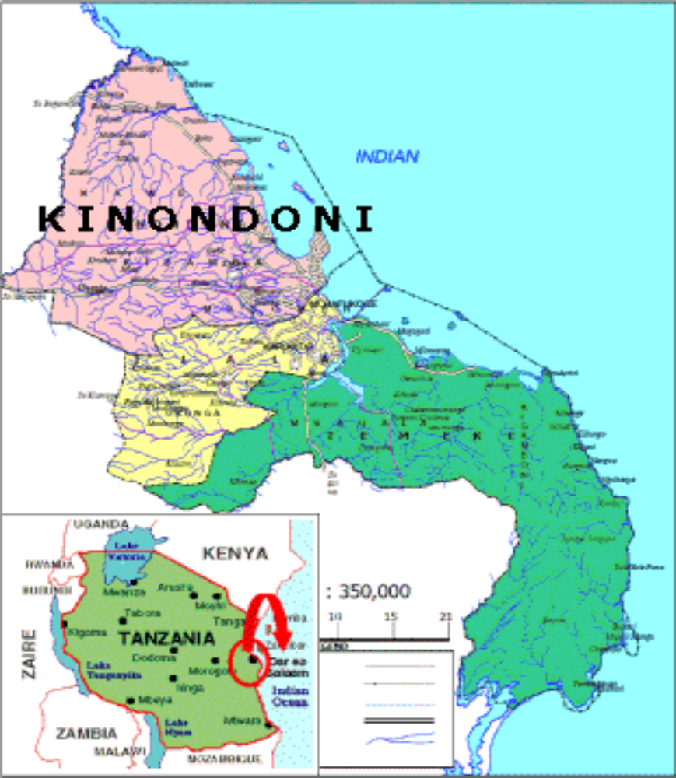

Appendix 5: OSHA application form for registration of building
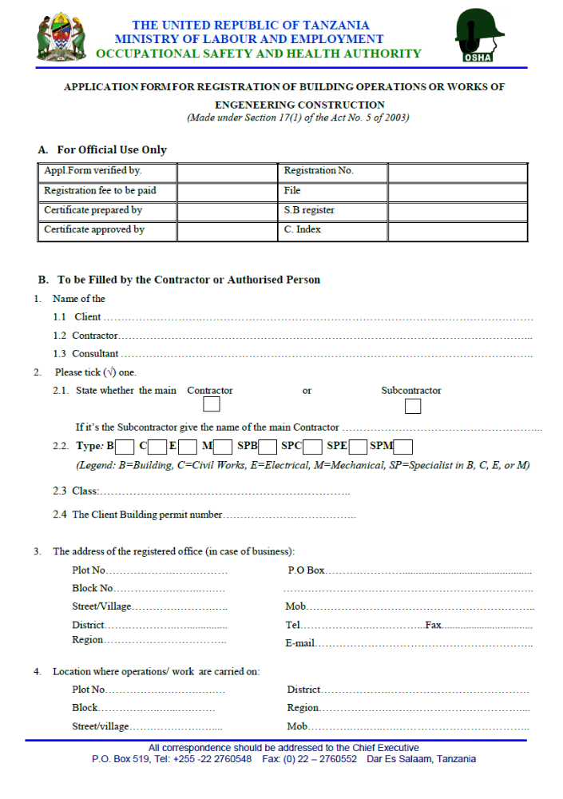

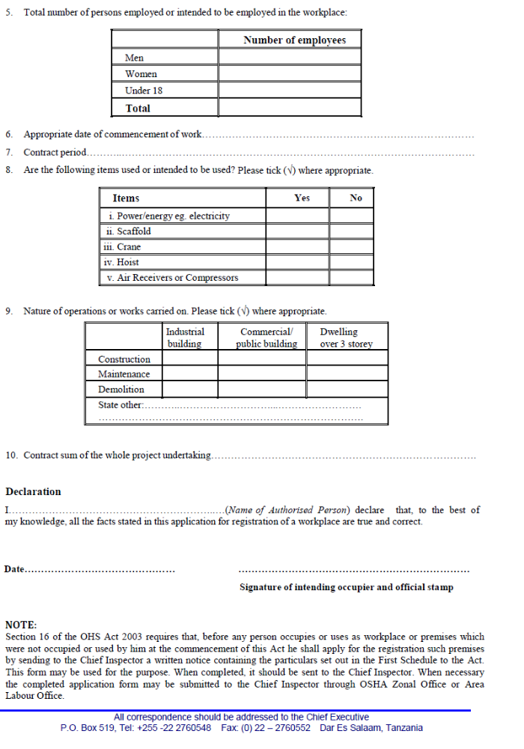

Appendix VI: OSHA Application Form for A Working Place


