ASSESSMENT OF IMPLEMENTATION OF ENVIRONMENTAL MANAGEMENT ACT OF 2004 ON THE ENVIRONMENTAL IMPACT ASSESSMENT PROCESS: THE CASE OF ACCOMODATION FACILITIES IN DAR ES SALAAM CITY

LILIAN JOHN KAPAKALA

A DISSERTATION SUBMITTED IN PARTIAL FULFILMENT FOR THE REQUIREMENTS FOR THE DEGREE OF MASTER OF SCIENCE IN ENVIRONMENTAL MANAGEMENT OF THE OPEN UNIVERSITY OF TANZANIA
2015

CERTIFICATION
The undersigned certifies that he has read and hereby recommends for acceptance by the Open University of Tanzania a dissertation entitled; Assessment of the Implementation of Environmental Management Act of 2004 on the Environmental Impact Assessment Process: The Case of Accommodation Facilities in Dar es Salaam, in partial fulfilment of the requirements for the award of degree of Master of Science in Environmental Management of the Open University of Tanzania.

………………………………………….
Dr. Josephat Alexander Saria
(Supervisor)

………………………………..
Date

COPYRIGHT
This dissertation is a copyright material under Berne Convention, the Copyright Act of 1999 and other International and National enactments, in that behalf, on intellectual property. No part of this dissertation may be reproduced, stored in any retrieval system, or transmitted in any form by any means, electronic, mechanical, photocopying, recording or otherwise without prior written permission of the author or the Open University of Tanzania in that behalf.

DECLARATION
I, Lilian John Kapakala, do declare that this dissertation is my own original work and that it has not been presented for a similar or any other award to any other university.

………………….………………………….
Lilian John Kapakala

………………………..…………..
Date

DEDICATION
This study is dedicated to my beloved Mother Ester Mwakipesile and my husband Mr. Ulindula Mwambela who struggled taking cover of my various responsibilities and family ties to ensure welfare of our families during the period of my studies. God bless them all.

.

ACKNOWLEDGEMENT
This work is the output of the study supported by a number of people and organizations. First and foremost may I take this opportunity to thank God for enabling me pursue with success this MES- Environmental Management. Secondary my appreciation goes to my employer, National Environment Management Council (NEMC) for allowing me to enroll for the course and also for the financial support owed by me. Thirdly much appreciation goes to my supervisor Dr. Josephat Saria of the faculty of Science, Technology and environmental studies and Prof. Hussein Sossovele from Institute of Resource Assessment in University of Dar es Salaam. The guidance and the constructive criticisms they provided for the whole period of this study are greatly appreciated. They made themselves available for assistance throughout the study.

Many thanks go to the Hotel managers and owners from Kinondoni, Temeke and Ilala Municipality to mention few i.e., Bahari Beach Ledger plaza, Kunduchi Beach hotel ,Slip way Hotel, Holiday inn Hotel, southern sand hotel, south beach hotel, White sand hotel. For allowing me to conduct this study in their respective accommodation facilities.

I acknowledge with thanks the support and spirit of cooperation provided by the Open university of Tanzania Lectures and other staffs. In particular, I am indebted to OUT lecturers from Dr. J. Saria (Coordinator of the programme), Dr. Yohana Lawi, (Director of Examination Syndicate), Dr. Mhache, Mr. Gervas E. Yeyeye and Dr. J. Kisoza. My special thanks goes to my Husband Mr. Ulindula Mwambela, my sister Navone Kisaka, brother Daniel Kapakala and Kelvin Ngowi for their sacrifices, support and encouragement their rendered to me throughout this MES- Management program. Without their support would have affected this big achievement.

ABSTRACT
The purpose of this study was to assess the implementation of Environmental Management Act of 2004 on the Environmental Impact Assessment (EIA) process using a case study of accommodation facilities in Dar es Salaam city. This study employed structured interviews and close-ended questionnaires as means of data collection. This study showed a number of important issues alongside the implementation of EMA of 2004 on EIA process to the accommodation facilities that are based in Dar es Salaam. The study revealed that 74% owners are not aware of the EMA of 2004. Also, only 40% accommodation facilities based in Dar es Salaam did EIA and comply with environmental management. This is because they are not aware of the importance of conducting EIA and its process. Furthermore, the study found out that there are several benefits of conducting EIA and these include management of solid and liquid waste (63%), utilities and sewage system facilitates safety and security of the customers and retain customer satisfaction. However, there are several challenges when conducting EIA. Among others, these are expensiveness, time consuming through its process and lack of experts specialized on the specific field. The government of Tanzania should clearly promulgate EIA policies, guidelines and procedures to stakeholders including owners of accommodation facilities so as to increase the level of awareness of EIA requirements. Also educational campaigns such as seminars, workshops and conferences should be increased by NEMC so as to spread awareness among stakeholders. It is hoped that the results of this study shall be of practical use to all stakeholders including owners of accommodation facilities and other governmental and non-governmental organizations that are based in Tanzania.

TABLE OF CONTENTS
CERTIFICATION ii
COPYRIGHT iii
DECLARATION iv
DEDICATION v
ACKNOWLEDGEMENT vi
ABSTRACT viii
TABLE OF CONTENTS ix
LIST OF FIGURES xiii
LIST OF ABBREVIATIONS xv
CHAPTER ONE 1
1.0 INTRODUCTION 1
1.1 General Introduction 1
1.2 Statement of Research Problem 4
1.3 Objectives of the Study and Research Questions 5
1.3.1 Main Objective 5
1.3.2 Specific Objectives 5
1.3.3 Research Questions 6
1.4 Significance of the Study 6
1.5 Limitation of the Study 7
CHAPTER TWO 8
2.0 LITERATURE REVIEW 8
2.1 Introduction 8
2.2 Definition of Key Concepts 8
2.2.1 Environment 8
2.2.2 Environmental Management 8
2.2.3 Environmental Impact Assessment 8
2.2.3 Environmental Management Act 9
2.3 Empirical Studies 9
2.3.1 Awareness on the Practice of Environmental Impact Assessment for Accommodation Facilities 9
2.3.2 Age and Education 12
2.3.3 Ownership of the Properties 13
2.4 Synthesis and Research Gap 18
2.5 Conceptual Framework for the Study 19
CHAPTER THREE 20
3.0 RESEARCH METHODOLOGY 20
3.1 Introduction 20
3.2 Research Design 20
3.3 Study Area 21
3.4 Sampling Procedure and Sample Size 21
3.5 Data Collection Methods 22
3.5.1 Secondary Data 22
3.5.2 Primary Data 23
3.5.2.1 Interviews 23
3.5.2.1 Questionnaires 24
3.6 Validity and Reliability 24
3.7 Data Analysis Plan 24
CHAPTER FOUR 26
4.0 RESULTS AND DISCUSSION 26
4.1 Introduction 26
4.2 Respondents’ Profile 26
4.2.1 Gender of Respondents 27
4.2.2 Age of Respondents 28
4.2.3 Education Level of Respondents 29
4.3 Awareness on the Practice of Environmental Impact Assessment for Accommodation Facilities 31
4.3.1 Knowledge of EMA of 2004 on EIA Process 31
4.3.2 Conduct of EIA in Your Accommodation Facility 33
4.3.4 Adherence to the Environmental Management Plan 35
4.4 Benefits Gained by doing EIA Process in Accommodation Facilities 37
4.4.1 EIA Study has Reduced Cost of Energy and water Consumption 37
4.4.2 Management of Sewage System 39
4.4.3 EIA Study Improved Safety and Security 40
4.3.4 EIA Study has helped to Manage Solid Waste 41
4.4 Problems Associated with EIA Compliance by Owners of Accommodation Facilities in Dar es Salaam 43
4.4.1 It is Costly to undertake EIA 43
4.4.2 It is Difficult to Get EIA Registered Experts 44
4.4.3 It is Difficult to Implement Environment Management Plan 45
4.4.4 EIA Process is Time Consuming 46
4.4.5 Getting Comments from Stakeholders for EIA is not an Easy Task 47
CHAPTER FIVE 50
5.0 CONCLUSIONS AND RECOMENDATIONS 50
5.1 Introduction 50
5.2 Conclusions 50
5.3 Recommendations 52
5.31 Recommendation for the Study 52
5.3.2 Recommendation for Further Study 53
REFERENCES 54
APPENDICES 58

LIST OF FIGURES
Figure 2.1: Conceptual Framework for the Study 19
Figure 4.1: Distribution of Respondents by Gender 27
Figure 4.2: Distribution of Respondents by Age 29
Figure 4.3: Distribution of Respondents by Education Level 31
Figure 4.4: Respondents Responses on Knowledge of the EMA of 2004 on EIA Process 32
Figure 4.5: Respondents’ Opinions on the Conduct of EIA in Your Accommodation Facility 34
Figure 4.6: Respondents’ Opinions on Adherence to the Environmental Management Plan 36
Figure 4.7: Respondents Opinion on the EIA Reduced Cost on Energy Consumption 38
Figure 4.8: Respondents Opinion on EIA has Reduced Cost on Water Consumption 39
Figure 4.10: Opinion on Whether EIA Study has Improved the Safety and Security 41
Figure 4.11: Respondents Opinion on EIA Study has helped to Manage Solid Waste 42
Figure 4.12: Respondents Opinion on the Cost to Undertake EIA 44
Figure 4.13: Respondents Opinion on It is Difficult to Get EIA Registered Experts 45
Figure 4.14: Respondents Opinion on It is Difficult to Implement Environment Management Plan 46
Figure 4.15: Respondents Opinion on EIA Process is Time Consuming 47
Figure 4.16: Respondents Opinion for EIA is not an Easy Task 48

LIST OF ABBREVIATIONS
CONSCORP Conservation Corporation (Africa) Limited
EIA Environmental Impact Assessment
EMA Environmental Management Act
EMP Environmental Management Plan
EP Environmental Permit
IHEI International Hotel Environmental Initiatives
NCA Ngorongoro Conservation Authority
NEMC National Environment Management Council
NEPA National Environmental Policy Act
NGO Non-Governmental Organization
TBL Tanzania Brewery Limited
TBS Tanzania Bureau of Standards
URT United Republic of Tanzania
US United States

CHAPTER ONE

1.0 INTRODUCTION

General Introduction
Large-scale projects involve a large number of stakeholders, which may trigger the environmental and socio-economic impacts of the projects and even cause conflicts of local, national and regional nature. Thus, the Environmental Impact Assessment (EIA) is applied, in order to ensure that environmental considerations are duly taken into account (Makarenko, 2012). That means, to identify and assess the likely environmental impacts that may occur; report on those impacts and identify measures to be taken to prevent, reduce or mitigate them. Sometimes may allow the public and other stakeholders to comment on the project and the EIA report, and provided this report and the comments of the public and other stakeholders- to the decision makers (Makarenko, 2012).

The United States (US) was the first country to develop a system of Environmental Impact Assessment (EIA) (Corson, 1962). According to Corson (1962) indicated that the US had reached high proportions and grew as very intense movements at the latter half of 1960s. The National Environmental Policy Act (1969) of the USA (NEPA) was constituted and for the first time. EIA requiring environmental consideration in large-scale projects was enforced as legislation. The influence of NEPA in which the concept of EIA system has its bedrock was extended beyond the US and provoked the introduction of EIA policy in many countries in Europe and Asia. In developing countries, the Asian countries started taking environmental measures very early with the many countries having an EIA system in place and by half of the 1980s legislative moves in the developing African countries and becomes popular. A survey conducted by the Environmental Agency of Japan in 1996 reveals that currently over 50 countries have provided EIA related systems and legislation. Ouma-Bottelberge (1995) found out that none of the industries studied carried out an EIA prior to their establishment and this has caused many development projects to be established without incorporating environmental issues. Tesli (2003) reported that most countries have introduced EIA legislation and regulations and the international donor agencies require EIAs to be carried out in order to approve large projects.

In Tanzania, EIA has been adopted slowly since 1980 when the first formal EIA process was undertaken in Rufiji for the Sitegeler’s George Power and Flood Control Project (Mwalyosi and Hughes, 1998). About 40 documents describing or supporting an environmental assessment have been identified in Tanzania (Mwalyosi & Hughes, 1998). This implies that almost all donor funded projects and EIA reports have been prepared with conditions, which must comply with their operational directives and policies for natural resources management including environmental protection (Mwalyosi and Hughes, 1998).

Sager (1995) identified that 198 EIA studies undertaken in Tanzania from 1993 to 2007; among those, 20.2% was from mining sector, electricity and gas sectors contribute 17.68% and tourism industry 14.65%. About 5.1% of the studies are auditing reports and only 1.5% of projects were monitored. At East Kilimanjaro Water supply project 30.8% were implemented while in Fish processing industry only 32% were implemented. Out of total proposed measures from TBL, 48.8% were implemented and Shelys pharmaceuticals project implemented 38.8%. The reasons are lack of enough commitment of developers, cost serving, improper follow up, lack of enough resources and knowledge about the importance of environmental protection. The employment of enough experts, education, introduction of environmental departments and employment of environmental experts and Amendment of Act can be used to improve the implementation (Sager 1995).

United Republic of Tanzania (URT) (2004) provides comprehensive environmental framework for management of the environment in Tanzania. The Environmental Management Act (EMA) makes EIAs mandatory and outlines projects that are subjects to an EIA prior to development. It outlines requirements for public participation in environmental management. The Act also repeals the NEMC Act 1983 and gives the District Council more powers to ensure compliance of the EMA of 2004 in collaboration with various stakeholders.

According to Abaza, et al., (2004), the key objectives of the EIA process in accommodation facilities include informing stakeholders about the proposed development and provide them with an opportunity to raise their concerns as well as to establish/confirm the scope and contents. EIA aims at understanding and thoroughly documenting the issues/concerns raised by stakeholders in such a way that delays due to misunderstanding that can be prevented at all cost (Wei et al., 1998). The issues are like environmental through application of a methodology for the determination of significance or identify/ describe possible environmental issues associated with the construction and operational phases of proposed change of land use and to determine the significance thereof (UNECE, 1992). Lastly it aims at assessing the relevant biophysical environmental components of the site to in appropriate level of detail. This includes the physical, biological, and socio-economic components; reflect all the required information/ findings in a logical and systematic way in order to assist the evaluation of the proposed change of land use in terms of the requirements of Country existing National Environmental Management Act (VROM, 1996).

The aim of our research is to assess the compliances of selected accommodation facilities with various policies, laws, regulation, and standards as well as determining if they provide the baseline data for subsequent environmental audit that has to be undertaken after every two year. Unfortunately, very little has been done on the related study in Tanzania. Therefore, this study intends to be the base of informing different stakeholders the consideration of environmental issues in the decision making so to ultimately arrive at actions that are more environmentally compatible for the betterment of our people and government at large.

1.2 Statement of Research Problem
EMA of 2004 of Tanzania requires project to carry out an EIA prior to project implementation. The impact Assessment and Audit Regulations of 2005 guide the EIA process and administration in Tanzania. The Regulations give mandate to NEMC to oversee the EIA process, which culminate with an award of the Environmental Permit (EP) by Ministry responsible for Environment. A study has shown that EMA has caused increasing trend of EIA performance in recent 5 years where during the last 10 years on 59 EIA studies (i.e. 29.7% of the EIAs) were undertaken while 70.3% were conducted during the last 5 years (Sager, 1995). Furthermore, study conducted by Mwalyosi and Hughes (1998) shows that for those projects that have gone through the process, the EIA has had very little impact on decision-making.

In most cases, EIAs were extremely late in starting, under resourced and generally did not involve many stakeholders. Most of small-scale development projects that are funded by local financial institutions such as banks do not have EIA as a requirement for issuing loans to accommodation facilities. As a result, we were not entirely sure if the owners of accommodation facilities do EIA or rather if they are aware of the EIA requirement. We needed to be entirely sure on this, because there is a mushrooming of accommodation facilities in Dar es Salaam, which might be destroying the environment purposely or unknowingly. Therefore, it is the intention of this study to assess the implementation of Environmental Management Act of 2004 on the Environmental Impact Assessment process of accommodation facilities in Dar es Salaam city.

1.3 Objectives of the Study and Research Questions

1.3.1 Main Objective
The overall objective is to assess the implementation of environmental management act of 2004 on the environmental impact assessment process using the case of accommodation facilities in Dar es Salaam city.

1.3.2 Specific Objectives
The specific objectives of this study are to:
- Determine whether owners of accommodation facilities are aware of the Environmental Impact Assessment requirement
- Examine benefits gained by doing Environmental Impact Assessment process in accommodation facilities
- Identify the problems associated with Environmental Impact Assessment compliance by owners of accommodation facilities.

1.3.3 Research Questions
- To what extent do the owners of the accommodation facilities are aware of the Environmental Impact Assessment requirement if practiced?
- What are the benefits gained by doing Environmental Impact Assessment process in accommodation facilities to customers?
- What are the problems associated with Environmental Impact Assessment compliance by owners of accommodation facilities?

1.4 Significance of the Study
Most of EIA experts know that this is a formal process used to predict the environmental consequences of any development project. The aim of EIA is to ensure that the potential problems are foreseen and addressed at an early stage in the projects planning and design. The findings of this study would be used as a source of knowledge to other researchers because though there is a global uptake of EIA as a management tool, the extent of empirical knowledge on what exactly motivates and drives firms to adopt EIA has remained limited and most of designers do EIA only when forced to do so. Also, this study proposes the best possible alternative solutions for identified problems in determining the benefits gained by doing Environmental Impact Assessment (EIA) process in accommodation facilities to the customers and its importance in sustainable management of the environment.

1.5 Limitation of the Study
The first limitation was time. It took a lot of time to collect data and do the analysis, because the key informants for this study had no enough time to talk to the researcher. The second limitation was limited budget in relation to the real cost of doing the research in terms of data collection research assistants, etc. Given these possible limitations, the researcher tried to minimize time and cost carefully without compromising the quality of the data, for example; in terms of the number of the people to study.

CHAPTER TWO

2.0 LITERATURE REVIEW

2.1 Introduction
This chapter presents a discussion of the literature related to the research problem, in order to develop gap that forms the need of this research. The chapter includes key concepts, theoretical framework, empirical studies, conceptual framework and research gap.

2.2 Definition of Key Concepts

2.2.1 Environment
According to Environmental Management Act, 2004, environment includes the physical factors of the surroundings of human beings including air, land, water, climate, sound, light, odour, taste, micro-organism, the biological factors of animals and plants, cultural resource and the social economic factor of aesthetics and includes both the natural and the built environment and the way they interact.

2.2.2 Environmental Management
According to Environmental Management Act, 2004, environment management includes the protection, conservation and sustainable use of various elements or components of the environment.

2.2.3 Environmental Impact Assessment
According to Environmental Management Act 2004, environmental impact assessment is a systematic examination conducted to determine whether or not a programme, activity or project will have any diverse impacts on the environment. But Mwalyosi (1995) described Environmental Impact Assessment as a process that can be used to improve decision-making and ensure that development options under consideration are environmentally, socially and economically sound and sustainable. It is concerned with identifying, predicting and evaluating the foreseeable impacts both beneficial and adverse of projects and alternatives. It aims to eliminate or minimize negative impacts and optimize positive impacts through mitigation and enhancement measures.

2.2.3 Environmental Management Act
Environmental management act was passed by the National Assembly in 2004 and in the beginning of 2005 the president assented to the act. The act repealed and replaced the National Environment Management Council Act 1983. This act is a framework Act in that it is the legislation governing environmental projects aspect in Tanzania. The Act includes provisions for; legal and institutional framework for sustainable management of environment, an outline principles for management, impact and risk assessments, prevention and control of pollution, waste management, environment quality standards, public participation, compliance and enforcement and the basis for implementation of international instruments on environment (Sager, 1995:13).

2.3 Empirical Studies

2.3.1 Awareness on the Practice of Environmental Impact Assessment for Accommodation Facilities
This section presents the empirical studies on the first specific objective of this study. Manyasa (2005) conducted a study to assess the effectiveness of Environmental Impact Assessment process found out that effectiveness of EIA largely depends on all stakeholders’ full participation at the planning stage and throughout project cycles. Also, it was revealed that effectiveness of EIA is incomplete without well-defined procedural guidelines, adequate expertise, EIA policy and effective political commitment, legal as well as institutional framework. This study recommended that stakeholders should be empowered through full information disclosure hence proving that among the stakeholders including owners of accommodation facilities who are not aware on the Environmental Impact Assessment requirements (Manyasa, 2005).

Mchome (2002) assessed the adequacy of the Draft EIA guidelines with focus on small-scale development projects drawing lessons from Dar es Salaam region. The author examined the impact of these projects on the environment whilst evaluating the sustainability of the draft guidelines for the screening process. There is no clear definition of what a small-scale development project is. Furthermore, there is very little awareness of the environmental management among developers and communities. However, this study provides practical recommendations where some of these measures include having all project regardless of the size subjected to EIA, to have clear definition of what a small-scale development is and provision of environmental education at all levels (Mchome, 2002).

Mwalyosi & Mohamed (1996) indicated that environmental awareness in Tanzania is mainly limited to the elite groups. Also what constitute the environment differed between different groups. Mwalyosi and Mohamed (1996) have proved that environmental issues generally meant only cleanliness of the area, while to others it meant tree planting. Furthermore, the developer’s awareness of existing institutions responsible for environmental management in Tanzania was inadequacy and misplaced. For example, some developers perceive that the role of institutions such as NEMC is to close down their enterprises when seen not to comply with the regulations. It was argued that despite various programmes prepared by local television, radio stations, local and international Non-Governmental Organizations (NGO’s), still many people are not aware of different aspects of Environmental Impact Assessment processes and its importance in sustainable development (Mchome, 2002).

Conservation Corporation (Africa) Limited (1997) conducted a study which focused on initial environmental examination of the rehabilitation and reconstruction of the Ngorongoro Conservation Area (NCA), Northern Tanzania (CONSCORP, 1997). The reconstruction has been necessitated by the substantial deterioration of the old lodge structures and the old Ngorongoro Crater Lodge had not been subjected to Environmental Impact Assessment (CONSCORP, 1997). There are major risks associated with storage of fuels, oil and chemicals, waste disposal and demolition of structures. Most of the lodge structures are prone to fire hazards. Also revealed that basing on previous experience example with the Ngorongoro Serena Lodge shows that some of the construction materials example decorative stones were acquired for free from within Ngorongoro Conservation Area (NCA).

This has in the end brought resentments from the Ngorongoro Conservation Area (NCA) and the local people. However, the author recommended that contingency measures should be put in place in case an accident takes place such measures should include firefighting equipment, preparedness to contain accidents, while the use of construction materials from within the conservation area should not be allowed. The Ngorongoro Conservation Area (NCA) should not entertain any requests for extraction of materials from the conservation area. Therefore, this shows that there is little awareness among owners of accommodation facilities on the Environmental Impact Assessment (EIA) requirements if practiced (CONSCORP, 1997).

2.3.2 Age and Education
This particular group consists of experienced and nearly retirement (Employment and Labour Relation Act, 2007) who are likely to be owning properties or who have stayed long enough in job to acquire managerial position (Hodari and Sturman 2014). Education level has been favoured by a number of organisations including chain managed Hotel favours education level and they give their general manager more autonomy based on a combination of experience and education level (Hodari and Sturman, 2014). In principle a general manager is in charge of the Hotel operation and fundamental success of the Hotel (Mayock, 2012). Thus having high level of education equips the manager with the tools to manage, run and oversee all of their property’s functional departments (Nebel and Ghei, 1993) that can make a Hotel prosper.

The extent to which education affects productivity can affect corporate support for governmental subsidies for education. Individuals’ educational attainments are not only part of a company’s human capital but also a part of a community’s core assets (Lepak and Snell, 1999). Use of education as an indicator of a person’s kill levels or productivity (Benson, Finegold, and Mohrman, 2004), they frequently employ it as a prerequisite in hiring decisions. The conceptualization of job performance has been expanded in recent years to include core task behaviors, citizenship behaviors, and counterproductive behaviors ((Ng and Feldman, 2007). Core task performance refers to the basic required duties of a particular job. Citizenship performance refers to those extra behaviors engaged in by employees, over and above their core task requirements, which actively promote and strengthen the organization’s effectiveness (Hunt, 1996; Organ, 1988). Education level was assessed as a parameter to see if they contribute to influencing awareness of the EMA 2004 requirements.

2.3.3 Ownership of the Properties
From the available literature (Kirk, 1998; Chan, 2008), it is clear that the pioneers in the introduction of ecological operation standards, i.e. environmental management, were mainly hotels belonging to the big hotel chains. This is due to the fact that, apart from the simplest rationalization measures, most activities require a significant starting investment which, although the return on it is relatively fast, cannot be afforded by hotels that operate without secure and stable financial and managerial support (Petrić and Pranić, 2009).

Moreover, in most countries environmental policy is mainly designed to penalize noncompliance with certain standards and regulations rather than to reward autonomous environmental initiative. Nevertheless, there are increasingly frequent government initiatives aimed at subsidizing hotels in their efforts to introduce ecological standards in their operations (Petrić and Pranić, 2009).
Class Category of the Facility; Class category of the Hotel of facility has significant contribution to the awareness of environmental requirements. There is healthy relationship between class category of the facility and environmental awareness which can be discussed under the Hospitality Industry and the Environmental Awareness. It was not until the 1990s that tourism - and in particular, the hospitality industry – started to respond to the needs of environmental management.

In 1992, the International Hotels Environment Initiative was developed when a number of the leading international hotel companies realized that they had a lot to gain from working together. The IHEI had developed a manual for managers (IHEI, 1993; as cited in Kirk, 1998), and a number of training aids for hotel companies. IHEI has now evolved into the International Tourism Partnership. The tourism programme of the International Business Leaders Forum (ITP, 2009), whose aim is to assist the industry to make a valuable contribution to the countries and cultures in which they operate, to their customers, their shareholders and future generations.

As part of wider environmental management, many (typically larger and/or franchised) tourism establishments now use the ISO 14001 environmental management standard (Petrić and Pranić, 2009); in Tanzania for example White Sands Hotel, Best-bite Hotel are among the facility with ISO 14001. The ISO 14000 series of eco-standards was developed and issued by the International Organization for Standardization (ISO) in 1996. They are meant to be complementary to national regulatory regimes and are not intended to replace or duplicate a country’s regulatory regime (Quazi, 1999). ISO 14001 was recognized as a step toward achieving EMAS, the Eco-Management and Audit Scheme. EMAS has become operative in the EU since April 1995 (EU/Environment, 2009). It is a voluntary scheme aiming to promote continuous evaluation and improvements in the environmental performance of participating organizations. EMAS goes beyond EN ISO 14001 in a number of ways, requiring the undertaking of an initial environmental review, the active involvement of employees in the implementation of EMAS, and the publication of relevant information to the public and other interested parties.

Green Globe 21 is also an environmental management standard, developed specifically for the travel and tourism industry. There are also a substantial number of ecolabels, codes of conduct, sustainability reporting schemes, awards, and benchmarking programs in the tourism industry. Font (2002, as cited in WTO & UNEP, 2008; 164) identified over 100 ecolabels of tourism, hospitality and ecotourism worldwide (such as Blue Flag, Pan Parks, etc.). Environmental management, certification and eco-labelling can be a useful basis for managing a business’s supply chain and for developing strategic partnerships.

Benefits Gained by Doing EIA Process in Accommodation Facilities; Pegna and Dizo (2006) studied a comprehensive state of the art review of environmental impact assessment of existing rapid prototyping and rapid tooling and identified perspective research needed. The author recommended that the awareness about the potential environmental impacts to society or community is briefly needed (Pegna and Drizo, 2006). Rajaram and Ashutoshi (2007) aimed to bring out the shortcomings of EIA model imported from developed countries when it is assessed for its focus on poverty alleviation in developing nations and to suggest the improvement in the existing framework. The paper explored the current performance of EIA process and revealed that supportive framework of generating the social ecological linkage document has the potential to enhance the EIA process in term of ensuring that plans, policies, programs and projects are sensitive to the need of ecosystem (Rajaram & Ashutoshi, 2007).

A study on engineering, construction and architectural management has revealed that environmental impact assessment is a recognized procedure for ensuring that potential environmental effect of new building or engineering development are considered before planning approval is considered due to the profound effect upon environmental that may occur (Griffin, 1996). However, researcher did not mention directly how society can benefit from the EIA process (Griffith, 1996).

Problems Associated with EIA Compliance by Owners of Accommodation Facilities, Nyihirani (2010) conducted a study to find out the levels of Environmental Impact Assessment (EIA) implementation and weaknesses that constrain industries in Dar es Salaam to implement EIA effectively and to propose measures to rectify the problem. The compliance to EIA by industries is still not satisfactory due to: lack of institutionalization of environmental units and environmental officers in industries, poor status of industrial environmental policy, poor institutional coordination and low capacity to implement EIA, inadequate annual environmental audit by the industries, inefficient follow ups by responsible authorities, low awareness of existence of Environmental Management Plan (EMP) and inadequate resources allocation, and lack of EIA compliance training.
The study wants to establish the fact that, most of the industries that have been subjected to EIA, do not implement the EIA recommendations especially when there is no frequent follow up and monitoring after EIA certification. EIA is only for the purpose of getting the certificate of their projects as a permit of continuing with their projects and not for the sake of sustainability. This is a serious problem because it is useless to conduct an EIA without full and effective implementation of its recommendations since there would be no mitigation measures for the significant adverse environmental impacts (Nyihirani, 2010).

Sager (1995) conducted a study that aimed to assess the general status of EIA study and its implementation in some selected projects from industries and water sectors. The results of the study identified reasons for improper implementation of EIA as follows: lack of enough human resources and close follow-up programs, lack of monitoring funds, developers intended to serve the operation costs, lack of awareness about importance of environmental protection, lack of environmental departments or units in all case study projects, and introduction of EIA at late stages of project design.

The study also shows that lack of clear methodologies for ensuring participation of all stakeholders, especially local communities is among the weakness of the EIA in Tanzania. These weaknesses however are related to the socio-political system, for example, lack of effective environmental leadership, lack of openness and transparency, increase political interference, minimal political will, lack of independent decision-making capabilities, and general lack of environmental awareness. The study recommended that adequate public participation in the EIA process would make the project implementation process more effective as it will build the sense of ownership for the project. For example, at East Kilimanjaro Water Supply Project, there is a lot of complaints from the communities due to lack of important information about the project and compensation were not addressed (Sager, 1995).

2.4 Synthesis and Research Gap
In order to archive the implementation of Environmental Management Act of 2004 on the Environmental Impact Assessment (EIA) process which encompasses; registration, screening, preliminary assessment, organization, scoping, the EIA study, review, identification, prediction impact evaluation, mitigation, documentation, monitoring and auditing on the case of accommodation facilities. The government should clearly promulgate the EIA policies, guidelines and procedures to the stakeholders (Gilpin, 2000).

It’s argued that the stakeholders especially owners of accommodation facilities are not involved to participate fully in the EIA activities as a result they are not aware on the EIA guidelines, policies and procedures hence poor implementation of the act. For the case of Tanzania many literatures have been explained on the EIA processes being conducted in big projects such as road construction, big buildings construction and industrial construction. Therefore, this study seeks to assess the implementation of Environmental Management Act of 2004 on the Environmental Impact Assessment process on the case of accommodation facilities in Dar es Salaam city.

2.5 Conceptual Framework for the Study
IMPLEMENTATON OF EMA CAP 191 OF 2004 ON EIA
AWARENESS OF EIA REQUIREMENT
BENEFITS OF EIA
PROBLEMS OF EA COMPLIANCE
EIA PROCESS

Figure 0.1: Conceptual Framework for the Study
Source: Researcher’s Design

EMA of 2004 has great importance in accommodation facilities when practiced. Implementation of EMA of 2004 is independent variable for this study, whereas awareness of EIA requirement, benefit of doing EIA and problem associated with EIA compliance are dependent variables for this study. Therefore, if awareness, benefit gained and problem associated with EIA compliance are brought to owners of accommodation facilities in Dar es Salaam about the EMA of 2004 on EIA process, EIA process would be implemented, and hence; sustainable management of the environment.

CHAPTER THREE

3.0 RESEARCH METHODOLOGY

3.1 Introduction
This chapter represents a systematic analysis of the research techniques that were used in this study to collect and analyze data. The chapter covers research design, study area, sample size and sampling procedures, data collection methods, validity and reliability, and data analysis techniques.

3.2 Research Design
A research design is the arrangement of conditions for collection and analysis of data in a manner that aims to combine relevance to the research purpose with economy in procedure. It constitutes the blue print for the collection, measurement and analysis of data (Kothari, 2004). Bryman (2012: 46) argues that research design provides a framework for the collection and analysis of data. At a general view the aim of research design is to facilitate the smooth sailing of the various research operations thereby making research as efficient as possible yielding maximal information with minimal expenditure of effort, time and money. Also research design is to guide a researcher control the process of data collection and data interpretation (Kothari, 2004). The study employed both qualitative and quantitative approaches due to nature of the research problem. Qualitative research (descriptive) is conducted in an attempt to accurately describe or measure what actually exists in the environment with respect to a single variable.

According to Kane and O’Reilly (2001:17); Best and Kahn (1993) qualitative research methodology normally contributes to better understanding of phenomenon researched by using a single example and to understand the subject and its contextual setting. Quantitative research was used so as to gather quantity information for the aim of verifying the research problem, but furthermore this approach is useful to minimize time and cost during the time of study (Kane & O'Reilly, 2001; Best & Kahn, 1993).

3.3 Study Area
Dar es Salaam region in Tanzania is where this study was conducted. Dar es Salaam is selected for this study, because of its accessibility and it is considered to be a city where there are many accommodation buildings as compared with other regions in Tanzania. In addition, choosing any other region would mean travelling a long distance just to make contact with the owners of accommodation facilities, which would have been very difficult considering the time frame of this study.

3.4 Sampling Procedure and Sample Size
A sample design is a definite plan for obtaining a sample from a given population. It is a technique or procedure that the researcher would adopt in selecting items for the sample (Kothari, 2004). Probabilistic and non-probabilistic sampling strategies are tools involved in sampling procedures. For the case of this study non-probabilistic sampling, especially stratified sampling was used for this study, due to the fact that non-probability sample refers to a sample that has not been selected using a random selection method. This implies that some units in the population are more likely to be selected than others. Under stratified sampling the population is divided into several sub-populations that are individually more homogeneous than the total population (the different sub-populations are called “strata”) and then select items from each stratum to constitute a sample (Kothari, 2004).

In order to sample respondents from the accommodation facilities owners, the stratified random sampling was employed so that each of the accommodation facility is considered as a stratum, whereby respondents from each stratum have equal chance of being studied in the sample. In these strata targeted population included building managers, building engineer and construction. Simple random sampling was also used for selecting accommodation dwellers that was encountered during the study. This study involved 60 respondents; 20 respondents from each of the three municipalities of the Dar es Salaam region.

3.5 Data Collection Methods
Due to the nature of the research topic and objectives, and in order to get the required answers for the research objectives and questions, the study used secondary and primary data as the methods of data collections as discussed below:

3.5.1 Secondary Data
According to Kothari (2004), secondary data are those already available, which have been collected and analyzed by someone else, but for the current research project these data are valuable for use. Secondary data are important because they may help the researcher to save time and money. Secondary data may either be published data or unpublished data. This study used both published and unpublished materials, for example technical and trade journals, books, magazines, newspapers, pamphlets, dissertations, public records and statistics these are published materials while unpublished materials are like diaries, letters, trade associations, and labor bureaus.

3.5.2 Primary Data
Kane and O’Reilly (2001) argue that the fact that secondary data were collected from other different purposes is one of the challenges of secondary data, but researchers recognize this and are aware for these challenges before they make decision to use primary data.

3.5.2.1 Interviews
The interview method of collecting data involves presentation of oral-verbal stimuli and reply in terms of oral-verbal responses (Kothari, 2004). Interviews provide in depth information about a particular research issue or question as well as gather a broad range of information from a few subjects (Best & Kahn, 1993). In this study, interview was used to gather required information whereby the researcher considered face-to-face interviews. The method of collecting information through personal interview is usually carried out in a structural way; such interviews involve the use of a set of predetermined questions and of highly standardized techniques of recording. The advantages of using interview are: firstly, it is flexible tool, allows a more permissive atmosphere than the case when using other techniques of investigation, and secondly, the questions not readily grasped by interviewees can be rephrased or repeated with proper emphasis and explanations (Kothari, 2004).

In this study, structured interview was employed to verify whether the accommodation facilities in Dar es Salaam effectively implement EMA Act of 2004, because structured interview is one of the two main ways of administering a survey research instrument, it entails the administration of an interview schedule by an interviewer. The aim is for all interviewees to be given exactly the same context of questioning, this means each respondent receives exactly the same stimulus as any other. This method is relevant for this study due to the fact that it can ensure that interviewees’ replies can be aggregated and evaluated properly.

3.5.2.1 Questionnaires
This method of data collection is quite popular, particularly in case of big enquiries and being adopted by private individuals, research workers, private and public organizations and governments (Kothari, 2004). This approach saves time as the respondents fill all questionnaires at a time in a particular stratum. As with the interview questions, each questionnaire was equipped with a good number of items or questions that guided them in providing sufficient information on the problem for the study.

3.6 Validity and Reliability
According to Kothari (2004), validity means the truthiness of the data and findings in the research, while reliability means that if the same or independent observer repeats the research with the same methods, they would yet get the same results or data. In order to achieve validity and reliability, this study employed a triangulation of methods, and before data collection, there was a need to pre-test the data collection tools. Also, the interview guideline and questionnaires were designed in such a way that they capture relevant information in relation to the research objectives (see the sample questionnaire in the appendices).

3.7 Data Analysis Plan
Data analysis refers to the computation of certain measures along with searching for patterns of relationship that exists among data groups (Kothari, 2004). Qualitative data analysis technique was used. Qualitative data analysis techniques such as coding methods were used to arrange themes and findings in a systematic order, whereby the codes were applied and reapplied to the qualitative data collected in relation to the research objectives. With the use of coding method, it permitted data to be segregated, grouped, and regrouped in order to accomplish the goal of explaining the problem. But also the researcher employed tables and graphs, in order to view the credibility of the data.

CHAPTER FOUR

4.0 RESULTS AND DISCUSSION

4.1 Introduction
This chapter presents the research findings of the study. It discusses the major findings and describes the information derived from questionnaires, observations and interviews gathered from Dar es Salaam region as well as from similar study conducted elsewhere wherever possible. This chapter is divided into two major parts: the first part contains the respondents’ profile and the second part contains the data on the specific research objectives that include; to determine the awareness among owners of accommodation facilities in Dar es Salaam city on the environmental impact assessment requirement, to assess the benefits gained by doing EIA in accommodation facility in Dar es Salaam city and to examine the problems associated with EIA compliance by owners of accommodation facilities in Dar es Salaam. In this chapter, the findings are discussed in order to provide answers to each of the research questions or rather objectives.

4.2 Respondents’ Profile
This section presents general characteristics of the sample and the profile of the respondents who responded to the questionnaires and interviews of this study. This part is useful as it gives the general features of the respondents. In any research which deals with individual, knowing the characteristics of respondents is very important and it play significant for researcher to know the kind of people he/she is dealing with. Apart from knowing the number of samples from different institutions, in this study a set of personal characteristics namely; age, gender and education level, was examined.

4.2.1 Gender of Respondents
Out of 60 respondents for this study, 31 respondents equivalent to 52% were males and 29 respondents equivalent to 48% were females. Statistically this implies that the sample of this study was a representative of both genders as were included to give out their opinions. The percentage contribution of respondent is fifty-fifty chance of representing the gender. Thus, having equal representation eliminates element of bias in terms of respondent included in the study. The data on respondent percentage also tells us that the ownership of accommodation facility is not only by men as significant number of female own as properties as well (ICRW, 2006).
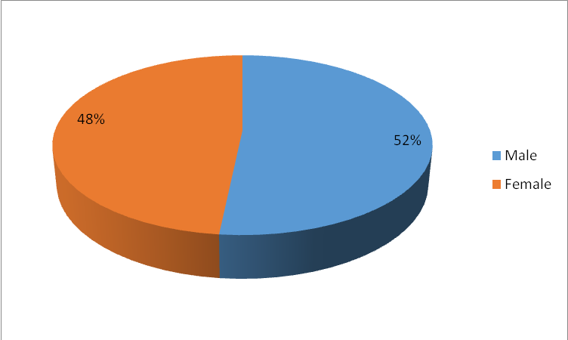

Figure 0.2: Distribution of Respondents by Gender
Source: Field Data

This trend is result of the Asia reform in policy of property ownership in 1990s where government deliberately issued a policy to allocate 40% of surplus land to women and the rest 60% to both spouses (ICRW, 2006). Thus, this fifty-fifty percent is a reflection of the policy reform to property ownership. The gender profile of the respondents is presented in Figure 0.2.

4.2.2 Age of Respondents
Age of the respondents is one of the most important characteristics in understanding respondent’s views about the particular problem. Older people have level of maturity in that sense age becomes more important to examine the response. Out of 60 respondents who were asked to respond to the study questions, 24 respondents equivalent to 40% fell in the category of 31-40 years, 22 respondents equivalent to 37% fell in the category of 18-30 years, 8 respondents equivalent to 13% fell in the category of 41-55 years and 6 respondents equivalent to 10% fell in the category of above 56 years. Thus, this shows that all respondents of this study were adults and that undoubtedly are employees and owners of accommodation facilities found in Ilala, Temeke and Kinondoni districts.

The age class distribution (Figure 0.3) depicted by respondent reflects a working class from legal perspectives covering actively working class (about 53% constituting 31 -55 age class). This particular group consists of experienced and nearly retirement (Employment and Labour Relation Act, 2007) who are likely to be owning properties or who have stayed long enough in job to acquire managerial position (Hodari and Sturman, 2014). Therefore, the studied sample chooses the right age group and thus the information gathered from the respondent is a true reflection of the reality in developing countries.
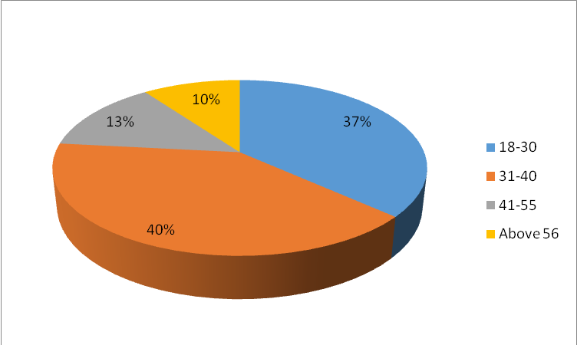

Figure 0.3: Distribution of Respondents by Age
Source: Field Data

4.2.3 Education Level of Respondents
According to (Abera, 2003), education is one of the most important characteristics that might affect the person’s attitudes and the way of looking and understanding any particular social phenomena like importance of doing EIA and comply with the given rules. In a way, the response of an individual is likely to be determined by his educational status and therefore it becomes imperative to know the educational background of the respondents (Figure 0.4).

Out of 60 respondents surveyed in this study, 26 respondents equivalent to 43% had attained a University level education, 25 respondents equivalent to 42% had attained College level and 9 respondents equivalent to 15% had attained a secondary school education (Figure 4.3). This implies that the 85% of the managers had attended college or university level of education with significantly few managers having secondary school education level. The large percentage of managerial personnel with collage to university level correlate with the findings by Ng, et al., (2005) who found that education level attainment is associated with positive carrier outcome, salary level, number of promotion, development opportunities and job mobility (Ng and Feldman, 2007).

Education level has been favoured by a number of organisations including chain managed Hotel favours education level and they give their general manager more autonomy based on a combination of experience and education level (Hodari and Sturman, 2014). In principle a general manager is in charge of the Hotel operation and fundamental success of the Hotel (Mayock, 2012). Thus having high level of education equips the manager with the tools to manage, run and oversee all of their property’s functional departments (Nebel and Ghei, 1993) that can make a Hotel prosper.

The remaining 15% representing managers with secondary school level are likely to be from the organisation that operates or owned as independent property where a relatives or someone closer to owner of the property is appointed as manager. In many hotels, the General Manager is an employee of a hotel operating firm and is effectively an agent of the operator or owner of the Hotel (Hodari and Sturman, 2014). For majority of independent owner the general manager is given more autonomy on the property than chain managed thus someone who is closer to the owner will perform like owner of the property. The differences in level of education among these managers will have implications on awareness and implementation of environmental issues as stipulated by the law.
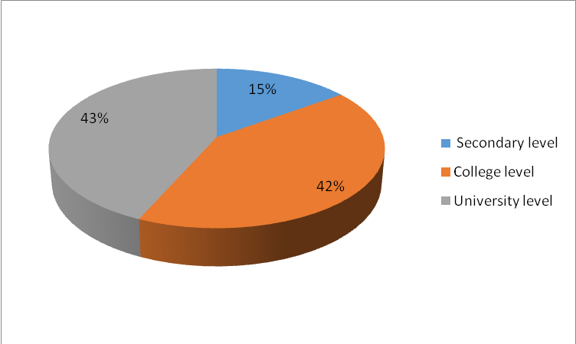

Figure 0.4: Distribution of Respondents by Education Level
Source: Field Data

4.3 Awareness on the Practice of Environmental Impact Assessment for Accommodation Facilities
Awareness on the practice of Environmental Impact Assessment for accommodation facilities constituted the first objective of the study that aimed at determining whether the owners of accommodation facilities in the city of Dar es Salaam were aware of the Environmental Impact Assessment Requirement or not. The study evaluated the issue of awareness by requiring respondents to indicate if they know about EMA 2004, if they have conducted EIA for their accommodation facility, and if they adhere to the prepared EMP as required by EMA of 2004. The respondents response were analyzed in independently and drawing implications of their response in terms of awareness of the issue in question.

4.3.1 Knowledge of EMA of 2004 on EIA Process
With regards to whether the owners of accommodation facilities know the EMA of 2004 on EIA process the results indicates that majority close to 74% do not know the EMA of 2004 thus they are unaware of it and its requirement. Out of the total 60 respondents 34 respondents’ equivalent to 57% disagreed and 10 respondents equivalent to 17% strongly disagreed that they know the EMA of 2004 on the EIA process. Having 74 % of owner of the accommodation facility unaware of the law implies that other parameters like conducting of EIA and adherence to the EMP requirement will not be achieved by the owner.
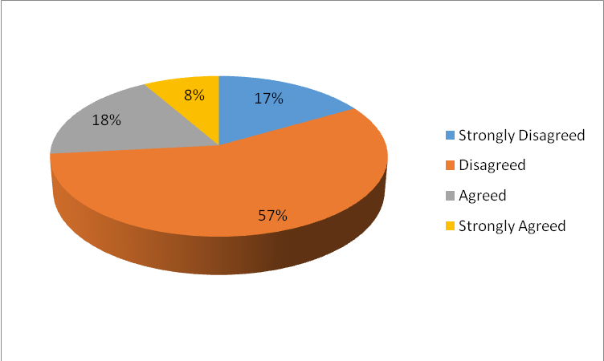

Figure 0.5: Respondents Responses on Knowledge of the EMA of 2004 on EIA Process
Source: Field Data

Further analysis of the data revealed that large contribution of the accommodation facility with less than three stars belonged to this category of respondent who are unaware of the EMA of 2004. The luck of awareness could be the driving force to none-implementation of EMA 2004 requirements. The result of this work tallies the number and category of accommodation (hotels and lodges) in Dar es Salaam that operates without an EIA certificates (Mchome, 2002).
The remaining 26% of owner belongs to accommodation facilities ranging above three stars and also majority of the chain managed accommodation facilities belonged to the group of those aware of the EMA 2004. The findings that majority of the chain managed accommodation are aware of the environmental requirement with consistent findings by Petrić and Pranić, (2009). The reason for this could be that majority of the chain operated accommodation facility are either signatory to International Hotel Environmental Initiatives (IHEI) or Green Hoteliers or Green Globe 21 that adhering to protection of environmental is a mandate of the company in Business in travel and tourism industry (Petrić and Pranić, 2009).

This skewness of awareness is due to the fact that, apart from the simplest rationalisation measures, most activities require a significant starting investment which, although the return on it is relatively fast, cannot be afforded by hotels that operate without secure and stable financial and managerial support (Petrić and Pranić, 2009). Moreover, in most countries environmental policy is mainly designed to penalise non-compliance with certain standards and regulations rather than to reward autonomous environmental initiative (Petrić and Pranić, 2009).

4.3.2 Conduct of EIA in Your Accommodation Facility
The other level of awareness was tested from respondent if they have undertaken EIA for their facilities. This level intended to link how knowledge to EMA 2004 is translated into implementation of some of the requirement of EMA 2004 such as undertaking EIA for the facility prior to opening up the business. The results obtained on this level of assessment revealed that 60% of the owners did not subject their facilities to EIA process prior to establishment of business. This high percentage of non-compliance to EMA 2004 could be contributing to high number of accommodation facility in Tanzania to operate without following EMA 2004 requirements. High number of Hotel facility operating in Dar es Salaam without EIA was found by Gilpin (2000).

The 40% accommodation owners (Figure 0.6) with their facility undertaking EIA prior to commencement of the business represent a growing awareness in terms of undertaking EIA. Possibly due to law enforcement and penalties associated with non-compliance in EIA. The growing awareness in compliance with EIA has made even though who are not aware of the EMA 2004 to carry out EIA for their facility simply because the laws requires them to undertake EIA prior to initiating business on their accommodation facilities.
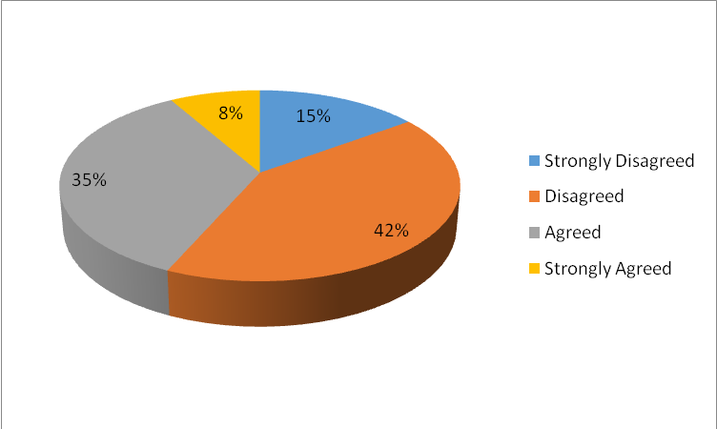

Figure 0.6: Respondents’ Opinions on the Conduct of EIA in Your Accommodation Facility
Source: Field Data

4.3.4 Adherence to the Environmental Management Plan
In relation to undertaking EIA for the facility is the development of EMP which guides operation of the facility in terms of environmental performance. The implementation of EMP is actually the implementation of compliance of EMA requirement by the facility in day to day activities of the facility. Therefore, adherence to the EMP by the facility constituted another level of awareness by the facility owner to EMA of 2004. On this criterion the results indicates that 55% of the accommodation owners (Figure 0.7) adhere to EMP developed as part of EIA.

The figure here are 50 -50 because the response analyzed comes from their own perception of adherence to EMP requirements. If an independent assessment is conducted to scrutinize their adherence a different outcome could be revealed. This argument is put forward because of the inconsistence in awareness criteria used to assess the awareness. If the owner is not aware of the EMA of 2004 and yet his accommodation facility did go through the EIA process and he/she is implementing EMP is likely to be due to law enforcement done by regulatory authority (NEMC) and second is possibly due to penalties associated with non-compliance to EMA 2004.

Petrić and Pranić, (2009) argued that in most countries environmental policy is mainly designed to penalise non-compliance with certain standards and regulations rather than to reward autonomous environmental initiative, thus, the finding of this study is consistent with other findings.
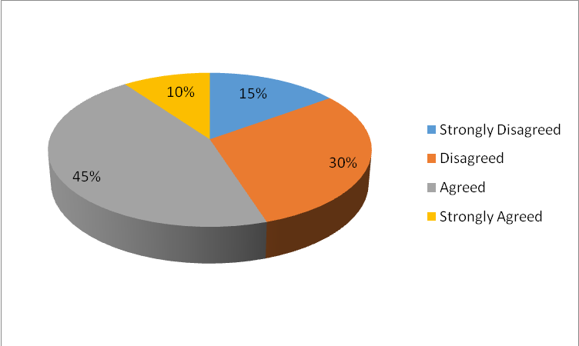

Figure 0.7: Respondents’ Opinions on Adherence to the Environmental Management Plan
Source: Field Data

The arguments that Hotel owners conduct EIA as obligatory to law requirement was backed up by 50% respondent owners who explained why they did EIA for their accommodation facilities; other reasons were safety issues and compliance to procedures for development of the projects. The other 50% constituted reasons for not doing EIA for their facilities which included lack of awareness to the process and requirement of the law, cost in terms of financial and time of doing EIA and bureaucracy in terms of procedural implementation. To confirm awareness level a follow up question on process of EIA was asked and only 6% were able to describe fully the EIA process.

The remaining 94% who could mention the steps and the process confirmed that large majority are not aware of the EIA process. These results support Mwalyosi & Mohamed (1996) who indicated that environmental awareness in Tanzania is mainly limited to the elite groups. If they undertake the assessment is only due to law enforcement as they conduct EIA to meet the requirement of the EMA 2004. Similarly, Sager, (1995) mentioned the reasons for their unawareness which include lack of enough commitment of developers, cost serving, improper follow up, lack of enough resources and knowledge about the importance of environmental protection. This low level of awareness pose a big challenge in addressing all compliance issues regarding conditional issued with Environmental Certificates and voluntary compliance with the requirement of the law.

4.4 Benefits Gained by doing EIA Process in Accommodation Facilities
The second objective of this study looked at the benefits gained by doing EIA for accommodation Facilities in Dar es Salaam. To this end, data were collected from opinions raised by respondents on benefits gained by their facilities in terms of reduction in consumption of water, energy, costs and improvement in management of waste after conducting EIA for the facility and adherence to the EMP. Here the benefits were looked at how frequent the facility is servicing or repairing or penalized in terms of sewerage breakage and also how efficient the facility is dealing with solid waste. The study evaluated the issue of advantages associated with conducting EIA process on accommodation facilities by gathering the gain mentioned/described by high percentage of respondent. These were discussed in terms of their significance and how they would improve the environmental performance of the facility to meet the compliance level as stipulated by existing TBS standards.

4.4.1 EIA Study has Reduced Cost of Energy and water Consumption
Results on whether undertaking EIA by the facilities has helped facilities to reduce cost of energy and water consumption indicates that nearly 60% and 51% of the owner did not reduce the cost of energy and water consumption respectively. The remaining 40% and 49% for energy and water respectively agreed that undertaking EIA for their facilities has helped to minimize the cost of fuel consumption. This difference in perceiving the benefit is attributed to timing of undertaking the EIA and development of the true or actual mitigation measures developed to offset the impact.

The timing of conducting an EIA is very important because timely undertaking for example during planning stage may influence changes in the design of the project including design of the generator with efficient performance that are environmental clean. However, in most cases our EIAs have been conducted late when the project has been planned sometimes even some items of the project procured such that it fail or lack influence on decision making about the project (Mwalyosi, 1995). This lack of influence on decision making about the project concurs with 60% respondent who indicated that EIA has not help the project minimize cost of energy consumption. The summary of the responses is shown Figure 0.8 and Figure 0.9.
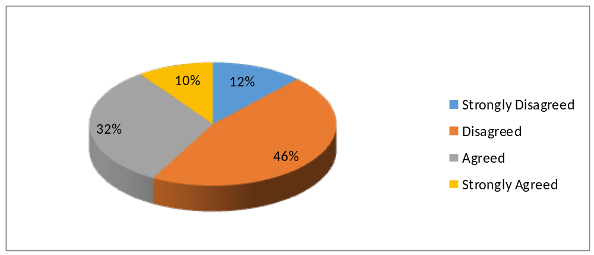

Figure 0.8: Respondents Opinion on the EIA Reduced Cost on Energy Consumption
Source: Field Data

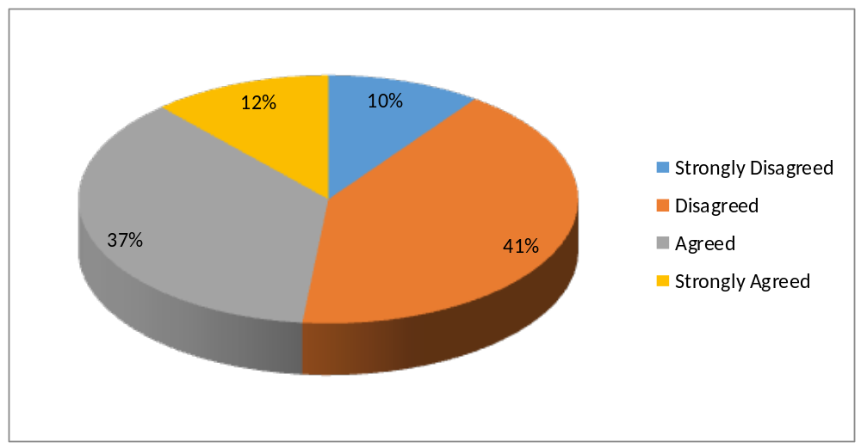Figure 0.9: Respondents Opinion on EIA has Reduced Cost on Water Consumption
Source: Field Data

4.4.2 Management of Sewage System
Similar trend in terms of percentage contribution of EIA in helping improve sewage management was found. Results indicate that 60% of accommodation owners (Figure 0.10) were not able to improve sewage management system after conducting EIA for their facility. In most cases the design of the accommodation facilities in Dar es Salaam is not influenced by EIA process, rather EIA process is done to either approve the already approved design by the project implementers or the project design has been approved by the municipal or city council.

Similarly some of the facility particularly those located at city center they benefit from already existing municipal sewage system such that EIA either approve their proposed connection by the regulatory authority or proposes how the facility will be linked to the existing sewer without influencing the actual design of the system. This again manifest itself as failure to influence decision making by EIA tool due to poor timing of when to undertake a particular EIA as argued by Mwalyosi, (2004).
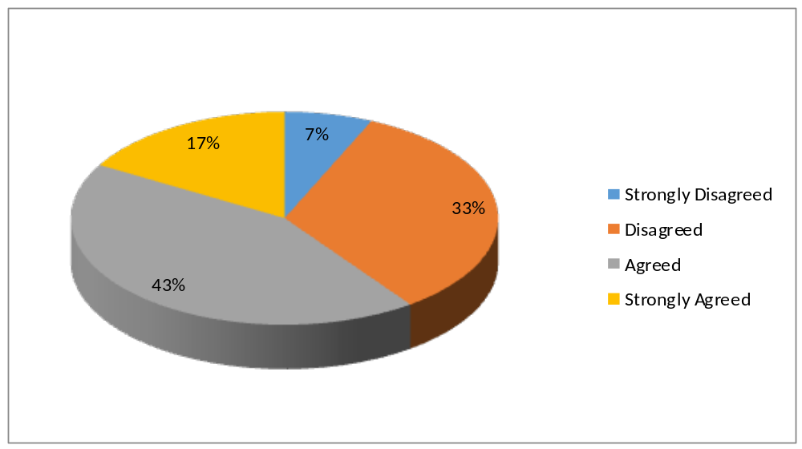Figure 0.10: Respondents opinion on Management of Sewage Systems
Source: Field Data

4.4.3 EIA Study Improved Safety and Security
In terms of improved safety and security of accommodation, results indicate that 70% of the owners (Figure 0.11) were benefiting from safety and security of their facilities. It appears that preparation of health and safety management plan as part of EIA and as part of compliance to OSHA Act of 2003 provides double advantages to the facility. The OSHA Act of 2003 requirements are regularly visited and as their impacts are easily seen and can destroy the entire facility within a very short time. For example incidence of fire, collapsing of the building as opposed to sewage failure or high water consumption. The safety issues are taken more seriously and rectification of minor default is dealt with promptly. This has made large percentage of accommodation owners to perceive it of more advantageous than other benefits analyzed.

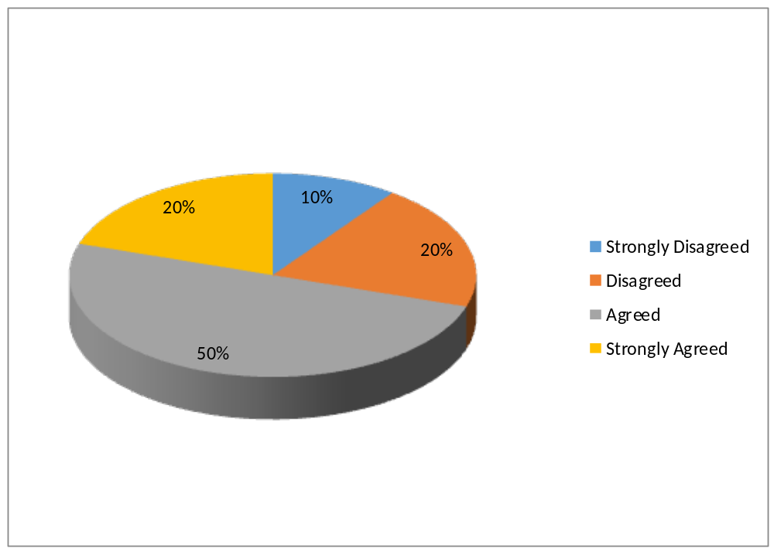Figure 0.11: Opinion on Whether EIA Study has Improved the Safety and Security
Source: Field Data

4.3.4 EIA Study has helped to Manage Solid Waste
For solid waste management, 63% owners of accommodation facilities (Figure 0.12) benefited from improved solid waste management with less than 40% disagreeing on the benefit. The majority benefited on improved solid waste management due to the fact that a lot of EIA conducted emphasizes on management of wastes particularly sewage waste (Mashauri, 1997). Similarly most of the accommodation facilities in Dar es Salaam have contacted a third part company to deal with solid waste management as a result EIA guides the accommodation facilities on managing the collection points and transfer station as the final destination of the solid waste is dealt with the third part person or company.
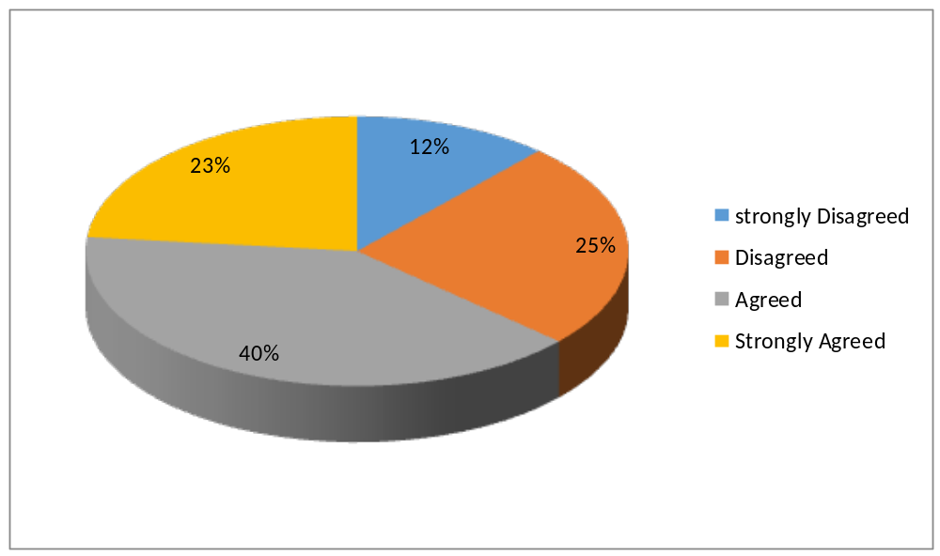

Figure 0.12: Respondents Opinion on EIA Study has helped to Manage Solid Waste
Source: Field Data

Based on the findings discussed it is clear that respondents knew that EIA process has benefits to their accommodation facilities. It further alerts a researcher that owners of accommodation facilities know the importance of conducting EIA process. Nonetheless, owners of accommodation facilities are not involved in participating fully in the EIA activities as a result they are not aware on the EIA guidelines, policies and procedures hence poor implementation of the EMA of 2004 (Gilpin 2000).

It is important to emphasize to the owners of accommodation facilities that conducting an EIA process is a participatory process and involvement of the owners from the planning stage of the EIA enhance ownership and understanding of the process and makes EIA tools for decision making about a particular project proposed or planned. Internalization of the benefits that owners of accommodation facilities will gain by undertaking EIA for their facility will contribute to raising their awareness and importance of doing EIA and therefore enhance compliance to the EMA 2004 requirement.

4.4 Problems Associated with EIA Compliance by Owners of Accommodation Facilities in Dar es Salaam
The third objective of this study aimed at assessing the problems associated with EIA compliance by owners of Accommodation Facilities in Dar es Salaam. The study assessed the problems faced by owners of accommodation facilities when complying with EIA requirements. Respondents were required to agree or disagree with the variables considered to be the problems associated with implementation and compliance to EMA 2004 particularly on carrying out EIA and implementation of EMP. The variables were; cost, availability of EIA experts, the process itself and implementation of EMP. These variables were tested in form of questionnaire and owners were required to respond accordingly if it is costly to do EIA, it is difficult to get EIA registered experts, the EIA process is time consuming, getting comments from stakeholders for EIA is not an easy task and difficult to implement environmental management plan.

4.4.1 It is Costly to undertake EIA
On whether it is costly to do EIA, 61% of owners supported the argument that it is costly to carry out EIA (Figure 0.13). The costs attached to the process include cost of hiring the consultant, Environmental experts, transport cost to the site, review process and production of the document itself. There are big variations in terms of cost of hiring environmental experts, and this is adding to the cost of implementing the project. Given the source and amount initial capital available at disposal for most of the investor being small scale loans most of the investor fail to meet the cost of carrying out EIA and end up establishing the project without subjecting it to EIA process. The cost implication in meeting environmental standards requirement is supported by Petrić and Pranić, (2009).
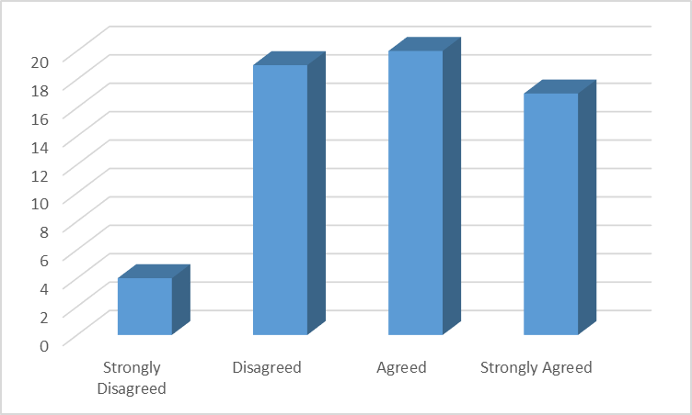

Figure 0.13: Respondents Opinion on the Cost to Undertake EIA
Source: Field Data

4.4.2 It is Difficult to Get EIA Registered Experts
In this criterion 57% indicated that environmental experts are available to do the job as only 43% indicated difficulties in obtaining environmental experts (Figure 0.14). Although respondents indicate availability of environmental experts in conducting EIA still there is big variations in terms of quality EIA produced per experts. And this corresponds very much with the cost of hiring individual experts and cost of undertaking a quality EIA work. It is very important for the regulatory authority NEMC to regularly check the quality of the experts and their work and updates accordingly their registration status for bleaching quality work.
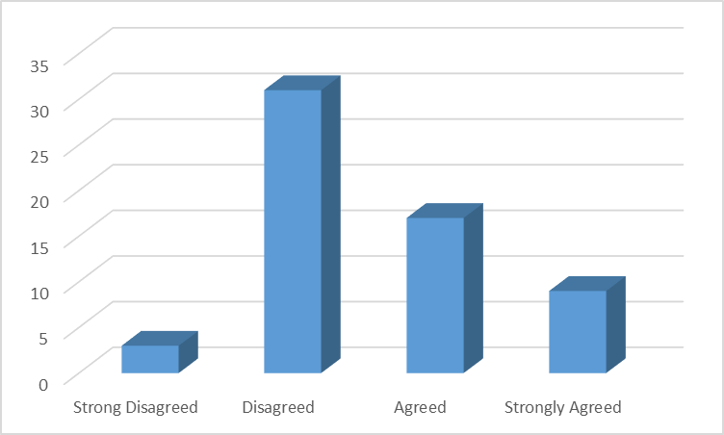

Figure 0.14: Respondents Opinion on It is Difficult to Get EIA Registered Experts
Source: Field Data

4.4.3 It is Difficult to Implement Environment Management Plan
Implementation of EMP reflects the understanding of the requirement and compliance to EMA of 2004 requirements. Comprehensive implementation of the EMP helps the facilities to identify and rectify any ill-functioning or none-compliance to the day to day operation of the facility. However, full implementation requires resources in terms of cost and experts who can intemperate the requirement to be implemented. Also it requires full commitment to the environmental protection by the implementer or actor. Therefore, having 70% of owner (Figure 0.15) agreeing that it is difficult to implement EMP, it reflects the real situation on the ground. The cost implications seem to take a leading role and it supported by Petrić and Pranić, (2009) and Mwalyosi (1995).
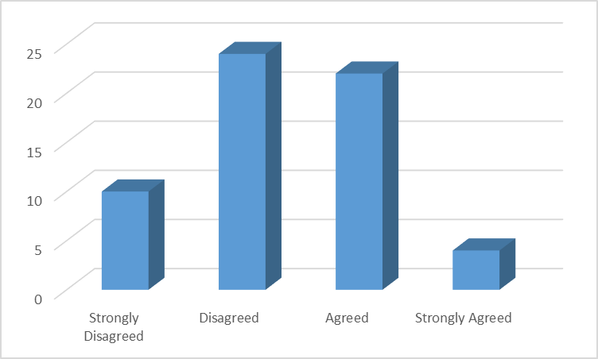

Figure 0.15: Respondents Opinion on It is Difficult to Implement Environment Management Plan
Source: Field Data

4.4.4 EIA Process is Time Consuming
On the question whether the EIA process is time consuming, was supported by 70% of respondents with only 30% responding contrary to time consuming (Figure 0.16). The process of completing EIA study is very long such that it deters investor to conduct an EIA. For example for investor with small loan intending to set up a small project will cost him /her 9 month to 12 month to complete the process if it goes straight away. A big contributor to this significant lengthy time is lack of correct /accurate information from the initial stage of project investment or development. If the investor intending to acquire loan to invest in Tanzania, the environmental requirements should be known right away as the requirement to investment. Therefore, an environmental desk should be established at Tanzania Investment center where all investors begin their investment process. Lack of accurate information in a right time compels some of the investor to start paying back their loan while they have not invested waiting for the environmental certificate.
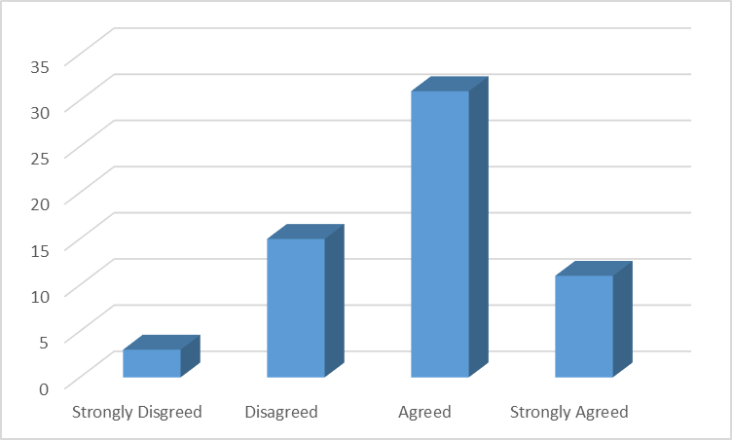

Figure 0.16: Respondents Opinion on EIA Process is Time Consuming

Source: Field Data

4.4.5 Getting Comments from Stakeholders for EIA is not an Easy Task
On the question of getting comments from stakeholders for EIA 57% had their opinion that it is not difficult to obtain comments from stakeholders. While 43% of respondents agreed that getting comments from stakeholders for EIA is not an easy task (Figure 0.17). Stakeholder involvement is being advocated by the EMA 2004 and the EIA and Audit regulations of 2005. Similarly number of NGOs are encouraging stakeholder’s participation from the grass route to enhance ownership of the project and to gain support from local communities. Thus, argument that it is difficult to obtain comments is not a valid argument. What is required by the experts is to develop skills of involving communities and make the EIA process two way interactive process.
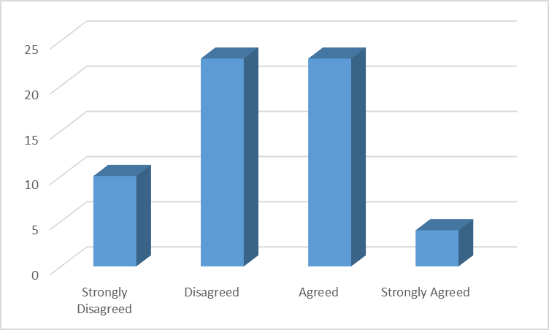

Figure 0.17: Respondents Opinion for EIA is not an Easy Task
Source: Field Data

Based on the fact that 61% of the respondents were aware of the existing problems that are associated with EIA compliance by the owners of accommodation facilities in Dar es Salaam such as difficulties in getting environmental experts for conducting EIA, difficulties in getting permission for conducting EIA, poor co-operation from stakeholders, financial constraints, lack of knowledge about the importance of conducting EIA, and the presence of very few Environmental Impact Assessment companies, it implies that conducting EIA is difficult because these problems.

These findings are consistence with the findings of Nyihirani (2010) who conducted a study on the levels of Environmental Impact Assessment (EIA) implementation and weaknesses that constrain industries in Dar es Salaam to implement EIA effectively. He found out that the compliance to EIA by industries indicated that lack of institutionalization of environmental units and environmental officers in industries, poor status of industrial environmental policy, poor institutional coordination and low capacity to implement EIA, inadequate annual environmental audit by the industries, inefficient follow ups by responsible authorities, low awareness of existence of Environmental Management Plan (EMP) and inadequate resources allocation, and lack of EIA compliance training.

Also, Albina, (2008) identified some of the weaknesses of EIA in Tanzania. However, these weaknesses are related to the socio-political system, for example, lack of effective environmental leadership, lack of openness and transparency, increase political interference, minimal political will, lack of independent decision-making capabilities, and general lack of environmental awareness. It can be suggested that the government of Tanzania should reduce a number of complications for conducting EIA. This is due to the fact that EIA processes requires a lot of procedures to follow and this makes the whole process difficult to be complied by the owners of accommodation facilities. For stance, one of the complications is governmental arrangement on certifying EIA certificate which is done by two institutions such as NEMC and Vice President Office. This cause the delay of EIA processes. This can be one of the obstacles for EIA to be conducted by owners of accommodation facilities. Therefore, the EMA of 2004 should be reviewed and assign one institution to do all the requirements.

CHAPTER FIVE

5.0 CONCLUSIONS AND RECOMENDATIONS

5.1 Introduction
This chapter gives a conclusion and recommendations on the implementation of EMA of 2004 on EIA processes using accommodation facilities that are based in Dar es Salaam as a case study. It is believed that the recommendations will improve the implementation of EMA of 2004 to many stakeholders.

5.2 Conclusions
The study assessed the awareness on EMA 2004 as tool guiding environmental performance among the Hotel owners and operators of the facilities in Dar es Salaam. Parameters like age, education and ownership of the properties were evaluated to see if they have any influence on the awareness and performance of individual owners or operators with regards to EMA 2004 requirements. The study concludes that education, ownership in terms of autonomy of the manager/operator and class category of the facilities contributes to awareness of environmental requirement as per EMA 2004.

The author argues that more effort should be placed to the stakeholders so as they become be aware of the EMA of 2004 and be in a position to conduct EIA for their developmental projects. Further there is a need for employment of enough experts, education, introduction of environmental departments and employment of environmental experts and Amendment of Act can be used to improve the implementation. Similarly, there is need for the government of Tanzania to provide awareness of the EIA policies, guidelines and procedures to the stakeholders including owners of accommodation facilities so as to increase the awareness of EIA requirements. This would facilitate stakeholders to conduct EIA, in order to protect the environment. Since, many respondents are aware of the benefits that can be gained after the conducting the EIA process such as management of solid waste and sewage system, safety to customers, diseases control, intensive security, retaining customer and customer satisfaction it is important for the owners to conduct EIA for their accommodation facilities because of those mentioned benefits.

The challenges in conducting EIA as pointed out by the respondents of this study such as it is too expensive to conduct EIA, difficult to get experts, difficult to implement environment management plan, it consumes time and lack of knowledge about the importance of conducting EIA can be rectified jointly by preparing educational seminars or fliers and radio campaign stipulating importance of carrying EIA foe the facility, need for early inclusion of EIA at the designing stage of the investment and participatory appraisal of the projects.

Efforts in addressing each problem can be well handled if each party plays its role effectively, such that property owners and operator take on board EIA at initial stage of their investment, the government minimizes bureaucratic procedures requirements for even minor projects that requires only screening, and for NEMC to establish desk at investment center to sensitize investors on need for EIA and advantage of initiating EIA at planning stage of the investment. Coordination among the stakeholders is crucial in resolving problems arising from delay and non-compliance and brings compliance of the EIA process among the stakeholders.

5.3 Recommendations

5.31 Recommendation for the Study
This study recommends the following to be taken by government and other stakeholders, in order to implement the EMA of 2004 on EIA process to accommodation facilities owners that are based in Tanzania;

First, the government of Tanzania should provide awareness on the EIA policies, guidelines and procedures to the stakeholders including owners of accommodation facilities so as to increase the level of awareness of EIA requirements. This will facilitate stakeholders to conduct EIA, in order to protect the environment. Also educational campaigns such as seminars, workshops and conferences should be used by NEMC so as to spread awareness among stakeholders.

Second, NEMC should make follow-ups to all accommodation facilities that have not been conducted EIA and enforce them to conduct the EIA. NEMC should have an effective follow up program that will insist all developers of any projects to conduct EIA. Therefore, this would lead to institutional coordination.

Third, the author recommends for the government of Tanzania to reduce a number of complications when conducting EIA. This is due to the fact that EIA processes require a lot of procedures to follow and this makes the whole process difficult to be complied with the owners of accommodation facilities. For stance, it should provide mandate to one institution in supervising EIA processes and certification. Therefore, this will combat the delay EIA processes and certification.

5.3.2 Recommendation for Further Study
There is a need to determine the accountability problems associated with inadequate awareness of the environmental laws which involve contradictory decisions made by municipal leaders on development projects along the cities in Tanzania. Municipal authorities allowed developers to develop various accommodations including construction of multi storey buildings in areas especially in the beach, where the environmental law prohibits any development within 60 m from the highest watermark. While, residents in those areas contested such decisions, the National Environment Management Council directed the developers to conduct EIAs, in order to determine the environmental implications of the proposed developments. These decisions are controversial and can be reflected as weaknesses in the EIA system. The Environmental Management Act predetermined where development is allowed in beach areas namely beyond 60 m from the highest watermark.

The arguments about lack of awareness or capacities indicate only part of the problem in this study; this assessment shows that, in order to be able to explain weaknesses in accountability issues, there is also is need to look at the cultural and sociological psychological context in which the EIA process is taking place. The low level of public awareness of environmental concerns, and limited expertise, experience and lack of coherent legal frameworks and guidelines has compromised EIA not only in Tanzania but Africa in general. There is a need to have comprehensive study on the cause of all these problems focus been on accommodation facilities.

REFERENCES
Abaza, H., Bisset, R. and Sadler, B. (2004), Environmental Impact Assessment and Strategic Environmental Assessment: Towards an Integrated Approach the United Nations Environment Programme
Albina, J. (2008), Assessment of Environmental Impact Assessment (EIA) Status and its Implementation for Selected Projects in Tanzania. Dar es salaam: University of Dar es Salaam.
Best, J. W. and Kahn, J. V. (1993), Research in Education, 7th ed, New Delhi: Prentice Hall of India.
Bryman, A. (2012), Social Research Methods 4th Edn New York: Oxford University Press Inc.
CONSCORP, (1997), Reconstruction/Re-habilitation of the Ngorongoro Crater Lodge: Enviromental Impact Assessment. Dar es Salaam: Institute of Resource Assessment (IRA).
Gilpin, A. (2000), Enviromental Impact Assessment: Cutting Edge for Twenty First Century. London: Cambridge University Press.
Griffith, A. (1996), Review of Environmental Assessment in UK Building Construction: Current Awareness Concerns and Issues. Engineering, Construction and Architectural Management, 13(3),78-96.
Hodari, D. and Sturman, M. C. (2014). Who’s in Charge Now? The Decision Autonomy of Hotel General Managers. Cornell Hospitality Quarterly, 55,433-447.
ICRW, (2006). Property Ownership and Inheritance Rights of Women for Social Protection –The South Asia Experience: Synthesis Report of Three Studies
Kane, E., and O'Reilly, B. (2001), Doing your Own Research. Journal of Wide Information System, 27: 4- 17.
Kothari, C. R. (2004), Research Methodology, Second Edition. New Delhi: New Age Publisher International.
Manyasa, M. C. (2005), An assessment on Effectiveness of Environmental Impact Assessment (EIA) in Projects Development in Tanzania. Dar es Salaam: University of Dar es salaam.
Mashauri, D. A. (1997), Waste Water Treatment at Some Selected Hotels/Lodges in Tourism Industry in Tanzania. Preliminary Research Report for Tanzania, Boku-Vienna Austria (Unpublished) 13 -56.
Mayock, P. (2012), Brands vs. Owners: Who knows best? Hotel News Now, April 2. http://www.hotelnewsnow.com/articles.
Mchome, B. S. (2002), An Assessment of the Draft Environmental Impact Assessment (EIA) Guidelines with Focus on Screening Procedures for Small-Scale Development Projects: Lesson from Dar es salaam. Dar es Salaam: University of Dar es salaam.
Mwalyosi, R. (1995), Introductory Course on Environmental Impact assessment in Tanzania: Resource Handbook. Dar es Salaam: Institute of Resource Assessment (IRA). University of Dar es Salaam Press.
Mwalyosi, R. B. and Mohamed, A. (1996), A Survey of Expertise on Natural Resource Management and Environmental Conservation in Tanzania. Dar es salaam: Institute of Resource Assessment. University of Dar es Salaam Press.
Mwalyosi, R. and Hughes, R. (1998), The Performance of Environmental Impact Assessment in Tanzania: An Assessment: IRA, University of Dar es Salaam, Tanzania. University of Dar es Salaam Press.
Nebel, E. C., and Ghei, A. (1993), A conceptual framework of the hotel general manager’s job. Journal of Hospitality & Tourism Research 16 (3): 27-38.
Ng, T.W.H, and Feldman, D.C. (2007), School-to-work Transition: A role Identity Perspective. Journal of Vocational Behavior, 71, 114–134.
Ng, T. W. H, Eby, L. T., Sorensen, K. L., Feldman, D. C. (2005), Predictors of Objective and Subjective Career Success: A meta-analysis. Personnel Psychology, 58, 367– 408.
Nyihirani, F. (2010), The Identification of Weakness in Implementation of Environmental Impact Assessment in the Tanzanian Industrial Sector. Masters Dissetation, Dar es Salaam: University of Dar es Salaam.
Ouma-Bottleberge, S. A. (1995), Industrial Development and Environmental Degradation in Tanzania: A case Study of Industrial Pollution Management and Environmental Degradation in Selected Industries. Dar es Salaam: University of Dar es Salaam Press.
Pegna, J., & Drizo, A. (2006), Enviromental Impact Rapid Prototyping: An Overview of Research to Date. Rapid Prototyping Journal, 12(2), 57-123.
Petrić, L. and Pranić, L. (2009), Environmental Awareness in the Croatian Lodging Industry; Matice hrvatske 31 Split, Croatia
Rajaram, T., & Ashutoshi, D. (2007), Sustainable Frugality through Environmental Impact Assessment:The Role of Social Ecological Linkages in Poverty Alleviation, Journal of Management of Environmental Quality, 18(5), 43-89.
Sager, T. (1995) “From Impact assessment to Recommendation: How are the Impact Assessment Results Presented and Used?” Environmental Impact Assessment Review 15(4)377-97.
Tesli, A. (2003), "Dynamic Development in Sustainable World in Site Resources". World Development Report.
UNECE, (1992), Application of Environmental Impact Assessment Principles to Policies, Plans and Programmes, UNECE Environmental Series No.5, Geneva.
URT, (2003), OSHA Act of 2003, Tanzania: Government Printer.
URT, (2004), Environmental Management Act, No 20, of 2004, (EMA, 2004). Tanzania: Goverment Printer.
URT, (2007), Employment and Labour Relation Act, No 8, of 2007, Tanzania: Government Printer.
VROM – Netherlands Ministry of Housing, Spatial Planning and the Environment (1996), Environmental Test, VROM 14349/175, The Hague.
Wei, L., Wang H. and Liu, D. (1998), Progress on Environmental Impact Assessment and its Methods in China, in A. Porter and J. Fittipaldi (eds.) Environmental Methods Review: Retooling Impact Assessment for the New Century, International Association for Impact Assessment, Fargo, ND, USA.

APPENDICES

Appendix I: Questionnaires

Part A: Personal Information
- Gender
- Male_____
- Female______
- Age Group
- 18-30 years
- 31-40 years
- 41-55 years
- Above 56 years
- Education
- Secondary level
- College level
- University level
Part B: Specific Objective No. 1: Awareness among Owners of Accommodation Facilities in Dar es Salaam City on the Environmental Impact Assessment Requirement
Dimension/Scale | Strongly Disagree | Disagree | Neutral | Agree | Strongly Agree
Do you know the EMA of 2004 on EIA process?
Did you do EIA for your accommodation facility?
Do you adhere to the environmental management plan

Part C: Specific Objective No. 2:Benefits Gained by doing EIA Process in Accommodation Facilities in Dar es Salaam City
Dimension/Scale | Strongly Disagree | Disagree | Neutral | Agree | Strongly Agree
Has the EIA study reduced cost on energy consumption?
Has the EIA study helped you to minimize water consumption?
Has the EIA study helped you to manage sewage system?
Has the EIA study improved the safety and security around your accommodation facility and customers?
Has the EIA study helped you to manage solid waste?

Part D: Specific Objective No. 3: Problems Associated with EIA Compliance by Owners of Accommodation Facilities in Dar es Salaam
Dimension/Scale | Disagree | Strongly Disagree | Neutral | Agree | Strongly Agree
It is costly to do EIA
It is difficult to get EIA registered experts
Generally, the EIA process is time consuming
Getting comments from stakeholders for EIA is not an easy task
Difficult to implement environmental management plan

Thank You for Your Cooperation
Appendix II: Interview Guidelines

Part A: Personal Information
- Gender
- Male__________
- Female_________
- Age Group
- 18-30 years
- 31-40 years
- 41-55 years
- Above 56 years
- Education
- Secondary level
- College level
- University level

Part B: Specific Objective No. 1:Awareness among Owners of Accommodation Facilities on the Environmental Impact Assessment Requirement in Dar es Salaam City
- Are you aware of Environmental Impact Assessment requirement? Yes/No________, kindly, what is it?
__________________________________________________________________________________________________________________________________________________________________________________________Did you do EIA for your accommodation facilities? If yes/no
Explain the reasons for your answer.
____________________________________________________________________________________________________________________________

- What are the Environmental Impact Assessment processes? Please mention them!
__________________________________________________________________________________________________________________________________________________________________________________________

Part C: Specific Objective No. 2: The Benefits Gained by doing EIA Process in Accommodation Facilities to the Customers in Dar es Salaam city
- What do you think are the benefits your customers get after having conducted EIA for your accommodation facility? Please explain briefly by mentioning those benefits.
________________________________________________________________________________________________________________________________________________________________________________________________________________________________________________________________________________________________________________________________________________________________________________________________________________________________________________________________________________________________________________________________________
- Are there any benefits of conducting EIA before construction of any accommodation facilities? Please explain
_______________________________________________________________________________________________________________________________________________________________________________________________________________________________________________________________________________________________________________________________________________________________________________________

Part D: Specific Objective No. 3: Problems Associated with EIA Compliance by Owners of Accommodation Facilities in Dar es Salaam City
- Which problems do you face when conducting Environmental Impact Assessment? Could you please explain?
_______________________________________________________________________________________________________________________________________________________________________________________________________________________________________________________________________________________________________________________________________________________________________________________________________________________________________________________________________________________________________________________________________________________________________________________________
- What do you think are the solutions to solve the mentioned problems
________________________________________________________________________________________________________________________________________________________________________________________________________________________________________________________________________________________________________
- Are you satisfied with the conduct of Environmental Impact Assessment processes for your accommodation facility?
- Yes________
- No______
Explain the reasons for your answer
________________________________________________________________________________________________________________________________________________________________________________________________________________________________________________________
Thank You for Your Cooperation
Appendix III: Letters

