IMPACT OF POWER OUTAGE TO SMALL AND MEDIUM ENTERPRISE AT SMALL INDUSTRIES DEVELOPMENT ORGANIZATION IN DAR ES SALAAM

ANASTAZIA LINA RWEGASILA

A DISSERTATION SUBMITTED IN PARTIAL FULFILMENT OF THE REQUIREMENTS FOR THE DEGREE OF MASTERS IN PROJECT MANAGEMENTOF THE OPEN UNIVERSTIY OF TANZANIA
2015

CERTIFICATION

I the undersigned certify that I have read and hereby recommend for acceptance by the Open University of Tanzania the dissertation with the title “Impact of Power Outage to Small and Medium Enterprise at Small Industries Development Organization (SIDO) Dar Es Salaam” in Partial fulfillment for the requirements of the Master Degree of Project Management of the Open University of Tanzania.

………………..…………..…………..
Prof. Prosper Ngowi
Supervisor

………………………………..
Date

COPYRIGHT

No part of this dissertation may be reproduced, stored in any retrieval system or Transmitted in any form by any means, electronic, mechanical, photocopying, recording or otherwise without prior written permission of the author or The Open University of Tanzania.

DECLARATION
I, Anastazia Lina Rwegasila, declare that this dissertation is my own original work and that it has not been and shall not be submitted to any other university or higher leaning institution for a similar or any other degree award.

………………………………

Signature

...............................................
Date

DEDICATION
I dedicate this work to my beloved daughter Malaika Nyamisi Mukono.
“eishoma lillichungura omwana wange”

ACKNOWLEDGEMENTS
First and foremost I would like to thank my Supervisor Prof P. Ngowi for his tireless efforts in reading, correcting and providing constructive guidance that made sure I come up with a quality work.

Secondly, I would like to thank my family members: My mother and father, Mr, G. Mukono (my fiancee), my sisters Janet and Diana and my brother Allen, my friend Mercy Mwashambwa for their encouragement and support in making sure I have an easy and smooth life during the time of my study.

Last but not least, I would like to thank all SIDO members for their support in making sure I receive quality assistance especially during the time of data collection. Also, I would like to thank my fellow MPM students, for their assistance, support and constructive criticism during the time of my studies.

ABSTRACT
The main objective of this study was study was to assess the effects of power outage to SMEs by using SIDO Dar es Salaam as a case study. In order to achieve this objective, the study had several specific objectives that reduced the main objective into simple objectives that are also achievable. These objectives included; To establish the rate of power blackout in Dar es Salaam; To determine the factors causing power outage in Dar es Salaam; To identify the effects caused by power breakouts to SMEs and To suggest measures to reduce the impacts caused by power outage to SMEs. The study used questionnaires and documentary reviews as data collection methods and a total of 180 respondents were also questioned for this study. In the end this study found out, there is power outbreak in the region however is not the extreme as the respondents explain the occurrence is once per day and nil in other days. The respondents also identified the causes of power outages which for this case were: Vandalism of Equipment; Misuse of the available energy; Poor/low power generation capabilities; Natural disasters; Lack of trained personnel to run the existing power plants and lastly; Political mischiefs. Lastly the researcher managed to establish the effects that can results due to power failures. The effects mentioned included: Loss of machinery; Increased Cost of production; Stagnant growth; Loss of money when the light goes off; Low productivity and profit; and Unemployment.

TABLE OF CONTENT
CERTIFICATION ii
COPYRIGHT iii
DECLARATION iv
DEDICATION v
ACKNOWLEDGEMENTS vi
ABSTRACT vii
TABLE OF CONTENT viii
LIST OF FIGURES xi
LIST OF TABLES xii
LIST OF ABBREVIATIONS xiii
CHAPTER ONE 1
1.0 INTRODUCTION 1
1.1 Background to the Problem 1
1.2 Statement of the Problem 3
1.3 Research Objectives 5
1.3.1 Main objective 5
1.3.2 Specific Objective 5
1.4 Research Questions 5
1.5 Significance of the Study 6
1.6 Limitations of the Study 6
1.7 Delimitations 7
1.7.1 Prepare Flexible Budget 7
1.7.2 Elaborate to the Respondent 8
1.7.3. Remind Respondents 8
1.8 Organization of the Report 8
CHAPTER TWO 10
2.0 LITERATURE REVIEW 10
2.1 Introduction 10
2.2 Definition of Key Terms 10
2.3 Electricity Provision and SMEs in Tanzania 13
2.4 Electrification and Industrialization 16
2.5 Empirical Literature Review 18
2.6 Synthesis and Research Gap 20
CHAPTER THREE 22
3.0 METHODOLOGY 22
3.1 Introduction 22
3.2 Research Design 22
3.3 Study Area 23
3.4 Population of Study 23
3.5 Sample, Sample Size and Sampling Procedure 23
3.6 Data Collection Methods 25
3.6.1 Interviews 25
3.6.2 Documentary Reviews 26
3.7 Data Analysis 26
CHAPTER FOUR 28
4.0 DATA ANALYSIS, FINDING AND DISCUSSION 28
4.1 Introduction 28
4.2 Demographic Characteristics of the Respondents 28
4.3 The rate of Power Outages in Dar es Salaam 31
4.4 The Factors Causing Power Outage in Dar Es Salaam 33
4.5 The Effects Caused by Power Breakouts to SMEs 34
4.6 Discussion of the Findings 35
CHAPTER FIVE 43
5.0 SUMMARY, CONCLUSION AND RECOMMENDATIONS 44
5.1 Introduction 44
5.2 Summary of the Study 44
5.3 Conclusion 45
5.4 Study Recommendations 46
5.4 Areas for Further Study 47
REFERENCES 48
APPENDICES 53

LIST OF FIGURES

Figure 2.1 Conceptual Frame Work………………………………………………….20

Figure 4.1 Respondent of the Answers on Occurrence of the Power Blackout….…..33

Figure 4.2 Respondent Answer of the Power Blackout……………………...………34

Figure 4.3 Respondent Answer of Power Causing the Power Blackout…………..…35

Figure 4.4 Respondent Answer on the Effects of Power out Gate……………..…….37

LIST OF TABLES

Table 2.1 Power Outages Characteristics ……………………………………………12
Table 3.1 Respondent Description…………………………….…..…………………23
Table 4.1 Gender of the Respondent…………………………..……………...……..27
Table 4.2 Age of the Respondent……………………...………………..………..….28
Table 4.3 Education Level of the Respondent…………………………………...…..30
Table 4.4 Respondent of the Workers Experiences………………………..…..…….31

LIST OF ABBREVIATIONS

GDP Gross Domestic Product
IEA International Energy Agency
NBS National Bureau of Statistics
SADC Southern Africa Development Commission
SMEs Small and Medium Enterprises
TANESCO Tanzania Electricity Supply Company

CHAPTER ONE

1.0 INTRODUCTION

1.1 Background to the Problem
Access to modern affordable energy services in developing countries is essential for the achievement of the internationally agreed development goals, including the Millennium Development Goals (MDGs) and Sustainable Development Goals (United Nations, 2013). According to the International Energy Agency (IEA) in 2011, 1.4 billion people that are equal to 20% of the global population lacked access to reliable electric source, while 2.7 billion people equaling 40% of the global population depended on traditional use of dung, crop wastes and woods as source of energy for households.

The importance of having stable electricity to economic development of any nation cannot be overemphasized (Ayodele, 1998). This is because in general electricity supply improves both the welfare and productivity in general (Schwartz, 2003). Specifically, stable electric supply is defined as a presence of reliable and sufficient electrical power to meet the needs of the users (Andersson, 1986). To business enterprises, stable electric supply serves as among indispensable inputs in the production sense and in its involvement in the comfortability of the human capital in the production process (Imoke, 2001;Berst and Michael 2008). Electricity provision in Africa has and is continuing being impaired by low generation, poor supply and frequent power outages (Paul and Seed, 2008; Jokeo, 2010). With an exception of few countries, majority of the continent’s countries are seriously affected by the problem of power outages (ADB, 2009). Poor electricity supply has in many cases proved to be the major constraint to the businesses in the continent, and it has been cited as the major contributor to the lowered productivity and poor competitiveness of the manufacturing sector (Brighton and Seed, 2009; Kamukilwa, 2012; Brian, 2012). Survey conducted between the years 2006 and 2010 showed that, more than 50% of the firms in Sub-Sahara African identified electricity as a major drawback to their business development compared to just 27.8% which cited transportation as the most critical problem (World Bank Enterprise Survey Online Database, 2012).

Tanzania is among countries in the continent with abundant energy resources such as natural gas, coal, uranium and renewable energies (hydro, solar, wind, geothermal, bio-energies, tidal waves) (URT, 2010). However, despite the presence of these resources, there is yet an insufficient supply of modern energy services with in turn leads to either power shortage or outage (Bihemo, 2010). According to Simonoff et al. (2005) the basic causes of power outage include: equipment failure; operational error; capacity shortage: human error; natural disaster and equipment theft.

In Africa, different scholars argues that the major cause of power outages are inadequate installed and generating capacity, which arise from poor planning and implementation (Ise et.al., 2000).These continuous occurring outage are said to have different impacts to the parties seeking to utilize the produced energy (Seymour and Horseley, 2010). One of the affected parties is Small and Medium Enterprises (SMEs) sector in the country. SMEs are essential in the growth of economy due to their enormous contributions in terms of employment opportunities and increase in the government revenue resulting from tax to the sector (Díaz, 2010). Due to growth of technology and the need to improve the production process, majority of SMEs have increased their reliance of electricity for different activities. Hence, the ongoing power outages affects the SMEs in terms of stopping the production process or increasing the overall cost of production and storage in general due to the need of alternative sources of energy (Baumol and Blinder, 2007). The energy sector in Tanzania faces considerable challenges which include: mobilizing funds for investment; attracting private capital in the electricity sub-sector; increasing connection and access levels to electricity; diversifying energy resources for power generation; enhancing affordability and reliability of power supply; and reducing power system losses both technical and non-technical (MEM, 2014).

Due to these challenges, the issue of power outage has been continuing to exist despite the different efforts that are placed to curb the issue (Bihemo, 2010). Different scholars have attempted to study the issue of power outages in the world and Tanzania in specific (Baumol and Blinder, 2007; Berst and Michael 2008; Bihemo, 2010). However, majority of their studies have focused on the causes of power shortages while neglecting the impacts that can be brought about by these outages (Kamukilwa, 2012; URT, 2010). Due to this, the researcher attempt to conduct a study on the impacts of power shortage to SMEs in Tanzania by taking SIDO as a case study.

1.2 Statement of the Problem
Power supply is considered as one of the key ingredients in the success of any economy (Bauer, 2010). This is due to the fact that, majority of the machinery employed to reduce workload in different businesses is usually powered by a certain form of energy (Schwartz, 2003). The utilization of machinery is essential as among others it helps in improving the quality of products while at the same time assuring efficient utilization of the available resources (Kamukilwa, 2010). Hence basing on this, it is right to argue that electricity has become an indispensable factor essential to socio-economic and industrial development of any nation. (Odili and Mokwunye, 2003). Currently, due to growth of competition and the solidification of the market, majority of Small and Medium Enterprises owners are utilizing different sort of machinery in manufacturing and packing their products. Such machineries range from small blenders for making juices to complicated grinding machines for making flour. Other forms of machines include electronic fiscal devices and computers that are effective in business accountings and record keeping (Andersson, 1986). With the growth of technology, the utilization of these modern machinery and tools is becoming more of a must rather than a luxurious for serious SMES owners.

However, despite of the undeniable benefits of advanced machinery in business success, utilization of these tools in developing countries is usually crippled by the ongoing power breakouts. In majority of these countries, power breakouts have become a serious problem to majority of the firms in Africa (Larsson and Danell, 2006). In Sub-Sahara Africa, an average firm suffers loss of economic activities of about 77 hours a month due to power outages (Andersson, 1986; Beenstock, 1991)

Energy is an essential ingredient for economic development as both agricultural and industrial activities increase, the demand for energy similarly increases (Andersson, 1986). In the developing world provision of a greater access to energy has been suggested by some that will help grow their economies and improve the lives of the poor. However, this growth is crippled by the continuous power outages (Beenstock, 1991). Power outages doesn’t not only affects the economic growth, in its simplest form it affects and destruct the ongoing efforts of SMEs in detaching themselves from poverty (Larsson, and Danell, 2006). Different reasons have been suggested as the causes of power outages (Ise et.al., 2000; Simonoff et al., 2005). The major ones out of all these are poor technology, wearing out of machinery and lack of human capital (Seymour and Horseley, 2010). The continued existence of power outages is said to affect both small and large enterprises (Makarov, et. al., 2005). However, due to large initial capital large enterprises surfer less compared to small enterprises (SMEs) that in most case fails to employ new means once the power is out. Little research has been conducted so as to see the general effects that can be brought about by this power outage to business, especially to the SMEs. Due to that, this study will use SIDO as a case study in order to assess the effects that can be brought about by power outages to SMEs.

1.3 Research Objectives

1.3.1 Main objective
The main objective of this study was to assess the effects of power outage to SMEs

1.3.2 Specific Objective
- To establish the rate of power blackout in Dar es Salaam
- To determine the factors causing power outage in Dar es Salaam
- To identify the effects caused by power breakouts to SMEs
- To suggest measures to reduce the impacts caused by power outage to SMEs

1.4 Research Questions
- How often do we have power outage in Dar es Salaam?
- What are the responsible factors for power outage in Dar es Salaam?
- How do you think SMEs are affected by this power outage?
- What do you think can be used as measures to reduce the impacts of power outage?

1.5 Significance of the Study
First and foremost, the study will be essential to SME owners as it will establish the effects and solution of power outages hence it will help in their endeavors to curb the issue. Secondly; the study will also be important to people interested in undergoing such kind of research, or those seeking to extend the objective of this research. Hence on this perspective, the results from this study will act as an essential source of material in the form of literatures so as to provide background for another person intending to perform such kind of research. Lastly, the study results also will provide useful information to stakeholders like investors, shareholders, employees, pressure groups, consumer associations, and other on the useful suggestions to improve their service delivery for their respective power/electricity operators in the country.

1.6 Limitations of the Study
This study like any other studies anticipated to be faced with number of limitations. Among these include:
Time constraint: The study was carried out for a short period of time because of the requirement to be able to follow the deadline of the Institute’s (OPEN UNIVERSITY) calendar.
Financial constraint: It was also anticipated that financial constraints would affect number of respondents expected to be involved in during data collection process. This means that inadequate funding may have hampered the researcher to interview all planed respondents as explained on chapter three of research methodology. The researcher prepared a plan that enable her to reach many respondents in one day which reduced the amount of resources that was used for the data collection procession.
Confidentiality of information: The study was carried out in relation to TANESCO, which is a public organization. Due to that some information was explained as confidential and should not be disposed of due to various reasons including but not limited to competition and safety or some of the respondents may feel the study is on the assessment of their competence. Basing on this, the researcher had to ensure the respondents that the information provided would be kept and used for academic purposes only.
Uncooperative attitude of respondents: Some respondent’s acted reluctantly and or sometimes uncooperative to respond due to various reasons including being busy and ignoring. Due to this, the researcher had to design a specific timetable, which ensured effective follow-up of the respondents in order to increase the chance of completing all the interviews.

1.7 Delimitations
Delimitations of the study simply stand for factors or issues that set boundaries or setbacks for completion of the study. Below are the delimitations for this study

1.7.1. Prepare Flexible Budget
The researcher had to set the budget a bit flexible so as to set off the ups and downs, which may arise during the study. Either the researcher had to search for stationaries support from his/her office so that in one way the cost could be reduced and hence the budget for stationaries could be adjusted to fix other part, which seems to overrun the budget.

1.7.2 Elaborate to the Respondent
To overcome the anticipated problem of respondents unwilling to provide required data the researcher used more effort on influencing the respondent to respond accordingly. In this, the researcher had to elaborate and ensure the respondent that the information required will be used only for academic purpose and not otherwise.

1.7.3. Remind Respondents
The researcher had to set time to the respondent that is after every week so that the respondents could take the questionnaires into consideration. This gave ample time to respondents to give actual details to the questions.

1.8 Organization of the Report
This dissertation is divided into five chapters. Chapter one which is introduction presents general information of the study problem. Chapter two which is literature review contains the examination of various written sources that have been written regarding SMEs, Power outages and the effects of power outages on SMEs development. This chapter also presents a summary if studies that were conducted on SMEs and power outages in Tanzania and nearby areas. Chapter three which is the research methodology describes the various methods that were employed in data retrieval, processing and analysis. Chapter four which is Research Results, Analysis and Discussion presents the findings of the study in regard to the effects of power outages to SMEs growth and its analysis according to study objectives. Lastly, Chapter Five, which is Summary Conclusions and Recommendations, presents the summary of the general study, then the conclusion, which focuses on the study objectives and finally recommendations and conclusion

CHAPTER TWO

2.0 LITERATURE REVIEW

2.1 Introduction
This chapter explains the rationale of the problem studied as well as previous research related to the topic and how the findings relate to the problem at hand. The review concentrates mainly on the theoretical orientation of the study and related literature in line with the objectives of the study.

2.2 Definition of Key Terms
- SMEs
The definition of SMEs varies from one country to another. This is because each country has its own experience and the environment in which the SMEs operate. A study conducted in 1993 by United States Agency for International development (USAID) found out over 50 different definitions in 75 different countries. The basis for categorization has often been a combination of qualitative and quantitative criteria, which include number of employees, capital invested, share capital, number of shareholders, total assets, turnover, organization complexity, management composition and degree of formalization (Rutashobya and Olomi, 1999). For example in many countries, the basis of classifying firms to either small or medium is based on the number of employees and the value of total assets owned by such firm (Adjei, 2010).

In Thailand, the firm categorized as an SME if it employees less than 200 people and holds a fixed capital of less than 200 million (Rutashobya and Olomi, 1999; Asiama and Osei, 2007). Further, SMEs in the country are also classified in terms of sector that is Service, Trade and Manufacturing. Basing on this category, SMEs in Service. In Tanzania, the commonly used yardstick to define small and micro-enterprises are based on number of employees, total investment and sales turnover. In Tanzanian context, micro-enterprises are those who are engaging up to four people and employing capital amounting up to Tsh. five million. Small enterprise are defined as a business enterprise with five to forty nine employees and capital invested of five million to two hundred million (URT, 2003). According to Amijee (2004) SMEs in Tanzania are relatively small compared to SMEs in other countries. They range from $1000 to $50,000.

- Power Outage
Power outage is defined as a short or long-term lossor supply interruption of electric power in an area (Eto et al., 2001). According to Díaz (2010) there are seven main types of power problems, these include Transient(Impulsive and Oscillatory); Interruptions; Sag / Under voltage; Swell / Overvoltage; Waveform Distortion (DC Offset, Harmonics, Inter-harmonics, Notching and Noise); Voltage Fluctuations; and Power Frequency Variations. Nooij et al. (2007) and Eto et al. (2001) argued that electricity outages have many different characteristics it terms of costs depending on the nature of customer and the costs involved in creating the same amount of energy required. Table below is adapted from Nooij et al. (2007) and Eto et al. (2001) that seek to explain how different customers are affected by power outages.

Table 2.1 Power Outages Characteristics
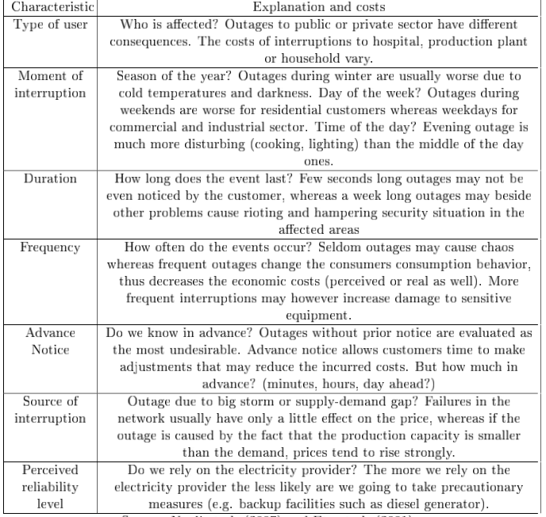
Adapted from Nooij et al. (2007) and Eto et al. (2001)
- Electricity
Electricity sources are everywhere in the world. These energy resources fall into two main categories, often called renewable and non-renewable energy resources. Each of these resources can be used as a source to generate electricity. Renewable energy sources are Wind power, Hydro power, Solar Power and Improved Biomass, while Non- Renewable energy sources are: Fossil Fuel, Oil and natural gas, and Coal (Electricity forum, 2011). The need to increase access to energy in under developing countries has proved to be a challenging issue within the international development community. Inadequate access to energy also exacerbates rapid urbanization in most under developed countries, by driving people to seek better living conditions. It has been estimated that around 1.6 billion people in this countries lack access to adequate energy services. 80% live in rural areas, predominantly in sub- Saharan Africa and South Asia” (UK Parliament, 2002). Around half of all people in these countries are dependent for fuel on wood, dung and crop residue, collectively known as ‘traditional biomasses. Three quarters of these live in China, India and sub-Saharan Africa. The International Energy Agency (IEA) has forecast that use of traditional biomass will decrease in many countries, but is likely to increase in South Asia and sub-Saharan Africa alongside population growth.

Sources of electricity are everywhere in the world. There is a range of energy resources available to generate electricity. These energy resources fall into two main categories, often called renewable and non-renewable energy resources. Each of these resources can be used as a source to generate electricity, which is a very useful way of transferring energy from one place to another. Non-renewable sources of energy can be divided into two types: fossil fuels and nuclear fuel. Renewable sources of energy can be divided into; Wind power, Hydropower, Solar energy, Biomass.

2.3 Electricity Provision and SMEs in Tanzania
There is no good definition of electricity access in Tanzania. There is a need to distinguish electricity penetration (whether people live in the vicinity of a source of electricity) and electricity access (whether they are actually using electricity). Access is a theoretically preferable and does Southern Africa Development Community (SADC) choose the definition for comparability across member states. It implies availability, affordability and acceptability (this reflecting both cultural acceptability and the consumer willingness to pay). Current figure that is widely quoted in Tanzania is that national access to electricity is 14% of the population, while in the rural area it is about 6%. This figure appears to be based on the National Bureau of Statistics (NBS) Household Budget survey Data (NBS, 2002). Updated ratios are best calculated in terms of household using grip or renewable electricity as percentage of total number of households (URT, 2011).

Tanzania has indigenous energy resources including hydro, natural gas and coal biomas, wind, solar, geothermal and uranium that can be developed and utilized sustainably in order to reduce the country’s dependency imported energy. Energy demand in Tanzania has grown rapidly due to population growth and the increase in economic activities (including mining) during the past 50 years. Over 75% of the population lives in rural area, depending on agriculture that accounts for about 50% of the Gross Domestic Product (GDP) and over 60% of the export earnings. Tanzania Electricity Supply Company (TANESCO) has set a target of 100,000 grid connections per annul (124,000 households) and 30% access by 2015. However, it is argued that in order to attain this target, it needs 287,500 connections per annum; the best year was 66,000 connections in 2010 (URT, 2011). The total number of customers is estimated to be over 850,000 with annual electricity demand growth of 12% to 15%, and annual per capita consumption of electricity in Tanzania is 100 kWh. Most energy consumption is for households for cooking, with the bulk being provided by biomass energy sources. Traditional biomass (mainly firewood and charcoal) is the dominant source of energy, accounting for 70% to 90% of total energy demand. There are different forms of SMEs in the whole of Tanzania. These SMEs can be distinguished as how several scholars have argued, in terms of services provided (the nature of activities) and type of energy services they use for production or performing their services. SMEs such as brick burning, ceramic firing, salt drying, fish drying and smoking, and charcoal production depend on biomass fuels as a source of process heat (Kamukilwa, 2004).

Other small enterprises like retail shops, salons, restaurants and bars, wood processing, welding, depend on electricity services for lighting, refrigeration, entertaining customers, baking, cooking, shaft power, grain grinding and oil processing (Sawe, 2003). In addition, MEs technologies are easier to acquire, transfer and adopt such that there are better positioned to satisfy limited demands brought about by small and localized markets due to their lower overheads and fixed costs (URT, 2003).

Worldwide SMEs tend to be more effective in the utilization of local resources using simple and affordable technology (Terry, 2003). In Tanzania most micro-enterprises use local resources and affordable technology to undertake their activities, these activities include: Making craftwork e.g. carpentry, pottery, clothes-making/tailoring; Small-scale agricultural activities such as dairy processing, bee keeping, poultry farming and goat keeping; Food preparation and processing such as bakeries, local beer brewing, honey processing, grain milling and fish smoking and mall-scale mining and processing activities such as tinsmiths and blacksmiths.

2.4 Electrification and Industrialization
It’s very clear that electrification is a prerequisite to modern industrialization; hence we cannot minimize the importance of this notion. It is quite clear that there is no nation which can develop and industrialize without sound electric base (Paul, 2020; Thompson and John, 2008). Today we depend on electricity for basic needs such as food, water, shelter, communication, employment and health care. Those needs are served by infrastructures for food preservation, water treatment, heat and light, phone service, Internet, offices, factories, hospitals and emergency response, to name a few. Yet all of those essentials are without electricity. We could easily argue that population growth is fueling the growth in electricity demand.

The developing world is rapidly catching up to the electricity hungry lifestyle of the industrialized world, Through the electrification of everything which increase the dominance of electricity as the preferred form of energy, Several developments have driven electricity into every aspect of our lives, most notably motors, microprocessors and microwaves. And now another massive change is about to begin: the switch to electric transportation.
In an economic sense, energy performances add value to intermediate products as they are progressively transformed into final consumer goods, electric power is of fundamental importance to the economic, social and industrial development of a nation, electric power is so vital to all aspect of human life, production and service delivery contribute no small measures to the standard of living, as such the right to an adequate standard of living cannot be realized without general electrification. Electric power is properly considered as a key element of the so called Second Industrial Revolution, having considered agriculture to be the first industrial revolution, Modern industrial societies are commonly described as energy intensive, which is, perfectly accurate. A central feature of industrial development over the past two decades is that it has been characterized by a growth in the amount of energy utilization per worker, or per person. (Rosenberg, 1998). Electricity's rapid rise to dominance as a source of industrial power was based on a number of compelling advantages. First and foremost, electricity could be packaged in almost any size. In terms of availability, future prospects for electricity appear to be reassuring. “In the industrial world electricity is already widely available at prices that are typically lower in real terms than they were twenty years ago." (Joskow 1997). The demand for energy in this particular form is further reinforced by its energy saving role that has been emphasized thoroughly, as well as its labor saving features that have been neglected. Moreover, the many possibilities for building "environmentally friendly" new technologies on electrical foundations appear likely to enhance the demand for electricity.
Industrialization on the other hand, is the transformation of a society or country from a primarily agricultural society into one based on the manufacturing of goods and services. Industrialization includes the use of technological innovation to solve problems as opposed to superstition or dependency upon conditions outside human control such as the weather, as well as more efficient division of labor and economic growth. (Investopedia 2011). An area where industrialization had a massive effect was in Eastern Europe. It emerged as a need to modernize and unify Europe. Although Britain led industrialization at first, it quickly exploded from Spain all the way through Russia. Industrialization has brought many changes and even modernizes most countries; it also had its negative effects. It is evident that the positive affects out weight the negative. If not for industrialization most of Europe would be in the dark. And industrialization also made the world much smaller by most of the inventions such as the steam engine and mass expansion of railroads. (Economic Change and Effect 2011).

2.5 Empirical Literature Review
The first study is by Oseni (2010), which was titled Power Outages and the Costs of Unsupplied Electricity: Evidence from Backup Generation among Firms in Africa. The main objective of this study was investigating the extent to which firms’ characteristics affect the costs of power outages and how that might create incentives to invest in backup generation. The results reveal that while the demand for backup is influenced by power outages, firm’s size, manager’s experience, other factors such as firm’s reputation and the use of the Internet for firm’s operations play more roles in decision to invest in backup. The results also indicate that the previous studies on Africa have underestimated the costs of power outages due to the omission of additional costs that may result from incomplete investments in backup.
The second study is by Cerny (2013) which was titled “Economic and Social Costs of Power Outages: The Case of Pakistan”. This study aimed at determining the economic and social costs of power outages in Gilgit, Pakistan through survey data collected through face-to-face interviews with 149 residents. In the end, the results of this study showed that, the ownership of a generator, high electricity bill and the number of outages have a positive effect on the stated willingness to pay, while students and those whose perceived price of electricity is high are not willing to pay extra. The third study is by Sinan (2013), which was titled Evaluation of Power Outage Costs for Industrial and Service Sectors in Finland. The main purpose of this study was to develop a proper mathematical model to be able to reach a conclusion to make estimations about the customer outage costs and to give the utilities and large power consuming customers an idea about these costs.

The results of this study showed that huge amount of energy being consumed in these customers is huge and there are professional employees who can give high accuracy responses about interruption costs to the questions in the survey. The power usage characteristics and thus the outage costs of these customers are more complicated than those of industrial and service sector customers. As a result, in the future, a new comprehensive and carefully carried out customer survey is needed to analyze power outage costs of service sector in Finland.

The last study is by Maleoko (2014), which was titled “Impact of Electricity Services on Microenterprise in Rural Areas in Tanzania”. This study aimed at exploring the linkages between increased access to grid electricity services and micro-enterprise development in rural areas in Tanzania. The research findings serve as tools to stimulate the understanding of linkages between grid electricity services and micro-enterprise development, allowing stakeholders to take actions and support rural electrification programs, and increasing awareness for entrepreneurs about impact of electricity services on income generating activities and finally to reduce poverty in rural areas in Tanzania.

2.6 Synthesis and Research Gap
Several researches have been conducted both inside and outside Tanzania. All these researches were aiming at investigating the general issue of power outages and the effects that it can bring in the economy through affecting the growth of enterprises in the country or continent.

However, despite the large number of these researches on power outages, there are several important key points that can be generated through in depth analysis of these literatures. Firstly, majority of these researches focused on understanding the whole issue of work power outages and how it is caused; what are essential factors responsible for these outages; Secondly, though there are some study which tried to understand the effects which the outages have on enterprises performance, all these did put much emphasis on understanding the effects of outages of Micro enterprises and those that focused on SMEs are being done outside the country. Due to this, it is possible to argue that, the research conducted on power outages in Tanzania, have focused much on other forms of enterprises while neglecting the issue of SMEs.

Hence, basing on these observations, the researcher saw the gap in studying the effects of power outages on enterprises performance, but the emphasis on this study diverged from other studies, where in this case, the researcher focused on small industries and in this case SIDO in Dar es Salaam was be used as a case study.

Conceptual Framework

Power Outages
Independent Variable

SME’s

Dependent variables
Loss of Electrical Equipment’s
Reduction of Production Speed

Increased Cost of Production

Failure to Meet Production deadlines

Figure 2.1: Conceptual Framework
Source: Adapted from Díaz (2010)

CHAPTER THREE

3.0 METHODOLOGY

3.1 Introduction
According to Kothari (2008), a research methodology is a way to systematically solve the research problem. This chapter specifically presents the different methods and techniques that were used in collecting and analyzing the data obtained for this study. It is also in this section where the study area, study population, sampling design and sample population of the study are described.

3.2 Research Design
Research design is a specific plan or strategy that shows how data will be collected effectively and efficiently (Kothari, 2004). Also Research design can be defined as a detailed description of the structured process of the complete research methodology (Johannessen et al., 2009). It serves as a blueprint for conducting a study that maximizes control over factors that could interfere with the validity of the findings (Burns and Grove 2005). This study employed a descriptive case study.

Descriptive research design is the research design, which seeks to describe phenomenon as they exist or occur in their natural context or situations (Kothari, 2004). This form of research design is essential in researches aimed at facts finding, or seeking at describing a particular issue (Orodho and Kolombo, 2002). This research aimed at understanding the effects of power outages to SME owners. Hence, the descriptive research design was a right choice of research design, particularly in describing actual situation of the effects generated by the power outages.

3.3 Study Area
The study area of this was Dar es Salaam. This is because it is where SIDO facility, which is the case study for this study, is located. Apart from that, the researcher is working with TANESCO Dar es Salaam hence working with SIDO and TANESCO in Dar es Salaam was essential in simplifying the whole process of data collection.

3.4 Population of Study
Population refers to a large group of people possessing one or more characteristics in common on that a research studies focuses (Creswell, 1994). The population of study is defined as a group of subjects from whom the researcher expects to draw conclusions about the research topic (Kothari, 2004). This study was conducted in Dar es Salaam city. Thus, the target population for this study was the SME owners at SIDO facility and TANESCO staffs. The total population of the study area was 600 people.

3.5 Sample, Sample Size and Sampling Procedure
3.5.1 Sample and Sample Size
Sample is a small group of subjects drawn from the population in which researcher is interested in gaining information and drawing conclusions about the universe (Kothari, 2004). Sample size is the part of the population selected to represent the whole population, it enables the researcher to achieve objectives with reduced resources. Also it enables the researcher to achieve objectives with reduced resources. The sample for this study was 120 respondents that were selected out of 600 respondents with business at SIDO facility working area. This is equal to the 20% of the whole respondents that were available for this study. Below is the description of this study population
Table 3.1 Respondents description
Description | Number
TANESCO staffs | 35
SIDO (Business owners) | 30
SIDO (Workers) | 55
Total | 120
Source: Field data (2005)

    - Sampling Procedure
Sampling procedure is explained as a method or strategy that is used in selecting the sample for the intended study (Kothari, 2004; Kumar, 2002). Sampling procedures involve the techniques to which the sample was drawn from the population (Kothari, 2004).In order to ensure that accurate and reliable information on the effects of power outages to SME are obtained, the study utilized the purposive sampling technique and simple random sampling technique in deciding whom to interview.
The choice of the purposive sampling technique is motivated by the fact that the information on power outages is specific and therefore an expert with the requisite experience is required in order to achieve data that is reliable. According to Kamuzora and Adam (2008:138), purposive sampling is sometimes known as judgmental sampling. The researcher chooses only elements which he/he believes were able to deliver the required data. Purposive sampling was employed to TANESCO workers particularly those that have reliable information on the causes and durations of power outages.

3.6 Data Collection Methods
Data collection involved all processes that deal with acquiring data from the population targeted. The study used both primary and secondary data to draw its conclusion. The primary data are those that are collected afresh and for the first time, and thus happen to be original in character. The secondary data, on the other hand, are those which have already been collected by someone else and which have already been passed through the statistical process (See Kothari, 2004). Primary data for this study were collected using interviews while using documentary reviews the researcher collected secondary data.

3.6.1 Interviews
Interview as a research tool is advantageous because: it is highly flexible tool, allows a more permissive atmosphere than the case when using other techniques of investigation (Young, 2001). Also, through interviews the questions not readily grasped by interviewees can be rephrased, or repeated with proper emphasis and explanations when necessary. Also the interviewer has a greater opportunity to appraise the accuracy and validity of replies as contradictory statements can be followed up and possible reasons for contradictions can be learned. In order to become well versed with the problem researched for this study, both closed and open-ended questions were asked to respondents. Closed ended questions are meant to guide the researcher keep track of the main issues to be investigated. While open-ended questions aim at having a wider understanding of respondents’ feelings, views, beliefs, perceptions, attitude and knowledge. Face to face interviews were conducted to TANESCO officials from Headquarters and SIDO facility SME owners located in Dar es Salaam.

3.6.2 Documentary Reviews
Documentary review is simply a review of different written documents to enrich both the understanding of research in question and provision of addition materials to improve the discussion of the results obtained from respondents (Kumar, 2004; Kothari, 2008). Documentary review is simply the act of reading or reviewing various literatures that has been written concerning the intended topics.

This method enables the researcher to learn what other scholars have written on the same or similar subject and thus being able to pointing out what knowledge gaps still exist. Indeed, this method is more economic as it saves time and money since the data already exist for answering research questions (Kothari, 2004). The collection of secondary data involved reviewing of procedural manuals that contain policies and procedure relating to electricity supply and provision. Also the researcher will review different newspapers and articles so as to access different information concerning the rate of power outage in Dar es Salaam.

3.7 Data Analysis
Data analysis usually involves reducing accumulated data to manageable size, developing summaries, looking for patterns and applying statistical techniques (Cooper and Schindler, 2006). Raw data collected in this study were edited to make sure they contain no errors. This was effected through checking the content for completeness as well as internal consistence of the responses as how Kumar (1996) argues, editing is important because it involves scrutinizing the completed research instruments to identify and minimize as far as possible errors, incompleteness and gaps in the information obtained from the respondents. In terms of quantitative approaches, simple tables, charts, and or graphs were used to show ratios, percentages and frequencies in distribution of analyzed samples.

In qualitative approach, descriptive data analyses were used in order to elaborate the thematic issues in question that could not be adequately captured in numbers and percentages. The descriptive analyses used mainly cover those areas where respondents were asked for their opinion, or asked to give a recommendation on the research topic.

CHAPTER FOUR

4.0 DATA ANALYSIS, FINDING AND DISCUSSION

4.1 Introduction
This chapter presents the findings that were recovered during the data collection process.

4.2 Demographic Characteristics of the Respondents
4.2.1 Gender of the Respondents
During the data collection process, the researcher was interested in establishing the gender of the respondents. Out of all 120 respondents that were questioned for this research, 71 (59.2%) respondents were males and the remaining 49 (40.8%) were females. In terms of answers provided by the respondents, there was no observable deference between the females and males. All respondents seemed to have sufficient knowledge concerning the topic in question.

Table 4.1: Gender of the Respondents
Category | Number | Percentage
Male | 71 | 59.2
Female | 49 | 40.8
Total | 120 | 100
Source: Research data (2015)

4.2.2 Age of the Respondents
The researcher was also interested in establishing the age of the respondents that were involved in the research. In this, in order to establish this, the researcher provided the respondents with several options, which included: Below 20 years; 21-30 years; 31-40 years; and Above 40 years. The results in this were as follows: Out of all 120 respondents that were questioned for this, 13 (10.3%) respondents selected below 20 as their age category; 25 (20.8%) selected 21-30 as their age category; 44 (36.7%) selected 31-40 as their age category; while the remaining 38 (31.7%) selected above 40 as their age category.

Table 4.2: Age of the Respondents
Category | Number | Percentage
Below 20 | 13 | 10.3
21-30 years | 25 | 20.8
31-40 years | 44 | 36.7
Above 40 | 38 | 31.7
Total | 120 | 100
Source: Research data (2015)
Looking at the provided answers, again in this, there was no observable difference in terms of the answers that were provided by the respondents from different age category. All respondents seemed to have sufficient knowledge concerning the research topic and the questions that were posed to them.

4.2.3 Education Level of the Respondents
Apart from gender and age of the respondents, the researcher was also interested in establishing the overall level of education of the respondents that were involved in the research. In this, the researcher provided the respondents with options on which they were supposed to select the most suitable one to represent their education levels. The provided options included: Primary school; Secondary school; Diploma and Certificates; BA/BSC and above and others. The results obtained in this were as follows; Out of all 120 respondents that were questioned, 23 (19.2%) respondents had primary school as their level of education; 37 (30.8%) respondents had secondary school as their level of education; 19 (15.8%) of respondents had diploma and certificate as their level of education; while the remaining 14 (11.7%) selected BSC/BA as their level of education. During data analysis process there was an observable difference on the answers that were provided between people in different levels of education.

In this, the observable difference was that, people of higher levels of education had better understanding on the things in question, with some going far to even quote key people who have provided different meanings on the research ideas in question. However, despite this, those of lower levels of education did also highlight some key items that were also essential in overall understanding of the intended research questions.
Table 4.3 Education Level of Respondents
Category | Number | Percentage
Primary school | 23 | 19.2
Secondary school | 37 | 30.8
Diploma and certificates | 19 | 15.8
BA/BSC and above | 14 | 11.7
Total | 120 | 100
Source: Research data (2015)

4.2.4 Workers Experience
Lastly but not least, the researcher was interested in establishing the number of years that the respondents have spent in the bank. This question was specifically directed to the bank workers in order to establish the overall understanding of the bank workers on the ideas in question. In this, the options that were provided as answers for this included Less than 1 year; 1-5 years; 6-10 years and Greater than 10 years. Out of the 80 respondents that were questioned for this, 9 (11.3%) respondents had 1 year experience; 16 (20%) respondents selected 1-5 years as their experience; 21 (26.3%) had 6-10 years of experience; while the remaining 34 (42.5%) respondents selected greater than 10 as their experience.

Table 4.4: Respondent Workers Experience
Category | Number | Percentage
1 year | 9 | 11.3
1-5 years | 16 | 20
6-10 years | 21 | 26.3
Greater than 10 years | 34 | 42.5
Total | 80 | 100
Source: Research data (2015)

4.3 The rate of Power Outages in Dar es Salaam
During the data collection process, the researcher was interested in establishing the rate of power blackout in Dar es Salaam. Before establishing the rate, the researcher was interested in establishing what the respondents understood on the meaning of blackout. In this it was realized that majority of the respondents seemed to understand what it actually meant by power blackouts. In this, two basic statements were identified, the first one is the one that holds power blackout simply means frequent power interruptions while other group thought power blackout means having several periods with not electricity. Below are the two statements that were highly mentioned by the respondents to explain power blackout
“Kukatika katikakwa Umeme” roughly translates into “frequent power interruptions”
“Kutokua na umeme kwa vipindi kadhaa” roughly translates into “several periods of not having electric power”
After establishing the respondents understanding on the meaning of power blackout what followed was the respondents answer on the overall status of power blackout. In this, the first question that was posed to the respondents was Does your business frequently face the problem of power outage?. In order to provide answers for this, the respondents were given three options, which were Yes, No, and I don’t know. The results in this is as follows: Out of 120 respondents that were questioned in this, 93 (77.5%) selected Yes in this meaning there is power blackout; 1 (14.2%) selected No meaning there is No power blackout; while the remaining 10 (8.3%) respondents selected I don’t know as their answer to this. This data can be presented diagrammatically as follows;
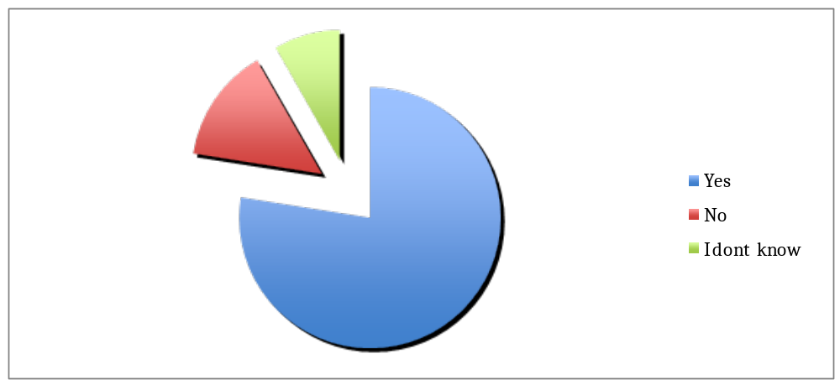 Figure 4.1: Respondents Answers on the Occurrence of Power Blackout
Source: Research data (2015)
The second question that followed this was the respondent’s answer on the frequency of power blackouts. In this, the question that was posed to the respondents was straightforward asking how many times are you faced by power outages daily? To answer this, several options were provided to the respondents, this included; 1; 2; 3 and Often. The results obtained in this, is as follows: Out of the 120 respondents that were questioned in this, 56 (46.7%) selected 1; 39 (32.5%) selected 2; 11 (9.2%) selected 3; while the remaining 14 (11.2%) selected Often as the results in this. This data can be summarized diagrammatically as follows
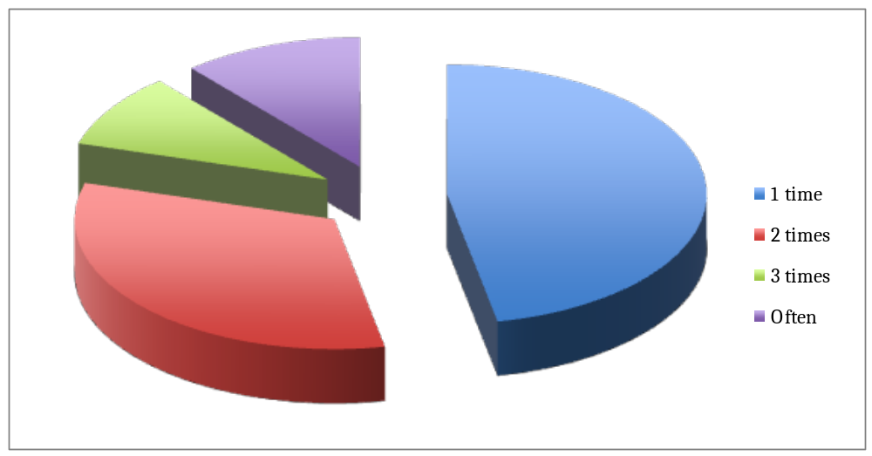 Figure 4.2: Respondents answer on the frequency of power blackouts
Source: Research data (2015)

4.4 The Factors Causing Power Outage in Dar Es Salaam
During the process of data collection, the researcher was interested in establishing what are the causes that led to power outages in Dar es Salaam. In order to answer this, the respondents were given an open-ended question that simply wanted them to provide their answers on the actual causes. In this, the causes were taken to include both those that are direct and those which are indirect. Below are the results that were obtained in this section; Out of the 120 respondents that were questioned the following are the factors that were mentioned by large percentage of the respondents. 21 (17.5%) mentioned poor and outdated infrastructures; 19 (15.8%) respondents mentioned Vandalism of Equipment; 7 (5.8%) respondents mentioned Misuse of the available energy; 16 (13.3%) mentioned Poor/low power generation capabilities; 12 (10%) mentioned Natural disasters; 14 (11.7%) Lack of trained personnel to run the existing power plants and lastly; 31 (25.8%) mentioned Political mischiefs as the factors causing power outages in Dar es Salaam. This data can be summarized diagrammatically as follows;
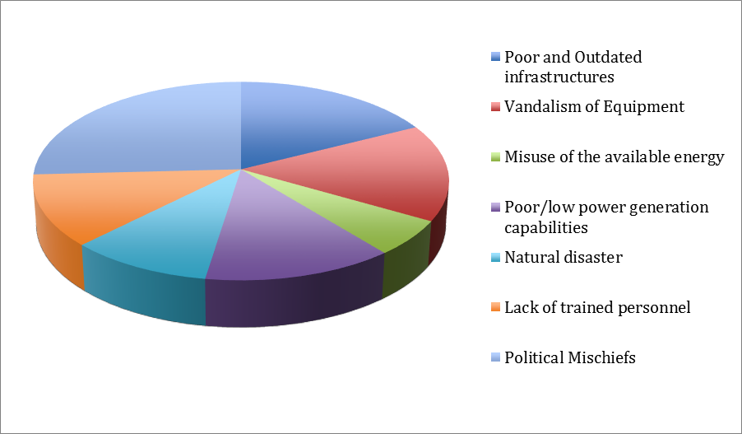 Figure 4.3: Respondents Answers on the Factors Causing Power Blackout
Source: Research data (2015)

4.5 The Effects Caused by Power Breakouts to SMEs
After establishing the causes of power outages on Dar es Salaam. The researcher was interested in establishing if there are any effects that are caused by these blackouts. In this, the researcher started by asking the respondents are there any effects that are caused by these blackouts?. The results in this, was as follows :Out of the 120 respondents that were questioned in this, 85 respondents that are equal to 70.8% selected Yes in this, 24 respondents that are equal to 20 selected No and the remaining 9.2 selected I don’t know as their answer in this. These results can be presented diagrammatically as follows; After that, the researcher provide the respondents with an open question on which the respondents were supposed to mention on what they think are the effects of power blackout to them. The results in this were as follows; Out of the 120 respondents that were questioned in this, 20 (16.7%) mentioned Loss of machinery as the effects; 15 (12.5%) mentioned Increased Cost of production as an effect; 29 (24.2%) mentioned Stagnant growth as an effect; 19 (15.8%) mentioned Loss of money when the light goes off; 21 (17.5%) mentioned Low productivity and profit; and the remaining 16 (13.3%) mentioned Unemployment as an effect. Below is the diagram that summarizes this data
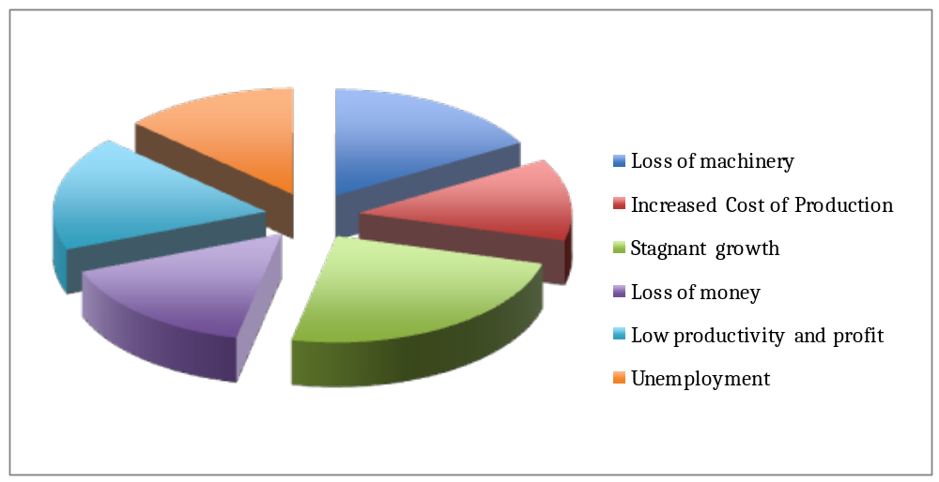Figure 4.4: Respondents Answers on the Effects of Power Outages

Source: Research data (2015)

4.6 Discussion of the Findings
This section discusses the findings from the interviews and questionnaires. The discussion of the findings is organized according to the four research objectives and in doing so, it makes links to the relevant literature, in particular the literature covered in Chapter Two which is Literature Review.

4.6.1 General Observation
The major focus/objective of this study was to assess the effects of power outage to SMEs. The process of data collection was done through questioning a total of 120 respondents that provided a basis for this discussion. In order to clearly present the data obtained, the presentation of the data was based on how the obtained data answers the research question which for this study were four i.e. How often do we have power outage in Dar es Salaam?; What are the responsible factors for power outage in Dar es Salaam?; How do you think SMEs are affected by these power outage?; and What do you think can be used as measures to reduce the impacts of power?. To start with, the research had to collect the general demographic characteristics of the respondents that were involved in the research. In this, attributes such as age, sex, education level, and experience of the respondents were collected.

In terms of age the respondent, the distribution was fair as the respondents category was evenly distributed from those with below 20 years until those with 60 +. Basically, in terms of the age of the respondents, the researcher managed to cover the respondents from various age groups hence the information generated can be said to come from respondents from various age groups.

For the aspect of sex, unknowingly the researcher came to realize during data collection that the total percentage of male respondents (59.2) was a bit bigger compared to that of their female counterparts (40.8). However, during data analysis there was no observable difference in terms of responses between the male and female respondents. Analysis shows all respondents were aware and well equipped to provide sufficient information that will be essential for tackling the research objective that were intended by this study. Looking at the education level of the respondents, the data analysis shows the research managed to interview people with all sort of education. This is evidenced by the presence of various respondents with education starting from primary school to Doctorate (PhD). In terms of answers, there was no observable difference between the people with primary education and those with PhDs particularly in the closed-ended questions. However, in the open-ended question, there was a bit difference in terms of one emphasize on the intended point. In this, it was realized that people with higher level of education seemed to provide in depth presentation of their problem particulars on the follow-up questions where the researcher demanded the respondents to provide addition information to justify their choice of answers on the closed-ended questions. However, all of the respondents provided enough information that was essential in coming up with the report for this research. The researcher was also interested in establishing the respondent’s experiences. For the case of this study, experience was divided in two cadres. Generally, the data on this section was also convincing, as majority of the respondents from both cadres seemed to have sufficient knowledge due to their long time with the operator as customer.

4.6.2 Objective 1: The rate of power blackout in Dar es Salaam
During data collection process, the researcher was interested in establishing the overall rate of power outages. Copying from Frederick and Selase (2012) a better way of establishing power outages was to combine respondents answer on the knowledge of what it means by power outages, existence of power outages and frequency of power outages. The researcher concurred with this approach and prepared a set of three questions that aimed at establishing this.
The first question strictly wanted the respondents to provide personal explanation on what it means by power outages. In this, the respondents provided different answers. Both provided answers either focused on absence of electricity or on the frequency of which the respondents sees power going out and coming on again. However, a good point to note is that the respondents seemed to be aware of what is meant by power outages.

The second question was on occurrence of power outages. The question posed in this was does power outages occur in your work area?, and in order to answer this, the respondents were supposed to used Yes, no and I don’t know. Looking at the collected data large percentage of the respondents agreed with this, this means that they aware of the power outages occurring in the area. The question that followed in this was to establish the frequency of power outages in the region. Harrison, (2004) and Freon, (2009) has stipulate a best way to measure the extent of power outage is to put it in number 1,2,3 and often. The interpretation in this is that, if large number of respondents selected 1 and 2 that means the power outages is minimal, but if large number select 3 and often that indicate the situation is critical to business people.

However, to challenge this Chikuo and Abbas, (2011) contested against this posing several criticisms including the fact that data used by Harrison and Freon was from developed country, which is quite different from developing countries, where power outages are a frequent phenomenon. Data obtained in this section showed that, large percentage of the respondents 79.2% selected 1 and 2 as the frequency of power outages per day, while the remaining 20.8% selected 3 and often. Basing on what Harrison, (2004) and Freon, (2009) the problem is not that big as it is not to critical stage. But using the production index for SMEs provided in a paper by Frederick and Selase (2012), this rate also has an impact particularly to the business that cannot afford an alternative source of power. Hence despite the statistics showing a small effect, this is actual a problem which need addressing in order to give much room for the growing SMES to thrive.

6.4.3 Objective 2: Factors causing power outage in Dar es Salaam
The second objective for this study was to establish the factor causing power outage in Dar es Salaam. In this, the respondents were given an open-ended question to discuss the actual factors that are causing power outages. The results provided in this provided several answers which were: poor and outdated infrastructures; Vandalism of Equipment; Misuse of the available energy; Poor/low power generation capabilities; Natural disasters; Lack of trained personnel to run the existing power plants and lastly; Political mischiefs as the factors causing power outages.

Looking at the provided answers, large percentage of the respondents that were questioned in these selected political mischiefs as the major causes of power outages. According to them, political mischiefs occur when things that are supposed to be organized by scientific procedures are done politically causing dissatisfaction. This data concurs with what Henry and Johnson (2010) proposed that majority of electrical problems in least developed countries are caused by political mischiefs. Other factors proposed are the same as those proposed by Woodford, (2009); Peterson, 2010 and Allan, (2011).

6.4.4 Objective 3: Effects of power outages to SMEs
Lastly, the researcher was interested in establishing the actual effects that can occur due to power outages. As in the previous objective, the respondents were given an open-ended question that the respondents were supposed to provide their opinions on what they actually face as the challenge to the power outages. Asking them to whether there is power outage. In this, as provided by the respondents, large percentage agreed with this by answering yes, when asked about the effects of power outages.

After that, the researcher was interested in establishing the actual effects that can be brought by power outages. In this he provided answers which were given by respondents including the following; Loss of machinery as the effects; Increased Cost of production; Stagnant growth; Loss of money when the light goes off; Low productivity and profit; and Unemployment. The results provided in this showed that; 20 (16.7%) mentioned Loss of machinery as the effects; 15 (12.5%) mentioned Increased Cost of production as an effect; 29 (24.2%) mentioned Stagnant growth as an effect; 19 (15.8%) mentioned Loss of money when the light goes off; 21 (17.5%) mentioned Low productivity and profit; and the remaining 16 (13.3%) mentioned Unemployment as an effect.

6.4.5: Measures to reduce the effects of power outages to SMEs
Lastly, the researcher thought of asking the respondents on what do they think are the measures to mitigate the effects of power outages to SMEs. The following where the measures

- Buying new equipment’s
One of the challenges that were mentioned by the respondents as the major causes of power outages was poor and outdated equipment’s. In this power outages was explained as a result of failure of the available equipment’s; in providing enough energy which can cater for all needs of the people. As a results power outage become a common theme. In order to solve this problem, the respondents proposed the buying of new equipment’s as since the power blackout is causes by wear out of the existing power provision equipment’s then buying new one will be a better means to solve that problem.

- Heavy Investment of the electricity industry
Another means that was proposed by the respondents as the measure to reduce power blackouts was the heavy investment in the electric industry. In this, the respondents were under the impression that, the overall amount that is invested in the electric industry is not sufficient enough to allow the utilization of heavy machinery and modern equipment’s that are highly required for effective provision of electricity. Due to this, the respondents proposed on the heavy investment by different stakeholders or the government itself so as to allow effective and reliable provision of electricity.

- Having Alternative Sources for Electricity
Another means that was proposed by the respondents was having an alternative source of electricity. In this, majority of the respondents were under the impression that during some time, power breakouts is usually explained as to be the results of water shortage due to climatic changes that affects the general rain levels. In order to provide solution for this, the respondents were under the impression that, there is a need to find an alternative source from the hydroelectric power, so as to reduce the associated challenges that are posed by the reduction or lack of reliable water supply.

In order to utilize this, the respondents proposed the use of wind or solar power as the alternative source of energy. In this, the respondents thought wind, gas and solar energy would be saved for emergences when the hydroelectric power fails to meet the need of the people, then they will be used as an alternative. This will help in reducing the overall effects that can be brought about by the problem of power breakage.

- Provision of Education
Another measure that was proposed by the respondents was the provision of education. In this, during data collection process the researcher discovered that there are basic two causes of power outages that are the results of lack of education. These two factors were failure of operating the available equipment and vandalism of some equipment’s. In this, large percentage of the respondents proposed provision of education or awareness raising programs for different respondents in order to reduce the overall number of people that are performed offensive acts towards the equipment’s or failure to operate the equipment’s which in return affects the overall production of electricity which results into power outages. Due to that provision of education will be a good way of solving the problem.

- Setting security Measures for Equipment’s
Another measure that was proposed was the provision of security to the electricity supplying equipment. In this, the respondents proposed this as one of the basic way that was mentioned as to cause power outages was the theft of machinery and equipment by dishonest people. In order to solve this, the respondents proposed that, there should be particular set of security measures that will specifically prohibit theft of these equipment. While in broader perspective another security measures can be enactment of serious by-laws that will punish people heavily once they are found guilty of stealing or destroying electricity producing equipment.

CHAPTER FIVE

5.0 SUMMARY, CONCLUSION AND RECOMMENDATIONS

5.1 Introduction
This chapter presents the summary of the findings of the study. The way the conclusions are presented relates to the objectives established at the beginning of the research. Also it is in this chapter where the summary of the research and research recommendations are presented.

5.2 Summary of the Study
The main objective of this study was study was to assess the effects of power outage to SMEs by using SIDO D ar es Salaam as a case study. In order to achieve this objective, the study had several specific objectives that reduced the main objective into simple objectives that are also achievable. These objectives included; To establish the rate of power blackout in Dar es Salaam; To determine the factors causing power outage in Dar es Salaam; To identify the effects caused by power breakouts to SMEsand To suggest measures to reduce the impacts caused by power outage to SMEs.

In order to achieve these objectives, the researcher had several research questions, which included: How often do we have power outage in Dar es Salaam?; What are the responsible factors for power outage in Dar es Salaam?; How do you think SMEs are affected by these power outage?; and What do you think can be used as measures to reduce the impacts of power outage? In order to collect data for this research, the researcher utilized questionnaires and documentary reviews as data collection methods. Data from primary source (questionnaires) gave the researcher an on-site observation that was directly obtained from responders themselves who has first-hand information of the organization of the data. In terms of documentary reviews, this method was essential as it gave the research addition information on the overall issues of power outages.

5.3 Conclusion
This study specifically focused on assessing the effects of power outages on SMEs. In doing so the researcher thought that the obtained information will serve the growing needs of SMEs coming into market as they will be aware on their biggest challenge (power outages) and means combat it. According to the outcome from the interviews completed for this work, he power crisis in Dar es Salaam have forced middle size enterprises to implement solutions to feed and protect their electronic assets, whenever the local power supplier fails to deliver. Blackouts are constant in our country, and continuously cause equipment failuresand operations delay.

Data collected in this study has shown that, it is true that the respondents are aware of the presence of power outages in the regions. This is evidenced by marge number of the respondents that selected yes on the question that simply thought of addressing if they are aware of the presence of power outages. Coming to the causes and effects of the power outages, the respondents were also aware of the issue. In this, the respondents provided different answers once asked on the causes and effects that can be brought about by power outages. In this the factor mentioned as the causes included poor and outdated infrastructures; Vandalism of Equipment; Misuse of the available energy; Poor/low power generation capabilities; Natural disasters; Lack of trained personnel to run the existing power plants and lastly; Political mischiefs. For the effects of power outages, the mentioned factors included Loss of machinery as the effects; Increased Cost of production; Stagnant growth; Loss of money when the light goes off; Low productivity and profit; and Unemployment.

General, the respondents were aware of the rate, causes and effects that can be cause by power outages to SMEs. Apart from that, the study also have managed to establish different measures which once employed they can be used to reduce the impact of power outages. Furthermore, a business must count with Disaster recovery and Business continuity plans in place. These should be tested periodically, and updated. Backup test should be designed not to disrupt the business continuity. Also, concurrent maintenance to equipment must be completed within a power protection plan. Automated tools should be used in Disaster recovery and Business continuity plans to prevent human faults that can results into power failure.

5.4 Study Recommendations

- TANESCO should establish a scheme of helping small-scale entrepreneurs when it comes to power supply. In this, since because the area where SIDO is located is defined, TANESCO should at least provide exception for the area in order to assist them in reaching their goals rather than being part of the power rational scheme as of other non-business areas.

- For business owners, there should be plans of settling special electricity backup plan either for single business or as a group to reduce overall costs involved. Basing on the current growth of technology, electric supply are widely available form different area hence with proper effort and willingness SIDO can manage to establish their own backup source to avoid the associated effects and challenges that are brought about by power fluctuations

- To the Ministry responsible for energy supply in general, the ministry should set in place plans to find an alternative source of energy as the current reliance to hydroelectric power has many challenges. In this, instead of depending on a single source, the ministry can focus on adding even the newly discovered gas as part of electric power source. In other area with strong winds such as Singida, the ministry can engage in the used of wind vanes as source of energy all in all to reduce the reliance in hydroelectric power.

5.4 Areas for Further Study

- This study centered on the effect of power outages to SMEs by taking on SIDO headquarters as a case study. Another study can be conducted to look at the causes of power outages. So this study did try to cover up the causes, but the coverage is not convincing as a study that will solely focus on such issues.

- This study used SIDO as a case study, another study can be conducted on a same issue, but it should include two or more case studies either both from one sector or a cross-comparison between sectors.

REFERENCES

Adjei, H. (2010). “Energy Development and Utilization in Nigeria”, Economics Department; NISER, Ibadan, Nigeria
Amijee, A. F. (2003). Electric infrastructure failures in Nigeria: a survey-based analysis of the costs and adjustment responses. Energy Policy, 31(14), 1519-1530.doi:10.1016/S0301-4215(02)00208-2
Andersson, R., and Taylor, L. (1986). The social cost of unsupplied electricity A critical review. Energy Economics, 139- 146.
Asiama, C and Osei, A. (2007). Development of the energy industry in the philippines. Challenges and Opportunities in Energy (pp. 107-110).
Ayodele, S. A. (1998). Energy Crisis the Case of Electric Energy Market. Pp. 26- 36.
Baumol and Blinder, 2007
Bauer, C. (2011): Economic Analysis and Policy in Underdeveloped Countries, 3rdedition, Duke University Press.
Berst, D. and Michael, D. (2008). New Opportunities from the Transformation of the Electric Power Sector, The Electricity Economy fifth edition.
Beenstock, M. (1991). Generators and the cost of electricity outages. Energy Economics, 13(4), 283-289.
Bihemo (2010): The role of energy in economic growth. Retrieved August 2, 2011, from http://vijana.fm/2015/12/26/the-role-of-energy-in-economic-growth-2/
Brian, T (2012) Cost of unserved power in Karnataka, India.Energy Policy, 34(12), 1434-1447.
Brighton, B. and Seed, W. (2009). The Cost of Electric Power Interruptions in Industrial Sector: Estimates Derived from Interruptible Service Programs. Land Economics, 68(1), 49-61.
Chikuo, D. and Abbas, I. (2011). “Conventional Energy Resources of Nigeria”, Conference Proceedings on Energy Issues in Nigeria: Today and Tomorrow. National Committee of the World Energy Council.

Imoke, T. (2001): “Investment Opportunities in the Power Sector”. Paper Presented at conference of Institution of Director, Lagos. NEPA Today.
Ise, T., Hayashi, Y. and Tsuji, K. (2000). "Definitions of Power Quality Levels and the Simplest Approach for Unbundled Power Quality Services," Harmonics and Quality of Power. Proceedings. Ninth International Conference on , vol.2, no., pp.385-390 vol.2, 2000.
Johannessen K., Riley, and C., Rao, J. (2009). The Voluntary Formalization of Informal Enterprises in a Developing Economy. University of Twente, The Netherlands
Kamukilwa, M (2012) The Potential of Informal Sector in Poverty Alleviation through Employment and income generation in Tanzania: A case study of Kilimanjaro region. Paper presented on National Workshop about strategies for poverty alleviation in Tanzania.
Kamuzora, B. and Adam, J. (2008). “Country Inception Phase Report Tanzania”,. Enabling Access to Sustainable energy (EASE) study.
Larsson, S., and Danell, A. (2006). The black-out in southern Sweden and eastern. IEEE, 309-313
Maleoko T (2014) Customer preferences for reliable power supply : using data on actual choices of back-up equipment. The Review of Economics and Statistics, 76(3), 434-446
Makarov, Y. V., Reshetov, V. I., Stroev, V. A., and Voropai, N. I. (2005). Blackouts in North America and Europe: Analysis and generalization. 2005 IEEE Russia Power Tech, 1-7.
Nooij, G., Ryen, K., and Hestnes, B. (2007). Vulnerability of electric power networks. Nordic Distribution and Asset Management Conference 2006.
Odili, L. and Mokwunye, M. (2003). Customer preferences for reliable power supply : using data on actual choices of back-up equipment. The Review of Economics and Statistics, 76(3), 434-446.
Oseni, N. (2010). Economic criteria for optimizing power system reliability levels. The Bell Journal of Economics, 10(1), 353-365.
Paul, M. and Seed, D. (2008). A Development framework for rural electrification: Some preliminary findings. Energy and Development Research Centre, University of Cape Town.

Rutashobya, B. and Olomi, C. (1999). Research of the African Miracle: Debates on successful small enterprise development in Africa. Habitat International 25 (2001) 115-142.
UK Parliament (2002): Access to Energy in Developing Countries. Retrieved August 12, 2015, from the Parliamentary Office of Science and Technology webpage http://www.parliament.uk/post
United Nations, (2013) Energy for sustainable Development: A policy Agenda

United Republic of Tanzania (URT,2003). The National Energy policy, Ministry of Energy and Minerals
URT, (2011) Small and Medium Enterprise Development Policy, Ministry of industry and trade
Schwartz, J. "Disaster Plans Get New Scrutiny After Blackout." New York Times 19 Aug. 2003, Late Edition (East Coast): Pro-Quest National Newspapers Premier, ProQuest. Web. 7 Apr. 2010
Simonoff, J. S., Zimmerman, R., Restrepo, C. E. (2005). Electricity Case: Statistical Analysis of Electric Power Outages, CREATE Report #05-013, New York University- Wagner Graduate School
Sinan, A. P. (2013). Optimal electricity supply reliability using customer shortage costs. Energy Economics, 5(2), 129-136.
Seymour, J. and Horseley, T. (2010). “The Seven Types of Power Problems.” White paper #18. APC.
Terry, L. (2003). Electricity supply, reliability estimating the value of lost load.Energy Policy, 25(1), 97-103.
World Bank (2012). Access to Electricity, [online], accessed on 24/4/2015, <http://data. Worldbank.org/indicator/EG.ELC.ACCS.ZS>
Young, D. (2001) The economic cost of electricity outages: Evidence from a sample study of industrial and commercial firms in the Lagos area of Nigeria. CBN Economic and Financial Review, 31(3), 34-36.

APPENDICES

APPENDIX 1: QUESTIONNARES
Section A: Demographic characteristics
- Gender
- Male ( )
- Female ( )
- Age
- Below 20 ( )
- 20-30 ( )
- 30-40 ( )
- 40-50 ( )
- 50-60 ( )
- 60 + ( )
- Please indicate your level of Education
- Doctorate ( )
- Master’s Degree ( )
- Postgraduate Degree ( )
- Bachelor’s Degree ( )
- Diploma Degree ( )
- Certificate ( )
- Secondary School ( )
- Primary School ( )
- How long have you been working at SIDO facility?
- Less than a year ( )
- 1-5 years ( )
- 6-10 years ( )
- 11-15 years ( )
- 16-20 years ( )
Section B: Question
- What do you understand by power outages?
…………………………………………………………………………………………
…………………………………………………………………………………………
……………………………………………………………………………………….
…………………………………………………………………………………………
…………………………………………………………………………………………
- Does you business frequently face the problem of power outage?
- Yes
- No
- I don’t know
- If yes in the above question, how many times
- 1
- 2
- 3
- Often
- What do you think are the cause for power outage?
- Due to these power outages, what effects have you faced?
- …………………………………………………………………………..
- …………………………………………………………………………..
- …………………………………………………………………………..
- …………………………………………………………………………..
- …………………………………………………………………………..

- If given a chance, what do you think are the mitigation measures for this problem?
- …………………………………………………………………………..
- …………………………………………………………………………..
- …………………………………………………………………………..
- …………………………………………………………………………..
- …………………………………………………………………………..

