EFFECTS OF AVAILABILITY AND USE OF LABORATORIES ON STUDENTS PERFORMANCE IN SCIENCE SUBJECTS IN COMMUNITY SECONDARY SCHOOLS IN KINONDONI MUNICIPALITY

MERCY MNZAVA MULELA

DESERTATION SUBMITTED IN PARTIAL FULFILMENT OF THE REQUIREMENTS FOR THE DEGREE OF MASTER OF EDUCATION IN ADMINISTRATION, PLANNING AND POLICY STUDIES IN THE OPEN UNIVERITY OF TANZANIA
2015

CERTIFICATION
The undersigned certifies to have read and hereby recommends for acceptance by Open University of Tanzania, a dissertation entitled: “Effects of availability and use of laboratories on students performance in science subjects in community secondary schools”; for the Master Degree in Education Administration, Planning and Policy Studies in Kinondoni Municipality.

..............................................................
Prof I M Omari
(Supervisor)

...............................................
Date

COPYRIGHT
“No part of this dissertation may be reproduced, stored in retrieval system, mechanical or transmitted in any form by any means, electronic, mechanical, photocopying, recording or otherwise without prior written permission of the author or Open University of Tanzania in that behalf.”

DECLARATION
I, Mercy Mnzava Mulela, do hereby declare to the senate of Open University of Tanzania that the content of this dissertation is my original work which has never been submitted and will not be submitted for a similar degree in any other University.

..........................................................
Signature

...............................................
Date

AKNOWLEDGEMENTS
I owe my first thanks to Almighty God, the most Holly graceful, perfect and with limitless mercy, who helped me to attain this level of educational achievement. I greatly remain indebted to my beloved family; my husband Godwin and children, Noel, David, Michael and Esther who missed my love and care during the period of my study. My profound gratitude goes to my supervisor Professor I. M. Omari for his guidance, patience, moral support and constructive ideas that shaped this study. His assistance and encouragement from the scratch of the research proposal development to the time of production of this dissertation have been very critical to what I have achieved.

I extend my gratitude to the Open University of Tanzania, especially to all staff of Post-graduate Studies, who in one way or other contributed to success of my accomplishment of this work. Last but not least I am grateful to all respondents who cooperated with me during the data collection exercise.

ABSTRACT
This study was designed to examine effects of availability and use of laboratories on students’ performance in science subjects in community secondary schools. The study was conducted in six community secondary schools in Kinondoni municipality. The study examined the availability of laboratories, examine the use of laboratories, and assess the availability of science teachers, and science teachers ’perceptions how laboratories availability influence students’ performance in science subjects. The problem was that students’ performance in science subjects is appalling in community secondary schools. Survey research design was used and the study employed quantitative approaches where observation, checklist, school records and likert scales were used for data collection. The sample of the study included 6 heads of schools, 6 schools and 36 science teachers. The data were analyzed using frequency, percentages and ratio. Findings revealed that schools did not have laboratories; instead they had science rooms which lacked laboratory space. It was noted that apparatus and chemicals were either insufficient or absent in all sampled schools; instead schools improvised those equipment by using locally available materials in their environment. Experiments were done in large groups with little students. There was an acute shortage of science teachers. It was recommended that, policy makers need to ensure that students enrolment should match with the availability of laboratory facilities, more laboratory need to be built in schools and more science teachers be trained.

TABLE OF CONTENTS
CERTIFICATION ii
COPYRIGHT iii
DECLARATION iv
AKNOWLEDGEMENTS v
ABSTRACT vi
TABLE OF CONTENTS vii
LIST OF TABLES xi
LIST OF FIGURES xii
CHAPTER ONE 1
1.0 BACKGROUND AND STATEMENT OF THE PROBLEM 1
1.1 Background to the Problem 1
1.2 Statement of the Problem 5
1.3 Purpose and Objectives of the Study 6
1.4.ResearchTasks and Questions 6
1.5,Significance of the Study 8
1.6 Limitations of the study 8
1.7 Delimitation of the Study 9
1.8 Conceptual Framework 9
1.9 Organization of the Study 10
CHAPTER TWO 11
2.0 LITERATURE REVIEW 11
2.1 Introduction 11
2.2 The Concept and Rationale for Teaching Science 11
2.3 The Concept of Community Secondary Schools 12
2.4 Approaches of Teaching and Learning Science 13
2.5 Science Practical as a Teaching Mode 14
2.6 The Role of Practical Work in Teaching and Learning of Science Subjects 14
2.7 Practical Sciences in Schools 16
2.8 Science Laboratory Teaching in Global perspective 17
2.8 Science Laboratory Teaching in Developing Countries 19
2.9 Science Laboratory Teaching in Tanzania 19
2.10 Knowledge Gap 21
CHAPTER THREE 23
3.0 RESEARCH METHODOLOGY 23
3.1 Introduction 23
3.2 Research Approach 23
3.3 Research Design 23
3.4 Study Area 24
3.5 Target Population 24
3.5.1 The Sample of the Study 24
3.5.2 Sampling Procedures 25
3.5.2.1 Purposive Sampling Techniques Used 26
3.6 Instruments for Data Collection 26
3.6.1 Attitude Scales 26
3.6.2 Observation Checklist 27
3.6.3 Review of School Records 27
3.7 Validation of the Instruments 28
3.8 Data Analysis Procedures 28
3.9 Ethical Considerations Taken into Account 28
CHAPTER FOUR 30
4.0 DATA ANALYSIS AND PRESENTATION 30
4.1 Introduction 30
4.2 Availability of Laboratories in Community Secondary Schools 30
4.2.1 Laboratories Prescription by the Ministry of Education 30
4.2.2 Laboratory Rules and Safety Measures 36
4.2.3 Laboratories Apparatus, Chemicals, Models and Specimen 36
4.2.3.1 Laboratory Apparatus 36
4.2.4 Availability of Chemicals in the Six Sampled Schools 38
4.2.5 Laboratory Teaching Models 40
4.2.6 Specimen for Biology Subject Teaching 43
4.3 Laboratory Use 44
4.3.1 Timetable on use of Laboratories 44
4.3.2 Classroom Observation on the use of Laboratory 45
4.4 Availability of Human Resources in Community Secondary Schools 47
4.4.1 Availability of Human Resources, Laboratory and Use of Laboratory on Students Performance 49
4.5 Perceptions of Teachers on the Availability and Use of Laboratories 52
4.6 Summary of the Chapter 55
CHAPTER FIVE 56
5.0 DISCUSSION OF THE RESEARCH FINDINGS 56
5.1 Introduction 56
5.2 Availability of Laboratories in CSS 56
5.3 Use of laboratories 58
5.4 Availability of Human Resources 61
5.5 Teachers’ Perceptions on the Availability and Use of Laboratory 63
CHAPTER SIX 64
6.0 SUMMARY, CONCLUSION AND RECOMENDATION 64
6.1 Introduction 64
6.2 Summary of Study 64
6.2.1 Availability of Laboratories in CSS 64
6.2.2 Use of Laboratories 65
6.2.3 Availability of Human Resources 65
6.2.4 Teachers Opinions 66
6.3 Conclusion Based on the Finding 66
6.3.2 Availability of Laboratories in CSS 66
6.3.3 Use of Laboratories in CSS 66
6.3.4 Availability of Human Resources 67
6.3.5 Teachers’ Opinions 67
6.4 Recommendations 67
6.4.1 Practical Recommendations 67
6.4.2 Policy Recommendation 68
6.4.3 Recommendations for Further Studies 68
REFERENCES 69
APPENDICES 77

LIST OF TABLES
Table 3.1: Students Enrollment in Kinondoni Municipality Sampled Schools 25
Table 3.2: Sample Composition for the Study 25
Table 4.1: Availability of Laboratories in Community Secondary Schools 31
Table 4.2 Availability of Apparatus in Sampled School 37
Table 4.3: Laboratory Chemicals in six Sampled Schools 39
Table 4.4: Availability of Models in the six Sampled Schools 41
Table 4.5: Availability of Science Teachers in Sampled Schools 49
Table 4.6: Performance of Students in CSEE 2010 – 2012 for Science Subjects 50
Table 4.7: Pass Grades in Science Subjects in the Year 2011 and 2012 52
Table 4.8 Teachers’ Perceptions on the Availability of Laboratories (N=36) 53
Table 4.9: Teachers’ Perceptions on Use of Laboratories 55

LIST OF FIGURES
Figure 1.1: Conceptual Framework 9
Figure 4.1: Laboratory at Turiani Secondary School 32
Figure 4.2: Cupboard for Storing Ammeter, Voltmeter and Chemicals at Oysterbay Secondary School 33
Figure 4.3: Bench for Storing Apparatuses at Mtakuja Secondary School 34
Figure 4.4: Cupboard at Turiani Storing Volume Measuring Apparatus 34
Figure 4.5: Ammeter and Voltmeter Stored in a Cupboard at Bunju A Secondary School 35
Figure 4.6: Chemicals Stored on a Bench at Mugabe Secondary School 40
Figure 4.7: Place of Articulation Model at Bunju A Secondary school 41
Figure 4.8: Models of Ear, Heart, Kidney and Eye at Kawe Ukwamani Secondary School 4 42
Figure 4.9: Alimentary Canal at Turiani Secondary School 43
Figure 4.10: Biological Specimen Preserved at Mugabe Secondary School 43
Figure 4.11: A Practical Class in an open Air space: Preparation of Chlorine Gas at Oysterbay Secondary School 46
Figure 4.12 Group Performingan Experiment at Mtakuja Secondary School 47

CHAPTER ONE

1.0 BACKGROUND AND STATEMENT OF THE PROBLEM

1.1 Background to the Problem
This study dealt with an assessment of the effect of availability and use of laboratory on student performance in science subjects in Community Secondary school (CSS) in Tanzania. The science subjects involved in the study are Biology, Chemistry and Physics. The chapter comprises of the background, statement of the problem, purpose and objective of the study, research tasks and questions, significance of the study, delimitation of the study and conceptual framework.

A good system of education in any country must be effective on two fronts: First, the quantitative level is used to ensure access to education and quality in distribution and allocation of resources to various segments of the society, and second, on the qualitative level to ensure that the country produces the skills needed for rapid social and economic development (United Republic of Tanzania, 1995).The development of Universal Primary Education(UPE) in Sub-Saharan Africa (SSA) has drawn widespread international support because of its perceived role in poverty reduction (United Nations 2008).

The expansion of secondary school education in developing countries is now seen as a major priority due to its importance in linking primary education to tertiary education and further professional development as well as its role in responding to the demands of globalization and its potential to build skills for transforming livelihoods (World Bank, 2005; Association of Development of Education in Africa, (ADEA), 2007 &African Human Development Department, (AHDD), 2007).
The challenges of education development in SSA at the beginning of the twenty first century are unprecedented. Faced with persistent gaps in coverage of primary schooling, almost all countries have launched major efforts to ensure that all children will have the opportunity to complete a primary education of acceptable quality (Mosha, 2012). At the same time, governments are committed to expand access to further learning. The Education Sector Development Programme (EDSP-2001) implementation of free primary education to achieve Education for All (EFA, 2000) goals and Millennium Development Goals (MDGs) has exerted pressure on government to expand chances for secondary education. The achievement of UPE has translated into greater demands on human resources for the education sector. This has resulted in increased demand for teachers, and graduate teachers in particular.

In response, the government of Tanzania launched the Secondary Education Development Plan (SEDP) in 2004 attempting to expand secondary education (URT, 2004). The Ministry of Education and Vocational Training (MoEVT) provided guidelines for establishing new secondary schools whether privately or community owned. The educational inspectors used these criteria for assessing whether the new schools could be registered or not. One of the required facilities are two laboratories with furniture in each all school.

The government of Tanzania aimed at having at least one secondary school in each ward, and the number of community owned secondary schools increased remarkably from 1202 in 2004 to 3216 in 2010 (URT,2010). On the one hand, this increased number of secondary schools in the country is a great achievement. But on the other hand, it is a challenge for the government on how the increased number of schools and students maintains the quality of education. Despite the guidelines, most of these schools neither have proper laboratories nor laboratory equipment for conducting practical lessons for science subjects (Kibga, 2004, 2013). The main focus in this study was to examine the effects of availability and use of laboratories on student performance in science subjects at the ordinary level secondary education.

Expanding access, equity and improving quality and relevance at the same time are twin challenges faced by the secondary school education system throughout the developing countries (World Bank, 2005, Chimombo, 2005, Babaci& Geo-JaJa, 2011). After the implementation of SEDP, the increase of community secondary schools and the expansion of enrolment of students could not match with the demand for science teachers. Science teachers leading the demand in the year 2008 there were shortage of science subjects, shortage teachers in Biology subject was 3672 teachers which is equivalent to 71%, in Chemistry subject was 3705 teachers which was equivalent to 72% and in Physics was 5212 teachers which is equivalent to 75% (Omari, 2013). This situation does not give hope in the near future that secondary schools will have enough science teachers and student will be able to learn science as indicated in the syllabus. This implies that unless the government and other stakeholders find alternative ways of training more science teachers for secondary education, these few available teachers will not meet the demand of secondary education even with the current teaching and learning resources.

Various studies have been conducted on the problem relating to science education delivery in Tanzanian secondary schools, in which availability and use of laboratories is highlighted (Chonjo, Osaki, Posi & Mrutu, 1996; Mafumiko, 1998; Chonjo & Welford 2001; Richard 2005, Kibga, 2004). These studies established that among the problems associated with science education delivery are lack of resources such as laboratories, equipment, apparatus, inadequate teachers and inadequacy of technical support in laboratory based teaching. This may cause schools not to properly play the role of delivering science education. Science teaching requires special approach in laboratories instruction skills, management skills and laboratory procedures such as handling of chemicals and repair of equipment. Furthermore, Kibga (2004) found that practical classes had no preliminary preparation done, so students wasted a lot of time to collect apparatus from laboratory store before setting experiments.

Since the examination of science subjects currently consists of two papers namely Paper 1 (theory oriented) and Paper 2 (practical), how these practical examinations can be done during exams as well as the teaching and learning process if laboratories are absent remains a question with no clear answer. There is a direct relationship between the availability and use of laboratories in schools on the one hand and the performance in science subjects examinations on the other. The performance in science subjects in ward secondary schools in Tanzania is dismal compared to those schools that have been around for a long time.

In this study the main focus is to investigate whether the availability or in-availability of laboratories in CSS has any link with the academic performance. Shortage of laboratories equipment in secondary schools in Tanzania has been increasingly recognized as an important barrier in improving the quality of science education (Ndabise, 2008).

1.2 Statement of the Problem
The government of Tanzania took the initiative to establish community secondary schools in every ward through the Secondary Education Development Programme (SEDP) since 2004. This initiative resulted in an expansion of education places that had not been observed before in secondary education. However, in spite of the massive expansion of secondary education, it is not clear whether this quantitative expansion was associated with the provision of adequate facilities, including laboratories. Although there are some criteria established for schools to be registered, such as availability of library, classrooms and two laboratories with furniture, among others, the availability and use of laboratory facilities in CSS does not seem to have been in accordance to laid down guidelines.

This follows the experienced reality where students’ performance in science subjects is appalling in CSS. The performance of students in science subjects for the year 2009, 2010, 2011, and 2012 for CSS has tended to be lower compared to performance in the same subjects in other schools. Such a scenario causes the need for a study to establish if performance of students in science subjects has any relationship with availability and use of laboratories. The government knows the importance of science in supporting sustainable development, that is why it insists on science and technology in its Education and Training Policy (ETP) (URT, 1995). Quality science education requires students to perform experiments with their own hands. The learning and practice of science cannot be achieved in the environment which does not give emphasis on practical and hands on activities in schools. Students are supposed to do both theory and practical learning activities. Nevertheless, since science is an activity based subject, its effective teaching and learning cannot be feasible unless it is enriched with practical activities. Practical activities must occupy greater part of the time allocated to science subjects than the chalk and talk method of teaching the theoretical aspects. This study therefore intended to assess the availability and use of laboratory in Tanzania CSS.

1.3 Purpose and Objectives of the Study
General Objective is to examine the relationship between the availability and use of laboratories and students’ performance in community secondary schools in science subjects namely Biology, Chemistry and Physics. Specifically, the study was guided by the following specific objectives:
- To assess the availability of laboratory facilities in community secondary schools.
- To assess the use of laboratories in community secondary schools.
- To assess how the availability of human resource influence performance in science subjects.
- To explore science teachers’ perceptions on effects of availability or non-availability of laboratories on students’ performance.

1.4.ResearchTasks and Questions
This study was guided by the following research tasks and questions
Research task 1:To determine the extent of availability of laboratories in the established Community Secondary schools in Tanzania.
Research Questions
- To what extent are laboratories available in the ward schools established in Tanzania?
- To what extent are laboratories in ward schools sufficient for conducting practical lessons?

Research task 2: To assess the extent to which laboratories are used in the teaching and learning of science subjects in ward schools.

Research Questions
- How often are laboratories used for conducting practical lessons?
- How are practical lessons linked with real life application of skills learned to determine acquisition of competences among students?

Research task 3: To assess the influence of human resources qualifications on students’ performance in science subjects.

Research Questions
- What is the degree of availability of qualified science teachers in the ward schools in Tanzania?
- To what extent do secondary school science teachers in ward schools qualify to teach form 3 and 4 classes as per the policy guidelines?

Research task 4: To explore science teachers’ perceptions on the effects of availability or non- availability of laboratories and equipment on students’ performance in examinations.
Research Questions
- What are the teachers’ opinions on influence of availability of laboratories on their role of teaching?
- What challenges do teachers face in using laboratories for practical lessons?

1.5,Significance of the Study
Finding of this study are expected to be useful since science teaching and learning is essential for success of any nation, as there is a direct relationship between achievement in science and technology on one hand and economic growth of any given country on the other. Findings of these study will also benefit the MoEVT in planning and budgeting so as to provide enough funds to support science subjects in schools, building laboratories, train more science teachers, purchase adequate teaching and learning resources including books, teaching model, laboratory equipment, apparatus and chemicals. Furthermore, findings will hopefully influence further research on how use of laboratories may promote learning of science for development of the nation.

1.6 Limitations of the study
The study was restricted to one out of eleven school inspection zone, the Dar es salaam zone in which one district, the Kinondoni municipality was sampled for the study. The study was only concerned with CSS. Period of observation was short so not sure if laboratory always used. The little time that was available to researcher was well planned and full utilized to gather as much relevant data as possible. The study involved only one district, thus the finding from such a small sample may not generalizable to all secondary schools in Tanzania.

1.7 Delimitation of the Study
The study was undertaken in community secondary schools which come out due to SEDP. Due to limit time the study take a small sample in Kinondoni municipal.

1.8 Conceptual Framework
A model of four categories of variables, guided the framework for this study, the researcher has adopted Stufflebeam’s model (1971) (figure 1.1). The model explains various issues of interactive system such as context, input, process and product variables. The context is system of education, directives in laboratories, poor exam results. Inputs refers to basic requirements for the proper and effective use laboratories in schools which includes availability of laboratories, financial resource, teachers, laboratory technicians, laboratory facilities and materials. Process refers to a set of activities used to improve teaching and learning processes, which include teaching and learning methods, practical lessons in laboratory, management of laboratory and technicians role.

Context
Product
Process
Input
-System of education
- directives on laboratories
- rapid expansion of secondary schools

- Financial resource
- Teachers
- Laboratory facilitiesand materials
- Laboratory technicians
-practical lessons in laboratories
- Management of laboratories

-Job performance
- Academic performance due to use/misuse of laboratories

Figure 1.1 Conceptual Framework
Source: Stufflebeam ( 1971)

Products are results coming from processes that can be observed. Also products depend on the inputs that were put in place. In this study, products consist of improvement of academic performance due to use/misuse of laboratories and job performance. The major components of the overall conceptual framework are summarized in Figure 1.1

1.9 Organization of the Study
The study is organized into six chapters. Chapter one provides an introduction to the study, it presents introduction, background, purpose and objective of the study, research tasks and questions, significance of the study, delimitation of the study limitation of study and conceptual framework. Chapter two is the literature review. While chapter three presents the research methodology used, chapter four provides data presentation and analysis procedures. Chapter five presents discussion of the research findings and chapter six comprises summary, conclusions and recommendations.

CHAPTER TWO

2.0 LITERATURE REVIEW

2.1 Introduction
This chapter presents the review of literature related to availability and use of laboratories in community secondary schools in relation to performance in Tanzania. It presents the concept and rationale for teaching science, concept of community secondary schools, approaches of teaching and learning science, practical work, the role of practical work in teaching and learning of science subjects, practical science in schools and knowledge gaps.

2.2 The Concept and Rationale for Teaching Science
Scientists have defined science in many ways. Science is knowledge about how nature works, revealed by careful, objective observation and measurement. Science is a system of knowledge about the universe through data collection by observation and controlled experiment. As data are collected, theories are advanced and account for what has been observed. Today, the study of science is not only concerned with what we know, or content, but also how we come to know it, or process. Also the study of science is not only to produce scientists, but also to produce scientifically literate citizens who can fit into high technological modern world.

Across the world, science is increasingly being viewed as of life-long subject to all students whether or not they enter science related careers. A more science literate populace is perceived as being better equipped to sustainable economic development and to the social welfare. Science is very important in the development of any country. Knowing that, UNESCO in 1966, urged all countries in the world including Tanzania to modernize science education so as to accelerate social and economic development in developing countries (UNESCO, 1966).Science is essential for the success of any nation since there is a direct relationship between achievement in science and economic growth of any given country.

There are many factors to consider when attempting to improve students achievement in science. These include the availability of laboratory, scientific equipment and the quality of science teacher. Science practical in schools is supposed to prepare students to be able to solve different problems in their own society including the use of science knowledge in agriculture and efficient energy use. The country development plans which are highlighted in Tanzania’s Development vision 2025 cannot be achieved if science subjects are ignored in secondary schools. For example one of the stated goals in vision 2025 aims at attaining high quality livelihood for all Tanzanian which will allow people to use science and technology in daily life (URT, 2001).

2.3 The Concept of Community Secondary Schools
Community Secondary Schools were built jointly by Local Government and the parents in the communities, where the government was responsible for provision of both physical and human resource to these schools. Literature shows that there was no community schools in Tanzania until the year 1984, when two schools were established (Chediel, Sekwao & Kirumba, 2000). In 1999 there were 350 Community Secondary Schools. These secondary schools were not enough to meet the high demand of the large output of students from primary schools resulting from PEDP from 2002 up to 2007. The Government through the Ministry of Education and Vocational Training (MoEVT) then established Secondary Education Development Plan (SEDP) in 2004, with the aim of increasing the enrolment and access of primary school leavers to secondary schools. The government directed each ward to have at least one Community Secondary School. One of the aims of establishing these schools were also to improve science education and out of science graduates.

2.4 Approaches of Teaching and Learning Science
Most enjoyable aspects of teaching and learning can occur when a variety of teaching methods are used. Teaching approaches such as cooperative or group learning approach, inquiry, project lecture-demonstration approach and experiments, problem solving approach have been recommended for teaching science subjects. Using inquiry-based instruction allows children to improve their ability to reason and provides experiences that enhance the early stages of cognitive development. Students are encouraged to work in small groups for maximum participatory and cooperative learning (URT, 2010a).

Giving students direct contact with scientific investigations helps to prepare them for life, which is proving to be an increasing complex scientific and technological world. Students are better able to understand the natural world when they work directly with natural phenomena, constructing their knowledge as they go along as opposed to experiencing it only through print materials. Students involved in inquiry-based programs increase their creativity, have better attitudes toward science subjects, and have improved logic development, communication skills and reading readiness. Students who are exposed to inquiry approach to science express a more positive attitude to learning all areas, show increased enjoyment of school, and have increased skill proficiency in many areas, including independent thinking abilities, than those students in the tradition way, based on lecture method and chalk on board.

2.5 Science Practical as a Teaching Mode
Practical work in science has evolved through a series of stages over recent years. According to Gott & Duggan (2007) there has been a tendency for most practical works to be illustrated in nature, characterized by a teacher demonstrating a concept or law, or by guiding learners to discover concepts or laws themselves. Practical work later involved more open-ended investigations which were still laboratory based tasks. Learners were encouraged to design their own investigations, collect and interpret their data, though it was in more contrived context.

Practical activities make learning more real than abstract, more enjoyable than boring and above all skills ideas, knowledge and attitudes are easily acquired and readily put into practice. In addition, according to Watson (2000), despite changes in the kind of practical work done over time, in all studies the aims remains more popular, to encourage accurate observation and careful recording, to make phenomena greatly real; to arouse as well as maintain interest; and promote a logical as well as reasoning method.

2.6 The Role of Practical Work in Teaching and Learning of Science Subjects
Science is different from other disciplines by its processes which are observations, classification, measurement, prediction, problem identification, collection, analysis and interpretation of data, drawing conclusion and experimentation. Practical work plays an important role in teaching and learning science. Apart from helping students to gain insights into scientific knowledge, it also helps them to acquire a number of scientific skills, namely cognitive and manipulative, and not to mention motivational factors it creates in the student. The attainment of these goals, however, depends on the way practical work is organized. Mafumiko (2006) argues that practical work forms essential component of science education provision in secondary schools in Tanzania. Ideally (in the official curriculum) every class at both O-level and A-level is supposed to do practical work. In terms of assessment, it constitutes 40 percent of final examination grade for both Form IV and Form VI.

Abrahams & Millar (2008) emphasize that not only does practical work with real objects and materials help us to communicate information and ideas about the natural world, but also they provide opportunities to develop students’ understanding and scientific approach to inquiry. Millar (2004) explains that the role of practical work in teaching and learning of science content is also to help students make link between two domains of knowledge, the domain of objects and observable properties and event on the hand, and the domain of ideas on the other. How successful any practical activity may be depends on the intended learning objectives. Therefore, the teacher has to make sure what he /she does in the laboratory during practical activity is to ensure that it links the students’ two domains of knowledge.

Mustapha (2002) clams that the importance of practical in science subjects is that it provides learners opportunities to use scientific equipment to develop basic manipulative skills and practice investigative or enquiry activities, and develop problem solving attitudes needed to future work in science. According to Omosewo (2006) a deeper understanding of the science and technology process can be achieved through laboratory activities, which encourages active participation and serve to develop critical thinking. It also provides concrete experiences to substantiate the theoretical aspect that has been taught.

Usmani (2011) believes that students with a lot of practical experience are much more likely to perform well than those with limited practical skills. This it implies that there is a strong relationship between theories and practical meaning that performance of students in one could be used to determine performance in the other. Students also see practical work as being both effective in terms their learning and enjoyment of science. One cannot imagine science being taught without experimental work; but however necessary, such work is not sufficient (Petty, 2009).

2.7 Practical Sciences in Schools
Studies argue that laboratory-based teaching and learning (practical work) is more learner centered instructional approach. Motswiri (2004) indicates that the aim of teaching science should reflect the goals such as: provide concrete experiences and ways to help student confront their misconceptions, provide opportunities for data manipulation through the use of misconceptions, provide opportunities for developing skills in logical thinking and organization, especially with respect to science, technology and societal issues, and provide opportunity of building values especially those related to the nature of science. These science teaching goals through activity-based are applicable to all science subjects.
Practical teaching promotes the development of cognitive abilities such as; problem solving, analysis, generalizing, evaluating, decision making and creativity (Tilya 2003 & Mafumiko, 2006). Practical teaching and learning is essential for developing skills of various kinds; manipulative, inquiry, investigative, organizational and communicative. Practical teaching and learning helps students to more easily understand the concepts underlying scientific research such as, definition of scientific problem, hypothesis, assumption, prediction and conclusion. Further research has also shown that science instruction needs to consist of direct physical manipulation of objects, equipment and materials to be successful (Haury & Rillero, 1994). According to Kitta & Mafumiko (2009) effective science teaching and learning in schools needs well trained teachers who are obtained from both pre-service and in-service programmes.

2.8 Science Laboratory Teaching in Global perspective
In most cases science practice is governed by school curriculum and it varies from one country to another. A recent National Endowment for Science Technology and the Arts (NESTA) survey (n=510), indicates that 99% of the sample of United Kingdom (UK) science teachers believe that enquiry learning has positive impact on student performance and attainment (NESTA, 2005). A study made by Roth & Garnier (2006) on the methods of teaching and understanding of science in Czech Republic revealed that students had positive attitudes towards the instructional methods as they had accurate science subject understanding.

The study carried out these approaches or methods used for teaching science subjects in Netherlands showed that during learning science subjects, students work independently, often on assignments and check their work as they progress (Roth & Garnier, 2006). The findings showed that students prefer these methods in teaching and learning science subjects because they take an active and responsible part (Ebenezer & Zoller, 2006). Students’ attitudes towards performance in science subjects through application of these methods through individual’s beliefs, creativity and self-evaluation of the impact of the progress led them in positive way (Ajzen, 1998; Roth & Garnier, 2006).

Magennis & Farell (2004) describe the variety of activities used in active teaching and learning science subjects. These activities are activity-based, problem solving, hands-on activities, competence-based and others. These methods are commonly applied in United States of America (USA) where students’ instruction in science subjects is through activities with almost equal emphasis on practical, hands-on activities, independent seatwork including reading and writing and whole class discussion (Magennis & Farell, 2004; Roth & Garnier 2006). From these activities student build a sense of touch, likeness, positive attitudes and motivation towards studying the subjects and high quality performance in the in subjects (Magennis & Farell, 2004; Roth and Garnier 2006; Ebenezer & Zoller, 2006).

Rogan (2004) when describing the profile of implementation of science subjects in the schools divided the profile into four levels. In each level he discussed classroom interactions, science practical work, science in society and assessment. In order to implement effective science practice learners are supposed to; merge theories with practice, learners interpret data collected from experiments in support of competing theories or explanations.

2.8 Science Laboratory Teaching in Developing Countries
The study of science education and development carried for SSA countries found that the reading and copying from text books were main teaching methods and students learn by rote memorization. Practical work takes less than 20% of time for science experiments because of lack of equipment and facilities (AHDD, 2007). In Kenya Wachanga & Mwangwi (2004) found out that teaching methods that allow students to use hands, eyes, ears and mind in studying science subjects enhance effective learning and students’ achievement more than the teacher centered methods.

In Nigeria, Ogunbiyi (1986) established that many secondary schools students are unfamiliar with more than of the laboratory apparatus and are unable to know to know in what experiment they are used. Likewise, in Malawi, shows serious shortage of laboratory space and equipment. Half of the practical works were demonstrated theoretically by teachers (Zeymelman, 1990). In Botswana Motswiri (2004), indicates that the aim of teaching science should reflect the following goals: provide concrete experiences and ways to help students confront their misconceptions, provide opportunities for data manipulations through their use of misconceptions, provide opportunities for developing skills in logical thinking and organization, especially with respect to science, technology and societal issues, and provide opportunity of building values especially those related to nature of science.

2.9 Science Laboratory Teaching in Tanzania
Studies done in Tanzania indicates that the deterioration of quality of education in Tanzania has been a major source of curriculum changes in teacher education, but that methods of teaching science subjects in both schools and colleges are inappropriate (Mosha, 2000). With the introduction of competence based curriculum, there is paradigm shift from the content based curriculum which intends to prepare students who can apply science knowledge outside the classroom. Directive have stated that science lessons should be student-centered, competence-based, activity oriented and connect students with life experience (URT, 2011). Hence, the implementation of science practices in schools has not been easy, as there are a lots of challenges including the use of non-interactive teaching methods, theoretical teaching where students are not involved in doing experiments, unavailability of teaching and learning resources, inadequate availability of science teachers and laboratory technicians. All these are big stumbling block for implementing science practices (Kibga, 2004; Anney, 2007; Kabuje, 2009 & Kalolo, 2010).

In most Tanzania Secondary schools, there is a big shortage of instructional facilities which could be used in teaching and learning science subjects for production of knowledge and skills (Mafumiko, 2006; Kibga, 2004). These affect the methods of instruction and attitudes to both teachers and students and even the outcome from the teaching and learning process (Kibga, 2004).Good performance, as an element of interest development, is achieved only if there are supporting inputs which include positive peer and society pressure towards the subject, enabling conditions, positive schooling climate and appropriate teaching and learning interaction and instructional approaches.

Osaki (2007) points out that science teaching which was experimental based faced challenges and one of these challenges is the expenses of equipment. The lack of resources such as laboratory equipment, laboratory space and shortage of chemicals and apparatus is among the challenges of teaching sciences. Knowing the challenges of implementing science curriculum, the MoEVT applied for financial assistance from African Development Bank (ADB) to improve science and mathematics by purchasing relevant text books, construction of school laboratories and designing of science in-serving training (INSET) courses and materials in 2002 (Osaki, 2007). Furthermore Kibga found out that during practical classes no preliminary preparation were done, so students wasted a lot of time to collect apparatus from science rooms followed by setting experiments.

Kibga (2004) showed that teaching and learning methods can be affected by the number of streams for a given form and a number of students in one stream. This is supported by Magennis and Farell (2004) & Rusbult (2001) that congested laboratories make difficult for teachers to implement on learning challenging content through collaborative, problem solving and activity base to students. It seems probable that school and classroom climate can influence student performance and engagement in specific learning context. The increased enrolment rates of students in secondary school and the large number of student make difficult for teachers to instruct science subjects through demonstration, experimentation, hands-on activities and other teaching and learning methods which need close supervision of students.

2.10 Knowledge Gap
Practical activities in science education are regarded as necessary elements of promoting understanding of scientific principles (Hoftein & Naaman, 2007). Various studies have been under taken on the problem relating to science education delivery in Tanzania secondary schools. (Chonjo, Osaki, Possi & Mrutu 1996; Mafumiko, 1998; 2001; and Kibga, 2004). These studies establish that among the problems associated with secondary education delivery are lack of resources such as laboratory equipment and space, chemicals, inadequate teachers’ knowledge and skills, and absence of technical support in laboratory based teaching among others.

Thus, effective science teaching heavily depends on availability of facilities such as laboratory, equipment and human resource such as teachers and laboratory technicians. However the study undertaken on importance of laboratories in teaching and learning of science subjects have not related availability of laboratories with student academic performance the extent to which availability and use of laboratory influences performance in the examinations is not yet known. Therefore, this study intended to investigate effects of availability and use of laboratories on students’ performance in science subjects in community secondary schools.

CHAPTER THREE

3.0 RESEARCH METHODOLOGY

3.1 Introduction
This chapter presents the methodology of the research. It presents the employed research approach, design, data collection methods and procedures, the study area, study population and targeted sample population as well as sampling techniques, instruments for data collection, validation of the instruments and data analysis.

3.2 Research Approach
The study employed the quantitative research approach. The study was quantitative research approach, based on measurement of quantities, quantity of apparatus available, quantity of chemicals, quantity of teaching model, frequency of practical work, scores in science subjects, total number of science teachers, total number of laboratories, among others. The qualitative approach, on the other hand, will be used to collect teachers’ opinions, and elaborate information on availability and use of laboratories.

3.3 Research Design
The design refers to the conceptual plans which convey the approaches and strategies of exploration which was used by a researcher in the process of collecting data. The research design provides structure to the research and shows all the parts of the research work together to address the central question. In this study the research design that was used is descriptive survey design. Frankel and Wallen (2000) contend that descriptive survey design gives the description of the state of the events as they exist and provide opportunity to employ qualitative and quantitative research approaches. The descriptive research design was chosen in this study in order to produce rich and strong description and understanding of the availability and use of laboratories in the CSS.

3.4 Study Area
The study was carried out in Dar es Salaam region, Tanzania. This study area was selected because in spite of being an urban and city area, Dar es Salaam community secondary schools could not perform well in the science subjects as they seemed to be affected by absence of laboratories. The Kinondoni district was particularly selected as all its secondary schools except one, are community secondary schools established after 2004.

3.5 Target Population
A target population refers to a group of individuals, objects or items from which samples are taken for measurement (Kombo & Tromp, 2006). Omari (2011) further defines a population as the totality of any group of units which have one or more characteristics in common that are of interest to the researcher. In this study, the population included heads of schools, heads of the Chemistry, Physics and Biology subjects, subject teachers for Chemistry, Physics and Biology subjects.

3.5.1 The Sample of the Study
A sample is a small proportion of a population selected for observation and analysis (Omari, 2011). Samples are always subsets or small parts of total number that could be studied (Kombo & Tromp, 2006). Sample in this study included six Community Secondary Schools as shown in Table 3.1, where the heads of schools and science teachers were selected from these schools.

Table 3.1: Students Enrollment in Kinondoni Municipality Sampled Schools
Location | Name of school | Girls | Boys | Total
Magomeni | Turiani | 716 | 690 | 1406
Msasani | Oysterbay | 691 | 535 | 1226
Kawe | KaweUkwamani | 713 | 679 | 1392
Sinza | Mugabe | 647 | 593 | 1240
Kunduchi | Mtakuja | 583 | 552 | 1135
Bunju | Bunju A | 402 | 407 | 809
 |  | 3752 | 3456 | 7208
Source: Kinondoni Municipal (2014)

Sample in this study included six heads of secondary schools, eighteen heads of departments of science subjects, and eighteen teachers teaching science subjects. In total, the sample involved in the study included forty two respondents as Table 3.2 illustrates

Table 3.2: Sample Composition for the Study
Category of respondents | Sch 1 | Sch 2 | Sch 3 | Sch 4 | Sch 5 | Sch 6 | Total
Heads of Schools  Heads of Departments  Science teachers | 1  3  3 | 1  3  3 | 1  3  3 | 1  3  3 | 1  3  3 | 1  3  3 | 6  18  18
Grand Total | 7 | 7 | 7 | 7 | 7 | 7 | 42
Source: Field (2014)

3.5.2 Sampling Procedures
Sampling is a procedure a researcher uses to gather people, places or things to study. It is a process of selecting a number of individuals or objects from a population such that the selected group contains elements representative of the characteristics found in the entire group (Kombo & Tromp, 2006). The sampling procedures that were employed in this study were purposive sampling.

3.5.2.1 Purposive Sampling Techniques Used
According to Kombo & Tromp (2006), purposive sampling is the procedure where the researcher purposively targets groups of people believed to be reliable for the study. Purposive sampling was employed to select science teachers in these schools because they are the ones who are responsible in teaching science subjects. Heads of Departments were selected for virtue of their position as they directly related to the use of laboratory. Heads of schools were selected due to their position as they are in charge of these schools and whose administrative functions were to ensure that the implementation curriculum in their schools take place.

3.6 Instruments for Data Collection
Data collection method refers to many different methods and procedures depending on the nature of the research. In this study the following instruments were used to collect data, which are altitude scale, observation checklists, and review of school records.

3.6.1 Attitude Scales
An attitude scale, according to (Omari, 2011), is a measuring device allowing the assignment of symbols or numbers to individuals, or their behaviors, using prescribed rules. In this study, the Likert scale was used to explore teachers’ opinions towards the availability of laboratories and how this influences performance in science subjects. The attitude scales was also enable the researcher to tap teachers’ feelings towards laboratory teaching and students performance in science subjects. (Annex I & J)

3.6.2 Observation Checklist
The observation method was used to examine the specification of availability of laboratories. Cohen, Manion and Morrison (2000) contend that observational data are attractive because they offer the researcher the opportunity to gather data from real situations. This technique was used since it enabled the researcher to capture information from the actual settings. This method tends to eliminate subjectivity and bias in data collection and gives accurate information related to what is actually seen in time and place. Observation increases the chance of researcher to obtain valid and credible picture of phenomena being studied (Kothari, 2008).

Observation was concerned with, among other things, the availability of laboratories and facilities, and how practical lessons are conducted in the laboratories. It also investigated aspects like mode of doing practical sessions, teachers’ demonstration of experiments, students’ participation, teachers’ role in the experimental work and interaction of students with materials, practical work discussion before and after experiment just to mention a few. During every practical observation the researcher was assume the role of non-participant observer, using eyes to observe and record events of relevance to the study.(Annex E, F, G & H).

3.6.3 Review of School Records
School records were used to seek information on availability of human resources, teaching loads and Form IV examination results from the National Examination Council of Tanzania (NECTA) and allocation of periods for practical sessions, among others. ( Annex K )

3.7 Validation of the Instruments
The study tested the research instruments before it was conducted. The researcher did a pilot study at one secondary school so as to obtain comments on adequacy, that is, validity and reliability, of the research instruments. The researcher then made necessary adjustments to the instruments before going for the data collection exercise.

3.8 Data Analysis Procedures
Data gathered through likert scale, observation, and documentary review were subjected to content analysis. The data was first summarized and then categorized and then organized to become more meaningful information, which is the process known as coding. The data later was analyzed by quantitative methods.

3.9 Ethical Considerations Taken into Account
The researcher was given permission from the Open University of Tanzania (OUT) in order to conduct a research study in Dar-es-Salaam region. Therefore a letter from Vice Chancellor’s office was sought for in order to introduce researcher to various areas or authorities that she was conducting the study. Ethical principles were observed in conducting the study. Firstly, the various research instruments were administered with the consent of the respondents after they had been informed about the purpose of the study. Hence, respondents had an option to participate or not.

Secondly, the researcher observed the right to privacy of the subjects. Confidentiality of the information given by those individuals was maintained. Moreover, the researcher was responsible for the security and storage of information provided by respondents and would not divulge it without authorization. In any case, in the report, neither names nor personal identities would be associated with any information’s details volunteered by respondents.

CHAPTER FOUR

4.0 DATA ANALYSIS AND PRESENTATION

4.1 Introduction
This chapter presents findings of the study on effects of availability and use of laboratories on students’ performance in science subjects in Community Secondary Schools (CSS) in Kinondoni municipality. The research is guided by four objectives: First, to assess the availability of laboratories in community secondary schools; second, to assess the use of laboratories, third to assess the availability of science teachers in community secondary schools, and fourth, to explore science teachers’ perceptions on effects of availability of laboratories on students’ performance.

4.2 Availability of Laboratories in Community Secondary Schools
The first research objective was devised to assess the availability of laboratories in CSS. For effective science practice, secondary schools are supposed to have physical resources including well equipped laboratories. The purpose of this objective was to obtain data on availability of laboratories and facilities such as apparatus, chemicals, models and specimen in relation to performance in national examinations for science subjects namely Biology, Chemistry, and Physics.

4.2.1 Laboratories Prescription by the Ministry of Education
A Laboratory is a special room or building that are designed and used for scientific experiments. Laboratories have special tools and equipment called apparatus. Cabinets and drawers should be included in the design of a laboratory so as to be used for storing apparatuses. Laboratories are usually supplied with water, a source of heat and electricity. Laboratory floors should not be polished as this will make them slippery, an adequately equipped First Aid kit should be in every laboratory and Fire extinguishers should be fitted in accessible position. It must also be well illuminated and ventilated (MoEVT, 2010a).Data on availability of laboratories in the six sampled schools were obtained through observation. Findings showed that in all sampled community secondary schools, no laboratory room was available. Instead, there were modified classrooms which were transformed to serve laboratory purposes. Table 4.1 shows the availability of laboratories in sampled schools against the government directives.

Table 4.1: Availability of Laboratories in Community Secondary Schools
 |  | Schools
Ministry Guidelines on requirements | Items | S1 | S2 | S3 | S4 | S5 | S6
- Heat source | Gas tanks with valve | 0 | 0 | 0 | 0 | 0 | 0
 | Installation of gas system in the chemistry laboratory. | 0 | 0 | 0 | 0 | 0 | 0
 | Bunsen burners and rubber tubing for connection to the gas taps. | 0 | 0 | 0 | 0 | 0 | 0
 | Kerosene stove. | 4 | 6 | 7 | 8 | 8 | 10
- Drainage system | Good drainage system taps and sinks to be fixed around the work benches. | 0 | 0 | 0 | 0 | 0 | 4
- Benches(tables) | Eight (8) benches. | 5 | 9 | 10 | 10 | 10 | 3
- Stools | Forty (40) stools. | 0 | 0 | 0 | 0 | 0 | 30

Key: S1 = Bunju A, S2 = KaweUkwamani, S3 = Mtakuja, S4 = Mugabe, S5 = Oysterbay, S6 = Turiani.

Findings from Table 4.1 indicate that all schools studied used the heat source by means of kerosene stoves which requires the constant supply of kerosene as source of fuel. Five out of six sampled schools have no drainage system placed in the so called laboratories. Furthermore, laboratory rooms do not have standard windows as well as fans for maintaining ventilation. The floors recommended are not available in all schools. Facilities such as fume chambers are absent in all sampled schools. No preparation room was available in those schools as the laboratory rooms also play the part of preparation room.

The researcher observed that the science room at Turiani had put sinks, benches, stools and cupboards as shown in figure 4.1. In terms of stools, Turiani secondary school had 30 out of 40 required stools, which is 75%. Other schools did not have any stool. The benches in all sampled schools are not standard. However, those benches are small tables compared to the required ones.
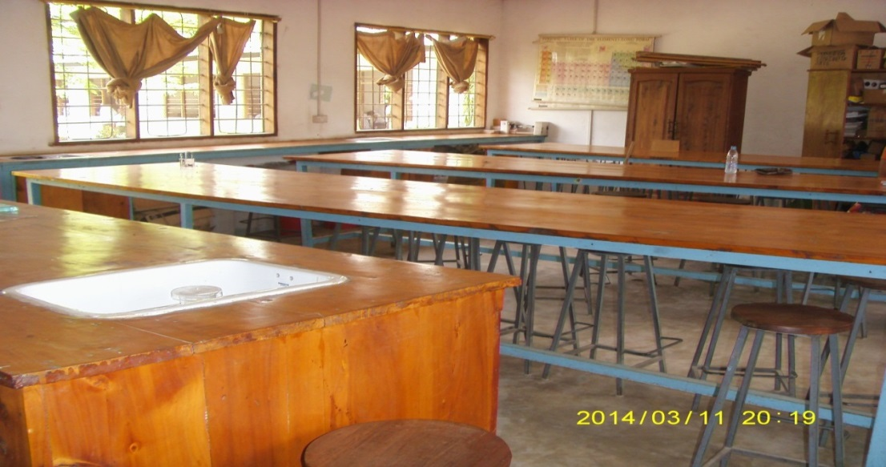 Figure 4.1 Laboratory at TurianiSeconda1

Figure 4.1: Laboratory at Turiani Secondary School

Figure 4.1 shows that the laboratory at Turiani Secondary School (S6) had no tap water connected to sinks. Instead, buckets are used as source of obtaining water. There were three benches (tables) instead of five according to requirements. Only periodic table was put on the wall. No other charts were observed on the walls, such as warning and safety signs charts.

In other sampled schools, cupboards were used to store apparatus such as voltmeter, ammeter and chemicals. Figure 4.2 shows cupboards ammeter, voltmeter and chemicals stored in this school.
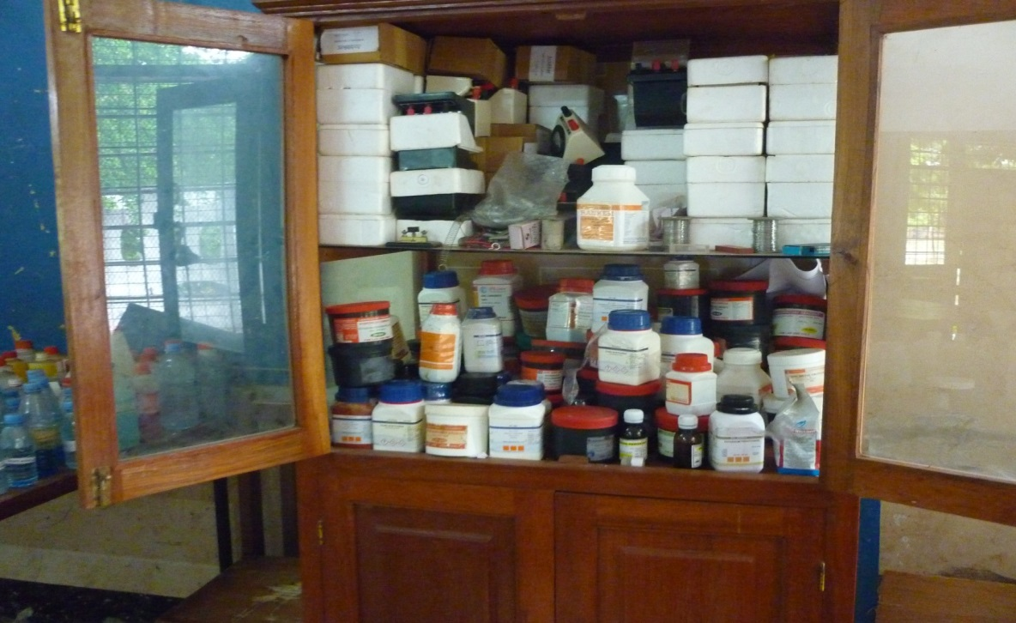 Figure 4.2 Cupboard for Storing Ammeter,

Figure 4.2: Cupboard for Storing Ammeter, Voltmeter and Chemicals at Oysterbay Secondary School

Figure 4.2 show that the upper part of the cupboard keeps ammeters, voltmeter, galvanometer and stopwatches and a containers of chemicals. This is dangerous because any leakage of a container can damage other apparatus. The lower part of the cupboard has different chemicals. This arrangement is not systematic. Those laboratory rooms have few wooden benches which are used for laying down apparatus and materials such as chemicals. Figure 4.3 shows apparatus on wooden bench in one of the schools. The apparatus are beakers, pipette, conical flasks and measuring cylinders.
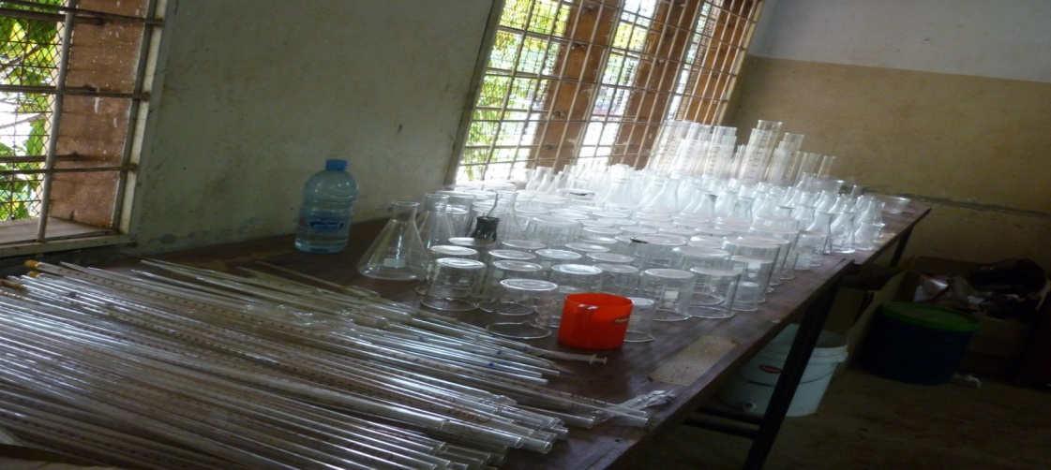

Figure 4.3: Bench for Storing Apparatuses at Mtakuja Secondary School

Figure 4.3 shows apparatus made of glass. The way burettes and pipettes are arranged makes them look like firewood. It is risk to handle apparatus made up of glass. The researcher observed that there is a poor system of handling apparatus because there are no enough cupboards to store apparatus. The system of handling apparatus is rather good in S6 as shown in Figure 4.4.
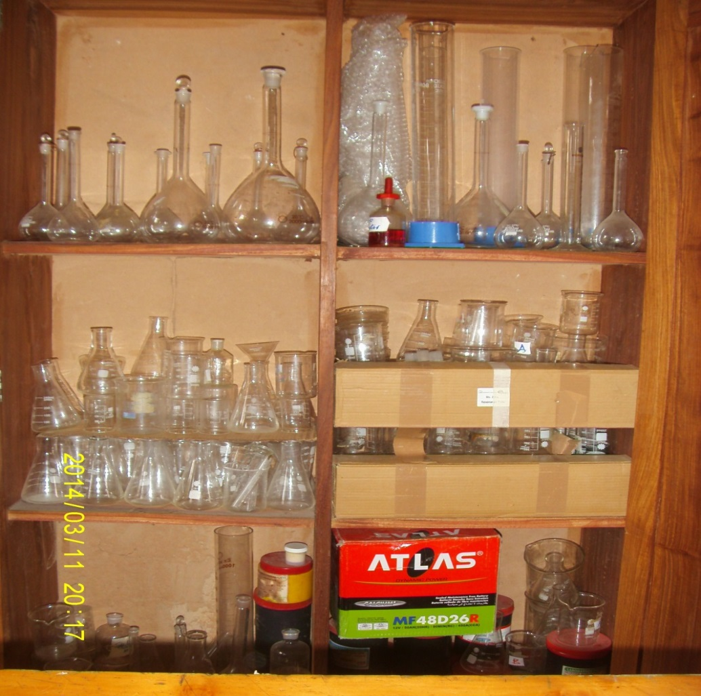 Figure 4.4 Cupboard at Turiani Storing V 1

Figure 4.4: Cupboard at Turiani Storing Volume Measuring Apparatus
Figure 4.4 shows volume apparatus stored in the cupboard such as round bottom flask of different sizes, conical flask, measuring cylinders and beaker. The arrangement is in good order as it is not easy to break apparatus. On the contrary, the tendency of keeping apparatus at Bunju A Secondary School can be observed on Figure 4.5.
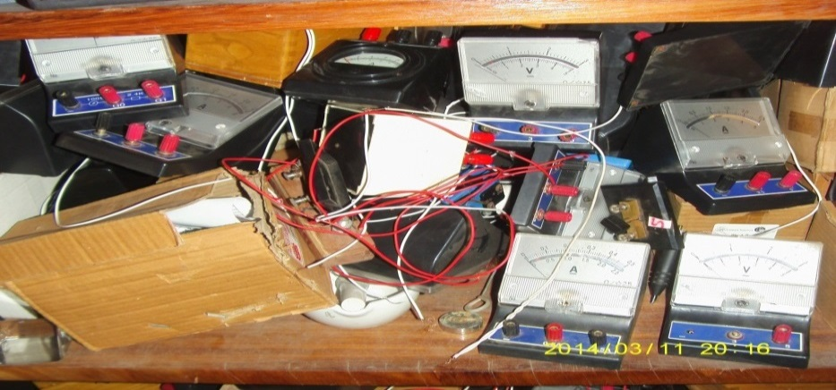

Figure 4.5: Ammeter and Voltmeter Stored in a Cupboard at Bunju A Secondary School

The apparatus shown in Figure 4.5 are ammeter and voltmeter. They look like a heap of stone. Other voltmeter still connected with wires while in the cupboard. It seems that after practical sessions, the apparatus are dumped rather than being disconnected and keeping them safely. All sampled schools used buckets as source of water. Bunju A, Kawe Ukwamani, Mtakuja, Mugabe and Oysterbay had no sinks in the science rooms. In all six sampled CSS the laboratories were used as multipurpose rooms where experiments for all science subjects, namely: Chemistry, Biology and Physics were conducted in the same room at different times.

4.2.2 Laboratory Rules and Safety Measures
As in all activities, safety in handling of chemicals and apparatus in the laboratory is the responsibility of every laboratory user. There is a set of rules which should be observed when carrying out experiments in the laboratory. No experiments should be performed in the laboratory without following proper procedures. In additional to laboratory rules, all of those involved in performing experiments in the laboratory must be aware of some safety measures. The researcher observed that in all these sampled schools no any warning signs, Fire extinguisher and First Aid Kit in these science rooms.

4.2.3 Laboratories Apparatus, Chemicals, Models and Specimen

4.2.3.1 Laboratory Apparatus
Availability of apparatus in the six sampled schools was obtained through observation and checklist. The findings in general indicated that some basic laboratory apparatus were found in CSS such as beakers, equipment for measuring volumes, test tubes, conical flask, tripod stand, wire gauze, meter rule, burettes, pipettes, stop watch and retort stands. Table 4.3 indicates availability of apparatus in sampled schools.

Table 4.2 shows availability of basic apparatus in the six sampled schools which are useful in science practical lessons. It was observed that in terms of apparatus were available in all sampled schools. This shows that these schools are trying to equip themselves with required apparatus though there are problems elsewhere.

Table 4.2 Availability of Apparatus in Sampled School
S/N | Item | Schools and amount of apparatuses
S/N | Item | S1 | S2 | S3 | S4 | S5 | S6
1 | Test tubes | 200 | 235 | 228 | 230 | 229 | 240
2 | Beakers (100cc/ 250cc) | 50 | 82 | 82 | 85 | 81 | 90
3 | Beakers (500cc) | 12 | 25 | 30 | 25 | 20 | 28
4 | Conical flask (100cc/250cc) | 50 | 80 | 78 | 80 | 83 | 85
5 | Conical flask 500cc | 10 | 15 | 15 | 15 | 15 | 15
6 | Test tube holders | 50 | 68 | 70 | 70 | 71 | 75
7 | Test tube racks | 30 | 40 | 40 | 41 | 42 | 40
8 | Measuring cylinder (100cc/200cc) | 20 | 36 | 40 | 42 | 40 | 46
9 | Measuring cylinder (250cc/500cc) | 15 | 25 | 25 | 27 | 30 | 30
10 | Reagent bottles (250cc capacity) | 70 | 86 | 87 | 85 | 90 | 90
11 | Pipette (20cc/25cc) | 45 | 51 | 50 | 52 | 50 | 55
12 | Beam balance | 1 | 1 | 1 | 1 | 1 | 1
13 | Droppers | 50 | 75 | 80 | 85 | 83 | 85
14 | Glass rod / steers | 50 | 58 | 60 | 59 | 60 | 57
15 | Hand lens | 20 | 38 | 40 | 43 | 45 | 42
16 | Retort stand | 40 | 68 | 70 | 70 | 64 | 73
17 | Wire gauze | 05 | 10 | 06 | 07 | 08 | 10
18 | Pendulum bob | 20 | 30 | 30 | 30 | 30 | 30
19 | Meter rule | 30 | 50 | 55 | 50 | 50 | 50
20 | Standard weights (10g,20g,……600g) | 25 | 35 | 50 | 45 | 45 | 50
21 | Spring balance | 18 | 32 | 34 | 40 | 40 | 35
22 | Voltmeter | 15 | 20 | 20 | 20 | 20 | 20
23 | Ammeter | 30 | 38 | 40 | 35 | 40 | 40
24 | Galvanometer | 03 | 05 | 05 | 05 | 05 | 05
25 | Rheostats / variable resistors | 05 | 10 | 10 | 10 | 10 | 10
26 | Resistance boxes | 20 | 40 | 40 | 40 | 40 | 40
27 | Switch / keys | 70 | 85 | 90 | 90 | 90 | 90
28 | Glass blocks | 30 | 50 | 48 | 47 | 48 | 50
29 | Thermometer | 18 | 24 | 20 | 20 | 22 | 25
30 | Vernier caliper | 01 | 04 | 03 | 03 | 03 | 05
31 | Micrometer screw gauge | 18 | 20 | 20 | 20 | 20 | 20
32 | Glass prisms | 10 | 15 | 12 | 14 | 15 | 15
33 | Stop watch | 25 | 30 | 35 | 35 | 32 | 36
34 | Meter bridge | 15 | 20 | 20 | 20 | 20 | 20

The findings reveal that some apparatus were totally absent in all sampled schools, including the equipment for doing special experiment such as beehives, condenser, kips apparatus, absorption vessel, and separating funnel. Further observation revealed that equipment such as student microscope, potential meters, cathode ray oscilloscope, colorimeters with jackets and pH meter were not found in the CSS. In spite of their total absence, they are important in science subjects, such that teachers use alternative means in teaching. As indicated in the syllabus, in case the commercial teaching and learning resources are not available, the teacher should work with the students to collect or improvise alternative resources available in their environment. For example, during the preparation of hydrogen and oxygen, the teacher conducted experiment using improvised wooden made beehives because the glass made equipment is not available.

4.2.4 Availability of Chemicals in the Six Sampled Schools
Findings through observation showed that most of the chemicals needed in the Chemistry, Physics and Biology subjects were present in the six sampled schools. Table 4.3 shows the availability of chemicals in the sampled schools. It is also shows that CSS seem to be well equipped with chemicals. Thus, the question is not on availability but on effective use as the second objective will explore. Findings show that basic chemicals for performing experiments are available. Moreover, some chemicals serve more than one purpose, such that missing of one is not an excuse as others can be used alternatively. For example, sodium chloride is used in qualitative analysis, properties of alkalis, sublimation and electrolysis. Basic acids are present, that is, sulphuric acid and hydrochloric acid. Figure 4.6 shows different chemicals stored on the bench at Mugabe Secondary school.

Table 4.3: Laboratory Chemicals in six Sampled Schools
S/N | Item | School and chemicals available *
S/N | Item | S1 | S2 | S3 | S4 | S5 | S6
1 | Ammonia solution | 2 | 4 | 4 | 4 | 3 | 4
2 | Benedict solution | 1 | 1 | 1 | 1 | 1 | 1
3 | Barium Chloride | 1 | 1 | 1 | 1 | 1 | 1
4 | Copper Sulphate | 1 | 1 | 1 | 1 | 1 | 1
5 | Copper Nitrate | 1 | 1 | 0 | 0 | 0 | 1
6 | Copper Chloride | 1 | 1 | 1 | 1 | 1 | 1
7 | Chloroform | 3 | 5 | 5 | 5 | 5 | 5
8 | Calcium Hydroxide | 1 | 2 | 2 | 2 | 2 | 2
9 | Calcium Carbonate | 1 | 1 | 1 | 1 | 1 | 1
10 | Ammonia Chloride | 2 | 2 | 2 | 2 | 2 | 2
11 | Ferrous Sulphate (Iron II Sulphate) | 0 | 0 | 2 | 2 | 2 | 2
12 | Ferric Chloride (Iron III Chloride) | 2 | 2 | 1 | 1 | 1 | 1
13 | Hydrochloric acid (concentrated) | 1 | 1 | 1 | 1 | 1 | 1
14 | Iodine Crystals | 1 | 1 | 1 | 1 | 1 | 1
15 | Lead Nitrate | 1 | 1 | 1 | 1 | 1 | 1
16 | Lead Carbonate | 1 | 0 | 1 | 1 | 0 | 1
17 | Litmus paper (blue & red) | 20 | 20 | 20 | 20 | 20 | 20
18 | Magnesium Sulphate | 0 | 1 | 1 | 0 | 1 | 0
19 | Magnesium Carbonate | 1 | 1 | 1 | 1 | 1 | 1
20 | Methylene orange powder | 1 | 1 | 1 | 1 | 1 | 1
21 | Manganese Dioxide | 1 | 1 | 1 | 1 | 1 | 1
22 | Nitric acid (concentrated) | 2 | 2 | 2 | 2 | 2 | 2
23 | Oxalic acid | 1 | 1 | 1 | 1 | 1 | 1
24 | Phenolphttialein powder | 1 | 1 | 1 | 1 | 1 | 1
25 | Sulphuric acid (concentrated) | 2 | 2 | 2 | 2 | 2 | 2
26 | Sodium Hydroxide | 1 | 1 | 1 | 1 | 1 | 1
27 | Sodium Carbonate (unhydrous) | 1 | 1 | 1 | 1 | 1 | 1
28 | Sodium Carbonate (hydrated) | 1 | 1 | 1 | 1 | 1 | 1
29 | Sodium chloride | 1 | 1 | 1 | 1 | 1 | 1
30 | Potassium Ferricyamide | 1 | 1 | 1 | 1 | 1 | 1
*Chemicals are in bottles of 500grams7
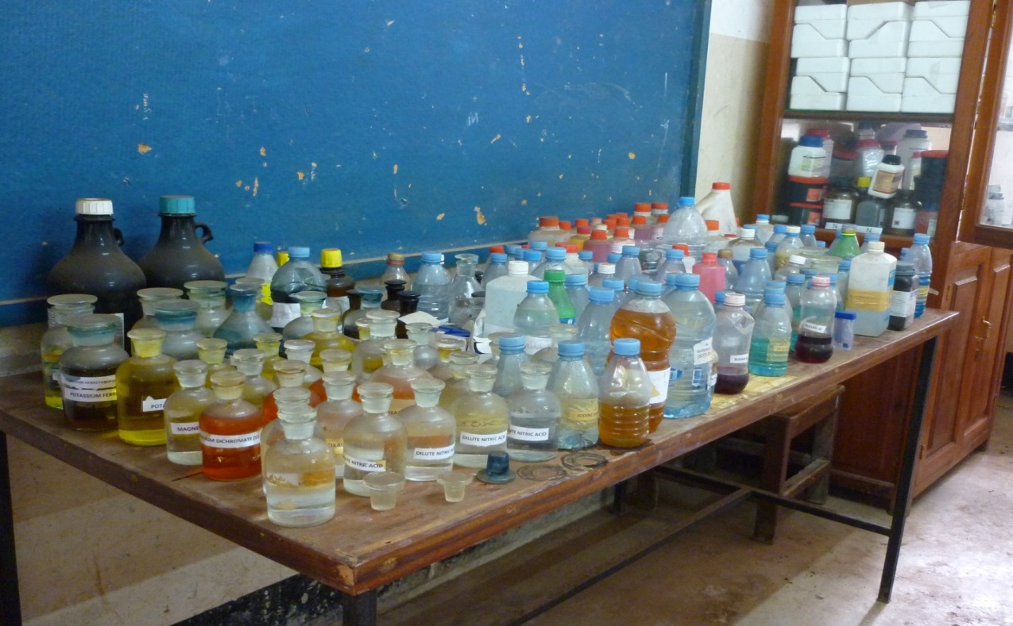

Figure 4.6: Chemicals Stored on a Bench at Mugabe Secondary School

Figure 4.6 shows chemicals on the bench. Observation shows that there are some improvisation of containers which stored some chemicals. Those containers are Uhai and Kilimanjaro plastic bottles. The containers store Sudan (III) solution, Benedict solution, Copper Sulphate solution and Iodine solution. Since scientific chemicals follow rules and regulations to store them it is better to follow those regulations in order to appreciate the spirit of science.

4.2.5 Laboratory Teaching Models
Teaching models are tools that teachers use in the classroom for imparting to students subject knowledge and skills and subject matter in an understandable way (Wikipedia, 2009). The findings show that the availability of teaching models, especially in Biology subject as recommended in the current syllabus (URT, 2010b) varied from one school to another. Since teaching models are meant to foster student’s understanding, they are supposed to be used all times according to the topic to stir up interest in the students towards the lesson and make students like the subject. Table 4.4 shows the availability of models in the sampled schools.

Table 4.4: Availability of Models in the six Sampled Schools
S/N | Item | Schools
S/N | Item | S1 | S2 | S3 | S4 | S5 | S6
1 | Eye | 0 | 1 | 1 | 1 | 11 | 1
2 | Ear | 0 | 1 | 1 | 1 | 1 | 1
3 | Heart | 0 | 0 | 1 | 1 | 1 | 1
4 | Kidney | 0 | 0 | 0 | 0 | 0 | 1
5 | Dental formula | 0 | 1 | 1 | 0 | 0 | 0
6 | Lung | 0 | 1 | 0 | 1 | 1 | 1
7 | Human body skeleton | 0 | 0 | 0 | 1 | 1 | 1
8 | Alimentary canal | 0 | 0 | 0 | 0 | 0 | 1
9 | Brain | 0 | 1 | 1 | 0 | 1 | 0
10 | Pancreas | 0 | 0 | 0 | 0 | 0 | 1

From Table 4.4, it can be deduced that the availability of models differs from one school to another. Bunju A had no any model while Kawe Ukwamani, Mtakuja and Mugabe have five models each. Oysterbay has six models and Turiani has eight models. These models belong to one group of Zoology, the mammal in the Biology subject. Since Bunju A did not have any model, the researcher observed the picture on the wall in the science room represents parts of respiratory system of human beings is used as a teaching aid as can be observed in figure 4.7.
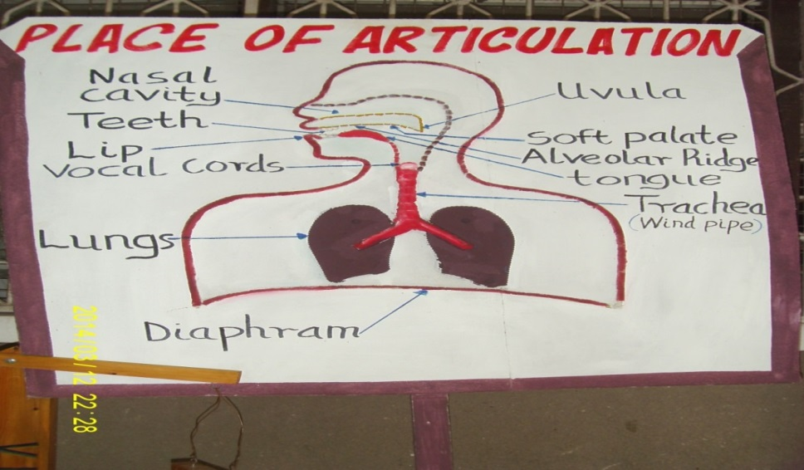igure 4.7 Place of Articulation

Figure 4.7: Place of Articulation Model at Bunju A Secondary school

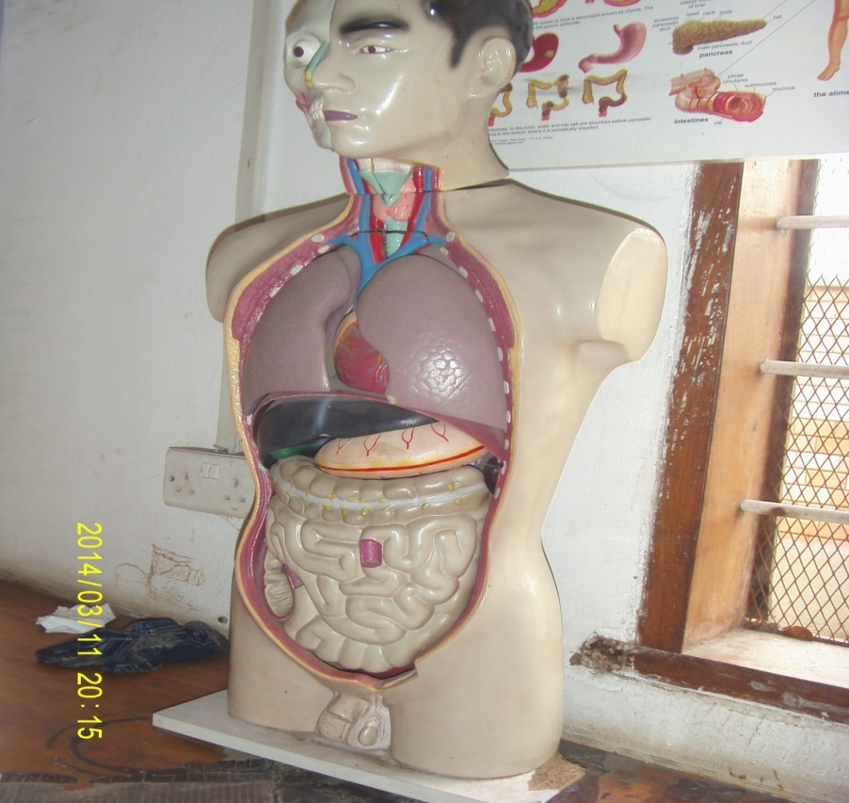
Figure 4.8: Models of Ear, Heart, Kidney and Eye at Kawe Ukwamani Secondary School 4 Models of Ear

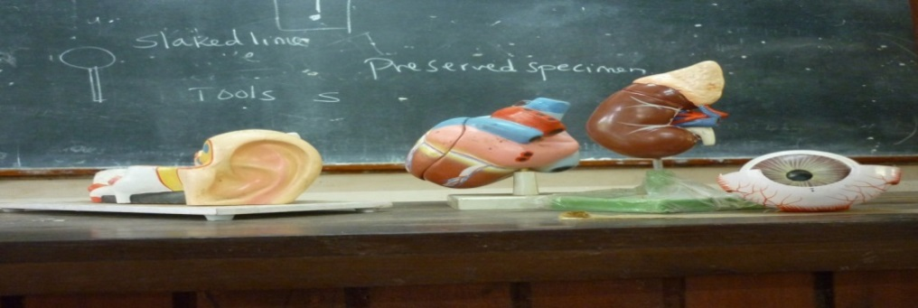
Figure 4.7 shows the labeled parts of respiratory system of human beings. The diagram was used when the teacher was teaching gaseous exchange and respiration. It demonstrates the movement of parts of the body during inhalation (inspiration) and exhalation (expiration) of air(oxygen and carbon dioxide). Other schools had models as is indicated in Figures 4.8 and 4.9.

Figure 4.9: Alimentary Canal at Turiani Secondary School
Figure 4.9 shows the model of alimentary canal showing digestion system of human being. It is used to show different parts from where different food sources are digested in human being. It shows also glands that have enzymatic reagents which when combined with food, they give out the end product of certain food substances according to food taken by the person. Apart from that the model can be dismantled to show heart, kidney, ear, eye, pancreas and lungs. This model has advantages compared to single organs as shown in figure 4.8. So it is easier for students to observe the relationship between those organs when learning its functions.

4.2.6 Specimen for Biology Subject Teaching
Specimen is part of teaching aids which teachers use in the classroom for imparting knowledge and skills in understandable way to students. Specimen for the Biology subjects are found outside and inside the science room. Findings show that some biological specimen are stored in reserved bottles as shown in Figure 4.10.
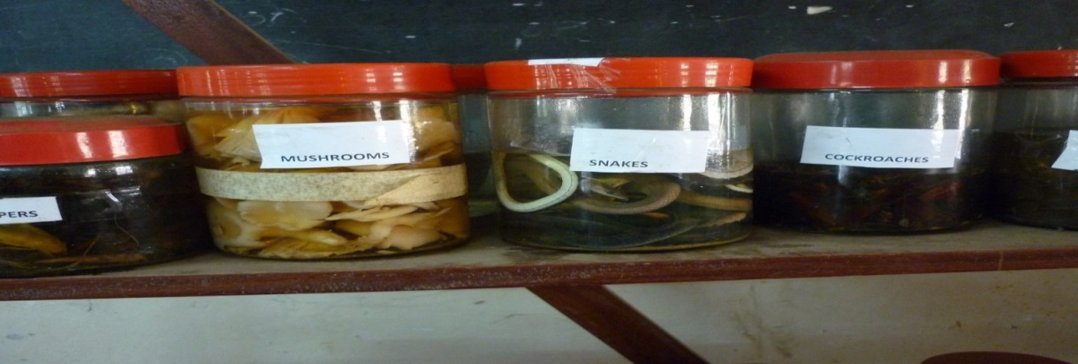

Figure 4.10: Biological Specimen Preserved at Mugabe Secondary School

Figure 4.4 shows mushrooms, snakes and cockroaches. Mushrooms are specimens belonging to kingdom Monera. They are used in practical lessons when teaching the topic of classification of living things or organisms and are found in dead organic matters. Snakes belong to kingdom Animalia and phylum chodata. In practical lessons they are used to represent the class of mammals that are vertebrates. Cockroaches are belonging to the kingdom Animalia and phylum Anthropode and in practical lesson represent invertebrates and are found in the class insects.

4.3 Laboratory Use
The second research objective intended to assess the uses of laboratories. The purpose was to establish whether or not laboratories were effectively used in schools so as to contribute to academic performance in science subjects. Experiments are part and parcel of the current competence based curriculum. According to Omosewo (2006) a deeper understanding of the science and technology process can be achieved through laboratory activities, which encourages active participation and serves to develop critical thinking. Laboratories provide concrete experiences to substantiate the theoretical aspect that has been taught. Laboratory teaching promotes the development of cognitive abilities such as problem-solving, analysis, generalizing, evaluating, decision making and creativity (Tilya,2003. Mafumiko, 2006). They also promote psychomotor and affective domains as they involve practical activities and collaboration among students, teachers and technicians. If students are not doing experiments, the desired competences cannot be developed.

4.3.1 Timetable on use of Laboratories
Data on use of laboratories were obtained through observation. The timetable showed that each stream used the laboratory once in a week. Findings showed that teachers took apparatus to classrooms for demonstration and to conduct practical session, because the science rooms had no space for practical. This was observed in all sampled schools. The science rooms in these schools were used for storage and preparation. However, the timetable for candidate classes (Form IV) includes remedial classes, where students spend more time doing practical work after class hours in all sampled schools.

4.3.2 Classroom Observation on the use of Laboratory
This section presents different science teaching practices which were noted during classroom observation. In one of the observations that the researcher made at S5, the teacher was teaching the topic namely preparation of chlorine gas in the form four class. Figure 4.7 shows a chemistry teacher demonstrating the preparation of chlorine gas. The practical was conducted in an open space due to absence of fume chamber since chlorine gas is poisonous.
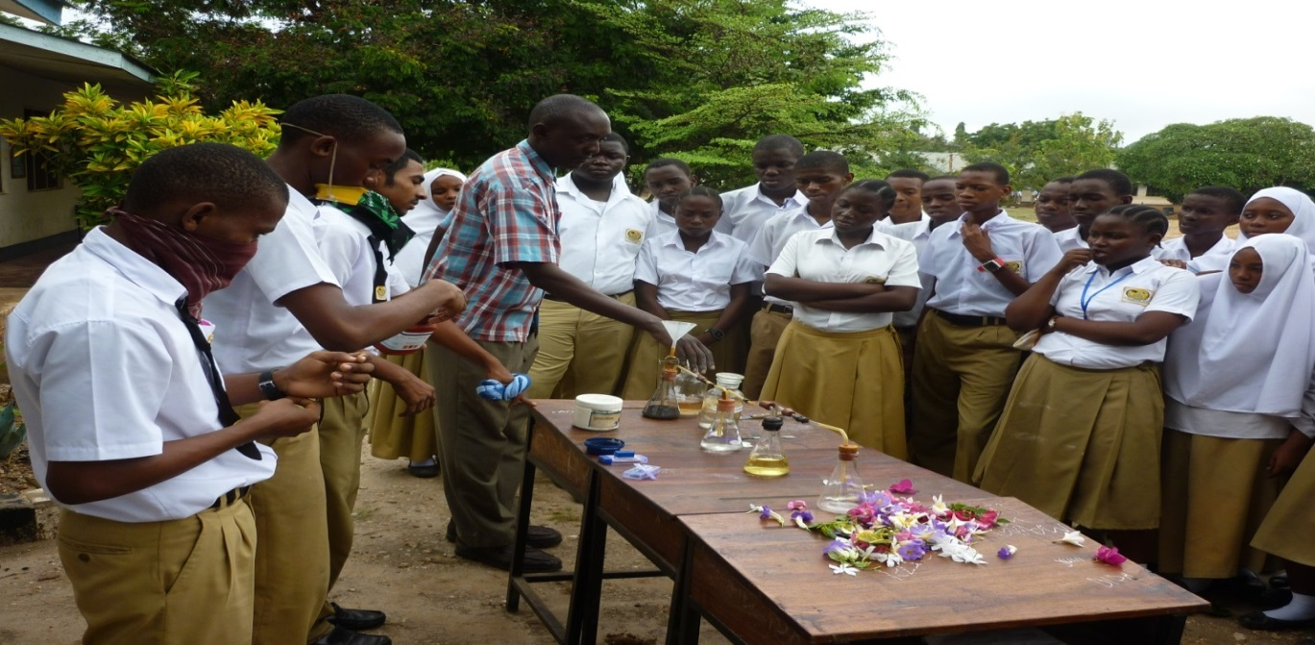

Figure 4.11: A Practical Class in an open Air space: Preparation of Chlorine Gas at Oysterbay Secondary School
Figure 4.11 shows a Chemistry teacher demonstrating how to prepare chlorine gas. Flowers of different colors on the table were there to be used to confirm the presence of chlorine gas. When chlorine gas passed through the flower, the flowers decolorized. This lesson aimed to show the bleaching action of chlorine gas.

Laboratory observation indicated that practical were done with a large group of students (10 to 20). The findings showed that teachers faced problems in organizing the group members. As such, not each student is able to participate in the learning process. Findings too, showed that only few students benefited by dominating and participating fully in practical sessions while others remained as observers who at the end lacked the skills and knowledge of planned laboratory experiment.
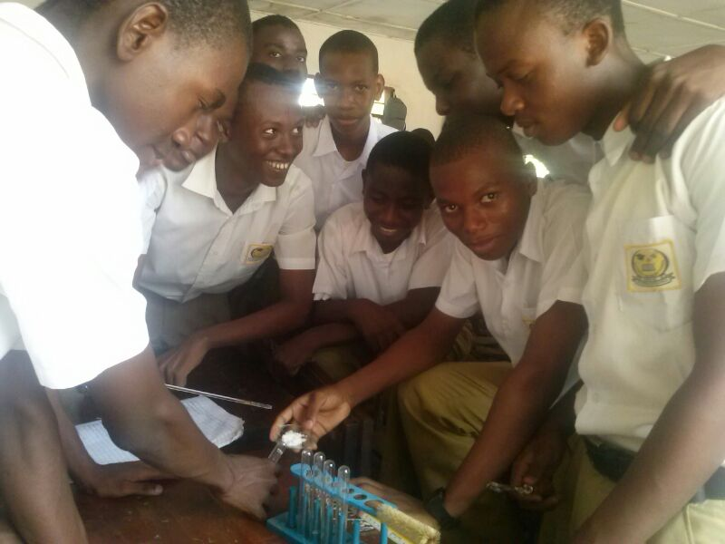

Figure 4.12: Group Performingan Experiment at Mtakuja Secondary School

Figure 4.12 shows students in group performing practical on qualitative analysis. The group is too big for other students to pay attention to the task. Furthermore, findings revealed that when teacher demonstration was done in the overcrowded class due to small laboratory space, students who sit in front desks near the teacher’s table benefited much while those at the back got problems in observing and understanding the procedures and hence fail to comprehend the concepts and topic in general. Effective learning demands good relationship between the teacher and learners in a well-organized classroom and that teachers make proper use of the appropriate teaching methods (URT,2005).

4.4 Availability of Human Resources in Community Secondary Schools
The third objective in the study intended to relate the availability of science subject teachers in CSS with performance. If learning were a one-way process, we would learn perfectly, satisfactorily from books and videos, and teachers would be just unnecessary irritation (Petty, 2009). It means that learning is a two-way process a teacher as facilitator to promote, guide and help learning activities while students learns by doing series of logical activities which leads to participatory method. Teachers are important for any school to have effective science practical learning. The conceptual framework of the present study suggests that if the students learn science in secondary school in appropriate ways the performance of the student would improve. Table 4.5shows the availability of teachers in the sampled schools.

Table 4.5 indicates that there is shortage of science teachers in all sampled schools. Bunju A has no graduate science teacher for all science subjects. In Kawe Ukwamani there was no graduate available for physics subject. The same was the case in Mtakuja where Biology graduate teacher was missing. In Mugabe had no Physics and Chemistry graduates teachers. In Oysterbay and Turiani were well equipped with graduates teachers in science subjects. Shortage of Biology teachers in the sampled six schools range from 16.6% to 50%. While shortage of teachers in Chemistry for five sampled schools is 33.3% except at Turiani which is well equipped with teachers in the chemistry subject. This shows that there is a great demand in the Physics subject in all sampled schools for both diploma and degree holders.
School | Size of class | Number of students | Number of stream | Subject | Availabilty of teachers |  |  |  |  |  | Teaching load per week | TPR in science subject
 |  |  |  |  | Required |  | Available |  | Deficiency |  | Teaching load per week | TPR in science subject
 |  |  |  |  | Dip | Bsc | Dip | Bsc | Dip | Bsc | Teaching load per week | TPR in science subject
S1 | 51 | 809 | 16 | Bio | 2 | 1 | 2 | 0 | 0 | 0 | 20 | 1:405
S1 | 51 | 500 | 10 | Chem | 2 | 1 | 2 | 0 | 0 | 1 | 20 | 1:250
S1 | 51 | 500 | 10 | Phy | 2 | 1 | 1 | 0 | 1 | 1 | 30 | 1:500
S2 | 71 | 1392 | 16 | Bio | 2 | 2 | 1 | 1 | 1 | 1 | 30 | 1:464
S2 | 71 | 915 | 10 | Chem | 2 | 1 | 1 | 1 | 1 | 0 | 22 | 1:458
S2 | 71 | 915 | 10 | Phy | 2 | 1 | 1 | 0 | 1 | 1 | 44 | 1:915
S3 | 78 | 1135 | 16 | Bio | 2 | 2 | 2 | 1 | 0 | 1 | 20 | 1:378
S3 | 78 | 785 | 10 | Chem | 2 | 1 | 1 | 1 | 1 | 0 | 20 | 1:393
S3 | 78 | 785 | 10 | Phy | 2 | 1 | 1 | 0 | 1 | 0 | 38 | 1:785
S4 | 87 | 1240 | 16 | Bio | 3 | 2 | 2 | 2 | 1 | 0 | 21 | 1:413
S4 | 87 | 840 | 10 | Chem | 2 | 1 | 2 | 0 | 0 | 1 | 20 | 1:420
S4 | 87 | 840 | 10 | Phy | 2 | 1 | 1 | 0 | 1 | 1 | 30 | 1:840
S5 | 77 | 1226 | 16 | Bio | 2 | 2 | 1 | 2 | 1 | 0 | 30 | 1:409
S5 | 77 | 820 | 10 | Chem | 2 | 1 | 0 | 1 | 2 | 0 | 44 | 1:820
S5 | 77 | 820 | 10 | Phy | 2 | 1 | 0 | 2 | 1 | 0 | 30 | 1:410
S6 | 70 | 1406 | 20 | Bio | 3 | 3 | 2 | 3 | 1 | 0 | 30 | 1:281
S6 | 70 | 948 | 14 | Chem | 2 | 1 | 1 | 2 | 0 | 0 | 26 | 1:474
S6 | 70 | 948 | 14 | Phy | 2 | 1 | 2 | 0 | 0 | 1 | 26 | 1:474

Table 4.5: Availability of Science Teachers in Sampled Schools

Findings through observation and school records indicate that Bunju A has one Physics teacher for all classes. The head of school was looking for part time teachers since previous part time teacher had resigned. At Mtakuja hired one Physics teacher from private secondary school and laboratory technician to try to fill the gap from private secondary schools. School Mugabe hired one Chemistry Physics teacher to fill the gap. At Kawe Ukwamani uses teachers on study leave on weekend days and holidays that is, those who were currently, teaching there Physics and Chemistry. At Oysterbay hired one Chemistry teacher who is not employed to fill the gap. Furthermore, findings reveal that despite the guidelines that direct graduates to teach form three and form four classes, (URT, 2005) diploma holders do teach more than form 1 and form 2. The allocation of periods does not follow those guidelines due to shortage of teachers. The researcher observed that in all six sampled schools, there are shortages of science graduates teachers especially for Physics and Chemistry in these community secondary schools.

In general, the findings from objective three show that teachers were inadequate and therefore could not teach science well as suggested in the syllabi. Since the teacher is at the heart of classroom instruction (Galabawa, 2001),the effectiveness of students’ performance is affected by teachers availability. Teachers’ competence (academically and pedagogically) and efficiency (ability, work load and commitment), are important in additional to teaching and learning resources and methods (Mosha, 2004). The teaching load in science subjects ranges from 20 periods to 44 periods per week. These period too many since one stream is two in one as shown in table 4.7. This lowered the efficiency in the teaching process in most of these schools. The TPR is wider as shown in the Table 4.5 in all science subjects also the class size is not standard.

4.4.1 Availability of Human Resources, Laboratory and Use of Laboratory on Students Performance
In educational institutions, success is measured by academic performance. Measuring of student academic performance in science subjects is a product of many factors, including the extent of availability of laboratory and facilities and sufficiency use of those facilities. The use of facilities it depend on the human resource available in school, it means teachers and laboratory technicians. Table 4.6 shows the number of students who sat for Biology, Chemistry and Physics national examinations and their results for 2010 – 2012 years.

Table 4.6: Performance of Students in CSEE 2010 – 2012 for Science Subjects
Name of school | Year | Biology Grades |  |  |  |  |  | Chemistry Grades |  |  |  |  |  | Physics Grades
 |  | A | B | C | D | F | Total | A | B | C | D | F | Total | A | B | C | D | F | Total
S1 | 2010 | 0 | 0 | 0 | 0 | 0 | 000 | 0 | 0 | 0 | 0 | 0 | 0 | 0 | 0 | 0 | 0 | 0 | 00
S1 | 2011 | 0 | 0 | 1 | 18 | 94 | 103 | 0 | 0 | 0 | 2 | 12 | 14 | 0 | 0 | 0 | 3 | 11 | 14
S1 | 2012 | 0 | 2 | 122 | 31 | 92 | 137 | 0 | 0 | 4 | 11 | 24 | 39 | 0 | 0 | 01 | 12 | 26 | 39
S2 | 2010 | 0 | 1 | 07 | 31 | 387 | 427 | 1 | 7 | 20 | 17 | 11 | 56 | 0 | 5 | 14 | 21 | 21 | 54
S2 | 2011 | 0 | 0 | 08 | 94 | 164 | 276 | 0 | 0 | 16 | 25 | 06 | 47 | 0 | 0 | 04 | 30 | 13 | 47
S2 | 2012 | 0 | 2 | 04 | 36 | 196 | 238 | 0 | 1 | 5 | 19 | 17 | 44 | 0 | 0 | 02 | 16 | 24 | 44
S3 | 2010 | 0 | 5 | 10 | 86 | 358 | 459 | 2 | 4 | 09 | 22 | 52 | 89 | 2 | 2 | 09 | 34 | 42 | 89
S3 | 2011 | 0 | 0 | 12 | 87 | 222 | 321 | 0 | 4 | 06 | 14 | 23 | 47 | 0 | 1 | 1 | 18 | 27 | 47
S3 | 2012 | 0 | 12 | 63 | 91 | 162 | 332 | 0 | 8 | 40 | 43 | 12 | 103 | 0 | 1 | 33 | 45 | 24 | 103
S4 | 2010 | 0 | 1 | 10 | 64 | 266 | 338 | 1 | 4 | 20 | 13 | 15 | 53 | 1 | 3 | 18 | 28 | 02 | 53
S4 | 2011 | 0 | 4 | 07 | 60 | 92 | 162 | 0 | 3 | 09 | 30 | 10 | 53 | 0 | 0 | 22 | 24 | 08 | 53
S4 | 2012 | 0 | 0 | 14 | 36 | 128 | 191 | 0 | 0 | 09 | 14 | 17 | 40 | 0 | 0 | 04 | 07 | 24 | 38
S5 | 2010 | 0 | 0 | 13 | 87 | 301 | 401 | 0 | 0 | 7 | 50 | 11 | 64 | 0 | 1 | 15 | 33 | 4 | 63
S5 | 2011 | 0 | 2 | 21 | 102 | 110 | 235 | 3 | 1222 | 9 | 26 | 05 | 55 | 0 | 0 | 23 | 26 | 6 | 55
S5 | 2012 | 0 | 5 | 25 | 44 | 77 | 158 | 0 | 2 | 19 | 25 | 00 | 46 | 0 | 1 | 8 | 25 | 12 | 46
S6  11 | 2010 | 0 | 1 | 24 | 102 | 314 | 541 | 1 | 5 | 24 | 32 | 29 | 91 | 2 | 8 | 24 | 35 | 20 | 89
S6  11 | 2011 | 1 | 8 | 17 | 119 | 177 | 322 | 1 | 5 | 22 | 17 | 14 | 59 | 0 | 0 | 14 | 33 | 12 | 59
S6  11 | 2012 | 0 | 5 | 28 | 50 | 142 | 219 | 0 | 5 | 11 | 16 | 20 | 52 | 0 | 3 | 9 | 19 | 21 | 52
Source: National Examination Council of Tanzania (2010, 2011, 2012).

Table 4.6 indicates that out of 1451 candidates from the six sampled schools who sat for the Biology exam in the year 2011, only 538 (40.2%) passed at the A to D grades. The rest scored grade F which means they failed the examination. In 2012 only 37.5 percent scored grade A to D. The performance of science subjects in S1 shows that in the year 2011 no candidate obtained grade A and B in Biology, no candidate obtained grade A, B and C in Chemistry and physics. In S2, no candidate obtained grade A and B in all science subjects. In S3 and S4, no candidate obtained grade A in all science subjects. In S5, three candidates obtained grade A in Chemistry but no grade A in Biology and Physics. In S6, one candidate obtained grade A in Biology, one candidate obtained grade A in Chemistry but there was no grade A in Physics. Table 4.6 shows pass of grades in science subjects in sampled schools.

Table 4.7: Pass Grades in Science Subjects in the Year 2011 and 2012
School | Year | Biology |  |  | Chemistry |  |  | Physics
School | Year | Sat | A-C grade | % A-C grade | Sat | A-C grade | % A-C grade | Sat | A-C grade | % A-C grade
S1 | 2011 | 103 | 01 | 0.9 | 14 | 00 | 0.0 | 14 | 00 | 0.0
S1 | 2012 | 137 | 14 | 8 | 39 | 04 | 10.3 | 39 | 01 | 2.6
S2 | 2011 | 276 | 08 | 2 | 47 | 16 | 34 | 47 | 04 | 8.5
S2 | 2012 | 238 | 06 | 2.5 | 44 | 06 | 13.6 | 44 | 02 | 4.5
S3 | 2011 | 321 | 12 | 3.7 | 47 | 10 | 21.3 | 47 | 02 | 4.3
S3 | 2012 | 332 | 75 | 22.6 | 103 | 48 | 46.6 | 103 | 34 | 23.3
S4 | 2011 | 162 | 11 | 6.8 | 53 | 09 | 17 | 53 | 22 | 41.5
S4 | 2012 | 191 | 14 | 7.3 | 40 | 09 | 22.5 | 38 | 04 | 10.5
S5 | 2011 | 235 | 23 | 9.8 | 55 | 24 | 43.6 | 55 | 23 | 41.8
S5 | 2012 | 158 | 30 | 19 | 46 | 21 | 45.7 | 46 | 09 | 19.6
S6 | 2011 | 322 | 26 | 8.1 | 59 | 28 | 47.5 | 59 | 14 | 23.7
S6 | 2012 | 219 | 33 | 15.1 | 52 | 16 | 30.8 | 52 | 12 | 23.1

Table 4.7 indicates that the percentage pass in science subject in the year 2011 and 2012. In S1, the percentage pass of Biology was 0.09 (2011) and 8 (2012), in Chemistry was 0 (2011) and 10.3 (2012) and in physics was 0 (2011) and 2.6 (2012).In S2, the percentage pass for Biology was 2 (2011) and 2.5 (2012), in Chemistry was 34 (2011) and 13.6 (2012) and in Physics was 8.5 (2011) and 4.5 (2012). In S3, the percentage pass in Biology was 3.7 (2011) and 22.6(2012), in Chemistry was 21.3(2011) and 46.6 (2012) and in Physics was 4.3 (2011) and 23.3 (2012). In S4, the percentage pass in Biology was 6.8 (2011) and 7.3 (2012), in Chemistry was 17 (2011) and 22.5 (2012) and in Physics was 41.5 (2011) and 10.5 (2012).
In S5, the percentage pass in Biology was 9.8 (2011) and 19 (2012), in Chemistry was 43.5 (2011) and 45.7 (2012) and in Physics was 41.8 (2011) to 19.6 (2012). In S6 percentage pass in Biology was 8.1(2011) and 15.1 (2012), in Chemistry 47.5 (2011) and 30.8 (2012) and in Physics was 23.7 (2011) and 23.1 (2012). These science subject results have been fluctuating from year to year, subject to subject. Also neither school nor subject had candidates passed above 50% in these two years. Findings in the second objective of the study provide the picture that laboratory use in CSS, is affected by the large number of students in one stream which result to big size group when performing practical. As a result, few students who dominate the process by handling apparatus and following the procedure perform well in examination majority lack the knowledge this a result of poor performance in science subjects.

4.5 Perceptions of Teachers on the Availability and Use of Laboratories
The fourth objective sought teachers’ perceptions on the availability and use of laboratories and how this influenced students’ performance. The first part was on the teacher’s perceptions on the availability of laboratories and while the second part was be on the use of laboratories. Table 4.8 shows teachers’ perceptions on the availability of laboratories and the opinions of teachers on the availability of laboratories, show that laboratories are essential in teaching science subjects, as laboratory equipment help the teachers to link theory and real situation through practical done in the laboratories. 100% of the respondents agreed that availability of laboratory has greater influence on student’s performance in science subjects.92% of respondents agree that the availability of materials and chemicals influences the performance on science subjects; That is, if equipment and chemicals are available, students’ chance to perform better increases.

Table 4.8 Teachers’ Perceptions on the Availability of Laboratories (N=36)
S/N | Item | School | Strongly  Agree | Agree | Disagree | Strongly  Disagree
i | Availability of laboratory has greater influence on students’ performance in science subjects | S1 | 5 | 1 | 0 | 0
i |  | S2 | 3 | 3 | 0 | 0
i |  | S3 | 4 | 2 | 0 | 0
i |  | S4 | 5 | 1 | 0 | 0
i |  | S5 | 5 | 1 | 0 | 0
i |  | S6 | 4 | 2 | 0 | 0
ii | The availability of materials and chemicals influences the performance on science subjects. | S1 | 3 | 3 | 0 | 0
ii |  | S2 | 4 | 2 | 0 | 0
ii |  | S3 | 3 | 2 | 1 | 0
ii |  | S4 | 2 | 3 | 1 | 0
ii |  | S5 | 4 | 1 | 1 | 0
ii |  | S6 | 3 | 3 | 0 | 0
iii | The class population, laboratory space and facilities may affect effectiveness of practical works. | S1 | 5 | 1 | 0 | 0
iii |  | S2 | 5 | 1 | 0 | 0
iii |  | S3 | 4 | 2 | 0 | 0
iii |  | S4 | 3 | 3 | 0 | 0
iii |  | S5 | 2 | 4 | 0 | 0
iii |  | S6 | 6 | 0 | 0 | 0
iv | Teaching load affects practical lessons | S1 | 3 | 3 | 0 | 0
iv | Teaching load affects practical lessons | S2 | 2 | 4 | 0 | 0
iv | Teaching load affects practical lessons | S3 | 4 | 2 | 0 | 0
iv | Teaching load affects practical lessons | S4 | 3 | 3 | 0 | 0
iv | Teaching load affects practical lessons | S5 | 1 | 5 | 0 | 0
iv | Teaching load affects practical lessons | S6 | 0 | 6 | 0 | 0
v | Support to teachers from head of school influences effectiveness of practical lessons | S1 | 3 | 3 | 0 | 0
v |  | S2 | 2 | 4 | 0 | 0
v |  | S3 | 3 | 3 | 0 | 0
v |  | S4 | 3 | 3 | 0 | 0
v |  | S5 | 4 | 2 | 0 | 0
v |  | S6 | 2 | 3 | 1 | 0

100% of respondents agreed that the class population, laboratory space and facilities may affect the effectiveness of practical work. This it implies that with large classes some students cannot participate well. 100% of respondents agreed that teaching load affects practical lessons. Heavy teaching load observed to science teachers, teachers lack time to prepare experiments. 97% of teachers agreed that support to teachers from heads of school influence effectiveness of practical lessons. Since, heads of schools are the facilitator in terms of materials used in the laboratories.
Table 4.9 opinions of teachers on the use of laboratories show that 100% of respondents agreed that practical lessons have greater influence on the performance of science subjects.61% of respondents agreed that practical sessions may be conducted without laboratories as an optional aspect. 72% of respondents agreed that improvisation has greater influence on student performance. 81% of respondents disagreed that practical sessions need to be done by laboratory technicians. 81% disagreed that teachers skills on science practical activities affect practical lessons, hence performance.

Table 4.9: Teachers’ Perceptions on Use of Laboratories
SN | Item | School | Strongly agree | Agree | Disagree | Strongly disagree
i | Use of laboratory has greater influence on student’s performance in science subjects | S1 | 5 | 1 | 0 | 0
i |  | S2 | 3 | 3 | 0 | 0
i |  | S3 | 4 | 2 | 0 | 0
i |  | S4 | 5 | 1 | 0 | 0
i |  | S5 | 5 | 1 | 0 | 0
i |  | S6 | 4 | 2 | 0 | 0
ii | Practical sessions may be conducted even without laboratories. | S1 | 0 | 5 | 0 | 1
ii |  | S2 | 0 | 2 | 3 | 1
ii |  | S3 | 0 | 3 | 2 | 1
ii |  | S4 | 0 | 3 | 2 | 1
ii |  | S5 | 0 | 5 | 0 | 1
ii |  | S6 | 0 | 4 | 1 | 1
iii | The use of locally made materials may help when the required materials not available. | S1 | 0 | 4 | 2 | 0
iii |  | S2 | 1 | 3 | 2 | 0
iii |  | S3 | 1 | 4 | 1 | 0
iii |  | S4 | 0 | 5 | 1 | 0
iii |  | S5 | 4 | 2 | 0 | 0
iii |  | S6 | 2 | 2 | 2 | 0
iv | Supervision of practical activities should involve laboratory technicians and teachers together. | S1 | 0 | 2 | 3 | 1
iv |  | S2 | 1 | 2 | 2 | 1
iv |  | S3 | 0 | 2 | 4 | 0
iv |  | S4 | 0 | 3 | 2 | 1
iv |  | S5 | 0 | 1 | 4 | 1
iv |  | S6 | 0 | 3 | 3 | 0
v | Some teachers’ skills on science practical activities affect practical lessons, hence performance. | S1 | 1 | 2 | 3 | 0
v |  | S2 | 0 | 1 | 4 | 1
v |  | S3 | 0 | 0 | 4 | 2
v |  | S4 | 0 | 0 | 3 | 3
v |  | S5 | 0 | 1 | 5 | 0
v |  | S6 | 0 | 2 | 4 | 0

4.6 Summary of the Chapter
The present study revealed that, First CSS has no proper laboratories instead of having science rooms which plays part of laboratory. These science rooms had no fume chambers, so that practical on poisons gas are not allowed in those rooms. Floors are slippery, no safety and warning charts on walls this is dangerous for the uses in case for an accident, it is difficult to the victim to take precaution. However they were equipped with equipment, apparatus, chemicals and specimens though expensive equipment was absent in all sampled schools. They use improvised materials, chemicals and equipment in order to make sure that all topics are taught as directed in the syllabus.

Secondly, timetable for laboratory use was not properly followed. Teachers they prefer to conduct practical in classrooms especially for Biology subjects, since the subject is compulsory. Most of laboratory activities were done in groups, and groups are big in size. Practical need some preparations, due to lack of time for experiment preparation necessitated the teacher to plan to attend practical laboratories after classroom hours. Thirdly, there was a shortage of teachers in all sampled schools. This made the teachers to be not able to identify and deal with slow learners when attending practical sessions. Lastly, perception of teachers on the availability and use of laboratories in relation to performance indicates that practical teaching influence students performance.

CHAPTER FIVE

5.0 DISCUSSION OF THE RESEARCH FINDINGS

5.1 Introduction
This chapter presents discussion of the research findings. This study dealt with an assessment of effects of availability and use of laboratories in Community Secondary School in Tanzania. The study was concerned with the relationship between availability and use of laboratories in the teaching and learning of science subjects namely Biology, Chemistry and Physics on the one hand, and academic performance, on the other.

5.2 Availability of Laboratories in CSS
Science subjects require availability of laboratories with facilities to develop manipulative skills and knowledge acquisition. Many studies show the insufficiency of laboratory equipment in CSS. This is supported by Kibga, (2004), Chonjo & Welford, (2001), in their studies which indicate that Tanzanian schools had no well-furnished laboratory to support science subjects teaching. In the words of Ajileye, (2006) insufficient resources for teaching and learning science constitute a major cause for student under achievement. These insufficient resources include laboratories, science equipment and specimen to be used as teaching aids.

Effective science teaching needs well equipped laboratories. However, results from observation and checklist showed that, these sampled CSS had no proper laboratories; instead they had science rooms with some equipment, apparatus and chemicals. The science room is storage of apparatus, chemicals, models and specimen. These science rooms lack space for conducting experiments. In the absence of industrial apparatus and chemicals, science teachers improvised those apparatus and chemicals.

One of the strategy and activities highlighted in EDSP 2008-2017 which will be addressed through SEDP II 2010-2015 include to enable practical sciences to be delivered through well-stocked science laboratories (URT, 2010). The government of Tanzania with the Ministry of Education and vocational Training has been making efforts to stabilize the situation providing first, teachers’ guide using locally available materials in science subjects (URT, 2011) and capitation grants.

Guidelines on provision of development capitation fund from the government in 2012 with Ref KMC/ED/SS/C.3/1 directed heads of schools to purchase laboratory equipment and chemicals in their schools. However, the schools failed to purchase expensive apparatus such as, Kipps apparatus, student microscope, cathode ray oscilloscope, calorimeters with jackets and pH meter. Nevertheless missing of equipment and apparatus is not the excuse of not doing experiments. According to science syllabi guidelines, in case the commercial teaching and learning resources are not available, the teacher should work with students to collect or improvise alternative resources available in their environment (URT, 2010 a). It may be claimed that after provision of the capitation and improvisation of materials from the environment, the performance has tended to start improving.

Locally designed or low cost materials have been found to be effective in teaching several topics in science subjects as figure 4.6 shows. There is an improvisation of containers such as Uhai and Kilimanjaro plastic bottles, as an alternative way to reduce scarcity of laboratory equipment of laboratory equipment in science subject teaching. On determination of pH of different acids and bases with the help of pH paper, teachers use low cost apparatus such as cups of tea, wooden spoon, wooden funnel, cotton cloths and acids such as lemon juice (citric acid) vinegar (CH₃COOH) and base such as NaCO₃, caustic soda and NaCl these are low cost chemicals.

Though the government of Tanzania put much effort on the supply of apparatuses in CSS, the storage facilities in science rooms are found to be very poor and apparatuses are stored in un-appropriate way as it shown in the Figure 4.3 grass apparatuses: beakers, pipette, burettes, conical flasks and measuring cylinders are stored in table. This poor storage may lead to loss and damage of apparatuses also can cause injuries. The government should build laboratories or ensure science rooms are also supplied with proper storage facilities including cabinets and drawers in order to ensure the long lasting of laboratory apparatuses in schools.

5.3 Use of laboratories
Use of laboratories is among the prerequisites teaching science subjects as suggested in the O-level syllabi of science subjects that is Biology, Chemistry, and Physics. Students are encouraged to work in small groups for maximum participatory and cooperative learning (URT, 2010 a). Mosha (2004) defines participatory approach as a technique believed to foster active learning so that individual learners can cope with the current challenges and changes. It requires teachers and students to have equal participation during the learning process. Teachers are advised to use participatory teaching and learning strategies as much as possible to help learners to demonstrate self-esteem, confidence and assertiveness (URT, 2010 b).
A deeper understanding of the science and technology process can be achieved through laboratory activities, which encourage active participation and serve to develop critical thinking; they provide concrete experiences to substantiate the theoretical aspect that has been taught (Omosewo, 2006) & Mustapha (2002) claims that the importance of practical in science subjects, it provides learners opportunities to use scientific equipment to develop basic manipulative skills and practice investigative or enquiry activities, and develop problem solving attitudes needed for future work in science.

Motswiri (2004), indicates that the aim of teaching science should reflect the following goals: provide concrete experiences and ways to help students confront their misconceptions, provide opportunities for data manipulations through their use of misconceptions, provide opportunities for developing skills in logical thinking and organization, especially with respect to science, technology and societal issues, and provide opportunity of building values especially those related to nature of science. Practical work teaches techniques and skills for handling equipment and material safely, as well as promoting the scientific reasoning, so that the student can understand, through direct experience, the importance of evidence on supporting scientific explanations and theories (SCORE, 2007).

Holfstein & Lunetta (2004) revealed that subject matter in Chemistry are highly complex, teachers get hard to teach and student face difficult to comprehend. Similarly, Holfstein (2004) asserted that many of the concepts in Chemistry are abstract, and are inexplicable without of the use of equipment or facilities. For example, it is very difficult for students who have never seen how electrons migrate during electrolysis of sodium chlorine solution (NaCl) to come to understand despite the fact that the teacher clearly have explained theoretically how the process occurs, Learning of such concepts, for example, migration of electrons, color change in determination of pH of substances can take short time to comprehend and understand if experiment were conducted using laboratory equipment. Supported by Sanga (2011) teaching science without giving students the opportunity to do practical or visualize what they are learning through models and pictures can reduce their ability to comprehend and understand the subject. Even a single concept if taught without using proper teaching aids becomes very complex to learners.

Since Biology is a compulsory subject in Tanzanian secondary education classes are large than Chemistry and Physics which are optional subjects with few students. Large number in classrooms interfered the effectiveness of practical lessons. Figure 4.12 showed that due to large class, groups were too large for students to participate fully. Supported by Kibga (2004) that, teaching and learning methods can be affected by number of streams for a given form and the number of students in one stream. The situation were observed in table 4.5 the size of classes are large in all sampled schools.

The issue is that, when it comes to the examinations the few who dominate the group perform well the examinations. This was observed in table 4.7, where the percentage pass in Biology subject is low compared to Physics and Chemistry in all sampled schools. For example, at Kawe Ukwamani in the year 2011the percentage pass of student in Biology subject who got grade A to C is 2%, in Chemistry subject is 34% and in Physics is 8.5%. The situation observed in this study shows that performance cannot be good due to overcrowded classes.

The researcher observed that use of laboratories in the schools involved big groups of students in these schools hence, lacked practical skills and missed opportunity to practical on their own. The impact is seen in table 4.6 where the performance of students in science subjects. For example in Biology subject grade A was obtained by one candidate in the years 2010 to 2011 in Turiani secondary school. In 2011 only 1 candidate out of 1419 candidates scored grade A in Biology which is equivalent to 0.07%.

5.4 Availability of Human Resources
Teachers are very important for any school to have effective science practice. According to researchers’ view, teachers cannot be replaced by computers or internet. The science teacher will always have to be there to guide science practice. Science teaching is a goal- directed activity and the provider of the objectives in school context is a teacher (Jenkins, 2006). Therefore, the teacher has to make sure that what he/she does in the laboratory during practical activity is to ensure that it links the student in two domains of knowledge. The domain of objects and observable properties and events on the other hand, and the domains of ideas on the other.

According to Maro, Kidumu, Skulu & Chaguo (2005), teaching methods are means by which the teacher attempts to bring about the desired learning. They are concerned with the way teachers organize and use of techniques of teaching, subject matter and teaching materials in meeting learning objectives. Therefore, effective teaching and learning science is by using experiments, teaching model and specimen to stimulate ideas, demand and active response from the learners and provide enjoyment. The lesson becomes more alive and understanding and grasping of the major concepts becomes easier.

One of the objectives of science subjects, insists on the provision of opportunities to student to acquire new skills through the interaction with external world in the laboratory (URT, 2010c). Students can achieve all these if they are engaged in exploration, explanation and evaluation through science practical. These CSS first, size of classes are large and second, faces shortage of science teachers which resulted practical to be done under unfavorable environment and overcrowded laboratory space. Such situation undoubtedly suggests that during experiments students cannot participate fully and leave them with less opportunity to handle and manipulate apparatus.

The government admits that the country had shortage of science teachers, no clear strategies are set how to overcome the situation only is the question of debate. This situation does not give hope to the near future that CSS will have science teachers and improve performance in science subjects. The situation has not changed much but may have worsened in some subjects, given the recent secondary expansion associated with the introduction of Ward Secondary Schools have been reported by Omari (2013). From this study TPR be one of the factor which is affecting the performance of students in science subject as it observed in table 4.5 the wide TPR in all science subjects.
Laboratory technicians are also important human resource in secondary schools. They have skills on how to do science practical, handling apparatuses, doing simple maintenance, advising science teachers and heads of schools the appropriate chemicals and apparatus which are useful for the schools. Laboratory technicians could give a lot of assistance for science teachers especially in the improvisation of different apparatus, collection of specimens and preparation of practical lessons and even as sitting students in some practical classes. These could reduce the teachers work load.

5.5 Teachers’ Perceptions on the Availability and Use of Laboratory
Laboratory experiences require a high degree of student- teacher interaction. Overcrowding in the laboratory class has a serious effect on the involvement and performance of students. Practical classes provide students with opportunities to think about, discuss and solve real problems. The fewer the students there are in laboratory experiments, the greater the opportunity for a student to ask questions and the teacher to clarify procedures and encourage student to conduct experiment on their own.

CHAPTER SIX

6.0 SUMMARY, CONCLUSION AND RECOMENDATION

6.1 Introduction
This chapter presents the summary of major findings of the study. In addition, conclusion were presented followed by recommendations on the availability and use of laboratory in student performance.

6.2 Summary of Study
This study focused on the effect of availability and use of laboratories on students’ performance in science subjects in CSS in Kinondoni municipality, Dar es Salaam region. The objectives of the study were to investigate the availability of laboratory in CSS, to assess the use of laboratories in CSS, to assess the availability of science teachers’ in CSS and to explore science teachers’ view on the effect of availability and use of laboratories on student’ performance.

6.2.1 Availability of Laboratories in CSS
With respect to availability of laboratories in CSS, the finding of this study indicated that no laboratory was found in these schools. Instead, the schools had science rooms without First Aid kit, Fire extinguishers, cabinets and drawers. Chemicals, teaching models, apparatuses and specimen were stored either on the table or in the cupboard. Science room is used for demonstration and most of experiments are done in classrooms due to lack of space in the science rooms. However, the result from checklists and observations indicated that essential equipment and chemicals for basic experiments were available in all sampled schools.
The findings further showed that some equipment for doing special experiments such as pH meter, absorption vessel, beehives, condenser, separating funnel and kip’s apparatus were missing in all sampled schools. Findings observed that the improvisation of equipment is a technique to complement lack of laboratories in the schools, where for example, schools used buckets as source of obtaining water. Teachers made their own equipment and chemicals using locally available resources, or alternatively purchased low cost apparatus which are available in the local market. In CSS alternative used to overcome the absence of apparatus, equipment and chemicals.

6.2.2 Use of Laboratories
The sampled schools used laboratories once per week for Form I to III. Form IV class used laboratories more than once depending on the topic and when the examinations were near. Finding show that teacher prefers to use classrooms instead of laboratories, due to the fact that laboratory space does not match the number of students in one stream. Further, since science rooms stored laboratory equipment, chemicals, apparatus, Biology teaching models and specimen, these reduces the laboratory space. In addition, the findings further shown that majority of teachers did not skip or abandon the topics due to total absence of laboratory apparatus rather they improvised the equipment using locally available resource. The wide TPR and large class size affected teaching and learning science subjects, most of the students found below credit passes (D and F grade).

6.2.3 Availability of Human Resources
Success of any science subjects in secondary schools depends to a large extent on the teachers. The poor performance in science subjects is due to number of fundamental reasons, including shortage of science teacher in quality and quantity. Findings of this study observed that there is a wide TPR in science subjects due to shortage of teachers, made teaching of science be ineffective as syllabus directed. In syllabuses students are encouraged to work in small groups for maximum participation and cooperative learning, but practically in these schools groups are big with less participatory approaches.

6.2.4 Teachers Opinions
Teachers preferred to teach science subjects especially practical through well-stocked science laboratories. Heavy teaching load is barrier to help slow learners. This is supported by Kibga (2004) view that teaching and learning can be affected by number of streams for a given class and the number of students in one stream. Finding of this study show that class size are big compared to the standard class of 40 students in one stream.

6.3 Conclusion Based on the Finding

6.3.2 Availability of Laboratories in CSS
No laboratory available in these sampled schools. Science rooms were used to store apparatuses, chemicals, teaching models and specimens.

6.3.3 Use of Laboratories in CSS
Use of laboratories in these CSS does not match with the objectives in the sciences syllabuses. In this study was noted that there are low of number of student who were opting for science in Form III. If students learn science in a proper ways the number of students who taking science subjects would increase. This in turn would accelerate the development of country through science and technology.

6.3.4 Availability of Human Resources
In general all the CSS which were involved in this study had shortage of science teachers and laboratory technicians are absent. Teachers were inadequate and therefore could not teach science well as suggested in the syllabuses. They taught large classes and had heavy teaching load. Under this condition the participation of students during teaching and learning process becomes poorer as the class had a lot of students. Government should find strategy to overcome the shortage of teachers and to train laboratory technicians.

6.3.5 Teachers’ Opinions
The government knows the challenges of teaching science in secondary schools and is not acting. Teachers will fail to teach science effectively and hence endanger science prospect in the country

6.4 Recommendations
On the basis of the study findings as indicated in the conclusion, the following recommendations are provided:

6.4.1 Practical Recommendations
The study recommends that in order to improve science subjects practical.
- Students’ enrollment should correspond with increase in teaching resources including laboratories, equipment, chemicals, teaching models and specimen to facilitate teaching both theoretically and practically.
- Government should provide more laboratory equipment to schools to strengthen more the learning of students. There is a need for the government to provide more funds for construction of proper laboratories to CSS.
- Due to the shortage of teachers the government and other stakeholders should find alternative ways of training more science teachers for secondary schools.
- Teachers should be exposed to various types of local teaching materials through seminars and workshops in the district levels and science exhibitions conducted national wide to emphasize on the importance of improvisation and use of the local equipment and material for conducting experiments.

6.4.2 Policy Recommendation
- This study recommends that policy makers undertake enough research before the policy to be implemented to reduce the inconvenience to the implementers of the policy. For example these CSS were established without following the procedure of open or registering new school, As a result, these schools are opened in the absence of laboratories.
- Policy makers and authorities should consider whether schools and teachers are adequately equipped to cope with challenges of teaching and learning science in secondary schools.

6.4.3 Recommendations for Further Studies
Study on class size and laboratory space as a factor towards performance of science in ordinary level secondary schools.

REFERENCES
Abrahams, L. & Millar, R. (2008). Does Practical Work Really Work? A study of the effectiveness of practical work as a teaching method in science. International Journal of Science Education. 30(14): 1945-1969.
ADEA (2007). Ad.hoc working Group on post primary education. [http://www.dfid,gov.uk/countries/africa/tanzania] site visited on 2/6/2013.
AHDD (2007). At the Crossroads: Choice for Secondary Education and training in Sub-Saharan Africa, secondary education in Africa (SEIA), World Bank. 276pp.
Ajileye, O. O. (2006). Towards Effective Science Education: Issue in Universal Basic.
Ajzen, I. (1998). Models of human social behavior and their application to health psychology. Psychology and health, 13: 735-739.
Babaci-Wilhite, Z, & Geo-JaJa, M. A. (2011). A critique and rethink of ‘modern education’ in Africa’s development in the 21stcentury. Paper in Education and Development, University of Dar es Salaam 30: 133-153.
Chediel, R. W., Sekwao, N., & Kirumba, P. L. (2000). Private and Community Schools. In Tanzania; Paris, International Institute for Education Planning / UNESCO.
Chimombo, P. G. (2005). Issue in basic education in the developing countries: An
Chonjo, P. N., & Welford, G. (2001). Reasons for poor performance of students in A-level science examination in Tanzania. Papers in Education and Development. 21: 14-25.
Chonjo, P.N., O-saki, K.M. & Mrutu, M. (1996). Improving science education in Secondary schools: A situational analysis of selected government secondary Schools in Tanzania mainland. Dar Es Salaam, Tanzania.
Cohen, L., Manion, L., & Marrison K. (2000). Research Methods in Education. London: Routledge.
Ebenezer, J. V., & Zoller, U. (2006). Grade 10 students’ perception of and attitudes towards science teaching and science. Journal of research in science teaching. 30 (2): 175-186.
Education Programme. Journal of Sports Management and Education Research (2): 337.
Exploration of Policy options for improved delivery. Journal of international co-operation in Education 8 (1): 129-152.
Galabawa, J. C. (2001). Perspective in educational management and administration. Dar es Salaam: University of Dar es Salaam.
Gott, R. & Duggan., S. (2007). A framework for practical work in science and scientific.
Hofstein, A. & Naaman, R. M. (2007). The laboratory in science education. The state of the art: [http://www.rsc.org/images/hofstein %20 intro %20 final] site visited on 5/7/2013.
Kabuje, R. B. (2009). A Study on Impact of Education II Project on Teaching.
Kalolo, J. F. (2010). School Climate as a Factor towards Decline of Interest in Science Subjects among Secondary School Students: A Survey of Iringa District in Iringa Region. A dissertation for award M.Ed Science degree at University of Dar es Salaam, Dar es salaam, Tanzania. 130pp.
Kibga, E. Y. K. (2004). The Role of practical assessment in teaching and learning of physics in O-level secondary schools in Tanzania. A thesis for award M.Ed Science degree at University of Dar es Salaam. Tanzania. 157pp.
Kibga, E. Y. K. (2013). Strengthening science practical work for school teachers in Tanzania through development of in-service training materials. A thesis for award of PhD degree at university of Dodoma, Dodoma, Tanzania. 356pp.
Kitta, S., & Mafumiko, F. M. S. (2009). “The Impact of Pear Collaboration in Enhancing Mathematics Teachers’ Pedagogical Content Knowledge and Skills: Lesson from Tanzania “ NUE Journal of International Cooperation. 4: 43-54.
Kombo, D.K. & Tromp, D.L.A. (2006). Proposal and thesis writing. An introduction Nairobi: Paulines Publications Africa. 168pp.
Kothari, C.R. (Eds.) (2008). Research Methodology Methods and Techniques New Age International , New Delhi, India. 196pp.
Learning in Tanzania: The Case Study of Biology in Selected Ordinary Secondary Schools. A Dissertation for award of M.Ed Science degree at University of Dar es Salaam, Dar es salaam, Tanzania. 112pp.
Literacy Through argumentation. Research in Science and Technological Education. 25 (3): 271-291.
M. K. Senkoro, and A. F. Lwaitama (Eds). Quality of education in Tanzania. Issues and Experiences, Dar es Salaam: Institute of Kiswahili research.
Mafumiko, F. (2006). Micro-scale experimentation as a catalyst for improving the Chemistry Curriculum in Tanzania. A dissertation for award of Doctorate degree at University of Twente Enschede 202pp.
Maro, W, Kidumu, J. O., Skulu, J. M and Chaguo, T. C. M. (2005). In service training manual for college science teachers. Dar es Salaam: Ministry of Education and Culture.
Millar, R. (2004). The role of practical work in teaching and learning science. Washington, DC. October 2004. 25pp.
MoEVT (2010a). Chemistry for Secondary School Forms 1 & 2. Oxford University Press. Tanzania. 168pp.
Mosha H. J. (2000.) “Conceptualizing quality of education” .In J. C. J. Galabawa, F.E.
Mosha, H. J. (2004). New Direction in Teacher Education for Quality Improvement in Africa Paper in Education and Development. 24: 45-68.
Mosha, H. J. M. (2012). The state of quality of education in Tanzania: A reflection. Paper in Education and Development, Journal of School of Education, University of Dares Salaam 31: 61-76.
Motswiri, M. (2004). Supporting Chemistry Teachers in Implementing Formative Assessment in Investigative Practical work in Botswana. A Thesis for award of PhD degree at University of Twente Enschede 226pp.
MoVET (2010b). Physics for Secondary Schools Form 1 & 2. Oxford University Press, Tanzania. 336pp.
MoVET (2010c). Biology for Secondary Schools Form 1 & 2. Oxford University Press, Tanzania. 202pp
Mustapha, M. T. (2002). Integrated Science Lecture’s Perception of Practical Work Assessment Practical in college of Education in Nigeria. Journal of Teacher Education. 10(1): 1-9.
Ndabise, D. (2008). National education debate community secondary: How long is the journey to quality education. Paper presented at National Maktaba Conference Hall Dar es Salaam.
NESTA (2005). Science Teachers Survey. London: [http://www.planet-science.com/sciteach/real] Site visited on 3/6/2013.
Ogunbiyi, M. B (1986). Teaching science in Africa. Ibadan: University Press
Omari, I. M. (2011). Concept and Methods in Educational Research. A Practical Guide Based On Experience. Oxford University Press. Dares Salaam. 157pp.
Omari, I. M. (2013). The Education Sector Human Resources Production and Management Crisis in Tanzania. Delah investment Ltd, Dar es salaam. 280pp.
Omosewo, E. O (2006). Laboratory Teaching Method in Science based discipline. African Journal of Educational studies. 4 (2): 65-73.
Park, H. (2006). Summary of challenges of teaching chemistry in the twenty first century. The chemical education journal (CEJ.) 9 (2): 32-36.
Petty, G. (Eds.) (2009). Teaching Today: A practical guide. Nelson Thornes, United Kingdom. 614pp.
Roth, K. & Garnier, H. (2006). What science teaching looks like; An international perspectives. [Http://nces.ed.gov/timss] site visited on 10/4/2014.
Rusbult, C. (2001). Problem-solving skills in education and life; Effective problem- solving, critical thinking in education and life. [http://www.Asa3.Org/ASA/ education/think/methods.html] site visited on 10/7/2013.
Sanga, C. (2011). Prospects and Practice of Secondary School Science: The Case Study of Education Development Programme (SEDP) in Community Secondary Schools in Tanzania. A dissertation for award of M.Ed. Science degree at University of Dar es Salaam. Dar es Salaam, Tanzania. 116pp.
Stufflebeam, D. L. (1971). Educational evaluation and decision making. Itasca, Ill: Peacock.
Tilya, F. N. (2003). Teacher support for the use of MBL in activity-based Physics teaching in Tanzania. A dissertation for award of M. Ed Science degree University of Twente: Enschede. Printpark Iskamp.
Tilya, F.N. & Mafumiko, F. (2010). The compatibility between teaching method and competence Based curriculum in Tanzania. Dar es Salaam: Paper in Education and Development. Journal of the school of Education University of Dar es Salaam. 29 (29): 37-54.
UNESCO (2008). Improving Science in Arab states: A Draft Paper for 5th Session of Economic and Social council’s Advisory Committee on Science and Technology to Development Paris, UNESCO. 91pp.
United Nations (2008). Millennium development goals report 2008. New York:United Nations Department of Economic and Social Affairs.
URT (2010a). Chemistry Syllabus for Ordinary level secondary school Education form I-IV Ministry of Education and Vocational training. Tanzania Institute of Education. Dar Es Salaam. 84pp
URT (2012). Best Education Statistics of Tanzania. Dar es Salaam: MoEVT
URT (1995). Education and Training Policy. Dar es Salaam: Adult Education Press. 117pp.
URT (2001). Education Sector Development Program. National Strategy for Basic Education Inter-Ministerial Basic Education Task Force. Ministry of Education and Culture. Adult Education Press. Dar es Salaam.
URT (2004). Education Sector Development Program: Secondary Education Development Plan (2004-2009). Ministry of Education and Culture. 75pp.
URT (2006). Secondary Education Development Plan, annual Performance Report. July 2005-June 2006. Ministry of Education and Vocational training.
URT (2010b). Education Sector development Program: Secondary Education Development Program II (July 2010-June 2015). Dar es Salaam: MoEVT. 105pp.
URT (2010c). Biology Syllabus for Ordinary level secondary school Education form I-IV Ministry of Education and Vocational training. Tanzania Institute of Education. Dar Es Salaam. 171pp.
URT (2010d). Physics Syllabus for Ordinary level secondary school Education form I-IV Ministry of Education and Vocational training. Tanzania Institute of Education. Dar Es Salaam. 134pp
URT (2011). Ordinary Level Secondary School Education Chemistry Practicals Using locally Available Materials Ministry of Education and Vocational training. Tanzania Institute of Education. Dar Es Salaam. 209pp
Usmani (2011). Teaching A2 Physics Practical skills. [http://www.scrib.com/doc/6468392/] Teaching-Physics-Practical skill site visited on 4/6/2013.
Wachanga, S. W. and Mwangi, J. G. (2004). Effects of the cooperative class experiment teaching method on secondary school students’ chemistry achievement in Kenya’s Nakuru district. International education journal 5 (1): 26-33.
Watson, R. (2000). The role of practical work In M. Monk & J, Osborne (Eds) Good Practices In Science teaching. What research has to say? (pp, 57-71). Dar es Salaam: Open University Press.
Word Bank (2005). Expanding opportunities and Building Competence for Young People: A new Agenda for Secondary Education. Direction in the Development. The World Bank Washington D.C.
Zymelman, M. (1990). Science Education and development in Sub-Saharan Africa (SSA).Washington DC: International Bank of reconstruction and development / World Bank.

APPENDICES
Appendix A: Letters
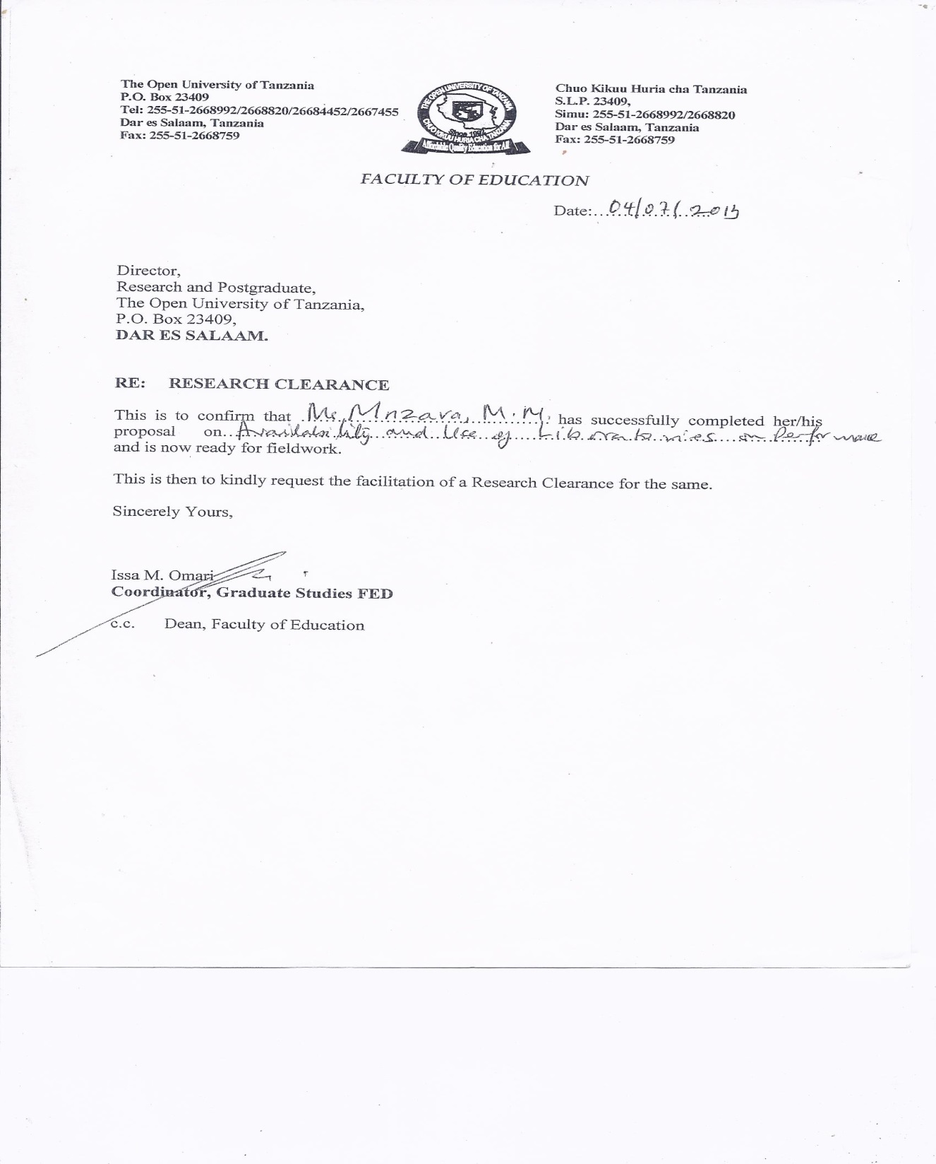
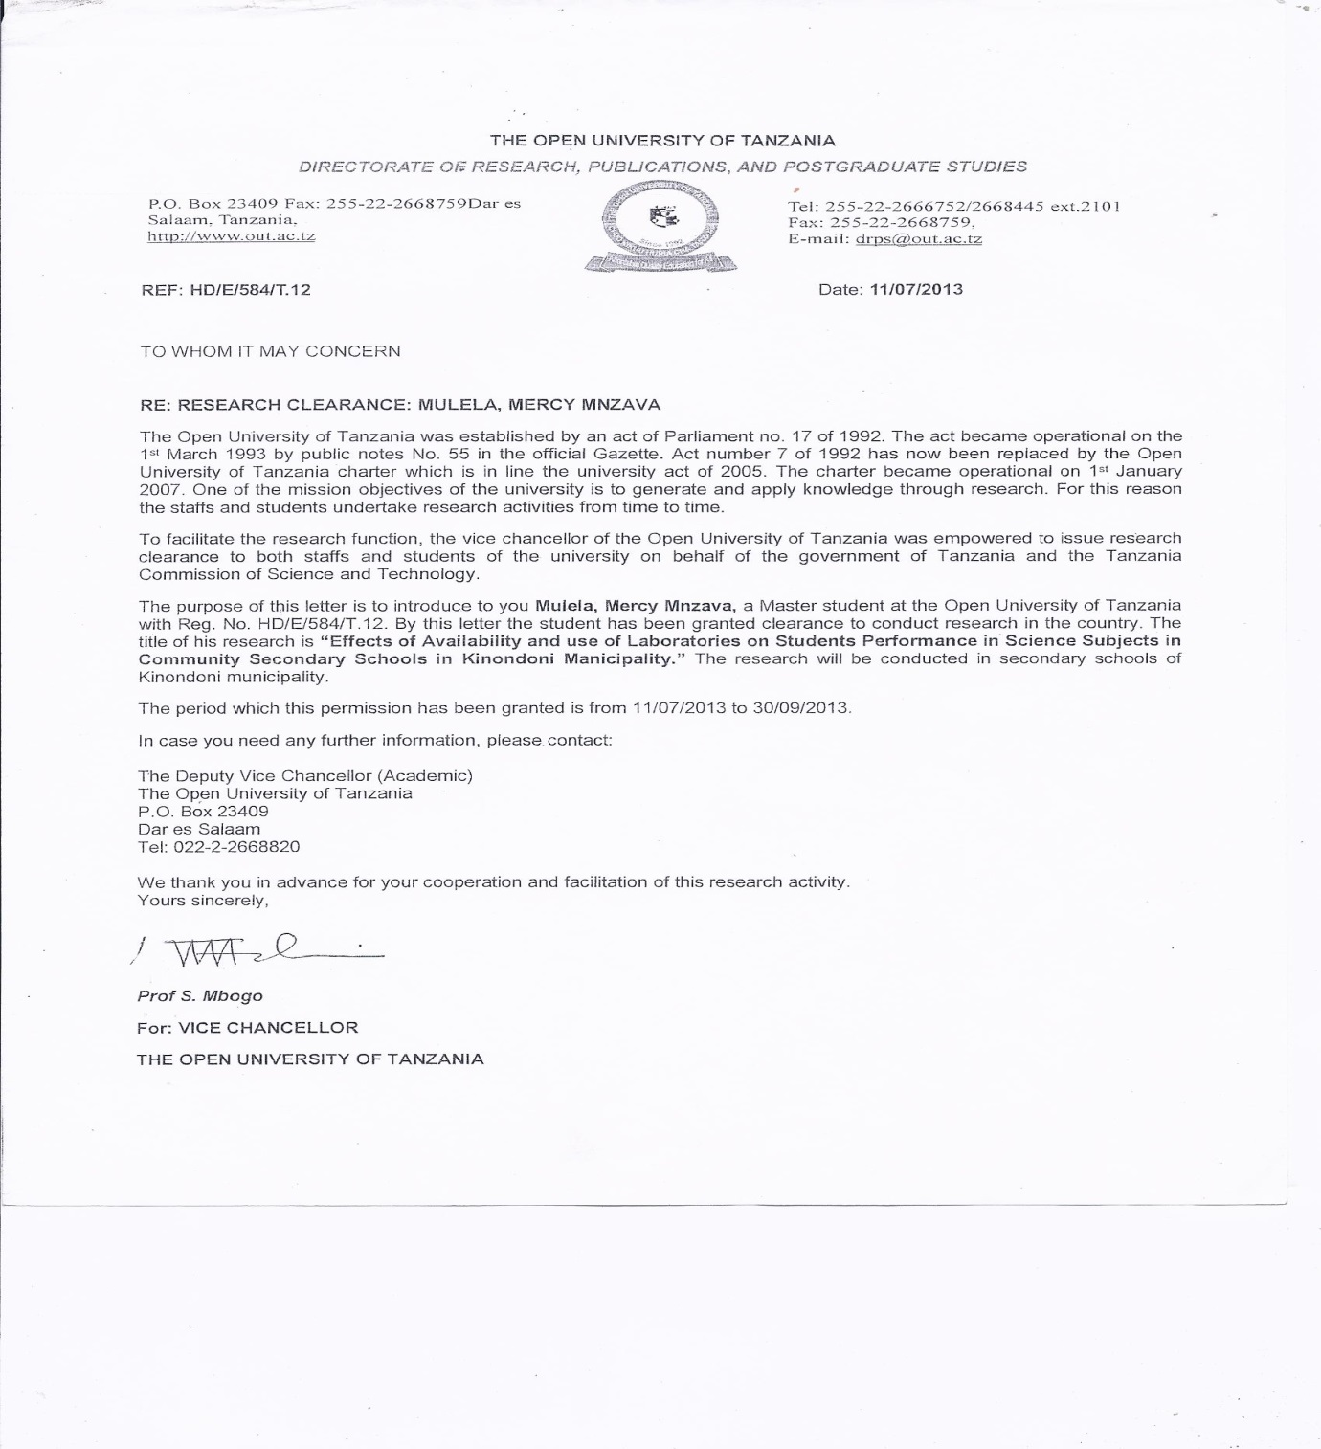

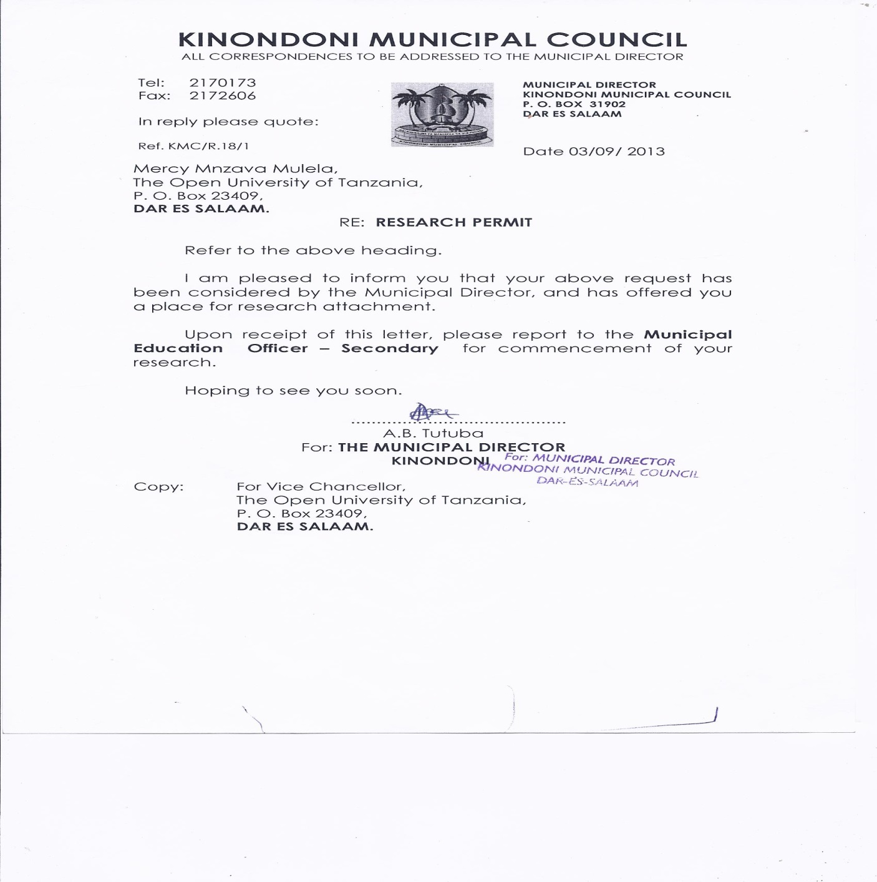
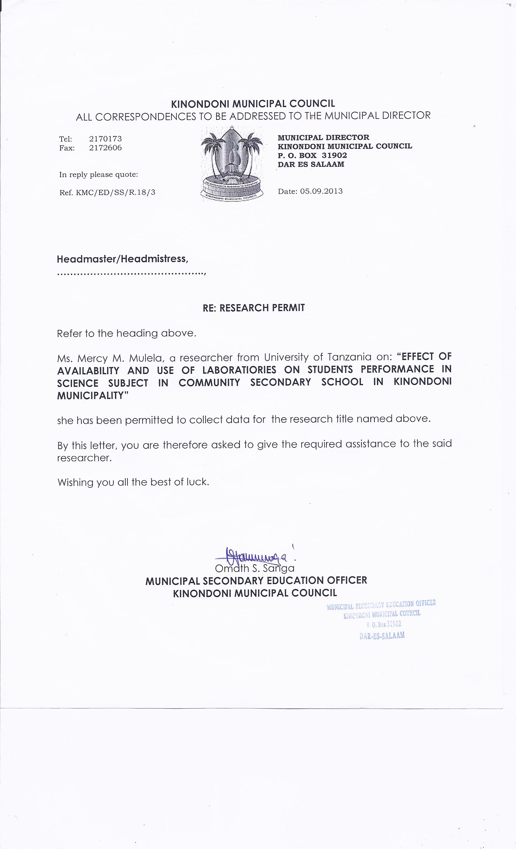

Appendix B: Laboratory Requirements by MoEVT
 |  | Schools
Ministry Guidelines on requirements | Items | S1 | S2 | S3 | S4 | S5 | S6
- Heat source | Gas tanks with valve
 | Installation of gas system in the chemistry laboratory.
 | Bunsen burners and rubber tubing for connection to the gas taps.
 | Kerosene stove.
- Drainage system | Good drainage system taps and sinks to be fixed around the work benches.
- Benches(tables) | Eight (8) benches.
- Stools | Forty (40) stools.

Appendix C: Availability of Teaching Mode
S/N | Item | Schools
S/N | Item | S1 | S2 | S3 | S4 | S5 | S6
1 | Eye
2 | Ear
3 | Heart
4 | Kidney
5 | Dental formula
6 | Lung
7 | Human body skeleton
8 | Alimentary canal
9 | Brain
10 | Pancreas

Appendix D: Availability of Apparatus
S/N | Item | Schools and amount of apparatuses
S/N | Item | S1 | S2 | S3 | S4 | S5 | S6
1 | Test tubes
2 | Beakers (100cc/ 250cc)
3 | Beakers (500cc)
4 | Conical flask (100cc/250cc)
5 | Conical flask 500cc
6 | Test tube holders
7 | Test tube racks
8 | Measuring cylinder (100cc/200cc)
9 | Measuring cylinder (250cc/500cc)
10 | Reagent bottles (250cc capacity)
11 | Pipette (20cc/25cc)
12 | Beam balance
13 | Droppers
14 | Glass rod / steers
15 | Hand lens
16 | Retort stand
17 | Wire gauze
18 | Pendulum bob
19 | Meter rule
20 | Standard weights (10g,20g,……600g)
21 | Spring balance
22 | Voltmeter
23 | Ammeter
24 | Galvanometer
25 | Rheostats / variable resistors
26 | Resistance boxes
27 | Switch / keys
28 | Glass blocks
29 | Thermometer
30 | Vernier caliper
31 | Micrometer screw gauge
32 | Glass prisms
33 | Stop watch
34 | Meter bridge

Appendix E: Availability of Chemicals
S/N | Item | School and chemicals available *
S/N | Item | S1 | S2 | S3 | S4 | S5 | S6
1 | Ammonia solution
2 | Benedict solution
3 | Barium Chloride
4 | Copper Sulphate
5 | Copper Nitrate
6 | Copper Chloride
7 | Chloroform
8 | Calcium Hydroxide
9 | Calcium Carbonate
10 | Ammonia Chloride
11 | Ferrous Sulphate (Iron II Sulphate)
12 | Ferric Chloride (Iron III Chloride)
13 | Hydrochloric acid (concentrated)
14 | Iodine Crystals
15 | Lead Nitrate
16 | Lead Carbonate
17 | Litmus paper (blue & red)
18 | Magnesium Sulphate
19 | Magnesium Carbonate
20 | Methylene orange powder
21 | Manganese Dioxide
22 | Nitric acid (concentrated)
23 | Oxalic acid
24 | Phenolphttialein powder
25 | Sulphuric acid (concentrated)
26 | Sodium Hydroxide
27 | Sodium Carbonate (unhydrous)
28 | Sodium Carbonate (hydrated)
29 | Sodium chloride
30 | Potassium Ferricyamide

Appendix F: Likert Scale on Availability of Laboratory
S/N | Item | School | Strongly  Agree | Agree | Disagree | Strongly  Disagree
I | Availability of laboratory has greater influence on students’ performance in science subjects | S1
I |  | S2
I |  | S3
I |  | S4
I |  | S5
I |  | S6
ii | The availability of materials and chemicals influences the performance on science subjects. | S1
ii |  | S2
ii |  | S3
ii |  | S4
ii |  | S5
ii |  | S6
iii | The class population, laboratory space and facilities may affect effectiveness of practical works. | S1
iii |  | S2
iii |  | S3
iii |  | S4
iii |  | S5
iii |  | S6
iv | Teaching load affects practical lessons | S1
iv | Teaching load affects practical lessons | S2
iv | Teaching load affects practical lessons | S3
iv | Teaching load affects practical lessons | S4
iv | Teaching load affects practical lessons | S5
iv | Teaching load affects practical lessons | S6
V | Support to teachers from head of school influences effectiveness of practical lessons | S1
V |  | S2
V |  | S3
V |  | S4
V |  | S6

Appendix G:

SN | Item | School | Strongly agree | Agree | Disagree | Strongly disagree
I | Use of laboratory has greater influence on student’s performance in science subjects | S1
I |  | S2
I |  | S3
I |  | S4
I |  | S5
I |  | S6
Ii | Practical sessions may be conducted even without laboratories. | S1
Ii |  | S2
Ii |  | S3
Ii |  | S4
Ii |  | S5
Ii |  | S6
Iii | The use of locally made materials may help when the required materials not available. | S1
Iii |  | S2
Iii |  | S3
Iii |  | S4
Iii |  | S5
Iii |  | S6
Iv | Supervision of practical activities should involve laboratory technicians and teachers together. | S1
Iv |  | S2
Iv |  | S3
Iv |  | S4
Iv |  | S5
Iv |  | S6
V | Some teachers’ skills on science practical activities affect practical lessons, hence performance. | S1
V |  | S2
V |  | S3
V |  | S4
V |  | S5
V |  | S6

Appendix H: Availability of Teachers

School. ……………………………………..
Subject. | Number of stream | Establishment. | Present. | Shortage
Biology
Chemistry
Physics

